First round evaluation 5 June 2015
Second round evaluation 28 October 2015

AusPAR Attachment 2

Extract from the Clinical Evaluation Report for Adalimumab
  - Proprietary Product Name: Humira
  - Sponsor: AbbVie Pty Ltd

About the Therapeutic Goods Administration (TGA)
- The Therapeutic Goods Administration (TGA) is part of the Australian Government Department of Health, and is responsible for regulating medicines and medical devices.
- The TGA administers the Therapeutic Goods Act 1989 (the Act), applying a risk management approach designed to ensure therapeutic goods supplied in Australia meet acceptable standards of quality, safety and efficacy (performance), when necessary.
- The work of the TGA is based on applying scientific and clinical expertise to decision-making, to ensure that the benefits to consumers outweigh any risks associated with the use of medicines and medical devices.
- The TGA relies on the public, healthcare professionals and industry to report problems with medicines or medical devices. TGA investigates reports received by it to determine any necessary regulatory action.
- To report a problem with a medicine or medical device, please see the information on the TGA website <https://www.tga.gov.au>.
About the Extract from the Clinical Evaluation Report
- This document provides a more detailed evaluation of the clinical findings, extracted from the Clinical Evaluation Report (CER) prepared by the TGA. This extract does not include sections from the CER regarding product documentation or post market activities.
- The words [Information redacted], where they appear in this document, indicate that confidential information has been deleted.
- For the most recent Product Information (PI), please refer to the TGA website <https://www.tga.gov.au/product-information-pi>.
Copyright
© Commonwealth of Australia 2016
This work is copyright. You may reproduce the whole or part of this work in unaltered form for your own personal use or, if you are part of an organisation, for internal use within your organisation, but only if you or your organisation do not use the reproduction for any commercial purpose and retain this copyright notice and all disclaimer notices as part of that reproduction. Apart from rights to use as permitted by the Copyright Act 1968 or allowed by this copyright notice, all other rights are reserved and you are not allowed to reproduce the whole or any part of this work in any way (electronic or otherwise) without first being given specific written permission from the Commonwealth to do so. Requests and inquiries concerning reproduction and rights are to be sent to the TGA Copyright Officer, Therapeutic Goods Administration, PO Box 100, Woden ACT 2606 or emailed to <tga.copyright@tga.gov.au>.

Contents
List of abbreviations 5
1. Introduction 11
2. Clinical rationale 11
2.1. Clinical rationale for the use of adalimumab in HS 11
3. Contents of the clinical dossier 12
3.1. Scope of the clinical dossier 12
3.2. Paediatric data 12
3.3. Good clinical practice 13
Pharmacokinetics 13
4. 13
4.1. Studies providing pharmacokinetic data 13
4.2. Summary of pharmacokinetics 13
4.3. Evaluator’s overall conclusions on pharmacokinetics 21
5. Pharmacodynamics 21
5.1. Studies providing pharmacodynamic data 21
5.2. Summary of pharmacodynamics 21
5.3. Evaluator’s overall conclusions on pharmacodynamics 22
6. Dosage selection for the pivotal studies 22
7. Clinical efficacy 22
7.1. Hidradenitis suppurativa 22
8. Clinical safety 50
8.1. Studies providing evaluable safety data 50
8.2. Pivotal studies that assessed safety as a primary outcome 51
8.3. Patient exposure 51
8.4. Adverse events 52
8.5. Laboratory tests 62
8.6. Post-marketing experiences 66
8.7. Evaluator’s overall conclusions on clinical safety 66
9. First round benefit-risk assessment 67
9.1. First round assessment of benefits 67
9.2. First round assessment of risks 67
9.3. First round assessment of benefit-risk balance 68
10. First round recommendation regarding authorisation 68
11. Clinical questions 68
11.1. Pharmacokinetics 68
11.2. Pharmacodynamics 68
11.3. Efficacy 68
11.4. Safety 68
12. Second round evaluation of clinical data submitted in response to questions 68
12.1. Efficacy 68
13. Second round benefit-risk assessment 70
13.1. Second round assessment of benefits 70
13.2. Second round assessment of risks 71
13.3. Second round assessment of benefit-risk balance 71
14. Second round recommendation regarding authorisation 71
15. References 71

List of abbreviations
Abbreviation | Meaning
AAA | Anti adalimumab antibody
AE | Adverse event
AESI | Adverse event of special interest
ALS | Amyotrophic lateral sclerosis
ALT/SGPT | Alanine aminotransferase/serum glutamic-pyruvic transaminase
AST/SGOT | Aspartate aminotransferase/serum glutamic-oxaloacetic transaminase
AN | Abscess and inflammatory nodule
AN25 | At least 25% reduction in abscess and inflammatory nodule count relative to Baseline
AN50 | At least 50% reduction in abscess and inflammatory nodule count relative to Baseline
AN75 | At least 75% reduction in abscess and inflammatory nodule count relative to Baseline
AN100 | 100% reduction in abscess and inflammatory nodule count relative to Baseline
ANA | Antinuclear antibody
AS | Ankylosing spondylitis
BCG | Bacille Calmette Guérin
BD | Twice a day
BMI | Body mass index
BUN | Blood urea nitrogen
CD | Crohn’s disease
CDA | Clinical drug accountability
CDC | Centres for Disease Control and Prevention
CHF | Congestive heart failure
CI | Confidence interval
CL/F | Apparent clearance
CMH | Cochran Mantel Haenszel
CRF | Case report form
CRP | C-reactive protein
CTC | Common Toxicity Criteria
CV | Coefficient of variation
CVA | Cerebrovascular accident
CXR | Chest x-ray
DB | Double blind
DE | Dose escalation
DLQI | Dermatology Life Quality Index
DNA | Deoxyribonucleic acid
dsDNA | Double-stranded deoxyribonucleic acid
ECG | Electrocardiogram
eCRF | Electronic case report form
EDC | Electronic data capture
ELISA | Enzyme-linked immunosorbent assay
eow | Every other week
ET | Early termination
E/100PY | Events per 100 patient-years
EU | European Union
ew | Weekly
GCP | Good Clinical Practice
HBcAb | Hepatitis B core antibody
HBsAb | Hepatitis B surface antibody
HBsAg | Hepatitis B surface antigen
HBV | Hepatitis B virus
HCG | Human chorionic gonadotropin
HiSCR | Hidradenitis Suppurativa Clinical Response
HIV | Human immunodeficiency virus
HS | Hidradenitis suppurativa
HSTCL | Hepatosplenic T-cell lymphoma
hs-CRP | High sensitivity C-reactive protein
HS-PGA | Hydradenitis suppurative Physician`s Global Assessment
IBD | International birth date
ICF | Informed consent form
ICH | International Conference on Harmonisation
IEC | Independent ethics committee
IGRA | Interferon gamma release assay
ILD | Interstitial lung disease
IP | Investigational product
ITT | Intent to treat
IV | Intravenous
IXRS | Interactive voice response system/interactive web response system
JIA | Juvenile idiopathic arthritis
LOCF | Last observation carried forward
LOR | Loss of response
LOQ | Limit of quantification
MedDRA | Medical Dictionary for Regulatory Activities
MI | Myocardial infarction
NMSC | Non-melanoma skin cancer
NR | Non-responder
NRI | Non-responder imputation
NRS | Numeric rating scale
Nr-ax SpA | Non-radiographic axial spondylarthritis
NYHA | New York Health Association
OL | Open label
OLE | Open label extension
PA | Posterior-anterior
PBO | Placebo
PCR | Polymerase chain reaction
PE | Pulmonary embolism
PGA | Physician's Global Assessment
PI | Product Information
PK | Pharmacokinetic
PML | Progressive multifocal leukoencephalopathy
PO | Oral
POR | Proof of Receipt
PP | Per protocol
PPD | Purified protein derivative
PRN | Pro re nata (as needed)
Ps | Psoriasis
PsA | Psoriatic arthritis
PT | Preferred term
PY | Patient year
QoL | Quality of life
RA | Rheumatoid arthritis
RBC | Red blood cell
RCT | Randomised controlled trial
RPLS | Reversible posterior leukoencephalopathy syndrome
SAE | Serious adverse event
SAP | Statistical analysis plan
SC | Subcutaneous
SLE | Systemic lupus erythematosus
SOC | System organ class
SpA | Spondylarthritis
SUSAR | Suspected unexpected serious adverse reactions
TB | Tuberculosis
TEAE | Treatment-emergent adverse event
TESAE | Treatment emergent serious adverse event
TNF | Tumor necrosis factor
TSQM | Treatment Satisfaction Questionnaire for Medication
UC | Ulcerative colitis
ULN | Upper limit of normal
US | United States
V/F | Apparent volume of distribution
WBC | White blood cell
Wk | Week
WOAI | Worsening or absence of improvement
WPAI:SHP | Work Productivity and Activity Impairment Questionnaire: Specific Health Problem

Introduction
This is a submission to:
- extend indications for adalimumab to hidradenitis suppurativa in adult patients
- make changes to the Product information (PI) of adalimumab relating to hidradenitis suppurativa, chronic plaque psoriasis of the hands and/or feet and ulcerative colitis
Adalimumab is a recombinant human immunoglobulin monoclonal antibody against tumour necrosis factor (TNF). It belongs to the pharmacotherapeutic group of selective immunosuppressive agents. It neutralizes the biological function of TNF by blocking its interaction with the p55 and p75 cell surface TNF-α receptors. Adalimumab also modulates biological responses that are induced or regulated by TNF.
The approved indications are rheumatoid arthritis (RA), polyarticular juvenile idiopathic arthritis (JIA), psoriatic arthritis (PsA), ankylosing spondylitis (AS), Crohn’s disease (CD), ulcerative colitis (UC) and psoriasis (Ps).
The proposed additional indication is hidradenitis suppurativa (HS) using the following Product Information (PI) text:
Humira is indicated for the treatment of active moderate to severe hidradenitis suppurativa (acne inversa) in adult patients, including treatment of inflammatory lesions and prevention of worsening of abscesses and draining fistulas.

Clinical rationale

Clinical rationale for the use of adalimumab in HS
Hidradenitis suppurativa (HS) is a debilitating, chronic inflammatory follicular disease characterised by the formation of recurrent abscesses, inflammatory nodules, and fistulas. It mainly involves skin regions with apocrine glands such as axillae, groins, perineal and perianal areas, and submammary areas. Lesions are often painful and result in malodorous discharge. Complications include excessive scarring and fibrosis potentially leading to contractures and limitations in mobility, as well as anal, urethral, and rectal strictures. Other comorbidities associated with HS include anaemia, secondary infection, malignancy (such as non-melanoma skin cancer [NMSC]), depression, and anxiety. These disease sequelae result in significant reduction of health-related quality of life in affected individuals.
The estimated prevalence of HS is approximately 1%. The disease onset is typically in the second and third decade of life and is rare in prepubertal children. Women are affected more commonly than men (female/male ratio approximately2:1). Predisposing factors include obesity and cigarette smoking. The diagnosis is usually established based on the clinical presentation. Several disease severity scores have been developed, with the most commonly used being the three-stage Hurley score.
Regarding management, the general lack of large randomised controlled studies limits therapeutic options for HS, which include both medical and surgical treatments. Medical treatment options include topical and systemic antibiotics (clindamycin and rifampicin alone or in combination, tetracyclines), oral anti-androgen agents in women, dapsone and/or isotretinoin. More recently, the use of systemic anti-TNF therapy (infliximab, etanercept, adalimumab) has shown promising results. Surgical options include radical excisions and deroofing as well as laser ablation (CO₂ and Nd:YAG lasers). Most of the described treatments are based on small case series, and no widely accepted therapeutic guidelines are available for HS.
The sponsor`s Clinical Overview states: Given that (a) the abscesses and inflammatory nodules of HS cause pain and malodour, and may culminate in scar formation; (b) there are no approved medical therapies for the abscesses and inflammatory nodules of HS; and (c) surgical and laser therapies can be associated with significant post-procedure morbidity and uncertain long-term disease control, there is a significant unmet medical need for therapies to treat this condition. Based on the current treatment options and unmet medical need, sponsor considers that adalimumab has the potential to provide safe and effective therapy for moderate to severe HS and thus conducted a clinical development program for this indication.

Contents of the clinical dossier

Scope of the clinical dossier

For HS
The clinical dossier documented a development program of pharmacokinetic and immunogenicity, dose-finding, pivotal and other clinical trials relating to the proposed extension of indications.
The submission contained the following clinical information:
- 2pivotal efficacy/safety studies
- 1 Phase II efficacy/safety study
- 3 separate pharmacokinetic reports derived from the pivotal efficacy/safety studies
- Integrated Summary of Efficacy and Integrated Summary of Safety
- A measurement report for the use of the HS Clinical Response (HiSCR) measure
- 2 Evidentiary Dossiers to Support the use of various quality of life measurements in HS patients
- Literature references.
In addition the submission contained a Clinical Overview, Summary of Clinical Efficacy, and Summary of Clinical Safety.

For hand-foot psoriasis
- 1 open-label long term efficacy/safety study.

For ulcerative colitis
- 1 open-label long term efficacy/safety study.
Comment: Overall, the submission was well presented. Nevertheless, at many times navigation through the complex folders and pdf files was inefficient and time consuming given the sheer number of documents supplied, many of which were duplicates. This was somewhat offset by the provision of the adequately hyper-linked cover document.

Paediatric data
The submission did not include paediatric data.
Comment: The exclusion of paediatric patients is reasonable given the low incidence of HS in prepubertal children and lack of evidence for the use of adalimumab in adolescent HS patients.

Good clinical practice
The sponsor declared that all individual studies in this application complied with the principles of Good Clinical Practice, and were conducted with the approval of Ethics Committees or Institutional Review Boards. Informed consent was reported to have occurred for all subjects, and the studies performed in accordance with the version of the Declaration of Helsinki that applied at the time the studies were conducted.
Comment: No evidence was found by the evaluators to contradict this claim.

Pharmacokinetics

Studies providing pharmacokinetic data
Summaries of the pharmacokinetic studies are presented in Table 1.
Comment: Adalimumab is a registered drug for various indications in Australia. Pharmacokinetic data are available in the approved PI. No separate pharmacokinetic studies were submitted in this application. Rather, the presented data were derived as part of the pivotal efficacy/safety studies. Population pharmacokinetics was also evaluated for HS subjects in this submission.

Table 1: Submitted pharmacokinetic studies
PK topic | Subtopic | Study ID
PK in special populations | Target population (HS) §  Multi-dose | M10-467  M11-313  M11-810
Population PK analyses | Healthy subjects | -
Population PK analyses | Target population | M10-467  M11-313  M11-810
Population PK analyses | Other | -
None of the pharmacokinetic studies had deficiencies that excluded their results from consideration.

Summary of pharmacokinetics
The information in the following summary is derived from conventional pharmacokinetic studies unless otherwise stated.

Physicochemical characteristics of the active substance
The sponsor states in the submission that bioanalytical methods for adalimumab were provided with previous submissions. No additional biopharmaceutic or analytical studies were included in this filing.

Pharmacokinetics in healthy subjects
No data were submitted for healthy subjects.
Comment: This is acceptable, since the PK of adalimumab in normal human subjects have been characterised previously. Data from these studies are available in the PI.

Pharmacokinetics in the target population
The pharmacokinetics and immunogenicity of adalimumab were evaluated in subjects with moderate to severe HS in a Phase II study (Study M10-467) and two Phase III studies (Studies M11-313 and M11-810).

Study M10-467
Study M10-467 was a 52-week, multicenter, Phase II study conducted to evaluate the short and long term clinical efficacy and safety of adalimumab in adult subjects with moderate to severe HS. The study was divided into 2 treatment periods. Period A was a 16-week, double blind (DB), placebo-controlled treatment period where subjects are randomised in a 1:1:1 ratio to receive adalimumab (40 mg weekly or 40 mg every other week [eow]) or matching placebo. Period B was a 36-week, open label treatment period where all subjects received open label adalimumab 40 mg (eow) with the option to escalate to weekly dosing. Blood samples were obtained for the measurement of serum adalimumab concentrations at Baseline, Weeks 4, 8, 16, 28, 31, 39, 45, and Week 52, and at the early termination (ET) visit if the subject discontinued prior to Week 52.
Summaries of serum adalimumab concentrations in the DB period in Study M10-467 are presented in Table 2 and Figure 1. The mean adalimumab concentrations across the period were about 10 to 12 µg/mL and 6 to 7 µg/mL, respectively, for subjects who received 40 mg ew and 40 mg eow treatments. At the end of the DB period (Week 16), the mean adalimumab concentration following 40 mg ew was about 2-fold of that observed with 40 mg eow treatment, demonstrating the dose-proportionality of adalimumab in this dose range.

Table 2: Summary of serum adalimumab concentrations (µg/mL) in double blind period (Study M10-467)
Treatment Groups | Mean ± SD (Min – Max), N
Treatment Groups | Week
Treatment Groups | 0 | 4 | 8 | 16
Double-blind  40 mg ew (N = 51) | 0.00 ± 0.00  (0.00 – 0.00), 51 | 10.0 ± 5.32  (0.00 – 21.5), 50 | 11.3 ± 6.93 (0.00 – 26.8), 47 | 12.4 ± 9.16 (0.00 – 40.5), 45
Double-blind  40 mg eow (N = 52) | 0.00 ± 0.00  (0.00 – 0.00), 52 | 7.00 ± 3.62  (0.43 – 14.7), 51 | 6.46 ± 4.57 (0.00 – 20.5), 52 | 5.89 ± 5.16 (0.00 – 18.9), 52
Figure 1: Mean (SD) Serum adalimumab concentrations versus time in double blind period (Study M10-467)
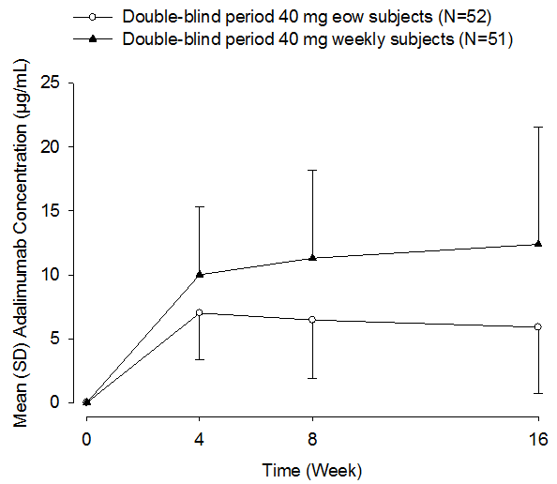
Summaries of serum adalimumab concentration in the open label (OL) period in Study M10-467, separately by treatment group in the DB period, are presented in Figure 2. For subjects who received adalimumab 40 mg ew or eow in the DB period, the mean adalimumab concentrations at Week 28 in subjects who later remained on 40 mg eow dosing (without dose escalation [DE]) were relatively higher (about 1.5- to 2-fold) than those observed in subjects who subsequently escalated to 40 mg ew dosing (with DE). For both DB adalimumab groups, the mean adalimumab concentrations in subjects without DE declined between Weeks 28 to 39 and were remained relatively constant at 5 to 6 µg/mL after Week 39. For DB adalimumab 40 mg eow group, the mean adalimumab concentration in subjects with DE increased over time (from approximately 5 µg/mL at Week 28 to approximately 10 µg/mL by Week 52). For DB adalimumab 40 mg ew group, the mean adalimumab concentration in subjects with DE increased between Weeks 28 to 39 and was maintained relatively constant at approximately 8 µg/mL after Week 39.
For subjects who received placebo during the DB period and went into OL 40 mg eow treatment, the mean adalimumab concentrations in the OL period were relatively stable (approximately 4 µg/mL). For the DB placebo subjects with DE, the mean adalimumab concentration increased between Weeks 28 to 39 and then maintained relatively constant at 7 to 8 µg/mL.
Figure 2: Mean (SD) serum adalimumab concentrations versus time in open label period (separately by treatment groups from double-blind period) (Study M10-467)
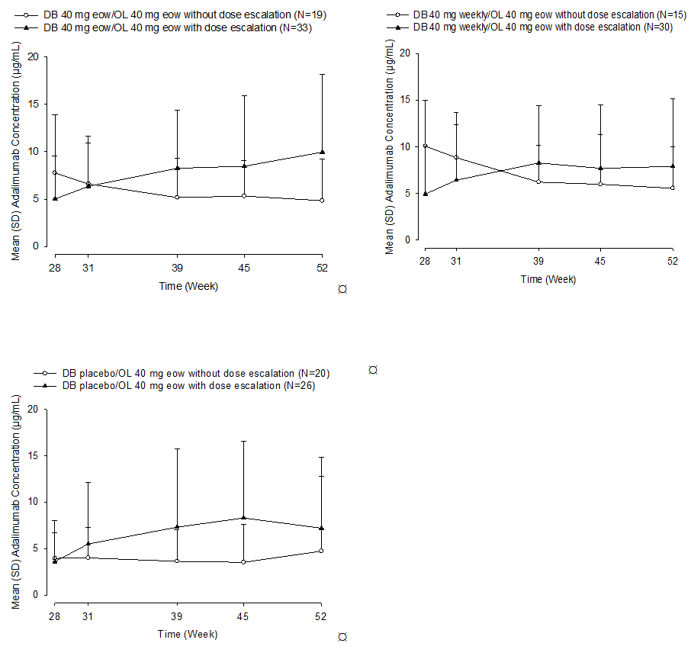

Studies M11-313 and M11-810
Studies M11-313 and M11-810 were DB placebo controlled Phase III studies of similar design and are summarised together. Both studies were divided into 2 treatment periods. In the first period, Period A (Week 0 to Week 16), subjects were randomised in a 1:1 ratio to receive adalimumab 40 mg ew or matching placebo. In the second period, Period B, subjects randomised to adalimumab in Period A were re-randomised at Week 12 in a 1:1:1 ratio to receive adalimumab 40 mg ew, adalimumab 40 mg eow or matching placebo from Week 12 to Week 35. Subjects randomised to placebo in Period A were assigned (using re-randomisation numbers) to receive adalimumab 40 mg ew in Study M11-313, or continue on blinded placebo in Study M11-810.
In both studies, blood samples were obtained for the measurement of serum adalimumab concentrations at Baseline, Weeks 2, 4, 8, 12, 14, 16, 20, 24, 32, 36, and at the ET visit if the subject discontinued prior to Week 36.
Summaries of serum adalimumab concentrations from subjects who received adalimumab treatment in Period A are presented in Table 3 and Figure 3. Following adalimumab 40 mg ew treatment (starting at Week 4, with 160 mg at Week 0 and 80 mg at Week 2), the mean serum adalimumab concentrations appeared to reach steady state (7 to 9 µg/mL) by Week 2, which was maintained through to Week 12. Adalimumab concentrations were comparable between Studies M11-313 and M11-810.

Table 3: Summary of serum adalimumab concentrations (µg/mL) for subjects with HS in Period A (Studies M11-313 and M11-810)
Treatment: Period A Adalimumab 40 mg ew | Mean ± SD (Range), N
Treatment: Period A Adalimumab 40 mg ew | Week
Treatment: Period A Adalimumab 40 mg ew | 0 | 2 | 4 | 8 | 12
Study M11-313 (N = 153) | 0.026 ± 0.327  (0 – 4.05), 153 | 7.69 ± 3.69 (0 – 18.9), 149 | 7.45 ± 4.52 (0 – 23.4), 148 | 7.64 ± 5.12 (0 – 28.0), 146 | 8.66 ± 6.39 (0 – 28.6), 145
Study M11-810 (N = 163) | 0 ± 0  (0 – 0), 163 | 7.38 ± 3.29 (0 – 16.4), 161 | 7.45 ± 4.18 (0 – 20.9), 161 | 8.61 ± 5.41 (0 – 25.6), 158 | 8.95 ± 6.27 (0 – 29.4), 153
Figure 3: Mean (+SD) serum adalimumab concentrations versus time in subjects with HS in Period A (Studies M11-313 and M11-810)
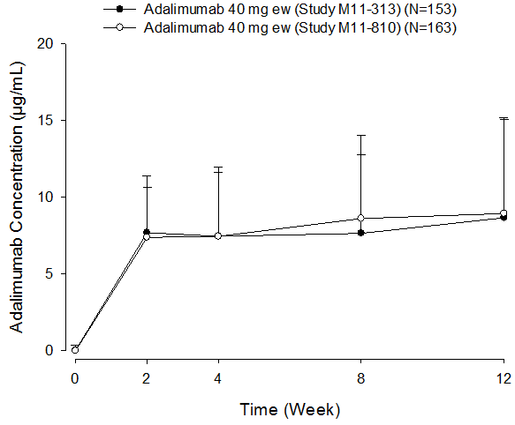
At the end of Period A (Week 12), subjects were evaluated for the primary efficacy endpoint of HiSCR. In subjects that received adalimumab 40 mg ew, responders had slightly higher adalimumab concentrations compared to non-responders (8 to 11 µg/mL versus 6 to 7 µg/mL) in both Phase III studies.
The mean (+ SD) serum adalimumab concentrations in Period B by treatment groups are shown in Figure 4. For subjects treated with adalimumab 40mg ew in Period A, the mean serum adalimumab concentrations were maintained approximately constant at the same steady-state values during Period B in ew/ew subjects and, as expected, declined with time during Period B in ew/eow and ew/pbo subjects. The mean serum adalimumab concentrations were higher in ew/ew subjects compared to that observed in subjects treated with adalimumab 40mg ew/eow (2 to 3 fold higher during Weeks 24 to 36), and exposure of adalimumab was dose-proportional in this range.
Figure 4: Mean (+ SD) serum adalimumab concentrations versus time in subjects with HS in Period B (Studies M11-313 and M11-810)
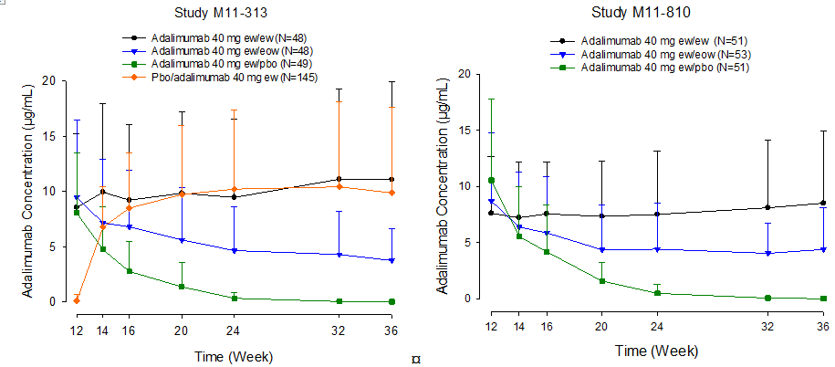
Adalimumab 40 mg ew/ew = adalimumab 40 mg ew in both Period A and Period B. Adalimumab 40 mg ew/eow = adalimumab 40 mg ew in Period A and eow in Period B. Adalimumab 40 mg ew/pbo = adalimumab 40 mg ew in Period A and placebo in Period B. Pbo/adalimumab 40 mg ew = placebo in Period A and adalimumab 40 mg ew in Period B.
For subjects treated with placebo in Period A and re-randomised to receive adalimumab 40 mg ew in Period B (pbo/ew subjects in Study M11-313), mean serum adalimumab concentrations appeared to reach steady state approximately by Week 20 and were comparable to those achieved in ew/ew subjects.

Comparison of PK in submitted studies with other patient populations
During initial dosing, subjects in Phase III studies in HS received 160 mg adalimumab at Week 0 and 80 mg at Week 2. The same regimen was tested in subjects with CD (Study M02-403) and UC (Study M06-827). Adalimumab concentrations were lower in subjects with HS (approximately 7.5 µg/mL) compared to subjects with CD and UC (approximately 12 µg/mL) following the initial doses of 160 mg/80 mg administered at Week 0/Week 2.
In the maintenance phase of the studies, adalimumab concentrations following 40 mg ew treatment in subjects with HS were compared to those observed in subjects with Ps (Study M02-528). Adalimumab concentrations were lower in subjects with HS (8.8 µg/mL at Week 12) compared to subjects with Ps (17.6 µg/mL at Week 11) following 40 mg ew maintenance treatment.
Comment: The reason for the observed difference in adalimumab levels in HS patients and other patient groups is unknown. However, only one timepoint for HS and Ps was presented. In addition, the current PI states that the mean steady-state trough concentration of adalimumab in Ps patients was 5 µg/mL during adalimumab 40 mg eow monotherapy treatment (after an initial loading dose of 80 mg), which appears comparable to HS patients on eow dosing.

Population PK
Population pharmacokinetic analyses were performed using the NONMEM software combining data from Studies M10-467, M11-313 and M11-810. The final model included a one-compartment model with correlated exponential terms for inter-individual variability on the apparent clearance (CL/F) and the apparent volume of distribution (V2/F), and a combined residual error model. Significant covariates for CL/F included the presence of anti-adalimumab antibodies (AAA) (modelled to affect CL/F starting 3 weeks after adalimumab treatment), baseline C-reactive protein (CRP) and baseline body weight. Baseline body weight was also a significant covariate for V2/F. Based on the population pharmacokinetic analyses, the median CL/F and V2/F of adalimumab was estimated to be 27.8 mL/h (0.667 L/day) and 13.5 L, respectively, in subjects with moderate to severe HS.

Exposure-response relationship
The exposure-response relationship for the efficacy and safety of adalimumab during Period B of the Phase III studies was explored using time-to-event models. Serum adalimumab concentration was a significant predictor for loss of response (LOR) in HiSCR responders and for HS reported as an AE (exacerbation of underlying disease). Subjects with higher adalimumab concentrations were less likely to experience LOR or HS as an AE. No apparent exposure-response relationship was identified for worsening or absence of improvement in HiSCR non-responders or infection in subjects with HS.

Immunogenicity
Immunogenicity of adalimumab in the HS population was assessed in Studies M10-467, M11-313 and M11-810 using a double antigen sandwich enzyme-linked immunosorbent assay (ELISA) method. A sample was classified as AAA+ if the AAA concentration in serum was > 20 ng/mL and the serum sample was collected within 30 days after an adalimumab dose.
In the Phase II Study M10-467, five subjects were AAA positive (4.9%, 5 out of 103 subjects) during the DB period (Weeks 0 to 16): 2 subjects in the 40 mg ew group (2 out of 51 subjects, 3.9%) and 3 subjects in the 40 mg eow group (3 out of 52 subjects, 5.8%). Another 11 (7.1%, 11 out of 154) new subjects became AAA+ in the OL period (Weeks 17 to 52). The percentage of subjects with AAA+ samples was 10.4% (16 out of 154 subjects) during the entire study period (Week 0 to Week 52).
In the Phase III Studies M11-810 and M11-313, the percentage of subjects testing positive for AAA who received 40 mg ew through Week 36 (Period A and B) was 10.1% (10 out of 99 subjects). The percentage of subjects who received at least one dose of adalimumab testing positive for AAA was 6.5% (30 out of 461 subjects). In Period B, the AAA+ rate appeared to be comparable between subjects who received 40 mg ew and 40 mg eow in the HS program.
Overall, the mean serum adalimumab concentrations were lower in AAA+ subjects compared to those in AAA– subjects and remained low throughout the studies. None of the AAA+ subjects in Period A from Study M11-810 (0%, 0 out of 2 subjects) and Study M11-313 (0%, 0 out of 8 subjects) achieved HiSCR at Week 12. The number of AAA+ subjects was too small in both studies to provide a definitive conclusion regarding the impact of immunogenicity on efficacy.
For the safety analysis of all subjects, the rate of any AEs and the rate of infectious AEs were comparable between AAA+ and AAA– subjects. For the remaining AEs (for example serious AEs, serious infection AEs, allergic reactions, worsening/new onset of Ps and hematologic disorders), the numbers of AAA+ and/or AAA– subjects who reported these AEs were too small to make a definitive conclusion.

Pharmacokinetics in other special populations
No data for other special populations were provided.
Comment: This is acceptable, since the PK of adalimumab in other special populations (for example subjects with impaired renal function) have been characterised previously.

Pharmacokinetic interactions

Pharmacokinetic interactions demonstrated in human studies
No data on pharmacokinetic interactions were provided.

Clinical implications of in vitro findings
No data on in vitro findings were provided.

Evaluator’s overall conclusions on pharmacokinetics
Adalimumab is a registered drug for several inflammatory conditions in Australia. The PK data of adalimumab in normal human subjects and approved indications were provided in previous submissions by the sponsor. Key PK data from these studies have been included in the Product Information (PI) sheet. The evaluation is based on PK obtained during submitted pivotal efficacy/safety studies in HS patients. The submitted data together with historical data on other patient groups (that are UC and CD which have similar dosing regimens as HS patients) are acceptable for judging the PK in the HS population group.
Long-term treatment serum concentrations of adalimumab in the three pivotal HS studies were largely consistent and were around 9 to 11 µg/mL for 40 mg ew at Week 36. Slightly higher trough concentrations were observed in Period A in Study M10-476 as compared to Studies M11-313 and M11-810, but this may relate to the different sample sizes and patient groups in the Phase II versus Phase III studies.
Compared to other study populations, including CD and UC, HS populations appeared to have lower adalimumab serum levels despite similar dosing. This may relate to the fact that HS patient groups have different demographics as compared to the other patient groups. An inconsistency between presented PK in psoriatic patients in the submission and the PI needs to be clarified (that is, the PI states that trough concentrations were 5 µg/mL during adalimumab 40 mg fortnightly monotherapy, which is lower than the trough concentration observed in HS patients).
Serum adalimumab concentration was a significant predictor for LOR in subjects who had been HiSCR responders at Week 12 and for worsening of underlying HS where subjects with higher adalimumab concentrations were less likely to experience LOR or HS worsening. LOR in subjects who had been HiSCR responders at Week 12, and rates of flares and HS worsening were related to lower adalimumab concentrations, as observed in Period B.
Regarding immunogenicity, the percentage of subjects testing positive for AAA who received 40 mg ew through Week 36 was 10%. Development of AAA may be associated with lower adalimumab serum concentrations and, therefore, may impact on the efficacy of therapy. There was no increased risk of AE in AAA+ as compared to AAA- subjects, although sample numbers were low and further studies are required for definitive conclusions about AAA and safety.
Overall, the PK data provided in the submission are consistent with previous data in other patient groups. The proposed PI is generally an adequate summary of the PK presented in the submission.

Pharmacodynamics

Studies providing pharmacodynamic data
No pharmacodynamic data were provided.

Summary of pharmacodynamics
Not applicable.

Evaluator’s overall conclusions on pharmacodynamics
Not applicable.

Dosage selection for the pivotal studies
The dosing regimens for the pivotal studies (M11-810, M11-313) were selected based on data from Study M10-467, a 52-Week 2-period Phase II study. The proportion of HS subjects who achieved a clinical response in Study M10-467 was significantly higher in the adalimumab 40 mg ew arm and numerically higher in the adalimumab 40 mg eow arm compared with subjects in the placebo arm at Week 12 and Week 16. A numerical trend favouring adalimumab 40 mg ew compared with adalimumab 40 mg eow was noted at both Week 12 and Week 16. A decline in response rate was seen following the decrease from adalimumab ew to eow dosing during Period B; dose escalation to adalimumab ew dosing resulted in improved efficacy.

Clinical efficacy

Hidradenitis suppurativa

Pivotal efficacy studies
The sponsor provided two pivotal efficacy studies (M11-313, M11-810, M12-555) for the HS indication.
Comment: While Studies M11-313 and M11-810 are acceptable as pivotal efficacy studies, M12-555 represents an open label extension study of these two Phase III trials. At the time of submission, this study was still ongoing and was therefore not considered pivotal by the evaluator.

Study M11-313
A Phase III multicenter study of the safety and efficacy of adalimumab in subjects with moderate to severe hidradenitis suppurativa – (PIONEER I).

Study design, objectives, locations and dates
A randomised double blind, multicentre, placebo controlled study conducted in 48 sites worldwide (Australia, Czech Republic, Germany, Canada, Hungary and United States [US]) between November 2011 and January 2014. It assessed the safety and efficacy of adalimumab in the treatment of HS.
Comment: The study was designed as an initial 12-week double-blind treatment period (Period A), a subsequent 24-week double-blind treatment period (Period B) and a day 70 follow up phone call. The study report includes periods A and B (dated September 2014).
The study design schematic is shown in Figure 5. In period A, subjects were randomised in a 1:1 ratio to receive blinded adalimumab 160 mg at Week 0, 80 mg at Week 2, and 40 mg ew or matching placebo starting at Week 4 for an evaluation of safety and efficacy.
In period B, all subjects were re-randomised at Week 12. Subjects randomised to adalimumab in Period A were to be re-randomised in a 1:1:1 ratio to receive adalimumab 40 mg ew, adalimumab 40 mg eow, or matching placebo. Subjects randomised to placebo in Period A were to be assigned to receive adalimumab 40 mg ew.

Primary objective
To evaluate the clinical safety and efficacy of adalimumab compared to placebo in subjects with moderate to severe HS after 12 weeks of treatment as defined by Hidradenitis Suppurativa Clinical Response (HiSCR).

Secondary objective
To evaluate safety and explore efficacy for continuous weekly dosing versus dose reduction versus maintenance of response off therapy from Week 12 to Week 36. The pharmacokinetics and immunogenicity of adalimumab following subcutaneous (SC) injection were also assessed.
Figure 5: M11-313 Study Design Schematic
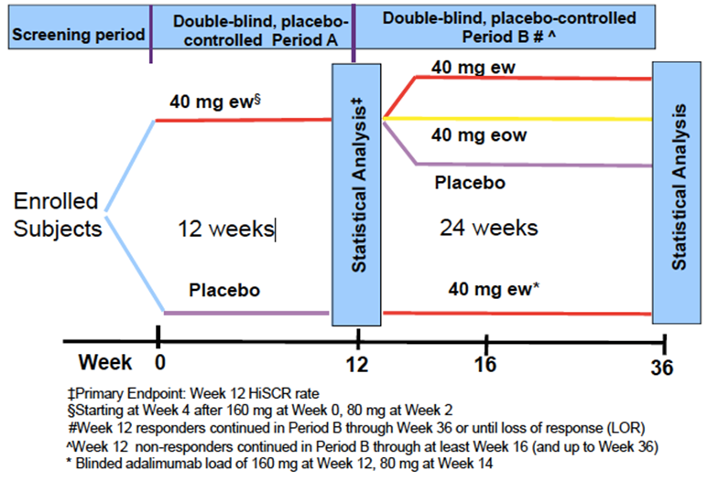

Inclusion and exclusion criteria
Inclusion: Adults (≥ 18 years of age) with a diagnosis of HS for at least 1 year prior to baseline, who met the following criteria:
- HS lesions present in at least 2 distinct anatomic areas (for example, left and right axilla; or left axilla and left inguino-crural fold), one of which was Hurley Stage II or Hurley Stage III.
- Inadequate response to at least a 3-month (90 days) trial of oral antibiotics for treatment of HS (or had intolerance or contraindication to oral antibiotics for treatment of HS).
- Stable HS for at least 2 months (60 days) prior to Screening and also at the Baseline visit.
- Total AN count of greater than or equal to 3 at the Baseline visit.
- Female subjects were either not of childbearing potential, surgically sterile or was practicing approved birth control throughout the study and for 150 days after the last dose of the study drug.
- Negative serum pregnancy test.
- Agreed to daily use of 1 of the following over-the-counter topical antiseptics on their body areas affected with HS: chlorhexidine gluconate, triclosan, benzoyl peroxide, or dilute bleach in bathwater.
- Had a negative TB screening assessment and negative CXR at Screening. Subject with evidence of a latent TB infection, must have completed a minimum of 4 weeks of anti-TB therapy, or have documented completion of a course of anti-TB therapy prior to Baseline.
- Had good general health as determined by the Principal Investigator based upon the results of a medical history, physical examination, laboratory profile, CXR and a 12-lead ECG performed during the Screening period and confirmed at Baseline.
- Able to self-administer SC injections or had a qualified person(s) who could reliably administer SC injections.
- Able and willing to provide informed consent and comply with study protocol.
Exclusion:
- Prior treatment with adalimumab or other anti-TNF therapy (for example infliximab, etanercept), or participation in an adalimumab trial.
- Any other active skin disease or condition (for example bacterial, fungal or viral infection) that could have interfered with HS assessment.
- Oral antibiotic treatment within 28 days or prescription topicals for treatment of HS within 14 days prior to the Baseline visit.
- Systemic non-biologic therapies with potential therapeutic impact for HS < 28 days prior to Baseline visit.
- Oral concomitant analgesics (including opioids) for HS-related pain within 14 days prior to the Baseline visit.
- For non-HS related pain: subject on opioid analgesics within 14 days or not on a stable dose of non-opioid oral analgesics for at least 14 days prior to the Baseline visit (´as needed´ [PRN] was not considered a stable dose).
- Required or was expected to require, opioid analgesics for any reason.
- Draining fistula count of greater than 20 at the Baseline visit.
- Treatment with any investigational drug of chemical or biologic nature within a minimum of 30 days or 5 half-lives (whichever was longer) prior to the Baseline visit.
- Prior exposure to biologics that had a potential or known association with progressive multifocal leukoencephalopathy (PML; that is natalizumab, rituximab, or efalizumab).
- Infections that required treatment with intravenous anti-infectives within 30 days prior to Baseline or oral anti-infectives within 14 days prior to Baseline, except as required as part of an anti-TB regimen.
- History of moderate to severe congestive heart failure (New York Health Association [NYHA] class III or IV), recent cerebrovascular accident and any other condition that would put the subject at risk by participation in the protocol.
- History of demyelinating disease (including myelitis) or neurologic symptoms suggestive of demyelinating disease.
- History of invasive infection (for example listeriosis, histoplasmosis).
- Human immunodeficiency virus (HIV).
- Active systemic viral infection that based on the investigator's clinical assessment made the subject an unsuitable candidate for the study.
- Hepatitis B surface antigen (HBsAg) positive or Hepatitis B virus DNA PCR positive.
- Chronic recurring infections or active TB.
- Known hypersensitivity to adalimumab or its excipients.
- Positive pregnancy test at Screening or Baseline.
- Female subjects who were breastfeeding or considering becoming pregnant during the study.
- History of malignancy (including lymphoma and leukemia) other than a successfully treated non-metastatic cutaneous squamous cell carcinoma, basal cell carcinoma or localised carcinoma in situ of the cervix.
- History of clinically significant drug or alcohol abuse in the last 12 months.
- Clinically significant abnormal screening laboratory results as evaluated by the investigator.
- Subject was considered by the investigator for any reason, to be an unsuitable candidate for the study and not able to comply with the study protocol.
Comment: Study does not document the source from which subjects were recruited, and thus it is difficult to assess the generalizability of the study.

Study treatments
Period A (Week 0 to Week 11)
- Treatment 1: Week 0 adalimumab 160 mg, Week 2 adalimumab 80 mg, Week 4-11 adalimumab 40 mg weekly.
- Treatment 2: placebo.
Period B (Week 12 to 35)
- If subject was in Period A Treatment 1:
  - Treatment 3: adalimumab 40 mg ew.
  - Treatment 4: adalimumab 40 mg eow.
  - Treatment 5: placebo.
- If subject was in Period A Treatment 2:
  - Treatment 6: adalimumab 40 mg ew.

Efficacy variables and outcomes
The primary efficacy outcome was the proportion of subjects achieving Hidradenitis Suppurativa Clinical Response (HiSCR, defined as ≥ 50% reduction from baseline in total abscess and inflammatory nodule [AN] count, with no observed increase in either abscess or draining fistula counts) at Week 12.
The secondary efficacy outcomes were:
- Proportion of subjects who achieved AN count of 0, 1, or 2 at Week 12, among subjects with Hurley Stage II (one or more widely separated recurrent abscesses with tract formation and scars) at Baseline.
- Proportion of subjects who achieved at least 30% reduction and at least 1 unit reduction from Baseline in Patient's Global Assessment of Skin Pain (Numerical rating scale 30 [NRS30]) – at the worst at Week 12, among subjects with Baseline NRS ≥ 3.
- Change in modified Sartorius score from Baseline to Week 12.
Comment: HiSCR is a validated and meaningful endpoint for assessing treatment efficacy in controlling inflammatory manifestations in HS.

Randomisation and blinding methods
Subjects were randomised and stratified by Hurley Stage (II versus III) in a 1:1 ratio in treatment Period A. All subjects who continued to Period B were re-randomised at Week 12:
- Subjects randomised to adalimumab in Period A were to be re-randomised in a 1:1:1 ratio to receive adalimumab 40 mg ew, adalimumab 40 mg eow, or matching placebo.
- Subjects randomised to placebo in Period A were re-randomised receive adalimumab 160 mg at Week 12, 80 mg at Week 14, and adalimumab 40 mg ew from Week 16 to Week 35.
- The re-randomisation was stratified by Week 12 HiSCR status (responder versus non-responder) and by baseline Hurley Stage (II versus III).
The investigator, study site personnel, sponsor with direct oversight of the trial and the subject remained blinded to each subject’s treatment. Study drug (adalimumab and matching placebos) were dispensed to subjects in a blinded fashion.

Analysis populations
Intent to treat (ITT) analysis set: Used for efficacy analysis and includes:

- ITT_A – all subjects randomised at Week 0 in Period A (307 subjects).
- ITT_B – all subjects re-randomised at entry of Period B (290 subjects).
  - ITT_B_R – subjects randomised to adalimumab in Period A and re-randomised as HiSCR responders (63 subjects).
  - ITT B_NR – subjects randomised to adalimumab in Period A and re-randomised as HiSCR non-responders (82 subjects).
  - ITT_B_PRR – subjects in the ITT_B_R population and Partial Responders (25% reduction in AN count at Week 12). This was identified post hoc (90 subjects).
  - ITT_B_EW – subjects randomised to placebo in Period A (145 subjects).
Per Protocol (PP) analysis set: included all subjects in ITT population who received at least 1 dose of the study drug, and had not violated any major protocols including key entry criteria.
Safety analysis set: included all randomised ITT population who received at least 1 dose of the study drug. Safety_A (305 subjects) and Safety_B (290 subjects) were the safety population in each period, defined as all subjects in the ITT population of the corresponding period, and received at least 1 dose of the study drug. This was used for safety analysis.
Comment: The analysis of the primary efficacy and safety was conducted on the ITT population, which is the most appropriate population.

Sample size
This study was designed to enrol approximately 300 subjects, in order to provide adequate information to characterise the safety profile of adalimumab and have sufficient power for the primary efficacy endpoint. The rationale for the study sample size was based on the hypothesis tests for primary efficacy endpoint. A sample size of 150 per group provided more than 90% power to detect the treatment difference with 0.05 two-sided Type I error. No power evaluation was performed for Period B since it was for exploratory analysis.

Statistical methods
Primary Outcome: The primary analysis was the comparison of the proportion of subjects who achieved HiSCR at Week 12 in the adalimumab treatment group versus the placebo treatment group. The difference in response rates (adalimumab – placebo) was compared using a Cochran Mantel Haenszel (CMH) test, stratified by baseline Hurley Stage (II versus III). The primary analysis was carried out in the ITT_A.
All statistical tests were 2-tailed with the significance level 0.05.
Additional Analysis: Subgroup analysis of efficacy was performed with logistic regression for categorical variables. No formal interim analysis was planned.
Secondary Outcomes: In Period B, the analyses of each adalimumab arm versus placebo, and between the 2 adalimumab arms, were performed. In addition, the ranked secondary efficacy endpoint in Period A and the time to LOR in Period B among subjects who were HiSCR responders at the entry of Period B were analysed in the PP populations. For the analysis of Patient's Global Assessment of Skin Pain NRS (NRS30) in Period A, subjects who received analgesics other than ibuprofen or acetaminophen (for example tramadol) for skin pain were counted as non-responders for categorical variables, and had their last pain assessment before the start of the analgesic carried forward for continuous variables. Categorical variables were analysed by CMH adjusting for Baseline Hurley Stage (II/III). Continuous variables were analysed by analysis of covariance (ANCOVA) with Baseline value and Baseline Hurley Stage (II versus III) in the model.
Comment: Acceptable statistical plan using appropriate statistical methods and significance level.

Participant flow
Participant flow is shown in Figure 6.
Figure 6: Study M11-313 participant flow
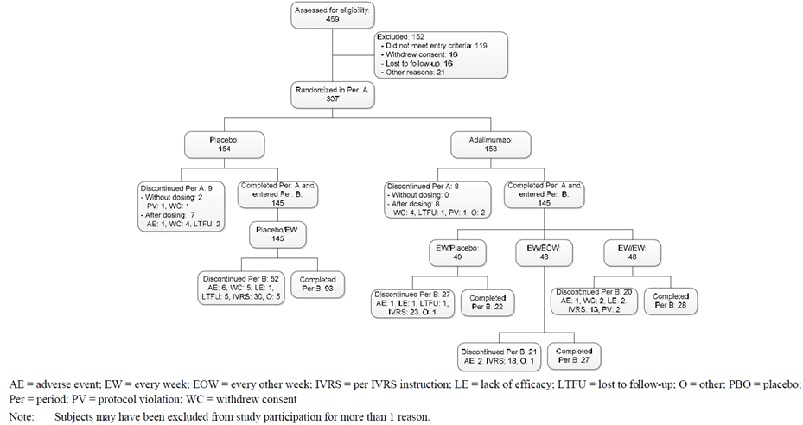

Major protocol violations/deviations
64 subjects had reportable protocol deviations in Period A. The majority of protocol deviations were subjects who had entered into the study even if they did not satisfy entry criteria. Deviations related to the use of analgesics, which potentially impacted the evaluation of pain, were accounted for in the primary and the sensitivity analyses to ensure the robustness of the results. All other deviations were reviewed per the classification plan exclusion of subjects from the PP population. The primary and ranked secondary efficacy variables were evaluated in the PP population and the results were consistent with the results in the ITT population.
Comment: The protocol deviations were equally distributed within the placebo and adalimumab treatment groups.

Baseline data
The majority of subjects in Period A were female, White, and under 40 years of age. The mean BMI was approximately 34 kg/m² and the majority of subjects currently used nicotine and alcohol. The median duration of HS was 9 years. The majority of subjects had an AN count of at least 11. Approximately 11% of the total population had prior surgery (not including incision and drainage) for HS. There were no considerable differences between adalimumab and placebo groups in abscess count, draining fistula count, inflammatory nodule count or hypertrophic scar count. Compared to subjects randomised to adalimumab, a higher proportion of subjects randomised to placebo had ≤ 5 AN counts at baseline and ≥ 11 AN counts at baseline. The remainder of the baseline data is shown in Table 4.
Comment: Overall, the demographic and baseline characteristics of HS were similar between the placebo and adalimumab treatment group. The participants are representative of the known epidemiology of HS (more common in young women, high BMI and smokers), and is representative of who will receive adalimumab if the submission is approved.

Table 4: Demographic characteristics (ITT_A Population)
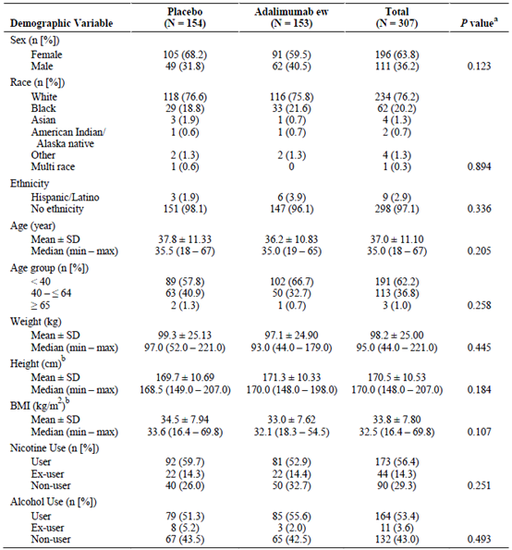
BMI = body mass index; ew = every week. a: p value for differences between treatment groups from Fisher`s exact test for sex, race, ethnicity, nicotine use, and alcohol use; chi–square test for age and BMI categories; and one-way ANOVA for age, weight, height, and BMI. Non-white races were combined for analysis of race. b: adalimumab ew n = 152. A subject may be a user of 1 type of tobacco (or nicotine–containing product), an ex-user of another type of nicotine and a non-user of another type of nicotine. A subject was counted in the category closest to user. Percentages were calculated on non-missing values.

Results for the primary efficacy outcome
A statistically significantly higher proportion of subjects in the adalimumab ew group achieved HiSCR at Week 12 (primary efficacy endpoint), as compared to placebo (41.8% versus 26.0% respectively, P = 0.003, 95% CI 5.3-26.5) (see Table 5). The HiSCR rate was higher in the adalimumab group than in the placebo group in each Hurley Stage. There was a larger treatment difference observed among subjects with Hurley Stage III (17.1%) than those with Hurley Stage II (14.8%).

Table 5: Proportion of subjects achieving HiSCR at Week 12 (ITT_A Population)
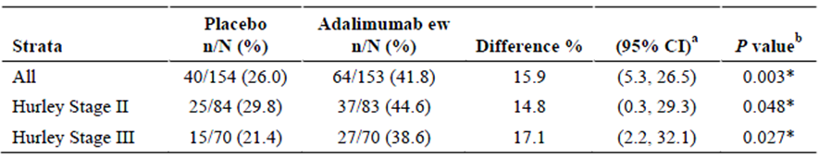
CI = confidence interval; ew = every week; NRI = non-responder imputation a.: Across all strata, 95% CI for adjusted difference was calculated according to the extended Mantel-Haenszel statistic for the comparison of 2 treatment groups; within each stratum of baseline Hurley Stage, 95% CI for difference was calculated based on normal approximation to the binominal distribution. b.: Across all strata, p value was calculated from the Cochran-Mantel-Haenszel test adjusted for strata; within each stratum of baseline Hurley stage, p value was calculated based on chi-square test (or Fisher`s exact test if ≥ 20% of the cells have expected cell count < 6).
The proportion of subjects who achieved HiSCR at Week 12 in Period A was further analysed for subgroups defined by the following demographic and baseline characteristics: age category, sex, race, duration of HS, weight, BMI category, current smoking status, change in smoking habit (increase, decrease), high sensitivity C-reactive protein (hs-CRP) level, AN count category, prior HS surgery, time from prior HS surgery to first dose of study drug. In most subgroups, the HiSCR rate was higher in the adalimumab ew group than in the placebo group, except for the subgroup of subjects with BMI ≥ 40, where both the adalimumab and placebo groups had similar HiSCR rates (36% and 34.3% respectively). This was also true for the subgroup AN Category: 6-10 (35.2% and 36.4% respectively). The differences in HiSCR were not significant in the subgroups.
Comment: In Hurley Stage II, the 95% CI is 0.3-29.3, and is close to crossing zero. Overall the 15.9% difference in proportion of subjects achieving HiSCR in the adalimumab group compared to the placebo group is clinically meaningful. The subgroup analysis results should be interpreted with caution due to small sample sizes.

Results for other efficacy outcomes
Period A
The secondary efficacy variables were analysed according to the rank order shown in Table 6. All 3 ranked secondary endpoints did not achieve statistical significance. Since the statistical significance was not achieved for the treatment comparisons in ranked secondary endpoints, the P values for other efficacy endpoints are not considered confirmatory.
- Among subjects with baseline Hurley Stage II, subjects in the adalimumab ew group and the placebo group had similar proportion achieving AN of 0, 1, or 2 at Week 12 (28.9 versus 28.6%, p = 0.961).
- Among subjects with baseline NRS ≥ 3, there was no difference between the adalimumab ew group and the placebo group, in the proportion of subjects who achieved NRS30 at Week 12 (27.9% versus 24.8%, p = 0.628).
- There was a non-significant greater mean decrease in modified Sartorius score at Week 12 between the adalimumab ew group and the placebo group (-24.4 versus -15.7, p = 0.124).

Table 6: Ranked secondary endpoints presented in rank order (ITT_A Population)
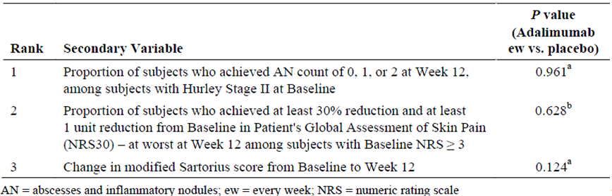
a. p value was calculated from the Cochran-Mantel-Haenszel test adjusted for strata. b. p value was calculated from ANCOVA with stratum, baseline value, and treatment in the model.
Other secondary endpoints in Period A included:
- Reduction in inflammatory lesions
  - By Week 12, a higher proportion of subjects in the adalimumab ew group achieved 50%, 75% and 100% reduction in AN compared with subjects in the placebo group using non-responder imputation (NRI) (All 3 have p < 0.05).
- Health-related quality of life
  - DLQI scores range from 0 to 30, with higher scores indicating a more impaired quality of life. Subjects in the adalimumab ew group had a greater mean decrease (improvement) in DLQI from Baseline to Week 12 compared to subjects in the placebo group (p < 0.001).
Comment: Important to note that p-values for all other secondary endpoints, regardless of significance, are not confirmatory.
Period B
ITT_B_R Population included subjects who were randomised to adalimumab 40 mg ew in Period A and re-randomised into Period B as HiSCR responders. All groups in the ITT_B_R Population experienced reductions in the response rates over time. In Period B, the proportion of ITT_B_R subjects who retained HiSCR at Week 36 was higher for subjects who were re-randomised to the adalimumab groups compared to those re-randomised to the placebo group. HiSCR response rates between adalimumab ew and adalimumab eow were similar. By Week 36, the proportions of HiSCR responders were 52.4%, 50.0%, and 27.3% in the ew/ew, ew/eow, and ew/placebo groups, respectively (Figure 7). The difference was not significant (ew/eow versus ew/pbo p=0.123, ew/ew versus ew/pbo p=0.085).
Figure 7: Proportion of subjects achieving HiSCR by visit (ITT_B_R Population)
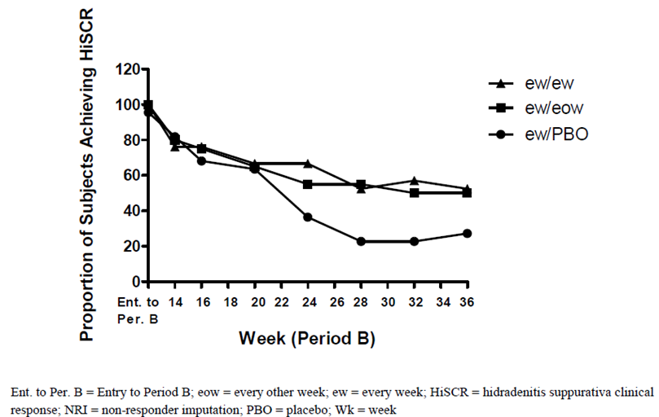
The mean increase in DLQI (worsening) from Week 12 to Week 36 was similar among subjects in the ew/placebo, ew/eow and ew/ew re-randomisation groups (2.2, 3.8, 1.2respectively).
Comment: Interpretation of the results should take into account that the sample sizes in the re-randomised groups are small (< 30 subjects/group). There was no significant difference in HiSCR or DLQI between subjects in the ew/placebo, ew/eow and ew/ew group. This indicates that continuation of adalimumab had no benefit over placebo for subjects who were classified as responder at Week 12.
The ITT_B_NR population included subjects who were randomised to adalimumab 40 mg ew in Period A and re-randomised in Period B as HiSCR non-responders. At Week 36, 37.0% of subjects in the ew/ew group were HiSCR responders, compared to 17.9% for the ew/eow group and 25.9% for the ew/placebo group. The difference was not significant.
Comment: There was no significant difference in HiSCR or DLQI between subjects in the ew/placebo, ew/eow and ew/ew group. This indicates that continuation of adalimumab had no benefit over placebo for subjects who were classified as non-responder at Week 12.
The ITT_B_PRR Population included subjects in the ITT_B_R Population (that is, achieved HiSCR at the end of Period A) and subjects who achieved a partial response (AN 25) at the end of Period A in the ITT_B_NR Population. In the ITT_B_PRR population, HiSCR was achieved at Week 36 by 65.5% of subjects re-randomised to the ew/ew group, as compared to 48.1% of subjects in the ew/eow group, and 29.4% of subjects in the ew/placebo group (EW/EOW versus EW/PBO p = 0.141, EW/EW versus EW/PBO p ≤ 0.05).
Comment: The ITT_B_PRR population was identified post-hoc.

Study M11-810
A phase III multicenter study of the safety and efficacy of adalimumab in subjects with moderate to severe hidradenitis suppurativa (PIONEER II).

Study design, objectives, locations and dates
Study design: The study was designed to enrol 300 subjects to meet scientific and regulatory objectives without enrolling an undue number of subjects in alignment with ethical considerations. Therefore, once the target number of subjects was enrolled, there was the possibility that additional subjects in screening would not be enrolled. This study consisted of a 30-day screening period, an initial 12-week double-blind treatment period (Period A), and a subsequent 24-week double-blind treatment period (Period B), plus a Day 70 follow-up phone call approximately 70 days after the last dose of study drug administration. The study design is shown in Figure 8.
Figure 8: M11-810 study design schematic
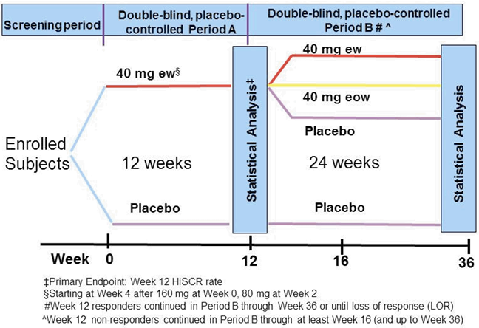
Objectives: The primary objective of this study was to determine the clinical safety and efficacy of adalimumab, as compared to placebo, in subjects with moderate to severe HS after 12 weeks of treatment. A secondary objective was to evaluate safety and explore efficacy for continuous weekly dosing versus dose reduction versus maintenance of response off-therapy from Week 12 to Week 36. The pharmacokinetics and immunogenicity of adalimumab following subcutaneous (SC) injection also were to be assessed.
Locations: 53 sites in Australia, Canada, the EU, Puerto Rico, Switzerland, Turkey, and the US
.
Dates: The first subject's first visit occurred on 28 December 2011. The last subject's last visit was 28 April 2014.

Inclusion and exclusion criteria
Men and women 18 years or older with moderate to severe HS (abscess and inflammatory nodule count of greater than or equal to 3) who met all inclusion criteria and who did not meet any of the exclusion criteria were eligible for this study. The population being studied represented normal clinical practice with a broad spectrum of subjects with a high medical need due to great physical disability and discomfort. This ensured the activity of adalimumab could be evaluated across a distribution of disease severity in the study.
Inclusion criteria:
- Male and female subjects ≥ 18 years of age.
- Subject had a diagnosis of HS for at least 1 year prior to Baseline.
- HS lesions were present in at least 2 distinct anatomic areas, 1 of which was Hurley Stage II or Hurley Stage III.
- Subject had an inadequate response to at least a 3-month trial of oral antibiotics for treatment of HS (or demonstrated intolerance to, or had a contraindication to, oral antibiotics for treatment of their HS).
- Subject had stable HS for at least 2 months prior to screening and also at the baseline visit, as determined by the investigator through subject interview and review of the medical history.
- Subject had a total AN count of greater than or equal to 3 at the baseline visit.
- If female, subject was either:
  - Not of childbearing potential, defined as postmenopausal for at least 1 year or
  - Surgically sterile or
  - Of childbearing potential and was practicing an approved method of birth control throughout the study and for 150 days after the last dose of study drug.
- Subject must have agreed to daily use (throughout the entirety of the study) of 1 of the following over-the-counter topical antiseptics on their body areas affected with HS lesions: chlorhexidine gluconate, triclosan, benzoyl peroxide, or dilute bleach in bathwater.
- Subject had a negative TB screening assessment (including a PPD test or QuantiFERON-TB Gold test, or equivalent) and negative CXR (posterior-anterior [PA] and lateral views) at Screening. If the subject had evidence of a latent TB infection, the subject must have initiated and completed a minimum of 4 weeks of anti-TB therapy or have documented completion of a course of anti-TB therapy, prior to Baseline.
- Subject was judged to be in good general health, as determined by the Principal Investigator, based upon the results of a medical history, physical examination, laboratory profile, CXR, and a 12-lead ECG performed during the screening period and confirmed at Baseline.
- Subject must have been able and willing to self-administer SC injections or had a qualified person who could reliably administer SC injections.
- Subject must have been able and willing to provide written informed consent and comply with the requirements of the study protocol.
Exclusion criteria:
- Prior treatment with adalimumab or other anti-TNF therapy (for example infliximab, etanercept) or participation in an adalimumab trial.
- Any other active skin disease or condition (for example bacterial, fungal, or viral infection) that could interfere with assessment of HS.
- Subjects on permitted oral antibiotic treatment (doxycycline or minocycline only) for HS who had not been on a stable dose for at least 28 days prior to the baseline visit.
- Subject received prescription topical therapies for the treatment of HS within 14 days prior to the baseline visit.
- Subject received systemic non-biologic therapies with potential therapeutic impact for HS < 28 days prior to baseline visit (other than permitted oral antibiotics).
- Subject received oral concomitant analgesics (including opioids) for HS-related pain within 14 days prior to the baseline visit.
- If entering the study on concomitant oral analgesics for non-HS-related pain:
  - Subject on opioid analgesics within 14 days prior to baseline visit.
  - Subject not on a stable dose of non-opioid oral analgesics for at least 14 days prior to the baseline visit.
- Subject required or was expected to require opioid analgesics for any reason (excluding tramadol).
- Subject had a draining fistula count of greater than 20 at the baseline visit.
- Subject had been treated with any investigational drug of chemical or biologic nature within a minimum of 30 days or 5 half-lives (whichever was longer) of the drug prior to the baseline visit.
- Prior exposure to biologics that had a potential or known association with progressive multifocal leukoencephalopathy (PML; that is natalizumab, rituximab or efalizumab).
- Subject had had infections that required treatment with intravenous (IV) anti-infectives (antibiotics, antivirals, antifungals) within 30 days prior to Baseline or oral anti-infectives (antibiotics, antivirals, antifungals) within 14 days prior to Baseline, except as required as part of an anti-TB regimen.
- History of moderate to severe congestive heart failure (NYHA class III or IV), recent cerebrovascular accident, and any other condition which, in the opinion of the investigator, put the subject at risk by participation in the protocol.
- History of demyelinating disease (including myelitis) or neurologic symptoms suggestive of demyelinating disease.
- History of invasive infection (for example listeriosis, histoplasmosis) or human immunodeficiency virus (HIV).
- Subject had an active systemic viral infection or any active viral infection that, based on the investigator's clinical assessment, made the subject an unsuitable candidate for the study.
- Hepatitis B surface antigen (HBsAg) positive (+) or detected sensitivity on the hepatitis B virus (HBV)-DNA polymerase chain reaction (PCR) qualitative test for hepatitis B core antibody (HBcAb)/hepatitis B surface antibody (HBsAb) + subjects.
- Chronic recurring infections or active TB.
- Known hypersensitivity to adalimumab or its excipients.
- Positive pregnancy test at Screening or Baseline.
- Female subjects who were breastfeeding or considering becoming pregnant during the study.
- Evidence of dysplasia or history of malignancy (including lymphoma and leukemia) other than a successfully treated non-metastatic cutaneous squamous cell carcinoma, basal cell carcinoma, or localized carcinoma in situ of the cervix.
- History of clinically significant drug or alcohol abuse in the last 12 months.
- Clinically significant abnormal screening laboratory results, as evaluated by the investigator.
- Subject was considered by the investigator, for any reason, to be an unsuitable candidate for the study and not able to comply with the study protocol.
Comment: Inclusion and exclusion criteria are reasonable for the indication.

Study treatments
Period A
Subjects randomised to the adalimumab 40 mg ew group (Arm 1) were to receive:
- 160 mg adalimumab at Baseline (Day 1) administered as four 40 mg injections SC.
- 80 mg adalimumab at Week 2 administered as two 40 mg injections SC.
- 40 mg adalimumab ew from Week 4 through Week 11 administered as one 40 mg injection SC.
Subjects randomised to the placebo group (Arm 2) were to receive:
- Four 0.8 mL placebo injections at Baseline (Day 1).
- Two 0.8 mL placebo injections at Week 2.
- One 0.8 mL placebo injection ew from Week 4 through Week 11.
Period B
Subjects from the adalimumab 40 mg ew group (Arm 1) in Period A were to be re-randomised and were to receive:
- 40 mg adalimumab ew from Week 12 to Week 35 administered as one 40 mg injection SC.
OR
- 40 mg adalimumab eow from Week 12 to Week 34 administered as one 40 mg injection SC.
- One 0.8 mL placebo injection eow from Week 13 to Week 35.
OR
- One 0.8 mL placebo injection ew from Week 12 to Week 35.
Subjects from the placebo group (Arm 2) in Period A were to be assigned (using re-randomisation numbers) to receive:
- One 0.8 mL placebo injection ew from Week 12 to Week 35.
Comment: The choices of starting and maintenance doses, as well as treatment duration, are acceptable.

Efficacy variables and outcomes
Primary Variable
The primary efficacy variable was the proportion of subjects who achieved HiSCR at Week 12.
Secondary Variables
Ranked Secondary Efficacy Variables:
- Proportion of subjects who achieved AN count of 0, 1, or 2 at Week 12, among subjects with Hurley Stage II at Baseline.
- Proportion of subjects who achieved at least 30% reduction and at least 1 unit reduction from Baseline in Patient's Global Assessment of Skin Pain (NRS30), at worst at Week 12 among subjects with Baseline NRS ≥ 3.
- Change in modified Sartorius score from Baseline to Week 12.
Other Secondary Efficacy Variables for Period B
Efficacy was explored for Period B.
- The secondary efficacy variables were summarised for each subpopulation in the Intent-to-Treat (ITT) Population in Period B (ITT_B). The treatment comparisons were performed in ITT_B subjects who were randomised to adalimumab in Period A and were Week 12 HiSCR responders (ITT_B_R). In addition, change from re-randomisation was analysed for continuous variables for ITT_B_R.
- Time to LOR was analysed for ITT_B_R.
- Time to the second incidence of the 2 consecutive visits with AN count ≥ baseline AN count was summarised for the ITT_B subjects who were randomised to adalimumab in Period A and were Week 12 HiSCR non-responders (ITT_B_NR).
Comment: HiSCR is a validated and meaningful endpoint for assessing treatment efficacy in controlling inflammatory manifestations in HS.

Randomisation and blinding methods
The randomisation schedules were generated before the start of the study. All subjects were assigned a unique identification number as they were screened for the study. The subjects were randomised centrally and stratified by Hurley Stage (II versus III) and concomitant use of oral antibiotics (yes versus no) in a 1:1 ratio to either adalimumab 40 mg ew or placebo at Week 0. All subjects who continued to Period B, regardless of the treatment in Period A, were to be re-randomised at Week 12 to maintain the blind. Subjects randomised to adalimumab in Period A were to be re-randomised in a 1:1:1 ratio to receive adalimumab 40 mg ew, adalimumab 40 mg eow, or matching placebo. Subjects randomised to placebo in Period A were to be assigned (using re-randomised numbers) to continue on placebo from Week 12 to Week 35. The re-randomisation was stratified by Week 12 HiSCR status (responder versus non-responder) and by baseline Hurley Stage (II versus III).
All sponsor personnel with direct oversight of the conduct and management of the trial, the investigator, study site personnel, and the subject remained blinded to each subject's treatment throughout the blinded periods of the study. The interactive voice response system (IXRS) provided access to blinded subject treatment information in the case of medical emergency. The sponsor was to be notified before the blind was broken unless identification of the study drug was required for medical emergency. The date and reason that the blind was broken was to be recorded in the source documentation and electronic case report form (eCRF).
Comment: Randomisation and blinding protocols are acceptable.

Analysis populations
The intent to treat (ITT) subject population in each period was used for the efficacy analyses.
- The ITT Population in Period A (ITT_A) was defined as all subjects who were randomised at Baseline (Week 0).
- The ITT Population in Period B (ITT_B) was defined as all subjects who were re-randomised at entry to Period B (received re-randomisation number, regardless of the randomisation treatment in Period A). Subpopulations for this period were as follows:
  - ITT_B_R: subjects who were randomised to adalimumab in Period A and were Week 12 HiSCR responders.
  - ITT_B_NR: subjects who were randomised to adalimumab in Period A and were Week 12 HiSCR non-responders.
  - ITT_B_PBO: subjects who were randomised to placebo in Period A.
The Per-Protocol (PP) Population in Period A (PP_A) was used for efficacy analysis of the primary efficacy endpoint and ranked secondary efficacy endpoints. The Per-Protocol Population in Period B (PP_B) was to be used to summarise the time to LOR for subjects who were HiSCR responders at entry of Period B.
- The PP_A included subjects in ITT_A who met all the following criteria:
  - Received at least 1 dose of study drug for subject who discontinued the Period A due to AE or lack of efficacy (based on all reasons) and at least 75% of the planned study drug in Period A for subjects who completed Period A or discontinued Period A due to reasons other than AE or lack of efficacy.
  - Provided at least 1 post-baseline assessment on lesion count.
  - Had baseline AN count ≥ 3.
  - Had baseline draining fistula count ≤ 20.
  - Did not take the following exclusionary medication during the screening period or during Period A:
    - Any antibiotics for the treatment of HS, except the protocol allowed baseline concomitant antibiotics.
    - MTX, cyclosporin, corticosteroids, and retinoids for any reason or other medication for treatment of their HS that would confound the efficacy evaluation (to be determined and documented in the classification results prior to blind break).
The safety population in each period (Safety_A Population and Safety_B Population) was defined as all subjects who were in the ITT population of the corresponding period and received at least 1 dose of study drug in the corresponding period. The safety population in each period was to be used for safety analysis.
Comment: Assessment of efficacy on the ITT population is appropriate.

Sample size
This study was designed to enrol approximately 300 subjects, in order to provide adequate information to characterise the safety profile of adalimumab as well as to have sufficient power for the primary efficacy endpoint. The rationale for the study sample size was based on the hypothesis test for the primary efficacy endpoint. The response rates observed in Study M10-467 for HiSCR at Week 12 were 61% and 16% in the adalimumab ew group and placebo group, respectively. A sample size of 150 per group provided more than 90% power to detect the treatment difference with alpha level of 0.05. No power evaluation was performed for Period B since it is for exploratory analysis.
In Period A, a total of 326 subjects were randomised 1:1 to either placebo or adalimumab 40 mg ew and comprise the ITT_A Population. All randomised subjects in Period A received at least 1 dose of study drug. 306 subjects completed Period A and continued to Period B, where subjects initially randomised to adalimumab were re-randomised to receive either adalimumab ew, adalimumab eow, or placebo. All re-randomised subjects received at least 1 dose of study drug. Of the 306 subjects who were re-randomised in Period B, 116 subjects completed Period B and 190 subjects discontinued from the study.

Statistical methods
All statistical tests were 2-tailed with the significance level 0.05. Descriptive statistics were provided, including the number of observations, mean, and standard deviation for continuous variables and counts and percentages for discrete variables. The analyses were to be performed using SAS version 9.2 (SAS Institute Inc., Cary, NC, USA) or higher with the UNIX operating system.
The efficacy analyses compared the adalimumab ew group and the placebo group in Period A. All pairwise comparisons for the ITT_B_R and the ITT_B_NR Populations were provided. Efficacy summaries were provided for the pbo/pbo group in Period B. For categorical variables, frequencies and percentages were provided. The treatment arms were compared using a Cochran Mantel Haenszel (CMH) test with baseline Hurley Stage (II versus III) and concomitant use of oral antibiotics (yes/no) as the stratification factors for the analysis in Period A, and with baseline Hurley Stage (II versus III) as the stratification factor for the analysis in Period B. For the analysis of change or percent change from Baseline (or from re-randomisation) for continuous variables, the model-based mean and standard error were provided. The means for Baseline (or re-randomisation) and visit were also presented for each treatment group for subjects who had Baseline (or re-randomisation) and post-Baseline (or post-re-randomisation) visit values. The treatment groups were compared using ANCOVA with treatment group, Baseline value (or re-randomisation value), Baseline Hurley Stage (II versus III), and concomitant use of oral antibiotics (yes/no for Period A only) in the model. For the analysis of time to loss of response/worsening or absence of improvement (LOR/WOAI), the treatment difference was analysed using the stratified log-rank test with Baseline Hurley Stage (II versus III) as the stratification factor.
Comment: Statistical methods are appropriate.

Participant flow
The flow of subjects that entered, discontinued, and completed Period A and Period B in the study are shown in Figure 9.
Figure 9: Participant flow in Study M11-810
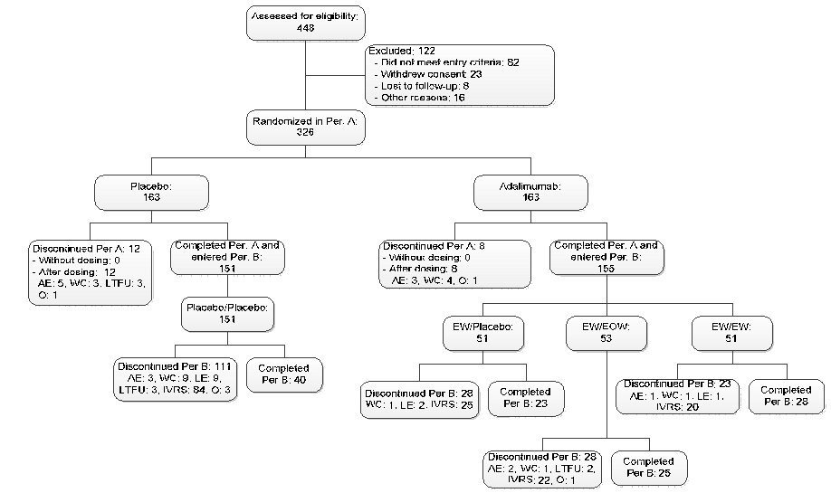
All randomised subjects in Period A received at least 1 dose of study drug. A total of 306 subjects completed Period A and 20 subjects discontinued from the study. The rate of discontinuation in Period A was low in each group (8 of 163 subjects [4.9%] in the adalimumab ew group and 12 of 163 subjects [7.4%] in the placebo group).
All subjects who completed Period A entered Period B (ITT_B Population). Of the 306 subjects who entered Period B, 116 subjects completed Period B and 1 90 subjects discontinued from the study. Of the 326 subjects randomised in the study, 306 subjects completed Period A and continued to Period B, where subjects initially randomised to adalimumab were re-randomised to receive either adalimumab ew, adalimumab eow, or placebo. Subjects initially randomised in Period A to placebo continued to receive placebo in Period B in a blinded fashion. Re-randomisation was stratified by HiSCR at Week 12 (responder versus non-responder) and baseline Hurley Stage (II versus III). All re-randomised subjects received at least 1 dose of study drug. Of the 306 subjects who were re-randomised in Period B, 116 subjects completed Period B and 190 subjects discontinued from the study. The majority of the subjects (111 of 151 subjects [73.5%]) who continued on placebo discontinued from the study, while approximately one-half of the subjects re-randomised to adalimumab ew (23 of 51 subjects [45.1%]), adalimumab eow (28 of 53 subjects [52.8%]), or placebo (28 of 51 subjects [54.9%]) discontinued from the study.

Major protocol violations/deviations
A total of 104 subjects had reportable protocol deviation, including entry criterion violations. Deviations related to the use of analgesics, which potentially impacted the evaluation of pain, were accounted for in the primary and the sensitivity analyses to ensure the robustness of the results. All other deviations were reviewed per the classification plan for exclusion of subjects from the PP population. The classification plan and the classification results were finalized prior to database lock and the unblinding of treatment. The primary and ranked secondary efficacy variables were evaluated in the PP population and the results were consistent with the results in the ITT population. No subjects received the treatment to which they were not randomised for an entire period; therefore, all subjects were analysed as randomised for both safety and efficacy analyses.
Comment: Protocol deviations/violations were similar in the treatment (n = 55 [33.7%]) and placebo group (n = 49 [30.1%]). No impact on analysis and conclusions is expected.

Baseline data
The majority of subjects in the ITT_A population were White, female, had a mean BMI of 32.1, and were users of nicotine and alcohol (Table 7). The mean age was 35.5 years. Baseline demographic characteristics were generally balanced among subjects in the adalimumab ew and placebo treatment groups, except that the mean weight was 5.5 kg lower for subjects randomised to adalimumab ew than subjects randomised to placebo (P = 0.039). Baseline disease characteristics were typical for a subject population with moderate to severe HS and generally balanced between the adalimumab ew and placebo treatment groups. No statistically significant differences were observed between treatment groups for baseline AN, abscess, draining fistula, inflammatory nodule, and hypertrophic scar counts, severity of erythema, and quality of life (QoL) scores. The majority of subjects did not have prior surgery to treat their HS. Nearly all subjects reported prior antibiotic use for treatment of HS. All subjects received concomitant medications. The most frequently reported concomitant medications were chlorhexidine, which was one of the required disinfectants used as a daily antiseptic wash, and paracetamol and ibuprofen for pain.

Table 7: Demographic characteristics (ITT_A Population)
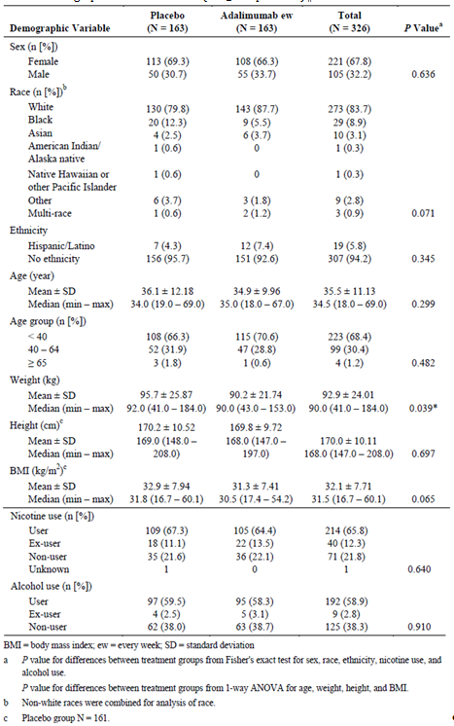
Comment: Overall, the demographic and baseline characteristics of HS were similar between the placebo and adalimumab treatment group. The participants are representative of the known epidemiology of HS (more common in young women, high BMI and smokers), and the study population is representative of who will receive adalimumab.

Results for the primary efficacy outcome
Period A
A statistically significantly higher proportion of subjects randomised to adalimumab ew achieved HiSCR at Week 12 (primary efficacy endpoint), as compared to subjects randomised to placebo (58.9% versus 27.6%, respectively; Table 8). Consistent treatment effects were observed for subjects in each Hurley Stage and in each baseline antibiotic use strata. Furthermore, a greater proportion of subjects in the adalimumab group achieved HiSCR than subjects in the placebo group at each visit during Period A (p < 0.001 at all visits).
The proportion of subjects who achieved HiSCR at Week 12 in Period A was further analysed for subgroups defined by the following demographic and baseline characteristics: age category, sex, race, duration of HS, weight, BMI category, current smoking status, hs-CRP level, AN count category, prior HS surgery, smoking habit change (increase, decrease), Time from prior HS surgery to first dose of study drug. In all subgroups, the HiSCR rate was higher in the adalimumab ew group than in the placebo group. The lower bound of the 95% confidence interval for the treatment difference exceeded 0, except for the subgroups of black, BMI < 25, AN count ≤ 5, and prior surgical history. The number of subjects was relatively small in these 4 subgroups and for each subgroup the numerical trend in HiSCR favoured adalimumab therapy. Treatment by subgroup interactions were not significant (p > 0.1), except for median baseline AN count, where subjects who had higher than median AN count at Baseline experienced a larger adalimumab treatment effect.

Table 8: Primary efficacy outcomes in Period A
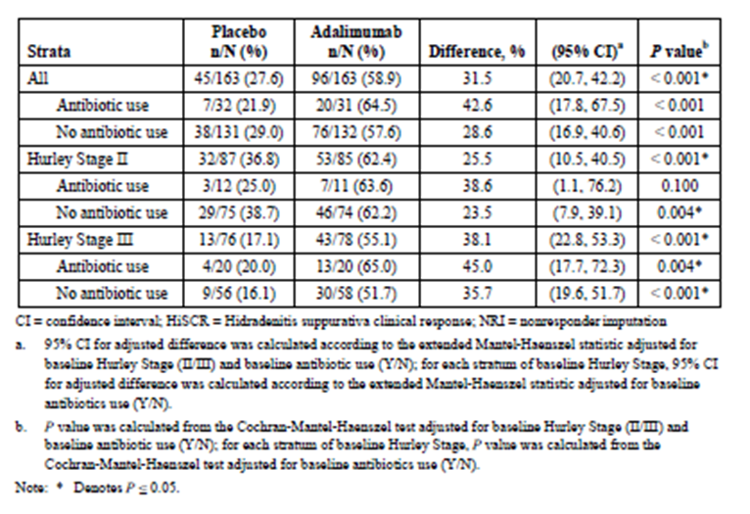

Results for other efficacy outcomes
Period A
All 3 ranked secondary endpoints achieved statistical significance (Table 9).
- Among subjects with baseline Hurley Stage II, a higher proportion of subjects in the adalimumab ew group than the placebo group achieved AN of 0, 1, or 2 at Week 12 (51.8% versus 32.2%, p = 0.010)
- Among subjects with baseline NRS ≥ 3, a higher proportion of subjects in the adalimumab ew group than the placebo group achieved NRS30 at Week 12 (45.7% versus 20.7%, p < 0.001)
- Greater mean decreases were observed for the adalimumab ew group than the placebo group in modified Sartorius score at Week 12 (–28.9 versus –9.5, p < 0.001).

Table 9: Ranked secondary endpoints efficacy outcomes
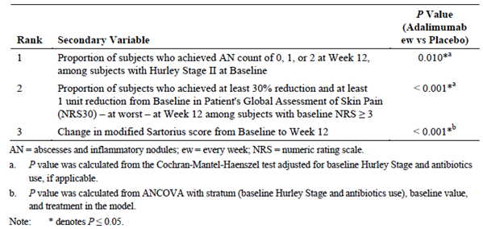
Other secondary endpoints in Period A included:
- Reduction in Inflammatory Lesions
  - The overall proportions of subjects achieving complete elimination of AN (AN = 0), AN of 0/1 (counts of 0 or 1), and AN of 0/1/2 (counts of 0, 1, or 2) at Week 12 were higher for subjects randomised to adalimumab ew compared to subjects randomised to placebo (p ≤ 0.05).
- Improvement in patient-reported HS-related skin pain at each visit
  - The proportion of subjects who achieved at least 30% reduction and at least 1 unit reduction from baseline in the Patient's Global Assessment of Skin Pain (NRS30) – at worst at Week 12 among subjects with Baseline Skin Pain NRS ≥ 3 was the second ranked secondary endpoint for this study. The proportion of subjects achieving NRS30 in the adalimumab ew group was higher than that in the placebo group at every visit during Period A (p ≤ 0.05)
- Health-related quality of life
  - The DLQI ranges from 0 – 30, with lower scores reflecting less impairment and improved health-related quality of life. Compared to placebo-treated subjects, adalimumab-treated subjects had greater improvement in DLQI as measured by mean change between Baseline and Week 12 (P ≤ 0.05).
Period B
The ITT_B_R Population included subjects who were randomised to adalimumab ew in Period A and re-randomised into Period B as HiSCR responders. The proportion of subjects who retained their HiSCR was numerically higher from Week 24 to Week 36 for subjects re-randomised to the adalimumab groups than for subjects re-randomised to the placebo group. Response rates for the ew/eow and ew/ew groups were similar. By Week 36, the proportions of HiSCR responders were 35.5%, 43.8%, and 45.2% for the ew/placebo, ew/eow, ew/ew groups, respectively (Figure 10).
Figure 10: Proportion of subjects achieving HiSCR (ITT_B_R Population)
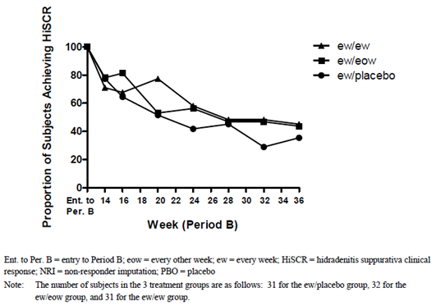
The mean increase in DLQI from Week 12 to Week 36 was similar among subjects in the 3 re-randomisation groups; however, subjects in the Hurley Stage III stratum who were re-randomised to the ew/eow or ew/ew groups had smaller mean increases than subjects in the Hurley Stage III stratum who were re-randomised to ew/placebo (Last observation carried forward [LOCF]) (Table 10).

Table 10: Mean change from re-randomisation in DLQI at Week 36 (ITT_B_R Population)
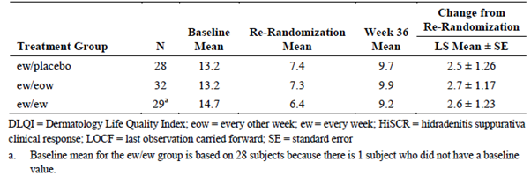
Comment: The fact that there was no significant difference in HiSCR and DLQI the three groups indicates that continuation of adalimumab had no benefit over placebo for subjects who were responders at week 12. It should be noted that the sample size in the three randomised groups was rather small (approximately 30 subjects/group).
The ITT_B_NR Population included subjects who were randomised to adalimumab ew in Period A and re-randomised in Period B as HiSCR non-responders. The proportion of subjects in the ITT_B_NR Population achieving HiSCR in Period B was greater for subjects re-randomised to the ew/ew group than for subjects re-randomised to the ew/eow or ew/placebo groups (NRI). At Week 36, 40.0% of subjects re-randomised to the ew/ew group were HiSCR responders, as compared to 9.5% of subjects in the ew/eow group and 20.0% of subjects in the ew/placebo group.
Comment: Although there appears to be a (numerical) difference in the three groups, no statistical analysis was provided for these data. Therefore, conclusions about efficacy in the ITT_B_NR population in Period B cannot be drawn.
Among HiSCR non-responders who achieved a partial response (that is, AN25 responders), a higher HiSCR rate was observed at Week 36 among subjects in the ew/ew group than among subjects in the ew/eow or ew/placebo groups (60% versus 9.1% and 12.5%, respectively). Among subjects who failed to achieve AN25 at the end of Period A, no noticeable difference in HiSCR rate at Week 36 was observed across treatment groups.
Comment: Again no statistical analysis was provided for these data. In addition, the number of subjects in these groups was very low, making sound conclusions difficult.
Subjects in the ITT_B_PBO (placebo) population in Period B showed a low level HiSCR rate that decreased from Week 12 (29.1%) to Week 36 (15.9%).

Other efficacy studies

Study M10-467
Study M10-467 was a Phase II double-blind (DB), placebo-controlled, randomised study with an open label (OL) phase multicenter study of the safety and efficacy of adalimumab in subjects with moderate to severe chronic hidradenitis suppurativa.
This study was performed between April 2009 and November 2010 at 26 sites in the US, Netherlands, Denmark, and Germany. The primary objective of this study was to determine the efficacy and safety of adalimumab in subjects with moderate to severe chronic hidradenitis suppurativa (HS) after 16 weeks of treatment. Subjects were randomised in a 1:1:1 ratio at Week 0 to receive adalimumab 40 mg ew or 40 mg eow or matching placebo. Randomisation was stratified by Hurley stage (Stage III versus Stage I or II) for HS. Inclusion criteria were males and females ≥ 18 years of age, diagnosis of HS for at least 6 consecutive months that involves ≥ 2 distinct anatomic areas, and Physician's Global Assessment (PGA) of at least moderate disease (score of ≥ 3) at Baseline. A total of 154 subjects were analysed (51 placebo, 52 adalimumab eow, and 51 adalimumab ew). The majority of all enrolled subjects were female (71.4%), White (71.4%), < 40 years old (63.6%), nicotine users (55.2%), and Hurley Stage II (55.2%). Mean weight for all enrolled subjects was 97.2 kg.
Efficacy Results: A statistically significantly higher proportion of subjects in the adalimumab ew treatment group achieved clinical response, compared with subjects in the placebo group at Week 16 (17.6% versus 3.9%, p = 0.025) as well as at Week 12 (21.6% versus 5.9%, p = 0.020). The proportion of subjects in the adalimumab eow treatment group at Weeks 12 and 16 (7.7% and 9.6%, respectively) was not statistically significantly different from placebo. Treatment with adalimumab ew was superior to placebo in the majority of secondary endpoints evaluated, with statistically significant differences observed most often at Week 12 or Week 16.
Maintenance of response was assessed in subjects who had a PGA < 3 at entry into Period 2. During OL adalimumab eow treatment in Period 2, two-thirds of all subjects treated with adalimumab in Period 1 were unable to maintain this level of response or required dose escalation. The as observed data show 13 of 68 subjects (19.1%) achieved HiSCR. The LOCF data show 13 of 86 subjects (15.1%) achieved HiSCR. Discounting the contribution of dose escalation at Weeks 28 or 31, the proportion of subjects achieving clinical response was low at Week 52, regardless whether subjects had initiated therapy with eow dosing or ew dosing.
Comment: This study represented the basis for the 2 Phase III trials (M11-313 and M11-810) discussed above. Consistent with these studies, adalimumab ew treatment was superior to placebo in the treatment of HS, although the number of responders was lower in both placebo and treatment groups. The reasons for this discrepancy are unclear. However, given the high rate of responders in the placebo groups in the Phase III trials, this seems to be relevant and should be addressed.

Study M12-555
M12-555 was a Phase III open label study of the safety and efficacy of adalimumab in subjects with moderate to severe Hidradenitis Suppurativa – PIONEER (Open Label Extension [OLE]). The study was designed as a 60 week study (or until marketing authorisation or permanent withdrawal of the marketing application in the subject's country of residence), and was conducted in 94 sites worldwide (US, Canada, Australia, Germany, Czech Republic, France, Switzerland, Denmark, Greece, Hungary, The Netherlands, and Sweden). The primary objective was to assess the long-term safety, and efficacy of adalimumab in the treatment of HS. It’s secondary objective was to assess the pharmacokinetics and immunogenicity of adalimumab following SC injection.
Subjects who participated in Study M11-810 and Study M11-313 were eligible to enrol. All subjects received adalimumab 40mg ew regardless of previous treatment assignment. If at any time on or after Week 24, a subject failed to demonstrate a clinically relevant response, the principal investigator and the subject were to evaluate the risk/benefit of having the subject continue in the study.
The key efficacy variables and outcomes were HiSCR response, AN 0/1/2 NRS30 (at worst and on average) and modified Sartorius score. The populations included the ew/ew/ew population, ew/eow/ew population, ew/pbo/ew population, pbo/ew/ew population, pbo/pbo/ew population, ‘the continuous ew’ population (including ew/ew/ew, pbo/ew/ew and pbo/pbo/ew), and the ‘all adalimumab treated’ population. As of 29 April 2014, there were 497 subjects treated and analysed. Since this was an open-label continuation study, descriptive statistics were provided.
Baseline disease characteristics were generally similar across the analysis populations. Approximately half of all subjects were Hurley Stage II and half were Hurley Stage III. 40 subjects in Study M12-555 had reportable protocol deviations reported as of the database cut-off date. Subjects could have multiple protocol violations. At the database cut-off date, there were 10 inclusion/exclusion criterion violations as evaluated at the study entry, and 35 protocol deviations. The most common protocol violation was receiving excluded concomitant treatment which included antibiotics, corticosteroids, and pain medications. Protocol deviations were similar across the populations.
Comment: The study report is an interim report of 497 subjects with a cut-off date of 29 April 2014 (report dated 25th September 2014). The study commenced 12th April 2012 and is ongoing. A total of 358 (74%) of subjects remain ongoing. Descriptive statistics are appropriate for an open label study. No major differences in baseline characteristics were noted at extension study entry.

Efficacy results
At Week 72, the rate of subjects achieving HiSCR was similar amongst the ew/ew/ew, ew/eow/ew, and the ew/pbo/ew populations (58.3%, 62.2% and 54.9% respectively). As of the cut-off date, not all ongoing subjects had visits beyond Week 36. At Week 36, the rate of subjects achieving HiSCR was higher in the ew/ew/ew population, than the ew/eow/ew and ew/pbo/ew population (63.1%, 54.4% and 52.7% respectively). A consistent mean reduction in DLQI of 4.8 to 6.3 was observed over time in the ew/ew/ew population. In the ew/ew/ew population, the proportion of subjects achieving NRS30 reached 34.6% by Week 12 and 52.6% by Week 36, and subsequently appeared to be maintained through Week 72 (50.0%).
Comment: The study states that the results demonstrate the benefit of uninterrupted treatment with adalimumab ew, as dose interruption and dose reduction were temporally associated with decreases in HiSCR. However these are only descriptive statistics, and no statistical analysis provided. Therefore efficacy conclusions should not be drawn from these populations.

Analyses performed across trials (pooled analyses and meta-analyses)
The sponsor provided an integrated analysis of efficacy of Studies M11-313, M11-810 and M12-555. Data from Study M10-467 were not included due to differences in design. Based on the similarities in the 2 Phase III studies (study design, eligibility, dosing, duration, and key measures of efficacy), it was appropriate to pool their efficacy data. In addition, due to the limited sample size in Period B within each individual study, the integrated analysis based on the pooled data provides a more robust and precise assessment.
In the ITT_A Population, 50.6% of subjects in the adalimumab group achieved HiSCR at Week 12 compared to 26.8% of subjects in the placebo group (p < 0.001; Table 12). The HiSCR rate was higher in the adalimumab group than in the placebo group in each Hurley stage (p ≤ 0.05). The treatment effect was slightly higher for subjects with Hurley Stage III versus Hurley Stage II.

Table 11: Primary efficacy outcomes for pooled analysis
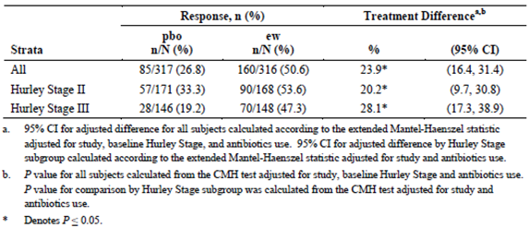
Integrated results from the ranked secondary endpoints are presented in Table 12 in rank order. Because the first ranked secondary endpoint (AN count of 0, 1, or 2 in Hurley Stage II subjects at Week 12) did not achieve statistical significance (p = 0.051), none of the secondary ranked endpoints can be interpreted as confirmatory.
Table 12: Ranked secondary outcomes for pooled analysis
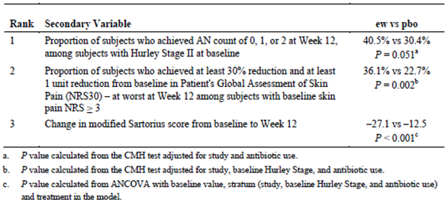
Period B: When all subjects who were re-randomised after the adalimumab ew treatment in Period A were analysed (ITT_B_R and ITT_B_NR Populations combined), the proportion of subjects with HiSCR at Week 36 was higher for subjects in the ew/ew group compared with the ew/eow and ew/pbo groups: 43.4%, 30.7%, and 28.0% in the ew/ew, ew/eow, and ew/pbo groups, respectively (Table 13).

Table 13: HiSCR at Week 24 and Week 36 (Combined ITT_B_R and ITT_B_NR populations)
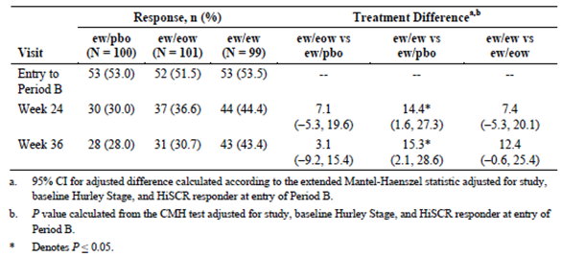
To characterise the comparative efficacy of continuing adalimumab weekly dosing (ew/ew) versus reducing the dose frequency to every other week (ew/eow) or discontinuing adalimumab therapy (ew/pbo) in the most clinically relevant population, a new population was defined post-hoc. This population, termed ITT_B_PRR (Partial Responder and Responder), comprises subjects who had achieved HiSCR at Week 12 as well as subjects who achieved a 25% reduction in AN count but not HiSCR at Week 12; these latter subjects are considered to have the potential of eventually achieving a clinically relevant response. In the ITT_B_PRR Population, HiSCR at Week 36 was achieved by a higher proportion of subjects in the ew/ew group compared to the ew/eow or ew/pbo groups (Figure 11); the difference between ew/ew and ew/pbo at Week 36 was 55.7% versus 30.1% (p ≤ 0.05). HiSCR rates declined slightly for all groups during Period B.
Figure 11: Pooled analysis of HiSCR by visit in Period B (ITT_B_PRR Population)
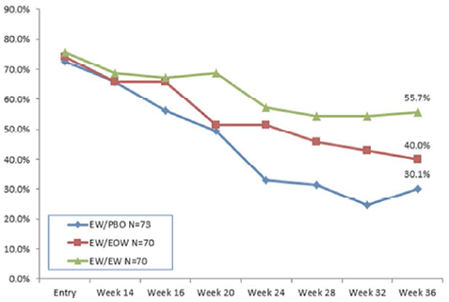

Evaluator’s conclusions on clinical efficacy for HS
Study M10-467 represented the basis for the selection of adalimumab ew in Period A in the pivotal efficacy studies. This was appropriate as adalimumab ew population and placebo population had a statistically significant difference in clinical response rate, compared to adalimumab eow population versus placebo population. The choice of adalimumab ew dosing for the subsequent studies and also the proposed PI is acceptable. The overall clinical response rates in both placebo and treatment groups were lower in all groups in Study M10-467, as compared to M11-313 and M11-810. The reason for this discrepancy is unclear and should be addressed by the sponsor.
The two pivotal efficacy studies, Study M11-313 and M11-810, were well designed and conducted. The double blinding methods were acceptable. The primary outcome of achieving HiSCR is a validated and clinically meaningful endpoint for assessing efficacy in moderate to severe HS. There were an acceptable number of protocol violations and they were well balanced between the treatment and placebo populations. The two pivotal efficacy studies appear internally valid. The study population is adequately representative of the population likely to receive adalimumab for HS (more common in young women, high BMI and smokers). The inclusion and exclusion criteria were appropriate, and the studies overall are externally valid.
The primary end points were reached in both pivotal studies. A statistically significant proportion of subjects in the adalimumab ew group achieved HiSCR at Week 12 as compared to placebo in both Study M11-313 and M11-810 (41.8% versus 26.0% p = 0.003, 58.9% versus 27.6% p < 0.001, respectively). The pooled analyses of the two studies, showed a statistically significant higher HiSCR rate in the adalimumab ew group compared to placebo at Week 12 (50.6% compared to 26.8%, p < 0.001). The difference was statistically significant in both Hurley Stage II and Hurley Stage III disease; however the treatment effect was more prominent for Hurley Stage III. The difference of 23.9% in the pooled analysis is clinically meaningful at Week 12. It was unclear why the HiSCR rate in the placebo groups was high. This could relate to the inherently fluctuating disease course of HS, but the sponsor is encouraged to comment on this point.
In Study M11-313, all 3 ranked secondary endpoints did not achieve statistical significance. All 3 ranked secondary endpoints had very similar results in the adalimumab ew group and placebo group. In contrast, all 3 ranked secondary endpoints achieved statistical significance in Study M11-810 (all p < 0.01). The two populations in the different studies are similar, and the study design was identical in Period A. The difference in outcome is unexplained.
In contrast to short-term adalimumab therapy (3 months), the evidence for maintenance of effect is not convincing. In Period B of both pivotal studies, there was no significant difference in HiSCR and DLQI between adalimumab ew/ew, ew/eow or ew/pbo for maintaining response in subjects considered responders at Week 12. There was approximately a 50% loss of response in both adalimumab ew and adalimumab eow populations in Period B. The subgroups should be interpreted with caution as the numbers were low (< 30). There is limited evidence of clinically meaningful efficacy maintenance.
A separate analysis group of responders/partial responders was identified post hoc (ITT_B_PRR). This group analysis should be interpreted with caution. The selection criteria for this group seemed somewhat arbitrary and its clinical meaningfulness is questionable. The ITT_B_PRR population did demonstrate a statistically significant difference in HiSCR rate between ew/ew and ew/pbo population at Week 36 (55.7% versus 30.1%, p < 0.05), which was not seen between ew/eow and ew/pbo population. The decreasing response rate even in the pooled responder/partial responder population is still concerning.
Overall, evidence for the short term benefits of adalimumab treatment of subjects with moderate to severe HS is convincing. However, there is limited evidence of a clinically meaningful maintenance of efficacy. Nevertheless, this needs to be considered in the context of the lack of HS treatment options. There has been no other randomised placebo controlled trials conducted that shows a significant clinical response in HS. HS is a debilitating condition with physical and psychological impacts. There are limited effective treatment options, and the only curative treatment is surgical excision and flap repair.

Clinical safety

Studies providing evaluable safety data
The safety of adalimumab in HS was determined using data from four clinical studies: two completed multicentre, multinational, DB, placebo-controlled, Phase III pivotal studies (M11-313, M11-810), which assessed safety as a primary outcome, one initial dose finding study (M10-467) and one ongoing OL extension trial, M12-555.
Comment: The sponsor submitted an integrated safety analysis from these 4 studies, which will be presented below.

Pivotal efficacy studies
In the pivotal efficacy studies, the following safety data were collected:
- Adverse events (AEs) were assessed by collection of adverse events throughout the studies until a certain time period following discontinuation of the study drug (range 70 days).
- Treatment-emergent AE (TEAE), defined as an event with onset or worsening after the first study drug injection and within approximately 70 days after the last study drug injection.
- AEs of special interest, including infections, malignancies, immune reactions, cardiovascular/vascular, respiratory, gastrointestinal events, skin and subcutaneous tissue disorders, nervous system disorders, hematologic events, hepatic events, other.
- Laboratory variables, including haematology, clinical chemistry, and urinalysis variables.
- Viral sign variables, including systolic/diastolic blood pressure, pulse, respiratory rate, temperature, weight.

Pivotal studies that assessed safety as a primary outcome
Studies M11-313 and M11-810 were pivotal studies that assessed safety as a primary outcome.

Dose-response and non-pivotal efficacy studies
The dose-response and non-pivotal efficacy studies provided safety data, as follows:
- Study M10-467 provided data on safety, including TEAEs and laboratory variables (22nd April, 2009 to 9th November 2010)
- Study M-12-555 provided data on safety, including AEs, AEs of special interest (12th April 2012 to 29th April, 2014)

Other studies evaluable for safety only
Not applicable.

Pivotal studies that assessed safety as a primary outcome
Comment: Safety data are presented from the integrated safety analysis provided by the sponsor.

Patient exposure
The 4 analysis sets used for the integrated safety analyses were:
- The Placebo-Controlled Analysis Set (n = 785) allows for an assessment of the short term safety profiles for the adalimumab ew, adalimumab eow, and adalimumab total (ew and eow combined) treatments versus placebo and is based on the DB data from Period A of Phase II Study M10-467 (first 16 weeks) and Period A of the Phase III studies, Studies M11-810 and M11-313, (first 12 weeks) with a focus on the comparison between adalimumab ew and total treatments versus placebo (Table 14 and 15).
- The Maintenance Analysis Set (n = 300) allows for an assessment of the safety profiles for continuous adalimumab ew (that is, adalimumab ew in both Period A and Period B) and step-down to adalimumab eow (that is, adalimumab ew in Period A and adalimumab eow in Period B) treatments, as compared to withdrawal from adalimumab ew treatment (that is, adalimumab ew in Period A and placebo in Period B), and is based on the DB data from Period B of the Phase III studies, Studies M11-810 and M11-313.
- The All adalimumab ew Analysis Set (n = 688) allows for an assessment of the safety profile for adalimumab ew treatment that is based on all adalimumab ew exposure in Studies M10-467, M11-810, M11-313, and M12-555.
- The All adalimumab Analysis Set (n = 727) allows for an assessment of safety data that is based on all subjects exposed to adalimumab ew and adalimumab eow in Studies M10-467, M11-810, M11-313, and M12-555.
Across the studies, a total of 727 subjects with HS received at least 1 dose of adalimumab as of 29 April 2014 for a cumulative exposure of 635.7 patient years (PYs). Of these subjects, 576 subjects (79.2%) had been exposed to adalimumab for at least 6 months, 336 subjects (46.2%) had been exposed to adalimumab for at least 1 year, and 69 subjects (9.5%) had been exposed to adalimumab for over 2 years. The mean (standard deviation) duration of adalimumab exposure was 319.4 (168.26) days and the median (min to max) duration was 321 (5 to 883) days.

Table 14: Drug exposure for studies (placebo-controlled analysis set)
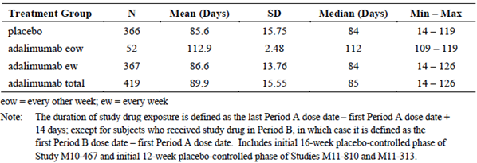

Table 15: Duration of drug exposure for studies (placebo-controlled analysis set)
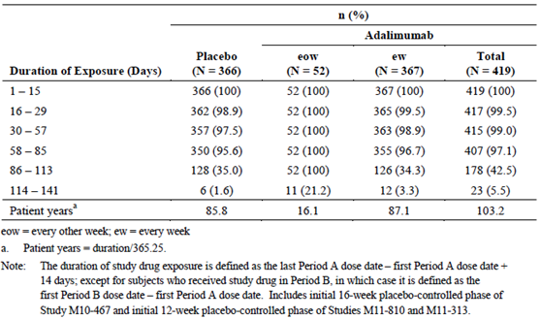
Comment: Adalimumab exposure was sufficient to identify new safety issues in this patient group.

Adverse events

All adverse events (irrespective of relationship to study treatment)
Data in this category were not provided.

Treatment-related adverse events (adverse drug reactions)

Placebo-Controlled Analysis Set
An overview of the number and percentage of subjects who reported TEAEs as well as the incidence rates are provided for the Placebo-Controlled Analysis Set in Table 16. The percentage of subjects who reported any TEAE as well as the incidence of any TEAE were lowest in the adalimumab ew group as compared to the adalimumab eow and placebo groups (57.5% versus 63.5% and 63.7%, respectively; 669.3 events per 100 patient-years [E/100 PYs] versus 782.6 E/100 PYs and 744.8 E/100 PYs, respectively). The percentage of subjects who reported serious infections and who reported any TEAE or treatment-emergent serious adverse event (TESAE) at least possibly related to study drug, as well as the event rate (E/100 PYs) of serious infections and TEAEs at least possibly related to study drug, were higher for the adalimumab ew group, than for the placebo group. For all other TEAE categories in the overview table, the percentages were lower for the adalimumab ew group, as compared to the placebo group. None of these differences were statistically significant.
No subjects across treatment groups reported events in any of the following categories: opportunistic infection (excluding oral candidiasis and TB); TB (active or latent), lymphoma, non-melanoma skin cancer (NMSC) or demyelinating disorder. There were also no TEAEs leading to death or deaths across treatment groups.

Table 16: TEAEs (placebo-controlled analysis set)
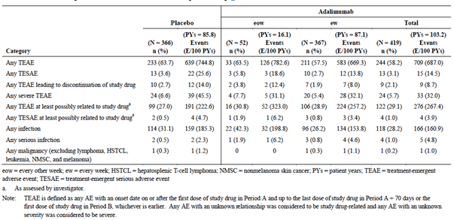

Maintenance analysis set

The percentage of subjects reporting any TEAE, as well as the incidence of any TEAE, were lower for the adalimumab ew/ew and adalimumab ew/eow groups, as compared to the adalimumab ew/placebo group (59.6% and 57.4% versus 65.0%; 471.8 E/100 PYs and 492.4 E/100 PYs versus 591.2 E/100 PYs) (Table 17).
The percentage of subjects who reported serious infections was higher for the adalimumab ew/ew group than for the adalimumab ew/eow and ew/placebo groups (1.0% for the adalimumab ew/ew group, 0% for the adalimumab ew/eow group, and 0% for the adalimumab ew/placebo group).
A greater percentage of subjects in the adalimumab ew/eow group reported any severe TEAE, as compared to the adalimumab ew/ew and adalimumab ew/placebo groups and the exposure-adjusted rate was higher in the adalimumab ew/ew and adalimumab ew/eow groups for any TESAE, any severe TEAE, and any TESAE at least possibly related to study drug, as compared to the adalimumab ew/placebo group. Two subjects each in the adalimumab ew/ew and adalimumab ew/eow groups reported any TESAE at least possibly related to study drug. One subject in the adalimumab ew/ew group reported a serious infection and 1 subject in the adalimumab ew/eow group reported NMSC. No subjects in the adalimumab ew/placebo group reported such events. No subjects across treatment groups reported events in any of the following categories: opportunistic infection (excluding oral candidiasis and TB); TB (active or latent), lymphoma, malignancy (excluding lymphoma, hepatosplenic T-cell lymphoma [HSTCL], leukemia, NMSC, and melanoma), or demyelinating disorder. Overall, the TEAE profile was similar between the adalimumab ew/ew and adalimumab ew/eow groups and no clear relationship between adalimumab dose and rate of TEAEs was observed during Period B.

Table 17: TEAEs (maintenance analysis set)
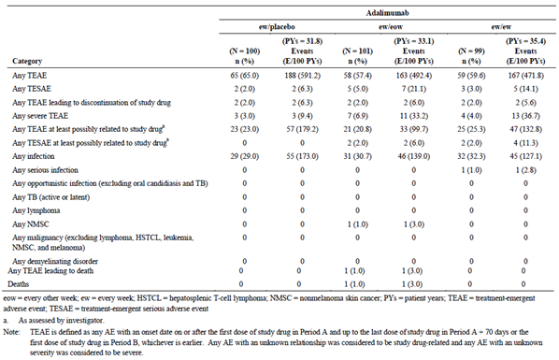

All adalimumab analysis set
A total of 78.7% of subjects reported any TEAE (468.0 E/100 PYs), 10.7% reported any TESAE (18.1 E/100 PYs), 14.7% reported any severe TEAE (26.6 E/100 PYs), 44.3% reported any TEAE at least possibly related to study drug (150.7 E/100 PYs), and 51.9% reported any infection (124.1 E/100 PYs). A total of 21 subjects reported any serious infection (3.9 E/100 PYs), 3 subjects reported latent TB (0.5 E/100 PYs), 3 subjects reported any malignancy (excluding lymphoma, HSTCL, leukaemia, NMSC, and melanoma) (0.5 E/100 PYs), 1 subject reported lymphoma (0.2 E/100 PYs), and 1 subject reported NMSC (0.2 E/100 PYs)(Table 18).

Table 18: TEAEs through to 29 April 2014 for Studies M10-467, M11-810, M11-313, M12-555 (all adalimumab analysis set)
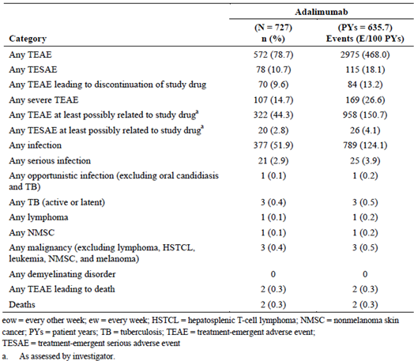

Common AEs
In the Placebo-Controlled Analysis Set, the most frequently reported TEAEs for both the adalimumab total and placebo groups were headache, hidradenitis, and nasopharyngitis (Table 19). The percentage of subjects who reported hidradenitis, as well as the incidence of the event, was lower in the adalimumab total group, as compared to the placebo group (7.6% versus 12.8%; 34.9 E/100 PYs versus 67.6 E/100PYs). No other clinically meaningful differences were noted in the incidence rate of events between the adalimumab total and placebo groups.
Of the subjects who reported TEAEs, the majority had events that were mild or moderate. The most frequently reported severe TEAE for both the adalimumab total and placebo groups was hidradenitis (1.2% and 1.6%); all other severe TEAEs were reported in < 1% of subjects.

Table 19: Common TEAEs reported in placebo-controlled analysis set (only top AEs are shown)
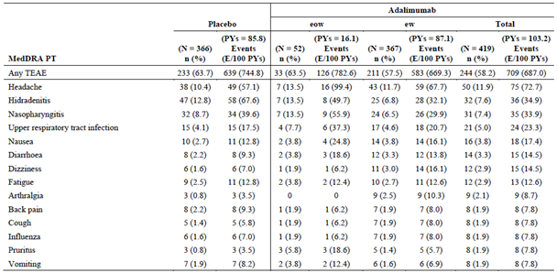
All adalimumab Analysis set: A total of 44.3% of subjects reported TEAEs that were considered by the investigator to be possibly or probably related to study drug. The most frequently reported TEAEs that were considered by the investigator to be at least possibly related to study drug were nasopharyngitis (6.2%), hidradenitis (5.8%), and headache (5.0%). The majority (81.3%) of subjects with any TEAE reported TEAEs that were mild or moderate. The most frequently reported severe TEAE was hidradenitis (5.6%) subjects; all other severe TEAEs were reported in ≤ 1% of subjects.

AEs of special interest

Overview
Placebo-Controlled Analysis Set: The most frequently reported treatment-emergent adverse event of special interest (AESI) in both the adalimumab total and placebo groups were injection site reaction, allergic reaction (most were events of urticaria and pruritus generalized; 1 event of drug sensitivity), and hematologic disorder (most events were anaemia, 2 events of neutropenia were reported by subjects receiving placebo). Malignancy was reported by 1 subject each in the placebo (invasive ductal breast carcinoma) and adalimumab total (vocal cord neoplasm [benign]) groups. Two subjects in the placebo group reported worsening or new onset of psoriasis, as compared to no subjects in the adalimumab total group.
A total of 28.2% and 31.1% of subjects in the adalimumab total and placebo groups, respectively, reported treatment-emergent infections. A total of 1.0% and 0.5% of subjects in the adalimumab total and placebo groups, respectively, reported treatment-emergent serious infections: Escherichia infection, genital infection bacterial, infection, pilonidal cyst, and pyelonephritis in the adalimumab total group; and gastroenteritis and viral infection in the placebo group.
Overall, no subjects reported treatment-emergent events in the following AESI categories:
Legionella infection, active TB, latent TB, parasitic infection, reactivation of hepatitis B, Progressive multifocal leukoencephalopathy (PML), HSTCL, melanoma, leukaemia, lupus-like reaction and systemic lupus erythematosus (SLE), cutaneous vasculitis, sarcoidosis, autoimmune hepatitis, myocardial infarction (MI), cerebrovascular accident (CVA), congestive heart failure (CHF), pulmonary embolism (PE), interstitial lung disease (ILD), intestinal perforation, pancreatitis, Steven's-Johnson syndrome, erythema multiforme, amyotrophic lateral sclerosis (ALS), reversible posterior leukoencephalopathy syndrome (RPLS), and Humira administration-related medication errors.
Maintenance Analysis Set: The most frequently reported treatment-emergent AESI in the adalimumab and placebo groups were allergic reaction (1 event of drug hypersensitivity), hematologic disorder (anaemia), and worsening or new onset psoriasis. Three subjects in the adalimumab ew/eow group, 1 subject in the adalimumab ew/ew and 2 subjects in the adalimumab ew/placebo group reported allergic reaction-related AEs. Three subjects in the adalimumab ew/ew group, 1 subject in the adalimumab ew/eow and 1 subject in the adalimumab ew/placebo group reported worsening or new onset of psoriasis. One subject in the adalimumab ew/eow group experienced a malignancy (squamous cell carcinoma located on the right nasal slope).
A total of 32.3%, 30.7%, and 29.0% of subjects in the adalimumab ew/ew, adalimumab ew/eow, and adalimumab ew/placebo groups, respectively, reported treatment-emergent infections. One subject in the adalimumab ew/ew group reported a serious infection (pneumonia), which was severe and considered by the investigator to be probably related to study drug.
Overall, no subjects reported treatment-emergent events in the following AESI categories:
Legionella infection, diverticulitis, oral candidiasis, active TB, latent TB, reactivation of hepatitis B, PML, HSTCL, melanoma, leukaemia, vasculitis (cutaneous and non-cutaneous), sarcoidosis, autoimmune hepatitis, CVA, pulmonary embolism, ILD, intestinal perforation, pancreatitis, Stevens-Johnson syndrome, erythema multiforme, ALS, reversible posterior leukoencephalopathy syndrome (RPLS), liver failure and other liver event, and Humira administration-related medication errors.
All adalimumab Analysis Set: The most frequently reported treatment-emergent AESI were injection site reaction (7.4%; 16.8 E/100 PYs), allergic reaction (1 event of drug hypersensitivity) (3.7%; 5.5 E/100 PYs), worsening/new onset psoriasis (3.2%; 4.2 E/100 PYs), and hematologic disorders (mainly anaemia, 2 subjects each reported events of neutropenia and lymphopenia) (3.0%; 4.1 E/100 PYs). All other treatment-emergent AESI were reported in < 1% of subjects each.
A total of 51.9% of subjects reported treatment-emergent infections (124.1 E/100 PYs). A total of 2.9% subjects reported treatment-emergent serious infections (3.9 E/100 PYs). One subject reported a non-serious opportunistic infection (excluding TB and oral candidiasis) of cutaneous coccidiomycosis, 3 subjects reported oral candidiasis, and 3 subjects reported latent TB; no subjects reported active TB.
No subjects reported treatment-emergent events in the following AESI categories:
Legionella infection, active TB, reactivation of hepatitis B, PML, HSTCL, melanoma, leukaemia, vasculitis (cutaneous and non-cutaneous), sarcoidosis, intestinal perforation, Stevens-Johnson syndrome, ALS, RPLS, and Humira administration-related medication errors.

All Infections
Placebo-Controlled Analysis Set: A total of 28.2% and 31.1% of subjects in the adalimumab total and placebo groups, respectively, reported treatment-emergent infections. Overall, the most frequently reported treatment-emergent infections were nasopharyngitis, upper respiratory tract infection, urinary tract infection, and bronchitis. Of the subjects who reported treatment-emergent infections, 47 of 118 subjects (39.8%) in the adalimumab total group and 45 of 114 subjects (39.5%) in the placebo group reported events that were considered by the investigator to be at least possibly related to study drug. Of the subjects who reported treatment-emergent infections, 8 of 118 subjects (6.8%) in the adalimumab total group and 7 of 114 subjects (6.1%) in the placebo group reported severe events.
Maintenance Analysis Set: 32.3% of subjects in the adalimumab ew/ew group, 30.7% of subjects in the adalimumab ew/eow group, and 29.0% of subjects in the adalimumab ew/placebo group reported treatment-emergent infections. Of the subjects who reported treatment-emergent infections, 12 of 32 subjects (37.5%) in the adalimumab ew/ew group, 7 of 31 subjects (22.6%) in the adalimumab ew/eow group, and 11 of 29 subjects (37.9%) in the adalimumab ew/placebo group reported events that were considered by the investigator to be at least possibly related to study drug. No subjects in the adalimumab eow/ew and adalimumab ew/placebo groups reported severe treatment-emergent infections. Three subjects in the adalimumab ew/ew group reported severe treatment-emergent infections: nasopharyngitis, otitis externa, and pneumonia.
All adalimumab Analysis Set: A total of 51.9% subjects reported treatment-emergent infections in the All adalimumab Analysis Set (124.1 E/100 PYs). The most frequently reported treatment-emergent infections were nasopharyngitis, upper respiratory tract infection, and urinary tract infection. Of the subjects who reported treatment-emergent infections, 158 of 377 subjects (41.9%) reported events that were considered by the investigator to be at least possibly related to study drug. Of the subjects who reported treatment-emergent infections, 27 of 377 subjects (7.2%) reported severe events.

Serious infections
A total of 1.0% and 0.5% of subjects in the adalimumab total and placebo groups reported treatment-emergent serious infections in the Placebo-Controlled Analysis Set. Treatment-emergent serious infections that were considered by the investigator to be at least possibly related to study drug were reported in 2 adalimumab total subjects (infection and pyelonephritis). Severe treatment-emergent infections were reported in 3 adalimumab total subjects (infection, pilonidal cyst, and pyelonephritis) and 2 placebo subjects (gastroenteritis and viral infection).
A total of 2.9% subjects reported treatment-emergent serious infections in the All adalimumab Analysis Set (3.9 E/100 PYs). Of the subjects who reported treatment-emergent serious infections, 10 of 21 subjects (47.6%) reported events that were considered by the investigator to be at least possibly related to study drug. Of the subjects who reported treatment-emergent serious infections, 18 of 21subjects (85.7%) reported severe events.

Tuberculosis
No subjects reported treatment-emergent active TB during Studies M10-467, M11-810, M11-313, and M12-555.
Three subjects reported treatment-emergent latent TB while receiving adalimumab ew treatment during Study M12-555; all events were mild and non-serious. The AEs were considered by the investigator to be probably not related to study drug. One subject had a negative Quantiferon-TB at Screening of the initial study and a positive result on Day 255; the subject discontinued study drug due to this AE, which the investigator considered probably related to study drug. The investigator noted that x-ray results for this subject were negative.

Malignancies
Five subjects in the All adalimumab Analysis Set reported treatment-emergent malignancies. One of these subjects reported a treatment-emergent malignancy (seminoma) that was considered by the investigator to be at least possibly related to study drug; the other 4 reported events that were considered probably not related or not related to study drug. One subject reported treatment-emergent lymphoma (Hodgkin's disease), while receiving adalimumab ew treatment in Study M12-555, one subject reported treatment-emergent NMSC (squamous cell carcinoma located on the right nasal slope) while receiving adalimumab eow treatment during Period B of Study M11-810, and one subject had breast cancer stage III in Study M11-313.

Allergic reactions
A total of 1.7% and 0.8% of subjects in the adalimumab total and placebo groups reported treatment-emergent allergic reactions in the Placebo-Controlled Analysis Set. Treatment-emergent allergic reactions in 2 subjects in the adalimumab total group (pruritus generalized and urticaria) were considered by the investigator to be at least possibly related to study drug, were mild, and did not result in discontinuation. All other reported events in the adalimumab total and placebo groups were considered by the investigator to be probably not related or not related. Three subjects in the adalimumab total group reported events of asthma, though all events were an exacerbation or worsening of a pre-existing condition. Overall, no subjects reported serious or severe treatment-emergent allergic reactions.
A total of 3.7% of subjects reported treatment-emergent allergic reactions in the All adalimumab Analysis Set. Treatment-emergent allergic reactions in 9 subjects were considered by the investigator to be at least possibly related to study drug; none of the reported events led to study drug discontinuation. Seven subjects reported events of asthma; only 1 of which was considered by the investigator to be at least possibly related to study drug. Events in 5 of these subjects were an exacerbation or worsening of a pre-existing condition. In the other 2 subjects, 1 subject had a history of allergic rhinitis and 1 subject had no relevant medical history. Overall, no subjects reported serious or severe treatment-emergent allergic reactions.

Worsening/new onset psoriasis
In the Placebo-Controlled Analysis Set, 2 subjects in the placebo group and no subjects in the adalimumab total group reported events of psoriasis, both of which were considered worsening of psoriasis. No subjects reported new onset psoriasis. No subjects reported serious or severe treatment-emergent worsening psoriasis; none of the events led to study drug discontinuation.
A total of 3.2% subjects reported events of psoriasis in the All Adalimumab Analysis Set. Treatment-emergent worsening/new onset psoriasis in 19 subjects was considered by the investigator to be at least possibly related to study drug; 11 of these subjects discontinued study drug due to the events. Of the subjects who reported treatment-emergent worsening/new onset psoriasis, 6 subjects had a prior history of psoriasis. Four subjects reported events that were severe, while receiving adalimumab ew treatment; one of the reported events, which occurred during Study M12-555 was also serious. Each of these subjects discontinued study drug due to the events. Follow-up for reports of psoriasis in the HS clinical development program included assessment of the specific type of psoriasis (that is, plaque, guttate, or pustular) and location of psoriasis.

Hematologic disorders
A total of 0.7% and 1.4% of subjects in the adalimumab total and placebo groups, respectively, reported treatment-emergent hematologic disorders in the Placebo-Controlled Analysis Set. Treatment-emergent hematologic reactions reported in subjects in the adalimumab total group were considered by the investigator to be probably not related or not related to study drug. Two subjects reported events that were serious and 2 subjects reported events that were severe; no subjects discontinued study drug.
A total of 3.0% subjects reported treatment-emergent hematologic disorders in the All Adalimumab Analysis Set; the majority of these subjects reported events of anaemia, which is a recognized co-morbidity of moderate to severe HS. Of the subjects who reported treatment-emergent hematologic disorders, 6 reported events that were considered by the investigator to be at least possibly related to study drug. Two subjects reported 3 serious events of anaemia. Two events reported by 1 of the subjects were considered by the investigator to be possibly related to study drug and led to study drug discontinuation and 1 event reported by the second subject was considered probably not related to study drug. One subject reported severe events of anaemia.

Injection site reactions
A total of 4.5% and 2.7% of subjects in the adalimumab total and placebo groups reported treatment-emergent injection site reactions in the Placebo-Controlled Analysis Set. Of the subjects who reported treatment-emergent injection site reactions, 94.7% in the adalimumab total group and 100% in the placebo group reported events that were considered by the investigator to be at least possibly related to study drug. No subjects reported treatment-emergent injection site reactions that were serious or severe; none of the events led to discontinuation.
Comment: No statistics were provided to evaluate whether the observed difference was significant.
A total of 7.4% subjects reported treatment-emergent injection site reactions in the All adalimumab Analysis Set. Of the subjects who reported treatment-emergent injection site reactions, 94.4% reported events that were considered by the investigator to be at least possibly related to study drug. No subjects reported treatment-emergent injection site reactions that were serious or severe; none of the events led to discontinuation.

Deaths and other serious adverse events

Deaths
One subject died in Study M11-810. A 35-year-old male in the adalimumab ew/eow group, had an event of cardio-respiratory arrest on Day 234, 42 days after the last dose of study drug (Period B). The investigator considered the event not related to adalimumab, but a result of coronary heart disease. The subject had a prior event of non-ST elevation myocardial infarction on Day 196 and there was a family history of early onset coronary heart disease. Other risk factors include a diagnosis of diabetes mellitus since 2008 and heavy smoking for 16 years.
One subject died in Study M12-555. A 62-year-old female in the placebo/placebo/ew group (that is, received placebo throughout Study M11-810 and then received adalimumab ew in the OLE study) with a history of Hashimoto's thyroiditis experienced a fatal AE of autoimmune pancreatitis on Day 214 and cardiac arrest/respiratory failure on Day 241 (30 days after the last dose of adalimumab ew). The investigator considered the event not related to adalimumab. Of note, Hashimoto's thyroiditis has been associated with autoimmune pancreatitis. The cause of death was septic shock that developed after an event of ascending cholangitis due to severe autoimmune pancreatitis.

Other TESAEs
Placebo-Controlled Analysis Set: TESAEs were reported in 3.1% of subjects in the adalimumab total group and 3.6% of subjects in the placebo group. All TESAEs were reported in 1 subject each in the adalimumab total and placebo groups, except for suicide attempt (2 subjects in the placebo group) and hidradenitis (2 subjects in the adalimumab total group and 5 subjects in the placebo group).
Maintenance Analysis Set: TESAEs were reported in 3.0% of subjects in the adalimumab ew/ew group, 5.0% of subjects in the adalimumab ew/eow group, and 2.0% of subjects in the adalimumab ew/placebo group. All TESAEs were reported in 1 subject each across treatment groups, except for hidradenitis (3 subjects in the adalimumab ew/eow group and 2 subjects in the adalimumab ew/placebo group). No subjects in the adalimumab ew/ew group reported TESAEs of hidradenitis.
All adalimumab Analysis Set: A total of 10.7% of subjects reported TESAEs (18.1 E/100 PYs). The following TESAEs were reported in ≥ 2 subjects each: anaemia, cellulitis, ectopic pregnancy, hidradenitis, non-cardiac chest pain, palpitations, pilonidal cyst, pneumonia, postoperative wound infection, sepsis, and septic shock. All other TESAEs were reported in 1 subject each.

Discontinuation due to adverse events
TEAEs leading to discontinuation in the Placebo-Controlled Analysis Set were reported in 2.1% of subjects in the adalimumab total group and 2.7% of subjects in the placebo group in the Placebo-Controlled Analysis Set (Table 20). TEAEs leading to discontinuation in 4 subjects in the adalimumab total group and 3 subjects in the placebo group were considered by the investigator to be at least possibly related to study drug. All TEAEs leading to discontinuation were reported in ≤ 1 subject in the adalimumab total and placebo groups, except for hidradenitis (3 subjects in the adalimumab total group and 2 subjects in the placebo group).

Table 20: Discontinuation due to TEAE (placebo-controlled analysis set)
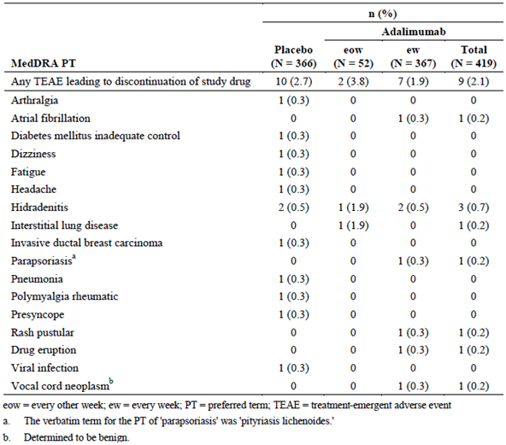
In the All adalimumab Analysis Set, A total of 9.6% subjects reported TEAEs leading to discontinuation. Of the subjects who reported TEAEs leading to discontinuation, 60.0% reported events that were considered by the investigator to be at least possibly related to study drug. TEAEs leading to discontinuation that were reported in ≥ 2 subjects included hidradenitis in 23 subjects (3.2%), pustular psoriasis in 6 subjects (0.8%), psoriasis in 3 subjects (0.4%), weight increased, rash pustular, paraesthesia, and drug eruption in 2 subjects (0.3%) each.

Laboratory tests

Liver function

Placebo-controlled analysis set
- ALT values ≥ 3 × upper limit of normal (ULN) were experienced by 3 subjects in the adalimumab total group and 2 subjects in the placebo group. ALT values ≥ 5 × ULN were experienced by 1 subject in the adalimumab total group and 2 subjects in the placebo group. ALT values ≥ 10 × ULN were experienced by 1 subject in the placebo group. No subjects experienced ALT values ≥ 20 × ULN.
- AST values ≥ 3 × ULN were experienced by 1 subject in the adalimumab total group and 2 subjects in the placebo group. AST values ≥ 5 × ULN were experienced by 2 subjects in the placebo group. AST values ≥ 10 × ULN were experienced by 1 subject in the placebo group. No subjects experienced AST values ≥ 20 × ULN.
- Alkaline phosphatase values ≥ 1.5 × ULN were experienced by 3 subjects each in the adalimumab total group and placebo group.
- No subjects experienced total bilirubin ≥ 2 × ULN, ALT and/or AST ≥ 3 × ULN and concurrent total bilirubin ≥ 1.5 × ULN, or ALT and/or AST ≥ 3 × ULN and concurrent total bilirubin ≥ 2 × ULN.

All adalimumab analysis set
- ALT values ≥ 3 × ULN were experienced by 10 subjects; ALT values ≥ 5 × ULN were experienced by 2 subjects; and ALT values ≥ 10 × ULN were experienced by 1 subject. No subjects experienced ALT values ≥ 20 × ULN.
- AST values ≥ 3 × ULN were experienced by 6 subjects. No subjects experienced AST values ≥ 5 × ULN.
- Total bilirubin ≥ 2 × ULN was experienced by 1 subject.
- Alkaline phosphatase values ≥ 1.5 × ULN were experienced by 13 subjects.
- ALT and/or AST ≥ 3 × ULN and concurrent total bilirubin ≥ 1.5 × ULN was experienced by 1 subject.
- ALT and/or AST ≥ 3 × ULN and concurrent total bilirubin ≥ 2 × ULN was experienced by 1 subject.

Kidney function
No clinically meaningful differences in creatinine and blood urea nitrogen were observed between subjects receiving placebo or adalimumab in all analysed sets (Placebo-Controlled Analysis Set, All adalimumab Analysis Set).

Other clinical chemistry
In the Placebo-Controlled Analysis Set, chemistry values of common toxicity criteria (CTC) Grade ≥ 2 occurred in less than 2% of subjects for all measured parameters, except hypophosphatemia and hypertriglyceridemia (p = 0.005 versus placebo) and hyperglycaemia in the adalimumab total group (Table 21). Chemistry values of CTC Grade ≥ 2 occurred in less than 2% of subjects in the placebo group for all measured parameters, except hypophosphatemia and hyperglycaemia. Chemistry values of CTC Grade ≥ 3 occurred in ≤ 1% of subjects in both the adalimumab total and placebo groups. None of these values were considered clinically meaningful. There was no significant difference among the adalimumab total and placebo groups in the proportion of subjects with CTC Grade ≥ 3 elevations in triglycerides.

Table 21: Potentially clinically significant chemistry values (placebo-controlled analysis set)
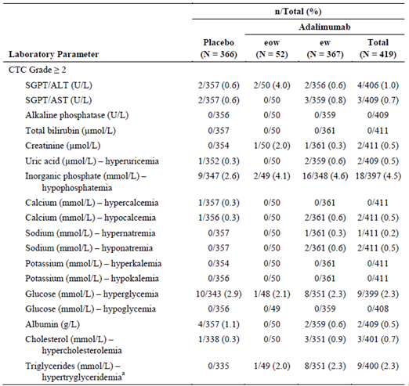

Haematology
In the Placebo-Controlled Analysis Set, haematology values of CTC Grade ≥ 2 were observed for haemoglobin (1.8% of subjects) and neutrophils (0.5% of subjects) in the adalimumab total group, and for haemoglobin (1.7% of subjects), white blood cell (WBC) count (0.3% of subjects), neutrophils (0.8% of subjects), lymphocytes (0.6% of subjects) in the placebo group. Haematology values of CTC Grade ≥ 3 were observed for haemoglobin in 1 subject in the adalimumab total group and for haemoglobin and neutrophils in 2 subjects each in the placebo group. Based on a medical review of the changes, none of these values were considered clinically meaningful.
In the All adalimumab Analysis Set, haematology values of CTC Grade ≥ 2 were observed for haemoglobin (3.9% of subjects) and WBC count (0.3% of subjects), neutrophils (1.1% of subjects), lymphocytes (0.7% of subjects), and platelets (0.1% of subjects). Haematology values of CTC Grade ≥ 3 were observed for hemoglobin (0.8% of subjects) and WBC count (0.1% of subjects), neutrophils (0.4% of subjects), lymphocytes (0.3% of subjects), and platelets (0.1% of subjects). Based on a medical review of the changes, none of these values were considered clinically meaningful.

Other laboratory tests

Urinalysis
Shifts in urinalysis values from normal or high at Baseline to low at the final visit or low or normal at Baseline to high at the final visit were generally infrequent and not considered clinically meaningful in the adalimumab total and placebo groups in the Placebo-Controlled Analysis Set and the All adalimumab Analysis Set.

Electrocardiograph
No data on ECG were provided.

Vital signs
Placebo-controlled Analysis Set: Mean changes in vital sign values from Baseline to the final visit and the incidence of potentially clinically significant vital sign values were not considered to be clinically meaningful in the Placebo-Controlled Analysis Set. The numbers of subjects with potentially clinically significant vital sign values were low and balanced for the adalimumab ew, adalimumab total, and placebo groups (Table 22).

Table 22: Potentially clinically significant vital signs values (placebo-controlled analysis set)
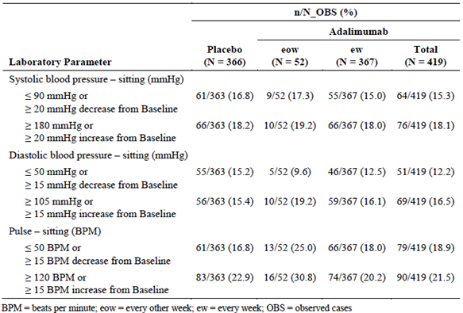
Mean changes in vital sign values from Baseline to the final visit and the incidence of potentially clinically significant vital sign values were not considered to be clinically meaningful in the All adalimumab Analysis Set.

Safety in special groups

Intrinsic factors

Sex
A greater percentage of females versus males in the adalimumab total group reported TEAEs (60.1% versus 54.8%). However, a greater percentage of subjects of either sex in the placebo group reported more TEAEs, as compared to the adalimumab total group (females = 63.5%, males = 64.0%). There was no treatment by sex interaction observed overall for TEAEs, including TESAEs, TEAEs leading to study drug discontinuation, TEAEs leading to death, and AESI categories. More female subjects experienced allergic reactions and injection site reactions than male subjects in the adalimumab total group.
Statistically significant treatment by gender interactions were detected for the events of gastroesophageal reflux disease (p = 0.003), oropharyngeal pain (p = 0.049), muscle spasms (p = 0.019), and muscle strain (p = 0.032). The events of gastroesophageal reflux disease and oropharyngeal pain were non-serious, the number of events is small, and the clinical significance of this finding is unclear. All, but one of these events, was non-serious.

Age
No clinically meaningful differences by age (that is, subjects < 40 years of age ["younger"] and subjects ≥ 40 years ["older"]) in the percentage of subjects experiencing TEAEs were observed.
Among the AESI categories, no statistically significant treatment, by age, interactions were observed. In the adalimumab total group, a numerically greater percentage of younger subjects reported injection site reactions, as compared to older subjects (6.0% versus 1.4%); similar results were observed in the placebo group. All of these events were non-serious.

Race
Similar percentages of non-White and White subjects reported TEAEs in the adalimumab total (56.3% versus 58.7%) and placebo groups (63.0% versus 63.9%). In both treatment groups, a numerically greater percentage of non-White subjects reported TESAEs. In the adalimumab total group, a statistically significantly greater percentage of non-White subjects reported TEAEs considered by the investigator to be at least possibly related to study drug (p = 0.037). Also in the adalimumab total group, a numerically greater percentage of non-White subjects reported TESAEs considered by the investigator to be at least possibly related to study drug, infections, and serious infections.
Comment: Due to the limited sample size results should be interpreted with caution.

Baseline BMI
A numerically greater percentage of subjects with baseline BMI ≥ 40 kg/m² (that is, ≥ 40) than subjects with baseline BMI < 40 kg/m² (that is, < 40) reported TEAEs overall (67.1% versus 56.5%), TEAEs considered by the investigator to be at least possibly related to study drug (35.6% versus 27.8%), and infections (41.1% versus 25.5%). In the adalimumab total group, a numerically greater percentage of subjects with baseline BMI ≥ 40 kg/m² reported TESAEs, TEAEs leading to discontinuation of study drug, severe TEAEs, TESAEs considered by the investigator to be at least possibly related to study drug, and serious infections. In the placebo group, a numerically greater percentage of subjects with baseline BMI < 40 kg/m² reported TEAEs overall and TEAEs considered by the investigator to be at least possibly related to study drug.
A statistically significant treatment by BMI interaction was detected for the event of headache (p = 0.015), asthenia (p = 0.005), and injection site bruising (p = 0.034). In the adalimumab total group, a greater percentage of subjects with baseline BMI ≥ 40 kg/m² reported upper respiratory tract infection than subjects with baseline BMI < 40 kg/m²; the difference was not statistically significant between treatment groups.
Comment: Due to the limited sample size results should be interpreted with caution.

Intrinsic factors

Concomitant antibiotic use
A numerically greater percentage of subjects not currently using antibiotics (nonusers) versus subjects currently using antibiotics (users) in the adalimumab total group reported TEAEs (58.4% versus 56.5%). A similar percentage of subjects with either antibiotic use status in the placebo group reported TEAEs, as compared to the adalimumab total group (users = 63.9%, nonusers = 63.6%). A significant treatment by antibiotic use interaction was observed overall for TESAEs (p = 0.015) with more TESAEs reported in subjects using concomitant antibiotics and adalimumab; however, the number of subjects is small and the results should be interpreted with caution. There was no significant treatment by antibiotic use interaction observed overall for TEAEs, TEAEs leading to study drug discontinuation, TEAEs leading to death, and AESI categories.

Post-marketing experiences
Adalimumab was first approved for treatment of RA on 31 December 2002 (international birth date [IBD]). As of 31 December 2013, adalimumab has been evaluated in over 42,000 subjects (exposure of > 43,000 PYs) with rheumatoid arthritis (RA), juvenile idiopathic arthritis (JIA), paediatric enthesitis related arthritis, psoriatic arthritis (PsA), Crohn's disease (CD), paediatric CD, psoriasis (Ps), paediatric Ps, ulcerative colitis (UC), ankylosing spondylitis (AS), spondyloarthritis (SpA), non-radiographic axial SpA (nr-axSpA), HS, uveitis, and intestinal Behçet's disease. Adalimumab is approved for the treatment of RA, AS, PsA, CD, Ps, UC, and JIA in the European Union (EU) and United States (US). The estimated cumulative postmarketing patient exposure since the IBD through 31 December 2013 is 2.9 million PYs.
The sponsor continues to monitor for potential new safety signals through its ongoing standard postmarketing safety surveillance practices for adalimumab. This surveillance includes reports of serious adverse events from clinical studies, all reports from spontaneous sources, the literature, regulatory agencies, postmarketing studies, and registries. Eight AbbVie-sponsored adalimumab safety registries are ongoing with > 32,000 adult and paediatric patients. One Abbvie-sponsored registry of 3,435 patients with moderate to severe RA (ReAlise) has been completed. New safety risks that are identified from the postmarketing experience are reflected in the company core labelling for the product. The postmarketing safety data with adalimumab in the approved adult indications has been consistent with the types and severity of AEs observed in the clinical trials for these patients with HS.

Evaluator’s overall conclusions on clinical safety
In the two Phase III trials, the recommended adalimumab dose regimen for adult patients with moderate to severe HS was safe and well tolerated. Safety data were generated using appropriate methods. No new safety signals were identified in the HS program. Adalimumab treatment demonstrated higher rates of injection site reactions compared with placebo treatment. The two deaths in these studies did not appear to be related to adalimumab treatment. The observation period of 36 weeks in the Phase III trials does not allow evaluation of risks in the long-term.
In the OL Study, no new safety risks for adalimumab were identified as of the 29 April 2014 data cut-off date. Adalimumab was generally well tolerated as evaluated by TEAEs, laboratory values, and vital signs values. One death was reported during the study in a subject who had multiple SAEs that included autoimmune pancreatitis, sepsis, cholangitis, and cardiac arrest. The death was considered unrelated to study drug by the investigator.
Overall, the incidence and severity of TEAEs, premature discontinuations due to TEAEs, and changes in laboratory and vital sign values were generally comparable between the adalimumab and placebo groups, as well as between the adalimumab ew and eow groups, and were consistent with a population of subjects with moderate to severe HS. The rates of treatment-emergent AESI were generally consistent with previous studies in approved adalimumab indications, such as psoriasis, UC or CD.

First round benefit-risk assessment

First round assessment of benefits
HS is a debilitating dermatological condition with very limited effective treatment options. Evaluation of the data contained in this proposal revealed the following benefits of adalimumab therapy in HS:
- In two pivotal studies, M11-313 and M11-810, short course (12 weeks) adalimumab treatment of HS produced meaningful clinical responses. Statistically significant proportions of subjects in the adalimumab ew group in both trials achieved HiSCR (primary end point). These well-conducted randomised controlled trials (RCTs) are the first to demonstrate a significant treatment option for HS.
- The selection of adalimumab ew dosing was evidence based, with adalimumab ew population and placebo population achieving a significant difference in clinical response (HS-PGA) rate, compared to adalimumab eow population versus placebo population in the Phase II Study, M10-467.
- Short term adalimumab was effective as a treatment option for HS patients with Hurley Stage II and III disease. The treatment effect was most prominent in subjects with severe Stage III disease.
- Short term adalimumab was effective in the typical HS population (young women, high BMI and smokers), who will be the most likely to receive the treatment.
- No clear evidence of a clinically meaningful maintenance of efficacy beyond 12 weeks of therapy. There was approximately a 50% loss of response in both adalimumab ew and adalimumab eow populations in Period B.

First round assessment of risks
The risks of adalimumab in the proposed usage are:
- Overall, the incidence and severity of TEAEs, premature discontinuations due to TEAEs, and changes in laboratory and vital sign values were generally comparable between the adalimumab and placebo groups, as well as between the adalimumab ew and eow groups, and were consistent with a population of subjects with moderate to severe HS.
- No new safety signals were identified.
- Adalimumab treatment consistently demonstrated higher rates of injection site reactions compared with placebo treatment.
- Ten percent of subjects receiving adalimumab developed AAA. The long-term effect of adalimumab immunogenicity on its efficacy and safety profiles remains unknown.
The overall safety profile of adalimumab in the HS indication is consistent with other approved indications, such as CD, UC and psoriasis.

First round assessment of benefit-risk balance
The benefit-risk balance of adalimumab, given the proposed usage in HS, is favourable for short-term or induction treatment for 12 weeks.

First round recommendation regarding authorisation
A 12 week course (as per dosing protocol) of adalimumab provides a statistically significant and clinically meaningful treatment option in the management of HS. Pivotal studies were performed in patients with Hurley stage II or III disease, and thus treatment should be limited to this subset of patients. The evidence does not demonstrate a significant benefit from ongoing maintenance treatment with adalimumab ew compared to placebo after this initial 12 week period. As such, the evaluator recommends approval for 12 weeks of adalimumab as per dosing protocol (160 mg at week 0, 80 mg at Week 2, thence 40 mg every week from Week 4 to Week 12), but not for ongoing maintenance treatment.

Clinical questions

Pharmacokinetics
Nil

Pharmacodynamics
Nil

Efficacy
- The overall HiSCR rates in both placebo and treatment groups were lower in all groups in Study M10-467, as compared to M11-313 and M11-810. The reason for this discrepancy is unclear and should be addressed by the sponsor.
- In Study M11-313 and M11-810 the HiSCR rate in the placebo groups were unusually high (26.0% and 27.6%). The sponsor is encouraged to comment on this point. Is this only related to inherently fluctuating disease or specific features of the study?

Safety
Nil

Second round evaluation of clinical data submitted in response to questions

Efficacy

Question 1
Question: The overall HiSCR rates in both placebo and treatment groups were lower in all groups in Study M10–467, as compared to M11–313 and M11-810. The reason for this discrepancy is unclear and should be addressed by the sponsor.

Sponsor response
The Physician's Global Assessment for Hidradenitis Suppurativa (HS-PGA) was the primary efficacy endpoint for Study M10-467 and the Hidradenitis Suppurativa Clinical Response (HiSCR) was the primary efficacy endpoint for Studies M11-810 and M11-313. These endpoints have different definitions of clinical response and cannot be directly compared. To provide a more appropriate comparison of these data, post hoc analyses were performed on the dataset from Study M10-467 in which subjects with Hurley Stage I disease were excluded. This modified population of subjects was similar to the population studied in Studies M11-810 and M11-313. Of the subjects in this post hoc population, more subjects treated with adalimumab 40 mg ew achieved HiSCR than subjects treated with placebo at Week 12 (61.1% versus 16.2%, p < 0.001) and at Week 16 (55.6% versus 21.6%, p = 0.003) (Table 23).

Table 23: Proportion of subjects achieving HiSCR at Week 12 and Week 16 in Study M10-467 (NRI) (mITT-1 population)
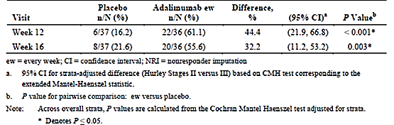
These results are similar to what were observed in the Phase III studies at Week 12 (Study M11-810: 58.9% versus 27.6%, P = < 0.001; Study M11-313: 41.8% versus 26.0%, P = 0.003) (Table 24).

Table 24: Proportion of subjects achieving hiSCR at Week 12 in Studies M11-810 and M11-313 (NRI)(ITT_A Population)
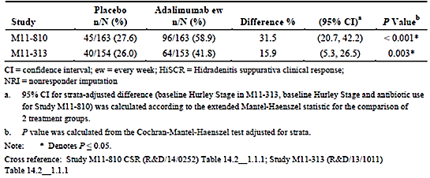

Evaluator’s response
The response sufficiently addresses the clinical question and explains the initial apparent difference between the clinical response rates in M10-467, and Studies M11-810 and M11-313.

Question 2
Question: In Study M11–313 and M11–810, the HiSCR rates in the placebo groups were unusually high (26.0% and 27.6%). The sponsor is encouraged to comment on this point. Is this only related to inherently fluctuating disease or specific features of the study?

Sponsor response
Hidradenitis suppurativa is a chronic, inflammatory skin condition known to have periods of quiescence and flare. Limited data on the natural history of the disease are available to fully characterise disease activity in HS and there are no published prospective studies of the clinical course of HS that can provide expected placebo response rates.
Studies M11-810 and M11-313 are the first large placebo-controlled Phase III studies that investigate a pharmaceutical intervention and were the first studies to prospectively use a newly validated measure, HiSCR, as the primary efficacy endpoint. HiSCR is defined as at least a 50% reduction in the total abscess and inflammatory nodule (AN) count with no increase in abscess count and no increase in draining fistula count relative to Baseline. As with any placebo-controlled clinical trial, it is expected that some subjects in the placebo group will have a response. Given the fluctuations in the course of HS and considering the definition of achieving HiSCR, some response to placebo would be expected in the study population.
A subgroup analysis of the integrated data from Studies M11-810 and M11-313 by baseline AN count category (≤ 5, 6 – 10, and > 10) showed the response to placebo varied, depending on the baseline AN count (Table 25). Specifically, the HiSCR rate decreases as the baseline AN count increases, reflecting a greater threshold to achieve at least a 50% decrease in the AN count without adalimumab intervention. In contrast, HiSCR rates for the adalimumab group were similar across the 3 categories; the treatment difference was greatest in the baseline AN count category of > 10. Despite the observed placebo response in both Phase III studies, the percentage of subjects in the adalimumab group who achieved HiSCR at Week 12 was significantly higher than subjects in the placebo group. These results represent a clinically meaningful difference between treatment groups.

Table 25: Number and proportion of subjects who achieved HiSCR at Week 12 by baseline AN count (NRI)(ITT_A Population)
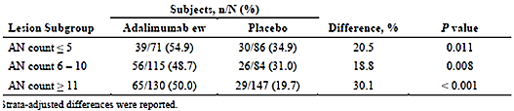

Evaluator’s response
The response is acceptable. The fluctuating clinical nature of HS is likely to explain the high HiSCR rates in the placebo groups. The sponsor shows that the HiSCR rates decrease in the placebo groups with a higher baseline AN count. Despite the high HiSCR rates in the placebo groups, there was a statistically significant higher HiSCR rate at Week 12 in the adalimumab ew group compared to the placebo group (50.6% compared to 26.8%, p < 0.001).

Second round benefit-risk assessment

Second round assessment of benefits
After consideration of the responses to clinical questions, the benefits of adalimumb in HS patients in short-term usage (12 weeks) are unchanged from those identified in Section 9.1. For maintenance therapy after 12 weeks, the Sponsor provides acceptable arguments for the benefits of Humira, including post hoc analysis of patient groups. While this is circumstantial evidence, the evaluator has taken this clinical experience into consideration. Together, the use of adalimumab for the treatment of HS beyond 12 weeks is considered appropriate if assessment of the HiSCR response shows at least 50% improvement. It is recommended to perform HiSCR assessments at 12 and 24 weeks, and 6 monthly intervals thereafter.

Second round assessment of risks
No new clinical information was submitted in response to questions.

Second round assessment of benefit-risk balance
The benefit-risk balance of adalimumab, given the proposed usage in hidradenitis suppurativa, is favourable. The benefit-risk balance is unchanged from the first round assessment of benefit-risk balance.

Second round recommendation regarding authorisation
A 12 week course (as per dosing protocol) of adalimumab provides a statistically significant and clinically meaningful treatment option in the management of HS. Pivotal studies were performed in patients with Hurley stage II or III disease, and thus treatment should be limited to this subset of patients.
The large loss of response rates of 47.6% and 54.7% respectively in Study M11-313 and M11-810 are concerning. After consideration of the sponsor’s response and revisiting the pivotal Studies M11-313 and M11-810, the evaluator acknowledges that the participants who lost response and entered into Study M12-555, was not given the opportunity to demonstrate any subsequent improvement and regain HiSCR. The pooled Period B analysis from Study M11-313 and M11-810 demonstrates a statistically significant difference in HiSCR response between ew/ew and ew/pbo adalimumab dosing at Week 36 (43.4% and 28.0%, p < 0.05).
As such, the evaluator recommends approval for 12 weeks of adalimumab as per dosing protocol (160 mg at week 0, 80 mg at Week 2, thence 40 mg every week from Week 4 to Week 12). The evaluator recommends assessment of HiSCR response at Weeks 12 and 24. HiSCR responses should be assessed every 6 months thereafter. A minimum 50% improvement in the HiSCR response should be present for continuation of treatment at the assessment timepoints. Patients, who demonstrate maintenance of HiSCR response, should be given ongoing maintenance treatment.

References
Kimball AB et al. Assessing the validity, responsiveness and meaningfulness of the Hidradenitis Suppurativa Clinical Response (HiSCR) as the clinical endpoint for hidradenitis suppurativa treatment. Br J Dermatol. 2014; 171:1434-1442.
Rambhatla, P. V et al. A systematic review of treatments for hidradenitis suppurativa. Arch Dermatol, 2012; 148: 439-446.

Therapeutic Goods Administration
PO Box 100 Woden ACT 2606 Australia
Email: info@tga.gov.au Phone: 1800 020 653 Fax: 02 6232 8605
https://www.tga.gov.au

