April 2021

Australian Public Assessment Report for Adalimumab
  - Proprietary Product Name: Abrilada
  - Sponsor: Pfizer Australia Pty Ltd

About the Therapeutic Goods Administration (TGA)
- The Therapeutic Goods Administration (TGA) is part of the Australian Government Department of Health and is responsible for regulating medicines and medical devices.
- The TGA administers the Therapeutic Goods Act 1989 (the Act), applying a risk management approach designed to ensure therapeutic goods supplied in Australia meet acceptable standards of quality, safety and efficacy (performance) when necessary.
- The work of the TGA is based on applying scientific and clinical expertise to decision-making, to ensure that the benefits to consumers outweigh any risks associated with the use of medicines and medical devices.
- The TGA relies on the public, healthcare professionals and industry to report problems with medicines or medical devices. TGA investigates reports received by it to determine any necessary regulatory action.
- To report a problem with a medicine or medical device, please see the information on the TGA website <https://www.tga.gov.au>.

About AusPARs
- An Australian Public Assessment Report (AusPAR) provides information about the evaluation of a prescription medicine and the considerations that led the TGA to approve or not approve a prescription medicine submission.
- AusPARs are prepared and published by the TGA.
- An AusPAR is prepared for submissions that relate to new chemical entities, generic medicines, major variations and extensions of indications.
- An AusPAR is a static document; it provides information that relates to a submission at a particular point in time.
- A new AusPAR will be developed to reflect changes to indications and/or major variations to a prescription medicine subject to evaluation by the TGA.

Copyright
© Commonwealth of Australia 2021
This work is copyright. You may reproduce the whole or part of this work in unaltered form for your own personal use or, if you are part of an organisation, for internal use within your organisation, but only if you or your organisation do not use the reproduction for any commercial purpose and retain this copyright notice and all disclaimer notices as part of that reproduction. Apart from rights to use as permitted by the Copyright Act 1968 or allowed by this copyright notice, all other rights are reserved and you are not allowed to reproduce the whole or any part of this work in any way (electronic or otherwise) without first being given specific written permission from the Commonwealth to do so. Requests and inquiries concerning reproduction and rights are to be sent to the TGA Copyright Officer, Therapeutic Goods Administration, PO Box 100, Woden ACT 2606 or emailed to <tga.copyright@tga.gov.au>.

Contents
List of abbreviations 4
I. Introduction to product submission 6
Submission details 6
Product background 8
Regulatory status 10
Product Information 13
II. Registration timeline 13
III. Submission overview and risk/benefit assessment 14
Contents of the submission 14
Quality 15
Nonclinical 16
Clinical 17
Risk management plan 30
Risk-benefit analysis 32
Outcome 35
Attachment 1. Product Information 37

List of abbreviations
Abbreviation | Meaning
ACM | Advisory Committee on Medicines
ACR | American College of Rheumatology
ACR20 | American College of Rheumatology 20% response score
ADA | Antidrug antibody
ADCC | Antibody dependent cellular cytotoxicity
ARTG | Australian Register of Therapeutic Goods
ASA | Australian-specific Annex
AUC | Area under the concentration-time curve
AUC_{0-2wk} | Area under the concentration-time curve from time zero to 2 weeks
AUC_{0-inf} | Area under the concentration-time curve from time zero extrapolated to infinity
AUC_{0-t} | Area under the concentration-time curve from time zero to last measurable concentration
CHMP | Committee on Medicinal Products for Human Use (European Union)
CI | Confidence interval
C_{max} | Maximum concentration
CRP | C-reactive protein
DAS | Disease Activity Score
EMA | European Medicines Agency (European Union)
ESR | Erythrocyte sedimentation rate
EU | European Union
EULAR | European League against Rheumatism
FDA | Food and Drug Administration (United States)
GMP | Good Manufacturing Practice
GVP | Good pharmacovigilance practice
NAb | Neutralising antibody
PI | Product Information
PK | Pharmacokinetic(s)
PSUR | Periodic safety update report
RMP | Risk management plan
SC | Subcutaneous
T_{max} | Time of maximum concentration
TP1 | Treatment phase 1
TP2 | Treatment phase 2
US(A) | United States (of America)

I. Introduction to product submission

Submission details
Type of submission: | New biosimilar medicine
Product name: | Abrilada
Active ingredient: | Adalimumab
Decision: | Approved
Date of decision: | 8 February 2021
Date of entry onto ARTG: | 22 February 2021
ARTG numbers: | 334496, 334497, 334498 and 334499
Black Triangle Scheme: | No
Sponsor’s name and address: | Pfizer Australia Pty Ltd  Level 17, 151 Clarence Street,  Sydney, NSW, 2000
Dose form: | Solution for injection
Strengths: | 20 mg (20 mg/0.4 mL solution), and 40 mg (40 mg/0.8 mL solution)
Containers: | Prefilled syringe, prefilled pen, and vial.
Pack sizes: | 2 prefilled syringes (20 mg/0.4 mL sterile solution)  1, 2, 4, and 6 prefilled syringe(s) (40 mg/0.8 mL sterile solution)  1, 2, 4, and 6 prefilled pen(s) (40 mg/0.8 mL sterile solution)  1 pack of 2 boxes each containing 1 vial (40 mg/0.8 mL sterile solution), 1 empty sterile injection syringe, 1 needle and 1 adapter
Approved therapeutic use: | Rheumatoid arthritis  Abrilada is indicated for reducing signs and symptoms, as well as inhibiting the progression of structural damage in adult patients with moderate to severely active rheumatoid arthritis. This includes the treatment of patients with recently diagnosed moderate to severely active disease who have not received methotrexate.  Abrilada can be used alone or in combination with methotrexate.  Juvenile idiopathic arthritis  Polyarticular juvenile idiopathic arthritis  Abrilada in combination with methotrexate is indicated for reducing the signs and symptoms of moderately to severely active polyarticular juvenile idiopathic arthritis in patients 2 years of age and older who have had an inadequate response to one or more disease modifying antirheumatic drugs (DMARDs). Abrilada can be given as monotherapy in case of intolerance to methotrexate or when continued treatment with methotrexate is inappropriate.  Enthesitis-related arthritis  Abrilada is indicated for the treatment of enthesitis-related arthritis in children, who have had an inadequate response to, or who are intolerant to, conventional therapy.  Psoriatic arthritis  Abrilada is indicated for the treatment of signs and symptoms, as well as inhibiting the progression of structural damage, of moderate to severely active psoriatic arthritis in adult patients where response to previous DMARDs has been inadequate.  Ankylosing spondylitis  Abrilada is indicated for reducing signs and symptoms in patients with active ankylosing spondylitis.  Crohn's disease in adults and children (≥ 6 years)  Abrilada is indicated for the treatment of moderate to severe Crohn's disease, to reduce the signs and symptoms of the disease and to induce and maintain clinical remission in patients;  who have had an inadequate response to conventional therapies or,  who have lost response to or are intolerant to infliximab.  Ulcerative colitis  Abrilada is indicated for the treatment of moderate to severe ulcerative colitis in adult patients who have had an inadequate response to conventional therapy or who are intolerant to or have medical contraindications for such therapies. Patients should show a clinical response within 8 weeks of treatment to continue treatment beyond that time. (see 5.1 pharmacodynamic properties - clinical trials).  Psoriasis in adults and children  Abrilada is indicated for the treatment of moderate to severe chronic plaque psoriasis in adult patients who are candidates for systemic therapy or phototherapy.  Abrilada is indicated for the treatment of severe chronic plaque psoriasis in children and adolescent patients from 4 years of age who have had an inadequate response to or are inappropriate candidates for topical therapy and phototherapy.  Hidradenitis suppurativa in adults and adolescents (from 12 years of age)  Abrilada is indicated for the treatment of active moderate to severe hidradenitis suppurativa (acne inversa) in patients with an inadequate response to conventional systemic hidradenitis suppurativa therapy.  Uveitis  Abrilada is indicated for the treatment of non-infectious intermediate, posterior and panuveitis in adult patients who have had an inadequate response to corticosteroids, in patients in need of corticosteroid sparing, or in whom corticosteroid treatment is inappropriate.
Route of administration: | Subcutaneous injection
Dosage: | As the dosage of Abrilada (adalimumab) is based on multiple factors, including the condition being treated (of which there are many), the age (including children) and the body weight of the patient, please refer to the Product Information for specific dosage information.
Pregnancy category: | C  Drugs which, owing to their pharmacological effects, have caused or may be suspected of causing, harmful effects on the human fetus or neonate without causing malformations. These effects may be reversible. Accompanying texts should be consulted for further details.  The use of any medicine during pregnancy requires careful consideration of both risks and benefits by the treating health professional. This must not be used as the sole basis of decision making in the use of medicines during pregnancy. The TGA does not provide advice on the use of medicines in pregnancy for specific cases. More information is available from obstetric drug information services in your State or Territory.

Product background
This AusPAR describes the application by Pfizer Australia Pty Ltd (the sponsor) to register the following:
- Abrilada (adalimumab) 20 mg/0.4 mL solution for injection pre-filled syringe;
- Abrilada (adalimumab) 40 mg/0.8 mL solution for injection pre-filled syringe;
- Abrilada (adalimumab) 40 mg/0.8 mL solution for injection pre-filled pen; and
- Abrilada (adalimumab) 40 mg/0.8 mL solution for injection vial.
This is a new biosimilar medicine to the registered Australian reference product Humira (adalimumab). The proposed indications are the same as the Australian indications for Humira; these are:
Rheumatoid Arthritis
Abrilada is indicated for reducing signs and symptoms, as well as inhibiting the progression of structural damage in adult patients with moderate to severely active rheumatoid arthritis. This includes the treatment of patients with recently diagnosed moderate to severely active disease who have not received methotrexate.
Abrilada can be used alone or in combination with methotrexate.
Juvenile Idiopathic Arthritis
Polyarticular Juvenile Idiopathic Arthritis
Abrilada in combination with methotrexate is indicated for reducing the signs and symptoms of moderately to severely active polyarticular juvenile idiopathic arthritis in patients 2 years of age and older who have had an inadequate response to one or more disease modifying anti-rheumatic drugs (DMARDs). Abrilada can be given as monotherapy in case of intolerance to methotrexate or when continued treatment with methotrexate is inappropriate.
Enthesitis-Related Arthritis
Abrilada is indicated for the treatment of enthesitis-related arthritis in children, who have had an inadequate response to, or who are intolerant to, conventional therapy.
Psoriatic Arthritis
Abrilada is indicated for the treatment of signs and symptoms, as well as inhibiting the progression of structural damage, of moderate to severely active psoriatic arthritis in adult patients where response to previous DMARDs has been inadequate.
Ankylosing Spondylitis
Abrilada is indicated for reducing signs and symptoms in patients with active ankylosing spondylitis.
Crohn’s disease in adults and children (≥ 6 years)
Abrilada is indicated for the treatment of moderate to severe Crohn’s disease, to reduce the signs and symptoms of the disease and to induce and maintain clinical remission in patients;
who have had an inadequate response to conventional therapies or,
who have lost response to or are intolerant to infliximab.
Ulcerative colitis
Abrilada is indicated for the treatment of moderate to severe ulcerative colitis in adult patients who have had an inadequate response to conventional therapy or who are intolerant to or have medical contraindications for such therapies. Patients should show a clinical response within 8 weeks of treatment to continue treatment beyond that time. (see 5.1 Pharmacodynamic Properties - Clinical Trials).
Psoriasis in Adults and Children
Abrilada is indicated for the treatment of moderate to severe chronic plaque psoriasis in adult patients who are candidates for systemic therapy or phototherapy.
Abrilada is indicated for the treatment of severe chronic plaque psoriasis in children and adolescent patients from 4 years of age who have had an inadequate response to or are inappropriate candidates for topical therapy and phototherapy.
Hidradenitis Suppurativa in Adults and Adolescents (from 12 years of age)
Abrilada is indicated for the treatment of active moderate to severe hidradenitis suppurativa (acne inversa) in patients with an inadequate response to conventional systemic hidradenitis suppurativa therapy.
Uveitis
Abrilada is indicated for the treatment of non-infectious intermediate, posterior and pan-uveitis in adult patients who have had an inadequate response to corticosteroids, in patients in need of corticosteroid sparing, or in whom corticosteroid treatment is inappropriate.
Adalimumab is a recombinant fully human immunoglobulin (IgG1) monoclonal antibody specific for tumour necrosis factor (TNF) alpha. Adalimumab binds to TNF and neutralises the biological function of TNF by blocking its interaction with the p55 and p75 cell surface TNF receptors. TNF is a naturally occurring cytokine that is involved in normal inflammatory and immune responses. Elevated levels of TNF are found in the synovial fluid of rheumatoid arthritis, including juvenile idiopathic arthritis, psoriatic arthritis and ankylosing spondylitis patients and play an important role in both the pathologic inflammation and the joint destruction that are hallmarks of these diseases. Increased levels of TNF are also found in psoriasis plaques, which contribute to the inflammatory response, to the proliferation and decreased maturation of keratinocytes and to the associated vascular damages that are characteristic of the disease.
Adalimumab also modulates biological responses that are induced or regulated by TNF, including changes in the levels of adhesion molecules responsible for leukocyte migration (endothelial leukocyte adhesion molecule 1, vascular cell adhesion molecule 1, and intercellular adhesion molecule 1 with a half maximal inhibitory concentration (IC₅₀) of 1 to 2 x 10⁻¹⁰ M).
This application was submitted through the TGA’s Comparable Overseas Regulator approach B (COR-B) process, using evaluation reports from the European Medicines Agency (EMA) which led to the marketing authorisation of Amsparity in the European Union (EU). Amsparity and Abrilada are identical products with different tradenames. The full dossier for Amsparity was also submitted to the TGA.

Regulatory status
This is the first submission to register Abrilada in Australia.
Adalimumab was first registered in Australia as Humira in 2003. A number of biosimilars of Humira have been registered in Australia in recent years. This application to register Abrilada is based on biosimilarity to Humira. The application utilises the COR-B pathway, based on the European Medicine Agency’s (EMA) evaluation which led to the marketing authorisation of Amsparity in the European Union (EU); noting that Amsparity and Abrilada are the same product). As the Abrilada clinical development program used Humira sourced from the EU and United States of America (USA), the submission included a bridging study to confirm the comparability of these products with Humira sourced from Australia.
Adalimumab (Humira) was designated as an orphan drug in Australia for paediatric Crohn’s disease in 2012, followed by paediatric enthesitisidiopathic arthritis, and uveitis, both in 2015.
Table 1 (shown below) gives a comparison of any drug product differences between Australian-sourced Humira to EU-approved Amsparity and Australian (proposed) Abrilada.
Table 1: Dosage forms, strengths and presentations of Australian-sourced Humira, Abrilada (as proposed) and EU-approved Amsparity
Humira (Australia) | Abrilada (proposed) | Amsparity (EU)
80 mg per 0.8 mL (100 mg/mL) solution for injection in PFS and PFP
40 mg per 0.8 mL (50 mg/mL) solution for injection in PFS and PFP | 40 mg per 0.8 mL (50 mg/mL) solution for injection in vial, PFS and PFP | 40 mg per 0.8 mL (50 mg/mL) solution for injection in vial, PFS and PFP
40 mg per 0.4 mL (100 mg/mL) solution for injection in PFS and PFP
20 mg per 0.4 mL (50 mg/mL) solution for injection in PFS | 20 mg per 0.4 mL (50 mg/mL) solution for injection in PFS | 20 mg per 0.4 mL (50 mg/mL) solution for injection in PFS
20 mg per 0.2 mL (100 mg/mL) solution for injection in PFS
Note: Not all presentations may be marketed.
EU = European Union; PFS = prefilled syringe; PFP = prefilled pen.

Overseas regulatory status
Table 2 (shown below) gives a summary of similar submissions for Abrilada (adalimumab), also known as Amsparity in some jurisdictions (including the EU).
Note that in the EU, Amsparity (adalimumab) is approved for all the same EMA-approved indications currently approved for Humira (adalimumab) in the EU. The same is also true for Abrilada (adalimumab) in Canada, with all indications approved for Humira (adalimumab) also being approved for Abrilada.
Whilst the indications for Humira (adalimumab) are broadly the same as those approved by the EMA, note that neither Axial spondyloarthritis without radiographic evidence of ankylosing spondylitis nor juvenile uveitis are current indications for Humira (adalimumab) and the sponsor has not proposed to add these conditions to the proposed indications of Abrilada (adalimumab) in this submission.
In the USA, at the time of submission, all indications approved for Abrilada (adalimumab) are the same as for Humira (adalimumab) with the exception of hidradenitis suppurativa and uveitis, and none of the paediatric indications approved for Humira (adalimumab) were approved for Abrilada (adalimumab) at the time of submission.
Table 2: International regulatory status
Country / region | Submission date | Status | Indications (approved or proposed)
European Union (Centralised procedure) | November 2018 | Approved: February 2020 | Rheumatoid arthritis  Juvenile idiopathic arthritis (paediatric juvenile idiopathic arthritis; enthesitis idiopathic arthritis)  Ankylosing spondylitis  Axial spondyloarthritis without radiographic evidence of ankylosing spondylitis  Psoriatic arthritis  Psoriasis  Paediatric plaque psoriasis  Hidradenitis suppurativa  Crohn’s disease (adult and paediatric)  Uveitis (adult and paediatric).
United States of America | November 2018 | Approved: November 2019 | Rheumatoid arthritis  Juvenile idiopathic arthritis  Psoriatic arthritis  Ankylosing spondylitis  Crohn’s disease  Ulcerative colitis  Plaque psoriasis
Canada | January 2020 | Under evaluation | Rheumatoid arthritis  Pediatric juvenile idiopathic psoriasis  Psoriatic arthritis  Ankylosing spondylitis  Crohn’s disease (adult and pediatric)  Ulcerative colitis  Hidradenitis Suppurativa  Plaque psoriasis  Uveitis (adult and paediatric)
Switzerland | [Information redacted] | Under evaluation | Rheumatoid arthritis  Paediatric juvenile idiopathic arthritis  Psoriatic arthritis  Ankylosing spondylitis  Crohn’s disease (adult and paediatric)  Ulcerative colitis  Hidradenitis Suppurativa  Plaque psoriasis  Uveitis
New Zealand | [Information redacted]
Singapore | [Information redacted]

Product Information
The Product Information (PI) approved with the submission which is described in this AusPAR can be found as Attachment 1. For the most recent PI, please refer to the TGA website at <https://www.tga.gov.au/product-information-pi>.

II. Registration timeline
The following table captures the key steps and dates for this application and which are detailed and discussed in this AusPAR.
Table 3: Timeline for submission PM-2020-01818-1-3
Description | Date
Submission dossier accepted and first round evaluation commenced | 2 June 2020
First round evaluation completed | 30 September 2020
Sponsor provides responses on questions raised in first round evaluation | 30 October 2020
Second round evaluation completed | 2 November 2020
Delegate’s Overall benefit-risk assessment | 5 January 2021
Registration decision (Outcome) | 8 February 2021
Completion of administrative activities and registration on the ARTG | 22 February 2021
Number of working days from submission dossier acceptance to registration decision* | 148 days
* The COR-B process has a 175 working day evaluation and decision timeframe.

III. Submission overview and risk/benefit assessment
The submission was summarised in the following Delegate’s overview and recommendations.

Contents of the submission

Clinical studies submitted for evaluation
The clinical development program submitted to the EMA included five studies: three single dose PK studies in healthy volunteers (Studies B5381001, B5381005, and B5381007), a pivotal efficacy and safety study in moderate to severe rheumatoid arthritis patients (Study B5381002), and a single arm, prefilled pen sub-study in moderate to severe rheumatoid arthritis patients (Study B5381002b).

Guidance
The following guidance documents are considered relevant to this submission:
- Guideline on similar biological medicinal products CHMP/437/04 Rev. 1; first published 29 October 2014, effective (EU): 30 April 2015. Replaced CHMP/437/04, adopted by the TGA: 15 June 2006.
- Guideline on similar biological medicinal products containing biotechnology-derived proteins as active substance: quality issues (revision 1) EMA/CHMP/BWP/247713/2012; first published: 3 June 2014; effective (EU): 1 December 2014. Replaced EMEA/CHMP/BWP/49348/2005, adopted by the TGA: December 2006.
- Guideline on similar biological medicinal products containing monoclonal antibodies - non-clinical and clinical issues EMA/CHMP/BMWP/403543/2010; first published: 15 June 2012; effective (EU) 1 December 2012.

Quality
The proposed medicine is identical in strength, formulation, and manufacturing process to that evaluated and approved by the EMA. The quality evaluation for the TGA is based largely on the EMA evaluation, with additional assessments undertaken to meet Australian specific requirements (for example, biosimilarity, stability, temperature excursions and Good Manufacturing Practice; GMP). The submission included a bridging study which demonstrated comparability of Australian-sourced Humira (adalimumab) with EU- and US-sourced Humira (adalimumab).
The sponsor performed a comprehensive similarity program in line with the general principles described in the Guideline on similar biological medicinal products containing biotechnology-derived proteins as active substance: quality issues.³ Extensive physicochemical/biological comparability has been conducted utilising sufficient batches/lots, comparability criteria and method qualification. Analytical comparability studies included primary, secondary and higher order structures, post-translational modifications (charge variants and glycan profiles), purity and impurities, quantity, biological activity in fragment antigen-binding and fragment crystallisable related functions, and comparative stability studies.
High similarity was demonstrated between Abrilada (adalimumab) and EU-sourced Humira (adalimumab) for:
- Primary structure
- Higher order structure
- Dimers, aggregations, and fragments
- Glycosylation, with the exception of total afucosylation/high mannose variants
- Charge variant profile
- Binding to both soluble TNF and transmembrane TNF
- C1q binding and complement-dependent cytotoxic activity.
Minor differences between Abrilada (adalimumab) and EU-sourced Humira (adalimumab) were observed for some quality attributes:
- The levels of high mannose variants differed between Abrilada (adalimumab) and EU-sourced Humira (adalimumab): From a pharmacokinetic perspective, the sponsor provided a literature-based discussion on the impact of high mannose variants on pharmacokinetics. Experimental data on high mannose content showed only minimal impact on the area under the concentration-time curve (AUC). The extrapolation data on Abrilada (adalimumab) and EU- and US-sourced Humira (adalimumab) further concluded that the differences in high mannose could theoretically result only in a small difference in all pharmacokinetic parameters. In response to a question raised by the EMA evaluator, the sponsor was able to demonstrate through a series of biological and binding assays that these minor differences did not translate to meaningful biological or clinical differences. The evaluator agrees with the sponsor’s assessment that the difference observed in high mannose content is minor and the impact on the pharmacokinetics of adalimumab is not expected to be significant.
- Abrilada (adalimumab) shows lower level of total %afucosylation when compared to EU-sourced Humira (adalimumab). The lower %afucose levels correlate with the lower antibody dependent cellular cytotoxicity (ADCC) activity on natural killer cells observed with Abrilada (adalimumab) batches. The applicant responded to this concern by providing a more relevant ADCC assay (to that which is obtainable in vivo) and showed substantial overlap in the ADCC activity range for Abrilada (adalimumab) and EU-sourced Humira (adalimumab). In addition, the applicant proposed to control G0 and Man5 levels as part of drug substance specifications, as G0 and Man5 are the main afucosylated glycans present in adalimumab. The evaluator agreed with the EMA assessor that this approach is sound and provides confidence that the afucosylation level is appropriately controlled.
There are no issues pertaining to drug substance and drug product stability. There are no issues pertaining to drug substance and drug product specifications. All analytic procedures are validated. The proposed specifications for the pre-filled pen are acceptable.
There are no objections to the registration of Abrilada (adalimumab) from sterility, endotoxin, container safety and viral safety related aspects.
The PI is acceptable from a quality perspective.
The evaluation report also identified missing information regarding GMP status. This needs to be addressed prior to finalisation of this submission.

Quality–related proposed conditions of registration
The quality evaluator proposed the following conditions of registration:

Laboratory testing and compliance with certified product details
- All batches of Abrilada supplied in Australia must comply with the product details and specifications approved during evaluation and detailed in the Certified Product Details (CPD).
- When requested by the TGA, the Sponsor should be prepared to provide product samples, specified reference materials and documentary evidence to enable the TGA to conduct laboratory testing on the Product. Outcomes of laboratory testing are published biannually in the TGA Database of Laboratory Testing Results http://www.tga.gov.au/ws-labs-index and periodically in testing reports on the TGA website.

Certified product details
- The Certified Product Details (CPD), as described in Guidance 7: Certified Product Details of the Australian Regulatory Guidelines for Prescription Medicines (ARGPM) (http://www.tga.gov.au/industry/pm-argpm-guidance-7.htm), in PDF format, for the above products should be provided upon registration of these therapeutic goods. In addition, an updated CPD should be provided when changes to finished product specifications and test methods are approved in a Category 3 application or notified through a self-assessable change.

Nonclinical
The scope of the nonclinical program was adequate. The nonclinical dossier contained comparative studies on in vitro cellular uptake and in vivo repeat-dose toxicity (including toxicokinetics).
The effect of different levels of mannose N-linked glycan content between Abrilada (adalimumab) and US-sourced Humira (adalimumab) was investigated by assessing uptake of adalimumab into a rat macrophage cell line (expressing a mannose receptor). There appeared to be minimal involvement in the role of the mannose receptor in cellular uptake and there was no significant difference between the two test products, suggesting that the difference in mannose N-linked glycan patterns appears to have no significant functional effect.
Comparable serum kinetic profiles after subcutaneous administration were evident for Abrilada (adalimumab) and EU-sourced Humira (adalimumab) from toxicokinetic data obtained in monkeys. No meaningful differences between Abrilada (adalimumab) and EU-sourced Humira (adalimumab)were observed in the comparative toxicity study.
The nonclinical data support the biosimilarity of Abrilada (adalimumab) and Humira (adalimumab)
The Product Information is acceptable from a nonclinical perspective.

Clinical
The clinical development program for Abrilada (adalimumab) included 3 single-dose PK studies in healthy volunteers (Studies B5381001, B5381005 and B5381007) and an efficacy and safety study in patients with moderately to severely active rheumatoid arthritis (Study B5381002), including a single arm, prefilled pen sub-study (Study B5381002b). The product proposed for registration is the same product assessed in the clinical studies.

Pharmacology

Pharmacokinetics

Study B5381001
Study B5381001 was a double blind, randomised, parallel group, 3-arm, 40 mg single dose, PK similarity study of Abrilada (adalimumab), EU- and US-sourced Humira (adalimumab) and administered subcutaneously in the lower abdomen by a prefilled syringe to healthy adult volunteer subjects. The primary objective was to compare the PK of Abrilada (adalimumab), to EU- and US-sourced Humira (adalimumab). Other objectives were to compare the PK of EU- and US-sourced Humira (adalimumab), to evaluate the single-dose safety and tolerability, and to evaluate immunogenicity.
210 healthy subjects were randomised 1:1:1 to the three treatment groups. The PK sampling time period was up to 6 weeks, rather than at least 10 weeks as advised by the EMA’s Committee on Medicinal Products for Human Use (CHMP) before the study was conducted. Consequently, in nearly 50% of subjects, the area under the concentration-time curve from time zero to the last measurable concentration (AUC_{0-t}) did not cover at least 80% of the area under the concentration-time curve from time zero extrapolated to infinity (AUC_{0-inf}), so the late elimination phase of the PK profile was not optimally characterised.
The concentration-time profile of Abrilada (adalimumab) was similar to EU- and US-sourced Humira (adalimumab), but median concentrations were numerically higher in the Abrilada group from 48 hours post-dose, as shown in Figure 1, below.
Figure 1: Study B5381001 Median serum concentration (ng/mL) versus time (h) profiles of Abrilada, US- and EU-sourced Humira (per protocol analysis set)
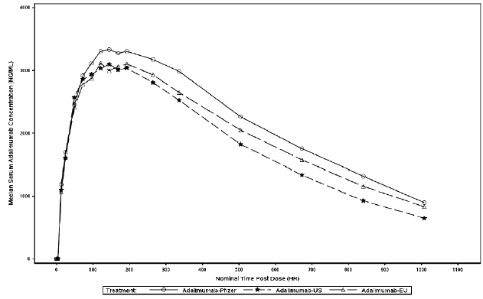
PK similarity was demonstrated for maximum (peak) concentration (Cmax) and the area under the concentration time curve from time zero to 2 weeks (AUC0-2wk), but not for AUC0-t and AUC0-inf (see Table 4, below).
Table 4: Study B5381001 Summary of statistical comparisons of PK exposure parameters between test and reference products (Days 1 to 43, per protocol analysis set)
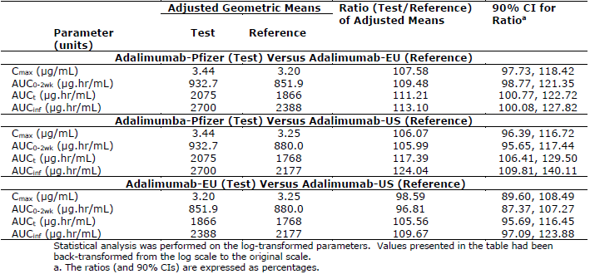
For Abrilada versus EU-sourced Humira, the upper limit of the 90% confidence interval (CI) for AUC_{0-inf} exceeded 125%, and for Abrilada versus US-sourced Humira, the upper limit of the 90% CI exceeded 125% for both AUC_{0-t} and AUC_{0-inf.}
The incidence of antidrug antibodies (ADA) in the Abrilada, EU-sourced Humira and US-sourced Humira groups was 85.5%, 90.0% and 94.4% respectively, and the incidence of neutralising antibodies (Nab) was 53.6%, 61.4% and 66.2% respectively, as shown in Table 5, below.
Table 5: Percentage of patients with antidrug antibodies and neutralising antibodies across studies
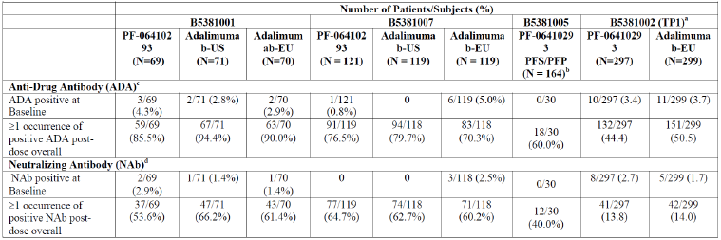
a) The summary is for TP.1. Overall, a positive subject was defined as having at least one post-dose sample that tested positive during TP1, regardless of the pre-dose ADA status.
b) ADA testing was performed for a subset of subjects with adverse events of injection site reactions and/or rash (n = 15) and for a subset of matched control subjects (n = 15).
c) ADA positive and negative test results were defined as ADA titre ≥ 1.88 and < 1.88 for all studies respectively.
d) Nab positive and negative results were defined as Nab titre ≥ 0.70 and < 0.70 for all studies, respectively.
Differences in the incidence of ADA and NAb, and earlier onset of ADAs in the US-sourced Humira group, may have contributed to the failure to demonstrate similarity for AUC0-t and AUC_{0-inf}.

Study B5381007
Study B5381007 was a double blind, randomised, parallel group, 3-arm, 40 mg single dose, PK similarity study of Abrilada, US-sourced and EU-sourced Humira administered SC in the lower abdomen by a prefilled syringe to healthy adult volunteer subjects. This study was performed because PK comparability was not adequately demonstrated in Study B5381001. This study was designed with a larger sample size, longer PK sampling period, and randomisation was stratified by weight. The primary objective was to compare the PK of Abrilada to EU-sourced Humira and to US-sourced Humira. Other objectives were to compare the PK of EU- and US-sourced Humira, to evaluate the single dose safety and tolerability, and to evaluate immunogenicity.
362 healthy subjects were randomised 1:1:1 to the 3 treatment groups. The PK sampling time period was up to 50 days (approximately 7 weeks). A higher proportion of subjects achieved AUC_{0-t} of at least 80% of AUC_{0-inf} than in Study B5381001, but in approximately 20% of subjects AUC_{0-t} did not cover at least 80% of AUC_{0-inf}.
This study confirmed similarity in PK between Abrilada, US-sourced and EU-sourced Humira, with the 90% CIs for the primary PK parameters all within the equivalence range 80% to 125%, as shown in Table 6, below.
Exposure was slightly higher for Abrilada compared to EU- and US-sourced Humira. The point estimates for the C_{max} and AUC ratios were all above 100%, and for Abrilada versus EU-sourced Humira, the 90% CIs were above 100% for C_{max} and AUC_{0-2wk}, and for Abrilada versus US-sourced Humira, the 90% CIs were above 100% for all of the C_{max} and AUC parameters. Figure 2, shown below, demonstrates the median serum adalimumab concentration versus time profiles in the per protocol analysis set for the Abrilada, US- and EU-sourced Humira treatment groups.
Table 6: Summary of statistical comparisons of PK exposure parameters (Cmax, AUC0-2wk, AUCt, and AUCinf) between test and comparator products, Study B5381007
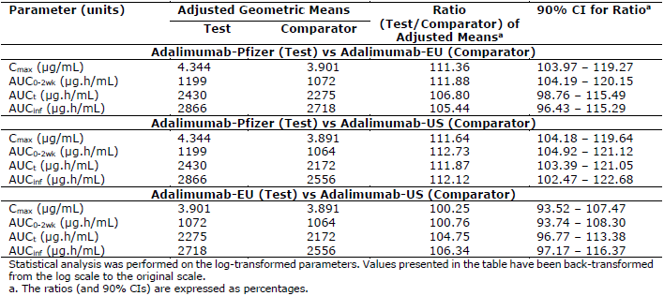
Figure 2: Study B5381007 Median serum adalimumab concentration (ng/mL) versus time (h) profiles of Abrilada, US- and EU-sourced Humira (per protocol analysis set)
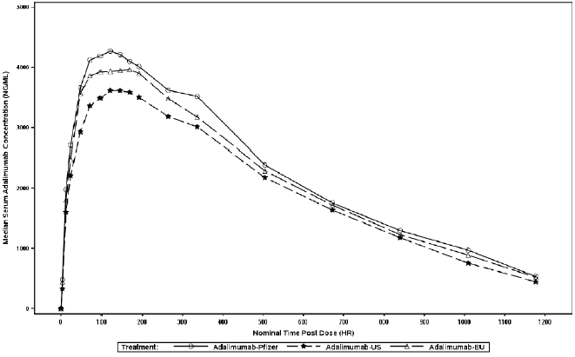
The incidence of ADAs in the Abrilada, EU-sourced and US-sourced Humira groups was 76.5%, 70.3% and 79.7% respectively, and the incidence of NAbs was 64.7%, 60.2% and 62.7% respectively (refer to Table 5, above). The incidence of early onset ADAs was similar across the three groups.

Study B5381005
Study B5381005 was an open-label, randomised (1:1), parallel group, 2-arm, 40 mg single dose relative bioavailability study to assess the PK of Abrilada following SC administration using a prefilled syringed or a prefilled pen in healthy adult volunteer subjects. The primary objective was to compare the single-dose PK of Abrilada administered with a prefilled pen compared to a prefilled syringe in healthy adult subjects. Secondary objectives were to evaluate the safety and tolerability of Abrilada administered with the prefilled pen device compared to the prefilled syringe, and to evaluate the full PK profile following a single-dose of Abrilada administered with the prefilled pen device and the prefilled syringe. An exploratory objective was to evaluate the immunogenicity of adalimumab administered with the prefilled pen and with the prefilled syringe.
163 subjects were included in the per protocol population. The PK sampling period was up to 6 weeks. The primary PK endpoints were Cmax and AUC0-2wk for demonstration of PK comparability, because the sponsor had an opinion that differences in the delivery devices were not anticipated to impact the terminal phase of the PK profiles.
Comparable PK was demonstrated for Abrilada administered by prefilled pen and prefilled syringe, as shown in Table 7, below. Median time to maximum concentration (Tmax) was 166 hours for the prefilled syringe (range 48 to 674 hours) and 142 hours for the prefilled pen, (range 45 to 336 hours).
Table 7: Study B5381005 Summary of statistical comparisons of pk exposure parameters between test and reference treatment arms
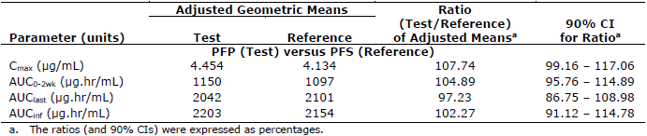
Figure 3, shown below, demonstrates the median serum concentration versus time profiles of Abrilada in healthy volunteers following the subcutaneous administration of a 40 mg dose via a prefilled syringe, and a prefilled pen.
Figure 3: Study B5381005 Median serum concentration (ng/mL) versus time (h) profiles of Abrilada following SC administration of 40 mg dose using a prefilled syringe or prefilled pen in healthy subjects (per protocol population)
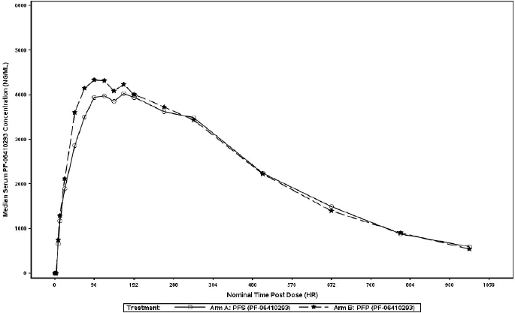

Study B5381002
Study B5381002 was a multinational, 2-arm, randomised, double blind, parallel group study comparing the safety, efficacy, population PK, and immunogenicity of Abrilada (drug development name: PF-06410293) versus EU-sourced Humira, in combination with methotrexate (methotrexate) in patients with moderately to severely active rheumatoid arthritis who had an inadequate response to methotrexate therapy. The evaluation of PK was a secondary objective. The study design is described in further detail in the efficacy section, below. 597 patients were randomised 1:1 to receive either Abrilada or EU-sourced Humira-40 mg every other week administered SC in the abdomen or thigh by a prefilled syringe.
The mean serum trough concentrations were slightly higher in the Abrilada group than the EU-sourced Humira group throughout the study, but there was considerable overlap in serum concentrations between the two study groups, and inter-individual variability in serum trough concentrations was high, as shown in Table 8, below. The steady-state mean trough concentrations with Abrilada were similar to those reported in rheumatoid arthritis patients with methotrexate in the Humira Summary of Product Characteristics (SmPC; approximately 5 to 8 μg/mL). Mean trough concentrations were lower in ADA-positive subjects than ADA-negative subjects.
Table 8: Study B5381002 Serum Abrilada and EU-sourced Humira concentrations versus time by antidrug antibody status (PK population; treatment phase 1)
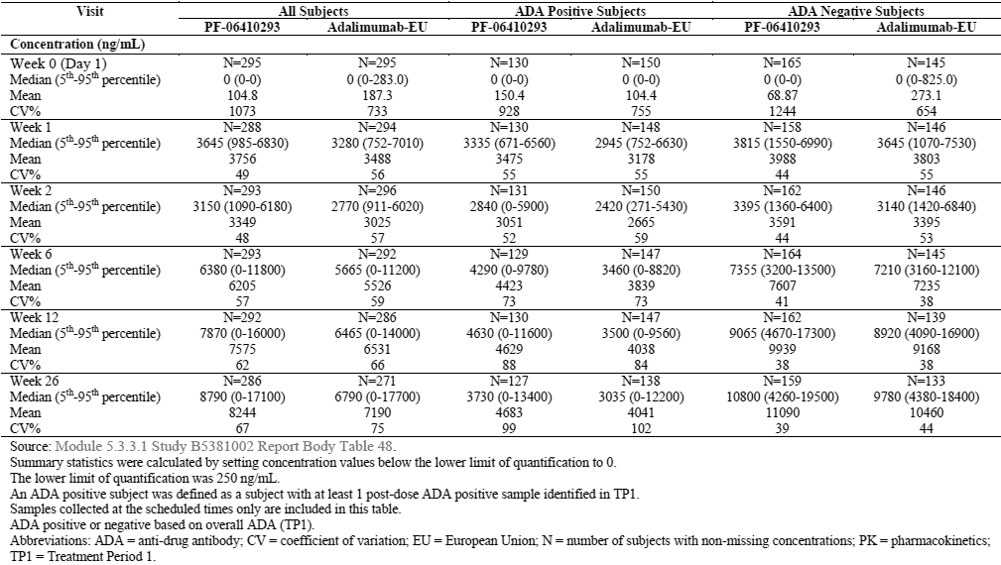

Population pharmacokinetic data
Two population PK analysis reports were presented in the dossier: one for data from Studies B5381001 and B5381007 (single dose in healthy subjects; dense PK sampling) and another for data from Study B5381002 (multiple doses in rheumatoid arthritis patients; sparse PK sampling). The population PK analysis for healthy subjects was an exploratory analysis. Abrilada was estimated to have roughly 8% lower clearance than EU-sourced Humira, which is in line with the observed higher AUC values of Abrilada in Studies B5381001 and B5381007. Other identified covariates on clearance (increased clearance in subjects with ADAs, and decreased clearance with increasing serum albumin level) are biologically plausible. The population PK models in rheumatoid arthritis patients had several uncertainties and it cannot be concluded that the models adequately describe the PK in patients with rheumatoid arthritis. Clarification of the models was not requested as population PK modelling is not an important consideration in concluding biosimilarity with Humira.

Pharmacodynamics
No specific clinical pharmacodynamic biomarkers are available for tumour necrosis factor alpha (TNF-α) functional studies. Study B5381002 included high sensitivity C-reactive protein (hs-CRP) data and exploratory data from Vectra-DA analysis, which did not reveal clinically significant differences between the two treatments.

Efficacy

Study B5381002
Study B5381002 was a multinational, 2-arm, randomised, double blind, parallel group study comparing the safety, efficacy, population PK, and immunogenicity of Abrilada versus EU-sourced Humira, in combination with methotrexate in patients with moderately to severely active rheumatoid arthritis who had an inadequate response to methotrexate therapy. The study was also designed to evaluate clinical response, safety and immunogenicity after transition (randomised blind single transition) from EU-sourced Humira to Abrilada after 6 or 12 months of EU-sourced Humira treatment. Adalimumab 40 mg was administered SC every other week by prefilled syringe.
The primary objective was to demonstrate therapeutic equivalence of Abrilada and EU-sourced Humira, based on the primary endpoint of ACR20 response at Week 12. The EMA’s CHMP endorsed a symmetric equivalence margin (-14%, 14%) for the 2-sided 95% CI. The US Food and Drug Administration (FDA) endorsed an alternative, asymmetric equivalence margin (-12%, 15%) for the 2-sided 90% CI. Secondary objectives were to evaluate the multiple composite and individual parameters of clinical response, to evaluate the overall safety, tolerability and immunogenicity, and to evaluate the population PK and pharmacodynamic response.
Study B5381002 recruited adult patients with moderately to severely active rheumatoid arthritis treated with oral, SC or intramuscular methotrexate for at least 12 weeks and on a stable dose for at least 4 weeks. Subjects were required to continue their background methotrexate without change for the duration of the study, and any background oral corticosteroid for the first 12 months, unless required for toxicity.
The study design is shown in Figure 4.
Figure 4: Study B5381002 design schema
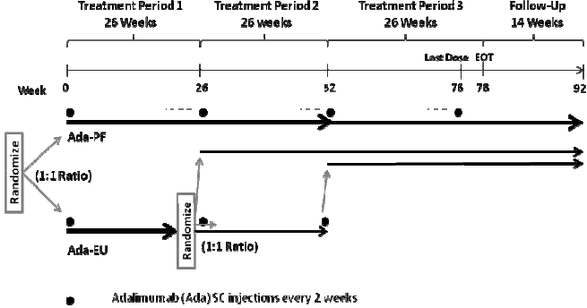
The study was blinded up to Week 52. 597 patients were randomised 1:1 to Abrilada or EU-sourced Humira. 584 subjects completed Week 12 (primary endpoint), 291 of 297 in the Abrilada group and 293 of 300 in the EU-sourced Humira group. 559 patients completed Treatment Period 1 (TP1), 286 (96.3%) in the Abrilada group and 273 (91.0%) in the EU-sourced Humira group. At the end of TP1, patients in the EU-sourced Humira group were re-randomised 1:1 to EU-sourced Humira or Abrilada. At the end of TP2, all remaining patients on EU-sourced Humira were changed to Abrilada (open label extension).
The primary efficacy endpoint was ACR20 response at Week 12.⁶ Secondary efficacy endpoints were: ACR20 at Weeks 2, 4, 6, 8, 18 and 26; ACR50 and ACR70 at Week 12 and Weeks 2, 4, 6, 8, 18 and 26; individual components of the ACR criteria (including HAQ DI) with change from Baseline at Week 12 and Weeks 2, 4, 6, 8, 18 and 26; mean change from Baseline in disease activity measured by DAS28-4 (CRP) at Week 12 and Weeks 2, 4, 6, 8, 18 and 26; EULAR response at Week 12 and Weeks 2, 4, 6, 8, 18 and 26; proportion of subjects with DAS remission (DAS ≤ 2.6) at Week 12 and Weeks 2, 4, 6, 8, 18 and 26; and proportion of subjects with ACR/EULAR remission at Week 12 and Weeks 2, 4, 6, 8, 18 and 26.
The baseline demographic and disease characteristics were well balanced across the groups.
For the primary efficacy endpoint in the intention to treat population, 204 (68.7%) subjects in the Abrilada arm and 218 (72.7%) subjects in the EU-sourced Humira arm achieved an ACR20 response at Week 12, a treatment difference of -3.98%. The primary analysis for ACR20 response at Week 12 is shown in Table 9 below. Therapeutic equivalence was demonstrated for the primary endpoint, as the 2-sided 95% CI of the difference in ACR20 response at Week 12 in the intention to treat population was within the pre-specified equivalence margin (-14%, 14%). A similar result was seen in the per protocol population. The finding of therapeutic equivalence was further supported by the 2-sided 90% CI falling within the pre-specified asymmetric equivalence margin (-12%, 15%) in both the intention to treat and per protocol populations.
Table 9: Study B5381002 Exact binomial approach for ACR20 response rate at Week 12, using non-responder imputation for missing data (Intention to treat and per protocol populations; TP1)
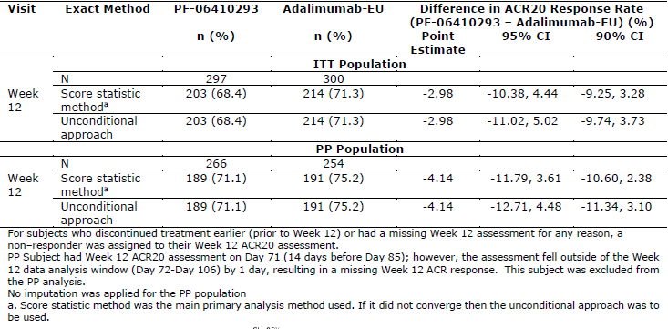
The difference in ACR20 response rate between the treatment arms ranged from -4.17% to 2.26% across all time-points in TP1, as shown in Figure 5, below.
Figure 5: Study B5381002 ACR20 response rate by visit (Intention to treat population; TP1)
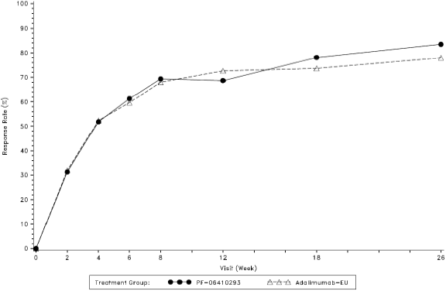
Although not pre-specified, the 95% CI for each time-point was within the equivalence margin set for the primary endpoint (-14%, 14%). ACR50 and ACR70 response rates were also similar between treatment groups (see Figure 6, below) with the differences ranging from -1.88% to 4.93% for ACR50 and 2.50% to 0.79% for ACR70 across all study visits in the intention to treat population up to Week 26.
Figure 6: Study B5381002 ACR50 response rate by visit (Intention to treat population; TP1)
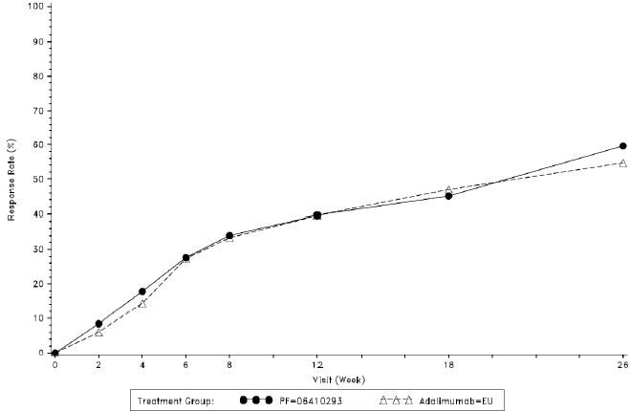
The differences in DAS28-4 (CRP) between the treatment arms at each visit were all less than the minimal clinically important difference of 0.6 (see Figure 7, below). Outcomes for EULAR response, DAS remission and ACR/EULAR remission were also similar across the treatment groups.
Figure 7: Study B5381002 Mean change from Baseline in DAS28-4 (CRP) value by visit (Intention to treat population; TP1)
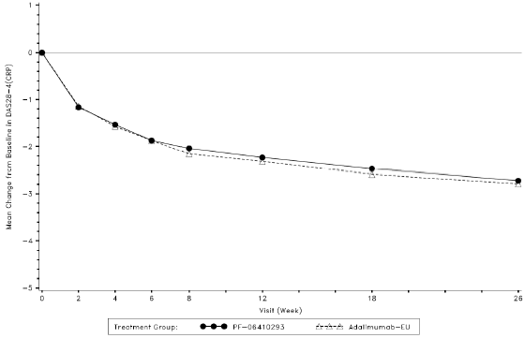
ACR20 response rates based on ADA status were similar across the two treatment groups. In both arms, ACR20 response rates trended higher in ADA negative and NAb non-positive subjects, compared to ADA positive and NAb positive subjects. Week 12 ACR20 response rates were 63.7% and 65.7% for the Abrilada and EU-sourced Humira ADA positive subgroups, respectively, and 70.9% and 77.2% for the ADA negative subgroups, respectively. Week 12 ACR20 response rates were 50.0% and 64.0% for the Abrilada and EU-sourced Humira NAb positive subgroups, respectively, and 70.9% and 74.0% for the NAb non-positive subgroups, respectively.
In Treatment Phase 2 (TP2), efficacy outcomes for patients who switched from EU-sourced Humira to Abrilada were similar to patients who continued to receive Abrilada or EU-sourced Humira. ACR20, ACR50 and ACR70 response rates were similar across the three treatment groups over TP2. Mean DAS28-4 (CRP) values at Week 26 pre-dose were 3.2, 3.4, and 3.0 in the Abrilada/Abrilada; EU-sourced Humira/EU-sourced Humira; and EU-sourced Humira /Abrilada groups, respectively, and at Week 52 were 3.0, 3.2 and 2.8, respectively. Measures of major response (ACR70, EULAR good response, DAS remission and ACR/EULAR remission) showed additional improvement during TP2 in all treatment groups.

Study B5381002b
An open-label, single arm, prefilled pen sub-study (Study B5381002b) was conducted in a subset of patients (n = 50) participating in Study B5381002 during the open label Treatment Phase 3 (TP3). It evaluated the success of Abrilada administration by the subject or their non-healthcare professional caregiver using the prefilled pen device. The subjects received a minimum of 6 injections using the prefilled pen with the option of staying on the prefilled pen device to the end of the study. The study included a wide age range, but few of the participants had severe hand disability. The primary endpoint was a delivery system success rate based on participant (actual prefilled pen user) and investigator/designated observer observations of the success of Abrilada administration by prefilled pen. The delivery system success rate at each visit was 100.0% with the lower bound of the 2-sided 95% CI exceeding 92% and the upper bound being 100.0%. The observer assessment tool observers recorded all injections as successful. 95.9% of completed substudy patients selected to continue prefilled pen injections for the remainder of the Study B5381002 study period.

Safety
Humira was first registered in Australia in 2003. The safety profile of Humira has been well characterised across the proposed indications.
The safety profile of Abrilada was assessed in 3 single-dose PK studies in healthy volunteers (Studies B5381001, B5381005 and B5381007), and a multi-dose comparative efficacy and safety study in patients with moderately to severely active rheumatoid arthritis (Study B5381002) which included a single arm, prefilled pen sub-study (Study B5381002b). 1,329 subjects received at least one dose of study medication in these studies, with 950 subjects receiving Abrilada. A pooled safety analysis was not performed due to the heterogeneity of study populations (rheumatoid arthritis patients versus healthy subjects) and the difference in duration of treatment/exposure (multiple doses versus single-dose).

Study B5381002
Study B5381002 compared the safety of Abrilada and EU-sourced Humira, 40 mg SC every other week by prefilled syringe in either the thigh or abdomen, in patients with moderately to severely active rheumatoid arthritis. The safety population in TP1 included 596 subjects who received SC adalimumab, 297 in the Abrilada arm and 299 in the EU-sourced Humira arm. The median duration of treatment in TP1 was 24.1 weeks in each arm. Prior to Week 26 dosing, patients in the EU-sourced Humira arm were re-randomised in a 1:1 ratio to Abrilada or EU-sourced Humira. The safety population in TP2 included 283 subjects in the Abrilada/Abrilada group, 135 subjects in the EU-sourced Humira/ EU-sourced Humira group, and 133 subjects in the EU-sourced Humira/Abrilada group. Patients treated in TP3 received open-label Abrilada. The median duration of treatment in TP3 was 24.1 weeks.
All-causality treatment emergent adverse events (TEAE) for Abrilada were similar to EU-sourced Humira in TP1 and TP2 (see Tables 10 and 11, respectively). The most frequently reported TEAEs for Abrilada in TP1 were viral upper respiratory tract infection, headache, anaemia, alanine transaminase increased, and hypertension (see Table 12, below).
Table 10: Study B5381002 All-causality treatment emergent adverse events (safety population; TP1)
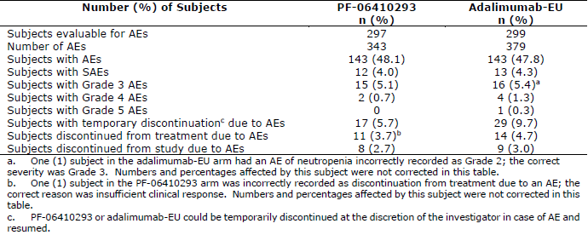
Table 11: Study B5381002 All-causality treatment emergent adverse events (safety population; TP2)
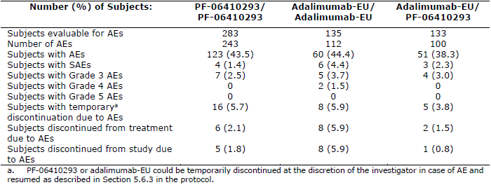
Table 12: Study B5381002 All-causality treatment emergent adverse events in ≤ 2% subjects in any treatment arm by Preferred Term (safety population; TP1)
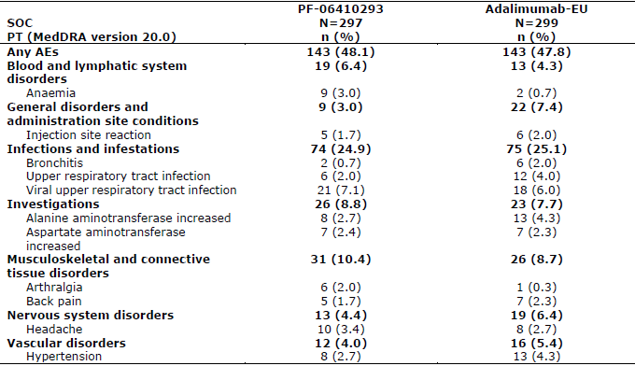
Table 13: Study B5381002 All-causality treatment emergent adverse events in ≤ 2% subjects in any treatment arm by Preferred Term (safety population; TP2)
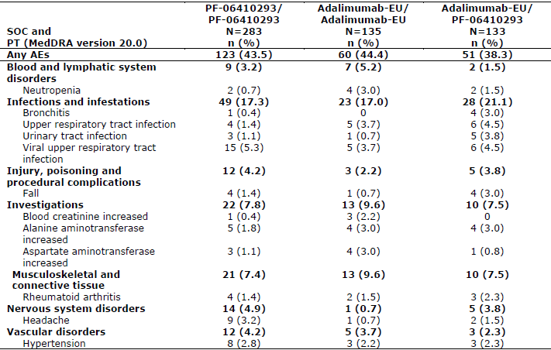
Treatment-related TEAEs were similar in the Abrilada and EU-sourced Humira arms in TP1 (18.5% versus 23.1%). The most frequently reported treatment-related TEAEs were injection site reaction, alanine transaminase increased, and viral upper respiratory tract infection. In TP1, there were 8 (2.7%) treatment-related adverse events of Grade 3 or higher in the Abrilada arm and 9 (3.0%) in EU-sourced Humira arm. In TP2, there were only single treatment-related adverse events of Grade 3 or higher.
Serious AEs were similar in the Abrilada and EU-sourced Humira arms in TP1 (4.0% versus 4.3%), with the most common MedDRA System Organ Class being Infections and infestations (3 (1.0%) subjects in each arm). Two deaths were reported in Study B5381002. The first death occurred in the EU-sourced Humira arm during TP1, and was assessed as related to underlying medical history. The patient experienced a serious adverse event of myocardial infarction on Day 131, was hospitalised and received percutaneous angioplasty, but died the next day. The other death was due to serious adverse events of anaemia, upper gastrointestinal haemorrhage, shock, pneumonia aspiration and respiratory failure during TP3. This patient was in the EU-sourced Humira/EU-sourced Humira/Abrilada group, and the death was reported to be related to a concomitant medication.
Adverse events of special interest in Study B5381002 included injection site reactions, anaphylactic reaction/angioedema/urticaria, and opportunistic infections including tuberculosis. No clinically meaningful differences in adverse events of special interest were observed for Abrilada and EU-sourced Humira. In TP1, the incidence of injection site reactions was similar in the Abrilada (1.7%) and EU-sourced Humira (2.0%) arms, with no serious adverse events. There were no cases of anaphylactoid reaction. Six cases of latent tuberculosis (QuantiFERON-TB conversion) were reported in TP1, 5 in the Abrilada arm and 1 in the EU-sourced Humira arm, leading to permanent discontinuation of study treatment. There were no cases of active tuberculosis. The incidences of neoplasms were similar for Abrilada and EU-sourced Humira.
Safety findings for laboratory parameters in Study B5381002 were similar for Abrilada and EU-sourced Humira.
In Study B5381002 (TP1), the incidences of ADA and NAb were similar in the Abrilada and EU-sourced Humira arms. The proportion of patients who developed ADA was lower in the rheumatoid arthritis study than in the studies of healthy volunteers (see Table 5, earlier in this document). The presence of ADA and NAb did not affect safety outcomes.
The safety findings in the single-dose PK similarity studies were consistent with the established safety profile of adalimumab. In the PK Study B5381005 which compared Abrilada administered by prefilled syringe or prefilled pen, the incidence of injection site reactions was similar in both groups, and no notable differences were observed in the injection site pain assessment.

Risk management plan
The sponsor has submitted EU-risk management plan (RMP) version 1.0 (date 11 October 2019; data lock point 5 January 2018) and Australian-specific Annex (ASA) version 1.0 (date 13 April 2020) in support of this application. At the second round of evaluation, the sponsor submitted ASA version 2.0 (date 12 October 2020).
The summary of safety concerns and their associated risk monitoring and mitigation strategies are summarised in Table 14.
Table 14: Summary of safety concerns
Summary of safety concerns |  | Pharmacovigilance |  | Risk Minimisation
 |  | Routine | Additional | Routine | Additional
Important identified risks | Serious infections |  | – |  | *
Important identified risks | Tuberculosis (TB) |  | – |  | *
Important identified risks | Malignancies |  | – |  | *
Important identified risks | Demyelinating disorders (including multiple sclerosis (MS), Guillain-Barré syndrome (GBS) and optic neuritis (ON)) |  | – |  | *
Important identified risks | Bacillus Calmette-Guérin (BCG) disease following live BCG vaccination in infants with in utero exposure to adalimumab |  | – |  | *
Important potential risks | Progressive multifocal leukoencephalopathy (PML) |  | – | – | –
Important potential risks | Reversible posterior leukoencephalopathy syndrome (RPLS) |  | – | – | –
Important potential risks | Adenocarcinoma of colon in ulcerative colitis (UC) patients |  | – |  | –
Missing information | Patients with immune compromised conditions |  | – |  | –
Missing information | Long-term safety information in the treatment of children aged from 6 years to less than 18 years with Crohn’s disease (CD) |  | – | – | –
Missing information | Episodic treatment in psoriasis (Ps), UC and juvenile idiopathic arthritis (JIA) |  | – | –
Missing information | Long-term safety information in the treatment of adults and children with uveitis |  | – |  | –
* Adult and paediatric Patient Reminder Cards
The summary of safety concerns is generally consistent with the reference product and other adalimumab biosimilars.
Routine pharmacovigilance is proposed for all safety concerns, with no additional pharmacovigilance activities proposed. This is acceptable.
Routine and additional risk minimisation activities generally align with the innovator, however mock-ups of adult and paediatric Patient Reminder Cards have not been provided for review. The sponsor is requested and commits to providing copies of the Cards to TGA for review prior to launch. Per the agreed RMP, the Card is to be distributed to prescribers of adalimumab (regardless of indication of use) who will then provide to their patients. Draft packaging labels have been provided, which direct consumers to the Pfizer website to access the CMI. The sponsor is advised that the link to the Consumer Medicines Information (CMI) document must remain up-to-date and consistent with the most recent approved PI document and that the website used must be acceptable to the TGA and in compliance with all advertising restrictions.
At the third round of evaluation the CMI has been provided in the new format. The RMP is acceptable. The sponsor has agreed to submit the adult and paediatric Patient Reminder Cards for review prior to product launch.

Recommended conditions of registration
The RMP evaluator recommended the follow wording as conditions of registration:
The Abrilada EU-Risk Management Plan (RMP) (version 1.0, dated 11 October 2019, data lock point 05 January 2018), with Australian Specific Annex (ASA) (version 2.0, dated 12 October 2020), included with submission PM-2020-01818-1-3, and any subsequent revisions, as agreed with the TGA will be implemented in Australia.
An obligatory component of risk management plans is routine pharmacovigilance. Routine pharmacovigilance includes the submission of periodic safety update reports (PSURs).
Reports are to be provided in line with the current published list of EU reference dates and frequency of submission of PSURs until the period covered by such reports is not less than three years from the date of this approval letter.
The reports are to at least meet the requirements for PSURs as described in the European Medicines Agency’s Guideline on good pharmacovigilance practices (GVP) Module VII-periodic safety update report (Rev 1), Part VII.B Structures and processes. Note that submission of a PSUR does not constitute an application to vary the registration.

Risk-benefit analysis

Delegate’s considerations

Biosimilarity
This application to register Abrilada (adalimumab) is based on biosimilarity to the Australian reference product, Humira (adalimumab). The proposed indications, dosage, and route of administration of Abrilada are the same as Humira in Australia (these are listed under section: Introduction to product submission, at the start of this document). The comparability studies for Abrilada were based on EU- and US-sourced Humira, but the findings are applicable to Australia because a bridging study demonstrated comparability of Australian-sourced Humira with EU- and US-sourced Humira.
The sponsor performed a comprehensive comparability program following the principles described in the Guideline on similar biological medicinal products containing biotechnology-derived proteins as active substance: quality issues;³ the Guideline on similar biological medicinal products containing monoclonal antibodies – non-clinical and clinical issues;⁴ and the overarching Guideline on similar biological medicinal products.²
The quality assessment demonstrated high similarity between Abrilada and Humira for primary, secondary and higher order structures, post-translational modifications (charge variants and glycan profiles), purity and impurities, quantity, biological activity in fragment antigen binding and fragment crystallisable related functions, and comparative stability studies. Comprehensive in vitro studies demonstrated similarity of key functional activities of Abrilada and Humira. Minor differences in high mannose variants and afucosylation levels are not expected to be clinically significant. Comparable toxicity and toxicokinetic findings were demonstrated for Abrilada and EU-sourced Humira in cynomolgus monkeys.
Clinical comparability studies included three single dose PK studies in healthy volunteers (Studies B5381001, B5381005 and B5381007) and a randomised, double-blind efficacy and safety study in patients with moderately to severely active rheumatoid arthritis (Study B5381002) which included a prefilled pen sub-study (Study B5381002b). Overall, the clinical PK, efficacy, safety, and immunogenicity data support the biosimilarity of Abrilada and Humira.
The comparability of the PK of a single 40 mg SC dose of Abrilada, EU-sourced and US-sourced Humira in healthy subjects was assessed two clinical PK similarity studies, Studies B5381001 and B5381007. In Study B5381001, comparable PK was demonstrated for C_{max} and AUC_{0-2wk}, but not for AUC_{0-t} and AUC_{0-inf}. Exposure was numerically higher for Abrilada compared to EU- and US-sourced Humira. The 6 week PK sampling period limited the capacity of the study to characterise the late elimination phase of the PK profile. In addition, the sponsor considered that small differences in immunogenicity between the groups may have impacted on the failure to demonstrate comparable AUC_{0-t} and AUC_{0-inf}. Study B5381007 was conducted to address uncertainties in the PK and immunogenicity findings from Study B5381001. Study B5381007 demonstrated comparable PK (C_{max}, AUC_{0-2wk}, AUC_{0-t}, and AUC_{0-inf}) for Abrilada, EU-sourced Humira and US-sourced Humira. Study B5381005 demonstrated comparable PK for a single 40 mg SC dose of Abrilada administered by prefilled syringe or prefilled pen. In patients with rheumatoid arthritis (Study B5381002), mean trough concentrations were slightly higher in the Abrilada group than the EU-sourced Humira group throughout the study, but there was considerable overlap in serum concentrations between the two study groups, and inter-individual variability in serum trough concentrations was high. The steady-state mean trough concentrations of Abrilada were similar to those reported in rheumatoid arthritis patients with methotrexate in the Humira SmPC (around 5 to 8 μg/mL).
The randomised, double-blind efficacy and safety study, Study B5381002, demonstrated therapeutic equivalence of Abrilada and EU-sourced Humira based on ACR20 response at Week 12.⁶ The primary outcome demonstrating equivalent efficacy was supported by consistent findings from sensitivity analyses and secondary efficacy endpoints.
The safety profile of Humira in the proposed indications is well established. The safety profile of Abrilada has been adequately characterised in the development program. The safety profile of Abrilada was similar to EU-sourced Humira in Study B5381002, and consistent with the established safety profile of Humira. The randomised, single-dose PK similarity studies in healthy volunteers supported similar safety for Abrilada and Humira.
The immunogenicity of Abrilada is overall similar to EU-sourced Humira and US-sourced Humira. The incidence of ADA was very high in healthy subjects after administration of a single 40mg SC dose of adalimumab in the PK similarity studies, and a majority of ADA-positive subjects were also positive for NAb. Small differences in the immunogenicity of Abrilada, EU- and US-sourced Humira were observed in the single-dose PK similarity studies, but there was not a consistent pattern across the studies. The proportion of patients who developed ADA was lower in the rheumatoid arthritis study than in the studies of healthy volunteers, possibly due to concomitant methotrexate treatment and/or the underlying condition. In Study B5381002, the proportions of patients who developed ADA and NAb were similar for Abrilada and EU-sourced Humira. Mean trough concentrations were notably lower in ADA-positive subjects compared to ADA-negative subjects for both Abrilada and EU-sourced Humira. ACR20 response rates trended higher in ADA negative and NAb non-positive subjects, compared to ADA positive and NAb positive subjects, for both Abrilada and EU-sourced Humira. The presence of ADA and NAb did not affect safety outcomes. No anaphylaxis or systemic allergic reactions were reported in any of the studies.
The Abrilada development program has demonstrated that Abrilada is highly similar to the Australian reference product, Humira. Clinical studies demonstrating similar PK, efficacy, safety and immunogenicity support a conclusion of biosimilarity of Abrilada to Humira.

Proposed indications
The proposed indications are the same as the approved Australian indications for Humira (adalimumab). The demonstration of biosimilarity to the Australian reference product, Humira, supports the use of Abrilada (adalimumab) in the proposed indications. The proposed indications are similar to the approved EU indications for Amsparity (adalimumab). There are some differences in the wording of the EU and Australian indications, but these differences do not meaningfully affect the assessment of benefit-risk. There are several indications approved in the EU which are not approved for Humira in Australia (axial spondyloarthritis without radiographic evidence of ankylosing spondylitis; and paediatric uveitis) and these indications are not proposed in this application.
In the EU, the 40 mg/0.8 mL prefilled syringe and prefilled pen are approved for all indications, whereas the 20 mg/0.4 mL prefilled syringe and the 40 mg/0.8 mL vial are approved only for paediatric indications. In Australia, all of the approved indications for Humira apply to each of the registered products, including the 20 mg/0.4 mL prefilled syringe and 20 mg/0.2 mL prefilled syringe, so it is acceptable for all of the indications to apply to each of the Abrilada products.

Limitations of the data
This application does not include an 80 mg strength. The proposed presentations of Abrilada (adalimumab) are 20 mg/0.4 mL solution for injection in a prefilled syringe, 40 mg/0.8 mL solution for injection in a prefilled syringe, 40 mg/0.8 mL solution for injection in a prefilled pen, and 40 mg/0.8 mL solution for injection in a vial. All of the proposed dosages are feasible with Abrilada, but patients requiring 80 mg or 160 mg dosages would require multiple injections. This is adequately addressed in the dosing guidance in Section 4.2 of Abrilada PI.
The usability of the prefilled pen was assessed in a sub-study of Study B5381002 (Study B5381002b). This sub-study showed a high level of success with the prefilled pen device, but few of the participants had severe hand disability. The usability of the prefilled pen device in patients with severe hand disability would need to be assessed by the prescriber on an individual patient basis. Similarly, patients with severe hand disability who are prescribed the prefilled syringe would need to be assessed by the clinician with regard to their ability to self-administer the medicine. This is adequately addressed in the dosing guidance in Section 4.2 of the Abrilada PI.

Proposed action
The data presented in this submission demonstrate that Abrilada (adalimumab) is highly similar to the Australian reference product, Humira (adalimumab), with comparable PK, efficacy, safety, and immunogenicity. Biosimilarity of Abrilada to Humira has been satisfactorily demonstrated, supporting the use of Abrilada in the proposed indications.
There are no outstanding clinical issues requiring independent expert advice from the Advisory Committee on Medicines (ACM).
The Delegate proposed, at the time, to approve the registration of Abrilada with the additional conditions of registration listed, subject to satisfactory resolution of the outstanding issues: the updated labels submitted on 23 December 2020 will be reviewed by the quality evaluator; and the quality evaluation identified an issue with GMP status which needs to be addressed prior to finalisation of this submission.

Advisory Committee considerations
The Delegate did not refer this application to the Advisory Committee on Medicines (ACM) for advice.

Outcome
Based on a review of quality, safety and efficacy, the TGA approved the registration of:
- Abrilada (adalimumab) 20 mg solution for injection pre-filled syringe;
- Abrilada (adalimumab) 40 mg solution for injection pre-filled pen;
- Abrilada (adalimumab) 40 mg solution for injection pre-filled syringe; and
- Abrilada (adalimumab) 40 mg solution for injection vial.
The approved indications for these therapeutic goods are as follows:
Rheumatoid Arthritis
Abrilada is indicated for reducing signs and symptoms, as well as inhibiting the progression of structural damage in adult patients with moderate to severely active rheumatoid arthritis. This includes the treatment of patients with recently diagnosed moderate to severely active disease who have not received methotrexate.
Abrilada can be used alone or in combination with methotrexate.
Juvenile Idiopathic Arthritis
Polyarticular Juvenile Idiopathic Arthritis
Abrilada in combination with methotrexate is indicated for reducing the signs and symptoms of moderately to severely active polyarticular juvenile idiopathic arthritis in patients 2 years of age and older who have had an inadequate response to one or more disease modifying anti-rheumatic drugs (DMARDs). Abrilada can be given as monotherapy in case of intolerance to methotrexate or when continued treatment with methotrexate is inappropriate.
Enthesitis-Related Arthritis
Abrilada is indicated for the treatment of enthesitis-related arthritis in children, who have had an inadequate response to, or who are intolerant to, conventional therapy.
Psoriatic Arthritis
Abrilada is indicated for the treatment of signs and symptoms, as well as inhibiting the progression of structural damage, of moderate to severely active psoriatic arthritis in adult patients where response to previous DMARDs has been inadequate.
Ankylosing Spondylitis
Abrilada is indicated for reducing signs and symptoms in patients with active ankylosing spondylitis.
Crohn’s disease in adults and children (≥ 6 years)
Abrilada is indicated for the treatment of moderate to severe Crohn’s disease, to reduce the signs and symptoms of the disease and to induce and maintain clinical remission in patients;
who have had an inadequate response to conventional therapies or,
who have lost response to or are intolerant to infliximab.
Ulcerative colitis
Abrilada is indicated for the treatment of moderate to severe ulcerative colitis in adult patients who have had an inadequate response to conventional therapy or who are intolerant to or have medical contraindications for such therapies. Patients should show a clinical response within 8 weeks of treatment to continue treatment beyond that time. (see 5.1 Pharmacodynamic Properties - Clinical Trials).
Psoriasis in Adults and Children
Abrilada is indicated for the treatment of moderate to severe chronic plaque psoriasis in adult patients who are candidates for systemic therapy or phototherapy.
Abrilada is indicated for the treatment of severe chronic plaque psoriasis in children and adolescent patients from 4 years of age who have had an inadequate response to or are inappropriate candidates for topical therapy and phototherapy.
Hidradenitis Suppurativa in Adults and Adolescents (from 12 years of age)
Abrilada is indicated for the treatment of active moderate to severe hidradenitis suppurativa (acne inversa) in patients with an inadequate response to conventional systemic hidradenitis suppurativa therapy.
Uveitis
Abrilada is indicated for the treatment of non-infectious intermediate, posterior and pan-uveitis in adult patients who have had an inadequate response to corticosteroids, in patients in need of corticosteroid sparing, or in whom corticosteroid treatment is inappropriate.

Specific conditions of registration applying to these goods
- The Abrilada EU-Risk Management Plan (RMP) (version 1.0, dated 11 October 2019, data lock point 5 January 2018), with Australian Specific Annex (version 2.0, dated 12 October 2020), included with submission PM-2020-01818-1-3, and any subsequent revisions, as agreed with the TGA will be implemented in Australia.
An obligatory component of risk management plans is routine pharmacovigilance. Routine pharmacovigilance includes the submission of periodic safety update reports (PSURs).
Reports are to be provided in line with the current published list of EU reference dates and frequency of submission of PSURs until the period covered by such reports is not less than three years from the date of this approval letter.
The reports are to at least meet the requirements for PSURs as described in the European Medicines Agency’s Guideline on good pharmacovigilance practices (GVP) Module VII-periodic safety update report (Rev 1), Part VII.B Structures and processes. Note that submission of a PSUR does not constitute an application to vary the registration.
- The Product Information applying to these therapeutic goods must meet the TGA's approval at all times. Any proposed changes to the approved text of the PI, including safety related changes, must be submitted to, and be approved by, the TGA prior to distribution.
For all injectable products the Product Information must be included with the product as a package insert.
- Laboratory testing and compliance with Certified Product Details (CPD)
  - All batches of Abrilada supplied in Australia must comply with the product details and specifications approved during evaluation and detailed in the Certified Product Details (CPD).
  - When requested by the TGA, the sponsor should be prepared to provide product samples, specified reference materials and documentary evidence to enable the TGA to conduct laboratory testing on the Product. Outcomes of laboratory testing are published biannually in the TGA Database of Laboratory Testing Results http://www.tga.gov.au/ws-labs-index and periodically in testing reports on the TGA website.
  - Certified Product Details: The Certified Product Details (CPD), as described in Guidance 7: Certified Product Details of the Australian Regulatory Guidelines for Prescription Medicines (ARGPM) (http://www.tga.gov.au/industry/pm-argpm-guidance-7.htm), in PDF format, for the above products should be provided upon registration of these therapeutic goods. In addition, an updated CPD should be provided when changes to finished product specifications and test methods are approved in a Category 3 application or notified through a self-assessable change.

Attachment 1. Product Information
The PI for Abrilada approved with the submission which is described in this AusPAR is at Attachment 1. For the most recent PI, please refer to the TGA website at <https://www.tga.gov.au/product-information-pi>.

Therapeutic Goods Administration
PO Box 100 Woden ACT 2606 Australia
Email: info@tga.gov.au Phone: 1800 020 653 Fax: 02 6232 8605
https://www.tga.gov.au

The Black Triangle Scheme provides a simple means for practitioners and patients to identify certain types of new prescription medicines, including those being used in new ways and to encourage the reporting of adverse events associated with their use. The Black Triangle does not denote that there are known safety problems, just that the TGA is encouraging adverse event reporting to help us build up the full picture of a medicine's safety profile.
CHMP/437/04 Rev. 1 Guideline on similar biological medicinal products; European Medicines Agency. First published 29 October 2014. Available at: https://www.ema.europa.eu/en/similar-biological-medicinal-products#document-history---revision-1-(current-version)-section
EMA/CHMP/BWP/247713/2012 Guideline on similar biological medicinal products containing biotechnology-derived proteins as active substance: quality issues (revision 1); European Medicines Agency. First published 3 June 2014. Available at: https://www.ema.europa.eu/en/similar-biological-medicinal-products-containing-biotechnology-derived-proteins-active-substance
EMA/CHMP/BMWP/403543/2010 Guideline on similar biological medicinal products containing monoclonal antibodies - non-clinical and clinical issues; European Medicines Agency. First published: 15 June 2012; available at: https://www.ema.europa.eu/en/similar-biological-medicinal-products-containing-monoclonal-antibodies-non-clinical-clinical-issues
Good Manufacturing Practice clearance status was resolved allowing ARTG registry.
The ACR (American College of Rheumatology) criteria are a standardised measure of disease improvement widely used in rheumatology trials, but less so clinically. The ACR20 is a composite measure defined as both improvement of 20% in the number of tender and number of swollen joints, and a 20% improvement in three of the following five criteria: patient global assessment, physician global assessment, a patient functional ability measure (most often the Health Assessment Questionnaire (HAQ), Visual Analog Scale (VAS) for Pain, and erythrocyte sedimentation rate (ESR) or C-reactive protein (CRP). ACR50 and ACR70 are the same instruments with an improvement of 50% and 70% respectively.
The Disease Activity Score 28 (DAS28) is a system developed and validated by the European League Against Rheumatism (EULAR) to measure the progress and improvement of rheumatoid arthritis. The Disease Activity Score-28-C-reactive Protein 4 (DAS28-CRP(4)) composite measure for rheumatoid arthritis (RA) is based on 4 variables: tender and swollen joint counts (amongst 28 joints), C-reactive protein, and patient global assessment. Scores range from a minimum of 2.0 to maximum of 10.0.
The European League against Rheumatism (EULAR) response criteria are based on the assessment of disease activity using the Disease Activity Score (DAS), a statistically-derived index consisting of number of tender joints, number of swollen joints, erythrocyte sedimentation rate or C-reactive protein, and global disease activity.
MedDRA = Medical Dictionary for Regulatory Affairs
QuantiFERON TB testing uses a blood test (Interferon gamma release assay; IGRA) that aids in the detection of Mycobacterium tuberculosis, the bacteria which causes tuberculosis (TB).
Routine risk minimisation activities may be limited to ensuring that suitable warnings are included in the product information or by careful use of labelling and packaging. Routine pharmacovigilance practices involve the following activities: - All suspected adverse reactions that are reported to the personnel of the company are collected and collated in an accessible manner; - Reporting to regulatory authorities; - Continuous monitoring of the safety profiles of approved products including signal detection and updating of labelling; - Submission of PSURs; - Meeting other local regulatory agency requirements.
Humira adalimumab 40 mg per 0.8 mL (50 mg/mL) solution for injection in prefilled syringe and prefilled pen; Humira 20 mg per 0.4 mL (50 mg/mL) solution for injection in prefilled syringe and prefilled pen.
SmPC Humira adalimumab (EMEA/H/C/000481 - IA/0206); European Medicines Agency. https://www.ema.europa.eu/en/documents/product-information/humira-epar-product-information_en.pdf
All outstanding issues were addressed by the sponsor, allowing for registration to proceed.
The ACM provides independent medical and scientific advice to the Minister for Health and the Therapeutic Goods Administration (TGA) on issues relating to the safety, quality and efficacy of medicines supplied in Australia including issues relating to pre-market and post-market functions for medicines. The Committee is established under Regulation 35 of the Therapeutic Goods Regulations 1990. Members are appointed by the Minister. The ACM was established in January 2017 replacing Advisory Committee on Prescription Medicines (ACPM) which was formed in January 2010. ACM encompass pre and post-market advice for medicines, following the consolidation of the previous functions of the Advisory Committee on Prescription Medicines (ACPM), the Advisory Committee on the Safety of Medicines (ACSOM) and the Advisory Committee on Non-Prescription Medicines (ACNM). Membership comprises of professionals with specific scientific, medical or clinical expertise, as well as appropriate consumer health issues relating to medicines.

