Date of first round report: 12 October 2015
Date of second round report: 24 March 2016

AusPAR Attachment 2

Extract from the Clinical Evaluation Report for Adalimumab
  - Proprietary Product Name: Humira
  - Sponsor: AbbVie Pty Ltd

About the Therapeutic Goods Administration (TGA)
- The Therapeutic Goods Administration (TGA) is part of the Australian Government Department of Health, and is responsible for regulating medicines and medical devices.
- The TGA administers the Therapeutic Goods Act 1989 (the Act), applying a risk management approach designed to ensure therapeutic goods supplied in Australia meet acceptable standards of quality, safety and efficacy (performance), when necessary.
- The work of the TGA is based on applying scientific and clinical expertise to decision-making, to ensure that the benefits to consumers outweigh any risks associated with the use of medicines and medical devices.
- The TGA relies on the public, healthcare professionals and industry to report problems with medicines or medical devices. TGA investigates reports received by it to determine any necessary regulatory action.
- To report a problem with a medicine or medical device, please see the information on the TGA website < https://www.tga.gov.au>.
About the Extract from the Clinical Evaluation Report
- This document provides a more detailed evaluation of the clinical findings, extracted from the Clinical Evaluation Report (CER) prepared by the TGA. This extract does not include sections from the CER regarding product documentation or post market activities.
- The words [Information redacted], where they appear in this document, indicate that confidential information has been deleted.
- For the most recent Product Information (PI), please refer to the TGA website < https://www.tga.gov.au/product-information-pi>.
Copyright
© Commonwealth of Australia 2016
This work is copyright. You may reproduce the whole or part of this work in unaltered form for your own personal use or, if you are part of an organisation, for internal use within your organisation, but only if you or your organisation do not use the reproduction for any commercial purpose and retain this copyright notice and all disclaimer notices as part of that reproduction. Apart from rights to use as permitted by the Copyright Act 1968 or allowed by this copyright notice, all other rights are reserved and you are not allowed to reproduce the whole or any part of this work in any way (electronic or otherwise) without first being given specific written permission from the Commonwealth to do so. Requests and inquiries concerning reproduction and rights are to be sent to the TGA Copyright Officer, Therapeutic Goods Administration, PO Box 100, Woden ACT 2606 or emailed to < tga.copyright@tga.gov.au> .

Contents
List of common abbreviations 5
1. Introduction 8
1.1. Clinical rationale 8
2. Contents of the clinical dossier 10
2.1. Scope of the clinical dossier 10
2.2. Paediatric data 10
2.3. Good clinical practice 11
3. Pharmacokinetics 11
3.1. Studies providing pharmacokinetic data 11
3.2. Summary of pharmacokinetics 12
3.3. Evaluator’s overall conclusions on pharmacokinetics 16
3.4. Population pharmacokinetics 1 17
3.5. Population pharmacokinetics 2 27
4. Pharmacodynamics 40
4.1. Summary of pharmacodynamics 40
4.2. Pharmacodynamic effects 40
4.3. Evaluator’s overall conclusions on pharmacodynamics 40
5. Dosage selection for the pivotal studies 40
5.1. Enthesitis related arthritis 40
5.2. Paediatric psoriasis 41
6. Clinical efficacy 41
6.1. Indication 1: Enthesitis related arthritis 41
6.2. Other efficacy studies 55
6.3. Analyses performed across trials (pooled analyses and meta-analyses) 55
6.4. Evaluator’s conclusions on efficacy for ERA 55
6.5. Indication 2: Psoriasis in children (≥ 4 years of age) 57
6.6. Other efficacy studies 73
6.7. Analyses performed across trials (pooled analyses and meta-analyses) 73
6.8. Evaluator’s conclusions on efficacy for PSOR children ≥ 4 y o 73
7. Clinical safety 75
7.1. Studies providing evaluable safety data 75
7.2. Patient exposure 76
7.3. Adverse events 78
7.4. Laboratory tests 88
7.5. Post-marketing experience 91
7.6. Safety issues with the potential for major regulatory impact 91
7.7. Evaluator’s overall conclusions on clinical safety 92
8. First round benefit-risk assessment 93
8.1. First round assessment of benefits 93
8.2. First round assessment of risks 94
8.3. First round assessment of benefit-risk balance 94
8.4. First round recommendation regarding authorisation 95
9. Clinical questions 96
9.1. Pharmacokinetics 96
9.2. Pharmacodynamics 96
9.3. Efficacy 97
9.4. Safety 97
10. Second round evaluation of clinical data submitted in response to questions 98
11. Second round benefit-risk assessment 104
11.1. Second round assessment of benefits 104
11.2. Second round assessment of risks 104
11.3. Second round assessment of benefit-risk balance 104
12. Second round recommendation regarding authorisation 105
12.1. Enthesitis related arthritis 105
12.2. Paediatric psoriasis 105
13. References 106

List of common abbreviations
Abbreviation | Meaning
AAA | Anti-Adalimumab Antibody
ACR | American College of Rheumatology
ADA | Adalimumab
AE | Adverse Event
AJC | Active Joint Count
AS | Ankylosing Spondylitis
ANA | Antinuclear Antibody
BASDAI | Bath Ankylosing Spondylitis Disease Activity Index
BSA | Body Surface Area
CD | Crohn’s disease
CDLQI | Children's Dermatology Life Quality Index
CHAQ | Childhood Health Assessment Questionnaire
CI | Confidence interval
CL/F | Apparent clearance
CRP | C-Reactive Protein
CS | Corticosteroid
DMARD | Disease Modifying Anti-Rheumatic Drug
EE | Early Escape
eow | Every other week
ERA | Enthesitis Related Arthritis
GCP | Good Clinical Practice
IIV | Interindividual variability
ILAR | International League of Associations for Rheumatology
ITT | Intention-to-Treat
JIA | Juvenile Idiopathic Arthritis
LOCF | Last Observation Carried Forward
LOM | Limitation of Movement
MASES | Maastricht Ankylosing Spondylitis Enthesitis Score
MCID | Minimal Clinically Important Difference
MTX | Methotrexate
N | Number of subjects
NONMEM | Nonlinear Mixed-Effect Modelling software
NRI | Non-Responder Imputation
NSAID | Non-Steroidal Anti-inflammatory Drug
OL | Open Label
PBO | Placebo
PD | Pharmacodynamic
PedsQL | Paediatric Quality of Life Inventory
PGA | Physician Global Assessment
PK | Pharmacokinetic
PP | Per Protocol
PsA | Psoriatic Arthritis
PT | Preferred Term
PY | Patient Year
PSOR | Psoriasis
RA | Rheumatoid Arthritis
RF | Rheumatoid Factor
SAE | Serious adverse event
SC | Subcutaneous
SD | Standard Deviation
SJC | Swollen Joint Count
SOC | System Organ Class
SPARCC | Spondyloarthritis Canadian Research Consortium
SSZ | Sulfasalazine
TJC | Tender Joint Count
TNF | Tissue Necrosis Factor
ULN | Upper Limit of Normal
URTI | Upper Respiratory Tract Infection
VAS | Visual Analogue Scale

Introduction
This application is a full submission requesting 2 significant changes to the current approved indication for adalimumab (ADA). Firstly, the sponsor is requesting an extension of indication to include the treatment of an additional sub-type of Juvenile Idiopathic Arthritis (JIA), known as Enthesitis-related arthritis (ERA). The current JIA indication for ADA is limited to active polyarticular course JIA (pJIA) in patients aged 4 years or older. Secondly, the sponsor is requesting to lower the age limit of treatment for the currently approved treatment indication of moderate to severe chronic plaque psoriasis (PSOR). The current PSOR indication is restricted to adult patients (18 years of age or older) and the sponsor is proposing to include the treatment of children and adolescents from 4 years of age. The third element of this submission relates to an update the currently approved Product Information (PI).
ADA is a member of the Tumour Necrosis Factor alpha (TNFα) inhibitor drug class (ATC code: L04AB04). It is a recombinant humanised antibody, which binds with high affinity to human TNFα, thereby neutralising its effect.
ADA also has several other approved treatment indications in Australia such as severely active RA, PsA, ulcerative colitis and AS in adult patients; as well as Crohn’s disease in adults, children and adolescents (≥ 6 years of age).
ADA is currently registered for supply in Australia as a 10 mg, 20 mg and 40 mg solution for injection via a pre-filled syringe or auto-injector device or single-use vial. No new dosage forms or strengths are proposed in this submission.

Clinical rationale

Enthesitis related arthritis
JIA encompasses a diverse group of arthritic conditions of unknown etiology that begin before the sixteenth birthday and persist for at least 6 weeks. It is one of the most physically disabling conditions of childhood with prevalence in Australia of 0.3% according to the Australian Institute of Health and Welfare 2012 report. JIA is a heterogeneous disorder, and the subtypes have varying clinical and laboratory features that reflect distinct immunopathogenic processes. The pathogenesis of each subtype is multifactorial and likely to be triggered by environmental stimuli in genetically susceptible individuals.
JIA is a WHO endorsed, internationally accepted umbrella term that has replaced all previously used nomenclatures such as juvenile rheumatoid arthritis (JRA) and juvenile chronic arthritis (JCA). Historically, 3 different validated sets of criteria have been published to define the chronic forms of arthritis seen in children, that is, the EULAR (European) criteria, the ACR (American) criteria, and the more recent International League of Associations for Rheumatology (ILAR) definition of JIA. The ILAR classification criteria were first developed in 1997, and were revised in 2001. It includes 7 categories of the JIA (Table 1 below; taken from Petty et al, 2004) and has become the internationally accepted nomenclature.

Table 1: Frequency, Age at Onset and Gender Distribution of the ILAR Categories of JIA
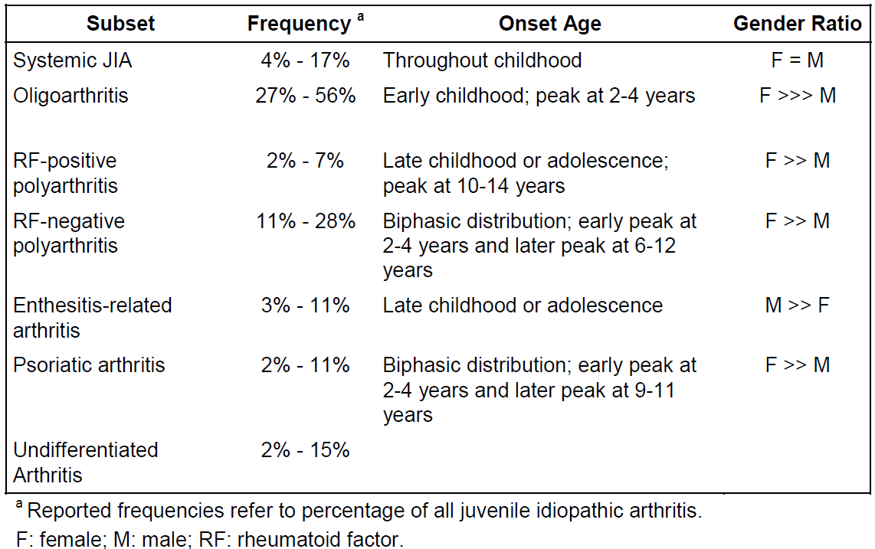
In this submission, the enthesitis-related arthritis (ERA) subtype of JIA was studied in the pivotal Study M11-328. Approximately 3-11% of all JIA cases present as ERA, although the estimates are wide ranging (1.2-27.9%). ERA typically begins after the age of 6, has a mean age at diagnosis of 11.7 years and more commonly affects boys. It is characterised initially by lower limb arthritis and enthesitis (inflammation of the point where a tendon, ligament or fascia inserts into the bone). The most common sites of enthesitis are the insertions of the plantar fascia, Achilles tendon, and around and below the patella. Symptoms of sacroiliitis and spinal arthritis are uncommon at presentation but may become involved later in the disease course (10-15 years after disease onset). Uveitis affects these patients as well but it tends to be symptomatic (painful, red eye). There is often a family history of similar illness or AS. The HLA-B27 antigen is found in 50% of patients, while ANA (antinuclear antibody) testing is usually negative.
TNF is a pro-inflammatory cytokine, which is present in significantly elevated serum and synovial concentrations in patients with most JIA subtypes. It affects a variety of pathophysiological processes including activation of T-cells, induction of acute phase proteins, and stimulation of haemopoietic precursor cell growth and differentiation. ADA is a recombinant, humanised monoclonal antibody, which has high affinity binding to TNF (both soluble and transmembrane forms) and blocks its interaction with cell surface TNF receptors. Current approved treatment options in Australia for moderately to severely active ERA include NSAIDs, corticosteroids (CS), non-biological DMARDs (mainly, methotrexate and/or sulfasalazine) and etanercept. However, a proportion of patients fail to respond to these treatment options and as such there is an unmet need for additional therapies for active, treatment refractory ERA.

Paediatric plaque psoriasis
Psoriasis (PSOR) is a chronic immune-mediated proliferative skin condition that occurs in up to 3% of the population. Approximately 15% of all cases of PSOR begin in children before the age of 15 years and the condition may start as young as infancy. The typical appearance is of red, thickened, scaly patches (plaques) on the skin. These plaques can vary in size and distribution. In some people, PSOR may affect small areas of skin while in others large areas covering their body may be involved.
PSOR is polygenetically inherited and requires environmental factors to become activated. Common trigger factors are infections (streptococcal and viral), trauma to the skin, psychological stress and drugs. Although PSOR may present at any age, when it commences in childhood and adolescence it tends to be more severe and has a strong familial history.
TNF is a pro-inflammatory cytokine, which is present in significantly elevated concentrations in the affected skin of patients with PSOR. Current approved treatment options in Australia for paediatric patients with severe chronic PSOR include topical therapy with salicylic acid, CS and coal tar, phototherapy and MTX. However, a proportion of patients fail to respond to these treatment options and as such there is an unmet need for additional therapies for severe, treatment refractory PSOR in paediatric patients.

Guidance
There are 5 specific regulatory guidelines pertaining to the requested extensions of treatment indication. Two of the guidelines relate to the application for ERA. In particular, the TGA adopted the EU guidelines CPMP/EWP/422/04 “Guideline on Clinical Investigation of Medicinal Products for the Treatment of Juvenile Idiopathic Arthritis” (effective 26 June 2009) and “Concept Paper on the need for revision of the Guideline on Clinical Investigation of Medicinal Products for the Treatment of Juvenile Idiopathic Arthritis” (effective 15 December 2012). For the proposed indication of paediatric PSOR there is one specific guideline CHMP/EWP/2454/2004 “Guideline on Clinical Investigation of Medicinal Products for the Treatment of Psoriasis” (effective June 2006). Other relevant EU guidelines, adopted by the TGA are: CHMP/ICH/2711/99 “Note for Guidance on Clinical Investigation of Medicinal Products in the Paediatric Population” (effective 19 April 2001) and EMEA/CHMP/EWP/147013/2004 “Guideline on the role of Pharmacokinetics in the Development of Medicinal Products in the Paediatric Population” (effective 24 August 2009).

Contents of the clinical dossier

Scope of the clinical dossier
The submission contained a single pivotal efficacy and safety study in each of the newly proposed treatment indications (paediatric ERA and PSOR), as well as population pharmacokinetic analyses in each of the new indications. The submission was well presented in the correct CTD format.
The submission contained the following clinical information:
- No specific clinical pharmacology studies but pharmacokinetic (PK) data was collected in the 2 pivotal, efficacy/safety Phase III studies (M11-328 and M04-717).
- 2 population pharmacokinetic analyses; 1 in each of the new treatment indications.
- 1 pivotal efficacy and safety trial in paediatric ERA (Study M11-328).
- 1 pivotal efficacy and safety trial in paediatric PSOR (Study M04-717).
- No dose-finding studies.
- No supporting efficacy and safety studies in either proposed treatment indication.

Paediatric data
The submission included paediatric pharmacokinetic, efficacy and safety data as the requested extension of treatment indications are for patients aged 4-17 years (> 6 years of age for the ERA indication).

Good clinical practice
The 2 pivotal clinical trials (Study M11-328 in ERA and Study M04-717 in PSOR) evaluating the use of ADA in children and adolescents were conducted in accordance with the principles of Good Clinical Practice (GCP), and compliance with ethical requirements were met.

Pharmacokinetics

Studies providing pharmacokinetic data
In both of the newly proposed treatment indications, pharmacokinetic (PK) data was collected in the corresponding pivotal Phase III trial: Study M11-328 for the ERA treatment indication and Study M04-717 for the paediatric PSOR indication. Neither of the PK sub-studies had significant deficiencies that excluded their results from consideration. The PK data collected in each pivotal trial was then used to develop a population PK model for a paediatric treatment population. Each population PK study report is being comprehensively reviewed by an expert in population PK. However, their data will also be reviewed for their clinical relevance in this report.

Enthesitis related arthritis
Study M11-328 was a multicentre, randomised, double-blind study for subjects who were at least 6 years of age but less than 18 years at baseline, who had been diagnosed with ERA as per the ILAR criteria. A total of 46 subjects from 16 global sites participated in the trial. The study design included a screening period of up to 30 days, followed by a 12 week, double-blind, placebo-controlled treatment period with an early escape option, and an open-label extension phase of up to a maximum of 144 weeks whereby ADA injections were given fortnightly. Subjects meeting the entry criteria were randomised in a 2:1 ratio to receive either ADA 24 mg/m² body surface area (BSA), up to a maximum dose of 40 mg (n=31) or matching placebo injections (n=15). The subject’s height and weight measurements at baseline determined their dose of study medication for the entire double-blind period (first 12 weeks), and at visits in the open-label phase of the trial, subject height and weight were measured at each scheduled visit and ADA dose adjustments could be made for the duration of treatment. Blood samples for PK analysis were collected from all subjects just prior to dosing at baseline, Weeks 2, 4, 8, 12, 24, 36 and 52. Blood samples for anti-adalimumab antibodies (AAA) were collected at baseline, Weeks 12, 24, 36 and 52 – refer to section 8.5.5 of this report regarding immunogenicity.

Paediatric psoriasis
Study M04-717 was a Phase III, randomised, double-dummy, double-blind study evaluating 2 doses of ADA (0.4 mg/kg and 0.8 mg/kg) versus oral MTX in paediatric subjects aged 4-17 years with chronic plaque PSOR. The trial had 4 phases. There was a primary treatment period of 16 weeks duration (Period A) followed by a withdrawal phase (Period B) of up to 36 weeks in responder patients from Period A, then a re-treatment period (Period C) for subjects who received ADA because of PSOR relapse. There is also an ongoing, long-term, follow-up phase (Period D) for all subjects, regardless of continuing treatment, for a further 52 weeks. Blood samples for PK analysis were collected from all subjects in Period A just prior to dosing at baseline, Weeks 1, 4, 11 and 16; for Period B at Weeks 4, 12 and 16; for Period C at baseline, Weeks 1, 4 and 11; and for Period D at baseline, Weeks 1, 8 and 16. Blood samples for AAA analysis were collected in Period A at baseline, Weeks 11 and 16; in Period B at Weeks 12 and 16; in Period C at baseline and Week 11; and for Period D at baseline, Weeks 8 and 16 – refer to section 8.5.5 of this report regarding the incidence of AAA (that is, immunogenicity) and its potential association with safety.

Summary of pharmacokinetics
The information in the following summary is derived from conventional PK studies in humans with supporting information derived from the sponsor’s summaries as well as the currently approved product information (PI).

Physicochemical characteristics of the active substance
ADA is a humanised monoclonal antibody of the IgG1 isotype, comprised of heavy and light chain segments containing a total of 1330 amino acids. It binds with high affinity and specificity to soluble tumour necrosis factor (TNF-alpha), but not lymphotoxin (TNF-beta). ADA binds to TNF and neutralises the biological activity of TNF by blocking its interactions with the p55 and p75 cell surface TNF receptors, which are expressed on a variety of cell types within the body. ADA has an approximate molecular weight of 148 kDa. It is produced by recombinant DNA technology in a mammalian cell expression system. The sponsor does not propose any change to the physiochemical structure or manufacturing process of ADA with this application for extension of treatment indications.

Pharmacokinetics in adults and approved paediatric indications

Healthy adult subjects
The PK characteristics of ADA administered by subcutaneous (SC) injection in healthy adult volunteers and adult patients with moderate to severe RA have already been evaluated in previous submissions and a summary of the key PK findings is provided. ADA is slowly absorbed from the site of SC injection, reaching maximum serum concentration 5 days after administration. Absolute bioavailability in healthy adult volunteers is 64%, which is similar to the bioavailability for human IgG (65 – 67%). The PK characteristics of ADA are linear over the examined dose range of 0.5-10 mg/kg. No studies have examined the effects of food or administration timing on the PK of ADA.
In adult patients with active RA receiving a SC dose of 40 mg ADA (via prefilled syringe) at fortnightly intervals, the mean steady state trough serum concentrations of ADA are 5 µg/mL without concomitant methotrexate (MTX) and 8-9 µg/mL with concurrent MTX. The apparent volume of distribution following 40 mg of SC administered ADA in adult subjects ranges from 4.7-6.0 L, which suggests that ADA undergoes limited distribution to peripheral compartments. The mean elimination half-life of ADA is estimated to be 2 weeks (range: 10-20 days) in adult patients. Although no studies have examined the metabolic pathways involved in ADA metabolism, it is expected that the drug be degraded into small peptides and amino acids via catabolic pathways in the same manner as endogenous IgG. No specific studies have been performed to assess the effect of renal or hepatic impairment on the PK of ADA. Age and gender do not appear to be significant factors in determining the PK characteristics of ADA in adult patients with RA and PSOR.

Approved paediatric treatment indications
In patients with polyarticular JIA aged 4-17 years, the mean steady state trough concentrations of ADA for subjects weighing < 30 kg receiving 20 mg SC per fortnight without concomitant MTX are 6.8 µg/mL, and 10.9 µg/mL with concurrent MTX. The mean steady state trough concentrations of ADA for subjects weighing > 30 kg receiving 40 mg SC per fortnight without concomitant MTX are 6.6 µg/mL, and 8.1 µg/mL with concurrent MTX. Similar PK results have been observed in paediatric patients with moderately to severely active Crohn’s disease receiving maintenance ADA therapy (SC dose of 20-40 mg per fortnight) using a weight-based regimen.

Pharmacokinetics in the target population
Before assessing the PK data, the following outlines 2 key issues regarding methodology:

(1) Method of analysing serum ADA concentrations
Total ADA concentrations (that is, free ADA plus ADA bound to TNF) were analysed in human serum using a specific validated ELISA method, which had a lower limit of quantification (LLOQ) of 31.3 ng/mL (=0.0313 μg/mL). The intra-day accuracy and intra-day precision of the assay technique was within an acceptable range, as was the inter-day accuracy and inter-day precision. The calibration method contained standards ranging from 1.25 to 200 ng/mL with a validated analytical range of 3.13 to 50 ng/mL in diluted serum. In-study quality control samples, supplemented with ADA concentrations of 4, 24 and 38 ng/mL were also analysed. The coefficients of variation (CV) values were ≤ 5.3%, and the mean analytical % bias ranged between –3.3% and 7.1% of their theoretical values. Serum stored for estimation of ADA concentrations was proven to be stable at -20°C.

(2) Background to population PK models
Population PK analyses were conducted using Non-Linear Mixed Effects Modelling in NONMEM, combining the serum ADA concentration data in paediatric subjects from different treatment indications: JIA (Studies DE038 and M10-444), ERA (Study M11-328), PSOR (Study M04-717) and Crohn’s Disease (Study M06-806). A one-compartment model with first-order elimination and first-order absorption was established as the base population PK model. The descriptive and predictive capabilities of each developed population PK model were appropriately validated using goodness-of-fit plots and predictive checks.
In both of the 2 newly proposed treatment indications, several covariates were investigated for a potential impact on the PK of ADA. These covariates included subject body weight, height, body surface area (BSA), age, use of concomitant MTX and the presence of AAA. The dose of ADA for subjects enrolled in Study M11-328 was based on a dosing regimen of 24 mg/m² BSA, up to a total dose of 40 mg, administered fortnightly as a single dose via SC injection. Subjects in Study M11-328 weighed between 21 and 90 kg. This is consistent with the expected weight for children aged 6 years and older. The majority of subjects in Study M11-328 (40/46, 87.0%) weighed ≥ 30 kg and received ≥ 30 mg ADA fortnightly (or the equivalent volume of placebo injection) at baseline. Following the 12 week, double-blind period of Study M11-328, 91.3% (42/46) of subjects weighed ≥ 30 kg and therefore received ≥ 30 mg ADA injections.

Enthesitis related arthritis
For the PK analysis in ERA, all 46 subjects involved in Study M11-328 contributed data. A total of 357 PK samples were received for analysis and 352 samples were analysed at single laboratory in Germany between October 2012 and January 2013. Five samples were not analysed for PK parameters as they were not clearly assigned.
In the 31 paediatric subjects with ERA randomised to ADA, the mean serum ADA trough concentrations at steady-state (between Weeks 12 and 52) were slightly higher in the subjects who received concomitant MTX (9.7 – 11.8 μg/mL) compared to those who didn’t take concomitant MTX (7.5 – 9.4 μg/mL) ; refer to Table 2. This is consistent with the known PK characteristics of ADA in adult patients with RA and subjects with polyarticular JIA. However, for the 15 subjects initially randomised to placebo injections in the double-blind period (first 12 weeks), which then switched to ADA starting at Week 12, the mean serum trough ADA concentrations reached an approximate steady state level of 8.0-10.5 μg/mL (between Weeks 24 and 52), regardless of the concomitant use of MTX. Overall, the mean serum trough ADA concentrations in ERA appeared to be comparable to those observed in 4-17 year old subjects with polyarticular JIA.

Table 2: Serum Trough Adalimumab Concentrations (μg/mL) in Study M11-328
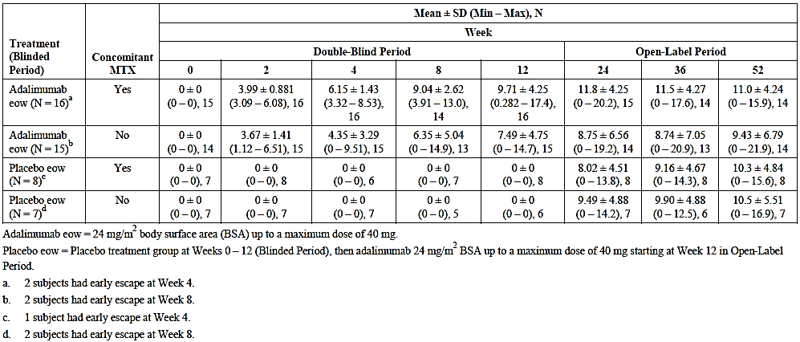
A total of 10.9% (5/46) of subjects who had samples for PK analysis in Study M11-328 tested positive for AAA during the 52-week trial. Among the 5 subjects, 2 received placebo for the first 12 weeks and then ADA treatment thereafter (1 with MTX and 1 without MTX) and 3 received ADA for 52 weeks (1 with MTX and 2 without MTX). None of the subjects with positive AAA samples escaped or terminated early from the study. Serum trough ADA concentrations were below the LLOQ in all 5 AAA positive subjects from when they became AAA positive. In contrast, only 2 of 41 AAA negative subjects had at least 1 ADA trough concentration below the LLOQ between weeks 24 and 52. This finding is consistent with the known PK of ADA. The presence of AAA is associated with increased drug clearance. However, all 5 AAA positive subjects in Study M11-328 demonstrated a significant clinical response (that is, marked reduction from baseline in active joint count) at Week 52 suggesting that the presence of AAA did not impact upon clinical efficacy.
Serum ADA concentration data was also analysed using population PK modelling. The population PK model showed that an increase in subject body weight results in a less than proportional increase in drug clearance and apparent volume of distribution. Subjects with a body weight of 10 kg and 20 kg more than the median population weight were expected to have a 20.0% and 39.6% increase in drug clearance (respectively), and a 19.7% and 39.1% increase in apparent volume of distribution (respectively). Positive testing for AAA, concomitant use of MTX and baseline BSA were significant covariates affecting drug clearance. Baseline subject BSA was a significant covariate impacting upon the apparent volume of distribution of ADA. The simulated PK model also showed that trough ADA concentrations using weight-based dosing regimens of 20 mg or 40 mg administered at fortnightly intervals were comparable to that observed with simulated trough ADA concentrations following BSA-based dosing regimens.

Paediatric psoriasis
For the PK analysis in paediatric PSOR, a total of 1157 samples from 114 subjects contributed PK data. All samples were analysed at single laboratory in Germany. During the double-blind phase (Period A) of Study M04-717, the mean serum steady-state concentration (Weeks 11-16) of ADA was 7.42 – 10.6 μg/mL following ADA 0.8 mg/kg and approximately 3 μg/mL for ADA 0.4 mg/kg therapy; refer to Table 3. At the end of Period A (Week 16), subjects were evaluated for the primary efficacy endpoints of PASI 75 and PGA response. The mean serum trough concentrations of ADA for clinical responders were more than double (13.8 μg/mL with 0.8 mg/kg and 4.1 μg/mL with 0.4 mg/kg) compared to non-responders (6.5 μg/mL with 0.8 mg/kg and 1.5 μg/mL with 0.4 mg/kg). Furthermore, in the ADA 0.8 mg/kg group, the mean serum trough ADA concentrations prior to treatment withdrawal (week 16 of Period A) were higher in subjects who didn’t experience a loss of disease control in Period B (20.2 μg/mL) compared to those who received the same dose of ADA in Period A who lost response in Period B (12.3 μg/mL). The same observation was not seen with ADA 0.4 mg/kg therapy.

Table 3: Mean Serum Trough Adalimumab Concentrations in Period A of Study M04-717
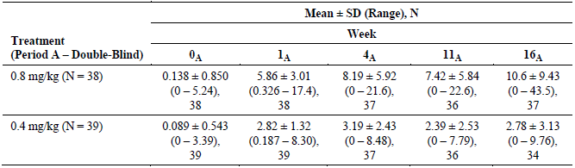
During Period B of Study M04-717, mean serum ADA concentrations in subjects treated with either dose of ADA declined over the 16 weeks following withdrawal of treatment. During re-treatment with ADA in Period C, the mean serum ADA concentrations were maintained at approximately 7 μg/mL following 0.8 mg/kg therapy and approximately 3 μg/mL following 0.4 mg/kg (between Weeks 4 and 11); refer to Table 4. For subjects treated with MTX in Period A and then who switched to ADA 0.8 mg/kg in Period C, the mean serum ADA concentrations were approximately 13 μg/mL at Week 11, which is higher than that observed in subjects treated with the same dose of ADA in Period A.

Table 4: Mean Serum Trough Adalimumab Concentrations in Period C of Study M04-717
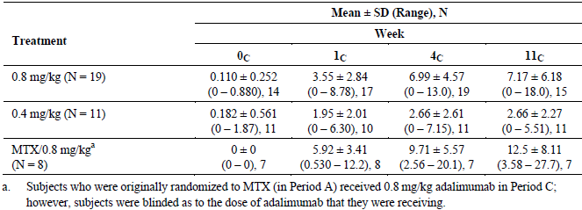
During Period D (between Weeks 8 and 16), the mean serum ADA concentrations were maintained at approximately 7 μg/mL in those continuing to receive ADA 0.8 mg/kg injections and approximately 3 μg/mL with ADA 0.4 mg/kg therapy. For the subjects treated with MTX in Period A who then received ADA 0.8 mg/kg in Period D, the mean serum ADA concentrations were maintained at approximately 7–8 μg/mL; refer to Table 5.
Overall, serum trough ADA concentrations observed during re-treatment (Period C) or during Period D were comparable to the levels observed prior to withdrawal (Period A).

Table 5: Mean Serum Trough Adalimumab Concentrations in Period D of Study M04-717
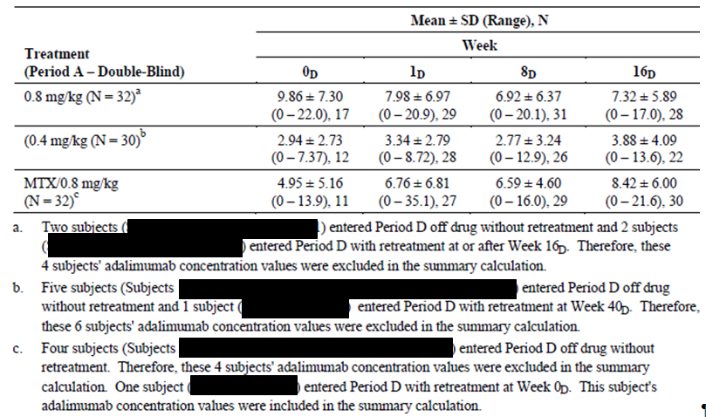
By Week 16 of Period A, 10 subjects (13.0% of 77; 5 in each ADA dose group) tested positive for AAA. With re-treatment in Period C, 10% of all subjects (3/30) tested positive for AAA. In both Periods A and C, the mean serum trough ADA concentrations in AAA positive subjects were less than half of that recorded in patients who were negative for AAA. The presence of AAA by the end of Period A was not associated with a lower likelihood of clinical response. However, when those subjects were followed into Period B there was a significantly shorter median time to loss of response in subjects testing positive to AAA versus AAA negative patients. For the ADA 0.8 mg/kg group in Period B, the median time to loss of PASI 75 response was 28 days in the AAA positive subjects (n=2) compared with 252 days in the AAA negative patients (n=11).
Based on the population PK analysis, the median drug clearance and apparent volume of distribution for ADA in paediatric subjects with severe chronic PSOR were 11.1 mL/h and 5.5 L, respectively. These values are similar to those observed in other paediatric treatment indications.
Simulations based on the final population PK model suggested that the PK of ADA is similar among paediatric subjects over the age range from 4 to 17 years of age when weight-based dosing of 0.8 mg/kg (up to 40 mg per dose) is applied versus dosing based on subject BSA. A total of 250 subjects were simulated in this model. Linear regression models for observed subject body weight with age (4-17 years) and observed BSA with age (4-17 years) showed a high level of correlation between the 2 covariates of interest. In addition, the profiles of ADA concentration over time show the median and 90% confidence interval of ADA concentration is similar across the ages of 4-17 years if weight based dosing of 0.8 mg/kg (up to 40 mg per dose, given fortnightly by SC injection) is simulated.

Evaluator’s overall conclusions on pharmacokinetics
In the PK summary of this report, the 2 new treatment indications (ERA and paediatric PSOR) will be considered together because the interpretation of the results and conclusions are similar with respect to PK characteristics. Overall, the sponsor has provided a sufficient quantity of new PK data (including serum trough ADA concentrations collected at regular intervals over time in each of the pivotal studies for each treatment indication) in this submission for patients with the additional treatment indications of active ERA and paediatric PSOR. The sponsor is proposing minor changes to the PK section of the current PI to include the new PK data.
The key PK findings for ADA use in paediatric patients with active ERA or PSOR are:
- Serum trough concentrations of ADA are seen to increase over the first 12 weeks of dosing and steady state is reached between 12 and 24 weeks of therapy, which is consistent with known half-life of ADA;
- Mean serum trough steady state concentration of ADA in subjects with ERA receiving the proposed dose of 24 mg/m² was approximately 10 μg/mL;
- In subjects with active ERA receiving concurrent MTX, the mean serum trough concentrations of ADA are approximately 30% higher;
- In paediatric subjects with severe PSOR the mean steady state trough concentration of ADA (measured at week 11) was approximately 7.4 μg/mL with inter-patient variability [CV] of 79%;
- The development of anti-adalimumab antibodies is associated with low or undetectable serum trough concentrations of ADA but their relationship to efficacy outcomes is unclear;
- In the paediatric population, the main covariate factor of potential clinical relevance for producing an alteration (increase) in apparent clearance and volume of distribution for ADA is when the subject body weight exceeds the median population weight by > 10 kg; and
Modelling of data in both ERA and Paediatric PSOR (combined with data from 3 other paediatric studies – 2 in JIA and 1 in Crohn’s disease) indicates that mean serum trough ADA concentrations using weight-based dosing regimens were comparable to that observed with simulated BSA-based dosing regimens.

Population pharmacokinetics 1

Rationale for this evaluation
This evaluation reviews the pharmacokinetics (PK) and immunogenicity results from an ongoing Phase III study of adalimumab in paediatric subjects aged 6 – 17 years with ERA, conducted as part of a Paediatric Investigation Plan for adalimumab. The report was evaluated to determine the validity of the analysis methods and results, and their implications for dosage recommendations in paediatric subjects with ERA.

Evaluation scope
The contract specified that the evaluation should comprise:
- replication of the key population pharmacokinetic analysis to confirm the results submitted by the sponsor,
- a detailed written review of the population PK report using the Guideline on Reporting the Results of Population Pharmacokinetic Analyses CHMP/EWP/185990/06 published by the European Medicines Agency and adopted by the TGA (referred to as EMEA guidelines in this evaluation),
- a review of the PK/immunogenicity analyses in the population PK report and implications of the results for dosing,
- comment on the consequences or implications, if any, of the results of this review on first-round benefit-risk assessment and relevant sections of the proposed Australian Product Information.

Evaluation of analysis conducted

Analysis conducted
The primary analysis used descriptive statistics and graphical evaluations to summarise trough serum adalimumab concentrations and immunogenicity over time in Study M11-328 (paediatric ERA subjects) and compare the results with those from Study DE038 (paediatric polyarticular JIA subjects). A population PK analysis for Study M11-328 was also conducted.
Analyses were conducted by AbbVie.

Evaluation of analysis conducted
The base and final population PK model were evaluated. Other model variations were also evaluated in order to assess reported results. Analyses were run using NONMEM v7.2, as used to generate the PK results provided by the sponsor.
The results of the associated PK output files were replicated. PK parameter estimates were the same as or similar to those provided (to at least 2 decimal places).

Results of PK report evaluation

Evaluation of analysis plan (Item 4.2 of EMEA Guidelines)
Contrary to the criteria of the EMEA guidelines, a separate analysis plan was not provided.

Evaluation of PK Report Summary (Item 4.3.1 of EMEA Guidelines)
The PK report synopsis focused primarily on the design of the Phase III trial instead of focusing on the technical details of the immunogenicity and population PK analyses. While the objective of the PK analysis was stated, it was stated secondary to the objective of the Phase III trial. Similarly, the clinical study design was extensively described while details of the immunogenicity assessment and population PK analysis were missing. Immunogenicity and PK results were presented however the results were not well synthesised or adequately discussed to address the purpose of the analyses. As such, the Synopsis only partially met the criteria of the EMEA guidelines.

Evaluation of introduction to PK report (Item 4.3.2 of EMEA Guidelines)
The Introduction of the PK report provided a clinical context for the use of adalimumab in ERA. There was mention of clinical studies of adalimumab in children but PK data and dose selection criteria in those studies were not stated. Consequently, there was no link between the Introduction and the purpose of the PK report. Accordingly, the Introduction did not meet the criteria of the EMEA guidelines.

Evaluation of objectives of PK analyses (Item 4.3.3 of EMEA Guidelines)
The objectives of the analysis were specified as follows:
To evaluate the efficacy and safety of adalimumab given SC every other week (eow) as compared to placebo in paediatric subjects with ERA, and to examine the PK and immunogenicity of adalimumab following SC administration in this population.
It was further stated that the PK report focused on the PK and immunogenicity assessments through to week 52. In addition, the PK report included a comparison with previous polyarticular JIA data.
A clear description of the overall purpose and specific objectives of the PK analysis would have been desirable as it would have provided a context for the analyses conducted and a more focused evaluation of the results and discussion. Efficacy and safety were not evaluated in the PK report and should have been omitted from the statement of the objectives. This section partially met the requirements of the EMEA guidelines.

Evaluation of data used in PK analyses (Item 4.3.4 of EMEA Guidelines)

Data included in the analyses
The PK analysis included data from 46 subjects aged 6 to 18 years diagnosed with ERA in Study M11-328. The design for Study M11-328 was described in detail. The study design included a 30 day screening period, 12 week double-blind placebo-controlled treatment period with an early escape option and up to 144 weeks of open-label adalimumab administered eow. Eligible subjects were randomised in a 2:1 ratio to receive 24 mg/m² adalimumab (maximum 40 mg per dose) or matching placebo.
Blood samples for PK analysis were collected prior to dosing at baseline and at Weeks 2, 4, 8, 12, 24, 36 and 52. For the immunogenicity analysis, samples were collected at baseline and at Weeks 12, 24, 36 and 52. Samples were also collected at the termination visit if prior to Week 52.
The analysis set included serum adalimumab concentrations from 46 subjects over a period up to the 52 week interim database lock. Although not final locked data, the data set appeared intact with only one imputed dose time flagged. There were 245 serum adalimumab concentration measurements. In addition, although not specified in the data specification documentation, the analysis contained 25 anti-adalimumab antibody (AAA) serum concentrations from 8 subjects. Additional records were included for each subject to permit simulation of individual concentration versus time profiles. These records were identified using the event identification variable (EVID=2).
AAA assays were conducted for subjects with at least one adalimumab concentration measurement < 2 μg/mL. It was stated in section 9.4.1 that 84 samples were analysed. Based on evaluation of the analysis set, these samples were from 10 subjects, of which samples from 5 subjects contained measureable AAA (above BLQ) ranging from 0.014 to 224 μg/ml.
Data specification was provided. In the data specification, the compartment variable (CMT) was not completely defined; it was not stated that the analysis set included AAA data in CMT =3.

Procedures for handling missing data and outliers
It was stated in the PK report that 352 samples were analysed for adalimumab. Handling of missing adalimumab samples was stated. All baseline samples and samples drawn during the placebo treatment group in the double-blind phase of the study were excluded from the analysis set. Missing samples were assigned “.”. Measurements below the assay limit of quantitation (LLOQ) were assigned LLOQ/2. Of 245 serum adalimumab concentration measurements in the data set, 23 (9%) were BLQ. The influence of BLQ on PK parameter estimation and handling of outliers were not considered.

Covariates
The data set included baseline demographic characteristics (age, sex, race, body weight, height, lean body weight, body mass index, body surface area (BSA), alcohol and tobacco use) and time-varying body weight, baseline kidney and liver markers (plasma albumin, serum creatinine, calculated creatinine clearance, bilirubin, aspartate aminotransferase, alanine aminotransferase), AAA status, prior and concomitant methotrexate and clinical characteristics at baseline (number of joints with pain, swelling, loss of motion and active arthritis, C reactive protein concentration, number of sites of enthesitis, MASES score and SPARCC enthesitis score).
Methods for calculation of derived covariates and handling of missing covariates were not stated.

Data summary
Two major criticisms of the data used for the population PK analysis are as follows:
- Sparse trough serum adalimumab samples were collected in Study M11-328. The study design was therefore adequate to estimate CL/F of adalimumab but not designed to inform estimation of other PK parameters such as the absorption rate constant. The inclusion of other studies in which there was sampling during the absorption phase would have been useful to inform PK parameter estimation and should have been considered.
- A purpose of the PK analysis was to compare adalimumab exposures in paediatric ERA subjects in Study M11-328 with adalimumab exposures in other paediatric subjects. In the report, a comparison between serum trough adalimumab concentrations in Study M11-328 (ERA) and Study DE038 (JIA) was performed using qualitative methods. However, data from these and other PK studies could have been included in the analysis to permit comparison of exposures among diseases using population PK analysis. Consequently, the population PK analysis in the report was underutilised as it was not central to the primary purpose of the analysis.
The Data section of the PK report also lacked description of exploratory graphical evaluations of the data. While the PK analysis data set was adequately described, several aspects of the Data description were missing and overall only partially complied with the EMEA guidelines.

Evaluation of methods used in the analyses (Item 4.3.5 of the EMEA Guidelines)

Bioanalytical methods
Bioanalytical reports for adalimumab and AAA were provided. The PK report contained adequate assay details including the assay range, brief quality control results and lower limits of quantitation (LLOQ) for adalimumab and AAA. LLOQ were 31.3 ng/mL and 10.31 ng/mL for adalimumab and AAA, respectively.

Immunogenicity
The PK report defined a subject considered to be AAA+ if the subject had at least one AAA serum concentration greater than 20 ng/mL and the sample was collected within 30 days after an adalimumab dose.
Methods describing assessment of the impact of immunogenicity on efficacy, safety and PK were missing.

PK Modelling methods
Population PK modelling methods were described in the PK report.

Choice of analysis and software
Model-based analyses were implemented using the nonlinear mixed effects modelling program, NONMEM (version 7.2). Population PK analyses were conducted using the Laplacian method with interaction and slow numerical integration in NONMEM. The computing environment was not stated.
Methods and software for graphical evaluations and descriptive statistics of demographics, trough concentrations and AAA samples were missing.

Model
Previously, the adalimumab PK were described using a one compartment model with first order absorption and first order elimination in paediatric subjects with JIA. A similar study design (trough samples) was implemented in that study (DE038). It was noted that sufficient samples were collected during the absorption phase in Study DE038 to characterize the first order absorption rate constant. It was further stated that a two compartment model for adalimumab may be characterized with adequate sampling during the elimination phase, although there was no supporting citation/reference.
A one compartment model was most likely given the limited sampling design.

Variability models
Variability models were described. Interindividual variability (IIV) in PK parameters was assumed to be described by log-normal parameter distributions. Residual error models tested were additive, proportional and combined additive and proportional models. The choice and description (including equations) of variability models was appropriate for the analysis.

Covariate model
After identification of the base model, individual post hoc estimates of apparent adalimumab clearance were plotted against all potential covariates. Subsequently, all potential covariates were screened on CL/F and body size metrics were screened on Vc/F.
Following univariate analysis of covariates in NONMEM, a forward addition/backward elimination process was used to build the population PK model. In the forward addition process, the parameter-covariate relationship resulting in the most significant improvement in NONMEM objective function value (OFV) was incorporated into the model and the resulting model served as the reference model for the next stage of covariate screening. A full model was determined when no additional covariates could significantly improve the OFV at a significance level of α = 0.01. Subsequently, covariates were deleted one at a time from the full model using a significance level of α = 0.001. The resultant model was the final population PK model. Clinical relevance criteria were not considered.
The effects of continuous covariates were modelled using power models while categorical covariates were modelled as a fractional change. Consideration could have been given to testing allometric models (for the effect of body weight on CL/F and Vc/F) in this paediatric population.
In summary, covariates to be tested, parameterisation of the covariate model and the model building procedure were specified in accordance with EMEA guidelines.

Model evaluation
Model evaluation methods were stated in the PK report and included evaluation of OFV, reduction in IIV and/or residual error, improvement in goodness of fit plots, precision of bootstrap estimation and visual predictive check (VPC). Details of VPC were not stated. Model evaluation criteria were appropriate for the analysis performed and consistent with EMEA guidelines.

Methods summary
The Methods section of the PK report provided an adequate description of the population PK model-building methods and generally met the requirements of the EMEA guidelines.
However, methods describing assessment of the impact of immunogenicity on efficacy, safety and PK were missing.

Evaluation of results (Item 4.3.6 of EMEA Guidelines)

Immunogenicity
Five subjects (11%) of the study population were AAA+ during the 52 week analysis period. Once these subjects became AAA+, all subsequently measured adalimumab trough concentrations were BLQ.
Descriptions of the differences in efficacy (number of active joints with arthritis) and safety (number of adverse events) between AAA+ subjects compared with all subjects were presented. However, no conclusions were drawn due to the small AAA+ sample size.

PK data description
A description of the data in the PK analysis data set was included in the PK report. Baseline demographics were summarised and were similar between treatment groups. Descriptive statistics of all covariates in the PK analysis set were presented. Distributions of continuous covariates and correlations among covariates were not presented.
Scatterplots of observed serum adalimumab concentrations over time were missing. Accordingly, no consideration was given to identification of outliers or other data exclusions.
Descriptive statistics of trough serum adalimumab concentrations by treatment group and week as well as by treatment group, week and concomitant MTX were presented. The range of serum adalimumab concentrations was similar between subjects taking concomitant MTX and those not taking concomitant MTX although the mean serum concentration was increased in subjects taking concomitant MTX in the adalimumab treatment group. In comparison, there was no difference in mean serum adalimumab concentration between subjects taking and not taking concomitant MTX during the open label phase for subjects assigned to placebo in the preceding double-blind phase.
The PK report presented a description of the design of Study DE038, a multicentre, Phase III, randomised, double-blind, stratified parallel study of adalimumab (24 mg/m², maximum 40 mg) in children (aged 4 to 17 y) with polyarticular JIA. Similar mean (SD) serum adalimumab trough concentrations were shown over time in Studies M11-328 and DE038 in AAA- subjects on concomitant MTX. Profiles for subjects who were not taking concomitant MTX were not presented. Profiles for AAA+ subjects were not presented due to small sample size (N = 5 in Study M11-328 and N = 7 in Study DE038).

PK model
The PK model development process was described in the PK report and corresponded with the listing of model development steps.

Base PK model
A one compartment model with first order absorption and first order elimination described serum adalimumab concentration versus time data in Study M11-328. Due to insufficient data in the absorption phase, the absorption rate constant was fixed to that estimated in the PK analysis of Study DE038. As stated previously, the inclusion of PK data from other studies such as Study DE038 in the analysis set to inform PK parameter estimation should have been a consideration for this analysis.
Parameter estimates for the base model were presented.
Replication of the results in order to evaluate diagnostic plots (not presented in the PK report) showed reasonable goodness of fit of the base model to the data. There was uniform distribution of conditional weighted residuals (CWRES) around 0 and good agreement between observations and individual predictions. There was reasonable agreement between observed versus predictions (upper left panel below) with low concentrations (circled), likely due to AAA+, not yet accounted for by the model.
Figure 1: Goodness of fit plots of observed and predicted data
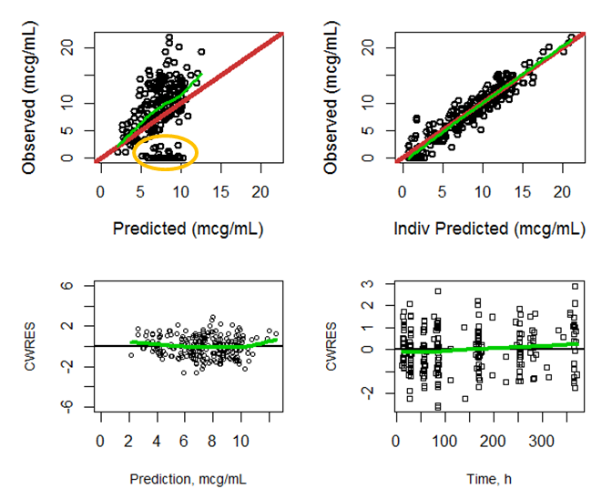
In upper row, red line represents unity; green lines represent a smoothing function.
Consideration should have been given to the fraction of BLQ samples in the data set and the possible impact on parameter estimation.

Covariate selection
Plots of parameter-covariate relationships for the base model were presented. For continuous covariates, a smoothing function or trend line would have been useful to assist in visualising parameter-covariate relationships (or lack thereof).
In the univariate parameter-covariate screening process, significant effects of presence of AAA+, body weight and BSA on CL/F and body weight, height, body mass index, lean body weight and age on Vc/F were identified. Body weight was the body size metric selected based on decreases in OFV for both CL/F and Vc/F. There was not a significant effect of concomitant MTX on CL/F.
Due to the small number of AAA+ subjects (N=5) and the high proportion of BLQ samples in these subjects, the effect of AAA+ on adalimumab CL/F was not reliably estimated. The effect of AAA+ on CL/F was fixed to a value of 2. This value was reported to be the approximate value estimated in an analysis of PK data from Study DE038.
The full model included effects of AAA+ on CL/F and body weight on CL/F and Vc/F. Backward elimination of covariates did not lead to exclusion of covariates.

Final PK model
Final population PK parameter estimates and bootstrap estimates were comparable. There was an error in the reporting of IIV on CL/F (47% not 35.5%). Nevertheless, IIV on CL/F decreased substantially (by 35%) to 47% relative to the base model, due primarily to the effect of AAA+ on CL/F. All structural parameters, covariate effects and random effects were estimated with reasonable precision (5 - 25%). Shrinkage of the random effect on CL/F was low (5%).
Plots of significant parameter-covariate relationships for CL/F were shown in the PK report. Summary statistics of the PK parameters by AAA status and body weight category were presented.

PK Model evaluation
Goodness of fit plots presented in Figure 2 lacked smoothing functions or trend lines. However replication of the plots with smoothing functions showed reasonable agreement between observations and predictions and no systematic trends in the plots of residuals versus predictions and time.
Figure 2: Goodness of fit plots of observed and predicted data
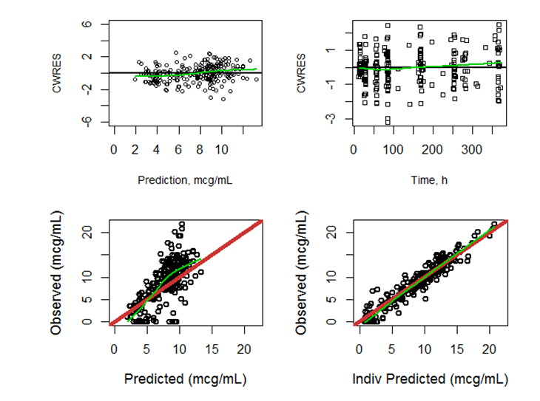
In upper row, red line represents unity; green lines represent a smoothing function.
Distributions of CL/F and residuals were consistent with assumptions. Individual plots of observations and predicted adalimumab concentration versus time profiles showed reasonable agreement for the majority of subjects.
Results of a bootstrap analysis of the final PK model were presented and distributions of bootstrap parameter estimates were shown graphically. There was good agreement between parameter estimates obtained using NONMEM and bootstraps estimates.
The VPC was presented. It showed reasonable performance of the model in capturing the variability in the data. The central tendency was strongly influenced by the BLQ samples and highlighted the need to investigate the impact of BLQ samples on parameter estimation.

Results summary
In summary, the results included a descriptive statistical analysis of the trough serum adalimumab concentrations in Study M11-328 and graphical comparison with those in Study DE038. The impact of immunogenicity on adalimumab PK was assessed using descriptive statistics as well as in the population PK analysis, but these results were not tied together. Results of the population PK analysis used standard techniques for model building and evaluation and provided a reasonable description of the data in accordance with EMEA guidelines.

Evaluation of discussion and conclusion (Item 4.3.7 of EMEA Guidelines)
Discussion points/conclusions drawn in the PK report and a critique of these were as follows:
- Based on the descriptive statistics of trough serum concentrations by treatment group, week and concomitant MTX presented, it was stated that steady-state serum adalimumab concentrations appeared to be higher in subjects who received concomitant MTX compared to the non-MTX stratum.
- In comparison, the population PK analysis did not identify an effect of MTX on CL/F, an important determinant of steady-state serum concentration. The disparity between the results of the descriptive analysis and the population PK analysis was not addressed in the PK report.
- As noted in the PK report, this finding was likely due to the comparable magnitude of variability in serum adalimumab concentrations between subjects taking MTX and those who were not in Study M11-328. This finding was not consistent with previous results and warranted further consideration in the PK report.
- During the 52 week analysis period, 5 subjects (11%) were classified as AAA+. While the number of subjects was too small to provide meaningful assessment of the impact of immunogenicity on efficacy and safety, the results of the impact on PK could have been tied with the results of the population PK analysis which identified AAA+ as an important factor influencing adalimumab CL/F and consequently exposure (trough concentrations).
- The population PK model was described together with a summary of the effects of body weight on CL/F and Vc/F. However, discussion of the impact of AAA+ on adalimumab CL/F and exposure was omitted.
- It was stated that serum adalimumab concentrations appeared to be comparable to those observed in paediatric subjects with polyarticular JIA.
- This conclusion was drawn based on visual inspection of overlaid mean (SD) plots. It is unfortunate that this qualitative assessment was performed separately from the quantitative population PK analysis conducted for M11-328. Moreover, it is unfortunate that the population PK analysis was not appropriately planned to address this objective. The standalone population PK analysis of Study M11-328 essentially ignored accumulated prior knowledge in favour of fixing PK parameters to approximate values previously obtained. This is a far less desirable approach than building on prior knowledge by combining data sets and using a population analysis approach to explore covariate effects and to compare exposures between populations of interest in the analysis set.
A separate population analysis of five paediatric studies including Study M04-717 (paediatric psoriasis), Study M06-806 (paediatric CD) and three studies in paediatric RA including studies DE038 and M10-444 (JIA) and Study M11-328 (ERA) showed no difference in PK across indications. (Source: “Interim Pharmacokinetic and Immunogenicity Assessments from the Phase III Trial: A Multicentre, Randomised, Double-Dummy, Double-Blind Study Evaluating Two Doses of Adalimumab Versus Methotrexate (MTX) in Pediatric Subjects with Chronic Plaque Psoriasis (Ps). Interim Pharmacokinetic Report R&D/13/1067. Adalimumab (D2E7)/Protocol M04-717”)
As part of this review, the population model of 5 paediatric studies was probed to specifically address the primary objective of this analysis. This was achieved by testing ERA on adalimumab CL/F in the base model using the likelihood ratio test and covariate testing criteria specified in the PK report. Change in OFV was 5.074 (OFV for the base model was 8093.462 and for the model with an effect of ERA on CL/F was 8088.388) and was not statistically significant.
The findings from this analysis support the conclusion that serum adalimumab concentrations were comparable to those observed in paediatric subjects with polyarticular JIA.

Simulation
Simulations based on the population PK model of five paediatric studies were performed to compare weight–based and BSA–based dosing. The model was used to simulate steady-state serum trough adalimumab concentrations under the BSA-based dosing regimen used in Study M11-328 (equivalent to 15 – 40 mg adalimumab eow) compared to a weight-based dosing regimen (20 mg adalimumab eow for body weight < 30 kg or 40 mg adalimumab eow for body weight ≥ 30 kg) for 24 weeks. The body weight distribution used for the simulations was not specified. In addition, the sampling scheme was not specified.
Distributions of steady-state adalimumab serum trough concentrations for body weight < 30 kg and ≥ 30 kg under the two dosing designs were shown. Distributions of simulated steady-state adalimumab serum trough concentrations for the weight-based regimen were comparable to the simulated trough concentrations for the BSA-based regimen.
Based on the results it was concluded that the proposed weight-based dosing regimen was appropriate for use in paediatric ERA and aligned with the approved dosing regimen for the treatment of polyarticular JIA. However, it would have been useful to visualize the serum trough adalimumab concentration distributions arising from weight-based dosing relative to BSA-based dosing at the extremes of the body weight range (for example, < 15 kg, ≥ 50 kg) to determine the validity of this conclusion.

Summary and implications of findings

Summary of findings
The objectives of the analysis were to examine the PK and immunogenicity of adalimumab following SC administration in paediatric subjects with ERA. However, in order to support extending the indications for adalimumab to include ERA, the main purpose of the analysis should have been to show that adalimumab exposures in paediatric subjects with ERA were similar to those observed in other paediatric subjects.
The most expedient approach to addressing the purpose of the analysis would have been to conduct a population PK analysis including data from Study M11-328 and one or more comparator studies. Instead, the sponsor used qualitative methods to compare steady-state trough serum adalimumab concentrations between Study M11-328 and a comparator study, DE038, a Phase III study of paediatric patients with polyarticular JIA. Neither the source data nor the PK report for Study DE038 was included as part of the review documents and therefore data presented from Study DE038 had to be accepted at face value.
The report also included the description of a population PK analysis using the data from Study M11-328. It was performed as a standalone analysis with no model application.
On the basis of this evaluation, it was concluded:
- A population PK model was developed for adalimumab in paediatric ERA subjects. Modelling assumptions and model building methods were generally sound and consistent with EMEA guidelines. The base and final PK models were successfully replicated, verifying the models and the reported PK parameters in the report.
- CL/F and Vc/F increased with increasing body weight. The clinical relevance and implications for dosing in children were not explored in the PK report.
- AAA+ subjects had substantially increased CL/F resulting in low (BLQ) adalimumab exposures.
- Trough serum concentrations of adalimumab in paediatric ERA subjects (M11-328) were qualitatively similar to those in paediatric polyarticular JIA subjects (Study DE038). While no quantitative analysis was performed to verify this result in the PK report, it was confirmed in a separate population analysis of five paediatric studies in three indications, RA (including JIA and ERA), CD and psoriasis, which showed no difference in PK across indications, and specifically no difference in PK between ERA subjects and other paediatric subjects.
- Broader review of the PK and immunogenicity results in the context of other studies was not possible because the documentation provided was limited to paediatric ERA and Ps indications in Studies M11-328 and M04-717, respectively.

Implications of findings
No assessment of benefit-risk was possible in the absence of exposure – response (efficacy and safety) data for adalimumab.
Considerations with regard to the proposed Australian Product Information (API) are as follows:
- Pharmacokinetics (Paediatrics) and Dosage and Administration
“Based on a population pharmacokinetic (PK) modelling approach, simulated steady-state adalimumab serum trough concentrations for a weight-based dosing regimen (20 mg adalimumab fortnightly for body weight < 30 kg and 40 mg adalimumab fortnightly for body weight ≥ 30 kg) were comparable to the simulated trough concentrations for the body surface area-based regimen.”
The veracity of this statement cannot be determined from the information provided.

Population pharmacokinetics 2

Rationale for this evaluation
This evaluation reviews the pharmacokinetics (PK) and immunogenicity results from an ongoing Phase III study of adalimumab in children and adolescents subjects aged ≥ 4 years with Ps, conducted as part of a Paediatric Investigation Plan approved by the European Medicines Agency for adalimumab. The report was evaluated to determine the validity of the analysis methods and results, and their implications for dosage recommendations in paediatric subjects with Ps.

Clinical Pharmacology summary
A summary of the clinical pharmacology of adalimumab was derived from documentation and the proposed Australian product information:

Pharmacodynamics
After treatment with adalimumab, patients experienced improvement in haematological signs of chronic inflammation. A rapid decrease in C reactive protein (CRP) levels was observed in patients with RA, polyarticular JIA, CD and ulcerative colitis.
In Phase II/III trials, the serum adalimumab concentration-efficacy relationship, as measured by the American College of Rheumatology response criteria (ACR20), was described using an Emax model with EC₅₀ estimates ranging from 0.8 to 1.4 μg/mL

Pharmacokinetics
- Absorption from a single 40 mg subcutaneous injection was characterised by a slow rate of absorption with peak serum adalimumab concentrations after approximately 5 days and mean bioavailability of 64% in healthy adult subjects.
- In RA patients following intravenous doses ranging from 0.25 to 10 mg/kg, the PK of adalimumab was linear. Steady-state volume of distribution ranged from 4.7 to 6.0 L. Adalimumab concentrations in synovial fluid ranged from 31 to 96% of those in serum. Typical adalimumab clearance was less than 12 mL/h. The mean terminal phase half-life ranged from 10 to 20 days.
- Mean steady-state serum trough concentrations after 40 mg SC doses administered fortnightly to patients with RA were 5 μg/mL without concomitant methotrexate (MTX) and 8 to 9 μg/mL with concomitant MTX, respectively. These trough concentration levels are well above the EC₅₀ estimates of 0.8 to 1.4 mcg/mL (see Pharmacodynamics). Steady-state trough concentrations increased approximately proportionally with dose following 20, 40 and 80 mg fortnightly and every week SC dosing for periods of dosing of more than 2 years.
- Population pharmacokinetic analyses with data from over 1200 RA patients revealed increased apparent clearance (CL/F) of adalimumab with increasing body weight and in patients who developed the presence of anti-adalimumab antibodies. Minor, clinically unimportant, increases in CL/F were predicted in RA patients receiving doses lower than the recommended dose and in RA patients with high rheumatoid factor or CRP concentrations.
- Other results of population pharmacokinetic analyses:
  - There was a significant difference in mean CL/F in patients with CD studied short term (4 weeks, 13.1 mL/h) versus long term (56 weeks, 16.8 mL/h).
  - No gender-related pharmacokinetic differences were observed after correction for a patient’s body weight.
  - No pharmacokinetic data are available in patients with hepatic or renal impairment.
  - Healthy volunteers and patients with RA displayed similar adalimumab pharmacokinetics.
  - In 21 RA patients on stable MTX therapy, adalimumab administration did not influence serum MTX concentration profiles. In contrast, after single and multiple dosing, MTX reduced adalimumab CL/F by 29% and 44%, respectively.

Evaluation scope
The contract specified that the evaluation should comprise:
- replication of the key population pharmacokinetic analysis to confirm the results submitted by the sponsor,
- a detailed written review of the population PK report using the Guideline on Reporting the Results of Population Pharmacokinetic Analyses CHMP/EWP/185990/06 published by the European Medicines Agency and adopted by the TGA (referred to as EMEA guidelines in this evaluation),
- a review of the PK/immunogenicity analyses in the population PK report and implications of the results for dosing,
- comment on the consequences or implications, if any, of the results of this review on first-round benefit-risk assessment and relevant sections of the proposed Australian Product Information.

Evaluation of analysis conducted

Analysis conducted
Qualitative evaluations of serum trough adalimumab concentrations and the effect of immunogenicity on PK, safety and efficacy in Study M04-717 were conducted. A population PK analysis including five paediatric studies including 3 studies in RA, 1 study in CD and Study M04-717 (Ps) was performed.
Analyses were conducted by AbbVie.

Evaluation of analysis conducted
Electronic files of the control streams and analysis data set for the population PK analysis of adalimumab were not provided. Therefore, they were reconstructed from the listings provided in the appendices of the PK report. The analysis data set was constructed from the listings in Appendix 14.3__13 and included 12150 records. The data set included dosing records (identified by compartment variable (CMT) = 1 and event identification variable (EVID) = 1) and adalimumab concentrations (CMT = 2, EVID = 0).
Base and final population PK models were extracted from Appendices 14.3__4.2 and 14.3__4.3, respectively. Other model variations were also evaluated in order to assess reported results. Analyses were run using NONMEM v7.3, as used to generate the PK results provided by the sponsor.
Results were compared with the NONMEM outputs for the base and final models included in Appendices 14.3__4.2 and 14.3__4.3 of the PK report, respectively. The number of records in the sponsor’s analysis data set was 107658. Based on previous assessment of the analysis data set for Study M11-328, the discrepancy was likely due to inclusion of records at additional time points to permit simulation of individual serum adalimumab concentration versus time profiles (identified using EVID=2). As a result of the difference in data sets, the objective function values differed between the sponsor’s outputs and the replicated results. However, PK parameter estimates (including estimates of shrinkage, fixed and random effects and their standard errors) were similar to those produced by the sponsor and the results of the analyses were considered to be verified.

Results of PK report evaluation

Evaluation of Analysis Plan (Item 4.2 of EMEA Guidelines)
Contrary to the criteria of the EMEA guidelines, a separate analysis plan was not provided.

Evaluation of PK Report Summary (Item 4.3.1 of EMEA Guidelines)
The PK report synopsis focused primarily on summarizing the objectives and design of Study M04-717 with minimal technical details of the immunogenicity and population PK analyses specified in the Methods. Data used for the population PK analysis included 4 studies in addition to Study M04-717 however, these studies were neither identified nor described. The results included qualitative evaluations of serum trough adalimumab concentrations and immunogenicity data in Study M04-717 together with a brief description of the population PK modelling and simulation results. The conclusions were appropriate to the analyses with the exception that the statement of lack of effect of immunogenicity on safety and efficacy should have been qualified by noting that the results were based on a qualitative assessment and a small sample size (N = 10) for the immunogenic group.
The synopsis partially met the requirements of the EMEA guidelines.

Evaluation of Introduction to PK Report (Item 4.3.2 of EMEA Guidelines)
The Introduction of the PK report provided a detailed description of the nature and incidence of Ps and available treatment options for adults and children. A brief description of Study M04-717 and its approval by the Paediatric Committee of the EMA was included. Despite establishing a context for studying adalimumab in children, there was no mention of the intent of the PK analysis and as an Introduction to the PK report, it did not meet the criteria of the EMEA guidelines.

Evaluation of Objectives of PK Analyses (Item 4.3.3 of EMEA Guidelines)
The stated objectives were not specific to the PK and immunogenicity analyses. It was noted that the focus of the interim PK report was on the assessment of PK and immunogenicity of adalimumab in Study M04-717 up to an interim data cut-off point. However, the purpose of the analyses and specific objectives for the population PK and immunogenicity analyses were not stated and failed to meet the requirements of the EMEA guidelines.

Evaluation of Data Used in PK Analyses (Item 4.3.4 of EMEA Guidelines)

Data included in the analyses
Data from 5 studies were included in the population PK analysis: Study M04-717 (paediatric Ps), Study M06-806 (paediatric CD) and three studies in paediatric RA including studies DE038 and M10-444 (JIA) and Study M11-328 (paediatric enthesitis related arthritis (ERA)).
The data description in the PK report focused only on Study M04-717. Study M04-717 included four phases:
- a primary treatment phase (Period A) where subjects were assigned to receive 0.8 mg/kg adalimumab (up to a maximum of 40 mg) every other week (eow), 0.4 mg/kg adalimumab (up to a maximum of 20 mg) eow or weekly methotrexate (MTX, at a starting dose of 0.1 mg/kg and up to 25 mg) in a 1:1:1 ratio for 16 weeks,
- a withdrawal phase (Period B) where responders were withdrawn from active treatment and monitored for loss of disease control for up to 36 weeks,
- a retreatment phase (Period C) of 16 weeks for subjects who experienced loss of disease control in period B, and
- a follow-up phase (Period D) of 52 weeks where subjects received 0.4 mg/kg or 0.8 mg/kg adalimumab (up to a maximum of 40 mg) eow.
The study design included a 30 day screening period. Baseline was defined as the date of the first administration of study drug. Interim analysis was scheduled to occur after Period C. Discontinuation of adalimumab treatment was permitted at any time during study participation.
A flow chart of the study design is shown below:
Figure 3: Study design
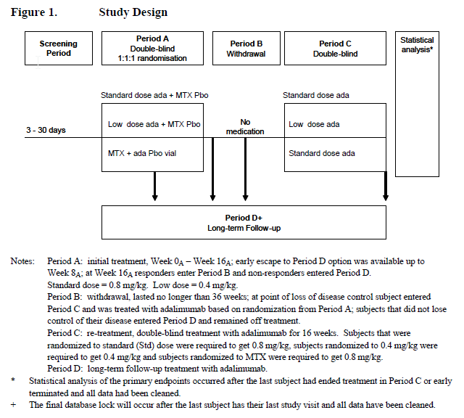
In Study M04-717, blood samples for analysis of serum adalimumab were collected at the following time points: at baseline and at Weeks 1, 4, 11 and 16 in Period A, at Weeks 4, 12 and 16 in period B, at Weeks 0, 1, 4 and 11 in Period C and at Weeks 0, 1, 8 and 16 in period D. For the immunogenicity analysis, blood samples for analysis of serum anti-adalimumab antibody (AAA) were collected at the following time points: at baseline and at Weeks 11 and 16 in period A, at Weeks 12 and 16 in Period B, at Weeks 0 and 11 in Period C and at Weeks 0, 8 and 16 in Period D. Blood samples for serum adalimumab and AAA concentrations were also collected at early termination visits. The population PK analysis included interim, cleaned data collected through to the end of period C in Study M04-717.
The PK analysis data set was not described in the PK report. Examination of the PK analysis set revealed that it included 2575 serum adalimumab concentrations from 524 subjects aged from 2 to 18 years. An average of 5 samples was collected per subject over a median period of 252 days (range 18 to 364 days). The number of subjects and samples (including samples below the assay limit of quantitation (BLQ)) by study and overall were as follows:

Table 6: Number of subjects and the number of samples collected across the 5 studies
Study Number (STDY) | Number of Subjects | Number of Samples | Av. Number of Samples/Subject | Number (%) of BLQ samples
38 | 169 | 850 | 5 | 98 (11.5)
4717 | 109 | 686 | 6 | 129 (18.8)
6806 | 189 | 785 | 4 | 19 (2.4)
10444 | 12 | 24 | 2 | 0
11328 | 45 | 230 | 5 | 21 (9.1)
Total | 524 | 2575 | 5 | 267 (10.4)
According to the PK report, a total of 1157 human serum samples were analysed for adalimumab in Study M04-717. AAA assays were conducted for subjects with at least one adalimumab concentration measurement < 2 μg/mL. It was stated that 435 samples were analysed for AAA. These numbers could not be reconciled with the PK analysis set.
A data specification file was not provided. However, field descriptions were listed in Appendix 13.3__1 of the PK report.

Procedures for handling missing data and outliers
All subjects with at least one serum adalimumab concentration above the lower limit of quantitation (LLOQ) were included in the PK analysis set. Serum adalimumab concentrations at baseline and samples drawn during the placebo or off-treatment period of studies were excluded from the analysis set. In addition, to avoid errors in associating dose and samples around the data cut-off point for Study M04-717 data, samples drawn more than 14 days after the last reported dose were excluded. Exclusions were not documented by study in the PK report.
Handling of missing adalimumab samples was stated -. Missing samples were assigned “.”. BLQ samples were assigned LLOQ/2 in the PK analysis set. Of 2575 serum adalimumab concentration measurements in the data set, 267 (10.4%) were BLQ. The influence of BLQ on PK parameter estimation and handling of outliers were not considered.

Covariates
The data set included the following covariates: baseline demographic characteristics (age, sex, race, body weight, body surface area (BSA), height, lean body weight and body mass index), baseline kidney and liver markers (plasma albumin, calculated creatinine clearance, bilirubin, aspartate aminotransferase, alanine aminotransferase), baseline CRP, AAA status, study number and flags for indication and concomitant MTX.
In Study M04-717 (and presumably other studies), body weight was assessed at each visit to permit dosing adjustments. Time-varying body weight (and other body size metrics) would have been a more relevant covariate than baseline body weight for this paediatric study population.
Methods for calculation of derived covariates and handling of missing covariates were not stated.

Data summary
The Data section of the PK report lacked adequate description of the studies used in the population PK analysis. Exploratory graphical evaluations of the data were also missing. As a result the data description failed to substantially meet the criteria of EMEA guidelines.

Evaluation of Methods Used in the Analyses (Item 4.3.5 of the EMEA Guidelines)

Bioanalytical methods
Bioanalytical reports for adalimumab and AAA were not provided for this interim PK analysis. The PK report included the type of assay and the LLOQ for adalimumab and AAA assays. LLOQ values were 31.3 ng/mL and 10.31 ng/mL for adalimumab and AAA, respectively.

Immunogenicity
The PK report defined a subject considered to be AAA+ if the subject had at least one AAA serum concentration greater than 20 ng/mL and the sample was collected within 30 days after an adalimumab dose. In Study M04-717 samples drawn during the withdrawal phase (period B) with > 20 ng/mL AAA were also counted as AAA+.
Methods describing assessment of the impact of immunogenicity on efficacy, safety and PK were missing. Efficacy endpoints (defined in the PK report) were the proportions of subjects achieving a 75% reduction in the Psoriasis Area and Severity Index (PASI 75) and Physicians Global Assessment of Psoriasis (PGA) score of 0/1 at Week 16 in period A. Safety endpoints were the number (%) of treatment emergent adverse events (AE) during periods A, B and C and during periods A, B, C and D.
AAA serum concentrations were not included in the population PK analysis set. However, the AAA variable in the analysis set flagged AAA+ subjects.

PK Modelling methods
Population PK modelling methods were described in the PK report.

Choice of analysis and software
Model-based analyses were implemented using the nonlinear mixed effects modelling program, NONMEM (version 7.3). Population PK analyses were conducted using the First Order Conditional Estimation (FOCE) method with interaction. The computing environment was not stated.
Methods and software for graphical evaluations and descriptive statistics of demographics, trough concentrations and AAA samples were missing.

Model
Previously, the adalimumab PK were described with a one compartment model with first order absorption and first order elimination based on sparse sampling in paediatric subjects with JIA (Study DE038). It was noted that sufficient samples were collected during the absorption phase in Study DE038 to characterise the first order absorption rate constant. It was further stated that a two compartment model for adalimumab may be characterised with adequate sampling during the elimination phase, although there was no supporting citation/reference.

Variability models
Variability models were described. Interindividual variability (IIV) in PK parameters was assumed to be described by log-normal parameter distributions. Residual error models tested were additive, proportional and combined additive and proportional models. The choice and description (including equations) of variability models was appropriate for the analysis.

Covariate model
After identification of the base model, individual post hoc estimates of apparent adalimumab clearance were plotted against all potential baseline covariates.
Following univariate analysis of covariates in NONMEM, a forward addition/backward elimination process was used to build the population PK model using the likelihood ratio test for nested models. In the forward addition process, the parameter-covariate relationship resulting in the most significant improvement in NONMEM objective function value (OFV) was incorporated into the model and the resulting model served as the reference model for the next stage of covariate screening. A full model was determined when no additional covariates could significantly improve the OFV at a significance level of α = 0.01. Subsequently, covariates were deleted one at a time from the full model using a significance level of α = 0.001. The resultant model was the final population PK model. Clinical relevance criteria were not considered.
The effects of continuous covariates were modelled using power models while categorical covariates were modelled as a fractional change.
In the analysis, all potential covariates were tested on CL/F and Vc/F without consideration for biological plausibility of each relationship, increasing the risk of identifying spurious relationships by chance. A select subset of covariates primarily including body size metrics would have been more appropriate for assessment on Vc/F. Furthermore, exploratory plots of parameter-covariate relationships could have been used to guide covariate selection.
Values of covariates were limited to baseline values. Consideration should also have been given to testing allometric models (for the effect of body weight on CL/F and Vc/F) and time-varying metrics of body size (particularly body weight and BSA) in addition to baseline metrics of body size in this paediatric population.
In summary, additional consideration could have been given to choice and selection of covariates to be tested. However, parameterisation of the covariate model and the model building procedure were generally specified in accordance with EMEA guidelines.

Model evaluation
Model evaluation methods were stated in the PK report and included evaluation of goodness of fit plots, precision and biological plausibility of parameter estimates, precision of bootstrap estimates (using 1000 bootstrap replicates of the data set) and adequacy of a visual predictive check (VPC) using 1000 simulated replicates of the data set.
Model evaluation criteria were appropriate for the analysis performed and consistent with EMEA guidelines.

Simulations
Although not stated as a study objective nor mentioned in the Methods section of the PK report, simulations were performed to investigate the comparability of adalimumab exposures in younger children (4 – 6 years old) with older children (6 – 18 years old) following weight based dosing, as described in the PK report.
The final population PK model was used. A total of 250 trials each with 250 subjects who received 0.8 mg/kg adalimumab (up to a maximum of 40 mg) eow for 12 weeks. Age was assumed to be uniformly distributed over the range of interest, 4 – 18 years. Age appropriate values of albumin, BSA and body weight (for weight based dosing) were generated by modelling the relationships of these covariates with age using linear regression. No concomitant MTX use was assumed and 12% of subjects were assumed to be AAA+.
The sampling scheme was not specified. BLQ samples (< 0.03 μg/mL) were set to 0.03 μg/mL.
Simulations were implemented using Pharsight Trial Simulator (version 2.2.2).

Methods summary
The Methods section of the PK report provided an adequate description of the population PK model-building methods and generally met the requirements of the EMEA guidelines. However, methods describing assessment of the impact of immunogenicity on efficacy, safety and PK were missing.

Evaluation of results (Item 4.3.6 of EMEA Guidelines)

Immunogenicity
Based on examination of the PK analysis set, a total of 64 subjects in the PK analysis set were AAA+. There were 27, 26, 6 and 5 AAA+ subjects in studies DE038 (JIA), M04-717 (Ps) and M06-806 (CD), respectively. Of 383 serum adalimumab concentrations for these 64 subjects, 203 (53%) were BLQ.
In Study M04-717, 26 (or 22.8%) subjects were AAA+ out of 114 subjects included in the interim analysis of clinical data. Thirteen percent of subjects had AAA+ samples during period A, 26.8% during period B (withdrawal phase) and 7.9% and 13% upon retreatment in periods C and D, respectively.

Effect on serum trough concentrations
Plots of mean (SD) serum trough adalimumab concentrations versus time by AAA status in Study M04-717 showed lower mean concentrations in AAA+ subjects that remained low throughout the study.

Effect on efficacy
At Week 16 in period A of Study M04-717, 10 subjects were AAA+ (5 in each of the adalimumab treatment groups). The proportion of subjects achieving the efficacy endpoints, PASI 75 and PGA 0/1, was similar for AAA+ subjects and AAA- subjects. In addition change in PASI and PGA scores by AAA status over time were similar regardless of AAA status. Taken together, these results suggest that immunogenicity did not affect the efficacy of adalimumab, however, no definitive conclusions were drawn due to the small AAA+ sample size. Similarly, the number of samples was too small to determine the effect of AAA status on time to loss of response following withdrawal of adalimumab in period B of Study M04-717.

Effect on safety
The number (%) of treatment emergent adverse events stratified by AAA status for periods A, B and C and periods A, B, C and D were presented. The percentage of subjects per AE was generally similar between AAA+ and AAA- group and AAA status did not appear to impact the safety profile of adalimumab.

Immunogenicity results summary
Based on this qualitative evaluation of a small sample of immunogenicity data, AAA+ resulted in lower mean serum adalimumab concentrations but did not appear to impact efficacy or safety.

PK data description
Baseline demographics in Study M04-717 were summarised and were similar between treatment groups. Descriptive statistics of all covariates in the PK analysis set were presented and correlations among covariates were not presented.
Scatterplots of observed serum adalimumab concentrations over time were missing. Accordingly, no consideration was given to identification of outliers or other data exclusions.
Descriptive statistics of trough serum concentrations by treatment period, treatment group and week in Study M04-717 were presented in the PK report. In general, mean steady-state serum concentrations of adalimumab range from 7 – 11 μg/mL following 0.8 mg/kg adalimumab eow and 2- 3 μg/mL following 0.4 mg/kg adalimumab eow regardless of period (double-blind or open label) in Study M04-717. Prior administration of MTX resulted in higher mean serum adalimumab concentrations than those subjects not assigned to receive MTX in the double-blind period (A).

PK model
The PK model development process was described in the PK report and corresponded with the listing of model development steps presented in Appendix 14.3__3.

Base PK model
A one compartment model with first order absorption and first order elimination described serum adalimumab concentration versus time data. Inclusion of a second compartment was not supported by the data. IIV on CL/F and Vc/F, covariance between CL/F and Vc/F and a combined additive and proportional residual error model that varied by study were included in the model based on decrease in OFV.
On the basis of prior knowledge, the influence of AAA status on CL/F was included in the base model. Due to the sparse nature of data collection for AAA, the effect of AAA+ on CL/F was evaluated at several time points (0, 2, 4, 8, 12 and 16 weeks) after the start of treatment. The model with the lowest OFV was selected; the effect of AAA+ was modelled as an increase in CL/F at 2 weeks after the start of treatment.
Consideration should have been given to the fraction of BLQ samples in the data set and the possible impact on parameter estimation. Furthermore, since CL/F in CD subjects differed between short and long term periods of administration (see above), the potential for time-varying CL/F should also have been considered.
Parameter estimates for the base model were presented in the PK report. The 95% confidence interval included the value of 1 for the effects of studies DE038 and M06-806 on the residual error, suggesting that these values were not statistically significant. Fixing these values to 1 in the base model resulted in an increase in OFV of < 1 point confirming that the effects of these studies on residual variability were not significant. Nevertheless, their inclusion in the model had no deleterious impact on the modelling results.
Assessment of the base model diagnostic plots (not presented in the PK report) showed reasonable goodness of fit of the base model to the data with uniform distribution of conditional weighted residuals (CWRES) around 0 and good agreement between observations and individual predictions. There was a small trend to toward over prediction at high concentrations in the observed versus predicted plot (upper left panel below).
Figure 4: Observed versus predicted values and goodness of fit
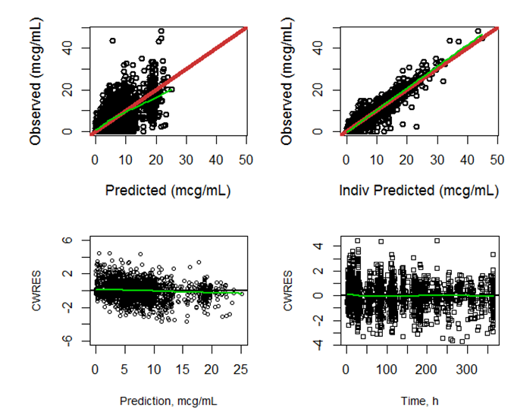
In upper row, red line represents unity; green lines represent a smoothing function.

Covariate selection
Plots of parameter-covariate relationships for the base model were presented in Appendices 14.3__5.1 and 14.3__5.2. For continuous covariates, a smoothing function or trend line would have been useful to assist in visualizing parameter-covariate relationships (or lack thereof).
Results of the univariate parameter-covariate screening process in NONMEM were presented in the PK report. The most significant effects were body weight and BSA at baseline on CL/F and Vc/F. Allometric and time-varying body size metrics should have been considered in the covariate selection for this paediatric population. In addition, BSA was chosen over body weight due to slightly lower OFV. However, these effects were comparable. Since adalimumab dosing was weight based in Study M04-717 (not based on BSA), consideration might have been given to selection of body weight over BSA.
The full model included effects of AAA+, BSA, MTX and albumin on CL/F and BSA and albumin on Vc/F. Backward elimination of covariates using a stricter selection criterion resulted in the exclusion of albumin on Vc/F.
The final population PK model included effects of AAA+, BSA, MTX and albumin on CL/F and BSA on Vc/F. PK parameters did not differ by disease indication.

Final PK model
Final population PK parameter estimates and bootstrap estimates were comparable. The estimated covariance between CL/F and Vc/F was omitted from the table. Tabulated structural parameters, covariate effects and random effects were estimated with reasonable precision (2 - 23%). Shrinkage of the IIV random effect on CL/F was low (< 10%) while that for Vc/F was moderate (45%). Compared with the base model, the addition of covariates into the population PK model resulted in decreased IIV on CL/F and Vc/F by 39% and 76%, respectively.
Post hoc PK parameters summarised by age and indication were presented in the PK report. By virtue of the relationship between age and body size in children, CL/F and Vc/F increased with increasing age. However, distributions of CL/F and Vc/F were similar among indications (RA, CD and Ps).

PK model evaluation
Goodness of fit plots presented lacked smoothing functions or trend lines. However replication of the plots with smoothing functions showed good agreement between observations and predictions and no systematic trends in the plots of residuals versus predictions and time.
Figure 5: Goodness of fit plot Observed versus Predicted data
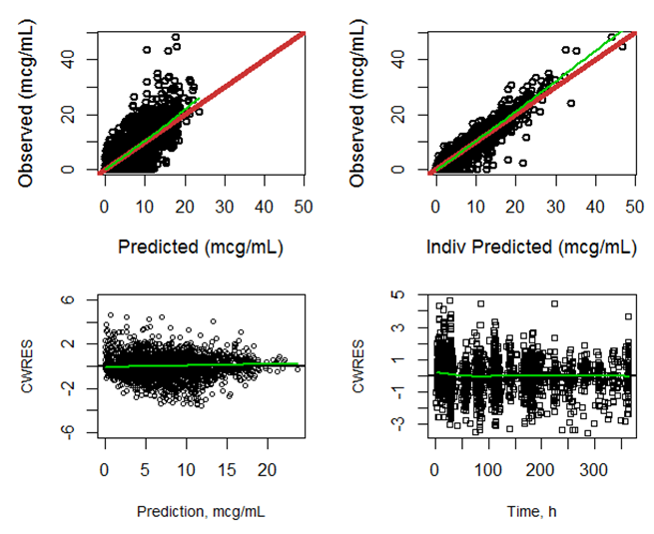
In upper row, red line represents unity; green lines represent a smoothing function.
Distributions of ETAs and residuals were consistent with assumptions and plots of ETA versus covariates for the final model did not identify any trends.
Results of a bootstrap analysis of the final PK model were presented in the PK report and distributions of bootstrap parameter estimates were shown graphically in Appendices 14.3__10.1 and 14.3__10.2. There was good agreement between parameter estimates obtained using NONMEM and bootstraps estimates.
The VPC was presented. A prediction corrected VPC may have been a better choice to reduce the number of plots required to show all the groups associated with the covariates in the final model. It showed reasonable performance of the model in capturing the central tendency and variability in the data.

Simulations
Methods and results of the simulations based on the final population PK model were described in the PK report.
The PK report shows that adalimumab exposures were similar for young children aged 4 – 6 years and older children aged 6 - 18 years following weight based dosing of 0.8 mg/kg (up to 40 mg) eow.
A sensitivity analysis might have been considered to explore the impact of variations in the assumed age-covariate relationships (for example, 20% variation in slope) on the results.

PK modelling results summary
In summary, a qualitative evaluation of the impact of immunogenicity on serum trough adalimumab concentrations was adequately described and interpreted. It would have been useful if these results could have been tied to the results of the effect of AAA+ on adalimumab CL/F estimated in the population PK analysis. Results of the population PK analysis used standard techniques for model building and evaluation. Addition of smoothing functions or trend lines to the graphical evaluations would have assisted in interpreting diagnostic plots and parameter-covariate relationships. Overall the population PK model provided an acceptable description of the data and the results were generally presented in accordance with EMEA guidelines.

Evaluation of discussion and conclusion (Item 4.3.7 of EMEA Guidelines)
Discussion and conclusions drawn in the PK report mainly reiterated results of the qualitative evaluations of the data for the M04-717 study in paediatric Ps subjects. These conclusions and a critique are as follows:
- Based on the descriptive statistics of trough serum concentrations by treatment period over time, steady-state serum adalimumab concentrations achieved during retreatment in period C were comparable to those observed prior to withdrawal in period A and during follow-up (Period D).
- A more quantitative evaluation of the expected exposures under the M04-717 study design could have been achieved by performing simulations using the final population PK model and comparing the distributions of trough serum adalimumab concentrations across study periods.
- An increased rate of immunogenicity after withdrawal of adalimumab during Period B was attributed to increased detection of AAA. However, after treatment was reinstated (Period C), the prevalence returned to a rate similar to that prior to adalimumab withdrawal in Period A.
- Despite lower serum adalimumab concentrations in AAA+ subjects, there did not appear to be a corresponding impact on safety or efficacy. This conclusion should have been qualified by noting that the number of AAA+ subjects was too small to permit definitive conclusions to be drawn regarding the effect of immunogenicity on safety and efficacy of adalimumab.
- Median estimates of adalimumab CL/F and Vc/F were reported for AAA- Ps subjects. It was concluded that based on the simulations using the final population PK parameter estimated exposures were expected to be similar over the age range (4 – 18 years) following weight based dosing of 0.8 mg/kg (up to 40 mg) eow.
- Discussion of the covariate effects and their clinical implications, particularly in the context of prior knowledge, was missing. In particular the choice of BSA over body weight on CL/F should have been discussed in the context of weight based dosing for adalimumab. How did PK in paediatrics compare to that in adults? Was the median estimated 22% reduction in adalimumab CL/F with concomitant MTX consistent with previous findings and what are the implications in terms of dosing recommendations? Was the reduction in CL/F due to elevated albumin clinically relevant?
- Furthermore simulations could have been used to examine the impact of AAA+ on exposure and tie this analysis to the results of the qualitative evaluations of immunogenicity in Study M04-717.

Summary and implications of findings

Summary of findings
The analyses conducted to evaluate the effect of immunogenicity on PK, safety and efficacy and to explore adalimumab exposures across indications in children using a population analysis approach were generally appropriate and adequate for their purpose and informative. However, the presentation of these analyses as a component of the M04-717 study report was unwieldy and resulted in missing elements, such as adequate description of the analysis data set and exploration of the raw data. Moreover, objectives specific to the analyses conducted and their applications would have permitted a more focused report with a clear theme for discussion and conclusions.
On the basis of this evaluation, it was concluded:
- A population PK model was developed for adalimumab using data from 5 studies in paediatric subjects with RA, CD and PSOR. Modelling assumptions and model building methods were generally sound and consistent with EMEA guidelines. The base and final PK models were verified using a data set and NONMEM control files extracted from the report.
- Based on the results of the population analysis there was no difference in exposures across indications in paediatric subjects.
- CL/F and Vc/F increased with increasing BSA. However, simulations based on the final population PK model showed similar exposures between younger (4 – 6 years) and older (6 – 18 years) children following administration of 0.8 mg/kg adalimumab eow.
- AAA+ subjects had substantially increased CL/F resulting in low exposures to adalimumab. Although the number of AAA+ subjects was small and despite low adalimumab exposures, there did not appear to be an effect of AAA+ on safety (AEs) and efficacy (PASI 75 and PGA 0/1) based on qualitative assessment of data.
- Graphical evaluation of data was performed. The plots show mean (SD) serum adalimumab concentrations in paediatric Ps subjects from Study M04-717 after 0.4 and 0.8 mg/kg eow and adult PSOR subjects in Studies M03-656 and M02-528 (left panel) and M03-658 (right panel) after 80 mg loading dose followed by 40 mg eow. Mean serum adalimumab concentrations were comparable between children receiving 0.8 mg/kg eow in Study M04-717 and adults receiving 40 mg eow in Studies M03-656 and M03-658 over 12 weeks. In Study M02-528 the mean serum adalimumab concentration at Week 16 was substantially less than the mean concentration at Weeks 11 and 12 in the other studies.
- The increased rate of immunogenicity after withdrawal of adalimumab during Period B followed by reduction to a rate similar to that prior to adalimumab withdrawal in paediatric Ps subjects in Study M04-717 was similar to the trends observed in adult PSOR subjects in Study M03-658, although rates of immunogenicity appeared to be higher in children.
- Broader review of the PK and immunogenicity results in the context of other studies was not possible because the documentation provided was limited to paediatric PSOR and ERA indications in Studies M04-717 and M11-328, respectively.

Implications of findings
No assessment of benefit-risk was possible in the absence of exposure – response data for adalimumab. Qualitative assessment of immunogenicity data suggested no effect of AAA+ on safety and efficacy despite low adalimumab exposures, although this finding requires verification with a larger (pooled) data set.
Considerations with regard to the proposed Australian Product Information (API) are as follows:
- Pharmacokinetics (Absorption and Distribution)
Population PK parameters estimated in the population PK analysis of paediatric studies were consistent with those stated in the API. These statements are therefore applicable to paediatric and adult patients.
- Pharmacokinetics (Steady-State)
‘In patients with psoriasis, the mean steady-state trough concentration was 5 mcg/mL during adalimumab 40 mg fortnightly monotherapy treatment (after an initial loading dose of 80 mg sc).’ This statement should be reviewed. Data presented for studies M03-656 and M03-658 over 12 weeks showed serum adalimumab concentrations after 40 mg eow in adult Ps subjects comparable to those following 0.8 mg/kg eow in paediatric Ps subjects in Study M04-717 (range 7 – 11 μg/mL).
- Pharmacokinetics (Drug Interactions, MTX)
Based on the results of the population PK analysis (22% reduction in CL/F), these statements are generally applicable to paediatric as well as adult patients.

Pharmacodynamics

Summary of pharmacodynamics
The information in the following summary is derived from conventional PD studies in humans. The following information is derived from the sponsor’s summaries as well as the currently approved PI.

Pharmacodynamic effects
Within 1 week of commencing treatment with SC administered ADA, there is a rapid decrease in the serum levels of inflammatory markers such as C-Reactive Protein (CRP), and key pro-inflammatory cytokines such as Interleukin-6.

Evaluator’s overall conclusions on pharmacodynamics
The PD properties of ADA when used in patients aged 4-17 years with active polyarticular JIA as well as adult subjects with severe chronic plaque PSOR have been previously assessed. No new PD data was presented in this submission and the sponsor is not proposing any changes to the PD section of the current PI.

Dosage selection for the pivotal studies

Enthesitis related arthritis
In the single pivotal trial in children and adolescents with active ERA (Study M11-328), the selection of a BSA dosing strategy for ADA using a regimen of 24 mg/m² (up to a maximum single dose of 40 mg) given at fortnightly intervals by SC injection was selected because it has been previously studied and has been shown to be safe and effective in children with active polyarticular JIA. However, the doses of preceding and background concomitant treatment with MTX and corticosteroid used by patients in the single pivotal study (M11-328) are unclear and should be further elaborated by the sponsor to determine if they are consistent with contemporary clinical practice in Australia.

Paediatric psoriasis
Population PK modelling and simulations based on the data from a study in paediatric patients with active polyarticular JIA (Study DE038) was used to identify the doses of ADA to be evaluated in the single pivotal trial in paediatric PSOR (Study M04-717). The model identified a subject body weight adjusted dosing regimen with a lower weight limit of 13 kg, as this represents the 5th percentile of body weight for boys and girls aged 4 years, which was the lower age limit for inclusion in Study M04-717. The model simulations also explored loading and maintenance doses based on subject body weight adjustment. Body weight adjusted doses ranging from 0.4 mg/kg to 1.2 mg/kg were compared in Study M02-528, which was a 12 week, Phase II trial in adult subjects with moderate to severe PSOR. It was assumed that a maximum of 40 mg per dose would be recommended (as per the adult dosing strategy). The simulated results predicted that a maintenance ADA dose of 0.8 mg/kg would produce similar mean serum ADA concentrations in paediatric subjects as that observed in adult subjects with PSOR. The ADA 0.4 mg/kg regimen was also simulated and produced serum concentrations of ADA, which were approximately one-half of that shown to be efficacious in adult patients with PSOR. The use and doses of low dose oral MTX as a comparator treatment in Period A of Study M04-717 is appropriate as it is commonly used as a systemic therapy in paediatric patients with severe PSOR.

Summary
Although no specific dose-finding studies have been performed in paediatric patients with ERA and PSOR, the dose and administration frequency of ADA therapy identified for further evaluation in the 2 pivotal studies included in this submission has been reasonably justified. Assessment of the available population PK data at the time of design and model simulations in paediatric subjects with related autoimmune treatment indications, suggest a comparable and sufficient drug exposure to ADA with the proposed posology for examination in both of the pivotal studies.

Clinical efficacy

Indication 1: Enthesitis related arthritis

Pivotal efficacy studies

Study M11-328

Study design, objectives, locations and dates
Study M11-328 is a Phase III, double-blind, placebo (PBO)-controlled trial which included a screening period of up to 30 days, followed by a 12 week double-blind, PBO controlled treatment period with an early escape (EE) option and an open-label (OL) extension phase with ADA given fortnightly for period with a maximum duration of 144 weeks. The study schematic is presented in Figure 6.
Figure 6: Design Schematic for Study M11-328
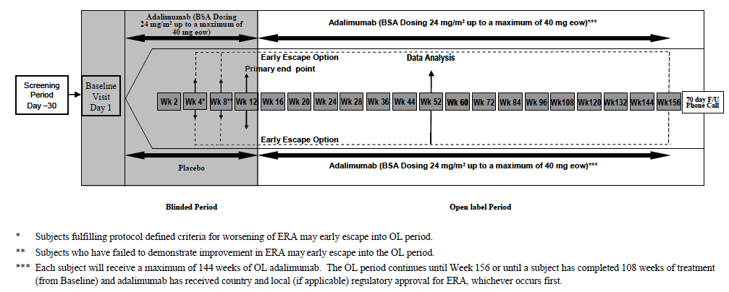
The blinded study period began at the baseline visit and ended at the Week 12 visit. Subjects who met enrolment criteria were randomised in a 2:1 ratio to receive either ADA (with body surface area [BSA] dosing of 24 mg/m²; up to a maximum of 40 mg per dose) or matching PBO via SC injection. There was an option for EE at Weeks 4 and 8 for subjects who either experienced a worsening of their disease or failed to improve. Worsening of disease at week 4 was defined as an increase in active joint count (AJC) ≥ 30% with a minimum of at least 2 additional active joints compared to baseline. Failure to improve at week 8 was defined as < 30% improvement in AJC compared to baseline. Study visits during the blinded period were scheduled to occur at baseline, Weeks 2, 4, 8 and 12. The study visit window was ±3 days for the blinded period.
For subjects who completed the blinded period, the OL period began at the Week 12 visit. For subjects who met the criteria for EE, the OL period began at the Week 4 or 8 visit (depending on when they met the criteria). During the OL period, each subject received OL ADA fortnightly for a maximum of 144 weeks. The OL period continues until Week 156 or until a subject has completed 108 weeks of treatment (from baseline). Study visits during the OL period were scheduled to occur every 4 weeks between Weeks 12 and 52, and every 12 weeks after Week 60. The study visit window was ±7 days for the OL period. Enrolment is complete and the study is ongoing. An interim study report with data collected up to the Week 52 visit has been provided in this submission.
The first patient visit in Study M11-328 occurred in September 2010 and the last subject completing their Week 52 assessment took place in November 2012. The trial was conducted at 16 study sites in Canada, France, Germany, Italy, Mexico, Poland, Spain, Sweden and Switzerland. The main objective of the study was to evaluate the efficacy and safety of ADA compared to PBO in children and adolescents with active ERA and a history of intolerance or inadequate response to at least 1 NSAID and at least 1 conventional DMARD (either MTX or SSZ).
The original study protocol was amended twice. Five subjects were enrolled under the original protocol, 17 subjects were enrolled under the first amendment and 24 subjects were enrolled under the second amendment. The first amendment updated and clarified the inclusion/exclusion criteria as well as safety related screening tests (for example, for assessment of latent tuberculosis and Hepatitis B virus). The second protocol amendment redefined baseline disease activity as children having at least 3 active joints and evidence of enthesitis in at least 1 location (either documented in the past or present at baseline) as well as clarifying that the efficacy and safety analyses were to be conducted when all ongoing subjects in the study had completed their Week 52 visit (that is, no interim data analyses were to be performed). Neither of the protocol amendments altered the study’s overall integrity.

Inclusion and exclusion criteria
To be eligible for inclusion in Study M11-328, patients had to be at least 6 years of age but less than 18 years at the time of enrolment with a diagnosis of ERA according to the ILAR criteria. The ERA had to be clinically active at screening with at least 3 active peripheral joints (that is, swelling not due to deformity and/or limitation of movement [LOM] with accompanying pain or tenderness) and have evidence of enthesitis in at least one location (either documented in the past or present at baseline). Patients were required to have a history of either inadequate response or intolerance to at least 1 NSAID and a 3 month course of at least 1 conventional DMARD (MTX or sulfasalazine [SSZ]) at adequate dose.
Background conventional DMARD treatment (single therapy only) could be continued on study in those receiving it in a stable dose for at least 28 days prior to study entry. In particular, MTX could be continued at a stable dose not exceeding 15 mg/m² (maximum dose of 25 mg/week) or SSZ could be continued at a stable dose not exceeding 50 mg/m² (maximum dose of 3 g/day). Continuing treatment with NSAID and low dose prednisone (no more than 10 mg/day or 0.2 mg/kg/day, whichever was less) was also permitted if the patient had received a stable dose for the 14 days prior to baseline. Prior treatment with any biological DMARD therapy (including anti-TNF drugs) was not allowed. If appropriate, female patients were required to use contraception.
The exclusion criteria involved 3 domains and patients meeting any 1 of the criterion were excluded:
- Co-morbidities: infection requiring antibiotics within 14-30 days (oral or intravenous); history of recurrent infection, demyelinating disease, inflammatory bowel disease, personal or family history of psoriasis; active tuberculosis, joint surgery within 2 months and any history of malignancy;
- Baseline laboratory results: serum creatinine > 1.6 mg/dL, total serum bilirubin ≥ 3 mg/dL, ALT or AST > 1.5 upper limit of normal (ULN), presence of IgM Rheumatoid Factor; and positive hepatitis B surface antigen, hepatitis B core antibody, or positive HIV serology;
- Past treatments: prior treatment with any biological DMARD at any time point and live or attenuated vaccines within 90 days of baseline visit.

Study treatments
Subjects who met enrolment criteria were randomised 2:1 to either ADA or matching PBO given fortnightly via SC injection. The dose of ADA evaluated in Study M11-328 was 24 mg/m² BSA, up to a total single dose of 40 mg. The baseline measurement of the subject's height and weight were used to determine the subject's dose of ADA from baseline through to the Week 12 visit. At the Week 12 visit and all subsequent visits, new study drug dose calculations were determined on the basis of height and weight at each corresponding visit. In the event a subject's dose calculation fell in the middle of 2 ranges, the dose of ADA was to be rounded up. ADA was provided as a preservative-free, sterile solution contained in 0.8 mL single-use vials containing 40mg/0.8 mL (final concentration of 50 mg/mL). After the baseline visit, study drug was to be given SC by either the subject themselves, parent or legal guardian, or a qualified designee.
Doses of prednisone, NSAID, MTX and SSZ were to remain stable for the first 12 weeks, except for safety reasons. Dose adjustments or commencement of treatment with these agents was permitted after Week 12. Subjects on stable doses of analgesics were allowed to continue during the trial. However, opioid analgesics were prohibited from baseline to Week 12. The dose of analgesic drugs being used for ERA related pain was not to be changed up to Week 12. For subjects who were taking analgesic medicines on an as needed basis, were required to discontinue them for at least 24 hours prior to a study visit assessment. Analgesic drugs could be initiated during the study after the Week 12 visit. No intra-articular corticosteroid injection for a peripheral joint was allowed during the first 12 weeks of the study. After Week 12, intra-articular corticosteroid injections were allowed at the investigator's discretion. Once a joint was injected, it was to be considered as not evaluable for 28 days following injection. Non-drug treatment such as physiotherapy and hydrotherapy was allowed at any time during the study.
During Study M11-328 (up to Week 52), the concomitant use of MTX was recorded in 69.6% of all subjects (32/46) at equivalent frequencies in each of the treatment groups (67.7% [21/31] in the ADA group and 73.3% [11/15] in the PBO arm). Concurrent SSZ therapy was used in 19.6% (9/46; 6 in the ADA group and 3 in the PBO arm) of the overall population and NSAID use was recorded in 73.9% (34/46) of all subjects. In addition, one third (32.6%; 15/46) of all patients received oral corticosteroid in Study M11-328. The study report did not specify the dose of concomitant MTX, SSZ or corticosteroid to evaluate the impact of associated DMARD therapy.

Efficacy variables and outcomes
The main efficacy variables were:
- American College of Rheumatology (ACR) Paediatric (Pedi) response criteria and its individual components;
- Enthesitis Assessment – total number affected and distribution (axial or peripheral); and
- Bath Ankylosing Spondylitis Disease Activity Index (BASDAI).
The ACR Pedi response is derived from 6 variables:
- Parent/patient global assessment of disease activity (range of 0 to 100 on a 100 mm Visual Analogue Scale [VAS] with 0=very well and 100=very poor).
- Physician Global Assessment (PGA) of disease activity (range of 0 to 100 on a 100 mm VAS with 0=no activity and 100=maximum activity).
- Number of joints with active arthritis (defined as joints with swelling; or in the absence of swelling, joints with LOM and concurrent pain and/or tenderness). A total of 68 joints were assessed for swelling and 72 joints for pain and/or tenderness.
- Number of joints with LOM (n=66 joints). LOM is classified as either present (1) or absent (0).
- Functional ability determined by Childhood Health Assessment Questionnaire (CHAQ). The parent or subject is asked to report their ability to perform activities of daily living, over the past week, in 8 domains including dressing, arising, eating, walking, hygiene, reach, grip, and common activities among a total of 30 items. Each item within a domain is scored on a 4-point Likert scale from 0 to 3 with 0=no difficulty, 1=some difficulty, 2=much difficulty and 3=unable to do. The CHAQ score is calculated as the mean of the 8 functional areas. The CHAQ is derived from the adult HAQ and is a validated assessment of functional disability in subjects with JIA.
- C Reactive Protein (CRP) in mg/L.
The patient is considered to have attained an ACR Pedi30 response if at least 3 of the 6 core variables had improved by at least 30% from baseline, and no more than 1 of the other variables had worsened by more than 30%. The ACR Pedi30 index is a validated, internationally accepted disease activity measure in JIA. The ACR Pedi50 and ACR Pedi70 response criteria use the same data components as the ACR Pedi30, but at a higher level of response.
Enthesitis assessments were calculated by 2 methods: Maastricht Ankylosing Spondylitis Enthesitis Score (MASES) and the Spondyloarthritis Canadian Research Consortium (SPARCC) enthesitis index. The MASES index assesses 15 core axial sites (for example, bilateral first and seventh costochondral joints, and proximal insertion of the Achilles tendon but not the plantar fascia insertions into the calcaneus) in a dichotomous 0/1 score for tenderness (0=non-tender and 1=tender). The MASES has a score range of 0-15. The SPARCC enthesitis index is preferred to the MASES because it has better reliability. The SPARCC enthesitis index assesses 18 peripheral sites (for example, Achilles tendon insertion, plantar fascia insertion and patellar ligament insertion into the patella and tibial tuberosity) in a dichotomous 0/1 score for tenderness. The SPARCC enthesitis index has a score range of 0-16. Unlike the CHAQ, there is no validated acceptance of what constitutes the minimally clinically accepted improvement in enthesitis score (by either method) and the clinical scoring methods have been criticised for limited inter-observer reliability.
The BASDAI is a validated, self-reported instrument consisting of 6 questions (all rated on a 10 cm scale) relating to fatigue, spinal and peripheral joint pain and swelling, enthesitis, and morning stiffness (both severity and duration) over the last week. To give each symptom equal weighting, the mean of the 2 scores relating to morning stiffness (Questions 5 and 6) is taken. The resulting 0-50 score is divided by 5 to give a final 0-10 BASDAI score. Scores of 4 or more (out of 10) indicate active axial arthritis. A clinically meaningful response is defined as a 50% decrease (improvement) in the score over a time period of at least 12 weeks (that is, a BASDAI50 response). The BASDAI score has only been validated in patients with AS, and not in patients with ERA. Paediatric ERA has several similarities to AS in adult patients, and one of ILAR classification criteria for ERA includes a history of AS in an adult first degree relative.
The primary efficacy outcome was the percentage change from baseline to Week 12 in the number of active joints with arthritis (that is, joint swelling not due to deformity, or joints with LOM plus pain and/or tenderness).
The efficacy of ADA compared to PBO was evaluated using the following ranked secondary efficacy variables analysed at Week 12:
- Number of sites affected by enthesitis for 35 different anatomical sites,
- Tender Joint Count (TJC) for 72 joints,
- Swollen Joint Count (SJC) for 68 joints,
- ACR Pedi30 response,
- ACR Pedi50 response, and
- ACR Pedi70 response.
The study examined a large number of other efficacy outcomes (tertiary), which included:
- Number of joints with active arthritis at Weeks 24, 36 and 52,
- ACR Pedi30/50/70 Responses at Weeks 24, 36 and 52,
- Individual components of the ACR Pedi criteria at Weeks 12, 24, 36 and 52,
- Number of sites affected by enthesitis and the change from baseline in the SPARCC enthesitis index and MASES at Weeks 12, 24, 36 and 52, and
- Mean change from baseline in the BASDAI and the percentage of patients achieving BASDAI50 response at Weeks 12, 24, 36 and 52.

Randomisation and blinding methods
At baseline, all eligible patients were randomised via interactive response technology (phone or web based) to 1 of the treatment arms. Randomisation at baseline was not stratified by any specific factor, including recruitment site.
Patients and investigator staff remained blinded to the identity of study treatment. In the extension phase of Study M11-328, all continuing patients received OL treatment with ADA.

Analysis populations
The primary efficacy analysis was based on the Intention-to-Treat (ITT) population, which included all randomised subjects. In order to evaluate the impact of major protocol deviations (in particular, those deviations with the potential to impact on the primary efficacy endpoint), a sensitivity analysis of the primary and ranked secondary efficacy endpoints was conducted using the Per-Protocol (PP) population, which consists of subjects in the ITT analysis set after excluding those subjects with recorded major protocol deviations. The PP cohort analysis was added with Amendment 1 to the original statistical analysis plan.

Sample size
The trial planned to enrol 45 paediatric patients with ERA. With a total sample size of 45 subjects (using 2:1 randomisation would yield 30 subjects in the ADA group and 15 subjects in the PBO arm) and an expected percentage change of 70% for ADA versus 35% for PBO, assuming common standard deviation (SD) of 33%, the study provided 90% statistical power to detect the treatment difference using a 2-sided, 1-way ANOVA with type 1 error level alpha of 5%.

Statistical methods
The primary statistical analysis of the primary efficacy outcome was done using an Analysis of Covariance (ANCOVA) model adjusting for the number of active joints at baseline with an alpha level of 0.05. A hierarchical fixed sequence testing procedure was used for the ranked secondary efficacy outcomes. For the comparison of treatment related differences in the ranked secondary efficacy endpoints, Fisher’s exact test was used for discrete variables and 1-way ANOVA was used for continuous endpoints. No covariate adjustment was used for the secondary and tertiary efficacy variables.
In the efficacy analyses, missing or incomplete data was primarily handled using the Last Observation Carried Forward (LOCF) method for continuous variables and Non-Responder Imputation (NRI) for dichotomous variables. Sensitivity analyses were also performed using the as observed data.

Participant flow
Table 7 provides a summary of the participant flow in Study M11-328. A total of 46 patients were enrolled into Study M11-328 and received at least 1 dose of study medication: 31 subjects in the ADA group and 15 in the PBO arm. All subjects completed the initial 12 week, double blind period with 3 patients (2 in the ADA group and 1 in the PBO arm) meeting EE at week 4 and another 4 subjects (2 in each treatment group) meeting EE at Week 8. Most subjects (93.5%; 43/46) completed the OL period up to 52 weeks. There were 2 withdrawals (1 from each treatment group) before 52 weeks because of adverse events (AEs) and 1 patient in the ADA group prematurely discontinued because of a lack of efficacy.

Table 7: Subject Disposition in Study M11-328
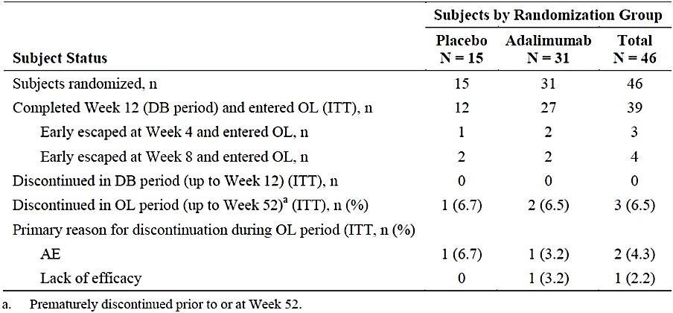

Major protocol violations/deviations
Up until Week 52, a total of 11 subjects in the ITT analysis (4 in the PBO group and 7 in the ADA arm) had at least 1 recorded protocol violation, including 3 subjects in the PBO group and 5 in the ADA arm who failed to meet the inclusion or exclusion criteria of the trial. Five subjects (4 in the ADA group and 1 in the PBO arm) were judged to have experienced major protocol violations with the potential to impact on efficacy endpoints and as such were excluded from the PP analysis set (41 subjects in total: 27 in the ADA group and 14 in the PBO arm). The 4 patients in the ADA treatment group with major protocol violations included 1 case of MTX dose reduction at Day 28 (reduced from a stable baseline dose of 20 mg/week to 17.5 mg/week within the double-blind period), 1 case of receiving prohibited medicine (opioid analgesia) during the double blind phase and 2 subjects failed to meet the inclusion/exclusion criteria (neither had received prior DMARD therapy despite the absence of a contraindication).

Baseline data
Table 8 summarises the key baseline demographic characteristics of the patients involved in Study M11-328. The overall mean age of the cohort was 12.9 years with 2 patients (4.3%) aged 6 to < 9 years, 13 subjects (28.3%) aged 9 to < 12 years, 16 patients (34.8%) aged 12 to < 15 years and 15 subjects (32.6%) aged ≥ 15 years. As expected, the majority of patients were male (67.4%; 31/46) and were of Caucasian ethnicity (76.1%; 35/46). Patients in the trial had a mean body mass index of 20.4 kg/m². There were no statistically significant differences between the treatment groups for baseline demographic features.

Table 8: Baseline Demographic Characteristics of the ITT Population in Study M11-328
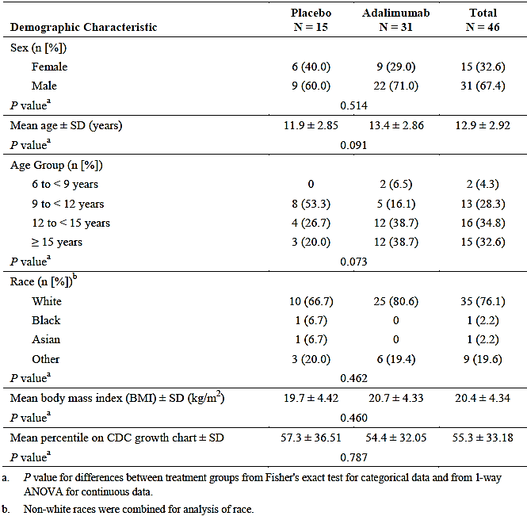
There were no significant differences between the 2 treatment groups regarding baseline disease characteristics. Subjects reported having had symptoms of ERA for a mean of 2.6 years (median 1.9 years) and had been formally diagnosed with ERA for a mean of 1.9 years prior to baseline (median 0.8 years; range: 0.1-8.1 years). Three subjects in the PBO group had a history of uveitis. All subjects tested negative for rheumatoid factor at baseline and the majority of subjects expectedly had a positive HLA-B27 test (67.4%; 31/46). Most subjects (58.7%; 27/46) were ANA negative at baseline, with the majority of those who were positive demonstrating a low titre result. All of the ANA positive subjects tested negative for anti-dsDNA antibodies (that is, not consistent with lupus).
Prior to the study, 91.3% (42/46) of all subjects had received at least 1 DMARD for ERA (either MTX [n=29] or SSZ [n=20]), all (100%) had taken NSAID therapy and 56.5% (26/46) of all subjects had previously used oral corticosteroids, with no statistically significant differences between the 2 treatment groups. The study report did not specify the dose of prior MTX or SSZ to evaluate the adequacy of prior DMARD therapy. Three subjects (1 in the PBO group and 2 in the ADA arm) tested positive for latent tuberculosis at baseline and were enrolled into the study under TB prophylaxis guidelines (that is, concomitant use of isoniazid for prophylaxis).
There were no statistically significant differences between the 2 treatment groups at baseline for ERA disease activity; refer to Table 9. In general, patients had moderately to severely active ERA at baseline with the mean number of active joints being 7.8, mean tender joint count being 12.9, mean swollen joint count being 6.2 and the mean number of joints with LOM being 4.9. Patients with ERA had a significant degree of soft tissue disease manifestations with the mean number of enthesitis affected sites being 8.1 at baseline. The MASES and SPARCC enthesitis scores show a mixture of peripheral and axial sites affected by enthesitis. The mean baseline CRP was 9.0 mg/L (median 2.6 mg/L). Only 18 subjects (8 in the PBO group and 10 in the ADA arm) had a CRP reading > ULN at baseline. Patients showed moderately active axial disease manifestations at baseline. The mean baseline BASDAI score was 4.7 (scale range of 0-10). The CHAQ index was also consistent with moderate functional impairment at baseline with the median score being 0.8 (scale range 0-3).

Table 9: Summary of Baseline ERA Disease Activity Assessments in Study M11-328 (ITT Population)
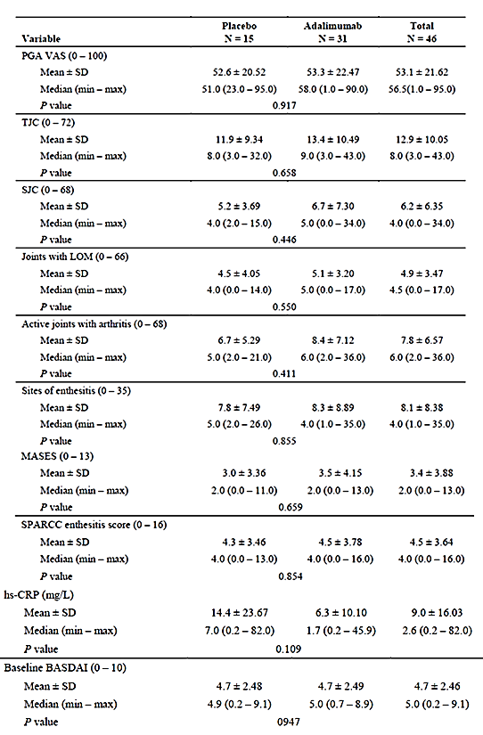

Results for the primary efficacy outcome
The primary efficacy outcome was the percentage change from baseline to Week 12 in the number of joints with active arthritis in the ITT analysis set using LOCF. Patients treated with ADA versus PBO showed a statistically larger decrease from baseline to Week 12 in the mean percentage number of active joints (-62.6% for ADA versus -11.6% for PBO; treatment related difference 51.2%; p=0.039); refer to Table 10. Four supporting analyses of the primary efficacy endpoint, such as those with alternative data handling methods (observed data method, that is, excludes EE patients) and using the PP population, demonstrated a similar treatment related response in favour of ADA. The PP analysis set (using LOCF) was numerically superior for ADA, but was not statistically superior (p=0.093).

Table 10: Percentage Change from Baseline to Week 12 in Number of Active Joints in Study M11-328
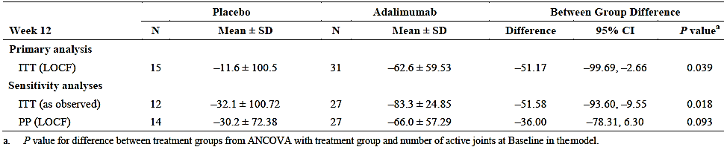
Additional analyses using the non-parametric exact Wilcoxon test, which accounts for deviations in normality of data distribution and a limited number of subjects, produced statistically significant results in favour of ADA using both the ITT (LOCF) and PP (LOCF) populations; refer to Table 11.

Table 11: Sensitivity Analyses of Primary Efficacy Outcome in Study M11-328 (Non-Parametric Test)
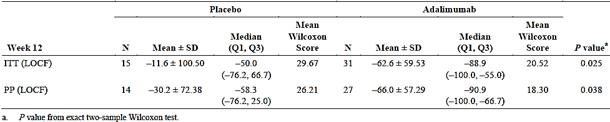
Subgroup analyses of the primary efficacy outcome by various factors were also conducted. The factors included subject age (6-9 years, 9-12 years, 12-15 years and > 15 years), gender, race (White versus non-White), HLA-B27 status (yes/no), baseline CRP reading (normal versus > ULN), concomitant DMARD use, concomitant NSAID use, and body mass index (underweight < 5th percentile, healthy weight 5th-85th percentile, overweight 85th-95th percentile and obese > 95th percentile). Many of the subgroups were too small to make meaningful conclusions regarding differences in treatment response; however, there were a few trends worth noting:
- Male subjects (-66.65% difference) showed a greater treatment related difference with ADA versus PBO than female patients (-20.34% difference),
- HLA-B27 positive subjects (-64.8% difference) showed a greater treatment related difference with ADA versus PBO than HLA-B27 negative patients (-23.64% difference), and
- Healthy weight subjects (-80.82% difference) and even overweight patients (-45.91% difference) showed a greater treatment related difference with ADA versus PBO than underweight patients (-21.39% difference).

Results for other efficacy outcomes

Ranked Secondary Efficacy Outcomes
While the results for each of the secondary ranked efficacy variables (enthesitis sites, TJC, SJC, ACR Pedi30 response, ACR Pedi50 response and ACR Pedi70 response at 12 weeks) were numerically higher with ADA versus PBO, only the last ranked secondary efficacy outcome (ACR Pedi70 response) reached statistical significance at Week 12; refer to Table 12.

Table 12: Mean Change from Baseline and Responder Status at Week 12 in Study M11-328 for Ranked Secondary Outcomes (ITT Population)
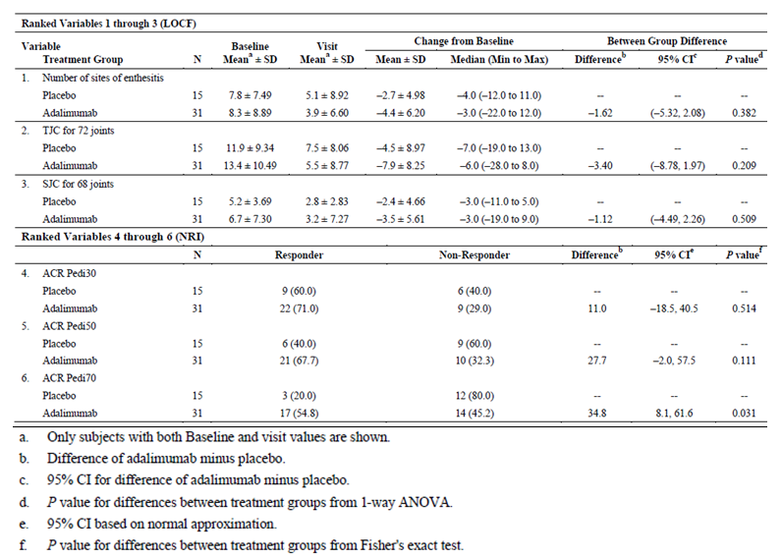

Other efficacy outcomes of clinical significance and/or included in the proposed PI
Although many of the supporting efficacy variables assessing the multiple dimensions of active ERA (for example, enthesitis, axial disease and the individual components of the ACR Pedi response criteria) were numerically greater with ADA versus PBO in the initial 12 week double-blind period, none reached statistical significance. The data collected in the OL phase up to Week 52 showed that continued treatment with ADA resulted in sustained improvements, and for PBO subjects who switched to ADA they achieved improvements in disease activity similar to that observed with ADA in the double-blind period.

Active joints with arthritis up to Week 52
In the OL period of Study M11-328 (using the ITT population and NRI), decreases from baseline in the number of active joints with arthritis continued through to Week 52 so that on average there were only 0.7 joints with active arthritis at Week 52 (versus 7.8 joints at baseline); refer to Table 13.

Table 13: Number of Active Joints with Arthritis over Time (up to Week 52) in Study M11-328
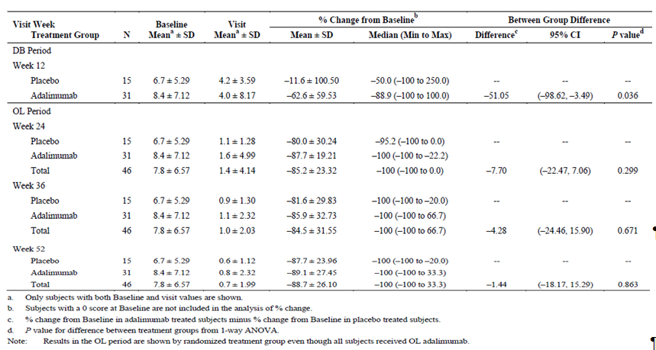

ACR pedi responses up to week 52
During the OL phase (using the ITT population and NRI), over 80% of subjects achieved ACR Pedi30 and ACR Pedi50 response by week 52, and three-quarters of subjects achieved ACR Pedi70 response; refer to Table 14.

Table 14: ACR Pedi Responses over Time (up to Week 52) in Study M11-328
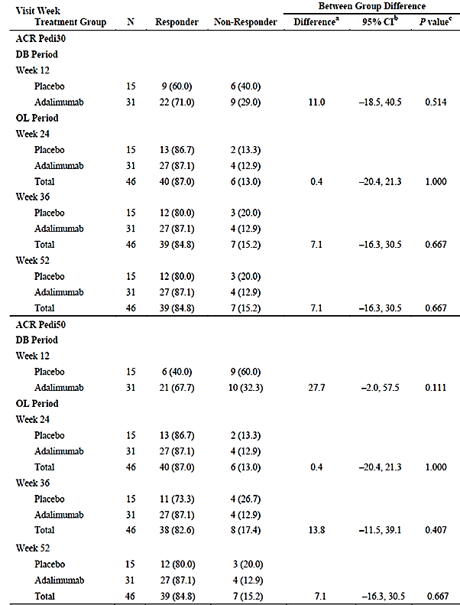

Table 14 (Continued): ACR Pedi Responses over Time (up to Week 52) in Study M11-328
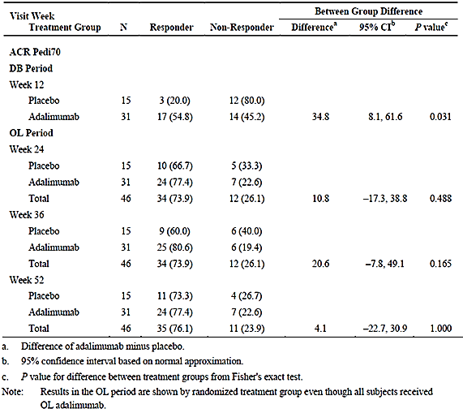

Components of ACR pedi criteria
For each of the 6 ACR Pedi components apart from CRP, the mean changes from baseline to Week 12 were numerically greater in the ADA treatment group versus PBO but none of the treatment related comparisons reached statistical significance. After 12 weeks of double-blind treatment, the mean overall change from baseline in individual components comprising the ACR Pedi criteria were:
- TJC (baseline mean of 13.4 in the ADA group and 11.9 in the PBO arm): -7.9 joints in the ADA group versus -4.5 joints in the PBO arm,
- SJC (baseline mean of 6.7 in the ADA group and 5.2 in the PBO arm): -3.5 joints in the ADA group versus -2.4 joints in the PBO arm,
- Number of joints with LOM (baseline mean of 5.1 in the ADA group and 4.5 in the PBO arm): -3.3 joints in the ADA group versus -1.1 joints in the PBO arm,
- Physician Global VAS assessment (baseline mean of 53 mm in both groups): -31.4 in the ADA group versus -22.1 in the PBO group,
- CHAQ score (baseline mean of 0.80 in both groups): -0.2 for ADA versus -0.1 for PBO, and
- CRP (baseline mean of 6.3 mg/L in the ADA group and 14.4 mg/L in the PBO arm): 0.4 mg/L in the ADA group versus -4.81 in the PBO arm.
During the OL treatment period whereby all continuing subjects received ADA, each of the individual components of the ACR Pedi criteria demonstrated mean improvements from baseline of 75-90% by Week 52, suggesting that ADA treatment maintains its beneficial treatment effect over medium term follow-up. This observation was true for subjects who received ADA from randomisation as well as initially PBO treated patients who switched to ADA by Week 12.

Enthesitis
During the double-blind phase (first 12 weeks) the mean number of sites with enthesitis reduced by 4.4 (baseline mean of 8.3) in the ADA treatment group versus 2.7 (baseline mean of 7.8) in the PBO arm. Similar responses (improvement) were seen at Week 24 in the PBO group who switched to ADA at Week 12 (mean enthesitis score reduced by 6.5 from a baseline mean of 7.8). During the open-label period, further decreases in the number of sites affected by enthesitis were seen in the ADA group. At Week 52, the mean number of affected enthesitis sites was 1.5 in the ADA group (reduced from a baseline mean 8.5); refer to Table 15.

Table 15: Number of Sites with Enthesitis over Time (up to Week 52) in Study M11-328
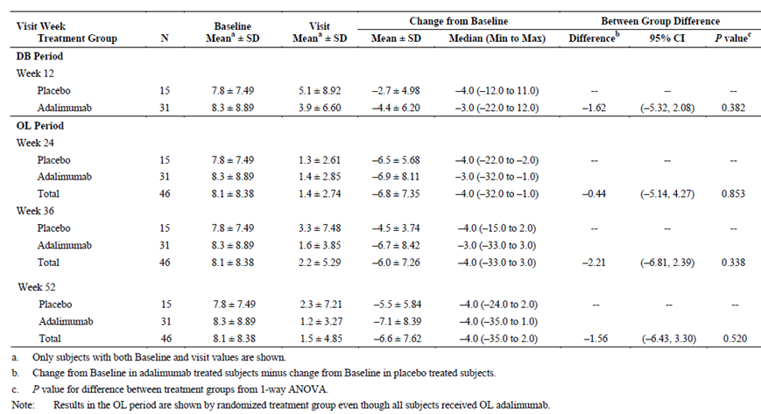
During the double-blind period, no statistically significant treatment related decrease from baseline was observed in the mean change of either the SPARCC enthesitis index or the MASES. At Week 12, the mean change from baseline in the SPARCC enthesitis index was -2.6 (baseline mean of 4.5) in the ADA group and -2.4 (baseline mean of 4.3) in the PBO arm (p=0.804). At Week 12, the mean change from baseline in the MASES was -1.7 (baseline mean of 3.5) in the ADA group and -0.7 (baseline mean of 3.0) in the PBO arm (p=0.208). During the OL phase, both the MASES and SPARCC enthesitis index continued to decrease and by Week 52, both enthesitis indices showed a mean 90% decrease from baseline with any exposure to ADA (Week 52 mean of 0.8 for both the MASES and SPARCC enthesitis index, regardless of initial treatment allocation).

BASDAI response
During the double-blind period, no statistically significant difference for the mean change from baseline to Week 12 was observed in the BASDAI for ADA versus PBO. At Week 12, the mean change from baseline in BASDAI was -2.5 (baseline mean of 4.7) in the ADA group and -1.4 (baseline mean of 4.7) in the PBO arm (p=0.173). During the OL phase, the BASDAI continued to decrease in those receiving ADA and by Week 52 showed a mean 68% decrease from baseline (mean BASDAI of 1.5 at Week 52); refer to Table 16. PBO subjects who switched to ADA by week 12 showed a similar level of improvement in the mean BASDAI as those who received ADA from randomisation.

Table 16: Change in BASDAI from Baseline over Time (up to Week 52) in Study M11-328
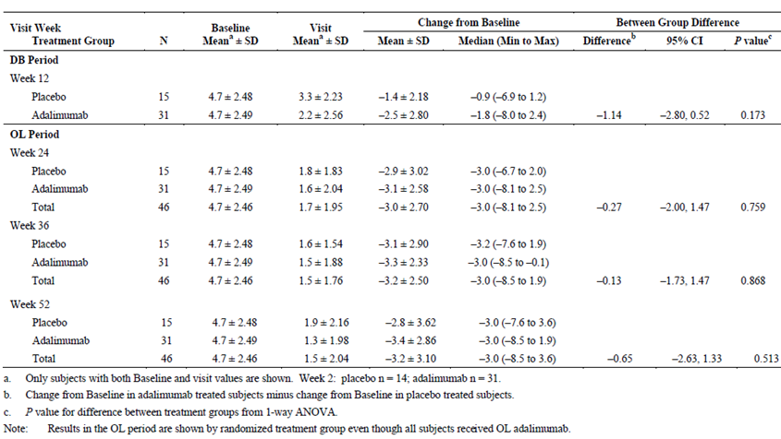
During the double-blind period, a greater number of patients treated with ADA achieved BASDAI50 response compared to PBO group. The treatment related difference was statistically significant at Weeks 2 and 8, but failed to maintain statistical significance at Week 12 (p=0.057). The BASDAI50 response rate at Week 12 was 61.3% (19/31) in the ADA group and 26.7% (4/15) in the PBO arm. With OL ADA treatment, the rate of BASDAI50 response continued to steadily improve over time so that by week 52, 71.7% (33/46) of all subjects reached this response (65.2% [30/46] at week 24 and 69.6% [32/46] at week 36).

Other efficacy studies
The submission did not contain any non-pivotal efficacy studies in support of the ERA application.

Analyses performed across trials (pooled analyses and meta-analyses)
Not applicable as only a single trial was submitted in support of the ERA treatment application.

Evaluator’s conclusions on efficacy for ERA
JIA affects approximately 1 in 1000 children in Australia and ERA represents 3-11% of all cases of JIA. There is significant unmet need for additional effective therapies as response to current treatment options is variable. In support of the extension of indication of ADA to include the treatment of active ERA in patients 6 years of age and older, the sponsor has provided data from a single pivotal Phase III trial (Study M11-328) which had a 12 week, double-blind, PBO controlled treatment period followed by an OL extension phase which provided continued treatment data up to Week 52 in this submission. The study recruited 46 paediatric patients who had demonstrated an inadequate response or intolerance to at least 1 NSAID and a 3 month course of at least 1 DMARD (MTX or SSZ).
The submission has gained approval in the European Union and is consistent with the TGA adopted guidelines of interest (that is, CHMP guidelines on Clinical Investigation of Medicinal Products for the Treatment of Juvenile Idiopathic Arthritis). In particular, the pivotal study has been conducted as an initial PBO controlled trial of appropriate duration (that is, maximum of 12 weeks), which is regarded as high quality evidence, combined with an early escape design for ethical reasons. To establish longer term efficacy, the pivotal study has an OL treatment period, which has reported efficacy and safety data for up to 52 weeks of active treatment with ADA. Overall the single pivotal trial provides a sufficient exposure for evaluation of efficacy that is appropriate for the claimed indication.
For Study M11-328, the choice of efficacy endpoints and statistical analysis were appropriately performed. The initial 12 week period of the pivotal trial was double-blind and strategies to maintain blinding and randomisation procedures at baseline were suitable.
The baseline demographic and disease related characteristics of patients in Study M11-328 are similar to those in the anticipated Australian patient cohort, and therefore generalisation of these results to the Australian context is expected. The majority of patients were male, of Caucasian ethnicity with a broad age range between 6 and 18 years (mean age of 12.9 years). However, there are some caveats to the generalisability of the treatment population. For example, Study M11-328 excluded patients who were at a significant risk of infection, or who had various abnormal laboratory results at baseline (for example, abnormal liver function tests).
The pivotal Study M11-328 enrolled patients with moderately to severely active ERA and demonstrated that ADA produces a clinically relevant treatment benefit in those who have either failed to respond to conventional treatment options, such as DMARD (often MTX) and/or NSAID. The primary efficacy endpoint of Study M11-328 was the percentage change from baseline to Week 12 in the number of joints with active arthritis. In the primary ITT analysis, ADA demonstrated a statistically significant percentage reduction in joints affected by active arthritis (-62.6% for ADA versus -11.6% for PBO; treatment related difference of -51.2%; p=0.039). Various sensitivity analyses (ITT population as observed and/or PP cohort with LOCF method for handling of missing data) of the primary efficacy outcome confirmed the robustness of the primary statistical analysis in favour of active treatment with ADA.
Results for the ranked secondary efficacy outcomes in Study M11-328 also showed a consistent and numerically higher treatment benefit with ADA versus PBO. However, only the 6th ranked outcome in the hierarchical testing sequence was statistically superior for ADA. The ACR Pedi70 response rate at 12 weeks was 54.8% (17/31) in the ADA treatment group compared with 20.0% (3/15) in the PBO arm (p=0.031). In patients treated with ADA, the rates of achieving an ACR Pedi30 response at Week 12 were high at 71.0% (2/312) and the majority of patients were observed to achieve an even higher level of clinical response (ACR Pedi50 response was 67.7% [21/31] at 12 weeks). Response to ADA treatment was also seen using different efficacy measures such as the individual core components comprising the ACR Pedi criteria, enthesitis related outcomes and spondylitis measures such as the change from baseline in BASDAI.
Study M11-328 also showed that in the subgroup analyses of the primary efficacy outcome, male subjects, HLA-B27 positive and healthy weight subjects demonstrated greater treatment related benefits with ADA versus PBO than their comparator subgroup.
In the OL extension phase of the trial (up to Week 52) there was persistence of efficacy response for patients who continued ADA in Study M11-328. For example, the rate of ACR Pedi30 and Pedi50 response were consistently > 80% at each 12 week interval up until 52 weeks and the rate of ACR Pedi70 response was 76.1% (35/46).
Overall, the results of Study M11-328 represent a clinically meaningful, treatment related benefit with ADA (versus PBO) in the management of paediatric patients with treatment refractory, active ERA. ADA is an effective therapy for up to 52 weeks in reducing the signs and symptoms of ERA, which has heterogeneous clinical manifestations (peripheral and axial arthritis, enthesitis and functional consequences).

Indication 2: Psoriasis in children (≥ 4 years of age)

Pivotal efficacy studies

Study M04-717

Study design, objectives, locations and dates
Study M04-717 is a Phase III, double-blind, double-dummy trial which included a screening period of up to 30 days, followed by a multi-period study design which is summarised in Table 17. There is a primary treatment period of 16 weeks duration (Period A) followed by a withdrawal phase (Period B) of up to 36 weeks in responder patients from Period A, then a re-treatment period (Period C) for subjects who received ADA because of PSOR relapse. There is also a long-term follow-up phase (Period D) for all subjects, regardless of continuing treatment, for a further 52 weeks. The total duration of study involvement for individual subjects depends on their response to treatment and the time that a subject enters Period D. The minimum time in Study M04-717 is 56 weeks (based on a minimum duration of 4 weeks in Period A and a maximum of 52 weeks in Period D) and the maximum time in the study is 120 weeks (based on a subject losing disease control at Week 36 in Period B and completing all other study periods). In this submission, an interim study report with data collected on all subjects up to a minimum of the Week 16 visit of Period C has been provided.

Table 17: Design Schematic for Study M04-717
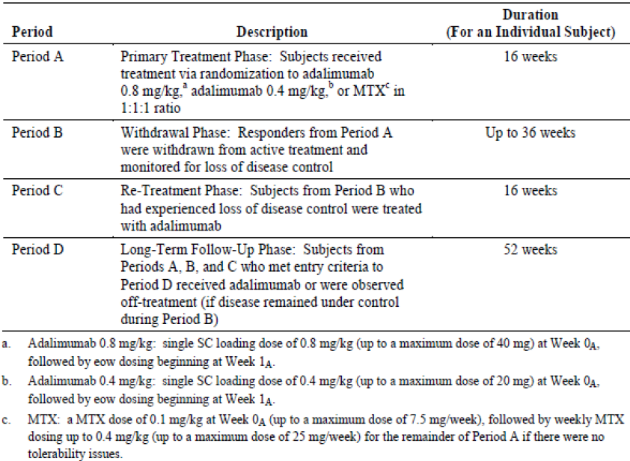
The duration of the screening period was to be a minimum of 72 hours and a maximum of 30 days, during which time all of the inclusion and exclusion criteria were to be evaluated and potential drug washout periods were to be followed. Subjects that initially failed screening were permitted to be re-screened and there was no minimum period of time that a subject had to wait before re-screening. At enrolment, subjects were randomised in a 1:1:1 ratio to receive ADA 0.8 mg/kg, ADA 0.4 mg/kg or MTX. Subjects randomised to ADA (either dose) were to receive a single SC loading dose of 0.8 or 0.4 mg/kg (up to a maximum dose of 40 mg) at baseline followed by a dose every fortnight starting at Week 1. Subjects randomised to MTX were to receive an oral loading dose of MTX 0.1 mg/kg (up to a maximum dose of 7.5 mg) followed by a weekly maintenance dose of oral MTX of 0.4 mg/kg (up to a maximum of 25 mg/week, unless tolerability issues arose). The active treatment period was of 16 weeks duration. There was an option for EE at Weeks 4 and 8 for subjects who either experienced a worsening of their disease. Worsening of PSOR at Week 4 was defined as an increase in Psoriasis Area and Severity Index (PASI) score of 50% compared to baseline. Worsening of PSOR at Week 8 was defined as ≥ 25% increase from baseline in PASI score and by at least 4 points at each of 2 consecutive study visits prior to or at Week 8. Subjects who met either of the EE criteria were permitted to enter Period D at the time that the criterion was met. Upon entry into Period D, all subjects were to receive OL ADA at a dose of 0.8 mg/kg fortnightly (up to a maximum single dose of 40 mg). Study visits during Period A were scheduled to occur at baseline, Weeks 1, 4, 8, 11 and 16. The study visit window was ±3 days for the blinded period.
During Period B (treatment withdrawal phase), responders from Period A were to be withdrawn from active therapy and monitored for loss of disease control (that is, worsening of PGA [Physician’s Global Assessment of Psoriasis] in comparison to Week 16 by at least 2 grades). Subjects who experienced a loss of disease control were to enter the re-treatment phase (Period C) at the time point when loss of disease control was noted. Subjects who did not experience a loss of disease control were to continue until the end of Period B (Week 36 visit). These subjects were to enter Period D (long-term, follow-up phase) following the Week 36 visit, where they were to continue to be observed off study medication. Subjects who did not experience a loss of disease control in Period B, but subsequently experienced a loss of disease control during Period D, were eligible to receive ADA until the end of Period D (Week 52 visit). All relapsing subjects originally randomised to MTX were to receive ADA 0.8 mg/kg in Period C, and subjects originally randomised to ADA who relapsed were to receive re-treatment with ADA according to their original dose assignment (that is, 0.4 or 0.8 mg/kg) in Period C. Study visits during Period B were scheduled to occur every 4 weeks. Study visits during Period C were identical to Period A and scheduled to occur at baseline, Weeks 1, 4, 8, 11 and 16. Study visits during Period D were scheduled to occur at Weeks 1, 4, 8, 11, 16, 20, 28, 40 and 52 (or upon early termination). The study visit window was ±7 days for Periods B-D.
The first patient visit in Study M04-717 occurred in December 2010 and the last subject completing their week 16 assessment visit in Period C took place in December 2013. The trial was conducted at 38 study sites in Belgium, Canada, Chile, Czech Republic, Germany, Hungary, Italy, Mexico, Poland, Netherlands, Spain, Switzerland and Turkey. The main objectives of Study M04-717 are to evaluate the efficacy and safety of 2 doses of ADA compared to MTX in children and adolescents with severe PSOR, to determine the time to loss of disease control and the ability to regain response upon re-treatment with ADA.
The original study protocol was amended on 3 occasions. No subjects were enrolled under the original protocol, 27 subjects were enrolled under the first amendment, 87 subjects were enrolled under the second amendment and no subjects were enrolled under the third amendment. The first trial amendment clarified minor inconsistencies in the protocol relating to study procedures and activities. The second protocol amendment clarified minor inconsistencies in the inclusion and exclusion criteria as well as safety related screening tests (for example, for assessment of latent tuberculosis and Hepatitis B virus). The third amendment updated and added safety monitoring information in relation to the occurrence of malignancy in patients exposed to anti-TNF therapy. None of the protocol amendments altered the study’s overall integrity.

Inclusion and exclusion criteria
To be eligible for inclusion, patients had to be at least 4 years of age and no older than 18 years of age with a diagnosis of PSOR for at least 6 months prior to the first administration of study medication. Subjects were required to have a weight of at least 13 kg at baseline and their PSOR had to be stable for at least 2 months as well (that is, stable PSOR in the short-term with no recent escalation of therapy).
Patients were to have failed topical therapy; failed to respond, be intolerant or contra-indicated to heliotherapy (if < 12 years) or phototherapy (if ≥ 12 years) as well as be candidates for systemic treatment with at least 1 of the following:
- PGA score of ≥ 4,
- Body Surface Area (BSA) involvement > 20%,
- Very thick PSOR lesions with BSA > 10%,
- PASI score > 20, or
- PASI score > 10 and at least 1 of the following: active psoriatic arthritis unresponsive to NSAID; clinically relevant facial, genital or hand/foot involvement; or CDLQI score > 10.
Concomitant NSAID (27.2%; 31/114) and paracetamol use (37.7%; 43/114) were permitted at baseline and during the study, but no concurrent systemic therapies for PSOR were allowed.
The exclusion criteria involved 3 domains and patients meeting any 1 of the criterion were excluded:
- Co-morbidities; infection requiring antibiotics within 14-30 days (oral or intravenous); history of recurrent infection, demyelinating disease, cardiac failure; active tuberculosis and any history of malignancy;
- Baseline laboratory results; serum creatinine > 1.6 mg/dL, total serum bilirubin ≥ 3 mg/dL, ALT or AST > 1.75 ULN and positive hepatitis B surface antigen, hepatitis B core antibody, hepatitis C virus or positive HIV serology;
- Past treatments; prior treatment with any biological therapy apart from etanercept (and etanercept was to be ceased at least 4 weeks prior to baseline), topical treatments or phototherapy for PSOR within 7 days of the baseline visit, and live vaccines within 90 days of baseline visit.

Study treatments

Period A
Subjects who met enrolment criteria were randomised equally to 1 of 3 possible treatment groups: ADA 0.8 mg/kg (up to a maximum of 40 mg per dose), ADA 0.4 mg/kg (up to a maximum of 20 mg per dose) or MTX. Subjects randomised to ADA were to receive a single SC loading dose at baseline (Week 0), followed by another dose at week 1 and thereafter every fortnight (from Week 3 through to Week 15). To maintain blinding in Period A, subjects randomised to ADA were also to receive a weekly dosing of PBO tablets. ADA (and matching PBO injections) was provided as a preservative-free, sterile solution contained in 0.8 mL single-use vials containing either 20 mg/0.8 mL or 40mg/0.8 mL (depending on which ADA treatment arm the subject was allocated). After the baseline visit, ADA was to be given SC by either the subject themselves, parent or legal guardian or a qualified designee. Between Weeks 3 and 15, SC injections were to be given at home unless the injection coincided with a scheduled visit assessment.
The baseline measurement of the subject's weight was used to determine the subject's dose of ADA at baseline (Week 0). Thereafter ADA dosing was adjusted up and down according to the patient’s weight obtained at each corresponding visit. The following doses of ADA were selected based on the subject's weight: 10 mg for 13-16 kg, 15 mg for 17-22 kg, 20 mg for 23-28 kg, 25 mg for 29-34 kg, 30 mg for 35-40 kg, 35 mg for 41-46 kg and 40 mg for ≥ 47 kg.
Subjects randomised to MTX were to receive the following oral doses of MTX: 0.1 mg/kg at baseline (Week 0) and thereafter up to 0.4 mg/kg (maximum weekly dose of 25 mg) for the duration of Period A as long as they did not have tolerability issues. To maintain blinding in Period A, subjects randomised to MTX were also to receive a weekly dosing of PBO SC injections at Week 0 and 1, followed by fortnightly PBO injections between Weeks 3 and 15. MTX or matching PBO tablets for oral administration were supplied in bottles as 2.5 mg and 10 mg tablets. All subjects were required to take folic acid 0.8-1.0 mg/day for 6 days/week (on every day except the day of taking MTX or PBO tablets).

Period C
Subjects who experienced a loss of PSOR control in Period B were to enter Period C for re-treatment. Subjects who were originally randomised to ADA in Period A were to receive blinded re-treatment with the same dose of ADA (0.4 or 0.8 mg/kg). Subjects who were originally randomised to MTX in Period A were to receive re-treatment with ADA 0.8 mg/kg, but were to be blinded to the actual dose of ADA. The same injection schedule and dose calculations were applied in Period C as described for Period A.

Period D
In the long-term follow-up phase, ADA was to be administered as either 0.8 mg/kg (up to a maximum of 40 mg per dose) or 0.4 mg/kg (up to a maximum of 20 mg per dose). Subjects who entered Period D from Period A were to receive OL fortnightly injections of ADA 0.8 mg/kg (up to a maximum of 40 mg per dose). Subjects who entered Period D from Period C were to receive blinded fortnightly injections of ADA at the same dose they received in Period C (either 0.4 or 0.8 mg/kg). Subjects entering from Period C who developed a loss of disease control in Period D were to receive OL ADA at a fortnightly dose of 0.8 mg/kg (up to a maximum of 40 mg per dose). The ADA dose schedule in Period D involved fortnightly injections commencing at baseline (Week 0) and continuing up to and including week 50. There was no ADA injection at the Week 52 visit.

Efficacy variables and outcomes
The main efficacy variables were:
- Psoriasis Area and Severity Index (PASI),
- Physician’s Global Assessment (PGA) of Psoriasis, and
- Quality of Life (QOL) indices: 1 specific to paediatric Psoriasis (CDLQI) and 1 generic (PedsQL).
The Psoriasis Area and Severity Index (PASI) is an assessment of 4 anatomic sites (head, upper extremities, trunk, and lower extremities) for erythema, induration, and desquamation using a scale of zero (the best evaluation, no symptoms) to four (the worst evaluation, very marked). The extent of lesions in a given area is assigned a numerical value from one (< 10%) to six (90-100%). The PASI score is then calculated from a weighted average based on the % of body surface area (BSA) of the anatomic site (head, 10%; upper extremities, 20%; trunk, 30%; and lower extremities, 40%). The PASI score has a range from 0 (no disease) to 72 (maximal disease), and responses can be based on at least 50%, 75%, 90% and 100% improvement in scores from baseline. The PASI 50 response is generally considered the minimal clinically important difference.
The Physician’s Global Assessment (PGA) of PSOR is another widely used tool to evaluate PSOR in clinical trials. In its typical format (as used in Study M04-717), it has a 7-point scale ranging from clear (=0) and almost clear (=1) to severe (=6). There are also the categories of mild (=2), mild to moderate (=3), moderate (=4) and moderate to severe (=5). With the PGA, the individual elements of PSOR plaque morphology or the degree of BSA involvement are not quantified. Although the PGA has the advantage of evaluating PSOR severity in a more intuitive way than the 0 to 72 PASI score, it presents different limitations, including it does not discriminate small changes and the tool has limited inter-rater reliability. In Study M04-717, each site was to make every attempt to have the same individual conduct the PGA assessments throughout Period A for each subject.
The Children’s Dermatology Life Quality Index (CDLQI) is a validated way for assessing QOL related to PSOR in paediatric patients. Like the adult version, the children’s specific tool consists of 10 questions covering 6 domains (symptoms and feelings, daily activities, leisure, school, personal relationships and trouble with PSOR treatment). The response options for each question range from 0 (not affected at all) to 3 (very much affected). This gives an overall score range of 0–30 and a lower score means a better QOL. The reliability, construct validity and sensitivity to change of the CDLQI have all been demonstrated in paediatric patients with PSOR. In Study M04-717 subjects aged from 4 to 12 years were to complete the written version of the CDLQI questionnaire with a parent or legal guardian assistance and adolescents aged 13 to 17 years were to complete the written version of the CDLQI questionnaire independently. Whenever possible, the CDLQI questionnaire was to be completed before any other study-related procedures were performed.
The Paediatric Quality of Life Inventory (PedsQL) is a generic health assessment questionnaire intended to measure general health concepts in children and adolescents. This instrument has been validated in paediatric patients with PSOR. It contains 23 items assessed through 4 health domains: physical functioning (8 questions), emotional functioning (5 questions), social functioning (5 questions) and school functioning (5 questions). It also can be subdivided into 2 summary scores, the Physical Health Summary Score (8 questions) and the Psychosocial Health Summary Score. The total PedsQL score has a range of 0-100 with a higher score indicating better QOL.
The primary efficacy outcomes of Study M04-717 (in the a priori defined order of the statistical hypothesis testing) were the proportion of subjects receiving ADA 0.8 mg/kg versus MTX achieving ≥ PASI 75 response at Week 16 and the proportion of subjects receiving ADA 0.8 mg/kg versus MTX achieving a PGA of "cleared" or "minimal" (that is, score of 0 or 1) at Week 16. The TGA adopted guideline of relevance (that is, CHMP/EWP/2454/2004 “Guideline on Clinical Investigation of Medicinal Products for the Treatment of Psoriasis”) strongly recommends that 2 endpoints are used in determining efficacy. In particular, the guideline states that a validated global score such as the PGA should be used in conjunction with PASI assessment to evaluate efficacy. The sponsor has met this recommendation of efficacy endpoint assessment in Study M04-717.
The following secondary efficacy outcomes were evaluated as per the following ranking order:
- Proportion of subjects achieving a PASI 90 response at Week 16 (ADA 0.8 mg/kg versus MTX),
- Proportion of subjects achieving a PASI 100 response at Week 16 (ADA 0.8 mg/kg versus MTX),
- Change from baseline in the CDLQI scores at Week 16 (ADA 0.8 mg/kg versus MTX),
- Change from baseline in the PedsQL scores at Week 16 (ADA 0.8 mg/kg versus MTX),
- Proportion of subjects achieving PGA of "cleared" or "minimal" (that is, score of 0 or 1) upon completion of re-treatment in Period C, according to their original randomised group assignment in Period A (ADA 0.8 mg/kg versus ADA 0.4 mg/kg), and
- Time to loss of disease control (Period B), according to the original randomised group assignment in Period A (ADA 0.8 mg/kg versus ADA 0.4 mg/kg and MTX).
Other efficacy outcomes of clinical relevance and/or included in the proposed PI included:
- Proportion of subjects achieving PASI response (50, 75 and 90) by Study Period and Visit,
- Proportion of subjects achieving PGA response (score of 0 or 1) by Study Period and Visit,
- Mean change from baseline to week 52 of Period D in the CDLQI and PedsQL scores, and
- Proportion of subjects achieving Minimal Clinically Important Difference (MCID) change from baseline in the CDLQI and PedsQL scores at Week 16 of Period A.

Randomisation and blinding methods
At baseline, all eligible patients were randomised 1:1:1 via interactive response technology (phone or web based) to 1 of the 3 treatment arms. Randomisation at baseline was stratified by past exposure to etanercept and was performed using an adequate block size. However, due to the expected small number of subjects to be enrolled in each centre, randomisation was not stratified by study site.
In Period C (16 week re-treatment phase), subjects who experienced a loss of PSOR control in Period B (withdrawal phase) were re-treated with ADA. Subjects initially randomised to ADA in Period A were to receive re-treatment according to their initial ADA dose assignment (0.4 or 0.8 mg/kg). Subjects who were initially randomised to MTX in Period A were to receive ADA 0.8 mg/kg in Period C. All subjects treated in Period C were blinded to their treatment allocation.
Patients and investigator staff remained blinded to the identity of study treatment from the time of subject randomisation until the last subject completed their week 16 visit in Period A. In Period D of Study M04-717, all continuing patients received OL treatment with ADA.

Analysis populations
All efficacy analyses were to be based on the ITT population, which included all randomised subjects.. In order to evaluate the impact of major protocol deviations (in particular, those deviations with the potential to impact on the primary efficacy endpoint), a sensitivity analysis of the primary and ranked secondary efficacy endpoints was conducted using the PP population, which consists of subjects in the ITT analysis set after excluding those subjects with recorded major protocol deviations.

Sample size
Study M04-717 planned to enrol a total of 111 subjects (37 subjects in each treatment group). The trial was estimated to provide 90% power for the comparison of ADA 0.8 mg/kg versus MTX in the PASI 75 response rate and 80% power for the comparison of ADA 0.8 mg/kg versus MTX in the PGA response rate. Randomisation was stratified by prior exposure to etanercept.
The following assumptions were made for subjects without a history of prior etanercept exposure. The Week 16 PASI 75 response rate was predicted to be 72% in the ADA 0.8 mg/kg group and 35% in the MTX arm. The Week 16 PGA response of cleared or minimal disease (score of 0-1) was estimated to be 62% in the ADA 0.8 mg/kg group and 30% in the MTX arm. For subjects with a history of prior etanercept exposure, all response rates were predicted to be 10 percentage points lower (for example, Week 16 PASI 75 response of 62% in the ADA 0.8 mg/kg group). With a prevalence of 30% of subjects with past exposure to etanercept, the overall Week 16 PASI 75 response rate was predicted to be 69% in the ADA 0.8 mg/kg group and 32% in the MTX arm. The adjusted Week 16 PGA response of cleared or minimal disease (score of 0-1) was estimated to be 59% in the ADA 0.8 mg/kg group and 27% in the MTX arm.

Statistical methods
The statistical plan had a strict a priori order of hypothesis testing, which was to be adhered to for confirmatory statistical testing. This involved a step down procedure, whereby the ranked primary endpoints were analysed first (PASI 75 response at Week 16, then PGA response at Week 16 for ADA 0.8 mg/kg versus MTX) followed by the ranked secondary efficacy outcomes analysed in a fixed sequence hierarchical testing order. All statistical tests were to be done at a level of significance of 5% and the overall type I error level was preserved.
The primary analysis of the primary efficacy endpoints was done using chi-square tests at an alpha level of 0.05. A sensitivity analysis of the primary efficacy endpoints was also performed using a Cochran-Mantel-Haenszel test stratified for prior etanercept use. For the comparison of treatment related differences in the ranked secondary efficacy endpoints, a chi-square test or Fisher’s exact test (if expected cell count was < 5) was used for discrete variables, 1-way ANOVA was used for continuous endpoints and a log-rank test was used for the time to event variables.
In the efficacy analyses, missing or incomplete data was primarily handled using the LOCF method for continuous variables and NRI for dichotomous variables. Subjects who did not have a PGA or PASI assessment at Week 16 in Period A were to be imputed as non-responders in the primary analysis. Subjects that escaped early from Period A to OL therapy with ADA in Period D were also to be imputed as non-responders for the primary efficacy endpoints.

Participant flow
A total of 114 subjects were randomised into Study M04-717 and all received at least 1 dose of study medication: 39 in the ADA 0.4 mg/kg group, 38 in the ADA 0.8 mg/kg arm and 37 in the MTX group. Figure 7 provides a summary of the participant flow in Study M04-717. At the date of data cut-off for the submitted interim study report (2 December 2013), 69 of the 114 subjects (60.5%) had completed the trial through to the end of Period D, 21 patients were ongoing in Period D and a total of 24 subjects had discontinued from the study (including 18 patients who withdrew during Period D). There was a higher rate of discontinuation in the 2 ADA treatment groups (33.3% [13/39] in the 0.4 mg/kg arm and 21.1% [8/38] in the 0.8 mg/kg group) compared to the MTX arm (8.1%; 3/37). Lack of efficacy was the main reason for discontinuation and this was recorded in 9 patients in the ADA 0.4 mg/kg group, 3 subjects in the ADA 0.8 mg/kg arm and 1 patient in the MTX group. Another 3 subjects (1 in each treatment group) ceased study medication due to other recorded terms indicating lack of efficacy such as inadequate response and loss of disease control. Two patients randomised to ADA 0.8 mg/kg ceased study medication due to pregnancy and 2 other subjects discontinued due to adverse events (1 subject in the ADA 0.4 mg/kg group due to flare of PSOR [that is, lack of efficacy] and 1 MTX treated patient due to urticaria). The other 4 patients who prematurely discontinued were reported to have either withdrawn consent (n=3) or were lost to follow-up (n=1).
Figure 7: Subject Disposition in Study M04-717 in Period A through to Period D
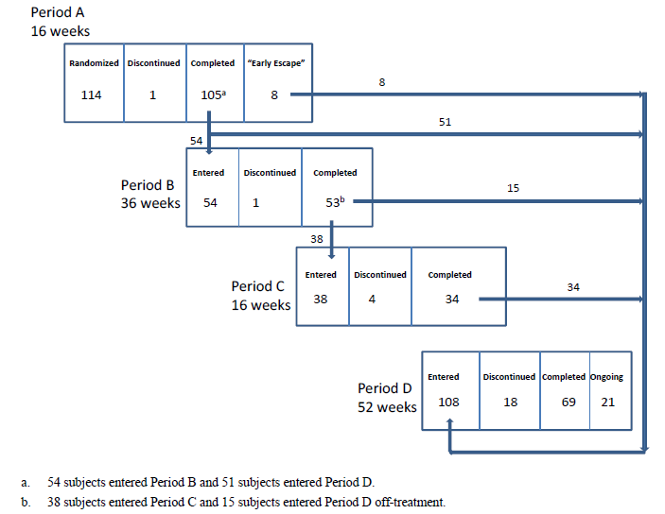

Major protocol violations/deviations
A total of 11 subjects (6 in the ADA 0.4 mg/kg group, 3 in the ADA 0.8 mg/kg arm and 2 in the MTX group) were judged to have experienced major protocol deviations with the potential to impact on efficacy endpoints and as such were excluded from the PP analysis set. The PP population was comprised of 103 subjects in total: 33 in the ADA 0.4 mg/kg group, 35 in the ADA 0.8 mg/kg arm and 35 in the MTX group. Three subjects (1 in each group) were excluded from the PP dataset because they received prohibited concomitant therapy (2 received topical CS and 1 received live varicella zoster vaccine without incident).
In the ITT population, a total of 7 patients (3 in each ADA group and 1 in the MTX arm) failed to meet the inclusion or exclusion criteria of the trial. The most commonly reported criteria deviation was positive serology for Hepatitis B virus (surface antigen positive or positive HBV-DNA PCR test) at baseline. Furthermore, a total of 16 patients in the ITT population (8 in the ADA 0.4 mg/kg group, 3 in the ADA 0.8 mg/kg arm and 5 in the MTX group) received at least 1 wrong treatment or incorrect dose of study treatment. This included 1 case of MTX overdose, whereby a subject received a MTX dose of 18.75 mg at Week 1 versus the protocol recommended dose of 7.5 mg. This patient experienced the AEs of abdominal pain and somnolence and escaped early (at Week 4) to Period D. In addition, 2 subjects received lower doses of study treatment (1 subject in the ADA 0.4 mg/kg group and 1 patient in the MTX arm). Another 5 subjects were incorrectly classified as responders in Period A and then subsequently entered treatment withdrawal in Period B, instead of progressing straight to Period D.

Baseline data
The 3 treatment groups were well matched for baseline demographic features in Study M04-717. The overall mean age of the cohort was 13.0 years with 6 patients (5.3% of 114) aged 4-6 years (all of whom received ADA 0.4 mg/kg), 19 subjects (16.7% of 114) aged > 6 to 9 years, 21 patients (18.4% of 114) aged > 9 to 12 years, 31 subjects (27.2% of 114) aged > 12 to 15 years and 37 subjects (32.5% of 114) aged > 15 years. The youngest subject randomised to ADA 0.8 mg/kg was 6 years of age at enrolment. As expected, the majority of patients were of Caucasian ethnicity (90.4%; 103/114) and there were slightly more female subjects (57.0%; 65/114) than male subjects. More than half the patients in the trial (59.6%; 68/114) had a BMI in the 5th to 85th percentile of the age and gender specific WHO BMI charts. The 2 countries with the highest number of enrolled subjects (n=28 for both countries) were Canada and Poland followed by Germany (n=11), Spain (n=10) and Hungary (n=8). All other enrolling countries recruited 1-6 subjects each.
There were no significant differences between the 3 treatment groups regarding baseline disease characteristics. Subjects reported a mean duration of PSOR of 5.0 years (median 4.4 years) and almost one third of subjects (32.7%; 37/114) had a family history of PSOR. Only 1 subject (in the ADA 0.4 mg/kg group) had associated psoriatic arthritis, which was active at baseline.
There were no statistically significant differences between the 3 treatment groups at baseline for PSOR disease activity; refer to Table 18. In general, patients had severe plaque PSOR at baseline with the mean PASI score being 18.3 (median 16.1), mean BSA affected by PSOR being 27.9% (median 21.0%) and most subjects had either a PGA score of moderate (47.4%; 54/114) or marked (43.0%; 49/114). The heath related QOL measures were also significantly impaired at baseline with the mean CDLQI score being 11.3 and the mean PedsQL score being 73.1.

Table 18: Baseline Disease Measures in Study M04-717 (ITT Population)
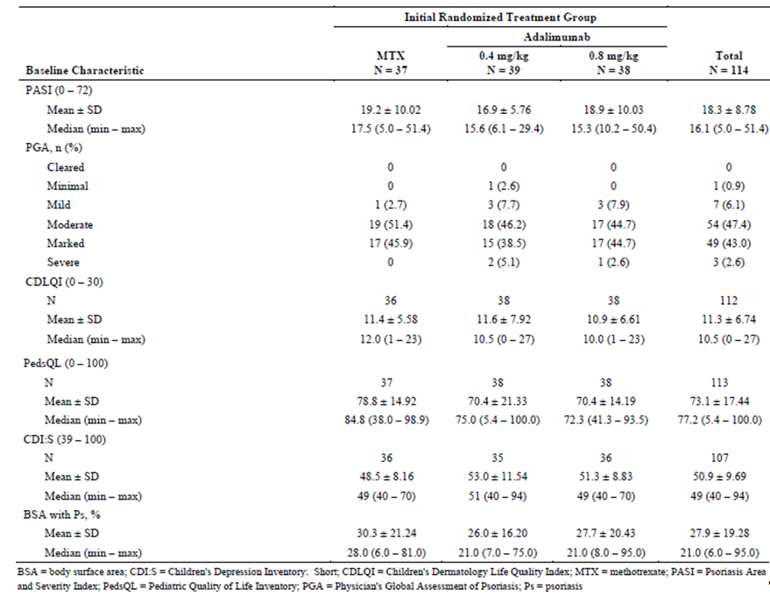
Prior to the study, only 9.6% (11/114) of all subjects had previously received etanercept (4 subjects in each ADA treatment group and 3 patients in the MTX arm). Less than one third of all subjects (29.8%; 34/114) had received at least 1 prior systemic non-biological therapy for PSOR: 13.2% (15/114) had received acitretin, 13.2% (15/114) had prior cyclosporine and only 5.3% (6/114) had previously received MTX. Just over half of all subjects (51.8%; 59/114) had previously received phototherapy and all subjects had previously used topical treatment for PSOR, including 44.7% (51/114) using vitamin D analogue, 44.7% (51/114) using prior high potency topical CS and 43.9% (50/114) trying mid potency topical CS. There were no significant differences between the 3 treatment groups for prior PSOR therapy apart from a higher proportion of subjects randomised to ADA 0.8 mg/kg receiving either etanercept or systemic non-biological therapy compared to the 2 other treatment groups (44.7% versus 27.0-32.4%). Three subjects (1 in the ADA 0.8 mg/kg group and 2 in the ADA 0.4 mg/kg arm) tested positive for latent tuberculosis at baseline and were enrolled into the study under TB prophylaxis guidelines (that is, concomitant use of isoniazid for prophylaxis).

Results for the primary efficacy outcome
At Week 16 (using the ITT dataset and NRI method), a statistically greater proportion of subjects in the ADA 0.8 mg/kg group (57.9%; 22/38) achieved PASI 75 response compared with subjects in the MTX treatment arm (32.4%; 12/37). The 25.5% treatment related difference between ADA 0.8 mg/kg and MTX was clinically significant and had a p-value of 0.027 (chi-square test). The rate of PASI 75 response at Week 16 in the ADA 0.4 mg/kg group was 43.6% (17/39). The 16 week PASI 75 response rates were not statistically different between the 2 ADA dose groups.
The PASI 75 results using the PP dataset and NRI method were of similar magnitude as the primary analysis, but did not reach statistical significance. At Week 16 (using the PP dataset and NRI), a numerically greater proportion of subjects in the ADA 0.8 mg/kg group (57.1%; 20/35) achieved PASI 75 response compared with subjects in the MTX treatment arm (34.3%; 12/35). The 22.8% treatment related difference between ADA 0.8 mg/kg and MTX was clinically significant but had a non-significant p-value of 0.055 (chi-square test). The rate of PASI 75 response at Week 16 in the ADA 0.4 mg/kg group using the PP dataset was 42.4% (14/33). A total of 8 subjects (4 in the MTX group, 3 in the ADA 0.4 mg/kg arm and 1 in the ADA 0.8 mg/kg group) had an imputed non-responder result at Week 16.
Although the Week 16 rates of PGA 0-1 response (cleared or minimal) in the ITT population using NRI were numerically higher (20% treatment related difference) in the ADA 0.8 mg/kg group (60.5%; 23/38) compared with the MTX arm (40.5%; 15/37), this did not reach statistical significance (p=0.083). The rate of PGA 0-1 response at Week 16 in the ADA 0.4 mg/kg group was 41.0% (16/39). The sponsor has provided post hoc analyses of the Week 16 PGA response data to indicate that if 1 additional subject in the ADA 0.8 mg/kg group achieved this outcome or 1 less subject in the MTX arm failed to achieve PGA response then the pair-wise comparison between ADA 0.8 mg/kg and MTX would reach statistical significance (p< 0.05). Furthermore, the sponsor asserts that a higher proportion of subjects in the ADA 0.8 mg/kg arm had either prior exposure to etanercept or systemic non-biological therapy compared to the MTX group (44.7% versus 27.0%, respectively). The post-hoc observations are suggestive of a clinically significant treatment related difference for ADA 0.8 mg/kg versus MTX, but should be interpreted with caution and not relied upon as a scientifically robust finding from Study M04-717.
Subgroup analyses of the primary efficacy outcomes by various factors were also conducted. The factors included subject age (4-6 years, > 6-9 years, > 9-12 years, > 12-15 years and > 15 years), gender, race (White versus non-White), subject weight (< 50 kg versus > 50 kg) and body mass index (underweight < 5th percentile, healthy weight 5th-85th percentile, overweight 85th-95th percentile and obese > 95th percentile). Many of the subgroups were too small to make meaningful conclusions regarding differences in treatment response (ADA 0.8 mg/kg versus MTX); however, 2 potential trends were noteworthy. Older subjects (> 15 years of age) showed a greater treatment related difference with ADA versus MTX (both the week 16 PASI 75 and PGA responses were 6/10 in the ADA group versus 2/13 in the MTX arm). Overweight subjects showed a greater treatment related difference with ADA versus MTX (for example, the Week 16 PASI 75 response was 5/7 for ADA versus 0/6 for MTX) than any other weight category of patients (approximately 20% treatment related difference in favour of ADA versus MTX).
In addition, sensitivity analyses of both primary efficacy endpoints were performed using stratification by prior etanercept use and then an adjustment for prior systemic non-biological or etanercept treatments. Only very small numbers of subjects in the ADA 0.8 mg/kg (n=4) and MTX (n=3) groups had a history of prior etanercept use. This did not reveal any significant differences in treatment response according to prior use of etanercept. The 16 week rates of PASI 75 response among those randomised to ADA 0.8 mg/kg were 50.0% (2/4) in the etanercept experienced subjects compared with 58.8% (20/34) in the etanercept naïve subgroup. The 16 week rates of PGA response among those randomised to ADA 0.8 mg/kg were 75.0% (3/4) in the etanercept experienced subjects compared with 58.8% (20/34) in the etanercept naïve subgroup. In the 3 MTX treated subjects with a past history of etanercept exposure the rates of PASI 75 and PGA response were both 33.3% (1/3). The sponsor has also provided a post-hoc sensitivity analysis of the primary efficacy endpoints adjusted for a past history of exposure to either systemic non-biological treatment or etanercept use. Despite small patient numbers, a relatively low percentage (10-20%) of MTX treated subjects with past systemic drug exposure achieved PASI 75 or PGA response compared to 52.9% (9/17) of patients randomised to ADA 0.8 mg/kg; refer to Table 19.

Table 19: Proportion of Subjects with PASI 75 and PGA Response at Week 16 in Study M04-717 adjusted for prior systemic non-biological treatment or etanercept use
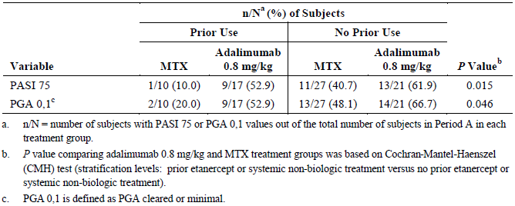

Results for other efficacy outcomes

Ranked Secondary Efficacy Outcomes
Because the second ranked primary efficacy endpoint of PGA response at Week 16 for ADA 0.8 mg/kg versus MTX did not achieve statistical significance, none of the secondary ranked efficacy variables can be considered as confirmatory.

PASI 90 and PASI 100 Responses at Week 16
Analysing the ITT dataset using NRI, the rates of PASI 90 or PASI 100 response at Week 16 were numerically higher with ADA 0.8 mg/kg versus MTX (treatment related difference of 7.3% for PASI 90 and 15.7% for PASI 100 response), but neither of the pair-wise treatment comparisons reached statistical significance; refer to Table 20. For the ADA 0.4 mg/kg group, the Week 16 rate of PASI 90 response was numerically higher than ADA 0.8 mg/kg by almost 2%, but the comparative rate of PASI 100 response was 8.1% lower.

Table 20: Proportion of Subjects with PASI 90 and PASI 100 Response at Week 16 in Study M04-717
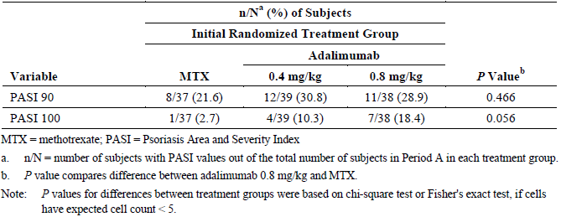

Change from baseline in CDLQI Scores at week 16
For subjects in the ADA 0.8 mg/kg group there was a greater mean decrease (improvement) in CDLQI score from baseline to Week 16 compared to those randomised to MTX (-6.6 versus -5.0, respectively, using LOCF in the ITT population), however, the difference was not statistically significant (p=0.304); refer to Table 21. The ADA 0.4 mg/kg group showed a mean decrease (improvement) of 4.9 from baseline (11.6) to Week 16 (6.7) in the CDLQI score.

Table 21: Mean Change from Baseline to Week 16 in CDLQI Score in Period A of Study M04-717
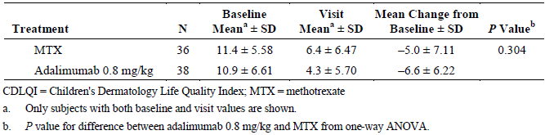

Change from Baseline in PedsQL Scores at Week 16
A statistically greater mean increase (improvement) from baseline in PedsQL score was observed for those randomised to ADA 0.8 mg/kg compared to those in the MTX group (10.8 versus 1.9, respectively, p=0.005; using LOCF in the ITT population); refer to Table 22. The ADA 0.4 mg/kg group showed a mean improvement of 9.5 from baseline (70.4) to week 16 (79.8) in the PedsQL.

Table 22: Mean Change from Baseline to Week 16 in PedsQL Score in Period A of Study M04-717
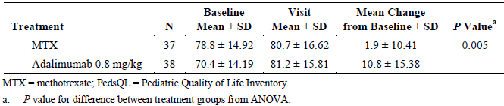

PGA response upon re-treatment in period C
Using the ITT cohort and NRI, 52.6% (10/19) of subjects initially randomised to ADA 0.8 mg/kg regained a PGA score of 0-1 at Week 16 in Period C (that is, upon re-treatment with ADA 0.8 mg/kg). This was numerically higher than that observed with re-treatment with ADA 0.4 mg/kg (27.3%; 3/11), but the 28.3% difference in PGA response between the 2 ADA treatment groups did not reach statistical significance (p=0.113); refer to Table 23. A high proportion of subjects initially randomised to MTX, achieved PGA response at Week 16 in Period C (62.5%; 5/8) as this group of subjects were re-treated with ADA 0.8 mg/kg in Period C.

Table 23: Proportion of Subjects with PGA Response (0, 1) at Week 16 in Period C of Study M04-717
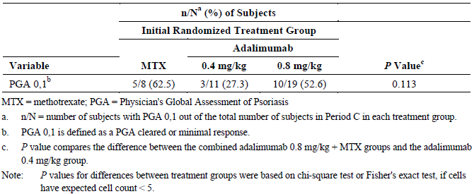

Time to loss of disease control in period B
Loss of disease control was defined as a worsening of PGA score by at least 2 grades after treatment withdrawal (that is, after Week 16 of Period A). Using observed data in the ITT population, the median time to loss of disease control was numerically shorter for subjects randomised to ADA 0.8 mg/kg (118 days) compared to those treated with ADA 0.4 mg/kg (217 days) but this outcome did not reach statistical significance (p=0.204); refer to Table 24. Furthermore, 9 patients in the MTX group (n=13) had a median time to loss of disease control of 184 days, which was also numerically longer than the ADA 0.8 mg/kg group (HR 1.58 [95% CI 0.70, 3.54]; p=0.262). A total of 6 subjects (3 in the ADA 0.4 mg/kg group, 2 in the ADA 0.8 mg/kg arm and 1 in the MTX group) mistakenly entered into Period B, although they did not qualify as responders at Week 16 of Period A. No subject in the study met the criteria of PSOR rebound, defined as a PASI score ≥ 125% of baseline PASI within 90 days of treatment discontinuation.

Table 24: Median Time to Loss of Disease Control Following Treatment Withdrawal in Period B
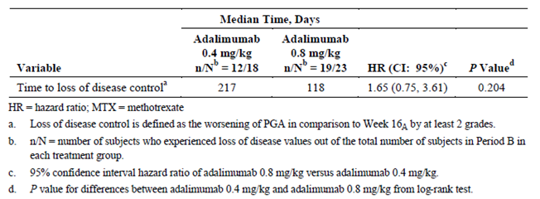

Other efficacy outcomes of clinical significance and/or included in the proposed PI
Although all of the supporting efficacy variables assessing PSOR disease activity and health related QOL were numerically greater with ADA 0.8 mg/kg versus MTX in the initial 16week, double-blind Period A, none reached statistical significance apart from the mean change from baseline in PedsQL score. However, the data collected in Periods C and D (up to Week 52) showed that continued treatment with ADA 0.8 mg/kg resulted in sustained improvements in PSOR, and for MTX subjects who switched to ADA 0.8 mg/kg therapy they achieved improvements in disease activity similar to that observed with ADA 0.8 mg/kg in Period A.

PASI response by period and visit up to week 52 in period D
During Period A of Study M04-717 (using the ITT population and NRI), the rates of PASI 50 response were 20-36% higher in the ADA 0.8 mg/kg group compared to the MTX arm and the rates of PASI 75 response were 24-39% higher in the ADA 0.8 mg/kg group versus MTX; refer to Table 25. The treatment related differences were statistically significant at Weeks 4, 8, 11 (PASI 75 response only) and 16. In addition, ADA 0.8 mg/kg showed a statistically higher rate of PASI 90 response at Weeks 8 and 11 (21-26% higher) in Period A compared to MTX. The data observed in Period C shows that ≥ 75% of patients treated with ADA 0.8 mg/kg (that is, subjects from the original randomised ADA 0.8 mg/kg group and the MTX arm) were able to achieve PASI 75 response by Week 16 (and ≥ 87.5% achieved PASI 50 response by Week 16 in Period C). Moreover, for subjects initially randomised to ADA 0.8 mg/kg, the rates of PASI 50, 75 and 90 response at Week 52 in Period D were similar or slightly higher than that recorded at Week 16 in Period A for the same patient cohort. In the subgroup of subjects originally treated with MTX who were classified as non-responders in Period A and progressed directly to Period D, the majority achieved PASI 75 response with ADA 0.8 mg/kg at Week 16 (89.5%; 17/19) and most sustained this level of response until the end of the study (81.3% [13/16] at Week 52 in Period D).

Table 25: Proportion of Subjects achieving PASI Response by Period and Visit in Study M04-717
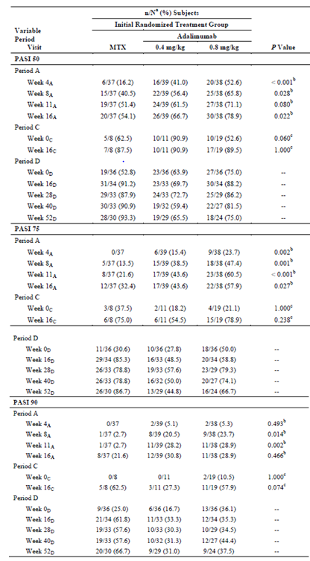

PGA response by period and visit up to week 52 in period D
In Period A (using the ITT population and NRI), the rates of PGA response (that is, score of 0-1) were 20-37% higher in the ADA 0.8 mg/kg group compared to the MTX arm; refer to Table 26. The treatment related differences were statistically significant at Weeks 4, 8 and 11, but not Week 16. In Period C, > 50% of patients treated with ADA 0.8 mg/kg (that is, subjects from the original randomised ADA 0.8 mg/kg group and the MTX arm) were able to achieve PGA response by Week 16. Subjects appeared to retain their PGA response through to at least Week 40 in Period D. In the subgroup of subjects originally treated with MTX who were classified as non-responders in Period A and progressed directly to Period D, the majority achieved PGA response with ADA 0.8 mg/kg at Week 16 (78.9%; 15/19) and most sustained this response until the end of the study (68.8% [11/16] at Week 52 in Period D).

Table 26: Proportion of Subjects achieving PGA Response by Period and Visit in Study M04-717
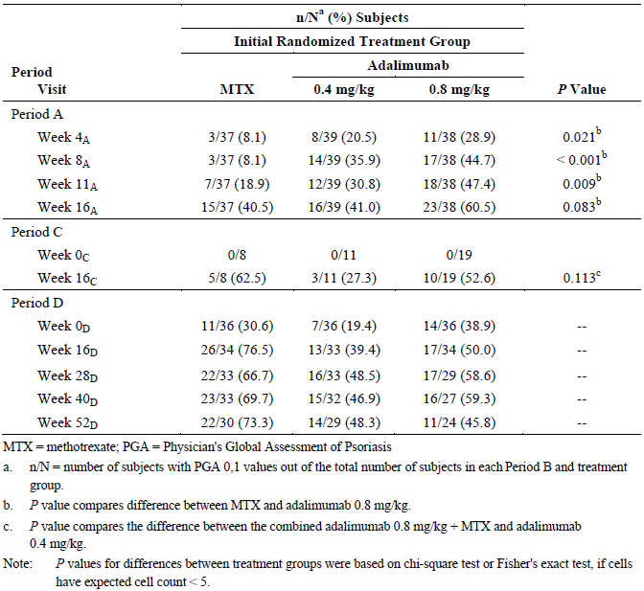

Change from baseline to week 52 of period D in CDLQI and pedsQL scores
The mean improvements in both QOL measures from baseline to Week 16 of Period A seen with ADA 0.8 mg/kg therapy were maintained through to Week 52 of Period D. For subjects originally randomised to ADA 0.8 mg/kg and who continued on this therapy up until Week 52 of Period D (n=24 subjects), the mean improvement from baseline in the CDLQI score was -7.4 (versus -6.6 in Week 16 of Period A) and the mean increase from baseline in the PedsQL score was 11.7 (versus 10.8 in Week 16 of Period A). For subjects originally randomised to MTX and who switched to ADA 0.8 mg/kg therapy (n=29 subjects), the mean improvement from baseline to week 52 of Period D in the CDLQI score was -8.8 (versus -5.0 in Week 16 of Period A) and the mean increase from baseline in the PedsQL score was 8.8 (versus 1.9 in Week 16 of Period A). For subjects originally randomised to ADA 0.4 mg/kg and who continued on this therapy up until Week 52 of Period D (n=28 subjects), the mean improvement from baseline in the CDLQI score was -6.5 (versus -4.9 in Week 16 of Period A) and the mean increase from baseline in the PedsQL score was 15.5 (versus 9.5 in Week 16 of Period A).

MCID responses in CDLQI and pedsQL scores at week 16 of period A
The minimal clinically important difference (MCID) of the CDLQI score in paediatric PSOR is a change from baseline of ≥ 2.5. At Week 16 in Period A (using the ITT dataset and NRI), a slightly higher proportion of subjects treated with ADA 0.8 mg/kg (68.4%; 26/38) achieved the MCID for CDLQI compared to the 2 other treatment groups (59.5% [22/37] for MTX and 59.0% [23/39] for ADA 0.4 mg/kg), but this outcome did not reach statistical significance for the comparison between ADA 0.8 mg/kg and MTX (p=0.419).
The MCID of the PedsQL score in paediatric PSOR is an increase from baseline score of ≥ 4.36. At week 16 in Period A (using the ITT dataset and NRI), a higher proportion of subjects treated with ADA 0.8 mg/kg (60.5%; 23/38) achieved the MCID for PedsQL compared to the 2 other treatment groups (43.2% [16/37] for MTX and 53.8% [21/39] for ADA 0.4 mg/kg) but this outcome did not reach statistical significance for the comparison between ADA 0.8 mg/kg and MTX (p=0.134).

Other efficacy studies
The submission did not contain any non-pivotal efficacy studies in support of the paediatric PSOR application.

Analyses performed across trials (pooled analyses and meta-analyses)
Not applicable as only a single trial was submitted in support of the newly proposed paediatric PSOR treatment application.

Evaluator’s conclusions on efficacy for PSOR children ≥ 4 y o
Paediatric PSOR affects approximately 1 in 1000 children in Australia and 27% of all cases of PSOR onset before the age of 16 years. While treatment options for paediatric patients with PSOR are similar to those available to adults, they are less in number because most treatments approved in adults are not registered for use in children. Low- to mid-potency topical CSs, such as hydrocortisone 0.1% cream, are currently approved for use in patients < 18 years of age. MTX has been used to treat paediatric PSOR, but its efficacy has not been established in well-controlled trials. Etanercept is the only biologic therapy registered in Australia for use in paediatric patients (from 4 years of age) with severe PSOR who are inadequately controlled by or are intolerant to other systemic therapies or phototherapy. As such, there is significant unmet need for additional effective therapies in paediatric PSOR.
In support of the extension of indication of ADA to include the treatment of severe chronic plaque PSOR in children 4-17 years of age, the sponsor has submitted data from a single pivotal Phase III trial (Study M04-717), which is a randomised, double-blind, active-controlled, multicentre trial with up to 4 treatment and/or observation phases. The study recruited a total of 114 paediatric patients (over 22 months at 38 sites) who had failed to respond to topical therapy and/or had a history of inadequate response to or were inappropriate candidates for phototherapy. The pivotal study is ongoing with an interim study report to a minimum of 16 weeks of re-treatment follow-up in continuing subjects in Period C being included in this submission. At the data cut-off date of 2 December 2013, 69 of the 114 subjects (60.5%) had completed the trial through to the end of Period D, 21 patients (18.4%) were ongoing in Period D and a total of 24 subjects (21.1%) had discontinued from the study (including 18 patients [15.8%] who withdrew during Period D).
This submission is seeking an extension of indication in severe PSOR affecting paediatric patients, and in general is consistent with the TGA adopted regulatory guideline pertaining to the requested indication: EMEA guideline CPMP/EWP/438/04 “Guideline on Clinical Investigation of Medicinal Products for the Treatment of Psoriasis” (effective June 2004). In addition, the single pivotal study (M04-717) had a design that met the criteria for single pivotal study applications. For Study M04-717, the choice of clinical (PASI and PGA response) and health related QOL efficacy endpoints were appropriate. Furthermore, a duration of 16 weeks treatment follow-up in Period A (main efficacy period) is justified as there is published data that in subjects with moderate to severe PSOR, the maximal rate of PASI 75 response is seen in MTX treated patients by 16 weeks and longer treatment follow-up (up to 52 weeks) does not result in higher rates of PASI 75 response.
The pre-specified statistical analysis plan was also correctly performed. However, the statistical analysis plan was adjusted post hoc to demonstrate statistical significance in favour of ADA as the primary statistical analysis was observed to be insufficient for demonstrating superiority with ADA 0.8 mg/kg therapy (versus MTX) in achieving many of the efficacy endpoints apart from the first ranked primary endpoint of PASI 75 response at 16 weeks. This is a deficiency of the current submission for the additional claim of improving the signs and symptoms of severe PSOR in paediatric patients.
The baseline demographic and disease related characteristics of patients in Study M04-717 are similar to those in the anticipated Australian patient cohort, and therefore generalisation of these results to the Australian context is expected. However, there are some caveats to the generalisability of the treatment population. For example, Study M04-717 excluded patients who had a significant risk of infection (recent or recurrent), history of any malignancy or who had various abnormal laboratory results at baseline (for example, abnormal liver function tests). The pivotal trial enrolled patients aged between 4 and 17 years (with a minimum weight of 13 kg) with severe chronic plaque PSOR of at least 6 months duration, and their PSOR had to be stable in severity for at least 2 months prior to study entry. In addition, subjects were required to have either failed to respond to topical therapy and have either inadequate response, be intolerant or contra-indicated to helio- or phototherapy. The sponsor is seeking a major change in registration to lower the age limit for ADA 0.8 mg/kg therapy in severe PSOR to 4 years. However, Study M04-717 only recruited 2 subjects aged < 6 years (1 was 4 years of age at enrolment, and the other was 5 years). Both of these subjects received ADA 0.4 mg/kg in Period A. The youngest patient randomised to ADA 0.8 mg/kg therapy was 6 years of age at enrolment. Although severe PSOR is a relatively rare condition in children 4-6 years of age and hence recruitment of potential subjects into clinical trials is difficult, the lack of subjects receiving the proposed dose of ADA (0.8 mg/kg) in Study M04-717 is a deficiency of the current supporting data.
In Study M04-717, the first ranked primary efficacy endpoint of the comparative proportion of subjects who achieved a PASI 75 response at 16 weeks was achieved in favour of ADA 0.8 mg/kg versus MTX therapy. Using the ITT cohort and NRI, 57.9% (22/38) of patients treated with ADA 0.8 mg/kg achieved this outcome versus 32.4% (12/37) of patients in the MTX group (p=0.027). However, a sensitivity analysis of this primary outcome failed to reach statistical significance when the PP cohort was analysed. In addition, the rates of PASI 75 response at 16 weeks were not statistically different between the 2 ADA dose groups (43.6% [17/39] in the 0.4 mg/kg group) although were numerically higher in the ADA 0.8 mg/kg arm. Furthermore, the second ranked primary efficacy outcome of the relative proportion of subjects who achieved a PGA response of 0-1 at 16 weeks also did not reach statistical significance despite being numerically higher in the ADA 0.8 mg/kg group versus MTX (60.5% [23/38] in the ADA 0.8 mg/kg group versus 40.5% [15/37] in the MTX arm; p=0.083).
All of the ranked secondary efficacy measures examining clinical and health related QOL outcomes were also numerically higher in the ADA 0.8 mg/kg group versus MTX but failed to reach statistical significance apart from the mean change from baseline to Week 16 in the PedsQL score. However, more than half (52.6%; 10/19) of subjects initially randomised to ADA 0.8 mg/kg regained a PGA score of 0-1 at Week 16 in Period C (that is, upon re-treatment with ADA 0.8 mg/kg). This outcome was numerically higher than that observed with re-treatment with ADA 0.4 mg/kg (27.3%; 3/11), but the 28.3% difference in PGA response between the 2 ADA treatment groups did not reach statistical significance (p=0.113). Interestingly, patients randomised to ADA 0.8 mg/kg had a shorter median time to loss of disease control than the 2 other treatment groups in Period B (118 days for ADA 0.8 mg/kg versus 217 days for ADA 0.4 mg/kg and 184 days for MTX). In the long term, OL treatment phase (Period D), a high proportion of subjects initially randomised to ADA 0.8 mg/kg demonstrated maintenance of response (for example, PASI 50, 75 and 90 response rates were 75.0%, 66.7% and 37.5% at 52 weeks, respectively). In addition, in patients initially randomised to MTX in Period A and who then were switched to ADA 0.8 mg/kg in Period D, the rates of sustained clinical response were high (for example, PASI 50, 75 and 90 response rates were 93.3%, 86.7% and 66.7% at 52 weeks in Period D, respectively).
In summary, although many of the efficacy endpoints (apart from the first ranked primary outcome and 1 of the secondary outcomes) did not reach statistical significance in favour of ADA 0.8 mg/kg versus active comparator therapy, most of the efficacy outcomes were numerically better with ADA 0.8 mg/kg (versus appropriate dose MTX and/or ADA 0.4 mg/kg). Most of the improvements observed with ADA 0.8 mg/kg therapy at 16 weeks of initial treatment (Period A), as well as upon re-treatment (Period C) and with continued therapy for up to 52 weeks in Period D were clinically significant changes. For example, the rates of PASI response (50, 75 and 90) at 16 weeks in Period C and at 52 weeks in Period D are reflective of a clinically meaningful sustained response in paediatric patients with severe PSOR who have exhausted initial treatment options and have limited future therapy options.

Clinical safety

Studies providing evaluable safety data
The following studies provided evaluable safety data:

Pivotal efficacy studies
In the pivotal efficacy studies (M11-328 for the ERA indication and M04-717 for the paediatric PSOR indication), the following safety data was collected:
- Adverse Events (AEs) in general were assessed by completion of the AE Case Report Form (CRF) and physical examination performed at each scheduled study visit (at least every 4 weeks in both studies).
- AEs of special interest, including infections (overall, serious and opportunistic), malignancies, immune related reactions, major adverse cardiorespiratory events, demyelination and worsening or new onset of PSOR were assessed by CRF and physical examination as per the schedule for general AE evaluation.
- Laboratory tests, including haematology, clinical chemistry and urinalysis were performed at baseline and at each scheduled visit thereafter. Episodes of abnormal liver function tests and neutropenia were AEs of special interest as these are identified risks with ADA.
- Screening tests for tuberculosis (Chest X-ray and QuantiFERON Gold® testing; or PPD skin testing in countries without QuantiFeron Gold® testing) were taken at baseline and were to be performed at least annually in continuing subjects.
- Vital signs such as blood pressure, pulse rate, subject weight and temperature were performed at each scheduled study visit.
- Urine pregnancy testing was performed at baseline and every scheduled study visit (that is, at least every 4 weeks in both studies) in women of reproductive age.
- Serum for anti-drug antibodies to ADA (AAA) was collected at baseline and Weeks 12, 24, 36 and Week 52 for Study M11-328; and for Study M04-717 was collected at baseline and Weeks 11 and 16 of Period A, Weeks 12 and 16 of Period B, baseline and Week 11 of Period C, as well as at baseline and Weeks 8 and 16 of Period D.
AE reporting was summarised by the Medical Dictionary for Regulatory Activities (MedDRA) classification using the System Organ Class (SOC) and Preferred Term (PT) nomenclature. In Study M11-328, version 15.1 of the MedDRA classification was used and in Study M04-717, version 16.0 of the MedDRA classification was used. AEs were also graded according to the National cancer Institute’s Common Terminology Criteria.

Pivotal studies that assessed safety as a primary outcome
Neither pivotal study in the ERA and paediatric PSOR treatment indications assessed safety as the primary outcome.

Dose-response and non-pivotal efficacy studies
Not applicable

Other studies evaluable for safety only
Not applicable

Patient exposure

Enthesitis related arthritis

Blinded study period
In the pivotal Study M11-328, a total of 46 subjects were randomised and all received at least 1 dose of study medication in the double-blind phase (first 12 weeks): 31 patients in the ADA treatment group and 15 patients in the PBO arm. The mean duration (SD) of study treatment in the double-blind period of Study M11-328 was similar between the 2 treatment groups at 76.3-78.5 days (15.6-17.14 days), with a range of 27 to 91 days (median 84 days); refer to Table 27. The overall exposure to ADA in the double-blind period of Study M11-328 was 6.7 patient-years (PY) and the overall observation with PBO therapy was 3.1 PY.

Table 27: Treatment Exposure in Double-Blind Period of Study M11-328
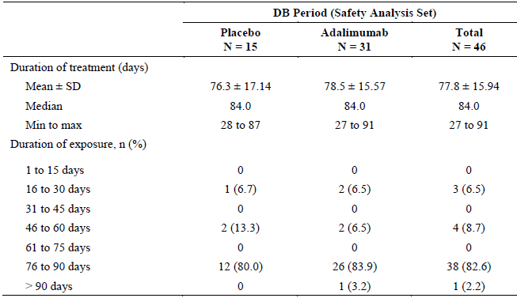
Total study period
Including the long-term, OL extension period of Study M11-328, the overall mean exposure to ADA is 338 days (median of 367 days), which reflects 12-13 months of treatment exposure ; refer to Table 28. The overall exposure to ADA for the 46 subjects in Study M11-328 is 42.6 PY.

Table 28: Overall Exposure to Adalimumab in Study M11-328
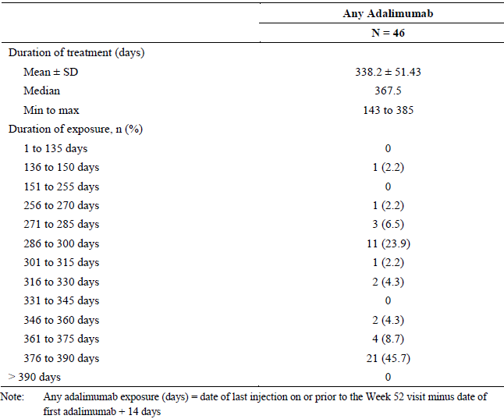

Paediatric psoriasis
The safety data collected in Study M04-717 will be presented by each study period as well as the overall cumulative exposure. However, because Period A is the primary treatment phase (of 16 weeks duration) with a double-blind, active treatment comparator (2 different doses of ADA and MTX) there will be a focus on this exposure period in the evaluation report.

Period A
During the primary, double-blind treatment phase of Study M04-717, the mean duration of treatment with ADA (0.4 or 0.8 mg/kg) was 112.4 days versus 104.1 days for MTX; refer to Table 29. More than two thirds of all subjects (67.5%; 52/77) treated with ADA (either dose) in Period A were exposed to drug for between 113 and 140 days. In contrast, less than half of all subjects (45.9%; 17/37) treated with MTX in Period A were exposed to drug for between 113 and 140 days. The mean total dose of MTX used in Period A was 120.1 +/- 80.2 mg, which correlates to a mean weekly dose of 8.0 +/-4.7 mg. The overall exposure to study medication in Period A of Study M04-717 was 10.67 PY for the MTX group, 11.77 PY for ADA 0.4 mg/kg and 11.93 PY for ADA 0.8 mg/kg (and 23.7 PY for the combined ADA treatment dataset).

Table 29: Treatment Exposure in Period A (initial 16 weeks) of Study M04-717
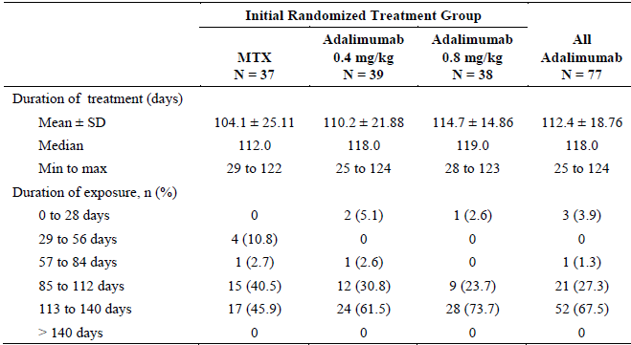

Total cumulative exposure
Table 30 provides a summary of the total duration of treatment exposure to injectable study medication (stratified by initial randomised treatment group) in Study M04-717. The mean cumulative exposure to injectable study medication (ADA and PBO) for subjects initially randomised to ADA was 379.7 days (median 436 days; range: 65-611 days).

Table 30: Cumulative Exposure to Injectable Study Medication in Study M04-717
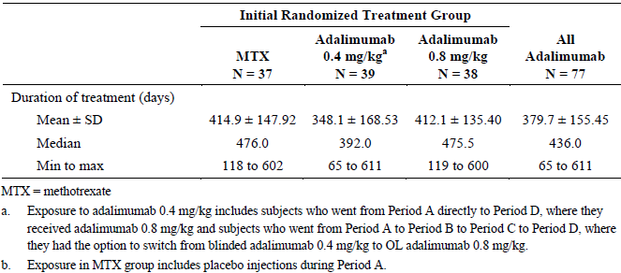

Adverse events

All adverse events (irrespective of relationship to study treatment)

Enthesitis related arthritis

Blinded study period
During the double-blind period of Study M11-328, a higher percentage of subjects in the ADA group (67.7%; 21/31) reported at least 1 AE compared to subjects who received PBO (53.3%; 8/15). In addition, during the double-blind period, subjects treated with ADA had a higher incidence of overall AEs per 100 PY compared to those in the PBO arm (750.3 AEs per 100 PY versus 542.8 AEs per 100 PY, respectively).
The most frequently reported AEs (affecting 2 or more patients in either treatment group) in the double-blind period were Upper Respiratory Tract Infection (URTI), headache, gastroenteritis, injection site pain, nausea, raised serum ALT, upper abdominal pain and syncope ; refer to Table 31. Although the overall patient numbers are small, 5 types of frequent AEs were more common in the ADA versus PBO group in the double-blind study period: headache, gastroenteritis, injection site pain, increased ALT and syncope. However, most of the common types of AEs were considered by the site investigator to be not treatment related (in particular, all cases of syncope, nausea and gastroenteritis [n=2 for each type of AE], as well as the 2 of the 3 cases of increased serum ALT).
During the double-blind period, a greater proportion of subjects in the ADA group (29.0%; 9/31) recorded at least 1 infection related AE compared to the PBO arm (20.0%; 3/15). URTI and gastroenteritis were the 2 most common types of infection followed by cystitis and paronychia.

Table 31: Most Frequently Reported Adverse Events in Double-Blind Period of Study M11-328
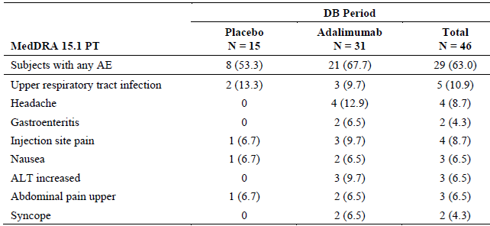

Total study period
Among subjects who received at least 1 dose of ADA at any time during Study M11-328, the majority of subjects (93.5%; 43/46) reported at least 1 AE. The most frequently reported AEs using the preferred term nomenclature (≥ 10% incidence) in the total ADA treatment cohort were URTI (26.1%), headache (17.4%), nasopharyngitis (15.2%), gastroenteritis (13.0%) and pharyngitis (10.9%); refer to Table 32 (summarising all types of AEs reported in at least 3 subjects). However, the preferred term nomenclature has under-recognised 2 types of highly related AEs which have been reported using 2 different terms. A total of 7 patients (15.2% of 46) have reported injection site reactions: 4 cases of injection site pain and 3 cases of injection site erythema. In addition, there were a total of 8 cases of either pharyngitis (n=5) or pharyngotonsillitis (n=3), which are highly similar types of AE.
Among subjects who received at least 1 dose of ADA at any time during Study M11-328, 80.4% (37/46) subjects reported a treatment emergent infection. The most frequent types of infection included URTI, nasopharyngitis and gastroenteritis. Most of these infectious AEs were of mild to moderate severity.

Table 32: Most Frequently Reported Adverse Events in ADA Treated Subjects in Study M11-328
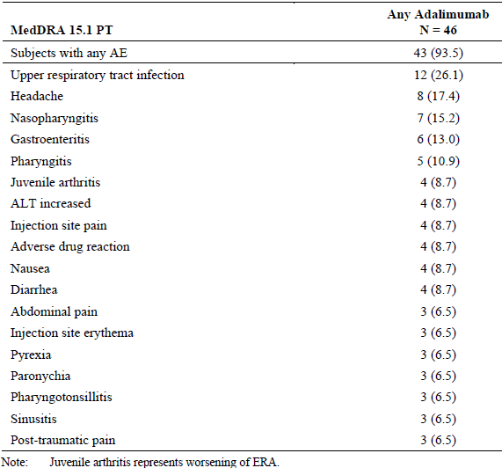

Paediatric psoriasis

Period A
In Period A of Study M04-717, 73.7% (84/114) of subjects reported at least 1 AE at a similar incidence across the 3 treatment groups (75.7% [28/37] in the MTX group, 76.9% [30/39] in the ADA 0.4 mg/kg arm and 68.4% [26/38] in the ADA 0.8 mg/kg group). However, the overall rate of AEs in Period A was somewhat higher in the ADA 0.8 mg/kg arm at 824 AEs per 100 PY compared to 787 AEs per 100 PY for patients randomised to MTX and 595 AEs per 100 PY in the ADA 0.4 mg/kg group.
The most frequently reported types of AEs in Period A by SOC were infections and infestations (52.6% overall; 60/114) followed by the SOC of gastrointestinal disorders (20.2% overall; 23/114). Gastrointestinal disorders were more frequently reported in MTX treated subjects (24.3% [9/37] for MTX versus 18.2% [14/77] for the combined ADA dataset). This was explained by a higher incidence of nausea and abdominal pain in the MTX group, which are known side effects associated with MTX therapy.
The most frequently reported type of AEs (≥ 5% incidence) by PT are summarised in Table 33. Nasopharyngitis was the most common individual type of AE reported in each treatment group in Period A and occurred at a slightly higher incidence in the ADA treatment groups (25.6% [10/39] in the ADA 0.4 mg/kg dose group and 21.1% [8/38] in the 0.8 mg/kg arm) compared to the MTX group (18.9%; 7/37). However, URTI was also very common and was recorded at a higher frequency in the MTX group (16.2%; 6/37) compared to both ADA dose groups (10.3% [4/39] in the 0.4 mg/kg arm and 5.3% [2/38] in the 0.8 mg/kg group). Rhinitis was also relatively common and was reported at a slightly higher incidence in the ADA 0.8 mg/kg group (7.9%; 3/38) compared to the 2 other treatment arms (2.6-2.7% frequency). There were also 2 cases of herpes zoster infection in Period A (1 in each of the ADA dose groups). Headache was also more commonly reported in ADA treated subjects (16.9%; 13/77) than in those receiving MTX (10.8%; 4/37). Injection site reactions (3 in total) were only recorded in ADA treated subjects. However, injection site pain occurred at a similar but slightly higher incidence in the MTX group (8.1% [3/37] for MTX versus 5.2% [4/77] for combined ADA dataset).

Table 33: Most Frequently Reported Adverse Events (≥ 5% incidence in any treatment group) by Primary SOC and PT in Period A of Study M04-717
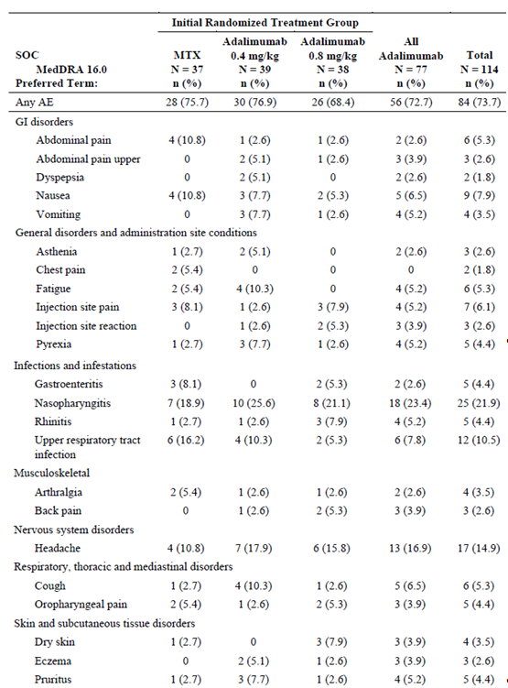

Period B
In Period B, no study medication was given but AEs were considered to be treatment emergent if they were reported within 70 days after the last dose of study medication in Period A. Less than half of all subjects (42.6%; 23/54) experienced at least 1 AE in Period B. The 2 most frequently reported AEs (≥ 5% incidence) in Period B were nasopharyngitis (9.3%; 5/54) and headache (5.6%; 3/54).

Period C
In Period C, all subjects received treatment with ADA (0.4 mg/kg if initially randomised to this dose group or 0.8 mg/kg for all other subjects). The majority of all subjects (65.8%; 25/38) treated in Period C reported at least 1 AE. The overall rate of AEs in Period C was higher in the ADA 0.8 mg/kg arm at 837 AEs per 100 PY (but similar to Period A for this treatment group) compared to 270 AEs per 100 PY for patients in the ADA 0.4 mg/kg group. For subjects initially randomised to MTX and now being treated with ADA 0.8 mg/kg injections, the overall rate was 985 AEs per 100 PY.
The most frequently reported AEs (≥ 5% incidence) in Period C were nausea, vomiting, fatigue, nasopharyngitis, oral herpes infection, URTI, back pain, headache, cough (all AEs were reported in 3 subjects; 7.9% of 38) and pruritus (5.3%; 2/38).

Period D
All subjects who entered Period D received ADA therapy, with the exception of 11 subjects who entered Period D off treatment and continued to maintain PSOR control. None of these 11 off treatment subjects experienced treatment emergent AEs (that is, within 70 days of their last dose of study medication). The overall rate of AEs in Period D was 413.2 AEs per 100 PY, which included an incidence of 419 AEs per 100 PY in the ADA 0.8 mg/kg group, 377 AEs per 100 PY in the ADA 0.4 mg/kg arm and 436 AEs per 100 PY for subjects randomised to MTX but receiving ADA 0.8 mg/kg injections.
A total of 78 actively treated subjects (72.2% of 108) recorded at least 1 AE in Period D. The most frequently reported AEs (≥ 5% incidence) in Period D were nasopharyngitis (21.3%; 23/108); nausea (10.2%; 11/108); influenza infection and worsening of PSOR (both 6.5% frequency; 7/108); pharyngitis, URTI, headache and upper abdominal pain (all 5.6% incidence; 6/108).
Another case of herpes zoster infection (3 in total; 2 recorded in Period A) was reported in a subject receiving ADA 0.4 mg/kg injections in Period D. Two of the herpes zoster infections were regarded as being moderate in severity and 1 was judged to be of mild severity.
Overall study
Table 34 provides a summary of AEs reported in at least 5% of subjects in any treatment group (by their initial randomisation group) for the overall safety dataset (that is, combined AE information from all 4 study periods). It should be noted that subjects who received MTX in Period A were given ADA 0.8 mg/kg injections in Periods C and D.
Infection was the most common type of AE by SOC affecting 75.4% (86/114) of all subjects. Nasopharyngitis was the most common type of infection (35.1%) followed by URTI (10.2%), influenza (7.0%) and rhinitis (7.0%). Of particular note, oral herpes infection affected 4.4% of subjects (5/114) and herpes zoster occurred in 2.6% of subjects (3/114).
The overall rate of AEs for all subjects who received ADA 0.8 mg/kg therapy in Study M04-717 was 501 AEs per 100 PY. For the most frequently reported AEs of special interest, the rate of infection with ADA 0.8 mg/kg therapy was 167 AEs per 100 PY and incidence of injection site reactions was 15 AEs per 100 PY for the commercially proposed dose of ADA.

Table 34: Most Frequently Reported Adverse Events (≥ 5% incidence in any treatment group) by Primary SOC and PT for the Overall Safety Dataset of Study M04-717
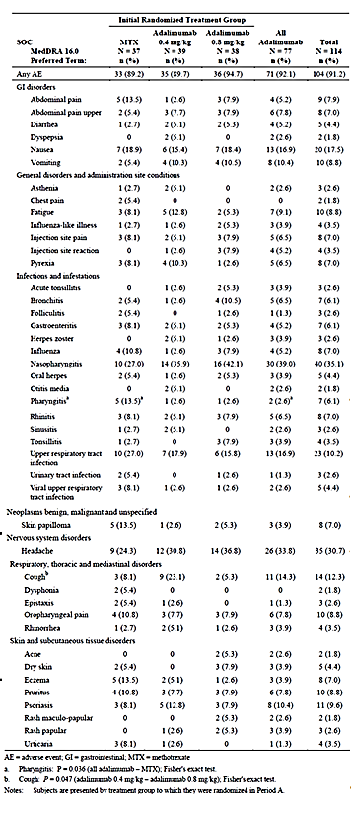

Treatment-related adverse events (adverse drug reactions)

Enthesitis related arthritis

Blinded study period
During the double-blind period of Study M11-328, a similar percentage of subjects in the ADA group (29.0%; 9/31) reported at least 1 AE assessed by the site investigator to be at least possibly related to study medication compared to subjects in the PBO arm (26.7%; 4/15). Furthermore, during the double-blind period, subjects treated with ADA had a similar incidence of treatment related AEs per 100 PY to those in the PBO arm (195.1 AEs per 100 PY versus 191.6 AEs per 100 PY, respectively).
In the double-blind period, 3 subjects treated with ADA reported injection site pain compared with only 1 subject in the PBO arm. All 4 reports of injection site pain were rated as mild in severity and were considered to be treatment related. There was also 1 additional AE report of treatment related injection site erythema in an ADA treated subject. None of these injection related AEs resulted in patient discontinuation from study treatment. Two of the 4 cases of headache in ADA treated subjects were also considered to be treatment related. Three infections (2 involving the upper respiratory tract and 1 case of cystitis) and 1 report of upper abdominal pain in ADA treated subjects were also considered to be treatment related. The study report also states that 1 ADA treated patient developed varicella infection in the double-blind period of Study M11-328 but this AE was not considered to be treatment related.

Total study period
Among subjects who received at least 1 dose of ADA at any time during Study M11-328, 47.8% of subjects (22/46) were considered to have experienced at least 1 treatment related AE. The most frequently reported treatment related AE was various types of infection. There was a total of 23 infection related AEs in the total study period of Study M11-328. The majority of treatment related infections involved the upper respiratory tract or ENT system; however, there was also 1 report of herpes zoster and 1 AE of oral herpes infection.
Among all subjects who received at least 1 dose of ADA, 7 subjects (15.2% of 46) reported injection site reactions (either local pain or erythema), which for 1 patient resulted in treatment cessation. Only 2 of the 4 recorded cases of increased serum ALT were considered to be possibly related to ADA. Two reports of headache were considered to be treatment related and 1 subject developed new onset PSOR that was deemed to be possibly related to treatment. Another subject (15 year old female) experienced cutaneous vasculitis of moderate severity on study day 282 (day 198 of the OL period) which lasted for 23 days and was considered to be possibly related to ADA.

Paediatric psoriasis

Period A
In Period A of Study M04-717, 36.0% (41/114) of subjects reported at least 1 AE that was assessed by the site investigator as possibly or probably related to study drug. The frequency of these events occurred at a similar incidence across the 3 treatment groups (35.1% [13/37] in the MTX group, 38.5% [15/39] in the ADA 0.4 mg/kg arm and 34.2% [13/38] in the ADA 0.8 mg/kg group). The overall rate of treatment related AEs in Period A was lower in the ADA 0.8 mg/kg arm at 192.8 AEs per 100 PY compared to 215.6 AEs per 100 PY for patients randomised to MTX and 263.4 AEs per 100 PY in the ADA 0.4 mg/kg group.
The most common type of treatment related AEs by SOC and PT was infections and infestations (mainly, nasopharyngitis and URTI) followed by general disorders and administration site conditions (mainly, fatigue and injection site reaction or pain), gastrointestinal disorders (mainly, nausea) and nervous system disorders (mainly, headache).

Period B
As no study medication was administered in Period B, the majority of AEs reported in this period were not considered to be treatment related. A total of 5 subjects experienced treatment emergent AEs that were considered by the site investigator to be at least possibly related to ADA. Two subjects who received ADA 0.8 mg/kg therapy in Period A developed nasopharyngitis within 70 days of their last treatment. There were also individual AE reports of benign skin papilloma and worsening of PSOR in subjects treated with ADA 0.8 mg/kg and 1 AE of URTI in a subject given ADA 0.4 mg/kg.

Period C
A total of 9 subjects (23.7% of 38) were deemed to have experienced ADA related AEs in Period C. The only type of AE recorded in more than 1 subject was nasopharyngitis, which was reported in 3 subjects being treated with ADA 0.8 mg/kg injections. The total rate of treatment related AEs for ADA therapy in Period C was 214.5 AEs per 100 PY.

Period D
In Period D, 29.6% (32/108) of subjects were reported as having ADA related AEs; the most common by SOC was some type of infection (17.6%; 19/108). The most common types of infection were nasopharyngitis (10.2%; 11/108), URTI (3.7%; 4/108) and bronchitis (2.8%; 3/108). Four gastrointestinal disorders were recorded, which included individual reports of upper abdominal pain, diarrhoea, nausea and cheilitis. There were also 3 different types of injection site related AEs (pain, pruritus and non-specific reaction) as well as 3 headache AEs. Four abnormal investigation related AEs were also recorded, which included individual reports of neutropenia, raised liver enzymes, abnormal lymphocyte morphology and positive tuberculin test.
The total rate of treatment related AEs for ADA therapy in Period D was 92.8 AEs per 100 PY, which is less than that observed in the 2 other active treatment periods (A and C) of Study M04-717.

Overall study
For the overall study, 51 subjects (44.7% of 114) recorded treatment related AEs, with the most common type of AE being infection seen in 25.4% (29/114) of patients. As displayed in Table 35, the most frequently reported treatment related infections were nasopharyngitis (11.4%) and URTI (8.8%). However, there were also 3 cases each of bronchitis and herpes zoster infection. Also of note is that 17.5% of subjects (20/114) recorded AEs in the SOC of general disorders and administration site conditions. This was mainly due to fatigue (7.0%) and injection site reactions or pain (10.5% together).

Table 35: Treatment Related Adverse Events (affecting at least 1 patient in any treatment group) for the Overall Study Period of Study M04-717
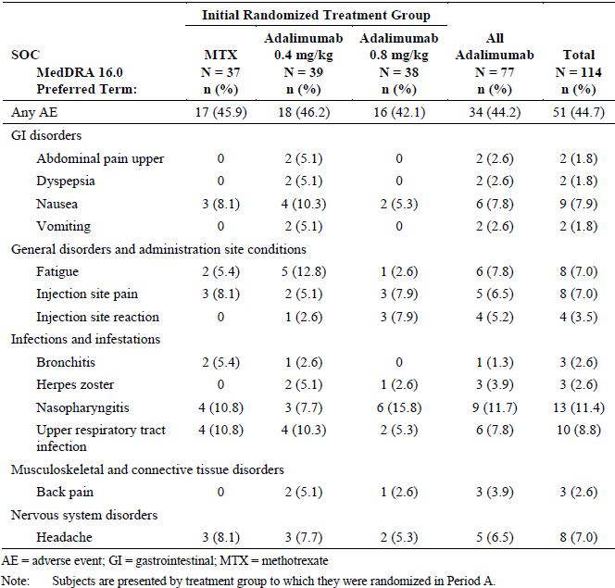

Deaths and other serious adverse events

Enthesitis related arthritis
No deaths have been reported in Study M11-328. Up to 52 weeks of treatment follow-up, a total of 5 subjects experienced 8 SAEs. Two subjects had SAEs that were judged by the site investigator to be possibly related to study medication. A 13-year-old male randomised to ADA was hospitalised with upper abdominal pain and headache on Day 67 of the double-blind study period. The symptoms lasted for 20 days and were of unclear etiology. The same subject was hospitalised again on study Day 220 (Day 138 of the OL period) because of pain related to worsening of ERA. The subject prematurely discontinued from the study because of worsening musculoskeletal pain. The other subject (also a 13-year-old male) who experienced an SAE that was possibly related to study medication was hospitalised for appendicitis on study Day 242 (Day 158 of the OL period). The appendix was removed and histology showed purulent appendicitis. The investigator considered the infection to be possibly related to ADA.
The other 3 subjects who reported SAEs had events that were considered to be not related to study medication. A 14-year-old female randomised to PBO who escaped early to OL ADA at Week 8 was hospitalised with musculoskeletal chest pain on study Day 77 (Day 23 of OL therapy). The event lasted 15 days and was considered by the site investigator to be related to enthesitis (that is, disease related manifestation). A 13-year-old female randomised to ADA sustained concussion on study Day 309 (Day 250 of the OL period) which resulted in hospitalisation. A 15-year-old female randomised to ADA was hospitalised for a worsening of ERA on study Day 299, which was 32 days following her last treatment.
In Study M11-328, no invasive opportunistic infections, malignancies, lupus-like syndromes, systemic allergic reactions, serious neurologic conditions such as demyelination, or major adverse cardiovascular events were reported.

Paediatric psoriasis
One death was reported during Study M04-717. A 17-year-old male randomised to ADA 0.8 mg/kg died of an accidental fall that occurred 11 days after the last dose of ADA in Period D (but before the last scheduled visit in Period D). The death was correctly judged to be not drug related.
A total of 7 subjects (6.1% of 114) reported 8 SAEs in Study M04-717. Three SAEs occurred in Period A and all affected subjects were receiving treatment with ADA 0.4 mg/kg injections. The SAEs included hand fracture requiring surgical wiring (18-year-old male), gastroenteritis attributed to food poisoning (18-year-old female) and agitation following excess alcohol consumption (17-year-old female). None of these SAEs were considered to be treatment related. There was 1 SAE of haemorrhagic ovarian cyst in Period B (day 52) affecting 15-year-old female treated with ADA 0.8 mg/kg injections in Period A. The same subject also experienced an SAE of protocolitis in Period B (day 195), which was ongoing for > 492 days. Excluding the death, 3 treatment emergent SAEs were reported in Period D including 1 case of tendon rupture requiring surgical reconstruction (same subject who recorded SAE of hand fracture in Period A), maculo-papular rash in a 15-year-old female receiving ADA 0.8 mg/kg therapy and musculoskeletal chest pain in a 16-year-old female receiving ADA 0.8 mg/kg injections (Day 23 of Period D) after taking MTX in Period A. None of the SAEs reported in Periods B and D were attributed to study medication. The frequency of SAEs was very low in Study M04-717 at 5.3 SAEs per 100 PY for all subjects treated with ADA 0.8 mg/kg, and 6.4 events per 100 PY for all subjects treated with ADA (either 0.4 or 0.8 mg/kg).
Two subjects (1 in each ADA dose arm) tested positive for TB conversion in Period D. Both were 15-year-old female subjects, 1 of whom lived in Mexico. Both received oral isoniazid for reactivated latent TB and the AE is ongoing at 83-142 days of follow-up. Both events were considered to be related to ADA. In Study M04-717, no other invasive opportunistic infections, malignancies, lupus-like syndromes, systemic allergic reactions, serious neurologic conditions such as demyelination, or major adverse cardiovascular events were reported.

Discontinuation due to adverse events

Enthesitis related arthritis
Up to 52 weeks in Study M11-328, a total of 3 patients prematurely discontinued because of AEs, 2 of which were considered to be related to ADA. A 15-year-old female receiving ADA withdrew on study Day 267 (Day 180 of the OL period) because of intermittent injection site pain and pruritus. A 10-year-old female initially randomised to PBO who escaped early to ADA at Week 8, withdrew because of new onset of PSOR on study Day 180 (Day 127 of the OL period). The third subject (13 year old male) who prematurely discontinued has already been described in the SAE section. This subject withdrew because of worsening musculoskeletal pain (ERA related), which the site investigator attributed to “natural progression of disease”.

Paediatric psoriasis
Two subjects discontinued from Study M04-717 because of AEs. A 10-year-old male subject initially randomised to MTX in Period A but receiving ADA 0.8 mg/kg injections in Period C developed severe urticaria on study Day 209 that led to withdrawal. The AE resolved with 7 days of topical CS and was considered to be related to ADA. A 13-year-old male randomised to ADA 0.4 mg/kg discontinued therapy in Period D due to a moderate flare of PSOR on study Day 57 of Period D. The site investigator judged the AE to be unrelated to ADA.
The overall incidence of discontinuation was 2.5 per 100 PY for all treatments in Study M04-717 and 3.2 per 100 PY for all subjects who received ADA 0.8 mg/kg therapy.

Laboratory tests

Liver function

Enthesitis related arthritis
A total of 10 subjects developed an abnormality of liver function tests in Study M11-328, but none of the abnormalities were considered to be related to study medication. In the double-blind period, 3 subjects randomised to PBO (all had a mild transient increase in serum ALT) and 2 treated with ADA had abnormalities of liver function. One of the ADA treated subjects had elevated serum ALT and AST at screening and baseline, which fluctuated over the first 85 days of Study M11-328 (reaching a peak of 3 x ULN), before normalising thereafter on continued ADA therapy (up to Day 365). Another ADA treated patient had a minor elevation in serum ALT and AST at baseline which rose during the double-blind treatment period to peak of 6.36 x ULN (Day 57). This subject continued ADA treatment and the serum ALT value at Day 365 was < 1.5 x ULN.
In the extended treatment period of Study M11-328, another 5 ADA treated subjects developed abnormalities of liver function tests. One subject had an asymptomatic increase in total serum bilirubin to 1.89 x ULN on Day 113 (Day 30 of the OL period) which persisted until Day 389 (1.68 x ULN). The other 4 affected patients had mild transient increases in serum ALT and/or AST, which onset between study Days 168 and 309 (that is, between study Days 83 and 224 of the OL period).

Paediatric psoriasis
In Study M04-717, clinically significant abnormalities in liver function tests for individual subjects was determined according to ≥ 2.5 x ULN value in serum transaminases or alkaline phosphatase, and ≥ 1.5 x ULN value in total serum bilirubin. Three subjects developed potentially significant abnormalities of liver function tests in Study M04-717. A 15-year-old female treated with ADA 0.8 mg/kg therapy from randomisation had elevated serum transaminases (ALT 174 U/L [ULN 48 U/L] and AST 121 U/L [ULN 42 U/L]) on Day 106 of Period D, which resolved at the day 14 post-treatment visit following Period D. A 14-year-old male randomised to ADA 0.4 mg/kg had persistently raised bilirubin levels (> 1.5 ULN) from screening until Day 28 of Period D. A 17-year-old female initially randomised to MTX and then who received ADA 0.8 mg/kg therapy in Period D had 3 episodes of raised ALT (Day 1 and 113 of Period D, as well as 5 days post-treatment). The site investigator attributed the AE of increased hepatic enzyme to be possibly related to ADA, and post-study follow-up was planned but no further information is available.

Kidney function

Enthesitis related arthritis
One patient treated with ADA in Study M11-328 developed a mild transient increase in blood urea nitrogen level but otherwise no significant changes in renal function were observed.

Paediatric psoriasis
None of the patients treated in Study M04-717 developed increases in blood urea nitrogen or serum creatinine levels.

Other clinical chemistry

Enthesitis related arthritis
No significant mean changes in clinical chemistry parameters (serum sodium, potassium, calcium, lipids and glucose) were noted in Study M11-328. One subject treated with ADA that developed a mild transient increase in serum ALT also had a single, moderately elevated serum triglyceride reading on study Day 139 (Day 55 of the OL period).

Paediatric psoriasis
Overall and in Period A of Study M04-717, mean and individual shifts in clinical chemistry values were rare and generally insignificant. A total of 3 subjects developed ≥ Grade 3 abnormalities of blood chemistry. A 13-year-old female treated with ADA 0.8 mg/kg from randomisation recorded intermittent asymptomatic hypoglycaemia in screening (21 days pre-treatment), Days 6 and 78 of Period A, and Days 1 and 29 of Period D. A 17-year-old female randomised to MTX and then switched to ADA 0.8 mg/kg in Period D developed hypernatraemia (serum sodium of 158 mmol/L) on day 5 of Period D. A 9-year-old female treated with MTX developed hypertriglyceridaemia (triglyceride reading of 5.95 mmol/L) on study Day 8 of Period A, which improved thereafter.

Haematology

Enthesitis related arthritis
Most shifts in haematology parameters were not clinically relevant in Study M11-328. Consistent with the control of active systemic inflammation, 12 subjects treated with ADA had normalisation of their platelet counts (from high baseline readings) and 9 subjects had increases in haematocrit levels with ADA treatment during Study M11-328. However, 1 ADA treated subject developed a treatment emergent Grade 3 abnormality relating to transient neutropenia (study Day 311), which resolved at the next visit (63 days later).

Paediatric psoriasis
There were no clinically relevant differences between the 3 treatment groups in Period A for the mean changes from baseline in haematology parameters. In the entire study, 2 subjects developed potentially significant (≥ Grade 3) abnormalities of haematology values. An 11-year-old male receiving ADA 0.8 mg/kg therapy from randomisation had asymptomatic neutropenia (0.84 x 10⁹/L) identified on Day 29 of Period D following previous normal values. There was an incomplete resolution of neutropenia (< Grade 3 severity) on study Day 105 of Period D. An 18-year-old male randomised to ADA 0.4 mg/kg injections recorded new onset of neutropenia (0.82 x 10⁹/L) identified on Day 1 of Period B, which partially improved to < Grade 3 abnormality thereafter.

Immunogenicity (anti-drug antibodies)

Enthesitis related arthritis
In Study M11-328, serum measurement of AAA (anti-adalimumab antibodies) was obtained just prior to dosing at baseline and at Weeks 12, 24, 36 and 52. A subject was considered to be positive for AAA if they had at least 1 AAA concentration > 20 ng/mL (on a screening test followed by a confirmatory assay test) and that the serum sample had been collected within 30 days after receipt of ADA. Both the screening and confirmatory AAA assays used a validated double antigen immunoassay. The assays detect free (unbound) AAA. Consistent with previous experience and knowledge, Study M11-328 only analysed for AAA when the serum ADA concentration was low (< 2 µg/mL). The LLOQ for AAA was established at 10.31 ng/mL in undiluted serum and 1.031 ng/mL in 10% diluted serum. Study M11-328 collected a total of 229 samples for AAA measurement but only 84 samples had a serum ADA concentration < 2 µg/mL, so that number was analysed for the presence of AAA at a single laboratory in Germany.
Among 46 subjects who had samples for PK analysis, 5 subjects tested positive for AAA during the 52 week study. Among the 5 subjects, 2 received PBO for the first 12 weeks and then ADA (1 with MTX and 1 without), 3 received ADA treatment for 52 weeks (1 with MTX and 2 without). The overall rate of developing positive AAA in Study M11-328 was 10.9% (5/46). None of the subjects with positive AAA testing escaped or terminated early from the trial. One subjects tested positive for AAA at baseline and continued to do so throughout the study and all other AAA positive subjects returned a positive test on at least 2 occasions (typically weeks 24 and 52).
Four of the 5 AAA positive subjects experienced at least 1 AE (2 of which were considered to be treatment related), which is a similar frequency to that observed in the AAA negative cohort (95.1% [39/41] had at least 1 AE and 48.8% [20/41] were judged to be treatment related). The AEs reported in the AAA positive group included 4 minor infections, 1 injection site reaction and 1 case of cutaneous vasculitis of moderate severity.

Paediatric psoriasis
In Study M04-717, serum measurement of AAA was obtained at baseline and Weeks 11 and 16 of Period A, Weeks 12 and 16 of Period B, baseline and Week 11 of Period C, as well as at baseline and Weeks 8 and 16 of Period D. An identical method of AAA analysis to that described for Study M11-328 was undertaken in Study M04-717. Study M04-717 collected a total of 1157 samples for PK analysis but only 435 samples had a serum ADA concentration < 2 µg/mL, so that number was analysed for AAA at a single laboratory in Germany.
In Period A, the percentage of all ADA treated subjects who tested positive for AAA was 13.0% (10/77); 12.8% (5/39) in the ADA 0.4 mg/kg group and 13.2% (5/38) in the ADA 0.8 mg/kg arm. After withdrawal of ADA in Period B, the proportion of ADA treated subjects who tested positive for AAA increased to 26.8% (11/41). Of those 11 subjects who tested positive to AAA in Period B, 6 patients only did so upon treatment withdrawal in Period B. With re-treatment in Period C, the percentage of subjects who tested positive for AAA reduced to 10% (3/30), which is similar to that observed in Period A. The observation of a lower incidence of AAA in active treatment periods (initial and upon re-treatment) versus withdrawal (for example, Period B in Study M04-717) is consistent with the known data in adult subjects with PSOR treated with ADA. In Period D, 13.0% (14/108) of subjects tested positive for AAA, at an identical incidence in both ADA dose groups (0.4 and 0.8 mg/kg). For the overall study, 22.8% (26/114) tested positive for AAA on at least 1 occasion. The incidence of positive AAA was 28.9% (11/38) in the group receiving ADA 0.8 mg/kg from randomisation, 33.3% (13/39) in the ADA 0.4 mg/kg arm and 5.4% (2/37) in the group randomised to MTX who later switched to ADA 0.8 mg/kg therapy.
The presence of AAA in Study M04-717 was not associated with an increased rate of AEs (overall, serious or severe and infection related). Although the patient numbers are small, there was a slightly higher incidence of injection site reactions (15.4% [4/26] for AAA positive subjects versus 11.9% [10/84] for AAA negative patients) and allergic AEs (7.7% [2/26] for AAA positive subjects versus 6.0% [5/84] for AAA negative patients) in the AAA positive versus AAA negative cohorts.

Vital signs

Enthesitis related arthritis
During the double-blind period of Study M11-328, mean changes from baseline in vital signs were small and statistically different between the treatment groups. The incidence of individual values outside the normal range (high or low) for systolic and diastolic blood pressure was very low. No patients withdrew from the trial because of blood pressure abnormalities. Overall, growth data measurements (height, weight and BMI) reflected the expected changes as a result of normal growth in children and adolescents.

Paediatric psoriasis
There were no statistically significant or clinically relevant changes over time in the mean and median baseline values of blood pressure, pulse rate, respiratory rate and temperature by treatment group in Period A, as well as between the 4 treatment phases. Expectedly, weight, height and BMI increased over the course of the study as a result of normal growth in children and adolescents. One subject treated with ADA 0.8 mg/kg injections in Period D had a recorded AE of increased blood pressure.

Pregnancy

Enthesitis related arthritis
There were no pregnancies in Study M11-328.

Paediatric psoriasis
Three pregnancies were reported in Study M04-717, 1 of which was identified in the post-treatment follow-up phase and the other 2 in Period D (requiring discontinuation from study medication). All subjects received ADA 0.8 mg/kg therapy and were 15-16 years of age (2 in Poland and 1 subject in Mexico). The outcome of 2 of the pregnancies is unknown as the expected date of delivery is after the cut-off date for the interim clinical study report provided in this submission. The other subject delivered a healthy female infant without complications.

Post-marketing experience
The submission did not contain any post-marketing experience specific the 2 newly proposed treatment indications of ERA and paediatric PSOR. Both of these treatment indications have only been approved in the EU in the last 12 months. However, the sponsor has provided post-marketing safety data for all currently approved indications (including polyarticular JIA and paediatric Crohn’s disease) but in a format that is difficult to interpret for safety concerns in paediatric specific patient cohorts.

Safety issues with the potential for major regulatory impact

Serious and opportunistic infection
In both clinical studies presented in this submission, there was a very low incidence of serious, treatment related infection although minor infections (particularly involving the upper respiratory tract) were common. Several subjects in both studies experienced oral herpes or varicella-zoster infection. None of these infections resulted in permanent discontinuation from ADA. Screening for tuberculosis was a requirement of screening at baseline in both studies. Two patients in Study M04-717 experienced tuberculosis during the trial which required the concomitant administration of isoniazid. No other invasive opportunistic infections were reported in either study.

Malignancy potential
No cases of malignancy were reported in either of the pivotal studies included in this submission, however, reports of malignancy (in particular, lymphoma and skin malignancies) have been reported with anti-TNF therapy when used in both adult and paediatric treatment populations. Malignancies associated with ADA therapy have been reported at a median of 30 months of treatment follow-up and the for the 2 new treatment indications, there is only a median of 13-15 months of reported follow-up. This issue will require ongoing pharmacovigilance.

Unwanted immunological events
Injection site reactions were observed in 15.2% of patients in Study M11-328 and 10.5% of subjects in Study M04-717. The majority of these AEs were mild in severity and did not result in drug discontinuation. There was also a relatively low incidence of developing anti-adalimumab antibodies (11% in ERA and 13% in paediatric PSOR) and their clinical relevance is yet to be defined with no discernible link to safety concerns. Generalised allergic or systemic hypersensitivity reactions were rarely observed in the 2 new studies although 1 subject discontinued from Study M04-717 due to severe generalised urticaria in association with ADA.

Hepatic events
In adult patients treated with ADA there have been rare reports of liver failure, other clinical hepatic events (such as autoimmune hepatitis) and abnormal liver function tests. In the JIA trials, the incidence of raised serum transaminases in subjects treated with ADA was 4.4%, but no significant clinical hepatic events were observed. In the 2 newly submitted studies, no significant clinical hepatic AEs were reported but there was low incidence of abnormal liver function tests seen in both ERA and PSOR patients, which is consistent with the previous experience (rate and pattern) of that observed in the previous JIA trials - refer to section on abnormal liver function tests in Studies M11-328 and M04-717 above.

Evaluator’s overall conclusions on clinical safety
In this submission, the total clinical safety dataset for the use of ADA in patients aged 6-17 years with active ERA consists of 46 patients treated with ADA for a median of 13 months in 1 pivotal Study (M11-328). The majority of subjects in this trial received ADA 30-40 mg fortnightly by SC injection. About half of the patients in the dataset received concurrent MTX. For the paediatric PSOR treatment indication, a total of 114 patients aged between 4 and 17 years of age received either low dose oral MTX or ADA injections for severe PSOR (0.4 mg/kg or 0.8 mg/kg). In the pivotal paediatric PSOR Study M04-717, the overall median exposure to ADA in 77 treated subjects was for 436 days, which is a sufficient volume data to make a meaningful assessment of safety at least for up to 15 months of treatment in the paediatric population with either ERA or PSOR.
Infection was the most common AE recognised in the ADA in both studies with more than half of all patients experiencing an infection related AE. The majority of infections were mild in severity, self-limiting, and predominately involved either the upper respiratory tract (nasopharyngitis and URTI) or gastrointestinal system. However, there were several reports of oral herpes and zoster infection, as well as 2 cases of reactivated tuberculosis in Study M04-717. It is unclear if the use of concurrent MTX and/or corticosteroid increases the risk of infection associated with ADA. Subject age did not appear to be a determinant of the risk of infection. In the paediatric PSOR trial were ADA 0.8 mg/kg was compared with low dose ADA (0.4 mg/kg) and oral MTX, the risk of infection was comparable to other systemic based therapies.
Injection site reactions were a relatively common type of AE occurring in patients receiving ADA. In Study M11-328, 7 subjects (15.2% of 46) experienced an injection reaction (pain and/or erythema) and 12 patients (10.5% of 114) reported this type of AE in Study M04-717. The majority of injection site reactions were mild, resolved without specific intervention and did not result in discontinuation from ADA treatment.
No treatment related deaths were reported in either of the pivotal studies. The rate of treatment related SAEs was low (2-4%) in both treatment cohorts and the incidence of discontinuation due to AEs was also very low (2 cases in both pivotal studies). One patient in each trial discontinued due to skin reactions following ADA therapy (1 case of injection site pain with pruritus, and 1 case of severe generalised urticaria).
Elevations in hepatic transaminases (AST and ALT) were recorded in up to 3-5% of patients treated with ADA in the 2 pivotal studies. The majority of these abnormalities in liver function tests were mild and without associated clinical implications. In addition, 3 ADA treated patients (1 in the ERA trial and 2 in the paediatric PSOR study) developed Grade 3 neutropenia without clinical sequelae.
The incidence of subjects developing anti-ADA antibodies is relatively low (11% in ERA and 13% in paediatric PSOR) and their clinical relevance is yet to be defined with no discernible link to the risk of infection, injection related reactions or any other significant safety concern.
Overall, growth data measurements (height, weight and BMI) in both studies reflected the expected changes as a result of normal growth in children and adolescents. However, the study reports did not state any observed drug effect on development such as the Tanner assessment of sexual maturity.
In summary, the safety data included in this submission indicates that ADA has an acceptable overall safety profile over a median of 13 months of treatment follow-up in the treatment of patients aged between 6 and 17 years with active ERA or severe plaque PSOR. Safety data in both of the newly proposed treatment indications is consistent with the known safety profile in paediatric patients with other treatment indications (polyarticular JIA and Crohn’s disease) as well adult patients with severe PSOR. The current submission contains a small but sufficient volume of short and medium term safety data for the 2 newly requested indications, but there is limited longitudinal (multi-year) safety follow-up. There are some significant safety concerns including the risk of serious infection, opportunistic infection, injection site reactions and abnormal liver function tests. Significant pharmacovigilance would be required if approval is granted for extension of treatment indications to include ERA and paediatric PSOR. This would include vigilance for opportunistic infections and malignancy.

First round benefit-risk assessment

First round assessment of benefits

Enthesitis related arthritis
The benefits of ADA in the proposed usage are:
- Clinically significant, percentage reduction in the number of joints with active arthritis after 12 weeks of treatment (62.6% decrease from baseline with ADA versus 11.6% reduction with PBO therapy).
- Significant rates of clinically meaningful JIA ACR responses (in particular, ACR Pedi70 response rate at Week 12 of 54.8% with ADA compared with 20.0% in the PBO arm).
- The beneficial effect of ADA observed in the first 12 weeks of treatment in Study M11-328 were improved upon or sustained for an extended period of treatment in the OL extension phase (up to 52 weeks).
- Convenient SC dosing strategy of 24 mg/m² (up to a maximum of 40 mg per dose) given at fortnightly intervals.
- ADA offers an alternative treatment strategy for patients with moderately-severely active ERA, which currently has limited treatment options and a significant unmet therapeutic need.

Paediatric psoriasis
The benefits of ADA in the proposed usage are:
- Clinically significant, higher rate of PASI 75 response after 16 weeks of treatment (57.9% with ADA 0.8 mg/kg versus 32.4% with weekly low dose oral MTX therapy).
- Numerically higher rate of PGA response (score of 0-1) after 16 weeks of treatment (60.5% with ADA 0.8 mg/kg versus 40.5% with weekly low dose oral MTX therapy).
- Significant rates of clinically meaningful PASI 75 and PGA response in patients with a prior history of systemic non-biological drug treatment or etanercept use (53% with ADA 0.8 mg/kg versus 10-20% with MTX).
- Clinically significant improvements in health related QOL (PSOR specific [CDLQI score], and in general [PedsQL score]) with ADA 0.8 mg/kg compared to MTX.
- The beneficial effect of ADA 0.8 mg/kg observed in the first 16 weeks of treatment in Study M04-717 were obtained again upon re-treatment and sustained for an extended period of treatment in the long-term, OL phase (up to 52 weeks of therapy).
- Convenient SC dosing strategy given at fortnightly intervals.
- ADA offers an alternative treatment strategy for patients with severe PSOR, which currently has limited treatment options and a significant unmet therapeutic need.

First round assessment of risks
The risks of ADA in the proposed usage (for both treatment indications) are similar and include:
- ADA treatment carries an increased risk of infection (both overall and serious infection). While most infections are mild and self-limiting, it is likely to ADA therapy will lead to cases of serious infection and potentially death. No infection related deaths were reported in either of the pivotal studies.
- Increased risk of opportunistic infections, in particular, varicella-zoster and oral herpes infection, were observed in the 2 pivotal studies (M11-328 and M04-717).
- ADA carries a risk of injection site reactions (15.2% of 46 patients in Study M11-328 and 10.5% of 114 subjects in Study M04-717).
- Changes in laboratory parameters, in particular, abnormal liver function tests and a few cases of neutropenia were seen in the studies involving paediatric patients with active ERA or severe PSOR. These abnormalities did not result in clinical consequences for the majority of subjects in the studies, but some individual patients did develop clinically significant (≥ Grade 3) laboratory abnormalities.
- Limited numbers of paediatric patients with ERA and PSOR have received long-term (multi-year) treatment with ADA. This may be important for the assessment of safety issues such as development of malignancy and autoimmune disorders, which require prolonged longitudinal follow-up in a moderately large number of patients.

First round assessment of benefit-risk balance

Enthesitis related arthritis
The overall benefit-risk balance of ADA in the target population of subjects with active ERA aged between 6 and 17 years is favourable. The currently approved therapeutic arsenal for the target population is limited to a single anti-TNF agent (etanercept) and there is unmet need for additional therapies in ERA when it remains severely active despite conventional treatment. Although many of the secondary efficacy outcomes were not achieved in the single pivotal study (M11-328), a clinically relevant treatment effect with ADA was recorded, which included the attainment of the primary efficacy endpoint (that is, a statistically significant and clinically relevant percentage reduction in the number of active joints versus PBO after 12 weeks of treatment follow-up). The dataset supporting this submission is limited due to the low overall number of observed subjects (n=46), but no new safety signals have been observed. In addition, the safety profile of ADA is well characterised in the adult and paediatric populations from other datasets with similar treatment indications.
The sponsor proposes that ADA is administered by fortnightly subcutaneous injection using a weight based dosing strategy (20 mg in those weighing between 15-30 kg, and 40 mg in those weighing > 30 kg). This dosing regimen has been justified in this submission, based primarily on the results of the single pivotal trial (Study M11-328).

Paediatric psoriasis
The efficacy and safety results from the single pivotal study (M04-717) in paediatric patients aged from 6 through to 17 years with severe chronic plaque PSOR who are inadequately controlled by topical therapies and heliotherapy/phototherapy support a favourable overall benefit-risk balance with ADA 0.8 mg/kg. Although Study M04-717 was small trial, there was a clear and clinically relevant benefit demonstrated with ADA 0.8 mg/kg therapy versus MTX and low dose ADA (0.4 mg/kg) in Period A which was sustained in the majority of subjects. The withdrawal phase of that study (Period B) shows that ADA 0.8 mg/kg can be successfully withdrawn in a subset of patients after 16 weeks of therapy. Further, the re-treatment phase of the study (Period C) shows that ADA 0.8 mg/kg can be successfully recommenced in relapsed patients. No new safety signals with ADA therapy were observed in Study M04-717 and the safety profile of ADA is well characterised in the adult PSOR and other paediatric treatment populations.
The single pivotal study (M04-717) has demonstrated that the proposed dosing strategy of 0.8 mg/kg (weekly for first weeks and then fortnightly thereafter) is the most effective dose of ADA with an overall level of safety at least comparable to 0.4 mg/kg and MTX. Furthermore, the proposed weight based dosing strategy for ADA maintenance therapy is supported by simulations using the population PK modelling data.

First round recommendation regarding authorisation

Enthesitis related arthritis
The evaluator recommends acceptance of the sponsor’s proposed extension of treatment indication for ADA to include the treatment of children and adolescents (6 years of age or older) with active ERA who have had an inadequate response or intolerance to at least 1 NSAID and at least 1 conventional DMARD therapy (MTX or SSZ). The current submission provides robust evidence that ADA improves the various symptoms and signs of active ERA for up to 52 weeks. ERA exhibits a heterogeneous mix of clinical manifestations (peripheral and axial arthritis, enthesitis and functional consequences), which were all largely improved by ADA therapy. The concurrent use of NSAID or DMARD did not appear to significantly impact upon efficacy outcomes. The proposed dose of ADA is 20 mg in those weighing 15 to < 30 kg and 40 mg in subjects weighing ≥ 30 kg. It is recommended that ADA is given by SC injection at fortnightly dosing intervals in ERA. There is a sufficient volume of data to indicate that the proposed posology is the most efficacious dose in this patient group with a relatively low risk of safety concerns. The evaluator does not recommend any changes to the sponsor proposed indication wording for ERA.
Should approval of the sponsor’s proposed extension of indication be granted, the evaluator also recommends that approval of the sponsor’s proposed extension of indication be subject to:
- Satisfactory response to the questions in section 12 of this report,
- Regular periodic safety update reports, and
- When available, the sponsor provides the TGA with the final clinical study report for Study M11-328.

Paediatric psoriasis
The evaluator recommends acceptance of the sponsor’s proposed extension of treatment indication for ADA 0.8 mg/kg to include the treatment of paediatric patients with severe PSOR following a failure of topical treatment and/or heliotherapy or phototherapy. The current submission provides reasonably robust evidence that ADA improves the symptoms and signs of severe PSOR, as well as health related QOL. The sponsor has asked for the approval of a single dose strategy in this treatment indication being ADA 0.8 mg/kg (up to a maximum of 40 mg per dose) given by SC injection with initial dosing at Weeks 0 and 1 (loading regimen) followed by fortnightly injections starting at Week 3 (maintenance treatment phase). This dosing posology has been demonstrated to be the minimum most effective approach with a comparable safety to the lower examined dose of ADA (0.4 mg/kg).
The sponsor has requested that the lower age limit of treatment be 4 years of age but no subject of that age at enrolment in the single pivotal study received the proposed ADA dose of 0.8 mg/kg in that trial. The youngest patient treated with ADA 0.8 mg/kg in Study M04-717 was 6 years of age at enrolment. Given the lack of direct clinical trial evidence in subjects aged between 4 and 6 years of age with ADA 0.8 mg/kg therapy, the evaluator recommends that the registered lower age limit of ADA treatment in this indication be adjusted to 6 years, unless the sponsor can adequately address this concern in the their response. The evaluator recommends that the sponsor proposed indication wording be amended to
Humira is indicated for the treatment of severe chronic plaque psoriasis in children and adolescent patients from 6 years of age who have had an inadequate response to or are inappropriate candidates for topical therapy and phototherapy.
The proposed amendment is underlined.
The evaluator would also recommend that approval of the sponsor’s proposed extension of indication be subject to:
- Satisfactory response to the questions in section 12 of this report,
- Regular periodic safety update reports, and
When available, the sponsor provides the TGA with the final clinical study reports for Study M04-717.

Clinical questions

Pharmacokinetics

Both indications
- Could the sponsor discuss why the proposed weight based dosing strategies compared to dosing according to subject body surface area is justified in the 2 new paediatric treatment indications?
- The sponsor is kindly requested to justify why, given the inter-patient variability of trough concentration of approximately 78%, all paediatric patients receive the same dose per kg body weight rather than categorising weight into groups with a different dose per group, given the changes in body composition expected?

Pharmacodynamics
Nil.

Efficacy

Enthesitis related arthritis
- Could the sponsor provide the dose, duration and reason for discontinuation (if applicable) of prior DMARD therapy in the ITT population enrolled in Study M11-328?
- Could the sponsor provide the dose of concomitant DMARD and/or corticosteroid therapy (if applicable) in the ITT population enrolled in Study M11-328?

Paediatric psoriasis
- Despite the inclusion criteria for Study M04-717 having a lower age limit of 4 years, the youngest subject who received adalimumab therapy in the trial was 6 years of age. Could the sponsor justify their request for the lowest age of treatment (from 4 years of age) in the proposed extension of indication given that no subjects aged < 6 years has actually received adalimumab in the single pivotal trial supporting the registration of adalimumab in paediatric psoriasis?

Safety

Enthesitis related arthritis
- In the double-blind period of Study M11-328, 1 subject treated with adalimumab experienced varicella infection and this adverse event was considered by the site investigator to be not related to treatment. Could the sponsor provide their opinion on the possible relationship between the reported varicella infection and adalimumab, and the reason for making such a determination?
- For several of the reported types of adverse events in Study M11-328, there appears to be inconsistency between which events are considered to be drug related or not. For example, 2 of the 4 reported headache adverse events in the double-blind period were considered to be treatment related by the site investigators and 2 were not. Could the sponsor state if a central determination (or censoring) of all adverse events, with respect to their possible relationship to study medication has been undertaken, and if so, present that dataset?

Paediatric psoriasis
- Three pregnancies were reported in Study M04-717 and the outcome of 1 of those pregnancies was provided in the study report included in this submission. Could the sponsor provide an update on the outcome of the 2 other reported pregnancies (Subjects 10800208 and 10700202) in Study M04-717?
- In Study M04-717, a 17-year-old female subject [information redacted] recorded 3 episodes of increased serum ALT, which was possibly attributed to adalimumab. The study report states that post-study follow-up was planned. Could the sponsor provide an update to this subject’s assessment?

Both indications
- Could the sponsor provide a summary of the post-marketing experience in currently approved paediatric treatment indications such as polyarticular JIA and paediatric Crohn’s disease, as well as any information from the EU database in the 2 newly requested treatment indications?
- In both studies, the reports state that growth data measurements (height, weight and body mass index) reflected the expected changes as a result of normal growth in children and adolescents. Could the sponsor expand upon the data supporting this claim with adalimumab therapy in children and report any developmental assessments that may have been recorded in the pivotal trials such as the Tanner assessment of sexual maturity?
- Could the sponsor provide an analysis of safety data in both studies according to the nearest collected trough serum adalimumab concentration?

Second round evaluation of clinical data submitted in response to questions
The sponsor’s response dated January 18, 2016 addresses 12 questions that were raised in the first round clinical assessment. In addition, the TGA has requested consideration of the relevant Pharmaceutical Subcommittee (PSC) minutes of meeting 166 (25 January 2016) and the sponsor response in the second round evaluation.
Q1. Could the sponsor discuss why the proposed weight based dosing strategies compared to dosing according to subject body surface area is justified in the 2 new paediatric treatment indications?
Sponsor Response: In the response, the sponsor states that the proposed dosing regimen of ADA in ERA (based on Study M11-328) is aligned with the approved TGA posology for patients with polyarticular JIA (pJIA) who weigh ≥ 15 kg. In addition, based on the distribution of doses administered using BSA-based dosing (24 mg/m², up to a total dose of 40 mg) in Study M11-328, the majority of subjects received doses similar to the weight based dosing regimen in the proposed PI. Furthermore, population PK modelling and simulation of trough serum ADA concentrations reveals substantial overlap between drug levels following BSA and weight based dosing regimens.
Regarding paediatric PSOR, a weight based, SC administered regimen using ADA 0.4 mg/kg or 0.8 mg/kg was investigated in the single pivotal study (M04-717). However, in the response, the sponsor is proposing an alternative posology in this treatment indication to align with the approved dosing regimens in other Australian approved paediatric treatment indications. The newly proposed regimen categorises patients into groups according to body weight, with a different dose per weight group. The justification for this change in posology is explored in detail in question 2 of the response.
Evaluator Comment: The sponsor has proposed to align all paediatric treatment indications (pJIA, ERA, PSOR and Crohn’s disease) for ADA with weight based dosing regimens, which is primarily justified on the basis of population PK modelling and simulation, with support from the clinical efficacy and safety data collected in each of the treatment indications. The proposal to have a consistent posology across paediatric treatment indications would be advantageous for minimising the risk of dosing errors. Given BSA based dosing regimens for ADA in paediatric subjects significantly overlap from a PK endpoint perspective (that is, trough ADA concentrations) with weight based dosing; the sponsor proposal for weight based dosing is supported for consistency of dosing instructions across the paediatric treatment indications.
Q2. The sponsor is kindly requested to justify why, given the inter-patient variability of trough concentration of approximately 78%, all paediatric patients receive the same dose per kg body weight rather than categorising weight into groups with a different dose per group, given the changes in body composition expected?
Sponsor Response: The sponsor understands this question to principally relate to the results of Study M04-717 and the initially proposed dosing regimen in this submission for paediatric PSOR, which is the correct interpretation of the question. The proposed posology in ERA, as well as approved dosing regimen in pJIA and paediatric Crohn’s disease are based on categorising subjects into body weight groups with a different dose per group. In addition to simplifying the dose calculation method and potentially reducing the risk of dose errors, such dosing regimens may reduce inter-patient variability. Paediatric patients with PSOR enrolled in Study M04-717 had a body weight range of 15–108 kg (median = 51.5) with the majority of patients (72%) weighing ≥ 40 kg. Among the 38 patients randomized to receive ADA 0.8 mg/kg, 28 subjects were ≥ 40 kg and received ADA doses of 30–40 mg per injection and 10 patients were < 40 kg and received ADA doses of 15–25 mg. Given the observed weight range and doses administered in Study M04-717, a fortnightly dosing regimen of 20 mg and 40 mg for patients < or ≥ 40 kg, respectively, is predicted to provide adequate drug exposure for all paediatric PSOR patients. This observation is supported by population PK modelling and simulations using data from 5 studies in paediatric treatment indications (including paediatric PSOR subjects). The data from a total of 524 subjects aged between 2 and 18 years enrolled into the 5 paediatric studies (Studies DE038, M06-806, M10-444, M11-328 and M04-717) that received ADA and had at least one ADA serum concentration above the lower limit of quantification were included in the population PK analysis. After appropriate model building, analysis was performed based on a one-compartment model with linear absorption into the central compartment. For the different disease indications, PK parameters were similar, when adjusted for the significant covariates such as subject BSA. The population PK modelling indicated that the PK of ADA in paediatric subjects over an age range of 4 to 18 years, using weight-based dosing, was similar to that observed in Study M04-717. The simulation results demonstrate that the exposure of ADA following weight-based dosing (0.8 mg/kg, up to 40 mg was similar between paediatric subjects of < 6 years of age and > 6 years of age.
Evaluator Comment: The sponsor has developed a newly proposed dosing regimen in paediatric PSOR (based on a 40-kg body weight cut-off), which appears to simplify and reduce the inter-individual variability that may occur in the original proposed dosing regimen. The newly proposed posology should simplify dose calculation for paediatric PSOR patients and provide adequate exposure for subjects in both weight categories. I concur with the sponsor proposal of amending the ADA dosing regimen to 20 mg per fortnight injections if subjects weigh < 40 kg and for patients weighing ≥ 40 kg, then a fortnightly ADA dose of 40 mg is recommended.
Q3. Could the sponsor provide the dose, duration and reason for discontinuation (if applicable) of prior DMARD therapy in the ITT population enrolled in Study M11-328?
Sponsor Response: In Study M11-328, 63.0% (29/46) of subjects had a documented history of prior MTX use and 43.5% (20/46) of subjects had prior exposure to SSZ. Furthermore, the doses of prior DMARD therapy were appropriate for the age of the subjects (that is, 10-25 mg/week of MTX given either orally or by SC injection; and 1000-3000 mg/day of SSZ). The majority of patients had received prior DMARD treatment for at least 80 days, which indicates an adequate trial of DMARD prior to the introduction of biologic therapy. Just over a third of all patients (37.0%; 17/46) discontinued DMARD therapy because of insufficient response and 17.4% (8/46) of subjects ceased DMARD because of side-effects or drug intolerance.
Evaluator Comment: The response provides prior DMARD therapy data which is consistent with the stated inclusion criteria of Study M11-328 in that patients were required to have a history of either inadequate response or intolerance to at least 1 NSAID and a 3-month course of at least 1 conventional DMARD (MTX or SSZ) at adequate dose.
Q4. Could the sponsor provide the dose of concomitant DMARD and/or corticosteroid therapy (if applicable) in the ITT population enrolled in Study M11-328?
Sponsor Response: During Study M11-328, the majority of subjects (69.6%; 32/46) received concomitant DMARD therapy at baseline (24 subjects received MTX 10-25 mg/week [orally or by SC injection] and 8 patients took SSZ 1000-2000 mg/day) and one quarter of all subjects (26.1%; 12/46) were administered low dose oral CS at entry (1-10 mg/day of prednisolone or equivalent; median daily dose of 5 mg). At Week 52, the majority of continuing subjects remained on concurrent DMARD therapy (58.1%; 25/43) and one sixth of patients continued with low dose oral CS (16.3%; 7/43).
Evaluator Comment: The response provides concurrent treatment data (for DMARD and oral CS use) which is consistent with the expectations of the treatment population recruited into Study M11-328 (that is, patients with active ERA requiring anti-TNF and/or concurrent DMARD therapy).
Q5. Despite the inclusion criteria for Study M04-717 having a lower age limit of 4 years, the youngest subject who received adalimumab therapy in the trial was 6 years of age. Could the sponsor justify their request for the lowest age of treatment (from 4 years of age) in the proposed extension of indication given that no subjects aged < 6 years has actually received adalimumab in the single pivotal trial supporting the registration of adalimumab in paediatric psoriasis?
Sponsor Response: In the response, the sponsor states that severe PSOR is a relatively rare condition in subjects aged between 4 and 6 years of age but when it occurs there is significant unmet clinical need for treatment options. In addition, the sponsor asserts that the paediatric PSOR in subjects aged 4-6 years is of similar etiology, pathophysiology and course as that affecting older children (6-17 years).
In support of obtaining registration in the 4-6 year age group of subjects with severe PSOR, the sponsor has extrapolated PK modelling data (drug exposure) across the range of paediatric treatment indications as well as used supporting safety data from children in pJIA (approved for use in 2-17 years of age) and older paediatric PSOR subjects. Studies DE038 (pJIA patients aged 4-17 years) and M10-44 (patients aged 2-4 years versus those > 4 years, as well as those < 15 kg versus ≥ 15 kg) show that younger patients have a similar incidence and type of AEs as older subjects.
Evaluator Comment: Overall, the evaluator concurs with the sponsor that by extrapolation of safety and PK data there is sufficient evidence of probable beneficial response with a relatively low likelihood of AEs in the younger paediatric PSOR population (4-6 years of age), which is a niche group with limited treatment options.
Q6. In the double-blind period of Study M11-328, 1 subject treated with adalimumab experienced varicella infection and this adverse event was considered by the site investigator to be not related to treatment. Could the sponsor provide their opinion on the possible relationship between the reported varicella infection and adalimumab, and the reason for making such a determination?
Sponsor Response: An 11-year-old subject enrolled in Spain recorded an AE of varicella infection while receiving ADA treatment in the double-blind period of Study M11-328. This subject had not received varicella vaccination prior to entering the study, which represents a deviation from the inclusion criteria. The site investigator assessed this AE as being non-serious, mild in severity and not related to study medication. In the response, the sponsor states that it does not routinely assess causality for non-serious AEs and relies on the site investigator’s clinical expertise.
Evaluator Comment: The evaluator disagrees with the causality assessment of the site investigator. This infectious AE is probably related to ADA. The evaluator recommends the sponsor demonstrate a higher level of pharmacovigilance in reviewing the study’s source data. However, the risk of treatment related infection with ADA is currently included in the proposed PI.
Q7. For several of the reported types of adverse events in Study M11-328, there appears to be inconsistency between which events are considered to be drug related or not. For example, 2 of the 4 reported headache adverse events in the double-blind period were considered to be treatment related by the site investigators and 2 were not. Could the sponsor state if a central determination (or censoring) of all adverse events, with respect to their possible relationship to study medication has been undertaken, and if so, present that dataset?
Sponsor Response: In the response, the sponsor states that per Good Clinical Practice, it does not routinely assess causality for non-serious AEs or censor the assessment of such AEs made by the site investigators. The sponsor asserts that it reviews the totality of the safety data to evaluate for any new safety signals.
Evaluator Comment: The lack of a central determination or censoring of AEs with respect to their possible relationship to study medication in Study M11-328 confers that the determination of which AEs are treatment related or not has limited scientific validity in this safety dataset.
Q8. Three pregnancies were reported in Study M04-717 and the outcome of 1 of those pregnancies was provided in the study report included in this submission. Could the sponsor provide an update on the outcome of the 2 other reported pregnancies (Subjects [information redacted]) in Study M04-717?
Sponsor Response: In the 2 other reported pregnancies, both subjects (randomised to ADA 0.8 mg/kg therapy) delivered healthy infants without complications (maternal or neonatal).
Evaluator Comment: The small amount of additional pregnancy exposure data in Study M04-717does not raise any new safety concerns with ADA therapy regarding inadvertent drug exposure during pregnancy.
Q9. In Study M04-717, a 17-year-old female subject ([information redacted]) recorded 3 episodes of increased serum ALT, which was possibly attributed to adalimumab. The study report states that post-study follow-up was planned. Could the sponsor provide an update to this subject’s assessment?
Sponsor Response: The affected subject completed the study on 24 April 2012 with an elevated serum ALT reading of 146 U/L (range: 10-48 U/L). At a post-study visit on 1 June, 2012 (approximately 6 weeks later) the subject recorded a persistent elevation in serum ALT of 125 U/L and had negative serology for viral hepatitis A, B and C. Three subsequent ALT readings taken 2-2.7 years later (between June 2014 and January 2015) show that serum ALT values had returned to the normal range (22-46 U/L). No further clinical information has been provided in the response.
Evaluator Comment: The study reported AE of increased serum ALT in subject {information redacted] remains possibly related to ADA in the absence of any alternative etiology and following resolution of the abnormality with presumed treatment cessation.
Q10. Could the sponsor provide a summary of the post-marketing experience in currently approved paediatric treatment indications such as polyarticular JIA and paediatric Crohn’s disease, as well as any information from the EU database in the 2 newly requested treatment indications?
The sponsor sought further clarification on the above question, and the following additional information was provided by the clinical evaluator to answer the question.
Q10 a. The submission did not contain any post-marketing experience specific to the2 newly proposed treatment indications of ERA and paediatric psoriasis. However, both of these treatment indications were approved in the EU in the last 9 – 12 months. Does the sponsor have any interim post-marketing safety data specific to those target populations, following marketing authorisation in the EU?
Sponsor Response: ADA was approved in the EU for the treatment of ERA on 2 September 2014 and for the treatment of paediatric PSOR on 26 February 2015. The sponsor states that no new safety signals to date have been identified with routine post-marketing surveillance of limited experience Study M11-328 (ERA) has an open-label extension phase which is scheduled to provide a final study report in July 2016. This trial should provide longer term safety data for the ERA treatment indication.
Evaluator Comment: The sponsor has not been able to provide any interim post-marketing safety data to inform the longer term safety profile of ADA in the 2 newly proposed treatment indications so experience is limited to the current submitted dataset.
Q10 b. The dataset for adalimumab use in ERA and paediatric psoriasis is limited by an overall small number of subjects followed for a median of 13 months. To enhance the safety dataset in paediatric subjects (aged 4 – 17 years) exposed to adalimumab (for any treatment indication), can the sponsor provide a clear summary of the post-marketing safety experience for all currently approved paediatric treatment indications (that is, JIA and paediatric Crohn's disease), as the format presented in the current submission was difficult to interpret for safety concerns in paediatric-specific patient cohorts versus anyone exposed to adalimumab (that is, separate the post-marketing safety data collected in adults with various treatment indications from the paediatric safety reports). Furthermore, was the incidence and pattern of post-marketing safety data in paediatric subjects different from the adult experience?
Sponsor Response: In the response, the sponsor has provided safety data from an open-label, registry study in the pJIA treatment indication. Study P10-262 is an ongoing, 10-year, post-marketing, observational study in patients aged 2-17 years with pJIA, who have received treatment with ADA or MTX. The sponsor has provided the cumulative safety data from the 6th year report (dated 24 August 2015) of this study. As of 01 June 2015, 846 patients (543 patients in the ADA group and 303 patients in the MTX treatment arm) have been enrolled in this registry trial and 842 patients have been actively treated. Of the 543 ADA treated patients, 2 subjects were < 4 years of age, 114 were 4 – 8 years of age, 118 subjects were 9-12 years of age and 298 were 13 – 17 years of age at study entry. No new safety signals were observed in Study P10-262. No deaths have been reported. Furthermore, the rate of treatment-emergent AEs, SAEs, AEs leading to treatment discontinuation, infections and other AEs of special interest (such as haematologic AEs and worsening or new onset of PSOR) have been reported at similar exposure related rates between the ADA and MTX treatment groups. Expectedly, the only type of AE recorded at a higher frequency in the ADA group was injection site reactions (2.4/100 PY versus 0.8/100 PY with MTX).
In the response, the sponsor has also provided an analysis of safety data from the clinical studies across 3 paediatric treatment indications (JIA [grouping pJIA and ERA together], PSOR and Crohn’s disease). Overall, the safety results in children with PSOR appears to be comparable (in incidence and type) to JIA subjects. The sponsor has also provided a paediatric malignancy database in the response. Between 31 December 2012 and 31 December 2014, the sponsor has identified a total of 29 patients aged < 18 years reporting 32 malignancies in the post-marketing database. Of the 32 malignancies, more than half (n=19) were haematologic (lymphoma or leukaemia) and 11 cancers were reported in subjects with inflammatory bowel disease receiving ADA treatment. Five paediatric subjects with JIA reported 6 malignancies, 3 of which were lymphoma.
Regarding the comparison between adult and paediatric safety concerns, the sponsor reports a higher incidence of non-serious infections (mainly URTI) and local injection site reactions in children compared with a higher frequency of serious infection, malignancy and cardiovascular events in adult subjects receiving ADA. This observation is to be expected based on age and frequency of co-morbidities in the relative populations.
Evaluator Comment: In conclusion, the limited post-marketing experience of ADA in paediatric subjects (other than those with pJIA) reveals no unexpected safety signals in terms of the incidence and type of AEs, but ongoing surveillance for potential new safety concerns is recommended.
Q11. In both studies, the reports state that growth data measurements (height, weight and body mass index) reflected the expected changes as a result of normal growth in children and adolescents. Could the sponsor expand upon the data supporting this claim with adalimumab therapy in children and report any developmental assessments that may have been recorded in the pivotal trials such as the Tanner assessment of sexual maturity?
Sponsor Response: In the response, the sponsor states that growth data measurements were not collected in the 2 new submitted studies (M11-328 for the proposed ERA indication and M04-717 for the proposed paediatric PSOR indication). However, the sponsor asserts that results from studies in other approved paediatric treatment indications such as Study DE038 (pJIA indication) and long-term paediatric Crohn’s disease studies show that ADA is associated with improvement and maintenance of growth (up to 52 weeks) and the drug does not adversely affect sexual maturation.
Evaluator Comment: Using extrapolation of information from other approved paediatric treatment indications, it is reasonable to concur with the sponsor that ADA is highly unlikely to adversely affect growth and sexual maturation in the 2 newly proposed paediatric treatment indications.
Q12. Could the sponsor provide an analysis of safety data in both studies according to the nearest collected trough serum adalimumab concentration?
Sponsor Comment: In the response, the sponsor has presented analyses of AEs (incidence and type) according to the nearest collected serum ADA concentration (sampling time up to 6 weeks before or after the recorded AE) for both of the newly submitted trials. In the double-blind period of each pivotal study, the median and range of serum trough ADA concentrations was similar in patients recording AEs (overall, treatment related and infectious) compared to all subjects at the corresponding nearest PK collection.
Evaluator Comment: Although the dataset is limited by small overall patient numbers and ADA concentration sampling times up to 6 weeks away from reported AEs, the analyses did not show any correlation between the occurrence of AEs and serum ADA level in paediatric subjects with ERA or PSOR.

Additional information relevant to second round evaluation
At the 25 January 2016 meeting, the Pharmaceutical Subcommittee (PSC) of the Advisory Committee on Prescription Medicines (ACPM) was asked to advise whether it supports the conclusions of the expert pharmacometrician in the evaluation report and to comment on the consistency or otherwise of the results of the population PK analyses presented in the sponsor submission. The sponsor has provided a response to the opinion of the PSC (dated 18 March 2016).
PSC Comment: The PSC agreed with the comments and conclusions of the expert pharmacometrician in the evaluation report. The PSC also noted that the population PK analyses did not show any major variations in findings with prior PK data concerning ADA therapy. However, the sponsor has not adhered to all elements of the relevant TGA adopted regulatory guideline, “EMEA Guideline on Reporting the Results of Population Pharmacokinetic Analyses”, which was noted in the meeting minutes. Furthermore, the PSC was of the view that drug immunogenicity was potentially important and should be further explored.
The PSC also recommended several changes to the draft PI including a statement about the drug solution being isotonic. There were 2 other PI recommendations of particular note. Firstly, the PSC recommended a change in the steady state PK section of the draft PI to state “serum adalimumab concentrations after 40 mg fortnightly in adult PSOR subjects is comparable to those following 0.8 mg/kg fortnightly in paediatric PSOR subjects in Study M04-717 (range 7-11 µg/mL)” – based on the data presented for Studies M03-656 and M03-658 over 12 weeks. Secondly, the PSC recommended the following statement regarding paediatric PK in ERA “Based on a population PK modelling approach, simulated steady state ADA serum trough concentrations for a weight-based dosing regimen (20 mg ADA fortnightly for body weight < 30kg and 40 mg ADA fortnightly for body weight ≥ 30 kg) were comparable to the simulated trough concentrations for the body surface area-based regimen”.
Sponsor Response: In general, the sponsor has agreed to the recommended changes in the draft PI but with some minor ongoing discrepancies. Firstly, the sponsor proposes “In patients with psoriasis, mean steady-state trough concentrations ranged from 5-8 µg/mL during ADA 40 mg fortnightly monotherapy treatment (after an initial loading dose of 80 mg SC)." The sponsor states that the 5–8 μg/mL range (versus PSC recommended 7-11 μg/mL range) reflects concentrations observed in Studies M02-528, M03-656 and M03-658 following ADA 40 mg fortnightly dosing.
Regarding ADA dosing in paediatric subjects with ERA, the sponsor asserts that the newly proposed posology based on subject weight is aligned with the ADA dosing regimen in other approved paediatric treatment indications (such as pJIA). In addition, there is no anticipated use in ERA in patients < 15 kg (based on the expected weight range of subjects with a lower age limit of 6 years). In Study M11-328, patients weighed between 21.0 and 90.0 kg.
Evaluator Comment: Regarding the PI statement about steady state ADA concentrations in paediatric PSOR, the evaluator concurs with the PSC in that the observed data in the target population is in the 7-11 μg/mL range.
Given BSA based dosing regimens for ADA in paediatric subjects significantly overlap from a PK endpoint perspective (that is, trough ADA concentrations) with weight based dosing; the sponsor proposal for weight based dosing in ERA is adequately supported. The proposal to have a consistent posology across paediatric treatment indications would be advantageous for minimising the risk of dosing errors.

Second round benefit-risk assessment

Second round assessment of benefits
After consideration of the responses to the clinical questions (1-5), the benefits of ADA for the treatment of paediatric patients with active ERA or PSOR in the proposed usage are unchanged from those identified in the first round of this report. In particular, the Phase III ERA study (M11-328) was a reasonably well conducted trial, which demonstrates a robust and clinically meaningful efficacy benefit with ADA. Furthermore, the newly proposed dosing regimen in paediatric PSOR, using a weight based patient categorisation (20 mg injections for those < 40 kg, and 40 mg injections for subjects weighing ≥ 40 kg), has been reasonably justified in the response. The sponsor has also sufficiently justified by extrapolation the claim to extend the use of ADA to paediatric patients with PSOR aged between 4 and 6 years of age.

Second round assessment of risks
After consideration of the responses to the clinical questions (6-12), the risks of ADA for the treatment of paediatric patients with active ERA or PSOR in the proposed usage are unchanged from those identified in the first round of this report. In particular, the limited post-marketing data and additional safety information presented for patients involved in the 2 pivotal trials in this submission have not revealed any new safety concerns with ADA use in a broad range of paediatric subjects.

Second round assessment of benefit-risk balance

Enthesitis related arthritis
After consideration of the responses to the clinical questions, there is no change to the opinion expressed in in the first round. The benefit-risk balance of ADA injections in the proposed treatment indication of active ERA in paediatric patients is favourable. Clinically relevant, robust efficacy has been observed with ADA in the treatment of ERA in the single pivotal Phase III study (M11-328) where the majority of subjects had prior exposure to conventional DMARD therapy (MTX and/or SSZ). Unfavourable effects consistent with other anti-TNF therapy have been observed with ADA, including infections and injection site reactions. Although a higher incidence of herpes virus infections observed with ADA, there was no increased prevalence of serious opportunistic infections (including mycobacterium infection) in the ERA population.

Paediatric psoriasis
After consideration of the responses to the clinical questions, there is no change to the opinion expressed in in the first round. The benefit-risk balance of ADA injections in the proposed treatment indication of active PSOR in paediatric patients is favourable. Clinically relevant efficacy has been observed with ADA in the treatment of paediatric PSOR, and the nature and risk of side-effects with ADA is consistent with anti-TNF therapy used in paediatric patients with active autoimmune disease.

Second round recommendation regarding authorisation

Enthesitis related arthritis
The evaluator recommend acceptance of the sponsor’s proposal for an extension of treatment indication for ADA to include active ERA in paediatric subjects. The concurrent use of NSAID or DMARD did not appear to significantly impact upon efficacy outcomes. The proposed dose of ADA is 20 mg in those weighing 15 to < 30 kg and 40 mg in subjects weighing ≥ 30 kg. It is recommended that ADA is given by SC injection at fortnightly dosing intervals in ERA. There is a sufficient volume of data to indicate that the proposed posology is the most efficacious dose in this patient group with a relatively low risk of safety concerns. The evaluator does not recommend any changes to the sponsor proposed indication wording for ERA.
Should approval of the sponsor’s proposed extension of indication be granted, the evaluator recommends approval of the sponsor’s proposed extension of indication be subject to:
- Regular periodic safety update reports, and
- When available, the sponsor provides the TGA with the final clinical study report for Study M11-328.

Paediatric psoriasis
The evaluator recommends acceptance of the sponsor’s proposal for an extension of treatment indication for ADA to include active PSOR in children aged between 4 and 17 years of age. Based on the data available, ADA is effective and demonstrates an acceptable safety profile in the management of active PSOR in paediatric patients. Furthermore, the sponsor has proposed a new posology for ADA in paediatric PSOR, which is acceptable based on the response. The proposed dose of ADA is 20 mg in those weighing < 40 kg and 40 mg in subjects weighing ≥ 40 kg. There is a sufficient volume of data to indicate that the proposed posology is the most efficacious dose in this patient group with a relatively low risk of safety concerns.
The evaluator recommends that approval of the sponsor’s proposed extension of indication be subject to:
- Regular periodic safety update reports, and
- When available, the sponsor provides the TGA with the final clinical study reports for Study M04-717.

References
Langley RGB, Krueger GG and Griffiths CEM. Psoriasis: epidemiology, clinical features and quality of life. Ann Rheum Dis 2005; 64 (Suppl II):18-23.
Paller AS, Siegfried EC, Langley RG, et al. Etanercept treatment for Children and Adolescents with Plaque Psoriasis. NEJM 2008; 358: 241-2571.
Petty RE, Southwood TR, Manners P, et al. International League of Associations for Rheumatology (ILAR): ILAR classification of juvenile idiopathic arthritis: second version. J Rheumatol 2004; 31: 390-392.
Ravelli A and Martini A. Juvenile Idiopathic Arthritis. Lancet 2007; 369: 767-778.
Salek MS, Jung S, Brincat-Ruffini LA, et al. Clinical Experience and psychometric properties of the Children’s Dermatology Life Quality Index (CDLQI). Brit J Derm 2013; 169: 734-759.

Therapeutic Goods Administration
PO Box 100 Woden ACT 2606 Australia
Email: info@tga.gov.au Phone: 1800 020 653 Fax: 02 6232 8605
https://www.tga.gov.au

The PP population was determined prior to breaking the blind.
The analysis of the double blind 16 week Period A, Period B and Period C will be done when all subjects have completed Period C or have discontinued and the data have been cleaned. This efficacy analysis is the only and final analysis of the double-blind Period A.
In Period D, subjects received either OL adalimumab treatment (0.8 mg/kg if they entered from Period A), blinded adalimumab treatment (if the entered from Period C) or were observed off drug (if they entered from Period B).
Sponsor comment: The second ranked primary endpoint (PGA 0,1) just missed statistical significance. The sponsor provided a post hoc analysis, indicating that 1 less responder in the MTX group or 1 more in the ADA group would have been sufficient to achieve statistical significance.
In Study M11-328, there was 1 event of herpes zoster and 2 events of oral herpes reported in the open-label period.

