August 2014

Australian Public Assessment Report for adalimumab
  - Proprietary Product Name: Humira
  - Sponsor: AbbVie Pty Ltd

About the Therapeutic Goods Administration (TGA)
- The Therapeutic Goods Administration (TGA) is part of the Australian Government Department of Health and is responsible for regulating medicines and medical devices.
- The TGA administers the Therapeutic Goods Act 1989 (the Act), applying a risk management approach designed to ensure therapeutic goods supplied in Australia meet acceptable standards of quality, safety and efficacy (performance), when necessary.
- The work of the TGA is based on applying scientific and clinical expertise to decision-making, to ensure that the benefits to consumers outweigh any risks associated with the use of medicines and medical devices.
- The TGA relies on the public, healthcare professionals and industry to report problems with medicines or medical devices. TGA investigates reports received by it to determine any necessary regulatory action.
- To report a problem with a medicine or medical device, please see the information on the TGA website <http://www.tga.gov.au>.
About AusPARs
- An Australian Public Assessment Record (AusPAR) provides information about the evaluation of a prescription medicine and the considerations that led the TGA to approve or not approve a prescription medicine submission.
- AusPARs are prepared and published by the TGA.
- An AusPAR is prepared for submissions that relate to new chemical entities, generic medicines, major variations, and extensions of indications.
- An AusPAR is a static document, in that it will provide information that relates to a submission at a particular point in time.
- A new AusPAR will be developed to reflect changes to indications and/or major variations to a prescription medicine subject to evaluation by the TGA.
Copyright
© Commonwealth of Australia 2014
This work is copyright. You may reproduce the whole or part of this work in unaltered form for your own personal use or, if you are part of an organisation, for internal use within your organisation, but only if you or your organisation do not use the reproduction for any commercial purpose and retain this copyright notice and all disclaimer notices as part of that reproduction. Apart from rights to use as permitted by the Copyright Act 1968 or allowed by this copyright notice, all other rights are reserved and you are not allowed to reproduce the whole or any part of this work in any way (electronic or otherwise) without first being given specific written permission from the Commonwealth to do so. Requests and inquiries concerning reproduction and rights are to be sent to the TGA Copyright Officer, Therapeutic Goods Administration, PO Box 100, Woden ACT 2606 or emailed to <tga.copyright@tga.gov.au>.

Contents
List of abbreviations 4
I. Introduction to product submission 6
Submission details 6
Product background 7
Regulatory status 7
Product Information 7
II. Quality findings 8
Introduction 8
Drug substance (active ingredient) 8
Drug product 8
Quality summary and conclusions 9
III. Nonclinical findings 11
IV. Clinical findings 11
Introduction 11
Pharmacokinetics 12
Pharmacodynamics 13
Dosage selection for the pivotal studies 13
Efficacy 13
Safety 15
First round benefit-risk assessment 16
First round recommendation regarding authorisation 16
Clinical questions 17
Second round evaluation of clinical data 17
Second round benefit-risk assessment 18
V. Pharmacovigilance findings 19
Risk management plan 19
VI. Overall conclusion and risk/benefit assessment 25
Quality 25
Nonclinical 25
Clinical 25
RMP evaluation 33
Outcome 42
Attachment 1. Product Information 43
Attachment 2. Extract from the Clinical Evaluation Report 43

List of abbreviations
Abbreviation | Meaning
6-MP | 6-mercatopurine
AAA | Anti-adalimumab antibody
AE | Adverse event
ALT | Alanine transaminase
ANCOVA | Analysis of covariance
ANOVA | Analysis of variance
AST | Aspartate transaminase
AZA | Azathioprine
BMI | Body mass index
BW | Body weight
CD | Crohn's disease
CDAI | Crohn's Disease Activity Index
CI | Confidence interval
DB | Double-blind
eow | Every other week
EU | European Union
Ew | every week, weekly
HACA | Human anti-chimeric antibody
ICH | International Conference on Harmonisation
IgG1 | Immunoglobulin
IEC | Independent Ethics Committee
IMM | Immunosuppressant
ITT | Intent-to-Treat
IV | Intravenous
IVRS | Interactive voice response system
JIA | Juvenile idiopathic arthritis
LFT | Liver function test
LOCF | Last observation carried forward
MTX | Methotrexate
NRI | Non-responder imputation
OC | Observed case
OL | Open-label
PCDAI | Paediatric Crohn's Disease Activity Index
PK | Pharmacokinetic
PP | Per-protocol
SC | Subcutaneous(ly)
TB | Tuberculosis
TEAE | Treatment-emergent adverse event
TNF | Tumour Necrosis Factor
US | United States

I. Introduction to product submission

Submission details
Type of submission: | Extension of Indications / New Strength
Decision: | Approved
Date of decision: | 2 June 2014
Active ingredient: | Adalimumab
Product name: | Humira
Sponsor’s name and address: | Abbvie (Australia) Pty Ltd  32-34 Lord Street  Botany NSW 2019
Dose form: | Solution for injection
Strengths: | Previously registered: 20 mg and 40 mg  New registration: 10 mg
Containers: | Pre-filled pen, pre-filled syringe, vial
Approved therapeutic use: | New Indication: Crohn’s Disease in Adults and Children (greater than or equal to 6 years);  - Humira is indicated for the treatment of moderate to severe Crohn’s disease, to reduce the signs and symptoms of the disease and to induce and maintain clinical remission in patients;  - Who have had an inadequate response to conventional therapies or,  - Who have lost response to or are intolerant of infliximab.
Route of administration: | Subcutaneous
Dosage: | Less than 40 kg: Moderate CD (Induction) 80 mg (day 0) 40 mg (day 14). Maintenance: 10 mg every fortnight starting day 28.  Severe: (Induction) 80 mg (day 0) 40 mg (day 14). Maintenance: 20 mg every fortnight starting day 28.  40 kg or more: Moderate CD (Induction) 160 mg (day 0) or 80 mg over 2 days 80 mg (day 14) Maintenance: 20 mg every fortnight starting day 28.  Severe: (Induction) 160 mg (day 0) or 80 mg over 2 days 80 mg (day 14) Maintenance: 40 mg every fortnight starting day 28.  Some patients may benefit from increasing the frequency to weekly if a disease flare or an inadequate response is experienced during maintenance dosing.
ARTG numbers: | 216038, 127116, 155315, 199410, 199411, 199412, 95779, 95780

Product background
This AusPAR describes the application by the sponsor to register Humira for the extended indications to include the use in paediatric patients aged 6 years to 17 years with Crohn’s disease (CD).
The proposed extension of indication (EOI) was granted an orphan drug designation by the TGA on 16 January 2012.
Adalimumab is currently approved in Australia for use in adults with CD (June 2007).
The only other anti-TNF agent approved for the treatment of CD in a paediatric population is infliximab. The paediatric CD indication for infliximab applies to patients aged from 6 to 17 years with moderate to severe CD. The dose regimen for infliximab is based on body weight (BW) with all age groups with CD receiving the 5 mg/kg each dose, whereas for adalimumab the proposed dose regimen is more coarsely adjusted with the same regimen for all children and adolescents with BW <40 kg and the same regimen for all those with BW greater than or equal to 40 kg. The infliximab dose recommendations also state the following: Available data do not support further infliximab treatment in children and adolescent patients (6-17 years) not responding within 10 weeks to the initial infusion. The sponsor has not proposed a similar limitation for use of adalimumab in CD.

Regulatory status
The product received initial registration on the Australian Register of Therapeutic Goods (ARTG) on 10 December 2003.
At the time the TGA considered this application, a similar application had been approved in the EU in November 2012 for the indication:
‘Humira is indicated for the treatment of severe active Crohn's disease in paediatric patients (6 to 17 years of age) who have had an inadequate response to conventional therapy including primary nutrition therapy, a corticosteroid, and an immunomodulator, or who are intolerant to or have contraindications for such therapies.’

Product Information
The approved Product Information (PI) current at the time this AusPAR was prepared can be found as Attachment 1. For the most recent PI please refer to the TGA website at <http://www.tga.gov.au/hp/information-medicines-pi.htm>.

II. Quality findings

Introduction
Adalimumab is a fully human IgG₁ antibody directed against human TNF-α. The protein is expressed in CHO cells and purified using a series of standard chromatographic steps, resulting in a slightly opalescent aqueous bulk solution. The protein is heat sensitive and has the potential to develop particulates in solution if not formulated properly.
Adalimumab binds specifically to TNF and neutralises the biological function of TNF by blocking its interaction with the p55 and p75 cell surfaces TNF receptors. Adalimumab also modulates biological responses that are induced or regulated by TNF, including changes in the levels of adhesion molecules responsible for leukocyte migration.
The currently registered presentations of Humira pre-filled syringes are Adalimumab 40 mg/0.8 mL and 20 mg/0.4 mL Solution for Injection. The sponsor seeks registration to extend the indications for all of the currently approved Humira adalimumab presentations, to include the treatment of CD in paediatric patients (children greater than or equal to 6 years) in addition to a new strength which will be presented in a 1 mL cartridge (Type I glass) containing 10 mg of adalimumab for injection, 0.2 mL.

Drug substance (active ingredient)
The company has stated in their application letter, dated 20 May 2013, that the drug substance remains unchanged and therefore has not been provided in this application.

Drug product
Adalimumab, single dose pre-filled syringe, 10 mg/0.2 mL, contains adalimumab as the active substance. The dosage form is a pre-filled syringe with 0.2 mL solution for injection (density of the solution: 1.022 g/mL).
Two other deviations were also reported and the issue centred on out of trend for osmolality. The parameter is still within the specification but outside the 3-sigma range about the mean for batches. The company states that this trend does not impact on the overall validation of the product because there are no changes made to the compounding process.
Comment: This is unusual since two out of 3 batches fall outside the 3-sigma range about the mean of 233 lots. The company should be asked if any investigation has been instigated as a result of this observed out of trend for osmolality.
The fill volume was set which corresponded to a range of 100% to 120% for the process validation batches whilst in application, the target range for the 40 mg/0.8 mL PFS is 100 to 104% of the nominal value. The company should be asked to clarify the discrepancy and justify the overfill of up to 120% of the nominal value for the 0.2 mL fill volume.
The release and shelf life specifications for Adalimumab, single dose semi-finished pre-filled syringe, 10 mg/0.2 mL, are identical to the currently approved 40 mg/0.8 mL PFS. The company claims that the analytical procedures and test methods used are also identical apart from minor changes like document numbering, naming conventions, worksheet format.
Comment: No stability data have been provided to support and justify all storage and shipping conditions. The company should be asked to supply the data.

Quality summary and conclusions
It is recommended that approval for registration of Humira 10mg/0.2 mL PFS not be given until the sponsor has provided satisfactory answers to the questions below.
- Q1. The proposed Australian PI and CMI do not contain information on the Humira 10 mg/0.2 mL PFS presentation. Please update the PI and CMI accordingly.

Second round evaluation of sponsor’s response
The company has provided both annotated and clean copies of the revised PI and CMI to include details of the 10 mg/0.2 mL PFS presentation. This is acceptable.
- Q2. Please amend the small container (syringe) label to include “Injection, solution” to comply with Section 3(2)(e) of the TGO69.

Second round evaluation of sponsor’s response
Revised small container label mock-up with the correct dosage form is provided. This is acceptable.
- Q3. Please clarify if [information redacted] will be used for the manufacture of the 10 mg/0.2 mL PFS presentation. If so, please provide the fill validation report, batch analysis and stability data for 3 batches of 10 mg/0.2 mL PFS manufactured at this site.

Second round evaluation of sponsor’s response
The company states that [information redacted] will not be used for the manufacture of the 10 mg/0.2 mL PFS presentation but will continue to be used for the manufacture of Humira 40 mg/0.8 mL PFS presentation. This is acceptable.
- Q4. The sponsor claims that finer needle was used to improve fill uniformity (lower standard deviation). However, the standard deviation (0.005) for extractable volume for batch 11240LX of which 1.6 mm needle was used was comparable to batches 10227LX95 and 11241LX95, of which a 1.2 mm needle was used (SD = 0.005 and 0.006). Quoting deviation 202222, the syringes should not have made it to the visual inspection stage because the system should have triggered an alarm (e.g. IPC high standard deviation for extractable volume or some check in place if a 1.6 mm needle was used instead of the prescribed 1.2 mm needle). Please comment.

Second round evaluation of sponsor’s response
The company states that the 1.6 mm needle was used only on rail 3 for batch LX11240LX whilst the other four rails were fitted with a 1.2 mm needle. The IPC was performed prior to removing the syringes from rail 3 and the standard deviation was derived predominantly from samples filled using the 1.2 mm needle (80%).
The performance of the 1.2 mm and 1.6 mm needles were compared in only one run during an engineering/development run prior to process validation. It was found that the 1.2 mm needle had a lower standard deviation compared to the 1.6 mm needle. However, the difference in SD was not considered significant and the 1.2 mm needle was chosen based on industry practice of using smaller needle as the volume of fill decreases. The IPC in place during the filling process is periodic determination of the weight of the solution, taking its density into account. This is acceptable.
- Q5. The fill range was set at 0.2 to 0.24 mL with the target of 0.22 mL and this corresponds to a range of 100% to 120% of the nominal value. It was noted in application 99/4129/3 that the target range for the 40 mg/0.8 mL PFS is 100% to 104% (0.8 to 0.832 mL) of the nominal value. Could the range for the 0.2 mL fill be tightened? If not, please justify the overfill of up to 120% of the nominal value for the 0.2 mL fill volume in comparison to 104% for the currently registered 0.8 mL PFS presentation.

Second round evaluation of sponsor’s response
The company claims that maintaining target range based on a fixed percentage of the fill volume is not possible while simultaneously ensuring that each PFS will contain the minimum labelled volume of drug product. The company also claims that the high limits of the range on a volume basis are similar at 0.04 mL and 0.032 mL for the 10 mg and 40 mg PFS, respectively.
The company also states that both a 10 mg and 20 mg maintenance dose demonstrated acceptable safety profiles and both doses were efficacious based on the dosing regimen and patient population recommended in the Clinical Summary of Efficacy document.
- Q6. Please clarify if any investigation has been conducted following the observed out of trend for IPC test for omolality for the 10 mg/0.2 mL PFS validation batches. This is unusual given that 2 out of 3 validation batches fall outside the 3-sigma range about the mean of 233 lots.

Second round evaluation of sponsor’s response
The company claims that full investigations were conducted following the observed out of trend (OOT) IPC results for osmolality for the 10 mg/0.2 mL PFS validation batches. The root cause had been identified to be a slight variation in the salt content of the bulk drug substance which led to the OOT result for osmolality during the drug product manufacturing. The company further states that the OOT result were within the specification and that the event had no impact on product quality. This is acceptable.
- Q7. Please provide the stability data (if available) to demonstrate product stability until the end of shelf-life in the event of unexpected temperature excursion during shipping. More information is available in Appendix 14.4.3 of the ARGPM. If the data is not available, please provide a commitment that this study will be undertaken.

Second round evaluation of sponsor’s response
The summary of the stability data is provided in an appendix. One batch of the 40 mg/0.8 mL PFS batch 692509A cycled to the elevated (25 ͦC/60% relative humidity, RH; 30 ͦC/65% RH and 40 ͦC/75% RH) and the reduced (-5 ͦC) temperatures was put back to storage under the approved 2-8°C. The PFS was tested at pre-defined time points and met specifications until the end of shelf-life:
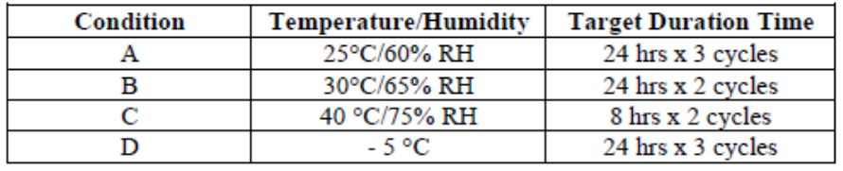
The company further states that the stability data trends for the 10 mg/0.2 mL PFS (6 months data to date) are comparable to the 40 mg/0.8 mL PFS under stressed and accelerated conditions. This is acceptable.

III. Nonclinical findings
There was no requirement for a nonclinical evaluation in a submission of this type.

IV. Clinical findings
A summary of the clinical findings is presented in this section. Further details of these clinical findings can be found in Attachment 2.

Introduction

Clinical rationale
The sponsor has advised that the clinical development program for adalimumab in paediatric patients with moderate to severe CD was a postmarketing commitment in the US and a Paediatric Investigation Plan commitment in the EU, includes one pivotal randomised, double blind (DB) study, Study M06-806, and an ongoing supportive, long-term, open label (OL) extension study, Study M06-807.
The only TNF alpha agonist approved for treatment of CD in children is infliximab, approved in 2007.
Therapeutic Guidelines notes the following with respect to CD in children: The incidence of CD in childhood is increasing. In general medical treatment is similar to that for adults, but with a strong emphasis on nutrition to avoid growth failure. Growth impairment is a presenting feature in up to 85% of prepubertal children. This may be due to disease activity, longstanding inadequate nutrition, or treatment (particularly with corticosteroids). Nutritional supplements are required in most cases to ensure adequate nutrients for catch-up growth. There is a role for 6 to 8 weeks of exclusive enteral nutrition (instead of corticosteroid therapy) to induce remission in children, especially those with small bowel disease. Referral to a dietician is advised.
Osteopenia is usually present at the time of diagnosis of inflammatory bowel disease, due to disease activity and malnutrition. Corticosteroids can exacerbate calcium loss, and a daily calcium supplement (1000 to 1300 mg elemental calcium) may be useful. Vitamin D status should be monitored as these children are frequently deficient, and supplements may be necessary.
Avoid prolonged corticosteroid use in children, and consider other therapies such as exclusive enteral nutrition or infliximab.

Guidance
The paediatric clinical development program was discussed with the European Rapporteur (Swedish Medical Products Agency [MPA]) in the context of the presubmission meeting for the adult CD indication on 17 May 2006. At that meeting the lack of placebo group in the paediatric clinical trials was discussed with the sponsor. The MPA expressed concern that the age group to be studied (6 to 17 years, inclusive) may include more newly diagnosed subjects in whom an active or placebo control arm could be utilized to demonstrate statistical superiority of one arm over another. However, AbbVie contended that the inclusion criteria in the final protocol would require all subjects to be adequately experienced and reflect a population that has had inadequate response to conventional treatments.
The clinical development program was discussed with the Food and Drug Administration (FDA) at a Type B end of Phase 2 meeting on 1 June 2006. The Agency agreed that the study could be performed without a placebo control group, that the age group and study duration were adequate, and that a successful outcome could be defined by similar maintenance of efficacy results in children when compared to adults. The Agency indicated that infliximab failures needed to be included, and as a result this was incorporated into the study protocol. The Agency also recommended that finding the lowest effective dose in view of potential safety concerns would be an advantage in the long run. AbbVie incorporated the low-dose treatment group into the study protocol as a result of the meeting discussion.

Contents of the clinical dossier
The submission contained the following clinical information:
- The sponsor’s Clinical Overview, Summary of Clinical Efficacy, Summary of Clinical Safety and literature references.
- 1 pivotal efficacy/safety study to demonstrate safety and efficacy and assess PK of adalimumab administered via SC injection in paediatric subjects (ages 6 to 17) with moderate to severe CD.
- 1 other efficacy/safety study to evaluate long-term maintenance of clinical response, safety, and tolerability of repeated administration of adalimumab in paediatric subjects with CD
- Integrated Summary of Safety from the two submitted studies.

Paediatric data
The submission included paediatric pharmacokinetic, efficacy and safety data.

Good clinical practice
The studies were conducted in accordance with the protocol, ICH GCP guidelines, applicable regulations and guidelines governing clinical study conduct, and the ethical principles that have their origin in the Declaration of Helsinki.

Pharmacokinetics

Studies providing pharmacokinetic data
Additional pharmacokinetic data were provided from the two safety and efficacy studies included in this submission.

Evaluator’s conclusions on pharmacokinetics
The sponsor is proposing to use the same adalimumab induction regimen for paediatric patients as is currently approved for adults. The adalimumab trough concentration data and modelling suggest that trough concentrations will be similar in adults and paediatric patients and support this induction regimen.
The sponsor has proposed that maintenance dose be determined by severity of disease as well as body weight for children. This is not the approach that was taken for adults or for the other anti-TNF agent (infliximab) (where dosing for adults and children is on a mg/kg basis). It’s been proposed that paediatric patients with “moderate” CD receive half the current recommended maintenance dose for adults provided BW is greater than or equal to 40 kg and a quarter of the adult dose if BW is <40 kg. For paediatric patients with “severe” disease the adult maintenance dose regimen is recommended if BW is greater than or equal to 40 kg and half the adult maintenance dose regimen if BW is <40 kg. Reducing the dose interval to weekly resulted in approximately doubling the trough concentration of adalimumab.
The proposed maintenance dose regimens resulted in mean adalimumab trough concentrations that were comparable to those seen in adults given 40 mg eow, with trough levels somewhat higher for those given the high dose regimen and somewhat lower for those given the low dose regimen compared with adults with CD given their recommended dose. Subjects with previous exposure to infliximab generally had reduced trough levels of adalimumab as did subjects who were HACA+. There were only 6 subjects who were AAA+ during the course of the pivotal study. Five of these subjects had serum adalimumab concentrations decline to below the limit of detection of the assay during the maintenance phase. The 6th subject terminated the study early with serum adalimumab concentration below the limit of detection.

Pharmacodynamics
No data submitted.

Dosage selection for the pivotal studies
Population PK modelling of serum adalimumab concentration data from paediatric subjects with JIA was used to identify doses to be evaluated in the current study in children with CD. A model based on the JIA population was chosen because the BW range closely paralleled that in a juvenile CD population. The low dose arm was included following discussion with the FDA on the establishment of the lowest effective dose in view of potential safety concerns. PK data obtained from this study was then compared with PK data obtained in the studies of CD in adults.
The results from 2 previously evaluated controlled studies in adults (Study M02-403 and Study M04-691) supported the proposed induction dose regimen of 160 mg at Baseline (Week 0) and 80 mg at Week 2 for adult patients with CD.
The results of the pivotal maintenance trial in adults (Study M02-404), in conjunction with results from Study M02-433,supported a maintenance dose of adalimumab 40 mg eow. The sponsor also claimed the data suggested that patients who lost response to adalimumab at 40 mg eow could be dose-escalated to 40 mg ew with the potential of regaining clinical response.

Efficacy

Studies providing efficacy data
- Study MO6-806
- Study M06-807

Evaluator’s conclusions on efficacy
No assessment of different induction doses was performed so the efficacy of any alternative induction regimen would be speculative, based on PK data alone. I recommend that the proposed weight-based induction regimen be accepted.
Paediatric patients with CD given the proposed dose regimens appear in the cross study comparison to adult patients with CD to have better outcomes in terms of remission at Week 26 regardless of whether they received the high or low dose maintenance regimen. No statistically significant difference was apparent between the high and low dose maintenance regimens for the internal primary efficacy analysis. This suggests the low dose treatment should be the recommended maintenance dose regimen. Prescribers should be advised of the extent of reduced response/ remission rates in patients with prior infliximab experience and/or the presence of HACA.
The lack of a placebo group for within study comparisons, while understandable, results in a lack of internal reference which is important for a disease which is known to vary in its severity over time irrespective of treatment. The responses and remissions shown in subjects who were AAA+ and had adalimumab levels below the limit of quantification suggest that responses and remissions would have occurred in subjects given placebo (in addition to their usual treatment). Due to the absence of a placebo group it is not possible to estimate the NNT for one patient to derive a clinical response or remission.
There was no planned analysis of efficacy of the high dose maintenance regimen by severity of disease, though the sponsor is proposing paediatric dose regimen based on disease severity that is the high dose regimen for severe disease and the low dose regimen for moderate disease. The statistical analysis plan did not provide for assessment of remission/response rates based on severity of disease at baseline. Any subsequent analysis would be post-hoc and its statistical significance would be limited by its status as an exploratory endpoint in a study in which the primary efficacy comparison (between high and low dose regimens) did not reach statistical significance. I do not consider that there has been sufficient examination of the effect of dose on efficacy stratified by disease severity for it to be supported as part of the dose regimen.
Differences in secondary efficacy endpoints between the high and low dose regimen were generally quite small, particularly for subjects with prior exposure to infliximab. Most of the statistical analyses of secondary endpoints were not valid due to lack of statistically significant results for the first ranked secondary endpoint. Although this is a major limitation to interpretation of the data it is likely that clinical response or remission at Week 4, no prior experience of infliximab and absence of HACA and AAA are predictors of subsequent response to adalimumab, regardless of whether the high or low dose regimen is used. In the study around ¼ of subjects taking systemic corticosteroids at baseline were able to stop them by Week 26 of treatment and 12% of subjects taking immunomodulators at baseline were able to cease them by Week 52. Subjects who required dose escalation to ew generally did worse than those not requiring dose escalation. The extent of reduced likelihood of remission should be adequately described in the Clinical Trials section of the PI, particularly for those subgroups least likely to benefit from treatment. I do not recommend continuing treatment in patients who have not responded to the induction dose regimen. To support continuing use I consider a placebo-controlled comparison is required.
There is no restriction on continued use of adalimumab in adults with CD who have predictors of poor subsequent response however consideration should be given to advising prescribers to cease treatment in paediatric patients who have not responded after receiving the induction regimen, particularly if those patients have prior infliximab exposure. It is not clear how long the trial of initial treatment should be from the data presented. The basis for the 12 weeks suggested in the SPC is not clear.
It is notable that for infliximab, paediatric patients aged from 6 to 17 years with moderate to severe CD the recommended dose regimen as is the same as the adult dose regimen with the additional statement that Available data do not support further infliximab treatment in children and adolescent patients (6-17 years) not responding within 10 weeks to the initial infusion.
At commencement of the OL maintenance study subjects taking low dose adalimumab could be increased to higher doses. Those who were taking ew regimens at the high dose continued. The sponsor has not proposed long term use of the higher dose for patients with moderate CD and there is no analysis of efficacy of the low dose regimen beyond 52 weeks.
From the descriptive data supplied it not possible to determine whether there is a loss of response over time due to the high loss of subjects from the extension study (M06-807). That study did show that subjects who continued treatment continued to respond. The extent of withdrawals from this study and reasons for withdrawal were not apparent in the interim study report. Persistence of efficacy in paediatric subjects with CD is likely to require post-market assessment.

Safety

Studies providing safety data
Studies M06-806 and its OL extension, Study Mo6-807provided evaluable safety data. A data cut-off date of 30 November 2010 applied to the Study M06-807 which is ongoing.
Subject disposition was provided in a combined analysis in the Safety Summary for the submission.

Patient exposure
Across both studies a total of 192 paediatric subjects with CD were exposed to at least 1 dose of adalimumab as of 30 November 2010. Cumulative exposure was 258.9 patient years (PYs). Of these subjects, 115 (59.9%) had greater than 12 months of adalimumab exposure and 91 (47.4%) had greater than 18 months of adalimumab exposure. The median exposure was 434 days (range, 14 to 1,184 days). The proportion of subjects decreased over time due to discontinuations, but primarily because the study is still ongoing and most subjects have not been exposed to study drug for longer durations at the cut-off date.
Further details may be found at Attachment 2.

Safety issues with the potential for major regulatory impact
The safety issues of most concern for adalimumab are serious infections and malignancies. In adolescents with CD there have been reports of lymphoma, including hepatosplenic T-cell lymphoma. While there were no reports of these events in these studies the sample and follow-up time were quite restricted for these rare adverse events.

Postmarketing data
This indication received marketing authorisation in the EU in 2012. Post-marketing data were not included in the submission.

Evaluator’s conclusions on safety
No new safety issues have been identified in these two studies. The number of paediatric subjects assessed was quite limited and insufficient to determine the extent of risk of rare serious adverse events such as malignancies and severe opportunistic infections. The proposed dose regimen has does not appear to have resulted in a clinically significant increased risk of adverse events compared with use in adults given their recommended dose regimen however, longer term safety will require post-market assessment.

First round benefit-risk assessment

First round assessment of benefits
The benefits of adalimumab in the proposed usage are:
- Adalimumab provides another treatment option for those patients who are already taking optimised conventional therapy for CD but who have had insufficient response.
- It is suitable for patients who did not respond to or lost response to infliximab and for patients who were intolerant of infliximab, though the probability of a treatment response is considerably reduced compared to infliximab naïve patients.
- It is more conveniently administered than infliximab, being administered via subcutaneous injection without the need for administration in a clinic (as is the case for infliximab)
- Regardless of the maintenance dose used in the pivotal study 54% of subjects had achieved a clinical response at Week 26 and 35% at Week 52. Clinical remission was achieved by 33.5% at Week 26 and by 28% at Week 52. Small increases in response and remission rates were seen if subjects who were dose escalated were included in the assessment of response and remission. This is a clinically significant benefit, though the benefits are greater for those without prior infliximab experience, no HACA or AAA, and who had an initial response to the induction regimen.

First round assessment of risks
The risks of adalimumab in the proposed usage are:
- The optimal dose regimen for paediatric patients with CD has not been adequately explored. Unlike infliximab the proposed dose regimen does not take BW into account on a mg/kg basis, but rather on the broad categorisation of <40 kg and greater than or equal to 40 kg. Further evidence of the uncertainty of optimal dose regimen is the inconsistency between the dose regimen approved in the EU and the dose regimen proposed for registration.
- The effect of long term exposure in terms of persistence of effect and long term safety is unclear and requires as a minimum, some form of post-market assessment.

First round assessment of benefit-risk balance
The benefit-risk balance of adalimumab is unfavourable given the proposed usage, but would become favourable if the changes recommended are adopted.

First round recommendation regarding authorisation
In the absence of exploration of alternative induction dose regimens in a clinical study the proposed induction dose regimen is accepted, however, patients who have not achieved a clinical response to the induction regimen should not continue treatment. A robust demonstration of continued benefit for these patients has not been provided and given the risks of continued treatment it is not acceptable to continue to expose patients to a treatment with potential for life-threatening side effects when the extent of benefit is known to be reduced but is otherwise unclear.
The proposed higher dose maintenance regimen has not been shown to be statistically superior to the low dose regimen. Therefore the low dose regimen of 20 mg eow for patients with BW greater than or equal to 40 kg and 10 mg eow for patients with BW <40 kg should be adopted. There is insufficient evidence to support increasing dosing to weekly in patients who lose response or who fail to respond to initial treatment regimens. Consideration could be given to implementing the high dose regimen in patients with severe disease who have responded to the induction regimen.

Clinical questions

Pharmacokinetics
The EMA approved a 40/20 mg/kg induction dose regimen for patients with BW <40 kg and 80 mg/40 mg for patients with BW greater than or equal to 40 kg. Are there any data or modelling to support these regimens?

Efficacy
- The SPC includes a statement that Continued therapy should be carefully considered in a subject not responding by Week 12. The basis for that statement is not clear. Are there any data to show clinical response and remission rates for subjects who did not achieve clinical response prior to Week 12 in Study M06-806?
- For Study M06-806 a subgroup analysis of efficacy results by baseline severity (PCDAI scores < 40 for moderate disease and greater than or equal to 40 for severe disease) has been included in the draft PI. This analysis could not be located in the submission. Please indicate where in the submission this analysis is located, or submit the analysis.
- For Study M06-807: This study was planned to conclude approximately 12 weeks after adalimumab received country and local (if applicable) regulatory approval for paediatric CD. Given the EMA has approved this indication is this study still ongoing? If so when is the next interim report anticipated?
- Are there any maintenance data beyond 52 weeks for the 20 mg/ 10 mg eow dose regimen for paediatric subjects?
- For Study M06-807: Please provide data on the number of subjects who withdrew from this study and the reasons for withdrawal.
- What was the basis for the restricting the indication to patients with severe CD in the EU? Were subgroup analyses of response and/ or remission by disease severity performed? If so please submit these analyses.

Second round evaluation of clinical data

Pharmacokinetics
The sponsor has responded to the question on PK data for the induction dose regimen recommended in the EU by providing an exposure-efficacy analysis to justify the regimen proposed for Australia. That analysis was based on data from Study M06-806. Patients were categorised into quartiles (Q1 to Q4) based on observed Week 4 serum adalimumab trough concentrations (following induction dosing) and Week 26 PCDAI remission rates (the primary efficacy endpoint) were compared. The results suggested a relationship between adalimumab exposure following the induction dose and the percentage of patients experiencing clinical remission at Week 26.
This post hoc analysis showed a positive correlation between adalimumab trough levels at Week 4 (2 weeks after receiving the second induction dose) and subsequent clinical remission at Week 26. Given it has previously been demonstrated that there is a positive relationship between dose and serum concentration it is reasonable to assume that remission rates at 26 weeks would be lower for patients given the lower dose induction regimen that is the standard regimen approved in the EU. The EU dose recommendations also allow for the induction dose regimen proposed for Australia if a rapid response is needed.

Efficacy
The sponsor provided analyses by clinical response at Weeks 4, 8 and 12. Results from these analyses are reproduced below and provide strong support for not continuing treatment beyond 12 weeks in patients who do not have a clinical response at Week 12. There is a clinically significant proportion of patients who while not exhibiting a clinical response at Week 4 subsequently do show a clinical response at Week 26 and/ or Week 52. The difference in subsequent response and remission rates between the Week 8 and Week 12 nonresponders is less pronounced.
Results by baseline disease severity with severe CD at baseline, as defined by PCDAI greater than or equal to 40, the adalimumab High-Dose was substantially more effective than the Low-Dose for both response and remission at Week 52. In patients with moderate disease at baseline (PCDAI < 40), efficacy was similar in the High-Dose and Low-Dose groups at Week 52. These results support the proposed higher dose for patients with more severe disease.
The open maintenance study (M06-807) is ongoing. The currently projected date for the last patient to complete the study is October 2016. No further interim reports are planned.
Maintenance data for the 10mg EOW (low dose) maintenance regimen for patients with BW <40kg are available only to 52 weeks.
There were only 100 patients enrolled in the open maintenance study and 46 of these had withdrawn prior to the cut-off date for the interim report. Nine of the 46 had withdrawn due to lack of efficacy. Of note the reason for discontinuation was absent for 19 patients. This study is not adequate to assess the extent of ongoing (that is beyond 12 months) efficacy from maintenance treatment with adalimumab in paediatric patients with CD.
The European indication for paediatric CD was restricted to patients with severe disease by request of the EMA because of considerations regarding potential serious AEs (SAEs) in patients with moderate disease. The sponsor does not agree with this restriction and has not proposed it for Australia.

Second round benefit-risk assessment

Second round assessment of benefits
After consideration of the responses to clinical questions the following issues have been clarified:
The longer term clinical response and remission rates in patients who do not show a clinical response at Week 4 is significant. Very few individuals would receive benefit from continuing treatment if they have not achieved a clinical response at their Week 12 assessment.
The proposed higher maintenance dose regimen for patients with severe disease is supported by the post-hoc analyses of clinical remission and response rates by baseline disease severity.

Second round assessment of risks
No new clinical information was submitted in response to questions. Accordingly, the risks are unchanged from those identified.

Second round assessment of benefit-risk balance
The benefit-risk balance of adalimumab, given the proposed usage, is favourable.

Second round recommendation regarding authorisation
Amendments previously recommended to the PI and CMI have not been implemented. This evaluator recommends these be implemented or a justification for not implementing the amendments be provided by the sponsor.

V. Pharmacovigilance findings

Risk management plan
The sponsor submitted a Risk Management Plan (EU-RMP Version 10.1, dated October 2012, with an Australian Specific Annex (ASA) Version: 2, dated 20 May 2013) which was reviewed by the TGA.

Contents of the submission
The sponsor proposes routine pharmacovigilance activities to monitor all the specified ongoing safety concerns. Additional pharmacovigilance activities are also proposed to further monitor and characterise all the specified ongoing safety concerns, except for the important identified risk: ‘Medication errors and maladministration’; the important potential risks: ‘Infections in infants exposed to adalimumab in utero’, ‘Medication errors with paediatric vial’ and ‘Off-label use’; and the important missing information: ‘Subjects with history of cancer, lymphoma, leukaemia, or lymphoproliferative disease; subjects with history of neurologic symptoms suggestive of demyelinating disorders’, ‘Children < 18 years of age for PsA, AS, Ps, UC, SpA, ERA, HS, and uveitis indications’, ‘ Children < 6 years of age for pedCD and pedERA indications’, ‘Patients taking concomitant biologic therapy’, ‘Long-term RA data beyond 10 years’ and ‘Long-term PsA data beyond 3 years’.
The sponsor concludes that routine risk minimisation activities are sufficient for all the specified ongoing safety concerns, except for the following to which additional risk minimisation activities are also applied: ‘Serious infections including diverticulitis and opportunistic infections, e.g., invasive fungal infections, parasitic infections, legionellosis, and TB’, ‘Lymphoma’, ‘Hepatosplenic T-cell lymphoma’, ‘Leukemia’, ‘NMSC’, ‘Melanoma’, ‘Demyelinating disorders’, ‘CHF’, ‘Medication Errors and Maladministration’ and ‘Other Malignancies (except lymphoma, HSTCL, leukemia, NMSC, and melanoma)’ (see Section 9.1). The ASA further states: “The previous RMPs for adalimumab have identified four areas of potential risk. These include serious infections, malignancies, demyelinating disorders and congestive heart failure. Various risk mitigating activities have been initiated to address these concerns, including educating physicians about the key safety risks associated with adalimumab use” and “As part of a global commitment to risk minimisation Abbvie has implemented and continues to develop programmes to further educate healthcare professionals (HCP) and patients about the special safety considerations associated with adalimumab (Humira) use”.
The ASA has not been compiled in accordance with the Risk Management Plan (RMP) Questions and Answers (Version 1.3, October 2012), as currently found on the TGA website. The sponsor should revise the ASA accordingly and provide an updated version, referencing the EU-RMP Version: 10.1, to the TGA for review.

Summary of ongoing safety concerns
Subject to the evaluation of the clinical aspects of the Safety Specification by the TGA, the summary of the Ongoing Safety Concerns as specified by the sponsor is as follows:
Table 1. Ongoing safety concerns.
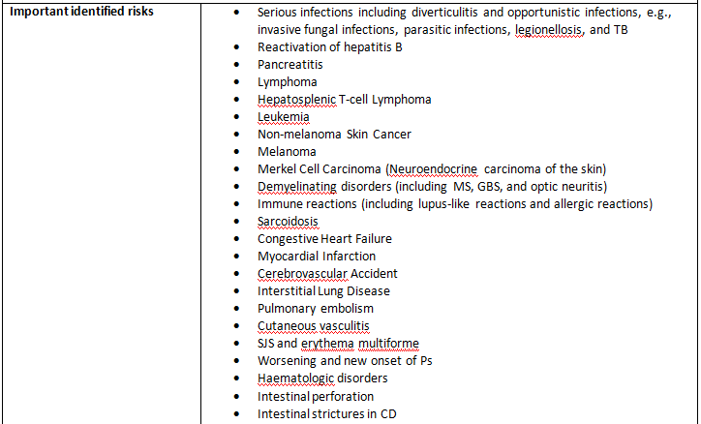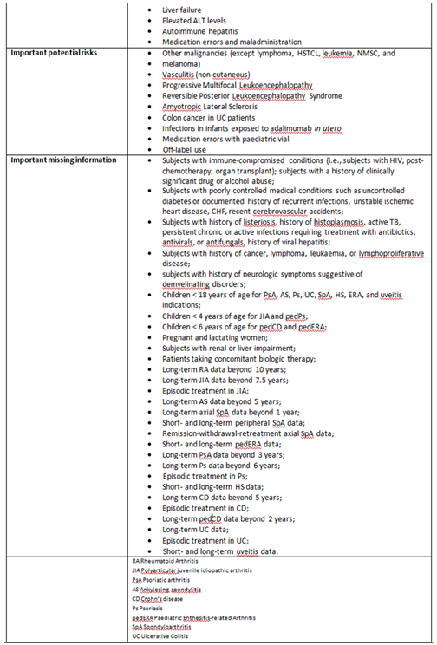

Evaluator comments
In comparison to the specified ongoing safety concerns previously accepted for Humira, the following changes have been observed:
- Diverticulitis has now been included in the important identified risk: ‘Serious infections’;
- ‘Merkel cell carcinoma (Neuroendocrine carcinoma of the skin)’ and ‘Autoimmune hepatitis’ have now been added as an important identified risks apparently upon request by the EMA; and
- Minor changes to some of the important missing information relating to rheumatoid arthritis, spondyloarthritis and ulcerative colitis.
In principle there are no objections to these changes and additions to the summary of the Ongoing Safety Concerns. Notwithstanding the evaluation of the clinical aspects of the SS it is considered that this list of ongoing safety concerns is acceptable.

Reconciliation of issues outlined in the RMP report
Table 2 summarises the TGAs first round evaluation of the RMP, the sponsor’s responses to issues raised and the TGA’s evaluation of the sponsor’s responses.
Table 2. Reconciliation of issues outlined in the RMP report
Recommendation in RMP evaluation report | Sponsor’s response | Evaluator’s comment
- The ASA has not been compiled in accordance with the Risk Management Plan (RMP) Questions and Answers (Version 1.3, October 2012), as currently found on the TGA website. The sponsor should revise the ASA accordingly and provide an updated version, referencing the EU-RMP Version: 10.1, to the TGA for review. | The ASA has been updated in line with the TGA’s Risk Management Plan (RMP) Questions and Answers (Version 1.3, October 2012) | This is acceptable.
- Safety considerations may be raised by the clinical evaluator through the consolidated section 31 request and/or the Clinical Evaluation Report respectively (see Section 6.1). It is important to ensure that the information provided in response to these include a consideration of the relevance for the Risk Management Plan, and any specific information needed to address this issue in the RMP. For any safety considerations so raised, the sponsor should provide information that is relevant and necessary to address the issue in the RMP. | The sponsor states that the safety profile of adalimumab is well established and no safety issues requiring further consideration were raised in the consolidated section 31 request. | Given no specific issues were raised in the CER (see above), this is acceptable.
- The ongoing studies are not considered to be part of the planned clinical studies in the pharmacovigilance plan (PP). Therefore the related study protocols have not been reviewed or requested for review if missing (see Section 8.1). Nevertheless these studies will either generate safety data that will simply support the known safety profile of the medicine or generate data that will provoke applications to amend the Australian registration details. To this end it is suggested that the sponsor should provide an attachment to the ASA setting out all the forthcoming studies in the PP and the anticipated dates for their submission in Australia. | The sponsor provided Table 3: ‘Overview of Ongoing and Planned Pharmacovigilance Actions’ in the revised ASA. | There are a number of ongoing and planned studies identified in Table 175: ‘Overview of Ongoing and Planned Pharmacovigilance Actions’ and Table 177: ‘Overview of Ongoing and Planned Pharmacovigilance Actions’ of the EU-RMP that do not appear in Table 3 of the ASA (see above).
- The sponsor’s conclusion in regard to the need for risk minimisation activities remains essentially similar to what was previously accepted for Humira. This continues to be acceptable. Nevertheless for the important identified risk: ‘Merkel cell carcinoma (Neuroendocrine carcinoma of the skin), Section 5: ‘Summary of the Risk Management Plan’ of the EU-RMP states: “Risk Minimisation actions in the form of an educational program is ongoing (Annex 8).” This is contrary to the corresponding information in Section 3.2: ‘Summary of Planned Actions’ and Section 4: ‘Risk Minimisation Plan’ of the EU-RMP. The sponsor should correct this internal inconsistency when this document is next updated. | The sponsor commits to correcting this inconsistency within the EU-RMP when the document is next updated. | This is acceptable.
- The draft versions of the educational materials for use in Australia should be attached to the updated ASA. The sponsor should also provide an assurance that the final versions of these documents will be provided to the TGA for review when they become available. | The sponsor states draft versions of the educational materials for use in Australia have now been provided and gives an assurance that the final versions of these documents will be provided to the TGA for review when they become available. | This is acceptable.
- The sponsor should provide an assurance that details of the evaluation tool to assess the effectiveness of the Australian Educational Programme will be provided to the TGA for review once it has been fully developed. | The sponsor gives an assurance that details of the evaluation tool to assess the effectiveness of the Australian Educational Programme will be provided to the TGA for review once it has been fully developed. | This is acceptable.
- The sponsor should provide a tabular ‘Summary of the Risk Management Plan in Australia’ in a revised ASA, including reference to specific wording pertaining to the routine risk minimisation activities for all the specified ongoing safety concerns in the proposed Australian PI and CMI. | The sponsor provided Table 4: ‘Summary of the Risk Minimisation Plan in Australia’ in the revised ASA. | There were a number of discrepancies observed between Table 4 of the ASA and the source document: EU-RMP Version 10.1 (dated October 2012) – see above.
- In regard to the proposed routine risk minimisation activities, it is recommended to the Delegate that the draft product information document be revised as follows:  - For the important identified risks: ‘Melanoma’ and ‘Merkel cell carcinoma (Neuroendocrine carcinoma of the skin)’, a statement such as “Melanoma and Merkel cell carcinoma have also been reported in patients treated with TNF-antagonists including adalimumab” should be included in the PRECAUTIONS section of the PI under the sub-heading: ‘Malignancies’ and crossed referenced to the ADVERSE EFFECTS section of the PI. This would align with the approved UK SPC and enhance safe use of these products | The sponsor states that the Precautions section of the Australian PI for Humira has been updated to include text relating to Melanoma and Merkel cell carcinoma under the sub-heading Malignancies. | This is acceptable.
- In regard to the proposed routine risk minimisation activities, it is recommended to the Delegate that the draft consumer medicine information document be revised to adequately reflect any changes made to the Australian PI as a result of the above recommendations. | The sponsor states that the Side effect section of the Humira CMIs have been updated to reflect changes to the PI relating to Melanoma and Merkel cell carcinoma. | This is acceptable.

VI. Overall conclusion and risk/benefit assessment
The submission was summarised in the following Delegate’s overview and recommendations:

Quality
The evaluators have raised no objections to the approval of the application to register Adalimumab 10mg/0.2ml solution for injection pre-filled syringe on quality and microbiological grounds.

Nonclinical
There was no requirement for a nonclinical evaluation in a submission of this type.

Clinical
The CE identified one pivotal study with efficacy, safety and pharmacokinetic data and one other study aimed at long term efficacy and safety data in paediatric subjects.

Pivotal study M06-806
In this multi-centre study, all subjects received an open-label induction regimen, dependent on their body weight at baseline.
- Subjects with BW greater than or equal to 40 kg: 160 mg at Week 0 and 80 mg adalimumab at Week 2.
- Subjects with BW < 40 kg: 80 mg at Week 0 and 40 mg adalimumab at Week 2.
At Week 4, subjects in each BW group were randomised 1:1 double-blindly to one of 2 maintenance treatment groups (low-dose or high-dose). Subjects with BW greater than or equal to 40 kg: low-dose 20 mg eow; high-dose 40 mg eow. Subjects with BW < 40 kg: low dose 10 mg eow; high dose 20 mg eow.
Subjects who did not respond to their initial maintenance dose were given the option to dose escalate from eow dosing to ew dosing. Subject’s BW taken at Week 26 was to be used to readjust the maintenance dosing regimen for subjects whose BW had increased from < 40 kg to greater than or equal to 40 kg during the study. Adalimumab was administered by subcutaneous [SC] injection.
A total of 188 subjects, with a diagnosis of CD greater than 12 weeks prior to screening (confirmed by endoscopy or radiologic evaluation) and PCDAI greater than 30 despite concurrent treatment with an oral corticosteroid, and/or azathioprine (AZA) or 6-metcaptopurine (6-MP),or methotrexate (MTX), were recruited. Also eligible for recruitment were subjects who had previously received infliximab with an initial response but then discontinued usage due either to a loss of subsequent response or intolerance to the medication. Some concomitant treatments for CD must be ceased at certain times prior to baseline [infliximab was required to be discontinued greater than or equal to 8 weeks before baseline. Previous use of any other anti-TNF medication, including previous adalimumab use, was prohibited. Cyclosporine, tacrolimus, and mycophenolate mofetil were prohibited within 4 weeks prior to baseline. Subjects taking Kineret (anakinra) were required to discontinue use 2 days prior to baseline. Subjects with any prior exposure to Tysabri (natalizumab) were excluded].
Subjects were to continue their doses of AZA, 6-MP and MTX and doses were to remain stable throughout the study. IMM therapy was to be discontinued at or after Week 26 at the investigator's discretion if the subject met the clinical response criterion. IMM therapy could not be reinstituted once discontinued. Subjects were to continue their doses of growth hormone and doses were to remain stable throughout the study.
Prednisone less than or equal to 40 mg/day and greater than or equal to 10 mg/day (or equivalent) was permitted provided subjects were on stable doses for at least 2 weeks prior to baseline. Budesonide less than or equal to 9 mg/day was permitted provided subjects were on stable doses for at least 2 weeks prior to baseline. Starting at Week 4, subjects who meet the definition of clinical response (defined as a PCDAI decrease of greater than or equal to 15 points compared to baseline) began a corticosteroid taper according to the following schedule:
Table 3: Corticosteroid taper schedule.
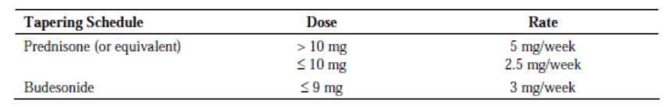
If the subject experienced a flare (defined as an increase in the PCDAI of greater than or equal to 15 points when compared to Week 4 and an absolute PCDAI greater than 30) or loss of response (not achieving a decrease in the PCDAI score of at least 15 points when compared to the baseline score for 2 consecutive visits at least 2 weeks apart), the corticosteroid dose could be increased to a maximal dose equivalent to the dose used at baseline. Reductions in concomitant therapy were allowed for CD treatment-related toxicities assessed as moderate to severe in the opinion of the investigator.
54 (56.8%) males and 41 (43.2%) females received either 10mg or 20mg maintenance low does adalimumab eow while 51 (54.8%) males and 42 (45.2%) females received either 20mg or 40mg maintenance high dose adalimumab eow. 35 (36.8%) and 60 (63.2%) subjects were aged respectively <13 years and greater than or equal to 13 years in the maintenance low dose, while 31 (33.3%) and 62 (66.7%) subjects were aged respectively <13 years and greater than or equal to 13 years in the maintenance high dose. The median age range was 6 to 17 years (mean ± SD = 13.5 ± 2.47 years) in the maintenance low dose while it was 7 to 17 years (mean ± SD = 13.7 ± 2.52 years) in the maintenance high dose. 35 (36.8%) and 60 (63.2%) subjects weighing respectively <40kg and greater than or equal to 40kg were in the maintenance low dose while 32 (34.4%) and 61 (65.6%) subjects weighing respectively <40kg and greater than or equal to 40kg were in the maintenance high dose.
The objective of pivotal study M06-806 was to demonstrate the safety and efficacy of adalimumab for the induction and maintenance of clinical remission in paediatric subjects with moderate to severe CD and to assess the pharmacokinetics (PK) of adalimumab administered by subcutaneous (SC) injection. The study duration was 52 weeks.
The primary measure of disease severity was the Paediatric Crohn’s Disease Activity Index (PCDAI), a validated rating scale to assess the severity of CD in children. Points are accrued based on reported abdominal pain, stool frequency, patient functioning/ well-being, haematocrit, ESR, albumin and body weight (gain or loss).
The primary efficacy endpoints were:
- The primary efficacy outcome was clinical remission at Week 26, defined as PCDAI score less than or equal to 10.
- The primary efficacy outcome aligned for external comparison at the PCDAI clinical remission at Week 26 in the ITT population. The external efficacy comparison was to compare data from the current paediatric study to data from the adult CD study, Study M02-404.
- The primary efficacy outcome aligned for internal comparison was to be the proportion of subjects who were in clinical remission at Week 26, as measured by the PCDAI in the ITT population. The internal primary analysis was to be the comparison of high-dose versus low-dose with respect to the primary efficacy outcome for internal comparison.
The major secondary efficacy endpoints (ranked) were:
- Proportion of subjects in PCDAI clinical remission at Week 52.
- Proportion of subjects in PCDAI clinical response at Week 26.
- Proportion of subjects in PCDAI clinical response at Week 52.
- Proportion of subjects in PCDAI clinical remission at Week 26 who were Week 4 responders.
- PCDAI clinical remission at Week 4.
- Proportion of subjects receiving corticosteroids at Baseline who had discontinued corticosteroids for at least 90 consecutive days prior to Week 26 and were in PCDAI clinical remission at Week 26.
- Change from baseline in z-score for height velocity at Week 26.
- Change from baseline in total IMPACT III scores at Week 26.
Secondary endpoints Number 4 and Number 5 are external comparisons of the paediatric and adult data; all other comparisons are internal comparisons of subjects in the High-Dose and Low-Dose treatment groups. Additional analyses were conducted after the study blind was broken including an analyses to compare the proportion of subjects in PCDAI clinical remission/clinical response (at Week 26 and Week 52) during the eow and ew double-blind maintenance phase.
According to the CE, pharmacokinetic profile of adalimumab in paediatric subjects was also derived from the pivotal StudyM06-806 data. Using the data, population pharmacokinetic and adalimumab exposure – PCDAI response models were built via nonlinear mixed effect modelling based on NONMEM 7.12 compiled with the Intel Fortran compiler (Version 11.1). For the pharmacokinetic purpose, blood samples were obtained for the measurement of adalimumab concentrations at baseline, Week 2, Week 4, Week 16, Week 26 and Week 52/Early Termination (ET). Serum for measurement of anti-adalimumab antibodies (AAAs) was obtained at baseline, Week 16, Week 26 and Week 52/ET. Samples were also obtained at baseline for measurement of human anti-chimeric antibody (HACA) to infliximab as well as infliximab drug levels prior to dosing with adalimumab.
As noted in the CER, the sample size was calculated assuming an expected clinical remission rate of 20% in the low-dose adalimumab group and 40% in the high-dose adalimumab group. A total sample size of 164 subjects that is 82 subjects per group was expected to provide 80% statistical power to detect the difference between the high and low dose treatment groups based on a 2-sided chi-square test with a significance level of 0.05. To allow for a pre-randomisation dropout rate / withdrawal rate of 10%, approximately 186 subjects were expected to be enrolled to provide approximately 164 randomised subjects. The study was stratified at Week 4 by body weight, responder status (Yes or No), and prior infliximab use (Yes or No) in order to ensure a balance of treatment groups across these adalimumab dose groups.
The primary population for all efficacy analyses was the ITT population, defined as all randomised subjects who received at least one dose of DB study medication. Results were also presented for the per-protocol (PP) population, which excluded all subjects with major protocol deviations and violations. Safety evaluations/analyses were based on the safety population, defined as all subjects who received at least one dose of adalimumab. The safety set was analysed as treated, according to treatment the subject actually received.
Statistical methods used in the pharmacokinetic and efficacy analyses include descriptive statistics (number of non-missing observations, median, standard deviations, coefficient of variation, geometric mean), two-sided tests with alpha level of 0.05, 95% CI, Cochran-Mantel-Haenszel test, Breslow-Day test at 10% significance level, observed case (OC) data with LOCF for imputed data, ANCOVA, et cetera.
Paediatric pharmacokinetic profile outcomes as in the CER:
- The mean adalimumab trough concentrations achieved during the induction phase (Week 0 through Week 4) in which both groups received the same induction dose were similar across treatment groups ranging from 12.1 to 15.5 mcg/mL. This compares with a mean of approximately 12mcg/mL in adults with CD given the same regimen.
- During maintenance phase, the mean adalimumab trough concentrations were approximately 10 and 4 mcg/mL for the high dose group (40/20 mg eow) and low dose group (20/10 mg eow), respectively. This compares with mean steady state trough concentrations in adults with CD receiving 40 mg eow of 6.6µg/mL at Week 24 and 7.2 µg/mL at Week 56. The mean trough concentrations appeared to be maintained in subjects who continued to receive adalimumab treatment eow for 52 weeks.
- In subjects whose doses were escalated, higher trough concentrations were achieved after dose escalation.
- Six (6/182, 3.3%) subjects were identified as AAA+ during the study.
- During the double-blind maintenance phase, mean serum adalimumab trough concentrations in infliximab experienced subjects were generally lower, but the range of concentrations overlapped. Adalimumab trough concentrations by dose and previous infliximab treatment status are shown in the figures on page 13 of the CER.
Paediatric primary efficacy outcomes as in the CER:
- The external comparison for the primary efficacy outcome is shown in the table below.
Table 4. Proportion of subjects in PCDAI Clinical Remission at Week 26.
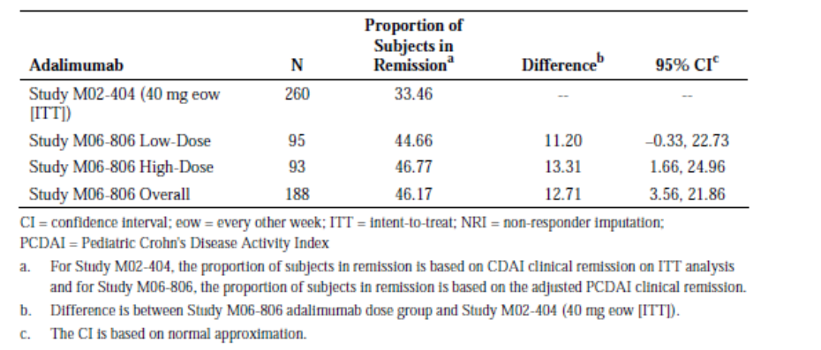Thus for the primary efficacy outcome external comparison, the study was a success in that the 95% CI for the difference in remission rates at Week 26 crossed 0 (or better) for the overall use of adalimumab in the paediatric population and for each dose regimen assessed (high-dose and low dose). Adalimumab performed better in the paediatric CD population than in the adult population.
- For the internal efficacy comparison, the difference in remission rates at Week 26 between low dose and high dose adalimumab did not reach statistical significance. Remission rates at Week 26 were 38.7% (high dose) and 28.4%(low dose), p = 0.075. Results are shown in Table 10 in section 18 of the CER. Although the primary internal comparison for the primary efficacy outcome did not reach statistical significance the sponsor produced the planned subgroup analyses for the primary efficacy outcome, some of which did reach statistical significance.
- For the subgroup of infliximab naïve subjects remission rates at Week 26 were 56.9% (high dose) and 35.2% (low dose), p= 0.026.
- Overall (for subjects given either dose regimen) 46% of infliximab naïve subjects were in remission at Week 26 compared with 18% infliximab experienced subjects.
- For infliximab experienced subjects the remission rate at Week 26 did not increase with increased adalimumab dose.
- A total of 83 out of 188 subjects (44.1%) who underwent induction treatment were in remission at week 4. Of the infliximab experienced subjects who had not achieved remission at Week 4 only 2/19 (10.5%) achieved remission at Week 26. This compares with 3/14 (21.4%) infliximab naïve subjects who were not in remission at Week 4 but who went on to remission at Week 26. Failed remission status at Week 4 and prior exposure to infliximab were strong negative predictors of remission status at Week 26 for both the high and low dose adalimumab groups. In fact, both prior infliximab use and the presence of HACA were associated with reduced remission rates.
- Similar results were obtained from the LOCF and PP analyses (NRI and LOCF).
- Of the 95 subjects randomised to low dose treatment, 48 (50.5%) were switched from eow to ew treatment compared with 35/93 (37.6%) who were randomised to high dose treatment.
Paediatric secondary efficacy outcomes as in the CER:
- The proportion of subjects in either PCDAI clinical remission at week 52 or clinical response at week 26 did not show statistically significant differences between the high and low dose adalimumab groups. However, the remission rates over time to 52 weeks revealed that from week 16 onwards, higher remission rates are reported in the high dose compared to the low dose group. Also, the mean reduction in PCDAI revealed that the differences between the high and low dose regimens are small but consistently favour the higher dose.
- The proportion of subjects in PCDAI clinical response at Week 52 was 28.4% and 41.9% respectively for low and high dose adalimumab (p value = 0.038).
Note: The clinical evaluator has provided the remaining secondary efficacy outcomes without the statistical comparisons on the basis that the earlier ranked secondary outcomes failed to reach statistical significance.
- Response at Week 4 appears to be predictive of remission rate at Week 26 for any dose of adalimumab. For subjects who responded at Week 4 the remission rate for the combined dose groups at Week 26 was 52% that is if treatment is continued in subjects who have not had a response at Week 4, only an additional 6% of patients with CD can be expected to achieve remission at Week 26. The remission rate at Week 52 was 23.2% for the low dose group and 33.3% for the high dose groups.
- No difference in terms of increased height velocity or quality of life measures between the high and low dose treatments was apparent. QOL was assessed using IMPACT III, a QOL questionnaire specifically developed and validated for paediatric patients with inflammatory bowel disease.
- A total of 26.8% of subjects who were taking systemic corticosteroids at baseline and discontinued the latter for greater than or equal to 90 consecutive days prior to Week 26, achieved PCDAI clinical remission at Week 26.
Related efficacy issues as in the CER:
- Six subjects were noted to be AAA+ during the study. Of these, 2 were on a concomitant immunosuppressant (methotrexate). Five of the 6 AAA+ subjects had serum concentrations decline to below the limit of detection of the assay during maintenance phase. The 6th subject early terminated the study with serum adalimumab concentration below the limit of detection. Two of these subjects (12903 and 31001) achieved remission at Week 26 whereas 4 subjects did not.
- Regarding the effect of escalation to weekly dosing on clinical response/remission at Week 52 (Table 15 of the CER), 20 subjects across the two groups who had not achieved a clinical response at Week 26 were dose escalated. Of these 20 subjects, 7 (35%) and 5 (25%) subjects respectively achieved a clinical response and remission at Week 52. Sixty-three (63) subjects were dose escalated after achieving a clinical response at Week 26. Thirty-six (57%) of those subjects remained in clinical response at Week 52 while fifteen (24%) were in clinical remission at Week 52.
- Of the 117 subjects who were taking immunosuppressants at baseline, 14 (12%) discontinued and were in remission at Week 52.

Other study M06-807
This was a multi-centre, open-label study to evaluate the efficacy and long-term safety and tolerability of repeated administration of adalimumab in paediatric subjects with CD who demonstrated a clinical response in Study M06-806 through to week 52. Only an interim report was included in this submission.

Interim efficacy outcome as in the CER
The clinical evaluator stated that from the descriptive data supplied it is not possible to determine whether there is a loss of response over time due to the high loss of subjects from the extension study (M06-807). That study did show that subjects who continued treatment continued to respond. The extent of withdrawals from this study and reasons for withdrawal were not apparent in the interim study report.

The CE’s overall conclusions (in part only) on paediatric pharmacokinetics are:
- The adalimumab trough concentration data and modelling suggested that trough concentrations will be similar in adults and paediatric patients.
- Reducing the dose interval to weekly resulted in approximately doubling the trough concentration of adalimumab.
- The proposed maintenance dose regimens resulted in mean adalimumab trough concentrations comparable to those observed in adults given 40mg eow. However, the trough levels were somewhat higher in those children given higher dose regimen, when compared with adults given the recommended dose.
Note: The CE requested that the sponsor provides the data or modelling upon which the induction dose regimens for both patients with BW<40kg and BW greater than 40 kg are based. In response, the sponsor provided an exposure-efficacy analysis based on Study M06-806. The CE accepted that the results suggested a relationship between adalimumab exposure following the induction dose and the percentage of patients experiencing clinical remission at Week 26.
Delegate’s comment: Agreeable.
- Subjects with previous exposure to infliximab generally had reduced trough levels of adalimumab as did subjects who were HACA positive.

The CE’s overall conclusions (in part only) on efficacy are:
- Paediatric patients with CD given the proposed dose regimens appear in the cross study comparison to adult patients with CD to have better outcomes in terms of remission at Week 26 regardless of whether they received the high or low dose maintenance regimen. No statistically significant difference was apparent between the high and low dose maintenance regimens for the internal primary efficacy analysis.
Note: The CE requested that the sponsor provides data (to be included in the Clinical Trial section of the PI) showing clinical response and remission rates for subjects who did not achieve clinical response prior to Week 12 in Study M06-806, in order to assess on -going therapy beyond Week 12 in subjects not responding by Week 12. In reply, the sponsor provided analyses by clinical response at Weeks 4, 8 and 12. The CE concluded that the results from these analyses provide strong support for not continuing treatment beyond Week 12 in patients who did not have a clinical response at that stage.
Delegate’s comment: For a start, the data provided by the sponsor would indicate that the number of non-responders increased with the number of weeks. The inference is that previous responders turned into non-responders which may probably be related to the issue of refractoriness/resistance to adalimumab (antibody development). While subsequent response/remission for non-responders at Weeks 4, 8 and 12 waned substantially with duration of treatment (that is Weeks 26 and 52) to varying levels on a comparative basis, the per cent response/remission to adalimumab never actually reached ZERO. That is, some Week 12 non-responders may benefit from treatment beyond Week 12. Therefore, the Delegate believes that the decision to either or not continue treatment in Week 12 non-responders is a clinical judgement best determined by the treating specialist gastroenterologists, especially given the reasonable safety profile of adalimumab.
Note: The CE requested for the subgroup data analysis of efficacy results by baseline disease severity (PCDAI scores <40 for moderate disease and greater than or equal to 40 for severe disease).The sponsor provided a baseline disease severity table and stated that “For patients with severe CD at baseline, as defined by PCDAI greater than or equal to 40, the adalimumab high-dose was substantially more effective than the low-dose for both response and remission at Week 52. In patients with moderate disease at baseline (PCDAI < 40), efficacy was similar in the high-dose and low-dose groups at Week 52”. The CE commented that these results support the proposed higher dose for patients with more severe disease.
Delegate’s comment: Agreeable.
- Prior infliximab experience and/or the presence of HACA reduced response/remission rates in patients.
- The lack of a placebo group for within study comparisons, while understandable, results in a lack of internal reference which is important for a disease which is known to vary in its severity over time without treatment. The responses and remissions shown in subjects who were AAA+ and had adalimumab levels below the limit of quantification suggest that responses and remissions would have occurred in subjects given placebo under the same conditions as those given adalimumab. Due to the absence of a placebo group, it is not possible to estimate the number needed to treat (NNT) for one patient to derive a clinical response/remission (? In AAA+ subjects).
- Differences in secondary efficacy endpoints (as is the case for the primary efficacy endpoints) between the high and low dose regimen were generally quite small, particularly for subjects with prior exposure to infliximab. Most of the statistical analyses of secondary endpoints were not valid due to lack of statistically significant results for the first ranked secondary endpoint. Although this is a major limitation to interpretation of the data, it is likely that clinical response or remission at Week 4, no prior experience of infliximab and absence of HACA and AAA+ are predictors of subsequent response to adalimumab, regardless of whether the high or low dose regimen is used.
- In the study, around one-quarter of subjects taking systemic corticosteroids at baseline were able to stop them by Week 26 of treatment and 12% of subjects taking immunomodulators at baseline were able to cease them by Week 52.
- Subjects who required dose escalation to ew generally did worse than those not requiring dose escalation (that is dose escalation did not lead to high proportion of dose escalated patients going into remission or achieving a clinical response).
- From the descriptive data provided for study M06-807, it is impossible to determine whether there is a loss of response over time due to the high loss of subjects from the extension study.
Note: The sponsor stated that this study is on-going and that the currently projected date for the last patient to complete the Study is October 2016 with no further interim reports planned. Furthermore, the sponsor stated that “There were only 100 patients enrolled in the open maintenance study and 46 of these had withdrawn prior to the cut-off date for the interim report. Nine of the 46 had withdrawn due to lack of efficacy. Of note, the reason for discontinuation was absent for 19 patients. The CE commented that study M06-807 is not adequate to assess the extent of ongoing (that is beyond 12 months) efficacy from the view of maintenance treatment with adalimumab in paediatric patients with CD.
Delegate’s comment: Agreeable.

Regarding safety, the CE’s overall conclusions are:
- No new safety issues have been identified in the two studies.
- The number of paediatric subjects assessed was quite limited and insufficient to determine the extent of risk of rare serious adverse events such as malignancies and severe opportunistic infections.
The proposed dose regimen does not appear to have resulted in a clinically significant increased risk of adverse events compared with use in adults given their recommended dose regimen; however, longer term safety will require post marketing assessment.

Recommendation regarding authorisation as per the CE (First round):
- In the absence of exploration of alternative induction dose regimens in a clinical study the proposed induction dose regimen is accepted, however, patients who have not achieved a clinical response to the induction regimen should not continue treatment. A robust demonstration of continued benefit for these patients has not been provided and given the risks of continued treatment it is not acceptable to continue to expose patients to a treatment with potential for life threatening side effects when the extent of benefit is known to be reduced but is otherwise unclear.
- The proposed higher dose maintenance regimen has not been shown to be statistically superior to the low dose regimen. Therefore the low dose regimen of 20 mg eow for patients with BW greater than or equal to 40 kg and 10 mg eow for patients with BW <40 kg should be adopted. There is insufficient evidence to support increasing dosing to weekly in patients who lose response or who fail to respond to initial treatment regimens. Consideration could be given to implementing the high dose regimen in patients with severe disease who have responded to the induction regimen.

Recommendation regarding authorisation as per the CE (Second round):
Following second round assessment, the CE stated that:
- Amendments previously recommended to the PI and CMI have not been implemented. The Delegate recommends these be implemented or a justification for not implementing the amendments be provided by the sponsor.

RMP evaluation
In the summary of recommendations, the RMP evaluator stated that:
The TGA provides these recommendations in the context that the submitted RMP is supportive to the application; the implementation of a RMP satisfactory to the TGA is imposed as a condition of registration; the submitted EU-RMP is applicable without modification in Australia unless so qualified; and the draft product information and consumer medicine information documents should NOT be revised until the Delegates Overview has been received:
- The ASA has not been compiled in accordance with the Risk Management Plan (RMP) Questions and Answers (Version 1.3, October 2012), as currently found on the TGA website. The sponsor should revise the ASA accordingly and provide an updated version, referencing the EU-RMP Version: 10.1, to the TGA for review.
- Safety considerations may be raised by the clinical evaluator and/or the Clinical Evaluation Report respectively. It is important to ensure that the information provided in response to these include a consideration of the relevance for the Risk Management Plan, and any specific information needed to address this issue in the RMP. For any safety considerations so raised, the sponsor should provide information that is relevant and necessary to address the issue in the RMP.
- The ongoing studies are not considered to be part of the planned clinical studies in the pharmacovigilance plan (PP). Therefore the related study protocols have not been reviewed or requested for review if missing. Nevertheless these studies will either generate safety data that will simply support the known safety profile of the medicine or generate data that will provoke applications to amend the Australian registration details. To this end it is suggested that the sponsor should provide an attachment to the ASA setting out all the forthcoming studies in the PP and the anticipated dates for their submission in Australia.
- The sponsor’s conclusion remains essentially similar to what was previously accepted for Humira. This continues to be acceptable. Nevertheless for the important identified risk: ‘Merkel cell carcinoma (Neuroendocrine carcinoma of the skin), Section 5: ‘Summary of the Risk Management Plan’ of the EU-RMP states: “Risk Minimisation actions in the form of an educational program is ongoing (Annex 8).” This is contrary to the corresponding information in Section 3.2: ‘Summary of Planned Actions’ and Section 4: ‘Risk Minimisation Plan’ of the EU-RMP. The sponsor should correct this internal inconsistency when this document is next updated.
- The draft versions of the educational materials for use in Australia should be attached to the updated ASA. The sponsor should also provide an assurance that the final versions of these documents will be provided to the TGA for review when they become available.
- The sponsor should provide an assurance that details of the evaluation tool to assess the effectiveness of the Australian Educational Programme will be provided to the TGA for review once it has been fully developed.
- The sponsor should provide a tabular ‘Summary of the Risk Management Plan in Australia’ in a revised ASA, including reference to specific wording pertaining to the routine risk minimisation activities for all the specified ongoing safety concerns in the proposed Australian PI and CMI.
- In regard to the proposed routine risk minimisation activities, it is recommended to the Delegate that the draft product information document be revised as follows:
- For the important identified risks: ‘Melanoma’ and ‘Merkel cell carcinoma (Neuroendocrine carcinoma of the skin)’, a statement such as “Melanoma and Merkel cell carcinoma have also been reported in patients treated with TNF-antagonists including adalimumab” should be included in the PRECAUTIONS section of the PI under the sub-heading: ‘Malignancies’ and crossed referenced to the ADVERSE EFFECTS section of the PI. This would align with the approved UK SPC and enhance safe use of these products.
- In regard to the proposed routine risk minimisation activities, it is recommended to the Delegate that the draft consumer medicine information document be revised to adequately reflect any changes made to the Australian PI as a result of the above recommendations.
Any issues raised in the RMP report that are not adequately addressed by the sponsor's response are likely to be referred to ACSOM.

RMP evaluation (second round)

Advice summary
This document seeks to reconcile issues identified in the RMP evaluation report for the above submission with consideration of the following documents:
- The EU-RMP (Version 10.1, dated October 2012) with an updated ASA (undated)
- Sponsor’s response to TGA Section 31 Request (2 January 2014)
- Clinical Evaluation Report (CER) for Humira (25 October 2013)
It is considered that the sponsor’s response to the TGA’s Request has not adequately addressed all of the issues identified in the RMP evaluation report.

Outstanding issues

Issues in relation to the RMP
It was suggested to the sponsor that an attachment to the ASA setting out all the forthcoming studies in the pharmacovigilance plan and the anticipated dates for their submission in Australia should provide. In response the sponsor provided Table 3: ‘Overview of Ongoing and Planned Pharmacovigilance Actions’ in the revised ASA. However, there are a number of ongoing and planned studies identified in Table 175: ‘Overview of Ongoing and Planned Pharmacovigilance Actions’ and Table 177: ‘Overview of Ongoing and Planned Pharmacovigilance Actions’ of the EU-RMP that do not appear in Table 3 of the ASA. The sponsor should provide compelling justification as to why these studies are not included in Table 3 of the ASA or revise this table to include such information. In addition it is noted that all the Australian milestones are annotated as ‘TBD’, whereas the TGA would expect these milestones to be closely aligned to the planned date for submission of interim and/or final data in Europe.
The sponsor was advised to provide a tabular ‘Summary of the Risk Management Plan in Australia’ in a revised ASA, including reference to specific wording pertaining to the routine risk minimisation activities for all the specified ongoing safety concerns in the proposed Australian PI and CMI. In response the sponsor provided Table 4: ‘Summary of the Risk Minimisation Plan in Australia’ in the revised ASA. However, the following discrepancies were observed:
- Details of routine risk minimisation for the important identified risk: ‘Intestinal stricture in CD’ found in Table 181: ‘Summary of Planned Risk Minimisation Actions’ of the EU-RMP have been omitted.
- Details of routine and additional risk minimisation for the important identified risk: ‘Medication error and maladministration’ found in Table 182: ‘Summary of Risk Minimisation Actions’ of the EU-RMP have been omitted.
- Details of routine risk minimisation for the other important potential risks besides ‘Other malignancies (except lymphoma, HSTCL, leukaemia, NMSC, and melanoma)’ found in Table 181: ‘Summary of Planned Risk Minimisation Actions’ of the EU-RMP have been omitted.
- Details of routine risk minimisation for the other important missing information besides ‘Subjects with immune-compromised conditions (that is, subjects with HIV, post-chemotherapy, organ transplant); subjects with a history of clinically significant drug or alcohol abuse’, ‘Subjects with poorly controlled medical conditions such as uncontrolled diabetes or documented history of recurrent infections, unstable ischemic heart disease, CHF, recent cerebrovascular accidents’, ‘Subjects with history of listeriosis, history of histoplasmosis, active TB, persistent chronic or active infections requiring treatment with antibiotics, antivirals, or antifungals, history of viral hepatitis’, ‘Subjects with history of cancer, lymphoma, leukaemia, or lymphoproliferative disease; subjects with history of neurologic symptoms suggestive of demyelinating disorders’ and ‘Children < 18 years of age for PsA, AS, Ps, UC, SpA, Paediatric Enthesitis-related Arthritis (pedERA), HS, and uveitis indications found in Table 181: ‘Summary of Planned Risk Minimisation Actions’ of the EU-RMP have been omitted.
The sponsor should provide compelling justification as to why these ongoing safety concerns and the associated details have not been included in Table 4 of the ASA or revise this table to include such information.

Advice from the Advisory Committee on the Safety of Medicines (ACSOM)
ACSOM advice was not sought for this submission.

Comments on the safety specification of the RMP

Clinical Evaluation Report
The clinical evaluator does not appear to have made any substantive comment on the clinical aspects of the Safety Specification in the draft RMP.

Suggested wording for conditions of registration

RMP
The European Risk Management Plan Version 10.1 (dated October 2012), with a revised Australian Specific Annex (ASA) agreed to by the TGA, must be implemented.

PSUR
The standard PSUR requirements apply.

Delegate’s discussion
The proposed paediatric induction and maintenance doses fit pharmacokinetic modelling built on nonlinear mixed effect and there is inference that the adalimumab trough concentrations will be similar in both adult and paediatric patients. The proposed induction and maintenance doses also appeared to be stratified for weight in the pivotal clinical trial. The latter will be appropriate given that affected individuals will have different presentations and disease severity depending on the anatomical location(s) of the disease in the gastrointestinal tract. The proposed induction dose regimens are not too dissimilar to those approved in EU because of the inserted caveat (underlined):
Paediatric Crohn's disease patients < 40 kg:
The recommended Humira induction dose regimen for paediatric subjects with severe Crohn's disease is 40 mg at Week 0 followed by 20 mg at Week 2. In case there is a need for a more rapid response to therapy, the regimen 80 mg at Week 0 (dose can be administered as two injections in one day), 40 mg at Week 2 can be used, with the awareness that the risk for adverse events may be higher with use of the higher induction dose.
After induction treatment, the recommended dose is 20 mg every other week via subcutaneous injection. Some subjects who experience insufficient response may benefit from an increase in dosing frequency to 20 mg Humira every week.
Paediatric Crohn's disease patients greater than or equal to 40 kg:
The recommended Humira induction dose regimen for paediatric subjects with severe Crohn's disease is 80 mg at Week 0 followed by 40 mg at Week 2. In case there is a need for a more rapid response to therapy, the regimen 160 mg at Week 0 (dose can be administered as four injections in one day or as two injections per day for two consecutive days), 80 mg at Week 2 can be used, with the awareness that the risk for adverse events may be higher with use of the higher induction dose.
After induction treatment, the recommended dose is 40 mg every other week via subcutaneous injection. Some subjects who experience insufficient response may benefit from an increase in dosing frequency to 40 mg Humira every week”.
Going by the eligibility criteria for study inclusion, virtually all the subjects had tried all other available therapies without much response or remission and are desirable of an instantaneous relief/response from adalimumab therapy if it works. There is also a possibility that initiating adalimumab therapy at a dose below what was trialled in the pivotal study could lead to the early development of anti-adalimumab antibody (AAA+) without an actual response, even when the adalimumab dose is subsequently increased. Also, following a similar reasoning, the proposed maintenance dose regimens trialled in the pivotal study, as opposed to any other arbitrary non-evidence based maintenance dose regimens, are appropriate.
Given that adalimumab’s safety profile is not any worse than most other immunomodifiers despite its use for a host of other indications, any decision to not proceed with its use in either patients not achieving a clinical response at induction or Week12 (that is Week12 non-responders) should be based on clinical judgement best left in the hand of the treating specialist’s team. In that regard, it is noted that only 83 out of 188 (44.1%) subjects randomised into the maintenance phase of the pivotal study were in remission at week 4 without further qualification as to the ‘response status’ of the remaining 105 subjects randomised. Again, the issue of dose escalation to weekly dosing should be a clinical decision best left in the hands of the treating specialist’s team as the evaluated data did show that some patients went on to have either a remission or a response. The latter fact is reflected in the approved EU’s dosing instructions stated earlier.
Regarding the CE’s recommendations to the dPI, I consider that there is no requirement to amend the dose regimens from “low and high doses” to “standard and high doses” as it will not be in keeping with the description in the submitted pivotal study, thus making it inaccurate. Also, the suggested column stratification into severe and moderate CD under “Dosage and Administration” section of the dPI is not necessary. The statements “Treatment should be discontinued in patients who do not respond to the induction treatment” and “Patients who have not shown a clinical response during 12 weeks of treatment should be withdrawn from treatment” require modifications along the line of the EU format to “Under specialist gastroenterologist’s care, continued therapy in patients either without a clinical response at (Week 4) induction or Week 12 could be considered”. The latter suggestion is also supported from the evaluated data which showed longer term clinical response and remission rates in patients who do not show a clinical response at Week 4 is significant and that few individuals can still receive benefit from continuing treatment if they have not achieved a clinical response at their Week 12 assessment.
While it is necessary to define the PCDAI scores for both moderate and severe CD in the “Clinical Trial” section of the PI, the current statement for maintenance therapy under “Dosage and Administration” section of the dPI is considered adequate to assist the treating specialist) without further expansion into “Subjects with severe disease, defined as PCDAI score of greater than or equal to 40 may benefit from increased maintenance dosing up to a maximum of 40mg fortnightly for patients with body weight greater than or equal to 40kg and 20mg fortnightly for patients with body weight < 40kg”.
There are no outstanding Quality issues to deter approval of the application.
While there are no new safety issues identified in the CER, the European Risk Management Plan Version 10.1 (dated October 2012), with a revised Australian Specific Annex (ASA) agreed to by the TGA, must be implemented as a condition of registration in addition to complying with the standard PSUR requirements.

Proposals for the ACPM’s deliberations/advice
- Appropriateness of the induction doses based only on weight and maintenance doses based on both weight and disease severity.
- Continuation of treatment in both Week 4 (induction) and Week 12 non-responders under specialist’s care.

Pre ACPM preliminary assessment/action
As a sequelae of the evidence based data evaluated, the Delegate is inclined at this stage to be positive towards the approval of the application subject to resolving issues, arising from the ACPM deliberations and finalisation of matters pertaining to the PI and RMP to the satisfaction of the TGA.

Response from sponsor
AbbVie Pty Ltd would like to take this opportunity to respond to the TGA review of the application to register Humira (adalimumab) Solution for Injection for the indication Paediatric CD.
AbbVie Pty Ltd agrees with the Delegate’s proposed action as stated in the Request for Advice dated 3 March 2014.
- The delegate seeks advice from the ACPM on the appropriateness of the induction doses based only on weight and maintenance doses based on both weight and disease severity.
AbbVie response: The submitted adalimumab dosing regimen, provided below, provides paediatric CD patients with a favorable benefit/risk profile.
Table 5. Submitted adalimumab dosing regimen.
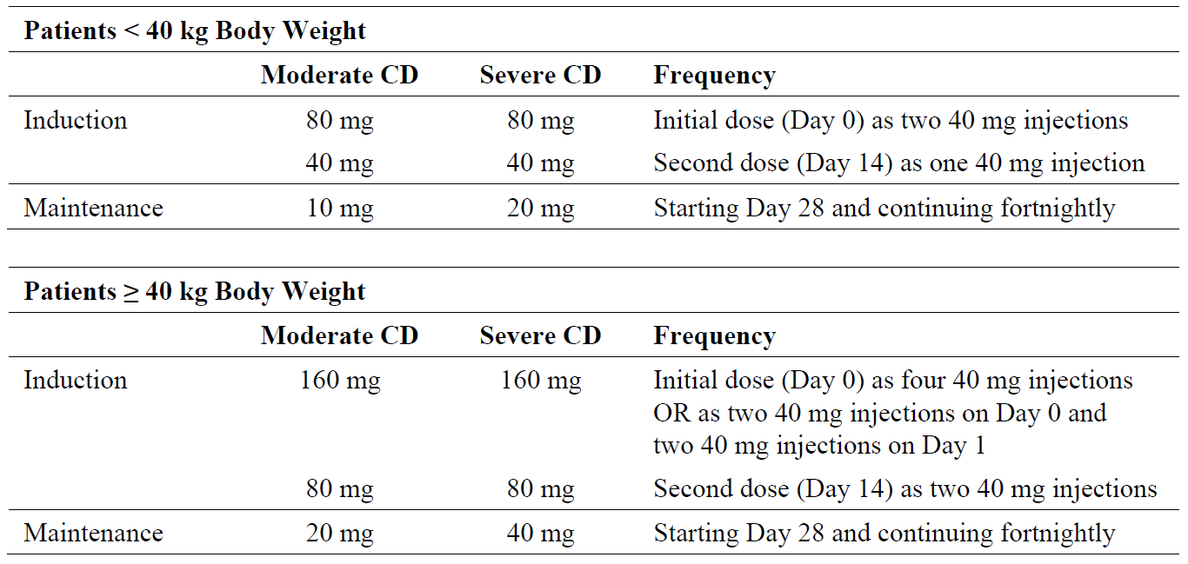
This regimen is in line with the induction doses that were studied in pediatric CD patients (Study M06-806).
Exposure-efficacy analysis was conducted to provide the justification for the current adalimumab induction regimen. Patients in Study M06-806 were categorized into quartiles (Q1 to Q4) based on observed Week 4 serum adalimumab trough concentrations (following induction dosing) and Week 26 PCDAI remission rates (the primary efficacy endpoint) were compared (Figure 1). The results suggest a clear relationship between adalimumab exposure following the induction dose and the percentage of patients experiencing clinical remission at Week 26. This is clinically meaningful since a greater exposure will provide a greater benefit to patients with symptoms and limited treatment options.
Figure 1. Percentage of patients achieving clinical remission at Week 26 stratified by adalimumab trough concentration quartiles at Week 4 in Study M06-806.
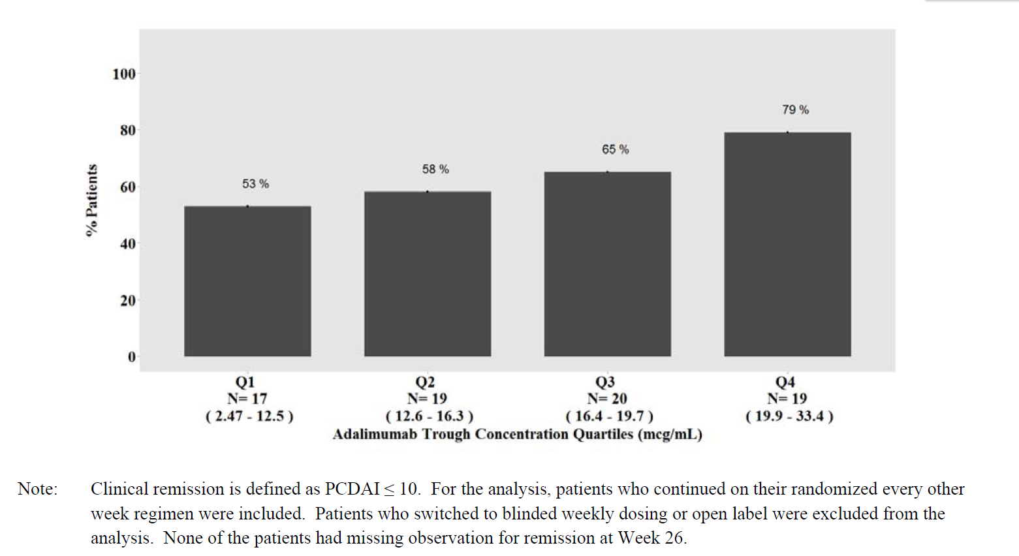
For patients with severe CD at baseline, as defined by PCDAI greater than or equal to 40, the adalimumab High-Dose was substantially more effective than the Low-Dose for both response and remission at Week 52, lending support to the higher maintenance dose in patients with severe CD. In patients with moderate disease at baseline (PCDAI < 40), efficacy was similar in the High-Dose and Low-Dose groups at Week 52 with regard to both remission and response rates.
Table 6. Comparison of the proportion of patients in PCDAI clinical remission/response at Week 52 by Baseline PCDAI in Study M06-806 (NRI, ITT population).
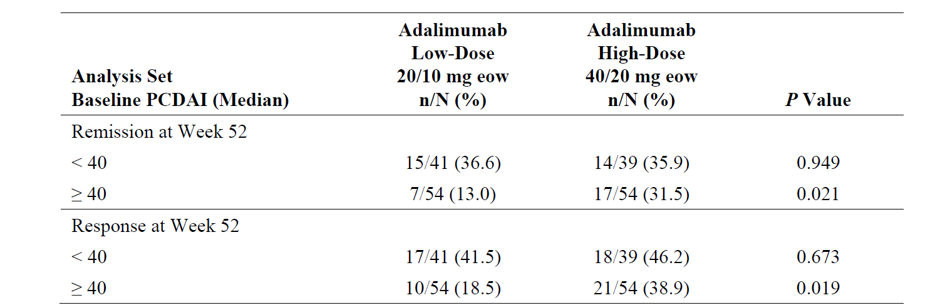
In patients with moderate disease at Baseline, the exposure adjusted SAE rate was higher in the High-Dose group (32.0 events [E]/100 patient years [PYs]) compared to the Low-Dose group (17.6 E/100 PYs). However, among patients with severe disease at Baseline, the exposure adjusted SAE rate was similar in the High-Dose group (54.8 E/100 PYs) and the Low-Dose group (64.5 E/100 PYs).
Because paediatric patients with moderately to severely active CD suffer a substantial symptomatic burden, the applicant feels that the proposed dosage regimen represents the greatest opportunity to achieve efficacy with an acceptable safety profile in this patient population.
- The Delegate seeks advice from the ACPM on the Suitability /Requirement to continue treatment in both Week4 (induction) and Week12 non-responders under specialist’s care.
AbbVie response: The sponsor agrees that continuing treatment beyond week 12 in non-responders is a clinical judgment best determined by the treating specialist gastroenterologist. This is supported by the data presented in Table 6, which shows clinical remission and response rates at Weeks 26 and 52 for patients who did not achieve clinical response prior to Week 12 in Study M06-806.
The proportion of Week 4 non-responders with response at Weeks 26 and 52 was high and clinically meaningful (27.3% and 24.2%, respectively). Week 4 non-responders also achieved clinically meaningful remission rates at Weeks 26 and 52 (15.2% and 21.2%, respectively). Thus, it is reasonable to continue treatment with adalimumab in patients who did not achieve response early after induction therapy. The proportion of Week 8 non-responders with response and remission at Week 26 or Week 52 was relatively low (4.5% to 12.5%). However, the proportion of Week 12 non-responders with response and remission at Week 26 or Week 52 was lower (0% to 11.1%). Similar findings have been observed in adult patients with CD treated with adalimumab, as found in the Australian package insert: ‘Of those in response at Week 4 who attained remission during the study, patients in Humira maintenance groups maintained remission for a significantly longer time than patients in the placebo maintenance group . Among patients who were not in response by Week 12, therapy continued beyond 12 weeks did not result in significantly more responses. The group that received Humira every week did not show significantly higher remission rates than the group that received Humira fortnightly.’
This is the basis for the sponsor's recommendation that the following statement be added to the dosage and administration section of the PI: ‘Continued therapy should be carefully considered in a subject not responding by week 12.’
Table 7. Comparison of proportion of patients who were non-responders at Weeks 4/8/12 and in PCDAI clinical remission/response at Weeks 26/52 (Study M06/806, ITT population).
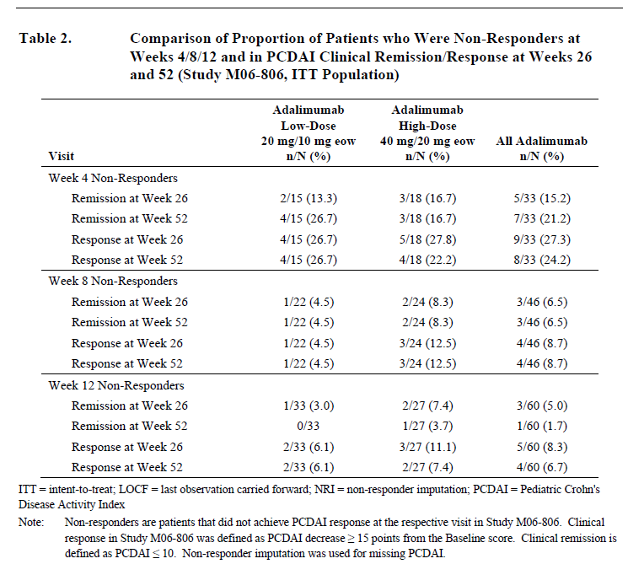

Advisory committee considerations
The Advisory Committee on Prescription Medicines (ACPM), having considered the evaluations and the Delegate’s overview, as well as the sponsor’s response to these documents, advised the following:
The submission seeks to register an extension of indications for a currently registered product.
The ACPM, taking into account the submitted evidence of efficacy, safety and quality, agreed with the delegate and considered Humira solution for injection containing 20 mg/0.4 ml and 40 mg /0.8 ml of adalimumab to have an overall positive benefit–risk profile for the indication;
Crohn's Disease in Adults and Children (greater than or equal to 6 years)
Humira is indicated for the treatment of moderate to severe Crohn's disease, to reduce the signs and symptoms of the disease and to induce and maintain clinical remission in patients;
- who have had an inadequate response to conventional therapies ,or
- who have lost response to or are intolerant of infliximab.

Proposed conditions of registration
The ACPM agreed with the delegate on the proposed conditions of registration.

Proposed Product Information (PI)/Consumer Medicine Information (CMI) amendments
The ACPM agreed with the delegate to the proposed amendments to the Product Information (PI) and Consumer Medicine Information (CMI) and specifically advised on the inclusion of the following:
- A statement on the therapeutic value of good nutrition in addition to pharmacologic intervention as per the therapeutic guidelines on the management of Crohn’s disease should be included in the PI and relevant sections of the CMI.
- Amendment of the CMI to better reflect Australian circumstances and with reference to the standard CMI template and the Usability Guidelines.

Specific advice
The ACPM advised the following in response to the Delegate’s specific questions on this submission:
- Appropriateness/Justification of the induction doses based only on weight and maintenance doses based on both weight and disease severity.
The ACPM was of the view that trough levels reported in trials indicate that weight-based dosing appears to be appropriate. No disease severity subgroup analysis of the primary outcome is provided and dosing based on severity is not logical.
There is evidence that the low dose maintenance therapy should be used rather than the high dose maintenance therapy; that is 20 mg for the over 40 kg subgroup, and 10 mg for the under 40 kg group. There is some evidence provided of limited benefit of dose increase during maintenance (but not of increased frequency of dosing). There is no evidence of superiority of higher maintenance dose.
- Suitability /Requirement to continue treatment in both Week 4 (induction) and Week 12 non-responders under specialist’s care.
Trials show a modest benefit for 4 week non-responders at 26 and 52 weeks; however, there is very little benefit in continuing therapy in 12 week non-responders. Continued treatment in non-responders is not a clinical problem as in practice a high dose regimen might be introduced for a brief period of time, but if a lack of response persists, then other treatments, including surgery, would have to be seriously considered in this small group of patients. The statement on cessation of treatment in non-responders is not necessary in the proposed indication (as in ulcerative colitis) but should be clear in PI.
The ACPM advised that the implementation by the sponsor of the recommendations outlined above to the satisfaction of the TGA, in addition to the evidence of efficacy and safety provided would support the safe and effective use of these products.

Outcome
Based on a review of quality, safety and efficacy, TGA approved the registration of:
- Humira adalimumab (rch) 10 mg solution for injection pre-filled syringe and
- to approve above product, and the following previously registered Humira products for the new indication:
Chrohn’s disease in adults and children (greater than or equal to 6 years)
Humira is indicated for the treatment of moderate to severe Crohn’s disease, to reduce the signs and symptoms of the disease and to induce and maintain clinical remission in patients:
- Who have had an inadequate response to conventional therapies or,
- Who have lost response to or are intolerant of infliximab.
  - Humira adalimumab (rch) 40 mg solution for injection pre-filled pen
  - Humira adalimumab (rch) 20 mg solution for injection pre-filled syringe
  - Humira adalimumab (rch) 40 mg solution for injection pre-filled pen
  - Humira adalimumab (rch) 20 mg solution for injection pre-filled syringe
  - Humira adalimumab (rch)40 mg solution for injection pre-filled syringe
  - Humira adalimumab (rch) 40 mg solution for injection vial
  - Humira adalimumab (rch) 40 mg solution for injection pre-filled syringe

Specific conditions of registration applying to these goods
- The Humira (adalimumab) European Risk Management Plan (Version: 10.1 dated October 2012) with an Australian Specific Annex (Version: 2.4 dated May 2014) included with submission PM-2013-01154-1-1, and any subsequent revisions, as agreed with the TGA must be implemented in Australia.

Attachment 1. Product Information
The PI approved for Humira at the time this AusPAR was published is at Attachment 1. For the most recent PI, please refer to the TGA website at <http://www.tga.gov.au/hp/information-medicines-pi.htm>.

Attachment 2. Extract from the Clinical Evaluation Report

Therapeutic Goods Administration
PO Box 100 Woden ACT 2606 Australia
Email: info@tga.gov.au Phone: 1800 020 653 Fax: 02 6232 8605
http://www.tga.gov.au

The new indication is for the treatment of Crohn’s Disease in children (children greater than or equal to 6 years).
This information on the dosage relates to the new paediatric indication.

