June 2021

Australian Public Assessment Report for Ad26.COV2.S
  - Proprietary Product Name: COVID-19 Vaccine Janssen
  - Sponsor: Janssen-Cilag Pty Ltd

About the Therapeutic Goods Administration (TGA)
- The Therapeutic Goods Administration (TGA) is part of the Australian Government Department of Health and is responsible for regulating medicines and medical devices.
- The TGA administers the Therapeutic Goods Act 1989 (the Act), applying a risk management approach designed to ensure therapeutic goods supplied in Australia meet acceptable standards of quality, safety and efficacy (performance) when necessary.
- The work of the TGA is based on applying scientific and clinical expertise to decision-making, to ensure that the benefits to consumers outweigh any risks associated with the use of medicines and medical devices.
- The TGA relies on the public, healthcare professionals and industry to report problems with medicines or medical devices. TGA investigates reports received by it to determine any necessary regulatory action.
- To report a problem with a medicine or medical device, please see the information on the TGA website <https://www.tga.gov.au>.

About AusPARs
- An Australian Public Assessment Report (AusPAR) provides information about the evaluation of a prescription medicine and the considerations that led the TGA to approve or not approve a prescription medicine submission.
- AusPARs are prepared and published by the TGA.
- An AusPAR is prepared for submissions that relate to new chemical entities, generic medicines, major variations and extensions of indications.
- An AusPAR is a static document; it provides information that relates to a submission at a particular point in time.
- A new AusPAR will be developed to reflect changes to indications and/or major variations to a prescription medicine subject to evaluation by the TGA.

Copyright
© Commonwealth of Australia 2021
This work is copyright. You may reproduce the whole or part of this work in unaltered form for your own personal use or, if you are part of an organisation, for internal use within your organisation, but only if you or your organisation do not use the reproduction for any commercial purpose and retain this copyright notice and all disclaimer notices as part of that reproduction. Apart from rights to use as permitted by the Copyright Act 1968 or allowed by this copyright notice, all other rights are reserved and you are not allowed to reproduce the whole or any part of this work in any way (electronic or otherwise) without first being given specific written permission from the Commonwealth to do so. Requests and inquiries concerning reproduction and rights are to be sent to the TGA Copyright Officer, Therapeutic Goods Administration, PO Box 100, Woden ACT 2606 or emailed to <tga.copyright@tga.gov.au>.

Contents
List of abbreviations 4
I. Introduction to product submission 7
Submission details 7
Product background 8
Regulatory status 11
Product Information 12
II. Registration timeline 12
III. Submission overview and risk/benefit assessment 13
Quality 13
Nonclinical 16
Clinical 17
Risk management plan 28
Risk-benefit analysis 34
Outcome 38
Attachment 1. Product Information 41

List of abbreviations
Abbreviation | Meaning
ACV | Advisory Committee on Vaccines
Ad | Adenovirus
Ad26 | Adenovirus serotype 26
Ad26.COV2.S | Adenovirus serotype 26 encoding the SARS-CoV-2 spike glycoprotein (active substance of COVID-19 Vaccine Janssen)
AE | Adverse event
ARGPM | Australian Regulatory Guidelines for Prescription Medicines
ARTG | Australian Register of Therapeutic Goods
ASA | Australian specific annex
ATAGI | Australian Technical Advisory Group on Immunisation
CI | Confidence interval
CMI | Consumer Medicines Information
CNS | Central nervous system
COVID-19 | Coronavirus disease 2019
CPD | Certified Product Details
DIR | Dealing involving an Intentional Release
DLP | Data lock point
dsDNA | Double stranded deoxyribonucleic acid
ELISA | Enzyme linked immunosorbent assay
EMA | European Medicines Agency (European Union)
EU | European Union
GLP | Good Laboratory Practices
GMC | Geometric mean concentration
GMO | Genetically modified organism
GMT | Geometric mean titre
IC₅₀ | 50% (half maximal) inhibitory concentration
ICS | Intracellular cytokine staining
ICU | Intensive care unit
IM | Intramuscular
kbp | Kilobase pairs
kDa | Kilo Dalton
LLOQ | Lower limit of quantitation
MAAE | Medically attended adverse event
nAb | Neutralising antibody
OCABR | Official Control Authority Batch Release
OGTR | Office of the Gene Technology Regulator
PI | Product Information
RMP | Risk management plan
RNA | Ribonucleic acid
RSV | Respiratory syncytial virus
S | (SARS-CoV-2) spike glycoprotein
SARS-CoV | Severe acute respiratory syndrome coronavirus
SARS-CoV-2 | Severe acute respiratory syndrome coronavirus 2
TGA | Therapeutic Goods Administration
Th | T helper
UK | United Kingdom
US(A) | United States (of America)
VAERD | Vaccine associated enhanced respiratory disease
VE | Vaccine efficacy
VNA | Virus neutralisation assay
VP | Virus particles
WHO | World Health Organization
wtVNA | Wild type virus neutralisation assay

I. Introduction to product submission

Submission details
Type of submission: | New biological entity
Product name: | COVID-19 Vaccine Janssen
Active ingredient: | Adenovirus serotype 26 encoding the SARS-CoV-2 spike glycoprotein (Ad26.COV2.S)
Decision: | Approved for provisional registration
Date of decision: | 25 June 2021
Date of entry onto ARTG: | 25 June 2021
ARTG number: | 350150
Black Triangle Scheme: | Yes  As a provisionally registered product, this medicine will remain in the Black Triangle Scheme for the duration of its provisional registration

Sponsor’s name and address: | Janssen-Cilag Pty Ltd  1-5 Khartoum Road  Macquarie Park, NSW, 2113
Dose form: | Suspension for injection
Strength: | 5 x 10¹⁰ virus particles (VP)/0.5 mL
Container: | Multi-dose vial
Pack size: | Ten vials
Approved therapeutic use: | COVID-19 Vaccine Janssen has provisional approval for the indication:  COVID-19 Vaccine Janssen is indicated for active immunisation to prevent COVID-19 caused by SARS-CoV-2 in individuals 18 years of age and older.  The use of this vaccine should be in accordance with official recommendations.  The decision has been made on the basis of short term efficacy and safety data. Continued approval is dependent upon the evidence of longer-term efficacy and safety from ongoing clinical trials and post-market assessment
Route of administration: | Intramuscular injection
Dosage: | Individuals 18 years of age and older  COVID-19 Vaccine Janssen is administered as a single dose of 0.5 mL by intramuscular injection only.  Paediatric population  The safety and efficacy of COVID-19 Vaccine Janssen in children and adolescents (less than 18 years of age) have not yet been established. No data are available.  Elderly  No dose adjustment is required in elderly individuals aged 65 years or older. See also, the relevant sections (Sections 4.8 and 5.1) in the Product Information.  Other dosage information  For further information regarding dosage, refer to the Product Information.
Pregnancy category: | B1  Drugs which have been taken by only a limited number of pregnant women and women of childbearing age, without an increase in the frequency of malformation or other direct or indirect harmful effects on the human fetus having been observed.  Studies in animals have not shown evidence of an increased occurrence of fetal damage. The use of any medicine during pregnancy requires careful consideration of both risks and benefits by the treating health professional. This must not be used as the sole basis of decision making in the use of medicines during pregnancy. The TGA does not provide individual advice on the use of medicines in pregnancy for specific cases. More information is available from obstetric drug information services in your State or Territory.

Product background
This AusPAR describes the application by Janssen-Cilag Pty Ltd (the sponsor) to register the COVID-19 Vaccine Janssen (Ad26.COV2.S) containing 5 x 10¹⁰ virus particles (VP)/ 0.5 mL, suspension for intramuscular injection for the following proposed indication:
Janssen COVID-19 Vaccine is indicated for active immunisation for the prevention of coronavirus disease-2019 (COVID-19) in adults greater than or equal to 18 years of age.
The use of the vaccine should be in accordance with official recommendations.
Severe acute respiratory syndrome coronavirus 2 (commonly known as SARS-CoV-2) is a coronavirus that has spread rapidly and globally since its emergence, and is responsible for causing coronavirus disease 2019 (COVID-19). The World Health Organization (WHO) declared that the outbreak constituted a public health emergency of international concern on 30 January 2020, and declared the outbreak to be a pandemic on 11 March 2020.
Globally, as of 22 June 2021, there have been 178,360,849 confirmed cases of COVID-19, including 3,869,384 deaths, reported to the WHO; of these, approximately 30,356 confirmed cases of COVID-19 with 910 deaths, reported to the WHO have been reported in Australia.
Respiratory symptoms of COVID-19 typically appear 5 to 6 days following exposure to the virus; but may appear from 2 to 14 days following exposure, with the clinical manifestations ranging from mild symptoms to severe illness or death.^{5,}
Viral SARS-CoV-2 ribonucleic acid (RNA) has been detected in upper respiratory samples from asymptomatic or pre-symptomatic individuals, with an increasing number of studies demonstrating that asymptomatic individuals can transmit SARS-CoV-2. Although the extent to which asymptomatic transmission occurs remains unknown, it may significantly contribute to the transmission within the community.⁶
The COVID-19 Vaccine Janssen (also referred to, by its active ingredient, Ad26.COV2.S) is an adenovirus serotype 26 (Ad26)-based viral vector vaccine. Ad26.COV2.S is composed of a single replication-incompetent adenoviral vector encoding the SARS-CoV-2 spike (S) glycoprotein. The S glycoprotein was chosen as the target for neutralising antibodies based on promising published data from animal models used in the evaluation of candidate vaccines against the severe acute respiratory syndrome coronavirus (SARS-CoV) 2003 outbreak.,
The provisional determination for COVID-19 Vaccine Janssen (Ad26.COV2.S) was granted by the TGA on 16 November 2020. The provisional approval pathway allows sponsors to apply for provisional registration on the Australian Register of Therapeutic Goods (ARTG).
The evaluation of COVID-19 Vaccine Janssen (Ad26.COV2.S) was significantly expedited without compromising the TGA’s strict standards of safety, quality and efficacy. This was facilitated through rolling data submission; and through collaboration with international regulators.
The product contains a genetically modified organism (GMO). A licence application for a dealing involving an intentional release (DIR) of GMOs into the Australian environment under the Gene Technology Act 2000 was submitted by the sponsor to the Office of the Gene Technology Regulator (OGTR) under application DIR 182, and the licence was approved on 19 April 2021.
Currently (as of 16 June 2021), Australia has two vaccines on the ARTG for the prevention of COVID-19; these are:
- the Comirnaty BNT162b2 (mRNA) vaccine, by the sponsor Pfizer Australia Pty Ltd, for which provisional registration was granted for use in individuals over 16 years of age on 25 January 2021. The regimen is comprised of two doses, given four weeks apart.
- The COVID-19 vaccine (ChAdOx1-S) , by the sponsor AstraZeneca Pty Ltd, for which provisional registration was granted for use in individuals over 18 years of age on the 15 February 2021. The regimen is two doses, four to twelve weeks apart. This vaccine has been linked with a rare syndrome associated with thrombosis and thrombocytopenia. Australian Technical Advisory Group on Immunisation (ATAGI); has recommended to the Australian Government that the vaccine not be given as the preferred vaccine in people less than 60 years due to potential risk of clots in a setting of low viral transmission.
Both the Pfizer and AstraZeneca vaccine are being rolled out as part of the Australian Government Department of Health COVID-19 vaccination strategy.

Regulatory status
This product is considered a new biological entity for Australian regulatory purposes.
At the time the TGA considered this application, similar applications had been submitted and granted authorisation, including an Emergency Use Authorization by the United States of America (USA) on 27 February 2021, an Interim Order of Authorization granted by Canada on 5 March 2021, a Conditional Marketing Authorisation granted by the European Union (EU) on 11 March 2021 and it had been granted Temporary Authorization by Switzerland on 2 December 2020. Janssen-Cilag Pty Ltd declares that an application to register this new biological entity, COVID-19 Vaccine Janssen (Ad26.COV2.S) has not been rejected, withdrawn, or deferred in the USA or EU or any other country as of 19 November 2020.
Table 1: International regulatory status
Region | Submission date | Status | Approved indications
United States of America | 4 February 2021 | Emergency Use Authorization granted on 27 February 2021 | For the prevention of coronavirus disease 2019 (COVID-19) for individuals 18 years of age and older.
Canada | 16 February 2021 | Interim Order of Authorization granted on 5 March 2021 | Janssen COVID-19 vaccine (Ad26.COV2.S, recombinant) is indicated for active immunization against coronavirus disease 2019 (COVID-19) caused by the severe acute respiratory syndrome coronavirus 2 (SARS- CoV-2) in persons 18 years of age and older.
European Union via: Belgium and Spain (co-rapporteurs) | 15 February 2021 | Conditional Marketing Authorization granted on 11 March 2021 | COVID-19 Vaccine Janssen is indicated for active immunisation to prevent COVID-19 caused by SARS-CoV-2 in individuals 18 years of age and older.  The use of this vaccine should be in accordance with official recommendations.
Switzerland | 17 February 2021 | Temporary Authorization granted on 22 March 2021 | COVID-19 Vaccine Janssen is indicated for active immunisation to prevent COVID-19 caused by SARS-CoV-2 in individuals 18 years of age and older.  The use of this vaccine should be in accordance with official recommendations.

Product Information
The Product Information (PI) approved with the submission which is described in this AusPAR can be found as Attachment 1. For the most recent PI, please refer to the TGA website at <https://www.tga.gov.au/product-information-pi>.

II. Registration timeline
The following table captures the key steps and dates for this application and which are detailed and discussed in this AusPAR.
Data were provided as a rolling submission. Under normal circumstances, TGA's assessment (for both provisional and general registration) begins once all information to support registration is available. As part of the Department of Health's response to the pandemic, the TGA has agreed to accept rolling data for COVID-19 vaccines, to enable early evaluation of data as it comes to hand.

Table 2: Timeline for Submission PM-2020-06173-1-2
Description | Date
Designation (Provisional)^{9,10} | 16 November 2020
Submission dossier accepted | 1 December 2020
Evaluation completed | 16 June 2021
Delegate’s Overall benefit-risk assessment and request for Advisory Committee advice | 6 May 2021
Sponsor’s pre-Advisory Committee response | 21 May 2021
Advisory Committee meeting | 26 May 2021
Registration decision (Outcome) | 25 June 2021
Completion of administrative activities and registration on the ARTG | 25 June 2021
Number of working days from submission dossier acceptance to registration decision* | 136
*Statutory timeframe for standard applications is 255 working days

III. Submission overview and risk/benefit assessment
The submission was summarised in the following Delegate’s overview and recommendations.

Quality
Adenovirus serotype 26 (Ad26) are non-enveloped viruses, encapsulated in an icosahedral protein structure consisting of a number of structural proteins. In addition, the adenoviral genome encodes a number of core proteins (proteins that are associated with the adenoviral genome) (see Figure 1).
Figure 1: Schematic representation of the structure of the adenovirus serotype 26 virion
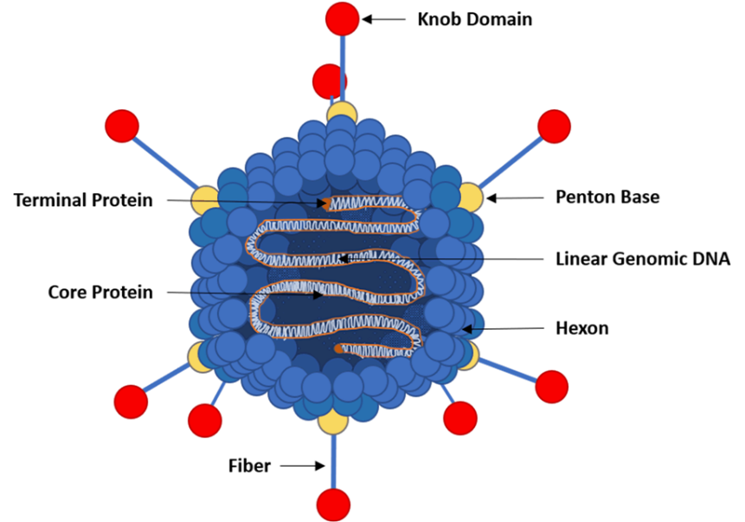

General properties
The general properties of the viral vector, Ad26.COV2.S are presented in Table 3. The sponsor has indicated that biochemical, immunological and biological properties have been determined based on the following potency parameters: transgene expression, infectious units and ratio of virus particles to infectious units.
Table 3: General properties of Ad26 COV2 S
Structure | Name | Parameter | Measurement
Vector particle | Ad26.COV2.S | Diameter | Around 90 nm (from vertex to vertex)a
Vector genome | dsDNA | Size | 33.1 kbp
Immunogen | SARS-CoV-2 spike protein | Size  Amino acids  Molecular weight | 3819 bp  1273 (antigen sequence)  141 kDab
ª San Martin, C. and Burnett R.M., 2003, p57-94; ^{b} Theoretical value derived from amino acid sequence.
dsDNA: Double stranded deoxyribonucleic acid; kDa: Kilo Dalton; kbp: Kilobase pairs; bp: Base pairs.
The S protein sequence in the COVID-19 Vaccine Janssen (Ad26.COV2.S) is based upon one of the earliest SARS-CoV-2 genomes to be isolated and fully characterised

Genetic modifications
The recombinant Ad26 vector, Ad26.COV2.S, is replication incompetent due to deletions in the early protein E1. The E1 deletion renders the vector replication incompetent in non-complementing cells such as human cells.

Shelf life and storage conditions
Store at 2 to 8°C for 3 months. Store in original container. Protect from light.

Conclusion and recommendation
There are no significant issues identified from the quality evaluation of the submitted data that would indicate the product should not be provisionally registered on the basis of quality, or safety related issues arising from the quality of the product. The manufacturing quality information submitted by the sponsor support the provisional registration of COVID-19 Vaccine Janssen (Ad26.COV2.S).
However, it should be noted that there are some issues that need to be fully resolved before it is possible to provide assurances that the product is able to meet all of the requirements of the Therapeutics Goods Act 1989 and its associated instruments.

Proposed quality conditions of registration
Batch Release Testing and Compliance
It is a condition of registration that all independent batches of COVID-19 Vaccine Janssen (Ad26.COV2.S) vaccine imported into Australia are not released for sale until samples and the manufacturer’s release data have been assessed and you have received notification acknowledging release from the Laboratories Branch, TGA.
For each independent batch of the product imported into Australia, the sponsor must supply the following:
- A completed Request for Release Form, available from vaccines@health.gov.au.
- Complete summary protocols for manufacture and quality control (QC), including all steps in production in the agreed format.
- At least 20 (twenty) vials (samples) of each manufacturing batch of Janssen COVID-19 vaccine-Ad26.COV2.S with the Australian approved labels, Product Information (PI) and packaging (unless an exemption to supply these has been granted) representative of all batches of product seeking distribution in Australia.
- At least 5 (five) vials (samples) of any further consignments of a manufacturing batch of Janssen COVID-19 vaccine-Ad26.COV2.S with the Australian approved labels, PI and packaging (unless an exemption to supply these has been granted). Further consignments cover batches previously supplied to TGA for the purposes of batch release testing but are seeking to be supplied again.
- If the manufacturing batch has been released in Europe or United Kingdom (UK) a copy of the EU Official Control Authority Batch Release (OCABR) certificate (or equivalent from the UK) must be provided.
- Any reagents, reference material and standards required to undertake testing, as requested by Laboratories Branch, TGA.
Sponsors must provide all requested samples and data in sufficient time (at least five business days) prior to any distribution date to allow the TGA to perform testing and review. Distribution of each batch of vaccine is conditional upon fulfilment of these conditions and receipt of a letter from the Laboratories Branch acknowledging release.
Samples and data should be forwarded to the Biotherapeutics Section, Laboratories Branch before release of each batch and with sufficient lead time to allow for Laboratories Branch testing.
The shipments (including reagents) to TGA are the responsibility of the Australian sponsor/agent who will be required to facilitate the import and customs clearance process.
Certified Product Details
An electronic copy of the Certified Product Details (CPD) as described in Guidance 7: Certified Product Details of the Australian Regulatory Guidelines for Prescription Medicines (ARGPM) https://www.tga.gov.au/guidance-7-certified-product-details should be provided upon registration of the therapeutic good. In addition, an updated CPD, for the above products incorporating the approved changes is to be provided within one month of the date of approval letter. A template for preparation of CPD for biological prescription medicines and vaccines can be obtained from the TGA website https://www.tga.gov.au/form/certified-product-details-cpd-biological-prescription-medicines. The CPD should be sent as a single bookmarked PDF document to Vaccines@health.gov.au as soon as possible after registration/approval of the product or any subsequent changes as indicated above.

Nonclinical
The composition of the nonclinical dossier submitted met regulatory guidelines for vaccines. The nonclinical evaluator was satisfied that the sponsor had conducted adequate studies on pharmacology and toxicity of the vaccine. All safety related studies were performed under Good Laboratory Practice (GLP) conditions.
The COVID-19 Vaccine Janssen (Ad26.COV2.S) was immunogenic in BALB/c mice, Syrian hamsters, rabbits and rhesus monkeys. Ad26.COV2.S induced T helper (Th) 1 skewed humoral and cellular immune responses in the animal models. Antibodies neutralised virus strains isolated at the beginning of the pandemic as well as the D614G mutant. However, animal data on immune responses and protective efficacy (in hamsters and monkeys) were generally of short duration.
The protective efficacy of the COVID-19 Vacine Janssen (Ad26.COV2.S) against disease caused by SARS-CoV-2 was demonstrated in Syrian hamsters (including in a severe disease model) and in adult and aged rhesus monkeys. No evidence of vaccine elicited disease enhancement was observed in any of the protection studies. The proposed single dose regimen were supported by the nonclinical data, although immune responses were slightly increased with prime-boost regimens. The duration of protection after immunisation was not investigated (there are ongoing clinical studies in monkeys and results should be provided when available).
The sponsor did not submit any nonclinical studies to assess directly the potential effects of an immune response towards the Ad26 vector. According to the sponsor, based on data from other vaccines using the same vector platform the presence of neutralising antibodies (nAb) to Ad26 did not affect immune responses to a variety of antigens.
No separate safety pharmacology studies were submitted. The repeat-dose toxicity studies with Ad26.COV2.S and other Ad26 based vaccines do not suggest that these vaccines have a significant impact on central nervous system (CNS), cardiovascular or respiratory function. Biodistribution data found no vector distribution in the brain or heart.
The sponsor submitted two single dose vaccine biodistribution studies in rabbits using the same Ad26 vector platform to assess the distribution, persistence and clearance of vector following intramuscular (IM) administration. Vector detection was limited to the injection site muscle or skin, draining lymph nodes and to a lesser extent, the spleen, and was largely cleared 180 days post-immunisation. No vector was detected in the brain or gonads.
The COVID-19 Vaccine Janssen (Ad26.COV2.S) is expected to have negligible risks of integrating into the human genome or recombination with other human adenoviruses.
A single repeat-dose toxicity study by the IM route was conducted in rabbits (three doses with two weeks dosing intervals). Use of a single species (rabbit) was consistent with the relevant guidelines and demonstration of good immunogenicity. Aside from the anticipated pharmacological response (transient acute inflammation at the injection site and increases in body temperature, white blood cell counts and plasma inflammatory proteins and increased lymphoid cellularity of germinal centres in the draining lymph nodes and spleen), no target organs for toxicity were identified. Ad26.COV2.S was generally well tolerated.
The COVID-19 Vaccine Janssen (Ad26.COV2.S) given by IM injection in rabbits (three doses, each 26 times the clinical dose on a mg/kg basis) did not affect embryofetal development or postnatal development of offspring up to 28 days age. The exposure of fetuses and kits to vaccine specific antibodies was demonstrated.
The COVID-19 Vaccine Janssen (Ad26.COV2.S) was well tolerated locally in rabbits.

Conclusion and recommendation
Primary pharmacology studies indicate the vaccine elicits both neutralising antibody and cellular immune responses to the spike antigen in animal models, and is protective in animal models of SARS-CoV-2 infection, including in a severe disease hamster model and in aged monkeys.
Neutralising antibody titres showed a slight tendency to decrease following a single immunisation in hamsters, but were relatively stable for up to 14 weeks in rabbits and monkeys. A long term follow up study in monkeys is in progress.
The potential for neutralising antibodies against the Ad26 vector to impair the immune response to Ad26.COV2.S was not examined, but appears unlikely based on data from other vaccines using the same vector platform.
New variants are continuously emerging and require testing to confirm effective immunity and protection by Ad26.COV2.S.
A repeat dose toxicity study with the proposed vaccine in rabbits raised no safety issues. Treatment related findings were limited to transient acute inflammation at the injection sites and evidence of a systemic immune response.
A reproductive toxicity study in female rabbits found no adverse effects on embryofetal development or postnatal development of offspring up to 28 days age. The nonclinical evaluator considered that the Pregnancy Category B1; was acceptable.
There were no nonclinical objections to the provisional registration of the vaccine. Long term immunity studies are underway and should be submitted when available.

Clinical
The clinical dossier consisted of the following:
- one Phase I/IIa bioavailability study (Study COV1001);
- one Phase I bioavailability study (Study COV1002);
- one Phase IIa bioavailability study(Study COV2001);
- one Phase II efficacy and safety study (Study COV2004); and
- two Phase III efficacy and safety studies (Study COV3001 and Study COV3009).

Pharmacology

Pharmacodynamics
Study COV1001 provided the most comprehensive immunological data. The results were supported by data from Studies COV1002, COV2001 and COV3001.
Study COV1001 is an ongoing, first in human, randomised, double blind, placebo controlled Phase I to II study designed to evaluate the safety, reactogenicity and immunogenicity of COVID-19 Vaccine Janssen (Ad26.COV2.S) in adults aged 18 to 55 years (cohort 1a, n = 369) and adults aged 65 years and older (cohort 3, n = 398). It examined two doses levels, 5 x 10¹⁰ virus particles (VP) (as in the vaccine described in this submission) and 1 x 10¹¹ VP administered IM as single or two doses regimens.
Immunological assessment was measured as a virus neutralisation assay (VNA), enzyme linked immunosorbent assay (ELISA) and intracellular cytokine staining (ICS).
Table 4: Study COV1001 Immunological assessment assays and responder definitions
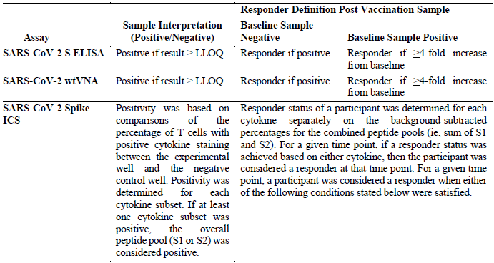
ELISA = enzyme linked immunosorbent assay, wtVNA = wild type virus neutralisation assay, ICS = intracellular cytokine staining, LLOQ = lower limit of quantitation.

Virus neutralisation assay
The virus neutralisation assays were performed on 125 subjects from each of cohorts 1a and 3.
The wild type virus neutralisation assay (wtVNA) assays were performed by Public Health England; and used SARS-CoV-2 virus stocks derived from a viral genome ; which has high homology to the to the original S protein sequence in the vaccine.
In the 18 to 65 year age group, by Day 29 the proportion of responders in the active vaccine groups ranged from 88% to 96%. Geometric mean titres (GMT) were similar between the 5 x 10¹⁰ VP and 1 x 10¹¹ VP dose groups. Following two doses of active vaccine (Day 71), there was a substantial increase in GMTs (2.6 to 2.9 fold geometric mean increase from pre-dose 2) which was sustained at Day 85, while for the single dose groups, GMTs increased to Day 57 then plateaued. 100% of subjects in each active vaccine group, regardless of the dosage regimen, were responders by Day 71.
The response in those older than 65 was similar to the younger population, except that the GMTs at day 87 were lower.

Spike-protein binding antibody
In the 18 to 65 year age group, all geometric mean concentrations (GMC) were below the lower limit of quantitation (LLOQ) at Baseline. By Day 29, 99 to 100% of subjects were responders. For groups receiving two doses, GMCs increased by 2.5- to 2.6-fold at Day 71. For groups receiving a single dose, GMCs rose until Day 57 then plateaued. There were 4 responders in the placebo group (under investigation).
There was a very strong correlation between the wtVNA titres and the S-binding antibody concentrations, with Spearman correlation > 0.80 at both Day 29 and 71, suggesting that ELISA could be used as a surrogate assay for wtVNA in future analyses.
The response in those over 65 years was similar to those less than 65 years.
Figure 2: Study COV1001 Humoral immunogenicity summary
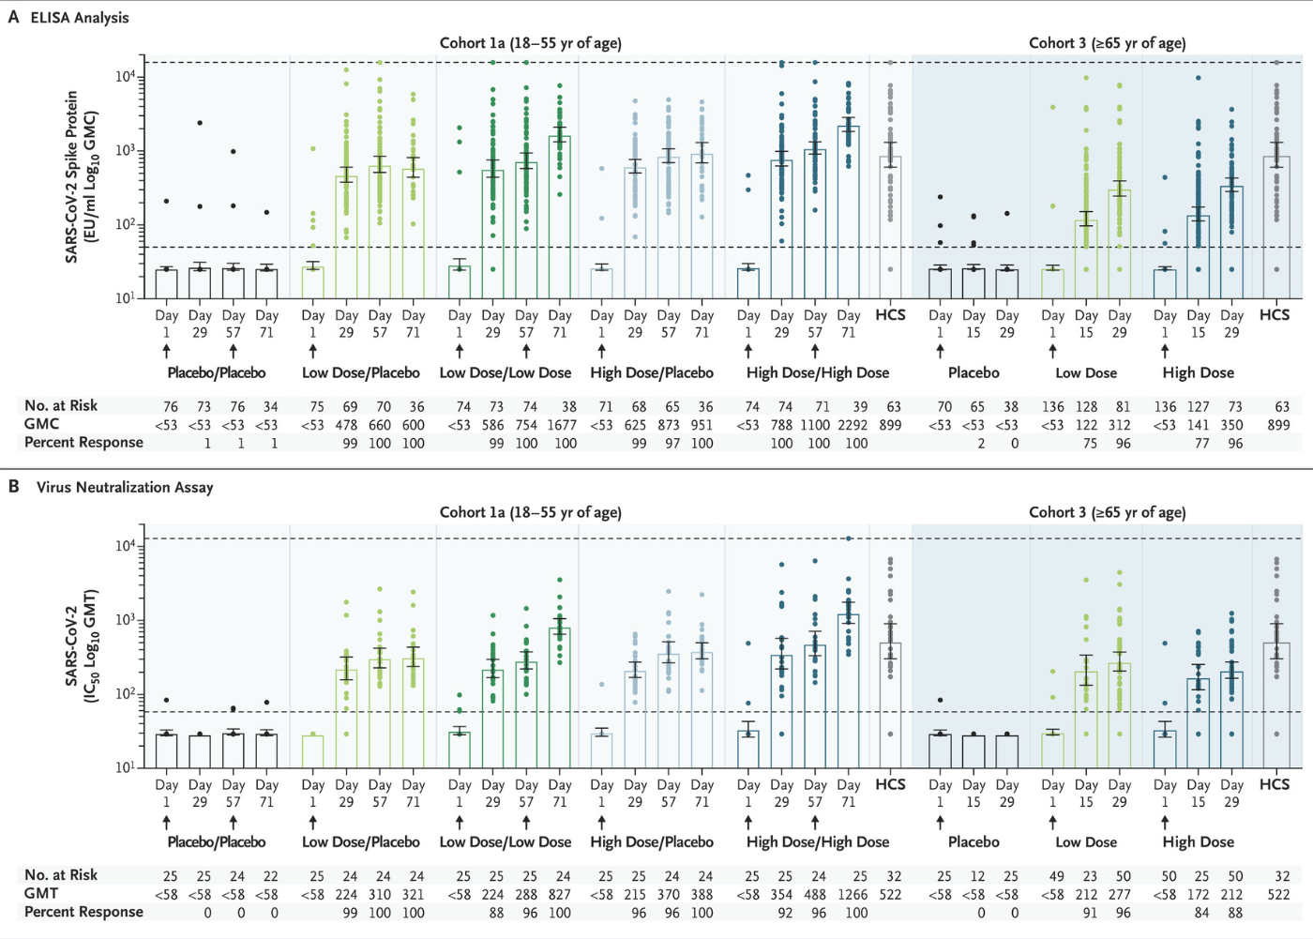
High dose: 1 x 10¹¹ VP; low dose: 5 x 10¹⁰ VP; HCS: human convalescent serum. Horizontal dotted lines indicate the LLOQ and upper limit of quantification (ULOQ) for the respective assays. GMC = geometric mean concentration, GMT = geometric mean titre.
In relation to Ad26 neutralising antibodies (anti-vector antibodies), four subjects (including two in the placebo group), were positive to Ad26 neutralising antibodies at Baseline. At Day 29, 96 to 100% of subjects in the active vaccine group were Ad26 VNA positive. The presence of anti-vector antibodies did not prevent further increases in SARS-CoV-2 neutralising antibodies after a second dose.

CD4⁺ and CD8⁺ T cell response
There was a Th1 response (in 74 to 85%) peaking at around Day 15 and remaining stable to Day 29. The response was greater in younger than older subjects

Antibodies against the Alpha variant virus strain
Samples from cohort 1a which showed high titres in the genomic wtVNA (see Virus neutralisation assay section above) were selected for measurement of neutralising antibodies against the Alpha lineage; at Day 29 and 71. The assay used for this variant has not been qualified and no responder definition was applied. Titres were expressed as 50% inhibitory concentration (IC₅₀) units.
All 20 samples receiving the 5 × 10¹⁰ VP dose had detectable neutralising antibody against SARS-CoV-2 Alpha viral variant strainat Day 71, while all four samples receiving placebo were below detection. 14 of 20 had titres ≥ 100 at Day 71. GMTs at Day 71 were 3.3-fold lower against the SARS-CoV-2 Alpha variant strain as compared to the reference strain used in the wtVNA assay

Efficacy
Study COV3001 is a randomised, double blind, placebo controlled Phase III study to assess the efficacy and safety of the COVID-19 Vaccine Janssen (Ad26.COV2.S) for the prevention of SARS-CoV-2 mediated COVID-19 infection in adults aged 18 years and older. The dossier to support provisional registration contained the primary data analysis from data lock 22 January 2021.
The study being conducted Argentina, Brazil, Chile, Columbia, Mexico, Peru, South Africa and the USA. It commenced in September 2020. The study duration is 52 weeks, with a one year follow up period.
Subjects were randomised 1:1 to receive the vaccine or placebo. The study was performed in two phases. Phase I enrolled individuals 18 to 60 years, Phase II enrolled individuals over 60 years (aim 30% of the study population). Each phase had two stages, stage a, for individuals without co-morbidities, and stage b, for individuals with co-morbidities.
The primary efficacy endpoint was the prevention of molecularly confirmed, moderate to severe/critical COVID-19, as compared to placebo, in SARS-CoV-2 seronegative adults (see Table 5). The initial endpoint was to be assessed 14 days post vaccination. There was a protocol amendment to include a co-primary endpoint assessed 28 days after vaccination.
The study enrolled individuals over 18 years and included those with comorbidities which were stable. The main exclusion criteria included an acute illness, known or suspected allergy or history of adverse event to a vaccine, abnormal immune function, prior treatment with immunoglobulins or blood products, or other vaccines.
Individuals received a serological test for SARS-CoV-2 on Day 1. Seropositive individuals were included in the study but excluded from the pre-protocol analysis.
Table 5: Study COV3001 Case definitions
 | Mild | Moderate | Severe
Requirement | A SARS-CoV-2 positive reverse transcription polymerase chain reaction or molecular test result from any available respiratory tract sample or other sample, and, at any time during the course of observation (lasting at least 14 days post-symptom onset, or until resolution of episode, whichever is longer)
Symptoms | Any one of the following:  - fever ≥ 38.0°C  - sore throat  - malaise (loss of appetite, generally unwell, fatigue, physical weakness)  - headache  - muscle pain (myalgia)  - gastrointestinal symptoms  - cough  - chest congestion  - runny nose  - wheezing  - skin rash  - eye irritation or discharge  - new or changing olfactory or taste disorders  - red or bruised looking feet or toes  - chills or rigors | Two of the following worsening signs or symptoms:  - Fever > 38°C  - heart rate > 90 beats per minute  - chills or rigors  - sore throat  - cough  - malaise  - headache  - muscle pain  - gastrointestinal tract symptoms  - change in smell or taste  - red or bruised feet or toes
Signs |  | One of the following:  - respiratory rate > 20 breaths per minute  - oxygen saturations > 93% but abnormal  - clinical or radiological pneumonia  - radiological evidence of a deep vein thrombosis  - shortness of breath | One of the following:  - clinical signs at rest indicative of severe systemic illness (respiratory rate ≥ 30 breaths per minute, heart rate ≥ 125 beats per minute, oxygen saturation ≤ 93% on room air at sea level  - respiratory failure (defined as needing high-flow oxygen, non-invasive ventilation, mechanical, extracorporeal membrane oxygenation)  - evidence of shock (defined as systolic blood pressure < 90 mmHg, diastolic blood pressure < 60 mmHg, or requiring vasopressors)  - significant acute renal, hepatic, or neurologic dysfunction  - admission to the ICU  - death
The study used continuous sequential analysis to generate an efficacy signal as soon as it was possible. The target number of events was 152, however in addition, there were to be six cases in those over 60 years of age, and five cases considered to be of severe/critical disease. Secondary endpoints were adjusted for multiplicity using a graphical approach.
43,783 subjects received the study vaccine. The median follow up time post vaccination was 58 days.
The study population for the main efficacy analysis was predominantly North American (46.7%), Latin American (40.6%) and South African (12.7%). 62.1% of subjects were White. 44.5% of subjects were female. Median age was 53 years (range: 18 to 100), and 34.6% were aged ≥ 60 years. 402 (1.0%) were aged ≥ 80 years. Median body mass index was 26.90 kg/m². 39.9% of subjects had one or more baseline comorbidities, the most frequent of which was obesity. 2.5% were human immunodeficiency virus (HIV) positive.

Results
259 cases meeting the primary endpoint definition of moderate to severe/critical COVID-19 were observed for events with onset at least 28 days after vaccination.
Vaccine efficacy (VE) (adjusted 95% confidence interval (CI)) against molecularly confirmed moderate to severe/critical COVID-19 was 66.9% (adjusted 95% CI: 59.03; 73.40) when evaluated at least 14 days after vaccination, and was 66.1% (adjusted 95% CI: 55.01; 74.80) when evaluated at least 28 days after vaccination.
Similar outcomes were seen by in the age groups ≥ 18 to < 60 years, and ≥ 60 years, VE 63.7% (adjusted 95% CI: 53.87; 71.58) and 76.3% (adjusted 95% CI: 61.58; 86.04), respectively, when evaluated at least 14 days after vaccination.
There were 74 molecularly confirmed severe/critical COVID-19 cases with an onset at least 14 days after vaccination and 39 with an onset at least 28 days after vaccination. VE (adjusted 95% CI) was 76.7% (54.56; 89.09) when evaluated at least 14 days after vaccination and was 85.4% (adjusted 95% CI: 54.15; 96.90) when evaluated at least 28 days after vaccination.
Figure 3: Study COV3001 Cumulative incidence of molecularly confirmed moderate to severe/critical COVID-19 cases with onset at least one day after vaccination (Full analysis set)
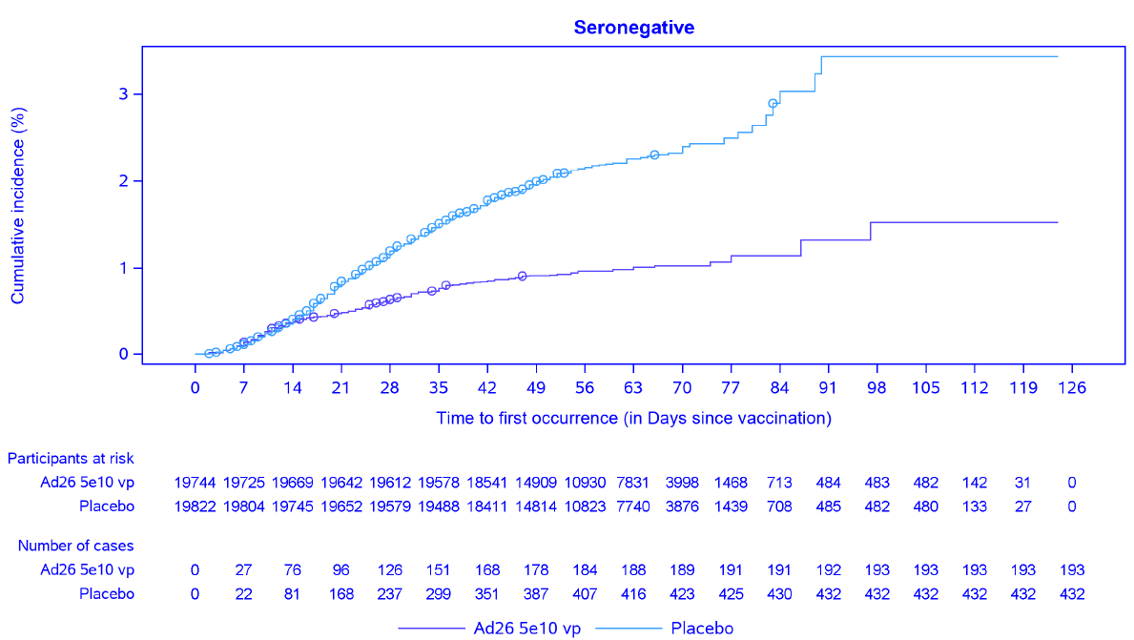
At least 28 days after vaccination, any SARS-Co-V-2 infection (including asymptomatic or undetected) was observed in 285 participants (71 in the Ad26.COV2.S group and 214 in the placebo group), resulting in a VE of 67.2% (95% VE = 56.86 to 75.26).
The vaccine efficacy was similar across subgroups for country, race, and age.
The results of other secondary efficacy endpoints, including variants, will be available with the full analysis set.
The S protein sequence in the Ad26.COV2.S vaccine is based upon an original reference genomic variant. As of 11 February 2021, viral sequencing data through whole genome sequencing of SARS-CoV-2 in molecularly confirmed COVID-19 cases had been performed in 512 out of 714 (71.7%) cases in Study COV3001. Of the 512 sequenced cases, the majority (63.7%) matched the reference variant while 16.8% matched the Beta virus variant; and 18.6% matched the Zeta virus variant. In South Africa, 91 of 136 total cases have been sequenced, of which 86 (94.5%) were found to be the Beta variant. The sponsor has not yet performed VE against SARS-CoV-2 variants. Data is presented in Table 6 below.
Table 6: Study COV3001 Proportion of molecularly confirmed cases infected with SARS-CoV-2 variant with spike protein amino acid variation versus the SARS-CoV-2 reference sequence with substitution profile of the 20I/501Y.V1 (Alpha variant), 20H/501Y.V2 (Beta variant), 20J/501Y.V3 (Gamma variant), CAL.20C (Epsilon variant) or ref+E484K (Zeta variant) spike protein variants. (Full analysis set)
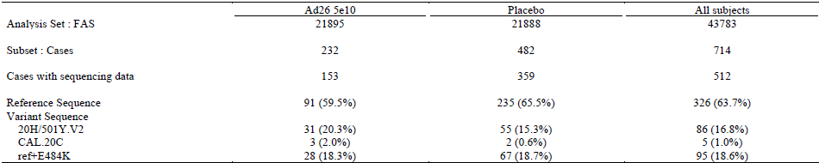
Ad26 = adenovirus type 26, FAS = full analysis set
Note: the denominator is the number of cases with sequencing data available at case episode.
Reference sequence is defined as the early original sequence with the addition of amino acid variation D614G. Amino acid variation are defined as changes from the reference sequence. Sequencing was performed using NGS Swift assay using 1% and baseline polymorphisms defined with a cut-off of 15%.

Safety
The most comprehensive safety data is from Study COV3001, where over 40,000 adult participants were followed for a median of two months. Supportive data comes from Studies COV1001, COV1002, COV2001 and COV3009.

Study COV3001
The safety objectives were:
- to evaluate safety in terms of serious adverse event (AE) during the entire study, medically attended adverse event (MAAE) until six months post vaccination, and MAAE leading to study discontinuation.
- in a subset of participants, safety and reactogenicity were evaluated in terms of solicited adverse event (AE) during 7 days after vaccination and unsolicited AEs during 28 days post vaccination.

Solicited adverse events
Data on solicited AEs were collected on a subset of patients from 45 of the 225 vaccination sites. There were 6736 subjects in the safety subset (see Table 7). Solicited AEs were more commonly reported with Ad26.COV2.S vaccination (66%) than in the placebo (41.9%) treatment arms (See Table 7).
Table 7: Solicited adverse events
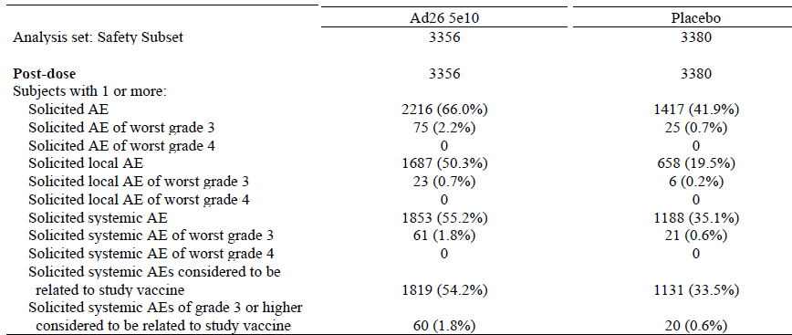
AE = adverse event. Note: Subjects are counted only once within a period for any given event, regardless of the number of times they actually experience the event in the period. Relationship to vaccine is assessed by the investigator.
Solicited AEs were less common in those over 60 years (54.5%) than those 18 to 59 years (73.5%).
The most common local solicited AE was pain (48.7%) followed by erythema (7.3%) and swelling (5.3%). The median time of onset was 1 to 2 days and median duration 1 to 3 days.
The most common systemic solicited AE was headache (39%), followed by fatigue (38.3%), myalgia (33.2%), nausea (14.2%) and pyrexia (9.0%) (See Table 8)
Table 8: Study COV3001 Systemic solicited adverse events
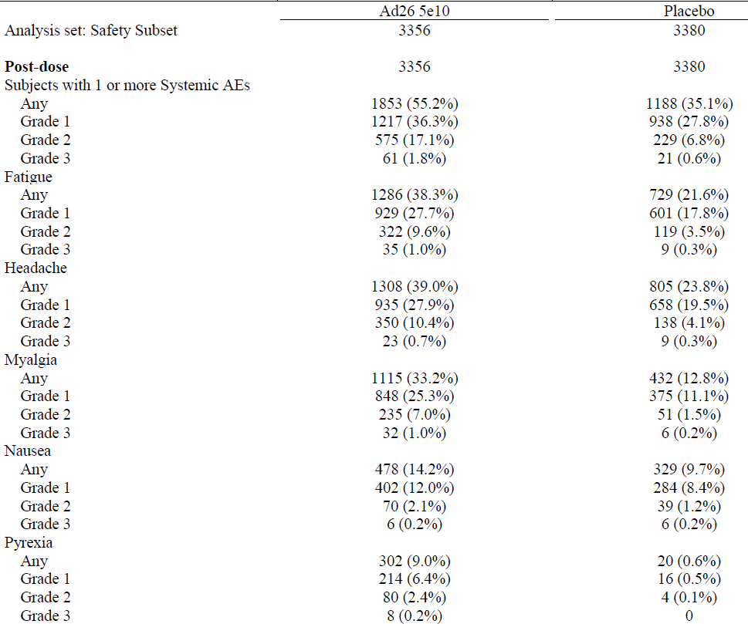
The median time of onset of systemic solicited AEs was two days, and median duration one to two days.

Unsolicited adverse events
Severe adverse events up to 28 days post vaccine occurred in 14 (0.4%) of the vaccine group and 19 (0.6%) of the placebo group, 9 in each group were seven days post vaccine.
Overall, unsolicited AEs were reported in 13.1% of the vaccine group and 12% of the placebo group.
Table 9: Study COV3001 Unsolicited adverse events occurring in > 1% of vaccine group participants within 28 days following vaccination, by Medical Dictionary for Regulatory Activities, according to primary System Organ Class and Preferred Term (safety subset)
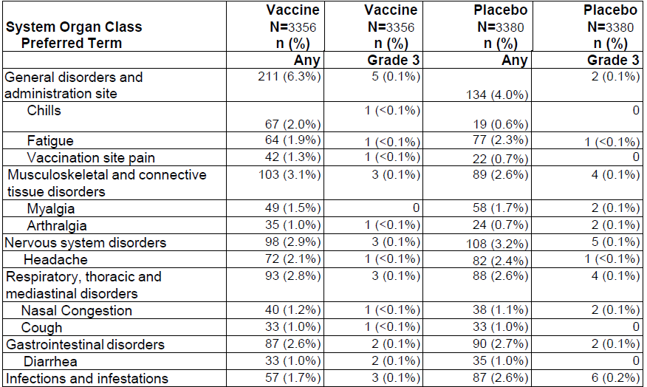
Source: Safety subset: subset of full analysis set for analysis of solicited and unsolicited AEs.
n = number of participants with specified reaction
N = number of exposed subjects who submitted any data for the event, percentage are based on n/N.
19 deaths occurred in the study. None were considered to be related to the study vaccine. Nine participants reported ten serious adverse events which were considered to be related to the study vaccine.
The serious adverse events considered to be related to COVID-19 Vaccine Janssen (Ad26.COV2.S) treatment included:
- brachial radiculitis (ongoing 75 days post vaccination)
- post-vaccination syndrome
- pericarditis
- Bell’s palsy (2 subjects)
- Guillain Barre syndrome (17 days post vaccine)
There was an additional serious adverse events which the sponsor described as unlikely to be vaccine related, this was a case of thrombosis and thrombocytopenia in a young male.
Serious adverse events in the placebo arm included deep vein thrombosis, Epstein-Barr virus and atrial flutter.
At the time of data cut-off, one or more medically attended adverse event (MAAE) had been reported in 304 (1.4%) participants in the COVID-19 Vaccine Janssen (Ad26.COV2.S) group compared to 408 (1.9%) participants in the placebo group. The most frequently reported MAAE (≥ 0.5% of participants in any vaccine group) was infections and infestations by System Organ Class.

Adverse events of special interest
Adverse events of special interest included:
- anaphylaxis was reported in 15 subjects receiving vaccine and eight receiving placebo (but none met Brighton Collaboration criteria); hypersensitivity in six vaccine recipients and four in placebo
- tinnitus in six receiving vaccine, none in placebo
- convulsions/seizures in four vaccinated individuals, one in placebo
- thrombotic and thromboembolic events in 14 subjects treated with COVID-19 Vaccine Janssen (Ad26.COV2.S) and ten receiving placebo. Most had underlying medical conditions.
Eight pregnancies were reported. Three of these are ongoing.
There was no vaccine associated enhanced respiratory disease (VAERD). The vaccine induces a humoral and cellular immune response with Th1 bias.
The sponsor reanalysed the clinical study data in relation to thrombosis and haemorrhage in relations to concerns by international regulators.
There were 51 participants with at least one case of thrombosis. Venous thromboembolic events were more common in the vaccine arm, arterial thrombotic events were more common in the placebo arm.
Table 10: Study COV3001 Thrombotic and thromboembolic events
¹ Data until 17 March 2021
² Includes one event reported as ‘venous thrombosis limb’ and one event reported as ‘embolism venous’
³ One patient reported both deep vein thrombosis and pulmonary embolism as separate terms
⁴ Two events reported in one participant
⁵ One participant reported two events of stent occlusion (one venous, one arterial)
There were 81 events of bleeding, more common in the placebo group (51 events) than the vaccine group (30 events) and from a variety of causes.
There were five cases of thrombosis and haemorrhage. The four other cases were in the control group.

Risk management plan
The sponsor has submitted EU-risk management plan (RMP) version 1.1 (12 February 2021; (data lock point (DLP): 22 January 2021) and Australian specific annex (ASA) version 1.0 (23 February 2021) in support of this application. On 12 March 2021, the sponsor provided an updated EU-RMP version 1.3 (10 March 2021; DLP: 22 January 2021) as part of the EU consolidated package after the conditional approval in the EU.
In response to TGA questions, the sponsor has provided an updated ASA version 2.0 (19 March 2021) and EU-RMP version 1.4 (12 March 2021; DLP 22 January 2021).
In response to the second round of RMP evaluation, the sponsor has provided an updated ASA version 3.0 (9 April 2021). Lastly, the sponsor has provided an updated ASA version 4.0 (19 April 2021) with the response to the third round of RMP evaluation report.
The summary of safety concerns and their associated risk monitoring and mitigation strategies are summarised in Table 11.
Table 11: Summary of safety concerns
Summary of safety concerns |  | Pharmacovigilance |  | Risk Minimisation
 |  | Routine | Additional | Routine | Additional
Important identified risks | Anaphylaxis | ¹ | ² |  | –
Important potential risks | Vaccine-associated enhanced disease, including vaccine associated enhanced respiratory disease | ¹ | ² | – | –
Important potential risks | Venous thromboembolism |  | ² | – | –
Missing information | Use during pregnancy and while breastfeeding | ¹ | ^{2,3} |  | –
Missing information | Use in immunocompromised patients |  | ² |  | –
Missing information | Use in patients with autoimmune or inflammatory disorders |  | ² | – | –
Missing information | Use in frail patients with comorbidities (for example, chronic obstructive pulmonary disease, diabetes, chronic neurological disease, cardiovascular disorders) |  | ² | – | –
Missing information | Interaction with other vaccines |  | ² |  | –
Missing information | Long-term safety |  | ² | – | –
¹ Targeted follow-up forms
² Clinical trials
³ Global pregnancy registry
Routine and additional pharmacovigilance activities have been proposed as indicated in the table above. Routine pharmacovigilance measures include targeted follow-up questionnaires to monitor risks of ‘Anaphylaxis’ and ‘Vaccine-associated enhanced disease (VAED), including vaccine associated enhanced respiratory disease (VAERD)’ , provision of monthly summary safety reports and ensuring traceability of batch/lot numbers. The sponsor has also committed to discuss and develop a ‘track and trace mechanism’ for the supply chain should this vaccine be supplied through the private market. Australian participants are not involved in the clinical trials. However, the outcomes of these trials are expected to be applicable to the Australian context. The sponsor states that the global pregnancy registry will be open to Australian participants.
The sponsor has proposed only routine risk minimisation activities through the PI and Consumer Medicines Information (CMI). These and the information/training expected to be provided by the Department of Health/ COVID-19 Vaccine Taskforce are anticipated to adequately mitigate the risks associated with this vaccine. Sponsor has also committed to developing additional risk minimisation materials in line with the risk minimisation materials implemented as part of the national COVID-19 vaccine rollout, should the vaccine be supplied through the private market. If the current understanding of the safety profile of this vaccine changes, the risk minimisation plan will require re-assessment.
The sponsor has committed to
- discuss and develop a ‘track and trace mechanism’ for the supply chain should this vaccine be supplied via the private market.
- develop and implement appropriate additional risk minimisation materials, in line with the risk minimisation materials implemented as part of the national COVID-19 vaccine rollout, should the vaccine be supplied through the private market.
- update the Consumer Medicines Information (CMI) in line with any changes made to the proposed PI.

Proposed wording for conditions of registration
Any changes to which the sponsor has agreed should be included in a revised RMP and ASA. However, irrespective of whether or not they are included in the currently available version of the RMP document, the agreed changes become part of the risk management system.
The suggested wording is:
The COVID-19 Vaccine Janssen EU-risk management plan (RMP) (version 1.4, dated 12 March 2021, data lock point 22 January 2021), with Australian-Specific annex (version 4.0, dated 19 April 2021), included with submission PM-2020-01673-1-2, to be revised to the satisfaction of the TGA, will be implemented in Australia.
An obligatory component of risk management plans is routine pharmacovigilance. Routine pharmacovigilance includes the submission of periodic safety update reports (PSURs).
Unless agreed separately between the sponsor and the TGA, the first report must be submitted to TGA no later than six calendar months after the date of this approval letter. The subsequent reports must be submitted no less frequently than six monthly until the period covered by such reports is not less than three years from the date of the approval letter, or the entire period of provisional registration, whichever is longer.
The reports are to at least meet the requirements for PSURs as described in the European Medicines Agency’s Guideline on good pharmacovigilance practices (GVP) Module VII-periodic safety update report (Rev 1), Part VII.B Structures and processes. Note that submission of a PSUR does not constitute an application to vary the registration. Each report must have been prepared within ninety calendar days of the data lock point for that report.
Additional to the routine submission of the routine PSURs, expedited monthly, safety summary reports (including safety data for patients in Australia) are to be provided for the first 6 months post registration, and thereafter at intervals specified by the TGA.
COVID-19 Vaccine Janssen is to be included in the Black Triangle Scheme. The PI and CMI for COVID-19 Vaccine Janssen must include the black triangle symbol and mandatory accompanying text for the products entire period of provisional registration.

Clinical study plan to support full registration
The sponsor has included a comprehensive study plan detailing the current and planned studies evaluating the efficacy and safety of COVID-19 Vaccine Janssen. These studies include use of a two doses regimen, efficacy and safety in pregnant women and those with co-morbidities, and co-administration with influenza and respiratory syncytial virus (RSV) vaccines. The estimated final clinical study report dates are 2022 to 2024, well within the six years provisional registration period. The risk management evaluator and Delegate for the provisional application considered that the study plan was acceptable.
Table 12: Ongoing and planned additional pharmacovigilance studies
Study | Objectives | Milestones
Ongoing
Study COV1001  A Phase I/IIa first in human study to evaluate safety, reactogenicity and immunogenicity of Ad26.Cov2 S in healthy adult aged ≥ 18 to ≤55 years and adults ≥ 65 years old. Several dose regimens/schedules are being tested | Primary objectives:  To assess immunogenicity of Ad26.Cov2 S.  To assess the safety of Ad26.Cov2 S  To assess persistence of immune response generate against Ad26.Cov2 S.  To assess the immunogenicity of booster shots in 18 to 55 years old. | Final clinical study report due second quarter of 2024
Study COV1002  A Phase I study to assess safety and reactogenicity of Ad26 COV2 S in healthy adults aged ≥ 18 to ≤55 years and adults ≥ 65 years old. | Primary objectives:  To assess safety and immunogenicity of Ad26 COV2 S. | Final clinical study report to be determined.
Study COV2001  A Phase II study to further assess vaccine administration dose and schedule in healthy adults aged ≥ 18 to ≤ 55 years old. Initial safety data from Study COV1001 will trigger Study COV2001 study start | Primary objectives:  To assess immunogenicity of Ad26.Cov2 S at one, two and three months intervals.  To assess the safety of Ad26.Cov2 S at one, two and three months intervals. | Final clinical study report due first quarter of 2023
Study COV3001  A multicentre, randomised double blinded, placebo controlled Phase III study to assess efficacy and safety of a single dose Ad26 COV2 S for the prevention of SARS-CoV-2 mediated COVID-19 in adults aged ≥ 18 to ≤ 59 years and adults ≥ 60 years old. | Primary objectives:  To assess efficacy of Ad26.Cov2 S.  To assess the safety of Ad26.Cov2 S.  To assess immunogenicity of Ad26.Cov2 S.  With two years follow up. | Final clinical study report due second quarter of 2022
Planned
COV3009  A multicentre, randomised double blinded, placebo controlled Phase III study evaluating the efficacy and safety of two doses of Ad26 COV2 S for prevention of SARS-CoV-2 mediated COVID-19 in adults aged ≥ 18 to ≤ 59 years and adults ≥ 60 years old.  Same dose level as per Study COV3001, doses given eight weeks apart. | Primary objectives:  To assess the safety and immunogenicity of Ad26 COV2 S, with a two year follow up period. | Final clinical study report due third quarter of 2022
COV2004  A randomised, double blinded, placebo controlled Phase II study to evaluate the safety, reactogenicity of Ad26 COV2 S in healthy pregnant woman aged 18 to 35 years. | Primary objectives:  To assess safety and immunogenicity in pregnant woman and their infant up to 6 months post-partum | Final clinical study report due third quarter of 2022
COV3002  A Phase III study to evaluate safety and immunogenicity of Ad26 COV2 S in children and adults at high risk for severe COVID-19. | Primary objectives:  To assess safety and immunogenicity in children and adult at high risk for severe COVID-19. | Final clinical study report due second quarter of 2023
COV3003  A randomised, doubled blinded, placebo controlled Phase III study to evaluate three dose levels of Ad26 COV2 S administrated as single dose or two doses schedules in healthy adults. | Primary objectives:  To demonstrate non-inferiority of lot representative of end of shelf life to lot representative of release potency. | Final clinical study report due third quarter of 2022
COV3004  A Phase III, randomised, double blinded, placebo-controlled study to evaluate the immunogenicity, safety, reactogenicity and consistency of three consecutive lots of Ad26 COV2 S in healthy adults. | Primary objectives:  To demonstrate that three consecutively manufactured lots of Ad26 COV2 S induce an equivalent humoral immune response. | Final clinical study report due third quarter of 2022
COV3005  To evaluate the safety and immunogenicity of Ad26 COV2 S when co-administrated with influenza and RSV vaccines. | Primary objectives:  To evaluate the safety and immunogenicity of Ad26 COV2 S when co-administrated with influenza and RSV vaccines. | Final clinical study report due second quarter of 2023
COV3006  A randomised, double blinded, placebo controlled, Phase II/III study to evaluate the safety, reactogenicity and immunogenicity of different dose levels of Ad26 COV2 S adminstrated as a single dose or two doses regimen in children aged 2 months to 11 years(inclusive) and to evaluate one dose level of Ad26 COV2 S adminstrated as a two doses regimen in healthy adults aged 18 to 55 years (inclusive) | Primary objectives  To evaluate the safety and immunogenicity of Ad26 COV2 S with a booster shot at 12 months and the persistence of the immune response one year post booster vaccination.  To demonstrate non-inferiority of humoral immune response in children, toddlers and infants to adults. | Final clinical study report due third quarter of 2022

Post market safety signal
The European Medicine Agency’s (EMA) safety committee reviewed the post market data in relation to blood clots with the COVID-19 Vaccine Janssen. It concluded that unusual blood clots with low platelet count should be added as a potential risk for the COVID-19 Vaccine Janssen. This syndrome is similar to that seen with the COVID-19 Vaccine AstraZeneca. However, that overall the risk benefit assessment remains positive. As of 13 April 2021, there were eight cases in over seven million vaccinated.28
The United States (US) Food and Drug Administration temporarily paused the use of the COVID-19 Vaccine Janssen in their vaccination program. The pause has now been lifted.
The sponsor has updated the Australia PI to include a warning about the risk of thrombosis and thrombocytopenia
‘Thrombosis with thrombocytopenia syndrome
A combination of thrombosis and thrombocytopenia, in some cases accompanied by bleeding, has been observed very rarely following vaccination with COVID-19 Vaccine Janssen. This includes severe cases of venous thrombosis at unusual sites such as cerebral venous sinus thrombosis, splanchnic vein thrombosis as well as arterial thrombosis concomitant with thrombocytopenia. Fatal outcome has been reported. These cases occurred within the first three weeks following vaccination, and mostly in women under 60 years of age.
Cases have occurred in patients with and without other risk factors for thrombosis and thrombocytopenia. As a precautionary measure, administration of the COVID-19 Vaccine Janssen in patients with a history of cerebral venous sinus thrombosis with thrombocytopenia, or heparin induced thrombocytopenia (HIT) should only be considered when the benefit outweighs the potential risk.
Healthcare professionals should be alert to the signs and symptoms of thromboembolism and/or thrombocytopenia. Those vaccinated should be instructed to seek immediate medical attention if they develop symptoms such as shortness of breath, chest pain, leg swelling, or persistent abdominal pain following vaccination. Additionally, anyone with neurological symptoms including severe or persistent headaches or blurred vision after vaccination, or who experiences skin bruising (petechia) beyond the site of vaccination after a few days, should seek prompt medical attention.
Thrombosis in combination with thrombocytopenia requires specialised clinical management. Healthcare professionals should consult applicable guidance and/or consult specialists (for example, haematologists, specialists in coagulation) to diagnose and treat this condition.
Individuals diagnosed with thrombocytopenia within 3 weeks after vaccination with COVID-19 Vaccine Janssen should be actively investigated for signs of thrombosis. Similarly, individuals who present with thrombosis within 3 weeks of vaccination should be evaluated for thrombocytopenia.’’

Risk-benefit analysis

Delegate’s considerations
In relation to quality, the sponsor is working with the quality evaluators to address a number of outstanding issues. These issues are not of significant concern to prevent provisional registration.
In relation to efficacy, immunological data in humans demonstrated the development of a cellular and humoral immune response. The immune response is similar, or slightly lower, than that of the human convalescent serum. It is noted that two doses produce a greater antibody titre. There are ongoing clinical studies for a two doses regimen.
The primary efficacy endpoint was prevention of moderate/severe COVID. Primary efficacy was reported at Days 14 and 28.
The primary efficacy endpoint met the WHO criteria for an effective COVID vaccine. Similar vaccine efficacy was reported at Days 14 and 28, and in different countries, and in those < 60 years and older than 60 years.
The study assessed the serotype of COVID amongst cases detected. Further data about immunity and efficacy against variants will be reported in ongoing analysis.
In relation to safety, there was local and systemic signs of reactagenicity 1 to 2 days after the vaccine, these symptoms lasted 103 days.
A case of cerebral venous thrombosis was reported in a vaccinated participant, with an onset of 19 days after vaccination. This event was not considered related to the vaccine by the sponsor due to the multiple other risk factors in this subject. However, of review of further information this patient had positive Pf4 antibdoies, which makes a causal link likely
Other severe adverse events reported included brachial radiculitis, post vaccination syndrome, pericarditis, Bells Palsy and Guillian Barre syndrome. Reported adverse effects of special interest included anaphylaxis (although none met the Brighton Collaboration criteria)26, tinnitus, seizures and thrombosis.

Proposed action
The data available at this time to support the efficacy and safety of the COVID-19 Vaccine Janssen is sufficient to support provisional registration.
Cases of thrombosis and thrombocytopenia, similar to that observed with the COVID-19 Vaccine AstraZeneca have been reported in the post market setting. The sponsor has updated the PI in relation to this information. There are ongoing pharmacovigilance activities.
As with other vaccines, their use in the Australian COVID-19 vaccination program will be informed by ATAGI and the vaccine taskforce.

Questions for the sponsor
The sponsor provided the following response to questions from the Delegate.
- Please update the TGA on the current international safety data in relation to the Janssen COVID-19. In particular, the number of cases of thrombosis and thrombocytopenia.
The overall international safety data for the Ad26.COV2.S. COVID-19 Vaccine Janssen are closely monitored and summarized each month in a monthly summary safety report (MSSR) covering one calendar month period.
As of 7 May 2021, Janssen cumulative (US) post-marketing exposure according to the US Centers of Disease Control (CDC) is a total of 8,739,657 doses of Ad26.COV2.S COVID-19 Vaccine Janssen.
As of 7 May 2021, Janssen cumulative post-marketing exposure from the European Union/European Economic Area according to the European Centres of Disease Control (ECDC) is a total of 596,377 doses of Ad26.COV2.S COVID-19 Vaccine Janssen.
As of 7 May 2021, a total of 381,528 participants had received a single dose of Ad26.COV2.S at the selected dose level (that is 5 x 10¹⁰ VP) in an open label collaborative study.
A search of the Global Safety Database was performed using the following search criteria:
- Cumulative cases completed with cutoff date of 7 May 2021
- Spontaneous/solicited cases from the open label collaborative Study VAC31518COV3012.
- Standarised MedDRA Queries (SMQ) of Embolic and thrombotic events; and the Higher Level Term (HLT) of Thrombocytopenias; or the SMQ of Haematopoietic thrombocytopenia
There are a total of 863 post marketing cases (853 spontaneously reported and 10 reported from the VAC31518COV3012 study);³² with at least one event in the SMQ of Embolic and Thrombotic events. Of those 863 cases, there are a total of 52 cases with at least 1 event in the SMQ Embolic and thrombotic events and at least 1 event from the HLT Thrombocytopenias or SMQ Haematopoietic thrombocytopenia. All 52 cases were reported from spontaneous sources.
As of 07 May 2021, the total estimated exposure from the clinical trial databases for Ad26.COV2.S is 77,344.
A search of the Global Clinical Database was performed using the following search criteria:
- Cumulative cases completed with cutoff date of 07 May 2021
- SMQ Embolic and thrombotic events, and HLT Thrombocytopenias or SMQ Haematopoietic thrombocytopenia
There are a total of 143 clinical trial cases with at least one event in the SMQ of Embolic and Thrombotic events. One case was identified that reported a thromboembolic event with thrombocytopenia (cerebral venous sinus thrombosis and cerebral haemorrhage) within Study COV3001 following administration of Ad26.COV2.S. Further methodology was applied to assess potential cases of thrombosis and thrombocytopenia in those participants presenting with thromboembolic adverse events classified within the SMQ of Embolic and thrombotic events. Follow-up requests went out to sites to collect platelet counts for those subjects who experienced embolic and thrombotic events alone or in combination with thrombocytopenia (reported as adverse event). Based on this methodology, 16 additional cases of thrombosis and thrombocytopenia have been identified.
As noted in the Delegates overview, the sponsor has been providing TGA with regular updates as information on the cases of thrombosis and thrombocytopenia have evolved. Since the 14 April, the sponsor has submitted a further 12 updates including proposed revisions to the draft Australian PI and CMI with updated Clinical Overview (12 May, 2021), as well as two Monthly Safety Reports (15 April 2021 and 14 May 2021, respectively) which provides further details on the cases reported to the sponsor.
An updated Company Clinical Overview Addendum for the Ad26.COV2.S. COVID-19 Vaccine Janssen is currently being prepared to provide a summary of the events available to the Company for the signal of thrombosis with thrombocytopenia syndrome (TTS). Based on this new information, the European Risk Management Plan (EU-RMP) for the Ad26.COV2.S COVID-19 Vaccine Janssen has been updated and is being finalised with EMA. The final approved documents will be provided to TGA as soon as they are available.
- Would the sponsor consider manufacturing a single dose vial for use for private prescriptions?
As noted in the previous response to the TGA questions, the development of a single dose presentation is currently ongoing.
Janssen is not planning to supply the COVID-19 Vaccine Janssen privately in Australia during the pandemic phase (including through 2021).
Janssen continues discussions with the Australian Government COVID-19 Vaccine Taskforce. Stock is not currently allocated for supply in Australia in 2021. However, if an APA should be signed in the future, Janssen will notify the TGA.

Advisory Committee considerations
The Advisory Committee on Vaccine (ACV), having considered the evaluations and the Delegate’s overview, as well as the sponsor’s response to these documents, advised the following.

Specific advice to the Delegate
The ACV advised the following in response to the Delegate’s specific request for advice.
- Please comment on the wording of the indication. The primary efficacy endpoint was moderate/severe disease, however efficacy was also demonstrated against any infection. Should it state for the prevention of moderate/severe COVID-19?
The ACV advised that the current proposed indication is acceptable, and aligns with other provisionally-approved COVID-19 vaccines.
The ACV advised that the indication does not need to specify ‘for the prevention of moderate/severe COVID-19’. The secondary endpoints from the pivotal trial were reassuring that the vaccine shows efficacy against all levels of severity of COVID-19 disease; vaccine efficacy (VE) against any SARS-CoV-2 infection (including asymptomatic) was 67.2% (adjusted 95% CIs: 56.86; 75.26).
- What role do you think this vaccine will have in Australia’s vaccination strategy?
The ACV noted the importance of having alternative COVID-19 vaccines available in Australia, for example, to address supply chain issues and, as proposed, to provide a single dose regimen.
There is no advance purchasing agreement from the Australian government to purchase this vaccine. The ACV noted the information from the sponsor that it is not planning to supply COVID-19 Vaccine Janssen privately in Australia during the pandemic phase (including throughout 2021).
Thus, it is unlikely that the Janssen vaccine will have a major role in the Australian vaccination strategy.
- Please comment on the wording of the Product Information in relation to thrombosis and thrombocytopenia.
The ACV supported the wording in the proposed Product Information (PI) (draft dated 21 May 2021) for the precaution on thrombocytopenia and coagulation disorders.
Based on the number of cases of thrombosis and thrombocytopenia with positive platelet factor 4 (PF4) antibodies that have been identified in Australia following use of COVID-19 Vaccine AstraZeneca, the ACV recommended that the PI should include advice for close follow-up of patients who develop thrombosis in typical sites together with thrombocytopenia post vaccination.
- Are any additional risk mitigation strategies required?
The ACV noted the RMP and supported the implementation of robust post-market safety monitoring.
The ACV supported the recent changes that the sponsor has implemented to add the risk of thrombosis with thrombocytopenia syndrome (TTS) to the list of safety concerns within the RMP, and the inclusion of safety information regarding TTS in the PI and CMI.
The ACV noted that in the EU the sponsor has implemented a direct healthcare professional communication in the form of a direct healthcare professional communications letter; this could also be implemented in Australia if the vaccine is supplied here.
Other advice
The ACV noted the recent joint statement from the Australian Technical Advisory Group on Immunisation (ATAGI) and the Thrombosis and Haemostasis society of Australia and New Zealand (THANZ) on Thrombosis with thrombocytopenia syndrome (TTS) and the use of COVID-19 Vaccine AstraZeneca. The statement includes advice against the use of COVID-19 Vaccine AstraZeneca in persons with a history of anti-phospholipid syndrome or mesenteric thrombosis. The ACV advised that the relevance of this precaution to COVID-19 Vaccine Janssen should be investigated and reflected in the PI as appropriate.

Conclusion
The ACV considered COVID-19 Vaccine Janssen to currently have an overall positive benefit-risk profile, and therefore supported the following:
COVID-19 Vaccine Janssen has provisional approval for the indication:
Active immunisation to prevent COVID-19 caused by SARS-CoV-2 in individuals 18 years of age and older.
The use of this vaccine should be in accordance with official recommendations.
The decision has been made on the basis of short term efficacy and safety data. Continued approval is dependent upon the evidence of longer-term efficacy and safety from ongoing clinical trials and post-market assessment.

Outcome
Based on a review of quality, safety and efficacy, the TGA approved the registration of COVID-19 Vaccine Janssen (Ad26.COV2.S) 5 x 10¹⁰ virus particles (VP)/0.5 mL, suspension for injection, multi-dose vial, indicated for:
COVID-19 Vaccine Janssen has provisional approval for the indication:
COVID-19 Vaccine Janssen is indicated for active immunisation to prevent COVID-19 caused by SARS-CoV-2 in individuals 18 years of age and older.
The use of this vaccine should be in accordance with official recommendations.
The decision has been made on the basis of short term efficacy and safety data. Continued approval is dependent upon the evidence of longer-term efficacy and safety from ongoing clinical trials and post-market assessment.

Specific conditions of registration applying to these goods
- COVID-19 Vaccine Janssen (Ad26.COV2.S) is to be included in the Black Triangle Scheme. The Product Information and Consumer Medicines Information for COVID-19 Vaccine Janssen must include the black triangle symbol and mandatory accompanying text for the products entire period of provisional registration.
- The COVID-19 Vaccine Janssen EU-risk management plan (RMP) (version 1.4, dated 12 March 2021, data lock point 22 January 2021), with Australian-Specific annex (version 4.0, dated 19 April 2021), included with Submission PM-2020-01673-1-2, to be revised to the satisfaction of the TGA, will be implemented in Australia.
An obligatory component of risk management plans is routine pharmacovigilance. Routine pharmacovigilance includes the submission of periodic safety update reports (PSURs).
Unless agreed separately between the sponsor and the TGA, the first report must be submitted to TGA no later than six calendar months after the date of the approval letter. The subsequent reports must be submitted no less frequently than six monthly until the period covered by such reports is not less than three years from the date of the approval letter, or the entire period of provisional registration, whichever is longer.
The reports are to at least meet the requirements for PSURs as described in the European Medicines Agency’s Guideline on Good Pharmacovigilance Practices (GVP) Module VII-periodic safety update report (Rev 1), Part VII.B Structures and processes. Note that submission of a PSUR does not constitute an application to vary the registration. Each report must have been prepared within ninety calendar days of the data lock point for that report.
Additional to the routine submission of the routine PSURs, expedited monthly, safety summary reports (including safety data for patients in Australia) are to be provided for the first six months post registration, and thereafter at intervals specified by the TGA.
- Batch Release Testing and Compliance
It is a condition of registration that all independent batches of COVID-19 Vaccine Janssen (Ad26.COV2.S) vaccine imported into Australia are not released for sale until samples and the manufacturer’s release data have been assessed and you [the sponsor] have received notification acknowledging release from the Laboratories Branch, TGA.
For each independent batch of the product imported into Australia, the sponsor must supply the following:
  - A completed Request for Release Form, available from vaccines@health.gov.au.
  - Complete summary protocols for manufacture and quality control, including all steps in production in the agreed format.
  - At least 20 (twenty) vials (samples) of each manufacturing batch of COVID-19 Vaccine Janssen (Ad26.COV2.S) with the labels approved for Australian supply, PI and packaging (unless an exemption to supply these has been granted) representative of all batches of product seeking distribution in Australia.
  - At least 5 (five) vials (samples) of any further consignments of a manufacturing batch of COVID-19 Vaccine Janssen (Ad26.COV2.S) with the labels approved for Australian supply, PI and packaging (unless an exemption to supply these has been granted). Further consignments cover batches previously supplied to TGA for the purposes of batch release testing but are seeking to be supplied again.
  - If the manufacturing batch has been released in Europe or United Kingdom a copy of the EU Official Control Authority Batch Release (OCABR) certificate (or equivalent from the UK) must be provided.
  - Any reagents, reference material and standards required to undertake testing, as requested by Laboratories Branch, TGA.
Sponsors must provide all requested samples and data in sufficient time (at least five business days) prior to any distribution date to allow the TGA to perform testing and review. Distribution of each batch of vaccine is conditional upon fulfilment of these conditions and receipt of a letter from the Laboratories Branch acknowledging release. Samples and data should be forwarded to the Biotherapeutics Section, Laboratories Branch before release of each batch and with sufficient lead time to allow for Laboratories Branch testing.
The shipments (including reagents) to TGA are the responsibility of the Australian sponsor/agent who will be required to facilitate the import and customs clearance process.
- Certified Product Details
An electronic copy of the Certified Product Details (CPD) as described in Guidance 7: Certified Product Details of the Australian Regulatory Guidelines for Prescription Medicines (ARGPM) https://www.tga.gov.au/guidance-7-certified-product-details should be provided upon registration of the therapeutic good. In addition, an updated CPD, for the above products incorporating the approved changes is to be provided within one month of the date of approval letter. A template for preparation of CPD for biological prescription medicines and Vaccines can be obtained from the TGA website https://www.tga.gov.au/form/certified-product-details-cpd-biological-prescriptionmedicines. The CPD should be sent as a single bookmarked PDF document to Vaccines@health.gov.au as soon as possible after registration/approval of the product or any subsequent changes as indicated above.
- Clinical
Confirmatory trial data (as identified in the sponsor’s plan to submit comprehensive clinical data on the safety and efficacy of the medicine before the end of the six years that would start on the day that registration would commence) must be provided.
- Post approval quality commitments
As a provisionally registered medicine, extensive post-approval commitments will be required of the sponsor. The additional requested quality data and notifications to the TGA should be provided as post-approval commitments. This includes the following commitments:
  - Commitment is required from the sponsor that they maintain the validity of all manufacturer GMP clearances and adhere to the conditions of the GMP clearance approvals for the duration of product supply to Australia.
  - The sponsor should inform TGA of any temperature deviation during shipment and not supply product that has been exposed to a temperature excursion outside of the approved storage conditions of -20±5°C (frozen) or 2 to 8°C (thawed/in use).
  - To provide the requested additional data in relation to drug substance and drug product including stability data.

Attachment 1. Product Information
The PI for COVID-19 Vaccine Janssen approved with the submission which is described in this AusPAR is at Attachment 1. For the most recent PI, please refer to the TGA website at <https://www.tga.gov.au/product-information-pi>.

Therapeutic Goods Administration
PO Box 100 Woden ACT 2606 Australia
Email: info@tga.gov.au Phone: 1800 020 653 Fax: 02 6232 8605
https://www.tga.gov.au

The Black Triangle Scheme provides a simple means for practitioners and patients to identify certain types of new prescription medicines, including those being used in new ways and to encourage the reporting of adverse events associated with their use. The Black Triangle does not denote that there are known safety problems, just that the TGA is encouraging adverse event reporting to help us build up the full picture of a medicine's safety profile.
Coronaviridae Study Group of the International Committee on Taxonomy of Viruses., Gorbalenya, A.E., Baker, S.C. et al. The species Severe acute respiratory syndrome-related coronavirus: classifying 2019-nCoV and naming it SARS-CoV-2. Nat Microbiol 5, 536–544 (2020).
World Health Organization’s General Director 11 March 2020; available at: https://www.who.int/director-general/speeches/detail/who-director-general-s-opening-remarks-at-the-media-briefing-on-covid-19---11-march-2020
Accessible via the WHO Coronavirus (COVID-19) Dashboard as of 16 June 2021; available via https://covid19.who.int/
Gandhi R, Lynch J, Del Rio C. Mild or Moderate Covid-19. N. Engl J. Med. M. 383 (2020) (18): pp. 1757–1766. Available at: https://www.nejm.org/doi/10.1056/NEJMcp2009249
Wiersinga W, Rhodes A, Cheng A, Peacock S, Prescott H. Pathophysiology, Transmission, Diagnosis, and Treatment of Coronavirus Disease 2019 (COVID-19): A Review. JAMA. (2020) 324 (8): 782–793. Available at: https://jamanetwork.com/journals/jama/fullarticle/2768391
Drosten C, Günther S, Preiser W, van der Werf S, Brodt HR, Becker S, Rabenau H, Panning M, Kolesnikova L, Fouchier RA, et al. Identification of a novel coronavirus in patients with severe acute respiratory syndrome. N. Engl. J. Med., 348 (2003), pp. 1967-1976. Available at: https://www.nejm.org/doi/full/10.1056/NEJMoa030747
Ksiazek TG, Erdman D, Goldsmith CS, Zaki SR, Peret T, Emery S, Tong S, Urbani C, Comer JA, Lim W, et al. SARS Working Group. A novel coronavirus associated with severe acute respiratory syndrome. N. Engl. J. Med., 348 (2003), pp. 1953-1966. Available at: https://www.nejm.org/doi/full/10.1056/NEJMoa030781
TGA News and Public Notices (Prescription Medicines), published online: 18 November 2020. Available at: https://www.tga.gov.au/tga-grants-third-provisional-determination-covid-19-vaccine
As part of the provisional approval pathway, the provisional registration process will allow certain medicines to be provisionally registered in the Australian Register of Therapeutic Goods (ARTG) for a limited duration. These medicines are registered on the basis of preliminary clinical data, where there is the potential for a substantial benefit to Australian patients. The TGA will re-assess risks related to the absence of evidence through data provided at a later stage, as part of the confirmatory data. Confirmatory data should confirm the relationship between outcomes predicted by the surrogate endpoint, or other preliminary data, and the clinical benefit as demonstrated by direct clinical outcomes. The sponsor may apply to transition to full registration at any time up until the provisional registration lapse date, once they have completed the obligations outlined for the provisional registration period and complete confirmatory data on safety and efficacy are available.
Under normal circumstances, the TGA's assessment (for both provisional and general registration) begins once all information to support registration is available. As part of the Department of Health's response to the pandemic, the TGA has agreed to accept rolling data for COVID-19 vaccines, to enable early evaluation of data as it comes to hand.
Documents related to the licence decision for DIR 180 are available on the OGTR website at: http://www.ogtr.gov.au/internet/ogtr/publishing.nsf/Content/DIR182
AusPAR for BNT162b2 (mRNA) Corminary Pfizer Australia Pty Ltd, published January 2021. Available at: https://www.tga.gov.au/auspar/auspar-bnt162b2-mrna-comirnaty
AusPAR for ChAdOx1-S - COVID-19 Vaccine AstraZeneca Pty Ltd, published February 2021. Available at: https://www.tga.gov.au/auspar/auspar-chadox1-s
The Australian Technical Advisory Group on Immunisation (ATAGI) advises the Minister for Health on the National Immunisation Program (NIP) and other immunisation issues; provide advice to research organisations on current immunisation research and areas that need more research; provides industry sponsors with pre-submission advice for potential submissions to the Pharmaceutical Benefits Advisory Committee (PBAC) on vaccine effectiveness and use in Australia (ATAGI advice must be sought prior to a sponsor making a submission to the PBAC); consults with relevant organisations to produce the Australian Immunisation Handbook (AIH); and consults with relevant organisations in implementing immunisation policies, procedures and vaccine safety.
ATAGI statement on revised recommendations on the use of COVID-19 Vaccine AstraZeneca. Available at: https://www.health.gov.au/news/atagi-statement-on-revised-recommendations-on-the-use-of-covid-19-vaccine-astrazeneca-17-june-2021
Australia’s COVID-19 Vaccine and Treatment Strategy, Publication date: 18 August 2020 Last updated: 23 April 2021; available via: https://www.health.gov.au/resources/publications/australias-covid-19-vaccine-and-treatment-strategy
E1 gene products are early proteins that include the E1A and E1B. These are involved in the replication of adenovirus. E1 protein is considered to be an early protein. Early proteins are those proteins that are transcribed early in the early transcribed regions and required for proceeding the later steps in viral replication, hence deletion of such early proteins renders vector replication incompetent.
Pregnancy Category B1: Drugs which have been taken by only a limited number of pregnant women and women of childbearing age, without an increase in the frequency of malformation or other direct or indirect harmful effects on the human fetus having been observed. Studies in animals have not shown evidence of an increased occurrence of fetal damage.
Public Health England (PHE) is an executive agency of the Department of Health and Social Care in the United Kingdom.
Caly L, Druce J, Roberts J, Bond K, Tran T, Kostecki R, et al. Isolation and rapid sharing of the 2019 novel coronavirus (SARS-CoV-2) from the first patient diagnosed with COVID-19 in Australia. Med J Aust. 2020;212:459–462. Available online at: https://www.ncbi.nlm.nih.gov/pmc/articles/PMC7228321/
Sadoff J et al, Interim Results of a Phase 1–2a Trial of Ad26.COV2.S Covid-19 Vaccine. New England Journal of Medicine, 2021; 384: 1824-1835.
Under the World Health Organization SARS-COV-2 labelling system, the Alpha virus variant strain, is classed as a variant of concern, with a Pango lineage of B.1.1.7, and a GISAID clade/lineage of GRY (formerly GR/501Y.V1) variant 20I/501Y.V1 strain). For further information, see the WHO’s Tracking SARS-CoV-2 variants information site, available at: https://www.who.int/en/activities/tracking-SARS-CoV-2-variants/
Under the World Health Organization SARS-COV-2 labelling system, the Beta virus variant strain, is classed as a variant of concern, with a Pango lineage of B.1.351, and a GISAID clade/lineage of GH/501Y.V2. For further information, see the WHO’s Tracking SARS-CoV-2 variants information site, available at: https://www.who.int/en/activities/tracking-SARS-CoV-2-variants/
Under the World Health Organization SARS-COV-2 labelling system, the Zeta virus variant strain, is classed as a variant of interest, with a Pango lineage of P.2, and a GISAID clade/lineage of GR/484K.V2. For further information, see the WHO’s Tracking SARS-CoV-2 variants information site, available at: https://www.who.int/en/activities/tracking-SARS-CoV-2-variants/
SO2- D2.5.2.1 Anaphylaxis: Case Definition Companion Guide for 1st Tier AESI Anaphylaxis Assessable via www.brightoncollaboration.us
Routine risk minimisation activities may be limited to ensuring that suitable warnings are included in the product information or by careful use of labelling and packaging. Routine pharmacovigilance practices involve the following activities: - All suspected adverse reactions that are reported to the personnel of the company are collected and collated in an accessible manner; - Reporting to regulatory authorities; - Continuous monitoring of the safety profiles of approved products including signal detection and updating of labelling; - Submission of PSURs; - Meeting other local regulatory agency requirements.
European Medicine Agency media release on 20 April 2021, COVID-19 vaccine Janssen: EMA finds possible link to very rare cases of unusual blood clots with low blood platelets. Accessible via www.ema.europa.eu.
Food Drug Administration United States of America media release on 23 April 2021, FDA and CDC Lift Recommended Pause on Johnson & Johnson (Janssen) COVID-19 Vaccine Use Following Thorough Safety Review. Accessible via www.fda.gov.
All outstanding quality issues have been resolved prior to approval or included as post approval commitments.
Considerations for evaluation of COVID19 vaccines, points to consider for manufacturers of COVID19 vaccines (Version 24 September 2020). Assessible via www.who.int.
Sisonke (Together) trail: An Open-label, Single-arm Phase 3B Implementation Study to Monitor the Effectiveness of the Single-dose Ad26.COV2.S COVID-19 Vaccine Among Health Care Workers in South Africa (VAC31518COV3012)
Standardised MedDRA Queries (SMQs) are tools developed to facilitate retrieval of MedDRA-coded data as a first step in investigating drug safety issues in pharmacovigilance and clinical development. SMQs are validated, pre-determined sets of MedDRA terms grouped together after extensive review, testing, analysis, and expert discussion. SMQs are a unique feature of MedDRA and provide a strong tool to support safety analysis and reporting. The SMQ topics are intended to address the important pharmacovigilance topics needed by regulatory and industry users. The SMQs are maintained with each release of MedDRA.
The Advisory Committee on Vaccines (ACV) provides independent medical and scientific advice to the Minister for Health and the Therapeutic Goods Administration (TGA) on issues relating to the safety, quality and efficacy of vaccines supplied in Australia including issues relating to pre-market assessment, post-market monitoring and safe use in national immunisation programs. The Committee is established under Regulation 39F of the Therapeutic Goods Regulations 1990 and the members are appointed by the Minister for Health. The ACV was established in January 2017, following consolidation of previous functions of the Advisory Committee on the Safety of Vaccines (ACSOV) and the pre-market functions for vaccines of the Advisory Committee on Prescription Medicines (ACPM). Membership comprises professionals with expertise in specific scientific, medical or clinical fields, or consumer health issues.
https://www.health.gov.au/news/joint-statement-from-atagi-and-thanz-on-thrombosis-with-thrombocytopenia-syndrome-tts-and-the-use-of-covid-19-vaccine-astrazeneca, dated 23 May 2021
Refer to ‘clinical study plan to support full registration’ in risk management plan section above.

