First round report: 19 June 2013
Second round report: 25 October 2013

AusPAR Attachment 2

Extract from the Clinical Evaluation Report for Aclidinium bromide
  - Proprietary Product Name: Bretaris Genuair
  - Sponsor: A.Menarini Australia Pty Ltd

About the Therapeutic Goods Administration (TGA)
- The Therapeutic Goods Administration (TGA) is part of the Australian Government Department of Health, and is responsible for regulating medicines and medical devices.
- The TGA administers the Therapeutic Goods Act 1989 (the Act), applying a risk management approach designed to ensure therapeutic goods supplied in Australia meet acceptable standards of quality, safety and efficacy (performance), when necessary.
- The work of the TGA is based on applying scientific and clinical expertise to decision-making, to ensure that the benefits to consumers outweigh any risks associated with the use of medicines and medical devices.
- The TGA relies on the public, healthcare professionals and industry to report problems with medicines or medical devices. TGA investigates reports received by it to determine any necessary regulatory action.
- To report a problem with a medicine or medical device, please see the information on the TGA website <http://www.tga.gov.au>.
About the Extract from the Clinical Evaluation Report
- This document provides a more detailed evaluation of the clinical findings, extracted from the Clinical Evaluation Report (CER) prepared by the TGA. This extract does not include sections from the CER regarding product documentation or post market activities.
- The words [Information redacted], where they appear in this document, indicate that confidential information has been deleted.
- For the most recent Product Information (PI), please refer to the TGA website <http://www.tga.gov.au/hp/information-medicines-pi.htm>.
Copyright
© Commonwealth of Australia 2013
This work is copyright. You may reproduce the whole or part of this work in unaltered form for your own personal use or, if you are part of an organisation, for internal use within your organisation, but only if you or your organisation do not use the reproduction for any commercial purpose and retain this copyright notice and all disclaimer notices as part of that reproduction. Apart from rights to use as permitted by the Copyright Act 1968 or allowed by this copyright notice, all other rights are reserved and you are not allowed to reproduce the whole or any part of this work in any way (electronic or otherwise) without first being given specific written permission from the Commonwealth to do so. Requests and inquiries concerning reproduction and rights are to be sent to the TGA Copyright Officer, Therapeutic Goods Administration, PO Box 100, Woden ACT 2606 or emailed to <tga.copyright@tga.gov.au>.

Contents
List of abbreviations 5
1. Clinical rationale 10
2. Contents of the clinical dossier 11
2.1. Scope of the clinical dossier 11
2.2. Paediatric data 13
2.3. Good clinical practice 13
3. Pharmacokinetics 13
3.1. Studies providing pharmacokinetic data 13
3.2. Summary of pharmacokinetics 14
3.3. Pharmacokinetics in healthy subjects 15
3.4. Pharmacokinetics in the target population 27
3.5. Pharmacokinetics in other special populations 29
3.6. Pharmacokinetic interactions 31
3.7. Evaluator’s overall conclusions on pharmacokinetics 31
4. Pharmacodynamics 33
4.1. Studies providing pharmacodynamic data 33
4.2. Summary of pharmacodynamics 33
4.3. Evaluator’s overall conclusions on pharmacodynamics 36
5. Dosage selection for the pivotal studies 37
5.1. Study M34273/29 38
6. Clinical efficacy 44
6.1. Indication 1 44
6.2. Other efficacy studies 69
6.3. Analyses performed across trials (pooled analyses and meta-analyses) 107
6.4. Evaluator’s conclusions on clinical efficacy for Indication 1 117
7. Clinical safety 123
7.1. Studies providing evaluable safety data 123
7.2. Patient exposure 126
7.3. Adverse events 128
7.4. Laboratory tests 132
7.5. Other safety parameters. Analysis of TEAEs of special interest categorised by organ system or syndrome 141
7.6. Post-marketing experience 150
7.7. Safety issues with the potential for major regulatory impact 150
7.8. Other safety issues 151
7.9. Other safety issue: Use in pregnancy, lactation 155
7.10. Other safety issue- Overdose, drug abuse, withdrawal and rebound 155
7.11. Safety results from ongoing studies M/34273/39 and M34273/40 155
7.12. Evaluator’s overall conclusions on clinical safety 156
8. First round benefit-risk assessment 159
8.1. First round assessment of benefits 159
8.2. First round assessment of risks 161
8.3. First round assessment of benefit-risk balance 162
9. First round recommendation regarding authorisation 162
10. Clinical questions 162
10.1. Pharmacokinetics 162
10.2. Pharmacodynamics 162
10.3. Efficacy 163
10.4. Safety 163
11. Second round evaluation of clinical data submitted in response to questions 164
11.1. Efficacy questions 164
11.2. Safety questions: 169
12. Second round benefit-risk assessment 171
12.1. Second round assessment of benefits 171
12.2. Second round assessment of risks 171
12.3. Second round assessment of benefit-risk balance 172
13. Second round recommendation regarding authorisation 172
14. References 172

List of abbreviations
Abbreviation | Meaning
ADME | Absorption, distribution, metabolism and excretion
ADR | Adverse Drug Reaction
Ae | Amount of unchanged drug excreted into urine.
AEMPS | Agencia Española de Medicamentos y Productos Sanitarios
AEs | Adverse events
AFSSAPS | Agence Française de Sécurité Sanitaire des Produits de Santé
ALT | alanine aminotransferase
Am | Amount of metabolite excreted into urine
Am1 | Amount of LAS34850 excreted into urine
Am2 | Amount of LAS34823 excreted into urine
ANCOVA | Analysis of covariance
AST | aspartate aminotransferase
ATS | American Thoracic Society
AUC | Area-under-the-curve
AUC0-t | Area under the concentration-time curve from time zero up to the last measurable concentration
AUCo-∞ | Area under the concentration-time curve from time zero to infinity
AUCτ | Area under the concentration-time curve during a dosing interval (τ)
AUCτ,SS | Area under the concentration-time curve during dosing interval (τ) at steady state
BChE | Butyrylcholinesterase
BDI | Baseline Dyspnoea Index
BD | Twice daily
BLQ | Below the lower limit of quantification
BMI | body mass index
BP | blood pressure
bpm | beats per minute
BUN | Blood urea nitrogen
CI | Confidence interval
CI | Confidence interval
CL | Total body clearance from plasma
CL/f | Total body clearance from plasma after extravascular administration
CLcr | Creatinine clearance
CLR | Renal clearance
Cmax | Maximum observed plasma concentration
Cmax,SS | Maximum observed plasma concentration at steady state
Cmin | Minimum observed plasma concentration
Cmin,SS | Minimum observed plasma concentration at steady state
COPD | Chronic obstructive pulmonary disease
CV | Coefficient of variation
CYP450 | Cytochrome P450
DPI | Dry powder inhaler
ECG | Electrocardiogram
EMA | European Medicines Agency
ENR | expanded normal range
E-RS | Exacerbations of COPD Tool – Respiratory Symptoms
EXACT | Exacerbations of Chronic Obstructive Pulmonary Disease Tool
F | Absolute bioavailability expressed in %
FDC | fixed-dose combination
fe | Percentage of dose excreted in urine
FEV1 AUC0-24/24h | Normalised area under the FEV1 versus time curve from 0 to 24 h post-dose
FEV1 | Forced expiratory volume in 1 second
FEV1 | Forced expiratory volume in 1 second
FRC | Forced residual capacity
FRC | Functional residual capacityADO
FVC AUC0-24/24h | Normalised area under the FVC versus time curve from 0 to 24 h post-dose
FVC | Forced vital capacity
FVC | Forced vital capacity
g | Gram(s)
Gaw | Reciprocal airway conductance.
GGT | γ-glutamyl transferase
GOLD | Global initiative for Chronic Obstructive Pulmonary Disease
h | H(s)
HLT | high level term
IC | Inspiratory capacity
IC50 | Concentration of compound that provides 50% inhibition
ICH | International Conference on Harmonisation
ICS | Inhaled corticosteroids
IMP | Investigational medicinal product
ISS | Integrated Summary of Safety
ITT | Intent-to-treat
iv | Intravenous
iv | Intravenous(ly)
Ki | Constant of inhibition
L | Litre(s)
LAS34273 | Aclidinium bromide
LAS34850 | active metabolite of aclidinium
LAS34823 | alcoholo metabolite of aclidinium
LC/MS/MS | Liquid chromatography with tandem mass spectrometric detection
LLOQ | Lower limit of quantification
LS | Least squares
MAA | Marketing Authorisation Application
MACE | Major Adverse Cardiovascular Events
MBq | Megabecquerels (Becquerel = one nuclear disintegration per second)
MCID | Minimum clinically important difference
MCID | Minimum clinically important difference
MedDRA | Medical Dictionary for Regulatory Activities
MHRA | Medicines and Healthcare products Regulatory Agency
MIP | maximal inspiratory pressure
mi | Minute(s)
mL | Millilitre(s)
MMRM | Mixed-effects model for repeated measures
msec | Millisecond(s)
MTD | Maximum tolerated dose
NA | Not applicable
NADPH | Nicotineamide-adenine-dinucleotide phosphate
NC | Not calculated/not calculable
ng | Nanogram(s)
nM | Nanomolar
OR | Odds ratio
PCS | potentially clinically significant
PD | Pharmacodynamic(s)
PDA | Personal digital assistant
pg | Picogram(s)
PIF | Peak inspiratory flow
PK | pharmacokinetic
PK | Pharmacokinetic(s)
pm | Post-meridiem
PP | Per-protocol
PT | preferred term
QD | once daily (quoque die)
QoL | Quality of life
QT | Time in msec from start of the Q wave to end of the T wave (on ECG)
QTc | Corrected QT interval
QTc | QT interval corrected for heart rate
QTcB | QT interval corrected by Bazett formula [QT/RR1/2]
QTcF | QT interval corrected by Fridericia formula [QT/RR1/3] where RR interval is time in msec between R peaks of 2 consecutive QRS complexes
QTci | QT interval corrected by subject-specific correction formula
Raw | Airway resistance
SAE | Serious adverse event
SAP | Statistical analysis plan
SD | Standard deviation
SE | Standard error
sec | Seconds(s)
SEM | Standard error of the mean
sGAW | Specific airway conductance
SGRQ | St George’s Respiratory Questionnaire
SmPC | Summary of Product Characteristics
SMQ | Standardised MedDRA query
SOC | System organ class
t. | Elimination half-life
TDI | Transition Dyspnoea Index
TEAE | treatment-emergent adverse event
TLC | Total lung capacity
Tmax | Time to reach Cmax
Vz | Apparent volume of distribution during the terminal phase
Vz/f | Apparent volume of distribution during the terminal phase after extravascular administration
Wmax | Highest work rate the patient is able to maintain for at least 30 seconds
λZ (Terminal) | elimination rate constant
µCi | Microcurie
µg | Microgram(s)
µM | Micromolar

Clinical rationale
Parasympathetic nerves are the dominant bronchoconstrictor neural pathway in airways, and cholinergic tone is the major reversible component in COPD (Postma DS, 1985; Coulson FR, 2003). Cholinergic mechanisms are also important in the regulation of submucosal gland secretion, which is increased in COPD. Cholinergic nerves exert their bronchoconstrictor and mucus secretory effects via the activation of muscarinic receptors in airway smooth muscle and submucosal glands, respectively. Blockade of these muscarinic receptors with antagonists, such as ipratropium, oxitropium and tiotropium provides clinical benefit in COPD.
Short-acting inhaled anticholinergic drugs (e.g. ipratropium, oxitropium), which require frequent dosing to maintain a bronchodilator effect, have been used to treat patients with symptomatic COPD since the 1970s as first-line agents and are known to be safe and effective bronchodilators (Ferguson GT, 1993). The sponsors state that only one long-acting anticholinergic bronchodilator is available (tiotropium).
Comments: Recently¹, another long-acting anticholinergic bronchodilator Seebri Breezhaler (glycopyronnium bromide) has been approved for once daily use in long term maintenance treatment of COPD [information redacted].
Clinical trials have shown that tiotropium provides clinical benefit in COPD but is also associated with certain anticholinergic events such as urinary retention and dry mouth (Keston S, 2009), and as tiotropium is excreted via the kidney there is also the need to closely monitor patients with renal impairment. Aclidinium bromide, like tiotropium, is a long-acting, inhaled anticholinergic agent which has strong affinity and selectivity for all muscarinic receptor subtypes (M1-M5) and kinetic selectivity for the M3 receptor over the M2 receptor (Gavalda A, 2009). Aclidinium bromide is an ester and is highly unstable in plasma, undergoing rapid and extensive non-enzymatic (chemical) and enzymatic hydrolysis (mainly by butyrylcholinesterase [BChE]) (Alberti. J, 2010) into two pharmacologically-inactive metabolites. As a result, aclidinium bromide undergoes very rapid and complete clearance from the body and its systemic bioavailability following inhalation is very low (<5%). These characteristics of aclidinium bromide confer the following potential advantages to its use: (1) Sustained bronchodilation over 24 h with BD dosing. (2) A reduced potential for anticholinergic side effects. Nonclinical studies have shown that the propensity of aclidinium bromide to induce pharmacological effects typical of anticholinergic drugs, such as urinary difficulty/urinary retention, dry mouth and constipation, was lower than that of tiotropium and/or ipratropium (Monteroi JL, 2008; Gras J, 2008). (3) A good safety profile: conventional nonclinical studies of safety pharmacology, repeated dose toxicity, genotoxicity, carcinogenic potential and reproductive and developmental toxicity revealed no special hazard for humans, and a significant safety margin when aclidinium bromide is administered at the therapeutic dose, (4) A reduced potential for drug interactions: it was considered unlikely that other medicinal products metabolised by human cytochrome P450 (CYP450) enzymes or esterases would be affected by co-administration of aclidinium bromide. (5) No need for dose adjustment in renal/hepatic impairment. (6) Potentially better treatment compliance due to ease of administration through the DPI.

Contents of the clinical dossier

Scope of the clinical dossier
This application for marketing authorisation for aclidinium bromide is supported by data from clinical studies in which 5447 COPD patients worldwide received at least one dose of investigational medicinal product (IMP).
The dossier includes 182 volumes in Module 5. The hardcopy and electronic files submitted to the TGA are not identical; the electronic copies include full descriptions of Individual Patient Data (IPD) in Module 5.
The sponsor provides an assurance that the dataset submitted in the EU and Canada is identical to that submitted in Australia. The dataset submitted in the US is identical to that submitted in EU and Canada with the exception of minor differences in module 3.
The current dossier includes twice daily (BD) dosing studies (proposed dosing frequency) as well as once daily (QD) dosing and fixed combination dosing studies. The submission contained the following clinical information:
- Module 5:
  - Eleven clinical pharmacology studies, including 8 that provided pharmacokinetic data and 3 that provided pharmacodynamic data. Biopharmaceutics of inhaled aclidinium bromide investigated lung deposition (M/34273/03) and absolute bioavailability (M/34273/05), and also evaluated whether the proposed patient population had sufficient peak inspiratory flow (PIF) to use the inhaler device (M/34273/07). Clinical pharmacology studies provided information on pharmacokinetics (M/34273/01, M/34273/05, M/34273/06 and LAS-PK-12) and the influence of age (M/34273/09) and renal impairment (M/34273/08) on pharmacokinetics, and in addition provided information on the absorption, distribution, metabolism and excretion (ADME; M/34273/03, M/34273/04), on the primary pharmacodynamic effects of aclidinium bromide (M/34273/00, M/34273/21) and on the effects of aclidinium bromide on QTc interval (M/34273/11).
  - Population pharmacokinetic analyses- Not applicable.
  - Three pivotal randomised, double blind placebo controlled, efficacy/safety studies which aclidinium bromide 400 µg and 200 µg BD; one with a 24 week treatment duration (M/34273/34) and the other two with 12 week treatment durations (LAS-MD-33, LAS-MD-38 Part A). evaluated
  - Two Phase II dose-finding studies (M/34273/23 and M/34273/29).
  - Three long term safety and efficacy studies of aclidinium bromide ; 400 µg and 200 µg BD were investigated in two randomised, double blind, parallel group studies: a 52 week extension study of LAS-MD-33 (LAS-MD-36) and a further 52 week study (LAS-MD-35). In addition, a 40 week open label extension study of LAS-MD-38 Part A (LAS-MD-38 Part B) which investigated long term safety and efficacy of aclidinium bromide 400 µg was conducted.
  - Seven studies with once daily dosing of aclidinium bromide. Prior to conduct of the clinical development program of aclidinium bromide BD, a clinical development program of aclidinium bromide administered once daily (QD) had been conducted.
  - Clinical development of aclidinium bromide in combination with formoterol is ongoing in a parallel clinical program. Details of this ongoing program are not provided as it is not considered relevant for this application (safety data have been provided as appropriate).
  - Three studies of combination of aclidinium bromide and formoterol. Efficacy data from this study has not been evaluated in as much detail as it is not relevant to this submission however the safety data has been evaluated in detail.
  - Pooled analyses, meta-analyses, Integrated Summary of Efficacy, Integrated Summary of Safety, etc.
Two clinical studies of aclidinium bromide 400 µg BD were ongoing; one study to confirm the bronchodilatory profile over 24 h compared to that of tiotropium (M/34273/39) and a further study to investigate effects on exercise tolerance (M/34273/40).
Comments: The submission was well organised. The electronic data submission was well indexed and hyperlinks were well structured. The studies conducted to date with aclidinium bromide provide an extensive body of information that enables a rigorous evaluation of the benefit-risk profile for aclidinium bromide as a maintenance bronchodilator treatment for patients with moderate to severe COPD.

Paediatric data
The submission did not include paediatric data. On 3 December 2007, the European Medicines Agency (EMA) granted a class waiver (P/1/2007) for the condition COPD from the European Paediatric Regulation (Regulation [EC] Number 1901/2006) requirement for a Paediatric Investigation Plan on the basis that the condition should only be considered in an individual over the age of 40 years with characteristic symptoms of COPD according to GOLD.

Good clinical practice
All clinical trials have been conducted in accordance with the principles and practices of Good Clinical Practice and the Declaration of Helsinki.

Pharmacokinetics

Studies providing pharmacokinetic data
Table 1 (below) shows the studies relating to each pharmacokinetic topic.
Table 1. Submitted pharmacokinetic studies.
PK topic | Subtopic | Study ID
PK in healthy adults | General PK - Single dose | M/34273/ 05  M/34273/ 00  M/34273/ 03  M/34273/ 04
PK in healthy adults |  | M/34273/ 01
PK in healthy adults | - Multi-dose | LAS-PK-12A  M/34273/ 06
PK in healthy adults | Bioequivalence† - Single dose | Not applicable
PK in healthy adults | - Multi-dose
PK in healthy adults | Food effect | Not applicable
PK in special populations | Target population §- Single dose  - Multiple dose | M/34273/ 21  M/34273/ 09
PK in special populations | Hepatic impairment | None
PK in special populations | Renal impairment | M/34273/08
PK in special populations | Neonates/infants/children/adolescents | None
PK in special populations | Elderly | None
Genetic/gender-related PK | Males versus females | None
PK interactions | Not evaluated | None
Population PK analyses | Healthy subjects | None
Population PK analyses | Target population | None
Population PK analyses | Other | None
† Bioequivalence of different formulations.
§ Subjects who would be eligible to receive the drug if approved for the proposed indication.
None of the pharmacokinetic studies had deficiencies that excluded their results from consideration.

Summary of pharmacokinetics
The information in the following summary is derived from conventional pharmacokinetic studies unless otherwise stated.

Physicochemical characteristics of the active substance
The following information is derived from the Sponsor’s summaries in Module 2.
Aclidinium bromide (chemical name: (3R)-3-[(hydroxy) di (thiophen-2-yl) acetyloxy]-1-(3- phenoxypropyl)-1λ5-azabicyclo [2.2.2]octan-1-ylium bromide; Molecular formula: C26H30NO4S2Br; Molecular weight: 562.5) is a muscarinic receptor antagonist with bronchodilatory properties. The product has one optically active centre. Aclidinium bromide is a single stereoisomer with the (3R) configuration. It has been synthesised and is being developed by Almirall, S.A. for the maintenance bronchodilator treatment to relieve symptoms of patients with COPD. The preferred route of administration of aclidinium bromide is by inhalation directly to the sites of local action in the lung, thereby minimising dose and systemic exposure. The inhalation powder comprises an adhesive mixture of micronized aclidinium bromide and α-lactose monohydrate carrier. Aclidinium bromide is micronized in order to obtain an appropriate size grade for inhalation with a high respirable fraction that is, with a high proportion of particles between 2 and 5 μm in size that will penetrate deep into the pulmonary airways, thereby increasing the likelihood of deposition in the lung. A breath-actuated device-metered DPI, designed to accurately deliver aclidinium bromide to the lungs and minimise systemic absorption has been chosen as the delivery device. This type of inhaler device was chosen over a pressurised metered dose inhaler because of the environmental issues associated with propellants, and over a nebuliser because aclidinium bromide is not sufficiently stable in aqueous solution. The strength of aclidinium bromide from the to-be-marketed DPI is 400 µg twice daily (BD) equivalent to a maximum daily dose of 800 µg aclidinium bromide.

Analysis of aclidinium bromide and metabolites in plasma and urine samples
The bioanalytical methods used to quantify aclidinium bromide in plasma and urine samples from clinical studies were validated liquid chromatography with tandem mass spectrometric detection assays. As the fraction of inhaled aclidinium bromide absorbed into plasma is very low and given that the compound is rapidly hydrolysed in plasma into its alcohol (LAS34823) and acid (LAS34850) metabolites, it was challenging to develop validated assays with appropriate assay sensitivity. Over the course of the clinical development program, the analytical methods for quantification of aclidinium bromide in plasma were optimised and revalidated. By the time of the more recently conducted Phase I studies (that is, LAS-PK-12, M/34273/04, M/34273/05, M/34273/08 and M/34273/09), the lower limit of quantification (LLOQ) of the assay had been reduced to 1/100th of the original LLOQ of the validated assay used for the first pharmacokinetic Study M/34273/00 (from 0.5 ng/mL to 5.0 pg/mL).

Pharmacokinetics in healthy subjects

Absorption

Sites and mechanisms of absorption
Aclidinium bromide is rapidly absorbed from the lung following inhalation. In healthy subjects, peak plasma concentrations (Cmax) of aclidinium bromide were achieved approximately 5 minutes following inhalation (studies LAS-PK-12, M/34273/05, M/34273/08, and M/34273/01). In COPD patients, Cmax was achieved approximately 10 to 15 minutes following inhalation (Study M/34273/09). Aclidinium bromide plasma exposure increased with increasing single inhaled doses up to 4200 µg (M/34273/01) and exhibited linear and time-independent pharmacokinetic behaviour following multiple dose inhaled administration of 200 µg or 400 µg QD (M/34273/09) or 200 µg, 400 µg or 800 µg BD (LAS-PK-12). The rate (Cmax) and extent of absorption (AUC) showed a moderate to high degree of variability (coefficients of variation [CVs] were generally in the range 40-60%), as expected from the inhalation route. The mean Cmax, attained after inhalation of single doses of 400 µg was approximately 80 pg/mL in COPD patients (M/34273/09, n=24 [12 young and 12 elderly]) and higher at 100 pg/mL to 200 pg/ml in healthy volunteers (Studies M/34273/08 [n=6] and LAS-PK-12 [n=8], respectively). Cmax values achieved following inhalation of multiple doses were similar after the first dose and at steady-state, irrespective of whether the administration regimen was QD (Studies M/34273/06, M/34273/09 and M/34273/11) or BD (Study LAS-PK-12).

Bioavailability

Absolute bioavailability
Three clinical studies investigated the biopharmaceutics of aclidinium bromide and the Almirall inhaler (M/34273/05, M/34273/03 and M/34273/07).
In the Phase I Study M/34273/05, the absolute bioavailability of a single inhaled 200 µg dose of aclidinium bromide, administered via the Almirall inhaler, was low in comparison to a single iv 200 µg dose, with mean values of less than 5% (values for individual subjects ranged from approximately 1.6% to 9.1%).
In Study M/34273/03, the mean percentage of the aclidinium bromide metered dose deposited in the whole lung was 0.1% and the highest deposition occurred in the most central lung region (9.9% of metered dose). The total lung deposition observed with aclidinium bromide compares to lung deposition of 5% to 30% observed with a variety of DPIs containing a number of different substances (Pauwells R, 1997).
M/34273/ 07 was an open-label, cross-over, randomised, placebo medical device trial to characterise the peak inspiratory flow (pif) generated through the Novolizer and the HandiHaler® dry powder inhalers in 48 COPD patients and this study has been discussed in detail in Comparison of drug delivery devices : Novoliser (for aclidinium) vs Handihaler (for Tiotropium). Overall, results from this study showed that patients with moderate to severe COPD attained adequate inspiratory airflow through the Almirall inhaler to consistently inhale the full dose and correctly reset the device. Proposed Almirall device (to be marketed as Genuair) used for delivery of aclidinium is a modification of this marketed novolizer device.
Comments: The CPMP “Points to Consider on the Requirements for Clinical Documentation for Orally Inhaled Products” (CPMP/4151/EWP/00) requires definition of the patient groups which may normally be expected to generate sufficient PIF to use the breath actuated inhaler device. This was investigated in medical device Study M/34273/07 which showed that patients with moderate to severe COPD attained adequate inspiratory airflow through the proposed Almirall inhaler to consistently inhale the full dose and correctly reset the device. The mean PIF generated by patients with moderate to severe COPD was such that a similar whole lung deposition of aclidinium bromide may be expected in patients with moderate to severe COPD as was observed in healthy subjects (in Study M/34273/03).

Bioavailability relative to an oral solution or micronised suspension
Not applicable.

Bioequivalence of clinical trial and market formulations
The qualitative composition of the aclidinium bromide inhalation powder was unchanged during the clinical development process. Early clinical trials (M/34273/00, M/34273/01 and M/34273/21) were performed using a CyclohalerR capsule-based inhalation device (Pharbita BV, Zaandam, Holland). All subsequent trials were performed using the Almirall inhaler which was developed as an improved version of the marketed Novolizer® DPI, in parallel with the clinical development program. No clinical trials were performed with the marketed Novolizer®. Changing from the Cyclohaler® to the Almirall inhaler required a change in the grade of the carrier, α-lactose monohydrate. No other changes were made. Therapeutic equivalence between the Cyclohaler® device and the Almirall inhaler was not demonstrated as the Cyclohaler® was used as the delivery device for early exploratory studies only.
[information redacted]
In vitro data demonstrate that the iterative development of the Almirall inhaler during the full development process of aclidinium bromide did not affect its aerodynamic performance. Consistent and equivalent pharmaceutical performance of aclidinium bromide applied with the different inhaler prototypes was observed. Therefore, the clinical efficacy results obtained with the different Almirall inhaler prototypes can be compared across trials. In vitro studies also showed that the aerodynamic behaviour of aclidinium bromide dry powder within the Almirall inhaler was independent of flow rate over the range likely to be generated by the patients using the device (study UB-209 for the to-be-marketed version of the Almirall inhaler and study UB-121, study UB-028 and study UB167, for previous iterations of the Almirall inhaler, respectively) (refer Comparison of drug delivery devices : Novoliser (foraclidinium) vs Handihaler (for Tiotropium)).

Bioequivalence of different dosage forms and strengths
There is only one proposed dose of aclidinium bromide (400 µg).

Bioequivalence to relevant registered products
Not applicable.

Influence of food
Not applicable.

Dose proportionality
Two phase 1 studies were conducted to explore the safety and tolerability of ascending doses of aclidinium bromide after single (M/34273/01) or multiple administrations (M/34273/06). Single administrations from 600 µg up to 6000 µg in 16 subjects, using the Cyclohaler® device, were well tolerated (Study M/34273/01). Dose proportionality could not be demonstrated for aclidinium bromide or for the metabolites with regard to maximum plasma drug concentration (Cmax) and area under the plasma concentration versus time curve (AUC). More specifically, the Cmax and AUC values of aclidinium bromide increased with increasing doses up to 4800 µg but decreased with higher doses (5400 and 6000 μg) (Tables 2 and 3).
Table 2. Pharmacokientic parameters of LAS34273 (mean ± SE)
Table 3. Analysis of dose proportionality of LAS34273 and its metabolites LAS34850 and LAS34823
Comments: Irregular curves due to intra-subject variability and also inter-subject variability due to differences between the 2 randomisation groups, for eg. Mean AUC for LAS 34273 was lower for the 3000 µg dose in group A than for the 2400 µg dose in group B. However, inspection of the dose response curves within each of the 2 groups implied dose linearity up to 4800 µg. For the higher doses of 5400 and 5000 µg, AUC and Cmax declined most likely due to decreased absorption (Figures 1-3 below).
Figure 1. Geometric mean AUC_{0-tn} for LAS 34273
Figure 2. Geometric mean AUC_{0-tn} for LAS 34850
Figure 3. Geometric mean AUC_{0-tn} for LAS 34823
In study M34273/05, visual analysis of the single-dose pharmacokinetic parameters of aclidinium bromide indicated that exposure, based on mean AUC(0-t), and maximum systemic exposure, based on Cmax, increased in a proportional manner with increasing dose across the 50 to 300 µg dose range. At the 300 µg IV dose level, exposure to aclidinium bromide reached a plateau, with AUC(0-t) and Cmax being similar at the 300 and 400 µg doses.
In the Phase 1 multiple dose study LAS-PK-12, exposures for all aclidinium bromide and its 2 main metabolites increased with increasing dose but in a less than dose-proportional manner (Tables 4-6).
Table 4. Pharmacokientic parameters (mean %CV) for aclidinium
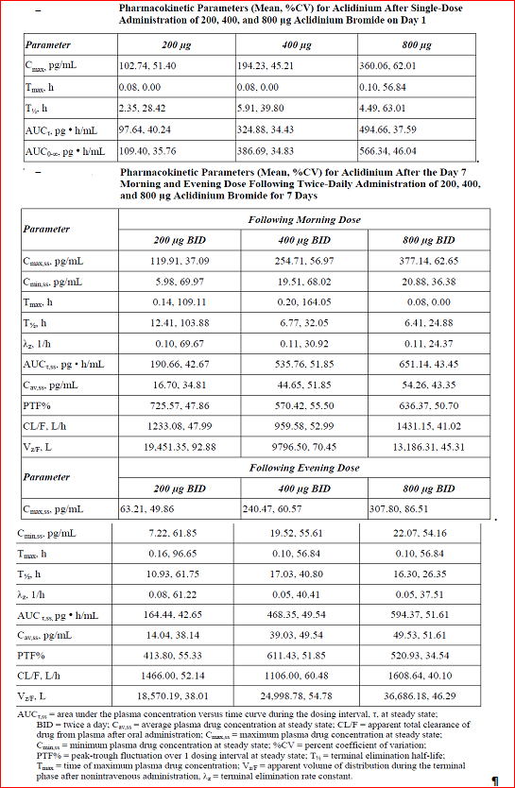
Table 5. Pharmacokientic paramters (mean %CV) for LAS34823
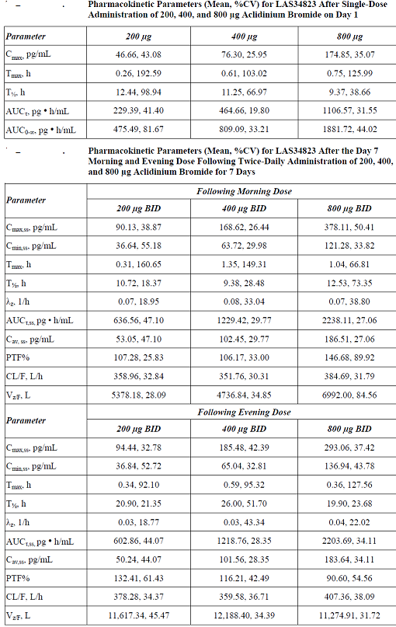
Table 6. Pharmacokientic paramters (mean %CV) for LAS34850
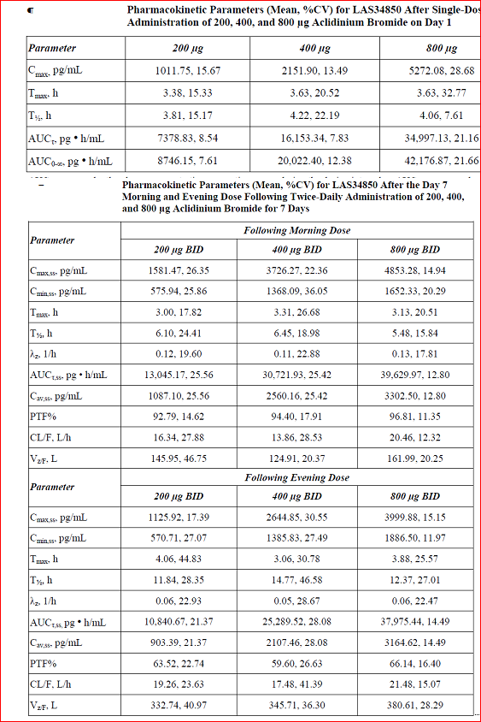

Bioavailability during multiple-dosing
In the Phase 1 study LAS-PK-12, the time-independence of aclidinium was determined by comparing PKs on Day 1 AUC0-∞ and Day 7 AUCτ,ss. The between-patient %CV values for these 2 parameters were similar across groups and ranged from 34.4 to 51.9. Use of the Wilcoxon signed rank test showed a significant difference in these parameters only at the 200-μg dose level (p-value: 0.01) while no difference (p-value > 0.05) was seen for the 400 and 800 µg dose groups. This discrepancy is believed to be due to the larger number of values that were below the limit of quantification on Day 1 following administration of 200 µg as compared with the higher doses. An assay with a lower limit of quantification may confirm time-independent pharmacokinetics following administration of 200 µg BD as was seen following administration of 400 and 800 µg BD. Comparison of the aclidinium Cmin values from Day 7 (obtained before the morning dose, before the evening dose, and 12 h after the evening dose) shows similar Cmin values. The similarity of these concentration values, along with similar Day 7 morning and evening AUC estimates, indicates not only that steady state was achieved but also kinetic linearity and time independent pharmacokinetics since no changes in aclidinium bromide clearance occurred following multiple dosing (Table 4). Mean Day 7 morning and evening aclidinium concentration versus time profiles are virtually superimposable (Figure 4), further supporting that aclidinium steady state has been achieved within 7 days. Similarly steady state was achieved for both metabolites of aclidinium (Tables 5 and 6).
Figure 4. Mean Day 7 morning abd evening aclidinium plasma concentration time profiles following 7 days of BD dosing at 200 and 400 µg (A) and 800 µg (B) aclidinium bromide.
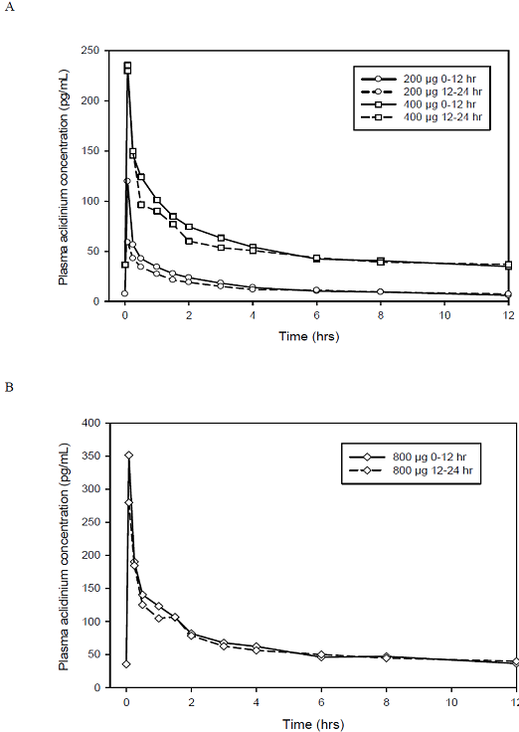
Results from the Phase 1, randomised, multiple dose, cross over study M34273/06 in 16 healthy male and female subjects should be interpreted with caution due to low number of measurable plasma concentrations which limited PK evaluation for LAS34273 and its metabolites, LAS 34823 and 34850. Furthermore, this study only evaluated multiple dosing with once daily inhalation which is not the proposed dosing regimen for which sponsors are seeking approval (the sponsors seek approval for twice daily dosing).

Effect of administration timing
Not evaluated.

Distribution

Volume of distribution
Following iv administration of 25μg to 400 µg aclidinium bromide in study M34273/05, Aclidinium bromide was subject to very rapid clearance from the body, with individual values ranging from 83.7 to 286.1 L/h across the 25 to 400 µg aclidinium bromide IV dose range. The mean apparent volume of distribution during the terminal phase for aclidinium bromide appeared to increase with ascending dose from 200 to 400 µg aclidinium bromide IV, from 140 to 302 L, respectively, although individual subject data at all dose levels were highly variable.
Comments: The observed differences in the volume of distribution with different doses are more likely related to the highly variable results and the small number of subjects per dose level rather than to changes in this parameter (CVs of 81% and 79% with the 200 µg and 400 µg iv doses, respectively).
Following inhalation of aclidinium bromide, very high and aberrant physiological values for the volume of distribution (Vz/f) were observed, reflecting the very low bioavailability associated with this route of administration (Studies LAS-PK-12, M/34273/08 and M/34273/09).

Plasma protein binding
The plasma protein binding of aclidinium bromide was investigated in vitro (study AML/10). The main plasma protein which binds aclidinium bromide in vivo is albumin. Due to the rapid hydrolysis of aclidinium bromide, it is likely that the protein binding measured corresponded to the protein binding of the metabolites. Plasma protein binding was 87% for the acid metabolite (LAS34850) and 15% for the alcohol metabolite (LAS34823).

Erythrocyte distribution
Not applicable.

Tissue distribution
The Phase 1, single dose, open-label study M34273/03 evaluated the in vivo pulmonary deposition and distribution of LAS 34273 from a multidose dry powder inhaler (Novoliser) at 90L/min in 12 healthy male subjects. Whole lung deposition of inhaled aclidinium bromide averaged approximately 30% of the metered dose (Table 7). Deposition within the lungs was highest in the most central lung region (Table 8).
Table 7. Mean± SD percentage distribution of metered dose
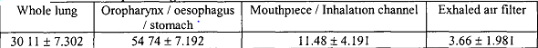
Table 8. Mean± SD percentage distribution of metered dose in lungs
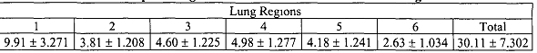
The mean peak inhaled flow rate generated in this clinical study was 79L/min rather than the targeted value of 90L/min. The quality of the drug/ radiolabel match deteriorated at flow rates lower than 90L/min. At 90L/min, the radiolabelling validation data showed a good match between the unlabelled drug and the radiolabel; data indicated that the radiolabel would slightly overestimate whole lung deposition as the radiolabel fine particle fraction (FPF) was slightly higher than unlabelled drug FPF (42.1% versus 40.3%). In contrast the match between drug and radiolabel at 60L/min was not as good as the radiolabel underestimated unlabelled drug deposition (mean FPF: 32.8% versus 37.5%). The sponsors claim that the differences between the drug and radiolabel were relatively small at both these flow rates; they state that results from this study are valid and accurate as the actual mean flow rate in this study (79L/min) was closer to 90L/min rather than 60L/min.
Comments: DPIs have been used for many years for delivery of locally acting drugs to the lungs. In all currently marketed DPIs, metered amounts of powder are entrained in a stream of air drawn through the inhaler by the patient’s own inspiratory flow. One of the major benefits of DPIs is that the patient does not have to coordinate firing of the device with inhalation- a common problem associated with pressurised metered dose inhalers (pMDIs).
In the breath actuated DPI, drug delivery is likely to be dependent on the peak inhaled flow rate achieved by the subject. Maximum inspiratory effort and high peak inhaled flow rate maybe required to ensure that de-aggregation of drug particles and the separation of drug particles from carrier particles is as efficient as possible which allows lung deposition to be optimal. In this study, subjects were instructed to inhale at a target peak inspiratory flow rate of 90 L/min which corresponds approximately to maximum inspiratory effort. Drug particle release from DPIs is determined by a patient's peak inspiratory flow rate and pressure slope. Both depend on the patient's effort, related to the peak flow and the pressure build-up during the first part of the inhalation profile. It is important that patients should be instructed to inhale in a fast and powerful fashion and this has been stressed in the proposed Pi and CMI for aclidinium bromide.

Metabolism

Interconversion between enantiomers
Not applicable.

Sites of metabolism and mechanisms / enzyme systems involved
The mass balance and metabolic profile of aclidinium bromide in healthy subjects was determined in Study M/34273/04. The study confirmed that aclidinium bromide was rapidly hydrolysed in plasma to an alcohol metabolite, and an acid metabolite.
In vivo (M/34273/04) and in vitro studies (B.34273.22, B.34273.25, B.34273.38, AML/09, B.34273.39) showed biotransformation via CYP450 isozymes plays a minor role in the total metabolic clearance of aclidinium bromide. All metabolites of aclidinium bromide appeared to be produced by hydrolysis directly (hydrolysis alone) or indirectly (hydrolysis plus additional metabolic transformation or vice versa). As no additional metabolite in significant quantity was observed, it may be concluded that almost the entire dose of aclidinium bromide was eliminated by hydrolysis to its alcohol (LAS34823 cation) and acid (LAS34850 free acid) metabolites. Following the hydrolysis of the aclidinium bromide, approximately 50% of the alcohol metabolite (LAS34823 cation) from hydrolysis was eliminated as p-hydroxy LAS34823, and the remaining LAS34823 cation metabolite was excreted as unchanged LAS34823 cation. In addition, approximately 30% of the acid metabolite (LAS34850 free acid) from hydrolysis was eliminated as 2-thiopheneglyoxylic acid and the “reduced” LAS34850 free acid metabolites, and the remaining LAS34850 free acid metabolite was excreted as unchanged LAS34850 free acid metabolite.

Non-renal clearance
Aclidinium bromide is rapidly and extensively hydrolysed to its pharmacologically inactive alcohol- and carboxylic acid-derivatives. The hydrolysis occurs both chemically (non-enzymatically) and enzymatically by esterases (butyrylcholinesterase being the main human esterase involved in the hydrolysis). Plasma levels of the acid metabolite are approximately 100-fold greater than those of the alcohol metabolite and the unchanged active substance following inhalation. Following intravenous administration of 400 µg radiolabelled aclidinium bromide to healthy subjects, approximately 1% of the dose was excreted as unchanged aclidinium bromide in the urine. Up to 65% of the dose was eliminated as metabolites in the urine and up to 33% as metabolites in the faeces.

Metabolites identified in humans

Active metabolites
Nonclinical studies showed both the acid and alcohol metabolites of aclidinium bromide to be pharmacologically inactive.

Other metabolites
None.

Pharmacokinetics of metabolites
In the mass-balance study M34273/ 04, aclidinium bromide, LAS34850 and LAS34823 appeared rapidly in plasma following both the [phenyl-U-14C] and [glycolyl-U-14C] aclidinium bromide treatments, with maximum concentrations for all three analytes being observed at the end of the 5-minute infusion. At 5 minutes after the IV administration of aclidinium bromide to healthy male subjects, the plasma concentration of aclidinium was 2 to 5 ng eq/mL and provided a good indication on the rapid hydrolysis of aclidinium. The hydrolysed products, the alcohol metabolite (LAS34823 cation) and acid metabolite (LAS34850 free acid) were the major metabolites observed in plasma. The 2-thiopheneglycoxylic acid metabolite was a minor plasma metabolite and its plasma AUC was less than 9% of the plasma AUC of the acid metabolite.
The pharmacokinetic parameters obtained showed a greater systemic exposure for LAS34850 compared to LAS34823 and with mean t½ values of 3.4 and 2.7 h, respectively, which was consistent with previous pharmacokinetic findings for these metabolites (Study M/34273/05). Because aclidinium is rapidly hydrolyzed to its alcohol (LAS34823 cation) and acid (LAS34850 free acid) metabolites, the difference in radioactivity concentration probably indicates that the clearance of the acid metabolite is slower than the clearance of the alcohol metabolite and/or its metabolite(s). Total systemic exposure to the acid metabolite, LAS34850, is at least 50 to 100-fold higher than that of aclidinium bromide after single and multiple doses (Studies M/34273/01, M/34273/05, M/34273/06, LAS-PK-12, M/34273/08, M/34273/09 and M/34273/11), whereas that of the alcohol metabolite is similar or slightly higher (Studies M/34273/01 and M/34273/11), or only slightly higher (Studies M/34273/05, M/34273/06; LAS-PK-12; M/34273/08 and M/34273/09).

Consequences of genetic polymorphism
As the major biotransformation route for aclidinium bromide in human liver microsomes is non-enzymatic hydrolysis, it was not considered necessary to assess the impact of the genetic polymorphism affecting butyrylcholinesterase activity on the pharmacokinetics of aclidinium bromide.

Excretion

Routes and mechanisms of excretion
In Phase I study M34273/05, the main fraction of the dose administered by inhalation or by IV infusion over 5 minutes was recovered in urine as parent drug and metabolites within the first 12 h post-dose. Following single dose iv or inhaled administration, aclidinium bromide exhibited very low urinary excretion with approximately 1% (M/34273/04) and 0.1% of the dose (M/34273/08 and M/34273/09), respectively, excreted in urine within 48 h of dosing as unchanged aclidinium bromide.

Mass balance studies
The metabolism and excretion of aclidinium and its metabolites was evaluated in the Phase 1 study M34273/04 in 12 healthy subjects. Following IV administration of a 400 µg dose of [14C] aclidinium bromide ([phenyl-U-14C] or [glycolyl-U-14C]) to healthy male subjects, aclidinium was extensively metabolised and approximately 1% of the dose was excreted as unchanged aclidinium. Approximately 54% to 65% of the radioactivity of the dose was excreted in urine and 20% to 33% of the dose was excreted in faeces. The combined results from human metabolism of [phenyl-U-14C] aclidinium bromide and of [glycolyl-U-14C] aclidinium bromide in this study indicated that almost the entire aclidinium bromide (LAS34273) dose was eliminated by hydrolysis. Clearance of aclidinium bromide from the plasma is rapid with an elimination half-life (t1/2) of approximately 2-3 h after a single administration or repeat QD administration of 200 µg or 400 µg aclidinium bromide (Studies M/34273/05, M/34273/08 and M/34273/09). Longer t_{1/2}. estimates (in the range of 4 to 12 h for most subjects) were observed with repeat BD administration of 400 µg (LAS-PK-12), an observation which is probably related to the availability of more non-zero values for estimation of the terminal slope of the concentration-time curve after the last day of treatment.

Renal clearance
Following inhalation of 200 µg and 400 µg of aclidinium bromide by healthy subjects or COPD patients, the urinary excretion of unchanged aclidinium was very low at about 0.1% of the administered dose, indicating that renal clearance plays a minor role in the total aclidinium clearance from plasma. Up to 65% of the intravenous dose of aclidinium bromide was eliminated as metabolites in the urine and up to 33% as metabolites in the faeces (M/34273/04). These observations indicate that renal clearance plays a minor role in the clearance of aclidinium bromide from plasma.

Intra- and inter-individual variability of pharmacokinetics
The rate (Cmax) and extent of absorption (AUC) showed a moderate to high degree of variability (coefficients of variation [CVs] were generally in the range 40-60%), as expected from the inhalation route.
Peak plasma concentrations and overall systemic exposure to inhaled aclidinium bromide 200 µg, 400 µg or 800 µg were higher in healthy subjects of study LAS-PK-12 from the first dose onwards than in other studies which investigated the pharmacokinetics of aclidinium bromide in healthy subjects (M/34273/05, M/34273/08, M/34273/11). Nevertheless, it should be considered that the intrinsic intra- and inter-subject variability in lung deposition and absorption with the inhalation route is high and that study LAS-PK-12 was conducted in a small number of subjects (eight subjects received aclidinium bromide and two received placebo per dose group). Despite this, linear kinetics was observed in study LAS-PK-12 and the pharmacokinetic behaviour of aclidinium bromide was consistent with that observed in other clinical trials.

Pharmacokinetics in the target population
The pharmacokinetics of aclidinium bromide administered by inhalation, after single administration and at steady state, in a broad age range of patients with moderate to severe COPD was studied in an open-label, multiple-dose (200 µg and 400 µg once daily over 3 consecutive days), 2-period clinical trial. Twenty four COPD patients divided into 2 groups were included in the study: 1 group of young patients aged between 40 and 59 years and 1 group of elderly patients aged ≥70 years. There were slight differences between 2 age groups in baseline characteristics (Tables 9 and 10).
Table 9. Demographic characteristics (including vital signs). Safety population
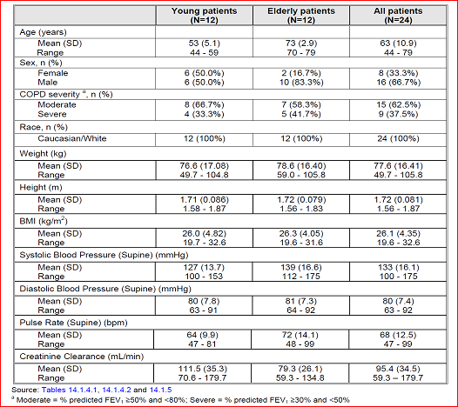
Table 10. Key baseline characteristics at screening. Safety population.
Aclidinium bromide appeared rapidly in plasma, with a median Tmax between 10 to 15 minutes post-dose for young and elderly patients, at each dose level and day. The mean Cmax, attained after inhalation of single doses of 400 µg was approximately 80 pg/mL in COPD patients (Study M/34273/09, n=24 [12 young and 12 elderly]) and higher at 100 pg/mL to 200 pg/ml in healthy volunteers (Studies M/34273/08 [n=6] and LAS-PK-12 [n=8], respectively). Following Cmax, the plasma levels of aclidinium bromide declined rapidly, with individual t_{1/2} values generally between 1 and 3 h for young and elderly patients. Based on Cmax, AUC_{(0-t)}, AUC and AUCτ, there were no differences in the rate and extent of exposure, between age group, dose level or day. AUC_{(0-t)} and Cmax for aclidinium bromide appeared to increase in a dose-proportional manner on both days in the young and elderly. There was no accumulation of aclidinium bromide upon multiple dosing and steady state was achieved at the start of multiple dosing (Day 1). The urinary excretion of aclidinium bromide was very low at 0.07% to 0.14% of the dose across all age groups, dose levels and days. The mean renal clearance of aclidinium bromide ranged from 47 to 51 mL/min in young patients compared to 35 to 39 mL/min in elderly patients, for each dose level and Day. The PK profiles of the metabolite LAS34850 showed greater exposure (AUC and Cmax) in the elderly than the young for each dose and day, and also on Day 3 compared to Day 1, for each age group and dose level. This increase is considered clinically irrelevant since this metabolite is devoid of activity at a wide array of receptors and enzymes, including muscarinic receptors. Similar results were observed for the metabolite LAS34823.
Overall, the plasma exposure at the 400 µg dose was about 2-fold higher than that for the 200 µg dose.
Comments: In Study M/34273/09, aclidinium was administered once daily and this study did not evaluate the PKs of aclidinium bromide and its metabolites following the proposed 400 µg BD dosing regimen for which approval is being sought in this submission.

Pharmacokinetics in other special populations

Pharmacokinetics in subjects with impaired hepatic function
Hepatic metabolism plays a very minor role in the clearance of aclidinium bromide, which is metabolised mainly by chemical (non-enzymatic) and enzymatic cleavage by esterase activity. As human BChE has been identified as the most important esterase responsible for the enzymatic hydrolysis (Alberti J, 2010), and BChE is predominantly expressed in human plasma, the enzymatic cleavage of aclidinium will occur mainly in the systemic circulation. Consequently, a study to assess the influence of hepatic dysfunction on pharmacokinetics of aclidinium bromide was not considered necessary and has not been performed. Dose adjustments are not considered necessary for patients with hepatic impairment.

Pharmacokinetics in subjects with impaired renal function
The pharmacokinetics of single inhaled doses of aclidinium bromide 400 µg in subjects with normal renal function and with mild, moderate and severe renal impairment were investigated in Study M/34273/08. Following administration of single doses of 400 µg aclidinium bromide administered via the Almirall Inhaler to healthy subjects with normal renal function and subjects with varying degrees of renal insufficiency (mild, moderate and severe), aclidinium bromide appeared rapidly in plasma, with a median Tmax of 0.08 h (5 minutes) post-dose for each renal function group. The mean Cmax was similar across all four renal function groups. Most of the concentrations measured beyond 4 or 6 h after dosing were close to the LLOQ of the bioanalytical method and the individual values of the estimated apparent elimination half-life were subjected to a high degree of variability (CV > 50%) (Table 11).
Table 11. Summary of the mean plasma pharmacokinetic parameters of aclidinium bromide in subjects with normal renal function and renal insufficiency (mild, moderate and severe). PP population.
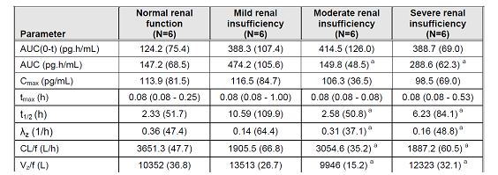
The urinary excretion of aclidinium bromide was very low, with a mean at 0.09% of the dose in subjects with normal renal function, and 0.10%, 0.06% and 0.02% in subjects with mild, moderate and severe renal insufficiency. The apparent terminal elimination half-life of LAS34850 was generally longer than that observed for aclidinium bromide, and longer in subjects with renal insufficiency. The exposure of LAS34850 was very high compared to the parent drug, aclidinium bromide, with increases in AUC(0-t) of 181, 55, 76 and 95-times for the subjects with normal renal function, and mild, moderate and severe renal insufficiency. This increase is considered clinically irrelevant since this metabolite is devoid of any pharmacological activity in a wide array of receptors and enzymes, including muscarinic receptors. The urinary excretion of LAS34850 was markedly higher than that of aclidinium bromide, at 17% of the dose in subjects with normal renal function, decreasing to 12%, 7% and 4% in subjects with mild, moderate and severe renal insufficiency, respectively.
The mean Cmax for LAS34823 was generally similar for the renal function groups and it was lower than that of aclidinium bromide. Statistical analysis showed no significant difference for exposure, based on the median AUC(0-t) and AUC, for the mild, moderate and severe renal insufficiency groups compared to the subjects with normal renal function. The urinary excretion of LAS34823 was higher than that of aclidinium bromide, but lower than that of LAS34850, at 7% of the dose in subjects with normal renal function, decreasing to 5%, 3% and 2% in subjects with mild, moderate and severe renal insufficiency, respectively. The Applicant considers that this single-dose study supports registration of doses up to 400 µg BD.
Comments: Although renal dysfunction resulted in a reduced renal excretion of aclidinium bromide and metabolites, the impact of the renal dysfunction on the plasma exposure was minor, with no significant differences between the normal renal function group and each of the renal insufficiency groups for plasma PK parameters and no apparent trend for subjects with lower creatinine clearance to have higher plasma exposure (AUC). Considering the wide therapeutic index of aclidinium bromide (inhaled doses up to 6000 µg [30-fold the expected therapeutic dose] have been safely administered to healthy subjects), and the safety, tolerability and PK results found in the present study, it can be concluded that the PK behaviour of aclidinium bromide and its two main inactive metabolites is not altered to a clinically significant extent in subjects with impaired renal function. As such, a dosage adjustment in patients with mild, moderate or severe renal impairment is not needed.
“The Note for Guidance on the Evaluation of the Pharmacokinetics of Medicinal Products in Patients with Impaired Renal Function” (CHMP/EWP/225/02) states that a multiple-dose study is desirable only when a drug or active metabolites are known to exhibit non-linear or time-dependent pharmacokinetics. A multiple-dose study to investigate pharmacokinetics in renal impairment was not considered necessary as aclidinium bromide exhibited linear and time-independent pharmacokinetics in multiple-dose Studies M/34273/09 and LAS-PK-12. The acceptability of this study to support registration of aclidinium bromide 400 µg BD was discussed, and in principle agreed, at national Scientific Advice meetings with the MHRA (2009), AFSSAPS (2009) and the AEMPS (2009).

Pharmacokinetics according to age
The PKs of inhaled aclidinium bromide 200 µg or 400 µg QD for 3 days were investigated in moderate to severe COPD patients aged 40 to 59 years and aged 70 years and over (M/34273/09). Aclidinium bromide was rapidly absorbed in both age groups with a median time to peak plasma concentrations of 10-15 minutes for both age groups. No differences in aclidinium systemic exposure (based on Cmax and AUC) were observed between age groups. Therefore, no dose adjustment is considered necessary for elderly COPD patients. The Sponsor considers that the results of this study support registration of aclidinium bromide 400 µg BD based on the observations that peak plasma concentrations are similar after 7 days dosing with 400 µg BD to those observed after the first dose (study LAS-PK-12) and that the safety margins between human systemic exposure with 400 µg BD and the no observed adverse effect levels in non-clinical toxicity studies are 17- to 187-fold.
Comments: Study M/34273/09 investigated the effect of age on the pharmacokinetics of multiple once daily doses of aclidinium bromide. The acceptability of Study M/34273/09 to support registration of aclidinium bromide 400 µg BD was discussed and, in principle, agreed, at national Scientific Advice meetings [MHRA (2009), AFSSAPS(2009) and the AEMPS (2009)].

Pharmacokinetics related to genetic factors
Not evaluated.

Pharmacokinetics {in other special population / according to other population characteristic}
Not evaluated.

Pharmacokinetic interactions

Pharmacokinetic interactions demonstrated in human studies
Not evaluated (see below).

Clinical implications of in vitro findings
In vitro drug-drug interaction studies of aclidinium bromide and its major metabolites indicate that at the plasma concentrations achieved with the therapeutic dose, neither aclidinium bromide nor its two main metabolites are likely to inhibit human esterases or to inhibit or induce CYP450 isozymes and, therefore, inhaled aclidinium bromide is unlikely to alter the disposition of drugs metabolised by CYP450 enzymes or human esterases. In addition, P-glycoprotein does not play a significant role in the ADME of aclidinium bromide and the disposition of co-administered P-glycoprotein substrate drugs is not expected to be affected by aclidinium bromide. As a result of the observations in these in vitro drug-drug interaction studies, in vivo drug-drug interaction studies have not been performed.

Evaluator’s overall conclusions on pharmacokinetics
Absorption: Aclidinium bromide is rapidly absorbed from the lung, achieving maximum plasma concentrations within 5 minutes of inhalation in healthy subjects and normally within the first 15 minutes in COPD patients. The mean C_{max}, attained after inhalation of single doses of 400 µg was approximately 80 pg/mL in COPD patients (Study M/34273/09, n=24 [12 young and 12 elderly]) and higher at 100 pg/mL to 200 pg/mL in healthy volunteers (Studies M/34273/08 [n=6] and LAS-PK-12 [n=8], respectively). Steady-state plasma levels were attained within seven days of twice daily dosing and considering the short half-life; steady-state may be reached soon after the first dose. No accumulation on repeat dosing was observed at steady-state. The fraction of the inhaled dose that reaches the systemic circulation as unchanged aclidinium is very low at less than 5%.
Distribution: Whole lung deposition of inhaled aclidinium bromide via the Genuair inhaler averaged approximately 30% of the metered dose. The plasma protein binding of aclidinium bromide determined in vitro most likely corresponded to the protein binding of the metabolites due to the rapid hydrolysis of aclidinium bromide in plasma; plasma protein binding was 87% for the carboxylic acid metabolite and 15% for the alcohol metabolite. The main plasma protein that binds aclidinium bromide is albumin.
Metabolism: Aclidinium bromide is rapidly and extensively hydrolysed to its pharmacologically inactive alcohol and carboxylic acid derivatives. The hydrolysis occurs both chemically (non-enzymatically) and enzymatically by esterases, butyrylcholinesterase being the main human esterase involved in the hydrolysis. Plasma levels of the acid metabolite are approximately 100 fold greater than those of the alcohol metabolite and the unchanged active substance following inhalation. The low absolute bioavailability of inhaled aclidinium bromide (<5%) is because aclidinium bromide undergoes extensive systemic and pre systemic hydrolysis whether deposited in the lung or swallowed. Biotransformation via CYP450 enzymes plays a minor role in the total metabolic clearance of aclidinium bromide.
Elimination: The terminal elimination half-life of aclidinium bromide is approximately 2 to 3 h. Following intravenous administration of 400 µg radiolabelled aclidinium bromide to healthy subjects approximately 1% of the dose was excreted as unchanged aclidinium bromide in the urine. Up to 65% of the dose was eliminated as metabolites in the urine and up to 33% as metabolites in the faeces. Following inhalation of 200 µg and 400 µg of aclidinium bromide by healthy subjects or COPD patients, the urinary excretion of unchanged aclidinium was very low at about 0.1% of the administered dose indicating that renal clearance plays a minor role in the total aclidinium clearance from plasma.
PKs in special populations: In Study M34273/09, PK profiles of aclidinium bromide in plasma were similar between Days 1 and 3, in COPD patients aged 40 to 59 years and in patient’s aged ≥70 years. The plasma exposure at the 400 µg inhaled dose being approximately 2 times higher than that for the 200 µg dose. Thus, it can be concluded that the pharmacokinetic behaviour of aclidinium bromide in elderly patients is not different from that in younger adult patients. Furthermore, the higher exposure of the two main metabolites observed in the elderly patients is considered clinically irrelevant since these metabolites are devoid of activity at a wide array of receptors and enzymes, including muscarinic receptors. As such, a dosage adjustment for elderly COPD patients is not required.
No significant pharmacokinetic differences were observed between subjects with normal renal function and subjects with renal impairment. Therefore, no dose adjustment and no additional monitoring are required for renally impaired COPD patients.
No studies have been performed on hepatically impaired patients. As aclidinium bromide is metabolised mainly by chemical and enzymatic cleavage in the plasma, hepatic dysfunction is very unlikely to alter its systemic exposure. No dose adjustment is required for hepatically-impaired COPD patients.
Drug interations: No human drug interaction studies have been conducted. In vitro studies have shown that aclidinium bromide at the therapeutic dose or its metabolites do not inhibit or induce any of the cytochrome P450 (CYP450) enzymes and do not inhibit esterases (carboxylesterase, acetylcholinesterase and butyrylcholinesterase). In vitro studies have shown that aclidinium bromide or the metabolites of aclidinium bromide are not substrates or inhibitors of P-glycoprotein.

Pharmacodynamics

Studies providing pharmacodynamic data
Table 12 shows the studies relating to each pharmacodynamic topic.
Table 12. Submitted pharmacodynamic studies.
PD Topic | Subtopic | Study ID
Primary pharmacology:  Secondary Pharmacology | In male COPD patients  To characterise PIF generated through Novolizer and the Handihaler dry powder inhalers by COPD patients  Effect on QT intervals | M/34273/21  M/34273/07  M/34273/11
Gender other genetic and Age-Related Differences in PD Response | Effect of gender | None
 | Effect of age | None
PD Interactions | Not evaluated | None
Population PD and PK-PD analyses | Healthy subjects | Not applicable
Population PD and PK-PD analyses | Target population | None
None of the pharmacodynamic studies had deficiencies that excluded their results from consideration.

Summary of pharmacodynamics
The information in the following summary is derived from conventional pharmacodynamic studies in humans unless otherwise stated.

Mechanism of action
Aclidinium bromide is a competitive, selective muscarinic receptor antagonist (also known as an anticholinergic) with a longer residence time at the M3 receptors than the M2 receptors. M3 receptors mediate contraction of airway smooth muscle. Inhaled aclidinium bromide acts locally in the lungs to antagonise M3 receptors of airway smooth muscle and induce bronchodilation. Nonclinical in vitro and in vivo studies showed rapid, dose-dependent and long-lasting inhibition by aclidinium bromide of acetylcholine-induced bronchoconstriction. Aclidinium bromide is quickly broken down in plasma and the level of systemic anticholinergic side effects is therefore low. The affinity of aclidinium bromide, LAS34823 and LAS34850 for various receptors and enzymes was studied in radioligand binding assays and enzymatic studies, respectively. Aclidinium bromide showed only moderate affinity (IC50 ≥ 1 μM) on alpha-adrenergic (α)1 (non-selective) receptors, histaminergic (H)1 (central) receptor, Neurokinin (NK)1 receptors and had moderate inhibitory effects on 5-hydroxytryptamine (5-HT) uptake, in contrast to its strong affinity for muscarinic receptors. The metabolites were devoid of significant affinity for any of the receptors studied, including muscarinic receptors. Furthermore, aclidinium bromide and its metabolites were generally inactive in a panel of relevant enzymes.

Pharmacodynamic effects

Primary pharmacodynamic effects
Results of the pilot Study M/34273/00 in 12 healthy male subjects suggest that aclidinium bromide is effective in improving specific airway conductance and reducing bronchial hyperresponsiveness. The 2 higher doses of 300 µg and 600 µg were more effective than the lower dose of 50 µg. The PD activity of LAS34273 (aclidinium) was evident between 1 and 24 h supporting once daily administration. LAS34273 was well-tolerated and the parent compound or its metabolites were not detected in plasma following inhalation.
The Phase II, single ascending dose, placebo controlled, crossover study in 17 COPD male patients (M/34273/21) showed statistically significant improvement in the 4 spirometric parameters measured (FEV1, FVC, PEFR, FEF25-75) following single inhalation of LAS34273 (100 µg, 300 µg and 900 µg). Compared to placebo, all three LAS34273 doses showed statistically significant improvement in FEV1 and FVC to suggest the bronchodilatory effect of LAS34273; however, there was no significant difference between the 3 doses although the time to maximal efficacy was faster with 300 µg and 900 µg doses (2 h) compared to the 100 µg dose (2h). The secondary variables of PEFR and FEF 25-75 showed statistically significant improvements over placebo only with the higher LAS34273 doses (300 µg and 900 µg). Statistically significant improvements compared with placebo for FEV1 and FVC were observed for all LAS34273 doses (100 µg, 300 µg and 900 µg) from 15 min to 24 h after single inhalation. The results showed highest degree of reversibility with the dose of 300 µg. The onset of action is very fast (15 mins) and efficacy is maintained until 24-32h postdose for the 300 µg and 900 µg doses supporting a once daily administration dosing regimen which was initially refused by the sponsor (see Other Efficacy Studies, Long term Efficacy section of this report). Statistically significant improvements compared with placebo for FEV1 and FVC were observed for all LAS34273 doses (100 µg, 300 µg and 900 µg) from 15 min to 24 h after single inhalation. The results showed highest degree of reversibility with the dose of 300 µg.
Comments: The proposed dose of 400 µg BD was not evaluated in this study.

Secondary pharmacodynamic effects
The Phase I, prospective, multiple dose, randomised, parallel group, placebo- and positive-controlled study in 272 male and female healthy volunteers (M/34273/11) showed that LAS34273 at therapeutic dose (200 µg) or supra-therapeutic doses (800 µg) did not produce any clinically relevant effect on QTci/ QTcF, QTcB/ QT. This lack of effect on cardiovascular safety was observed after single administration or following 3 days dosing (at PK steady state). The assay sensitivity of the study was confirmed as moxafloxacin 400 µg (positive control) produced significant increase in QT intervals compared with placebo. The number of subjects with prolonged QTci (>450, 480 or 500msecs) was low and comparable in the placebo, LAS34273 200 µg and 800 µg groups, while more subjects in the positive control (moxafloxacin) group had prolonged QT values with similar results for percentage of subjects with QTc increases ≥30 or ≥60msecs.
Comments: No thorough QT study was conducted with the proposed twice daily dosing regimen of aclidinium bromide.

Time course of pharmacodynamic effects
In the Phase II study, statistically significant improvements compared with placebo for FEV1 and FVC were observed for all LAS34273 doses (100 µg, 300 µg and 900 µg) from 15min to 24 h after single inhalation. The results showed highest degree of reversibility with the dose of 300 µg. The onset of action is very fast (15 mins) and efficacy is maintained until 24-32h post-dose for the 300 µg and 900 µg doses supporting a once daily administration dosing regimen which was initially evaluated (refer QD dosing clinical development program section Other Efficacy Studies, Long term Efficacy of this report).

Relationship between drug concentration and pharmacodynamic effects
Aclidinium bromide acts locally in the lungs and the plasma concentration of the parent drug is negligible (absolute bioavailability of <5%) and so pharmacological activity of aclidinum bromide is not dependent of its plasma concentration.
No relationship was observed between plasma levels of parent compound (LAS34273) or its metabolites (LAS34850 and LAS34823) and QTci changes in the well-conducted study M/34273/11 following inhalation of therapeutic (200 µg) and supratherapeutic doses (800 µg) of aclidinium bromide once daily for 3 days.

Genetic-, gender- and age-related differences in pharmacodynamic response
Not evaluated.

Pharmacodynamic interactions
Not evaluated.

Comparison of drug delivery devices: Novoliser (foraclidinium) vs Handihaler (for Tiotropium)
A Phase II, open-label, cross-over, randomised, placebo dose, medical device trial evaluated the PIF generated through the Novolizer and HandiHaler® dry powder inhalers by 48 patients with moderate and severe COPD (M34273/07). There was a marked higher mean PIF generated through the Novolizer (92.0 L/min) compared to the HandiHaler® (46.1 L/min), confirming the lower resistance of the Novolizer. COPD patients with a wide range of disease (moderate and severe) are able to generate sufficient inspiratory airflow through the Novolizer to reliably inhale the full dose and activate the trigger threshold. For both the moderate and severe COPD groups, the highest and mean inhalation volumes were similar for the Novolizer and HandiHaler® (A), and were slightly greater than HandiHaler® (B). For each device and COPD severity group, the total inhalation volume was similar across the three attempts.
Using the Novolizer, the number of successful and optimal inhalations was 97.2%, being slightly higher in moderate than severe COPD patients at 98.6% and 95.8%, respectively. For patients with moderate COPD, 71 of the 72 inhalations (98.6%) using the Novolizer were successful and optimal, with only one out of the three inhalations in a patient being unsuccessful and non-optimal. For patients with severe COPD, 69 of the 72 inhalations (95.8%) using the Novolizer were successful and optimal, with all three inhalations, except for one patient. In 21.5% (31/144) of the inhalations with the HandiHaler® some powder remained in the inhaler.
There was an apparent gender effect for PIF for patients with moderate COPD only, which was greatest for the Novolizer, with the highest and mean PIF values for males (109 and 102 L/min) being greater than females (80 and 74 L/min) by approximately 38%, compared to HandiHaler® (A) and HandiHaler® (B) at approximately 15% and 25%, respectively. For patients with severe COPD, the increases were no more than 5% for any device. These data, however, should be treated with caution due to the small number of females compared to males (totals of 6 and 18 patients, respectively) and to the fact that a gender difference in PIF was also observed without the device. In addition, despite the higher PIF observed in males compared to females, all patients were able to generate a PIF of 45 L/min through the Novolizer, meaning the amount of drug reaching the lungs is constant and not affected.
Comments: The results of an unpublished in vitro study (UB-028-03) of fine particle dose (FPD) using an Andersen Cascade Impactor and assessing the delivery of aclidinium at inspiratory flow rates ranging from 25 L/min to 95 L/min, showed that FPD was consistent between flow rates of 45 and 95 L/min, whereas a flow dependency of FPD was observed for flow rates between 25 and 35 L/min. Successful inhalation was defined in this study as the ability of the patient to activate the interlocking system by producing enough inspiratory flow through the inhaler. The inspiratory flow threshold that triggers the interlocking system (and therefore responsible for the change from green to red in the control window) for the Novolizer ranges from 25 to 55 L/min. All patients were able to successfully inhale (change in the control window) with the exception of one patient However, the rest of results obtained with the Novolizer in the present study showed that the Novolizer is a suitable device for administration of inhaled treatments to COPD patients. Results of this study show that all COPD patients enrolled in the trial were able to produce a higher PIF through the Novolizer inhaler than through the HandiHaler® device (irrespective of whether inhalation instructions A or B were applied). Apart from the highest mean PIF value obtained for the Novolizer, the minimum values obtained for the Novolizer may indicate that COPD patients will, in general, be able to more effectively achieve the correct dose from the Novolizer than from the HandiHaler®. Overall, COPD patients with a wide range of disease (moderate and severe) are able to generate sufficient inspiratory airflow through the Novolizer to reliably inhale the full dose and activate the trigger threshold.

Evaluator’s overall conclusions on pharmacodynamics
Aclidinium bromide is a competitive, selective muscarinic receptor antagonist (anticholinergic) with a longer residence time at M3 receptors than M2 receptors. M3 receptors mediate contraction of airway smooth muscle. Inhaled aclidinium bromide acts locally at airway smooth muscle to antagonise M3 receptors and induce bronchodilation. Nonclinical in vitro and in vivo studies showed rapid, dose-dependent and long lasting inhibition by aclidinium bromide of acetylcholine induced bronchoconstriction. Aclidinium bromide is quickly broken down in plasma and the level of systemic anticholinergic side effects is therefore low.
The Phase II, single, ascending dose Study M/34273/21 in COPD patients showed statistically significant improvements compared with placebo for FEV1 and FVC at all LAS34273 doses (100 µg, 300 µg and 900 µg) from 15 min to 24 h after single inhalation. However, the proposed dose of 400 µg BD was not evaluated in this study.
No effects on QT interval (corrected using either the Fridericia or Bazett method or when individually corrected) were observed when aclidinium bromide (200 µg or 800 µg) was administered once daily for 3 days to 272 healthy subjects in a thorough QTc study M/34273/11.
The proposed drug is an inhalation powder containing active drug and lactose in a dry powder inhaler (DPI), the Novolizer inhaler⁷. This device presents minor changes with respect to the marketed Novolizer® and meets at least the same standards. The main difference is that the Novolizer® is a refillable device whereas the proposed Almirall Novolizer is a disposable device. Each device has a dose counter display to track the number of doses remaining and features to ensure patient compliance. When the coloured button on the top of the DPI device is pressed a single dose of inhalation powder is loaded into the powder inhalation channel. A window on the front of the device simultaneously changes from red to green to indicate that the dose is ready for breath actuated inhalation. During the breath, patients should hear a click indicating that they have breathed in strongly enough for the device to work. Additionally, a change in the front window from green to red informs the patient that the inhalation has been successfully performed.
As per the EU Guideline CPMP/EWP/4151/00 (Points to consider on the requirements for clinical documentation for orally inhaled products), it should be defined which patient groups will normally be able to produce a sufficient Peak Inspiratory Flow (PIF) to use the inhaler and which special groups may have problems. According to the FDA guidance for industry entitled “Points to consider: clinical development programs for Metered Dose Inhaler (MDI) and DPI products” to relate the in vitro tests to in vivo performance for DPIs (which are dependent on patient effort for deaggregation and dose delivery) studies should be conducted to determine what flow characteristics are obtained through the device by adult patients with varying degrees of obstructed lung function. The Phase II Study M34273/07 was conducted to assess the PIF generated by moderate and severe COPD patients through the proposed Novolizer DPI containing placebo. Results of this study show that all COPD patients enrolled in the trial were able to produce a higher PIF through the Novolizer inhaler than through the HandiHaler® device. Overall, COPD patients with a moderate to severe disease were able to generate sufficient inspiratory airflow through the Novolizer to reliably inhale the full dose and activate the trigger threshold.

Dosage selection for the pivotal studies
Two Phase II studies with BD dosing (M/34273/29 and M/34273/23) evaluated the BD dosing regimen of aclidinium bromide and used formoterol and tiotropium for benchmark comparison. Study 29 evaluated a range of doses of aclidinium (100, 200 and 400 µg) and will be discussed in this section while study 23 used only one dose of aclidinium bromide (400 µg BD) and will be discussed later.

Study M34273/29

Study design, objectives:
The Phase IIb, prospective, double blind, double-dummy, randomised, 5x5 Latin square cross-over, placebo and active controlled multinational, multicentre Study M/34273/29 evaluated the efficacy and safety of three doses of aclidinium bromide (100 µg, 200 µg or 400 µg) twice a day (BD) compared to formoterol 12 μg BD and placebo in 79 patients with moderate to severe COPD. The study was conducted at 11 centres in Germany (10) and Belgium (1 site) from 21 April 2010 to 19 August 2010.

Inclusion, exclusion criteria:
The study included adult patients with stable moderate to severe COPD (GOLD guidelines), post -salbutamol FEV1 <80% and ≥30% of predicted normal value and FEV1/forced vital capacity (FVC) <70%, current or ex−smokers of ≥10 pack-years. The main exclusion criteria were patients with history or current diagnosis of asthma, signs of COPD exacerbation within 6 weeks prior to the screening visit and other clinically significant respiratory and/or cardiovascular conditions or laboratory abnormalities, patients with contraindication to use of anticholinergic drugs.
There were no meaningful differences between the patient eligibility criteria for Phase II studies, M/34273/23 and M/34273/29, and those for the pivotal studies. Although not an eligibility criterion, patients in Study M/34273/29 were required to demonstrate that variability of lung function (FEV1) prior to commencement of each treatment period was <15% compared to baseline in order to confirm COPD stability during this 5-way cross-over study.

Study treatments:
Patients fulfilling inclusion/exclusion criteria at the time of the screening visit were entered into a run-in period of 14 ± 3 days to assess patient’s disease stability. Patients who met entry criteria at Visit 2 were assigned to 1 of the 5 treatment sequences (Table 13) using a balanced randomisation ratio (1:1:1:1:1). The treatment period consisted of 5 periods of 7 treatment days each separated by a washout period of 7 (±2) days. The treatments were placebo, aclidinium bromide 100 µg, aclidinium bromide 200 µg, aclidinium bromide 400 µg and formoterol fumarate 12 μg. As this was a double-dummy study, to maintain blinding, patients received both aclidinium bromide BD or placebo to aclidinium bromide via Genuair® inhaler and formoterol BD or placebo to formoterol via Aerolizer® inhaler.
Table 13. Treatment sequences Study M34273/29
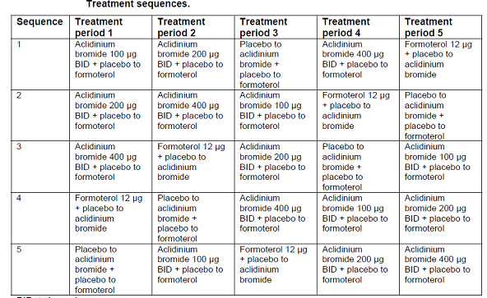
Inhalers containing aclidinium bromide and placebo to aclidinium bromide (Genuair®) presented the same external appearance to ensure the double blind nature of the study. Inhalers containing formoterol and placebo to formoterol (Aerolizer®) also presented the same external appearance. Aclidinium bromide, formoterol and matching placebo were administered BD in the morning (09:00 ± 30 minutes) and in the evening (21:00 ± 30 minutes). Relief medication (salbutamol pressurised metered dose inhaler [pMDI] 100 µg/puff) was permitted as needed throughout the study duration for all participants. In addition, several maintenance medications for the treatment of COPD (inhaled corticosteroids, oral or parenteral corticosteroids up to a maximum of 10 mg of prednisone/day or 20 mg every other day, and oral sustained-release theophyllines) were permitted when stable for at least 4 weeks prior to entering the study. Relief and maintenance therapies were allowed to minimise the risk of COPD exacerbations.

Efficacy variables:
The primary efficacy variable was Change from baseline in normalised FEV1 area under the curve (AUC) over the 12 h (h) period immediately after morning study drug administration (AUC₀₋₁₂) at Day 7 on treatment. Secondary efficacy variables were: Change from baseline in normalised FEV1 AUC₁₂₋₂₄, AUC₀₋₂₄ and morning pre-dose (trough) FEV1 at Day 7 on treatment. Additional efficacy variables were :Change from baseline in normalised FVC AUC₀₋₁₂, AUC₁₂₋₂₄ and AUC₀₋₂₄ at Day 7 on treatment; Change from baseline in normalised FEV1 and FVC AUC over the 6 h period immediately after morning IMP administration (AUC₀₋₆) at Days 1 and 7 on treatment; Change from baseline in morning pre-dose (trough) FVC at Day 7 on treatment; Absolute values of morning pre-dose (trough) FEV1 and FVC at Day 7; Change from baseline in the morning and evening peak FEV1 and FVC at Day 7 on treatment; Change from baseline in the morning peak FEV1 and FVC at Day 1 on treatment; Time to morning peak FEV1 at Days 1 and 7; Time to evening peak FEV1 at Day 7; Change from baseline in FEV1 and FVC at each specific time-point at Day 1 and Day 7 on treatment; Absolute values of FEV1 and FVC by day and time-point; Number (and percentage) of patients using relief medication after 7 days of treatment; Change from baseline in the use of relief medication (number of puffs) after 7 days on treatment. Other variables assessed were exposure to study drug, prior and concomitant medication, number of withdrawals and reason for withdrawal and convenience of device.

Sample size, statistical methods:
A sample size of 60 COPD patients (12 patients per treatment sequence) provided at least 90% power to detect a difference of 120 mL in change from baseline in normalised FEV1 AUC₀₋₁₂ after 7 days of treatment between one of the aclidinium bromide doses and placebo with a 0.05 two-sided significance level and assuming 200mL as a SD of differences. The sample size of this study was selected not only to have sufficient power versus placebo, but also to obtain estimates of the spirometric FEV1 curves with high precision to allow appropriate identification of the optimum dose. Taking into account an approximate 10% drop-out rate, a total of 65 patients (13 patients per treatment sequence) were planned to be randomised. The analysis of all the efficacy variables was performed on the ITT population and the primary efficacy variable was also analysed using the PP population. All demographic and baseline characteristics, safety outcomes and other variables were analysed using the Safety population. All statistical comparisons were two-sided hypothesis tests, and the significance level was set at 0.05. The primary, secondary and additional efficacy variables except for “Time to peak FEV1” and “Number (and percentage) of patients using relief medication after 7 days of treatment” were analysed by means of an analysis of covariance (ANCOVA) for cross-over designs with sequence, treatment and period as fixed effect factors, subject within sequence as random effect, and baseline value at each period as covariate. “Time to peak FEV1” and “Number (and percentage) of patients using relief medication after 7 days of treatment” were analysed descriptively. Safety and tolerability outcomes, convenience of device assessment and other variables were summarised by means of descriptive statistics.

Participant flow, protocol violations, deviations:
A total of 99 patients were screened of whom 79 patients were assessed as eligible and were randomised into the study. Eleven patients were discontinued from the study. The main reason for discontinuation was due to adverse events (n=7). Six patients had a protocol violation which led to their exclusion from the PP population (5 of these had major protocol deviation of difference between FEV1 baseline values >20% and ≥200 mL).

Baseline data:
The mean age of the patients was 61.1 years. All patients were Caucasian. There were 59 (74.7%) male patients and 20 (25.3%) female patients. Mean weight, height and BMI were 81.6 kg, 173.2 cm and 27.1 kg/m², respectively. Overall, 45 (57.0%) patients were current smokers and smoking consumption ranged from 10 to 142.5 pack-years. The patients in this study suffered from COPD for a mean of 10.4 years and had COPD stage II (moderate) disease (59.0%) or stage III (severe) disease (41.0%). Overall post-bronchodilator FEV1 values at screening were between 30.0% and 77.6% of the predicted normal value, with a mean value of 48.2%. Mean post-bronchodilator FEV1/FVC ratio was 45.1% (<70% threshold used for defining COPD). Mean bronchodilator reversibility was 13.7% and the absolute change in bronchodilation after the reversibility test was 0.183 L. A total of 33 patients (42.3%) had reversible airway obstruction (defined as an increase of 12% and 200 mL compared to baseline after 400 µg of salbutamol). The most common pre-study COPD medications were SABA (58.2% of patients), LAMA (30.4%) and LABA + ICS (30.4%). The most frequent prior medications (≥10% of patients) were tiotropium bromide (30.4%), salbutamol (27.8%), budesonide (24.1%), acetylsalicylic acid (17.7%), budesonide with formoterol fumarate (16.5%), seretide and fluticasone propionate (both 11.4%) and formoterol fumarate (10.1%).

Primary efficacy results:
Administration of aclidinium bromide BD induced statistically significant improvements in pulmonary lung function compared to placebo which was evident from post-morning administration on Day 1, was sustained over time and maintained until the end of the treatment period at Day 7. At the end of 7 days on treatment all aclidinium bromide BD doses (100 µg, 200 µg and 400 µg) provided dose-dependent and statistically significant bronchodilation 12 h after morning and evening administration (p<0.0001) with aclidinium bromide 400 µg BD showing statistically significantly greater improvements compared to aclidinium bromide 100 µg BD for all values. The magnitude of the improvement in FEV1 provided by aclidinium bromide 400 µg BD during the first 12 h after morning dose was comparable to formoterol 12 μg BD, although it was significantly lower than formoterol after the evening administration (0.056, p=0.0065).

Secondary efficacy results:

Trough FEV1:
According to the ANCOVA model, the adjusted mean change from baseline in morning pre-dose (trough) FEV1 was -0.025 L for placebo, 0.081 L for aclidinium bromide 100 µg, 0.089 L for aclidinium bromide 200 µg, 0.130 L for aclidinium bromide 400 µg and 0.123 L for formoterol. At the end of 7 days of treatment, all aclidinium doses showed statistically significantly greater improvements in the adjusted mean change from baseline in trough FEV1 compared with placebo (p<0.0001). The adjusted mean treatment differences compared with placebo were dose dependent with 0.106 L, 0.114 L and 0.154 L for aclidinium bromide 100 µg, 200 µg and 400 µg, respectively. The treatment difference in the adjusted mean change from baseline in trough FEV1 between aclidinium bromide 400 µg and aclidinium bromide 100 µg reached statistical significance, favouring the 400 µg dose (0.048 L; p=0.0278). Aclidinium bromide 400 µg showed greater numerical improvement over aclidinium bromide 200 µg, but without statistical significance (0.040 L). Formoterol showed statistically significantly greater treatment differences in the adjusted mean change from baseline in trough FEV1 compared to placebo (0.148 L; p<0.0001). There were no statistically significant differences between the aclidinium bromide doses and formoterol for trough FEV1.

FEV1 AUC₀₋₂₄:
At the end of 7 days of treatment, all aclidinium bromide doses showed statistically significantly greater improvements (p<0.0001) in adjusted mean change from baseline in normalised FEV1 AUC₀₋₂₄ compared with placebo. The treatment differences versus placebo were 0.150 L, 0.162 L and 0.195 L for aclidinium bromide 100 µg, 200 µg and 400 µg, respectively. The treatment difference in the adjusted mean change from baseline in normalised FEV1 AUC₀₋₂₄ between aclidinium bromide 400 µg and aclidinium bromide 100 μg reached statistical significance, favouring the 400 µg dose (0.044 L; p=0.0178). Aclidinium bromide 400 µg showed greater numerical improvement over aclidinium bromide 200 µg but without statistical significance (0.033 L). Formoterol showed statistically significantly greater improvements in adjusted treatment differences in the change from baseline in normalised FEV1 AUC₀₋₂₄ compared to placebo (0.225 L; p<0.0001), aclidinium bromide 100 µg (0.075 L; p<0.0001) and aclidinium bromide 200 µg (0.063 L; p=0.0008). The treatment difference between formoterol and aclidinium bromide 400 µg in the adjusted mean change from baseline in normalised FEV1 AUC₀₋₂₄ was not statistically significant (0.031 L, p=0.099).

FEV1 AUC₁₂₋₂₄:
At the end of 7 days of treatment, all aclidinium bromide doses showed statistically significantly greater improvements (p<0.0001) in the adjusted mean change from baseline in normalised FEV1 AUC₁₂₋₂₄, compared to placebo. The treatment differences versus placebo were 0.147 L, 0.150 L and 0.189 L for aclidinium bromide 100 µg, 200 µg and 400 µg, respectively. The treatment difference in the adjusted mean change from baseline in normalised FEV1 AUC₁₂₋₂₄ at Day 7 on treatment was statistically significantly greater in aclidinium bromide 400 µg group compared to the 100 µg group (0.042 L; p=0.0404). Aclidinium bromide 400 µg showed greater numerical improvement over aclidinium bromide 200 µg but without statistical significance (0.039 L). Formoterol showed statistically significant greater improvements in the change from baseline in normalised FEV1 AUC₁₂₋₂₄ compared to placebo (0.244 L, p<0.0001), aclidinium bromide 100 µg (0.097 L, p<0.0001), 200 µg (0.094 L, p<0.0001) and 400 µg (0.056 L; p=0.0065).

FVC:
After 7 days of treatment, all aclidinium bromide doses and formoterol showed statistically significant treatment differences in the adjusted mean change from baseline in normalised FVC AUC₀₋₁₂ and FVC AUC₁₂₋₂₄ compared to placebo (p<0.0001) but there were no statistically significant differences between the three doses of aclidinium bromide. There was no significant difference between any dose of aclidinium bromide and formoterol in AUC₀₋₁₂. However, formoterol showed a statistically significantly greater adjusted mean change from baseline in normalised FVC AUC₁₂₋₂₄ compared to placebo (p<0.0001), aclidinium bromide 100 μg (p=0.0013), aclidinium bromide 200 µg (p=0.0010) and aclidinium bromide 400 µg (p=0.0358).

Trough FVC:
At the end of 7 days of treatment, all aclidinium bromide doses showed statistically significantly greater improvement in the adjusted mean change from baseline in morning pre-dose (trough) FVC compared to placebo (p=0.0008 for aclidinium bromide 100 µg and p<0.0001 for aclidinium bromide 200 µg and 400 µg). There was no significant difference between the three doses of aclidinium bromide. Formoterol showed statistically significantly greater improvement in the adjusted mean change from baseline in morning pre-dose (trough) FVC compared to placebo (p<0.0001), but there was no significant difference between any dose of aclidinium bromide and formoterol.

Other efficacy results:
The slope of the FEV1 curve of aclidinium bromide BD was comparable to the slope of an approved BD drug (formoterol 12 μg in Aerolizer®) at both 12 h and 24 h, thus supporting the BD dose regimen of aclidinium bromide. All doses of aclidinium bromide BD were statistically significantly different from placebo at the majority of timepoints throughout the 24 h period. Treatment with aclidinium bromide 400 µg BD resulted in significantly greater changes than the 100 µg BD dose throughout the 24 h period at all timepoints, except for the 30 minutes, 1, 10, 13, 22 and 23 h time points, with significance being achieved again at 24 h post dose (Figure 5).
Figure 5. Change from baseline in FEV1 over 24 h postdose in Day 7. ITT population.
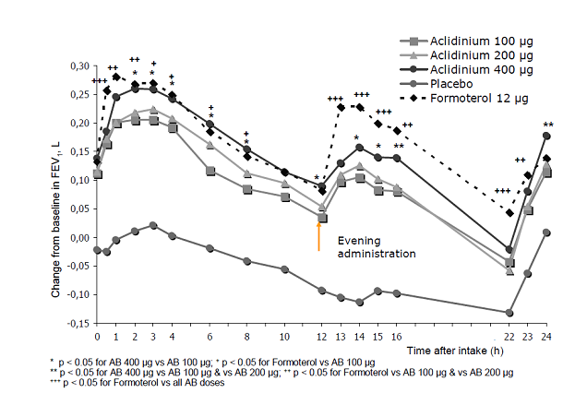
All doses of aclidinium bromide BD provided a statistically significant higher morning peak FEV1 when compared to placebo at Day 1 and this effect increased at Day 7 (p<0.0001). The difference between the highest (400 µg BD) and the lowest (100 µg BD) doses of aclidinium bromide was statistically significant at both Day 1 and Day 7. Peak FEV1 values for aclidinium bromide 400 µg BD were comparable to those of formoterol 12 μg BD at Day 1 and Day 7. All doses of aclidinium bromide showed statistically significantly greater improvements in the adjusted mean change from baseline in evening peak FEV1 (p<0.0001) compared to placebo at Day 7. Aclidinium bromide 400 µg showed a statistically significantly greater improvement in the adjusted mean change from baseline in evening peak FEV1 (p=0.0227) compared to aclidinium bromide 100 µg. Formoterol showed statistically significantly greater improvements in the adjusted mean change from baseline in evening peak FEV1 (p=0.0058 to p<0.0001) compared to placebo and all doses of aclidinium bromide.
After 7 days on treatment, the percentage of patients using relief medication (daily, day time and night time) was higher with placebo than active treatments. A dose response was observed for aclidinium bromide with more patients receiving 100 µg requiring relief medications (50.7% and 49.3% for daily and day time use, respectively) than 200 µg (49.3% and 46.6%, respectively) or 400 µg (46.6% and 43.8%, respectively). At night time, slightly more patients receiving 400 µg (20.6%) and 200 µg (19.2%) required relief medication compared to 100 µg (15.1%). After 7 days on treatment, there was a statistically significant reduction compared to placebo in the use of daily and day time relief medication (number of puffs) with aclidinium bromide 200 µg (-0.39, p=0.0243 and -0.32, p=0.0264, respectively) and aclidinium bromide 400 µg (-0.48, p=0.0051 and -0.40, p=0.0056, respectively). There was no statistically significant difference between placebo and aclidinium bromide (all doses) in the use of night time relief medication. There was a statistically significant reduction in the use of daily (-0.67, p=0.0001), day time (-0.55, p=0.0001) and night time (-0.12, p=0.0244) relief medication with formoterol compared to placebo. There was also a statistically significant difference between formoterol and aclidinium bromide 100 µg in daily use (p=0.0226) and day time use (p=0.0384).

Convenience of device:
Most patients assessed the ease of use and the ease of dose preparation of both devices as “very easy” or “easy”. More patients found the Genuair® “very easy” to use (65.4%) than the Aerolizer® (24.4%). Similarly, more patients found the dose “very easy” to prepare with the Genuair® (73.1%) than the Aerolizer® (19.2%). No patients found the Genuair® to be very difficult to use or for dose preparation, whereas 2 patients found the Aerolizer® very difficult to use and 1 patient found the Aerolizer® very difficult for dose preparation. Most patients (62.8%) preferred Genuair®, with only 6.4% preferring the Aerolizer®.
Comments: This was a well-conducted dose-ranging study. Although the crossover design has its limitations in a disease known to be progressive, the study duration was only 7 days and enough precautions were taken to assure that the COPD status was stabilised in all patients.
Treatment with aclidinium bromide BD has shown a marked and sustained bronchodilator response at the 3 doses tested that was evident after the first dose at Day 1 up to 7 days on treatment. The bronchodilation provided by all 3 doses of aclidinium bromide was clinically and statistically significantly higher than placebo for all study spirometric endpoints.
Aclidinium bromide showed a dose response relationship over the dose range used in this study. Clear dose separation was noted between the 100 µg and 400 µg doses at Day 1 which was maintained at Day 7. The differences between aclidinium bromide 400 µg and aclidinium bromide 100 µg were statistically significant for the majority of the spirometric parameters, thus suggesting that the 100 µg dose is suboptimal relative to the 400 µg dose.
The efficacy profile of aclidinium bromide BD is supported by the slope of the FEV1 curve over 12 and 24 h postdose which is comparable to Foradil (formoterol 12 μg), an approved BD compound. In addition, during daytime the magnitude of bronchodilation provided by aclidinium bromide 400 µg was comparable to formoterol 12 μg. However during night time the treatment difference was significantly greater with formoterol. The formoterol effect after the evening dose is not consistent with the literature where the evening peak was substantially lower than the morning one (Coulson, 2003) which was not observed in this study. However, this was not later reflected in the trough FEV1, where similar values were obtained with both treatments. All doses of aclidinium bromide were safe and well tolerated. No dose-dependent side effects were observed.
The completed phase III program of once daily aclidinium bromide 200 µg (refer to Long term efficacy section) showed a statistically significant bronchodilation at 24 h compared to placebo as measured by the trough FEV1 and the magnitude of this improvement was approximately 60 mL. These results suggested that some patients might not benefit from the once daily 200 µg dose and a higher daily dose or a different dose regimen (e.g., administered BD) may provide an additional benefit for a group of patients. Two Phase II studies with BD dosing- study 29 (discussed above) and study 23 (refer Supportive studies with proposed twice daily dosing section of this report), that used formoterol and tiotropium for benchmark comparison evaluated the BD dosing regimen of aclidinium bromide. Data generated from these studies support a twice daily dosing frequency and the 400 µg twice daily dose demonstrated a greater change in trough FEV1 and time profile serial FEV1 measurement compared to lower doses of 100 µg and 200 µg twice daily. The 400 µg twice daily doses in these studies generally performed better than lower doses (statistically significantly >100 µg and numerically but not statistically >200 µg) and in a similar range to the two active comparators. Based on these data and previous experience with the 200 µg once daily dose, the selection of the 200 and 400 µg twice daily doses of aclidinium bromide for further evaluation in confirmatory Phase III studies was reasonable.

Clinical efficacy

Indication 1
Long-term maintenance bronchodilator treatment to relieve symptoms in adult patients with Chronic Obstructive Pulmonary Disease (COPD).

Pivotal efficacy studies

Study M34273/34

Study design, objectives, locations and dates
This was a prospective, randomised, parallel group, placebo controlled, double blind, multinational and multicentre clinical study. The objectives of this study were to assess the long term bronchodilator efficacy of inhaled aclidinium bromide 200 µg and 400 µg, both administered twice a day (BD) compared to placebo in patients with moderate to severe stable COPD. Secondary objectives were to evaluate effects on disease-related health status, COPD symptoms and COPD exacerbations and to assess safety and tolerability of aclidinium bromide 200 µg and 400 µg BD. This study was conducted at 103 sites, 100 of which randomised patients: 21 sites in Poland, 17 in Germany, 13 in Hungary, 13 in South Africa, 10 in the Czech Republic, 10 in the Russian Federation, 5 in France, 5 in Spain, 5 in Ukraine, 3 in Italy and 1 in Peru.
Comments: The study design generally complied with guidelines outlined in the CPMP/EWP/562/98, ‘Points to consider on clinical investigation of medicinal products in the chronic treatment of patients with COPD.’ Following the results of the once daily 200 µg Phase III trials and also the two Phase II studies with BD dosing, the present study was conducted to further assess the efficacy, safety and tolerability of aclidinium bromide 200 µg and 400 µg administered BD compared to placebo over 24 weeks, which is the recommended duration to support any indication for symptomatic relief of COPD.

Inclusion and exclusion criteria
The main inclusion criteria were: Adult male or female patients aged 40 years or older with stable moderate to severe COPD (as defined by Global Initiative for Chronic Obstructive Lung Disease [GOLD] guidelines), Current or ex-smokers of ≥10 pack years, Post-salbutamol FEV1 ≥30% and <80% of predicted normal value and FEV1/forced vital capacity (FVC) <70%.
The main exclusion criteria were: History or current diagnosis of asthma; Any respiratory tract infection (including the upper respiratory tract) or COPD exacerbation in the 6 weeks before the Screening Visit (Visit 1); patients who developed a respiratory tract infection or exacerbation during the run-in period were discontinued from the study before randomisation; hospitalised for an acute COPD exacerbation within 3 months prior to the Screening Visit; patients with clinically significant respiratory conditions or cardiovascular conditions; Use of long term oxygen therapy (≥15 hrs/day); BMI ≥40 kg/m²; Participation in an acute pulmonary rehabilitation program within the previous 6 months (Patients on a stable pulmonary rehabilitation exercise regimen for at least 6 weeks were not excluded); Non-controlled history of infection with human immunodeficiency virus and/or active hepatitis; Resting SBP ≥200 mmHg, resting DBP≥120 mmHg, or a resting HR ≥105 bpm at Screening Visit; QTc [Bazett’s formulae above 470 milliseconds at the screening ECG; Clinically relevant abnormalities in clinical laboratory tests, other ECG parameters, physical examination; any serious or uncontrolled medical or mental dysfunction; history of hypersensitivity reaction to inhaled anticholinergics, sympathomimetic amines, or inhaled medication or any component thereof (including report of paradoxical bronchospasm) or patients with acute urinary retention, symptomatic prostatic hypertrophy, bladder neck obstruction or narrow-angle glaucoma; Unable to properly use a dry powder or pMDI inhaler device or to perform spirometry measurements; Current diagnosis of cancer other than basal or squamous cell skin cancer; Participation in other studies involving aclidinium bromide; patients who did not maintain regular day/night, waking/sleeping cycles (for example, night shift workers).

Study treatments
Study treatments included Aclidinium bromide Inhalation powder or matching placebo given by oral inhalation using Genuair® multi-dose dry powder inhaler; 1 puff of 200 µg or 400 µg in the morning (08:00-10:00) and in the evening (20:00-22:00). After screening and run-in period of 14±3 days to assess patient’s disease stability, patients were randomised according to a randomisation ratio of 1:1:1 to aclidinium bromide 200 µg BD, aclidinium bromide 400 µg BD or placebo BD for a period of 24 weeks. Patients had to take one puff from the Genuair® inhaler following Investigator’s instructions, and these instructions were also provided to the patient; the study drug was to be inhaled during a deep inspiration. During the double blind treatment period, patients visited the site to assess clinical efficacy and safety on seven occasions (from Visit 2 to Visit 8) and after treatment completion; a follow-up contact was performed 2 weeks later. A subgroup of 20% of patients at selected sites took part in a 12-h serial spirometry study.
Use of treatments which might have interfered with the evaluation and interpretation of the results of the study were excluded throughout the entire study. These included anti-cholinergic medications, β2-agonists (except for salbutamol pMDI 100 μg/puff which was allowed as relief medication), combination inhaled drugs (Fixed inhaled combinations of long-acting β2-agonists and corticosteroids such as Symbicort, Advair or short-acting β2-agonist and an anticholinergic agent- Combivent). Patients who were receiving such a medication were excluded or, if ethically justified, the medication was withdrawn gradually before the patient entered the study. The following concomitant medications were permitted, provided their administration was stable before study entry at screening and a change in daily dose, dosing schedule, formulation or treatment was unlikely during the course of the study, unless necessary for the treatment of a COPD exacerbation: (1) Inhaled corticosteroids or oral sustained release theophyllines stable for at least 4 weeks prior to screening. Patients switched from combinations of long-acting β2-agonists and corticosteroids to the same inhaled corticosteroid (same dose and dose regimen) who were following a stable regimen of the combination for at least 4 weeks did not need additional stabilisation period prior to screening. (2) Oral or parenteral corticosteroids used at maximal stable doses of the equivalent of 10 mg of prednisone per day or 20 mg every other day. These medications had to be stable for at least 4 weeks prior to screening. (3) Oxygen therapy administered on an as-needed basis and for less than 15 h a day, stable for at least 4 weeks prior to screening, but oxygen therapy had to be discontinued at least 2 h before each Visit and until the end of the visit. (4) H1-antihistamines stable for at least 4 weeks prior to screening.
Treatment compliance was assessed by the Investigator at each visit by review of the returned Genuair® inhalers already used by the patient by checking if the dose indicator for the unlocked inhalers was adequate considering the expected number of daily doses planned to be administered since previous visit. Additionally, the total number of inhalations from each inhaler administered between visits, including the one performed at the clinic, was recorded in the electronic diary by the patient.

Efficacy variables and outcomes
A centralised spirometry company (CareFusion) provided the spirometers or pneumotach and all necessary equipment (computer, calibration syringe, printer, paper, ink, etc.), a detailed study manual and training (for qualification of technicians in charge of conducting spirometry) to all sites involved in this clinical study. These spirometers were only to be used for this specific clinical study. The spirometers measured FVC, FEV1, and IC, and met ATS and ERS recommendations for accuracy and precision. Pulmonary function tests were performed by highly experienced personnel. At each time point, three technically adequate measurements were performed according to the acceptability and repeatability criteria of the ATS/ERS which were automatically evaluated by the computerised spirometer via pre-programd checks. Test conditions had to be similar on all occasions with respect to time of the day, temperature and pressure and were to be performed by the same technician. Patients were not allowed to smoke for at least one h prior to testing. They were to be at rest and comfortable for 15 minutes prior to the test; tight clothing was loosened to allow the thorax to move freely. Measurements were made with the patient seated in an upright posture and wea ring a nose clip. Prior to the first manoeuvre, the trained operator demonstrated the procedure using a detached mouthpiece, then allowed two practice attempts. Spirogram tracings (including calibration) were printed and then kept in the patient’s medical records as source documents.
The primary efficacy variable was: Change from baseline in morning pre-dose (trough) FEV1 at Week 24 for the European Union (EU) filing and Week 12 for the United States (US) filing. Secondary efficacy variables were: Change from baseline in peak FEV1 at Week 24 for the EU filing and Week 12 for the US filing; Number (%) of patients achieving a clinically relevant improvement (≥1 unit) in Transition Dyspnoea Index (TDI) focal score at Week 24; Number (%) of patients achieving a clinically relevant improvement (≥4 units) compared to baseline in the Saint George’s Respiratory Questionnaire (SGRQ) total score at Week 24.
Additional efficacy variables were: Pulmonary function tests (FEV1, FVC and inspiratory capacity [IC]) at trough, peak, and by time point including time points from 12-h serial spirometry sub-study, normalised area under the curve (AUC) from 0 to 3 h (AUC_{0-3h}); TDI focal score, SGRQ total score, EXACT (Exacerbations of Chronic Pulmonary Disease Tool) respiratory symptoms (E-RS) captured in the EXACT–Patient Reported Outcome (EXACT-PRO), night time and morning COPD symptoms, daily use of relief medication, EQ-5D questionnaire, COPD exacerbations based on Health Resource Utilisation (electronic Case Report Form [eCRF]) and COPD exacerbations derived from EXACT-PRO.
Disease-specific health status was evaluated by means of a self-administered instrument, the SGRQ. This questionnaire is a standardised self-completed tool for measuring impaired health and perceived well-being (“QoL”) in respiratory diseases. The questionnaire contained 50 items divided into three dimensions- Symptoms, Activity and Impact. Each of the three sections of the questionnaire was scored separately in the range from 0 to 100, zero score indicating no impairment of life quality. A summary score utilising responses to all items is the total SGRQ score which also ranges from 0 to 100. The SGRQ scores were calculated using weights attached to each item of the questionnaire which provided an estimate of the distress associated with the symptoms or state described in each item. Higher scores indicated poorer health. The EQ-5D self-administered questionnaire is a 3-level, five dimensional standardised instrument for use as a measure of health outcome applicable to a wide range of health conditions such as COPD (generic instrument) and was used to complement the SGRQ questionnaire (disease-specific instrument). Daily symptoms were assessed electronically by the patients each day in the evening, before bed, through the Exacerbations of Chronic Pulmonary Disease Tool – Patient Reported Outcome (EXACT-PRO), validated in different languages. EXACT is a single patient-reported outcome (PRO) measure to evaluate the effects of pharmacologic treatment (preventive and curative) on acute exacerbations of COPD, including chronic bronchitis presence/frequency, severity, duration and resolution. The 14-item EXACT was scored from 0-100 with higher scores indicating more severe symptoms of exacerbation. Only the EXACT total score was to be used for analytical assessment of an exacerbation event. Chronic obstructive pulmonary disease exacerbation was evaluated by the Investigator at each visit on the basis of the information registered by the patient (and subsequently checked by the Investigator at each visit) into the Electronic Diary (COPD symptoms) and Paper Diary (concomitant medication).
Comments: The clinical assessments in this study are widely used and recognised as reliable, accurate and relevant for the evaluation of efficacy and safety in patients with COPD.

Randomisation and blinding methods
Patients who met the inclusion/exclusion criteria were allocated at random, by calling the IVRS, to one of the three treatment groups (aclidinium bromide 200 µg, aclidinium bromide 400 µg or placebo) with a 1:1:1 randomisation ratio. Study personnel, and study patients were blinded as to whether the patient was using aclidinium bromide or placebo. The Genuair® inhalers containing aclidinium bromide and those containing placebo were of the same external appearance to ensure the double blind nature of the study. Treatment assignments were kept strictly confidential, accessible only to authorised persons, until the time of unblinding. Only after the study was completed, and the data were verified and locked, were the randomisation codes made available for data analysis. Investigators were not provided with emergency sealed envelopes identifying the treatment group. Whenever the maintenance of the safety and well-being of the patient, as assessed by the Investigator, required the knowledge of the information on the actually administered IMPs, the Investigator was allowed to break the blind by calling the IVRS indicating the patient concerned.
Comments: The CHMP guidelines for ‘Clinical investigation of medicinal products in treatment of patietns with COPD’ states that formal stratification of patients according to their smoking status (current smokers, ex-smokers) should be performed prior to randomisation. This was not done in any of the pivotal clinical studies for aclidinium bromide. Furthermore, tobacco exposure was not monitored during the study and any change in smoking status did not appear to be documented or reported. Use of nicotine replacement therapy or other smoking cessation aids such as varenicline was also not documented.

Analysis populations
Of the 828 randomised patients, 819 were evaluated for safety, 819 were included in the ITT efficacy analysis, 759 in the per protocol analysis and 191 patients were evaluated in the serial spirometry sub-study (Table 14).
Table 14. Analysis population sets
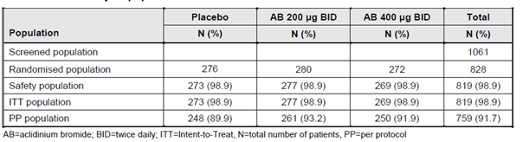

Sample size
A sample size of 244 evaluable patients per treatment group provided at least a 90% power to detect as significant a difference of 90 mL between any of the doses of aclidinium bromide and placebo in change from baseline in morning pre-dose (trough) FEV1 after 24 weeks of treatment for EU filing or 12 weeks of treatment for US filing; assuming a common standard deviation of 240 mL, using two-sided tests and adjusting for multiple treatment comparisons at the overall significance level of 0.05. The sample size also provided sufficient power to detect treatment differences in the secondary endpoints that were adjusted for multiplicity using a sequential approach to hypothesis testing.
Around 810 patients were planned to be randomised to account for a 10% drop-out rate, to allow sufficient patients with at least one post-randomisation symptomatic assessment.
Comments: No justification was provided for the assumed 90 ml difference between aclidinium bromide (200 or 400 µg BD) and placebo. Earlier studies with Seebri and other long-acting anticholinergic agents have used a difference of 100 or 120 mL.

Statistical methods
All efficacy analyses were performed on the ITT population, using last-observation-carried-forward (LOCF) if missing value was present. For the primary variable, a mixed-effects model for repeated measures based on observed cases and a per-protocol analysis based on LOCF were performed as sensitivity analyses of the ITT population and missing data approach, respectively. For the primary variable, Hochberg multiplicity adjustment was applied for the two aclidinium bromide doses versus placebo. Secondary efficacy variables were tested if the primary variable was significant in both treatment comparisons (aclidinium bromide 200 µg BD versus placebo and aclidinium bromide 400 µg BD versus placebo). The testing procedure for secondary variables was performed in a sequential manner as follows: Change from baseline in peak FEV1 at Week 24 for EU filing and Week 12 for US filing; Percentage of patients achieving a clinically relevant improvement (≥1 unit) in TDI focal score at Week 24; and Percentage of patients achieving a clinically relevant improvement (≥4 units) compared to baseline in the SGRQ total score at Week 24. The primary efficacy variable (change from baseline in morning pre-dose FEV1) and secondary variable (change from baseline in peak FEV1) were analysed by means of an analysis of covariance (ANCOVA) model which included sex and treatment group as factors along with baseline FEV1 value and age as covariates. The dichotomous secondary variables were analysed by means of logistic regression models with baseline, age, sex, and treatment as explanatory variables.

Participant flow
Of the 1061 patients screened, 828 were randomised to study treatment and 736 completed the study. Overall, 89.0% of randomised patients completed the treatment (84.1%, 90.4% and 92.6% of patients in the placebo, aclidinium bromide 200 µg and 400 µg groups, respectively) with higher rate of discontinuations in the placebo than from the aclidinium bromide groups (14.6%, 8.6% and 6.3%, respectively). Additional details are shown in Figure 6.
Figure 6. Summary of patient disposition
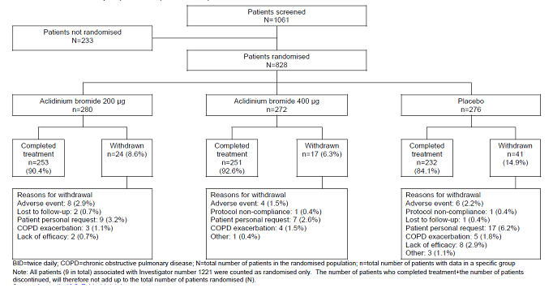

Major protocol violations/deviations
A total of 60 patients were identified as protocol violators and excluded from the PP Population. The most frequent reason for exclusion from the PP population was “Treatment compliance <75%” at last visit on treatment. A slightly higher number of patients were excluded from the placebo group (25 patients), than from the aclidinium bromide 200 µg and 400 µg groups (16 patients and 19 patients, respectively).

Baseline data
Majority of the patietns were male (65-69%), Caucasians (95%) with mean BMI of 26.5 to 27.0 kg/m². There were some differences in the age distribution of patients between the three treatment groups. In the aclidinium bromide 400 µg group, a slightly higher percentage of patients were >70 years and a slightly lower percentage of patients were between 60 and 70 years, compared to the placebo and aclidinium bromide 200 µg groups. Overall, 432 (52.8%) patients were current smokers and 387 (47.3%) were ex-smokers. Mean (SD) smoking duration and smoking consumption was 38.8 (10.3) years and 40.2 (19.8) pack/years, respectively. Smoking status, duration and consumption were similar across the treatment groups. All patients with available data had either moderate (554 [68.1%]) or severe (260 [31.9%]) COPD, with an overall mean (SD) duration of 6.8 (6.2) years. The mean COPD duration was similar across treatment groups. The majority of patients (65.3%) had no self-reported COPD exacerbations in the 12 months prior to the study, and 34.7% patients reported one or more COPD exacerbation in the previous 12 months. The percentage of patients with each COPD phenotype (chronic bronchitis and/or emphysema) was similar across treatment groups. Both the pre-bronchodilator and post-bronchodilator FEV1 and FVC mean values were similar across treatment groups at Visit 1 and pre-IMP administration at Visit 2. The maximum value of the post-bronchodilator FEV1/FVC ratio for all treatment groups were below the 70% threshold used to define COPD reversible airway obstruction after the administration of 400 µg of salbutamol (that is, demonstrated an improvement in FEV1 of ≥ 12% and ≥ 0.200 L compared to pre-salbutamol FEV1) which was similar across treatment groups and ranged from 30.0% to 33.9%. The use of medication for COPD prior to the study was reported for 90% of patients overall, with >88% of patients in all individual treatment groups reporting the use of prior medication for COPD. The most commonly used (in >20% of patients) prior medications for COPD were SABAs (50.4%), ICS (38.1%), LABAs (30.3%), LAMAs (27.0%) and xanthines (20.9%). The use of these medications was generally similar across treatment groups, except for LAMAs and ICS. A higher proportion of patients in the aclidinium bromide 200 µg and 400 µg groups (31.0% and 28.6%, respectively) reported the use of LAMAs compared to the placebo group (21.2%). Conversely, a higher percentage of patients in the placebo group (42.1%) reported the use of ICS, compared to patients in the aclidinium bromide 200 µg and 400 µg groups (35.0% and 37.2%, respectively).
Concomitant medication use was similar between treatment groups. The most common concomitant medications (taken by ≥20% patients in any group) taken before randomisation, and continued after randomisation were ‘other drugs for obstructive airway diseases, inhalants’, ‘angiotensin-converting enzyme (ACE) inhibitors, plain’ and ‘other systemic drugs for obstructive airway diseases’. The most commonly used medications in these categories were budesonide (21.6% to 27.8% of patients), theophylline; (16.4% to 20.2%) and fluticasone propionate (15.2% to 17.2%). Concomitant medications were generally related to the patients’ underlying co-morbidities, with no obvious differences between treatment groups. A patient was considered compliant if the treatment compliance rate was at least 75%. Overall, 93.3% patients were treatment compliant, with a similar percentage of treatment compliant patients in each treatment group.

Results for the primary efficacy outcome
Compared to placebo, a statistically significant greater adjusted mean change from baseline morning pre-dose (trough) FEV1 was observed for aclidinium bromide 200 µg (0.077 L; p-value=0.0001) and 400 µg (0.105 L; p-value<0.0001) groups after treatment for 12 weeks with similar results after 24 weeks (aclidinium bromide 200 µg=0.099 L; p-value<0.0001; 400 µg= 0.128 L; p-value<0.0001). The bronchodilation provided by aclidinium bromide 400 µg was numerically greater than that provided by aclidinium bromide 200 µg at Week 12 (0.028 L; p-value=0.1671) and at Week 24 (0.029 L; p-value=0.1868) in the ITT population (Table 15). Similar results were observed for the mixed model for repeated measures (MMRM) analysis and for comparisons in the PP population at Weeks 12 and 24, confirming the robustness of ther results.
Table 15. Change from baseline in morning predose (trough) FEV1 (L) at Week 12 and Week 24 (LOCF). Primary efficacy analysis. ITT population.
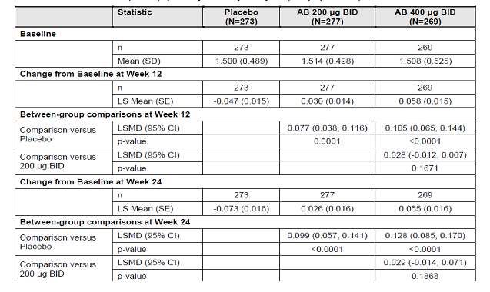

Results for other efficacy outcomes

Secondary endpoints:
A statistically significant greater adjusted mean change from baseline in peak FEV1 was observed for aclidinium bromide 200 µg (0.182 L; p-value<0.0001) and 400 µg (0.191 L; p-value<0.0001) groups compared to placebo after 12 weeks of treatment. Similar results were observed after 24 weeks of treatment for aclidinium bromide 200 µg (0.185 L; p-value<0.0001) and 400 µg (0.209 L; p-value<0.0001) groups compared to placebo. The peak FEV1 achieved in the aclidinium bromide 400 µg group was numerically greater than that achieved in the aclidinium bromide 200 µg at Week 24 (0.025 L; p-value=0.2919, ITT population). Similar results were observed for comparisons in the PP population at Weeks 12 and 24.
A statistically significant greater percentage of patients achieved a clinically relevant improvement in the TDI focal score (≥1 unit) at 24 weeks in the aclidinium bromide 200 µg group (53.3%; odds ratio=1.47; p-value=0.0317) and the aclidinium bromide 400 µg group (56.9%; odds ratio=1.68; p-value=0.0038) compared to the placebo group (45.5%). These significant differences were already observed at Week 4 and were maintained at Week 12. The percentage of patients with clinically relevant improvement in TDI focal score in the aclidinium bromide 400 µg group was always numerically larger than in the aclidinium bromide 200 µg group.
A statistically significant greater percentage of patients achieved a clinically relevant improvement in the SGRQ total score (≥4 units) in the aclidinium bromide 200 µg (56.0%; odds ratio =1.83; p-value=0.0006) and 400 µg (57.3%; odds ratio=1.87; p-value=0.0004) groups compared to the placebo group (41.0%). Statistically significant improvements were observed as early as at Week 4 (first timepoint assessed) for the aclidinium bromide 400 µg dose (odds ratio=1.60; p=0.0104) and since Week 12 for aclidinium bromide 200 µg dose (odds ratio=1.64; p=0.0059).
Taking into account the multiplicity adjustment procedure, both aclidinium bromide 200 µg and 400 µg showed a significant effect compared to placebo for all primary and the secondary endpoints.

Additional efficacy parameters:
The difference in the adjusted mean change from baseline in trough FEV1 ranged from 0.077 L (Week 12) to 0.105 L (Week 18) for aclidinium bromide 200 µg compared to placebo, and ranged from 0.105 L (Week 12) to 0.140 L (Week 18) for aclidinium bromide 400 µg compared to placebo. The adjusted mean changes from baseline in trough FEV1 in the aclidinium bromide 400 µg group was consistently numerically higher than that of the aclidinium bromide 200 µg group, and the difference between them ranged from 0.016 L (Week 4) to 0.035 L (Week 18).
The adjusted mean change from baseline in spirometry variables of FEV1, FVC and IC was significantly greater for aclidinium bromide 200 µg and 400 µg versus placebo at Weeks 12 and 24; the aclidinium bromide 400 µg group was always numerically greater than the aclidinium bromide 200 µg group except for peak FVC at Week 12.

Results of the spirometry substudy:
Results obtained within the sub-study on Day 1, up to 3 h post-dose were relatively similar to those observed in the overall ITT population. At 3 h post-dose, the difference in the adjusted mean change from baseline in (trough) FEV1 in the aclidinium bromide 200 µg and 400 µg groups compared with placebo was 0.181 L (p-value<0.0001), and 0.184 L (p-value<0.0001), respectively; this was similar to 0.188 L and 0.208 L, respectively in the total ITT population at Day 1, 3 h post-dose.
On Day 1, the greatest adjusted mean change from baseline in FEV1 for both doses compared to placebo was observed between 3 and 4 h post-dose to be approximately 0.180 L (p-value <0.0001) and the differences versus placebo were strongly maintained up to 12 h with only a slight decrease over time. The maximum bronchodilation at Week 12 was achieved at 2 h post-dose. The differences in the adjusted mean changes from baseline in FEV1 between the aclidinium bromide 200 µg and 400 µg groups compared with placebo were 0.191 L (p-value<0.0001), and 0.145 L (p-value=0.0017), respectively. These results were not consistent with the overall ITT population, where differences in the adjusted mean change from baseline in FEV1 between the aclidinium bromide 200 µg and 400 µg groups and the placebo group observed at 2 h post-dose were 0.182 L (p-value<0.0001) and 0.202 L (p-value<0.0001), respectively.
The maximum bronchodilation at Week 24 was also achieved at 2 h post-dose. The differences in the adjusted mean changes from baseline in FEV1 between the aclidinium bromide 200 µg and 400 µg groups and the placebo group were 0.161 L (p-value=0.0009), and 0.172 L (p-value=0.0004), respectively. On Day 1, comparisons with placebo for the aclidinium bromide 200 µg and 400 µg groups in adjusted mean changes from baseline in FEV1 were statistically significant for both doses at all time points (p-value<0.05). At Week 12, comparisons between the aclidinium bromide 200 µg and 400 µg groups and the placebo group in the adjusted mean change from baseline in FEV1 were statistically significant at all time points, except for aclidinium bromide 400 µg compared to the placebo group at 12 h post dose (0.057 L; p-value=0.1724). At Week 24, the differences in the adjusted mean change from baseline in FEV1 between the aclidinium bromide 200 µg and 400 µg groups and the placebo group were statistically significant at every time point except at 12 h post-dose (0.067 L; p-value=0.1062, and 0.067 L; p-value=0.1053, respectively) (Figure 7).
Figure 7. Change from baseline in FEV1 (L) by time point on Day 1 (top), Week 12 (middle) and Week 24 (bottome). Serial spirometry study
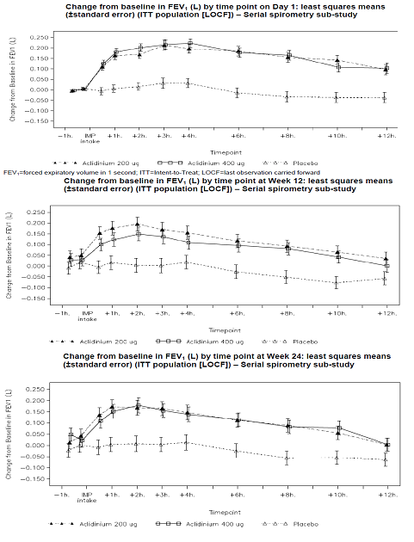

COPD symptoms:
TDI: At Week 24, the placebo adjusted mean change from baseline in TDI focal score was statistically significant in the aclidinium bromide 200 µg (0.60 unit, p-value=0.0387) and 400 µg group (1.00 unit, p-value=0.0006). The significant treatment effect in the aclidinium bromide 400 µg group was already present at Weeks 4 and 12 (approximately 0.90 units, p-value<0.010 for both weeks); however, the adjusted mean difference in the aclidinium bromide 200 µg group was statistically significant at week 4 (0.65 unit, p- value=0.0073) but not at week 12 (0.36 unit, p-value=0.1807).
SGRQ: At Week 24, the placebo adjusted mean change from baseline in SGRQ total score was -3.82 (p-value=0.0007) and -4.63 (p-value<0.0001) for the aclidinium bromide 200 µg and 400 µg groups respectively. The treatment effect in the aclidinium bromide 400 µg group was already statistically significant at Week 4 (-2.59, p-value= 0.0029), and was clinically relevant at Week 12 (-4.10. p-value<0.0001). However, the treatment effect in the aclidinium bromide 200 µg group was not significant at Week 4 (-0.75, p value= 0.3869) but reached statistical (though not clinical) significance at Week 12 (-3.17, p-value=0.0015).
EQ-5D questionnaire: The adjusted mean change from baseline in EQ-5D weighted score for the aclidinium bromide 400 µg group compared to the placebo group was statistically significant at Week 24 (0.03, p-value=0.0414); no other effect was statistically significant for this variable. The adjusted mean change from baseline in EQ-5D VAS score was also statistically significant at Week 24 (3.13, p-value=0.0047) for the 400 µg group.
Relief Medication: Assessed over the study period, the placebo adjusted mean reduction from baseline in the daily use of relief medication was statistically significant for the aclidinium bromide 400 µg group (0.95 puffs reduction, p-value=0.0045), the placebo adjusted mean reduction in the aclidinium bromide 200 µg group was borderline significant (0.61 puffs reduction, p-value=0.0663). When assessed as change from baseline in the percentage of full days without relief medication over the study period, the adjusted mean difference between the aclidinium bromide 200/ 400 µg groups and placebo was 11.0% (p-value=0.0003).
E-RS Total Score, Breathlessness, Chest and Cough and Sputum domain scores: Compared to placebo, aclidinium bromide 200 µg and 400 µg decreased the E-RS Total score assessed over the study period by 1.3 units (p-value=0.0002) and 2 units (p-value<0.0001), respectively. Aclidinium bromide 200 µg and 400 µg decreased the Cough and Sputum score by 0.21 units (p-value=0.0322) and 0.44 units (p-value<0.0001), respectively: The decreases in Breathlessness score were equal to 0.80 units (p-value<0.0001) and 1.05 units (p-value<0.0001, respectively. The decreases in Chest Symptom score were 0.33 units (p-value<0.0031) and 0.52 units (p-value<0.0001), respectively.
Night-time and morning symptoms: Overall, a lower percentage of days with any night time or morning COPD symptoms, including symptoms of feeling short of breath, coughing, bringing up phlegm or mucus, chest tightness or congestion and wheezing was observed in the aclidinium bromide 200 µg and 400 µg groups compared to the placebo group, over the 24 week study period as assessed by the night time and morning (COPD) symptoms questionnaire.
COPD Exacerbations based on Health Resource Utilisation (eCRF): A numerically smaller percentage of patients experienced at least one COPD exacerbation (mild, moderate, or severe) in the aclidinium bromide 200 µg group (15.9%) and 400 µg group (14.1%) than in the placebo group (20.5%). Compared to placebo, the percent reduction in odds was 27% (p-value=0.1676) and 36% (p-value=0.0513) for the aclidinium bromide 200 µg and 400 µg doses, respectively. When assessed as exacerbation rates per patient-year, the percent reduction was approximately 30% (p-value<0.05 for both doses). A numerically smaller percentage of patients experienced at least one moderate or severe COPD exacerbation in the aclidinium bromide 200 µg group (13.0%) and aclidinium bromide 400 µg group (12.3%) than in the placebo group (16.1%). Compared to placebo, the percent reduction in odds was 22% (p-value=0.3173) and 27% (p-value=0.2063) in the 200 µg and 400 µg dose, respectively. When assessed as exacerbation rates per patient-year, the percent reduction was 26% (p-value= 0.0845) and 28% (p-value=0.0629) for the 200 µg and 400 µg dose, respectively.
Exacerbations based on EXACT-PRO questionnaire. A numerically smaller percentage of patients experienced at least one COPD exacerbation in the aclidinium bromide 200 µg group (30.0%) and 400 µg group (29.0%) than in the placebo group (36.6%). Compared to placebo, the percent reduction in odds was not statistically significant (25%, p-value=0.1067 and 29%, p-value=0.0644 for the 200 µg and 400 µg doses, respectively. When assessed as exacerbation rates per patient-year, the percent reduction was approximately 30% (p-value<0.05 for both doses).
The mean duration (in days) of COPD exacerbations (any) was reported for 145 patients in total, and ranged from 11.7±8.2 days in the aclidinium bromide 400 µg group to 14.9±13.4 days in the placebo group. The mean duration (in days) of moderate or severe COPD exacerbations was reported for 116 patients in total, and ranged from 11.7±8.0 days in the aclidinium bromide 400 µg group to 16.5±14.2 days in the placebo group. Twelve patients were withdrawn from the study due to COPD exacerbation; 5 patients (1.8%) in the placebo group, 3 patients (1.1%) in the aclidinium bromide 200 µg group and 4 patients (1.5%) in the aclidinium bromide 400 µg group. Overall, 15 patients were hospitalised for COPD exacerbations (10 in placebo group); the mean number of days of hospitalisation for COPD exacerbations at any unit was 15.5±20.0, 20.0±14.7 and 5±1.4 days in the placebo, aclidinium bromide 200 µg and 400 µg groups, respectively.

Efficacy in subgroups:
Age (<60 years, 60-70 years and >70 years), gender (male versus females), COPD severity (moderate or severe, smoking status , reversibility, inhaled corticoid use and BMI did not affect the efficacy of aclidinium bromide 200 µg and 400 µg for the primary (change from baseline in trough FEV1) and secondary endpoints (TDI and SGRQ).
Comments: Overall, twice daily administration of 200 µg and 400 µg doses of aclidinium bromide provided superior bronchodilation compared to placebo in trough FEV1 (primary endpoint) and peak FEV1 (secondary endpoint) at both Week 12 and Week 24 as well as at all other time points measured. The bronchodilation provided by aclidinium bromide 400 µg compared to placebo was clinically relevant as it was consistently above 0.100L in trough FEV1 over all post-baseline visits ranging from 0.105 L to 0.140 L. The bronchodilation observed within the aclidinium bromide 200 µg treatment group in trough FEV1 compared to placebo was below 0.100 L at most of the time points ranging from 0.77 L to 0.99 L with the exception of Week 18 where a level of 0.105 L was attained. However, there was no statistically significant difference between the 200 and 400 µg doses of aclidinium bromide. The improvements in FEV1 demonstrated in the primary and secondary endpoints were also supported by the improvements of FVC and IC which were statistically significant versus placebo at all time points measured.
Both doses of aclidinium bromide showed statistically significant greater improvement in patient rated endpoints measured using the dyspnoea (TDI) and health-related QoL (SGRQ Total score) since Week 4 (first timepoint assessed) to Week 24 using the percentage of patients demonstrating a clinically significant improvement (with the exception of aclidinium bromide 200 µg in the SGRQ at Week 4).
An apparent treatment benefit on COPD exacerbations irrespective of the instrument that was used to assess exacerbations (Healthcare Utilisation or EXACT-PRO symptoms) was observed. Overall the incidence of exacerbations doubled when the EXACT-PRO methodology was utilised to assess exacerbation rates in the placebo group of 1.4 and 0.6 for each method respectively. The rate of exacerbations using the EXACT-PRO definition was lower in the aclidinium bromide treatment groups when compared to the placebo group, with a reduction in rate of exacerbations of approximately 30% for both doses. A similar magnitude of apparent benefit was seen for aclidinium bromide treatment when using the Health Resource Utilisation method. Both doses of aclidinium bromide demonstrated statistically significant improvement in E-RS Total score and all domains of Breathlessness, Chest symptoms and Cough and sputum over the whole study period relative to placebo. Aclidinium bromide 400 µg demonstrated numerically greater levels of improvement within these symptoms versus placebo. Both doses of aclidinium bromide demonstrated a greater reduction in the overall daily use of relief medication, and an increase in the number of relief-medication free days compared to placebo over 24 weeks.

Study LAS –MD-33

Study design, objectives, locations and dates
This was a Phase III, multicenter, multinational, randomized, double blind, placebo controlled, parallel-group, 3-arm study of 16 weeks’ duration: a 2 week run-in period, followed by a 12 week treatment period and a 2 week follow-up phone contact/study visit. In addition, 2 subset populations were used to assess 12-h serial spirometry and 12-lead Holter evaluations.
The primary objective was to assess the bronchodilator efficacy of inhaled aclidinium bromide, 200 µg and 400 µg administered twice daily, once in the morning and once in the evening via the Genuair multidose dry-powder inhaler, as compared with placebo in patients with moderate to severe COPD. The secondary objectives were to evaluate benefit of aclidinium bromide, 200 µg and 400 µg administered twice daily, on COPD exacerbations, disease-related health status as measured by the St. George’s Respiratory Questionnaire (SGRQ), COPD symptoms and also to assess its safety and tolerability. This study was conducted from 28 April 2009 to 3 November 2009 at 106 enrolling study centres (North America): 100 centres in the United States and 6 centres in Canada. A total of 99 study centres randomized the patients.
Comments: Although this study did comply with most of the guidelines for CHMP guidelines for ‘Clinical investigation of medicinal products in treatment of patietns with COPD’ , the duration of treatment ws only 12 weeks while the guidelines recommend 24 weeks treatment for proposed indication of symptomatic relief in COPD patients. Furthermore, like study 34 described above, this stuidy also did not have formal stratification of patients according to their smoking status (current smokers, ex-smokers) prior to randomisation; tobacco exposure, change in smoking status or use of nicotine replacement therapy or other smoking cessation aids was also not monitored.

Inclusion and exclusion criteria
These were similar to those described for the pivotal 24 week Study M34273/34 above.

Study treatments
Study treatments included Aclidinium bromide Inhalation powder or matching placebo given by oral inhalation by Genuair® multi-dose dry powder inhaler; 1 puff of 200 µg or 400 µg in the morning (08:00-10:00) and in the evening (20:00-22:00). After screening and run-in period of 14±3 days to assess patient’s disease stability, patients were randomised according to a randomisation ratio of 1:1:1 to aclidinium bromide 200 µg BD, aclidinium bromide 400 µg BD or placebo BD for a period of 12 weeks. At each visit, the Investigator could review the inhaler used by the patient to assess treatment compliance. In case of inadequate compliance, patients were to be reinstructed accordingly by the Investigator. The concomitant treatments allowed and disallowed in this study were similar to those discussed in Study 34. The only exception was that in this study albuterol hydrofluoroalkane 108μg/puff was also permitted as rescue medication in addition to or salbutamol sulphate 100 µg/puff.

Efficacy variables and outcomes
The primary efficacy endpoint was: Change from baseline in morning predose (trough) FEV1 at Week 12. The secondary endpoint was Change from baseline in peak FEV1 at Week 12 Additional efficacy parameters evaluated in this study were: Pulmonary function tests (FEV1, FVC, inspiratory capacity [IC]) at peak, trough, and by time point; SGRQ;Transition Dyspnea Index (TDI); COPD exacerbations; and rescue medication use. The health economics and outcomes research assessments included the COPD Night-Time Symptoms (modified Welte) Questionnaire and the Daily Sleep Diary (Haythornthwaite et al, 1991). The efficacy assessments were done at screening, baseline, Week 1, Week 4, 8 and 12 and then at Week 14 (follow-up visit, 2 weeks after end of double blind treatment period).

Randomisation and blinding methods
These were identical to those discussed for Study M34273/ 34 above.

Analysis populations
All efficacy analyses were based on the ITT Population, except for the COPD exacerbations. The COPD exacerbations were reported based on the ITT Population as well as on the Safety Population. In addition, the primary efficacy parameter, change from baseline to Week 12 in morning predose (trough) FEV1, and the secondary efficacy parameter, change from baseline to Week 12 in peak FEV1, were analyzed for the European Union submission based on the PP Population. In addition, the PP analysis was performed for TDI and SGRQ. 24-h, 12–lead ECG Holter monitoring was performed at Baseline and Week 12 for a predefined subgroup of patients (at least 30% of the patients in the Safety Population). The main analysis populations are summarised in Table 16.
Table 16. Study LAS-MD 33 Patient population-All patients
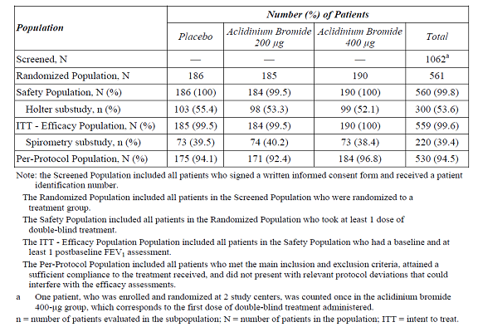

Sample size
For assessment of sample size and statistical power, it was assumed that 165 patients in each treatment group were in the ITT Population for the analysis of the primary and the secondary efficacy parameter. To detect a treatment difference of 0.100 L for the primary efficacy parameter (change from baseline in morning predose [trough] FEV1) at Week 12 assuming a 0.240 L standard deviation, each of the 2 comparisons for the twice-daily aclidinium bromide dose levels versus placebo had at least 93% statistical power, adjusting for the multiple comparison procedure, at the overall significance level of 0.05. Again, to detect a treatment difference of 0.150 L for the secondary efficacy parameter (change from baseline in peak FEV1) at Week 12 assuming a 0.300 L standard deviation, each of the 2 comparisons for the twice-daily aclidinium bromide dose levels versus placebo had at least 92% statistical power, adjusted for the multiple comparison procedure, at the overall significance level of 0.05.
Comments: The treatment difference to be detected in this study was 100ml which is more commonly accepted as being clinically relevant, compared to only 90 mL in study 34 described above.

Statistical methods
All statistical tests were 2-sided hypothesis tests performed at the 5% level of significance for main effects, unless otherwise specified. All confidence intervals (CIs) were 2-sided 95% CIs, unless otherwise stated. The primary efficacy variable was the change from baseline to Week 12 in morning predose (trough) FEV1. The primary efficacy parameter was analyzed using an analysis-of-covariance (ANCOVA) model with treatment group and sex as factors and baseline FEV1 and age as covariates. Adjustment for multiplicity was performed using the Hochberg method The secondary efficacy parameter was the change from baseline to Week 12 in peak FEV1, defined as the highest FEV1 value observed in the 3-h period immediately after morning dosing, with treatment group and sex as factors and baseline FEV1 and age as covariates. All additional efficacy analyses were considered exploratory. No multiple comparisons were performed to adjust for the pairwise comparisons.

Participant flow
A total of 1062 patients were screened for eligibility and 561 were randomized to a study treatment group (186 to placebo, 185 to aclidinium bromide 200 µg, and 190 to aclidinium bromide 400 µg). Overall, the percentage of patients who completed the study was slightly lower in the placebo group (80.1%, 82.2% and 87.4% in the placebo, aclidinium bromide 200 µg and 400 µg groups, respectively). The percentage of patients who discontinued prematurely was slightly higher in the placebo group (19.9%, 17.9% and 12.6%, respectively).

Major protocol violations/deviations
A total of 29 patients were excluded from the PP Population. The most frequent reason for exclusion from the PP Population was “end date of a moderate or severe COPD exacerbation less than 4 weeks before Visit 6 or last visit in study for discontinued patients.

Baseline data
The baseline demographics and physical characteristics were similar across treatment groups with mean age of 63-65 years, mean BMI of 27kg/m²; 52-55% were males and 92-95% were Caucasian. The baseline COPD disease characteristics and smoking history was similar across treatment groups. Majority of patients had moderate COPD (60%, 53% and 62%, respectively) with mean duration of COPD being about 8-9 years. Approximately 25% of the patients had a COPD exacerbation in the year prior to entering the study; from this subset of patients, the mean number of COPD exacerbations was 1.4 in all treatment groups. The proportion of patients who were ex-smokers was similar between the groups and greater than the proportion who were current smokers (55.2% versus 44.8% overall, respectively). Cigarette consumption ranged from 53 to 57 pack-years. Both prebronchodilator and postbronchodilator FEV1 and FVC mean values were similar across treatment groups. Patients who were considered to have reversible airway obstruction after the administration of 400 µg of albuterol (demonstrated an improvement in FEV1 of ≥ 12% and ≥ 0.200 L compared with prealbuterol/salbutamol FEV1) ranged from 41% to 45% of the patients. The class of drugs most frequently used as prior medications (> 20%) were SABAs (64.1% overall), LABAs plus ICSs (37.5%), and LAMAs (30.2%). None of the patients took SABAs in combination with ICSs, and none had an influenza vaccine. Concomitant medications, including medications started before randomization and continuing after randomization, were taken by similar proportions of patients in each group (Antihypertensives, lipid-lowering, vitamins, etc being most common). The class of drugs most frequently started (> 5% by class) concomitantly with the study medication included: corticosteroids (for systemic use [plain], used in 7.5%, 5.4%, and 6.8% of patients in the placebo, aclidinium bromide 200 µg, and aclidinium bromide 400 µg groups, respectively) and other analgesics and antipyretics (used in 2.7%, 8.7%, and 4.2% of patients in the placebo, aclidinium bromide 200 µg, and aclidinium bromide 400 µg groups, respectively).The most frequently used corticosteroid was prednisone (used in 6.5%, 4.9%, and 5.8% in the placebo, aclidinium bromide 200 µg and 400 µg groups, respectively). Corticosteroids were used primarily to treat exacerbation of COPD during the study. A patient was defined as compliant if his/her treatment compliance rate was at least 75%. The overall percentage of patients who were compliant was 98.9%, 99.5%, and 100% in the placebo, aclidinium bromide 200 µg, and aclidinium bromide 400 µg groups, respectively. At each assessment time point (Weeks 1, 4, 8 and 12), mean compliance was similar in each treatment group (97.8% or higher).

Results for the primary efficacy outcome
At the end of 12 weeks of treatment, patients in the aclidinium bromide 200 µg and 400 µg groups showed a statistically significantly greater improvement in the adjusted mean change from baseline in morning predose (trough) FEV1 over placebo patients by 0.086 L (p < 0.0001) and 0.124 L (p < 0.0001), respectively, based on the primary LOCF ITT analysis. Aclidinium bromide 400 µg showed greater numerical improvement over aclidinium bromide 200 µg by 0.038 L (p = 0.069). Similar findings were observed using the mixed-effects model for repeated measures analysis (improvement of 0.091 L [p = 0.0001] and 0.132 L [p < 0.0001] for the aclidinium bromide 200 and 400 µg groups, respectively both compared with placebo) and in the PP population analysis (improvement of 0.088 L [p = 0.0001] and 0.123 L [p < 0.0001] for the aclidinium bromide 200 and 400 µg groups, respectively) confirming the robustness of the results. The significant bronchodilatory effect (trough FEV1) of aclidinium bromide was observed from week 1 and it was maintained till week 12 (Figure 8).
Figure 8. Change from baseline in morning predose (trough) FEV1 by visit (LOCF) over 12 weeks. Least squares mean (±SE). ITT population
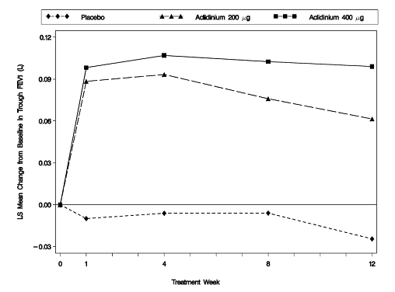

Results for other efficacy outcomes
Secondary efficacy endpoint: At the end of 12 weeks of treatment, patients in the aclidinium bromide 200 µg and 400 µg groups showed a statistically significantly greater improvement in the adjusted mean change from baseline in peak FEV1 over placebo patients by 0.146 L (p < 0.0001) and 0.192 L (p < 0.0001), respectively, based on the LOCF ITT analysis. Aclidinium bromide 400 µg showed a statistically significantly greater improvement over aclidinium bromide 200 µg by 0.046 L (p = 0.0409). The significant increase from baseline in peak FEV1 with aclidinium bromide compared with placebo was observed from week 1 and it was maintained till week 12 (Figure 9). Similar findings were observed in the PP population analysis (improvement of 0.146 L [p < 0.0001] and 0.189 L [p < 0.0001] in the aclidinium bromide 200 µg and 400 µg groups, respectively, both compared with placebo).
Figure 9. Change from baseline in peak FEV1 by visit (LOCF) over 12 weeks. Least squares mean (±SE). ITT population
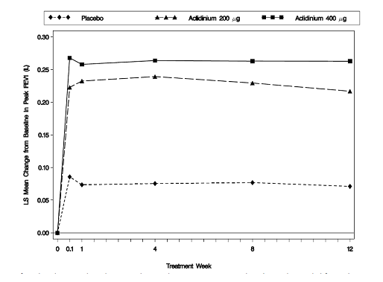
Additional efficacy parameters: On Day 1 and at Week 12, the change from baseline in FEV1 by time-point showed rapid onset of action with significant difference from placebo at 0.5h post-dose and peak action at 3 h post-dose. Furthermore, the adjusted mean difference between the aclidinium bromide 400 µg group and the aclidinium bromide 200 µg group was 0.061 L (p = 0.0002) and 0.053 L at H 3 (p = 0.0232) at day 1 and week 12, respectively.
FVC and IC: At Weeks 1, 4, 8 and 12, the adjusted mean differences in change from baseline in trough FVC and IC values were higher in the aclidinium bromide groups than in the placebo group and were statistically significant at all time points (p < 0.01).
12-h spirometry substudy results: A total of 220 patients participated in the 12-h PFT substudy: 73 (39.5%) were treated with placebo, 74 (40.2%) were treated with aclidinium bromide 200 µg and 73 (38.4%) were treated with aclidinium bromide 400 µg. Mean baseline FEV1 values were 1.424 L, 1.381 L and 1.418 L for placebo, aclidinium bromide 200 µg and 400 µg groups, respectively.
The treatment difference for aclidinium bromide 200 µg and 400 µg versus placebo in the change from baseline in FEV1 at H 3 of Day 1 was 0.153 L and 0.257 L (p < 0.0001), respectively; this was generally similar to the change observed in the overall ITT Population (0.157 L and 0.218L with 200 µg and 400 µg, respectively), although slightly greater efficacy for aclidinium 400 µg was observed in the substudy. Overall, the subgroup of patients with serial spirometry was considered reasonably representative of the overall ITT Population. At H 3 of Day 1, the bronchodilation provided by aclidinium bromide 400 µg compared with placebo in change from baseline in FEV1 was 0.257 L (p < 0.0001) in the substudy, and this difference was maintained during the subsequent h (0.173 L [p < 0.0001] at 12 h after the morning dose). Similarly, at H 3 of Week 12, the bronchodilation provided by aclidinium bromide 400 µg compared with placebo in the change from baseline in FEV1 was 0.214 L (p < 0.0001). This difference was maintained during the subsequent h and reached 0.151 L at 12 h after the morning dose (p = 0.0001). Similar results were observed for 200 µg dose (Figure 10). From the comparison of the 2 doses after 12 weeks of treatment, the aclidinium bromide 400 µg dose was statistically superior to the aclidinium bromide 200 µg dose (p ≤ 0.01 at every time point, except at H 10 [p = 0.1225]). The serial spirometry based on FVC over the 12-h period on Day 1 and at Week 12 had a similar pattern to that of FEV1, but with larger differences supporting the greater effect of the aclidinium bromide 400 µg dose over the aclidinium bromide 200 µg dose (Figure 11).
Figure 10. Least squares mean change from baseline in FEV1 by time point on Day 1 for 12 h serial spirometry patients
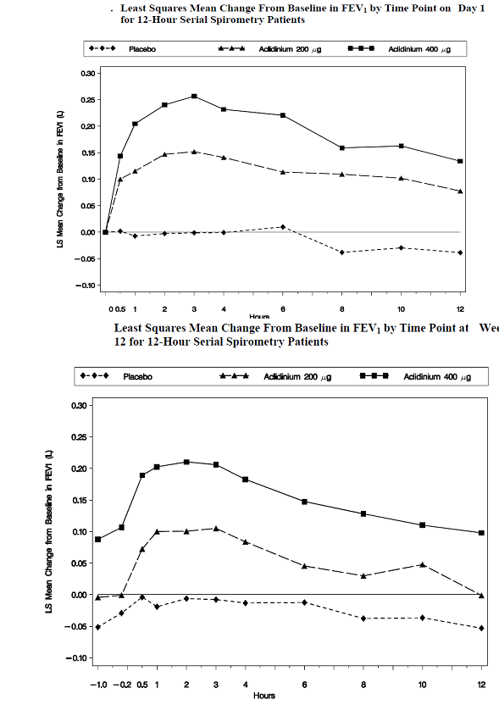
Figure 10 continued. Least squares mean change from baseline in FEV1 by time point in Week 12 for 12 h serial spirometry patients
Figure 11. Least squares mean change from baseline in FVC (L) by time point on Day 1 (top) and Week 12 (bottom) for 12 h serial spirometry patients
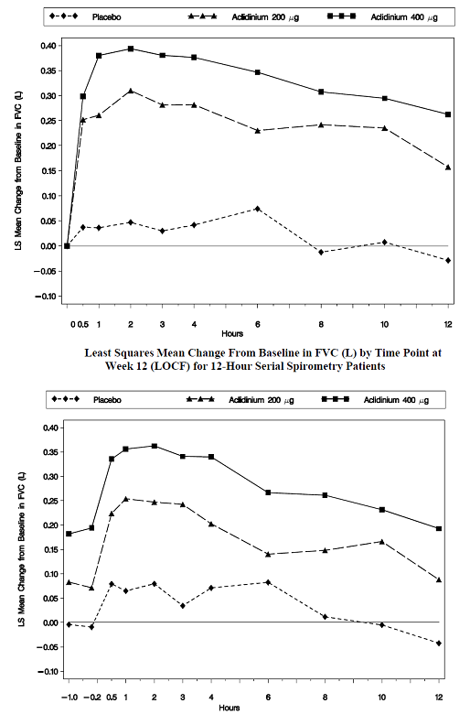
Health-related endpoints: At Week 12, the adjusted mean difference versus placebo in change from baseline in SGRQ total score was statistically significant with both aclidinium bromide 200 µg (–2.7, p = 0.0126) and 400 µg (–2.5, p = 0.0186) with maximum improvement observed at week 4. At Week 12, both aclidinium bromide 200 µg and 400 µg doses showed statistically significant greater improvement in the SGRQ symptom score [adjusted mean difference versus placebo in change from baseline was –5.9 (p = 0.0001) and –5.1 (p = 0.0007) in the aclidinium bromide 200 µg and 400 µg groups, respectively] and SGRQ activity score [ –1.8 (p = 0.1842) and –1.1 (p = 0.3871), respectively] with no significant improvement in the SGRQ impact score (p=0.108 and p=0.077 for 200 µg and 400 µg groups, respectively). Based on odds ratios, a statistically significantly higher percentage of patients in each aclidinium bromide group achieved a clinically meaningful improvement in quality of life (≥ 4-point improvement from baseline in SGRQ total score) compared with the placebo group at all time points assessed, except for the aclidinium bromide 400 µg group at Week 12 (35.9%, 49.4% and 44.4% for placebo, aclidinium bromide 200 µg and 400 µg, respectively). Over time, the percentage of responders increased slightly more in the placebo group (from 27.1% to 35.9%) than in the aclidinium bromide groups (from 41.7% to 49.4% in the aclidinium bromide 200-μg group and from 40.7% to 46.0% in the aclidinium bromide 400 μg group).
The change from baseline to Weeks 4, 8 and 12 in dyspnea status, as measured by the TDI (change in functional impairment, change in magnitude of task, and change in magnitude of effort) showed statistically significant improvement with both aclidinium bromide 200 µg and 400 µg (p < 0.05) versus placebo (except for Week 8 for aclidinium bromide 200 µg versus placebo, p = 0.0599). At Week 12, the adjusted mean difference in the change from baseline versus placebo in TDI focal score was 0.9 and 1.0 in the aclidinium bromide 200 µg and 400 µg groups, respectively (p < 0.01). These estimates were close to and at the MCID level of the TDI. Number and percentage of patients who achieved a clinically meaningful difference in TDI (Improvement in the Focal Score) at Weeks 4, 8 and 12 (LOCF) was statistically significantly greater for both aclidinium 200 µg and 400 µg compared with placebo. At Week 12, 32.9%, 50.9% and 47.7% of the patients in the placebo, aclidinium bromide 200 µg and 400 µg groups, respectively achieved a clinically meaningful improvement in TDI focal score.
COPD exacerbations: The incidence of COPD exacerbations was slightly higher in the placebo groups compared with the aclidinium bromide groups (11.9%, 8.7% and 6.3% with placebo, aclidinium 200 µg and 400 µg, respectively). Aclidinium bromide 200 µg numerically delayed the time (days) to first mild, moderate, or severe COPD exacerbation compared with placebo (hazard ratio of 0.6; 95% CI = 0.3 to 1.3; p = 0.2003) with similar delay observed for the 400 µg dose (hazard ratio of 0.5; 95% CI = 0.3 to 1.1; p = 0.0753). There was a numerical trend in reducing the rate of moderate to severe exacerbations, although not statistically significant (0.63, 0.42 and 0.42 per patient per year for placebo, 200 µg and 400 µg, respectively). The estimated reduction of the rate of moderate to severe exacerbations was 34% for aclidinium bromide 400 µg compared with placebo (rate ratio: 0.66; p = 0.0912) and 33% for aclidinium bromide 200 µg compared with placebo (rate ratio: 0.67; p = 0.1033). The estimated reduction of the rate of mild, moderate to severe exacerbations compared with placebo was 48% for aclidinium bromide 400 µg (rate ratio: 0.52; p = 0.0094) and 30% for aclidinium bromide 200 µg (rate ratio: 0.70; p = 0.1180). The duration of COPD exacerbation from the derived definition of mild, moderate or severe COPD exacerbations ranged from 10.8 days to 16.3 days across the treatment groups. It is important to note that analysis of exacerbation days is only based on the small number of patients who had exacerbations during the double blind treatment period. Twelve patients were withdrawn from the study due to COPD exacerbation [7 patients (3.8%), 4 patients (2.2%) and 1 patient (0.5%) in the placebo, aclidinium bromide 200 µg and 400 µg groups, respectively] and 4 patients were hospitalized [ 1 (0.5%), 1 (0.5%) and 2 (1.1%), respectively).
Other efficacy variables: There was a statistically significant reduction in the total daily use of rescue medication in both aclidinium bromide groups compared with placebo. The reduction in total daily use of rescue medication was mainly driven by a reduction in the use of daytime–period rescue medication. Severity of the night time COPD symptoms showed statistically significant improvements compared with placebo at all time points in the aclidinium bromide 400 µg group and at most time points in the aclidinium bromide 200 µg group, with the exception of Week 8 for breathlessness, cough, and sputum production. Overall, aclidinium bromide 400 µg group was consistently associated with numerically greater improvement than the aclidinium bromide 200 µg group for most of the health outcome parameters.
Comments: In this 12 week study, the 400 µg dose showed statistically significant greater improvement compared to the 200 µg dose for the primary (trough FEV1) and secondary efficacy (peak FEV1) endpoints. Treatment with aclidinium bromide 400 µg and 200 µg twice daily resulted in statistically significant improvements in lung function versus placebo in moderate to severe COPD patients after 12 weeks of treatment for both primary and secondary end points, change from baseline in morning predose (trough) and peak FEV1, respectively. Results from the overall ITT population and from the 12-h serial spirometry substudy supported a dose-dependent difference in bronchodilation favouring the higher dose. Aclidinium bromide 400 µg provided sustained, bronchodilation over 12 weeks that was consistently numerically higher than aclidinium bromide 200 µg. Both aclidinium bromide doses showed improvements in patients’ quality-of-life and COPD symptomatology as measured by SGRQ and BDI/TDI, respectively. Despite higher bronchodilation provided by aclidinium bromide 400 µg compared to 200 µg, no dose differences in response were observed in the SGRQ and TDI. Both doses reduced the daily use of rescue medication as well as the frequency, quantity, and severity/impact of night time and early morning symptoms. There was a numerical trend in reducing the rate of moderate or severe exacerbations in the aclidinium bromide 400 µg and 200 µg groups relative to placebo. The MCID for trough FEV1 has not been defined. A recent ATS/ERS task force (Cazzola et al 2008) mentions that from a regulatory point of view, improvements in FEV1 of 5-10% are considered clinically relevant; improvements < 3% are not relevant; however, they did not specify whether this refers to peak, average, or trough FEV1. In this study, the difference versus placebo in percent change from baseline in trough FEV1 was a clinically relevant 10.4% in the aclidinium bromide 400 µg group and 8.4% in the aclidinium bromide 200 µg group. Aclidinium bromide 400 µg provided higher bronchodilation than 200 µg in the peak FEV1 after 12 weeks of treatment (0.046 L; p = 0.0409) as well as in the FEV1 over 3 h postdose after the first dose (0.045 L; p = 0.0013) and at Week 12 (0.048 L; p = 0.0267).

Study LAS –MD-38A
This was a Phase III, multicenter, multinational, randomized, double blind, placebo controlled, parallel-group, 3-arm study of 16 weeks’ duration: a 2 week run-in period, followed by a 12 week treatment period and a 2 week follow-up phone contact/study visit. In addition, 2 subset populations were used to assess 12-h serial spirometry and 12-lead Holter evaluations. Part B of this study was a multicenter, open-label, 40 week treatment continuation of patients enrolled in Part A and will be discussed separately below.
The primary objective was to assess the bronchodilator efficacy of inhaled aclidinium bromide, 200 µg and 400 µg administered twice daily, once in the morning and once in the evening via the Genuair multidose dry-powder inhaler, as compared with placebo in patients with moderate to severe COPD. The secondary objectives were to assess its safety and tolerability. This study was conducted from 3 December 2009 to 13 September 2010 at 102 enrolling study centres (North America): 100 centres in the United States and 2 centres in Canada. A total of 99 study centres randomized the patients.
The inclusion/ exclusion criteria, study treatments, efficacy variables, randomisation/ blinding methods, analysis populations, sample size/statistical methods were identical to those described for the Phase III, 12 week study LAS-md-34 described above.

Participant flow, major protocol violations/ deviations
A total of 1236 patients were screened for eligibility and 544 were randomized to a study treatment group (182 to placebo, 184 to aclidinium bromide 200 µg, and 178 to aclidinium bromide 400 µg). The percentage of patients who discontinued prematurely was comparable in the placebo (17.0%), aclidinium bromide 200 µg (15.8%) and 400 µg (16.9%) treatment groups. The most frequent reasons for discontinuation were withdrawal of consent (4.8%), AEs (2.8%), insufficient therapeutic response (2.0%), and COPD exacerbation (2.0%). The number of patients in each of the analysis populations is summarised in Table 17. A total of 45 patients were excluded from the PP Population and the most frequent reason for exclusion from the PP Population was “treatment compliance < 75% for the time the patient was in the study” in 15 patients, followed by “change in use of inhaled corticosteroids” in 10 patients.
Table 17. Patient populations-All patients
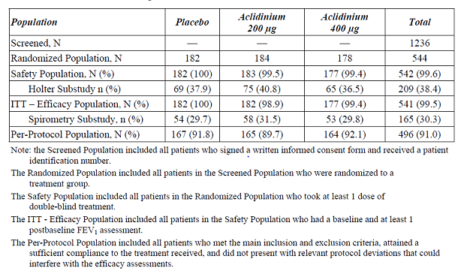

Baseline data
Majority of the patients were male (50-55%), Caucasians (89-92%) with mean age of 62-63 years and mean BMI of 27 kg/m² and treatment groups were generally comparable with respect to baseline demographics. At baseline, there were unexpected imbalances among the treatment groups in FEV1 (1.459 L, 1.397 L and 1.249 L in the placebo, aclidinium bromide 200 µg and 400 µg groups, respectively) and in the percentage of patients with severe Stage III COPD (37%, 48% and 55%, respectively). Other than the imbalances in FEV1 and in COPD severity, the treatment groups were generally comparable with respect to the other baseline disease characteristics. The percentage of patients who used prior medications for COPD before screening was higher in the aclidinium bromide 400 μg group than in aclidinium bromide 200 µg and placebo groups (81.4%, 78.1% and 72.5%, respectively) and the class of drugs most frequently used as prior medications (> 20%) were SABAs (52.4%), LABAs plus ICSs (30.6%), and LAMAs (26.4%). There was a higher percentage of patients in the aclidinium bromide 400 µg group than in the placebo group using LAMAs, SABA + SAMA, ICs, and LABA as prior medications, and that is consistent with patients with more severe COPD being randomized in the aclidinium bromide 400 µg group. The overall percentage of patients who were compliant was 97.8%, 97.3%, and 98.9% in the placebo, aclidinium bromide 200 µg, and aclidinium bromide 400 µg groups, respectively. Other than in the placebo group at Week 1 (compliance of 89.0%), mean compliance was similar in each treatment group (95.0% or higher) at each assessment time point (Weeks 1, 4, 8 and 12).

Efficacy results:
Primary endpoint: At the end of 12 weeks of treatment, patients in the aclidinium bromide 200 µg and 400 µg groups showed a statistically significantly greater improvement in the adjusted mean change from baseline in morning predose (trough) FEV1 over placebo by 0.051 L (p = 0.0192) and 0.072 L (p = 0.0012), respectively, based on the primary LOCF ITT analysis. Aclidinium bromide 400 µg showed slightly greater improvement over 200 µg by 0.021 L (p = 0.342). However, the imbalance among the treatment groups in baseline FEV1 (1.459 L, 1.397 L, and 1.249 L, respectively in placebo, aclidinium bromide 200 µg and 400 µg groups , respectively) was shown to be statistically significant in a post hoc analysis (p = 0.0009). The post hoc analysis of the primary efficacy parameter by COPD severity at baseline (mild + moderate, and severe + very severe) suggest that aclidinium (200 µg and 400 µg) showed statistically significant improvements over placebo in the trough FEV1 in patients with mild/moderate COPD severity, but this significant improvement was not observed in patients with severe/ severe COPD (Table 18).
Table 18. Change from baseline in morning predose (trough) FEV1 at Week 12 by COPD severity group. ITT population
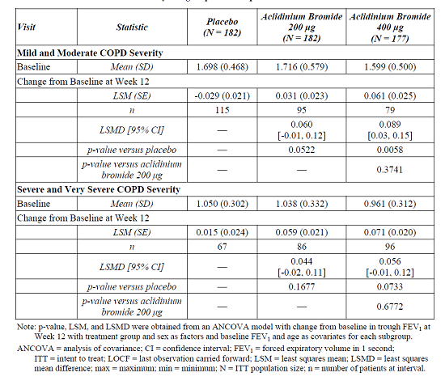
Secondary Endpoint: At the end of 12 weeks of treatment, aclidinium bromide 200 µg and 400 µg showed statistically significant greater improvement in the adjusted mean change from baseline in peak FEV1 over placebo by 0.115 L (p < 0.0001) and 0.125 L (p < 0.0001), respectively, based on the LOCF ITT analysis. The treatment difference between aclidinium 400 µg and aclidinium 200 µg was not significant (0.010L, p = 0.6922).
The adjusted mean differences versus placebo in trough FEV1 were 0.101 L and 0.072 L at week 1 and Week 12, respectively for the aclidinium bromide 400 µg group and 0.084 L and 0.05 1L, respectively for the aclidinium bromide 200 µg group (Figure 12).
Figure 12. Change from baseline in morning predose (trough) FEV1 by visit (LOCF) over 12 weeks. Least squares mean. ITT population
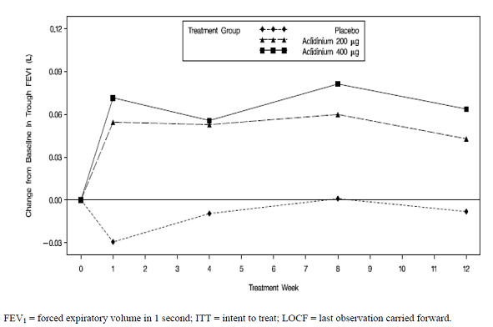
The adjusted mean difference from placebo in change from baseline in normalized AUC_{0-3h} ranged from 0.122 L (Week 12) to 0.166 L (Week 1) in the aclidinium bromide 200 µg group and from 0.137 L (Week 12) to 0.188 L (Week 1) in the aclidinium bromide 400 µg group. The adjusted mean difference between the aclidinium bromide 400 µg dose and 200 µg dose in change from baseline in normalized AUC_{0-3h} FEV1 was statistically significantly greater on Day 1 (0.039 L, p = 0.0029) but not at Week 12 (0.015L, p = 0.5299).
The median time to peak FEV1 in the aclidinium bromide 200 µg and 400 µg groups was approximately 2 h on Day 1 and at Weeks 1, 4, 8 and 12. Following dosing on Day 1, a greater improvement in peak FEV1 was noted in both aclidinium bromide groups compared with the placebo group. This improvement was sustained over 8 weeks for the aclidinium bromide 200 µg and 400 µg groups, and decreased slightly at the 12 week visit due to an increase in the placebo response.
Comments: The magnitude of bronchodilation observed over time appeared to decrease in both the aclidinium groups, although this may have been affected by the increase in placebo response with time and a greater proportion of patients with severe disease in the aclinidium treatment groups.
All analyses of the additional efficacy spirometric parameters based on FVC, and IC were statistically significant for both aclidinium bromide 200 µg and 400 µg versus placebo at all time points at Weeks 1, 4, 8 and 12, with the exception of Week 12 for trough FVC in the aclidinium bromide 200 µg group only (p = 0.0521).

Other efficacy results:
A small number of patients from the ITT population participated in the 12-h serial spirometry substudy: 54, 58 and 53 in the placebo, aclidinium bromide 200 µg and 400 µg groups, respectively. As observed for the total ITT population, there was an unexpected imbalance in the baseline FEV1 values in the substudy.
On Day 1, the bronchodilation provided by aclidinium bromide 400 µg compared with placebo in change from baseline in FEV1 was highest at H 4 (0.189 L, p < 0.0001) in the substudy, and this difference decreased during the subsequent h to 0.119 L (p = 0.0028) at 12 h after the morning dose. At Week 12, the change from baseline in FEV1 was highest at H 3 (0.150 L, p = 0.0040) and this difference was generally maintained during the subsequent h (ranging between 0.133 and 0.155 L) and was 0.124 L at 12 h after the morning dose (p = 0.0171). However, the 200 µg dose only showed significant changes compared with placebo at H 2 on Day 1 and H 2 at Week 12 and the difference was no longer statistically significant at 10-12 h after the morning dose On Day 1 or Week 12. From the comparison of the 2 doses after 12 weeks of treatment, the aclidinium bromide 400 µg dose was numerically higher than the aclidinium bromide 200 µg dose at every time point other than 1 h post dose, but the difference was not statistically significant (Figure 13). The serial spirometry based on FVC over the 12-h period on Day 1 and at Week 12 had a similar pattern to that of FEV1.
Figure 13. Least squares mean change from baseline in FEV1 by time point on Day 1 (top) and Week 12 (bottom) for 12 h serial spirometry patients
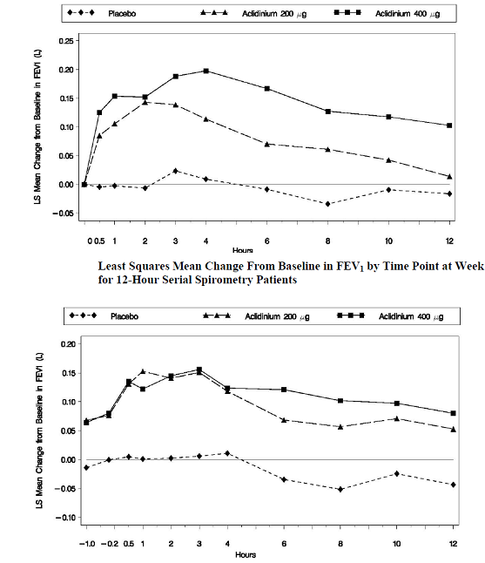
Dyspnea: Aclidinium bromide 200 µg and 400 µg showed a statistically significant improvement (p < 0.05) compared with placebo at Week 12 in TDI focal score; the adjusted mean difference in the change in dyspnea status from baseline versus placebo in TDI focal score was 0.7 (p = 0.0416) and 1.0 (p = 0.0054) in the aclidinium bromide 200 µg and 400 µg groups, respectively. Similarly, a higher percentage of patients in the aclidinium bromide groups achieved a clinically meaningful difference in TDI (>1 unit) at Week 12 compared with the placebo group (34.5%, 45.6% and 50.7% in the placebo, aclidinium bromide 200 and 400 µg groups, respectively), but the difference was statistically significant versus placebo in the aclidinium bromide 400 μg group only (p = 0.0150).
Health Status Variables: No statistically significant differences were observed between both aclidinium doses and placebo in the change from baseline in SGRQ total score at Week 12, which may have been affected by an unexpectedly high placebo response beyond the clinically meaningful threshold of 4 units (-4.3, -6.0 and -5.4 in the placebo, aclidinium bromide 200 and 400 µg groups, respectively). Although not statistically significant, a higher percentage of patients in each aclidinium bromide group achieved a clinically meaningful improvement in quality of life (≥ 4-point improvement from baseline in SGRQ total score) compared with the placebo group at Week 12 (38.8%, 47.2% and 44.8%, respectively).
COPD Exacerbations: The number of patients experiencing COPD exacerbations of any severity (mild, moderate or severe) showed no difference between treatment groups (19, 14 and 19 patients in the placebo, aclidinium bromide 200 µg and 400 µg groups, respectively). The estimated rates of moderate to severe COPD exacerbations were numerically lower but not statistically significant between aclidinium bromide 400 µg and placebo (rate ratio: 0.82; p = 0.6345) and between aclidinium bromide 200 µg and placebo (rate ratio: 0.57; p = 0.2170). The median duration of moderate or severe COPD exacerbations was 8.0, 10 and 9 days in the placebo aclidinium bromide 200 µg and 400 µg groups, respectively. Eleven patients were withdrawn from the study due to COPD exacerbation; 4 patients (2.2%) in the placebo group, 1 patient (0.6%) in the aclidinium bromide 200 µg group and 6 patients (3.4%) in the aclidinium bromide 400 µg group. Overall, 8 patients were hospitalized due to COPD exacerbations, 3 (1.7%) in the placebo group, 4 (2.2%) in the aclidinium bromide 200 µg group, and 1 (0.6%) in the aclidinium bromide 400 μg group.
Rescue Medication: There were no statistically significant differences in the total daily use of rescue medication in both aclidinium bromide groups compared with placebo (-0.17 puffs for the aclidinium bromide 200 µg group versus placebo [p = 0.5334] and -0.31 puffs for the aclidinium bromide 400 µg group versus placebo [p = 0.2490]).
Health Economics and Outcomes Research Assessment: There were no differences between the aclidinium bromide groups and placebo in the weighted state health index and visual analog scale score of the EuroQoL-5D questionnaire at Weeks 4, 8 and 12.
Comments: Treatment with aclidinium bromide 400 µg and 200 µg twice daily resulted in statistically significant improvements in lung function versus placebo in moderate to severe COPD patients after 12 weeks of treatment for both primary and secondary end points, change from baseline in morning predose (trough) and peak FEV1, respectively. Both aclidinium bromide doses showed improvements in patients’ COPD symptomatology compared with placebo as measured by TDI. Additionally, aclidinium bromide provided TDI improvements at the clinically meaningful level of 1 unit in the aclidinium bromide 400 µg group compared to the placebo group. No statistically significant improvements were observed for the aclidinium bromide 400 µg and 200 µg groups relative to placebo in quality of life, reduction of COPD exacerbations, and the use of rescue medication. However, interpretation of results from this Phase III study were confounded by the following limitations: (1) significant imbalances among the treatment groups in baseline FEV1 and COPD severity, (2) duration of treatment was only 12 weeks, (3) patients nor randomised by smoking status at baseline and change in smoking status not monitored throoughtout the study duration.

Other efficacy studies

Supportive studies with proposed twice daily dosing

Active controlled phase IIa study M/34273/23

Study design, study treatment, efficacy endpoints:
This Phase IIa, randomised, double blind, double-dummy, placebo- and active comparator-controlled (tiotropium), 3-period cross-over study was the first clinical study which investigated the 24-h bronchodilatory profile of multiple doses of inhaled aclidinium bromide 400 µg BD administered to 30 patients with stable moderate to severe COPD and other characteristics similar to that included in the pivotal studies of BD administration. This study was conducted at two centres in Germany from 9 March 2009 to 1 July 2009. Following a 5 to 9-day run-in period during which the stability of the patients’ COPD was confirmed, eligible patients were randomised, in a ratio of 1:1:1:1:1:1 to one of six treatment sequences. For each patient, the study consisted of 3 periods of 15 treatment days each separated by a washout period of 9 to 15 days. During each period, patients received one of 3 treatments according to the randomisation scheme: aclidinium bromide 400 µg BD, tiotropium 18 μg QD or placebo. The final follow-up assessment was performed 4 to 6 days after the last dose. The primary efficacy endpoint was the change from baseline to Day 15 in the normalised area under the FEV1 versus time curve for the 12-h period following the morning dose (FEV1 AUC_{0-12/12h}). Secondary efficacy endpoints included: Change from baseline in normalised FEV1 AUC₀₋₂₄ and FEV1 AUC1₂₋₂₄ on Days 1 and 15 of treatment and the change from baseline in normalised FEV1 AUC₀₋₁₂ on Day 1 of treatment; all the above-mentioned primary and secondary endpoints for FEV1 were also assessed for FVC; Change from baseline in FEV1 and FVC at each timepoint on Days 1 and 15; Change from baseline in morning pre-dose (trough) FEV1 and morning peak FEV1; Change from baseline in COPD symptom scores; Change from baseline in daily use of relief medication; ease of use of the inhaler devices was assessed by the patients at the end of their participation in the study. The analysis of all the efficacy variables was performed on the ITT population (primary efficacy variable also confirmed in the PP population). All variables of efficacy were analyzed using Analysis of Covariance (ANCOVA) models for crossover designs. Sequence, period and treatment were included in the model as fixed effects, patient was a random effect and baseline FEV1 was included as a covariate.

Results:
Of 30 randomised patients, 27 patients (90.0%) completed the study. A total of 30 patients were evaluated for safety and efficacy (ITT population). Majority of patients were male (63%), Caucasian (100%), current smokers (63%) with COPD of moderate severity (63%) and mean age of 58 years (43-73years) and COPD duration of 9 years.
Twice-daily doses of aclidinium bromide 400 µg BD induced a marked bronchodilatory effect compared to placebo that was evident from post-morning administration on Day 1, was sustained over time and was well preserved until the end of the entire treatment period, that is, 24 h after morning administration on Day 15. The treatment difference between aclidinium bromide and tiotropium in the change from baseline in all FEV1 AUC on Day 1 reached statistical significance, favouring aclidinium bromide, ranging from 0.052 L in the AUC0-12/12h (p=0.0411) to 0.101 L in the AUC12-24/12h (p=0.0017). Aclidinium bromide 400 µg BD has shown a bronchodilatory profile that was similar to tiotropium in the first 12 h and slightly higher than that after tiotropium over the last 12 h after 15 days of treatment as demonstrated by statistically significant differences in FEV1 AUC12-24/12h and comparable AUC0-12/12h and AUC0-24. Aclidinium bromide 400 µg BD provided similar bronchodilation on Day 1 compared to Day 15 in all parameters assessed. The bronchodilation provided by tiotropium was lower on Day 1 compared to Day 15 (Table 19). These results might suggest that the pharmacodynamic steady state is reached after the first day of treatment with aclidinium bromide, whereas at least 1 week is needed to reach this state after tiotropium, as defined in its Summary of Product Characteristics (SmPC).
Table 19. Phase IIa study M/34273/23 Treatment effects of change from baseline in normalised FEV1 AUC₀₋₁₂ (L). Analysis based on the ANCOVA model. ITT population.
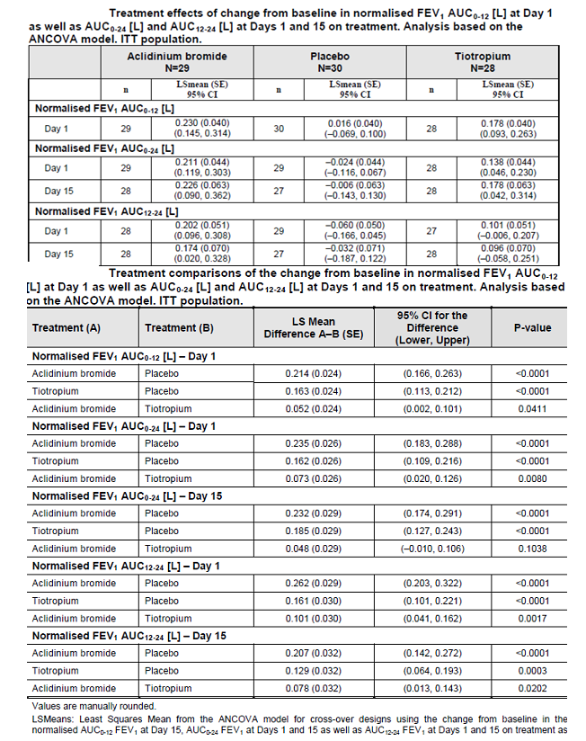
In addition, aclidinium bromide has provided a clinically and statistically significant bronchodilation at morning pre-dose FEV1 at Day 15 on treatment compared with placebo (0.186 L; p<0.0001) and the magnitude of this improvement was slightly higher than that in the tiotropium group, although this difference was not statistically significant (treatment difference of 0.036 L; p =0.2560). The magnitude of the improvement with tiotropium compared to placebo (0.150 L) is consistent with previous clinical trials. The bronchodilatory effects of aclidinium bromide were sustained for the duration of the 24- h observation periods on Days 1 and 15 (Figure 14). Similar results to those obtained for FEV1 were obtained for the FVC at Days 1 and 15 on treatment. Adjusted mean differences between aclidinium bromide and placebo in the change from baseline in morning peak FEV1 increased from 0.218 L on Day 1 to 0.277 L on Day 15 (both p<0.0001). There was also an increase in the adjusted treatment differences between tiotropium and placebo from 0.170 L on Day 1 to 0.252 L on Day 15 (both p<0.0001), respectively. The adjusted mean differences between aclidinium bromide and tiotropium on Days 1 and 15 were 0.048 L (p=0.059) and 0.026 L (p=0.586), respectively.
Figure 14. Change from baseline in FEV1 (mL) at each specific time point. ITT population.
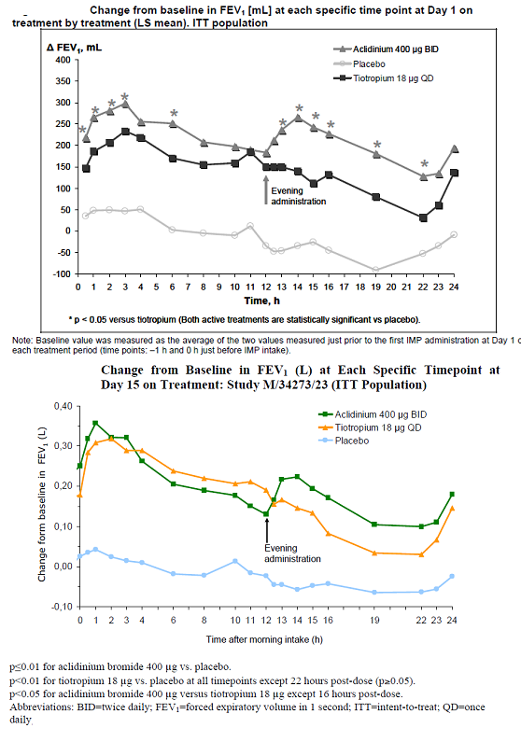
The daily use of relief medication (number of puffs) over the 15-day treatment period was statistically significantly lower with aclidinium bromide compared with placebo (by 2.01 puffs per day; p<0.0001) and with tiotropium compared with placebo (by 1.32 puffs per day; p=0.005). The proportion of patients using relief medication daily (day and night) was lower during the treatment period of aclidinium bromide administration (51.7%) than that during the treatment periods of placebo (73.3%) and tiotropium (75.0%) administration. The proportions of patients who used relief medication at day-time were generally similar to that of daily users (48.3%, 73.3% and 67.9%, respectively). The proportion of patient reporting the night time use of relief medication was generally lower than that at day-time, but was again lower during treatment with aclidinium bromide (20.7%) than that during treatment with placebo (36.7%) and tiotropium (42.9%).
Statistically significant improvements, in breathlessness, cough and night time symptoms, but not sputum production, over the 15 day treatment period, were noted with aclidinium bromide compared with placebo (p=0.026, 0.039, 0.049 and 0.627, respectively). Tiotropium was not associated with statistically significant improvements in any of these COPD symptoms over the 15-day treatment period, compared to placebo (Table 20). Of the 30 patients in this study, 29 (97%) found the Almirall inhaler easy or very easy to use while 25 patients (83%) found the tiotropium Handihaler® easy or very easy to use. A total of 15 patients (50%) preferred the Almirall inhaler and 3 patients (10%) preferred the Handihaler®.
Table 20. Treatmen effects of change from baseline in COPD symptom scores at Weeks 1 and 2 on treatment.
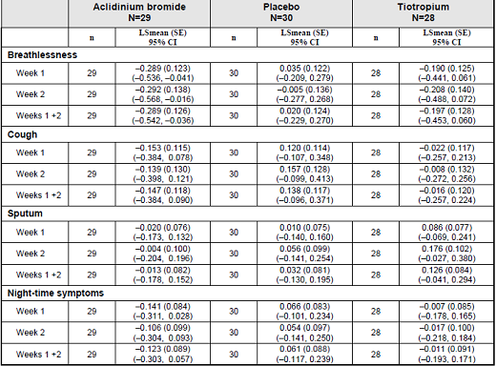
Comments: Results from this prospective, randomised, double blind, double-dummy, 3-way crossover study showed that aclidinium bromide 400 µg BD induced a clinically significant bronchodilation compared to placebo, which was evident after the first administration on Day 1 and was maintained until the end of the 15-day treatment period. The bronchodilatory profile of aclidinium bromide 400 µg BD was similar to that of tiotropium 18 μg QD in the 12 h after the morning dose, but greater than that of tiotropium in the 12 h after the evening dose. Furthermore, the BD dosing with 400 µg alidinium bromide also seemed to provide significantly greater night time relief of COPD symptoms and use of less rescue medication compared to once daily dosing with tiotropium. Aclidinium bromide 400 µg BD provided similar bronchodilation on Day 1 compared to Day 15 in all parameters assessed but the bronchodilation provided by tiotropium was lower on Day 1 compared to Day 15. However, these results can only be considered indicative due to small sample size (<30 patients) and cross-over study design and will need to be confirmed in randomised, parallel group studies of longer duration.

Phase 2b dose-ranging study M/34273/29
This study has been discussed previously in this report.

Long-term efficacy
The eligibility criteria for long term studies LAS-MD-35, LAS-MD-36 and LAS-MD-38 Part B were the same as those for the pivotal studies, with the exception of additional criteria for patient entry into extension study, LAS-MD-36; which excluded those who had experienced clinically significant anticholinergic adverse effects in the lead-in study, LAS-MD-33, or who had prolongation of QTc interval (Bazett-corrected) greater than 500 msec on both the pre- and post-dose ECGs.
Although LAS-MD-35, LAS-MD-36 and LAS-MD-38 Part B were designed primarily to assess long term safety of aclidinium bromide, some efficacy variables were also evaluated to add information on the long term COPD status of patients treated with aclidinium bromide. It was recognised that the usefulness of these efficacy data might prove to be limited due to the lack of placebo-control in these studies and the natural history of COPD, which is one of progressive deterioration. Primary and secondary efficacy variables for both studies (changes from baseline in trough FEV1 and peak FEV1, respectively), were similar to those for the pivotal Phase III studies. Additional efficacy measures evaluated (spirometric measures, SGRQ and use of rescue medication) and the methods for collection of these data were the same as those described for the pivotal studies.

Study LAS-md-36
This was a long term, open-label extension study to evaluate efficacy and safety of aclidinium bromide 200 µg and 400 µg BD in patients who had completed the 12 week pivotal study LAS-md-33. The objectives of study LAS-MD-36 were to evaluate the long term safety and tolerability of inhaled aclidinium bromide 200 µg or 400 µg BD in patients with moderate to severe COPD, and to evaluate long term efficacy, pharmacoeconomic and health-related quality of life benefits. This Phase III, randomised, double blind, parallel-group extension study was conducted at 77 centres in the United States and Canada. Patients completing 12 week lead-in study LAS-MD-33 were eligible for enrolment. Patients who received aclidinium bromide 200 µg or 400 µg BD in LAS-MD-33 continued to receive aclidinium bromide in this study at the same dose BD for a further 52 weeks. Patients who received placebo in LAS-MD-33 were randomised in a 1:1 ratio to receive in this study either aclidinium bromide 200 µg or 400 µg BD for up to 52 weeks. The final follow-up assessment (by telephone contact) was 2 weeks after the last dose of study treatment. The baseline for efficacy evaluation was the baseline for lead-in study LAS-MD-33. The primary efficacy endpoint was the change from baseline in morning pre-dose (trough) FEV1 at Week 64. The secondary efficacy endpoint was the change from baseline in peak FEV1 at Week 64. Additional efficacy endpoints included: Change from baseline in morning pre-dose (trough) FEV1 and peak FEV1 by visit over 64 weeks. Change from baseline in SGRQ Total score by visit over 64 weeks.
The aclidinium bromide 400 µg and 200 µg treatment groups were balanced for demographic characteristics and were generally balanced for baseline characteristics, with the exception of some imbalances between the groups for COPD severity and baseline FEV1. Patients who received placebo in lead-in study LAS-MD-33 and aclidinium bromide 400 µg in this study had more severe COPD than patients who received placebo in the lead-in study and aclidinium bromide 200 µg in this study (39.1% and 25.0% of patients with severe Stage III COPD in aclidinium bromide 400 µg and 200 µg groups, respectively, and baseline FEV1 of 1.35 L and 1.54 L, respectively). A slightly lower proportion of patients who received aclidinium bromide 400 µg during both the lead-in study and this study had severe Stage III COPD (33.0 %) compared to patients who received aclidinium bromide 200 µg through the lead-in study and this study (44.1%). At each assessment time point (Weeks 12, 24, 36, 48 and 52), the percent compliance was generally similar between treatments and ranged from 87.9% to 94.6% for aclidinium bromide 200 µg and from 83.9% to 93.1% for aclidinium bromide 400 µg.
Primary and secondary efficacy results: Improvement relative to baseline in mean morning pre-dose (trough) FEV1 at Week 64 was observed for patients who remained on active treatment in the extension study and for patients who were randomized to the placebo – aclidinium bromide 400 µg treatment sequence (Table 21). For those patients who were randomized to the placebo – aclidinium bromide 200 µg treatment sequence, predose trough FEV1 was maintained over time but the effect declined substantially at Week 64 (Figure 15). Similar results were observed for the change from baseline in peak FEV1 (Tables 22 and 23).
Table 21. Change from baseline in morning predose (trough) FEV1 at Week 64 (LOCF). ITT population.
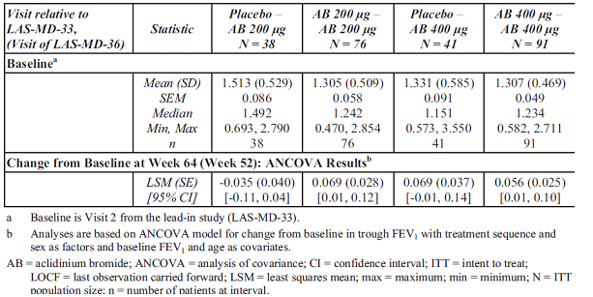
Figure 15. Change from baseline in morning predose (trough) FEV1 by Visit (LOCF) over 64 weeks, Least square mean ± SE. ITT population
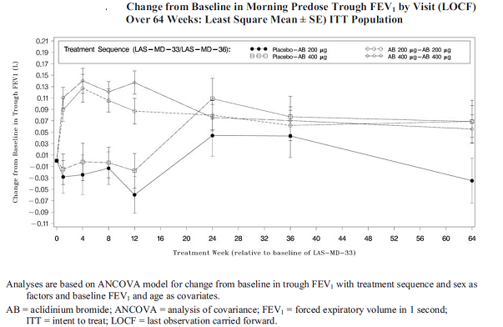
Table 22. Change from baseline peak FEV1 (L) by Visit (LOCF) over 64 weeks. Secondary efficacy analysis. ITT population
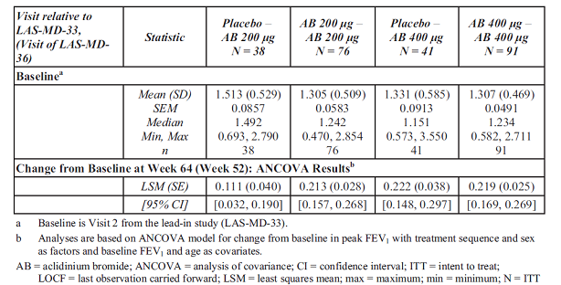
Table 23. Change from baseline in normalised AUC0-3h FEV1 (L) on Day 1 and ay Weeks 1, 4, 8, 12, 24, 36 and 64 (LOCF). ITT population
Additional efficacy results: At Week 64, the adjusted mean change from baseline in normalized AUC_{(0-3 h)} FEV1 was 0.053 L, 0.157 L, 0.155 L and 0.149 L for the placebo – aclidinium bromide 200 µg, 200 µg – 200 µg, placebo – aclidinium bromide 400 µg and the aclidinium bromide 400 µg – 400 µg sequences, respectively. At Week 64, the adjusted mean change from baseline in predose trough FVC was 0.055 L, 0.229 L, 0.221 L and 0.213L, respectively.
For those patients who were randomized to the placebo – aclidinium bromide 200 µg treatment sequence, SGRQ total score was maintained over time but the effect declined at Weeks 60 and 64. At Week 64, the adjusted mean change from baseline in SGRQ was -4.85, -6.98, -5.68 and -7.92 for the placebo – aclidinium bromide 200 µg, 200 µg – 200 µg, placebo – aclidinium bromide 400 µg and the aclidinium bromide 400 µg – 400 µg sequences, respectively. Similar reductions were seen in the activity subscale score of the SGRQ at Week 64. At Week 64, the percentage of patients who achieved at least a 4-point reduction from baseline in SGRQ total score was 43%, 51%, 59%, and 64%, respectively. The adjusted mean of the overall use of rescue medication was similar across treatments ranging from 2.2 to 2.7puffs/day. Overall, the number of puffs per day of the rescue medication used by patients throughout the postbaseline period of the study was less than at the baseline in all treatment sequences.
Comments: Aclidinium 400 µg provided a sustained bronchodilatory benefit over 64 weeks as assessed by the morning predose trough and peak FEV1 (primary and secondary endpoints of this study). These benefits were supported by other lung function endpoint data, quality of life assessments, and rescue medication usage data. The bronchodilatory and symptomatic improvements of the aclidinium bromide 200 µg dose over 64 weeks were only demonstrated for those patients who were active in the lead-in-study. Patients randomized to the placebo – aclidinium bromide 200 µg sequence also had an initial therapeutic benefit however, this effect was not as strong as that observed in the other treatment sequences and the magnitude was not sustained for the duration of the study although the small sample size of this treatment sequence may have confounded results. The therapeutic benefit of aclidinium bromide 400 µg BD was sustained with long term continued treatment. A similar effect was noted for those patients who were randomized from placebo to aclidinium bromide 400 µg.

Study LAS-md-35

Study design, objectives:
This was a long term, randomized, double blind, multicenter, parallel-group study. It was conducted from 23 November 2009 to 28 April 2011 at 97 centres (94 in the United States; 3 in Canada). The primary objective of the study was to assess the long term safety and tolerability of inhaled aclidinium bromide 200 µg or 400 µg administered twice a day (BD), once in the morning and once in the evening, via a multidose dry-powder inhaler in 605 patients with moderate to severe, stable COPD. The secondary objective was to assess the long term efficacy, health-related quality-of-life benefits. The study consisted of a 2 week run-in period designed to assess the stability of patients’ disease and establish each patient’s baseline characteristics; this was followed by a 52 week double blind treatment period. Patients meeting the entry criteria for this study were randomized in a 1:1 ratio to either aclidinium bromide 200 µg or 400 µg BD. Two weeks following the last dose of investigational product, a follow-up phone call with the investigative study center (or an in-person visit if deemed necessary by the Investigator) took place. The main inclusion and exclusion criteria were similar to those described in the pivotal Phase III studies above.

Efficacy endpoints, statistical considerations:
The primary efficacy variable was Change from baseline in morning predose (trough) FEV1 at Week 52. The secondary endpoint was Change from baseline in peak FEV1 at Week 52. Additional efficacy endpoints included pulmonary function tests (FEV1, FVC), at peak, trough, and by time point and the area under the curve from time 0 to 3 h postdose (AUC_{(0-3h)}); health-related quality-of-life (St. George’s Respiratory Questionnaire [SGRQ]) and EuroQol. quality-of-life questionnaire [EQ-5D]); and rescue medication use. Efficacy analyses were based on the ITT Population using both last-observation-carried-forward (LOCF) and observed cases (OC) approach. The primary efficacy parameter (change from baseline in morning predose [trough] FEV1 at Week 52) was analyzed by means of an analysis-of-covariance model with treatment group and sex as factors and baseline FEV1 and age as covariates. The sample size of at least 600 patients (out of 1200 patients screened) was not based on statistical power to meet the efficacy objective, but was considered sufficient to meet the safety objective of the study and to supplement long term safety data.

Participant flow, baseline data:
Of the 605 randomised patients, 600 (99.2%) had at least 1 post-baseline FEV1 assessment and qualified for the ITT Population (aclidinium 200 µg=310 and 400 µg=290). All patients in the ITT Population were included in the efficacy analyses. The percentages of patients who discontinued prematurely in the aclidinium bromide 200 µg (42.6%) and 400 µg (44.7%) treatment groups were comparable. Majority of the patients were male (58%) and Caucasian (91-93%). The treatment groups were generally comparable with respect to the demographic characteristics. However, the percentage of patients > 70 years of age was higher in the aclidinium bromide 400 μg group (33.0%) compared with the 200 µg group (26.7%) and a higher percentage of patients had Stage III (severe) COPD in the aclidinium bromide 400 µg group (51.2%) compared with the 200 µg group (42.4%).

Results:
At the end of 52 weeks of treatment, the adjusted mean change from baseline in morning predose (trough) FEV1 was 0.034 L and 0.072 L in the aclidinium bromide 200 µg and 400 µg groups, respectively with slightly greater numerical improvement in bronchodilation in the 400 µg groups (Table 24).
Table 24. Change from baseline in morning predise (trough) FEV1 at Week 52 (LOCF). Primary efficacy analysis. ITT population.
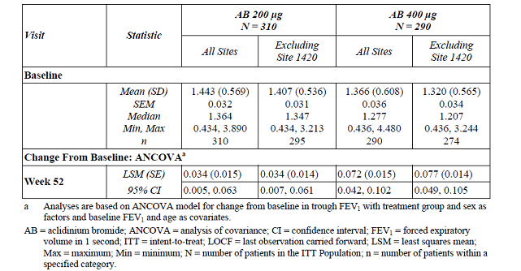
When data from Site 1420 were excluded from the analysis, similar findings were found with respect to improvement in bronchodilation for both doses of aclidinium bromide (0.034L and 0.077 L, respectively). Both doses of aclidinium bromide showed improvement in secondary endpoint of peak FEV1 from baseline and aclidinium bromide 400 µg showed a numerically greater response than the 0.185 L in the aclidinium bromide 200-μg group (0.185 L and 0.214 L in in the aclidinium bromide 200ug and 400 µg groups, respectively) with similar findings when data from site 1420 were excluded (0.181 L and 0.225 L, respectively). The change from baseline in morning predose (trough) FEV1 was evaluated at Weeks 1, 12, 24, 36, 48 and 52 (LOCF) for the ITT Population and showed improvement in bronchodilation for both aclidinium bromide groups at each time point. As early as Week 1, aclidinium bromide 400 µg exhibited an apparent dose separation from aclidinium bromide 200 µg in providing a numerically greater response that was sustained throughout the study although, there was a decline in trough FEV1 in both treatment groups after week 24, most probably due to the natural decline in FEV1 seen in COPD (Figure 16). The change from baseline in peak FEV1 showed that aclidinium bromide 400 µg exhibited dose separation from aclidinium bromide 200 µg as early as Day 1, with a numerically greater response in peak FEV1 that was sustained throughout the study (Figure 17).
Figure 16. Change from baseline in morning predose (trough) FEV1 over 52 weeks. Least squares mean ±SE ITT population.
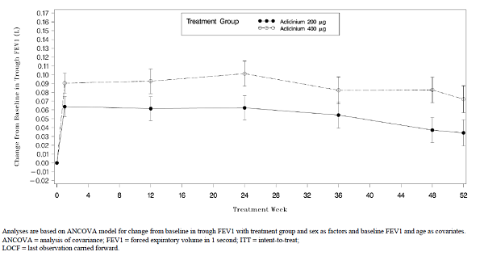
Figure 17. Change from baseline in Peak FEV1 by Visit (LOCFO) over 52 weeks Least squares mean ±SE ITT population.
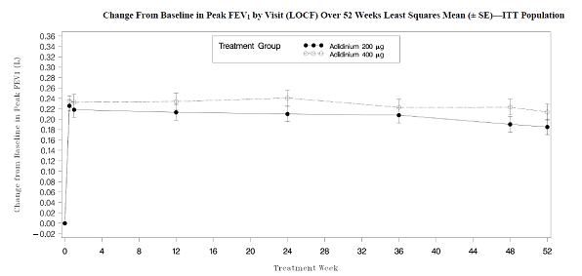
Similar results were observed for the change from baseline in normalized AUC_{(0-3h)} FEV1, trough FVC and peak FVC. Both doses of aclidinium bromide showed improvement in quality-of-life as measured by SGRQ total scores from baseline to Week 52 (LOCF) beyond the 4-units improvement threshold considered as clinically significant. Throughout the study, a higher percentage of patients in the aclidinium bromide 400 µg group achieved a clinically meaningful improvement in quality-of-life (≥ 4-point improvement from baseline in SGRQ total score) compared with the aclidinium bromide 200 µg group. For both EQ-5D parameters, there were numerical increases from Baseline at Week 12 up to Week 52 observed for both aclidinium bromide dose groups; at Week 52, the changes in adjusted mean of the VAS were 2.6 and 2.0 for aclidinium bromide 200 µg and 400 µg groups, respectively. The mean total daily rescue medication usage overall was similar in the aclidinium bromide 200 µg group (1.5 puffs) and the aclidinium bromide 400 µg group (1.4 puffs) corresponding to a 1.4 puff per day reduction in each group.
Comments: This was a long term, randomized, double blind, parallel-group study evaluating the safety, tolerability, and efficacy of aclidinium bromide administered at doses of 200 µg or 400 µg BD via a multidose dry-powder inhaler to 602 patients with moderate to severe stable COPD. Patients were randomized in a 1:1 ratio to receive either aclidinium bromide 200 µg or 400 µg for 52 weeks. There were some differences between treatment groups at baseline in lung function. For example, patients in the aclidinium bromide 400 µg group had a slightlyhigher percentage of COPD exacerbations in the previous year (21.3%) compared with patients in the aclidinium bromide 200 µg group (17.0%). Also patients in the aclidinium bromide 400 µg group had lower prebronchodilator values (1.354 L) compared with the aclidinium bromide 200 µg group (1.407 L). Results from this 52-week, double blind study provided evidence for long term efficacy of aclidinium bromide 400 µg and 200 µg BD. The 400 µg BD does of aclidinium bromide showed numerically greater broncholdilation (in terms of trough FEV1, peak FEV1) and improved quality of life (SGRQ total scores) than 200 µg BD from week 1 and this difference was maintained till week 52. The greater efficacy with proposed dose of 400 µg BD was observed despite the imbalance at baseline.

LAS-md-38B

Study design, objectives, inclusion/ exclusion criteria:
Part B of study LAS-MD-38 was conducted in North America, and was a multicenter, open-label 40 week treatment continuation of patients enrolled in Part A of study LAS-md-38. Following successful completion of Part A (randomized, double blind, placebo controlled, parallel-group, 3-arm, 12 week treatment, preceded by a 2 week run-in period), all randomized patients who continued into Part B received open-label aclidinium bromide at the higher dose of 400 µg BD for 40 weeks. A total of 101 study centres (99 centres in United States and 2 centres in Canada) continued treatment of patients (that completed Part A) in Part B; the study was conducted from 21 December 2009 to 8 June 2011. The objective of Part B of this study was to assess the long term safety, tolerability, and efficacy of inhaled aclidinium bromide, 400 µg administered BD for an additional 40 weeks.

Efficacy endpoints, statistical considerations:
The primary efficacy variable was Change from baseline in morning predose (trough) FEV1 at Week 52. The secondary endpoint was Change from baseline in peak FEV1 at Week 52. Additional efficacy endpoints included pulmonary function tests (FEV1, FVC), at peak, trough, and by time point and the area under the curve from time 0 to 3 h postdose (AUC_{(0-3h)}); health-related quality-of-life (St. George’s Respiratory Questionnaire [SGRQ]) and EuroQol. quality-of-life questionnaire [EQ-5D]); and rescue medication use. Efficacy analyses were based on the ITT Population using both last-observation-carried-forward (LOCF) and observed cases (OC) approach. The primary efficacy parameter (change from baseline in morning predose [trough] FEV1 at Week 52) was analyzed by means of an analysis-of-covariance model with treatment group and sex as factors and baseline FEV1 and age as covariates. A total of 510 patients were planned to meet the objective of Part A (actual number was 544 randomized). Assuming an overall discontinuation rate of 16.8%, as observed in a similar study (Study LAS-MD-33, 2011), it was expected that approximately 450 patients would receive open-label investigational product in Study LAS-MD-38 Part B. This sample size was sufficient to meet the objective of Part B.

Participant flow, baseline data:
A total of 448 of the 454 patients who completed Part A of the study continued into Part B: 147 patients in the placebo – aclidinium bromide 400 µg sequence, 154 patients in the aclidinium bromide 200 µg – 400 µg sequence, and 147 patients in the aclidinium bromide 400 µg – 400 µg sequence. A total of 344 patients (76.8%) completed Part B of the study and 104 patients (23.2%) discontinued prematurely, with only minimal differences among the treatment sequences. The most frequent reasons for discontinuation overall were adverse event (6.0%), withdrawal of consent (5.8%), insufficient therapeutic response (2.9%), protocol violation (2.7%), and lost to follow-up (2.7%). The demographic and baseline characteristics of the treatment sequences in Part B were similar to the treatment groups in Part A, with the exception of an imbalance in the age distribution among the treatment sequences in Part B (a younger mean age in the placebo – aclidinium bromide 400 µg sequence [61.3 years] than in the aclidinium bromide 200 µg – 400 µg sequence [63.8 years] or aclidinium bromide 400 µg – 400 µg sequence [63.1 years]). At baseline for Part A, there were unexpected imbalances among the treatment allocations in the percentage of patients with severe Stage III COPD, therefore, the distribution of severe COPD Stage III for Part B was 53.1%, 45.5% and 37.4% for the placebo – aclidinium bromide 400 µg, 200 µg – 400 µg and the 400 µg - 400 µg treatment sequences, respectively. The treatment sequences were generally comparable with respect to the other demographic and baseline characteristics. The percentage of patients who used prior medications for COPD before screening was higher in the aclidinium bromide 400 µg - 400 µg sequence than in aclidinium bromide 200 µg – 400 µg and placebo – aclidinium bromide 400 µg sequences (83.0%, 77.3% and 72.8 %, respectively). The class of drugs most frequently used as prior medications (> 20%) were SABAs (53.3% overall), LABAs plus ICSs (29.0%), and LAMAs (25.2%). There was a higher percentage of patients using prior COPD medication in the aclidinium bromide 200 µg – 400 µg sequence (14.9%) and aclidinium bromide 400 µg – 400 µg sequence (11.6%) than in the placebo – aclidinium bromide 400 µg sequence (0.7%).

Results:
At the end of 52 weeks of treatment, the adjusted mean change from baseline (Visit 2 in Part A) in morning predose (trough) FEV1 (LOCF) was 0.045 L, 0.030 L and 0.048 L for the placebo – aclidinium bromide 400 µg, 200 µg – 400 µg and the 400 µg - 400 µg treatment sequences, respectively. Numerical improvement relative to baseline at Week 52 was observed in all treatment sequences. Similar results were observed for the secondary endpoint of change from baseline in peak FEV1 (0.185 L, 0.176 L and 0.172 L, respectively). Overall, improvement relative to baseline in trough (Figure 18) and peak FEV1 (Figure 19) observed during the 12 week double blind period was generally sustained up to 52 weeks in all treatment sequences.
Figure 18. Change from baseline in morning dose (trough) FEV1 by Visit over 52 weeks. Least squares mean ITT Population.
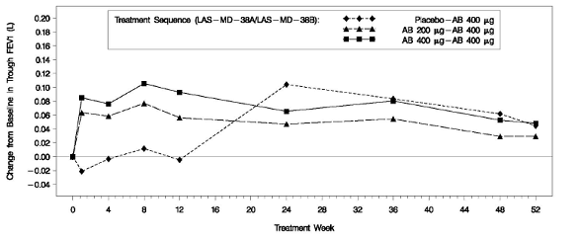
Figure 19. Change from baseline in morning dose (trough) FEV1 by Visit over 52 weeks. Least squares mean ITT Population.
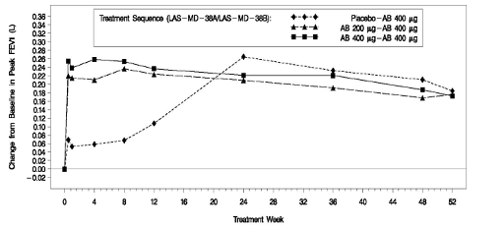
For change FEV1 normalized AUC_{(0-3h)}, trough FVC, peak FVC, and FVC normalized AUC_{(0-3h)} , the improvement from baseline was generally sustained with long term continued treatment with aclidinium bromide 400 µg BD. The changes from baseline in the placebo-aclidinium bromide 400 µg sequence became consistent with the other treatment sequences once active treatment was initiated (LOCF and OC).
Improvement from baseline in SGRQ total scores was observed at all visits (LOCF and OC). At Week 52, the adjusted mean change from baseline in SGRQ total score (LOCF) was clinically meaningful (-8.25, -6.19 and -6.82, respectively in the placebo - aclidinium bromide 400 µg, 200 µg – 400 µg and 400 µg – 400 µg treatment sequences, respectively) with 59.8%, 53.7%, and 56.3% of patients, respectively, achieving at least a 4-point reduction from baseline in SGRQ total score. For both EQ-5D parameters (Weighted State Health Index and VAS), there were similar numerical increases from baseline at all visits up to Week 52 among the treatment sequences. Improvement relative to baseline in TDI focal score (improvement ≥ 1 unit in the focal score) was sustained over time in all 3 treatment sequences and the percentage of patients who achieved a clinically meaningful difference in TDI was 46.3%, 44.6%, and 45.5%, respectively. At baseline, the use of rescue medication (reported in mean puffs) was 4.14, 4.74 and 4.59 in the placebo - aclidinium bromide 400 µg, 200 µg – 400 µg and 400 µg – 400 µg treatment sequences, respectively. The mean total daily rescue medication usage overall was 2.8 puffs/day in all 3 treatment sequences, and was approximately 40% less than at the baseline in all treatment sequences.
Comments: The improvements in the primary and secondary endpoints (trough and peak FEV1) were generally maintained throughout Part B of the study, especially when the natural decline in long term lung function seen in other studies (LAS-MD-35 and LAS-MD-36) is taken into account. In line with improvements in lung function data and health-related quality-of-life, patients required numerically less rescue medication to control symptoms (2.8 puffs per day). There was a beneficial impact on quality of life recorded using the SGRQ total score Improvement relative to baseline in TDI focal score and the percentage of patients who achieved a clinically meaningful difference in TDI (improvement ≥ 1 unit in the focal score) was sustained over time in all 3 treatment sequences. The therapeutic benefit of aclidinium bromide observed during the 12 week double blind treatment period was generally sustained with long term continued treatment. The changes from baseline in the placebo-aclidinium bromide sequence became consistent with the other treatment sequences after the initiation of treatment with aclidinium bromide 400 µg in Part B.

Studies with once daily dosing
Prior to conduct of the clinical efficacy program of aclidinium bromide BD, a clinical program to investigate the efficacy of aclidinium bromide 200 µg once daily (QD) in patients with COPD was conducted and completed. An overview of the clinical studies designed to provide efficacy information on aclidinium bromide QD is provided in Table 25 (below).
Table 25. Overview of other studies which assessed efficacy of aclidinium bromide
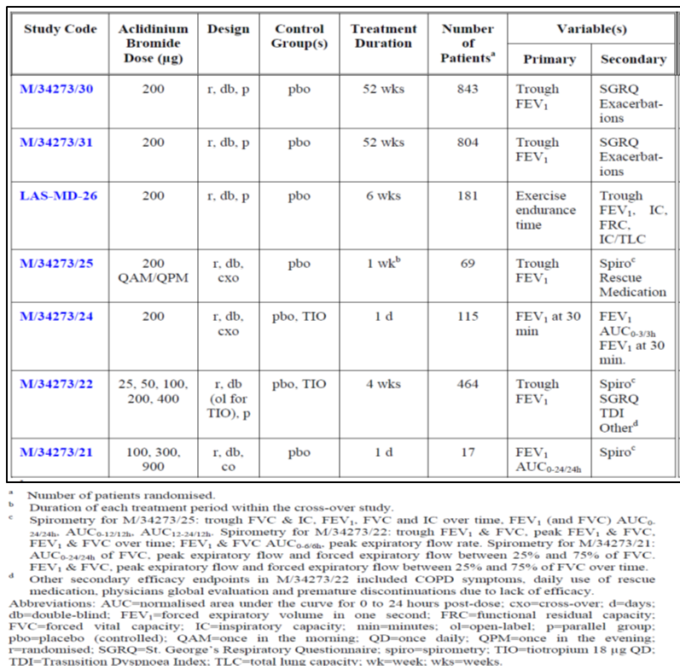
Studies M/34273/21 and M/34273/24 have not been discussed further as in Study M/34273/21, aclidinium bromide was administered via a different inhaler device to that used for all other efficacy studies and Study M/34273/24 only investigated the effects of aclidinium bromide 200 µg on lung function in the 3 h post-dose following single administration.

52 week placebo controlled studies: M34273/30 and M34273/31
The study design, objectives, inclusion/ exclusion criteria, efficacy endpoints and statistical considerations/ sample size were similar for the two 52 week studies. Results of these studies have been discussed separately.

Study design, objectives, inclusion/ exclusion criteria:
Both M/34273/30 and M/34273/31 were Phase III, double blind, randomised, parallel-group, placebo controlled studies. Following a 2 week run-in period in which the stability of the patients’ COPD was confirmed, eligible patients were randomised, in a 3:1 ratio, to receive either aclidinium bromide (200 µg QD) or placebo for aclidinium bromide, for up to 52 weeks. A final follow-up assessment was performed 2 weeks after the last dose. The objectives of this study were to assess the long term bronchodilator efficacy of inhaled aclidinium bromide 200 µg QD, to assess the benefit of treatment in terms of exacerbation control and disease-specific health status (and additional outcomes) and to evaluate long term safety and tolerability. Study 30 was conducted from 10 August 2006 to 6 May 2008 at 139 centres in 16 countries across Europe. Study 31 was conducted during the same time period as study 30 but it was at 125 centres in the United States, Argentina, Australia, South Africa, Canada, New Zealand and Mexico. The inclusion/ exclusion criteria were similar to those already described for the pivotal Phase III studies for BD dosing of aclidinium bromide (see above).

Efficacy endpoints:
The primary efficacy endpoint was the trough FEV1 after 28 weeks of treatment. Secondary efficacy endpoints were: Percentage of patients who achieved a clinically significant improvement (≥ 4-units decrease) in SGRQ Total score at 52 weeks; Time to first moderate or severe COPD exacerbation. Additional efficacy endpoints included: Change from baseline by timepoint in trough and peak FEV1, FVC and IC; Percentage of patients who achieved a clinically significant improvement (≥ 4-units decrease) in SGRQ Total score by timepoint; percentage of patients who achieved a clinically significant improvement (≥ 1-unit increase) in TDI Focal score at Week 52; Change from baseline by timepoint in TDI Focal score and SGRQ Total score. The ease of use of the inhaler devices was assessed by the patients at the end of their participation in the study.

Statistical considerations and sample size
Analysis of the primary efficacy variable, the trough FEV1 at 12 weeks of treatment for the US filing and 28 weeks of treatment for the EU filing was analysed using an Analysis of Covariance (ANCOVA) model. A last observation carried forward (LOCF) approach was used for the imputation of missing data. Sex and treatment group were factors in the model along with baseline trough FEV1 and age as covariates. The treatment comparison between aclidinium bromide 200 µg and placebo was carried out by means of the contrasts on the treatment factor. The treatment effect was estimated by Least Square (LS) means and their standard error (SE) along with 95% confidence intervals (CI). The differences between treatments were estimated by differences between LS means and their SE and 95% CI. To confirm the robustness of the analysis, the analysis was repeated using the PP population and a sensitivity analysis was performed using a mixed model for repeated measures for which no data were imputed. There were two secondary efficacy variables defined in the study: the time to first moderate or severe COPD exacerbation after the first intake of IMP and the number (%) of patients who achieved at least a 4-unit reduction from baseline in SGRQ total score at 52 weeks of treatment. For the time to first moderate or severe COPD exacerbation, the 95% CI of the hazard ratio between treatment groups (aclidinium bromide 200 µg / placebo) and p-value were estimated using a Cox Proportional Hazards model. Kaplan-Meier probability curves for each treatment were also provided. The number of patients who achieved at least a 4-unit reduction from baseline in SGRQ total score at 52 weeks of treatment were dichotomised into success (reduction from baseline in SGRQ total score ≥4 units) and failure (reduction from baseline in SGRQ total score <4 units). LOCF was used to impute missing SGRQ total scores. Analysis was performed using a Logistic Regression model including treatment and sex as factors and age and baseline SGRQ total score as covariates in the model. Statistical significance was tested using the Wald test. The treatment comparison was performed by estimating the odds ratio (OR) corresponding to the treatment effect and its 95% CI.
It was estimated that a total sample size of 820 patients (615 patients in the aclidinium bromide 200 µg arm and 205 patients in the placebo arm, according to a 3:1 allocation ratio) would provide at least 90% power to detect as statistically significant a difference of 100 mL between aclidinium bromide 200 µg QD and placebo in trough FEV1 after 12 weeks of treatment for the US filing and 28 weeks of treatment for the EU filing. A 0.05 two-sided Type I error was set and a common standard deviation of 310 mL (based on the results from trial M/34273/22) was assumed. Taking into account a drop-out rate of 15% in the aclidinium bromide 200 µg arm and 50% in the placebo arm after 1 year of treatment, this sample size (820 randomised patients) allowed at least an 80% power to detect a difference of 100 mL between both treatments in trough FEV1 at all scheduled time points (assuming the Type I error and standard deviation mentioned above.

Results of study M/34273/30:

Participant flow, protocol violations/ deviations:
Overall, 843 patients were randomised to treatment (aclidinium 200 µg QD=627; placebo=216) and 84% completed treatment [aclidinium= 538 ([85.8%); placebo= 169 (78.2%)]. The most common reasons for premature discontinuation were the patient’s personal request (33.1%) and adverse events (27.2%), both similarly distributed between treatment groups. Overall, 48 patients exhibited one or more major protocol deviations, 34 (5.4%) treated with aclidinium bromide 200 µg and 14 (6.5%) treated with placebo; 17 patients had no acceptable baseline and/or post-baseline trough FEV1 values and so were excluded from the ITT population (and the PP population) and a further 31 patients had major deviations that led to their exclusion from the PP population The most common major protocol deviation was use of prohibited medications before baseline (11 patients).

Baseline data:
Majority of the patients were male (78-81%), Caucasian (>99%), with moderate COPD (55-63%). The mean age was 63 years, mean duration of COPD was 7.7 years and approximately 50% of patients had a moderate/ severe COPD exacerbation in the previous year. The treatment groups were well matched with regard to demographic and baseline characteristics; with the exception of a slightly lower proportion of patients with severe COPD (GOLD stage III) in the aclidinium bromide group compared to the placebo group (31.6% and 38.4%, respectively). Treatment compliance figures were beyond 100% for some patients due to the variability of the method used. At each assessment time point, compliance was similar in each treatment group and at least 96% of patients were ≥60% compliant.
Comments: In the pivotal Phase III BD dosing studies, patients were considered compliant to treatment if they showed at least 75% treatment compliance. It appears that assessment of treatment compliance was less conservative in the QD dosing studies (compliance at >60%).

Primary efficacy results:
After both 12 and 28 weeks of treatment, adjusted mean trough FEV1 values were higher for aclidinium bromide 200 µg than for placebo and the adjusted mean differences between treatment groups (0.061 L and 0.067 L, respectively) were statistically significant at both time points (p=0.0005 and p=0.0002, respectively) (Table 26). Results of the ANCOVA analysis for the PP Population were similar to those of the ITT population, confirming the robustness of the analyses; .the adjusted mean treatment difference from the ANCOVA model was 0.064 L (95% CI= 0.028 to 0.099 L; p=0.0004) at Week 12 and 0.070 L (95% CI=0.034 to 0.107 L; p=0.0001) at Week 28.
Table 26. Trough FEV1 (L) after 12 or 28 weeks of treatment. ANCOVA model treatment estimates. ITT population.
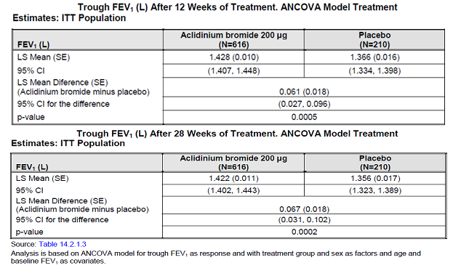

Secondary efficacy results:
A total of 48.1% of patients in the aclidinium bromide group and 39.5% of patients in the placebo group had a clinically significant improvement (that is, at least a 4-unit improvement) in SGRQ Total score at Week 52 . Compared to patients treated with placebo, patients treated with aclidinium bromide were 1.47 times more likely to achieve a clinically significant improvement in SGRQ Total score (p=0.025). No statistically significant difference between treatment groups in the time to first moderate or severe exacerbation was observed (Cox Proportional Hazards Analysis; HR=1.0; p=0.887). A total of 26.6% of patients in the aclidinium bromide group and 25.7% of patients in the placebo group experienced at least one moderate or severe exacerbation.

Additional efficacy results:
At all visits from Day 1 up to Week 52, adjusted mean treatment differences between aclidinium bromide and placebo in trough FEV1 ranged from 0.060 L to 0.067 L (p<0.005 for all comparisons), with the exception of Weeks 1 and 4 when the smallest differences were observed (0.044 L, p=0.002 and 0.037 L, p=0.021, respectively) (Figure 20).
Figure 20. LS mean changes from baseline in trough FEV1 by visit (LOCF). ITT population.
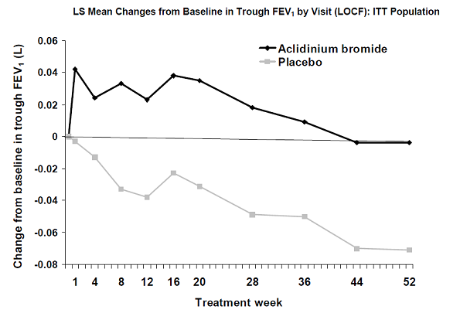
Adjusted mean treatment differences (aclidinium minus placebo) in peak FEV1 at all time-points up to Week 52 were greater than 0.145 L and statistically significant (p<0.0001). Adjusted mean treatment differences between aclidinium bromide and placebo in trough IC at visits up to Week 52 ranged from 0.058 L to 0.101 L (p<0.05 for all comparisons). Statistically significant differences between aclidinium bromide and placebo, in favour of aclidinium bromide, were observed also for trough and peak FVC and peak IC at all timepoints up to Week 52. The median time to onset of bronchodilation measured by FEV1 was 2 h (95% CI=2 to 3 h) for aclidinium bromide 200 µg and was not estimable for placebo. Time to onset of action measured by FEV1 was significantly faster with aclidinium bromide 200 µg than with placebo (HR=4.8; 95% CI=3.40, 6.81; p<0.0001). Median times to onset of action on the basis of FVC were not estimable but similarly to FEV1, time to onset of action was statistically significantly faster with aclidinium bromide 200 µg than with placebo (HR=5.0; 95% CI=3.35, 7.49; p<0.0001). Forty-one (41) patients participated in a Pulmonary function sub-study: 32 treated with aclidinium bromide 200 µg and 9 treated with placebo. There was an increase in mean normalised AUC_{(0-12 h)} FEV1 on each of Day 1, Week 12 and Week 52 after treatment with aclidinium bromide and a decrease following placebo treatment (Figure 21). Patients treated with aclidinium bromide showed significantly greater improvement in the SGRQ Total score (at Weeks 12 and 28, but not at Weeks 44 and 52) and in each of the SGRQ component scores (Table 27).
Figure 21. Changes from baseline in FEV1 over 12 h, Patients participating in 12 h pulmonary function sub study
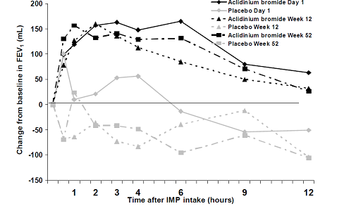
Table 27. Change from baseline in SGRQ scores over 52 weeks of treatment. ANCOVA model treatment comparisons. ITT population.
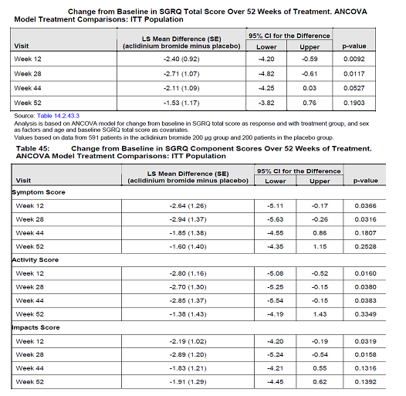
Table 27. Change from baseline in SGRQ scores over 52 weeks of treatment. ANCOVA model treatment comparisons. ITT population. Component scores.
A total of 56.4% of aclidinium bromide patients and 38.0% of placebo patients had a clinically significant improvement in dyspnoea (that is, at least a 1 unit increase in TDI) at Week 52 (p<0.0001). Compared to patients treated with placebo, patients treated with aclidinium bromide were 2.22 times more likely to achieve such an improvement (p<0.0001). Adjusted mean treatment differences (aclidinium minus placebo) in change from baseline in TDI Focal score ranged from 0.73 units at Week 44 to 1.22 units at Week 52 (p<0.01 at Weeks 12, 28, 44 and 52 in favour of aclidinium bromide; p-values from <0.0001 to 0.007). Mean daily usage of rescue medication at baseline was similar in the two treatment groups and it decreased during treatment in both groups with no significant differences between treatments at Week 12, Week 28 or Week 52. Over 52 weeks, the adjusted mean daily usage was 3.31 puffs/day in the aclidinium bromide 200 µg group and 3.23 puffs/day in the placebo group. Small improvements in symptom scores were seen in both treatment groups during the study with the biggest changes being observed for cough, but no statistically significant difference between groups. The majority of patients (513 of 599 [85.6%] in the aclidinium bromide group and 169 of 205 patients [82.4%] in the placebo group) rated the Almirall inhaler very easy or easy to use.

Results of Study M/34273/31:

Participant flow, protocol violations/ deviations:
Overall, 804 patients were randomised to treatment (aclidinium 200 µg QD=600; placebo=204) and 564 (70%) completed treatment [aclidinium= 446 ([74.3%); placebo= 118 (57.8%)]. The most common reasons for premature discontinuation in the aclidinium bromide 200 µg group were the patient’s personal request (26.0%) and lack of efficacy (22.1%), while in the placebo group, 41.9% of withdrawals were due to lack of efficacy and 19.8% to the patient’s personal request. Sixty-six patients exhibited one or more major protocol deviations, 47 (7.8%) treated with aclidinium bromide 200 µg and 19 (9.3%) treated with placebo; 9 patients had no acceptable baseline and/or post-baseline trough FEV1 values and so were excluded from the ITT population (and the PP population) and a further 57 patients had major protocol deviations that led to their exclusion from the PP population. The most common major protocol deviations were use of systemic antiallergic drugs during the study (19 patients) and use of prohibited bronchodilators before baseline measurements (13 patients).

Baseline data:
Majority of the patients were male (61-64%), Caucasian (92%), with moderate COPD (55-63%) with mean age of 65 years, mean duration of COPD of 7.4years and only 31% of patients had a moderate/ severe COPD exacerbation in the previous year. The treatment groups were well matched with regard to demographic and baseline characteristics. Mean pulmonary function test results at baseline were slightly higher in the aclidinium bromide 200 µg group than in the placebo group. At each assessment time point, compliance was similar in each treatment group and at least 95% of patients were ≥60% compliant.

Primary efficacy results:
After both 12 and 28 weeks of treatment adjusted mean trough FEV1 values were higher for aclidinium bromide 200 µg than for placebo and the adjusted mean differences between treatment groups (0.063 L and 0.059 L, respectively) were statistically significant at both time points (p<0.0001 and p=0.0002, respectively). Results of the ANCOVA analysis for the PP Population were similar to those of the ITT population confirming the robustness of the analyses; the adjusted mean treatment difference from the ANCOVA model was 0.066 L (95% CI= 0.038 to 0.094L; p<0.0001) at Week 12 and 0.062 L (95% CI=0.031 to 0.094 L; p=0.0001) at Week 28.

Secondary efficacy results:
For the ITT population, 197 patients (33.2%) in the aclidinium bromide 200 µg group and 80 patients (39.8%) in the placebo group experienced a moderate or severe exacerbation. The median time to first moderate or severe COPD exacerbation could not be estimated for either group since fewer than 50% of the population had experienced a moderate or severe exacerbation. Analysis using a Cox’s Proportional Hazard model showed that there was a statistically significant difference between treatment groups in the time to first moderate or severe exacerbation in favour of aclidinium bromide 200 µg with a 30% reduction in the risk of experiencing a moderate or severe exacerbation at any time in the study compared with placebo (HR=0.7; 95% CI=0.55 to 0.92; p=0.0100). In total, 224 patients (39.0%) in the aclidinium bromide 200 µg group and 64 patients (32.8%) in the placebo group achieved at least a 4-unit decrease in SGRQ total score after 52 weeks. Although patients in the aclidinium bromide 200 µg group were 1.38 times more likely to achieve a clinically meaningful improvement in SGRQ total score than patients in the placebo group, this difference failed to reach statistical significance (OR=1.375; p=0.0737).

Additional efficacy results:
The adjusted mean changes from baseline ranged from an increase of 0.092 L at Day 2 to an increase of 0.007 L at Week 44 in the aclidinium bromide 200 µg group and ranged from an increase of 0.014 L at Day 2 to a decrease of 0.048 L at Weeks 44 and 52 in the placebo group. The adjusted mean differences between treatments were statistically significant at all time points (p-values ranging from 0.0011 to <0.0001) (Figure 22). Adjusted mean changes from baseline ranged from increases of 0.236 L at Day 1 to 0.175 L at Week 44 in the aclidinium bromide 200 µg group and from smaller increases of 0.083 L at Day 1 to 0.034 L at Weeks 44 and 52 in the placebo group. The adjusted mean differences between treatments were statistically significant at all time points (p<0.0001).
Figure 22. LS mean change from baseline in trough FEV1 by Visit (LOCF). ITT population
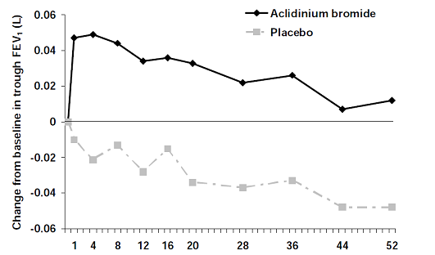
Onset of bronchodilator action was defined as a 15% increase from baseline in FEV1 or FVC on the first day after IMP administration. The median time to onset of bronchodilation measured by FEV1 was 1 h (95% CI=1 to 2 h) for aclidinium bromide 200 µg and was not estimable for placebo. Time to onset of action measured by FEV1 was significantly faster with aclidinium bromide 200 µg than with placebo (HR=7.6; 95% CI=5.15, 11.27 p<0.0001). Similar results were seen for FVC. The median time to onset of bronchodilation was 2 h (95% CI=1 to 2 h) for aclidinium bromide 200 µg and was not estimable for placebo and time to onset of action measured by FVC was statistically significantly faster with aclidinium.
Overall, 101 patients participated in the pulmonary function sub-study, 73 treated with aclidinium bromide 200 µg and 28 treated with placebo. Mean baseline FEV1 values for patients treated with placebo (1.122 L) were slightly lower than aclidinium bromide 200 µg (1.194 L). Mean changes from baseline over 12 h were generally greater on Day 1, than at Week 52 for each treatment group. In the aclidinium bromide 200 µg group, maximum bronchodilation was achieved 2 to 4 h after dosing (maximum mean change from baseline in FEV1 was 0.208 L at 4 h on Day 1, 0.174 L at 2 h at Week 12 and 0.151 L at 3 h at Week 52) and the minimum mean change was observed at 12 h after dosing (0.109 L at Day 1, 0.074 L at Week 12 and 0.065 L at Week 52) (Figure 23).
Figure 23. Changes from baseline in FEV1 over 12 h. Patient participating in 12 h pulmonary function substudy.
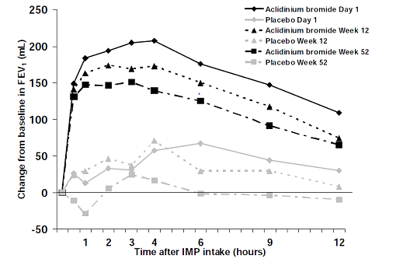
Patients treated with aclidinium bromide showed significantly greater improvement in the SGRQ Total score (at Weeks 12 and 28, but not at weeks 44 and 52) and each of the SGRQ component scores. Statistically significant mean improvements in dyspnoea, as measured by the TDI, were observed for aclidinium bromide 200 µg compared with placebo at Weeks 12, 28 and 44 but not at Week 52. Mean differences between the two treatments were clinically meaningful (difference >1 unit) at Week 28 and Week 44. Some statistically significant differences between treatments in favour of aclidinium bromide 200 µg were seen for rescue medication use and patient-recorded daily symptom scores for breathlessness, cough, sputum production or wheezing but no clear pattern was apparent. The majority of patients (506 of 550 patients assessed [92.0%] in the aclidinium bromide 200 µg group and 152 patients of 181 patients assessed [84.0%] in the placebo group) rated the inhaler very easy or easy to use.

Study M34273/22
A Phase IIb dose-finding study (M/34273/22) in patients with moderate to severe COPD, conducted to select the optimum dose for Phase III development, tested 5 doses of aclidinium bromide in the via the Novolizer® multidose dry powder inhaler (MDPI) Almirall inhaler (25, 50, 100, 200 and 400 µg) and matching placebo, administered once daily for 4 weeks. An open-label arm of commercial tiotropium 18 μg given via the Handihaler® was also included in this study. A total of 464 patients were randomized in 7 European countries, and 441 patients completed the 28-day treatment of the study. The primary efficacy endpoint was the trough FEV1 after 28 days of treatment. Secondary endpoints included: Trough FVC after 28 days IMP administration and Change from baseline in peak FEV1 and peak FVC (the highest FEV1 or FVC observed in the 6-h time period following the first and last dose). Demographic and baseline characteristics were comparable across treatment groups.
Adjusted mean trough FEV1 values after 28 days of treatment were statistically significantly higher in the aclidinium bromide 200 µg, 400 µg and tiotropium groups compared with placebo (Table 28) with similar observations for adjusted mean trough FVC (Table 29).
Table 28. Adjusted mean trough FEV1 difference with placebo at Visits 1-4 Imputaiton on ITT populaiton
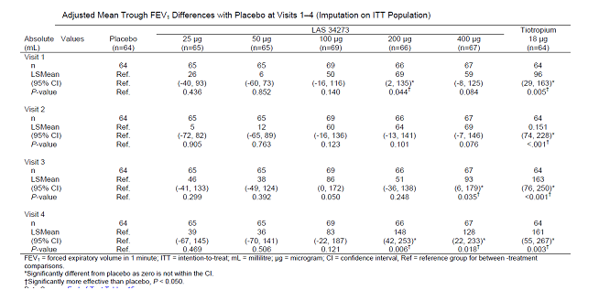
Table 29. Trough FVC and treatment comparisons at Visits 1-4 (ITT population).
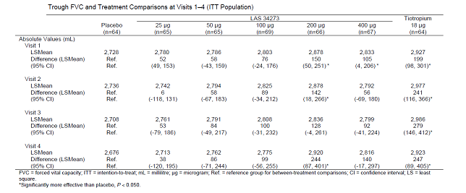
During the 0–6 h serial spirometric tests, adjusted mean treatment differences between aclidinium bromide 100, 200 or 400 µg or tiotropium and placebo in changes from baseline in peak FEV1 were 0.103, 0.148, 0.123 and 0.104 L, respectively, on the first day of dosing (p<0.05 for all comparisons) and 0.129, 0.202, 0.204 and 0.215 L, respectively, on the last day of dosing (p<0.05 for all comparisons) (Figure 24) with similar results for FVC.
Figure 24. FEV1 LS mean changes (LS) from baseline after the first (Visit 1; top) an last dose (Visit 4; bottom)
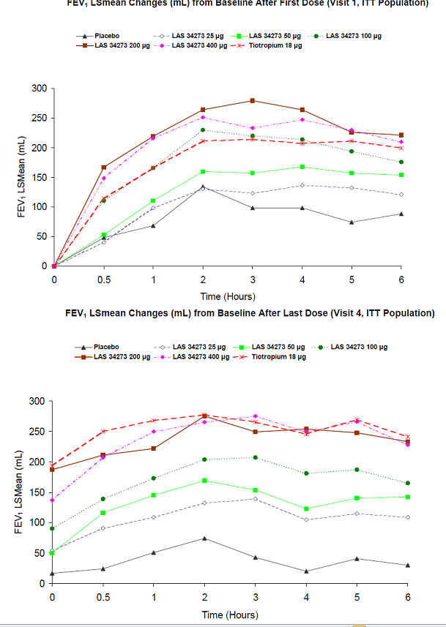
In general, peak bronchodilatory effects (as assessed by FEV1 and FVC) on the first and last days of dosing were higher for aclidinium bromide 200 µg than for aclidinium bromide 400 µg and comparable for aclidinium bromide 200 µg and tiotropium. During the 0–6 h serial spirometric tests (mean FEV1, peak FEV1, mean FVC, peak FVC) after the first and last dose, there was a clear dose response increase observed in both FEV1 and FVC, with the maximal effect achieved after aclidinium bromide, 200 µg with no incremental efficacy provided with 400 µg; thus confirming 200 µg as the dose of aclidinium bromide with the best efficacy profile. The minimally effective dose of aclidinium bromide was shown to be 100 µg once daily. The bronchodilatory effects of aclidinium bromide (peak and trough FEV1 and FVC) were maintained over the 4 week treatment period, indicating an absence of tachyphylaxis over 4 weeks of treatment.
Comments: The relatively low bronchodilator efficacy attained with aclidinium bromide 200 µg QD in pivotal QD studies, M/34273/30 and M/34273/31, compared to that achieved with aclidinium bromide 200 µg QD in this study, provoked a review of per-patient FEV1 data from this study. (Note that the pivotal studies used centralized spirometry and had quality control processes in place to detect outliers but no such processes were in place for M/34273/22). It was noted that trough FEV1 values reported at Day 28 for one patient in the 200 µg aclidinium bromide group were markedly higher than the trough FEV1 values reported for other patients in the study (absolute change from baseline to Day 28 in trough FEV1 was 4.09 L for the outlier whereas the range of values for all other study patients was between -0.65 and 1.55 L). [information redacted].

Study M34273/ 25
This was a Phase II, randomised, double blind, double-dummy, 3-period cross-over, placebo controlled study in 69 adult patients with stable moderate/ severe COPD. It was conducted from 20 Nov, 2007 to 13 March, 2008 at 10 centres in Germany and Poland. The overall objectives of study were to assess whether the time of dosing (morning [am] or evening [pm]) at steady state influences the bronchodilator response to inhaled aclidinium bromide compared with placebo and to evaluate safety and tolerability. The study consisted of 3 periods of 7 treatment days each separated by a washout period of 7 (± 2) days. Following a 7 (± 2) day run-in period, during which the stability of the patients’ COPD was confirmed, eligible patients were randomised, in a ratio of 1:1:1:1:1:1 to one of six treatment sequences. During each treatment period, patients received one of 3 treatments according to the randomisation scheme: either, aclidinium bromide 200 µg am and placebo pm or placebo am and aclidinium bromide 200 µg pm or placebo am and pm. A final follow-up contact was performed 4-6 days after the last dose. The primary efficacy endpoint was the change from baseline in trough FEV1 after 6 days of treatment. Secondary efficacy endpoints included: Change from baseline in the trough FVC after 6 days of treatment; Change from baseline in FEV1 and FVC at all timepoints after 7 days of treatment with the am regimen and after 6 to 7 days of treatment with the pm regimen.; Change from baseline in normalised FEV1 and FVC area under the curve in the 12 h after morning dosing (AUC0-12/12h) and in the 12 h after evening dosing (AUC_{12-24/12h}) after 7 days of treatment.
Of 69 randomised patients, 67 patients (97.1%) completed the study. The adjusted mean trough FEV1 increased from baseline for both aclidinium bromide 200 µg a.m. and 200 µg pm after 6 days of treatment (adjusted mean changes from baseline in trough FEV1 were 0.048 and 0.020 L, respectively). Although, there was a trend for a treatment difference between each of the aclidinium bromide treatments and placebo, favouring the active treatments, these differences were not statistically significant. Similarly, no statistically significant difference was observed between aclidinium bromide 200 µg given in the morning and evening. Similar results were observed for change from baseline in trough FVC and trough IC.
Statistically significant differences in adjusted mean changes in FEV1 were seen between aclidinium bromide 200 µg and placebo for timepoints up to 12-15 h after dosing whether the dose was administered in the morning or the evening. Some statistically significant differences were also observed between am and pm dosing with aclidinium bromide 200 µg; these were in favour of am dosing at 12:00, 15:00, 18:00 and 21:00 on Day 7 and in favour of pm dosing at 06:00 on Day 8 (Figure 25).
Figure 25. Change from baseline in FEV1 (L). LS mean across time by treatment at Day 7/8. ITT population.
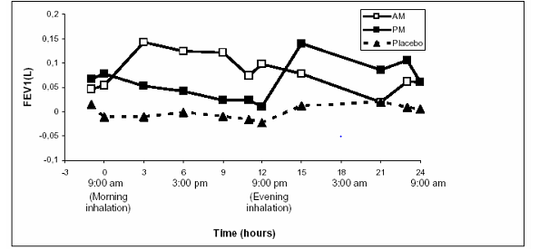
Statistically significant differences in adjusted mean changes in FVC were seen between aclidinium bromide 200 µg am and placebo at 12:00, 15:00, 18:00 and 21:00 on Day 7 and between aclidinium bromide 200 µg pm and placebo at 00:00 (midnight) on Day 8. Statistically significant differences were also observed between am and pm dosing with aclidinium bromide 200 µg; these were observed at 12:00, 15:00, 18:00, and 21:00 on Day 7 and were in favour of am dosing (Figure 26).
Figure 26. Change from baseline in FVC. LS mean across time by treatment at Day 7/8. ITT population.
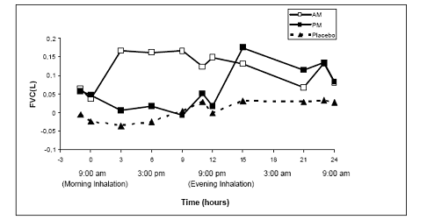
After treatment, there were adjusted mean increases from baseline in normalised AUC0-24 FEV1; the adjusted mean treatment difference compared with placebo was 0.085 L (p<0.0001) and 0.071 L (p=0.0003) for aclidinium bromide 200 µg am and 200 µg p.m., respectively. No statistically significant difference was observed between aclidinium bromide 200 µg am and pm. Similar changes were seen for normalised AUC_{0-24h} FVC.
Baseline normalised AUC₀₋₁₂ FEV1 values were higher for am treatment regimens than for pm regimens due to circadian rhythm, but values for aclidinium bromide 200 µg and placebo were similar for each regimen. After treatment, there were adjusted mean increases from baseline in normalised AUC₀₋₁₂ of FEV1 for aclidinium bromide 200 µg am and aclidinium bromide 200 µg pm and a slight change was observed with placebo. The adjusted mean treatment difference in normalised AUC₀₋₁₂ FEV1 for aclidinium bromide 200 µg am compared with placebo am was 0.121 L (p<0.0001) and the adjusted mean treatment difference for aclidinium bromide 200 µg pm compared with placebo pm was 0.093 L (p<0.0001). Similar results were observed for normalised AUC₀₋₁₂ FVC values. For normalised AUC (12-24h) FEV1, the adjusted mean treatment difference for aclidinium bromide 200 µg am compared with placebo am was 0.048 L (p=0.0138) and the adjusted mean treatment difference for aclidinium bromide 200 µg pm compared with placebo pm was 0.053 L (p=0.0076) with similar changes observed for normalised AUC (12-24h) FVC.
Comments: No clinically important bronchodilation was observed after 6 to 7 days of treatment with once daily dosing with either aclidinium bromide 200 µg am or aclidinium bromide 200 µg pm at the end of the dosing interval. The limited bronchodilatory effect during the night following once daily dosing with 200 µg am coupled with the known increase in nocturnal cholinergic tone may affect patients’ nighttime/early-morning symptom control. Nevertheless, the sponsor considered it unlikely that an increase in aclidinium bromide dose to 400 µg QD would provide clinically relevant night time bronchodilation, given the negligible night time bronchodilation known to be associated with the 200 µg dose QD, and the relatively small increase in pre-dose (trough) FEV1 (approximately 40 mL) between the 200 and 400 µg doses observed in the post hoc analysis of Study M/34273/22. The sponsors further state that it was considered likely that the increase in QD aclidinium bromide dose required to achieve night time bronchodilation could be of a magnitude to compromise the safety profile and that a BD dosing regimen may be the better option. The above statement does not seem justified considering the fact that the sponsors have not conducted any study to compare QD versus BD dosing with the 2 doses of aclidinium bromide (200 µg and 400 µg). Would not a dose of 400 µg QD be likely to have less safety concerns than BD dosing of the same dose? Could the sponsors please clarify what they mean by the above statement in the CSR (Module 5).
Overall, data from this study provided some preliminary evidence to suggest that a BD dosing regimen may provide improved 24-h bronchodilation. However, interpretation from this study was limited due to its crossover design. The sponsors have not conducted a large, randomised, parallel group study to directly compare the QD versus BD dosing regimen of aclidinium bromide.

LAS-MD- 26- effect on exercise tolerance

Study design, objectives:
LAS-MD-26 was a Phase III, randomised, double blind, placebo controlled, parallel-group study to examine the effect of inhaled aclidinium bromide 200 µg QD on exercise endurance and on reducing resting and dynamic lung hyperinflation, and to evaluate safety and tolerability in 181 patients with stable moderate/ severe COPD. This study was conducted from 27 July 2006 to 18 December 2008 at 52 centres in the United States and Canada. Following a 2 week run-in period in which the stability of the patients’ COPD was confirmed and patients were familiarised with testing procedures, eligible patients were randomised, in a 1:1 ratio, to receive either aclidinium bromide 200 µg or matching placebo QD for up to 6 weeks. A final follow-up contact was performed one week after the last dose.

Efficacy endpoints, statistical considerations:
The primary efficacy endpoint of this study was the change from baseline to Week 6 in Endurane Time (ET). ET was defined as the time from the increase in work rate at 75% Wmax to the point of symptom limitation (Wmax is the highest work rate the patients are able to maintain for at least 30 seconds). Secondary efficacy endpoints were: Change from baseline to Week 6 in trough FEV1, IC, FRC and IC/TLC. Additional efficacy endpoints included: Change from baseline in ET at Day 1 and at Week 3; Dyspnoea evaluation measured by the TDI at Weeks 3 and 6; Changes from baseline in IC and dyspnoea (Borg Scale) at rest (that is, pre-exercise), isotime (that is, minimum ET among constant work-rate test at 75% Wmax) and peak (that is, end of exercise) on Day 1 and at Weeks 3 and 6.
A total sample size of 266 patients (133 patients per treatment arm) was planned to provide at least 80% power to detect a statistically significant difference of 100 seconds (sec) between aclidinium bromide 200 µg and placebo in the change from baseline in ET after 6 weeks of treatment assuming a 0.05 two-sided Type I error with common SD of 290 sec. Assuming a 10% drop-out rate, 296 patients (148 patients per treatment arm) were planned to be randomized. Due to early termination of the study, the final sample size was 181; this sample size provided at least 57% power to detect a statistically significant difference of 100 secs between aclidinium bromide 200 µg and placebo in the change from baseline in ET after 6 weeks of treatment.

Participant flow, baseline data:
The majority of patients were male (58%), Caucasian (97%) with mean age of 65years. The treatment groups were well matched with regard to demographic and baseline characteristics with the exception of a higher proportion of patients who had severe COPD (GOLD stage III) and who were current smokers in the aclidinium bromide group compared to the placebo group (58.1% versus 41.9% and 44.2% versus 32.6%, respectively).

Primary efficacy results:
The mean ETs at baseline were 414.1 seconds and 425.8 seconds in the aclidinium bromide and placebo treatment groups, respectively. Compared with placebo, the adjusted mean change from baseline in ET after 6 weeks treatment with aclidinium bromide increased by 116.4 seconds (1 minute and 56 seconds) (p=0.004).

Secondary efficacy results:
Statistically significant improvements in the change from baseline to Week 6 in trough FEV1, IC and IC/TLC were observed with aclidinium bromide treatment compared to placebo, with mean treatment differences of 0.101 L (p<0.0001), 0.102 L (p=0.014), and 0.017 (p=0.037) respectively, indicating an improvement in resting lung function. Although a reduction in FRC was observed in aclidinium bromide-treated patients, compared to placebo treated patients, this was not statistically significant (-0.062 L; p=0.446).

Additional efficacy results:
A statistically significant treatment difference in the change from baseline in ET in favour of aclidinium bromide was observed at both Day 1 (143.0 seconds, p<0.001) and Week 3 (126.0 seconds, p<0.001) (Figure 27).
Figure 27. Change from baseline in Endurance time ITT population
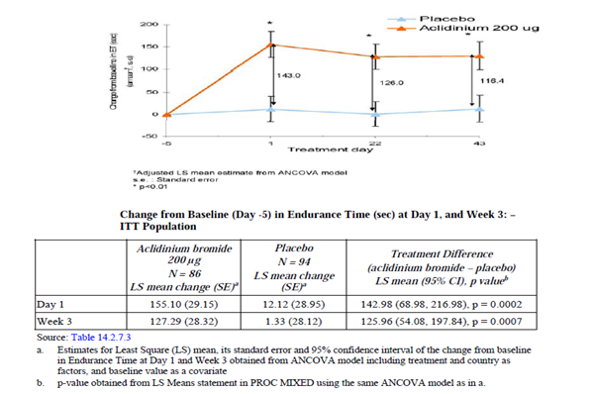
Treatment with aclidinium bromide 200 µg led to an improvement in resting lung function. Aclidinium bromide significantly improved IC measured at rest (that is, pre-exercise), isotime and peak at Day 1 and Week 3, suggesting a beneficial effect on dynamic hyperinflation. However, improvements in dynamic hyperinflation were no longer statistically significant at Week 6. The reasons for this are not clear since the beneficial effects of aclidinium on resting lung function measured through centralised spirometry and breathing pattern during exercise were maintained through Week 6. At least in part, the loss of statistical significance at Week 6 is due to an increased placebo effect at this timepoint (and also to a lower response to aclidinium bromide) compared to those observed at preceding timepoints. Treatment with aclidinium bromide 200 µg led to an improvement in exertional dyspnea at isotime, with a statistically significant decrease compared to placebo of more than an adjusted mean of 1 Borg unit on Day 1 and Week 3 and of 0.704 Borg unit after 6 weeks of treatment (p = 0.0129). Similar improvements were observed in leg discomfort at isotime, with statistically significant reduction in leg discomfort of an adjusted mean of -0.853 Borg unit at isotime on Day 1 (p = 0.0015) and 0.603 (p =0.0215) at Week 3, but not at Week 6. No differences between aclidinium bromide 200 µg and placebo were observed at rest for exertional dyspnea or leg discomfort. At peak exercise, statistically significant differences were observed only for leg discomfort at Week 6 (LS mean = 0.636; p = 0.0157).
Comments: This study demonstrated that treatment with aclidinium bromide 200 µg once daily for six weeks in COPD patients with moderate-to-severe disease (as per GOLD 2006) led to a statistically significantly improvement in symptom-limited exercise endurance time during cycle ergometry at 75% of maximal work capacity by an adjusted mean of 116 sec. Treatment differences in endurance time between active and placebo treatments showed a rapid onset, maintained effect, with an adjusted mean value of 143 sec on Day 1. Aclidinium bromide 200 µg also provided clinically significant bronchodilation as measured by the trough FEV1 during the 6 week period (LS mean = 101 mL improvement) as well as an improvement in lung hyperinflation at rest, as shown by a statistically significant improvement in trough IC and a positive trend in FRC. In addition there were improvements in TDI, by an adjusted mean of 1.7 units versus placebo, indicating clinically relevant reductions in chronic activity-related dyspnea as well as on exercise-related dyspnea (LS mean = -0.7 Borg units at isotime versus placebo). Overall, this study provided some preliminary evidence to suggest beneficial effect of aclidinium bromide (200 µg QD) on exercise tolerance. It is noted that no such study has been conducted with the proposed dose of 400 µg BD.

Studies of the combination of aclidinium bromide and formoterol
A parallel clinical program investigating the fixed-dose combination of aclidinium bromide and formoterol is ongoing and three Phase IIb studies that included an aclidinium bromide monotherapy arm have been completed to date. As the results of these studies do not contribute significantly to the efficacy evaluation of proposed aclidinium bromide 400 µg BD, they are only discussed briefly below.
LAC-MD-27 was a multicenter, randomized, double blind, placebo controlled, balanced, incomplete-block crossover, dose-ranging Phase IIB clinical study to assess the efficacy and safety of 2 fixed-dose combinations (FDCs) of aclidinium bromide with formoterol fumarate (400/6 μg or 400/12 μg) compared with placebo, aclidinium bromide (400 µg), and formoterol fumarate (12 μg), all administered twice daily (BD) in 128 patients with stable, moderate to severe COPD. Study included four 14-day treatment periods and a 7- to 10-day washout period between each treatment period. All active treatment arms (FDC 400/12 μg, 400/6μg, formoterol 12 μg, aclidinium 400 µg) demonstrated clinically and statistically significant bronchodilation versus placebo on the primary endpoint FEV1 AUC0-12. Improvements in both FDC 400/12 μg and FDC 400/6 μg reached statistical significance versus formoterol but not versus aclidinium (FDC 400/6 μg only). Similar trends were observed in both secondary (change from baseline to day 14 in morning pre-dose FEV1 and in peak FEV1) and additional efficacy parameters (COPD symptom scores and use of rescue medication) with both FDCs having clinical and statistically significant improvements versus formoterol and aclidinium (in most instances).
M273fo23 was a Phase IIb, double blind, randomised, 6 arm parallel-group, placebo controlled, dose-finding study. to assess the efficacy and safety of three combinations of aclidinium bromide 200 µg with formoterol (6, 12 or 18 μg) compared to placebo, monotherapy treatment formoterol 12 μg and monotherapy treatment aclidinium bromide 200 µg in 566 patients with moderate to severe COPD; another objective was to determine the optimal formoterol dose combined with aclidinium bromide 200 µg to be investigated in subsequent clinical trials. Patients were randomised to 4 weeks treatment with once daily treatment with aclidinium bromide 200 µg + formoterol 6, 12 or 18 μg; aclidinium bromide 200 µg only; formoterol 12 μg only or placebo, the trial randomisation ratio was 2:2:2 (the 3 fixed dose combination [FDC] arms):1:1:1 (the aclidinium bromide alone, formoterol alone and placebo arms). The primary treatment comparison showed that all three FDC groups were statistically significantly superior to placebo (p<0.0001), with mean treatment differences (active – placebo) in normalised FEV1 AUC(0-12 h)of 0.206 L in the FDC 6μg group, 0.254 L in the FDC 12 μg group and 0.265 L in the FDC 18 μg group. All fixed dose combinations were statistically significantly superior to both monotherapies (p<0.001) except for the comparison FDC 6 μg and formoterol 12 μg. These results were similar when considering normalised FEV1 AUC at (0-3 h), (0-6 h), (0-24 h) and (12-24 h) as well as trough and peak FEV1. There was a small improvement in COPD symptom scores (mainly breathlessness and cough scores) and reduction in use of rescue medication after 4 weeks in all treatment groups, including placebo with no difference was observed between any of the treatment groups.
LAC-MD-26 was a multicenter, randomized, double blind, placebo controlled, 4-period, balanced incomplete cross-over, 14-day treatment periods, placebo controlled, dose-finding, Phase IIb clinical study designed to assess the efficacy and safety of 2 doses of aclidinium/ formoterol fixed dose combination (FDC) (FDC 200/12 μg and FDC 200/6 μg) compared to aclidinium monotherapy 200 µg, formoterol monotherapy 12 μg or placebo, all administered BD via Genuair inhaler, in 135 patients with moderate to severe COPD. Both FDC doses and both monotherapies were significantly superior (p < 0.0001) to placebo at Day 14 with improvements in normalised FEV1 AUC_{(0-12 h)}. FDC 200/12 μg was significantly superior to formoterol monotherapy 12 μg but not versus aclidinium monotherapy 200 µg. However, FDC 200/6 μg was significantly superior to both aclidinium monotherapy 200 µg and formoterol monotherapy 12 μg.

Results from ongoing studies M/34273/39 and M34273/40

Study M34273/39

Study design:
This was a Phase IIIb, 6 week prospective, randomised, double blind, double-dummy, placebo and active comparator controlled, parallel multicentre clinical study. The main objectives were to evaluate (i) the 24-h bronchodilatory efficacy of inhaled aclidinium bromide 400 μg twice daily (BD) versus placebo in moderate to severe COPD patients; (ii) the night time bronchodilation of inhaled aclidinium bromide 400 μg BD versus tiotropium bromide in moderate to severe COPD patients, (iii) the safety and tolerability of inhaled aclidinium bromide 400 μg BD in the same target population. This study was conducted at 49 enrolling sites. A total of 41 sites randomised patients: 3 sites in the Czech Republic, 20 sites in Germany, 5 sites in Hungary and 13 sites in Poland.

Inclusion/ exclusion criteria:
The main inclusion criteria were adult male and female patients aged ≥40 years with stable moderate to severe COPD (as defined by the GOLD guidelines); Post-salbutamol FEV1 ≥30% and <80% of predicted normal value and FEV1/forced vital capacity (FVC) <70%; Current or ex-smokers of ≥10 pack-years. The main exclusion criteria were: Patients with history or current diagnosis of asthma; signs of respiratory tract infection or COPD exacerbation within 6 weeks prior to the Screening Visit, any evidence of clinically significant respiratory and/or CV conditions or laboratory abnormalities or any conditions which are contraindicated to use of anticholinergic drugs such as known symptomatic prostatic hypertrophy, bladder neck obstruction or narrow-angle glaucoma. Patients previously included in prior studies with aclidinium bromide (administered as monotherapy or in combination) were allowed to be included in this study.

Study treatments:
Patients fulfilling inclusion/exclusion criteria at the time of the Screening Visit were entered into a run-in period of 14 to 21 days to assess disease stability and during this period, patients recorded their COPD symptoms daily. Patients who still met entry criteria at Visit 1 were assigned to one of the 3 treatment arms all given by oral inhalation: aclidinium bromide 400 μg BD (by Genuair® multidose dry powder inhaler) tiotropium bromide 18 μg once daily (by Handihaler single dose dry powder inhaler) or placebo according to a 2:2:1 randomisation ratio. During the 6 week double blind treatment period, patients visited the site to assess clinical efficacy and safety on two occasions (Day 1 [Visit 1] and Day 42 [Visit 2]). A phone contact was performed after 3 weeks of treatment and a follow-up contact was performed 2 weeks after treatment completion to monitor the safety of the patients. All patients received twice daily dosing in the morning (09:00 ± 1h) and in the evening (21:00 ± 1h).

Efficacy endpoints and statistical analysis:
The primary efficacy variable was change from baseline in normalised FEV1 area under the curve over the 24-h period immediately after morning administration of study treatment (AUC₀₋₂₄) after 6 weeks of treatment. Secondary efficacy variable was change from baseline in normalised FEV1 area under the curve over the 12-h night time period (AUC ₁₂₋₂₄) after 6 weeks of treatment. Additional efficacy variables were Pulmonary function (FEV1 and FVC) at Day 1 and after 6 weeks of treatment; use of relief medication and any change in the percentage of relief medication-free days; Daily COPD symptoms and any change in the percentage of days without daily COPD symptoms; Percentage of patients who preferred one of the 2 devices and percentage of patients who were willing to continue on each device. The analysis of the primary and secondary efficacy variables were performed using the ITT population. In addition, the primary and secondary efficacy variables were also analysed using the PP population to assess the robustness of the findings from the ITT population. Efficacy variables, except for time to peak FEV1 and percentage of patients preferring each device and willing to continue to use them, were analysed by means of ANCOVA with treatment and sex as factors and corresponding baseline and age as covariates. All between-group comparisons were tested using the appropriate contrast in the ANCOVA model. Between-groups least squares (LS) means (adjusted means) and 95% confidence intervals (CI) were given for all pairwise comparisons. Time to peak FEV1 was analysed descriptively. The percentage of patients preferring each device was described and the percentage of patients preferring Genuair® was compared to 50% using an exact binomial test. The mean difference in scores corresponding to “willingness to continue” for the two devices was tested to be different from zero using a t-test. A sensitivity analysis for the primary and secondary efficacy variables was also carried out by using a mixed model for repeated measures. The primary comparison for AUC₀₋₂₄ was between aclidinium bromide 400 μg BD and placebo. Other treatment comparisons (tiotropium bromide 18 μg QD versus placebo and aclidinium bromide 400 μg BD versus tiotropium bromide 18 μg QD) were considered additional. For AUC₁₂₋₂₄, a hierarchical testing approach was carried out and no control for multiplicity was implemented.
A sample size of 385 COPD patients (77 and 154 patients in the placebo and each of the active treatment groups, respectively) would have provided at least a 99% power to detect a difference of 130 mL in change from baseline in normalised FEV1 AUC ₀₋₂₄ after 6 weeks of treatment between the aclidinium bromide 400 μg and placebo groups with a 0.05 two-sided significance level and assuming a common standard deviation (SD) of 210 mL. Taking into account a 5% dropout rate, it was planned to randomise a total of 405 patients (162 to aclidinium bromide 400 μg, 162 to tiotropium bromide 18 μg and 81 to placebo). Similarly, with this sample size, there would have been 99% power to detect a difference between aclidinium bromide 400 μg BD and placebo for the change from baseline in normalised FEV1 AUC₁₂₋₂₄ after 6 weeks of treatment equal to 130 mL (assumed SD = 210 mL). There would have been 83% power to detect a difference between aclidinium bromide 400 μg BD and tiotropium bromide in the change from baseline in normalised FEV1 AUC₁₂₋₂₄ after 6 weeks of treatment equal to 70 mL assuming a common SD of 210 mL. Assumptions about the SD of AUC ₀₋₂₄ and AUC₁₂₋₂₄ were obtained from prior studies with aclidinium bromide.

Patient disposition:
A total of 485 patients were screened, of whom 414 patients were assessed as eligible and were randomised into the study. Overall, 400 (96.6%) of the randomised patients completed the study. A total of 14 (3.4%) patients were discontinued from the study, mainly due to AEs (10 [2.4%] patients overall: 4 in the placebo group and 3 in each active treatment group).

Major protocol violations:
A total of 23 patients were excluded from the PP population (9 patients each in the aclidinium bromide and tiotropium bromide groups and 5 patients in the placebo group). The most frequent reason for exclusion from the PP population was lack of treatment compliance (treatment compliance <80% according to the e-diary at the last visit on treatment). All 414 patients were included in the ITT population and 391 were included in the PP population.

Baseline data:
Overall, the treatment groups were similar with respect to demographic and baseline characteristics, with the exception of a higher percentage of male patients in the aclidinium bromide (66.7%) and tiotropium bromide (73.4%) groups compared with placebo group (56.5%). The mean baseline FEV1 value at Visit 1 was slightly numerically higher in the tiotropium bromide group (1.543 L) compared to the aclidinium bromide (1.462 L) and placebo (1.422 L) groups, however the mean baseline percentages of predicted FEV1, which account for differences related to gender, were similar across the treatment groups (50.3% to 51.8%).
The use of medication for COPD prior to the study was reported for 86.7% of patients overall and the most commonly used (in ≥20% of patients overall) prior medications for COPD were SABAs (62.1%), LABAs (35.7%), LABA + ICS fixed dose combinations (26.3%), LAMAs (25.6%) and ICS (21.0%). The use of these medications was generally similar across treatment groups, except for SABAs. A higher proportion of patients in the placebo group (74.1%) reported the use of SABAs compared to the aclidinium bromide (60.2%) and tiotropium bromide (57.6%) groups. Overall, the use of concomitant COPD medication started before treatment in any therapeutic category was reported for 89.1% of patients (SABAs 82.9%, ICS 44.7%, xanthines 13.3%, systemic corticosteroids 1.9% and oxygen 0.5%). The use of these COPD medications was similar across all treatment groups. Overall, 96.8% of patients were treatment compliant, with a similar percentage of treatment compliant patients in each treatment group. An overall mean compliance of 96.5% and 97.2% was observed for the Genuair® and HandiHaler® devices, respectively.

Primary efficacy results:
After 6 weeks of treatment, aclidinium bromide 400 μg BD showed a statistically significantly greater increase in the adjusted mean change from baseline in normalised FEV1 AUC₀₋₂₄ compared to placebo (0.150 L; p<0.0001) and a numerically greater increase compared to tiotropium bromide (0.010 L; p>0.05).

Secondary efficacy results:
After 6 weeks of treatment, aclidinium bromide 400 μg BD showed a statistically significantly greater increase compared to placebo (0.160 L; p<0.0001) and a numerically greater increase in adjusted mean change from baseline in normalised FEV1 AUC₁₂₋₂₄ compared to tiotropium bromide (0.037 L; p>0.05).

Other efficacy results:
At Day 1 and after 6 weeks of treatment, aclidinium bromide showed statistically significantly greater increases compared to placebo in the adjusted mean changes from baseline in all additional FEV1 variables (AUC₀₋₁₂ at Week 6, AUCs at Day 1, morning and evening peak and pre-dose [trough] FEV1 at both time points) and all FVC variables (AUCs, peak FVCs and pre-dose FVCs at both time points) (Table 30). Aclidinium bromide also showed numerically greater increases from baseline in most of the FEV1 and FVC variables compared to tiotropium bromide, with statistically significant improvements in favour of aclidinium bromide in AUC₀₋₁₂, AUC₁₂₋₂₄, morning pre-dose values and evening peak values at Day 1 for both FEV1 and FVC.
Table 30. Differences in adjusted mean changes from baseline in FEV1 (L)
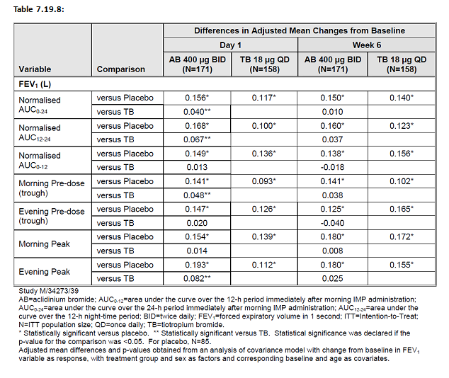
At all time points during the 24-h observation period, aclidinium bromide showed statistically significantly greater increases in the adjusted mean change from baseline in FEV1 values compared to placebo both at Day 1 and Week 6 (0.070 L to 0.202 L; p<0.0001 to p=0.0046). At Day 1, aclidinium bromide generally showed numerically greater increases from baseline in FEV1 compared to tiotropium bromide throughout the 24-h observation period, with statistical significance at 13 to 23 h post-dose (0.042 L to 0.092 L; p<0.0001 to p=0.0238). At Week 6, aclidinium bromide showed numerically greater increases from baseline in FEV1 compared to tiotropium bromide at 0 to 2 h and 13 to 24 h post-dose (0.007 L to 0.047 L; p>0.05), while increases between 3 and 12 h post-dose were numerically lower than tiotropium bromide (-0.005 L to -0.046 L; p>0.05).
Additional efficacy variables: Aclidinium bromide provided a consistent and greater improvement in COPD symptoms compared to placebo in most of the symptomatic variables over 6 weeks of treatment, with statistically significantly greater improvements from baseline in daily E-RS scores (total score, Breathlessness, Cough and Sputum and Chest domains), the severity of morning symptoms (overall and by symptom) and of night time symptoms) and of the limitation of activity due to COPD symptoms. Moreover, aclidinium bromide also showed a statistically significant increase in the percentage of days without morning symptoms compared to placebo (any symptoms, cough, wheeze and shortness of breath: 7.2% to 8.9%; p=0.0004 to 0.0213). The improvements in COPD symptoms observed in the tiotropium bromide group were numerically inferior to those observed for aclidinium bromide and were only statistically significantly greater than placebo for E-RS total, Breathlessness and Chest scores, severity of any morning symptoms and percentage of days without morning symptoms. Over 6 weeks of treatment, both aclidinium bromide and tiotropium bromide showed a statistically significantly greater increase from baseline in the percentage of relief medication-free days (24 h without relief medication use) compared to placebo (9.6%; p=0.0229 and 8.9%; p=0.0366, respectively) and a numerically greater reduction from baseline in the use of daily relief medication compared to placebo (-0.4 puffs; p>0.05 for both active treatments). Over 6 weeks of treatment, the majority of patients (80.1%) preferred the Genuair® inhaler to the HandiHaler® device. Patients were significantly more willing to continue using the Genuair® inhaler than the HandiHaler® device, with overall mean “willingness to continue” scores of 88.8 and 45.4 out of 100, respectively (p<0.0001).
Comments: At Day 1 and after 6 weeks of treatment, aclidinium bromide 400 μg BD provided statistically significantly greater improvements in bronchodilation compared to placebo. Moreover, aclidinium bromide 400 μg BD also provided numerically greater improvements in bronchodilation over tiotropium bromide 18 μg QD, with improvements being statistically superior favouring aclidinium bromide on Day 1 for most of the spirometric variables, mainly due to differences during the night time period. Aclidinium bromide provided statistically significantly greater improvements compared to placebo in early morning and night time COPD symptoms for most of the symptomatic variables, while tiotropium bromide did not. Moreover, both aclidinium bromide and tiotropium bromide significantly improved daily COPD symptoms assessed by E-RS scores when compared to placebo (except for the Cough and Sputum domain for tiotropium bromide). The symptomatic improvements observed with aclidinium bromide were consistently numerically greater than those observed with tiotropium bromide. Over 6 weeks of treatment, the majority of patients preferred the Genuair® inhaler to the HandiHaler® device.
Overall, in terms of bronchodilation and symptomatic endpoints, results from this well-conducted study confirmed that twice-daily dosing with aclidinium bromide 400 µg produced statistically significant greater benefits than placebo and numerically greater benefits than tiotropium 18 µg QG.

Study M/34273/40
This was a Phase IIIb, prospective, multiple dose, double blind, randomised, 2 period crossover, placebo controlled, multinational, multicentre clinical study. The objectives of this study were to evaluate the effect of aclidinium bromide 400 μg twice daily (BD)on exercise endurance, hyperinflation and dyspnoea at rest and during exercise compared with placebo in patients with moderate to severe COPD. The secondary objective was to assess the safety and tolerability of inhaled aclidinium bromide 400 μg BD in the same target population. This study was conducted at from 10 Nov 2011 to 4 June, 2012 at 14 sites (10 sites in Germany, 3 sites in Spain and one site in the United Kingdom).
The main inclusion criteria were males and non-pregnant, non-lactating female patients aged ≥40 years with a clinical diagnosis of stable moderate to severe COPD, according to the GOLD Guidelines and stable airway obstruction. Post-salbutamol FEV1/forced vital capacity (FVC) <70% at the Screening Visit (that is, 100 x post-salbutamol FEV1/FVC <70%). Patients whose FEV1 at the Screening Visit measured between 10-15 minutes post-inhalation of 400 μg salbutamol was ≥30% and <80% of the predicted normal value (that is, 100 x observed post-salbutamol FEV1/predicted FEV1 <80% and ≥30%). Functional residual capacity (FRC) measured by body plethysmography at the Screening Visit ≥120% of predicted value. Patients with an oxygen saturation >85% during cycle exercise on room air at the Screening Visit, Run-in Visit and Visit 1; Current or former smokers with a smoking history of at least 10 pack-years. The main exclusion criteria were: Patients with no history or current diagnosis of asthma; signs of an exacerbation within 6 weeks (or 3 months if resulted in hospitalisation) prior to the Screening Visit or during the run-in period; evidence of clinically significant respiratory (other than COPD) and/or cardiovascular conditions or laboratory abnormalities; conditions where the use of anticholinergic drugs was contraindicated, such as known symptomatic prostatic hypertrophy, bladder neck obstruction or narrow-angle glaucoma; contraindications of cardiopulmonary exercise testing (CPET); Patients who, in the investigator’s opinion would need to start a pulmonary rehabilitation program during the study and/or patients who had just started/finished pulmonary rehabilitation at least 3 months prior to the Screening Visit. Patients previously included in prior studies with aclidinium bromide (administered as monotherapy or in combination) were allowed to be included in this study.
Patients fulfilling inclusion/exclusion criteria at the time of the Screening Visit were entered into a run-in period of 14 to 21 days to assess disease stability. During this period, one site visit (Run-in Visit) was performed to familiarise patients with study testing procedures (body plethysmography, spirometry and a constant work rate cycle exercise test). At the end of the run-in period, patients who met entry criteria at Visit 1 were randomised (1:1) to one of the 2 treatment sequences. Randomised patients received either aclidinium bromide 400 μg BD in the first period followed by placebo in the second period, or to receive placebo in the first period followed by aclidinium bromide 400 μg BD in the second period, with each treatment period comprising of 3 weeks (22 [±2] days). A washout period of 2 weeks between the 2 treatment phases was considered sufficient to avoid any relevant carry-over effect in the efficacy outcomes. During the double blind treatment period, patients visited the site for assessment of clinical efficacy and safety on 4 occasions (Day 1 [Visits 1 and 3] and Day 22 [Visits 2 and 4] of each treatment period). A follow-up contact was performed 2 weeks after treatment completion.
The primary efficacy variable was change from baseline in endurance time (ET) during constant work rate cycle ergometry to symptom limitation at 75% of the maximum work rate (Wmax) after 3 weeks of treatment, where ET is the time from the increase in work rate at 75% Wmax to the point of symptom limitation. Secondary efficacy variables: were change from baseline in pre-dose (trough) inspiratory capacity (IC) after 3 weeks of treatment; Change from baseline in intensity of dyspnoea based on the Borg CR10 Scale® at isotime during constant work rate cycle ergometry after 3 weeks of treatment, where isotime is the duration of the shortest exercise test on Visit 1, 2, 3 and 4. Additional efficacy variables were: Percentage change from baseline in ET during constant work rate cycle ergometry after 3 weeks of treatment; Change from baseline in IC during constant work rate cycle ergometry after 3 weeks of treatment (at rest, every 2 minutes during exercise, at isotime and at end of exercise); Change from baseline in intensity of dyspnoea based on the Borg CR10 Scale® during constant work rate cycle ergometry after 3 weeks of treatment (at rest, every 2 minutes during exercise and at end of exercise); Change from baseline in intensity of leg discomfort based on the Borg CR10 Scale® during constant work rate cycle ergometry after 3 weeks of treatment (at rest, every 2 minutes during exercise, isotime and at end of exercise); Percentage of patients stopping exercise because of breathing discomfort, leg discomfort, breathing and leg discomfort, or other reasons during constant work rate cycle ergometry; after 3 weeks of treatment, change from baseline in morning pre-dose (trough) FEV1, trough FVC, morning pre-dose (trough) specific airway conductance (sGaw), FRC, residual volume (RV), total lung capacity (TLC), IC/TLC, morning post-dose sGaw, FRC, RV and TLC; change from baseline over 3 weeks of treatment in the daily average use of relief medication and percentage of relief medication-free days (day-time, night time and daily); change from baseline of the physical activity parameters including: steps per day, minutes of at least moderate activity (defined as any physical activity >3 metabolic equivalents), mean physical activity level, mean daily active energy expenditure (>3 metabolic equivalents) and number of nocturnal awakenings due to COPD symptoms.
All statistical comparisons were two-sided hypothesis tests, and the significance level was set at 0.05. All confidence intervals (CIs) were two-sided at the 95% confidence level. All efficacy endpoints, except the percentage of patients stopping exercise because of a specific reason, were analysed using a mixed model with treatment and period as fixed effects, patient as a random effect and baseline value prior to IMP intake of each period as a covariate. Between-treatment least squares (LS) means and 95% CIs were calculated. The percentage of patients stopping exercise because of breathing discomfort, leg discomfort or both breathing and leg discomfort during constant work rate cycle ergometry was analysed using a binomial model, using patients stopping exercise as a response with baseline, treatment group and period as factors and Generalised Estimating Equations (GEE) to take into account the correlation between patients. For the variables that were analysed every 2 minutes during exercise, analyses were performed provided at least 20 patients had data at the specific time point.
A total of 149 patients were screened, of whom 112 patients were assessed as eligible and were randomised into the study. Overall, 106 (94.6%) of the randomised patients completed the study and 6 (5.4%) patients were discontinued from the study due to AEs (4 and 2 following aclidinium bromide and placebo, respectively). a total of 7 patients were excluded from the PP population. The most frequent reason for exclusion from the PP population was failure to undergo the required washout period for prohibited medications (LABA + ICS, LAMA or PDE4), which led to the exclusion of 4 patients (including Patient 1929-04, as mentioned above) from the PP population.
All patients were Caucasian, with a mean age of 60.3 years, mean smoking history of 48.0 pack-years. The majority of patients were males (76; 67.9%) and had moderate (GOLD Stage II) COPD with a mean duration of COPD at baseline of 8.8 years. At screening, the overall mean FRC (5.045 L) was 152.3% of the predicted value. The mean baseline FEV1 value at Visit 1 was 1.480 L. Baseline demographics and disease characteristics were similar in both treatment groups. The use of prior, concomitant and relief medications was also similar for both treatments. Overall, 99.1% of patients were treatment compliant for both aclidinium bromide and placebo.

Primary efficacy results:
After 3 weeks of treatment, aclidinium bromide 400 μg BD showed a statistically significantly greater increase in the adjusted mean change from baseline in ET during constant work rate cycle ergometry compared to placebo, with an adjusted mean difference from placebo of 58.5 seconds (p=0.0210).

Secondary efficacy results:
Aclidinium bromide also showed a statistically significantly greater reduction in dynamic hyperinflation compared to placebo by providing greater increases in IC at isotime and at end of exercise during constant work rate cycle ergometry after 3 weeks of treatment. At Week 3, compared to placebo, aclidinium bromide 400 μg BD showed a statistically significantly greater increase in the adjusted mean change from baseline in pre-dose (trough) IC (0.078 L, p=0.0248) and greater decrease in the adjusted mean change from baseline in intensity of dyspnoea at isotime during constant work rate cycle ergometry compared to placebo (-0.63; p=0.0122).

Other efficacy results:
After 3 weeks of treatment, compared to placebo, aclidinium bromide 400 μg BD showed a numerically greater increase in the adjusted mean percentage change from baseline in ET during constant work rate cycle ergometry (8.9%; p=0.1196), greater increases in the adjusted mean changes from baseline in IC at rest, isotime and end of exercise (with differences from placebo of 0.176 L, p<0.0001; 0.155 L, p=0.0002 and 0.161 L, p<0.0001 respectively).
After 3 weeks of treatment, aclidinium bromide provided statistically significantly greater improvements in bronchodilation and static lung hyperinflation compared to placebo, based on morning pre-dose (trough) spirometry parameters (FEV1 and FVC) and morning pre-dose (trough) and post-dose body plethysmography parameters (sGaw, FRC, RV, TLC and IC/TLC).
Aclidinium bromide provided statistically significantly greater increases compared to placebo in the daily duration of at least moderate activity and daily active energy expenditure. Over 3 weeks of treatment, aclidinium bromide 400 μg BD showed statistically significantly greater adjusted mean increases from baseline in the duration of at least moderate activity (10.1 minutes; p=0.0156) and daily active energy expenditure (54.5 kcal; p=0.0103) compared to placebo. Aclidinium bromide also showed numerically greater increases versus placebo in step count (459.0 steps per day; p>0.05) and physical activity level (0.024; p>0.05).
Aclidinium bromide also provided statistically significantly greater decreases in the need for relief medication compared to placebo. Over 3 weeks of treatment, aclidinium bromide 400 μg BD showed statistically significantly greater improvements from baseline in daily relief medication use (-0.9 puffs; p<0.0001) and in the percentage of days free from relief medication use (14.6%; p<0.0001) compared to placebo.
There were no statistically significant differences from placebo in changes from baseline in intensity of dyspnoea at rest and end of exercise or in intensity of leg discomfort at isotime.
After 3 weeks of treatment, there was no statistically significant difference between the treatments with respect to the percentage of patients stopping the exercise test for any of the specified reasons (breathing and leg discomfort, breathing discomfort alone and leg discomfort alone).
Comments: One of the major consequences of COPD is expiratory flow limitation, leading to lung hyperinflation. Dynamic hyperinflation is a primary mechanism of the exertional dyspnoea and reduced exercise capacity associated with COPD. Limitation in exercise capacity represents an important feature of COPD, and is one of the main factors that negatively impact patients’ quality of life. The treatment goals applicable to the development of an anticholinergic bronchodilator include improvement of exercise tolerance. Overall, aclidinium bromide 400 μg BD via the Genuair® inhaler appeared to be a good treatment option in patients with stable moderate to severe COPD, showing improvements in exercise endurance, lung hyperinflation and daily physical activity over 3 weeks of treatment. However, due to the crossover nature of the study, effect of treatment sequence on the efficacy results should also have been evaluated to rule out any bias.

Analyses performed across trials (pooled analyses and meta-analyses)

Pooled efficacy analysis:
Comparison and analysis of efficacy results was done for the pivotal studies that assessed the efficacy of aclidinium bromide BD (M/34273/34, LAS-MD-33 and LAS-MD-38 Part A). These pivotal studies were very similar in design and efficacy variables assessed. Two pooled analyses of the pivotal studies were performed; a pooled analysis of Studies M/34273/34 and LAS-MD-33 only and a pooled analysis comprising all three pivotal studies. A pooled analysis of pivotal studies excluding study LAS-MD-38 Part A was performed because the sponsor considers that estimates of treatment effect in LAS-MD-38 Part A may not be a valid representation of the true treatment effects within the target patient population due to imbalance in baseline COPD severity (with more severe COPD patients in the aclidinium bromide 400 µg BD group). The pooled analysis of all three pivotal studies provided useful information to assess the extent to which study LAS-MD-38 Part A influenced treatment effects. The results from supportive studies were not pooled with those of the pivotal studies due to markedly different study designs and treatment durations.
Comments: Although the sponsors have done a pooled analysis of the 3 pivotal studies, it is important to note that study 34 was the only one with the recommended 24 weeks study duration (according to CHMP guidelines for evaluation of drugs for indication of suymptom relief of COPD) and studies 33 and 38A had study duration of only 12 weeks. However, the pooled analysis summary results also show results from individual studies allowing valid interpretation of results across studies.

Patient population, baseline data:
Overall, 1378 patients were included in the pooled efficacy analysis of pivotal Studies M/34273/34 and LAS-MD-33 (461, 459 and 458 treated with aclidinium bromide 200 µg, 400 µg and placebo, respectively). The pooled analysis of the three pivotal studies (M/34273/34, LAS-MD-33 and LAS-MD-38 Part A) included 1919 patients (643, 636 and 640, respectively). Of the randomised populations in M/34273/34, LAS-MD-33 and LAS-MD-38 Part A, 89.0%, 83.2% and 83.5%, respectively, completed the study. Reasons for premature study discontinuation in the pooled population of Studies M/34273/34 and LAS-MD-33 were comparable across treatment groups, with the exception of insufficient therapeutic response (1.5%, 0.2% and 3.7% in aclidinium bromide 200 µg, 400 µg and placebo groups, respectively), COPD exacerbation (1,3%, 0.2% and 2.4%, respectively) and withdrawal of consent (2.6%, 2.8% and 5.0%, respectively). A similar pattern was observed in the pooled population of all three pivotal studies. In pooled patient population of Studies M/34273/34 and LAS-MD-33, the mean patient age was 63 years (range 40 to 89 years) and the majority of enrolled patients were male (61.5%) and Caucasian (94.6%). The demographic characteristics of the pooled patient population comprising all three pivotal studies weres similar. The pooled population comprising Studies M/34273/34 and LAS-MD-33 showed that nearly all of the enrolled patients had moderate or severe COPD (98.7%) which was consistent with the protocols’ eligibility criteria. A higher proportion of patients had Stage II (moderate) COPD (63.9%) than Stage III (severe) COPD (34.8%) and majority of patients (69.2%) had not experienced an exacerbation of their COPD within the previous 12 months. Mean smoking consumption was 45.9 pack-years and approximately 50% of the population were current smokers. The baseline COPD status and smoking history of the pooled population comprising all three pivotal studies was similar with the exception that the proportion of patients with Stage III COPD was slightly higher (37.9%) than that observed for the pooled population of Studies M/34273/34 and LAS-MD-33 (34.8%). In the pooled population comprising Studies M/34273/34 and LAS-MD-33, baseline FEV1 was 1.446 L and FEV1 percentage predicted was 50.3%, consistent with a patient population with moderate to severe COPD. Bronchial reversibility to short-acting β2-agonists was 13.7% (mean absolute change of 0.165 L). The baseline lung function of the pooled population comprising the three pivotal studies was very similar. The medications used by the highest proportions of patients before study entry in M/34273/34, LAS-MD-33 and LAS-MD-38 Part A were short-acting β2-agonists (50.4%, 64.0% and 52.5% of patients, respectively). In addition, significant proportions of patients across all studies had previously taken long-acting muscarinic antagonists (27.0%, 30.2% and 26.4%, respectively).

Trough FEV1:
In the analysis of the pooled population from pivotal Studies M/34273/34 and LAS-MD-33, both aclidinium bromide 400 µg and 200 µg showed statistically significantly greater improvement in trough FEV1 compared with placebo (0.112 L and, 0.080 L respectively, p<0.0001 for both comparisons). Adjusted mean treatment differences between aclidinium bromide and placebo were lower but still statistically significant when study LAS-MD-38 Part A was included in the pooled population (treatment differences between aclidinium bromide 400 µg or 200 µg and placebo being 0.100 L and 0.071 L, respectively, p<0.0001 for both comparisons). Although adjusted mean treatment differences between aclidinium bromide 400 µg and 200 µg were not statistically significant in the individual studies, a consistent trend favouring aclidinium bromide 400 µg over 200 µg dose was observed across studies. However, analysis of the pooled population of Studies M/34273/34 and LAS-MD-33 demonstrated statistical superiority of 400 µg over 200 µg for trough FEV1 (0.032 L, p=0.027). Statistical superiority of the 400 µg dose over the 200 µg dose was also observed in the pooled analysis of the three pivotal studies (0.029 L, p=0.017) (Table 31).
Table 31. Change from baseline in trough FEV1 (L) to Week 24 for Study M/34273/34 and to Week 12 for Studies M/34273/34, LAS-MD-33 LAS-MD-38 Part A and Pooled populations. ITT population.
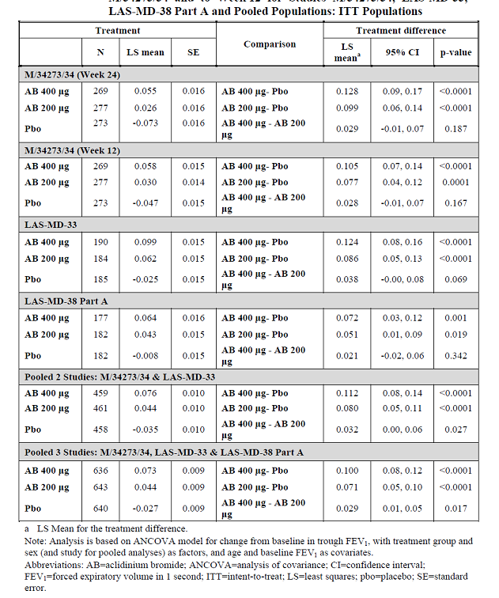

Peak FEV1:
Analysis of peak FEV1 in the pooled population of Studies M/34273/34 and LAS-MD-33 showed statistically significant improvements over placebo with both aclidinium bromide 400 µg and 200 µg (0.191 L and 0.167 L, respectively; p<0.001). Similar results were observed in pooled analysis of 3 pivotal studies although the magnitude of the treatment difference between aclidinium bromide 400 µg or 200 µg and placebo was reduced to 0.172 L and 0.152 L, respectively. Aclidinium bromide 400 µg showed statistical superiority over aclidinium bromide 200 µg in Study LAS-MD-33 only and a consistent trend for numerically greater improvement with 400 µg dose was observed across the other two studies. However, pooled analysis of the 2 and the 3-pivotal studies failed to show statistically significant difference between the 400 µg and 200 µg doses although 400 µg showed numerically greater improvements in peak FEV1 (Table 32).
Table 32. Change from baseline in peak FEV1 (L) to Week 24 for Study M/34273/34 and to Week 12 for Studies M/34273/34, LAS-MD-33 LAS-MD-38 Part A and Pooled populations. ITT population.
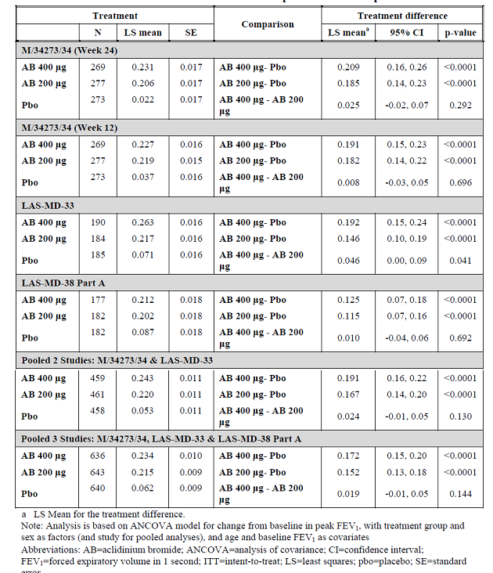

TDI focal score:
Analysis of the pooled population of Studies M/34273/34 and LAS-MD-33 showed that aclidinium bromide 400 µg or 200 µg increased the likelihood of patients achieving a clinically significant improvement in TDI Focal score (> 1 unit) at Week 12, compared to placebo, by 1.94-fold and 1.73-fold, respectively. Very similar results were obtained with the pooled population comprising all three pivotal studies (Table 33). A trend for greater treatment differences between aclidinium bromide and placebo with the 400 µg dose group, compared to the 200 µg dose group, was observed in Studies M/34273/34 and LAS-MD-38 Part A. In study LAS-MD-33, the magnitude of the treatment differences between aclidinium bromide and placebo was similar for both dose groups. Analysis of the pooled population of Studies M/34273/34 and LAS-MD-33 for the change from baseline in TDI Focal score at 12 weeks showed that the treatment differences between aclidinium bromide 400 µg or 200 µg and placebo were 0.92 units (p<0.0001) and 0.58 units (p=0.006), respectively. Very similar results were obtained when the pooled population from all three pivotal studies was analysed (Table 34).
Table 33. Proportions of patients with clinically significant improvementsª in TDI focal score at Week 24 for Study M/34273/34 and to Week 12 for Studies M/34273/34, LAS-MD-33 LAS-MD-38 Part A and Pooled populations. ITT population.
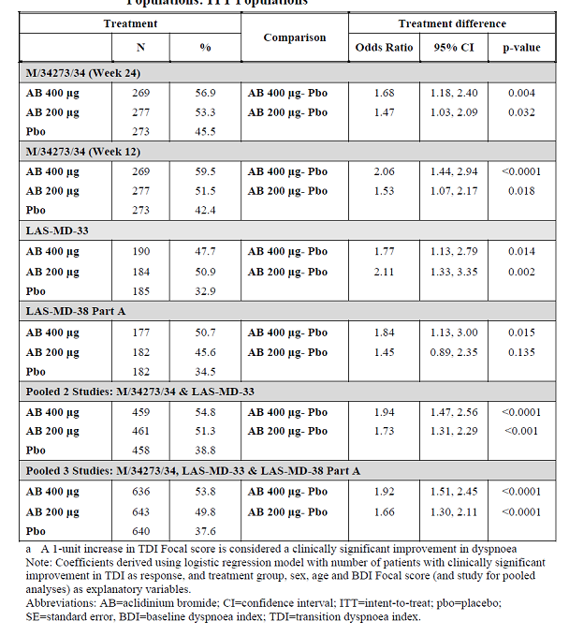
Table 34. Changes from baseline in TDI focal score to Week 24 for Study M/34273/34 and to Week 12 for Studies M/34273/34, LAS-MD-33 LAS-MD-38 Part A and Poolrf populations. ITT population.
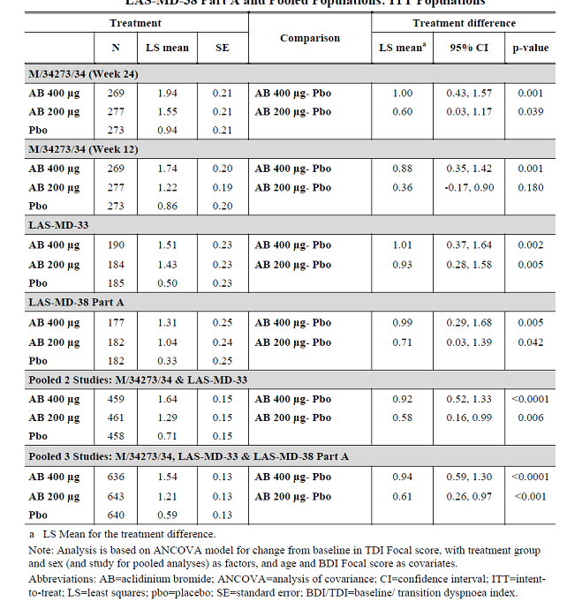

SGRQ total score:
The likelihood of patients achieving a clinically significant improvement in SGRQ Total score (> 4 units) at Week 12 was statistically significantly higher with aclidinium bromide 400 µg versus placebo in Study M/34273/34 only (2.0-fold; p<0.001). Although the placebo treatment effect was comparable across Studies M/34273/34, LAS-MD-33 and LAS-MD-38 Part A (with 39.5%, 36% and 39% of patients achieving a clinically significant improvement), the treatment effect associated with aclidinium bromide 400 µg was lower in studies LAS-MD-33 and LAS-MD-38 Part A (44% and 45% responders) than in Study M/34273/34 (56.9% responders). The likelihood of patients achieving a clinically significant improvement in SGRQ Total score at Week 12 was statistically significantly higher with aclidinium bromide 200 µg versus placebo in Studies M/34273/34 and LAS-MD-33 (1.64-fold [p=0.006] and 1.75-fold [p=0.010], respectively). Pooled analysis of the patient populations from Studies M/34273/34 and LAS-MD-33 showed that aclidinium bromide 400 µg and 200 µg, compared to placebo, increased the likelihood of patients achieving a clinically significant improvement in SGRQ Total score by 1.67-fold and 1.68-fold, respectively (p=0.0002 for both comparisons) with similar results observed in pooled analysis of all three pivotal studies (Table 35). Analysis of the pooled population comprising Studies M/34273/34 and LAS-MD-33 showed that the treatment differences between aclidinium bromide 400 µg or 200 µg and placebo were -3.44 units and, -3.02 units respectively (p<0.0001 for both comparisons). When LASMD-38 Part A was included in the pooled population, treatment differences between aclidinium bromide 400 µg or 200 µg and placebo were lower at -2.79 units and -2.59 units, respectively (Table 36).
Table 35. Proportions of patients with clinically significant improvementsª in SGRQ score at Week 24 for Study M/34273/34 and to Week 12 for Studies M/34273/34, LAS-MD-33 LAS-MD-38 Part A and Poolrf populations. ITT population.
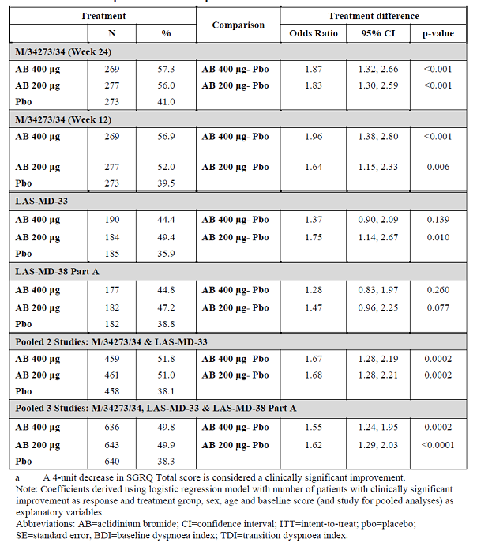
Table 36. Changes from baseline in SGRQ total score to Week 24 for Study M/34273/34 and to Week 12 for Studies M/34273/34, LAS-MD-33 LAS-MD-38 Part A and Pooled populations. ITT population.
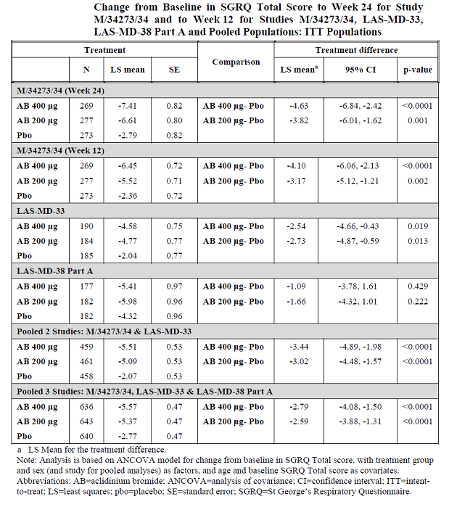

Normalised FEV1 AUC _{(0-3h)}:
Across all pivotal studies, adjusted mean changes from baseline in normalised FEV1 AUC0-3h were statistically significantly higher for aclidinium bromide 400 µg or 200 µg compared to the placebo at all timepoints from Day 1 to the end of treatment (p<0.0001 for all comparisons) and were numerically greater for the 400 µg than for the 200 µg dose group. In comparison to placebo, statistically and clinically significant increases in FEV1 were observed by 0.5 h post-dose with aclidinium bromide 400 µg in Studies M/34273/34, LAS-MD-33 and LAS-MD-38 Part A (0.129 L, 0.125 L and 0.142 L, respectively).

Onset of bronchodilation:
Aclidinium bromide 200 µg was associated with statistically significant increases compared to placebo in FEV1 at 0.5 h post-dose in all three pivotal studies, but the magnitude of the treatment difference versus placebo only reached the level considered clinically significant in Study M/34273/34 (0.106 L). Analysis of the pooled patient population comprising pivotal Studies M/34273/34 and LAS-MD-33 showed the adjusted mean treatment differences between aclidinium bromide 400 µg or 200 µg and placebo in the change from baseline to 0.5 h post-dose on Day 1 in FEV1 was 0.128 L (p<0.0001) and 0.099 L (p<0.0001), respectively. The adjusted mean treatment difference between the 400 µg and 200 µg aclidinium bromide groups was statistically significant (0.028 L; p=0.0003). Similar results were obtained when the pooled population from all three pivotal studies (M/34273/34, LAS-MD-33 and LAS-MD-38 Part A) was analysed (Table 37).
Table 37. Changes from baseline to 0.5 h h postdose on Day 1 in FEV1 (L) for pivotal studies M/34273/34, LAS-MD-33 LAS-MD-38 Part A and Pooled populations. ITT population.
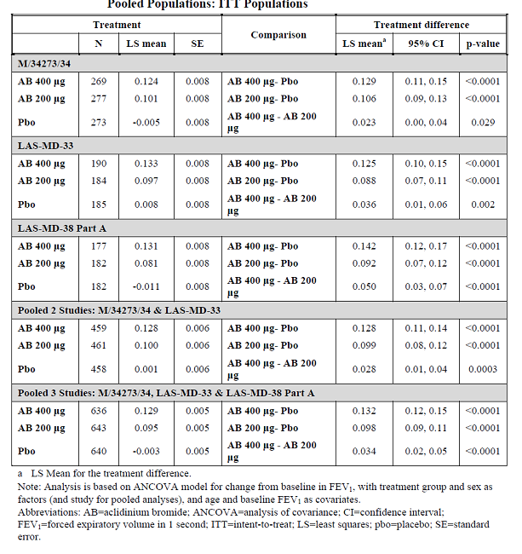

Rescue medication use:
A trend towards a greater reduction in daily rescue medication use with aclidinium bromide 400 µg compared to aclidinium bromide 200 µg was observed in Studies M/34273/34 and LAS-MD-33. The analysis of the pooled population of Studies M/34273/34 and LAS-MD-33 showed that the treatment differences between aclidinium bromide 400 µg or 200 µg and placebo in reductions of daily rescue medication use were 0.9 puffs/day (p<0.0001) and 0.7 puffs/day (p=0.002), respectively. Pooled analysis of the patient populations of the three pivotal studies showed treatment differences between aclidinium bromide 400 µg or 200 µg and placebo in the reduction of rescue medication use of 0.8 puffs/day (p<0.0001) and 0.5 puffs/day (p=0.003), respectively (Table 38).
Table 38. Changes from baseline in total daily use of rescue medication (Puffs) over treatment duration in the pivotal studies M/34273/34, LAS-MD-33 LAS-MD-38 Part A and Pooled populations. ITT population.
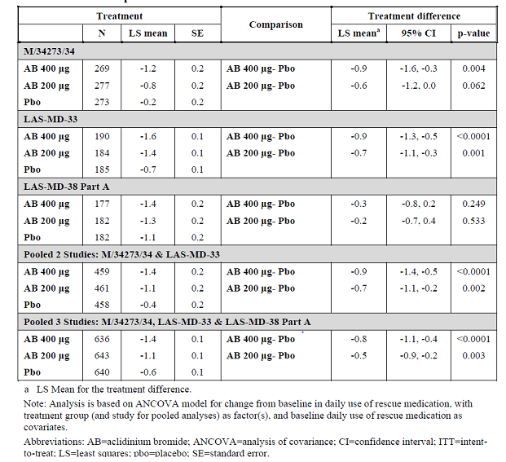

COPD exacerbation rate:
Analysis of the pooled population of Studies M/34273/34 and LAS-MD-33 showed that aclidinium bromide 400 µg and 200 µg compared to placebo were associated with statistically significant reductions in the rate of exacerbations (any severity) of approximately 36% (RR=0.64; p=0.001) and 28% (RR=0.72; p=0.012), respectively. Statistically significant reductions in the rate of moderate or severe exacerbations with aclidinium bromide 400 µg and 200 µg compared to placebo were also observed (rate ratios 0.71 [p=0.015] and 0.74 [p=0.026], respectively). Pooled analysis of the three pivotal studies showed statistically significant reductions with aclidinium bromide 400 µg or 200 µg compared to placebo in the rate of any exacerbation of approximately 30% (rate ratios 0.70 [p=0.002] and 0.72 [p=0.004], respectively). Reductions in the rate of moderate or severe exacerbations with aclidinium bromide 400 µg or 200 µg compared to placebo were also observed (rate ratios 0.74 [p=0.010] and 0.69 [p=0.002], respectively). When COPD exacerbations were assessed in Study M/34273/34 according to the EXACT, exacerbation rates were higher (rates of 0.98, 1.00 and 1.39 exacerbations per patient per year for aclidinium bromide 400 µg, aclidinium bromide 200 µg and placebo, respectively) than when exacerbations were assessed according to the Health Resource Utilisation definition (rates of 0.40, 0.43 and 0.60, respectively). A statistically significant and consistent reduction compared to placebo in the rate of exacerbations of approximately 30% was observed for aclidinium bromide 400 µg and 200 µg (rate ratios of 0.71 [p=0.012] and 0.72 [p=0.017], respectively).

COPD symptoms:
Daily symptoms were evaluated in pivotal Study M/34273/34 using the E-RS. Over the 24- week treatment duration, aclidinium bromide 400 µg and 200 µg resulted in statistically significant improvements compared to placebo in the E-RS Total score and the component symptom scores for ‘breathlessness’, ‘chest symptoms’ and ‘cough and sputum’ with numerically greater improvements with aclidinium bromide 400 µg compared to 200 µg. Night-time and morning symptoms were evaluated in Studies M/34273/34 and LAS-MD-33 using different assessment tools. Statistically significant improvements in symptoms and their impacts with aclidinium bromide 400 µg observed in both studies included improvements in night time and morning breathlessness, cough and night time sputum production and a reduced impact of symptoms on morning activities. Statistically significant improvements in symptoms and their impacts observed with aclidinium bromide 200 µg in both studies included an improvement in breathlessness.

Efficacy in subpopulations:
Evaluation of the pooled population comprising Studies M/34273/34 and LAS-MD-33 showed no statistically significant differences in the magnitudes of the adjusted mean treatment differences between aclidinium bromide and placebo based on sex (male or female), age group (<60 years, 60 years to 69 years or ≥70 years), BMI group (obese, preobese or normal weight/ underweight), COPD severity (mild/moderate or severe/very severe), smoking status (current smokers or ex-smokers), bronchodilator reversibility (reversible or non-reversible) or concomitant use of ICS (using ICS or not using ICS). Similar observations were made with the pooled population comprising studies LAS-MD-33 and LAS-MD-38 Part A, with the exception of smoking status (increased treatment effect of the 400 µg dose and reduced treatment effect of the 200 µg dose in current smokers) and bronchodilator reversibility (reduced efficacy in non-reversible patients).
Although it was planned to perform a subpopulation analysis by race, the majority of patients in the pooled populations were Caucasian (94.6% of the pooled population comprising Studies M/34273/34 and LAS-MD-33). The number of non-Caucasians in the pooled populations and in Study M/34273/34 was too low to allow for meaningful analysis. A subpopulation analysis by geographical region (Europe, US/Canada and rest of the world) was also planned. Although no apparent differences were observed in the magnitudes of the adjusted mean treatment differences between aclidinium bromide and placebo in Europe and US/Canada, the proportion of patients from the rest of the world (10.2%) was too low to allow for meaningful interpretation of this analysis.

Evaluator’s conclusions on clinical efficacy for Indication 1
Long-term maintenance bronchodilator treatment to relieve symptoms in adult patients with Chronic Obstructive Pulmonary Disease (COPD).
Prior to conduct of the clinical efficacy program of aclidinium bromide BD, a clinical program to investigate the efficacy of aclidinium bromide 200 µg once daily (QD) in patients with COPD was conducted and completed. An overview of the clinical studies designed to provide efficacy information on aclidinium bromide QD is provided in the Other efficacy studies, Long-term efficacy section above.
Although statistically significant bronchodilatory effects of aclidinium bromide 200 µg QD were demonstrated in two Phase III, double blind, placebo controlled, randomised clinical trials (M/34273/30 and M/34273/31), the trough FEV1 effect size (that is, approximately 60 mL) observed with aclidinium bromide 200 µg QD was lower than the 0.100 L effect size considered of clinical relevance and suggested that a higher daily dose and/or a different dose regimen (such as BD) may be necessary to improve bronchodilator efficacy. Furthermore results of another Phase II crossover Study M/34273/25 which investigated further the bronchodilatory profile of aclidinium bromide 200 µg QD administered in the morning or in the evening showed that night time bronchodilation following morning administration of aclidinium bromide was insufficient to overcome the known increase in nocturnal cholinergic tone. Relevant night time bronchodilation was achieved, however, following evening administration of aclidinium bromide.
The Phase II, placebo controlled, dose-finding Study M/34273/22 evaluated 5 doses of aclidinium bromide administered once daily for 4 weeks in 464 COPD patients; this study also included an open-label tiotropium treatment arm. In general, peak bronchodilatory effects (as assessed by FEV1 and FVC) on the first and last days of dosing were higher for aclidinium bromide 200 µg than for aclidinium bromide 400 µg and comparable for aclidinium bromide 200 µg and tiotropium.
The relatively low bronchodilator efficacy attained with aclidinium bromide 200 µg QD in pivotal QD studies M/34273/30 and M/34273/31 compared to that achieved with aclidinium bromide 200 µg QD in this study provoked a review of per-patient FEV1 data from this study. It was noted that trough FEV1 values reported at Day 28 for one patient in the 200 µg aclidinium bromide group were markedly higher than the trough FEV1 values reported for other patients in the study (absolute change from baseline to Day 28 in trough FEV1 was 4.09 L for the outlier whereas the range of values for all other study patients was between -0.65 and 1.55 L). [information redacted]. However, the sponsors have not conducted any direct comparison between QD and BD dosing with 400 µg aclidinium bromide.
The clinical efficacy program for aclidinium bromide 200 µg and 400 µg, administered BD, was conducted in North America, Europe and South Africa, and comprises three pivotal studies (M/34273/34, LAS-MD-33 and LAS-MD-38 Part A) and five supportive studies, two Phase II studies (M/34273/23 and M/34273/29) and three Phase III long term safety studies (LAS-MD-35, LAS-MD-36 and LAS-MD-38 Part B).
The primary evidence of the efficacy of aclidinium bromide is from the 6 month pivotal Study M/34273/34. This study showed aclidinium bromide 400 µg BD to be associated with clinically and statistically significant effects with respect to bronchodilation, symptomatic improvements including exacerbation control and improvements in disease-specific health status. The results of pivotal Study LAS-MD-33 were comparable to those of Study M/34273/34. Further evidence of the benefits of aclidinium bromide was to be obtained from pivotal Study LAS-MD-38 Part A but due to an imbalance between treatment groups at baseline in lung function and COPD severity in Study LAS-MD-38 Part A the sponsor considers that although statistically significant results were obtained for its primary and secondary endpoints, the study may not provide a reliable estimate of the true treatment effect due to imbalance in baseline COPD characteristics. Supportive evidence of efficacy is derived from Phase II Studies M/34273/23 and M/34273/29 and long term studies LAS-MD-35 and LAS-MD-36.

Patient population
The pivotal studies included male and females aged > 40 years, current or ex-smokers of more than or equal to 10 pack years with a clinical diagnosis of moderate to severe stable COPD (as per the Global Initiative for Chronic Lung Disease (GOLD) criteria) with postbronchodilator FEV1 <80% predicted and >30% of predicted and FEV1/FVC less than 0.7 and an absence of respiratory tract infection or COPD exacerbation in the 6 weeks (3 months if hospitalisation was required) prior to the screening visit. The inclusion and exclusion critieria confirmed that patients included in the studies were representative of the target patient population for aclidinium bromide (namely patients with moderate to severe COPD). In the pivotal studies and long term safety studies, patients were permitted to continue treatment with stable doses of inhaled corticosteroids, oral sustained release theophylline and/or oxygen as required (≤15 h per day). Stable doses of oral and/or parenteral corticosteroids (≤10 mg/day) were also permitted. Patients were provided with a marketed salbutamol metered dose inhaler to be taken as needed. Thus, the Phase III clinical studies have been performed in the patient population in which therapy with aclidinium bromide would be appropriate.

Efficacy endpoints
FEV1 is a well-established measure of treatment efficacy that is commonly used to evaluate lung function improvement in COPD trials; its use in the diagnosis of COPD is supported by GOLD guidelines (2008). The CPMP “Points to Consider on Clinical Investigation of Medicinal Products in the Treatment of Patients with Chronic Obstructive Pulmonary Disease” (CPMP/EWP/562/98) states that for an indication of symptomatic relief of COPD, statistically significant benefit should be demonstrated not only for FEV1 but also for a pre-specified measure of symptomatic benefit. In Study M/34273/34 (the only study with recommended 24 week study duration), the proportion of patients with a clinically significant improvement in the Mahler Transition Dyspnoea Index (TDI) Focal score was pre-specified as the dominant symptomatic endpoint. The proportion of patients with a clinically significant improvement in the St George’s Respiratory Questionnaire (SGRQ) Total score was evaluated as a further secondary endpoint. These efficacy measures were assessed as additional efficacy variables in studies LAS-MD-33 and LAS-MD-38 Part A due to the shorter treatment duration (12 weeks). Daily COPD symptoms were additional efficacy variables in Study M/34273/34. Daily symptoms were assessed according to the Exacerbations of Chronic Pulmonary Disease Tool - Respiratory Symptoms (E-RS). COPD exacerbations by PROs in 12 week studies 33 and 38A; however, investigated by PRO and EXACT criteria in pivotal Study 34. Other supportive endpoints such as use of relief medication, etc were also used in all pivotal studies. Spirometric substudies within each of the 3 pivotal Phase III studies further evaluated detailed bronchoilidlatory profile of aclidinium bromide 200 and 400 µg BD.

Efficacy results

Bronchodilation
In each of the pivotal studies and in the analysis of the pooled populations, aclidinium bromide 400 µg was associated with greater numerical improvements versus placebo in the change from baseline to Week 12 and/or Week 24 in M/34273/34 in trough FEV1 than the 200 µg dose. The treatment differences between aclidinium bromide 400 µg and placebo were of a magnitude (>100ml difference from placebo in trough FEV1) considered clinically significant in Studies M/34273/34 and LAS-MD-33 and in both pooled analyses. Clinically significant treatment differences between aclidinium bromide 200 µg and placebo in the change from baseline in trough FEV1 were not observed in any of the pivotal studies or in the pooled analysis. Statistical superiority of the 400 µg dose over the 200 µg dose in the change from baseline in trough FEV1 was observed in the pooled population of M/34273/34 and LAS-MD-33 and in the pooled population of all three pivotal studies but not in the individual pivotal studies (Table 39).
Table 39. LS Mean Treatment differences between aclidinium bromide 400 µg or 299 µg and placebo in the change from baseline in trough and peak FEV1 in pivotal studies M/34273/34 and LAS-MD-33 and LAS-MD-38 Part A and the pooled population. ITT populations.
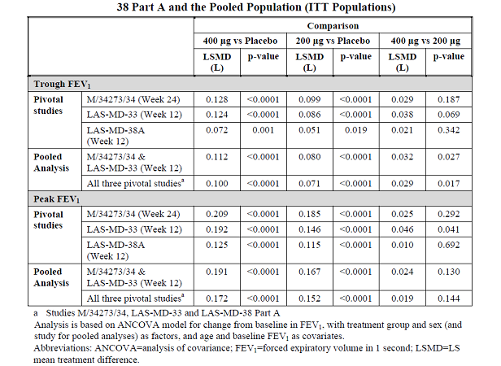
In the 6 month pivotal Study M/34273/34, clinically significant treatment differences in trough FEV1 were observed between aclidinium bromide 400 µg and placebo at all timepoints from week 1 up to week 24 but not between aclidinium bromide 200 µg and placebo (Figure 28).
Figure 28. Changes from baseline in FEV1 up to 3 h postdose at Week 12 by treatment in the pooled populations of studies M/34273/34 and LAS-MD-33 ITT population.
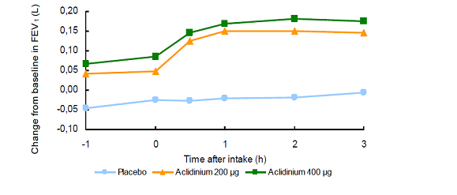
Aclidinium bromide 400 µg was associated with greater numerical improvements versus placebo in the change from baseline to Week 24 and/or Week 12 in peak FEV1 than the 200 µg dose in Studies M/34273/34 and LAS-MD-33. Pooled analysis of Studies M/34273/34 and LAS-MD-33 showed that the changes from baseline in peak FEV1 were numerically greater with the 400 µg dose than with the 200 µg dose at Weeks 1 (0.030 L, p=0.022), 4 (0.022 L, p=0.125), 8 (0.034 L, p=0.126) and 12 (0.024 L, p=0.130). Similar observations were made in the pooled analysis of three pivotal studies. In the pooled population of Studies M/34273/34 and LAS-MD-33, the changes from baseline up to 3 h post-dose were numerically greater with aclidinium bromide 400 µg compared to aclidinium bromide 200 µg at 0.5 h (0.022 L, p=0.146), 1 h (0.018 L, 0.250), 2 h (0.032 L, p=0.042) and 3 h (0.028 L, p=0.084) postdose. Similar observations were made for the pooled analysis of the three pivotal studies.

Symptomatic improvements
M/34273/34, as this was the only placebo controlled study conducted with treatment duration of 6 months and was the most important study for evaluation of symptoms. A clinically significant increase in TDI Focal score is at least 1.0 unit and changes from baseline in TDI Focal score with aclidinium bromide 400 µg compared to placebo in Studies M/34273/34, LAS-MD-33 and LAS-MD-38 Part A and in the pooled analyses were either at the minimum clinical important difference (MCID) or very close but this was not observed for the 200 µg dose. At Week 24 in Study M/34273/34, greater numerical increases compared to placebo were observed for aclidinium bromide 400 µg than 200 µg in the likelihood of patients achieving a clinically significant improvement in SGRQ Total score and in the change from baseline to Week 24 in SGRQ Total score. The reduction in SGRQ Total score observed with aclidinium bromide 400 µg in Study M/34273/34 was of a magnitude considered to be clinically significant (that is, at least 4.0 units). This dose response relationship was not seen in Studies LAS-MD-33 or LAS-MD-38 Part A; an observation which may reflect the relatively short duration of these studies for evaluation of this efficacy measure. Greater numerical increases compared to placebo in the changes from baseline in SGRQ Total score with the 400 µg dose than with the 200 µg dose were observed in the pooled analysis of Studies M/34273/34 and LAS-MD-33. Aclidinium bromide 400 µg and 200 µg were associated with statistically significant reductions in exacerbation rate of approximately 30% (exacerbations defined on basis on Health Resource Utilisation or EXACT). COPD exacerbations were categorised by severity and defined as increased COPD symptoms of at least 2 consecutive days requiring one of the following:
- increased rescue medications and/or inhaled corticosteroid use (mild exacerbation);
- treatment with antibiotics and/or systemic corticosteroids (moderate exacerbation), or
- hospitalisation or emergency room treatment (severe exacerbation).
Exacerbation results from the six-month Study 34 suggested a decrease in exacerbations with aclidinium bromide treatment. Results from the 3 month studies were less consistent although this variability may be due in part to a low background rate of exacerbations overall.

Long-term efficacy of proposed dose
The treatment duration of the 3 long term studies (LAS-md 35, LAS-md-36 and LAS-md-38B) were consistent with ICH E1 “Population Exposure: The Extent of Population Exposure to Assess Clinical Safety” (CPMP/ICH/375/95). Results of the 6 month pivotal Study M/34273/34 demonstrated consistent improvements with proposed dose of 400 µg BD in terms of bronchodilation (in trough FEV1, peak FEV1) and symptoms (TDI score and SGRQ total score) over the 24 week treatment duration. The results of the pivotal Study M/34273/34 provide no indication of tachyphylaxis with aclidinium bromide when administered over a 6 month treatment duration. Supportive evidence for persistence of efficacy is obtained from long term studies LAS-MD-35, LAS-MD-36 and LAS-MD-38 Part B. Across all three long term studies, increases from baseline in trough FEV1 showed some decline over the treatment period, an observation which is likely to reflect the known decrease in FEV1 that occurs over time in patients with COPD rather than a diminution of the efficacy of aclidinium bromide. Studies LAS-MD-35 LAS-MD-36 and LAS-MD-38 Part B provide evidence for the persistence of efficacy of aclidinium bromide over time and support the observations from pivotal Study M/34273/34 that there is no loss of efficacy with prolonged administration.

Efficacy in subgroups
Evaluation of the pooled population comprising Studies M/34273/34 and LAS-MD-33 showed no statistically significant differences in the magnitudes of the adjusted mean treatment differences between aclidinium bromide and placebo based on sex (male or female), age group (<60 years, 60 years to 69 years or ≥70 years), BMI group (obese, preobese or normal weight/ underweight), COPD severity (mild/moderate or severe/very severe), smoking status (current smokers or ex-smokers), bronchodilator reversibility (reversible or non-reversible) or concomitant use of ICS (using ICS or not using ICS). Similar observations were made with the pooled population comprising studies LAS-MD-33 and LAS-MD-38 Part A with the exception of smoking status (increased treatment effect of the 400 µg dose and reduced treatment effect of the 200 µg dose in current smokers) and bronchodilator reversibility (reduced efficacy in non-reversible patients).

Justification for the proposed 400 µg BD dose
Dose selection and dosing frequency selection for aclidinium bromide were based on previously conducted studies that evaluated a dose of 200 µg once daily and two additional studies, Study 23 and Study 29 that used tiotropium and formoterol for benchmark comparison. Data generated from these studies support a twice daily dosing frequency and the 400 µg twice daily dose demonstrated a greater change in trough FEV1 and time profile serial FEV1 measurement compared to lower doses of 100 µg and 200 µg twice daily (Study M/34273/29). The 400 µg twice daily doses in these studies generally performed better than lower doses and in a similar range to the two active comparators; formoterol 12 μg in Study 29 and tiotropim 18 μg in Study 23. Based on these data and previous experience with the 200 µg once daily dose (200 µg may be suboptimal and that night time bronchodilation achieved with once daily morning dose of aclidinium bromide may be insufficient), the selection of the 400 µg twice daily dose for further evaluation in confirmatory Phase III studies was reasonable.
However, there was no study directly comparing QD and BD dosing of proposed dose of 400 µg aclidinium bromide which is particularly important considering the fact that 400 µg QD showed a clinically relevant improvement in trough FEV1 after 4 weeks treatment in Phase II Study M/34273/22.
In all three pivotal Phase III BD studies, a statistically and clinically significant increase from baseline in morning trough FEV1was observed for aclidinium bromide 400 µg BD compared with placebo. The effect size for the 400 µg twice daily dose ranged from 72 ml to 124 mL across the three studies at Week 12, and the treatment effect appeared to persist when assessed at Week 24 in Study 34. The 200 µg twice daily dose also demonstrated a statistically significant difference from placebo, although the magnitude of the treatment difference was 51 to 86 mL which was smaller than the effect size observed for the 400 µg twice daily dose. Other spirometry based efficacy variables such as peak FEV1 and time profile serial FEV1 curve also support 400 µg twice daily as the appropriate bronchodilator dose for aclidinium bromide. The change from baseline in the SGRQ total symptom score was assessed as another efficacy variable in the three confirmatory studies. Greater decreases in total score were observed for aclidinium bromide compared to placebo and were generally supportive of efficacy but only Study 34 demonstrated a treatment difference between the 400 µg twice daily dose and placebo that exceeded the minimum clinical important difference (MCID) threshold of a 4 unit change.

Limitations of data submitted
- There was no study directly comparing QD and BD dosing with proposed dose of 400 µg aclidinium bromide which is particularly important considering the fact that 400 µg QD showed a clinically relevant improvement in trough FEV1 after 4 weeks treatment in Phase II Study M/34273/22.
Change in smoking status, tobacco exposure and use of nicotine replacement therapy (as an aid to smoking cessation) was not recorded in the pivotal studies and its potential effect on efficacy outcomes was not evaluated.

Clinical safety

Studies providing evaluable safety data
Two separate clinical development programs of aclidinium bromide were conducted between 2000 and 2011, both in patients with moderate to severe COPD. The latter development program investigated the efficacy and safety of aclidinium bromide BD (Figure 29) while the earlier program investigated the efficacy and safety of aclidinium bromide 200 µg QD (Figure 30). Both programs also included Phase I studies in healthy subjects.
Figure 29. Overview of aclidinium bromide BD clinical program
Figure 30. Overview of aclidinium bromide QD clinical program
The primary evidence of the safety of aclidinium bromide BD is derived from the pooled analysis of the 3 double blind, placebo controlled, parallel-group Phase III studies, (M/34274/34, LAS-MD-33, and LAS-MD-38 Part A referred to as “Pivotal Study Population” or BD Group 1A) conducted in patients with moderate to severe COPD. This Population was chosen for the primary evaluation of safety as the study designs were similar with all three studies being placebo controlled. Supportive evidence of safety is based on the pooled data from the 3 long term safety studies (LAS-MD-33 and LAS-MD-36 combined; LAS-MD-38 Part A and Part B combined, and LAS-MD-35) referred to “Long-term Study Population” of BDGroup 1B (Figure 31). Additional supportive data from the BD clinical program is provided by a single completed Phase I, single-blind, placebo controlled, parallel group, dose-escalation, safety, tolerability and PK study (LAS-PK-12) conducted in 30 healthy volunteers. The size of the safety database is adequate.
The secondary safety data is drawn from the QD development program and consists of 8 clinical studies conducted in a similar moderate to severe COPD population to that of the BD program (collectively grouped as QD Group 1) and a further 7 Phase I studies predominately in healthy subjects (QD Group 2). The design features and safety findings from these studies, while not directly supportive of the BD dosing regimen, do provide additional safety information, although at a different treatment regimen and in most of the studies at a lower dose (Figure 31). Three studies evaluating combination of aclidinium bromide with formoterol were only evaluated for their safety data (Studies M/273fo/23, LAC-MD-26 and LAC-MD-27).
Figure 31. Study groupings for the Integrated summary of safety
Safety evaluation was consistent across the BD and QD programs for COPD patients and healthy volunteers. Safety assessments in clinical studies in COPD patients included: recording of treatment-emergent AEs (TEAEs) and serious adverse events (SAEs), the monitoring of haematology, blood biochemistry and urinary parameters, as well as physical examinations including blood pressure and electrocardiographic (ECG) assessments. In addition, at selected sites in studies LAS-MD-33 and LAS-MD-38 Part A within the BD program, 24-h Holter monitoring was performed. AE data was collected on diary cards by patients between visits and via specific questioning by the site staff at each clinic visit. ECG data were collected via a centralised cardiology vendor using standardised equipment. Safety assessment within the Phase I healthy volunteer studies included: recording of TEAEs and SAEs, monitoring of haematology, blood biochemistry and urinary parameters and physical examinations including blood pressure and ECG assessments (with Holter assessments included in Study M/34273/11). AEs , including COPD exacerbations, and medical history were coded using the Medical Dictionary for Regulatory Activities (MedDRA) dictionary (Version 13.1), and concomitant medication was coded using the World Health Organisation-Drug Dictionary (WHO-DD) (March 2009). Within the QD program AEs and medical history were initially coded using the MedDRA dictionary (Version 9.1), and concomitant medication was coded using the WHO-DD (March 2006). To permit comparison of AEs and medical history data between the BD and QD programs, the earlier QD program data has been converted to MedDRA Version 13.1. Analysis of TEAEs of special interest was done by evaluation of combined occurrence rates of medically similar AEs. Collapsed MedDRA preferred terms (PTs) were provided for myocardial infarction, atrial fibrillation, angina, stroke, congestive heart failure, tachycardia, and pneumonia, as well as for other events of regulatory interest and other events relevant either to the disease or the mechanism of action of aclidinium bromide. Additionally, an analysis of Major Adverse Cardiovascular Events (MACE) was performed.

Pivotal studies that assessed safety as a primary outcome
None.

Clinical pharmacology studies
There were a few Phase 1-2 studies with both BD and QD dosing which provided safety data for aclidinium bromide (see Figure 31).

Pivotal studies that assessed safety as a primary outcome
None.

Patient exposure
Overall, inhaled aclidinium bromide (at any dose and dose regimen) has been evaluated in 2341 healthy adult subjects and 4344 patients with COPD. A total 2879 COPD patients were treated in clinical trials of aclidinium bromide BD. Of these, 2419 patients received at least one dose of aclidinium bromide BD. Of the 1471 patients treated with proposed dose of aclidinium bromide 400 µg, 970 patients were treated for at least 6 months and 387 patients were treated for at least one year. The extent of exposure at the time of submission meets the minimum of number of patients required for safety evaluation by the relevant by the International Conference On Harmonisation Of Technical Requirements For Registration Of Pharmaceuticals For Human Use Guideline. Additionally, a total of 2568 COPD patients were included in studies of aclidinium bromide QD of whom 1925 patients received aclidinium bromide QD for at least one day; 1066 patients received aclidinium bromide 200 µg QD for at least 6 months and 767 patients received aclidinium bromide 200 µg QD for one year (Table 40).
Table 40. Extent of exposure to aclidinium bromide in patients with COPD. Twice daily and once daily adminsitration.
These studies provide safety data from substantial cumulative exposure to aclidinium bromide totalling 1394.93 patient-years (PY) in the BD program with exposure ranging from 1 week to ≥357 days (≥51 weeks) in duration, and 1122.45 patient-years in the QD program. A total of 1921 patients were included in the Safety Population of the Pivotal Study Population (BD Group 1A) and 1573 patients were included in the safety population of the Long-Term Study Population (BD Group 1B) from which safety data for long term exposure to aclidinium bromide is derived. It should be noted that 500 patients who participated in extension studies LAS-MD-36 and LAS-MD-38 Part B and received aclidinium bromide in lead-in studies LAS-MD-33 and LAS-MD-38 Part A, respectively were included in both the Pivotal Study Population and the Long-Term Study Population. The Phase II Population (BD Group 1C) included 300 patients who received aclidinium bromide of whom 197 received aclidinium bromide 400 µg, 173 received aclidinium bromide 200 µg, 73 received aclidinium bromide 100 µg and 299 received placebo. Duration of exposure for all patients in these short term cross-over studies (BD Group 1C) was up to 2 weeks and 74 patients received at least 3 weeks treatment with aclidinium bromide. In general, extent of exposure by subgroup was balanced across treatment groups with the exception of subgroups of patients with severe/very severe COPD and patients aged 70 years or older who showed higher exposure to aclidinium bromide, in particular to aclidinium bromide 400 µg, than to placebo.

Adverse events

All adverse events (irrespective of relationship to study treatment)

Pivotal studies
In the BD Pivotal Study Population, the placebo group had slightly higher incidence of patients reporting a TEAE (53.7%) compared with the aclidinium bromide treatment groups (49.8% and 50.2% with 200 µg and 400 µg, respectively), SOCs with the highest incidence of TEAEs (that is, ≥ 15% incidence in any treatment group) included Respiratory, Thoracic and Mediastinal disorders and Infections and Infestations (Table 41).
Table 41. SOCs with an incidence TEAEs ≥2% double blind, placebo controlled clinical studies of aclidinium bromideadminsitered twice daily to patients iwht COPD BD Group 1A
The most frequent PTs (that is ≥ 5% incidence in either treatment group) were COPD (exacerbation) followed by headache and nasopharyngitis. COPD (exacerbation) was the only event reported at an incidence >10%, but the incidence was lower in the aclidinium bromide treatment arms than in the placebo arm. Common TEAEs (≥ 2% in any treatment group) that were reported at numerically higher incidence and incidence rate in the aclidinium bromide 400 µg group compared to the placebo group were headache, nasopharyngitis, cough, and diarrhoea. The higher incidence of these 4 TEAEs in the aclidinium bromide 400 µg treatment group compared with the placebo group was due to a slightly higher incidence of mild and moderate TEAEs. Severe TEAEs were reported at a low incidence in both treatment groups (placebo versus aclidinium 400 µg: 0.5% versus 0.6% for severe headache; 0.2% versus 0.3% for severe nasopharyngitis; no severe cough or severe diarrhoea reported). No patients treated with either placebo or aclidinium bromide 400 µg reported TEAEs of headache, nasopharyngitis, cough or diarrhoea that were considered serious or led to premature study discontinuation. Other than slight increases in the incidence of moderate TEAEs in the aclidinium bromide 400 µg group compared to placebo for rhinitis, toothache, fall and vomiting, there were no other differences between the two treatment groups, and no severe TEAEs, treatment-related TEAEs, SAEs or TEAEs leading to discontinuation for these four PTs.
Other TEAEs reported at an incidence of ≥ 0.5% to <1% in the aclidinium bromide 400 µg group and at a higher incidence in the aclidinium bromide 400 µg group than in the placebo group (by at least 2 patients) included tooth abscess (0.9% versus 0.3%, respectively), diabetes mellitus (0.9% versus 0.2%), myalgia (0.8% versus 0.5%), pyrexia (0.8% versus 0.5%), vertigo (0.8% versus 0.5%), skin laceration (0.6% versus 0.3%), atrioventricular block first degree (0.6% versus 0.2%), osteoarthritis (0.5% versus 0%), ECG abnormal (0.5% versus 0.2%), gastroenteritis (0.5% versus 0.2%), syncope (0.5% versus 0.2%), abdominal discomfort (0.5% versus 0%), candidiasis (0.5% versus 0%) and dysphonia (0.5% versus 0%).
The percentages of patients in BD Group 1A with at least 1 TEAE of severe intensity were comparable across treatment groups (placebo: 6.7%, aclidinium bromide 200 µg: 6.4% and aclidinium bromide 400 µg: 5.8%). The most frequently reported TEAE of severe intensity and the only TEAE reported at an incidence above 1% in any treatment group was COPD (exacerbation). Incidences of severe COPD (exacerbation) were lower in the aclidinium bromide treatment groups compared to the placebo group (placebo: 2.7%, aclidinium bromide 200 µg: 1.4% and aclidinium bromide 400 µg: 1.7%).
Other TEAEs of severe intensity reported in ≥ 2 patients in any treatment group but at an incidence lower than 1% were: headache, back pain, acute respiratory failure, vertigo, nasopharyngitis, gastroenteritis, bronchitis, myocardial ischaemia, diarrhoea, lung adenocarcinoma, osteoarthritis, and cholelithiasis. The incidences of these severe TEAEs were generally no greater with aclidinium bromide than with placebo except for severe gastroenteritis which was reported in 3 patients treated with aclidinium bromide (2 patients [0.3%] in 200 µg treatment group and 1 patient [0.2%] in 400 µg treatment group) but none with placebo, and for severe diarrhoea, severe lung adenocarcinoma and severe osteoarthritis which were each reported with aclidinium bromide 200 µg (2 patients [0.3%] each) but not with placebo or aclidinium bromide 400 µg.

Other studies

BID long term studies:
The percentage of patients reporting TEAEs in the BD Group 1B (long term) studies was numerically lower in the aclidinium bromide 200 µg group compared with the 400 µg group (65.5% versus 69.1%, respectively), although incidence was lower in the 400 µg group based on the number of patients with TEAEs per 1000 years of exposure (200 versus 400 µg: 974.3 versus 915.6). The only SOC with a higher incidence of TEAEs in the aclidinium bromide 400 µg BD group compared to the aclidinium bromide 200 µg BD group (by at least 2% and 20 per 1000 PY) was Nervous System Disorders. The most frequently reported PT with aclidinium bromide 200 µg and 400 µg was COPD exacerbation (18.3% and 15.1%, respectively). The only other PT reported an incidence greater than 5% was nasopharyngitis, which was reported at a similar incidence with both aclidinium bromide dose groups. All other events were reported at incidences < 5%. TEAEs reported with an incidence > 3% in either treatment group were nasopharyngitis, upper respiratory tract infection, sinusitis, headache, cough, urinary tract infection, and nausea. Of the TEAEs that were reported with an incidence ≥ 2% in either treatment group, TEAEs of upper respiratory tract infection, diarrhoea, back pain, hypertension and oropharyngeal pain exhibited numerically higher incidences and incidence rates in the aclidinium bromide 400 µg group compared with the aclidinium bromide 200 µg group. The common TEAEs (≥2%) that were reported more frequently with aclidinium bromide 400 µg than placebo in the placebo controlled BD Group 1A studies (that is, headache, nasopharyngitis, cough and diarrhoea) were reviewed for relative incidence, intensity, causality, seriousness and the outcome of discontinuation for BD Group 1B. The incidence rates per 1000 PY of each of these events in the aclidinium bromide 200 µg and 400 µg groups were lower in the BD Group 1B long term studies than in the BD Group 1A placebo controlled studies suggesting that their frequency does not increase with increasing duration of exposure. Of the events of headache, nasopharyngitis, cough and diarrhoea, only diarrhoea was reported with an increased incidence rate in the 400 µg group compared to the 200 µg group in BD Group 1B. The percentages of patients in BD Group 1B with at least 1 TEAE of severe intensity was slightly higher in the aclidinium bromide 400 µg group compared to 200 µg (200 versus 400 µg: 11.4% versus 12.8%) and COPD (exacerbation) was the most frequently reported severe TEAE (2.5% versus 3.5%). The incidences of individual TEAEs of severe intensity were comparable for the aclidinium bromide 200 µg and 400 µg BD dose groups, with the exception of cardiac failure congestive (0% versus 0.5%) and headache (0% versus 0.4%).

BID short term studies:
In the BD placebo controlled, short term studies (BD Group 1C), the percentage of patients reporting TEAEs was low in all treatment groups, ranging from 15.1% to 20.3%. The most frequent SOCs overall were similar to the placebo controlled and long term safety studies. Events from Infections and Infestations SOC were reported more frequently in aclidinium bromide 400 µg BD group, mainly due to events of upper respiratory tract infections. The incidences of common TEAEs for each of the treatment groups were very low and were similar for the 3 aclidinium bromide treatment groups and placebo. The most frequently reported event was headache, which had an incidence ranging from 2.5% (with aclidinium bromide 400 µg) to 5.5% (with aclidinium bromide 100 µg) across the treatments. Only 6 aclidinium bromide-treated patients (2 in the 200 µg group [1.2%] and 4 in the 400 µg group [2.0%]) and 3 placebo-treated patients [1.0%] reported TEAEs of severe intensity, with only one TEAE reported by ≥2 patients in any treatment group (COPD [exacerbation] reported by 3 patients in the placebo group only [1.0%])
In Study M34273/05 the maximum tolerated IV dose of aclidinium bromide was not reached in Part I of this study. Single ascending IV doses of 25 to 400 µg, and a 200 µg inhaled dose, of aclidinium bromide were well tolerated when administered to healthy male subjects. There was no apparent treatment or dose-related trends in laboratory values, vital signs or 12-lead ECG parameters, or any dose-relationship in the incidence of TEAEs, following IV and inhaled administration of aclidinium bromide.

Treatment-related adverse events (adverse drug reactions)

Pivotal studies
The percentage of patients with at least 1 TEAE judged by the investigator to be related to study treatment was comparable across the treatment groups (8.0%, 8.7% and 7.4% in the placebo, aclidinium bromide 200 µg and 400 µg groups, respectively). Treatment related TEAEs with an incidence ≥ 1% in any treatment group were dry mouth (0.6%, 1.1%, and 0.5%, respectively) and headache (1.1%, 1.1% and 0.9%, respectively). The incidences of treatment-related TEAEs of headache, nasopharyngitis, cough, and diarrhoea were comparable across the placebo and aclidinium bromide 400 µg groups (placebo versus aclidinium bromide 400 µg: 1.1% versus 0.9% for headache, 0% versus 0.3% for nasopharyngitis, 0.2% versus 0.3% for cough, 0.2% versus 0% for diarrhoea).

Other studies

BID long term studies
The percentage of patients with at least 1 TEAE judged by the investigator to be related to study treatment was slightly higher in the aclidinium bromide 400 µg group compared with the aclidinium bromide 200 µg group, 13.4% versus 10.0%, respectively TEAEs related to investigational product, with an incidence ≥ 1% in either treatment group were dry mouth (200 versus 400 µg: 1.1% versus 1.5%), headache (0.2% versus 1.6%) and cough (0.5% versus 1.1%).

BID short term studies
The percentage of patients with at least 1 TEAE judged by the investigator to be related to study treatment was numerically higher with placebo (5.4%) and comparable in the aclidinium bromide treatment groups (4.1%, 4.0% and 4.6% in the 100 µg, 200 µg and 400 µg groups, respectively). TEAEs related to investigational product, by PT, with an incidence ≥ 1% in any treatment group were bundle branch block right (1.4% [1 patient] aclidinium bromide 100 µg group only), hyperkalaemia (1.0% [2 patients] aclidinium bromide 400 µg group only), headache (2.0%, [6 patients] placebo, 1.4% [1 patient] aclidinium bromide 100 µg and 1.2% [2 patients] aclidinium bromide 200 µg) and cough (0.3% [1 patient] placebo, 1.4% [1 patient] aclidinium bromide 100 µg and 0.5% [1 patient] aclidinium bromide 400 µg.

Deaths and other serious adverse events

Pivotal studies
A total of 6 deaths were reported in the BD Group 1A studies. PTs for the TEAEs resulting in death were within the SOC Cardiac Disorders for 3 aclidinium bromide-treated patients (1 with aclidinium bromide 200 µg and 2 with aclidinium bromide 400 µg) and none of the 3 cardiac deaths were considered treatment-related. In Study M/34273/34, 2 patients died more than 30 days after last investigational product administration, 1 patient due to suicide 32 days after stopping aclidinium bromide 200 µg and 1 patient due to sepsis 35 days after completing treatment with aclidinium bromide 400 µg. The overall incidence of SAEs was comparable across all treatment groups, ranging from 4.4% to 4.8%. The most frequently reported SAE was COPD (exacerbation) which was reported at a lower incidence in the aclidinium bromide treatment groups compared to placebo (2.7% placebo, 1.4% aclidinium bromide 200 µg and 1.6% aclidinium bromide 400 µg). No other SAEs were reported at an incidence of 1% or greater in any treatment group; the number of patients per treatment group reporting other SAEs was too low to allow for meaningful evaluation of their incidence across groups.

Other studies

BID long term studies
Overall, 10 on-treatment deaths were reported in the BD Group 1B population which includes 2 patient deaths that occurred during BD Group 1A lead-in studies. PTs for the TEAEs resulting in death were within the SOC Cardiac Disorders for 4 patients in the aclidinium bromide 400 µg group. None of the deaths were considered related to study treatment by the investigators.
The overall incidences of SAEs were comparable in the aclidinium bromide treatment groups (10.9% in the 200 µg group and 11.3% in the 400 µg group). The most frequently reported SAE was COPD (exacerbation), the incidence of which was numerically higher in the aclidinium bromide 400 µg group compared with the aclidinium bromide 200 µg group (3.6% versus 2.5%, respectively). Other than COPD (exacerbation), pneumonia was the only additional SAE reported in at least 1% of the patients, but the incidence was not higher with aclidinium bromide 400 µg compared to aclidinium bromide 200 µg (0.6% versus 1.1%, respectively). Even when combining all SAE terms of pneumonia (including PTs of pneumonia bacterial, pneumonia, lobar pneumonia and pneumonia pneumococcal), the lower incidence with the 400 µg group compared to the 200 group was maintained (1.0% versus 1.4%, respectively). There was a higher incidence of acute renal failure in the aclidinium bromide 400 µg group (0.5%) compared with the 200 µg group (0.0%). Review of these 5 cases of acute renal failure in the 400 µg treatment group, showed that the patients had pre-existing renal conditions or that the renal failure was secondary to other events. The incidence of cardiac failure congestive was low but slightly higher in the aclidinium bromide 400 µg group compared with the 200 µg group (0.4% versus 0.0%).

BID short term studies
No on-treatment deaths were reported in the BD Group 1C studies. In the cross-over studies (Group 1C), there were no SAEs (by preferred term) that occurred at an incidence ≥ 1%. In this study grouping, there was a total of 6 patients who experienced at least 1 SAE while on therapy: 3 (1.0%) patients in the placebo group (1 thermal burn and 2 COPD exacerbations), 1 (0.6%) patient in the aclidinium bromide 200 µg group (myocardial infarction) and 2 (1.0%) patients in the aclidinium bromide 400 µg group (metastatic renal cell carcinoma and infective exacerbation of COPD).

Discontinuation due to adverse events

Pivotal studies
The incidences of discontinuation due to AEs were similar in the placebo, aclidinium bromide 200 µg and 400 µg groups (5.1%, 4.2% and 4.6%, respectively). A significant proportion of the discontinuations were due to events in the Respiratory, Thoracic and Mediastinal Disorders SOC, but the incidences in the aclidinium bromide groups were comparable to placebo (2.8%, 1.6% and 2.5%, respectively). Other SOCs in which at least 2 patients in any treatment group had ADOs included Cardiac Disorders, Investigations, Nervous System Disorders, Gastrointestinal Disorders, Neoplasms Benign, Malignant and Unspecified (including cysts and polyps), General Disorders and Administration Site Conditions and Infections and Infestations, all with incidences of <1% in any treatment group. The most frequently reported ADO (in ≥ 2 patients in any treatment group) was COPD exacerbation and the incidence was lower in the aclidinium bromide groups compared to placebo (2.5%, 1.4% and 1.9%, respectively). The only other ADO reported in ≥ 2 patients in any treatment group was dyspnoea, which was reported at a comparable incidence in the aclidinium bromide groups and placebo (0.3%, 0.2% and 0.5%, respectively).

Other studies

BID long term studies
Overall, 11.6% of patients in the aclidinium bromide 200 µg group and 9.7% of patients in the aclidinium bromide 400 µg group permanently withdrew due to a TEAE. The most frequently reported ADO and the only ADO reported in more than 1% of patients in either treatment group was COPD (exacerbation) in 3.3% and 2.7% of patients in the aclidinium bromide 200 µg and 400 µg groups, respectively. The only other TEAEs which resulted in premature discontinuation of at least 0.3% of patients in either the aclidinium bromide 200 µg or aclidinium bromide 400 µg treatment groups included dyspnoea (200 µg versus 400 µg: 0.2% versus 0.6%), cough (0% versus 0.4%), syncope (0% versus 0.3%), pruritus (0.4% versus 0.1%, respectively), fatigue (0.4% versus 0%), dizziness (0.4% versus 0%), lobar pneumonia (0.4% versus 0%) and lung adenocarcinoma (0.4% versus 0%).

BID short term studies
The incidences of discontinuation due to TEAEs in the aclidinium bromide 200 µg (1.7%) and 400 µg (2%) groups were comparable to that of the placebo group (2.3%). The only SOCs with ADOs leading to the discontinuation of ≥ 2 patients in any treatment group were the Respiratory, Thoracic and Mediastinal Disorders SOC (1.3%, 0.6% and 1.0% in placebo, aclidinium bromide 200 µg and 400 µg groups, respectively) and the Cardiac Disorders SOC (0.7%, 0.6% and 0.5%, respectively). The only PTs reported by ≥ 2 patients in any treatment group were COPD exacerbation and atrial fibrillation (0.7%, 0% and 0%, respectively).

Laboratory tests
Criteria for potentially clinically significant (PCS) laboratory values and notable abnormalities in laboratory values were summarised in the submission.

Liver / kidney function
Refer to clinical chemistry discussed below.

Haematology

Pivotal studies
Haematological data obtained during the 3 double blind, placebo controlled studies did not disclose any clinically relevant change from baseline to end-of-study for any parameter and were not dose dependent. Haematology parameters with a 1% or more incidence of new shifts from baseline to PCS levels at end-of-study included neutrophils, leucocytes, lymphocytes, monocytes, eosinophils and platelets, with the most common being new shifts in neutrophils (3.7% for placebo and 2.7% for both doses of aclidinium bromide). Overall, there was no sign of a higher incidence of new haematology abnormalitites with aclidinium bromide compared to placebo. There was no worsening of baseline haematology abnormalities reported at an incidence above 1% at end-of-study. COPD (exacerbation) was the most frequently reported TEAE associated with PCS clinical laboratory abnormalities (placebo: 0.6% [4 patients]; 200 µg BD: 0.5% [3 patients] and 400 µg BD: 0.3% [2 patients]). The PCS clinical laboratory abnormalities associated with COPD (exacerbation) were increases in at least one of neutrophils, lymphocytes and/or white blood cells. The low incidences of individual TEAEs associated with PCS clinical laboratory abnormalities did not allow reliable evaluation of any dose-relationships.

Other studies

BD long term studies:
The most frequently observed “new” haematological abnormality at the end-of-study was an increase in neutrophils (200 µg BD: 4.7% and 400 µg BD: 4.3%). The incidences of “new” PCS haematological abnormalities reported in at least 1% of patients in either treatment group in long term BD Group 1B population were comparable for both aclidinium bromide dose groups, with the exception of eosinophils which were reported at a higher incidence with the 400 µg BD dose (1.0%) than with the 200 µg BD dose (0.2%). In the placebo controlled BD Group 1A studies, the incidences of “new” haematological abnormalities including eosinophils were comparable with both aclidinium bromide doses to those observed with placebo. No “worsening” haematological abnormalities were observed at an incidence greater than 1%. The frequencies of notable haematology abnormalities were low (0.5% or less).

Clinical chemistry

Pivotal studies
Mean change from baseline values for the chemistry determinations also showed no relevant changes or dose dependence in any treatment arm at end-of-study except for an apparent dose-associated increase in uric acid levels. However, these uric acid changes were not considered to be clinically relevant. The frequency of patients with new abnormalities in blood chemistry parameters reported at an incidence of ≥1% at end-of-study was low (approximately 4% or less) except for glucose which was reported at a comparable incidence across the treatment groups (7.2%, 8.0% and 8.4% for placebo, aclidinium bromide 200 µg and 400 µg, respectively). In general, the incidence of new blood chemistry abnormalities was comparable across treatment groups with the exception of creatine kinase which were reported more frequently with aclidinium bromide 200 µg and 400 µg than with placebo (4.2% and 3.4% versus 1.7%, respectively). Worsening of abnormal baseline blood chemistry parameters at end-of-study reported by ≥1% of patients included creatine kinase, GGT, glucose and AST. The incidences were low (approximately 3% or less for each parameter) and were not higher in the aclidinium bromide treatment groups compared to the placebo group.
The frequency of notable laboratory abnormalities was low (≤ 0.5%) with the exception of GGT values with most of the abnormalities being present at baseline that further progressed to notable elevations, although the incidence of such occurrences was comparable to placebo.
No SAEs associated with notable abnormalities in clinical laboratory parameters at the end-of-study were reported. TEAEs associated with notable abnormal laboratory values were generally mild or moderate in intensity and none were considered treatment-related. TEAEs of severe intensity were reported for 2 patients in the aclidinium bromide 200 µg dose group (hepatitis C and white blood cell count increased); both events necessitated discontinuation of study drug treatment. No other TEAEs associated with notable laboratory abnormalities resulted in treatment discontinuation. No individual TEAEs associated with PCS clinical laboratory abnormalities at any timepoint were reported in more than 0.6% of patients in any treatment group. The low incidences of individual TEAEs associated with PCS clinical laboratory abnormalities did not allow reliable evaluation of any dose-relationships.

Other studies

BD long term studies:
With the exception of small clinically nonsignificant mean increases in uric acid levels and creatinine levels in both aclidinium bromide dose groups (with greater increases in the 400 µg group), no clinically relevant mean changes from baseline to end-of- study values in laboratory tests were noted. The observed mean increases from baseline in uric acid values are broadly consistent with the mean increases from baseline in uric acid values observed in the placebo controlled BD Group 1A population. The observed mean increases from baseline in creatinine values were not noted in placebo controlled BD Group 1A population.
The most frequently observed “new” PCS blood chemistry abnormality was glucose (12.7% with aclidinium bromide 200 µg and 9.2% with aclidinium bromide 400 µg). All other “new” PCS blood chemistry abnormalities had incidences < 5% in either treatment group. “New” PCS blood chemistry abnormalities observed at an incidence of at least 1% and at a higher incidence (by at least 1%) with aclidinium bromide 400 µg than with aclidinium bromide 200 µg were: increases in AST (200 µg versus 400 µg: 1.6% versus 2.5%), ALT (1.6% versus 2.7%), triglycerides (3.1% versus 4.1%) and uric acid (0.8% versus 1.9%). The most frequently reported “worsening” PCS blood chemistry abnormality was GGT, which was reported in 1.6% and 3.2% of patients treated with aclidinium bromide 200 µg and 400 µg BD, respectively. Other “worsening” PCS blood chemistry abnormalities were reported in less than 1.6% of patients in either treatment group. Other than GGT, no “worsening” PCS blood chemistry abnormalities were reported at an incidence greater than 1% and at a higher incidence (by at least 1%) with the 400 µg dose compared to the 200 µg dose of aclidinium bromide.
The frequencies of notable blood chemistry abnormalities were low (0.5% or less) with the exception of notable abnormalities in GGT at the end-of-study in patients who already had elevated GGT at baseline (200 µg BD: 1.2% and 400 µg BD: 2.7%). Similar observations were made in the placebo controlled BD Group 1A population, although a dose-relationship in the percentage of patients with elevated GGT at baseline and notable GGT abnormalities at the end-of-study was not observed (placebo: 2.2%, 200 µg BD: 2.6% and 400 µg BD: 2.0%).
Two patients (both in the aclidinium bromide 400 µg treatment group) had SAEs associated with notable clinical laboratory abnormalities (metastases to liver and renal failure). Both SAEs were severe in intensity, but neither necessitated a change in study drug dosing. Non-serious TEAEs that were severe in intensity were reported for 2 patients in the aclidinium bromide 200 µg dose group (hepatitis C and blood glucose increased) and 2 patients in the aclidinium bromide 400 µg dose group (AST increased and ALT increased for one patient and two events of hepatic enzymes increased for the other patient). Of the 4 TEAEs of severe intensity, only the TEAE of hepatitis C necessitated discontinuation of study drug treatment. All other TEAEs (200 µg: 3 events in 3 patients; 400 µg: 12 events in 11 patients) reported in patients with notable clinical laboratory abnormalities were of mild or moderate intensity and only 1 TEAE (GGT increased in a patient in the 200 µg group) resulted in premature treatment discontinuation. As observed with the Pivotal Study Population, the most frequently reported TEAE associated with PCS clinical laboratory abnormalities at any timepoint was COPD (exacerbation), which was reported for 1.2% and 2.1% of patients dosed with 200 µg and 400 µg BD, respectively. The PCS clinical laboratory abnormalities considered associated with COPD (exacerbation) were increases in one or more of neutrophils, lymphocytes, monocytes and/or white blood cells. Other TEAEs associated with PCS clinical laboratory abnormalities and reported in at least 1% of patients in either treatment group were blood creatine phosphokinase increased (200 µg versus 400 µg BD: 0.9% versus 1.1%) and blood glucose increased (1.8% versus 0.8%).

Electrocardiograph

Pivotal studies
For the placebo controlled BD Group 1A population, baseline ECG values were similar across treatment groups, including QRS, PR and RR interval and heart rate and the mean changes from baseline showed no relevant between-group differences. The QTcF interval was < 2.5 msecs in all 3 treatment groups but was slightly longer in both aclidinium bromide treatment groups (2.1 and 2.3msec in aclidinium bromide 200 µg and 400 µg groups, respectively) compared to the placebo group (1.7 msec) (Table 42). Two sets of criteria were applied to the classification of ECG parameters- Criterion 1 and Criterion 2 described in Table 43.
Table 42. Mean changes from baseline to end of study for electrocardiographic vales. Double-blind, placebo controlled studies. BD Group 1A
Table 43. Criteria for potentially clinically significant changes from baseline to endpoint
The limits of Criterion 2 represented greater abnormalities than the limits of Criterion 1. Incidences of PCS postbaseline ECG findings, including events of tachycardia and bradycardia, were generally similar across treatment groups, with no apparent dose-associated trend. Slight differences in incidences between treatment groups were observed for bradycardia, QTcF interval and QRS interval. Bradycardia <50 bpm with a 15% reduction from baseline (as per Criterion 1) were reported in slightly more aclidinium-treated patients compared with placebo (5.0%, 6.1% and 6.3% in placebo, aclidinium bromide 200 µg and 400 µg groups, respectively). However, the proportions of patients with bradycardia <40 bpm (if baseline was greater than 40 bpm; as per Criterion 2) were similar across treatment groups. Based on Criterion 1 (QTcF interval greater than 480 msec or with an increase in QT interval of at least 30 msec), the proportions of patients with QTcF abnormalities were numerically higher in the aclidinium bromide groups compared with placebo (QTcF interval > 480 msec: 0.6%, 1.9% and 1.0%, respectively; QT interval increase ≥30 msec: 13.9%, 18.8% and 15.9%, respectively). The proportions of patients with QtcF intervals greater than 500 msec or increases in QTcF interval of at least 60 msec were very low and similar across treatment groups. Increases in QRS interval of at least 100 msec with a 25% increase over baseline (as per Criterion 1) were also reported in more patients treated with aclidinium bromide (1.1%, 3.7% and 1.9%, respectively). The proportions of patients with a QRS interval greater than 150 msec (if QRS interval was less than 150 msec at baseline; as per Criterion 2) were comparable across treatment groups (Table 44).
Table 44. Number of patients with potentially clinically significant 12-lead ECG values. Double-blind, placebo controlled studies. BD Group 1A
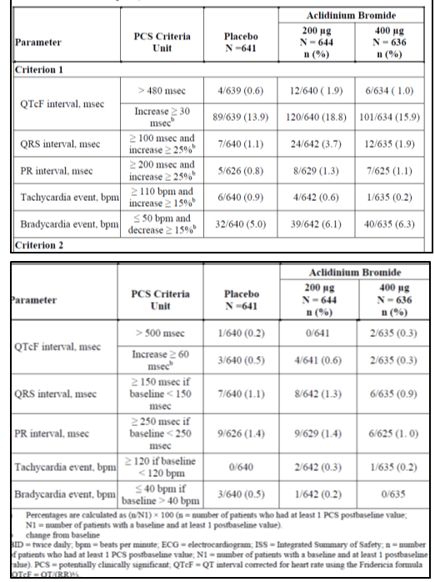
Compared with the findings at baseline, the number and percentage of patients with abnormal ECG findings at end-of-study were relatively small. Overall, there was no indication of dose-associated trends or any evidence of consistent changes over the duration of administration. The most frequent finding at end-of-study was left anterior hemiblock (8.9%, 7.4%, and 9.3% in placebo, aclidinium bromide 200 µg and 400 µg groups, respectively). However, these percentages were similar to those recorded at baseline in each group. The next most frequent observation was first degree AV block (7.6%, 7.6% and 8.7%, respectively), also at similar incidences at end-of-study as baseline.
The most frequent observation at end-of-study was sinus bradycardia (3.7%, 2.8% and 3.1%, respectively) and was twice the incidence when compared to baseline. There were no observed sinus pauses at end-of-study and only 1 patient receiving aclidinium bromide 200 µg evidenced supraventricular tachycardia (not present at baseline). The most frequent ectopy findings were atrial premature complexes (2.7%, 3.6% and 2.7%, respectively) and ventricular premature complexes (2.6%, 1.6% and 3.5%, respectively). Frequent atrial premature complexes (>3) were found in a few patients: 0, 1 and 2 patients, respectively and frequent premature ventricular complexes (>2) in 2, 0, and 2 patients, respectively. There was a numerically greater incidence of patients with morphologic abnormalities in the 2 aclidinium bromide groups at end-of-study, at similar incidences at baseline (ie, left ventricular hypertrophies: placebo (1), aclidinium bromide 200 µg (5) and aclidinium bromide 400 µg (3)). Changes from baseline on other ECG abnormal findings (ST segment, T waves and U waves) showed no differences across groups or over time. The percentages of patients who had a PCS ECG abnormality reported as a TEAE were similar across treatment arms (1.6%, 1.4% and 1.3%, respectively). Individual TEAEs associated with PCS ECG abnormalities were reported by no more than 2 patients (0.3%) in any treatment arm. The only TEAEs reported by 2 patients in either active treatment arm were atrial fibrillation, ECG abnormal and ECG QT prolonged. All other TEAEs associated with PCS ECG abnormalities were single occurrences in either treatment group. Two SAEs associated with PCS ECG assessments were reported: 1 in the 200 µg BD group (myocardial infarction [Study M/34273/34] and 1 in the 400 µg BD group (sick sinus syndrome Study M/34273/34]. Both events were considered to be of severe intensity. Study drug was prematurely discontinued due to the myocardial infarction, but was not discontinued in response to the event of sick sinus syndrome. In addition to the patient in the 200 µg BD group who prematurely discontinued study drug due to the SAE of myocardial infarction, an additional 2 patients, both in the 200 µg BD group, prematurely discontinued study drug due to TEAEs [ECG ST-T change] and AV block first degree]. Both TEAEs resulting in treatment discontinuation were of mild or moderate intensity.

Other studies
In the long term BD studies, mean changes from baseline to end-of-study were numerically small and similar for the 2 aclidinium bromide dose groups. Incidences of post-baseline PCS ECG findings including events of tachycardia and bradycardia were generally similar for the 2 aclidinium bromide dose groups, with the exceptions of PCS increases in QTcF interval and PR interval: QTcF interval increases ≥ 30 msec (as per Criterion 1) were reported in 19.8% and 21.6% of patients dosed with aclidinium bromide 200 µg and 400 µg, respectively. The proportions of patients in each treatment group with increases in QTcF interval ≥ 60 msec (as per Criterion 2) were similar for the aclidinium bromide 200 µg and 400 µg dose groups (1.1% and 1.0%, respectively). The proportions of patients with a QTcF interval ≥ 480 msec (as per Criterion 1) or with a QTcF interval ≥ 500 msec (as per Criterion 2) were low, particularly for Criterion 2, and similar for the 2 aclidinium bromide doses. Increases in PR interval ≥ 200 msec with a 25% increase over baseline (as per Criterion 1) were reported for 0.9% and 1.4% in 200 µg and 400 µg groups, respectively, although it should be considered that the numbers of patients in each dose group with such increases were low and the difference in incidence between the dose groups was small and of doubtful clinical relevance. Increases in PR interval ≥ 250 msec if baseline is <250 msec (as per Criterion 2) were reported for the same percentage of patients in the aclidinium bromide 200 µg and 400 µg dose groups (1.1% of both dose groups).
Overall, the percentages of patients who had a PCS ECG abnormality reported as a TEAE were similar for the aclidinium bromide 200 µg BD (2.3%) and 400 µg BD (2.0%) dose groups. TEAEs associated with PCS ECG assessments and reported by more than 2 patients in either treatment group were bradycardia, ECG ST segment depression, myocardial ischaemia, AV block first degree, atrial fibrillation, ventricular extrasystoles and ECG abnormal. The incidence of individual TEAEs was low, with no TEAE reported in more than 3 patients in either treatment group. A total of 4 PCS ECG assessments were reported as SAEs; 2 in the 200 µg BD group [T-wave inversion and acute myocardial infarction] and 2 in the 400 µg BD group [atrial flutter myocardial ischaemia]. Study drug treatment continued unaffected for the patient with acute myocardial infarction while the other 3 patients discontinued study drug. In addition to the 3 patients with SAEs who discontinued study drug, a further 5 patients discontinued aclidinium bromide due to TEAEs associated with PCS ECG assessments; 2 in the 200 µg BD arm (atrial fibrillation and bradycardia] and 3 in the 400 µg BD arm ( ECG PR prolongation, ECG QT prolongation, AV block first degree and sinus bradycardia). All these events were of mild or moderate intensity except 1 which was considered severe (atrial fibrillation).

Holter data
Twenty-four h 12-lead Holter monitoring was conducted before initiation of twice daily study drug administration and again at the conclusion of the double blind, placebo controlled treatment period for studies LAS-MD-33 and LAS-MD-38A in a subset of at least 30% of the patients at selected sites that were capable of conducting 24-h Holter monitoring assessments. The patients were generally similar across all 3 treatment groups at baseline. A numerically lower percentage of patients experienced tachycardia at 12 weeks compared to baseline, which in turn, was slightly numerically lower in the placebo group than in the aclidinium bromide treatment arms (30.8%, 31.8% and 35.4% in placebo, aclidinium bromide 200 µg and 400 µg groups, respectively). Additionally, a higher percentage of patients had bradycardia episodes at Week 12 compared to baseline in the aclidinium bromide treatment groups (Table 45). Cardiologist’s review of Holter ECG data showed that there were no occurrences of ventricular fibrillation, accelerated idioventricular tachycardia, or torsade de pointes. There was a numerical increase with aclidinium bromide compared to placebo in the number of patients exhibiting episodes of increased non-sustained supraventricular tachycardia (14.0%, 25.4%, and 23.9%, respectively) that did not appear to be dose related. The increase of episodes of non-sustained supraventricular tachycardia were mainly of one single episodes and higher number of patients had increases of at least 2 episodes in placebo than in aclidinium groups (58.3%, 48.8% and 47.4%, respectively).
Table 45. Holter data Double-blind, placebo controlled studies.
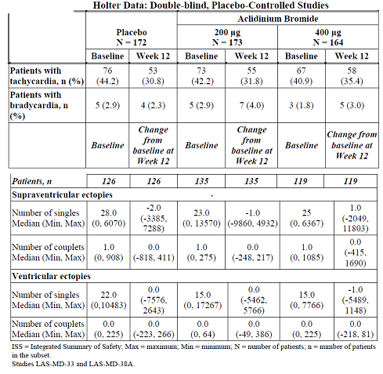
In the QD long term safety population, mean changes from baseline at week 52 in QTcF was -0.3 in the aclidinium bromide treatment group and -0.2 in the placebo group. The number of patients (percentages) with postbaseline outlier values for QTcF > 500 msec with aclidinium bromide were very few and comparable to those with placebo (0.2% versus 0.5% for aclidinium bromide and placebo, respectively). One of the subjects receiving aclidinium bromide had a QTcF baseline value of 500 msec and this was reflected in 2 postbaseline QTcF readings greater than 500 msec, but the increases compared to baseline were only 2.5 and 10.5 msec. The proportion of patients showing sporadic QTcF postbaseline changes ≥ 60 msec was also similar in the aclidinium bromide group compared to the placebo group (0.9% for aclidinium bromide and 0.7% for placebo). Comparable differences between the treatment groups were observed for the proportion of patients with postbaseline QTcF values > 480 msec or changes ≥ 30 msec, respectively. In the aclidinium bromide group, the highest percentage of patients treated with aclidinium bromide with an ‘increase in heart rate to ≥ 110 bpm and increase ≥ 15%’ compared to baseline was observed at Week 12 (0.4%); in patients treated with placebo the highest percentage was noticed at Week 28 (0.6%). For ‘increase to ≥ 120 bpm’ the highest percentage was (0.5%) at Week 44 for aclidinium bromide-treated patients similar to the highest incidence in placebo (0.3%) at Week 28. No relevant differences were observed in the presence of bradycardia events. There were no relevant differences in the ECG global abnormalities. Quantitative differences in cardiac conduction TEAEs were observed between aclidinium bromide and placebo, but these were not confirmed by ECG because there was a high incidence of conduction abnormalities at baseline in the COPD long term patient population enrolled in the aclidinium bromide QD clinical studies. Holter monitoring was performed in a subset of patients from the COPD long term patient population and showed no apparent difference in the proportions of patients with abnormal Holter monitoring findings between the aclidinium bromide treatment groups and the placebo group.
In the thorough QT Study M/34273/11 which evaluated effect of QD dosing with 200 µg and 800 µg aclidinium bromide, 162 AEs were reported in 146 healthy subjects, most of them (98%) being mild or moderate (2%). The most common AE reported across the 4 treatment groups (approximately 85% of all AEs) were application site reactions (due to ECG electrodes). Other AEs reported at least by 2 subjects were: dizziness (2 subjects on the 200 µg group), headache (1 subject on the 200 and 1 on the 800 µg group, and 1 on the moxifloxacin group), diarrhoea (2 subjects on moxifloxacin group) and rash (2 subjects in the moxifloxacin group). No SAEs were reported. Only 1 patient discontinued the study due to an AE, an allergic reaction to moxifloxacin (nasal congestion, pruritus and rash). No differences in aclidinium bromide versus placebo were observed in other safety parameters (laboratory tests, physical examination and vital signs).

Vital signs

Pivotal studies
Data obtained during the 3 double blind, placebo controlled studies did not disclose any relevant mean change from baseline to end-of-study for either mean systolic or mean diastolic blood pressure. Vital sign values were considered potentially clinically significant (PCS) if they fell outside the limits listed. For the placebo controlled BD Group 1A population, the incidences of PCS vital signs were low (≤ 1%). There was a small numerical difference noted for aclidinium bromide in the number of patients who experienced systolic/diastolic BP increases. However, there were no consistent changes over time and no indication of a dose response relationship for this variable. Overall, the frequencies of BP assessments reported as TEAEs were low for both the placebo controlled BD Group 1A population and the long term BD Group 1B population. Only 2 blood PCS blood pressure assessments were reported as TEAEs: hypertension in 1 of 644 patients receiving aclidinium bromide 200 µg and in 1 of 636 patients receiving aclidinium bromide 400 µg. Both of these events were mild or moderate in intensity, neither was serious nor considered treatment-related nor resulted in treatment discontinuation.

Other studies

BD long term studies:
Consistent with observations in the BD Group 1A population, no clinically relevant mean changes from baseline to end-of-study with aclidinium bromide 200 µg BD or 400 µg BD for either systolic (0.7 mm Hg and -1.6 mm Hg, respectively) or diastolic (0.1 mm Hg and -0.4 mm Hg, respectively) blood pressure (BP) parameters were observed in the long term BD Group 1B population. The long term BD Group 1B studies demonstrated a low incidence of PCS abnormalities of blood pressure, which was comparable to the incidence observed in the placebo controlled BD Group 1A studies. In the long term safety studies, only 5 patients were reported to have experienced PCS blood pressure assessments that were reported as TEAEs: 2 patients with aclidinium bromide 200 µg BD and 3 patients with aclidinium bromide 400 µg BD. Of the 5 TEAEs, only 1 was reported as a SAE (uncontrolled hypertension; aclidinium bromide 200 µg); the SAE was of severe intensity, considered not treatment related and did not result in treatment discontinuation. The patient, who had a medical history which included hypertension, recovered from the event. The other 4 TEAEs (hypertensive nephropathy, DBP increased and 2 events of hypertension) were mild or moderate in severity; none was considered treatment-related and none resulted in treatment discontinuation. With the exception of the event of DBP increased, all events had resolved by the time of last observations for the studies.

Other safety parameters. Analysis of TEAEs of special interest categorised by organ system or syndrome

Cardiovascular events
Two analyses were performed to evaluate the overall cardiovascular risk of the drug: (1) Analysis of Major Adverse Cardiovascular Events (MACE), and (2). Analysis of cardiac events of interest based on Standardised MedDRA queries (SMQs). MACE and cardiac events of interest based on SMQs were analysed using data obtained from pooled Phase III placebo controlled studies (BD Group 1A) and from the individual long term safety studies, LAS-MD-35, LAS-MD-36, and LAS-MD-38 Part B. MACE was defined as a composite of cardiovascular death, non-fatal myocardial infarction, and non-fatal stroke. A MACE Score was defined as the total number of patients with cardiovascular deaths, non-fatal myocardial infarctions and/or non-fatal strokes reported in that particular treatment group.
Of the 16 deaths, 5 deaths were considered by the adjudication committees to be cardiovascular”. Of the 5 CV deaths, 2 were sudden cardiac deaths reported as cardiac arrest while the remaining deaths were due to: possible myocardial infarction, acute cardiac failure and subarachnoid haemorrhage. All 5 patients had extensive cardiovascular medical histories. In addition, the 2 patients with cardiovascular deaths due to cardiac arrest, who were relatively young (aged 48 and 51 years), had a history of drug abuse, and the patient with cardiovascular death due to subarachnoid haemorrhage was receiving concomitant anticoagulant treatment.
In the BD pivotal studies, no apparent differences between treatment groups were observed in MACE Scores or in the incidences of cardiovascular death, non-fatal myocardial infarction or nonfatal stroke. No notable differences were observed between the aclidinium bromide treatment groups in studies LAS-MD-35 and LAS-MD-36 for the MACE Scores or for the incidences of CV death, non-fatal myocardial infarction or non-fatal stroke, suggesting no dose-dependency.

MACE- CV death
The incidence rate (per 1000 PY) of cardiovascular death in BD Group 1 was low (2 patients in placebo controlled BD Group 1A studies and 3 patients in long term safety studies). While there were no cardiovascular deaths in placebo-treated patients in clinical trials of aclidinium bromide, the incidence rates of cardiovascular death observed in the aclidinium bromide groups were in line with those reported in the literature in the placebo group of placebo controlled studies with tiotropium and indacaterol and for tiotropium itself.

MACE: AMI
In the placebo controlled BD Group 1A studies, only 1 non-fatal myocardial infarction, as per the SMQ, was reported (in a placebo-treated patient). The long term studies, LAS-MD-35 and LAS-MD-36, which investigated both the 200 µg and 400 µg doses of aclidinium bromide, revealed no dose-dependency in the incidences or incidence rates of non-fatal myocardial infarction. The incidence rate of non-fatal myocardial infarction observed in the open-label study of aclidinium bromide 400 µg LAS-MD-38 Part B was within the range observed in the other studies of aclidinium bromide. Furthermore, the incidence rates of non-fatal myocardial infarction reported in clinical studies of aclidinium bromide were comparable to those reported in clinical trials of tiotropium.
Similarly, the incidences of myocardial infarction observed with aclidinium bromide were comparable to those observed in two retrospective epidemiological studies (Sidney et al, 2005 [patient population: 45,966] and Curkendall et al, 2006 [patient population: 11,493]) that showed the incidences per 1000 PY of hospitalisation for acute myocardial infarction to be 9.5 and 10.9 respectively. In conclusion, the incidence rates of non-fatal myocardial infarction observed in aclidinium bromide-treated patients are broadly comparable to those observed in the general COPD population and in patients treated with tiotropium.

MACE: Non-fatal stroke
In the placebo controlled BD Group 1A studies, fewer non-fatal strokes (as per the SMQ) were reported in the aclidinium bromide treatment groups than in the placebo group. The long term studies, LAS-MD-35 and LAS-MD-36, which investigated both the 200 µg and 400 µg doses of aclidinium bromide, revealed no dose-dependency in the incidences or incidence rates of non-fatal stroke. The incidence rate of non-fatal stroke in the open-label long term study of aclidinium bromide 400 µg, LAS-MD-38 Part B, was similar to that observed in the placebo group of the pooled placebo controlled studies of aclidinium bromide. Incidence rates of non-fatal stroke with aclidinium bromide observed in placebo controlled BD Group 1A studies and in the long term studies were comparable to those observed with placebo in the BD Group 1A studies. Incidence rates of non-fatal stroke with aclidinium bromide are also similar to those observed in a similar COPD population in randomised clinical trials of tiotropium and salmeterol/fluticasone. Moreover, the incidence rate of non-fatal stroke in aclidinium bromide-treated patients is generally similar to incidence rates for hospitalisation due to stroke observed in retrospective epidemiological studies in COPD patients (8.1 events per 1000 PY[ Sidney, 2005]; 12.4 events per 1000 PY[Curkendall, 2006]).

Cardiac events of interest based on Standard MedDRA Queries (SMQs)
In the placebo controlled BD Group 1A population, TEAEs within the bradyarrhythmia/ Conduction Defects/Sinus Node Disorders SMQ were the most frequently reported. The incidences and incidence rates of TEAEs within the SMQs Supraventricular Tachycardia, Myocardial Infarction and Ischaemic Heart Disease Other were similar with aclidinium bromide 400 µg and placebo or slightly lower with aclidinium bromide 400 µg than with placebo. The incidences and incidence rates of events within the SMQ Cardiac Failure and the SMQ Bradyarrhythmia/Conduction Defects/Sinus Node Disorders were slightly higher with aclidinium bromide 400 µg than with placebo. In long term studies LAS-MD-35 and LAS-MD-36, TEAEs within the bradyarrhythmia/ Conduction Defects/Sinus Node Disorders SMQ were the most frequently reported. In study LAS-MD-38 Part B, TEAEs within the Ischemic Heart Disease Other SMQ were the most frequently reported. In individual studies LAS-MD-35 and LAS-MD-36, the combined incidences and incidence rates for all Cardiac Events of Interest (by SMQ) were either numerically similar between the aclidinium bromide 200 µg and 400 µg treatment arms or lower in the 400 µg arm than in the 200 µg arm. In Study LAS-MD-38 Part B the incidence rates of Cardiac Events of Interest were generally similar to those observed with aclidinium bromide in the other long term safety studies, with the exception of events within the SMQ Ischaemic Heart Disease Other, which were reported at an increased incidence rate (Table 46).
Table 46. Incidences of patients with TEAEs of cardiac disorders by specific SMQ category in clinical studies LAS-MD-35, LAS-MD-36 and LAS-MD-38 Paart B: aclidinium bromideadminsitered twice daily to patients with COPD.

SMQ supraventricular tachyarrhythmias
The incidences and incidence rates of TEAEs mapping to the SMQ Supraventricular Tachyarrhythmias were lower with aclidinium bromide 400 µg than with aclidinium bromide 200 µg or placebo in the placebo controlled BD Group 1A population and comparable for the 200 µg and 400 µg dose groups of aclidinium bromide in long term studies LAS-MD-35 and LAS-MD-36.

SMQ of ischaemic heart disease other
The incidence rates of PTs within the SMQ of Ischaemic Heart Disease Other were slightly lower with aclidinium bromide 400 µg than with aclidinium bromide 200 µg or placebo in placebo controlled BD Group 1A and no dose-dependency were observed in long term safety studies, LAS-MD-35 and LAS-MD-36 . Incidence rates of events within the SMQ of ‘Ischaemic Heart Disease Other’ observed with aclidinium bromide 400 µg were generally comparable to, or lower than, those observed in the placebo group of pooled clinical trials of tiotropium, or in the placebo group of the TORCH study of salmeterol/ fluticasone.

SMQ cardiac failure
In the placebo controlled BD Group 1A population, the incidences and incidence rates of TEAEs within the SMQ Cardiac Failure were slightly higher with aclidinium bromide 400 µg BD than with aclidinium bromide 200 µg BD or placebo. Of the patients in BD Group 1A with TEAEs which mapped to the SMQ Cardiac Failure, 1 patient in the placebo group, 1 patient in the 200 µg dose group and 3 patients in the 400 µg dose group reported TEAEs that were considered serious. Only 1 event within the Cardiac Failure SMQ was fatal (in the aclidinium bromide 400 µg group).While the incidences of TEAEs within the SMQ Cardiac Failure were comparable between aclidinium bromide and placebo in study LAS-MD-33 and study LAS-MD-38 Part A, more events within the SMQ Cardiac Failure were reported in Study M/34273/34 compared to the other 2 placebo controlled studies, however it should be noted that the duration of exposure in Study M/34273/34 was twice that of studies LAS-MD-33 and LAS-MD-38 Part A (Table 47).
Table 47. Number (%) of patients (by study) with potentially TEAEs of cardiac disorder by cardiac falilure SMQ: Double-blind, placebo controlled studies. Double-blind, placebo controlled studies of aclidinium bromide administered twice daily to patients with COPD. BD Group 1A
No dose-dependency in the incidence rates of patients with events which mapped to the SMQ Cardiac Failure was observed in individual long term safety studies, LAS-MD-35 and LAS-MD-36. Only one patient had such an event in study LAS-MD-35 (in the 400 µg group) and this event was considered serious. Of the 4 patients with cardiac failure events in study LAS-MD-36 (2 in each dose group), all but 1 (in the 200 µg group) was considered serious. The incidence rate of TEAEs within the SMQ Cardiac Failure with aclidinium bromide 400 µg in study LAS-MD-38 Part B was comparable to those observed with aclidinium bromide in the long term study LAS-MD-36 and in the BD Group 1A population. Of the 5 patients with cardiac failure events in study LAS-MD-38 Part B, only 1 was considered serious. No fatal cardiac failure events were reported in the long term studies. The incidence rates of events within the Cardiac Failure SMQ observed with aclidinium bromide 400 µg BD in the placebo controlled BD Group 1A population and the individual long term safety studies were comparable to those observed in the pooled placebo populations of clinical trials of tiotropium.
In summary, all but one of the patients in placebo controlled BD Group 1A with events which mapped to the SMQ Cardiac Failure and all the patients in the long term studies with events within the SMQ Cardiac Failure had pre-existing cardiovascular conditions that may have predisposed to the cardiac failure events or had preceding adverse events that may have contributed to the development of cardiac failure or to a worsening of the pre-existing condition. While an apparent numerical imbalance in the incidence of TEAEs within the SMQ Cardiac Failure between the aclidinium bromide 400 µg group and the placebo group of the placebo controlled BD Group 1A, no dose-dependency in the incidences of cardiac failure were observed in the long term safety studies.

Bradyarrhythmia/conduction defects/sinus node disorders SMQ
The majority of the TEAEs in this group mapped to the Conduction Defects SMQ, which showed a slightly higher incidence in the aclidinium bromide 400 µg group compared with placebo, mainly due to higher incidence in the aclidinium bromide 400 µg group in pivotal Study 34. Conduction defects reported in the placebo controlled BD Group 1A population included a variety of different ECG abnormalities but no clinically significant symptoms or events. The numerical imbalance observed in the BD Group 1A population between the placebo group and the aclidinium bromide 400 µg group was mainly driven by an apparent imbalance between these treatment groups in the numbers of patients with atrioventricular (AV) block first degree.
No dose dependency in the incidence or incidence rate of the combined occurrence of events within the Conduction Defects SMQ or of individual PTs within the Conduction Defects SMQ (including AV block first degree) were observed for studies LAS-MD-35 and LAS-MD-36. The incidence rate of TEAEs within the Conduction Defects SMQ in study LAS-MD-38 Part B was lower than that observed in the other long term safety studies.
In conclusion, while an apparent dose-dependent numerical increase in the incidence and incidence rate of events which mapped to the SMQ Conduction Defects was observed in the placebo controlled BD Group 1A, this was not confirmed in the individual long term safety studies. Evaluation of any potential effect of aclidinium bromide on the incidence of events within the Conduction Defects SMQ is hampered by the low number of reported events. While first-degree AV block was the only event in the placebo controlled BD Group 1A population for which a numerical imbalance between treatment groups was observed (aclidinium bromide 400 µg: 4/636 patients, placebo 1/641 patients). However, sponsors state that 2 of the 4 PTs in the 400 µg group and the PT in the placebo group should not have been reported as the events were not treatment-emergent. Exclusion of these 3 patients from the total numbers of patients with AV block first degree per treatment group in BD Group 1A negates the slight dose-relationship previously observed in the incidence of this event; the numbers (and percentages) of patients per treatment group with this TEAE are: placebo: no patients (0%); aclidinium bromide 200 µg: 1 patient (0.2%); aclidinium bromide 400 µg: 2 patients (0.3%). Aclidinium bromide has no apparent effect on the incidence of events within the SMQ Conduction Defects.
Comments: Based on limited data provided, it is difficult to justify exclusion of the 3 cases described above as not treatment-emergent. Hence, it is recommended that 1st degree AV block also be added to list of AEs with incidence <1%, but higher incidence in aclidinium bromide 400 µg group compared with placebo in the proposed PI.

Cerebrovascular AEs
The combined incidences and incidence rates of cerebrovascular disorders (by SMQ) were numerically similar across treatment groups of BD Group 1A, with a slightly greater incidence in the placebo group compared to the 2 aclidinium bromide groups and no signal for any potential dose dependency. The incidences of individual PTs within the SMQ of Central Nervous System Haemorrhages and Cerebrovascular Conditions were low; the only TEAE reported in more than 1 patient was cerebrovascular accident, which was reported for 2 patients in the placebo group and there were no fatal TEAEs. The incidences and incidence rates of cerebrovascular disorders were numerically balanced in both arms in long term safety studies LAS-MD-35 and LAS-MD-36. The incidence and incidence rate in long term safety study LAS-MD-38 Part B were low and comparable to those in the other long term studies. The incidence rates observed in the long term safety studies were comparable to that observed with placebo in the placebo controlled BD Group 1A studies. Furthermore, the incidence rates observed with aclidinium bromide in the BD Group 1A studies and the long term safety studies are consistent with those observed in the placebo arms of randomised clinical trials of tiotropium 9Keston, 2006; Worth, 2011) and salmeterol/ fluticasone (Calverly, 2010). One fatal TEAE was reported within the SMQ Central Nervous System Haemorrhages and Cerebrovascular Conditions (subarachnoid haemorrhage; aclidinium bromide 400 µg; LAS-MD-35).

Respiratory AEs
TEAEs by preferred term, within the SOC Respiratory, Thoracic and Mediastinal Disorders that occurred in a least 1% of patients were: dyspnoea, COPD exacerbation, cough, and oropharyngeal pain. The incidences and incidence rates were comparable in the aclidinium bromide treatment groups to that in the placebo group, with the exception of cough which was reported at a slightly higher incidence with aclidinium bromide than with placebo (aclidinium bromide 400 µg: 3.0% [95.8 per 1000 PY], aclidinium bromide 200 µg: 2.6% [85.3 per 1000 PY], placebo: 2.2% [73.5 per 1000 PY]). The incidence rate of patients with at least one TEAE within the Respiratory, Thoracic and Mediastinal SOC was slightly lower in the aclidinium bromide 400 µg group than in the aclidinium bromide 200 µg group, indicating no dose-dependency. The only TEAE reported at an increased incidence rate (by at least 10 per 1000 PY) with aclidinium bromide 400 µg BD compared to aclidinium bromide 200 µg BD was oropharyngeal pain. By comparison, in the placebo controlled BD Group 1A studies the incidence rates for oropharyngeal pain were lower in the aclidinium bromide 200 µg BD and 400 µg BD dose groups than in the placebo group.

Pneumonia
PT terms of pneumonia in the placebo controlled BD Group 1A population showed a slightly higher incidence of pneumonia in the placebo group (0.8%) compared to the aclidinium bromide 200 µg (0.6%) and 400 µg (0.3%) groups. Most of the events of pneumonia in placebo controlled BD Group 1A were mild or moderate in intensity (placebo [3 of 5]; aclidinium bromide 200 µg [3 of 4] and aclidinium bromide 400 µg [1 of 2]), and all events were considered not related to the study drug. One subject who experienced lobar pneumonia while receiving aclidinium bromide 200 µg permanently discontinued study drug due to the event. The incidences and incidence rates of pneumonia in the pooled long term safety studies were slightly higher in the aclidinium bromide 200 µg group than in the aclidinium bromide 400 µg group which suggests no dose-dependency. Most of the events of pneumonia in long term BD Group 1B were mild or moderate in intensity (aclidinium bromide 200 µg [10 of 16], aclidinium bromide 400 µg [13 of 23]. Only 2 of the events was considered to be related to study drug (both pneumonia in the aclidinium bromide 200 µg group). A total of 3 patients, all in the aclidinium bromide 200 µg group, permanently discontinued study medication due to TEAEs of pneumonia (1 patient) or lobar pneumonia (2 patients). The incidence rates of pneumonia in the aclidinium bromide 200 µg BD and 400 µg BD dose groups of the placebo controlled BD Group 1A population and the long term BD Group 1B population were comparable to that observed in the placebo arm of the BD Group 1A population and also comparable to those reported in the literature in the placebo arms in clinical trials of tiotropium and salmeterol/fluticasone.
An analysis of the incidence of pneumonia based on prior use of inhaled corticosteroids (ICS; internal data) showed that patients who had prior use of ICS reported more events of pneumonia that those patients who had not prior use of ICS in BD Group 1A were (ICS users versus ICS non-users) 0.8% versus 0% for aclidinium bromide 400 µg, 0.8% versus 0.5% for 200 µg and 1.2% versus 0.5% for placebo. The incidences in the BD Group 1B were 3.8% versus 1.4% for aclidinium bromide 400 µg and 4.9% versus 1.8% for 200 µg. The incidence rates of bronchitis were similar in aclidinium and placebo groups in the pivotal BD studies and showed no dose-dependency in the long term BD studies. The incidence rates of respiratory failures (acute respiratory failure and respiratory failure) in BD Group 1A were numerically similar across treatment groups (10.5, 0 and 15.1 per 1000 PY in the placebo, aclidinium bromide 200 µg and 400 µg groups, respectively). Incidence rates of respiratory failures (acute respiratory failure, respiratory failure and chronic respiratory failure) with aclidinium bromide 200 µg and 400 µg in BD Group 1B were also numerically similar (10.5 and 11.9 per 1000 PY, respectively) indicating no dose-dependency. There was only 1 case of bronchospasm (nonserious) reported in all studies combined.

Anticholinergic AEs
The majority of the events reported had low incidence rates and occurred with aclidinium bromide at comparable incidences to placebo. TEAEs that occurred in >1% of patients and at a greater incidence (by at least 2 patients) and incidence rate (by 10 per 1000 PY) with either aclidinium bromide 200 µg or 400 µg than placebo were: dry mouth, urinary tract infection, and dizziness. TEAEs that occurred in fewer than 1% of patients in any treatment group but that were reported with aclidinium bromide 400 µg at an incidence higher than placebo (by at least two patients and 10 per 1000 PY) were dysphonia and tachycardia only TEAE that occurred in the long term BD Group 1B studies in at least 1% of patients in either aclidinium bromide dose group, and which occurred with a higher incidence (by at least 2 patients) and incidence rate (by at least 10 per 1000 PY) with the 400 µg BD dose group than the 200 µg BD dose group was oropharyngeal pain.
Potential anticholinergic side effects are discussed by SOC below.

Gastrointestinal disorders
Dry mouth is an adverse event that is typically associated with anticholinergic treatments. However, in the placebo controlled BD Group 1A population, the incidences of dry mouth were low. The incidence rate of dry mouth observed with aclidinium bromide 200 µg BD (35.1 per 1000 PY) was higher than that observed with placebo (21.0 per 1000 PY), although the incidence rate in the 400 µg BD group (25.2 per 1000 PY) was similar to that of placebo. The difference in incidence between the aclidinium bromide 200 µg group and the placebo group comprised 3 patients only and is, therefore, of uncertain clinical significance. In the long term BD Group 1B population, the incidence rates of dry mouth in the aclidinium bromide 200 µg and 400 µg groups were numerically similar (18.3 per 1000 PY and 22.4 per 1000 PY, respectively). Another potential side effect associated with anticholinergic drugs is constipation. However, in the placebo controlled BD Group 1A population, there were no events of constipation reported in the aclidinium bromide 400 µg group and the incidence rate of constipation was higher in the placebo group (31.5 per 1000 PY) than in either the 200 µg or 400 µg dose groups (20.1 per 1000 PY and 0 per 1000 PY, respectively). Similarly, in the long term studies constipation occurred at a higher incidence rate with aclidinium bromide 200 µg BD (41.9 per 1000 PY) compared to aclidinium bromide 400 µg BD (17.2 per 1000 PY) suggesting no dose-dependency.

Renal and urinary disorders
Only 1 patient in the placebo controlled BD Group 1A population (in the 400 µg group; 0.2%; 5 per 1000 PY) and 2 patients in the long term BD Group 1B population (both in the 400 µg group; 0.2%; 2.6 per 1000 PY) reported TEAEs of urinary retention. None of the events were of severe intensity, none of the events were considered treatment-related and none of the events resulted in treatment discontinuation.

Eye disorders
In the placebo controlled BD Group 1A population, there was only 1 event each of transient blindness, visual acuity reduced, vision blurred and dry eye reported within the SMQ Anticholinergic Syndrome in the aclidinium bromide 200 µg arm with no such events reported in the placebo arm or aclidinium bromide 400 µg arm. The subject who experienced the severe event of transient blindness while receiving aclidinium bromide 200 µg had a medical history of episodic blindness that was ongoing and was considered legally blind. In the long term safety studies (BD Group 1B), the incidences with aclidinium bromide 200 µg BD and aclidinium bromide 400 µg BD of eye disorders within the SMQ Anticholinergic Syndrome (dry eye [0.4% and 0.3%, respectively], vision blurred [0.2%, 0.2%], visual acuity reduced [0.0%, 0.1%] and accommodation disorder [0.0%, 0.1%]) were numerically low and comparable for the two treatment arms . A total of 2 events of glaucoma (both only moderate intensity) were reported within the SMQ Anticholinergic Syndrome in the aclidinium bromide 400 µg BD group (1 angle closure glaucoma and 1 glaucoma) while none was reported in the aclidinium bromide 200 µg BD group. Neither event necessitated a change in study drug treatment. One of the 2 patients had a medical history of Hashimoto’s thyroiditis but the other patient had no relevant medical history.

Other disorders
In the placebo controlled BD Group 1A population, no apparent dose-relationship was observed in the incidence rates of dizziness (26.2, 35.1 and 20.2 per 1000 PY in placebo, aclidinium bromide 200 µg and 400 µg groups, respectively). All events of dizziness were mild/moderate in severity and the majority of the events were considered not related to the study drug (placebo [2 not related and 3 related], aclidinium bromide 200 µg. The incidence rates of dizziness in the long term BD Group 1B studies were numerically higher with aclidinium bromide 200 µg BD than with aclidinium bromide 400 µg BD (34.5 and 15.8 per 1000 PY, respectively), suggesting no dose dependency. While an apparent dose-relationship was observed for dysphonia in the placebo controlled BD Group 1A population (placebo: 0; 200 µg BD: 10.0 per 1000 PY% and 400 µg BD: 15.1 per 1000 PY), the difference in incidence was based on a difference of 3 patients between placebo and aclidinium bromide 400 µg BD and is, therefore, of uncertain clinical significance. The incidence rates of dysphonia in the long term BD Group 1B population were comparable for aclidinium bromide 200 µg BD (15.7 per 1000 PY) and aclidinium bromide 400 µg BD (13.2 per 1000 PY). The incidence and incidence rate of tachycardia in the placebo controlled BD Group 1A population was also low and while a possible dose-relationship was observed (placebo: 0 per 1000 PY; 200 µg: 5.0 per 1000 PY; 400 µg: 10.1 per 1000 PY), the difference in incidence rate between the placebo and 400 µg groups was based on a difference of 2 patients. A low incidence and incidence rate of tachycardia was also observed in the long term BD Group 1B population with no dose-dependency observed (10.5 and 1.3 per 1000 PY with 200 µg and 400 µg, respectively).

Safety results in the Once Daily (QD) dosing studies
In the long term COPD patient population (Studies M/34273/30 and M/34273/31), the percentage of patients with TEAEs was similar in the aclidinium bromide 200 µg QD and the placebo group: 74.4% and 73.8%, respectively. COPD (exacerbation) was the most common TEAE in both treatment groups, followed by (reported at an incidence >5% in any treatment arm) nasopharyngitis, headache, upper respiratory tract infection, and back pain. TEAEs reported by at least 2% of the patients and that were more frequent in the aclidinium bromide treatment group compared with placebo (in at least 1% more patients) were nasopharyngitis, diarrhoea, arthralgia, abdominal pain and musculoskeletal pain.
Overall, there were 21 deaths who received at least 1 dose of the investigational product in the clinical trials of aclidinium bromide QD in COPD patients. Overall, 14 deaths occurred in patients treated with aclidinium bromide (14/1925 patients: 0.7%) and 7 deaths occurred in patients treated with placebo (7/819 patients: 0.9%). Four (4) of the 21 deaths occurred more than 30 days after stopping study treatment. Of the 4 deaths, 3 deaths were in Study M/34273/31 (2 placebo and 1 aclidinium bromide 200 µg) and 1 death was in Study M/34273/30 (placebo). All deaths were considered to be not related to the investigational product.
The overall frequency of SAEs for aclidinium bromide was similar to placebo (8.8% versus 9.8%, respectively). The most frequently occurring SAEs (that is, in 3 patients or more) with a numerically higher incidence in the aclidinium bromide group compared to placebo were lobar pneumonia (0.3% versus 0.2%, respectively), pulmonary embolism (0.2% versus 0.0%), acute myocardial infarction (0.2% versus 0.0%), and angina unstable (0.2% versus 0.0%). COPD (exacerbation) were not reported as SAEs in Studies M/34273/30 and M/34273/31, except in case of fatal or life-threatening events, thus the number of serious COPD (exacerbation) are understated.
MACE or specific cardiac SMQs were not performed for events observed in the QD studies. The incidence of cardiac events in the aclidinium bromide overall group was identical to that in the placebo group (4.4%). Incidence of ischaemic coronary artery disorders (placebo versus aclidinium bromide: 1.1% versus 0.9%), supraventricular arrhythmias (1.1% versus 1.1%) and rate and rhythm disorders (0.9% versus 0.9%) were numerically similar. Incidence rates of cardiac conduction disorders were numerically slightly higher in the aclidinium bromide arm (0.5%) compared to the placebo arm (0.1%). However, the total incidences were low (1 in placebo, 9 in aclidinium bromide) and the majority of the events were atrioventricular block first degree (5). Incidence rates of cardiac failures occurred at a lower incidence in aclidinium bromide (0.2%) compared to placebo (0.7%). Overall, there were no cardiac signals observed in the Total COPD population in the QD studies.
Incidence rates of CNS haemorrhages and cerebrovascular accidents were low in both treatment arms (0.3% in aclidinium bromide and 0.1% in placebo) Respiratory, thoracic and mediastinal system TEAEs that occurred in at least 1% of patients in the overall aclidinium bromide group (< 200 µg, 200 µg, and >200 µg) in the QD studies are COPD exacerbation (19.5% placebo, 22.0% aclidinium bromide), cough (2.9%, 3.5%), oropharyngeal pain (2.0%, 2.8%) and dyspnoea (2.3%,1.7%). All events were comparable between aclidinium bromide and placebo. Incidence rates of lower respiratory tract and lung infections such as pneumonia were numerically small and similar between placebo (1.6%) and aclidinium bromide (1.5%) There was only 1 case of bronchospasm reported in a subject who had received aclidinium bromide 200 µg in the QD studies (Total COPD population). Incidence rates of respiratory failures were numerically similar between placebo (0.5%) and aclidinium bromide (0.3%).
The majority of individual potential anticholinergic TEAEs reported in the Long-Term Safety Population occurred with a low frequency (<3%) in either treatment groups. Those reported by at least 2 patients and occurring with aclidinium bromide 200 µg QD at an incidence greater than placebo included oropharyngeal pain (3.7% versus 3.3%), pyrexia (1.6% versus 1.0%), tachycardia (0.5% versus 0.2%), dry eye (0.5% versus 0.2%), cystitis (0.5% versus 0%), gait disturbance (0.2% versus 0%) and somnolence (0.2% versus 0%). Although cystitis was reported at a higher frequency in the aclidinium bromide group of patients, urinary tract infection was reported at a slightly lower incidence in the aclidinium bromide group. In addition, constipation, a TEAE frequently associated with anticholinergic treatments, was observed in 1.4% of patients receiving aclidinium bromide and 1.0% of patients receiving placebo. None of the patients discontinued due to these AEs except for one patient with pyrexia in the aclidinium bromide group. One patient in the aclidinium bromide group only reported one case of angle closure glaucoma and another patient reported one case of urinary retention. The incidence of dry mouth, a commonly reported event with other anticholinergics, was lower with aclidinium bromide than with placebo (0.7% versus 1.2%).
The overall percentage of patients reporting at least one TEAE during the first 3 months of treatment in the long term, double blind, placebo controlled studies with aclidinium bromide QD (QD Group 1A studies) was 42.7% for aclidinium bromide 200 µg QD and 45.0% for placebo which was comparable to that observed for the same analysis of the double blind placebo controlled BD Group 1A studies with aclidinium bromide BD (aclidinium bromide 200 µg BD: 45.2%; aclidinium bromide 400 µg BD: 44.8%; placebo: 47.1%). There was no increase in the overall TEAE incidence with the change from QD to BD dosing and results suggest a lack of a dose response. Comparison of the most commonly reported SOCs and individual preferred terms in these QD and BD analyses also did not reveal a dose response effect.
In QD group 1A safety dataset, age, gender and COPD severity did not have any clinically relevant effect on safety of aclidinium bromide administered QD.

Phase I studies in non-COPD subjects
Overall, 2 SAEs were reported in Phase I studies investigating aclidinium bromide in non-COPD subjects (Studies M/34273/00, M/34273/01, M/34273/03, M/34273/04, M/34273/05, M/34273/06, M/34273/08, and M/34273/11). The SAEs were: Viral meningitis in 1 subject in Study M/34273/00 treated with aclidinium bromide 300 µg. The subject was prematurely discontinued from study. Severe diarrhoea reported in 1 subject in Study M/34273/06 after completion of the last dosing period (800 µg aclidinium bromide). The subject was hospitalised and the diarrhoea was diagnosed to be of bacterial origin. Both SAEs were considered unrelated to investigational product administration and both completely resolved.
In the Phase I single-ascending dose study in healthy subjects, the incidence of AEs was similar in LAS34273 (600 to 6000 µg) and placebo (7/16, 44%) groups. The highest incidence of AEs for LAS 34273 was after the 4200 µg dose in 3/6 (50%) subjects with 13 AEs and after the 4800 µg dose in 5/6 (83%) subjects with 7 AEs. However, none of the doses fulfilled the criteria of minimum tolerated dose and so the Maximum tolerated dose could not be identified.

Post-marketing experience
Not applicable.

Safety issues with the potential for major regulatory impact

Liver toxicity
Although, there was some worsening of abnormal baseline blood chemistry parameters of GGT, glucose and AST at end-of-study, the incidences was low (≤3% for each parameter) and not higher in the aclidinium bromide treatment groups compared to the placebo group. TEAEs of severe intensity were reported for 2 patients in the aclidinium bromide 200 µg dose group (hepatitis C and white blood cell count increased); both events necessitated discontinuation of study drug treatment. There were no cases of ‘Hy’s Law cases’ in any of the clinical studies. Based on data provided, there did not appear to be any safety concerns related to liver toxicity associated with proposed dosing of aclidinium bromide 400 µg BD.

Haematological toxicity
Overall, there was no sign of a higher incidence of new haematology abnormalitites with aclidinium bromide compared to placebo. There was no worsening of baseline haematology abnormalities reported at an incidence above 1% at end-of-study. COPD (exacerbation) was the most frequently reported TEAE associated with PCS clinical laboratory abnormalities (0.6%, 0.5% and 0.3% with placebo, aclidinium bromide 200 µg and 400 µg, respectively). The PCS clinical laboratory abnormalities associated with COPD (exacerbation) were increases in at least one of neutrophils, lymphocytes and/or white blood cells. Based on data provided, there did not appear to be any safety concerns related to haematological toxicity with proposed dosing of aclidinium bromide 400 µg BD.

Serious skin reactions
None.

Cardiovascular safety
Cardiovascular adverse events are a specific safety event of interest for anticholinergic drugs given the previous findings with tiotropium. To assess cardiovascular safety of aclidinium bromide, an analysis of major adverse cardiac events (MACE) was done. The MACE score is defined as the total number of cardiovascular deaths, nonfatal myocardial infarctions, and nonfatal strokes. The results do not indicate an increased overall MACE score for aclidinium bromide and do not show a definite signal of imbalance for any of the individual categories of events, but the strength of this assessment is limited by the relatively small sample size and a low event rate. Some of the differences seen in the studies were due to only one event, which is not enough to make a definitive conclusion. These data neither confirm nor prove any contribution of aclidinium bromide to cardiovascular risk and interpretation was limited by the limited number of events that were seen in the program.. Furthermore, patients with a myocardial infarction during the previous 6 months, unstable angina, newly diagnosed arrhythmia within the previous 3 months or hospitalisation within the previous 12 months for heart failure functional classes III and IV as per the New York Heart Association were excluded from the clinical trials, the proposed PI does state that the safety of these patient groups has not been investigated and aclidinium bromide in these patient groups should be used with caution. Other safety assessments, such as ECGs, Holter monitoring and a thorough QT study, did not show any cardiac safety signals.

Unwanted immunological events
None.

Other safety issues

Safety in special populations
Effect of intrinsic factors on safety: Two clinical studies investigated the influence of the intrinsic factors, renal impairment and age, on PK and safety parameters of QD aclidinium bromide (Studies M/34273/08 and M/34273/09, respectively).
The results from these two studies and those from the subgroup analyses (by intrinsic factor) of the BD Group 1A studies and the QD Group 1A studies did not reveal any major clinically significant differences in the incidence of TEAEs with aclidinium bromide according to renal function, age, sex, BMI, COPD severity and pre-existing disease; no firm conclusions could be drawn for the effect of race due to the small group size for non-Caucasians.
The single-dose, open-label, Study M/34273/08 evaluated PK and safety parameters of inhaled aclidinium bromide (400 µg) in 6 subjects with normal renal function and 18 and with various degrees of stable, chronic renal insufficiency. A total of 8 TEAEs were reported in 7 of 24 (29.2%) subjects, these were: 3 TEAEs in 3 (50.0%) subjects with normal renal function, 3 TEAEs in 2 (33.3%) subjects with mild renal impairment, 1 TEAE in 1 (16.7%) subject within both the moderate and severe renal impairment groups, respectively. The most frequently reported TEAE was headache: 5 TEAEs were reported by 4 (16.7%) subjects (2 TEAEs in 2 subjects with normal renal function and 3 in 2 subjects with mild renal insufficiency). The other TEAEs reported were fatigue (1 TEAE in 1 subject with normal renal function) and somnolence and restlessness (1 TEAE each in 1 subject with moderate and severe renal insufficiency, respectively). All TEAEs were of mild intensity except 1 headache of moderate intensity in a subject with normal renal function. All TEAEs were considered to be related to the study drug, most probably related to the open-label nature of the study and none was ongoing at the end of the study. There were no serious TEAEs and there were no subject discontinuations due to TEAEs. There were no clinically meaningful changes in any laboratory parameter (other than due to renal impairment), vital signs or ECG. In conclusion, single inhaled doses of aclidinium bromide 400 µg were considered to be safe and well tolerated when administered to subjects with normal renal function and those with mild, moderate or severe renal insufficiency.
The multiple dose, open-label, 2-period, Study M/34273/09 assessed the PKs of aclidinium bromide (200 µg and 400 µg) administered once daily by inhalation, after single administration and at steady state, in a broad age range of patients with moderate to severe chronic obstructive pulmonary disease. Twenty-four patients were randomised; 12 young patients aged 40 to 59 years and 12 elderly patients aged ≥70 years. The overall incidence of TEAEs was generally low for both age groups at both dose levels that is, at 200 µg aclidinium bromide: 58.3% (n=7) in younger patients versus 25% (n=3) in elderly patients, and at 400 µg aclidinium bromide: 41.7% (n=5) versus 16.7% (n=2), respectively. Overall, there were no signs for age- or dose-relationship trends in the incidence of TEAEs, including anticholinergic TEAEs (dry mouth during 200 µg treatment: 1 patient in the younger patient group compared to none in the elderly group or during 400 µg treatment. There were no deaths or SAEs reported and no patient discontinued from the study due to a TEAE.

Effect of intrinsic factors on safety of aclidinium bromide in BD pivotal studies.

Age:
Subgroup analyses of the impact of age on TEAEs were performed for the double blind, placebo controlled BD studies. The age categories were <60 yrs (N=637), 60 yrs to < 70 yrs (N=826), and ≥70 yrs (N=458). The overall distribution of TEAEs showed that the percentage of patients with at least 1 TEAE in the aclidinium bromide groups (overall) was higher in patients who were ≥70 yrs and older (55.2%) compared with patients who were <60 yrs (47.7%) and those who were 60 yrs to < 70 yrs (48.7%). Importantly, when overall TEAE incidences were compared among the age subgroups relative to placebo, TEAE incidences were lower in both aclidinium bromide treatment groups compared with placebo in all 3 age categories. Based on a review of common TEAEs considered potentially associated with aclidinium bromide treatment (COPD [exacerbation], nasopharyngitis, headache, cough, diarrhoea, hypertension, back pain and bronchitis) the following PTs (by age category) had greater incidences with aclidinium bromide 400 µg relative to placebo: Diarrhoea in all age subgroups; Headache in the ≥ 60 yrs to < 70 yrs and ≥ 70 yrs age subgroups; Nasopharyngitis in the < 60 yr and ≥ 60 yrs to < 70 yrs; Cough in the < 60 yr age subgroup; Back pain in the ≥ 70 yrs age subgroup. Examination of common TEAE incidence by age subgroups did not indicate that a particular age category was associated with an increased incidence of experiencing AEs when treated with aclidinium bromide. Although some minor differences in AE incidence were detected when compared with placebo (as listed above), the number of patients experiencing the events were few. For example, for back pain in patients ≥70 yrs the difference between aclidinium bromide 400 µg and placebo was only 2 patients. Overall, the minor differences detected were not considered to be clinically relevant.

Gender:
The overall distribution of TEAEs showed that the percentage of patients with at least 1 TEAE in the aclidinium bromide groups (overall) was higher in females (55.5%) compared with males (46.1%). However, when overall TEAE incidences were compared within the male and female subgroups relative to placebo, TEAE incidences were equivalent or lower in both aclidinium bromide treatment groups compared with placebo and there was no dose dependence. Based on a review of common TEAEs considered potentially associated with aclidinium bromide treatment the following PTs (by gender) had greater incidences with aclidinium bromide 400 µg relative to placebo: Headache, nasopharyngitis, cough, and diarrhoea in females; Headache in males. The differences observed in TEAE incidences (by PT) between females and males were not considered to be clinically significant.

Race:
Subgroup analyses of the impact of race (Caucasian versus non-Caucasian) on TEAEs were performed for the double blind, placebo controlled BD studies. However, the number of non-Caucasian patients (N=125) was low in comparison with the number of Caucasian patients (N=1796). The percentage of patients with at least 1 TEAE in the aclidinium bromide groups was lower in non-Caucasians (40.2%) versus Caucasians (50.7%). Importantly, when overall TEAE incidences were compared within race subgroups relative to placebo, TEAE incidences were lower in both aclidinium bromide treatment groups compared with placebo and there was no dose dependence. Based on a review of common TEAEs considered potentially associated with aclidinium bromide treatment the following PTs (by race) had greater incidences with aclidinium bromide 400 µg relative to placebo: Headache, nasopharyngitis, cough, and diarrhoea in Caucasians; Nasopharyngitis in non-Caucasians. Due to the large difference between the size of the two race categories, the differences observed in TEAE incidences (by PT) between the two race categories precludes any definitive conclusions.

BMI:
The BMI categories were: <25 kg/m² (underweight to normal [N = 705]), 25 to <30 kg/m² (pre-obese [N = 680]), and ≥30kg/m² (obese [N = 535]). The overall distribution of TEAEs showed that the percentage of patients with at least 1 TEAE in the aclidinium bromide groups (overall) was higher in patients in the obese category (56.0%) compared with patients in the underweight to normal (49.6%) and the pre-obese (45.8%) categories. However, when overall TEAE incidences were compared among the BMI subgroups relative to placebo, TEAE incidences were lower in both aclidinium bromide treatment groups compared with placebo in all 3 BMI categories and there was no dose dependence. Based on a review of common TEAEs considered potentially associated with aclidinium bromide treatment the following PTs (by BMI category) had greater incidences with aclidinium bromide 400 µg relative to placebo:
- Nasopharyngitis, cough, diarrhoea, and hypertension in the underweight to normal category
- Headache and nasopharyngitis in the pre-obese category;
- Headache, cough, nasopharyngitis, and diarrhoea in the obese category.
The differences observed in TEAE incidences (by PT) among the BMI categories were not considered to be clinically relevant.

COPD severity:
Subgroup analyses of the impact of COPD severity were performed for the double blind, placebo controlled BD studies. The categories were: mild/moderate (N=1170) and severe/very severe (N=735). The percentage of patients with at least 1 TEAE in the aclidinium bromide groups in mild/moderate COPD patients (50.1%) and in severe/very severe COPD patients (49.6%) were comparable. Among the COPD severity subgroups, TEAE incidences were lower in both aclidinium bromide treatment groups compared with placebo and there was no dose dependence. Based on a review of common TEAEs considered potentially associated with aclidinium bromide treatment, the following PTs (by COPD severity) had greater incidences with aclidinium bromide 400 µg, relative to placebo:
- Headache, nasopharyngitis, cough, diarrhoea, and back pain in the mild/moderate COPD category:
- Nasopharyngitis and cough in severe/very severe COPD category.
The differences observed in TEAE incidences (by PT) based on COPD severity were not considered to be clinically relevant.

Pre-existing disease:
In the BD pivotal studies, the overall levels of TEAE incidence in patients with and without gastrointestinal atonic and hypomotility disorders for the placebo, 200 µg and 400 µg doses were 54.8% versus 53.3%, 45.9% versus 50.8% and 57.2% versus 48.2%, respectively. Whilst the difference in TEAEs incidence with pre-existing disease is higher at the 400 µg dose relative to placebo there does not appear to be a dose dependence as this effect is not demonstrated at the 200 µg level. The overall levels of TEAE incidence in patients with and without vascular hypertensive disorders were 59.4% versus 47.2%. 47.5% versus 52.5% and 53.5% versus 46.5% for the placebo, 200 µg and 400 µg doses. Overall, there appears to be no major difference in TEAE incidence in the aclidinium bromide treatments groups compared with placebo in patients with pre-existing diseases of gastrointestinal atonic and hypomotility disorders and vascular hypertensive disorders.

Effect of extrinsic factors on safety of aclidinium bromide in BD pivotal studies

ICS use:
The percentage of patients with at least 1 TEAE in the aclidinium bromide groups who used ICS and who did not use ICS were comparable; 51.7% and 48.9%, respectively. When overall TEAE incidences were compared among the use or non-use of ICS relative to placebo (55% and 52.7%), TEAE incidences were lower in both aclidinium bromide treatment groups compared with placebo. Based on results in the aclidinium bromide 400 µg group, the following PTs (by ICS use/non-use) had greater incidences, relative to placebo:
- Headache, nasopharyngitis, cough, and diarrhoea in patients who used ICS;
- Headache, nasopharyngitis, cough, diarrhoea, and back pain in patients who did not use ICS.
The differences observed in TEAE incidences (by PT) based on ICS use were not considered to be clinically relevant.

Safety related to drug-drug interactions and other interactions
Although not specifically designed to study drug interactions of aclidinium bromide with other agents, the study designs of Studies LAC-MD-27 and M/40464/26 had 2 treatment arms which included a combination of aclidinium bromide and formoterol fumarate. The aclidinium bromide dose was 400 µg for Study LAC-MD-27 and 200 µg for Study M/40464/26. Formoterol doses were 12 μg and 6 μg. A drug interaction, as measured by an increase in TEAEs with the combination of aclidinium bromide and formoterol fumarate compared with the incidence of TEAEs in the monotherapy treatment arms, was not observed in the studies In Study LAC-MD-27, TEAE incidence for the 2 fixed dose combinations of aclidinium bromide and formoterol (400 µg/12 μg and 400 µg/6 μg) were 19.5% and 22.0%, respectively. These values were comparable to the monotherapy arm of aclidinium bromide 400 µg (20.2%), and lower than the rate in the formoterol 12 μg monotherapy arm (29.3%). Hence, there was no evidence of a drug interaction based on TEAE incidence. The same pattern was found for Study M/40464/26; TEAE incidence for the aclidinium bromide and formoterol (200 µg/12 μg and 200 µg/6 μg) were 11.9% and 12.8%, respectively. These values were slightly lower than those of the monotherapy arms of aclidinium bromide 200 µg (17.0%) and the formoterol 12 μg (14.9%).
Overall, given the low plasma aclidinium bromide concentrations achieved in humans at therapeutic doses by inhalation, it is not expected that aclidinium bromide would alter the disposition of drugs metabolised by human CYP-450 enzymes or human esterases and metabolism mediated by cytochrome P450 is a very minor metabolic pathway. Hydrolysis of the ester bond accounts for the majority of the metabolism of aclidinium bromide. Due to the factors mentioned above, specific studies investigating drug-drug interaction studies have not been performed or are planned.
An overview of TEAE incidence stratified by use of allowed concomitant medications for BD Group 1A showed no major differences found in the frequencies of TEAEs in patients who used or did not use concomitant medications in the aclidinium bromide treatment groups when compared with placebo. An overview of TEAE incidence stratified by use of allowed concomitant medications for BD Group 1B studies showed a higher frequency of TEAEs for patients in the aclidinium bromide 400 µg treatment arm who received a concomitant medication compared to those not receiving concomitant treatment, especially Anti-inflammatory/anti-rheumatic drugs, nonsteroidal (81.1% users versus 65.0% nonusers), Short acting β2-agonists (69.7% users versus 56.6% non-users) mainly driven by a higher percentage of COPD exacerbations (14.0% non users versus 22.0% users), Antithrombotic agents (77.4% users versus 64.3% non-users).

Other safety issue: Use in pregnancy, lactation
There was only 1 pregnancy reported (placebo-treated patient) in the aclidinium bromide QD studies and none in the BD studies. Thus there are no data available on the use of aclidinium bromide in pregnant women. Nonclinical studies do not indicate direct or indirect harmful effects on foetal development, parturition or postnatal development. Effects in nonclinical studies with respect to reproductive toxicity (foeto-toxic effects) and fertility (slight decreases in conception rate, number of corpora lutea, and pre- and post-implantation losses) were observed only at exposures considered sufficiently in excess of the maximum human exposure for proposed indication. It is considered unlikely that aclidinium bromide administered at the recommended dose will affect fertility in humans. Aclidinium bromide should only be used during pregnancy if the expected benefits outweigh the potential risks.
It is unknown whether aclidinium bromide and/or its metabolites are excreted in human milk. As animal studies have shown excretion of small amounts of aclidinium bromide and/or metabolites into milk, a decision must be made whether to discontinue breastfeeding or to discontinue therapy with aclidinium bromide taking into account the benefit of breast-feeding for the child and the benefit of long term aclidinium bromide to the woman.

Other safety issue- Overdose, drug abuse, withdrawal and rebound
The highest intended dose of aclidinium bromide in the once daily clinical program (including completed clinical studies) was a single dose of 6000 μg, received by 6 healthy subjects in a Phase I study (Study M/34273/01). None of the patients experienced ‘no signs’ of drug toxicity. Two of the patients reported TEAEs of ‘headache’. The headache was of mild to moderate severity and completely resolved. Additionally, the safety of multiple dosing of aclidinium bromide to steady state, at dosages up to 800 µg once daily and twice daily in healthy subjects in Studies M/34273/06 and LAS-PK-12 was established.
Aclidinium bromide is not structurally or pharmacologically related to any drug known to cause abuse or dependence. During clinical trials there were no AEs that would be indicative of abuse or dependence potential. The risk of abuse or dependence with aclidinium bromide is considered very low. No specific, relevant clinical trials of the abuse or dependence potential of aclidinium bromide have been conducted or are planned. No studies were undertaken to specifically evaluate withdrawal and/or rebound following discontinuation. On the basis of the pharmacological/PK profile and reported AEs, it is considered unlikely that aclidinium bromide will affect the ability to drive or operate machinery.

Safety results from ongoing studies M/34273/39 and M34273/40
In the Phase IIIb, 6 week double blind, placebo and active controlled Study M34.273/39 involving 414 patients with moderate to severe COPD, 28.0% of the patients reported at least one treatment-emergent AE (TEAE), with the lowest incidence in the placebo group (25.9%) and the highest in the tiotropium bromide 18 µg OD group (29.7%). The majority of TEAEs were mild or moderate in intensity. The percentage of patients who experienced severe TEAEs was low (<2.5%) and similar between all treatment groups, including placebo. None of the severe TEAEs reported during this study were considered related to treatment. The most common TEAEs by PT were headache (5.1% of patients overall), nasopharyngitis (5.1%), COPD (exacerbation) (2.4%) and cough (2.2%). Headache was reported more frequently in the aclidinium bromide group than the placebo group, while nasopharyngitis was similarly reported across the active treatment groups and at a higher incidence than in the placebo group. Of the patients with TEAEs, the majority (25.8%) had TEAEs which were considered not related to treatment; 2.7% of patients had at least one treatment-related TEAE. The most common treatment-related TEAE was dry mouth, being reported in 3 patients (0.7%) overall (1 [0.6%] and 2 [1.3%] for the aclidinium bromide and tiotropium bromide groups, respectively). All other treatment-related TEAEs were reported in individual patients across all treatment groups. No deaths occurred during this study and the percentage of patients experiencing treatment-emergent serious TEAEs was low (≤2.5% of patients) and was similar between the active treatments (aclidinium bromide and tiotropium bromide; no SAEs were reported for the placebo group). Overall, there were no trends in the type of SAEs reported during the study and none of the SAEs were considered related to treatment. The percentage of patients experiencing TEAEs leading to discontinuation was low (≤3.5% of patients) and was similar between all treatments, including placebo. Overall, the most common TEAE leading to discontinuation was exacerbation of COPD (6 patients [1.4%]), as per protocol requirement. None of the TEAEs leading to discontinuation were considered related to treatment. The incidence of cardiac, cerebrovascular and potential anticholinergic events was low (≤2 patients in any treatment group). No clinically significant changes from baseline in BP and HR were observed after 6 weeks of treatment.
In the Phase IIIb, Study M34273/40, 58.9% of the patients reported at least one treatment-emergent AE (TEAE), with a higher incidence reported following aclidinium bromide (44.1%) compared to placebo (30.6%). The majority of TEAEs were mild or moderate in intensity, only one TEAE of severe intensity reported during the study, which was considered to be not related to treatment. The most common TEAEs by Preferred Term (PT) were nasopharyngitis (9.8% of patients overall), headache (7.1%) and product taste abnormal (5.4%), all of which were reported at a slightly higher incidence following aclidinium bromide (6.3%, 4.5% and 3.6%, respectively) than following placebo (3.7%, 2.8% and 1.9%, respectively). Of the patients with TEAEs, 54.5% had TEAEs which were considered not related to treatment and 12.5% had at least one treatment-related TEAE. The most common treatment-related TEAE was ‘product taste abnormal’, being reported in 6 patients (5.4%) overall (4 [3.6%] following aclidinium bromide and 2 [1.9%] following placebo). The only other treatment-related TEAEs that were reported in more than one patient overall were dyspnoea (reported by 2 [1.9%] patients following placebo only) and dry mouth (2 [1.8%] patients following aclidinium bromide only).
No deaths occurred during the study and no SAEs were reported following aclidinium bromide (2 SAEs reported in 2 patients following placebo). TEAEs leading to discontinuation were reported in 6 patients (5.4%) overall. The percentage of patients with TEAEs leading to discontinuation was slightly higher following aclidinium bromide (4 [3.6%] patients) compared to placebo (2 [1.9%]). The most common TEAE leading to discontinuation was moderate COPD exacerbation (discontinuation required by the protocol), which was reported in 4 patients (3.6%) overall (2 patients following each treatment). None of the TEAEs leading to discontinuation were considered to be related to treatment. Overall, the incidence of potential anticholinergic events and cardiac events was low (<2% of patients overall), and no cerebrovascular event were reported during the study.

Evaluator’s overall conclusions on clinical safety
Overall, inhaled aclidinium bromide (at any dose and dose regimen) has been evaluated in 2341 healthy adult subjects and 4344 patients with COPD. A total 2879 COPD patients were treated in clinical trials of proposed BD dosing with aclidinium bromide. Of these, 2419 patients received at least one dose of aclidinium bromide BD. Of the 1471 patients treated with aclidinium bromide 400 µg, 970 patients were treated for at least 6 months and 387 patients were treated for at least one year. The extent of exposure at the time of submission meets the minimum of number of patients required for safety evaluation by ICH E1³⁶. Additionally, a total of 2568 COPD patients were included in studies of aclidinium bromide QD of whom 1925 patients received aclidinium bromide QD for at least one day; 1066 patients received aclidinium bromide 200 µg QD for at least 6 months and 767 patients received aclidinium bromide 200 µg QD for one year. The size of the safety database is adequate.
Aclidinium bromide 200 µg or 400 µg BD was well tolerated. The overall incidence of AEs was similar in the aclidinium bromide treated groups and the placebo group. Most AEs were mild or moderate in intensity. The incidence of adverse events (AEs) of severe intensity was similar in the aclidinium bromide and placebo groups. The incidence of serious AEs (SAEs) and adverse events leading to premature study discontinuation was similar for aclidinium bromide and placebo treatment groups. The most frequently reported AE (reported in more than 10% of patients) in the Pivotal Study Population and Long-Term Study Population was COPD (exacerbation) which was reported at a lower incidence in the aclidinium bromide treatment groups than in the placebo group in the Pivotal Study Population. Adverse drug reactions observed with aclidinium bromide 400 µg BD are headache, nasopharyngitis, cough, diarrhoea and sinusitis.
The incidence rates per 1000 patient-years (PY) of each of these events in the aclidinium bromide 200 µg and 400 µg groups were lower in the BD Group 1B long term studies than in the BD Group 1A placebo controlled studies suggesting that their frequency does not increase with increasing duration of exposure. Of the treatment-emergent AEs (TEAEs) that were reported with an incidence ≥ 2% in either treatment group, TEAEs of upper respiratory tract infection, diarrhoea, back pain, hypertension and oropharyngeal pain exhibited numerically higher incidences and incidence rates in the aclidinium bromide 400 µg group compared with the aclidinium bromide 200 µg group. Of the common AEs of headache, nasopharyngitis, cough and diarrhoea only diarrhoea was reported with an increased incidence rate in the 400 µg group compared to the 200 µg group in BD Group 1B.
The percentages of patients in BD Group 1B with at least 1 TEAE of severe intensity was slightly higher in the aclidinium bromide 400 µg group compared to 200 µg (200 versus 400 µg: 11.4% versus 12.8%) and COPD (exacerbation) was the most frequently reported severe TEAE (2.5% versus 3.5%). The incidences of individual TEAEs of severe intensity were comparable for the aclidinium bromide 200 µg and 400 µg BD dose groups with the exception of cardiac failure congestive (0% versus 0.5%) and headache (0% versus 0.4%). The percentage of patients with at least 1 TEAE judged by the investigator to be related to study treatment was higher in the aclidinium bromide 400 µg group compared with the aclidinium bromide 200 µg group, 13.4% versus 10.0%, respectively. TEAEs related to investigational product with an incidence ≥ 1% in either treatment group were dry mouth (200 versus 400 µg: 1.1% versus 1.5%), headache (0.2% versus 1.6%) and cough (0.5% versus 1.1%). The incidence of cardiac failure congestive was low but slightly higher in the aclidinium bromide 400 µg group compared with the 200 µg group (0.4% versus 0.0%).
Cardiovascular adverse events are a specific safety event of interest for anticholinergicdrugs given the previous findings with tiotropium. To assess cardiovascular safety of aclidinium bromide, an analysis of major adverse cardiac events (MACE) was done. The MACE score is defined as the total number of cardiovascular deaths, nonfatal myocardial infarctions and nonfatal strokes and results of this analysis have been summarised in Tables 48 and 49.
Table 48. Incidence of patients with MACE:Double-blind, placebo controlled studies of aclidinium bromide administered twice daily to aptients with COPD BD Group 1A
Table 49. Incidence of patients with MACE in studies LAS-MD-35, LAS-MD-36 and LAS-MD-38 Part B: aclidinium bromide administered twice daily to patients with COPD BD Group 1A
These results do not indicate an increased overall MACE score for aclidinium bromide and do not show a definite signal of imbalance for any of the individual categories of events but the strength of this assessment is limited by the relatively small sample size and a low event rate. Some of the differences seen in the studies were due to only one event which is not enough to make a definitive conclusion. These data neither confirm nor prove any contribution of aclidinium bromide to cardiovascular risk and interpretation was limited by the limited number of events that were seen in the program. Furthermore, patients with a myocardial infarction during the previous 6 months, unstable angina, newly diagnosed arrhythmia within the previous 3 months, or hospitalisation within the previous 12 months for Heart Failure Functional Classes III and IV as per the New York Heart Association were excluded from the clinical trials, the proposed PI does state that the safety of these patient groups has not been investigated and aclidinium bromide in these patient groups should be used with caution.
The risk of patients with COPD developing pneumonias, bronchitis or respiratory failure was not increased with aclidinium bromide administration. The incidence of potential anticholinergic adverse events was low with no individual potential anticholinergic adverse event reported in more than 1.7% of patients in any treatment group of the Pivotal Study Population and no individual potential anticholinergic AE was reported in more than 1.1% of patients in the aclidinium bromide 400 µg treatment group. Potential anticholinergic AEs to be reported as adverse drug reactions (ADRs) include dry mouth, dysphonia and tachycardia, although it should be noted that the difference in the incidence of these events between each aclidinium bromide dose group and placebo in the Pivotal Study Population did not exceed 3 patients and therefore the clinical relevance of the observation remains to be determined.
A total of 14 on-treatment deaths were reported in BD Group 1 studies (all studies of aclidinium bromide BD in COPD patients). Of these 14 deaths, 6 were reported in placebo controlled BD Group 1A studies and 8 were reported in the long term safety studies. No deaths were reported in the short term BD Group 1C studies. No dose relationships were observed in the incidence of deaths. The incidence of death (all causes; per 1000 patient-years) in aclidinium bromide clinical trials was consistent with that observed in clinical trials of other medications used in the treatment of COPD. The most common causes of death (by Preferred term (PT)) were in the Cardiac Disorders System organ Classs (SOC) (6 of 14 deaths but only 4 of these were adjudicated [by the independent adjudication committee] as cardiovascular deaths according to MACE followed by lung cancer (2 of 14 deaths). The causes of death varied. Some cases appeared unlikely to be related to aclidinium (including lung cancer and sepsis occurring a month after discontinuation) but in other cases causality could neither be confirmed nor ruled out.
The overall percentage of patients reporting at least one TEAE during the first 3 months of treatment in the long term, double blind, placebo controlled studies with aclidinium bromide QD (QD Group 1A studies) was 42.7% for aclidinium bromide 200 µg QD and 45.0% for placebo which was comparable to that observed for the same analysis of the double blind placebo controlled BD Group 1A studies with aclidinium bromide BD (aclidinium bromide 200 µg BD: 45.2%; aclidinium bromide 400 µg BD: 44.8%; placebo: 47.1%).
There was no increase in the overall TEAE incidence with the change from QD to BD dosing and results suggest a lack of a dose response. Comparison of the most commonly reported SOCs and individual preferred terms in these QD and BD analyses also did not reveal a dose response effect.
The safety data submitted as part of this submission demonstrate that aclidinium bromide 400 µg BD is not associated with significant safety concerns. The pattern of AEs does not differ from that observed for other products of this class.

First round benefit-risk assessment

First round assessment of benefits
The benefits of aclidinium bromide 400 µg BD in the proposed usage are:
- Low systemic exposure as inhaled aclidinium bromide has <5% bioavailability resulting from both pulmonary and intestinal absorption.
- Low potential for drug-drug interactions: In vitro drug-drug interaction studies indicate that inhaled aclidinium bromide is unlikely to alter the disposition of drugs metabolised by CYP450 enzymes or human esterases or to affect the disposition of co-administered P-glycoprotein substrate drugs. As a consequence of the serious nature of COPD coupled with the likely presence in the COPD population of co-morbid conditions, polypharmacy is common and the availability of additional therapeutic options without potential for drug-drug interactions would be a useful addition to the physicians’ armamentarium.
- No requirement for dosage adjustment in the elderly or in renally or hepatically impaired populations: No differences in systemic exposure to aclidinium bromide or in the adverse event profile were observed in elderly patients compared to young patients and in patients with renal impairment compared to patients without renal impairment (in Studies M/34273/09 and M/34273/08, respectively). As aclidinium bromide is metabolised by chemical and enzymatic cleavage in plasma, hepatic dysfunction is very unlikely to alter its systemic exposure. There are no special dosage instructions therefore for elderly and patients with renal or hepatic impairment.
- The primary evidence of the efficacy of aclidinium bromide is from the 6 month pivotal Study M/34273/34. This study showed aclidinium bromide 400 µg BD to be associated with clinically and statistically significant effects with respect to bronchodilation, symptomatic improvements including exacerbation control and improvements in disease-specific health status. The results of pivotal study LAS-MD-33 were comparable to those of Study M/34273/34. Further evidence of the benefits of aclidinium bromide was to be obtained from pivotal study LAS-MD-38 Part A but due to an imbalance between treatment groups at baseline in lung function and COPD severity in study LAS-MD-38 Part A the sponsor considers that although statistically significant results were obtained for its primary and secondary endpoints, the study may not provide a reliable estimate of the true treatment effect. Supportive evidence of efficacy is derived from Phase II Studies M/34273/23 and M/34273/29 and long term studies LAS-MD-35 and LAS-MD-36.
Principal benefits of aclidinium bromide include:
- Bronchodilation: Aclidinium bromide 400 µg BD is associated with clinically significant bronchodilatory effects in the 12 h following morning and evening administration, which are observed within 30 minutes of the first dose. Peak bronchodilation compared to baseline is achieved within 1 h to 3 h following dosing and is maintained for the duration of the study treatment period. Furthermore, Phase II Studies M/34273/23 and M/34273/29 showed the overall bronchodilation of aclidinium bromide 400 µg BD to be broadly comparable to that of commercially available bronchodilators, tiotropium and formoterol.
- Dyspnoea (Transitional Dyspnoea Index (TDI) Focal score): A statistically significantly greater percentage of patients treated with aclidinium bromide 400 µg BD compared to placebo had a clinically significant improvement in their breathlessness as assessed by the TDI Focal score (OR 1.7). In addition, the mean increase from baseline to Week 24 in TDI Focal score was of a clinically-significant magnitude.
- Disease-specific health status (St. George's Respiratory Questionnaire (SGRQ) Total score): A statistically significantly higher percentage of patients treated with aclidinium bromide 400 µg BD compared to placebo had a clinically significant improvement in disease-specific health status as assessed by the SGRQ Total score (Odds Ratio (OR) 1.9 fold). Aclidinium bromide 400 µg BD treatment also resulted in a clinically significant improvement from baseline to the end of treatment in SGRQ Total score, compared to placebo.
- Maintenance of effect: The bronchodilatory effects of aclidinium bromide 400 µg BD were maintained from Week 1 for the duration of the 24 week study treatment period. The effects on dyspnoea and disease-specific health status were maintained from Week 4 for the duration of the 24 week study treatment period. Supportive evidence for the persistence of efficacy (FEV1 and SGRQ) when aclidinium bromide is administered over a one year treatment period is obtained from long term Studies LAS-MD-35, LAS-MD-36 and LAS-MD-38 Part B.
- Daily symptoms and night time and early morning symptoms: Aclidinium bromide 400 µg BD resulted in statistically significant improvements compared to placebo in daily symptoms of breathlessness, chest symptoms and cough and sputum, in night time sputum production and in night time and morning symptoms of breathlessness and cough.
- Rescue medication use: Statistically significant reductions with aclidinium bromide 400 µg BD compared to placebo were observed in daily use of rescue medication; an observation which reflects the improvement in symptoms following treatment with aclidinium bromide 400 µg BD.
- Exacerbation control: A statistically significant reduction in exacerbation rate of approximately 30% was observed with aclidinium bromide 400 µg BD compared to placebo whether exacerbations were defined according to the validated EXACT daily diary or on the basis of health resource utilisation.
- Inhalation device: Aclidinium bromide is administered via the Almirall inhaler, a multidose, device metered, dry powder inhaler whose ease of use was reported by 85% or more of patients in Studies M/34273/30, M/34273/31, M/34273/23 and M/34273/29. The ease of use of the Almirall inhaler may represent an advantage over other devices used for long term bronchodilators. Indeed in Study M/34273/23, 50% preferred the Almirall inhaler to the tiotropium Handihaler®, while 10% preferred the Handihaler® to the Almirall inhaler. In Study M/34273/29, 76% preferred the Almirall inhaler to the formoterol Aerolizer® while 10% preferred the Aerolizer® to the Almirall inhaler.
- Good safety profile: Tolerability of medication is a particular challenge in COPD because patients commonly have comorbidities and often receive a number of concomitant medications. There was no increase in the overall TEAE incidence with the change from QD to BD dosing and results suggest a lack of a dose response. Comparison of the most commonly reported SOCs and individual preferred terms in these QD and BD analyses also did not reveal a dose response effect. The safety data submitted as part of this submission demonstrate that aclidinium bromide 400 µg BD is not associated with significant safety concerns. The pattern of AEs does not differ from that observed for other products of this class.

First round assessment of risks
The risks of aclidinium bromide 400 µg BD in the proposed usage are:
- Lack of a study directly comparing efficacy and safety of QD and BD dosing with 400 µg aclidinium bromide in COPD patients.
- Change in smoking status, tobacco exposure and use of nicotine replacement therapy (as an aid to smoking cessation) was not recorded in the pivotal studies and its potential effect on efficacy outcomes was not evaluated.
- The cardiac and cerebrovascular safety of other anticholinergic agents has required regulatory discussions in the past. A detailed review of the cardiovascular and cerebrovascular risk associated with aclidinium bromide 400 µg BD has been performed and showed no apparent evidence of an increased cardiovascular or cerebrovascular risk with aclidinium bromide. As patients with a myocardial infarction during the previous 6 months, unstable angina, newly diagnosed arrhythmia within the previous 3 months, or hospitalisation within the previous 12 months for heart failure Functional Classes III and IV as per the New York Heart Association have not been included in clinical trials, the EU Summary of product Characteristics (SmPC) will state that the safety of these patient groups has not been investigated and aclidinium bromide in these patient groups should be used with caution.
- Anticholinergic adverse effects: The low bioavailability of inhaled aclidinium bromide suggests a low potential for systemic anticholinergic activity. A thorough review of potential anticholinergic adverse effects in the Pivotal Study Population showed the frequency of individual potential anticholinergic adverse events to be low (≤1.1% with aclidinium bromide 400 µg) and in the range of, or lower than, that reported for other anticholinergic drugs. Few potential anticholinergic adverse events are considered to be ADRs. Furthermore, as patients with symptomatic prostatic hyperplasia, bladder-neck obstruction or narrow-angle glaucoma have not been included in clinical trials the SmPC will state that consistent with the anticholinergic activity of aclidinium bromide it should be used with caution in these patient groups. The coadministration of aclidinium bromide with other anticholinergic drugs has not been studied and is not recommended.

First round assessment of benefit-risk balance
The benefit-risk balance of aclidinium bromide (Bretaris Genuair), given the proposed usage, is favourable.
Overall the benefit-risk profile is considered favourable for aclidinium bromide 400 µg BD given the clinically and statistically significant treatment benefits (as assessed by measures of lung function, symptoms including exacerbations, disease specific health status and exercise tolerance) compared to the identified safety profile. Aclidinium bromide will provide physicians and COPD patients with an effective and safe alternative treatment option for a disease which has limited therapeutic options. Given the serious nature of COPD, the necessity of polypharmacy due to the presence of co-morbid conditions and the highly variable response of patients to treatment, the development of additional pharmacological options, especially those with a good efficacy and safety profile and reduced potential for drug interactions, is necessary.

First round recommendation regarding authorisation
It is recommended that Bretaris Genuair (aclidinium bromide 400 µg twice daily by inhlation) be approved for the long term maintenance bronchodilator treatment to relieve symptoms in adult patients with Chronic Obstructive Pulmonary Disease (COPD). However, the approval is subject to incorporation of suggested changes to the proposed PI and satisfactory response to the clinical questions raised in this report (see below).

Clinical questions

Pharmacokinetics
None.

Pharmacodynamics
None.

Efficacy
- There was no study directly comparing QD and BD dosing with proposed dose of 400 µg aclidinium bromide which is particularly important considering the fact that 400 µg QD showed a clinically relevant improvement in trough FEV1 after 4 weeks treatment in Phase II Study M/34273/22. Why would someone prescribe or use a BD product like aclidinium when a once daily product (tiotropium) and now even Seebri (glycopyronium bromide) is available, efficacious and generally safe? The sponsors seem to claim that aclidinium reaches therapeutic levels within 2 days, compared to more than a week for tiotropium, and aclidinium resulted in higher night time FEV1s and also lower COPD symptom scores compared to tiotropium. However, the sponsors have not evaluated if a once daily dose of 400 µg would achieve the same effect as there is no direct comparison between twice daily and once daily dosing with 400 µg dose of aclidinium bromide. Could the sponsors please justify lack of such a direct comparison.
- In the Phase II study M34273/25, the limited bronchodilatory effect during the night following once daily dosing with 200 µg am coupled with the known increase in nocturnal cholinergic tone may affect patients’ nighttime/early morning symptom control. Nevertheless, the sponsor considered it unlikely that an increase in aclidinium bromide dose to 400 µg QD would provide clinically relevant night time bronchodilation, given the negligible night time bronchodilation known to be associated with the 200 µg dose QD, and the relatively small increase in pre dose (trough) FEV1 (approximately 40 mL) between the 200 and 400 µg doses observed in the post hoc analysis of Study M/34273/22. Indeed, it was considered likely that the increase in QD aclidinium bromide dose required to achieve night time bronchodilation could be of a magnitude to compromise the safety profile and that a BD dosing regimen may be the better option.
- The above statement does not seem justified considering the fact that the sponsors have not conducted any study to compare QD versus BD dosing with the 2 doses of aclidinium bromide (200 µg and 400 µg). It would seem that a dose of 400 µg QD be likely to have less safety concerns than BD dosing of the same dose? Could the sponsors please clarify what they mean by the above statement in the Company Study Report (CSR)?
- Change in smoking status, tobacco exposure and use of nicotine replacement therapy (as an aid to smoking cessation) was not recorded in the pivotal studies and its potential effect on efficacy outcomes was not evaluated. Could the sponsors please provide information on this, especially if any analysis was done to evaluate effect of any change in these parameters on the efficacy outcomes?
- Two clinical studies of aclidinium bromide 400 µg BD are ongoing; one study to confirm the bronchodilatory profile over 24 h compared to that of tiotropium (M/34273/39) and a further study to investigate effects on exercise tolerance (M/34273/40). Are any results available from these studies and if they are could the sponsors provide the same for evaluation?

Safety
- Cardiovascular adverse events are a specific safety event of interest for anticholinergic drugs given the previous findings with tiotropium. To assess cardiovascular safety of aclidinium bromide, an analysis of major adverse cardiac events (MACE) was done. The MACE score is defined as the total number of cardiovascular deaths, nonfatal myocardial infarctions, and nonfatal strokes and results of this analysis have been summarised in Tables 48 and 49). These results do not indicate an increased overall MACE score for aclidinium bromide and do not show a definite signal of imbalance for any of the individual categories of events but the strength of this assessment is limited by the relatively small sample size and a low event rate. Some of the differences seen in the studies were due to only one event, which is not enough to make a definitive conclusion. These data neither confirm nor prove any contribution of aclidinium bromide to cardiovascular risk and interpretation was limited by the limited number of events that were seen in the program. Does the sponsor plan to conduct any postmarketing study to assess CV safety of aclidinium bromide?

Second round evaluation of clinical data submitted in response to questions
The initial questions raised by the TGA are shown in the previous section (Clinical questions) and the sponsor’s response and the evaluator’s comments on the sponsor’s response are shown below.

Efficacy questions

Question 1.

Sponsor’s response
Given the high prevalence of COPD, very limited treatment options are currently available. Currently five long-acting bronchodilators are available to patients with COPD; tiotropium and glycopyrronium and three β2-agonists, indacaterol, formoterol and salmeterol. Considering the serious nature of COPD, the necessity of polypharmacy due to the presence of co-morbid conditions (Huiart L, 2005; Soriano JB, 2005) and the highly variable response of patients to treatment, the development of additional pharmacological options, especially those with a good efficacy and safety profile and reduced potential for drug interactions, is necessary.
Overall aclidinium bromide 400 μg BD has shown to provide clinically and statistically significant treatment benefits (as assessed by measures of lung function, symptoms including exacerbations, disease specific health status and exercise tolerance). The addition of aclidinium bromide to the physicians’ armamentarium for the treatment of patients with moderate to severe COPD represents a useful new therapeutic option. Once-daily (QD) medication has been generally considered the best option for patients with COPD. The main argument to support this is that QD medication is easier to use and improves compliance with treatment, a key aspect in the management of any chronic disease. However, this argument originates from the treatment of chronic asymptomatic diseases, such as arterial hypertension or hypercholesterolemia. Because COPD most often is a symptomatic disease, this concept may not apply directly to many of those who may actually prefer more frequent relief of their symptoms (Alvar A, 2011). Furthermore, in general, patient adherence to treatments administered via inhaler devices is poor because of the complex procedures required for their use, as well as the tedious dosing frequency (Tamura G, 2007). For example, to inhale the full dose of tiotropium via either of its pharmaceutical forms (HandiHaler® or Respimat® devices) patients have to follow several steps and this may result in a higher probability of ineffective use (Wieshammer S, 2008; Dahl R, 2003 and Van der Palen J, 2007). As inadequate adherence to inhaled therapy is a major cause of poor clinical outcome in the treatment of COPD (Wieshammer S, 2008), the development of a long-acting bronchodilator within a user-friendly inhaler is an important means of improving compliance. The ease of use and device preference has been assessed during the clinical development of aclidinium bromide where around 90% of the patients found the device easy or very easy to use and preferred over the tiotropium Handihaler® and formoterol Aerolizer® Aclidinium bromide is administered via a multidose, device-metered dry powder inhaler (DPI) (Genuair®) whose ease of use may represent an additional advantage over other bronchodilator devices (Wieshammer S, 2008).
With regard to the lack of a direct comparison between twice daily and once daily dosing with the 400 μg dose of aclidinium bromide, given the extensive clinical data available at the finalisation of the 200 μg QD clinical development, as exposed below, the sponsor considered that increasing the once-daily dose would not provide the optimal benefit-risk balance of aclidinium bromide.
The two Phase III, randomised, double blind, placebo controlled studies of aclidinium bromide 200 μg QD (M/34273/30 and M/34273/31) showed that the trough FEV1 effect size observed was lower than the 0.100 L effect size considered of clinical relevance and suggested that a higher daily dose and/or a different dose regimen (such as BD) might be necessary to improve bronchodilator efficacy.
After the unexpectedly low bronchodilator efficacy observed with aclidinium bromide 200 μg QD in Phase III studies, a review of the per-patient FEV1 data in the M/34273/22 dose finding study identified an outlier in the 200 μg dose group for the primary efficacy endpoint. [information redcated]
Table 50. Trough and peak FEV1 (L) after 28 days of IMP administration. Study M/34273/22 (ITT population).
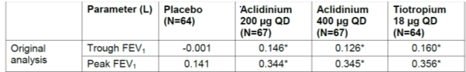
Furthermore, Study M/34273/25 showed that night time bronchodilation following morning (am) administration of aclidinium bromide 200 μg QD was insufficient to overcome the known increase in nocturnal cholinergic tone and that the treatment effect of aclidinium bromide administered once-daily at night was negligible.
Figure 32. Change from baseline to Day 7/8 in FEV1 over time by treatment. Study M/34273/25 (ITT population).
As shown in Figure 32 above, following am administration of aclidinium bromide, the bronchodilatory effects peaked at approximately 3 h post dose and then decreased to a minimum at about 3 h pre dose (that is, at approximately 0600 h on Day 8; adjusted mean treatment difference -0.0004 L [p=0.988]), before increasing again immediately pre dose (adjusted mean treatment difference 0.056 L [p=0.064] at 0900 h). Evening administration of aclidinium bromide induced night time bronchodilation that was statistically significantly higher than that achieved with am administration, mainly during the h of increased cholinergic tone (usually between 0300 and 0600 h). Furthermore no clinically important bronchodilation was observed with either aclidinium bromide 200 μg am QD or aclidinium bromide 200 μg pm QD at the end of the dosing interval. Consequently, aclidinium bromide 200 μg am QD provided a clear limited bronchodilatory effect during the night which, based on the post hoc analysis of Study M/34273/22, would be difficult to overcome by doubling the dose as an increase in FEV1 of 30 mL was not considered enough to ensure an adequate bronchodilation during the night time. In addition it was not considered appropriate to increase the QD dose of aclidinium bromide to a level that would overcome the increased nocturnal cholinergic tone because the dose required to maintain clinically relevant bronchodilation during both day and night might have been associated with peak plasma concentrations that would have compromised the benefit-risk profile.
Therefore, the sponsor decided to discontinue development of aclidinium bromide QD and instead to investigate a BD dosing regimen evaluating the safety and efficacy of aclidinium bromide at 200 μg administered twice daily to maximise bronchodilation during the whole 24-h period, especially overnight. In addition, as no specific risk was anticipated with this dose and dose regimen based on the clean drug safety profile, the 400 μg dose administered BD was also included in order to explore the potential offered by the BD regimen at a higher dose. The adequacy of the BD regimen was confirmed by the two Phase II studies in the BD development program (M/34273/23 and M/34273/29). Study M/34273/23 showed that following similar peak increases from baseline in FEV1 with aclidinium bromide 400 μg and the commercially available QD bronchodilator, tiotropium, the subsequent fall in FEV1 over the first 12 h after the morning dose compared to placebo was slightly faster with aclidinium bromide than with tiotropium; an observation which supported the selection of a more frequent dosing regimen for aclidinium bromide than that of tiotropium (Figure 33 below).
Figure 33. Change from baseline in FEV1 (L) at each specific time point at Day 15 of treatment. M/34273/23 ITT population
Results from Study M/34273/29 showed the time-courses of the bronchodilatory effect of aclidinium bromide and formoterol over 12 h to be similar, thus providing further support to the BD dose regimen of aclidinium bromide and ruling out the need to explore more frequent dose regimens (Figure 34 below).
Figure 34. Change from baseline in FEV1 (L) at each specific time point at Day 7 of treatment. M/34273/29 ITT population
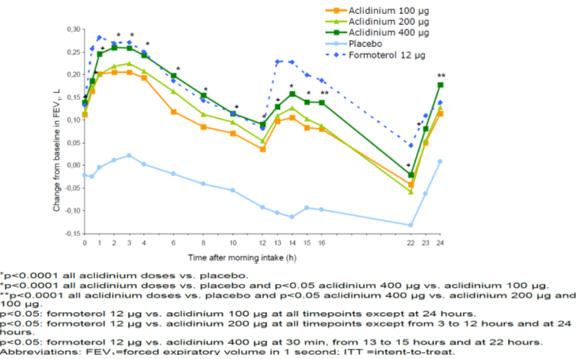
The results from Study M/34273/23 have been confirmed in the Phase IIIb Study M/34723/39 which has shown the overall bronchodilation of aclidinium bromide 400 μg BD to be broadly comparable to tiotropium.
In summary based on these results and the previous experience with aclidinium bromide at a lower nominal dose and less frequent dosing regimen, it was considered not necessary to further explore the QD administration of aclidinium bromide.
Furthermore, considering the high prevalence of COPD and the limited treatment options currently available, aclidinium bromide would offer physicians an efficacious and safe alternative for symptomatic patients that may benefit from a second daily dose.

Evaluator’s comments on sponsor’s response
The sponsors have stated that twice daily dosing with an ‘easy to use’ inhaler would provide better 24 h bronchodilation especially to counter the increase in cholinergic tone at nightime and this has been confirmed in the new study submitted by the sponsors (M34273/39). Overall, the sponsor’s response is acceptable.

Question 2

Sponsor’s response
The sponsors state that there are several ways to assess the posology of a drug, that is, the dosing regimen can be determined by comparing the same nominal dose at different dose regimens (QD versus BD) but also by comparing the shape of the FEV1 curves with a known reference QD or BD drug. Hence, during the aclidinium bromide clinical development program, the bronchodilator curve of aclidinium bromide was compared with one of the well known BD bronchodilator, formoterol, as previously described in the response to Question 1 above. Most likely, in order to have enough bronchodilation at night with a QD dose, the 200 μg dose would have to be increased up to 4 times which at the same time would have increased the peak FEV1. Raising the dose to such level would increase plasma levels and consequently the risk of anticholinergic side effects such as tachycardia and dry mouth. This is confirmed by the safety data obtained in study LAS-PK-12 where doses up to 800 μg BD were tested showing a clean safety profile but with the only anticholinergic side effects observed in the 800 μg dose group.
The sponsor considered that there was an opportunity to maximise bronchodilation during the whole 24 h period, in particular overnight, by administering an additional dose in the evening in a BD regimen. This was confirmed in the long term BD efficacy and safety studies that support this application.

Evaluator’s comments on sponsor’s response
The sponsor’s response is acceptable.

Question 3

Sponsor’s response
The sponsor recorded the change in smoking status during the one year pivotal Studies M/34273/30 and M/34273/31 conducted as part of the QD clinical program however few number of patients changed smoking status during these studies (6.38%). This is supported by the data of the tiotropium UPLIFT study (4 years duration) where 26.1% of patients were classified as intermittent smokers, defined as subjects who changed their smoking behaviour from randomisation on in at least one clinic visit. If a one year trial duration is considered, the % of intermittent smokers would be similar to that observed in the one year pivotal Studies M/34273/30 and M/34273/31 corresponding to 6.5% of the patients (Tashkin DP, 2010). Consequently, the changes in smoking status were not collected the Phase III clinical studies of the aclidinium bromide BD clinical development program due to the low percentage of patients changing smoking status observed in the previous Phase III QD studies and the shorter duration of the studies (6 and 3 months treatment duration). It was considered that the change in smoking status of the patients during these studies would be negligible and therefore for efficacy analyses the smoking status at the start of the study would be used.

Evaluator’s comments on sponsor’s response
The CHMP guidelines for ‘Clinical investigation of medicinal products in treatment of patients with COPD’ states that formal stratification of patients according to their smoking status (current smokers, ex-smokers) should be performed prior to randomisation. This was not done in any of the pivotal clinical studies for aclidinium bromide. Furthermore, tobacco exposure was not monitored during the study and any change in smoking status did not appear to be documented or reported. Use of nicotine replacement therapy or other smoking cessation aids such as varenicline was also not documented. The above reason provided by the sponsors is not acceptable and this issue remains a limitation of this submission.

Question 4

Sponsor’s response
A summary of the results of the Study M/34273/39 and M/34273/40 is provided in the updated Module 2.5 and Module 2.7.3 provided in this response. The corresponding Clinical Study Reports are also provided in Module 5.3.5.1
In Study M34273/39, aclidinium bromide 400 μg BD induced sustained bronchodilation over 24 h in patients with moderate to severe COPD. The magnitude of the bronchodilation associated with aclidinium bromide BD is generally similar to that observed with tiotropium QD although trends towards improved night time bronchodilation with aclidinium bromide relative to tiotropium were observed. Both aclidinium bromide and tiotropium were associated with improvements in COPD symptoms compared to placebo; the magnitudes of these improvements were consistently numerically greater with aclidinium bromide than with tiotropium. The majority of patients preferred the Almirall inhaler to the HandiHaler® device.
In Study 34273/40, aclidinium bromide 400 μg administered BD for 22 days resulted in a statistically significant improvement from baseline in symptom-limited exercise endurance. In addition, the treatment with aclidinium bromide was associated with statistically significant improvements in static hyperinflation, as well as improvements in IC and dyspnoea during exercise and improvements in parameters of physical activity compared to placebo. Bearing in mind the relevance of the improvement in exercise tolerance for the patients and physicians and the positive results of Study M/34273/40, the sponsor is proposing to include in the Australian Product Information a wording with the main results of this study. The same wording presented below has been recently approved in the European Summary of Product Characteristics.
“Exercise tolerance: In a 3 week crossover, randomised, placebo controlled clinical study Eklira Genuair was associated with a statistically significant improvement in exercise endurance time in comparison to placebo of 58 seconds (95% CI=9-108; p=0.021; pre-treatment value: 486 seconds). Eklira Genuair statistically significantly reduced lung hyperinflation at rest (functional residual capacity [FRC]=0.197 L [95% CI=0.321, 0.072; p=0.002]; residual volume [RV]=0.238 L [95% CI=0.396, 0.079; p=0.004]) and also improved trough inspiratory capacity (by 0.078 L; 95% CI=0.01, 0.145; p=0.025) and reduced dyspnoea during exercise (Borg scale) (by 0.63 Borg units; 95% CI=1.11, 0.14; p=0.012).”

Evaluator’s comments on sponsor’s response
These 2 studies have been evaluated in section Results from ongoing studies M34273/39 and M34273/40 above. In Study M34273/39, 24 h bronchodilation with aclidinium bromide 400ug BD was similar to that of tiotropium QD although there was a trend for better night time bronchodilation with aclidinium bromide and numerically greater improvement in COPD symptoms as well as a greater preference for the Almirall inhaler compared to the Handihaler used for tiotropium.
The aim of 3 week, double blind, crossover Study M34273/40 was to evaluate the effect of aclidinium bromide 400 μg BD compared with placebo on exercise endurance, hyperinflation (as determined by inspiratory capacity [IC] and body plethysmography parameters. Results from this study showing improvements in exercise endurance, lung hyperinflation and daily physical activity over 3 weeks of treatment with aclidinium bromide 400ug BD compared with placebo. However, interpretation was limited by crossover nature of the study.
Results of these 2 studies help to confirm the positive benefit-risk profile of aclidinium bromide and the inclusion of the above statement regarding effects of aclidinium bromide on exercise tolerance in proposed PI also seems justified.

Safety questions:

Question 1

Sponsor’s response
The sponsor plans to conduct the following studies to assess the cardiovascular (CV) safety of aclidinium bromide:
- US Long Term Cardiovascular Safety Clinical Trial (ASCENT)
- EU Post-Authorisation Cardiovascular Safety Study (PASS)
After the Food and Drug Administration (FDA) Pulmonary-Allergy Drug Advisory Committee meeting on Aclidinium bromide held on February 23 2012, the holder of the product in the United States and the FDA agreed that a separate study would be needed to conclusively answer the question of CV safety in patients at risk of CV events. This double blind, randomised, placebo controlled, parallel-group study will evaluate major adverse cardiovascular events (MACE) and other cardiovascular events of interest for up to 3 years in patients with moderate to very severe COPD. The objectives of this study are:
- To assess the safety of aclidinium bromide on MACE
- To assess the overall safety of aclidinium bromide
- To assess whether aclidinium bromide reduces moderate or severe COPD exacerbations
Study patient population will be male and female outpatients ≥ 40 years of age with moderate to very severe COPD (% predicted FEV1 < 70%), with at least 1 documented COPD exacerbation within 1 year prior to screening and at least one of the following 4 criteria:
- Documented cerebrovascular disease (stroke or transient ischemic attack, carotid stenosis)
- Documented coronary artery disease (angina, myocardial infarction, angioplasty/stent/ bypass)
- Documented peripheral vascular disease or history of claudication
- At least 2 of the following atherothrombotic risk factors as determined by the investigator:
  - Male ≥ 65 years or female ≥ 70 years ; - Diabetes ; - Dyslipidemia ; - Hypertension; - Waist circumference in males ≥ 40 inches or in females ≥ 38 inches.
A total of 4000 patients will be enrolled across approximately 500 study centers (North America). Patients meeting entry criteria will be randomized (1:1) to aclidinium bromide 400 μg BD or placebo BD as a background of standard of care treatment. Rescue medication (albuterol/salbutamol) will be provided for all patients.
The study will consist of a 2 week washout/run-in period followed by a maximum of 36 month double blind treatment period. Patients on a long-acting muscarinic antagonist (LAMA) (that is, inhaled anticholinergics) must washout 2 weeks prior to randomisation. During this time, the patient should be started on alternate therapy (such as LABA or LABA/inhaled corticosteroid (ICS)). Patients on a combination of both LAMA and LABA/ICS therapies at washout or screening will not be eligible to participate.
The primary endpoints are: Time to first MACE; Rate of moderate or severe COPD exacerbations per patient per year during the first year of treatment.
The secondary endpoints are: Rate of hospitalisations due to COPD exacerbations per patient per year during the first year of treatment; Time to first MACE or other serious cardiovascular events of interest (that is, standardised MedDRA query (SMQ) of cardiac disorders and SMQ of cerebrovascular disorders). Safety assessments will include physical examination, vital signs, adverse event (AE) monitoring, serious adverse event (SAE) reporting and electrocardiograms (ECGs). Patients who prematurely discontinue investigational product will participate in a post treatment follow-up period. The follow-up period will include on-site visits and telephone visits to collect MACE, COPD exacerbations, concomitant medications and SAEs for the remainder of the study duration. This study will conclude when 122 patients have experienced an adjudicated MACE. The first patient randomised is planned by end this year and results will be provided as soon as available. A synopsis of the protocol is provided with this response.
The protocol of the PASS study was provided as part of this MAA in the Annex 5 of the European Risk Management Plan originally submitted to the TGA. This protocol has been reviewed by the CHMP (CHMP Rapporteur’s Assessment Report EMA/487537/2012) and as a result of this assessment an update of the protocol was submitted to the EMA. See the synopsis of the approved protocol in this response document.
In conclusion, the sponsor believes these studies are sufficient to confirm the cardiovascular safety of aclidinium bromide in the overall population and should also be applicable to the Australian population.

Evaluator’s comments on sponsor’s response
Review of the study protocols of the proposed ASCENT and the PASS study (provided in this response document) indicate that these 2 postmarketing studies should enable adequate assessment of CV safety of aclidinium bromide.

Second round benefit-risk assessment

Second round assessment of benefits
After consideration of the response to clinical questions, the benefits of aclidinium bromide 400 µg BD in the proposed usage are unchanged from those identified in the First Round Assessment.

Second round assessment of risks
After consideration of the response to clinical questions, the risks of aclidinium bromide 400ug BD in the proposed usage are:
- The CHMP guidelines for ‘Clinical investigation of medicinal products in treatment of patients with COPD’ states that formal stratification of patients according to their smoking status (current smokers, ex-smokers) should be performed prior to randomisation. This was not done in any of the pivotal clinical studies for aclidinium bromide. Furthermore, change in smoking status, tobacco exposure and use of nicotine replacement therapy (as an aid to smoking cessation) was not recorded in the pivotal studies and its potential effect on efficacy outcomes was not evaluated.
- The cardiac and cerebrovascular safety of other anticholinergic agents has required regulatory discussions in the past. A detailed review of the cardiovascular and cerebrovascular risk associated with aclidinium bromide 400 µg BD has been performed and showed no apparent evidence of an increased cardiovascular or cerebrovascular risk with aclidinium bromide. As patients with a myocardial infarction during the previous 6 months, unstable angina, newly diagnosed arrhythmia within the previous 3 months or hospitalisation within the previous 12 months for heart failure Functional Classes III and IV as per the New York Heart Association have not been included in clinical trials, the SmPC will state that the safety of these patient groups has not been investigated and aclidinium bromide in these patient groups should be used with caution.
- Anticholinergic adverse effects: The low bioavailability of inhaled aclidinium bromide suggests a low potential for systemic anticholinergic activity. A thorough review of potential anticholinergic adverse effects in the Pivotal Study Population showed the frequency of individual potential anticholinergic adverse events to be low (≤1.1% with aclidinium bromide 400 µg) and in the range of or lower than that reported for other anticholinergic drugs. Few potential anticholinergic adverse events are considered to be ADRs. Furthermore, as patients with symptomatic prostatic hyperplasia, bladder-neck obstruction or narrow-angle glaucoma have not been included in clinical trials the SmPC will state that consistent with the anticholinergic activity of aclidinium bromide, it should be used with caution in these patient groups. The co-administration of aclidinium bromide with other anticholinergic drugs has not been studied and is not recommended.

Second round assessment of benefit-risk balance
After consideration of the response to clinical questions, the benefit-risk balance of aclidinium bromide 400 µg BD in the proposed usage are unchanged from those identified in First Round Assessment.

Second round recommendation regarding authorisation
It is recommended that Bretaris Genuair (aclidinium bromide 400 µg twice daily by inhalation) be approved for the long term maintenance bronchodilator treatment to relieve symptoms in adult patients with Chronic Obstructive Pulmonary Disease (COPD). However, the approval is subject to incorporation of suggested changes to the proposed PI.

References
AEMPS, 2009: Minutes of Aclidinium Bromide Scientific Advice meeting with the Agencia Españolade Medicamentos y Productos Sanitarios. Meeting dated 11-March 2009.
AFSSAPS, 2009: Minutes of Aclidinium Bromide Scientific Advice meeting with the Agence Française de Sécurité Sanitaire des Produits de Santé. Meeting dated 20-February 2009.
Albertí J, Martinet A, Sentellas S, et al. Identification of the human enzymes responsible for the enzymatic hydrolysis of aclidinium bromide. Drug Metab Dispos. 2010 Jul;38(7):1202-10.
Alvar A, Am J Current Controversies and Future Perspectives in Chronic Obstructive Pulmonary Disease. Respir Crit Care Med Vol 184. pp 507–513, 2011.
Calverley PM, Anderson JA, Celli B, et al. TORCH Investigators. Cardiovascular events in patients with COPD: TORCH study results. Thorax 2010;65(8):719-25.
Cazzola M, MacNee W, Martinez FJ, et al. on behalf of the American Thoracic Society/European Respiratory Society Task Force on outcome of COPD. Outcomes for COPD pharmacological trials: from lung function to biomarkers. Eur Respir J 2008;31:416-68.
Coulson FR, Fryer AD. Muscarinic acetylcholine receptors and airway diseases. Pharmacol Ther 2003; 98:59-69.
Coulson FR, Fryer AD. Muscarinic acetylcholine receptors and airway diseases. Pharmacol Ther 2003; 98:59-69. 12. Beeh KM, Welte T, Buhl R. Anticholinergics in the treatment of COPD. Respiration 2002, 69(4):372-9.
Dahl R, Backer V, Ollgaard B, et al. Assessment of patient performance of the HandiHaler® compared with the metered dose inhaler four weeks after instruction. Respir Med 2003; 97:1126-33.
Donohue JF. Minimal clinically important differences in COPD lung function). COPD. 2005 Mar; 2(1):111-24.
Ferguson GT, Cherniack RM. Management of chronic obstructive pulmonary disease. N Engl J Med 1993; 32:1017-22.
Gavalda A, Miralpeix M, Ramos I, et al. Characterization of aclidinium bromide, a novel inhaled muscarinic antagonist, with long duration of action and a favourable pharmacological profile [published online ahead of print August 26, 2009]. J Pharmacol Exp Ther. oi:10.1124/jpet.109.151639.
Global Initiative for Chronic Obstructive Lung Disease (GOLD) guidelines; Global Strategy for Diagnosis, Management, and Prevention of COPD. Updated 2010.
Global Initiative for Chronic Obstructive Lung Disease. Global strategy for the diagnosis, management, and prevention of chronic obstructive pulmonary disease. Medical Communications Resources, Inc; 2009. Available from: <http://www.goldcopd.org//> Guidelineitem.asp?l1=2&l2=1&intId=2003. Accessed 2009 Jun 11.
Gras J, Llupia J, Llenas JL, et al. The preclinical urinary and renal safety profile of aclidinium bromide, a novel long-acting anticholinergic drug. Poster ERS Berlin 2008.
Haythornthwaite JA, Hegel MT, Kerns RD. Development of a sleep diary for chronic pain patients. J Pain Symptom Manage 1991;6:65-72.
Huiart L, Ernst P, Suissa S. Cardiovascular morbidity and mortality in COPD. Chest 2005; 128:2640-6.
Kesten S, Celli B, Decramer M, et al. Tiotropium Handihaler in the treatment of COPD: a safety review. Int J Chron Obstruct Pulmon Dis 2009; 4:397-409.
Kesten S, Jara M, Wentworth C, Lanes S. Pooled clinical trial analysis of tiotropium. Chest 2006;130;1695-703.
MHRA, 2009: Minutes of Aclidinium Bromide Scientific Advice meeting with the UK Medicines andHealthcare products Regulatory Agency. Meeting dated 4 February 2009.
Montero JL, Anton F, Viñals M, et al. Effect of aclidinium bromide, a novel long-acting anticholinergic, on salivation, colonic motility and faecal output in different animal models. Poster ERS Berlin 2008.
Pauwels R, Newman S, Borgstrom L. Airway deposition and airway effects of antiasthma drugs delivered from metered-dose inhalers. Eur Respir J 1997; 10:2127- 38.
Postma DS, Keyzer JJ, Koeter GH, et al. Influence of the parasympathetic and sympathetic nervous system on nocturnal bronchial obstruction. Clin Sci 1985; 69: 251-8.
Soriano JB, Visick GT, Muellerova H, et al. Patterns of comorbidities in newly diagnosed COPD and asthma in primary care. Chest 2005; 128: 2099-107.
Tamura G, Ohta K. Adherence to treatment by patients with asthma or COPD: comparison between inhaled drugs and transdermal pathc. Respir Med 2007; 101: 1895-1902.
Tashkin D.P. Tashkin, B. Celli, S. Kesten, T. Lystig, S. Mehra and M. Decramer. Long-term efficacy of tiotropium in relation to smoking status in the UPLIFT trial. Eur Respir J 2010; 35: 287–294.
Van der Palen J, Eijsvogel MM, Kuipers BF, et al. Comparison of the Diskus® inhaler and the Handihaler® regarding preference and ease of use. Aerosol Med 2007; 20:38-44.
Wieshammer S, Dreyhupt J. Dry Powder Inhalers: Which Factors Determine the Frequency of Handling Errors? Respiration 2008; 75:18-25.

Therapeutic Goods Administration
PO Box 100 Woden ACT 2606 Australia
Email: info@tga.gov.au Phone: 1800 020 653 Fax: 02 6232 8605
http://www.tga.gov.au

This was correct at the time of this submission. Seebri inhaler was included on the ARTG in November 2012.
Inhaled aclidinium bromide inhibited acetylcholine-induced bronchoconstriction in anesthetised guineapigs, with a duration of action (expressed as the half-life for the bronchodilatory effect) of 29 h; substantially longer than that of ipratropium (8 h) but shorter than that of tiotropium (64 h).
Absolute bioavailability calculated using AUC(0-4 h) and AUC(0-6 h) was considered reliable, and clearly reflects the fraction of nominal administered aclidinium bromide dose that is systemically available. The use of a truncated AUC for the calculation of F instead of using AUC(0-∞) as stated in the protocol, was a consequence of inconsistent extended pharmacokinetic profiles of aclidinium bromide found in Part II of the study for 5 subjects following IV administration and for a further 5 subjects following inhalation.
Sponsor clarification: ’This study was not conducted with the marketed Novolizer device but with an already modified device. It was an intermediate version between Novolizer and Genuair.’
The Novolizer is a multidose, refillable, breath-actuated dry powder inhaler that delivers up to 200 metered doses of drug from a single cartridge. It has a multiple-feedback control mechanism to ensure that the inhalation was performed correctly.
Regional lung deposition was quantified by dividing the lungs into 6 concentric lung-shaped zones with zone 1 innermost and zone 6 outermost; data showed that zone 1 had the highest deposition.
Sponsor clarification: This study was not conducted with the marketed Novolizer device but with an already modified device. It was an intermediate version between Novolizer and Genuair.
The HandiHaler is an inhalation device used to inhale the dry powder contained in the SPIRIVA capsule. The dry powder is delivered from the HandiHaler device at flow rates as low as 20 L/min. Under standardized in vitro testing, the HandiHaler device delivers a mean of 10.4 mcg tiotropium when tested at a flow rate of 39 L/min for 3.1 seconds (2L total). In a study of 26 adult patients with chronic obstructive pulmonary disease (COPD) and severely compromised lung function [mean FEV1 1.02 L (range 0.45 to 2.24 L); 37.6% of predicted (range 16%–65%)], the median peak inspiratory flow (PIF) through the HandiHaler device was 30.0 L/min (range 20.4 to 45.6 L/min). The amount of drug delivered to the lungs will vary depending on patient factors such as inspiratory flow and peak inspiratory flow through the HandiHaler device, which may vary from patient to patient, and may vary with the exposure time of the capsule outside the blister pack. For administration of SPIRIVA, a capsule is placed into the center chamber of the HandiHaler device. The capsule is pierced by pressing and releasing the green piercing button on the side of the inhalation device. The tiotropium formulation is dispersed into the air stream when the patient inhales through the mouthpiece
Before the inhalation through the Novolizer, patients were instructed to inhale as fast and hard as possible. Inhalations through the HandiHaler® were performed following two different instructions: A. Patients were instructed to breathe in slowly and deeply, but a rate rapid enough to hear the capsule vibrate. B. Patients were instructed to inhale as fast and hard as possible.
This patient had no previous experience with Novoliszer; despite generating PIFs between 61.8 and 91.8 L/min and considering the device fully functional when tested in the laboratory, no clear explanation for the three consecutive unsuccessful inhalations can be given. An incorrect use by the patient during the inhalation process could explain the detected problem but this cannot be proved.
FPD was the mass of active ingredient capable of being inhaled into the lung, therefore mass of particles below 5 μm in diameter)
Known active tuberculosis; History of interstitial lung or pulmonary thromboembolic disease; Pulmonary resection or lung volume reduction surgery during the past 12 months.; History of bronchiectasis secondary to respiratory diseases others than COPD (e.g., cystic fibrosis, Kartagener’s syndrome, etc); Post organ transplantation.; Patients who in the Investigator’s opinion may have required pulmonary rehabilitation or thoracotomy or other lung surgery during the study; Patients with a history of a1-antitrypsin deficiency.
Myocardial infarction in the previous 6 months; Unstable angina, unstable arrhythmia which required changes in the pharmacological therapy or other intervention in the previous 12 months, or newly diagnosed arrhythmia in the previous 3 months.; Hospitalisation within the previous 12 months for heart failure functional classes III (marked limitation of activity and only comfortable at rest) and IV (need of complete rest, confinement to bed or chair, discomfort at any physical activity and presence of symptoms at rest) as per the NYHA.
For training purposes, a patient educational video demonstrating proper use of the inhaler was provided to the sites to train the patients. Additionally, patients were provided with printed instructions. The Investigator had to ensure that the patient understood the instructions, and knew how to correctly use the Genuair® inhaler at Screening (Visit 1) and Visit 2 prior to randomisation. At each visit, the Investigator confirmed that the patient was properly using the inhaler, with proper re-instruction when appropriate (using a training inhaler). After completing the inhalation, the Investigator assessed whether the patient had properly inhaled the treatment by checking the control window of the inhaler.
Patients on these medications were allowed to participate in the study, provided treatment was interrupted at least 6 h before screening (Visit 1, Day –14) and throughout the study. Patients taking fenoterol or terbutaline had to switch to salbutamol pMDI (100 μg/puff).
Transition Dyspnoea Index (TDI) included three categories, each one with ranges from minus three (major deterioration) to plus three (major improvement) including a zero score to indicate “no change”. Also for the TDI the three categories were added to obtain a focal score ranging from minus nine, including zero, to plus nine. Provision was made for circumstances when dyspnoea could not be rated: “Z” if reduction of activities, effort or functional impairment was caused by reasons other than respiratory. A change of 1 unit in TDI was used as the criterion for a minimal meaningful improvement.
Symptoms which included items concerned with the level of symptomatology, including frequency of cough, sputum production, wheeze, breathlessness, and the duration and frequency of attacks of breathless or wheeze. A typical question in this section was “In an average week, how many good days (with little chest trouble) have you had?”. There are five possible responses to this item (i.e., 5-point Likert scale): none; one or two; three or four; nearly every day; and every day.
“Activity” which was concerned with physical activities that cause or are limited by breathlessness. A typical item in this section was “Because of my breathing, jobs such as house work take a long time or I have to stop for rests”. Responses in this section were dichotomous (that is, either true or false).
“Impacts” which covered a range of aspects related to social functional and psychological disturbances resulting from the disease, such as employment, being in control of health, panic, stigmatisation, the need for medication and its side effects, expectations for health and disturbances in daily life. An example of these items was “I get afraid or panic when I cannot catch my breath”. Responses to items in this section were dichotomous (i.e., either true or false).
The EQ-5D descriptive system (Screen 2) comprised five dimensions of health (mobility, self-care usual activities, pain/discomfort, anxiety/depression). Each dimension comprised three levels (no problems, some/moderate problems, extreme problems).
The EXACT captures the cardinal symptoms of COPD (dyspnoea, cough, sputum production) since exacerbations represent a sustained worsening in the patient’s condition and also includes additional items capturing dyspnoea with activity and several systemic manifestations of COPD (e.g. tired/weak).
The severity of a COPD exacerbation was to be assessed according to the following scale: Mild: Increase in COPD symptoms (eg, dyspnea, cough, sputum volume, sputum purulence) during at least 2 consecutive days, managed by the patient at home by increasing short-acting bronchodilator and/or inhaled corticosteroid use Moderate: Increase in COPD symptoms during at least 2 consecutive days that does not lead to hospitalization but is treated with antibiotics and/or systemic corticosteroids Severe: Increase in COPD symptoms during at least 2 consecutive days that leads to hospitalization (overnight stay at hospital or emergency room) emergency room)
For the change from baseline in the morning (trough) FEV1 and secondary endpoints based on SGRQ and TDI, the magnitude of the treatment effect between each dose of aclidinium bromide and placebo was similar across the smoker categories (Current Smoker, Ex-Smoker). For the secondary endpoint of change from baseline in peak FEV1 at Week 24, the observed treatment effect of aclidinium bromide at each dose was larger in the current smoker subgroup compared to the ex-smoker subgroup: for the current smoker subgroup, the adjusted treatment effect was -0.012 L; 0.228 L, and 0.247 L in the placebo, 200 μg and 400 μg groups respectively; while for the ex-smoker group, the adjusted treatment effect was 0.060 L; 0.185L, and 0.211L in the placebo, 200 μg and 400 μg groups respectively. This larger treatment effect on peak FEV1 in the subgroup of current smoker is mainly driven by the low peak FEV1 observed in the placebo group for the current smokers compared to the ex-smokers.
COPD exacerbations were evaluated by the Investigator at each visit on the basis of information provided by the patient. A COPD exacerbation was defined as an increase in COPD symptoms (eg, dyspnea, cough, sputum volume, sputum purulence) during at least 2 consecutive days with severity characterized as follows: • Mild: self-managed by the patient at home by increasing short-acting bronchodilator and/or ICS use • Moderate: did not lead to hospitalization but was treated with antibiotics and/or systemic corticosteroids • Severe: led to hospitalization (overnight stay at hospital or emergency room [ER])
Instruments were administered to evaluate whether aclidinium bromide administered twice daily was associated with improvement in nighttime symptoms, early morning symptoms, and sleep. Both instruments were administered each morning beginning at Visit 1 (Screening) through Visit 6 (Week 12) using an eDiary.
Sponsor comment: ‘This was a double-blind study and not an open label study.’
One study site (Site 1420) that randomized 31 patients had performance issues including frequent and significant deviations from the protocol, poor investigator oversight, and inclusion of several patients whose improvements in lung function were of questionable clinical plausibility. The sponsor terminated this investigative site on 21 December 2010 and the FDA was notified on 07 January 2011 of the sponsor’s decision to terminate the site and all ongoing patients. The decision to terminate this site was made before unblinding of the study for the interim analysis to support the NDA. A separate analysis excluding Site 1420 was performed for the following efficacy parameters: Change from baseline in morning predose (trough) FEV1 and in peak FEV1 at Week 52 (LOCF), Change from baseline in trough FEV1 by visit.
Data submitted as part of S31 response.
ITT population patients who took at least 1 dose of IMP and had at least a baseline FEV1 assessment and at least one post-baseline FEV1 value were included in the analysis.
The comparison between aclidinium bromide 400 μg BID and placebo in the first step and the comparison between aclidinium bromide 400 μg BID and tiotropium bromide 18 μg QD in the second step. The other treatment comparison (tiotropium bromide 18 μg QD vs. placebo) for AUC₁₂₋₂₄ was considered additional.
For both treatments, the mean percentage of nights free from relief medication use at baseline was higher (83.8% and 82.7% for aclidinium bromide and placebo, respectively) than that for the days free from day-time relief medication use (36.5% and 35.9%, respectively). At baseline, the mean percentages of days free from daily relief medication use (over 24 h) were similar for aclidinium bromide (35.8%) and placebo (34.9%).
Intensity of dyspnoea was based on the Borg CR10 Scale®, ranging from “nothing at all” (0) to “extremely strong/maximal” (10; the highest possible numerical value).
Physical activity level was a ratio calculated as the total daily energy expenditure divided by the whole night sleeping energy expenditure
The E-RS is a patient-reported outcome tool developed to evaluate the severity of COPD symptoms (domains of breathlessness, cough and sputum, chest symptoms). An algorithm was used to calculate the E-RS Total Score from the domain scores. The items comprising the E-RS were selected from an existing measure, the Exacerbations of Chronic Obstructive Pulmonary Disease Tool (EXACT)28,29 that was developed to assess frequency, severity and duration of exacerbations of COPD. The E-RS is designed as a daily diary to be completed nightly before bedtime via an electronic device, for example, a personal digital assistant (PDA).
Cazzola M, MacNee W, Martinez FJ, et al. on behalf of the American Thoracic Society/European Respiratory Society Task Force on outcome of COPD. Outcomes for COPD pharmacological trials: from lung function to biomarkers. Eur Respir J 2008;31:416-68
ICH E1: The extent of population exposure to assess clinical safety for drugs intended for long-term treatment of Non-life-threatening conditions.
The long term safety studies were analysed individually as the Applicant considered that analysis of the pooled population of the long-term studies would not yield meaningful results given that study LAS-MD-38 Part B is an open-label study testing aclidinium bromide 400 μg only.
Patient [information redacted] (aclidinium bromide 400μg): baseline (Day 1) PR interval was 203 msec and the PR interval at 2 h post-dose on Day 1 was 205 msec. It is unlikely that an increase of 2 msec from baseline resulted in a worsening of a pre-existing AE. In fact the highest rise during the post-treatment period was to 217 msec (4 weeks after the start date of the AE). Patient [information redacted](aclidinium bromide 400μg): the baseline PR interval was 218 msec and as the patient withdrew from the study before the first post-treatment evaluation, as per protocol, at 2 h post-dose no further ECGs were performed. Patient [information redacted] (placebo): the baseline (Day 1) PR interval was 212 msec and the PR interval at 2 h post-dose on Day 1 was 217 msec.
A female patient initiated aclidinium bromide 400μg BID and experienced bronchospasm that same day. It was considered moderate in severity and related to the study drug. Aclidinium bromide was not interrupted and the patient recovered the next day.
According to the FDA document for Guidance for industry: Drug induced liver injury premarketing clinical evaluation, June 2009, a Hy’s law case requires ALL of the following conditions to be satisfied: (1) Drug can cause hepatocellular injury generally shown by a higher incidence of ALT or AST elevations of >3xupper limit of normal (ULN) compared to placebo or a non-hepatotoxic control drug. (2)In a trial subject with such a transaminase elevation, the subject also ahd elevation of total serum bilirubin (TBL) to >2xULN without initial findings of cholestatis (elevated serum alkaline phosphatase) AND (3) No other reason can be found to explain the combination of increased transaminase and TBL, such as viral hepatitis A, B or C, pre-existing acute liver disease or another drug capable of causing the observed injury.
Data submitted as part of S31 response.
The study report for this study was submitted by the sponsors as part of the S31 response.
Heart Failure Functional Classes III and IV as per the New York Heart Association: 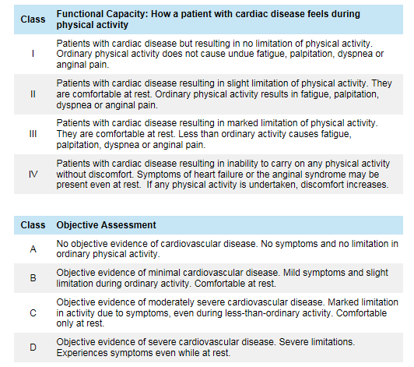
Measures changes in dyspnea severity from the baseline. Rated by seven grades ranging from -3 (major deterioration) to +3 (major improvement). Total score ranging - 9 to + 9. The lower the score, the more deterioration in severity of dyspnea.
Disease-specific instrument designed to measure impact on overall health, daily life, and perceived well-being in patients with obstructive airways disease. Scores range from 0 to 100, with higher scores indicating more limitations.

