February 2020

Australian Public Assessment Report for Acalabrutinib
  - Proprietary Product Name: Calquence
  - Sponsor: AstraZeneca Pty Ltd

About the Therapeutic Goods Administration (TGA)
- The Therapeutic Goods Administration (TGA) is part of the Australian Government Department of Health and is responsible for regulating medicines and medical devices.
- The TGA administers the Therapeutic Goods Act 1989 (the Act), applying a risk management approach designed to ensure therapeutic goods supplied in Australia meet acceptable standards of quality, safety and efficacy (performance) when necessary.
- The work of the TGA is based on applying scientific and clinical expertise to decision-making, to ensure that the benefits to consumers outweigh any risks associated with the use of medicines and medical devices.
- The TGA relies on the public, healthcare professionals and industry to report problems with medicines or medical devices. TGA investigates reports received by it to determine any necessary regulatory action.
- To report a problem with a medicine or medical device, please see the information on the TGA website <https://www.tga.gov.au>.
About AusPARs
- An Australian Public Assessment Report (AusPAR) provides information about the evaluation of a prescription medicine and the considerations that led the TGA to approve or not approve a prescription medicine submission.
- AusPARs are prepared and published by the TGA.
- An AusPAR is prepared for submissions that relate to new chemical entities, generic medicines, major variations and extensions of indications.
- An AusPAR is a static document; it provides information that relates to a submission at a particular point in time.
- A new AusPAR will be developed to reflect changes to indications and/or major variations to a prescription medicine subject to evaluation by the TGA.
Copyright
© Commonwealth of Australia 2020
This work is copyright. You may reproduce the whole or part of this work in unaltered form for your own personal use or, if you are part of an organisation, for internal use within your organisation, but only if you or your organisation do not use the reproduction for any commercial purpose and retain this copyright notice and all disclaimer notices as part of that reproduction. Apart from rights to use as permitted by the Copyright Act 1968 or allowed by this copyright notice, all other rights are reserved and you are not allowed to reproduce the whole or any part of this work in any way (electronic or otherwise) without first being given specific written permission from the Commonwealth to do so. Requests and inquiries concerning reproduction and rights are to be sent to the TGA Copyright Officer, Therapeutic Goods Administration, PO Box 100, Woden ACT 2606 or emailed to <tga.copyright@tga.gov.au>.

Contents
Common abbreviations 4
I. Introduction to product submission 6
Submission details 6
Product background 7
Regulatory status 8
Product Information 8
II. Registration timeline 8
III. Submission overview and risk/benefit assessment 9
Quality 9
Nonclinical 10
Clinical 12
Risk management plan 15
Risk-benefit analysis 17
Outcome 18
Attachment 1. Product Information 19

Common abbreviations
Abbreviation | Meaning
ACP-196 | Acalabrutinib (drug development name)
ACP-5862 | Active metabolite of acalabrutinib
AE | Adverse event
ALT | Alanine aminotransferase
ARTG | Australian Register of Therapeutic Goods
ASA | Australian specific Annex
AST | Aspartate aminotransferase
AUC | Area under the concentration-time curve
BCR | B cell antigen receptor
BCRP | Breast cancer resistance protein
BD | Twice daily; bis in die (Latin)
BTK | Bruton’s tyrosine kinase
CLL | Chronic lymphocytic leukaemia
C_{max} | Maximum plasma concentration
CNS | Central nervous system
COR-B | Comparable Overseas Regulator approach B
CR | Complete response
CYP3A4/5 | Cytochrome P450 3A4/5
DLP | Data lock point
DOR | Duration of response
EMA | European Medicines Agency (EU)
EU | European Union
FDA | Food and Drug Administration (US)
GLP | Good Laboratory Practice
HC | Health Canada
ICH | International Council for Harmonisation
ISS | Integrated Summary of Safety
IV | Intravenous
MATE1 | Multidrug and toxin extrusion protein 1
MCL | Mantle cell lymphoma
NHL | Non-Hodgkin lymphoma
ORR | Overall response rate
OS | Overall survival
PFS | Progression free survival
PI | Product Information
PO | Oral; per os (Latin)
PR | Partial response
QD | Once daily
R/R | Relapsed or refractory
RMP | Risk management plan
SAE | Serious adverse event(s)
TGA | Therapeutic Goods Administration
T_{max} | Time to maximum plasma concentration

I. Introduction to product submission

Submission details
Type of submission: | New chemical entity
Decision: | Approved for provisional registration
Date of decision: | 21 November 2019
Date of entry onto ARTG: | 21 November 2019
ARTG number: | 321419
Black Triangle Scheme | Yes  This product will remain in the scheme for 5 years, starting on the date the product is first supplied in Australia
Active ingredient: | Acalabrutinib
Product name: | Calquence
Sponsor’s name and address: | AstraZeneca Pty Ltd  PO Box 131  North Ryde NSW 1670
Dose form: | Hard capsule
Strength: | 100 mg
Container: | Blister pack
Pack size: | 56 capsules
Approved therapeutic use: | Calquence (acalabrutinib) was provisionally approved for the following therapeutic use:  Calquence is indicated for the treatment of patients with mantle cell lymphoma who have received at least one prior therapy.  This indication is approved via the provisional approval pathway, based on overall response rate. Full registration for this indication depends on verification and description of clinical benefit in confirmatory trials.  The provisional registration period for the above medicine is two years starting on the day specified in the ARTG certificate of registration.
Route of administration: | Oral
Dosage: | Treatment with Calquence should be initiated and supervised by a physician experienced in the use of anticancer therapies.  Recommended dosage (18 years and above): the recommended dose of Calquence is 100 mg twice daily (equivalent to a total daily dose of 200 mg). Doses should be separated by approximately 12 hours.  Treatment with Calquence should continue until disease progression or unacceptable toxicity.  For further information refer to the Product Information.

Product background
This AusPAR describes the application by AstraZeneca Pty Ltd (the sponsor) to register Calquence (acalabrutinib) 100 mg hard capsule for the following indication:
Calquence is indicated for the treatment of patients with mantle cell lymphoma who have received at least one prior therapy.
Mantle cell lymphoma (MCL) is a cancer of B cells within a region of the lymph node known as the mantle zone. It is a rare form of non-Hodgkin lymphoma (NHL), comprising about 7% of adult NHL. Most patients with MCL have advanced disease at diagnosis, with 75% presenting with lymphadenopathy and 25% with extra-nodal disease.
Treatment for relapsed or refractory (R/R) patients has a variable response rate, but progression free survival (PFS) and overall survival (OS) is generally less than two years. MCL is incurable with current therapies, with the exception of rare patients who achieve long-term disease-free survival after allogeneic stem cell transplantation.
Bruton’s tyrosine kinase (BTK) is a signalling molecule of the B cell antigen receptor (BCR) and cytokine receptor pathways. In B cells, BTK signalling results in activation of pathways necessary for B-cell proliferation, trafficking, chemotaxis, and adhesion. The first-generation BTK inhibitor ibrutinib is currently part of the therapeutic options for R/R MCL. Latter generation BTK inhibitors such as acalabrutinib have been rapidly assessed for potentially having improved toxicity with favourable efficacy compared to first-generation BTK inhibitors.
This application was made through the TGA’s provisional registration process, which requires further clinical trials to be submitted to confirm efficacy and safety. This application was submitted through the TGA’s Comparable Overseas Regulator approach B (COR-B); process (United States (US) Food and Drug Administration (FDA)). The submission was made to register acalabrutinib for the treatment of MCL, allowing an extension of indication application (for the treatment of chronic lymphocytic leukaemia (CLL)) to be considered contemporaneously under the inter-agency collaborative project Orbis.
The clinical evidence in support of registration of acalabrutinib is based mainly on a single pivotal trial, Study ACE-LY-004.

Regulatory status
At the time this application was under consideration, Calquence (acalabrutinib) was considered a new chemical entity for Australian regulatory purposes.
Orphan designation for the indication of MCL was granted by the FDA on 21 September 2015, European Medicines Agency (EMA) on 18 February 2016 and Swissmedic on 1 January 2017. At the time the TGA considered this application, a similar application had been approved in the USA (approved on 31 October 2017) and was under consideration in Canada (Table 1).
Table 1: International regulatory status of Calquence (acalabrutinib) as of 31 July 2019
Region | Submission date | Status | Indication
USA | 13 June 2017 | Approved:  31 October 2017 | Calquence is a kinase inhibitor indicated for the treatment of adult patients with mantle cell lymphoma (MCL) who have received at least one prior therapy.  This indication is approved under accelerated approval based on overall response rate. Continued approval for this indication may be contingent upon verification and description of clinical benefit in confirmatory trials
Canada | 14 March 2018 | Under evaluation | Under evaluation

Product Information
The Product Information (PI) approved with the submission which is described in this AusPAR can be found as Attachment 1. For the most recent PI, please refer to the TGA website at <https://www.tga.gov.au/product-information-pi>.

II. Registration timeline
The following table captures the key steps and dates for this application and which are detailed and discussed in this AusPAR.
Table 2: Timeline for Submission PM-2019-03536-1-6
Description | Date
Provisional designation | 17 July 2019
Submission dossier accepted and first round evaluation commenced | 12 August 2019
Evaluation completed | 18 November 2019
Delegate’s Overall benefit-risk assessment | 18 November 2019
Sponsor’s pre-Advisory Committee response | Not applicable
Advisory Committee meeting | Not applicable
Registration decision (Outcome) | 21 November 2019
Completion of administrative activities and registration on ARTG | 21 November 2019
Number of working days from submission dossier acceptance to registration decision* | 73
*Target timeframe for COR-B applications is 175 working days

III. Submission overview and risk/benefit assessment
The submission was summarised in the following Delegate’s overview and recommendations.
This is a TGA summary of wording used in TGA’s Delegate’s overview, which discussed numerous aspects of overseas evaluation reports and included some information that was considered commercial-in-confidence and has been redacted.

Quality
The following points were summarised in the quality evaluation:
- Acalabrutinib is chemically synthesised and is structurally related to other antineoplastic protein kinase inhibitors such as ibrutinib and bosutinib.
- The finished product is a capsule filled with 100 mg of acalabrutinib and packaged in blisters in packs of 56 capsules.
- The capsules are proposed for the treatment of patients with MCL who have received at least one prior therapy and are dosed at 100 mg twice daily (equivalent to a total daily dose of 200 mg) to be taken with or without food.
- The company has provided two bioavailability summaries for the following studies:
  - Study ACE-HV-001; a Phase I, single centre, open label, sequential dose escalation study of ACP-196 (acalabrutinib) in healthy subjects to evaluate safety, pharmacokinetics, pharmacodynamics, food effects, and drug-drug interactions;
  - Study ACE-HV-009; a study examining the absolute bioavailability, pharmacokinetics, excretion, and metabolism of [¹⁴C]ACP-196 (acalabrutinib) in healthy subjects.
- Study ACE-HV-001, Part 2/Cohort 6 (the fed arm of the study) was evaluated in detail and found acceptable. A high fat, high calorie meal did not affect the extent of absorption of acalabrutinib but time to maximum plasma concentration (T_{max}) was delayed by an average of 2 hours and maximum plasma concentration (C_{max}) decreased by 73%. It was noted that the product used in this particular clinical study had a different formulation, method of manufacture and a faster dissolution profile in acidic medium than the proposed commercial product. It is unlikely that food will affect the extent of exposure to acalabrutinib from the commercial product.
The Delegate commented that the pharmaceutical evaluator has raised no issues with the registration of acalabrutinib.

Nonclinical
The proposed dosing regimen of Calquence involves oral administration of one capsule (100 mg) twice daily.
The following points were summarised in the nonclinical evaluation:
- The submitted nonclinical data were in general accordance with the relevant International Council for Harmonisation (ICH) guideline; and were of adequate quality. All pivotal safety-related studies were Good Laboratory Practice (GLP) compliant.
- In vitro, acalabrutinib and its main human metabolite, ACP-5862, were shown to be irreversible inhibitors of BTK. Acalabrutinib and ACP-5862 inhibited B cell signalling in cellular assays and tumour growth inhibition was seen in murine xenograft models of B cell malignancies. Lower efficacy is suggested in patients with MCL. The main human metabolite, ACP-5862, is expected to significantly contribute to the safety and efficacy profile of acalabrutinib.
- In secondary screens against other tyrosine kinases, receptors, ion transporters and ion channels, notable off-target effects include the protein tyrosine kinases ErbB4 and Tec. Both of these kinases appear to have cardioprotective roles and Tec plays a role in platelet activation. No adverse effects on central nervous system (CNS), respiratory or cardiovascular function were seen in adequately conducted studies.
- Acalabrutinib was readily and rapidly absorbed following oral administration, with a similar T_{max} in all species. Exposures (area under the concentration-time curve (AUC)) in female mice, rats and humans were generally higher than their male counterparts. There were no consistent sex differences in pharmacokinetic parameters in dogs. Following oral dosing, exposures to ACP-5862 were approximately 4.5, 0.08 and 2.5 to 3.0 times the acalabrutinib exposures in rats, dogs and humans. A tissue distribution study in pigmented rats indicated some retention of radioactivity in melanin-containing tissues. There was minimal penetration of blood-brain barrier. In vitro studies indicated a major role of cytochrome P450 3A4/5 (CYP3A4/5) in the formation of ACP-5862. Excretion of acalabrutinib and/or its metabolites was predominantly via the faeces in all species. Biliary excretion was evident.
- In vitro studies indicated inhibitors/inducers of CYP3A4/5, P-glycoprotein and breast cancer resistance protein (BCRP) may alter acalabrutinib exposures. Acalabrutinib may increase exposure to orally co-administered CYP3A4 or BCRP substrates by inhibition of intestinal CYP3A4 (irreversible) or intestinal BCRP, respectively. ACP-5862 may increase exposure to co-administered multidrug and toxin extrusion protein 1 (MATE1) substrates.
- Acalabrutinib had a moderate to low order of acute intravenous (IV) toxicity in rats.
- Repeat dose toxicity studies were conducted in mice (28 days), rats (up to 26 weeks; two different strains) and dogs (up to 39 weeks) using the proposed clinical route (oral; PO). The studies were adequately conducted. The major target organs for acalabrutinib were the lymphoid tissues (as expected based on the drug’s primary pharmacology), liver and kidney, and in rats only, the pancreas and heart. The effects in the pancreas and heart are not expected to be clinically relevant. Degenerative lesions in the liver (hepatocyte degeneration/necrosis) and kidney (and tubular degeneration/necrosis) were accompanied by clinical chemistry indicators of liver damage (elevated alanine aminotransferase (ALT) and aspartate aminotransferase (AST)) and renal damage (elevated blood urea nitrogen and creatinine levels). Given the margins, some hepatic or renal effects may be seen in some patients. Based on the primary pharmacology of the drug, an immunosuppressive effect is expected in patients (B cell and immunoglobulin deficiencies).
- Acalabrutinib was not mutagenic in an Ames test and was not clastogenic in vitro (in human lymphocytes) nor in vivo in a rat micronucleus test. No carcinogenicity studies were conducted, which is considered acceptable.
- Reproductive toxicity studies examined effects on fertility (rats), embryofetal development (rats and rabbits) and pre/postnatal development (rats). Male and female fertility were unaffected in rats. Acalabrutinib crossed the placenta in rats and could be detected in fetal plasma. No direct effects on embryofetal development were seen in rats or rabbits. Fetal effects in rabbits occurred in the context of maternotoxicity. Acalabrutinib and ACP-5862 were excreted into milk in rats, with levels higher than maternal plasma levels, but pup plasma levels were low. No adverse effects on pup development were seen. Treatment related dystocia was seen in rats at clinically relevant doses.
- While acalabrutinib was phototoxic in vitro, this is not expected to be of concern in patients.
- Specified limits for impurities in the drug substance and drug product are considered to be toxicologically acceptable.
Conclusions and recommendations from the nonclinical evaluation:
- No notable nonclinical deficiencies were identified.
- The primary pharmacology studies lend some support for the proposed indications.
- Studies in animals revealed the following findings of potential clinical relevance:
  - some risk of liver toxicity;
  - some risk of kidney toxicity;
  - dystocia, if taken during pregnancy.
- There are no objections on nonclinical grounds to the proposed registration of Calquence for the proposed indications.
- The draft PI should be amended as directed and the nonclinical safety specification of the risk management plan (RMP) should be modified as directed.
Delegate’s comments on the nonclinical evaluation:
- The nonclinical evaluator has raised no issues with the registration of Acalabrutinib.
- The Delegate notes that a single toxicology review was performed for this evaluation.
- The nonclinical evaluator has recommended amendments to the draft PI.
- The Delegate notes that the toxicology information has been adequately incorporated into the draft MCL/CLL Australian PI document provided by the sponsor to the Delegate for the application to register acalabrutinib for the treatment of CLL. Since this will supersede the Australian PI for this application, this is considered acceptable.

Clinical
The following studies were included in the clinical dossier (Table 3).
Table 3: Studies submitted in the clinical dossier
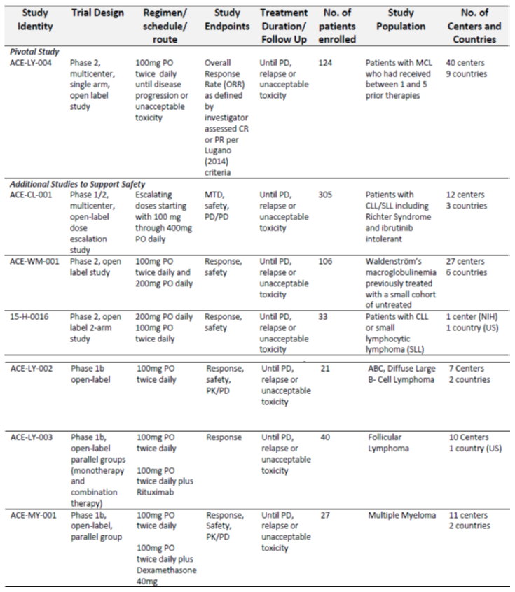

Pharmacology
Acalabrutinib is rapidly absorbed, achieving a peak plasma concentration in 0.75 hours with an absolute bioavailability of 25%. It is highly bound to plasma proteins (98%) with a volume of distribution of 34 litres and a blood/plasma ratio of 0.7 to 0.8.
Acalabrutinib is primarily metabolised by CYP3A4 enzymes. It has an active major metabolite, ACP-5862, which is less slowly cleared and has 50% less BTK inhibitory potency. The terminal half-life of acalabrutinib is 1 to 2 hours, and that of its metabolite (ACP-5862), 7 hours.
Study ACE-CL-001 was a Phase II study which examined escalating doses of acalabrutinib between 100 mg and 400 mg once daily (QD) in 305 patients suffering from CLL. The dose of 100 mg was chosen for further development in the treatment of MCL because this dose produced the highest receptor occupancy and lowest inter-patient variability.
Amendments to dosing for concomitant use of strong CYP3A4 inhibitors or inducers, as well as gastric acid reducing agents, have been suggested, which is consistent with information proposed by the sponsor in the draft Australian PI.

Efficacy
The pivotal Study ACE-LY-004 was a Phase II single arm multi-centre trial that enrolled 124 patients with R/R MCL who received acalabrutinib 100 mg daily. The trial excluded patients with previous BTK treatment. The primary endpoint was the overall response rate (ORR) as assessed by investigators using the Lugano (2014) criteria.
Patients had received an average of 2 prior therapies, with a range of between 1 and 5 (Table 4). Almost all patients (95.2%) had received rituximab therapy prior to the trial.
Table 4: Prior therapies of patients enrolled in Study ACE-LY-004
The results of Study ACE-LY-004 indicated an ORR of 80.6%, made up of a majority of patients achieving either complete response (CR) or partial response (PR; 39.5 and 41.1% respectively).
Table 5: Summary of results of Study ACE-LY-004
The median duration of response (DOR) was not achieved, being 11.8 months for the first quartile.
Figure 1: Duration of response for acalabrutinib responders
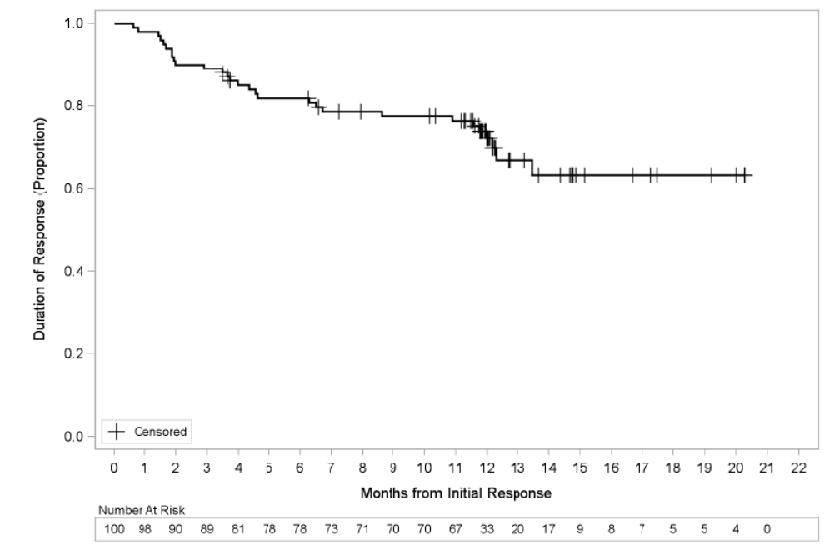

Safety
Acalabrutinib was generally well tolerated in the trial population. The sponsor assessed two safety populations in addition to Study ACE-LY-004. Integrated Summary of Safety (ISS)-100 (a subset of the ISS-All population) consisted of 442 patients who had received 100 mg acalabrutinib twice daily (BD) monotherapy for haematological malignancies, and ISS-ALL comprised 610 patients who received acalabrutinib monotherapy at any dose.
The majority of patients in the safety population had received > 12 months of exposure to acalabrutinib (Table 6).
Table 6: Exposure in safety evaluation datasets
Serious adverse events (SAE) were reported in 38.7% of patients. The most common of these were pneumonia, anaemia, sepsis, tumour lysis syndrome and vomiting. Treatment discontinuation due to any adverse event occurred in 6.5% of patients, with no particular adverse event (AE) being prominent as a cause of discontinuation.
Table 7: Serious adverse events occurring in > 2% in Study ACE-LY-004
Overall the most common non-haematological adverse reactions were headache (37.9%), diarrhea (30.6%), fatigue (27.4%), myalgia (21.0%) and bruising. None of these were severe enough to lead to treatment discontinuation.
Overall, anaemia occurred in 46.0%, thrombocytopaenia in 44.4% and reduced neutrophil count in 36.3% of patients.
There were no deaths attributable to acalabrutinib treatment.

Risk management plan
Summary from the risk management plan (RMP):
- Submission PM-2019-03536-1-6 proposes to register the new chemical entity, acalabrutinib (Calquence), through the Comparable Overseas Regulator (COR);1 and Provisional registration pathways. In this submission Calquence is proposed to be used for the treatment of MCL in patients who have received at least one prior therapy. The proposed dosing regimen involves oral administration of one capsule (100 mg) twice daily until disease progression or unacceptable toxicity.
- The sponsor has submitted Core RMP version 1.0 (date 26 February 2018; data lock point (DLP) 29 May 2017 (Study ACE-LY-004), 3 April 2017 (Study ACE-CL-001), 1 June 2017 (Studies ACE-WM-00, 15-H-0016, ACE-LY-002, ACE-LY-003 and ACE-MY-001)) and Australian specific Annex (ASA) version 1.0 (date 25 July 2019) in support of application PM-2019-03536-1-6. After the first round evaluation the sponsor provided updated Core RMP version 2 (date 19 August 2019; DLP 8 February 2019) and ASA version 1.0 Succession 2 (date 20 September 2019) which are acceptable for evaluation for both submissions PM-2019-03536-1-6 and PM-2019-04317-1-6. After the second round evaluation the sponsor provided updated ASA version 1.0 Succession 3 (date 8 November 2019).
- Evaluation of submissions PM-2019-03536-1-6 and PM-2019-04317-1-6 is contained in a single RMP evaluation report.
- The proposed summary of safety concerns and their associated risk monitoring and mitigation strategies for both submissions are summarised in Table 8.
Table 8: Summary of safety concerns
Summary of safety concerns |  | Pharmacovigilance |  | Risk Minimisation
 |  | Routine | Additional | Routine | Additional
Important identified risks | Haemorrhage |  | – |  | –
Important identified risks | Infections |  | –
Important identified risks | Anaemia |  | – |  | –
Important identified risks | Leukopenia |  | – |  | –
Important identified risks | Thrombocytopenia |  | – |  | –
Important identified risks | Second primary malignancy |  | – |  | –
Important identified risks | Atrial fibrillation/flutter |  | – |  | –
Important potential risks | Nil | – | – | – | –
Missing information | Long term safety |  | * | – | –
Missing information | Use in patients with moderate to severe cardiac impairment |  | * | – | –
* Global Phase IIIb, multicentre, open-label, single-arm clinical study: Study D8220C00008 (Assure trial)
- The summary of safety concerns is the same for both submissions. At the second round of evaluation the sponsor reclassified the important potential risks of infections, anaemia, leukopaenia, thrombocytopaenia, second primary malignancy and atrial fibrillation/flutter as important identified risks. The sponsor also removed use in pregnancy and lactation, and use in patients with severe hepatic impairment as missing information. The summary of safety concerns is considered acceptable subject to final review of clinical and nonclinical data by the Delegate.
- The sponsor has proposed routine pharmacovigilance activities for all safety concerns and a global, Phase III, multicentre clinical study involving patients with CLL addressing missing information regarding use in patients with moderate to severe cardiac impairment, and long term safety. This approach is acceptable for both submissions.
- The sponsor has provided a Clinical Study Plan for confirmatory trial data for the provisional indication for MCL in submission PM-2019-03536-1-6. The level of detail in the plan is acceptable. The Delegate will consider the final acceptability of the plan.

Delegate’s conclusions on risk management plan evaluation
The sponsor has proposed routine risk minimisation activities and no additional risk minimisation activities, which is acceptable for both submissions.
The RMP evaluator has assessed this application in conjunction with the contemporaneous one to extend the indications to include treatment of CLL. The sponsor has proposed routine risk minimisation activities and no additional risk minimisation activities, which the RMP evaluator has concluded is acceptable for both submissions.

Risk-benefit analysis

Delegate’s considerations
Relatively early data for acalabrutinib indicate that it may be a useful additional therapy for R/R MCL, which is a life-threatening condition for which treatment options are currently limited. The ORR of over 80% and potentially prolonged DOR (median not reached at 15.2 months of follow-up) suggest there may be a clinically meaningful increase in OS although this remains to be established.
The Delegate notes that 32% of patients discontinued therapy due to progressive disease an 18% of patients died of progressive disease in Study ACE-LY-004 and so, despite the high initial ORR, acalabrutinib requires further ongoing study. 24 month data from Study ACE-LY-004 was available to the sponsor during this evaluation but not at the time of application, and has therefore not been considered in this decision. Additional studies of acalabrutinib are underway.
The Delegate notes that the provisional nature of any approval of acalabrutinib should be made clear in the indications.

Proposed action
The Delegate proposes to approve acalabrutinib for the indication:
Calquence is indicated for the treatment of patients with mantle cell lymphoma who have received at least one prior therapy.
This indication is approved via the provisional approval pathway, based on overall response rate. Full registration for this indication depends on verification and description of clinical benefit in confirmatory trials.
The Delegate intends to place a condition on the registration of acalabrutinib that:
- A final study report of Study ACE-LY-004 will be submitted to TGA for evaluation when it is available.
- A final study report of Study ACE-LY-308 will be submitted to TGA for evaluation at the same time as it is submitted for evaluation to either the FDA, EMA or Health Canada, whichever is the earliest.

Advisory Committee Considerations
The Delegate did not refer this application to the Advisory Committee on Medicines (ACM) for advice.

Outcome
Based on a review of quality, safety and efficacy, the TGA approved the provisional registration of Calquence (acalabrutinib) 100 mg hard capsule, indicated for:
Calquence is indicated for the treatment of patients with mantle cell lymphoma who have received at least one prior therapy.
This indication is approved via the provisional approval pathway, based on overall response rate. Full registration for this indication depends on verification and description of clinical benefit in confirmatory trials.
The provisional registration period for the above medicine is two years starting on the day specified in the ARTG certificate of registration.

Specific conditions of registration applying to these goods
- Calquence (acalabrutinib) is to be included in the Black Triangle Scheme. The PI and Consumer Medicines Information (CMI) for Calquence must include the black triangle symbol and mandatory accompanying text for five years, which starts from the date that the sponsor notifies the TGA of supply of the product.
- Confirmatory trial data (as identified in the sponsor’s plan to submit comprehensive clinical data on the safety and efficacy of the medicine before the end of the 6 years that would start on the day that registration would commence) must be provided.
Specifically the sponsor must conduct studies as described in the clinical study plan in version 1.0, succession 3, (date 7 November 2019) of the Australia-specific Annex. The following study reports should be submitted to TGA:
  - ACE-LY-004, A Phase II, multicenter, open-label study in subjects with histologically documented MCL, who had relapsed after or been refractory to ≥ 1 (but not > 5) prior treatment regimens, by Q3 2020;
  - ACE-LY-308, A Phase III, randomized, double-blind, placebo-controlled, multicenter study of bendamustine and rituximab alone versus in combination with acalabrutinib in subjects with untreated MCL, by Q1/Q2 2024.
Further guidance for sponsors is available on the TGA website.
- The Calquence Core Risk Management Plan version 2; date; data lock point 8 February 2019 (RMP) (version 2, dated 19 August 2019, data lock point 8 February 2019), with Australian Specific Annex (version 1.0, succession 3, dated 7 November 2019) included with submission PM-2019-03536-1-6, and any subsequent revisions, as agreed with the TGA will be implemented in Australia.
An obligatory component of risk management plans is routine pharmacovigilance. Routine pharmacovigilance includes the submission of periodic safety update reports (PSURs).
Unless agreed separately between the supplier who is the recipient of the approval and the TGA, the first report must be submitted to TGA no later than 9 calendar months after the date of the approval letter. The subsequent reports must be submitted no less frequently than annually from the date of the first submitted report until the period covered by such reports is not less than three years from the date of the approval letter or for the entire period of provisional registration, whichever is longer. The annual submission may be made up of two PSURs each covering six months. If the sponsor wishes, the six monthly reports may be submitted separately as they become available.
The reports are to at least meet the requirements for PSURs as described in the European Medicines Agency’s Guideline on Good Pharmacovigilance Practices (GVP) Module VII periodic safety update report (Rev 1), Part VII.B Structures and processes. Note that submission of a PSUR does not constitute an application to vary the registration. Each report must have been prepared within ninety calendar days of the data lock point for that report.
- A final study report of ACE-LY-004 will be submitted to TGA for evaluation when it is available.
- A final study report of ACE-LY-308 will be submitted to TGA for evaluation at the same time as it is submitted for evaluation to either the Food and Drug Administration (FDA), European Medicines Agency (EMA) or Health Canada, whichever is the earliest.

Attachment 1. Product Information
The PI for Calquence approved with the submission which is described in this AusPAR is at Attachment 1. For the most recent PI, please refer to the TGA website at <https://www.tga.gov.au/product-information-pi>.

Therapeutic Goods Administration
PO Box 100 Woden ACT 2606 Australia
Email: info@tga.gov.au Phone: 1800 020 653 Fax: 02 6232 8605
https://www.tga.gov.au

The COR report-based process is associated with a shortened evaluation and decision timeframe. The aim of this process is to reduce duplication of evaluation of prescription medicines that have already been approved by a COR, while maintaining existing quality, safety and efficacy standards for medicines supplied in Australia. The intention is that the TGA will only need to evaluate data generated specifically for the Australian context. For example, Australian labels, product information and consumer medicine information. However, in some instances, additional data may need to be considered. For example, safety data generated since the COR approval. Under the COR-B approach, the TGA regulatory decision will still be mostly based on a critical review of the COR assessment reports. The COR-B process has a 175 working day evaluation and decision timeframe, allowing for TGA evaluation of certain data, in addition to the label, PI and RMP.
European Medicines Agency (EMA), Committee for Medicinal Products for Human Use (CHMP), ICH S9 Guidance on nonclinical evaluation for anticancer pharmaceuticals, EMEA/CHMP/ICH/646107/2008.
Van Heertum, R.L. et al. (2017). Lugano 2014 criteria for assessing FDG-PET/CT in lymphoma: an operational approach for clinical trials. Drug Des Devel Ther. 2017; 11: 1719–1728.
Routine risk minimisation activities may be limited to ensuring that suitable warnings are included in the product information or by careful use of labelling and packaging. Routine pharmacovigilance practices involve the following activities: - All suspected adverse reactions that are reported to the personnel of the company are collected and collated in an accessible manner; - Reporting to regulatory authorities; - Continuous monitoring of the safety profiles of approved products including signal detection and updating of labelling; - Submission of PSURs; - Meeting other local regulatory agency requirements.
The ACM provides independent medical and scientific advice to the Minister for Health and the Therapeutic Goods Administration (TGA) on issues relating to the safety, quality and efficacy of medicines supplied in Australia including issues relating to pre-market and post-market functions for medicines. The Committee is established under Regulation 35 of the Therapeutic Goods Regulations 1990. Members are appointed by the Minister. The ACM was established in January 2017 replacing Advisory Committee on Prescription Medicines (ACPM) which was formed in January 2010. ACM encompass pre and post-market advice for medicines, following the consolidation of the previous functions of the Advisory Committee on Prescription Medicines (ACPM), the Advisory Committee on the Safety of Medicines (ACSOM) and the Advisory Committee on Non-Prescription Medicines (ACNM). Membership comprises of professionals with specific scientific, medical or clinical expertise, as well as appropriate consumer health issues relating to medicines.

