First round CER: 30 January 2013
Second round CER: 29 April 2013

AusPAR Attachment 2

Extract from the Clinical Evaluation Report for Abiraterone Acetate
  - Proprietary Product Name: Zytiga
  - Sponsor: Janssen-Cilag Pty Ltd

About the Therapeutic Goods Administration (TGA)
- The Therapeutic Goods Administration (TGA) is part of the Australian Government Department of Health and is responsible for regulating medicines and medical devices.
- The TGA administers the Therapeutic Goods Act 1989 (the Act), applying a risk management approach designed to ensure therapeutic goods supplied in Australia meet acceptable standards of quality, safety and efficacy (performance), when necessary.
- The work of the TGA is based on applying scientific and clinical expertise to decision-making, to ensure that the benefits to consumers outweigh any risks associated with the use of medicines and medical devices.
- The TGA relies on the public, healthcare professionals and industry to report problems with medicines or medical devices. TGA investigates reports received by it to determine any necessary regulatory action.
- To report a problem with a medicine or medical device, please see the information on the TGA website <http://www.tga.gov.au>.
About the Extract from the Clinical Evaluation Report
- This document provides a more detailed evaluation of the clinical findings, extracted from the Clinical Evaluation Report (CER) prepared by the TGA. This extract does not include sections from the CER regarding product documentation or post market activities.
- The words [Information redacted], where they appear in this document, indicate that confidential information has been deleted.
- For the most recent Product Information (PI), please refer to the TGA website <http://www.tga.gov.au/hp/information-medicines-pi.htm>.
Copyright
© Commonwealth of Australia 2014
This work is copyright. You may reproduce the whole or part of this work in unaltered form for your own personal use or, if you are part of an organisation, for internal use within your organisation, but only if you or your organisation do not use the reproduction for any commercial purpose and retain this copyright notice and all disclaimer notices as part of that reproduction. Apart from rights to use as permitted by the Copyright Act 1968 or allowed by this copyright notice, all other rights are reserved and you are not allowed to reproduce the whole or any part of this work in any way (electronic or otherwise) without first being given specific written permission from the Commonwealth to do so. Requests and inquiries concerning reproduction and rights are to be sent to the TGA Copyright Officer, Therapeutic Goods Administration, PO Box 100, Woden ACT 2606 or emailed to <tga.copyright@tga.gov.au>.

Contents
List of abbreviations 5
1. Clinical rationale 6
2. Contents of the clinical dossier 6
2.1. Scope of the clinical dossier 6
2.2. Paediatric data 6
2.3. Good clinical practice 6
3. Pharmacokinetics 6
3.1. Studies providing pharmacokinetic data 6
3.2. Summary of pharmacokinetics 7
3.3. Evaluator’s overall conclusions on pharmacokinetics 7
4. Pharmacodynamics 7
5. Dosage selection for the pivotal studies 7
6. Clinical efficacy 7
6.1. Treatment of patients with metastatic castration resistant prostate cancer (mCRPC) who are asymptomatic or mildly symptomatic after failure of androgen deprivation therapy (ADT) 7
6.2. Analyses performed across trials (pooled analyses and meta-analyses) 23
6.3. Evaluator’s conclusions on clinical efficacy 23
7. Clinical safety 24
7.1. Studies providing evaluable safety data 24
7.2. Pivotal efficacy study 25
7.3. Non-pivotal efficacy studies 31
7.4. Postmarketing experience 32
7.5. Safety Issues with the potential for major regulatory impact 32
7.6. Evaluator’s overall conclusions on clinical safety 33
8. First round benefit-risk assessment 34
8.1. First round assessment of benefits 34
8.2. First round assessment of risks 34
8.3. First round assessment of benefit-risk balance 34
9. First round recommendation regarding authorisation 34
10. Clinical questions 34
10.1. Efficacy 34
10.2. Safety 34
11. Second round evaluation of clinical data submitted in response to questions 35
11.1. Updated analysis of overall survival 35
11.2. Formulation used in Study 302 36
11.3. Coagulation parameters 37
12. Second round benefit-risk assessment 37
13. Second round recommendation regarding authorisation 37

List of abbreviations
Abbreviation | Meaning
ADT | Androgen Deprivation Therapy
AE | Adverse Event
ALT | Alanine Transaminase
AST | Aspartate Transaminase
CIOMS | Council for International Organisations of Medical Sciences
CL | Clearance
ECG | Electrocardiograph
ECOG | Eastern Cooperative Oncology Group
EMA | European Medicines Agency
F | Absolute bioavailability
FDA | Food and Drug Administration
GnRH | Gonadotrophin Releasing Hormone
HR | Hazard Ratio
IDMC | Independent Data Monitoring Committee
ISS | Integrated Summary of Safety
ITT | Intention to Treat
mCRPC | Metastatic Castration Resistant Prostate Cancer
OS | Overall Survival
PCWG2 | Prostate Cancer Clinical Trials Working Group-2
PD | Pharmacodynamics
PFS | Progression-Free Survival
PI | Product Information
PK | Pharmacokinetics
PSA | Prostate Specific Antigen
RECIST | Response Evaluation Criteria In Solid Tumours
rPFS | Radiographic Progression-Free Survival
SCS | Summary of Clinical Safety
WHO | World Health Organisation

Clinical rationale
Current methods of castration (GnRH agonists and antagonists, orchidectomy) inhibit production of testosterone from the testes. Abiraterone inhibits the production of testosterone from the testes and from other sites such as the adrenal and from prostate cancer tissue. The drug might therefore be expected to be effective in patients who have become castration resistant. The safety profile of abiraterone is also more favourable than that of taxanes. Hence the introduction of abiraterone prior to the use taxane chemotherapy is a logical rationale for the application.

Contents of the clinical dossier

Scope of the clinical dossier
The clinical submission to support the new indication included clinical efficacy and safety data from one large pivotal randomised controlled trial. Population PK data were also collected during this trial.
The submission contained the following clinical information:
- 1 population pharmacokinetic analysis;
- 1 pivotal efficacy/safety study (Study 302) in chemotherapy-naïve metastatic Castration Resistant Prostate Cancer (mCRPC) subjects;
- Safety updates of several previously submitted phase I and II studies;
- An integrated summary of safety (ISS) which provided additional tabulations of safety data to those contained in the sponsor’s Summary of Clinical Safety;
- Literature references.

Paediatric data
The submission did not include paediatric data. As prostate cancer is disease of adults, this is acceptable.

Good clinical practice
The report for the pivotal study included an assurance that the study was conducted in accordance with the ethical principles of the Declaration of Helsinki, and with Good Clinical Practice and other applicable regulatory requirements.

Pharmacokinetics

Studies providing pharmacokinetic data
The only new PK data in the submission come from a population PK analysis of plasma samples obtained from a subgroup of patients who participated in the pivotal study (Study 302).

Summary of pharmacokinetics
The PK parameters of abiraterone were evaluated and summarised in the original application to register the drug. Apart from the population PK analysis referred to above, no new data on the PK of the drug were submitted.

Evaluator’s overall conclusions on pharmacokinetics
The PK of abiraterone in patients who are naïve to chemotherapy is comparable to that previously documented for the drug.

Pharmacodynamics
No new PD data were submitted.

Dosage selection for the pivotal studies
The dose selected for use in the pivotal study was the same as that currently approved (that is, 1,000 mg daily). The original dose was justified on the grounds that, in dose-ranging studies:
- Dose limiting toxicity was not observed with doses up to 2,000 mg per day; and
- A plateau in the increase in upstream hormones (for example, corticosterone) was observed at a dose of 750 mg per day.
Comment: CYP17 activity is likely to be similar in the currently approved and proposed new populations. The decision to use the same dose is therefore acceptable.

Clinical efficacy

Treatment of patients with metastatic castration resistant prostate cancer (mCRPC) who are asymptomatic or mildly symptomatic after failure of androgen deprivation therapy (ADT)

Pivotal efficacy study (COU-AA-302)

Study design, objectives, locations and dates

Design
The study was a Phase III, randomised, double blind, placebo-controlled trial with two parallel groups. Subjects were randomised (1:1) to receive abiraterone in combination with prednisone, or placebo in combination with prednisone.
The study consisted of a screening period (within 14 days prior to commencement of treatment), a treatment period (from commencement of treatment until the End-Of-Study visit) and a follow-up period (for survival, every 3 months for up to 5 years).

Objectives
The primary objective of the study was: “to compare the clinical benefit of abiraterone acetate plus prednisone to placebo plus prednisone in men with asymptomatic or mildly symptomatic chemotherapy-naïve metastatic CRPC”.
The secondary objectives of the study were:
- “To establish additional clinically relevant improvements in prostate cancer subjects treated with abiraterone acetate in comparison with placebo;
- To characterize the safety profile of abiraterone acetate in this subject population;
- To characterize the pharmacokinetics of abiraterone acetate when administered concurrently with prednisone”.

Locations
The study was conducted at 151 sites in the USA, Europe, Canada and Australia.

Dates
The first patient was enrolled on 28 April 2009 and the last patient was enrolled on 23 June 2010. There were two analyses conducted. The date for data cut-off for the first analysis (final analysis of radiographic Progression-Free Survival (PFS) endpoint and first interim analysis of Overall Survival (OS) endpoint) was 20 December 2010. The data cut-off date for the second analysis (second interim analysis for OS) was 20 December 2011. The submitted study report was dated 31 May 2012.

Inclusion and exclusion criteria
Subjects were required to have metastatic disease and be either surgically or medically castrated (serum testosterone < 2.0 nmol/L). They were required to have evidence of disease progression based on rising PSA levels (using PCWG2 criteria)or radiographic imaging (using RECIST criteria). Progression must have occurred after discontinuation of antiandrogen therapy, as responses to withdrawal of these agents may occur.
Comment: Enrolment was restricted to patients with asymptomatic or mildly symptomatic disease, as chemotherapy would be indicated in symptomatic patients and use of prednisone alone would not be ethical.
Patients were excluded if they had already received chemotherapy, biological therapy (for example, sipuleucel-T) or ketoconazole (a CYP17 inhibitor) for the treatment of their disease.

Study treatments
Subjects were randomised (1:1) to receive either:
- Abiraterone 1000mg once daily in combination with prednisone (or prednisolone) 5 mg twice daily;
- Placebo once daily in combination with prednisone (or prednisolone) 5 mg twice daily.
Comment: There are no accepted therapies for the treatment of asymptomatic/mildly symptomatic mCRPC. The use of placebo/prednisone was therefore acceptable as a comparator arm.
Food was not to be consumed for at least 2 hours before and for at least 1 hour after the dose of abiraterone/placebo. Although treatment was continuous, it was divided into ‘cycles’ of 28 days each.
In the event of toxicity, the abiraterone dose could be decreased to 750 mg and then to 500 mg per day. If the 500 mg dose could not be tolerated, study drug was to be discontinued. The protocol provided specific guidance on the management of hypokalaemia, hypertension, oedema and fluid retention, hepatotoxicity and non-mineralocorticoid related toxicities. Dose reductions of prednisone were at the discretion of the investigator.
Patients were continued on treatment until one of the following occurred:
- Radiographic progression
- Unequivocal clinical progression (defined as per Table 1);
- The subject withdrew from the study;
- The investigator the subject due to unresolved adverse events or the initiation of new anticancer treatment.
Table 1:Pivotal study 302 – Criteria for unequivocal clinical progression
- Cancer pain requiring initiation of chronic administration of opiate analgesia (oral opiate use for ≥3 weeks; parenteral opiate use for ≥7 days); Patients with cancer pain requiring opiate analgesia for relief should also be assessed by the investigator for the need for initiating systemic chemotherapy.
Or
- Immediate need to initiate cytotoxic chemotherapy or the immediate need to have either radiation therapy or surgical intervention for complications due to tumor progression, even in the absence of radiographic evidence of disease progression.
Or
- Deterioration in ECOG performance status to Grade 3 or higher. Patients whose ECOG performance status decreases to Grade 2 during the study should be assessed carefully for their need for docetaxel therapy.
When study treatment is discontinued due to unequivocal clinical progression, the investigator should obtain imaging studies at the Treatment Discontinuation Visit to assess for radiographic progression, including a confirmatory bone scan, as appropriate.
Study treatment will be continued on patients who have increasing PSA values in the absence of radiographic or unequivocal clinical progression. Although serial PSA’s will be measured on this study, progression or change in PSA values is not considered a reliable measure of disease progression, and should not be used as an indication to discontinue study therapy.
Of note, the study protocol specified the following:
“Study treatment will be continued on patients who have increasing PSA values in the absence of radiographic or unequivocal clinical progression. Although serial PSA’s will be measured on this study, progression or change in PSA values is not considered a reliable measure of disease progression, and should not be used as an indication to discontinue study therapy.”
In patients who had not undergone orchidectomy, ongoing treatment with a GnRH agonist was mandatory to maintain serum testosterone < 2.0 nmol/L. Concomitant use of other drugs that may have affected the disease process (for example antiandrogens, 5α–reductase inhibitors, ketoconazole, cyproterone) were prohibited.

Efficacy variables and outcomes
The main efficacy variables were:
- Tumour measurements (computed tomography (CT), magnetic resonance imaging (MRI), bone scan) were performed at screening and on Day 1 of Cycles 3 (that is, after 8 weeks), 5 (16 weeks), 7 (24 weeks), 10 (36 weeks) and then after every 3 cycles;
- Data on survival status, opiate use, ECOG performance status grade, and first cytotoxic chemotherapy for prostate cancer were assessed every month up to 5 years;
- Serum Prostate-specific antigen (PSA) measurements (performed at a central laboratory) were done at screening, Cycle 1 Day 1, Cycles 3, 5, 7, and 10 and then every 3 cycles beyond Cycle 10, at treatment discontinuation if applicable, and at the End-of-Study Visit;
- The Functional Assessment of Cancer Therapy–Prostate (FACT-P) questionnaire was administered to assess quality of life / functional status at Cycle 1 Day 1, Cycles 3, 5, 7, and 10 and then every 3 cycles beyond Cycle 10;
- The Brief Pain Inventory Short Form (BPI-SF) and an analgesic usage score (scored from 0 for no analgesia to 3 for opiates for severe pain) were measured after each cycle.
PK samples were to be collected from a subgroup of patients for a population PK analysis.
There were two primary efficacy outcomes (‘co-primary endpoints’):
- Radiographic Progression-Free Survival (rPFS), defined as the time from randomisation to the time of radiographic progression (as defined in Footnote 3) or death, whichever occurs first;
- Overall Survival (OS), defined as the time from randomisation to death from any cause.
- Imaging to assess progression was assessed by radiologists and nuclear medicine physicians who were independent from the investigators and were blinded to subjects’ treatment allocation and clinical information.
Comment: Overall survival is a standard endpoint in oncology trials. rPFS is a novel endpoint that is not specifically referred to in the European Union (EU) guidelines on anticancer agents., Conventionally, measurement of PFS requires use of an established set of criteria (RECIST or WHO) for documenting disease progression. These established criteria are of limited applicability to the setting of mCRPC as only a minority of patients have measurable disease. The most common site of metastatic disease in prostate cancer is bone. Bone lesions are considered unmeasurable using CT or MRI and there are no accepted criteria for interpreting the clinical significance of changes in size or intensity of lesions on bone scan.
The proposed rPFS endpoint incorporates criteria for establishing the presence of disease progression using bone scan, in addition to the use of the conventional RECIST criteria (see Footnote 3). The new criteria for progression essentially require the development of at least 2 new lesions on bone scan. New lesions appearing in the first 12 weeks may represent disease that was present but undetected at baseline. Therefore the early appearance of new lesions does not qualify as disease progression unless further lesions are documented at a later time.
The sponsor submitted a justification for the use of rPFS as an acceptable primary endpoint. Points made by the sponsor included the following:
- The bone scan criteria are objective and verifiable;
- It is biologically plausible that it could correlate with clinical benefit, as progression of metastatic bone disease is associated with pathological fractures, pain, spinal cord compression etc.;
- The criteria are based on a set of expert consensus guidelines on the conduct of clinical trials in prostate cancer;9
- The secondary endpoints of the trial will measure the actual clinical benefit to the patient (in terms of pain, performance status etc.)
- The European Medicines Agency (EMA) itself considered that rPFS was an acceptable primary endpoint (provided that the secondary endpoints measuring clinical benefits were positive);
The EMA guidelines envisage the use of alternative measures of disease progression as illustrated by the following extract (emphasis added):
“Disease progression and recurrence are typically assessed based on objective radiological findings. Whenever possible, the definition of progression should follow established response evaluation criteria (for example,, RECIST or WHO criteria, EBMT criteria). However, it is acknowledged that, depending on the type of agent, the site and type of lesion, and the objectives of the trial, modified criteria might be more appropriate. For instance, additional objective clinical and biochemical or radiological criteria may be used to assess progression. In all cases, it is important that the criteria for definition of a progression event are as objective as possible, and that the definitions be clearly and prospectively defined in the protocol.”
Overall, the use of rPFS as a primary endpoint for the trial is considered acceptable.
Secondary efficacy endpoints were:
- Time to opiate use for cancer pain;
- Time to initiation of cytotoxic chemotherapy;
- Time to clinical deterioration in ECOG performance status by ≥ 1 grade;
- Time to PSA progression. PSA progression was defined according to Prostate Cancer Clinical Trials Working Group-2 (PCWG2) criteria, which require a minimum level of 2 ng/mL and a sequence of rising values at least 1 week apart.
- The definitions for these endpoints are shown in Table 2.
Table 2: Pivotal study 302 – Secondary efficacy endpoints
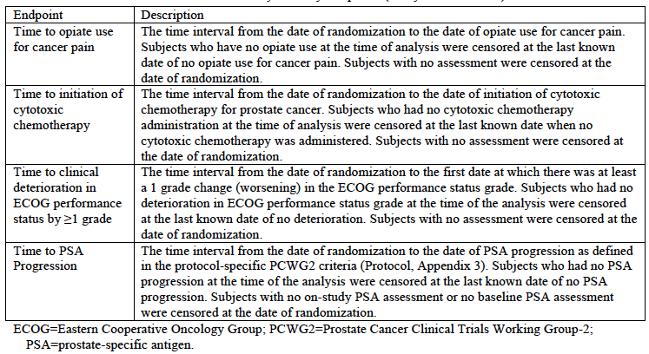
Other efficacy outcomes used in the study are shown in Table 3.
Table 3: Pivotal Study 302 – Other efficacy endpoints
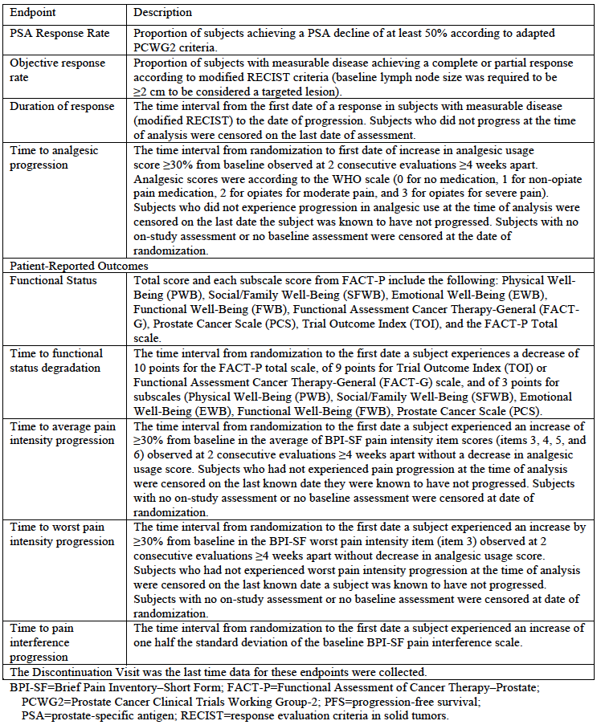

Randomisation and blinding methods
An independent statistician generated the randomisation schedule using a stratified, permuted block design. Randomisation was stratified by baseline ECOG performance status (0 versus 1). Subjects were allocated to treatment via an Interactive Web or Voice Response System (IWRS/IVRS).
The study was double-blinded through use of a placebo that matched the abiraterone tablets in size colour and shape. Prednisone or prednisolone tablets were not blinded. Radiologists and nuclear medicine physicians who performed the independent assessment of imaging were also blinded to the patient’s treatment allocation.

Analysis populations
The intent-to-treat (ITT) population included all subjects randomised into the study. Subjects were to be classified according to assigned treatment group, regardless of the actual treatment received. The ITT population was used for all efficacy analyses and all analyses of disposition, demographic, and baseline disease characteristics.
The safety population included all subjects in the ITT population who received any study medication.

Sample size
The overall level of significance for the study was 0.05, which was allocated between the co-primary endpoints (0.01 for rPFS and 0.04 for OS).
The median rPFS in subjects with mCRPC who have not received cytotoxic chemotherapy and who are asymptomatic or mildly symptomatic, was estimated to be approximately 4 months, based on a published Phase III trial. It was assumed that treatment with abiraterone would produce a hazard ration (HR) of 0.667, with a median rPFS of 6 months with abiraterone and 4 months with placebo. Given the 2-tailed level of significance of 0.01, it was estimated that 378 rPFS events would be required to provide the study with 91% power.
The median survival in the same group was estimated to be in the range of 20 to 22 months, based on published data. It was assumed that treatment with abiraterone would produce a hazard ration (HR) of 0.80, with a median OS of 27.5 months with abiraterone and 22 months with placebo. Given the 2-tailed level of significance of 0.04, it was estimated that 773 OS events would be required to provide the study with 85% power.
Assuming an enrollment rate of 50 patients per month (20 months to complete enrollment) and study duration of approximately 64 months, a total sample size of approximately 1000 patients was planned.

Statistical methods
All time-to-event endpoints were analysed using Kaplan-Meier methods to estimate survival distributions and the median time-to-event. For rPFS and OS the treatments were compared using the stratified log rank test.
Only one analysis of rPFS was planned, after 378 events. Three interim analyses and one final analysis of the OS endpoint were planned, after 116, 311, 425 and 773 events (corresponding to approximately 15%, 40%, 55% and 100% of the total events). The first interim analysis was scheduled for the same time as the rPFS analysis. The purpose of the interim analyses was to terminate the study if superiority of abiraterone was demonstrated. O’Brien-Fleming stopping boundaries, incorporating an alpha-spending function were used.
Subgroup analyses were conducted for both rPFS and OS with the HR within each subgroup estimated using a non-stratified Cox proportional hazard model. Various sensitivity analyses were also planned, including investigator-assessed rPFS.
The secondary endpoints were analysed using the Hochberg test procedure, with the overall level of significance controlled at the 2-tailed, 0.05 level.
Analyses of other endpoints did not include adjustments for multiplicity for multiple comparisons. Each endpoint was tested at a 2-tailed 0.05 level of significance.

Participant flow
A total of 1,088 subjects were randomised and 1,082 received treatment. At the 20 December 2011 cut-off date 31% of patients in the abiraterone arm and 16% of subjects in the placebo arm were still receiving treatment.
A flow diagram for the study is shown in Figure 1. Reasons for discontinuation are shown in Table 4 and Table 5.
Figure 1:Pivotal study 302 - Participant flow and analysis sets.
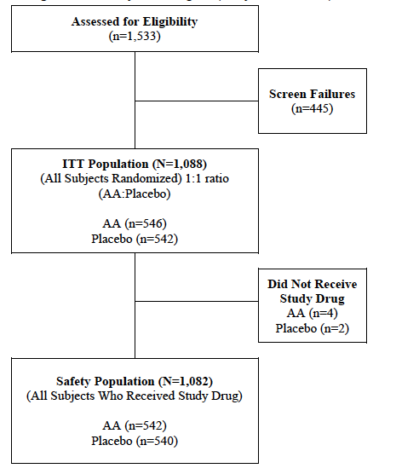
Table 4: Pivotal study 302 – Discontinuations
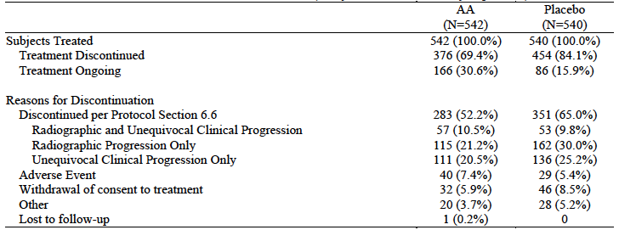
Table 5: Pivotal study 302 – Discontinuations due to unequivocal clinical progression
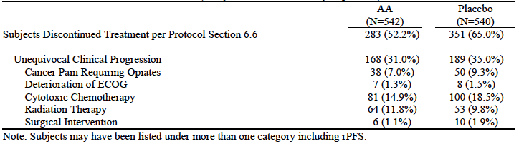

Major protocol violations/deviations
Major protocol violations are shown in Table 6. These were balanced between treatment arms.
Table 6: Pivotal study 302 – Major protocol violations
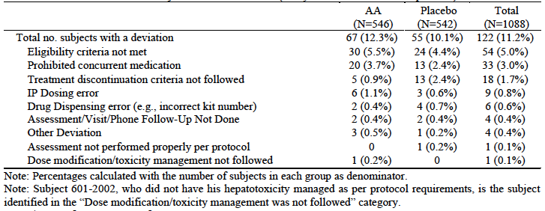

Baseline data
Baseline data indicate that the two groups were well matched at baseline. The groups were also well matched with respect to baseline BPI-SF pain scores and analgesic use.

Results for the primary efficacy outcomes

rPFS
The data cut-off for rPFS was 20 December 2010. At this time the median duration of follow up was 8.3 months. Results for rPFS are shown in Table 7 and Figure 2. A total of 401 rPFS events had occurred. Abiraterone treatment was associated with a statistically significant reduction in the risk of experiencing an rPFS event (HR = 0.425; 95%CI: 0.347 – 0.522; p-value < 0.0001). There was a numerical reduction in the number of both bone scan-detected events and CT/MRI-detected events. Median rPFS was 8.3 months in the placebo group and had not been reached in the abiraterone group. The proportion of patients who were event-free at 12 months increased from 34% in the placebo group to 56% in the abiraterone group.
Subgroup analyses for rPFS demonstrated consistent efficacy over all subgroups tested (see Figure 3).
The sponsor conducted a number of sensitivity analyses (both pre-specified and post-hoc) all of which showed a statistically significant benefit for abiraterone. Several of these involved assessment of rPFS by the investigators, as opposed to independent review. The results of these are shown in Table 8. Although only conducted as sensitivity analyses, these data provide estimates of median survival for both treatment groups. They suggest a prolongation of median rPFS of approximately 4-8 months.
Table 7: Pivotal Study 302 – Results for rPFS co-primary endpoint
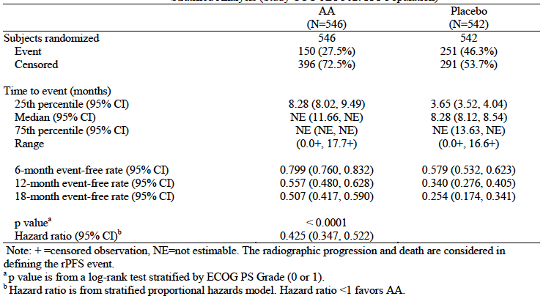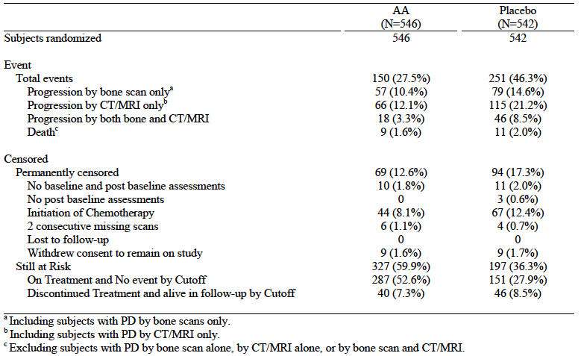
Figure 2: Pivotal study 302 – Kaplan-Meier curves for rPFS co-primary endpoint
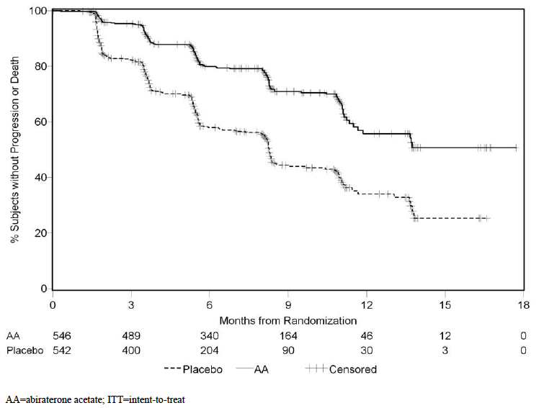
Figure 3: Pivotal study 302 – Subgroup analyses of rPFS co-primary endpoint.
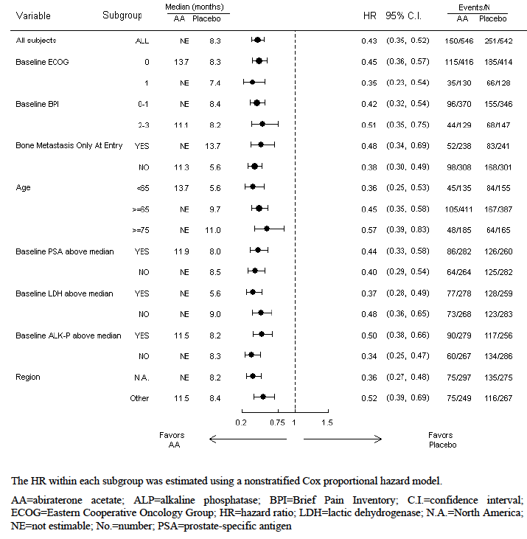
Table 8: Pivotal Study 302 – Investigator assessment of rPFS
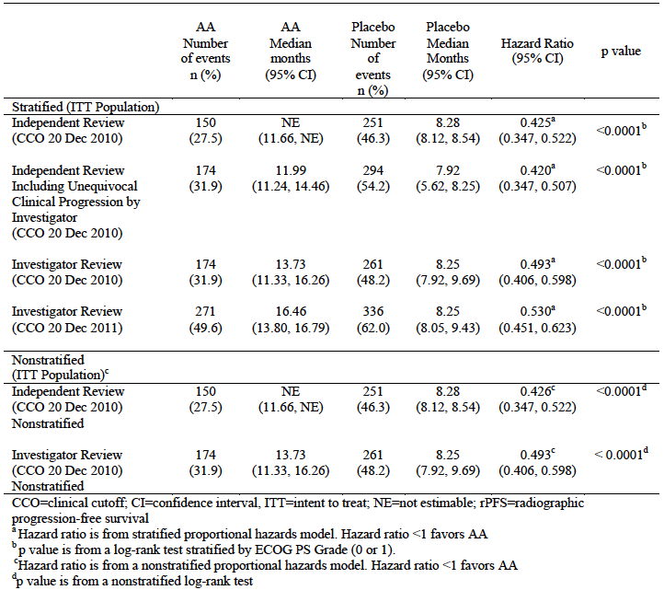
Comment: It is notable that the median rPFS in the placebo group (8.3 months) was double that expected in the sample size calculations.

OS
Results were presented for the second interim analysis of OS, which had a data cut-off of 20 December 2011. At this time the median duration of follow-up was 22.2 months. Results for OS are shown in Table 9 and Figure 4.
At the time of the second interim analysis of OS, a total of 333 deaths had occurred. There was a 25% reduction in the risk of death in the abiraterone group (Hazard Ratio (HR) = 0.752; 95%confidence Interval (CI): 0.606 – 0.934). Due to multiplicity of testing, the pre-specified statistical significance level for this analysis was p = 0.008. The p-value obtained with the pre-specified log rank test was p = 0.0097, and hence the difference in OS was not statistically significant. Median OS was 27.2 months in the placebo group and had not been reached in the abiraterone group. The proportion of patients who were alive at 2 years was increased from 60% in the placebo group to 71% in the abiraterone group.
Table 9: Pivotal study 302 – Results for OS co-primary endpoint
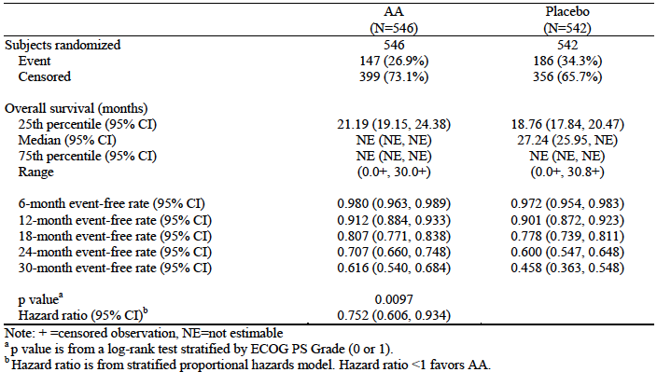
Figure 4: Pivotal study 302 – Kaplan-Meier curves for OS co-primary endpoint
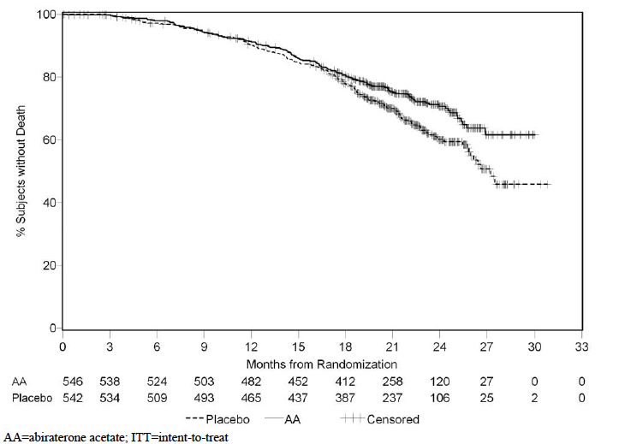
Subgroup analyses for OS demonstrated consistent efficacy over all subgroups tested (see Figure 5). A number of sensitivity analyses were conducted and these showed hazard ratios similar to that obtained using the OS co-primary endpoint analysis.
After discontinuation from study drug or placebo subjects could be treated with further anticancer therapy at the discretion of the investigators; 56% of subjects in the placebo group and 41% of subjects in the abiraterone group received subsequent antineoplastic agents. More patients in the placebo arm received subsequent docetaxel (53% versus 40%) and subsequent abiraterone (10% versus 5%). These imbalances may have biased the survival outcome in favour of placebo.
Figure5: Pivotal study 302 - Subgroup analyses of OS co-primary endpoint.
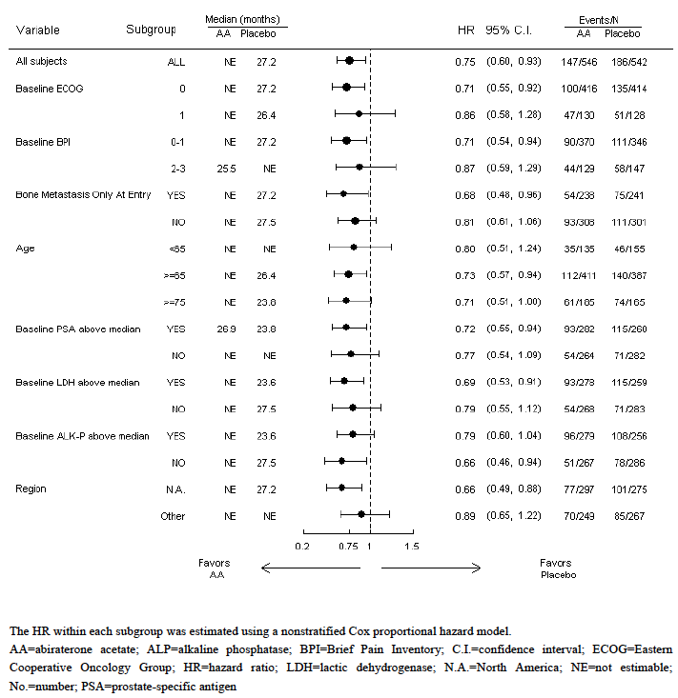
On reviewing the blinded results of the second interim analysis (on 27 February 2012) the independent data monitoring committee (IDMC) for the study concluded that all of the efficacy data demonstrated a “highly significant advantage” for subjects in one of the treatment arms. It unanimously recommended unblinding of the study. The arm providing the advantage was revealed to be the abiraterone arm and therefore the IDMC recommended allowing patients in the placebo group to receive abiraterone. The sponsor implemented the IDMC recommendations.
Comment: It appears that the IDMC recommendation was based on an assessment of all the efficacy data, including rPFS and the secondary endpoints. Hence the trial was unblinded and crossover allowed even though the stopping boundary for OS had not been crossed. At the time of the second interim analysis, the OS data were not mature with only 43% (333/773) of the required number of deaths having occurred. Further analyses of OS are planned after 55% and 100% of the required number of deaths. However, patients in the placebo arm could be crossed over to abiraterone and it is possible that this may obscure a statistically significant survival benefit on these later analyses.

Results for secondary efficacy outcomes

Time to opiate use for cancer pain
Abiraterone significantly prolonged time to the initiation of opiates (HR = 0.686; 95%CI: 0.566 – 0.833; p = 0.0001). At 24 months 62% of abiraterone subjects were opiate-free compared to 49% of placebo patients.

Time to initiation of cytotoxic chemotherapy
Abiraterone significantly prolonged time to the initiation of chemotherapy (HR = 0.580; 95%CI: 0.487 – 0.691; p < 0.0001). Median time to initiation was delayed by approximately 8 months (25 versus 17 months).

Time to deterioration in ECOG performance status
Abiraterone significantly prolonged time to deterioration (HR = 0.821; 95%CI: 0.714 – 0.943; p = 0.0053). Median time to deterioration was delayed by approximately 1.4 months (12.3 versus 10.9 months).

Time to PSA progression
Abiraterone significantly prolonged time to deterioration (HR = 0.488; 95%CI: 0.420 – 0.568; p = 0.0001). Median time to progression was approximately doubled (11.1 versus 5.6 months).
Comment: The results of the first 3 secondary endpoints provide evidence of benefit on clinically relevant outcomes, especially in terms of delaying the need for cytotoxic chemotherapy and opiate analgesia.

Results for other efficacy outcomes
- PSA response rate was increased in the abiraterone arm (62% versus 24%; p < 0.0001);
- Objective response rate (in subjects with measurable disease) was also increased in the abiraterone arm (36% versus 16%; p < 0.0001);
- There was no significant difference in duration of response (median = 10.0 months with abiraterone and 8.6 months with placebo);
- Time to analgesic progression was prolonged in the abiraterone arm (HR=0.687; 95% CI: 0.538, 0.878; p=0.0026). Median time to progression was not reached in either group.
- Table 10 summarises the results for time to degradation of the various functional status scores. For all scores except the Social/Family Wellbeing subscale, abiraterone treatment was associated with statistically significant benefit.
- Time to average pain intensity progression was prolonged with abiraterone treatment (HR=0.817; 95%CI: 0.668 - 0.999; p=0.0490 - median time to progression 26.7 versus 18.4 months).
- Time to worst pain intensity progression was prolonged with abiraterone treatment (HR=0.777; 95% CI: 0.607 - 0.995; p=0.0446) Median time to progression was not reached in either group.
- Time to pain interference progression was prolonged with abiraterone treatment (HR=0.792; 95% CI: 0.674 - 0.931; p=0.0045 - median time to progression 10.3 versus 7.4 months).
Table 10: Pivotal study 302 – Results for time to degradation of functional status
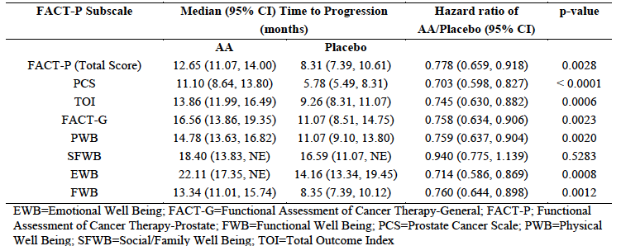

Analyses performed across trials (pooled analyses and meta-analyses)
There were no pooled analyses or meta-analyses of efficacy in the submission.

Evaluator’s conclusions on clinical efficacy
The pivotal study was well designed and conducted. The design generally complied with the relevant EU guidelines, adopted by the TGA. The use of the novel co-primary endpoint of rPFS was adequately justified.
The results for the co-primary endpoint of OS just failed to meet the pre-specified criterion for statistical significance. It might be expected that further analyses of OS, with more mature OS data, would establish a statistically significant effect on overall survival. However, the ability of patients in the placebo arm to now crossover and receive abiraterone may make demonstration of a survival benefit impossible.
There was a highly significant benefit with abiraterone treatment for the co-primary endpoint of rPFS. Although a novel endpoint, it is analogous to the conventional PFS endpoint that is accepted by the TGA. The novel aspects of the rPFS endpoint (determination of progression using bone scan criteria) are objective and have been recommended by an expert consensus group not associated with the sponsor.
The OS and rPFS data are supported by convincing results on the secondary endpoints, particularly those relating to the initiation of cytotoxic chemotherapy and opiate analgesia. The other endpoints suggest that abiraterone is likely to be also associated with maintenance of functional status/quality of life.
Overall the data from the pivotal study are considered to provide convincing evidence of the efficacy of abiraterone in chemotherapy-naïve patients with mCRPC.
Only one pivotal efficacy study was submitted. The TGA has adopted an EU “Points to Consider” document relevant to this situation. The pivotal study is considered to meet the prerequisites in section III.2 of this document. It could also be argued that the previously submitted Phase III trial (Study 301) was conducted in a similar population of patients and hence the EU document should not apply.

Clinical safety

Studies providing evaluable safety data
The following studies provided evaluable safety data:

Pivotal studies that assessed safety as a primary outcome
There were no pivotal studies assessing safety as a primary outcome.

Pivotal efficacy study
In the pivotal efficacy study, the following safety data were collected:
- General adverse events (AEs) were assessed voluntary subject reporting and investigator review of subject history. For all AEs the investigator was required to assess causality of the event. A drug-related AE was defined as one that had an unlikely, possible or related relationship to study medication. Severity of events was graded using National Cancer Institute Common Terminology Criteria for Adverse Events (NCI CTCAE) Version 3.
- Physical examination was conducted at regular intervals.
- Laboratory tests were performed at regular intervals.
- Full blood count: haemoglobin (Hb), haematocrit (Hct), red blood cell (RBC) count, white blood cell (WBC) count (with differential), platelet count;
- Chemistry: albumin, alkaline phosphatase (ALP), alanine aminotransferase (ALT), amylase, aspartate aminotransferase (AST), blood urea nitrogen, calcium, carbon dioxide, chloride, creatinine, direct bilirubin, gamma-glutamyl transferase (at screening only), glucose, lactate dehydrogenase (LDH), magnesium, phosphorus, potassium, sodium, total bilirubin, total protein, uric acid. Liver function tests (LFTs) were measured at Day 15 of Cycles 2 and 3 only.
- Coagulation factors: prothrombin time (PT), partial thromboplastin time (PTT), international normalized ratio (INR); - performed at screening and Day 15 only.
- Serum lipids: cholesterol, high density lipoprotein (HDL), low density lipoprotein (LDL), triglycerides;
- Urinalysis: blood, protein, glucose (with microscopic examination if abnormal) was performed at baseline only.
- Electrocardiograms (ECGs) were performed at screening, at Cycles 3, 5, 7, and 10 and then every 3 cycles beyond Cycle 10, and at the End-of-Study Visit
- Left ventricular ejection fraction (LVEF) assessment by echocardiogram (ECHO) or multiple-gated acquisition (MUGA) scan was performed at baseline only.

Non-pivotal efficacy studies
The sponsor included a number of updates of Phase I and II studies that had been evaluated as part of the original submission to register abiraterone.

Other data
The summary of clinical safety (SCS) and the Integrated Summary of Safety (ISS) presented various analyses of AEs including:
- Side-by-side presentation of the incidence of AEs in the two Phase III placebo controlled trials (Study 302 in this submission and Study 301 from the original submission), together with the incidence figures for the two studies combined;
- A pooled analysis of AEs occurring in previously submitted Phase I and II trials, based on updated safety reports for these studies.

Pivotal studies that assessed safety as a primary outcome
Not applicable.

Pivotal efficacy study

Patient exposure
The extent of exposure to abiraterone/placebo in the pivotal study, as of 20 December 2011, is summarised in Table 11. Median duration of treatment was 13.8 months in the abiraterone arm and 8.3 months in the placebo arm.
Table 11: Pivotal Study 302 – Extent of exposure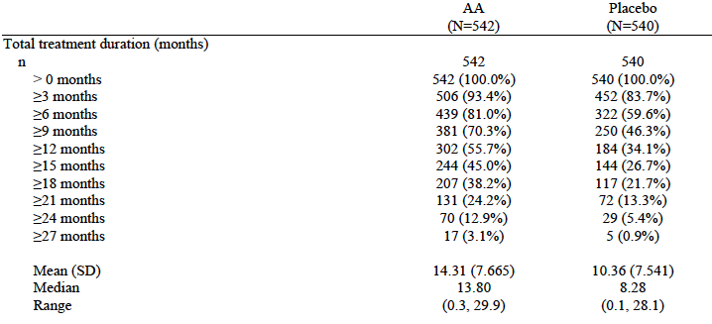

Adverse events

All adverse events (irrespective of relationship to study treatment)
The overall safety profile in the pivotal study, in terms of the incidence of adverse events (AEs) and so on, is summarised in Table 12.
The incidence of overall AEs was comparable in the two treatment arms (99.1% versus 97.0%). Grade 3 or 4 AEs were marginally more common in the abiraterone arm (47.6% versus 41.7%).
Table 12: Pivotal study 302 – Overall safety profile
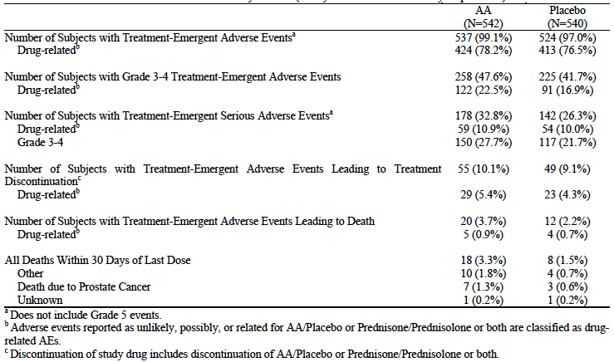
Individual AEs (that is, those occurring in > 5% of subjects) more common in the abiraterone arm included the following:
- Hypertension (21.6% versus 13.1%) and other AEs indicative of mineralocorticoid excess such as peripheral oedema (24.7% versus 20.0%) and hypokalaemia (16.8% versus 12.6%);
- Increased ALT (11.6% versus 5.0%) and AST (10.7% versus 4.8%).
These are known adverse reactions for abiraterone.
Upper respiratory tract infections were also more common with abiraterone (12.0% versus 8.0%). These were all of Grade 1 or 2 in severity. There were no other striking differences in individual AEs between groups.
In terms of individual AE terms of Grade 3 or 4 severity, increased ALT (5.4% versus 0.8%) and increased AST (3.0% versus 0.9%) were more common with abiraterone treatment. Other individual grade 3 or 4 AEs were evenly distributed across the two arms.

Treatment-related adverse events (adverse drug reactions)
The incidence of AEs considered related to study drug was comparable in the two treatment arms (78.2% versus 76.5%). Common drug-related AEs (occurring in >2% of subjects in either arm) are shown in Table 13. The pattern of toxicity was consistent with that described above for all adverse events.
The incidence of Grade 3 or 4 AEs considered related to study drug was marginally higher in the abiraterone arm (22.5% versus 16.9%).
Table 13. Pivotal study 302 - Incidence of common drug-related AEs (reported in at least 2% of subjects)
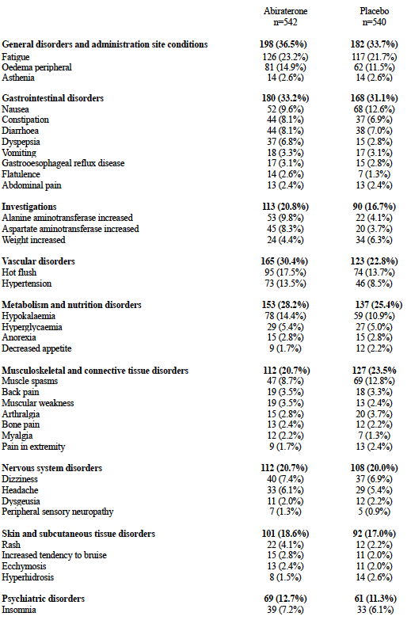
Table 13 continued. Pivotal study 302 - Incidence of common drug-related AEs (reported in at least 2% of subjects) 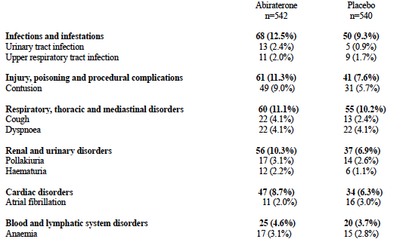
The sponsor performed an analysis of treatment related AES that met the following criteria:
- Incidence was at least 1% higher in the abiraterone arm;
- When corrected for differences in duration of exposure between the two groups, a higher incidence in the abiraterone group of at least 5 events per 100 patient-years of treatment existed;
- Council for International Organizations of Medical Sciences (CIOMS) criteria for relatedness were met.
Results are shown in Table 14Error! Reference source not found.. As a result of this analysis the sponsor proposes to add dyspepsia and haematuria as adverse drug reactions (ADRs) in the product information.
Table 14: Pivotal study 302 – Drug-related AEs
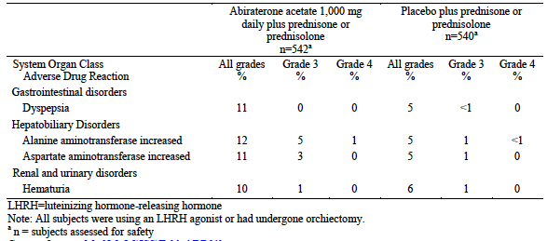

Deaths and other serious adverse events

Deaths
There was an excess of fatal AEs in the abiraterone arm (20 versus 12). However the incidence of fatal AEs that were considered related to study drug was comparable in the two arms (5 versus 4).

Serious adverse events
Serious AEs were more common in the abiraterone arm (32.8% versus 26.3%). However the incidence of drug-related SAEs was comparable in the two arms (10.9% versus 10.0%). SAEs occurring in > 1% of subjects in either arm are shown in Table 15. The incidence of cardiac SAEs was increased in the abiraterone arm (5.4% versus 2.6%).
Table 15: Pivotal study 302 – Serious AEs occurring in >1% of subjects
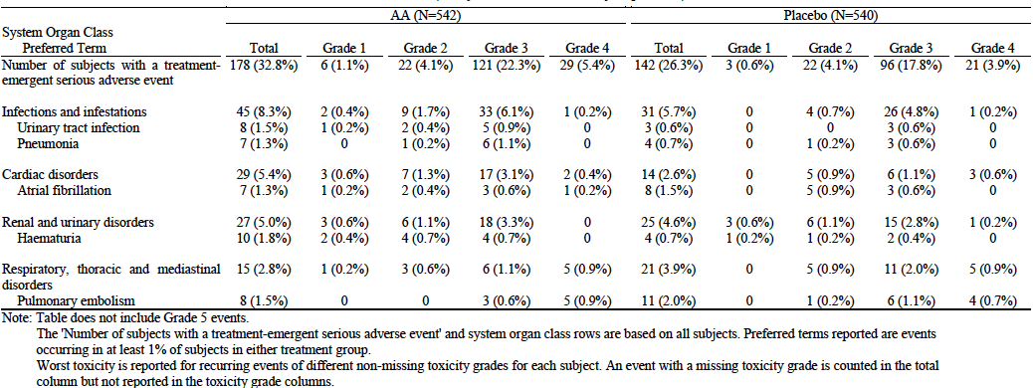

Discontinuation due to adverse events
The incidence of AEs leading to discontinuation was comparable in the two treatment arms (10.1% versus 9.1%). The only specific AE terms for which discontinuation were notably more common with abiraterone were:
- ALT increased (9 versus 1 cases);
- AST increased (7 versus 0 cases).

Adverse events of special interest

Fluid retention / hypokalaemia / hypertension
These are known toxicities of abiraterone, due to mineralocorticoid excess produced by the pharmacological effect of the drug. A summary of the incidence in the pivotal study of AEs suggestive of these toxicities showed that hypertension was clearly more common with abiraterone. The difference between treatments in the incidence of fluid retention (mainly peripheral oedema) and hypokalaemia was less marked.

Hepatotoxicity
Abiraterone has previously been shown to produce hepatotoxicity. In the pivotal study in this submission, abiraterone was clearly shown to be associated with an increased incidence of hepatotoxicity, predominantly transaminase elevations. Hepatotoxicity AEs are summarised in Table 16.
Table 16: Pivotal Study 302 – Hepatotoxicity AEs
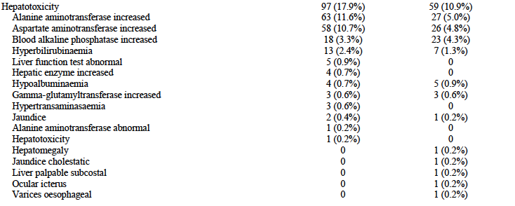In the pivotal study there were no cases of hepatotoxicity that met Hy’s Law criteria (that is, cases to suggest that the drug might be associated with severe drug-induced liver injury).

Cardiac toxicity
In the Phase III clinical trial that supported the initial registration of abiraterone (Study 301), there was a suggestion that the drug might be associated with a small increased risk of cardiac toxicity.
The incidence of cardiac AEs in the pivotal study was summarised in the report. These data show that there was a small increase in the incidence of cardiac AEs in the abiraterone group (19.0% versus 15.7%). However when these data were corrected for the fact that patients in the abiraterone arm had received treatment for a longer period of time, there was no difference in the incidence of cardiac events (cardiac events per 100 patient-years of exposure: 27.1 with abiraterone versus 29.2 with placebo). However, the incidence of cardiac failure events remained elevated in the abiraterone group (3.6 versus 0.4 per 100 patient-years of exposure), consistent with the fluid retaining effects of the drug.

Laboratory tests

Haematology and Biochemistry
For the pivotal trial, the incidence of haematology and biochemistry laboratory abnormalities (presented as the worst toxicity grade experienced during the study) were summarised.
As previously described, abnormal LFTs and hypokalaemia are known adverse reactions to abiraterone. Examination of the incidence of Grade 3 or 4 abnormalities in the table does not suggest any clinically significant effects on other laboratory tests.

Electrocardiograph
The sponsor has previously submitted a study that demonstrated that abiraterone does not affect the QT interval. In the pivotal study, ECGs were obtained pre-dose (at the screening visit) and at approximately 2 hours post-dose (at Cycles 1, 2, and 5). One subject who was treated with abiraterone SAEs of Grade 2 ST segment depression and Grade 3 QT prolongation, both of which resolved without any action being taken.

Vital signs
As indicated above, abiraterone is associated with an increased incidence of hypertension. The incidence of vital sign abnormalities in the pivotal study is shown in Table 17. Elevations in systolic blood pressure were more common in the abiraterone arm. Abnormalities of other parameters were equally distributed in the two arms.
Table 17: Pivotal study 302 – Abnormalities of vital signs
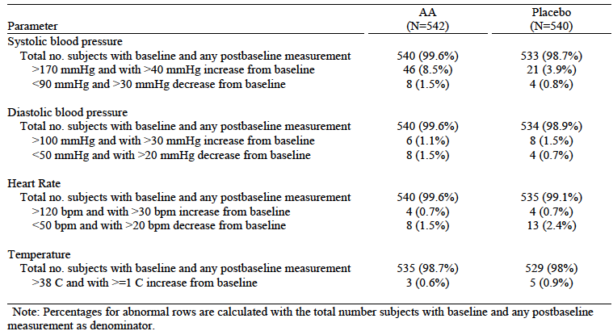

Non-pivotal efficacy studies
The sponsor included a number of updates of studies that had been evaluated as part of the original submission to register abiraterone. The following four studies were conducted in mCRPC patients who were naïve to chemotherapy and hence the safety data are relevant to the current submission.

COU-AA-001 / 001EXT
This was a Phase I/II dose ranging study. Subjects enrolled in the trial were able to continue open-label abiraterone treatment until the onset of progressive disease.
The original study report had a data cut-off of 20 February 2009. The current submission included a study report addendum (17 pages only) with a data cut-off 20 September 2011. It consisted of tabulations of adverse events and laboratory abnormalities in 42 subjects who had continued to receive a 1,000 mg daily dose of abiraterone. Median duration of exposure was 14.39 months.

Study COU-AA-002
This was another Phase I/II dose ranging study in which subjects were able to continue open-label abiraterone treatment until the onset of progressive disease.
The original study report had a data cut-off of 22 January 2010. The current submission included a study report addendum (16 pages only) with a data cut-off 20 September 2011. It consisted of tabulations of adverse events and laboratory abnormalities in 45 subjects who had continued to receive a 1,000 mg daily dose of abiraterone. Median duration of exposure was 11.27 months.

Study COU-AA-BMA
This is an ongoing Phase II single arm study in which subjects receive open-label abiraterone and prednisone treatment until the onset of progressive disease. The objective of the study is to “... evaluate the effect of abiraterone..... on androgens and steroid metabolites in bone marrow”. It is unclear whether a report of this study was included in the original submission.
The current submission included a study report addendum (13 pages only) with a data cut-off 20 September 2011. It consisted of tabulations of adverse events and laboratory abnormalities in 57 subjects who had continued to receive a 1,000 mg daily dose of abiraterone. Median duration of exposure was 7.62 months.

Study COU-AA-015
This was a Phase I study examining potential interactions between abiraterone and dextromethorphan and theophylline. The original study report had a data cut-off of 12 August 2010. The current submission included a study report addendum (893 pages) with a data cut-off 1 December 2011. It consisted of detailed safety data from 34 subjects who had continued to receive abiraterone. Median duration of treatment was 35.9 weeks.
The safety data provided for these studies have been reviewed and they do not raise any additional concerns. The types of adverse events and their incidence rates were generally comparable to those seen in the pivotal study.
The submission also included similar updates for various other previously evaluated Phase I/II studies that were conducted in mCRPC patients who had already received chemotherapy (COU-AA-BE, COU-AA-004, COU-AA-003 / 003EXT and COU-AA-006). These studies are not considered directly relevant to the current application.
A pooled analysis of AEs occurring in Phase I/II studies was included in the ISS. This analysis was based on the above updated safety data. Review of this analysis did not raise any new safety issues.

Postmarketing experience
There were no post-marketing data included in Module 5 of the current submission. The sponsor’s Summary of Clinical Safety included the following statement:
“The first marketing approval for abiraterone acetate was on 28 April 2011 in the United States. Based on the 2,245,830 grams distributed worldwide, the estimated post marketing exposure for abiraterone acetate from launch to 31 January 2012 is 2,245,830 person-days. No new ADRs have been detected for abiraterone acetate from post marketing data.”

Safety Issues with the potential for major regulatory impact

Liver toxicity
See Adverse events of special interest Hepatotoxicity above. The additional analyses in the SCS/ISS, based on previously evaluated studies, gave similar results.

Haematological toxicity
Examination of the incidence of serious haematological AEs in the pivotal Study 302 did not suggest any increased risk for serious idiosyncratic haematological events with abiraterone. In a combined analysis of the two Phase III placebo-controlled studies (301 and 302) the incidence of pancytopaenia was 0.2% with abiraterone and 0.3% with placebo.

Serious skin reactions
There was no suggestion of an increased incidence of severe skin reactions with abiraterone in the pivotal study. There were no cases of Stevens-Johnson syndrome or Toxic Epidermal Necrosis reported in the combined analysis of the two Phase III placebo-controlled studies.

Cardiovascular safety
See Adverse events of special interest Cardiac toxicity above. The additional analyses in the SCS/ISS, based on previously evaluated studies, did not indicate any new cardiovascular safety issues.

Unwanted immunological events
There was no suggestion of an increased incidence of immunological reactions with abiraterone in the pivotal study or in the additional analyses in the SCS/ISS.

Other safety issues

Safety in special populations
In the pivotal study, an analysis of the overall safety profile of the drug according to age group (<65 versus 65-74 versus ≥ 75 years) demonstrated that the incidence of AEs generally increased with increasing age. This was true for both the abiraterone and placebo groups. In the very elderly population (≥ 75 years) the incidence of AEs in the abiraterone group was only marginally higher than that in the placebo group.
An analysis of AEs according to race (white versus non White) was not meaningful due to the small number of non White subjects treated (n= 55).
An analysis of AEs by baseline ECOG subgroup (0 versus 1) demonstrated that the incidence of AEs was higher in patients with ECOG 1. This was true for both the abiraterone and placebo groups. In the subgroup of patients with ECOG 1, incidence of AES was higher with abiraterone (for example, serious AEs: 47% versus 29%).
AEs were more frequent in patients with higher baseline LDH and those with lower baseline haemoglobin (both markers for more advanced disease).

Evaluator’s overall conclusions on clinical safety
The toxicity profile of abiraterone in Study 302 was comparable to that previously observed in the pivotal study (Study 301) that supported the original registration of the drug. It confirmed that the drug is associated with an increased incidence of AEs suggestive of mineralocorticoid excess (hypertension, hypokalaemia, fluid retention) and with hepatotoxicity. The study did not suggest that the drug is associated with an increased risk of cardiac toxicity, apart from cardiac failure.
The toxicity of the drug appears modest in the chemotherapy-naïve mCRPC setting. The difference between abiraterone and placebo in the incidences of AEs, Ggrade 3 or 4 AEs, serious AEs etc were typically < 7% (see Table 12 above). The difference in the rate of discontinuation due to AEs was approximately 1%. This suggests that the toxicity of the drug is manageable with dose interruptions or dose reductions. The safety profile of the drug appears more favourable than that of taxane chemotherapy.
Updated safety data from previously evaluated Phase I/II studies did not raise any new safety issues.

First round benefit-risk assessment

First round assessment of benefits
The benefits of abiraterone in the proposed usage are:
- A decreased risk of disease progression as assessed by bone scan/MRI/CT;
- A delay in the need for chemotherapy and opiate analgesia;
- Maintenance of functional status/quality of life.
A benefit in terms of prolongation of survival has not been definitively established. However, there was a trend in favour of abiraterone on this endpoint.

First round assessment of risks
The risks of abiraterone in the proposed usage are:
- Adverse events associated with mineralocorticoid excess (for example, hypertension, fluid retention, hypokalaemia);
- Hepatotoxicity.

First round assessment of benefit-risk balance
The benefit-risk balance of abiraterone, given the proposed usage, is favourable.

First round recommendation regarding authorisation
It is recommended that the application be approved.

Clinical questions

Efficacy
Please provide the results of the third interim and final analyses of overall survival from Study 302. If the results are not yet available, please provide an estimate of when these results will be available.
Please confirm that the formulation of abiraterone acetate used in Sstudy 302 was identical to the currently marketed formulation in Australia.

Safety
In Study 302, coagulation parameters were to be tested at screening and Day 15. The results do not appear to have been included in the study report. Please provide the results of this testing.

Second round evaluation of clinical data submitted in response to questions

Updated analysis of overall survival
The sponsor provided an updated survival analysis, based on a data cut-off of 22 May 2012. At this time point, a further 101 deaths had occurred in the study. Results are shown in Table 18 and Figure 6, and a comparison of the initial and updated OS analyses is shown in Table 19.
Table 18: Pivotal study 302 – Results for OS co-primary endpoint (Updated analysis)
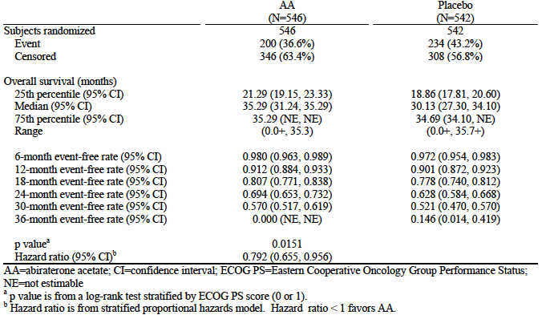
Figure 6:- Pivotal study 302 – Kaplan-Meier curves for OS co-primary endpoint (Updated analysis)
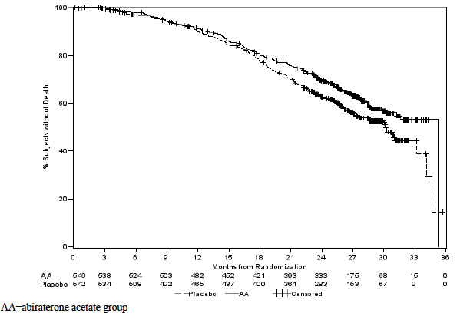
Table 19: Pivotal study 302 – Comparison of results for OS co-primary endpoint (Initial versus Updated analysis)
 | Initial (2nd interim) analysis |  | Updated (3rd interim) analysis
Data Cut-off |  | 20 Dec 2011 | 22 May 2012
Report date |  | 31 May 2012 | 6 Aug 2012
Median Follow-up |  | 22.2 months | 27.1 months
Deaths
- Total |  | 333 (30.6%) | 434 (39.9%)
- Abiraterone |  | 147 (26.9%) | 200 (36.6%)
- Placebo |  | 186 (34.3%) | 234 (43.2%)
Hazard Ratio  (95% CI) |  | 0.752  (0.606 – 0.934) | 0.792  (0.655 – 0.956)
p-value |  | 0.0097 | 0.0151
Median OS – Abiraterone  (95% CI) |  | NE  (NE-NE) | 35.29 months  (31.24 – 35.29)
Median OS – Placebo  (95% CI) |  | 27.24 months  (25.95 – NE) | 30.13 months  (27.30 – 34.10)
The results again showed a trend towards a survival benefit with abiraterone treatment. The hazard ratio for OS was 0.79 (95% CI: 0.655 – 0.956). Due to multiplicity of testing, the pre-specified statistical significance level for this analysis was p = 0.0035. The p-value obtained with the pre-specified log rank test was p = 0.0151, and hence the difference in OS was not statistically significant. In the updated analysis the median survival was reached for the abiraterone group (35.29 months; 95%CI: 31.24 – 35.29).
A subgroup analysis for OS again demonstrated consistent efficacy over all subgroups tested with all hazard ratios being less than 1.0 (that is, in favour of the abiraterone group).
Comment: The OS findings are essentially unchanged, with a non-significant trend in favour of abiraterone. Prior to the data cut-off of 22 May 2012 the sponsor had unblinded the study and patients who had been treated with placebo were offered abiraterone. As of the data cut-off, 14.4% of patients who had been randomised to placebo had received subsequent abiraterone treatment (compared with 10% on the previous analysis).
The final analysis of OS will be carried out when the number of death events reaches 773. The sponsor estimates this may occur sometime in 2014.

Formulation used in Study 302
The sponsor has provided an assurance that the formulation of abiraterone acetate used in Study 302 was identical to that currently marketed in Australia. This is acceptable.

Coagulation parameters
The sponsor provided summary data on coagulation testing (prothrombin tine, APTT and INR) done at screening and Day 15 in study 302. The incidence of abnormal results was comparable in the two treatment arms.

Second round benefit-risk assessment
The additional data provided in the sponsor’s response does not alter the benefit-risk assessment, which remains favourable.

Second round recommendation regarding authorisation
It is recommended that the application be approved.

Scher HI, Halabi s, Tannock I et al. Design and End Points of Clinical Trials for Patients With Progressive Prostate Cancer and Castrate Levels of Testosterone: Recommendations of the Prostate Cancer Clinical Trials Working Group. J Clin Oncol 2008. 26(7): 1148-1159.
Therasse P, Arbuck SG, Eisenhauer EA et al; New Guidelines to Evaluate the Response to Treatment in Solid Tumours. J Natl Cancer Inst 2000. 92(3): 205-216.
Pivotal study 302 - Criteria for radiographic progression A patient is considered to have progressed by bone scan if: - The first bone scan with ≥ 2 new lesions compared to baseline is observed <12 weeks from randomization and is confirmed by a second bone scan taken ≥6 weeks later showing ≥ 2 additional new lesions (a total of ≥ 4 new lesions compared to baseline); - The first bone scan with ≥2 new lesions compared to baseline is observed ≥12 weeks from randomization and the new lesions are verified on the next bone scan ≥6 weeks later (a total of ≥2 new lesions compared to baseline). Progression of soft tissue lesions measured by CT or MRI as defined in modified RECIST criteria.
ECOG Performance Status. The Eastern Cooperative Oncology Group (ECOG) has developed criteria used by doctors and researchers to assess how a patient's disease is progressing, assess how the disease affects the daily living abilities of the patient, and determine appropriate treatment and prognosis. The following are used: 0 - Fully active, able to carry on all pre-disease performance without restriction 1- Restricted in physically strenuous activity but ambulatory and able to carry out work of a light or sedentary nature, e.g., light house work, office work 2 - Ambulatory and capable of all selfcare but unable to carry out any work activities. Up and about more than 50% of waking hours 3 - Capable of only limited selfcare, confined to bed or chair more than 50% of waking hours 4 - Completely disabled. Cannot carry on any selfcare. Totally confined to bed or chair 5 – Dead
European Medicines Agency. Guideline on the Evaluation of Anticancer Medicinal Products in Man (CPMP/EWP/205/95/Rev.3/Corr.); 2005.
European Medicines Agency. Appendix 1 To The Guideline On The Evaluation of Anticancer Medicinal Products In Man: Methodological Considerations For Using Progression-Free Survival (PFS) As Primary Endpoint In Confirmatory Trials For Registration (EMEA/CHMP/EWP/27994/2008); 2008.
Scher HI, Morris MJ, Kelly WK. Prostate Cancer Clinical Trial End Points: “RECIST”ing a Step Backwards. Clin Cancer Research 2005; 11:5223-5232.
Therasse P, Arbuck SG, Eisenhauer EA et al; New Guidelines to Evaluate the Response to Treatment in Solid Tumours. J Natl Cancer Inst 2000. 92(3): 205-216.
Scher HI, Halabi s, Tannock I et al. Design and End Points of Clinical Trials for Patients With Progressive Prostate Cancer and Castrate Levels of Testosterone: Recommendations of the Prostate Cancer Clinical Trials Working Group. J Clin Oncol 2008. 26(7): 1148-1159.
European Medicines Agency. Guideline on the Evaluation of Anticancer Medicinal Products in Man (CPMP/EWP/205/95/Rev.3/Corr.); 2005.
European Medicines Agency. Appendix 1 To The Guideline On The Evaluation of Anticancer Medicinal Products In Man: Methodological Considerations For Using Progression-Free Survival (PFS) As Primary Endpoint In Confirmatory Trials For Registration (EMEA/CHMP/EWP/27994/2008); 2008.
European Medicines Agency. Points to Consider on Application with 1. Meta-Analyses; 2. One Pivotal Study (CPMP/EWP/2330/99); 2001.
QT interval: a measure of the time between the start of the Q wave and the end of the T wave in the heart's electrical cycle. A prolonged QT interval is a risk factor for ventricular tachyarrhythmias and sudden death.

