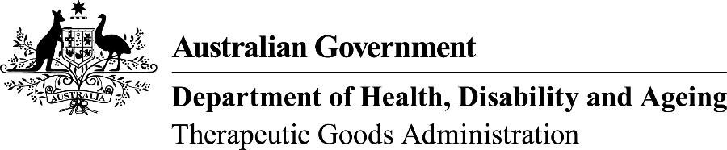

TGA use only

This form, when completed, will be classified as 'For official use only'.
For guidance on how your information will be treated by the TGA see: Treatment of information provided to the TGA at <https://www.tga.gov.au/treatment-information-provided-tga>.

Add or remove a connection to your manufacturing organisation
Complete this form if you are a Manufacturer and you wish to authorise another organisation (Agent or Sponsor) to undertake regulatory correspondence with us in regards to Conformity Assessment certification, or remove an existing contact.
Please note: These organisations will be authorised to:
- submit Conformity Assessment applications to TGA on your behalf
- access your currently active conformity assessment certificates (medical devices)
 | TGA Business Services (TBS) Terms and Conditions

Complete your organisation details (Manufacturer)
Organisation business name:
Organisation ID:
I want to: | Add an organisation connection  Remove an organisation connection

Complete the details of the organisation you want the connection with (Sponsor or Agent)
Organisation name:
Organisation ID:
Email:
Telephone: |  | Fax:
Please complete a separate form to authorise each organisational connection.

Declaration
Note: The following declaration must be signed by an individual with the relevant authority (e.g. – for a corporation a company director, company secretary, or other executive, for other organisations an owner, partner or other delegated individual):
I declare that I am authorised to make this request; and that the following information is correct:
Printed name:
Position in organisation:
Email address:
Phone number:
Signature: |  | Date:
Please provide your contact and organisation details in the above table.

