▼This medicinal product is subject to additional monitoring in Australia. This will allow quick identification of new safety information. Healthcare professionals are asked to report any suspected adverse events at www.tga.gov.au/reporting-problems.
AUSTRALIAN PRODUCT INFORMATION WAINUA®

(eplontersen) solution for injection pre-filled pen
- NAME OF THE MEDICINE
Eplontersen sodium

QUALITATIVE AND QUANTITATIVE COMPOSITION
Each pre-filled pen contains 45 mg eplontersen (as eplontersen sodium) in 0.8 mL of solution. Each mL contains 56 mg eplontersen (as eplontersen sodium).
For the full list of excipients, see Section 6.1 List of excipients.

PHARMACEUTICAL FORM
Solution for injection.
Clear, colourless to yellow solution (pH of approximately 7.4 and osmolality 250 to 330 mOsm/kg) .

CLINICAL PARTICULARS

THERAPEUTIC INDICATIONS
WAINUA is indicated for the treatment of hereditary transthyretin-mediated amyloidosis (ATTRv) in adult patients with stage 1 or stage 2 polyneuropathy.

DOSE AND METHOD OF ADMINISTRATION
Treatment should be prescribed and supervised by a physician experienced in the treatment of patients with hereditary transthyretin-mediated amyloidosis.

Dosage
The recommended dose of eplontersen is 45 mg administered monthly by subcutaneous injection.
Vitamin A supplementation at approximately, but not exceeding, 2500 IU to 3000 IU vitamin A per day is advised for patients treated with WAINUA (see section 4.4 Special warnings and precautions for use).
Treatment should be initiated as early as possible after symptom onset. For patients with vitamin A deficiency, vitamin A levels should be corrected and any ocular symptoms should be evaluated (see section 4.4 Special warnings and precautions for use).
The decision to continue treatment in those patients whose disease progresses to stage 3 polyneuropathy should be taken at the discretion of the physician based on the overall benefit and risk assessment.

Missed dose
If a dose of WAINUA is missed, then the next dose should be administered as soon as possible. Dosing should be resumed at monthly intervals from the date of the last dose; a double dose should not be administered.

Special patient populations

Renal impairment
No dose adjustment is necessary in patients with mild to moderate renal impairment (estimated glomerular filtration rate [eGFR] ≥ 45 to < 90 mL/min/1.73 m²). Eplontersen has not been studied in patients with eGFR < 45 mL/min/1.73 m² or end-stage renal disease (see section 5.2 Pharmacokinetic properties) and should only be used in these patients if the anticipated clinical benefit outweighs the potential risk.

Hepatic impairment
No dose adjustment is necessary in patients with mild hepatic impairment. Eplontersen has not been studied in patients with moderate or severe hepatic impairment and should only be used in these patients if the anticipated clinical benefit outweighs the potential risk (see section 5.2 Pharmacokinetic properties).

Patients undergoing liver transplant
The safety and efficacy of WAINUA have not been evaluated in patients undergoing liver transplant. No data are available.

Use in the elderly

No dose adjustment is required in elderly patients (≥ 65 years of age) (see section 5.2 Pharmacokinetic properties)

Paediatric use
The safety and efficacy of WAINUA in children and adolescents below 18 years of age have not been established. No data are available (see section 5.1 Pharmacodynamic properties).

Method of administration
Product is for single use in one patient only. Discard after use.
The first injection administered by the patient or caregiver should be performed under the guidance of an appropriately qualified health care professional. Patients and/or caregivers should be trained in the subcutaneous administration of WAINUA.
The pre-filled pen should be removed from refrigerated storage at least 30 minutes before use and allowed to reach room temperature prior to injection. Other warming methods should not be used.
Inspect solution visually before use. The solution should appear colourless to yellow. Do not use if cloudiness, particulate matter, or discolouration is observed prior to administration.
If self-administered, WAINUA should be injected in the abdomen or upper thigh region. If a caregiver administers the injection, the back of the upper arm can also be used.
WAINUA should not be injected into skin that is bruised, tender, red, or hard, into scars or damaged skin, the area around the navel should be avoided.
Additional information and instructions for the preparation and administration of WAINUA using the prefilled syringe/prefilled pen are given in the Instructions for Use booklet provided in each pack.

CONTRAINDICATIONS
Hypersensitivity to the active substance or to any of the excipients listed in section 6.1.

SPECIAL WARNINGS AND PRECAUTIONS FOR USE

Identified precautions
Vitamin A deficiency
Based on the mechanism of action, WAINUA is expected to reduce serum vitamin A (retinol) below normal levels (see section 5.1 Pharmacodynamic properties). Serum vitamin A levels below the lower limit of normal should be corrected and any ocular symptoms or signs related to vitamin A deficiency should be evaluated prior to initiation of treatment with WAINUA.
Patients receiving WAINUA should take oral supplementation of approximately, but not exceeding, 2500 IU (female) to 3000 IU (male) of vitamin A per day to reduce the potential risk of ocular symptoms due to vitamin A deficiency. Referral for ophthalmological assessment is recommended if patients develop ocular symptoms consistent with vitamin A deficiency, including reduced night vision or night blindness, persistent dry eyes, eye inflammation, corneal inflammation or ulceration, corneal thickening or corneal perforation.
During the first 60 days of pregnancy, both too high and too low vitamin A levels may be associated with an increased risk of fetal malformation. Therefore, pregnancy should be excluded before treatment initiation and women of childbearing potential should practise effective contraception (see section 4.6 Use in pregnancy). If a woman intends to become pregnant, WAINUA and vitamin A supplementation should be discontinued, and serum vitamin A levels should be monitored and have returned to normal before conception is attempted.
In the event of an unplanned pregnancy, WAINUA should be discontinued. Due to the long half-life of eplontersen (see section 5.2 Pharmacokinetic properties), a vitamin A deficit may even develop after cessation of treatment. No recommendation can be given whether to continue or discontinue vitamin A supplementation during the first trimester of an unplanned pregnancy. If vitamin A supplementation is continued, the daily dose should not exceed 3000 IU per day, due to the lack of data supporting higher doses. Thereafter, vitamin A supplementation of 2500 IU to 3000 IU per day should be resumed in the second and third trimesters if serum vitamin A levels have not yet returned to normal, because of the increased risk of vitamin A deficiency in the third trimester.
It is not known whether vitamin A supplementation in pregnancy will be sufficient to prevent vitamin A deficiency if the pregnant female continues to receive WAINUA. However, increasing vitamin A supplementation to above 3000 IU per day during pregnancy is unlikely to correct serum retinol levels due to the mechanism of action of eplontersen and may be harmful to the mother and fetus.

Use in hepatic impairment
No dose adjustment is necessary in patients with mild hepatic impairment. Eplontersen has not been studied in patients with moderate or severe hepatic impairment and should only be used in these patients if the anticipated clinical benefit outweighs the potential risk (see section 5.2 Pharmacokinetic properties).

Use in renal impairment
No dose adjustment is necessary in patients with mild to moderate renal impairment (estimated glomerular filtration rate [eGFR] ≥ 45 to < 90 mL/min/1.73 m²). Eplontersen has not been studied in patients with eGFR < 45 mL/min/1.73 m² or end-stage renal disease (see section 5.2 Pharmacokinetic properties) and should only be used in these patients if the anticipated clinical benefit outweighs the potential risk.
Use in the elderly

No dose adjustment is required in elderly patients (≥ 65 years of age) (see section 5.2 Pharmacokinetic properties)

Paediatric use
The safety and efficacy of WAINUA in children and adolescents below 18 years of age have not been established. No data are available (see section 5.1 Pharmacodynamic properties).

Effects on laboratory tests
No data available.

INTERACTIONS WITH OTHER MEDICINES AND OTHER FORMS OF INTERACTIONS
No clinical drug-drug interaction studies have been conducted.
Eplontersen is unlikely to be a substrate for CYP450 enzymes and was not a substrate for or inhibitor of the following transporters in vitro: BCRP, BSEP, P-gp, OAT1, OAT3, OCT1, OCT2, OATP1B1, OATP1B3, MATE1 and MATE2-K. Eplontersen was not an inhibitor of CYP1A2, 2B6, 2C8, 2C9, 2C19, 2D6, 2E1 or 3A4, or inducer of CYP1A2, 2B6 or 3A4 in in vitro assays. Eplontersen did not displace other highly protein bound actives, like warfarin or ibuprofen, in competitive plasma protein binding assays.

FERTILITY, PREGNANCY AND LACTATION

Effects on fertility
There is no information available on the effects of eplontersen on human fertility.
In a fertility and embryofetal development study in mice, males and females were administered subcutaneously (SC) with vehicle or eplontersen at weekly equivalent doses up to 75 mg/kg (30-fold the monthly clinical dose of 45 mg based on a mg/m² human equivalent dose) or a mouse-specific surrogate at a weekly equivalent dose of 25 mg/kg. Males and females were treated prior to and during mating, while dosing in females continued throughout the period of organogenesis. There were no adverse effects on mating or fertility. Although eplontersen is not pharmacologically active in mice, findings with the mouse-specific surrogate, which was associated with >90% inhibition of TTR mRNA, would have assessed any potential effects associated with pharmacological action.

Use in pregnancy – Category D
There are no data on the use of eplontersen in pregnant women. Animal studies are insufficient with respect to embryofetal developmental toxicity. Due to the potential teratogenic risk arising from unbalanced vitamin A levels, WAINUA should not be used during pregnancy and in women of childbearing potential not using contraception. In case of pregnancy, close monitoring of the fetus and vitamin A status should be carried out, especially during the first trimester (see section 4.4 Special warnings and precautions for use).

Women of child-bearing potential
WAINUA will reduce the plasma levels of vitamin A, which is crucial for normal fetal development. It is not known whether vitamin A supplementation will be sufficient to reduce the risk to the fetus (see section 4.4 Special warnings and precautions for use). For this reason, pregnancy should be excluded before initiation of WAINUA therapy and women of child-bearing potential should practice effective contraception.

If a woman intends to become pregnant, WAINUA and vitamin A supplementation should be discontinued, and serum vitamin A levels should be monitored and have returned to normal before conception is attempted (see section 4.4 Special warnings and precautions for use). Serum vitamin A levels may remain reduced for more than 15 weeks after the last dose of treatment.

Use in lactation
It is unknown whether eplontersen or its metabolites are excreted in human milk or the effects on milk production or milk quality. A risk to the breastfed child cannot be excluded.
A decision must be made whether to discontinue breast-feeding or to discontinue/abstain from WAINUA therapy, taking into account the benefit of breast feeding for the child and the benefit of therapy for the woman.

EFFECTS ON ABILITY TO DRIVE AND USE MACHINES
Eplontersen has no or negligible influence on the ability to drive and use machines.

ADVERSE EFFECTS (UNDESIRABLE EFFECTS)
The most frequent adverse reactions during treatment with eplontersen were vitamin A decreased (97% of patients) and vomiting (9% of patients).
Tabulated list of adverse reactions
The safety data reflects exposure to WAINUA in 144 patients with polyneuropathy caused by ATTRv (ATTRv-PN) randomised to eplontersen and who received at least one dose of eplontersen. 130 patients completed treatment with eplontersen through Week 85. The mean duration of treatment was 541 days (range: 57 to 582 days).
Adverse reactions are organised by MedDRA System Organ Class (SOC). Within each SOC, preferred terms are arranged by decreasing frequency and then by decreasing seriousness. Frequencies of occurrence of adverse reactions are defined as:
very common (≥ 1/10);
common (≥ 1/100 to < 1/10);
uncommon (≥ 1/1 000 to < 1/100);
rare (≥ 1/10 000 to < 1/1 000);
very rare (< 1/10 000) and
not known (cannot be estimated from available data).

Table 1: Adverse reactions reported for WAINUA

System organ class | Adverse reaction | Frequency
Gastrointestinal disorders | Vomiting | Common
General disorders and administration site conditions | Injection site erythema | Common
General disorders and administration site conditions | Injection site pain | Common
General disorders and administration site conditions | Injection site pruritus | Common
Investigations | Vitamin A decreased | Very common*
* Based on laboratory findings of vitamin A below the lower limit of normal during the study.

Reporting suspected adverse effects
Reporting suspected adverse reactions after registration of the medicinal product is important. It allows continued monitoring of the benefit-risk balance of the medicinal product. Healthcare professionals are asked to report any suspected adverse reactions at www.tga.gov.au/reporting-problems.

OVERDOSE
There is no specific treatment for an overdose with eplontersen. In the event of an overdose, supportive medical care should be provided.
For information on the management of overdose, contact the Poison Information Centre on 131126 (Australia).

PHARMACOLOGICAL PROPERTIES

PHARMACODYNAMIC PROPERTIES
Pharmacotherapeutic group: Other nervous system drugs, ATC code: N07XX21.

Mechanism of action
Eplontersen is a N-acetylgalactosamine (GalNAc)-conjugated 2′-O-2-methoxyethyl-modified chimeric gapmer antisense oligonucleotide (ASO) with a mixed backbone of phosphorothioate and phosphate diester internucleotide linkages. The GalNAc conjugate enables targeted delivery of the ASO to hepatocytes. The selective binding of eplontersen to the transthyretin (TTR) messenger RNA (mRNA) within the hepatocytes causes the degradation of both mutant and wild type (normal) TTR mRNA. This prevents the synthesis of TTR protein in the liver, resulting in significant reductions in the levels of mutated and wild type TTR protein secreted by the liver into the circulation.
TTR is a carrier protein for retinol binding protein 4, which is the principal carrier of vitamin A (retinol). Therefore, a reduction in plasma TTR is expected to result in the reduction of plasma retinol levels to below the lower limit of normal.

Pharmacodynamic effects
In the clinical study in patients with ATTRv-PN receiving eplontersen, a decrease in serum TTR concentrations was observed at the first assessment (Week 5) and TTR concentrations continued to decrease through Week 35. A sustained reduction of TTR concentration was observed throughout the duration of the treatment (85 weeks). Mean (SD) for serum TTR percent reduction from baseline was 82.1% (11.7) at Week 35, 83.0% (10.4) at Week 65 and 81.8% (13.4) at Week 85 when treated with eplontersen. Similar reduction from baseline in serum TTR concentrations was observed regardless of sex, race, age, region, body weight, cardiomyopathy status, previous treatment, Val30Met mutation status, disease stage, and familial amyloid cardiomyopathy clinical diagnosis at baseline.

Clinical trials
The efficacy and safety of eplontersen was evaluated in a randomised, multicentre, open-label, trial (NEURO-TTRansform) that included a total of 168 adult patients with ATTRv-PN. Patients were randomised in a 6:1 ratio to receive subcutaneous injection of eplontersen 45 mg every 4 weeks (N=144) or inotersen 284 mg weekly (N=24) as a reference group. Of the 144 patients randomised to eplontersen, 140 (97.2 %) patients completed treatment through Week 35, 135 (93.8%) completed
treatment through Week 65 and 130 (90.3%) completed treatment through Week 85.

An external placebo control consisted of a placebo cohort of patients from the inotersen pivotal study (NEURO-TTR): randomised, double-blind, placebo-controlled, multicentre clinical trial in adult patients with ATTRv-PN. That cohort received subcutaneous injections of placebo once weekly. Both studies employed similar eligibility criteria. The characteristics of the eplontersen and external placebo groups were generally similar, and potential imbalances in key baseline characteristics (Val30Met mutation status, disease stage, and previous treatment) were accounted for in the prespecified statistical analysis.
Of the 144 patients randomised to eplontersen, the median patient age at baseline was 51.5 years (range 24 to 82), 30.6% were ≥ 65 years old, and 69.4% of patients were male. Twenty (20) different TTR variants were represented: Val30Met (59.0%), Phe64Leu (3.5%), Leu58His (2.8%), Thr60Ala (2.8%), Val122Ile (2.8%), Ser77Tyr (2.1%), Ser50Arg (1.4%), Thr49Ala (0.7%), Glu89Gln (0.7%),
and Other (24.3%, includes Ala97Ser (15%)). At baseline, 79.9% of patients had stage 1 disease (unimpaired ambulation; mild sensory, motor, and autonomic neuropathy in the lower limbs), 20.1% had stage 2 disease (assistance with ambulation required; moderate impairment of the lower limbs, upper limbs, and trunk); participants with stage 3 disease were excluded from enrolment. 69.4% of patients had prior treatment with either tafamidis or diflunisal.
At Week 66 analysis, the co-primary endpoints included percent change from baseline in serum TTR concentration at Week 65, change from baseline in mNIS+7 score and change from baseline in Norfolk QoL-DN total score at Week 66, all when eplontersen was compared to placebo.
The mNIS+7 is an objective assessment of neuropathy and comprises the NIS and Modified +7 composite scores. In the version of the mNIS+7 used in the trial, the NIS objectively measures deficits in cranial nerve function, muscle strength, reflexes, and sensations, and the Modified +7 assesses heart rate response to deep breathing, quantitative sensory testing (touch-pressure and heat-pain), and peripheral nerve electrophysiology. The validated version of the mNIS+7 score used in the trial had a range of -22.3 to 346.3 points, with higher scores representing a greater severity of disease.
The Norfolk QoL-DN scale is a patient-reported assessment that evaluates the subjective experience of neuropathy in the following domains: physical functioning/large fibre neuropathy, activities of daily living, symptoms, small fibre neuropathy, and autonomic neuropathy. The version of the Norfolk QoL-DN that was used in the trial had a range from -4 to 136 points, with higher scores representing greater impairment.
Other secondary endpoints were formally tested hierarchically at Week 66 analysis and included change from baseline in neuropathy symptoms and change score, in the physical component summary score of short form 36-item health survey (version 2), in polyneuropathy disability score and in nutritional status (modified body mass index).
Treatment with eplontersen in NEURO-TTRansform study demonstrated statistically significant improvements in all endpoints at both Week 35 and Week 66 (see Table 2) compared to the external placebo group (all p < 0.0001). Graphical representation of the results are presented in Figures 2 to 4.

Table 2: Summary of clinical efficacy results from NEURO-TTRansform Study

Analysis/ Endpoint | Mean (SD) |  | LSM Change/Percent Change from Baseline, (Estimate SE) [95% CI] |  | Eplontersen-Placebo* Difference in LSM  [95% CI] | p-value
 | Placebo* | Eplonter sen | Placebo* | Eplontersen
PRIMARY ENDPOINTS
Full analysis set | N = 59 | N = 140 | N = 59 | N = 140
Serum TTR, g/L ¹
Baseline | 0.15  (0.04) | 0.23  (0.08)
Week 35 ¹ |  |  | -14.8% (2.0)  [-18.73, -10.80] | -81.2% (1.7)  [-84.55, -77.84] | -66.4%  [-71.39, -61.47] | p < 0.0001
Week 65 ¹ |  |  | -11.2% (1.9)  [-15.06, -7.41] | -81.7% (1.6)  [-84.82, -78.48] | -70.4%  [-75.17, -65.66] | p < 0.0001⁴
mNIS+7
composite score
Baseline | 74.1  (39.0) | 79.6  (42.3)
Week 35 ^{2,} ³ |  |  | 9.2 (1.9)  [5.54, 12.91] | 0.2 (1.9)  [-3.46, 3.89] | -9.0  [-13.48, -4.54] | p < 0.0001
Week 66 ¹ |  |  | 25.1 (2.4)  [20.23, 29.88] | 0.3 (2.4)  [-4.46, 5.06] | -24.8  [-30.96, -18.56] | p < 0.0001⁴
Norfolk QOL-DN total score ¹
Baseline | 48.6  (27.0) | 43.3  (26.2)
Week 35 ^{2,} ³ |  |  | 8.7 (2.1)  [4.53, 12.81] | -3.1 (2.1)  [-7.19, 0.96] | -11.8  [-16.82, -6.76] | p < 0.0001
Week 66 ¹ |  |  | 14.2 (2.4)  [9.51, 18.97] | -5.5 (2.3)  [-10.03, -0.96] | -19.7  [-25.63, -13.84] | p < 0.0001⁴
SECONDARY ENDPOINTS
Neuropathy symptom and change score (NSC)
Full analysis set | N = 52 | N = 132 | N = 52 | N = 132
Baseline | 22.92  [12.725] | 22.70  [12.045]
Week 66 ² |  |  | 8.2  [6.24, 10.12] | -0.0  [-1.92, 1.86] | -8.2  [-10.65, -5.76] | p < 0.0001
Physical component score of short form 36 item health survey
Full analysis set | N = 50 | N = 136 | N = 50 | N = 136
Baseline | 37.191  [9.9258] | 39.886  [9.2007]
Week 65 ² |  |  | -4.46  [-6.139, -2.770] | 0.85  [-0.711, 2.412] | 5.31  [3.195, 7.416] | p < 0.0001
Peripheral Neuropathy Disability (PND) score
Full analysis set | N = 51 | N = 134 | N = 51 | N = 134

Baseline | 1.9  [0.92] | 1.9  [0.88]
Week 65 |  |  | 0.3  [0.2, 0.4] | 0.1  [0.0, 0.2] | -0.2  [-0.4, 0.0] | P=0.0241
Modified body mass index (mBMI)
Full analysis set | N = 49 | N = 130 | N = 49 | N = 130
Baseline | 1053.697  4  [228.453  7] | 1027.652  4  [233.843  4]
Week 65 ² |  |  | -90.8  [-112.84, -  68.69] | -8.1  [-28.55, 12.42] | 82.7  [54.64, 110.76] | p < 0.0001
* External placebo group from another randomised controlled trial (NEURO-TTR).
- Based on an ANCOVA with a reference-based multiple imputation approach for missing data, adjusted by propensity score weights with fixed categorical effects for treatment, time, treatment-by-time interaction, disease stage, Val30M mutation, previous treatment, fixed covariates for the baseline value and the baseline- by-time interaction. In the reference-based imputation approach, missing data in the placebo group and missing data in eplontersen treatment group while on treatment, is imputed under a within treatment arm missing at random assumption. For a patient in eplontersen treatment group who discontinued, missing data were imputed based on the placebo group.
- Based on a MMRM adjusted by propensity score weights with fixed categorical effects for treatment, time, treatment-by-time interaction, disease stage, Val30M mutation, previous treatment, fixed covariates for the baseline value and the baseline-by-time interaction.
- Participants with a missing mNIS+7 or Norfolk QoL-DN at Week 35 had value multiply imputed using an imputation model. Each of 500 imputed data sets was analysed using simple ANCOVA model and the 500 ANCOVA model results were combined using Rubin’s rules.
- Not formally tested due to statistically significant results at Week 35.
ANCOVA = analysis of covariance; CI = confidence interval; LSM = least squares mean; MMRM = mixed effects model with repeated measures; mNIS+7 = modified neuropathy impairment score +7; N = number of participants in group; Norfolk QoL-DN = Norfolk quality of life – diabetic neuropathy questionnaire; SD = standard deviation; SE = standard error; TTR = transthyretin.

Figure 1: LSM Percent Change in Serum TTR Concentration from Baseline to Week 65, WAINUA vs. External Placebo* through Week 65 (NEURO-TTRansform Study) (full analysis set)

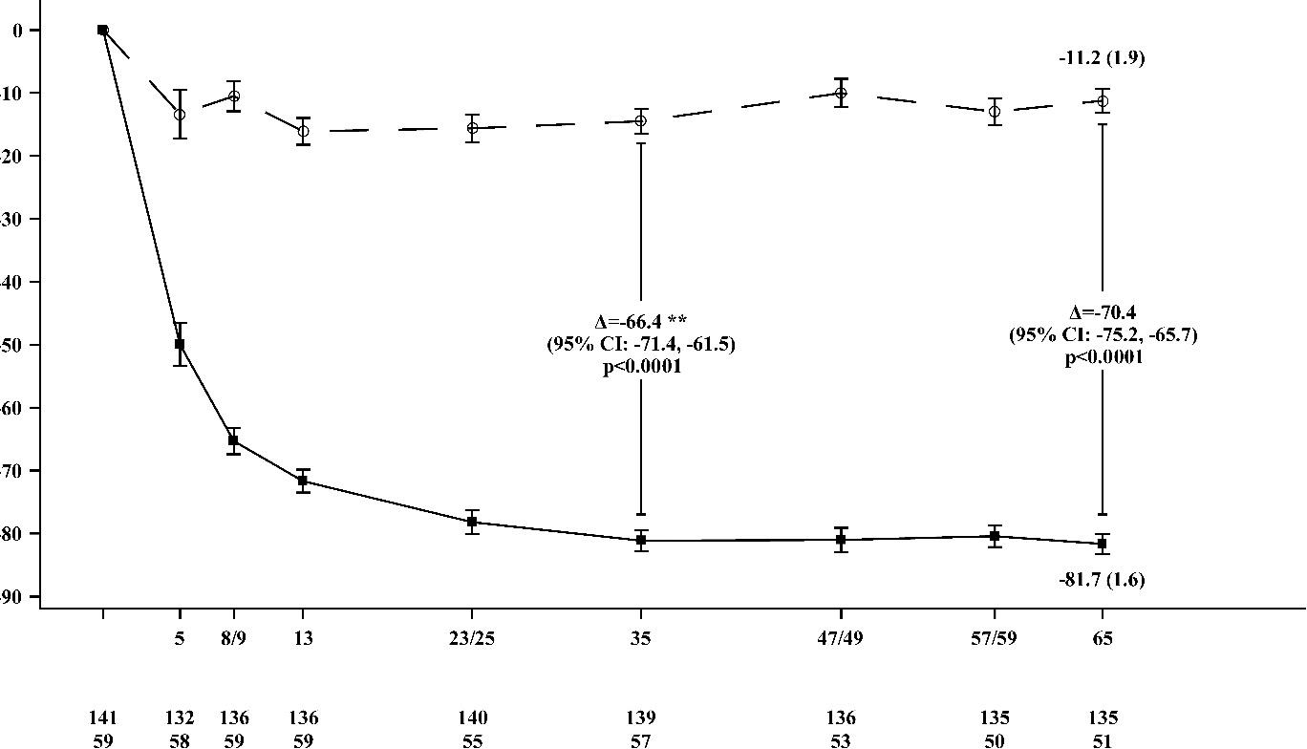
Placebo*
LSM Mean (SEM) Percent Change from Baseline in TTR

WAINUA

Baseline
N evaluable

Week

WAINUA
Placebo*
* External placebo group from another randomised controlled trial (NEURO-TTR).
** Treatment difference presents results from formal Week 35 interim analysis. Only data up to Week 35 are included in the Week 35 interim analysis.
Based on MMRM adjusted by propensity score weights with fixed categorical effects for treatment, time, treatment-by-time interaction, and disease stage, Val30Met mutation, previous treatment, and fixed covariates for the baseline and the base-line-by-time interaction.
Analysis based on data collected up to 28 days after last dose of study treatment. Data up to Week 65 are included. Placebo was assessed at Baseline, Weeks 5, 8, 13 23, 35, 47, 59 and 65, WAINUA assessed at Baseline, Weeks 5, 9, 13, 25, 35, 49, 57 and 65. The Week 35 and Week 65 LS Mean treatment difference (WAINUA – Placebo) with 95% CI (unadjusted) are presented.
CI = Confidence Interval; LSM = Least squares mean; SEM = standard error of mean, MMRM = Mixed effects model with repeated measures; TTR = Transthyretin.

Figure 2: LSM Change in mNIS+7 Composite Score from Baseline (NEURO-TTRansform Study) (full analysis set)
LS Mean (SEM) Change from Baseline in mNIS+7 Composite Score

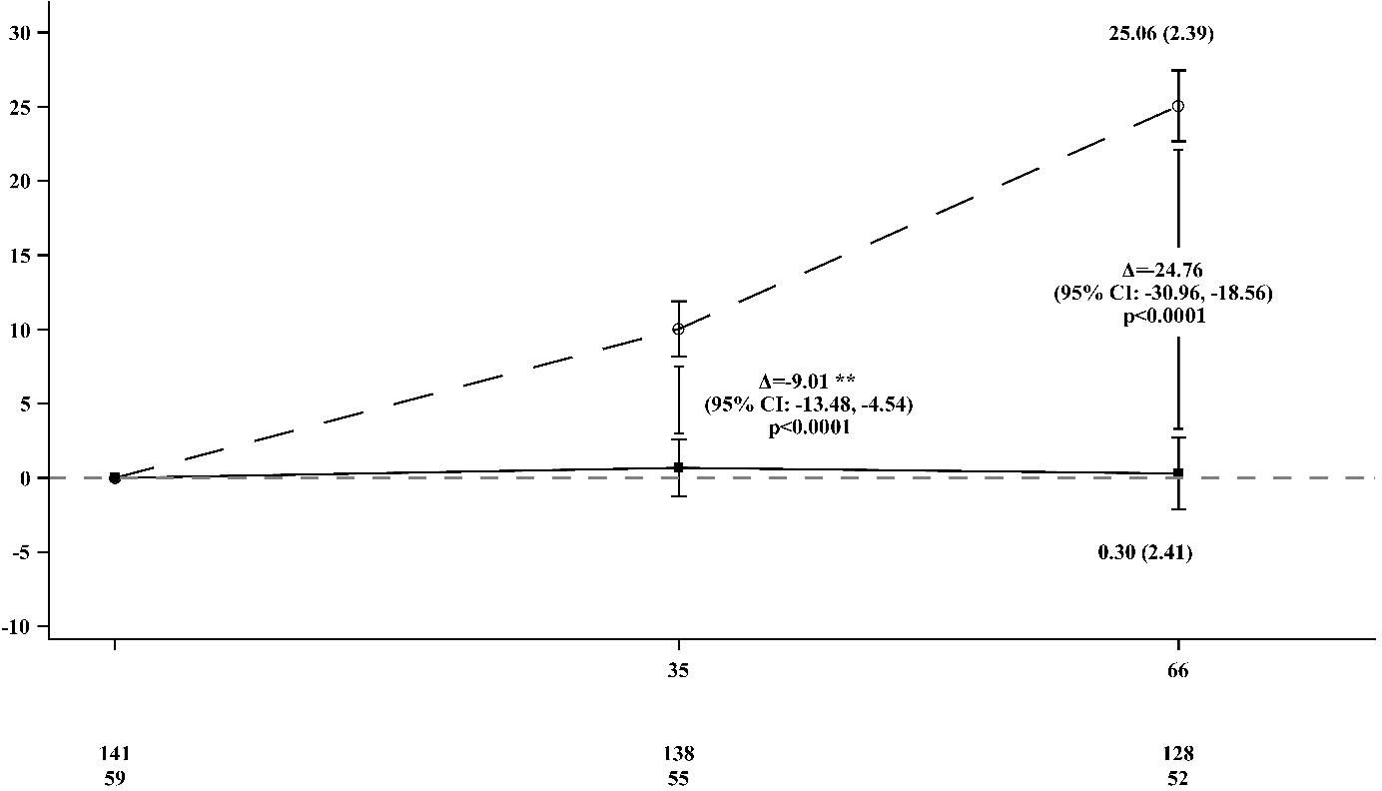
*
Placebo*
WAINUA
Baseline
Week
N evaluable
WAINUA
Placebo*
External placebo group from another randomised controlled trial (NEURO-TTR).
** Treatment difference presents results from formal Week 35 interim analysis. Based on MI ANCOVA adjusted by propensity score weights with fixed categorical effects for treatment, disease stage, Val30Met mutation, previous treatment, and fixed covariates for the baseline. Only data up to Week 35 are included in the Week 35 interim analysis.
Week 66 analysis based on MMRM adjusted by propensity score weights with categorical effects for treatment, time, treatment-by-time interaction, and disease stage, Val30Met mutation, previous treatment, and fixed covariates for the baseline and the baseline-by-time interaction.
Analysis based on data collected up to 52 days after last dose of study treatment. Data up to Week 66 are included. The Week 35 and Week 66 LS Mean treatment difference (WAINUA – Placebo) with 95% CI (unadjusted) are presented.
CI = Confidence interval; LS Mean = Least squares mean; SEM = standard error of mean, MI ANCOVA = Multiple imputation Analysis of covariance; MMRM = Mixed effects model with repeated measures.

Figure 3: LSM Change in Norfolk QoL-DN Total Score from Baseline (NEURO-TTRansform Study)
LS Mean (SEM) Change from Baseline in Norfolk QoL-DN Total Score

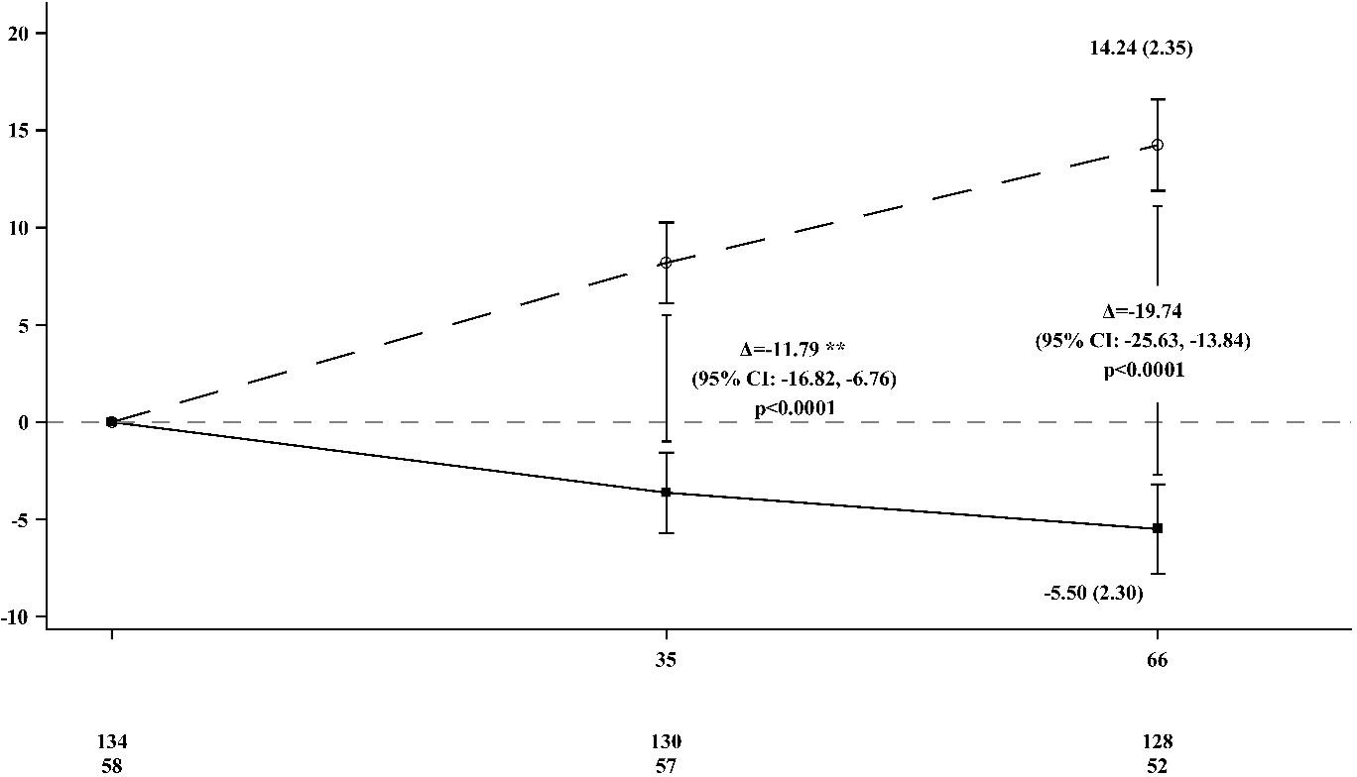
*
Placebo*
WAINUA
Baseline
N evaluable
WAINUA
Placebo*
Week
External placebo group from another randomised controlled trial (NEURO-TTR).
** Treatment difference presents results from formal Week 35 interim analysis. Based on MI ANCOVA adjusted by propensity score weights with fixed categorical effects for treatment, disease stage, Val30Met mutation, previous treatment, and fixed covariates for the baseline. Only data up to Week 35 are included in the Week 35 interim analysis. Week 66 analysis based on MMRM adjusted by propensity score weights with categorical effects for treatment, time, treatment-by-time interaction, and disease stage, Val30Met mutation, previous treatment, and fixed covariates for the baseline and the baseline-by-time interaction.
Analysis based on data collected up to 52 days after last dose of study treatment. Data up to Week 66 are included. The Week 35 and Week 66 LS Mean treatment difference (WAINUA – Placebo) with 95% CI (unadjusted) are presented.
CI = Confidence interval; LS Mean = Least squares mean; SEM = standard error of mean, MI ANCOVA = Multiple imputation Analysis of covariance; MMRM = Mixed effects model with repeated measures.

The secondary endpoint of change from baseline in PND score at Week 65 was statistically significant in favour of eplontersen (p= 0.02). More patients in the eplontersen group experienced improvement from baseline in PND score than in the external placebo group (5.7% vs 3.4%) and fewer patients in the eplontersen group experienced a worsening from baseline than in the external placebo group (12.8% vs. 22.0%).
Patients receiving eplontersen experienced similar improvements relative to placebo in the reduction of serum TTR concentration, mNIS+7 composite and Norfolk QoL-DN total scores across all subgroups including age, sex, race, region, Val30Met mutation status, cardiomyopathy status, familial amyloid cardiomyopathy clinical diagnosis at baseline and disease stage.
Through the end of treatment with eplontersen at Week 85, reduction of TTR concentration and the observed effect in mNIS+7 composite score were sustained, and the mean Norfolk QoL-DN total score remained stable.

Immunogenicity
In the clinical study in patients with ATTRv-PN, after an 84-week treatment period (median treatment duration of 561 days (80 weeks), range: 57 to 582 days), 58 patients (40.3%) developed treatment-emergent anti-drug antibodies (ADAs). ADA to eplontersen tended to be persistent with a late onset

(median onset 223 days) and low titer (median peak titer 200). In the patients who tested positive for anti-eplontersen antibodies, there was no clinically meaningful impact on the efficacy, safety, pharmacokinetics, or pharmacodynamics of eplontersen.

PHARMACOKINETIC PROPERTIES
The pharmacokinetic properties of WAINUA were evaluated by measuring plasma concentrations of eplontersen following subcutaneous administration of single and multiple doses (once every 4 weeks) in healthy subjects and multiple doses (once every 4 weeks) in patients with ATTRv-PN.

Absorption
Following subcutaneous administration, eplontersen is absorbed rapidly into the systemic circulation with the time to maximum plasma concentrations of approximately 2 hours, based on population estimates in participants with ATTRv-PN. The estimates of maximum concentrations (Cmax), and area under the curve (AUC0-168h) were 0.250 μg/mL and 1.803 μg h/mL, respectively, following a 45 mg SC dose using a pre-filled syringe with autoinjector in healthy volunteers. No accumulation of eplontersen Cmax and AUC was observed in plasma after repeated dosing (once every 4 weeks). Accumulation was observed in Ctrough, and steady-state was reached after approximately 17 weeks.

Distribution
Eplontersen is highly bound to human plasma proteins (> 98%). The population estimates for the apparent central volume of distribution is 12.9 L and the apparent peripheral volume of distribution is 11,100 L. Based on animal studies, eplontersen is expected to distribute primarily to the liver and kidney cortex after subcutaneous dosing.

Metabolism
Eplontersen is metabolised by endo- and exonucleases into short oligonucleotide fragments of varying sizes. Liver is the primary site of metabolism, which has been shown in animal species. There were no major circulating metabolites in humans. Oligonucleotide therapeutics, including eplontersen, are not metabolised by CYP enzymes.

Excretion
Eplontersen is primarily eliminated by metabolism followed by renal excretion of the short oligonucleotide metabolites. The mean fraction of unchanged ASO eliminated in urine was less than 1% of the administered dose within 24 hours. The terminal elimination half-life is approximately 3 weeks based on population estimates.

Linearity/non-linearity
Eplontersen Cmax and AUC showed a slightly greater than dose-proportional increase following single subcutaneous doses ranging from 45 to 120 mg (i.e. 1 to 2.7 times the recommended dose) in healthy volunteers.

Special populations
Based on the population pharmacokinetic, body weight, sex, race, and Val30Met mutation status are unlikely to have a clinically meaningful effect on eplontersen exposure. Definitive assessments were limited in some cases as covariates were limited by the overall low numbers.

Elderly population
No overall differences in pharmacokinetics were observed between adult and elderly (≥ 65 years of age) patients.

Renal impairment
No formal clinical studies have been conducted to investigate the effect of renal impairment on eplontersen pharmacokinetics. A population pharmacokinetic and pharmacodynamic analysis showed no clinically meaningful differences in the pharmacokinetics or pharmacodynamics of eplontersen based on mild and moderate renal impairment (eGFR ≥ 45 to < 90 mL/min/1.73 m²). Eplontersen has not been studied in patients with eGFR < 45 mL/min/1.73 m² or in patients with end-stage renal disease.

Hepatic impairment
No formal clinical studies have been conducted to investigate the effect of hepatic impairment on eplontersen. A population pharmacokinetic and pharmacodynamic analysis showed no clinically meaningful differences in the pharmacokinetics or pharmacodynamics of eplontersen based on mild hepatic impairment (total bilirubin ≤ 1 × ULN and AST > 1 × ULN, or total bilirubin > 1.0 to 1.5 × ULN and any AST). Eplontersen has not been studied in patients with moderate hepatic impairment (total bilirubin > 1.5 to 3 × ULN and any AST) or severe hepatic impairment (total bilirubin > 3 to 10 × ULN and any AST) or in patients with prior liver transplant.

PRECLINICAL SAFETY DATA

Genotoxicity
Eplontersen was not mutagenic in the Ames bacterial mutagenicity assay or genotoxic in the in vitro
chromosomal aberration assay in Chinese hamster lung cells or the in vivo mouse micronucleus assay.

Carcinogenicity
There was no evidence of an increased incidence of tumours in transgenic rasH2 mice following repeated monthly subcutaneous administration of eplontersen for 26 weeks at doses up to 1500 mg/kg (equivalent to approximately 150-fold the monthly clinical dose of 45 mg based on a mg/m² human equivalent dose).

PHARMACEUTICAL PARTICULARS

LIST OF EXCIPIENTS
Monobasic sodium phosphate dihydrate, Dibasic sodium phosphate, Sodium chloride, Hydrochloric acid (for pH adjustment), Sodium hydroxide (for pH adjustment), Water for injections.
See Section 2. Qualitative and quantitative composition.

INCOMPATIBILITIES
In the absence of compatibility studies, this medicinal product must not be mixed with other medicinal products.

SHELF LIFE
In Australia, information on the shelf life can be found on the public summary of the Australian Register of Therapeutic Goods (ARTG). The expiry date can be found on the packaging.
WAINUA may be stored in the original carton unrefrigerated for up to 6 weeks below 30°C. If not used within 6 weeks, it should be discarded.

SPECIAL PRECAUTIONS FOR STORAGE
Store at 2°C – 8°C. (Refrigerate. Do not freeze).

Store in the original package in order to protect from light.

NATURE AND CONTENTS OF CONTAINER
0.8 mL sterile solution for injection in a single-use, type I glass syringe with a staked 27-gauge ½ inch (12.7 mm) stainless steel needle, rigid needle shield, and siliconised chlorobutyl elastomer stopper in a pre-filled pen.
Pack size of one single-use pre-filled pen.

SPECIAL PRECAUTIONS FOR DISPOSAL
In Australia, any unused medicine or waste material should be disposed of in accordance with local requirements.

PHYSICOCHEMICAL PROPERTIES
Eplontersen is a transthyretin-directed antisense oligonucleotide (ASO), covalently linked to a ligand containing three N-acetyl galactosamine (GalNAc) residues to enable delivery of the ASO to hepatocytes.

Chemical structure
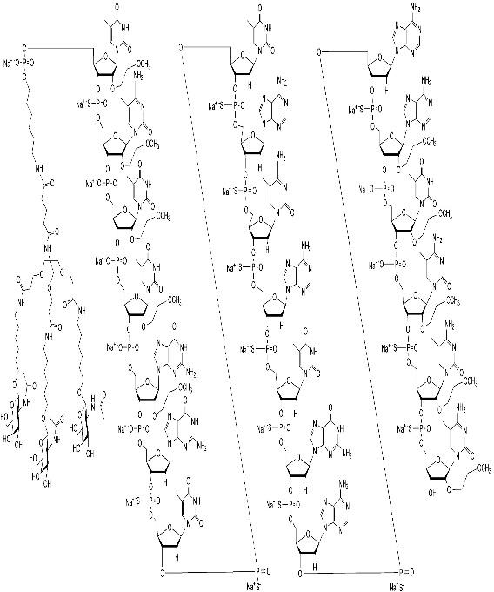

Figure 4 Chemical structure/General structure of eplontersen sodium

WAINUA contains eplontersen sodium as the active ingredient. Eplontersen sodium is a white to yellow solid and it is freely soluble in water and in phosphate buffer. The molecular formula of eplontersen sodium is C296H417N77O156P20S13Na20 and the molecular weight is 9046.1 daltons. The chemical name of eplontersen sodium is DNA, d([2′-O-(2-methoxyethyl)]m5rU-sp-[2′-O-(2-methoxyethyl)]m5rC-[2′-O-(2- methoxyethyl)]m5rU-[2′-O-(2-methoxyethyl)]m5rU-[2′-O-(2-methoxyethyl)]rG-G-sp-T-sp-T-sp-A-sp- m5C-sp-A-sp-T-sp-G-sp-A-sp-A-sp-[2′-O-(2-methoxyethyl)]rA-[2′-O-(2-methoxyethyl)]m5rU-[2′-O-(2- methoxyethyl)]m5rC-sp-[2′-O-(2-methoxyethyl)]m5rC-sp-[2′-O-(2-methoxyethyl)]m5rC), 5′-[26-[[2-(acetylamino)-2-deoxy-β-D-galactopyranosyl]oxy]-14,14-bis[[3-[[6-[[2-(acetylamino)-2-deoxy-β-D-galactopyranosyl]oxy]hexyl]amino]-3-oxopropoxy]methyl]-8,12,19-trioxo-16-oxa-7,13,20-triazahexacos- 1-yl hydrogen phosphate], sodium salt (1:20).

CAS number
1637600-16-8 (eplontersen)
2131025-75-5 (eplontersen sodium)

MEDICINE SCHEDULE (POISONS STANDARD)
Prescription only medicine (Schedule 4)

SPONSOR
AstraZeneca Pty Ltd ABN 54 009 682 311
66 Talavera Road
MACQUARIE PARK NSW 2113
Telephone: 1800 805 342

DATE OF FIRST APPROVAL
DD MMM YYYY

DATE OF REVISION
Not applicable.

SUMMARY TABLE OF CHANGES

Section changed | Summary of new information
N/A | New product

WAINUA is a registered trademark of the AstraZeneca group of companies.

© AstraZeneca, 2026

VV-RIM-08880878 V 5.0

