Australian Public Assessment Report for Jaypirca
  - Active ingredient/s: Pirtobrutinib
  - Sponsor: Eli Lilly Australia Pty Ltd
October 2026

About the Therapeutic Goods Administration (TGA)
- The Therapeutic Goods Administration (TGA) is part of the Australian Government Department of Health, Disability and Ageing and is responsible for regulating therapeutic goods, including medicines, medical devices, and biologicals.
- The TGA administers the Therapeutic Goods Act 1989 (the Act), applying a risk management approach designed to ensure therapeutic goods supplied in Australia meet acceptable standards of quality, safety, and efficacy.
- The work of the TGA is based on applying scientific and clinical expertise to decision-making, to ensure that the benefits to the Australian public outweigh any risks associated with the use of therapeutic goods.
- The TGA relies on the public, healthcare professionals and industry to report problems with therapeutic goods. The TGA investigates reports received to determine any necessary regulatory action.
- To report a problem with a therapeutic good, please see the information on the TGA website.

About AusPARs
- The Australian Public Assessment Report (AusPAR) provides information about the evaluation of a prescription medicine and the considerations that led the TGA to approve or not approve a prescription medicine submission. Further information can be found in Australian Public Assessment Report (AusPAR) guidance.
- AusPARs are prepared and published by the TGA.
- AusPARs are static documents that provide information that relates to a submission at a particular point in time. The publication of an AusPAR is an important part of the transparency of the TGA’s decision-making process.
- A new AusPAR may be provided to reflect changes to indications or major variations to a prescription medicine subject to evaluation by the TGA.

Copyright
© Commonwealth of Australia 2026
This work is copyright. You may reproduce the whole or part of this work in unaltered form for your own personal use or, if you are part of an organisation, for internal use within your organisation, but only if you or your organisation do not use the reproduction for any commercial purpose and retain this copyright notice and all disclaimer notices as part of that reproduction. Apart from rights to use as permitted by the Copyright Act 1968 or allowed by this copyright notice, all other rights are reserved and you are not allowed to reproduce the whole or any part of this work in any way (electronic or otherwise) without first being given specific written permission from the Commonwealth to do so. Requests and inquiries concerning reproduction and rights are to be sent to the TGA Copyright Officer, Therapeutic Goods Administration, PO Box 100, Woden ACT 2606 or emailed to <tga.copyright@tga.gov.au>.

Contents
List of abbreviations 4
Product submission 6
Submission details 6
Product background 7
Disease or condition 7
Current treatment options 8
Clinical rationale 9
Regulatory status 10
Australian regulatory status 10
International regulatory status 10
Registration timeline 11
Assessment overview 12
Quality evaluation summary 12
Nonclinical evaluation summary 13
Clinical evaluation summary 14
Pharmacology 14
Efficacy 17
Safety 26
Risk management plan 28
Risk-benefit analysis 29
Delegate’s considerations 29
Proposed action 30
Assessment outcome 30
Specific conditions of registration 30
Product Information and Consumer Medicine Information 30

List of abbreviations
Abbreviation | Meaning
AE(s) | Adverse event(s)
AIHW | Australian Institute of Health and Welfare
ALT | Alanine aminotransferase
ARTG | Australian Register of Therapeutic Goods
ASA | Australia-specific annex
AUC | Area under the concentration time curve
AUC_{0–24,ss} | Area under the concentration time curve from time 0 to 24 hours at steady state
AUC_{0-inf} | Area under the concentration time curve from 0 to infinity
BCL-2 | B-cell lymphoma-2
BendaR | Bendamustine plus rituximab
BTK | Bruton's tyrosine kinase
C_{av} | Average concentration
CD20 | Cluster of differentiation 20
CI | Confidence interval
CLL | Chronic lymphocytic leukemia
C_{max} | Maximum concentration
C_{max,ss} | maximum concentration at steady state
CMI | Consumer Medicines Information
C_{min,ss} | Minimum concentration at steady state
COVID-19 | Coronavirus disease 2019
CR | Complete response
CV | Coefficient of variation
CYP3A4 | Cytochrome P450 isoenzyme 3A4
DLP | Data lock point
DOR | Duration of response
EFS | Event free survival
ER | Exposure response
ESMO | European Society for Medical Oncology
EU | European Union
HR | Hazard ratio
IdelaR | Idelalisib plus rituximab
IRC | Independent review committee
IV | Intravenous
iwCLL | International Workshop on Chronic Lymphocytic Leukemia
KM | Kaplan-Meier
LOXO-305 | Pirtobrutinib
NE | Not estimable
NHL | Non-Hodgkin lymphoma
ORR | Overall response rate
OS | Overall survival
PD | Progressive disease
PFS | Progression free survival
PI | Product Information
PK | Pharmacokinetic(s)
PopPK | Population pharmacokinetic(s)
PR | Partial response
PR-L | Partial response with lymphocytosis
RMP | Risk management plan
SAE(s) | Serious adverse event(s)
SD | Standard deviation
SLL | Small lymphocytic lymphoma
TEAE(s) | Treatment emergent adverse event(s)
TGA | Therapeutic Goods Administration
T_{max} | Time to maximum concentration
TTNT | Time to next treatment
UGT1A8 | UDP-glucuronosyltransferase family 1 member A8
UGT1A9 | UDP-glucuronosyltransferase family 1 member A9

Product submission

Submission details
Type of submission: | New chemical entity
Product name: | Jaypirca
Active ingredient: | Pirtobrutinib
Decision: | Approved
Date of decision: | 4 March 2026
Date of entry onto ARTG: | 5 March 2026
ARTG number(s): | 481185 and 483365
Black Triangle Scheme  for the current submission: | Yes
Sponsor’s name and address: | Eli Lilly Australia Pty Ltd  Level 9 60 Margaret Street  Sydney NSW 2000
Dose form: | Film coated tablet
Strengths: | 50 mg and 100 mg
Container: | Blister pack
Pack sizes: | 30 (50 mg), 30 and 60 (100 mg)
Approved therapeutic use for the current submission: | Jaypirca as monotherapy is indicated for the treatment of adult patients with relapsed or refractory chronic lymphocytic leukemia/small lymphocytic lymphoma (CLL/SLL) who have been previously treated with a covalent Bruton's tyrosine kinase (BTK) inhibitor.
Route of administration: | Oral
Dosage: | The recommended dose is 200 mg once daily.  Treatment should be continued until disease progression or unacceptable toxicity.  For further information regarding dosage, such as dosage modifications to manage adverse reactions, refer to the Product Information.
Pregnancy category: | D  Drugs which have caused, are suspected to have caused or may be expected to cause, an increased incidence of human fetal malformations or irreversible damage. These drugs may also have adverse pharmacological effects. Accompanying texts should be consulted for further details.  The use of any medicine during pregnancy requires careful consideration of both risks and benefits by the treating health professional. The pregnancy database must not be used as the sole basis of decision making in the use of medicines during pregnancy. The TGA does not provide advice on the use of medicines in pregnancy for specific cases. More information is available from obstetric drug information services in your state or territory.

Product background
This AusPAR describes the submission by Eli Lilly Australia Pty Ltd (the sponsor) to register Jaypirca (pirtobrutinib) 50 mg and 100 mg, film coated tablet, blister pack for the following proposed indication:
Jaypirca is indicated for the treatment of adult patients with chronic lymphocytic leukemia/small lymphocytic lymphoma (CLL/SLL) who have been previously treated with a Bruton's tyrosine kinase (BTK) inhibitor.

Disease or condition
Chronic lymphocytic leukemia (CLL) is the most frequent type of leukemia. Leukemic transformation is initiated by specific genomic alterations that interfere with the regulation of proliferation and apoptosis in clonal B-cells. Some of the most affected genes in CLL are tumour protein 53 (TP53), ataxia telangiectasia mutated (ATM), neurogenic locus notch homolog protein 1 (NOTCH1), and splicing factor 3B subunit 1 (SF3B1). The genetic changes in CLL leads to production of abnormal white blood cells (lymphocytes) in the bone marrow. In CLL the abnormal white cells are mainly found in the bone marrow and the bloodstream. If the abnormal white cells are mainly found in the lymph nodes this is diagnosed as small lymphocytic lymphoma (SLL). The World Health Organization 2022 classification considers SLL and CLL as a single entity/disease and are treated in the same way.
Chronic lymphocytic leukemia is the most diagnosed leukemia in Australia, and it is ranked 16 among the 20 most diagnosed cancers in Australia (Australian Institute of Health and Welfare (AIHW), 2024). It is estimated that the age standardised incidence rate of CLL in Australia was 6.8 cases per 100,000 persons with a projected 2401 cases diagnosed in 2024 (AIHW, 2024). It is more prevalent in males with a rise in the age-standardised incidence rate from 333 cases (6.3 cases per 100,000 males) in 1982 to an estimated 1,475 cases (8.9 cases per 100,000 males) in 2024; similar increase has also been observed in females (from 215 cases (3.2 cases per 100,000 females) in 1982 to an estimated 926 cases (4.9 cases per 100,000 females) in 2024) (AIHW, 2024). Chronic lymphocytic leukemia is associated with an immunocompromised state and an increased rate of complications from infections. Typically, CLL follows a slow progression, but the course of the disease can vary significantly among individuals. Comprehensive prognostic scores such as the commonly used CLL international prognostic index (CLL-IPI) integrates genetic, biological, and clinical variables to identify distinct risk groups of patients with CLL.

Current treatment options
Asymptomatic patients with early-stage disease (Rai stage 0, Binet stage A) should be monitored without therapy unless they have evidence of rapid disease progression or until the disease becomes symptomatic. Some of the agents used in treatment of CLL are:
- Cytostatic agents: alkylating agent (chlorambucil), purine analogues (fludarabine, pentostatin and cladribine) and bendamustine which is now established as a potent single agent for treatment of CLL.
- Monoclonal antibodies: anti-cluster of differentiation 20 (CD20) antibodies, rituximab, ofatumumab and obinutuzumab.
- Targeted therapies:
  - phosphatidylinositol-3-kinase (PI3K) inhibitors such as idelalisib and duvelisib (although reports of side effects including pneumonia, neutropenia and diarrhoea have reduced use and stopped further development of this class of agents for treatment of CLL/SLL.)
  - Covalent Bruton's tyrosine kinase (BTK) inhibitors: ibrutinib, acalabrutinib and zanubrutinib.
  - B-cell lymphoma-2 (BCL-2) inhibitors: venetoclax
- CD19 chimeric antigen receptors (CAR) T cells therapy (although additional clinical studies are required).
The following treatments are available in Australia for intermediate and advanced stages of CLL:
- Chemoimmunotherapy (for example, obinutuzumab, chlorambucil and rituximab)
- Covalent BTK inhibitors (for example, ibrutinib, acalabrutinib and zanubrutinib)
- BCL-2 inhibitors (for example, venetoclax)
- Allogeneic stem cell transplant
- Novel targeted treatments available through clinical trials
- Supportive care includes other therapies to treat symptoms of CLL and may include antibiotics, blood transfusions and corticosteroids.
Bruton’s tyrosine kinase (BTK) inhibitors and BCL-2 inhibitors are the preferred standard of care for the first- and second-line treatment of CLL/SLL. However, as with long term exposure of most current targeted agents, most patients eventually develop resistance to BTK and BCL-2 inhibitors. As patients continue to relapse, the durations of subsequent treatments shorten with each line of therapy. Different treatment strategies available for first line therapy of CLL are summarised in Figure 1. Recently published European Society for Medical Oncology (ESMO) clinical practice guideline interim update on new targeted therapies in first line and at relapse of CLL supports the use of venetoclax-rituximab (Rai stage III, Binet stage A), idelalisib-rituximab (Rai stage III, Binet stage B) or non-covalent BTK inhibitor (Rai stage III, Binet stage A) in treatment of symptomatic relapsed CLL that has progressed on a BTK inhibitor (Figure 1).
Figure 1: Relapse therapy for chronic lymphocytic leukemia
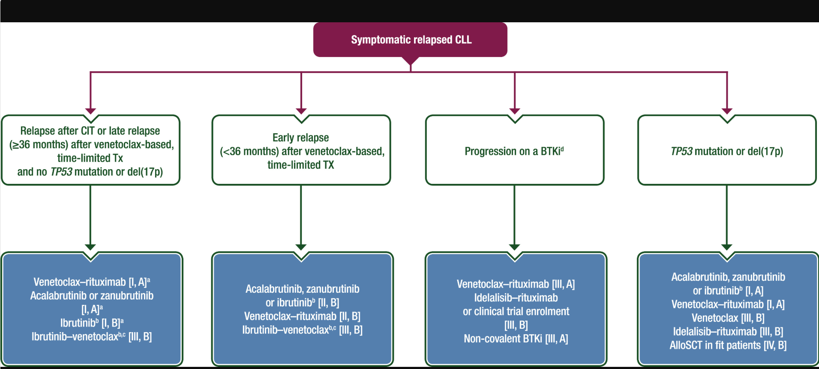
Abbreviations: alloSCT = allogeneic stem cell transplantation, BTKi = Bruton tyrosine kinase inhibitor, CIT = chemoimmunotherapy, CLL = chronic lymphocytic leukemia, del = deletion, EMA = European Medicines Agency, FDA = Food and Drug Administration, Tx = treatment.
ª For relapse after CIT, BTKis or venetoclax/rituximab should be considered equally, depending on comorbidities, comedication, access and preference.
^{b} Ibrutinib should be considered carefully particularly in older patients with cardiac comorbidities.
^{c} Not EMA approved, not FDA approved in relapse.
^{d} If a patient relapses after prior treatment with a BTKi, which was stopped due to side-effects, changing to a different BTKi or rechallenge could be considered (Rai stage III, Binet stage B).

Clinical rationale
The clinical rationale as stated by the sponsor is as follows:
Pirtobrutinib (LOXO-305, LY3527727) is an oral reversible, small molecule, noncovalent inhibitor of BTK. BTK plays a critical role in the proliferation and survival of diverse B-cell malignancies. In B-cells, BTK signalling results in activation of pathways necessary for B-cell proliferation, trafficking, chemotaxis, and adhesion. Pirtobrutinib binds with equal affinity to wild type BTK as well as to BTK harbouring C481 mutations, leading to inhibition of BTK activity.
In nonclinical studies, pirtobrutinib inhibited BTK-mediated B-cell CD69 expression and inhibited malignant B-cell proliferation. Pirtobrutinib showed dose dependent tumor growth inhibition and induced tumor regression in BTK wild type and BTK C481S mutant mouse xenograft models.
Pirtobrutinib is distinct from the other BTK inhibitors (ibrutinib, acalabrutinib, and zanubrutinib) due to its favourable absorption, distribution, metabolism and excretion (ADME) properties, noncovalent binding mode, and selectivity. At the recommended dosage, pirtobrutinib delivers tonic BTK target inhibition throughout the once daily dosing period, regardless of the intrinsic rate of BTK turnover. This allows pirtobrutinib to retain target coverage through the end of the dosing interval (i.e., trough coverage) and in rapidly proliferating tumours with higher BTK protein turnover.
Moreover, the noncovalent binding mode of pirtobrutinib is unaffected by BTK C481 substitutions, which commonly cause resistance to covalent BTK inhibitors, particularly in CLL/SLL. Additionally, pirtobrutinib is a highly selective molecule that is more than 300-fold more selective for BTK versus 98% of 370 non-BTK kinases tested, with no significant inhibition of non-kinase targets at 1 μM, thus limiting the potential for off-target mediated toxicities.

Regulatory status

Australian regulatory status
This product is considered a new chemical entity for Australian regulatory purposes.

International regulatory status
At the time the TGA considered this submission, a similar submission had been considered by other regulatory agencies. The following table summarises these submissions and provides the indications where approved.
Table 1: International regulatory status
Region | Submission date | Status | Approved indications
United States of America | 03 February 2025 | Approved on 3 December 2025 | Jaypirca is indicated for the treatment of adult patients with relapsed or refractory chronic lymphocytic leukemia or small lymphocytic lymphoma (CLL/SLL) who have previously been treated with a covalent BTK inhibitor
European Union | 11 March 2024 | Approved on 28 March 2025 | Jaypirca as monotherapy is indicated for the treatment of adult patients with relapsed or refractory chronic lymphocytic leukaemia (CLL) who have been previously treated with a BTK inhibitor.
Canada | 27 December 2024 | Approved on 17 October 2025 | Jaypirca (pirtobrutinib) is indicated as monotherapy for the treatment of adult patients with chronic lymphocytic leukemia/small lymphocytic lymphoma (CLL/SLL) who have received at least two prior lines of therapy including a BTK inhibitor and a BCL-2 inhibitor.
United Kingdom | 11 March 2025 | Approved on 13 August 2025 | Jaypirca as monotherapy is indicated for the treatment of adult patients with relapsed or refractory chronic lymphocytic leukaemia (CLL) who have been previously treated with a BTK inhibitor.
Switzerland | 29 March 2024 | Approved on 23 September 2025 | Jaypirca as monotherapy is indicated for the treatment of adult patients with relapsed or refractory chronic lymphocytic leukaemia (CLL) who have received at least two prior lines of therapy, including a BTK inhibitor (see «Clinical efficacy»)
Singapore | 28 March 2025 | Under consideration | Under consideration

Registration timeline
The following table captures the key steps and dates for this submission.
This submission was evaluated under the standard prescription medicines registration process.
Table 2: Timeline for Submission PM-2025-00498-1-4
Description | Date
Submission dossier accepted and first round evaluation commenced | 31 March 2025
Evaluation completed | 22 January 2026
Registration decision (Outcome) | 4 March 2026
Registration in the ARTG completed | 5 March 2026
Number of working days from submission dossier acceptance to registration decision* | 164
*Statutory timeframe for standard submissions is 255 working days

Assessment overview
A summary of the TGA’s assessment for this submission is provided below.
The following guideline was referred to by the Delegate as being relevant to this submission:
- EMA: ICH Topic S9 Guideline on Non-clinical Evaluation for Anticancer Pharmaceuticals (EMA/CHMP/ICH/646107/2008)
- TGA-adopted, effective date: May 2010.

Quality evaluation summary
Pirtobrutinib (structure shown in Figure 2) is an oral reversible, small molecule, noncovalent inhibitor of Bruton’s tyrosine kinase (BTK). BTK plays a critical role in the proliferation and survival of diverse B-cell malignancies. In B-cells, BTK signalling results in activation of pathways necessary for B-cell proliferation, trafficking, chemotaxis, and adhesion. Pirtobrutinib binds with equal affinity to wild type BTK as well as to BTK harbouring C481 mutations, leading to inhibition of BTK activity.
Figure 2: Structure of pirtobrutinib
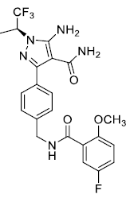
The recommended dose of Jaypirca is 200 mg once daily. The tablet can be taken with or without food. Proposed pack sizes are 30 tablets for 50 mg, and 30 and 60 tablets for 100 mg, each contained in a carton. The Jaypirca 50 mg film coated tablet is a blue, arc-triangle debossed with ‘Lilly’ over ‘50’ on one side and ‘6902’ on the other and is approximately 9 x 9 mm in size. The Jaypirca 100 mg film coated tablet is a blue, round tablet debossed with ‘Lilly’ over ‘100’ on one side and ‘7026’ on the other side and is approximately 10 mm in size.
The recommended shelf life of Jaypirca is 36-months stored below 30 °C.
The application and the supporting data relating to the composition, development, manufacture, quality control, and stability of the product have been assessed and checked for compliance, as applicable, with Australian legislation and requirements for new medicines and in accordance with pharmacopoeial standards and the technical guidelines adopted by the TGA.
The quality evaluation has confirmed that approval for registration of the proposed product can be recommended from a pharmaceutical chemistry perspective.

Nonclinical evaluation summary
The submitted nonclinical dossier was in accordance with the relevant ICH guideline for the nonclinical assessment of anticancer pharmaceuticals (ICH S9). All pivotal safety related studies were Good Laboratory Practice compliant. All safety related nonclinical studies were conducted with crystalline pirtobrutinib suspended in 0.5% hydroxypropyl methylcellulose and not with spray dried dispersion form of pirtobrutinib used in commercial product with the exception of the 3- and 9-month dog studies LOXO-305-TOX-017 and 8003850, respectively.
In vitro, pirtobrutinib bound the BTK and BTK C481S mutant with nanomolar affinity and inhibition was observed at half maximal inhibitory concentration values within expected clinical plasma concentrations. In vivo, pirtobrutinib demonstrated moderate tumour regression in various human B-cell malignancy xenograft mouse models at exposure level comparable to clinical maximum concentration (C_{max}), supporting the proposed clinical indication.
Pirtobrutinib had inhibitory activity against erb-b2 receptor tyrosine kinase 4 (ERBB4/HER4), breast tumour kinase (BRK), mitogen-activated protein kinase 2 (MEK2), mitogen-activated protein kinase (MEK1), tyrosine kinase YES (YES/YES1), tyrosine kinase (TXK), and C-terminal Src kinase (CSK) kinases at potentially clinically relevant concentrations.
Dedicated safety pharmacology studies assessed effects of pirtobrutinib on the cardiovascular system. No significant inhibition of human ether-a-go-go related gene potassium channel tail current was observed at clinically relevant concentrations. In conscious male dogs, pirtobrutinib had no effect on electrocardiogram or other haemodynamic parameters at low multiples of clinical exposures. The central nervous system and respiratory safety pharmacology endpoints were assessed in repeat-dose toxicity studies, where no adverse effects on central nervous system function were observed in rats. No adverse effects on respiratory rate were seen in dogs treated with oral pirtobrutinib providing only subclinical exposures.
Overall, the pharmacokinetic profile in rats and dogs was qualitatively similar to that of humans. Pirtobrutinib (spray-dried dispersion form) was rapidly absorbed (time to maximum concentration (T_{max}) ≤ 2h) in rats, dogs and humans, but T_{max} was generally moderate in rats and dogs for crystalline pirtobrutinib. Half-life was longer in humans than nonclinical species. Plasma protein binding of pirtobrutinib was high in mice, rabbits, and humans and it was moderate in rats and dogs. Tissue distribution of pirtobrutinib was relatively high in tissues involved in elimination (liver, kidney, urinary bladder) and the adrenal and thyroid glands, but penetration into brain and spinal cord was very limited. Unchanged pirtobrutinib was by far the dominant circulating species in humans and female rats, while metabolite M1 was dominant circulating species in male rats. Pirtobrutinib was primarily metabolised by cytochrome P450 isoenzyme 3A4 (CYP3A4), UDP-glucuronosyltransferase family 1 member A8 (UGT1A8) and UDP-glucuronosyltransferase family 1 member A9 (UGT1A9). Drug related material was excreted via urine and faeces with urine as the predominant route of excretion in humans while faeces predominated for rats.
As pirtobrutinib is predominantly metabolised by CYP3A4, CYP3A4 inhibitors/inducers may alter the systemic exposure to pirtobrutinib. In vitro data suggested that pirtobrutinib may increase the exposure of cytochrome P450 isoenzyme 2C8 (CYP2C8) and/or cytochrome P450 isoenzyme 2C9 (CYP2C9) substrates when coadministered. Pirtobrutinib exhibited mechanism dependent irreversible inhibition of systemic and intestinal CYP3A enzymes, direct inhibition of intestinal CYP3A enzymes, and induction of systemic and intestinal CYP3A enzymes in vitro; thus, pirtobrutinib may cause net inhibition of CYP3A enzymes and increase exposures of oral coadministered drugs that are CYP3A substrates. Pirtobrutinib may increase the exposure of coadministered drugs that are substrates of P-glycoprotein or breast cancer resistance protein.
Pirtobrutinib may also increase systemic exposure to a coadministered drug that is a substrate of the bile salt export pump, organic anion transporting polypeptide 1B1 (OATP1B1), organic anion transporting polypeptide 1B3 (OATP1B3), organic anion transporter 3 (OAT3), organic cation transporter 2 (OCT2), multidrug and toxin extrusion transporter 1 (MATE1), or multidrug and toxin extrusion protein 2 (MATE2-K) transporter.
Pirtobrutinib had a high to very high order of acute oral toxicity in rats and dogs, respectively.
Repeat-dose toxicity studies by the oral route were conducted in rats (up to 6 months) and dogs (up to 9 months). Maximum exposures (area under the concentration time curve (AUC)) were low in female rats and subclinical in male rats and dogs. Pirtobrutinib was not tolerated in male rats and dogs at or beyond clinical exposures. Target organs for toxicity were the lymphoid organs (lymphoid depletion, decreased B-cells), immune system (decreased T-cell dependent antibody response to antigens), erythroid parameters (decreased red blood cell, haemoglobin, haematocrit), lungs (vascular/perivascular necrosis/inflammation), and eyes (epithelial hyperplasia, stromal fibrosis).
Pirtobrutinib was not mutagenic (bacterial mutation assay/Ames test) or clastogenic in vivo (rat micronucleus test). In vitro, pirtobrutinib induced micronuclei (in human peripheral blood lymphocytes) through an aneugenic mechanism. No carcinogenicity studies were conducted, which is considered acceptable. However, there may be a risk for secondary malignancies in patients as pirtobrutinib is an immunosuppressant.
Fertility was unaffected in male and female rats treated with pirtobrutinib at exposure levels 0.3- and 2.5-times the clinical AUC, respectively. Decreased fetal weight, increased resorptions and increased skeletal and visceral abnormalities (dilated ureters, absent kidneys, malpositioned ovaries, misshapen sternebrae) were seen in rat embryofetal development study without accompanying maternal toxicity, at exposures (AUC) slightly higher than clinical exposure. Pirtobrutinib is considered to be teratogenic. Pirtobrutinib is not phototoxic.
The proposed limits for impurities in the drug product have not been adequately qualified by submitted toxicity data.
There are no nonclinical objections to registration of Jaypirca for the proposed indications provided a commitment is supplied that outstanding concerns on the clastogenic potential of two specified impurities are resolved with clastogenicity studies and that data will be provided in a subsequent submission to the TGA.

Clinical evaluation summary

Pharmacology
There were 13 pharmacokinetic-pharmacodynamic studies, population pharmacokinetic (popPK) analysis and exposure response (ER) analysis which provided a comprehensive evaluation of the clinical pharmacology of pirtobrutinib for the proposed indication.

Pharmacokinetics
- Pirtobrutinib (LOXO-305) was steadily absorbed following a single oral dose of 200 mg LOXO-305 as 2 100 mg tablets, with a median t_{max} value of 5 hours, and a geometric mean half-life of 18.6 hours.
- The geometric mean absolute bioavailability of pirtobrutinib was 85.5% (ranging from 75.9% to 90.9%) based on the ratio of area under the concentration time curve from 0 to infinity (AUC_{0-inf}) after oral dosing versus intravenous (IV) dosing (Study 20007).
- Consumption of a high-fat meal prior to administration of LOXO-305 had no effect on the overall exposure (AUC_{0-inf} and area under the concentration time curve from time 0 to the time of the last measurable concentration of pirtobrutinib LOXO-305. The C_{max} decreased by 22.5% and median t_{max} was delayed by 1 hour (Study 20009).
- Hepatic metabolism is the main route of clearance for pirtobrutinib. Pirtobrutinib is metabolised to several inactive metabolites by CYP3A4, UGT1A8, and UGT1A9.
- In the metabolite profiling and characterisation, LOXO-305 was the primary drug related component. Three minor metabolites were observed, M1, M2, and M4, each accounting for a mean of 7.8%, 3.3%, and 2.3%, respectively, of circulating radioactivity. The primary clearance pathways involved in pirtobrutinib metabolism were oxidative, hydrolytic, and direct glucuronidation.
- The mean systemic volume of distribution of pirtobrutinib after an IV dose is 36.3 L in healthy participants. The mean apparent central volume of distribution of pirtobrutinib is 32.8 L in cancer patients. Pirtobrutinib is moderately bound to plasma proteins and serum albumin, with a mean bound fraction of approximately 95% and 98%, respectively.
- The mean apparent clearance of pirtobrutinib is 2.02 L/h with an effective half-life of approximately 19 hours. Following a single radiolabelled dose of pirtobrutinib 200 mg to healthy subjects, 37% of the dose was recovered in faeces (18% unchanged) and 57% in urine (10% unchanged).

Population pharmacokinetic data
The conduct, modelling and analyses for the submitted PopPK reports was satisfactory and complied with the US Guidance for Industry: Population Pharmacokinetics and the TGA-adopted EMA Guideline on Reporting the Results of Population Pharmacokinetic Analyses.
The pharmacokinetics (PK) of pirtobrutinib in patients with haematological malignancies in Study 18001 was well characterised by a 2-compartment distribution model with linear clearance and 4 transit compartments for absorption. The precision of the final parameter estimates was confirmed by bootstrap analysis and visual predictive check was performed to ensure that the developed PopPK model reflected the observed data. The main findings from the PopPK analyses were as follows:
- The final model included 3 covariates (body weight, renal function, serum albumin) which were selected based on prespecified criteria in the population PK model analysis plan. While these changes were statistically significant, they were within the range of normal variability in the patient population and were not considered clinically meaningful.
- The mean elimination half-life of pirtobrutinib in patients with haematological malignancies (in Study 18001) was estimated to be 18.8 hours. At a dose of 200 mg once daily in Phase II patients, the mean maximum concentration at steady state (C_{max,ss)} was 6460 ng/mL (26% coefficient of variation (CV)), minimum concentration at steady state (C_{min,ss}) was 2260 ng/mL (65% CV), and area under the concentration time curve from time 0 to 24 hours at steady state (AUC_{0-24,ss}) was 91300 ng*h/mL (41% CV).
- The geometric mean elimination half-life of pirtobrutinib in Study 20020 was estimated to be 20 hours (31% CV). For patients from Study 20020, C_{max,ss} was 6868 ng/mL (23% CV), C_{min,ss} was 2618 ng/mL (52% CV), AUC_{0–24,ss} was 100370 ng*h/mL (35% CV) and the average concentration during a dosing interval at steady state was 4182 ng/mL (35% CV).
- The pirtobrutinib PK exposure of patients receiving 200 mg once daily was slightly higher in Study 20020 in CLL/SLL patients compared to Study 18001 (in patients with CLL/SLL, mantle cell lymphoma and non-Hodgkin lymphoma (NHL)) but was generally similar between the two main studies.
- Pirtobrutinib disposition was not affected by formulation (initial tablet and commercial formulation, age, sex, cancer type, race, ethnicity and mild hepatic impairment.

Pharmacodynamics
Pirtobrutinib is a reversible, noncovalent inhibitor of BTK. BTK is a signalling protein of the B-cell antigen receptor (BCR) and cytokine receptor pathways. In B-cells, BTK signalling results in activation of pathways necessary for B-cell proliferation, trafficking, chemotaxis, and adhesion. Pirtobrutinib binds to wild type BTK as well as BTK harbouring C481mutations leading to inhibition of BTK kinase activity.
At proposed dose of pirtobrutinib 200 mg once daily, BTK inhibition was expected to exceed 96% in most patients (66%) from the combined population of Study 18001 and Study 20020 over the entire dosing interval at steady state, indicating extensive and consistent engagement of the drug target.
The ER analysis for progression free survival (PFS) showed that a higher pirtobrutinib trough concentration was associated with longer PFS in CLL/SLL patients. Within the range of exposures achieved at a dose level of pirtobrutinib 200 mg once daily, there was lack of any apparent relationship between pirtobrutinib exposure (average concentration (C_{av}) and minimum concentration) and overall response rate (ORR) in CLL/SLL patients from Study 20020.
The safety ER analysis explored the potential relationship between pirtobrutinib exposure (C_{av} and C_{max}) and the following adverse events (AEs):
- 7 safety treatment-emergent adverse events of interest (Grade ≥3 anaemia, Grade ≥3 neutropenia, Grade ≥3 thrombocytopenia, Grade ≥3 infection/infestation, any grade hypertension, any grade bleeding, and Grade ≥3 any adverse event) for patients with CLL from Study 20020 and Study 18001.
- 5 continuous safety measures over time (neutrophil count, platelet count, haemoglobin, systolic blood pressure, and diastolic blood pressure) for patients with CLL from Study 20020 and Study 18001.
Pirtobrutinib exposure did not negatively impact safety measures (neutrophil count, platelet count, haemoglobin, systolic blood pressure, and diastolic blood pressure) at the range of exposures in the pivotal Phase III study CLL/SLL patients at the proposed starting dose of 200 mg once daily.
The single dose, randomised, partially double blind, placebo and positive controlled, 3-way crossover design Study LOXO-BTK-20011 evaluated the effect of a supratherapeutic dose of pirtobrutinib (900 mg) on the QTc interval corrected for heart rate compared with placebo in 30 healthy subjects (moxifloxacin 400 mg was the positive control). The effect on ΔΔQTcF larger than 10 milliseconds could be excluded across the observed range of LOXO-305 plasma concentrations (approximately 25100 ng/mL) based on this concentration QTc analysis. Pirtobrutinib at supratherapeutic dose of 900 mg did not have an effect on heart rate or cardiac conduction (that is, PR and QRS intervals).

Efficacy
The dose of 200 mg once daily (orally with or without food) selected for the pivotal Phase III Study 20020 was justified based on results from the Phase I/II Study 18001.
Pivotal study:
- Study LOXO-BTK-20020 (also known as Study 20020, J2N-OX-JZNN): a Phase III open label, randomised study of LOXO-305 versus investigator’s choice of idelalisib plus rituximab or bendamustine plus rituximab in BTK inhibitor pretreated chronic lymphocytic leukemia/small lymphocytic lymphoma.
Supportive studies:
- Study LOXO-BTK-18001 (also known as Study 18001): a Phase I/II Study of oral LOXO-305 in patients with previously treated chronic lymphocytic leukemia/small lymphocytic lymphoma (CLL/SLL) or non-Hodgkin lymphoma (NHL).

Study LOXO-BTK-20020
This was a Phase III, open label, randomised study of pirtobrutinib (LOXO-305) versus investigator’s choice of idelalisib plus rituximab (IdelaR) or bendamustine plus rituximab (BendaR) in BTK Inhibitor pretreated adult CLL/SLL patients with an indication for treatment as defined by International Workshop on Chronic Lymphocytic Leukemia (iwCLL) 2018 criteria.
This study was conducted at 235 centres that enrolled patients in regions of Europe, North America, Asia, and Australia. The first patient was enrolled on 9 March 2021, and the last patient was enrolled on 17 July 2023.
Figure 3: Study LOXO-BTK-20020 schematic
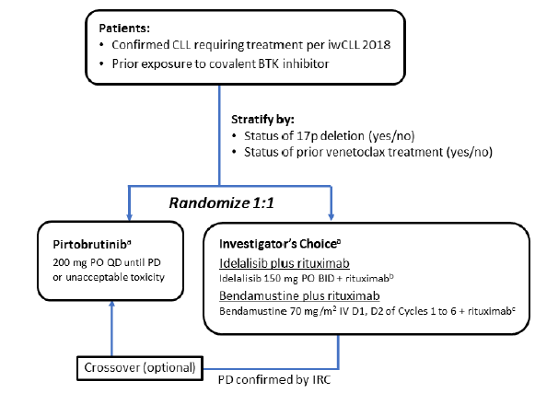
ª Detailed study treatment dosing instructions were provided in the dossier.
^{b} Day 1 of Cycle 1, first dose of rituximab at 375 mg/m², next 4 infusions at 500 mg/m² every 2 weeks, next 3 infusions at 500 mg/m² every 4 weeks.
^{c} Day 1 of Cycle 1, first dose of rituximab at 375 mg/m², next 5 infusions Day 1 of Cycle 2 through Cycle 6 at 500 mg/m².
Table 3: Objectives and endpoints of Study LOXO-BTK-20020
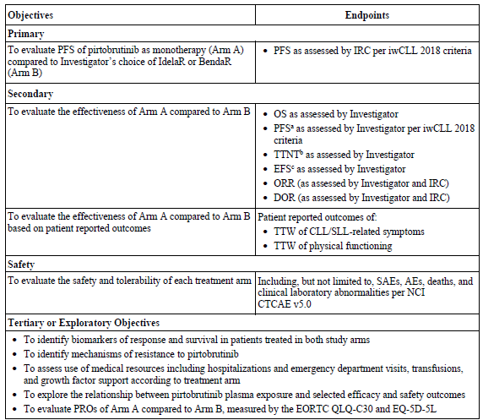
Abbreviations: AE = adverse event, BendaR = bendamustine plus rituximab, CLL = chronic lymphocytic leukemia, DOR = duration of response, EFS = event-free survival, EORTC = European Organisation for Research and Treatment of Cancer, EQ-5D-5L = 5-level-EuroQol, IdelaR = idelalisib plus rituximab, IRC = Independent Review Committee, iwCLL = International Workshop on Chronic Lymphocytic Leukemia, NCI CTCAE v5.0 = National Cancer Institute Common Terminology Criteria in Adverse Events v5.0, ORR = overall response rate, OS = overall survival, PD = progressive disease, PFS = progression free survival, PROs = patient reported outcomes, QLQ-C30 = Quality of Life Questionnaire Core 30, SAE = serious adverse event, SLL = small lymphocytic lymphoma, TTNT = time to next treatment, TTW = time to worsening.
ª IRC assessments were the principal data source for ORR, DOR, and PFS. Supplemental analyses based on investigator assessments are provided.
^{b} TTNT is defined as time from the date of randomization to the date of the next systemic anticancer therapy for CLL (Protocol Section 9.0, Protocol version 6.0, dated 15 September 2023, Appendix 16.1.1).
^{c} EFS is defined as the time from date of randomization to the date of PD or start of new treatment for CLL or discontinuation from treatment due to toxicity or death, whichever occurs first.
The primary efficacy endpoint of PFS was defined as the time from the date of randomisation until progressive disease (PD, assessed by the independent review committee (IRC) per iwCLL 2018 criteria) or death from any cause, whichever occurs first. Patients known to be alive and without PD will be censored at the time of the last adequate disease assessment.

Main inclusion criteria
The main inclusion criteria were:
- Patients aged > 18 years with confirmed diagnosis by redacted local laboratory report of CLL/SLL as defined by iwCLL 2018 criteria.
- Requirement for therapy consistent with iwCLL 2018 criteria for initiation of therapy.
- Known 17p deletion status (wildtype for 17p locus or positive for 17p deletion) by fluorescence in situ hybridisation.
- Previously treated with a covalent BTK inhibitor, investigational or approved, and either alone or in combination with other agents. Patients may have received an unlimited number of lines of prior therapy.
- Adequate organ function.

Main exclusion criteria
The main exclusion criteria were:
- Known or suspected Richter’s transformation to diffuse large B-cell lymphoma, prolymphocytic leukemia, or Hodgkin’s lymphoma at any time preceding enrolment.
- Known or suspected history of central nervous system involvement by CLL/SLL.
- Patients who experienced a major bleeding event on a prior BTK inhibitor.
- Prior exposure to non-covalent (reversible) BTK inhibitor.

Study treatment
Table 4: Study interventions, dose, and mode of administration
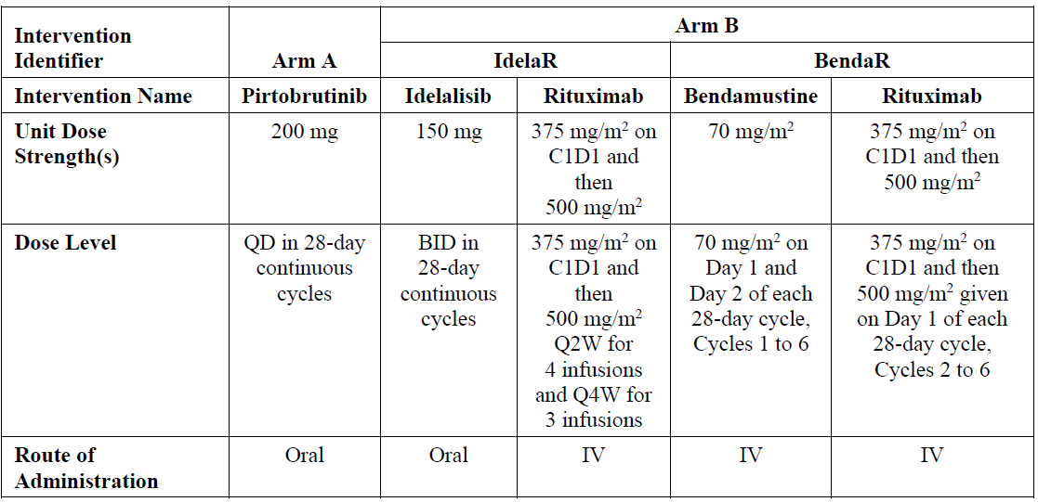
Abbreviations: BendaR = bendamustine plus rituximab, BID = twice a day, C1D1 = Cycle 1 Day 1, IdelaR = idelalisib plus rituximab, IV = intravenous, QD = once daily.

Duration of treatment
Patients assigned to Arm A were allowed to continue pirtobrutinib treatment beyond progression (with prior sponsor approval) if the patient was tolerating study treatment and was, in the opinion of the investigator, deriving ongoing clinical benefit; patients in Arm A were not allowed to cross over.
Patients assigned to Arm B were allowed to cross over to Arm A upon meeting eligibility criteria for crossover treatment, that is, IRC confirmation of PD according to iwCLL 2018 and this included Arm B patients who discontinued treatment for toxicity.

Participant flow
Overall, 238 patients were randomised (119 patients to each treatment arm): Arm A (pirtobrutinib, n = 119) or Arm B (IdelaR = 82 or BendaR = 37).
Table 5: Patient disposition and analysis set summary
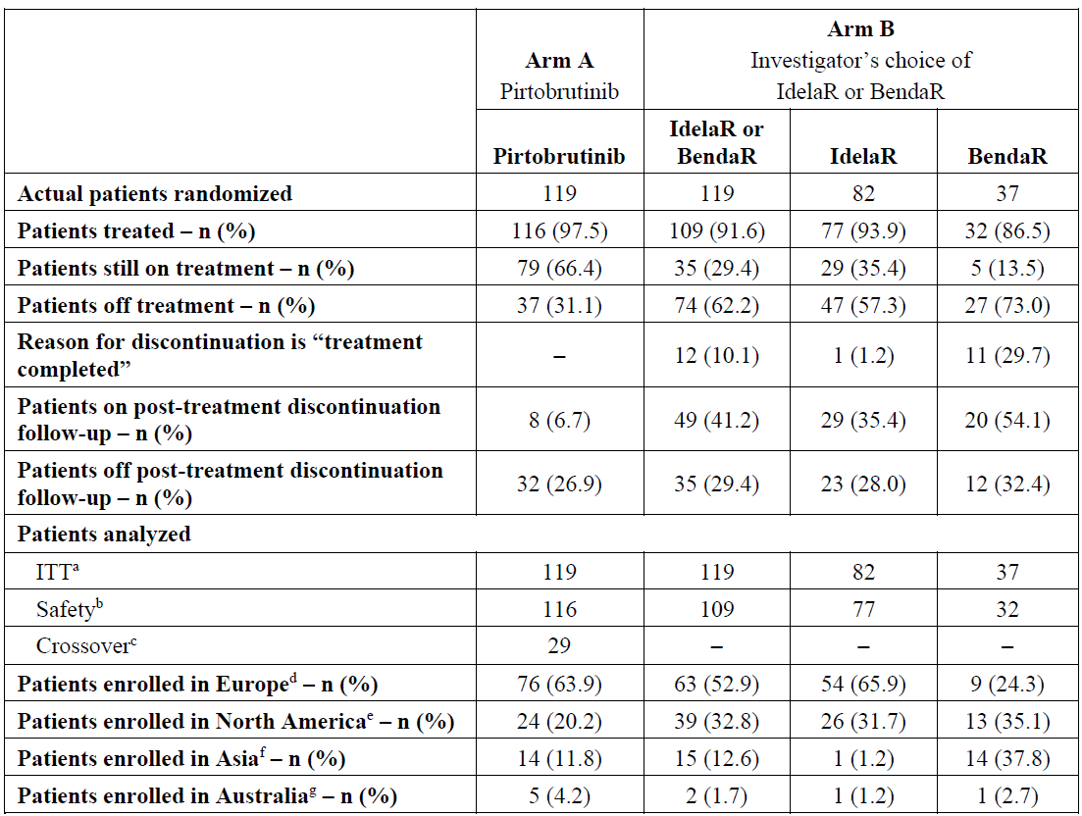
Abbreviations: BendaR = bendamustine plus rituximab, IdelaR = idelalisib plus rituximab, ITT = intention to treat, n = number. Data cutoff date 29 August 2023.
ª All randomised patients.
^{b} All randomised patients who received at least 1 dose (including a partial dose) of study treatment.
^{c} A subpopulation of patients in the ITT population who were randomised to Arm B and crossed over to Arm A and received at least 1 dose of pirtobrutinib.
^{d} Europe included Austria, Belgium, Croatia, Czech Republic, France, Germany, Hungary, Ireland, Israel, Italy, Poland, Russian Federation, Spain, Switzerland, Turkey, and the United Kingdom.
^{e} North America included Canada and the United States of America.
^{f} Asia included China, Japan, Korea (Republic of), and Taiwan.
^{g} Australia included Australia only.
Overall, most baseline disease characteristics were similar across study Arms A and B, and in Arm B were similar across the IdelaR and BendaR treatment groups.

Results for the primary efficacy outcome
Pirtobrutinib monotherapy showed a statistically significant longer IRC assessed PFS compared to investigator’s choice of IdelaR or BendaR Arm B (PFS events = 37.8% (45 out of 119) versus 42% (50 out of 119); hazard ratio (HR) = 0.583 (95% confidence interval (CI): 0.383, 0.887), p = 0.0105). The median PFS by IRC assessment was 11.24 months (95% CI: 9.46, 11.43) and was 8.74 months (95% CI: 7.20, 10.15) for Arms A and B, respectively; median follow-up time was 8.31 months (95% CI: 5.85, 9.0) and 6.05 months (95% CI: 4.83, 8.34), respectively.
Table 6: Progression free survival based on independent review committee assessments, intention to treat population
 | Arm A (n = 119) | Arm B (n = 119)
Number of Events, n (%) | 45 (37.8) | 50 (42.0)
PFS (months)
Median (95% CI) | 11.24 (9.46, 11.43) | 8.74 (7.20, 10.15)
HR (95%CI) | 0.583 (0.383, 0.887)
p-value | p = 0.0105ª
PFS follow-up time (months)
Median (95% CI) | 8.31 (5.85, 9.00) | 6.05 (4.83, 8.34)
Abbreviations: CI = confidence interval, HR= hazard ratio, ITT = intent-to-treat, n = number of patients, PFS = progression free survival.
^{*a} 2-sided p-value based on stratified log-rank test.
The Kaplan-Meier (KM) estimate for the probability of being progression-free by IRC assessment was higher in the pirtobrutinib compared to the IdelaR or BendaR treatment arm at 6 months (74.7% (95% CI: 64.2, 82.5) versus 62.0% (95% CI: 50.3, 71.7)) and at 9 months (64.3% (95% CI: 52.2, 74.1) versus 42.6% (95% CI: 29.5, 55.0)); difference was much lesser at 12 months (34.9% (17.2, 46.0) versus 26.6% (14.6, 40.2)) although interpretation was limited by smaller number of patients at risk (n = 11 and 9 in Arms A and B, respectively).
Figure 4: Kaplan-Meier plot of progression free survival based on independent review committee assessments, intention to treat population
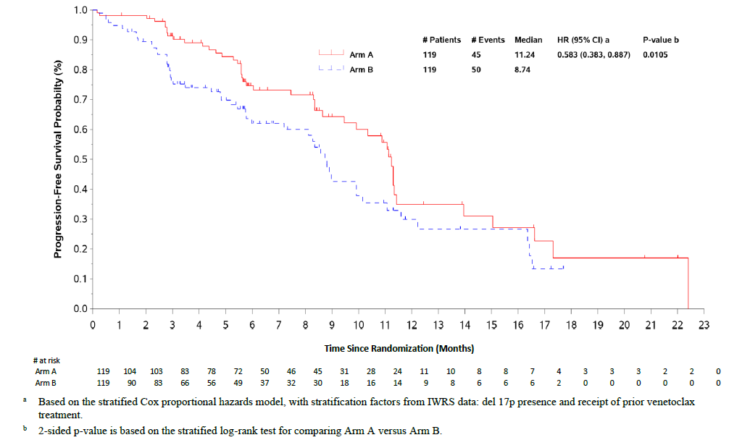
Sensitivity analyses of IRC assessed PFS were consistent with primary efficacy results.

Results for key secondary endpoints

Overall survival
At the time of data cutoff for original clinical study report, overall survival (OS) data were immature, though no OS detriment for pirtobrutinib was observed [16.8% (20 out of 119) versus 18.5% (22 out of 119); HR = 0.869, 95% CI 0.473, 1.596, p = 0.649). The OS rate at 9 months was 83.9% and 83.2% in treatment arms A and B, respectively. In the sensitivity analysis, 5 patients with deaths after crossover from Arm B were censored, resulting in 20 (16.8%) patient deaths that occurred in Arm A, and 17 (14.3%) patient deaths that occurred in Arm B (HR was 0.895 (95% CI: 0.464, 1.724)) and these results were consistent with the primary OS analysis.

Investigator assessed progression free survival
Investigator assessed PFS showed improvement for pirtobrutinib monotherapy compared to Arm B (HR = 0.467; 95% CI: 0.303, 0.721) with results consistent with IRC assessed PFS discussed above. The concordance rate between IRC and investigator assessed PD was similar in the pirtobrutinib (86.6% (95% CI: 79.1, 92.1)) and IdelaR or BendaR (89.9% (95% CI: 83.0, 94.7)) groups.

Overall response rate
Independent review committee (IRC) assessed ORR was comparable between pirtobrutinib (Arm A) and IdelaR or BendaR (Arm B) groups (31.1% versus 29.4%). The incidence of complete response (CR) was lower in the pirtobrutinib compared to the IdelaR or BendaR treatment arm (1.7% versus 4.2%) while that of partial response (PR) (28.6% versus 25.2%), partial response with lymphocytosis (PR-L) (7.6% vs 0.8%), and standard deviation (SD) (40.3% versus 29.4%) was higher in the pirtobrutinib arm.

Duration of response
At the time of data cutoff, the HR comparing IRC assessed duration of response (DOR) of PR or better between Arm A and Arm B was 0.909 (95% CI: 0.379, 2.176), and the CI includes unity (median DOR at time of data cutoff was 8.57 and 9.43 months in arms A and B, respectively). For IRC assessed DOR of PR-L or better, the HR comparing Arm A and Arm B is 0.640 (95% CI: 0.277, 1.482) (median DOR was 11.07 and 9.43 months, respectively).
Similar results were observed for HR comparing investigator assessed DOR of PR or better between arms (0.531 (95% CI: 0.251, 1.125); median DOR was 11.07 versus 8.64 months) and investigator assessed DOR of PR-L or better (0.625 (95% CI: 0.303, 1.290); median DOR was 11.07 versus 11.07 months).

Event free survival
The event free survival (EFS) results based on Investigator assessments showed improvement for pirtobrutinib monotherapy compared to Arm B (HR = 0.398; 95% CI: 0.265, 0.599). The median EFS by investigator assessment was 11.40 and 7.26 months for Arm A and B, respectively; median EFS follow-up time was 8.28 and 8.34 months, respectively. The EFS rates were higher in the pirtobrutinib versus IdelaR or BendaR group at 6 months (73.5% versus 52.8%) and at 9 months (65.5% versus 37.8%).

Time to next treatment
The time to next treatment (TTNT) results based on investigator assessments showed improvement for pirtobrutinib monotherapy compared to Arm B (HR = 0.402; 95% CI: 0.251, 0.645; p = <0.001). Median TTNT was not reached for Arm A, and it was 10.64 months for Arm B. Subsequent anticancer therapy was received by 11 (9.2%) patients in Arm A and by 9 (7.6%) patients in Arm B (not including therapy after crossover in this study). Subsequent therapy of pirtobrutinib after crossover was received by 29 (24.4%) patients in Arm B who had previously received IdelaR or BendaR. The proportion of patients remaining free of next treatment was numerically higher for pirtobrutinib versus IdelaR or BendaR group beginning at 3 months (95.5% versus 84.3%) and continuing through 18 months (54.6% versus 29.6%).

Results from the updated clinical study report addendum
The clinical study report addendum presented follow-up efficacy and safety analyses, and a prespecified final OS analysis, at a time point that is 12 months after the database cutoff for the primary analysis. Data cutoff of 29 August 2024.

Progression free survival
Longer follow-up from the primary analysis (median follow-up time was 19.35 and 17.74 months in Arms A and B, respectively) allowed the PFS data to further mature and pirtobrutinib monotherapy continued to show a clinically meaningful benefit in IRC assessed PFS compared to Arm B (IdelaR or BendaR) with a HR of 0.536 (95% CI: 0.385, 0.746; p = 0.0002). Estimated PFS rates were consistently higher in the pirtobrutinib treatment arm at all time points up to 24 months.
Table 7: Study 20020 clinical study report addendum progressions free survival based on independent review committee assessments, intention to treat population
 | Arm A (n = 119) | Arm B (n = 119)
Number of Events, n (%) | 74 (62.2) | 79 (66.4)
PFS (months)
Median (95% CI) | 13.96 (11.24, 16.56) | 8.74 (8.08, 10.38)
HR (95%CI) | 0.536 (0.385, 0.746)
p-value | p = 0.0002ª
PFS follow-up time (months)
Median (95% CI) | 19.35 (16.66, 22.14) | 17.74 (13.93, 22.90)
Abbreviations: CI = confidence interval, HR = hazard ratio, ITT = intent-to-treat, n = number of patients, PFS = progression free survival.
^{*a} This analysis was descriptive and not alpha-controlled for statistical testing. P-value is 2-sided based on stratified log-rank test.
The median PFS was 13.96 months (95% CI: 11.24, 16.56) and 8.74 months (95% CI: 8.08, 10.38) in Arms A and B, respectively.
Figure 5: Kaplan-Meier plot of progression free survival based on independent review committee assessments, intention to treat population
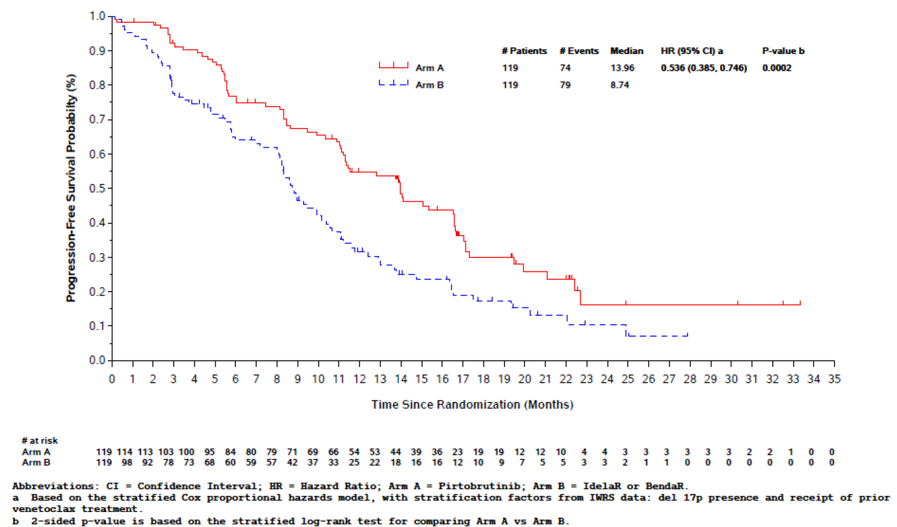

Overall survival
The prespecified final analysis occurred with the preplanned 70 OS events following the longer follow-up. Median OS was 29.67 months (95% CI: 27.10, not estimable (NE)) in Arm A and was not reached in Arm B (95% CI: 28.88, NE). The HR for OS was 1.090 (95% CI: 0.679, 1.749) with interpretation limited by wide CIs and overlapping KM curves for pirtobrutinib monotherapy (Arm A) compared to investigator’s choice of IdelaR or BendaR (Arm B) at the prespecified final OS analysis. At the final OS analysis, the 18-month OS rate was 73.4% (95% CI: 63.9, 80.7) and 70.8% (95% CI: 60.9, 78.7) in Arms A and B, respectively.
Interpretation of results for OS was confounded by crossover of eligible patients from Arm B (IdelaR or BendaR) to receive pirtobrutinib monotherapy. The crossover rate was 75.8% as 50 of the 66 patients with investigator assessed PD in Arm B crossed over to pirtobrutinib treatment. Three commonly used OS sensitivity analyses in the oncology setting were performed to evaluate the effect of crossover on the OS analysis. The pre-specified sensitivity analysis of OS that censored patients at the time of crossover resulted in an HR of 0.986 (95% CI: 0.570, 1.706).

Objective response rate
The IRC assessed ORR of PR or better was greater following pirtobrutinib monotherapy (Arm A versus Arm B: 48.7% (95% CI: 39.47, 58.07) versus 38.7% (95% CI: 29.87, 48.02); p = 0.110). Similar results were observed for ORR of PR-L or better (52.9% versus 39.5%, p = 0.0341). The incidence of CR was lower in the pirtobrutinib compared to the IdelaR or BendaR group (1.7% (2 out of 119) versus 4.2% (5 out of 119)); incidence of PR (47.1% versus 34.5%) and SD (34.5% versus 26.9%) was higher in the pirtobrutinib group.
Investigator assessed ORR of PR or better showed significantly greater improvement in the pirtobrutinib compared to the IdelaR or BendaR group (66.4% versus 48.7%, p = 0.0062) with similar results observed for ORR including PR-L or better (68.9% versus 49.6%, p = 0.0025). Investigator based assessment led to equal number of CRs in both groups (6 subjects (5%) each), higher incidence of PR (59.7% versus 42%) and lower incidence of SD (15.1% versus 13.4%) compared to the IRC assessed ORR.

Study LOXO-BTK-18001
This is a Phase I/II open label, multicentre study of oral pirtobrutinib to evaluate safety and efficacy in patients with CLL/SLL or NHL who have failed or were intolerant to standard of care. This study includes two portions: pirtobrutinib monotherapy and combination therapy.
The monotherapy portion includes a Phase I dose escalation and dose expansion, as well as Phase II. The combination therapy Phase Ib portion is a safety assessment and expansion of pirtobrutinib in combination with venetoclax with or without anti-CD20 therapy (rituximab).
Figure 6: Study LOXO-BTK-18001 schematic
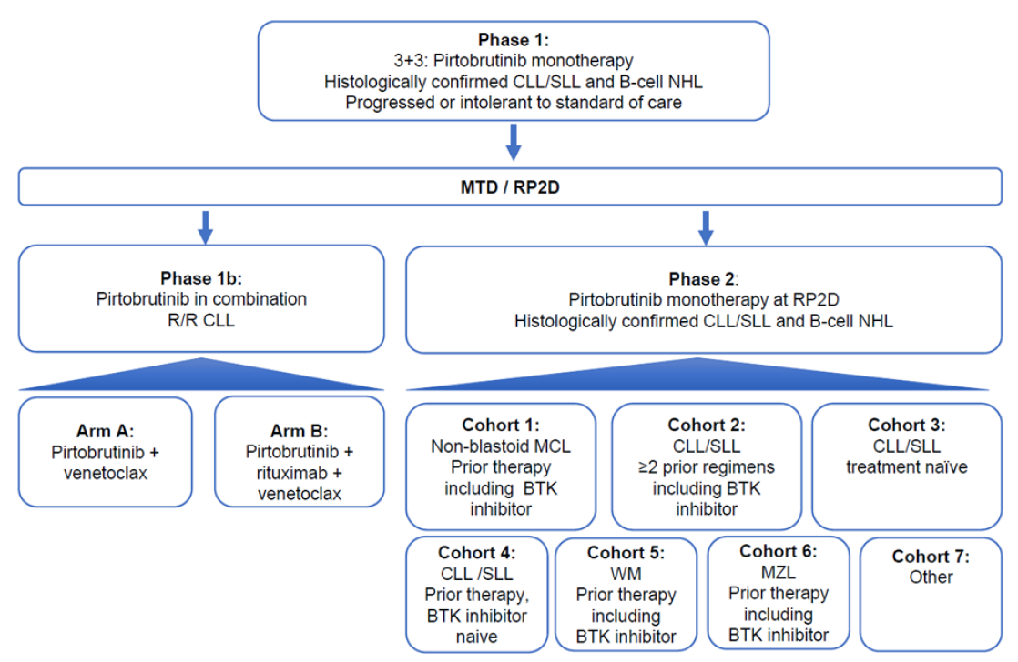
Supportive evidence in this submission was provided by results from the Phase I/II Study LOXO-BTK-18001 (Study 18001), where pirtobrutinib demonstrated a manageable safety profile and durable antitumor activity against a variety of B-cell malignancies, including CLL/SLL, regardless of prior treatment, and including in patients previously treated with covalent BTK inhibitors. A total of 263 patients with CLL/SLL in Cohort 2 and 19 patients with CLL/SLL in Cohort 7 treated with pirtobrutinib 200 mg once daily monotherapy are relevant to the current submission. In these cohorts, treatment with pirtobrutinib demonstrated clinically meaningful and durable evidence of efficacy in terms of:
- ORR of PR or better: 63 to 68%; ORR including PR-L: 68 to 75%.
- DOR: median of about 18 months; by KM analysis, an estimated 69.4%, 58.3% and 51.5% were maintaining response at 12, 15, and 18 months, respectively.
- PFS: median of 19.4 months; the probability of being progression free was 68.9%, 52.4% and 37.0% at 12, 18, and 24 months, respectively.
- OS: the median OS was not reached with 79 (30.0%) deaths observed in 263 patients after a median follow-up of 27.40 months. The KM estimate for OS rate was 84.9%, 78.7% and 72.8% at 12, 18, and 24 months, respectively.

Safety
The main studies providing evidence for safety of pirtobrutinib in the proposed indication are outlined in Table 8 below.
Table 8: Analysis population for safety assessment
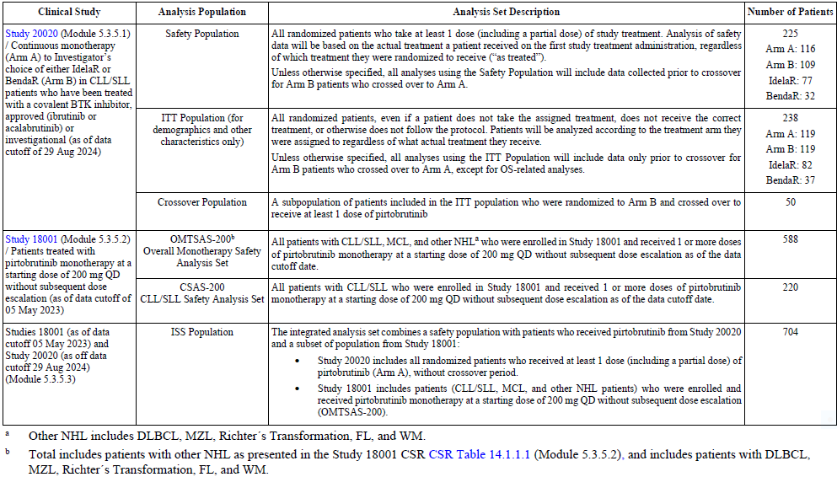
The main evidence for safety of pirtobrutinib in proposed indication was provided by the pivotal Phase III, global, randomised, open label study conducted in 238 adult patients with CLL/SLL previously treated with any BTK inhibitor who had an indication for treatment as defined by iwCLL 2018 criteria,9 including those who discontinued prior covalent BTK therapy due to PD or intolerance. The initial clinical study report with data cutoff date of 29 August 2023 provided the safety data for primary analysis and the updated safety data (data cutoff of 29 August 2024) provided 12 months of additional follow-up for 116 patients treated with pirtobrutinib.
Overall, pirtobrutinib monotherapy demonstrated a favourable safety profile as compared to IdelaR or BendaR. Patients treated with pirtobrutinib (versus IdelaR or BendaR) experienced fewer Grade 3 or 4 adverse events (AEs) (38.8% versus 54.1%), treatment discontinuations due to AEs (10.3% versus 23.9%), and serious adverse events (SAEs) (31.0% versus 35.8%).
The most common AEs (occurring in ≥ 15% of patients) in the pirtobrutinib treatment arm were pneumonia, anaemia, neutropenia, cough and diarrhoea. The most common AEs (occurring in ≥ 15% of patients) in Arm B in patients treated with IdelaR were diarrhoea, cough, pyrexia, COVID-19, fatigue, nausea, alanine aminotransferase (ALT) increased, aspartate aminotransferase increased, headache, vomiting, weight decreased, pneumonia and neutropenia. The most common AEs (occurring in ≥ 15% of patients) in Arm B in patients treated with BendaR were anaemia, neutropenia, nausea, neutrophil count decreased, vomiting, weight decreased, infusion-related reaction.
The incidence of pneumonia was higher in the pirtobrutinib arm compared to the IdelaR or BendaR treatment arm in the original and the updated clinical study report: pneumonia: any grade (22.4% versus 11.9%); Grade 3/4 (15.5% versus 8.3%); Grade 5 (1.7% versus 2.8%). Incidence of upper respiratory tract infection was also slightly higher in the pirtobrutinib arm: any grade (10.3% versus 6.4%); Grade 3/4 (0.9% versus 0%). Other common treatment emergent adverse events (TEAEs) were reported at a higher incidence in the IdelaR or BendaR treatment arm (Arm A versus B): pyrexia (12.9% versus 26.6%), fatigue (11.2% versus 20.2%), diarrhoea (16.4% versus 31.2%), nausea (11.2% versus 20.2%), vomiting (6.9% versus 17.4%), neutrophil count decreased (7.8% versus 17.4%) and infusion-related reaction (0% versus 17.4%).
Overall incidence of TEAEs of Grade 3/4 severity was lower in the pirtobrutinib arm versus IdelaR or BendaR treatment arm (Arm A versus B: 47.4% versus 67.2%); however, it was noted that incidence was higher in the pirtobrutinib arm for Grade 3/4 TEAEs of pneumonia (15.5% versus 8.3%), anaemia (11.2% versus 7.3%) and neutropenia (14.7% versus 11.9%).
Of the most common treatment-related AEs, patients treated with pirtobrutinib reported higher incidence of pneumonia (Arm A versus B: any Grade = 6.9% versus 2.8%; Grade 3/4: 5.2% versus 2.8%) and neutropenia (any Grade = 12.9% versus 8.3%; Grade 3/4: 9.5% versus 7.3%) in both the original and updated clinical study report diarrhoea, anaemia and fatigue were more common in the IdelaR or BendaR treatment arm.
Deaths due to AEs (Arm A versus B) were reported in 9 (7.8%) versus 7 (6.4%) patients. There were no deaths during treatment with pirtobrutinib. The majority of deaths due to AEs were under the system organ class of infections and infestations (11 of 15) and were predominantly associated with COVID-19 (7 of 11). None of the deaths were considered related to pirtobrutinib by the investigator. Serious AEs were reported at similar frequencies in both treatment arms (Arm A versus B: 47.4% versus46.8%). However, incidence of SAE of pneumonia was slightly higher in the pirtobrutinib group (15.5% versus 11%) while that of COVID-19 was slightly higher in the IdelaR or BendaR group (1.7% versus 4.6%); most of the other SAEs occurred at similar rate in both treatment arms.
Adverse events that led to permanent discontinuation of study drug were reported at lower frequency in the pirtobrutinib treatment arm (Arm A versus B): any grade (17.2% versus 34.9%; treatment-related: 5.2% versus 21.1%) and Grade 3/4 (6.9% versus 20.2%; treatment-related: 3.4% versus 13.8%). In Arm B, discontinuations due to AEs occurred more frequently in patients treated with IdelaR (45.0%) than with BendaR. The most common AEs (in ≥ 1% of patients) that led to discontinuation of study drug in the pirtobrutinib arm were infections including COVID-19 and COVID-19 pneumonia whereas those in Arm B were COVID-19, pneumonia, ALT increased, diarrhoea, hypercalcemia, and rash. Dose reductions due to AEs occurred in fewer patients in the pirtobrutinib treatment arm (A versus B: 9.5% versus 27.5% treatment-related: 4.3% versus 18.3%) and in more Arm B patients receiving IdelaR (22 (28.6%)) than BendaR (4 (12.5%)). The most common AE leading to dose reductions in the pirtobrutinib treatment arm was neutropenia.
Overall, the proportion of patients reporting greater adverse events of potential clinical significance of any grade was similar in the two treatment arms (A versus B: 33.6% versus 31.2%; Grade 3/4: 11.2% versus 10.1%). Second primary malignancy was reported for 8 (6.9%) patients in Arm A and 2 (1.8%) patients in Arm B. Of these, 4 patients (3.4%) in Arm A had 5 events of nonmelanoma skin cancer and one patient in Arm B had one event of nonmelanoma skin cancer (squamous cell carcinoma). Majority of these events in Arm A were Grade 1 or 2 (6 patients (5.1%)).

Risk management plan
Eli Lilly Australia Pty Ltd has submitted European Union (EU) risk management plan (RMP) version 3.1 (date 19 November 2024; data lock point (DLP) 29 August 2023) and Australia-specific annex (ASA) version 1.0 (date 13 February 2025) in support of this application.
The summary of safety concerns and their associated risk monitoring and mitigation strategies are summarised in Table 9. The TGA may request an updated RMP at any stage of a product's life cycle, during both the pre-approval and post-approval phases.
Table 9: Summary of safety concerns
Summary of safety concerns |  | Pharmacovigilance |  |  | Risk Minimisation
 |  | Routine | Additional | Routine |  | Additional
Important identified risks | Serious haemorrhage |  | – |  |  | –
Important identified risks | Serious infections |  | – |  |  | –
Important identified risks | Atrial fibrillation and atrial flutter |  | – |  |  | –
Important potential risks | Second primary malignancies other than non-melanoma skin cancer |  | * |  |  | –
Important potential risks | Second primary non-melanoma skin cancer |  | * |  |  | –
Missing information | None | – | – | – |  | –
*Integrated analysis of 5 years clinical trials follow up supplemented with post market reports
The summary of safety concerns in the ASA aligns with the approved EU-RMP and generally includes important class risks of BTK inhibitors. The summary of safety concerns is acceptable from an RMP perspective.
Routine pharmacovigilance is proposed for all safety concerns. Additional pharmacovigilance is proposed for the important potential risks, in the form of an integrated safety analysis of clinical trial data supplemented with post market reports. The pharmacovigilance plan in the ASA aligns with the EU-RMP and is acceptable.
Routine risk minimisation is proposed for all safety concerns. Additional risk minimisation activities are not proposed. This aligns with the EU-RMP and with the risk minimisation plans of other BTK inhibitors and is acceptable.
The RMP evaluation recommended conditions of registration relating to the versions of the risk management plan, requirement for periodic safety update reports, and inclusion of the medicine in the Black Triangle Scheme.

Risk-benefit analysis

Delegate’s considerations

Quality
The quality evaluation has confirmed that approval for registration of the proposed product can be recommended from a pharmaceutical chemistry perspective.

Efficacy
There were 13 pharmacokinetic-pharmacodynamic studies, popPK analysis, and ER analysis, which offered a thorough assessment of the clinical pharmacology of pirtobrutinib for the proposed indication.
Pirtobrutinib is a reversible, noncovalent inhibitor of BTK. BTK is a signalling protein of the B-cell antigen receptor (BCR) and cytokine receptor pathways. In B-cells, BTK signalling results in activation of pathways necessary for B-cell proliferation, trafficking, chemotaxis, and adhesion. Pirtobrutinib binds to wild type BTK as well as BTK harbouring C481 mutations leading to inhibition of BTK kinase activity.
Pirtobrutinib exposure did not adversely affect safety parameters (neutrophil count, platelet count, haemoglobin levels, systolic blood pressure, and diastolic blood pressure) across the range of exposures observed in the pivotal Phase III study involving CLL/SLL patients at the proposed initial dose of 200 mg once daily.
The 200 mg once daily dose (administered orally with or without food) chosen for the pivotal Phase III Study 20020 was supported by findings from the Phase I/II Study 18001.
Efficacy was assessed in Study 20020, a randomised, open label, active controlled trial. The trial enrolled 238 patients previously treated for CLL/SLL, including those who received a covalent BTK inhibitor. Patients were randomised in a 1:1 ratio to receive either pirtobrutinib or the investigator's choice of idelalisib combined with a rituximab product (IdelaR) or bendamustine combined with a rituximab product (BendaR). Crossover to Jaypirca monotherapy was permitted for patients in the investigator's choice arm upon confirmed disease progression.
The primary efficacy outcome was progression free survival (PFS), evaluated by an independent review committee (IRC) in accordance with the 2018 iwCLL criteria. Median PFS was 11.2 months (95% CI: 9.5, 11.4) in the pirtobrutinib arm and 8.7 months (95% CI: 7.2, 10.2) in the investigator’s choice of IdelaR/BendaR arm (HR 0.58 (95% CI: 0.38, 0.89); p-value 0.0105). Of the 119 patients in the investigator’s choice arm, 50 crossed over to receive Jaypirca therapy. According to an updated analysis with a median follow-up duration of 19.8 months, the HR for overall survival (OS) was 1.09 (95% CI: 0.68, 1.75).

Safety
In the pivotal Phase III Study 20020 involving 238 adult patients with relapsed/refractory CLL/SLL, those receiving pirtobrutinib experienced a lower incidence of Grade 3 or 4 adverse events (38.8% versus 54.1%), treatment discontinuations due to adverse events (10.3% versus 23.9%), and serious adverse events (31.0% versus 35.8%) compared to the IdelaR or BendaR treatment arm.
The product information (PI) includes special warnings and precautions for infections, haemorrhage, cytopenias, atrial fibrillation/flutter, secondary primary malignancies, and tumour lysis syndrome to help mitigate the main safety concerns and risks associated with pirtobrutinib monotherapy in the proposed indication.

Proposed action
Overall, based on the review of data on quality, safety and efficacy, the Delegate considers that the benefit-risk balance of Jaypirca (pirtobrutinib) is favourable in the following indication:
Jaypirca as monotherapy is indicated for the treatment of adult patients with relapsed or refractory chronic lymphocytic leukemia/small lymphocytic lymphoma (CLL/SLL) who have been previously treated with a covalent BTK inhibitor.

Assessment outcome
Based on a review of quality, safety, and efficacy, the TGA decided to register Jaypirca (pirtobrutinib) 50 mg and 100 mg, film coated tablet, blister pack, indicated for:
Jaypirca as monotherapy is indicated for the treatment of adult patients with relapsed or refractory chronic lymphocytic leukemia/small lymphocytic lymphoma (CLL/SLL) who have been previously treated with a covalent Bruton's tyrosine kinase (BTK) inhibitor.

Specific conditions of registration
- Jaypirca (pirtobrutinib) is to be included in the Black Triangle Scheme. The PI and CMI for Jaypirca must include the black triangle symbol and mandatory accompanying text for five years, which starts from the date of first supply of the product.
- The Jaypirca EU-Risk Management Plan (RMP) (version 3.1, dated 19 November 2024, data lock point 29 August 2023), with Australia specific annex (version 1.0, dated 13 February 2025), included with submission PM-2025-00498-1-4, and any subsequent revisions, as agreed with the TGA will be implemented in Australia.
- An obligatory component of risk management plans is routine pharmacovigilance. Routine pharmacovigilance includes the submission of periodic safety update reports (PSURs).
Reports are to be provided in line with the current published list of EU reference dates and frequency of submission of PSURs until the period covered by such reports is not less than three years from the date of the approval letter. Each report must be submitted within ninety calendar days of the data lock point for that report.
- The reports are to at least meet the requirements for PSURs as described in the European Medicines Agency’s Guideline on good pharmacovigilance practices (GVP) Module VII-periodic safety update report (Rev 1), Part VII.B Structures and processes. Note that submission of a PSUR does not constitute an application to vary the registration.
- An empirical assessment of the clastogenic potential of the two specified impurities (LSN3849804 and LSN3849825), in the drug product, should be provided to the TGA in a subsequent filing submitted no later than two years from the approval letter.

Product Information and Consumer Medicine Information
For the most recent Product Information (PI) and Consumer Medicine Information (CMI), please refer to the TGA PI/CMI search facility.

Therapeutic Goods Administration
PO Box 100 Woden ACT 2606 Australia
Email: info@tga.gov.au Phone: 1800 020 653 Fax: 02 6203 1605
https://www.tga.gov.au

This is the original indication proposed by the sponsor when the TGA commenced the evaluation of this submission. It may differ to the final indication approved by the TGA and registered in the Australian Register of Therapeutic Goods.
Alaggio, R., et al., The 5th edition of the World Health Organization Classification of Haematolymphoid Tumours: Lymphoid Neoplasms. Leukemia. 2022 Jul;36(7):1720-1748. doi: 10.1038/s41375-022-01620-2.
Chronic lymphocytic leukaemia (CLL) information booklet, Leukaemia Foundation, 27 August 2025, available from: Chronic lymphocytic leukaemia (CLL) information booklet
International CLL-IPI Working Group. An international prognostic index for patients with chronic lymphocytic leukaemia (CLL-IPI): a meta-analysis of individual patient data. The Lancet Oncology. 2016 Jun 1;17(6):779-90.
Skånland SS, Okkenhaug K, Davids MS. PI3K inhibitors in hematology: When one door closes. Clinical Cancer Research. 2024 Sep 3;30(17):3667-75.
Eichhorst B., et al., ESMO Clinical Practice Guideline interim update on new targeted therapies in the first line and at relapse of chronic lymphocytic leukaemia, Annals of Oncology, 2024; 35:9, 762-768. doi.org/10.1016/j.annonc.2024.06.016.
FDA. Guidance for industry: population pharmacokinetics. 2022. Available from: https://www.fda.gov/regulatory-information/search-fda-guidance-documents/populationpharmacokinetics [accessed 03 February 2022].
EMA. Committee for Medicinal Products for Human Use (CHMP). Guideline on reporting the results of population pharmacokinetic analyses, Doc. Ref. CHMP/EWP/185990/06, London, 21 June 2007: Available from: http://www.ema.europa.eu/docs/en_GB/document_library/Scientific_guideline/2009/09/WC500003067.pdf
Hallek M., et al., iwCLL guidelines for diagnosis, indications for treatment, response assessment, and supportive management of CLL. Blood. 2018 Jun 21;131(25):2745-2760. doi: 10.1182/blood-2017-09-806398.
Major bleeding is defined as bleeding having one or more of the following features: life-threatening bleeding with signs or symptoms of hemodynamic compromise; bleeding associated with a decrease in the haemoglobin level of at least 2 g/dL; or bleeding in a critical area or organ (for example, retroperitoneal, intraarticular, pericardial, epidural, or intracranial bleeding or intramuscular bleeding with compartment syndrome).

