Australian Public Assessment Report for Hibruka
  - Active ingredient: Orelabrutinib
  - Sponsor: Innocare Pharma Australia Pty Ltd
October 2026

About the Therapeutic Goods Administration (TGA)
- The Therapeutic Goods Administration (TGA) is part of the Australian Government Department of Health, Disability and Ageing and is responsible for regulating therapeutic goods, including medicines, medical devices, and biologicals.
- The TGA administers the Therapeutic Goods Act 1989 (the Act), applying a risk management approach designed to ensure therapeutic goods supplied in Australia meet acceptable standards of quality, safety, and efficacy.
- The work of the TGA is based on applying scientific and clinical expertise to decision-making, to ensure that the benefits to the Australian public outweigh any risks associated with the use of therapeutic goods.
- The TGA relies on the public, healthcare professionals and industry to report problems with therapeutic goods. The TGA investigates reports received to determine any necessary regulatory action.
- To report a problem with a therapeutic good, please see the information on the TGA website.

About AusPARs
- The Australian Public Assessment Report (AusPAR) provides information about the evaluation of a prescription medicine and the considerations that led the TGA to approve or not approve a prescription medicine submission. Further information can be found in Australian Public Assessment Report (AusPAR) guidance.
- AusPARs are prepared and published by the TGA.
- AusPARs are static documents that provide information that relates to a submission at a particular point in time. The publication of an AusPAR is an important part of the transparency of the TGA’s decision-making process.
- A new AusPAR may be provided to reflect changes to indications or major variations to a prescription medicine subject to evaluation by the TGA.

Copyright
© Commonwealth of Australia 2026
This work is copyright. You may reproduce the whole or part of this work in unaltered form for your own personal use or, if you are part of an organisation, for internal use within your organisation, but only if you or your organisation do not use the reproduction for any commercial purpose and retain this copyright notice and all disclaimer notices as part of that reproduction. Apart from rights to use as permitted by the Copyright Act 1968 or allowed by this copyright notice, all other rights are reserved and you are not allowed to reproduce the whole or any part of this work in any way (electronic or otherwise) without first being given specific written permission from the Commonwealth to do so. Requests and inquiries concerning reproduction and rights are to be sent to the TGA Copyright Officer, Therapeutic Goods Administration, PO Box 100, Woden ACT 2606 or emailed to <tga.copyright@tga.gov.au>.

Contents
List of abbreviations 4
Product submission 8
Submission details 8
Product background 9
Disease or condition – Mantle cell lymphoma 9
Current treatment options 9
Clinical rationale 10
Regulatory status 10
Australian regulatory status at the time of this assessment 10
International regulatory status at the time of this assessment 10
Registration timeline 11
Assessment overview 12
Quality evaluation summary 12
Nonclinical evaluation summary 13
Clinical evaluation summary 14
Summary of clinical studies 14
Clinical pharmacology 15
Efficacy 19
Safety 37
Risk management plan 49
Risk-benefit analysis 49
Delegate’s considerations 49
Proposed action 53
Independent expert advice 53
Advisory Committee considerations 53
Assessment outcome 53
Specific conditions of registration 54
Product Information and Consumer Medicine Information 54

List of abbreviations
Abbreviation | Meaning
1L | First line
2L | Second line
3L | Third line
ADME | Absorption Distribution Metabolism Elimination
ADA | Anti-Drug Antibody
AE | Adverse Event
AESI | Adverse Event of Special Interest
ALT | Alanine aminotransferase
alloHSCT | Allogenic Haematopoietic Stem Cell Transplant
ANC | Absolute Neutrophil Count
ARTG | Australian Register of Therapeutic Goods
AST | Aspartate aminotransferase
ASTCT | American Society for Transplantation and Cellular Therapy
AUC | Area Under the Concentration-Time Curve
autoHSCT | Autologous Haematopoietic Stem Cell Transplant
BD or BID | Twice daily
BMX | Bone Marrow Expressed Kinase
BR | Bendamustine + Rituximab
BTK | Bruton's Tyrosine Kinase
BTKi | Bruton's Tyrosine Kinase Inhibitors
CAR-T | Chimeric Antigen Receptor T-cell
CI | Confidence Interval
CLL | Chronic Lymphocytic Leukaemia
CMI | Consumer Medicine Information
CMR | Complete Metabolic Response
CNS | Central Nervous System
CR | Complete Response
CrCL | Creatinine Clearance
CRF | Case Report Form
CRO | Contract Research Organisation
CRP | C-Reactive Protein
CT | Computed Tomography
ctDNA | Circulating Tumour DNA
DOCR | Duration of Complete Response
DOOR | Duration of Objective Response
DDI | Drug-Drug Interaction
DOR | Duration of Objective Response
ECG | Electrocardiogram
ECOG | Eastern Cooperative Oncology Group
EGFR | Endothelial Growth Factor Receptor
EPO | Erythropoietin
Fab | Fragment antigen-binding antibody
FDA | Federal Drugs Administration
FDG-PET | 18F-fluorodeoxyglucose positron emission tomography
FISH | Fluorescence in situ hybridisation
G-CSF | Granulocyte colony stimulating factor support
GCP | Good clinical practice
GGT | Gammaglutamyltransferase
GORD | Gastroesophageal reflux disease
HBV | Hepatitis B virus
HbcAb | Hepatitis B core antibody
HbsAg | Hepatitis B surface antigen
HCV | Hepatitis C virus
HIV | Human immunodeficiency virus
HRQoL | Health related quality of life
HSCT | Haemopoietic stem cell transplant
IHC | Immunohistochemistry
IMP | Investigational medical products
INR | International normalised ratio
IP | Investigational product
IPI | International Prognostic Index
iPET | Interim PET
IRC | Independent Review Committee
IRR | Infusion related reaction
IT | Intrathecal
ITT | Intent to treat
IV | Intravenous
IxRS | Interactive voice or Web-based response system
LDH | Lactate dehydrogenase
mAb | Monoclonal antibody
MCL | Mantle cell lymphoma
MDM | Multidisciplinary meeting
MIPI-c | combined MCL Internation Prognostic index
MZL | Marginal zone lymphoma
NA | Not assessed or not applicable
NALT | Next anti-lymphoma therapy
NCI CTCAE | National Cancer Institute Common Toxicity Criteria for Adverse Events
NCCN-IPI | National Comprehensive Cancer Network International Prognostic Index
NHL | Non-Hodgkin Lymphoma
NR | Not reported
OD or QD | Once daily
ORR | Objective response rate
OS | Overall survival
PBAC | Pharmaceutical Benefits Advisory Committee
PBS | Pharmaceutical Benefits Scheme
PD | Pharmacodynamics
PFS | Progression free survival
PI | Product information
PK | Pharmacokinetics
PR | Partial response
PRO | Patient reported outcome
QOL | Quality of life
R | Rituximab
R-CHOP | Rituximab, cyclophosphamide, doxorubicin, vincristine and prednisolone
R/R | Relapsed or refractory
RCT | Randomised controlled trial
RR | Response rate
RT | Radiotherapy
SAE | Serious adverse event
SAP | Statistical analysis plan
SLL | Small lymphocytic lymphoma
SOC | Standard of care
TCR | T cell receptor
TEC | Tyrosine kinase expressed in hepatocellular carcinoma
TGA | Therapeutics Goods Administration
TKI | Tyrosine kinase inhibitor
TLS | Tumour lysis syndrome
Vs | Versus
WHO | World Health Organisation
WM | Waldenström’s Macroglobulinaemia

Product submission

Submission details
Type of submission: | New chemical entity
Product name: | Hibruka orelabrutinib 50 mg tablet bottle
Active ingredient: | Orelabrutinib
Decision: | Approved for provisional registration in the Australian Register of Therapeutic Goods (ARTG)
Date of decision: | 26 May 2026
Date of entry into ARTG: | 3 June 2026
ARTG number: | 481251
Black Triangle Scheme  for the current submission: | Yes
Sponsor’s name and address: | Innocare Pharma Australia Pty Ltd  Suite 1903, 109 Pitt Street, Sydney, NSW, 2000 Australia
Dose form: | Tablets
Strength: | 50 mg
Container: | Bottle
Pack size: | 30 tablets
Approved therapeutic use for the current submission: | Hibruka has provisional approval in Australia for the treatment of adult patients with relapsed or refractory mantle cell lymphoma (MCL). The decision to approve this indication has been made on the basis of overall response rate (ORR).  Continued approval of this indication depends on verification and description of benefit in confirmatory trials.
Route of administration: | Oral
Dosage: | The recommended dose of Hibruka is 150 mg taken orally once daily until disease progression or unacceptable toxicity.  For further information regarding dosage, such as dosage modifications to manage adverse reactions, refer to the Product Information.
Pregnancy category: | Pregnancy Category C  Drugs which have caused, are suspected to have caused or may be expected to cause, an increased incidence of human fetal malformations or irreversible damage. These drugs may also have adverse pharmacological effects. Accompanying texts should be consulted for further details.  The use of any medicine during pregnancy requires careful consideration of both risks and benefits by the treating health professional. The pregnancy database must not be used as the sole basis of decision making in the use of medicines during pregnancy. The TGA does not provide advice on the use of medicines in pregnancy for specific cases. More information is available from obstetric drug information services in your state or territory.

Product background
This AusPAR describes the submission by Innocare Pharma Australia Pty Ltd (the sponsor) to provisionally register Hibruka (orelabrutinib) 50 mg tablet bottle for the following proposed indication:
Hibruka is indicated for the treatment of adult patients with mantle cell lymphoma (MCL) who have received at least one prior therapy.
Following the clinical evaluation, the sponsor amended the wording of the proposed indication to the following:
Hibruka is indicated for the treatment of adult patients with mantle cell lymphoma who had no response or demonstrated progressive disease to at least one prior therapy. This indication is approved via the provisional pathway, based on ORR. Full registration for this product for this indication depends on verification and description of clinical benefit in confirmatory trials.

Disease or condition – Mantle cell lymphoma
Mantle cell lymphoma (MCL) is a rare and aggressive subtype of B-cell non-Hodgkin lymphoma and is a life-threatening illness with an overall poor prognosis.

Current treatment options
Current therapeutic options for patients with relapsed or refractory disease consists of a BTK inhibitor (if not previously received in upfront setting):
- Ibrutinib, a first generation BTK inhibitor, has been TGA approved for use in patients with MCL who have received at least one prior therapy.
- Acalabrutinib is provisionally approved in Australia for the treatment of adult patients with MCL who have received at least one prior therapy.
  - It is noted that in the US, the FDA has now granted conversion from accelerated to traditional approval of Calquence for the treatment of adults with MCL who have received at least one prior therapy. This was based on ACE-LY-308, a phase III, double-blind RCT of BR alone versus BR in combination with acalabrutinib in patients with untreated MCL, which also provided data to support the approval of Calquence for use in combination with BR in patients with previously untreated MCL who are ineligible for autologous HSCT.
- Zanubrutinib is provisionally approved in Australia for the treatment of adult patients with MCL who have received at least one prior therapy.
Effective agents are still needed for the treatment of relapsed or refractory MCL (R/R MCL).

Clinical rationale
MCL is a rare, aggressive type of B-cell non-Hodgkin lymphoma that begins in the lymphatic system. Bruton's tyrosine kinase (BTK) is crucial for the survival and growth of malignant B-cells in MCL (Satterthwaite and Witte, 2000).
Hibruka (orelabrutinib) is a selective BTK inhibitor with an IC50 of 1.6 nM for BTK inhibition. BTK is a signalling molecule of the B cell antigen receptor (BCR) and cytokine receptor pathways. The signalling pathway activated by BCR is necessary for B-cell migration, chemotaxis, and adhesion. Orelabrutinib can inhibit BTK-mediated signalling and subsequent B cell activation and proliferation.

Regulatory status

Australian regulatory status at the time of this assessment
This product is considered a new chemical entity (NCE) for Australian regulatory purposes.
Orelabrutinib was granted orphan and provisional designation by the TGA on 19 December 2024.
For provisional determination, the TGA concluded that the sponsor had provided sufficient evidence of a plan to submit comprehensive clinical data of the medicine (the proposed confirmatory study plan for Study ICP-CL-00128 is summarised in figure 1 below and in figure 9 on page 50).
Figure 1: Study design for Study ICP-CL-00128
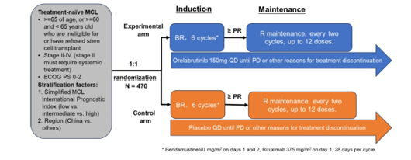
At the time of the TGA’s assessment, Study ICP-CL-00128 had commenced enrolment in China and Clinical Trial Application filings.

International regulatory status at the time of this assessment
At the time the TGA assessed this submission, the international regulatory status of orelabrutinib was as follows (table 1).
Table 1: International regulatory status at the time of this assessment
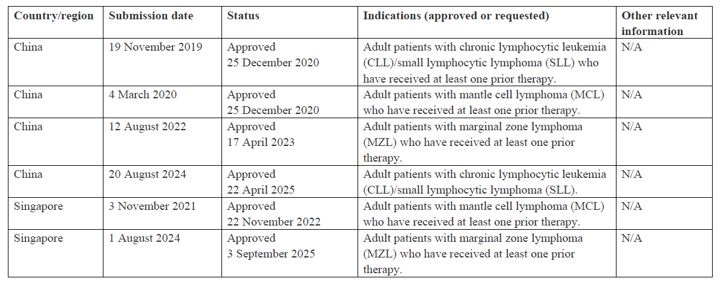
The applicant also stated in their pre-submission presentation that orelabrutinib:
- was conditionally approved in China for R/R MCL in 2020
- received breakthrough therapy designation by the Food and Drug Administration (FDA) in 2021
- received orphan drug designation by the FDA in 2022.

Registration timeline
The following table captures the key steps and dates for this submission. This submission was evaluated under the provisional registration process.
Table 2: Registration timeline for Submission PM-2025-00463-1-4
Description | Date
Designation (Orphan) | 19 December 2024
Determination (Provisional) | 19 December 2024
Submission dossier accepted and first round evaluation commenced | 31 March 2025
Evaluation completed (End of round 2) | 14 November 2025
Advisory committee meeting | April 2026
Registration decision (Outcome) | 26 May 2026
Registration in the ARTG completed | 3 June 2026
Number of working days from submission dossier acceptance to registration decision* | 172 days
*Statutory timeframe for standard submissions is 255 working days

Assessment overview
A summary of the TGA’s assessment for this submission is provided below.

Quality evaluation summary

Drug substance
Orelabrutinib is a white to off-white crystalline powder that is manufactured by chemical synthesis. The drug substance is practically insoluble in water.
The proposed specification adequately controls the identity, potency, purity and chemical and physical properties of the drug substance relevant to the dose form.
The impurities are controlled at or under ICH Q3A and therefore are suitably qualified.
The analytical methods used to analyse the product were adequately described and validated.

Drug product
The drug product is white or off-white round uncoated tablets and is packaged in a high-density polyethylene (HDPE) bottle with a polypropylene child resistant closure. A pack size of 30 tablets is described.
The drug product specifications adequately control the quality of the drug product at release and throughout the shelf-life.
The impurities are controlled according to International Council for Harmonisation (ICH) guideline - Impurities in New Drug Products Q3B (R2) and are therefore qualified.
The provided nitrosamine risk assessment has suitably demonstrated there is low risk for nitrosamines in the drug product.
The analytical methods used to analyse the product were adequately described and validated.
The dissolution limits were adequately justified based on the dissolution profiles of the clinical study batches and are discriminatory.

Biopharmaceutics
The drug product formulation used in the Phase 3 clinical studies is the same as the product formulation proposed for registration. No bridging studies were required.

Other information
The Product Information is considered acceptable from a pharmaceutical quality perspective.
The labelling is considered acceptable from a pharmaceutical quality perspective.
The provisional ARTG records are finalised.
The GMP clearances for all manufacturing sites are current at the time of this evaluation.

Recommendation
Approval is recommended from a quality and biopharmaceutic perspective.

Nonclinical evaluation summary
There are no non-clinical objections to the registration of Hibruka for the proposed indication.
The submitted dossier was compliant with the relevant ICH guideline on the development of anti-cancer pharmaceuticals (ICH S9). Consistent with this guideline, no carcinogenicity studies were conducted. The overall quality of the dossier was adequate, with generally all pivotal safety studies conducted in compliance with OECD GLP conditions. The sponsor provided appropriate information on test article characterisation.
In vitro, orelabrutinib irreversibly inhibited the BTK receptor with nanomolar affinity. Orelabrutinib inhibited autophosphorylation of BTK and tumour growth in B-cell lymphoma cell-lines. In vivo, orelabrutinib significantly inhibited tumour growth in mouse models of B-cell malignancies.
Orelabrutinib had no significant interactions for the tested receptors, channels, or 456 kinases in secondary screens.
Safety pharmacology studies assessed effects on cardiovascular, respiratory and central nervous systems. No clinically relevant adverse effects were observed on cardiovascular, respiratory or CNS function in adequately conducted studies.
Orelabrutinib was rapidly absorbed in rats and dogs. Exposures (based on AUC) in female rats were generally higher than their male counterparts. There were no consistent sex differences in in dog and humans. Orelabrutinib was highly bound to plasma protein of rats, dogs and humans. Tissue distribution of orelabrutinib was wide with minimal penetration of blood-brain barrier.
The main human metabolite (M461-3) was detected in both dogs and rats. CYP3A4 was responsible for orelabrutinib metabolism in vitro. Excretion of orelabrutinib and/or its metabolites was predominantly via faeces in rats and humans. Biliary excretion was evident in rats.
In vitro studies indicated that inhibitors/inducers of CYP3A4 may alter orelabrutinib exposures. Orelabrutinib may increase exposure to orally co-administered CYP3A4, CYP2C9, CYP2D6, P-glycoprotein and BCRP substrates by inhibition of intestinal CYP3A4 or systemic CYP2C9 and CYP2D6, P-glycoprotein (P-gp) and intestinal BCRP. Orelabrutinib was a substrate for P-gp.
Orelabrutinib had a low order of acute toxicity in rats and dogs.
Repeat-dose toxicity studies were conducted in rats (up to 6 months) and dogs (up to 9 months) using the proposed clinical route. The studies were adequately conducted. The major target organs for orelabrutinib were the lymphoid tissues (via expected pharmacological action), haematopoietic system, gastrointestinal system, pancreas (in rats only) and thyroid (in rats only) and liver (in rats only). The effects in the pancreas, thyroid and liver are not considered clinically relevant. Lymphoid depletion, effects on haematopoietic system and gastrointestinal system are expected in patients.
Orelabrutinib was not mutagenic in an Ames test and was not clastogenic in in vitro (in Chinese hamster ovary cells) or in in vivo rat micronucleus test in a set of adequately conducted studies. No carcinogenicity studies were conducted, which is considered acceptable.
Reproductive toxicity studies examined effects on fertility (rats), embryofetal development (rats and rabbits) and pre-/postnatal development (rats). Male and female fertility were unaffected in rats. No treatment-related increase in malformations or embryofetal lethality was observed in rats or rabbits. Orelabrutinib was excreted into milk in rats, with levels lower than maternal plasma levels. Plasma levels of orelabrutinib in pups were low, with no adverse effects on pup development.
Orelabrutinib was not expected to be phototoxic.
Specified limits for impurities in the drug substance and drug product are toxicologically acceptable.

Conclusions and recommendation
No major deficiencies were identified from a nonclinical perspective.
The primary pharmacology studies lend some support for the proposed indication. However, in the absence of exposure data in disease-related in vivo models, efficacy for the proposed indication at expected clinical exposures following maximum recommended human dose (MRHD) will rely solely on clinical data.
Studies in animals revealed the following findings of potential clinical relevance:
- diminished immune reactions (lymphoid depletion)
- haematological changes
- gastrointestinal effects (emesis).
While no malformations or other adverse effects on embryofetal development were observed in studies performed in rats and rabbits, concern for potential harm with use in pregnancy is held for orelabrutinib based on its pharmacological activity, namely the potential for long-lasting immunosuppression in the offspring through B-cell depletion. As such, assignment to Pregnancy Category C is warranted (not Category B1 as proposed by the sponsor).
There are no nonclinical objections to the registration of Hibruka for the proposed indication.

Clinical evaluation summary

Summary of clinical studies
The clinical dossier documented a full clinical development program of pharmacology, efficacy and safety studies.
Detailed clinical study reports (CSRs) included were as follows.
- Pivotal Phase 1/2 study (ICP-CL-00102, China only). This was a multicenter, open-label clinical study to evaluate the safety and efficacy of ICP-022 in patients with relapsed/refractory mantle cell lymphoma (R/R MCL).
- Main supporting Phase 1/2 study (ICP-CL-00107, non-China). This was a phase 1/2, multicenter, open- label, study of a novel bruton’s tyrosine kinase inhibitor, orelabrutinib, in patients with b-cell malignancies.
- Supporting Phase 2 study (ICP-CL-00127, China, a study supporting the dose schedule in regard to efficacy and toxicity). This was a randomized, open-label, multicenter, Phase 2 Trial evaluating two different doses of orelabrutinib in MCL.
- Studies providing supporting safety data for reference to patient narratives for important safety concerns (ICP-CL-00103, ICP-CL-00104, ICP-CL-00105, ICP-CL-00106, ICP-CL-00111).
Study ICP-CL-00128, a Phase 3 confirmatory trial is currently recruiting so no CSR was provided.
Phase 1 studies providing pharmacokinetic (PK) and pharmacodynamic (PD) data included:
- 3 studies in healthy subjects (ICP-CL-001 (dose-escalation, PK-PD, safety and food effect), ICP-CL-00110 (ADME) and the thorough QT/QTc study (TQT) ICP-CL-00120)
- 2 studies evaluating drug-drug interactions (DDIs): ICP-CL-00117, ICP-CL-00122 and a Physiologically Based Pharmacokinetic (PBPK) report (Incp-1-b)
- one study (ICP-CL-00119) to evaluate PK/ safety in subjects with hepatic impairment
- PK-PD results from the pivotal Phase II Study ICP-CL-00102
- one population PK (PopPK) analysis: Report INNO-PMX-ORELABRUTINIB-35255.

Clinical pharmacology

Pharmacokinetics
The composition of the formulation has remained unchanged over the course of clinical development. It is noted that the 10mg tablet was only used in the Phase I studies in healthy subjects. All other clinical studies used the 50mg tablet, which is intended to be commercially used for the treatment of patients with MCL. Therefore, no clinical bioequivalence studies were deemed necessary. The recommended clinical dose is 150 mg (three 50 mg tablets) once daily.

Pharmacokinetics in healthy subjects
The exposure of orelabrutinib AUC and C_{max} increases proportionally over a dosage range from 20 mg to 400 mg. There were no significant changes in the PK profile following repeated administration with no systemic accumulation of orelabrutinib. The mean (CV%) of orelabrutinib steady-state AUC₀₋₂₄ was 7555 (24.54%) ng*h/mL, and the mean (CV%) of the steady-state C_{max} was1240 (31.94%) ng/mL following administration of the proposed dose of 150 mg once daily.

Absorption, distribution, metabolism, and elimination profile
The median time to maximum concentration (t_{max}) for oral administration of orelabrutinib was approximately 2 hours. Food did not have clinically significant effects on orelabrutinib PKs; the geometric mean AUC and C_{max} of orelabrutinib after a high-fat and high-calorie meal were 111% and 76.55%, respectively of those under fasted conditions.
Human plasma protein binding of orelabrutinib was 93.5%. The in vitro blood-to plasma ratio of orelabrutinib was about 0.9. At a dose of 150 mg once daily, the mean (CV%) of the apparent volume of distribution (Vz/F) was 123 (21.58%) L.
Metabolism is the main route of elimination for orelabrutinib and it is primarily metabolized by CYP3A4. Orelabrutinib is eliminated primarily in the form of metabolites via faeces and urine (parent orelabrutinib accounted for <1.0% of the administered dose in faeces and in urine). After a single oral administration of radio labelled [14C] orelabrutinib to healthy subjects, approximately 83.6% of the dose was recovered (49.4% in faeces and 34.3% in urine). After repeated doses of 150 mg once daily, the mean terminal elimination half-life (t1/2) value of orelabrutinib was approximately 4 hours, and the mean (CV%) of the apparent clearance (CL/F) values was 20.9 (29.81%) L/h.

Pharmacokinetics in the target patient population
The pharmacokinetic profile of orelabrutinib in MCL patients shows no significant difference to that observed in healthy subjects.
PK results from the Phase II study ICP-CL-00127 indicated that the proposed dose of 150mg QD provided higher drug exposure but lower trough concentrations than the 50mg BID dose; t1/2, apparent clearance and volume of distribution were similar in both dose groups.

Effect of hepatic impairment on orelabrutinib pharmacokinetics
Subjects in study ICP-CL-00119 were enrolled based on Child-Pugh classification (8 subjects each in the mild, moderate hepatic impairment (HI) and normal hepatic function groups and 1 subject in the severe HI group). Based on the Child-Pugh classification, the total AUC of orelabrutinib increased by 65% in subjects with mild HI (Child-Pugh class A) and by 93% in subjects with moderate HI (Child-Pugh class B) relative to subjects with normal liver function. The unbound AUC of orelabrutinib increased by 71% in subjects with mild HI and by 162% in subjects with moderate HI relative to subjects with normal liver function.
The predominant use of Child-Pugh classification in HI studies in non-cancer subjects is consistent with FDA and European Medicines Agency (EMA) guidance on the topic. Exploratory PK analysis was also conducted in this study by classifying subjects based on National Cancer Institute Organ Dysfunction Working Group (NCI-ODWG) classification, which is more commonly used in oncology practice.
Based on the NCI-ODWG classification, the total AUC of orelabrutinib in subjects with mild hepatic impairment (total bilirubin ≤ ULN and aspartate aminotransferase (AST) > ULN or total bilirubin > 1 to ≤ 1.5 × ULN and any AST) had no significant difference, and increased by 50% in subjects with moderate hepatic impairment (total bilirubin > 1.5 to ≤ 3 × ULN and any AST) and by 83% in subjects with severe hepatic impairment (total bilirubin > 3 × ULN and any AST) relative to subjects with normal liver function. The unbound AUC of orelabrutinib increased by 21% in subjects with mild hepatic impairment, by 102% in subjects with moderate hepatic impairment, and by 199% in subjects with severe hepatic impairment relative to subjects with normal liver function.
Given that dosing recommendations for many approved oncology compounds are using Child-Pugh, whereas the prescribing oncologists are more commonly using NCI, an integrated approach to inform dosing recommendation for oncology compounds based on hepatic function would be useful. This was incorporated in the draft Australian PI which included PK results based on both classification (Child-Pugh and NCI-ODWG), but the dosing recommendations in hepatic impairment only included the results from the analysis based on the NCI-ODWG classification.

Effect of renal impairment on orelabrutinib pharmacokinetics
There were no studies conducted to evaluate PKs of orelabrutinib in subjects with renal impairment. Results of the PopPK analysis showed no clinically meaningful differences in the orelabrutinib PKs based on mild to moderate renal impairment (creatinine clearance (CrCl) ≥ 30mL/min, as estimated by Cockcroft-Gault equation). The effect of severe renal impairment (CrCl < 30 mL/min) and dialysis on orelabrutinib PKs is unknown.

Results of population pharmacokinetics analysis
The conduct and analysis of the population pharmacokinetics (PopPK) modelling of orelabrutinib was satisfactory and complied with the US Guidance for Industry: Population Pharmacokinetics and the TGA-adopted EMA Guideline on Reporting the Results of Population Pharmacokinetic Analyses.
The PopPK analyses evaluated PK and covariate data obtained from Studies ICP-CL-001, ICP-CL-00102, ICP-CL-00103, ICP-CL-00104, ICP-CL-00105, ICP-CL-00106, ICP-CL-00107, ICP-CL-00111, ICP-CL-00117, ICP-CL-00119, ICP-CL-00120, ICP-CL-00122, and ICP-CL-00127.
The source data included dosing information, PK sampling information, demographics, clinical laboratory values, and other covariate information collected in the clinical studies under the analysis plan. Handling of missing data was clearly stated and appropriate.
The PK analysis dataset included 4218 observations from 338 subjects from 13 studies. Of these subjects, 179 (53%) subjects had B-cell malignancies, while the remaining 159 (47%) were healthy subjects. Orelabrutinib dose ranged from 20 to 400 mg, with single dosing in 141 subjects (41.7%), daily dosing in 182 subjects (53.8%), and BID dosing for 15 subjects (4.4%).
The PK of orelabrutinib following oral administration was well characterized by a 2-compartment model and linear elimination with absorption characterized by 4 transit compartments between the depot and central compartment.
In the final PopPK model, covariate effects of body weight, gamma-glutamyl transferase (GGT) and presence of B-cell malignancies caused statistically significant improvements in model fit.
Body weight was included using fixed-allometric exponents on clearance (0.75) and volume of distribution (1.0) parameters. With fixed allometry exponents, increases in bodyweight result in higher clearance and volume of distribution thus lowering exposure. Increase in gamma-glutamyl transferase (GGT) was estimated to decrease orelabrutinib clearance while healthy subjects were expected to have a higher clearance than subjects with B-cell malignancies. The model was thoroughly validated using goodness-of-fit (GOF) plots, -plots, SIR and pcVPC techniques. Model validation techniques confirmed that orelabrutinib PK is not statistically significantly impacted based on other covariates including age, sex, race, Chinese origin or renal impairment. There were not sufficient subjects on concomitant drugs to adequately evaluate their impact on orelabrutinib PK.
Covariate analysis on pharmacokinetic model parameters identified a statistically significant impact of body weight on all clearance/volume of distribution parameters, time-varying GGT, and subject type (healthy subject versus subject with B-cell malignancies) on elimination clearance. All covariates were evaluated against standard exposure metrics (AUC, C_{max} and C_{min}) and most stayed between the clinically relevant limits of 0.8 to 1.25 when compared to a reference typical subject (71.6 kg with B-cell malignancies and GGT of 19.0 IU/L). Even covariates such as body weight and GGT that were considered most significant, showed less than 50% impacts on orelabrutinib exposure across the 90% range of any particular covariate, suggesting lack of clinically relevant changes.
The dataset used for the above analysis was updated with 44 new subjects and additional PK observations for several existing subjects. Sensitivity testing of this new dataset using the final popPK model did not change any outcome of the analysis using the prior dataset.

Summary of drug-drug interaction studies and physiologically based pharmacokinetic modelling results

CYP3A inhibitors
- Co-administration of multiple doses of itraconazole (strong CYP3A inhibitor) increased the orelabrutinib C_{max} by 59% and AUC by 110%.
- Co-administration of multiple doses of fluconazole (moderate CYP3A inhibitor) was predicted to increase orelabrutinib C_{max} by 30% and AUC by 70%.
- Co-administration of multiple doses of cimetidine (weak CYP3A inhibitor) was predicted to have no clinically significant interaction.

CYP3A inducers
- Co-administration of multiple doses of rifampin (strong CYP3A inducer) decreased the orelabrutinib C_{max} by 75% and AUC by 87%.
- Co-administration of multiple doses of efavirenz (moderate CYP3A inducer) was predicted to decrease orelabrutinib C_{max} by 34% and AUC by 53%.
- Co-administration of multiple doses of dexamethasone (weak CYP3A inducer) was predicted to decrease orelabrutinib C_{max} by 18% and AUC by 30%.
Adequate precautions regarding risks of increase exposure to orelabrutinib (and increased risk of toxicity) following co-administration with a moderate or strong CYP3A4 inhibitors is included in the draft Australian PI; reduction of dose of orelabrutinib is recommended during concomitant administration with strong or moderate CYP3A4 inhibitors. Similarly, risk of decrease in exposure to orelabrutinib (and risk of reduced efficacy) has been highlighted in the draft Australian PI and it is recommended that concomitant administration with strong or moderate CYP3A4 inducers should be avoided.

Gastric reducing agents
The impact of administration of proton pump inhibitors (PPI) on the plasma exposure of orelabrutinib is predicted to be not clinically significant.

CYP3A4, CYP2D6, CYP2C9, CYP2C19, CYP1A2, CYP2B6 substrates
Orelabrutinib:
- had no clinically meaningful effect on the plasma exposure of midazolam (CYP3A substrate)
- increased the AUC and C_{max} of dextromethorphan (CYP2D6 substrate) by 29% and 37%, respectively
- had no clinically meaningful effect on the plasma exposure of S-warfarin (CYP2C9 substrate)
- increased the AUC of omeprazole (CYP2C19 substrate) by 27% and had no clinically significant impact on C_{max}
- had no clinically meaningful effect on the plasma exposure of caffeine (CYP1A2 substrate)
- was predicted to have no DDI risk when co-administered with bupropion (CYP2B6 substrate).

P-gp, BCRP Substrates
Multiple doses of orelabrutinib:
- increased the C_{max} of digoxin (P-gp substrate) by 52% but had no clinically significant impact on AUC
- had no clinically significant impact on the plasma exposure of rosuvastatin (BCRP substrate).

Pharmacodynamics

Primary pharmacodynamic actions
BTK occupancy, which demonstrates the percentage of total BTK bound by orelabrutinib, was used as a PD biomarker in the Phase II studies in MCL patients. Orelabrutinib achieved nearly complete and persistent BTK occupancy up to 24 hours after a therapeutic dose of 150 mg QD. The E-R analysis showed that even at the nadir values of C_{max} 372 ng/mL and AUC_{0-t} 3154 h*ng/mL in MCL patients, the BTK occupancy was almost 100% at 4 hours post-dose.

Secondary pharmacodynamic actions
The concentration-QTc model predicted effect on ΔΔQTcF at the geometric mean C_{max} was 1.65 ms (90% CI: 1.18 to 2.12) and 3.65 ms (90% CI: 2.62 to 4.67) after single orelabrutinib doses of 150 and 400 mg, respectively. This suggests that an effect on ΔΔQTcF exceeding 10 ms can be excluded within the full observed range of orelabrutinib plasma concentrations up to ~4550 ng/mL. Based on the concentration-QTc analysis, an effect on ΔΔQTcF exceeding 10 ms (the threshold for regulatory concern as described in ICH E14 guidelines) can be excluded within the full observed range of orelabrutinib plasma concentrations up to ~4550 ng/mL. Assay sensitivity was well established in this study by using moxifloxacin as a positive control which generated an effect on ΔΔQTcF exceeding 5 ms.

Efficacy

Studies providing efficacy data
The dossier contained 3 studies for efficacy evaluation in R/R MCL or B-cell malignancies.
- The pivotal Phase 1/2 study (ICP-CL-00102)
- The main supporting Phase 1/2 study (ICP-CL-00107)
- A supporting Phase 2 study (ICP-CL-00127)

Study ICP-CL-00102

Design and location
This was a Phase 1/2, multi-centre, open-label study evaluating safety and efficacy of orelabrutinib in adults with R/R MCL (failed or intolerant to standard of care).
The study was conducted in 26 centres in China. The recruitment period was 2 April 2018 to
19 April 2019. The study schema is presented in figure 2.
- Phase 1: (n=40); recommended Phase 2 dose (RP2D) was determined at 150mg daily.
- Phase 2: (n=66); total of 86 participants including 20 from the 150mg daily dose group in Phase 1.
Figure 2: Study schema for ICP-CL-00102
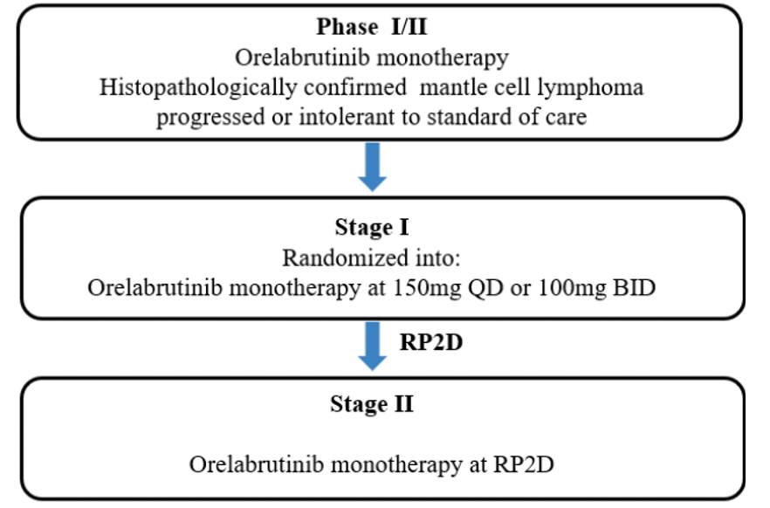

Key inclusion criteria
Key inclusion criteria included the following:
- histopathologically confirmed relapsed or refractory (between 1-4 treatments) Mantle cell lymphoma
- age: ≥18 and ≤75 years
- ECOG: 0-2
- measurable disease
- adequate organ function

Key exclusion criteria
Key exclusion criteria included the following:
- lymphoma involving CNS
- previous alloSCT
- autoSCT within 6 months
- previous BTK inhibitor/BCL2 kinase inhibitor.

Intervention
Orelabrutinib as follows:
- Stage 1: planned n=40 (20 patients at each dose of 150mg daily or 100mg bd)
- Stage 2: planned n=60 (RP2D = 150mg orally daily).

Randomisation and blinding
In Stage 1, subjects were randomised 1:1 into the 100 mg BD dose group or the 150 mg OD dose group. Each patient enrolled was identified by a unique patient number, which was assigned in the screening period, and remained unchanged during screening, randomisation, and throughout the study. Eligible subjects enrolled were randomised on day 1. Investigational products were randomly numbered according to the grouping label. The randomisation scheme was completed by a statistician from a contract research organisation (CRO). The investigator recorded the patient's randomisation number in the case report form (CRF) and source documents.
This study was an open-label study (without blinding). Both the investigator and the subjects were aware of the randomisation. All patients in Stage 2 were treated at the RP2D (150 mg OD).

Statistical analysis plan and efficacy endpoints
The statistical analysis plan for each efficacy endpoint is provided in table 3.
No formal statistical hypotheses were tested. The data were analysed in a descriptive manner.
Table 3: Efficacy outcome definitions and statistical analysis in ICP-CL-00102
Efficacy Outcome | Definition | Statistical Analysis Plan
Overall Response Rate (ORR) either by IRC or investigator | Defined as the number of subjects who achieved CR or PR (as best overall response, defined as the best overall response [BOR] from the first dose to disease progression, end of study or new anti-tumour treatment, whichever occurs first) divided by the number of subjects included in the efficacy evaluation. | Number and percentages of subjects who achieved Overall Response (CR, PR) were described. 95% CI for ORR were estimated using Clopper-Pearson exact method. BOR was also summarized by response category (CR, PR, SD, PD, NE (including no post-baseline overall response). A swimmer plot over the whole treatment period was provided, and the overall response in each post-baseline visit was marked in the plot. ORR by subgroups together with 95% confidence interval were summarized. 95% CI was calculated using Clopper-Pearson exact method. A forest plot was provided to show the results of subgroup analysis. Concordance of ORR by IRC and investigator was assessed. The overall concordance rate and the kappa statistic was calculated.
Progression Free Survival (PFS) | Defined as the time from the date of the first dose to the earlier of the dates of the first documented disease progression or death. | Subjects without disease progression or death, or subjects who were lost to follow-up without disease progression before end of study (or date of data cut-off) were censored.  PFS was calculated as:  • PFS (Month) = (Date of disease progression/death/last evaluable tumour assessment – Date of first dose + 1)/30.4375
Duration of Response (DOR) | Defined as the time from the first documented response to the dates of the first documented disease progression or death | DOR was only calculated for subjects who achieved CR or PR. DOR was calculated as:  • DOR (Month) = (Date of disease progression/death/last evaluable tumour assessment – Date of first documented response of CR or PR + 1)/30.4375
Overall Survival (OS) | Defined as the time from the date of the first dose to the date of death. | Subjects without death before end of study (or date of data cut-off) were censored to last known alive date. OS was calculated as:  • OS (Month) = (Date of death/last known alive date – Date of first dose + 1)/30.4375
Disease Control Rate (DCR) | Defined as the number of subjects who achieved CR, PR and SD divided by the number of subjects included in the efficacy evaluation. | Number and percentages of subjects who achieved best overall response of CR, PR, or SD were described. The 95% CI was estimated using Clopper-Pearson exact method.
Time to Response (TTR) | Defined as the time from the date of first dose to the first documented response for CR and PR | TTR was only calculated for subjects who achieved CR or PR. TTR was calculated as:  • TTR (Month) = (Date of first documented response – Date of first dose + 1)/30.4375
Time to Progression (TTP) | Defined as the time from the date of the first dose to date of the first documented disease progression. | Subjects without disease progression, death without disease progression, or subjects who were lost to follow-up without disease progression before end of study (or date of data cut-off) were censored.  TTP was calculated as:  • TTP (Month) = (Date of first documented disease progression/last evaluable tumour assessment – Date of first dose + 1)/30.4375.
Percentage changes from baseline of SPD in target lesions | The tumour measurement  at the screening visit will be used as the baseline tumour measurement. | Percentage changes from baseline of SPD at each visit were calculated. A spider plot was generated to show changes of SPD over time by patient. The reference lines for +/- 50% were added to the plot. Waterfall plot was provided based on the best percentage changes by patient, with best overall response of each patient labelled in the plot.
Complete Response Rate (CRR) | Defined as the proportion of subjects who achieve complete response (CR) based on PET/CT/MRI imaging and clinical results in accordance with the 2014 International Working Group criteria for non-Hodgkin’s lymphoma. | This analysis was only performed for subjects with PET scans at baseline. Number and percentages of subjects who achieved CR response were described. The 95% CI was estimated using Clopper-Pearson exact method. BOR, ORR, and DCR based on PET/CT/MRI will be also provided.
Additional information for all time-to-event-endpoints |  | For each of these time-to-event endpoints, number and percentage of subjects with event and censored subjects were summarised. Median, 25% percentile, and 75% percentile were estimated using Kaplan-meier method, and the associated two-sided 95% CIs were calculated using Brookmeyer-Crowley method. The descriptive statistic minimum and maximum value were  also provided. The survival rate for PFS, DOR, and OS and event rate for TTR and TTP associated with 95% CI at the specific timepoints were estimated using Kaplan-meier method. A Kaplan-Meier plot was provided. Subgroup analysis was performed for PFS and DOR, number and percentage of subjects with event, number and percentage of censored subjects, 25% percentile, median, and 75% percentile associated with the 95% CI was provided in each subgroup.
Note: Response is assessed based on the status of lymph nodes and lesions, per the 2014 International Working Group criteria for non-Hodgkin's lymphoma by investigator and IRC.

Participant flow
A total of 106 patients were enrolled: 20 patients in 100mg twice daily (BID), and 86 patients in 150mg once daily (QD) (figure 3).
Figure 3: Participant flow in ICP-CL-00102
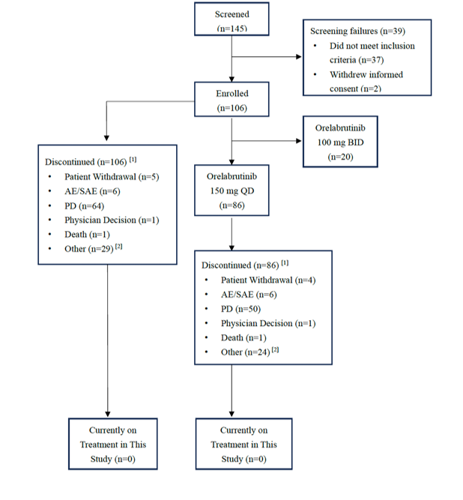
Note: 25.5% (27/106) remain on treatment through compassionate access although the study is closed.

Protocol deviations
It is notable that 5 patients (of 86) received concurrent or within wash out alternative anti-cancer therapy. Otherwise, the majority of deviations were not considered to impact on efficacy or safety analysis.

Baseline characteristics
Median follow-up was 47.1 months. 25.5% (27/106) patients remain on treatment through compassionate access although the study is closed.
- 79% were male (any dose)
- Median age was 62 years (range: 56, 65) (any dose)
- 100% were Asian (any dose)
- ECOG 0: 49% (150mg daily, n=86)
- ECOG 0: 48% (any dose, n=106)
Most patients had stage IV disease with largest lesion <5cm, LDH <ULN, did not have cytopenia, hepatomegaly or splenomegaly, had a Ki67 >/= 30% and a low simplified Mantle Cell Lymphoma International Prognostic Index (sMIPI) score.
Bone marrow involvement was seen in 41.9% (36/86) in the 150mg OD and 40.6% (43/106) in the any dose groups.
Nearly all patients were not experiencing B symptoms at baseline.
A summary of prior anti-tumour therapy is provided in table 4. Most patients had not had a prior Hematopoietic Stem Cell Transplantation (HSCT), had received 1-2 lines of previous therapy and experienced CR or PR as best response with previous therapy. As expected, nearly all patients had received previous rituximab. Most had received a previous high intensity chemotherapy regimen and an R-CHOP type regimen. No patients had previously received bendamustine and most had not received bortezomib or lenalidomide/thalidomide.
Table 4: Prior anti-tumour therapy in ICP-CL-00102
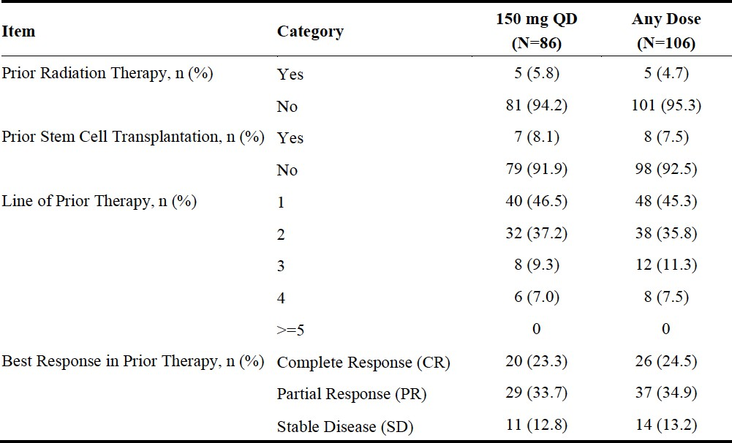
Table 4 (continued): Prior anti-tumour therapy in ICP-CL-00102
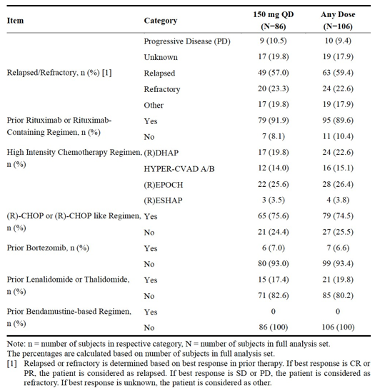

Results for the primary endpoint
The primary endpoint was Independent Review Committee (IRC) assessed overall response rate (ORR) performed only in the 150mg OD group.
The ORR by IRC in the FAS population was 72.1 % (61.4, 81.2) which passed the target ORR of 65% with the lower CI being >45% (table 5).
The results in the per protocol set (PPS) population were similar. All subgroups contained small numbers (as overall n=86), limiting the interpretation of this analysis. Generally, all subgroups favoured orelabrutinib with the ORR remaining similar within the limitations of this interpretation.

Table 5: Overall response rate (ORR) by IRC in ICP-CL-00102 - (FAS population)
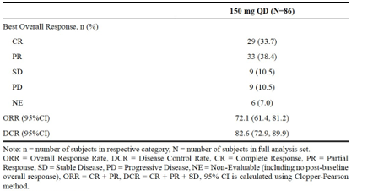

Results for secondary endpoints
Overall response rate (ORR) by investigator: 79.1% (69, 87.1) and 82.1% (73.4, 88.8) in the 150mg OD and any dose arms, respectively.
Disease control rate (DCR) as assessed by IRC: DCR (150mg OD) was 82.6% (72.9, 89.9).
DCR by investigator: DCR was 84.9% (75.5, 91.7) and 87.7% (79.9, 93.3) in the investigator assessed 150mg OD and any dose populations respectively.
Duration of response (DOR): The median DOR by IRC in the FAS population (150mg OD) was not reached (NA 20.27, NA)). The 6- and 24-month DOR rate was 86.8% (75.4, 93.2) and 59.6% (45.6, 71.1) respectively.
As per regulatory guidelines, time-to-event endpoints, such as progression free survival (PFS) and overall survival (OS), are difficult to interpret in single arm trials, given the lack of contemporaneous internal controls. The results for PFS and OS have not been used for regulatory decision-making in this submission.
The following comments on the evaluation of ICP-CL-00102 were noted:
- This pivotal trial does strongly suggest that orelabrutinib has efficacy based on the ORR and complete response (CRR) as surrogate markers for time-to-event outcomes in a rare disease.
- Other factors supporting the efficacy of orelabrutinib include that the median DOR, PFS and OS are not reached with 47.1 months of follow up (median) and that 25.5% (27/106) patients remain on treatment through compassionate access although the study is closed (the time-to-event results are immature).
- External validity of this study is limited as it was conducted only in Chinese patients. Extrapolation to predominantly Caucasian population in Australia is limited although this has been addressed in study ICP-CL-00107 conducted in non-Chinese patients (predominantly in the USA).

Study ICP-CL-00107 (USA, Israel, Ukraine)

Study design and dates
This was a Phase 1/2, multi-centre, open-label study of a novel bruton’s tyrosine kinase inhibitor,
orelabrutinib, in patients with b-cell malignancies.
The study commenced on 18 November 2019 with a data cut-off date for this evaluation of 1 May 2024.
The study design was a classical phase 1 dose escalation followed by a phase 2 dose expansion phase (figure 3, page 26). Dose escalation was performed in R/R B-cell malignancies at 100mg OD (cohort 1) and 150mg OD (cohort 2) of orelabrutinib. The recommended Phase 2 dose (RP2D) was determined at 150mg OD.
Figure 4: Dose expansion design in ICP-CL-00107
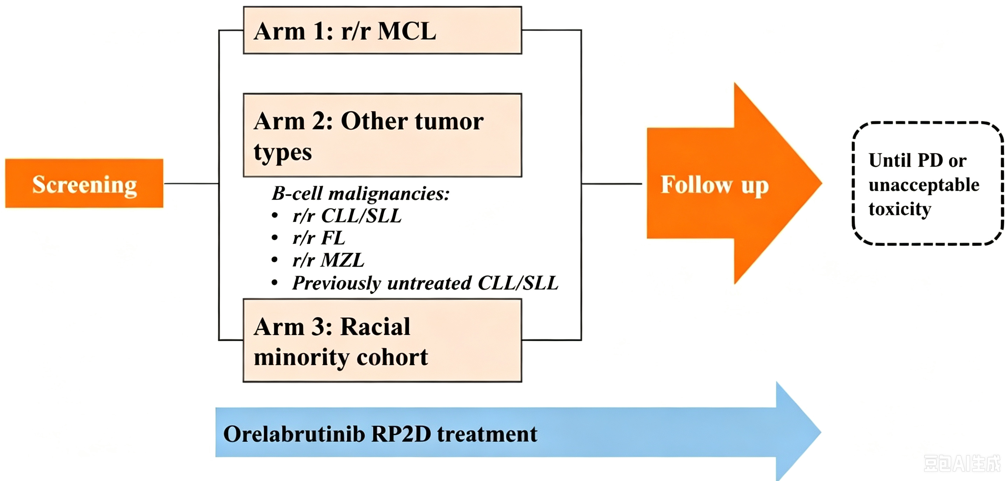

Study location
The study was conducted in 45 centres (the principal site was in the USA). Sites included the USA (12), Israel (2) and Ukraine (6).

Key inclusion criteria
Key inclusion criteria included the following:
- histopathologically confirmed relapsed or refractory (R/R) B-cell malignancies (grade 1-3a FL, MZL, MCL, and CLL/SLL)
- age ≥18 years
- ECOG: 0-1
- measurable disease
- adequate organ function
- dose escalation phase: participants must have received >1 or ≤4 prior therapies
- dose expansion phase: participants with R/R FL must have received ≥2 or ≤4 prior therapies
- other r/r malignancies: participants must have received >1 or ≤4 prior therapies.

Key exclusion criteria
Key exclusion criteria included the following:
- lymphoma involving CNS
- recent high dose steroid use
- previous alloSCT
- in expansion phase: previous BTK inhibitor in arm 1 (R/R MCL).

Randomisation and blinding
A set of screening numbers was provided to each site by the sponsor or designee. Sites were required to notify the Sponsor or designee of planned subject screening to manage recruitment. An Eligibility Screening Form (ESF) documenting the investigator’s assessment of each screened subject with regards to the protocol’s inclusion and exclusion criteria was completed and signed by the investigator (or designee). The investigator maintained a screening log to record details of all subjects screened and to confirm eligibility or record reasons for screening failure, as applicable. Under no circumstances were subjects who enrolled and received study medication, as specified in this clinical trial, permitted to be allocated to a new enrolment number/subject number and re-enrol in this study.
The study was open-label and therefore blinding was not applicable.

Statistical analysis plan and efficacy endpoints
No formal statistical hypotheses were tested. The data were analysed in a descriptive manner.
All subjects with MCL enrolled in Phase 1 and arm 1 of Phase 2 were combined and included in the efficacy analysis of patients with MCL subjects.
The primary efficacy analysis was based on the ORR assessed by IRC for MCL subjects in both Phase 1 and arm 1 of Phase 2.
Table 6: Efficacy endpoints, definitions and statistical analysis plans in ICP-CL-00107
Endpoint | Definition | Statistical Analysis Plan
ORR by IRC (for NHL patients, this includes MCL) | includes complete response (CR) and partial response (PR) | Tumour response data was reported using descriptive statistics. Objective overall response rate was summarized using frequencies and proportions. ORR and its 95% CI was calculated using Clopper-Pearson exact method.
DOR | defined as the period from CR or PR to progressive disease (PD) or death | Kaplan-Meier method was used to estimate duration of response.
DCR | represents the total rate of CR, PR, and SD. | DCR and its 95% CI was calculated using Clopper-Pearson exact method.
PFS | defined as the time between first dose and PD or death (caused by any reason) whichever occurs earlier | Kaplan-Meier method was used to estimate PFS.
OS | defined as the time between first dose and death (caused by any reasons) | For the subjects lost to follow-up, OS is the time between first dose and the date of last visit; if the subject is still alive at the end of study, OS is defined as the time between first dose and the date that the study ends. Kaplan-Meier method was used to estimate OS.

Participant flow
A total of 45 patients with R/R MCL were screened across both phase 1 and 2 with 43 subjects enrolled (2 screen-failed). Of these, 51.2% (22/43) remained on ongoing study treatment.
Overall, 26.5% (11/43) experienced disease progression, 11.6% (5/43) discontinuation for AEs and 23.3% (10/43) death.
The median follow-up was 16.8 months in the R/R MCL population.
Table 7: Study disposition in ICP-CL-00107
 | Phase 1 |  |  | Phase 2: Orelabrutinib 150 mg QD |  |  | Phase 1 & 2:  All r/r MCL Subjects
 | 100 mg QD  (N=3) | 150 mg QD (N=9) | Total  (N=12) | r/r MCL  (N=39) | Other Tumour Types (N=43) | Total  (N=82) | Total  (N=43)
Subjects Screened | / | / | 14 (100) | / | / | 103 (100) | 45 (100)
Screening Failed | / | / | 2 (14.3) | / | / | 21 (20.4) | 2 (4.4)
Reason for Screening Failure | / | / | / | / | / | / | /
Inclusion Criteria not Met | / | / | 1 (7.1) | / | / | 13 (12.6) | 1 (2.2)
Exclusion Criteria Met | / | / | 1 (7.1) | / | / | 9 (8.7) | 1 (2.2)
Consent Withdrawn | / | / | 0 | / | / | 1 (1.0) | 0
Other | / | / | 0 | / | / | 0 | 0
Subjects Treated [1] | 3 (100) | 9 (100) | 12 (100) | 39 (100) | 43 (100) | 82 (100) | 43 (100)
Ongoing Study Treatment | 0 | 5 (55.6) | 5 (41.7) | 20 (51.3) | 28 (65.1) | 48 (58.5) | 22 (51.2)
Discontinued from Study Treatment | 3 (100) | 4 (44.4) | 7 (58.3) | 19 (48.7) | 15 (34.9) | 34 (41.5) | 21 (48.8)
Primary Reason for Discontinuation | / | / | / | / | / | / | /
Disease progression | 0 | 3 (33.3) | 3 (25.0) | 9 (23.1) | 6 (14.0) | 15 (18.3) | 11 (25.6)
Adverse Event | 2 (66.7) | 1 (11.1) | 3 (25.0) | 5 (12.8) | 5 (11.6) | 10 (12.2) | 5 (11.6)
Withdrawal of Consent | 0 | 0 | 0 | 1 (2.6) | 0 | 1 (1.2) | 1 (2.3)
Investigator Decision | 0 | 0 | 0 | 2 (5.1) | 2 (4.7) | 4 (4.9) | 2 (4.7)
Death | 0 | 0 | 0 | 1 (2.6) | 0 | 1 (1.2) | 1 (2.3)
Other | 1 (33.3) | 0 | 1 (8.3) | 1 (2.6) | 2 (4.7) | 3 (3.7) | 1 (2.3)
Completed Study | 0 | 0 | 0 | 0 | 0 | 0 | 0
Ongoing Study | 0 | 7 (77.8) | 7 (58.3) | 26 (66.7) | 35 (81.4) | 61 (74.4) | 29 (67.4)
Discontinued from Study | 3 (100) | 2 (22.2) | 5 (41.7) | 13 (33.3) | 8 (18.6) | 21 (25.6) | 14 (32.6)
Primary Reason for Discontinuation | / | / | / | / | / | / | /
Withdrawal of Consent | 2 (66.7) | 1 (11.1) | 3 (25.0) | 2 (5.1) | 3 (7.0) | 5 (6.1) | 2 (4.7)
Death | 0 | 1 (11.1) | 1 (8.3) | 9 (23.1) | 2 (4.7) | 11 (13.4) | 10 (23.3)
Investigator Decision | 0 | 0 | 0 | 1 (2.6) | 2 (4.7) | 3 (3.7) | 1 (2.3)
Other | 1 (33.3) | 0 | 1 (8.3) | 1 (2.6) | 1 (2.3) | 2 (2.4) | 1 (2.3)

Protocol deviations
Major protocol violations evaluated were considered unlikely to affect safety and efficacy on study, particularly as efficacy analysis was in the intention to treat (ITT) population.

Baseline characteristics
Within the R/R MCL cohort:
- 86% were male
- median age was 64 years (39-84)
- 88% were white
- most patients were fit (ECOG 0 = 60.5%), with evidence of bone marrow involvement, non-bulky disease <5cm, relapsed disease (rather than refractory), had a median of 3 years from diagnosis and had stage 4 disease
- patients were mostly low risk (based on MIPI).
While the baseline and disease characteristics in Study ICP-CL-00107are similar to ICP-CL-00102 (apart from this being a Caucasian population), the previous treatment characteristics display a higher variation, including a higher number of patients having previous Hematopoietic Stem Cell Transplantation (HSCT) (table 8). This either indicates higher risk disease (not reflected in the baseline disease characteristics), more heavily pretreated disease (not reflected in median lines of previous therapy) or more aggressive treatment practices/different treatment paradigm in the study locations.
Table 8: Summary of prior anti-tumour therapy in ICP-CL-00107
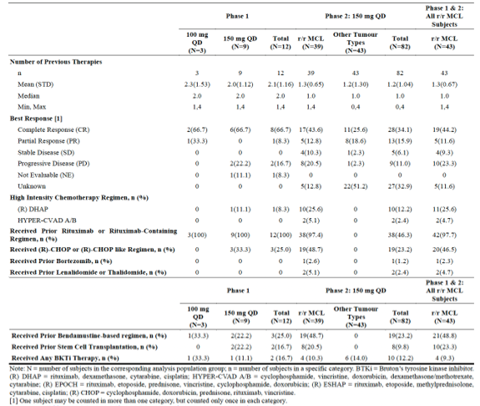

Results for the primary efficacy endpoints
The evaluation focused on the efficacy results in the R/R MCL full analysis (FAS) population and by IRC.
It was noted that technically the Phase 2 primary efficacy endpoint was ORR by IRC in each arm of the Phase 2 study component (R/R MCL, other B-cell malignancies, ethnic minority population with R/R MCL), although the statistical analysis plan stated that all R/R MCL patients would be grouped for analysis.
The R/R MCL population included 43 subjects (39 from phase II and 4 subjects from Phase 1 who received 150mg OD orelabrutinib). The ORR by IRC (FAS- R/R MCL) was 83.7% (69.30, 93.19).
Table 9: Evaluation of best overall response by IRC (R/R MCL - FAS) in ICP-CL-00107
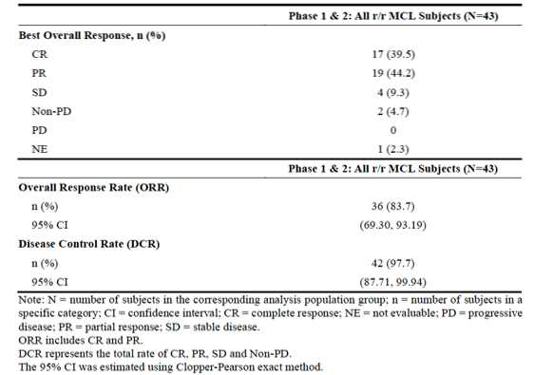
Interpretation of the subgroup analysis (not pre-defined) is limited by small numbers although overall trend is to favour a positive ORR to orelabrutinib that is similar to the overall population

Figure 5: Forest plot of ORR (IRC evaluation, all R/R MCL - FAS) in ICP-CL-00107
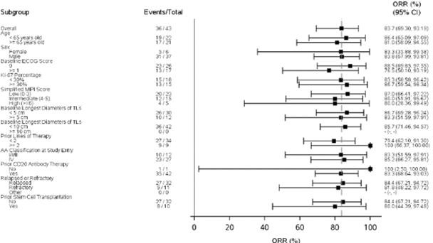

Figure 6: Waterfall plot of best percentage change from baseline in SPD of target lesions (IRC, all R/R MCL, FAS) in ICP-CL-00107
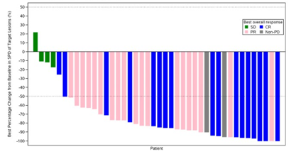

Results for the secondary endpoints
Not all secondary efficacy outcomes were predefined in the analysis plan.
DCR and CRR by IDC:
- DCR was 97.7% (87.71, 99.94).
- CRR was 39.5%.
ORR, DCR and CRR by Investigator:
- ORR and DCR followed a similar pattern to IRC assessment but were slightly higher total percentages (88.4% and 100% respectively).
- CRR was the same as by IRC assessment.
DOR:
- The median DOR was not reached (NR) in the R/R MCL (FAS) subjects in either the IRC or Investigator assessed groups (NR (13.832, NR) and NR (12.123, NR) respectively).
- The DOR rates at 6- and 24- months were 88 % (71.02, 95.30) and 70.1% (49.74, 83.42) respectively.
- The DOR rates by investigator assessment were similar to the IRC assessed rates (<5% difference).
As per regulatory guidelines, time-to-event endpoints, such as PFS and OS, are difficult to interpret in single arm trials, given the lack of internal contemporaneous controls. The results for PFS and OS have not been used for regulatory decision-making in this submission.
The following comments on evaluation of ICP-CL-00107 were noted:
- As noted previously (on page 30), while the baseline and disease characteristics are similar to ICP-CL-00102 (apart from this being a Caucasian population), the previous treatment characteristics display a higher variation, including a higher number of patients having previous HSCT either indicating higher risk disease (not reflected in the baseline disease characteristics), more heavily pretreated patients (not reflected in median lines of previous therapy) or more aggressive treatment practices/different treatment paradigm in the study locations.
- The evaluation focussed on the efficacy results in the R/R MCL FAS population and by IRC. The ORR by IRC (FAS- R/R MCL, primary efficacy endpoint in expansion) was 83.7% (69.30, 93.19), the overall trend of the subgroup analysis (secondary or exploratory endpoint) reflecting these results. The DCR was 97.7% (87.71, 99.94) with a CRR of 39.5%. The concordance between IRC and investigator assessment was high (90.7%, 39/43). Time-to-event data analysis was limited by small numbers of events, as with ICP-CL-00102. The median DOR was NR in the R/R MCL (FAS) subjects in the IRC assessed groups (NR (13.832, NR). Median TTR was 2.79 (2.793, 2.825). The median PFS was NR (16.591, NR) and OS was NR (42.251, NR) in the FAS R/R MCL IRC assessed population. The 24-month PFS rate was >60% (IRC) and the 24-month OS rate was high (73.8% (53.80, 86.15)). The median change from baseline in SPD was -84%.
- The study analysis population was approximately half the size of ICP-CL-00102 in a Caucasian population. The results of the efficacy analysis are very similar to those in ICP-CL-00102. However, the median follow up was much shorter than in ICP-CL-00102 (16.8 months compared to 47.1 months) confirming that the time-to-event data is immature. Approximately half (51.2%, 22/43) of the patients remain on ongoing study treatment, which is promising in terms of efficacy.
- Overall, results observed in this study conducted in Caucasians were consistent with those observed in the Chinese Study ICP-CL-00102.

Study ICP-CL-00127
Study ICP-CL-00127 is a randomized, open-label, multi-centre, Phase 2 trial evaluating two different doses of orelabrutinib in MCL.
This is an ongoing study supporting dose schedule, with a start date of 18 August 2023 and a data cut-off date for this evaluation of 24 April 2024. Enrolment has closed and occurred in 14 centres (19 sites were initiated) and all included patients were Asian.
This study, as with ICP-CL-00102, was only performed in Asian patients with another main difference being the enrolling of 20% treatment naïve patients.
In total, 40 patients were enrolled (FAS) and the primary efficacy outcome, as with the other efficacy studies was ORR (but only by investigator assessment). Demographics were similar to ICP-CL-00102 and ICP-CL-00107. Patients had slightly higher MIPI scores in this study with bone marrow involvement more similar to ICP-CL-00102. Previous anti-tumour therapies were more variable due to inclusion of treatment naïve patients. Less patients had received intensive chemotherapy regimens which may reflect a better prognostic disease state or less fit patients.
Overall, the results of ICP-CL-00127 support the efficacy of orelabrutinib in MCL and were consistent with results of ICP-CL-00102 and ICP-CL-00107. The ORR by investigator assessment (FAS, total) was 65% (48.3, 79.4) with the subgroup analysis in treatment naïve vs R/R MCL allowing limited interpretation due to low numbers. The CRR was 32.5% (18.6, 49.1). The median DOR, PFS and OS (low number of event outcomes) was not reached with a 91.7% (70.6, 97.8) OS rate at 6 months. The median TTR (FAS, total) was 1.840 months (1.807, 1.873). Most patients received some degree of reduction in SPD with the majority in both groups achieving >50% reduction, which is a similar pattern to both ICP-CL-00102 and ICP-CL-00107.

Conclusions from the clinical efficacy evaluation
Three studies were submitted to provide evidence of efficacy of orelabrutinib in R/R MCL. All of these were phase I/II studies. There was no phase III RCT within the dossier, which is acceptable according to EMA guidelines on the clinical evaluation of anticancer medicinal products, 2023 (given this is a rare cancer).
The pivotal study was ICP-CL-00102 (Asian population only) with the supporting studies of ICP-CL-00107 (main supporting, Caucasian, mainly USA) and ICP-CL-00127 (minor supporting, Asian population only) included. The overall study designs and implementation were similar across studies. Most patients received orelabrutinib at 150mg OD (the R2PD defined in multiple studies). The main efficacy endpoint across all studies was ORR (either by IRC in ICP-CL-00102 and ICP-CL-00107 or by investigator assessment in ICP-CL-00127). Time-to-event endpoints were secondary. The inclusion/exclusion criteria were similar except for the exclusion of patients >75 years old in ICP-CL-00102 and the enrolment of 20% treatment naïve patients in ICP-CP-00127.
The patient populations were similar across studies including mostly patients of median age 61-64 years, male, with relapsed disease, had received 1-2 lines of previous treatment, had stage IV disease and were of good ECOG. Caucasian patients had higher median BMIs (overweight) compared to Asian populations. Most patients had not had previous HSCT but had received an
R-CHOP like regimen. In ICP-CL-00102 and ICP-CL-00107, patients also mostly had received intensive chemotherapy induction regimens. A higher proportion of patients in ICP-CL-00107 had bone marrow involvement. The previous treatment characteristics in ICP-CL-00107 display a higher variation, including a higher number of patients having previous HSCT either indicating higher risk disease (not reflected in the baseline disease characteristics), more heavily pretreated patients (not reflected in median lines of previous therapy) or more aggressive treatment practices/different treatment paradigm in the study locations. Overall numbers of included patients are small but are not unreasonable in this rare disease. Patient numbers within these studies are not dissimilar to studies provided to PBAC for acalabrutinib and zanubrutinib approval.
The main results of these 3 studies with comparison to ibrutinib, acalabrutinib and zanubrutinib are presented in table 10.

Table 10: Cross trial comparison of main efficacy results in ICP-CL-00102, ICL-CL-00107, ICP-CL-00127 with market comparators
 | ICP-CL-00102 (FAS 150mg OD) | ICP-CL-00107 (R/R FAS 150mg OD) | ICP-CL-00127 (FAS, total)** | Ibrutinib (pooled studies)ª | Acalabrutinibª | Zanubrutinib^{b}
Population (n) | 86 | 43 | 40 | 370 | 124 | 37
Main ethnicity | Asian | Caucasian | Asian | - | - | -
Median follow-up (months) | 47.1 | 16.8 | 4.5 | 41.4 | 38.1 | 19.42
ORR (IRC)* | 72.1 % (61.4, 81.2) | 83.7% (69.30, 93.19) | 65% (48.3, 79.4)*** | 69.7% (64.1, 75.3) | 81.5% (74.0, 88.0) | 81.1% (64.8, 92.0)
CRR (IRC) | 33.7% | 39.5% | 32.5% | 27% (22.5, 31.5) | 47.6% (38.8, 56.4) | 24.3% (11.8, 41.2)
DCR (IRC) | 82.6% (72.9, 89.9) | 97.7% (87.71, 99.94) | 80% (32/40) | 81.4% (301/370) | 89.5% (111/124) | -
Median DOR (IRC) | NA [20.27 NA] | NR (13.83, NR) | NA (2.76, NA) | - | - | -
Median PFS (IRC) | 24.94 (19.15, NA) | NR (16.59, NR) | NA (3.88, NA) | 12.5 (9.8, 16.6) | 22.0 (16.6, 33.3) | 17.3 (13.2, 30.7)
24 month PFS rate (IRC) | 52% [40.0, 62.7] | 65.1% (46.28, 78.79) | - | - | 49.6% (40.1, 58.4) | -
Median OS | NA [44.912,NA] | NR (42.251, NR) | NA (NA, NA) | 26.7 (22.5, 38.4) | NA (36.5, NE) | 27.20 (18.9, 38.2)
24month OS rate | 72.9% [68.7, 86.2] | 73.8% (53.80, 86.15) | - | - | 72.4% (63.5, 79.5) | -
*Primary efficacy endpoint (predefined)
**This study included 20% treatment naïve MCL patients. The FAS, total population includes patients treated at both 150mg OD and 50mg BD dosing schedules.
***response was only assessed by investigator in this study
All time-to-event parameters are reported in months
ªFrom Tables 1.11a-b (p151-152) Acalabrutinib public summary document for R/R MCL indication- July 2021 (PBAC, 2021a)
^{b}From Tables 1.12a-b (p153-154) Zanubrutinib public summary document for R/R MCL indication- July 2021 (PBAC, 2021b). Results from AU-003 were used as study 206 was Chinese patients only.
When comparing the results of orelabrutinib between trials (ICP-CL-00102, ICP-CL-00107 and ICP-CL-00127) these are grossly comparable. The ORR, CRR and DCR in ICP-CL-00107 (Caucasian) are higher than in ICP-CL-00102 and ICP-CL-00127 (Asian), noting that ICP-CL-00107 is a smaller study than ICP-CL-00102. The longest median follow up was ICP-CL-00102 and thus the results of ICP-CL-00107 and ICP-CL-00127 may be impacted by shorter follow-up time (particularly the better results in ICP-CL-00107). The time-to-event data is largely uninterpretable across all studies due to limited events and follow-up. ICP-CL-00102, the study with the longest follow up, did reach median PFS. Median PFS, OS and DOR in all studies besides median PFS in ICP-CL-00102 was not reached. The 24-month PFS rate in ICP-CL-00107 was higher than in ICP-CL-00102 which may have been affected by the shorter follow up time. The 24-month OS rate in both ICP-CL-00102 and ICP-CL-00107 was comparable. From the limited data, mainly response rates, this does suggest efficacy of orelabrutinib. Given the high number of patients remaining on treatment (approximately 25% in ICP-CL-00102 and 50% in ICP-CL-00107) it seems likely this will translate to time-to-event data, however, this needs to be confirmed.
When the orelabrutinib data is compared to ibrutinib, the results are mixed. Whilst ICP-CL-00107 has a higher ORR, CRR and DCR, the results from ICL-CL-00102 are similar to ibrutinib. The immature median PFS in ICP-CL-00102 is superior to ibrutinib, with the lower 95% CI of PFS in ICP-CL-00102 and ICP-CL-00127 being higher than the ibrutinib median PFS. Although median OS is not reached, the mature ibrutinib data has a median follow up of 41.4 months with median OS defined. This does suggest that perhaps the orelabrutinib data with more time, will show PFS/OS benefit. The lower 95% CI of the median OS in in ICP-CL-00102 and ICP-CL-00127 is higher than the median OS of ibrutinib. Currently, the efficacy data, mainly based on response rates suggest likely non-inferiority to ibrutinib in cross-trial comparison but are not strongly suggestive of superiority. This may change with more robust time-to-event data.
A similar pattern is seen when compared to acalabrutinib, which has a shorter median follow up in this included data. The results of ORR in ICP-CL-00107 are comparable to acalabrutinib, although acalabrutinib has a higher CRR, whilst ICP-CL-00107 a higher DCR (likely more SD). The ORR results from ICP-CL-00102 are lower. The median PFS in ICP-CL-00102 is similar to acalabrutinib along with the 24-month PFS rate (which is higher in ICP-CL-00107). The 24-month OS rate from ICP-CL-00102 and ICP-CL-00107 is comparable to acalabrutinib. Of note, at median follow up of 38.1 months, the acalabrutinib median OS was also not reached. There is no clear suggestion here that orelabrutinib will be superior to acalabrutinib, despite the preclinical assertions. Further time-to-event data may change this. In general, from this data, orelabrutinib does seem to be more comparable to acalabrutinib than Zanubrutinib in efficacy. Another difference being that acalabrutinib also now has data in the 1L setting in combination with BR (FDA approval based on PFS benefit- (FDA, 2025).
Overall, there is evidence that orelabrutinib is efficacious in R/R MCL based on response rates, which, with time is likely to be confirmed in time-to-event data. When comparing across trials (within those limitations), the suggestion is that orelabrutinib is non-inferior to ibrutinib and acalabrutinib (and zanubrutinib). However, the assertion that it is superior is not clearly proven from this early data. The evaluator is comfortable with the efficacy of orelabrutinib being non-inferior to ibrutinib (with some suggestion that time-to-event data will end up with improvement). However, additional benefits in terms of safety when compared to ibrutinib would be required to firmly prove that orelabrutinib is of benefit to the Australian market (compared to ibrutinib) based on this early data. Non-inferiority of orelabrutinib to acalabrutinib cannot be confirmed based on this data. This is largely because results from the larger ICP-CL-00102, in terms of response rates are lower in orelabrutinib compared to acalabrutinib, with the smaller ICP-CL-00107 study showing more comparable results to acalabrutinib. The limited time-to-event data (of 24-month PFS and OS rate and median PFS from ICP-CL-00102) however is promising that orelabrutinib will ultimately be non-inferior to acalabrutinib when further data is provided.
For the purposes of provisional registration in the context of this submission, satisfactory efficacy of orelabrutinib does not require demonstration of neither superiority, nor non-inferiority, of orelabrutinib with other agents including acalabrutinib or Zanubrutinib.
The ORR demonstrated in the two pivotal single-arm phase 1/2 studies (ICP-CL-00102 and ICP-CL-00107) strongly suggest that orelabrutinib is efficacious in the evaluated patient population, irrespective of the availability of any other registered (provisional or standard) BTKIs.

Safety
The sponsor provided safety data from several studies, with 3 main studies contributing to the safety evaluation:
- Study ICP-CL-00102 (China; n=106)
- Study ICP-CL-00107 (mainly USA; n=43)
- Study ICP-CL-00127 (n=40).
A pooled safety set of patients with B cell malignancies receiving orelabrutinib 150 mg daily (n=565) was also evaluated.
Exposure from the main safety population of R/R MCL and PK/PD studies is presented in table
11. Exposure across ICP-CL-00102 and ICP-CL-00107 was similar (16.2-22.9 months) and mostly >12 cycles (67.9-69.8%). ICP-CL-00127 had reduced exposure (approximately 100 days) due to the short median follow-up.
Table 11: Summary of exposure of orelabrutinib
Study | Study location/status | Population | Placebo | Dose | Number exposed (n) | Safety Set (n) | Median duration of exposure (months) | Treatment duration >12 cycles % | Median Daily dose | Median dose intensity
ICP-CL-00102 | China, completed | R/R MCL | No | 100mg BD  150mg OD | 20  86 | 106 | 22.883 (Q1-Q3 7.425, 51.943) | 67.9% (72/106) | 149.84 (148.08, 150.00) | 99.64 (98.31, 100.00)
ICP-CL-00107 | Global, ongoing | B-cell malignancies | No | 100mg OD (phase I- n=3)  150mg OD (phase I and II) | All R/R MCL (phase I and II)  All phase II | 43  82 | 16.2 (range 1.9, 46.5)  17.5 (range 0.4, 36.4) | 69.8% (30/43)  73.2% (60/82) | 149.71 (range 96.1, 155.1)  149.43 (range 96.1, 150.2) | 99.81 (range 64.0, 103.4)  99.62 (range 64.0, 100.1)
ICP-CL-00127 | China, ongoing | Treatment naïve and R/R MCL | No | 150mg OD  50mg BD | 20  20 | 40 | 100.0 days (Q1-Q3 67.5, 160.5)* | 0% (<6 cycles 72.5%) | 113.77 (99.66, 150.00) | 100.00 (Q1-3, 96.45, 100.00)
ICP-CL-001 | Australia, completed | Healthy volunteers | Yes | 20-400mg single dose  100mg OD, 200mg OD, 100mg BD | 30 + 6(fed)  Placebo-12  18  Placebo-6 | 40 +8 (fed)  24 | Single dose  14 days (100% of subjects) | NA | 100 (range 20, 400)  Fed-200 (range, 200, 200)  Median total dose: 2266.7 (range 1200, 2800) | NA
ICP-CL-00119 | China, completed | Subjects with varying degrees of hepatic dysfunction | No | 50mg OD | 25 (normal 8, mild 8, moderate 8, severe 1) | 25 | Single dose (100% of subjects) | NA | NA | NA
ICP-CL-00120 | China, completed | Healthy volunteers | Yes | 150mg and 400mg OD | 48 | 48 | Single dose (100% of subjects) | NA | NA | NA
*Note median follow-up in this study is only 4.5 months.

Adverse events
A broad overview of adverse events (AEs) across ICP-CL-00102, ICP-CL-00107, ICP-CL-00127 and the B cell malignancies safety is presented in table 12.
Table 12: Overview of AEs in ICP-CL-00102, ICP-CL-00107, ICP-CL-00127 and B-cell malignancies safety set
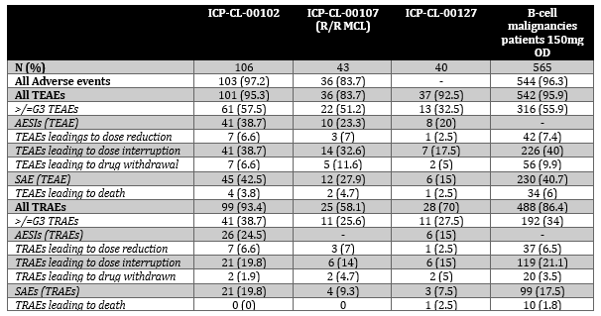
Across all studies, any form of AEs and treatment emergent adverse events (TEAEs) were common, with similar rates of >/=grade 3 TEAEs across both main R/R MCL studies and the pooled B cell malignancy population. Most patients experienced TEAEs related to investigations, infections and infestations, gastrointestinal disorders, metabolism and nutrition disorders. Generally, there were lower rates of TEAEs in ICP-CL-00107 (Caucasian) compared to
ICP-CL-00102 (Chinese) and the B-cell malignancy pool.
In Study ICP-CL-00102:
- All AEs = 97%
- Grade ≥3 AEs = 58%
- SAEs = 43%
- AEs leading to dose interruption (39%), dose reduction (6.6%), drug withdrawal (6.6%)
- TEAEs leading to death = 3.8% (TRAEs leading to death = 0)
- AESIs = 39%.
In Study ICP-CL-00107:
- All AEs = 84%
- Grade ≥3 AEs = 51%
- SAEs = 28%
- AEs leading to dose interruption (33%), dose reduction (7%), drug withdrawal (11.6%)
- TEAEs leading to death = 4.7% (TRAEs leading to death = 0)
- AESIs = 23%.

Adverse events in Study ICP-CL-00102
The most commonly reported AEs were platelet count decreased (38.7%), upper respiratory tract infection (30.2%), neutrophil count decreased (27.4%), anaemia (23.6%), white blood cell count decreased (23.6%), hypokalaemia (20.8%), rash (19.8%), pneumonia (19.8%) and cough (18.9%).
The most common treatment related adverse events (TRAEs) were: investigations (81.1%), infections and infestations (38.7%), platelet count decreased (35.8%), cardiac disorders (26.4%), neutrophil count decreased (24.5%), metabolism and nutrition disorders (23.6%), respiratory/thoracic/mediastinal disorders (22.6%), other arrhythmias (22.6%), white blood cell count decreased (20.8%), blood and lymphatic system disorders (18.9%), gastrointestinal disorders (17.9%), vascular disorders (17.9%), hypertension (17%), anaemia (15.1%), rash (15.1%), upper respiratory tract infection (14.2%), and pneumonia (14.2%).
The most commonly reported grade ≥3 AEs by SOC and PT were investigations (29.2%), infections and infestations (21.7%), platelet count decreased (15.1%), metabolism and nutrition disorders (11.3%), neutrophil count decreased (10.4%), pneumonia (9.4%), blood and lymphatic system disorders (9.4%), and anaemia (8.5%).
The most common serious adverse events (SAEs) occurring in more than one patient were pneumonia (19.8%), platelet count decreased (4.7%) and pneumonitis (3.8%).

Adverse events in Study ICP-CL-00102, Study ICP-CL-00107, and B-cell malignancy pooled dataset

Deaths
In Study ICP-CL-00102, there were 9 deaths that occurred within 28 days after the last dose of the study drug, 5 due to disease progression.
There were no TRAEs leading to death. Deaths related to TEAEs included disease progression, pneumonia, COPD and ‘death’. The patient whose TEAE was listed as ‘death’ died out of hospital without receiving medical care. It was deemed likely to as result of a cardiovascular or cerebrovascular event unlikely related to orelabrutinib and occurred approximately one month after receiving study drug. The patient was at the palliative stage of disease management and the evaluator agreed with this assessment based on information provided.
In Study ICP-CL-00107, deaths related to TEAEs included cardiac arrest, myocardial infarction (both considered not related) and pneumonitis (possibly related). The pneumonitis occurred in context of COVID-19 which is an alternate and common cause of pneumonitis.
In Study ICP-CL-00127, the single TEAE leading to death was due to pneumonia (related by investigator). The sponsor considers this not related and the evaluator agreed with this assessment.

Table 13: Overview of deaths in ICP-CL-00102, ICP-CL-00107, ICP-CL-00127 and B-cell malignancies safety set
 | ICP-CL-00102 | ICP-CL-00107 (R/R MCL) | ICP-CL-00127 | B-cell malignancies patients 150mg OD
N (%) | 106 | 43 | 40 | 565
All deaths | 47 (44.3) | 10 (23.3) | 2 (5) | 124 (21.9)
Disease Progression | 27 (25.5) | 6 (14) | 1 (2.5) | 60 (10.6)
TEAEs leading to death | 4 (3.8) | 2 (4.7) | 1 (2.5) | 34 (6)
TRAEs leading to death | 0 | 0 | 1 (2.5) | 10 (1.8)
Deaths within 28 days of last dose | 9 (8.5) | 2 (4.7) |  | 38 (6.7)
Related to TRAEs | 0 | 0 |  | 6 (1.1)
Disease progression | 5 (4.7) | 0 |  | 12 (2.1)

Serious adverse events
Rates of serious adverse events (SAEs) due to TEAEs were higher in ICP-CL-00102 and the B-cell malignancy pool compared to ICP-CL-00107. A similar pattern of SAEs, with lower rates overall, is seen for SAEs due to TRAEs. There were no concerning patterns or flags in SAEs due to TEAEs in ICP-CL-00102, ICP-CL-00107 or ICP-CL-00127.
Table 14: Overview of SAEs in ICP-CL-00102, ICP-CL-00107, ICP-CL-00127 and B-cell malignancies safety set
 | ICP-CL-00102 | ICP-CL-00107 (R/R MCL) | ICP-CL-00127 | B-cell malignancies patients 150mg OD
N (%) | 106 | 43 | 40 | 565
SAE (TEAE) | 45 (42.5) | 12 (27.9) | 6 (15) | 230 (40.7)
SAEs (TRAEs) | 21 (19.8) | 4 (9.3) | 3 (7.5) | 99 (17.5)
Pneumonia | 4 (3.8) | 0 | 3 (7.5) | 32 (5.7)
Gastrointestinal infection | 1 (0.9)
Meningitis cryptococcal | 1 (0.9)
Pneumocystis jirovecii pneumonia | 1 (0.9)
Pneumonia bacterial | 1 (0.9) |  |  | 4 (0.7)
Encephalitis herpes |  | 1 (2.3)
Oral candiasis |  | 1 (2.3)
Otitis media |  |  |  | 2 (0.4)
Urinary tract infection |  |  |  | 2 (0.4)
Platelet count decreased | 5 (4.7) |  |  | 8 (1.4)
Full blood count decreased | 1 (0.9)
White blood cell count increased | 1 (0.9)
Pneumonitis | 4 (3.8) | 0 |  | 7 (1.2)
Interstitial lung disease |  |  |  | 1 (0.2)
Pleural effusion |  |  |  | 2 (0.4)
Anaemia | 1 (0.9) |  |  | 4 (0.7)
Pancytopenia |  | 1 (2.3) |  | 2 (0.4)
Febrile neutropenia |  |  |  | 3 (0.5)
Lymphadenitis |  |  |  | 2 (0.4)
Middle ear inflammation | 1 (0.9)
Asthenia | 1 (0.9)
Bladder cancer | 1 (0.9)
Headache | 1 (0.9)
Diarrhoea |  | 1 (2.3)
Atherosclerosis coronary artery |  |  |  | 2 (0.4)

Discontinuation/dose interruption or reduction due to adverse events
Rates were grossly similar across studies and lower overall for TRAEs leading to drug withdrawal, dose reduction or interruption.
Table 15: Overview of adverse events in ICP-CL-00102, ICP-CL-00107, ICP-CL-00127 and B-cell malignancies safety set - discontinuations, dose interruptions, and dose reductions
 | ICP-CL-00102 | ICP-CL-00107 (R/R MCL) | ICP-CL-00127 | B-cell malignancies patients 150mg OD
N (%) | 106 | 43 | 40 | 565
All Adverse events | 103 (97.2) | 36 (83.7) | - | 544 (96.3)
All TEAEs | 101 (95.3) | 36 (83.7) | 37 (92.5) | 542 (95.9)
>/=G3 TEAEs | 61 (57.5) | 22 (51.2) | 13 (32.5) | 316 (55.9)
AESIs (TEAE) | 41 (38.7) | 10 (23.3) | 8 (20) | -
TEAEs leadings to dose reduction | 7 (6.6) | 3 (7) | 1 (2.5) | 42 (7.4)
TEAEs leading to dose interruption | 41 (38.7) | 14 (32.6) | 7 (17.5) | 226 (40)
TEAEs leading to drug withdrawal | 7 (6.6) | 5 (11.6) | 2 (5) | 56 (9.9)
SAE (TEAE) | 45 (42.5) | 12 (27.9) | 6 (15) | 230 (40.7)
TEAEs leading to death | 4 (3.8) | 2 (4.7) | 1 (2.5) | 34 (6)
All TRAEs | 99 (93.4) | 25 (58.1) | 28 (70) | 488 (86.4)
>/=G3 TRAEs | 41 (38.7) | 11 (25.6) | 11 (27.5) | 192 (34)
AESIs (TRAEs) | 26 (24.5) | - | 6 (15) | -
TRAEs leading to dose reduction | 7 (6.6) | 3 (7) | 1 (2.5) | 37 (6.5)
TRAEs leading to dose interruption | 21 (19.8) | 6 (14) | 6 (15) | 119 (21.1)
TRAEs leading to drug withdrawn | 2 (1.9) | 2 (4.7) | 2 (5) | 20 (3.5)
SAEs (TRAEs) | 21 (19.8) | 4 (9.3) | 3 (7.5) | 99 (17.5)
TRAEs leading to death | 0 (0) | 0 | 1 (2.5) | 10 (1.8)

In Study ICP-CL-00102, AEs leading to drug withdrawal included new cancers, platelet count decreased, disease progression and COPD. AEs leading to dose reduction included platelet count decreased, neutrophil count decreased, skin infection, pneumonitis and palmar-plantar erythrodysaesthesia syndrome.
In Study ICP-CL-00107, TEAEs leading to treatment withdrawal included leukocytosis, pancytopenia, cardiac arrest, diarrhoea and hepatitis C. Events leading to treatment interruption were largely related to infections. Events leading to dose reduction included muscle spasms, myalgia, haematuria and hypertension.
In Study ICP-CL-00127, TRAEs leading to withdrawal included pneumonia, ALT increased, and AST increased. Events leading to interruption were generally related to infections, pyrexia, platelet count decreased, and AST and ALT increased. Events leading to dose reduction included platelet count decreased.

Adverse events of special interest
Adverse events of special interest (AESIs) for orelabrutinib included cytopenias, infection (including hepatitis B reactivation), haemorrhage, arrhythmia, second primary malignancy, and tumour lysis syndrome.
Table 16: Adverse events of special interest in ICP-CL-00102, ICP-CL-00107 and B-cell malignancies safety set
AESI | ICP-CL-00102 (n=86) | ICP-CL-00107 (n=43) | Pooled B-cell malignancy data set (n=565)
Any AESI | 88.4% | 65.1% | 84.2%
Grade ≥3 AESI | 40.7% | 25.6% | 40.2%
Infections/infestations  - grade ≥3 | 62.8%  18.6% | 46.5%  14.0% | 64.1%  24.6%
Haemorrhage  - grade ≥3 | 24.4%  0 | 34.9%  2.3% | 33.5%  2.3%
Neutrophil count decreased  - grade ≥3 | 36.5%  16.5% | 25.6%  16.3% | 38.7%  17.0%
Platelet count decreased  - grade ≥3 | 51.8%  21.2% | 39.5%  4.7% | 36.1%  9.4%
Anaemia  - grade ≥3 | 35.3%  16.5% | 30.2%  7.0% | 35.3%  9.8%
Hypertension  - grade ≥3 | 19.8%  5.8% | 14.0%  9.3% | 10.8%  4.1%
Diarrhoea | 14.0% | 32.6% | 13.3%
Malignant neoplasms | 5.8% | 7.0% | 4.8%
AF or atrial flutter | 2.3% | 0 | 1.2%

Rates of AESIs (TRAEs) were higher in ICP-CL-00102 compared to the other 2 studies.
Most AESIs were related to infection (particularly pneumonia) and investigation abnormalities (platelet count decreased). Neoplasms (benign, malignant and unspecified) were varied and not uncommon.
Rates in ICP-CL-00107 are generally lower than that in ICP-CL-00102 and the B-cell malignancy pool.
There were overall high rates of infection, particularly upper respiratory tract infection,
COVID-19, pneumonia and UTI. Cytopenia were common, showing a similar pattern between studies. Haemorrhage was identified as a common grouped term TEAE. The rates were similar across all studies (24.4-34.9%) with purpura/petechiae and bruising not the only contributors to the pooled haemorrhage term. Second primary malignancies were not uncommon (5.8% ICP-CL-00102, vs 7% ICP-CL-00107 vs 4.8% B cell malignancy pool) and were not predominantly accounted for by non-melanomatous skin cancer. This is unusual but may reflect orelabrutinib effect or the effect of previous treatment with rituximab or the disease itself. Rates of arrhythmias were <5% but it is unclear what contributed to the pooled term.
Incidence of class related AESIs including hypertension, diarrhoea and tumour lysis syndrome (TLS) were low, which could be attributed to the limited exposure in the studies.
The following concerns were highlighted (from ICP-CL-00102 versus ICP-CL-00107 versus ICP-CL-00127 versus B-cell malignancy pooled data):
- Electrocardiograph findings and cardiovascular safety
  - High rates of QT prolongation were observed (TEAE: 12.3% vs 0% vs NR vs 3.5%, TRAE: 10.4% vs 0% vs NR vs 3%). There is high discrepancy between Chinese and Caucasian studies.
  - Hypertension was common (TEAE: 18.9% vs 14% vs NR vs 10.8% TRAE: 17% vs 7% vs NR vs 5.5%) with common rates of >/=grade 3 events (TEAE: 6.6% vs 9.3% vs 2.5% vs 4.1% TRAE: 5.7% vs 4.7% vs 2.5% vs NR). There was some discrepancy between Chinese and Caucasian populations.
  - Cardiac disorders were common (TEAE: 34% vs 12.2% vs NR vs 25.3%) with high discrepancy between Chinese and Caucasian populations.
  - Rates of atrial fibrillation, cardiac failure, myocardial infarction/ischaemia, cardiac arrest and coronary artery disease/atherosclerosis were low.
  - Sinus bradycardia was common (TEAE: 7.5% vs 4.7% vs 7.5% vs 7.6% TRAE: 5.7% vs 0% vs 5% vs 6.4%).
  - There were high rates of other arrhythmias reported (excluding sinus arrhythmia and pooled by evaluator) although these are of varied clinical significance (TRAE: 22.6% vs 4.7% vs NR vs NR). There is high discrepancy between Chinese and Caucasian populations. Supraventricular extrasystoles (TRAE: 6.6% vs 0% vs NR vs 4.4%) and ventricular extrasystoles (TRAE: 4.7% vs 2.3% vs NR vs 3.2%) were reported in the B-cell pool also. Supraventricular tachycardia was reported as a >/=grade 3 TRAE (2.3% ICP-CL-00107).
  - Rates of peripheral oedema were variable between Caucasian and Chinese populations (TEAE: 3.8% vs 16.3% vs NR vs 6.5% TRAE: 1.9% vs 2.3% vs NR vs NR). Rates of other forms of oedema or effusions were low (including pericardial effusion TEAE: 1.9% vs 0% vs NR vs 07%).
  - Only atherosclerosis coronary artery was reported as an SAE in the B-cell malignancy pool. There were no cardiovascular SAEs in the MCL patients.
  - There were 3 cardiovascular related deaths which were considered not related. Given the average age and sex of the underlying population, it is likely there would be background rates of cardiovascular events and deaths and so this is plausible.
  - In the summary of clinical safety prepared by the sponsor, the pooled rates of arrhythmia reported are lower than when examining the individual CSRs as above (4.7% vs 0% vs NR vs 3.2%). All events were grade 1-2. In the B-cell malignancies pool, two (0.4%) subjects experienced serious adverse events of arrhythmias, which were considered not related to treatment. Treatment-related arrhythmias led to treatment interruption in 0.4% of subjects, with neither dose reduction nor discontinuation reported. No SAEs or treatment changes were seen in the MCL population related to arrhythmia.
- Infections
  - TEAEs relating to infection were seen in >60% of patients (ICP-CL-00102 vs ICP-CL-00107 vs B-cell malignancy pool) (62.8% vs 65.1% vs 64.1%). These were most commonly related to upper respiratory tract infection, COVID-19, pneumonia and urinary tract infections. Herpes virus infection was seen in rates of 4.7-8.7%. Hepatitis B reactivation was uncommon.
  - Infections were the highest contributor to deaths. There was one death due to TEAE pneumonia in both ICP-CL-00102 and ICP-CL-00127. In other B-cell malignancy studies (table 21) there were 4 deaths due to TRAE pneumonia and one from febrile neutropenia, hepatitis, fungal infection, septic shock and hepatitis B reactivation respectively.
Table 17: Treatment related adverse events leading to death across all studies
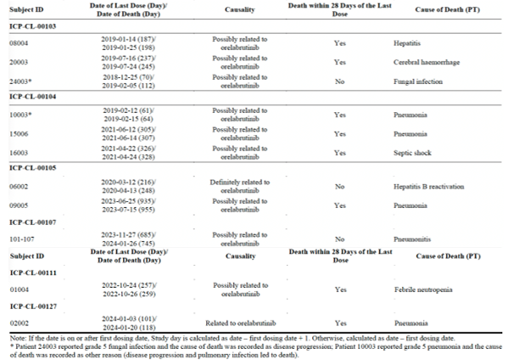
- Malignancies
  - Secondary primary malignancies were not uncommon (4.8-7%). These were not fully accounted for by non-melanoma skin cancers (0-2.3%). It possible that the rates of second cancers may be related to previous rituximab exposure. While all significant, there was no cancer which accounted for >1 occurrence.
  - No second primary malignancies were reported in ICP-CL-00127.
- Haemorrhage
  - Pooled rates of haemorrhage were not uncommon (24.4% vs 34.9% vs 33.5%) which included haemorrhage (12.8% vs 20.9% vs 22.1%), purpura/petechiae (7% vs 7% vs 9.9%) and bruising (5.8% vs 11.6% vs 7.4%). Individual rates of haemorrhage in each study were low.
  - In ICP-CL-00127, haemorrhoidal haemorrhage contributed to 1 SAE. No >/= grade 3 CNS or internal organ bleeding occurred.
  - In ICP-CL-00103, there was one death due to cerebral haemorrhage.

Conclusions from the safety evaluation
The following key findings were noted.
- Three main studies contributed to the safety evaluation: ICP-CL-00102 (China), ICP-CL-00107 (Non-Chinese patients, mainly USA) and ICP-CL-00127. Supporting PK studies included ICP-CL-001, ICP-CL-00119 and ICP-CL-00120. Exposure across ICP-CL-00102 and ICP-CL-00107 was similar (16.2-22.89 months) and mostly >12 cycles (67.9-69.8%). ICP-CL-00127 had reduced exposure (approximately 100 dyu7kiays) due to the short median follow-up.
- In general, Caucasian populations (ICP-CL-00107) experienced lower rates of TEAEs than Chinese (ICP-CL-00102) with similar rates of higher grade TEAEs (>/= grade 3), AEs leading to dose reduction or interruption and death. Rates of AESIs, and SAEs were lower in ICP-CL-00107 but rates of TEAEs leading to drug withdrawal were slightly higher. This overall pattern was consistent with TRAEs (ICP-CL-00107 had much lower rates of TRAEs than ICP-CL-00102). Common TEAEs occurred in blood count abnormalities and infections (in >60% of patients across all studies, upper respiratory tract infection, COVID-19, pneumonia and urinary tract infections most commonly).
- Diarrhoea was common in ICP-CL-00107 particularly (33% vs 13% in ICP-CL-00102). Haematuria and urinary occult blood positive (higher haematuria in ICP-CL-00107 and higher urinary occult blood positive in ICP-CL-00102) hypertension (across all studies >10%) and cough (across all studies >10%) occurred commonly. Rates of contusion were high in ICP-CL-00107 (11.6%). It is unclear why this is, although contusion may occur more commonly in context of haematological and consequentially occurring bleeding disorders.
- Other TEAEs of note, occurring at rates <10% included blood creatinine increased, hyperlipidaemia, hypertriglyceridaemia and hypercholesterolaemia (>3% in ICP-CL-00102 and ICP-CL-00127, with none reported in ICP-CL-00107), pneumonitis (14% ICP-CL-00102 vs 0% ICP-CL-00107, however, dyspnoea occurred in 11.6% in ICP-CL-00107 with 0% in ICP-CL-00102) and sinus bradycardia (4-8% across studies). Higher pneumonitis rates in ICP-CL-00102 may be related to higher rates of COVID-19 infection. The incidence of COVID-19 was 11.3% (12/106), 2.3% (1/43) and 16.3% (92/565) in ICP-CL-00102, ICP-CL-00107 and the B-cell malignancy pool respectively. Oedema occurred at varying rates (3.8-16.3%). Some additional differences in reported TRAEs were that the rates of investigation related TRAEs were much lower in ICP-CL-00107 (including myelosuppressive abnormalities) and rates of gastrointestinal TRAEs and fatigue were higher (including diarrhoea). TRAE oedema was low over all studies and rash (>10%) was more common in ICP-CL-00102. There was a large difference in reported hypertension rates between ICP-CL-00102 and ICP-CL-00107 (17% vs 7%), however, this is unlikely to be of significance in practice. Although serious skin reactions did not occur, there were a few cases of Henoch-Schonlein purpura (0.9% in ICP-CL-00102).
- Of concern, there was a large variation in reported cardiac disorders (26.4% vs 4.7%). Of note, this included discrepancy in rates of sinus bradycardia (5.7% vs 0%). The B-cell malignancy pool had sinus bradycardia rates of 6.4%. ICP-CL-00102 reported rates of other arrhythmias at 22.6% compared to 4.7% in ICP-CL-00107 (pooled rate by the evaluator). Whilst some of these arrhythmias are of questionable clinical significance, the rates remain highly discrepant. Pooled arrhythmia rates provided by the sponsor were lower and all grade 1-2 (<5%). Although QTc prolongation was reported commonly in ICP-CL-00102 and 0% in ICP-CL-00107, the QTc specific study does not show significant QT prolongation concerns. Based on the concentration-QTc analysis, an effect on ΔΔQTcF exceeding 10 ms (the threshold for regulatory concern as described in ICH E14 guidelines) can be excluded within the full observed range of orelabrutinib plasma concentrations up to ~4550 ng/mL. Although the populations will have background risk of cardiac disorders and arrhythmias due to median age, these rates seem high (particularly for sinus bradycardia and arrhythmias), albeit the risk seems lower based on data in Caucasian populations.
- Large discrepancies in >/=grade 3 TRAEs existed between ICP-CL-00102 and ICP-CL-00107 particularly in terms of investigations (25.5% vs 4.7%) as well as infections (11.3% vs 4.7%). Hypertension rates were similar. Pneumonia was a significant cause of >/=grade 3 TEAE and accounted for a common cause of SAEs across studies. Grade >/=3 pneumonitis occurred in 2.8% of ICP-CL-00102. TRAEs across other studies in Chinese populations (and other B-cell malignancies) showed consistent TRAE profiles to ICP-CL-00102.
- In terms of severe events, TEAEs leading to death were uncommon and no TRAEs lead to death in the main R/R MCL populations. The listed reasons for TEAE leading to death did not suggest a safety concern (as expected due to haematological malignancy, infections were a high contributor). There were no concerning patterns or flags in SAEs due to TEAEs in ICP-CL-00102, ICP-CL-00107 or ICP-CL-00127. Haemorrhage was identified as a common grouped term TEAE (which was not displayed in the individual studies). The rates were similar across all studies (24.4-34.9%) with purpura/petechiae and bruising not the only contributors to the pooled haemorrhage term. Second primary malignancies were not uncommon (5.8% ICP-CL-00102, vs 7% ICP-CL-00107 vs 4.8% B cell malignancy pool) and were not predominantly accounted for by non-melanomatous skin cancer (no non-skin cancer accounted for >1 event). This is unusual but may reflect orelabrutinib effect or the effect of previous treatment with rituximab or the disease itself. Reasons leading to dose reduction, interruption and withdrawal were typical of haematological malignancies and their treatments (e.g. infections and cytopenias).
- Liver function test abnormalities were common in ICP-CL-00102, but not common in ICP-CL-00107. In ICP-CL-00107, AST and ALT increases in laboratory abnormalities were more common than were reported as TEAEs, whilst in ICP-CL-00102 the reverse was true (high grade abnormalities uncommon). There were no cases meeting the criteria for Hy’s law. Most abnormalities in clinic chemistry were grade 1-2. Common grade 1-2 clinical chemistry abnormalities (>10% in ICP-CL-00102 with lower rates in ICP-CL-00107) included: hypoalbuminaemia, hypercholesterolaemia, increased LDH, hypertriglyceridaemia, hypocalcaemia (higher in ICP-CL-00107), hypokalaemia and hyponatraemia. Hyperglycaemia is also listed as a common TEAE in the summary of clinical safety.
- The most common cytopenia (TRAE) in relation to investigations was platelet count decreased, followed by neutrophil count decreased and white blood cell count decreased. Of note, ICP-CL-00107 had much lower rates of reported TRAE cytopenia’s than ICP-CL-00102, ICP-CL-00127 or the B-cell malignancy pool. Grade >/=3 platelet count decreased and neutrophil count decreased were common and followed a similar pattern across studies as above. Grade >/=3 anaemia and neutropenia were less common, with neutropenia >/=grade 3 only occurring in ICP-CL-00107. Cytopenias contributed to both SAEs (platelet count decreased 4.7% in ICP-CL-00102) and drug interruption, reduction and withdrawals (<6% across studies). Haematological laboratory abnormalities were common (both higher and lower grade). However, cytopenias are common AEs in lymphoma treatments as well as in the disease process which are manageable generally with supportive care and experience. ECOG scores mostly remained stable across treatment.
- Non-significant variations in AE rates occurred when analysed by sex. Generally lower rates of >/=grade 3 TEAEs and SAEs were seen in the <65 years population in MCL studies (and similar rates in the B-cell malignancy pool). TEAE leading to death were less common in the younger population. These results are not unexpected (i.e. that older patients have more significant AEs and are more likely to die). Only 15.7% of patients in the B-cell malignancy pool were white (88/562). In the B-cell malignancy pool, white patients seemed to experience less AEs (including SAEs and TEAEs leading to death) than Asian patients. White patients in ICP-CL-00107 seemed to experience lower rates of AEs overall (and similar rates of TEAEs leading to death) compared to Asian patients in ICP-CL-00102. Rates of TRAEs were vastly lower in ICP-CL-00107. Whilst it does not seem that orelabrutinib is less safe in white populations, the vast difference in AE reporting between race is concerning for the reproducibility and conduct of the study between regions. The low rates of white patients overall, in the B-cell malignancy pool, is also concerning for verification of safety. No information was provided on safety in varying degrees of renal impairment and no post-marketing data was provided.
- Possibilities that may have affected the difference in AE rates between ICP-CL-00107 and ICP-CL-00102 include decreased exposure of orelabrutinib in ICP-CL-00107 due to higher average body weight, smaller numbers in ICP-CL-00107 and shorter median follow-up or regional variations in AE reporting (i.e. differences in causality designation between disease related and drug related and/or significance of the abnormality). The population-PK modelling does not suggest PK is statistically significantly impacted based on covariates including age, sex, race, Chinese origin or renal impairment. The claim that traditionally EGFR inhibition related AEs (i.e. rash and diarrhoea) would be reduced with orelabrutinib given reduced inhibition of EGFR compared to other BTKi cannot be firmly established based on the reported AE profile.
- The clinical evaluation noted that indirect comparative data suggests that orelabrutinib seems to cause less high grade TEAEs and SAEs than ibrutinib. It also has the advantage of less dose reductions due to TEAE compared to ibrutinib.
- When comparing safety data from other BTKi’s, ibrutinib (comparator), acalabrutinib and Zanubrutinib, limitations of cross trial comparisons exist and must be acknowledged.

Recommendation regarding registration following clinical evaluation
It is recommended that approval not be granted for the following proposed indication:
Hibruka is indicated for the treatment of adult patients with mantle cell lymphoma (MCL) who have received at least one prior therapy.
However, based on the evaluation of the clinical data and evidence provided in current submission, approval could potentially be granted for the following wording for indication:
Hibruka is indicated for the treatment of adult patients with relapsed or refractory mantle cell lymphoma (MCL) who have received at least one prior therapy. This indication is approved via the provisional pathway, based on ORR. Full registration for this product for this indication depends on verification and description of clinical benefit in confirmatory trials.
The sponsor may alternatively consider the following wording if the term ‘relapsed or refractory’ is not acceptable:
Hibruka is indicated for the treatment of adult patients with mantle cell lymphoma (MCL) who have demonstrated progressive disease to at least one prior therapy. This indication is approved via the provisional pathway, based on ORR. Full registration for this product for this indication depends on verification and description of clinical benefit in confirmatory trials.
As discussed above, there are limitations in the data, particularly relating to use in Caucasian populations Additional data in Caucasian population are expected upon the completion of the confirmatory RCT ICP-CL-00128.While provisional approval could be granted by the delegate, it could also be prudent to await further confirmatory data and longer follow-up in the Caucasian population based on the uncertainties associated with the data.
The Delegate noted that confirmatory data is not required in the context of this provisional application but would be required for full/standard registration (i.e. conversion to full registration from provisional) within the legislated time frame. Provisional determination of orelabrutinib for Mantle Cell Lymphoma has already been granted by TGA on 19/12/2024, having considered the Sponsor’s proposed confirmatory study plan (i.e. ICP-CL-00128) to be satisfactory.

Risk management plan
The summary of safety concerns and their associated risk monitoring and mitigation strategies are summarised in table 18.
Table 18: Summary of safety concerns
Summary of safety concerns |  | Pharmacovigilance |  | Risk minimisation
 |  | Routine | Additional | Routine | Additional
Important identified risks | Haemorrhage | ü* | – | ü | –
Important identified risks | Serious infection | ü | – | ü | –
Important potential risks | Second primary malignancy | ü | – | ü | –
Important potential risks | Atrial fibrillation/Flutter and Sinus bradycardia | ü | – | ü | –
Missing information | Patients with severe hepatic impairment | ü | – | ü | –
*Specific adverse reaction follow-up form
The RMP evaluation recommended conditions of registration, including relating to the versions of the risk management plan, requirement for periodic safety update reports, and inclusion of the medicine in the Black Triangle Scheme.
The TGA may request an updated RMP at any stage of a product's life cycle, during both the pre-approval and post-approval phases. Further information regarding the TGA’s risk management approach can be found in risk management plans for medicines and biologicals and the TGA's risk management approach. Information on the Australia-specific annex (ASA) can be found on the TGA website.

Risk-benefit analysis

Delegate’s considerations
MCL is a rare, aggressive subtype of B-cell non-Hodgkin lymphoma, and is a life-threatening illness with an overall poor prognosis. Despite high response rates after first-line chemoimmunotherapy, most patients relapse and require subsequent treatment.
Current treatment options per international guidelines are noted (including NCCN guidelines v2.2025 B cell lymphomas).
In Australia, ibrutinib is registered for use in patients with MCL who have received at least one prior therapy. At the commencement of this submission, acalabrutinib and zanubrutinib were also provisionally approved by TGA for the treatment of adult patients with MCL who have received at least one prior therapy.

Proposed indication
The sponsor initially proposed to provisionally register orelabrutinib, a new therapeutic entity, for the following indication:
Hibruka indicated for the treatment of adult patients with mantle cell lymphoma
(MCL) who have received at least one prior therapy.
Following evaluation, the sponsor amended the wording of the proposed indication to the following:
Hibruka is indicated for the treatment of adult patients with mantle cell lymphoma who had no response or demonstrated progressive disease to at least one prior therapy. This indication is approved via the provisional pathway, based on ORR. Full registration for this product for this indication depends on verification and description of clinical benefit in
confirmatory trials.
The proposed dose is 150 mg orally once daily.

Benefits-uncertainties of benefits

Benefits
The sponsor has provided adequate evidence of effectiveness to support provisional approval of orelabrutinib for the evaluated population (patients with mantle cell lymphoma who have progressed on at least one prior systemic therapy), with a high overall response rate of ORR = 72.1% (95% CI: 61.4, 81.2) in Study ICP-CL-00102, and ORR = 83.7% (95% CI: 69.3, 93.2) in Study ICP-CL-00107. The results of the supportive study ICP-CL-00127 were consistent with results of ICP-CL-00102 and ICP-CL-00107 (ORR by investigator assessment (FAS, total) = 65% (48.3, 79.4)).

Uncertainties
Currently available data in support of the efficacy (ORR and DOR) for orelabrutinib in the evaluated population are from single arm phase 1/2 studies, as above, with relatively small sample sizes. No direct head-to-head comparison of orelabrutinib with a standard treatment option in the proposed population has been performed as yet. To address this uncertainty, further data would be required to confirm (and more precisely, to estimate the degree of) benefit and safety (as noted below); this is expected to be provided by the Sponsor in a subsequent submission to convert registration from provisional to full.
As a part of the provisional designation application (PM-2024-05542-1-4), the Sponsor included a clinical study plan for the submission of comprehensive clinical efficacy and safety data from a confirmatory phase 3 study ICP-CL-00128. Figure 7 has been reproduced from the evaluation of the provisional designation assessment (determination granted by TGA 19 December 2024).
Figure 7: Clinical study plan for ICP-CL-00128
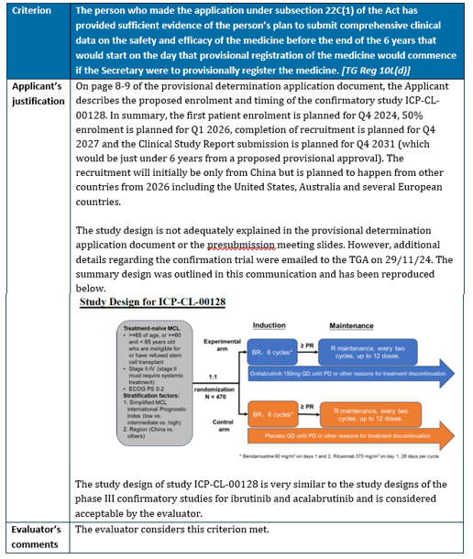
From ClinicalTrials.gov (https://clinicaltrials.gov/study/NCT06363994), Study NCT06363994/ICP-CL-00128 (randomised phase 3 study of orelabrutinib in combination with rituximab and bendamustine (BR) vs. BR in patients with treatment-naïve mantle cell lymphoma) has commenced enrolment, with study commencement date 29 May 2024 and estimated study completion 25 June 2031. The study is currently recruiting in China (38 sites). The sponsor states that study enrolment is confirmed in countries outside of China, including Australia, US and European countries, with clinical sites ex-China currently being selected and CTA filings in different countries/regions currently underway. The targeted ex-China patient percentage is >30% (i.e. >150 patients) as projected in the Provisional Determination application.
The Delegate noted that in the event that study ICP-CL-00128 fails to recruit patients globally, (i.e. should the confirmatory phase 3 data be from a study population from China only), the applicability and generalisibility of efficacy and safety data to patients in Australia may then be of concern. This would be an issue that would need to be considered in the anticipated future submission for conversion of the registration of orelabrutinib from provisional to standard/full.

Risks-uncertainties of risk

Risks
The safety profile of orelabrutinib has been satisfactorily established in the context of this provisional registration application.

Uncertainties
The single arm study design of ICP-CL-00102 and ICP-CL-00107 precludes the direct comparison of safety/toxicity profile of orelabrutinib with current standards of care. The number of patients in these studies was relatively small, limiting the ability to fully characterise rare AEs.
As discussed above, a larger randomised study is needed to further confirm efficacy and safety of orelabrutinib in patients with MCL (the Sponsor will be required to provide data from the confirmatory study as planned, to convert the registration of orelabrutinib from provisional to standard/full).

Benefit-risk balance
Overall, the benefit-risk assessment for orelabrutinib in the evaluated population is favourable with respect to supporting provisional registration. The ORRs from the Study ICP-CL-00102 and ICP-CL-00107 are considered to be clinically meaningful and reasonably likely to predict clinical benefit in the evaluated population. Although orelabrutinib can cause serious toxicities, the safety profile demonstrated is acceptable when considered in the context of a life-threatening disease (i.e. R/R MCL).
The study design limits interpretation of survival. Although available evidence supports provisional approval, further data is required in order to confirm clinical benefit. The sponsor will be required to submit final reports of the relevant confirmatory study (outlined above in figure 7).
The Delegate notes both (1) the sponsor’s amendment of the wording of the proposed indication during the course of clinical evaluation, and (2) the clinical evaluator’s preferred wording of indication. However, neither of these fully represent or capture, respectively, the patient population evaluated per inclusion criteria of studies ICP-CL-00102 and ICP-CL-00107.
It would be more appropriate for the wording of the indication to specify adult patients who have relapsed or refractory MCL. Therefore, the Delegate supports the provisional registration of orelabrutinib as follows:
Hibruka has provisional approval in Australia for the treatment of adult patients with relapsed or refractory mantle cell lymphoma (MCL).
The decision to approve this indication has been made on the basis of overall response rate (ORR). Continued approval of this indication depends on verification and description of benefit in confirmatory trials.
Alternatively, the following wording of the indication could be considered reasonable:
Hibruka is indicated for the treatment of adult patients with mantle cell lymphoma (MCL) who have received at least one prior therapy.
The decision to approve this indication has been made on the basis of overall response rate (ORR). Continued approval of this indication depends on verification and description of benefit in confirmatory trials.
This wording is in alignment with that of similar agents provisionally registered in this patient population (i.e. acalabrutinib based on Phase 2 study ACE-LY-004 and zanubrutinib based on Phase 2 studies BGB-3111-206/BGB-3111-AU-003), and also in alignment with that for orelabrutinib approved by other global health regulatory agencies.

Proposed action
Currently, the benefit-risk assessment for orelabrutinib in the evaluated population is considered to be favourable.
The Delegate will refer this submission to the Advisory Committee on Medicines (ACM) for further advice regarding the wording of the therapeutic indication.

Independent expert advice
The Delegate received the following independent expert advice.

Advisory Committee considerations
The Advisory Committee on Medicines (ACM), having considered the evaluations and the Delegate’s Overview, as well as the sponsor’s response to these documents, advised the following.

Specific advice to the Delegate
The ACM advised the following in response to the Delegate’s specific request for advice:
1. Based on the available data, does ACM support the use of orelabrutinib for the proposed population? (If yes, please advise regarding wording of indication)
Overall, the ACM was satisfied that the available efficacy and safety data supported the provisional registration of orelabrutinib for patients with relapsed or refractory MCL as per the clinical trial program.
While it was acknowledged that the Sponsor’s preferred indication according to their pre-ACM response aligned with wording previously approved for other BTK inhibitors, the ACM noted the role of BTK inhibitor maintenance treatment in the front-line setting is still unclear in patients who are in remission or have had response to first line therapy. Therefore, the ACM advised that the wording of the indication should not include maintenance therapy as there was no supporting evidence provided for its use as such a therapy.

Advisory committee conclusion
The ACM considered orelabrutinib to have an overall positive benefit-risk profile for the Delegate’s proposed indication:
Hibruka has provisional approval in Australia for the treatment of adult patients with relapsed or refractory mantle cell lymphoma (MCL). The decision to approve this indication has been made on the basis of overall response rate (ORR). Continued approval of this indication depends on verification and description of benefit in confirmatory trials.

Assessment outcome
Based on a review of quality, safety, and efficacy, the TGA decided to provisionally register Hibruka (orelabrutinib) 50 mg, tablet, bottle.
The indication for the medicine is:
Hibruka has provisional approval in Australia for the treatment of adult patients with relapsed or refractory mantle cell lymphoma (MCL). The decision to approve this indication has been made on the basis of overall response rate (ORR). Continued approval of this indication depends on verification and description of benefit in confirmatory trials.

Specific conditions of registration
- Hibruka (orelabrutinib) is to be included in the Black Triangle Scheme. The PI and CMI for Hibruka must include the black triangle symbol and mandatory accompanying text for five years, or the product’s entire period of provisional registration, whichever is longer.
- The Hibruka AU-Risk Management Plan (RMP) (version 0.3, dated 24 November 2025, data lock point 1 May 2024), included with submission PM-2025-00463-1-4, and any subsequent revisions, will be implemented in Australia
- An obligatory component of risk management plans is routine pharmacovigilance. Routine pharmacovigilance includes the submission of periodic safety update reports (PSURs).
  - Unless agreed separately between the supplier who is the recipient of the approval and the TGA, the first report must be submitted to TGA no later than 15 calendar months after the date of this approval letter. The subsequent reports must be submitted no less frequently than annually from the date of the first submitted report until the period covered by such reports is not less than three years from the date of the approval letter, or the entire period of provisional registration, whichever is longer. Each report must be submitted within ninety calendar days of the data lock point for that report.
  - The reports are to at least meet the requirements for PSURs as described in the European Medicines Agency’s Guideline on good pharmacovigilance practices (GVP) Module VII-periodic safety update report (Rev 1), Part VII.B Structures and processes. Note that submission of a PSUR does not constitute an application to vary the registration.
- The sponsor must conduct studies as described in the clinical study plan in version 0.3 (dated 24 November 2025, data lock point 1 May 2024) of the Australia-Specific Annex. The following study report(s) should be submitted to TGA: ICP-CL-00128, by end Q4 2031.

Product Information and Consumer Medicine Information
For the most recent Product Information (PI) and Consumer Medicine Information (CMI), please refer to the TGA PI/CMI search facility.

Therapeutic Goods Administration
PO Box 100 Woden ACT 2606 Australia
Email: info@tga.gov.au Phone: 1800 020 653 Fax: 02 6203 1605
https://www.tga.gov.au

Satterthwaite, A. B. and Witte, O. N. (2000) The role of Bruton’s tyrosine kinase in B-cell development and function: a genetic perspective. Immunol. Rev. 175: 120-127.
Elmeliegy M, et al. Discordance Between Child-Pugh and National Cancer Institute Classifications for Hepatic Dysfunction: Implications on Dosing Recommendations for Oncology Compounds. J Clin Pharmacol. 2021 Jan;61(1):105-115. doi: 10.1002/jcph.1702. Epub 2020 Jul 20. PMID: 32691438; PMCID: PMC7754409.
FDA. Guidance for industry: population pharmacokinetics. 2022. Available from: https://www.fda.gov/regulatory-information/search-fda-guidance-documents/populationpharmacokinetics [accessed 03 February 2022].
EMA. Committee for Medicinal Products for Human Use (CHMP). Guideline on reporting the results of population pharmacokinetic analyses, Doc. Ref. CHMP/EWP/185990/06, London, 21 June 2007: Available from: http://www.ema.europa.eu/docs/en_GB/document_library/Scientific_guideline/2009/09/WC500003067.pdf
https://www.fda.gov/drugs/resources-information-approved-drugs/fda-approves-acalabrutinib-bendamustine-and-rituximab-previously-untreated-mantle-cell-lymphoma

