Australian Public Assessment Report for Exdensur
  - Active ingredient: Depemokimab
  - Sponsor: GlaxoSmithKline Australia Pty Ltd
September 2026

About the Therapeutic Goods Administration (TGA)
- The Therapeutic Goods Administration (TGA) is part of the Australian Government Department of Health, Disability and Ageing and is responsible for regulating therapeutic goods, including medicines, medical devices, and biologicals.
- The TGA administers the Therapeutic Goods Act 1989 (the Act), applying a risk management approach designed to ensure therapeutic goods supplied in Australia meet acceptable standards of quality, safety, and efficacy.
- The work of the TGA is based on applying scientific and clinical expertise to decision-making, to ensure that the benefits to the Australian public outweigh any risks associated with the use of therapeutic goods.
- The TGA relies on the public, healthcare professionals and industry to report problems with therapeutic goods. The TGA investigates reports received to determine any necessary regulatory action.
- To report a problem with a therapeutic good, please see the information on the TGA website.

About AusPARs
- The Australian Public Assessment Report (AusPAR) provides information about the evaluation of a prescription medicine and the considerations that led the TGA to approve or not approve a prescription medicine submission. Further information can be found in Australian Public Assessment Report (AusPAR) guidance.
- AusPARs are prepared and published by the TGA.
- AusPARs are static documents that provide information that relates to a submission at a particular point in time. The publication of an AusPAR is an important part of the transparency of the TGA’s decision-making process.
- A new AusPAR may be provided to reflect changes to indications or major variations to a prescription medicine subject to evaluation by the TGA.

Copyright
© Commonwealth of Australia 2026.
This work is copyright. You may reproduce the whole or part of this work in unaltered form for your own personal use or, if you are part of an organisation, for internal use within your organisation, but only if you or your organisation do not use the reproduction for any commercial purpose and retain this copyright notice and all disclaimer notices as part of that reproduction. Apart from rights to use as permitted by the Copyright Act 1968 or allowed by this copyright notice, all other rights are reserved, and you are not allowed to reproduce the whole or any part of this work in any way (electronic or otherwise) without first being given specific written permission from the Commonwealth to do so. Requests and inquiries concerning reproduction and rights are to be sent to the TGA Copyright Officer, Therapeutic Goods Administration, PO Box 100, Woden ACT 2606 or emailed to <tga.copyright@tga.gov.au>.

Contents
List of abbreviations 4
Product submission 7
Submission details 7
Product background 8
Conditions 8
Current treatment options 10
Clinical rationale 12
Regulatory status 13
Australian regulatory status 13
International regulatory status 13
Registration timeline 15
Assessment overview 15
Quality evaluation summary 16
Nonclinical evaluation summary 16
Clinical evaluation summary 17
Summary of clinical studies 17
Pharmacology 17
Efficacy - Asthma 22
Efficacy - CRSwNP 26
Safety - Asthma studies 34
Safety - CRSwNP studies 38
Risk management plan 42
Risk-benefit analysis 43
Delegate’s considerations - Asthma 43
Delegate’s considerations - CRSwNP 46
Conclusions 48
Advisory Committee considerations 49
Risk/benefit assessment (post-Advisory Committee Meeting) 50
Assessment outcome 50
Specific conditions of registration 50
Product Information and Consumer Medicine Information 51

List of abbreviations
Abbreviation | Meaning
AAER | Annualised asthma exacerbation rate
ACM | Advisory Committee on Medicines
ADA(s) | Anti-drug antibody/ antibodies
AE | Adverse event
AESI | Adverse event of special interest
AI | Autoinjector
ALT | Alanine aminotransferase
ARTG | Australian Register of Therapeutic Goods
ASA | Australia-specific annex
ASCIA | Australasian Society of Clinical Immunology and Allergy
AST | Aspartate aminotransferase
AUC_{τ,ss} | Area under the concentration time curve during a dosing interval at steady state
BIPAP | Bilevel positive airway pressure
BL | Baseline
C_{av,ss} | Average concentration during a dosing interval at steady state
CI | Confidence interval
CL | Clearance
C_{max} | Maximum measured concentration of drug
CMI | Consumer Medicines Information
COVID-19 | Coronavirus Disease 2019
CPAP | Continuous positive airway pressure
CRSwNP | Chronic Rhinosinusitis with Nasal Polyps
CRwNP | Chronic Rhinosinusitis with Nasal Polyps
CT | Computerised Tomography
C_{trough, week26} | Trough concentration at the end of the first administration
DLP | Data lock point
ECG | Electrocardiograph
ED | Emergency department
FAS | Full analysis set
Fc | Fragment crystallisable
FeNO | Fractional exhaled nitric oxide
FEV1 | Forced Expiratory Volume in one second
FP | Fluticasone propionate
F_{rel} | Relative bioavailability
FVC | Forced Vital Capacity
GCP | Good Clinical Practice
GINA | Global Initiative for Asthma
GLP | Good laboratory practice
HFA | Hydrofluoroalkane
HRQoL | Health-related quality of life
ICH | International Council on Harmonisation
ICS | Inhaled corticosteroids
IgE | Immunoglobulin E
IL4Rα | Interleukin-4 receptor alpha
IL-5 | Interleukin-5
IL5Rα | Interleukin-5 receptor alpha
IV | Intravenous
k_{a} | Absorption rate constant
LABA | Long-acting beta agonist
LAMA | Long-acting muscarinic antagonist
LLQ | Lower Limit of Quantification
NAb | Neutralising antibodies
NERD | NSAID-exacerbated respiratory disease
NOAEL | No observed adverse effect level dose
NP | Nasal polyp(s)
OCS | Oral corticosteroid
PFS | Pre-filled syringe
PI | Product Information
PopPK | Population PK
PSUR | Periodic safety update report
PT | Preferred Term
Q26W | Dosing every twenty-six weeks
QTc | QT interval (Corrected for heart rate)
QTcF | Corrected QT interval (Fridericia’s formula)
RMP | Risk management plan
RR | Relative risk
SAE | Serious adverse events
SC | Subcutaneous
SCS | Systemic corticosteroids
SD | Standard deviation
SoC | Standard of care
SOC | System order class
t_{½} | Half-life
TRAE | Treatment related adverse event
TGA | Therapeutic Goods Administration
T_{max} | Time to observe maximum drug concentration
TSLP | Thymic stromal lymphopoietin
URTI | Upper respiratory tract infection
US(A) | United States (of America)
V | Volume of distribution
VRS | Verbal response scale
Vz/F | Apparent volume of distribution during terminal phase

Product submission

Submission details
Type of submission: | New biological entity
Product name: | Exdensur
Active ingredient: | Depemokimab
Decision: | Approved
Date of decision: | 21 July 2026
Date of entry onto ARTG: | 24 July 2026
ARTG numbers: | 486145, 486146
Black Triangle Scheme  for the current submission: | Yes
Sponsor’s name and address: | GlaxoSmithKline Australia Pty Ltd  Level 4, 436 Johnston Street,  Abbotsford, Victoria 3067
Dose form: | Solution for injection
Strength: | 100 mg/mL
Containers: | Type I glass: Prefilled pen (autoinjector), Prefilled syringe (safety syringe)
Pack sizes: | Single packs
Approved therapeutic use for the current submission: | Asthma  Exdensur is indicated as add-on maintenance treatment of severe asthma in patients aged 12 years and older with type 2 inflammation characterised by an eosinophilic phenotype who are inadequately controlled on medium- to high-dose inhaled corticosteroids (ICS) plus another asthma controller (see Section 5.1 PHARMACODYNAMIC PROPERTIES, Clinical Trials).  Chronic Rhinosinusitis with Nasal Polyps (CRSwNP)  Exdensur is indicated as an add-on therapy with intranasal corticosteroids for the treatment of adult patients with CRSwNP inadequately controlled by systemic corticosteroids or surgery.
Route of administration: | Subcutaneous (SC) injection
Dosage: | Asthma  The recommended dose is 100 mg of Exdensur administered by subcutaneous injection once every 6 months.  Chronic Rhinosinusitis with Nasal Polyps  The recommended dose is 100 mg of Exdensur administered by subcutaneous injection once every 6 months.  For further information regarding dosage, such as dosage modifications to manage adverse reactions, refer to the Product Information.
Pregnancy category: | Pregnancy Category B2  There are limited data from the use of Exdensur in pregnant women. No animal studies have been performed to evaluate the potential effects of depemokimab in pregnancy.  The use of any medicine during pregnancy requires careful consideration of both risks and benefits by the treating health professional. The pregnancy database must not be used as the sole basis of decision making in the use of medicines during pregnancy. The TGA does not provide advice on the use of medicines in pregnancy for specific cases. More information is available from obstetric drug information services in your state or territory.

Product background
This AusPAR describes the submission by GlaxoSmithKline Australia (the sponsor) to register Exdensur (depemokimab) 100 mg solution for injection in pre-filled pen (autoinjector) or pre-filled syringe (safety syringe) for the following proposed indication:
Asthma
As add-on maintenance therapy of asthma in patients with type 2 inflammation characterised by an eosinophilic phenotype who are inadequately controlled on medium-to-high doses of inhaled corticosteroids (ICS) plus another asthma controller.
Chronic Rhinosinusitis with Nasal Polyps (CRwNP)
As add-on maintenance therapy in patients with inadequately controlled chronic sinusitis with nasal polyps.
The proposed dose is 100 mg SC once every 6 months.
The safety and efficacy have not been established in patients with CRwNP aged < 18 years.

Conditions

Asthma
Asthma is a chronic heterogeneous lung disease featuring inflammation, airway hyper-responsiveness and variable airflow obstruction. Clinical manifestations are typically episodic, including wheeze, cough, chest tightness and dyspnoea, with diagnosis confirmed by evidence of reversible or variable expiratory airflow obstruction on spirometry.
In predisposed individuals, exposure to specific triggers such as aeroallergens, exercise, respiratory infections, irritants, and climate oscillations initiates an early phase immune response, primarily mediated by immunoglobulin E (IgE). This leads to mast cell and basophil degranulation, releasing pro-inflammatory mediators such as histamine, prostaglandins and leukotrienes, agents that induce bronchoconstriction, mucosal oedema and mucous hypersecretion.
The late phase response involves the recruitment of additional inflammatory cells, including eosinophils, basophils, mast cells, neutrophils, and T-lymphocytes, perpetuating airway inflammation and tissue remodelling.

Type 2 inflammation and asthma pathophysiology
Approximately 50- 70% of asthma cases are driven by Type 2 inflammation. This immunological pathway secretes key cytokines including, but not limited to, Interleukin-5 (IL-5) which is central to eosinophil maturation, recruitment and survival.
Interleukin-5 is a pivotal cytokine in the pathogenesis of eosinophilic asthma, exerting effects via:
- differentiation and maturation of eosinophils from bone marrow progenitors
- promoting eosinophil recruitment, activation and survival in airway tissues
- inducing degranulation and release of cytotoxic granules, contributing to epithelium damage and airway remodelling.²
Elevated eosinophil levels correlate with increased exacerbation risk, progressive lung function decline, and poor corticosteroid responsiveness. IL-5 is produced by Th2 cells, ILC2s, mast cells and eosinophils themselves, forming a feedback loop that sustains inflammation.
The Australian Bureau of Statistics published statistics in the 2022 reference period state around 2.8 million Australians had asthma, and 33.9% used daily asthma medication. In 2025, Asthma accounted for 2.5% of the total disease burden in Australia and was the leading cause of total disease burden in children aged 1–9 years of age. It is more common in males up to the age of 14 but is greater in females aged 15 and older^{.5} In 2023–2024, 0.3% of all hospitalisations were for asthma, and around 43% of hospitalisations with a principal diagnosis of asthma were for people aged 0–14 years.⁵
Severe asthma is defined as asthma that is uncontrolled despite adherence with high dose ICS and long-acting beta agonists (LABA) and management of contributory factors, or patients requiring high dose ICS-LABA to maintain good asthma control. Contributory factors may include treatment adherence, inhaler device technique, self-monitoring, trigger avoidance and identification and management of comorbidities. Uncontrolled asthma includes persistent symptoms, frequent or severe exacerbations, airflow limitation or controlled asthma that worsens on tapering of corticosteroid treatment.

Chronic rhinosinusitis with nasal polyps
Chronic Rhinosinusitis with Nasal Polyps (CRSwNP) is a chronic inflammatory disorder affecting the mucosa of the nasal passages, linings and/or paranasal sinuses characterised by the formation of benign, soft tissue nasal polyps. These polyps often present bilaterally and contribute to significant health-related quality of life (HRQoL) impairment, including nasal obstruction, anosmia (loss of smell), rhinorrhoea and sleep disturbances.
CRSwNP is estimated to affect 1–4% of the general population though it varies across geographic regions. CRSwNP is more prevalent in males than females, with the greatest prevalence in the 60- to 69-year age group.⁷ The condition is frequently associated with comorbidities such as asthma, allergic rhinitis and NSAID-exacerbated respiratory disease (NERD) which can complicate management and worsen prognosis.
CRSwNP is predominantly driven by Type 2 inflammation, present in over 80% of patients with uncontrolled disease. The immunologic pathway involves Th2 lymphocytes and ILC2 cells which release cytokines including:
- IL-4 – promotes IgE synthesis
- IL-5 – central to eosinophil recruitment, activation and survival.
- IL-13- contributes to mucous hypersecretion and epithelial barrier dysfunction.
IL-5 plays a critical role in eosinophilic inflammation which is a hallmark of CRSwNP. Elevated IL-5 levels correlate with tissue eosinophilia, polyp growth, and disease severity.
The Australasian Society of Clinical Immunology and Allergy (ASCIA) provides a summary of typical symptoms of chronic rhinosinusitis with nasal polyps (CRSwNP), to help guide diagnosis and management. These include nasal blockage or congestion, runny nose (rhinorrhoea), itchy nose, ears or throat, sneezing, anosmia, symptoms affecting day to day function leading to sleep disturbance, daytime tiredness, poor concentration (if uncontrolled), and recurrent sinus infections. Triggers possibly include inhaled allergens, airborne irritants, and physical or hormonal factors medications, older age and chronic health issues.¹⁰ Although patients may test positive for inhaled allergens on skin testing or allergen specific IgE, these are not the drivers of the condition. The guidance suggests endoscopy or CT scan as additional investigations.

Current treatment options

Asthma
The main goals of asthma management are symptom control, reduction in frequency and risk of exacerbations and minimisation of the adverse effects of medications. Asthma is considered ‘controlled’ when a patient has daytime symptoms fewer than twice per week, no airway limitations in performing activities of daily life, an absence of nocturnal symptoms, no exacerbations, utilisation of reliever medications less than twice weekly, and normal/near normal lung function.
The Australian Asthma handbook recommends four levels of treatment, with alternatives at level 1 through to level 3 (Figure 1).
Figure 1. Treatment Algorithm for Adult and Adolescent Asthma, Australian Asthma Handbook.
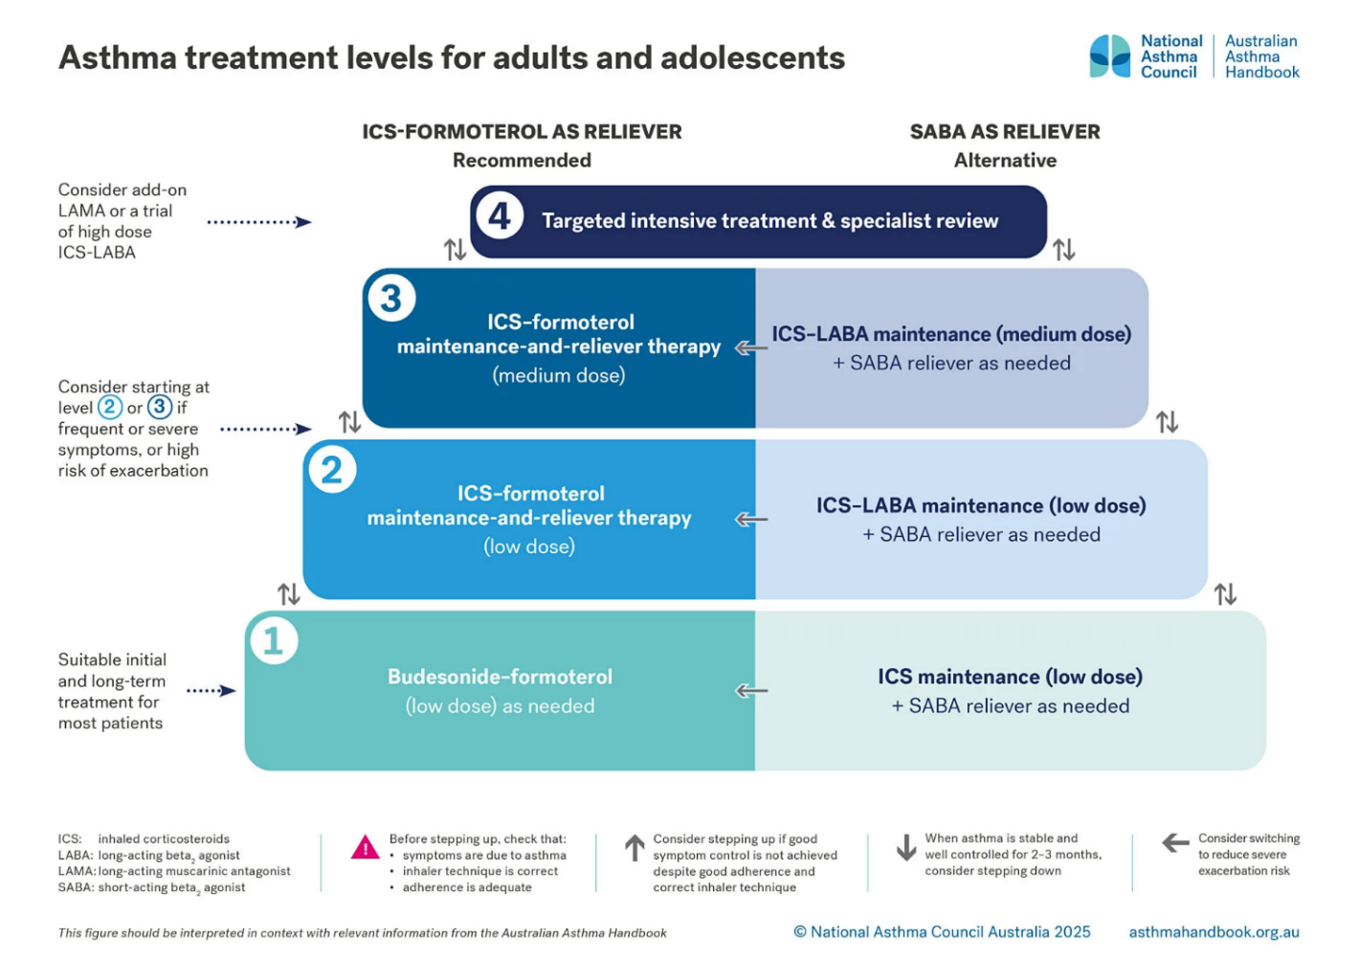
Most patients with asthma are managed with inhaled agents, using an escalation approach as depicted above. The guidelines recommend spirometry, blood eosinophil measurement and specialist referral for patients who cannot achieve good asthma control with medium dose ICS-LABA with good adherence and correct inhaler technique.
Severe asthma, by definition, requires high-dose ICS-LABA with good inhaler technique, or oral maintenance corticosteroid. The guidelines emphasise these are not recommended long term treatments. After ruling out other contributing factors, monoclonal antibodies are the next treatment option, including:
- Benralizumab (anti-IL5Rα) is indicated as an add-on treatment for patients aged 12 years and over with severe eosinophilic asthma (blood eosinophil count 300 cells/microlitre or 150 cells/microlitre if on oral corticosteroid treatment).
- Mepolizumab (anti-IL-5) is indicated as an add-on treatment for severe eosinophilic asthma in patients aged 12 years and over.
- Dupilumab (anti-IL-4Rα) is indicated as add on maintenance treatment in patients aged 6 years and older with moderate to severe asthma with type 2 inflammation (elevated eosinophils or elevated fractional exhaled nitric oxide [FeNO]) that is inadequately controlled despite therapy with other medicinal products for maintenance treatment.
- Omalizumab (anti-IgE) is approved in children aged 6 to < 12 years, as add-on to improve asthma control in patients with severe allergic asthma who had documented exacerbations despite daily high dose inhaled corticosteroid, and who have immunoglobulin E levels corresponding to the recommended dose range. It is also approved for the management of adult and adolescent patients with moderate to severe allergic asthma, who are already being treated with inhaled steroid, and who have serum immunoglobulin E levels corresponding to the recommended dose range.
The guidelines also list azithromycin, breathing exercises and bronchial thermoplasty as strategies sometimes used in specialist care.

Chronic rhinosinusitis with nasal polyps
The Australasian Society of Clinical Immunology and Allergy (ASCIA) 2025 checklist¹⁰ recommends trigger minimisation or avoidance, saline nasal sprays or rinses, antihistamines, intranasal corticosteroids (potentially with antihistamine) used regularly and correctly. It also suggests consideration of allergen immunotherapy (which requires the specific allergens to be confirmed on testing), and the occasional use of antibiotics and short course corticosteroids. Biological medicines (which it refers to a biologics) are recommended if symptoms are severe. Specialist referral to an ENT surgeon is for consideration, and referral to a clinical immunologist or allergy specialist is recommended.¹⁰
In Australia, three monoclonal therapies are approved as add-on maintenance treatments in adults with severe CRSwNP. These include:
- Mepolizumab: Inhibits IL-5.¹³
- Dupilumab: Inhibits IL-4 and IL-13 signalling.¹⁴
- Omalizumab: Blocks IgE-mediated pathways.¹⁵

Clinical rationale

Asthma
Asthma exacerbations are acute episodes of symptom worsening that significantly impair respiratory function and quality of life. In severe or difficult to treat asthma, exacerbations often necessitate short courses of systemic corticosteroids (SCS), which are administered in most patients. While effective in controlling acute inflammation, SCS are associated with a range of adverse effects.
Short-term SCS use increases the risk of infections, hyperglycaemia, and mood disturbances. Repeated courses or chronic use can lead to long-term complications including metabolic syndrome (weight gain, type II diabetes, hypertension, lipid disturbance); osteoporosis and fractures; and ocular abnormalities such as cataracts. Frequent exacerbations are also linked to accelerated lung function decline, increased healthcare utilisation, and in severe cases, hospitalization or death. Beyond clinical consequences, exacerbations contribute substantially to asthma-related economic burden through direct healthcare costs, lost productivity, and disruption to education and employment.
Biologic therapies targeting Type 2 inflammatory pathways, such as anti-IgE, anti-IL-5, anti-IL-5Rα, and anti-TSLP agents, have demonstrated efficacy in reducing exacerbation frequency, minimising systemic corticosteroid dependence, and improving overall disease control. However, treatment outcomes are influenced by adherence to dosing schedules which typically involve subcutaneous (SC) or intravenous (IV) administration every 2 to 8 weeks. Therapies with shorter dosing intervals are thought to have lower adherence rates, underscoring the potential benefit of biologics with a favourable risk-benefit profile and extended dosing intervals to support sustained disease control in this population.

Chronic rhinosinusitis with nasal polyps
Biologic therapies have demonstrated efficacy in both asthma and CRSwNP by reducing eosinophil counts and polyp size, improving disease control, including asthma symptoms, nasal airflow and olfaction, and decreasing reliance on systemic corticosteroids, as well as the need for surgical intervention.
However, adherence to recommended dosing schedules, typically SC every 2 to 8 weeks, is purported to provide a significant challenge in real-world settings. Factors contributing to poor adherence include treatment burden, scheduling complexity and administration logistics.
Less frequent dosing schedules are perceived, by the sponsor, as more convenient and conducive to long-term compliance. This underscores the potential role for biologic therapies that offer a favourable risk-benefit profile while supporting extended dosing intervals thereby enhancing adherence and optimising clinical outcomes in patients with severe asthma and inadequately controlled CRSwNP.

Depemokimab
Depemokimab is an ultra-long-acting monoclonal antibody. Depemokimab targets human IL-5 with high binding affinity and specificity, thereby blocking the binding to the IL-5 receptor alpha expressed on the cell surface with picomolar potency in vitro. Depemokimab contains a triple amino acid substitution (YTE) in the fragment crystallisable (Fc) region which increases binding to the neonatal Fc receptor and thereby extends the elimination half-life. These modifications allow for dosing every 6 months.
IL-5 is a core cytokine in Type 2 inflammation along with IL-4 and IL-13. Type 2 inflammation driven by IL-5 is an important component in the pathogenesis of asthma and CRSwNP. As an anti-IL-5 therapy and ultra-long-acting SC injectable, Exdensur is purported to deliver an efficacy and safety profile similar to current anti-IL-5/IL-5R mAbs but with a reduced dosing frequency (once every 6 months as compared with existing therapies administered every 4 or 8 weeks) due to its longer half-life and high potency.

Regulatory status

Australian regulatory status
This product is considered a new biological entity for Australian regulatory purposes.

International regulatory status
At the time the TGA considered this submission, similar submissions had been considered by other regulatory agencies. The following table summarises these submissions and provides the indications where approved.
Table 1. International regulatory status.
Region | Submission date | Status | Approved indications
European Union | 18 December 2024 | Approved on 12 February 2026 | Asthma  Exdensur is indicated as an add-on maintenance treatment for severe asthma with type 2 inflammation characterised by blood eosinophil count in adults and adolescents in 12 years and older who are inadequately controlled despite high dose inhaled corticosteroids (ICS) plus another asthma controller.  Chronic rhinosinusitis with nasal polyps (CRSwNP)  Exdensur is indicated as an add-on therapy with intranasal corticosteroids for the treatment of adult patients with severe CRSwNP for whom therapy with systemic corticosteroids and/or surgery do not provide adequate disease control.
United Kingdom | 5 February  2025 | Approved on 15 December 2025 | Asthma  Exdensur is indicated as an add-on maintenance treatment of asthma in adult and adolescent patients aged 12 years and older with type 2 inflammation characterised by an eosinophilic phenotype who are inadequately controlled on maximum moderate-dose or high-dose inhaled corticosteroids (ICS) plus another asthma controller.  Chronic rhinosinusitis with nasal polyps (CRSwNP)  Exdensur is indicated as an add-on therapy with intranasal corticosteroids for the treatment of adult patients with severe CRSwNP for whom therapy with systemic corticosteroids and/or surgery do not provide adequate control.
United States of America | 16 December 2024 | Approved on 16 December 2025 | Exdensur is indicated for the add-on maintenance treatment of severe asthma characterized by an eosinophilic phenotype in adult and pediatric patients aged 12 years and older.
Canada | 26 February 2025 | Approved on 15 June 2026 | Asthma  Exdensur (depemokimab injection) is indicated as an add-on maintenance treatment in adults and adolescents 12 years and older with severe asthma characterized by an eosinophilic phenotype and inadequately controlled by medium- to high-dose inhaled corticosteroids (ICS) plus another asthma controller.  Chronic rhinosinusitis with nasal polyps (CRSwNP)  Exdensur is indicated as an add-on maintenance treatment with intranasal corticosteroids in adults with severe chronic rhinosinusitis with nasal polyps (CRSwNP) inadequately controlled by systemic corticosteroids and/or surgery.

Registration timeline
The following table captures the key steps and dates for this submission.
This submission was evaluated under the standard prescription medicines registration process.
Table 2: Timeline for Submission PM-2025-01558-1-5
Description | Date
Submission dossier accepted and first round evaluation commenced | 3 June 2025
Evaluation completed (End of round 2) | 23 March 2026
Advisory committee meeting | 5 June 2026
Registration decision (Outcome) | 21 July 2026
Registration in the ARTG completed | 24 July 2026
Number of working days from submission dossier acceptance to registration decision* | 245 working days
*Statutory timeframe for standard submissions is 255 working days

Assessment overview
A summary of the TGA’s assessment for this submission is provided below.

Quality evaluation summary
The active substance is made using recombinant technology. It is a human IL-5 – specific fucosylated IgG1κ monoclonal antibody. The evaluator found the information about the manufacture, storage and control facilities sufficient to support the quality of the product.
Excipients are well known pharmaceutical ingredients supported by appropriate standards.
Secondary evaluators of sterility, adventitious agents, container and endotoxin safety considered the steps of manufacture and concluded adequate data were presented to give reassurance on removal/reduction to safe levels of contaminants.
The finished product is a solution for subcutaneous administration presented as a sterile liquid in a pre-filled syringe housed in a safety syringe device (SSD) or autoinjector pen (AI). The syringe component has a clear glass barrel with a staked 29G stainless steel needle with a thermoplastic elastomer needle shield covered by a rigid needle shield. The PFS barrel is sealed on the flange end with a fluroresin coated bromobutyl rubber plunger stopper.
The container suitability for the intended purpose was demonstrated by compatibility and stability studies. Sufficient stability data were provided to support a 36-month shelf life for the drug substance when stored at ≤-35°C and protected from light. The product is not photostable. Sufficient stability data were provided to support a 24-month shelf-life if stored at 2 - 8°C, protected from light. It can be stored at room temperature (up to 30°C) for 8 hours with exposure to light. It can be kept at room temperature (up to 30°C) for 7 days in the carton followed byfor 8 hours at 30°C with exposure to light. Temperature excursions of 1°C to -5°C (≤ 72 hours) or 9°C to 30°C (≤ 72 hours) are permitted.
The quality evaluator did not have any objection to the registration of depemokimab

Nonclinical evaluation summary
While the nonclinical dossier was generally acceptable, the safety pharmacology endpoints for the respiratory system were considered inadequate. All pivotal safety-related studies were GLP compliant.
The pharmacokinetics of depemokimab in monkeys and human subjects demonstrated very long half-lives and limited distribution. Depemokimab did not bind non-primate IL-5. In vitro, depemokimab bound the human IL-5 and inhibited the IL-5 induced proliferation of the TF-1 cells with an IC50 of 4 pM. In vivo, maximum level of total IL-5 in depemokimab-treated monkeys was higher and declined later than in mepolizumab-treated monkeys at same dose, suggesting increased binding potency and a longer half-life for depemokimab.
Depemokimab reduced the eosinophil count when dosed ≥10 mg/kg Q14W: ER AUC ≥9.
The evaluator noted the similarities with the mepolizumab toxicity profile.
Depemokimab had a low order of acute SC toxicity in monkeys. Adverse vascular inflammation in many organs with the presence of granular deposits containing monkey IgG, IgM and/or C3 was observed in two treated animals. An indirect relationship to treatment with depemokimab through exacerbation of spontaneous immune complex disease cannot be excluded. This observation was made on the single dose 4-week study and not reproduced on the repeat 6-month study.
An adequately conducted repeat dose toxicity of SC depemokimab in monkeys (6 months) achieving high relative exposure did not identify any target organ toxicity apart from decreases in circulating eosinophils.
Carcinogenicity and genotoxicity studies were not conducted; however, this was acceptable in accordance with ICH S6(R1) given the absence of concerning features such as proliferative lesions in the general repeat-dose toxicity studies and the physiological role of the target.
No reproductive and developmental toxicity studies were conducted. Male and female fertility were unaffected based upon no adverse histopathological findings in the reproductive organs from cynomolgus monkeys receiving SC dosages up to 100 mg/kg depemokimab for 6 months. In silico modelling was used to compare foetal exposures of depemokimab to exposures in the mepolizumab pre-and post-natal development study. The evaluator recommended a pregnancy category B2.
Anti-drug antibodies were detected in some monkeys in the repeat-dose toxicity study and were typically associated with reduced systemic exposure.
The nonclinical evaluator had no objections to the approval of depemokimab from a nonclinical perspective.

Clinical evaluation summary

Summary of clinical studies
The clinical dossier consisted of:
- Asthma – Phase 1 studies
  - Study 208021 - Healthy Chinese participants
  - Study 205722 (FTIH) PD and PK/PD study
  - Study 214099 – PK comparability study
- Asthma - Phase 3 studies
  - Study 206713 (SWIFT-1)
  - Study 213744 (SWIFT-2)
- Asthma – ongoing study:
  - Study 212895 (AGILE) Ongoing study from SWIFT 1/2 participants
  - Study 206785 (NIMBLE) – on going non inferiority trial
- Chronic Rhinosinusitis with Nasal polyps - Phase 3 studies
  - Study 217095 (ANCHOR-1)
  - Study 218079 (ANCHOR-2)

Pharmacology

Pharmacokinetics - Asthma
Human pharmacokinetics (PK) were obtained from healthy volunteer studies, early studies in mild to moderate asthma, limited data from phase 3 studies in asthma and chronic rhinosinusitis with nasal polyps, and modelling and simulation.
Absolute bioavailability has not been established. Depemokimab has been developed for SC use only. The median T_{max} is 8 to 14 days. The apparent volume of distribution (Vz/F) is 6 – 9 L.
It is catabolised by proteolytic enzymes that are not restricted to hepatic tissue. The modelled apparent clearance was 0.092 L/day. The half-life was between 38 and 53 days.
In subcutaneous doses from 10 mg to 300 mg depemokimab demonstrated dose proportionality, and no apparent accumulation although only two doses were administered in most patients studied.
In the population PK (popPK) modelling age (≥12 years to 85 years) did not meaningfully influence the depemokimab PK in asthmatic patients (Table 3). There are no studies in asthmatic paediatric patients aged < 12 years.
Table 3. Derived secondary PK parameters, SWIFT-1 and SWIFT-2 depemokimab 100mg SC Q26W, by age.
Parameter - geometric mean (%CV) | 12-17 years old n=15 | 18-64 years old n=352 | ≥ 65 years old n=127 | Overall N=494
AUC_{tau,ss} (µg*day/mL) | 1051 (31.18) | 1068 (28.34) | 1121 (25.46) | 1081 (27.75)
C_{av,ss} (µg /mL) | 5.773 (31.18) | 5.868 (28.34) | 6.161 (25.46) | 5.939 (27.75)
C_{max},26-52 (µg/mL) | 14.58 (30.44) | 13.60 (28.49) | 13.59 (25.14) | 13.63 (27.69)
T_{max}, 26-52 (day) | 10.83 (8.750) | 13.17 (16.47) | 15.22 (15.83) | 13.59 (17.80)
C_{trough, week52} (µg/mL) | 1.081 (39.32) | 1.280 (39.02) | 1.451 (34.12) | 1.315 (38.37)
t1/2 (day) | 44.73 (8.578) | 48.23 (9.802) | 49.91 (8.432) | 48.55 (9.645)

Depemokimab is a large molecule of around 149 kDa, precluding renal elimination. There were no dedicated studies in renal impairment. Based on the popPK analysis there was no meaningful effect on PK in states of chronic kidney disease. There were no dedicated studies in hepatic impairment. From the popPK and using observed data hepatic impairment does not have a clinically significant impact on depemokimab apparent clearance.
The absence of expression of IL-5 on hepatocytes together with the observation that there is minimal elevation of systemic pro-inflammatory markers in severe refractory eosinophilic asthma suggest a low potential for an interaction with CYP450 enzymes and drug transporters.
Relative bioavailability from the autoinjector and the safety syringe supported use of either device.

Population PK data
Depemokimab PK was described by a 1-compartment model with first order absorption and elimination. The mean Vz/F was 6.3L, and the Vz/F was consistent and independent of dose, suggesting dose linear kinetics.
Using data from the first in human study in mild to moderate asthma and employing model informed drug development principles the 100 mg SC Q26W dosing was chosen to take forward into the phase 3 efficacy studies. The evaluator supported this dose for the asthma studies.

Pharmacokinetics - CRSwNP
The pharmacokinetic (PK) analysis specific to patients with CRSwNP was derived from data obtained from 143 adult participants in ANCHOR-1 and 129 adult participants in ANCHOR-2 dosed with depemokimab, with ≥1 PK sample that was analysed, and was measurable (including imputed values < LLoQ). There are no studies in CRSwNP paediatric patients (< 18 years).
The pharmacokinetic endpoint was depemokimab plasma concentration at measured timepoints during the 52-week period in both ANCHOR-1 and ANCHOR-2 studies.
Maximum plasma concentrations were observed at Week 2 and Week 4 after dosing (Day 1 and Week 26). Concentrations declined gradually in a monophasic manner over the dosing interval. No evidence of accumulation or unexpected PK behaviour in CRSwNP was demonstrated in the data collected (Figure 2, Figure 3).
Figure 2. Mean (+/- SD) depemokimab plasma concentration - time plots (linear and semi-log), PK population, ANCHOR-1 study.
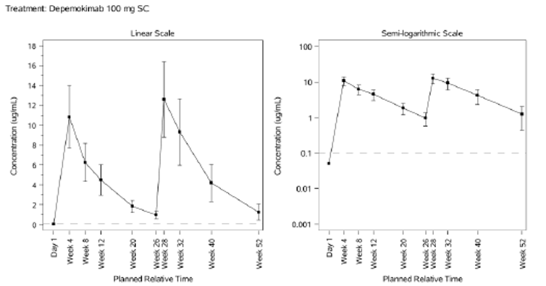
Note: LLQ=0.1 μg/mL. LLQ shown by horizontal reference line. If more than 30% of values are imputed, then SD is set to missing. Values less than or equal to 0 have been set to 0 on the linear scale and 0.001 on the semi-logarithmic scale.
Figure 3. Mean (± SD) depemokimab plasma concentration - time plots (linear and semi- log), PK population, ANCHOR-2 study.
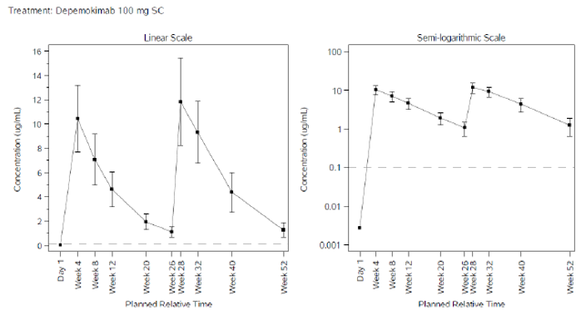
Note: LLQ=0.1μg/mL. LLQ shown by horizontal reference line. If more than 30% of values are imputed, then SD is set to missing. Values less than or equal to 0 have been set to 0 on the linear scale and 0.001 on the semi-logarithmic scale
The submission included population pharmacokinetic modelling. The popPK evaluator found the model was built in accordance with Guideline on Reporting the Results of Population Pharmacokinetic Analyses, that the process was rigorous, and the results should be accepted. Data were included from four phase 3 studies in asthma and CRSwNP and three phase I studies in healthy and mild-mod asthma.
Depemokimab is catabolised by proteolytic enzymes, so its metabolism is not limited to the function of a single organ. The target is not membrane bound so target mediated drug degradation is not a feature of the PK.
The long half-life (~6-8 weeks) supports extended dosing intervals.
The popPK model did not demonstrate significant relationships between renal function or hepatic function, although dedicated PK studies were not included in the submission.
Based on analyses of PK from the SWIFT studies in asthma and the ANCHOR studies in CRSwNP the 18% greater in exposure in Asian participants compared with White participants was not considered clinically significant and warranting dose adjustment. No dose adjustment is proposed based for patients aged > 65 years based on an analysis of PK from patients aged > 65 years across the program.
No dose adjustment is proposed on the basis of body weight because the C_{trough} for a 160kg patient was predicted to be greater than the EC₅₀ and an expected PD response of a 71% reduction in eosinophil count at that weight.
Based on the evaluator’s considerations of the exposure-response analysis a target C_{trough, Week52} ≥1.259 μg/mL was suggested as appropriate. The evaluation proposed a dose of 200 mg q26w as a possible alternative dose.

Pharmacodynamics - Asthma
Consistent with expected pharmacodynamic (PD) effects of IL-5 inhibitors, depemokimab demonstrated rapid and sustained reductions in blood eosinophils following depemokimab 100 mg SC Q26W. Reductions were evident within 2 weeks of dosing and maintained throughout the treatment interval with an approximate 79% (95% CI: 75.8, 81.8) decrease from baseline at Week 52 compared to placebo.
In the population PK-PD analysis, age did not predict a meaningful difference in eosinophil responses. Exposure-response relationships did not clearly delineate a relationship between PD parameters and annualised exacerbation rate.
No thorough QT/QTc study was conducted. This approach is consistent with clinical programs for other large antibodies that have a low likelihood of interacting with ion channels. Electrocardiograph (ECG) examinations were performed in the clinical studies.

Pharmacodynamics - CRSwNP
The pharmacodynamic (PD) outcome and endpoints for ANCHOR-1 and ANCHOR-2 was ratio to baseline in absolute blood eosinophil count at measured timepoints during the 52-week period.
The baseline geometric mean blood eosinophil counts were generally similar between the depemokimab (0.319 GI/L) and placebo (0.359 GI/L) groups in ANCHOR-1, and in ANCHOR-2 counts were slightly higher in the depemokimab (0.375 GI/L) group compared to placebo (0.288 GI/L). Both studies showed a reduction in eosinophil count from Week 4 through Week 52, as described by in Figure 4 and Figure 5.
Figure 4. Adjusted geometric means (and 95% CIs) of ratio to blood eosinophil count data (GI/L), FAS population, ANCHOR-1 study.
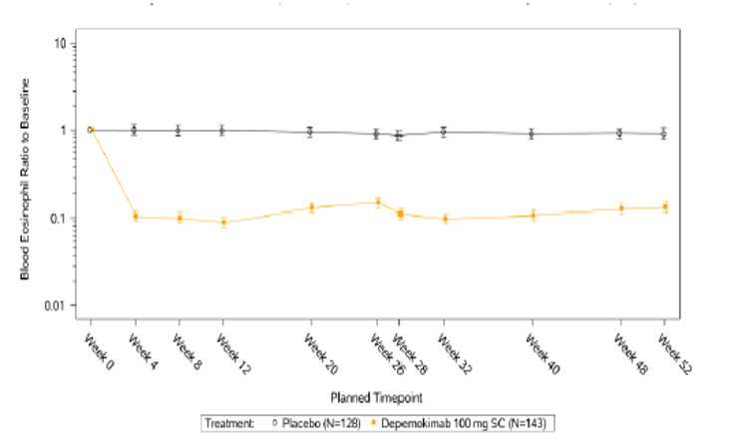
Figure 5. Line plot of adjusted geometric means (and 95% CIs) of ratio to blood eosinophil count data (GI/L), FAS population, ANCHOR-2 study.
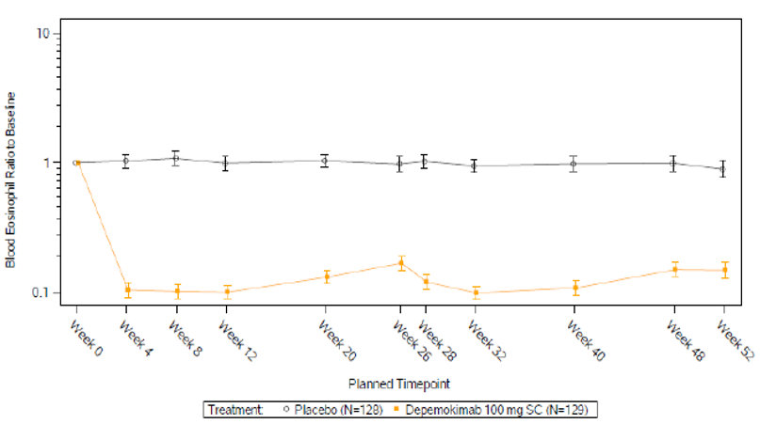

Dose finding
To support depemokimab Phase 3 dose selection for CRSwNP an exposure-response analysis was conducted. The dose selected corresponded to a predicted 82% reduction in baseline eosinophil count at Week 52.

Efficacy - Asthma
The efficacy of depemokimab in asthma was supported by two replicate Phase 3 studies (SWIFT-1 and SWIFT-2), an open-label 52-week Phase 3 study that enrolled participants from the SWIFT studies (the AGILE study), and data from an ongoing non-inferiority Phase 3 study in adults and adolescents comparing depemokimab with mepolizumab or benralizumab (the NIMBLE study).

SWIFT-1 and SWIFT-2
SWIFT-1 and SWIFT-2 were 52-week randomised, placebo-controlled, parallel group, multicentre, global studies of the efficacy and safety of depemokimab as add-on therapy in adults and adolescents with severe uncontrolled asthma and an eosinophilic phenotype. Both studies commenced in 2021. The study schematic is below (Figure 6).
Figure 6. Study SWIFT-1 and SWIFT-2 study schematic.
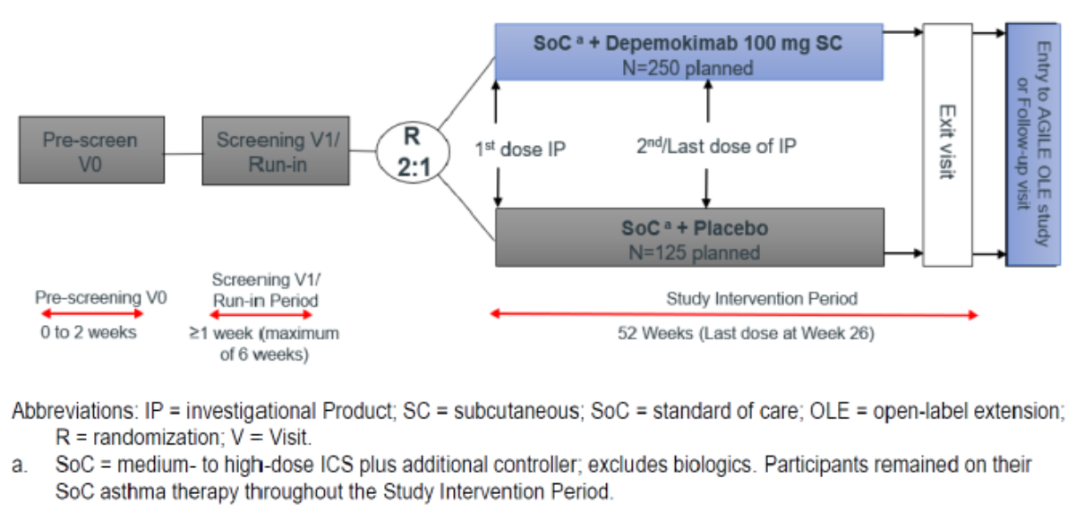
The patient population included participants aged ≥12 years with documented asthma for ≥2 years, and ≥2 confirmed asthma exacerbations requiring systemic corticosteroids in the 12 months prior to Visit 1, despite the use of inhaled corticosteroids at doses ≥440 mcg fluticasone propionate (FP), hydrofluoroalkane (HFA) or equivalent.
Participants required a blood eosinophil count of ≥300 cells/μL in the 12 months before Visit 1 or ≥150 cells/μL at Screening Visit 1; a Visit 1 pre-bronchodilator FEV1 <80% predicted if ≥18 years of age or a pre-bronchodilator FEV1 <90% predicted, or an FEV1: FVC ratio <0.8 if 12-17 years of age; and documented reversibility or hyper-responsiveness (as described in the study protocol). Participants needed regular treatment with medium- to high-dose ICS in the 12 months before Visit 1 [± maintenance oral corticosteroid], current treatment with ≥ 1 additional controller medication for ≥ 3 months, a maintenance ICS dose of ≥440 mcg FP HFA daily, or equivalent, and participants on medium dose ICS also required regular LABA to qualify.
Potential participants were excluded if they had a clinically significant lung condition other than asthma, a parasitic infestation within 6 months prior to Visit 1, a known immunodeficiency unless related to corticosteroid therapy for asthma, or other conditions with elevated eosinophils such as hyper-eosinophilic syndromes. Other exclusion criteria included current smoker or ex-smokers with a ≥10 pack year history, vasculitis or active COVID-19 infection. Treatment exclusions were treatment with mepolizumab, reslizumab, or benralizumab ≤12 months before Visit 1 or omalizumab or dupilumab <130 days before Visit 1, or any mAb < 5 half-lives of Visit 1, and documented anti-IL-5/5R therapy failure. Cardiac exclusion criteria were QTc(F) ≥450 msec or QTc(F) ≥480 msec (with Bundle Branch Block).
Across both studies, 61% of participants were female, 77% were of White race, and the median age was 56.0 years (range12, 82 years) and 15 in each treatment group were aged 12–17 years.
Participants had a mean (SD) duration of asthma of 23.4 (17.45) years, and with a mean (SD) 2.4 (1.46) exacerbations in the 12 months prior to screening was 2.4 (1.46). Most (80%) had 2 exacerbations requiring systemic corticosteroids in the previous 12 months, the remaining 20% had ≥3 exacerbations, and 7.9% had ≥1 exacerbation requiring hospitalisation prior to screening.
All participants were using ICS at baseline (44% receiving medium-dose, 56% receiving high-dose), and 29% were receiving ICS + LABA + long-acting muscarinic antagonists (LAMA) at screening.
Overall, g-mean baseline blood eosinophil counts were 318 cells/μL, 53% had eosinophils ≥300 cells/μL in the12 months before screening and 90% had eosinophil ≥150 cells/μL at screening.
The mean (SD) baseline predicted FEV1 was 62% (15.6%) pre-bronchodilator and the mean (SD) baseline FEV1 reversibility after bronchodilator was 18%. Mean (SD) baseline ACQ-5 score was 2.21 (1.097) in the depemokimab group and 2.24 (1.059) in the placebo group and 75% had a baseline ACQ-5 score ≥1.5 in the pooled SWIFT-1+2 population. The Clinical Evaluation Report includes additional details of the baseline characteristics.
Eligible participants were randomised 2:1 to receive either depemokimab 100 mg SC or placebo 0.9% sodium chloride SC, in addition to current stable maintenance asthma medications.
Permitted stable medications ICS plus ≥1 controller (e.g. LABA, LAMA) ± maintenance OCS, and additional asthma medications (e.g. theophylline, anti-leukotrienes) if used regularly for ≥3 months prior to screening. CPAP/BiPAP for obstructive sleep apnoea was permitted if initiated before screening. Allergen specific immunotherapy was permitted if taken regularly for ≥6 months prior to screening. COVID-19 vaccination and, if needed, COVID-19 treatment authorised therapies (including monoclonal antibodies) per guidelines but not experimental treatments.
Exclusion of data from affected study sites in the US and Japan with GCP non-compliance impacting 2.8% of the SWIFT-1 study and 3.1% SWIFT-2 study was unlikely to have affected the overall efficacy or safety conclusions.
The primary endpoint, the annualised rate of clinically significant exacerbations measured over the study intervention period of 52 weeks, was measured for each study individually and based on an integrated analysis.
Statistical significance was achieved in both SWIFT-1 and SWIFT-2 studies. The annualised rate of clinically significant exacerbation (AAER) of asthma in both:
- SWIFT-1:
  - AAER depemokimab 0.46; 95% CI: 0.36, 0.58
  - AAER placebo 1.11; 95% CI: 0.86, 1.43
  - rate ratio depemokimab vs placebo 0.42; 95% CI: 0.30, 0.59, P <0.001
- SWIFT-2:
  - AAER depemokimab 0.56; 95% CI: 0.44, 0.70
  - AAER placebo 1.08; 95% CI: 0.83, 1.41
  - rate ratio depemokimab vs placebo 0.52; 95% CI: 0.36, 0.73, P <0.001
In Swift-1, efficacy was demonstrated for each ICS dose stratum: medium (rate ratio: 0.36; 95% CI: 0.21, 0.62) and high (rate ratio: 0.46; 95% CI: 0.30, 0.72).
In Swift-2, efficacy was demonstrated for each ICS dose stratum: medium (rate ratio: 0.43; 95% CI: 0.24, 0.77) and high (rate ratio: 0.57; 95% CI: 0.37, 0.88).
The secondary endpoints SWIFT-1 and SWIFT-2 are summarised below (Table 4).
Table 4. Secondary Endpoint Data: SWIFT-1 and SWIFT-2
Parameter | SWIFT-1: Depemokimab vs SoC | SWIFT-2: Depemokimab vs SoC
Change in BL vs Week 52: SGRQ | -13.03(1.112) vs -9.67 (1.544)  P-value= 0.080 | -14.80 (1.041) vs -12.49 (1.455)  P-value= 0.2
Change in BL vs Week 52: ACQ-5 | -0.82 (0.066) vs -0.77 (0.091)  P-value= 0.690 | -0.81 (0.065) vs -0.70 (0.091)  P-value= 0.333
Change in BL vs Week 52: pre-bronchodilator FEV₁ (L) | 0.160 (0.026) vs 0.160 (0.036)  P-value= 0.991 | 0.240 (0.029) vs 0.184 (0.041)  P-value= 0.267
Change in BL vs Week 52: ANSD | -1.39 (0.120) vs -1.30 (0.168)  P-value= 0.650 | -1.18 (0.091) vs -0.97 (0.127)  P-value= 0.173
Change in BL vs Week 52:  ADSD | -1.33 (0.101) vs -1.25 (0.140)  P-value= 0.647 | -1.13 (0.080) vs -0.93 (0.112)  P-value= 0.138
Annualized rate of exacerbations requiring hospitalization and/or ED visit over 52 weeks. | <20 exacerbations: insufficient for conducting statistical analysis.  n=3 (1%) vs 11 (8%) | Rate ratio: 0.42.  95% CI: 0.16 - 1.13  P-value= 0.087
^{*BL: Baseline}
Statistical significance was not reached for the secondary endpoints in the testing hierarchy.

AGILE
The AGILE trial (Study 212895) was a Phase 3a, multi-centre, open-label extension study to evaluate the long-term safety of depemokimab in adult and adolescent participants with severe asthma with an eosinophilic phenotype, who received two doses of study medication and completed the SWIFT-1 (Study 206713) and SWIFT-2 (Study 213744) trials. Study dates were 1 March 2022 to the last patient last visit 19 May 2025; with the data base lock on 9 June 2025.
Eligible participants received depemokimab 100 mg at enrolment and at Week 26, plus standard of care (SoC) medications, with follow-up to Week 52 (intervention period), and Week 56 (post follow-up). ICS and LABAs were taken by >99% of participants, and 37% also took leukotriene receptor agonist and 30% used a long-acting anticholinergic.
While the main contribution to the submission was safety, the Delegate notes the annualised clinically significant exacerbation rate overall was 0.56 (95% CI: 0.49, 0.65); with a rate of 0.58 (95% CI: 0.45, 0.73) in the prior placebo group and 0.55 (95% CI: 0.47, 0.66) in the prior depemokimab group. Around 34% of participants experienced an exacerbation on-treatment, 5% had an exacerbation requiring hospitalisation or an Emergency Department visit, and 1% were hospitalised.

NIMBLE
The NIMBLE (206785) study is an ongoing 52-week randomised, double-blind, double dummy, parallel group, multi-centre, non-inferiority trial assessing exacerbation rate, additional measures of asthma control, and safety in adult and adolescent participants with severe asthma and an eosinophilic phenotype using mepolizumab 100 mg SC QW or benralizumab 30 mg SC QW for ≥1 year prior to screening with documented benefit. Patients receive either depemokimab or their mepolizumab or benralizumab.
The main role of the NIMBLE study in the submission is to provide safety data. No efficacy data was available at the time of submission.

Efficacy - CRSwNP

ANCHOR-1 and ANCHOR-2
ANCHOR-1 and ANCHOR-2 were randomised, double-blind, parallel group, replicate Phase 3 studies that compared depemokimab to placebo both on a background of SoC, for the treatment of chronic rhinosinusitis with nasal polyps.
ANCHOR 1 was conducted between 22 April 2022 and 27 August 2024 in 82 centres in Argentina, Belgium, Canada, China, France, Germany, Japan, Netherlands, Spain, United Kingdom and the United States.
ANCHOR 2 was conducted between 18 April 2022 and 06 August 2024 in 74 centres in China, Italy, Japan, Poland, Romania, Spain, Turkey, and the United States.
The study schematic of the studies is shown below (Figure 7).
Figure 7. Schematic of studies ANCHOR1 and ANCHOR-2.
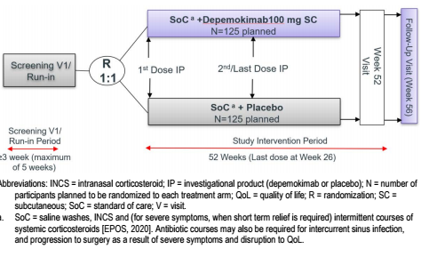
Standard of care in all countries except Japan included intranasal steroids, saline nasal douching, occasional short courses of steroids (although prohibited during the run-in period) and antibiotics if warranted. In Japan, participants not taking intranasal corticosteroid could do so after starting the trial for symptom management, but if started had to remain on this treatment for the duration of the study.
At the end of the run-in period, study participants were eligible for randomisation if:
- they had an endoscopic bilateral NP score of ≥ 5 out of 8 (minimum score of 2 in each nasal cavity) at Visit 1 (assessed at central laboratory)
- a nasal obstruction mean-verbal response score (VRS) ≥ 2 over the last 7 days preceding Week 0 (excluding Week 0) (from an eDiary)
- eDiary compliance ≥ 4/7 days preceding but excluding Visit 2
- no NP surgery (and NOT on a waitlist)
- no laboratory abnormality (haematological, biochemical, liver function or urinalysis) or ECG abnormalities
- no asthma exacerbations, no new corticosteroid therapy, and no unresolved URTI ≥ 6 weeks from Visit 1.
Eligible participants were randomised in a 1:1 ratio into either of depemokimab100 mg SC or placebo (both in addition to SoC) for a total of 2 doses (26 weeks apart). Randomisation was stratified based on previous surgery for NP and country.
ANCHOR-1 randomised 143 participants to depemokimab and 133 to placebo, and ANCHOR-2 randomised 132 participants to depemokimab and 132 to placebo. Because of GCP concerns at one site in ANCHOR-1 and 2 sites in ANCHOR-2 the participant numbers were adjusted in the full analysis set (FAS) and safety sets to:
- ANCHOR-1: 143 participants to depemokimab and 128 to placebo
- ANCHOR-2: 129 participants to depemokimab and 128 to placebo.
The pooled analysis included 272 in the depemokimab group and 256 in the placebo group.

Inclusion and exclusion criteria
The ANCHOR studies’ key inclusion and exclusion criteria are summarised in Table 5.
Table 5. ANCHOR Studies Key inclusion and exclusion criteria.
Inclusion criteria | Exclusion criteria
- 18 years and older  - Endoscopic bilateral NP score of ≥ 5 out of a maximum score of 8 (≥ 2 in each nasal cavity)  - At least one of the following:  - previous nasal surgery for the removal of NP  - ≥ 3 consecutive days of systemic CS in the previous 2 years for NP treatment  - unsuitable or intolerant of systemic CS  - Daily treatment with INCS (including intranasal liquid steroid wash/ douching) for ≥ 8 weeks (not participants from Japan)  - Severe NP symptoms defined as symptoms of nasal congestion/blockade/obstruction with moderate or severe severity and loss of smell or rhinorrhoea  - ≥2 symptoms for ≥ 12 weeks prior to Visit 1, including either nasal blockage/congestion or nasal discharge (anterior or posterior), along with facial pain/pressure and/or a reduced or lost sense of smell | - Severe nasal septal deviation occluding one nostril prevented assessment of NPs  - Sino-nasal or sinus surgery changing the lateral wall structure preventing evaluation of NP score  - Acute sinusitis or URTI at screening or in 2 weeks prior to screening and 2 weeks  prior to randomisation  - Intranasal and/or sinus surgery within 6 months prior to screening or any NP surgery, including being added to a waitlist prior to randomisation  - Rebound or chemical induced rhinitis  - Concurrent medical conditions including eosinophilic diseases, parasitic infections, immunodeficiency, malignancy, liver disease, vasculitis  - Prior or concomitant therapy with monoclonal antibodies (mAbs) targeting IL-5/5R including mepolizumab, reslizumab or benralizumab  - Other mAbs in the treatment of asthma or CRSwNP including omalizumab or dupilumab  - Any other mAb (for a different purpose) within 5 half-lives of visit 1

Efficacy variables and outcomes including supplementary estimand strategy
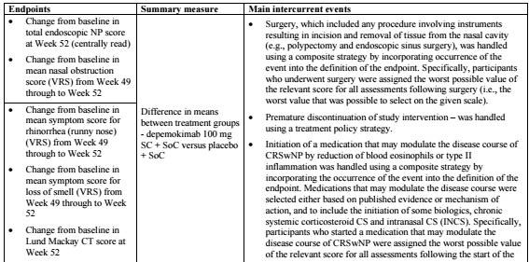
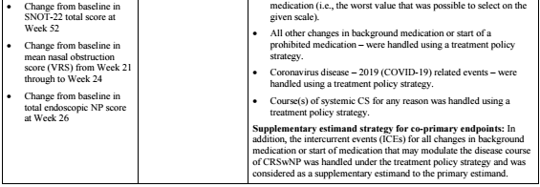
Table 6. ANCHOR-1 and ANCHOR-2 estimands.

Supplementary estimand: Participants who experienced an intercurrent event were assigned the worst possible value of the relevant score for all assessments following the intercurrent event, i.e. intercurrent event assigned a total endoscopic NP score of 8 for every scheduled clinic visit after the date of the first intercurrent event (regardless of whether the visit occurred) and a nasal obstruction VRS mean score of 3 for every day after the date of the first intercurrent event.

Statistical methods
The sample size calculations for each study were based on the co-primary efficacy endpoints. Approximately 250 participants were planned to be randomised in a 1:1 ratio (125 per group), allowing for a minimum 118 evaluable participants in each group. This gave an overall power of >99% for the total endoscopic NP score, assuming a true population difference of -1.10 between depemokimab and placebo (SD 1.665) at the 2-sided 5% significance level, and the smallest treatment difference for statistical significance of -0.42. It also gave an overall power of >99% for the total nasal obstruction VRS mean score over Week 49 to Week 52, assuming a true population difference of -0.70 between depemokimab and placebo (SD 0.84) at the 2-sided 5% significance level, and the smallest treatment difference for statistical significance of -0.21.
Assessment of co-primary endpoints
Each co-primary endpoint was tested at the 2-sided 5% alpha level and both tests had to be significant to achieve the primary study objective.
Testing of secondary endpoints and multiplicity adjustment
Within each study, testing of secondary endpoints was carried out in a hierarchical manner, dependent on statistical significance that would have been achieved for the previous endpoint in the hierarchy.
Participant flow
The participant flow for the ANCHOR-1 and ANCHOR-2 studies are tabulated below (Table 7).
Table 7. Participant flow ANCHOR-1 and ANCHOR-2 studies.
 | ANCHOR-1 |  | ANCHOR-2
 | Placebo | Dep’mab | Placebo | Dep’mab
FAS excluding participants from sites with GCP violation
Received 1 dose of study treatment | 132 | 143 | 128 | 129
Completed study | 115 | 128 | 111 | 122
Withdrew from study | 13 | 15 | 17 | 7
Completed study intervention | 118 | 130 | 118 | 121
Premature discontinuation of study treatment | 10 | 13 | 10 | 8
Premature discontinuation of study treatment with follow up | 10 | 13 | 10 | 8

Major protocol violations/deviations
Around 22% of the ANCHOR-1 study and 17% of the ANCHOR 2 study participants had important protocol deviations, mostly related to eligibility criteria and study procedures, in ANCHOR-1 and study procedures in ANCHOR-2.
Table 8. Summary of important protocol deviations, FAS population, ANCHOR-1 study
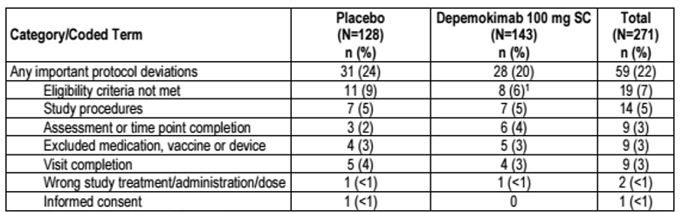Note: Participants can be counted in more than once category.
Table 9. Summary of important protocol deviations, FAS population, ANCHOR-2 study.
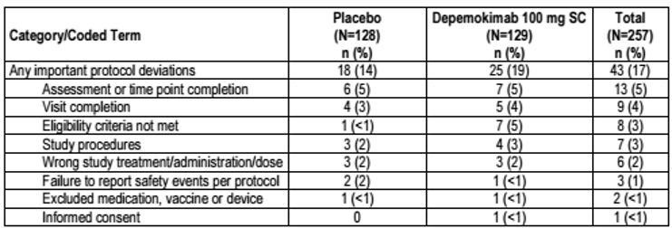Note: Participants can be counted in more than once category

Baseline data
Baseline demographics were generally similar between the depemokimab and placebo groups. The median age in ANCHOR-1 was 55.0 years in both groups, and 50.0 years in ANCHOR-2. In ANCHOR-1, the median weight was 77.85 kg in the placebo group and 78.2 kg in the depemokimab group. In ANCHOR-2, the median weight was 76.90 kg in the placebo group and 77.0 kg in the depemokimab group.
Table 10. Summary of baseline demographics ANCHOR-1 and ANCHOR-2.
 | ANCHOR-1 |  | ANCHOR-2
 | Placebo | Depemokimab | Placebo | Depemokimab
Sex
Female: | 30% | 31% | 31% | 31%
Male: | 70% | 69% | 69% | 69%
Race
Asian: | 24% | 27% | 20% | 21%
Black  African American: | 2% | 3% | 2% | 2%
White: | 71% | 70% | 77% | 77%
Other or unknown: | 3% | <1% | <1% | <1%
Region
Europe | 36% | 36% | 65% | 64%
USA | 8% | 8% | 8% | 8%
Rest of world | 56% | 57% | 27% | 28%

Baseline characteristics
The table below (Table 11) summarises participant baseline disease characteristics in ANCHOR-1 and ANCHOR-2.
Table 11. Summary of CRSwNP and asthma disease history and characteristics.
 | ANCHOR-1 |  | ANCHOR-2
 | Placebo (N=128) | Depemokimab  (N=143) | Placebo (N=128) | Depemokimab  (N=129)
Duration of NP, years
n | 128 | 143 | 128 | 129
Mean (SD) | 12.344 (10.0857) | 13.451 (12.1230) | 11.020 (8.9764) | 11.245 (8.4786)
Duration of CRS, years
n | 128 | 143 | 128 | 129
Mean (SD) | 14.242  (11.4867) | 15.511  (14.1261) | 12.153 (10.1405) | 11.623  (8.5441)
Number of previous surgeries for NP, n (%)
n | 128 | 143 | 128 | 129
0 | 47 (37) | 53 (37) | 49 (38) | 46 (36)
1 | 47 (37) | 51 (36) | 39 (30) | 38 (29)
2 | 13 (10) | 20 (14) | 20 (16) | 21 (16)
3 | 11 (9) | 12 (8) | 13 (10) | 13 (10)
4 | 6 (5) | 2 (1) | 1 (<1) | 8 (6)
5 | 3 (2) | 2 (1) | 1 (<1) | 2 (2)
>5 | 1 (<1) | 3 (2) | 5 (4) | 1 (<1)
Most recent nasal surgery procedure, n (%)
n | 81 | 90 | 79 | 83
Nasal polypectomy with functional ESS | 53 (65) | 53 (59) | 50 (63) | 52 (63)
Nasal polypectomy (simple with no functional ESS) | 16 (20) | 17 (19) | 17 (22) | 22 (27)
Sinuplasty (no removal of tissue, example balloon sinuplasty) | 0 | 1 (1) | 1 (1) | 0
Other nasal surgery procedure | 3 (4) | 5 (6) | 3 (4) | 2 (2)
Unknown | 9 (11) | 14 (16) | 8 (10) | 7 (8)
Number of courses of systemic CS for NP in the previous 12 months, n (%)
n | 128 | 143 | 128 | 129
0 | 43 (34) | 38 (27) | 47 (37) | 38 (29)
1 | 48 (38) | 74 (52) | 57 (45) | 62 (48)
2 | 18 (14) | 17 (12) | 12 (9) | 13 (10)
>2 | 19 (15) | 14 (10) | 12 (9) | 16 (12)
Participants used at least 3 consecutive days of systemic CS in the previous 2 years, n (%)
n | 128 | 143 | 127 | 129
Yes | 96 (75) | 109 (76) | 92 (72) | 97 (75)
No | 32 (25) | 34 (24) | 35 (28) | 32 (25)
Participant medically unsuitable or intolerant to systemic CS, n (%)
n | 128 | 143 | 127 | 129
Yes | 6 (5) | 5 (3) | 5 (4) | 8 (6)
No | 122 (95) | 138 (97) | 122 (96) | 121 (94)
Total IgE (U/mL)
n | 127 | 141 | 126 | 129
Geo. Mean (SD logs) | 139.88 (1.265) | 142.94 (1.491) | 116.28 (1.253) | 114.58 (1.224)
Baseline eosinophils (GI/L)
n | 128 | 143 | 128 | 129
Geo. Mean (SD logs) | 0.359 (0.8539) | 0.319 (0.9233) | 0.288 (0.8215) | 0.375 (0.6571)
INCS use, n (%)
n | 128 | 143 | 128 | 129
Yes | 126 (98) | 139 (97) | 123 (96) | 126 (98)
No | 2 (2) | 4 (3) | 5 (4) | 3 (2)
AERD, n (%)
n | 128 | 143 | 128 | 129
Yes | 17 (13) | 26 (18) | 19 (15) | 23 (18)
No | 110 (86) | 115 (80) | 108 (84) | 106 (82)
Not assessed | 1 (<1) | 2 (1) | 1 (<1) | 0
Baseline Asthma characteristics
Participants with asthma (%) | 62 | 57 | 49 | 53
Asthma exacerbation in past year (%) | 8 | 17 | 14.3 | 14.7
Partially or not well controlled (%) | 76 | 72 | 77 | 73
Note: Percentages are calculated based on “n”. Baseline eosinophil values of 0GI/L are imputed with a value of 0.005GI/L.

Primary endpoints
The co-primary endpoints were change from baseline in the total endoscopic NP score at Week 52, and the change from baseline in the nasal obstruction VRS mean score over week 49 to Week 52. Efficacy outcomes endpoints in ANCHOR-1 and ANCHOR-2 are summarised below (Table 12).
Table 12. Summary of co-primary and secondary outcomes, ANCHOR-1 and ANCHOR-2 studies.
 | ANCHOR-1 |  | ANCHOR-2
 | Placebo (N=128) | Depemokimab  (N=143) | Placebo  (N=128) | Depemokimab  (N=129)
Total endoscopic nasal polyp score at Week 52 (co-primary)
n | 128 | 143 | 128 | 129
Baseline mean (SD) | 6.0 (1.37) | 5.9 (1.34) | 5.8 (1.37) | 5.9 (1.21)
LS mean change (SE) | 0.2 (0.15) | -0.6 (0.14) | 0.1 (0.15) | -0.5 (0.14)
Adj. mean diff (95% CI), p value | -0.7 (-1.1, -0.3), <0.001 |  | -0.6 (-1.0, -0.2), 0.004
Supplementary estimand analysis (95% CI) | -0.8 (-1.2 to -0.4) |  | -0.5 (-0.9 to -0.1)
Jump to reference sensitivity analysis (95% CI) | -0.7 (-1.1 to -0.3) |  | -0.6 (-1.0 to -0.2)
Nasal obstruction VRS mean score Week 49 to 52 (co-primary)
n | 128 | 143 | 128 | 129
Baseline mean (SD) | 2.53 (0.472) | 2.55 (0.487) | 2.57 (0.418) | 2.62 (0.426)
LS mean change (SE) | -0.53 (0.083) | -0.76 (0.079) | -0.53 (0.078) | -0.77 (0.076)
Adj. mean diff (95% CI), p value | -0.23 (-0.46, 0.00), p=0.047 |  | -0.25 (-0.46, -0.03), p=0.025
Supplementary estimand analysis (95% CI) | -0.25 (-0.48 to -0.03) |  | -0.20 (-0.42 to 0.01)
Jump to reference sensitivity analysis (95% CI) | -0.22 (-0.44 to 0.00) |  | -0.25 (-0.46 to -0.04)
Secondary endpoints
Rhinorrhoea (runny nose) VRS mean score
n | 128 | 143 | 128 | 129
Baseline mean (SD) | 2.18 (0.711) | 2.16 (0.697) | 2.27 (0.648) | 2.25 (0.689)
LS mean change (SE) | -0.49 (0.087) | -0.71 (0.084) | - 0.54 (0.082) | - 0.72 (0.080)
Adj. mean diff (95% CI), p value | -0.22 (-0.46, 0.02), p=0.074 |  | - 0.18 (-0.40, 0.05), p=0.125
Loss of smell VRS mean score Week 49 to Week 52
n | 128 | 143 | 128 | 129
Baseline mean (SD) | 2.74 (0.564) | 2.70 (0.547) | 2.77 (0.421) | 2.85 (0.388)
LS mean change (SE) | - 0.29 (0.072) | -0.48 (0.069) | -0.30 (0.068) | - 0.56 (0.066)
Adj. mean diff (95% CI) | -0.19 (-0.39, 0.00) |  | -0.26 (-0.45, -0.07)
Lund Mackay CT score at Week 52
n | 127 | 139 | 128 | 129
Baseline mean (SD) | 19.0 (3.99) | 18.4 (4.15) | 18.2 (4.51) | 19.6 (3.75)
LS mean change (SE) | - 0.8 (0.46) | - 2.8 (0.45) | - 0.3 (0.44) | - 3.5 (0.42)
Adj. mean diff (95% CI) | - 2.0 (-3.3, -0.8) |  | - 3.2 (-4.4, -2.0)
SNOT-22 total score at Week 52
n | 125 | 140 | 126 | 126
Baseline mean (SD) | 56.6 (21.70) | 58.2 (22.60) | 60.1 (18.34) | 60.1 (21.51)
LS mean change (SE) | - 6.5 (3.08) | - 13.3 (2.96) | - 15.9 (2.83) | - 6.0 (2.87)
Adj. mean diff (95% CI) | -6.8 (-15.2, 1.6) |  | - 9.9 (-17.9, -2.0)
Nasal obstruction VRS mean score Week 21 to 24
Baseline mean (SD) | 2.53 (0.472) | 2.55 (0.487) | 2.57 (0.418) | 2.62 (0.426)
LS mean change (SE) | -0.57 (0.074) | - 0.74 (0.071) | - 0.54 (0.069) | -0.78 (0.068)
Adj. mean diff (95% CI) | - 0.17 (-0.37, 0.03) |  | -0.24 (-0.43, -0.04)
Total endoscopic nasal polyp score at Week 26
Baseline mean (SD) | 6.0 (1.37) | 5.9 (1.34) | 5.8 (1.37) | 5.9 (1.21)
LS mean change (SE) | 0.1 (0.13) | - 0.6 (0.13) | - 0.1 (0.12) | -0.5 (0.12)
Adj. mean diff (95% CI) | -0.8 (-1.1, -0.4) |  | - 0.3 (-0.7, 0.0)
No secondary endpoints were statistically significant due to hierarchical testing constraints.

Endoscopic nasal polyp score – additional analyses
In both studies results of the change from baseline in the total endoscopic NP score at week 52 based on the supplementary estimand were consistent with those of the primary estimand. Two sensitivity analyses to understand the impact of missing data were conducted for the endoscopic NP score.
A Jump to reference sensitivity analysis using the placebo group’s response to impute a response for participants in the depemokimab group with missing data after study withdrawal was conducted:
- ANCHOR-1 treatment difference at Week 52: -0.7 (95% CI: -1.1 to -0.3; nominal p <0.001)
- ANCHOR-2 treatment difference at Week 52: -0.6 (95% CI: -1.0 to -0.2; nominal p= 0.004)
A tipping point sensitivity analysis was also conducted. For each treatment group, the imputed values varied separately by a value of delta, where delta represented a change in endoscopic NP score for each imputed timepoint. The delta values evaluated ranged from -3 to 3 by a 1-point increment. In both studies, results showed that for the conclusions of statistical significance to no longer hold, there must be a large difference between the assumed imputed values of missing NP score data from the depemokimab group compared with the placebo group.
The subgroup analyses of the total endoscopic NP Score at Week 52 were consistent with those of the overall population in both studies except for the overall population except for the subgroup of participants aged ≥65 years in the ANCHOR-2 study

Nasal obstruction VRS mean score – additional analyses
The results of the analysis on change from baseline in the nasal obstruction VRS mean score over Week 49 to Week 52 based on the supplementary estimand were:
- ANCHOR-1: -0.25 (95% CI: -0.48 to -0.03; nominal p=0.028)
- ANCHOR-2: -0.20 (95% CI: -0.42 to 0.01; nominal p=0.063)
Two sensitivity analyses to understand the impact of missing data were conducted for the nasal obstruction VRS mean score.
A Jump to reference sensitivity analysis using the placebo group’s response to impute a response for participants in the depemokimab group with missing data after study withdrawal was conducted:
- ANCHOR-1: -0.22 (95% CI: -0.44 to 0.00; p=0.049)
- ANCHOR-2: -0.25 (95% CI: -0.46 to -0.04; p=0.020)
A tipping point sensitivity analysis conducted for both studies to investigate the impact of missing data used a multiple imputation step approach under a missing at random assumption. Imputed values for each treatment group varied separately by a value of delta, where delta represented a change in VRS mean score over a 4-week interval covering a range from -1.5 to 1.5 by 0.5-point increments. The nasal obstruction VRS mean score imputed values from 0 to 3. Findings supported the findings of the primary endpoint.
Results of the subgroup analyses of the nasal obstruction VRS mean score Week 49 to Week 52 were consistent with those of the overall population except for participants with 2 previous surgeries in the ANCHOR-1 study and participants from US, and participants without asthma in the ANCHOR-2 study.

Pooled efficacy analysis
The ANCHOR-1 and ANCHOR-2 studies did not enrol enough participants to reliably evaluate the impact of depemokimab on reducing the need for nasal polyp surgery, systemic corticosteroid use, and improving asthma control. Therefore, efficacy analyses for these endpoints were pre-specified to be conducted using pooled data from both studies. The pooled analysis identified 2 populations: the randomised population comprising the 275 participants from the depemokimab arms and 265 participants from the placebo arms of the studies, plus the FAS population comprising 272 participants from the depemokimab arms and 256 participants from the placebo arms of the studies.
The pooled analyses were pre-specified and conducted after both studies were completed and had achieved statistical significance for their co-primary endpoints. Four key secondary endpoints were tested using a closed-testing procedure based on a predefined hierarchy at a significance level of 4.75% (α – α²). If all four reached significance, additional pre-specified pooled efficacy endpoints were tested at the same level without further multiplicity adjustment.
Assuming a true population HR of 0.38 the pooled analysis had >90% power to observe statistical significance at the 2-sided 4.75% level. The smallest observed effect predicted to result in a statistically significant difference between the two treatment groups was a HR of 0.64 for the risk of surgery. The pre-specified pooled analysis of time to first surgery (actual or entry on waiting list) or disease-modulating medication for CRSwNP had >90% to detect differences.
The pooled analyses of the secondary efficacy endpoints results are tabulated below (Table 13).
Table 13. Secondary endpoints (pooled analyses) full analysis set.
Time to first NP surgery (actual or entry on waiting list) or disease-modulating medication for CRSwNP up to Week 52
Hazard ratio (95% CI); p-value | 0.735 (0.495, 1.092); p= 0.128
Time to first NP surgery (actual) or disease-modulating medication for CRSwNP up to Week 52
Hazard ratio (95% CI); p-value | 0.713 (0.453, 1.124); p=0.146
Requiring at least 1 course of systemic CS or disease-modulating medication for CRSwNP or NP surgery (actual) during the 52-week treatment period
Odds ratio (95% CI); nominal p-value | 0.58 (0.40, 0.86); p = 0.006¹
Change from baseline in ACQ-5 score at Week 52 in participants with partially or not well-controlled asthma
Difference (depemokimab - placebo) (95% CI); nomina p-value | -0.75 (-1.26, -0.25); p=0.004¹
- Nominal significance (i.e., p<0.05 without multiplicity control) was achieved. However, statistical significance was not achieved due to a break in the multiplicity-controlled testing hierarchy.

Safety - Asthma studies
Across the phase 3 asthma studies in the submission, 1247 participants with severe asthma received ≥1 100 mg SC dose of depemokimab. The safety comprised safety set data from 9 participants with mild to moderate asthma, 150 healthy volunteers and 272 participants with CRSwNP. Specifically related to the asthma population, the SWIFT studies were pooled, and safety was also reported for the AGILE study, and the interim analysis of the NIMBLE study.

SWIFT 1+2 pool
In the SWIFT pool (n=762), 501 participants received ≥ 1 dose of depemokimab 100 mg SC + SoC, 261 participants received placebo + SoC, and 92% of each group completed treatment and 52 weeks follow up. The mean (SD) exposure was 11.7 (1.4) months for the depemokimab group and 11.8 (1.2) months for the placebo group.

AGILE
At the final analysis, 419 participants had received depemokimab 100 mg SC + SoC, and 210 had received placebo + SoC in a SWIFT study. At the end of the study 409 participants had received 4 doses of depemokimab and 104 weeks of follow up. The overall median exposure was 364 days.

NIMBLE
At the data cut-off for interim analysis (IA) (15 July 2024) the NIMBLE safety population included 1076 participants. Of those, 536 received depemokimab 100 mg SC + SoC and 536 received mepolizumab/benralizumab +SoC. Two patients from each group only received placebo matching or unknown doses. At the IA, 87% (n=468) of the depemokimab group had completed 2 doses of depemokimab 52 weeks of follow up. At the interim analysis, 89% (n=479) of the mepolizumab/benralizumab group completed treatment and for 52 weeks of the study. The total mean (SD) treatment exposure was 11.6 (1.7) months for the depemokimab group and 11.8 (2.5) months for the mepolizumab/benralizumab group.

Treatment emergent adverse events

SWIFT-1 and SWIFT-2 Pool
The most frequently reported AEs (>3% of participants in any given treatment group), were comparable between groups (Table 14). Most commonly reported (≥10% participants in either group) were COVID-19 (17.6% depemokimab, 18.4% placebo) and nasopharyngitis (12.4% depemokimab, 19.9% placebo). There was no notable difference in the AE profile over time for either the depemokimab or placebo group.
Table 14. Overview of all on-treatment AEs (SWIFT 1+2 pool). 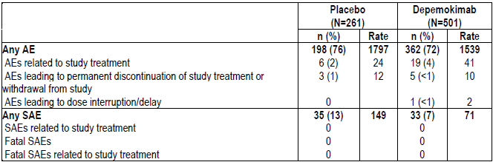
Note: Rate is incidence rate per 1000 subject-years, calculated as: (total number of subjects with AE)/ (total exposure duration/365.25) *1000. If an AE belonging to the category being summarized occurs during the exposure period, then that subject's exposure ends at the start of the first occurrence of the AE.
Most participants in either treatment group had an AE with a maximum intensity of mild (27% vs 27%) or moderate (42% vs 41%), for the depemokimab vs placebo groups, respectively.
Severe AEs were reported for 3% depemokimab and 8% placebo groups, with the most frequently reported (≥1% in either treatment arm) being pneumonia (<1% depemokimab and 1% placebo) and asthma (<1% depemokimab and 3% placebo).

AGILE study
At the time of the final analysis, the proportion of participants with AEs was 71%, and was similar between previous placebo (70%) and previous depemokimab (72%) groups. The most commonly reported treatment - emergent AEs across the study were nasopharyngitis (13%), URTI (11%), COVID-19 (7%) and bronchitis 5%.

NIMBLE study - Interim analysis
At the time of the interim analysis (IA) (data cut-off July 2024), the safety profile of depemokimab in NIMBLE was generally similar to that observed in the SWIFT studies, and similar to the safety profile of continued treatment with either mepolizumab or benralizumab (Table 15).
Table 15. NIMBLE IA: Overview of on-treatment Adverse Events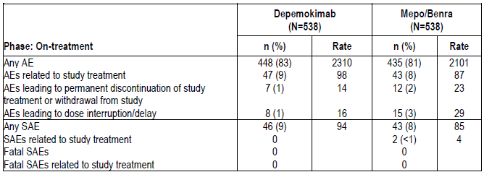
Standard of care proportions of events were similar between the depemokimab and mepolizumab /benralizumb arms. Most AEs were mild (34% and 36%) or moderate (42% and 38%) for the depemokimab and comparator groups, respectively. Severe AEs were reported in 7% of both groups, but the only severe AE occurring in ≥1% was asthma (2% depemokimab group, 1% the comparator group).

Treatment related adverse events
In the SWIFT 1+2 pool 4% vs 2% of the depemokimab vs placebo groups had treatment-related AEs. No individual event was reported for ≥1% of participants. In the AGILE study 3% had adverse events considered treatment related.
In the NIMBLE study, treatment related AEs were reported in similar proportions of each group, The most commonly reported was injection site reaction (2% in both groups).

Serious adverse events
In the SWIFT 1+2 pool the proportion of participants with a serious adverse event (SAE) was lower in the depemokimab vs placebo group (7% vs 13%), with asthma (<1% vs 3%) and pneumonia (<1% vs 1%) being the most common. None of the events were considered treatment related.
In the AGILE study, 9% of the depemokimab-depemokimab group and 10% of the placebo – depemokimab group reported SAEs. The most common event was asthma. None of the SAEs were considered related to the study treatment. There were no post treatment SAEs.
In the NIMBLE safety set, SAEs were reported for 9% vs 8% of the depemokimab and comparator groups, respectively. The SAE occurring at ≥2% was asthma: 2% in both groups. No SAEs were considered related to depemokimab; and 2 SAEs were deemed treatment-related in the comparator group: thunderclap headache and atrial fibrillation.

Deaths
There were no deaths in the SWIFT 1+2 pool or the AGILE data during treatment. One death in the AGILE study, diagnosed with hypokalemia, cerebral infarction and COVID-19 in the post-treatment period, died of COVID-19 after withdrawal from the study.
In the interim analysis of the NIMBLE study, one fatal SAE of metastatic melanoma in the comparator group was reported in the post-treatment period. This was assessed as unrelated to study treatment. There were no other fatal SAEs.

Adverse events of special Interest
In the SWIFT 1+2 pool, local injection site reactions were reported for 1% of the depemokimab group and <1% of the placebo group. Other systemic reactions (other than type I or type III hypersensitivity) were reported for 2% of the depemokimab group and <1% of the placebo group.
In the AGILE study, one participant (previous placebo group) had a Type I hypersensitivity reaction of pruritus which was assessed as mild, non-serious, related to study treatment. There were no reports of anaphylaxis, or type III hypersensitivity reactions. Mild, non-serious local injection site reactions were reported in 6 participants, all in the previous depemokimab group. The QTc prolongation reported in 1 participant was not deemed related to the study treatment.
In the NIMBLE study, all adverse events of special interest were non-serious. Type I hypersensitivity events were reported in <1% in depemokimab group, none in the comparator group. There were no events of anaphylaxis, type III hypersensitivity or QTc prolongation. The local injection site reactions reported in 3% depemokimab group, and 4% comparator group, were all either mild or moderate.

Adverse events leading to treatment interruption or discontinuation
In the AGILE study, 4 participants (<1%) reported AEs leading to treatment discontinuation or study withdrawal: humerus fracture, prostate cancer and cerebral infarction (2 events), none of which was considered related to the study treatment.
In the NIMBLE study, around 1% of the depemokimab group and of the 2% comparator group had AEs leading to discontinuation or withdrawal. Events in the depemokimab included rash, Bell’s palsy, and cough. Events in the comparator group included ecchymosis, atrial fibrillation, peripheral oedema, and increased blood urea.

Participants aged 12 to 17 years
SWIFT-1 included 8 participants and SWIFT-2 included 22 participants aged 12 – 17 years. Of those, 15 received depemokimab. Eleven of the depemokimab recipients had AEs, although only 1 was considered treatment related and none resulted in discontinuation. One depemokimab participant in this analysis had one SAE.

Laboratory testing results (including vital signs)
Overall, mean changes from baseline clinical laboratory results, ECG and vital signs were minimal over the course of the study, other than the expected decline in blood eosinophil count (BEC).

Hepatic events
In the AGILE study, 4 participants met the liver cessation criteria. These included one participant with a biopsy-confirmed autoimmune hepatitis judged treatment- unrelated, and a highly elevated severe ALT/AST elevation judged treatment-related, and two participants with persistent transaminitis/ steatosis.

Electrocardiograph findings and cardiovascular safety
In the AGILE study, one participant experienced QTc prolongation which was not deemed related to the study treatment.

Immunogenicity and immunological events
Around 10% of the SWIFT- and SWIFT-2 study participants who received ≥1 dose of depemokimab developed treatment-emergent anti-drug antibodies (ADAs), and of those, 6% were positive for neutralising antibodies.
Low levels of ADAs, generally close to the lower limit of quantitation were observed in the study of Chinese participants. Because of the low frequency in early studies, neutralising antibodies were not studied further.
In the AGILE study, 9% of the participants developed ADAs with generally low titres. Of those, 5 participants developed neutralising antibodies (Nab). On-treatment AEs were reported by 84% of the 55 ADA positive participants and 70% of the 567 ADA negative participants.
There was no apparent increased risk of safety events or pharmacology differences among participants who developed ADA.

Other (e.g. companion diagnostic considerations, drug delivery device)
Depemokimab is proposed for delivery via a prefilled safety syringe or an autoinjector. No adverse events were reported relating to the use of the devices.
Patient experience in the form of patient related outcomes, questionnaires and reportage of symptoms forms part of the submission in endpoints described above and in the Clinical Evaluation Report. No data from non-conventional studies were included in the submission.

Safety - CRSwNP studies
The safety of depemokimab in the CRSwNP indication was investigated in studies ANCHOR-1 and ANCHOR-2, and because of the similarity of the studies a pooled safety analysis was presented.
In the ANCHOR study pool, 272 participants received ≥1 dose of depemokimab 100 mg SC Q26W in addition to standard of care and 256 participants received placebo. Of those, 92% of the depemokimab group and 87% of the placebo group completed study treatment. The mean exposure was 11.6 months in each arm.
Table 16. Summary adverse events from ANCHOR-1 and ANCHOR-2 & pooled data.
 | ANCHOR-1 |  | ANCHOR-2 |  | POOLED
 | Placebo (N=128) | Dep’mab (N=143) | Placebo (N=128) | Dep’mab (N=129) | Placebo  (N=256) | Dep’mab  (N=272)
 | n %) | n (%) | n (%) | n (%) | n (%) | n (%)
On- and post-treatment
Any AE (%) | 101 (79) | 106 (74) | 102 (80) | 98 (76) | No data provided
AEs related to study treatment | 3 (2) | 9 (6) | 6 (5) | 8 (6)
AEs leading to permanent treatment discontinuation or study withdrawal | 2 (2) | 0 | 1 (<1) | 2 (2)¹
AEs leading to dose interruption/delay | 0 | 0 | 1 (<1) | 0
Any SAE | 6 (5) | 5 (3) | 10 (8) | 6 (5)
TRSAEs | 0 | 0 | 0 | 0
On treatment
 | ANCHOR-1 |  | ANCHOR-2 |  | POOLED
Any AE (%) | 101 (79) | 105 (73) | 102 (80) | 98 (76) | 203 (79) | 203 (75)
TRAEs | 3 (2) | 9 (6) | 6 (5) | 8 (6) | 9 (4) | 17 (6)
AEs leading to perm. discont. or study withdrawal | 2 (2) | 0 | 1 (<1) | 0 | 3 (1) | 0
AEs leading to dose interruption or delay | 0 | 0 | 1 (<1) | 0 | 1 (<1) | 0
Any SAE | 6 (5) | 5 (3) | 10 (8) | 4 (3) | 16 (6) | 9 (3)

The most frequently reported AEs (≥10% participants in either treatment group) were nasopharyngitis [18.0% (depemokimab group), 14.8% (placebo group)] and upper respiratory tract infection [10.3% (depemokimab group), 11.3% (placebo group)]. There were no statistically significant differences in the proportion of participants of who experienced common AEs between the groups, except for influenza which was more common in the placebo group.
Two participants in the depemokimab group experienced AEs leading to permanent treatment discontinuation of study treatment or withdrawal from study after 182 days of the last dose date of study intervention.
Most of the events were mild or moderate severity. Severe events were reported for 4% of the depemokimab group and 9% of the placebo group.
Serious adverse events (SAEs) were reported in 3% of the depemokimab group and 6% of the placebo group, as summarised in Table 16 and Table 17. None of the SAEs were considered related to study treatment, and there were no fatal events.
Table 17. Pooled on-treatment SAEs, AESIs, Incidence (CMH-adjusted) RR and Risk Difference.
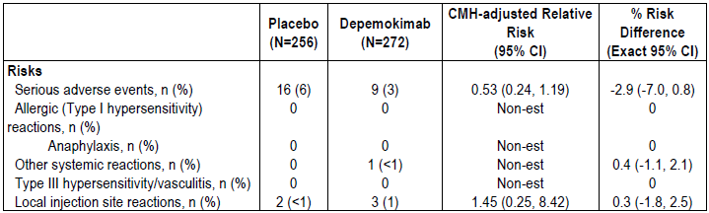
AESI=adverse event of special interest; CMH=Cochran-Mantel-Haenszel; non-est=non-estimated; RR=relative risk; SAE=serious adverse event.

Treatment related adverse events (adverse drug reactions)
TRAEs were reported in 6% in the depemokimab group and 4% in the placebo group. No individual PT was reported for ≥1% of participants and there was no apparent pattern based on SOC.
The most commonly reported TRAEs SOCs (those with ≥10% participants in the depemokimab/placebo groups) were infections/infestations (48%/53%), respiratory, thoracic and mediastinal (24%/26%), musculoskeletal/CT (9%/14%), nervous system (10%/13%), gastrointestinal (12%/10%), injury, poisoning, procedural complications (7%/11%) (Table 18).
Five events in three participants in the depemokimab group and 2 events in 2 participants in the placebo group were local injection site reactions that were considered study treatment related.
Table 18. Summary of on-treatment drug-related Adverse Events by SOC and PT (ANCHOR 1+2 pool)
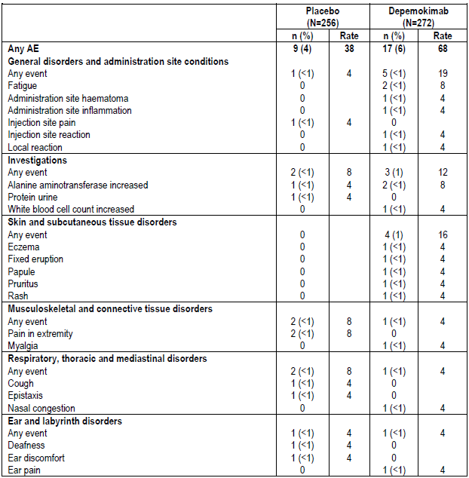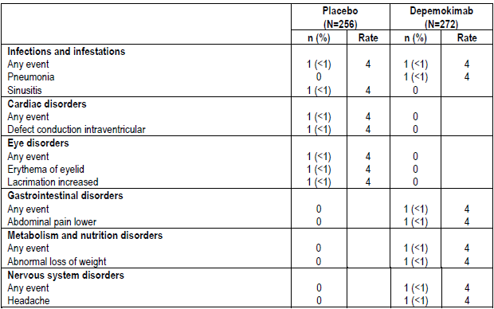
Note: Rate is incidence rate per 1000 subject-years, calculated as: (total number of subjects with AE)/(total exposure duration/365.25)*1000. If an AE belonging to the category being summarised occurs during the exposure period, then that subject's exposure ends at the start of the first occurrence of the AE.

Discontinuations due to adverse events
None of the depemokimab group and 1% in the placebo group discontinued the study drug due to AEs. No rebound of symptoms was observed after treatment discontinuation.

Laboratory testing results (including vital signs)

Hepatic events
In the pooled study no participants met the biochemical Hy’s Law criteria. Serum ALT levels (≥3×ULN) were observed in 1.5% of the depemokimab group and 0.8% of the placebo group. Two participants in the depemokimab group met the protocol-defined liver stopping criteria, 2 from each group required increased liver monitoring, but none of the events were deemed treatment related. One participant met the ALT ≥8×ULN criterion based on local lab results, and another met the ALT ≥5×ULN but <8×ULN criterion without sufficient weekly monitoring.

Electrocardiograph findings and cardiovascular safety
As identified in the ANCHOR-1 and ANCHOR-2 studies to meet the safety objective, mean changes from baseline in ECG parameters, including QTcF, were similar between treatment groups over time. No participants in the depemokimab arm exceeded protocol-defined stopping criteria: QTcF >500 ms or uncorrected QTc >600 ms. Maximum QTcF increases from baseline were ≤30 ms for most participants (72% in depemokimab group, 67% in placebo).
The MedDRA SMQ Broad “Torsade de pointes/QT Prolongation” AEs reported in 2 participants (<1%) in the placebo group were deemed unrelated to the study treatment. No notable differences were seen between treatment groups in ECG parameters over time (QTc, heart rate, QRS duration, PR interval).

Immunogenicity and immunological events
No participants were reported to have a Type I hypersensitivity or anaphylactic reaction. One participant had a fixed drug eruption considered related to the treatment. Similar on-treatment AEs were reported for participants with or without anti-drug antibodies (ADA), and no impact of immunogenicity on safety. Of the 272 participants with a post-baseline ADA assay result in the depemokimab group:
- 21 participants were ADA-positive and 15 (71%) had ≥ 1 AE.
- 251 were ADA-negative and 188 (75%) had ≥ 1 AE.
The most frequently reported SOC was Infections and infestations, with AEs being reported more by a greater proportion of ADA-positive participants (62%, 13/21) than ADA-negative participants (47%, 117/251). The most common AEs overall (≥10% participants in either ADA category) by PT are summarised in Table 19, below.
Table 19. Most common AEs related to ADA class.
SOC | ADA-positive (%) | ADA-negative (%)
Upper respiratory tract infection | 29 | 9
Nasopharyngitis | 10 | 19
Diarrhea | 14 | 2
Bronchitis | 10 | 3
Epistaxis | 10 | 4
Cough | 10 | 2
Pyrexia | 10 | 1
Oropharyngeal pain | 10 | 2

Other (e.g. companion diagnostic considerations, drug delivery device)
No companion diagnostics were assessed or required for patient selection in this study series. Real World Evidence or Real-World Data were not included in the submission. Patient reported outcomes were included in the dossier to support efficacy and are described in the relevant sections of this document.

Pregnancy outcomes
Seven pregnancies of the total 11 pregnancies reported in the data set were reported in participants receiving depemokimab. Of these the outcomes were 1 live birth, 2 elective terminations, 1 spontaneous abortion at ≤ 22 weeks gestation, 2 reports of spontaneous abortion within approximately 1 month and one ongoing pregnancy. No congenital anomalies were reported. The partner of a male participant reported a live birth without apparent congenital anomaly.

Risk management plan
The submitted RMP covers both proposed indications in the submission.
The RMP evaluator evaluated EU-RMP version 0.1 (dated 16 December 2024; DLP 20 September 2024) and ASA version 1.0 (dated 04 April 2025) and EU-RMP version 1.0 (dated 04 December 2025; DLP 20 September 2024) associated with an ASA version 1.1 (dated 19 December 2025). The evaluator has accepted the most recent versions of each of these documents.
The summary of safety concerns and their associated risk monitoring and mitigation strategies are summarised in Table 20.
Table 20. Summary of safety concerns for Exdensur.
Summary of safety concerns |  | Pharmacovigilance |  | Risk minimisation
 |  | Routine | Additional | Routine | Additional
Important identified risks | None | - | - | - | -
Important potential risks | None | - | - | - | -
Missing information | Use in pregnant patients | ü | - | ü | -
The RMP evaluator was not satisfied with all the safety information in the Exdensur PI and has referred several alignments with the Exdensur SmPC for inclusion in the decision-making phase.
The RMP evaluation recommended conditions of registration relating to the versions of the risk management plan, requirement for periodic safety update reports, and inclusion of the medicine in the Black Triangle Scheme.
The TGA may request an updated RMP at any stage of a product's life cycle, during both the pre-approval and post-approval phases. Further information regarding the TGA’s risk management approach can be found in risk management plans for medicines and biologicals and the TGA's risk management approach. Information on the Australia-specific annex (ASA) can be found on the TGA website.

Risk-benefit analysis

Delegate’s considerations - Asthma
Depemokimab is an IL-5 inhibitor with specific structural engineering features that result in a longer half-life than other medicines in the class. The 26-week dosing interval this allows sets it apart from shorter acting molecules.
The exposure response relationships do not demonstrate a lower response rate based on PK or eosinophil suppression quintile. Although a concern may be potential tapering of efficacy toward the end of the dosing interval, this has not been demonstrated in the studies in the submission.

Efficacy
The efficacy of depemokimab was derived primarily from the SWIFT studies: 52-week, replicate, double-blind, randomised, parallel group comparing depemokimab with placebo in adults and adolescents from age 12 years, as add-on therapy to standard of care in patients with asthma with an eosinophilic profile.
Patients were sufficiently representative of potential Australian patients.
In both SWIFT studies the primary endpoint was met. The annualised rate showed some improvement in both groups, and the magnitude of benefit in terms of risk reduction was similar in both studies. Sensitivity analyses were consistent with the main analysis. The Delegate found these findings persuasive from an efficacy perspective.
Secondary endpoints, however, are less compelling and did not reach statistical significance. Although the proportions of affected patients were small, the annualised rate of exacerbation requiring hospitalisation or an emergency department (ED) visit was in favour of depemokimab.
The findings of the SWIFT studies are supported by the AGILE study results. The annualised clinically significant exacerbation rate overall was 0.56 (95% CI: 0.49, 0.65); with a rate of 0.58 (95% CI: 0.45, 0.73) in the prior placebo group and 0.55 (95% CI: 0.47, 0.66) in the prior depemokimab group. Around 66% of participants were free of exacerbations, 5% had an exacerbation requiring hospitalisation or an ED visit, and 1% were hospitalised.

While acknowledging the uncertainties that arise due to the findings for the secondary endpoints in the SWIFT studies, the Delegate considers the findings for the primary endpoint clinically meaningful in addition to their statistical significance. There is support of efficacy and its durability from the AGILE study. Overall, the Delegate concludes sufficient evidence has been to establish the efficacy of depemokimab for the proposed use.

Safety
The safety data set is of sufficient size to draw regulatory conclusions.
Similar proportions of adverse events occurred in each of the depemokimab and placebo groups. The Delegate notes both groups were also exposed to the same standard of care, and each group had a similar severity of disease at baseline.
Most events were mild or moderate. Common events included nasopharyngitis, upper respiratory tract infection, COVID-19 and bronchitis. Severe AEs and SAEs included pneumonia and asthma. There were no deaths in the main study, but there was a death post treatment in the AGILE study, described in the main body of the Delegate’s Overview. In the NIMBLE study, the SAEs of note were single events of thunderclap headache and atrial fibrillation.
Hypersensitivity reactions were adverse events of special interest. Local injection site reactions occurred in around 1% of participants, and other hypersensitivity events occurred in similar or lower proportions of participants. There were no reports of anaphylaxis or type III hypersensitivity reactions.
A potential signal for hepatic events is suggested from 4 events in the AGILE study requiring further characterisation as clinical trials and post-marketing experience accrues. This is an uncertainty for the current submission.
An assessment of the safety set from participants aged 12 to 17 years did not reveal any new safety concerns compared with adults; however, the safety set is very small, and only the most common of events are likely to be detected. The safety from adults is extrapolated to the adolescent population.
There are long term safety uncertainties in the adult and adolescent population. The Delegate acknowledges there are some data from patients exposed to depemokimab for up to 104 weeks in the safety data and that this duration of exposure is acceptable to support the safety of a medicine proposed for long term use.
Overall, the Delegate considers there is sufficient evidence to establish the safety of the medicine for the proposed use and populations

Quality
Based on the quality assessment the Delegate concludes there is sufficient information to establish the quality of depemokimab.

Use in adolescents
The proposed indication is no longer age agnostic. Patients aged 12 years and older were included in the submission. Inclusion of adolescents was planned for the SWIFT studies and across the studies 30 participants in this age group were randomised to the depemokimab group.
Data from these patients, population pharmacokinetic and pharmacodynamics, modelling and simulation contributed to an extrapolation exercise consistent with the approach of ICH-E11A to support the specific inclusion of patients in the indication. The Delegate notes that in the pooled SWIFT study data the point estimate of the rate ratio annualised clinically significant exacerbations of 0.57 was similar to the adult population. The Delegate considers the mechanism of disease is likely to be sufficiently similar in both age groups to support this approach
A challenge for the submission is that the adolescent sample is small, however, the extrapolation strategy is sound, compliant with ICH E11A and consistent with current regulatory practice. The limited adolescent numbers do not preclude approval for the 12–17-year age group within the asthma indication.

Indication
In considering the indication the Delegate has worked through the descriptor of the patient population in a stepwise fashion.
It is agreed the medicine should be added on to maintenance treatment. All the patients in the SWIFT studies had at least one background therapy, and almost all were receiving ICS, and almost all were receiving a LABA.
All patients had an eosinophilic phenotype.
The main question for the Delegate is whether only patients with severe asthma should be included in the indication. The evaluator has outlined some of the challenges in the evaluation report. The delegate has concluded the patient population should be only those with severe asthma for the following reasons.
The current GINA guidelines note the guidelines’ ongoing support the definition of severe asthma as asthma that remains uncontrolled despite optimised treatment with high-dose ICS-LABA, or that requires high-dose ICS-LABA or biologic therapy to prevent it from becoming uncontrolled.
There is also a distinction between difficult to treat asthma and severe asthma. The concepts differ due to the presence of modifiable factors such as inhaler technique, treatment compliance or comorbidities whose management could be optimised in patients with difficult to treat asthma. Taking such measures could bring asthma under control.
The Delegate considers optimising existing therapies and managing cofactors prior to adding a depemokimab is the preferable approach. While benefits and harms for depemokimab have been characterised in the submission, there are uncertainties, and additional evidence is being collected. The Delegate is concerned that to describe the patient population as uncontrolled, rather than severe, potentially lowers the threshold for considering this medicine in the treatment algorithm, and that might not be adequately justified by the strength of the evidence in the submission.
The Delegate is also mindful of aspects of regulatory consistency. While prior decisions are not binding future decisions, in Australia, other IL-5/IL-5R inhibitors are limited to severe asthma. There are no data in the submission that support depemokimab as a treatment to be used in preference to the existing IL-5/IL-5R inhibitors in asthma with an eosinophilic phenotype. This could be a potential effect of allowing an indication in inadequately controlled asthma, which is a broader and less stringently defined group. The NIMBLE study will provide information about the use of depemokimab in patients transitioning from an IL-5/IL-5R inhibitor compared with continuing that activity, but it will not clarify where among biological therapies depemokimab should be placed.
Taking the above into consideration the Delegate’s preferred indication
As add-on maintenance therapy of severe asthma in patients aged 12 years and older with type 2 inflammation characterised by an eosinophilic phenotype (see Section 5.1 PHARMACODYNAMIC PROPERTIES, Clinical Trials).
The Delegate usually prefers the indication is self-contained and complete, but in this instance agrees with the evaluator’s suggestion to include more detail than usual in the Clinical Trials description. This will also assist in future-proofing the indication, as descriptors and classifications of disease severity and/or control in international guidelines can change over time.

Dose
The dose is supported by PD findings of suppression of eosinophils, with no clear exposure response relationship. The dose is further supported by the efficacy data from the SWIFT and AGILE studies. The Delegate proposes to approve a dose of 100 mg SC Q26W.
The Delegate notes a six-monthly injection is a potentially attractive regimen for patients taking numerous medicines. Whether will assist with compliance is uncertain.

Delegate’s considerations - CRSwNP
The submission includes two replicate Phase 3 studies conducted at a similar time. These are global, multicentre studies. The sponsor has addressed issues with the conduct of the studies by a clinical research organisation operating at a limited number of sites by removing the results of the trial participants at those sites from the analysis. The small number of patients involved is unlikely to have materially affected the outcomes, and the matter is considered resolved.
Both studies enrolled participants who had significant disease. The inclusion criteria required either previous nasal surgery for polyp removal or at least a short course of systemic corticosteroids in the previous 2 years or steroid intolerance. For most patients’ standard of care included intranasal steroid and saline washing/douching. Depemokimab was assessed as an add-on to this standard of care.
The studies were conducted in Asia, Europe and the United States. The Delegate considers these settings would suggest participant baseline characteristics are likely to be sufficiently similar to Australian patients to allow extrapolation of the findings.
The dose of depemokimab was 100 mg SC Q26W, the same for both ANCHOR studies. Dose selection for the studies was based on eosinophil suppression. The popPK evaluator suggested a dose of 200 mg SC Q26 may have been preferable based on C_{trough}. No dose escalation study in this condition was provided in the dossier. The optimal dose has not been defined in the submission and is an uncertainty for this indication.
Each ANCHOR study had co-primary endpoints. Both endpoints had to be met for each study for the findings to be considered favourable for depemokimab.
The first co-primary outcome was total endoscopic NP score. The outcomes were statistically significant and were not sensitive to the alternative assumptions and techniques used in the supplementary estimand analysis and the Jump to reference analysis. Although the evaluator had concerns about the multidirectional tipping point approach, large differences from the observed trial results would have been needed in the population for the findings not to be upheld.
The second co-primary outcome was the nasal obstruction verbal response score from Weeks 49 to 52. The results for this endpoint were less compelling, which is important because the studies were designed to require statistically significant two co-primary endpoints. The adjusted mean baseline adjusted difference for the two treatments in each study was between -0.2 to -0.25. In the ANCHOR-1 study, the upper bound of the 95% CI for the endpoint is very close to zero and is reported as zero to 2 decimal places for this endpoint in the main analysis and in the Jump to reference sensitivity analysis. The study does just reach statistical significance.
In the ANCHOR-2 study the 95% confidence interval for the supplementary estimand analysis of the nasal obstruction VRS mean score using alternative assumptions to the main analysis includes zero (no difference).
The minimum clinically important difference for the nasal obstruction VRS score administered by eDiary is unclear. The ACM’s assistance in interpreting the overall robustness of the evidence and the clinical meaningfulness of the findings for this endpoint is requested.
There is no difference between the treatment arms in either ANCHOR study for rhinorrhoea mean score. There are differences in other scores trending towards a benefit for depemokimab. However, time to event endpoints using pooled data from both studies did not demonstrate a benefit for time to first NP surgery (actual, or actual/on waiting list) or disease modulating medicine up to Week 52. There was a trend toward a benefit for a reduced odds of requiring at least one course of systemic corticosteroids or disease-modulating medicine for CRSwNP or NP surgery during the 52 weeks of treatment in favour of depemokimab.
There was also a trend towards a benefit for the ACQ5 questionnaire reflecting asthma symptoms for depemokimab compared to placebo. The Delegate notes that in the asthma studies a benefit in reduction of exacerbations was consistently demonstrated for depemokimab.
The relative high number of protocol deviations, which the sponsor describes in terms of eligibility criteria and study procedures, adds some uncertainty to the robustness of the findings.
Prior or concomitant use of other monoclonal antibodies targeting IL-5/5R were not permitted. While that approach is rational based on the study question, a subgroup of stable patients on an IL-5/5R may transition to a product that offers less frequent self-injection.
The final consideration regarding efficacy is that the long half-life of the medicine would result in a long wash out before another monoclonal antibody could be commenced if there is an inadequate response.
Taken together, the uncertainties about the magnitude of benefit and its clinical meaningfulness of a co-primary endpoint outcome, and the mixed findings in the secondary endpoints, currently are currently obstacles to a conclusion that the efficacy of depemokimab is established for this indication.
In the CRSwNP studies similar proportions of participants experienced adverse effects, and the types of effects were generally similar between the arms of the studies. Nasopharyngitis was reported more frequently in the depemokimab arm (18% vs 14%). Treatment related adverse events were infrequent (6% vs 4%). There were no fatal adverse events in any of the studies in the submission with depemokimab.
Local injection site reactions and events such as headache, fatigue and rash were reported in around 1% of participants.
Limitations in the safety information include the limited duration of follow up. Although participants were followed for around 12 months, meeting the usual regulatory requirements for an ongoing therapy this only reflects two doses, so no patient has yet reached steady state.
An unknown with immune therapies is the long-term risk of new malignancies. Longer follow-up may be needed to further characterise this potential risk.
A further unknown is the safety of the medicine as a next subsequent therapy after another monoclonal antibody for CRSwNP, and the safety of follow-on monoclonal antibody therapy in patients who do not respond to depemokimab.
Some assurance of the safety of IL-5/5R targeting medicines is provided by other agents in the class, some with several years of experience in Australia.

Proposed action

Asthma indication
In this preliminary review of the evidence, the Delegate finds sufficient evidence to support the quality, safety and efficacy of depemokimab as add-on maintenance therapy of severe asthma in patients aged 12 years and older with type 2 inflammation characterised by an eosinophilic phenotype, when dosed at 100 mg SC Q26W.
In the response to the asthma indication component of the Delegate’s Overview, the sponsor proposed a revised indication:
Exdensur is indicated as an add-on maintenance treatment of severe asthma in patients aged 12 years and older with type 2 inflammation characterised by an eosinophilic phenotype who are inadequately controlled on medium- to high-dose inhaled corticosteroids (ICS) plus another asthma controller (see Section 5.1 PHARMACODYNAMIC PROPERTIES, Clinical Trials)
The sponsor notes the proposed indication is consistent with the approach taken by the TGA for tezepelumab (TEZSPIRE). The Delegate notes it is also consistent with the approach taken by Health Canada for Exdensur. The proposed amended indication is acceptable.

CRSwNP indication
In this preliminary review of the evidence, the Delegate finds the population described is broader than the clinical trial population randomised in the ANCHOR studies. The Delegate is not persuaded the evidence is sufficiently robust to allow extrapolation of the findings to a broader interpretation of inadequate control than described in the inclusion criteria of the study. The input of the ACM will be considered when reaching conclusions about the wording of the indication if it is approved.
The sponsor proposes the following CRSwNP indication:
As add-on maintenance therapy in patients with inadequately controlled chronic sinusitis with nasal polyps.

Conclusions
The Delegate is not in a position to provide a regulatory conclusion for the entirety of submission PM-2025-01588-1-5 but is seeking specific input from the ACM about the clinical interpretation of the ANCHOR studies’ evidence supporting the CRSwNP indication.

Advisory Committee considerations
The Advisory Committee on Medicines (ACM), having considered the evaluations and the Delegate’s overview, as well as the sponsor’s response to these documents, advised the following.

Specific advice to the Delegate – CRSwNP only
The ACM advised the following in response to the Delegate’s specific request for advice:
The minimum clinically important difference or alternatively, an assessment of the clinical meaningfulness of the nasal obstruction VRS score.
Overall, the ACM was satisfied that the minimum clinically important difference (MCID) in nasal obstruction VRS was achieved as defined by the ANCHOR-1 and ANCHOR-2 trials, although this difference was modest and borderline statistically significant.
However, the ACM expressed alignment with the US FDA’s assessment that the clinical meaningfulness of the nasal obstruction VRS value selected was uncertain, given inconsistencies present in the literature.
Whether the efficacy findings are sufficient to overcome the uncertainties to support a regulatory approval for this indication.
The ACM agreed with the US FDA’s assessment that the available data demonstrated a numerically small effect size in both co-primary endpoints defined in the ANCHOR clinical trial program and was limited by statistical deficiencies.
However, the ACM noted the heterogeneity of the pathogenic mechanisms underlying CRSwNP between individual patients and could not conclusively discount the possibility of strong responses in patients with eosinophilic and/or IL-5 driven disease presentations. The ACM stated that more detailed patient-level data would be required to characterise patient populations that are likely to respond well to depemokimab.
Additionally, the ACM was satisfied that the safety profile of depemokimab was unlikely to pose a significant concern.
Ultimately, the ACM reasoned that, on balance, the safety and efficacy data are likely sufficient to allow for regulatory approval.
If so, should the indication be limited to the clinical trial population in the ANCHOR studies?
The ACM agreed that the proposed indication should reflect the clinical trial population as defined in the ANCHOR studies, with depemokimab prescribed as an ‘add-on therapy’ to standard of care for adult patients with CRSwNP. The ACM noted that the available efficacy data was not sufficiently granular to determine a more specific population with CRSwNP that would be most likely to respond to depemokimab.

Advisory committee conclusion
The ACM considered this product to have an overall positive benefit-risk profile for the indication:
Exdensur is indicated as an add-on therapy with intranasal corticosteroids for the treatment of adult patients with CRSwNP inadequately controlled by systemic corticosteroids or surgery.

Risk/benefit assessment (post-Advisory Committee Meeting)
The Delegate must have regard to the advice of the ACM. The ACM reasoned that the clinical utility of the medicine for the proposed indication, together with the medicine’s safety profile sufficiently overcomes the statistical uncertainties regarding the coprimary endpoint, to support a regulatory approval.
Weighting the advice of the ACM to approve the medicine for this indication, the Delegate is prepared to accept the ACM’s proposed indication wording and proposes to approve the indication, as follows
Exdensur is indicated as an add-on therapy with intranasal corticosteroids for the treatment of adult patients with CRSwNP inadequately controlled by systemic corticosteroids or surgery
As of 1 July 2026, PI negotiations are ongoing regarding the final text in the PI for this indication.

Assessment outcome
Based on a review of quality, safety, and efficacy, the TGA decided to register Exdensur (depemokimab) 100 mg solution for injection in pre-filled pen (autoinjector) or pre-filled syringe (safety syringe), indicated for:
Asthma

Exdensur is indicated as add-on maintenance treatment of severe asthma in patients
aged 12 years and older with type 2 inflammation characterised by an eosinophilic
phenotype who are inadequately controlled on medium- to high-dose inhaled
corticosteroids (ICS) plus another asthma controller (see Section 5.1
PHARMACODYNAMIC PROPERTIES, Clinical Trials).

Chronic Rhinosinusitis with Nasal Polyps (CRSwNP)

Exdensur is indicated as an add-on therapy with intranasal corticosteroids for the
treatment of adult patients with CRSwNP inadequately controlled by systemic
corticosteroids or surgery.

Specific conditions of registration
- Exdensur (depemokimab) is to be included in the Black Triangle Scheme. The PI and CMI for Exdensur must include the black triangle symbol and mandatory accompanying text for five years, which starts from the date of first supply of the product.
- The Exdensur EU-Risk Management Plan (RMP) version 1.0 (dated 04 December 2025, data lock point 20 September 2024), with Australia-Specific Annex (ASA) version 1.1 (dated 19 December 2025), included with submission PM-2025-01558-1-2, and any subsequent revisions, as agreed with the TGA will be implemented in Australia.
- An obligatory component of risk management plans is routine pharmacovigilance. Routine pharmacovigilance includes the submission of periodic safety update reports (PSURs). Unless agreed separately between the supplier who is the recipient of the approval and the TGA, the first report must be submitted to TGA no later than 15 calendar months after the date of this approval letter. The subsequent reports must be submitted no less frequently than annually from the date of the first submitted report until the period covered by such reports is not less than three years from the date of this approval letter. The annual submission may be made up of two PSURs each covering six months. If the sponsor wishes, the six-monthly reports may be submitted separately as they become available.
If the product is approved in the EU during the three years period, reports can be provided in line with the published list of EU reference dates no less frequently than annually from the date of the first submitted report until the period covered by such reports is not less than three years from the date of this approval letter.
The reports are to at least meet the requirements for PSURs as described in the European Medicines Agency’s Guideline on good pharmacovigilance practices (GVP) Module VII-periodic safety update report (Rev 1), Part VII.B Structures and processes. Note that submission of a PSUR does not constitute an application to vary the registration. Each report must be submitted within ninety calendar days of the data lock point for that report.
- Laboratory testing & compliance with Certified Product Details (CPD)
  - All batches of Exdendur depemokimab supplied in Australia must comply with the product details and specifications approved during evaluation and detailed in the Certified Product Details (CPD).
  - When requested by the TGA, the Sponsor should be prepared to provide product samples, specified reference materials and documentary evidence to enable the TGA to conduct laboratory testing on the Product. Outcomes of laboratory testing are published biannually in the TGA Database of Laboratory Testing Results http://www.tga.gov.au/ws-labs-index and periodically in testing reports on the TGA website.
- Certified Product Details
The Certified Product Details (CPD), as described in Guidance 7: Certified Product Details of the Australian Regulatory Guidelines for Prescription Medicines (ARGPM), in PDF format, for the above products should be provided upon registration of these therapeutic goods. In addition, an updated CPD should be provided when changes to finished product specifications and test methods are approved in a Category 3 application or notified through a self-assessable change.
A template for preparation of CPD for biological prescription medicines can be obtained from the TGA website [for the form] https://www.tga.gov.au/form/certified-product-details-cpd-biologicalprescription-medicines [for the CPD guidance] https://www.tga.gov.au/guidance-7-certified-product-details

Product Information and Consumer Medicine Information
For the most recent Product Information (PI) and Consumer Medicine Information (CMI), please refer to the TGA PI/CMI search facility.

Therapeutic Goods Administration
PO Box 100 Woden ACT 2606 Australia
Email: info@tga.gov.au Phone: 1800 020 653 Fax: 02 6203 1605
https://www.tga.gov.au
Reference/Publication #

This is the original indication proposed by the sponsor when the TGA commenced the evaluation of this submission. It may differ to the final indication approved by the TGA and registered in the Australian Register of Therapeutic Goods.
Pelaia C, Paoletti G, Puggioni F, Racca F, Pelaia G, Canonica GW and Heffler E (2019) Interleukin-5 in the Pathophysiology of Severe Asthma. Front. Physiol. 10:1514. Frontiers | Interleukin-5 in the Pathophysiology of Severe Asthma
When Asthma Is More Than Just Asthma: Type 2 Inflammation - Allergy & Asthma Network Updated July 2026.
Asthma, 2022 | Australian Bureau of Statistics
Chronic respiratory conditions: Asthma - Australian Institute of Health and Welfare
Global Initiative for Asthma Global Strategy for Asthma Management and Prevention GINA Strategy Report 2025 Front Cover
Chen, S., Zhou, A., Emmanuel, B., Thomas, K., & Guiang, H. (2020). Systematic literature review of the epidemiology and clinical burden of chronic rhinosinusitis with nasal polyposis. Current Medical Research and Opinion, 36(11), 1897–1911. https://doi.org/10.1080/03007995.2020.1815682
Misirovs, R., Chan, R., & Lipworth, B. (2023) Type 2 biomarkers and quality of life in chronic rhinosinusitis with nasal polyps. Annals of Allergy, Asthma & Immunology, 131(60): 777-779. https://doi.org/10.1016/j.anai.2023.09.001
Laidlaw T., Mullol J., Woessner K., Amin, N &∙Mannent, L.P. (2020) Chronic Rhinosinusitis with Nasal Polyps and Asthma. The Journal of Allergy and Clinical Immunology: In Practice, 9: 1133-1141 https://doi.org/10.1016/j.jaip.2020.09.063
ASCIA_HP_Non-Allergic_Rhinitis_Allergic_Rhinitis_Chronic_Rhinosinusitis_2025.pdf
Australian Asthma Handbook | Treatment levels for adults and…
AusPAR: Benralizumab | Therapeutic Goods Administration (TGA)
AusPAR: Mepolizumab | Therapeutic Goods Administration (TGA)
AusPAR: Dupilumab | Therapeutic Goods Administration (TGA)
AusPAR: Omalizumab | Therapeutic Goods Administration (TGA)
Gelhorn HL, Balantac Z, Ambrose CS, Chung YN, Stone B. (2019) Patient and physician preferences for attributes of biologic medications for severe asthma. Patient Prefer Adherence, 13:1253-1268. https://doi.org/10.2147/PPA.S198953

