This medicinal product is subject to additional monitoring in Australia. This will allow quick identification of new safety information. Healthcare professionals are asked to report any suspected adverse events at www.tga.gov.au/reporting-problems.
▼

Australian PRODUCT INFORMATION

EXDENSUR (depemokimab) solution for injection

Name of the medicine
Depemokimab

Qualitative and quantitative composition
Depemokimab is a recombinant humanised (IgG1, kappa) monoclonal antibody specific for human interleukin-5 (IL-5) produced in Chinese hamster ovary cells by recombinant DNA technology.
Solution for injection in pre-filled pen (auto-injector)
Each pre-filled pen (auto-injector) delivers 100 mg depemokimab in 1 mL (100 mg/mL).
Solution for injection in pre-filled syringe (safety syringe)
Each pre-filled syringe (safety syringe) delivers 100 mg depemokimab in 1 mL (100 mg/mL).
For the full list of excipients, see Section 6.1 LIST OF EXCIPIENTS.

Pharmaceutical form
Solution for injection in pre-filled pen (auto-injector)
Colourless, yellow to brown, clear to opalescent solution in a single-use, pre-filled pen.
Solution for injection pre-filled syringe (safety syringe)
Colourless, yellow to brown, clear to opalescent solution in a single-use, pre-filled syringe.

Clinical particulars

THERAPEUTIC INDICATIONS
Asthma
EXDENSUR is indicated as add-on maintenance treatment of severe asthma in patients aged 12 years and older with type 2 inflammation characterised by an eosinophilic phenotype who are inadequately controlled on medium- to high-dose inhaled corticosteroids (ICS) plus another asthma controller (see Section 5.1 PHARMACODYNAMIC PROPERTIES, Clinical Trials).
Chronic Rhinosinusitis with Nasal Polyps (CRSwNP)
EXDENSUR is indicated as an add-on therapy with intranasal corticosteroids for the treatment of adult patients with CRSwNP inadequately controlled by systemic corticosteroids or surgery.

DOSE AND METHOD OF ADMINISTRATION
EXDENSUR should be prescribed by specialist physician, or a healthcare professional in consultation with a specialist physician, experienced in the diagnosis and treatment of asthma or CRSwNP.
EXDENSUR must only be administered as a subcutaneous (SC) injection (see Method of Administration below).
EXDENSUR may be self-administered by adult or adolescent patients or administered by a caregiver using the pre-filled pen or pre-filled syringe if their healthcare professional determines that it is appropriate, and the patient or caregiver are trained in injection techniques.
EXDENSUR is for single use in one patient only. Discard any residue.
Missed Doses
If a dose is missed, administer as soon as possible. If the missed dose is taken 1 month or longer after the scheduled dose, resume the 6 monthly (every 26 weeks) injection schedule from the date of when the missed dose was given.
Dose
EXDENSUR is intended for long-term treatment. Periodically assess treatment benefit using clinical judgement to guide continuation, considering treatment benefit, disease severity and exacerbation control.
Asthma
Adults and Adolescents (12 years and older)
The recommended dose is 100 mg of EXDENSUR administered by subcutaneous (SC) injection once every 6 months.
Available data for EXDENSUR in adolescents aged 12 to 17 years are described in Section 5.1 PHARMACODYNAMIC PROPERTIES, Clinical Trials.
Children aged less than 12 years of age
The safety and efficacy of EXDENSUR have not been established in patients less than 12 years of age.
Chronic Rhinosinusitis with Nasal Polyps
Adults
The recommended dose is 100 mg of EXDENSUR administered by subcutaneous (SC) injection once every 6 months.
Children
The safety and efficacy of EXDENSUR have not been established in patients less than 18 years of age.
Special Populations
Elderly
No dosage adjustment is recommended in patients 65 years or older (see Section 5.2 PHARMACOKINETIC PROPERTIES, Special Patient Populations).
Renal impairment
No dose adjustment is recommended in patients with renal impairment (see Section 5.2 PHARMACOKINETIC PROPERTIES, Special Patient Populations).
Hepatic impairment
No dose adjustment is recommended in patients with hepatic impairment (see Section 5.2 PHARMACOKINETIC PROPERTIES, Special Patient Populations).
Method of Administration
See the Instructions for Use leaflet for complete administration instructions with illustrations, which is available in the carton.
See Section 6.4 SPECIAL PRECAUTIONS FOR STORAGE for instructions on storage and in-use shelf-life.

CONTRAINDICATIONS
No contraindications identified.

SPECIAL WARNINGS AND PRECAUTIONS FOR USE
Hypersensitivity reactions
Acute and delayed systemic reactions, including hypersensitivity reactions (such as urticaria and pruritus), have occurred following administration of EXDENSUR. These reactions generally occur within hours of administration, but some had a delayed onset (i.e., days). In the event of a hypersensitivity reaction, clinical judgement must be used regarding re-administration of EXDENSUR.
Asthma-related adverse events or exacerbations
EXDENSUR must not be used to treat acute asthma symptoms or acute exacerbations.
Asthma-related adverse events or exacerbations may occur during treatment with EXDENSUR. It is recommended that patients be instructed to seek medical advice if their asthma remains uncontrolled or worsens after initiation of treatment with EXDENSUR.
Reduction of corticosteroid dosage
Abrupt discontinuation of background medications (including systemic and inhaled corticosteroids) after initiation of EXDENSUR therapy is not recommended. Reductions in the dosages of background medications, if appropriate, must be gradual and performed under the supervision of a physician.
Parasitic (helminth) infections
Eosinophils may be involved in the immunological response to some helminth infections. Patients with pre-existing helminth infections were excluded from participation in the clinical trial programme. Patients with pre-existing helminth infections should be treated for their infection prior to EXDENSUR therapy. If patients become infected while receiving treatment with EXDENSUR and do not respond to anti-helminth treatment, consider delaying administration of the next EXDENSUR dose until the infection resolves.

Use in the elderly
There are no special precautions for use in the elderly.

Paediatric use
Asthma
The safety and efficacy of EXDENSUR have not been established in patients less than 12 years of age.
Chronic Rhinosinusitis with Nasal Polyps
The safety and efficacy of EXDENSUR have not been established in patients less than 18 years of age.

Effects on laboratory tests
No data available.

INTERACTIONS WITH OTHER MEDICINES AND OTHER FORMS OF INTERACTIONS
EXDENSUR has a low potential for drug- drug interactions, based on its route of metabolism and mechanism of action.

FERTILITY, PREGNANCY AND LACTATION

Effects on fertility
There are no fertility data in humans. No dedicated fertility studies were performed with depemokimab in animal models.
Male and female fertility are unlikely to be affected based on the absence of adverse
histopathological findings in the reproductive organs from sexually mature cynomolgus
monkeys receiving SC dosages up to 100 mg/kg/13 week (about 90-times the clinical
exposure based on plasma AUC) depemokimab for 6 months. Mating and reproductive
performance were unaffected in male and female CD-1 mice receiving a rat anti-human-
IL-5 antibody (up to 50 mg/kg/week, IV), which inhibits the activity of murine IL-5.

Use in Pregnancy

(Pregnancy Category B2)
There are limited data from the use of EXDENSUR in pregnant women. No animal studies have been performed to evaluate the potential effects of depemokimab in pregnancy.
In a monkey embyrofetal development study, a monoclonal antibody targeting IL-5 signalling pathways did not show developmental effects up to 100 mg/kg/ IV monthly (31-times the clinical exposure based on plasma AUC).
Monoclonal antibodies, such as depemokimab, are expected to be transported across the placenta in a linear fashion as pregnancy progresses. The higher affinity of depemokimab to the neonatal Fc receptor may lead to increased transfer across the placenta compared to unmodified monoclonal antibodies. The potential clinical impact is unknown.
EXDENSUR should be used during pregnancy only if the expected benefit to the mother justifies the potential risk to the fetus.

Use in lactation
There are no data regarding the excretion of depemokimab in human or animal milk. However, depemokimab is a humanised monoclonal antibody (immunoglobulin G1 [IgG1] kappa), and immunoglobulin G (IgG) is present in human milk in small amounts. The effects of local gastrointestinal exposure and the extent of systemic exposure in the breastfed infant to EXDENSUR are unknown.
A decision should be made whether to discontinue breast-feeding or discontinue EXDENSUR, taking into account the importance of breast-feeding to the infant and the importance of the drug to the mother.

EFFECTS ON ABILITY TO DRIVE AND USE MACHINES
There have been no studies to investigate the effect of EXDENSUR on the ability to perform tasks that require judgement, motor or cognitive skills. A detrimental effect on such activities would not be anticipated from the pharmacology of EXDENSUR. The clinical status of the patient and the adverse event profile of EXDENSUR should be borne in mind when considering the patient's ability to perform tasks that require judgement, motor, or cognitive skills.

ADVERSE EFFECTS (UNDESIRABLE EFFECTS)
Clinical trial data
EXDENSUR was studied in a clinical development programme involving adolescent (aged 12 years and older) and adult patients with asthma (SWIFT-1 and SWIFT-2 studies) and adult patients with CRSwNP (ANCHOR-1 and ANCHOR -2 studies). In these 4 randomised, 52-week, placebo-controlled, multicentre studies, patients received either subcutaneous (SC) depemokimab or placebo once every 6 months.
Adverse reactions considered at least possibly related to EXDENSUR are listed by MedDRA body system organ class and frequency (see Table 1).
The frequency of adverse reactions is defined using the following convention: very common (≥1/10); common (≥1/100 to ˂1/10), uncommon (≥1/1,000 to ˂1/100) and rare (≥1/10,000 to ˂1/1,000).
Table 1. Adverse Reactions
System Organ Class | Adverse Reaction | Frequency
Immune system disorders | Hypersensitivity reactions (systemic allergic)^{a, b} | Uncommon
Skin and subcutaneous tissue disorders | Pruritus | Common
General disorders and administration site conditions | Administration-related systemic reactions (non-allergic)^{b, c} | Common
General disorders and administration site conditions | Local injection site reactions^{d} | Common
ª Observed in a phase 1 study and in an open-label extension study.
^{b} The majority of events (85%) resolved in ≤7 days, with most events (65%) resolving in ≤2 days from their onset.
^{c} Symptoms include headache, fatigue, rash.
^{d} Symptoms include pain, erythema, swelling, and itching. The majority of events were mild in intensity and 79% resolved in ≤7 days, with most events (56%) resolving in ≤2 days from their onset.
Asthma
In SWIFT-1 and SWIFT-2, adolescent (aged 12 years and older) and adult patients with asthma received either depemokimab 100 mg or placebo SC once every 6 months in addition to their existing background medications. A total of 501 patients received at least 1 dose of depemokimab in these trials. Less than 1% of the patients who received either EXDENSUR or placebo discontinued treatment due to adverse events. Adverse events that occurred more commonly in depemokimab-exposed versus placebo-exposed patients are shown in Table 2.
Other phase 3 clinical trials include an ongoing open-label 52-week extension study (AGILE) involving asthma patients who had previously completed either of SWIFT-1 or SWIFT-2. This study has enrolled 629 patients (419 previously exposed to depemokimab, 210 previously exposed to placebo in the SWIFT studies). Based on the interim analysis, the safety profile of depemokimab was consistent with that observed in the placebo-controlled studies.
Table 2. Adverse Events with depemokimab with ≥3% Incidence and More Common than Placebo in Patients with Asthma in a pooled safety population (SWIFT-1 and SWIFT-2), regardless of causality
Adverse Event | Depemokimab  (n = 501)  % | Placebo  (n = 261)  %
Upper respiratory tract infection | 9 | 8
Rhinitis allergic | 6 | 3
Influenza | 5 | 4
Pharyngitis | 4 | 1
Arthralgia | 4 | 3

CRSwNP
In ANCHOR-1 and ANCHOR-2, adult patients received either depemokimab 100 mg or placebo SC once every 6 months in addition to their existing background medications. A total of 272 patients received at least 1 dose of depemokimab in these trials. Less than 1% of the patients who received depemokimab discontinued treatment due to adverse events compared with 1% of patients receiving placebo. Adverse events that occurred more commonly in depemokimab-exposed versus placebo-exposed patients are shown in Table 3.
Table 3. Adverse Events with depemokimab with ≥3% Incidence and More Common than Placebo in Patients with CRSwNP in a pooled safety population (ANCHOR-1 and ANCHOR-2), regardless of causality
Adverse Event | Depemokimab  (n = 272)  % | Placebo  (n = 256)  %
Nasopharyngitis | 18 | 15
Epistaxis | 4 | 2
Acute sinusitis | 3 | 2

Reporting suspected adverse effects
Reporting suspected adverse reactions after registration of the medicinal product is important. It allows continued monitoring of the benefit-risk balance of the medicinal product. Healthcare professionals are asked to report any suspected adverse reactions at www.tga.gov.au/reporting-problems.

OVERDOSE
There is no clinical experience with overdose of EXDENSUR.
There is no specific treatment for an overdose with EXDENSUR. If overdose occurs, the patient should be treated supportively with appropriate monitoring as necessary.
For information on the management of overdose, contact the Poisons Information Centre on 13 11 26 (Australia).

Pharmacological properties

PHARMACODYNAMIC PROPERTIES

Mechanism of action
Depemokimab is an ultra-long-acting monoclonal antibody. Depemokimab targets human IL-5 with high binding affinity (10.5 pM) and specificity, thereby blocking the binding to the IL-5 receptor alpha expressed on the cell surface with picomolar potency (IC₅₀ 4 pM) in vitro. Depemokimab contains a triple amino acid substitution (YTE) in the fragment crystallisable (Fc) region which increases binding to the neonatal Fc receptor and thereby extends the elimination half-life. These modifications allow for dosing every 6 months.
IL-5 is a core cytokine in Type 2 inflammation along with IL-4 and IL-13. Type 2 inflammation driven by IL-5 is an important component in the pathogenesis of asthma and CRSwNP. IL-5 is the major cytokine responsible for the growth and differentiation of eosinophils in the bone marrow, and recruitment, activation, and survival of eosinophils in the tissue space. Additional cell types that express IL-5R alpha, including mast cells, plasma cells, epithelial cells, and fibroblasts, are also involved in inflammation.
Pharmacodynamic effects
In placebo-controlled studies involving adult and adolescent patients aged 12 years and older with asthma, a 100 mg dose of depemokimab administered SC every 6 months for 52 weeks reduced blood eosinophils to an adjusted geometric mean count of 56 cells/mcL at Week 52. This corresponds to a geometric mean reduction of 79% (95% CI: 75.8, 81.8) compared to placebo. This magnitude of blood eosinophil reduction was observed within 2 weeks of treatment (at the first assessment) and was maintained throughout the treatment period.
In placebo-controlled studies involving adult patients with CRSwNP, a 100 mg dose of depemokimab administered SC every 6 months for 52-weeks reduced blood eosinophils to an adjusted geometric mean count of 46 cells/mcL at Week 52. This corresponds to a geometric mean reduction of 85% (95% CI: 82.4, 86.7) compared to placebo. This magnitude of blood eosinophil reduction was observed within 4 weeks of treatment (at the first assessment) and was maintained throughout the treatment period.
In a clinical pharmacology study with mild-to-moderate asthma patients, a single 100 mg SC dose of depemokimab produced a rapid reduction in blood eosinophil count. Blood eosinophils were reduced by 54% compared to placebo 24 hours after dosing, which was the first post-dose assessment.
Immunogenicity
In patients who received at least one 100 mg dose of depemokimab administered SC every 6 months, 9% (44/499) of patients with asthma (SWIFT-1 and SWIFT-2) and 8% (21/272) of patients with CRSwNP (ANCHOR-1 and ANCHOR-2) were positive for anti-depemokimab antibodies (ADA) during the 52-week studies.
The percentage of patients who were positive for ADA was 7% (43/588) in an ongoing 52-week open-label extension asthma study (AGILE; n = 214 with data collected for 104 weeks) and 3% (17/531) in an ongoing 52-week study of asthma patients who were previously treated with either mepolizumab or benralizumab (NIMBLE).
Across the placebo-controlled studies for asthma and CRSwNP indications, <1% of the patients were positive for neutralising antibodies (5/963).
Anti-depemokimab antibodies did not discernibly impact the pharmacokinetics of depemokimab and there was no evidence of a correlation between antibody titres and changes in eosinophil level. Patients that were ADA-positive had a generally similar profile of adverse reactions as those who were ADA-negative. There was no identified clinically significant effect of ADA on the pharmacokinetics, pharmacodynamics, or safety of depemokimab.

Clinical trials
Asthma
The efficacy of depemokimab was evaluated in 2 replicate, randomised (2:1 ratio to depemokimab and placebo), double-blind, placebo-controlled, parallel-group, multicentre clinical studies of 52-weeks treatment duration (SWIFT-1 and SWIFT-2). The 2 studies enrolled patients 12 years and older with asthma with type 2 inflammation characterised by an eosinophilic phenotype. In these studies, depemokimab 100 mg was administered SC once every 6 months for a total of 2 doses in addition to standard of care (SoC) therapy. Patients were required to have 2 or more asthma exacerbations requiring treatment with systemic corticosteroids (SCS) in the last 12 months, while on medium to high-dose ICS plus at least one additional asthma controller. Patients were also required to have a blood eosinophil count of >150 cells/mcL at screening or >300 cells/mcL documented in the year prior to study entry and reduced lung function at baseline (pre-bronchodilator forced expiratory volume in 1 second [FEV₁] <80% predicted normal in adults and [FEV₁] <90% or FEV₁ to forced vital capacity [FVC] ratio <0.8 in adolescents). Patients were enrolled without requiring a minimum baseline Asthma Control Questionnaire-5 (ACQ-5) score.
Depemokimab was administered as add-on to background asthma treatment which was continued throughout the duration of the studies. The Full Analysis Set (FAS) population consisted of 762 patients who were randomised and received at least 1 dose of depemokimab or placebo in the 2 studies (382 in SWIFT-1 and 380 in SWIFT-2).
The demographics and baseline characteristics of the patients in these 2 studies are provided in Table 4
Table 4. Demographics and Baseline Characteristics (FAS Population)
 | SWIFT-1  N = 382 | SWIFT-2  N = 380
Age (y) of patients, mean (SD) | 54 (14.2) | 53 (16.2)
Female, n (%) | 223 (58) | 241 (63)
White, n (%) | 316 (83) | 272 (72)
Duration of asthma, years, mean (SD) | 22 (16.2) | 25 (18.5)
Mean pre-bronchodilator % predicted FEV₁ (SD) | 62 (15.2) | 62 (15.9)
Mean % reversibility (SD) | 17 (15.3) | 18 (17.4)
Eosinophil count, cells/mcL, Median (min, max) | 310  (20, 2360) | 340  (10, 4440)
Mean number of exacerbations in previous year (SD) | 2.2 (0.69) | 2.7 (1.92)
Medium-dose ICS use (%)ª | 179 (47) | 154 (41)
High-dose ICS use (%)ª | 203 (53) | 226 (59)
ICS + LABA + LAMA use (%) | 95 (25) | 127 (33)
Mean SGRQ total score (SD), range 0-100 | 44.3 (20.70) | 44.5 (18.69)
Patients with ACQ ≥1.5 at baseline (%) | 280 (75) | 279 (75)
OCS use (%) | 21 (5) | 19 (5)
Total IgE, U/mcL,  Median (min, max) | 185  (1.9, 12,142) | 180  (2.2, 16,198)
ACQ-5 = Asthma Control Questionnaire, FEV₁ = forced expiratory volume in 1 second, OCS = Oral corticosteroid; IgE = immunoglobulin E; ICS = inhaled corticosteroid; OCS = Oral corticosteroid; SGRQ = St. George’s Respiratory Questionnaire.
ª Medium ICS dose = 500 mcg Fluticasone Propionate (FP) daily metered dose or equivalent; High ICS dose >500 mcg FP daily metered dose or equivalent.
Exacerbations
The primary efficacy outcome for SWIFT-1 and SWIFT-2 was the annualised rate of clinically significant exacerbations over the 52-week treatment period. A clinically significant exacerbation was defined as worsening of asthma requiring use of SCS (IV or oral steroids for at least 3 days or a single IM corticosteroid dose) and/or hospitalisation and/or Emergency Department visit. For patients on maintenance SCS, at least double the existing maintenance dose for at least 3 days was required. All patients experiencing an exacerbation were treated with SCS and the majority remained in the study.
In SWIFT-1 and SWIFT-2, the annualised rate of asthma exacerbations was significantly lower in patients receiving depemokimab compared to placebo (Table 5). During the 52-week treatment period, fewer patients experienced exacerbations in the depemokimab groups (32% and 32%) compared with the placebo groups (46% and 50%) in SWIFT-1 and SWIFT-2, respectively.
Table 5: Results of Primary Exacerbation Endpoint (FAS Population)
 | SWIFT-1 |  | SWIFT-2
 | Depemokimab  N = 250 | Placebo  N = 132 | Depemokimab  N = 252 | Placebo  N = 128
Annualised Asthma Exacerbation Rate
Exacerbation rate per year | 0.46 | 1.11 | 0.56 | 1.08
Rate ratio (95% CI)  Percent reduction  (95% CI) | 0.42 (0.30, 0.59)  58%  (41%, 70%) |  | 0.52 (0.36, 0.73)  48%  (27%, 64%)
P-value | <0.001 |  | <0.001
FAS = Full Analysis Set
The percentage of patients with exacerbations requiring hospitalisation and/or Emergency Department visit was lower for patients treated with depemokimab (1% and 4%) compared with placebo (8% and 10%) in SWIFT-1 and SWIFT-2, respectively. In a pooled analysis of SWIFT-1 and SWIFT-2, the percentage of patients with exacerbations requiring hospitalisation and/or Emergency Department visit over 52 weeks was 3% for depemokimab compared with 9% for placebo. Depemokimab reduced the rate of exacerbations by 72% compared with placebo (rate ratio [RR]: 0.28; 95% CI: [0.13, 0.61]).
In a pooled analysis from SWIFT-1 and SWIFT-2, based on the time to first exacerbation analysis, treatment with depemokimab reduced the risk of exacerbation by 46% compared with placebo (hazard ratio [HR] of 0.54 [95% CI: 0.43, 0.69]) (Figure 1).
Figure 1: Kaplan Meier Curve for Time to First Clinically Significant Exacerbation (Pooled FAS Population)
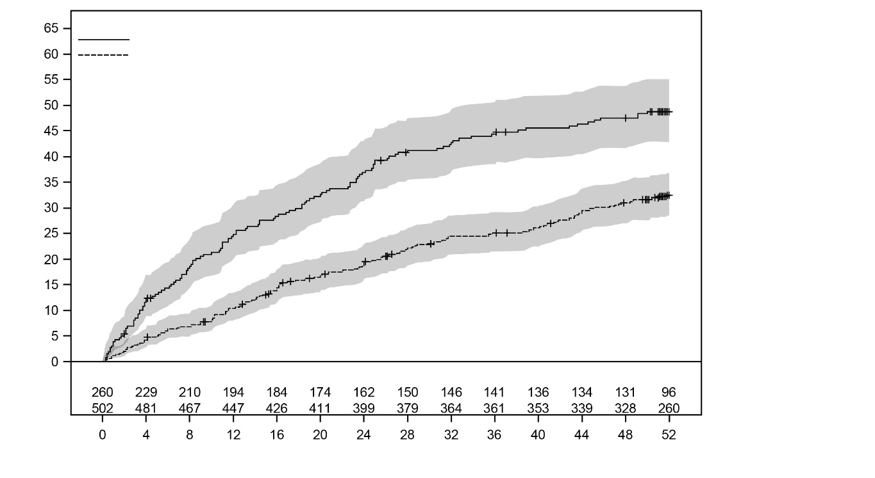
Placebo
Depemokimab 100 mg SC
Placebo
Depemokimab 100 mg SC
Probability of Event (%)
Number at risk
Time to Event (Weeks)
NOTE: Number (%) of subjects with event(s) in depemokimab group vs. placebo group is 160 (32%) vs. 125 (48%).
In a pooled analysis of SWIFT-1 and SWIFT-2, a reduction in exacerbation rate with depemokimab was observed regardless of whether patients were on medium or high dose ICS, and baseline blood eosinophil counts were ≥150 cells/mcL or <150 cells/mcL (post-hoc analysis) (Figure 2).
Figure 2: Annualised Asthma Exacerbation Rate Ratio Over 52 Weeks Across Medium and High Dose ICS and Blood Eosinophil Count (cells/mcL) (Pooled FAS Population)
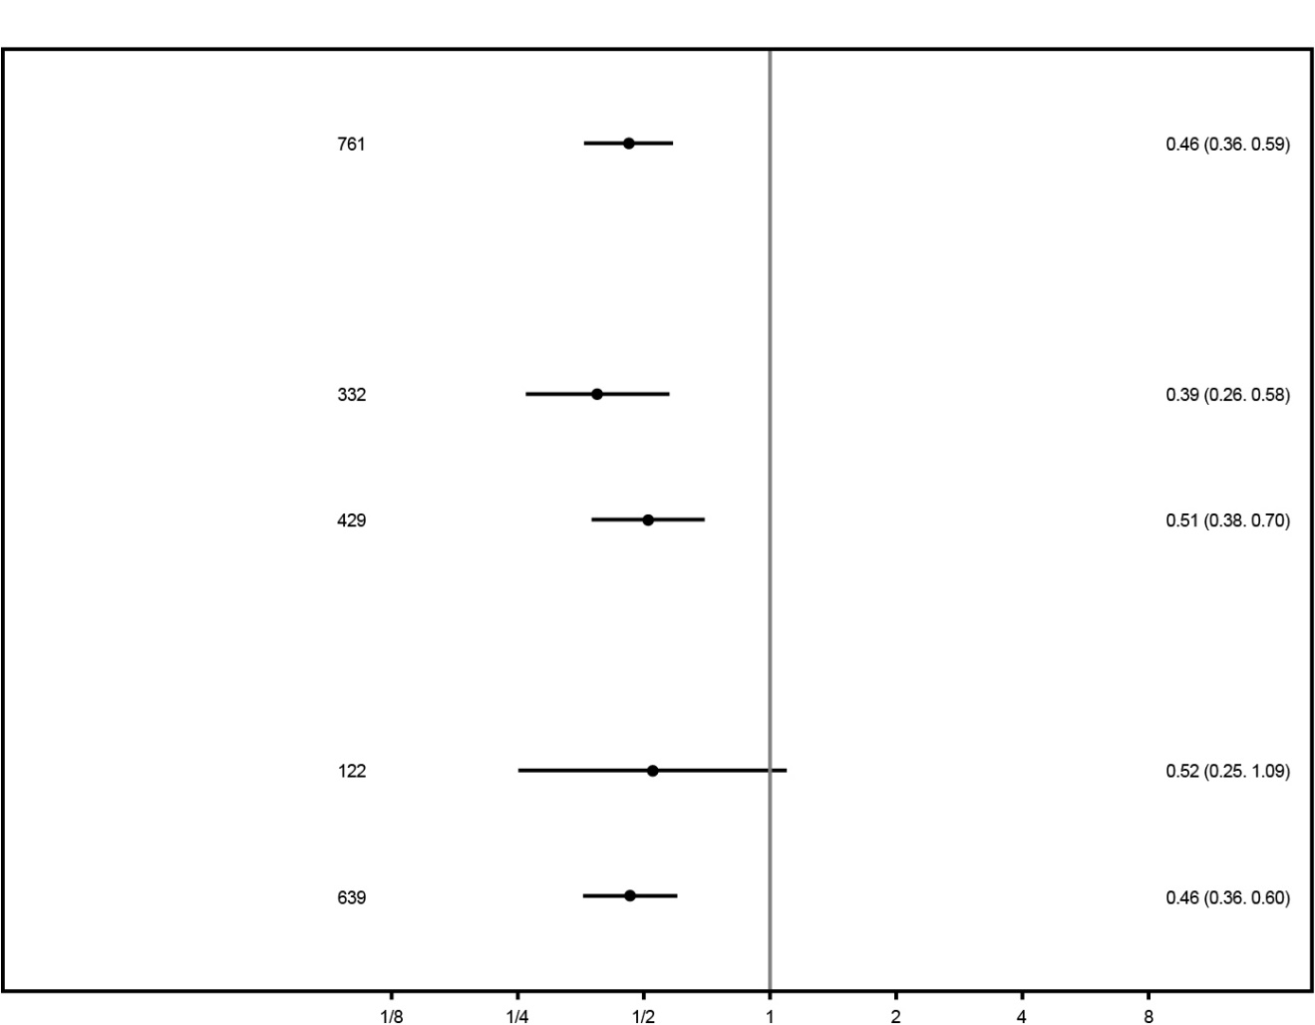
No. of Patients
<<< Favours Depemokimab
Favours Placebo>>>
Rate Ratio (95% C.I)
Overall
Baseline ICS
Medium
High
Baseline Eosinophil
<=0.15 (cells/mcL)
>0.15 (cells/mcL)
FAS = Full Analysis Set; ICS = Inhaled Corticosteroids.
Secondary Endpoints
Analysis of SGRQ for the individual studies did not achieve statistical significance. Therefore, the multiplicity hierarchies for each study were broken, and the remaining tests of secondary endpoints did not have multiplicity control.
Table 6 provides the results of these secondary endpoints for the FAS population of SWIFT-1 and SWIFT-2
Table 6: Results of Secondary Endpoints (FAS Population)*
 | SWIFT-1 |  | SWIFT-2
 | Depemokimab  N = 250 | Placebo  N = 132 | Depemokimab  N = 252 | Placebo  N = 128
St. George’s Respiratory Questionnaire (SGRQ) total score at Week 52
nª | 224 | 114 | 224 | 116
LS Mean Change from Baseline (SE) | -13.0  (1.11) | -9.7 (1.55) | -14.8  (1.04) | -12.5 (1.46)
Adjusted treatment difference^{b} | -3.4 |  | -2.3
(95% CI) | (-7.1, 0.4) |  | (-5.8, 1.2)
Asthma Control Questionnaire-5 (ACQ-5) score at Week 52
nª | 224 | 114 | 224 | 116
LS Mean Change from Baseline (SE) | -0.82  (0.066) | -0.77  (0.091) | -0.81  (0.065) | -0.70  (0.091)
Adjusted treatment difference^{b} | -0.04 |  | -0.11
(95% CI) | (-0.27, 0.18) |  | (-0.33, 0.11)
Pre-bronchodilator FEV₁ (mL) at Week 52
nª | 224 | 115 | 226 | 112
LS Mean Change from Baseline (SE) | 160  (26.3) | 160 (36.4) | 240  (28.6) | 184  (40.7)
Adjusted treatment difference^{b} | -1 |  | 56
(95% CI) | (-89, 88) |  | (-43, 154)
FEV₁ = Forced Expiratory Volume in 1 second; LS = Least Squares
*These secondary endpoints did not achieve statistical significance within the testing procedure; results are descriptive only.
ª Number of patients with analysable data at the timepoint
^{b} Adjusted treatment difference (depemokimab vs. placebo).

Open-Label Extension Study in Asthma (AGILE)
Patients who completed either the SWIFT-1 or SWIFT-2 study were able to enrol in an open-label extension study (AGILE) where they all received up to 2 doses of depemokimab over an additional 52 weeks. An interim analysis of AGILE (n = 629) showed an annualised exacerbation rate of 0.47 (95% CI: 0.40, 0.56).
Chronic Rhinosinusitis with Nasal Polyps
The efficacy of depemokimab in adult patients with CRSwNP was evaluated in 2 replicate, randomised, double-blind, placebo-controlled, parallel-group, multicentre clinical studies of 52 -weeks treatment duration (ANCHOR-1 and ANCHOR-2). These studies evaluated the efficacy of 100 mg of depemokimab administered SC once every 6 months for a total of 2 doses in addition to standard of care (SoC) therapy. All patients had either been treated with systemic corticosteroids (SCS) within the past 2 years; and/or had a medical contraindication/intolerance to SCS; and/or had a documented history of prior surgery for nasal polyps (NP) prior to screening. Randomised patients were required to have an endoscopic bilateral NP score of at least 5 out of a maximum score of 8 with a minimum score of 2 in each nasal cavity and a mean nasal obstruction Verbal Response Scale (VRS) score of 2 or greater at baseline. Other than nasal obstruction, there were no other entry requirements for symptoms or for quality of life at randomisation. A total of 528 patients (271 in ANCHOR-1 and 257 in ANCHOR-2) were included in the Full Analysis Set (FAS) population.
The demographics and baseline characteristics of the patients in these 2 studies are provided in Table 7 below.
Table 7: Demographics and Baseline Characteristics (FAS Population)
 | ANCHOR-1  N = 271 | ANCHOR-2  N = 257
Age (y) of patients, mean (SD) | 54 (13.4) | 50 (12.9)
Female, n (%) | 83 (31) | 80 (31)
White, n (%) | 185 (70) | 197 (77)
Duration (y) of CRSwNP, mean (SD) | 13 (11.2) | 11 (8.7)
Patients with ≥1 previous NP surgery, n (%) | 171 (63) | 162 (63)
SCS use for NP in past 12 months, n (%) | 190 (70) | 172 (67)
Asthma, n (%) | 161 (59) | 131 (51)
Intranasal corticosteroid use, n (%) | 265 (98) | 249 (97)
AERD, n (%) | 43 (16) | 42 (16)
Blood eosinophil count, cells/mcL, median (min, max) | 360  (10, 10,550) | 360  (30, 1,670)
Total endoscopic NP score^{a, b, c}, mean (SD), maximum score = 8 | 6.0 (1.35) | 5.9 (1.29)
Nasal obstruction VRS mean score^{a, d}, mean (SD), maximum score = 3 | 2.5 (0.48) | 2.6 (0.42)
Rhinorrhoea VRS mean score^{a, d}, mean (SD), maximum score = 3 | 2.2 (0.70) | 2.3 (0.67)
Loss of smell VRS mean score^{a, d}, mean (SD), maximum score = 3 | 2.7 (0.55) | 2.8 (0.41)
LMK CT score^{a, b}, mean (SD), maximum score = 24 | 18.7 (4.08) | 18.9 (4.19)
SNOT-22 total score^{a, e}, mean (SD), maximum score = 110 | 57.4 (22.15) | 60.1 (19.95)
Patients with SNOT-22 total score ≥40, n (%) | 204 (75) | 207 (81)
AERD = aspirin-exacerbated respiratory disease; CRSwNP = chronic rhinosinusitis with nasal polyps, FAS = full analysis set, LMK CT = Lund MacKay Computed Tomography, NP = nasal polyps, SCS = systemic corticosteroid, SNOT-22 = Sino-Nasal Outcome Test, VRS = verbal response scale.
ª Higher scores indicate greater disease severity.
^{b} As graded by independent blinded assessors.
^{c} NP score is the sum of scores from both nostrils (0-8 scale) where each nostril was graded (0 = no polyps; 1 = small polyps in the middle meatus not reaching below the inferior border of the middle concha; 2 = polyps reaching below the lower border of the middle turbinate; 3 = large polyps reaching the lower border of the inferior turbinate or polyps medial to the middle concha; 4 = large polyps causing almost complete congestion/obstruction of the inferior meatus).
^{d} Collected daily by patients on a 0 to 3 scale where 0 = no symptoms, 1 = mild symptoms, 2 = moderate symptoms, 3 = severe symptoms.
^{e} SNOT-22 is a health-related quality of life assessment tool and includes 22 items in 6 domains of symptoms and impact associated with CRSwNP (nasal, non-nasal, ear/facial, sleep, fatigue, emotional consequences). Higher scores indicate worse health related quality of life.
Total Endoscopic Nasal Polyp Score and Nasal Obstruction VRS Score
The co-primary efficacy endpoints in each study were change from baseline in total endoscopic NP score (0-8 scale) at Week 52 as graded by central blinded readers and change from baseline in mean nasal obstruction VRS score (0-3 scale [0=no symptoms, 1=mild symptoms, 2=moderate symptoms, 3=severe symptoms]) over Weeks 49 to 52 as self-reported by patients using a daily diary. Patients who received depemokimab had a statistically significant improvement (reduction) in total endoscopic NP score at Week 52 and nasal obstruction VRS score over Weeks 49 to 52 compared with placebo in both ANCHOR-1 and ANCHOR-2. The results for the co-primary endpoints in the individual ANCHOR studies and the results from a pooled analysis from ANCHOR-1 and ANCHOR-2 are presented in Table 8.
Table 8: Results of Co-Primary Endpoints (FAS Population)
 | ANCHOR-1 |  | ANCHOR-2 |  | Pooled
 | Depemokimab  N = 143 | Placebo  N = 128 | Depemokimab  N = 129 | Placebo  N = 128 | Depemokimab  N = 272 | Placebo  N = 256
Total Endoscopic NP Score at Week 52^{a, b}
n^{c} | 128 | 120 | 120 | 115 | 248 | 235
LS Mean (SE) | 5.4  (0.14) | 6.2  (0.15) | 5.4  (0.14) | 6.0  (0.15) | 5.4  (0.10) | 6.1  (0.10)
LS Mean change from baseline (SE) | -0.6  (0.14) | 0.2  (0.15) | -0.5  (0.14) | 0.1  (0.15) | -0.5  (0.10) | 0.1  (0.10)
Adjusted treatment difference^{d} (95% CI) | -0.7  (-1.1, -0.3) |  | -0.6  (-1.0, -0.2) |  | -0.7  (-0.9, -0.4)
P-value | <0.001 |  | 0.004 |  | -
Nasal Obstruction VRS Mean Score over Weeks 49 to 52^{a, b}
n^{c} | 125 | 116 | 119 | 111 | 244 | 227
LS Mean (SE) | 1.77  (0.079) | 2.00  (0.083) | 1.83  (0.076) | 2.07  (0.078) | 1.80  (0.055) | 2.04  (0.057)
LS Mean change from baseline (SE) | -0.76  (0.079) | -0.53  (0.083) | -0.77  (0.076) | -0.53  (0.078) | -0.77  (0.055) | -0.53  (0.057)
Adjusted treatment difference^{d} (95% CI) | -0.23  (-0.46, 0.00e) |  | -0.25  (-0.46, -0.03) |  | -0.24  (-0.39, -0.08)
P-value | 0.047 |  | 0.025 |  | -
FAS = Full Analysis Set; LS = Least Squares, NP = Nasal Polyps; VRS = Verbal Response Scale.
ª Patients who had nasal surgery or used disease-modulating medication for CRSwNP prior to the timepoint of interest were assigned the worst possible value of the relevant score for all assessments following surgery or initiation of disease-modulating medication.
^{b} Based on Mixed Model Repeat Measures (MMRM) analyses with covariates of treatment, baseline score, log(e) baseline blood eosinophil count, region, previous surgery for nasal polyps, visit and interaction terms for visit by baseline and visit by treatment. For the pooled analysis, study was included as an additional covariate.
^{c} Number of patients with analysable data at the given timepoint.
^{d} Adjusted treatment difference (depemokimab vs. placebo).
^{e} The upper limit of the 95% CI represents a rounded value of -0.003.
In a pooled analysis from ANCHOR-1 and ANCHOR-2, a treatment difference in favour of depemokimab was observed by Week 12 (first timepoint assessed) for the total endoscopic NP score and by Weeks 1-4 (first timepoint assessed) for the nasal obstruction VRS mean score that was maintained up to Week 52 (Figure 3 and Figure 4).
Figure 3: LS Mean Change from Baseline (95% CI) in Total Endoscopic NP Score up to Week 52 (Pooled FAS Population)
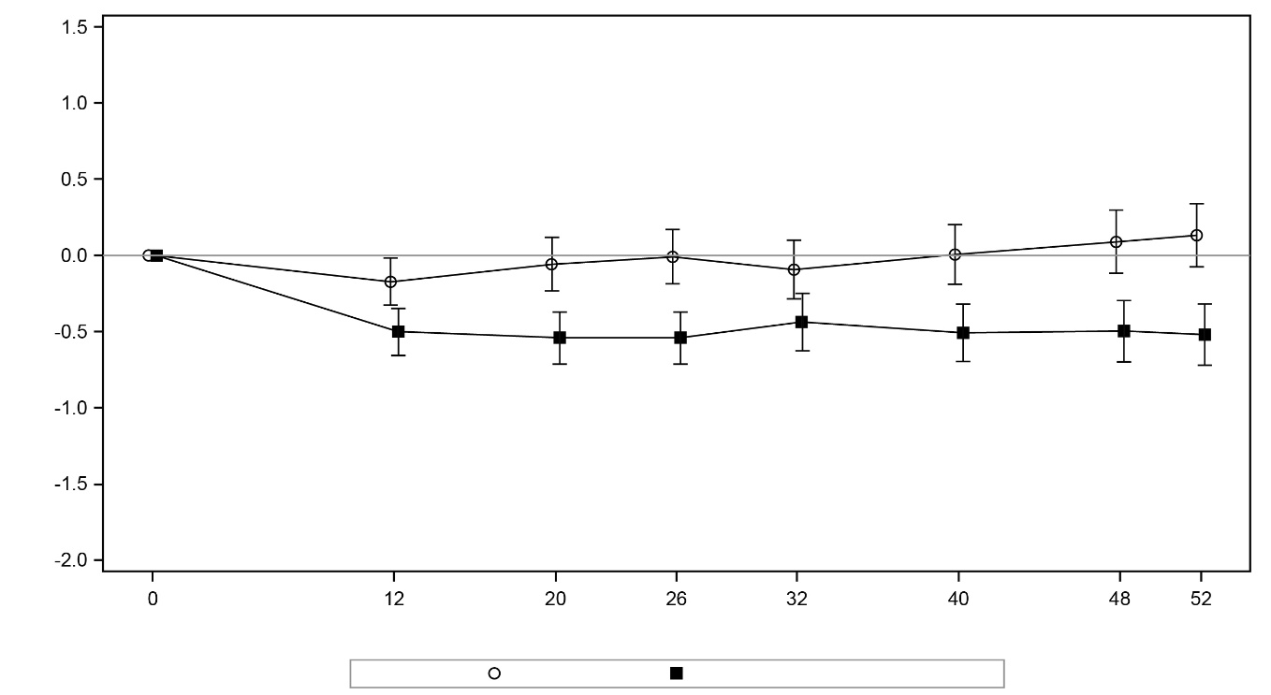
Treatment: Placebo (N=256) Depemokimab 100 mg SC (N=272)
LS Mean Change from Baseline and 95% CI
Week of Study
FAS = Full Analysis Set; LS = Least Squares; NP = Nasal Polyps.
Figure 4: LS Mean Change from Baseline (95% CI) in Nasal Obstruction VRS Mean Score up to Week 52 (Pooled FAS Population)
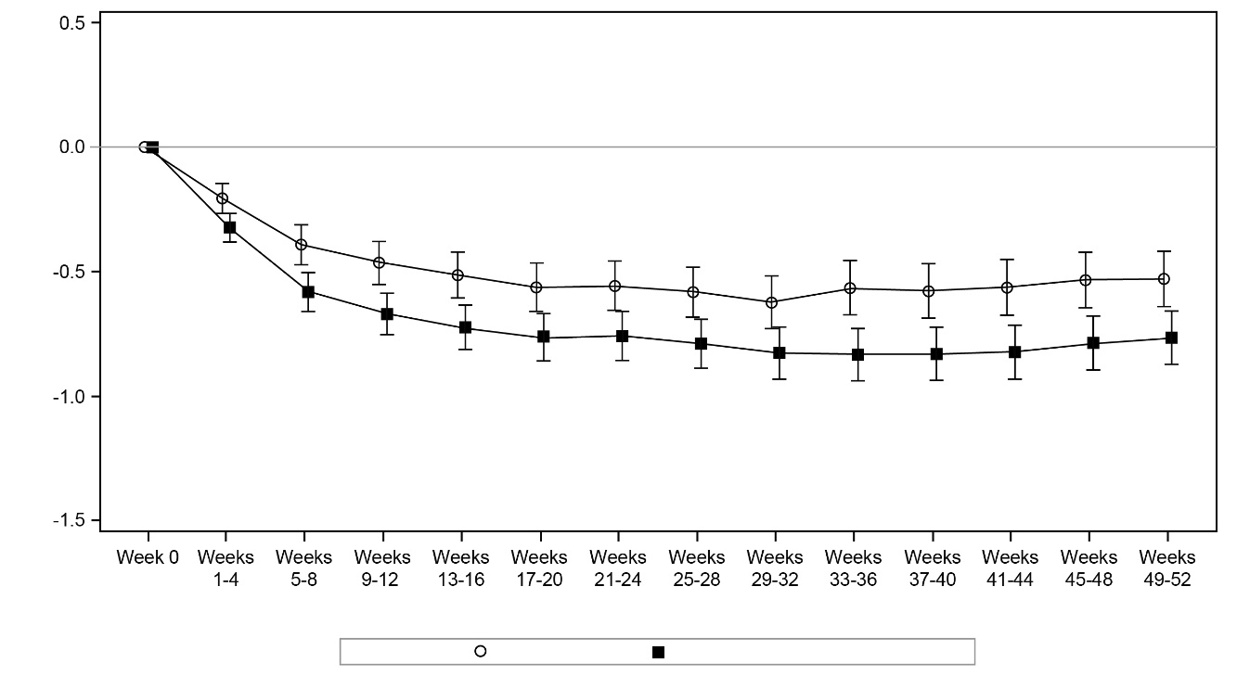
Treatment: Placebo (N=256) Depemokimab 100 mg SC (N=272)
LS Mean Change from Baseline and 95% CI
Week of Study
FAS = Full Analysis Set; LS = Least Squares; VRS = Verbal Response Scale.
In a pooled analysis from ANCHOR-1 and ANCHOR-2, the proportion of total endoscopic NP score responders (≥1-point improvement [decrease] from baseline) at Week 52 was 43% (116/272) for depemokimab compared with 24% (62/256) for placebo with an OR of 2.31 (95% CI: 1.58, 3.38) and the proportion of nasal obstruction VRS mean score responders (≥1-point improvement [decrease] from baseline) over Weeks 49 to 52 was 40% (110/272) for depemokimab compared with 29% (75/256) for placebo with an odds ratio (OR) of 1.56 (95% CI: 1.07, 2.27).
In a pooled subgroup analysis of the co-primary endpoints, patients with/without comorbid asthma or blood eosinophil counts above or below 300 cells/mcL at baseline showed improvements with depemokimab compared to placebo that were consistent with the overall population.
Nasal Surgery, Systemic Corticosteroid Use, Initiation of Disease-Modulating Medication for CRSwNP
Across the 2 ANCHOR studies, the proportion of patients who required nasal surgery (actual or planned) or initiated disease-modulating medication for CRSwNP was 16% (44/272) in the depemokimab group and 22% (56/256) in the placebo group (27% risk reduction; HR: 0.735; 95% CI: 0.495, 1.092, Figure 5). The proportion of patients who had nasal surgery or initiated disease-modulating medication for CRSwNP was 12% (33/272) in the depemokimab group, compared with 17% (43/256) in the placebo group, representing a 29% risk reduction (HR: 0.713; 95% CI: 0.453, 1.124).
Figure 5: Kaplan Meier Curve for Time to First Nasal Polyps Surgery (Actual or Planned) or Initiation of Disease-Modulating Medication for CRSwNP up to Week 52 (Pooled FAS Population)
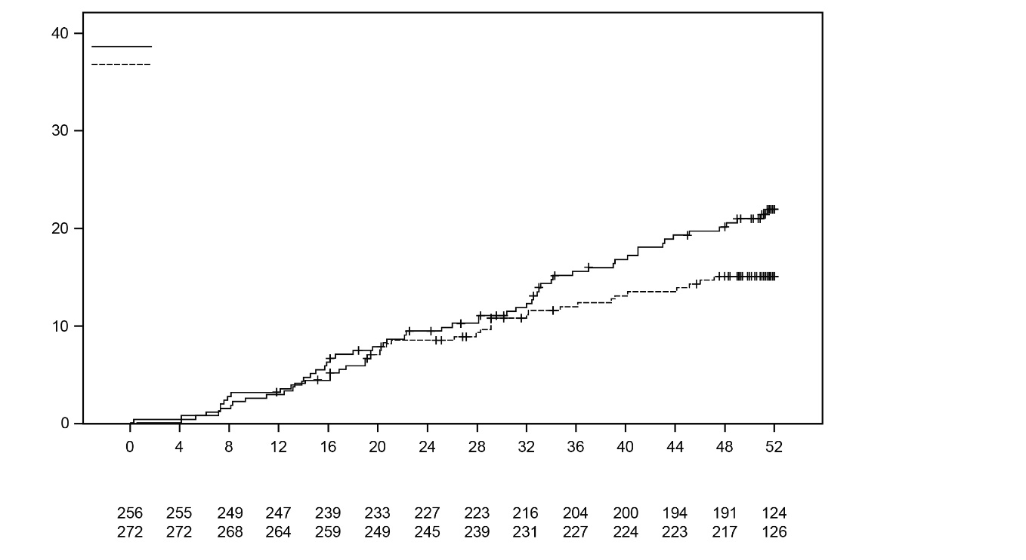
Placebo
Depemokimab 100 mg SC
Placebo
Depemokimab 100 mg SC
Probability of Event (%)
Number at risk
Time to Event (Weeks)
CRSwNP = Chronic Rhinosinusitis with Nasal Polyps; FAS = Full Analysis Set.
Across the 2 ANCHOR studies, the proportion of patients that required at least 1 course of SCS for CRSwNP or disease-modulating medication for CRSwNP or nasal surgery treatment was 26% (72/272) in the depemokimab group compared with 36% (92/256) in the placebo group (OR: 0.58, 95% CI: 0.40, 0.86).
Paediatric population
Asthma
In the SWIFT-1 and SWIFT-2 studies, there were 30 adolescents (12 to 17 years old), of which 15 received placebo and 15 received depemokimab 100 mg subcutaneously. In a combined analysis of these studies, a 43% reduction in clinically significant exacerbations was observed in adolescents following depemokimab treatment compared to placebo (rate ratio 0.57; 95% CI: 0.15, 2.13). The safety profile was generally similar to that seen in adults. No additional adverse reactions were identified.
Chronic rhinosinusitis with nasal polyps (CRSwNP)
There are no clinical data available in children and adolescents aged less than 18 years old.

PHARMACOKINETIC PROPERTIES
Depemokimab exhibited approximately dose-proportional pharmacokinetics over a dose range of 10 to 300 mg in patients with asthma following SC administration. Depemokimab pharmacokinetics were consistent in patients with asthma and CRSwNP with an average concentration at steady state of 5.9 mcg/mL and 5.2 mcg/mL, respectively after SC administration of 100 mg depemokimab every 6 months.

Absorption
Following single SC administration (doses ranging from 2 to 300 mg), maximum observed plasma concentrations (C_{max}) were achieved at a median time ranging from 8 to 14 days. Following repeat SC administration once every 6 months there was no accumulation.

Distribution
Following single SC administration of depemokimab, the mean volume of distribution is 6 to 9 L.

Metabolism
Depemokimab is a monoclonal antibody which is catabolised by ubiquitous proteolytic enzymes not restricted to hepatic tissue.

Excretion
Following single SC administration of depemokimab, the geometric mean terminal elimination half-life ranged from 38 to 53 days, with geometric mean apparent clearance values ranging from 0.081 to 0.16 L/day.

Special patient populations
Population pharmacokinetic analyses indicated no clinically relevant effect of age, race or gender on depemokimab pharmacokinetics.
Children
There are limited pharmacokinetic data available in the paediatric population. The pharmacokinetics of depemokimab in adolescents aged 12 to 17 years were consistent with adults.
The pharmacokinetics of depemokimab have not been studied in paediatric patients aged less than 12 years.
Renal impairment
No formal studies have been conducted to investigate the effect of renal impairment on the pharmacokinetics of depemokimab. Based on population pharmacokinetic analyses, no dose adjustment is required in patients with an estimated glomerular filtration rate [eGFR] <60 mL/min/1.73m². Data are limited in patients with an eGFR <60 mL/min/1.73m².
Renal impairment is not expected to have a significant impact on clearance as depemokimab is not cleared renally.
Hepatic impairment
No formal studies have been conducted to investigate the effect of hepatic impairment on the pharmacokinetics of depemokimab. Since depemokimab is degraded by widely distributed proteolytic enzymes, not restricted to hepatic tissue, changes in hepatic function are unlikely to have an effect on the elimination of depemokimab. Based on population pharmacokinetic analysis, baseline hepatic function biomarkers (alanine aminotransferase [ALT], aspartate aminotransferase [AST], and bilirubin) had no clinically relevant effect on depemokimab apparent clearance.

PRECLINICAL SAFETY DATA

Genotoxicity
No genotoxicity studies have been conducted.

Carcinogenicity
No carcinogenicity studies have been conducted.

Pharmaceutical particulars

LIST OF EXCIPIENTS
EXDENSUR solution for injection also contains the excipients trehalose dihydrate, arginine hydrochloride, histidine hydrochloride monohydrate, histidine, polysorbate 80, disodium edetate and water for injections.

INCOMPATIBILITIES
Not applicable.

SHELF LIFE
In Australia, information on the shelf life can be found on the public summary of the Australian Register of Therapeutic Goods (ARTG). The expiry date can be found on the packaging.

SPECIAL PRECAUTIONS FOR STORAGE
Store at 2°C to 8°C (Refrigerate. Do not freeze).
Protect from light. Store in the original carton until use.
The pre-filled pen and pre-filled syringe can be removed from the refrigerator and kept in the unopened carton for up to 7 days (store below 30°C), when protected from light. Discard if left out of the refrigerator for more than 7 days.
The pre-filled pen or pre-filled syringe must be administered within 8 hours once removed from the carton. Discard if not administered within 8 hours.

NATURE AND CONTENTS OF CONTAINER
Solution for injection pre-filled pen (autoinjector)
EXDENSUR is presented as a 1 mL siliconised, Type I glass syringe with a fixed 0.5 inch (12.7 mm), 29-gauge, stainless steel needle assembled as an auto-injector.
EXDENSUR is supplied in a pack containing a one single use pre-filled pen (auto-injector).
Solution for injection pre-filled syringe (safety syringe)
EXDENSUR is presented as a 1 mL siliconised, Type I glass syringe with a fixed 0.5 inch (12.7 mm), 29-gauge, stainless steel needle assembled with a needle guard.
EXDENSUR is supplied in a pack containing one single use pre-filled syringe (safety syringe).
Not all dose forms and container types may be distributed in Australia.

SPECIAL PRECAUTIONS FOR DISPOSAL
In Australia, any unused medicine or waste material should be disposed of in accordance with local requirements.

PHYSICOCHEMICAL PROPERTIES

Chemical structure
Structure of depemokimab:
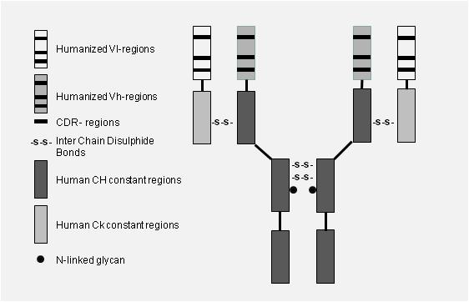
The estimated molecular weight of depemokimab is 149 kDa.

CAS number
2243274-14-6

Medicine schedule (Poisons Standard)
Schedule 4 – Prescription Only Medicine

Sponsor
GlaxoSmithKline Australia Pty Ltd
Level 4, 436 Johnston Street,
Abbotsford, Victoria, 3067
Phone: 1800 033 109
www.gsk.com.au

Date of first approval
24 July 2026

Date of revision
Not applicable

SUMMARY TABLE OF CHANGES
Section Changed | Summary of new information
 | New Product Information

Version 1.0
Trade marks are owned by or licensed to the GSK group of companies.
© 2026 GSK group of companies or its licensor.

