Australian Public Assessment Report for Zoladex 10.8 Implant
  - Active ingredient: Goserelin
  - Sponsor: AstraZeneca Pty Ltd
September 2026

About the Therapeutic Goods Administration (TGA)
- The Therapeutic Goods Administration (TGA) is part of the Australian Government Department of Health, Disability and Ageing and is responsible for regulating therapeutic goods, including medicines, medical devices, and biologicals.
- The TGA administers the Therapeutic Goods Act 1989 (the Act), applying a risk management approach designed to ensure therapeutic goods supplied in Australia meet acceptable standards of quality, safety, and efficacy.
- The work of the TGA is based on applying scientific and clinical expertise to decision-making, to ensure that the benefits to the Australian public outweigh any risks associated with the use of therapeutic goods.
- The TGA relies on the public, healthcare professionals and industry to report problems with therapeutic goods. The TGA investigates reports received to determine any necessary regulatory action.
- To report a problem with a therapeutic good, please see the information on the TGA website.

About AusPARs
- The Australian Public Assessment Report (AusPAR) provides information about the evaluation of a prescription medicine and the considerations that led the TGA to approve or not approve a prescription medicine submission. Further information can be found in Australian Public Assessment Report (AusPAR) guidance.
- AusPARs are prepared and published by the TGA.
- AusPARs are static documents that provide information that relates to a submission at a particular point in time. The publication of an AusPAR is an important part of the transparency of the TGA’s decision-making process.
- A new AusPAR may be provided to reflect changes to indications or major variations to a prescription medicine subject to evaluation by the TGA.

Copyright
© Commonwealth of Australia 2026
This work is copyright. You may reproduce the whole or part of this work in unaltered form for your own personal use or, if you are part of an organisation, for internal use within your organisation, but only if you or your organisation do not use the reproduction for any commercial purpose and retain this copyright notice and all disclaimer notices as part of that reproduction. Apart from rights to use as permitted by the Copyright Act 1968 or allowed by this copyright notice, all other rights are reserved and you are not allowed to reproduce the whole or any part of this work in any way (electronic or otherwise) without first being given specific written permission from the Commonwealth to do so. Requests and inquiries concerning reproduction and rights are to be sent to the TGA Copyright Officer, Therapeutic Goods Administration, PO Box 100, Woden ACT 2606 or emailed to <tga.copyright@tga.gov.au>.

Contents
List of abbreviations 4
Product submission 5
Submission details 5
Product background 6
Condition and current treatment options 6
Clinical rationale 7
Regulatory status 7
Australian regulatory status 7
International regulatory status 8
Registration timeline 9
Assessment overview 10
Quality evaluation summary 10
Nonclinical evaluation summary 10
Clinical evaluation summary 10
Summary of clinical studies 10
Pharmacology 13
Efficacy 21
Safety 23
Risk management plan 26
Risk-benefit analysis 26
Comparability of the 10.8 mg and 3.6 mg goserelin implant strengths 26
Conclusions 28
Assessment outcome 29
Product Information and Consumer Medicine Information 29

List of abbreviations
Abbreviation | Meaning
AEs | Adverse events
ARTG | Australian Register of Therapeutic Goods
AUC | Area under the concentration-time curve
CMI | Consumer Medicines Information
C_{max} | Maximum concentration
E2 | Oestradiol
ER | Oestrogen-receptor
FAS | Full analysis set
FSH | Follicle stimulating hormone
LH-RH | Luteinising hormone-releasing hormone
LLOQ | Lower limits of quantification
OFS | Ovarian function suppression
ORR | Objective response rate
PI | Product Information
PD | Pharmacodynamic(s)
PK | Pharmacokinetic(s)
PTs | Preferred terms
SAEs | Serious adverse event(s)
TGA | Therapeutic Goods Administration
T_{max} | Time to maximum concentration

Product submission

Submission details
Type of submission: | Extension of indication
Product name: | Zoladex 10.8 Implant
Active ingredient: | goserelin (as acetate)
Decision: | Approved
Approved therapeutic use for the current submission: | Management of oestrogen-receptor (ER) positive early and advanced breast cancer in pre and peri menopausal women.
Date of decision: | 28 August 2026
Date of entry onto ARTG: | 28 August 2026
ARTG number: | 55242
Black Triangle Scheme | No
Sponsor’s name and address: | AstraZeneca Pty Ltd, 66 Talavera Road, Macquarie Park, NSW, 2113
Dose form: | Implant
Strength: | Each Zoladex implant contains goserelin 10.8 mg (as goserelin acetate)
Container: | Zoladex 10.8 mg SAFESYSTEM Implant is supplied as a sterile, biodegradable cylindrical implant containing the equivalent of 10.8 mg of goserelin base together with the inactive ingredient polyglactin and is presented as 1x (one) pre-filled syringe applicator.
Pack size: | 1 pre-filled syringe per carton
Route of administration: | Subcutaneous injection
Dosage: | One implant of Zoladex 10.8 mg injected subcutaneously into the anterior abdominal wall, every 12 weeks.  For further information regarding dosage, refer to the Product Information.
Pregnancy category: | Category D  Drugs which have caused, are suspected to have caused or may be expected to cause, an increased incidence of human fetal malformations or irreversible damage. These drugs may also have adverse pharmacological effects.  The use of any medicine during pregnancy requires careful consideration of both risks and benefits by the treating health professional. The pregnancy database must not be used as the sole basis of decision making in the use of medicines during pregnancy. The TGA does not provide advice on the use of medicines in pregnancy for specific cases. More information is available from obstetric drug information services in your state or territory.

Product background
This AusPAR describes the submission by AstraZeneca Pty Ltd (the Sponsor) to register Zoladex 10.8 Implant (goserelin) for the following extension of indications:
Breast cancer
Management of oestrogen-receptor (ER) positive early and advanced breast cancer in pre and peri menopausal women.

Condition and current treatment options
Breast cancer is the most commonly diagnosed cancer in women worldwide and is the leading cause of cancer death in women. Globally, the age-standardised incidence rate was 87.7 per 100,000 while that for mortality was 14.0 per 100,000.
In Australia, there are projected to be 20,336 new cases of breast cancer (20,129 in women; 207 in men) diagnosed in 2025, which is an age-standardised incidence rate of 73.5 per 100,000 persons (140.1 per 100,000 females; 1.6 per 100,000 males). In 2025, approximately 3,300 deaths due to breast cancer are predicted in Australia, which is an age-standardised rate of 12.1 deaths per 100,000 people. Five-year survival rates for breast cancer in Australia are 92.7% overall, 87.2% for First Nations people, and 90.4% for the most disadvantaged Australians (SEIFA quintile 1).
Although the risk of breast cancer increases with age, approximately 11% of women with breast cancer are diagnosed before the age of 45 years, i.e. when they are pre- and perimenopausal. Approximately 80% of premenopausal patients with breast cancer have ER-positive tumours. Thus, oestradiol (E2) deprivation is an important strategy for controlling disease in these patients. Goserelin is an luteinising hormone-releasing hormone (LH-RH) agonist which provides reversible ovarian function suppression (OFS).
Current clinical guidelines, including those from the National Institute for Health and Care Excellence (NICE), recommend adjuvant OFS in combination with endocrine therapy (such as tamoxifen or aromatase inhibitors) for premenopausal women with ER-positive invasive breast cancer. The European Society for Medical Oncology (ESMO), American Society of Clinical Oncology (ASCO), and National Comprehensive Cancer Network (NCCN) recommend that the combination may be most beneficial for women at higher risk of relapse. However, the guidelines, including NICE, encourage a balanced discussion of the benefits and risks of adding OFS to endocrine therapy in all patients for whom this regimen is considered.
The recommendation for adjuvant OFS in combination with endocrine therapy is based on data from two large, randomised studies (Suppression of Ovarian Function Trial [SOFT] and Tamoxifen and Exemestane Trial [TEXT]), which showed that ovarian suppression plus tamoxifen increased disease-free survival and overall survival compared with tamoxifen alone, while ovarian suppression plus an aromatase inhibitor (exemestane) resulted in higher rates of freedom from recurrence.

Clinical rationale
Goserelin acetate is a synthetic decapeptide analogue of naturally occurring LH-RH that acts as a LH-RH agonist. Chronic administration of a LH-RH agonist using a depot formulation (such as Zoladex) results in an initial stimulation of gonadotrophin release, which is quickly followed by a reduction in gonadotrophin secretion due to downregulation of the anterior pituitary gland LH-RH receptors, and a subsequent decrease in the serum testosterone concentrations in males, and serum E2 concentrations in females ,,,. In premenopausal women with hormone receptor (HR)-positive breast cancer, suppression of serum E2 to concentrations comparable with those seen in postmenopausal women (< 30 pg/mL [110 pmol/L]) is regarded as an important strategy for controlling disease in these patients.

Regulatory status

Australian regulatory status
The Zoladex (goserelin) 3.6 mg implant was first listed on the ARTG on 14 October 1991; the 10.8 mg implant was first registered on 22 May 1996.
This submission relates to the 10.8 mg strength only.
The current approved indications for the 10.8 mg strength are:
Prostate cancer
Palliative treatment of metastatic (M+) or locally advanced prostate cancer where suitable for hormonal manipulation.
Adjuvant and neoadjuvant therapy in combination with radiotherapy for the management of locally advanced prostate cancer in men suitable for hormonal manipulation.
The current approved indications for the 3.6 mg strength are:
Prostate cancer
Palliative treatment of metastatic (M+) or locally advanced prostate cancer, where suitable for hormonal manipulation.
Adjuvant and neo-adjuvant therapy in combination with radiotherapy for the management of locally advanced prostate cancer in men suitable for hormonal manipulation.
Breast cancer
Treatment of advanced breast cancer (T3b, T4 or any T with N2, 3 or M+) in premenopausal women suitable for hormonal manipulation.
Adjuvant therapy in early breast cancer, in pre- and perimenopausal women suitable for hormonal manipulation.
Endometriosis
In the management of visually proven endometriosis to reduce symptoms including pain and the size and number of endometrial lesions.
Uterine fibroids
In the management of fibroids, ZOLADEX shrinks the lesions and reduces the symptoms, including pain. ZOLADEX also increases the haemoglobin concentration and haematocrit in women with anaemia attributable to menorrhagia. It is used as an adjunct to surgery to facilitate the operative technique and reduce operative blood loss.
Endometrial thinning
Use as an endometrial thinning agent prior to endometrial ablation.
Assisted Reproduction
Pituitary down regulation in preparation for controlled ovarian superstimulation.
The current submission has occurred in the context of a commercial change/commercial viability notified by the Sponsor to withdraw the 3.6 mg product. The Sponsor has provided an assurance that the withdrawal decision is not related to any safety or efficacy concerns. The Sponsor’s justification for this regulatory action also includes reducing the frequency of treatment visits for patients, arising out of pandemic-related considerations.

International regulatory status
At the time the TGA considered this submission, a similar submission had been considered by other regulatory agencies. Table 1 summarises these submissions and provides the indications where approved.
Table 1. International regulatory status at the time the TGA considered this submission
Country | Submission date | Approval date | Comment / Approved Indication
Brazil | 27 Aug 2021 | 13 Jun 2022 | Approved Indication:  ZOLADEX 10.8 mg is indicated in:  The management of breast cancer in pre and perimenopausal women suitable for hormonal manipulation.
Canada | 24 May 2023 | 06 May 2024 | Approved Indication:  Breast Cancer:  the management of estrogen receptor (ER)-positive early breast cancer with a high risk of recurrence or advanced breast cancer in pre- and perimenopausal women.
European Union | - | - | Not submitted
Great Britain | 27 May 2021 | 23 Dec 2021 | Approved Indication:  ZOLADEX LA 10.8 mg is indicated in the  management of oestrogen-receptor (ER) positive early and advanced breast cancer in pre and peri menopausal women.
Japan | 29 Mar 2013 | 17 Mar 2014 | Approved Indication:  Premenopausal Breast Cancer
New Zealand | - | - | Not submitted
Singapore | 16 Jun 2020 | 16 Feb 2021 | Approved Indication:  ZOLADEX LA 10.8 mg is indicated in the  management of oestrogen-receptor (ER) positive breast cancer in pre-menopausal women.
Switzerland | - | - | Not submitted.
United States | - | - | Not submitted.

Registration timeline
Table 2 captures the key steps and dates for this submission.
This submission was submitted through the TGA’s Comparable Overseas Regulator (COR-B) process, using evaluation reports from the Medicines and Healthcare products Regulatory Agency (UK). The full dossier was submitted to the TGA.
Table 2. Registration timeline for Zoladex 10.8 Implant (goserelin), submission PM-2026-01228-1-4
Description | Date
Submission dossier accepted evaluation commenced | 30 April 2026
Evaluation completed | 20 August 2026
Registration decision (Outcome) | 28 August 2026
Registration in the ARTG completed | 28 August 2026
Number of working days from submission dossier acceptance to registration decision* | 63
* The COR-B process has a 175 working day evaluation and decision timeframe.

Assessment overview
A summary of the TGA’s assessment for this submission is provided below.

Quality evaluation summary
Quality evaluation is not required for this submission as there are no proposed changes to the quality of the currently approved product in Australia. The quality of the currently approved product is suitable for the proposed changes in this submission. A full quality evaluation was conducted at the time this product received initial registration.

Nonclinical evaluation summary
No new nonclinical data or further nonclinical evaluation were required for this submission. The TGA considers that previously submitted and evaluated data satisfactorily address nonclinical aspects of safety/efficacy relating to this submission.

Clinical evaluation summary
Clinical data supporting this submission are from 3 randomised, multicentre, open-label, parallel group studies conducted between 2006 and 2012. The studies compared the efficacy, safety and tolerability of goserelin 10.8 mg (administered every 12 weeks) with goserelin 3.6 mg (administered every 4 weeks), when given concomitantly with oral tamoxifen 20 mg daily, in 490 premenopausal patients with breast cancer. The 3 trials are Study D8666C00001, Study D8664C00004, and Study D8664C00008.

Summary of clinical studies

Study D8666C00001 - Premenopausal women with locally advanced or metastatic ER-positive breast cancer
Study D8666C00001 was a phase 3, open-label, randomised, multicentre trial conducted in premenopausal women aged ≥20 years with histologically/cytologically confirmed locally advanced or metastatic ER-positive breast cancer, who were candidates to receive endocrine therapy. Patients were randomised to receive either goserelin 3.6 mg subcutaneous implant once every 4 weeks for 24 weeks or goserelin 10.8 mg subcutaneous implant once every 12 weeks for 24 weeks. All patients also received a daily oral dose of tamoxifen (20 mg) starting on the same day of or one day after the first dose of goserelin and continued until Week 24.
Premenopausal was defined as 1) last menses within 1 year of randomisation, and 2) E2 ≥10 pg/mL and follicle stimulating hormone (FSH) ≤ 30 IU/L within 4 weeks of randomisation. For patients who had had a hysterectomy, it was acceptable to meet only criterion 2.
The primary objective of this study was to evaluate whether Zoladex (goserelin) 10.8 mg is non-inferior to Zoladex (goserelin) 3.6 mg in premenopausal women with ER-positive advanced breast cancer by assessment of progression-free survival (PFS) at 24 weeks. Non-inferiority was concluded if the lower limit of the 95% CI for the difference in PFS between treatment groups was above -17.5%, which would represent 75% relative efficacy of the 12 weekly Zoladex 10.8 mg treatment to the 4 weekly Zoladex 3.6 mg regimen.
The choice of the 75% minimum relative efficacy margin was based on:
- reported efficacy of 4 weekly Zoladex 3.6 mg with or without daily tamoxifen 20 mg in premenopausal patients with advanced breast cancer in the literature.
- natural treatment response variability expected due to biological variables such as tumour size, extent of disease, and primary or emerging resistance to endocrine therapies.
- non-inferiority margins from other phase 3, non-inferiority studies in the published literature that have assessed patients with advanced breast cancer or non-small cell lung cancer.
- pragmatic trial considerations, particularly the difficulties in recruitment from a small population (i.e. chemotherapy-naïve, premenopausal patients with advanced breast cancer). It was calculated that a sample size of 660 patients would have been required if a non-inferiority margin of 10% was used, and this would have made the trial unfeasible.
A sample size of 216 patients (108 per group) was calculated to provide 80% power to conclude non-inferiority.
Secondary endpoints included E2 serum concentrations at 24 weeks.
A total of 222 patients were randomised into the study; 109 in the 10.8 mg group, 113 in the 3.6 mg group. Most (74.3% in the 10.8 mg group, 73.5% in the 3.6 mg group) had tumours classified as invasive ductal. All patients were ER-positive, and most were both ER- and progesterone receptor (PgR)-positive (82.6% in the 10.8 mg group; 77.9% in the 3.6 mg group). Most patients (88.7%) had metastatic disease. Patient ethnicities were Japanese (26.6%) or non-Japanese Asian (73.4%). The most common countries of residence were Japan (26.6%), India (25.2%), and Philippines (19.8%). Median age was 42.0 years (range: 23, 54).

Study D8664C00004 - Premenopausal women with ER-positive early breast cancer
Study D8664C00004 was a phase 2, open label, randomised, multicentre study to compare E2 suppression between goserelin 10.8 mg subcutaneous depot given once every 12 weeks and goserelin 3.6 mg depot given once every 4 weeks in premenopausal patients with ER-positive early breast cancer. All patients also received concomitant oral tamoxifen (20 mg daily).
Premenopausal status was defined as menses within 1 year before enrolment, and within 3 weeks before randomisation, E2 ≥10 pg/mL and FSH ≤30 IU/L.
The primary objective for this study was to examine whether Zoladex (goserelin) 10.8 mg depot was non-inferior to Zoladex (goserelin) 3.6 mg by assessment of area under the curve (AUC) of E2 serum concentration from Week 4 to Week 24 of treatment. Non-inferiority was to be concluded if the upper limit of the 95% confidence interval of the ratio (10.8 mg/3.6 mg) of the area under the E2 concentration-time curves was ≤ 1.25.
The limit of non-inferiority of 1.25 was chosen as it was felt to be reasonably small for a highly variable measurement of E2 and was consistent with the upper limit for bioequivalence studies.
A planned sample size of 152 patients (76 per group) was calculated to provide 80% power to establish non-inferiority.
The study randomised 170 patients; 86 to the goserelin 10.8 mg group and 84 to the goserelin 3.6 mg group. Most patients had invasive breast cancer (95.3%) that was PgR-positive (94.7%), stage T1 (60.6%) and N0 (93.5%). No patients had distant metastases. All patients were Japanese. Median age was 44.0 years (range: 26, 53).

Study D8664C00008 - Premenopausal women with locally advanced or metastatic ER-positive breast cancer
Study D8664C00008 was a phase 3, open-label, randomised, multicentre trial conducted in 98 premenopausal women aged ≥18 years with histologically/cytologically confirmed locally advanced or metastatic ER-positive breast cancer, who were candidates to receive endocrine therapy. Patients were randomised to receive either goserelin 3.6 mg subcutaneous implant once every 4 weeks (n=49) or goserelin 10.8 mg subcutaneous implant once every 12 weeks (n=49). All patients also received a daily oral dose of tamoxifen (20 mg).
Premenopausal was defined as 1) last menses within 1 year of administration of study drug, and 2) E2 ≥10 pmol/L and FSH ≤30 IU/L within 4 weeks of administration of study drug. For patients who had a hysterectomy, it was acceptable to meet only criterion 2.
The primary objective of this study was to evaluate whether Zoladex (goserelin) 10.8 mg was non-inferior to Zoladex (goserelin) 3.6 mg by assessment of PFS at Week 24. Non-inferiority of the 12-weekly 10.8 mg treatment regimen to the 4-weekly 3.6 mg regimen was concluded if the lower limit of the 95% CI for the difference (10.8 mg minus 3.6 mg) was above -17.5%.
Secondary endpoints included E2 serum concentrations at 24 weeks.
Patients in this trial were Japanese (39.8%) or Caucasian (60.2%; of whom most were in Ukraine [50.8%] or Russia [37.3%]). Median age was 43.0 years (range: 26, 59). Most patients had infiltrating ductal carcinoma (79.6%) and metastatic/recurrent disease (78.6%). The most frequent metastatic sites were lymph nodes (50.0%) and bone (42.9%).
The study aimed to recruit 216 patients evaluable in the analysis of the primary efficacy outcome variable, to ensure that an 80% power was achieved for the conclusion of non-inferiority. However, the study was terminated prematurely and reported early without recruiting the required 216 evaluable patients; in total 98 patients were randomised. Early termination was due to difficult recruitment, which the Sponsor states was due to the evolving landscape of treatment of ER-positive advanced breast cancer in pre- and peri-menopausal women. Due to the low recruitment numbers, the study was no longer adequately powered to detect non-inferiority and thus is designated as a supportive study only.

Pharmacology

Pharmacokinetics
In all 3 clinical trials, only patients receiving the 10.8 mg dose had blood samples collected for measurement of goserelin concentrations (20 patients planned per trial). No samples for goserelin pharmacokinetics (PK) were collected from any patients receiving the 3.6 mg depot.
The goserelin PK results for the 10.8 mg dose from the 3 clinical trials submitted with this application are presented in Table 3 (Study D8666C00001), Table 4 (Study D8664C00004), and Table 5 (Study D8664C00008).
Table 3. Pharmacokinetic parameters of goserelin, all centres (PK subgroup set; Study D8666C00001)
Treatment | Variable | n | Geometric mean | CV (%) | Arithmetic mean | SD | Median | Min | Max
ZOLADEX 10.8 mg | Cmax (ng/mL) | 20 | 3.997 | 107.5 | 5.412 | 3.734 | 4.995 | 0.77 | 12.50
ZOLADEX 10.8 mg | tmax (h) | 20 | – | – | – | – | 1.98 | 1.0 | 2.1
ZOLADEX 10.8 mg | AUC (0–8 week) (ng.day/mL) | 17 | 19.999 | 65.5 | 23.126 | 11.460 | 18.409 | 5.86 | 40.61
ZOLADEX 10.8 mg | AUC (0–10 week) (ng.day/mL) | 17 | 22.986 | 63.5 | 26.431 | 12.944 | 21.242 | 7.47 | 46.08
ZOLADEX 10.8 mg | AUC (0–12 week) (ng.day/mL) | 9 | 18.179 | 56.6 | 20.429 | 9.991 | 21.298 | 8.68 | 37.14
ZOLADEX 10.8 mg | AUC (0–last) (ng.day/mL) | 18 | 23.768 | 70.1 | 27.949 | 14.434 | 24.475 | 6.70 | 49.71
Table 4. Pharmacokinetic variables for goserelin (PK analysis set (1); Study D8664C00004)
Variables | n | Geometric mean | CV | Arithmetic mean | SD | Min | Median | Max
AUC₀-₈ week (ng·day/mL) | 20 | 31.4590 | 45.1324 | 34.2139 | 14.1424 | 11.724 | 31.7018 | 67.895
AUC₀-₁₀ week (ng·day/mL) | 20 | 35.5071 | 43.8026 | 38.4838 | 15.7850 | 13.985 | 36.3369 | 77.877
AUC₀-₁₂ week (ng·day/mL) | 16 | 41.6459 | 40.4070 | 44.4878 | 16.1720 | 15.862 | 40.8546 | 82.016
Cₘₐₓ (ng/mL) | 20 | 4.5 | 82.3 | 5.7 | 3.7 | 1 | 4.7 | 12
Tₘₐₓ (h) | 20 | NA | NA | NA | NA | 1 | 2.4 | 24
Table 5. Pharmacokinetic variables for goserelin, all centres (PK subgroup set; Study D8664C00008)
Treatment | Variables | N | Geometric mean | Gmean−SD | Gmean+SD | CV | Arithmetic mean | SD | Min | Median | Max
ZOLADEX 10.8 mg (N=19) | AUC(0–8 week) (ng·day/mL) | 19 | 27.887 | 15.580 | 49.913 | 63.512 | 32.024 | 15.700 | 7.49 | 27.500 | 62.40
ZOLADEX 10.8 mg (N=19) | AUC(0–10 week) (ng·day/mL) | 19 | 31.410 | 17.564 | 56.174 | 63.406 | 36.058 | 17.619 | 8.42 | 31.000 | 70.50
ZOLADEX 10.8 mg (N=19) | AUC(0–12 week) (ng·day/mL) | 18 | 33.021 | 18.468 | 59.040 | 63.377 | 37.924 | 18.694 | 9.13 | 32.550 | 73.70
ZOLADEX 10.8 mg (N=19) | Cₘₐₓ (ng/mL) | 19 | 4.565 | 1.923 | 10.840 | 105.454 | 6.010 | 3.859 | 0.501 | 6.500 | 14.000
ZOLADEX 10.8 mg (N=19) | Tₘₐₓ (hours) | 19 | 1.9 | 1.0 | 3.8 | 78.12 | 2.9 | 5.18 | 1 | 2.0 | 24

Population pharmacokinetic data
One population PK (popPK) study was submitted, titled Population Pharmacokinetics Report for Zoladex (goserelin) 10.8 mg in Pre-menopausal Women with Estrogen Receptor Positive Breast Cancer (report date 21 Dec 2018).
The analysis used PK data from studies D8666C00001, D8664C00004, D8664C00008. The primary interest of the modelling was to investigate the difference, if any, in plasma exposure among the three clinical studies. A nonlinear mixed effect modelling approach was used to estimate the PK parameters of goserelin, their variability among patients, and variability in PK parameters between the 3 studies. This analysis focused on Zoladex 10.8 mg. No PK analysis was performed for patients receiving Zoladex 3.6 mg.
The total number of patients in the three clinical studies was 489 patients. Of these, 242 patients were randomised to the 10.8 mg dose, and not all of those patients had PK measurements. The final population model was developed including 147 subjects with 1330 PK samples.
Few PK samples were collected for each patient, and only at around Weeks 4, 12 and 24. Additionally, many of the measurements were below the limit of quantification. This precluded the researchers’ ability to model in detail the kinetics of release of goserelin from the depot, its absorption, distribution and clearance. They used a standard likelihood method for modelling observations below the limit of quantification. Given a short half-life of goserelin in plasma, the two-compartment model with bolus administration described the empirical kinetics of goserelin in plasma that is driven by a combination of slow-release kinetics, and disposition of goserelin. Due to this, the correlations of individual model parameters and covariates were very weak.
The parameter estimates of the final goserelin 10.8 mg population PK model are presented in Table 6.
Table 6. Parameter estimates of the final Zoladex 10.8 mg population PK model 100080
Parameter | Unit | Description | Point estimate | % RSE
CL | L/h | Goserelin clearance | 12.7 | 6.46
V1 | L | Volume of central compartment | 2690 | 11.4
Q | L/h | Intercompartmental clearance | 110 | 8.3
V2 | L | Volume of peripheral compartment | 4870 | 13.5
STUDY1-V2 |  | Impact of D8666C00001 study on volume of peripheral compartment | 3.62 | 31.2
STUDY8-V2 |  | Impact of D8664C00008 study on volume of peripheral compartment | 2.04 | 45.6
Additive error | ng/ml |  | 0.0838 | 7.46
Proportional error |  |  | 0.497 | 5.26
IIV_CL | CV% | Interindividual variability | 0.23 | 17.3
IIV_V1 | CV% | Interindividual variability | 0.66 | 11.3
IIV_V2 | CV% | Interindividual variability | 0.254 | 26.2
RSE, Relative standard error
To assess the impact of study on plasma exposure of goserelin, the AUC of plasma goserelin after three doses of 10.8 mg goserelin depot given 12 weeks apart was simulated. The plasma exposure was not meaningfully different between the 3 clinical studies included in the popPK analysis (Figure 1).
Figure 1. Final model 1000080 simulated goserelin AUCs at steady state
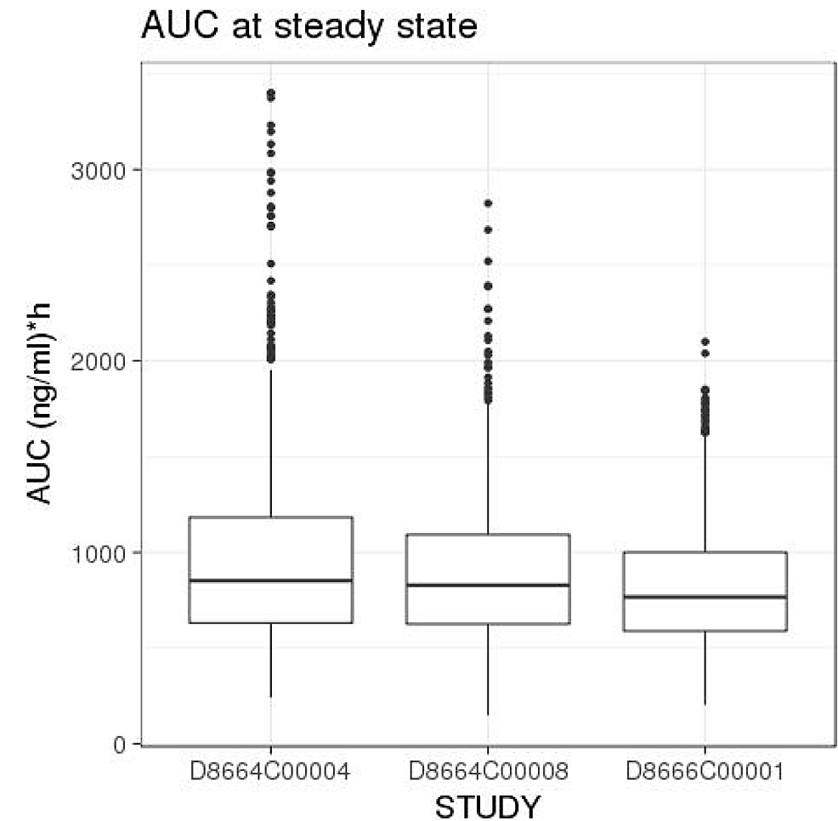

Pharmacodynamics
All three supporting clinical studies collected serum E2 measurements. The Sponsor has defined postmenopausal E2 levels as <30 pg/mL (≈110 pmol/L), referencing a study by Lee, Ettinger, Stanczyk, et al. (2006). The Royal College of Pathologists of Australasia (RCPA) defines the upper limit of the reference interval for postmenopausal E2 concentrations as 200 pmol/L (≈54 pg/mL) . Therefore, the Sponsor’s definition of postmenopausal E2 levels is more conservative than that off the RCPA. This is acceptable.

Study D8666C00001
In this study the lower limits of quantification (LLOQs) for serum E2 and FSH concentration were 18.07 pg/mL (≈66 pmol/L) and 0.6 IU/L, respectively. For values lower than the LLOQ, one-half of LLOQ (i.e., 9.035 pg/mL) was used for statistical analysis of E2 data, and the LLOQ (i.e., 0.6 IU/L) was used for statistical analysis of FSH data.
On Day 1 and from Week 12 onwards, blood samples were drawn prior to goserelin depot administration.
Comparisons of the unadjusted serum E2 concentrations between treatment groups in the full analysis set (FAS) are provided in Table 7 and Figure 2.
Table 7. Summary of untransformed E2 concentrations (pg/mL) (FAS)
 | Baseline |  | Week 12 |  | Week 24
 | 3.6 mg | 10.8 mg | 3.6 mg | 10.8 mg | 3.6 mg | 10.8 mg
Number of patients | 110 | 107 | 77 | 81 | 70 | 74
Number >LLOQ | 101 | 101 | 52 | 49 | 42 | 41
Mean | 116.285 | 132.566 | 25.444 | 26.332 | 24.798 | 20.302
Standard deviation | 122.068 | 123.228 | 41.299 | 62.134 | 28.149 | 12.251
Median | 76.940 | 93.640 | 22.090 | 19.690 | 23.270 | 20.135
Minimum | NQ | NQ | NQ | NQ | NQ | NQ
Maximum | 690.09 | 657.58 | 372.92 | 570.35 | 231.89 | 53.90
LLOQ: Lower limit of quantification (18.07 pg/mL); NQ: Not quantifiable
Data from the samples collected within the acceptable time window specified in CSP were used for analysis.
Values below the LLOQ were handled as 9.035 pg/mL (=one-half of LLOQ) for calculation.
Figure 2. Mean serum E2 concentration (pg/mL) versus time (FAS)
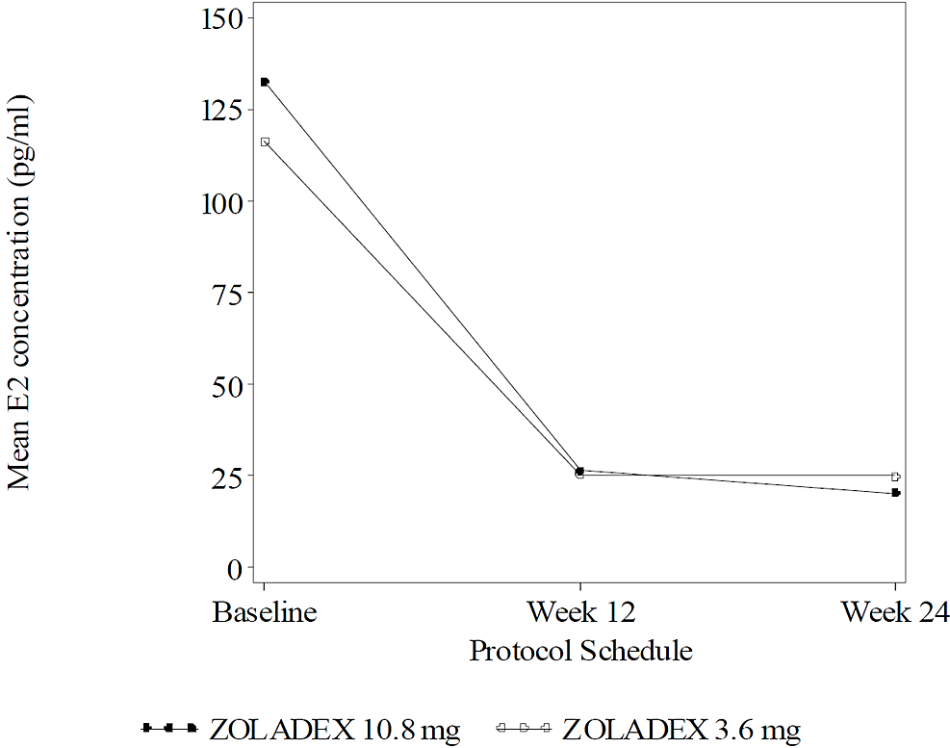
The proportions of patients with E2 serum concentrations ≤ 30 pg/mL (study-defined postmenopausal level) were similar in the 2 treatment groups at Weeks 12 and 24 (Table 8).
Table 8. Mean E2 serum concentrations and proportion of patients with E2 serum concentrations ≤ 30 pg/mL in Study D8666C00001 (FAS)
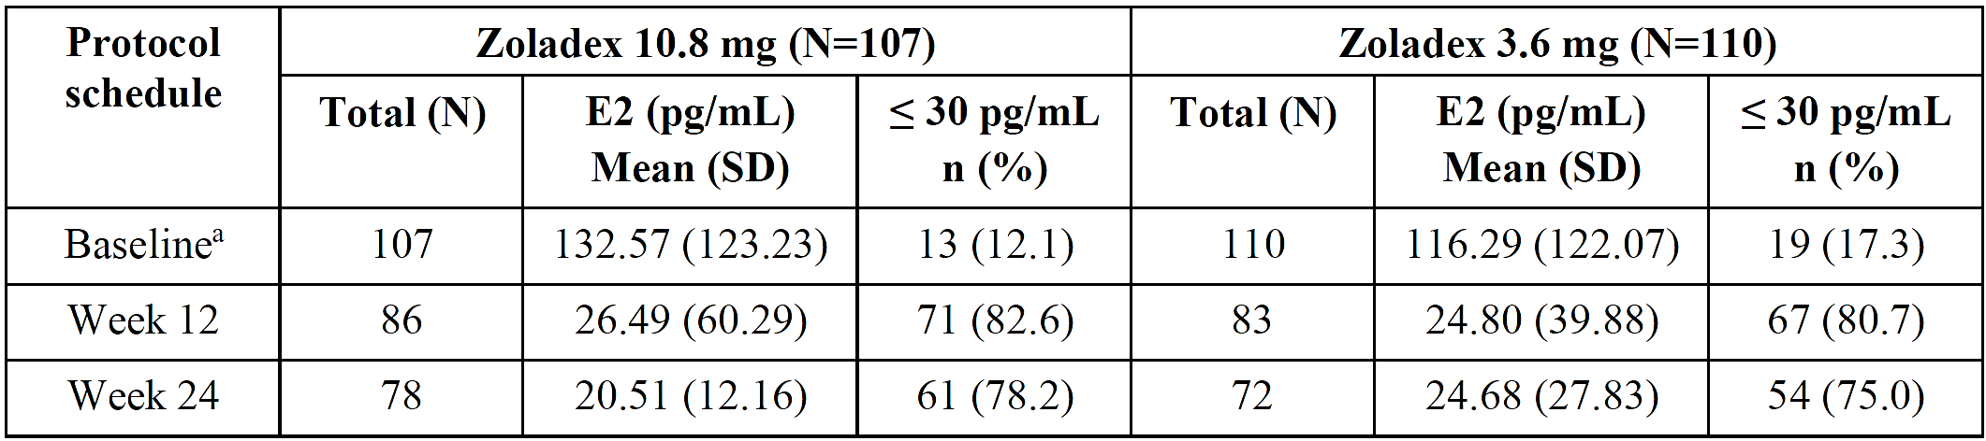
a Study inclusion criterion: Premenopausal defined as (1) last menses within 1 year of administration of study drug, and (2) E2 ≥ 10 pmol/L and FSH ≤ 30 IU/L within 4 weeks of administration of study drug. For patients who had a hysterectomy, it was acceptable to meet only criterion 2.
LLOQ of E2: 18.07 pg/mL. Values below the LLOQ were handled as 9.035 pg/mL.
E2, oestradiol; FAS, full analysis set; FSH, follicle stimulating hormone; LLOQ, lower limit of quantification; SD, standard deviation.
After adjusting for treatment group, baseline E2 serum concentrations and ethnicity (Japanese vs non-Japanese) as covariates, the ratio of the least square means of E2 concentrations for the 10.8 mg group compared to the 3.6 mg group was 0.92 (95% CI 0.75, 1.13) at Week 12, and 0.92 (95% CI 0.74, 1.14) at Week 24. That is, suppression of E2 serum concentrations was similar between goserelin 3.6 mg and 10.8 mg among the premenopausal women with advanced breast cancer enrolled in this trial (Table 9).
Table 9. Least square means and the 95% CI for difference of mean E2 serum concentrations (pg/mL) at week 12 and 24 using analysis of covariance (FAS)
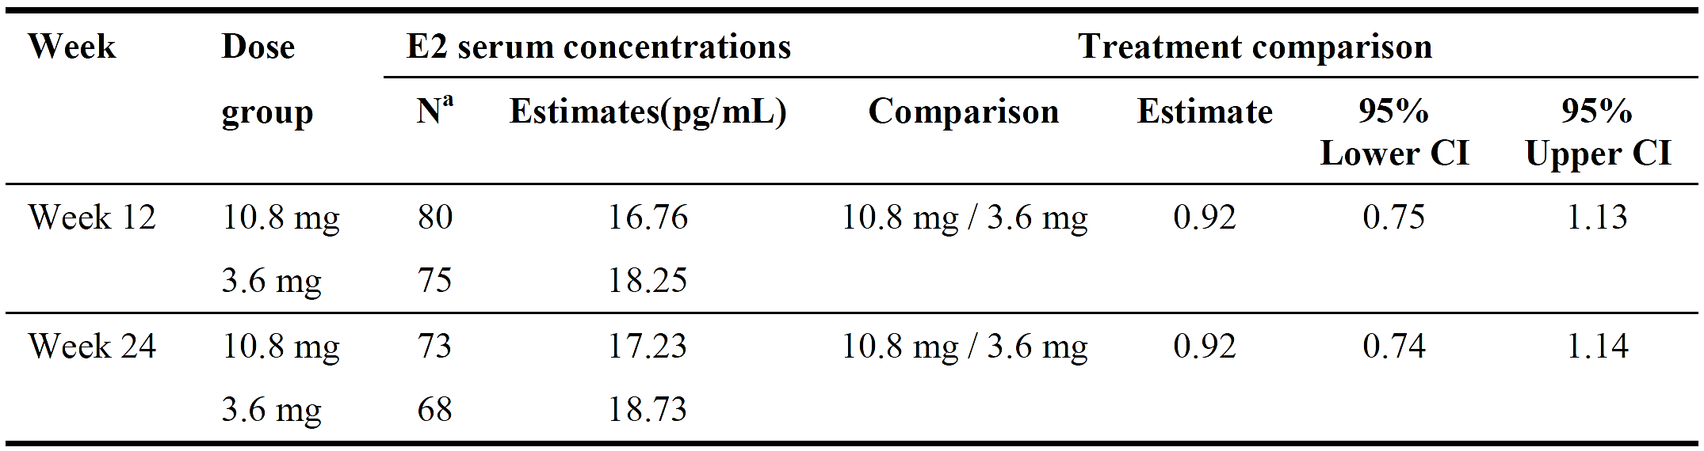
a Patients with a measurement both at baseline and post-treatment.
CI: Confidence interval
Data from the samples collected within the acceptable time window specified in CSP were used for analysis.
Results based on analysis of covariance (ANCOVA) with treatment group, baseline E2 serum concentrations and ethnicity (Japanese vs non-Japanese) as covariates. E2 data were log-transformed prior to analysis. Least square means and 95% CI calculated based on the model were exponentiated.
FSH suppression was numerically similar between treatment groups. Median serum FSH concentration decreased from baseline to Week 12 and Week 24 in the 10.8 mg group (7.79 IU/L, 2.42 IU/L, and 2.05 IU/L, respectively) and the 3.6 mg group (7.43 IU/L, 2.53 IU/L, 2.37 IU/L).

Study D8664C00004
The LLOQ of E2 in this trial was 1.4 pg/mL (≈5 pmol/L), and values below the LLOQ were handled as 0.7 pg/mL.
At baseline, median (range) serum E2 concentrations were 53.50 pg/mL (0.7, 327.0) in the 3.6 mg group and 49.70 (0.7, 275.4) in the 10.8 mg group.
Blood samples were collected before injection of goserelin depot.
The geometric mean of the AUC of E2 serum concentration from Week 4 to Week 24 of treatment was 18.95 pg/mL⋅week in the 3.6 mg group and 18.32 pg/mL⋅week in the 10.8 mg group. The AUC ratio of 10.8 mg group/3.6 mg group, adjusted by baseline E2 value, was 0.974 (95% CI: 0.799 to 1.188) (Table 10). As the 95% CI upper limit was below the non-inferiority margin of 1.25, the study met its primary endpoint; i.e. the Zoladex (goserelin) 10.8 mg implant every 12 weeks was non-inferior to Zoladex (goserelin) 3.6 mg implant every 4 weeks in terms of E2 suppression in premenopausal patients with ER-positive early breast cancer receiving concomitant daily tamoxifen 20 mg.
Table 10. Analysis of AUC of E2 serum concentration from Week 4 to Week 24 (FAS)
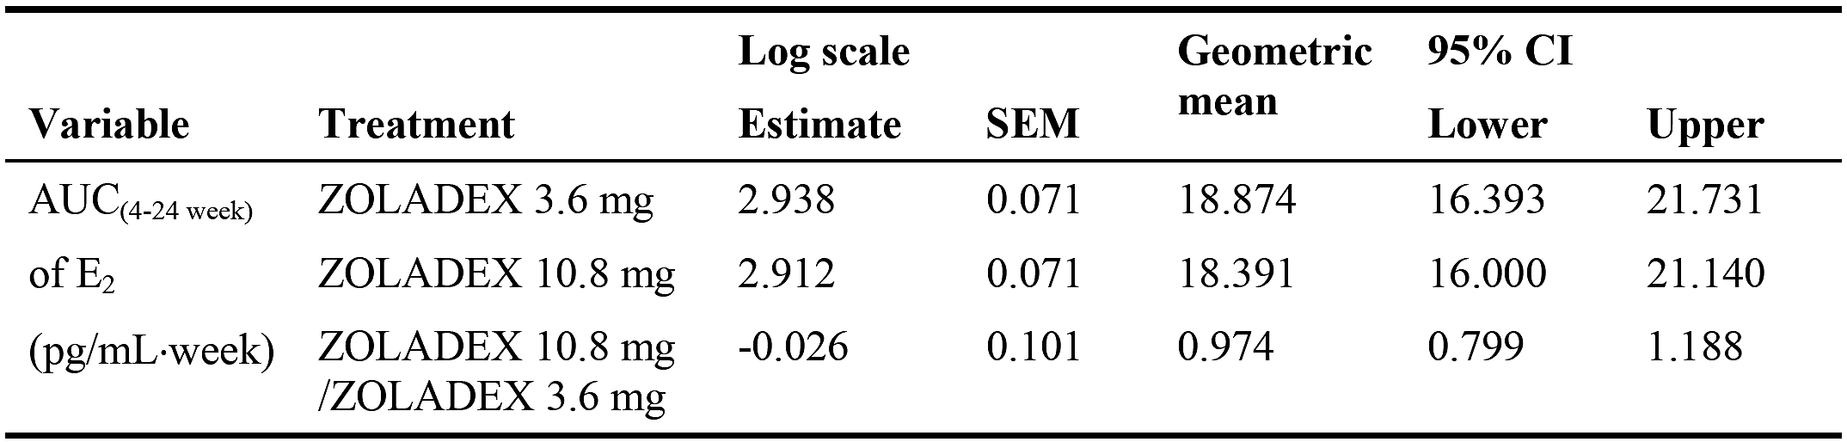
Analysis of Covariance model including treatment as fixed factor, and log(baseline) as a covariate.
LOQ of E2: 1.4 pg/mL
Values below the LOQ were handled as 0.7 pg/mL.
Mean plot of E2 serum concentration versus time to Week 24 is shown in Figure 3. The median serum E2 concentration was 0.70 pg/mL in both treatment groups for all measured time points from Week 4 (4W, 8W, 10W, 12W, 16W, 20W, 22W, 24W, 48W, 72W).
Figure 3. Mean plot of E2 serum concentration versus time (24 weeks) (FAS)
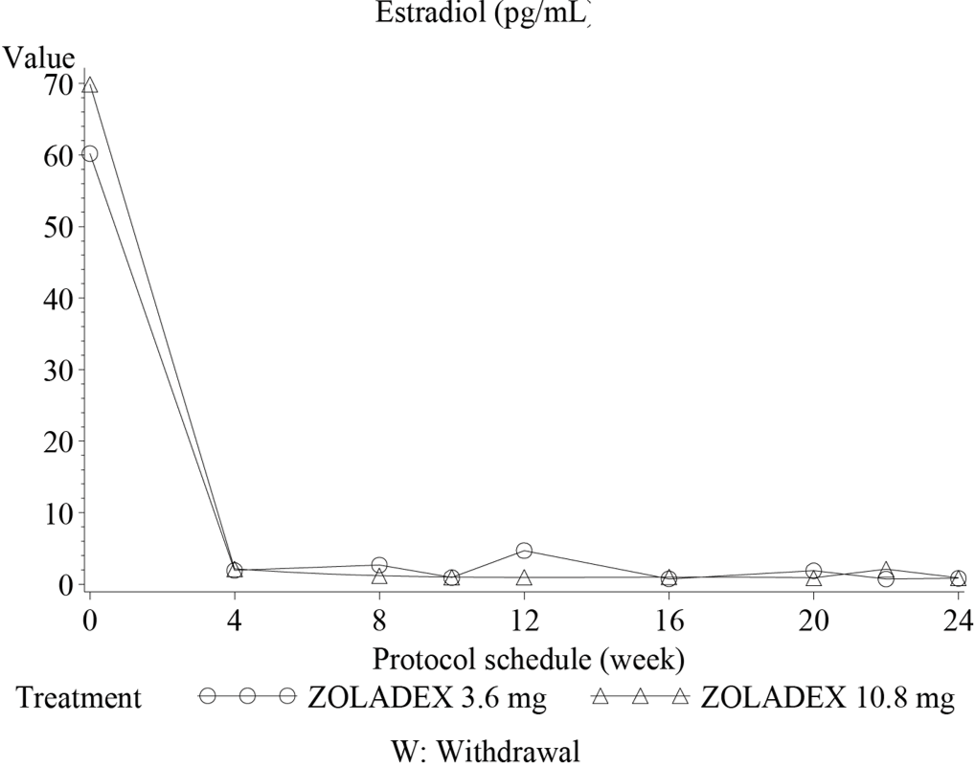
LOQ of E2: 1.4 pg/mL
Values below the LOQ were handled as 0.7 pg/mL
Most patients (≥98.8%) had E2 serum concentrations below 30 pg/mL from Week 4 onwards (Table 11).
Table 11. Summary of percentage of patients with E2 serum concentrations less than 30 pg/mL (FAS)
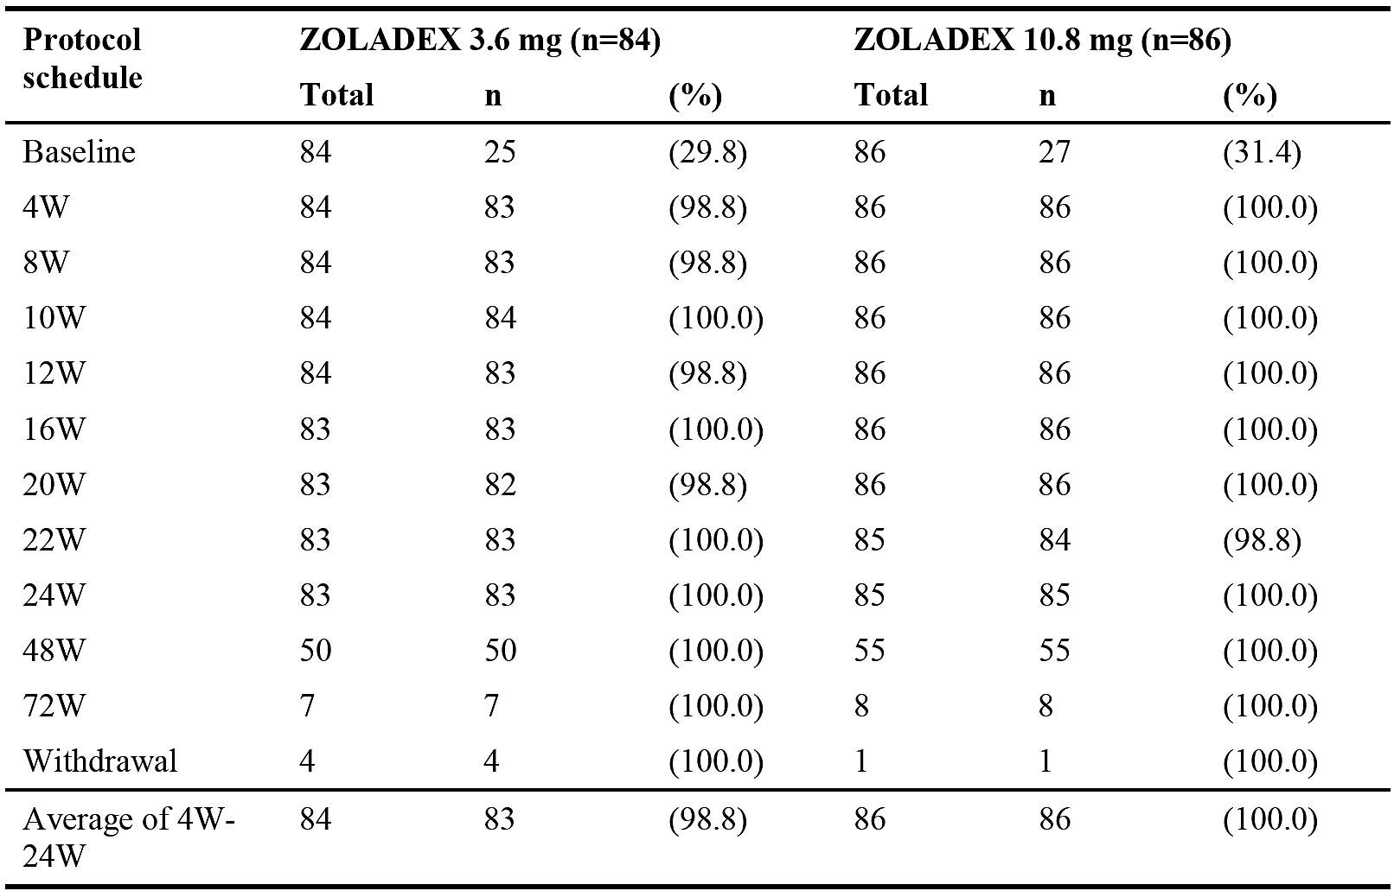
The proportion of patients who had menses from Week 0 to Week 4 of treatment was 72.6% for the 3.6 mg group and 67.4% for the 10.8 mg group. This decreased to 1.2% and 2.3%, respectively, from Week 4 to Week 8, indicating that almost all the patients became amenorrheic. In the 10.8 mg group, no patients were confirmed to have menses after Week 12.
Baseline mean FSH serum concentrations were 7.716 IU/L and 8.178 IU/L in the 3.6 mg and 10.8 mg groups, respectively. Mean FSH measurements after Week 4 were suppressed in both treatment groups and the mean values were in a range of 1.283 IU/L to 2.061 IU/L.

Study D8664C00008
The LLOQ for the E2 serum assay used in this study was 5 pmol/L. Any values <5 pmol/L were summarised and analysed as 2.50 pmol/L.
On Day 1 and from Week 12 onwards, blood samples were drawn prior to goserelin administration.
Parametric statistical analyses (ANCOVA of log E2, with treatment group and log baseline E2 serum concentrations as covariates) indicated comparable E2 serum concentrations between the 2 treatment groups at Week 12 and Week 24 in the full analysis population (Table 12). The same calculations in the subgroup of Caucasian patients (n=59) also showed little difference between the two treatment groups at Week 12 (treatment ratio [10.8 mg / 3.6 mg] = 1.10; 95% CI: 0.48, 2.53) or Week 24 (treatment ratio = 1.16; 95% CI: 0.56, 2.37).
The median E2 serum concentration was 2.50 pmol/L for both treatment groups in the FAS at Week 12 and Week 24.
Table 12. E2 serum concentrations (pmol/L) at weeks 12 and 24 (LOCF) (FAS)
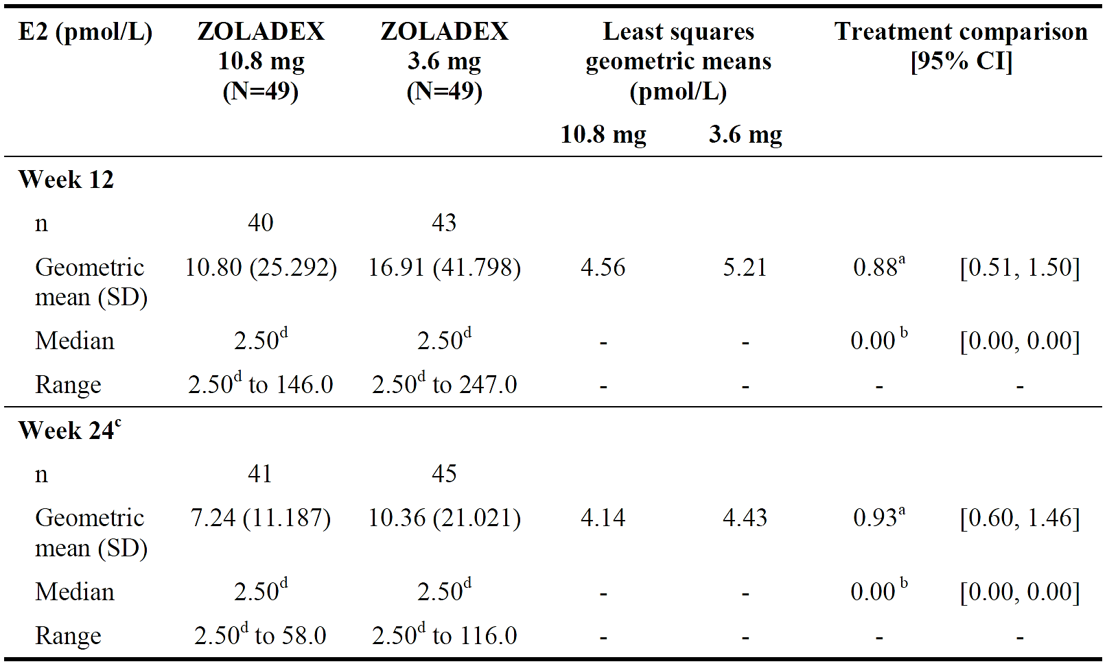
CI: confidence interval; E2: oestradiol; FAS: full analysis set; LOCF: last observation carried forward; N: number of patients in analysis set; n: number of patients in category; SD: standard deviation
a Treatment ratio (10.8 mg / 3.6 mg)
b Hodges Lehmann estimate of the difference in medians
c Secondary efficacy analysis
d The lower limit of quantification for the E2 serum assay used in this study was 5 pmol/L. Any values <5 pmol/L were summarised and analysed as 2.50 pmol/L (the midpoint between 0 and the lower limit of quantification)
LOCF was applied to E2 serum concentrations and results were log transformed for the analysis. The least squares means, difference in least squares means and confidence interval have been back transformed.

Effect of race on pharmacodynamics
Assessment of serum E2 endpoints by race is possible for Study D8664C00008 (Japanese vs Caucasian) and Study D8666C00001 (Japanese vs non-Japanese Asian [Indian and Filipino most common]). Study D8664C00004 enrolled Japanese patients only.
Goserelin 10.8 mg resulted in suppression of mean E2 serum concentrations in premenopausal breast cancer patients without notable differences by race in studies D8666C00001 (Figure 4) and D8664C00008 (Figure 5).
Figure 4. Time course of mean E2 serum concentration with Zoladex 10.8 mg in Study D8666C00001 (E2 Subgroup)
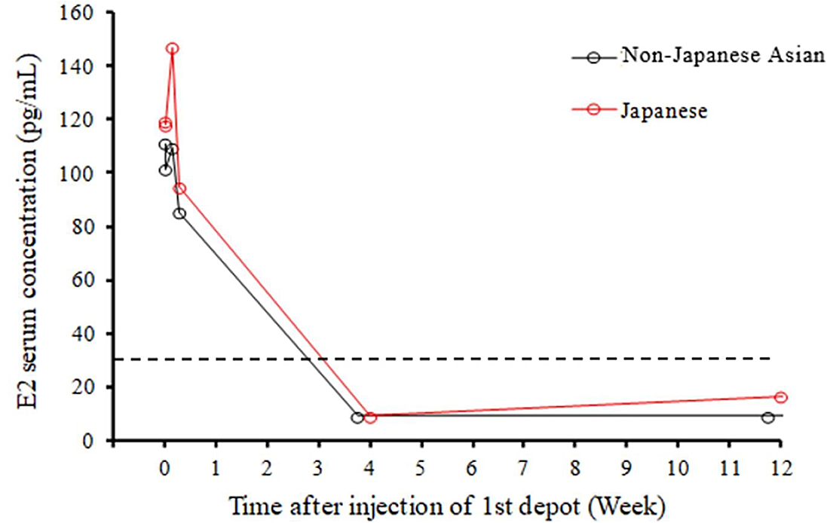
E2 = oestradiol
Dashed line indicates threshold for postmenopausal E2 levels (30 pg/mL)
Measurements were available for 20 patients in the first 24 hours, 18 patients at Week 4, and 17 patients at Week 12
Figure 5. Time course of mean E2 serum concentration with Zoladex 10.8 mg in Study D8664C00008 (E2 Subgroup)
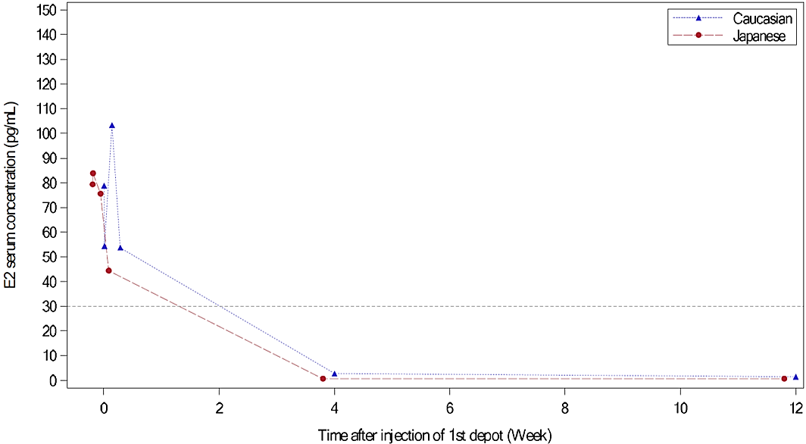
E2 = oestradiol
Dashed line indicates threshold for postmenopausal E2 levels (30 pg/mL)
Measurements were available for 18 patients at baseline, 17 patients at Week 4, and 16 patients at Week 12

Efficacy

Progression-free survival at week 24
Non-inferiority per PFS at Week 24 was the primary endpoint for studies D8666C00001 and D8664C00008. However, early termination of recruitment for Study D8664C00008 means that it was no longer adequately powered to detect statistical non-inferiority.
In Study D8666C00001, 61.47% of patients in the 10.8 mg group and 60.18% of the 3.6 mg group were progression free at Week 24. The difference between groups was 1.29 percentage points with a 95% CI from -11.40 to 13.90 (Table 13). Therefore, this result meets the prespecified margin (lower limit of the 95% CI for the difference in PFS between treatment groups above -17.5%), and non-inferiority of goserelin 10.8 mg 12-weekly to goserelin 3.6 mg 4-weekly was shown in premenopausal women with advanced breast cancer. Consistent results were seen in analysis of the per-protocol set (PPS), and a sensitivity analysis of the FAS using the life table method.
In Study D8664C00008, non-inferiority of Zoladex 10.8 mg to Zoladex 3.6 mg could not be concluded from the 95% CI for the difference (-21.4 to 13.6) (Table 13). The Sponsor considered that this may be partly due to the fewer than planned number of patients randomised.
Table 13. Progression-free survival at week 24 in studies D8666C00001 and D8664C00008 (FAS)
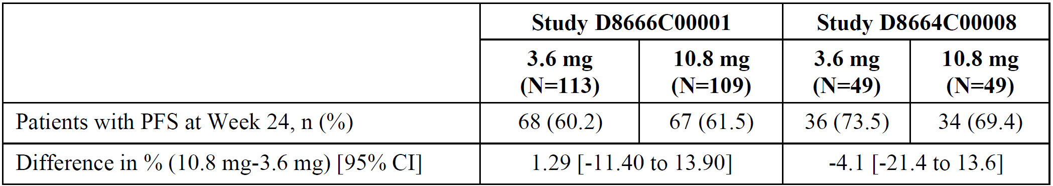
CI, confidence interval; CSR, clinical study report; FAS, full analysis set; PFS, progression-free survival.

Objective response rate at week 24
Objective response rate (ORR) was a secondary endpoint in studies D8666C00001 and D8664C00008. ORR was not statistically powered in either study. Unconfirmed best ORRs were similar between 3.6 mg and 10.8 mg treatment groups in both studies (Table 14). In study D8664C00008, confirmed best ORR was 25.6% in the 3.6 mg group and 26.7% in the 10.8 mg group. Confirmed ORR is not available for study D8666C00001.
Table 14. Unconfirmed objective response rate at week 24 in Studies D8666C00001 and D8664C00008 (FAS)
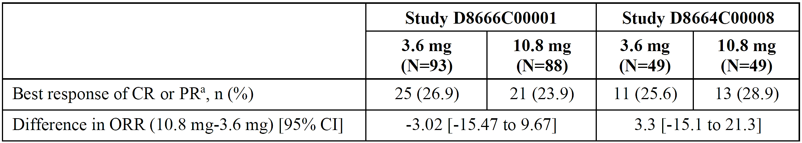
ª Unconfirmed best ORR
CI, confidence interval; CR, complete response; FAS, full analysis set; ORR, objective response rate; PR, partial response

Effect of race on progression-free survival and objective response rate
Racial information for patients is summarised for each of the 3 clinical studies in the section entitled ‘Summary of clinical studies’ (p.10). Assessment of efficacy endpoints by race is possible for Study D8664C00008 and Study D8666C00001.

Progression-free survival at week 24
Progression-free survival at Week 24 between treatment groups and by race is presented in Table 15 and Table 16 for studies D8666C00001 and D8664C00008, respectively. These results should be interpreted with caution due to smaller sample sizes and the exploratory nature of the analyses.
Table 15. Summary of PFS at Week 24 in Japanese and non-Japanese subgroups in Study D8666C00001 (FAS)
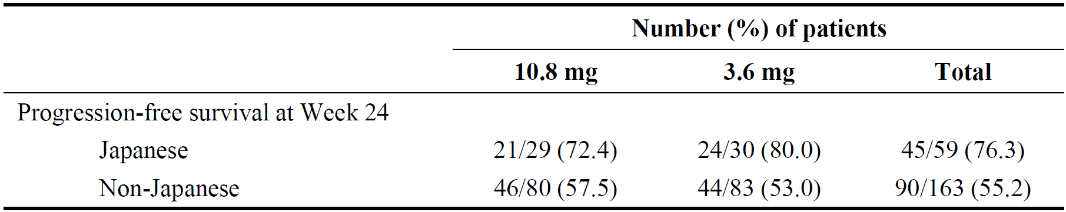
Table 16. PFS at Week 24 in Caucasian and Japanese subgroups in Study D8664C00008 (FAS)
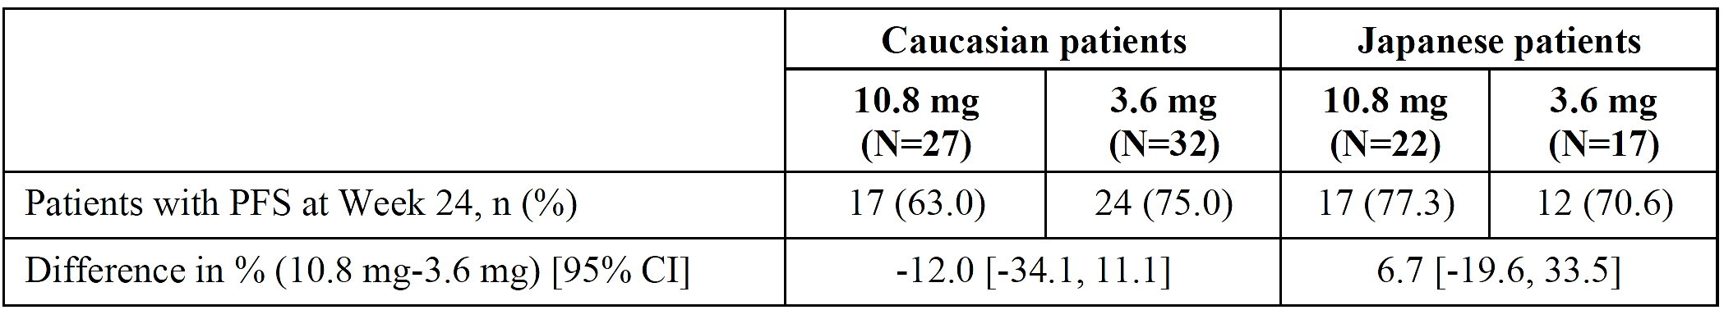
CI, confidence interval; FAS, full analysis set; PFS, progression-free survival.

Objective response rate at week 24
Objective response rate at Week 24 between treatment groups and by race is presented in Table 17 and Table 18 for studies D8666C00001 and D8664C00008, respectively. These results should be interpreted with caution due to smaller sample sizes and the exploratory nature of the analyses.
Table 17. Summary of unconfirmed ORR at Week 24 in Japanese and non-Japanese subgroup in Study D8666C00001 (FAS)
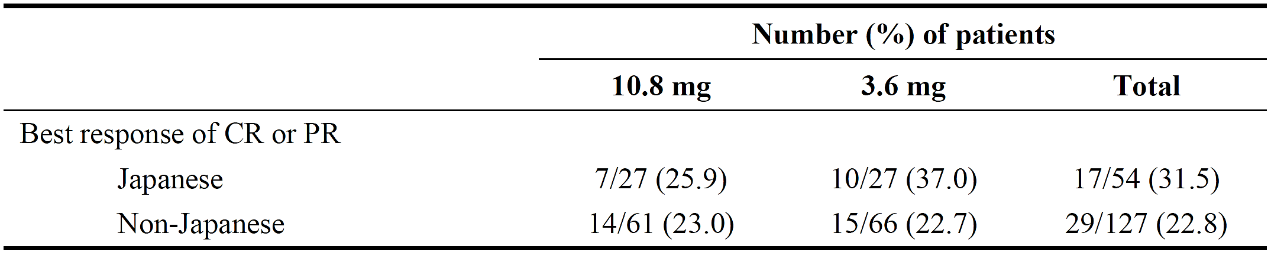
Table 18. Objective response rate at week 24 in Study D8664C00008 (FAS)
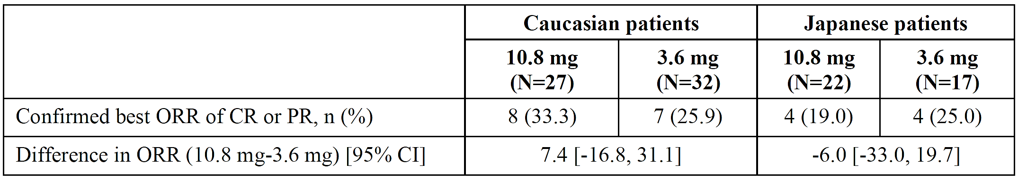
CI, confidence interval; CR, complete response; FAS, full analysis set; ORR, objective response rate; PR, partial response.

Safety
The durations of exposure to goserelin in the 3 submitted clinical studies are summarised in Table 19.
Table 19. Duration of exposure to Zoladex in the breast cancer studies (Safety Analysis Set)
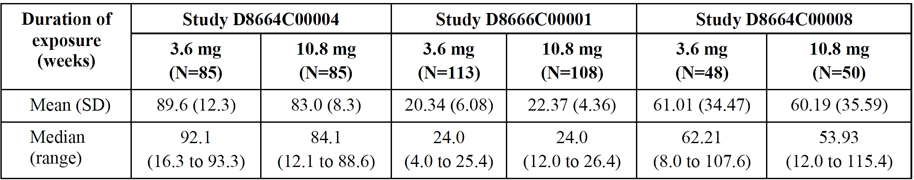
A summary of adverse events (AEs) in the 3.6 mg and 10.8 mg dose groups in each of the 3 clinical studies is provided in Table 20. No concerning signals are seen.
Table 20. Summary of adverse events (Safety Analysis Set)
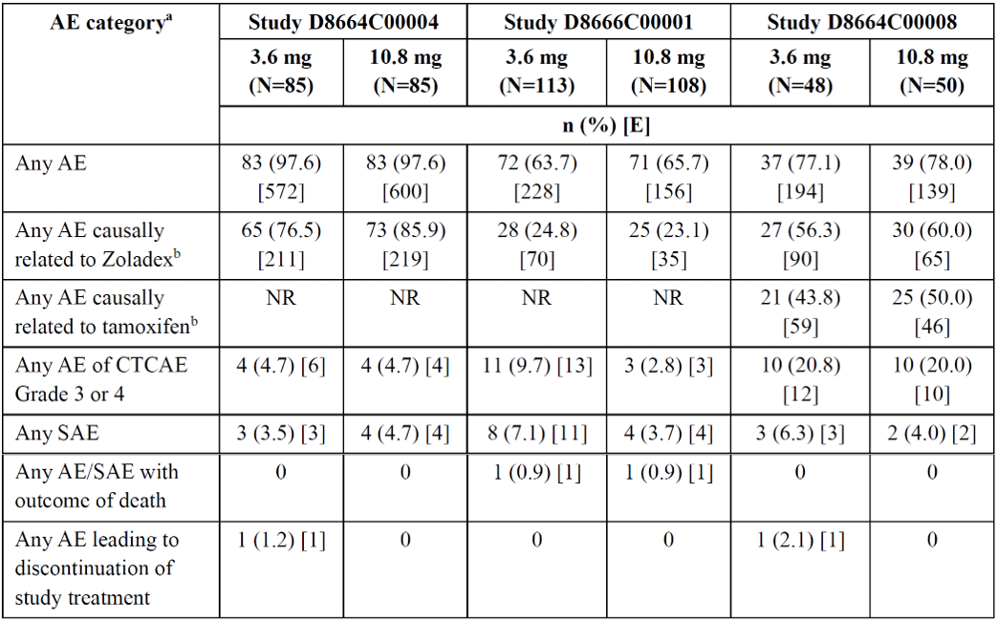
ª Patients with multiple events in the same category are counted only once in that category. Patients with events in more than 1 category are counted once in each of those categories.
^{b} Causality was judged by the investigator.
AE, adverse event; CTCAE, Common Terminology Criteria for Adverse Events; E, event; n, number of patients in category; N, number of patients in analysis set; NR, not reported; SAE, serious adverse event.
Across the 3 studies, hot flush was the most frequently reported AE in both treatment groups, experienced by 65.9% of patients in the 3.6 mg group and 70.6% of patients in the 10.8 mg group in Study D8664C00004; 19.5% and 13.9% of patients in the 3.6 mg and 10.8 mg groups, respectively, in Study D8666C00001, and 37.5% and 38.0% of patients in the 3.6 mg and 10.8 mg groups, respectively, in Study D8664C00008.
In Study D8664C00004, other AEs reported at a frequency of ≥10% included nasopharyngitis, headache, arthralgia, musculoskeletal stiffness, hyperhidrosis, back pain, and dizziness (all reported in both treatment groups), eczema and insomnia (Zoladex 10.8 mg group), and hypoaesthesia (Zoladex 3.6 mg group). In Study D8664C00008, AEs of amenorrhoea, weight increased, and nasopharyngitis were reported in ≥10% of patients in both groups. In Study D8666C00001, nasopharyngitis was reported in 12.0% of patients in the Zoladex 10.8 mg group.
There were no AEs leading to death reported in Studies D8664C00004 and D8664C00008.
Two patients in Study D8666C00001 experienced AEs with an outcome of death – one due to chest pain, vomiting and diarrhoea (assigned to the 10.8 mg group); and the other due to dyspnoea (assigned to the 3.6 mg group). Neither of the deaths was considered related to study treatment (Zoladex or tamoxifen) by the investigator.
In Study D8666C00001, 3 patients in the 3.6 mg group experienced serious AEs (SAEs) of dyspnoea, and 2 SAEs of anaemia (1 each in the 3.6 mg and 10.8 mg groups) were reported. In Study D8664C00008, SAEs of endometrial hyperplasia were reported in 2 patients (1 each in the 3.6 mg and 10.8 mg groups). The remaining SAEs in the studies were all single reports. None of the SAEs was considered causally related to the study treatment.
In Study D8666C00001, a numerically higher rate of Grade 3 or 4 AEs and SAEs were noted in the 3.6 mg treatment group compared to the 10.8 mg arm (Table 20). The Sponsor undertook a review of baseline characteristics and the narratives of the reported AEs. Baseline demographic and disease characteristics were considered broadly comparable between the treatment arms.
The SAEs and Grade ≥3 AEs were heterogeneous and distributed across unrelated preferred terms (PTs), with most events supported by clinically plausible alternative aetiologies. Among the reported SAEs and Grade ≥3 AEs, dyspnoea was the only PT observed in more than one patient, with three serious cases occurring in the 3.6 mg group and one Grade 3, non-serious case in the 10.8 mg group. The observed dyspnoea events were clinically heterogeneous and more plausibly explained by disease-related pulmonary involvement, infective or embolic complications, respiratory comorbidity, metabolic disturbance, or opioid-related respiratory depression rather than a treatment-related pulmonary toxicity. LHRH agonists have no established direct pulmonary toxicity, and no consistent clinical pattern or safety concern suggestive of a study drug effect was identified.
The Sponsor considered that observed numerical imbalance in SAE and Grade ≥3 event rates were most consistent with random variation in a limited dataset, given the heterogeneous distribution of events across unrelated PTs and absence of a treatment-related pattern. All events were assessed as not related to study drug by the investigator.
The Sponsor’s assessment that the imbalance is most likely due to chance is acceptable. There is no imbalance seen in SAE or Grade ≥3 AE rates between treatment arms in the other 2 clinical studies.

Effect of race on safety
Racial information for patients is summarised for each of the 3 clinical studies in the section entitled ‘Summary of clinical studies’ (p.10). Assessment of safety endpoints by race is possible for Study D8664C00008 and Study D8666C00001.
The overall incidences of AEs tended to be higher in Japanese patients in studies D8664C00008 and D8666C00001 (Table 21); the reason for this is unclear. It is acknowledged that AE reporting patterns vary between countries, reflecting differences in the reporting culture, clinical practice and underlying patient populations. It is not possible to fully comment on these differences in the clinical studies as, particularly in Study D8664C00008, the denominators were small for exploring differences in the event frequencies.
There were no clear differences in the most common AEs between racial groups.
Table 21. Summary of adverse events in Studies D8664C00008 and D8666C00001 by race (Safety Analysis Set)
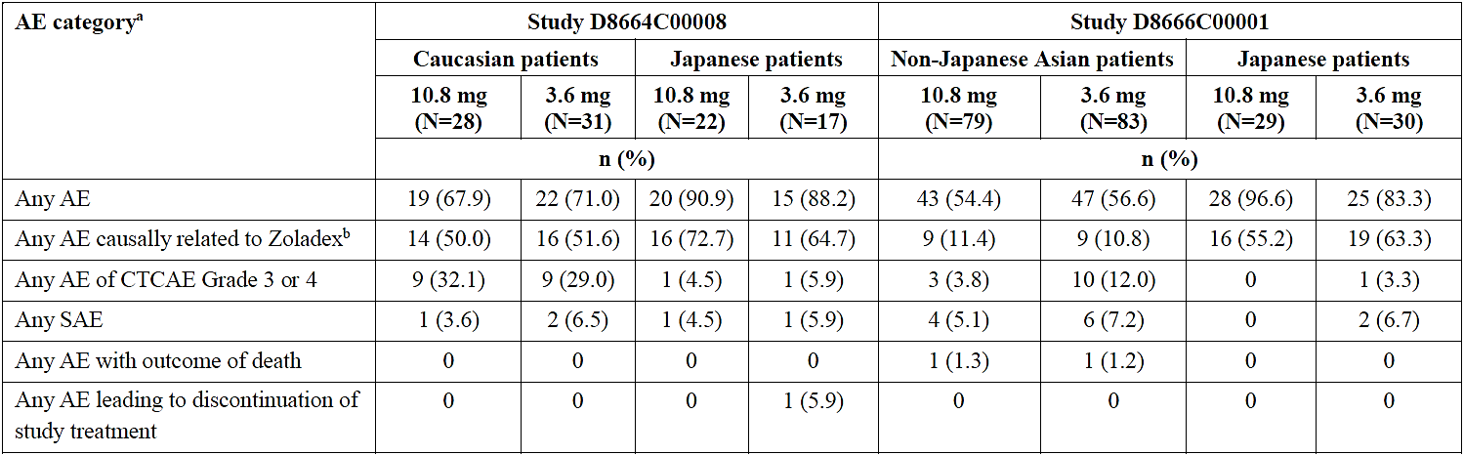
ª Patients with multiple events in the same category are counted only once in that category. Patients with events in more than 1 category are counted once in each of those categories.
^{b} Causality was judged by the investigator.
AE, adverse event; CTCAE, Common Terminology Criteria for Adverse Events; n, number of patients in category; N, number of patients in analysis set; SAE, serious adverse event.

Postmarketing data
The cumulative global postmarketing exposure to Zoladex from 2001 to 30 April 2020 is approximately 9,891,305 patient-years, including 6,834,111 patient-years globally for the 10.8 mg strength (Europe: 3,053,092; North America: 952,817).
From launch to 31 August 2020, the Sponsor has received a total of 2,122 AEs (356 serious) from 657 case reports with the use of Zoladex 10.8 mg in female patients. For Zoladex 3.6 mg, a total of 8,612 AEs (1,766 serious) from 4,244 case reports were reported in female patients.
There were no observed trends between Zoladex 10.8 mg and 3.6 mg in the type and severity of AEs reported in female patients. In patients treated with Zoladex 10.8 mg, the AEs reported at the highest numbers were hot flush, headache, amenorrhoea, and vaginal haemorrhage, which are expected pharmacological effects of sex hormone suppression. Similarly, with Zoladex 3.6 mg, the AEs reported at the highest numbers were hot flush, headache, arthralgia, nausea, and vaginal haemorrhage.

Risk management plan
A Risk Management Plan was not required for this submission.

Risk-benefit analysis

Comparability of the 10.8 mg and 3.6 mg goserelin implant strengths

Ovarian function suppression
In Study D8664C00004, conducted in premenopausal patients with early breast cancer (age range 26 to 53 years), the primary endpoint was met: the adjusted E2 AUC ratio for patients treated with 10.8 mg compared to 3.6 mg was 0.974, with a 95% CI of 0.799 to 1.188, remaining below the prespecified non-inferiority margin of 1.25. Additionally, almost all patients (≥98.8%) had E2 serum concentrations below 30 pg/mL from week 4 onwards, supporting sustained ovarian suppression across the dosing interval. The proportion of patients with E2 serum concentrations below 30 pg/mL was comparable between the 10.8 mg and 3.6 mg treatment groups (Table 11).
The evidence in advanced breast cancer is also supportive. In Study D8666C00001 (age range 23 to 54 years), E2 suppression was similar between the two treatment groups at weeks 12 and 24. The adjusted ratio of least square mean E2 concentrations for 10.8 mg compared with 3.6 mg was 0.92 at both Week 12 and Week 24 (Table 9). The proportions of patients with E2 concentrations ≤30 pg/mL were also similar between treatment groups (Table 8). Study D8664C00008 (age range 26 to 59 years) provided consistent supportive data: ANCOVA analyses indicated comparable E2 concentrations between treatment groups (ratio 0.93 at week 24; Table 12).

Other efficacy measures
Study D8666C00001 met its primary endpoint for PFS at Week 24, with 61.47% of patients remaining progression-free in the 10.8 mg group compared with 60.18% in the 3.6 mg group, and the confidence interval for the between-group difference remained within the prespecified non-inferiority margin (Table 13).
Study D8664C00008 was broadly consistent with Study D8666C00001, demonstrating numerically similar PFS at Week 24 in the 10.8 mg and 3.6 mg groups (n=34/49 and 36/49, respectively). However, Study D8664C00008 was underpowered due to early termination of recruitment and, therefore, non-inferiority cannot be determined, and the results should be interpreted with a degree of caution due to the smaller sample size reducing the certainty of the result.
Objective response rates were similar between 10.8 mg and 3.6 mg treatment groups in both Study D8666C00001 and Study D8664C00008 (Table 14).
Overall, the submitted clinical data package provides adequate evidence of non-inferior efficacy of the 12-weekly goserelin 10.8 mg implant compared to the 4-weekly goserelin 3.6 mg implant for the proposed indication in premenopausal patients with early and advanced ER-positive breast cancer.

Use with aromatase inhibitors
A limitation of the submitted clinical studies is that the comparative data for goserelin 10.8 mg and 3.6 mg were generated with concomitant tamoxifen 20 mg daily. The studies did not directly evaluate either dose strength in combination with exemestane or another aromatase inhibitor (AI).
It is important to note that the clinical evidence supporting the combination of AI and OFS in premenopausal patients with breast cancer was not dependent on the specific use of goserelin 3.6 mg. As described earlier in this report (see ‘Condition and current treatment options’, p.6) the SOFT and TEXT studies provide the pivotal evidence for use of adjuvant OFS in combination with endocrine therapy (including exemestane). In these trials, OFS was achieved by triptorelin, oophorectomy or ovarian irradiation, not goserelin. The current Australian use of exemestane with 4-weekly goserelin 3.6 mg therefore already involves extrapolation from evidence generated with other accepted methods of OFS.
Therefore, the key consideration is whether 12-weekly goserelin 10.8 mg provides comparable OFS to the currently approved 4-weekly goserelin 3.6 mg. The evidence submitted with this application establishes non-inferiority of OFS with 12-weekly goserelin 10.8 mg compared to 4-weekly goserelin 3.6 mg in premenopausal patients with early or advanced breast cancer. E2 measurements collected immediately before the next goserelin dose confirm that OFS is in effect for the duration of the treatment interval (see ‘Pharmacodynamics', p. 14).
Overall, whilst direct comparative data including AI treatment would have provided more certainty, its absence should not preclude the proposed use of goserelin 10.8 mg and is, in fact, consistent with the current use of goserelin 3.6 mg.

Racial/Ethnic characteristics in the supporting evidence
The total of 490 study patients across the 3 supporting clinical trials included a substantial Japanese population (n=268; 54.7%), however, non-Japanese Asian (n=163; 33.2%) and Caucasian (n=59; 12.0%) subgroups were also represented.
Pharmacodynamic comparisons did not identify notable differences in E2 suppression by race among patients treated with goserelin 10.8 mg (see ‘Effect of race on pharmacodynamics’, p.21).
Subgroup analyses of PFS and ORR by race were exploratory and limited by small sample sizes, but there was no clear signal suggesting a clinically important difference between racial subgroups (see ‘Effect of race on progression-free survival and objective response rate’ p.21) which is consistent with the pharmacodynamic results.
Safety analyses demonstrated no clear differences in the most commonly reported AEs. There was a tendency towards higher overall AE reporting in Japanese patients in some studies, however with the caveat that reporting patterns may vary by country and clinical practice (see ‘Effect of race on safety’, p.24). The postmarketing data are also supportive, with extensive global exposure to Zoladex at both 3.6 mg and 10.8 mg, and no observed trends between the 10.8 mg and 3.6 mg strengths in the type or severity of AEs reported in female patients worldwide (see ‘Postmarketing data’, p.25).
Furthermore, the Sponsor has provided the following additional justifications that goserelin 10.8 mg fulfils the criteria for low likelihood for ethnic sensitivity as described in Appendix D of the ICH E5 (R1) Guideline (ICH E5(R1) 1998), a guidance which has been adopted by the TGA. These factors include:
- A linear PK profile;
- A flat PD (effect-concentration) curve across the dose range attributed to the mode of action of Zoladex (downregulation of LH-RH receptors);
- Metabolism through multiple pathways (hepatic and renal), reducing the risk of interactions arising due to extrinsic or intrinsic variations across populations;
- Low protein binding (20% to 28%);
- No known drug-drug or drug-diet interactions;
- Little potential for inappropriate use due to administration of the depot by a healthcare professional.
Overall, the submitted evidence is sufficient to justify that differences in the efficacy or safety of goserelin 10.8 mg for the treatment of premenopausal breast cancer between races or ethnicities are unlikely. Thus, the data are acceptable to support an application for registration to treat Australian patients.

Conclusions
The decision to register a prescription medicine requires that the quality, efficacy and safety for the proposed use be satisfactorily established.
No changes have been proposed to the ingredients, manufacturing or other quality aspects of the Zoladex (goserelin) 10.8 mg implant. Therefore, quality remains established.
The key evidence demonstrates that 12‑weekly goserelin 10.8 mg provides non-inferior efficacy (E2 suppression and PFS) to 4‑weekly goserelin 3.6 mg in premenopausal patients with early and advanced breast cancer. Therefore, efficacy is established.
The submitted clinical trials did not demonstrate any meaningful or concerning differences in the safety of goserelin 10.8 mg compared to 3.6 mg in premenopausal patients with early and advanced breast cancer. Therefore, safety is established.

Assessment outcome
Based on a review of quality, safety, and efficacy, the TGA decided to register Zoladex 10.8 Implant (goserelin) for the following extension of indications:
Breast cancer
Management of oestrogen-receptor (ER) positive early and advanced breast cancer in pre and peri menopausal women.

Product Information and Consumer Medicine Information
For the most recent Product Information (PI) and Consumer Medicine Information (CMI), please refer to the TGA PI/CMI search facility.

Therapeutic Goods Administration
PO Box 100 Woden ACT 2606 Australia
Email: info@tga.gov.au Phone: 1800 020 653 Fax: 02 6203 1605
https://www.tga.gov.au

This is the original indication proposed by the Sponsor when the TGA commenced the evaluation of this submission. It may differ to the final indication approved by the TGA and registered in the Australian Register of Therapeutic Goods.
Australian Institute of Health and Welfare (AIHW). (14 Jul 2026). Cancer data in Australia: Cancer summary data visualisation. Last accessed 17 Jul 2026 from: https://www.aihw.gov.au/reports/cancer/cancer-data-in-australia/contents/summary-dashboard
Australian Institute of Health and Welfare. (14 Jul 2026). Cancer data in Australia: Cancer mortality by age visualisation. Last accessed 17 Jul 2026 from: https://www.aihw.gov.au/reports/cancer/cancer-data-in-australia/contents/cancer-mortality-by-age-visualisation
Australian Institute of Health and Welfare. (14 Jul 2026). Cancer data in Australia: Cancer survival data visualisation. Last accessed 17 Jul 2026 from: https://www.aihw.gov.au/reports/cancer/cancer-data-in-australia/contents/survival
Australian Institute of Health and Welfare. (14 Jul 2026). Cancer data in Australia: First Nations cancer incidence, mortality and survival. Last accessed 17 Jul 2026 from: https://www.aihw.gov.au/reports/cancer/cancer-data-in-australia/contents/first-nations-cancer-incidence-mortality-and-survi
Australian Institute of Health and Welfare. (14 Jul 2026). Cancer data in Australia: SEIFA - cancer incidence, mortality and survival. Last accessed 17 Jul 2026 from: https://www.aihw.gov.au/reports/cancer/cancer-data-in-australia/contents/socio-economic-disadvantage-cancer-incidence-morta
Francis PA, Pagani O, Fleming GF, et al. Tailoring Adjuvant Endocrine Therapy for Premenopausal Breast Cancer. N Engl J Med. 2018;379(2):122-137. doi:10.1056/NEJMoa1803164
Goldspiel BR, Kohler DR. Goserelin acetate implant: a depot luteinizing hormone-releasing hormone analog for advanced prostate cancer. DICP. Ann Pharmacother. 1991;25(7-8):796-804.
Furr BJA. Pharmacology of the luteinising hormone-releasing hormone (LHRH) analogue, Zoladex. Horm Res. 32:86-92.
Nicholson RI, Walker KJ, Turkes A, Turkes AO, Dyas J, Blamey RW, et al. Therapeutic significance and the mechanism of action of the LH-RH agonist ICI 118630 in breast and prostate cancer. J Steroid Biochem. 1984;20(1):129-35.
Nicholson RI, Walker KJ, Walker RF, Read GF, Turkes A, Robertson JFR, et al. Review of the endocrine actions of luteinising hormone-releasing hormone analogues in premenopausal women with breast cancer. Horm Res. 1989;32(Suppl 1):198-201.
Nicholson RI, Walker KJ. Use of the LH-RH agonists in the treatment of breast disease. Proc R Soc Edinb. 1989;95B:271-81.
Lee JS, Ettinger B, Stanczyk FZ, Vittinghoff E, Hanes V, Cauley JA, et al. Comparison of methods to measure low serum estradiol levels in postmenopausal women. J Clin Endocrinol Metab. 2006;91(10):3791-7.
In Australia, pmol/L are the units used for oestradiol. This report will generally use pg/mL for consistency with the submitted supporting data. To convert from pg/mL to pmol/L, multiply the value in pg/mL by 3.671.
The supporting studies reported FSH in mIU/mL, however, the Australian standard is IU/L. These units are numerically equivalent (i.e. 1 mIU/mL = 1 IU/L). This report uses IU/L.
Lee, J. S., Ettinger, B., Stanczyk, F. Z., et al. (2006). Comparison of methods to measure low serum estradiol levels in postmenopausal women. J Clin Endocrinol Metab., 91(10), 3791–3797. https://doi.org/10.1210/jc.2005-2378
Note that Study D8664C00008 presented E2 results in pmol/L (compared to pg/mL in the other two clinical studies). To convert from pmol/L to pg/mL, divide the value in pmol/L by 3.671.
Pagani, O., Regan, M. M., Walley, B. A., et al. (2014). Adjuvant exemestane with ovarian suppression in premenopausal breast cancer. N Engl J Med, 371(2), 107–118. https://doi.org/10.1056/NEJMoa1404037
eviQ. (5 Nov 2024). Breast adjuvant exemestane and goserelin. ID: 1785 v.4. Last accessed 14 Aug 2026 from: https://www.eviq.org.au/medical-oncology/breast/neoadjuvant-adjuvant/1785-breast-adjuvant-exemestane-and-goserelin
Therapeutic Goods Administration. (16 Dec 2024). International scientific guidelines adopted in Australia: ICH Topic E 5 (R1) - Ethnic factors in the acceptability of foreign clinical data. Last accessed 17 Aug 2026 from: https://www.tga.gov.au/resources/resources/international-scientific-guidelines-adopted-australia/ich-topic-e-5-r1-ethnic-factors-acceptability-foreign-clinical-data

