Australian Public Assessment Report for Cenrifki
  - Active ingredient: Tolebrutinib
  - Sponsor: Sanofi-Aventis Australia Pty Ltd
September 2026

About the Therapeutic Goods Administration (TGA)
- The Therapeutic Goods Administration (TGA) is part of the Australian Government Department of Health, Disability and Ageing and is responsible for regulating therapeutic goods, including medicines, medical devices, and biologicals.
- The TGA administers the Therapeutic Goods Act 1989 (the Act), applying a risk management approach designed to ensure therapeutic goods supplied in Australia meet acceptable standards of quality, safety, and efficacy.
- The work of the TGA is based on applying scientific and clinical expertise to decision-making, to ensure that the benefits to the Australian public outweigh any risks associated with the use of therapeutic goods.
- The TGA relies on the public, healthcare professionals and industry to report problems with therapeutic goods. The TGA investigates reports received to determine any necessary regulatory action.
- To report a problem with a therapeutic good, please see the information on the TGA website.

About AusPARs
- The Australian Public Assessment Report (AusPAR) provides information about the evaluation of a prescription medicine and the considerations that led the TGA to approve or not approve a prescription medicine submission. Further information can be found in Australian Public Assessment Report (AusPAR) guidance.
- AusPARs are prepared and published by the TGA.
- AusPARs are static documents that provide information that relates to a submission at a particular point in time. The publication of an AusPAR is an important part of the transparency of the TGA’s decision-making process.
- A new AusPAR may be provided to reflect changes to indications or major variations to a prescription medicine subject to evaluation by the TGA.

Copyright
© Commonwealth of Australia 2026
This work is copyright. You may reproduce the whole or part of this work in unaltered form for your own personal use or, if you are part of an organisation, for internal use within your organisation, but only if you or your organisation do not use the reproduction for any commercial purpose and retain this copyright notice and all disclaimer notices as part of that reproduction. Apart from rights to use as permitted by the Copyright Act 1968 or allowed by this copyright notice, all other rights are reserved and you are not allowed to reproduce the whole or any part of this work in any way (electronic or otherwise) without first being given specific written permission from the Commonwealth to do so. Requests and inquiries concerning reproduction and rights are to be sent to the TGA Copyright Officer, Therapeutic Goods Administration, PO Box 100, Woden ACT 2606 or emailed to <tga.copyright@tga.gov.au>.

Contents
List of abbreviations 4
Product submission 5
Submission details 5
Product background 6
Disease or condition – Multiple Sclerosis 6
Current treatment options 7
Clinical rationale 8
Regulatory status 9
Australian regulatory status at the time of this assessment 9
International regulatory status at the time of this assessment 9
Registration timeline 9
Assessment overview 10
Quality evaluation summary 10
Nonclinical evaluation summary 11
Clinical evaluation summary 13
Pharmacology 13
Summary of clinical studies 22
Efficacy 23
Safety 48
Risk management plan 57
Risk-benefit analysis 59
Delegate’s considerations 59
Proposed action 61
Independent expert advice 61
Advisory Committee on Medicines considerations 61
Risk-benefit assessment (post Advisory Committee meeting) 63
Assessment outcome 63
Specific conditions of registration 63
Product Information and Consumer Medicine Information 64

List of abbreviations
Abbreviation | Meaning
AESIs | AEs of special interest
CL_{intH} | Hepatic intrinsinc clearance
CL_{r} | Renal clearance
DDI | Drug-drug interaction
DMT | Disease modifying therapies
DLP | Data lock point
EDSS | Expanded Disability Status Scale
f_{m} | Fraction metabolized
K_{p} | Partition coefficient here used for the ratio of tissue drug concentration to the concentration of drug in the emergent venous blood of the tissue
M2 | A hydroxylated metabolite of the parent compound (50-fold less pharmacologically potent on BTK than tolebrutinib)
nrSPMS | Non-relapsing secondary progressive multiple sclerosis
PIRA | Progression independent of relapse activity
PRN2246 | Tolebrutinib
PRN2677 | M2
PSM | Pharmacostatistical model
PSUR | Periodic safety update report
RAW | Relapse associated worsening
SAR442168 | Tolebrutinib

Product submission

Submission details
Type of submission: | New chemical entity
Product name: | Cenrifki
Active ingredient(s): | Tolebrutinib
Decision: | Approved for registration in the Australian Register of Therapeutic Goods (ARTG)
Date of decision: | 5 May 2026
Date of entry into ARTG: | 18 May 2026
ARTG number(s): | 496226
Black Triangle Scheme  for the current submission: | Yes
Sponsor’s name and address: | Sanofi-Aventis Australia Pty Ltd  Box R1810, Royal Exchange, NSW, 1225 Australia
Dose form: | Tablet, film coated
Strength: | 60 mg
Container: | Blister pack
Pack sizes: | 7 tablets (starter pack)  28 tablets (blisters or calendarised wallet pack)
Approved therapeutic use for the current submission: | Cenrifki is indicated in adults:  - for the treatment of non-relapsing Secondary Progressive Multiple Sclerosis (nrSPMS)  - to slow disability accumulation in the absence of relapse activity with Secondary Progressive Multiple Sclerosis (SPMS).
Route of administration: | Oral
Dosage: | The recommended dose of Cenrifki in adults is 60 mg orally once daily. For further information regarding dosage, such as dosage modifications to manage adverse reactions, refer to the PI.
Pregnancy category: | Use in pregnancy (Category B3)  Drugs that have been taken by only a limited number of pregnant women and women of childbearing age, without an increase in the frequency of malformation or other direct or indirect harmful effects on the human fetus having been observed.  Studies in animals have shown evidence of an increased occurrence of fetal damage, the significance of which is considered uncertain in humans.  The use of any medicine during pregnancy requires careful consideration of both risks and benefits by the treating health professional. The pregnancy database must not be used as the sole basis of decision making in the use of medicines during pregnancy. The TGA does not provide advice on the use of medicines in pregnancy for specific cases. More information is available from obstetric drug information services in your state or territory.

Product background
This AusPAR describes the submission by Sanofi-Aventis Australia Pty Ltd (the sponsor) to register Cenrifki (tolebrutinib) 60 mg tablets for the following proposed indication:
Cenrifki is indicated in adults:
- for the treatment of non-relapsing Secondary Progressive Multiple Sclerosis (nrSPMS)
- and to slow disability accumulation in the absence of relapse activity in adults with non-relapsing Secondary Progressive Multiple Sclerosis (nrSPMS) in adults.

Disease or condition – Multiple Sclerosis
Multiple Sclerosis (MS) has heterogeneous clinical and imaging manifestations, which differ between patients and change within individual patients over time. There is no single pathognomonic clinical feature or diagnostic test; diagnosis of multiple sclerosis relies on the integration of clinical, imaging, and laboratory findings. MRI abnormalities associated with other diseases and non-specific MRI findings, which are common in the general population, can be mistaken for multiple sclerosis.
There is increasing evidence that disability progression in MS occurs primarily because of neurodegeneration that is independent of relapse activity. Lublin et al. conducted an analysis suggesting that progression independent of relapse activity (PIRA), defined as confirmed disability worsening over 3 to 6 months with either no prior relapse or beginning more than 90 days after the start of the last relapse, was present early in the course of MS in all clinical phenotypes and became the major driver of disability in later stages of MS. Longitudinal imaging studies have also associated evidence of neurodegeneration, denoted by atrophy, with risk of clinical progression.
Whilst published literature suggests significant improvement in disease outcomes for MS patients since the advent of disease-modifying therapies, it is unequivocal that MS, in all its phenotypes, is associated with a significant burden of irreversible neurologic disability. This is particularly true for patients with Secondary Progressive Multiple Sclerosis (SPMS), characterised by the steady progression of disability and with an unmet clinical need in terms of effective treatment. As noted in the background section, MS is also associated with increased mortality.
In Australia there is evidence that MS prevalence is increasing over time, in line with global estimates, and that the positive latitudinal gradient is maintained, with highest prevalence of MS found in Tasmania and lowest prevalence in northern Australia.4 Campbell et al. have recently reported national age-standardised prevalence of 136.1/100,000, with the rate in Tasmania higher at 203.5/100,000.

Non-relapsing Secondary Progressive Multiple Sclerosis
Clinically, SPMS is defined as steadily progressing neurologic dysfunction without unequivocal recovery, which is predominantly independent of relapses and can be termed nrSPMS.
About 85 to 95% of patients with SPMS have the non-relapsing form. There is not a distinct transition between relapsing and SPMS; rather relapses occur on a background of subtle progression, prior to progression becoming dominant.

Disability accumulation independent of relapse activity
Disability accrual in MS can derive from relapse associated worsening (RAW) or progression independent of relapse activity (PIRA).
Recent studies have also uncovered an underlying accrual of disability in RMS populations, where post-hoc analysis of RMS clinical trials reveal 80% to 90% of overall disability accumulation occurred independent of relapses.

Relapsing MS
A relapse is monophasic clinical episode with patient-reported symptoms and objective findings typical of multiple sclerosis, reflecting a focal or multifocal inflammatory demyelinating event in the CNS, developing acutely or sub-acutely, with a duration of at least 24 hours, with or without recovery, and in the absence of fever or infection (MacDonald criteria).
The term ‘relapsing MS’ (RMS) applies to those affected patients either with a relapsing remitting multiple sclerosis (RRMS) or SPMS with superimposed relapses.
RRMS is a multiple sclerosis course characterised by relapses with stable neurological disability between episodes and is the most common form of MS. About 85% of people with MS are diagnosed with RRMS. It is caused by flare ups or exacerbations of the neurological symptoms of MS, also known as relapses, followed by periods of recovery or remission.
SPMS is a secondary phase of relapsing remitting MS that can develop years to decades following the initial onset of symptoms. SPMS is characterised by a reduction in relapses and a progressive worsening of symptoms (accumulation of disability) over time, with no obvious signs of remission.

Current treatment options
Treatment of MS can be divided into disease modifying therapies (DMT) and symptomatic therapies.⁴
Current expert consensus is to commence DMT at the time of definite diagnosis for RRMS, with the treatment goals of preventing relapses/attacks, and reducing the accumulation of disability over time.,
DMT treatment options include immunosuppressant or immunomodulatory agents, with choice of specific agent individualised. There is no consensus approach to treatment of SPMS; for those who continue to have active disease with relapses any of the DMTs used for RRMS may give benefit. However, for those who become less responsive to DMTs, or who experience SPMS without relapses options are more limited. Siponimod has been shown to reduce disability accumulation in the Phase 3 EXPAND trial10 resulting in marketing authorisation in a number of jurisdictions for SPMS, including Australia. However, the study population in the EXPAND trial included SPMS patients both with and without relapses, with data deemed insufficient to support a specific indication for non-active SPMS (SPMS without relapses) by the FDA.
There remains unmet medical need for effective treatments for non-active SPMS/non-relapsing SPMS.
Prognosis of MS has been positively influenced by the advent of DMT. However, the gradual accumulation of disability over time leads to significant morbidity and impact on quality of life, whilst mortality is also increased in MS patients.5
Of the DMTs currently included in the ARTG with approved MS indications, only Siponimod has an approved indication which does not specify SPMS with relapses.
While Siponimod is included in the ARTG with the approved indication ‘treatment of adult patients with secondary progressive MS (SPMS)’ the evaluator of the Priority Review noted that this approved indication does not specify between recognised subgroups of SPMS, namely non-active/non-relapsing SPMS, and active/relapsing SPMS. Based on recent medical literature and the current ICD-11 listing for SPMS summarised in the background of this assessment report, it was accepted by the evaluator that these two subgroups of SPMS are recognised clinical entities.

Clinical rationale
The approved treatment options for MS are primarily focused on relapsing disease, and there remains a significant unmet need for effective treatments in progressive forms of MS and to slow disability progression across the spectrum of MS.
BTK is present in microglia and is critical for the inflammatory activation of B lymphocytes, macrophages, and microglia, with expression in both in the periphery and the CNS. BTK is an essential proximal component of several signalling pathways downstream of the B cell receptor that control B cell maturation, survival and activation, as well as production of cytokines and antigen-dependent stimulation of T cells (thus, the BTK pathway involves both innate and adaptive immune responses and is involved in the inflammatory and neurodegenerative processes that drive the accrual of disability in MS).
Tolebrutinib is:
- an orally administered, small molecule that binds covalently to BTK
- a CNS-penetrant, irreversible inhibitor of BTK with sub-nanomolar potency.
BTK inhibition has the potential to inhibit the inflammatory and neurodegenerative processes that drive the accrual of disability in MS.

Regulatory status

Australian regulatory status at the time of this assessment
This product is considered a new chemical entity for Australian regulatory purposes.
Priority review was approved on 25 February 2025 for the proposed indication:
‘treatment of non-relapsing secondary progressive multiple sclerosis (nrSPMS) and to slow disability accumulation independent of relapse activity in adults.’

International regulatory status at the time of this assessment
A submission to register Cenrifki is under review in United States, European Union (EU), since January 2026, Canada and Switzerland.
It was noted that the quality, nonclinical and clinical evaluations were based on data submitted in the European Union (EU) for the proposed indication: ‘for the treatment of non-relapsing secondary progressive multiple sclerosis (nrSPMS) in adults.’ Cenrifki was subsequently approved in the EU in June 2026 for the following indication:
Cenrifki is indicated for the treatment of adult patients with secondary progressive multiple sclerosis (SPMS) without relapses in the last 2 years.

Registration timeline
This submission was assessed under the Priority determination pathway. The following table captures the key steps and dates for this submission.
Table 1: Timeline for Submission PM 2025-02736-1-1
Description | Date
Priority determination | 25 February 2025
Submission dossier accepted and first round evaluation commenced | 15 August 2025
Evaluation completed (end of Round 2) | 4 May 2026
Advisory Committee meeting | 5 February 2026
Registration decision (Outcome) | 5 May 2026
Administrative activities and registration in the ARTG completed | 18 May 2026
Number of working days from submission dossier acceptance to registration decision* | 143
*Target timeframe for priority submissions is 150 working days from acceptance for evaluation to the decision.

Assessment overview
A summary of the TGA’s assessment for this submission is provided below.
This section is a TGA summary of wording used in TGA’s evaluation reports, which discussed numerous aspects of overseas evaluation reports and included some information that was commercial-in-confidence.

Quality evaluation summary

Indication and dosage
Tolebrutinib is a brain-penetrant Bruton’s tyrosine kinase inhibitor for the treatment of non-relapsing Secondary Progressive Multiple Sclerosis and to slow disability accumulation independent of relapse activity in adults.
The Bruton’s tyrosine kinase pathway is critical to signalling in B cells and myeloid cells including CNS-resident macrophages and microglia. Each of these cell types are implicated in the pathophysiology of MS. Although the exact mechanism by which tolebrutinib exerts its therapeutic effect in MS is not fully understood, there is evidence to support it inhibits the activation of B cells, macrophages and microglia in the periphery and CNS. Tolebrutinib forms a covalent bond with cysteine 481 near the ATP-binding site leading to inhibition of BTK enzymatic activity in B cells and microglia.
The recommended (and maximum) daily dose is 60 mg (one tablet once daily), taken with a meal.

Drug product
The proposed tolebrutinib 60 mg tablets are orange film-coated, drop-shaped tablets debossed with ‘60’ on one side.
Pack sizes are 7 tablets (starter pack) and 28 tablets (blisters or calendarised wallet pack).
The drug product specifications adequately control the quality of the drug product at release and throughout the shelf-life.
The analytical methods used to analyse the product were adequately described and validated.
The dissolution limits were adequately justified based on the dissolution profiles of the clinical study batches.
The nitrosamine risk assessment performed in accordance with applicable regulatory guidelines and batch data concluded that there is no significant risk.

Product information and labelling
The Product Information (PI) document is considered acceptable from a pharmaceutical quality perspective. The labelling is considered acceptable from a pharmaceutical quality perspective.

Recommendation
Approval is recommended from a quality and biopharmaceutic perspective.

Nonclinical evaluation summary
Cenrifki is proposed to be used for the treatment of non-relapsing Secondary Progressive Multiple Sclerosis (nrSPMS) and to slow disability accumulation independent of relapse activity in adults. The proposed dosing regimen involves oral administration of one tablet (60 mg) once daily. Treatment is expected to be chronic.
The nonclinical data was of good overall quality and adequate in scope, consistent with ICH M3 (R2).
All pivotal safety-related studies were conducted according to Good Laboratory Practice (GLP).
In vitro, tolebrutinib bound BTK with subnanomolar affinity and inhibited it with an IC50 value within expected clinical plasma concentrations. In vivo, tolebrutinib acted centrally, modestly reducing disease severity in a mouse model of multiple sclerosis.
Metabolite M2, but not the major human metabolite M8, was shown to have similar potency cf. its parent. Its contribution to efficacy in patients is seen to be substantial.
Tolebrutinib has moderate selectivity and high affinity for Bruton’s tyrosine kinase (BTK) but also binds B lymphoid tyrosine kinase (BLK), erb-b2 receptor tyrosine kinase 4 (ERBB4), TEC, BMX, TXK and EGFR in the subnanomolar to nanomolar range. Inhibition of other receptors and transporters was observed, but not at clinically relevant concentrations. No off-target effects were identified for M2 within the receptors set examined; however, the assessment was limited, which represents a deficiency.
In vitro, no significant effects on cardiac ion channel (hERG) were observed for tolebrutinib and M2 at clinically relevant concentrations. However, although no clinically relevant effects on CNS and respiratory function were identified in rats and/or dogs following administration of tolebrutinib, M2 is not formed or only poorly formed in these species and therefore the potential effects of M2 and the total active moieties on CNS and respiratory function cannot be fully characterised based on nonclinical data and will rely on clinical data to address this gap.
Rapid absorption of tolebrutinib after oral administration was seen in laboratory species and humans. Plasma protein binding of tolebrutinib was high across laboratory species and moderate in humans, while it was moderate for M2 and M8 across laboratory species and humans.
No particular distribution of tolebrutinib into blood cells was apparent. Tissue distribution of drug-related material was moderate. Penetration of the blood-brain barrier (in rats) was shown and binding to melanin was apparent. CYP2C8 and CYP3A4 were identified as the main enzymes involved in the metabolism of tolebrutinib.
Excretion of tolebrutinib and/or its metabolites was predominantly via the faeces in mice, rats and dogs, as in humans. Based on mass balance characterisation in animals, the M2 metabolite is poorly, if at all, produced in the selected animal species. In vitro data indicate the potential for CYP2C8 and CYP3A4 inhibitors/inducers to alter the systemic exposure to total active moiety. P-glycoprotein, BCRP and MATE1 inhibitors/inducers could alter M2 exposure in patients.
Repeat-dose toxicity studies by the oral route were conducted in Wistar rats (up to 6 months) and beagle dogs (up to 9 months). Maximum exposures (AUC) were high in both rats and dogs. Target organs for toxicity were the haemostatic, immune and lymphopoietic systems, pancreas and skin. Haemorrhage was observed in multiple tissues/organs including the pancreas, lymph nodes (mesenteric and mandibular) and eye in rats, and in the stomach, lymph nodes (retropharyngeal), kidney, testes and ovary in dogs. This is considered to be associated with a BTK inhibitor class effect on platelet function. Lymphoid depletion in various organs was consistent with BTK inhibition. Due to decreases in tissue lymphocytes, immunocompetence in patients may be compromised with an associated increased risk of infection. Fibrosis and inflammation observed in the rat pancreas are likely a species-specific class effect of BTK inhibitors. The target organs for M2 toxicity are consistent with those observed for tolebrutinib. Estimated exposures to M2 and M8 were adequate.
Tolebrutinib was not mutagenic in the bacterial mutation assay but positive in the in vitro micronucleus assay with human peripheral blood lymphocytes. An in vivo rat micronucleus assay was conducted as a follow-up study and returned negative results. Metabolite M2 was not mutagenic in the bacterial mutation assay or clastogenic in vitro (TK6 micronucleus test) but was positive in the in vitro micronucleus test in human peripheral blood lymphocytes. A follow-up combined in vivo micronucleus/comet study was performed with M2 and it returned negative results.
Tolebrutinib was not carcinogenic in transgenic mice or rats. The pharmacologically active metabolite, M2, was not carcinogenic in transgenic mice.
A set of GLP-compliant reproductive and developmental toxicity studies examined potential effects on fertility (rats), embryofetal toxicity (rats and rabbits), pre-/postnatal development (rats) and effect on juvenile animals (rats). Fertility was unaffected in male and female rats treated with tolebrutinib. Placental transfer of tolebrutinib was demonstrated in rabbits, with tolebrutinib detected in the placenta and amniotic sac, and the fetus. Increased post-implantation loss was seen in embryofetal development studies in rats. No treatment-related effects on embryofetal development were observed in rabbits. Excretion of tolebrutinib in breast milk was not investigated. Postnatal development was unaffected in rat treated with tolebrutinib or M2 at high clinical exposures.
Tolebrutinib was shown not to be phototoxic in an in vitro assay.
The proposed limit for impurities in the drug substance and in the drug product has been adequately qualified by submitted toxicity data. Concerns regarding the potential genotoxicity of impurities have been adequately addressed.

Conclusions and recommendations
The deficiencies of the submitted nonclinical data include:
- the off-target potential of M2 has not been adequately assessed,
- the absence of adequate of toxicokinetics studies in pivotal 6-month carcinogenicity study, rat fertility and pre-/post-natal studies with tolebrutinib.
Primary pharmacology studies demonstrated BTK inhibition by tolebrutinib and its metabolite (M2). The pharmacology studies offer some support for the utility of tolebrutinib for the proposed clinical indication.
Target organs identified in repeat dose toxicity studies were the haemostatic, immune and lymphopoietic systems. Effects on these systems are related to the pharmacology of tolebrutinib and its active metabolite M2 and are relevant to patients.
Tolebrutinib and its metabolites, M2 and M8, are not considered to be mutagenic or clastogenic. The Pregnancy Category should be revised from B1 to B3.
There are no nonclinical objections to the registration of Cenrifki for the proposed indication.

Clinical evaluation summary

Pharmacology

Pharmacokinetics (PK) in healthy subjects

Absorption
Tolebrutinib is rapidly absorbed after oral administration, with a median t_{max} of about 1 hour when fasted and 2 hours when fed; nearly complete absorption (96%) occurs at the 60mg dose. In a pivotal food effect study, taking tolebrutinib with a high-fat meal increased its AUC by 1.77-fold but did not affect C_{max} or M2 exposure. Due to this food effect, all Phase 3 participants were advised to take the 60mg tablet with a meal.

Bioavailability
Tolebrutinib's absolute oral bioavailability is low at 5.3% when fasted but increases to 10.3% with food due to higher first-pass extraction as a consequence of increased gut/liver flow.

Bioequivalence of clinical trial and market formulations
A similar bioavailability was demonstrated between the film-coated tablet 1A1 (4 x 15mg tablets) and the initial oral solution formulation at the 60mg dose level (the maximum dose in Phase 2b study) in a PK bridging Study PRN2246-002.
The Phase 3 tablets 1B2 and 1C3 have the same qualitative composition as the Phase 2 tablets 1A1, but with a higher tolebrutinib loading strength (60mg tablets versus 2.5mg and 15mg tablets). Similarity in dissolution profiles was demonstrated between the Phase 2 tablets 1A1 and the Phase 3 tablet 1B2 and between the Phase 3 tablet 1B2 and the to-be-marketed tablet 1C3, leading to the expectation of similar bioavailability in humans.
Figure 1: Overview of tolebrutinib drug product development and link between formulations tested in clinical studies
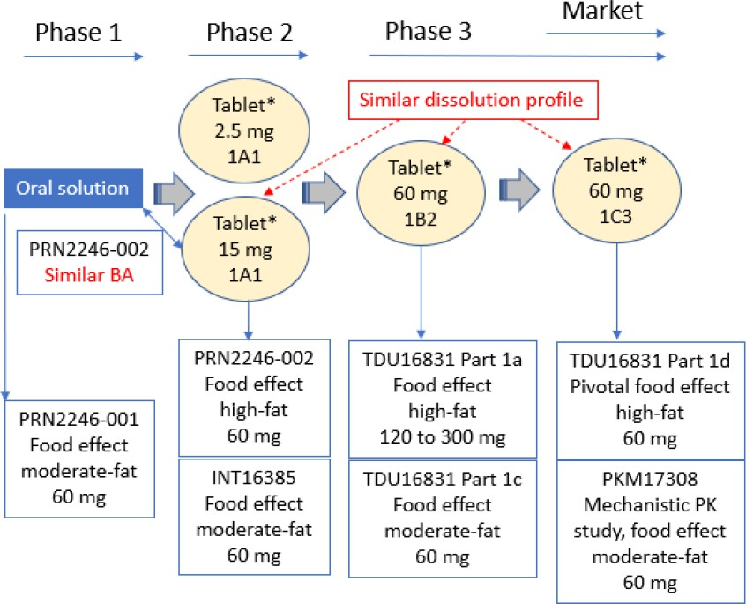
* All tablet formulations are immediate-release, f11m-coated tablets.

Influence of food
Food increases the bioavailability to 10.3% due to an increase in first-pass extraction as a consequence of increased gut/liver flow upon consumption of a meal (PKM17308).

Dose proportionality
From 60mg to 300mg single doses (TDU16831) and from 120mg to 240mg repeated doses (TDR16862) of tolebrutinib administered under fed conditions, tolebrutinib and M2 Cmax and AUC increased with no major deviation from dose proportionality.

Bioavailability during multiple dosing
After repeated once daily doses of tolebrutinib from 7.5mg to 90mg under fasted conditions, no accumulation occurred for tolebrutinib (tolebrutinib-001). Similarly, no accumulation was observed for tolebrutinib and M2 after repeated doses of tolebrutinib from 120 to 240mg under fed conditions (TDR16862).

Distribution

Volume of distribution
Volume of distribution in the terminal phase (Vz) after IV administration of [14C]-tolebrutinib was estimated to be 255L (PKM17308).

Plasma protein binding
Tolebrutinib and M2 in vitro protein binding in human plasma, primarily to human serum albumin, ranged from 87.5% to 88.9%, and from 84.9% to 91.4%, respectively. Thus, the tolebrutinib and M2 in vitro unbound fraction ranged from 11.1% to 12.5% and from 8.6% to 38%, respectively. An unexpected higher unbound fraction was observed for M2 metabolite at lower concentrations (38% for concentrations < 0.1μM versus 8.65% to 15.1% from 0.3 to 10μM).

Erythrocyte distribution
The blood to plasma tolebrutinib ratio for distribution in humans was 1.10 (DVR0322).

CSF distribution
At the 60mg intended therapeutic dose, tolebrutinib and M2 CSF concentrations exceeded their respective Bruton's tyrosine kinase (BTK) KI values in enzymatic assay (0.68 and 0.17ng/mL, respectively) for a time much longer than 500% of the t1/2 of BTK inactivation (17 and 11 minutes, respectively, based on kinact).
This indicates relevant covalent BTK inhibition in CNS. Tolebrutinib concentration also exceeded the IC50 (0.3ng/mL) for BTK occupancy in microglial cells.
Following single dose oral administration of 60 and 120mg, tolebrutinib and M2 maximum observed concentrations in CSF increased with dose with no major deviation from dose proportionality.

Metabolism

Sites of metabolism and mechanisms / enzyme systems involved
In total, 21 Phase 1 and 4 Phase 2 metabolites of tolebrutinib were fully or partially elucidated in plasma, urine, and faeces. All metabolites observed in vivo in humans were not all observed in vitro in liver microsomes/hepatocytes.
After a single 60mg oral dose of [14C]-tolebrutinib to healthy participants (BEX16018), extensively metabolized to numerous metabolites. 19 metabolites were identified in plasma and were primarily excreted in faeces (MEH0099). The PK profile of total radioactivity in plasma is characterized by a rapid elimination of parent drug and metabolites while a portion of radioactivity, covalently bound to plasma proteins, is slowly eliminated. Almost all radioactivity is eliminated from the body within one week as recovery of administered radioactivity is nearly complete (> 90%) by this time.
The observed covalent binding in plasma can be attributed to tolebrutinib and metabolites bearing the intact acryloyl moiety, which can be formed via first-pass gut or liver metabolism.
Based on an in vitro experiment in human hepatocytes, tolebrutinib is mainly metabolized by CYP3A4 (fm = 38%) and CYP2C8 (fm = 34%), and to a lesser extent by CYP2D6 (fm = 9%), and CYP2J2 (fm = 19%) (MIH0967).
In vitro, M2 is formed from tolebrutinib exclusively by CYP2C8 (MIV0736) and is mainly metabolized by CYP3A4/5 (66% to 79%) and to a lesser extent by CYP2D6 and CYP2J2 (ECH0043).
DDI studies (INT16835 and INT16726) in human were conducted to assess the effects of a potent CYP3A4 inhibitor (itraconazole), a potent CYP2C8 inhibitor (gemfibrozil), and a potent CYPs inducer (rifampicin) on tolebrutinib and M2 plasma exposures. Based on the results of these PK interaction assessments, in vivo fm for tolebrutinib metabolism was estimated to be > 90% for CYP2C8 and the remaining for CYP3A4, and the fm of M2 was refined to be 25% for CYP3A4/5 (PBM0102).

Metabolites identified in humans: active and other – In vivo
Tolebrutinib was more metabolized in human microsomes and hepatocytes in vitro than in the animal species investigated, with certain metabolites (M13, M18, M17, and M15) uniquely observed in human and not in animal models (MIV0736).
Among these metabolites, only M2 is pharmacologically active on BTK and contributes to the pharmacological activity in vivo. M2 is an irreversible BTK inhibitor, with a potential of covalent binding that is approximately 62% of that of tolebrutinib.

Excretion

Routes and mechanisms of excretion
After single and repeated once daily ascending dose oral administration under fed conditions, tolebrutinib and M2 t1/2z were similar ranging from 3.0 to 7.8 hours regardless of meal composition (Studies TDU16831 and TDR16862).
Following an IV infusion of 100 μg [14C]-tolebrutinib dose, the mean tolebrutinib t1/2z was similar between fasted and fed conditions (1.95 ± 1.07 hours versus 1.77 ± 0.701 hours) and approximately 3-fold shorter than those observed after oral administration. The shorter t1/2z of tolebrutinib when given by the IV route suggests that the rate of elimination for tolebrutinib given by oral route is limited by the rate of GI absorption.

Mass balance studies
Following a single oral dose of 60mg [14C]-tolebrutinib, the t1/2z of plasma radioactivity was approximately 150 hours. This long t1/2z is consistent with a covalent binding of tolebrutinib and its metabolites to plasma proteins. The majority of the radioactivity (85.0%) was excreted within 72 hours after [14C]-tolebrutinib administration. Radioactivity was predominantly excreted in faeces (78% of dose) and to a lesser extent in urine (14% of dose).
Tolebrutinib represented 3.8% of the administered dose in faeces and was not quantifiable in urine. Among the 14 metabolites recovered in excreta, the main metabolite excreted was M8 (17.9%). M2 represented 1.48% of the dose in excreta with the majority in urine (1.24%). All other metabolites each represented ≤ 5% to the administered dose.

Pharmacokinetics in the target population
In the PopPK analyses with data from participants with nrSPMS (EFC16645 study) or RMS (EFC16033), age, sex, and body weight were not identified as significant covariates affecting the PK of tolebrutinib and M2 metabolite (POH1142 and POH0855).
The PK variabilities in participants with nrSPMS and RMS in EFC16645 and EFC16033 studies were very high (CV%: 60% to 65% for tolebrutinib and 56% to 58% for M2), but consistent with the variabilities observed in healthy participants in Phase 1 studies.

Pharmacokinetics in special populations

Pharmacokinetics in subjects with impaired hepatic function
Only the effect of mild hepatic impairment on the PK of tolebrutinib and M2 was evaluated following a single oral dose of 60mg tolebrutinib under fed conditions compared to matched participants with normal hepatic function (Study POP16398). Total and unbound AUC decreased by a maximum of 13% for tolebrutinib and increase by a maximum of 26% for M2.
No relevant relationship was identified between CYP2C8 and CYP2D6 polymorphism with PK exposures of tolebrutinib and M2 metabolite.

Pharmacokinetics in subjects with impaired renal function
Due to the negligible elimination in urine of tolebrutinib (not quantifiable) and its active metabolite M2 (1.2% of the administered dose) in the excretion balance/metabolism study BEX16018, the PK of tolebrutinib and M2 was assessed in a reduced design study (POP16399) with only severely renal-impaired participants (without dialysis). In these participants, following a single oral dose of 60mg tolebrutinib under fed conditions compared with matched participants with normal renal function, total and unbound AUC increased by a maximum of 64% and 21% for tolebrutinib and M2, respectively.
In PopPK analysis, renal function (evaluated by eGFR) was not identified as a significant covariate impacting tolebrutinib and M2 PK in nrSPMS and RMS populations.

Pharmacodynamics
Cenrifki is a brain-penetrant and bioactive inhibitor of Bruton’s tyrosine kinase (BTK). The BTK pathway is critical to signalling B cells and myeloid cells including CNS-resident macrophages and microglia. Each of these cell types are implicated in the pathophysiology of MS. Although the exact mechanism by which tolebrutinib exerts its therapeutic effect in MS is not fully understood, there is evidence to support it inhibits the activation of B cells, macrophages and microglia in the periphery and CNS. Tolebrutinib forms a covalent bond with cysteine 481 near the ATP-binding site leading to inhibition of BTK enzymatic activity in B cells and microglia.

Pharmacodynamic effects

Exposure/response analysis

POH0856 in Relapsing Multiple Sclerosis patients
No clear relationship could be visualized between AUC of tolebrutinib, of M2 and of the sum of both and any pharmacodynamic endpoints.

POH1143 in non-relapsing Secondary Progressive Multiple Sclerosis patients
No clear relationship could be visualized between AUC of tolebrutinib, of M2 and of the sum of both and any pharmacodynamic endpoints. A slight tendency was noted with the percent change between end of study and Month 6 of brain volume loss.
CTS0154 in both EFC16033 (in Relapsing Multiple Sclerosis patients) and EFC16645 (in non-relapsing secondary progressive Multiple Sclerosis patients).
- Exposure / Response for annualized relapse rate in study EFC16033 (in patients with relapsing multiple sclerosis).
No exposure – response was detected with annualized relapse rate.
- Exposure / Response for Time to onset of Confirmed Disability Worsening in study EFC16033 (in patients with relapsing multiple sclerosis).
The first two secondary endpoints were:
- Time to onset of Confirmed Disability Worsening, confirmed over at least 6 months, assessed by the EDSS.
- Time to onset of Confirmed Disability Worsening, (assessed by the EDSS score and confirmed over at least 3 months).
Only the 6 months results were analysed.
No exposure – response was detected with 6-month Confirmed Disability Worsening.
The hazard ratios of all tolebrutinib and or active metabolite M2 exposure metrics versus teriflunomide did not significantly differ from 1 whether the analysis models included the stratification covariates or the selected significant main and interaction effects of subgroups.
- Exposure / Response for Time to onset of Confirmed Disability Progression in Study EFC16645 (in non-relapsing secondary progressive Multiple Sclerosis patients).
The primary endpoint was Time to onset of 6-month Confirmed Disability Progression.
The third secondary endpoint was Time to onset of 3-month Confirmed Disability Progression as assessed by the EDSS score.
Both 3- and 6-month results were analysed.
An exposure – response was detected with 6-month Confirmed Disability Progression, when the exposures to tolebrutinib and or active metabolite M2 were divided above and below median. The hazard ratios of all tolebrutinib and or active metabolite M2 exposure metrics versus placebo did not significantly differ from 1 when exposures were below median but were significantly lower than 1 (range between 0.581 to 0.618) when exposures were above median.
With 6-month Confirmed Disability Progression, when the AUC are divided in 2 groups relative to median, the hazard ratios of AUC in Q1 (below median) do not significantly differ from 1, whereas the hazard ratios of AUC in Q2 (above median) versus placebo are significantly lower than 1, suggesting an exposure – response effect.

Tolebrutinib-001 in healthy male volunteers
The secondary objective included in Part A (single dose), Part B (repeat dose) and Part C (open label single dose):
- To assess the impact of tolebrutinib on BTK occupancy in peripheral blood mononuclear cell (PBMCs).

Results
Single doses of tolebrutinib at 5mg to 120mg in Part A resulted in a dose-dependent increase in occupancy of BTK in human Peripheral blood mononuclear cells (PBMC). Maximal BTK occupancy of 97% was achieved after single tolebrutinib doses of 60mg and 120mg. The percentage of BTK occupancy was not changed by food intake.
In Part B, a dose-dependent increase in BTK occupancy was observed. Within each cohort, occupancy levels increased with additional doses. Mean BTK occupancy of >75% was achieved and maintained in all dose cohorts by Day 10 (7.5mg to 90mg daily dosing) and had returned toward baseline by 7 days after dosing in all cohorts.

EFC16645 non-relapsing Secondary Progressive Multiple Sclerosis
Secondary objectives/endpoints included:
- To evaluate pharmacodynamics (PD) of tolebrutinib.
  - Change in plasma neurofilament light chain (NfL) levels at the end of study (EOS) compared to baseline.
  - Change in lymphocyte phenotype subsets in whole blood at the EOS compared to baseline in a subset of participants.
  - Change in serum immunoglobulin level at baseline compared to the EOS.
  - Change in serum chitinase-3 like protein-1 (Chi3L1) levels at baseline compared to the end of study (EOS).

Results
Mean NfL levels did not differ over time between both intervention groups, showing only a slight numerical increase from baseline.
An overall decreasing trend in mean counts of B cells (CD19) was observed from baseline to Month 12 in the tolebrutinib group, and then the mean counts of B cells (CD19) remained generally stable at EOS, whereas in the placebo group, the mean counts of B cells (CD19) was overall stable up to EOS with some variability due to the limited samples analysed.
These mean values remained within normal ranges.
In both intervention groups, mean IgG levels remained generally stable from baseline over time.
A slight numerical increase in mean Chi3L1 levels was observed in both intervention groups, starting from Month 12 in the tolebrutinib group and Month 6 in the placebo group. When compared to the placebo group, less increase in the mean ChiL3 levels was observed in the tolebrutinib group throughout the study.

EFC16033 in relapsing forms of Multiple Sclerosis
Secondary objectives/endpoints included:
- To evaluate pharmacodynamics (PD) of tolebrutinib
  - Change in plasma neurofilament light chain (NfL) levels at the EOS compared to baseline, where available.
  - Change in lymphocyte phenotype subsets in whole blood at the EOS compared to baseline in a subset of participants.
  - Change in serum immunoglobulin level at the EOS compared to baseline.
  - Change in serum chitinase-3 like protein-1 (Chi3L1) levels at the EOS compared to baseline.

Results
In the tolebrutinib group, a slight numerical reduction from baseline in mean NfL levels was observed through Month 6, followed by a plateau until Month 24 and a numerical increase up to Month 36. In the teriflunomide group, a continuous reduction from baseline was observed up to Month 36.
Both intervention groups showed an overall decreasing trend in mean counts of B cells (CD19) from baseline over time. These mean values were within the normal ranges.
In both intervention groups, mean IgG levels remained generally stable from baseline over time, with a numerical decrease observed at Month 6 in the teriflunomide group.
In both study intervention groups, a numerical reduction from baseline in mean Chi3L1 levels was observed up to Month 12, with a median change (% change) from baseline at Month 12 of - 1711.100 pg/mL (-9.506%) in the tolebrutinib group and -2800.000 pg/mL (-13.442%) in the teriflunomide group.

EFC16034 in relapsing forms of Multiple Sclerosis
Secondary objectives/endpoints included:
- To evaluate pharmacodynamics (PD) of tolebrutinib
  - Change in plasma neurofilament light chain (NfL) levels at the end of study (EOS) compared to baseline, where available.
  - Change in serum immunoglobulin level at the EOS compared to baseline.
  - Change in serum chitinase-3 like protein-1 (Chi3L1) levels at the EOS compared to baseline.
In both intervention groups, a slight numerical decrease in mean NfL levels was observed, with an effect more pronounced in the teriflunomide group.
The median change in IgG (% change) from baseline at the EOS were 0.140 g/L (1.209%) in the tolebrutinib group and -0.590 g/L (-5.417%) in the teriflunomide group. In both intervention groups, mean IgG levels remained generally stable from baseline over time, with a numerical decrease observed at Month 6 in the teriflunomide group.
The median change (% change) from baseline at the EOS in Chi3L1 levels were 1462.500 pg/mL (7.210%) in the tolebrutinib group and -281.100 pg/mL (-1.350%) in the teriflunomide group. In the tolebrutinib group, levels remained below the baseline up to Month 12, whereas in the teriflunomide group they stayed below baseline up to Month 36.

Population Pharmacokinetics (PopPK)

PopPK analysis POH0855
There were 624 participants included in the analysis with 6267 non-BLQ tolebrutinib observations and 6115 M2 observations. There were 333 (53.3%) females and 292 (46.7%) males. There were seven participants with hepatic failure. There were 490 (78.4%) Caucasian participants and 76 (12.2%) Asian. The median (range) age was 35.0 (18.0 to 76.0) years and weight was 80.6 (49.8 to 114) kg.
The structural model was further refined and determined to be three compartments for parent tolebrutinib and one compartment for M2. Elimination for parent was linear (parameterised as CL) with a first order constant describing elimination to M2. Elimination of M2 was also described by a first-order constant. Absorption was modelled with a first order absorption constant, and transit compartments with a mean transit time. Bioavailability was included as a parameter. The volume of distribution of the M2 metabolite (V8) was not identifiable and was fixed at 1.
The base model parameters were estimated with acceptable precision, but the shrinkage was high for the IIV terms for clearance (CL), the absorption rate constant (KA) and mean transit time (MTT).
The final covariate model included RAC4 (Chinese vs non-Chinese) on V2 (central volume of distribution) and SUBTYPE (healthy volunteers vs multiple sclerosis) on BIO (bioavailability).
The final model parameters were estimated with acceptable precision, but all of the IIV terms had high shrinkage. The plots of IPRED and PRED vs observed are acceptable for tolebrutinib and M2. The plots of CWRES vs time and PRED indicate an appropriate specification for the residual error model and few outliers.
There was good agreement between the final estimates and the bootstrap estimates.
The VPC is difficult to interpret because the legend is incomplete. The sponsor does not provide any interpretation of the VPC in the text of the report. The evaluator’s interpretation is that the red lines represent the predictions and the blue the observations. This would indicate that the model underpredicts the high values and overpredicts the low values. This means the error model does not approximate the true distribution of the data. While the median value is reliable, the extremes of the predictions (high or low) would be unreliable.
The model was then used to estimate PK and exposure parameters. The mean values are likely to be reliable, but the distributions may be underpredicted.
The PopPK modelling was conducted and reported in accordance with the Guideline on Reporting the Results of Population Pharmacokinetic Analyses (CHMP/EWP/185990/06).
The base model was the result of a rigorous development process and is plausible. The covariate model was developed using machine learning, but this does not appear to have improved the covariate selection process. Physiologically plausible covariates, such as body weight, appear to have been excluded at an early stage. The initial base model appears to have had allometric scaling of weight, but this does not appear to be present according to the text of the report or the NONMEM code.
There was high shrinkage of all the IIV terms in the final model. The evaluator would ordinarily expect that some of these IIV terms would be excluded from the model, and the change in OFV measured. This may have improved the model. However, this does not appear to have been tested, despite the sponsor stating that shrinkage >25% was undesirable. The sponsor explained that since removing the IIV term did not improve the OFV, the PopPK evaluator agreed it is reasonable to retain the IIV term in the model.
The VPC indicates that the error model underestimates variance. This means that simulations from the model will also underestimate the distribution of the parameter estimates.
Although the model is suitable as a descriptive model, the evaluator considers it unsuitable for simulations. In the opinion of the evaluator, further development of the error model is required.

PopPK analysis POH1142
There were 865 participants included in the analysis with 6892 non-BLQ (non-below the Limit of Quantification) tolebrutinib observations and 6856 M2 observations by oral administration; and 175 non-BLQ tolebrutinib observations and 143 M2 observations by IV administration. There were 424 (50.1%) females and 423 (49.9%) males. There were seven participants with hepatic failure. There were 751 (88.7%) Caucasian participants 48 (5.7%) Black and 37 (4.4%) Asian. The median (range) age was 49.0 (27.0 to 60.0) years, and weight was 73.0 (49.0 to 101) kg.
The base model from POH0855 was retained. The error model included IIV terms on V2, CL, KA, KeM and BIO and a IIV-IOV variable on MTT. The residual error was exponential (additive on log-transformed data).
The parameters were estimated with acceptable precision for the base model. However, shrinkage was high for all the IIV terms except for that on bioavailability.
The final covariate model only included SUBTYPE (healthy volunteers vs patients) on bioavailability.
The parameters were estimated with acceptable precision for the final model. However, again, shrinkage was high for all the IIV terms except for that on bioavailability.
The plots of IPRED and PRED vs observed are acceptable for tolebrutinib. The plots of CWRES vs time and PRED indicate an appropriate specification for the residual error model and few outliers.
There was good agreement between the final estimates and the SIR estimates.
As with POH0855, the VPC is difficult to interpret because the legend is incomplete. The sponsor’s interpretation was ‘PK variabilities and median concentrations were quite well predicted for both analytes.’ However, the Evaluator’s interpretation is that the red lines represent the predictions and the blue the observations. This would indicate that the model underpredicts the high values and overpredicts the low values. This means the error model does not approximate the true distribution of the data. While the median value is reliable, the extremes of the predictions (high or low) would be unreliable.
The model was then used to estimate PK and exposure parameters for tolebrutinib and M2. In the opinion of the Evaluator, the mean values are likely to be reliable, but the distributions may be underpredicted.
The PopPK modelling was conducted and reported in accordance with the Guideline on Reporting the Results of Population Pharmacokinetic Analyses (CHMP/EWP/185990/06).
The base model was previously developed and validated in POH0855. The covariate model was developed using machine learning, but this does not appear to have improved the covariate selection process. Physiologically plausible covariates, such as body weight, appear to have been excluded at an early stage.
With the exception of the IIV for bioavailability, there was high shrinkage of all the IIV terms in the final model. The Evaluator would ordinarily expect that some of these IIV terms would be excluded from the model, and the change in OFV measured. This may have improved the model. However, this does not appear to have been tested, despite the sponsor stating that shrinkage >25% was undesirable.
The VPC indicates that the error model underestimates variance. This means that simulations from the model will also underestimate the distribution of the parameter estimates.
Hence, although the model is suitable as a descriptive model, the Evaluator considers it unsuitable for simulations. In the opinion of the Evaluator, further development of the error model is required.

Dosage selection for the pivotal studies

Pharmacokinetics and pharmacodynamics: dose finding studies
In Study DRI15928. The numbers of new Gd-enhancing T1 hyperintense and new or enlarging T2 lesions decreased with increasing tolebrutinib exposure. Based on this relationship and because of food increase tolebrutinib exposure, the selected Phase 3 dose was 60mg once daily given with a meal.

Phase 2 dose finding studies
The 60mg dose was selected based on the effect of tolebrutinib on Gadolinium (Gd) - enhancing T1 hyperintense lesion formation on Magnetic Resonance Imaging (MRI) after 12 weeks of treatment in the Phase 2b trial.

Summary of clinical studies
- EFC16033 – A Phase 3, randomized, double-blind efficacy and safety study comparing tolebrutinib to teriflunomide (Aubagio) in participants with relapsing forms of multiple sclerosis (GEMINI 1).
- EFC16034 – A Phase 3, randomized, double-blind efficacy and safety study comparing tolebrutinib to teriflunomide (Aubagio) in participants with relapsing forms of multiple sclerosis (GEMINI 2).
- EFC16645 – A Phase 3, randomized, double-blind, efficacy and safety study comparing tolebrutinib to placebo in participants with non-relapsing secondary progressive multiple sclerosis (HERCULES).
- DRI15928 – A Phase 2b, multicentre, international, randomized, double-blind, placebo-controlled, crossover, dose-ranging study to investigate the MRI efficacy and the safety of
12-week administration of tolebrutinib in participants with relapsing multiple sclerosis.
- LTS16004 – A Phase 2b, long-term extension safety and efficacy study of tolebrutinib in participants with relapsing multiple sclerosis. See 8.2.4 formulation 1A1 (part A), formulation 1B2 (part B).
- EFC16035 – A Phase 3, randomized, double-blind, efficacy and safety study comparing tolebrutinib to placebo in participants with primary progressive multiple sclerosis (PERSEUS) protocol only submitted.

Other studies
- LTS17043 – An interventional, Phase 3 extension study to investigate long-term safety and tolerability of tolebrutinib in participants with relapsing multiple sclerosis, primary progressive multiple sclerosis, or non-relapsing secondary progressive multiple sclerosis protocol only submitted.
- ISS – Integrated Summary of Safety.
- ISE – Integrated Summary of Efficacy.
- DALA - Drug Abuse Liability Assessment.

Efficacy
Clinical efficacy for nrSPMS was provided by the Study EFC16645.
For the clinical efficacy of Cenrifki in relapsing form of MS, studies GEMINI1 and GEMINI 2 provided the main data and study DRI15928 provided supporting data.

Non-relapsing secondary progressive multiple sclerosis

Study EFC16645
A Phase 3, randomized, double-blind, efficacy and safety study comparing Cenrifki to placebo in participants with non-relapsing secondary progressive multiple sclerosis (HERCULES).
Figure 2: Study design for EFC16645
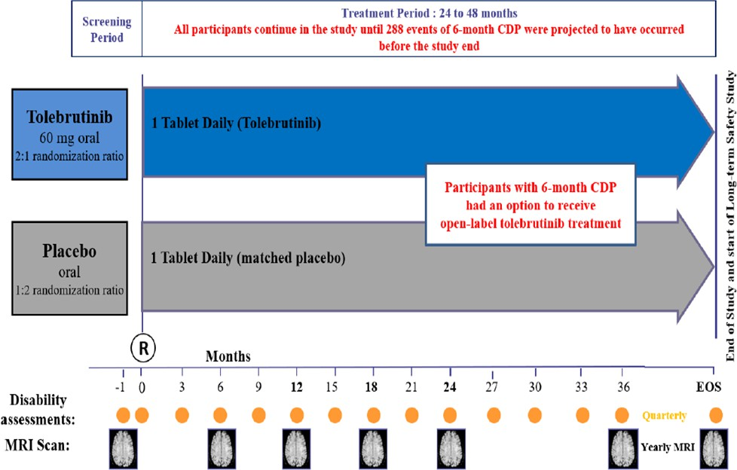

Primary objective
To determine the efficacy of Cenrifki compared to placebo in delaying disability progression in nrSPMS.

Secondary objectives
- To evaluate efficacy of Cenrifki compared to placebo on clinical endpoints, MRI lesions, cognitive performance, physical function, and quality of life.
- To evaluate safety and tolerability of Cenrifki.
- To evaluate population pharmacokinetics of Cenrifki and relevant metabolite(s) in nrSPMS and its relationship to efficacy and safety.
- To evaluate pharmacodynamics (PD) of Cenrifki.

Primary endpoint
Time to onset of 6-month confirmed disability progression (CDP).

Secondary endpoints
- Time to onset of sustained 20% increase in the 9-hole Peg Test (9-HPT) for at least 3 months.
- Time to onset of sustained 20% increase in the Timed 25-Foot Walk (T25_FW) for at least 3 months.
- Time to onset of 3-month confirmed disability progression as assessed by the EDSS score.
- Total number of new and/or enlarging T2-hyperintense lesions as detected by MRI.
- Time to onset of confirmed disability improvement (CDI).
- Percent change in brain volume as detected by MRI scans at the EOS compared to Month 6.
- Change in cognitive function at the EOS compared to baseline as assessed by Symbol Digit Modalities Test (SDMT).
- Change in cognitive function at the EOS compared to baseline as assessed by California Verbal Learning Test (CVLT)-II, where available.
- Change in MSQoL-54 questionnaire score from baseline through the EOS.

Tertiary/exploratory endpoints
There were 18 tertiary/exploratory efficacy endpoints.

Sample size
This study is planned as an event-driven trial based on 6-month confirmed disability progression. The study will continue until approximately 288 events are projected to have occurred to provide 80% power to detect a 30% risk reduction in 6-month confirmed disability progression with Cenrifki compared to placebo (2-sided α = 0.05).

Participant flow
Table 2: Participant disposition - randomised population - EFC16645
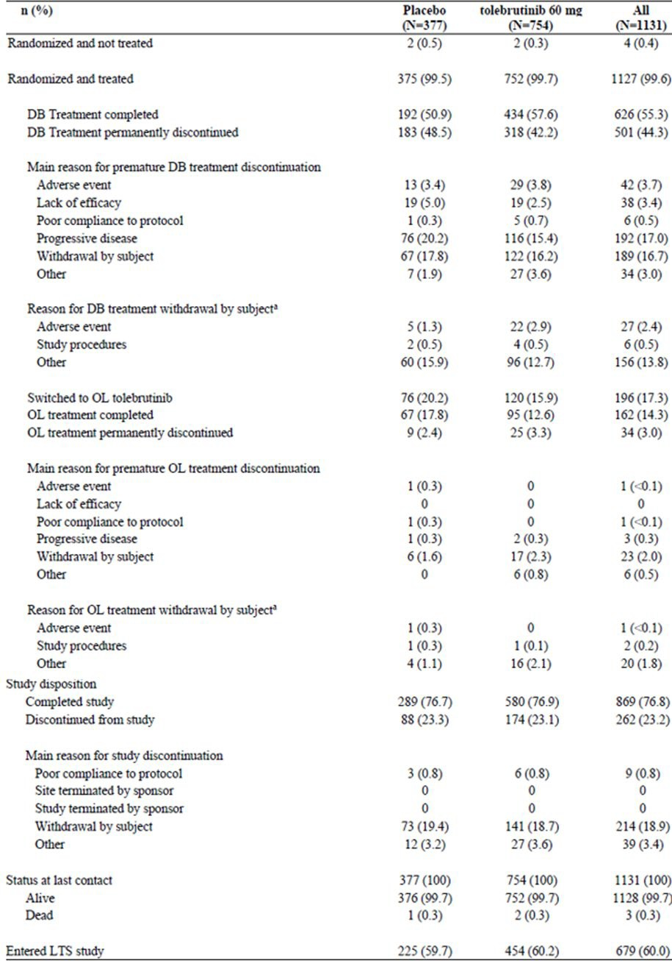

Figure 3: Flow diagram (randomised n = 1131) - EFC16645
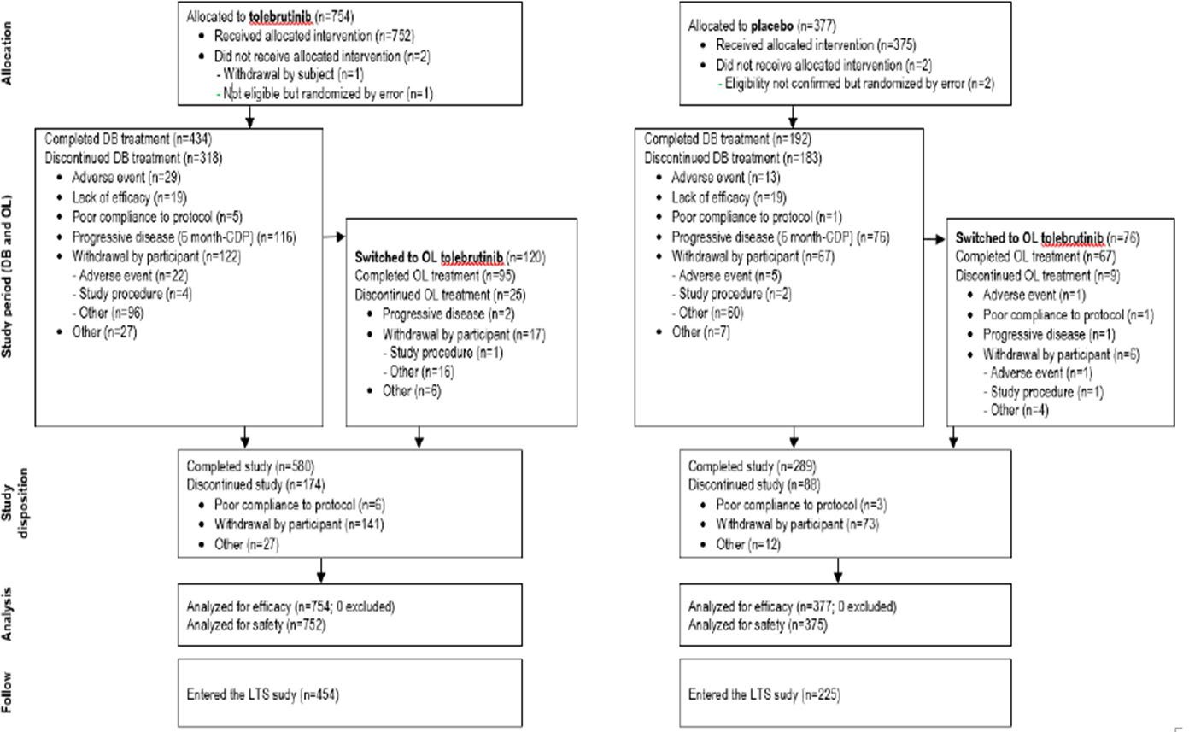

Table 3: Demographics and participant characteristics at baseline - randomised group - EFC16645
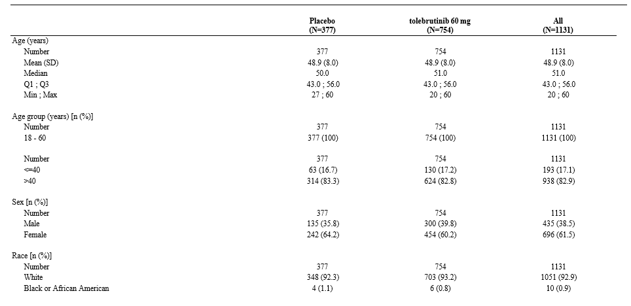
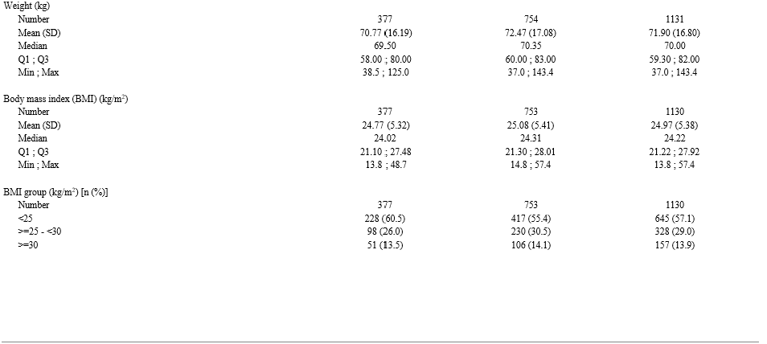
Number = Number of participants assessed. Percentages are calculated using number of participants assessed as denominator.
Table 4: Disease characteristics at baseline - randomised population - EFC16645
 |  | Placebo | Cenrifki 60mg
 |  | (N=377) | (N=754)
Time since symptom of RRMS onset (years) | Mean (SD) Min ; Max | 17.55 (8.43)  1.0 ; 41.6 | 17.13 (8.33)  1.1 ; 43.9
Time since diagnosis of SPMS (years) [n (%)] | <1  >=1 to <5 | 45 (11.9)  127 (33.7) | 113 (15.0)  242 (32.1)
Time since diagnosis of SPMS (years) [n (%)] | >=5 to <10 | 84 (22.3) | 155 (20.6)
Time since diagnosis of SPMS (years) [n (%)] | ≥ 10 | 121 (32.1) | 244 (32.4)
Time since diagnosis of SPMS (years) [n (%)] | Mean (SD) | 8.388 (7.783) | 7.905 (7.321)
Time since diagnosis of SPMS (years) [n (%)] | Min ; Max | 0.00 ; 35.74 | 0.00 ; 41.33
Time since most recent relapse (years) | Mean (SD) | 7.63 (5.47) | 7.43 (5.31)
Time since most recent relapse (years) | Min ; Max | 2.0 ; 36.0 | 2.0 ; 32.8
Previous disease modifying therapy [n (%)] | 0 | 89 (23.6) | 205 (27.2)
Previous disease modifying therapy [n (%)] | 1 | 102 (27.1) | 200 (26.5)
Previous disease modifying therapy [n (%)] | ≥ 2 | 186 (49.3) | 349 (46.3)
Baseline EDSS scorea | Mean (SD) | 5.59 (0.94) | 5.49 (0.99)
Baseline EDSS scorea | Median | 6.00 | 6.00
Baseline EDSS scorea | Min ; Max | 2.5 ; 6.8 | 2.8 ; 6.5
Baseline EDSS score [n (%)] | <=4.5 | 71 (18.8) | 183 (24.3)
Baseline EDSS score [n (%)] | >4.5 | 306 (81.2) | 571 (75.7)
Baseline EDSS score [n (%)] | <=5.5 | 145 (38.5) | 309 (41.0)
Baseline EDSS score [n (%)] | >5.5 | 232 (61.5) | 445 (59.0)
Gd-T1 lesions at baseline [n (%)] (observed data) | Presence | 49 (13.1) | 93 (12.5)
Gd-T1 lesions at baseline [n (%)] (observed data) | Absence | 324 (86.9) | 649 (87.5)
Gd-T1 lesions at baseline [n (%)] (observed data) | Mean (SD) | 0.6 (3.5) | 0.4 (2.0)
Gd-T1 lesions at baseline [n (%)] (observed data) | Median | 0.0 | 0.0
Gd-T1 lesions at baseline [n (%)] (observed data) | Min ; Max | 0 ; 54 | 0 ; 35
Gd-T1 lesions at baseline [n (%)] (imputed data) | Presence | 49 (13.0) | 93 (12.3)
Gd-T1 lesions at baseline [n (%)] (imputed data) | Absence | 328 (87.0) | 661 (87.7)
RRMS = Relapsing-remitting multiple sclerosis, SPMS = Secondary progressive multiple sclerosis, EDSS = Expanded Disability Status Scale, Gd = gadolinium
a Average of screening and randomization EDSS. Source: Table 8

Results for primary efficacy outcome ‘Time to onset of 6-month confirmed disability progression’
Cenrifki delayed the time to onset of 6-month confirmed disability progression (CPD) with a relative risk reduction of 31% compared with placebo, HR of 0.693 (95% CI: 0.546 to 0.880, p = 0.0026).
Table 5: Analysis of time to onset of 6-month CDP - ITT population - EFC16645
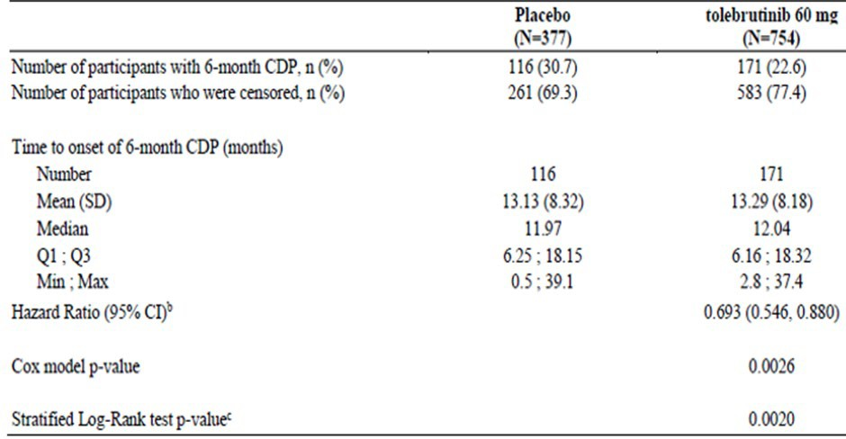
CDP=confirmed disability progression
Participants who complete the study without an initial onset of disability progression or have an initial onset of disability progression but complete the study at the common study end date without 3-month confirmation or prematurely discontinue the study before 6-month confirmation of an onset of disability progression will be censored at their last EDSS assessment date.
Missing events will be imputed via multiple imputation method.
b Derived using Cox proportional-hazards model with robust variance estimation. Covariates are treatment group, age at screening (> 40, ≤ 40 years), geographic region (US, non-US), baseline EDSS score and baseline Gd-enhancing T1 lesions (presence, absence). c Derived from log-rank test with stratification of age at screening (>40, ≤ 40 years) and geographic region (US, non-US).
Figure 4: Kaplan-Meier plot of cumulative incidence rate of onset of 6-month CDP - ITT population - EFC16645
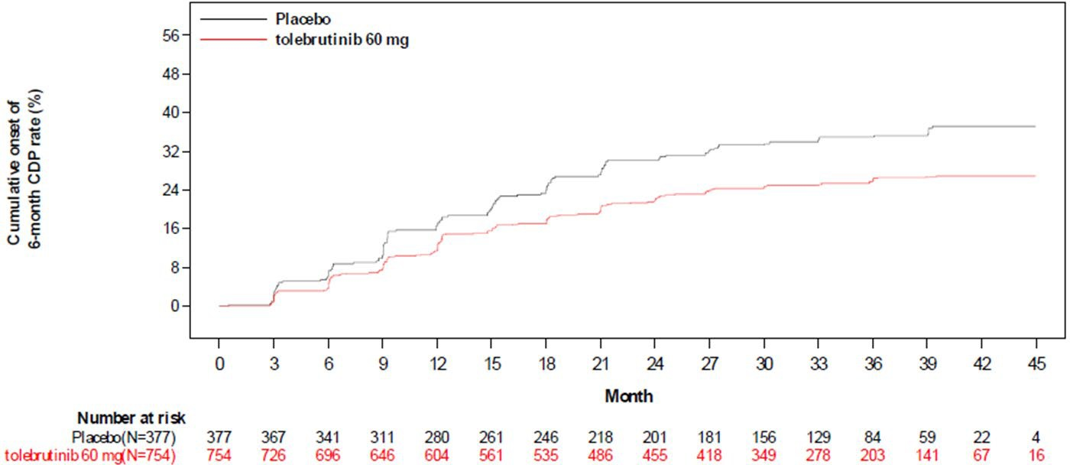

Results for other efficacy outcomes

Time to onset of 3-month CDP as assessed by the EDSS score
Tolebrutinib reduced the risk of 3-month CDP by 24% compared with placebo, with an HR of 0.757 (95% CI: 0.607 to 0.944, p=0.0134).

Total number of new and/or enlarging T2-hyperintense lesions over the study period
Overall, 176 patients (46.7%) on placebo and 280 patients (37.1%) on Cenrifki developed ≥ 1 new and/or enlarging T2-hyperintense lesion.
Table 6: Total number of new and/or enlarging T2-hyperintense lesions - ITT - EFC16645
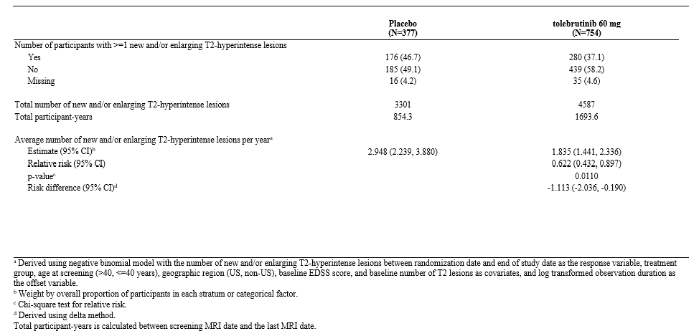

Total number of new and/or enlarging T2-hyperintense lesions per year
A total of 361 individuals on placebo, over 854.3 total participant years had 3301 new and/or enlarging T2-hyperintense lesions.
A total 719 individuals on Cenrifki, over 1693 total participant years had 4587 new and/or enlarging T2-hyperintense lesions.
Analysis produced an estimated average number of new and/or enlarging T2-hyperintense lesions per year (95% CI) of 2.948 (2.239, 3.880) for those on placebo and 1.835 (1.441, 2.336) for those on Cenrifki Relative risk (95% CI) 0.622 (0.432, 0.897) p-value 0.0110.

Time to onset of sustained 20% increase in the 9-HPT for at least 3 months
The percentage achieving sustained 20% increase in the 9-HPT for at least 3 month was < 20% in both groups with no statistical difference shown.

Subsequent results in the Statistical Analysis Plan hierarchy
In the Statistical Analysis Plan (SAP) the remaining hypotheses in the specified hierarchy were not to be formally tested as the preceding one is not significant at the 5% level.

Clinical efficacy in relapsing forms of MS

Main efficacy studies
- EFC16033 – A Phase 3, randomized, double-blind efficacy and safety study comparing Cenrifki to teriflunomide (Aubagio) in participants with relapsing forms of multiple sclerosis (GEMINI 1).
- EFC16034 – A Phase 3, randomized, double-blind efficacy and safety study comparing Cenrifki to teriflunomide (Aubagio) in participants with relapsing forms of multiple sclerosis (GEMINI 2).
- DRI15928 – A Phase 2b, multicentre, international, randomized, double-blind, placebo-controlled, crossover, dose-ranging study to investigate the MRI efficacy and the safety of 12-week administration of tolebrutinib in participants with relapsing multiple sclerosis.

Study EFC16033

Study design, objectives, locations and dates
Phase 3, randomized, double-blind, double-dummy, 2-arm, active-controlled, parallel-group, multicentre, event driven (6-month confirmed disability worsening (CDW)) trial with a variable treatment duration expected to range from approximately 18 to 36 months.
- Screening period: Day -28 to Day -1.
- Randomization/start of investigational medicinal product (IMP): Eligible participants were randomly assigned at a 1:1 ratio to receive:
  - 60mg selected dose (established from dose-finding Study DRI15928) of oral, once daily Cenrifki as well as placebo to match the oral, once daily teriflunomide tablet; OR
  - 14mg oral, once daily teriflunomide as well as placebo to match the oral, once daily Cenrifki tablet.
- Safety follow-up period: 4 weeks after the last dose of study intervention.
- Study end date was when approximately 162 events of 6-month confirmed disability worsening would have occurred in the pooled EFC16033 and EFC16034 studies.
Figure 5: Study design - EFC16033
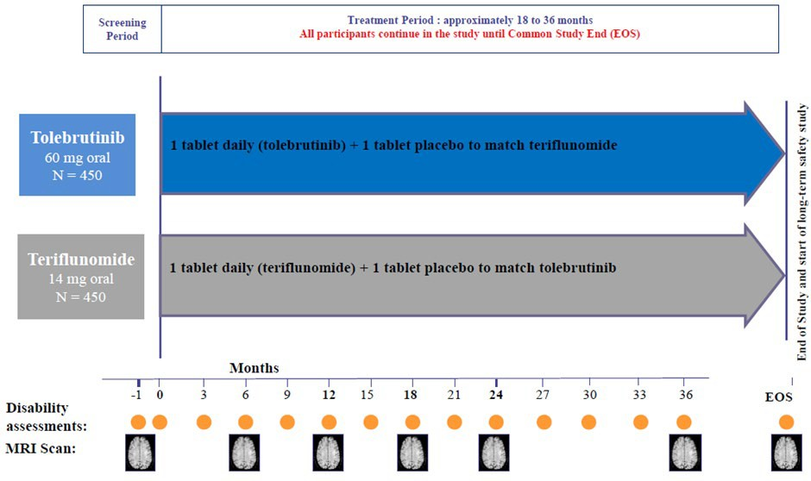

Primary objective
To assess the efficacy of daily Cenrifki compared to a daily dose of 14mg teriflunomide (Aubagio) measured by the ARR in participants with relapsing forms of MS.

Secondary objective
To assess the efficacy of Cenrifki compared to teriflunomide (Aubagio) on disability progression, MRI lesions, cognitive performance, and quality of life.

Efficacy variables and outcomes

Primary endpoint
ARR during the study period assessed by confirmed protocol-defined adjudicated relapses.

Key secondary endpoint
Time to onset of confirmed disability worsening, confirmed over at least 6 months, pooled across EFC16033+EFC16034.

Other secondary endpoints
- Time to onset of confirmed disability worsening, assessed by the EDSS score and confirmed over at least 3 months.
- Total number of new and/or enlarging T2-hyperintense lesions as detected by MRI.
- Total number of new Gd-enhancing T1-hyperintense lesions as detected by MRI.
- Time to CDI, defined as a ≥ 1.0 point decrease on the EDSS from the baseline EDSS score confirmed over at least 6 months.
- Percent change in brain volume as detected by brain MRI scans at the EOS compared to Month 6.
- Change in cognitive function at the EOS compared to baseline as assessed by the Symbol Digit Modalities Test (SDMT).
- Change in cognitive function at the EOS compared to baseline as assessed by the California Verbal Learning Test (CVLT-II), where available.
- Change in MS QoL-54 questionnaire score at the EOS compared to baseline.

Sample size
A total of 900 (± 10%) participants randomly assigned to the study intervention: approximately half to each treatment group, Cenrifki and teriflunomide. This study sample size provides greater than 90% power to detect a 45% relative reduction of ARR (primary endpoint) with Cenrifki compared to teriflunomide.

Participant flow
Table 6: Participant disposition - randomised population - EFC16033
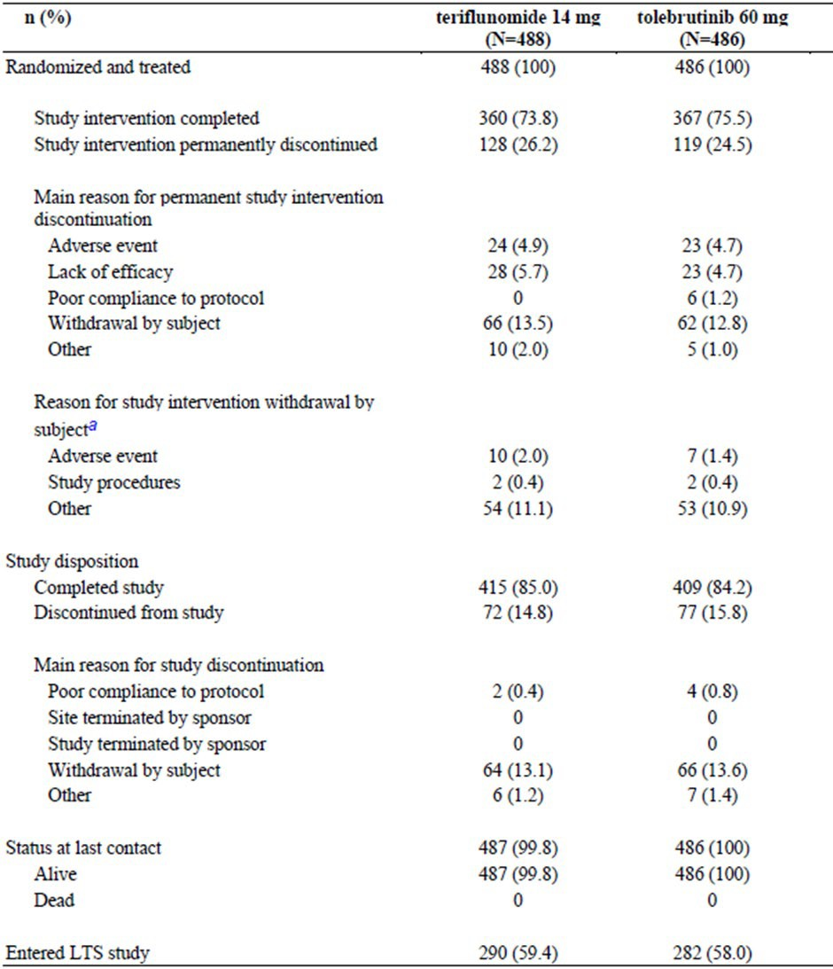
Percentages are calculated using the number of participants randomized as denominator. LTS: long-term safety.
a This is a further breakdown of the reasons for withdrawal by subject reported above, as collected in the standard CRF.
Figure 6: Flow diagram randomised patients - EFC16033
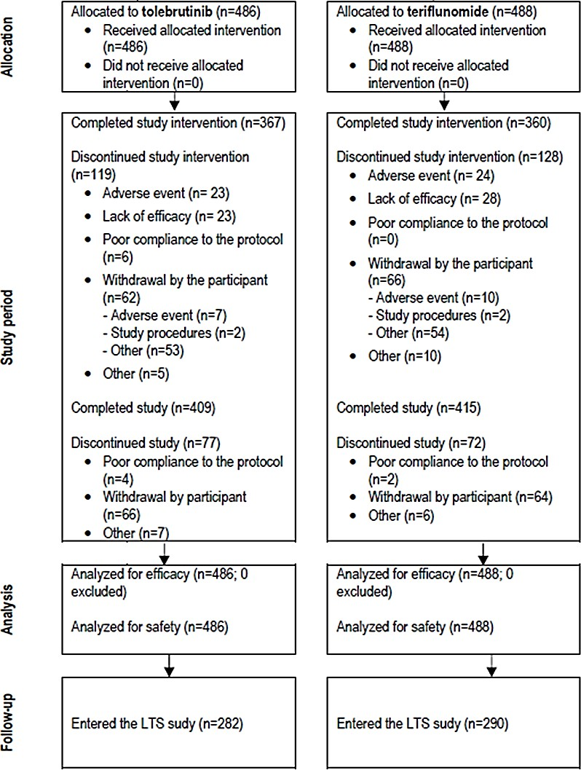

Baseline data
Table 7: Demographics and participant characteristics at baseline - randomised group - EFC16033
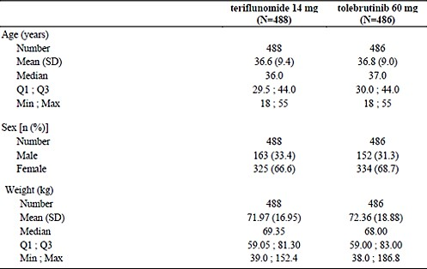
Number = Number of participants assessed. Percentages are calculated using number of participants assessed as denominator.
Table 8: Disease characteristics at baseline - randomised population - EFC16033
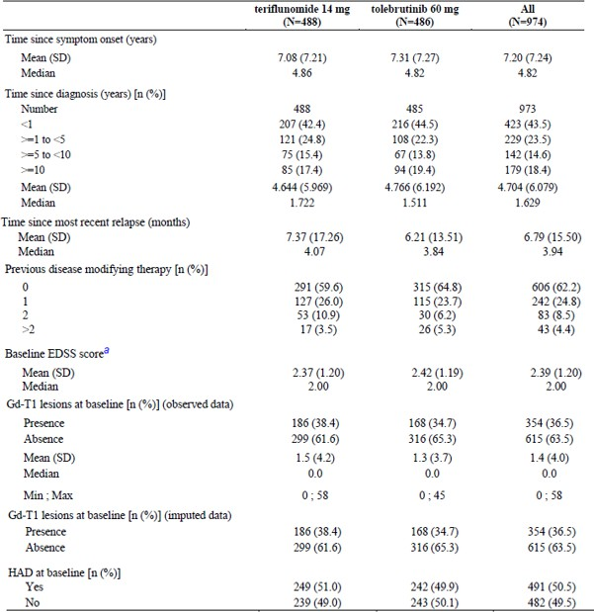
HAD = Highly active disease
a Average of screening and randomization EDSS.

Results for the primary efficacy outcome
ARR during the study period assessed by confirmed protocol-defined adjudicated relapses.
The study did not meet its primary efficacy endpoint. The adjusted ARR did not differ between Cenrifki and teriflunomide (0.130 versus 0.122; RR [95% CI]: 1.061 [0.808 to 1.393]; p = 0.6691).
Table 9: Analysis of ARR using negative binomial regression model - ITT population - EFC16033
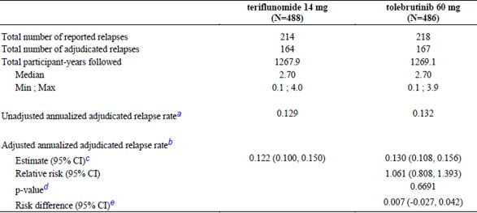
a Total number of adjudicated relapses that occurred during the study period divided by the total participant years in the study.
b Derived using negative binomial model with the number of adjudicated relapses onset between randomization date and end of study date as the response variable, treatment group, Gd-enhancing T1 lesions at baseline (presence, absence), EDSS strata (<4, >=4) and geographic region (US, non-US) as covariates, and log transformed observation duration as the offset variable.
c Weight by overall proportion of participants in each stratum or categorical factor.
d Chi-square test for relative risk.
e Derived using delta method.

Results for other efficacy outcomes
Table 10: Results for other efficacy outcomes - EFC16033
Secondary endpoint | Teriflunomide (N=488) | Tolebrutinib (N=486)
New Gd enhancing Tl hyperintense lesions per scan a | 0.35 | 0.67
New and/or enlarging T2 hyperintense lesions per yeara | 5.87 | 6.78
Symbol Digit Modalities Test change from baseline at the EOS LS mean (SE) | 0.329 (0.0318) | 0.364 (0.0318)
California Verbal Learning Test change from baseline at the EOS LS mean (SE) | 15.827 (0.7241) | 17.700 (0.7236)
Change in Brain volume at the EOS compared to Month 6 LS mean (SE) percent | -0.884 (0.0368) | -0.688 (0.0369)
a Unadjusted by modelling.
Table 11: Results for other efficacy outcomes - Studies EFC16033 and EFC16034 combined
Secondary endpoint | Teriflunomide (N=940) | Tolebrutinib (N=933)
6-month confirmed disability worsening Studies EFC16033 and EFC16034, n (%) with event | 106 (11.3%) | 78 (8.3%)
3-month confirmed disability worsening Studies EFC16033 and EFC16034, n (%) with event | 144 (15.3%) | 109 (11.7%)
6-month confirmed disability improvement Studies EFC16033 and EFC16034, n (%) with event | 98 (10.4%) | 118 (12.6%)

Study EFC16034
Study EFC16034 was a phase 3, randomized, double-blind efficacy and safety study comparing Cenrifki to teriflunomide (Aubagio) in participants with relapsing forms of multiple sclerosis (GEMINI 2) - to be marketed formulation.
This study was identical to Study EFC16033 in terms of study treatment, inclusion/exclusion criteria, efficacy variables and outcomes, randomisation and blinding methods, Analysis populations, sample size and statistical methods.

Participant flow
Table 12: Participant disposition - randomised population -EFC16034
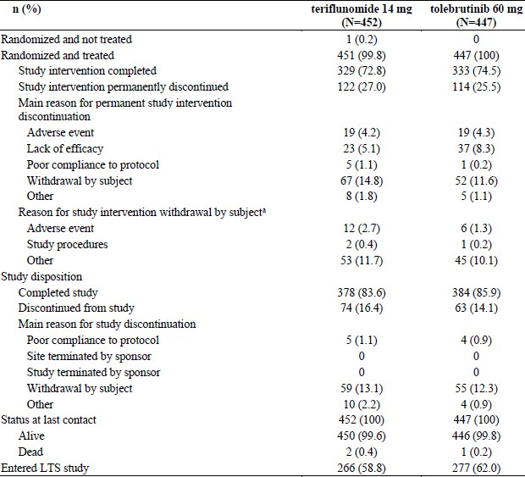
Percentages are calculated using the number of participants randomized as denominator.
LTS = Long-term safety.
a This is a further breakdown of the reasons for withdrawal by subject reported above, as collected in the standard CRF.
Figure 7: Participant disposition
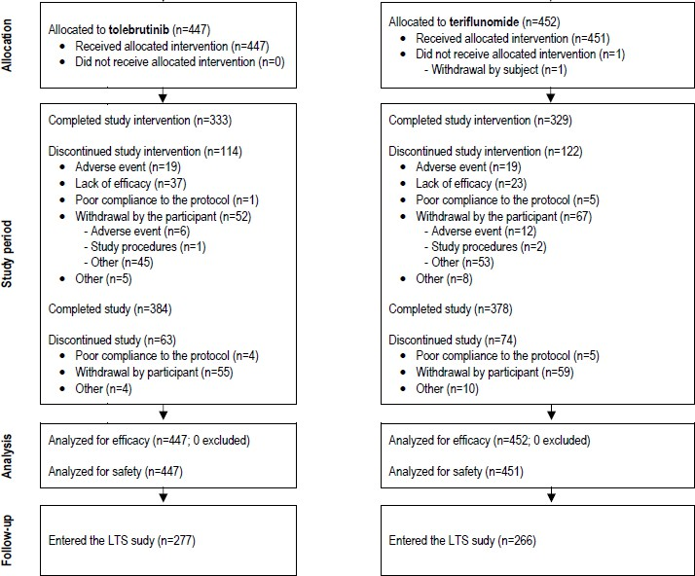

Baseline data
Table 13: Demographics and participant characteristics at baseline - randomised population
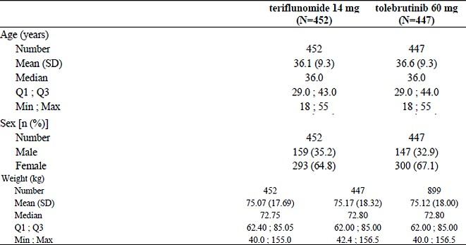
Number = Number of participants assessed. Percentages are calculated using number of participants assessed as denominator.
Table 14: Disease characteristics at baseline - randomised population
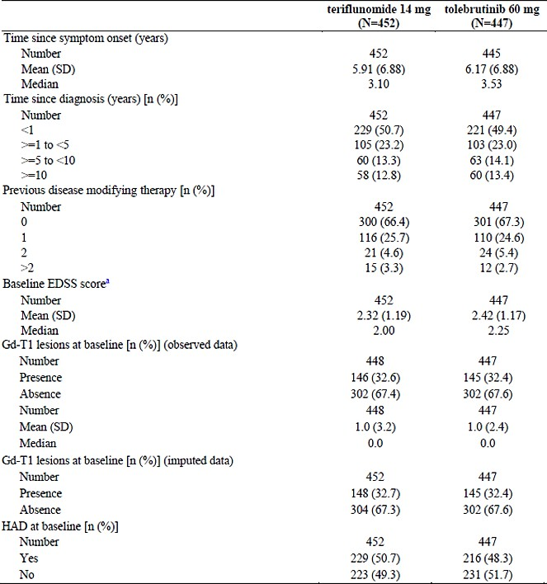
HAD=Highly active disease
a Average of screening and randomization EDSS

Results for the primary efficacy outcome
ARR during the study period assessed by confirmed protocol-defined adjudicated relapses:
The study did not meet its primary efficacy endpoint. The adjusted ARR was low and did not differ between Cenrifki and teriflunomide (0.108 versus 0.109; relative risk [RR] [95% CI]: 0.996 [0.754 to 1.315]; p = 0.9758).

Results for other efficacy outcomes
Table 15: Results for other efficacy outcomes - Study EFC16034
Secondary endpoint | Teriflunomide (N=452) | Tolebrutinib (N=447)
New Gd enhancing Tl hyperintense lesions per scan a | 0.32 | 0.54
New and/or enlarging T2 hyperintense lesions per yeara | 5.55 | 5.79
Symbol Digit Modalities Test change from baseline at the EOS LS mean (SE) | 0.428 (0.0373) | 0.374 (0.0370)
California Verbal Learning Test change from baseline at the EOS LS mean (SE) | 16.431 (0.6825) | 15.819 (0.6740)
Change in Brain volume at the EOS compared to Month 6 LS mean (SE) percent | -0.740 (0.0394) | -0.696 (0.0387)
a unadjusted by modelling

Study DRI15928

Study design, objectives, locations and dates
A Phase 2b, multicentre, international, randomized, double-blind, placebo-controlled, crossover, dose-ranging study to investigate the magnetic resonance imaging (MRI) efficacy and the safety of 12-week administration of tolebrutinib in participants with relapsing multiple sclerosis (RMS).
Conducted at 44 sites in 10 countries worldwide from 29 March 2019 to 2 January 2020.
Participants were centrally assigned to 1 of 8 arms (4 dose groups at an equal ratio to start with tolebrutinib in Cohort 1 or placebo in Cohort 2 before crossing over).
- Within each cohort, participants were randomly assigned equally to 1 of 4 tolebrutinib doses, 5, 15, 30, or 60mg once daily, in a blinded manner.
- Cohort 1: Participants received 1 of the 4 tolebrutinib doses for the first 12 weeks, then crossed over to placebo for 4 weeks.
- Cohort 2: Participants received placebo for the first 4 weeks, then crossed over to 1 of the 4 tolebrutinib doses for 12 weeks.
Figure 8: Study design – Study DRI15928
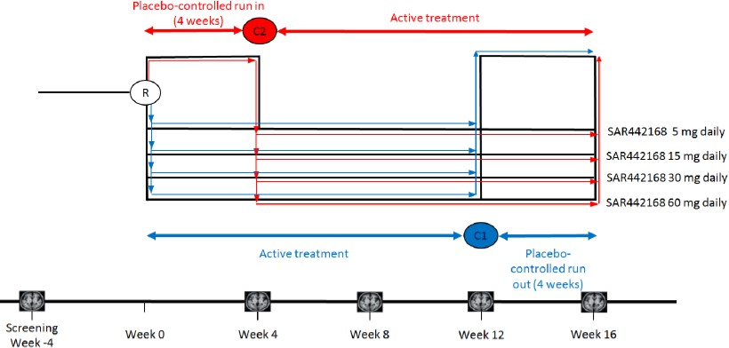

Primary objective
To determine the dose-response relationship for tolebrutinib to reduce the number of new active brain lesions.

Secondary objective
To evaluate efficacy of tolebrutinib on disease activity as assessed by imaging measures.

Study treatments
To maintain a total of 4 tablets daily in a blinded fashion:
- tolebrutinib 2.5 or 15mg film-coated tablet 5, 15, 30, or 60mg daily doses for 12 weeks.
- Matching placebo for 4 weeks.
Taken with or without food and at any time of the day but consistently.

Efficacy variables and outcomes
Primary endpoint was number of new Gd-enhancing T1-hyperintense lesions at the end of 12 weeks of tolebrutinib treatment as detected by brain MRI.

Secondary endpoints
- Number of new or enlarging T2 lesions at the end of 12 weeks of tolebrutinib treatment.
- Number of Gd-enhancing T1-hyperintense lesions at the end of 12 weeks of tolebrutinib treatment.
There were 9 tertiary/exploratory endpoints.

Sample size
Assuming 15% of participants without the primary endpoint at the end of 12 weeks of tolebrutinib, 105 participants (approximately 26 per tolebrutinib dose) has at least 83% power to detect the maximum reduction of 85% using a 2-step Multiple Comparison Procedure-Modelling (MCP-Mod) with 6 pre-defined dose response curves (2 Emax models, a quadratic model, a linear model, a logistic model, and an exponential model).

Participant flow
Table 17: Participant disposition
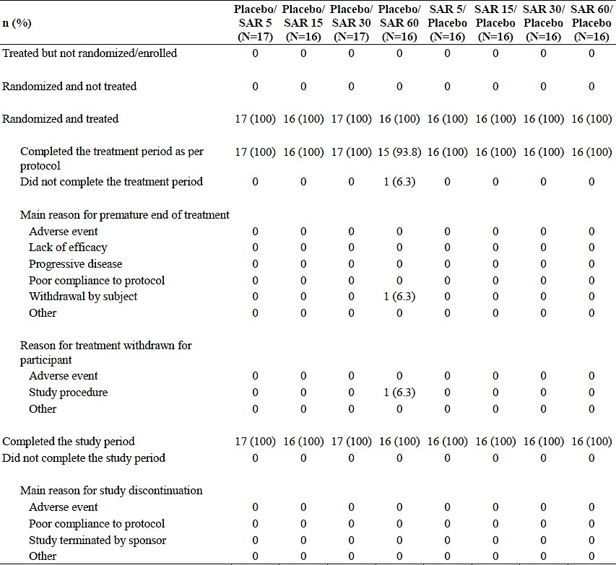

Figure 9: Participant disposition
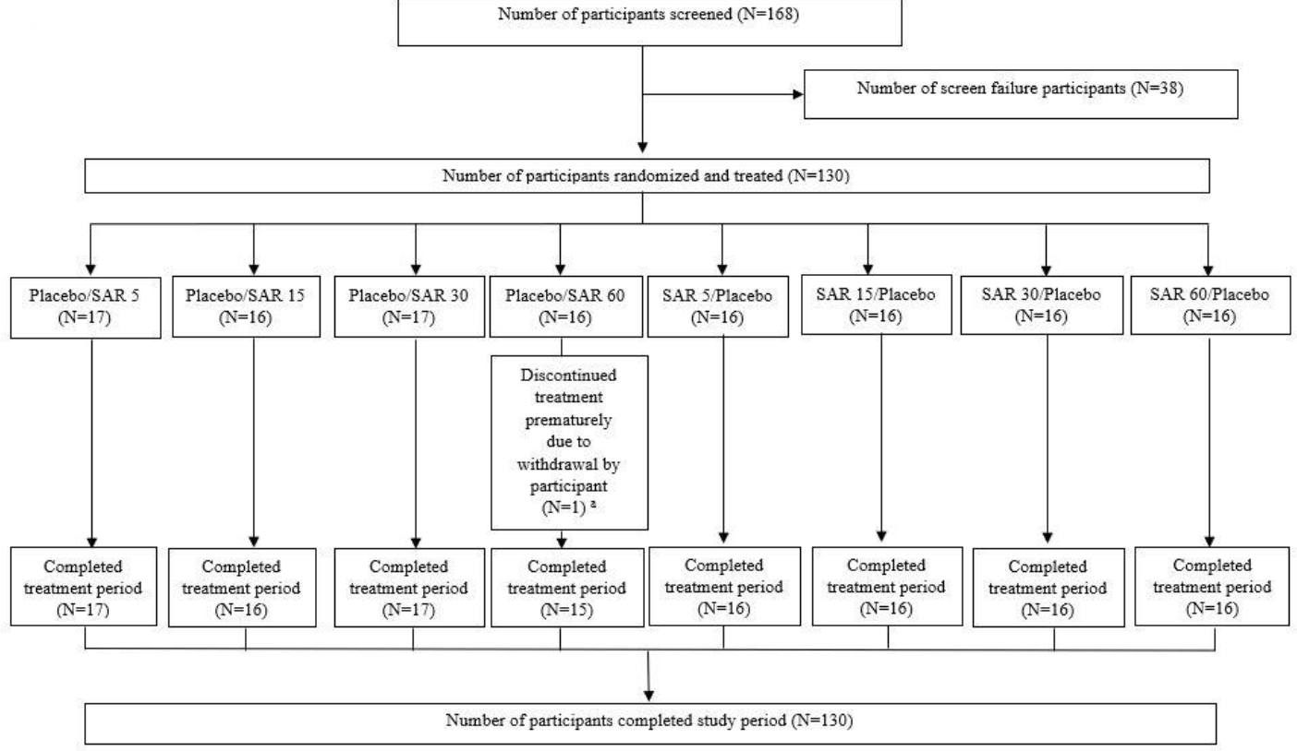
a One participant permanently discontinued treatment after Week 12 for declining to use a highly effective method of contraception.

Baseline data
Table 19: Demographics at baseline - randomised population
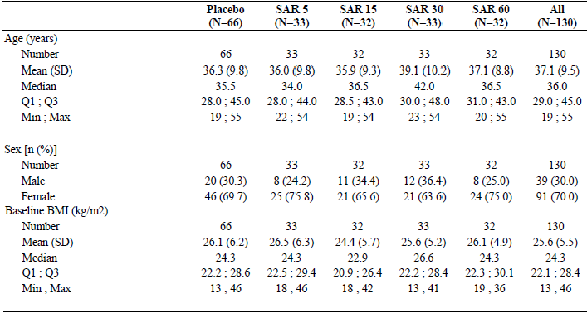
n: number of participants in the category
N: number of participants randomized
Placebo: the Cohort 2 4-week placebo period
Table 20: Disease characteristics at baseline - randomised population
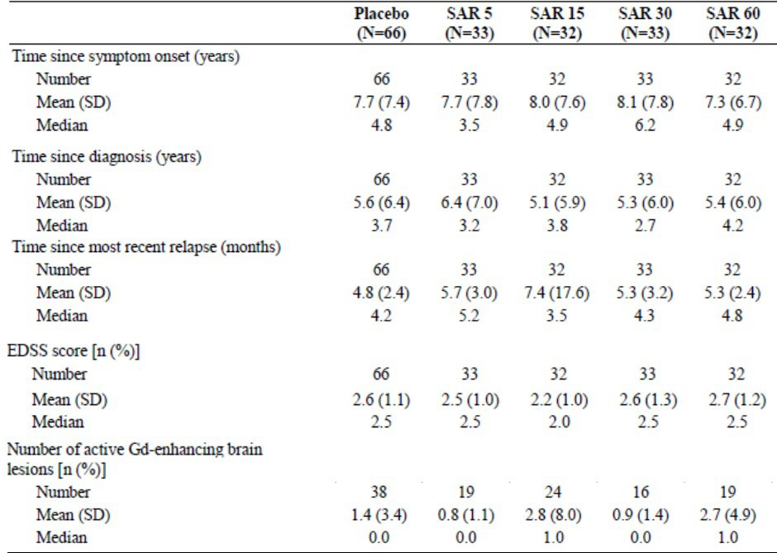
n: number of participants in the category
N: number of participants randomized
Placebo: the Cohort 2 4-week placebo period
The number of active Gd-enhancing brain lesions is obtained from an MRI scan in the past 6 months and prior to screening

Results for the primary efficacy outcome
The Primary Endpoint was the Number of new Gd-enhancing T1-hyperintense lesions at the end of 12 weeks of tolebrutinib treatment as detected by brain MRI.
Table 21: 1 New Gd-enhancing T1-hyperintense lesion outcomes after 12 weeks of treatment - mITT population
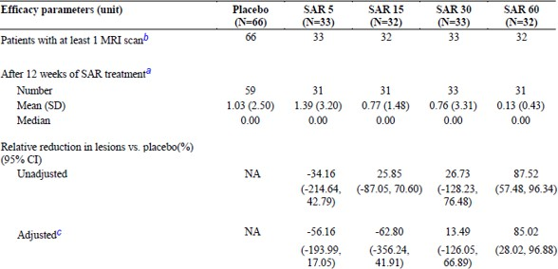
ª after 12 weeks of treatment stands for Week 12 for Cohort 1 for SAR 442168 treatment, Week 16 for Cohort 2 for SAR 442168 treatment, and Week 4 for Cohort 2 placebo.
^{b} The MRI assessment was excluded from the analyses if the participant was receiving systemic corticosteroids within the 30 days prior to the MRI assessment date.
^{c} Negative binomial model adjusting for baseline gadolinium-enhancing T1-hyperintense lesion activity (presence/absence).
Subgroup analyses were not reported (Efficacy data: there are no additional data).

Results for other efficacy outcomes
Table 22: New and enlarging T2 lesion outcomes after 12 weeks of treatment - mITT population
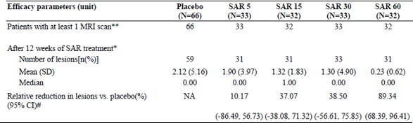
* after 12 weeks of treatment stands for Week 12 for Cohort 1 for SAR 442168 treatment, Week 16 for Cohort 2 for SAR 442168 treatment, and Week 4 for Cohort 2 placebo.
** The MRI assessment was excluded from the analyses if the participant was receiving systemic corticosteroids within the 30 days prior to the MRI assessment date.
# Negative binomial model without adjusting for baseline T2 lesion activity as all participants had at least one T2 lesion at baseline p-value without multiplicity adjustment.
Table 23: Total Gd enhancing T1 hyperintense lesion outcomes after 12 weeks of treatment - mITT population
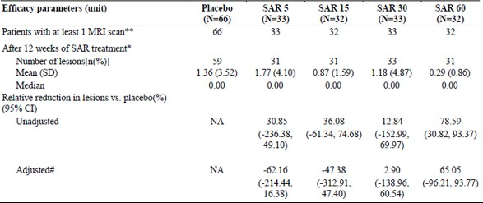
* after 12 weeks of treatment stands for Week 12 for Cohort 1 for SAR 442168 treatment, Week 16 for Cohort 2 for SAR 442168 and Week 4 for Cohort 2 placebo.
** The MRI assessment was excluded from the analyses if the participant was receiving systemic corticosteroids within the 30 days prior to the MRI assessment date.
# Negative binomial model without adjusting for baseline T2 lesion activity as all participants had at least one T2 lesion at baseline p-value without multiplicity adjustment.

Study LTS16004
Phase 2b long-term extension safety and efficacy study of tolebrutinib in participants with relapsing multiple sclerosis.

Design
The study consisted of 2 parts:
Part A: Double-blind period of continued study intervention with the respective tolebrutinib dose regimen administered in the DRI15928 study until (2 March 2020) selection of the Phase 3 dose regimen (60mg once daily tolebrutinib with a meal).
Part B: Open-label period of a single-group treatment with the Phase 3 dose regimen, 60mg tolebrutinib once daily with a meal.

Objective
To determine the long-term safety and tolerability of SAR442168 in RMS participants.

Results

Number of new gadolinium (Gd)-enhancing T1-hyperintense lesions by brain MRI
The observed mean (SD) number of new Gd-enhancing T1-hyperintense lesions at Week 240 (N=86) was 0.26 (0.60) in the overall mITT population.

Number of new or enlarging T2 lesions
The observed mean (SD) of new or enlarging T2 lesions per month at Week 240 (N = 91) was 0.27 (0.45) in the overall mITT population.

Total number of Gd-enhancing T1-hyperintense lesions
The observed mean (SD) total number of Gd-enhancing T1 hyperintense lesions at Week 240 (N=86) was 0.27 (0.60) in the overall mITT population

Number of relapses (annualized relapse rate [ARR]) during the study period
The adjusted ARR (95% CI) was 0.26 (0.15, 0.46) in the 5/60mg group, 0.24 (0.14, 0.42) in the 15/60mg group, 0.28 (0.18, 0.43) in the 30/60mg group, and 0.23 (0.13, 0.38) in the 60/60mg group.
The ARR (95% CI) during treatment with once daily 60mg tolebrutinib (N=124) was 0.24 (0.18, 0.31).

Change in Expanded Disability Status Scale (EDSS) score from baseline over time
The mean (SD) change from baseline in EDSS score at Week 240 (N = 91) was 0.21 (0.83) in the overall mITT population.

Safety

Studies that assessed safety as the sole primary outcome

Study LTS16004

Study design, objectives, locations and dates
A phase 2b long-term follow-up study to assess the safety and efficacy of tolebrutinib in participants who completed treatment in the previous DRI15928 study. Formulation 1A1 (part A), formulation 1B2 (part B).

Primary objective
To determine the long-term safety and tolerability of tolebrutinib in RMS participants.

Results for the primary safety outcome
Table 26: Overview of adverse event profile: Treatment Emergent Adverse Events (TEAEs) – safety population
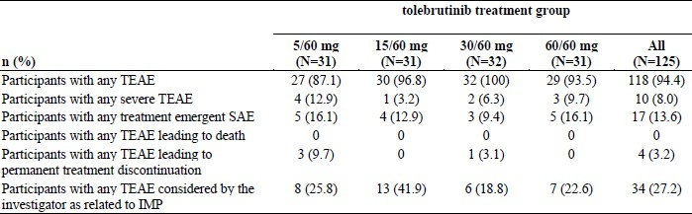
IMP = investigational medicinal product
n (%) = number and percentage of participants with at least one TEAE; N = number of participants in the treatment group
Table 27: Number (%) of participants with TEAEs that occurred in at least 5% of all participants by primary System Organ Class (SOC) and Preferred Term (PT) – safety population
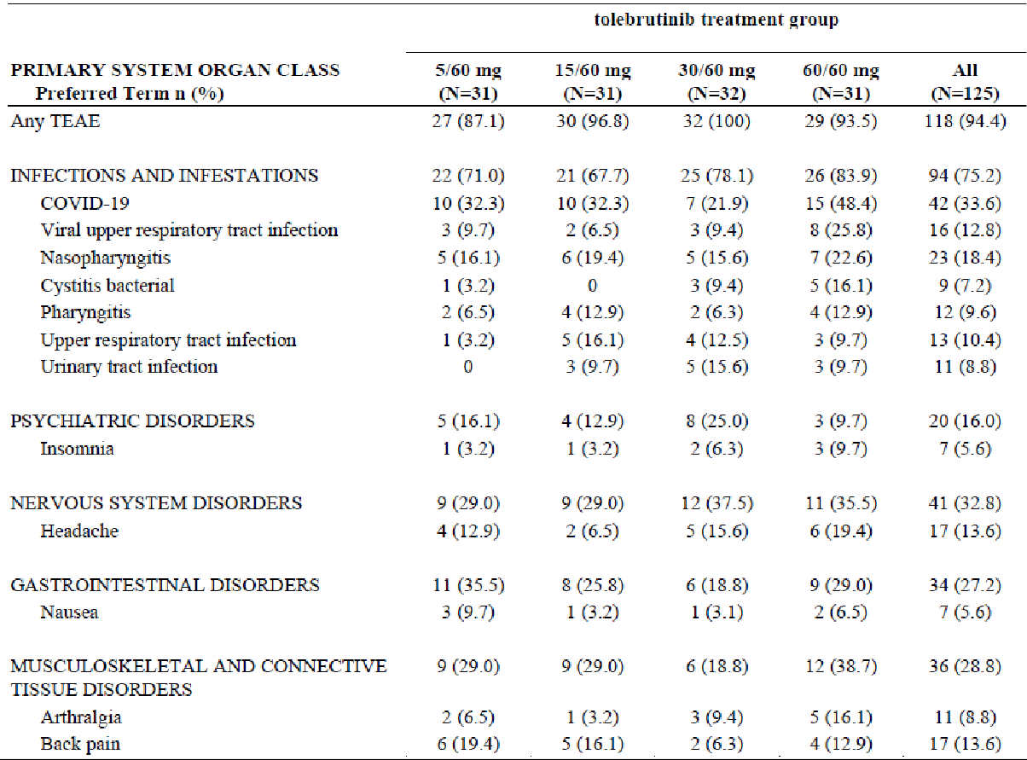
n (%) = number and percentage of participants with at least one TEAE; N = number of participants in the treatment group
Table sorted by SOC internationally agreed order and decreasing frequency of PT in the 60/60mg tolebrutinib treatment group within each SOC.
Serious Adverse Events (SAEs) were reported in 17 (13.6%) participants. Most of the SAE PTs were reported in single participants, except for Multiple sclerosis relapse (4 [3.2%] participants in the overall safety population, 1 in each dose group), Ovarian haemorrhage (2 [1.6%] participants in total, both in the 5/60mg group) and COVID-19 pneumonia (2 [1.6%] participants in total, 1 each in the 5/60 and 30/60mg groups).
Of the 17 participants with at least 1 treatment-emergent SAE, 5 (4.0%) participants experienced at least 1 SAE during Part A, including 0 in the 5mg group, 2 (6.5%) in the 15mg group, 1 (3.1%) in the 30mg group, and 2 (6.5%) in the 60mg group.
Of all treatment-emergent SAEs reported by at least 1 participant, PTs of Anxiety in 1 participant in the 5/60mg group and Multiple Sclerosis relapse in 1 participant in the 5/60mg group were considered by the Investigator as related to the Investigational Medicinal Product (IMP).
TEAEs leading to permanent study intervention discontinuation were reported in 4 (3.2%) participants in the overall safety population, including PTs of Headache, Trichorrhexis, and Pregnancy, each reported in 1 participant, and 1 participant with PTs of ALT increased and AST increased. All TEAEs leading to permanent study intervention discontinuation occurred during Part B at the 60mg dose regimen.
Treatment-emergent hepatic Adverse Events of Special Interest (AESI) were reported in 7 participants (1 Alanine aminotransferase increased in the tolebrutinib 5/60mg group, 1 Alanine aminotransferase increased in the tolebrutinib 15/60mg group, 4 in the tolebrutinib 30/60mg group [Cholelithiasis in 1 participant, Alanine aminotransferase increased in 2 participants, and Transaminases increased in 1 participant], and 1 Alanine aminotransferase increased in the tolebrutinib 60/60mg group. None of the events were severe in intensity. Of those, 1 participant with Alanine aminotransferase increased permanently discontinued the study intervention.
All participants recovered from the events. Three events were considered related to the IMP: 2 Alanine aminotransferase increased and 1 Transaminases increased.
One participant in the tolebrutinib 30/60mg group had an ALT >3 × ULN and AST >3 × ULN with related AEs of Alanine aminotransferase increased and Aspartate aminotransferase increased, which led to permanent study intervention discontinuation. The participant recovered from the event after the study intervention discontinuation.
Of 2 pregnancies in female participants, the outcome was live birth for 1 participant and induced abortion for 1.
There were live births with normal delivery resulting in a healthy baby for 2 participant partners.
The most frequent abnormalities in hematology parameters were haemoglobin decrease from baseline ≥20 g/L (29 of 125 [23.2%] participants in total), monocytes >0.7 × 109/L (46 of 125 [36.8%]), and basophils >0.1 × 109/L (54 of 125 [43.2%]).

Pooled safety data
Pool A is the pool of safety data from the 2 Phase 3 studies in RMS, EFC16033 and EFC16034. It had 933 on 60mg tolebrutinib QD versus 939 on14mg teriflunomide QD for an average of 2.3y per participant.
Pool B is a safety pool including participants with MS (nrSPMS [Study EFC16645] and RMS [Studies EFC16033, EFC16034, DRI15928, and LTS16004]) exposed to tolebrutinib 60mg QD. Data from Phase 2 Study DRI15928 and Study LTS16004 Part A with lower tolebrutinib doses (i.e., 5, 15, or 30mg), not intended to be marketed, were not included.

Patient exposure
Table 28: 60mg tolebrutinib exposed safety pool (pool B)
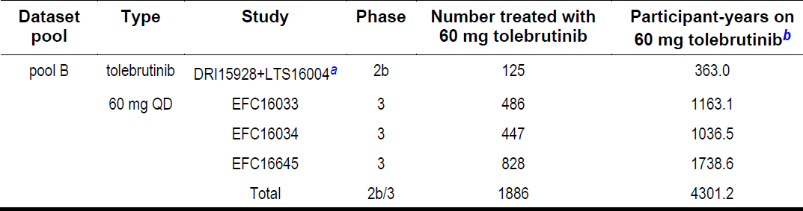
a Participants receiving tolebrutinib 60mg in DRI15928 and those switching from a lower dose (5, 15, or 30mg) to 60mg in Part B LTS16004.
b exposure calculated as last administration of tolebrutinib 60mg-first administration of tolebrutinib 60mg + 1, including any gaps between DRI15928 and LTS16004 and OL treatment in EFC16645.
The cumulative exposure to study intervention in the pool A safety population (EFC16033 + EFC16034) was 2199.59 PY in the tolebrutinib group and 2171.10 PY in the teriflunomide group. Of the 933 participants exposed to tolebrutinib 60mg QD and the 939 participants exposed to teriflunomide 14mg in pool A, 89.5% and 88.2% were exposed for at least 1 year (48 weeks) and 80.8% and 78.4% for at least 2 years (96 weeks) to tolebrutinib 60mg QD and teriflunomide 14mg, respectively.
In pool B safety population (EFC16645 + EFC16033 + EFC16034), 1886 participants were exposed to tolebrutinib 60mg. Of those, 87.0% were exposed for at least 1 year (48 weeks) and 75.6% for at least 2 years (96 weeks). The cumulative exposure to tolebrutinib 60mg QD was 4301.19 PY.
During clinical pharmacology studies 278 healthy participants were exposed to tolebrutinib, 6 at 5mg, 24 at 7.5mg, 14 at 15mg, 29 at 30mg, 155 at 60mg, 8 at 90mg, 35 at 120mg, 9 at 180mg, 17 at 240mg and 8 at 300mg. In addition, 7 participants with mild hepatic impairment (POP16398) and 12 participants with severe renal impairment (POP16399) were exposed to tolebrutinib 60mg.

Adverse events

All adverse events (irrespective of relationship to study treatment)

Study EFC16645
A ≥ 5% difference was observed for:
- Infections and infestations (409 [54.4%] in the tolebrutinib group versus 185 [49.3%] in the placebo group; difference of 5.1%), mainly driven by Coronavirus infections (27.0% in the tolebrutinib group and 23.5% in the placebo group); and the HLT Upper respiratory tract infections (16.9% and 14.1%).
- Skin and subcutaneous tissue disorders (125 [16.6%] in the tolebrutinib group versus 36 [9.6%] in the placebo group), with the imbalance mainly seen in the PT of petechiae (20 [2.7%] participants in the tolebrutinib group versus 1 [0.3%] participant in the placebo).
- In the System Organ Class (SOC) Investigations the difference was close to 5% (108 [14.4%] participants in the tolebrutinib group versus 39 [9.6%] participants in the placebo group) and mainly driven by the PT of alanine aminotransferase increased (33 [4.4%] participants in the tolebrutinib group and 6 [1.6%] participants in the placebo group).
Table 29: Overview of adverse event profile: Adverse Events (AEs) during EFC16645 DB period - safety population
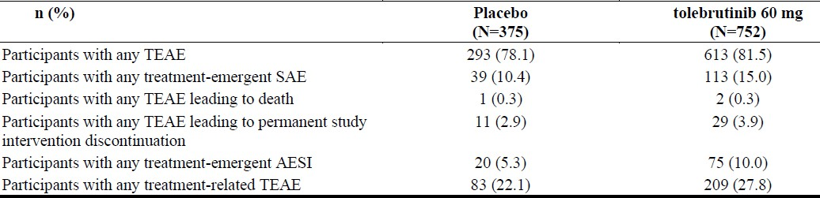
AESI: Adverse event of special interest; n (%) = number and percentage of participants with at least one TEAE Source: Table 18

Pool A
The most frequently (≥ 10% in any study intervention group) reported Treatment Emergent Adverse Events (TEAEs) by Preferred Term (PT) were: COVID-19 (24.1% in the tolebrutinib group and 26.8% in the teriflunomide group), nasopharyngitis (12.8% and 11.2%), alopecia (7.8% and 15.5%) and headache (12.5% and 10.4%).
A ≥ 5% difference between study intervention groups was observed for the SOC Gastrointestinal disorders for which TEAEs were 22.3% in the tolebrutinib group versus 27.8% in the teriflunomide group. The difference being mainly driven by PT of diarrhoea (4.7% versus 9.1%), a common adverse event of teriflunomide.
Table 30: Overview of adverse event profile - pool A (EFC16033 + EFC16034) safety population
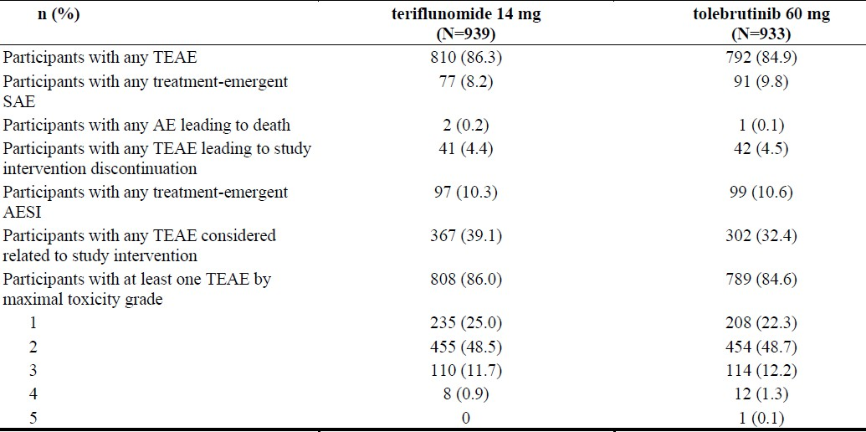
AESI: Adverse event of special interest, n (%) = number and percentage of participants with at least one TEAE Source: Table 20

Treatment related adverse events (adverse drug reactions)

Study EFC16645
- The most frequently (≥1%) reported related TEAEs by PT in the tolebrutinib group by decreasing frequency were alanine aminotransferase increased, urinary tract infection, headache, COVID-19, petechiae, diarrhoea, alopecia, nausea, and rash.
- The most frequently (≥1%) reported related TEAEs by PT in the placebo group by decreasing frequency were: urinary tract infection, alanine aminotransferase increased, COVID-19, diarrhoea, neutropenia, accidental overdose, and herpes zoster.
The number of participants with treatment-emergent SAEs assessed as related to the study intervention (1.9% in the tolebrutinib group and 1.3% in the placebo group) were mainly in SOC Infections and infestations, and with individual PTs observed once or twice by study intervention group.
Among the participants with SAEs assessed as related to the study intervention by the Investigator, there were:
- 11 participants (8 in the tolebrutinib group and 3 in the placebo group) with SAEs in the SOC Infections and infestations.
- 3 participants (2 in the tolebrutinib group and 1 in the placebo group) with SAEs in the SOC Hepatobiliary disorders.
- In the tolebrutinib group:
  - 1 participant experienced an SAE of hepatic failure leading to death.
  - 1 participant developed drug-induced liver injury (biochemical Hy’s law with peak on Day 57).
- In addition, in the tolebrutinib group, there was 1 participant with Grade 4 alanine transaminase increased with peak on Day 33.
- In the SOC Cardiac disorders, 1 participant in the tolebrutinib group with atrial fibrillation.
- In the SOC Nervous system disorders, 1 participant with ischaemic stroke in the tolebrutinib group.
In Pool A:
- The most frequently (≥ 1%) reported related TEAEs by PT in the tolebrutinib group by decreasing frequency were: alopecia, petechiae, alanine aminotransferase increased, headache, heavy menstrual bleeding, neutropenia, nasopharyngitis, increased tendency to bruise, upper respiratory tract infection, diarrhoea, nausea, ecchymosis, transaminases increased, COVID-19, and urinary tract infection.
- The most frequently (≥ 1%) reported related TEAEs by PT in the teriflunomide group by decreasing frequency were: alopecia, neutropenia, alanine aminotransferase increased, diarrhoea, headache, upper respiratory tract infection, neutrophil count decreased, leukopenia, aspartate aminotransferase increased, COVID-19, nasopharyngitis, nausea, hypertension, fatigue, and white blood cell count decreased.
SAEs that were assessed as related to the study intervention were mainly in SOC Infections and infestations, and most individual PTs were observed once or twice by study intervention group (12 participants in the tolebrutinib group and 9 participants in the teriflunomide group.
Among the participants with SAEs assessed as related to the study there were:
- 7 participants (4 in the tolebrutinib group and 3 in the teriflunomide group) with SAEs in the SOC Infections and infestations. In the tolebrutinib group, the PTs were: COVID-19, COVID-19 pneumonia, pyelonephritis acute and bronchitis.
- 3 participants (2 in the tolebrutinib group and 1 in the teriflunomide group) with SAEs in the SOC Hepatobiliary disorders. In the tolebrutinib group, there were 2 participants who had drug-induced liver injury (Hy’s law confirmed by HAC) before Week 8, that resolved after permanent study intervention discontinuation
- 3 participants (2 in the tolebrutinib group and 1 in the teriflunomide group) with SAEs in the SOC Investigations. In the tolebrutinib group the PTs were: transaminases increased and alanine aminotransferase increased.

Deaths
In Study EFC16645, on tolebrutinib one death was reported in a participant who developed hepatic failure and died due to complications of a liver transplant. There was also one death due to assisted suicide, deemed not related. On placebo there was a death from traumatic brain injury.
In Pool A, there were 3 deaths (2 in the teriflunomide group, and one in the tolebrutinib group). One death in each group was due to gunshot injury (self-inflicted in the teriflunomide group and due to homicide in the tolebrutinib group). The other death in the teriflunomide group was due to brain oedema following a subarachnoid haemorrhage.

Ongoing studies
In Study EFC16035 for PPMS, 5 reports of death were assessed as not related to the study intervention. In LTS17043 causal association with tolebrutinib cannot be ruled out in 1 participant with sepsis due to pneumonia with fatal outcome.
In Study EFC17262 (in generalised myasthenia gravis), 1 death was assessed as not related to the study intervention.

Serious adverse events
In Study EFC16645 DB period, the number (%) of participants with treatment-emergent SAE was 113 [15.0%] in the tolebrutinib group versus 39 [10.4%] in the placebo group. Individual PTs had a frequency < 1% (most of the PTs were observed once or twice), except COVID-19 pneumonia (8 [1.1%] in the tolebrutinib group and 2 [0.5%] in the placebo group) and multiple sclerosis relapse (8 [1.1%] in the tolebrutinib group and 0 in the placebo group).
In Pool A, the percentage of participants with treatment-emergent SAEs was 9.8% in the tolebrutinib group and 8.2% in the teriflunomide group. All individual PTs had a frequency < 1% and most were reported once or twice.
The SOCs with the highest proportion of participants with treatment-emergent SAEs (≥1% of participants in either study intervention group) by decreasing frequency in the tolebrutinib group were:
- Infections and infestations (23 [2.5%] in the tolebrutinib group and 21 [2.2%] in the teriflunomide group).
- Neoplasms benign, malignant, and unspecified (incl cysts and polyps) (14 [1.5%] in the tolebrutinib group and 8 [0.9%] in the teriflunomide group).
- Injury, poisoning, and procedural complications (15 [1.6%] in the tolebrutinib group and 8 [0.9%] in the teriflunomide group).
- Nervous system disorders (9 [1.0%] in the tolebrutinib group and 12 [1.3%] in the teriflunomide group).
There were 6 (0.6%) participants with SAEs in the SOC Hepatobiliary disorders in the tolebrutinib group compared to 3 (0.3%) in the teriflunomide group, including 2 participants with drug-induced liver injury in the tolebrutinib group versus zero in the teriflunomide group. In the SOC Psychiatric disorders there were 6 (0.6%) participants in the tolebrutinib group versus 3 (0.3%) in the teriflunomide group, with PT of suicidal attempt in 4 (0.4%) participants in the tolebrutinib group versus 0 in the teriflunomide group.

Discontinuations due to adverse events
In Study EFC16645, the permanent study discontinuation rate due to TEAEs in the Double-Blind (DB) period was 3.9% in the tolebrutinib group versus 2.9% in the placebo group.
Among participants receiving open label tolebrutinib, there was 1 participant in the placebo/tolebrutinib group and none in the tolebrutinib/tolebrutinib group with TEAE leading to permanent study intervention discontinuation (PT purpura).
In Pool A, the permanent study intervention discontinuation rate was 4.5% in the tolebrutinib group and 4.4% in the teriflunomide group.
The most frequent PTs that led to permanent study intervention discontinuation were alanine aminotransferase increased, neutropenia, and pregnancy, as per protocol temporary/definitive stopping rules. The frequency of these PTs was similar between study intervention group except for neutropenia (higher frequency in the teriflunomide group and Alanine aminotransferase increased higher in the tolebrutinib group). Other individual PTs were reported once or twice.
Three participants in the tolebrutinib group and zero in the teriflunomide group were in the PT of suicide attempt.

Liver function and liver toxicity
There were no significant liver injury findings in preclinical studies or in the early clinical development of tolebrutinib including the phase 2 clinical study. However, drug induced liver injury was identified as a risk during the Phase 3 tolebrutinib program.
The liver injury risk is time delimited with the greatest risk within the first 12 weeks of tolebrutinib exposure. The cases were generally mild and mostly reversible with study intervention discontinuation.
The Exposure Response Report CTS0154 found the Exposure-Response relationship does not show a clear trend between hepatotoxicity and exposure, particularly at higher exposure levels. The hepatotoxicity was equally distributed among each quartile suggesting an underlying idiosyncratic mechanism.
In Study EFC16645, the percentage of participants with treatment-emergent AESI of increase of ALT >3 × ULN was 3.6% in the tolebrutinib group compared to 1.3% in the placebo group.
In pool A the percentage of participants with treatment-emergent AESI of increase of ALT > 3 × ULN was 5.5% in the tolebrutinib group and 5.2% in the teriflunomide group.
The potentially clinically significant abnormality of ALT > 3 × ULN was 4.0% in the tolebrutinib group and 1.6% in the placebo group in Study EFC16645.
It was 5.6% in the tolebrutinib group and 6.3% in the teriflunomide group in pool A.
In most participants the increase in ALT > 3 × ULN did not lead to permanent study intervention discontinuation and all but 1 case resolved.

Hy’s law
Eight participants met criteria for biochemical Hy’s law from EFC16645 and pool A (7 in the tolebrutinib group, 1 in the teriflunomide group, and zero in the placebo group).
In addition, there were 4 participants with biochemical Hy’s law in completed Phase 2 Study LTS16004 or ongoing Phase 3 studies as of 11 September 2024.
In both Study EFC16645 and Pool A, in 4 out of 7 participants in the tolebrutinib group with concurrent elevation of ALT >3 × ULN and TBILI >2 × ULN, no alternative aetiology was found.
One of the 4 participants developed liver failure requiring a liver transplant and died due to postoperative complications.
In the remaining 3 participants, the events spontaneously resolved without sequelae after permanent study intervention discontinuation.

Rechallenge
Of the participants with liver events of interest, 15 had a rechallenge in which study intervention was restarted following event resolution (9 tolebrutinib, 6 teriflunomide). There were 2 positive rechallenges in the Possibly/Probably related tolebrutinib group.

Infections and infestations
The incidence rate of treatment-emergent serious and severe infection was higher in the tolebrutinib group as compared to the placebo group in Study EFC16645 (39 [5.2%] and 39 [5.2%] in the tolebrutinib group and 13 [3.5%] and 11 [2.9%] in the placebo group, respectively).
In Study EFC16645, there were no participants with TEAEs of infection with fatal outcome. The most frequently reported PTs for treatment-emergent SAEs were COVID-19 pneumonia and COVID-19.
Eleven participants (8 in the tolebrutinib group and 3 in the placebo group) had SAEs related to the study intervention.
The incidence rate of treatment-emergent serious and severe infection in Pool A was 2.5% and 2.3% of participants, respectively in the tolebrutinib group and 2.2% and 1.9%, respectively in the teriflunomide group.
Seven participants (4 in the tolebrutinib group and 3 in the teriflunomide group) as had SAEs related to the study intervention.
In ongoing studies, there was 1 participant with TEAE in the SOC Infections and infestation leading to death.
In studies in other participant population (gMG, Study EFC17262), there was 1 participant with an SAE of COVID19 pneumonia leading to death in the tolebrutinib group as per sponsor’s assessment, the causal relationship cannot be ruled out.

Suicidal ideation and behaviour
Suicidal ideation based on participants who were administered Columbia-Suicide Severity Rating Scale (C-SSRS):
- In Study EFC16645, 33 out of 718 (4.6%) participants receiving tolebrutinib and 15 of 364 (4.1%) participants receiving placebo had suicidal ideation during the treatment emergent period.
- In pool A, 28 out of 909 (3.1%) participants receiving tolebrutinib and 27 out of 907 (3.0%) receiving teriflunomide had suicidal ideation during the treatment-emergent period.
Suicidal behaviour based on AE grouping of suicidal behaviour and C-SSRS:
- In Study EFC16645, 3 out of 752 (0.4%) participants receiving tolebrutinib and 0 out of 375 (0.0%) participants receiving placebo had suicidal behaviour during the treatment emergent period.
- In pool A, 4 out of 933 (0.4%) participants receiving tolebrutinib and 3 out of 939 (0.3%) participants in the teriflunomide group experienced suicidal behaviour during the treatment emergent period.
In ongoing studies, there was 1 completed suicide and 3 attempted suicides.
No significant difference was observed in the incidence rates for suicide attempts among participants with MS exposed to tolebrutinib 60mg compared to patients with MS in a Swedish population.

Neoplasms
In Study EFC16645 malignancies observed were 12 (1.6%) participants in the tolebrutinib group and 1 [0.3%] participants in the placebo group.
In pool A, the incidence of malignancies was 8 (0.9%) participants in the tolebrutinib group and 7 (0.7%) participants in the teriflunomide group.
In both Study EFC16645 and pool A, the time to onset of malignancy ranged from 15 days to over 2 years after starting study intervention which is lower than the known latency periods for their development and detection.
In both Study EFC16645 and pool A, the number of malignancies observed in at least 2 participants in the tolebrutinib group included female breast cancer (7 participants), skin cancer (3 participants), bladder cancer (2 participants), and kidney cancer (2 participants), with incidence rates of 1.63, 0.70, 0.46, and 0.46, per 1000 patient-years respectively. The remaining malignancies were single occurrences.

Recommendation
The clinical evaluator recommends approval of Cenrifki, subject to a satisfactory PI, for the following indication.
Cenrifki is indicated in adults:
- for the treatment of non-relapsing secondary progressive multiple sclerosis (nrSPMS)
- to slow disability accumulation in the absence of relapse activity in adults with non-relapsing secondary progressive multiple sclerosis (nrSPMS).

Risk management plan
The summary of safety concerns and their associated risk monitoring and mitigation strategies are summarised in Table 3.
Table 3: Summary of safety concerns
Summary of safety concerns |  | Pharmacovigilance |  | Risk minimisation
 |  | Routine | Additional | Routine | Additional
Important identified risks | Drug-Induced Liver Injury (DILI) | ✓* | ✓†‡ | ✓ | ✓ǁ
Important identified risks | Serious infections | ✓* | ✓† | ✓ | –
Important potential risks | Atrial Arrhythmias (Atrial Fibrillation and Atrial Flutter) | ✓* | ✓† | – | –
Important potential risks | Use during pregnancy and breastfeeding | ✓* | ✓† | ✓ | –
Important potential risks | Long Term Safety | ✓ | ✓† | – | –
* Specific Follow up questionnaires
† LTS17043 - A Study to Investigate Long-term Safety and Tolerability of Tolebrutinib in Participants with Multiple Sclerosis.
‡ PASS ToleAdhere - Adherence to Liver Function Monitoring.
ǁ Prescriber Guide, Patient Guide, Risk Awareness Dialogue Form
The summary of safety concerns in the ASA aligns with the draft EU-RMP. The summary of safety concerns is acceptable from an RMP perspective, subject to the resolution of any recommendations from the clinical and non-clinical evaluations.
The sponsor has proposed routine pharmacovigilance for all safety concerns. This includes specific adverse reaction follow up questionnaires for all risks except long term safety. Additional pharmacovigilance includes a clinical trial LTS17043 and a non-interventional post-authorisation safety study (ToleAdhere). The pharmacovigilance plan in the ASA aligns with the EU-RMP and is acceptable.
Routine and additional risk minimisation activities have been proposed. Additional risk minimisation activities include Prescriber Guide, Patient Guide and Risk Awareness Dialogue Form. The risk minimisation plan is acceptable from an RMP perspective.
The TGA may request an updated RMP at any stage of a product's lifecycle, during both the pre-approval and post-approval phases. Further information regarding the TGA’s risk management approach can be found in risk management plans for medicines and biologicals and the TGA's risk management approach. Information on the Australia-specific annex (ASA) can be found on the TGA website.

Risk-benefit analysis

Delegate’s considerations

Efficacy

Non-relapsing Secondary Progressive Multiple Sclerosis

Proposed indication - to slow disability accumulation independent of relapse activity
Study EFC16645 achieved its primary objective determining the efficacy of tolebrutinib compared to placebo in delaying disability progression in non-relapsing Secondary Progressive MS (nrSPMS) with the primary endpoint the time to onset of 6-month confirmed disability progression. Tolebrutinib compared with placebo, reduced the risk by 31% with an HR of 0.693 (95% CI: 0.546 to 0.880, p = 0.0026).
The duration of the study was not predetermined but depended on the accumulation of approximately 288 events of 6-month CDP before the study end. However, the KM analysis does show continued separation of placebo vs. tolebrutinib as duration of treatment got longer.
The proposed Indication - to slow disability accumulation independent of relapse activity is thus supported for patients with non-relapsing Secondary Progressive MS (nrSPMS).

Proposed indication - for the treatment of non-relapsing secondary progressive multiple sclerosis (nrSPMS)
In Study EFC16645: After the primary analysis, in the subsequent hierarchical analysis, the analysis of the Time to onset of 3-month CDP as assessed by the EDSS score was significant. The next analysis produced an estimated average number of new and/or enlarging T2-hyperintense lesions per year (95% CI) of 2.948 (2.239, 3.880) for those on placebo and 1.835 (1.441, 2.336) for those on tolebrutinib Relative risk (95% CI) 0.622 (0.432, 0.897) p-value 0.0110. The subsequent secondary hierarchical results were not significant.
Thus, approving this treatment Indication relies on accepting MRI results as an indicator of disease treatment.
Different MRI-derived parameters have been related to clinical activity, e.g. gadolinium-enhancing lesions or new/enlarging T2 lesions have been related to relapses.

Relapsing Multiple Sclerosis
The proposed Indication to slow disability accumulation independent of relapse activity does not specifically exclude Relapsing MS. Accordingly that part of the submission has been evaluated for efficacy – not just safety.
The two similar studies both separately and combined failed to meet the primary ARR efficacy endpoint, the adjusted ARR did not differ between tolebrutinib and teriflunomide.
In the key secondary endpoint – the time to onset of 6-Month Confirmed Disability Worsening (6M-CDW) which was second in the hierarchical analysis of both trials, the added post hoc analysis of Progression independent of relapse activity failed to show a statistically significant difference between tolebrutinib and teriflunomide.

Safety

Pool A (EFC16033 + EFC16034)
Exposure was adequate for safety evaluation.
Discontinuations due to AEs were 4.4% with teriflunomide and 4.5% with tolebrutinib.
The only discontinuations due to AEs occurring in ≥ 1% were Neutropenia 9 (1.0%) with teriflunomide vs. 1 (0.1%) with tolebrutinib and Alanine aminotransferase increased 8 (0.9%) with teriflunomide and 13 (1.4%) with tolebrutinib.

Hepatic events and risk minimisation
A major concern with existing registered Bruton’s tyrosine kinase inhibitors is their causing hepatic impairment.

Pool A (EFC16033 + EFC16034)
- AEs that appeared more in tolebrutinib group:
  - any grade 3 or above (increased ALT>3 × ULN) TEAE 17 teriflunomide (1.8%) vs. tolebrutinib 25 (2.7)
  - any treatment related SAE 3 teriflunomide (0.3%) vs. 6 tolebrutinib (0.6%).
- Drug-induced liver injury 0 vs. 3(0.3%).
When reviewed by the hepatic assessment committee liver events of interest in pool A (EFC16033 + EFC16034):
- For teriflunomide, 5 events were possibly drug-related, while for tolebrutinib, 9 were possibly drug-related and another 2 were probably drug-related.
During Phase 3 studies, liver related adverse events occurred indicating that liver injury is an identified risk for tolebrutinib. Five participants had confirmed Hy’s law. One participant required a liver transplant and had a fatal outcome due to post operative complications. It is important to note that this case occurred prior to implementation of weekly liver monitoring for the first 12 weeks of study intervention initiation. All other participants with confirmed Hy’s law also occurred before weekly liver monitoring and recovered following study intervention discontinuation. The onset of these events was within the first 3 months following study intervention initiation. There was one case of confirmed Hy’s Law in a tolebrutinib participant since the start of weekly liver monitoring. This case was confounded among others, by Chinese hepatotoxic herbal medicine exposure. The sponsor conducted temporal analyses of liver events and found that the risk is time-delimited with a greater risk in the first 12 weeks following tolebrutinib initiation.

Atrial fibrillation and atrial flutter
Four participants in the tolebrutinib group, no participants in either teriflunomide or placebo groups.
The frequency in the tolebrutinib 60mg exposed participants (0.1 participant per 100 PY) seems to be lower than that in the general population (0.4 to 1.0%), given the population treated (patients with MS have approximately 2 times greater prevalence of comorbid cardiac arrhythmias).

Proposed action
Cenrifki has demonstrated signals of clinical benefit in non-relapsing Secondary Progressive Multiple Sclerosis (nrSPMS), including potential effects on slowing disability accumulation independent of relapse activity. However, interpretation of these benefits is limited by uncertainties in subgroup analyses and the absence of robust historical MRI data.
Major safety considerations include hepatic injury and atrial arrhythmias. Liver-related adverse events observed in Phase 3 studies confirm hepatotoxicity as an identified risk for tolebrutinib, requiring close monitoring. For atrial arrhythmias, the incidence in participants exposed to tolebrutinib 60 mg (0.1 per 100 PY) appears lower than general population estimates (0.4–1.0%), noting that MS patients typically have a higher baseline risk of cardiac arrhythmias.
Given the current evidence and identified safety concerns, the overall benefit–risk profile for the latest negotiated indication remains uncertain and warrants further deliberation by the Advisory Committee on Medicines (ACM).

Delegate’s recommendation
The Delegate considers that the current evidence does not clearly support registration of Cenrifki (tolebrutinib). The Delegate recommends that this application be referred to the Advisory Committee on Medicines (ACM) for further deliberation on whether any clinically identifiable population, risk mitigation strategy, or additional data could justify approval.

Independent expert advice
The Delegate received the following independent expert advice.

Advisory Committee on Medicines considerations
The Advisory Committee on Medicines (ACM), having considered the evaluations and the Delegate’s overview, as well as the sponsor’s response to these documents, advised the following.

Specific advice to the Delegate
- Does the Committee consider the benefit–risk profile of tolebrutinib acceptable in light of the observed incidence of severe drug-induced liver injury (DILI), including fatal cases, during clinical development? What additional risk mitigation strategies (beyond weekly monitoring) could be considered, if any?
The ACM measured the risk of severe DILI against the risks associated with limiting access to Cenrifki given the existing unmet clinical need.
The ACM considered data from the HERCULES trial that showed 4 participants (0.5%) in the tolebrutinib arm experienced severe DILI compared to 0 participants in the placebo arm. The ACM also noted that one of these patients died due to post-liver transplant complications.
The ACM also considered data that showed all elevated liver function test measures were resolved without sequelae following the introduction of an updated monitoring protocol which included weekly liver function testing. Subsequently, the ACM discussed potential risk management strategies that could be implemented to reduce the risk of DILI in these patients.
Ultimately, the ACM was satisfied that the potential benefits associated with preventing the worsening of disability in this patient population outweighed the potential risk if appropriate risk management strategies could be implemented.
The ACM considered a range of risk mitigation strategies to address reports of drug-induced liver injury in patients treated with Cenrifki. Drawing on historical evidence from comparable monitoring programs, the committee recommended that clear guidance be included in the Product Information regarding patient selection and monitoring, particularly during the first 90 days of treatment. Specifically, the ACM advised that at a minimum, liver function testing should be completed at baseline, weekly from weeks 1-12, monthly from weeks 13-52 and biannually from week 53. The ACM further advised that additional risk mitigation strategies such as excluding patients with baseline risk factors for pre-existing liver disease and screening for concomitant hepatotoxic medications should be considered. In addition, patient education, effective communication with healthcare professionals, scheduled benefit-risk reviews, and prompt interventions in the event of suspected drug-induced liver injury were identified as important components of the risk management approach.
- Given the lack of historical MRI data and the limitations of subgroup analyses, does the Committee consider the current evidence sufficient to define a clinically appropriate population for treatment?
The ACM noted that the absence of historical MRI data precluded retrospective classification of participants as having active or non-active disease. However, the ACM was satisfied that the conservative inclusion criteria employed in the HERCULES trial should be reflected as the appropriate population for Cenrifki treatment.
- Does the Committee consider the post hoc analyses supporting claims of slowing disability accumulation independent of relapse activity to be adequate?
The ACM noted that the treatment effect on slowing disability progression was evident in the HERCULES trial. The GEMINI trials demonstrated a statistically significant difference for the post-hoc, pooled analysis. The effect size was similar to HERCULES, but without adjustment for multiplicity or the post-hoc nature of the analysis, there exists substantial uncertainty about the estimate of effect.
- In light of diminished treatment effect in subjects with prior MS therapies and the negative PPMS study results, does the Committee consider the efficacy data sufficient for patients with advanced disease or prior treatment failure?
The ACM advised that modifiers of treatment effectiveness are broadly consistent across disease modifying therapies in MS. Further, it was the opinion of the ACM that the negative results from the PPMS study were not sufficient to negate the positive efficacy findings from the HERCULES and GEMINI trials. However, the ACM noted that these results should be interpreted with caution, as they are not generalisable across all MS phenotypes.
- Overall, does the Committee consider that tolebrutinib should be approved for any MS subpopulation in Australia given the current evidence and identified hepatotoxicity risk?
The ACM advised that the patient population should be defined as per the populations represented in the HERCULES and GEMINI 1 and 2 clinical trials.

Advisory committee conclusion
The ACM considered this product to have an overall positive benefit-risk profile for the Delegate’s proposed indication, provided appropriate risk management strategies could be implemented:
Cenrifki is indicated in adults:
- for the treatment of non-relapsing Secondary Progressive Multiple Sclerosis (nrSPMS)
- and to slow disability accumulation in the absence of relapse activity in adults with non-relapsing secondary progressive multiple sclerosis (nrSPMS) in adults.

Risk-benefit assessment (post Advisory Committee meeting)
In considering the benefit–risk balance, the ACM acknowledged the unmet clinical need in nrSPMS, particularly for therapies that slow irreversible disability accumulation. The observed efficacy in delaying progression was considered clinically meaningful in this context. The Committee concluded that, despite residual uncertainty in the magnitude and generalisability of benefit, the therapeutic benefit may outweigh the identified risks, provided that stringent risk mitigation strategies are implemented, including careful patient selection, intensive liver monitoring, and clear treatment discontinuation criteria. Overall, the benefit–risk balance was considered positive for the proposed population, with acceptability contingent on effective risk management measures.
Additional measures implemented during PI negotiation further strengthened risk mitigation by incorporating a formal liver function monitoring program in the Product Information (PI), aligned with ACM recommendations, and including a boxed warning to clearly highlight the risk of serious liver injury. The PI also reinforces structured monitoring schedules, emphasises prescriber awareness and clinical vigilance, and ensures clear communication of hepatotoxicity risks to patients to support safe use in clinical practice.

Assessment outcome
Based on a review of quality, safety, and efficacy, the TGA decided to register Cenrifki (tolebrutinib) 60mg film coated tablet blister pack.
The approved indication is:
Cenrifki is indicated in adults:
- for the treatment of non-relapsing Secondary Progressive Multiple Sclerosis (nrSPMS)
- to slow disability accumulation in the absence of relapse activity with Secondary Progressive Multiple Sclerosis (SPMS).

Specific conditions of registration
- Cenrifki (tolebrutinib) is to be included in the Black Triangle Scheme. The PI and CMI for CENRIFKI must include the black triangle symbol and mandatory accompanying text for five years, which starts from the date of first supply of the product.
- The Cenrifki (tolebrutinib) EU-Risk Management Plan (RMP) (version 0.2, dated 29 July 2025, data lock point 11 September 2024), with Australia-Specific Annex (ASA) (version 1.1, dated September 2025), included with submission PM-2025-02736-1-1, and any subsequent revisions, as agreed with the TGA will be implemented in Australia.
- An obligatory component of risk management plans is routine pharmacovigilance. Routine pharmacovigilance includes the submission of periodic safety update reports (PSURs).
  - Unless agreed separately between the supplier who is the recipient of the approval and the TGA, the first report must be submitted to TGA no later than 15 calendar months after the date of this approval letter. The subsequent reports must be submitted no less frequently than annually from the date of the first submitted report until the period covered by such reports is not less than three years from the date of this approval letter. The annual submission may be made up of two PSURs each covering six months. If the sponsor wishes, the six-monthly reports may be submitted separately as they become available.
  - If the product is approved in the EU during the three years period, reports can be provided in line with the published list of EU reference dates no less frequently than annually from the date of the first submitted report until the period covered by such reports is not less than three years from the date of this approval letter.
  - The reports are to at least meet the requirements for PSURs as described in the European Medicines Agency’s Guideline on good pharmacovigilance practices (GVP) Module VII-periodic safety update report (Rev 1), Part VII.B Structures and processes. Note that submission of a PSUR does not constitute an application to vary the registration. Each report must be submitted within ninety calendar days of the data lock point for that report.
- Submit long term study data report for Study LTS17043extension trial, once available.

Product Information and Consumer Medicine Information
For the most recent Product Information (PI) and Consumer Medicine Information (CMI), please refer to the TGA PI/CMI search facility.

Therapeutic Goods Administration
PO Box 100 Woden ACT 2606 Australia
Email: info@tga.gov.au Phone: 1800 020 653 Fax: 02 6203 1605
https://www.tga.gov.au

Thompson AJ, Banwell BL, Barkhof F, Carroll WM, Coetzee T, Comi G, et al. Diagnosis of multiple sclerosis: 2017 revisions of the McDonald criteria. Lancet Neurol. 2018;17(2):162- 73.
Lublin FD, et al. How patients with multiple sclerosis acquire disability. Brain. 2022;145(9):3147.
Cree BAC, et al Silent progression in disease activity-free relapsing multiple sclerosis. Ann Neurol. 2019;85(5):653.
Campbell JA et al Significantly increasing multiple sclerosis prevalence in Australia 2010 to 2021. Multiple Sclerosis Journal. 2024;30(9):1113-1127.
Yamout B, et al. Consensus recommendations for diagnosis and treatment of Multiple Sclerosis: 2023 revision of the MENACTRUMS guidelines. Mult Scler Relat Disord. 2024;83
Olek MJ,et al. Initial disease-modifying therapy for relapsing-remitting multiple sclerosis in adults. UpToDate, updated 10 January 2025.
Olek MJ,et al. Treatment of secondary progressive multiple sclerosis in adults. UpToDate, updated 12 April 2023.
FDA Center for Drug Evaluation and Research, Application number 209884Orig1s000 Summary Review, Siponimod. https://www.accessdata.fda.gov/drugsatfda_docs/nda/2019/209884Orig1s000SumR.pdf.
International Council for Harmonisation of Technical Requirements for Pharmaceuticals for Human Use (ICH) Guideline M3(R2): Nonclinical Safety Studies for the Conduct of Human Clinical Trials and Marketing Authorization for Pharmaceuticals
defined as: Increase of ≥1.5 points from the baseline EDSS score when the baseline score is 0, OR Increase of ≥1.0 point from the baseline EDSS score when the baseline score is 0.5 to ≤5.5, OR Increase of ≥0.5 point from the baseline
defined as: Increase of ≥1.0 point from the baseline EDSS score when the baseline score is ≤5.0, OR Increase of ≥0.5 point when the baseline EDSS score is >5.0
defined as: Increase of ≥ 1.0 point from the baseline EDSS score when the baseline score is ≤ 5.0, OR Increase of ≥ 0.5 point when the baseline EDSS score is > 5.0
defined as the sum of the individual number of new and/or enlarging T2 lesions at all scheduled visits starting after baseline up to and including the end of study (EOS) visit
defined as a ≥ 1.0 point decrease on the EDSS score from baseline confirmed over at least 6 months
defined as: Increase of ≥ 1.0 point from the baseline EDSS score when the baseline score is ≤ 5.0 OR Increase of ≥ 0.5 point when the baseline EDSS score is > 5.0
defined as: Increase of ≥1.5 points from the baseline EDSS score when the baseline score is 0, OR Increase of ≥1.0 point from the baseline EDSS score when the baseline score is 0.5 to ≤5.5, OR Increase of ≥0.5 point from the baseline EDSS score when the baseline score is >5.5
defined as the sum of the individual number of new and/or enlarging T2 lesions at all scheduled visits starting after baseline up to and including the EOS visit and number of new and/or enlarging T2-hyperintense lesions by visit over time
defined as the sum of the individual number of new Gd-enhancing T1-hyperintense lesions at all scheduled visits starting after baseline up to and including the EOS visit
Canada, Czech Republic, Estonia, France, the Netherlands, the Russian Federation, Slovakia, Spain, Ukraine, and the United States
The differences in the numbers observed between the laboratory values and AESI designation are due to the protocol requirement to confirm ALT >3 × ULN by retesting to meet criteria for AESI (6 participants had ALT <3 × ULN upon retest), occurrence outside of the treatment-emergent period (2 participants), Investigator discretion (ALT increase attributed to cholecystitis), and/or laboratory errors (1 participant).
EMA/CHMP/771815/2011, Rev. 2 Guideline on clinical investigation of medicinal products for the treatment of Multiple Sclerosis
ALT >3 × ULN with concurrent TBILI >2 × ULN or ALT >8 × ULN

