Review of cardiovascular safety of non-steroidal anti-inflammatory drugs
Version 2.1, October 2014

About the Therapeutic Goods Administration (TGA)
- The Therapeutic Goods Administration (TGA) is part of the Australian Government Department of Health, and is responsible for regulating medicines and medical devices.
- The TGA administers the Therapeutic Goods Act 1989 (the Act), applying a risk management approach designed to ensure therapeutic goods supplied in Australia meet acceptable standards of quality, safety and efficacy (performance), when necessary.
- The work of the TGA is based on applying scientific and clinical expertise to decision-making, to ensure that the benefits to consumers outweigh any risks associated with the use of medicines and medical devices.
- The TGA relies on the public, healthcare professionals and industry to report problems with medicines or medical devices. TGA investigates reports received by it to determine any necessary regulatory action.
- To report a problem with a medicine or medical device, please see the information on the TGA website <http://www.tga.gov.au>.
Copyright
© Commonwealth of Australia 2014
This work is copyright. You may reproduce the whole or part of this work in unaltered form for your own personal use or, if you are part of an organisation, for internal use within your organisation, but only if you or your organisation do not use the reproduction for any commercial purpose and retain this copyright notice and all disclaimer notices as part of that reproduction. Apart from rights to use as permitted by the Copyright Act 1968 or allowed by this copyright notice, all other rights are reserved and you are not allowed to reproduce the whole or any part of this work in any way (electronic or otherwise) without first being given specific written permission from the Commonwealth to do so. Requests and inquiries concerning reproduction and rights are to be sent to the TGA Copyright Officer, Therapeutic Goods Administration, PO Box 100, Woden ACT 2606 or emailed to <tga.copyright@tga.gov.au>.
Version history
Version | Description of change | Author | Effective date
V1.0 | Original publication | External evaluators for the Office of Product Review | 08/06/2012
V2.0 | Revision following redaction of commercially confidential information and consideration of comments from sponsors of the innovator products | Office of Product Review | 29/08/2014
V2.1 | Minor editorial changes | Office of Product Review | 07/10/2014

Contents
List of abbreviations 8
Executive summary 9
1. Introduction 11
2. Status of non-steroidal anti-inflammatory drugs in Australia 11
3. Contents of the dossier reviewed 11
4. Diclofenac 14
4.1. Review of publications referenced by TGA 14
4.1.1 Cardiovascular risk associated with diclofenac in patients with prior coronary heart disease 14
4.1.2 Cardiovascular risk with diclofenac in other observational studies 15
4.1.3 Meta-analyses 16
4.2 Submission from Novartis for prescription diclofenac 16
4.2.1 Literature-based evidence 16
4.2.2 Novartis clinical safety database 17
4.3 Submission from Novartis for over-the-counter diclofenac 18
Overview of post-marketing data for over-the-counter diclofenac 18
4.4 Submission from Pfizer for prescription diclofenac 18
4.5 Benefit-risk assessment of cardiovascular safety of diclofenac 19
4.5.1 Prescription diclofenac 19
4.5.2 Over-the-counter diclofenac 20
4.6 Comments on the Product Information/Consumer Medicine Information for diclofenac products 20
4.6.1 Prescription diclofenac 20
4.6.2 Over-the-counter diclofenac 21
5. Ibuprofen 21
5.1 Submission from Abbott for prescription ibuprofen 21
5.1.1 Myocardial infarction/acute coronary syndromes 21
5.1.2 Stroke 23
5.1.3 Mortality 26
5.1.4 Cardiovascular composite endpoints 27
5.1.5 Other cardiovascular outcomes 28
5.1.6 Meta-analyses 28
5.2 Submission from Reckitt Benckiser for over-the-counter ibuprofen 29
5.2.1 Company pharmacovigilance data of cardiovascular events 30
5.3 Submission from Pfizer 30
5.4 Ibuprofen and aspirin 30
5.5 Benefit-risk assessment of cardiovascular safety of ibuprofen 31
5.5.1 Prescription ibuprofen 31
5.5.2 Over-the-counter ibuprofen 31
5.6 Comments on the Product Information/Consumer Medicine Information for ibuprofen products 32
5.6.1 Prescription ibuprofen 32
5.6.2 Over-the-counter ibuprofen 32
6. Naproxen 33
6.1 Review of publications referenced by TGA 33
6.1.1 Evidence for reduced cardiovascular risk with naproxen 33
6.1.2 Evidence for increased risk of cardiovascular events with naproxen 37
6.1.3 Naproxen and aspirin 37
6.2 Review of data submitted by sponsors 38
6.3 Benefit-risk assessment of cardiovascular safety of naproxen 38
6.3.1 Prescription naproxen 38
6.3.2 Over-the-counter naproxen 38
6.4 Comments on Product Information/Consumer Medicine Information for naproxen products 38
6.4.1 Prescription naproxen 38
6.4.2 Over-the-counter naproxen 39
7. Cyclooxygenase-2 selective non-steroidal anti-inflammatory drug – celecoxib 39
7.1 Review of publications referenced by the TGA 40
7.1.1 Randomised controlled studies 40
7.1.2 Epidemiological studies which showed increased risk of cardiovascular events with celecoxib 45
7.1.3 Epidemiological studies which did not show increased risk of cardiovascular events with celecoxib 46
7.2 Review of data submitted by Pfizer 48
7.3 Benefit-risk assessment of cardiovascular safety of celecoxib 49
7.4 Comment on Product Information/Consumer Medicine Information for celecoxib products 50
8. Cyclooxygenase-2 selective non-steroidal anti-inflammatory drug – etoricoxib 50
8.1 Review of publications provided by TGA 50
8.2 Review of data submitted by etoricoxib sponsors 50
Multinational Etoricoxib and Diclofenac Arthritis Long-term (MEDAL) Study Program 51
Additional safety data from the MEDAL Program studies 52
Additional thrombotic cardiovascular safety data 52
8.3 Benefit-risk assessment of cardiovascular safety of etoricoxib 53
8.4 Comments on the Product Information/Consumer Medicine Information for etoricoxib products 53
9. Indomethacin 54
9.1 Review of publications referenced by TGA 54
9.2 Review of data submitted by sponsors 54
9.3 Benefit-risk assessment of cardiovascular safety of indomethacin 55
9.4 Comments on Product Information/Consumer Medicine Information for indomethacin products 55
10. Meloxicam 55
10.1 Review of publications referenced by TGA 55
10.2 Review of data submitted by Boehringer Ingelheim 56
10.3 Benefit-risk assessment of cardiovascular safety of meloxicam 56
10.4 Comments on Product Information/Consumer Medicine Information for meloxicam products 56
11. Piroxicam 57
11.1 Review of publications referenced by TGA 57
11.2 Review of data submitted by sponsors 57
11.3 Benefit-risk assessment for cardiovascular safety of piroxicam 57
11.4 Comments on Product Information/Consumer Medicine Information for piroxicam products 57
12. Additional information relevant to this review 58
Non-steroidal anti-inflammatory drugs and atrial fibrillation: 58
13. Benefit-risk assessment 58
13.1 Comparative benefit-risk analysis of safety of diclofenac, naproxen and ibuprofen when used at dosages available with and without a prescription. 58
13.2 Compare cardiovascular safety of diclofenac/naproxen/ibuprofen with that of celecoxib, etoricoxib, indomethacin, meloxicam and piroxicam 60
13.3 Overall conclusions regarding use of non-steroidal anti-inflammatory drugs following review of evidence since 2005 63
14. Comments on Product Information, Consumer Medicine Information and labels 64
14.1 Comments on warnings in Product Information/Consumer Medicine Information of prescription non-steroidal anti-inflammatory drugs 64
14.2 Comment on availability and warnings on labels for over-the-counter non-steroidal anti-inflammatory drugs 65
15. References 65
16. Figures and Tables 73

List of abbreviations
AF Atrial fibrillation
CAD Coronary artery disease
CHD Coronary heart disease
CI Confidence intervals
CMI Consumer Medicine Information
COX-2 Cyclooxygenase-2
COX-1 Cyclooxygenase-1
CVA Cerebrovascular accident
CV Cardiovascular
GI Gastrointestinal
HF Heart failure
HR Hazard ratio
ICSRs Individual Case Safety Reports
IHD Ischaemic heart disease
MACE Major adverse cardiac events
MedDRA Medical Dictionary for Regulatory Activities
MI Myocardial infarction
NSAIDs Non-steroidal anti-inflammatory drugs
OR Odds ratio
OTC Over-the-counter
PI Product Information
PPI Proton pump inhibitor
RCT Randomised controlled trial
RR Relative risk
TIA Transient ischaemic attack

Executive summary
A review has been carried out of the relevant medical literature published since 2005 and other relevant data relating to the cardiovascular (CV) risks associated with the use of the eight non-steroidal anti-inflammatory drugs (NSAIDs) diclofenac, naproxen, ibuprofen, celecoxib, etoricoxib, indomethacin, meloxicam and piroxicam.
The reviewers’ conclusions and recommendations are as follows:
- Cyclooxygenase-2 (COX-2) inhibitors and most traditional NSAIDs cause similar moderately increased risks of CV disease. It is critical that both COX-2 selective and traditional NSAIDs be used with caution in patients with CV risk factors. Although specific CV risk factors have not yet been determined, NSAIDs should be avoided in patients with previous myocardial infarction (MI), angina, cardiac failure, hypovolemia, significant peripheral vascular disease and pre-existing significant renal/liver dysfunction.
- NSAIDs are among the most commonly used pharmacological agents worldwide due to their efficacy as non-addictive analgesics and their anti-inflammatory properties. Hence, even a small absolute risk of serious CV effects associated with these drugs could produce a significant health burden in a given population.
- Although rofecoxib was withdrawn from the market, meloxicam, diclofenac and celecoxib account for almost two-thirds of all NSAID dispensings in Australia and all have been shown to be associated with significantly increased risk of stroke.
- Hence, current prescribing patterns for NSAIDs are a cause for concern and justify the need to raise more awareness among doctors and patients regarding the CV risks associated with all NSAIDs. Individual assessment of CV risk, careful deliberation of the balance between risk and benefits and appropriate supervision are required when initiating NSAID therapy. Enhancing patient awareness of the potential for serious adverse CV events with all NSAIDs may also help to attenuate risk.
- All NSAIDs ease the pain and other symptoms of arthritis, and other types of pain. At equivalent doses, there is no evidence that one NSAID is superior to others in relieving pain. However, NSAIDs probably do differ in their CV or gastrointestinal (GI) risks, but the evidence regarding the risks and safety profiles of the individual NSAIDs is not definitive, so it cannot be used as the basis to choose one NSAID over another. Treatment recommendations are much clearer for patients with high GI risk (co-treatment with proton-pump inhibitor) than for patients with high CV risk. In patients with high CV risk, neither COX-2 inhibitors, non-naproxen NSAIDs or naproxen are valid or safe options. In patients taking low-dose aspirin, concomitant use of ibuprofen and even naproxen may be unsafe. Before starting treatment for chronic pain with NSAIDs or COX-2 inhibitors, CV and GI risk should be carefully assessed for each patient and treatment chosen accordingly.
Hence, selection of an NSAID in a patient is based mainly on the risk profile of the patient. It is very important to individualise treatment based on likely benefits and risks to each patient and it is very difficult to provide general guidelines regarding the use of individual NSAIDs based on current evidence. Individual clinical judgments and policy decisions should include CV disease and non-CV disease risks including GI side effects and clinical benefits including improved quality of life from less pain and disability. Furthermore, before and after starting treatment with a COX-2 inhibitor or non-selective NSAID, blood pressure, renal function and body weight should be assessed to allow for early detection of cardiorenal side effects (Hermann M, 2009).
- The main conclusion that can be drawn from the current evidence (based on different studies that have been done with either selective COX-2 inhibitors or traditional NSAIDs since 2005) is that any prescription of NSAIDs should be individualised and reassessed periodically in order to balance their risks and benefits.
- The current Product Information (PI) and Consumer Medicine Information (CMI) documents for the innovator products for all eight NSAIDs available on prescription were found to be appropriate, adequate and representative of the current evidence regarding CV safety of NSAIDs. However, the wording of the ‘precautions’ and ‘dosage’ sections of all NSAIDs was not consistent and there is a need to strengthen the wording to stress the importance of assessment of risks in each individual patient, raising awareness of increased risk of CV events (especially in patients with prior CV disease or CV risk factors), and periodic assessment to detect any signs or symptoms indicating CV events associated with NSAID treatment.
- Based on the current evidence, there are no major changes required to the availability and warnings on labels for over-the-counter (OTC) diclofenac, ibuprofen and naproxen. These drugs provide effective pain relief when used according to the label at recommended doses for short durations. However, inappropriate, unsafe and overuse of these OTC NSAIDs could pose a significant health hazard. Hence, there is a need to increase consumer awareness about the CV profile of OTC NSAIDs (diclofenac, ibuprofen and naproxen), just as the knowledge about their GI risks is widespread.
- The labelling of these OTC products needs to include:
  - warnings that NSAIDs may cause an increased risk of serious CV thrombotic events, MI and stroke, which can be fatal, this risk may increase with duration of use, and consumers with CV disease or risk factors for CV disease may be at greater risk.
  - stronger reminders that patients with CV disease and/or CV risk factors should seek the advice of a physician before using these drugs, and that consumers should be made aware of the signs and symptoms of serious CV toxicity. Consumers should remain alert for CV events even in absence of previous CV symptoms and also be made more aware of the need to limit the dose and duration of treatment in accordance with the package instructions, unless otherwise advised by a physician.

1. Introduction
This is a safety review of the cardiovascular (CV) risks associated with the non-steroidal anti-inflammatory drugs (NSAIDs) diclofenac, naproxen, ibuprofen, celecoxib, etoricoxib, indomethacin, meloxicam and piroxicam based on published papers and relevant information provided by the sponsors and the TGA.

2. Status of non-steroidal anti-inflammatory drugs in Australia
The NSAIDs celecoxib, etoricoxib, indomethacin, meloxicam, piroxicam, diclofenac, ibuprofen and naproxen are available in Australia as prescription medicines. Diclofenac, naproxen and ibuprofen are also available in lower dose forms as either pharmacist-only (S3) or pharmacy (S2) medicines. Low-dose oral ibuprofen and topical piroxicam are unscheduled, available in supermarkets and other retail outlets and are widely used as analgesics.

3. Contents of the dossier reviewed
The use of NSAIDs at prescription only dosages is known to increase the risk of hypertension, heart failure (HF), myocardial infarction (MI) and stroke and, following a TGA review of the safety of these drugs in 2005–2006, their Australian Product Information (PI) and Consumer Medicine Information (CMI) documents were required to include appropriate warnings under “Precautions”. There have been many studies published in medical literature since 2005 which have assessed the CV risks associated with various NSAIDs.
The Office of Product Review (OPR) and the TGA library have carried out a search of the medical literature published from 2005 onwards and have identified and obtained copies of approximately 200 papers that appear relevant to the review.
The dossier of material reviewed consisted of six folders – Volumes 1 to 3 contained copies of the literature references relevant to the CV safety of NSAIDs (provided by TGA) and Volume 4 contained the PIs and CMIs of the NSAIDs being reviewed. The Australian sponsors of these drugs have also provided comments and/or additional information that might be of relevance to this review and these are provided in volumes 5 and 6 of the submission. Furthermore, there was an electronic submission only for over-the-counter (OTC) ibuprofen from Reckitt Benckiser Australia (see Table 1 below).
The TGA also provided the evaluators with information from its own records (such as adverse drug reaction reports) relevant to the review.
Tables 2.1 to 2.25 (p72–96) provide a brief tabular summary (study design, main results and limitations) of the important literature references provided by the TGA which mainly related to observational studies/meta-analyses of traditional NSAIDs.
Tables 3.1 to 3.17 (p97–113) provide a brief tabular summary (study design, main results and limitations) of the important literature references provided by the TGA which mainly related to observational studies/meta-analyses of cyclooxygenase-2 (COX-2) selective NSAIDs.

Table 1: Summary of data provided by sponsors of non-steroidal anti-inflammatory drugs
Company | NSAIDs marketed in Australia | Data submitted
Abbott Australasia | Prescription Brufen – ibuprofen 400 mg tablets and 100 mg/ml syrup. | Review of CV risks based on TGA references as well as other relevant studies not contained in the TGA literature search results. Volume 5. No company pharmacovigilance CV safety data submitted.
Alphapharm | Multiple OTC and prescription NSAIDs including diclofenac, naproxen, ibuprofen, meloxicam, piroxicam and indomethacin. | No data was submitted. Only a letter noting strength and weakness of evidence stating that no change is justified to current PI/CMI of individual NSAIDs. Volume 5.
Boehringer Ingelheim | Mobic – meloxicam 7.5 mg and 15 mg tablets/capsules available by prescription only. | No data was submitted. Only a letter confirming that analysis of latest periodic safety report. Some literature references did not provide any new evidence regarding CV risks of meloxicam. Volume 5.
Novartis Pharmaceuticals Australia | Prescription forms of diclofenac – Voltaren (diclofenac sodium) 25 mg/50 mg tablets; Voltaren (diclofenac sodium) 12.5, 25, 50 and 100 mg suppository; Voltaren Rapid (diclofenac potassium) 50 mg tablet; Voltfast (diclofenac potassium) 50 mg powder for oral solution. | Review of relevant TGA and other references; statement about pharmacovigilance data, but it was not submitted for review. Volume 6.
Novartis Pharmaceuticals Australia | OTC forms of diclofenac: Voltaren Rapid (diclofenac potassium) 12. 5 mg tablet and liquid capsules S2 (pharmacy medicine); Voltaren Rapid (diclofenac potassium) 25 mg tablet and liquid capsules S3 (pharmacist only medicine). | Review of relevant TGA and other references; statement about pharmacovigilance data, but it was not submitted for review. Volume 6.
Pfizer Australia | Celebrex (celecoxib) 100, 200 and 400 mg capsules, prescription only. | Review of relevant literature references. Volume 6.
Pfizer Australia | Arthrotec tablets (diclofenac 50 mg with misoprostol 200 ug), prescription only | Review of relevant literature references. Volume 6.
Pfizer Australia | Feldene 10 and 20 mg capsules (piroxicam), prescription only. | No new information provided at this time.
Pfizer Australia | Advil (ibuprofen). | Review of relevant literature references. Volume 6.
Reckitt-Benckiser Australia | OTC ibuprofen available as Nurofen 200 mg tablets (unscheduled, available in supermarkets); Nurofen 400 mg tablets S3 (pharmacist only). | Review of relevant TGA and other references; company pharmacovigilance data.  Electronic submission only.

4. Diclofenac
Diclofenac (2-[2, 6-dichloranilino] phenylacetic acid) is an NSAID which targets COX by blocking the hydrophobic channel of the active site of enzymes reversibly.
Diclofenac is available as 25 and 50 mg tablets and 12.5, 25, 50 and 100 mg suppositories (Voltaren and other brand names); and as 50 mg rapid release tablet (Voltaren Rapid and other brand names). The tablets are approved for treatment of inflammatory and degenerative forms of rheumatism: rheumatoid arthritis and osteoarthritis; relief of acute or chronic pain states with an inflammatory component; and symptomatic treatment of primary dysmenorrhoea. Suppositories are indicated for treatment of rheumatoid arthritis, osteoarthritis and short-term (up to three days) treatment of post-operative pain in children. Rapid release tablets are indicated for short-term treatment (up to one week) for relief of acute pain states with an inflammatory component; treatment of acute migraine attacks (with or without aura), and symptomatic treatment of primary dysmenorrhoea. The daily diclofenac dose ranges between 50 and 150 mg for various indications with a maximum daily dose of 200 mg.

4.1. Review of publications referenced by TGA

4.1.1 Cardiovascular risk associated with diclofenac in patients with prior coronary heart disease
The retrospective cohort study (Ray WA, et al, 2009) evaluated CV risks of NSAIDs in 48,566 patients recently hospitalised for serious coronary heart disease (CHD) (MI, revascularisation or unstable angina) with more than 110,000 person years of follow-up (Table 4.1.1, p114). In this study, naproxen users had the lowest adjusted rates of serious CHD (MI, CHD death; relative risk [RR]=0.88; 95% confidence interval [CI]: 0.66–1.17) and serious CV disease (MI, stroke, death from any cause; RR=0.91; 0.78–1.06). Relative to NSAID non-users, risk of serious CHD increased with short-term (less than 90 days) use of diclofenac (1.67; 1.09–2.57), ibuprofen and rofecoxib (Table 4.1.2, p115). Compared to naproxen, diclofenac users had increased risk of serious CHD (1.44; 0.96–2.15, p=0.076) and serious CV disease/death (1.52; 1.22–1.89; p=0.0002). Furthermore, diclofenac was associated with increased risk of serious CV disease/death with both low/moderate (less than 150 mg/day) and high dose (greater than 150 mg/day) (Table 4.1.3, p116).
The studies by Garcia-Rodriguez (2008, 2009) (Table 2.9, p80) showed that several NSAIDs including diclofenac could be associated with increased risk for acute MI; compared to non-use of NSAIDs, diclofenac showed an overall rate ratio for non-fatal acute MI of 1.67 with risk increasing with dose from 1.12 at 50 mg/day to 1.80 at 150 mg/day; furthermore if patients had been taking NSAIDs for greater than one year, they were exposed to increased risk of non-fatal MI up to six months after discontinuation of their NSAID.
In a case-crossover analysis of Danish administrative registers, diclofenac was also associated with increased risk of death or rehospitalisation for acute MI in patients surviving first hospitalisation due to HF (Gislason et al, 2009) (Table 2.12, p83).
A nationwide cohort study in Danish patients (Schjerning et al, 2011) (Table 2.19, p90) with prior MI showed that even short-term treatment with most NSAIDs was associated with increased risk of death and recurrent MI and the highest risk was seen with diclofenac (RR=3.26 at day one to seven of treatment). An evaluation of cause-specific CV risk associated with NSAID use according to treatment duration was done by individual level-linkage of nationwide registries of hospitalisation and drug dispensing from pharmacies in Denmark of patients aged greater than 30 years admitted for first time MI during 1997 to 2006 and their subsequent NSAID use was identified. Of the 83,675 patients included (mean age 68 years), 42% claimed NSAIDs during follow up and there were 23,505 CV disease/re-MIs. Use of NSAIDs was associated with increased CV risk (hazard ratio [HR]=1.44; 95% CI: 1.25–1.66) from start of treatment. The risk associated with use of diclofenac was increased at start of treatment (3.25, 2.63–4.01) whereas rofecoxib was associated with increased CV risk after 14 days of treatment (2.36; 1.68–3.33); naproxen was also associated with increased risk initially, but the risk decreased afterwards. Overall, use of most NSAIDs was associated with increased CV risk (CV death, non-fatal MI/stroke) in patients with prior MI after short time of treatment. Notably, commonly used NSAIDs such as diclofenac (OTC) without any expert advice on potential side effects were associated with increased risk at treatment onset and the risk continued to persist during the course of treatment. It was noteworthy that diclofenac was associated with a higher risk than the selective COX-2 inhibitor rofecoxib which was withdrawn from the market in 2004 owing to its unfavourable CV risk profile. The results of the above study suggest that there is no apparent safe therapeutic window for NSAIDs in patients with prior MI and challenge the current recommendations of low-dose and short-term use of NSAIDs as being safe. However, this study had its limitations (Table 2.19, p90) and these results would need to be confirmed in controlled trials.

4.1.2 Cardiovascular risk with diclofenac in other observational studies
A cohort study (Solomon et al, 2006) (Table 2.21, p92) showed that diclofenac was associated with an adjusted rate ratio for MI of 1.43 (95% CI: 1.22–1.87) compared to non-users of NSAIDs (rate ratios for celecoxib=0.99, rofecoxib=1.16, valdecoxib=1.06, ibuprofen=1.02 and naproxen=0.67); however, there was no increased risk of stroke following diclofenac.
Diclofenac was not associated with an increased risk of stroke in a large retrospective cohort study (Roumie et al, 2008) (Table 2.18, p89).
In another case control study (Van der Linden, 2009), the odds ratio (OR) for acute MI was 1.51 for diclofenac compared to remote use (Table 3.16, p112).
The RR for acute MI increased with numbers of prescriptions and higher doses of diclofenac in a retrospective study using data from the General Practice Research Database (Van Staa et al, 2008) (Table 2.24, p95); in the same study HRs for ibuprofen (1.03) and naproxen (1.04) were not significant. However, it is important to note that higher doses of diclofenac were defined as greater than 300 mg/day in this study whereas the maximum approved daily dose for diclofenac ranges between 100 to 200 mg.
A case control retrospective study (Andersohn et al, 2006) showed that diclofenac was the only traditional NSAID associated with increased risk of acute MI which was similar to that observed with the COX-2 selective NSAIDs celecoxib and rofecoxib (Table 3.2, p98).
One study compared risk of MI between users of diclofenac against other NSAIDs (Gudbjornsson B, et al. 2010). The Iceland nation-wide pharmaco-epidemiological study extending over three years shows a significantly increased risk of MI, cerebral infarction and unstable angina in patients using rofecoxib compared to the most commonly used NSAID (diclofenac). Naproxen also showed increased risk of MI relative to diclofenac while ibuprofen and celecoxib did not show an increased risk of CV events. However, results from this study should be interpreted with caution due to various limitations as summarised in Table 4.2 (p117).
A case-control study using direct structured interviews rather than electronic data retrieval showed that non-selective, non-aspirin NSAIDs (majority of subjects took ibuprofen and diclofenac) were associated with a significant increase in risk of MI (Hawkey CJ et al, 2006) (Table 2.13, p84).
Fosbol et al, 2010 (Table 2.8, p79) was one of the few studies which evaluated CV risks associated with NSAIDs in ‘healthy’ individuals (which they defined as those with no contact with the hospital system in the last five years and no claims of a prescription of a long list of drugs in the last two years) and showed that diclofenac and rofecoxib were associated with highest increase in CV morbidity and mortality (CV death, coronary death, non-fatal MI, fatal or non-fatal stroke).

4.1.3 Meta-analyses
Singh et al (2006) performed a meta-analysis of observational studies that included data from population databases during the time period 1980 to 2005. Of 13 studies meeting their inclusion criteria, five studies showed an increased risk of acute MI with diclofenac (pooled RR=1.38). Similar results were observed in a meta-analysis by McGettigan et al (2006) with summary RR for serious CV events of 1.40 for diclofenac) (compared to non-use of NSAIDs) Kearney et al 2006 (summary rate ratio for CV events diclofenac versus placebo=1.63) (Table 4.3, p118).
The MEDAL program consisting of pooled analysis of data from three double-blind, randomised trials – MEDAL, EDGE trials I and II (etoricoxib versus diclofenac) – showed similar risk of thrombotic CV events with diclofenac and etoricoxib (Table 4.4, p119).

4.2 Submission from Novartis for prescription diclofenac

4.2.1 Literature-based evidence
Novartis submitted some publications which were not included in the TGA list of references and these have been briefly summarised below:
In the nested case-control study using UK General Practice Research Database (1996–2001) and electronic prescription data (Fischer et al, 2005), the risk of first acute MI was (OR; 95% CI) 1.23 (1.0–1.53) for diclofenac, 1.16 (0.92–1.46) for ibuprofen and 0.96 (0.66–1.38) for naproxen compared to non-use of NSAIDs (Table 4.9, p123).
Two nested case control studies using UK General Practice Research Database data in subjects with no prior history of CHD or CV risk factors such as diabetes and hypertension showed that the risk of first acute MI increased with increasing number of prescriptions for diclofenac (Jick et al, 2006 and 2007) (Table 4.10.1 and Table 4.10.2, p124–125).
Compared to non-NSAID users, the incidence of acute MI and sudden cardiac death was highest in patients receiving diclofenac (OR=1.72; 0.98–3.01) (Cheetham et al, 2008) (Table 4.11.1 and Table 4.11.2, p126 ).
Compared to users of paracetamol, the risk of first acute MI was slightly higher in patients using diclofenac (OR=1.17; 0.96–1.43) (Rahme & Nedgar, 2007) (Table 4.12.1 and Table 4.12.2, p128).
Six meta-analyses provided pooled results of individual epidemiological studies to evaluate risk of CV events in users of COX-2 inhibitors and NSAIDs (including diclofenac) and two of these were not included in the list of references provided by TGA (McGettigan P, et al 2006 and Varas-Lorenzo et al, 2010). All NSAIDs had an increased risk of CV events in at least one meta-analysis but diclofenac and rofecoxib showed statistically significant increase of CV risk in all meta-analyses (Table 4.5, p120). Besides the limitations of each individual study included in the meta-analyses, common limitation with all of these meta-analyses is the high degree of heterogeneity between the studies.
There were 10 epidemiological studies which assessed the risk of stroke with diclofenac use. Four of these studies reported an increased risk of stroke for users of diclofenac (Anderson et al, 2006; Fosbol et al 20101; Chang et al, 2010; Caughey et al, 2011) (Table 4.6, p121). The study by Varas-Lorenzo (2011) was the first meta-analysis of observational studies assessing the risk of all types of stroke associated with use of individual NSAIDs compared to non-use of NSAIDs. Results of this meta-analysis showed that only rofecoxib was associated with statistically significant increased risk of stroke.
There were four large-scale RCTs including a total of more than 60,000 patients with osteoarthritis and/or rheumatoid arthritis in which COX-2 inhibitors were compared to diclofenac to compare gastrointestinal (GI) and/or CV risks of COX-2 inhibitors (celecoxib and etoricoxib) compared to traditional NSAIDs including diclofenac, ibuprofen and naproxen. There was no difference in serious thromboembolic CV events for diclofenac and other traditional NSAIDs or COX-2 inhibitors (see Table 4.7 below).

Table 4.7:
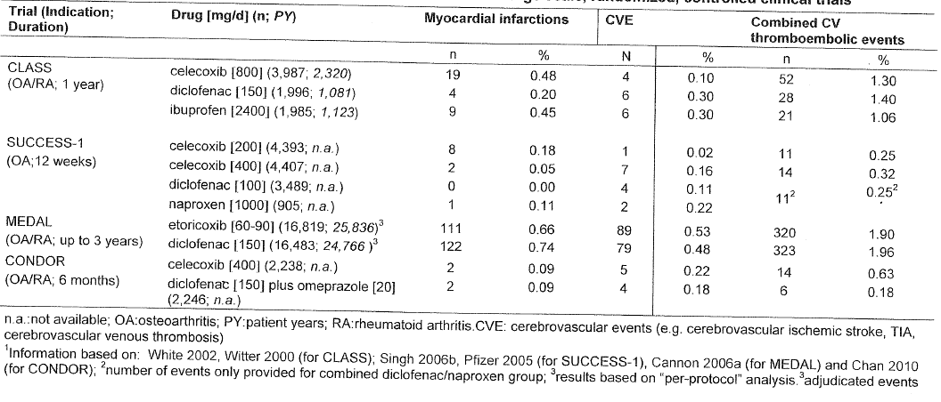
Comments: Interpretation about the CV risk associated with diclofenac from above studies was limited due to small number of CV events, the fact that studies were mainly designed to investigate GI tolerability, the lack of stratification for various confounding factors, and lack of direct comparison with placebo.

4.2.2 Novartis clinical safety database
A cumulative search in the Novartis safety database from Voltaren’s first introduction to market up to 12 November 2011 was performed using the following criteria: cerebrovascular accidents (CVA), including haemorrhagic and ischaemic cerebrovascular conditions; and MI, including MI or other ischaemic heart disease (IHD). Cases were retrieved irrespective of causality and included spontaneous reports, literature cases and post-marketing surveillance reports. Case numbers per year since 2000 were tabulated to identify changes in the reporting pattern (frequency and severity) since the 2005/2006 NSAID CV risk review. [confidential text redacted] Overall, the sponsors state that the new evidence since 2005 does not support a statement on comparatively higher risk for CV events with diclofenac compared to other NSAIDs.
Comment: Although the number of CV events was low, the sponsors did not provide details about diclofenac exposure and it is difficult to interpret results.

4.3 Submission from Novartis for over-the-counter diclofenac
The sponsors state that OTC diclofenac is only approved for use for short periods of time and none of the publications assessed the CV risk in OTC diclofenac users.

Overview of post-marketing data for over-the-counter diclofenac
A cumulative search in the global Novartis safety database for diclofenac containing products marketed under OTC status was performed since first launch until 31 Dec 2011. [confidential text redacted] The following Medical Dictionary for Regulatory Activities (MedDRA) standardised MedDRA queries were used to identify relevant CV events from the Individual Case Safety Reports (ICSRs): cardiac failure, IHD, shock, torsade de pointes, tachyarrythmias, central nervous system haemorrhages and cerebrovascular conditions. [confidential text redacted] In view of estimated patient exposure [confidential text redacted] in Australia and New Zealand, the total number of ICSRs associated with CV events is considered to be low. [confidential text redacted] Overall, the OTC post-marketing pharmacovigilance data are in line with the known CV safety profile described in the Voltaren Rapid Australian PI. In view of the estimated patient exposure [confidential text redacted] the total number of ICSRs associated with CV disorders [confidential text redacted] . The CVA rate [confidential text redacted] is considered low.
The sponsors state that evaluation of data on CV safety made available since the previous review in 2005 including findings from various sources (including epidemiological studies, post-marketing information and randomised controlled clinical trials) is not conclusive to support any further changes in the Australian PI for OTC diclofenac preparations.
Comments: Although the sponsors state that OTC diclofenac is only approved and likely to be used for short periods of time, there is some evidence to suggest that the increased CV risk associated with diclofenac is observed at low doses within the first seven days of dosing in patients with prior CV disease (Ray, 2009; Schjerning, 2011). It is accepted that the increased CV risk associated with diclofenac can only be confirmed in large scale, randomised, placebo-controlled trials, but it is equally unlikely that such trials will ever be conducted. Hence, it is imperative that all possible measures be taken in order to promote the safe use of OTC diclofenac. It is important to increase awareness about the CV risks associated with use of diclofenac just as the knowledge about its GI risks is widespread.

4.4 Submission from Pfizer for prescription diclofenac
The majority of data presented in the observational studies suggest a slightly increased risk of CV events with use of diclofenac compared to the non-use of NSAIDs although six studies found no statistically significant association between diclofenac and CV events. In studies that showed a statistically significant overall elevated risk of CV events with diclofenac, the point estimates ranged from 1.13 to 2.08 (Hippesley-Cox, 2005; Gislason, 2006; Gislason, 2009; Fosbol EL, 2009). However, the magnitude of CV risk associated with diclofenac did not appear to be different when compared to other NSAIDs that were included in these studies, as shown by overlapping confidence intervals around point estimates of diclofenac and other NSAIDs. Hence it would be very difficult to rank order the risk of CV events with diclofenac among the NSAIDs. Three studies that used stroke as the only endpoint showed no statistically significant association between diclofenac use and stroke events (Bak S, 2003; Haag MD, 2008; Roumie CL, 2008).
Only six studies provided point estimates for CV events by various diclofenac dosages. One nested case-control (Andersohn F, et al, 2006) and two retrospective cohort studies (Gislason GH, 2006; Gislason GH, 2009) reported an increase in the risk of CV events for patients who were prescribed diclofenac >100 mg/day compared to those who received less than 100 mg/day; Fischer LM (2005) showed no significant risk of CV events in patients receiving diclofenac prescriptions of either greater than or less than 100 mg/day compared to non-users. A large retrospective cohort study (Van Staa, 2008) showed that rate ratios for MI compared to non-NSAID use was similar among patients who received diclofenac less than 150 mg/day (1.13; 1.04–1.22), 150 mg/day (1.28; 1.18–1.39) and 151–299 mg/day (1.18; 0.85–1.65); however, there was a two-fold increased risk of MI (2.03; 1.09–3.77) in patients who received greater than or equal to 300 mg/day. Another study in Canadian patients (Rahme E, 2007) aged 65–80 years found no significant difference in risk of MI between patients prescribed greater than 150 mg/day compared to less than 150 mg/day.
Overall, the sponsors state that the current evidence suggests that all NSAIDs may have some CV risk, but the magnitude of risk is not distinguishable among the individual NSAIDs.

4.5 Benefit-risk assessment of cardiovascular safety of diclofenac

4.5.1 Prescription diclofenac
A majority of the individual observational studies which assessed the risk of CV event associated with the use of diclofenac and other NSAIDs published after 2005 showed a statistically significant association between CV events and use of diclofenac, although most analyses scanned many different traditional NSAIDs. There was great variation between studies in the risk estimates which are more likely due to differences in study design, particularly the outcome and exposure definitions which differed greatly between studies. The majority of studies were retrospective using health care databases from the US, UK, Australia, Canada and other countries in Europe. Although adjustments varied between studies, most of them did adjust for age, sex and baseline CV risk factors. However, a lack of adjustment for baseline indication was a common limitation across studies. The majority of studies did not take into account OTC use of NSAIDs or use of combinations of different types of NSAIDs. Data from all these observational studies and meta-analyses must be interpreted with caution due to fact that most of the studies were based on large medical databases with miscellaneous populations and were not designed to evaluate CV risks of the NSAIDs. A prospective, placebo-controlled randomised study that investigates the CV safety of diclofenac or any other traditional NSAID has never been conducted and, due to market laws and the role of industrial funding for prospective trials, is highly unlikely ever to be conducted.
Overall, evidence suggests that there is increased risk of serious CV events associated with diclofenac which may be similar to those associated with COX-2 selective NSAIDs. The clinical observation of increased CV risk with diclofenac may in part be explained by the fact it resembles a selective COX-2 inhibitor rather than a classical non-selective traditional NSAID (Krotz et al, 2010). Though considered as a non-selective NSAID, recent evidence shows a certain selectivity of diclofenac towards COX-2. In vitro data suggest a selectivity ratio of 20 (COX-2/cyclooxygenase-1 [COX-1]) for diclofenac, that is similar to celecoxib in terms of COX-2 selectivity. Clinical data suggest similarity of diclofenac with celecoxib in their mode of action. CV risks were similar between diclofenac and etoricoxib in three RCTs (Table 4.4, p119) although interpretation was limited due to lack of placebo control.
Overall, there was a moderately increased risk of CV events with diclofenac, especially in patients with prior CV disease, but there is no conclusive evidence to suggest that diclofenac is much worse than the other traditional NSAIDs. Furthermore, post-marketing surveillance data suggest a low incidence of CV events.

4.5.2 Over-the-counter diclofenac
There are very few studies which specifically examine the OTC use of diclofenac and the majority of studies do suggest that the CV risk associated with diclofenac does increase with higher doses and longer duration of diclofenac treatment (which are not recommended for OTC diclofenac formulations).
At the very least, the dose and duration of treatment with diclofenac should be strictly controlled. It is important to increase awareness about the CV profile of diclofenac, just as the knowledge about its GI risks is widespread. In order to confirm that diclofenac is only used in patients in whom it has a favourable benefit-risk profile, some recommendations have been made to the current PIs/CMIs for prescription and OTC diclofenac products which have been outlined in section 4.6 below.

4.6 Comments on the Product Information/Consumer Medicine Information for diclofenac products
Based on the evidence provided since 2005, it appears that diclofenac is associated with increased risk of serious CV events, although evidence that this risk is greater than that associated with other NSAIDs is not conclusive. It is very unlikely that any prospective, randomised studies to specifically address the CV risks associated with diclofenac will be conducted to determine CV risks of diclofenac compared to the other traditional NSAIDs. The increased CV risk associated with diclofenac is particularly evident in patients with prior MI or CHD in whom the risk is increased within first few days and even with short duration of treatment.
Since the withdrawal of the COX-2 selective inhibitors, use of traditional NSAIDs especially those available OTC has increased and it is very important to increase awareness about the CV profile of diclofenac, just as the knowledge about its GI risks is widespread.

4.6.1 Prescription diclofenac
It is recommended that changes be made to the PIs for all prescription diclofenac products (changes highlighted in bold).
Based on current evidence (from mainly observational studies), it is suggested that it may be prudent to add the following to the ‘contraindications’ section which is similar to that already included in the current PIs for indomethacin, piroxicam, meloxicam, celecoxib and etoricoxib: ‘Treatment of perioperative pain in setting of coronary artery bypass surgery (CABG).’
Precautions: ‘Cardiovascular thrombotic events: Observational studies have indicated that non-selective NSAIDs may be associated with an increased risk of serious CV events including myocardial infarction and stroke, which may increase with dose or duration of use. Patients with known CV disease, history of atherosclerotic CV disease or CV risk factors may also be at greater risk. To minimise the potential risk of an adverse CV event in patients taking an NSAID especially in those with CV risk factors, the lowest effective dose should be used for the shortest possible duration. Physicians and patients should remain alert for such CV events, even in the absence of previous CV symptoms. Patients should be informed about signs and/or symptoms of serious CV toxicity and the steps to take if they occur. There is no consistent evidence that the concurrent use of aspirin mitigates the possible increased risk of serious CV thrombotic events associated with NSAID use.’
The following should also be added to the ‘dosage and administration’ section of diclofenac PIs: ‘Patients on long term treatment should be reviewed regularly with regards to efficacy, risk factors and ongoing need for treatment.’

4.6.2 Over-the-counter diclofenac
The labels for OTC formulations of diclofenac should incorporate the following:
- The potential GI bleeding risks are covered extensively in the OTC labels but there is no mention under ‘warnings’ about the potential CV risks. The following could be added to the ‘warnings’ section of the labels of OTC diclofenac: ‘NSAIDs may cause an increased risk of serious cardiovascular thrombotic events, myocardial infarction, and stroke, which can be fatal. This risk may increase with duration of use. Patients with cardiovascular disease or risk factors for cardiovascular disease may be at greater risk.’
- Stronger reminders that patients with CV disease and/or CV risk factors should seek the advice of a physician before using these drugs. Physicians and patients should remain alert for CV events even in absence of previous CV symptoms. Patients should be informed about signs and/or symptoms of serious CV toxicity and the steps to take if they occur.
- Stronger reminders about limiting the dose and duration of treatment in accordance with the package instructions unless otherwise advised by a physician.

5. Ibuprofen
Ibuprofen is a propionic acid NSAID available as OTC (200 mg tablets) and by prescription (400 mg tablets). As an OTC NSAID, ibuprofen is indicated for temporary relief of acute and chronic pain states with an inflammatory component, such as osteoarthritis, rheumatoid arthritis, primary dysmenorrhoea; it is also indicated for symptomatic relief of pyrexia, minor aches and pains associated with common cold, headaches, dental pain up to maximum dose of 1200 mg/day. Prescription ibuprofen is indicated for similar conditions but maximum dose is up to 2400 mg/day.

5.1 Submission from Abbott for prescription ibuprofen
Methods of evaluation: Based on the TGA literature search, publications on the risk of CV outcomes associated with use of NSAIDs/ibuprofen were identified. However, only 46 publications with studies reporting individual results for ibuprofen (others provided grouped results for NSAIDs) were considered as relevant. Most of the publications were observational studies on association between ibuprofen and CV risk mainly focused on MI, related coronary syndromes, stroke or CV composite endpoints; other outcome measures were CV mortality, atrial fibrillation (AF) and other arrhythmias and HF.

5.1.1 Myocardial infarction/acute coronary syndromes
A total of 23 publications focused on risk of MI or related coronary syndromes associated with use of ibuprofen (compared with non-use or remote use). There was substantial heterogeneity among studies with respect to the risk estimates for ibuprofen as compared to non-use (or remote use) with a majority of the studies showing no difference, seven studies indicating an increased risk [Abraham, 2007; Fosbol 2010 (2); Gislason, 2009; Hippesley Cox, 2005; Lee, 2007 (2); Salmivaara, 2006 and Van der Linden, 2009] and only one study (Fosbol, 2010 (1)) showing a mild cardioprotective effect (see Figure 5.1 below).

Figure 5.1:
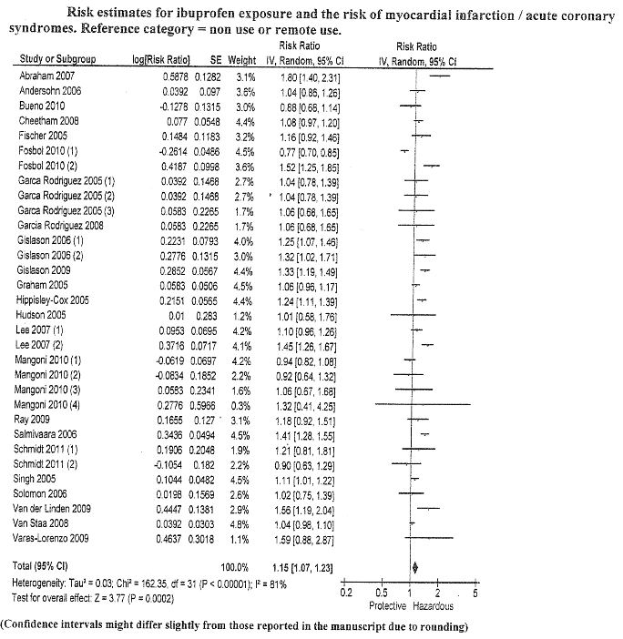
Methodological aspects of the different studies (study design, residual confounding) may be responsible for the heterogeneity of study results. When Fosbol et al, 2010 (Table 2.8, p79) used two different methodological approaches for analysis of the same data source, it led to conflicting results for ibuprofen and risk of coronary death/MI (cohort study HR=0.77, 95% CI: 0.70–0.84; case-crossover study: OR=1.52, 95% CI: 1.25–1.85).
Results from all identified studies were combined in a random-effects meta-analysis which showed an overall risk estimate for ibuprofen of 1.15 (1.07–1.23) for MI/acute coronary syndrome.
Comment: The following TGA references provided additional evidence of increased risk of MI associated with ibuprofen (see below).
In a population-based, retrospective cohort study involving more than 18,000 patients with a previous acute MI, patients taking aspirin who filled prescriptions for ibuprofen had a trend showing an increasing rate of recurrent acute MI as the duration of exposure to ibuprofen increased (Hudson M, 2005) (Table 2.15, p86).
A case-control study using direct structured interviews rather than electronic data retrieval showed that non-selective, non-aspirin NSAIDs (majority of subjects took ibuprofen and diclofenac) were associated with a significant increase in risk of MI (Hawkey CJ et al, 2006) (Table 2.13, p84).

5.1.2 Stroke
Abbott has identified seven studies on risk of stroke associated with use of ibuprofen (compared to non-use or remote use) and this showed heterogeneity in results with most studies showing a slight to moderate increase in risk and some showing reduced risk of stroke with ibuprofen. The majority of studies did not estimate a statistically significant effect of ibuprofen on the risk of stroke and the combined risk estimate of these studies showed RR=1.08 (95% CI: 0.97–1.19). (see Figure 5.2 below)

Figure 5.2:
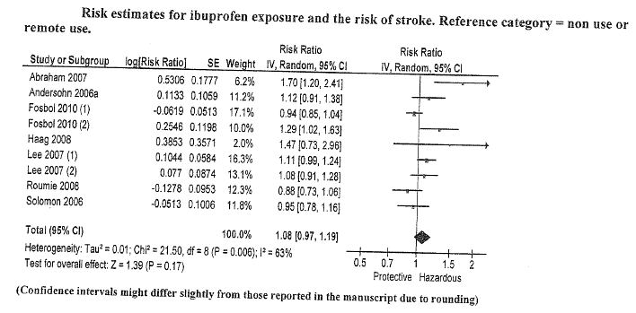
Comment: There were some recent publications relevant to ibuprofen and stroke which were not covered in the review by the sponsors and are discussed below briefly.
In a large retrospective cohort study of 162,065 Australian veterans (Caughey GE, et al, 2011) (Table 2.4, p75), incident use of NSAIDs was associated with 1.88 times increased risk (95% CI: 1.70–2.08) of hospitalisation for stroke following first ever dispensing of NSAIDs. The absolute risk of stroke in this study was 7.1 strokes/1000 persons/year which was increased with incident NSAID use to 13.4 strokes/1000 people/year. Examination by specific type of stroke showed ischemic stroke to be the most prevalent and incident use of NSAIDs was associated with a 1.90 times increased risk (95% CI: 1.65–2.18) of hospitalisation for ischemic stroke. Ibuprofen and piroxicam were not significantly associated with ischemic stroke while rofecoxib and diclofenac had greatest increased risk. Incident use of any NSAID was associated with a more than doubled increased risk of haemorrhagic stroke with all NSAIDs (2.1, 95%CI: 1.74–2.77) except ibuprofen (RR=1.35; 0.84–2.17) (see Table 5.3 below).

Table 5.3
Prescription event sequence symmetry analysis used in this study provides a method for rapid assessment and uses the individual patients as their own controls, minimising potential bias caused by individual variations. Further, a sensitivity analysis including only incident users who did not switch NSAIDs also showed similar results (see Table 5.4 below).

Table 5.4
Another retrospective case-crossover study in Chinese patients evaluated the risk of ischemic and haemorrhagic stroke associated with short-term use of selective and non-selective NSAIDs (Chang CH, et al. 2010) (Table 2.5, p76). This study also found that all NSAIDs – celecoxib and non-selective NSAIDs (ibuprofen, ketorolac, diclofenac, naproxen, piroxicam, meloxicam, mefenamic acid and indomethacin) – were associated with a significantly increased risk of ischemic and haemorrhagic stroke (Table 5.5 below).

Table 5.5
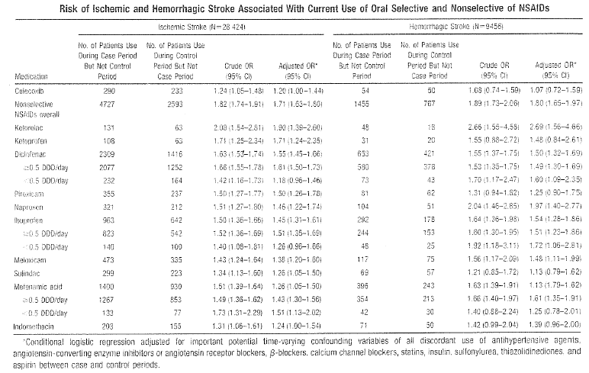
A meta-analysis of observational studies on NSAID use and risk of stroke (Varas-Lorenzo et al, 2011) (Table 2.24, p95) showed a non-significant mild increase in risk of stroke with ibuprofen (RR=1.10, 95% CI: 0.89–1.36).

5.1.3 Mortality
Abbott has quoted seven publications to assess risk of mortality associated with use of ibuprofen which showed conflicting results, although the majority of them did show a slight increase in mortality with ibuprofen with combined risk estimate of 1.18 (95% CI: 1.03–1.36) (see Figure 5.6 below).

Figure 5.6:
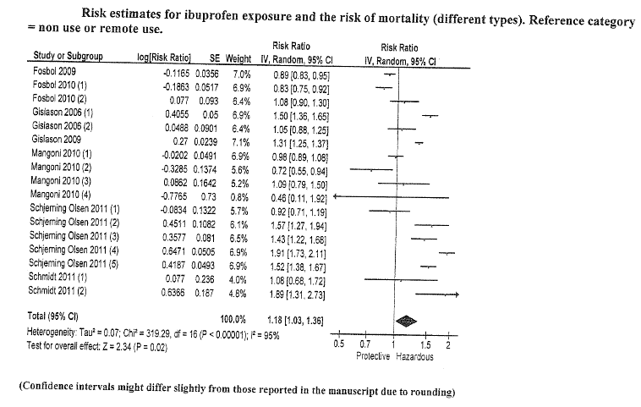
However, the above results should be interpreted with caution as methodological issues probably had an impact on the differences in risk estimates, that is different methods to analyse same data showed conflicting results (Gislason 2006 cohort study=hazardous effect; case-crossover study=no effect; Fosbol, 2010 cohort study=protective effect; case-crossover study=no effect). Schmidt et al (2011) (Table 2.20, p91) analysed mortality with respect to cause of death and showed no increase of cardiac mortality (HR=1.08; 95% CI: 0.68–1.73), but an increase in non-cardiac mortality (HR=1.89; 1.31–2.74) in patients who underwent percutaneous transluminal coronary angioplasty with stent implantation. Hence, observed increase in mortality is less likely to be related to CV side effects of ibuprofen but may be attributable to residual confounding, that is use of ibuprofen in patients with more serious illness.

5.1.4 Cardiovascular composite endpoints
Nine publications showed heterogeneity in results regarding association between ibuprofen and CV composite endpoint, although majority of the studies did show a slight increased risk of CV events. The study by Schjerning O, et al (2011) (Table 2.19, p90) which focused on NSAID use in patients with previous MI reported the highest increases in CV risk. Combined risk estimate for the CV composite endpoints was 1.15 (95% CI: 1.03–1.27). See Figure 5.7 below.

Figure 5.7:
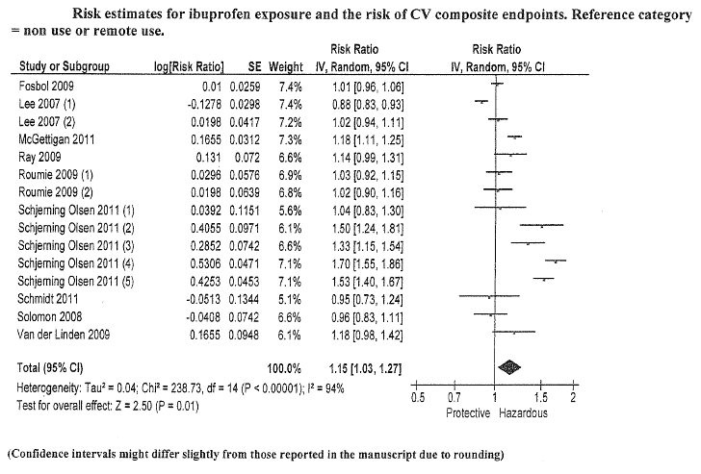

5.1.5 Other cardiovascular outcomes
Studies on AF were inconclusive with no increase in risk reported by De Caterina et al 2010 (Table 2.7, p78) and a slight increase in risk reported by Schmidt et al 2011a (Table 2.19, p90). Mangoni et al (2010) (Table 2.18, p89) reported no association between ibuprofen and arrhythmias. However, one study on HF indicated a small increased risk in mortality and rehospitalisation due to MI and HF (Gislason et al, 2009) (Table 2.12, p83).

5.1.6 Meta-analyses
Three meta-analyses of RCTs (Kearney, 2006; Chen 2006, Chen 2007) and one network meta-analysis (mixed treatment comparison) (Trelle et al, 2011) were reviewed by the sponsors. The studies by Chen (2006 and 2007) (Table 3.6, p102) compared different NSAIDs (with main focus on COX-2 selective NSAIDs) with respect to cerebrovascular events and MI; ibuprofen did not show any increased or decreased risk compared with combined COX-2 selective NSAIDs. Kearney et al (2006) (Table 3.13, p109) reported an increased risk estimate of 1.51 (95%: 0.96-2.37) for ibuprofen compared with placebo for serious vascular events (MI, stroke, vascular death) (see Figure 5.8, p134).
Trelle 2011 (Table 2.23, p94) performed a mixed treatment comparison of several NSAIDs and placebo to estimate the risk of different CV events for individual NSAIDs compared to placebo and included data from large RCTs comparing NSAIDs with other NSAIDs or placebo, independently from the indication of NSAID use. For ibuprofen, statistically significant increases in risk were reported for stroke (RR=3.36; 95% CI: 1–11.60) and composite outcome of non-fatal MI/stroke and CV death (RR=2.26; 1.11–4.89), but interpretation was confounded by wide CIs (see Figure 5.9, p135).

5.2 Submission from Reckitt Benckiser for over-the-counter ibuprofen
Reckitt Benckiser is the manufacturer of the Nurofen range of products. Nurofen is presented as ibuprofen 200 and 400 mg tablets and is available OTC, where it is indicated for short term pain relief at a maximum daily dose of 1200 mg/day for three days.
The sponsors quote three recent publications widely considered to be pivotal in assessing CV risk associated with traditional NSAIDs. These are considered key papers because they represent a large body of data and include one systematic review (McGettigan P, et al 2011), one meta-analysis (Trelle, 2011) and a nationwide cohort study (Schjerning O et al. 2011). They are briefly discussed below:
McGettigan P, (2011) conducted a systematic review of community-based controlled observational studies by conducting comprehensive literature searches, extracted adjusted RR estimates, and pooled the estimates for major CV events associated with use of individual NSAIDs, in different doses, and in populations with low and high background risks of CV events. The study also compared individual drugs in pair-wise (within study) analyses, generating ratios of RRs. Thirty case-control studies included 184,946 CV events, and 21 cohort studies described outcomes in 2.7 million exposed individuals. Of the extensively studied drugs (10 or more studies), the highest overall risks were seen with rofecoxib, 1.45 (95% CI 1.33–1.59), and diclofenac, 1.40 (1.27–1.55), and the lowest with ibuprofen, 1.18 (1.11–1.25), and naproxen, 1.09 (1.02–1.16). In a sub-set of studies, risk was elevated with low doses of rofecoxib, 1.37 (1.20–1.57), celecoxib, 1.26 (1.09–1.47), and diclofenac, 1.22 (1.12–1.33), and rose in each case with higher doses. Ibuprofen risk was seen only with higher doses (Table 5.10, p136). Furthermore, CV risk did not appear to be affected by baseline CV risk (Table 5.11, p136). This review suggests that among widely used NSAIDs, naproxen and low-dose ibuprofen may be least likely to increase CV risk.
Schjerning O, et al (2011) (Table 2.19, p90) studied the duration of NSAID treatment and CV risk in a nationwide cohort of patients with prior MI. A total of 102,138 patients were admitted with first-time MI in the period of 1997 to 2006, of whom 83,675 (81.9%) were discharged alive and included in the study. The most commonly used NSAIDs were ibuprofen (23.2%) and diclofenac (13.4%). Overall NSAID treatment was associated with statistically significantly increased risk of death at the beginning of the treatment, and the increased risk persisted throughout the course of treatment. Ibuprofen showed an increased risk only when used for more than one week. The risk associated with ibuprofen was lower than the risk with the COX-2 selective inhibitors and diclofenac.
Comment: The above review did not report results specifically for ibuprofen at OTC doses
(less than or equal to 1200 mg/day).
In the meta-analysis by Trelle S, et al (2011) (Table 2.23, p94) involving data from 31 trials, ibuprofen was evaluated least (only two trials). Etoricoxib and diclofenac had the largest number of patient years of follow-up (26,025 and 27,819 overall, respectively), whereas ibuprofen had the lowest number of patient years of follow-up (4832 overall). For three of the preparations (naproxen, diclofenac, and etoricoxib) evidence was lacking for an increased risk of MI compared with placebo. All other drugs seemed to be associated with an increased risk compared with placebo with estimated rate ratios for ibuprofen (1.61; 95% CI 0.50–5.77), celecoxib (1.35; 0.71–2.72), rofecoxib (2.12; 1.26–3.56), and lumiracoxib (2.00; 0.71–6.21). Twenty six trials with 377 accumulated events contributed to the analysis of stroke. All drugs seemed to be associated with an increased risk compared with placebo. Estimated rate ratios were highest for ibuprofen (3.36; 1.00–11.60), diclofenac (2.86; 1.09–8.36), etoricoxib (2.67; 0.82– 8.72), lumiracoxib (2.81; 1.05–7.48) and naproxen (1.76; 0.91–3.33). Twenty six trials with 312 accumulated events contributed to the analysis of CV death, accounting for 46% of all deaths. All drugs except naproxen showed some evidence for an increased risk of CV death compared with placebo. The estimated rate ratios for CV death were greater than one for ibuprofen (2.39; 0.69–8.64), diclofenac (3.98; 1.48–12.70), celecoxib (2.07; 0.98–4.55), etoricoxib (4.07; 1.23–15.70), rofecoxib (1.58; 0.88–2.84), and lumiracoxib (1.89; 0.64–7.09) (Figure 5.9, p135).
Comment: Although the analysis covered more than 100,000 patient years of follow-up, the number of events for most outcomes was low and estimates of rate ratios were imprecise, as indicated by wide CIs. It is important to note that only two trials out of the 31 trials in the paper included ibuprofen. This raises concern about the ability to draw reliable conclusions from the ibuprofen results, given the low number of patient years of follow up. In addition, in both trials where ibuprofen was included, the doses used were 2400 mg/day. This is a prescription dose; therefore the results are not directly applicable to OTC ibuprofen which is a maximum of 1200 mg/day.

5.2.1 Company pharmacovigilance data of cardiovascular events
Over the 10-year period 1 March 2002 to 29 February 2012, 315 cardiac adverse events were reported to the company for the Nurofen core range from worldwide sources, including spontaneous and regulatory reports, literature and clinical studies (see Table 5.12, p137–148). The exact global patient exposure to Nurofen was difficult to assess and was not determined, although many millions of packs of Nurofen are sold worldwide each year. The total number of CV adverse events reported appears to be low when compared with sales volume. To mitigate risk further, Reckitt Benckiser continuously monitors complaints on products sold. Data are gathered and analysed for complaints per million of product sold. In most one-month periods there are only between 10 and 30 complaints per million packs sold.

5.3 Submission from Pfizer
Pfizer submitted 10 other publications which were not included in the list of references provided by the TGA. However, the majority of these publications were dated either before or just around 2005 and did not provide any additional information to that already discussed in sections above.
Pfizer did not submit any post-marketing Periodic Safety Update Reports or post-marketing surveillance program results.

5.4 Ibuprofen and aspirin
Ibuprofen antagonises the irreversible platelet inhibition induced by aspirin (Lawson. C, 2001). Several pharmacodynamic studies indicate that sustained inhibition of COX activity by aspirin is blunted in presence of some NSAIDs. However, observational studies in patients have shown conflicting results of effect of aspirin and NSAIDs on mortality and MI (Corman SL et al. 2005) (Table 2.6, p77). In the TARGET study (Farkouh ME, 2007) results indicated that concomitant prophylactic aspirin use increased the RR of thrombotic and congestive HF events for ibuprofen/naproxen versus the COX-2 selective inhibitor lumiracoxib. A single-blind, randomised, three-way crossover study in 10 healthy volunteers showed that ibuprofen prevents the irreversible inhibition of platelet aggregation produced by aspirin; this was further confirmed in 28 patients taking both NSAIDs and aspirin for secondary stroke prophylaxis and this interaction has clinical consequences for patients taking aspirin (Gengo FM, et al. 2008) (Table 2.11, p82). A randomised, placebo-controlled study in 24 patients taking long-term treatment with aspirin (100 mg daily) showed that inhibition of platelet COX-1 activity and function by aspirin was affected by seven days’ treatment with ibuprofen (600 mg three times daily), but not by celecoxib (200 mg twice daily) (Renda G, et al, 2006). Several observational studies have also reported a decrease in aspirin-mediated prophylaxis in case of concomitant ibuprofen use. In a population-based, retrospective cohort study involving more than 18,000 patients with a previous acute MI, patients taking aspirin who filled prescriptions for ibuprofen had a trend showing an increasing rate of recurrent acute MI as the duration of exposure to ibuprofen increased (Hudson M, 2005) (Table 2.15, p86).
Comment: Overall, current evidence suggests that due caution should be exercised regarding concomitant administration of aspirin with NSAIDs.

5.5 Benefit-risk assessment of cardiovascular safety of ibuprofen

5.5.1 Prescription ibuprofen
For the outcome of MI and/or acute coronary syndromes, the overall evidence appears to be similar to that observed in the 2005 NSAID safety review. Recent evidence suggested increased risk of stroke with ibuprofen, especially haemorrhagic stroke (Caughey, 2011 and Chang, 2010) although risk was similar to that observed with other NSAIDs. Studies showed heterogeneity in results regarding association between ibuprofen and CV composite endpoint, although majority of the studies did show a slight increased risk of CV events. Overall, risks associated with prescription doses of ibuprofen appear to be similar to those with other NSAIDs and current evidence suggests that risks may be increased with dose and duration of treatment and may also be increased with concomitant use of low-dose aspirin.
Most of the recently published papers used for assessing CV risk associated with ibuprofen were not prospective randomised trials. There is currently a large ongoing randomised trial comparing the safety of celecoxib versus ibuprofen or naproxen. This is the first randomised trial examining the CV adverse effects of NSAIDs; the Prospective Randomized Evaluation of Celecoxib Integrated Safety versus Ibuprofen or Naproxen (PRECISION) trial. PRECISION will compare the CV safety of celecoxib with the two most commonly prescribed non-selective NSAIDs, ibuprofen and naproxen, in patients with osteoarthritis or rheumatoid arthritis and established or at high risk of developing CV disease. Results from this trial would potentially allow more accurate assessment of the CV safety of ibuprofen.

5.5.2 Over-the-counter ibuprofen
The current labelling and PI for OTC ibuprofen adequately explain that it is intended for use at low doses for the short-term treatment of minor ailments. When used according to the label, the benefit/risk profile of OTC ibuprofen is favourable. Company pharmacovigilance data over the past 10 years suggests that the number of adverse CV events reported has been low. In addition the number of consumer complaints per million Nurofen packs sold over the past five years is low. At OTC doses over short duration, ibuprofen has a safety profile distinctly more positive than that associated with the use of ibuprofen in the prescription setting.

5.6 Comments on the Product Information/Consumer Medicine Information for ibuprofen products

5.6.1 Prescription ibuprofen
The current PI adequately mentions the risk of increased risk of stroke and MI with ibuprofen treatment. However some modifications are suggested in order to make the CV warnings consistent across all traditional NSAIDs.
Based on current evidence (from mainly observational studies), it is suggested that it may be prudent to add the following to the ‘contraindications’ section which is similar to that already included in the current PIs for indomethacin, piroxicam, meloxicam, celecoxib and etoricoxib: ‘Treatment of perioperative pain in setting of coronary artery bypass surgery (CABG).’
It is also recommended that the ‘Precautions’ section of the PIs for all ibuprofen prescription products be changed to the following to maintain consistency across all traditional NSAIDs (changes highlighted in bold):
‘Cardiovascular thrombotic events: Observational studies have indicated that non-selective NSAIDs may be associated with an increased risk of serious CV events including myocardial infarction and stroke, which may increase with dose or duration of use. Patients with known CV disease, history of atherosclerotic CV disease or CV risk factors may also be at greater risk. To minimise the potential risk of an adverse CV event in patients taking an NSAID especially in those with CV risk factors, the lowest effective dose should be used for the shortest possible duration. Physicians and patients should remain alert for such CV events, even in the absence of previous CV symptoms. Patients should be informed about signs and/or symptoms of serious CV toxicity and the steps to take if they occur. There is no consistent evidence that the concurrent use of aspirin mitigates the possible increased risk of serious CV thrombotic events associated with NSAID use.’
The following should also be added to the ‘dosage and administration’ section of ibuprofen PIs: ‘Patients on long term treatment should be reviewed regularly, with regards to efficacy, risk factors and ongoing need for treatment.’

5.6.2 Over-the-counter ibuprofen
The labels for OTC formulations of ibuprofen should incorporate the following:
- The potential GI bleeding risks are covered extensively in the OTC labels but there is no mention under ‘warnings’ about the potential CV risks. The following could be added to the ‘warnings’ section of the labels of OTC ibuprofen: ‘NSAIDs may cause an increased risk of serious cardiovascular thrombotic events, myocardial infarction, and stroke, which can be fatal. This risk may increase with duration of use. Patients with cardiovascular disease or risk factors for cardiovascular disease may be at greater risk.’
- Stronger reminders that patients with CV disease and/or CV risk factors should seek the advice of a physician before using these drugs. Physicians and patients should remain alert for CV events even in absence of previous CV symptoms. Patients should be informed about signs and/or symptoms of serious CV toxicity and the steps to take if they occur.
- Stronger reminders about limiting the dose and duration of treatment in accordance with the package instructions unless otherwise advised by a physician.

6. Naproxen
Naproxen is a propionic acid derivative related to the arylacetic acid class of drugs. It has analgesic, anti-inflammatory and antipyretic properties. It is available as tablets containing 250 or 500 mg naproxen, sustained release tablet containing 750 or 1000 mg or as a suspension containing 25 mg/ml of naproxen. It is indicated for the treatment of rheumatoid arthritis, osteoarthritis and ankylosing spondylitis, for symptomatic treatment of primary dysmenorrhoea, for relief of acute or chronic pain states with an inflammatory component and as an analgesic in acute migraine attack. The recommended naproxen dose for chronic conditions is 375 to 1000 mg/day in two divided doses (or a sustained release formulation as single daily dose of 750 or 1000 mg); recommended dose for acute conditions is 500 to 1250 mg/day.

6.1 Review of publications referenced by TGA

6.1.1 Evidence for reduced cardiovascular risk with naproxen
A number of observational studies have attributed cardioprotective properties to naproxen. In one of these retrospective analyses in 4425 patients hospitalised for MI, only naproxen, but none of the other non-aspirin NSAIDs, was associated with a reduced risk of MI (Solomon DH, 2002). Another longitudinal cohort study by the same authors (Solomon DH et al, 2006) showed a reduced risk of hospitalisation due to MI or ischaemic stroke in patients receiving naproxen compared to non-NSAID users (0.75; 0.62–0.92) (Table 2.21, p92). A retrospective cohort study involving 48,556 patients recently hospitalised for MI, revascularisation or unstable angina with 111,000 person years of follow-up showed that naproxen had better CV safety than did diclofenac (low and high doses), ibuprofen and higher doses of celecoxib and rofecoxib (Ray WA, 2009) (see Table 6.1 below).

Table 6.1
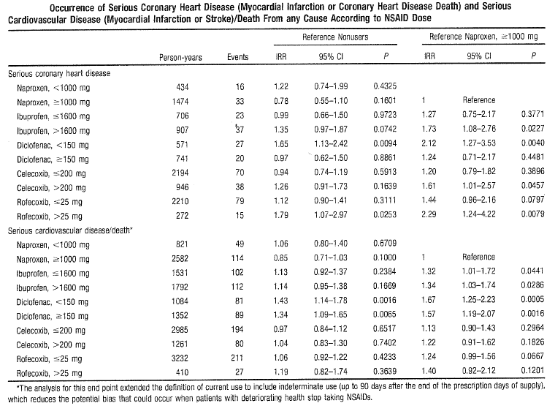
Comment: It is interesting to note that high dose of naproxen (greater than 1000 mg) had slightly greater cardioprotective effects compared to non-NSAID users; a likely explanation for this may be that naproxen at higher doses inhibits the production of thromboaxane and platelet aggregation.
A review of CV safety of NSAIDs by Hermann, M, et al (2009) suggested that although CV safety profile for naproxen appears to be favourable, evidence is not conclusive (see Table 6.2 below).

Table 6.2: Hermann M 2009
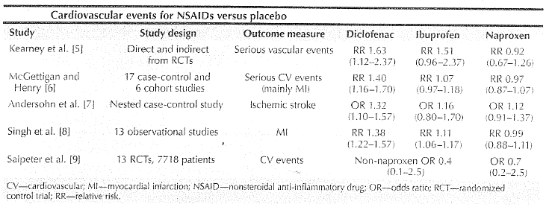
As shown above, the majority of the meta-analyses showed reduction in risk of CV events with naproxen. The meta-analysis by Trelle, et al, 2011 (Table 2.23, p94) also showed that naproxen was not associated with increased risk of MI or CV death. A meta-analysis of eight RCTs by Farkouh et al, 2008 (Table 2.8, p79) showed that there was no increased CV risk with naproxen relative to COX-2 selective NSAIDs and other non-selective NSAIDs.
Fosbol et al, 2010 (Table 2.8, p79) was one of the few studies which evaluated CV risks associated with NSAIDs in healthy individuals and showed that use of naproxen did not have any adverse effect on CV outcomes of CV death and coronary death or non-fatal MI, but showed a trend for increased risk of fatal or non-fatal stroke (see Table 6.3 below).

Table 6.3
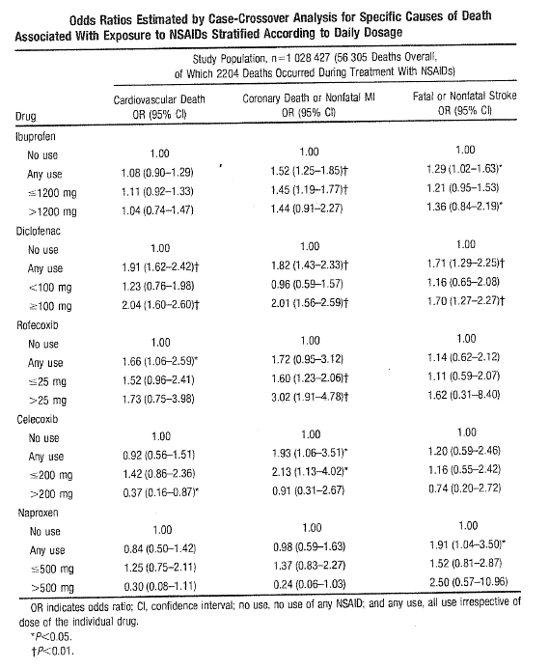
The retrospective cohort study by Roumie et al, 2008 (Table 2.18, p89) did not show an increased risk of stroke with naproxen. Similarly, current use of naproxen was not associated with increased risk of stroke in the meta-analysis by Varas-Lorenzo, et al, 2011 (Table 2.24, p95).

6.1.2 Evidence for increased risk of cardiovascular events with naproxen
Some epidemiologic studies and one RCT (Alzheimer’s Disease Anti-Inflammatory Prevention Trial (ADAPT)) demonstrated increased CV risk with naproxen. In the ADAPT, the HR for CV events (CV death, MI, stroke, congestive HF or transient ischaemic attack [TIA]) compared to placebo was 1.10 (95% CI: 0.67–1.79) for celecoxib and 1.63 (1.04–2.55) for naproxen although it should be noted that ADAPT was not designed to address CV safety and that celecoxib and naproxen were not event tested in the target patient population for NSAIDs (ADAPT, 2006).
A nested case-control study showed an increased risk for naproxen (OR=1.27, 95% CI: 1.01–1.60, p=0.04), ibuprofen (1.24; 1.11–1.39, p<0.001) and diclofenac (1.55; 1.39–1.72, p<0.001) (Hippesley-Cox, 2005) (Table 2.14, p85). Other observational studies which showed increased risk of CV events with NSAIDs (including naproxen) were Haara 2009, Hawkey 2006 and Salmivaara 2006 (Tables 2.12– 2.13, p83–84). There was an increase in mortality and risk of hospitalisation due to MI or HF with non-selective NSAIDs including high dose naproxen (Gislason, 2009) (Table 2.12, p83).
The large Icelandic national registry-based study with 163,406 patient years showed increased risk of CV events (cerebral infarction, MI and unstable angina pectoris) among users of rofecoxib and naproxen (1.46, 1.03–2.07, p=0.03) (Gudbjornsson B, et al, 2010) (Table 4.2, p117).
There was an increased risk of ischaemic stroke with all NSAIDs with adjusted ORs (95% CI) of about 1.50 for ibuprofen, naproxen, piroxicam and diclofenac (Chang et al, 2010) (Table 2.5, p76). The large Australian cohort study (Caughey et al, 2011) (Table 2.4, p75) also showed increased risk of both ischaemic and haemorrhagic stroke with naproxen (Table 5.3, p131).
In a population-based cohort study in 13,001 patients who underwent percutaneous coronary stent implantation, use of non-selective NSAIDs or COX-2 selective NSAIDs was not associated with an increased risk of major adverse cardiac events (MACE) in patient with coronary stents (Schmidt M, et al. 2011) (Table 2.20, p91). It was especially interesting to note that naproxen which is normally considered cardioprotective was actually associated with a much higher risk of MACE compared to the other NSAIDs including COX-2 selective NSAIDs. However, this study had various limitations including the fact that more high-risk patients may have been prescribed naproxen.

6.1.3 Naproxen and aspirin
Pharmacologic studies have shown that naproxen interfered with the inhibitory effect of aspirin on platelet COX-1 activity and function (Capone MI, et al 2005). The post-hoc analysis of the TARGET study also showed that concomitant prophylactic aspirin use increased the RR of thrombotic and congestive HF events for ibuprofen/naproxen versus COX-2 selective inhibitor lumiracoxib (Farkouh ME, 2007).
A meta-analysis of 16 cohort and case-control studies on NSAIDs and MI published between 2000 and 2005 showed no increased risk of MI with naproxen and ibuprofen; in fact naproxen was associated with a 17% reduced risk of MI in patients not using low-dose aspirin, which suggests that the apparent cardioprotective effect of naproxen was more likely to be evident in patients not having any prior CV risk factors (and not using low-dose aspirin) (Hernandez-Diaz, 2006) (Table 2.14, p85).

6.2 Review of data submitted by sponsors
None of the sponsors of naproxen (prescription or OTC products) submitted any data for review.

6.3 Benefit-risk assessment of cardiovascular safety of naproxen

6.3.1 Prescription naproxen
Following withdrawal of two COX-2 selective inhibitors and warnings regarding increased risk of CV events with NSAIDs, it has been suggested that naproxen might be associated with lower CV risk. Some recent recommendations on the treatment of patients with NSAIDs favour use of naproxen in patients with increased CV risk (Amer et al, 2010). However, the current evidence (as discussed above) does not justify such action and in fact risk of CV thrombotic events might even be increased in patients with high CV risk especially those taking concomitant aspirin.
Large scale RCTs that compare individual NSAIDs might the only approach likely to provide some clarification regarding the ongoing uncertainty of the risks of specific NSAIDs including naproxen. There is currently a large ongoing randomised trial comparing the safety of celecoxib versus ibuprofen or naproxen – the PRECISION trial. This is the first randomised trial examining the CV adverse effects of NSAIDs. PRECISION will compare the CV safety of celecoxib with the two most commonly prescribed non-selective NSAIDs, ibuprofen and naproxen, in patients with osteoarthritis or rheumatoid arthritis and established or at high risk of developing CV disease. Results from this trial would potentially allow more accurate assessment of the CV safety of naproxen. However, until such data is available, it is very important to provide education to health professionals as well as patients regarding the CV risks of all NSAIDs including naproxen.

6.3.2 Over-the-counter naproxen
CV risk associated with short-term, low-dose OTC use of naproxen was not evaluated specifically and many studies did not provide CV risk estimates based on dose. Overall, the current evidence suggests that OTC naproxen has CV risks similar to those associated with other OTC NSAIDs.

6.4 Comments on Product Information/Consumer Medicine Information for naproxen products

6.4.1 Prescription naproxen
The current PI and CMI for naproxen products provided adequate information regarding the CV profile of naproxen. However some modifications are suggested in order to make the CV warnings consistent across all traditional NSAIDs.
Based on current evidence (from mainly observational studies), it is suggested that it may be prudent to add the following to the ‘contraindications’ section which is similar to that already included in the current PIs for indomethacin, piroxicam, meloxicam, celecoxib and etoricoxib: ‘Treatment of perioperative pain in setting of coronary artery bypass surgery (CABG).’
It is also recommended that the precautions section of PI for naproxen products be changed to the following to maintain consistency across the non-selective NSAIDs (changes highlighted in bold):
‘Cardiovascular thrombotic events: Observational studies have indicated that non-selective NSAIDs may be associated with an increased risk of serious CV events including myocardial infarction and stroke, which may increase with dose or duration of use. Patients with known CV disease, history of atherosclerotic CV disease or CV risk factors may also be at greater risk. To minimise the potential risk of an adverse CV event in patients taking an NSAID especially in those with CV risk factors, the lowest effective dose should be used for the shortest possible duration. Physicians and patients should remain alert for such CV events, even in the absence of previous CV symptoms. Patients should be informed about signs and/or symptoms of serious CV toxicity and the steps to take if they occur. There is no consistent evidence that the concurrent use of aspirin mitigates the possible increased risk of serious CV thrombotic events associated with NSAID use.’
The following should also be added to the ‘dosage and administration’ section of naproxen PIs: ‘Patients on long term treatment should be reviewed regularly with regards to efficacy, risk factors and ongoing need for treatment.’

6.4.2 Over-the-counter naproxen
The labels for OTC formulations of naproxen should incorporate the following:
- The potential GI bleeding risks are covered extensively in the OTC labels but there is no mention under ‘warnings’ about the potential CV risks and the following could be added to the ‘warnings’ section of the labels of OTC naproxen: ‘NSAIDs may cause an increased risk of serious cardiovascular thrombotic events, myocardial infarction, and stroke, which can be fatal. This risk may increase with duration of use. Patients with cardiovascular disease or risk factors for cardiovascular disease may be at greater risk.’
- Stronger reminders that patients with CV disease and/or CV risk factors should seek the advice of a physician before using these drugs. Physicians and patients should remain alert for CV events even in absence of previous CV symptoms. Patients should be informed about signs and/or symptoms of serious CV toxicity and the steps to take if they occur.
- Stronger reminders about limiting the dose and duration of treatment in accordance with the package instructions unless otherwise advised by a physician.

7. Cyclooxygenase-2 selective non-steroidal anti-inflammatory drug – celecoxib
Of the COX-2 selective NSAIDs, only celecoxib and etoricoxib are currently available in Australia as prescription NSAIDs. Rofecoxib and valdecoxib were withdrawn due to CV safety concerns in 2005–2006 and lumiracoxib was withdrawn in 2007.
Celecoxib is available as 100 and 200 mg capsules (Celebrex) and is indicated for symptomatic treatment of rheumatoid arthritis, osteoarthritis and ankylosing spondylitis; for treatment of primary dysmenorrhoea and for short-term treatment of acute pain in adults following surgery or musculoskeletal and/or soft tissue injury. The maximum daily dose is 400 mg given as 200 mg twice daily.

7.1 Review of publications referenced by the TGA

7.1.1 Randomised controlled studies
There are three long-term, placebo-controlled trials involving celecoxib. Two of the celecoxib studies were on the prevention of intestinal polyps (adenomatous polyposis coli and pre- sporadic adenomatous polyps) and one placebo-controlled study of both celecoxib and naproxen examined prevention of Alzheimer’s disease progression (ADAPT).
The ADAPT study was a long-term, randomised, double-blind, placebo-controlled study of the effects of celecoxib 200 mg twice daily or naproxen 220 mg twice daily on the development of dementia in elderly subjects who had a history of dementia in a first-degree relative. Compared to placebo, the incidence of CV death/stroke/MI was significantly increased in the naproxen groups (mainly driven by increased risk of stroke), while celecoxib did not show such an increase (see Table 7.1 below).

Table 7.1:
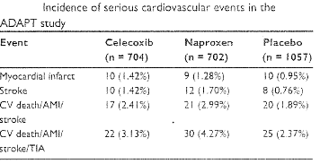
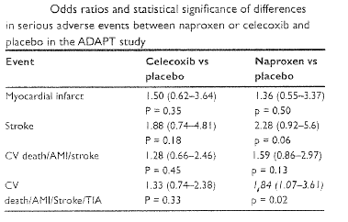
The adenomatous polyposis coli study was a three-arm study comparing celecoxib 200 and 400 mg twice daily and placebo in 2035 patients. The incidence of CV death/MI/stroke was 0.8%, 2.1% and 2.8% for placebo, celecoxib 200 and 400 mg twice daily, respectively. The difference between celecoxib 200 mg twice daily and placebo was of marginal statistical significance (OR=2.8, 95% CI: 1.0–7.7), while the difference between celecoxib 400 mg twice daily and placebo was statistically significant (OR=3.2; 1.2–8.8, p=0.01).
The pre-sporadic adenomatous polyps study was a two-arm study comparing celecoxib 400 mg once daily with placebo in 1561 patients. The incidence of CV events was 1.9% and 2.2% for placebo and celecoxib 400 mg once daily, respectively with no significant difference between the two. A combined analysis of these two placebo-controlled long-term cancer prevention studies showed a nearly two-fold increase risk of composite endpoint of CV death, MI, stroke or HF (see Table 7.2 below).

Table 7.2:
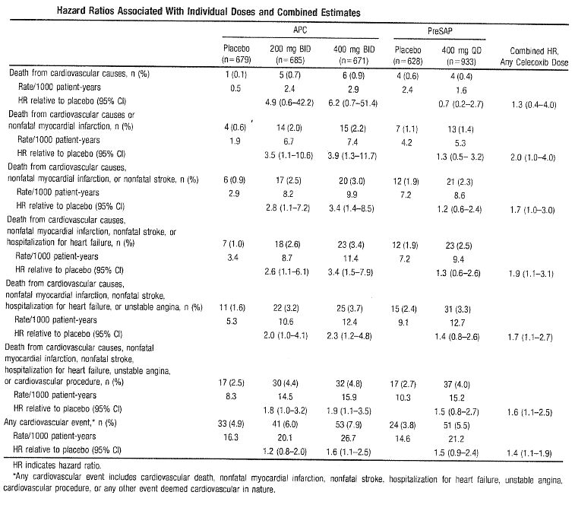
Comments: The incidence of CV death/MI/stroke was similar for celecoxib at total daily dose of 400 mg in both the adenomatous polyposis coli (2.1%) and pre-sporadic adenomatous polyps (2.2%) studies; however, the incidence with placebo was lower in the adenomatous polyposis coli study (0.8%) compared to the pre- sporadic adenomatous polyps study (1.9%) which may have led to significant difference in the adenomatous polyposis coli study. These results are difficult to interpret considering the small number of endpoints that the conclusions are drawn from. The observed dose-related increase in CV events and blood pressure raises the possibility that lower once daily dose regiments may be associated with lower overall CV hazard. However, results from this combined analysis cannot be extrapolated for short-term use of celecoxib as these studies do not have sufficient power to allow assessment of true time course of CV risk.
In the CLASS (Celebrex Long-term Arthritis Safety Study), Kaplan-Meier cumulative rates for investigator-reported serious CV thromboembolic adverse events (including MI, pulmonary embolism, deep venous thrombosis, unstable angina, TIA and ischemic CVA) demonstrated no difference between the celecoxib, diclofenac or ibuprofen treatment groups (cumulative rates at nine months were 1.2%, 1.4% and 1.1%, respectively). However, interpretation of these results was limited due to lack of placebo-control in this study.
A patient-level pooled analysis of adjudicated data from 7950 patients in six placebo-controlled trials comparing celecoxib with placebo for conditions other than arthritis (Solomon SD, et al, 2008) with follow-up of at least three years (16,070 patient years of follow-up) showed that hazard for CV endpoint (MI, stroke, CHD, thromboembolic event or CV death) increased with twice daily dose regimen of celecoxib (200 and 400 mg twice daily) compared to the 400 mg once daily regimen (Tables 7.3, 7.4, p153 and below). Furthermore, CV risk associated with celecoxib increased in patients with high baseline CV risk and celecoxib was associated with increased CV risk regardless of baseline aspirin use.

Table 7.3:
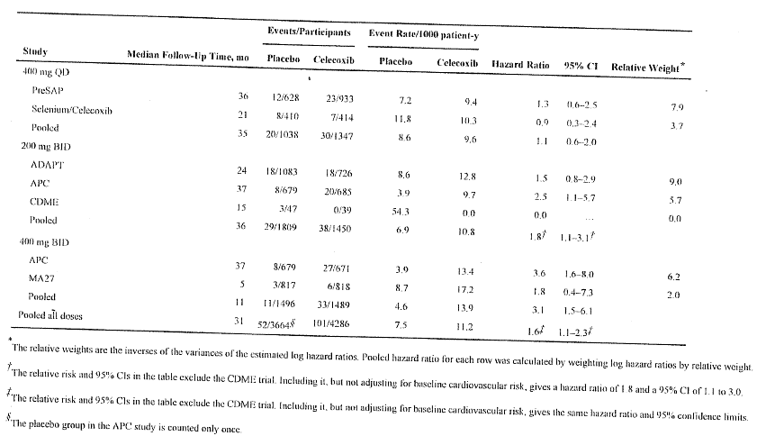

Table 7.4:
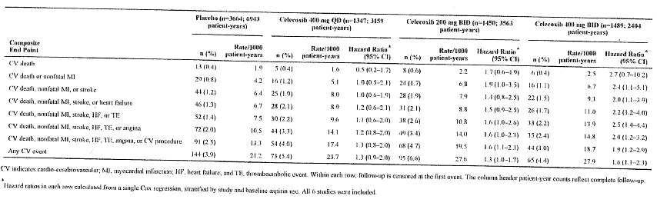
In the primary meta-analysis comparing celecoxib with placebo (4422 patients), the OR with celecoxib compared to placebo was 2.26 (95% CI: 1–5.1) for MI, 1.38 (95% CI: 0.91–2.10) for composite CV endpoint, 1.06 (95% CI: 0.38–2.95) for CV death and 1.0 (95% CI: 0.51–1.84) for stroke. The secondary meta-analysis which included six studies of 12,780 patients (with placebo, diclofenac, ibuprofen and paracetamol as comparators) showed similar findings with significantly increased risk with celecoxib for MI (OR=1.88, 95% CI: 1.15–3.08) but not for other outcome measures (Caldwell B, et al, 2006) (Table 3.6, p102).
Most of the controlled clinical trials of celecoxib did not appear to show increase in CV risk, but these were generally short-term studies designed to assess pain relief and adverse GI events. Since there is no direct randomised comparison study between rofecoxib and celecoxib, Lee YH, et al (2007) used an adjusted indirect method to provide some information on relative safety of the two COX-2 inhibitors, although such indirect comparisons should be interpreted with great caution. The adjusted indirect comparison used data from the APPROVE and adenomatous polyposis coli trials which had several similarities, both studies were well-conducted, placebo-controlled studies which followed up patients for three years. Overall, the adjusted indirect comparison using APPROVE and adenomatous polyposis coli trials shows comparable magnitude of CV events with celecoxib and rofecoxib when used for three years, although these results cannot be generalised to cases of short-term or intermittent use of celecoxib (see Table 7.5 below).

Table 7.5:
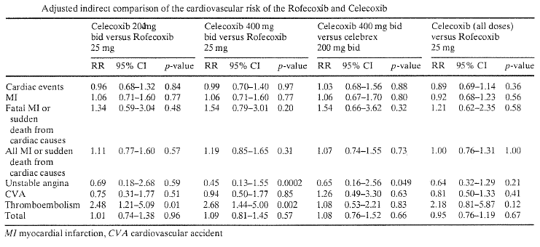
In a large meta-analysis of 55 RCTs involving 99,087 patients for various indications (osteoarthritis, rheumatoid arthritis, chronic back pain, colonic adenomas, Alzheimer’s disease), all COX-2 inhibitors (celecoxib, rofecoxib, valdecoxib, etoricoxib and lumiracoxib) were associated with increased pooled risks of MI (fatal and non-fatal) compared against placebo and other NSAIDs (Chen LC, et al. 2007) (Table 3.6, p102).
A meta-analysis of 40 RCTs involving 88,116 patients did not show any significant difference in risk of cerebrovascular event (fatal or non-fatal, ischemic/haemorrhagic stroke or TIA) associated with COX-2 inhibitors when compared against placebo or non-selective NSAIDs (Chen LC , et al. 2006) (Table 3.7, p103).
A review by Cox CD et al (2006) (Table 3.8, p104) summarises the major clinical trials that have raised concerns about COX-2 inhibitors and the risk of CV disease along with a discussion of the possible causes of these increased risks (Table 7.6, p155–156).
In one of the largest ‘patient level’ meta-analyses of celecoxib using data from RCTs (White B, et al, 2011) (Table 3.17, p113), there was no significant difference in the incidence of CV events associated with celecoxib compared with non-selective NSAIDs or compared with placebo up to one year of treatment exposure (see Figure 7.8 below).

Figure 7.8:
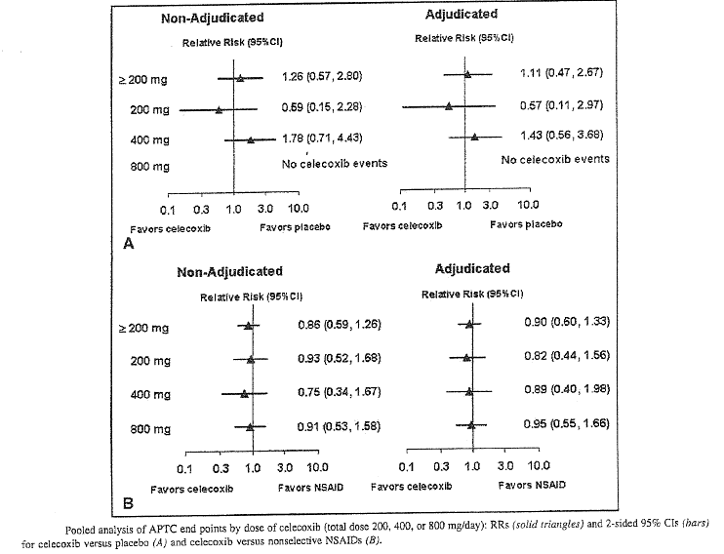

7.1.2 Epidemiological studies which showed increased risk of cardiovascular events with celecoxib
Results of the large retrospective cohort study in US veterans (Abrahams SL, et al, 2007) (Table 3.1, p97) showed that all NSAIDs increase risk of MI and CVA but this risk is greatest with highly COX-2 selective NSAIDs among both high-risk and low-risk patient populations. The estimates of risk in this study were similar to those observed in the Vioxx Gastrointestinal Outcomes Research (VIGOR) trial (RR=1.4; 95% CI: 1.4–4) and the Adenomatous Polyp Prevention on Vioxx (APPROVe) trial (RR=1.9; 95% CI: 1.2–3.1).
A nested case-control study in 469,674 patients within the UK General Practice Research Database showed that the risk of acute MI was increased with etoricoxib, rofecoxib, celecoxib (RR=1.56; 95% CI: 1.22–2.06), valdecoxib and diclofenac; the risk appeared to increase with higher daily dose of COX-2 selective NSAIDs and was also increased in patients without major CV risk factors (Andersohn F, et al, 2006) (Table 3.2, p98).
In the population-based large cohort study involving 122,079 elderly Canadian patients, celecoxib was only associated with increased risk of MI in those with previous MI (RR=1.40; 95% 1.06–1.84) and not in those without previous MI (RR=1.03; 95% CI: 0.88–1.24) (Brophy, et al, 2007) (Table 3.3, p99).
Trends in inpatient stays in MI were linked to the rise and fall of prescriptions of COX-2 inhibitors with an 18.5% increase in inpatient stays for MI when both rofecoxib and celecoxib were on the market (p<0.001); for every million prescriptions of rofecoxib or celecoxib, there was a 0.5% increase in MI (95% CI: 0.1 to 0.9) explaining 50.3% of the deviance in yearly variation of MI-related hospitalisations. Mean age at MI appears to have been lowered by use of these medications with negative association between mean age and MI and volume of prescriptions for rofecoxib and celecoxib (Spearman correlation -0.67, p<0.05) (Brownstein et al, 2007) (Table 3.4, p100).
A retrospective claims-based study showed that COX-2 users (rofecoxib, celecoxib and valdecoxib) had 1.7–1.9 times the rate of MI and MI/coronary revascularisation compared with the general cohort (Carman, W, 2011) (Table 3.5, p101).
Compared to placebo, COX-2 selective NSAIDs were associated with 42% relative increase in incidence of serious CV events (RR=1.42; 95% CI: 1.13–1.78, p=0.003) mainly due to increased risk of MI. Incidence of serious CV events was similar between COX-2 selective NSAID and a traditional NSAID with exception of naproxen (Kearney P, 2006 ) (Table 3.13, p109).
A retrospective analysis of veterans showed that long-term (greater than 180 days) use of celecoxib and rofecoxib was associated with significantly increased CV risks compared to long-term ibuprofen use. Neither short (less than or equal to 180 days) nor long-term exposure to naproxen and etodolac was associated with cardionegative or protective effects compared to ibuprofen use (Motsko SP, et al, 2006) (Table 3.14, p110).
In a prospective population-based study, there was a greater risk of stroke with current use of non-selective and COX-2 selective NSAIDs and risk was not limited to use of COX-2 selective NSAIDs; compared to non-use of NSAIDs, HR for celecoxib was 3.79 (95% CI: 0.52–27.6) (Haag MDM, 2008) (Table 3.10, p106).
While precautions taken for COX-2 inhibitors and associated CV risks appear to have limited serious CV consequences (MI, ischemic stroke and HF), there is preliminary evidence to suggest a risk of developing AF (Back M, et al, 2011) (Table 3.3, p99).
A nested case-control study using data from 367 general practices in the UK showed significantly increased risk of MI with rofecoxib, diclofenac and ibuprofen; celecoxib, naproxen and other non-selective NSAIDs also showed increased risk of MI although it did not reach the 0.01 significance level; there were no significant interactions between any of the NSAIDs and either aspirin or CHD (Hippisley-Cox, et al, 2005) (Table 2.14, p85).

7.1.3 Epidemiological studies which did not show increased risk of cardiovascular events with celecoxib
A meta-analysis of 16 cohort and case-control studies on association between NSAIDs and MI published between 2000 and 2005 showed no increased risk of MI with celecoxib, while rofecoxib was associated with a dose-dependent increase in risk of MI (Hernandez-Diaz, 2006) (Table 2.14, p85).
Current use of rofecoxib, etoricoxib but not celecoxib (OR=1.07, 95% CI: 0.79–1.44) was associated with significantly increased risk of ischemic stroke (Andersohn F, et al, 2006; Stroke) (Table 3.2, p98).
A retrospective cohort study involving 336,906 subjects aged 50–84 years (conducted between January 1999 and December 2004) with no history of stroke or serious medical illness showed an increased risk of stroke (mainly ischemic stroke) with current use of rofecoxib and valdecoxib, but not with celecoxib, ibuprofen, diclofenac and naproxen (Roumie CL, et al, 2008) (Table 2.18, p89).
A large retrospective cohort study (Cunnington M, et al 2008) (Table 3.9, p105) in 80,826 patients with osteoarthritis showed a significantly increased risk of hospitalisation due to acute MI or ischaemic stroke in chronic users of rofecoxib, but not with celecoxib (or naproxen). The strongest predictors for increased risk in the rofecoxib group was age greater than 65 years and prior history of ischaemic stroke.
A nested case-control study showed that rofecoxib use significantly increases risk of serious CHD (acute MI and sudden cardiac death) compared with celecoxib use and this risk is much greater with rofecoxib doses greater than 25 mg/day; in this study, naproxen use did not appear to protect against serious CHD (Graham DJ, et al. 2005) (Table 3.9, p105).
The Icelandic registry based study which analysed for prescription of NSAIDs or COX-2 inhibitors and its association with hospitalisations for unstable angina, MI or cerebral infarction over three years did not show increased risk for any of the endpoints with celecoxib (Gudbjornsson B, et al, 2010) (Table 3.10, p106).
A population-based analysis in Taiwanese adults showed no significant difference in risks of cerebrovascular events in patients prescribed one of four non-selective NSAIDs (etodolac, nabumetone, ibuprofen or naproxen) compared to celecoxib. Compared to meloxicam, celecoxib showed reduced risk of acute MI and stroke, while rofecoxib did not show any difference. History of CV disease and pre-existing medical conditions were the most important determinants of cerebrovascular event risk (Huang, et al 2006) (Table 3.11, p107).
A retrospective analysis of selected events using data from previously conducted prescription event monitoring (PEM) studies for rofecoxib and celecoxib in primary care involving more than 30,000 patients showed a 21% increased risk of symptomatic upper GI events with rofecoxib compared to celecoxib; however, there was no significant difference between the two COX-2 inhibitors with respect to complicated upper GI events, CV, cerebrovascular or peripheral venous thromboembolic events (Kasliwal R, 2005) (Table 3.12, p108).
In a retrospective case-control study (Kimmel SE, 2005) celecoxib was associated with reduced risk of MI compared to non-use or use of other NSAIDs (rofecoxib, ibuprofen, diclofenac). This study showed that COX-2 inhibitors differ in their CV effects, but interpretation was difficult due to many limitations of the study design (Table 3.12, p108).
A population of 49,711 Medicare beneficiaries aged greater than 65 years who initiated NSAID therapy between Jan 1999 to Dec 2002 was evaluated for increase in risk of GI complications and MI within 180 days of initiation of NSAIDs (rofecoxib, diclofenac, ibuprofen and naproxen compared with celecoxib) using instrumental variable analysis (Schneeweiss S, 2006). Results from this analysis revealed that celecoxib and rofecoxib both produce a significant short-term reduction in GI complications compared with all non-selective NSAIDs; however, compared with celecoxib, diclofenac and rofecoxib show increased risk of MI and no GI benefits within six months after initiation of treatment, while in elderly patients, naproxen has benefit-risk profile similar to that of celecoxib. (Tables 7.7.1, 7.7.2, p157).
An interim analysis of data from an Australian case-control study found no overall increase in risk of acute coronary syndrome with ingestion of either rofecoxib or celecoxib (McGettigan, 2006) (Table 3.14, p110).
The interim analysis in the post-marketing study involving about 11,000 New Zealand patients followed up to Sept 2004 showed no significant difference in risk of thrombotic CV events with celecoxib compared to rofecoxib although CIs were wide due to small number of events (Harrison-Woolrych, 2005) (Table 3.11, p107).
In arthritis patients treated with COX-2 inhibitors and non-selective NSAIDs, hypertension could be a clinically relevant mechanism for the development of CV thromboembolic AEs in a COX-2 inhibitor-treated cohort (Spalding WM, 2007) (Table 2.22, p93). However, in this retrospective cohort study, CV risk was increased only in rofecoxib-treated patients and not in celecoxib-treated or non-selective NSAID-treated patients suggesting that CV risk may not be a COX-2 inhibitor-class effect.
A hospital-based retrospective cohort study showed that the incidence of GI and CV events was lower for celecoxib and etoricoxib than for traditional NSAIDs, although the small number of GI/CV events limits interpretation (Turajane T, 2009) (Table 3.15, p111).
A retrospective case-control study showed that acute MI risk and CV risk increased similarly with COX-2 inhibitors (rofecoxib and celecoxib) and traditional NSAIDs (except naproxen), but naproxen and diclofenac were associated with increased GI risk (Van der Linden, 2009) (Table 3.16, p112).
A review of meta-analyses and large randomised trials specifically analysing serious GI bleeding (complicated upper GI perforations, ulcers and bleeds, but not symptomatic or endoscopic ulcers) and serious CV events (Anti-Platelet Trialists’ Collaboration outcomes of fatal/non-fatal MI, stroke or vascular death) following greater than six weeks treatment with COX-2 inhibitors, NSAIDs or placebo showed that for each COX-2 inhibitor, the reduction in complicated upper GI events was numerically greater than any increase in antiplatelet trial collaborator events (Moore RA, et al, 2007). There were 439 complicated upper GI events in 49,006 patient years of exposure and 948 serious CV events in 99,400 patient years. In the overall comparison, for every 1000 patients treated for one year with COX-2 inhibitor rather than NSAID there would be eight fewer complicated upper GI events but one more fatal or non-fatal heart attack or stroke. Three COX-2 inhibitor-NSAID comparisons had sufficient numbers of events for individual comparisons. For every 1000 patients treated for one year with celecoxib rather than NSAID there would be 12 fewer complicated upper GI events and two fewer fatal or non-fatal heart attack or stroke; for rofecoxib, six fewer upper GI events but three more fatal or non-fatal heart attack or stroke; for lumiracoxib eight fewer upper GI events but one more fatal or non-fatal heart attack or stroke.
Comments: There are many limitations with trying to analyse the balance of GI and CV risks for COX-2 inhibitors and NSAIDs. Firstly there is an unstated but implicit assumption that NSAIDs (COX-2 selective and traditional) are the only choices for treating pain, which is not true. Secondly, this approach only uses average data and the experience of the individual patient is likely to be different. Thirdly, interpretation of results is difficult due to small number of events.

7.2 Review of data submitted by Pfizer
The sponsor has provided six more references relevant to this NSAID CV safety review for celecoxib which were not included in the TGA reference list and have been briefly summarised below:
The six-month, double-blind, randomised trial (CONDOR) in patients with osteoarthritis/rheumatoid arthritis at increased GI risk showed similar incidence of CV events in the celecoxib 200 mg twice daily and diclofenac 75 mg sustained release plus omeprazole 20 mg once daily groups; however, it is important to note that the study was designed to evaluate serious GI and not CV events (Chan FK, et al, 2011) (Table 7.9, p159). In a French cohort study, mean duration of prescription with COX-2 inhibitors tended to be longer and they were more likely to be chronic users (Depont, F, et al, 2007) (Table 7.9, p159). Event simulation models using data from approximately 1% of the US population with arthritis suggest that the GI benefit for celecoxib is not offset by increased CV events or mortality (Varas-Lorenzo, 2007) (Table 7.10, p160). The prospective, randomised, open-label South Korean trial showed that three-month adjunctive celecoxib may be useful for reducing in-stent late loss of drug-eluting stent in patients with coronary stent implantation; however, there may be increased risk of thrombotic event with celecoxib despite patients receiving anti-platelet therapy (Kang HJ, 2012) (Table 7.10, p160). A large case-crossover Taiwanese study involving over 13 million NSAID users (Shau W, 2012) (Table 7.11, p161) showed a tendency of increased risk of acute MI with current use of some NSAIDs including celecoxib and the risk of acute MI appears to be higher in patients with hypertension and in those taking low-dose aspirin (Table 7.12, p162).

7.3 Benefit-risk assessment of cardiovascular safety of celecoxib
Overall, data on celecoxib and its CV risk has been inconclusive. Following withdrawal of the COX-2 inhibitors rofecoxib and valdecoxib in 2004–2005, evidence suggests consistent CV risk with rofecoxib, but the evidence for CV risk with celecoxib is more equivocal. Higher doses and longer duration of therapy with COX-2 selective NSAIDs (more than nine months) appear to increase the risk of CV events. Furthermore, the baseline CV risk has not been shown to be a consistent factor in development of CV events although underlying disease states, specifically rheumatoid arthritis and colorectal adenomas, may play a role (Cox CD, et al, 2006).
Evidence from randomised and observational studies suggest that all COX-2 inhibitors are associated with increased cardiotoxicity, but the CV risks of different COX-2 inhibitors are not homogenous and are likely influenced not only by a class effect, but also by individual drug, dosage and patient characteristics (Brophy JM et al, 2007) (Table 3.3, p99). Rofecoxib, the most highly COX-2 selective NSAID, was also responsible for greater cardiothrombotic events when individual NSAIDs were compared. Differences in chemical structure may explain why celecoxib appears to be less hazardous than rofecoxib. A sulphonamide such as celecoxib differs with regard to bioavailability, half-life and hepatic metabolism compared with a methylsulfone such as rofecoxib (which are more potent inhibitors of COX-2, have longer half-lives and are more selective than sulphonamides in vitro). An experimental study showed that celecoxib, but not rofecoxib or naproxen, attenuated cardiac hypertrophy and fibrosis induced in vitro by angiotensin and aldosterone (Wang B.H, et al. 2010).
Following withdrawal of rofecoxib in 2005, there have been no direct comparisons of celecoxib versus rofecoxib and such a trial is unlikely. There is currently a large ongoing randomised trial comparing the safety of celecoxib versus ibuprofen or naproxen (the PRECISION trial). This is the first randomised trial examining the CV adverse effects of NSAIDs. PRECISION will compare the CV safety of celecoxib with the two most commonly prescribed non-selective NSAIDs, ibuprofen and naproxen, in patients with osteoarthritis or rheumatoid arthritis and established or at high risk of developing CV disease. Results from this trial would potentially allow more accurate assessment of the CV safety of celecoxib.
The question of safety with COX-2 selective NSAIDs is still uncertain and until long term RCTs are completed to determine CV risks, only patients who meet defined criteria for their use should receive them at the lowest possible dose for the shortest possible duration.
Although caution in prescribing any anti-inflammatory drug, including celecoxib is important, the complete evidence from both randomised trials and observational studies suggests that the increased CV risk with celecoxib is most likely small, less than rofecoxib and comparable to most traditional NSAIDs.
Overall, evidence from randomised and epidemiological studies supports the relative CV safety of celecoxib when used at the recommended doses (maximum daily dose of 400 mg).

7.4 Comment on Product Information/Consumer Medicine Information for celecoxib products
The current PI provides adequate information about the CV safety profile of celecoxib and this incorporates all evidence available after 2005.

8. Cyclooxygenase-2 selective non-steroidal anti-inflammatory drug – etoricoxib
Etoricoxib is available in Australia as Arcoxia (30, 60 and 120 mg tablets – Merck Sharpe and Dohme) for symptomatic treatment of signs and symptoms of osteoarthritis, treatment of acute gouty arthritis and treatment of acute pain including primary dysmenorrhoea and minor dental procedures. The maximum approved dose is less than or equal to 60 mg daily for osteoarthritis, less than or equal to 90 mg daily for dental pain and less than or equal to 120 mg daily for acute pain and acute gout (limited to a maximum of eight days treatment).

8.1 Review of publications provided by TGA
A nested case-control study in 469,674 patients within the UK General Practice Research Database showed that the risk of acute MI was increased with etoricoxib (RR=2.09; 95% CI: 1.10–3.97), rofecoxib, celecoxib, valdecoxib and diclofenac; the risk appeared to increase with higher daily dose of COX-2 selective NSAIDs and was also increased in patients without major CV risk factors (Andersohn F, et al, 2006; Circulation) (Table 3.2, p98).
Current use of rofecoxib (OR=1.71; 95% CI: 1.22–2.18), etoricoxib (OR=2.36; 95% CI: 1.10–5.13) but not celecoxib (OR=1.07; 95% CI: 0.79–1.44) was associated with significantly increased risk of ischemic stroke. For etoricoxib, ORs tended to increase with higher daily dose and longer duration of use and also in patients with major stroke risk factors (Andersohn F, et al, 2006; Stroke) (Table 3.2, p98).
A hospital-based retrospective cohort study showed that the incidence of GI and CV events was lower for celecoxib and etoricoxib than for traditional NSAIDs although interpretation was limited by very small number of GI/CV events (Turajane T, 2009) (Table 3.15, p111).
A pooled analysis of all Phase IIb/III etoricoxib studies greater than 4 weeks in duration showed no significant increase in risk of thrombotic events following etoricoxib treatment (60–120 mg/day) compared with placebo (RR=1.11; 0.32–3.81), or non-naproxen NSAIDs (ibuprofen and diclofenac; RR=0.83; 95% CI: 0.26–2.84); however, there was an increased risk of thrombotic events with etoricoxib compared with naproxen (RR=1.70; 0.91–3.18). Furthermore, difference from naproxen starts early in treatment and results were not affected by dose of etoricoxib or diagnosis (osteoarthritis or rheumatoid arthritis) (Curtis SP, et al. 2006) (Table 3.8, p104).

8.2 Review of data submitted by etoricoxib sponsors
The sponsor Merck Sharp and Dohme did not submitted any data for evaluation. No post-marketing safety data has been provided.
The following information regarding CV safety of etoricoxib was available from the current PI (Arcoxia):

Multinational Etoricoxib and Diclofenac Arthritis Long-term (MEDAL) Study Program
The MEDAL Program was a prospectively designed CV safety outcomes program of pooled data from three individual, randomised, double-blind active comparator (diclofenac)-controlled trials (MEDAL study, EDGE II and EDGE). The MEDAL Program also evaluated upper and lower GI safety. The Program consisted of 34,701 osteoarthritis and rheumatoid arthritis patients treated with etoricoxib 60 mg daily (osteoarthritis) or etoricoxib 90 mg daily (osteoarthritis and rheumatoid arthritis, 1.5 to 3 times the doses recommended for osteoarthritis) versus diclofenac 150 mg daily for a mean period of approximately 18 months; approximately 12,800 had more than 24 months of exposure with some patients receiving up to 42 months of treatment.
Patients enrolled in the MEDAL Program had a wide range of baseline CV and GI risk factors. Approximately 47% of patients had a history of hypertension, approximately 12% had a history of symptomatic atherosclerotic CV disease and approximately 38% of patients had an increased CV risk at baseline (defined as having either a previous history of symptomatic atherosclerotic CV disease or two or more CV risk factors from among the following five: history of hypertension, history of diabetes mellitus, history of dyslipidaemia, family history of CV disease, cigarette use). Patients with a recent history of MI, coronary artery bypass grafting or percutaneous coronary intervention within six months preceding enrolment were excluded. Use of gastroprotective agents and low-dose aspirin were permitted in the studies with approximately 50% of the patients on gastroprotective agents and approximately 35% of the patients on low-dose aspirin. In the studies, efficacy of etoricoxib 60 and 90 mg was shown to be comparable to diclofenac.
The MEDAL Program showed that the rates of confirmed thrombotic CV serious adverse events (consisting of cardiac, cerebrovascular and peripheral vascular events) were comparable between etoricoxib and diclofenac. For the primary endpoint of confirmed thrombotic CV events, the RR between etoricoxib and diclofenac was 0.95 (95% CI: 0.81–1.11) in the pre-specified primary analysis. The event rates for individual types of thrombotic events (for example MI and stroke) were also similar between etoricoxib and diclofenac (see Table 8.1 below). The rates were similar between etoricoxib and diclofenac over the entire duration of the study, including in the subset of patients who were on treatment for greater than 24 months. There were no discernible differences in thrombotic event rates between etoricoxib and diclofenac across all subgroups analysed, including patient categories across a range of baseline CV risk. CV mortality, as well as overall mortality, was similar between the etoricoxib and diclofenac treatment groups.

Table 8.1:
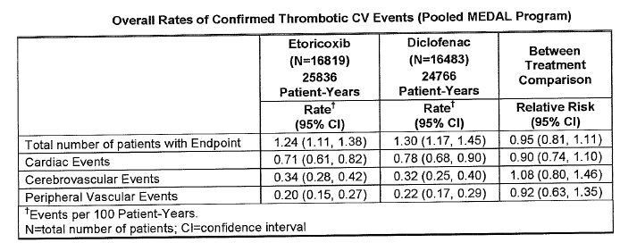
Comment: Interpretation of results from above studies is limited due to lack of placebo control in the MEDAL Program.

Additional safety data from the MEDAL Program studies
In the MEDAL study, an endpoint-driven CV outcomes trial involving 23,504 patients, the safety of etoricoxib 60 or 90 mg daily was compared to diclofenac 150 mg daily in patients with osteoarthritis or rheumatoid arthritis (mean duration of treatment was 20 months). In this large trial, only serious adverse events and discontinuations due to any adverse events were recorded. The rates of confirmed thrombotic CV serious adverse events were similar between etoricoxib and diclofenac. The incidence of discontinuations for hypertension-related adverse events was less than 3% in each treatment group; however, etoricoxib 60 and 90 mg demonstrated significantly higher rates of discontinuations for these events than diclofenac. The incidence of congestive HF adverse events (discontinuations and serious events) and the incidence of discontinuations due to oedema occurred at similar rates on etoricoxib 60 mg compared to diclofenac, however, the incidences for these events were higher for etoricoxib 90 mg compared to diclofenac (see Table 8.2 below). The incidence of discontinuations due to AF was higher for etoricoxib compared to diclofenac (in osteoarthritis patients: 0.8% versus 0.3 % for etoricoxib 90 mg and diclofenac respectively; 0.3 versus 0.2 for etoricoxib 60 mg versus diclofenac respectively).

Table 8.2:
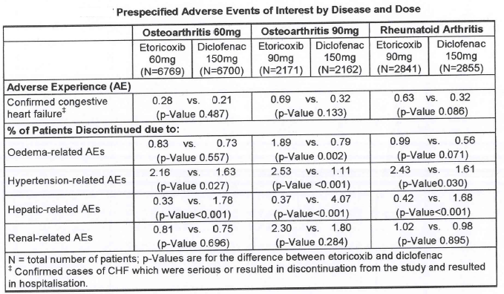

Additional thrombotic cardiovascular safety data
In a combined analysis of all Phase IIB to Phase V clinical studies of four weeks duration or longer (excluding the MEDAL Program Studies), there was no discernible difference in the rate of confirmed serious thrombotic CV events between patients receiving etoricoxib greater than or equal to 30 mg or non-naproxen NSAIDs. However, the rate of these events was higher in patients receiving etoricoxib compared with those receiving naproxen 500 mg twice daily, with a statistically significant increase in RR with etoricoxib with respect to the Anti-Platelet Trialists’ Collaboration combined endpoint. In the studies which directly compared etoricoxib to placebo (six to 12 weeks duration), there was no discernable difference in the event rates between patients receiving etoricoxib or placebo; however there were few events and the studies were limited in duration (see Table 8.3 below).

Table 8.3:
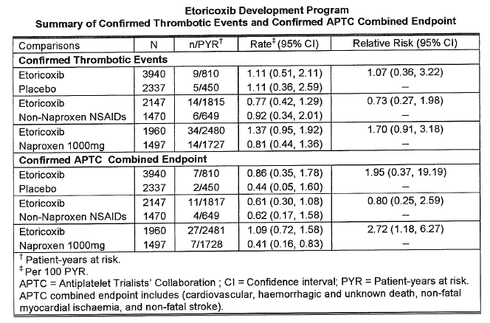

8.3 Benefit-risk assessment of cardiovascular safety of etoricoxib
Etoricoxib has not been studied in large multiple, long-term trials evaluating different dosage strategies, making it difficult to assess dose-related CV risks. However, high doses of etoricoxib used in the EDGE trial did not show an increased risk of CV events. Few observational studies evaluated CV risks associated with etoricoxib specifically, but those that did showed increased risk of CV events that also increased with dose and duration of etoricoxib treatment.

8.4 Comments on the Product Information/Consumer Medicine Information for etoricoxib products
The current PI/CMI for etoricoxib has adequate information to enable the physician to take an informed decision regarding the CV risk associated with prescription of etoricoxib in an individual patient. However, the following should be inserted in the ‘Precautions’ section of the PI in order to stress the importance of raising awareness about the potential CV risks:
‘Physicians and patients should remain alert for such CV events, even in the absence of previous CV symptoms. Patients should be informed about signs and/or symptoms of serious CV toxicity and the steps to take if they occur.’

9. Indomethacin
Indomethacin is available in Australia as Indocid (25 mg capsules and 100 mg suppositories) marketed by Aspen Pharmacare and also as Arthroxin (25 mg capsules) by Alphapharm. It is indicated for active stages of rheumatoid arthritis, osteoarthritis and ankylosing spondylitis, degenerative joint disease of the hip, gout; acute musculoskeletal disorders such as bursitis, tendonitis, synovitis, tenosynovitis, capsulitis of shoulder, sprains , strains; low back pain; inflammation, pain oedema following orthopaedic procedures and nonsurgical procedures associated with reduction and immobilisation of fractures; pain and associated symptoms of primary dysmenorrhoea. The recommended dose is 50 to 200 mg daily in divided doses.

9.1 Review of publications referenced by TGA
Very few studies provided separate risk estimates of CV events for indomethacin.
In a large retrospective cohort study of 162,065 Australian veterans (Caughey GE, et al, 2011), incident use of NSAIDs was associated with 1.88 times increased risk (95% CI: 1.70–2.08) of hospitalisation for stroke following first ever dispensing of NSAIDs ranging from 1.44 (95% CI: 1.16–1.80) for indomethacin to 1.80 (95% CI: 1.59–2.04) for rofecoxib (Table 5.3, p131).
Another retrospective case-crossover study in Chinese patients evaluated the risk of ischemic and haemorrhagic stroke associated with short-term use of selective and non-selective NSAIDs (Chang CH, et al. 2010). This study also found that all NSAIDs – celecoxib and non-selective (ibuprofen, ketorolac, diclofenac, naproxen, piroxicam, meloxicam, mefenamic acid and indomethacin) – were associated with a significantly increased risk of ischemic and haemorrhagic stroke.
Comments: Many of the studies assessed CV risks associated with non-selective NSAIDs which included indomethacin. When evaluated as part of the group of non-selective NSAIDs, the majority of the evidence suggested an increased risk of CV adverse events with all NSAIDs (non-selective and COX-2 selective). However, the proportion of patients using indomethacin was smaller than other commonly used non-selective NSAIDs such as diclofenac, ibuprofen and naproxen making it very difficult to assess the specific CV risk associated with indomethacin.

9.2 Review of data submitted by sponsors
Aspen Pharmacare (Indocid) did not submit any data.
Alphapharm submitted a two-page letter highlighting the limitations of observational studies and stating that it is not possible to accurately determine the CV risks associated with individual NSAIDs. Furthermore, they suggest that there is some evidence that the combined use of low-dose aspirin may decrease the CV risk associated with selective COX-2 inhibitors.
Neither of the sponsors of indomethacin products submitted any post-marketing CV safety data.
Comments: It is not clear why Alphapharm has made the above statement as there is considerable evidence to suggest that use of low-dose aspirin does not decrease the CV risk associated with NSAID use and in fact concomitant treatment with aspirin and ibuprofen/naproxen/diclofenac may also negate the cardioprotective effect of aspirin. The current PIs for most of the NSAIDs being marketed by Alphapharm do have the following statement to make it clear: ‘There is no evidence to suggest that concurrent use of aspirin mitigates the increased risk of CV events associated with NSAID use. However, the concurrent use of NSAIDs and aspirin does increase the risk of serious GI events.’

9.3 Benefit-risk assessment of cardiovascular safety of indomethacin
There is no evidence since 2005 to suggest any changes to the current status of indomethacin and its association with CV events.

9.4 Comments on Product Information/Consumer Medicine Information for indomethacin products
The current PI for indomethacin products contains appropriate information regarding CV effects of NSAIDs in general. However, the following needs to be added to the PIs of all approved indomethacin products in order to maintain consistency related to information provided in PIs of all NSAIDs regarding their CV risks.
The following should be added to the ‘precautions’ section of PI: ‘Physicians and patients should remain alert for such CV events, even in the absence of previous CV symptoms. Patients should be informed about signs and/or symptoms of serious CV toxicity and the steps to take if they occur.’
The following should be added to the ‘dosage and administration’ section: ‘Patients on long term treatment should be reviewed regularly with regards to efficacy, risk factors and ongoing need for treatment.’

10. Meloxicam
Meloxicam is available in Australia as Mobic 7.5 and 15 mg tablets and capsules (Boehringer Ingelheim) and is indicated for the symptomatic treatment of osteoarthritis and rheumatoid arthritis. The recommended dose is 7.5 mg once daily up to a maximum of 15 mg once daily.

10.1 Review of publications referenced by TGA
Following review of the TGA literature, there were very few studies which provided specific CV risk estimates for meloxicam.
A retrospective cohort study in Australian veterans (Caughey GE, 2011) (Table 2.4, p75) showed that incident use of all NSAIDs including meloxicam was associated with increased risk of ischaemic and haemorrhagic stroke; compared to non-users of NSAIDs, the RR estimates for meloxicam ranged between 1.66 to 1.88 (Table 5.3, p131). A Finnish population based case-control study (Helin-Salmivaara et al, 2006) (Table 2.13, p84) showed that current use of NSAIDs was associated with modest increase in risk of first-time MI with adjusted OR (compared to non-users of NSAIDs) of 1.50 for semi-selective NSAIDs (which included meloxicam, etodolac, nabumetone and nimesulfide) which was similar to that with conventional NSAIDs (Table 9, p166) although CV risk estimates for individual NSAIDs were not available. A population-based analysis in Taiwanese patients showed that compared to meloxicam, celecoxib was associated with reduced risk of acute MI and stroke, while rofecoxib and meloxicam showed similar effects; the most significant determinant of CV risk was history of such CV disease in prior year (Huang et al 2006) (Table 3.11, p107).

10.2 Review of data submitted by Boehringer Ingelheim
An analysis of the data from clinical trials for the registration of Mobic did not provide any evidence of excessive CV risk relative to other comparator NSAIDs although it should be noted that these trials were of short duration and lacked sufficient power to allow detection of significant differences for the CV safety endpoint.
The sponsors state that analysis of cardiac safety information from the latest company Periodic Safety Update Report for Mobic does not provide any post-marketing evidence to support a change to the PI.
Comment: The sponsors have not provided details of the post-marketing analysis to support the above statement.

10.3 Benefit-risk assessment of cardiovascular safety of meloxicam
There is no evidence since 2005 to suggest any changes to the current status of meloxicam and its association with CV events. Overall, the increased risk of CV events associated with NSAIDs (COX-2 selective and non-selective NSAIDs) applies to meloxicam as well.

10.4 Comments on Product Information/Consumer Medicine Information for meloxicam products
The section on ‘Precautions: Cardiovascular effects’ in the current Mobic PI is as follows:
‘Cardiovascular effects: Long term therapy with some COX-2 selective NSAIDs of the coxib class has been shown to increase the risk of serious cardiovascular thrombotic events. MOBIC is a COX-2 selective NSAID. Mobic has not been demonstrated to increase risk of CV adverse events compared to non-selective NSAIDs in clinical trials. However, long term placebo controlled data to adequately assess any CV risk are not available for Mobic. All NSAIDs, both COX-2 selective and non-selective may cause an increased risk of serious CV thrombotic events. This may increase with duration of use. Patients with CV disease or risk factors for CV disease may be at greater risk. Mobic should be used at the lowest dose and for the shortest duration consistent with effective treatment.’
Although the above paragraph contains some aspects of the statement regarding NSAID associated CV risk as recommended following the 2005 review of CV safety of NSAIDs, many important statements have been omitted. It is recommended that the following statements be added to the above paragraph to maintain consistency for all NSAIDs for which data from long-term, controlled studies is not available:
‘Physicians and patients should be alert for the development of such CV events even in the absence of previous CV symptoms. Patients should be informed about the signs and symptoms of serious CV toxicity and the steps to take if they occur. There is no consistent evidence that concomitant use of aspirin mitigates the increased risk of serious CV events associated with NSAID use.’
Another statement should also be added at the start of the section on ‘dosage and administration’: ‘Meloxicam should only be started after careful weighing of the risks and benefits in each individual patient. Furthermore, the clinical benefit and tolerability should be re-evaluated periodically.’

11. Piroxicam
Piroxicam is available in Australia as 10 and 20 mg capsules and 20 mg dispersible tablets (Feldene; Pfizer) and is indicated for the symptomatic treatment of osteoarthritis, rheumatoid arthritis and ankylosing spondylitis. Maximum daily dose is 20 mg.

11.1 Review of publications referenced by TGA
Very few studies provided specific CV risk estimate for piroxicam. Most provided data on CV risks associated with non-selective and selective NSAIDs.
A Finnish population based case-control study (Helin-Salmivaara et al, 2006) (Table 2.13, p84) showed that current use of NSAIDs was associated with modest increase in risk of first-time MI with adjusted OR (compared to non-users of NSAIDs) of 1.50 for semi-selective NSAIDs (which included meloxicam, etodolac, nabumetone and nimesulfide) which was similar to that with conventional NSAIDs (Table 9, p166) although CV risk estimates for individual NSAIDs were not available.
A systematic review of community-based controlled observational studies evaluated adjusted risk estimates for major CV events associated with individual NSAIDs, in different doses and in populations with low and high background risk of CV events (McGettigan, 2011). This showed that number of studies evaluating piroxicam was very small and the pooled RR was 1.20 (Table 10, p167).
A retrospective cohort study in Australian veterans (Caughey GE, 2011) (Table 2.4, p75) showed that incident use of all NSAIDs including piroxicam was associated with increased risk of ischaemic and haemorrhagic stroke; compared to non-users of NSAIDs, the RR estimates for meloxicam ranged between 1.74 to 2.97 (Table 5.3, p131).

11.2 Review of data submitted by sponsors
Pfizer did not submit any new data for the CV safety of piroxicam.
There was no post-marketing surveillance data available for evaluation.

11.3 Benefit-risk assessment for cardiovascular safety of piroxicam
There is no evidence since 2005 to suggest any changes to the current status of piroxicam and its association with CV events.

11.4 Comments on Product Information/Consumer Medicine Information for piroxicam products
There is no evidence to support any changes to the current PI which has adequate precautions regarding CV risks associated with piroxicam and with NSAIDs in general.

12. Additional information relevant to this review

Non-steroidal anti-inflammatory drugs and atrial fibrillation:
Current use of NSAIDs (such as diclofenac, naproxen, ibuprofen, indomethacin and others) was associated with a 44% increased risk of chronic AF (but no paroxysmal AF) in a nested case-control retrospective analysis of data on patients (aged 40–89 years) with AF from a UK primary care database (De Caterina R, et al. 2010) (Table 2.7, p78). The risk was increased further following long-term NSAID treatment (greater than 1 year), but did not appear to be related to dose of NSAIDs, unlike steroidal anti-inflammatories wherein the risk of chronic AF was increased much more in patients receiving high doses of steroidal anti-inflammatories.
A large population-based case-control study in 32,602 patients with first diagnosis of AF/flutter evaluated the association between use of NSAIDs and AF/flutter (Schmidt M, et al, 2011) (Table 2.19, p90). Compared to non-users, association with AF/flutter was strongest for new NSAID users with RR increase of 40–70%; equivalent to approximately four extra cases per year of AF per 1000 new users of non-selective NSAIDs and seven extra cases of AF per year per 1000 new users of COX-2 inhibitors. Hence, AF/flutter may also need to be monitored as an additional CV event that may be associated with NSAIDs.
With increasing uncertainty regarding plausible biological mechanism, the susceptibility of case-control studies to unmeasured confounders and inconsistent results in the two studies performed to date, a cautious approach seems warranted. NSAIDs (non-selective and COX-2 selective) should continue to be used very cautiously in older patients with a history of hypertension or HF, who are already at high risk for adverse effects of these drugs regardless of whether an association between NSAIDs and AF actually exists (Gurwitz JH. 2011).

Future trends:
More than 80 million patients were treated with rofecoxib before its voluntary withdrawal due to CV risks and a high number of patients are still being prescribed COX-2 inhibitors. Hence, the availability of a reliable biomarker as a screening instrument for patients who may have CV disease despite lack of symptoms would definitely be helpful. Giannitsis E (2005) suggest use of N-terminal pro-brain natriuretic peptide (NT-proBNP) levels. Natriuretic peptides are secreted as a reaction to increased wall tension (due to volume overload or MI) and the authors state that usefulness of NT-proBNP has been established by numerous studies which were reviewed in the article; however, this needs to be evaluated further in controlled trials.
There is a possibility that new designer drugs – antagonism of thromboaxane A2 receptor with COX-2 inhibition; or COX-inhibiting+nitric oxide donors – could also be effective but with improved GI and CV safety (Expert opinion, Fosbol et al, 2010).

13. Benefit-risk assessment

13.1 Comparative benefit-risk analysis of safety of diclofenac, naproxen and ibuprofen when used at dosages available with and without a prescription.
Recent review of studies published in the medical literature suggest that diclofenac carries levels of risk similar to those NSAIDs available only on prescription, while naproxen and ibuprofen carry lower (but still significant) levels of risk. This was seen in a systematic review of community-based controlled observational studies which evaluated adjusted risk estimates for major CV events associated with individual NSAIDs, in different doses and in populations with low and high background risk of CV events (McGettigan, 2011) (Table 3.14, p110). Of the extensively studied NSAIDs (10 or more studies), the highest overall risks (RR; 95% CI) were seen with rofecoxib (1.45; 1.33–1.59) and diclofenac (1.40; 1.27–1.47) and the lowest with ibuprofen (1.18; 1.11–1.25) and naproxen (1.09; 1.02–1.16). Paired analysis of dose effects of five NSAIDs that had been evaluated in 10 or more studies showed that the risk was elevated with low doses of rofecoxib, celecoxib and diclofenac and rose in each case with higher doses. Ibuprofen risk was seen only with higher doses and naproxen was risk neutral at all doses.
The majority of studies reviewed since 2005 suggest that diclofenac is associated with an increased risk of CV events and that this effect is related to dose and duration of treatment. Overall, the evidence suggests that there is increased risk of serious CV events associated with diclofenac which may be similar to those associated with COX-2 selective NSAIDs. The clinical observation of increased CV risk with diclofenac may in part be explained by the fact it resembles a selective COX-2 inhibitor rather than a classical non-selective traditional NSAID (Krotz et al, 2010). Though commonly mistaken for being a non-selective NSAID, recent evidence shows a certain selectivity of diclofenac towards COX-2. In vitro data suggest a selectivity ratio of 20 (COX-2/COX-1) for diclofenac that is similar to celecoxib in terms of COX-2 selectivity.
In a large retrospective cohort study using data from the UK General Practice Research Database, diclofenac had higher risks of MI (1.21) than ibuprofen (1.04) or naproxen (1.03), but exposure varied between drugs and the patterns of MI risk were similar between diclofenac, ibuprofen and naproxen after taking into account exposure characteristics. RR for MI increased with cumulative dose and daily dose (RR=1.05 for ibuprofen less than 1200 mg/day, 1.96 with dose greater than 2400 mg/day; diclofenac=1.13 for less than 150 mg/day and 2.03 with greater than 300 mg/day) (Van Staa, et al. 2008) (Table 2.24, p95).
There are trends to suggest that diclofenac may increase CV risk even at low doses and after short duration of treatment especially in patients with prior CV disease. However, the CV safety of diclofenac has not been analysed in controlled randomised studies and hence the findings in observational studies which suggest that diclofenac may have higher CV risks compared to ibuprofen and naproxen cannot be confirmed. The risk estimates of CV events for diclofenac were variable and the 95% confidence limits quite wide and overlapping with those for ibuprofen and naproxen. Furthermore, pharmacovigilance safety data provided by sponsors showed a small number of CV events compared to the widespread use of diclofenac and no major CV safety signals were observed in the post-marketing safety data.
It has been suggested that naproxen may be associated with a cardioprotective effect, but the current evidence is not unequivocal. Hence, it would not be prudent to suggest that naproxen is different from the other NSAIDs and the current evidence does not justify its preference as an NSAID in patients with CV risk factors.
Recent evidence suggested increased risk of stroke with ibuprofen, especially haemorrhagic stroke (Caughey, 2011; Chang, 2010). For the outcome of MI and/or acute coronary syndromes, the overall evidence for prescription ibuprofen appears to be similar to that observed in the 2005 NSAID safety review. Studies showed heterogeneity in results regarding association between ibuprofen and CV composite endpoint, although majority of the studies did show a slight increased risk of CV events. Overall, risks associated with prescription doses of ibuprofen appear to be similar to those with other NSAIDs and current evidence suggests that risks may be increased with dose and duration of treatment and may also be increased with concomitant use of low-dose aspirin.
In considering risk associated with non-prescription (OTC) use of NSAIDs, it is important to consider three factors: safety at low doses, with short duration of treatment and in patients with low background risk of CV disease. The maximum recommended daily doses for OTC NSAIDs are: ibuprofen: 1200 mg/day; naproxen: 750 mg/day and diclofenac: 75 mg/day. The CV risk estimates in this review were based on prescription data and not a survey of non-prescription drug users and the variable dose cut-off points used by different authors made interpretation of dose effects difficult. Ibuprofen at 1200 mg/day or less appears to have minimal CV risk, while naproxen did not significantly elevate CV risks at low or high doses. Of the three NSAIDs available without a prescription, ibuprofen and naproxen were free of CV risk at low doses, while diclofenac was associated with a significant 22% increased risk of CV events at low doses (McGettigan, 2011) (Table 5.10, p136); eight of the 10 studies that included analysis of low doses of diclofenac defined low-dose as 100 mg/day or less which is close to maximum recommended dose for non-prescription use (75 mg/day).
Although it is accepted that most of the evidence for increased CV risk with low doses of diclofenac is based on observational studies, it is highly unlikely that a prospective RCT will ever be conducted to confirm or clarify the increased CV risks associated with use of diclofenac. Due to the above reasons, it is extremely important to increase awareness of the CV risks with diclofenac and NSAIDs in general. At the very least, the dose and duration of treatment with diclofenac, especially OTC diclofenac, should be strictly controlled.
Post-marketing pharmacovigilance safety data submitted by sponsors of OTC diclofenac and ibuprofen indicate a low incidence of CV events compared to the widespread sales of these OTC NSAIDs. No post-marketing safety data was submitted for OTC naproxen.
Overall, OTC NSAIDs are safe and effective for the temporary relief of pain and inflammation when used as per the label. The lower doses of OTC NSAIDs and their short-term use mean that their safety profiles are different to their higher dose, prescription counterparts. But even the OTC NSAIDs can be dangerous when taken too often and/or in high doses regularly. The impact of this potential misuse (if prolonged use is not on medical advice) is difficult to assess. Although there are no studies that quantify the extent of the inappropriate or unsafe use of NSAIDs, overuse of non-prescription and/or prescription NSAIDs could have significant safety implications. Hence, it is important to increase awareness about the CV risk profile of OTC NSAIDs (diclofenac, ibuprofen and naproxen) just as the knowledge about their GI risks is widespread, especially when used more often or for longer than recommended. The recommendations to add certain additional warnings to the labels of OTC NSAIDs would help, to some extent, to ensure safe use of these drugs (see sections 4.6.2, p20; 5.6.2 , p31; and 6.4.2, p38).

13.2 Compare cardiovascular safety of diclofenac/naproxen/ibuprofen with that of celecoxib, etoricoxib, indomethacin, meloxicam and piroxicam
Overall, the data on celecoxib and its CV risk has been inconclusive. Following withdrawal of the COX-2 inhibitors rofecoxib and valdecoxib in 2004–2005, evidence suggests consistent CV risk with rofecoxib, but the evidence for CV risk with celecoxib is more equivocal. Higher doses and longer duration of therapy with COX-2 selective NSAIDs (more than nine months) appear to increase the risk of CV events. Evidence from randomised and observational studies suggest that all COX-2 inhibitors are associated with increased cardiotoxicity, but the CV risks of different COX-2 inhibitors are not homogenous and are likely influenced not only by a class effect, but also by individual drug, dosage and patient characteristics (Brophy JM et al, 2007) (Table 3.3, p99). Although caution in prescribing any anti-inflammatory drug, including celecoxib is important, the complete evidence from both randomised trials and observational studies suggests that the increased CV risk with celecoxib is most likely small, less than rofecoxib and comparable to most traditional NSAIDs. Overall, evidence from randomised and epidemiological studies supports the relative CV safety of celecoxib when used at the doses recommended for treatment of arthritis (daily dose of 400 mg only).
Etoricoxib has not been studied in large multiple, long-term trials evaluating different dosage strategies, making it difficult to assess dose-related CV risks. However, high doses of etoricoxib used in the EDGE trial did not show an increased risk of CV events. Few observational studies evaluated CV risks associated with etoricoxib specifically, but those that did showed increased risk of CV events which also increased with dose and duration of etoricoxib treatment.
Very few studies provided separate risk estimates of CV events for indomethacin, meloxicam and piroxicam and there is no evidence since 2005 to suggest that the CV risks of these NSAIDs is different to that observed with all NSAIDs in general.
Overall, evidence suggests that there is increased risk of serious CV events associated with diclofenac which may be similar to those associated with COX-2 selective NSAIDs. There is some evidence to suggest that diclofenac may increase CV risk even at low doses and after short duration of treatment especially in patients with prior CV disease.
It has been suggested that naproxen may be associated with a cardioprotective effect, but the current evidence is not unequivocal. Hence, it would not be prudent to suggest that naproxen is different from the other NSAIDs and there is not enough evidence to justify its preference as an NSAID in patients with CV risk factors.
Overall, risks associated with prescription doses of ibuprofen appear to be similar to those with other NSAIDs and current evidence suggests that risks may be increased with dose and duration of treatment and may also be increased with concomitant use of low-dose aspirin.
Concerns over the use of COX-2 selective NSAIDs would probably result in a decline in use of these agents in favour of traditional NSAIDs or paracetamol. A large prospective cohort analysis showed that there was no significantly elevated risk of CV events with less than daily use of NSAIDs and paracetamol, but there was significantly increased risk following high frequency use of NSAIDs and paracetamol (Chan AT, et al, 2006).
As part of the Safety of NSAIDs project, incidence of CV and GI events associated with the use of NSAIDs was reviewed using data collected from published meta-analyses of clinical trials of NSAIDs; 29 meta-analyses were selected for this review with estimations of CV and GI adverse events (Salvo F, et al, 2011). Some of the limitations of this review which made interpretation difficult were differences in study design (for example, duration of studies for meloxicam were 4–26 weeks whereas those for COX-2 inhibitors were up to four years), also the same RCTs could have been included in different meta-analyses. The main result from this extensive review was that there is a serious knowledge gap in the GI and CV safety evaluation of NSAIDs, especially the CV safety of traditional NSAIDs.
A retrospective case-control study showed that acute MI risk and CV risk increased similarly with COX-2 inhibitors (rofecoxib and celecoxib) and traditional NSAIDs (except naproxen) but naproxen and diclofenac were associated with increased GI risk (Van der Linden, 2009) (Table 3.16, p112).
In a cohort of patients with prior MI, NSAID treatment was associated with a statistically significant increased risk of death at the beginning of the treatment. The increased risk persisted throughout the course of treatment, with the highest risk being observed with diclofenac. Ibuprofen showed an increased risk only when used for more than one week. The risk associated with ibuprofen was lower than the risk with the COX-2 selective inhibitors and diclofenac. Diclofenac had a CV risk identical to that of rofecoxib and significantly higher RR than celecoxib, naproxen or ibuprofen. Etoricoxib had a significantly higher RR than ibuprofen or naproxen (Schjerning O, et al, 2011)(Table 2.19, p90). Duration of use is difficult to study as administrative datasets included information on prescribing or dispensing but not on actual consumption of NSAIDs.
Patients who have taken NSAIDs for more than one year are still exposed to increased risk of non-fatal MI up to six months after discontinuation of their NSAIDs (Garcia Rodriguez, 2009).
A large Danish retrospective cohort study (Sorenson R, et al, 2008) (Table 2.22, p93 ) showed that treatment with two COX-2 selective NSAIDs (rofecoxib and celecoxib) and high doses of two non-selective NSAIDs (ibuprofen and diclofenac) were associated with highly increased risk of death in patients with prior MI. There was also a trend of increased risk of recurrence of MI with all NSAIDs. The numbers of patients needed to receive treatment with each drug for one year to cause one additional death were 13, 14, 45 and 24 for rofecoxib, celecoxib, ibuprofen and diclofenac, respectively (Tables 11.1, 11.2, p168).
Most interventional studies have not been designed specifically to evaluate the CV safety of NSAIDs. A large population based historic cohort study (Fosbol EL, et al. 2010) was one of the first to evaluate an association between NSAIDs and CV risk (in terms of CV death, coronary death/ non-fatal MI, fatal/non-fatal stroke) in 4,614,807 health Danish individuals using case-crossover and Cox proportional hazard analysis. Ibuprofen was associated with a significant increase in coronary death or non-fatal MI, fatal/non-fatal stroke (only at high doses greater than 1200 mg/day). Diclofenac and rofecoxib also showed a significant increase in all CV parameters with a clear dose-response. Celecoxib showed no significant increase; naproxen was also neutral in terms of CV outcomes except for fatal/non-fatal stroke which showed a dose-dependent increase. Another cohort study in one million healthy Danish people (Fosbol EL, et al. 2009) showed that the selective COX-2 inhibitors as well as diclofenac are associated with an increased risk of death or MI. Compared to no NSAID use, HRs (95% CI) were 1.01 (0.96–1.07) for ibuprofen, 1.63 (1.52–1.76) for diclofenac, 0.97 (0.83–1.12) for naproxen, 2.13 (1.89–2.41) for rofecoxib and 2.01 (1.78–2.27) for celecoxib with dose-dependent increase in CV risk seen for selective COX-2 inhibitors and diclofenac.
A large meta-analysis of all studies conducted from 1990 to 2010 evaluated the association between NSAID use and incidence of non-fatal and fatal MI (Garcia Rodriguez, 2011) (Table 2.10, p81). NSAID treatment (both traditional NSAIDs and COX-2 inhibitors) predisposes to non-fatal MI with higher risk in patients with prior CV disease; however, the risk of fatal MI did not appear to be increased following treatment with NSAIDs, but interpretation of results were confounded by very few events in the studies and the data was insufficient to assess the risk of non-fatal MI with individual NSAIDs.
In the systematic review by McGettigan (2011) (Table 3.14, p110), of the extensively studied drugs (10 or more studies), the highest overall risks were seen with rofecoxib, 1.45 (95% CI 1.33–1.59), and diclofenac, 1.40 (1.27–1.55), and the lowest with ibuprofen, 1.18 (1.11–1.25) and naproxen, 1.09 (1.02–1.16). In a sub-set of studies, risk was elevated with low doses of rofecoxib, 1.37 (1.20–1.57), celecoxib, 1.26 (1.09–1.47) and diclofenac, 1.22 (1.12–1.33), and rose in each case with higher doses. Ibuprofen risk was seen only with higher doses (Table 5.10, p136).
A recently published network meta-analysis involving 31 trials in 116,429 patients with more than 115,000 patient years of follow-up showed that CV risk is not associated with specificity of COX-2 inhibition and so no prediction about CV safety can be made based on COX-2 selectivity (Trelle S, et al, 2011). Seven NSAIDs (rofecoxib, celecoxib, etoricoxib, lumiracoxib, naproxen, ibuprofen and diclofenac) were evaluated in this meta-analysis and all NSAIDs increased risk of CV death, death from any cause and Anti-Platelet Trialists’ Collaboration composite endpoints. Naproxen appears to be safest, but GI risks may limit its use. However, it was not possible to evaluate effects of low doses or short duration of NSAID use and hence these results cannot be extrapolated to OTC use of NSAIDs (Table 2.23, p94).
It is accepted that most of the evidence for increased CV risk with diclofenac, ibuprofen and naproxen is based on observational studies. However, a prospective, placebo-controlled randomised study that investigates the CV safety of diclofenac or any other traditional NSAID has never been conducted and is highly unlikely to ever be conducted. The COX-2 inhibitors (celecoxib and etoricoxib) have been extensively investigated in controlled studies but these studies were not designed to assess CV risks. There are very few studies providing information on CV risks associated with use of indomethacin, piroxicam and meloxicam. The risk estimates of CV events for individual NSAIDs were variable and the 95% confidence limits quite wide and overlapping. Overall, there is lack of adequate information to provide guidelines on which NSAID has the least CV risks (see section 13.3 below).

13.3 Overall conclusions regarding use of non-steroidal anti-inflammatory drugs following review of evidence since 2005
All clinical trials with COX-2 inhibitors and NSAIDs to date were underpowered to capture CV outcomes and the results are inconclusive. Hence, conclusions drawn from post-hoc and non-prespecified analyses are not confirmatory. Future trials would have to include patients with established CV disease in order to establish CV safety of these drugs in patients with both low and high CV risk. With the exception of trials of COX-2 selective agents in which certain non-aspirin NSAIDs (for example naproxen, ibuprofen and diclofenac) were used as controls, there have been no long-term RCTs evaluating the CV risks of non-aspirin NSAIDs. Large scale RCTs comparing individual NSAIDs might be the only way to resolve the uncertainty regarding CV risks associated with individual NSAIDs.
COX-2 inhibitors and most traditional NSAIDs cause similar moderately increased risks of CV disease. Until long-term prospective, randomised, adequately powered clinical studies in relevant patient populations with clinically appropriate pre-defined CV endpoints are completed, it is critical that both COX-2 selective and traditional NSAIDs be used with caution in patients with CV risk factors. Although specific CV risk factor have not yet been determined, NSAIDs should be avoided in patients with previous MI, angina, cardiac failure, hypovolemia, significant peripheral vascular disease and pre-existing significant renal/liver dysfunction (Joshi GP, et al, 2007).
NSAIDs are among the most commonly used pharmacological agents worldwide due to their efficacy as non-addictive analgesics and their anti-inflammatory properties. Hence, even a small absolute risk of serious CV effects associated with these drugs could produce a significant health burden in a given population.
In a Spanish observational study, more than half of the patients requiring NSAID treatment were at high risk of GI and/or CV events, but NSAID prescription habits were similar regardless of the presence of these risk factors. This study highlighted the need for generating more awareness and a more cautious approach to NSAID therapy (Lanas A et al, 2010) (Table 2.17, p88). A retrospective before and after analysis nested in a cohort analysis in osteoarthritis patients in Belgium (Simoens S, et al, 2006)(Table 2.20, p91) showed that the use of both selective and non-selective NSAIDs is associated with higher use of co-medication over time. The increase in anti-secretory co-medication was more prominent with non-selective NSAIDs and the rise in CV co-medication more pronounced with selective NSAIDs.
Although rofecoxib was withdrawn from the market, meloxicam, diclofenac and celecoxib accounted for almost two-thirds of all NSAIDs dispensed in 2008 in Australia and all were shown to be associated with significantly increased risk of stroke (Caughey GE et al, 2011).
Current prescribing patterns for NSAIDs are a cause for concern and justify the need to raise more awareness amongst doctors and patients regarding the CV risks associated with all NSAIDs. Individual assessment of CV risk, careful deliberation of the balance between risk and benefits and appropriate supervision is required when initiating NSAID therapy. Enhancing patient awareness of the potential for serious adverse CV events with all NSAIDs may also help to attenuate risk.
All NSAIDs ease the pain and other symptoms of arthritis, and other types of pain. At equivalent doses, there is no evidence that one NSAID is superior to others in relieving pain. However, while NSAIDs probably do differ in their CV or GI risks, the evidence regarding the risks and safety profiles of the individual NSAIDs is not definitive, so it cannot be used as the basis to choose one NSAID over another. Treatment recommendations are much clearer for patients with high GI risk (co-treatment with proton-pump inhibitor) than for patients with high CV risk. In patients with high CV risk, neither COX-2 inhibitors, non-naproxen NSAIDs or naproxen are valid or safe options. In patients taking low-dose aspirin, concomitant use of ibuprofen and even naproxen may be unsafe. Before starting treatment for chronic pain with NSAIDs or COX-2 inhibitors, CV and GI risk should be carefully assessed for each patient and treatment chosen accordingly.
Hence, selection of an NSAID in a patient is based mainly on the risk profile of the patient. It is important to individualise treatment based on likely benefits and risks to each patient and it is difficult to provide general guidelines regarding the use of individual NSAIDs based on current evidence. Individual clinical judgements and policy decisions should include CV disease and non-CV disease risks including GI side effects and clinical benefits including improved quality of life from less pain and disability (Hennekens CH, et al, 2008). Furthermore, before and after starting treatment with a coxib or non-selective NSAID, blood pressure, renal function and body weight should be assessed to allow for early detection of cardiorenal side effects (Hermann M, 2009).
The main conclusion that can be drawn from this review of the current evidence is that any prescription of NSAIDs should be individualised and patients reassessed periodically in order to balance their risks and benefits.

14. Comments on Product Information, Consumer Medicine Information and labels

14.1 Comments on warnings in Product Information/Consumer Medicine Information of prescription non-steroidal anti-inflammatory drugs
The current PI/CMI of the innovator products for all eight NSAIDs being reviewed were appropriate, adequate and representative of current evidence regarding CV safety of NSAIDs (COX-2 selective and non-selective). However, the wording of the ‘precautions’ and ‘dosage’ sections of all NSAIDs was not consistent and recommendations have been provided in this review to make these consistent across all NSAIDs. Please see sections 4.6.1 (p19), 5.6.1 (p31), 6.4.1 (p37), 7.4 (p49), 8.4 (p52), 9.4 (p54), 10.3 (p55) and 11.4 (p56) for details. In general, these recommendations mainly stress the following:
- the importance of assessing the risks in each individual patient.
- raising awareness of the increased risk of CV events, especially in patients with prior CV disease or CV risk factors.
- the importance of periodic assessment of patients to detect any signs/symptoms indicating CV events associated with NSAID treatment.

14.2 Comment on availability and warnings on labels for over-the-counter non-steroidal anti-inflammatory drugs
Based on the current evidence, there are no major changes suggested to the availability and warnings on labels for OTC diclofenac, ibuprofen and naproxen. These drugs provide effective pain relief when used according to the label at recommended doses for short durations. However, inappropriate, unsafe and overuse of these OTC NSAIDs could pose a significant health hazard. Hence, it is important to increase awareness about the CV profile of OTC NSAIDs (diclofenac, ibuprofen and naproxen) just as the knowledge about their GI risks is widespread. Hence, it is felt that the addition of the following to the labels of OTC NSAIDs would help to ensure safer use:
- The potential GI bleeding risks are covered extensively in the OTC labels but there is no mention under ‘warnings’ about the potential CV risks and the following could be added to the ‘warnings’ section of the labels of OTC NSAIDs: ‘NSAIDs may cause an increased risk of serious cardiovascular thrombotic events, myocardial infarction, and stroke, which can be fatal. This risk may increase with duration of use. Patients with cardiovascular disease or risk factors for cardiovascular disease may be at greater risk.’
- Stronger reminders that patients with CV disease and/or CV risk factors should seek the advice of a physician before using these drugs. Physicians and patients should remain alert for CV events even in absence of previous CV symptoms. Patients should be informed about signs and/or symptoms of serious CV toxicity and the steps to take if they occur.
- Stronger reminders about limiting the dose and duration of treatment in accordance with the package instructions unless otherwise advised by a physician.

15. References
Abraham NS et al. ‘Cyclooxygenase-2 selectivity of non-steroidal anti-inflammatory drugs and the risk of myocardial infarction and cerebrovascular accident.’ Alimentary Pharmacology and Therapeutics. 25 (8), pp182–183; 2007.
Abraham NS et al. ‘National mortality following upper gastrointestinal or cardiovascular event in older veterans with recent non-steroidal anti-inflammatory drug use.’ Alimentary Pharmacology and Therapeutics. 28 (1), pp97–106; 2008.
Abramson, Steven and Jeffrey Greenberg. ‘Are NSAIDs and selective COX-2 inhibitors associated with increased risk of myocardial infarction?’ Nature Clinical Practice Rheumatology. 4 (4) p 182–183, 2008.
ADAPT Research Group. ‘Cardiovascular and cerebrovascular events in the randomized, controlled Alzheimer’s Disease Anti-Inflammatory Prevention Trial (ADAPT).’ PloS clinical trials 1, no. 7 (2006): e33
Aldington S, et al. ‘Increased risk of cardiovascular events with parecoxib/valdecoxib: a systematic review and meta-analysis.’ The New Zealand Medical Journal. 118 (1226) pU1755. 2005.
Aldington S, et al. ‘Systematic review and meta-analysis of the risk of major CV events with etoricoxib therapy.’ The New Zealand Medical Journal. 118 (p1223) U1684, 2005.
Amer M, et al. ‘Use of NSAIDs in patients with cardiovascular disease: A cautionary tale.’ Cardiology in Review. 18 (4), p204–212. 2010.
Andersohn F, et al ‘Use of first- and second-generation cox-2 selective NSAIDs and risk of acute myocardial infarction.’ Circulation. 113, p1950–1957. 2006.
Andersohn F, et al. ‘Cyclooxygenase-2 selective NSAIDs and the risk of ischemic stroke: A nested case-control study. Stroke. 37 (7), p1725–1730. 2006.
Antman EM, et al. ‘Cycloxygenase inhibition and cardiovascular risk.’ Circulation. 112 (5), p759–770, 2005.
Antman EM, et al. ‘Cycloxygenase inhibition and cardiovascular risk.’ Circulation. 112 (5), p759–770, 2005. This report provides an overview of the relevant and pharmacology of NSAIDs, briefly summarises results of major clinical trials or meta-analysis and then offered suggestions on strategies for prescribing NSAIDs and also made observations on the regulatory and research implications of the data and their interpretation.
Antman EM, et al. ‘Use of NSAIDs: An update for clinicians: A scientific statement from the American Heart Association. Circulation. 115 (12), p1634–1642. 2007.
Antman EM, et al. ‘Use of NSAIDs: An update for clinicians: A scientific statement from the American Heart Association.’ Circulation. 115 (12), p1634–1642. 2007. This report is similar to that written in 2005 by the same authors but specifically addresses the following: treatment considerations; patient characteristics; does selectivity of COX-2 inhibitor matter?; and finally if patient is using aspirin can they use another NSAID?
Back M, et al. ‘Increased incidence of atrial fibrillation associated with the use of COX-2 inhibitors in a nationwide cohort study of 7 million individuals.’ European Heart Journal Conference: European Society of Cardiology ESC Congress 2011 publication p643.
Baraniak J et al. ‘The relation between taking NSAIDs and the occurrence of selected cardiovascular disease. Family Medicine and Primary Care Review. 11(3), p245–247. 2009. The article was in Polish and only the abstract was provided. It was a retrospective analysis of 365 randomly selected disease stories of patients treated in a public hospital in Lublin, Poland. (205 women, 160 men; mean age of 65 years of whom 269 (74%) had taken NSAIDs). Results suggested that more frequent occurrence of HF was observed in women treated with NSAIDs; arterial hypertension was more frequent in persons taking NSAIDs and taking NSAIDs did not significantly influence the occurrence of cardiac arrhythmias or MI.
Bavry A.A, et al. ‘Harmful effects of NSAIDs among patients with hypertension and coronary artery disease. American Journal of Medicine. 124 (7), p614–620. 2011.
Becker RC. ‘COX-2 inhibitors. Texas Heart Institute Journal. 32 (3), p380–393. 2005.
Bhatt LD.’ NSAIDs and the risk of myocardial infarction: Do they help or harm?’ European Heart Journal 27 (14), p1635–1636. 2006.
Blankfield RP. ‘Can natriuretic peptide levels predict the cardiovascular complications of COX-2 inhibitors and NSAIDs?’ Journal of American Board of Family Medicine. 19 (2), p178–182. 2006.
Brophy JM, et al. ‘The coronary risk of COX-2 inhibitors in patients with a previous myocardial infarction.’ Heart 93 (2), p189–194. 2007.
Brophy JM. ‘Celecoxib and cardiovascular risks.’ Expert Opinion on Drug Safety. 4(6), p1005–1015. 2005.
Brophy JM.’ Cardiovascular effects of COX-2 inhibitors.’ Current Opinion in Gastroenterology. 23 (6), p617–624. 2007.
Brownstein JS, et al. ‘The tell-tale heart: population-based surveillance reveals an association of rofecoxib and celecoxib with myocardial infarction.’ PloS One. 2 (9), p840. 2007.
Bueno H, et al. ‘Use of NSAIDs and type-specific risk of Acute Coronary Syndrome (ACS).’ American Journal of Cardiology. 105 (8), p1102–1106, 2010.
Caldwell B, et al. ‘Risk of cardiovascular events and celecoxib: A systematic review and meta-analysis.’ Journal of the Royal Society of Medicine. 99 (3), p132–140, 2006.
Carman WJ, et al. ‘Coronary heart disease outcomes among chronic opioid and COX-2 users compared with a general population cohort.’ Pharmacoepidemiology and Drug Safety. 20 (7), p754–762. 2011.
Caughey GE, et al. ‘Stroke risk and NSAIDs: an Australian population-based study.’ MIA 2011; 195: 525–529.
Chan A.T, et al. ‘NSAIDs, acetaminophen and the risk of cardiovascular events.’ Circulation. 113 (12), p1578–1587. 2006.
Chan AT, et al. ‘NSAIDs, acetaminophen and the risk of cardiovascular events.’ Circulation. 113(12), p1578–1587. 2006.
Chan FKL, et al. ‘Celecoxib vs. omeprazole and diclofenac in patients with osteoarthritis and RA (CONDOR): a randomised trial.’ Lancet 2010; 376: 173–179 and Erratum 2011; 378: 228.
Chang C H, et al. ‘Increased risk of stroke associated with NSAIDs: A nationwide case-crossover study.’ Stroke. 41 (9), p1884–1890. 2010.
Chen LC, et al. ‘Do selective COX-2 inhibitors increase the risk of cerebrovascular events? A metanalysis of randomised controlled trials.’ Journal of Clinical Pharmacy and Therapeutics. 31 (6), p565–576. 2006.
Chen LC, et al. ‘Risk of myocardial infarction associated with selective COX-2 inhibitors: Metanalysis of randomised controlled trials.’ Pharmacoepidemiology and Drug Safety. 16 (7), p 762–772. 2007.
Cheng JWM. ‘Use of non-aspirin NSAIDs (NANSAIDs) and the risk of cardiovascular events.’ Annals of Pharmacotherapy. 40 (10), p1785–1796. 2006.
Corman SL et al. ‘Impact of NSAIDs on the cardioprotective effects of aspirin.’ Annals of Pharmacotherapy. 39 (6), p1073–1079. 2005.
Cunnington M, et al. ‘Risk of ischaemic cardiovascular events from selective COX-2 inhibitors in osteoarthritis.’ Pharmacoepidemiology and Drug Safety. 17 (6), p601–608. 2008.
Curtis SP, et al. ‘Pooled analysis of thrombotic cardiovascular events in clinical trials of the COX-2 selective inhibitor etoricoxib.’ Current Medical Research and Opinion. 22 (12), p2365–2374. 2006.
Depont F, et al. ‘Channelling of COX-2 inhibitors to patients at higher gastrointestinal risk but not at lower cardiovascular risk: the COX-2 inhibitors and tNSAIDs description of users (CADEUS) study.’ Pharmacoepidemiology and Drug Safety. 2007; 16 (8):891–900.
Depont F, et al. ‘The CADEUS study: methods and logistics.’ Pharmacoepidemiology and Drug Safety. 2007; 16 (5): 571–580.
Dogne JM et al. ‘Coxibs and cardiovascular side-effects: From light to shadow.’ Current Pharmaceutical Design. 12 (8), p971–975. 2006.
Elliot WJ. ‘Do the blood pressure effects of NSAIDs influence CV morbidity and mortality?’ Current Hypertension Reports. 12 (4) p258–266. 2010.
Farkouh ME, et al. ‘An evidence-based review of the CV risks of NSAIDs.’ American Journal of Cardiology. 103 (9), p1227–1237. 2009.
Farooq M, et al. ‘Cardiovascular risks of COX- inhibition: Current perspectives’. Expert Opinion on Pharmacotherapy. 9 (8), p1311–1319. 2008.
Fosbol EL, et al. ‘Cause-specific CV risk associated with NSAIDs among healthy individuals.’ Circulation: Cardiovascular Quality and Outcomes. 3 (4), p395–405. 2010.
Fosbol EL, et al. ‘Risk of myocardial infarction and death associated with the use of NSAIDs among healthy individuals: A nationwide cohort study.’ Clinical Pharmacology and Therapeutics. 85 (2), p190–197, 2009.
Garcia Rodriguez, et al. ‘Long term use of traditional NSAIDs and the risk of myocardial infarction in the general population.’ BMC Medicine. 3 (article No 17), 2005.
Garcia Rodriguez, et al. ‘NSAID use selectively increases the risk of non-fatal MI: A systematic review of randomised trials and observational studies.’ PLoS ONE. 6(2), article number e16780. 2011.
Garcia Rodriguez, et al. ‘Risk of MI persisting after discontinuation of NSAIDs in the general population.’ Journal of Thrombosis and Haemostatis. 7 (5), p892–894. 2009.
Garcia Rodriguez, et al. ‘Role of dose potency in the prediction of risk of MI associated with NSAIDs in the general population.’ Journal of American College of Cardiology. 52 (20), p1628–1636. 2008.
Gengo FM, et al. ‘Effects of ibuprofen on the magnitude and duration of aspirin’s inhibition of platelet aggregation: Clinical consequences in stroke prophylaxis.’ Journal of Clinical Pharmacology. 48 (1), p117–122. 2008.
Germaine CG, et al. ‘Genetic polymorphisms and the CV risk of NSAIDs.’ American Journal of Cardiology. 105 (12), p1740–1745, 2010.
Giannitsis E. ’Rationale for testing CV risk for patients with COX-2 inhibitors on the basis of biomarker NT-proBNP.’‘ Clinical Laboratory. 51 (1–2), p63–72. 2005.
Gibson CM, et al. ‘Association of NSAIDs with outcomes in patients with ST-segment elevation MI treated with fibrinolytic therapy; An EXTRACT-TIMI 25 analysis.’ Journal of Thrombosis and Thrombolysis. 27 (1), p11–17. 2009.
Gislason GH, et al. ‘Increased mortality and CV morbidity associated with use of NSAIDs in chronic heart failure.’ Archives of Internal Medicine. 169 (2), p141–149. 2009.
Goodson NJ, et al. ‘NSAID use does not appear to be associated with increased CV mortality in patients with inflammatory polyarthritis: Results from a primary care based inception cohort of patients.’ Annals of Rheumatic diseases. 68 (3), p367–372. 2009.
Graham DJ, et al. ‘Risk of AMI and sudden cardiac death in patients treated with COX-2 selective and non-selective NSAIDs: Nested case-control study.’ Lancet. 365 (9458), p475–481. 2005.
Grosser T, et al. ‘Biological basis for the CV consequences of COX-2 inhibition: Therapeutic challenges and opportunities.’ Journal of Clinical Investigation. 116 (1), p4–15. 2006.
Gudbjornsson B, et al. ‘Rofecoxib, but not celecoxib increases the risk of thromboembolic CV events in young adults: A nationwide Registry based study.’ European Journal of Clinical Pharmacology. 66 (6), p619–625. 2010.
Gurwitz JH. ‘NSAIDs and atrial fibrillation.’ British Medical Journal. 343 (7814), 2011.
Haara M, et al. ‘Regular use of traditional analgesics predicts major coronary events: A cohort study.’ Therapeutics and Clinical Risk Management. 5 (1), p9–15. 2009.
Harrison- Woolrych M, et al. ‘Incidence of thrombotic CV events in patients taking celecoxib compared with those taking rofecoxib: Interim results from the New Zealand intensive medicines monitoring programme.’ Drug Safety. 28 (5), p435–442. 2005.
Hawkey CJ, et al. ‘Increased risk of MI as first manifestation of ischaemic heart disease and NSAIDs.’ British Journal of Clinical Pharmacology. 61 (6), p730–737. 2006.
Helin-Salmivaara A, et al. ‘NSAID use and the risk of hospitalisation for first MI in the general population: A nationwide case-control study from Finland.’ European Heart Journal. 27 (14), p1657–1663. 2006.
Hennekens CH, et al. ‘COX-2 inhibitors and most traditional NSAIDs cause similar moderately increased risks of CV disease.’ Journal of Cardiovascular Pharmacology and Therapeutics. 13 (1), p41–50. 2008.
Hermann M. ‘Cardiovascular risk associated with NSAIDs.’ Current Rheumatology Reports. 11 (1), p31–35. 2009.
Hernandez-Diaz, et al. ‘NSAIDs and the risk of acute MI.’ Basic and Clinical Pharmacology and Toxicology. 98 (3), p266–274. 2006.
Hippisley-Cox, et al. ‘Risk of MI in patients taking COX-2 inhibitors or conventional NSAIDs: Population based nested case-control analysis.’ British Medical Journal. 330 (7504), p1366–1369. 2005.
Howes LG. ‘Selective COX-2 inhibitors, NSAIDs and cardiovascular events: Is celecoxib the safest choice?’ Therapeutics and Clinical Risk Management. 3 (5), p831–845. 2007.
Johnson SP, et al. ‘Risk of hospitalisation for MI among users of rofecoxib, celecoxib and other NSAIDs: A population based case-control study.’ Archives of Internal Medicine. 165 (9), p978–984. 2005.
Joshi GP, et al. ‘Cardiovascular thromboembolic adverse effects associated with COX-2 selective inhibitors and nonselective anti-inflammatory drugs.’ Anaesthesia and Analgesia. 105 (6), p1793–1804. 2007.
Kang HJ, et al. ‘Effects of celecoxib on restenosis after coronary intervention and evolution of atherosclerosis (mini-COREA) trial: celecoxib, a double-edged sword for patients with angina.” European Heart Journal. J (08 March 2012)
Kasliwal R, et al. ‘A comparison of reported gastrointestinal and thromboembolic events between rofecoxib and celecoxib using observational data.’ Drug Safety. 28 (9), p803–816. 2005.
Kearney PM, et al. ‘Do selective COX-2 inhibitors and traditional NSAIDs increase the risk of atherothrombosis? Meta-analysis of randomised trials.’ British Medical Journal. 332 (7553); p 1302–1305. 2006.
Kimmel SE, et al. ‘Patients exposed to rofecoxib and celecoxib have different odds of nonfatal MI.’ Annals of Internal Medicine. 142 (3), p157–164. 2005.
Krotz F, et al. ‘A review on the risk of MI associated with the NSAID diclofenac.’ Cardiovascular and Haematological Disorders – Drug Targets. 10 (1), p53–65. 2010.
Laharie D, et al. ‘Hospitalisations for GI and CV events in the CADEUS cohort of traditional or Coxib NSAID users.’ British Journal of Pharmacology. 69 (3), p295–302. 2010.
Lanas A, et al. ‘Assessment of GI and CV risk in patients with osteoarthritis who require NSAIDs: The LOGICA study.’ Annals of Rheumatic Diseases. 69 (8), p1453–1458. 2010.
Lee TA, et al. ‘Impact of NSAIDs on mortality and the effect of pre-existing coronary artery disease in US veterans.’ American Journal of Medicine. 120 (1), p98). 2007.
Lee YH, et al. ‘Adjusted indirect comparison of celecoxib vs rofecoxib on CV risk.’ Rheumatology International. 27 (5), p477–482. 2007.
Mcgettigan P, et al. ‘Cardiovascular risk with NSAIDs: A systematic review of population-based controlled observational studies.’ PLoS Medicine. 8 (9), 2011. Article number: e1001098.
Mcgettigan P, et al. ‘Cycloxygenase-2 inhibitors and coronary occlusion: exploring dose-response relationships.’ British Journal of Clinical Pharmacology. 62 (3), p358–365. 2006.
Moore RA, et al. ‘COX-2 selective inhibitors and NSAIDs: balancing gastrointestinal and cardiovascular risk.’ BMC Musculoskeletal Disorders. 8 (p73), 2007.
Motsko SP, et al. ‘Temporal relationship between use of NSAIDs including selective COX-2 inhibitors and CV risk.’ Drug Safety. 29 (7), p621–632. 2006.
Olsen AM, et al. ‘Cause-specific CV risk associated with use of NSAIDs among patients with prior MI – A nationwide study.’ European Heart Journal Conference Publication 32 , p646. 2011.
Ray WA, et al. ‘CV risks of NSAIDs in patients after hospitalisation for serious CHD.’ Circulation; Cardiovascular Quality and Outcomes. 2 (3), p155–163. 2009.
Renda G, et al. ‘Celecoxib, ibuprofen and the antiplatelet effect of aspirin in patients with osteoarthritis and ischemic heart disease.’ Clinical Pharmacology and Therapeutics. 80 (3), p264–274. 2006.
Roumie CL, et al. ‘Nonaspirin NSAIDs, COX-2 inhibitors and the risk for stroke.’ Stroke. 39 (7), p2037–2045. 2008.
Salvo F, et al. ‘Cardiovascular and gastrointestinal safety of NSAIDs: A systematic review of meta-analyses of randomised clinical trials.’ Clinical Pharmacology and Therapeutics. 89 (6), p855–866. 2011.
Schjerning Olsen, et al. ‘Duration of treatment with NSAIDs and impact on risk of death and recurrent MI in patients with prior MI: A nationwide cohort study.’ Circulation. 123 (20), p2226–2235. 2011.
Schmidt M, et al. ‘NSAID use and CV risks after coronary stent implantation.’ Pharmacotherapy. 31 (5), p458–468. 2011.
Schmidt M, et al. ‘NSAID use and CV risks after coronary stent implantation.’ Pharmacotherapy. 2011; 31 (5): 458–468.
Schmidt M, et al. ‘NSAID use and risk of atrial fibrillation or flutter: Population based case-control study.’ British Medical Journal. 343 (7814), 2011.
Schneeweiss S, et al. ‘Simultaneous assessment of short-term GI benefits and CV risks of selective COX-2 inhibitors and nonselective NSAIDs: An instrumental variable analysis.’ Arthritis and Rheumatism, 54 (11), p3390–3398. 2006.
Shau WY, et al. ‘Risk of new AMI hospitalisation associated with use of oral and p parenteral NSAIDs: a case-crossover study of Taiwan’s National Health Insurance Claims database and review of current evidence.’ BMC Cardiovascular Disorders. 2012; 12:4.
Simoens S, et al. ‘Use and costs of anti-secretory and CV co-medication in osteoarthritis patients treated with selective or non-selective NSAIDs.’ Pharmacy World and Science. 28 (5), p309–317. 2006.
Solomon DH, et al. ‘CV outcomes in new users of coxibs and NSAIDs: High risk subgroups and time course of risk.’ Arthritis and Rheumatism. 54(5), p1378–1389. 2006.
Solomon DH, et al. ‘Subgroup analyses to determine CV risk associated with NSAIDs and coxibs in specific patient groups.’ Arthritis Care and Research. 59 (8), p1097–1104. 2008.
Solomon SD, et al. ‘CV risk of celecoxib in 6 randomised placebo-controlled trials: The cross trial safety analysis.’ Circulation. 117 (16), p2104–2113. 2008.
Solomon SD, et al. ‘Effect of celecoxib on CV events and blood pressure in two trials for the prevention of colorectal adenoma.’ Circulation. 114 (10), p1028–1035. 2006.
Sorenson R, et al. ‘Use of selective COX-2 inhibitors and nonselective NSAIDs in high doses increases mortality and risk of reinfarction in patients with prior MI.’ The Journal of Cardiovascular Nursing. 23 (1), p14–19. 2008
Spalding WM, et al. ‘Thromboembolic CV risk among arthritis patients using COX-2 selective inhibitor or nonselective NSAIDs.’ American Journal of Therapeutics. 14 (1), p3–12. 2007.
Trelle S, et al. ‘CV safety of NSAIDs: network meta-analysis.’ British Medical Journal. 342 , pc7086, 2011.
Turajane T. ‘GI and CV risk of nonselective NSAIDs and COX-2 inhibitors in elderly patients with knee osteoarthritis.’ Journal of the Medical Association of Thailand. 92 (suppl. 6, p519–520. 2009.
Van der Linden, et al. ‘The balance between severe CV and GI events among users of selective & non-selective NSAIDs.’ Annals of Rheumatic Disease. 68 (5), p668–673. 2009.
Van Staa, et al. ‘Does the varied use of NSAIDs explain the differences in risk of MI?’ Journal of Internal Medicine. 264 (5), p481–492. 2008.
Varas-Lorenzo C, et al. ‘Stroke risk and NSAIDs: A systematic review of observational studies.’ Pharmacoepidemiology and Drug Safety. 20 (12), p1225–1236. 2011.
Varas-Lorenzo C, et al. ‘Quantitative assessment of the gastrointestinal and cardiovascular risk-benefit of celecoxib compared to individual NSAIDs at the population level.’ Pharmacoepidemiology and Drug Safety. 2007; 16 (4): 366–376.
Velentgas P, et al. ‘CV risk of selective COX-2 inhibitors and other NSAIDs.’ Pharmacoepidemiology and Drug Safety. 15 (9), p641–652. 2006.
Wang B.H, et al. ‘Celecoxib, but not rofecoxib or naproxen attenuated cardiac hypertrophy and fibrosis induced in vitro by angiotensin and aldosterone.’ Clinical and Experimental Pharmacology and Physiology. 37 (9), p912–918. 2010.
White WB, et al. ‘Risk of CV events in patients receiving celecoxib: A misanalysis of randomised clinical trials.’ American Journal of Cardiology. 99 (1), p91–98. 2007.

16. Figures and Tables

Table 1: Summary of data provided by sponsors of non-steroidal anti-inflammatory drugs
Company | NSAIDs marketed in Australia | Data submitted
Abbott Australasia | Prescription Brufen – ibuprofen 400 mg tablets and 100 mg/ml syrup. | Review of CV risks based on TGA references as well as other relevant studies not contained in the TGA literature search results. Volume 5. No company pharmacovigilance CV safety data submitted.
Alphapharm | Multiple OTC and prescription NSAIDs including diclofenac, naproxen, ibuprofen, meloxicam, piroxicam and indomethacin. | No data was submitted. Only a letter noting strength and weakness of evidence stating that no change is justified to current PI/CMI of individual NSAIDs. Volume 5.
Boehringer Ingelheim | Mobic – meloxicam 7.5 mg and 15 mg tablets/capsules available by prescription only. | No data was submitted. Only a letter confirming that analysis of latest periodic safety report. Some literature references did not provide any new evidence regarding CV risks of meloxicam. Volume 5.
Novartis Pharmaceuticals Australia | Prescription forms of diclofenac – Voltaren (diclofenac sodium) 25 mg/50 mg tablets; Voltaren (diclofenac sodium) 12.5, 25, 50 and 100 mg suppository; Voltaren Rapid (diclofenac potassium) 50 mg tablet; Voltfast (diclofenac potassium) 50 mg powder for oral solution. | Review of relevant TGA and other references; statement about pharmacovigilance data, but it was not submitted for review. Volume 6.
Novartis Pharmaceuticals Australia | OTC forms of diclofenac: Voltaren Rapid (diclofenac potassium) 12. 5 mg tablet and liquid capsules S2 (pharmacy medicine); Voltaren Rapid (diclofenac potassium) 25 mg tablet and liquid capsules S3 (pharmacist only medicine). | Review of relevant TGA and other references; statement about pharmacovigilance data, but it was not submitted for review. Volume 6.
Pfizer Australia | Celebrex (celecoxib) 100, 200 and 400 mg capsules, prescription only. | Review of relevant literature references. Volume 6.
Pfizer Australia | Arthrotec tablets (diclofenac 50 mg with misoprostol 200 ug), prescription only | Review of relevant literature references. Volume 6.
Pfizer Australia | Feldene 10 and 20 mg capsules (piroxicam), prescription only. | No new information provided at this time.
Pfizer Australia | Advil (ibuprofen). | Review of relevant literature references. Volume 6.
Reckitt-Benckiser Australia | OTC ibuprofen available as Nurofen 200 mg tablets (unscheduled, available in supermarkets); Nurofen 400 mg tablets S3 (pharmacist only). | Review of relevant TGA and other references; company pharmacovigilance data.  Electronic submission only.

Table 2: Summary of general non-steroidal anti-inflammatory drugs (mainly non-selective) literature references: observational studies, meta-analyses, reviews

Table 2.1:
 | Literature reference | Study design | Main findings | Conclusions | Limitations
1 | Amer M, et al. “Use of NSAIDs in patients with cardiovascular disease: A cautionary tale.’ Cardiology in Review. 18 (4), p204–212. 2010. | Based on review of various studies evaluating CV risks of NSAIDs (selective and non-selective), the authors suggest a prescribing strategy for NSAIDs. | When GI risks outweigh the potential CV risks, COX-2 selective agents are recommended. If potential CV risk outweighs the GI risk, then use of COX-1 selective agents with a proton pump inhibitor (PPI) or H-2 receptor antagonist. | In patients with high CV risk, use or even COX-2 selective agents with PPI OR use naproxen in combination with PPI. Among non-selective NSAIDs, naproxen is preferred in patients with CV disease (even endorsed by FDA). | However, still need data from long-term, RCTs appropriately designed and powered to evaluate CV outcomes.
2 | Abramson S, et al. ‘Are NSAIDs and selective COX-2 inhibitors associated with increased risk of myocardial infarction?’ Nature Clinical Practice Rheumatology.’ 4 (4) p 182–183, 2008. | Review of observational studies (14 case-control and 6 cohort studies) and RCTs (4 colonic adenoma trials and 14 arthritis trials) | Fixed effects model of 14 case-control studies suggested slightly increased risk of MI with NSAID use. An increased risk of MI was found in 4 RCTs of NSAID use in colonic adenoma. In analysis of 14 RCTs that compared COX-2 inhibitors with traditional NSAIDs in arthritis patients, OR of MI with COX-2 inhibitors was 1.6 (95% 1.1–2.4) although most of it was accounted for by rofecoxib. | Clarification regarding CV risks of individual NSAIDs required and till then prescription of COX-2 selective and non-selective NSAIDs should be avoided esp. in patients with CV risk factors. | Large scale RCTs to compare individual NSAIDs might be only way to resolve uncertainty regarding CV risks associated with COX-2 selective and non-selective NSAIDs.

Table 2.2:
 | Literature reference | Study design | Main findings | Conclusions | Limitations
3 | Abraham NS, et al. ‘National mortality following upper gastrointestinal or cardiovascular events in older veterans with recent NSAID use. Alimentary Pharmacology and Therapeutics. 28 (1), p97–106. 2008. | Retrospective cohort study among veterans >65 years prescribed an NSAID or a COX-2 selective NSAID at any of the 176 VA facilities in USA. Primary aim to assess all-cause mortality following upper GI event, MI or CVA. | Among 474495 patients (98% male, 85% white, mean age= 74yrs). Death rate per 1000 person-years was 5.5 (95% CI: 5.4–5.6) post-upper GI event, 17.7 (95% CI: 17.5–17.9) post-MI and 21.8 (95% CI: 21.6–22.0) post-CVA. Predictors of mortality were advancing age, co-morbidity, increased use of COX-2 inhibitors and failure to ensure adequate gastroprotection. | Among elderly veterans with recent NSAID use, an upper GI event, MI or CVA is a clinically relevant pre-morbid event. The NNH values from unadjusted mortality rates showed that only 11 elderly NSAID users need to suffer a MI to result in one additional death within 30 days; similarly NNH for CVA was 20 and that for upper GI event was 105. | Identification of NSAID exposure based on filled prescriptions only; use of OTC NSAIDs not captured and may have led to underestimation of upper GI event among recent NSAID users; results specific for male veterans and may not be applicable to non-elderly or women.
4 | Bavry AA, et al. ‘Harmful effects of NSAIDs among patients with hypertension and coronary artery disease.’ American journal of medicine. 124 (7), p614–620. 2011. | Post-hoc analysis from the International Verapamil Trandolipril Study (INVEST), patients were classified as chronic users using NSAIDs at every visit (n=882) while all others (occasional or never users) were defined as non-chronic users (n=21694; 14408 never users and 7286 occasional users). | At a mean follow-up of 2.7 years, the primary composite outcome (all-cause death, non-fat MI or stroke) occurred at a rate of 4.4 events per 100 patient years in the chronic groups compared to 3.7 events per 100 patient years in the non-chronic group (HR=1.47, 95% CI: 1.19–1.82, p=0.0003), which was mainly due to an increase in CV mortality (adjusted HR=2.26, 95% CI: 1.70–3.01, p<0.0001). | Among hypertensive patients with coronary artery disease (CAD), chronic self-reported use of NSAIDs over a mean of 2.7 years was associated with a 47% increase in the first occurrence of death, non-fatal MI/ stroke, which was mainly due to 90% increase in all-cause mortality (which persisted into extended follow-up of more than 5 years, a 126% increase in CV mortality and a 66% increase in total Mis (no significant difference in stroke). | Post hoc analysis with very small sample size of chronic NSAID users compared to huge sample of non-chronic users (882 vs. 21694). There was no information on NSAID type or dose, so findings can only be considered as NSAID class effect.

Table 2.3:
 | Literature reference | Study design | Main findings | Conclusions | Limitations
5 | Blankfield RP. ‘Can natriuretic peptide levels predict the cardiovascular complications of COX-2 inhibitors and NSAIDs?’ Journal of American board of family medicine. 19 (2), p178–182. 2006. | Since elevated levels of natriuretic factor are a risk factor for adverse CV outcomes, the authors propose a hypothesis that monitoring natriuretic peptide levels before and after starting medications that cause fluid retention such as NSAIDs and COX-2 inhibitors might allow these medications to be used more safely. | Authors propose that patients showing an increase in natriuretic peptide levels after they start using NSAIDs or COX-2 inhibitors would be the ones at risk for adverse CV outcomes and so physicians could discontinue these drugs in these patients. | This is just a hypothesis but Natriuretic peptide may also increase with progression of disease in patients with underlying CV risk factors and it would be hard to ascertain if the elevated levels are due to administration of NSAIDs or progression of underlying disease. | In NSAID-treated patients without underlying CV risk factors, monitoring ANP levels could potentially help determine patients at risk of developing adverse CV outcomes; however, there are no clinical studies data available to substantiate whether such a strategy would actually work.

Table 2.4:
 | Literature reference | Study design | Main findings | Conclusions | Limitations
6 | Caughey GE, et al. ‘Stroke risk and NSAIDs: an Australian population-based study.’ MIA 2011; 195: 525–529. | Retrospective cohort study of 162065 Australian veterans with incident dispensing of NSAID b/w 1,Jan 2011 and 31 Dec 2008 using prescription event sequence symmetry analysis. Main outcome measures were hospitalisation for stroke; ischemic stroke or haemorrhagic stroke. | Absolute risk of stroke was low- 7.1/1000 person year. Incident use of NSAIDs was associated with 1.88 times increased risk (95% CI: 1.70–2.08) of hospitalisation for stroke following first ever dispensing of NSAIDs, for most NSAIDs ranging from 1.44 (95% CI: 1.16–1.80) for indomethacin o 1.80 (95% CI: 1.59–2.04) for rofecoxib. Increased absolute risk of 13.4 strokes/ 1000people/year. | Incident use of NSAID is associated with increased risk of stroke- both ischemic and haemorrhagic. | OTC use of analgesics was not monitored. Data limited to veterans (average age was 76 years). Analysis is associative only and does not prove causality. Undertaking a prescription event sequence symmetry analysis using national data would strengthen the evidence of association.
7 | Chan AT, et al. ‘NSAIDs, acetaminophen and the risk of cardiovascular events.’ Circulation. 113(12), p1578–1587. 2006. | Prospective cohort study of 70971 women aged 44–69 years, free of known CV disease or cancer that provided medication data biennially since 1990. | During 12 years of follow-up, 2041 major CV events- women reporting occasional use (1–22days/mth) of acetaminophen (paracetamol) or NSAIDs – no sig increase in risk of CV events; compared to non-users, those with frequent use (>22 days/mth) had RR for CV event of 1.44 (95% CI: 1.27–1.65) for NSAIDs and 1.35 (95% CI: 1.14–1.59) for acetaminophen. Elevated risk associated with frequent NSAID use evident among smokers (RR=1.82, 95% CI: 1.38–2.42) but was absent among non-smokers. | Significant dose response- Compared with non-users, the RRs for a CV event among women who used >15 tablets per week were 1.86 (95% CI: 1.27–2.73) for NSAIDs and 1.68 (95% CI: 1.10–2.58) for acetaminophen. | Observational study; use of analgesics was self-selected.  Only women were studied. Details of exact NSAIDs used was not provided. Difficult to establish causality as would a RCT especially in light of effect of smoking on the results.

Table 2.5:
 | Literature reference | Study design | Main findings | Conclusions | Limitations
8 | Chang C H, et al. ‘Increased risk of stroke associated with NSAIDs: A nationwide case-crossover study.’ Stroke. 41 (9), p1884–1890. 2010. | Retrospective case-crossover study by analysing Taiwan National health insurance database. Identified all ischemic and haemorrhagic stroke patients aged >20yrs in 2006; pharmacy prescription database searched for NSAID use during the case (1–30 days before index period)and control (91–120 days before index date)periods. | 28424 patients with ischemic stroke and 9456 with haemorrhagic stroke. 58% male, mean age was 63 yrs. For ischemic stroke, increased risk for all oral NSAIDs with adjusted ORs (95% CI) of 1.20 (1–1.44) for celecoxib, 1.90 (1.39–2.60) for ketorolac and about 1.50 for ibuprofen, naproxen, piroxicam and diclofenac. For haemorrhagic stroke, highest risk (adjusted OR) with ketorolac (2.6), naproxen (1.9) and other NSAIDs (approx. 1.5); however, celecoxib did not appear to increase risk (1.07). | The risk of ischemic stroke was increased with all oral NSAIDs including celecoxib. Haemorrhagic stroke risk also increased with all oral NSAIDs, but not celecoxib. Parenteral NSAIDs significantly increased risk for ischemic (OR=3.92, 3.25–4.72) and haemorrhagic stroke (5.98, 4.4–8.13). | OTC NSAID intake not documented; no information on risk factors such as smoking, alcohol, BMI, etc.; this study only assessed risk for short-term use of NSAIDs.
9 | Cheng JWM. ‘Use of non-aspirin NSAIDs (NANSAIDs) and the risk of cardiovascular events. ‘ Annals of Pharmacotherapy. 40 (10), p1785–1796. 2006. | Review of published evidence to justify FDA recommendation of CV risk warning statement on all non-aspirin NSAIDs PIs. No RCTs on the topic. 16 epidemiologic studies (5 cohort, 3 nested case-control, and 8 case-control). | Six studies showed increased risk for one or more non-aspirin NSAIDs- ORs varied from 1.13 to 3.08. Five studies showed cardioprotective effect (ORs varied from 0.48 to 0.84). None of the other studies showed any association b/w use of non-aspirin NSAIDs and risk of CV events. | Epidemiologic studies show conflicting results regarding the risk of CV events with long term use of non-selective non-aspirin NSAIDs. However, due to large number of patients consuming non-aspirin NSAIDs and potential public health impact, CV warning on PIs is justified until data from long-term RCTS become available. | Most studies included patients from health insurance database or population registry- so use of OTCs not recorded; if insurance benefits are capped, the claims data may not reflect actual consumption of non-aspirin NSAIDs. Studies used different outcome measures for CV events- not standardised.

Table 2.6:
 | Literature reference | Study design | Main findings | Conclusions | Limitations
10 | Combe B et al. ‘Cardiovascular safety and gastrointestinal tolerability of etoricoxib vs. diclofenac in a randomised controlled trial (MEDAL study). Rheumatology. 48 (4), p425–432. 2009. | Double blind, randomised study in 23504 osteoarthritis or rheumatoid arthritis patients. Primary endpoint was non-inferiority of etoricoxib vs. diclofenac for thrombotic CV events- venous and arterial (95% CI upper bound of HR <1.30). Osteoarthritis patients treated with etoricoxib 90mg, then to 60mg o.d. vs. diclofenac 75mg bd; rheumatoid arthritis patients received etoricoxib 90mg o.d. and diclofenac 75mg bd. | 491 patients reported CV events- 246 on etoricoxib and 245 on diclofenac; HR=0.96 ((5% CI: 0.81–1.15). The cumulative GI/liver AE discontinuation rate was sig lower for etoricoxib than diclofenac in each patient cohort- HR of 0.46, 0.52 and 0.49 for the 60mg osteoarthritis, 90mg osteoarthritis and rheumatoid arthritis cohorts. Max change in systolic BP was 3.4–3.6mmHg for etoricoxib vs. 0.9–1.9mmHg. | Long term etoricoxib use associated with CV risk comparable to that of diclofenac- etoricoxib had greater renovascular AEs but more favourable GI/liver tolerability profile. | Incidence of thrombotic CV events was low. Hypertension is imp risk factor for CV events and etoricoxib had greater increase in SBP as well as more discontinuations due to hypertension-related AEs.
11 | Corman SL et al. ‘Impact of NSAIDs on the cardioprotective effects of aspirin.’ Annals of Pharmacotherapy. 39 (6), p1073–1079. 2005. | Medline search of articles related to aspiring and NSAIDs drug interactions (1966 to May 2004). | Several PD studies indicate that Sustained inhibition of COX activity by aspirin is blunted in presence of some NSAIDs. However, observational studies in patients have shown conflicting results of effect of aspirin and NSAIDs on mortality and MI. | Clinical observational studies showed conflicting results regarding effect of aspirin and NSAIDs on clinical outcome s of mortality and MI. | Observational studies may not have shown effect of aspirin+NSAIDs on clinical outcomes due to multiple confounding factors.

Table 2.7:
 | Literature reference | Study design | Main findings | Conclusions | Limitations
12 | De Caterina R, et al. ‘Long term use of anti-inflammatory drugs and risk of atrial fibrillation.’ Archives of internal medicine. 170 (16), p1450–1455. 2010. | In patients aged 40–89 years with first ever diagnosis of AF (from UK primary care database), two separate nested case-control analyses were done to estimate risk of first time chronic or paroxysmal AF among users of SAIDs and NSAIDs. | Results confirmed reported association b/w current use of SAIDs and chronic AF (RR=2.49, 95% CI: 1.56–3.97) which increased to RR =3.41 (1.68–6.90) for high dose SAIDs. Also found that current use of NSAIDs was ass with increased risk of chronic AF (RR=1.44, 1.08–1.91)- this was further increased in long term users >1 year (RR=1.80, 1.20–2.72)- but there was no dose response for NSAIDs. | Current use of NSAIDs (such as diclofenac, naproxen, ibuprofen, indomethacin and others) was associated with a 44% increased risk of chronic AF (but no paroxysmal AF). | Causality between NSAIDs and AF difficult to confirm because patients who require SAIDs and NSAIDs have underlying inflammatory conditions which predisposes them to development of AF. Diagnosis of AF not well defined. Confounding variables cannot be eliminated in retrospective cohort studies
13 | Elliot WJ. ‘Do the blood pressure effects of NSAIDs influence CV morbidity and mortality?’ Current Hypertension reports. 12 (4) p258–266. 2010. | Review of the information available regarding increase in BP with COX-2 selective and non-selective NSAIDs and an attempt to correlate increased BP with the increased risk of CV events. | Significant correlation indicated b/w elevated BP by 5 COX-2 inhibitors and their rate ratios for CV events in placebo-controlled trials. More difficult to interpret comparisons b/w COX-2 inhibitors and traditional NSAIDs. Best evidence comes from adenomatous polyposis coli trial wherein if BP did not rise after 1–3 years, then CV risk did not increase significantly with celecoxib. |  | BP endpoints different in various studies- no standardisation; The only prospective RCT (PRECISION) involving CV endpoints is ongoing comparing celecoxib with ibuprofen or naproxen in over 20,000 patients with osteoarthritis or rheumatoid arthritis.
14 | Farooq M, et al. ‘Cardiovascular risks of COX- inhibition: Current perspectives’. Expert opinion on Pharmacotherapy. 9 (8), p1311–1319. 2008 | Review of all literature regarding CV risks associated with NSAIDs – Cox-1 and Cox-2 inhibitors. | RCTs shown increased CV risk with COX-2 inhibitors; lab studies, observational studies suggest increased risk with non-selective NSAIDs too, except aspirin; however, cardioprotective effect of aspirin may also be undermined by some NSAIDs such as ibuprofen. | There is growing evidence suggestive of an adverse CV profile of both COX-2 selective and traditional NSAIDs which are some of the most commonly used drugs- needs more cautious approach.

Table 2.8:
 | Literature reference | Study design | Main findings | Conclusions | Limitations
15 | Farkouh ME, et al. ‘An evidence-based review of the CV risks of NSAIDs.’ American journal of cardiology. 103 (9), p1227–1237. 2009. | Eight RCTs (active- and placebo-controlled), 5 epidemiologic studies and 5 meta-analyses were used to evaluate CV risk of non-selective NSAIDs; Some of the above trials and 7 additional studies were used to assess CV risk of COX-2 selective NSAIDs. | Naproxen- no increased CV risk relative to COX-2 inhibitors and other non-selective NSAIDs. Ibuprofen: slightly higher risk than naproxen- similar to celecoxib. Diclofenac- highest CV risk among non-selective NSAIDs. Most COX-2 inhibitors associated with increased risk of CV events, esp. rofecoxib and valdecoxib. | In terms of CV risk, naproxen least and diclofenac highest with other non-selective NSAIDs in between. Rofecoxib and valdecoxib- RCT evidence for increased risk; celecoxib elevated risk esp. at higher doses- only approved coxib; No definitive evidence for lumiracoxib and etoricoxib. | Lack of any RCTs specific for non-selective NSAIDs. More long-term RCTs reqd to understand exact CV risks associated with individual NSAIDs.
16 | Fosbol EL, et al. ‘Cause-specific CV risk associated with NSAIDs among healthy individuals.’ Circulation: Cardiovascular Quality and Outcomes. 3 (4), p395–405. 2010. | Population based historic cohort study in 4614807 Danish healthy individuals aged >10 years of which 2663706 (57.8%) had at least 1 prescription for NSAIDs from Jan 1997 to Dec 2005. The CV outcome measures were CV death; coronary death or non-fatal MI; fatal or non-fatal stroke. Associated with use of NSAIDs estimated by case-crossover and Cox proportional hazard analysis. . | Case crossover analysis showed that ibuprofen ass with sig increase in coronary death or non-fatal MI, fatal/ non-fatal stroke (only at high doses >1200mg/day); diclofenac ass with sig increase in all CV parameters with clear dose-response; Rofecoxib showed increased CV risk which was dose-dependent. Celecoxib showed no significant increase; naproxen was also neutral in terms of CV outcome except for fatal/ non-fatal stroke which showed dose-dependent increase. | One of the first studies to evaluate association b/w NSAIDs and CV risk in healthy individuals. Diclofenac and rofecoxib associated with highest increase in risk of CV mortality and morbidity; naproxen may be safer NSAID alternative. All NSAIDs except celecoxib were associated with sig increase in bleeding. | Observational study- Effect of confounders such as treatment indication, dosing differences and co-medication with OTC analgesics including paracetamol and aspirin. Considerable inequality b/w cohorts in terms of gender and age. CV outcomes only verified by review of death registry and hospital records and were not independently confirmed.

Table 2.9:
 | Literature reference | Study design | Main findings | Conclusions | Limitations
17 | Garcia Rodriguez, et al. ‘Risk of MI persisting after discontinuation of NSAIDs in the general population.’ Journal of Thrombosis and Haemostatis. 7 (5), p892–894. 2009 | Follow-up analysis of THIN database with 8852 cases of non-fatal MI and 20,000 controls in patients who had discontinued NSAIDs use b/w 7 and 365 days before the study index date. – there were 1478 such discontinuers and 2917 controls. . | Past users had slight increased risk of non-fatal MI (RR=1.11, 95% CI: 1.03–1.20). Those who recently stopped using NSAIDs after using for >1 year had high risk (RR=1.58, 1.27–1.96) similar to current users with similar duration of use (1.45, 1.27–1.65). Risk for patients who had used NSAIDs for >1 year was high during first 3 mths of discontinuation (1.74, 1.34–2.25), remained high over following 3 mths (1.61, 0.94–2.76) but returned to background risk thereafter (1.07, 0.64–1.81). | Patients who have taken NSAIDs for >1 year are still exposed to increased risk of non-fatal MI up to 6 months after discontinuation of their NSAIDs. | These analyses were only exploratory as the analysis was post-hoc. Actual cessation of treatment cannot be confirmed.
18 | Garcia Rodriguez, et al. ‘Role of dose potency in the prediction of risk of MI associated with NSAIDs in the general population.’ Journal of American College of Cardiology. 52 (20), p1628–1636. 2008. | A population-based, retrospective cohort study with nested case-control analysis using data from the THIN database in UK. 8852 cases of non-fatal MI identified in patients 50–84 year old b/w 2000 and 2005. Odds ratio and 95% CI for MI associated with NSAID use compared with non-use using unconditional logistic regression. In vitro whole blood assays done to determine COX-2 and COX-1 inhibition at therapeutic conc. of low-medium and high dose NSAIDs. | Risk of MI increased with current use of NSAIDs RR (95% CI): 1.35 (1.23–1.48)- the risk increased with treatment duration and daily dose. Significant correlation b/w degree of inhibition in vitro of whole blood COX-2, but not COX-1. Individual NSAIDs with degree of COX-2 inhibition <90% at therapeutic conc. Had RR=1.18 (1.02–1.35) whereas those with greater COX-2 inhibition had RR=1.60 (1.41–1.81). | Patients taking NSAIDs had a 35% increased risk of MI- excess risk observed after just 1 month of treatment and appeared to increase with longer treatment duration. | Data on OTC use of NSAIDs and aspirin not available. MI cases only ascertained thro review of computerised files.

Table 2.10:
 | Literature reference | Study design | Main findings | Conclusions | Limitations
19 | Garcia Rodriguez, et al. ‘NSAID use selectively increases the risk of non-fatal MI: A systematic review of randomised trials and observational studies.’ PLoS ONE. 6(2), article number e16780. 2011. | Search of PubMed from 1990 to 2010 for observational and RCTs that evaluated effect of NSAID (COX-2 selective and non-selective) on MI (fatal and non-fatal). | NSAID therapy carried a RR of 1.30 (95% CI: 1.20–1.41) for non-fatal MI with no effect on fatal MI (RR=1.02, 0.89–1.17) in 6 observational studies; 2 of these studies in patients with prior CV disease showed risk estimates for non-fatal MI about 58% (95% CI: 26–98%) higher than those for fatal MI. In 9 RCTs all with COX-2 inhibitors, the RR (95% CI) for non-fatal MI was 1.61 (1.04–2.50) and 0.86 (0.51–1.47) for fatal MI. | In NSAID users, compared to fatal MI, risk of non-fatal MI was 25% higher; it was 58% higher in patients with prior CV disease. Increased risk of non-fatal MI was found in both observational and RCTs- findings suggest that thrombi formed following NSAID therapy could be different from spontaneous thrombi. | The exact mechanisms involved in NSAID induced thrombi still need to confirmed. Number of events (fatal and non-fatal MI) quite small making interpretation of results difficult.
20 | Garcia Rodriguez, et al. ‘Long term use of traditional NSAIDs and the risk of myocardial infarction in the general population.’ BMC Medicine. 3 (article No 17), 2005. | Nested case control analysis of 4975 cases of acute MI and 20,000 controls, frequency matched to cases by age, gender and calendar year. | Current use of NSAIDs not ass with increased risk of MI (RR, 95% CI): 1.07 (0.95–1.21); however for treatment durations >1 year RR increased to 1.21 (1.00–1.48) for MI and 1.34 (1.06–1.70) for non-fatal MI. Risk also increased in patients not taking low-dose aspirin (RR=1.29, 1.01–1.65). Individual NSAIDs RR ranged from 0.87 (0.47–1.62) for naproxen to 1.38 (1.0–1.90) for diclofenac. | Chronic treatment with some traditional NSAIDs is associated with small (up to 20%)increased risk of non-fatal MI. | OTC use of NSAIDs was not recorded. Common limitations of observational studies– residual and unmeasured confounding. Study not designed to make direct comparisons between NSAIDs.

Table 2.11:
 | Literature reference | Study design | Main findings | Conclusions |  | Limitations
21 | Gengo FM, et al. ‘Effects of ibuprofen on the magnitude and duration of aspirin’s inhibition of platelet aggregation: Clinical consequences in stroke prophylaxis.’ Journal of clinical pharmacology. 48 (1), p117–122. 2008. | Single-blind, randomised, 3-way complete crossover study in 10 healthy volunteers.  Observational cohort study: Over 27mths, consecutive patients treated with aspirin for stroke prophylaxis and who also received ibuprofen or naproxen were identified- each patient had platelet function testing done. | Following co-administration of ibuprofen and aspirin, inhibition of platelet aggregation was the same as following ibuprofen alone- i.e., magnitude and duration of aspirin inhibitor effects on platelet aggregation were significantly reduced.  All the 28 patients taking ibuprofen/ naproxen +aspirin showed inhibition of platelet aggregation; however, removal of the NSAID reliably restored platelet responsiveness to aspirin. | Ibuprofen prevents the irreversible inhibition of platelet aggregation produced by aspirin needed for secondary stroke prophylaxis and this interaction has clinical consequences for patients taking aspirin. | Number of patients evaluated was too small to provide definite evidence of interaction.
22 | Gibson CM, et al. Association of NSAIDs with outcomes in patients with ST-segment elevation MI treated with fibrinolytic therapy; An EXTRACT-TIMI 25 analysis.’ Journal of thrombosis and thrombolysis. 27 (1), p11–17. 2009. | In EXTRACT TIMI 25, patients with STEMI were treated with aspirin and fibrinolytic treatment and randomised to either enoxaparin or unfractionated heparin. Patients who had received NSAIDs within 7 days of enrolment were evaluated for incidence of MI, composite of death and MI, composite of death, MI, severe HF and shock through 30 days. | NSAID treatment prior to study entry was associated with higher incidence of 30-day death or non-fatal recurrent MI (15.9% vs. 10.8%, p<0.001). In multivariate analysis adjusting for randomisation gps and baseline characteristics, NSAID use was ass with higher odds of (adjusted OR, 95% CI) MI= 1.44 (1.01–2.07, p=0.047), composite of death and MI= 1.29 (1–1.66, p=0.051) and composite of death, MI, severe HF and shock= 1.29 (1.02–1.65, p=0.037). | Among STEMI patients treated with a fibrinolytic agent and aspirin, use of NSAIDs in the week preceding the incident event was associated with a higher incidence of MI, composite of death and MI, composite of death, MI, severe HF and shock at 30 days. |  | Analysis was non-randomised and retrospective- identified and unidentified confounders may have influenced results. Type of NSAID (COX-2 selective or traditional NSAID) not known- hence this analysis only exploratory.

Table 2.12:
 | Literature reference | Study design | Main findings | Conclusions | Limitations
23 | Gislason GH, et al. ‘Increased mortality and CV morbidity associated with use of NSAIDs in chronic heart failure.’ Archives of Internal medicine. 169 (2), p141–149. 2009. | Retrospective cohort study in 1070992 patients surviving first hospitalisation due to HF b/w Jan 1995 to Dec 2004; 36454 had at least 1 prescription of NSAID from nationwide registries, drug dispensing in Denmark. | HR (95% CI) for death was rofecoxib=1.70 (1.58–1.82), celecoxib=1.75 (1.63–1.88), ibuprofen=1.31 (1.25–1.37), diclofenac=2.08 (1.95–2.21), naproxen=1.22 (1.07–1.39) and other NSAIDs=1.28 (1.21–1.35). Also dose-dependent increase in risk of death and hospitalisation due to MI/HF. | Increased mortality and risk of hospitalisation due to MI and HF related to NSAID use was shown in an unselected cohort of patients discharged alive after their first hospitalisation for HF; risks increased for rofecoxib, celecoxib, diclofenac and high doses of ibuprofen and naproxen. | Observational design; lack of detailed information about prognostic factors and indication for use of NSAIDs which might also predispose them to increased CV risk.
24 | Goodson NJ, et al. ‘NSAID use does not appear to be associated with increased CV mortality in patients with inflammatory polyarthritis: Results from a primary care based inception cohort of patients.’ Annals of Rheumatic diseases. 68 (3), p367–372. 2009. | Cohort study utilising data from Norfolk arthritis registry – primary care of patients with IP signs/ symptoms, synovitis affecting 2 or more joints for >4 weeks- included data collected by research nurse on NSAID prescription and OTC NSAIDs. Relationship b/w NSAID use and all-cause and CV disease mortality using logistic regression. | 923 patients recruited b/w 1990–1994 eligible- complete mortality follow-up done till 2004. 203 deaths recorded, 85 due to CV disease. At baseline NSAIDs used by 66% of patients; adjusted OR (95% CI) in baseline NSAID users was 0.62 (0.45, 0.84) for all-cause mortality and 0.54 (0.34–0.86) for CV disease mortality. Interval NSAID users: all-cause mortality=0.72 (0.52–1.00), CV disease mortality=0.66 (0.40–1.08). | In this cohort of 923 patients with early IP, NSAID use was not associated with increased risk of all-cause or CV mortality- patients exposed to NSAIDs had reduced risk of dying than the study patients who did not receive NSAIDs. | Potential inaccuracy in assessment of NSAID exposure; patients ‘never’ exposed to NSAIDs may have used them prior to baseline or in periods between assessments which were only done annually over first 5 years and then only every 2–3 years.
25 | Haara M, et al. ‘Regular use of traditional analgesics predicts major coronary events: A cohort study.’ Therapeutics and clinical risk management. 5 (1), p9–15. 2009. | Population sample of 8000 Finns aged >30yrs examined in 1978–1980. Information on analgesics collected with questionnaire. | 266 major coronary events (MI or coronary deaths) by end of 1994. Compared to non-users, RR of event was 1.51 (1.08–2.10) among regular users of analgesics; risk was high 5.27 (2.13–13.11) during first 2 years of follow-up, then it levelled off. | Almost all NSAIDs based on sales statistics were traditional NSAIDs and risk of coronary events was increased in these subjects. | Lack of information on names and amounts of analgesics used at baseline. Analgesic use was only assessed at baseline which may not indicate long-term use of analgesics.

Table 2.13:
 | Literature reference | Study design | Main findings | Conclusions | Limitations
26 | Hawkey CJ, et al. ‘Increased risk of MI as first manifestation of ischaemic heart disease and NSAIDs.’ British journal of clinical pharmacology. 61 (6), p730–737. 2006. | Case control study with direct structured interviews of cases and controls. Cases = 205 subjects with first non-fatal MI with no prior CV disease; community controls=258, hospital controls=205- from same practice and hospital at same time as index cases and not influenced by NSAID use. | NSAID use associated with increased risk of MI with OR (95% CI) of 1.77 (1.03–3.03) vs. community controls and 2.61 (1.38–4.95) vs. hospital controls- with values of 5 (1.18–21.28) and 7.66 (0.87–67.48), respectively in aspirin users. Similar results when naproxen was grouped with aspirin. Compared to community controls, OR=3.91 (2.52–6.04) for smoking and 3.92 (1.25–12.33) for use of antidiabetics. | Use of non-aspirin NSAIDs was associated with increased risk of MI. Majority of NSAID use in this cohort was ibuprofen and diclofenac. The extent of interference with action of aspirin needs further evaluation. | Study not powerful enough to detect differences b/w individual NSAIDs. Observational study subject to bias due to unmeasured confounders.
27 | Helin-Salmivaara A, et al. ‘NSAID use and the risk of hospitalisation for first MI in the general population: A nationwide case-control study from Finland.’ European heart journal. 27 (14), p1657–1663. 2006. | Population-based case-control study from 2000–2003 in outpatient residents of Finland. 33309 patients with first time MI and 138949 matched controls. Conditional logistic regression models taking into account 1:5 matching used to estimate OR of NSAID use and first MI. | For combined NSAIDs, adjusted OR (95% CI) was 1.40 (1.33–1.48); risk was similar for conventional (1.34; 1.26–1.43), semiselective (1.50; 1.32–1.71) and COX-2 selective (1.31; 1.13–1.50). No NSAID was associated with an MI-protective effect. | Current use of NSAIDs was associated with modest increase in risk of first-time MI. All durations from 1to 180 days for conventional NSAIDs and 31–90 days for COX-2 selective NSAIDs were associated with increased risk of MI. | No data on OTC aspirin and NSAID use. Confounders of MI- smoking, obesity, indication, use of low-dose aspirin. Only included MI admitted to hospitals- so fatal MIs or non-fatal MI in other health centres not included.

Table 2.14:
 | Literature reference | Study design | Main findings | Conclusions | Limitations
28 | Hernandez-Diaz, et al. ‘NSAIDs and the risk of acute MI.’ Basic and Clinical Pharmacology and Toxicology. 98 (3), p266–274. 2006. | Review of 16 cohort and case-control studies on NSAIDs and MI published b/w 2000 and 2005. | Compared to no NSAID use, the RR (95% CI) of MI was: naproxen=0.98 (0.92–1.05); 1.07 (1.02–1.12); diclofenac=1.44 (1.32–1.56); celecoxib=0.96 (0.90–1.02); rofecoxib (all doses)=1.26 (1.17–1.36); rofecoxib >25mg/ day=1.78 (1.36–2.24), <25mg/day =1.18 (1.07–1.31). RR for naproxen among non-users of low-dose aspirin was 0.83 (0.72–0.90). | Variability of effect on the risk of MI between individual NSAIDs. Neutral results for naproxen and ibuprofen; increased risk with diclofenac. Naproxen showed 17% reduced risk among patients not using low-dose aspirin. For COX-2 inhibitors- no significant increased risk with celecoxib; rofecoxib showed dose-dependent increased risk of MI. | Observational studies prone to confounding, selection and information bias. NSAID use mainly defined by prescriptions only- Data on OTC use of NSAIDs only available from 1 interview-based study.
29 | Hippisley-Cox, et al. ‘Risk of MI in patients taking COX-2 inhibitors or conventional NSAIDs: Population based nested case-control analysis.’ British Medical Journal. 330 (7504), p1366–1369. 2005. | Nested case-control study using data from 367 general practices in UK; 9218 cases with first ever diagnosis of MI during the 4 year study period, 86349 matched controls. Odds ratios adjusted for smoking status, comorbidity, use of statins, aspirin and antidepressants. Conditional logistic regression analysis. | ORs (95% CI) for current use compared to no use in past 3 years was: rofecoxib=1.32 (1.09–1.61, p=0.005); celecoxib=1.21 (0.96–1.54, p=0.11); diclofenac=1.55 (1.39–1.72, p<0.001); ibuprofen=1.24 (1.11–1.39, p<0.001); naproxen=1.27 (1.01–1.60, p=0.04); other non-selective NSAIDs=1.21 (1.02–1.44, p=0.03). . | Sig increased risk of MI with rofecoxib, diclofenac and ibuprofen; celecoxib, naproxen also showed increased risk although it did not reach the 0.01 significance level. No significant interactions b/w any of the NSAIDs and either aspirin or CHD. | Confounding by indication; no data on OTC use of NSAIDs and also no information about doses of individual NSAIDs.

Table 2.15:
 | Literature reference | Study design | Main findings | Conclusions | Limitations
30 | Hudson M, et al. ‘Ibuprofen may abrogate the benefits of aspirin when used for secondary prevention of MI.’ Journal of pharmacology. 32 (8), p1589–1593, 2005. | Population-based retrospective cohort study using government databases of patients >66 yrs old, hospitalised for acute MI b/w Jan 1992 to march 1999 and taking aspirin during follow-up period after first acute MI. | 18503 patients identified. 4079 patients took some NSAIDs and 14424 not given any prescription for any NSAID (unexposed); commonly prescribed NSAIDs were ibuprofen (n=372), naproxen (1239) and diclofenac (1474); other NSAIDs=1670. Increase in rate of recurrent acute MI in patients taking ibuprofen+ aspirin vs. aspirin alone as duration of exposure increases; HR (95% CI) for ever-exposed=1.01 (0.58–1.76), < 30 days= 1.13 (0.54–2.39) and >60 days=1.83 (0.76–4.42). | Regular but not intermittent ibuprofen may abrogate the benefits of aspirin when used for secondary prevention of acute MI. Rate of recurrent acute MI was similar in those dispensed a prescription of ‘any NSAID’ and aspirin compared to those taking aspirin alone. | Number of patients on ibuprofen very small compared to unexposed and total making interpretation of results inconclusive. OTC use of NSAIDs and treatment compliance not known.
31 | Huerta C, et al. ‘NSAIDs and risk of first hospital admission for heart failure in the general population.’ Heart. 92, p1610–1615. 2006. | Nested case-control study using data from UK general practices database. 1396 cases of first admission for non-fatal HF (from Jan 1997 to Dec 2000) compared with random sample of 5000 controls. | Incidence rate in gen population was 2.7/1000 person years. Prior clinical diagnosis of HF increased RR to 7.3 (95% CI: 6.1–8.8). Risk ass with current use of NSAIDs was 1.3 (1.1–1.6) after controlling for major confounding factors. RR in current NSAID users with prior HF was 8.6 (5.3–13.8). | Use of NSAIDs associated with small increase in risk of first hospitalisation for HF. In patients with prior HF, current use of NSAIDs led to worsening of pre-existing HF reqd hospital admission. | OTC use of NSAIDs not documented.

Table 2.16:
 | Literature reference | Study design | Main findings | Conclusions | Limitations
32 | Johnson SP, et al. ‘Risk of hospitalisation for MI among users of rofecoxib, celecoxib and other NSAIDs: A population based case-control study. | Population based case-control study. Data from hospital discharge registries of Denmark and other European countries. 10280 cases of first-time hospitalisation for MI and 102797 sex- and age-matched non-MI controls. RR estimates adjusted for CV risk factors, use of high-dose aspirin, and other drugs. | Elevated RR (95% CI) for all COX-2 selective and traditional NSAIDs: Rofecoxib=1.80 (1.47–2.21); celecoxib=1.25 (0.97–1.62); other COX-2 inhibitors =1.45 (1.09–1.93); naproxen =1.50 (0.99–2.29); other non-aspirin NSAIDs= 1.68 (1.52–1.85). Highest risks among new users of all NSAIDs. | Current and new users of all classes of non-aspirin NSAIDs (COX-2 selective and traditional) had elevated risk f or MI. | Use of discharge summaries only for diagnosis. Confounding factors for observational study- such as diet, lifestyle, indication for NSAIDs, etc.
33 | Laharie D, et al. ‘Hospitalisations for GI and CV events in the CADEUS cohort of traditional or Coxib NSAID users.’ British journal of pharmacology. 69 (3), p295–302. 2010. | CADEUS- a real-life population-based cohort pilot study (Sept 2003 to Aug 2004) of 23535 coxib (celecoxib and rofecoxib) and 22919 traditional NSAID users. Each hospitalisation b/w index date (NSAID delivery) and questionnaire submission (median 75 days) using hospital discharge summaries. GI and CV events validated according to predefined criteria by blinded expert committee. | 21 hospitalisations for GI events (12 and 9 in coxib and traditional NSAID cohorts, resp.); Rates of GI events (per 1000 patient years; 95% CI) were 0.51 (0.25–0.89) for COX-2 inhibitors and 0.39 (0.18– 0.75) for traditional NSAIDs.  21 hospitalisations for CV events (13 and 8 in coxib and traditional NSAID cohorts, resp.); Rates of CV events (per 1000 patient years; 95% CI) was 0.59 (0.24–1.22) for celecoxib, 0.51 (00.19–1.11) for rofecoxib and 0.35 (0.15–0.69) for traditional NSAIDs. | Hospitalisations for GI bleeding events 10–20 times lower than expected from published randomised studies maybe due difference in drug use and concomitant gastroprotection. CV events similar to those expected from general population data. | Actual event rates were much lower in the real-life conditions; this underlies need to develop large population health databases throughout Europe similar to the UK General Practice research database.

Table 2.17:
 | Literature reference | Study design | Main findings | Conclusions | Limitations
34 | Lanas A, et al. ‘‘Assessment of GI and CV risk in patients with osteoarthritis who require NSAIDs: The LOGICA study.’ Annals of rheumatic diseases. 69 (8), p1453–1458. 2010. | A multicentre observational study conducted in consecutive patients with osteoarthritis who required NSAID therapy and were visited by 374 rheumatologists throughout Spain’s National health system. Patients classified into 3 risk groups (low, moderate and high) for their GI and CV characteristics. | Of the 3293 consecutive patients, 86.6% were at increased GI risk; 22.3% were at high GI risk. CV risk was high in 44.2% of patients, moderate in 28.5% and low in 27.3%. Overall, 15.5% of patients had very high risk profile (both GI and CV)- but type of NSAID prescription was similar regardless of associated GI and CV risk profile. | Over half of the patients with osteoarthritis requiring NSAIDs for pain relief showed a high prevalence of GI and CV risk factors- hence, appropriate caution required in clinical practice. | Inherent confounders of an observational study.
35 | Lee TA, et al. ‘Impact of NSAIDs on mortality and the effect of pre-existing coronary artery disease in US Veterans.’ American journal of medicine. 120 (1), p98). 2007. | A nested case-control study in a cohort of 565451 US veterans with a diagnosis of osteoarthritis-16869 patients with pre-existing CAD and 11912 cases without CAD. Mean age was 70yrs for non-CAD and 72 years for CAD cases. | Relative to no NSAID exposure, adjusted OR for cardio/ cerebrovascular risks for any NSAID were 1.14 (1.08–1.21) in the non-CAD gp and 1.18 (1.11–1.27) in CAD gp. Exposure to NSAIDs was associated with decreased risk of all-cause mortality in both non-CAD (0.72; 0.68–0.77) and CAD (0.79; 0.73–0.86). | In elderly patients with osteoarthritis, NSAIDs seem to increase risk of cardio/ cerebrovascular events but are associated with a reduced risk of death. Use of COX-2 selective NSAIDs was low due to recent recommendations for NSAID use in elderly. | Cause-specific mortality analysis was not possible. Classification of patients as having pre-existing CAD only based on diagnostic codes and not clinical markers. Compliance with NSAID difficult to measure; exclusion of patients who switched NSAIDs raises concerns about generalisability because switching is common among NSAID users.

Table 2.18:
 | Literature reference | Study design | Main findings | Conclusions | Limitations
36 | Mangoni AA, et al. ‘use of NSAIDs and risk of incident MI, HF and all-cause mortality in the Australian veteran community.’ British journal of clinical pharmacology. 69 (6), p | Retrospective nested case-control study on Australian veterans using nationwide hospital admission and pharmacy dispensing data. Different measures of NSAID prescription supply over last 2 years (1) supplied at least once, (2) more than twice in last 30 days, (3) total supplies | 83623 cases and 1662099 matched controls (1:20) contributing 3862931 person years of exposure. Use of NSAID at least once in past 2 years did not increase risk of MI (OR=1.00; 0.96–1.04) but was associated with mild reduction in risk of HF (0.95; 0.92–0.98); all-cause mortality reduced for ns-NSAID (0.94 (0.90–0.97), selective COX-2 inhibitors (0.90; 0.88–0.93) or any NSAID (0.87; 0.85–0.90). | NSAID use was not associated with an increased risk of MI, PAD, HF, arrhythmias and cardiac arrest in a large elderly cohort with multiple co-morbidities. Clear reduction in all-cause mortality esp. when NSAID use was either prolonged or recent. | Use of aspirin and OTC NSAIDs not analysed. Confounders inherent in observational study.
37 | Roumie CL, et al. ‘Nonaspirin NSAIDs, COX-2 inhibitors and the risk for stroke.’ Stroke. 39 (7), p2037–2045. 2008. | Retrospective cohort study – Tennessee Medicaid enrolees aged 50–84yrs b/w Jan 1999 to Dec 2004 with no h/o of stroke or serious medical illness. Outcome was hospitalisation for CVA, ischemic stroke, intracerebral/ subarachnoid haemorrhage. Proportional hazard regression used to examine association b/w NSAID use as time-dependent covariate and time to stroke. 336906 persons in cohort (989826 person years of follow-up); | One of 7 common NSAIDs=78036; other NSAIDs or combinations =16420; nonusers=242450;65% women and 74% <65years old. Overall, there were 4354 hospitalisations for stroke (89% were ischaemic strokes). Rate per 1000 person years was: nonusers=4.51; rofecoxib=5.15 (HR=1.28; 1.06–1.53); valdecoxib=5.95 (1.41; 1.04–1.91); indomethacin=5.61 (1.20; 0.85–1.69). No increased risk of stroke for naproxen, ibuprofen, diclofenac and celecoxib. | Increased risk of stroke with current use of rofecoxib and valdecoxib- but not with celecoxib, ibuprofen, diclofenac and naproxen. | OTC use of naproxen/ ibuprofen may have been classified as nonusers; Potential confounders not well-documented; smoking history, use of aspirin probably underestimated. Majority of patients were female (65%) and aged <65 years (74%) - results cannot be generalised for all patients likely to use NSAIDs.

Table 2.19:
 | Literature reference | Study design | Main findings | Conclusions | Limitations
38 | Schjerning O, et al. ‘Duration of treatment with NSAIDs and impact on risk of death and recurrent MI in patients with prior MI: A nationwide cohort study.’ Circulation. 123 (20), p2226–2235. 2011. | Patients with first-time MI from 1997 to 2006 and their subsequent NSAID use by individual-level linkage of nationwide registries of hospitalisation and drug dispensing in Denmark. Risk of death/ recurrent MI according to NSAID treatment analysed by multivariable, time-stratified Cox proportional hazard models and by incidence rates per 1000 person years. | 83677 patients; 42.3% received NSAIDs- most common were ibuprofen (23.2%), diclofenac (13.4%); rofecoxib (4.7%) and celecoxib (4.8%). 35257 deaths/ recurrent MIs and NSAID treatment ass with sig increase in risk of death/ recurrent MI (HR=1.45, 95% CI: 1.29–1.62) at beginning of treatment which persisted throughout treatment course (HR=1.56; 1.46–1.64 after 90 days). Highest risk with diclofenac (3.26; 2.57–3.86 at day 1 to 7 of treatment). | Even short-term treatment with most NSAIDs was associated with increased risk of death/ recurrent MI in patients with prior MI. Results suggest that use of NSAIDs should be avoided in patients with prior CV disease. | Confounders for observations study regarding co-morbidities; indication for NSAID use; information bias regarding compliance with NSAIDs; use of OTC NSAIDs.
39 | Schmidt M, et al. ‘NSAID use and risk of atrial fibrillation or flutter: Population based case-control study.’ BMJ. 343 (7814), 2011. | Population based case-control study using data from medical databases (Northern Denmark). 32602 patients with first inpatient or outpatient diagnosis of AF/flutter b/w 1999 and 2008; 325918 age/sex-matched controls. Current NSAID use (new <60 days before diagnosis) or long term use; conditional logistic regression to determine ORs of association b/w NSAID use and AF/flutter. | 2925 cases (9%) and 21871 controls (7%) were current users of either non-selective or COX-2 selective NSAIDs. Adjusted incidence rate ratio ass current drug use with AF/flutter was 1.17 (1.10–1.24) for non-selective NSAIDs and 1.27 (1.20–1.34) for COX-2 inhibitors. Among new users, it was 1.46 (1.33–1.62) for non-selective NSAIDs and 1.71 (1.56–1.88) for COX-2 inhibitors; similar results for individual NSAIDs. | Compared to non-users, association with AF/flutter was strongest for new NSAID users with 40–70% increase in RR seen across both non-selective NSAIDs and COX-2 inhibitors. Hence, AF/flutter also needs to be added to the CV risks associated when prescribing NSAIDs. | Confounding variables- lifestyle factors, smoking, obesity, etc.; actual compliance with NSAID intake difficult to ascertain although exposure based on drug dispensing and not just prescriptions. Type of AF not determined.

Table 2.20:
 | Literature reference | Study design | Main findings | Conclusions | Limitations
40 | Schmidt M, et al. ‘NSAID use and CV risks after coronary stent implantation.’ Pharmacotherapy. 31 (5), p458–468. 2011. | Population based cohort study in 13001 patients who underwent first percutaneous coronary intervention with stent implantation b/w Jan 2001 and June 2005; all patients followed up for 3 years; patients comorbidities, time-varying use of NSAIDs and other drugs determined from Danish National database; risk of MACE (MI, revascularisation, stent thrombosis or cardiac death) by Cox proportional hazards regression analysis. | During 3 years follow-up, 5407 (42%) had at least one NSAID prescription; 686 hospitalisation for MI (5.3%), 146 for stent thrombosis (1.1%) and 1091 for target revascularisation (8.4%). 1220 (9.4%) patients died, 637 (4.9%) of cardiac causes. Compared to no NSAID use, the adjusted HR for MACE was 1.04 (0.83–1.31) for non-selective NSAIDs and 1.00 (0.81–1.25) for COX-2 selective NSAIDs. | Use of non-selective NSAIDs or COX-2 selective NSAIDs was not associated with an increased risk of MACE in patients with coronary stents. Although use of both non-selective NSAIDs and COX-2 NSAIDs was not associated with increased risk of cardiac death, HR for non-cardiac death was 1.82 (1.29–2.35) for current use of non-selective NSAIDs and 1.91 (1.40–2.61) for current use of COX-2 selective NSAIDs. | Confounding by unmeasured variables; bias for actual NSAID exposure. Naproxen showed much higher risk of MACE in patients with coronary stents- maybe due to fact that more high risk patients prescribed naproxen as it is considered cardioprotective.
41 | Simoens S, et al. ‘Use and costs of anti-secretory and CV co-medication in osteoarthritis patients treated with selective or non-selective NSAIDs.’ Pharmacy world and science. 28 (5), p309–317. 2006. | Retrospective before and after analysis nested in a cohort analysis in osteoarthritis patients in Belgium. Computerised pharmacy records of drug use at level of individual patients; Selective NSAIDs- rofecoxib and celecoxib; non-selective NSAIDs- ibuprofen, diclofenac, naproxen, piroxicam and others. Antisecretory co-medications include H2-receptor antagonists and PPI; CV co-medications- glucosides, anti-arrhythmic, lipid lowering, antihypertensive, anti-thrombotic and anti-angina drugs. | 9858 patients (71% female) with mean age of 75 yrs. 1376 (14%) taking selective NSAIDs (rofecoxib =603, celecoxib=841) and 8432 taking non-selective NSAIDs. Volume of anti0secretory co-medication increased by 36% with selective NSAIDs and by 55% for non-selective NSAIDs; CV co-medication increased by 18% with selective NSAIDs and 12% for non-selective NSAIDs. For patients who did not take anti-secretory co-medication in period 1, in period patients on selective NSAIDs were as likely to start antisecretory treatment as those on non-selective NSAIDs (OR=1.05; 0.90–1.23). . | The use of selective and ns NSAIDs is associated with higher use of co-medication over time; increase in anti-secretory co-medication more prominent with non-selective NSAIDs and rise in CV co-medication more pronounced with selective NSAIDs. Treatment of osteoarthritis with selective NSAIDs was more expensive than that with non-selective NSAIDs in terms of acquisition and costs of co-medication. | Use of NSAIDs- selective and non-selective as well that of antisecretory and CV co-medications expressed as number of packages and costs; defined daily doses would be more accurate measure. No data on use of aspirin and OTC NSAIDs may have affected results. Study limited to drug costs in ambulatory care- did not consider cost of physician visits, hospitalisations for GI or CV complications.

Table 2.21:
 | Literature reference | Study design | Main findings | Conclusions | Limitations
42 | Solomon DH, et al. ‘CV outcomes in new users of coxibs and NSAIDs: High risk subgroups and time course of risk.’ Arthritis and Rheumatism. 54(5), p1378–1389. 2006. | Longitudinal cohort study of new users of COX-2 inhibitors (rofecoxib, celecoxib, valdecoxib) and NSAIDs (diclofenac, ibuprofen, naproxen and others) receiving Medicare benefits in USA; primary composite endpoint was hospitalisation due to MI or ischemic stroke. Exposure based on filled prescription data. Compared to reference gp who did not use NSAIDs using Cox proportional hazard model. | 74838 users of NSAIDs or COX-2 inhibitors compared to 23532 comparable users of other drugs (Not NSAIDs), mainly thyroid hormones or glaucoma medication. Sig increase in CV events with rofecoxib (RR=1.15; 1.06–1.25) and sig reduction with naproxen (0.75; 0.62–0.92). No other coxib or NSAID showed any change in CV events. Increased rate with rofecoxib seen in first 60 days of use (1.14; 1.02–1.28). | Increased CV event rate with rofecoxib- more imp increase seen in first 60 days and maintained for duration of treatment. Risk reduced with naproxen. Other COX-2 inhibitors and NSAIDs showed no change in CV risk. Risk estimates not affected by baseline CV risk. | Analysis did not control for imp confounding factors such as age, sex, race, prior CV events, CHF, angina, HT, obesity, smoking etc. Lack of data on out of hospital sudden cardiac death, OTC use of NSAIDs and aspirin. More females and elderly in the study population-results cannot be generalised for all patients
43 | Solomon DH, et al. ‘Subgroup analyses to determine CV risk associated with NSAIDs and coxibs in specific patient groups.’ Arthritis Care and Research. 59 (8), p1097–1104. 2008. | Longitudinal cohort study which examined magnitude of interaction between patient characteristics and exposure to COX-2 inhibitors and NSAIDs. Medicare patients from 1999 to 2004. RR for CV disease events (MI, stroke, CHF, CV death) among users of COX-2 inhibitors and non-selective NSAIDs in prior 6 mths compared to non-users. | 76802 new users of COX-2 inhibitors, 53014 new users of non-selective NSAIDs and 46558 nonusers. Compared to nonusers, RR (95% CI) for rofecoxib=1.22 (1.14–1.30), naproxen= 0.79 (0.67–0.93). Patient characteristics associated with increased CV risk were age >80yrs, HT, prior MI, prior CV disease, rheumatoid arthritis, chronic renal disease and COPD. | Rofecoxib and ibuprofen confer increased CV risk in multiple patient subgroups, esp. rheumatoid arthritis, HT, age >80 yrs. Naproxen showed reduced CV risk and other COX-2 inhibitors and non-selective NSAIDs showed no change in CV risk. | Subgroup analysis less precise due to smaller sample sizes. Includes mainly older frail low-income patients; compliance with NSAIDs not known and no data on use of OTC drugs. Unmeasured confounders for observational study.

Table 2.22:
 | Literature reference | Study design | Main findings | Conclusions | Limitations
44 | Sorenson R, et al. ‘Use of selective COX-2 inhibitors and nonselective NSAIDs in high doses increases mortality and risk of reinfarction in patients with prior MI.’ The journal of cardiovascular nursing. 23 (1), p14–19. 2008. | Retrospective cohort study using data from Danish Patient Registry on hospitalisations for first MI and use of NSAIDs thereafter. Risk of recurrence of MI and death done by Cox-proportional hazard models; case-crossover models and then numbers needed to harm also calculated. 58432 patients discharged alive after first time MI b/w 195 and 2002; 21093 (36%) claimed at least 1 prescription of NSAID. | There were 9773 (18.6%) re-hospitalisations due to MI; 16561 (28.3%) deaths. Higher death and re-MI rates with all NSAIDs; there was dose-dependent increase in risk of death with all NSAIDs; no increase in death risk with low doses of non-selective NSAIDs. Trend of increased risk of re-MI with all NSAIDs. All results confirmed by case-crossover analysis. | Treatment with two COX-2 selective NSAIDs- rofecoxib and celecoxib and high doses of 2 non-selective NSAIDs (ibuprofen and diclofenac) are associated with highly increased risk of death in patients with prior MI. There was also a trend of increased risk of recurrence of MI with all NSAIDs. | Confounding by indication for NSAIDs.
45 | Spalding WM, et al. ‘Thromboembolic CV risk among arthritis patients using COX-2 selective inhibitor or nonselective NSAIDs.’ American journal of therapeutics. 14 (1), p3–12. 2007. | Population-based, retrospective cohort study from private medical and pharmacy database covering >3 million subjects in USA (Jan 1999 to June 2001). main outcome was incident acute MI and stroke. Objective to assess risk of thromboembolic CV events in hypertensive and non-hypertensive patients. | 31743 adult arthritis patients- Mean age =37.5yrs (median=40yrs), 52% females. 15950 (45.7%) prescribed non-selective NSAIDs, 4317 (13.6%) celecoxib and 2897 (12.3%) rofecoxib. Adjusted HR (95%CI) compared with nonusers was: rofecoxib=1.62 (1.21–2.16, p=0.001); celecoxib=1.23 (0.98–1.55, p=0.07); non-selective NSAIDs=1.05 (0.87–1.29, p=0.60). Similar results in hypertensive subjects-except rofecoxib risk increased (HR=2.16; 1.51–3.09) while celecoxib and non-selective NSAIDs still showed no significantly increased CV risk. After adjustment for CV risk factors, CV risk with naproxen similar to that of non-users and to non-naproxen non-selective NSAIDs. | Rofecoxib associated with 62% increase in thromboembolic (acute MI/stroke) CV event rate compared with non-users of NSAIDs. Celecoxib and non-selective NSAIDs showed no significant increase in CV risk. In treated hypertension patients, rofecoxib ass with 2-fold increased CV risk | NSAID exposure determined only by claims; use of OTC NSAIDs or low-dose aspirin not documented. Confounders by indication; size of subgroups limits interpretation of CV risk of individual NSAIDs.

Table 2.23:
 | Literature reference | Study design | Main findings | Conclusions | Limitations
46 | Trelle S, et al. ‘CV safety of NSAIDs: network meta-analysis.’ BMJ 342 , pc7086, 2011. | Data sources: Literature, conference proceedings, FDA website, manufacturer’s updates. All large scale RCTs comparing any NSAID with other NSAID or placebo for any indication except cancer and with at least 100 patient years of follow-up. 31 trials in 116429 patients with more than 115,000 patient years of follow-up. Primary outcome- MI; secondary- stroke, CV death or death from any cause. | MI= Increased risk of MI with rofecoxib (RR=2.12; 1.26–3.56); lumiracoxib=2 (0.71–6.21); ibuprofen=1.61; celecoxib=1.35. No increased risk of MI with naproxen, etoricoxib and diclofenac.  Stroke risk increased with all NSAIDs except rofecoxib and celecoxib with highest increase with ibuprofen (3.36; 1–11.6) and diclofenac (2.86; 1.09–8.36).  Estimated rate ratios for CV death increased with all NSAIDs except naproxen with highest risks for etoricoxib (4.07; 1.23–15.7) and diclofenac (3.98; 1.48–12.7), but death from any cause and Anti-Platelet Trialists’ Collaboration composite endpoint was increased with all NSAIDs. | CV risk is not associated with specificity of COX-2 inhibition and so no prediction about CV safety can be made based on COX-2 selectivity. Esp. imp to consider CV risks associated with OTC NSAIDs such as diclofenac and ibuprofen. Naproxen appears to be safest- but GI risks may limit use. Overall, options for treatment of chronic musculoskeletal pain are limited. | Number of CV events was low and estimate of rate ratios was imprecise as shown by wide confidence intervals. Not all NSAIDs were evaluated. Discrepancies in reported number of events; unable to explore effects of low doses or short duration of NSAID treatment on CV outcomes.

Table 2.24:
 | Literature reference | Study design | Main findings | Conclusions | Limitations
47 | Van Staa, et al. ‘Does the varied use of NSAIDs explain the differences in risk of MI?’ Journal of internal medicine. 264 (5), p481–492. 2008. | Retrospective cohort study using General practice research database in UK of patients >40yrs prescribed a traditional NSAID. Outcome: Risk of MI with diclofenac, ibuprofen and naproxen taking into account the exposure patterns. 729294 NSAID users and 443047 controls | RR for MI increased with cumulative dose (RR=1.05 with 0–4 prescriptions and 1.49 with 30+) and daily dose (RR=1.05 for ibuprofen<1200mg/day, 1.96 with dose >2400mg/day; diclofenac=1.13 for <150mg/day and 2.03 with >300mg/day). Diclofenac had higher risks of MI (1.21) than ibuprofen (1.04) or naproxen (1.03), but exposure varied between these drugs. | The patterns of MI risk were similar between diclofenac, ibuprofen and naproxen after taking into account exposure characteristics. | Comparator groups were not randomised so unmeasured confounders may affect results. OTC use of ibuprofen not documented. Many subgroups evaluated which were not pre-specified in study protocol.
48 | Varas Lorenzo C, et al. ‘Stroke risk and NSAIDs: A systematic review of observational studies.’ Pharmacoepidemiology and drug safety. 20 (12), p1225–1236. 2011. | Medline database 1990–2008- 75 eligible observational cohort or case-control studies, 6 of which reported RR of stroke. Naproxen, ibuprofen, diclofenac, celecoxib and rofecoxib most frequently evaluated. | Meta-analysis included more than 14375 stroke events (10063 ischemic, 1403 haemorrhagic and 273 unspecified). Compared to non-users, pooled RR of all incident stroke was increased with current use of rofecoxib (RR=1.64; 1.15–2.33) and diclofenac (1.27; 1.08–1.48); pooled estimate for ibuprofen, naproxen and celecoxib were lose to 1; risk of ischemic stroke also increased with rofecoxib (1.82; 1.09–3.14) and diclofenac (1.20; 0.99–1.45). | Increased risk of ischemic stroke with current use of rofecoxib and diclofenac. Data were inadequate to estimate pooled RR by dose or duration, for other individual NSAIDs or non-ischemic stroke subtypes. | Information on dose, duration of NSAIDs and of aspirin use was scarce in these studies. Unmeasured confounders. Data collection in many studies was not accurate.

Table 2.25:
 | Literature reference | Study design | Main findings | Conclusions | Limitations
49 | Velentgas P, et al. ‘CV risk of selective COX-2 inhibitors and other NSAIDs.’ Pharmacoepidemiology and drug safety. 15 (9), p641–652. 2006. | Retrospective cohort study among 424584 health plan subjects aged 40–64yrs who used non-aspirin NSAIDs by prescription from 1999 to 2001. Automated medical/ pharmacy claims data to compute person-time exposure to NSAIDs and to identify hospitalisation for ACS. Primary endpoint was ACS (acute MI, unstable angina and sudden cardiac death). | Incidence rate of ACS was rofecoxib=8.82, celecoxib=6.85, diclofenac=7.86, ibuprofen=6.77, naproxen=7.69; ibuprofen / diclofenac=7.18. Compared with ibuprofen or diclofenac use, RR (95% CI) for current use of rofecoxib=1.35 (1.09–1.65), celecoxib=1.03 (0.83–1.27), naproxen=1.14 (0.93–1.39). | RR of ACS increased with current use of rofecoxib compared to diclofenac/ ibuprofen. No increase in ACS risk with celecoxib. No protective association b/w current naproxen use and rate of MI/ACS. | Not compared with non-users of NSAIDs making interpretation of results less robust. NSAID exposure only determined using computerised records. Use of OTC NSAIDs and aspirin may affect results. Number of ACS events were few.

Table 3: Summary of literature references mainly related to COX-2 inhibitors: observational studies, meta-analyses and reviews

Table 3.1:
 | Literature reference | Study design | Main findings | Conclusions | Limitations
1 | Abraham NS, et al. ‘Cycloxygenase-2 selectivity of NSAIDs and the risk of MI and CVA. Alimentary Pharmacology and Therapeutics. 25 (8), p913–924. 2007. | Retrospective cohort study among veterans >65 years prescribed an NSAID or a COX-2 selective NSAID at any of the 176 VA facilities in USA. Incidence of MI and CVA assessed using Cox-proportional hazard model adjusted for gender, race, CV risk factors and propensity for [prescription of highly selective COX-2 NSAIDs. | Of 384322 patients (98% male, 85% white), 79.4%, 16.4% and 4.2% were prescribed poorly selective, moderately selective and highly selective NSAID. There were 985 cases of MI and 586 of CVA in >145,870 person-years. Highly selective agents had highest rate of MI (12.3 per 1000person years) (95% 12.2–12.3) and CVA (8.1, 95% CI: 8–8.2). | Highly COX-2 selective NSAIDs were associated with 61% increase in CVA and 41% increase in MI compared with poorly selective NSAIDs. Periods without NSAID exposure associated with lowest risk. | Identification of NSAID exposure based on filled prescriptions only; use of OTC NSAIDs not captured and may have led to underestimation of upper GI event among recent NSAID users; results specific for male veterans and may not be applicable to non-elderly or women.
2 | Aldington S, et al. ‘Increased risk of cardiovascular events with parecoxib/ valdecoxib: a systematic review and meta-analysis.’ The New Zealand medical journal. 118 (1226) pU1755. 2005. | A systematic review and meta-analysis of placebo-controlled, randomised, double-blind studies of IV parecoxib followed by oral valdecoxib following major surgery; these studies were identified from 6 databases including Medline and FDA website on parecoxib/ valdecoxib. 3 studies (post CABG or general surgery) with total of 2604 subjects | In these studies IV parecoxib was administered for at least 3 days and oral valdecoxib for the remainder 10–14 day period and showed significantly increased risk of major CV events with parecoxib/ valdecoxib (OR=2.3, 95% CI: 1.1– 4.7). This increase in CV risk was consistent for all parameters (CV death, MI and CVA). | The increased risk observed with parecoxib/ valdecoxib is similar to the 1.6 fold risk identified in meta-analysis of 16 RCTs of rofecoxib as well as the 2.3 to 3.4 fold increased risk of CV events reported with celecoxib therapy | Low power due to small sample size.
3 | Aldington S, et al. Systematic review and meta-analysis of the risk of major CV events with etoricoxib therapy.’ The New Zealand medical journal. 118 (p1223) U1684, 2005. | Systematic review and meta-analysis of placebo-controlled, randomised, double-blind trials at least 6 weeks duration to evaluate effect of etoricoxib on CV thromboembolic events; included 5 studies involving 2919 patients. | There were 7 CV thromboembolic events in 1441 patients treated with etoricoxib (0.5%), and 1 event in 906 placebo patients (0.1%) with an OR of 1.49 (95% CI: 0.42– 5.31). | Limited data provide weak evidence of increased CV risk with etoricoxib consistent with a class effect for COX-2 inhibitors. | Studies not designed nor powered to detect potential CV risks with etoricoxib therapy.

Table 3.2:
 | Literature reference | Study design | Main findings | Conclusions | Limitations
4 | Andersohn F, et al. ‘Cyclooxygenase-2 selective NSAIDs and the risk of ischemic stroke: a nested case-control study. Stroke. 37 (7), p1725–1730. 2006. | A nested case-control study in a cohort of 469.674 patients registered within the UK Practice Research Database who had at least one prescription of NSAID between 1 June 2000 and 31 October 2004. A total of 3643 cases with acute MI were matched to 13,918 controls on age, sex, year of cohort entry and general practice. | Current use of rofecoxib (OR=1.71, 95% CI: 1.22–2.18), etoricoxib (OR=2.36, 95% CI: 1.10–5.13) but not celecoxib (OR=1.07, 95% CI: 0.79–1.44) was associated with significantly increased risk of ischemic stroke. For etoricoxib and rofecoxib, ORs tended to increase with higher daily dose and longer duration of use and also in patients with major stroke risk factors. | COX-2 selective NSAIDs differ in their potential to cause ischemic cerebrovascular events which may be influenced by other pharmacological properties of COX-2 inhibitors. | As with all prescription based database, there is incomplete information on use of OTC NSAIDs.
5 | Andersohn F, et al ‘Use of first- and second-generation cox-2 selective NSAIDs and risk of acute myocardial infarction.’ Circulation 113, p1950–1957. 2006. | A nested case-control study in a cohort of 469.674 patients registered within the UK Practice Research Database who had at least one prescription of NSAID between 1 June 2000 and 31 October 2004. A total of 3643 cases with acute MI were matched to 13,918 controls on age, sex, year of cohort entry and general practice. | Compared to no use of NSAIDs in the prior year, risk of acute MI was increased with current use of etoricoxib (OR=2.09, 95% CI: 1.10–3.97), rofecoxib (RR=1.29, 95%: 1.02–1.63), celecoxib (RR=1.56, 95% CI: 1.22–2.06), valdecoxib (RR=4.60, 95% CI: 0.61– 34.51) and diclofenac (RR=1.37, 95% CI 1.17–1.58). Risk appeared to increase with higher daily dose of COX-2 inhibitors and was also increased in patients without major CV risk factors | Results from this study suggest that the elevated risk of acute MI is a class effect of COX-2 selective NSAIDs. | As with all prescription based database, there is incomplete information on use of OTC NSAIDs. elevated acute MI risks were also observed in patients without CV risk factors such as hypertension, CHD or diabetes, but the stratified analysis was not adequately powered to detect such an interaction.

Table 3.3:
 | Literature reference | Study design | Main findings | Conclusions | Limitations
6 | Back m, et al. ‘Increased incidence of atrial fibrillation associated with the use of cox-2 inhibitors in a nationwide cohort study of 7 million individuals.’ European heart journal conference: European society of cardiology esc congress 2011 publication p643. | large nation-wide population-based cohort study was initiated after the increased CV risk of COX-2 inhibitors was revealed (and appropriate warnings inserted in PI and CMIs). Cox proportional HRs were calculated after adjustment for age, gender, socioeconomic status, CV and rheumatoid com-morbidities and treatments. | The dispensed COX-2 inhibitors were celecoxib (41.8%) and etoricoxib (58.2%); the COX-2 inhibitor exposure was significantly lower in subjects previously hospitalised for a CV event compared with those not having had a previous event. There was no significant association of COX-2 inhibitor use with risk for either death/ hospitalisation due to MI (HR=1.05, 95% CI: 0.95– 1.17), ischemic stroke (HR=1.1, 95% CI: 0.99–1.2) or HF (HR=1.0, 95% CI: 0.91–1.16); however, COX-2 inhibitor use was associated with a slight increase in risk for a first hospitalisation due to AF (HR=1.2, 95% CI: 1.05– 1.29). | While precautions taken for COX-2 inhibitors and associated CV risks appear to have limited serious CV consequences (MI, ischemic stroke and HF), there is preliminary evidence to suggest risk of developing AF | Only 1 page from the conference publication was provided for review and the actual study report was not available for review.
7 | Brophy JM, et al. ‘The coronary risk of COX-2 inhibitors in patients with a previous myocardial infarction. Heart 93 (2), p189–194. 2007. | A population-based cohort of 122079 elderly people with and without previous MI newly treated with an NSAID between 1 Jan 1999 to 30 June 2002 were identified using the computerised health databases in Quebec, | Rofecoxib risk of MI increased in both those with (RR=1.59, 95% 1.15–2.18) and without previous MI (RR=1.23 95% CI: 1.05–1.45)- with higher risk in those with previous event. Celecoxib only associated with increased risk of MI in those with previous MI (RR=1.40, 95% 1.06–1.84) and not in those without previous MI (RR=1.03 95% CI: 0.88–1.24). | Rofecoxib users, both with and without previous MI were at increased risk of MI with a trend for greater risk among those with a previous event. By contrast celecoxib was only associated with an increased risk in people with previous MI. | Power of the study was insufficient to reliably assess risks among patients with previous MI treated with other NSAIDs, dose-response relationships or interaction with aspirin.

Table 3.4:
 | Literature reference | Study design | Main findings | Conclusions | Limitations
8 | Brownstein JS, et al. ‘The tell-tale heart: population-based surveillance reveals an association of rofecoxib and celecoxib with myocardial infarction.’ PLoS one. 2 (9), p840. 2007. | retrospective study of inpatients in two Boston hospitals form Jan 1997 to March 2006 to determine whether population health monitoring would have revealed the effects of COX-2 inhibitors on population level patterns of MI. | Trends in inpatient stays in MI were linked to the rise and fall of prescriptions of COX-2 inhibitors with an 18.5% increase in inpatient stays for MI when both rofecoxib and celecoxib were on the market (p<0.001) and for every million prescriptions of rofecoxib or celecoxib, there was a 0.5% increase in MI (95% CI: 0.1 to 0.9) explaining 50.3% of the deviance in yearly variation of MI-related hospitalisations. Mean age at MI appears to have been lowered by use of these medications with negative association between mean age and MI and volume of prescriptions for rofecoxib and celecoxib (spearman correlation -0.67, p<0.05). | Strong relationship b/w prescribing and outcome time series supports a population-level impact of COX-2 inhibitors on MI incidence. Furthermore, mean age at MI appears to have been lowered by use of these medications | study was based only on inpatients and may have underestimated population-level rates of MI. Hence, prospective analysis of healthcare databases to evaluate patterns of prescribing and outcomes, careful attention to issues of specificity and multiple testing would be reqd.

Table 3.5:
 | Literature reference | Study design | Main findings | Conclusions | Limitations
9 | Buono H et al. ‘use of NSAIDs and type-specific risk of Acute Coronary Syndrome (ACS). American Journal of Cardiology. 105 (8), p1102–1106, 2010 | prospective case control study was done by interviewing 2954 patients hospitalised for ACS at 32 Spanish hospitals; similar number of age-matched controls using structured questionnaire on use of NSAIDs, risk factors and CV history. Odds (ORs) for ‘any type’ and each ACS type were calculated adjusted for gender, body mass index, risk factors and concomitant medications by conditional logistic regression. | Adjusted OR of ACS associated with current use of NSAIDs was 1.16 (95% CI: 0.95–1.42) which increased in patients consuming high doses (OR=1.64, 95% CI: 1.06–2.53) and those with previous IHD (OR=1.84, 95% CI: 1.13–3.00); the increased risk was driven mostly by increase in risk for non-ST segment elevation ACS. | use of NSAIDs is not associated with major significant risk of ACS in general population, although NSAIDs taken in high doses for prolonged periods led to increase in risk for non-ST segment elevation ACS with a greater association in patients with previous IHD. | The absolute number of patients taking individual NSAIDs except ibuprofen was small and so study was not adequately powered to detect risk assessment associated with individual NSAIDs (esp. COX-2 inhibitors). The dose-dependent risk of NSAIDs may be confounded by fact that more chronically ill patients with greater baseline risk for ACS used higher doses of NSAIDs.
10 | Carman WJ et al. ‘Coronary heart disease outcomes among chronic opioid and COX-2 users compared with a general population cohort.’ Pharmacoepidemiology and Drug Safety. 20 (7), p754–762. 2011. | retrospective claims-based study using de-identified data from a commercially insured population was used to estimate incidence of MI and coronary revascularisation (CR) in a cohort of 148657 adult users of COT (chronic opioid therapy), a matched cohort of the general population and 3 cohorts of users of COX-2 inhibitor therapy (n=122810; 44236, 64072 and 20502 users of rofecoxib, celecoxib and valdecoxib, respectively). | IRRs standardised to the age-sex distribution of the general cohort and adjusted for CHD risk factors showed 2.7 times the rate of MI and 2.4 times the rate of MI/CR in the COT population compared with the general cohort (higher IRRs at high dose COT compared to low dose COT <15mg/day). Using the same analysis, COX-2 users had 1.7–1.9 times the rate of MI and MI/CR compared with the general cohort. | Increased CV risk was associated with chronic use of analgesia in users of both opioids and COX-2 inhibitors. | Observational study which may have been affected by unmeasured confounders and selection of high-risk patients to the chronic analgesia treatment arms.

Table 3.6:
 | Literature reference | Study design | Main findings | Conclusions | Limitations
11 | Caldwell B et al. ‘Risk of cardiovascular events and celecoxib: A systematic review and meta-analysis.’ Journal of the Royal Society of Medicine. 99 (3), p132–140, 2006. | Four placebo-controlled studies with 4422 patients were included in the primary meta-analysis comparing celecoxib with placebo. | The OR with celecoxib compared to placebo was 2.26 (95% CI: 1–5.1) for MI, 1.38 (95% CI: 0.91–2.10) for composite CV endpoint, 1.06 (95% CI: 0.38–2.95) for CV deaths and 1.0 (95% CI: 0.51–1.84) for stroke. The secondary meta-analysis which included 6 studies of 12780 patients (with placebo, diclofenac, ibuprofen and paracetamol as comparators) showed similar findings with significantly increased risk with celecoxib for MI (OR=1.88, 95% CI: 1.15–3.08) but nor for other outcome measures. | Results of this meta-analysis suggest that there is increased risk of MI associated with use of celecoxib, consistent with a class effect of COX-2 inhibitors and that the preferential risk-benefit assessment given to celecoxib over other COX-2 inhibitors by the FDA and other regulatory authorities may not be justified. | There were inconsistencies in the reporting of major CV and cerebrovascular events in the trials included in the meta-analysis due to differing classification of major outcomes.
12 | Chen LC, et al. ‘Risk of myocardial infarction associated with selective COX-2 inhibitors: Metanalysis of randomised controlled trials.’ Pharmacoepidemiology and Drug Safety. 16 (7), p 762–772. 2007. | 55 trials (99087 patients) were included in the meta-analysis to assess risk of MI for all COX-2 inhibitors against placebo, all non-selective NSAIDs and other COX-2 inhibitors in head-to-head comparisons. Primary outcome measure was MI (fatal and non-fatal). | COX-2 inhibitors against placebo: (from 28 RCTs, 26082 patients) showed sig increased risk of MI with COX-2 inhibitors vs. placebo OR (95% CI) was 1.46 (1.02–2.09)- all COX-2 inhibitors- celecoxib, rofecoxib, etoricoxib, valdecoxib and lumiracoxib showed increased risk; celecoxib at dose >200mg/day had even higher risk- 2.25 (1.06– 4.47).  COX-2 inhibitors against traditional NSAIDs: (37 RCTs, 81105 patients) showed sig increased risk, OR=1.45 (1.05–1.93); 18 RCTs including 48322 patients compared COX-2 inhibitors against naproxen and showed higher risk- OR=1.93 (1.22–3.05) with highest risk for rofecoxib , OR=5.39 (2.08–14.2). No sig diff in MI risk b/w celecoxib/ lumiracoxib vs. ibuprofen. No sig difference in MI risks b/w the diff COX-2 inhibitors. | COX-2 inhibitors were associated with increased pooled risks of MI (fatal and non-fatal) compared against placebo and other NSAIDs. | Small number of MI events available for analysis and lack of standardised reporting of AEs in some RCTs. No data on risk factors in patients.

Table 3.7:
 | Literature reference | Study design | Main findings | Conclusions | Limitations
13 | Chen LC, et al. ‘Do selective COX-2 inhibitors increase the risk of cerebrovascular events? A metanalysis of randomised controlled trials.’ Journal of Clinical Pharmacy and Therapeutics. 31 (6), p565–576. 2006. | Forty RCTs involving 88116 patients. The primary outcome measure was fatal or non-fatal cerebrovascular event (CVE) – including ischemic/ haemorrhagic stroke and TIA. | Overall pooled OR (95% CI) for CVE for any coxib against placebo was 1.03 (0.71–1.50) based on analysis of 17 RCTs in 16464 patients- no diff b/w individual COX-2 inhibitors and placebo. Analysis of 29 RCTs in 76620 patients showed no significant difference in risk of CVE against non-selective NSAIDs, OR=0.86 (0.64–1.16). Twelve RCTs in 42990 patients compared COX-2 inhibitors against naproxen showed no significant diff in CVE risk (OR=0.96, 0.60–1.46) although rofecoxib had slightly higher risk, OR=1.14 (0.50–2.57). Although CVE risk higher with rofecoxib compared with celecoxib and lumiracoxib, diff was not significant due to very wide CIs. | There was no significant difference in risk of CVEs associated with COX-2 inhibitors compared with placebo or other non-selective NSAIDs and increased risk of thrombotic vascular events with COX-2 inhibitors may be related attributable to increased risk of MI rather than CVEs. | Small number of CVE events available for analysis. CVEs not reported routinely in many RCTs and when reported, it was not standardised. No data on risk factors in patients

Table 3.8:
 | Literature reference | Study design | Main findings | Conclusions | Limitations
14 | Cox CD, et al. ‘Cardiovascular effects of COX-2 inhibitors: A review of the literature.’ P and T. 31 (10), p604–615. 2006. | Review of literature and summarised results of trials for the individual COX-2 inhibitors | VIGOR trials first to raise CV concerns with rofecoxib; confirmed in APPROVe where rofecoxib increased risk compared to placebo and naproxen.  CLASS – no increased CV risk with celecoxib vs. placebo in arthritis patients; adenoma prevention with celecoxib trial- celecoxib 200 and 400mg bd showed increased risk of CV events compared with placebo.  Valdecoxib- no long term RCTs- but short term trials post CABG showed increased risk of CV events.  Lumiracoxib- TARGET long term study showed no increased risk of CV events compared to naproxen and ibuprofen. Etoricoxib- Etoricoxib vs. diclofenac- no increased risk- EDGE. | RCTS showed clearly increased risk of CV events with rofecoxib, celecoxib and valdecoxib- but not so clear with etoricoxib and lumiracoxib. It appears that long term use of COX-2 inhibitors (18–33 mths) plays a role in risk of CV events.
15 | Curtis SP, et al. ‘Pooled analysis of thrombotic cardiovascular events in clinical trials of the COX-2 selective inhibitor etoricoxib.’ Current medical research and opinion. 22 (12), p2365–2374. 2006. | Pooled data from all etoricoxib clinical trials >4 weeks in duration. Primary endpoint was confirmed thrombotic event (by independent adjudication committee) including cardiac, CVA or peripheral vascular event such as unstable angina, MI, ischaemic stroke, TIA (fatal or haemorrhagic stroke not included). Active comparator studies were >2.5 years in duration. Patients treated with etoricoxib >60mg/day, naproxen (1000mg/day), ibuprofen (2400mg/day) diclofenac (150mg/day)or placebo. | Compared to placebo (n=1767), RR of thrombotic events for etoricoxib (n=2818) was 1.11 (95% CI: 0.32–3.81), compared to non-naproxen NSAIDs (n=718), RR for etoricoxib (n=1266) was 0.83 (0.26–2.84). But compared to naproxen (n=1497), RR for etoricoxib (n=1960) was 1.70 (0.91–3.18). | RR of thrombotic events following the use of etoricoxib at daily doses of 60–120mg is similar to non-naproxen NSAIDs, not much increased over placebo, but significantly greater than that with naproxen. Furthermore, diff from naproxen starts early in treatment. Results not affected by dose of etoricoxib or diagnosis (osteoarthritis or rheumatoid arthritis). | Placebo-controlled studies only up to max of 12 weeks duration. Absolute number of events small so not possible to evaluate effects on diff thrombotic events.

Table 3.9:
 | Literature reference | Study design | Main findings | Conclusions | Limitations
16 | Cunnington M, et al. ‘Risk of ischaemic cardiovascular events from selective COX-2 inhibitors in osteoarthritis.’ Pharmacoepidemiology and Drug Safety. 17 (6), p601–608. 2008. | Retrospective cohort study in 80,826 osteoarthritis patients. Primary outcome was hospitalisation due to MI or ischaemic stroke. Cohort of 16,580 subjects received chronic treatment with celecoxib, 9800 received rofecoxib, 2907 received naproxen and 51,539 were non-chronically exposed controls. | With median follow-up of 500 days, there were 2116 ischaemic events. Chronic COX-2 users were more likely to be older, females and heavier users of lipid-lowering agents. Compared to control group, only rofecoxib showed significant increased risk for acute MI or ischaemic stroke (adjusted HR=1.25, 95% CI: 1.04–150). No significant increase with celecoxib or naproxen. Strongest predictors were age >65 years (HR=2.28, 2.07–2.52) and history of ischaemic stroke (HR=2.34, 2.12–2.59). Absolute increase in rofecoxib users increased from 10.6 events per 1000PY in patients without history of ischaemic stroke and aged <65 years to 76.9 events per 1000PY in patients aged >65 years and with history of ischaemic stroke. HRs not affected by dose, duration of use or time since osteoarthritis diagnosis. | The absolute risk associated with rofecoxib varies substantially depending on underlying risk of CV disease. Celecoxib and naproxen were not associated with increased CV risk. | Little accurate data on dose and no information on OTC NSAIDs and aspirin, smoking, obesity, etc. Lack of validation of study endpoints of MI and ischaemic stroke. Small number of events for naproxen group (20), so adjustment for all covariates may have been suboptimal.
17 | Graham DJ, et al. ‘Risk of AMI and sudden cardiac death in patients treated with COX-2 selective and non-selective NSAIDs: Nested case-control study.’ Lancet. 365 (9458), p475–481. 2005. | Using data from Kaiser Permanante (a national integrated managed care system providing care to more than 6 million residents in California, USA), a cohort of all patients aged 18–84 years treated with NSAID between January 1999 and 31 December 2001 within which a nested case control study was done to evaluate association between NSAIDs and acute MI and sudden cardiac death. | During 2,302,029 person years of follow-up, 8143 cases of serious CHD of which 2210 were fatal. Multivariate adjusted ORs (95% CI) versus celecoxib were: 1.59 (1.10–2.52) for rofecoxib (all doses); 1.47 (0.99–2.17) for rofecoxib 25mg/day or less); 3.58 (1.27–10.11) for rofecoxib >25 mg/day or more. For naproxen vs. remote NSAID use, OR=1.14 (1.0–1.30, p=0.05). | Rofecoxib use increases risk of serious CHD compared with celecoxib use. Naproxen use does not protect against serious CHD. | NSAID exposure only from prescription data. Limited power to evaluate association between duration of NSAID use and serious CHD. Sample size limited for subgroups of high dose , low-dose rofecoxib.

Table 3.10:
 | Literature reference | Study design | Main findings | Conclusions | Limitations
18 | Gudbjornsson B, et al. ‘Rofecoxib, but not celecoxib increases the risk of thromboembolic CV events in young adults- A nationwide Registry based study.’ European journal of Clinical Pharmacology. 66 (6), p619–625. 2010. | Icelandic Medicines registry (all prescriptions to outpatients or private practice); national patient registry (all hospital admissions with primary and secondary diagnosis); registry for causes of death. This data analysed for prescription of NSAIDs or COX-2 inhibitors and its association with hospitalisations for unstable angina, MI or cerebral infarction over three years using Cox proportional hazards model and Poisson regression analysis. | A total of 108,700 patients received NSAIDs or COX-2 inhibitors of who 78,539 received only one drug (163,406 person years); 426 of these patients were discharged from hospital with endpoint diagnoses. All comparisons made to most commonly used NSAID- diclofenac. Incidence ratios (95% CI) were significantly higher for rofecoxib users for cerebral infarction (2.13, 1.54–2.97, p<0.001), MI (1.77, 1.34–2.32, p<0.001) and unstable angina (1.52, 1.01–2.30, p=0.047). Higher risk of MI for naproxen users (1.46, 1.03–2.07, p=0.03), but reduced risk of unstable angina with ibuprofen (0.63, 0.40–1.0, p=0.05). Celecoxib did not show increased risk for any of the endpoints | Icelandic national registry-based study with 163406 patient years showed increased risk of CV events (cerebral infarction, MI and unstable angina pectoris) among rofecoxib and naproxen users compared to diclofenac; risk more pronounced in young adults using rofecoxib. | Medicines registry did not provide information on drug use in hospitals or nursing homes. Not a randomised trial so confounders may have biased results. No placebo control – diclofenac was used as main comparator. No data on intake of other medications or underlying diseases or comorbidities in the cohort.
19 | Haag MDM, et al. ‘Cycloxygenase selectivity of NSAIDs and risk of stroke.’ Archives of Internal medicine. 168 (11), p1219–1224. 2008. | Prospective population-based Rotterdam study. 7636 persons free of stroke at baseline (1991–1993) followed up for incident stroke until September 2004. Cox regression models used to calculate adjusted HRs for stroke for time-dependent current use, compared with never use of NSAIDs according to COX selectivity and individual NSAIDs. | Mean age=70 years, 61% female. During 70,063 person years of follow-up (mean 9.2 years), 807 persons developed stroke (460 ischaemic, 74 haemorrhagic, 273 unspecified). HR (95% CI) for stroke was:- non-selective= 1.72 (1.22–2.44), COX-2 selective=2.75 (1.28–5.95), COX-1 selective=1.10 (0.41–2.97). HR for ischemic stroke=1.68 for non-selective and 4.54 for COX-2 selective NSAIDs. Naproxen=2.63 (1.47–4.72), rofecoxib=3.38 (1.48–7.74). Diclofenac (1.60; 1–2.57), ibuprofen (1.47; 0.73–3) and celecoxib (3.79; 0.52–27.6) not statistically significant. | There was a greater risk of stroke with current use of non-selective and COX-2 selective NSAIDs and risk was not limited to use of COX-2 selective NSAIDs. | OTC use of NSAIDs not documented. Small number of events and subgroup of each NSAID which makes interpretation of results difficult.

Table 3.11:
 | Literature reference | Study design | Main findings | Conclusions | Limitations
20 | Harrison- Woolrych M, et al. ‘Incidence of thrombotic CV events in patients taking celecoxib compared with those taking rofecoxib: Interim results from the New Zealand Intensive medicines monitoring programme.’ Drug Safety. 28 (5), p435–442. 2005. | Prescription event monitoring used in this prospective, longitudinal, observational cohort study. NZ patients with at least one prescription for rofecoxib or celecoxib between 1 December 2000 and 30 November 2001. Cox proportional hazard models applied to calculate HRs for celecoxib compared to rofecoxib. | Total cohort= 26403 rofecoxib and 32446 celecoxib patients; 4882 rofecoxib and 6267 patients completely followed up. In group in whom follow-up is complete- unadjusted HR=1.07 (95% CI; 0.59–1.93); age adjusted HR=0.94 (0.51–1.70). Adjustment for sex, prn use, indication, concomitant aspirin/ NSAID use and pre-existing CV disease did not change HRs of celecoxib vs. rofecoxib. | This interim analysis in the post-marketing study involving about 11,000 patients followed up to September 2004, there was no significant difference in risk of thrombotic CV events with celecoxib compared to rofecoxib although CIs were wide. | Celecoxib cohort was older and more patients were taking drug long term; unmeasured confounders such as smoking, obesity may have affected results in this observational study.
21 | Huang WF, et al. ‘CV events associated with the use of four nonselective NSAIDs (etodolac, nabumetone, ibuprofen or naproxen) versus a COX-2 inhibitor (Celecoxib): a population based analysis in Taiwanese adults.’ Clinical Therapeutics. 28 (11), p1827-1836. 2006. | Data from Taiwanese bureau of national health insurance – eligible patients using etodolac, nabumetone, ibuprofen, naproxen or Celecoxib for >180 days between 1 January 2001 and 31 December 2003. Primary outcome was prevalence of serious CVEs (acute MI, angina and/or TIA requiring hospitalisation). | A total of 16,236 patients, mean age=62 years who had received treatment with etodolac (2014), nabumetone (2262), ibuprofen (5239), naproxen (3049) or celecoxib (3762). Incidence of CVEs not significantly different between NSAID and celecoxib groups. Incidence of CVEs higher in long-term users with history of CV disease than in those without: acute MI: 4.76% vs. 0.99%; angina: 4.11% vs. 0.43%; CVA: 7.74% vs. 1.51%; TIA: 4.03% vs. 0.52%. History of CV disease also increased CVE recurrence. | No significant difference in risks of CVEs in patients prescribed one of four NSAIDs (etodolac, nabumetone, ibuprofen or naproxen) compared to celecoxib. History of CV disease and pre-existing medical conditions most important determinants of CVE risk. | Clinical diagnoses not validated using medical record reviews. No NSAID-naïve control group in this study. Subject to bias as NSAID treatment indication not assessed. OTC NSAID use not documented.
22 | Huang WF, et al. ‘CV events associated with long-term use of celecoxib, rofecoxib & meloxicam in Taiwan: An observational study.’ Drug safety. 29 (3), p261-272. 2006. | Similar study design as above but evaluated risk of serious CVEs in patients taking celecoxib, rofecoxib vs. meloxicam. | No significant difference between rofecoxib vs. meloxicam; celecoxib associated with lower risk vs. meloxicam for acute MI (HR=0.78, 95% CI: 0.63-0.96) and stroke (0.81; 0.70-0.93). | Compared to meloxicam, celecoxib showed reduced risk of acute MI and stroke, while rofecoxib did not show any difference. Most significant determinant of CV risk was history of such CV disease in prior year. | Termination of drug due to CVEs before 180 days not covered. Meloxicam as comparator not ideal; OTC NSAID use not documented

Table 3.12:
 | Literature reference | Study design | Main findings | Conclusions | Limitations
23 | Kasliwal R, et al. ‘A comparison of reported gastrointestinal and thromboembolic events between rofecoxib and celecoxib using observational data.’ Drug safety. 28 (9), p803-816. 2005. | Retrospective analysis of selected events using data from previously conducted prescription event monitoring studies for rofecoxib and celecoxib in primary care. Exposure data from dispensed prescriptions by primary GPs in England. Outcome data were clinical events and information on potential risk factors reported on questionnaires. Incidence for GI and CV events calculated during 270 days after patient started receiving either of the COX-2 inhibitors. | Adjusted rate ratios for rofecoxib compared with celecoxib calculated using Poisson regression modelling. Cohorts: rofecoxib=15,268, celecoxib=17,458. Symptomatic upper GI events= 1.21 (1.09-1.36); complicated upper GI events= 1.60 (0.95-2.70). CV thromboembolic events=1.04 (0.50-2.17); cerebrovascular events=1.43 (0.86-2.38); peripheral venous events= 0.36 (0.01-1.34). | For symptomatic upper GI events, 21% increase in risk with rofecoxib compared to celecoxib, but no significant difference for complicated GI events. No statistically significant difference in any of the thromboembolic endpoints between rofecoxib and celecoxib. | Confounding factors due to observational nature of study. OTC use of NSAIDs; dose of COX-2 inhibitors not known. Underreporting of adverse events possible in post-marketing observational studies.
24 | Kimmel SE, et al. ‘Patients exposed to rofecoxib and celecoxib have different odds of nonfatal MI.’ Annals of internal medicine. 142 (3), p157-164. 2005. | Case control study; data from 36 hospitals in UK; 1718 case-patients with first non-fatal MI admitted to hospital and 6800 controls selected randomly. Self-reported medication use thro telephone interviews. | Compared to non-use of NSAIDs, OR for MI (95% CI) was 0.43 (0.23-0.79) for celecoxib and 1.16 (0.70-1.93) for rofecoxib. Rofecoxib vs. celecoxib showed higher risk of MI with rofecoxib (2.72; 1.24-5.95, p=0.01). Rofecoxib vs. non-selective NSAIDs= 3.39 (1.37-8.40); celecoxib vs. ibuprofen/ diclofenac=0.77 (0.40-1.48). | In this study, celecoxib was associated with reduced risk of MI compared to non-use or use of other NSAIDs (rofecoxib, ibuprofen, diclofenac). COX-2 inhibitors differ in their CV effects. | Recall bias due to telephone interview method – no prescription monitoring; uncontrolled confounding in this observational study.

Table 3.13:
 | Literature reference | Study design | Main findings | Conclusions | Limitations
23 | Kearney P et al. ‘Do selective COX-2 inhibitors and traditional NSAIDs increase the risk of atherothrombosis? Meta-analysis of randomised trials.’ British Medical Journal. 332 (7553); p 1302-1305. 2006. | Included studies that compared COX-2 NSAIDs with placebo or vs. a traditional NSAID of at least four weeks duration with data on serious CV events (MI, stroke or vascular death). | Compared to placebo, COX-2 selective NSAIDs ass with 42% relative increase in incidence of serious CV events (RR=1.42; 95% CI: 1.13-1.78, p=0.003) mainly due to increased risk of MI. Incidence of serious CV events was similar between COX-2 NSAID and a traditional NSAID with exception of naproxen. Compared with placebo RR estimates were naproxen= 0.92 (0.67-1.26); ibuprofen=1.51 (0.96-2.37) and diclofenac= 1.63 (1.12-2.37). | Selective COX-2 inhibitors are associated with moderate increase in risk of serious CV events as are high dose regimens of ibuprofen and diclofenac (but not naproxen). | Small number of CV events for analysis which limits assessment of various comparisons. All included studies did not have independent adjudication of serious CV events. No analysis among subgroups of patients possible. Rate ratios for risk of traditional NSAIDs vs. placebo were based on direct and indirect estimates- very few studies directly compared traditional NSAID with placebo.

Table 3.14:
 | Literature reference | Study design | Main findings | Conclusions | Limitations
25 | McGettigan P, et al. ‘Cycloxygenase-2 inhibitors and coronary occlusion- exploring dose-response relationships. ‘British journal of clinical pharmacology. 62 (3), p358-365. 2006. | Case control study started in August 2003. Cases=patients admitted to hospital with acute coronary syndrome (ACS); controls= patients admitted for other reasons (not ACS or related to NSAIDs). Structured interviews within seven days of admission for information on CV events, doses of NSAIDs in past week and month. | Interim analysis- showed that between August 2003 and October 2004, 328 ACS cases and 478 controls. Compared to non-use of COX-2 inhibitors or NSAIDs, the adjusted ORs (95% CI) for ACS were: celecoxib=1.11 (0.59-2.11), rofecoxib=0.63 (0.31=1.68) and other NSAIDs=0.67 (0.41-1.09). Mean doses in controls were celecoxib=200 mg and rofecoxib=13.4 mg. ORs for ACS were low-dose=0.44 (0.19-1.03), high-dose=1.22 (0.67-2.21). | There was statistically significant interaction across COX-2 inhibitors doses (OR=2.8; 1.0-7.7) suggesting that at low doses, COX-2 inhibitors may be cardioprotective, becoming risk-inducing at higher doses. | Interim analysis- final recruitment target is 1200 cases; reduced statistical power; dosage information only based on interviews; recall bias.
26 | Motsko SP, et al. ‘Temporal relationship between use of NSAIDs including selective COX-2 inhibitors and CV risk.’ Drug Safety. 29 (7), p621-632. 2006. | Retrospective analysis of veterans database – patients aged >35 years who received celecoxib, rofecoxib, ibuprofen, etodolac or naproxen from 1 January 1999 through 31 December 2001 were included. Multivariate Cox proportional hazard models used to analyse relationship between CV risk and long-term (>180 days) and short-term (<180days) NSAID use. | A total of 12,188 exposure periods (11,930 persons) and 146 CV events. Compared with long-term ibuprofen use, sign increase in CV risk with long term use of celecoxib (HR=3.64; 1.36-9.70) and rofecoxib (6.64; 2.17-20.28); CV risk increased further in patients aged >65 years: celecoxib=7.36; 1.62-33.48) and rofecoxib (13.24; 2.59-67.68). Short term use of celecoxib (0.85; 0.39-1.86) and rofecoxib (0.75; 0.42-1.35) not associated with signicant increase compared to short-term ibuprofen use. | Long-term use of celecoxib and rofecoxib associated with significant increased CV risks compared to long-term ibuprofen use. Neither short- nor long-term exposure to naproxen and etodolac associated with cardionegative or protective effects compared to ibuprofen use. | Individual receiving celecoxib/ rofecoxib had more risk factors compared to those receiving ibuprofen. Comparisons to ibuprofen- non-use of NSAIDs may have been more appropriate. Small number of events- interpretation of results difficult.

Table 3.15:
 | Literature reference | Study design | Main findings | Conclusions | Limitations
27 | Solomon SD, et al. ‘CV risk of celecoxib in 6 randomised placebo-controlled trials: The cross trial safety analysis.’ Circulation. 117 (16), p2104-2113. 2008. | Patient level pooled analysis of adjudicated data from 7950 patients in six placebo-controlled trials comparing celecoxib with placebo for conditions other than arthritis with follow-up of at least three years. (16,070 patient years of follow-up) HR for CV endpoint (MI, stroke, HF, thromboembolic event or CV death) for each dose regimen of celecoxib and association with baseline CV risk. | HR (95% CI) for all celecoxib doses was 1.6 (1.1-2.3); risk for 400 mg once daily= 1.1 (0.6-2.0); 200 mg twice daily=1.8 (1.1-3.1); 400 mg twice daily=3.1 (1.5-6.1). Increased risk with twice daily regimens (200 mg or 400 mg) compared with 400 mg once daily. Overall risk increased with baseline CV risk: low to moderate=2 (1.5-2.6) and moderate-high CV risk=3.9 (2.3-6.7). Use of celecoxib in any dose associated with increased CV risk even after adjusting for baseline CV risk (HR+1.7; 1.2-2.4). | Evidence of differential CV risk as a function of celecoxib dose regimen and baseline CV risk, which may help guide treatment decisions for patients who require COX-2 selective NSAIDs. | None of the six trials were designed or powered to assess CV risk. Only adenoma prevention with celecoxib trial went for three years, all other trials stopped prematurely. Method of assigning baseline CV risk imprecise as all studies did not have identical baseline data.
28 | Turajane T. ‘GI and CV risk of nonselective NSAIDs and COX-2 inhibitors in elderly patients with knee osteoarthritis.’ Journal of medical association of Thailand. 92 (suppl. 6, p519-520. 2009. | Hospital-based retrospective cohort study. Data on prescription drugs from June 2004 to June 2007 in patients aged >60 years with knee osteoarthritis – patients with history of GI or CV disease were excluded. Mean age of cohort was 70 years, 74% female. | A total of 12,591 prescriptions in 1030 patients; 31.6% prescriptions for NSAIDs, 35% for celecoxib, 33% for etoricoxib; most common traditional NSAID was meloxicam (24%); patients on celecoxib (OR= 0.36) and etoricoxib (OR= 0.52) less likely to have GI events compared to traditional NSAIDs. GI risk also increased with age and dose exposure. | Incidence of GI and CV events was lower for celecoxib and etoricoxib than for traditional NSAIDs; patients with advanced age and higher drug exposure had significantly increased GI risk. | Very small number of GI and CV events- limits interpretation of results; also patients with GI and CV disease were excluded from the analysis. Unmeasured confounders; OTC use of drugs not documented.

Table 3.16:
 | Literature reference | Study design | Main findings | Conclusions | Limitations
29 | Van der Linden, et al. ‘The balance between severe CV and GI events among users of selective & non-selective NSAIDs.’ Annals of the rheumatic disease. 68 (5), p668-673. 2009. | Retrospective case-control study. Assess GI and CV risks of traditional NSAIDs and COX-2 inhibitors using Pharmo record linkage system – drug dispensing and hospitalisation data of >2 million residents of Netherlands. Subjects with first hospitalisation for MI, CV and GI events identified. Use of COX-2 inhibitors and traditional NSAIDs classified as remote, recent and current. 485,059 subjects (1,058,188 person years). | Ibuprofen=209,232, diclofenac=261,184, celecoxib=20,064, rofecoxib=56,009, other NSAIDs=110,045. Compared to remote use, acute MI risk increased with COX-2 inhibitors combined (OR=1.73; 1.37-2.19) and NSAID combined (1.41; 1.23-1.61); celecoxib=2.53 (1.53-4.18), rofecoxib=1.60 (1.22-2.10), ibuprofen= 1.56 (1.19-2.05), diclofenac=1.51 (1.22-1.87). CV risk was also increased with traditional NSAIDs and COX-2 inhibitors (OR 1.17 to 1.64). GI risk increased with rofecoxib (OR=1.99), naproxen (4.44), ibuprofen (1.90), diclofenac (4.77), other NSAIDs (2.59) but not celecoxib (1.36). Compared to celecoxib, acute MI risk was reduced only with naproxen (0.48; 0.26-0.87), but GI risk was increased with naproxen (3.26; 1.59-6.70) and diclofenac (3.50; 1.76-6.98). | Acute MI risk and CV risk increased similarly with COX-2 inhibitors and traditional NSAIDs (except naproxen) – but naproxen and diclofenac associated with increased GI risk. | Residual confounding and channelling. Data on OTC use of NSAIDs and background CV risk factors not obtained.

Table 3.17:
 | Literature reference | Study design | Main findings | Conclusions | Limitations
30 | Solomon SD, et al. ‘Effect of celecoxib on CV events and blood pressure in two trials for the prevention of colorectal adenoma.’ Circulation. 114 (10), p1028-1035. 2006. | Combined analysis of adjudicated data from patients in two similar placebo-controlled trials comparing celecoxib with placebo for prevention of recurrence of colorectal adenomas (10,500 patient years of follow-up). HR for CV endpoint (CV death, non-fatal MI, stroke, HF) and change in BP for each dose regimen of celecoxib. | Overall HR (95% CI) for pre-specified composite CV endpoint was 1.9 (1.1-3.1); it was 2.6 (1.1-6.1) for 200 mg twice a day, 3.4 (1.5-7.9) for 400 mg twice a day and 1.3 (0.6-2.6) for 400 mg once a day. Both twice daily doses showed significant increase in systolic blood pressure; 200 mg twice daily=2.0 and 2.6 mm Hg at one and three years , respectively; 400 mg twice daily=2.9 and 5.2 mmHg, respectively. The 400 mg once daily group did not show increase in systolic blood pressure. | Results of this study suggest a trend for dose-related increase in CV events and BP for celecoxib; raises possibility that lower doses or once daily dosing regimens may be associated with less CV risk. | Neither of the two trials were designed or powered to assess CV risk. Cannot extrapolate results for short-term use of celecoxib, as these studies do not have sufficient power to allow assessment of true time course of CV risk.
31 | White WB, et al. ‘Risk of CV events in patients receiving celecoxib: A misanalysis of randomised clinical trials.’ American journal of cardiology. 99 (1), p91-98. 2007. | Meta-analysis includes 7462 patients exposed to celecoxib (200-800 mg/day) compared with 4057 placebo patients; 19,733 celecoxib (200-800 mg/day) compared to 13,990 patients treated with non-selective NSAIDs (diclofenac, ibuprofen, naproxen, ketotifen). CV events adjudicated by three-member expert panel. | No significant difference in CV incidence rates between celecoxib and placebo and between celecoxib and non-selective NSAIDs. | No significant difference in CV incidence rates between celecoxib and placebo and between celecoxib and non-selective NSAIDs. Dose of celecoxib, use of aspirin and presence of CV risk factors did not alter results. | Studies not originally designed to assess safety. Short duration of trials so comparison vs. placebo may be imprecise.

Table 4: Cardiovascular risks of non-steroidal anti-inflammatory drugs in patients after hospitalisation for serious coronary heart disease

Table 4.1.1:
 | Literature reference | Study design | Main findings | Conclusions | Limitations
26 | Ray WA, et al. ‘CV risks of NSAIDs in patients after hospitalisation for serious CHD.’ Circulation; Cardiovascular quality and outcomes. 2 (3), p155-163. 2009. | Multi-site retrospective cohort study of commonly used NSAIDs in Tennessee Medicaid and UK General Practice Research Databases. A total of 48,566 patients recently hospitalised for MI (40%, re vascularisation (40%) or unstable angina (20%) with >111,000 person-years of follow-up. RR calculated as incidence rate ratio from Poisson regression models. | Current naproxen users had lowest adjusted rates (OR; 95% CI) of serious CHD (MI, CHD death; 0.88; 0.66-1.17) and serious CV disease (MI/stroke/death from any cause); risk did not increase with doses >1000 mg (ORs=0.78 and 0.85 for serious CHD and CV disease, respectively.). Compared to current naproxen users, current users of diclofenac had increased risk of serious CHD (1.44; 0.96-2.15, p=0.076) and serious CV disease (1.52; 1.22-1.89, p=0.0002) and ibuprofen only increased risk of CV disease (1.25; 1.02-1.52). | In patients recently hospitalised for serious CHD, naproxen had better CV safety than diclofenac, ibuprofen and higher doses of celecoxib/ rofecoxib. | Follow-up began 45 days after hospitalisation for CHD – no information on medications given in hospital. Incomplete data on OTC use, other prognostic variables. Sample size limited for several comparisons.

Table 4.1.2: Ray et al 2009

Table 4.1.3:
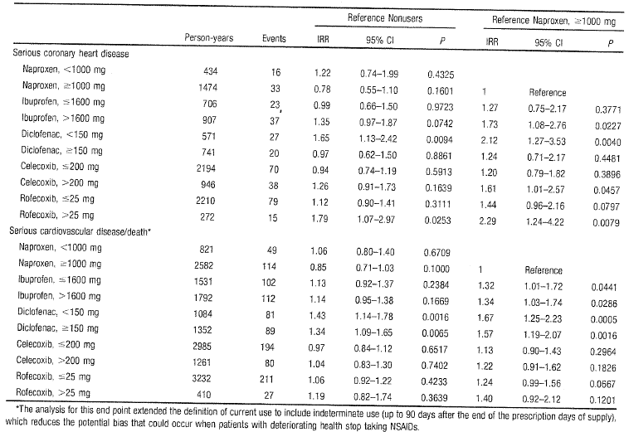

Table 4.2:
 | Literature reference | Study design | Main findings | Conclusions | Limitations
 | Gudbjornsson B, et al. ‘Rofecoxib, but not celecoxib increases the risk of thromboembolic CV events in young adults- A nationwide Registry based study.’ European journal of Clinical Pharmacology. 66 (6), p619-625. 2010. | Icelandic Medicines registry (all prescriptions to outpatients or private practice); National patient registry (all hospital admissions with prim and sec diagnosis); Registry for causes of death. This data analysed for prescription of NSAIDs or COX-2 inhibitors and its association with hospitalisations for unstable angina, MI or cerebral infarction over 3 years using Cox proportional hazards model and Poisson regression analysis. | 108700 patients received NSAIDs or COX-2 inhibitors of who 78539 received only 1 drug (163406 person years); 426 of these patients were discharged from hospital with endpoint diagnoses. All comparisons made to most commonly used NSAID- diclofenac. Incidence ratios (95%CI) were significantly higher for rofecoxib users for cerebral infarction (2.13, 1.54-2.97, p<0.001), MI (1.77, 1.34-2.32, p<0.001) and unstable angina (1.52, 1.01-2.30, p=0.047). Higher risk of MI for naproxen users (1.46, 1.03-2.07, p=0.03), but reduced risk of unstable angina with ibuprofen (0.63, 0.40-1.0, p=0.05). Celecoxib did not show increased risk for any of the endpoints | Icelandic national registry-based study with 163406 patient years showed increased risk of CV events (cerebral infarction, MI and unstable angina pectoris) among rofecoxib and naproxen users compared to diclofenac; risk more pronounced in young adults using rofecoxib. | Medicines registry did not provide information on drug use in hospitals or nursing homes. Not a randomised trial so confounders may have biased results. No placebo control – diclofenac was used as main comparator. No data on intake of other medications or underlying diseases or comorbidities in the cohort.

Table 4.3: Krotz, et al 2010
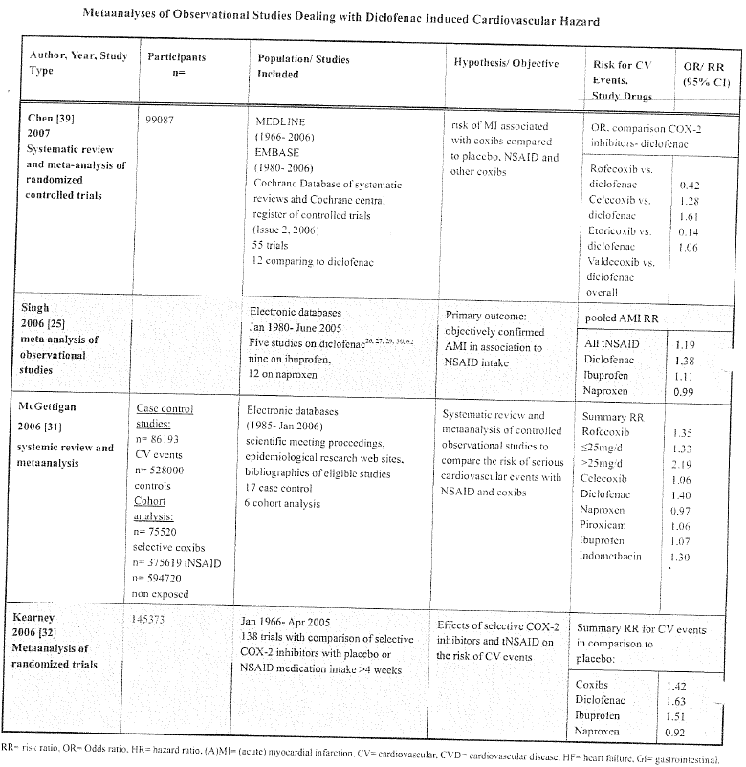

Table 4.4: Krotz, et al 2010 (cont’d)
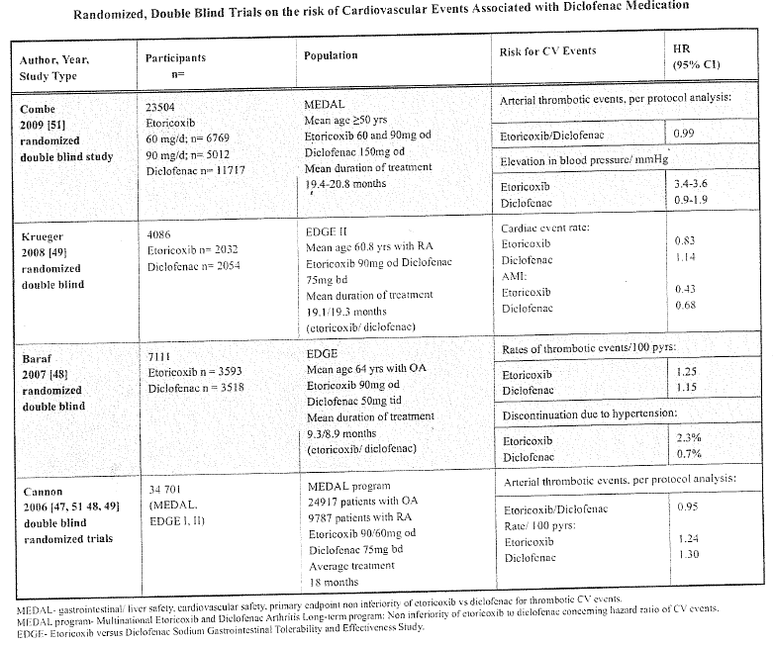

Table 4.5:
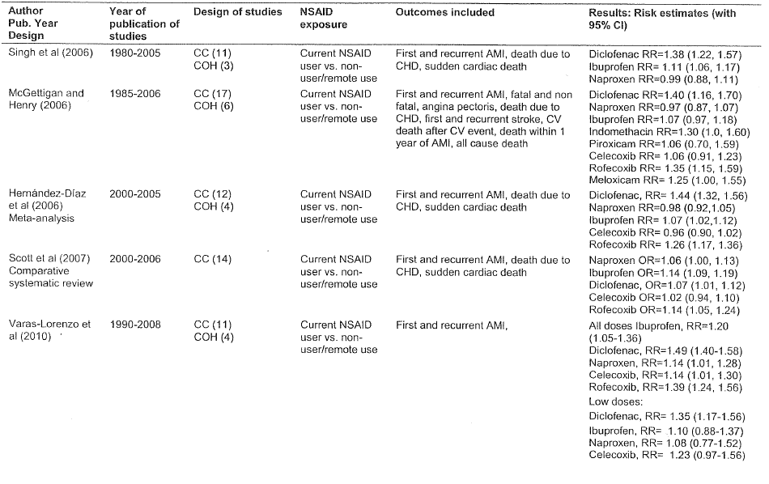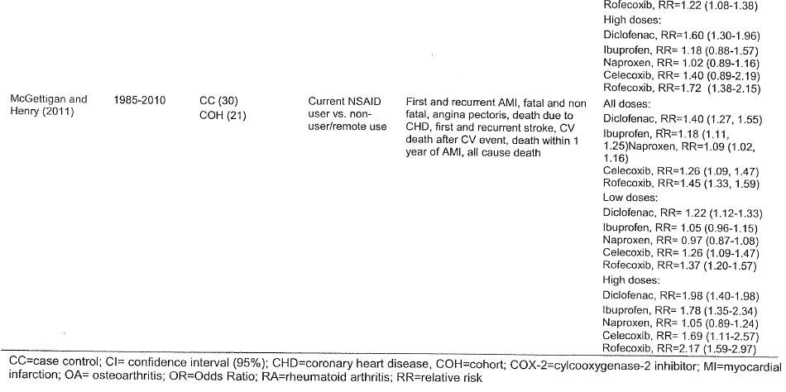

Table 4.6:
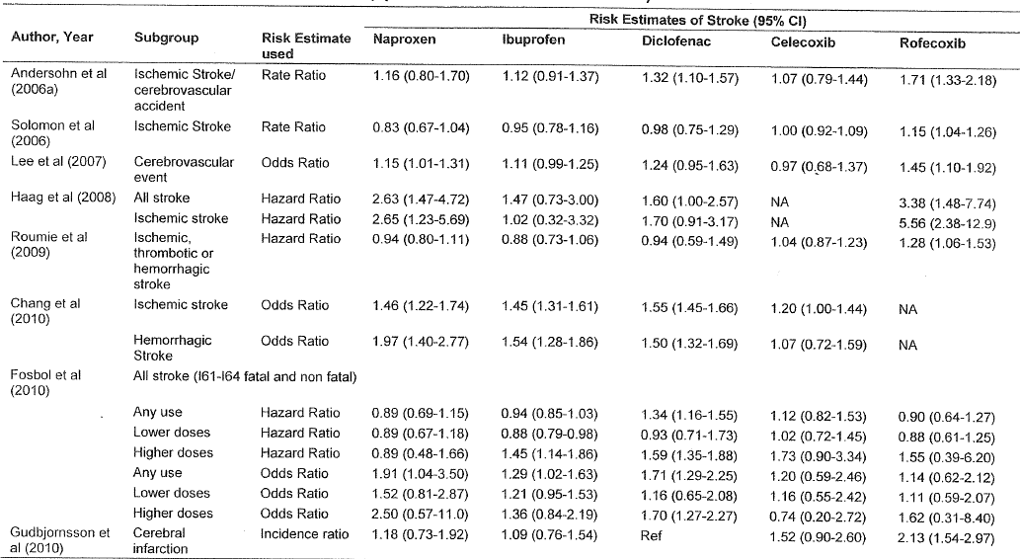
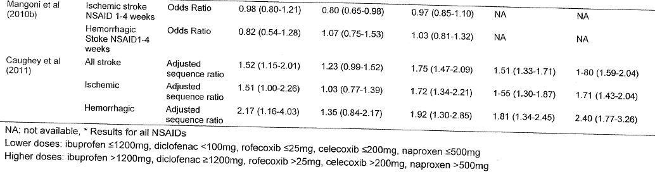

Table 4.7:
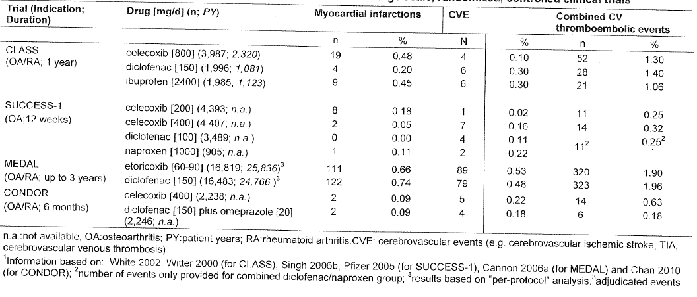

Table 4.8.1: [confidential text redacted]

Table 4.8.2: [confidential text redacted]

Table 4.9: Summary of publications provided by Novartis for diclofenac
Literature reference | Study design | Main findings | Conclusions | Limitations
Fischer LM, et al. ‘Current use of NSAIDs and the risk of MI.’ Pharmacotherapy 2005; 25 (4): 503-510. | Retrospective case control analysis using UK General Practice Research Database; potential cases of first MI between January 1995 and April 2001. Control subjects without acute MI identified at random. There were 650 cases and 2339 control taking NSAIDs. | Compared to non-use of NSAIDs, current use of any NSAID associated with OR (95% CI) of 1.07 (0.96-1.19); current use of diclofenac=1.23 (1-1.51); ibuprofen=1.16 (0.92-1.46), naproxen=0.96 (0.66-1.38). Current aspirin use with NSAID use associated with statistically significant risk reduction, OR=0.74 (0.57-0.97). | Risk of first-time MI during current use of NSAIDs not significantly increased. No evidence of reduced cardioprotective effect of aspirin with concomitant NSAID use. | Biases and residual confounding due to observational nature of study cannot be excluded. OTC use of NSAIDs not documented. No data on COX-2 inhibitors (these were not being commonly used at the time of this study).

Table 4.10.1: Summary of publications provided by Novartis for diclofenac
Literature reference | Study design | Main findings | Conclusions | Limitations
Jick H, et al. ‘NSAID and AMI in patients with no major risk factors.’ Pharmacotherapy 2006; 26 (10): 1379-1387. | Five separate nested case control studies (to minimize imp biases in other observational studies) to evaluate risk of long term use of 5 common NSAIDs- celecoxib, rofecoxib, ibuprofen, naproxen and diclofenac. Person from UK General Practice Research Database aged 30-79 yrs with first recorded prescription of one of 5 NSAIDs after Jan 1999- study RR risk for acute MI following 2-4, 5-9, 1-19 or >20 prescriptions compared with those receiving only 1 prescription of each of the NSAID. | Prolonged use of diclofenac increases risk of acute MI to almost 2-fold in the highest exposure (>20 prescriptions) similar to that seen with rofecoxib and celecoxib. | Extensive use of rofecoxib, celecoxib and diclofenac increases risk of acute MI but similar use of ibuprofen and naproxen does not. | Number of patients at each prescription level was small. RR not compared to non-use of NSAIDs.

Table 4.10.2: Jick et al 2006
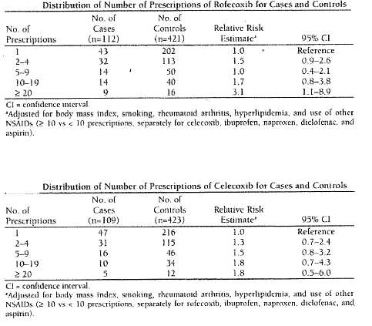
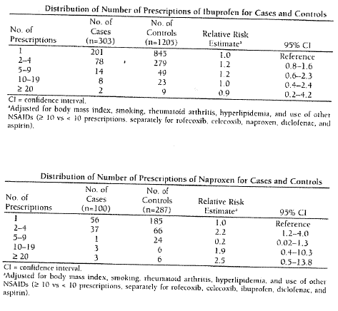
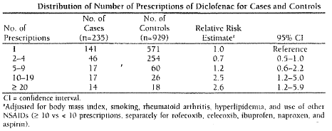

Table 4.11.1: Summary of publications provided by Novartis for diclofenac
Literature reference | Study design | Main findings | Conclusions | Limitations
Cheetham C, et al. ‘MI and its association with the use of NSAIDs: A nested case control and time to event analysis.’ Permanante journal, 2008. Vol 12 No. 1. | Nested case control study used to study NSAID users aged 18-84 years. Cases were hospital admissions for acute MI or outside hospital sudden cardiac death; control subjects matched for age, sex, location. ORs estimated using conditional logistic regression. | A total of 1,394,764 NSAID users; 8143 cases and 31,496 controls. Median time to event was <100 days. Risk of acute MI increased with diclofenac, indomethacin, naproxen and rofecoxib. | Some non-selective NSAIDs, such as indomethacin and naproxen, associated with increased risk of acute MI or sudden cardiac death, although risk is small compared to rofecoxib. | Risk factors information not complete; no data on OTC use of NSAIDs. Increased risk with naproxen and indomethacin small.

Table 4.11.2: Cheltham et al 2008
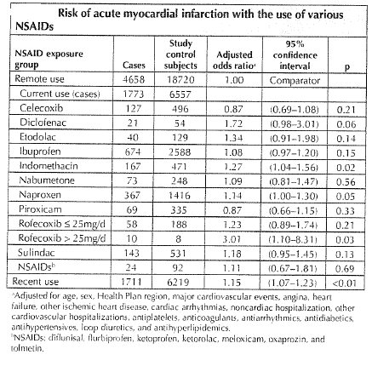

Table 4.12.1: Summary of publications provided by Novartis for diclofenac
Literature reference | Study design | Main findings | Conclusions | Limitations
Rahme E & Nedgar H. ‘Risks and benefits of COX-2 inhibitors vs. nsNSAIDs: does their cardiovascular risk exceed their gastrointestinal benefit? A retrospective cohort study.’ Rheumatology, 2007; 46 : 435-438. | Retrospective cohort study of patients aged >65 years who filled a prescription for NSAID between 1999 and 2002. Aim was to compare risks of hospitalisation due to acute MI and GI bleeding events among elderly patients using COX-2 selective and non-selective NSAIDs – paracetamol was the comparator. Outcomes compared using Cox regression models with time dependent exposures. | Person years of exposure among non-users of aspirin were paracetamol=75,781, rofecoxib-42,671, celecoxib=65,860, non-selective NSAIDs=37,495. Among users of aspirin, paracetamol=38,048, rofecoxib=14,671 celecoxib=22,675, non-selective NSAIDs=9832. Celecoxib appears to be least toxic compared to paracetamol among aspirin users and non-users. | Among non-users of aspirin, naproxen carries highest risk of acute MI/GI bleeding; acute MI/GI toxicity of celecoxib was similar to paracetamol and seemed to be better than rofecoxib and other non-selective NSAIDs. Among users of aspirin, celecoxib and naproxen seemed least toxic. | Differences in patients prescribed paracetamol compared to COX-2 inhibitors or non-selective NSAIDs such as smoking, obesity and so on. No information on compliance with prescribed medicines; no data on OTC use of NSAIDs.

Table 4.12.2: Rahme & Nedgar
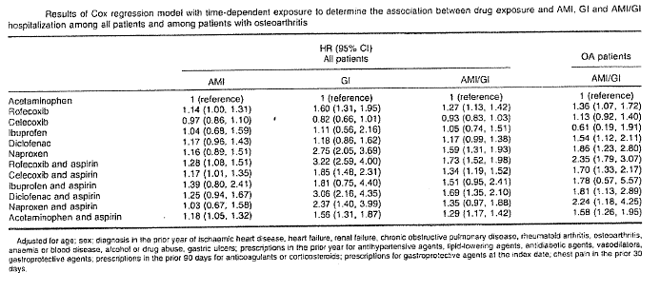

Figure 5.1:
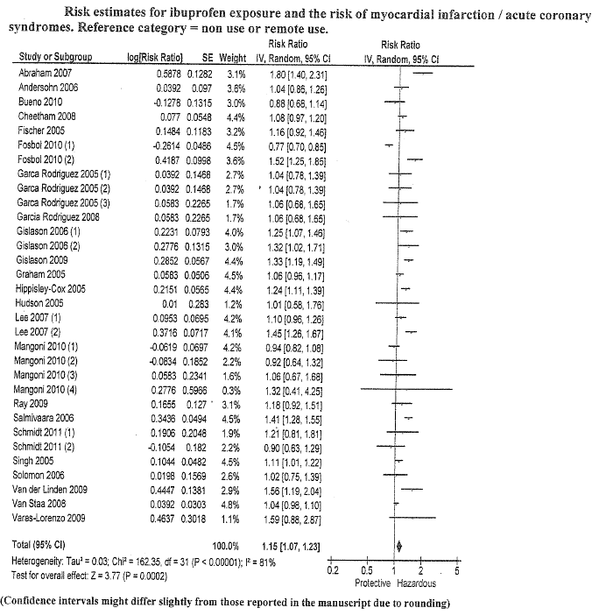

Figure 5.2:
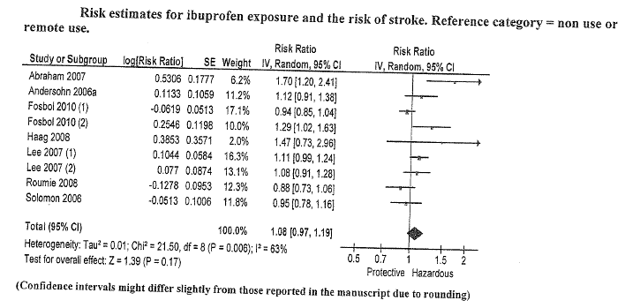

Table 5.3: Caughey 2011

Table 5.4: Caughey 2011

Table 5.5: Chang 2010
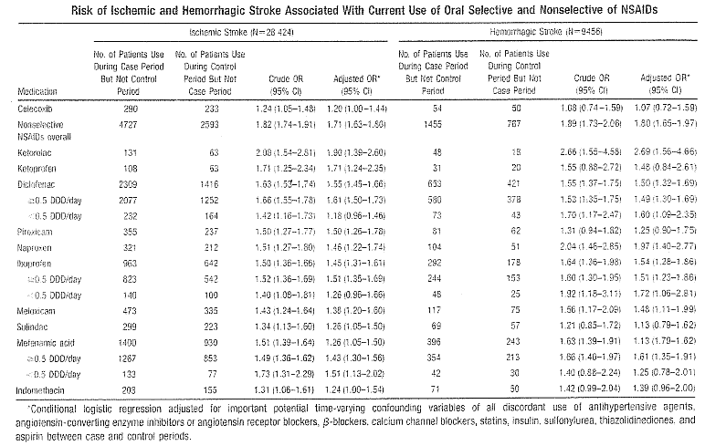

Figure 5.6:
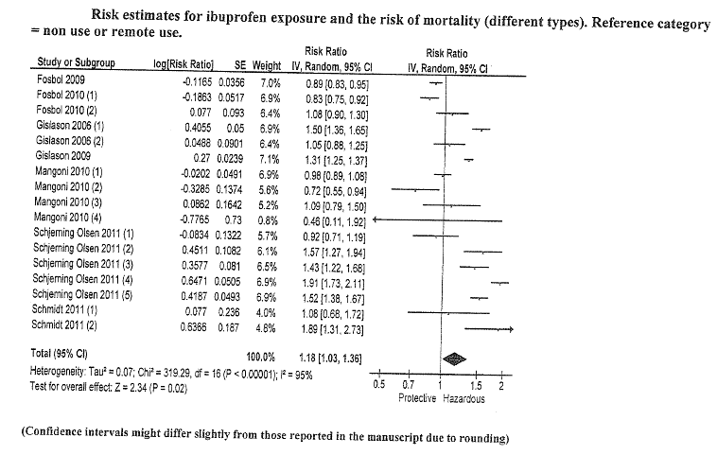

Figure 5.7:
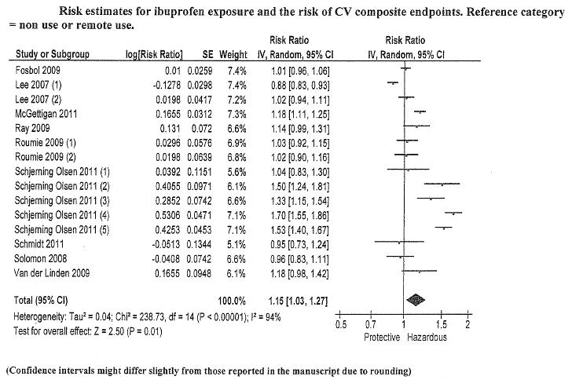

Figure 5.8: Kearney 2006

Figure 5.9: Trelle 2011
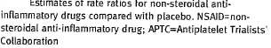

Table 5.10: Effect of dose of non-steroidal anti-inflammatory drugs on their cardiovascular risk estimates (McGettigan, 2011)
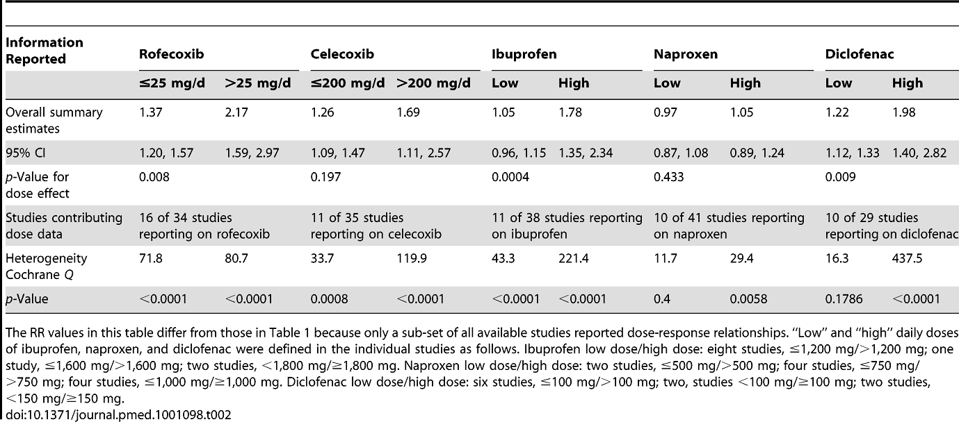

Table 5.11: Effect of baseline cardiovascular risk on the cardiovascular safety of NSAIDs (McGettigan, 2011)
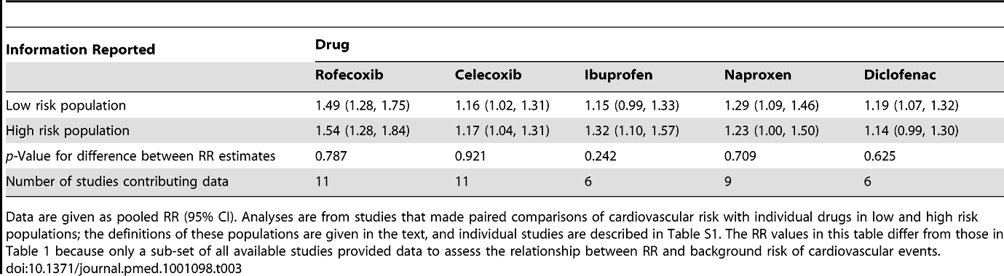

Table 5.12: Pharmacovigilance data of over-the-counter ibuprofen (data submitted by Reckitt-Benckiser, Australia)

Company pharmacovigilance data

Number of Reports by Term (Signs, Symptoms and Diagnoses) from Spontaneous (Medically Confirmed) Regulatory, Clinical Study and Literature Cases The sources stated as 'Other' will be literature (from papers or literature reports from an Authority) and those stated as 'Not Available' will be from Authorities. The data are run from 01-Mar-2002 to 29-Feb-2012.
Cardiac disorders | Acute coronary syndrome | Serious | Spontaneous | 1
Cardiac disorders | Acute myocardial infarction | Serious | Not Available | 1
Cardiac disorders | Angina pectoris | Non-Serious | Report from Study | 1
Cardiac disorders | Angina pectoris | Serious | Not Available | 2
Cardiac disorders | Angina pectoris | Serious | Other | 2
Cardiac disorders | Angina pectoris | Serious | Report from Study | 2
Cardiac disorders | Angina pectoris | Serious | Spontaneous | 1
Cardiac disorders | Angina unstable | Serious | Not Available | 1
Cardiac disorders | Angina unstable | Serious | Spontaneous | 1
Cardiac disorders | Arrhythmia | Serious | Not Available | 1
Cardiac disorders | Arrhythmia | Serious | Other | 1
Cardiac disorders | Atrial fibrillation | Serious | Not Available | 3
Cardiac disorders | Atrial fibrillation | Serious | Other | 1
Cardiac disorders | Atrial fibrillation | Serious | Spontaneous | 1
Cardiac disorders | Atrial flutter | Serious | Other | 1
Cardiac disorders | Atrioventricular block | Serious | Other | 2
Cardiac disorders | Atrioventricular dissociation | Serious | Other | 1
Cardiac disorders | Bradycardia | Serious | Other | 2
Cardiac disorders | Cardiac aneurysm | Serious | Other | 1
Cardiac disorders | Cardiac arrest | Serious | Not Available | 3
Cardiac disorders | Cardiac arrest | Serious | Other | 5
Cardiac disorders | Cardiac arrest | Serious | Spontaneous | 1
Cardiac disorders | Cardiac failure | Non-Serious | Not Available | 1
Cardiac disorders | Cardiac failure | Serious | Not Available | 2
Cardiac disorders | Cardiac failure | Serious | Other | 1
Cardiac disorders | Cardiac failure | Serious | Spontaneous | 2
Cardiac disorders | Cardiac failure congestive | Serious | Not Available | 1
Cardiac disorders | Cardiac failure congestive | Serious | Other | 1

Table 5.12 (cont.):
 | Cardiac tamponade | Serious | Other | 1
 | Cardiogenic shock | Serious | Other | 1
 | Cardio-respiratory arrest | Serious | Spontaneous | 1
 | Coronary artery disease | Serious | Other | 1
 | Coronary artery disease | Serious | Report from Study | 1
 | Coronary artery occlusion | Serious | Other | 1
 | Coronary artery stenosis | Serious | Other | 1
 | Cyanosis | Non-Serious | Not Available | 1
 | Cyanosis | Serious | Not Available | 1
 | Cyanosis | Serious | Spontaneous | 5
 | Left ventricular dysfunction | Serious | Not Available | 1
 | Left ventricular dysfunction | Serious | Spontaneous | 1
 | Myocardial infarction | Serious | Not Available | 4
 | Myocardial infarction | Serious | Other | 3
 | Myocardial infarction | Serious | Spontaneous | 2
 | Myocarditis | Serious | Spontaneous | 1
 | Palpitations | Non-Serious | Not Available | 2
 | Palpitations | Non-Serious | Report from Study | 4
 | Palpitations | Non-Serious | Spontaneous | 3
 | Palpitations | Serious | Not Available | 2
 | Palpitations | Serious | Other | 2
 | Palpitations | Serious | Spontaneous | 1
 | Palpitations | UNK | Spontaneous | 1
 | Pericardial effusion | Serious | Other | 1
 | Pericardial haemorrhage | Serious | Other | 1
 | Pulseless electrical activity | Serious | Not Available | 1
 | Pulseless electrical activity | Serious | Other | 1
 | Sinus tachycardia | Serious | Other | 1
 | Sinus tachycardia | Serious | Spontaneous | 2

Table 5.12 (cont.):
 | Tachycardia | Non-Serious | Not Available | 1
 | Tachycardia | Non-Serious | Spontaneous | 4
 | Tachycardia | Serious | Not Available | 14
 | Tachycardia | Serious | Other | 11
 | Tachycardia | Serious | Spontaneous | 3
 | Tachycardia | UNK | Other | 1
 | Torsade de pointes | Serious | Other | 1
 | Ventricular extrasystoles | Serious | Not Available | 1
 | Ventricular fibrillation | Serious | Not Available | 1
 | Ventricular fibrillation | Serious | Other | 1
 | Ventricular hypokinesia | Serious | Spontaneous | 1
 | Ventricular tachycardia | Serious | Not Available | 1
 | Ventricular tachycardia | Serious | Other | 2
 | Ventricular tachycardia | Serious | Spontaneous | 1
Vascular disorders | Aortic aneurysm rupture | Serious | Spontaneous | 3
Vascular disorders | Arterial haemorrhage | Serious | Other | 1
Vascular disorders | Bloody discharge | Non-Serious | Spontaneous | 1
Vascular disorders | Circulatory collapse | Serious | Not Available | 3
Vascular disorders | Circulatory collapse | Serious | Other | 6
Vascular disorders | Circulatory collapse | Serious | Spontaneous | 7
Vascular disorders | Deep vein thrombosis | Serious | Not Available | 1
Vascular disorders | Deep vein thrombosis | Serious | Report from Study | 1
Vascular disorders | Essential hypertension | Serious | Not Available | 1
Vascular disorders | Flushing | Non-Serious | Not Available | 2
Vascular disorders | Flushing | Non-Serious | Spontaneous | 1
Vascular disorders | Flushing | Serious | Not Available | 1
Vascular disorders | Flushing | Serious | Other | 3
Vascular disorders | Flushing | Serious | Spontaneous | 1
Vascular disorders | Flushing | UNK | Spontaneous | 2
Vascular disorders | Haematoma | Non-Serious | Report from Study | 1
Vascular disorders | Haematoma | Serious | Not Available | 6
Vascular disorders | Haematoma | Serious | Other | 2
Vascular disorders | Haematoma | Serious | Spontaneous | 4

Table 5.12 (cont.):
 | Haemodynamic instability | Serious | Not Available | 1
 | Haemodynamic instability | Serious | Other | 2
 | Haemodynamic instability | Serious | Spontaneous | 1
 | Haemorrhage | Non-Serious | Spontaneous | 3
 | Haemorrhage | Serious | Not Available | 7
 | Haemorrhage | Serious | Spontaneous | 5
 | Haemorrhage | UNK | Spontaneous | 1
 | Hot flush | Serious | Other | 1
 | Hot flush | UNK | Spontaneous | 2
 | Hyperaemia | Non-Serious | Not Available | 3
 | Hyperaemia | Non-Serious | Spontaneous | 1
 | Hyperaemia | Serious | Other | 1
 | Hypertension | Non-Serious | Other | 1
 | Hypertension | Non-Serious | Report from Study | 9
 | Hypertension | Non-Serious | Spontaneous | 1
 | Hypertension | Serious | Not Available | 3
 | Hypertension | Serious | Other | 4
 | Hypertension | Serious | Spontaneous | 2
 | Hypertensive crisis | Serious | Other | 1
 | Hypotension | Non-Serious | Not Available | 1
 | Hypotension | Non-Serious | Other | 1
 | Hypotension | Non-Serious | Spontaneous | 2
 | Hypotension | Serious | Not Available | 20
 | Hypotension | Serious | Other | 17
 | Hypotension | Serious | Report from Study | 1
 | Hypotension | Serious | Spontaneous | 5
 | Hypotension | UNK | Spontaneous | 2
 | Hypovolaemic shock | Serious | Other | 3
 | Intra-abdominal haematoma | Serious | Not Available | 2
 | Intra-abdominal haematoma | Serious | Other | 1
 | Labile blood pressure | Serious | Other | 1
 | Malignant hypertension | Serious | Not Available | 1

Table 5.12 (cont.):
 | Orthostatic hypotension | Serious | Spontaneous | 1
 | Pallor | Non-Serious | Spontaneous | 1
 | Pallor | Serious | Not Available | 5
 | Pallor | Serious | Other | 2
 | Pallor | Serious | Spontaneous | 1
 | Pallor | UNK | Spontaneous | 2
 | Peripheral coldness | Serious | Other | 1
 | Poor peripheral circulation | Non-Serious | Report from Study | 1
 | Shock | Serious | Other | 5
 | Shock | Serious | Spontaneous | 2
 | Systolic hypertension | Serious | Not Available | 1
 | Thrombosis | Non-Serious | Report from Study | 1
 | Thrombosis | Serious | Report from Study | 1
 | Thrombosis | Serious | Spontaneous | 1
 | Varicose vein ruptured | Serious | Spontaneous | 1
 | Vasculitis | UNK | Other | 1
 | Vein pain | Non-Serious | Report from Study | 1
Grand Total |  |  |  | 315
Nervous system disorders | Ageusia | Non-Serious | Spontaneous | 2
Nervous system disorders | Altered state of consciousness | Non-Serious | Spontaneous | 1
Nervous system disorders | Amnesia | Non-Serious | Spontaneous | 3
Nervous system disorders | Amnesia | Serious | Other | 1
Nervous system disorders | Amnesia | Serious | Spontaneous | 1
Nervous system disorders | Amnesia | UNK | Other | 1
Nervous system disorders | Aphasia | Non-Serious | Spontaneous | 1
Nervous system disorders | Aphasia | Serious | Not Available | 1
Nervous system disorders | Aphasia | Serious | Other | 2
Nervous system disorders | Aphonia | Serious | Spontaneous | 1
Nervous system disorders | Ataxia | Serious | Spontaneous | 1
Nervous system disorders | Ataxia | UNK | Not Available | 2

Table 5.12 (cont.):
 | Balance disorder | Non-Serious | Spontaneous | 2
 | Balance disorder | Serious | Spontaneous | 1
 | Bradykinesia | Serious | Not Available | 1
 | Brain injury | Serious | Other | 1
 | Brain injury | Serious | Spontaneous | 1
 | Brain oedema | Serious | Not Available | 2
 | Brain oedema | Serious | Other | 1
 | Brain stem haemorrhage | Serious | Other | 1
 | Brain stem syndrome | Serious | Other | 1
 | Burning sensation | Non-Serious | Report from Study | 2
 | Burning sensation | Non-Serious | Spontaneous | 15
 | Burning sensation | Serious | Not Available | 1
 | Burning sensation | UNK | Spontaneous | 4
 | Carotid artery aneurysm | Serious | Other | 1
 | Carotid artery occlusion | Serious | Other | 1
 | Cerebral haematoma | Serious | Other | 1
 | Cerebral haemorrhage | Serious | Not Available | 4
 | Cerebral haemorrhage | Serious | Other | 3
 | Cerebral haemorrhage | Serious | Spontaneous | 2
 | Cerebral hypoperfusion | Serious | Other | 1
 | Cerebral infarction | Serious | Other | 1
 | Cerebrovascular accident | Serious | Not Available | 7
 | Cerebrovascular accident | Serious | Other | 1
 | Cerebrovascular accident | Serious | Report from Study | 1
 | Cerebrovascular accident | Serious | Spontaneous | 1
 | Choreoathetosis | Serious | Not Available | 1
 | Cognitive disorder | Non-Serious | Spontaneous | 1
 | Cognitive disorder | Serious | Other | 1
 | Coma | Non-Serious | Spontaneous | 1
 | Coma | Serious | Not Available | 2
 | Coma | Serious | Other | 6
 | Coma | Serious | Spontaneous | 2
 | Coma hepatic | Serious | Spontaneous | 1

Table 5.12 (cont.):
 | Convulsion | Non-Serious | Spontaneous | 4
 | Convulsion | Serious | Not Available | 1
 | Convulsion | Serious | Other | 4
 | Convulsion | Serious | Report from Study | 2
 | Convulsion | Serious | Spontaneous | 6
 | Convulsion | UNK | Spontaneous | 2
 | Coordination abnormal | Serious | Other | 1
 | Crying | Non-Serious | Spontaneous | 5
 | Crying | Serious | Spontaneous | 1
 | Depressed level of consciousness | Non-Serious | Spontaneous | 4
 | Depressed level of consciousness | Serious | Not Available | 2
 | Depressed level of consciousness | Serious | Other | 7
 | Depressed level of consciousness | Serious | Spontaneous | 1
 | Disturbance in attention | Non-Serious | Not Available | 1
 | Disturbance in attention | Non-Serious | Report from Study | 1
 | Disturbance in attention | Non-Serious | Spontaneous | 3
 | Disturbance in attention | Serious | Not Available | 3
 | Disturbance in attention | Serious | Spontaneous | 1
 | Disturbance in attention | UNK | Not Available | 1
 | Dizziness | Non-Serious | Not Available | 4
 | Dizziness | Non-Serious | Other | 1
 | Dizziness | Non-Serious | Report from Study | 21
 | Dizziness | Non-Serious | Spontaneous | 15
 | Dizziness | Serious | Not Available | 19
 | Dizziness | Serious | Other | 8
 | Dizziness | Serious | Spontaneous | 12
 | Dizziness | UNK | Other | 2
 | Dizziness | UNK | Spontaneous | 12
 | Dysarthria | Non-Serious | Spontaneous | 3
 | Dysarthria | Serious | Other | 2

Table 5.12 (cont.):
 | Dysgeusia | Non-Serious | Report from Study | 4
 | Dysgeusia | Non-Serious | Spontaneous | 13
 | Dysgeusia | UNK | Other | 1
 | Dysgeusia | UNK | Spontaneous | 5
 | Dyskinesia | Serious | Other | 1
 | Dyskinesia | Serious | Spontaneous | 3
 | Dysstasia | Non-Serious | Spontaneous | 1
 | Encephalitis | Serious | Not Available | 1
 | Encephalitis | Serious | Other | 3
 | Encephalitis | UNK | Spontaneous | 1
 | Encephalopathy | Serious | Not Available | 1
 | Encephalopathy | Serious | Other | 3
 | Epilepsy | Serious | Other | 1
 | Exaggerated startle response | Non-Serious | Spontaneous | 1
 | Extensor plantar response | Serious | Other | 1
 | Extrapyramidal disorder | Serious | Spontaneous | 2
 | Formication | Non-Serious | Not Available | 1
 | Formication | Serious | Not Available | 1
 | Formication | Serious | Spontaneous | 1
 | Grand mal convulsion | Serious | Other | 2
 | Haemorrhage intracranial | Serious | Not Available | 1
 | Haemorrhage intracranial | Serious | Other | 2
 | Haemorrhagic stroke | Serious | Other | 1
 | Headache | Non-Serious | Not Available | 3
 | Headache | Non-Serious | Other | 1
 | Headache | Non-Serious | Report from Study | 106
 | Headache | Non-Serious | Spontaneous | 9
 | Headache | Serious | Not Available | 11
 | Headache | Serious | Other | 12
 | Headache | Serious | Report from Study | 1
 | Headache | Serious | Spontaneous | 7
 | Headache | UNK | Spontaneous | 4

Table 5.12 (cont.):
 | Hemiparesis | Serious | Not Available | 1
 | Hemiplegia | Serious | Other | 1
 | Hepatic encephalopathy | Serious | Spontaneous | 1
 | Hyperaesthesia | Serious | Not Available | 1
 | Hypertonia | Serious | Other | 1
 | Hypoaesthesia | Non-Serious | Report from Study | 1
 | Hypoaesthesia | Non-Serious | Spontaneous | 2
 | Hypoaesthesia | Serious | Not Available | 2
 | Hypoaesthesia | Serious | Report from Study | 1
 | Hypoaesthesia | UNK | Spontaneous | 2
 | Hypogeusia | Non-Serious | Spontaneous | 1
 | Hyponatraemic encephalopathy | Serious | Not Available | 1
 | Hyporeflexia | Serious | Other | 1
 | Hyposmia | Serious | Other | 1
 | Hypotonia | Non-Serious | Not Available | 1
 | Hypotonia | Serious | Other | 2
 | Hypotonia | Serious | Spontaneous | 2
 | Hypoxic-ischaemic encephalopathy | Serious | Other | 1
 | Incoherent | UNK | Other | 1
 | Intracranial pressure increased | Serious | Not Available | 1
 | Intracranial pressure increased | Serious | Spontaneous | 1
 | Intraventricular haemorrhage | Serious | Not Available | 1
 | Ischaemic stroke | Serious | Not Available | 1
 | Ischaemic stroke | Serious | Other | 3
 | Lethargy | Non-Serious | Report from Study | 6
 | Lethargy | Non-Serious | Spontaneous | 2
 | Lethargy | Serious | Not Available | 9
 | Lethargy | Serious | Other | 6
 | Lethargy | UNK | Other | 1

Table 5.12 (cont.):
 | Loss of consciousness | Serious | Not Available | 6
 | Loss of consciousness | Serious | Other | 5
 | Loss of consciousness | Serious | Spontaneous | 4
 | Loss of consciousness | UNK | Spontaneous | 2
 | Memory impairment | Non-Serious | Spontaneous | 1
 | Memory impairment | Serious | Spontaneous | 3
 | Meningeal disorder | Serious | Other | 1
 | Migraine | Non-Serious | Report from Study | 14
 | Migraine | Non-Serious | Spontaneous | 3
 | Migraine | Serious | Not Available | 1
 | Migraine | Serious | Report from Study | 1
 | Monoparesis | Serious | Other | 1
 | Motor dysfunction | Non-Serious | Spontaneous | 1
 | Movement disorder | Non-Serious | Spontaneous | 1
 | Myoclonus | Serious | Not Available | 1
 | Nervous system disorder | Non-Serious | Not Available | 2
 | Nervous system disorder | Non-Serious | Spontaneous | 1
 | Nervous system disorder | Serious | Not Available | 1
 | Neurological symptom | Serious | Other | 1
 | Paraesthesia | Non-Serious | Not Available | 1
 | Paraesthesia | Non-Serious | Report from Study | 9
 | Paraesthesia | Non-Serious | Spontaneous | 10
 | Paraesthesia | Serious | Not Available | 4
 | Paraesthesia | Serious | Other | 2
 | Paraesthesia | Serious | Spontaneous | 2
 | Paraesthesia | UNK | Other | 1
 | Paraesthesia | UNK | Spontaneous | 5
 | Paraparesis | Serious | Other | 1
 | Parosmia | Non-Serious | Spontaneous | 1
 | Partial seizures | Serious | Other | 1
 | Pleocytosis | Serious | Spontaneous | 1
 | Poor quality sleep | Non-Serious | Report from Study | 2

Table 5.12 (cont.):
 | Presyncope | Non-Serious | Not Available | 1
 | Presyncope | Non-Serious | Other | 1
 | Presyncope | Serious | Not Available | 2
 | Psychomotor hyperactivity | Non-Serious | Spontaneous | 7
 | Psychomotor hyperactivity | Serious | Spontaneous | 5
 | Psychomotor hyperactivity | UNK | Spontaneous | 4
 | Psychomotor skills impaired | Serious | Not Available | 1
 | Quadriparesis | Serious | Not Available | 1
 | Restless legs syndrome | Non-Serious | Not Available | 1
 | Retrograde amnesia | Non-Serious | Spontaneous | 1
 | Sciatica | Non-Serious | Report from Study | 7
 | Sedation | UNK | Not Available | 2
 | Sensory disturbance | Serious | Not Available | 1
 | Sinus headache | Non-Serious | Report from Study | 1
 | Somnolence | Non-Serious | Not Available | 3
 | Somnolence | Non-Serious | Report from Study | 2
 | Somnolence | Non-Serious | Spontaneous | 14
 | Somnolence | Serious | Not Available | 8
 | Somnolence | Serious | Other | 6
 | Somnolence | Serious | Spontaneous | 5
 | Somnolence | UNK | Spontaneous | 2
 | Speech disorder | Non-Serious | Not Available | 1
 | Speech disorder | Non-Serious | Spontaneous | 2
 | Speech disorder | Serious | Not Available | 1
 | Speech disorder | Serious | Spontaneous | 4
 | Status epilepticus | Serious | Other | 3
 | Subarachnoid haemorrhage | Serious | Other | 1

Table 5.12 (cont.):
 | Syncope | Non-Serious | Not Available | 1
 | Syncope | Non-Serious | Report from Study | 2
 | Syncope | Non-Serious | Spontaneous | 2
 | Syncope | Serious | Not Available | 16
 | Syncope | Serious | Other | 2
 | Syncope | Serious | Spontaneous | 6
 | Syncope | UNK | Spontaneous | 1
 | Tension headache | Non-Serious | Report from Study | 1
 | Toxic encephalopathy | Serious | Other | 1
 | Transient ischaemic attack | Serious | Not Available | 1
 | Transient ischaemic attack | Serious | Other | 1
 | Tremor | Non-Serious | Not Available | 1
 | Tremor | Non-Serious | Spontaneous | 5
 | Tremor | Serious | Not Available | 4
 | Tremor | Serious | Other | 3
 | Tremor | Serious | Spontaneous | 3
 | Tremor | UNK | Spontaneous | 1
 | Tunnel vision | Serious | Not Available | 2
 | Unresponsive to stimuli | Non-Serious | Spontaneous | 5
 | Unresponsive to stimuli | Serious | Not Available | 1
 | Unresponsive to stimuli | Serious | Other | 2
 | Unresponsive to stimuli | Serious | Spontaneous | 3
 | Vagus nerve disorder | Serious | Not Available | 1
 | VIIth nerve paralysis | Serious | Other | 1

Table 6.1: Ray 2009
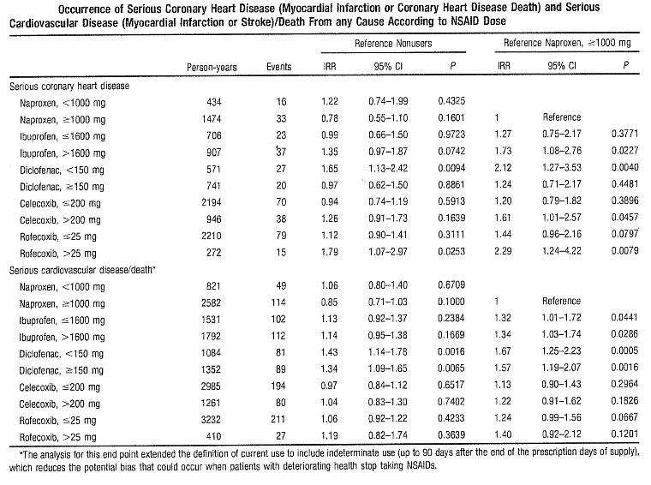

Table 6.2: Hermann M 2009
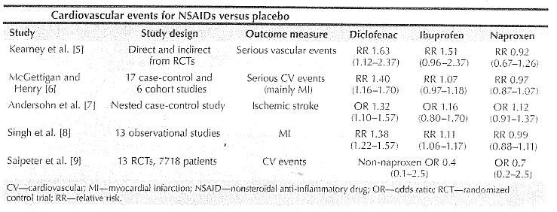

Table 6.3: Fosbol 2010
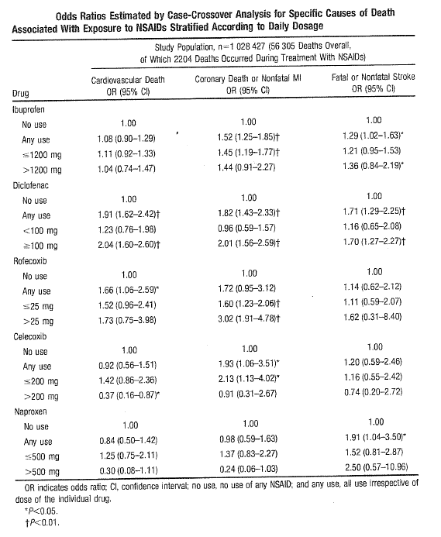

Table 7.1:
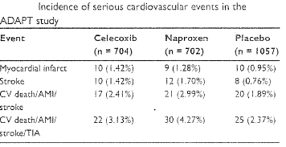

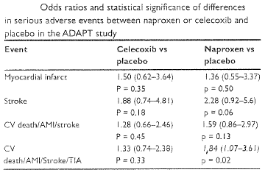

Table 7.2: Solomon et al. Celecoxib and cardiovascular risk 2006
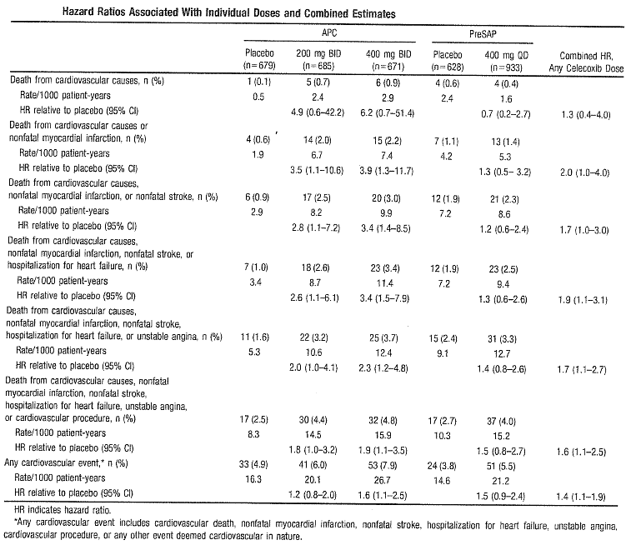

Table 7.3:
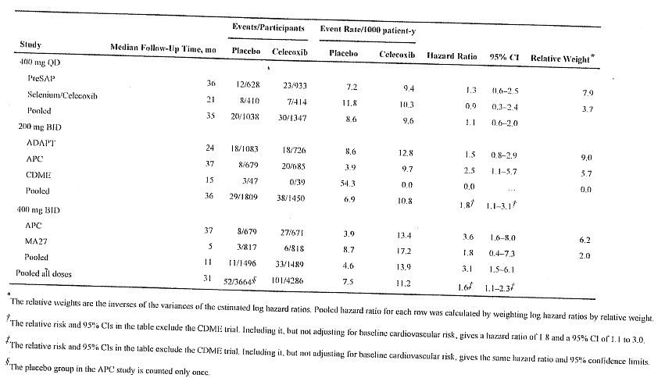

Table 7.4:
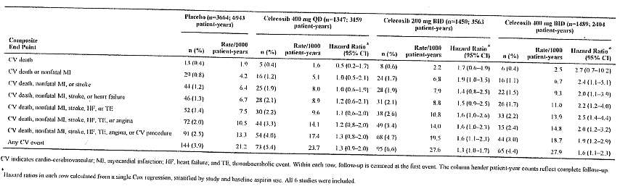

Table 7.5: Lee YH 2007
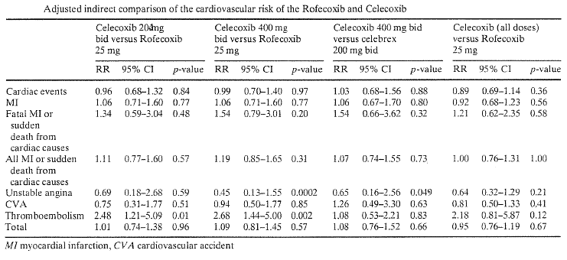

Table 7.6:
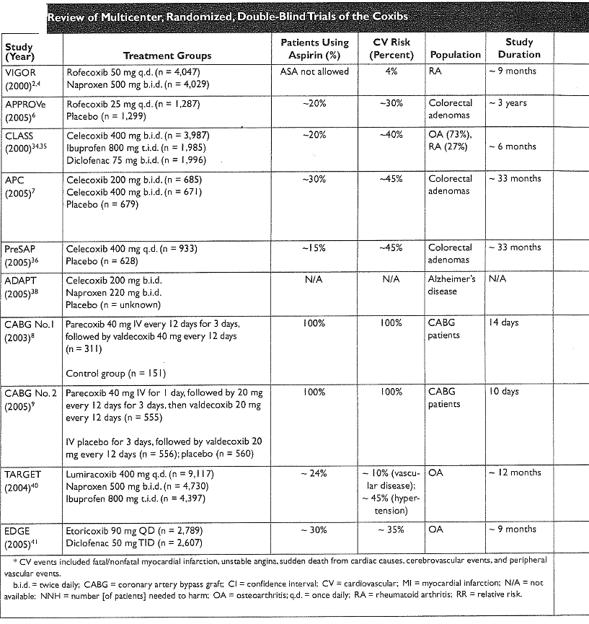

Table 7.6 (cont.):
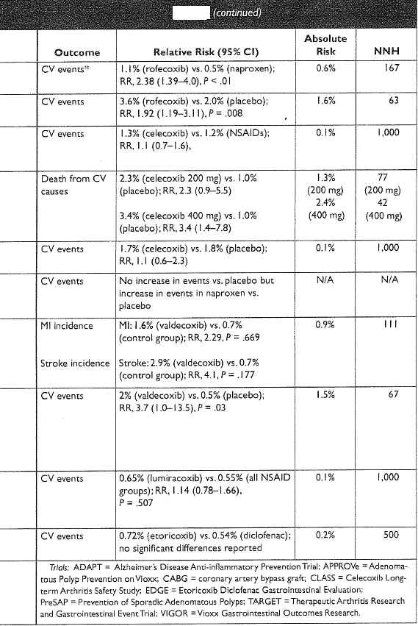

Table 7.7.1 Schneeweiss S et al 2006
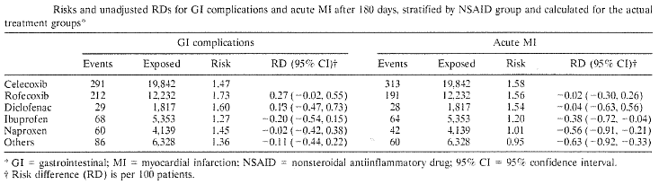

Table 7.7.2: Schneeweiss S et al 2006
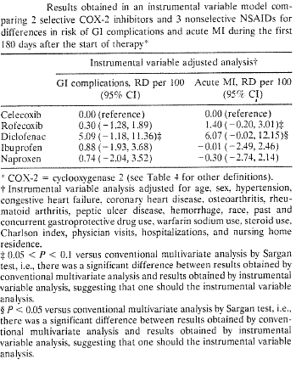

Figure 7.8: White B, et al 2011
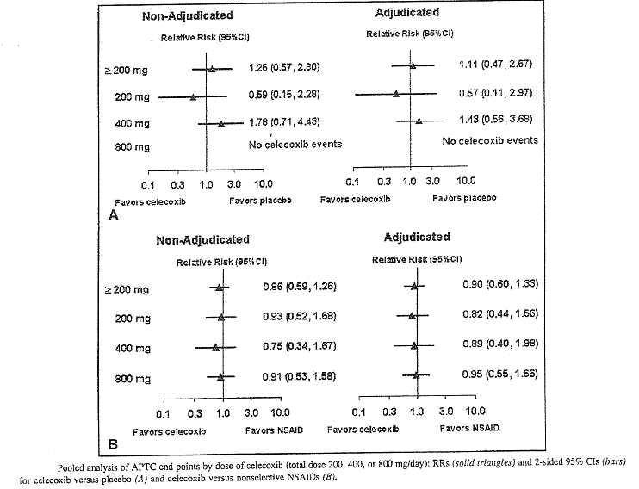

Table 7.9: Summary of publications provided by Pfizer for celecoxib
 | Literature reference | Study design | Main findings | Conclusions | Limitations
1 | Chan FKL, et al. ‘Celecoxib vs. omeprazole and diclofenac in patients with osteoarthritis and rheumatoid arthritis (CONDOR): a randomised trial.’ Lancet 2010; 376: 173-179 and Erratum 2011; 378: 228. | Six-month, double-blind, randomised trial in patients with osteoarthritis or rheumatoid arthritis at increased GI risk at 196 centres in 32 countries. Patients treated with celecoxib 200 mg twice a day or diclofenac 75 mg SR plus omeprazole 20 mg once a day. Primary endpoint – clinically significant upper- or lower-GI events adjudicated by independent committee. | A total of 4484 patients included in ITT analysis (2238 celecoxib; 2246 diclofenac+omeprazole); incidence of GI events: celecoxib=0.9%, diclofenac plus omeprazole=3.8%; HR for diclofenac plus omeprazole vs. celecoxib=4.3, 95% CI: 2.6-7.0, p<0.001). Two deaths in each group – celecoxib due to pulmonary embolism and bronchopneumonia; diclofenac plus omeprazole both due to cardiac arrest. | Risk of serious GI events was lesser in arthritis patients with celecoxib compared to use of traditional NSAID plus PPI (diclofenac plus omeprazole).  A total of 21 CV events with almost similar incidence in both groups – details not provided. | This study was not designed to assess CV safety and does not add much information regarding CV risks of NSAIDs.
2 | Depont F, et al. ‘The CADEUS study: methods and logistics.’ Pharmacoepidemiol Drug Saf 2007; 16 (5): 571-580. | Cohort study 45,217 randomly sampled monthly in French health database who received at least one prescription of celecoxib, rofecoxib or traditional NSAIDs (target ratio of 1:1:2) from September 2003 to August 2004. Patient and doctor questionnaires for more details on indication, medical history. | Of 45,217 patients, only 13,065 COX-2 inhibitors and 13,553 traditional NSAID users had prescriber data; 97% of COX-2 inhibitor prescriptions were for rheumatological indications whereas 37% of traditional NSAID use was for benign or analgesia. Among patients with rheumatological disease and first COX-2 inhibitor (2427) or traditional NSAID (n=2303) dispensing, multivariate analysis showed that compared to traditional NSAID users, COX-2 inhibitor users were older, more often female on sick leave or unemployed. COX-2 inhibitor use also associated with previous GI history or previous gastroprotective dispensing but not with previous CV history. | Choice of NSAID depended largely on indication and on previous GI history. Possible knowledge of CV risk associated with COX-2 inhibitors did not influence prescribing as this study was done before withdrawal of rofecoxib. Mean duration of COX-2 inhibitor prescription was longer and more likely to be chronic users. | Indications for which COX-2 inhibitors are approved in France differ from that in USA or Australia. Bias due to confounders because of the observational nature of study.

Table 7.10: Summary of publications provided by Pfizer for celecoxib
 | Literature reference | Study design | Main findings | Conclusions | Limitations
3 | Varas-Lorenzo C, et al. ‘Quantitative assessment of the gastrointestinal and cardiovascular risk-benefit of celecoxib compared to individual NSAIDs at the population level.’ Pharmacoepidemiol Drug Saf 2007; 16 (4): 366-376. | Objective was to estimate the net CV (CHD, stroke, CHF) and GI (peptic ulcer complications) risk-benefit public health impact of the use of celecoxib compared to non-selective NSAIDs in the arthritis population. Event simulation models to data from US national health surveys, Framingham heart study and population based studies. This evaluation included 1% of the US population with arthritis. | Celecoxib when applied to 100,000 patients over 1 year resulted in 570 (range: 440-691), 226 (124-313) and 746 (612-868) fewer ulcer complications than diclofenac, ibuprofen and naproxen, respectively. There were 20 (16-25), 8 (4-12) and 27 (22-32) fewer deaths from ulcer complications, respectively. No increase in CV events or all-cause mortality for celecoxib vs. other NSAIDs. | These simulations suggest a GI benefit for celecoxib which is not offset by increased CV events or mortality. | Bias due to indication for celecoxib vs. other NSAIDs. Effect of dose not evaluated. Results only apply up to one year of continuous treatment which does not reflect real-life situation. Variation due to sampling errors not considered in the simulation models.
4 | Kang HJ, et al. ‘Effects of celecoxib on restenosis after coronary intervention and evolution of atherosclerosis (mini-COREA) trial: celecoxib, a double-edged sword for patients with angina.” Eur Heart J (08 March 2012) | Prospective, randomised, open-label multicentre trial at five centres in South Korea between March 2006 and June 2009. To evaluate efficacy and safety of three-month duration of adjunctive celecoxib treatment (200 mg twice a day or placebo control) in reducing neointimal hyperplasia in patients with coronary stent implantation. Primary endpoint was in-stent late loss at six months | In stent late loss was significantly lower in celecoxib gp compared to control (0.64+0.54 vs. 0.55+0.47mm, p=0.02). Trend of late loss reduction with celecoxib was maintained in both paclitaxel- and zotarolimus-eluting stents. Trend of reduced target lesion revascularisation (9TLR) in celecoxib group (5.7 vs. 3.2%, p=0.09) but adverse cardiac events did not differ between groups – composite of cardiac death, non-fatal MI and TLR=8.6% vs. 7.7%, log rank p=0.84). Non-fatal MI and cardiac death occurred more frequently in celecoxib group (1.6% vs. 0.2%, log rank p=0.03). | Three-month adjunctive celecoxib may be useful for reducing late loss of drug eluting stent, but there may be increased risk of thrombotic event with celecoxib, despite patients receiving dual anti-platelet therapy. | Not relevant as celecoxib to be avoided in patient with CHD or CV risk factors according to current PI.

Table 7.11: Summary of publications provided by Pfizer for celecoxib
 | Literature reference | Study design | Main findings | Conclusions | Limitations
5 | Shau WY, et al. ‘Risk of new AMI hospitalisation associated with use of oral and parenteral NSAIDs: a case-crossover study of Taiwan’s National Health Insurance Claims database and review of current evidence.’ BMC Cardiovascular disorders 2012; 12:4. | Case-crossover study using Taiwan’s national health insurance claim database identifying 8354 patients with new acute MI hospitalised in 2006. There were 14 oral and three parenteral NSAIDs selected based on drug utilisation profile among 13.7 million NSAID users. | Adjusted OR (95% CI) for risk of acute MI with oral NSAIDs was 1.42 (1.29-1.56); parenteral NSAIDs=3.35 (2.50-4.47). Ketorolac had highest aOR of 2.02 for oral and 4.27 for parenteral ketorolac. | Tendency of increased risk of acute MI with current use of some NSAIDs – higher risk following parenteral NSAID | Data on some risk factors, such as smoking, obesity, alcohol consumption and family history of CV disease, not available. Unmeasured confounders for observational study although case-crossover design reduces the bias. Actual NSAID use and OTC use not monitored.

Table 7.12:
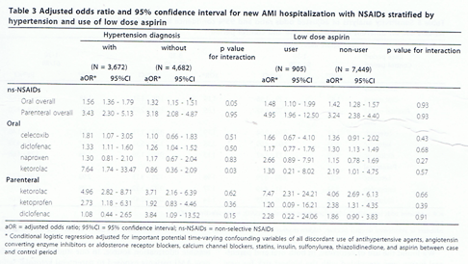
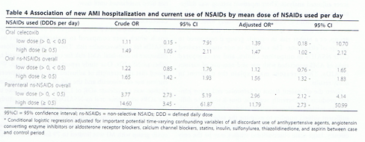

Table 8.1:
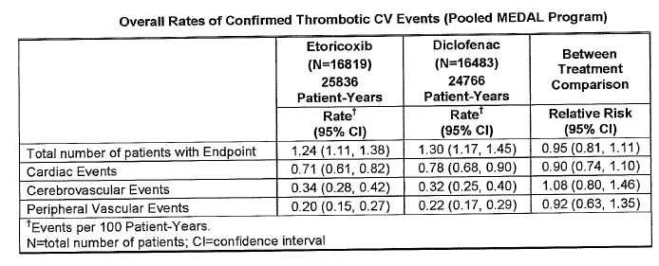

Table 8.2:
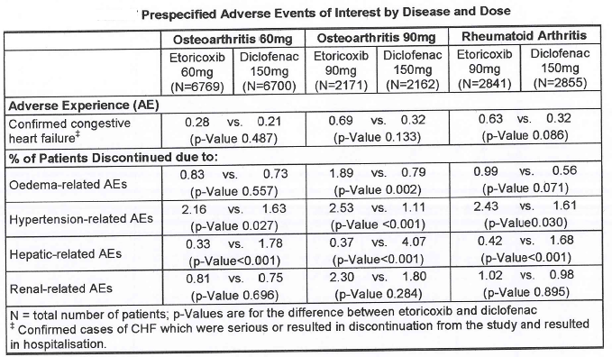

Table 8.3:
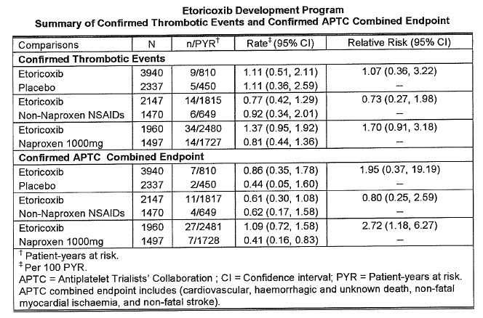

Table 9: H. Salmivaara, 2006
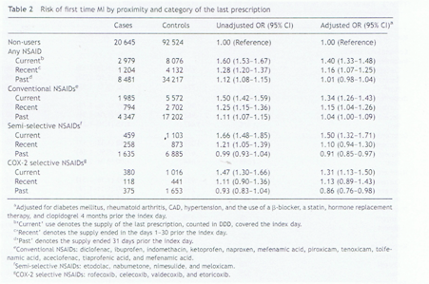

Table 10 Summary of the numbers of studies and overall results. (Sorenson 2008)
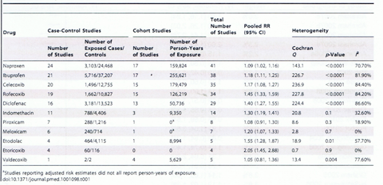

Table 11.1: Sorenson 2008
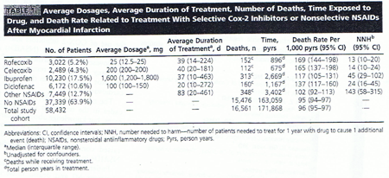

Table 11.2: Sorenson 2008
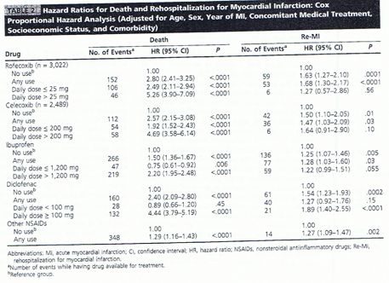

Therapeutic Goods Administration
PO Box 100 Woden ACT 2606 Australia
Email: info@tga.gov.au Phone: 1800 020 653 Fax: 02 6232 8605
http://www.tga.gov.au
R14/975329

Instrumental variable is based on the physician’s preference for prescribing each of the NSAIDs under study.

