Australian Public Assessment Report for Zirdawny
  - Active ingredient: Donidalorsen (as sodium)
  - Sponsor: Otsuka Australia Pharmaceutical Pty Ltd
August 2026

About the Therapeutic Goods Administration (TGA)
- The Therapeutic Goods Administration (TGA) is part of the Australian Government Department of Health, Disability and Ageing and is responsible for regulating therapeutic goods, including medicines, medical devices, and biologicals.
- The TGA administers the Therapeutic Goods Act 1989 (the Act), applying a risk management approach designed to ensure therapeutic goods supplied in Australia meet acceptable standards of quality, safety, and efficacy.
- The work of the TGA is based on applying scientific and clinical expertise to decision-making, to ensure that the benefits to the Australian public outweigh any risks associated with the use of therapeutic goods.
- The TGA relies on the public, healthcare professionals and industry to report problems with therapeutic goods. The TGA investigates reports received to determine any necessary regulatory action.
- To report a problem with a therapeutic good, please see the information on the TGA website.

About AusPARs
- The Australian Public Assessment Report (AusPAR) provides information about the evaluation of a prescription medicine and the considerations that led the TGA to approve or not approve a prescription medicine submission. Further information can be found in Australian Public Assessment Report (AusPAR) guidance.
- AusPARs are prepared and published by the TGA.
- AusPARs are static documents that provide information that relates to a submission at a particular point in time. The publication of an AusPAR is an important part of the transparency of the TGA’s decision-making process.
- A new AusPAR may be provided to reflect changes to indications or major variations to a prescription medicine subject to evaluation by the TGA.

Copyright
© Commonwealth of Australia 2026.
This work is copyright. You may reproduce the whole or part of this work in unaltered form for your own personal use or, if you are part of an organisation, for internal use within your organisation, but only if you or your organisation do not use the reproduction for any commercial purpose and retain this copyright notice and all disclaimer notices as part of that reproduction. Apart from rights to use as permitted by the Copyright Act 1968 or allowed by this copyright notice, all other rights are reserved, and you are not allowed to reproduce the whole or any part of this work in any way (electronic or otherwise) without first being given specific written permission from the Commonwealth to do so. Requests and inquiries concerning reproduction and rights are to be sent to the TGA Copyright Officer, Therapeutic Goods Administration, PO Box 100, Woden ACT 2606 or emailed to <tga.copyright@tga.gov.au>.

Contents
List of abbreviations 4
Product submission 6
Submission details 6
Product background 7
Disease or condition 7
Current treatment options 8
Clinical rationale 8
Regulatory status 9
Australian regulatory status 9
International regulatory status 9
Registration timeline 9
Assessment overview 10
Quality evaluation summary 10
Nonclinical evaluation summary 10
Clinical evaluation summary 12
Summary of clinical evaluation studies 12
Pharmacology 13
Efficacy 14
Safety 20
Risk management plan 22
Risk-benefit analysis 23
Delegate’s considerations 23
Proposed action 24
Assessment outcome 24
Specific conditions of registration 24
Product Information and Consumer Medicine Information 25

List of abbreviations
Abbreviation | Meaning
AE | Adverse event
AE-QoL | Angioedema quality of life
ALT | Alanine aminotransferase
ARTG | Australian Register of Therapeutic Goods
ASA | Australia-specific annex
ASO | Antisense oligonucleotide
C1-INH | C1 inhibitor
CI | Confidence interval
CL/F | Apparent clearance
CMI | Consumer Medicines Information
CNS | Central nervous systems
CYP | Cytochrome P450 (enzymes)
DLP | Data lock point
ECGs | Electrocardiograms
EMA | European Medicines Agency
EU | European Union
GLP | Good laboratory practice
HAE | Hereditary angioedema
HMWK | High molecular weight kininogen
ICH | The International Council for Harmonisation of Technical Requirements for Pharmaceuticals for Human Use
IFU | Instruction for Use
IIV | Interindividual variability
LLN | Lower limit of normal
LTP | Long-term prophylaxis
MMRM | Mixed effects model with repeated measures
MoA | Mechanism of action
mRNA | Messenger ribonucleic acid
NOAEL | No observed adverse effect level
OLE | Open-label extension
PD | Pharmacodynamic(s)
PI | Product Information
PK | Pharmacokinetic(s)
PKK | Prekallikrein
popPK | Population PK
PSUR | Periodic safety update report
q4w | Every four weeks
q8m | Every eight weeks
Q/F | Apparent inter-compartmental clearance
RMP | Risk management plan
SAEs | Serious adverse events
SAS | Special Access Scheme
SC | Subcutaneous
SD | Standard deviation
SEM | Standard error of mean
TEAE | Treatment emergent adverse event
TGA | Therapeutic Goods Administration
T_{max} | Time to maximum concentration
V_{c}/F | Apparent volume of distribution of central compartment
V_{p}/F | Apparent volume of distribution of peripheral compartment

Product submission

Submission details
Type of submission: | New chemical entity
Product name: | Zirdawny
Active ingredient: | Donidalorsen (as sodium)
Decision: | Approved
Date of decision: | 10 June 2026
Date of entry onto ARTG: | 11 June 2026
ARTG number: | 490867
Black Triangle Scheme  for the current submission: | Yes
Sponsor’s name and address: | Otsuka Australia Pharmaceutical Pty Ltd  Suite 2.03, Level 2  9 Help Street  Chatswood NSW 2067
Dose form: | Solution for injection in pre-filled pen (injection)
Strength: | 80 mg in 0.8 mL solution
Container: | Glass Type I Clear pre-filled syringe
Pack size: | 1 or 3 single-use pre-filled pens.
Approved therapeutic use for the current submission: | Zirdawny is indicated for routine prevention of recurrent attacks of hereditary angioedema (HAE) in adults and adolescents aged 12 years and older.
Route of administration: | Subcutaneous injection
Dosage: | The recommended starting dose in adult and adolescent patients is 80 mg donidalorsen by subcutaneous injection. Doses should be administered once monthly.  A dosing interval of 80 mg once every 2 months may be considered if the patient is well controlled (e.g., attack free) for at least 3 months while receiving Zirdawny.  For further information regarding dosage, such as dosage modifications to manage adverse reactions, refer to the Product Information.
Pregnancy category: | Pregnancy Category B1  There are no or limited amount of data (less than 300 pregnancy outcomes) from the use of Zirdawny in pregnant women.  The use of any medicine during pregnancy requires careful consideration of both risks and benefits by the treating health professional. The pregnancy database must not be used as the sole basis of decision making in the use of medicines during pregnancy. The TGA does not provide advice on the use of medicines in pregnancy for specific cases. More information is available from obstetric drug information services in your state or territory.

Product background
This AusPAR describes the submission by Otsuka Australia Pharmaceutical (the sponsor) to register Zirdawny (donidalorsen) 80 mg / 0.8 mL solution for injection pre-filled pen, for the following proposed indication:
Zirdawny is indicated for routine prevention of recurrent attacks of hereditary angioedema (HAE) in adults and adolescents aged 12 years and older.

Disease or condition
Hereditary angioedema is a rare disorder characterised by local subcutaneous oedema and submucosal oedema involving the upper respiratory and gastrointestinal tracts. There are several forms, with the most common being HAE 1, representing 85% of patients.² The HAE-C1INH-type1 (HAE 1) and HAE-C1INH-type2 (HAE 2) present in approximately 85% and 15% of cases, respectively. HAE 1 and HAE 2 are clinically indistinguishable but have different biochemical features. Both are caused by heterozygous mutations in the C1 inhibitor gene on Chromosome 11q. In HAE 1, serum levels of C1-1NH are <35% of normal, and in HAE 2 there are normal or elevated concentrations of C1-INH, but the protein is nonfunctional.
In rare cases, patients have a third type of HAE, nC1-INH-HAE (international nomenclature: HAE-nC1INH) (formerly referred to as HAE type III), is a rare genetic disease with similar phenotype to HAE-C1-INH but different genetic background, in which antigenic and functional C1-INH levels are normal.²
The inheritance is predominantly autosomal dominant, but some of the rarer variants can be autosomal recessive. Rarely, recurrent angioedema may be an acquired condition, resulting from C1 inhibitor deficiency resulting from anti-C1NH autoantibodies.
The clinical manifestations are recurrent episodes of localised oedema in the subcutaneous tissue of the extremities, face, trunk or genitalia, or the submucosal tissues of the gastrointestinal and upper respiratory tract. Laryngeal obstruction may be life threatening and may result in asphyxiation. Intestinal oedema may lead to obstruction and/or pain. Triggering factors include local trauma, infection and emotional stress but most attacks occur spontaneously.

Current treatment options
Treatments for HAE include bradykinin antagonist (Icatibant acetate), CI-esterase inhibitor (recombinant or plasma derived), kallikrein inhibitor (ecallantide, berotralstat and lanadelumab-flyo), androgens (e.g. danazol) and antifibrinolytics (aminocaproic acid and tranexamic acid).
In an epidemiological survey of HAE in South Australia, 46% of subjects were on long-term prophylaxis (LTP) therapy with danazol, 29% of subjects were managed with lanadelumab, 5.7% with tranexamic acid, and 5.7% with subcutaneous Ci-INH. There were 11% of subjects who received no long-term prophylaxis therapy^{.5}
The following therapies are approved for the treatment of HAE in Australia:
- Takhzyro (lanadelumab) 150 mg/1 mL and 300 mg/2 mL solution for injection
- Icatibant (as acetate) 30 mg/3 mL solution for injection
- Berinert SC Human C1 esterase inhibitor 2000 IU powder for injection glass vial with diluent vial
- Cinryze C1 esterase inhibitor 500 units powder for solution for injection vial with diluent vial
Danazol is currently not available in Australia but can be sourced using a Special Access Scheme (SAS) application to the TGA.

Clinical rationale
Donidalorsen is a 2’-O-methoxyethyl–modified antisense oligonucleotide (ASO) conjugated to a triantennary N-acetylgalactosamine (GalNAc3) moiety that causes ribonuclease H1 (RNase H1) mediated degradation of prekallikrein (PKK) mRNA (messenger ribonucleic acid) through selective binding to PKK mRNA, which results in reduced production of PKK protein. PKK is a pro-enzyme for plasma kallikrein, which drives the release of bradykinin, a vasodilator responsible for the swelling and pain in HAE. In patients with HAE, C1 inhibitor (C1-INH) deficiency or dysfunction leads to excessive plasma kallikrein activity and bradykinin generation, resulting in angioedema attacks. Donidalorsen lowers PKK and plasma kallikrein concentrations, preventing excessive bradykinin production in patients with HAE.
Current long-term prophylactic regimens for HAE include plasma-derived C1-INH concentrate (administered either intravenously or subcutaneously), monoclonal antibodies directed against plasma kallikrein, a small molecule inhibitor of plasma kallikrein, and attenuated androgens. These options reduce the number and severity of attacks due to HAE, although breakthrough attacks still occur. These treatment options can be associated with injection-site reactions, headache, nausea, rash, vomiting, fever, upper respiratory infection, myalgia, dizziness, and diarrhea. Current oral treatment options are associated with gastrointestinal adverse reactions in some patients. Current treatment options with oral long-term prophylaxis androgens can lead to adverse androgenic and anabolic effects, have a potential for drug-drug interactions, and have contraindications.
A need remains for long-term prophylaxis that provides less treatment burden, a more patient friendly experience (e.g., route of administration, dosing frequency), greater efficacy, safety and tolerability, and reduced anxiety for breakthrough attacks. In general, patients with HAE are highly motivated to switch to therapies with improved and more convenient dosing (e.g. route, frequency) as well as an overall reduction in treatment burden and improved quality-of-life.

Regulatory status

Australian regulatory status
This product is considered a new chemical entity for Australian regulatory purposes. The present submission is the first application for donidalorsen in Australia.

International regulatory status
At the time the TGA considered this submission, similar submissions had been considered by other regulatory agencies. The following table summarises the regulatory status of Zirdawny/Dawnzera (donidalorsen) with approved indications.
Table 1: International regulatory status
Region | Submission date | Status | Approved indications
United States of America | 21 August 2024 | Approved on 21 August 2025 | Dawnzera is indicated for prophylaxis to prevent attacks of hereditary angioedema (HAE) in adult and paediatric patients 12 years of age and older.
European Union | 20 November 2024 | Approved on 19 January 2026 | Dawnzera is indicated for routine prevention of recurrent attacks of hereditary angioedema (HAE) in adult and adolescent patients aged 12 years and older.
Switzerland | 11 March 2025 | Approved on 2 June 2026 | Dawnzera is indicated for routine prevention of recurrent attacks of hereditary angioedema (HAE) in adults and adolescents aged 12 years and older.

Registration timeline
The following table captures the key steps and dates for this submission. The active ingredient with its proposed indication was given orphan drug designation.
Table 2: Timeline for Submission PM-2026-02384-1-2
Description | Date
Designation (Orphan) | 11 April 2025
Submission dossier accepted and first round evaluation commenced | 31 July 2025
Evaluation completed (End of round 2) | 5 May 2026
Registration decision (Outcome) | 10 June 2026
Registration in the ARTG completed | 11 June 2026
Number of working days from submission dossier acceptance to registration decision* | 167
*Statutory timeframe for standard submissions is 255 working days

Assessment overview
A summary of the TGA’s assessment for this submission is provided below.

Quality evaluation summary
Donidalorsen is a 2’-O-methoxyethyl–modified antisense oligonucleotide conjugated to a triantennary N-acetylgalactosamine (GalNAc3) moiety.
The drug substance specification has been set in line with the ICH guidelines and the EMA draft guideline on development and manufacture of oligonucleotides. It includes appropriate tests for appearance, identification by mass, sequence confirmation, identity and quantity of counterion, assay, purity, oligonucleotide impurities and degradation products, residual solvents, bacterial endotoxins, microbial limits, and water content.
The analytical methods used to analyse the drug substance were adequately described and validated. Risk assessments on the potential presence of nitrosamines and elemental impurities were performed. No significant risk was identified.
The drug product is a sterile, clear, colourless to yellow, single-dose, ready-to-use, parenteral solution of donidalorsen for SC administration. It is packaged as 0.8 mL deliverable volume in a 1 mL staked needle glass pre-filled syringe closed with a siliconised butyl rubber plunger stopper. The autoinjector delivers a single dose of 80 mg donidalorsen.
The drug product shelf-life is 36 months when stored at 2-8 °C. Refrigerate. Do not freeze. Keep the pre-filled pen in the outer carton in order to protect from light. Do not expose to heat. The product may be stored in the original carton unrefrigerated for up to 6 weeks at or below 30 °C. If not used within 6 weeks, it should be discarded.

Nonclinical evaluation summary
The overall quality of the nonclinical dossier was sound, and all pivotal safety-related studies were GLP-compliant.
The in vitro and in vivo primary pharmacology studies submitted support that inhibiting the expression of PKK with donidalorsen produces the expected upstream target engagement (i.e. ↓ PKK mRNA), downstream pharmacodynamic effects (↓PKK protein; ↓HMWK cleavage), and functional efficacy readouts (↓vascular permeability). The data support the proposed mechanism of action (MoA) and indication. Cynomolgus monkeys were considered a pharmacologically responsive species. No significant off-target sites were identified in an in silico/in vitro screen.
Safety pharmacology studies assessed effects on the cardiovascular, respiratory and central nervous system (CNS) parameters in monkeys. No adverse effects were seen on the tested systems at doses associated with high exposure compared to human. No significant inhibition of hERG K+ channel tail current was observed in vitro at high concentrations. Donidalorsen is not expected to affect cardiovascular, respiratory or CNS parameters in patients.
Overall, the pharmacokinetic profile in animals was qualitatively similar to that of humans and similar to the profile of other GalNAc-conjugated oligonucleotides. Donidalorsen was readily and rapidly absorbed with a similar T_{max} in all species following SC dosing. The biphasic plasma concentration-time profile was indicative of a rapid tissue distribution phase, mainly to the liver (target tissue) and kidney (site of elimination), followed by a much slower elimination profile with the rate of the second phase dependent on tissue half-lives. Plasma protein binding of donidalorsen was high in all tested animal species and humans. Metabolism of donidalorsen involved rapid hydrolysis of the GalNAc linker component in tissues followed by metabolism of the oligonucleotide component by endo- and exonucleases in all species. Excretion of linker-related material was primarily in the faeces. Oligonucleotide-related components are expected to be excreted primarily in the urine.
Donidalorsen did not exhibit any appreciable activity against CYP isozymes or efflux and uptake transporters, thus pharmacokinetic drug interaction potential is considered negligible.
Key repeat-dose toxicity studies by the SC route were conducted in mice (up to 26 weeks) and cynomolgus monkeys (39 weeks). Maximum estimated systemic exposures achieved in mice were moderate while maximum exposures were very high in monkeys, relative to exposures at the proposed clinical dose. The most notable toxicity observed was severe thrombocytopenia in monkeys at high relative exposures. Given the margin at the NOAEL, this is unlikely to be clinically relevant. Most other findings were associated with areas of high localisation of the drug. These included the liver—the intended pharmacological target, through its GalNAc linker, the kidneys—the main excretory pathway, the injection site—site of administration, and the lymph nodes. All of the effects were associated with the uptake/disposition of the drug or an expected foreign body reaction. Degenerative findings in the liver of treated mice are considered rodent-specific. They are not considered to pose a concern for patients.
Donidalorsen does not pose a genotoxic concern based on negative results in the bacterial mutation assay, an in vitro clastogenicity study (Chinese hamster lung cells) and mouse bone marrow micronucleus test.
An increased incidence of hepatocellular adenomas was seen in males at the high dose in a carcinogenicity study conducted in transgenic mice (6-month in TgRasH2, SC). The underlying mechanism for formation of these tumours is considered to be rodent-specific and are not considered a concern in patients. A long-term rodent carcinogenicity study is in progress.
A combined fertility and embryofetal development study and pre-/ postnatal development study were performed in mice with moderate relative doses of donidalorsen. Donidalorsen did not affect functional fertility in male or female mice, and there was no evidence of adverse effects on embryofetal development or pre-/ postnatal development. Detectable but low level of donidalorsen could be seen in the placenta of female mice but it is unclear if it could be transferred to the foetus. Milk transfer was demonstrated in mice; however, due to the poor oral absorption of oligonucleotides, plasma levels of donidalorsen were below the levels of detection in pups.
No adverse effects on developmental parameters were seen in juvenile mice at a dose similar to the clinical dose.
Dedicated local tolerance studies were not conducted but repeat-dose toxicity studies showed injection site reactions to donidalorsen in both monkeys and mice consistent with an expected immune reaction to the drug.
Limits for specified impurities have been toxicologically qualified.

Conclusions and recommendation
The primary pharmacology studies support the proposed mechanism of action and indication.
No major deficiencies were identified. No clinically relevant organ system hazards were identified in the safety pharmacology or general toxicity studies.
Severe thrombocytopenia noted in 2 animals in the repeat-dose toxicity study in monkeys at high doses has unlikely clinical relevance.
The 2-year carcinogenicity study in rats currently in progress should be submitted to the TGA in a subsequent submission if the product is approved.
The proposed pregnancy category for donidalorsen (Category B1) is acceptable.
There are no nonclinical objections to the registration of donidalorsen for the proposed clinical use.

Clinical evaluation summary

Summary of clinical evaluation studies
Table 3. Studies submitted for clinical evaluation.
Topic | Subtopic/ Study | Study ID | *
PK in healthy adults | General PK - Multiple dose | Study CS01 | *
PK in healthy adults | Bioequivalence - Single dose | Study CS09 | * †
Population PK analyses, Population PD, PK-PD analyses | Healthy subjects and target population | PopPK 01 | * §
Primary Pharmacology (PD studies) | Effect on PKK, plasma proenzyme activation and HMWK cleavage. | Study CS01 | *
Primary Pharmacology (PD studies) | Effect on PKK, plasma proenzyme activation and cHK. | Study CS02 | *
Primary Pharmacology (PD studies) | Effect on PKK and plasma proenzyme activation. | Study CS03 | *
Population PD and PK-PD analyses | Healthy subjects and target population | PopPK 02 | * §
Population PD and PK-PD analyses | Healthy subjects and target population | PopPK 03 | * §
Efficacy | Pivotal Study: Study ISIS 721744-CS5 | Study CS05
Efficacy | Study ISIS 721744-CS2 | Study CS02
Efficacy | Study ISIS 721744-CS3 | Study CS03
Efficacy | Study ISIS 721744-CS7 | Study CS07
Safety | There were no pivotal studies that assessed safety as the primary outcome.
Pivotal and/or main efficacy study (safety data) | Study ISIS 721744-CS5 | Study CS05
Other efficacy studies, providing safety data | Study ISIS 721744-CS2 | Study CS02
Other efficacy studies, providing safety data | Study ISIS 721744-CS3 | Study CS03
Other efficacy studies, providing safety data | Study ISIS 721744-CS7 | Study CS07
Studies with evaluable safety data: dose finding and pharmacology | Study ISIS 721744-CS9 | Study CS09
 | Study ISIS 721744-CS1 | Study CS01
* Indicates the primary PK aim of the study.
† Bioequivalence of different formulations.
§ Subjects who would be eligible to receive the drug if approved for the proposed indication.

Pharmacology

Pharmacokinetics
The Pharmacokinetics (PK) of donidalorsen have been adequately characterised. Although donidalorsen, as a conjugated oligonucleotide, is a novel molecule its PK profile fitted well with a two-compartment model, with first order absorption and elimination. The interindividual variability was acceptable, indicating predictable exposures. It has a long half-life and is suitable for monthly or second monthly administration. The PK data are supportive of the proposed dosing regimen.

Population PK data
In Population PK data (popPK) PopPK 01, the final PopPK model was two compartments with first order absorption and elimination, parameterised as clearance. The covariate model included:
- Effects for body weight on CL/F, V_{c}/F, Q/F and V_{p}/F, with the exponents estimated.
- Site of administration on ka, with a 34% reduction for injection in the arm compared to abdomen or thigh.
- Drug presentation on ka, with a 26% increase for the autoinjector compared to the vial.
- Disease status on V_{c}/F (43% higher in HAE) and Q/F (26% lower in HAE).
Interindividual variability (IIV) was estimated on CL/F, V_{c}/F, Q/F and V_{p}/F. There was a full omega block with correlation terms for all the IIV parameters. Residual error was log-additive (exponential). The parameters were estimated with acceptable precision. Shrinkage on IIV parameters was acceptable (<30%).
The typical estimates (IIV, expressed as CV%) were 12.8 L/h (19.6%) for CL/F, 69.8 L (59.0%) for V_{c}/F, 1.79 L/h (10.2%) for Q/F and 1840 L (42.9%) for V_{p}/F. Age was not identified as a statistically significant covariate in the population PK analysis. Therefore, no dose adjustment is required based on age in patients 12 years of age and older. Donidalorsen has not been studied in children.

Pharmacodynamics
Donidalorsen is a 2’-O-methoxyethyl–modified antisense oligonucleotide (ASO) conjugated to a triantennary N-acetylgalactosamine (GalNAc3) moiety that causes ribonuclease H1 (RNase H1) mediated degradation of prekallikrein (PKK) mRNA through selective binding to PKK mRNA, which results in reduced production of PKK protein. PKK is a pro-enzyme for plasma kallikrein, which results in the release of bradykinin, a potent vasodilator causing swelling and pain in HAE. In patients with HAE, C1 inhibitor (C1-INH) deficiency or dysfunction leads to excessive plasma kallikrein activity, bradykinin generation, and angioedema attacks. Donidalorsen lowers PKK concentration, preventing excessive bradykinin production in patients with HAE.
The pharmacodynamics (PD) of donidalorsen have been adequately characterised. A lack of QT effect has been demonstrated. The Sponsor has described the concentration response relationships for both donidalorsen plasma concentration and PKK concentration. These relationships support the proposed dosing regimen of 80 mg q4w, and, in the presence of good HAE control, a reduction in dosing frequency to q8w.

Efficacy
The Sponsor has provided adequate justification of the proposed dosing regimen. This regimen is supported by the PKPD modelling data and from the results of the pivotal study. Study CS01 examined the dose range of 20 to 80 mg q4w and found there was greater decrease in PKK concentrations with increasing dose. Study CS02 investigated the 80 mg q4w dosing regimen only, in a proof-of-concept study. Study CS05 compared the 80 mg q4w and 80 mg q8w regimens with placebo.

Pivotal Study: Study ISIS 721744-CS5 (Study CS05)
Study CS05 was a Phase III, randomised, double blind, placebo-controlled study of donidalorsen in participants with HAE. The primary objective of this study was to evaluate the clinical efficacy of donidalorsen in patients with HAE. The study was conducted from 25th January 2022 to 9th November 2023, with a study treatment period of 24 weeks (Figure 1).
Figure 1. Study Schema for Study ISIS 721744-CS5 (Study CS05)
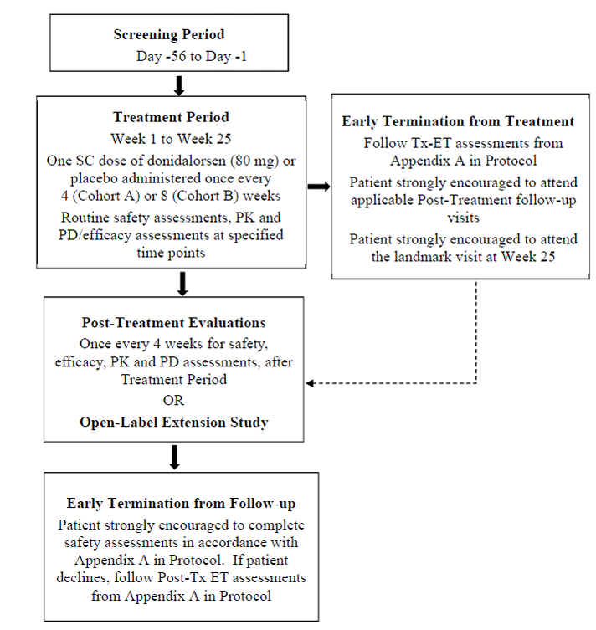
Key inclusion criteria
The key inclusion criteria included:
- Aged ≥12 years.
- A documented diagnosis of HAE-1/HAE-2 based upon ALL the following:
  - Documented clinical history consistent with HAE (subcutaneous or mucosal, non-pruritic swelling episodes without accompanying urticaria).
  - Diagnostic testing results that confirmed HAE-1/HAE-2: C1-INH functional level <40% normal level. Patients with a functional level of 40% to 50% of normal could be enrolled if their complement factor C4 level was below the lower limit of normal (LLN) or when a known pathogenic mutation in the SERPING1 gene had been demonstrated.
  - At least one of the following: age at reported HAE onset ≤30 years; a family history consistent with HAE-1/HAE-2; or complement component 1q within the normal range.
- Patients must have:
  - Experienced a minimum of 2 HAE attacks (confirmed by the Investigator) during the Screening Period.
  - Been willing to complete the patient reported outcome (PRO) assessments throughout the study.
The study treatments were:
- Donidalorsen 80 mg (0.8 mL of 100 mg/ml) vial, q4w
- Donidalorsen 80 mg (0.8 mL of 100 mg/ml) vial, q8w
- Placebo q4w or q8w
The primary efficacy outcome measure was the time-normalised number of Investigator-confirmed HAE attacks (per 4 week) from Week 1 to Week 25 compared with the placebo group for the q4w regimen.
Statistical methods
Counts, or rates, were analysed using Poisson regression models. Categorical outcomes were tested using logistic regression models. The change in AE-QoL score was tested using a mixed effects model with repeated measures (MMRM). Multiplicity was addressed by using a hierarchical ranking strategy in a testing sequence.
Participant flow
There were 116 patients screened, and 91 were randomised to treatment: 46 to donidalorsen q4w, 23 to donidalorsen q8w, and 22 to placebo. One patient in the donidalorsen q4w group withdrew prior to receiving treatment. The number (%) patients completing treatment was 44 (95.7%) in the donidalorsen q4w, 21 (91.3%) in the donidalorsen q8w, and 18 (81.8%) in the placebo. In total, 83 (95.6%) of patients rolled over to the open-label extension (OLE) study (Table 4).
Table 4. Patient Disposition (All Screened Patients).
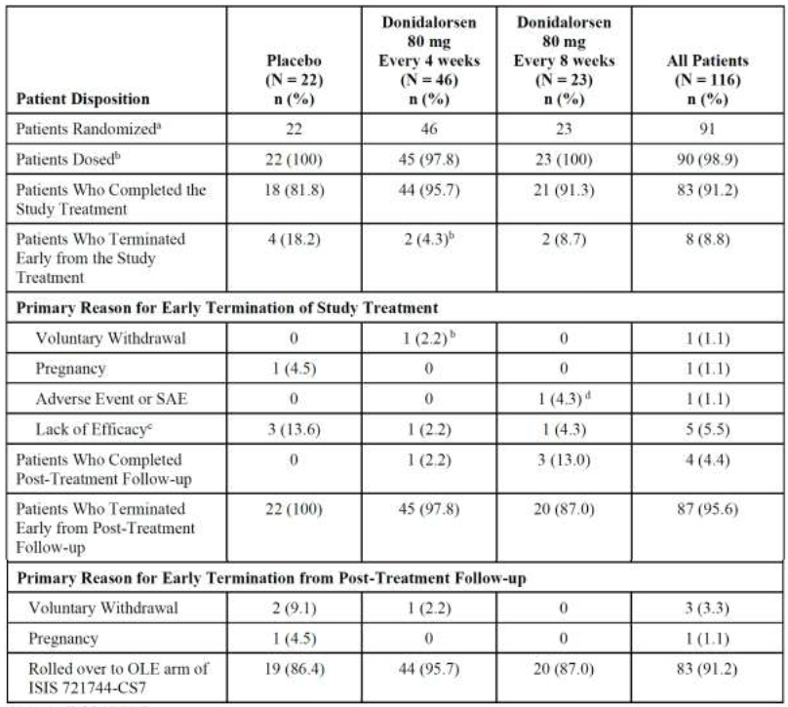
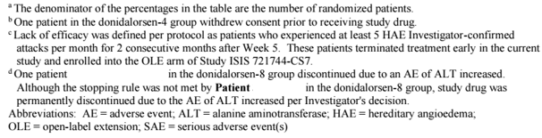
Baseline data
There were 48 (53.3%) females and 42 (46.7%) males. The median (range) age was 35.5 (12 to 68) years. There were seven (7.8%) patents aged 12 to 17 years, and two (2.2%) aged ≥65 years. There were 82 (19.1%) White patients. The median (range) BMI was 26.30 (16.0 to 57.4) kg/m². Median (range) C1-INH activity was 26.00 (2.9 to 56.0) %. There were 84 (93.3%) patients with HAE-I and six (6.7%) with HAE-2. Median (range) run-in period HAE attack rate was 2.85 (0.5 to 10.0) attacks/4 weeks. The most common prior medications taken by ≥20% of patients in at least one treatment group by preferred term included medications for use in HAE such as complement C1 esterase inhibitors, icatibant acetate, icatibant and paracetamol.
Results for the primary efficacy outcome
By the primary efficacy outcome measure, donidalorsen 80 mg q4w was superior to placebo. The mean (SD) time-normalised HAE attack rate from Week 1 to Week 25 was 0.89 (1.851) for donidalorsen 80 mg q4w and 2.29 (1.807) for placebo; mean rate ratio (95% CI) 0.19 (0.107 to 0.351); % difference relative to placebo (95% CI) -81 (-89.3 to -64.9) %, p <0.001 (Table 5).
Table 5. Analyses of Time-Normalized Investigator-Confirmed HAE Attack Rate (Per 4 Weeks) from Week 1 to Week 25 for the Donidalorsen-4 Group (Full Analysis Set).
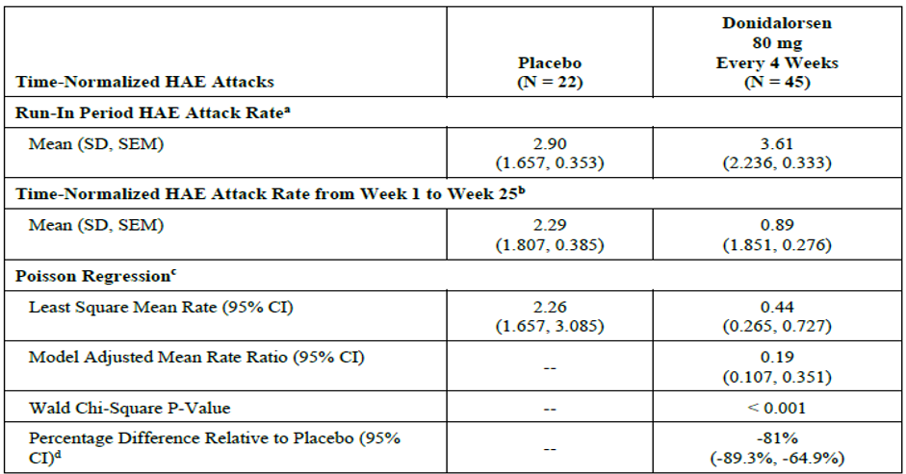
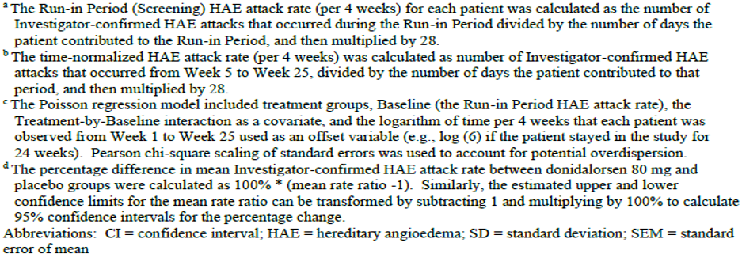
The benefit was apparent from Week 5, but maximal from Week 9 to Week 25 (Figure 2).
Figure 2. Percent Change from Baseline Mean (± SEM) of Investigator-Confirmed HAE Attack Rate (Per 4 Weeks) over Successive 4-Week Periods from Week 1 to Week 25 (Full Analysis Set).
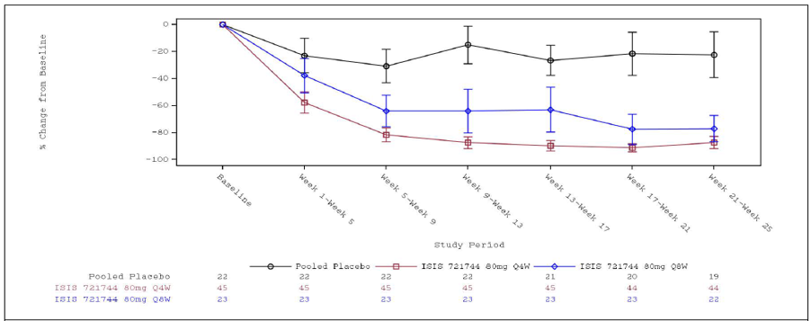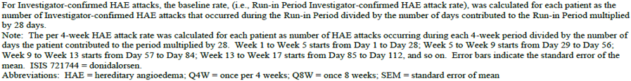
There were no significant subgroup effects (Table 6).
Table 6. Results of primary and secondary efficacy endpoints (full analysis set).
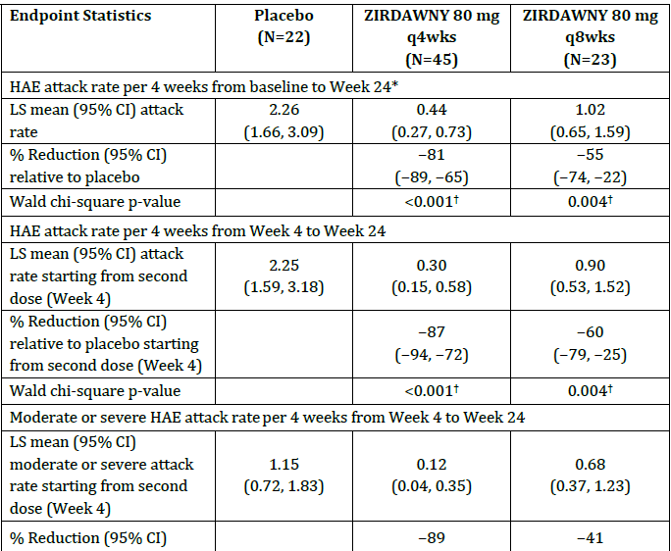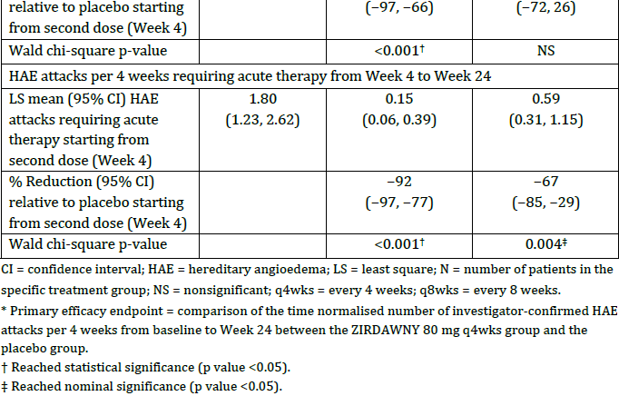

Other efficacy studies

Study ISIS 721744-CS2 (Study CS02)
Study CS02 was a Phase II study to assess clinical efficacy of donidalorsen conducted in two parts:
- Part A: a randomised, double-blind, placebo-controlled study in participants with either HAE Type I (HAE-1) or Type 2 (HAE-2).
- Part B: an open-label study in participants with HAE with normal C1-inhibitor (nC1-INH-HAE).
Study CS02 is supportive of efficacy for the 80 mg q4w regimen, and in a small sample size demonstrated superiority for donidalorsen compared to placebo. The mean (95% CI) number of confirmed HAE attacks in the treatment period was 0.23 (0.08 to 0.39) for donidalorsen and 2.21 (0.58 to 3.85) for placebo, rate ratio (95% CI) 0.10 (0.04 to 0.24).

Study ISIS 721744-CS3 (Study CS03)
Study CS03 was an OLE study of Study CS02. The treatment regimen was donidalorsen 80 mg q4w, with a step down to 80 mg q8w if attack free for ≥12 weeks, or a step up to 100 mg q4w of not attack-free at the start of the open label extension.
Study CS03 demonstrated preservation of efficacy, using the proposed dosing regimen, for up to 3 years.

Study ISIS 721744-CS7 (Study CS07)
Study CS07 was an OLE of Study CS05. The study commenced on 14 July 2022 and is ongoing, with a data cutoff for the present report of 10 April 2024. The study also included patients not previously enrolled in a donidalorsen study who had switched over from other treatments (switch patients).
Study CS07 demonstrated preservation of effect over a one-year period and that patients switching from other treatments benefited from donidalorsen. For the Switch patients, the mean (SD) time-normalized Investigator confirmed HAE attack rate (per 4 weeks) from Week 1 to Week 53 was 0.30 (0.46); mean % change (95% CI) -66.12 (-79.69 to -52.55) %; mean (95% CI) percent -51.05 (-78.77 to -23.32%) %, -76.47 (-93.38% to -59.56) %, and -78.20 (-97.31 to -59.09) % for the prior lanadelumab, prior berotralstat, and prior C1-esterase inhibitors groups, respectively.

Safety
Donidalorsen has a favourable safety profile. Overall, the rate of TEAEs was similar for donidalorsen and placebo, but with more treatment related injection site TEAEs in the donidalorsen group (Table 7).
Table 7. Treatment-Emergent Adverse Events in > 5% of Patients in Any Treatment Group by Preferred Term (Safety Set).
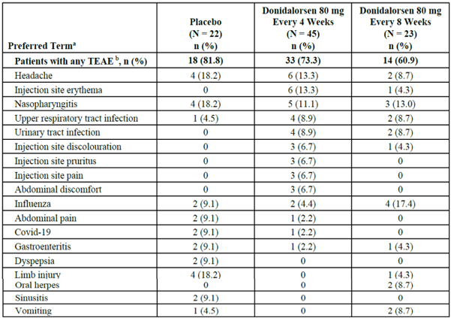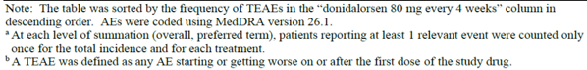
In the pooled analysis of Study CS05 and Study CS02, TEAEs were reported in 70.6% patients in the donidalorsen group and 81.8% in the placebo. The pattern of TEAEs was similar except for an increased rate of injection site erythema (9.4% patients in the donidalorsen group and none in the placebo) and urinary tract infection (8.2% patients in the donidalorsen group and none in the placebo).
In the pooled analysis of Study CS05 and Study CS02, TEAEs related to study treatment were reported in 32.9% patients in the donidalorsen group and 27.3% in the placebo. The most commonly reported TEAEs related to the study treatment in the donidalorsen group were injection site erythema in 9.4% patients, injection site discolouration in 5.9%, headache in 4.7%, injection site pain in 3.5% and injection site pruritus in 3.5%.
No deaths were reported in the study reports, but after database lock in Study CS07 one patient died by suicide. In the pooled analysis of Study CS05 and Study CS02. SAEs were reported in six (3.5%) patients in the donidalorsen group and one (3.6%) in the placebo. There were no SAEs related to study treatment.
There were no safety concerns with clinical laboratory tests, vital signs or ECGs.

Risk management plan
Otsuka Australia Pharmaceutical Pty Ltd has submitted a draft EU-RMP version 0.1 (dated 15 October 2024; DLP 19 April 2024) and ASA version 1.0 (dated June 2025) in support of this application. At Round 2, the sponsor has submitted EU-RMP version 1.1 (dated 10 November 2025; DLP 27 January 2025) and ASA version 1.1 (dated February 2026) in support of this application.
The summary of safety concerns and their associated risk monitoring and mitigation strategies are summarised in Table 8.
Table 8. Summary of safety concerns.
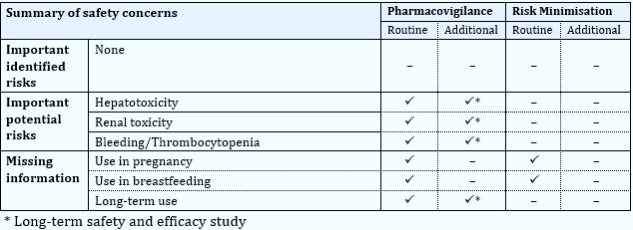
The summary of safety concerns proposed in the ASA align with the EU-RMP and is acceptable from an RMP perspective. There are no new and outstanding recommendations.
The sponsor has proposed routine pharmacovigilance for all safety concerns. An additional pharmacovigilance activity of a long-term safety and efficacy study has been proposed for all the important potential risks and the missing information of ‘long-term use’. The proposed pharmacovigilance plan aligns with the EU-RMP and is acceptable from an RMP perspective.
The sponsor has addressed missing information ‘Use in Pregnancy’ and ‘Use in Breastfeeding’ in the PI and the CMI. The sponsor does not propose any additional risk minimisation activities. The PI and IFU have been proposed as a package insert. The risk minimisation plan is acceptable from an RMP perspective.
The TGA may request an updated RMP at any stage of a product's life cycle, during both the pre-approval and post-approval phases. Further information regarding the TGA’s risk management approach can be found in risk management plans for medicines and biologicals and the TGA's risk management approach. Information on the Australia-specific annex (ASA) can be found on the TGA website.

Risk-benefit analysis

Delegate’s considerations

Quality
The evaluator has confirmed that approval is recommended from a quality and biopharmaceutic perspective.

Efficacy
Hereditary angioedema (HAE) is a rare and potentially life-threatening autosomal dominant inherited disease of vascular permeability. Donidalorsen lowers prekallikrein concentration, preventing excessive bradykinin (a potent vasodilator that causes swelling and pain in HAE) production in patients with HAE.
Donidalorsen's clinical pharmacology is deemed adequately characterised. The dose level of 80 mg once every 4 weeks was determined by the safety, tolerability, PK, pharmacodynamic, and immunogenicity data from the ISIS 721744-CS1 study in healthy volunteers, as well as the clinical efficacy data of the ISIS 721744-CS2 and ISIS 721744-CS5 study in patients with HAE.
The number of HAE attacks was substantially reduced by donidalorsen 80 mg when administered every four weeks in comparison to the placebo (primary endpoint). The secondary endpoints results revealed comparable findings, and comparable effects were observed in pre-specified subpopulations. In the pivotal study, Study CS05, the mean (SD) time-normalised HAE attack rate from Week 1 to Week 25 was 0.89 (1.851) for donidalorsen 80 mg q4w and 2.29 (1.807) for placebo. The mean rate ratio (95% confidence interval) was 0.19 (0.107 to 0.351), and the percentage difference relative to placebo (95% confidence interval) was -81 (-89.3 to -64.9), with a p-value of <0.001. The secondary endpoints results corroborated the primary endpoint. The benefit was sustained throughout the treatment period. The benefit was obvious from Week 5, but it was at its peak from Week 9 to Week 25. The frequency of attacks was assessed during these 25 weeks, and an open-label extension study was conducted subsequent to the controlled treatment period. The use of placebo as a comparator in the study that investigated the prophylactic effect of donidalorsen on recurrent attacks of HAE was deemed permissible due to the permissibility of acute medications to treat attacks as concomitant treatment.
Responding to the evaluator's enquiry, the sponsor verified that two phase 2 studies, ISIS 721744-CS2 and ISIS 721744-CS2-CS3, were conducted to assess the efficacy and safety of donidalorsen in patients with hereditary angioedema (HAE)-1/HAE-2 and in patients with normal C1-inhibitor (HAE-nC1-INH, formerly known as HAE Type 3). The Sponsor also provided a comprehensive analysis of three patients with nC1-INH who were enrolled in the study. The results of this analysis indicate that the patients did indeed have nC1-INH and that they responded adequately to donidalorsen. The Sponsor also emphasised that nC1-INH is a rare disorder, and as a result, it would be challenging to obtain additional efficacy data. Therefore, the inclusion of nC1-INH in the indication is considered appropriate.
Donidalorsen 80 mg q4w was reported to provide a ≥50% reduction in HAE attack rate from baseline in 93.3% of patients, and a ≥90% reduction in HAE attack rate from baseline in 62.2% of patients.
The 80 mg q4w regimen is efficacious, as evidenced by Study CS02, which reported a mean (95% CI) number of confirmed HAE attacks in the treatment period of 0.23 (0.08 to 0.39) for donidalorsen and 2.21 (0.58 to 3.85) for placebo, with a rate ratio (95% CI) of 0.10 (0.04 to 0.24).

Safety
In general, the incidence of TEAEs was comparable between donidalorsen and placebo; however, the donidalorsen group experienced a higher number of TEAEs related to the injection site of treatment. Clinical trials did not result in any deaths or serious adverse drug reactions.
Overall, it is acknowledged that the safety data provided indicate an acceptable safety and tolerability profile in HAE patients in adults and adolescents aged 12 years and older.

Proposed action
The Delegate considers that the benefit-risk balance of Zirdawny (donidalorsen) is favourable, in the following indication:
Zirdawny is indicated for routine prevention of recurrent attacks of hereditary angioedema (HAE) in adults and adolescents aged 12 years and older.

Assessment outcome
Based on a review of quality, safety, and efficacy, the TGA decided to register Zirdawny donidalorsen (as sodium) 80 mg/0.8 mL solution for injection pre-filled pen, indicated for:
Zirdawny is indicated for routine prevention of recurrent attacks of hereditary
angioedema (HAE) in adults and adolescents aged 12 years and older.

Specific conditions of registration
- Zirdawny (donidalorsen) is to be included in the Black Triangle Scheme. The PI and CMI for Zirdawny must include the black triangle symbol and mandatory accompanying text for five years, which starts from the date of first supply of the product.
- The Zirdawny EU-Risk Management Plan (RMP) version 1.1 (dated 10 November 2025, data lock point 27 January 2025), with Australia-Specific Annex (ASA) version 1.1 (dated February 2026), included with submission PM-2025-02384-1-2, and any subsequent revisions, as agreed with the TGA will be implemented in Australia.
- An obligatory component of risk management plans is routine pharmacovigilance. Routine pharmacovigilance includes the submission of periodic safety update reports (PSURs).
Reports are to be provided in line with the current published list of EU reference dates and frequency of submission of PSURs until the period covered by such reports is not less than three years from the date of this approval letter. Each report must be submitted within ninety calendar days of the data lock point for that report.
The reports are to at least meet the requirements for PSURs as described in the European Medicines Agency’s Guideline on good pharmacovigilance practices (GVP) Module VII-periodic safety update report (Rev 1), Part VII.B Structures and processes. Note that submission of a PSUR does not constitute an application to vary the registration.

Product Information and Consumer Medicine Information
For the most recent Product Information (PI) and Consumer Medicine Information (CMI), please refer to the TGA PI/CMI search facility.

Therapeutic Goods Administration
PO Box 100 Woden ACT 2606 Australia
Email: info@tga.gov.au Phone: 1800 020 653 Fax: 02 6203 1605
https://www.tga.gov.au
Reference/Publication #

This is the original indication proposed by the sponsor when the TGA commenced the evaluation of this submission. It may differ to the final indication approved by the TGA and registered in the Australian Register of Therapeutic Goods.
Sinnathamby ES, Issa PP, Roberts L, et al. (2023) Hereditary Angioedema: Diagnosis, Clinical Implications, and Pathophysiology. Advances in Therapy. 40(3):814-827. https://doi.org/10.1007/s12325-022-02401-0 PMID: 36609679; PMCID: PMC9988798.
Longhurst, H.J. & Bork, K. (2019) Hereditary angioedema: an update on causes, manifestations and treatment. British Journal of Hospital Medicine, Vol 80(7): 391-398. https://doi.org/10.12968/hmed.2019.80.7.391
Castaldo, A.J., Wells, K.E., Khalid, S., Rashidi, E., Selva, C.N., Corcoran, D., Christiansen, S.C., Riedl, M.A., Zuraw, B.L. and Loyo-Berrios, N. (2025) Establishing a hereditary angioedema prevalence for the United States using a large administrative claims database. Annals of Allergy, Asthma & Immunology; 135(3): 303-310. https://doi.org/10.1016/j.anai.2025.05.018.
Alexander Troelnikov, A., Milburn, K., Hissaria, P., Le T.T. and Smith, W. (2024) Hereditary angioedema prevalence and satisfaction with prophylaxis in South Australia. World Allergy Organization Journal, 17(7). https://doi.org/10.1016/j.waojou.2024.100918
Australian Society of Clinical Immunology and Allergy (ASCIA) (2022) Updated ASCIA HAE Position Paper 2022: Information for Health Professionals. Updated October 2022; Page 11. https://www.allergy.org.au/images/docs/ASCIA_HP_Position_Paper_HAE_2022_Updated_Nov.pdf

