Australian Public Assessment Report for Enflonsia
  - Active ingredient: Clesrovimab
  - Sponsor: Merck Sharp & Dohme (Australia) Pty Ltd
August 2026

About the Therapeutic Goods Administration (TGA)
- The Therapeutic Goods Administration (TGA) is part of the Australian Government Department of Health, Disability and Ageing and is responsible for regulating therapeutic goods, including medicines, medical devices, and biologicals.
- The TGA administers the Therapeutic Goods Act 1989 (the Act), applying a risk management approach designed to ensure therapeutic goods supplied in Australia meet acceptable standards of quality, safety, and efficacy.
- The work of the TGA is based on applying scientific and clinical expertise to decision-making, to ensure that the benefits to the Australian public outweigh any risks associated with the use of therapeutic goods.
- The TGA relies on the public, healthcare professionals and industry to report problems with therapeutic goods. The TGA investigates reports received to determine any necessary regulatory action.
- To report a problem with a therapeutic good, please see the information on the TGA website.

About AusPARs
- The Australian Public Assessment Report (AusPAR) provides information about the evaluation of a prescription medicine and the considerations that led the TGA to approve or not approve a prescription medicine submission. Further information can be found in Australian Public Assessment Report (AusPAR) guidance.
- AusPARs are prepared and published by the TGA.
- AusPARs are static documents that provide information that relates to a submission at a particular point in time. The publication of an AusPAR is an important part of the transparency of the TGA’s decision-making process.
- A new AusPAR may be provided to reflect changes to indications or major variations to a prescription medicine subject to evaluation by the TGA.

Copyright
© Commonwealth of Australia 2026
This work is copyright. You may reproduce the whole or part of this work in unaltered form for your own personal use or, if you are part of an organisation, for internal use within your organisation, but only if you or your organisation do not use the reproduction for any commercial purpose and retain this copyright notice and all disclaimer notices as part of that reproduction. Apart from rights to use as permitted by the Copyright Act 1968 or allowed by this copyright notice, all other rights are reserved and you are not allowed to reproduce the whole or any part of this work in any way (electronic or otherwise) without first being given specific written permission from the Commonwealth to do so. Requests and inquiries concerning reproduction and rights are to be sent to the TGA Copyright Officer, Therapeutic Goods Administration, PO Box 100, Woden ACT 2606 or emailed to <tga.copyright@tga.gov.au>.

Contents
List of abbreviations 5
Product submission 8
Submission details 8
Product background 9
Disease or condition – Respiratory Syncytial Virus (RSV) 9
Current treatment options 9
Clinical rationale 11
Regulatory status at the time of assessment 11
Australian regulatory status 11
International regulatory status 11
Registration timeline 12
Assessment overview 12
Quality and manufacturing summary 12
General information 13
Active substance 13
Specification and stability 13
Finished product 13
Formulation and manufacture 13
Nonclinical evaluation summary 15
Clinical evaluation summary 16
Summary of clinical studies 16
Efficacy 18
Main studies 19
Safety 24
Risk management plan 26
TGA comments 27
Risk-benefit analysis 28
Proposed action 29
Independent expert advice 29
Advisory Committee considerations 29
Assessment outcome 30
Specific conditions of registration 30
Black Triangle Scheme 30
Risk Management Plan and pharmacovigilance 30
Product Information and Consumer Medicine Information 32

List of abbreviations
Abbreviation | Meaning
ACM | Advisory Committee on Medicines
ACV | Advisory Committee on Vaccines
ADE | antibody-dependent enhancement
ALT | alanine aminotransferase
ALP | alkaline phosphatase
anti-N | anti-rsv nucleocapsid
APTT | activated partial thromboplastin time
ARTG | Australian Register of Therapeutic Goods
ASA | Australia-specific annex
AST | aspartate aminotransferase
AUC | area under the curve
BUN | blood urea nitrogen
CDR | complementarity determining region
CHO | chinese hamster ovary
CI | confidence interval
CL | clearance
CL_F | apparent clearance for extravascular administration
C_{max} | observed maximum concentration
CMV | cytomegalovirus
CoA | certificate of analysis
DP | drug product
DPBS | dulbecco's phosphate buffered saline
EC₅₀ | half-maximal effective concentration
EC₉₀ | effective concentration that corresponds to 90% reduction in viral load
ECL | electrochemiluminescence
ELISA | enzyme-linked immunosorbent assay
F | fusion glycoprotein
Fab | fragment antigen-binding
Fc | fragment crystallizable region
FcRn | neonatal fc receptor
FcγR | fc gamma receptor
FOB | functional observational battery
GLP | good laboratory practice
HCT | hematocrit
HER2 | human epidermal growth factor receptor 2
HGB | hemoglobin
IC₅₀ | half-maximal inhibitory concentration
IC₉₀ | concentration achieving 90% inhibition
ICH | International Conference on Harmonisation
IFN-γ | interferon gamma
IgG | immunoglobulin G
IL | interleukin
IM | intramuscular
IV | intravenous
K_{D} | equilibrium dissociation constant
LC-MS/MS | liquid chromatography-tandem mass spectrometry
LLoQ | lower limit of quantitation
LPS | lipopolysaccharide
mAb | monoclonal antibody
MARM | monoclonal antibody-resistant mutant
MCH | mean corpuscular hemoglobin
MCHC | mean corpuscular hemoglobin concentration
MCV | mean corpuscular volume
MFI | mean fluorescence intensity
MOI | multiplicity of infection
MPV | mean platelet volume
NOAEL | no observed adverse effect level
NOEL | no observed effect level
OOS | out of specification
PBMC | peripheral blood mononuclear cell
PCSK9 | proprotein convertase subtilisin/kexin type 9
pfu | plaque-forming units
PK | pharmacokinetics
Plt | platelets
popPK | population pharmacokinetics
PT | prothrombin time
RB-1 | anti-respiratory syncytial virus antibody, parental to clesrovimab
RBC | red blood cell
RSV | respiratory syncytial virus
SEC-HPLC | size exclusion high-performance liquid chromatography
SD | standard deviation
SE | standard error
SPR | surface plasmon resonance
t_{1/2} | half-life
TCR | tissue cross-reactivity
T_{max} | time to reach maximum concentration
TNF-α | tumor necrosis factor alpha
Vd_{ss} | apparent volume of distribution at steady state
Vz_F | apparent volume of distribution based on terminal phase for extravascular administration
WBC | white blood cell
WT | wild type
YTE | amino acid substitutions M252Y/S254T/T256E

Product submission

Submission details
Type of submission: | New biological entity
Product name: | Enflonsia clesrovimab 105 mg in 0.7 mL solution for injection prefilled syringe
Active ingredient: | Clesrovimab
Decision: | Approved
Date of decision: | 12 March 2026
Date of entry into ARTG: | 24 March 2026
ARTG number: | 478965
Black Triangle Scheme  for the current submission: | Yes
Sponsor’s name and address: | Merck Sharp & Dohme (Australia) Pty Ltd  North Ryde Post Business Centre, Locked Bag 2234, NORTH RYDE BC, NSW, 1670 Australia
Dose form: | Injection, solution
Strength: | 105 mg
Container: | Syringe Glass Type I Clear
Pack sizes: | 1, 10
Approved therapeutic use for the current submission: | Enflonsia is indicated for the prevention of respiratory syncytial virus (RSV) lower respiratory tract disease in neonates and infants who are born during or entering their first RSV season.  Enflonsia should be used in accordance with official recommendations.
Route of administration: | Intramuscular
Dosage: | The recommended dose is 105 mg administered as a 0.7 mL single intramuscular (IM) injection.  For further information regarding dosage, such as dosage modifications to manage adverse reactions, refer to the Product Information.
Pregnancy category: | Enflonsia is not indicated for use in females of child-bearing age.  Developmental toxicity studies have not been performed with Enflonsia.  The use of any medicine during pregnancy requires careful consideration of both risks and benefits by the treating health professional. The pregnancy database must not be used as the sole basis of decision making in the use of medicines during pregnancy. The TGA does not provide advice on the use of medicines in pregnancy for specific cases. More information is available from obstetric drug information services in your state or territory.

Product background
This AusPAR describes the submission by Merck Sharp & Dohme (Australia) Pty Ltd (the sponsor) to register Enflonsia (clesrovimab) 0.7 mL solution for injection in a pre-filled syringe for the following proposed:
Enflonsia is indicated for the prevention of respiratory syncytial virus (RSV) lower respiratory tract disease in neonates and infants who are born during or entering their first RSV season.

Disease or condition – Respiratory Syncytial Virus (RSV)
The following discussion of Respiratory Syncytial Virus (RSV) disease and its epidemiology in Australia is summarised from the ASA version 0.3 for clesrovimab, extracted from the TGA RMP Round 2 evaluation.
‘RSV is a highly infectious pathogen responsible for respiratory infections. While most RSV infections are mild and typically resolve within 2 to 8 days, severe cases can lead to serious complications such as bronchiolitis, pneumonia, and hospitalisation. RSV is the leading cause of lower respiratory infections in young children. RSV infections occur year-round. In temperate regions of Australia, such as New South Wales and Victoria, infections are most prevalent during the winter months. Tropical regions like the Northern Territory and Queensland experience a less distinct peak in RSV infections.
The greatest burden of disease associated with RSV is observed in children under 23 months of age compared to the overall population. Factors which contribute to an increased likelihood of RSV infection include younger age, prematurity, First Nations infants, congenital heart and lung diseases, immunosuppression, cystic fibrosis, and trisomy 21. Household crowding, exposure to passive smoke, attendance at childcare, and having older siblings are also associated with increased risk of RSV infection.
The highest risk for hospitalisation is in children under six months of age. Most children hospitalised due to RSV are otherwise healthy. However, children of Indigenous status, those born preterm, those with bronchopulmonary dysplasia, and those of low birth weight were at increased risk of RSV hospitalisation.’

Current treatment options
Monoclonal antibodies (mAbs) and maternal vaccines have been developed to provide passive immunity to RSV infection. In Australia, two mAbs are currently licensed: palivizumab, administered monthly during the RSV season, and nirsevimab, which requires only a single injection. Additionally, a maternal vaccine, Abrysvo, is licensed for active immunisation of pregnant women for prevention of RSV in infants from birth to six months of age.
Table 1: Maternal RSV vaccines and RSV monoclonal antibodies listed on the ARTG and their approved indications
Medicinal product | Indication
BEYFORTUS | Beyfortus is indicated for the prevention of Respiratory Syncytial Virus (RSV) lower respiratory tract disease in:  - Neonates and infants born during or entering their first RSV season.  - Children up to 24 months of age who remain vulnerable to severe RSV disease through their second RSV season.  Beyfortus should be used in accordance with official recommendations.
ABRYSVO | Abrysvo is indicated for:  - Active immunisation of pregnant women between 24-36 weeks of gestation for prevention of lower respiratory tract disease caused by respiratory syncytial virus (RSV) in infants from birth through 6 months of age.  - Active immunisation of individuals 60 years of age and above for prevention of lower respiratory tract disease caused by respiratory syncytial virus (RSV).  Abrysvo should be used in accordance with official recommendations.
SYNAGIS | Synagis (palivizumab) is indicated for the prevention of serious lower respiratory tract disease caused by respiratory syncytial virus (RSV) in children at high risk of RSV disease.  Safety and efficacy were established in children with bronchopulmonary dysplasia (BPD), infants with a history of prematurity (gestational age less than or equal to 35 weeks at birth) and children with haemodynamically significant congenital heart disease (CHD). (See Section 5.1 Pharmacodynamic properties -Clinical Trials).
In 2025, Australia introduced a national RSV prevention program including ‘free maternal vaccination with Abrysvo and targeted infant protection with nirsevimab for high risk or newborns whose mothers did not receive Abrysvo at least 2 weeks before delivery, funded by individual jurisdictions.’ The 2025 federal and complementary jurisdictional programs for RSV prevention highlight a commitment to addressing the burden of RSV in children in Australia. 2

Clinical rationale
Clesrovimab (also known as MK-1654) is a fully human immunoglobulin G1 (IgG1) monoclonal antibody, with a triple amino acid substitution (YTE: M252Y/S254T/T256E) in the Fc region to increase serum half-life. The binding epitope is located at antigenic site IV of RSV F protein. The binding site differs from both palivizumab (site II) and nirsevimab (site Ø), suggesting potential complementary activity.
Clesrovimab is designed to provide passive immunity by targeting the RSV F protein and is administered as a single intramuscular dose for use during the infant’s first RSV season. The Sponsor notes that to address potential resistance development, it is important to have another mAb treatment option that binds to a different antigen site than currently approved mAbs for RSV.

Regulatory status at the time of assessment

Australian regulatory status
This is a new biological entity for Australia.
The application was considered under the Access Consortium New Active Substance (NAS) work-sharing initiative (NASWSI) with Health Canada, Swissmedic, and the Health Sciences Authority (HSA) of Singapore.
Each regulator made independent decisions regarding approval (market authorisation) of the new medicine.

International regulatory status
Approval was granted by the FDA in June 2025. The application received a positive opinion from the EU CHMP in September 2025. At the time of review, the European Commission Decision process was on hold, pending submission of a revised dataset.
Table 2 outlines the approved indications for the FDA, EMA and Health Canada and the proposed indication for Australia. The application is under review in Canada, Switzerland and Singapore as part of this NASWSI submission. An application is planned for the UK.
Table 2: International regulatory status at the time the TGA assessed this submission
TGA (proposed) | FDA | EMA | Health Canada (proposed)
Enflonsia is indicated for the prevention of respiratory syncytial virus (RSV) lower respiratory tract disease in neonates and infants who are born during or entering their first RSV season. | Enflonsia is indicated for the prevention of respiratory syncytial virus (RSV) lower respiratory tract disease in neonates and infants who are born during or entering their first RSV season. | Enflonsia is indicated for the prevention of respiratory syncytial virus (RSV) lower respiratory tract disease in neonates and infants during their first RSV season.  Enflonsia should be used in accordance with official recommendations. | Enflonsia® (clesrovimab) is indicated for the prevention of respiratory syncytial virus (RSV) lower respiratory tract disease in neonates and infants who are born during or entering their first RSV season.

Registration timeline
The following table captures the key steps and dates for this submission.
Table 3: Timeline for Submission PM-2025-00512-1-2
Description | Date
Submission dossier accepted and first round evaluation commenced | 28 March 2025
Evaluation completed (End of round 2) | 25 July 2025
Advisory committee meeting | 5 February 2026
Registration decision (Outcome) | 12 March 2026
Registration in the ARTG completed | 24 March 2026
Number of working days from submission dossier acceptance to registration decision* | 171 days
*Statutory timeframe for standard submissions is 255 working days

Assessment overview
A summary of the assessment of this submission is provided below.

Quality and manufacturing summary
The quality and manufacturing evaluation was undertaken by the TGA.

General information
The finished product is presented as solution for intramuscular administration containing
105 mg / pre-filled syringe of clesrovimab as active substance. Clesrovimab drug product (DP) is a sterile liquid formulation supplied in a pre-filled syringe. Each syringe contains 0.7 mL of a 150 mg/mL clesrovimab solution for injection, delivering a total of 105 mg of protein per syringe. The primary container closure system is a 1.5 mL pre-filled Type 1 glass syringe with a plunger stopper. Other ingredients are Sucrose, L-arginine hydrochloride, L-histidine monohydrochloride monohydrate, L-histidine, Polysorbate 80 and water for injection.

Active substance
Clesrovimab is a fully human IgG1/kappa isotype monoclonal antibody, expressed in CHO cells, designed to neutralise RSV by blocking viral/host cell fusion. The mAb structure comprises two identical heavy and two identical light chains, linked by inter-chain disulfide bonds. The antibody features a YTE substitution in the Fc region for improved half-life and contains 32 cysteine residues, forming 4 interchain and 12 intrachain disulfide linkages.
The purification process has been described in sufficient detail, providing lists of process parameters and their acceptance criteria, for each step.
Clesrovimab active substance is stored in bags. Details and specifications of the bags, compatibility of the container, and a summary of an extractable and leachable study were presented and concluded that the risk for patients due to substances leaching into clesrovimab active substance is negligible.
The overall quality of the active substance was demonstrated via adequate control of the starting material, control of critical steps and intermediates, process validation, extensive characterisation using orthogonal and state-of-the-art analytical methods, control of impurities and contaminants, generation of robust reference materials and batch analyses that covered multiple manufacturing campaigns.

Specification and stability
Clesrovimab quality control testing for batch release includes appearance, purity, identity, quantity, potency, process-related impurities and endotoxins/bioburden (Ph. Eur.). The proposed release specification for the active substance is found acceptable, with respect to test methods chosen. The proposed specification limits are based on batch analysis and stability study results. This approach is considered acceptable.
Stability data have been generated under real time and stressed conditions to characterise the stability profile of the active ingredient and to establish a shelf life. The real time data submitted support the proposed shelf life.

Finished product

Formulation and manufacture
Clesrovimab (finished product Enflonsia) is a solution for injection presented at the concentration of 150 mg/mL. Each syringe contains 0.7 mL of a 150 mg/mL clesrovimab solution for injection, delivering a total of 105 mg of protein per syringe.
The product is available in a pre-filled syringe (Type 1 glass syringe) with a plunger stopper. One pre-filled syringe of 0.7 mL contains 105 mg of clesrovimab, sucrose, L-arginine hydrochloride, L-histidine monohydrochloride monohydrate, L-histidine, Polysorbate 80 in a preservative-free solution pH 5.5-6.5. The formulation development has been adequately described and the final formulation intended for marketing was used in the phase III clinical trials.
All excipients are well known pharmaceutical ingredients, and their quality is compliant with European Pharmacopoeia/USP standards. There are/are no novel excipients used in the finished product formulation. The container closure is considered suitable for its intended use as demonstrated by compatibility and stability studies.
The description of the manufacturing process has been provided in sufficient detail. To ensure that the finished product meets high quality standards, its manufacturing process was developed with defined manufacturing procedures, process validations, in-process parameters, batch analyses of multiple manufacturing campaigns. These were assessed and considered satisfactory.
All analytical methods used for testing of the finished product are satisfactorily described in the dossier and non-compendial methods have been validated.

Specification and stability
The finished product Quality Control for batch release includes identity, potency, purity, impurities, sterility, bacterial endotoxin and several other general tests (European Pharmacopoeia).
Stability data have been generated under stressed and real time conditions to characterise the stability profile of the product. Following evaluation, the recommended storage condition is 3 years when stored at 2ºC - 8ºC.
No in-use stability data have been submitted.
The storage recommendations:
Protect from Light, Do Not Freeze, and Do Not Shake - are justified and essential for maintaining product quality. ENFLONSIA DP may be kept at room temperature (20°C to 25°C; 68°F to 77°F) for a maximum of 48 hours. After removal from refrigeration, ENFLONSIA must be used within 48 hours or discarded. Stability studies supporting these recommendations have been conducted in accordance with relevant ICH guidelines.
The product is not photostable.
Storage/shelf-life details on the labels:
Store at 2°C to 8°C. (Refrigerate. DO NOT FREEZE.) Protect from light. Do not shake.

Storage/shelf-life details in the PI:
Store refrigerated at 2°C to 8°C.
Do not freeze.
Do not shake.
Keep the prefilled syringe in the original carton to protect from light until time of use.
ENFLONSIA may be kept at room temperature between 20°C to 25°C (68°F to 77°F) for a maximum of 48 hours. After removal from the refrigerator, ENFLONSIA must be used within 48 hours or discarded.
Storage conditions and the recommended shelf life in the PI, ARTG and on labels are consistent throughout.

Conclusions on the chemical, pharmaceutical and biological aspects
The quality of this product is considered to be acceptable when used in accordance with the conditions defined in the product information (PI), labels, consumer medicines information and the Australian Register of Therapeutic Goods (ARTG). Physicochemical and biological aspects relevant to the uniform clinical performance of the product have been investigated and are controlled in a satisfactory way. Information on development, manufacture and control of the active substance and finished product has been presented in a satisfactory manner. The results of tests carried out indicate consistency and uniformity of important product quality characteristics, and these in turn lead to the conclusion that the product should have a satisfactory and uniform performance in clinical use. From quality perspective, compliance with Therapeutic Goods Legislations (TG Act/Regs) and relevant TG Orders as well as consistency with relevant guidelines and the ARGPM has been demonstrated.
The TGA module 3 evaluator concluded that there were no objections on quality grounds to the approval of Enflonsia clesrovimab 105 mg/0.7 mL solution for injection, pre-filled syringe.

Nonclinical evaluation summary
Evaluation of the non-clinical data for this application was completed by HSA Singapore.
The TGA non-clinical evaluation summary was based on the HSA review and is presented below.
The TGA non-clinical evaluator highlighted that:
- Clesrovimab (also known as MK-1654) is a fully human immunoglobulin G1 (IgG1) monoclonal antibody (mAb), with a triple amino acid substitution (YTE: M252Y/S254T/T256E) in the Fc region to increase serum half-life.
- The drug product contains no novel excipients.
- The submitted nonclinical dossier was in accordance with the relevant ICH S6 (R1) Preclinical safety evaluation of biotechnology-derived pharmaceuticals - Scientific guideline | European Medicines Agency (EMA). The overall quality of the nonclinical dossier was high. All pivotal safety-related studies were GLP compliant, and studies not GLP-compliant or only partially GLP compliant were of adequate quality to rely upon.
- Regarding the pharmacokinetics, the non-clinical evaluator noted that clesrovimab displayed a pharmacokinetic profile typical of a monoclonal antibody in animals and humans, characterised by a long plasma half-life (32-38 days in monkeys and 44 days in humans).
- Regarding the potential for drug-drug interactions:
‘clesrovimab is a highly specific mAb that targets an exogenous antigen (RSV F glycoprotein). It is not expected to impact expression levels of metabolic enzymes or affect the PK of concomitantly administered medications. Studies assessing drug-drug interaction potential were not performed and it was considered to be acceptable.’
It was concluded that:
- The nonclinical data contained no major deficiencies.
- The submitted primary pharmacology studies offer support for the utility of clesrovimab in the proposed indication.
- No clinically relevant hazards were identified in secondary pharmacodynamic and repeat-dose toxicity studies.
- There were no nonclinical objections to registration of Enflonsia for the proposed indication.

Clinical evaluation summary
The clinical evaluation was undertaken by Health Canada and Swissmedic.
The TGA’s clinical evaluation is based on evaluation reports by Health Canada and Swissmedic, with relevant excerpts included in the following sections.

Summary of clinical studies
The clesrovimab clinical program supporting the marketing application included:
- three Phase 1 studies – MK-1654-001 and MK-1654-003 in healthy adults only, and
MK-1654-008 in healthy Chinese population (adults, children, and infants)
- one Phase 1b/2a study – MK-1654-002 in healthy preterm and full-term infants
- one Phase 2b/3 study – MK-1654-004 in healthy preterm and full-term infants
- one Phase 3 study – MK-1654-007 in infants and children at increased risk for severe RSV disease.
Interim results were submitted for the phase 3 study MK-1654-007. A final study report for study MK-1654-004 was submitted as part of the dossier to the TGA.

Pharmacology summary
Assessment of the clinical pharmacology data for this application was completed by SwissMedic and is summarised below.
The application included 6 clinical studies providing PK, immunogenicity, efficacy, and safety results to support the proposed indication.

Phase 1 studies
- MK-1654-001 (Japan) in healthy adults only; IM and IV administration
- MK-1654-003 (Japan) in healthy adults only; IM and IV administration
- MK-1654-008 (China) in healthy adults, children, and infants – no PK, PD or ADA

Phase 1b/2a study
- MK-1654-002 in healthy preterm and full-term infants

Phase 2b/3 study (pivotal – completed)
- MK-1654-004 in healthy preterm and full-term infants

Phase 3 study (pivotal – ongoing)
- MK-1654-007 in infants and children at increased risk for severe RSV disease
Four modelling reports are also included in this submission:
- a dose selection report for the pivotal studies 004 and 007(06FGB6)
- an integrated adult popPK and PK/PD model based on studies 001 and 003 in adults (08KHN7)
- an integrated paediatric popPK and PK/PD models based on studies 002, 004 and 007 (08KHN9)
- an exposure-efficacy modelling from study 004 (08KHNC).

Rationale for dose recommendation
The intended commercial clesrovimab formulation is a 105 mg strength glass PFS for IM administration.
Phase 1 studies were conducted with the Process 1 formulation (100 mg/mL of clesrovimab). The Process 2 formulation, which consists of a higher clesrovimab concentration (150 mg/mL) to allow for a reduced injection volume in infants, was used in late-stage clinical studies (pivotal studies 004 and 007).
The excipients used in Process 1 and Process 2 formulations are identical except for the addition of L-arginine hydrochloride in the Process 2 formulation.
Based on the popPK (08KHN9), there were no differences in PK between the formulations. The intended clesrovimab commercial image uses the Process 2 formulation.

TGA comments
The Sponsor stated that the 105mg dose is justified based on the observed PK, safety, and efficacy data from healthy adults in MK-1654-001, MK-1654-003, from infants in MK-1654-002, MK-1654- 004, and MK-1654-007, and modelling and simulation analysis including popPK, PK/PD, and exposure-efficacy.
‘Efficacy is extrapolated from healthy preterm and full-term infants (MK-1654-004) to infants at increased risk for severe RSV disease (MK-1654-007) based on comparable PK. In addition, the lack of clinically meaningful effects of intrinsic factors, including body weight, on clesrovimab PK, supports a fixed dose of clesrovimab without the need for dose adjustment.’

Summary of pharmacokinetics
The following summary of pharmacokinetics is extracted from the proposed Health Canada Product Information.
The PK of clesrovimab is approximately dose-proportional following a single IM administration of doses ranging from 20 mg to 210 mg in infants.

Absorption
The estimated clesrovimab absolute bioavailability is 77.8% and the median time to maximum concentration is 6.5 days.

Distribution
The estimated apparent volume of distribution for clesrovimab is 830 mL, for a typical infant weighing 5 kg.
Clesrovimab was readily detected in the nasal mucosa of sampled adult participants. The concentration of clesrovimab measured in the epithelial lining fluid of the nasal mucosa was 1.4% to 3.3% of the concentration measured in the serum.

Elimination
The clesrovimab terminal half-life is approximately 44.0 days and the estimated apparent clearance is 19.7 mL/day for a typical infant weighing 5 kg.

Metabolism
Clesrovimab is degraded into small peptides by catabolic pathways.
Swissmedic concluded that ‘the documentation is of good quality, allows the description of the PK and PD of clesrovimab, and supports the proposed posologies. All issues raised in the D60 clinical pharmacology LoQ were resolved.’
Dosing for infant undergoing cardiac surgery with cardiopulmonary bypass
TGA highlighted the following issue raised by Swissmedic regarding the dosing for infants undergoing cardiac surgery with cardiopulmonary bypass during the RSV season:
‘There is a paucity of data to support recommendations for an additional 105 mg dose a after surgery to ensure adequate clesrovimab serum levels.’
The applicant responded to the Swissmedic assessment as follows:
‘During the course of MK-1654-007 study (through the 05-FEB-2024 data cutoff), a total of 16 participants underwent ECMO or CPB, with 15 in RSV Season 1 (8 in the MK-1654 group, 7 in the palivizumab group) and 1 in RSV Season 2 (MK-1654 group in both seasons [Figure 1]). Of the 9 participants in the MK-1654 group, a total of 10 PK samples were measured post-procedure. Based on the review of observed clesrovimab PK data in participants who underwent ECMO or CPB, a consistent trend of lower PK was observed in participants after they received ECMO or CPB. These data are consistent with post-surgery PK reductions observed with other monoclonal antibodies such as palivizumab and nirsevimab. Furthermore, no new safety concerns were observed in MK-1654-007 participants who received an additional dose of clesrovimab post-surgery. Therefore, the totality of data supports the labelling recommendation for redosing of clesrovimab after ECMO or CPB for continued optimal protection against RSV disease.’
It was further noted that a recommendation to redose would be in line with the recommendations for palivizumab and nirsevimab.
‘Considering that the subjects requiring surgery are at particular risk, the proposed redosing is considered acceptable. It should however be specified that the redosing should occur if still in the first RSV season.’
The assessment by Swissmedic is supported and the Australian PI contains similar wording around redosing for infants undergoing cardiac surgery with cardiopulmonary bypass during the RSV season.

Efficacy
Table 3 lists the main/pivotal clinical studies provided in the submission.
Table 3: Overview of main studies (Phase 2 and 3 studies)
Study, dates, location | Design | Population | Number of subjects randomised | Follow up
MK-1654-004  April 2021-July 2024  192 sites in 22 countries | A Phase 2b/3, double-blind, randomised, placebo controlled, multi-site study to evaluate the efficacy, safety, and PK of clesrovimab | Healthy infants from birth up to 1 year entering their first RSV season | MK-1654 Group  Randomised: 2421  Treated: 2411  Placebo group  Randomised:1211  Treated: 1203* | Season 1: day 365 post-dose (safety)  Season 2: day 515 post-dose (subset of participants)
MK-1654-007  November 2021-ongoing  109 sites in 27 countries | A Phase 3, multicentre, randomised, partially blinded, palivizumab-controlled study to evaluate the safety, efficacy, and pharmacokinetics of MK-1654 in infants and children at increased risk for severe RSV disease. | Infants ≤35 weeks gestational age or infants with CLD of prematurity or hemodynamically significant CHD from birth up to 1 year entering their first RSV season. | RSV Season 1:  MK-1654 105 mg Group:  Randomised: 450 Treated: 446 Completed: 228  Palivizumab Group: Randomised: 451 Treated: 450 Completed: 230  RSV Season 2:  MK-1654 210 mg (open label):  Treated: 117 Completed: 51 | Season 1: at least 240 days post-dose  Season 2: at least 180 days post-dose
*One participant in the placebo group was dosed with clesrovimab in error, MK-1654: clesrovimab, CLD: chronic lung disease, CHD: congenital heart disease

Main studies

Study MK-1654-004
This was a Phase 2b/3, double-blind, randomised, placebo-controlled multi-site study to evaluate the efficacy and safety of clesrovimab in healthy preterm and full-term infants born during or entering their first RSV season.
The study is published at Clesrovimab for Prevention of RSV Disease in Healthy Infants and described in detail in the Health Canada BSEAR.

Primary objectives
- To evaluate the efficacy of MK-1654 compared to placebo as assessed by the incidence of RSV-associated medically attended lower respiratory infection (MALRI) (outpatient and inpatient) from Days 1 through 150 postdose.
Hypothesis: Administration of MK-1654 reduces the incidence of RSV-associated MALRI from Days 1 through 150 postdose compared to placebo (The statistical criterion for success requires the lower limit of the 95% CI for efficacy to be greater than 25%).
- To evaluate the safety and tolerability of MK-1654 compared to placebo as assessed by the proportion of participants experiencing AEs.

Primary endpoints
- RSV-associated MALRI (outpatient and inpatient), defined as the following seen in an outpatient or inpatient clinical setting:
  - Cough or difficulty breathing
AND
  - 1 or more of the following: wheezing, chest wall in-drawing/retractions, rales/crackles, hypoxemia, tachypnoea, dehydration due to respiratory symptoms
AND
  - RSV-positive RT-PCR NP sample
- Additional primary safety and tolerability endpoints (presented in the BSEAR):
  - Solicited injection-site AEs from Days 1 through 5 postdose
  - Solicited daily body temperature, with fever defined as rectal temperature ≥102.2°F (≥39.0°C) or axillary temperature ≥101.7°F (≥38.7°C), from Days 1 through 5 postdose.
  - Solicited systemic AEs from Days 1 through 5 postdose
  - Anaphylaxis/hypersensitivity AESI from Days 1 through 42 postdose
  - Rash AESI from Days 1 through 42 postdose
  - Nonserious AEs from Days 1 through 42 postdose
  - SAEs through the duration of study participation
Secondary and exploratory objectives and endpoints are described in the Health Canada BSEAR.

Subjects
A total of 3614 randomized participants received study intervention across 192 study sites in 22 countries; 2411 participants in the clesrovimab group and 1203 in the placebo group. However, one (1) participant in the placebo group was dosed with clesrovimab in error. Therefore, 2412 participants received clesrovimab and 1202 participants received placebo.
Approximately half (51.1%) of the participants were male. The median age at the time of enrollment was 3.1 months (range: 0 to 12 months) with a majority (79.9%) of participants in the <6 months age; and 4.2% of participants were ≥9 months of age at the time of enrollment. The majority (82.5%) of participants were late preterm and full-term infants (gestational age ≥35 weeks). The median body weight was 5.8 kg (range: 1.6 to 11.9 kg).

Results
In healthy preterm and full-term infants (MK-1654-004), prophylaxis with clesrovimab provides high efficacy with durable responses through the first RSV season. Clinically meaningful benefits in preventing RSV disease were shown by the reduction of:
- Incidence of RSV-associated MALRI (outpatient and inpatient) from days 1 through 150, postdose compared with placebo, with efficacy of 60.4% (95% CI: 44.1%, 71.9%; p<0.001).
- Incidence of RSV-associated hospitalisation from days 1 through 150 postdose compared with placebo, with efficacy of 84.2% (95% CI: 66.6%, 92.6%, p<0.001).
- Incidence of RSV-associated MALRI (outpatient and inpatient) from days 1 through 180 postdose compared with placebo, with efficacy of 59.5% (95% CI: 43.3%, 71.1%).
Table 4: Efficacy results – Health Canada Biologics Safety and Efficacy Assessment Report (BSEAR)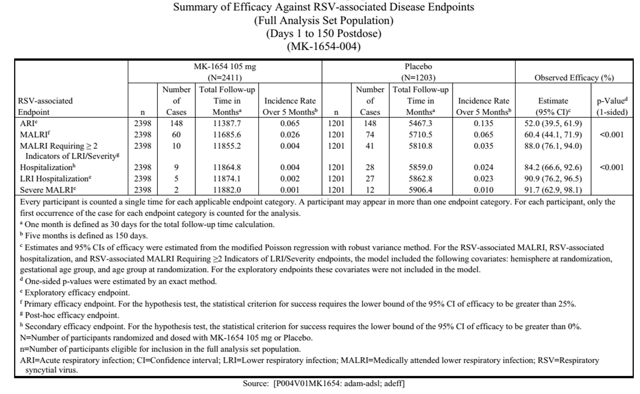
Table 5: Efficacy results – Health Canada BSEAR
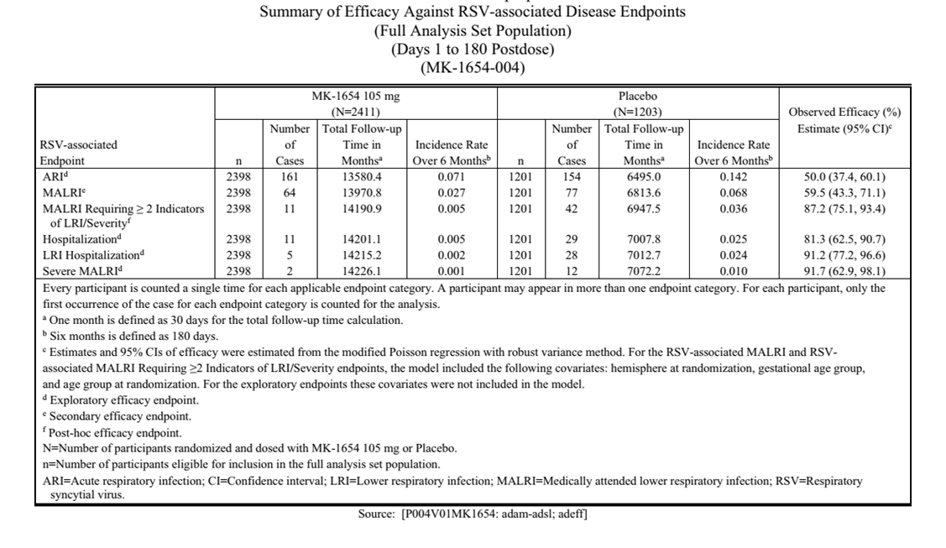

Study MK-1654-007
This is a Phase 3 partially blinded, randomised, active-controlled study to evaluate the safety, tolerability, and efficacy of MK-1654 versus palivizumab and the PK of MK-1654 in eligible infants who are born during or entering their first RSV season and recommended to receive palivizumab.
The study is published at Clesrovimab in Infants and Children at Increased Risk for Severe RSV Disease and described in detail in the Health Canada BSEAR.

Primary objective
RSV Season 1: To evaluate the safety and tolerability of MK-1654 compared to palivizumab in RSV Season 1 as assessed by the proportion of participants experiencing AEs.

Primary endpoints
- Solicited injection-site AEs from Days 1 through 5 after each dose
- Solicited daily body temperature, with fever defined as rectal temperature ≥102.2°F(≥39.0°C) or axillary temperature ≥101.7°F(≥38.7°C) from Days 1 through 5 after each dose
- Solicited systemic AEs from Days 1through 5 after each dose
- Anaphylaxis/hypersensitivity AESI from Days 1 through 42 post Dose 1
- Rash AESI from Days 1 through 42 post Dose 1
- Non-serious AEs from Days 1 through 42 post Dose 1 and 14 days after each subsequent dose
- SAEs through the duration of participation in RSV Season 1

Efficacy results
Efficacy was a secondary endpoint in this study.
Table 6: Summary of efficacy against RSV-associated disease endpoints – Health Canada BSEAR
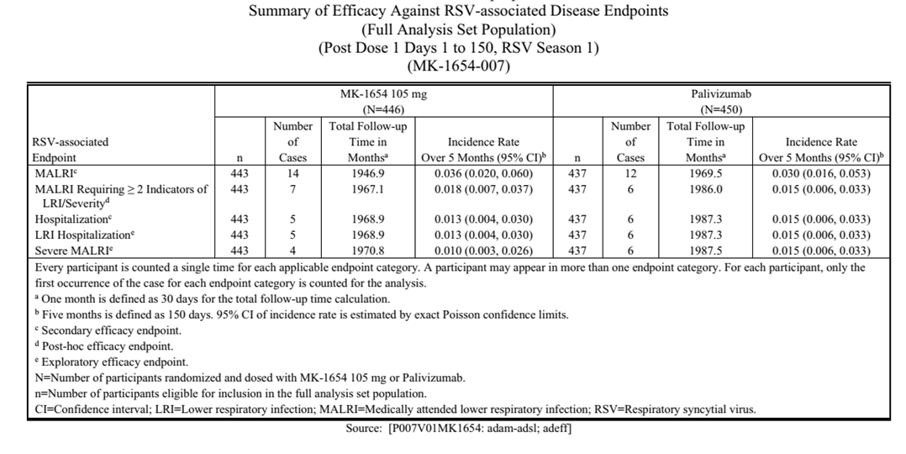

Health Canada conclusions (Full Analysis Set population)
The incidence rates of RSV-associated MALRI (outpatient and inpatient) from Days 1 through 150 post Dose 1 in RSV Season 1 were generally comparable between the MK-1654 group (incidence rate=3.6%) and the palivizumab group (incidence rate=3.0%).
The incidence rates for RSV Strains A and B were generally consistent with the overall results.
Clesrovimab sustained a similar level of protection against RSV-associated MALRI from Days 1 through 150 post Dose 1 in RSV Season 1 relative to palivizumab, as shown by the Kaplan-Meier plots of time to RSV-associated MALRI.
Sensitivity analysis results, including RSV PCR results tested at both the study central laboratory and local laboratories were consistent with these results (including RSV PCR results from the study central laboratory only).

Immunogenicity
Anti-drug antibodies (ADA) were assessed throughout clinical development of clesrovimab. In the Clinical Overview, the Sponsor notes that ADA positivity increased over time in the infant studies and is summarised in the individual study reports:
‘An integrated, prespecified assessment of the impact of ADA positivity on PK and PK/SNA relationship was conducted across pediatric studies (MK-1654-002, MK-1654-004, and MK-1654-007).’ The Sponsor concluded that ‘based on efficacy and safety analyses by ADA status, ADA also did not have meaningful impact on efficacy and safety of clesrovimab.’
Health Canada provides detailed commentary in their BSEAR report, highlighting that in study MK-1654-004:
‘The ADA profile for clesrovimab shows low early immunogenicity but a substantial cumulative increase by one year and beyond. While initial short-term use appears unaffected, repeat dosing strategies would require careful monitoring of ADA impact on efficacy, pharmacokinetics, and safety. Neutralizing potential and clinical relevance of ADA must be clarified before endorsing annual use.’

Safety
The Health Canada reports contain the complete description of the safety data. The TGA accepts the assessment from Health Canada.

Study MK-1654-004
Table 7: Analysis of Adverse Event summary (All Participants as Treated Population) – Days 1 through 365 Postdose – Health Canada BSEAR
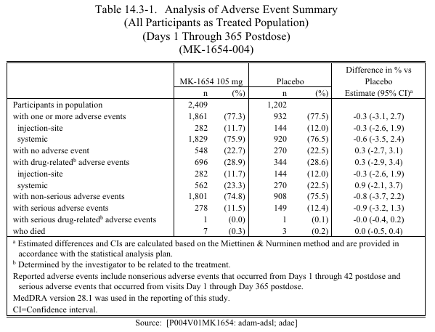

Study MK-1654-007
Table 8: Analysis of Adverse Event summary (All Participants as Treated Population) – Following Any Dose in RSV Season 1) – Health Canada BSEAR
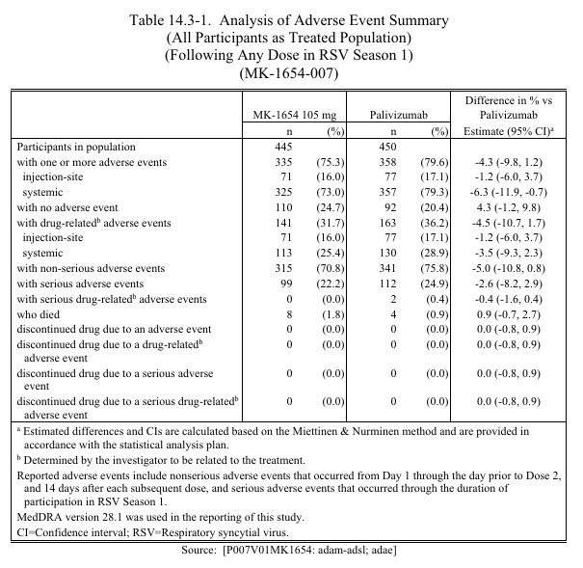

Infant safety database
Overall, 2947 infant participants received a single dose of clesrovimab, and 1690 infant participants received control in the 4 studies presented in the Sponsor’s summary of clinical safety:
Table 9: Total Number of Participants in the Overall Infant Safety Database – Health Canada BSEAR
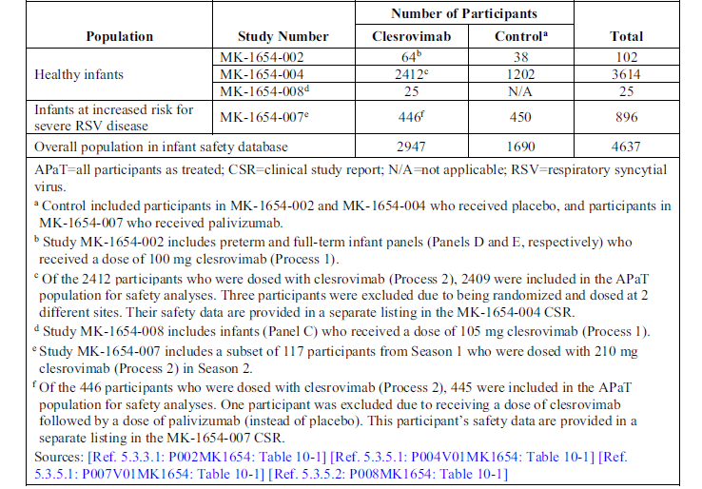
In their overall benefit/risk assessment, Health Canada concluded that:
‘Across >3,000 exposed infants in four studies, clesrovimab was well tolerated. The incidence and pattern of adverse events (AEs), including injection-site and systemic events, were comparable to placebo or palivizumab. Most AEs were mild/moderate; no treatment-related deaths, anaphylaxis, or hypersensitivity reactions were observed. Rash AEs were infrequent, non-serious, and balanced between groups. Anti-drug antibody (ADA) positivity increased over time, but no correlation with safety events was identified. Subgroup analyses, including low-weight infants (<5 kg), revealed no increased safety risk despite higher exposures. Safety in infants <1.1 kg is supported by PK simulations and small-number clinical data, although direct evidence is limited.’

Real world data
Real world data were not included in this submission.

Risk management plan
The lead agency for the ACCESS NASWASI workshare RMP evaluation was Health Canada.
The RMP evaluator noted that no safety concerns were proposed. The RMP evaluator concluded that the summary of safety concerns in the ASA aligned with the EU-RMP and other similar products and was acceptable.
The summary of safety concerns and their associated risk monitoring and mitigation strategies are summarised in Table 11.
Table 10: Summary of safety concerns
Summary of safety concerns |  | Pharmacovigilance |  | Risk minimisation
 |  | Routine | Additional | Routine | Additional
Important identified risks | None | – | – | – | –
Important potential risks | None | – | – | – | –
Missing information | None | – | – | – | –
The TGA may request an updated RMP at any stage of a product's life cycle, during both the pre-approval and post-approval phases. Further information regarding the TGA’s risk management approach can be found in risk management plans for medicines and biologicals and the TGA's risk management approach. Information on the Australia-specific annex (ASA) can be found on the TGA website.

TGA comments
The TGA RMP evaluator highlighted the following outstanding considerations in their evaluation:
‘No guidance on interchangeability with nirsevimab will be included in the PI as the sponsor does not anticipate interchangeability issues or impacts on safety. The sponsor advises following local recommendations. This rationale reflects the long duration of action of clesrovimab and nirsevimab, in comparison to palivizumab where substitution may be desirable to eliminate the need for monthly injections. However, as noted in the RMP evaluator comment in section 2.4, from an RMP perspective there is a need to provide greater clarity on interchangeability and warnings on the possibility of medication error in the PI. This issue is referred to the delegate for consideration.
The sponsor does not agree to add advice on use in infants with passive immunisation through maternal vaccination to the PI and advises following local recommendations, noting that these may vary. In the absence of adverse clinical outcomes in this scenario, this is acceptable from an RMP perspective.
The sponsor’s rationale for exclusion of information on special populations from the warnings and precautions section of the PI is referred to the Delegate.’
The Sponsor responded as follows:
- The Sponsor acknowledges the Agency’s concern about the potential for product administration errors. If a 105 mg dose of clesrovimab is inadvertently given in the second RSV season to a vulnerable older infant, this would be reported as a product administration error based on the current proposed indication. As with any product administration error, lack of effectiveness may be observed, however no other impact on safety would be anticipated since available data with clesrovimab at a higher dose in vulnerable older infants in the second RSV season has not identified any new safety concerns. It is also reassuring, as per the TGA website, that no AEs have been reported for most of the product administration errors related to RSV prevention products in Australia (https://www.tga.gov.au/news/safety-updates/correct-administration-rsv-vaccineand-antibody-products). As use of clesrovimab in vulnerable older infants in the second RSV season is outside of the scope of the proposed indication, the Sponsor does not propose to revise the ASA. The Sponsor will monitor product administration errors with clesrovimab via routine pharmacovigilance.
- Clesrovimab is proposed to be administered as a single-dose in the majority of infants such that interchangeability does not apply. However, interchangeability between clesrovimab and nirsevimab may be relevant for a minority of infants who are recommended to receive a second dose of a long-acting RSV-specific mAb. This includes infants undergoing cardiac surgery with cardiopulmonary bypass within the first RSV season. This also includes children at increased risk of severe RSV disease who might receive clesrovimab in the first RSV season but in whom additional dosing of a long-acting RSV-specific mAb in the second RSV season is recommended, as per the Australian Immunisation Handbook.
Interchangeability between clesrovimab and nirsevimab was not evaluated in the clesrovimab clinical development program and thus no data are available. Both nirsevimab and clesrovimab are passive immunizations that target a viral protein and do not interact with human host targets. Furthermore, clesrovimab and nirsevimab bind to distinct sites on the RSV F protein (Site IV and Site 0, respectively), making interference at the binding site unlikely. With respect to pharmacokinetic considerations, as noted in Company response 2.iv., in participants who received clesrovimab and subsequently underwent ECMO or CPB, a consistent trend of lower PK was observed after the procedure. In addition, in infants who receive clesrovimab in the first RSV season, the majority of clesrovimab (>99%) will have been eliminated from the body by the beginning of the second RSV season, as more than 8 clesrovimab half-lives will have elapsed. Based on these mechanistic and pharmacokinetic considerations, neither intra-seasonal interchangeability among infants undergoing ECMO or CPB nor sequential use of clesrovimab in the first RSV season and nirsevimab in the second RSV season are anticipated to have an impact on safety. On this basis, the Sponsor does not propose to revise the ASA. The sponsor will monitor interchangeability between clesrovimab and nirsevimab via routine pharmacovigilance.

Risk-benefit analysis
The TGA is of the view that registration may be recommended in Australia and accepts the assessments and recommendations of Health Canada, Swissmedic, the Health Sciences Authority of Singapore and the TGA evaluators.
Approval for use in the second RSV season and in infants at increased risk of severe disease has not been sought. Clesrovimab demonstrated clinically meaningful protection against RSV-associated medically attended lower respiratory infection (MALRI) in infants.
Health Canada concluded that ‘in the confirmatory Phase 2b/3 study (MK-1654-004), efficacy was robust (60.4% reduction in MALRI, p<0.001), with consistent benefit through Day 180 and substantial reduction in RSV-associated hospitalisation.’
‘Supportive evidence from the Phase 3 high-risk infant study (MK-1654-007) showed comparable protection to palivizumab, the current standard of care. Pharmacokinetic profiles were predictable, with sustained concentrations through Day 240, supporting extrapolation from healthy to high-risk populations. Low immunogenicity rates and practicality of a single-dose regimen support feasibility of widespread implementation.’
The TGA acknowledged that data are not available to compare the efficacy of clesrovimab to other prophylactic long-acting monoclonal therapies including nirsevimab.
Health Canada highlighted the following limitations and uncertainties:
‘Efficacy endpoints primarily measured incidence, not severity; hospitalization results may be influenced by local practice. Data in certain subgroups (infants <1.1 kg, ≥6 months at dosing, RSV-vaccinated maternal cohorts, immunosuppressed infants) are limited. RSV A subtype efficacy estimates are less precise. In high-risk infants, efficacy findings are supportive only, with potential bias from open-label design after Day 60. Long-term safety and protection in repeat seasons remain incompletely characterized.’
The TGA concurs that benefits of clesrovimab include substantial disease burden reduction and a simplified prophylaxis regimen. Clesrovimab provides an alternative to currently approved RSV monoclonal antibodies with a different mechanism of action, potentially reducing the risk of viral resistance.

Proposed action
Registration of Enflonsia is recommended for the amended indication:
for the prevention of respiratory syncytial virus (RSV) lower respiratory tract disease in neonates and infants who are born during or entering their first RSV season.
Enflonsia should be used in accordance with official recommendations.

Independent expert advice
The Delegate received the following independent expert advice.

Advisory Committee considerations
The Advisory Committee on Medicines (ACM), having considered the evaluations and the Delegate’s overview, as well as the sponsor’s response to these documents, advised the following.

Specific advice to the Delegate
The ACM advised the following in response to the Delegate’s specific request for advice:
- The TGA RMP evaluator has highlighted the following outstanding concerns: lack of guidance on interchangeability with nirsevimab in the proposed PI and the potential for inadvertent administration to a vulnerable older infant in the second RSV season.
What is the view of the ACM on this matter and the justification proposed by the Sponsor? Does the ACM support the Delegate’s revised statement in the PI?
The ACM found the available data – from the submission and more broadly – did not raise concerns regarding the interchanging between agents from RSV season 1 to RSV season 2.
However, the ACM advised that a statement clarifying the lack of empirical evidence regarding the risk profile of interchanging Enflonsia and nirsevimab be included in the Product Information.
- The sponsor was asked to comment on the safety impacts from use of clesrovimab in children with passive immunity from maternal vaccination. What is the view of the ACM on this matter and the explanation proposed by the Sponsor? Does the ACM support the Delegate’s revised statement in the PI?
The ACM supported the Delegate’s proposed revised statement regarding the lack of safety data on the use of Enflonsia in children with passive immunity from maternal vaccination.
The ACM acknowledged the risk of accidental administration was low as spacing was likely to occur. Therefore, the ACM considered the risk of accidental administration of Enflonsia following exposure to maternal vaccination in the previous year to be minimal due to standardised labelling procedures prior to the dispensing and ongoing guidance and education programs provided to clinicians.
- Please comment on the potential for interference with the results of RSV rapid antigen diagnostic assays in children and infants who have received clesrovimab, in light of the language in the approved US PI. Does the ACM agree with the revised wording proposed by the Delegate?
The ACM supported the Delegate’s proposed revisions to the PI wording relating to the potential for Enflonsia to interfere with the results of RSV rapid antigen and reverse transcriptase polymerase chain reaction (RT-PCR) diagnostic assays. Specifically, the ACM supported the wording contained within the Health Canada Product Monograph and the European Summary of Product Characteristics.

Advisory committee conclusion
The ACM considered this product to have an overall positive benefit-risk profile for the indication:
Enflonsia is indicated for the prevention of respiratory syncytial virus (RSV) lower respiratory tract disease in neonates and infants who are born during or entering their first RSV season.

Assessment outcome
Based on the assessment of quality, safety, and efficacy, the TGA decided to register Enflonsia (clesrovimab) 105 mg in 0.7 mL solution for injection prefilled syringe, for the following indication:
Enflonsia is indicated for the prevention of respiratory syncytial virus (RSV) lower respiratory tract disease in neonates and infants who are born during or entering their first RSV season.
Enflonsia should be used in accordance with official recommendations.

Specific conditions of registration

Black Triangle Scheme
- Enflonsia (clesrovimab) is to be included in the Black Triangle Scheme. The PI and CMI for Enflonsia must include the black triangle symbol and mandatory accompanying text for five years, which starts from the date of first supply of the product.

Risk Management Plan and pharmacovigilance
- The Enflonsia EU-Risk Management Plan (RMP) (version 1.0, dated date 11 September 2025; DLP 8 May 2024), with Australia-Specific Annex (ASA) (version 0.3, dated 21 October 2025), included with submission PM-2025-00512-1-2, and any subsequent revisions, as agreed with the TGA will be implemented in Australia.
- An obligatory component of risk management plans is routine pharmacovigilance. Routine pharmacovigilance includes the submission of periodic safety update reports (PSURs).
  - Unless agreed separately between the supplier who is the recipient of the approval and the TGA, the first report must be submitted to TGA no later than 15 calendar months after the date of this approval letter. The subsequent reports must be submitted no less frequently than annually from the date of the first submitted report until the period covered by such reports is not less than three years from the date of this approval letter. The annual submission may be made up of two PSURs each covering six months. If the sponsor wishes, the six-monthly reports may be submitted separately as they become available.
  - If the sponsor wishes, the six-monthly reports may be submitted separately as they become available. If the product is approved in the EU during the three years period, reports can be provided in line with the published list of EU reference dates no less frequently than annually from the date of the first submitted report until the period covered by such reports is not less than three years from the date of this approval letter.
  - The reports are to at least meet the requirements for PSURs as described in the European Medicines Agency’s Guideline on good pharmacovigilance practices (GVP) Module VII-periodic safety update report (Rev 1), Part VII.B Structures and processes. Note that submission of a PSUR does not constitute an application to vary the registration. Each report must be submitted within ninety calendar days of the data lock point for that report.

Laboratory testing and compliance with Certified Product Details (CPD)
- All batches of ENFLONSIATM clesrovimab 105 mg/0.7 mL solution for injection, prefilled syringe supplied in Australia must comply with the product details and specifications approved during evaluation and detailed in the Certified Product Details (CPD).
- When requested by the TGA, the Sponsor should be prepared to provide product samples, specified reference materials and documentary evidence to enable the TGA to conduct laboratory testing on the Product. Outcomes of laboratory testing are published biannually in the TGA Database of Laboratory Testing Results http://www.tga.gov.au/ws-labs-index and periodically in testing reports on the TGA website.

Certified Product Details
The Certified Product Details (CPD), as described in Guidance 7: Certified Product Details of the Australian Regulatory Guidelines for Prescription Medicines (ARGPM), in PDF format, for the above products should be provided upon registration of these therapeutic goods. In addition, an updated CPD should be provided when changes to finished product specifications and test methods are approved in a Category 3 application or notified through a self-assessable change.
A template for preparation of CPD for biological prescription medicines can be obtained from the TGA website.
- The form is available at https://www.tga.gov.au/form/certified-product-details-cpd-biologicalprescription-medicines Certified product details (CPD) - Biological prescription medicines.
- The CPD form is available at: https://www.tga.gov.au/guidance-7-certified-product-details

Product Information and Consumer Medicine Information
For the most recent Product Information (PI) and Consumer Medicine Information (CMI), please refer to the TGA PI/CMI search facility.

Therapeutic Goods Administration
PO Box 100 Woden ACT 2606 Australia
Email: info@tga.gov.au Phone: 1800 020 653 Fax: 02 6203 1605
https://www.tga.gov.au

This is the original indication proposed by the sponsor when the TGA commenced the evaluation of this submission. It may differ to the final indication approved by the TGA and registered in the Australian Register of Therapeutic Goods.
https://www.mja.com.au/journal/2025/222/11/respiratory-syncytial-virus-preventives-children-australia-current-landscape
https://www.ema.europa.eu/en/medicines/human/EPAR/enflonsia
Health Canada, Health Products and Food Branch, Biologics Safety and Efficacy Assessment Report (BSEAR), printed on 12 January 2026
Swissmedic, Clinical Assessment Report, printed on 12 January 2026
Health Canada, Health Products and Food Branch, Biologics Safety and Efficacy Assessment Report (BSEAR), printed on 12 January 2026
Health Canada, Health Products and Food Branch, Biologics Safety and Efficacy Assessment Report (BSEAR), printed on 12 January 2026
Health Canada, Health Products and Food Branch, Biologics Safety and Efficacy Assessment Report (BSEAR), printed on 12 January 2026

