Australian Public Assessment Report for Tzield
  - Active ingredient: Teplizumab
  - Sponsor: Sanofi-Aventis Australia Pty Ltd
July 2026

About the Therapeutic Goods Administration (TGA)
- The Therapeutic Goods Administration (TGA) is part of the Australian Government Department of Health, Disability and Ageing and is responsible for regulating therapeutic goods, including medicines, medical devices, and biologicals.
- The TGA administers the Therapeutic Goods Act 1989 (the Act), applying a risk management approach designed to ensure therapeutic goods supplied in Australia meet acceptable standards of quality, safety, and efficacy.
- The work of the TGA is based on applying scientific and clinical expertise to decision-making, to ensure that the benefits to the Australian public outweigh any risks associated with the use of therapeutic goods.
- The TGA relies on the public, healthcare professionals and industry to report problems with therapeutic goods. The TGA investigates reports received to determine any necessary regulatory action.
- To report a problem with a therapeutic good, please see the information on the TGA website.

About AusPARs
- The Australian Public Assessment Report (AusPAR) provides information about the evaluation of a prescription medicine and the considerations that led the TGA to approve or not approve a prescription medicine submission. Further information can be found in Australian Public Assessment Report (AusPAR) guidance.
- AusPARs are prepared and published by the TGA.
- AusPARs are static documents that provide information that relates to a submission at a particular point in time. The publication of an AusPAR is an important part of the transparency of the TGA’s decision-making process.
- A new AusPAR may be provided to reflect changes to indications or major variations to a prescription medicine subject to evaluation by the TGA.

Copyright
© Commonwealth of Australia 2026
This work is copyright. You may reproduce the whole or part of this work in unaltered form for your own personal use or, if you are part of an organisation, for internal use within your organisation, but only if you or your organisation do not use the reproduction for any commercial purpose and retain this copyright notice and all disclaimer notices as part of that reproduction. Apart from rights to use as permitted by the Copyright Act 1968 or allowed by this copyright notice, all other rights are reserved, and you are not allowed to reproduce the whole or any part of this work in any way (electronic or otherwise) without first being given specific written permission from the Commonwealth to do so. Requests and inquiries concerning reproduction and rights are to be sent to the TGA Copyright Officer, Therapeutic Goods Administration, PO Box 100, Woden ACT 2606 or emailed to <tga.copyright@tga.gov.au>.

Contents
List of abbreviations 4
Product submission 6
Submission details 6
Product background 7
Disease or condition 7
Current treatment options 8
Clinical rationale 9
Regulatory status 9
Australian regulatory status 9
International regulatory status 9
Registration timeline 10
Assessment overview 10
Quality evaluation summary 10
Recommendations to the clinical delegate 11
Nonclinical evaluation summary 11
Clinical evaluation summary 13
Pharmacology 13
Efficacy 18
Safety 28
Risk management plan 41
Risk-benefit analysis 43
Delegate’s considerations 43
Proposed action 45
Advisory Committee considerations 45
Assessment outcome 46
Specific conditions of registration 46
Product Information and Consumer Medicine Information 48

List of abbreviations
Abbreviation | Meaning
ACM | Advisory Committee on Medicines
ADA | Anti-drug antibodies
ADCC | Antibody dependent cellular cytotoxicity
AE | Adverse event
AESI | Adverse events of special interest
ARTG | Australian Register of Therapeutic Goods
ASA | Australia-specific annex
AUC | Area under the concentration-time curve
AUC_{inf} | Area under the concentration time curve from time zero to infinity
BSA | Body Surface Area
CD3 | A cell surface antigen present on T lymphocytes
CDC | Complement dependant cytotoxicity
CI | Confidence interval
C_{max} | Maximum serum concentration
CMI | Consumer Medicines Information
CMV | Cytomegalovirus
CRS | Cytokine release syndrome
DDIs | Drug‑drug interactions
DKA | Diabetic ketoacidosis
DLP | Data lock point
DNA | Deoxyribonucleic acid
DP | Drug product
DS | Drug substance
EBV | Epstein Barr Virus
EU | European Union
Fc | Fragment crystallizable
GLP | Good laboratory practice
HLA | Human leukocyte antigen
HRs | Hazard ratios
Ig | immunoglobulin
ITT | Intent to treat
IV | Intravenous
mAb | Monoclonal antibody
MHC | Major histocompatibility complex
MMRM | Mixed model repeated measures
OGTT | Oral glucose tolerance test
PBMC | Peripheral blood mononuclear cell
PI | Product Information
PK | Pharmacokinetics
PSUR | Periodic safety update report
QTc | Corrected QT interval
RMP | Risk management plan
RSE | Relative standard error
SAEs | Serious adverse events
SAP | Statistical analysis plan
SC | Subcutaneous
SD | Standard deviation
T1D(M) | Type 1 diabetes mellitus
TEAEs | Treatment emergent adverse events
TESAE | Treatment emergent serious adverse events
TGA | Therapeutic Goods Administration
TMDD | Target mediated drug disposition
Vd | Volume of distribution

Product submission

Submission details
Type of submission: | New biological entity
Product name: | Tzield
Active ingredient: | Teplizumab
Decision: | Approved
Date of decision: | 21 May 2026
Date of entry onto ARTG: | 21 May 2026
ARTG number: | 476208
Black Triangle Scheme  for the current submission: | Yes
Sponsor’s name and address: | Sanofi-Aventis Australia Pty Ltd  Level 23, Tower 3  300 Barangaroo Ave  Barangaroo NSW 2000  Australia
Dose form: | Concentrated injection
Strength: | Each vial contains 2 mg of teplizumab in 2 mL of concentrated solution (2 mg/2 mL).
Container: | Glass Type I Clear vial
Pack size: | Single pack
Approved therapeutic use for the current submission: | Tzield is indicated to delay the onset of Stage 3 type 1 diabetes mellitus (T1D) in adult and paediatric patients aged 8 years and older with Stage 2 type 1 diabetes mellitus (see Section 5.1 Pharmacodynamic Properties – Clinical trials).
Route of administration: | Intravenous Infusion
Dosage: | Tzield should be administered by intravenous infusion (over a minimum of 30 minutes), using a Body Surface Area (BSA) - based dosing, once daily for 14 consecutive days as follows:  - Day 1: 65 micrograms/m2  - Day 2: 125 micrograms/m2  - Day 3: 250 micrograms/m2  - Day 4: 500 micrograms/m2  - Days 5 through 14: 1030 micrograms/m2  For further information regarding dosage, such as dosage modifications to manage adverse reactions, refer to the Product Information.
Pregnancy category: | Category B3  There are no clinical data available for teplizumab on the effects on fertility. Fertility and reproductive performance were unaffected in female and male mice treated with a surrogate anti-mouse CD3 antibody up to 20 mg/kg by SC administration.  Available case reports from clinical trials with Tzield are insufficient to identify a drug-associated risk of major birth defects, miscarriage or other adverse maternal or foetal outcomes. Tzield is not recommended during pregnancy.  The use of any medicine during pregnancy requires careful consideration of both risks and benefits by the treating health professional. The pregnancy database must not be used as the sole basis of decision making in the use of medicines during pregnancy. The TGA does not provide advice on the use of medicines in pregnancy for specific cases. More information is available from obstetric drug information services in your state or territory.

Product background
This AusPAR describes the submission by Sanofi-Aventis Australia Pty Ltd (the Sponsor) to register Tzield (teplizumab) 2 mg/2 mL Concentrated injection vial for the following proposed indication:
Tzield is a disease modifying agent that preserves beta cell function indicated to delay the onset of Stage 3 type 1 diabetes (T1D) in adult and paediatric patients 8 years of age and older with Stage 2 T1D.

Disease or condition
Type 1 diabetes mellitus (T1DM or T1D) is a chronic disease secondary to pancreatic insufficiency of insulin production. This results in dysregulation of glucose homeostasis, mainly hyperglycaemia and its potential flow-on effects, e.g. neuropathy, nephropathy, retinopathy, or atherosclerosis.
There are a variety of causes of pancreatic insufficiency of insulin production which are typically grouped into genetic and environmental factors. In most patients newly diagnosed with T1DM, anti-islet autoantibodies have been present. There is an influence of genetic factors (especially regarding MHC/HLA), as close relatives of people with T1DM are at higher risk. Environmental factors (e.g. infections) may potentially be a trigger for the immune processes leading to T1DM.

Stages of T1DM
An overview of T1DM stages is shown in Table 1. T1DM starts at Stage 1, but clinical features are usually not present until Stage 3 (e.g. polyuria, polydipsia, blurred vision, weight loss, and fatigue) and potentially life-threatening complication such as diabetic ketoacidosis (DKA).
Table 1. Overview of T1DM stages.,
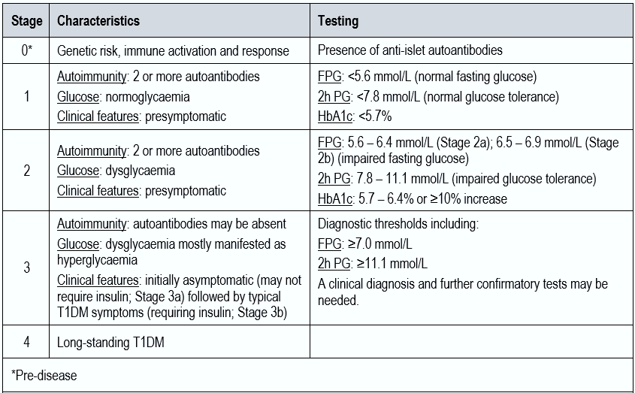

Australian epidemiology
Overall, the incidence of type 1 diabetes in Australia is approximately 12 per 100,000. In 2021, 81% of children, adolescents and young adults with type 1 diabetes mellitus were aged 10 to 19 years. In 2021, by age group, the prevalence was 27.4 per 100,000 (0-4 y), 127.2 per 100,000 (5-9 y), 279.5 per 100,000 (10-14 y), and 415.8 per 100,000 (15-19 y).² After adjusting for age, First Nations children, adolescents and young adults were approximately 21% less likely to have T1DM compared to their non-Indigenous counterparts.

Current treatment options
At this stage, insulin therapy is the mainstay of direct pharmacological T1DM treatment in Australia. No disease-modifying or preventative therapies are currently registered. The availability of such therapies would be highly advantageous. Those therapies could target T1DM at various stage along the disease process, e.g. preventing or delaying the onset, preserving insulin secretion, preserving β-cell function, β-cell replacement (including stem cell therapy).

Clinical rationale
Teplizumab preserves beta cell function by binding to CD3 (a cell surface antigen present on T lymphocytes) and delays the onset of Stage 3 T1D in Stage 2 patients. The mechanism may involve partial agonistic signalling and deactivation of pancreatic beta cell autoreactive T lymphocytes. Teplizumab leads to an increase in the proportion of regulatory T cells and of exhausted CD8+ T cells in peripheral blood.

Regulatory status

Australian regulatory status
This product is considered a new biological entity for Australian regulatory purposes. Tzield has not been registered on the ARTG previously.

International regulatory status
This submission was evaluated as part of the Australia-Canada-Singapore-Switzerland-United Kingdom (ACCESS) Consortium with work-sharing between the TGA and Swissmedic. Each regulator made independent decisions regarding approval (market authorisation) of the new medicine.
At the time the TGA considered this submission, similar submissions had been approved in the United States, Canada, United Kingdom and the European Union. The following table summarises these submissions and provides the approved indications.
Table 2. International regulatory status.
Region | Submission date | Status | Approved indications
United States of America | 31 October 2020 | Approved on 17 November 2022 | Tzield is indicated to delay the onset of Stage 3 type 1 diabetes (T1D) in adult and pediatric patients 1 year of age and older with Stage 2 type 1 diabetes.
Canada | 30 August 2024 | Approved on 5 May 2025 | Tzield is indicated to delay the onset of Stage 3 type 1 diabetes in adult and paediatric patients 8 years of age and older with Stage 2 type 1 diabetes.
United Kingdom | 30 August 2024 | Approved on 14 August 2025 | Tzield is indicated to delay the onset of Stage 3 type 1 diabetes in adult and paediatric patients 8 years of age and older with Stage 2 type 1 diabetes (T1D).
European Union | 19 December 2024 | Approved on 12 February 2026 | Teizeild is indicated to delay the onset of stage 3 type 1 diabetes (T1D) in adult and paediatric patients 8 years of age and older with stage 2 T1D.

Registration timeline
The following table captures the key steps and dates for this submission. This submission was evaluated under the standard prescription medicines registration process.
Table 3. Timeline for Submission PM-2025-00088-1-5.
Description | Date
Submission dossier accepted and first round evaluation commenced | 28 February 2025
Evaluation completed (End of round 2) | 19 December 2025
Advisory committee meeting | 9 – 10 April 2026
Registration decision (Outcome) | 21 May 2026
Registration in the ARTG completed | 21 May 2026
Number of working days from submission dossier acceptance to registration decision* | 218
*Statutory timeframe for standard submissions is 255 working days

Assessment overview
A summary of the TGA’s assessment for this submission is provided below.
This section is a TGA summary of wording used in TGA’s evaluation report, which discussed numerous aspects of overseas evaluation reports and included some information that was commercial-in-confidence.

Quality evaluation summary
The proposed medicine is identical to that evaluated and approved within the SMC package regarding strength or size, formulation, manufacturer and manufacturing process.
Drug substance
Teplizumab is a glycosylated IgG1 kappa monoclonal antibody that selectively binds to the CD3 complex of T lymphocytes. The active ingredient was produced using recombinant DNA technology.
Teplizumab drug product (DP) is supplied as a sterile solution with a concentration of 1.0 mg/mL for IV infusion. The formulation is the same as the drug substance. The teplizumab DP contains 1.0 mg/mL teplizumab in a buffer composed of 10 mM sodium phosphate at pH 6.1 containing 150 mM sodium chloride and 0.05 mg/mL polysorbate 80. There are no novel excipients, and no excipients of human or animal origin.
The DP is packaged in a Type I borosilicate glass vial with a butyl rubber stopper and an aluminium seal with a coloured polypropylene flip-off cap. The nominal fill volume is 2 mL.
The vial should be stored upright and remain in the outer carton to protect it from light. Do not freeze or shake the vials.

Stability data provided supports a shelf life of 36-months at a storage condition of 2 °C to 8 °C. For IV infusion bags the diluted solution for infusion can be held at room temperature (15 °C to 25 °C) and the infusion completed within 6 hours of the start of preparation (i.e., removing the cap from the vial). For syringe infusions the diluted solution for infusion can be held for 12 hours under refrigerated conditions (2 °C to 8 °C), followed by no more than 6 hours at ambient temperature (15 °C to 25 °C).

Recommendations to the clinical delegate
There are no objections on quality grounds to the approval of Tzield.

Nonclinical evaluation summary
The nonclinical dossier was adequate in scope in accordance with the relevant TGA-adopted guidelines and all pivotal safety-related studies were GLP-compliant.
The target of teplizumab, human CD3 shares high protein sequence homology with the chimpanzee CD3 epitope region, whereas CD3 of other species (rodent, monkey/macaque, pig, cat, dog) have less homology. For this reason, the chimpanzee was identified as the sole species likely to be pharmacologically responsive to teplizumab. In vitro, binding of teplizumab to soluble human CD3 and binding of a mouse surrogate mAb (Monoclonal antibody), 2C11-mG2a(Ala-Ala), to soluble mouse CD3, indicated comparable binding affinity (Kd: 2.3 and 3.0 μM, respectively).
In an in vivo study, the mouse mAb surrogate 2C11-mG2a(Ala-Ala) delayed onset of diabetes and reduced incidence of diabetes in a mouse model of pre-diabetes (non-obese diabetic, NOD mice). However, subsequent exposures to surrogate mAb (and to an isotype control mAb) caused hypersensitivity reactions, with high mortality observed due to anaphylactic reactions.
Modifications to two amino acids in the Fc portion of teplizumab immunoglobulin (Ig) are intended to reduce Fc mediated effector functions and complement binding. In vitro cellular assays did not identify discernible complement dependant cytotoxicity (CDC) and antibody dependent cellular cytotoxicity (ADCC) activity by teplizumab under test conditions.
In tissue cross-reactivity studies teplizumab showed targeted binding to T lymphocytes present in various tissues from a human tissue panel, but no binding to B or non-T regions of lymphoid tissues. Teplizumab induced mild increases of cytokine release in human PBMCs (peripheral blood mononuclear cells) in vitro, while in vivo mouse surrogate mAb also mildly induced cytokine release (IL-6 and IL-12, ≤3.5-fold).
Safety pharmacology assessments incorporated in the toxicity study designs did not indicate any organ system hazards of using teplizumab in patients.
A study that compared the pharmacokinetic profiles of early manufacturing process lots of teplizumab in rats showed bioequivalence between the two processes. The pharmacokinetics of teplizumab in chimpanzees and human patients was generally consistent with the protein nature of the antibody drug (i.e., long half-lives) and considered acceptably similar in chimpanzees and human subjects. The pharmacokinetics of the surrogate mAb in mice also displayed a long half-life and considered acceptably similar. Therefore, most nonclinical safety studies have been conducted with the surrogate mAb in mice.
The pivotal single dose subcutaneous (SC) toxicity study in chimpanzees showed teplizumab exerting a pharmacodynamic effect against T cells resulting in complete (albeit, transient) depletion of CD3+ T cells. At the highest dose this was associated with mortalities that were attributed to bacterial and viral infections (necro-suppurative bacterial pneumonia, lympho-proliferative disease, secondary to T cell suppression and Epstein Barr Virus (EBV)-like lymphocryptovirus infection).
At all doses there were decreases in T cell subpopulations, concurrent decreases in CD19+ B cells (transient) and increased circulating levels of TNF-α, IL-6, and IL-10 (peak at 6h and resolved at 2 weeks post-dose). There were no clinical signs of inflammation or irritation at the injection site. Dose-dependent release of cytokines (TNFα, IL-6, IL-10) peaked 6 h post-dose.
Repeat-dose toxicity studies in mice with the surrogate mAb [2C11-mG2a(Ala-Ala) indicated toxicities were primarily due to pharmacological actions on lymphocytes (decreased counts), correlating with findings in thymus (reduction in cellularity of the medulla) and spleen (haematopoiesis increase). B cells and NK cells were slightly lower throughout the 6-day study (6-week recovery) in spleen and/or only on Day 2 in peripheral blood. There were also findings in mandibular lymph nodes (neutrophil infiltration) and bone marrow (myeloid hyperplasia comprised primarily of mature neutrophils). All findings were generally reversible or partially reversible after the recovery period. Anaphylaxis and mortality based on hypersensitivity reactions after the 4th dose (IV dosing every 3 days) with the surrogate mAb was evident in a submitted (albeit incomplete) study.
No genotoxicity studies were submitted, which is acceptable for a biotechnology product.
A carcinogenicity risk assessment considered published literature related to CD3 inhibition, nonclinical toxicology data, current human safety data and its short-term use, and concluded that risk of teplizumab being carcinogenic to patients is low under the proposed conditions of use.
There were no adverse treatment-related histological findings in reproductive organs in chimpanzees of either sex following a single SC dose of teplizumab, nor were there any effects on male or female fertility with mouse surrogate mAb treatment in mice.
In the mouse embryofetal development study, the surrogate mAb increased post-implantation loss and decreased the live litter size of dams at 20 mg/kg (a dose associated with maternal toxicity, low body weight gain). There were no other litter findings or effects on embryofetal development. Placental transfer of surrogate mAb was not assessed nor was it determined whether the Fc-modifications on the surrogate mAb or teplizumab can impair FcRn binding and affect placental transfer. The draft Australian Product Information includes a statement on possible placental transfer of antibodies.
In the mouse pre/postnatal development study with the surrogate mAb, notable treatment related effects were observed in F1 offspring from dams treated at the HD and included reduced sperm count and motility and lower number of resulting pregnancies.
Treatment was also associated with decreases in the primary IgM/IgG response and secondary IgG response in F1 offspring of dams treated at the HD (determined in the TDAR assay), indicating impairments to humoral immunity. No corresponding effect was seen in F2 offspring.
Local tolerance (by IV infusion) will need to be addressed by clinical data. There were no SC injection site reactions in chimpanzees and mice following a single dose of teplizumab or multiple doses of the surrogate mAb, respectively.

Conclusions and recommendations
Teplizumab DS used in nonclinical studies/early clinical trials were from the early-stage manufacturing site; while later clinical studies were conducted using teplizumab DS from two alternative sites. No bridging pharmacokinetics/ pharmacodynamics (PK/PD) studies were conducted to confirm bioequivalence in the pharmacology and pharmacokinetics of the drug substance manufactured across the 3 sites. Advice on comparability should be sought from the TGA Module 3 evaluator indicating that the drug substance/product from the early-stage manufacturing site and the commercial site are comparable. The applicability of the nonclinical findings is dependent on acceptable similarities between the two drug substances.
Provided that the drug manufactured by each site is considered identical or highly comparable by the Module 3 evaluator, there are no other nonclinical objections to the registration of Tzield for the proposed indication.

Pregnancy category
There were no Module 4 data on teplizumab interactions with the neonatal Fc receptor (FcRn), noting also that potential FcRn binding was not discussed. As an IgG1, mAb teplizumab would be expected to bind FcRn but the Module 4 data do not appear to have addressed whether Fc-modifications also affect FcRn binding and the implications to antibody half-life or potential placental transfer if used during pregnancy. The draft Australian Product Information contains statements that strongly suggest teplizumab is capable of being actively transported across the placenta.
Assignment to Pregnancy Category B3 is supported. The clinical statements (including “avoiding use of Tzield during pregnancy and avoiding use for at least 30 days prior to planned pregnancy”) should be commented on by the clinical evaluator. The nonclinical statements are supported by submitted Module 4 data but should be updated to include details of the doses that were tested. Additionally, salient findings from the submitted pre-/postnatal development study should be included.

Clinical evaluation summary

Pharmacology
Pharmacology data were derived from 5 clinical studies:
- 1 bioequivalence study in healthy participants (PRV031-004),
- 1 study in participants with Stage 2 T1D at risk for developing Stage 3 T1D (pivotal TN-10 study)
- 3 studies in participants with Stage 3 T1D
  - Protégé CP-MGA031-01,
  - Encore CP-MGA-031-03 and the
  - PK/PD sub-study of the pivotal PROTECT study PRV-031-001.
In ENCORE, PROTÉGÉ, TN-10 and PROTECT, sparse sampling (C_{trough} on different days depending on the study, with one or two timepoints post-infusion in ENCORE, PROTÉGÉ, and PROTECT) was performed and analysed using a population PK approach, while non-compartmental analysis was used for study PRV-031-004, which is also included in the population pharmacokinetics analyses.

Population pharmacokinetics data
A number of population pharmacokinetics (popPK) analyses have been submitted. Each reflected the data available at the time including the non-availability of final PROTECT study data whilst the study was ongoing. Most relevant to this application is the final report referenced below, Population PK report 20231107 (Table 4), incorporating Models 411 and 436, as well as a regulatory authority requested re-estimation resulting in Model 460.
Table 4. Population PK report 20231107. Source data, excluding the PROTECT study.
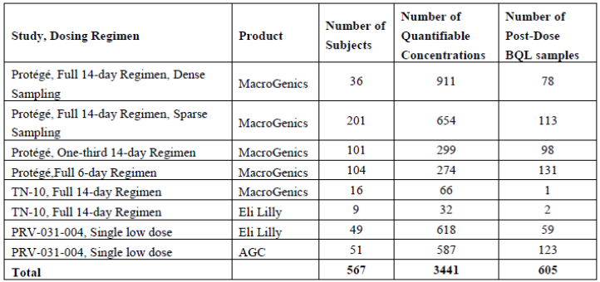

Methods
Source data: PK clinical data source (4 studies): PROTÉGÉ (Course 1), TN-10, and PRV-031-004 studies (Table 4), and PROTECT study final PK data (incorporating Course 1 and 2; as per Table 5).
Model: The population PK analysis was conducted via nonlinear mixed-effects modelling with NONMEM and R. This Population PK report built on previously developed models.
Table 5. Population PK report 20231107. Source data, from the PROTECT study.
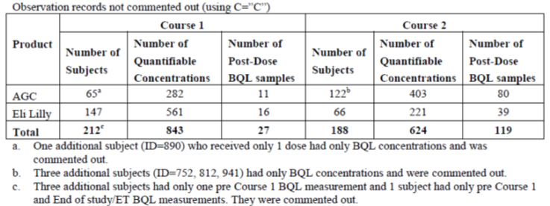

Results
The pharmacokinetics (PK) of teplizumab was described by a three-compartment quasi steady-state target-mediated drug disposition (TMDD) model (central, peripheral, and an additional, very fast peripheral compartment). The model included binding and TMDD elimination in all compartments and linear non-specific elimination from the central compartment. In addition, a non-renewable target undergoes TMDD elimination from the peripheral compartment. This joint population PK model described all populations (healthy, at-risk [Stage 2] and recently diagnosed [Stage 3] T1DM participants), all dosing regimens, and all teplizumab products employed in these studies and the model was qualified to be used for prediction of exposures.
The population PK model described above was used for both individual (conditional) PK simulations as well as typical (population) PK simulations to identify the proposed dosing regimen for the to-be-marketed product.
Estimated parameters: A summary of the estimated parameters (Model 460 and Model 411/436) is at Table 6.
Table 6. Population PK analysis. Parameter estimates for fixed-effect parameters (Model 411/436 vs. Model 460).
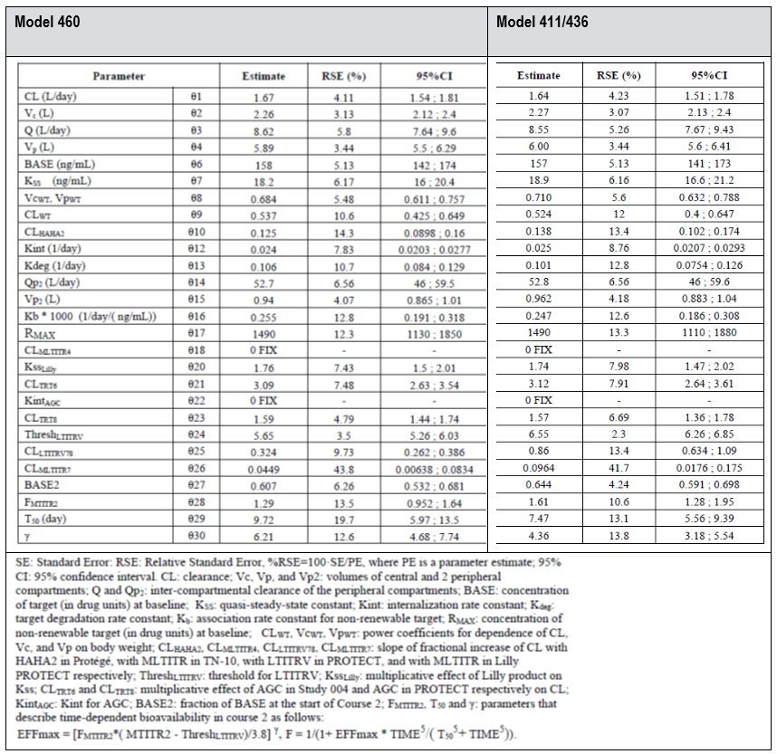

Comparability between formulations
The teplizumab DS was manufactured by MacroGenics from 2005 to 2006, by Eli Lilly from 2009 to 2010 and by AGC Biologics since 2019 (final material for the commercial Australian DP product including the currently US marketed DP). Thus, this determined the DS in the different clinical trials. Analytical comparability between MGNX and Eli Lilly material was reasonably well established (cf. Module 3 evaluation). Some issues were raised regarding comparability of Eli Lilly and the intended commercial material from AGC.
In biocomparability study PRV-031-004, in healthy volunteers, at a subtherapeutic dose, the AGC and Eli Lilly products were comparable with respect to C_{max} (ratio 94.5%, 90% CI: 84.5-106%) but not for AUC_{inf} (ratio 48.5 %, 90% CI: 43.6-54.1%). Based on those results, the exposure with the intended final material from AGC was thus lower compared to the Eli Lilly material used in the pivotal studies, requiring dose adjustments. An adapted posology is proposed based on modelling and simulations for Stage 2 T1DM to bridge from the exposure using MacroGenics/Eli Lilly material in Study TN-10 to the exposure when using AGC Biologics material (Table 7).
The bridging used data from Model 373 (the model that was used to support US registration of the Stage 2 T1DM indication, and despite incorporating data from Stage 3 T1DM studies could be used for the Stage 2 indication and TN-10 dose adjustments). This was further updated with newly available data in Model 436 and further with regulator-requested Model 460. The simulations from those models were highly similar, and thus the resultant bridging gives comparable exposures to what was studied in TN-10 over the whole range of expected bodyweight and body surface area.
In summary, the sponsor concluded that the differences between the predictions based on previous model 373 or updated model 460 were too small to require an update of the proposed dosing regimen. Hence, the dosing regimen based on model 373 remains the recommended regimen in the PI (Table 7).
Table 7. Dosing regimen in TN-10 and final proposed regimen for Tzield in Stage 2 T1DM.
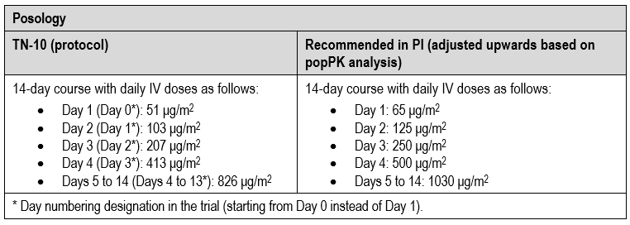

Summary of pharmacokinetics

Absorption
The bioavailability is 100%, as teplizumab is given IV.

Distribution
The central volume of distribution (Vd) of teplizumab was 2.27 L in a 60 kg subject (popPK model 460).

Metabolism
As a monoclonal antibody, teplizumab is expected to be subject to the usual proteolytic processes that result in degradation to small peptides and amino acids by catabolic pathways.

Excretion and elimination
Teplizumab showed saturable binding and elimination. Teplizumab has a target mediated drug disposition (TMDD), implicating its t_{1/2} varies with the dose. The population clearance (SD) of teplizumab is 2.7 (1.04) L/day in a 60 kg subject (popPK model 460).

Dose proportionality
Data regarding dose proportionality has not been presented. The currently proposed Stage 2 T1DM indication only requires a single treatment course in which steady state is not reached.

Immunogenicity
In TN-10, 60% of patients developed anti-drug antibodies (ADAs) after the single treatment course. After course 2 of PROTÉGÉ 98% developed ADAs, with lower and or more variable exposures in ADA-positive subjects. Its clinical relevance is unclear. The majority of ADAs were neutralising with uncertain clinical relevance. The ADA emergence and kinetics were similar between the AGC and Eli Lilly DS in PROTECT.
Based on this, the generated safety data is essentially reflecting the ADA positive population and its safety profile.

Intra- and inter-individual variability
In TN-19, observed PK data showed a relatively high inter-individual variability with a CV of approximately 50%. In particular, teplizumab trough levels from Days 10 through 13 showed large variability. Furthermore, there was a trend towards higher median concentrations and variability in patients who did not develop T1DM by the end of the study, compared with those who developed T1DM.
Intra-individual variability has not been investigated for the Stage 2 T1DM indication which only requires a single course.

Pharmacokinetics in the target population
The PK data were derived from studies in the target population (TN-10 in Stage 2 T1DM), and the remaining studies in Stage 3 T1DM. Only biocomparability study PRV-031-004 was conducted in health volunteers.

Drug-drug interaction studies
No interaction studies have been conducted. Given that teplizumab uses immunomodulation for its therapeutic effect, the modulation of cytokines that may have an impact on cytochrome P450, such as IL-6 (the cytokine most likely to be involved), may lead to drug-drug interactions (DDIs). However, based on the data (presented in response to Round 1 questions), there was no evidence for consistent IL-6 modulation (except for brief periods in the context of cytokine release syndrome (CRS) in some patients), and thus the interaction risk is considered low. Notably, the sponsor states that in the clinical experience to date, mild CRS with a slight IL-6 concentration increase occurs with the initial first 3 to 5 days of teplizumab therapy, or during dose escalation, and is dose-level related. Suggested premedication for those periods includes an NSAID or paracetamol, an antihistamine, and/or an antiemetic.

Special populations
- Age: No clinically significant differences in the pharmacokinetics of teplizumab were observed based on age (8 to 35 years old).
- Biological sex: No clinically significant differences in the pharmacokinetics of teplizumab were observed based on biological sex.
- Ethnicity: No clinically significant differences in the pharmacokinetics of teplizumab were observed based on racial groups (White, Asian) whilst also noting the very small number of Asian patients in TN-10.
- Body weight: BSA-based dosing normalises the exposure to teplizumab across different body weight values.
- Renal impairment: No specific studies to evaluate the PK of teplizumab in patients with renal impairment have been performed.
- Hepatic impairment: No specific studies to evaluate the PK of teplizumab in patients with hepatic impairment have been performed.
- Paediatric population: The PK were studied in children aged 8 years and older. The PK in children younger than 8 years of age have not been established.

Pharmacodynamics

Mechanism of action
Teplizumab is a recombinant, humanised immunoglobulin G1 (IgF1κ) monoclonal antibody and targets the CD3ε chain epitope of the T-cell receptor (TCR) complex on human T cells (CD4+ and CD8+ T cells). Binding of teplizumab to the TCR-CD3 complex is proposed to result in depletion/inactivation of CD3+ T cells resulting in transient, systemic immunosuppression with autoreactive cells losing their cytotoxic and pro-inflammatory potential, but with the sparing of regulatory T cell (Treg). Although the mechanism of action of anti-CD3 therapy in regulating T1DM pathogenesis is only partially understood, it seems that the overall predominant effect of anti-CD3 therapy is to enhance Treg activity.

Pharmacodynamics variables
Exposure-safety analyses: In a subgroup of participants in the ENCORE study, the effect of teplizumab on the corrected QT interval (QTc) was investigated. No supratherapeutic dose was administered, and thus the value of the QTc modelling is limited. Based on the analyses and the nature and size of the molecule, teplizumab does not have an impact on cardiac parameters.

Dose-finding
There was no systematic dose finding related to the indications requested. The Protégé and Encore studies explored different posologies which informed the dosing choice in TN-10 and PROTECT.

Efficacy
The efficacy of teplizumab is assessed from data from Study TN-10 (AT-RISK study), and the only clinical study to support efficacy for the proposed Stage 2 T1DM indication (Table 8).
The dossier contains additional clinical Phase 2 or Phase 3 studies that provide efficacy data for a Stage 3 T1DM indication: PROTÉGÉ (CP-MGA031-01), ENCORE (CP-MGA031-03), AbATE (ITN027AI), DELAY (ISCT-MGA031-001), PROTECT (PRV-031-001) and PROTÉGÉ Extension (CP-MGA031-02). Given the sponsor-initiated amendment for this indication to only include a Stage 2 T1DM indication, those clinical studies are no longer relevant for efficacy but are still relevant for safety considerations.
Table 8. Overview of Stage 2 T1DM and Stage 3 T1DM study characteristics.
Clinical Study  Study Phase  Status | Primary endpoint | Study Populationa | Total Planned/ Randomized/ Completed | Study Design  Type of Controlb  Follow-up Duration | Route of Administration  Dosage Regimen
Stage 2 T1D
TN-10  ISCT-MGA031-005 (At-Risk)  Phase 2  Completed | Time from randomization to clinical T1D diagnosis | Age ≥8 to ≤45 years  Relatives of participants with T1D without diabetes but were at high risk for development of clinical disease | 71/76/69 | Randomized, double-blind, 2-arm, multicentre study  Placebo  Follow-up duration: defined by time to protocol-specified number of T1D events observed; median duration ~24.5 months for all participants; median ~27.5 months for teplizumab and ~17.8 months for placebo | IV infusion  14-day regimen  1 single course:  Baseline  Total dose ~9034 μg/m2
Abbreviations: AUC= T1D=type 1 diabetes; IV=intravenous.
a 0.2 pmol/mL is equivalent to 0.2 nmol/L.
b Teplizumab or placebo were administered in addition to standard of care (insulin treatment). In AbATE and Study 1, the participants in the control group received standard of care only.

Pivotal phase 2 study TN-10 (ISCT-MGA031-005) (AT-RISK study)

Design
A pivotal, phase 2, multicentre (30 centres in 5 countries), 2-arm parallel-group (1:1), double-masked, randomised, placebo-controlled trial to assess the safety, efficacy, and mode of action of teplizumab in 76 paediatric and adult subjects at high risk for T1DM.
Subjects needed to be aged 1 to 45 years at the time of enrolment and ≥8 years at the time of randomisation. The study was conducted between 18 July 2011 and 30 November 2018.
Primary efficacy objective: to determine whether treatment with teplizumab of at-risk subjects resulted in delaying or preventing the onset of clinical Stage 3 T1DM.
Key secondary efficacy objective: to determine whether treatment with teplizumab was superior to placebo with respect to C-peptide responses to oral glucose, as obtained from timed collections during longitudinal tests.

Main inclusion criteria
- Participant in the TrialNet Natural History Study (TN-01) and thus a relative of a proband with T1D; age 1 to 45 years at enrolment in TN-01 and ≥8 years at randomisation in TN-10.
- TrialNet-conducted OGTT demonstrating abnormal glucose tolerance (if aged <18 years at randomisation within 7 weeks of baseline; if aged ≥18 years two consecutive abnormal TrialNet-conducted OGTTs with the most recent test been within 7 weeks of baseline):
  - FPG ≥110 mg/dL and <126 mg/dL, or
  - 2h PG ≥140 mg/dL and <200 mg/dL, or
  - 30, 60, or 90-minute value on OGTT ≥200 mg/dL.
- Positive for 2 or more diabetes-related autoantibodies on 2 occasions. The second occasion had been within the 6 months prior to study drug administration but did not have to involve the same 2 autoantibodies as those found on the first occasion. The autoantibodies to be confirmed were anti-GAD65, anti-ICA512, micro-insulin autoantibody (mIAA), ZnT8 antibody, and/or ICA.

Main exclusion criteria
Diabetes or OGTT in which FPG ≥126 mg/dL or 2h PG ≥200 mg/dL (if age ≥18years) or diabetes or random glucose ≥200 mg/dL (if age <18years); lymphopaenia; neutropaenia; thrombocytopaenia; anaemia; AST or ALT or total bilirubin >1.5xULN (except for Gilbert syndrome); INR >0.1 above ULN; pregnancy; chronic use of steroids or other immunosuppressants; recent vaccination; positive PPD; acute EBV or CMV infection; HIV, HBV, or HCV infection; asthma or atopic disease requiring chronic treatment; untreated hypothyroidism or active Graves’ disease; pharmaceuticals that affect glycaemic control; prior OKT-3 or other anti-CD3 treatment; mAb within the year before randomisation.

Treatments
Outlined in Table 9.

Randomisation and statistical analysis
Subjects were randomised 1:1 to either teplizumab or placebo stratified by TrialNet study site and whether the subject was less than 18 years of age or 18 years and older. The difference between groups in the cumulative incidence functions and the associated hazard functions was tested at the 0.025 level (one-sided) using the Cox proportional hazards model, stratified by age and the OGTT status (confirmed abnormal or not) prior to randomisation.
Table 9. Study TN-10. Study treatments.
Teplizumab group | Placebo group
14-day course with daily IV doses as follows:  - Day 0: 51 μg/m2  - Day 1: 103 μg/m2  - Day 2: 207 μg/m2  - Day 3: 413 μg/m2  - Days 4 to13: 826 μg/m2 | 14-day course of IV placebo (saline infusion)
The total dose for the 14-day course was approximately 9034 μg/m2. For subjects weighing 70 kg with a body surface area of 1.92 m², the cumulative dose of teplizumab delivered was ~18 mg.

Baseline characteristics
Patient demographics: Overall, there was a reasonable balance between groups. The age range was from 8.5 to 49.5 years with a median age of 14 years (teplizumab) vs. 13 years (placebo). Slightly over half were male (teplizumab 56.8%, placebo 53.1%). Most patients were white (97%). The median BMI was 20.0 kg/m² (teplizumab) vs. 21.6 kg/m² (placebo) (Table 10).
Disease characteristics: Approximately half of the patients had either 4 (34.2%) or 5 (18.4%) positive autoantibodies at baseline. 10.5% did not have either the DR3 or the DR4 allele (Table 11). The mean (SD) baseline glucose level was 162.5 (22.29) mg/dL and 155.3 (22.94) mg/dL, respectively. The mean (SD) baseline HbA1c level was 5.16 (0.33) % and 5.21 (0.26) %, respectively (Table 12).
Patient disposition (Figure 1): 76 patients were randomised; teplizumab (44 participants) and placebo (32 participants). Three patients discontinued the 14-day treatment course for protocol-specified reasons - 1 patient (2.3%) in the teplizumab group and 2 patients (6.3%) in the placebo group. However, they were still followed up (elevated liver function test results). Six patients discontinued the study participation; 3 (6.8%) in the teplizumab group and 3 (9.4%) in the placebo group. However, it should be noted that, among these 6 subjects, 3 subjects were diagnosed with T1D (i.e., met the primary endpoint) and therefore completed the study. Of the other 3 subjects, 1 was lost to follow-up, and 2 withdrew consent.
Table 10. Study TN- 10. Patient demographics.
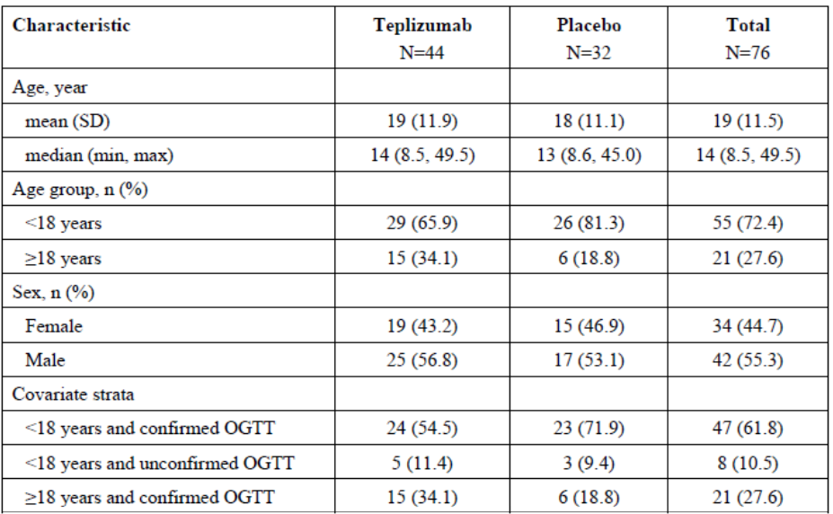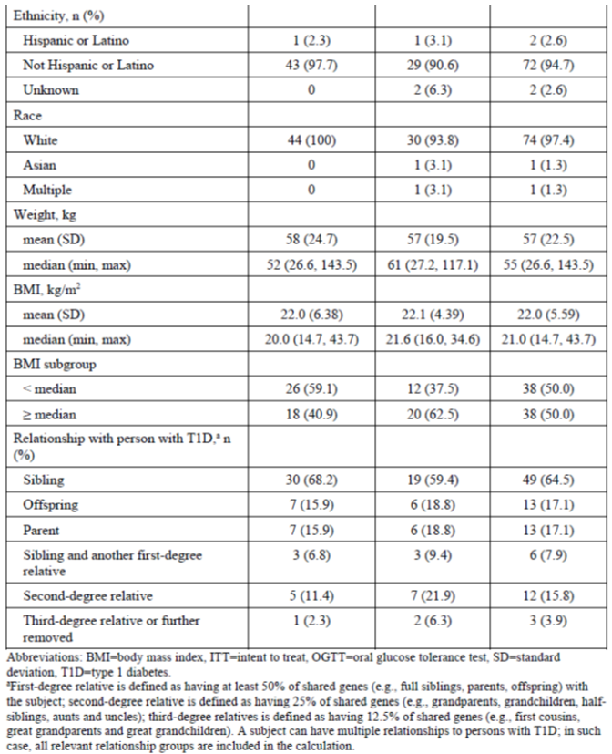
Table 11. Study TN-10. Type and frequency of autoantibodies at baseline and presence of HLA risk alleles (ITT population).
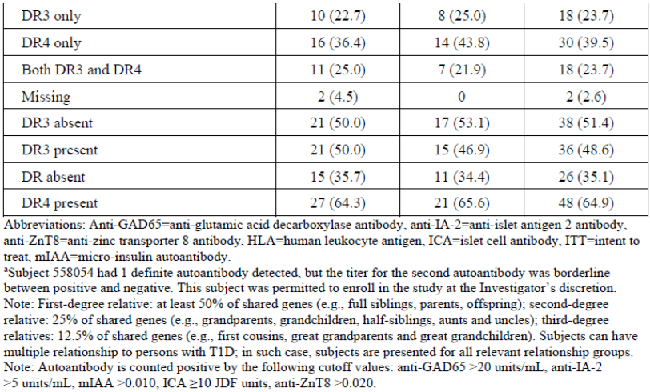
Table 12. Study TN-10. T1D-related clinical characteristics at baseline (ITT population).
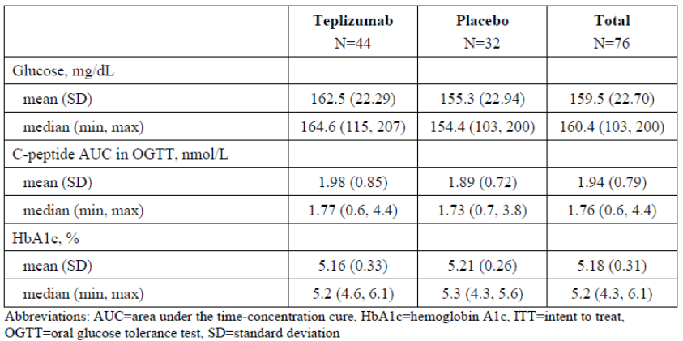
Figure 1. Study TN-10. Patient Disposition.

Magnitude of the treatment effect and its clinical significance
The primary analysis was conducted through the cutoff date of 30 November 2018, when > 40 subjects were diagnosed with T1DM, as prespecified in the statistical analysis plan (SAP) (20 (45.5%) patients in the teplizumab group and 23 (71.9%) in the placebo group were diagnosed with T1DM).
Primary efficacy endpoint: The primary endpoint was the time from randomisation to T1DM diagnosis or last contact. The cumulative incidence of diabetes onset over time from randomisation within each treatment group was estimated using the Kaplan-Meier method (proportion surviving diabetes-free as a function of time).
Treatment with a single 14-day course of teplizumab delayed the time to diagnosis of T1DM (i.e. the primary endpoint of the study was met). The median times to T1DM were 24.9 months (placebo) and 49.5 months (teplizumab) corresponding to a delay of T1DM onset by 24.6 months. HR = 0.41 (95% CI: 0.22 to 0.78) (p=0.0066) (Table 13). Cumulative hazard ratios (HRs) are shown in Table 14 and a Kaplan-Meier curve in Figure 2.
Table 13. Study TN-10. Results of the primary efficacy analyses (ITT population).
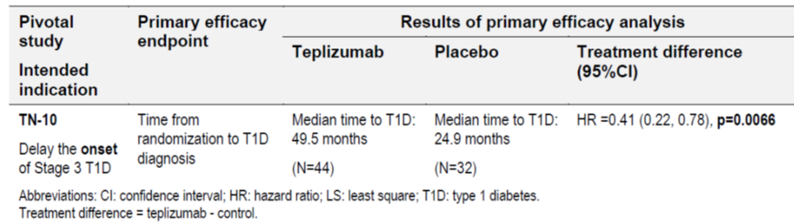
Table 14. Study TN-10. Yearly interval and cumulative hazard rations of time to T1D onset (ITT population).
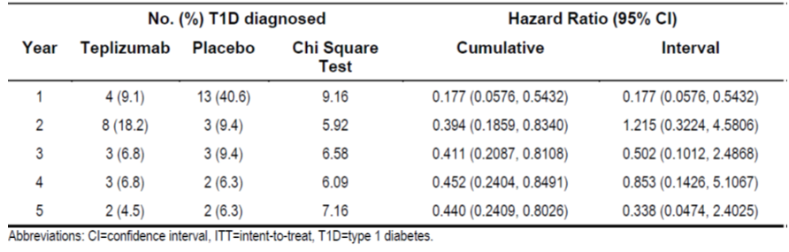
Figure 2. Study TN-10. Kaplan-Meier curve of time to T1DM diagnosis by treatment group (ITT population).
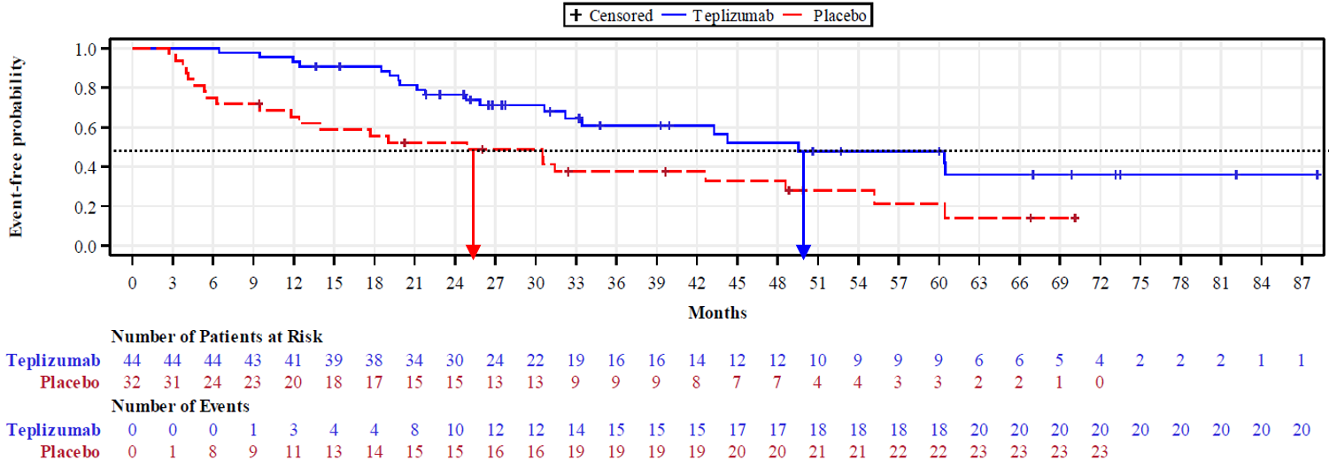
Primary endpoint sensitivity analyses (Figure 3): The outcomes of all three sensitivity analyses were consistent with the primary analysis with HR (95% CI) = 0.41 (0.22; 0.78) (ITT):
- Primary endpoint sensitivity analysis 1: Delaying the time to T1DM onset to 1 year after randomisation for placebo subjects with a T1DM onset within the first year. HR (95% CI) = 0.43 (0.22; 0.81).
- Primary endpoint sensitivity analysis 2: Considering subjects who terminated study participation early (either withdrew consent or lost to follow-up) as reaching T1DM onset at the time of termination. HR (95% CI) = 0.42 (0.22; 0.78).
- Primary endpoint sensitivity analysis 3: Both assumptions combined. HR (95% CI) = 0.43 (0.23; 0.81).
Figure 3. Study TN-10. Kaplan-Meier curve of time to T1D diagnosis by treatment group and sensitivity analysis (ITT population).
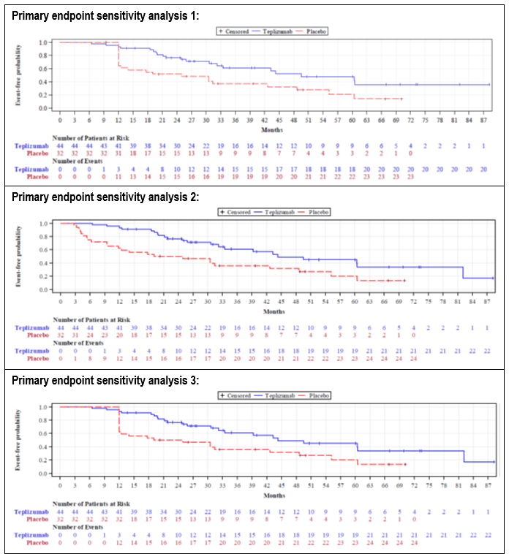
Primary endpoint subgroup analyses: The outcomes of all most subgroup analyses were consistent with the primary analysis, noting that the number of patients in each subgroup was relatively small and no adjustments for multiplicity were made.
The treatment effect appeared to be larger in subgroups with specific baseline characteristics (e.g. negative anti-ZnT8 antibodies; HLA DR3 negative; HLA DR4 positive; or C-peptide level AUC < median), but no definite conclusion can be made (Figure 4).
Figure 4. Study TN-10. Primary endpoint subgroup analyses: Forest plot on the effect of teplizumab compared with placebo (ITT population).
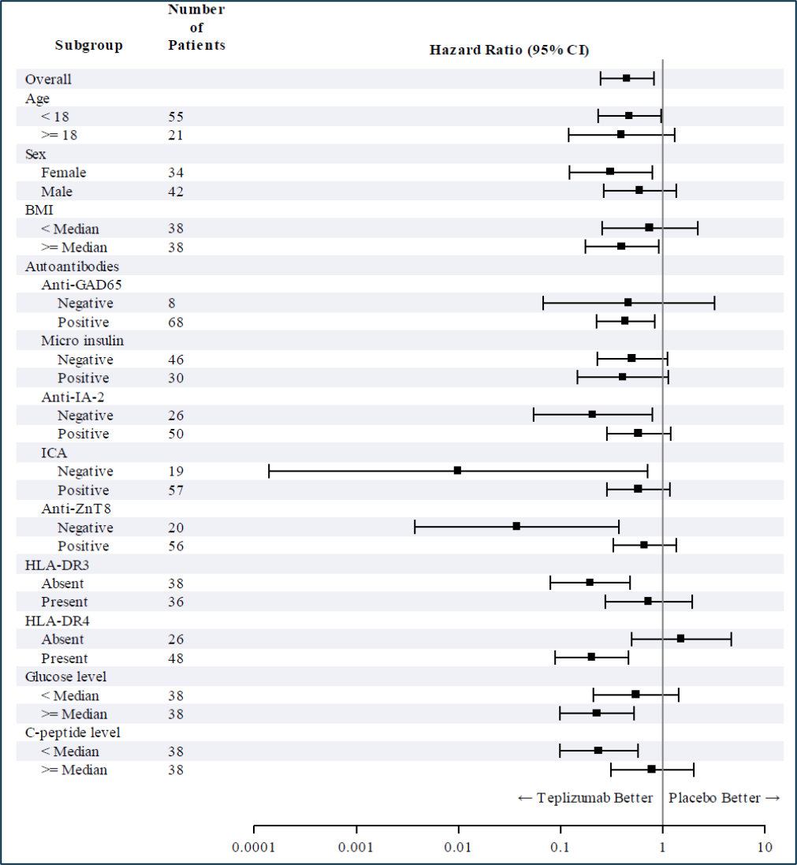
Other endpoints:
- C-peptide: Patients in the placebo group had an overall decline prior to randomisation and during the study. In contrast, teplizumab-treated patients appeared to stabilise and even to increase the C-peptide AUC levels following teplizumab treatment (Figure 5). The mixed model repeated measures (MMRM) analyses of C-peptide ln(AUC+1) data for the entire 24 months showed a statistically significant overall treatment effect (p=0.021), indicating that teplizumab treatment was associated higher C-peptide levels than placebo among all subjects. Analyses at time points 3 months (p=0.029) and 6 months (p=0.0106) also showed statistically significantly higher C-peptide ln(AUC+1) in teplizumab-treated subjects compared with placebo (Figure 6).
- HbA_{1c}: The mean [SD] HbA_{1c} was 5.16% [0.334] (teplizumab) and 5.21% [0.263] (placebo) and remained largely unchanged over time until diagnosis of T1DM.
Figure 5. Study TN-10. Change from baseline in mean C-peptide AUC in 2-hour OGTT (ITT population).
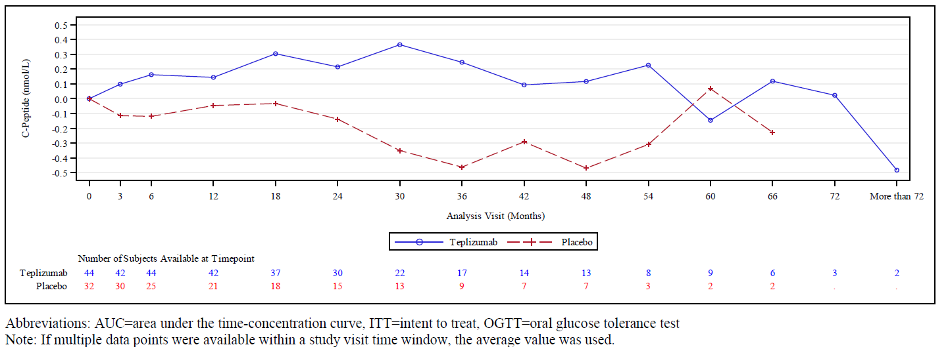
Figure 6. Study TN-10. C-peptide ln(AUC + 1) least square means (±SE) by treatment and time window from the 2-year model (ITT population).
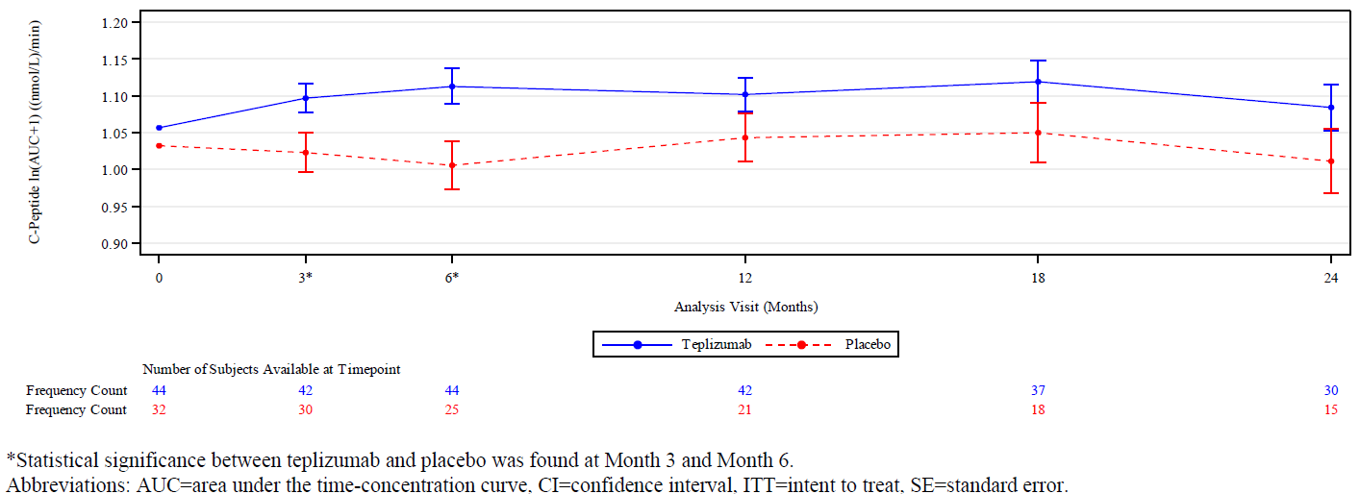

Safety
The integrated safety analysis (cut-off date: 23 August 2024) is based on 7 completed clinical trials (Table 15). They form the ‘All studies pool’ safety analysis population (pool).
Data from two completed studies were not included in the ISS or ‘All studies pool’ and were reported separately: the single dose biocomparability study (PRV-031-004) in healthy volunteers and the TN-10 Extension study (PRV-031-002).
Table 15. Studies providing safety data.
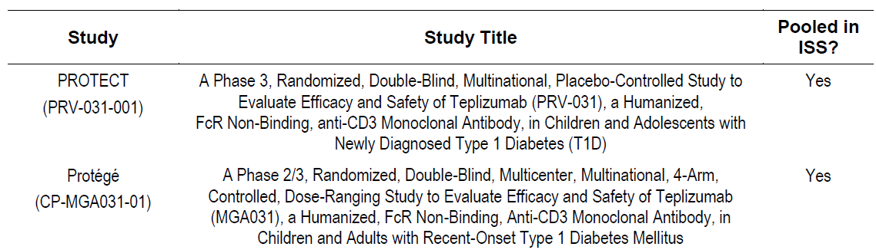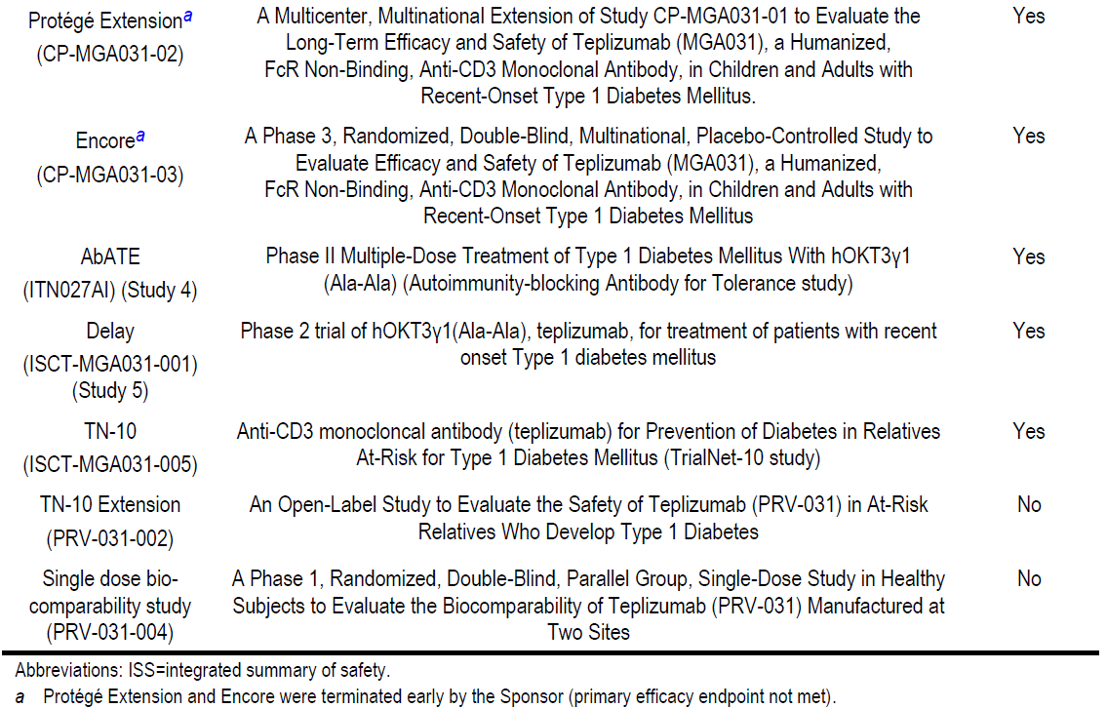
The safety analysis did not consider any data from studies of teplizumab in non-T1DM indications (e.g. psoriasis, psoriatic arthritis, renal allograft rejection, and islet cell transplantation).

Exposure
The ‘All studies pool’ included 990 participants in the teplizumab group and 356 in the control group. 18 control participants in the Delay study received teplizumab in an open-label phase which indicates 1008 participants exposed to teplizumab (Table 16).
Table 16. Safety analysis. Number of participants by study (All studies pool).
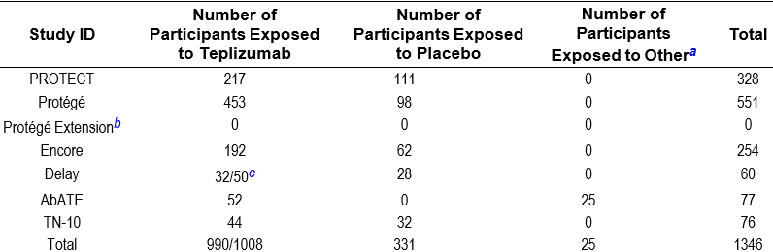
a “Other” refers to standard of care, no placebo infusion.
b A total of 219 participants from the Protégé study were enrolled in the Protégé Extension study. No treatment was given.
c In the Delay study, 32 participants were randomized to the teplizumab group in the double-blind part. In the open-label part,
Eighteen participants initially in the placebo group received teplizumab treatment and are counted in both the teplizumab and placebo groups.
The cumulative follow-up was 1865.6 PY in the teplizumab group and 631.6 PY in the control group. The median duration of follow-up was 724.5 (teplizumab) vs. 571.0 (placebo) days. Over 90% of the participants in both treatment groups were followed for ≥1 year (Table 17).
Table 17. Safety analysis. Summary of study follow-up duration (All studies pool).
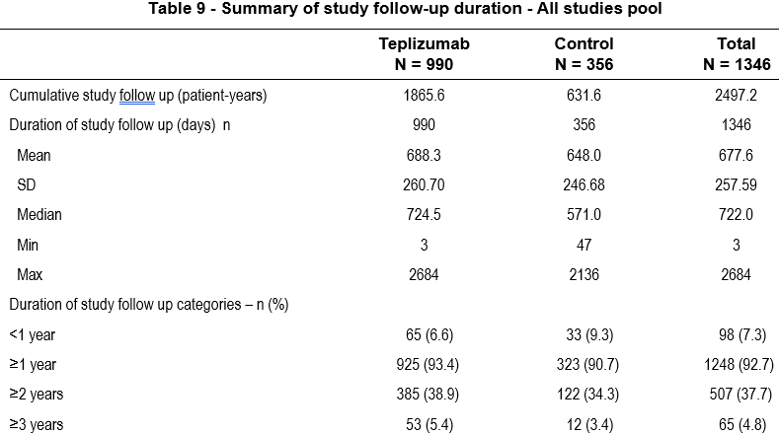
Six studies used a teplizumab regimen resulting in a cumulative dose of ~9034 μg/m² per treatment course (Table 18). Protégé and Encore additionally examined 2 alternative regimens of lower dose (‘1/3 14-day regimen’ with a cumulative dose of ~2985 μg/m² and a ‘Full 6-day regimen’ with a cumulative dose of ~2426 μg/m²). No treatment was given in the Protégé Extension study. The 12-day regimen with the same total dose per course was only used in PROTECT.
Most participants in the ‘all studies pool’ was <18 years of age (72.1%), male (62.0%), not Hispanic or Latino (93.3%), and White (76.2%), with generally balanced demographic characteristics between the treatment groups.
Table 18. Safety analysis. Teplizumab total dose by study.
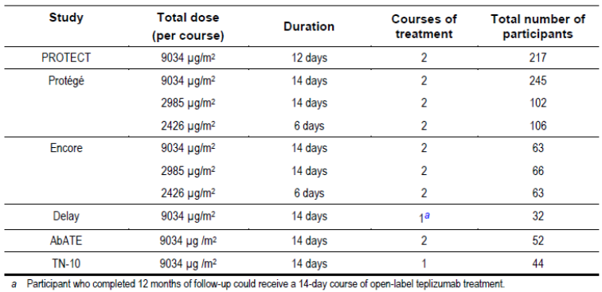

Adverse event overview
TN-10: Overall, 43 (97.7%) subjects in the teplizumab group and 22 (68.8%) subjects in the placebo group had at least one TEAE (Table 19). Grade 3 TEAEs occurred in 26 (59.1%) subjects in the teplizumab group and 3 (9.4%) subjects in the placebo group. No subjects had a Grade 4 TEAE.
The most common TEAEs for teplizumab were lymphopenia, rash, and leukopenia (more frequent for teplizumab vs. placebo). Infection-related TEAEs occurred more frequently in the teplizumab group (mostly Grade 1 and 2 in severity and involved the upper respiratory tract). There were 4 Grade 3 infections, and all were categorised as SAEs and AESIs, and one was deemed related to treatment. The most common Grade 3 TEAE in teplizumab subjects was lymphopenia. One TEAE of Grade 2 cytokine release syndrome (CRS) occurred in 1 teplizumab subject.
Table 19. Study TN-10. Overview of TEAEs (Safety population).
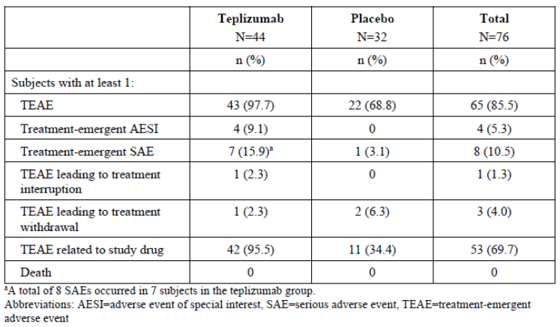
All studies pool: TEAEs occurred in 99.5% of participants in the teplizumab group and 95.8% of participants in placebo control. TEAEs leading to treatment interruption or treatment withdrawal were more frequent in the teplizumab group compared to control, which was primarily due to protocol mandated laboratory-related criteria and cytokine release syndrome. The majority of TEAEs were Grade 1 or Grade 2 in intensity (Table 20).
Noteworthy, subgroup analysis by follow-up time (1, 2 or >2 years) showed that TEAE, SAEs and AESIs were generally consistent with analyses in the overall pooled population.
Table 20. Overview of TEAEs (All studies pool).
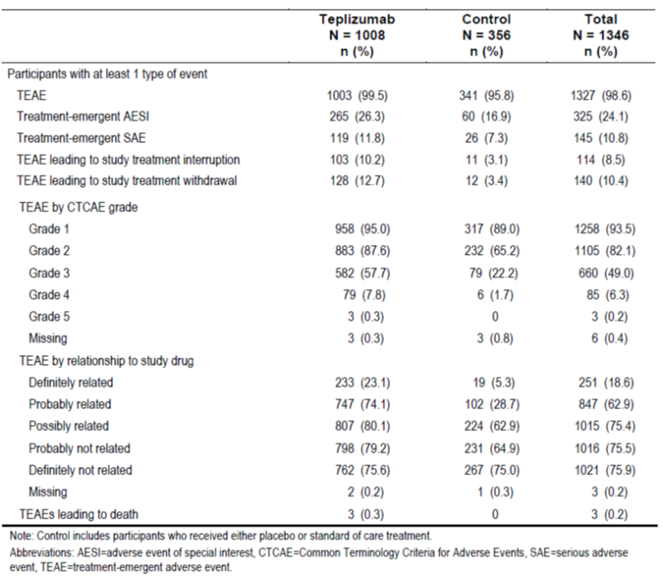
TEAEs were predominantly associated with the mechanism of action of teplizumab on white blood cells and with cytokine release, manifesting as transient haematological test abnormalities, liver enzyme increases, and symptoms such as rash, nausea, vomiting, and headache (Table 21). Additionally, a forest plot provides a summary of study size adjusted risk differences [95% CI] of the TEAEs with an incidence ≥5% (Figure 7).
Table 21. TEAEs with incidence ≥5% by SOC and PT (All studies pool).
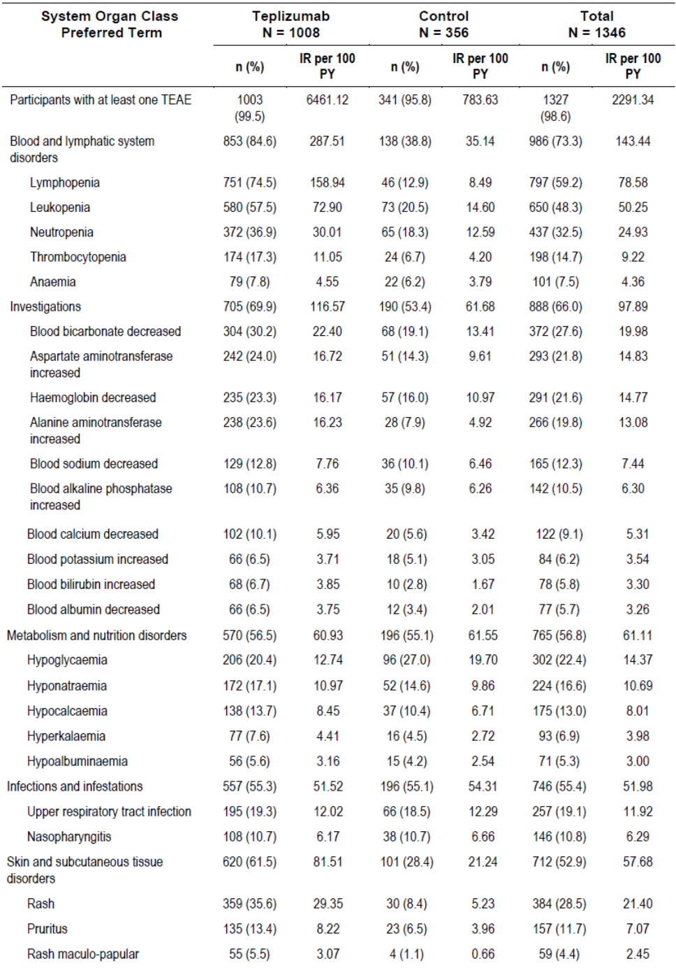
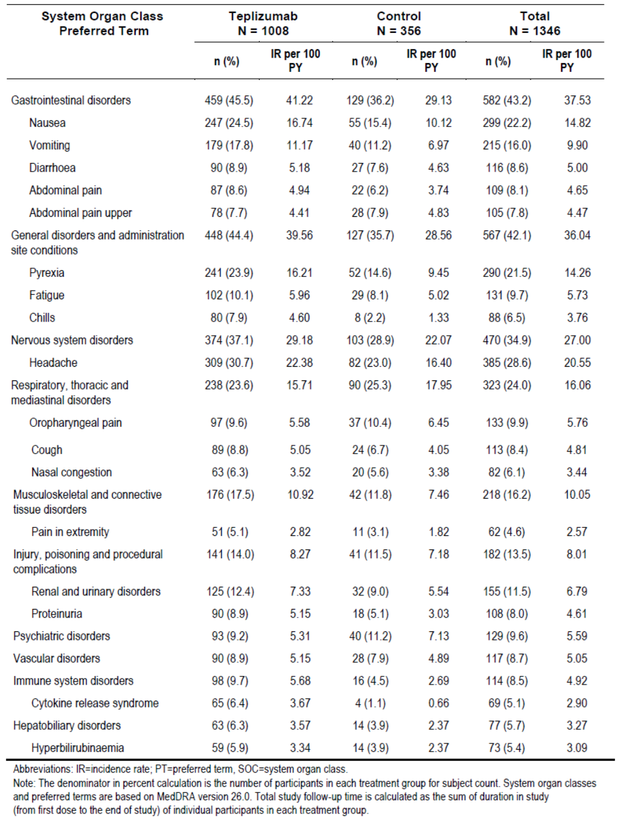
TEAEs with an incidence ≥5% during either treatment course, through to 28 days after last dose by PT are shown in Table 22.
Table 22. TEAEs with an incidence ≥5% during either treatment course and through to 28 days after last dose by PT (All studies pool).
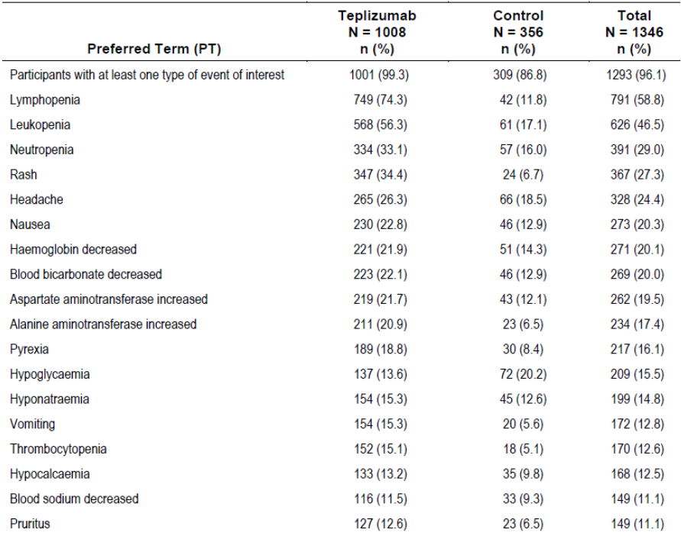
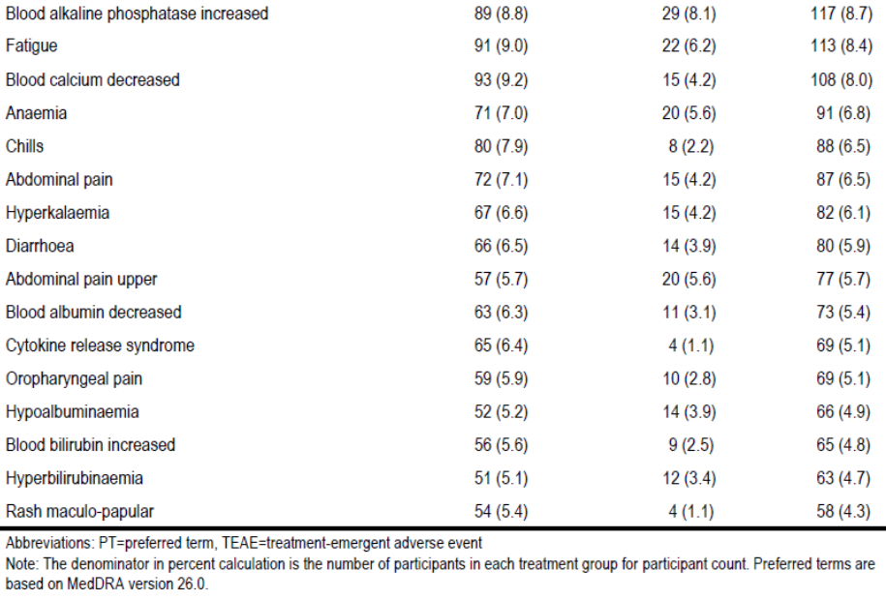
The 5 most common TEAEs with greater incidence in the teplizumab group compared with placebo were lymphopenia (74.5% vs. 12.9% and 158.94 vs. 8.49 IR per 100 PY), leukopenia (57.5% vs. 20.5% and 72.90 vs. 14.60 IR per 100 PY), neutropenia (36.9% vs. 18.3% and 30.01 vs. 12.59 IR per 100 PY), blood bicarbonate decreased (30.2% vs. 19.1% and 22.40 vs. 13.41 IR per 100 PY) and rash (35.6% vs. 8.4% and 29.35 vs. 5.23 IR per 100 PY). In addition, increased alanine aminotransferase occurred more frequently in the teplizumab group (23.6% vs. 7.9%).
The AE incidence within ‘Infections and infestations’ was comparable between treatment groups (55.3% [teplizumab] vs. 55.1% [placebo]) and likely based on the stringent exclusion criteria.
Cytokine release syndrome was reported in 6.4% (IR of 3.67 per 100 PY) of participants in the teplizumab group and 1.1% (IR of 0.66 per 100 PY) in the placebo control.

Treatment related adverse event (adverse drug reaction) overview
TN-10: ADRs occurred in 42 (95.5%) subjects in the teplizumab group and 11 (34.4%) subjects in the placebo group. The most common teplizumab-related TEAE was lymphopenia.
All studies pool: A summary for the All studies pool is in Table 22. Even though ADRs by PT were not presented separately to TEAEs, the Forest plot of adjusted risk difference between active and placebo provides relevant information for the All studies pool (Figure 7).
Figure 7. TEAEs with an incidence ≥5%: Forest plot of adjusted risk difference, and 95% CI (All studies pool).
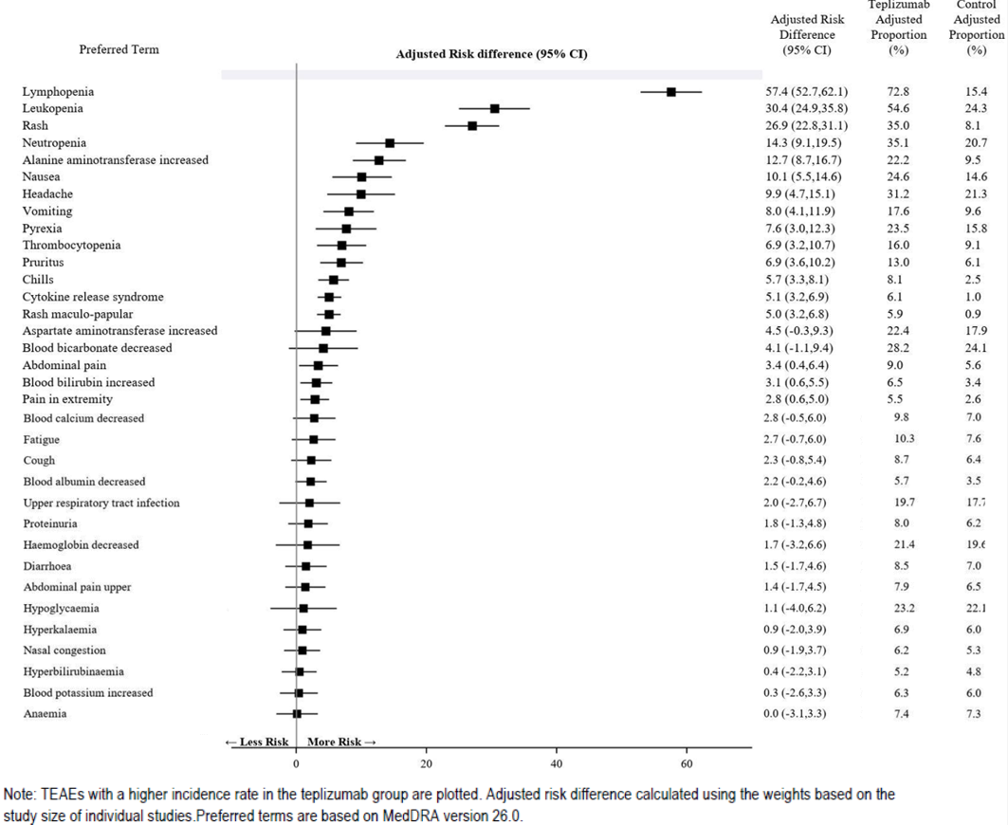

Deaths
TN-10: No deaths occurred.
All studies pool: 4 deaths were reported across the completed teplizumab program. Investigators considered these deaths as unlikely or not related to the study drug. All deaths occurred in the teplizumab-treated groups (Table 23):
- Two deaths occurred during the Protégé study: one due to DKA/intercapillary glomerulosclerosis and one due to acute MI/cardio-respiratory arrest/ventricular tachycardia.
- One death occurred in the Protégé Extension study: after 2 years and 2 months of receiving the last dose of study drug, the participant experienced abdominal pain, vomiting, and loose stools and was given an unknown treatment by a local doctor. The participant's death was reported 5 days after symptoms started. None of these deaths occurred during the treatment course.
- The fourth death occurred in the TN-10 Extension study where a participant with a history of anxiety and major depressive disorder experienced a TESAE (Completed suicide) that was fatal. The TESAE was assessed by the Investigator as not related to study treatment.
Table 23. Safety analysis. List of participant deaths (All studies pool and TN-10 extension).
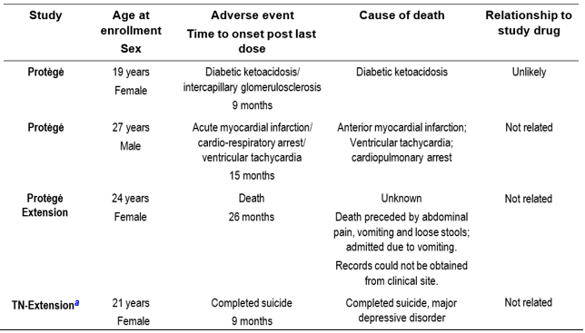
a TN10-Extension was not included in the pooled analyses.

Serious adverse events
TN-10: Eight (18.2%) subjects had 9 SAEs during the study (7 (15.9%) for teplizumab vs. 1 (3.1%) for placebo). One subject had 2 SAEs (dizziness and ankle fracture). Four SAEs in 4 subjects were infections (pneumonia, cellulitis, wound infection, and gastroenteritis). Two SAEs (serum sickness and pneumonia) in 2 subjects in the teplizumab group were considered by the investigators to be possibly related to the study treatment.
All studies pool: TESAEs occurred more frequently in the teplizumab group (11.8%) than in placebo control (7.3%) and were predominantly T1DM related AEs:
- DKA was the only TESAEs reported for >1% of participants in the teplizumab group (IR per 100 PY 1.13 vs. 0.16 for placebo). No DKA SAE occurred during the time window of the treatment course through 28 days after the last dose. The SAEs of DKA occurred several months after the treatment, usually triggered by infections or poor diabetes management. The patients with DKA had high blood sugar levels and low C-peptide levels, indicating poor insulin production. Notably, no DKA occurred in the PROTECT study (i.e. a Stage 3 T1DM population).
- Hypoglycaemic seizure was reported in 7 teplizumab-treated patients (IR of 0.37 per 100 PY) and none in the control group. All SAEs of hypoglycaemic seizure, hypoglycaemic unconsciousness, and hypoglycaemic coma events occurred in the Protégé and Encore studies. Factors associated with hypoglycaemic seizure included high insulin doses, non-compliant diet and glucose monitoring, increased physical activity combined with low prior food intake.
- Cytokine release syndrome (CRS) was reported in 9 participants in the teplizumab group (IR of 0.48 per 100 PY).
Additionally, a forest plot provides a summary of study size adjusted risk differences [95% CI] of the TESAEs (Figure 8).
Figure 8. TESAEs reported in ≥2 teplizumab-treated participants: Forest plot of adjusted risk difference, and 95% CI (All studies pool).
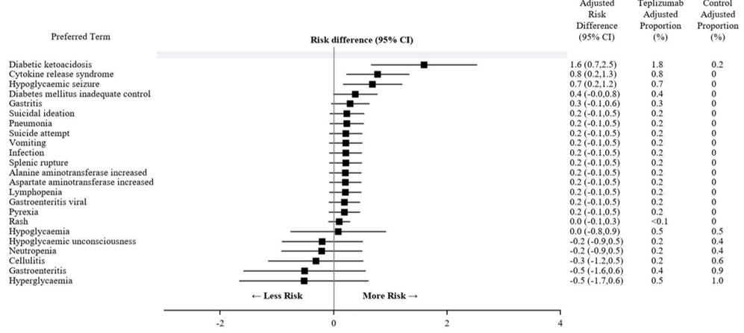

Discontinuations
TN-10: Three patients discontinued study treatment due to TEAEs: 1 (2.3%) in the teplizumab group (due to ALT increased after 11 days of treatment) and 2 (6.3%) subjects in the placebo group. All events were resolved or resolving by the end of the study.
All studies pool: A higher proportion of participants discontinued study drug due to TEAEs in the teplizumab group (12.7%) than in the placebo control (3.4%). The 5 most common TEAEs leading to study drug discontinuation in the teplizumab group were mostly protocol-mandated: alanine aminotransferase increased (4.5%), aspartate aminotransferase increased (2.2%), haemoglobin decreased (1.2%), CRS (1.3%), and neutropenia (1.1%).

Adverse events of special interest
Overall, the incidence of AESIs was greater in the teplizumab group (26.3%) than in placebo control group (16.9%) (Figure 9).
Figure 9. AESIs: Forest plot of adjusted risk difference, and 95% CI (All studies pool).
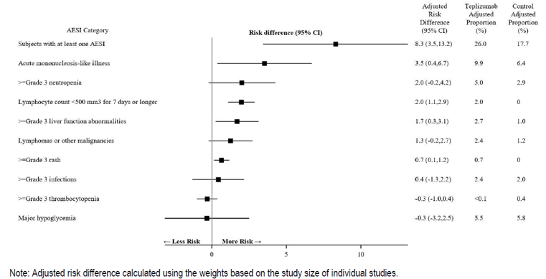
≥Grade 3 infections (includes all opportunistic infections): occurred in 2.5% (IR of 3.22 per 100 PY) teplizumab-treated participants and 2.0% (IR of 1.99 per 100 PY) of participants in placebo control group (study size adjusted risk difference [95% CI]: 0.4% [-1.3, 2.2]).
Acute mononucleosis-like illness (e.g. fever, pharyngitis, lymphadenopathy): There was a significant increase in the incidence of acute mononucleosis-like illness assessed using the global AESI classification (adjusted risk difference [95% CI]: 3.5% [0.4, 6.7]). Infectious mononucleosis (0.4% vs. 0.3%), and mononucleosis syndrome (<0.1% vs. 0%). were rare. The adjusted risk differences for both types of PTs were <0.1%. However, TEAEs associated with laboratory findings of Epstein-Barr virus (EBV) and Cytomegalovirus (CMV) were commonly more frequent in the teplizumab group than in placebo control:
- Epstein-Barr viremia: 2.6% vs. 0.8%,
- Epstein-Barr virus antibody positive: 3.1% vs. 3.1%,
- Epstein-Barr virus test positive: 0.9% vs. 0%,
- Epstein-Barr virus antigen positive: <0.1% vs. 0%,
- Cytomegalovirus test positive: 1.0 % vs. 0.6%.
Adjusted risks for all these PTs were ≤1.0%.
Lymphomas or other malignancies (AESI category): reported for 2.3% and 1.4% of the participants in the teplizumab and placebo groups, respectively (study size adjusted risk difference [95% CI]: 1.3% [ -0.2, 2.7]). No lymphoma was reported in any of the studies.
One participant in the Protégé study had an SAE of malignant metastatic melanoma not included as it was not identified using the algorithm for AESI. This was because the HLT used for this event was ‘Skin melanomas (excluding ocular)’. The participant had a history of dysplastic nevi, and metastatic melanoma occurred in a pre-existing lesion that was not diagnosed until after entering the study. The participant underwent excision of the lesion and was in full remission 2 years post-excision.
≥Grade 3 hypoglycaemic adverse events (severe): There was no obvious increase in the risk of severe hypoglycaemic adverse events:
- ≥Grade 3 events of hypoglycaemia (AESI category) were reported in 5.3% of participants in the teplizumab group, compared with 6.5% of participants in the control group (study size adjusted risk difference [95% CI: -0.4% [-3.0, 2.2]).
- ≥Grade 3 hypoglycaemia (PT) were reported in 4.4% (IR of 2.39 per 100 PY) in the teplizumab group compared with 5.9% (IR of 3.53 per 100 PY) in the control group.
- ≥Grade 3 or higher events of hypoglycaemia associated with altered mental and/or physical status (PTs of hypoglycaemic seizure, hypoglycaemic unconsciousness, and hypoglycaemic coma) were reported in 0.9% of participants (IR of 0.48 per 100 PY) in the teplizumab group and 0.6% of participants (IR of 0.33 per 100 PY) in the control group.
≥Grade 3 liver function abnormalities (i.e. an AST or ALT value >5.0 x ULN or a bilirubin value >3.0 x ULN): ≥Grade 3 or higher liver functions abnormalities occurred statistically significantly more often in the teplizumab group than in placebo control (adjusted risk difference [95% CI]: 1.7% [0.3, 3.1]). ≥Grade 3 or higher TEAEs of ALT increased and AST increased occurred more frequently in the teplizumab group (2.1% and 1.4%, respectively with IR of 1.14 and 0.75, respectively per 100 PY) than in placebo control (0.3% and 0.3%, with IR of 0.16 per 100 PY for both). Two (0.2%) participants (with IR of 0.11 per 100 PY), both in the teplizumab group, had Grade 3 or higher events of blood bilirubin increased.
≥Grade 3 thrombocytopenia (platelet counts less than 50,000/μL): There was no increase in thrombocytopenia. Grade 3 or higher thrombocytopenia occurred in 1 (0.1%) participant (IR of 0.05 per 100 PY) in the teplizumab group and 1 (0.3%) participant (IR of 0.16 per 100 PY) in placebo control (adjusted risk difference [95% CI]: -0.3% [-1.0, 0.4]).
≥Grade 3 neutropenia (<1000 PMN/μL on 2 consecutive evaluations performed on different days): ≥Grade 3 neutropenia occurred in 5.5% participants (IR of 3.06 per 100 PY) in the teplizumab group compared with 2.2% participants (IR of 1.33 per 100 PY) in placebo control group (adjusted risk difference [95% CI]: 2.0% [-0.2, 4.2]).
≥Grade 4 allergic/hypersensitivity reaction (through Study Day 365): No Grade 4 or higher allergic or hypersensitivity reactions occurred.
≥Grade 3 rash: All events (n=3) of Grade 3 or higher rash occurred in teplizumab-treated participants (0.3%) and included pruritus, dermatitis atopic, and rash papular. The IR for the SOC of skin and subcutaneous tissue disorders including these 3 PTs was 0.32 per 100 PY. The adjusted risk difference [95% CI] for Grade 3 or higher rash was 0.7% [0.1, 1.2].
≥Grade 4 cytokine-release syndrome (through Study Day 365) (i.e. life-threatening; pressor or ventilatory support indicated): No Grade 4 or higher CRS occurred in any participant.
Lymphocyte count <500 mm³ for 7 days or longer: Grade 3 or higher lymphopenia for 7 days or longer occurred in 1.9% participants (IR of 1.03 per 100 PY) in the teplizumab group versus none in placebo control (adjusted risk difference [95% CI]: 2.0% [1.1, 2.9]).

Post-market experience
Based on sales data (weighted average of 17 vials = 1 patients, assuming that ~25% of adult patients with BSA greater than 1.94 m² required the use of 24 vials), a total of ~347 patients were estimated to have been exposed to teplizumab following the initial approval of teplizumab in the US up to 31 August 2024. Based on this, the applicant claims that post-marketing safety data are consistent with those observed in clinical trials studying teplizumab. Evaluation of the cumulative safety data during routine safety surveillance has not identified any new safety concerns.

Ongoing studies
It is noted that the applicant is additional studies are ongoing and can provide further safety data. However, no CSRs are currently available, and their submission may be required as a condition of registration (some are already included in the RMP). The studies include:
- TN-10 Extension study
- Phase 4 study PETITE-T1D
- US Registry Study (OBS18177)
- Global Registry Study (OBS18565)

Risk management plan
Sanofi-Aventis Australia Pty Ltd has submitted EU-RMP version 0.1 (date 3 December 2024; DLP 31 August 2024) and ASA version 1.0 (date January 2025) in support of this application. At Round 2 the sponsor provided EU-RMP version 0.2 (date 8 July 2025; DLP 31 August 2024) and ASA version 1.1 (date September 2025).
The proposed summary of safety concerns and their associated risk monitoring and mitigation strategies documented in the EU-RMP are summarised in Table 24.
Table 24. Summary of safety concerns
Summary of safety concerns and missing information |  | Pharmacovigilance |  | Risk Minimisation
 |  | Routine | Additional | Routine | Additional
Important identified risks | Cytokine release syndrome | ü | ü†‡ | ü | ü*
Important identified risks | Lymphopenia | ü | ü†‡ | ü | ü*
Important identified risks | Serious Infections | ü | ü†‡ | ü | ü*
Important identified risks | Hypersensitivity reactions | ü | ü†‡ | ü | ü*
Important potential risks | Malignancies | ü | ü† | – | –
Missing information | Long-term safety in patients aged 8 to <18 years | ü | ü† | ü | –
Missing information | Use during pregnancy | ü | ü† | ü | –
Missing information | Use during lactation | ü | ü† | ü | –
* HCP guide and patient guide
† Global registry study (OBS18565)
‡ RMM survey study (OBS21717)
The RMP evaluation recommended conditions of registration relating to the versions of the risk management plan, requirement for periodic safety update reports, and inclusion of the medicine in the Black Triangle Scheme.
The summary of safety concerns in the ASA aligns with the draft EU-RMP. The sponsor was requested to consider the impact on the safety specification of cases of unresolved thrombocytopaenia and anaemia, clinical trials exclusion criteria, lack of long term follow up, and potential for repeat treatment. At Round 2, the sponsor upgraded ‘malignancies’ to an important potential risk, removed missing information ‘Use in paediatric population < 8 years’, and added missing information ‘long-term safety in patients aged 8 to <18 years.’
The summary of safety concerns aligns with the EU-RMP and is acceptable.

Pharmacovigilance plan
Routine pharmacovigilance only was proposed in the ASA and EU-RMP. The sponsor was asked to consider the need for long term safety studies and enhanced routine pharmacovigilance where appropriate. At Round 2, the sponsor has included additional pharmacovigilance items for the newly added long term safety missing information. The pharmacovigilance plan is acceptable.

Risk minimisation plan
Routine risk minimisation is proposed for all safety concerns. Additional risk minimisation in the form of an HCP Guide and Patient Guide is proposed for the important identified risks in the ASA, which aligns with the EU-RMP. At Round 2, the sponsor revised the CMI and the dissemination method for additional risk minimisation materials as requested.
The draft patient and HCP guides will be submitted for review prior to marketing. The risk minimisation plan is acceptable.

Additional RMP advice to the sponsor
The following advice is for the sponsor and should not impact registration:
- The sponsor has added a global registry study to the ASA to address all safety concerns, including the upgraded important potential risk of malignancies. This is a multinational study; however, the sponsor has not made it clear in the ASA whether it is anticipated that Australian patients will be included. While it is acknowledged that the study is being developed in conjunction with the EMA, it would be desirable for Australian patients to be included in this registry study. Once this information becomes available, the sponsor is requested to update Table 4 of the ASA at the following routine update, to clarify whether Australian patients will be included in the registry study. Regardless, the safety outcomes should be submitted in a revised ASA.
- The draft additional risk minimisation materials are not available at round 2 and will be provided prior to launch. As drafts of the additional risk minimisation materials have not been reviewed during the evaluation, please allow a minimum of 6 weeks for review and acceptance, to allow for the possibility of multiple rounds of revisions.
- Once the EU-RMP for this submission has been finalised, if there are any significant differences between the ASA and the approved EU-RMP, then the sponsor should submit the approved EU-RMP and a corresponding ASA as a post-market update.
The TGA may request an updated RMP at any stage of a product's life cycle, during both the pre-approval and post-approval phases. Further information regarding the TGA’s risk management approach can be found in risk management plans for medicines and biologicals and the TGA's risk management approach. Information on the Australia-specific annex (ASA) can be found on the TGA website.

Risk-benefit analysis

Delegate’s considerations

Clinical trial program

Clinical trial overview
The efficacy of teplizumab is assessed from data from Study TN-10 (AT-RISK study), and the only clinical study to support efficacy for the proposed Stage 2 T1DM indication. The reliance on a single phase 2 trial (Study TN-10) for efficacy was not ideal, and a second efficacy trial for the proposed Stage 2 T1DM indication would have been advantageous.
In the only efficacy study for this indication, TN-10, the patient population consisted of children aged 8 years and above. Studies in older children with a step-down approach once efficacy and safety had been established would have been preferable. The choice of antibodies used was not unreasonable, but the corresponding positive predictive values for the relevant antibodies for T1DM appeared not to have documented. Overall, the sample size was relatively small, and due to this a determination of potentially beneficial effects in certain subgroups (e.g. number of antibodies, different antibodies, OGTT results, etc.) was not possible.
Endpoints and clinical relevance
In TN-10, the primary efficacy endpoint was the time from randomisation to T1DM diagnosis or last contact. Measuring cumulative diabetes incidence is in line with TGA-adopted regulatory guidance, as an established, clinically relevant endpoint.

Efficacy
Efficacy data for the proposed indication: to delay the onset of Stage 3 T1D in adult and paediatric patients 8 years of age and older with Stage 2 T1D
The Phase 2 TN-10 study demonstrated that teplizumab-treatment in an early phase of the autoimmune process (Stage 2 T1DM) can delay of the onset of advanced disease. Median times to onset of T1DM were 24.9 months (placebo) and 49.5 months (teplizumab) corresponding to a delay by 24.6 months (primary analysis HR (95% CI) = 0.41 (0.22; 0.78) (ITT)) (Figure 10).
Even though the largest difference between teplizumab and placebo was observed in the first year after treatment, the cumulative HR continued to show an advantage of teplizumab over placebo through Year 5.
The outcomes of all three sensitivity analyses were consistent with the primary analysis. The hazard ratios ranged between 0.42 and 0.43 and supported the robustness of the primary analysis.
The outcomes of all most subgroup analyses were consistent with the primary analysis, noting that the number of patients in each subgroup was relatively small and no adjustments for multiplicity were made. The treatment effect appeared to be larger in subgroups with specific baseline characteristics (e.g. negative anti-ZnT8 antibodies; HLA DR3 negative; HLA DR4 positive; or C-peptide level AUC < median), but no definite conclusion can be made.
Teplizumab treatment improved C-peptide levels upon initiation, while placebo subjects had an overall decline. The treatment effect on C-peptide AUC for the 24-month analysis was statistically significant in all subjects (p=0.021) and in those who were diagnosed with T1D during the study (p=0.030). This further supports teplizumab’s effect on preserving beta cell function in this population.
The presence of anti-teplizumab antibodies did not appear to affect teplizumab blood levels nor the primary efficacy endpoint significantly.
Figure 10. Study TN-10 study. Summary of primary endpoint results: Kaplan-Meier curve of time to T1D diagnosis by treatment group (ITT population).
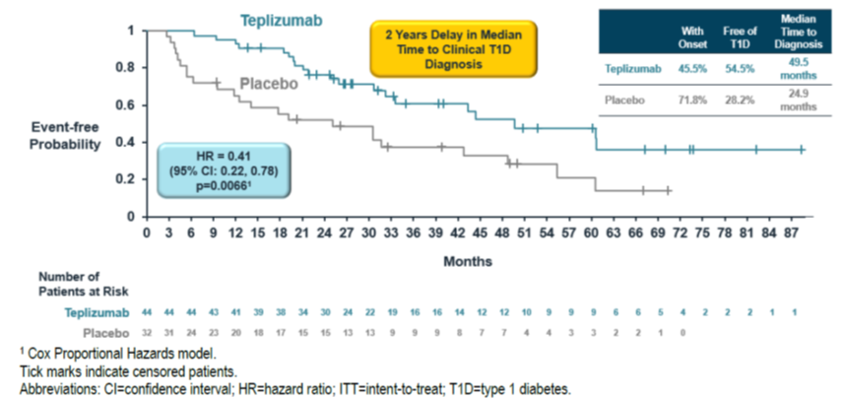

Safety
Non-clinical studies identified the potential risks of teplizumab treatment, including lymphopenia, reduced immune response, or increased cytokine release. The clinical trials provided clinical evidence for this.
Two main safety analysis sets were considered for the purposes of this decision overview. The TN-10 Safety population (as relevant to the proposed indication), and the ‘All safety pool’ that provided the majority of safety data, albeit in the closely related Stage 3 T1DM population. Approximately 1008 participants had been exposed to teplizumab in clinical trials. The AEs shown in those analysis sets appeared to show consistent results.
TEAEs more common in teplizumab-treated participants were lymphopenia, leukopenia, neutropenia, thrombocytopenia, increased liver enzymes, decreased blood bicarbonate, rash and pruritus, and cytokine release syndrome (CRS). These were detected in the standard (MedDRA term based) reporting of AEs and in the pre-specified assessment of AESIs.
The majority of TEAEs were Grade 1 or Grade 2 in intensity. Discontinuations in the teplizumab group were relatively low (12.7% vs. 3.4% for placebo) and mostly protocol mandated.
Teplizumab has been registered in the US, and an estimated number of at least 347 patients were exposed to teplizumab in the relevant Stage 2 T1DM indication. Evaluation of the cumulative safety data during routine safety surveillance has not identified any new safety concerns.

Benefit-risk balance and translation to clinical practice
Study TN-10 had some limitations including: an imbalanced allocation; a small sample size (noting that it was planned as a Phase 2 trial, and acknowledging the difficulties of recruiting paediatric patients with Stage 2 T1DM); no larger Phase 3 trial or other second study to corroborate the results; the small number of Asian patients; some methodological uncertainties (but that are unlikely to significantly affect the robustness of the primary analysis).
However, as outlined above, Study TN-10 provided robust evidence for efficacy for the proposed Stage 2 T1DM indication, supported by sensitivity and subgroup analyses.
The question of clinical significance of the 24.6-month difference in Stage 3 T1DM onset arises. It may be considered too small by some to be clinically significant. However, in many instances, from a quality-of-life point of view (even though not formally tested in the study), delaying the onset of T1DM by approximately 2 years (with a delay of the associated commencement of insulin therapy and lifestyle changes) in the formative years of a child or adolescent may be rather beneficial on an individual level, or otherwise.
The pre- and post-market safety data in the Stage 2 T1DM indication combined with the pre-market safety data in the Stage 3 T1DM indication provide a reasonably sized safety database. Despite this, rare adverse events may not have emerged and robust pharmacovigilance is needed. This has been proposed by the sponsor in the RMP, e.g. for the potential risk of malignancy. Furthermore, the rather restrictive exclusion criteria with regard to infections in TN-10 need to be adequately communicated to prescribers (in PI or healthcare professional’s education materials), as infections may be a more common adverse effect outside of a clinical trial setting with exclusions.
Currently, no TGA-approved medicine has the capacity to modify the progression of Stage 2 T1DM, and thus an unmet need does exist. Teplizumab would add to the armamentarium. A restriction to use by or under close supervision of a specialist paediatric endocrinologist would be expected.
The population health benefits of teplizumab are rather dependent on the presence of a relevant screening program. Type1Screen, an islet autoantibody screening program in Australia and New Zealand is typically targeted at those with a relative who has T1DM, and extending the screening program beyond that population may be advantageous.

Proposed action
Overall, in the context of the unmet need, the robust efficacy data, and the acceptable safety profile, the benefit-risk could be cautiously regarded as positive. This is dependent on the conduct of appropriate additional pharmacovigilance activities. These have been specified in the RMP and those not listed will be specified as a condition of registration, if this application were approved. Furthermore, the sponsor is proposing routine and additional risk minimisation activities. HCP and patient education are outlined in the RMP and are essential in the context of a novel medicine.
The current TGA-amended indication (amended from the sponsor-proposed wording) is:
Tzield is indicated to delay the onset of Stage 3 type 1 diabetes mellitus in adult and paediatric patients aged 8 years and older with Stage 2 type 1 diabetes mellitus.
Advice from the ACM is kindly requested.

Advisory Committee considerations
The Advisory Committee on Medicines (ACM), having considered the evaluations and the Delegate’s overview, as well as the sponsor’s response to these documents, advised the following.

Specific advice to the Delegate
Can the ACM comment on whether the provided data are sufficient to support registration for the proposed indication?
Overall, the ACM was supportive of the registration of teplizumab for the proposed indication based on the limited available data.
The ACM was satisfied that available efficacy results from the TN-10 study were clinically significant. Further, the ACM was satisfied that the short-term safety profile was reasonably well characterised, including cytokine release syndrome, lymphopenia and infection risk. However, the ACM emphasised the importance of additionally obtaining long-term follow-up data to better profile any potential risks which may be relevant to immunomodulatory therapies including malignancy and chronic infections.
The ACM also noted the available data were derived from a relatively small number of clinical studies. The ACM highlighted the need for further confirmatory/replicatory clinical trials and comprehensive long-term clinical studies. The ACM suggested that an ongoing pharmacovigilance program may be appropriate given teplizumab’s immunomodulatory mechanism of action. The currently ongoing clinical studies were noted.
The committee is also requested to provide advice on any other issues that it thinks may be relevant to a decision on whether or not to approve this application.
The ACM advised that the Delegate consider whether additional conditions are placed on the approval of teplizumab including:
- A sponsor commitment to ongoing long-term safety studies. The reporting of the results of the currently ongoing studies should be considered as a condition of registration.
- Inclusion of a statement in the teplizumab Product Information to highlight that efficacy has not been studied in patients without a familial history of T1DM.

Advisory committee conclusion
The ACM considered Tzield (teplizumab) to have an overall positive benefit-risk profile for the Delegate’s proposed indication:
Tzield is indicated to delay the onset of Stage 3 type 1 diabetes mellitus in adult and paediatric patients aged 8 years and older with Stage 2 type 1 diabetes mellitus.

Assessment outcome
Based on a review of quality, safety, and efficacy, the TGA decided to register Tzield (eplizumab) 2 mg/2 mL Concentrated injection vial, indicated for:
Tzield is indicated to delay the onset of Stage 3 type 1 diabetes mellitus (T1D) in adult and paediatric patients aged 8 years and older with Stage 2 type 1 diabetes mellitus (see Section 5.1 Pharmacodynamic Properties – Clinical trials).

Specific conditions of registration
- Tzield (teplizumab) is to be included in the Black Triangle Scheme. The PI and CMI for Tzield must include the black triangle symbol and mandatory accompanying text for five years, which starts from the date of first supply of the product.
- The Tzield EU-Risk Management Plan (RMP) version 0.2 (dated 8 July 2025; data lock point 31 August 2024), with Australia-Specific Annex (ASA) version 1.1 (dated September 2025), included with submission PM-2025-00088-1-2, and any subsequent revisions, as agreed with the TGA will be implemented in Australia.
- An obligatory component of risk management plans is routine pharmacovigilance. Routine pharmacovigilance includes the submission of periodic safety update reports (PSURs).
Unless agreed separately between the supplier who is the recipient of the approval and the TGA, the first report must be submitted to TGA no later than 15 calendar months after the date of this approval letter. The subsequent reports must be submitted no less frequently than annually from the date of the first submitted report until the period covered by such reports is not less than three years from the date of this approval letter. The annual submission may be made up of two PSURs each covering six months. If the sponsor wishes, the six-monthly reports may be submitted separately as they become available.
If the product is approved in the EU during the three years period, reports can be provided in line with the published list of EU reference dates no less frequently than annually from the date of the first submitted report until the period covered by such reports is not less than three years from the date of this approval letter.
The reports are to at least meet the requirements for PSURs as described in the European Medicines Agency’s Guideline on good pharmacovigilance practices (GVP) Module VII-periodic safety update report (Rev 1), Part VII.B Structures and processes. Note that submission of a PSUR does not constitute an application to vary the registration. Each report must be submitted within ninety calendar days of the data lock point for that report.
- Laboratory testing & compliance with Certified Product Details (CPD)
- All batches of Tzield supplied in Australia must comply with the product details and specifications approved during evaluation and detailed in the Certified Product Details (CPD).
- When requested by the TGA, the Sponsor should be prepared to provide product samples, specified reference materials and documentary evidence to enable the TGA to conduct laboratory testing on the Product. Outcomes of laboratory testing are published biannually in the TGA Database of Laboratory Testing Results http://www.tga.gov.au/ws-labs-index and periodically in testing reports on the TGA website.
- Certified Product Details
The Certified Product Details (CPD), as described in Guidance 7: CPD of the Australian Regulatory Guidelines for Prescription Medicines (ARGPM), in PDF format, for the above products should be provided upon registration of these therapeutic goods. In addition, an updated CPD should be provided when changes to finished product specifications and test methods are approved in a Category 3 application or notified through a self-assessable change.
A template for preparation of CPD for biological prescription medicines can be obtained from the TGA website [for the form] https://www.tga.gov.au/form/certified-product-details-cpd-biologicalprescription-medicines and [for the CPD guidance] https://www.tga.gov.au/guidance-7-certified-product-details
- The sponsor should provide the TGA with the final clinical study reports (CSRs) of the following studies, once available:
  - Phase 4 PETITE-T1D study (PRV-031-005)
  - US Registry Study (OBS18177)
  - Global Registry Study (OBS18565)
  - TEPLIZUMAB RMM SURVEY study (OBS21717)
The applicant should finalise the healthcare professional guide and patient guide materials referenced in the RMP to the satisfaction of the post-market evaluation area of the TGA, prior to supply.

Product Information and Consumer Medicine Information
For the most recent Product Information (PI) and Consumer Medicine Information (CMI), please refer to the TGA PI/CMI search facility.

Therapeutic Goods Administration
PO Box 100 Woden ACT 2606 Australia
Email: info@tga.gov.au Phone: 1800 020 653 Fax: 02 6203 1605
https://www.tga.gov.au
Reference/Publication #

This is the original indication proposed by the sponsor when the TGA commenced the evaluation of this submission. It may differ to the final indication approved by the TGA and registered in the Australian Register of Therapeutic Goods.
American Diabetes Association Professional Practice Committee (2024). 2. Diagnosis and Classification of Diabetes: Standards of Care in Diabetes-2024. Diabetes care, 47(Suppl 1), S20–S42. https://doi.org/10.2337/dc24-S002
Haller MJ et al. (2024) ISPAD Clinical Practice Consensus Guidelines 2024: Screening, Staging, and Strategies to Preserve Beta-Cell Function in Children and Adolescents with Type 1 Diabetes. Horm Res Paediatr. 28 December 2024; 97 (6): 529–545. https://doi.org/10.1159/000543035
AIHW 2024. Diabetes: Australian facts [online]. Available at: https://www.aihw.gov.au/reports/diabetes/diabetes/contents/how-common-is-diabetes/type-1-diabetes (accessed 11 Dec 2025).

