Australian Public Assessment Report for Tuoyi (Zytorvi)
  - Active ingredient: Toripalimab
  - Sponsor: AA-Med Pty Ltd (Dr Reddy's Laboratories Australia Pty Ltd)
July 2026

About the Therapeutic Goods Administration (TGA)
- The Therapeutic Goods Administration (TGA) is part of the Australian Government Department of Health, Disability and Ageing and is responsible for regulating therapeutic goods, including medicines, medical devices, and biologicals.
- The TGA administers the Therapeutic Goods Act 1989 (the Act), applying a risk management approach designed to ensure therapeutic goods supplied in Australia meet acceptable standards of quality, safety, and efficacy.
- The work of the TGA is based on applying scientific and clinical expertise to decision-making, to ensure that the benefits to the Australian public outweigh any risks associated with the use of therapeutic goods.
- The TGA relies on the public, healthcare professionals and industry to report problems with therapeutic goods. The TGA investigates reports received to determine any necessary regulatory action.
- To report a problem with a therapeutic good, please see the information on the TGA website.

About AusPARs
- The Australian Public Assessment Report (AusPAR) provides information about the evaluation of a prescription medicine and the considerations that led the TGA to approve or not approve a prescription medicine submission. Further information can be found in Australian Public Assessment Report (AusPAR) guidance.
- AusPARs are prepared and published by the TGA.
- AusPARs are static documents that provide information that relates to a submission at a particular point in time. The publication of an AusPAR is an important part of the transparency of the TGA’s decision-making process.
- A new AusPAR may be provided to reflect changes to indications or major variations to a prescription medicine subject to evaluation by the TGA.

Copyright
© Commonwealth of Australia 2026
This work is copyright. You may reproduce the whole or part of this work in unaltered form for your own personal use or, if you are part of an organisation, for internal use within your organisation, but only if you or your organisation do not use the reproduction for any commercial purpose and retain this copyright notice and all disclaimer notices as part of that reproduction. Apart from rights to use as permitted by the Copyright Act 1968 or allowed by this copyright notice, all other rights are reserved and you are not allowed to reproduce the whole or any part of this work in any way (electronic or otherwise) without first being given specific written permission from the Commonwealth to do so. Requests and inquiries concerning reproduction and rights are to be sent to the TGA Copyright Officer, Therapeutic Goods Administration, PO Box 100, Woden ACT 2606 or emailed to <tga.copyright@tga.gov.au>.

Contents
List of abbreviations 4
Product submission 6
Submission details 6
Product background 7
Disease or condition 7
Current treatment options 8
Clinical rationale 8
Regulatory status 8
Australian regulatory status 8
International regulatory status 8
Registration timeline 12
Assessment overview 13
Quality evaluation summary 13
Nonclinical evaluation summary 13
Nonclinical evaluation conclusions 15
Clinical evaluation summary 15
Summary of clinical studies 15
Clinical pharmacology 15
Efficacy 17
Safety 24
Recommendation following the clinical evaluation 31
Risk management plan 32
Risk-benefit analysis 33
Delegate’s considerations 33
Proposed action 36
Assessment outcome 36
Specific conditions of registration 36
Product Information and Consumer Medicine Information 38

List of abbreviations
Abbreviation | Meaning
ADA | Anti-drug antibodies
ARTG | Australian Register of Therapeutic Goods
ASA | Australia-specific annex
AST | Aspartate aminotransferase
CI | Confidence interval
CLcr | Creatinine clearance
CMI | Consumer Medicines Information
DLP | Data lock point
DOR/DoR | Duration of response
ECOG | Eastern Cooperative Oncology Group
ER | Exposure response
EU | European Union
FDA | United States Food and Drug Administration
HR | Hazard ratio
IRC | Independent Review Committee
IV | Intravenous
NE | Not estimable
NPC | Nasopharyngeal carcinoma
ORR | Objective response rate
OS | Overall survival
PD-1 | Programmed death receptor 1
PD-L1 | Programmed death ligand 1
PD-L2 | Programmed death ligand 2
PFS | Progression-free survival
PI | Product Information
PK | Pharmacokinetic(s)
PopPK | Population pharmacokinetic(s)
PTAS | Platinum treated analysis set
RECIST | Response Evaluation Criteria in Solid Tumours
RMP | Risk management plan
TGA | Therapeutic Goods Administration
ULN | Upper limit of normal
US | United States (of America)

Product submission

Submission details
Type of submission: | New biological entity
Product name: | Tuoyi
Active ingredient: | Toripalimab
Decision: | Approved
Date of decision: | 16 January 2025
Date of entry onto ARTG: | 21 January 2025
ARTG number: | 426950
Black Triangle Scheme  for the current submission: | Yes
Sponsor’s name and address: | AA-Med Pty Ltd  Suite 4, Level 10, 1 Chandos Street  St Leonards NSW 2065
Dose form: | Concentrated injection
Strength: | 240 mg/6 mL
Container: | Vial
Pack size: | One
Approved therapeutic use for the current submission: | Tuoyi is indicated, in combination with cisplatin and gemcitabine, for the first-line treatment of adults with metastatic or recurrent, locally advanced nasopharyngeal carcinoma (NPC).  Tuoyi is indicated, as a single agent, for the treatment of adults with recurrent unresectable or metastatic nasopharyngeal carcinoma (NPC) with disease progression on or after a platinum-containing chemotherapy.
Route of administration: | Intravenous infusion
Dosage: | For first line treatment of nasopharyngeal carcinoma (NPC) the recommended dosage of Tuoyi is 240 mg every three weeks until disease progression, unacceptable toxicity, or up to 24 months.  For treatment of recurrent nasopharyngeal carcinoma (NPC), the recommended dosage of Tuoyi is 3 mg/kg every two weeks until disease progression, unacceptable toxicity, or up to 24 months.  For further information regarding dosage, such as dosage modifications to manage adverse reactions, refer to the Product Information.
Pregnancy category: | D  Drugs which have caused, are suspected to have caused or may be expected to cause, an increased incidence of human fetal malformations or irreversible damage. These drugs may also have adverse pharmacological effects. Accompanying texts should be consulted for further details.  The use of any medicine during pregnancy requires careful consideration of both risks and benefits by the treating health professional. The pregnancy database must not be used as the sole basis of decision making in the use of medicines during pregnancy. The TGA does not provide advice on the use of medicines in pregnancy for specific cases. More information is available from obstetric drug information services in your state or territory.

Product background
This AusPAR describes the submission by AA-Med Pty Ltd (the sponsor)2 to register Tuoyi1 (toripalimab) 240 mg/6 mL, concentrated injection, vial for the following proposed indication:
Tuoyi is indicated, in combination with cisplatin and gemcitabine, for the first-line treatment of adults with metastatic or with recurrent, locally advanced nasopharyngeal carcinoma (NPC).
Tuoyi is indicated, as a single agent, for the treatment of adults with recurrent unresectable or metastatic NPC with disease progression on or after a platinum-containing chemotherapy.

Disease or condition
There were 133,354 new cases of nasopharyngeal carcinoma (NPC) diagnosed globally in 2020, and approximately 80,000 people died from NPC in 2020. More than 75% of the global cases of NPC develop in South and East Asia. Nasopharyngeal carcinoma is rare in the United States (US) and Europe (EU) (assumed to be similar in Australia) with less than one case for every 100,000 people each year but occurs frequently in Southeast Asia.
The World Health Organization classifies NPC in three major subtypes: non-keratinising undifferentiated, non-keratinising differentiated, and keratinising squamous cell carcinoma. While the non-keratinising undifferentiated subtype of NPC is the predominant subtype in both Southern China (95%) and the US (63%), the keratinising subtype of NPC is uncommon in Southern China (2%) relative to the US (25%).
The prognosis is poor for patients with locally recurrent, unresectable, or metastatic NPC, characterised by a median overall survival (OS) of 21 to 29 months.

Current treatment options
There are no therapies specifically approved by the TGA for the treatment of NPC as either first or later line treatment. Standard of care first-line treatment consists of cisplatin plus gemcitabine, which has demonstrated a median progression free survival (PFS) of 7.0 months and a median OS of 29.1 months. There is no well-established standard of care for the treatment of NPC with progression on or after platinum-based chemotherapy; usual treatment is primarily with single agent regimens with clinical data based only on small, single arm trials.
Given the limited treatment options and poor prognosis, the treatment of recurrent, unresectable and metastatic NPC represents an unmet medical need.

Clinical rationale
Toripalimab is a humanised immunoglobulin G4 monoclonal antibody that binds to the programmed death receptor 1 (PD-1) receptor and blocks its interaction with programmed death ligand 1 (PD-L1) and programmed death ligand 2 (PD-L2), releasing PD-1 pathway mediated inhibition of the immune response, including the anti-tumour immune response. Binding of the PD-1 ligands, PD-L1 and PD-L2, to the PD-1 receptor found on T cells, inhibits T cell proliferation and cytokine production. Upregulation of PD-1 ligands occurs in some tumours and signalling through this pathway can contribute to inhibition of active T cell immune surveillance of tumours. In syngeneic mouse tumour models, blocking PD-1 activity resulted in decreased tumour growth.

Regulatory status

Australian regulatory status
This product is considered a new biological entity for Australian regulatory purposes.

International regulatory status
This evaluation was facilitated through Project Orbis, an initiative of the United States Food and Drug Administration (FDA) Oncology Center of Excellence. Under this project, the FDA, Health Canada, National Health Surveillance Agency (Brazil), Ministry of Health (Israel), Health Sciences Authority (Singapore), Swissmedic (Switzerland), Medicines and Healthcare products Regulatory Agency (United Kingdom) and the TGA collaboratively reviewed the submission. This evaluation process provided a framework for process alignment and management of evaluation issues in real-time across jurisdictions. Each regulator made independent decisions regarding approval (market authorisation) of the new medicine.
At the time the TGA considered this submission, a similar submission had been considered by other regulatory agencies. The following table summarises these submissions and provides the indications where approved.
Table 1: International regulatory status
Region | Submission date | Status | Approved indications
European Union | 14 November 2022 | Approved on 25 July 2024 | Loqtorzi, in combination with cisplatin and gemcitabine, is indicated for the first-line treatment of adult patients with metastatic or recurrent, locally advanced nasopharyngeal carcinoma.  Loqtorzi, in combination with platinum-based chemotherapy, is indicated for the first-line treatment of adult patients with recurrent or metastatic oesophageal squamous cell carcinoma.
United States of America | 23 June 2022 | Approved on 27 October 2023 | Loqtorzi is indicated:  • in combination with cisplatin and gemcitabine, for first-line treatment of adults with metastatic or recurrent, locally advanced nasopharyngeal carcinoma (NPC).  • as a single agent for the treatment of adults with recurrent unresectable or metastatic NPC with disease progression on or after a platinum-containing chemotherapy.
United Kingdom | 21 November 2022 | Approved on 16 November 2024 | Loqtorzi, in combination with cisplatin and gemcitabine, is indicated for the first-line treatment of adult patients with metastatic or recurrent, locally advanced nasopharyngeal carcinoma.  Loqtorzi, in combination with platinum-based chemotherapy, is indicated for the first-line treatment of adult patients with recurrent or metastatic oesophageal squamous cell carcinoma.
Singapore | 8 November 2023 | Under consideration | Under consideration
Canada | 1 November 2024 | Under consideration | Under consideration
India | December 2023 | Approved in September 2024 | Zytorvi is indicated, in combination with cisplatin and gemcitabine, for first line treatment of adults with metastatic or with recurrent, locally advanced nasopharyngeal carcinoma (NPC).  Toripalimab is indicated, as a single agent, for the treatment of adults with recurrent unresectable or metastatic NPC with disease progression on or after a platinum-containing chemotherapy.
Hong Kong SAR | 24 April 2024 | Approved in October 2024 | Toripalimab in combination with cisplatin and gemcitabine for the first-line treatment of adult patients with metastatic or recurrent, locally advanced nasopharyngeal carcinoma (NPC),  As a single agent for the treatment of adult patients with recurrent unresectable or metastatic NPC with disease progression on or after a platinum-containing chemotherapy.
Jordan | 25 October 2024 | Under consideration | Under consideration
China | March 2018 | Approved on 17 December 2018 | Tuoyi: Treatment of patients with locally advanced or metastatic melanoma who have progressed on or after systemic therapy.
China | May 2020 | Approved on 7 April 2021 | Tuoyi: Treatment of patients with recurrent or metastatic nasopharyngeal carcinoma (NPC) who have progressed on or after second-line systemic therapy
China | April 2020 | Approved on 10 February 2021 | Tuoyi: Treatment of patients with locally advanced or metastatic urothelial carcinoma who have progressed on or after platinum-containing chemotherapy or progressed within 12 months of neoadjuvant or adjuvant platinum-containing chemotherapy.
China | February 2021 | Approved on 25 November 2021 | Tuoyi in combination with cisplatin and gemcitabine as the first-line treatment for patients with locally recurrent or metastatic NPC.
China | July 2021 | Approved on 10 May 2022 | In combination with paclitaxel and cisplatin in first-line treatment of patients with unresectable locally advanced/recurrent or distant metastatic esophageal squamous cell carcinoma (ESCC).
China | December 2021 | Approved on 14 September 2022 | In combination with pemetrexed and platinum as the first-line treatment in EGFR mutation negative and ALK mutation-negative, unresectable, locally advanced, or metastatic nonsquamous non-small cell lung cancer (NSCLC)
China | April 2023 | Approved on 26 December 2023 | Treatment in combination with chemotherapy as perioperative treatment and subsequently with monotherapy as adjuvant therapy for the treatment of adult patients with resectable stage IIIA-IIIB NSCLC.
China | July 2023 | Approved on 2 April 2024 | Treatment in combination with axitinib for the first-line treatment of patients with medium to high risk unresectable or metastatic renal cell carcinoma (RCC).
China | July 2023 | Approved on 4 June 2024 | Treatment in combination with etoposide plus platinum for the first-line treatment of extensive-stage small cell lung cancer (ES-SCLC).
China | May 2023 | Approved on 18 June 2024 | Treatment in combination with paclitaxel for injection (albumin-bound) for the first-line treatment of recurrent or metastatic triple-negative breast cancer (TNBC)
China | July 2024 | Under consideration | Under consideration
China | August 2024 | Under consideration | Under consideration

Registration timeline
The following table captures the key steps and dates for this submission.
This submission was evaluated under the standard prescription medicines registration process.
Table 2: Timeline for Submission PM-2023-04783-1-4
Description | Date
Designation (Orphan) | 25 September 2023
Submission dossier accepted and first round evaluation commenced | 30 November 2023
Evaluation completed | 31 July 2024
Registration decision (Outcome) | 16 January 2025
Registration in the ARTG completed | 21 January 2025
Number of working days from submission dossier acceptance to registration decision* | 201
*Statutory timeframe for standard submissions is 255 working days

Assessment overview
A summary of the TGA’s assessment for this submission is provided below.
This section is a TGA summary of wording used in TGA’s evaluation report, which discussed numerous aspects of overseas evaluation reports and included some information that was commercial-in-confidence.

Quality evaluation summary
Toripalimab is a glycosylated recombinant humanised immunoglobulin G kappa monoclonal antibody that specifically binds and neutralises human PD-1, a cell surface inhibitory receptor involved in down-regulating the immune response and promoting immunotolerance by suppressing T cell mediated activity. It has a molecular weight of approximately 147 kDa, and it is composed of two heavy chains and two light chains, with an N-linked glycosylation site on the heavy chain.
The active ingredient was produced using recombinant DNA technology. Information about the manufacturing, storage and control facilities for the active substance has been provided. Good Manufacturing Practice (GMP) compliance for the manufacturers has been demonstrated.
The overall quality of the active substance was demonstrated via adequate control of the starting material, control of critical steps and intermediates, process validation, extensive characterisation, control of impurities and contaminants, generation of robust reference materials and batch analyses that covered multiple manufacturing campaigns.
Toripalimab finished product, Tuoyi, is a concentrate for intravenous infusion presented at the concentration of 240 mg/6 mL. The product is available in a vial with a rubber stopper and an aluminium seal fitted with a removable plastic cap. The container closure is considered suitable for its intended use as demonstrated by compatibility and stability studies.
The recommended storage condition is 36 months (3 years) when stored at 5 ± 3 ℃ (2 to 8 ℃).
The recommended shelf life and storage conditions for diluted product are up to 8 hours at room temperature; up to 24 hours at 2 to 8 ℃; infusion time of 30 to 60 minutes including a hold time of no more than 8 hours at room temperature.
There are no objections from a quality perspective to the approval of Tuoyi.

Nonclinical evaluation summary
Tuoyi is proposed to be used in combination with cisplatin and gemcitabine, for the first-line treatment of adults with metastatic or with recurrent, locally advanced NPC and as a single agent for the treatment of adults with recurrent unresectable or metastatic NPC with disease progression on or after a platinum-containing chemotherapy. The proposed dosing regimen for the first-line NPC is 240 mg of Tuoyi every three weeks and for recurrent NPC is 3 mg/kg every two weeks. Tuoyi is to be administered via intravenous (IV) infusion over 60 minutes for the first dose, and over 30 minutes for subsequent doses. Treatment is for a maximum of 24 months, or until disease progression or unacceptable toxicity.
The submitted nonclinical dossier was in accordance with the relevant guidelines. The overall quality of the nonclinical dossier was high. All pivotal safety related studies were Good Laboratory Practice (GLP) compliant. Studies with the combination of toripalimab, cisplatin and gemcitabine have not been submitted.
In vitro, toripalimab exhibited nanomolar affinity for the PD-1, which is a cell surface receptor, and inhibited PD-1/PD-L1 and PD1/PD-L2 interactions, promoting T cell activity and proliferation. Although the drug’s affinity for the cynomolgus monkey PD-1 was approximately 6 times lower via enzyme-linked immunosorbent assay compared to the human orthologue, the half maximal effective concentration of primary T cell binding via flow cytometric analysis, remained comparable between both species. There was no reactivity observed with murine or rat PD-1, which supports the use of cynomolgus monkeys in the toxicology program. In vivo efficacy studies were conducted in mice, which is not considered a pharmacologically relevant species.
Induction of antibody dependent cellular cytotoxicity or complement dependent cytotoxicity is not expected. No clinically relevant tissue cross-reactivity was observed.
Examination of the safety pharmacology of toripalimab was incorporated into the repeat dose toxicity study in cynomolgus monkeys. No effects were observed on central nervous system, electrocardiogram or respiratory function at high toripalimab doses. No adverse effects on the function of central nervous system, cardiovascular or respiratory systems are predicted during clinical use.
The pharmacokinetics of toripalimab in cynomolgus monkeys and humans was generally consistent with the protein nature of the drug, long half-life and limited extravascular distribution. The pharmacokinetic profile of toripalimab was considered acceptably similar in cynomolgus monkeys and humans.
Toripalimab had a low order of acute toxicity in monkeys up to the highest dose tested (203 mg/kg).
Repeat dose toxicity studies by the clinical route were conducted in monkeys (up to 26 weeks) Maximum exposures (area under the concentration time curve) were high. There were no evident toxicities up to 100 mg/kg (the maximum dose tested; exposure ratio based on area under the concentration-time curve = 56 to 65). Despite consistent receptor saturation, no apparent impact on the frequency of major lymphocyte population or immune function parameters were observed in monkeys.
No genotoxicity studies were conducted. Given the protein nature of the drug, this is acceptable. No carcinogenicity studies were conducted. This is acceptable given the indication for the treatment of advance cancer.
No fertility or embryofetal development studies were conducted. Instead, the sponsor provided a discussion on the potential for toripalimab to cause reproductive and developmental toxicity. Based on published literature, toripalimab is expected to cause embryofetal lethality in pregnant patients.
Based on findings in repeat dose toxicity studies, injection site reactions are not expected during clinical use.

Nonclinical evaluation conclusions
- The pharmacology studies lend limited support for the proposed indication.
- Secondary and safety pharmacology studies did not identify any clinically relevant hazards.
- No target organs were identified in repeat dose toxicity studies in monkeys.
- Toripalimab is predicted to induce reproductive toxicity if used during pregnancy. Pregnancy Category D, as proposed by the sponsor, is recommended.
- There are no nonclinical objections to registration of toripalimab for the proposed indication.

Clinical evaluation summary

Summary of clinical studies
The clinical dossier consisted of:
- 9 Phase I studies
- 4 Phase II studies
- One Phase III study
The primary evidence to support the clinical efficacy and safety of toripalimab as first-line treatment in patients with recurrent/metastatic NPC is from JUPITER-02.
JUPITER-02 was a multinational, double blind, randomised placebo-controlled trial in which 289 patients with NPC who had received no prior therapy for recurrent/metastatic disease were randomised to toripalimab plus cisplatin/gemcitabine or placebo plus cisplatin/gemcitabine. The primary endpoint is Independent Review Committee (IRC) determined progression free survival (PFS). Key secondary endpoints are objective response rate (ORR) and overall survival (OS).
This is supported by data from 12 patients in Cohort 7 of POLARIS-02. These patients had not received systemic therapy for recurrent/metastatic NPC and were treated with toripalimab plus cisplatin/gemcitabine.
The primary evidence to support the clinical efficacy of toripalimab in patients with recurrent or metastatic NPC following platinum-based therapy is from 172 patients in Cohort 3 of POLARIS-02 who received toripalimab monotherapy. The key efficacy endpoints were IRC determined ORR and duration of response (DoR).
The primary evidence to support the safety of toripalimab is derived from:
- 851 patients with various tumour types who received toripalimab 3 mg/kg IV every 2 weeks as a single agent, including 190 patients with NPC in POLARIS-02/Cohort 3.
- 146 patients who received toripalimab 240 mg/kg IV every 3 weeks in combination with cisplatin and gemcitabine in JUPITER-02.

Clinical pharmacology
The primary assessment of toripalimab pharmacokinetics relies on population PK modelling. This base model was based on a dataset that included pharmacokinetic (PK) data from 862 patients enrolled across 12 clinical studies administered toripalimab as monotherapy, including data from patients enrolled in the pivotal study, Cohort 3/POLARIS-02 and data from a Phase I study (Study TAB001-01) conducted in the US.

Pharmacokinetics
- Distribution: toripalimab is primarily distributed in the plasma with a geometric mean volume of distribution at steady state of approximately 3.7 L (coefficient of variation = 27%).
- Metabolism: toripalimab is expected to be metabolised into small peptides by catabolic pathways. The mean clearance was 14.9 mL/hour (31%) after the first dose and 9.5 mL/hour (36%) at steady state. The mean terminal half-life (± standard deviation) was 10 ± 1.5 days after the first dose and 18 ± 9.4 days at steady state. Based upon its expected metabolism, toripalimab is not expected to have drug-drug interactions.
- Pharmacokinetics in special populations:
  - No clinically significant differences in the PK were observed based on age (21 to 85 years), body weight (32 to 164 kg), sex, race (White and Asian), concomitant chemotherapy, mild renal impairment (creatinine clearance (CLcr) 60 to 89 mL/minute), mild hepatic impairment (total bilirubin > 1 to 1.5 times upper limit of normal (ULN) with any aspartate aminotransferase (AST) or total bilirubin ≤ ULN with AST > ULN), tumour burden and primary cancer.
  - The effect of moderate (total bilirubin > 1.5 to 3 times ULN and any AST) or severe (total bilirubin > 3 times ULN and any AST) hepatic impairment or of moderate (CLcr 30 to 59 mL/minute) or severe (CLcr 15 to 29 mL/minute) renal impairment on the pharmacokinetics of toripalimab has not been studied.
- Based upon its expected metabolism, toripalimab is not expected to have drug-drug interactions
- Two population pharmacokinetics (popPK) models were developed in support of this submission.
  - The first model utilised a dataset that was limited to patients who received toripalimab as a single agent (that is, as monotherapy). This popPK analysis model was conducted on a database containing 9377 PK observation records in 862 patients with various cancers.
  - The second (updated) model was developed to assess the effects of concurrent chemotherapy on toripalimab PK and utilised a combined dataset that included all patients in the original popPK model and additional data from two studies, POLARIS-02/CT5 cohorts 5 to 8 and JUPITER-02, in which patients received toripalimab in combination with one of several platinum-based chemotherapy regimens. The updated popPK analysis model contained 10430 PK observation records from 1014 patients with various cancers.

Pharmacokinetics conclusions
- The updated popPK analysis model contained 10430 PK observations from 1014 patients with 25 tumour types; trials were primarily conducted in China. Toripalimab clearance decreases over time.
- The proposed dose regimen of toripalimab 240 mg once every 3 weeks in combination with chemotherapy was evaluated in clinical trials and seems acceptable.
- The proposed dosage in monotherapy of 3 mg/kg for previously treated NPC patients is supported by PK data.

Pharmacodynamics
The difference in clearance between White and Asian populations is unlikely to be meaningful. The available exposure response (ER) analysis to support efficacy and safety of toripalimab did not include US patients with NPC, which is a new indication for a PD-1 inhibitor drug. The sponsor plans to conduct a Phase IV trial in the US patient population. Sparse sampling for supportive ER analyses will be included in the Phase IV trial. The ER analyses may be used to help characterise efficacy and safety in a US patient population.
Independent analysis shows a flat ER relationship for ORR and shallow positive relationship was identified for disease control rate in patients with NPC treated with toripalimab as monotherapy. The flat ER relationship should be interpreted with caution as it was derived based on a small sample size and narrow exposure range from a single dose level.
There appears to be no apparent relationship between toripalimab exposure and Grade ≥ 3 adverse events. The observed trend of reversed ER relationship for safety could be due to other unknown confounding effects.
Dose adjustments are not required in the presence of mild hepatic failure or mild to moderate renal failure. Toripalimab has not been studied in patients will moderate hepatic failure or in patients with severe hepatic or renal failure.

Pharmacodynamics conclusions
- A flat ER relationship was observed for toripalimab monotherapy and in combination with chemotherapy. This conclusion was based on a small sample size, so should be treated with some caution.
- There also appears to be no relationship between toripalimab exposure and Grade ≥ 3 adverse events.

Clinical pharmacology conclusion
The clinical evaluation did not identify any outstanding concerns in the assessment of clinical pharmacology for toripalimab.

Efficacy
The pivotal data for efficacy are from JUPITER-02.

JUPITER-02
JUPITER-02 is a multinational, randomised, double blinded, placebo-controlled study designed to evaluate the efficacy and safety of toripalimab in combination with cisplatin and gemcitabine chemotherapy as first-line treatment of patients with histologically or cytologically confirmed, locally advanced, recurrent or primary metastatic NPC.

Trial location
The study was conducted from October 2018 until May 2020 at 35 sites in mainland China, Taiwan and Singapore.

Key inclusion/exclusion criteria
- Age 18 to 75 years
- Patients with recurrent or metastatic NPC
- Measurable disease per Response Evaluation Criteria in Solid Tumours (RECIST) v1.1
- Eastern Cooperative Oncology Group (ECOG) Performance status 0 to 1
- No prior systemic therapy for recurrent or metastatic disease
- Patients with recurrent NPC after treatment with curative intent were eligible if there was an interval of at least 6 months between recurrence and the last dose of radiotherapy or chemotherapy
- Patients were not amenable to potentially curative locoregional treatment
- Patients with necrotic lesions at risk for massive haemorrhage (per investigator) were not eligible
- An archival tumour specimen or fresh biopsy tumour sample was available
- No active autoimmune disease or a history of autoimmune disease (except vitiligo, childhood asthma)
- No concomitant diseases requiring treatment with immunosuppressive drugs or corticosteroids at a dose equivalent to > 10 mg/day prednisone
- No positive test for human immunodeficiency virus (HIV), hepatitis B surface antigen (HBsAg) with detectable hepatitis B virus (HBV) DNA
- No prior treatment with an anti-PD-1/L1, an anti-PD-L2, or an anti-CTLA4 antibody
- Toxicity from previous anticancer therapy must have recovered to grade 0 to 1, except alopecia, pigmentation

Study treatments
Patients were stratified by:
- ECOG performance status (0 versus 1) and
- Disease stage (recurrent versus metastatic)
Patients were randomised 1:1 to Arm A or B.
- Arm A
  - Toripalimab 240 mg IV once every 3 weeks
  - Cisplatin 80 mg/m² IV once every 3 weeks for 6 cycles
  - Gemcitabine 1000 mg/m² IV on Days 1 and 8 then once every 3 weeks for 6 cycles
- Arm B
  - Placebo IV once every 3 weeks
  - Cisplatin 80 mg/m² IV once every 3 weeks for 6 cycles
  - Gemcitabine 1000 mg/m² IV on Days 1 and 8 then once every 3 weeks for 6 cycles
After completing up to 6 cycles of cisplatin/gemcitabine, patients received toripalimab/placebo (depending upon initial assignment) once every 3 weeks.
Patients remained on treatment until disease progression, loss of clinical benefit, death, intolerable toxicity, withdrawal of consent, initiation of new anticancer therapy, or investigator’s decision.
Patients experiencing clinical benefit (per investigator) in the absence of unacceptable toxicity or symptomatic deterioration continued treatment with toripalimab/placebo until confirmed disease progression.
Crossover of patients in the control arm was not permitted.

Primary objective
The primary objective of the study is to evaluate the efficacy of toripalimab plus chemotherapy compared with placebo plus chemotherapy, as measured by IRC assessed PFS according to RECIST v1.1 in patients with recurrent or metastatic NPC in the intent-to-treat (all randomised patients) population.
Progression-free survival is defined as the time from randomisation to the time of first documented disease progression or death due to any cause (whichever occurs first).

Secondary objectives
To evaluate the efficacy of toripalimab plus chemotherapy compared with placebo plus chemotherapy as measured by OS and IRC determined ORR and DoR per RECIST v1.1.

Baseline characteristics
JUPITER-02 accrued patients in China, Taiwan and Singapore; all patients were Asian.
- Men: 84.9% (toripalimab) versus 81.1% (placebo)
- Age median: 46 years, range 19 to 72 (toripalimab) versus 51 years, range 21 to 72 (placebo)
- Asian: 100% (toripalimab) versus 100% (placebo)
- Histology subtype – non-keratinising: 99.3% (toripalimab) versus 97.9% (placebo)
- ECOG 0: 56.8% (toripalimab) versus 55.9% (placebo)
- ECOG 1: 43.2% (toripalimab) versus 44.1% (placebo)
- PD-L1 status ≥ 1%: 74.7% (toripalimab) versus 76.2% (placebo)
- Stage IVB at study entry: 87.0% (toripalimab) versus 84.6% (placebo)
- Recurrent disease at consent: 56.8% (toripalimab) versus 57.3% (placebo)
- Metastatic disease at consent: 43.2% (toripalimab) versus 42.7% (placebo)
Among the patients with recurrent disease at study entry, 70.3% (59 toripalimab, 62 placebo) of these patients received prior platinum-based chemoradiation for definitive treatment of loco-regional NPC.

Results

Primary efficacy results – progression free survival
An analysis of IRC determined PFS, conducted at the time of the pre-specified final analysis of PFS (data cut-off 8 June 2021) demonstrated a clinically meaningful and statistically significant improvement in IRC determined PFS with the addition of toripalimab to standard chemotherapy. Hazard ratio (HR) = 0.52 (95% confidence interval (CI): 0.37, 0.73).
Table 3: JUPITER-02 IRC determined progression free survival
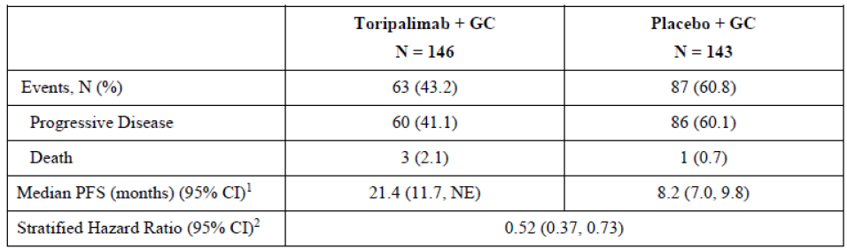
¹ Strata are performance status and disease stage.
² Crossed the boundary of 0.010 adjusted for 128 observed PFS events, for the interim analysis.
Abbreviation: CI = confidence interval, IRC = independent review committee, NE = not estimable, OS = overall survival, PFS = progression free survival.
Figure 1: JUPITER-02 final analysis of IRC determined progression free survival
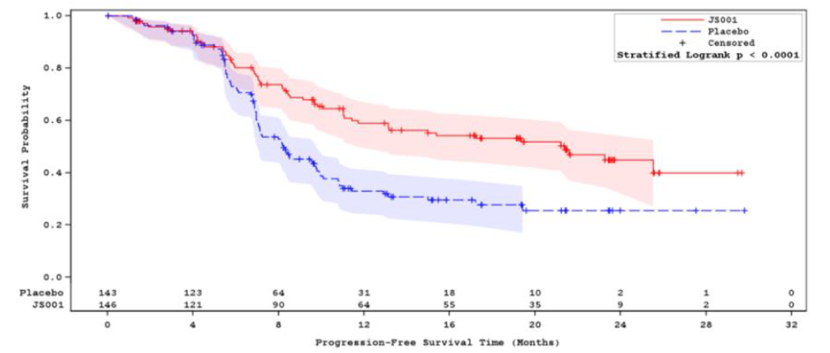
JS001 = toripalimab

Secondary endpoint – overall response rate
The difference in IRC determined response rates between the toripalimab and placebo arms, per RECIST v1.1, was statistically significant. Overall response rate of 77.4% in the toripalimab and 66.4% in the placebo arms, with a difference in ORR of 10.8%, p = 0.0335 (data cut-off 30 May 2020).
In the post hoc analysis (data cut-off 8 June 2021), IRC determined ORR was 78.8% and 67.1% in the toripalimab and placebo arms, respectively, which was similar to that seen at the time of the definitive analysis of ORR; however, IRC determined DoR was considerably longer with a median DoR of 18.0 months in the toripalimab and 6.0 months in the placebo arm as compared to the previous analysis.

Secondary endpoint – overall survival
The final analysis of OS demonstrated a clinically meaningful and statistically significant improvement in OS with the addition of toripalimab. The median OS was not estimable in the toripalimab arm (lower bound of the 95% CI 38.7 months) and 33.7 months in the placebo arm with a HR of 0.63 (95% CI: 0.45, 0.89), p = 0.0083.
Table 4: JUPITER-02 key secondary endpoints
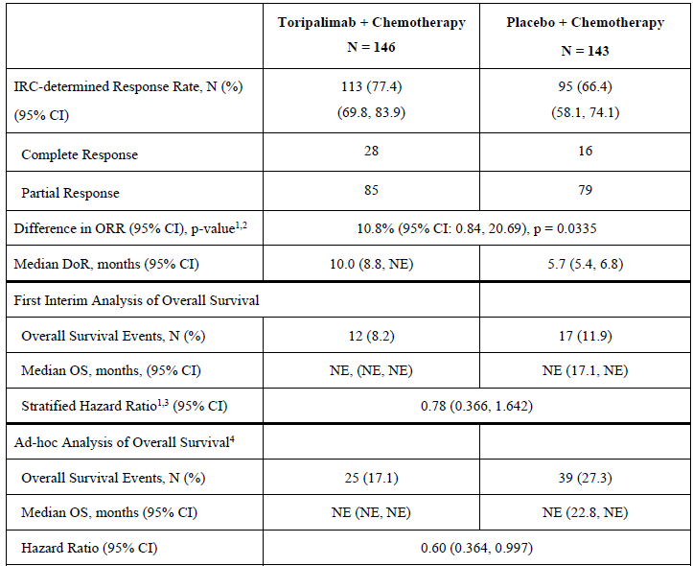
¹ Strata are performance status and disease stage
² Stratified Cochran-Mantel-Haenszel test
³ Cox proportional hazards model
⁴ Data cut-off date 18 February 2021
Abbreviations: CI = confidence interval, DoR = duration of response, IRC independent review committee, NE = not estimable, ORR = objective response rate, OS = overall survival.
Table 5: JUPITER-02 final analysis of overall survival
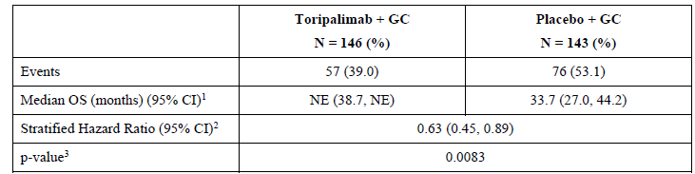
¹ Median OS was estimated using the Kaplan-Meier method. The Brookmeyer-Crowley method was used to construct the 95% confidence interval. Data cut-off 18 November 2022.
² The hazard ratio and its 95% confidence intervals were estimated using the Cox proportional hazards model using the stratification factors at randomisation.
³ The log rank test was used to determine the p-value.
Abbreviations: CI = confidence interval, GC = gemcitabine/cisplatin, NE = not estimable, OS = overall survival.
Figure 2: JUPITER 02 final analysis of overall survival
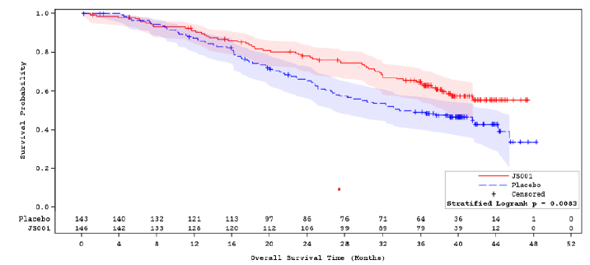
JS001 = toripalimab

POLARIS-02/Cohort 7
This was a Phase II, multiple cohort, activity estimating trial comprising 8 cohorts.
Supportive evidence of the clinical efficacy and safety of toripalimab as first line treatment in patients with recurrent/metastatic NPC is from data from 12 patients in Cohort 7 of POLARIS-02. Cohort 7 enrolled patients with NPC who had received no prior systemic therapy for recurrent or metastatic disease. Patients received toripalimab 240 mg or 360 mg IV once every 3 weeks in combination with cisplatin 80 mg/m² IV once every 3 weeks and gemcitabine 1000 mg/m² IV Days 1 and 8 then once every 3 weeks. The primary endpoint, investigator determined objective response rate per RECIST v1.1 was 75.0% (95% CI: 42.8, 94.5). The key secondary endpoint, median duration of response was 7.1 months (95% CI: 4.2, 15.3).
Given the low patient numbers, it is not considered that these data materially alter the efficacy assessment derived from JUPITER-02.

POLARIS-02/Cohort 3
The primary evidence to support the clinical efficacy of toripalimab in patients with recurrent or metastatic NPC following platinum-based therapy is from 172 patients in Cohort 3 of POLARIS-02 who received toripalimab monotherapy. This study was conducted in China.
Key inclusion criteria included adult patients (18 to 75 years) with recurrent NPC or metastatic NPC, who have previously received at least one prior line of treatment (including, but not limited to, chemotherapy or radio-chemotherapy) for advanced NPC with disease progression or who were intolerant to existing treatment regimens. Under version 5.0 of the protocol, eligibility for the NPC cohort was limited to patients who received at least two prior lines of treatment (including, but not limited to, chemotherapy or chemoradiotherapy) for advanced NPC with disease progression or who were intolerant existing treatment regimens.
Treatment with toripalimab was at 3 mg/kg IV once every 2 weeks. In 172 patients who had received prior platinum-based therapy, the IRC determined response rate was 20.9% (95% CI: 15.1, 27.8) and the IRC determined median DoR was 14.9 months (95% CI: 10.3, not estimable (NE))
Table 6: POLARIS-02/Cohort 3 independent review committee determined objective response rate and duration of response
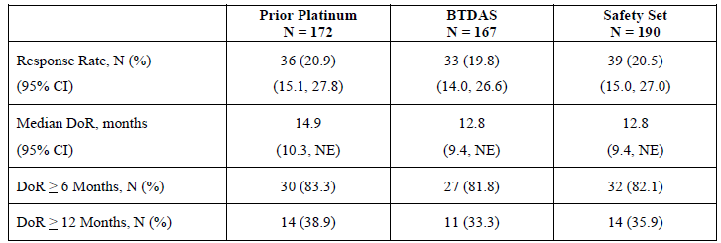
Abbreviations: CI = confidence interval, DoR = duration of response, IRC = independent review committee, NE = not estimable.

Efficacy conclusions
- The incidence of NPC is substantially higher in Southeast Asia relative to Australia.
- Although the epidemiologic data is not strong, the pattern of disease is expected to be similar to the US where a higher proportion of NPC patients develop the keratinising squamous subtype compared with China, where the vast majority of patients develop the non-keratinising undifferentiated subtype.
- The prognosis of metastatic NPC remains poor, characterised by a median OS of 21 to 29 months.
- There are no TGA approved therapies specifically for NPC.
- Standard of care therapy consists of first line chemotherapy with cisplatin plus gemcitabine. Usual treatment in second line and beyond is with single agent regimens; however, the clinical data supporting use are predominantly from small, single arm trials. Metastatic NPC represents a life-threatening disease with an unmet medical need.
- The design, methodology and sample size of the pivotal trials included in this submission are considered adequate to assess efficacy of toripalimab.
- The primary endpoint of PFS is a recognised regulatory endpoint and is supported by overall survival and ORR data.
- The 13.2-month improvement in median PFS demonstrated in JUPITER-02 is considered clinically meaningful in this disease setting. These results, supported by a statistically significant improvement in ORR, along with a longer median DoR in the toripalimab plus chemotherapy arm versus the placebo plus chemotherapy arm provide substantial evidence of effectiveness for toripalimab, in combination with cisplatin and gemcitabine, for the first line treatment of adults with metastatic or with recurrent, locally advanced NPC.
- The final analysis of OS, based on data cut-off 18 November 2022 demonstrated a clinically meaningful and statistically significant improvement in OS with the addition of toripalimab. The median OS was not estimable in the toripalimab arm (lower bound of the 95% CI, 38.7 months) and 33.7 months in the placebo arm with a HR of 0.63, p = 0.0083.
- POLARIS-02/Cohort 3, a multicohort trial, included 190 patients with previously treated recurrent unresectable or metastatic NPC, including 172 patients with disease progression on or after platinum-based chemotherapy (platinum treated analysis set (PTAS), efficacy population), who received toripalimab 3 mg/kg once every 2 weeks as a single agent.
- In the PTAS set of POLARIS-02/Cohort 3, the ICR assessed ORR was 21% (95% CI: 15, 28), with a median DoR of 14.9 months (95% CI: 10.3, NE). Among the 36 patients with an objective response, 83% had DoR of ≥ 6 months and 39% had DoR of ≥ 12 months.
- This result is considered clinically meaningful given the unmet need in the intended population.
- A limitation of the data is that the two primary trials supporting this application were conducted exclusively in Asia. JUPITER-02 had clinical sites only in China, Taiwan and Singapore, while POLARIS-02 was conducted exclusively in China, and all patients enrolled in both studies were Asian patients.
- Therefore, the patient population in the trials are not reflective of the racial and ethnic diversity of patients with NPC in Australia.

Safety
The review of the safety profile of toripalimab 240 mg once every 3 weeks in combination with cisplatin and gemcitabine as first line treatment for locally recurrent or metastatic NPC was based on data from 146 patients treated with toripalimab 240 mg once every 3 weeks in JUPITER-02.
The primary safety analysis populations for the review of the safety profile of toripalimab as a single agent were 190 patients with previously treated NPC in POLARIS-02/Cohort 3 who received toripalimab 3 mg/kg and a pooled safety dataset of 851 patients with various advanced solid tumours who received toripalimab as a single agent at a dose of 3 mg/kg once every 2 weeks across multiple clinical trials (this represents a subset of the sponsor’s originally submitted pooled dataset of 1066 patients because some of these patients received toripalimab at doses ranging from 0.3 mg/kg once every 2 weeks to 10 mg/kg once every 2 weeks and from 80 mg once every 2 weeks to 480 mg once every 2 weeks).

Adverse events
The most common adverse events (all grades) in JUPITER-02 for the toripalimab and gemcitabine/cisplatin arm were nausea (69.2%), vomiting (67.1%), decreased appetite (53.4%), constipation (39.0%), fatigue (35.6%), hypothyroidism (30.8%), pyrexia (30.8%), rash (27.4%), diarrhoea (30.1%), and peripheral neuropathy (30%). In the placebo and gemcitabine/cisplatin arm the most common adverse events were nausea (83.2%), vomiting (65.7%), decreased appetite (58.7%), constipation (44.8%), fatigue (35.7%), and peripheral neuropathy (28.7%) (Table 7).
In POLARIS-02/Cohort 3 the most common adverse events were hypothyroidism (25%), asthenia (22%), musculoskeletal pain (18%), cough (17%), and pyrexia (16%).
The most common adverse events ≥ Grade 3 in JUPITER-02 for the toripalimab and gemcitabine/cisplatin arm were pneumonia (10.3%), upper respiratory tract infection (3.4%), and rash (3.4%). In the placebo and gemcitabine/cisplatin arm the most common adverse events ≥ Grade 3 were pneumonia (3.5%), and nausea (2.8%) (Table 7).
Table 7: Treatment-emergent adverse events in greater than 10% of patients in JUPITER-02
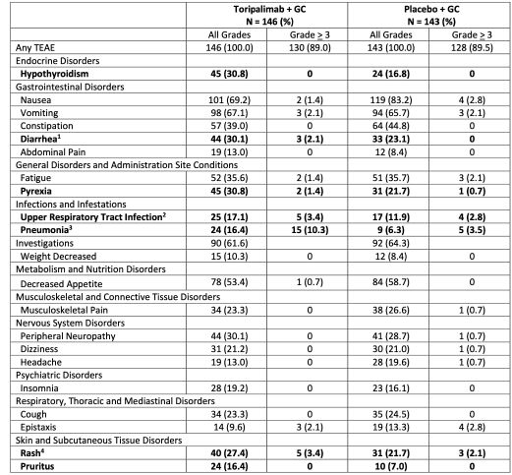
¹ Includes diarrhea, gastroenteritis
² Includes acute sinusitis, bronchitis, laryngitis, nasopharyngitis, pharyngitis, rhinitis, sinusitis, and upper respiratory tract infection
³ Includes pneumonia and aspiration pneumonia
⁴ Includes drug eruption, erythema, maculopapular rash, papule, pruritic rash, and rash

Deaths
In JUPITER-02, there was one death in the toripalimab arm and 2 deaths in the placebo arm within 30 days of the last dose. Adverse events accounted for 2 of the deaths (one in each arm) while one (placebo arm) was due to disease progression. In POLARIS-02/Cohort 3, 9 (4.7%) deaths occurred within 30 days of the last dose of toripalimab. Adverse events were the most common cause of death accounting for 6 of the 9 deaths.
In the toripalimab arm, epistaxis was the only death that occurred within 30 days of the last dose of study drug. There were 3 additional deaths attributed to an adverse event that occurred more than 30 days after the last dose of toripalimab. These were a death due to intracranial haemorrhage that occurred 61 days after the last dose of toripalimab that was related to an ongoing autoimmune event; a death due to disease progression that occurred 60 days after the last dose of toripalimab in a patient with documented progression; and a death that occurred 48 days after the last dose of toripalimab that was reported using the adverse event term death not otherwise specified.

Serious adverse events
Serious adverse events occurred in JUPITER-02 in 43.2% of patients in the toripalimab arm versus 43.4% in the placebo arm.
In the toripalimab arm, the most common serious adverse events (≥ 2%) were thrombocytopenia (14%), decreased neutrophil count (10%), pneumonia (10%), anaemia (9%), abnormal hepatic function (2.7%), and rash (2.1%).
In POLARIS-02/Cohort 3, 25% of patients had one or more serious adverse event. The most common serious adverse event (≥ 2%) included pneumonia (4.7%), hepatic function abnormal (2.6%), and hyperbilirubinemia (2.1%).

Discontinuation due to adverse events
In JUPITER-02 discontinuation due to adverse events occurred in 11.6% of patients in the toripalimab arm versus 2.9% in the placebo arm.
The most common causes of permanent discontinuation of toripalimab in ≥ 1% of patients were pneumonia (2.1%), pulmonary tuberculosis (1.4%) and rash (1.4%).
In POLARIS-2/Cohort 3, 8.9% of patients had an adverse event that resulted in permanent discontinuation.
In the toripalimab monotherapy safety dataset 12.1% of patients had an adverse event that resulted in permanent discontinuation.

Dose interruption due to adverse events
In JUPITER-02 dose interruption due to adverse events occurred in 50.0% of patients in the toripalimab arm versus 48.3% in the placebo arm.
In POLARIS-02/Cohort 3 dose interruption due to adverse events occurred in 23% of patients.
In the pooled safety set dose interruption due to adverse events occurred in 19% of patients.

Haematology/clinical chemistry
Laboratory abnormalities seen in > 20% of patients in JUPITER-02 are shown in the table below (Table 8).
Table 8: Worsening laboratory abnormalities from Baseline occurring in ≥ 20% of patients in the toripalimab arm of JUPITER-02
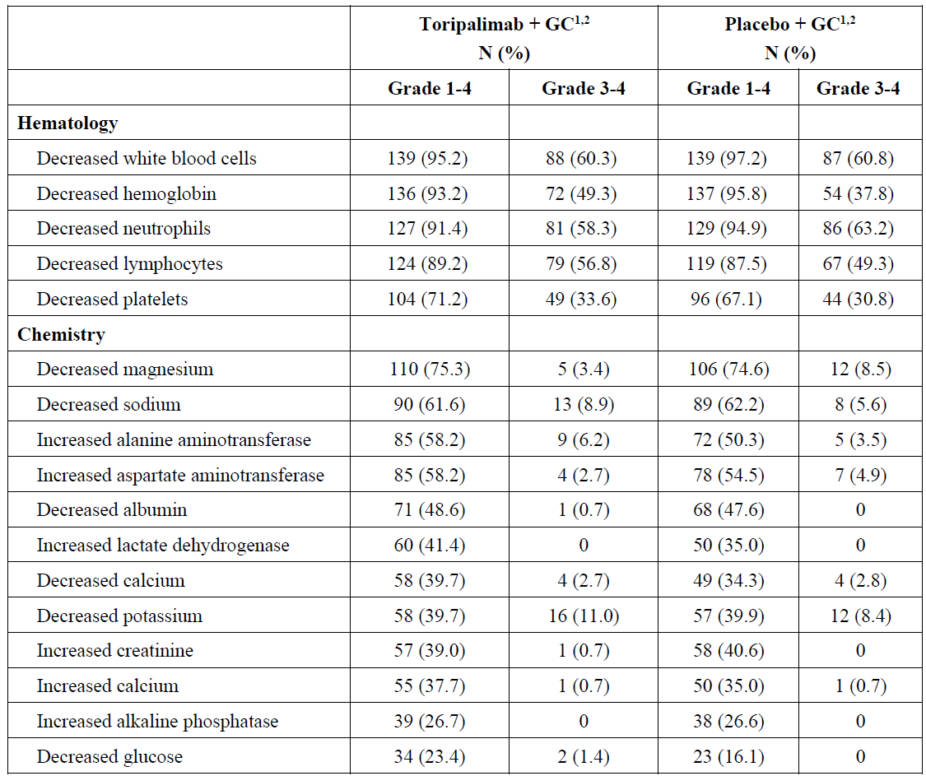
² Calculations are based on the actual number of patients with baseline and ≥ 1 post-baseline value.
Laboratory abnormalities seen in > 10% of patients in POLARIS-02/Cohort 3 are shown in the table below (Table 9).
Table 9: Worsening laboratory abnormalities in > 10% of patients in POLARIS-02/Cohort 3
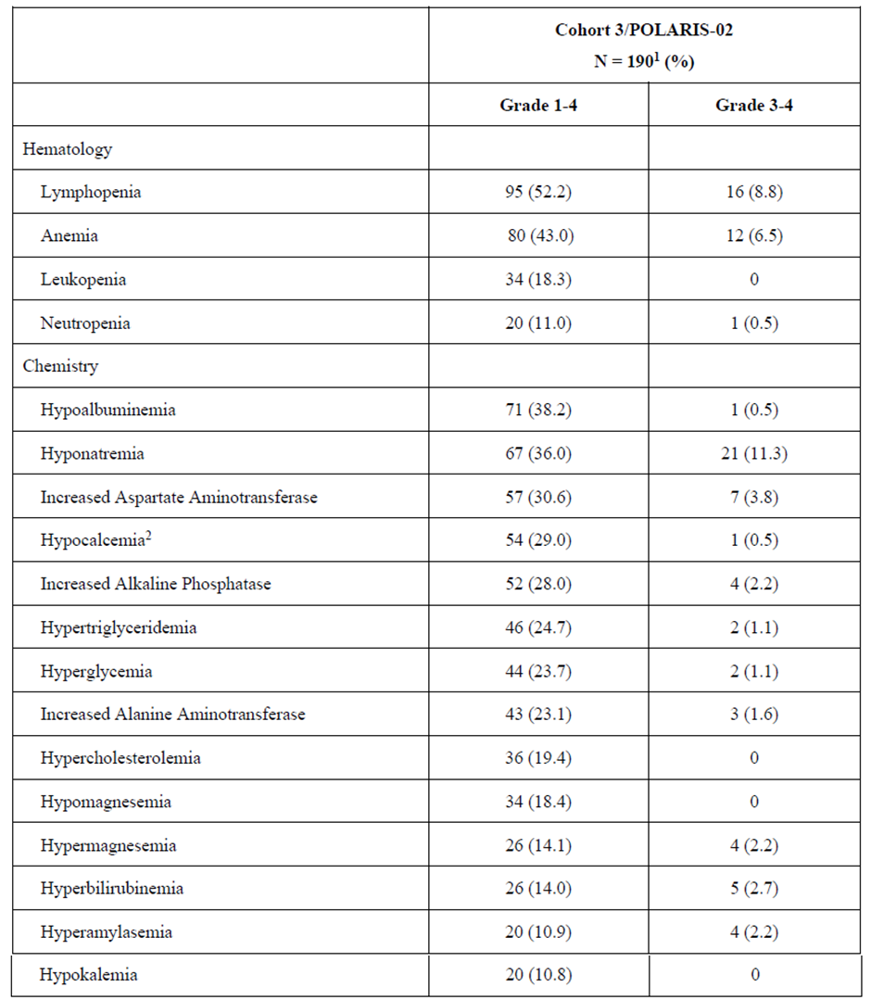
¹ Calculation are based on the actual number of patients with baseline and on study values.
² Uncorrected calcium.

Immune related adverse events
The most significant adverse events in patients treated with PD-1/L1 inhibitors are immune related adverse events. The development of immune related adverse events was expected based on the mechanism of action of the drug. Frequencies of immune related adverse events are shown in Table 10 and Table 11 below.
Table 10: JUPITER-02 applicant adjudicated immune related adverse events
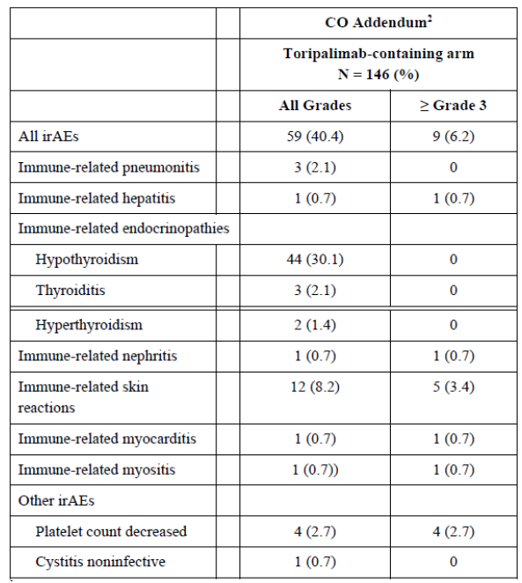
Table 11: Immune related adverse events in the toripalimab arm of JUPITER-02 and in the pooled safety dataset of toripalimab monotherapy
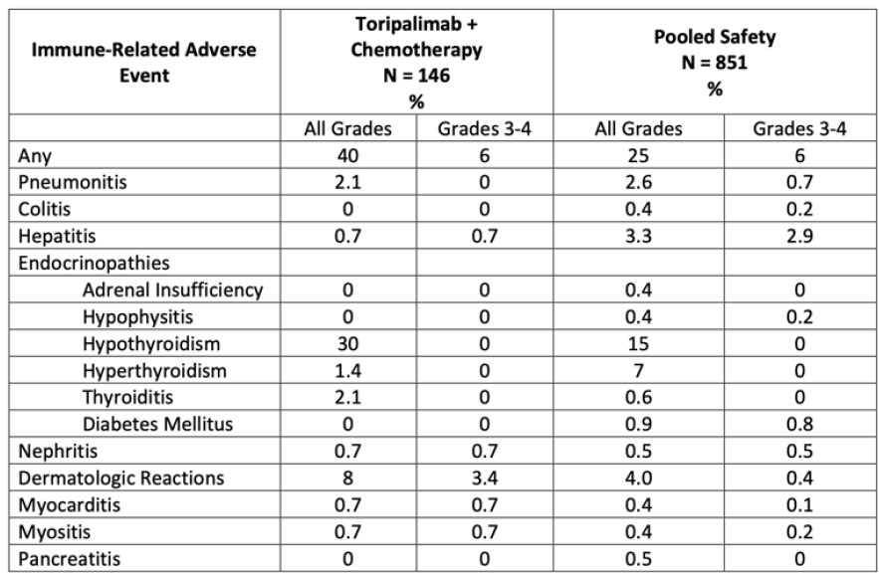
Infusion related adverse events have been reported in 4.1% of patients receiving toripalimab in combination with cisplatin and gemcitabine, including Grade 2 (0.7%) reactions. Infusion related adverse events occurred in 2% of 851 patients receiving toripalimab as a single agent, including Grade 3 (0.1%) and Grade 2 (0.6%). Toripalimab was withheld for one Grade 3 infusion related adverse event.

Immunogenicity
The incidence of anti-drug antibodies (ADA) among patients in POLARIS-02/Cohort 3 who received toripalimab monotherapy was 7 out of 190 (3.7%). In the PTAS population of POLARIS-02/Cohort 3, the ORR was 28.6% in those with ADA and 20.6% in those without ADA.
Among the 206 patients who received toripalimab in combination with platinum-based therapy, 8 (3.9%) developed ADA. The incidence of infusion related reaction was 1 out of 8 (12.5%) in those with ADA and 10 out of 198 (5.1%) in those without. When toripalimab was given in combination with cisplatin and gemcitabine in JUPITER-02, ADA was detected in 5 out of 146 (3.4%) patients. In the toripalimab arm of JUPITER-02, the ORR was 60.0% in those with ADA and 78.0% in those without.
Due to the low incidence of ADAs no conclusion can be made on the impact on efficacy.

Safety conclusions
- The evidence for clinical safety generated from JUPITER-02, POLARIS-02/Cohort 3 and the pooled safety dataset are considered adequate to assess the safety of toripalimab in the proposed indications.
- In JUPITER-02, the most frequent adverse events (≥ 20%) were nausea, vomiting, decreased appetite, constipation, hypothyroidism, rash, pyrexia, diarrhea, peripheral neuropathy, cough, musculoskeletal pain, upper respiratory infection, insomnia, malaise, and dizziness. In POLARIS-02/Cohort 3 the most frequent adverse events (≥ 20%) were hypothyroidism, fatigue, and cough. In the pooled safety dataset (n = 851), the most frequent adverse events (≥ 20%) were hypothyroidism, fatigue, and musculoskeletal pain.
- Discontinuation of toripalimab due to adverse events occurred in 12% of patients in JUPITER-02, and in 9% and 12.1% of patients in the POLARIS-02/Cohort 3 trial and the safety pooled dataset, respectively. In JUPITER-02, the most frequent adverse events leading to toripalimab discontinuation (≥ 1%) were pneumonia, pulmonary tuberculosis, rash, vomiting, and thrombocytopenia. In POLARIS-02/Cohort 3, the most frequent adverse events leading to toripalimab discontinuation (≥ 1%) were pneumonia, abnormal hepatic function, and hyperbilirubinemia.
- Adverse events leading to toripalimab dose interruptions occurred in 50%, 20%, and 19% of patients in JUPITER-02, POLARIS-02/Cohort 3, and the pooled safety dataset, respectively. In JUPITER-02, the most frequent adverse events leading to dose interruptions (≥ 2%) were anaemia, decreased neutrophil count, thrombocytopenia, pneumonia, acute kidney injury, fatigue, upper respiratory tract infection, and hypothyroidism. In POLARIS-02/Cohort 3, the most frequent adverse events leading to dose interruptions (≥ 1%) were pneumonia, thrombocytopenia, fatigue, hyperbilirubinemia, anaemia, decreased appetite, abnormal hepatic function abnormal, hypothyroidism, and pneumonitis.
- A review of deaths due to adverse events in JUPITER-02, POLARIS-02/Cohort 3, and the pooled safety dataset did not identify an unexpected safety signal relative to other agents in this class.
- Serious adverse events occurred in 43%, 24.9%, and 23% of patients in JUPITER-02, POLARIS-02/Cohort 3, and the pooled safety dataset respectively. In JUPITER-02, the most frequent serious adverse events (≥ 2%) were thrombocytopenia, decreased neutrophil count, pneumonia, anaemia, abnormal hepatic function, and rash. In POLARIS-02/Cohort 3, the most frequent serious adverse events (≥ 2%) were pneumonia, abnormal hepatic function abnormal, and hyperbilirubinemia.
- Immune related adverse events occurred in 40% (Grades 3 to 4, 6%) and 27.3% of patients (Grades 3 to 5, 6%) in JUPITER-02 and in the pooled safety dataset, respectively. In JUPITER-02, the most frequent immune related adverse events (≥ 2%) were hypothyroidism, dermatologic reactions, pneumonitis, and thyroiditis. In the pooled safety dataset, the most frequent immune related adverse events (≥ 2%) were hypothyroidism, hyperthyroidism, dermatologic reactions, hepatitis, and pneumonitis. Two patients in the pooled dataset had fatal immune related pneumonitis. Overall, the observed incidence of immune related adverse events was similar to that reported for other agents in this class, with the exception of a higher incidence of hypothyroidism, which is most likely related to the high proportion of patients who had received prior radiation as treatment for NPC.
- Infusion related reactions have been reported in 4.1% of patients receiving toripalimab in combination with cisplatin and gemcitabine, including Grade 2 (0.7%) reactions.
- Infusion related reactions occurred in 2% of 851 patients receiving toripalimab as a single agent, including Grade 3 (0.1%) and Grade 2 (0.6%). Toripalimab was withheld for one Grade 3 infusion related reaction.
- In JUPITER-02, the most frequent Grade 3 to 4 laboratory abnormalities (≥ 2%) were decreased neutrophils, decreased lymphocytes, decreased haemoglobin, decreased platelets, decreased potassium, decreased sodium, increased alanine aminotransferase, decreased magnesium, decreased calcium and increased aspartate aminotransferase. In POLARIS-02/Cohort 3, the most frequent Grade 3 to 4 laboratory abnormalities (≥ 2%) were decreased lymphocytes, decreased sodium, decreased haemoglobin, increased aspartate aminotransferase and increased alkaline phosphatase. In the pooled monotherapy safety dataset, the most frequent Grade 3 to 4 laboratory abnormalities (≥ 2%) were decreased sodium, decreased lymphocytes, decreased haemoglobin, decreased fibrinogen, increased lipase, increased aspartate aminotransferase, increased glucose and decreased phosphate.
- The safety profile of toripalimab was similar to other PD-1 blocking antibodies when combined with platinum-based chemotherapy or administered as a monotherapy. The most significant adverse reactions include immune related adverse events. Toripalimab, in combination with cisplatin or gemcitabine or as a monotherapy, appears to have an acceptable safety profile when assessed in the context of a life-threatening disease with unmet medical need.
- Patients in clinical practice may have a lower performance status than those enrolled in clinical trials and could potentially experience greater toxicity.
- A limitation of the data is that the two primary trials supporting this marketing application were conducted exclusively in Asia. JUPITER-02 had clinical sites only in China, Taiwan and Singapore, while POLARIS-02 was conducted exclusively in China, and all patients enrolled in both studies were Asian patients.
- Therefore, the patient population in the trials is not reflective of the racial and ethnic diversity of patients with NPC in Australia.

Recommendation following the clinical evaluation
The clinical data supports a positive risk-benefit assessment and is supportive of approval for toripalimab for the following indications:
- Toripalimab is indicated, in combination with cisplatin and gemcitabine, for the first-line treatment of adults with metastatic or with recurrent, locally advanced nasopharyngeal carcinoma (NPC),
- Toripalimab is indicated, as a single agent, for the treatment of adults with recurrent unresectable or metastatic NPC with disease progression on or after a platinum-containing chemotherapy.

Risk management plan
The sponsor has submitted European Union (EU) Risk Management Plan (RMP) version 1.2 (date 8 August 2023; data lock point (DLP) 16 December 2022) and Australia-Specific Annex (ASA) version 0.1 (date not provided) in support of this application. With the sponsors responses to TGA questions, the sponsor provided EU-RMP version 1.4.1 (date 13 June 2024; DLP 16 December 2022) and an updated ASA version 0.2 (date 13 June 2024).
The summary of safety concerns and their associated risk monitoring and mitigation strategies are summarised in Table 12. The TGA may request an updated RMP at any stage of a product's life cycle, during both the pre-approval and post-approval phases.
Table 12: Summary of safety concerns
Summary of safety concerns |  | Pharmacovigilance |  | Risk Minimisation
 |  | Routine | Additional | Routine | Additional
Important identified risks | Immune related adverse reactions (ARs) (including immune-related pneumonitis, colitis and diarrhoea, hepatitis, myocarditis, nephritis, endocrinopathies, pancreatitis, myositis, skin ARs, and other immune-related reactions) | ü | – | ü | ü†
Important identified risks | Solid organ transplant rejection | ü | – | ü | –
Important potential risks | Graft-versus-host-disease (GVHD) with toripalimab after allogeneic  hematopoietic stem cell transplantation  (HSCT) | ü | – | ü | –
Important potential risks | Embryotoxicities | ü | – | ü | –
Missing information | Safety during breast feeding* | ü | – | ü | –
*Australia-specific safety concern
† Patient Alert Card
The summary of safety concerns is identical to that included in EU-RMP version 1.4.1, except for the Australia-specific missing information of safety during breast feeding. This summary of safety concerns is acceptable from an RMP perspective.
The pharmacovigilance plan is acceptable from an RMP perspective.
The risk minimisation plan proposed in the EU includes a Patient Alert Card as an additional risk minimisation activity. The previous version of the EU-RMP had a Patient Guide and the sponsor has provided a draft Patient Guide. The contents of the Patient Guide are very similar to the contents of the Patient Alert Card. Thus, the sponsor is advised that not implementing the Patient Guide in Australia, in line with the approach in the EU, is acceptable.
The RMP evaluation recommended conditions of registration relating to the versions of the risk management plan, requirement for periodic safety update reports, and inclusion of the medicine in the Black Triangle Scheme.

Risk-benefit analysis

Delegate’s considerations
Toripalimab is a humanised modified IgG4κ monoclonal antibody specific against human programmed death-1 (PD-1), a co-inhibitory receptor expressed on T cells.

Proposed indication
The sponsor proposes to register toripalimab, a new therapeutic entity, for the following indications:
Tuoyi is indicated, in combination with cisplatin and gemcitabine, for the first-line treatment of adults with metastatic or with recurrent, locally advanced nasopharyngeal carcinoma (NPC).
Tuoyi is indicated, as a single agent, for the treatment of adults with recurrent unresectable or metastatic NPC with disease progression on or after a platinum-containing chemotherapy.
The proposed/recommended dosage is as follows:
Table 13: Recommended dosage of Tuoyi
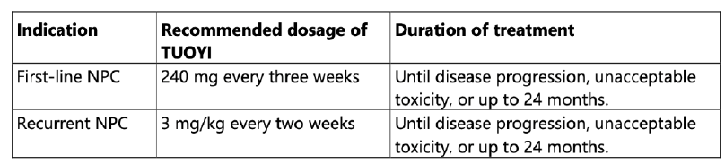

Benefits/uncertainties of benefit
The sponsor has provided adequate evidence of effectiveness and benefit to support approval of toripalimab for the proposed indications.

JUPITER-02 summary
- JUPITER-02 is a Phase III, double blind, placebo-controlled trial.
- A total of 289 patients with recurrent locally advanced or primary metastatic NPC who have not received prior systemic therapy for advanced disease were randomised 1:1 to toripalimab 240 mg IV once every 3 weeks in combination with 6 cycles of cisplatin/gemcitabine followed by toripalimab 240 mg IV once every 3 weeks (n = 146) or to placebo with cisplatin/gemcitabine followed by placebo once every 3 weeks (n = 143).
- The primary endpoint was PFS by IRC in the intent-to-treat population
  - Statistically significant improvement in PFS in the toripalimab arm, with a HR of 0.52 (95% CI 0.37, 0.73), corresponding to a median PFS of 21.4 months (95% CI: 11.7, NE) in the toripalimab in combination with cisplatin and gemcitabine arm and 8.2 months (95% CI: 7.0, 9.8) in the placebo in combination with cisplatin and gemcitabine arm.
- Secondary end points included ORR and DoR. Response rates were 77.4% and 66.4% in the toripalimab and placebo arms respectively, p = 0.03 and were accompanied by a median duration of response of 10.0 months in the toripalimab and 5.7 months in the placebo arm.
- Statistically significant improvement in OS with a HR of 0.63 (95% CI: 0.45, 0.89, p = 0.0083), with median OS not reached (95% CI: 38.7, NE) in the toripalimab in combination with cisplatin and gemcitabine treatment arm and 33.7 months (95% CI: 27.0, 44.2) in the placebo with cisplatin and gemcitabine arm.

POLARIS-02 summary
- POLARIS-02 is a Phase II, multiple cohort, activity estimating trial comprising 8 cohorts.
- Cohort 3 enrolled 190 adult patients with NPC recurrent or metastatic disease NPC and to have received at least 2 prior systemic regimens for advanced NPC or be intolerant to such therapy. A total of 172 patients who had received prior platinum-based therapy were treated with toripalimab 3 mg/kg once every 2 weeks as a single agent; the IRC determined response rate was 20.9% (95% CI: 15.1, 27.8) and the IRC determined median duration of response was 14.9 months (95% CI: 10.3, NE).
- Among the 36 patients with an objective response, 83% had DoR of ≥ 6 months and 39% had DoR of ≥ 12 months.
- Cohort 7 enrolled 12 patients with NPC who had received no prior systemic therapy for recurrent or metastatic disease. Investigator determined objective response rate per RECIST v1.1 was 75.0% (95% CI: 42.8, 94.5). The median duration of response was 7.1 months (95% CI: 4.2, 15.3).

Uncertainties
A limitation of the data is that the two primary trials supporting this marketing application were conducted exclusively in Asia. JUPITER-02 had clinical sites only in China, Taiwan and Singapore, while POLARIS-02 was conducted exclusively in China, and all patients enrolled in both studies were Asian patients. Therefore, as highlighted in the evaluation, the patient population in the trials is not totally reflective of the racial and ethnic diversity of patients with NPC in the Australia and the US. In addition, patients with NPC with keratinising histology are significantly underrepresented relative to the expected incidence of this histology in a US population of patients with NPC.
However, the following commentary in the Project Orbis evaluation is noted:
While both JUPITER-02 and POLARI-02 were conducted exclusively in Asia, a flexible regulatory approach is warranted given the high unmet need and lack of FDA-approved therapies for US patients with NPC. The Applicant will be collecting additional clinical data to further characterize the safety and efficacy of toripalimab in combination with cisplatin and gemcitabine for the treatment of NPC in a study population whose demographic and disease characteristics are more representative of the population of U.S. patients with NPC.
This approach would similarly apply in the Australian context. If registration for toripalimab is TGA approved, the Delegate proposes the following additional condition of registration to further inform clinical efficacy and safety that would be relevant for the Australian population:
- Conduct a clinical trial enrolling a total sample size of 100 patients in the US and Canada, that includes a sufficient representation of patients in racial and ethnic minority subgroups and is reflective of the US population of patients with nasopharyngeal carcinoma (NPC), to further characterise the safety and efficacy of toripalimab in combination with cisplatin and gemcitabine in these patients. Include a sufficient number of patients with the keratinising subtype reflecting the incidence of keratinising NPC in the US population. Conduct sparse sampling for supportive population pharmacokinetic and exposure response (ER) analyses. The ER analyses may be used as supportive evidence for the efficacy and safety in the intended patient population. In the ER analyses report, include an analysis of the presence and clinical impact of the neutralising anti-drug antibodies on pharmacokinetics, efficacy and safety of toripalimab.
Due to the low incidence of ADAs no conclusion can be made on their impact on efficacy.

Risks/uncertainties of risk
The overall safety profile of toripalimab was similar to that observed with other PD-1 blocking antibodies. Safety issues identified as significant and serious were immune related adverse events and infusion related reactions, which are adequately addressed by the information in the Warnings and Precautions and Dosage Modifications sections included in the (Product Information (PI)). Toripalimab appears to have an acceptable safety profile when assessed in the context of a life-threatening disease with unmet medical need.

Uncertainties
Due to the low incidence of ADAs no conclusion can be made on the impact on safety.

Benefit/risk balance
The improvement in PFS and OS demonstrated in JUPITER-02 for patients with metastatic or recurrent, locally advanced NPC in the first line treatment setting are considered to be clinically meaningful, and the safety profile acceptable, in the context of this life-threatening disease:
- Statistically significant improvement in IRC assessed PFS favouring the toripalimab arm, with a HR of 0.52 (95% CI 0.37, 0.73), corresponding to a median PFS of 21.4 months (95% CI: 11.7, NE) in the toripalimab in combination with cisplatin and gemcitabine arm and 8.2 months (95% CI: 7.0, 9.8) in the placebo in combination with cisplatin and gemcitabine arm.
- Statistically significant improvement in OS with a HR of 0.63 (95% CI: 0.45, 0.89, p = 0.0083), with median OS not reached (95% CI: 38.7, NE) in the toripalimab in combination with cisplatin and gemcitabine treatment arm and 33.7 months (95% CI: 27.0, 44.2) in the placebo with cisplatin and gemcitabine arm.
Likewise, POLARIS-02 provided evidence in support of treatment with toripalimab in patients with unresectable/metastatic NPC with disease progression on or after platinum-containing chemotherapy. The ICR assessed ORR was 21% (95% CI: 15, 28), with a median DoR of 14.9 months (95% CI: 10.3, NE). Among the 36 patients with an objective response, 83% had DoR of ≥ 6 months and 39% had DoR of ≥ 12 months. These results are considered clinically meaningful when considering the intended patient population, and the results of the JUPITER-02 study provide further confidence in the benefit of toripalimab for the treatment of patients with advanced NPC.
Despite some uncertainty in the applicability of the trial data generated in Asia to the Australian population, the Delegate’s opinion is that overall, approval of toripalimab for the proposed indications are warranted in view of the high unmet need and lack of TGA approved therapies for the relevant patient population in Australia. The comparator arm of cisplatin plus gemcitabine used in the JUPITER-02 study is considered standard of care for the first-line treatment of patients with NPC in Australia and is therefore applicable to Australian medical practice. The incidence of NPC is much higher in Southeast Asia (relative to countries such as United States and Australia, where NPC is a relatively rare disease), making enrolment to clinical trials more feasible in that region of the world. The clinical evaluation report confirms that clinical site inspections were conducted by the FDA to validate the data supporting this application.
A condition of registration for the submission of additional clinical data of toripalimab in combination with cisplatin and gemcitabine for the treatment of NPC in the US/Canadian population would further inform clinical efficacy and safety as relevant for the Australian population.
In addition, it is notable that the combination of toripalimab and cisplatin/gemcitabine in the 1L setting, and toripalimab monotherapy (if disease progression on or after platinum-containing therapy) in the 2L/subsequent setting, are now recommended standards of care for patients with unresectable/metastatic NPC in international treatment guidelines (that is, National Comprehensive Cancer Network v4.2024 Head and Neck Cancers May 1 2024).
Presently, the risk-benefit assessment of toripalimab is considered to be favourable for the proposed population.

Proposed action
The risk-benefit assessment for toripalimab is considered to be favourable; the Delegate supports registration of toripalimab for the following indications:
Toripalimab is indicated, in combination with cisplatin and gemcitabine, for the first-line treatment of adults with metastatic or with recurrent, locally advanced nasopharyngeal carcinoma (NPC),
Toripalimab is indicated, as a single agent, for the treatment of adults with recurrent unresectable or metastatic nasopharyngeal carcinoma (NPC) with disease progression on or after a platinum-containing chemotherapy.

Assessment outcome
Based on a review of quality, safety, and efficacy, the TGA decided to register Tuoyi (toripalimab) 240 mg/6 mL, concentrated injection, vial, indicated for:
Tuoyi is indicated, in combination with cisplatin and gemcitabine, for the first-line treatment of adults with metastatic or recurrent, locally advanced nasopharyngeal carcinoma (NPC).
Tuoyi is indicated, as a single agent, for the treatment of adults with recurrent unresectable or metastatic nasopharyngeal carcinoma (NPC) with disease progression on or after a platinum-containing chemotherapy.

Specific conditions of registration
- Tuoyi (toripalimab) is to be included in the Black Triangle Scheme. The PI and CMI for Tuoyi must include the black triangle symbol and mandatory accompanying text for five years, which starts from the date of first supply of the product.
- The Tuoyi EU-Risk Management Plan (RMP) (version 1.4.1, dated 13 June 2024; DLP 16 December 2022), with Australia Specific Annex (version 0.2, dated 13 June 2024), included with submission PM-2023-04783-1-4, and any subsequent revisions, as agreed with the TGA will be implemented in Australia.
- An obligatory component of risk management plans is routine pharmacovigilance. Routine pharmacovigilance includes the submission of periodic safety update reports (PSURs).
Unless agreed separately between the supplier who is the recipient of the approval and the TGA, the first report must be submitted to TGA no later than 15 calendar months after the date of the approval letter. The subsequent reports must be submitted no less frequently than annually from the date of the first submitted report until the period covered by such reports is not less than three years from the date of the approval letter. The annual submission may be made up of two PSURs each covering six months. If the sponsor wishes, the six-monthly reports may be submitted separately as they become available.
If the product is approved in the EU during the three years period, reports can be provided in line with the published list of EU reference dates no less frequently than annually from the date of the first submitted report until the period covered by such reports is not less than three years from the date of the approval letter. The reports are to at least meet the requirements for PSURs as described in the European Medicines Agency’s Guideline on good pharmacovigilance practices (GVP) Module VII-periodic safety update report (Rev 1), Part VII.B Structures and processes. Note that submission of a PSUR does not constitute an application to vary the registration. Each report must be submitted within ninety calendar days of the data lock point for that report.
- Conduct, and submit the final dataset and report for, a clinical trial enrolling a total sample size of 100 patients in the United States (US) and Canada, that includes a sufficient representation of patients in racial and ethnic minority subgroups and is reflective of the US population of patients with nasopharyngeal carcinoma (NPC), to further characterise the safety and efficacy of toripalimab in combination with cisplatin and gemcitabine in these patients. Include a sufficient number of patients with the keratinising subtype reflecting the incidence of keratinising NPC in the US population. Conduct sparse sampling for supportive population pharmacokinetic and exposure response (ER) analyses. The ER analyses may be used as supportive evidence for the efficacy and safety in the intended patient population. In the ER analyses report, include an analysis of the presence and clinical impact of the neutralising anti-drug antibodies on pharmacokinetics, efficacy and safety of toripalimab.
- Conduct, and submit the final report for, an assessment to determine the presence of neutralising anti-drug antibodies against toripalimab in all patient samples that tested positive for binding anti-drug antibodies in all completed studies with unexpired immunogenicity samples, as well as all ongoing and planned studies by using a validated neutralising anti-drug antibody assay. Evaluate the potential clinical impact of the neutralising anti-drug antibodies on pharmacokinetics, efficacy and safety of toripalimab in a final report.
- Laboratory testing & compliance with Certified Product Details (CPD)
i. All batches of Tuoyi supplied in Australia must comply with the product details and specifications approved during evaluation and detailed in the Certified Product Details (CPD).
ii. When requested by the TGA, the sponsor should be prepared to provide product samples, specified reference materials and documentary evidence to enable the TGA to conduct laboratory testing on the Product. Please note that outcomes of laboratory testing may be published on the TGA website.
- Certified Product Details
- The Certified Product Details (CPD), as described in Guidance 7: Certified Product Details of the Australian Regulatory Guidelines for Prescription Medicines (ARGPM), in PDF format, for the above products should be provided upon registration of these therapeutic goods. In addition, an updated CPD should be provided when changes to finished product specifications and test methods are approved in a Category 3 application or notified through a self-assessable change. A template for preparation of CPD for biological prescription medicines can be obtained from the TGA website [for the form] https://www.tga.gov.au/resources/resources/forms/certified-product-details-cpd-biological-prescription-medicines [for the CPD guidance] https://www.tga.gov.au/resources/guidance/submitting-certified-product-details-cpd-biological-prescription-medicines

Product Information and Consumer Medicine Information
For the most recent Product Information (PI) and Consumer Medicine Information (CMI), please refer to the TGA PI/CMI search facility.

Therapeutic Goods Administration
PO Box 100 Woden ACT 2606 Australia
Email: info@tga.gov.au Phone: 1800 020 653 Fax: 02 6203 1605
https://www.tga.gov.au
Reference/Publication #

On 4 April 2025 the TGA approved a change of tradename from Tuoyi to Zytorvi.
On 30 January 2025 the sponsorship of Tuoyi (Zytorvi) was transferred from AA-Med Pty Ltd to Dr Reddy's Laboratories Australia Pty Ltd.
This is the original indication proposed by the sponsor when the TGA commenced the evaluation of this submission. It may differ to the final indication approved by the TGA and registered in the Australian Register of Therapeutic Goods.

