Australian Public Assessment Report for Tabrecta
  - Active ingredient: Capmatinib
  - Sponsor: Novartis Pharmaceuticals Australia Pty Ltd
July 2026

About the Therapeutic Goods Administration (TGA)
- The Therapeutic Goods Administration (TGA) is part of the Australian Government Department of Health, Disability and Ageing and is responsible for regulating therapeutic goods, including medicines, medical devices, and biologicals.
- The TGA administers the Therapeutic Goods Act 1989 (the Act), applying a risk management approach designed to ensure therapeutic goods supplied in Australia meet acceptable standards of quality, safety, and efficacy.
- The work of the TGA is based on applying scientific and clinical expertise to decision-making, to ensure that the benefits to the Australian public outweigh any risks associated with the use of therapeutic goods.
- The TGA relies on the public, healthcare professionals and industry to report problems with therapeutic goods. The TGA investigates reports received to determine any necessary regulatory action.
- To report a problem with a therapeutic good, please see the information on the TGA website.

About AusPARs
- The Australian Public Assessment Report (AusPAR) provides information about the evaluation of a prescription medicine and the considerations that led the TGA to approve or not approve a prescription medicine submission. Further information can be found in Australian Public Assessment Report (AusPAR) guidance.
- AusPARs are prepared and published by the TGA.
- AusPARs are static documents that provide information that relates to a submission at a particular point in time. The publication of an AusPAR is an important part of the transparency of the TGA’s decision-making process.
- A new AusPAR may be provided to reflect changes to indications or major variations to a prescription medicine subject to evaluation by the TGA.

Copyright
© Commonwealth of Australia 2026
This work is copyright. You may reproduce the whole or part of this work in unaltered form for your own personal use or, if you are part of an organisation, for internal use within your organisation, but only if you or your organisation do not use the reproduction for any commercial purpose and retain this copyright notice and all disclaimer notices as part of that reproduction. Apart from rights to use as permitted by the Copyright Act 1968 or allowed by this copyright notice, all other rights are reserved and you are not allowed to reproduce the whole or any part of this work in any way (electronic or otherwise) without first being given specific written permission from the Commonwealth to do so. Requests and inquiries concerning reproduction and rights are to be sent to the TGA Copyright Officer, Therapeutic Goods Administration, PO Box 100, Woden ACT 2606 or emailed to <tga.copyright@tga.gov.au>.

Contents
List of abbreviations 4
Product submission 5
Submission details 5
Product background 6
Disease or condition 6
Current treatment options 7
Clinical rationale 7
Regulatory status 8
Australian regulatory status 8
International regulatory status 9
Registration timeline 10
Assessment overview 10
Quality evaluation summary 10
Nonclinical evaluation summary 11
Clinical evaluation summary 12
Pharmacology 12
Efficacy 13
Safety 18
Risk management plan 21
Risk-benefit analysis 21
Clinical evidence 22
Companion diagnostic testing 22
Uncertainties 23
Assessment outcome 23
Specific conditions of registration 23
Product Information and Consumer Medicine Information 24

List of abbreviations
Abbreviation | Meaning
AEs | Adverse event(s)
AESI | Adverse event(s) of special interest
ARTG | Australian Register of Therapeutic Goods
AUC | Area under the concentration-time curve
AUC_{ss} | Area under the concentration-time curve at steady state
BD | Twice daily dosing
CMI | Consumer Medicines Information
C_{avg} | Average concentration
CDx | Companion diagnostic
C_{max} | Maximum concentration
DOR | Duration of response
MET | mesenchymal-epithelial transition factor
MET∆ex14 | MET exon 14 skipping mutation
NSCLC | Non-small cell lung cancer
ORs | Odds ratio(s)
ORR | Overall response rate(s)
OS | Overall survival
popPK | Population pharmacokinetic(s)
PFS | Progression-free survival
PI | Product Information
PK | Pharmacokinetic(s)
PD | Pharmacodynamic(s)
PSUR | Periodic safety update report
RMP | Risk management plan
TEAEs | Treatment emergent adverse event(s)
TGA | Therapeutic Goods Administration

Product submission

Submission details
Type of submission: | New chemical entity
Product name: | Tabrecta
Active ingredient: | Capmatinib
Decision: | Approved
Date of decision: | 4 June 2026
Approved therapeutic use for the current submission: | Tabrecta is indicated for the treatment of adult patients with locally advanced or metastatic non-small cell lung cancer (NSCLC) with a MET exon 14 skipping mutation
Date of entry onto ARTG: | 5 June 2026
ARTG numbers: | 489645, 489646
Black Triangle Scheme | Yes
Sponsor’s name and address: | Novartis Pharmaceuticals Australia Pty Limited Level 25, Victoria Cross Tower 155 Miller Street  North Sydney NSW 2060
Dose form: | Film-coated tablet
Strengths: | 150 mg, 200 mg
Container: | PCTFE/PVC (polychlorotrifluoroethylene/polyvinyl chloride) or PVC/PE/PVDC (polyvinyl chloride/polyethylene/polyvinylidene chloride blisters backed with an aluminium lidding foil.
Pack size: | 60 or 120 film-coated tablets
Route of administration: | Oral
Dosage: | 400 mg twice daily  For further information regarding dosage, refer to the Product Information.
Pregnancy category: | Category D  Drugs which have caused, are suspected to have caused or may be expected to cause, an increased incidence of human fetal malformations or irreversible damage. These drugs may also have adverse pharmacological effects.  The use of any medicine during pregnancy requires careful consideration of both risks and benefits by the treating health professional. The pregnancy database must not be used as the sole basis of decision making in the use of medicines during pregnancy. The TGA does not provide advice on the use of medicines in pregnancy for specific cases. More information is available from obstetric drug information services in your state or territory.

Product background
This AusPAR describes the submission by Novartis Pharmaceuticals Australia Pty Ltd (the sponsor) to register Tabrecta (capmatinib) for the following proposed indication:
The treatment of adult patients with locally advanced or metastatic non-small cell lung cancer (NSCLC) with a MET exon 14 skipping mutation

Disease or condition
Lung cancer is the leading cause of cancer deaths worldwide with an estimated 1.8 million deaths globally. It was the most common cause of cancer death in Australia in 2023, causing 8,976 deaths. Estimated lung cancer statistics for 2025 in Australia are presented in Figure 1.
Figure 1. Estimated lung cancer statistics for 2025 in Australia2
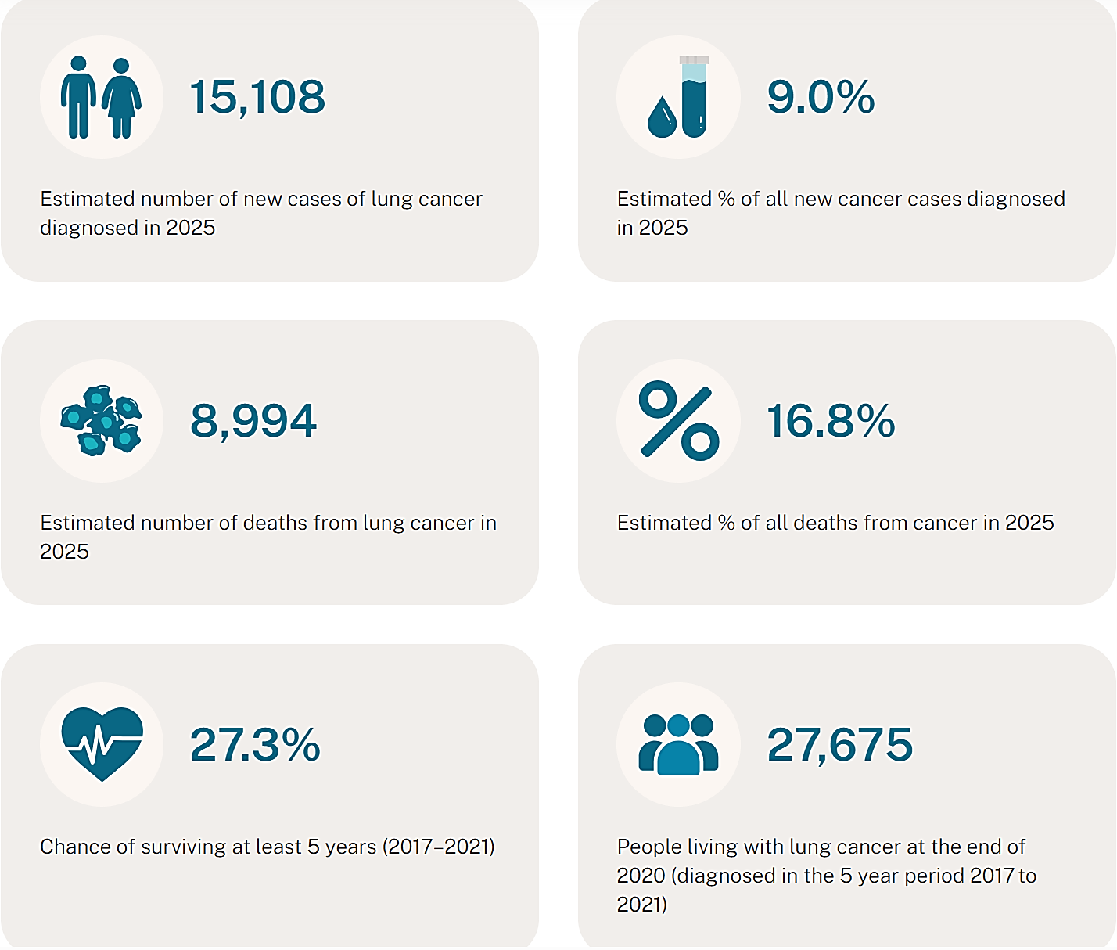
Non-small cell lung cancer (NSCLC) accounts for approximately 85% of all lung cancers. MET mutations leading to exon 14 skipping have been reported in approximately 2% to 4% of cases of NSCLC.
Patients with tumours that have mesenchymal-epithelial transition factor (MET) dysregulation (MET mutation and/or MET amplification) have poor prognosis compared to the unselected NSCLC patient population. In the most recent series of advanced MET-mutated NSCLC, overall survival (OS) from diagnosis of stage IV was only 8.1 months for patients not treated with a therapy targeting MET. Such patients tend to be elderly (median age > 70 years; ~more than 10 years older than other subpopulations of patients with NSCLC), making this population clinically challenging, primarily due to comorbidities and overall frailty, which limits the use of currently available treatment options, ultimately impacting on the prognosis of this subset of patients.

Current treatment options
Most patients with NSCLC have locally advanced or metastatic disease at the time of diagnosis and are not candidates for potentially curative surgery. Current treatment options for advanced NSCLC are systemic chemotherapy and immunotherapy, unless a patient has targetable molecular drivers (e.g. Anaplastic Lymphoma Kinase [ALK] gene rearrangements, ROS1 rearrangements, sensitising Epidermal Growth Factor Receptor (EGFR) mutations, B-Raf proto-oncogene [BRAF] V600E point mutations, etc.).
First-line treatment options for patients with advanced NSCLC with no established molecular driver include single-agent immunotherapy in patients whose tumours have programmed death-ligand-1 (PD-L1) expression >50%, or combined immunotherapy and chemotherapy (platinum doublets) irrespective of tumour PD-L1 expression, in patients fit for these therapies.
Compared to systemic chemotherapy, targeted therapies are associated with improved progression-free survival (PFS) and quality of life in advanced NSCLC. Patients with NSCLC tumours harbouring molecular drivers gain limited benefit from immunotherapy and should only receive this after exhausting the benefit from direct targeted therapy. This appears to hold true for patients with MET exon 14 skipping mutated (MET∆ex14) NSCLC who seem to gain limited benefit from immunotherapy with overall response rate (ORR) 6-20% and median PFS <2 months, irrespective of PD-L1 expression or tumour mutation burden.
There is one targeted therapy for MET∆ex14 NSCLC available in Australia – tepotinib, approved 17 January 2022.,
International guidelines for MET∆ex14 NSCLC recommend targeted treatment with tepotinib or capmatinib as preferred therapy.

Clinical rationale
MET, a proto-oncogene, encodes a receptor tyrosine kinase and is activated by the endogenous ligand, hepatocyte growth factor. MET regulates the cellular processes of differentiation, proliferation, cell cycle, motility, and apoptosis. In NSCLC, aberrant activation of the MET pathway occurs through a variety of mechanisms each of which leads to prolonged signaling and oncogenic capacity:,,
- MET splice mutation leading to skipping of exon 14,
- MET gene amplification, and
- Overexpression of the MET protein.
MET mutations leading to exon 14 skipping have been identified as an actionable target in NSCLC.,
Capmatinib is an oral inhibitor of MET receptor tyrosine kinase. Promising efficacy data have been published with MET inhibitors such as capmatinib, in patients whose tumors harbor MET mutations, including those that lead to exon 14 skipping.,,, Collectively, the data suggest that capmatinib possesses in vitro and in vivo biological and pharmacologic activities that support its efficacy for targeted oral treatment for human cancers with MET-dysregulation (either MET-mutated or amplified).

Regulatory status

Australian regulatory status
This product is considered a new chemical entity for Australian regulatory purposes.
An application to register capmatinib for the treatment of MET∆ex14 NSCLC was previously submitted to the TGA in May 2022 (Category 1, Type A) under Project Orbis. The preliminary view was to approve capmatinib for the proposed indication. However, the Advisory Committee on Medicines (ACM) was of the opinion that the efficacy data were insufficient to support full registration at that time. Whilst the application may have met the standard of evidence for provisional registration, it could not be converted because provisional designation was not sought prior to submission. The submission was subsequently withdrawn by the sponsor prior to the delegate’s decision.
In light of the above, the sponsor requested a pre-submission meeting prior to the current application. The meeting was held on 22 January 2025 and the discussion points included:
- Reasons the sponsor was considering potential re-submission
  - Patients with MET∆ex14 NSCLC are a small population with only one targeted product available in Australia and registration of capmatinib would offer physicians another treatment choice for their patients
  - Alignment with other major markets where both capmatinib and tepotinib are available
- Altered regulatory landscape since the previous submission
  - The TGA acknowledged the previous advice of the ACM, however also that some uncertainties from that time have since changed
  - Further post-marketing data is now available for capmatinib
  - Availability of final clinical study reports for the pivotal phase 2 study (GEOMETRY mono-1) and the GeoMETry-III trial
  - Capmatinib has been granted full approval by major regulators based on objective response rates and the durability of these responses.

International regulatory status
At the time the TGA considered this submission, a similar submission had been considered by other regulatory agencies. Table 1 summarises these submissions and provides the indications where approved.
Table 1. International regulatory status at the time the TGA considered this submission
Country/region | Submission date | Status | Indications (approved or requested) | Other relevant information
European Union (Centralised) | 15 April 2021 | Approved (20 June 2022) | Tabrecta as monotherapy is indicated for the treatment of adult patients with advanced non-small cell lung cancer (NSCLC) harbouring alterations leading to mesenchymal epithelial transition factor gene exon 14 (METex14) skipping, who require systemic therapy following prior treatment with immunotherapy and/or platinum-based chemotherapy. | Standard evaluation, full approval.
USA | 10 December 2019 | Approved (6 May 2020) | Tabrecta is indicated for the treatment of adult patients with metastatic non-small cell lung cancer (NSCLC) whose tumors have a mutation that leads to mesenchymal-epithelial transition (MET) exon 14 skipping as detected by an FDA-approved test. | Accelerated approval by the FDA was granted on 6 May 2020. Breakthrough designation as well as Orphan drug designation was granted in 2019. Regular approval granted in August 2022.
Canada | 19 August 2021 | Approved (26 May 2022) | Tabrecta is indicated for the treatment of adult patients with locally advanced or metastatic non-small cell lung cancer (NSCLC) with a MET exon 14 skipping mutation. | Granted Notice of Compliance with conditions status on August 9, 2021.
Singapore | 30 July 2020 | Approved (22 October 2021) | Tabrecta is indicated for the treatment of adult patients with metastatic non-small cell lung cancer (NSCLC) with a MET exon 14 skipping mutation. | Type C Project Orbis.
Switzerland | 16 July 2020 | Approved (26 April 2021) | Tabrecta is indicated for the treatment of adult patients with metastatic non-small cell lung cancer (NSCLC) with a MET exon 14 skipping mutation. | Evaluated through modified Type C project Orbis.
United Kingdom | 26 June 2022 | Approved (27 March 2023) | Tabrecta, as monotherapy, is indicated for the treatment of adult patients with unresectable locally advanced or metastatic non-small cell lung cancer (NSCLC) with a MET exon 14 skipping mutation. | Evaluated under Project Orbis.
Brazil | 19 August 2020 | Approved (07 June 2021) | Tabrecta is indicated for the treatment of patients with locally advanced or metastatic non-small cell lung cancer (NSCLC) with a MET exon 14 skipping mutation. | Evaluated through modified Type C project Orbis.

Registration timeline
Table 2 captures the key steps and dates for this submission.
This submission was evaluated under the standard prescription medicines registration process.
Table 2. Registration timeline for Tabrecta (capmatinib), submission PM-2025-01762-1-4
Description | Date
Submission dossier accepted evaluation commenced | 30 June 2025
Evaluation completed | 11 March 2026
Registration decision (Outcome) | 4 June 2026
Registration in the ARTG completed | 5 June 2026
Number of working days from submission dossier acceptance to registration decision* | 193
*Statutory timeframe for standard submissions is 255 working days

Assessment overview
A summary of the TGA’s assessment for this submission is provided below.

Quality evaluation summary
Capmatinib hydrochloride drug substance is a dihydrochloride salt in monohydrate form. It is a yellow crystalline powder. The drug substance is a BCS Class II compound with low solubility and high permeability. The drug substance manufacturing process, starting materials, impurity controls, analytical methods, batch data, and stability package are acceptable. Batch analyses from manufacturing sites comply with required specifications, and the proposed re-test period of 18 months when stored below 25°C and protected from light is supported.
Capmatinib hydrochloride has been formulated as an immediate release solid oral dosage form. The composition of the drug product is provided in Table 3. For the drug product, tablet formulation, manufacturing process, control strategy, process validation, and stability data are acceptable.
The product uses a wet granulation process, the two strengths are dose proportional, and the dissolution method and release limits are considered appropriate. Batch analyses from product manufacturing sites complied with product specifications, and no new impurities were identified. Stability data support a proposed 24-month shelf life below 30°C.
The sponsor’s approach to quality control at the manufacturing sites, including testing of incoming active ingredient for identity and reliance on release documentation under Good Manufacturing Practice (GMP) arrangements, is acceptable.
Table 3. Composition of capmatinib 150 mg and 200 mg film-coated tablets (tablet core)
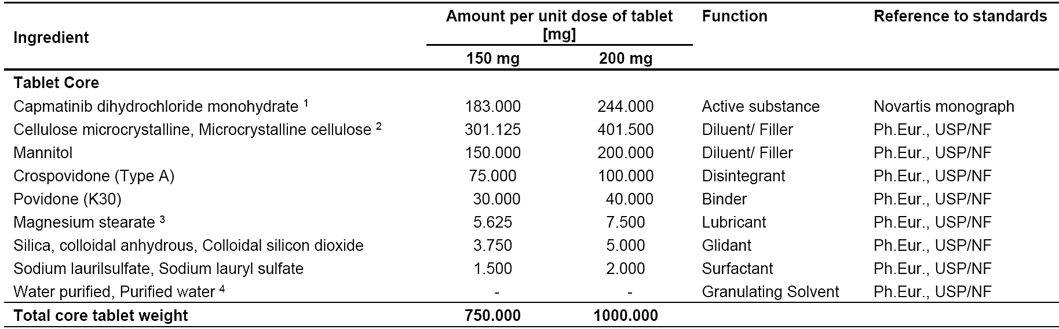
1. The drug substance content is calculated based on capmatinib dihydrochloride on anhydrous basis. The drug substance quantity is adjusted if the drug substance content is ≤ 99.5%.
150 mg of capmatinib (free base) corresponds to 183.000 mg capmatinib dihydrochloride monohydrate (salt/base ratio = 1.220) or 176.550 mg of capmatinib dihydrochloride on anhydrous basis (salt/base ratio = 1.177).
200 mg of capmatinib (free base) corresponds to 244.000 mg capmatinib dihydrochloride monohydrate (salt/base ratio = 1.220) or 235.400 mg of capmatinib dihydrochloride on anhydrous basis (salt/base ratio = 1.177).
2. If the quantity of drug substance is adjusted, a compensation is performed by adjusting the amount of microcrystalline cellulose to maintain the total core tablet weight.
3. Vegetable origin
4. Removed during processing
The product information uses the correct Australian Approved Name, capmatinib hydrochloride. Product labels have consistent naming and conform to Therapeutic Goods Order No. 91.
The sponsor has confirmed that the Australian specifications match those approved by comparable overseas regulators, including Switzerland (Swissmedic) and, with only a minor difference in microbial testing, the United States Food and Drug Administration (FDA).
The sponsor’s risk assessments for nitrosamine contamination found no significant risk for either the active substance or the finished products. On that basis, no routine additional nitrosamine testing is necessary.
Approval for the registration of Tabrecta (capmatinib) is recommended from a quality perspective.

Nonclinical evaluation summary
There were no objections to the registration of capmatinib from a nonclinical perspective following the previous evaluation of capmatinib (refer to the ‘Australian regulatory status’ section above). The sponsor has provided an assurance that all PI and CMI recommendations made during the previous application up to the time of the pre-ACM response, including those from the nonclinical dossier, were incorporated into the product documentation submitted with the current application. No new nonclinical data or further nonclinical evaluation were required for this submission. The TGA considers that previously submitted and evaluated data satisfactorily address nonclinical aspects of safety/efficacy relating to this submission.

Clinical evaluation summary

Pharmacology

Pharmacokinetics
The pharmacokinetics (PK) of capmatinib were characterised in 7 phase 1 studies in healthy subjects, and 7 studies in patients with advanced solid tumours including the pivotal phase 2 study in locally advanced or metastatic MET-mutated or MET-amplified NSCLC (Study A2201).
A hard-gelatin capsule formulation of capmatinib was initially used during clinical development program prior to switching to film coated tablets. A bioavailability study (X2103) established that the PK characteristics of the capsule and tablet formulations are different and therefore they cannot be considered as bioequivalent. The pivotal phase 2 study (A2201) and this application for registration are limited to the tablet formulation only.
Food-effect study X2107, using the tablet formulation, established that food did not have a clinically meaningful impact on capmatinib bioavailability in healthy subjects. This remained true for patients with cancer, based on data from studies A2108 and A2201.
Dose proportionality of the PK of tablets was demonstrated in healthy subjects using data from multiple studies. The dose-normalised C_{max} and AUC were comparable across the dose range of 200 mg to 600 mg once daily dosing.

Hepatic impairment
Study A2106 compared the PK of a single oral dose of 200mg capmatinib (2 x 100mg tablets) in non-cancer subjects with impaired hepatic function to the PK in non-cancer subjects with normal hepatic function. Compared to the normal hepatic function group (n=10), the mild (n=7), moderate (n=8) and severe (n=6) hepatic impairment groups did not show significant change in capmatinib exposure. No significant safety findings were reported in this study. All adverse events (AEs) suspected to be related to study drug were of Grade 1 severity.
No dose adjustment is considered necessary in subjects with mild, moderate, or severe hepatic impairment based on the results of Study A2106.

Population pharmacokinetic data
A population pharmacokinetics (popPK) report based on studies X1101, X2102, A2108 and A2201 was provided. The popPK analysis dataset included 3,882 PK observations from 501 subjects. Most subjects in this pooled population were treated with 400 mg of the tablet formulation; 600 mg of the capsule formulation was the next most common dose. The commonest dosing frequency was twice daily.
Following 400 mg twice daily (BD) dosing with tablets, simulated steady state trough concentrations showed that more than 99% of patients had capmatinib concentration above IC90, and approximately 96% of patients had concentration above IC95.

Age
Age had no statistically significant effect on the PK of capmatinib; therefore, no dose adjustment is required based on age. In the popPK analysis, the median age of patients was 63 years (range, 26 to 90 years). The ratios of the C_{max} and AUC_{ss} for age ≥65 years to <65 years was estimated to be 1.01 (95% CI: 0.92, 1.11) and 1.03 (95% CI: 0.92, 1.15), respectively.

Sex
Sex had no statistically significant effect on the PK of capmatinib; therefore, no dose adjustment based on sex is recommended. The popPK analysis estimated the ratios of C_{max} and AUC_{ss} for females compared to males were 1.00 (95% CI: 0.92, 1.09) and 1.00 (95% CI: 0.90, 1.12), respectively.

Renal impairment
The popPK analysis included 501 patients with cancer, of whom 207 had normal renal function (creatinine clearance [CrCl] ≥90 mL/min, 200 had mild renal impairment (CrCl 60 to 89 mL/min), and 94 had moderate renal impairment (CrCl 30 to 59 mL/min). No patients with severe renal impairment (CrCl 15 to 29 mL/min) were included in the analysis as they were excluded from all the studies included in the popPK analysis.
Simulations for capmatinib at 400 mg BD in the tablet formulation suggested that there was little variation in PK across the different categories of renal function.
Based on the popPK analysis and the limited renal excretion of capmatinib reported for humans, no dose adjustment is recommended in patients with mild to moderate renal impairment.

Pharmacodynamics
The only clinical pharmacodynamic (PD) analyses were exposure-response studies. The capmatinib-treated populations assessed were MET-mutated NSCLC patients for the exposure-efficacy analysis (n=94) and patients with solid tumours for the exposure-safety analysis (n=544).
In the exposure-efficacy analysis, there was no association between capmatinib exposure (C_{avg} and C_{max}) and any of ORR, best overall response (BOR), duration of response (DOR) or changes in tumour size. Although there was a trend towards improved PFS with increased exposure, the association was reported as inconclusive.
The exposure-safety pooled dataset included data from a wide range of doses and both tablet and capsule formulations. A statistically significant association was observed between capmatinib exposure and occurrence of nausea/vomiting events. The odds ratios (ORs) associated with a 50% increase in exposure to capmatinib (C_{max} and C_{avg}) were 1.28 and 1.31. No association was observed between capmatinib exposure and hepatic enzyme abnormalities. There was a positive, but weak, association between capmatinib exposure and the occurrence of peripheral oedema (of any CTC grade) events.
No meaningful impact of capmatinib concentration on change in QTcF was identified.
A statistically significant association was observed between capmatinib exposure and pancreatic enzyme abnormalities. For amylase, the ORs associated with a 50% increase in capmatinib exposure (C_{max} and C_{avg}) were 1.50 and 1.37, respectively. For lipase, the ORs associated with a 50% increase in capmatinib exposure were 1.34 and 1.27, respectively.

Efficacy
The proposed use of capmatinib is supported by efficacy data from the following studies:
- Phase 2 Study GEOMETRY MONO-1/ CINC280A2201 (Study A2201)
- Phase 3 study GeoMETry-III/ CINC280A2301 (Study A2301).
- Real world evidence (RWE) Study CINC280X2401 (Study X2401)
- RWE Study CINC280A2405 (Study A2405)

Pivotal trial: Study A2201 (CINC280A2201; GEOMETRY MONO-1)
The pivotal study A2201 (NCT02414139) was a multicentre, open-label, phase 2 study to evaluate the efficacy and safety of single-agent capmatinib in patients with EGFR wild-type (wt), ALK-negative rearrangement, locally advanced (Stage IIIB) or metastatic (Stage IV) NSCLC with prospective central laboratory confirmation of MET∆ex14 by reverse transcription polymerase chain reaction and/or MET amplification by fluorescence in situ hybridisation.
Study treatment was open label capmatinib 400 mg BD using the tablet formulation, administered continuously in 21-day cycles. All patients received the same treatment regimen irrespective of the cohort to which they were allocated.
Approximately 456 patients aged ≥18 years were planned to be enrolled in the study in 9 cohorts depending on prior treatment and MET-mutation and/or MET-amplification status. The study cohorts relevant to the proposed indication for treatment of MET∆ex14 NSCLC are Cohorts 4 and 6 for pre-treated patients (n=100); and Cohorts 5b and 7 for treatment naïve patients (n=60). All other cohorts comprised patients without a confirmed MET∆ex14 mutation.
The primary endpoint was ORR by blinded independent central review (BIRC) per Response Evaluation Criteria in Solid Tumors (RECIST) 1.1. The key secondary endpoint was DOR by BIRC.
Treatment with capmatinib was considered to have clinically relevant efficacy in Cohort 4 if an ORR of ≥35% was observed with the lower bound of the 95% CI >25%. In Cohorts 5b and 7, treatment with capmatinib was considered to have clinically relevant efficacy if an ORR of ≥55% was observed with the lower bound of the 95% CI >35%. No hypothesis testing was planned for Cohort 6 as its main purpose was to generate supportive data.

Baseline characteristics
The baseline demographic and disease characteristics of study patients were consistent with those generally observed in patients with EGFR wild-type, ALK-negative rearrangement, advanced or metastatic NSCLC with MET amplification and/or mutations.
Among MET∆ex14 NSCLC patients who were treatment naïve (Cohorts 5b+7), most were female (68.3%) and never smokers (63.3%). The median age was 72.5 years (range: 48, 86). Most had adenocarcinoma (90.0%) and 38.3% had >3 metastatic sites. The most common metastatic sites were lymph nodes (55.0%) and bone (55.0%); brain lesions were reported in 15.0% of patients.
Among MET∆ex14 NSCLC patients who were treatment-experienced (Cohorts 4+6), most were female (56.0%) and never smokers (59.0%). Median age was 70 years (range: 49, 90). Most had adenocarcinoma (78.0%) and 53.0% had >3 metastatic sites. The most common metastatic sites were lymph nodes (68.0%) and bone (62.0%); brain lesions were reported in 17.0% of patients. A single prior line of therapy was reported for 81% of patients, most commonly platinum doublet-based chemotherapy (85%); 32.0% had received immunotherapy, most commonly pembrolizumab (18%).

Primary endpoint: ORR by BIRC
The median duration of follow-up was 71.5 months (range: 61.4 to 85.2) in Cohort 4, 51.4 months (range: 47.5 to 58.6) in Cohort 6, 65.8 months (range: 59.3 to 73.9) in Cohort 5b, and 41.8 months (range: 38.1 to 47.1) in Cohort 7. Note that enrolment in Cohorts 6 and 7 started only after recruitment was completed in Cohorts 4 and 5b, respectively.
The prespecified clinically meaningful thresholds for the primary endpoint in patients with MET∆ex14 NSCLC were met (Table 4). The ORRs by BIRC were 68.3% (95% CI:55.0, 79.7) in treatment naïve patients (Cohorts 5b + 7), and 44.0% (95% CI: 34.1, 54.3) in pre-treated patients (Cohorts 4 + 6).
Table 4. Best overall response per BIRC by cohort for patients with MET∆ex14 NSCLC (Full analysis set)
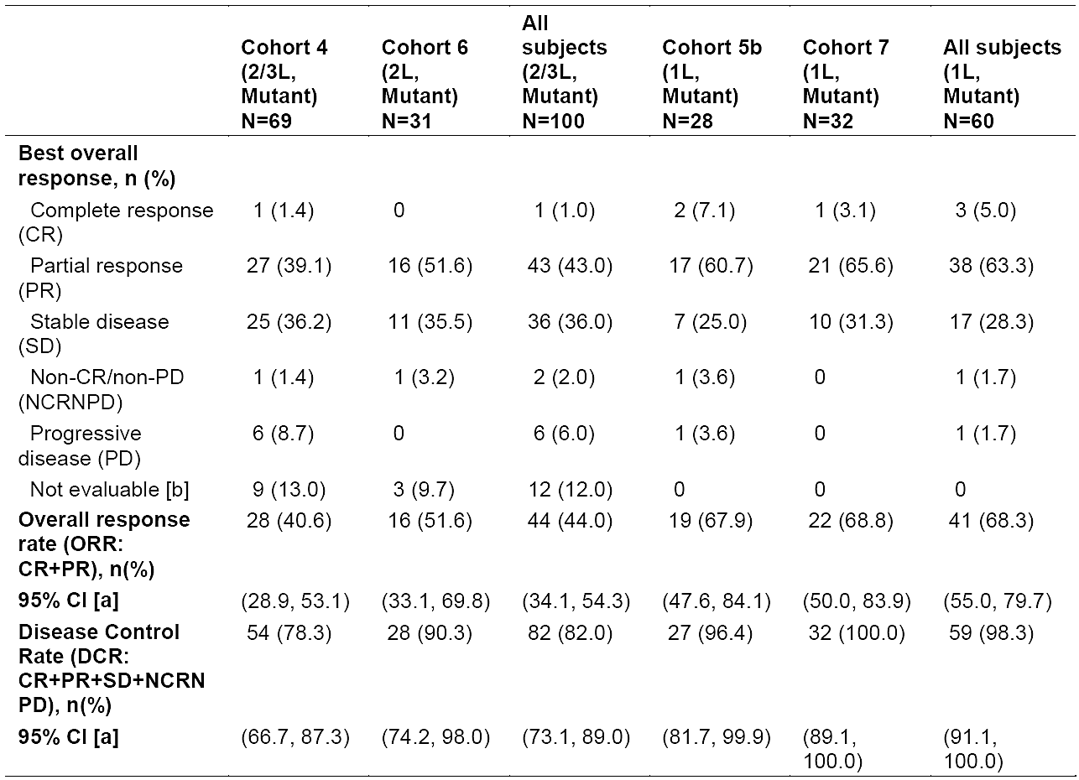
N: The total number of patients in FAS. It is the denominator for percentage (%) calculation.
n: Number of subjects who are at the corresponding category.
[a] Exact binomial 95% Confidence Interval.
[b]: Unknown as per RECIST 1.1 i.e., not qualified for confirmed CR or PR and without SD after > 6 weeks or early progression within the first 12 weeks.
No concerning trends were identified in analyses of ORR per BICR in pre-specified subgroups.

Key secondary endpoint: DOR by BIRC
The median follow-up time for DOR (from the start of response to the date of event/censoring on or prior to the LPLV date) for treatment naïve patients was 11.1 months (range: 2.8 to 60.8) in Cohort 5b, and 11.1 months (range: 2.1 to 42.9) in Cohort 7. For pretreated patients, it was 9.7 months (range: 2.8 to 51.7) for Cohort 4, and 9.1 months (range: 2.8 to 45.6) for Cohort 6.
The median durations of response per BIRC were 16.6 months (95% CI: 8.4, 22.1) in treatment naïve patients (Cohorts 5b + 7) and 9.7 months (95% CI: 5.6, 13.0) in all pretreated patients (Cohorts 4 + 6) (Table 5).
Table 5. Summary of duration of response (CR+PR) per BIRC assessment by cohort for patients with MET∆ex14 NSCLC (Full analysis set)
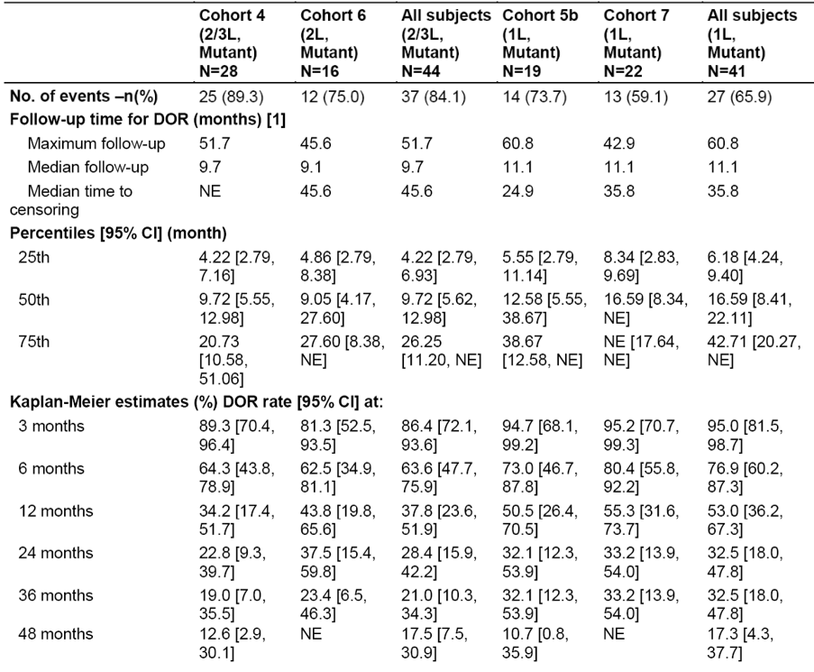
N: The total number of subjects with confirmed CR or PR in FAS. It is the denominator for percentage (%) calculation.
n: Number of subjects who are at the corresponding category.
[1] Follow-up time for DOR (months) = (Date of event or censoring – Start date of response + 1)/30.4375
*The total number of responders is the denominator for percentage (%) calculation.

Other efficacy studies

Phase 3 study A2301 (CINC280A2301; GeoMETry-III)
Study A2301 was a phase 3, randomised, controlled, open-label, multicentre study of capmatinib versus docetaxel (randomised 2:1) in previously treated patients with EGFR wt, ALK negative, locally advanced (stage IIIB/IIIC) or metastatic (Stage IV) MET∆ex14 NSCLC (staging per the 8th TNM edition). The primary endpoint was PFS by BIRC.
Due to changes in the treatment landscape leading to recruitment difficulties, the sponsor decided to permanently halt recruitment in Sep 2022 with 22 out of the planned 90 participants randomised, and 21 treated (15 with capmatinib and 6 with docetaxel). The early study closure was not driven by any safety concerns.
At the primary analysis, PFS by BIRC was not statistically significantly different between the 2 treatment arms (HR: 0.46; 95% CI: 0.16, 1.30; one-sided p = 0.066). Median PFS was 6.1 months (95% CI: 1.6, 11.1) in the capmatinib arm compared to 4.1 months (95% CI: 1.2, NE) with docetaxel.
ORR per BIRC, the key secondary endpoint, was 53.3% (95% CI: 26.6, 78.7) in the capmatinib arm compared to 0% (95% CI: 0, 41.0) with docetaxel.
OS results were heavily confounded by crossover from the docetaxel (5/6 participants treated) to capmatinib arm.

RWE Study X2401 (CINC280X2401)
A multinational (USA, Germany, Japan, Korea, France) medical record review assessed the natural history of patients with locally advanced or metastatic NSCLC with MET dysregulation (MET∆ex14 and/or MET-amplification), including clinical outcomes from systemic treatment. Outcomes considered were OS, PFS, BOR and ORR. The number of patients treated with MET inhibitors was restricted to ≤50% of all medical records collected. MET inhibitors had not been approved at the time of this study and were only available off label or in clinical studies.
Data was included from 157 patients with MET∆ex14 NSLCLC. Their median age was 73 years (range: 31, 94), and approximately 41% were never smokers. Most (68.8%) had Stage IV disease at diagnosis. Median number of lines of therapy was 1 (range: 0, 7). Platinum-based chemotherapy was the most common first-line treatment regimen. MET inhibitor treatment had been received by 31.2%.
Biomarker analysis confirmed that a MET mutation was usually mutually exclusive of other established molecular drivers (ALK, ROS1, BRAF, RET) although some co-occurrence with KRAS mutation was observed. Most patients had PD-L1 expression (41/58 tested [70.7%]), with most positive cases (61.0%) having high PDL1 expression (level ≥50%).
Median OS from first diagnosis of locally advanced/metastatic disease was 25.4 months (95% CI: 18.8, 40.9) for patients who received MET inhibitor therapy in any treatment line (n=49) versus 10.7 months (95% CI, 7.8, 14.4) without any MET inhibitor therapy (n=108).
This study was not designed to allow comparative assessment of treatment effectiveness. The study authors highlighted several limitations including generalisability to the broader population of NSCLC patients with MET dysregulation, varying criteria used to assess clinical responses, accuracy of timing of progression events as patients were not managed under a strict protocol and potential for confounding by uncontrolled and unobserved factors.

RWE Study A2405 (CINC280A2405)
This non-interventional, retrospective, cohort study described the outcomes of patients with advanced MET∆ex14 NSCLC in the Flatiron Health Foundation Medicine Clinico-Genomic Database (CGDB) compared to (i) patients with MET∆ex14 NSCLC treated with capmatinib in cohorts 4 (pre-treated) and 5b (treatment-naive) of Study A2201 and (ii) to a matched cohort of MET-wild type patients in a real-world population.
This was an exploratory study with a focus on estimation. No power calculations were carried out. Propensity score methods were used to reduce confounding due to differences in baseline characteristics.
The Real-World Cohorts were subject to survivorship bias due to the inclusion criteria of the CGDB. A lack of common support region between the Trial Cohort 4 and Real-World Cohort 4 resulted in high variability in the results, and these outcomes were not considered reliable.
Numerically longer median OS and PFS were observed for Trial Cohort 5b (20.8 months and 12.0 months, respectively) compared with Real-World cohort 5b (14.8 months and 6.2 months, respectively).

Safety

Pivotal trial: Study A2201
Exposure to capmatinib in Study A2201 is summarised in Table 6, and an overview of AEs is provided in Table 7.
Table 6. Exposure to capmatinib in study A2201 (patients with MET∆ex14 NSCLC)
Population | Treatment naïve subjects  (1L, mutant) |  |  | Pretreated subjects  (2L/3L, mutant) |  |  | All mutant subjects  N=160 | All study subjects  N=373
 | Cohort 5b  N=28 | Cohort 7  N=32 | All (1L, mutant)  N=60 | Cohort 4  N=69 | Cohort 6  N=31 | All (2L/3L, mutant)  N=100 | All mutant subjects  N=160 | All study subjects  N=373
Duration of exposure (weeks)
Mean (SD) | 74.5 (77.9) | 66.3 (59.3) | 70.1 (68.1) | 45.9 (59.4) | 67.9 (69.4) | 52.7 (63.2) | 59.3 (65.4) | 39.5 (55.2)
Median (range) | 48.2  (4.0, 269.6) | 42.6  (7.0, 195.7) | 43.9  (4.0, 269.6) | 22.1  (0.4, 264.1) | 36.0  (1.3, 234.0) | 27.9  (0.4, 264.1) | 34.9  (0.4, 269.6) | 17.9  (0.4, 280.4)
Table 7. Overview of adverse events in study A2201 (Safety set)
Category n (%) | All (1L,  mutant)  N=60 | All (2L/3L,  mutant)  N=100 | All mutant  subjects  N=160 | All study  subjects  N=373
Any AE | 59 (98.3) | 99 (99.0) | 158 (98.8) | 367 (98.4)
AE Grade 3/4 | 47 (78.3) | 71 (71.0) | 118 (73.8) | 263 (70.5)
SAE | 31 (51.7) | 52 (52.0) | 83 (51.9) | 202 (54.2)
SAE Grade 3/4 | 25 (41.7) | 42 (42.0) | 67 (41.9) | 164 (44.0)
Fatal SAEs | 3 (5.0) | 3 (3.0) | 6 (3.8) | 12 (3.2)
Treatment-Related Fatal SAE | 0 | 2 (2.0) | 2 (1.3) | 4 (1.1)
AE leading to dose interruption | 40 (66.7) | 60 (60.0) | 100 (62.5) | 215 (57.6)
AE leading to dose reduction | 26 (43.3) | 36 (36.0) | 62 (38.8) | 100 (26.8)
AE leading to dose discontinuation | 15 (25.0) | 19 (19.0) | 34 (21.3) | 68 (18.2)
AE = Adverse event; SAE = serious adverse event
Numbers (n) represent counts of subjects.
A subject with multiple severity grades for an AE is only counted under the maximum grade.
MedDRA version 26.0 was used. AEs were graded according to the CTCAE V4.03
Among all study participants, the most frequently reported AEs were oedema peripheral (54.7%), nausea (45.8%), vomiting (28.7%), blood creatinine increased (27.6%) and dyspnoea (25.5%).
The most frequently reported AEs were consistent between patients with MET-mutated NSCLC and all study subjects except oedema peripheral (73.3% in treatment naive subjects with MET∆ex14 NSCLC vs 54.7% in all study subjects), which could be attributed to the longer duration of exposure of subjects to capmatinib treatment in the first-line setting.

AEs of special interest (AESI) in all subjects included hepatotoxicity (32.2%), renal dysfunction (29.2%), CNS toxicity (18.8%), and pancreatitis (14.2%). Interstitial lung disease (ILD) and pneumonitis grouped frequency was 5.4%. Two fatal AEs were reported in the ILD/pneumonitis group. The proportion of patients with ILD/pneumonitis was numerically higher in patients with MET-mutated NSCLC than all subjects (7.5% vs 5.4%), however, the exposure-adjusted incidence was comparable between subjects in the MET-mutated cohorts and all study subjects. Hy's law was not met for any hepatotoxicity cases. AESIs are summarised in Table 8.
Table 8. Adverse events of special interest observed in Study CINC280A2201 (Safety set)
AESI | All (1L, mutant)  N=60 |  | All (2L/3L, mutant) N=100 |  | All mutant  subjects N=160 |  | All study  subjects N=373
AESI | All  grades  n (%) | Grade  3/4  n (%) | All  grades  n (%) | Grade  3/4  n (%) | All  grades  n (%) | Grade  3/4  n (%) | All  grades  n (%) | Grade  3/4  n (%)
Hepatotoxicity | 22 (36.7) | 9 (15.0) | 34 (34.0) | 12 (12.0) | 56 (35.0) | 21 (13.1) | 120 (32.2) | 43 (11.5)
Renal dysfunction | 23 (38.3) | 1 (1.7) | 36 (36.0) | 0 | 59 (36.9) | 1 (0.6) | 109  (29.2) | 2 (0.5)
CNS toxicity | 8 (13.3) | 0 | 21 (21.0) | 0 | 29 (18.1) | 0 | 70 (18.8) | 3 (0.8)
Pancreatitis | 13 (21.7) | 7 (11.7) | 14 (14.0) | 11 (11.0) | 27 (16.9) | 18 (11.3) | 53 (14.2) | 33 (8.8)
ILD and Pneumonitis | 4 (6.7) | 3 (5.0) | 8 (8.0) | 4 (4.0) | 12 (7.5) | 7 (4.4) | 20 (5.4) | 8 (2.1)
QTc interval  prolongation | 2 (3.3) | 0 | 1 (1.0) | 0 | 3 (1.9) | 0 | 10 (2.7) | 3 (0.8)
Teratogenicity | 2 (3.3) | 0 | 0 | 0 | 2 (1.3) | 0 | 2 (0.5) | 0
Photosensitivity | 0 | 0 | 1 (1.0) | 0 | 1 (0.6) | 0 | 1 (0.3) | 0
Drug-drug interaction  with strong and  moderate CYP3A4  inducers | 0 | 0 | 0 | 0 | 0 | 0 | 0 | 0
AESIs are sorted in descending frequency of "All Grades" column, as reported under "All Subjects".
Numbers (n) represent counts of subjects.
A subject with multiple severity grades for an AE is only counted under the maximum grade.
MedDRA version 26.0, CTCAE version V4.03
There were 12 SAEs leading to death reported in the study. Four deaths were assessed as related to study treatment by the investigator:
- Two fatal cases of ILD/pneumonitis as noted above, both in patients with MET∆ex14 NSCLC
  - Preferred term for 1 case was pneumonitis. Grade 3 Pneumonitis was first suspected on Day 5 of capmatinib. Capmatinib 400 mg BD treatment was continued until pneumonitis was confirmed; the last dose was administered on Day 18. The patient died 15 days after the last dose of capmatinib.
  - PT for 1 case was organising pneumonia. Capmatinib treatment was discontinued on the day of diagnosis with cryptogenic bronchiolitis obliterans organising pneumonia (Day 9). The patient died 21 days after the last dose of capmatinib.
- 1 case of cardiac arrest in a patient without MET-mutation
- 1 case of fatal hepatitis with co-occurring SAE of pancreatitis, acute in a patient without MET-mutation.
AEs leading to permanent discontinuation of study drug were reported in 18.2% of patients, and 62.7% required at least one dose adjustment and/or interruption due to AEs.

Study A2301
The median duration of exposure in Study A2301 was 29.9 months (range: 5, 88) for capmatinib and 9.1 months (range: 3, 24) for docetaxel.
The safety profile in the 15 subjects treated with capmatinib in Study A2301 was broadly consistent with the safety profile identified in Study A2201 and post-marketing surveillance. There were two SAEs which led to death in the capmatinib arm – one case of sepsis and one case of pneumonitis.

Post marketing experience
The Periodic Safety Update Report (PSUR) for 6 May 2024 to 5 May 2025 provided the latest update on capmatinib. A critical analysis of efficacy and safety confirmed that the overall benefit-risk profile of capmatinib remained favourable. There was no change in the risk profile since the last PSUR, and it remained consistent with the company core data sheet and EU-RMP v1.3 (date 25 Mar 2022).

Deafness
The previous PSUR (6 November 2023 to 5 May 2024) had evaluated a potential causal relationship of deafness with capmatinib following reports of sudden hearing loss in post market surveillance. A search of the sponsor’s safety database retrieved 50 patients with 53 events. Analysis of these cases revealed no medically relevant information that could imply a new association of reported events with capmatinib.
This potential signal was revisiting in the current PSUR (6 May 2024 to 5 May 2025). Interval data (18 new cases) did not reveal any new or changed safety information and was consistent with the previous cumulative assessment of deafness.
Considering the available safety data and that advanced age (median, 84 years) with comorbidities/underlying disease are risk factors, the available evidence was insufficient to establish a causal relationship between deafness and capmatinib. Of note, following the PSUR period, no new information or safety concerns have emerged for this topic. The topic of deafness will continue to be monitored in the next PSUR, as recommended by the Pharmacovigilance Risk Assessment Committee Assessment Report (PSUSA/00011022/202505).

Companion diagnostic considerations
The sponsor has considered the issue of companion diagnostic (CDx) testing. There are two approved MBS item numbers (73437 and 73438) for multi-gene panel testing, including testing for variants in MET exon 14, of tumour tissue from a patient with a new diagnosis of NSCLC. The sponsor concludes:
“Novartis considers it appropriate that no specific companion diagnostic device needs to be registered in tandem to enable access to Tabrecta in Australia, as patient eligibility will be confirmed using the existing Medicare funded METex14sk test.”
The TGA guidance for CDx provides the option for CDx requirements to be met if “Standard testing in Australia is anticipated to predict similar clinical outcomes to the pivotal clinical trials supporting the proposed medicine or biological indication.”
The pivotal clinical trial, Study A2201, used RT-PCR testing in a central laboratory to assess MET exon 14 skipping mutation status in tumour tissue samples from participants. The MBS item numbers noted above reimburse next generation sequencing (NGS) testing.
The United States Prescribing Information (US PI) for capmatinib describes the retesting of tumour tissue samples in Study A2201 with an NGS assay (FoundationOne CDx). The samples had undergone central confirmation of MET exon 14 skipping with the clinical trial RT-PCR assay prior to retesting with NGS. An estimated positive percentage agreement of 99% (72/73) between the clinical trial RT-PCR assay and the FDA-approved NGS assay was found15. In the US, the FoundationOne CDx NGS assay has an approved CDx indication for detecting MET exon 14 skipping mutations in NSCLC for deciding suitability for capmatinib use.

Risk management plan
The Tabrecta EU-Risk Management Plan (RMP) (version 1.3, dated 25 March 2022, data lock point 30 August 2021), with Australia-Specific Annex (ASA) (version 1.0, dated 21 May 2025), included with submission PM-2025-01762-1-4, and any subsequent revisions, as agreed with the TGA will be implemented in Australia
The summary of safety concerns and their associated risk monitoring and mitigation strategies are summarised in Table 9. The TGA may request an updated RMP at any stage of a product's life-cycle, during both the pre-approval and post-approval phases.
Table 9. Summary of safety concerns
Summary of safety concerns |  | Pharmacovigilance |  |  | Risk Minimisation
 |  | Routine | Additional | Routine |  | Additional
Important identified risks | Hepatotoxicity | ü | – | ü |  | –
Important identified risks | Interstitial lung disease/pneumonitis | ü | – | ü |  | –
Important identified risks | Pancreatitis | ü | – | ü |  | –
Important potential risks | Renal dysfunction | ü | – | ü |  | –
Important potential risks | Photosensitivity | ü | – | ü |  | –
Important potential risks | CNS toxicity | ü | – | – |  | –
Missing information | None | – | – | – |  | –

Risk-benefit analysis
Patients with MET∆ex14 NSCLC have only one targeted product, tepotinib, currently available in Australia. This population is clinically challenging, primarily due to older age (median 73 years) with associated higher likelihood of overall frailty and the presence of comorbidities. The proposed registration of capmatinib would offer physicians another choice to individualise therapy for their patients. Additionally, it would bring Australia into alignment with other major markets where both capmatinib and tepotinib are available.

Clinical evidence
The trial population of pivotal study A2201 is sufficiently similar to the Australian landscape such that the external generalisability of this study to treatment-naïve and treatment-experienced adults with locally advanced or metastatic MET∆ex14 NSCLC in Australia is acceptable.
In study A2201, the prespecified clinically meaningful thresholds for the primary endpoint in patients with MET∆ex14 NSCLC were met (Table 4). The ORRs by BIRC were 68.3% in treatment naïve patients, and 44.0% in pre-treated patients. Supporting trials, including real world evidence, broadly support the efficacy demonstrated in pivotal study A2201.
The safety profile of capmatinib in the proposed population is well characterised in the submitted clinical trials, real world evidence, and post-market pharmacovigilance.
The primary limitation of Study A2201 is the absence of a control group which prevents meaningful interpretation of time-to-event endpoints including overall survival and progression-free survival and doesn’t allow direct comparison with current standard of care treatments. The phase 3 randomised, controlled study A2301 was planned and commenced, however, unforeseen changes in the treatment landscape led to recruitment difficulties and loss of clinical equipoise. Therefore, the sponsor decided to permanently halt recruitment to the controlled trial. Importantly, the early study closure was not driven by any safety concerns. Conducting randomised, controlled studies in rare diseases such as MET∆ex14 NSCLC is generally acknowledged to be challenging.
The registration of tepotinib for the treatment of adults with MET∆ex14 NSCLC, the same population proposed for capmatinib, was supported by a single-arm, open-label, multicentre study (VISION) with primary endpoint of ORR2.
Overall, the submitted dossier of clinical data supporting this application for registration of capmatinib is acceptable considering relevant clinical and regulatory factors and the safety and efficacy of capmatinib have been established.

Companion diagnostic testing
NSCLC tissue testing for clinically relevant molecular drivers, including MET exon 14 skipping mutations, is available and funded15,16, in Australia. It is expected that suitability assessments for capmatinib treatment will utilise the same testing pathways as for tepotinib. The registration of tepotinib occurred prior to the latest TGA CDx guidance17 and, therefore, a companion diagnostic test for tepotinib is not currently included on the TGA CDx list and comparability assessments/justification between that testing and the pivotal clinical trial testing have not previously been considered by TGA. That step will need to occur between the funded testing and the capmatinib clinical trial assay prior to including such a test on the TGA CDx list.

However, given the nature of the MET-mutation testing for NSCLC tissue (funded, on market, in use for many years for companion diagnostic testing for access to a similar medicine), it is considered low risk to proceed with a registration decision for capmatinib, assuming this testing is likely to be used as companion testing for capmatinib in Australia until such time as a TGA-approved CDx or NATA-accredited and TGA-notified CDx becomes available.

Uncertainties

Dose optimisation
There is limited clinical information regarding the efficacy and safety of capmatinib tablets at doses other than the 400 mg BD dose selected for pivotal phase 2 study A2201. The exposure-response analyses suggest that further investigation of different capmatinib dosing might have been desirable with the potential to offer similar efficacy with a lower frequency of AEs such as nausea/vomiting, or pancreatic enzyme abnormalities. This might have benefitted the proposed real-world patient population who have a median age >70 yrs, advanced disease and potential for multiple comorbidities. Study A2201 excluded patients with increased susceptibility to AESIs associated with capmatinib treatment.

Place in therapy
Optimal sequencing of MET inhibitors, including capmatinib, in NSCLC patients with MET∆ex14 skipping mutations has not been determined; further evidence of appropriate treatment sequencing may optimise efficacy and the reduce development of resistance.
These uncertainties do not preclude the proposed registration of capmatinib.

Assessment outcome
Based on a review of quality, safety, and efficacy, the TGA decided to register Tabrecta (capmatinib) for the following indication:
Tabrecta is indicated for the treatment of adult patients with locally advanced or metastatic non-small cell lung cancer (NSCLC) with a MET exon 14 skipping mutation

Specific conditions of registration
Tabrecta (capmatinib dihydrochloride monohydrate) is to be included in the Black Triangle Scheme. The PI and CMI for Tabrecta must include the black triangle symbol and mandatory accompanying text for five years, which starts from the date of first supply of the product.
The Tabrecta EU-Risk Management Plan (RMP) (version 1.3, dated 25 March 2022, data lock point 30 August 2021), with Australia-Specific Annex (ASA) (version 1.0, dated 21 May 2025), included with submission PM-2025-01762-1-4, and any subsequent revisions, as agreed with the TGA will be implemented in Australia.
An obligatory component of risk management plans is routine pharmacovigilance. Routine pharmacovigilance includes the submission of periodic safety update reports (PSURs).
Reports are to be provided in line with the current published list of EU reference dates and frequency of submission of PSURs until the period covered by such reports is not less than three years from the date of this approval letter. Each report must be submitted within ninety calendar days of the data lock point for that report.
The reports are to at least meet the requirements for PSURs as described in the European Medicines Agency’s Guideline on good pharmacovigilance practices (GVP) Module VII-periodic safety update report (Rev 1), Part VII.B Structures and processes. Note that submission of a PSUR does not constitute an application to vary the registration.

Product Information and Consumer Medicine Information
For the most recent Product Information (PI) and Consumer Medicine Information (CMI), please refer to the TGA PI/CMI search facility.

Therapeutic Goods Administration
PO Box 100 Woden ACT 2606 Australia
Email: info@tga.gov.au Phone: 1800 020 653 Fax: 02 6203 1605
https://www.tga.gov.au
Reference/Publication #

This is the original indication proposed by the sponsor when the TGA commenced the evaluation of this submission. It may differ to the final indication approved by the TGA and registered in the Australian Register of Therapeutic Goods.
Cancer Australia. (2026). Lung cancer in Australia statistics. Last accessed 13 Mar 2026 from: https://www.canceraustralia.gov.au/cancer-types/lung-cancer/lung-cancer-australia-statistics
Australia Product Information for TEPMETKO (tepotinib (as hydrochloride monohydrate)). Last accessed 10 Apr 2026 from: https://www.ebs.tga.gov.au/ebs/picmi/picmirepository.nsf/pdf?OpenAgent&id=CP-2022-PI-01029-1
National Comprehensive Cancer Network (NCCN) (13 Mar 2026). NCCN Guidelines: Non-Small Cell Lung Cancer. Version 5.2026 – March 13, 2026. Last accessed 10 Apr 2026 from: https://www.nccn.org/professionals/physician_gls/pdf/nscl.pdf
Cappuzzo F, Marchetti A, Skokan M, et al (2009) Increased MET gene copy number negatively affects survival of surgically resected non-small-cell lung cancer patients. J Clin Oncol; 27:1667–74.
Park S, Choi YL, Sung CO, et al (2012) High MET copy number and MET overexpression: poor outcome in non-small cell lung cancer patients. Histol Histopathol; 27:197–207.
Tsuta K, Kozu Y, Mimae T, et al (2012) c-MET/phospho-MET protein expression and MET gene copy number in non-small cell lung carcinomas. J Thorac Oncol; 7:331–9.
Kong-Beltran M, Seshagiri S, Zha J, et al (2006) Somatic mutations lead to an oncogenic deletion of met in lung cancer. Cancer Res; 66:283-9.
Pasquine G, and Giaccone G (2018) C-MET inhibitors for advanced non-small cell lung cancer. Expert Opin Investig Drugs; 27:363-75.
Frampton GM, Ali SM, Rosenzweig M, et al (2015) Activation of MET via diverse exon 14 splicing alterations occurs in multiple tumor types and confers clinical sensitivity to MET inhibitors. Cancer Discov; 5:850-9.
Paik PK, Drilon A, Fan PD, et al (2015) Response to MET inhibitors in patients with stage IV lung adenocarcinomas harboring MET mutations causing exon 14 skipping. Cancer Discov; 5:842-9.
Jenkins RW, Oxnard GR, Elkin S, et al (2015) Response to crizotinib in a patient with lung adenocarcinoma harboring a MET splice site mutation. Clin Lung Cancer; 16:e101-4.
Mendenhall MA and Goldman JW (2015) MET-mutated NSCLC with major response to crizotinib [letter]. J Thorac Oncol; 10:e33-4.
At the time of study commencement (11 June 2015), the active version of the TNM staging system for NSCLC was the 7th edition. This did not include a Stage IIIC, which was introduced only in the 8th edition: Rami-Porta, R., Asamura, H., Travis, W. D., & Rusch, V. W. (2017). Lung cancer - major changes in the American Joint Committee on Cancer eighth edition cancer staging manual. CA: A Cancer Journal for Clinicians, 67(2), 138–155. https://doi.org/10.3322/caac.21390
MBS Online. Medicare Benefits Schedule - Item 73437. Last accessed 4 May 2026 from: https://www9.health.gov.au/mbs/fullDisplay.cfm?type=item&q=73437&qt=item&criteria=73437
MBS Online. Medicare Benefits Schedule - Item 73438. Last accessed 4 May 2026 from: https://www9.health.gov.au/mbs/fullDisplay.cfm?type=item&q=73438&qt=item
Therapeutic Goods Administration. 13 May 2025. Understanding regulatory requirements for in vitro diagnostic (IVD) companion diagnostics (CDx). Last accessed 23 Apr 2026 from
United States Food and Drug Administration. United States Prescribing Information for TABRECTA (capmatinib) tablets (Reference ID: 5346763). Last accessed 23 Apr 2026.
United States Food and Drug Administration. United States Summary of Safety and Effectiveness Data for FoundationOne CDx (PMA P170019/S048). Last accessed 23 Apr 2026.

