Australian Public Assessment Report for Slenyto
  - Active ingredient: Melatonin
  - Sponsor: RAD Data Australia Pty Ltd
July 2026

About the Therapeutic Goods Administration (TGA)
- The Therapeutic Goods Administration (TGA) is part of the Australian Government Department of Health, Disability and Ageing and is responsible for regulating therapeutic goods, including medicines, medical devices, and biologicals.
- The TGA administers the Therapeutic Goods Act 1989 (the Act), applying a risk management approach designed to ensure therapeutic goods supplied in Australia meet acceptable standards of quality, safety, and efficacy.
- The work of the TGA is based on applying scientific and clinical expertise to decision-making, to ensure that the benefits to the Australian public outweigh any risks associated with the use of therapeutic goods.
- The TGA relies on the public, healthcare professionals and industry to report problems with therapeutic goods. The TGA investigates reports received to determine any necessary regulatory action.
- To report a problem with a therapeutic good, please see the information on the TGA website.

About AusPARs
- The Australian Public Assessment Report (AusPAR) provides information about the evaluation of a prescription medicine and the considerations that led the TGA to approve or not approve a prescription medicine submission. Further information can be found in Australian Public Assessment Report (AusPAR) guidance.
- AusPARs are prepared and published by the TGA.
- AusPARs are static documents that provide information that relates to a submission at a particular point in time. The publication of an AusPAR is an important part of the transparency of the TGA’s decision-making process.
- A new AusPAR may be provided to reflect changes to indications or major variations to a prescription medicine subject to evaluation by the TGA.

Copyright
© Commonwealth of Australia 2026
This work is copyright. You may reproduce the whole or part of this work in unaltered form for your own personal use or, if you are part of an organisation, for internal use within your organisation, but only if you or your organisation do not use the reproduction for any commercial purpose and retain this copyright notice and all disclaimer notices as part of that reproduction. Apart from rights to use as permitted by the Copyright Act 1968 or allowed by this copyright notice, all other rights are reserved and you are not allowed to reproduce the whole or any part of this work in any way (electronic or otherwise) without first being given specific written permission from the Commonwealth to do so. Requests and inquiries concerning reproduction and rights are to be sent to the TGA Copyright Officer, Therapeutic Goods Administration, PO Box 100, Woden ACT 2606 or emailed to <tga.copyright@tga.gov.au>.

Contents
List of abbreviations 4
Product submission 6
Submission details 6
Product background 7
Disease or condition 7
Current treatment options 10
Clinical rationale 11
Regulatory status 12
Australian regulatory status 12
International regulatory status 12
Registration timeline 13
Assessment overview 14
Quality evaluation summary 14
Nonclinical evaluation summary 14
Clinical evaluation summary 14
Literature-based search strategy 14
Pharmacology 20
Efficacy 23
Safety 95
Risk Management Plan (RMP) evaluation 107
Risk-benefit analysis 107
Efficacy 107
Safety 121
Assessment outcome 123
Product Information and Consumer Medicine Information 124
References/footnotes 125

List of abbreviations
Abbreviation | Meaning
ADHD | Attention-deficit hyperactivity disorder
AEs | Adverse events
ANOVA | Analysis of variance
ARTG | Australian Register of Therapeutic Goods
AS | Angelman syndrome
ASD | Autism Spectrum Disorder
AUC | Area under the concentration-time curve
CADS-P | Conners Attention Deficit Scale, Parent version
CGAS | Children’s Global Assessment Scale
CGI-I | Clinical Global Impression-Improvement
CI | Confidence intervals
C_{max} | Maximum concentration
CMI | Consumer Medicines Information
CRSD | Circadian rhythm sleep disorders
CSDI | Composite Sleep Disturbance Index
DB | Double-blind
DLMO | Dim light melatonin onset
ESS | Epworth Sleepiness Scale
FAS | Full analysis set
IR | Immediate release
IV | Intravenous
LBS | Literature-based submission
LSE | Longest sleep episode
MD | Mean difference
MMRM | Mixed-effects model for repeated-measures
MPH | Methylphenidate
NA | Nocturnal awakening(s)
NGD | Neurogenetic disorder/disease
NNT | Number needed to treat
NOA | Number of awakenings
OL | Open label
OR | Odds ratio
PC | Placebo-controlled
PD | Pharmacodynamic(s)
PedPRM | Pediatric prolonged-release melatonin
PI | Product Information
PK | Pharmacokinetic(s)
PR | Prolonged release
PSQI | Pittsburgh Sleep Quality Index
QoL | Quality of life
RCTs | Randomised control trials
RMP | Risk management plan
RS | Rett syndrome
SD | Standard deviation
SDQ | Strength and Difficulties Questionnaire
SE | Standard error
SL | Sleep latency
SMS | Smith-Magenis syndrome
SND | Sleep and Nap Diary
SOI | Sleep onset insomnia
SOL | Sleep onset latency
TEAEs | Treatment emergent adverse events
TGA | Therapeutic Goods Administration
T_{max} | Time to maximum concentration
TSC | Tuberous sclerosis complex
TST | Total sleep time
WS | Williams syndrome

Product submission

Submission details
Type of submission: | Extension of indication
Product name: | Slenyto
Active ingredient: | Melatonin
Decision: | Approved
Date of decision: | 15 May 2026
Approved therapeutic use for the current submission: | Slenyto is indicated for the:  - treatment of insomnia in children and adolescents aged 2-18 years with Autism Spectrum Disorder (ASD), and / or neurogenetic disorders with aberrant diurnal melatonin secretion and/or nocturnal awakenings, where sleep hygiene measures have been insufficient.  - treatment of insomnia in children and adolescents aged 6-17 years with attention-deficit hyperactivity disorder (ADHD) where sleep hygiene measures have been insufficient.  Neurogenetic disorders are those of the central and peripheral nervous systems clearly associated with a characteristic set of symptoms and signs, which are caused by molecular defects in heritable material (usually DNA). Examples include Smith-Magenis syndrome, Angelman syndrome, Rett syndrome, Tuberous sclerosis complex, and Williams syndrome.
Date of entry onto ARTG: | 19 May 2026
ARTG numbers: | 319503, 319504
Black Triangle Scheme | No
Sponsor’s name and address: | RAD Data Australia Pty Ltd PKF Melbourne, Level 12, 440 Collins Street, Melbourne, VIC, 3000
Dose form: | Prolonged release tablet
Strength: | 1 mg and 5 mg
Container: | Blister packs (PVC/PVDC/Al)
Pack size: | Slenyto 1 mg tablets: packs of 30 or 60 tablets.  Slenyto 5 mg tablets: packs of 30 tablets.
Route of administration: | Oral
Dosage: | For insomnia in children and adolescents aged 2-18 years with ASD and / or neurogenetic disorders, the recommended starting daily dose is 2 mg of Slenyto. If an inadequate response has been observed, the daily dose should be increased to 5 mg, with a maximal dose of 10 mg.  For insomnia in children and adolescents aged 6-17 with ADHD the recommended starting daily dose is 1-2 mg of Slenyto. If an inadequate response has been observed, the daily dose should be increased to 5 mg, with a maximal dose of 10 mg.  For further information regarding dosage, refer to the Product Information.
Pregnancy category: | Category B3  Drugs which have been taken by only a limited number of pregnant women and women of childbearing age, without an increase in the frequency of malformation or other direct or indirect harmful effects on the human fetus having been observed.  Studies in animals have shown evidence of an increased occurrence of fetal damage, the significance of which is considered uncertain in humans.  The use of any medicine during pregnancy requires careful consideration of both risks and benefits by the treating health professional. The pregnancy database must not be used as the sole basis of decision making in the use of medicines during pregnancy. The TGA does not provide advice on the use of medicines in pregnancy for specific cases. More information is available from obstetric drug information services in your state or territory.

Product background
This AusPAR describes the submission by RAD Data Australia Pty Ltd (the sponsor) to register Slenyto (melatonin) for the following proposed extension of indication:
Slenyto is indicated for the treatment of insomnia in children and adolescents aged 2-18 with neurogenetic disorders with aberrant diurnal melatonin secretion and/or nocturnal awakenings, where sleep hygiene measures have been insufficient.
Slenyto is indicated for the treatment of insomnia in children and adolescents aged 2-18 with attention deficit hyperactivity disorder (ADHD), where sleep hygiene measures have been insufficient.

Disease or condition

Neurogenetic disorders
There is no clear definition of neurogenetic disorder (NGD) proposed by the sponsor. The sponsor describes the evidence of efficacy for the use of Slenyto in patients with NGDs to be based primarily on melatonin use in patients with the following neurological conditions, which have a strong genetic basis: Angelman syndrome (AS), Rett syndrome (RS), tuberous sclerosis complex (TSC) and Williams syndrome (WS).
The sponsor states that they are:
‘seeking to expand the approved indications (treatment of insomnia in children and adolescents aged 2-18 with ASD and / or SMS, where sleep hygiene measures have been insufficient) to include the treatment of insomnia in children and adolescents aged 2-18 years with neurodevelopmental disorders associated with NGDs (AS, RS, TSC and WS), where sleep hygiene measures have been insufficient.’
The sponsor proposes that the evidence presented in this submission relating to the NGDs above, which have a strong genetic basis and a well-defined clinical syndrome (often presenting in childhood) are sufficient to extrapolate to Slenyto use for the proposed indication to all disorders that could fall under the broad term “neurogenetic disorder”.
- WS, a genetic disorder characterised by a 1.5 to 1.8 Mb recurrent microdeletion of 7q11.23. While the disease is transmitted in an autosomal dominant fashion, almost all cases are the result of de novo mutations.
- RS is a genetic disorder characterised by pathological variants in the MECP2 gene.
- AS is a genetic disorder caused by absence of the maternally inherited copy of the UBE3A gene.
- TSC is an autosomal dominant genetic disorder caused by heterozygous pathogenic variants in the TSC complex subunit 1 (TSC1) or the TSC complex subunit 2 (TSC2) tumour suppressor genes.
Neurogenetic does not appear as a category or subcategory when used as a search term in the International Classification of Disease version 11th revision.
The Murdoch Children’s institute website defines a NGD as:
‘Each year, thousands of Australians are diagnosed with an inherited condition that affects their nervous system. Neurogenetic disease is an umbrella term to describe these conditions, which are primarily caused by an alteration – or mutation – in our DNA.”
This article then goes on to differentiate between monogenetic or complex NGD stating:
‘Diseases with a mutation in a single gene are referred to as “monogenetic diseases”. These include Huntington’s disease, myotonic dystrophy, RS and fragile X syndrome. In these cases, the single-gene mutation causes certain neurons in the central and/or peripheral nervous system to develop abnormally and/or function poorly. Some neurogenetic diseases are referred to as “complex diseases”, since multiple genes and environmental factors can contribute to the development of the disease. These include Parkinson’s disease and Alzheimer’s disease.’7
The American Brain Foundation website defines a NGD as: ‘Neurogenetic disease is caused by a defect in one or more genes which affects the nervous system.’
It appears that the term “neurogenetic disorder” is a broad term covering many different neurological disorders which have a genetic basis. The genetic basis for a NGD may be due to a single gene defect or a complex genetic basis with multiple interacting genes and the different medical conditions under the umbrella term “neurogenetic condition” are likely to have quite different pathophysiologies. Overall, it is difficult to define what a “neurogenetic disorder” is.

Attention deficit hyperactive disorder
Attention deficit hyperactive disorder (ADHD) manifests in early childhood with symptoms of hyperactivity, impulsivity, and/or inattention. These symptoms affect: cognitive, academic, behavioural, emotional, and social functioning.
The core symptoms of ADHD are hyperactivity/impulsivity and inattention which lead to impaired functioning. The pathogenesis of ADHD is not definitively known. Genetic factors are thought to contribute significantly to ADHD with increased risk of ADHD in first-degree relatives of patients with ADHD and twin studies from different countries provide heritability estimates of approximately 75 percent. Studies examining structural brain imaging in patients diagnosed with ADHD show changes such as asymmetry of caudate nucleus, smaller cerebral and cerebellar volumes and smaller posterior corpus callosum compared to patients without a diagnosis of ADHD.
Whilst there are several theorised environmental influences on the development and pathogenesis of ADHD, there are no clear causal environmental influences that have been proven to be involved in the pathogenesis of ADHD. In a meta-analysis of 175 studies the estimated prevalence of ADHD was 7.2% (95% CI 6.7%-7.8%) with most studies conducted in school age children. ADHD is more common in males then females, a study examining prevalence of mental health disorders in children across different health databases in the United States between 2013-2019 showed that the prevalence of ADHD was 12.9% in males and 6.2% in females.
Sleep complaints are common in children diagnosed with ADHD. In one study in patients with ADHD involving caregiver reports of their children’s sleep problems 28.5% reported mild sleep problems and 44.8% reported moderate or severe sleep problems. In a metanalysis of studies which compared sleep in patients with ADHD to those without common sleep complaints which had a statistically higher significance in patients with ADHD compared to those without included:
- Bedtime resistance
- Sleep-onset difficulties
- Night awakenings
- Difficulty with morning awakenings
- Sleep-related breathing problems
- Daytime sleepiness
Compared with the general population in children and adolescent patients with ADHD are also more likely to be diagnosed with the following sleep related conditions: periodic limb movements during sleep, obstructive sleep apnoea or reduced/disrupted sleep time. The association between ADHD and issues with sleep is complex. A sleep problem may be caused or exacerbated by environmental factors (such as poor sleep habits), psychiatric co-morbidities, stimulant medications, or a combination of these issues. Symptoms due to inadequate sleep could also mimic the symptoms of ADHD, which is why a clinical assessment of children for ADHD should include an assessment of a primary sleep related disorder (e.g. obstructive sleep apnoea and restless leg syndrome), co-morbid psychiatric disorder as well as other possible environmental contributing factors which can also contribute to sleep disturbance.
It has been suggested that ADHD diagnostic criteria can be applied to children as young as 4 years of age. There may be increased difficulty in diagnosing pre-school children with ADHD given one of the diagnostic criteria states that inattentive or hyperactive symptoms be observed in 2 or more settings; this may be difficult if a child does not attend a formal pre-school or child care program.19

Current treatment options

Neurogenetic disorders
Given the broad nature of this term, it is difficult to define what the current treatment options are as the term ‘neurogenetic disorder’ captures a large group of diverse medical conditions.

Attention-deficit hyperactive disorder
Pharmacological treatments for ADHD include stimulant medications such as methylphenidate (MPH) or lisdexamfetamine dimesilate which are used to treat the core symptoms of ADHD (both these active ingredients are in products on the Australian Register of Therapeutic Goods [ARTG], currently approved for the indication of treatment of ADHD). Atomoxetine is a further pharmacological treatment option (this active ingredient is in products on the ARTG currently approved for treatment of ADHD). Atomoxetine’s mechanism of action involves inhibition of presynaptic noradrenaline transporters, inhibition of serotonin uptake, is a weak inhibitor of dopamine uptake and has moderate affinity for 5-HT2 and GABAA receptors.
For the management specifically of sleep problems (such as insomnia/poor sleep) in patients diagnosed with ADHD (who should also be assessed for primary sleep disorders and psychiatric co-morbid conditions that may be contributing), non-pharmacological measures are first-line. This includes establishing and maintaining healthy sleep habits, treating behavioural contributors and establishing healthy circadian patterns. Adjustment of stimulant medications can also be considered. As medications with an amphetamine-like mechanism of action can interfere with sleep, this could involve changing from an extended-release formulation to an immediate release (IR) formulation to determine if this improves sleep.20
If chronic symptoms of sleep problems/insomnia continue despite non-pharmacological interventions and simulant medication adjustments, then a pharmacological treatment to aid in sleep may be considered. This includes the use of melatonin for patients with sleep onset insomnia (SOI).20 An α₂-adrenergic agonist such as clonidine is sometimes used as part of a regimen for treatment of ADHD and sometimes benefits sleep. Nonbenzodiazepine agonists such as zolpidem are usually avoided in the paediatric population due to adverse effects and uncertain efficacy.20
Melomed is a melatonin oral liquid product approved for the treatment of sleep disorders in children and adolescents aged 6 to 18 with neurodevelopmental disorders including ASD and ADHD, where sleep hygiene measures have been insufficient.
Voquily, a melatonin product in capsule form (2, 3, and 5 mg), is approved for the treatment of sleep disorders in children and adolescents aged 6 to 18 with neurodevelopmental disorders including ASD and ADHD, where sleep hygiene measures have been insufficient.
The recommended daily dose range of Melomed and Voquily for the treatment of sleep disorders in children and adolescents with neurodevelopmental disorders is 2 to 5 mg daily.

Clinical rationale
Melatonin (N-acetyl-5-methoxytryptamine) is an endogenous regulator of the circadian clock and a sleep promoter in humans. Melatonin is the primary hormone produced by the pineal gland; it is a lipid soluble substance with low molecular weight and is structurally related to serotonin and tryptophan. Melatonin production in humans is concurrent with nocturnal sleep and the physiological increase in melatonin levels in the evening correlates with the onset of self-reported sleepiness, and with the increase in evening sleep propensity. Inadequate regulation and secretion of melatonin has been found in children with neurodevelopmental disorders,,,,, a population with high prevalence of impairments of sleep initiation and maintenance. This suggests that impairment in melatonin production may be a cause of insomnia in certain paediatric populations. Consequently, melatonin replacement therapy aimed at ameliorating the deficiency in the endogenous sleep-regulating hormone may improve sleep and restore the daily sleep-wake cycle in children with neurodevelopmental and NGDs with insomnia.

Regulatory status

Australian regulatory status
Slenyto received initial registration in the Australian Register of Therapeutic Goods (ARTG) on 22 May 2020. It was approved for the following indication:
Slenyto is indicated for the treatment of insomnia in children and adolescents aged 2-18 with Autism Spectrum Disorder (ASD) and / or Smith-Magenis syndrome, where sleep hygiene measures have been insufficient.
An Australian Public Assessment Report (AusPAR) was published for this submission.

International regulatory status
At the time the TGA considered this submission, a similar submission had been considered by other regulatory agencies. Table 1 summarises these submissions and provides the indications where approved.
Table 1. International regulatory status at the time the TGA considered this submission
Region | Product Name | Submission date | Status | Approved indications
EU | Slenyto | ADHD: 4 June 2024  Neurogenetic disorders: 29 November 2023 | Approved:  ADHD: 17 March 2025  Neurogenetic disorders: 26 August 2024 | Slenyto is indicated for:  - treatment of insomnia in children and adolescents aged 2- 18 years with Autism Spectrum Disorder (ASD), and/or neurogenetic disorders with aberrant diurnal melatonin secretion and /or nocturnal awakenings, where sleep hygiene measures have been insufficient.  - treatment of insomnia in children and adolescents aged 6- 17 years with attention-deficit hyperactivity disorder (ADHD) where sleep hygiene measures have been insufficient.
US | N/A – Unscheduled in the US | N/A | N/A | N/A
Switzerland | Slenyto | NGD: 6 August 2024  ADHD: 13 February 2025 | NGD: 12 December 2024  ADHD: under evaluation | Slenyto is indicated for:  - treatment of insomnia in children and adolescents aged 2-18 years with Autism Spectrum Disorder (ASD), and / or neurogenetic disorders with aberrant diurnal melatonin secretion and /or nocturnal awakenings, where sleep hygiene measures have been insufficient.
UK | Slenyto | NGD: 5 September 2024  ADHD: 31  March 2025 | NGD: 20 November 2024  ADHD: under evaluation | Slenyto is for use in children and adolescents (2 to 18 years old) with autism spectrum disorder (ASD) and/or neurogenetic diseases (inherited conditions affecting the nerves and brain) associated with abnormal levels of melatonin and/or night-time awakenings.

Registration timeline
Table 2 captures the key steps and dates for this submission. This submission was evaluated under the standard prescription medicines registration process.
Table 2. Registration timeline for Slenyto (melatonin), submission PM-2025-02083-1-1
Description | Date
Submission dossier accepted evaluation commenced | 30 June 2025
Evaluation completed | 2 March 2026
Registration decision (Outcome) | 15 May 2026
Registration in the ARTG completed | 19 May 2026
Number of working days from submission dossier acceptance to registration decision* | 180
*Statutory timeframe for standard submissions is 255 working days

Assessment overview

Quality evaluation summary
Quality evaluation is not required for this submission as there are no proposed changes to the quality of the currently approved product in Australia. The quality of the currently approved product is suitable for the proposed changes in this submission. A full quality evaluation was conducted at the time this product received initial registration.30

Nonclinical evaluation summary
No new nonclinical data or further nonclinical evaluation were required for this submission. The TGA considers that previously submitted and evaluated data satisfactorily address nonclinical aspects of safety/efficacy relating to this submission.30

Clinical evaluation summary

Literature-based search strategy
This submission is a mixed literature-based submission (LBS) with the search strategy for this submission approved by the TGA on the 14th March 2025. This submission was also supported by the original sponsor clinical study data from a phase III clinical study (Study NEU_CH_7911), which has been previously evaluated by the TGA.30 Table 3 outlines the inclusion and exclusion criteria that were used to screen the literature references identified from the systematic literature search.
Table 3. Criteria for screening literature references identified from the systematic literature search.
Inclusion criteria | Exclusion criteria
- Only include human studies, in vivo  - Studies investigating the safety, tolerability and/or efficacy of melatonin monotherapy in ADHD and/or neurodevelopmental disorders  - Melatonin oral route of administration  - Order of level of evidence to be weighted as follows (i.e. systematic reviews of RCTs, RCTs, other controlled studies, comparator studies, uncontrolled studies, case series, case reports)*  - Order of quality of evidence to be weighted according to whether studies are approved by a relevant ethical institution and patient consent is obtained*  - Language, English only | - Not human study in vivo  - Age of subjects not relevant to proposed indications  - Studies not investigating melatonin in target indications  - Melatonin not oral and/or in combination with other medicine(s)  - Not a study in ADHD or neurodevelopmental disorders  - Quality of study insufficient to assess statistical significance of outcomes, such as not utilising relevant diagnostic criteria and endpoints and/or not reported in sufficient detail for evaluation  - Duplicate study  - Non-English language
RCT: randomised controlled trial
* If sufficient level I or II studies, with appropriate ethical consideration are identified, studies of lower evidence grade or quality may be excluded

Search results for ‘Attention deficit hyperactivity disorder’
For ADHD, out of the total of 269 articles screened, 17 were identified as meeting the inclusion criteria to support the efficacy of melatonin for insomnia and sleep disorders in children and adolescents with ADHD. Of the 17 articles:
- Sixteen were retrieved through systematic literature searches
  - Fifteen through the ADHD literature search
- Level I:
Salanitro M, et al. 2022
- Level II:
Gringras P, et al. 2017, Maras A, et al. 2018, Mohammadi MR, et al. 2012, Mostafavi SA, et al. 2012, Schroder CM, et al. 2019, Van der Heijden KB, et. al. 2007, Weiss MD, et al. 2006
- Level IV:
Ayyash HF, et al. 2015, Checa-Ros A, et al. 2023, Hoebert M, et al. 2009, Masi G, et al. 2019, Szeinberg A, et al. 2006, Tjon Pian Gi CV, et. al. 2003, and Yuge K, et. al. 2020.
  - One through the NGD literature search:
- Level II
Hayashi M, et al. 2021
- One was retrieved through non-systematic literature review:
  - Malow BA, et al. 2021

Search results for ‘neurogenetic disorder’
For NGDs, out of the total of 270 articles screened (including 7 papers identified in the bridging search), a total of 9 studies included efficacy assessments. None of the studies identified in the bridging search have been included. Out of 9 articles, 3 were retrieved from the systematic literature searches, along with 6 additional articles retrieved from non-systematic searches. The 6 additional articles from non-systematic searches were identified through a review of the EU dossier for the same product. The included studies are:
- Three published reports identified through the systematic literature review:
  - Level II: Braam W, et. al. 2008
  - Level III-1: De Leersnyder et.al. 2011, Takaesu Y, et. al. 2012
- Six published reports identified through the non-systematic literature review:
  - Level III-1: O'Callaghan FJ, et al. 1999, Hancock E, et. al. 2005, Zhdanova IV, et. al. 1999
  - Level IV: McArthur AJ, et al. 1998, Miyamoto A, et. al. 1999, Martens MA, et. al. 2017
Table 4 describes the National Health and Medical Research Council (NHMRC) levels of evidence for literature search articles that met the inclusion criteria as well as the sponsor’s original study NEU_CH_7911.
Table 4. Submitted studies/data with NHMRC levels of evidence
ADHD | NGD
Controlled clinical study
Study Neu_CH_7911
Level 1 evidence
Salanitro M, et al. 202231
Level II evidence
Gringras P, et al. 201732  Hayashi M, et al. 202145  Malow BA, et al. 202146  Maras A, et al. 201833  Mohammadi MR, et al. 201234  Mostafavi SA, et al. 201235  Schroder CM, et al. 201936  Van der Heijden KB, et. al. 200737  Weiss MD, et al. 200638  Yuge K, et. al. 202045 | Braam W, et. al. 200848 (AS)
Level III-1 evidence
Hancock E, et. al. 200552
O'Callaghan FJ, et al. 199951
(both TSC)
Level III-2 evidence
 | Zhdanova IV, et. al. 199953
Level III-3 evidence
De Leersnyder et.al. 201149(AS, RS, TSC)
Takaesu Y, et. al. 201250 (AS)
Level IV evidence
Ayyash HF, et al. 201539  Checa-Ros A, et al. 202340  Hoebert M, et al. 200941  Masi G, et al. 201942  Szeinberg A, et al. 200643  Tjon Pian Gi CV, et. al. 200344 | Martens MA, et. al. 201756  (WS Williams syndrome)  McArthur AJ, et al. 199854 (RS)  Miyamoto A, et. al. 199955 (RS)
Other data
Therapeutic guidelines  Off label use of Circadin/Slenyto in children and adolescents with ADHD  TGA DAEN reports from 1971 to 2025 | Compassionate Prescribing Framework CPC Annual report No. 2 (AS, RS, TSC)  Temporary Recommendation for Use (RTU) program for use with Circadin Report No. 6 (AS, RS, TSC)  Clinical practice guidelines  Post-marketing safety data
Abbreviations: AS: Angelman Syndrome; CPC: Slenyto Compassionate Prescribing Framework (CPC in French); DAEN: Database of Adverse Event Notifications; RS: Rett Syndrome; RTU: Temporary Recommendation for Use program with Circadin (Aspen melatonin product); TSC: Tuberous Sclerosis Complex.
Regarding the submitted literature references, various melatonin formulations were used, as shown in Table 5. The sponsor proposed that the range of doses used reinforces the suitability of lower starting doses and individualised dosing strategies for children with ADHD, minimising the risk of excessive sedation while maintaining therapeutic benefits.
Table 5. Melatonin formulations used in the submitted literature references
Reference | Daily dose | Form | Tradename/supplier
ADHD trials
Salanitro M, et al. 202231 | 1-6 mg/day for children | Immediate release & prolonged release | Various
Gringras P, et al. 201732 | 2 mg, 5 mg | Prolonged release tablet | Slenyto
Hayashi M, et al. 202146 | 1 mg, 4 mg | Granules | Nobelpharma Co. Ltd
Malow BA, et al. 202147 | 2 mg, 5mg, 10 mg | Prolonged release tablet | Slenyto
Maras A, et al. 201833 | 2 mg, 5mg, 10 mg | Prolonged release tablet | Slenyto
Mohammadi MR, et al. 201234 | 3 mg (<30 kg)  6mg (>30 kg) | Capsules | Nutricentury Canada
Mostafavi SA, et al. 201235 | 3 mg (<30 kg)  6mg (>30 kg) | Capsules | Nutricentury Canada
Schroder CM, et al. 201936 | 2 mg, 5mg, | Prolonged release tablet | Slenyto
Van der Heijden KB, et. al. 200737 | 3 mg (<40 kg),  6 mg (>40kg) | Fast release tablet | Pharma Nord, Denmark
Weiss MD, et al. 2006³⁸ | 5 mg | Immediate release tablet | Circa Dia BV
Ayyash HF, et al. 2015³⁹ | 2.5 mg, 5mg, 10 mg | Immediate release tablet | Not known
Checa-Ros A, et al. 2023⁴⁰ | 1 mg | Fast release | Not known
Hoebert M, et al. 2009⁴¹ | 3 mg (<40 kg),  6 mg (>40kg) | Not disclosed | Not known
Masi G, et al. 2019⁴² | 1 mg, up to 5 mg | Not disclosed | Not known
Szeinberg A, et al. 2006⁴³ | 3 mg to 5 mg | Not disclosed | Not known
Tjon Pian Gi CV, et. al. 2003⁴⁴ | 3 mg | Not disclosed | Not known
Yuge K, et. al. 2020⁴⁵ | 1 mg adjusted as needed | Melatonin granules | Not known
NGD trials
Braam W, et. al. 2008⁴⁸ | 2.5 mg (<6 years),  5 mg (≥6 years) | Immediate release tablet | Duchefa Farma BV
Hancock E, et. al. 2005⁵² | 5 mg, 10 mg | Not disclosed | Penn Pharmaceuticals Services Pty Ltd
O'Callaghan FJ, et al. 1999⁵¹ | 5 mg | Not disclosed | Penn Pharmaceuticals Services Pty Ltd
Zhdanova IV, et. al. 1999⁵³ | 0.3 mg | Gelatin capsule mixed with semi-liquid food | Nestle Switzerland
De Leersnyder et.al. 2011⁴⁹ | 2-4 mg (<40 kg)  6 mg (>40 kg) | Prolonged release tablet | Circadin
Takaesu Y, et. al. 2012⁵⁰ | 1 mg | Not disclosed | Not known
Martens MA, et. al. 201756 | Not specified | Not disclosed | Not known
McArthur AJ, et al. 1998⁵⁴ | 2.5-10 mg | Immediate release tablet | Dr Keith Parrott College of Pharmacy, Oregon State University, using analytical grade melatonin (Regis Chemical Company)
Miyamoto A, et. al. 1999⁵⁵ | Patient 1 (7 yr old female): 5 mg for 2 years then 3 mg.  Patient 2 | Not disclosed | Not known

Pharmacology

Pharmacokinetics

Pharmacokinetic studies previously evaluated by TGA
Previously submitted and evaluated studies (studies CHDR1219 and CHDR1742) provide pharmacokinetic (PK) information for Slenyto.
Study CHDR1219 was performed in children with ASD; there have been no PK /pharmacodynamic (PD) clinical studies conducted by the sponsor in children and adolescents with ADHD, or NGDs such as AS, RS, TSC, and WS.
Study CHDR1742 was conducted in healthy adults to demonstrate dose proportionality between the 1 and 5 mg strengths of Slenyto and comparability with Circadin 2 mg in healthy adults.
These studies demonstrated the prolonged release (PR) PK profile following Slenyto administration.
A brief summary of the results of these studies is shown in Table 6.
Table 6. Previously submitted Slenyto PK studies
Study | Results | Clinical implications
CHDR1219  An open label (OL), single ascending dose, cross- over study to assess the PK of PR (prolonged release) melatonin mini-tablets (Slenyto 2 x 1mg and 10x1mg) in children with NDD and sleep disturbances. | The PK profile of the Slenyto mini- tablets was similar to that of the Circadin 2 mg commercial tablets in adults and elderly patients. | The Sponsor maintained that these findings support the consistency and reliability of Slenyto's PK profile in real-world paediatric populations.
CHDR1742  Conducted to demonstrate dose proportionality between the 1 and 5 mg strengths of Slenyto and comparability with Circadin 2 mg in healthy adults. | Slenyto has a prolonged release profile that mimics physiological melatonin secretion.  The PK profile is linear and dose proportional across the 1 and 5 mg doses.  The PK profiles of 1 mg Slenyto, 2 mg Circadin, and 5 mg Slenyto under fed conditions were similar in shape and the dose adjusted PK parameters considered to be comparable and dose proportional.  Food reduces C_{max} but has minimal effect on AUC, indicating that the product can be taken with or without food.  Saliva melatonin levels are correlated to plasma melatonin levels. | The Sponsor indicated that these findings confirm that the PK behaviour of Slenyto is stable and predictable, making it suitable for individualised dosing in children with ADHD and NGD.
AUC=Area under the concentration-time curve; C_{max} = Maximum concentration

PK data obtained from literature search
Level II evidence was obtained from Braam W, et. al. 2008⁴⁸, level II-2 evidence from Zhdanova IV, et. al. 1999⁵³, and level IV evidence from Miyamoto A, et. al. 1999⁵⁵.
Braam W, et. al. 2008⁴⁸ was a randomised, placebo-controlled (PC) trial of children with AS with idiopathic chronic insomnia. A total of 8 patients were randomly assigned to receive melatonin (5 mg for those aged > 6 years and 2.5 mg for those < 6 years) or placebo daily for 4 weeks. Saliva specimens for measuring melatonin concentrations were collected at the end of the last week of the treatment period to examine whether the treatment had changed the endogenous melatonin circadian rhythm. In 35 of 80 salivary samples, the amount of saliva was too low for a melatonin analysis.
Visual inspection of the data on the remaining 45 samples showed that salivary melatonin concentrations, on a day no study medication was given, increased substantially after melatonin treatment, whereas melatonin concentrations after placebo treatment did not change. In 3 of the 4 patients who had received melatonin treatment, at least one salivary melatonin concentration was above 50 pg/mL on the first evening after treatment discontinuation.
Zhdanova IV, et. al. 1999⁵³ was an OL study of 13 patients aged 2-10 years with AS, in which subjects received melatonin 0.3 mg ½ to 1 h before their habitual bedtime. Within an hour of ingestion, circulating melatonin levels increased significantly, and remained above the daytime baseline levels for 12-15 h.
The peak serum hormone levels and circulating melatonin levels after the treatment were significantly higher (p < 0.001) than the mean peak endogenous melatonin level. The mean group AUC value was also significantly increased (p < 0.001) following the administration of a 0.3 mg dose of melatonin. Daytime melatonin levels were less than 5 pg/mL for all the children studied and were not significantly changed after five days of melatonin treatment.
Miyamoto A, et. al. 1999⁵⁵ was a case study in which 2 girls with RS with sleep disorders which failed to respond to conventional treatments were treated with melatonin 5 mg orally at bedtime. In the first patient (4 years and 3 months of age), after 2 months of melatonin treatment, the serum levels of melatonin at 30 minutes (min) after the oral administration on 2 consecutive days were 2,200 and 6,800 pg/mL, compared to peaks of 98 and 41 pg/mL before melatonin treatment. At 10 years of age, the second patient’s serum melatonin levels elevated to 1,400 pg/mL at 22:00 h after melatonin administration at 20:00, and 8 h later melatonin levels returned to the same levels (4–9 pg/mL) as before melatonin treatment.

Pharmacodynamics
The literature search did not identify any specific studies providing PD data. Literature references in which exogenous melatonin may have affected endogenous melatonin secretion have been summarised below.

Attention-deficit hyperactivity disorder
Van der Heijden et. al. 200737 was a randomised, DB, PC trial of 105 medication-free children, ages 6 to 12 years, with rigorously diagnosed ADHD and chronic SOI who were treated with 3 or 6 mg melatonin (depending on body weight) or placebo for 4 weeks.
Salivary DLMO was assessed at baseline and on the first evening of the fourth treatment week, on which night no melatonin was given. Melatonin-treated children showed an advance in DLMO of 44.4 ± 67.9 minutes, compared with a delay of 12.8 ± 60.0 minutes in children receiving placebo (p < 0.0001).

Neurogenetic disorders
In Braam W, et al, 200848, a randomised, PC trial of 8 individuals aged 4 to 20 years with AS, saliva specimens for measuring melatonin concentrations were collected in the qualification period on the last night of the baseline week and the last night of the fourth treatment week (no melatonin was given on this night), to examine whether 4 weeks of melatonin 2.5 or 5 mg had changed the endogenous melatonin circadian rhythm.
The data for the 45 evaluable samples showed that salivary melatonin concentrations increased substantially after melatonin treatment, whereas melatonin concentrations after placebo treatment did not change.
Zhdanova IV, et al, 199923 was an OL study of 13 patients aged 2-10 years with AS. After several weeks of administration of melatonin 0.3 mg.
For 2 of the 3 patients with a substantially delayed pretreatment onset of nocturnal melatonin secretion, a 2–3-hour phase advance in the onset of melatonin secretion was seen after exogenous melatonin withdrawal. In the other patient with delayed pretreatment onset of nocturnal melatonin secretion, administration of the exogenous melatonin close to the time of his nocturnal endogenous melatonin increase did not result in a temporal or quantitative change in his nocturnal melatonin production, in spite of a significant sleep promoting effect of the treatment.

Efficacy

Pivotal study relating to ADHD and NGD: Study NEU_CH_7911
Study NEU_CH_7911 was a Phase III, randomised, double-blind (DB), PC study to assess the efficacy and safety of PR melatonin for insomnia in children diagnosed with ASD and neurodevelopmental disabilities caused by NGDs (SMS, AS, and TSC). The study was conducted in 14 centres in the US and 10 centres in Europe, between January 2014 and February 2018.
All eligible children underwent a 4-week basic sleep hygiene and behavioural intervention wash-out period (if required), before they started a 2-week single-blind placebo run-in period. There was an initial randomised (1:1) treatment period of 13 weeks,32,36 during which time patients received either placebo or melatonin (2 mg or 5 mg daily), followed by a 91-week OL extension period33,47, in which the long-term efficacy and safety of PR melatonin 2, 5, and 10 mg were assessed. Withdrawal effects were assessed during a 2-week single-blind placebo run-out period.
All patients received placebo during the run-in period. Placebo minitablets were identical in appearance and formulation to the Slenyto minitablets. The run-in period was followed by 13 weeks of DB treatment, where the investigator and patient were blinded to treatment allocation. After 3 weeks of study, if dose modification was deemed necessary, patients received increased doses (5 minitablets containing 1 mg of Slenyto or placebo).
A total of 125 children aged 2 – 17 years were randomised into the DB phase; 60 were randomised to the Slenyto treatment arm and 65 to the placebo treatment arm. A total of 9 patients in the PR melatonin group discontinued the DB phase compared to 21 in the placebo group. During the first and second OL phases all patients received treatment with PR melatonin. A chi-square test for the difference in the number of dropouts between the Slenyto (15.0%) and placebo (32.3%) groups was statistically significant (p = 0.040), with withdrawal of parental consent and loss to follow-up higher among participants in the latter than in the former group.
Table 7. Study NEU_CH_7911 design
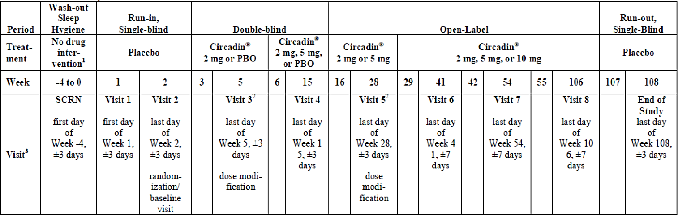
SCRN = Screening; PBO = placebo
* The visit should be carried out within ±3 days.
** The visit should be carried out within ±7 days.
1. First 2 weeks are a gradual withdrawal and the last 2 weeks are a complete withdrawal of prohibited medications.
2. Data analysis (assessment of sleep variables) will be performed at the end of Week 5 (Visit 3) and Week 28 (Visit 5) to determine if a dose modification (i.e., an increase to 5 mg or 5/10 mg
Circadin", respectively) is required.
3. All visits, except screening and Visit 1 will occur on the last day of the week in which they occur, as indicated above.
The primary objective was to compare the treatment effect of Circadin 2/5 mg minitablets to that of placebo on total sleep time (TST) as assessed by the Sleep and Nap Diary (SND) after 13 weeks of DB treatment.
Key inclusion criteria included that children were aged 2 – 17.5 years at Visit 2; they had a documented history of ASD or neurodevelopmental disabilities caused by NGDs (SMS, AS, Bourneville’s disease [TSC]); they had current sleep problems including: a minimum of 3 months of impaired sleep defined as ≤ 6 hours of continuous sleep and/or ≥ 0.5-hour sleep latency (SL) from lights off in 3 out of 5 nights; and that the dose of non-excluded medications (antiepileptics, antidepressants, stimulants, mood changing drugs, and beta blockers) had been stable for 3 months.
Key exclusion criteria included prior treatment with any forms of melatonin within 2 weeks prior to Visit 1 and moderate or severe sleep apnoea.
Regarding study treatments, all doses of study medication were to be taken at 0.5 to 1 hour before the desired (age-appropriate) bedtime. The tablets were to be swallowed whole.
All patients received the same dose (2 mg Slenyto or placebo) during the first 3 weeks of DB study treatment. Subsequently, at Week 5, Visit 3, the investigator reviewed the SNDs and the electronic case report form recommendation for dose increase and then made an assessment of treatment effect. If the investigator decided that a dose increase was necessary, pre-defined criteria had to be met before the increase could take place. The dose could be increased to 5 mg at Visit 3, and patients continued on a dose of 2 mg or 5 mg for the remainder of the DB period.
At Week 15, patients entered the OL phase and received Slenyto treatment at the same dose they had been receiving at the end of DB treatment. After 13 weeks of OL treatment (Week 28,
Visit 5), the investigator again made an assessment on the need for dose increase (as above); the dose could be increased from 2 mg to 5 mg or from 5 mg to 10 mg at Visit 5. Patients then continued OL 2, 5, or 10 mg melatonin for another 78 weeks, for a total of 91 weeks of OL melatonin treatment.
At any time, a patient’s dose could be decreased to 2 or 5 mg for reasons such as adverse events (AEs) that were considered related to the study drug, and/or for an unacceptable increase in daytime fatigue, an unacceptable behavioural change, or if the patient stopped responding to study drug (sleep improved and then deteriorated on a higher dose).
The primary endpoint of the study was the change from baseline in mean SND-assessed TST after 13 weeks of DB treatment.
Secondary endpoints of the study included (all were after 13 weeks of DB treatment):
- Change from baseline in SL.
- Sleep maintenance, as change from baseline in longest sleep episode (LSE), assessed by the SND.
- Change from baseline in Strength and Difficulties Questionnaire (SDQ)-assessed externalising behaviours (hyperactivity/inattention and conduct difficulties).
- Change from baseline in quality of life (QoL) score (WHO-5) of caregivers.
The change in TST, SL, and LSE were assessed throughout the OL period.
Regarding statistical analysis and sample size calculation to achieve 95% power at the 5% level for the primary objective (assuming a change of 0.72 hour in the Slenyto arm and 0.27 hour in the placebo arm and a standard deviation [SD] of 0.69 in the Slenyto arm and 0.45 in the placebo arm), 45 patients were required per combined group. Therefore, 90 patients in total were required to complete Visit 5. These estimations were based on previous studies conducted with Circadin.
At Visit 1, enough eligible male and female children, aged 2 to 17.5 years, were to be screened for the study to allow 120 patients to be randomised in a 1:1 ratio to receive Slenyto or placebo at Visit 2. A minimum of 90 children were expected to complete the DB and first OL period (up to Week 28). A minimum of 50 children were expected to complete the second OL safety follow-up period.
The change from baseline in mean TST was analysed using a mixed-effects model for repeated-measures (MMRM), which contained the TST at Visit 3 (Week 5) and Visit 4 (Week 15) as the dependent variable, with fixed effects for visit, the mean baseline TST, randomised treatment and the mean baseline TST and randomised treatment both nested within visit. Visit-to-visit repeated measures assumed a general (unstructured) covariance structure. Standard errors (SEs) and degrees of freedom for significance tests were derived using the Kenward-Roger method.
From this model, the adjusted mean change from baseline (and SE) in TST after 13 weeks of treatment for each treatment group was calculated and the associated 95% confidence intervals (CI) for the change presented. The estimated difference (and SE) between treatments was estimated, the associated 95% CI presented, and the null hypothesis that these means are equal was tested. In addition, the effect size was calculated based on Cohen’s d (mean difference [MD] between groups/pooled SD) where the MD is adjusted for other model factors using MMRM and the pooled SD is evaluated using the model SEs.
There was no adjustment for multiple comparisons in this study.
Regarding baseline demographic data included participants had ASD (96.8%) or SMS (3.2%); no patients with other NGD such as AS, TSC, or WS were enrolled, considered to be due to the low prevalence of these disorders. A total of 65.5% of children had previously been treated with melatonin, and 13.6% of children were being treated with melatonin at screening.
Mean age was 9.0 (SD +/- 4.08) in the PR melatonin group and 8.4 (SD +/- 4.24) in the placebo with a range of 2 to 17 years for both groups. In the PR melatonin group 75% were male with 72.3% being male in the placebo group. Mean weight was similar between groups with a mean weight of 37.86kg (SD +/- 21.495) in the PR melatonin group and 35.22kg (SD +/- 23.249) in the placebo group. There were a total of 19 patients between the ages of 2-6 years inclusive in the melatonin treatment group in this study.
ADHD was present as a comorbidity in 28.8% of children, and 10.4% of patients had prior ADHD treatment. A total of 77% of patients completing the DB phase with SDQ assessments had elevated hyperactivity/inattention scores of ≥ 7.
Demographic characteristics are shown in Table 8.
Table 8. Study NEU_CH_7911 demographic characteristics at screening (all randomized set)
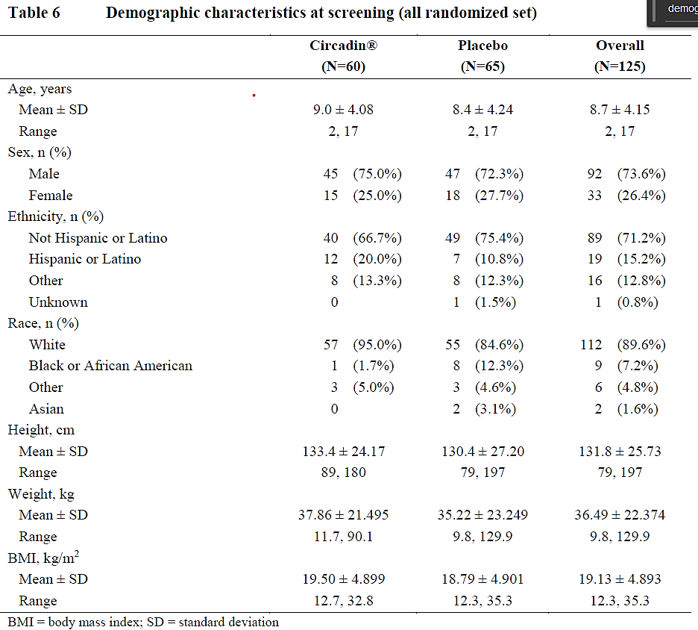
Changes in the primary efficacy endpoint of mean change from baseline in TST after 13 weeks of DB treatment in the full analysis set (FAS) was 57.4 minutes for Slenyto and 9.1 minutes for placebo. The estimated treatment difference was 32.32 minutes (95% CI: 2.38, 62.26), which was statistically significant (p = 0.035; Figure 1). Results were also clinically relevant for Slenyto, based on a minimal clinically important difference of 45 minutes for this endpoint in adults.
Table 9. Study NEU_CH_7911: SND and TST change from baseline at 13 Weeks of DB Treatment (Week 15) for the FAS Set and PPP
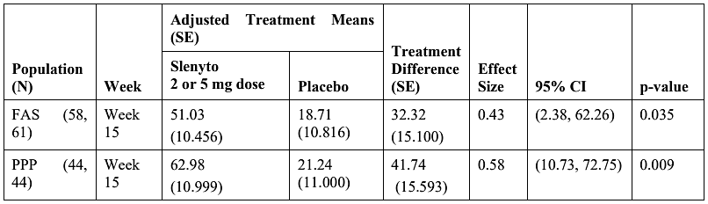
Figure 1. Study NEU_CH_7911: Change from baseline in mean (SE) TST (FAS)
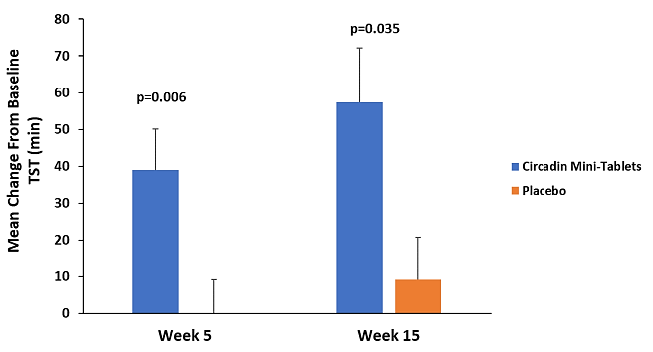
Similar improvements in TST during the DB phase were observed for patients with and without ADHD as shown in Table 10.
Table 10. Study NEU_CH_7911: SND and TST change from baseline at 13 Weeks DB – MMRM analysis including ADHD as a factor (FAS)
 | Adjusted Treatment Means (SE) (95% CI)
ADHD | n | Circadin 2 mg (N=58) | n | Placebo (N=61) | Treatment difference (SE) | 95% CI | p-value
No | 42 | 48.40 (12.333) (23.93, 72.86) | 42 | 15.62(13.248)  (-10.65, 41.89) | 32.78(18.109) | (-3.14, 68.69) | 0.073
Yes | 16 | 57.88 (20.256) (17.70,98.05) | 19 | 24.89(19.154)  (-13.10,62.87) | 32.99 (27.990) | (-22.52, 88.50) | 0.241
CI, confidence interval; SE, standard error.
Some of the secondary endpoints did not achieve statistical significance, although a positive trend favouring melatonin was noted with all secondary endpoints.
Significant results seen after 13 weeks of DB treatment for select measures are shown in Table 11.
Table 11. Study NEU_CH_7911: Summary of select secondary study outcomes after 13 weeks of DB treatment (FAS)
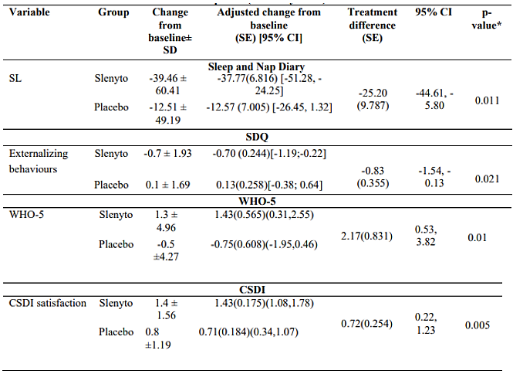
WHO-5: 5-item World Health Organization Well-Being Index (caregiver measure: covers positive mood, vitality, and general interests); CSDI: Composite Sleep Disturbance Index (satisfaction item records caregiver’s satisfaction with the child’s sleep patterns).
Figure 2. Study NEU_CH_7911: Change from baseline in mean sleep latency for the FAS
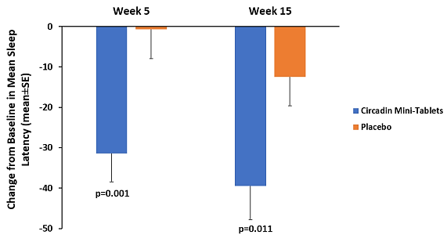
The improvement (decrease) in total SDQ score correlated with the improvement (increase) in TST from baseline (Spearman’s rank correlation R − 0.229 p = 0.024) which could be attributed to the improved LSE (Spearman’s rank correlation R − 0.21 p = 0.047) but not with the shortening of SL (Spearman’s rank correlation R 0.09 p = 0.379).36
There was a highly significant correlation between the improvement in caregiver’s QoL (WHO-5) from baseline and the improvement (decrease) in total SDQ score (Spearman’s rank correlation − 0.34 p = 0.0005), supporting the clinical meaningfulness of the effects of Slenyto on child behaviour.36
Caregivers' QoL had already improved significantly with Slenyto compared to placebo after 3 weeks of treatment (p = 0.03); by that time the hyperactivity/inattention scores also improved for Slenyto compared to the placebo treated group (p=0.045).36
For LSE, those in the Slenyto group also showed greater improvement compared to those in the placebo group, showing a trend towards statistical significance; mean (SE) adjusted treatment means of change from baseline after 13 weeks of DB treatment in longest sleep period in the Slenyto treated group (FAS) was 71.99 (14.76), vs 30.01 (15.49) minutes with placebo (p = 0.053).
For patients with/without ADHD subgroup analyses on select measures showed generally similar responses between those with and without ADHD for the following measures (Table 12)
Table 12. Study NEU_CH_7911: Results for secondary endpoints after 13 weeks of DB treatment according to presence/absence of ADHD
Measure | Results
Sleep disturbance (CSDI) | Patients without ADHD showed a greater treatment difference (in favour of Slenyto) in CSDI total score (-1.07 [95% CI: -2.30, 0.17]) than those with ADHD (-0.55 [95% CI: -2.40, 1.30]).  No clear conclusions could be drawn from the MMRM analyses of CSDI total score including prior ADHD treatment as a factor.
Social functioning (CGAS) | The treatment adjusted mean change from baseline in CGAS score for Slenyto was 2.03 in those without ADHD, and 1.75 in those with ADHD.  No clear conclusions could be drawn from the MMRM analyses of CGAS total score including prior ADHD treatment as a factor.
Behaviour (SDQ) | Patients with ADHD showed larger descriptive improvements in SDQ score with Slenyto treatment after 13 weeks of DB treatment, with treatment differences in favour of Slenyto of -1.40 (95% CI: -3.45, 0.65), compared to -0.89 (95% CI: -2.25, 0.47) for patients without ADHD.  No clear conclusions could be drawn from the MMRM analyses of SDQ total score including prior ADHD treatment as a factor.
CDSI: Composite Sleep Disturbance Index; CGAS: Children’s Global Assessment Scale
The long-term efficacy of Slenyto 2, 5, and 10 mg was assessed during the 91-week OL extension period. A total of 51 subjects from the Slenyto group and 44 from the placebo group entered the OL phase, and 79 patients completed the 39 weeks follow-up period, such that 41 patients from the Slenyto group had 52 weeks and 38 patients from the placebo group had 39 weeks of continuous Slenyto treatment.
The improvements in TST, SL and LSE seen in the DB phase with Slenyto were maintained or enhanced throughout the follow up period.
Subjects treated continuously with Slenyto for 52 weeks (N=41) slept on average (adjusted mean [SE]) 62.08 (21.5) minutes longer (p = 0.007), fell asleep 48.6 (10.2) minutes faster (p < 0.001), and had longer uninterrupted sleep duration (89.1 [25.5] minutes; p = 0.001). In addition, QOS improved (0.91 [0.22]; p < 0.001) and number of awakenings (NOA) decreased > 50%, from 0.78 to 0.3 (-0.41 [0.12] p = 0.001).36
The changes from baseline in mean TST during the DB and OL phases are shown in Figure 3.
Figure 3. NEU_CH_7911: Change from baseline in mean TST (minutes) during the DB and OL periods (FAS)
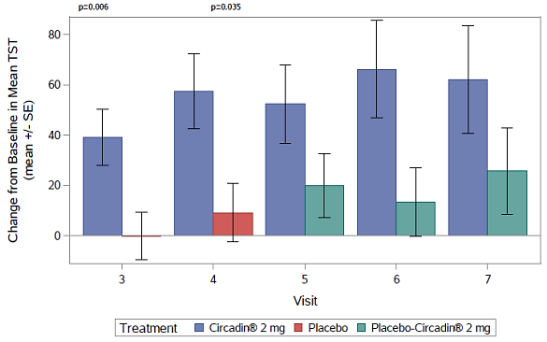
Other results included during the OL period:
- Sleep disturbance (CSDI) improved and the treatment differences compared to baseline were statistically significant at all time points (26, 39, 52, and 91 weeks of the OL period; p < 0.001).
- The improvement in caregivers’ well-being was also significant during the OL phase compared to baseline after 26 weeks (p = 0.001), 39 weeks (p = 0.006), and 91 weeks (p = 0.001) of treatment for the group that was randomised to Slenyto.
- Caregivers were more satisfied with their child’s sleep pattern with significant effects during the OL phase over baseline after 13 weeks (p < 0.001), 26 weeks (p < 0.001), 39 weeks (p < 0.001), and 91 weeks (p < 0.001) of treatment.
After the 2-week run-out period, most of the measured variables were reported to have declined descriptively compared to Week 91, but levels were still significantly better than baseline. These observations led the Sponsor to conclude that there were no signs of withdrawal and rebound effects after 91 to 104 weeks of active treatment.47
Regarding subgroup analysis of patients with an SDQ hyperactivity/inattention score of ≥ 7 at baseline there was a total of 77% of patients completing the DB phase with SDQ assessments had a SDQ hyperactivity/inattention score of ≥ 7. There was a significant effect on both TST and SL versus placebo after 13 weeks DB treatment in this subpopulation (Table 13).
Table 13. Study NEU_CH_7911: Sleep parameters after 13 weeks of DB treatment in those with SDQ hyperactivity/inattention score of ≥ 7 at baseline
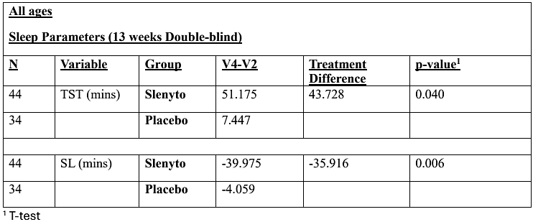
The following results were seen for the responder analyses after 13 weeks of DB treatment in the subgroup with SDQ hyperactivity/inattention score of ≥ 7 at baseline.32
- For increase in TST of ≥ 45 minutes: 41% for Slenyto vs 23% for placebo; the 18% difference in percentage between groups corresponds to a number needed to treat (NNT) of 5.5.
- For decrease in SL of ≥ 15 minutes: 70% for Slenyto vs 32% for placebo; the 38% difference in percentage between groups corresponds to a NNT of 2.6.
In the participant subgroup with SDQ hyperactivity/inattention score of ≥ 7 at baseline at 13 weeks Slenyto treatment compared to placebo resulted in:
- a significant improvement (decrease) in externalising behaviour compared to placebo treatment (mean treatment difference between Slenyto and placebo of − 0.85 [95% CI: − 1.65, − 0.05; p = 0.037]).
- a significant improvement in total SDQ (p = 0.013); the mean treatment difference over placebo was − 1.46 (95% CI: − 2.73, − 0.20; p = 0.024).
Using decrease in the total SDQ score by 1 unit or more as a criterion of clinical response36, the percentage of responders after 13 weeks of DB treatment in the Slenyto group was 54%, compared to 26% in the placebo-treated group (odds ratio [OR] 3.4; p = 0.011). The 28% difference in percentage between the groups corresponds to an NNT of 3.6.
These improvements persisted into the OL phase.
Regarding efficacy in participants < 6 years of age in this subpopulation, 20 patients were between 2 and 5 years of age inclusive. Although the results for TST and SL were not statistically significantly different between Slenyto and placebo, this was considered the result of the small sample size, with effect sizes similar to the total population present.
Table 14. Study NEU_CH_7911: Sleep parameters after 13 weeks of DB treatment in those aged 2-5 years inclusive with SDQ hyperactivity/inattention score of ≥ 7 at baseline
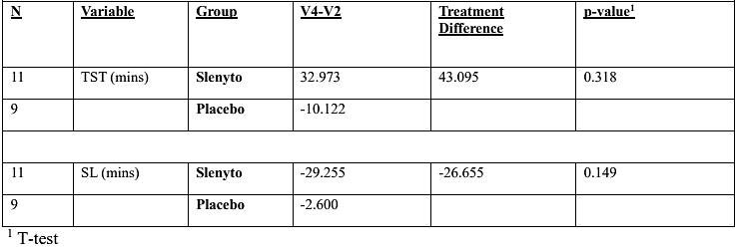
The responder analyses in this sub-population using the definitions above yielded the following results:
- TST: 27% Slenyto; 11% placebo; NNT = 6.25
- SL: 64% Slenyto; 22% placebo; NNT = 2.38
- SDQ total score: 55% Slenyto; 22% placebo; NNT = 3

Van der Heijden, KB, et al., 2007³⁷
Van der Heijden, KB, et al., 200737 was a randomised, DB, PC study of children with ADHD and chronic SOI. The study was conducted between November 2001 and June 2005.
The objective was to investigate the effect of melatonin treatment on sleep, behaviour, cognition, and QoL in children with ADHD and chronic SOI.
A total of 204 children with possible ADHD were screened for participation in this study. 176 participants were recruited from outpatient clinics for sleep-wake disorders of the Gelderse Vallei General Hospital and Kempenhaeghe by Dutch community mental health institutions and paediatric hospital departments. 28 participants were recruited through advertisements in magazines/media.
The children were randomised (1:1 ratio) to receive melatonin (3 mg when body weight < 40 kg [n = 44]; 6 mg when body weight > 40 kg [n = 9]) in fast-release tablets (Pharma Nord, Denmark) or identical-appearing placebo tablets at 7:00 PM. Treatment adherence was assessed after 3 weeks of treatment by medication counts. Of the 204 children screened, 107 children aged 6 to 12 years with diagnosed ADHD and SOI were enrolled in the study. The cohort consisted of outcomes for 53 patients treated with melatonin and 52 treated with placebo for a duration of 4 weeks. Two subjects were withdrawn because shortly after assignment they started another treatment without permission.
The 4-week randomised, DB, PC period was undertaken immediately following a 1-week baseline period. Measurements took place at baseline and during the fourth week of treatment. Children were allowed to go to bed whenever they felt tired rather than being tied to a scheduled bedtime. All of the participants were offered melatonin treatment after the end of the study.
The inclusion criteria were children 6 to 12 years old with a diagnosis of ADHD and SOI. The exclusion criteria were a total IQ < 80, pervasive developmental disorder, chronic pain, known disturbed hepatic or renal function, epilepsy, earlier use of melatonin, and use of stimulants, neuroleptics, benzodiazepines, clonidine, antidepressants, hypnotics, or β-blockers within 4 weeks before enrolment.
All children were assessed by a psychologist and a board-certified child and adolescent psychiatrist. The diagnosis of ADHD was made in accordance with guidelines of the American Academy of Pediatrics and American Academy of Child and Adolescent Psychiatry and included clinical history, amongst other reports.
SOI was defined as:
- complaints of sleep-onset problems expressed by parents and/or child,
- occurrence on at least 4 days/week for longer than 1 year,
- average sleep onset later than 8:30 PM for children at age 6 years and for older children 15 minutes later per year, and
- average SL exceeding 30 minutes.
The diagnostic procedures included clinical history, 1-week 24-hour actigraphy measurement, Dutch Sleep Disorders Questionnaire, and Children`s Sleep Hygiene Scale.
Efficacy endpoints for this study relating to change in sleep included: sleep onset, total time asleep, and sleep log item difficulty falling asleep (averaged over 7 days, on a scale of 1 [not difficult] to 5 [very difficult]). Sleep was estimated using actigraphy (Actiwatch, Cambridge Neurotechnology Ltd., Cambridge, UK) and sleep logs on seven consecutive days, at baseline, and during the fourth treatment week. Actigraphs, worn on the nondominant wrist, recorded the amount of movement at 1-minute epochs, 24 hours/day. Actigraphy data were converted into sleep parameters by the validated automatic Actiwatch scoring algorithm, using sleep log-derived lights out and rise time, and by subsequent manual verification based on sleep log data: sleep onset, SL (time from lights out until sleep onset), wake up time; total time asleep, sleep efficiency, and moving time (percentage time spent moving during assumed sleep period).
Dim light melatonin onset (DLMO) was assessed at baseline and on the first evening of the fourth treatment week. Hourly samples of saliva from 6:00 to 10:00 PM (6 to 7 years old), or 7:00 to 11:00 PM (8 to 12 years old) were obtained by chewing on a cotton plug for 1 minute (Salivetten, Sarstedt Numbrecht, Germany). No medication was taken on the evening of the salivary sample collection as medication may alter endogenous levels of melatonin. To prevent suppression of melatonin secretion by bright light, curtains needed to be closed, and only one dim light was allowed during the entire measurement period.
The efficacy endpoint of change in problem behaviours was measured via the averaged grade (1 = very severe; 10 = none) on three individually defined (spontaneously, not from a checklist), most serious, and common core problems of the child, given by parents as well as teachers.
The efficacy endpoint of change in emotional and behavioural problems were measured with the child behaviour checklist (CBCL) and Teacher’s report form (TRF), which consisted of 120 items (response scale: 0 = not true; 1 = somewhat or sometimes true; 2 = very true or often true) and yielding a total score and 8 syndrome scale scores (high scores indicating more problems).
The efficacy endpoint of change in sustained attention was assessed through the Sustained Attention Dots Task (SADT), a computerised visual task in which subjects were presented a continuous and consecutive series of 300 target (33%) and nontarget (67%) asymmetric dot configurations in a pseudo-random fashion. Subjects pushed a “yes” button whenever a target appeared and a “no” button after a nontarget signal, after which the next stimulus was presented immediately. The task parameters were inaccuracy (%) and task completion time (seconds).
The efficacy endpoint of change in QoL was assessed through the TNO-AZL Questionnaire for Children`s Health-Related Quality of Life, Parent Form (TACQOL-P) which consisted of 63 items on whether specific problems occurred or feeling had been present in recent weeks, with a 3-point Likert response scale, yielding a total sum score (maximum, 224: highest QoL) as well as scores on 7 subdomains.
Randomisation was performed by a hospital pharmacist not connected to the study in blocks of 4 to keep the number of patients in each treatment group closely balanced at all times. The following stratification criteria were used: (1) presence of psychiatric comorbidity (disruptive behaviour disorder [n = 59]; anxiety disorder [n = 16]; depressive disorder [n = 1]), (2) age category (6-9 years [n = 66]; 10-12 years [n = 39]), and (3) body weight (< 40 kg [n = 88]; ≥ 40 kg [n = 17]). Investigators and participants were unaware of treatment allocation.
Regarding statistical methods comparisons of demographic and clinical characteristics between treatment groups were conducted using independent samples t-test for continuous variables with a normal distribution, Mann-Whitney U test when distribution was not normal, and Pearson χ2 test for discrete categorical variables. Between group differences in mean day length (hours) and mean rate of change in day length (hours per week) were also analysed to control for possible confounding.
Analyses of between group differences in pre- to post-treatment were conducted using general linear model, repeated measures analysis of variance (ANOVA) and Pearson χ2 test for categorical variables. The relationship of pre- to posttreatment changes with variables of interest was analysed with linear regression analysis. Analyses were conducted using SPSS, 12.0.1 (SPSS, Inc., Chicago, IL) on an intention-to-treat basis (significance p = 0.05, two-sided) and the Bonferroni correction of p values was applied where applicable.
Regarding baseline demographic characteristics were no significant between-group differences in demographic variables, clinical characteristics, mean day length, or mean rate of change in day length were noted (Table 15). The mean age in the melatonin group was 9.1 years (SD +/- 2.3) and the mean age in the placebo group was 9.3 years (+/- 1.8)
Table 15. Demographic and Clinical Characteristics (Van der Heijden, KB, et al., 2007³⁷)
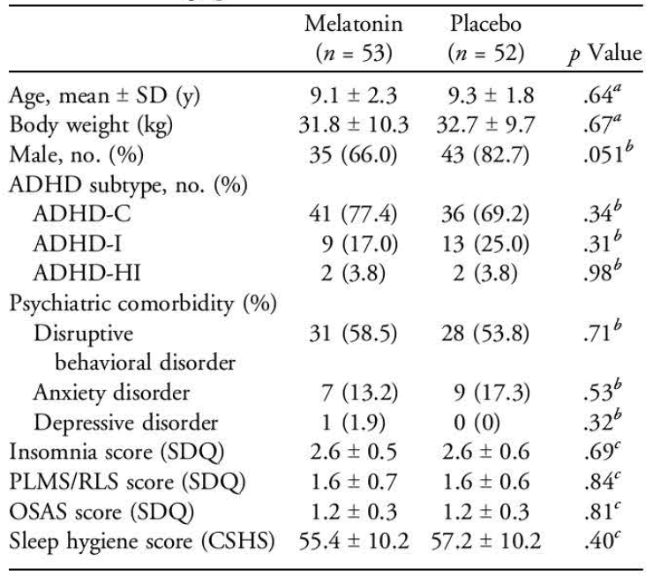
Note: ADHD = attention-deficit/hyperactivity disorder; ADHDC = attention-deficit/hyperactivity disorder combined subtype; ADHD-I = attention-deficit/hyperactivity disorder inattentive subtype; ADHD-HI = attention-deficit/hyperactivity disorder hyperactive/impulsive subtype; SDQ = Dutch Sleep Disorders Questionnaire (scale 1 = never to 5 = always); PLMS/RLS = periodic limb movement disorder/restless legs syndrome; OSAS = obstructive sleep apnea; CSHS = Children's Sleep Hygiene Scale (scale 25-150, higher values indicate worse sleep hygiene).
a Independent samples t test.
b Pearson X2 test.
c Mann-Whitney U test.
Pre- as well as posttreatment data were available from a mean (± SD) of 69.6% ± 17.4% (range, 32.4%- 86.7%) of the participants, varying with outcome measure. Missing data mainly resulted from technical problems (actigraphy), insufficient volume of collected saliva (DLMO), technical problems or refusal of children to perform the task (cognitive performance), partial completion of questionnaires, loss by participants, and nonadherence to instructions.
Results for all efficacy outcomes are shown Table 16. Between-group differences in changes of other actigraphic sleep measures were not significant.
Table 16. Outcome of variables assessed (Van der Heijden, KB, et al., 2007³⁷)
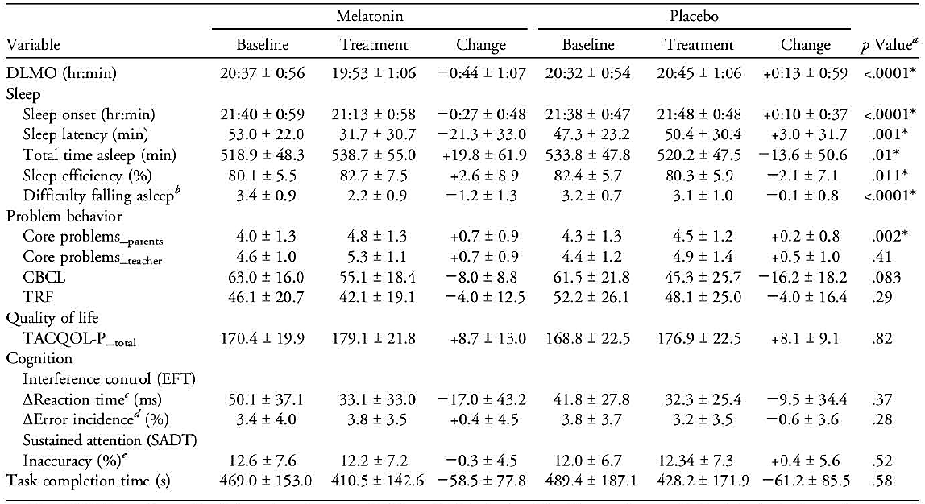
Note: DLMO = salivary dim light melatonin onset; CBCL = Child Behavior Checklist, total score; TRF = Teacher's Report Form, total score; TACQOL-P = TNO-AZL Questionnaire for Children's Health-Related Quality of Life, Parent Form; EFT = Eriksen Flanker Task; SADT = Sustained Attention Dots Task (Amsterdam Neuropsychological Tasks).
a General linear model repeated-measures test on group differences in pre- to posttreatment changes.
b Mean difficulty falling asleep as reported by parents, averaged over 7 days on a scale of 1 (not difficult) to 5 (very difficult).
c Difference in reaction time between incongruent and congruent trials.
d Difference in error incidence between incongruent and congruent trials.
e Percentage of misses plus false alarms relative to the total number of trials.
* Statistically significant difference (p = .05, two-sided).
For the melatonin group, pre- to post-treatment changes in sleep onset showed a significant linear relationship with pretreatment values of DLMO (R = 0.42; p = 0.008), indicating that more delayed DLMO values at baseline were associated with stronger advances of sleep onset after melatonin treatment. This relationship was not significant for placebo (R =0.078; p = 0.645).
For melatonin, pre- to post-treatment changes in DLMO were not significantly related with pre- to post-treatment changes in sleep onset (R =0.30; p = 0.124). Between-group differences in changes of DLMO were not significantly related to the presence of comorbid psychiatric disorders.
Follow-up at 2 years after participation yielded 24 of 26 completed questionnaires (2 families were untraceable): 19 of 24 still used melatonin (4.4 ± 2.0 mg at 7:42 PM ± 50 minutes), one used it occasionally, and 4 stopped after 17.23 ± 3.3 months (reasons: remission [n = 3], dizziness and drowsiness [n = 1]).

Other efficacy studies in ADHD

Salanitro M, et al., 202231
This systematic review and meta-analysis of published randomised control trials (RCTs) aimed to evaluate the efficacy and tolerability of melatonin in children, adolescents, and adults diagnosed with sleep or mental health disorders, using the same set of criteria across disorders and ages.
The study involved searching for RCTs through PubMed, OVID databases (PsycINFO, Embase, Embase Classic, Medline), and Web of Knowledge databases, Biological Abstracts, Biosis, Food Science and Technology Abstracts] up to 2 February 2021, with no language/data/type of document restrictions.
The authors searched for RCTs in children (> 3 years), adolescents, or adults with any sleep disorder (based on the International Classification of Diseases (ICD), Diagnostic and Statistical Manual of Mental Disorders (DSM) or International Classifications of Sleep Disorders (ICSD) criteria or defined based on core above cut-off in sleep questionnaires) or mental health condition diagnosed based on formal criteria (ICD or DSM, any version).
No conflicts of interests were declared by the authors.
Eligible studies were RCTs with participants with a primary diagnosis of sleep or mental disorders and secondary comorbid mental disorders were eligible. Studies including 100% of participants with a comorbid disorder were included but considered for a possible subgroup analysis. RCTs where the only intervention was represented by melatonin were included, while those that used melatonin agonists or melatonin in conjunction with another medicine/treatment were excluded. The melatonin dosage ranged from 1–6 mg/day for children and 0.1–10 mg/day for adults. Both PR and IR melatonin tablets were discussed in the included RCTs.
Screening of studies was performed independently and blindly by two study authors, with any disagreement resolved by the senior author. Data extraction from the included studies was conducted independently by two authors.
Following a pool of 6,000 references screened, a total of 34 RCTs were included in the study. There were 21 studies on children and adolescents, 12 of which were parallel RCTs and the remaining 9 being randomised crossover trials. All 21 studies were DB. Thirteen studies on adults were also included, 5 being parallel RCTs and the remaining 8 being randomised crossover trials.
Regarding variables assessed any subjective or objective variable reported in at least two RCTs was evaluated. Outcomes examined included sleep onset latency (SOL), TST, DLMO, and nocturnal awakenings (NA). Meta-analysis was performed to examine the comparative efficacy of melatonin for sleep parameters across sleep/neurodevelopmental disorders.
Regarding statistical methods a pairwise meta-analysis was performed per disorder, using MD for outcomes measured with the same metric and standardised mean difference (SMD) for others, both with 95% CIs based on a random effects model.
Tolerability was assessed by pooling ORs, with log ORs calculated with the following variables: melatonin dropouts due to AEs (n), melatonin total sample size (n), placebo dropouts due to AEs (n) and placebo total sample size (n). Log ORs were then analysed using a random effects model. Data were considered from intention-to-treat analyses.
Heterogeneity of effect size was assessed using Q-statistics (indicating presence) and I² index (measuring variance due to true heterogeneity). Publication bias was assessed visually through funnel plots (for meta-analyses with ≥ 10 studies) and quantitatively using rank correlation and regression tests for funnel plot asymmetry.
The study characteristics in children and adolescents are shown in Table 17; those for ADHD have been highlighted.
Table 17. Characteristics of RCTs in children and adolescents included in the meta-analysis (Salanitro M, et al., 202231)
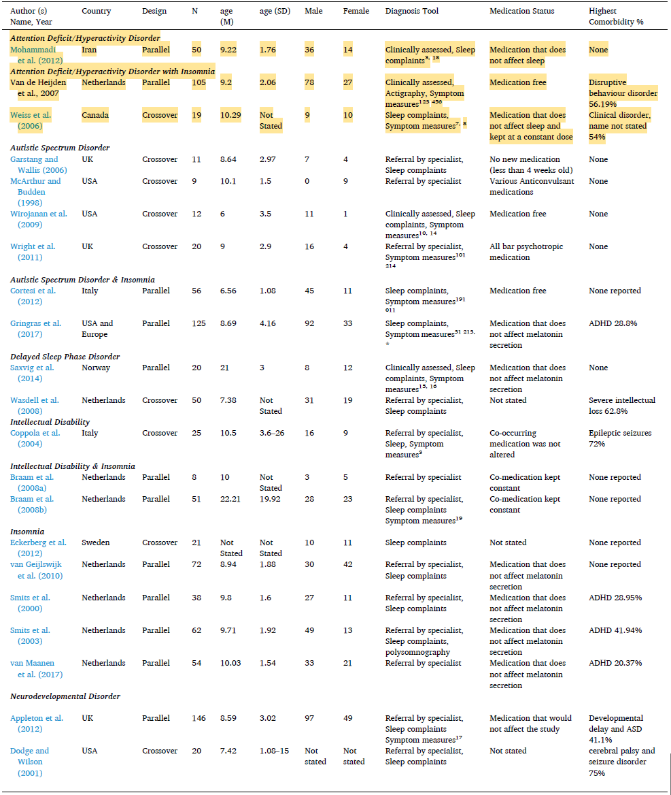
Note. Symptom measures: 1 - Child Behavior Check List, 2 - Teachers Report Form, 3 - Diagnostic and Statistical Manual of Mental Disorders-IV, 4 - Shortened IQ Test (WISC-R Dutch Version), 5 - Dutch Sleep Disorder Questionnaire, 6 - Children’s Sleep Hygiene Scale, 7 - Interview Schedule for Children-IV, 8 - Child Symptom Inventories, 9 - Diagnostic and Statistical Manual of Mental Disorders-IV Text Revision, 10 - Autistic Diagnostic Interview–Revised, 11 - Autism Diagnostic Observation Schedule–Generic, 12 - International Classification of Diseases, Tenth Revision, 13 - Diagnostic and Statistical Manual of Mental Disorders-5, 14 - Autism Diagnostic Observation Schedule, 15 - Structured Clinical Interview for DSM-IV Axis I Disorders, 16 - International Classification of Sleep Disorders, 17 - Adaptive Behaviour Assessment System, 18 - Sleep Disturbance Scale for Children, 19 - Social Functioning Scale for the Mentally Retarded. * A participant was checked with at least one of the symptom measures mentioned.

The authors reported that the dose and duration of melatonin showed no sign of consistency among studies when it came to selecting a given dose of melatonin. Similarly, administration time was found to be reported in multiple formats which were difficult to quantify in the same way. The general trend across studies was for melatonin to be administered around an hour or two before bedtime. The most frequent duration of treatment across all disorders was 4 weeks.
The results of the main meta-analysis of each outcome variable within and across disorders for children and adolescents are summarised in Table 18; results for ADHD have been highlighted. The MD effect size was considered for SOL on diary, SOL actigraphy, TST diary, TST actigraphy, and DLMO. The SMD was considered for NA.
For patients with ADHD with insomnia, the total number of studies included in this analysis was k = 2 (N = 124) and only one outcome variable qualified for analysis. The authors reported that the MD effect size was calculated for SOL actigraphy, and the results indicated a significant difference in favour of melatonin over placebo. The test for heterogeneity showed no significant heterogeneity. Overall, the authors stated that the result indicated that melatonin reduced SOL by on average 17.73 min in children and adolescents with ADHD and comorbid insomnia.
Table 18. Results of the main meta-analysis of each outcome variable within and across disorders for children and adolescents. Significant results are bolded (Salanitro M, et al., 2022³¹)
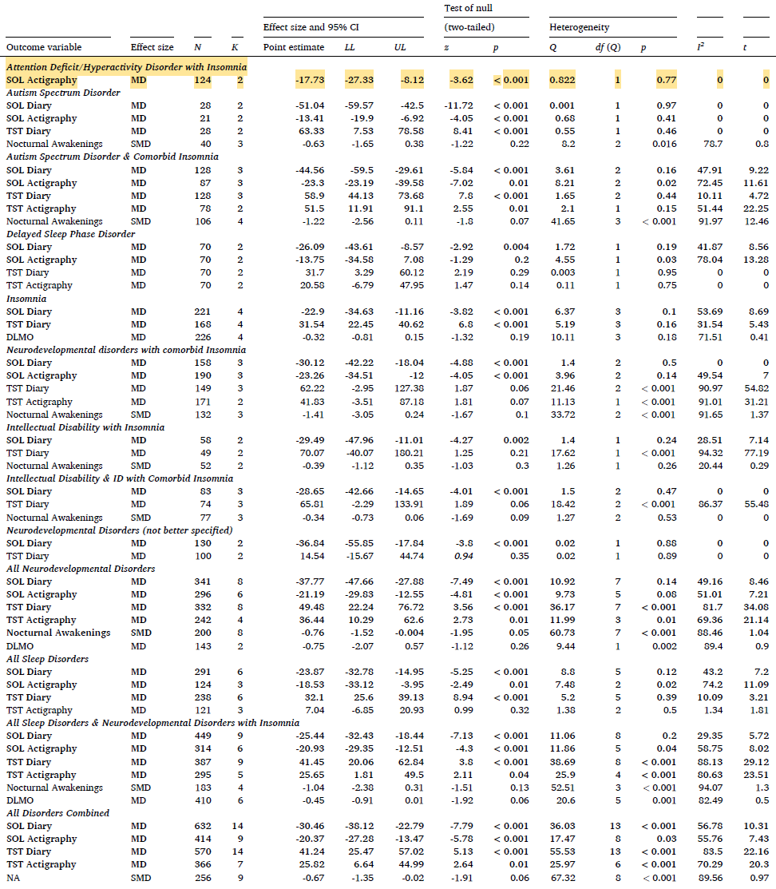
RE-random effects; FE, fixed effects; MD, mean difference; SMD, standardised mean difference
The MD effect size was considered for SOL on diary, SOL actigraphy, TST diary, TST actigraphy, and DLMO. The SMD was considered for NA.
For patients with all sleep disorders and neurodevelopmental disorders (including ADHD) with insomnia, the total number of studies included in these analyses was k = 24. Six variables qualified for this analysis. The authors reported that melatonin was related to significantly lower scores in SOL diary, SOL actigraphy, and DLMO compared to placebo. Furthermore, the authors stated that melatonin was related to significantly increased scores in TST diary and actigraphy in comparison to placebo. However, there was no significant difference between melatonin and placebo for NA scores.

Hayashi, M. et al., 202246
This was a multicentre, randomised, three parallel-group, DB, PC trial involving children aged 6-15 years with ASD including with or without ADHD who experienced SOL issues. The study was conducted to examine the efficacy and safety of oral melatonin as compared to placebo in preventing difficulties falling asleep among numerous sleep problems that children with ASD presented.
The trial consisted of 5 phases:
- the 7-day pre-monitoring phase, in which sleep status was checked;
- the 14-day screening phase, during which SOL was assessed;
- the 14-day, parallel-group, DB randomisation phase, in which eligible children were assigned 1:1:1 to receive 1 mg of melatonin (1-mg melatonin group), 4 mg of melatonin (4-mg melatonin group), or placebo (placebo group) once daily (before bedtime);
- the 42-day OL phase, in which all children were ensured to receive melatonin 1-, 2-, or 4-mg according to the titration procedure (initial dose: 1 mg) for assessing its clinical benefits
- the 14-day post-monitoring phase, in which withdrawal symptoms or rebound phenomenon were examined.
Eligible children, who met all of the following criteria that were examined in the last 7 days of the 14-day screening phase, were included in the 14-day, DB, randomisation phase: (1) SOL lasting ≥ 30 min over 3 or more days; (2) successful adherence (≥ 5 days) to time for medication and bedtime with allowance ranges of 15 min and 30 min, respectively; and (3) successful adherence (≥ 5 days) to the entry in the electronic sleep diary and/or to medication. All children underwent sleep hygiene interventions at the time of informed consent acquisition.
The inclusion criteria were children aged 6-15 years with a diagnosis of ASD based on DSM-5 criteria, a SOL ≥ 30 minutes on average that persisted for 3 or more months, and capable of being cooperative for sleep hygiene interventions. Exclusion criteria included Children with severe intellectual disabilities, a history of melatonin treatment, or complications such as breathing-related sleep disorders, hepatic function disorder, schizophrenia, or bipolar disorder.
Of the 229 children assessed for eligibility, 196 were enrolled in the study. A total of 65 children were assigned to the 1 mg melatonin group, 65 to the 4 mg melatonin group, and 66 to the placebo group (1:1:1 ratio). Children took melatonin or placebo at 45 min before bedtime as follows: placebo during the screening phase; 1 mg of melatonin, 4 mg of melatonin, or placebo (1:1:1) during the randomisation phase; and 1 mg of melatonin, increasing to 2 or 4 mg accordingly during the OL phase. Dose escalation was permitted after a minimum of 7-day administration at the previous dose, while dose tapering was permitted without restriction. Melatonin (1 mg and 4 mg granules, Nobelpharma Co., Ltd., Tokyo, Japan) and placebo were used for this study.
The primary efficacy outcome was the change from the median of SOL recorded during the last 7 days of the screening phase (baseline) to the median of SOL recorded during the last 7 days of the randomisation phase or before medication discontinuation. Caregivers were instructed to enter all of the information on the sleep status of their children in the sponsor-provided electronic sleep diary after awakening.
The key secondary outcomes were:
- Sleep variables assessed with the actigraph (FS-760; ACOS Co., Ltd., Handa, Nagano, Japan), SOL, number of wakenings after sleep onset (number of wakenings between time of falling asleep and wakening time), wakening time after sleep onset (total time of staying awake between time of falling asleep and wakening time), TST, and sleep efficiency defined as TST divided by time in bed].
- Changes in aberrant behaviours using the aberrant behaviour checklist and the Japanese version, Aberrant Behavior Checklist Japanese Version (ABC-J).
- Safety of melatonin treatment
At the initial visit, personal and demographic questionnaires, special tests for ASD, and sleep disturbance assessments were completed by caregivers. These measures were completed at baseline and repeated at the end of the randomisation phase.
Regarding statistical methods the required sample size was calculated to be 180 according to the bootstrap method stimulation under the conditions of ≥ 90% power at 2.5% 2-sided level to conduct 2 between-group comparisons for the 1- and 4-mg melatonin groups and the placebo group. The primary outcome was analysed according to Steel’s test. Continuous and categorical variables are expressed as medians with the interquartile range, and between-group comparisons were made using Wilcoxon signed rank test. Steel test was conducted to adjust the multiplicity of nonparametric analyses on the primary efficacy outcome. A value of p < 0.05 was considered statistically significant. All statistical analyses were conducted using SAS 9.3 (SAS Institute, Inc., Cary, NC, USA).
Overall, the mean (SD) age was 11.2 (2.5) years, 61.7% of the subjects were male, and ADHD was present in 108 (55.1%) of children. The study groups did not show significant differences in demographic and baseline characteristics (Table 19).
Table 19. Demographic and baseline characteristics (Hayashi, M. et al., 2021⁴⁶)
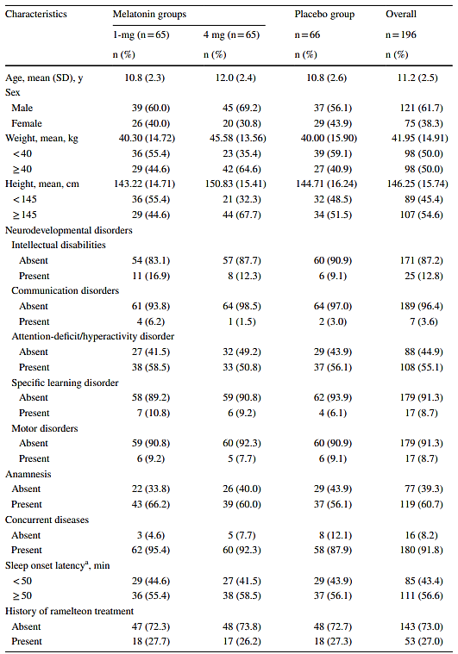
Regarding results of the primary efficacy outcome, the changes in the median SOL from the end of the randomised phase/before medication discontinuation from that recorded during the last 7 days of the screening phase were as follows: − 5.0 min, − 22.0 min, and − 28.0 min for the placebo group, the 1-mg melatonin group, and the 4-mg melatonin group, respectively. Steel’s test p-value for the melatonin 1 mg group against the placebo group was <0.0001, Steel’s test p-value for the melatonin 4 mg group compared to the placebo group was <0.0001.
Subgroup analyses conducted with respect to sex, age, weight (< 40 kg, ≥ 40 kg), SOL at baseline, history of ramelteon treatment, ID, ADHD, and height (< 145 cm, ≥ 145 cm) showed SOL shortened significantly (p < 0.05) in the 4-mg melatonin group than in the placebo group with respect to all subgroups. SOL shortened significantly (p < 0.05) more in the 1-mg melatonin group than in the placebo group with respect to all subgroups except “female,” “previous history of ramelteon treatment,” and “≥ 145 cm in height.”
Regarding secondary efficacy outcomes SOL assessed with the actigraph shortened significantly (p < 0.0001) more in the 1- and 4-mg melatonin groups (− 21.0 min and − 20.0 min, respectively) than in the placebo group (1.0 min). Sleep efficiency improved in the 4 mg melatonin group (2.35%, p = 0.0408) but not in the 1-mg melatonin group. There were no significant changes in TST or NOA. In the 1-mg melatonin group, wakening time after sleep onset extended significantly (p = 0.0072).
For aberrant behaviours assessed with the ABC-J (stereotypic behaviour, irritability, social withdrawal, hyperactivity/noncompliance, and inappropriate speech), there were no significant differences between the melatonin and placebo groups in the 14-day DB phase. However, they all were reported to have improved significantly during the 42-day OL phase (p < 0.0001, except stereotypic behaviour [p = 0.0014]).
Table 20. Sleep variables as assessed with actigraph (Hayashi, M. et al., 2021⁴⁶)
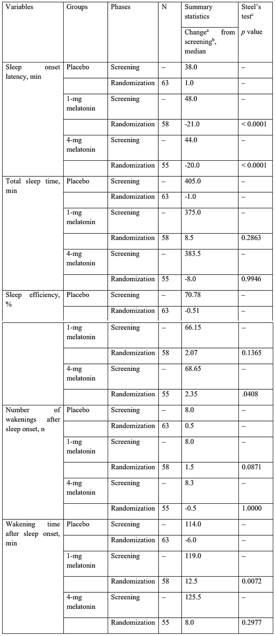
a. The median during the last 7 days of the randomisation phase - the median during the last 7 days of the screening phase; b. The median during the last 7 days of the screening phase; c. Against the placebo group
The study included a subgroup analysis of the primary efficacy outcome (change in median SOL) focusing on children with ADHD. Significant reductions in SOL were observed in both melatonin groups compared to placebo for children with ADHD shown in Table 21.
Table 21. Subgroup analysis of the primary endpoint on ADHD (Hayashi, M. et al., 2021⁴⁶)
Attention-deficit hyperactivity | Groups | Phases | No. of patients | Summary statistics (Changeª, median, min) | Steel’s test^{b}  p value
Absent | Placebo | Screening | – | – | –
Absent |  | Randomisation | 29 | -3.0 | –
Absent | 1 mg melatonin | Screening | – | – | –
Absent |  | Randomisation | 27 | -22.0 | 0.0319
Absent | 4 mg melatonin | Screening | – | – | –
Absent |  | Randomisation | 32 | -33.5 | 0.0030
Present | Placebo | Screening | – | – | –
Present |  | Randomisation | 37 | -7.0 | –
Present | 1 mg melatonin | Screening | – | – | –
Present |  | Randomisation | 38 | -22.3 | 0.0004
Present | 4 mg melatonin | Screening | – | – | –
Present |  | Randomisation | 33 | -28.0 | 0.0003
a. The median during the last 7 days of the randomisation phase – the median during the last 7 days of the screening phase.
b. Against the placebo group.

Malow, B. et al., 202147
This is a publication concerning Study NEU_CH_7911, a randomised, DB, PC, parallel-group, multicentre study of pediatric prolonged-release melatonin (PedPRM) for 13 weeks, followed by a prospective 91-week OL PedPRM treatment, and finally 2 weeks of placebo to evaluate withdrawal effects (Figure 4). The study was conducted between 1 December 2013 and 28 February 2018 in 14 centres in the US and 10 centres in Europe.
In the DB phase, the 3-month efficacy and safety of 2/5 mg PedPRM for insomnia in children and adolescents with ASD and NGD with/without ADHD comorbidity was demonstrated. This study examined the long-term effects of PedPRM treatment (2 mg, 5 mg, or 10 mg daily up to 2 years of continuous use) on sleep, growth, BMI, and pubertal development.
Figure 4. Overall study design, patient disposition, and dose breakdown for participants (Malow, B. et al., 2021⁴⁷)
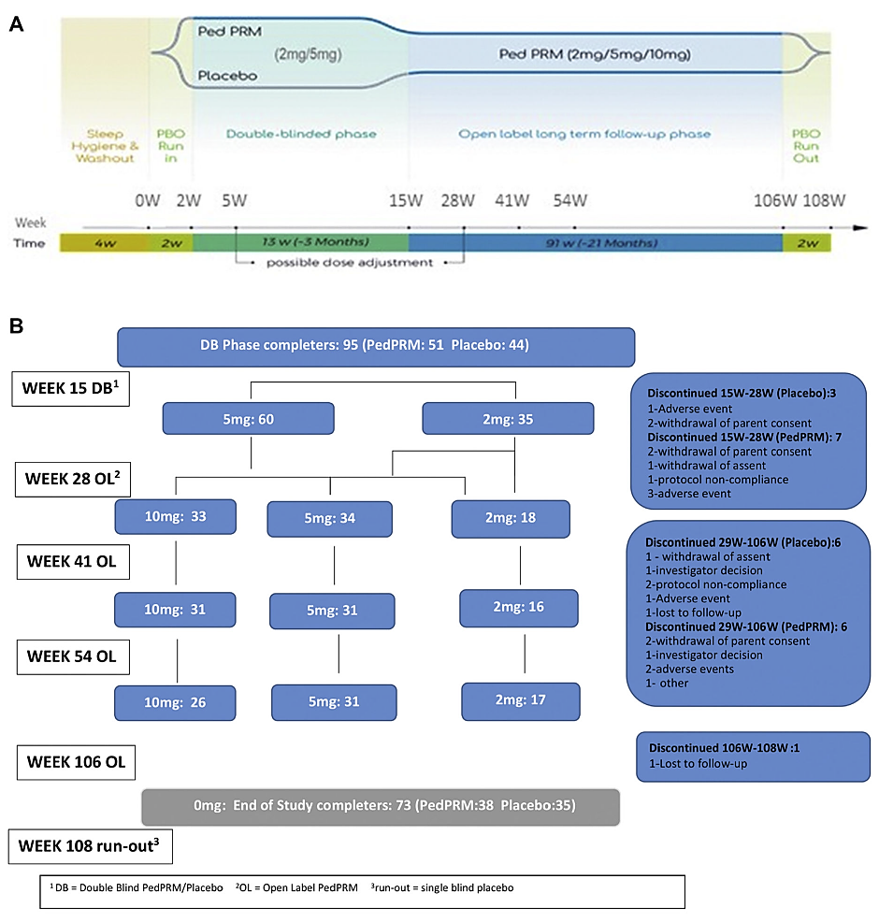
CSDI = Composite Sleep Disturbance Index; DB = double-blind; OL = open-label; PBO = placebo; PRM = prolonged-release melatonin; SND = sleep and nap diary; TST = total sleep time.
Participants were children and adolescents aged 2–17.5 years of age with confirmed physician-diagnosed ASD according to DSM-IV/DSM-5 or ICD-10 criteria or SMS and a minimum of 3 months of impaired sleep, defined as ≤ 6 hours of continuous sleep and/or ≥ 0.5-hour SL from light off 3 out of 5 nights per week for 2 weeks based on parent reports and patient medical history.
The starting dose was 2 mg PedPRM (or placebo equivalent) with optional dose escalation from 2 to 5 mg after 3 weeks of DB treatment (week 5 in the trial) and from 2 to 5 mg or from 5 to 10 mg/day after 13 weeks of OL treatment (week 28) if participants failed to improve TST and/or SL by at least 60 minutes from baseline. Optional decrease in dose was allowed at all times during the study, based on investigator decision.
Ninety-five (95) participants completed the 13-week DB phase and entered the OL phase; 51 had been assigned to PedPRM and 44 to placebo in the DB phase. Seventy-four (74) completed the treatment (week 106), and 73 completed the run-out phase (70 had ASD [95.9%] and 3 [4.1%] had SMS).
The primary efficacy endpoint measured was the change from baseline in mean TST over the 14 days by the end of the DB period. Other endpoints included changes from baseline in mean SL, NOA, LSE (duration of uninterrupted sleep), and QOS over the 14 days and change from baseline CSDI score. Efficacy results were generally described for those who completed the treatment (week 106; n = 74).
Sleep variables, reported by parent/caregiver, were assessed using a validated parent-reported SND. The SND was to be completed every morning by the parent/caregiver at home for 14 days before each visit throughout the 13-week DB period and the first 39 weeks of the OL period.
Child sleep was assessed at each visit throughout the 2-year study using the CSDI, which scores the frequency and duration of the participant’s sleep habits over the previous month (6 habits: settling at bedtime, sleep induction, waking up during the night, resettling, early wake time, and co-sleeping with caregivers; scored 0–2; total score range 0–12).
Caregiver’s measures included the Pittsburgh Sleep Quality Index (PSQI) score (range 0-21; a score > 5 is considered significant sleep disturbance), WHO-5 Well-Being index (WHO-5; covers positive mood, vitality, and general interests; total score range 1–25), and CSDI-recorded satisfaction of child’s sleep patterns (rated from 1 to 5).
The mean (SD) age of DB completers was 9 (4.2) years, age range was 2–17 years, and 74.7% of the subjects were male.
Regarding results from efficacy outcomes at week 106 of the OL period, there were no notable differences in outcomes at week 106 between participants originally assigned to placebo when given PedPRM treatment for 91 weeks (placebo group) or participants originally assigned to PedPRM and given PedPRM for 104 weeks (PedPRM group), thus allowing the groups to be combined.
The mean (SE) changes from baseline in Composite Sleep Disturbance Index (CSDI) sleep disturbance, caregiver’s satisfaction with child’s sleep patterns, and WHO-5 QoL for the combined PedPRM and placebo groups (n = 74) in the follow-up phase are presented below. Increase in efficacy was observed between week 28 and week 54 that followed dose optimisation (at week 28) allowing some children to escalate to 10 mg/day. Improvements in CSDI (decrease), in caregiver satisfaction with child’s sleep patterns (increase), and WHO-5 (increase) were significant over baseline values and maintained until the end of PedPRM treatment. After the 2-week run-out on placebo (week 108), the treatment effects decreased but remained significantly better compared with baseline (Figure 5).
Similarly, mean (SE) change from baseline in caregiver PSQI for the combined PedPRM and placebo groups (n = 74) at week 106 improved (−1.55 [0.448]; p = 0.001) showing maintenance of beneficial effect from values seen a year before (week 54). The effects declined during run-out on placebo. Nevertheless, significant improvements in PSQI were still reported at withdrawal. Diagnosis (ASD with or without ADHD or SMS) and co-medication (e.g., stimulants) did not affect PedPRM efficacy outcomes.
Figure 5. Effects of PedPRM treatment on child and caregiver parameters (Malow, B. et al., 2021)
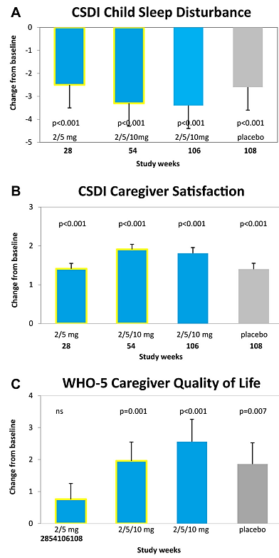

Maras, A. et al., 201833
This is a publication concerning Study NEU_CH_7911 and reviews efficacy and safety outcomes results of this study up to week 52. Efficacy outcomes up to week 52 have been reviewed in Study NEU_CH_7911 in this document. Given these efficacy results for this study have been reviewed already this publication has not been further reviewed.

Mohammadi, MR. et al., 201234
This was a randomised, PC, DB trial of MPH (Ritalin)-treated children with ADHD aged between 7 and 12 years.
The aim of this study was to determine melatonin effects on sleep patterns, and symptoms of hyperactivity and attention deficiency in children with ADHD. Assessments of ADHD and sleep patterns were completed at baseline, and at the second, fourth, and eighth weeks after the commencement of treatment. Anthropometric measurements were performed at baseline and after 8 weeks.
Sixty children diagnosed with ADHD were eligible. Eight children (25%) in the placebo group and 2 (7.25%) in the melatonin group dropped out of the study voluntarily or were excluded due to irregular drug consumption. A total of 26 children in the melatonin group and 24 in the placebo group completed the study.
Inclusion criteria were children aged 7-12 years who were diagnosed with ADHD (combined form) by a child and adolescent psychologist were included. Exclusion criteria included children using cofounding drugs or supplements; narcotic use; a history of major prenatal complications such as prematurity and low birth weight; any past or present psychosis; comorbid Tourette syndrome; celiac disease; phenylketonuria; autism; or other persistent developmental disorders.
Study treatments were MPH, (10 mg tablets, Basel, Switzerland), melatonin (3 mg capsules, Nutricenturi, Canada), and Placebo (starch capsule, made by Institute of Medicinal Plants, Tehran, Iran) were provided for this study. One group took melatonin (3 [for those < 30 kg] or 6 [for those > 30 kg] mg) combined with MPH (1 mg/kg), and the other group took placebo combined with MPH (1 mg/kg).
The examined efficacy outcomes were mean SL and total sleep disturbance. Sleep was assessed using the Sleep Disturbance Scale for Children (SDSC) and ADHD symptoms by the ADHD Rating Scale; both were completed by mothers. The SDSC is a standardized 27 item Likert-type scoring system for assessing different aspects of sleep disturbances in children and adolescents. The validity and reliability of the SDSC questionnaire were evaluated and verified again by the research team. The ADHD Rating Scale, designed based on DSM-IV criteria, is an 18 item Likert-type scoring system which ensures internationally validated and standardised criteria in the assessment of ADHD.
Regarding statistical methods the sample size was determined so that researchers could detect at least a 25-minute change in SL with a power of 80% and to detect a type I error of 5%. Based on these calculations, the number of 18 children was determined to be sufficient but the sample collection was continued to cover more than 20% case loss. The results were compared between the two groups using SPSS software version 17, and ANOVA with repeated measures analysis. Demographic parameters were compared between the two groups using Independent Sample t-test (for quantitative variables), Chi-Square, and Fisher’s Exact Test (for qualitative variables).
Regarding baseline demographics the mean age of children was 9.57 ± 1.65 in the melatonin group, and 8.83 ± 1.82 in the placebo group, but the difference was not statistically significant (p = 0.138). Similarly, maternal age at delivery time was also not statistically significantly different between the groups (26.4 years for melatonin and 25.2 for placebo; p = 0.381). There were no statistically significant differences between groups for the other demographic variables (Table 22).
Table 22. Similarity of distribution of demographic variables between the treatment groups (Mohammadi, MR. et al., 2012³⁴)
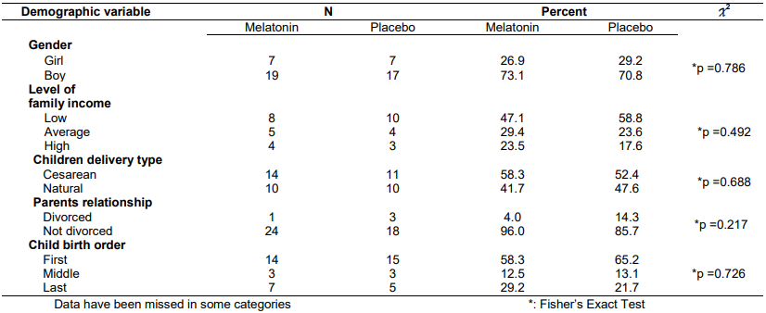
Regarding the efficacy results for sleep parameters, while the mean SL and total sleep disturbance scores were reduced in the melatonin group, and increased in the placebo group, the differences between the two groups were not statistically significant (p ≥ 0.05). This is shown in Figure 6 and Figure 7.
Figure 6. Mean total sleep duration (h) for the two trial groups (Mohammadi, MR. et al., 2012³⁴)
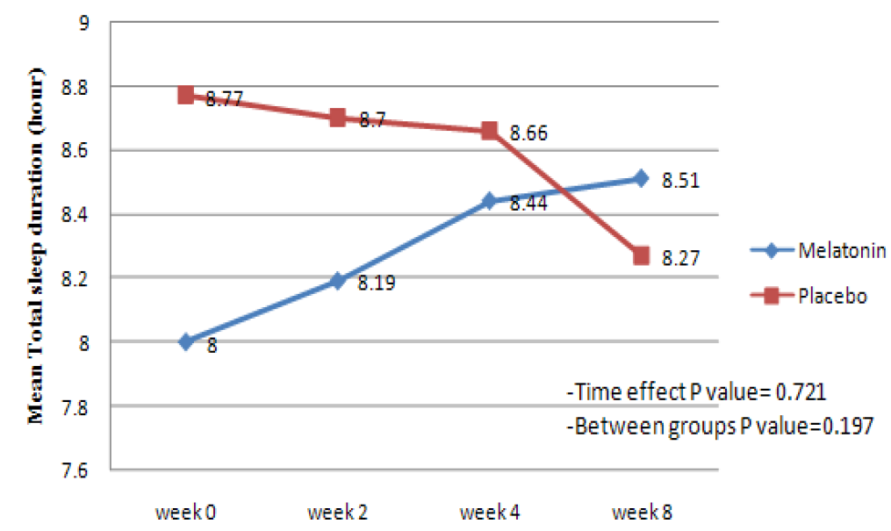
Figure 7. Mean sleep latency (min) for the two trial groups (Mohammadi, MR. et al., 2012³⁴)
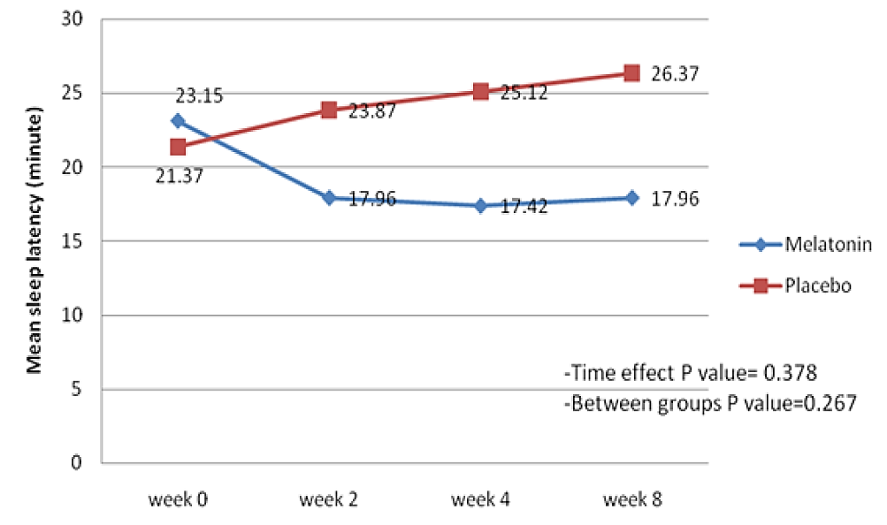
Regarding the efficacy results for ADHD symptoms, no statistically significant differences in attention deficiency or hyperactivity between the two groups were observed. This is shown in Figure 8 and Figure 9.
Figure 8. Mean attention deficiency scores for the two trial groups (Mohammadi, MR. et al., 2012³⁴)
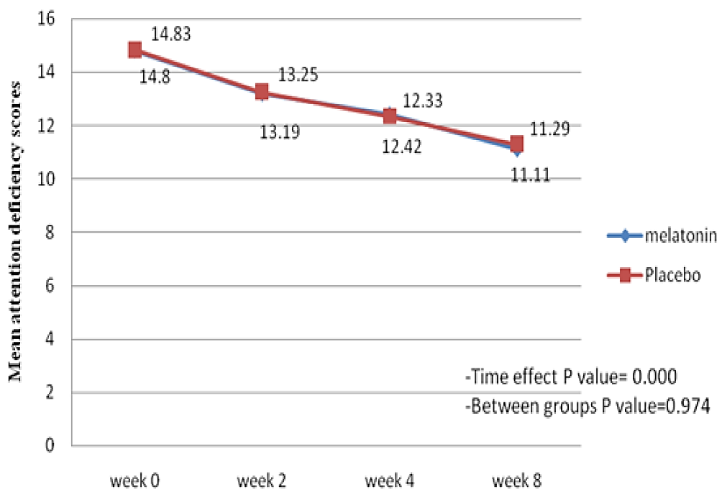
Figure 9. Mean hyperactivity scores for the two trial groups (Mohammadi, MR. et al., 2012³⁴)
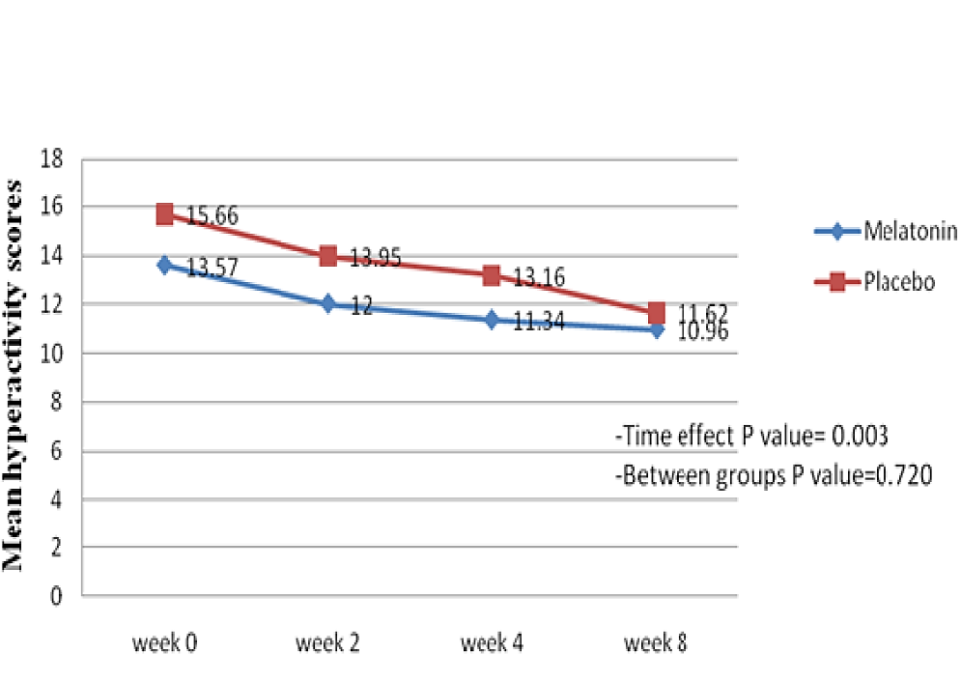

Schroder, CM. et al., 201936
This randomised, DB, PC study aimed to evaluate the effects of PedPRM compared with placebo on child behaviour in children with ASD (96.8%) or SMS (3.2%) and insomnia, as well as caregiver’s well-being outcomes. A total of 125 children aged 2-17.5 years were treated with Circadin 2 to 5 mg daily for 13 weeks in the DB phase; children could then continue in the OL phase of 91 weeks to receive Circadin 2, 5, or 10 mg daily. This publication concerns Study NEU_CH_7911, as such it will not be fully reviewed in this section. Select results from the publication are summarised below.
Efficacy outcomes examined in this study were related to child behaviour and caregiver’s outcomes included the SDQ, WHO-5, and PSQI. Outcomes for sleep included the Epworth Sleepiness Scale (ESS; caregivers’ sleepiness scale), TST, SL, and duration of uninterrupted sleep (LSE).
To evaluate whether and to what extent the improvement in sleep could explain the improvements in behaviour or in caregivers’ QoL, the correlation between the change in total SDQ and the main sleep variables were analysed, namely TST, SL and LSE in the total sample (PedPRM and placebo groups together). Similarly, the correlations between the change in caregiver’ QoL and the changes in the mean sleep variables and in total SDQ were analysed (Spearman’s rank correlation).
Results of the examined efficacy outcomes showed that PedPRM significantly improved externalising behaviour compared to placebo (mean difference: -0.83, p = 0.021) with clinically relevant improvements (≥ 1 unit improvement in externalising behaviour) in 53.7% of PedPRM-treated versus 27.6% of placebo-treated subjects. The 26% difference in percentage between the groups corresponds to an NNT of 3.8.
The greatest treatment effect in the total study population was for the hyperactivity/inattention SDQ item scores (Table 23). Mean SDQ hyperactivity/inattention score improved significantly with PedPRM and worsened with placebo. The estimated mean treatment difference between PedPRM and placebo for the change from baseline in SDQ hyperactivity/inattention score after the 13 weeks of DB treatment was − 0.54, with a trend to benefit in favour of PedPRM versus placebo (p = 0.065).
Table 23. Behaviour (SDQ) after 13 weeks of DB treatment (Schroder, CM. et al., 2019³⁶)
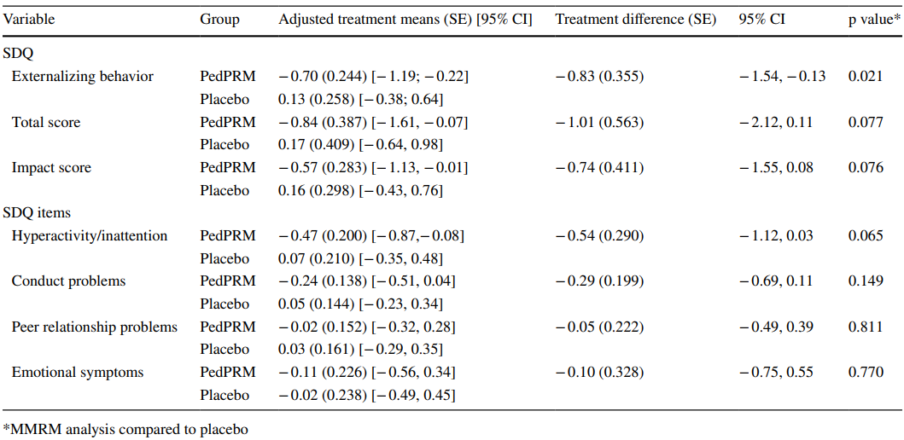
Based on MMRM analysis including co-occurring ADHD diagnosis as a factor, treatment effects on sleep variables along with improvement in total SDQ score did not differ significantly between the subgroups of participants with co-occurring ADHD as compared to those without an ADHD diagnosis (adjusted mean difference of − 1.40 [95% CI − 3.45, 0.65] vs − 0.89 [95% CI − 2.25, 0.47]).
The improvement in total SDQ score correlated modestly but significantly with increased TST from baseline (Spearman’s rank correlation R − 0.22, p = 0.024). This may be attributed to the improved LSE (Spearman’s rank correlation R − 0.21, p = 0.047), but not with the shortening of SL (Spearman’s rank correlation R 0.09, p = 0.379).
Regarding caregiver related efficacy outcomes there was a statistically significant improvement observed in mean WHO-5-assessed QoL following 13 weeks of PedPRM treatment, with a treatment difference between the PedPRM and placebo groups of 2.17 points (p = 0.01); treatment effects were evident after 3 weeks of treatment. Statistically significant improvements were also observed with PSQI assessed caregiver’s sleep quality, while caregivers’ sleepiness (ESS) also improved but not significantly. In contrast, treatment with placebo did not result in improvements in any of these outcomes (Table 24).
Table 24. Caregivers responses after 3 and 13 weeks of DB treatment (Schroder, CM. et al., 2019³⁶)
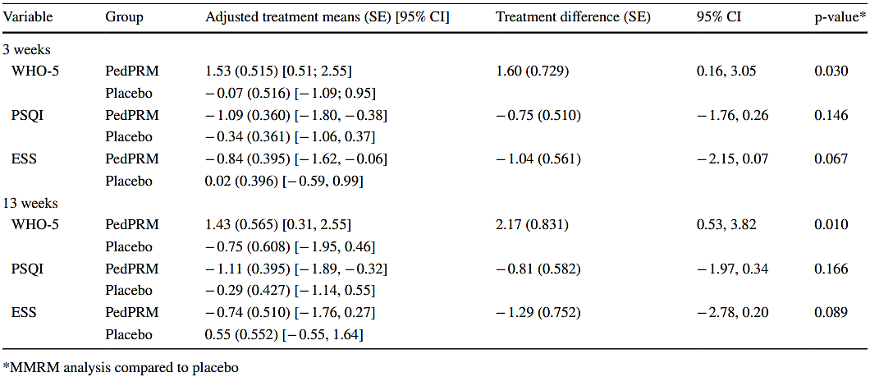
There was a highly significant correlation between the improvement in caregiver’s QoL (WHO-5) from baseline and the improvement in total SDQ score (Spearman’s rank correlation − 0.34 p = 0.0005) but not with the SND reported changes in child sleep variables (TST, SL and LSE; Figure 10).
Figure 10. Spearman Rank Correlation between the change from baseline in WHO-5 Caregiver’s well-being and total SDQ score after 13 weeks of treatment with either PedPRM or placebo (Schroder, CM. et al., 2019³⁶)
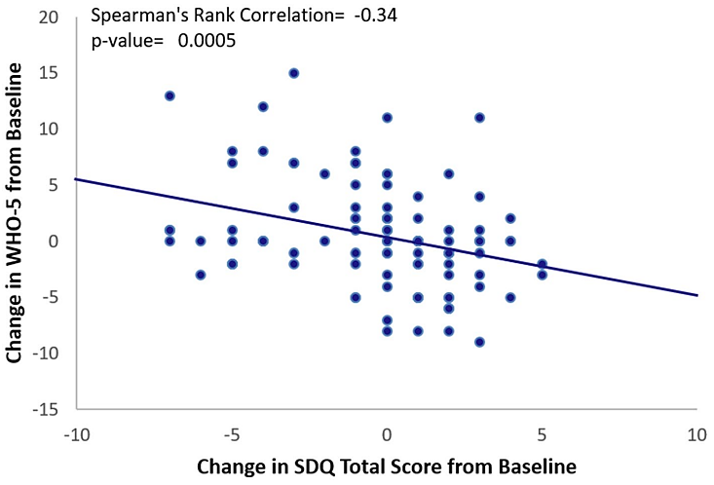

Weiss, MD. et al., 200638
This was a randomised, DB, PC crossover trial of children with ADHD and initial insomnia on stimulants.
Children aged 4-14 years old with ADHD and initial insomnia were recruited for this study through clinical referrals to the Provincial ADHD Program. Assessment of ADHD included the Diagnostic Interview Schedule for Children-IV and the parent and teacher report on the Child Symptom Inventories, with final confirmation determined by the clinician. Initial insomnia was defined by a baseline evaluation using parent-recorded somnologs as a mean SOL of > 60 minutes during a 10-night period.
This two-phase treatment study began with sleep hygiene intervention. Only children who continued to have initial insomnia of > 60 minutes were eligible to enter the DB, randomised, crossover part of the trial. These procedures included a baseline assessment of sleep patterns through the use of a parent-completed somnolog for 10 days. These somnologs were examined together with the parent and child as an educational tool to review patterns that were associated with initial insomnia. Children and parents were then instructed to choose a consistent bed time and awakening time, with a target sleep duration of at least 9.5 hours but no more than age-expected norms. Other sleep hygiene procedures included discontinuation of caffeine and naps. Adherence in less than 8 out of 10 nights during the screening phase resulted in retraining of sleep hygiene for the caregiver and the patient.
The crossover design permitted each patient to serve as his or her own control, so that between-subject variability caused by ADHD severity, stimulant medication, severity of sleep problem, or adherence to sleep hygiene could be minimised. The total duration of the randomised phase of the study was 30 days. Each treatment period was 10 days, followed by 5 days of washout with placebo to minimise carryover effects. To determine the ongoing effects of melatonin, all patients who responded to melatonin treatment were observed for 3 months in an OL study. The study design is shown in Figure 11.
Figure 11. Study design (Weiss, MD. et al., 2006³⁸)
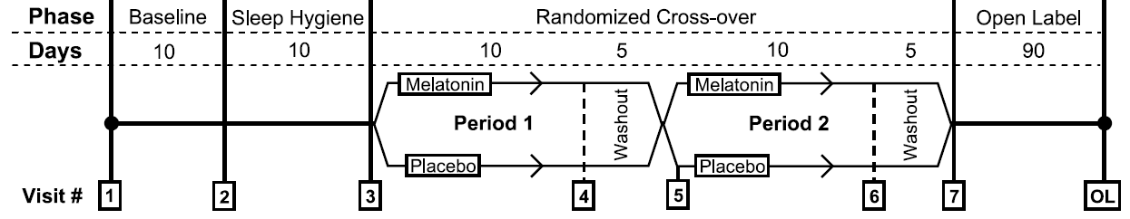
Bedtime and wake-up routines were structured. A fixed bedtime was required, to enable the reliable measurement of changes in SOL without the complication of variability in sleep debt.
Thirty-three (33) patients between 6 and 14 years seen in the ADHD clinic at British Columbia Children’s Hospital provided consent. Of these, 5 parents/patients withdrew consent or were unable to continue participating and 5 patients were sleep hygiene responders who did not continue into randomisation. Of the 23 patients eligible for randomisation, 1 withdrew consent and 3 discontinued due to protocol violations during the randomisation treatment phases, leaving 19 cases to be evaluated, all 19 patients completed the randomised part of the study.
A short-acting pharmaceutical-grade melatonin, 5 mg, manufactured by the study sponsor (Circa Dia BV), or placebo, was administered 20 minutes before bedtime. Each patient received a blister card of 30 days’ supply of medication as per the study protocol. An 80% compliance rate in each treatment phase was required for continued participation in the study.
The primary objective was to evaluate the efficacy of sleep hygiene and melatonin treatment for initial insomnia in children and adolescents with ADHD who were treated with stimulants.
Inclusion criteria required that the child be taking stimulant medication with no change in dose for at least 2 months and be willing to maintain the current dose for the duration of the trial. Parents had to demonstrate competence at completing the somnolog and children had to be willing and able to wear an actigraph wrist monitor and assent to the demands of the sleep hygiene program of a fixed bedtime and awakening time.
Exclusion criteria included children who were in stressful life circumstances that could account for new onset sleep difficulties or children who could or would not comply with sleep hygiene recommendations due to sharing a bed or other environmental factors that would account for their sleep deficits. This included children who had comorbid medical or psychiatric illness that could be associated with insomnia or required treatment with a medication other than a stimulant at dosages known to cause insomnia or sedation. Children living in multiple households were excluded unless all of the caregivers could reliably participate in the program. The resulting sample was comorbid for difficulties with oppositional disorder, enuresis, learning problems, and some degree of anxiety or depressive symptoms. Children with known diagnoses of other major sleep disorders were not accepted for the trial.
The primary efficacy variable examined was the mean SOL in each of the melatonin and placebo treatment phases as recorded on the parent-completed somnolog, which documented when the children were put to bed, when they fell asleep, when they awoke during the night, when they were awakened in the morning, and when they actually got out of bed. SOL was defined as the amount of time between when the child was put to bed and when he or she fell asleep. The parents were instructed to check on the child every 15 minutes to track whether the child was asleep or awake.
Secondary efficacy outcome measures obtained from somnolog recordings included night-to-night variability in SOL given by the SD of SOL and total sleep duration. The actigraph was used to provide an objective measure of sleep and data were analysed using the proprietary sleep software. Actigraph outcome measures included mean SOL, night-to-night variability in SOL, total sleep duration, and correlation with somnologs. The percentage of responders to treatment was defined as a clinician rating of ‘‘much improved’’ or ‘‘very much improved’’ on the Clinical Global Impression-Improvement (CGI-I), taking all aspects of the child`s well-being, including sleep, into account. To evaluate whether improved sleep outcome led to improvement in ADHD symptoms, the Conners Attention Deficit Scale, Parent version (CADS-P), a well-standardised measure with good sensitivity to change was administered at each visit.
The statistical analysis was conducted with a two-sided α level of 0.05 unless otherwise stated. Two-sample t tests were used to compare the baseline levels of the primary endpoint measure between the two treatment sequences to evaluate the success of the randomisation procedure. Two-sample t tests comparing the means of period differences in each of the two crossover-treatment sequences provided the estimate of the treatment effect (melatonin versus placebo) that was adjusted for period differences. Tests for period and carryover effects were conducted using two-sample t tests comparing the mean crossover differences and mean period sums for the two randomisation sequences, respectively. Pearson correlations were calculated to determine the baseline level of association between parent-completed somnologs and actigraph-generated sleep measures. The required sample size was based on the aim to detect as little as a 30-minute change in SOL with a power of 80% and a type I error of 5%. This determined an N of 25 patients to be sufficient with a dropout rate of 20%.
Regarding baseline demographic data the sample was 90.9% male with an average age of 10.29 (range 6.5-14.7) years. The racial distribution was consistent with the demographics of the clinic as a whole (87.9% white, 6.1% Aboriginal, 3.0% Asian, 3.0% black). Although the protocol did not stipulate ADHD subtype for inclusion, all but one ADHD Inattentive subtype patient were ADHD Combined subtype. The mean T score on the CADS-P at baseline was 74.7 ± 10.3 (range 50-90), 1 SD above the clinical cutoff for ADHD despite being on stimulant medication. Of the patient population, 67% were taking MPH, of which one third were taking OROS-MPH. The remaining 30% of patients were taking dextroamphetamine, of which 50% were on the spansule form. Fifty-four percent of the sample had comorbid oppositional disorder and 12% had enuresis. Clinicians described the severity of sleep disorder as mild in 3.0%, moderate in 42.4%, marked in 30.3%, and severe in 24.2% of patients.
Regarding the primary efficacy outcome the mean SOL before treatment was 91.7 minutes by somnolog and 98.1 minutes by actigraph. Five patients required repeated visits to achieve successful sleep hygiene. Five patients met the criteria for response to sleep hygiene (SL < 1 hour). Mean SOL after sleep hygiene was 69.3 minutes on the somnolog and 73.0 minutes on the actigraph. Both the somnolog and actigraph measures indicated significant improvement from baseline SOL (t (28) = 2.77, p = 0.01 and t (21) = 2.92, p < 0.01, respectively). The effect size of improvement in SOL from baseline to post-sleep hygiene was 0.67. Pearson correlations showed the post-sleep hygiene somnolog and actigraph measures of SOL to be strongly correlated, r = 0.76, p < 0.001. Mean SOL times are shown by intervention in Figure 12.
Figure 12. Somnolog sleep-onset latency by treatment (Weiss, MD. et al., 2006³⁸)
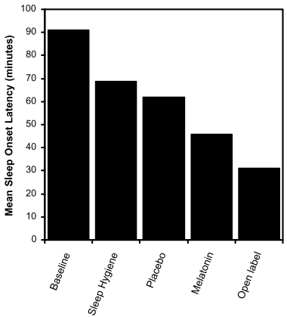
Mean somnolog SOL on placebo was 62.1 minutes (SD = 26.6) versus mean SOL on melatonin of 46.4 minutes (SD = 26.4). Two-sample t tests of the period and crossover differences indicated a significant difference between the sleep latencies for the two treatments, t (20) = -3.06, p < 0.01 and a significant period effect, t (20) = -2.20, p <0.05, respectively. There was no significant carryover effect. The effect size of the difference between melatonin and placebo treatment was 0.6.
Melatonin was clinically (16 minutes) and statistically significantly superior to placebo on actigraph measurement of SOL, t (18) = -4.54, p < 0.01. Treatment differences were not statistically significant for both somnolog and actigraph measures of variability of SOL. Treatment differences were evident on a somnolog measure of total nighttime sleep, where more time asleep (15.0 minutes) was evident during melatonin treatment, t (20) = 3.13, p < 0.01. Analysis of actigraph measurement of total sleep did not yield a significant treatment difference.
Analysis of change of treatment response status between placebo and melatonin conditions as measured by clinician CGI-I ratings was not significant. There was no significant change in CADS-P ratings between baseline and completion of the study or between melatonin and placebo.
Secondary efficacy outcomes after sleep hygiene showed SOL variability of 29.1 minutes on somnolog, representing a significant reduction of night-to-night variability from the baseline level of 47.7 minutes, t (28) = 3.81, p < 0.01. Actigraph measurement of SOL variability was also lower with sleep hygiene (53.26 - 40.57 minutes), but the latter difference was not significant, t (21) = 1.91, p = 0.07. Clinician ratings of improvement, CGI-I, identified 21% of patients as being much improved or very much improved and an additional 21% showed minimal improvement. No change was observed in 54% of patients and 4% were noted to be minimally worse. No significant change was observed on the CADS-P ratings of ADHD symptoms.
In an OL follow up 17 children received substantial benefit from melatonin and were considered treatment responders, and only those who had benefited from melatonin continued into OL follow-up. SOL at the end of the OL phase was 31 minutes, which was not statistically significantly different from SOL during the randomised melatonin treatment. Sleep duration, however, continued to improve by 23 minutes (t (12) = 3.90, p < 0.01).
Full remission of the sleep disorder was achieved with sleep hygiene or both treatments in 71% of the sample as measured by a CGI-I score of much improved or very much improved. SOL decreased from a mean 91 minutes to 31 minutes by the end of the OL follow-up. A SL of 30 minutes is considered normal. The overall effect size of the combined treatment was 1.7.

Efficacy and safety in level IV ADHD studies

Ayyash HF, et al. 2015³⁹
Design | This was a prospective observational naturalistic study, with a duration of treatment of 11 months (326 days).
Included subjects | Children with neurodevelopmental disorders (moderate to severe intellectual disability, ASD, ADHD) and severe sleep problems (at least 3 times/week: SOL > 1 hour; ≥ 1 nighttime wakening; wakes before 6 am; and LSE < 6 h of continuous sleep), who did not respond to behavioural management strategies. Children with OSA or nocturnal seizures were excluded.
Treatments | IR melatonin, 2.5 mg 30 min before desired bedtime. If no significant improvement in sleep patterns occurred after 4 weeks, the dose was increased up to 5 mg, and after a further 4 weeks to 10 mg if required. Children with ADHD continued with their usual stimulants.
Outcomes | Primary endpoints: TST, SOL, and number of night awakenings, measured with structured sleep diaries, assessed for at least 2 weeks before and after the start of melatonin treatment.
Randomisation & blinding | Not applicable.
Populations | 47 subjects were recruited; 2 were excluded (no further details).
Sample size | No sample size calculation was included.
Statistical methods | Two measurements per child were taken, one before and one after the intervention. A paired t-test was carried out separately on each of the three differences (i.e., after minus before treatment) in outcomes. Ninety-five percent confidence intervals (CIs) were also calculated. In addition, a one-way ANOVA was performed to assess possible differences on study outcomes in the three participant categories (ADHD, ASD, and ID); in the event of significant p-values (i.e., p < 0.05), ANOVA was followed by multiple pairwise comparisons between any two groups, with Bonferroni adjustment to allow for multiple significance tests. Finally, mean differences in outcomes between the three dosage groups (low, medium, and high) were assessed with ANOVA followed by pairwise comparison with Bonferroni adjustment. All analyses were performed using SPSS for Windows version 10th edition (SPSS, Chicago, IL, USA). Statistical significance was defined as p < 0.05 (two-tailed).
Participant flow | A total of 22% of subjects withdrew from the study due to side effects or ineffectiveness, and 78% responded: 17 subjects to 2.5 to 3 mg (3 stopped this dose due to irritability/hyperactivity increase and response), 14 to 5 to 6 mg (2 stopped this dose due to increased irritability and nighttime awakenings), and 4 to 10 mg (3 subjects failed to respond to the highest dose, 1 experienced decreased appetite, and 1 increased fitting).
Protocol violations | Two of the 47 subjects were excluded as parents failed to complete sleep diaries.
Baseline data | 35 males; mean age: 6.3 ± 1.7 years. ID (n = 29); ASD (n = 9); ADHD (n = 7). The majority of participants (n = 37, 82%) presented with sleep onset delay or frequent awakenings (n = 36, 80%).
Efficacy results | Thirty-eight percent of children responded to low (2.5–3 mg), 31% to medium (5–6 mg), and 9% to high doses (9–10 mg) of melatonin. Significant improvements were observed for all three parameters; the mean difference in TST was 1.93 ± 1.41. Mean  reduction in SOL was 1.25 ± 1.13 hours, and night awakenings were reduced (all p = 0.001).  Changes in sleep study outcomes from baseline to follow-up in the ADHD group
  Outcome | Attention-deficit/hyperactivity disorder  Mean ± SD; difference follow-up vs baseline), p-value
  Total sleep time (hours/night) | 2.68 ± 1.22, < 0.001
  Time to sleep onset | 1.24 ± 1.20, < 0.02
  Awakenings (n/night) | 0.23 ± 0.22, < 0.02
Safety results | The most significant side effect was worsening of seizure activity following treatment with 10 mg doses of melatonin (n = 1). This subject had ASD and was also taking dexamphetamine and sodium valproate. Another participant experienced decreased appetite. See also participant flow.
Conclusions | The study design allowed for selection of a broader study population, not just including those who can adhere to regulations of conventional trials. Results may therefore be applicable to the broader range of subjects seen in clinical practice.  Limitations included use of sleep diaries rather than polysomnography; lack of double-blind (DB) controlled design; and small sample size.  The authors concluded that increasing the melatonin dose above 6 mg/night adds further benefit only in a small percentage of children.

Checa-Ros, A. et al., 202340
Design | Single centre, single-arm, OL study of 4 weeks’ duration of children and adolescents with ADHD receiving extended-release formulations of psychostimulants. A seven-days sleep diary was collected prior to starting a four-week treatment with melatonin. Seven-day actigraphic assessments of sleep were performed before and after treatment.  The primary objective was to evaluate changes in the actigraphy parameters of sleep (SOL, TST, WASO [wake time after sleep onset], and sleep efficiency [SE]) before and after initiating treatment with melatonin.
Included subjects | Children aged 7–15 years with ADHD who were receiving extended-release MPH (CONCERTA) were recruited.  The exclusion criteria included the presence of heart disease, glaucoma, and neuropsychiatric, metabolic, or endocrine disorders able to justify the current symptoms; current intake of melatonin; concomitant intake of any sleep-disturbing medication except for MPH; and/or refusal to participate.
Treatments | Fast release melatonin, 1 mg 30 min before bedtime for 1 month. The product was prepared at the hospital pharmacy.
Outcomes | Primary endpoints: TST, SOL, and SE.  Patients were instructed to wear the MotionWatch 8® actigraph (Cambridge Neurotechnology Ltd., Cambridge, UK) on the nondominant wrist 24 h per day for seven consecutive days at baseline and after one month of treatment.
Randomisation & blinding | Not applicable.
Populations | 27 children consented to participate.
Sample size | Considering a 5% difference in total sleep length as clinically relevant, for an ADHD prevalence of 5%, assuming a power of 80% and an alpha of 0.05, the minimum sample size obtained was 26.5 patients.
Statistical methods | Descriptive data were presented as mean and SD. For comparative analyses, the Kolmogorov–Smirnov test was applied to verify the normality assumption before running a Student t test to make comparisons between the actigraphic parameters before/after treatment. The significance level was set at α = 0.05. The Statgraphics Centurion XVI software version 17 (StatPoint Technologies, Inc., Warrenton, VA, USA) was used for statistical calculations.
Participant flow | No specific details were provided beyond that 27 subjects were recruited.
Protocol violations | No details were provided.
Baseline data | Twenty-seven patients (17 males, 62.96%) aged 7 to 15 years participated in the study, who had been receiving CONCERTA 0.7–1 mg/kg for a mean period of 1.57 (1.11) months. Associated comorbidities had been detected in 15 participants (55.55%), predominantly oppositional defiant disorder, anxiety, and fine motor skill disorder.
Efficacy results | TST increased significantly: from 463 ± 49 min to 485 ± 41 min (p < 0.040). SOL: No significant change ([11 min vs. 10 [8] min, p = 0.699]). SE: No significant change (86.70 [7.13]% vs. 88.66 6.24]%, p = 0.271). WASO: 72 ± 44 min vs 71 ± 44 min, p = 0.933.
Safety results | No severe AEs were reported. Mild and transient gastric discomfort and anorexia were reported by 12 patients (44.44%).
Conclusions | Most notably in this study, there was a significant increase in the TST, with a nonsignificant reduction in the SOL, with minor improvements in other sleep values such as SE and Wakefulness After Sleep Onset.  Limitations included that the trial was not DB, PC, and randomised, which would have minimised the probability of performance bias; measurements of peripheral melatonin levels would have allowed a better optimisation of melatonin effects by adapting the dosing time to the patient’s actual secretion profile; the majority of patients reported watching television before going to bed, which would have diminished melatonin production; comparisons in the sleep diary data before and after melatonin administration could not occur, as a second daily sleep diary was not completed after therapy; and the wide age range could account for divergent and heterogeneous sleep values influencing the effects of melatonin.

Hoebert, M. et al., 200941
Design | The parents of all 105 children who previously participated in the randomised, DB, PC trial on melatonin treatment37 were accessed by telephone between September 2007 and February 2008, to ask for participation in the present follow-up study (up to 3.7 years). A questionnaire was sent together with a detailed information letter and a return envelope. Parents who did not return the questionnaire were accessed by telephone for a second time and requested once again to return the questionnaire.  At the end of the study, all participants were offered melatonin treatment by contact of regular care by specialised physicians. The prescribing physician encouraged discontinuation of melatonin treatment every year for at least 1 week during a holiday period to evaluate whether melatonin treatment was still necessary.  The aim was to assess relapse rate of SOL after discontinuing melatonin treatment and to obtain more data about effectiveness and safety of long-term melatonin treatment in children with ADHD.
Included subjects | Rigorously diagnosed ADHD, total IQ > 80, and chronic SOL, 6–12 years.37
Treatments | Melatonin (dose from not disclosed), 3 to 6 mg dependent on body weight (< 40 kg: ≥ 40 kg).
Outcomes | Primary: sleep onset. Secondary: behaviour and mood improvements, safety, relapse rate after discontinuation.  The questionnaire consisted of a combination of multiple choice, numeric, open-ended and scaled questions; 19 in total, to assess the above.
Randomisation & blinding | Not applicable.
Populations | In total, data of 94/105 (89.5%) of the children participating previously37 were included in this study.
Sample size | Not applicable.
Statistical methods | The chi-squared test was applied to analyse the difference between the group who did or did not temporarily discontinue treatment in the variable regarding complete discontinuation of melatonin treatment at follow up.  The Mann–Whitney U-test was applied to analyse the difference in pretreatment DLMO between the children who discontinued treatment completely because of improvement of SOL and of the remainder of the group. The Mann–Whitney U-test was applied to analyse the difference in pretreatment DLMO between the children who used melatonin occasionally and the children who used melatonin daily. Effect sizes were calculated with the Pearsons correlation coefficient. The Mann–Whitney U-test was applied to analyse the difference in age between the different groups mentioned above. Relationship between DLMO and age was analysed with the Pearson’s correlation coefficient.  Significance was set at P < 0.05 (two sided). Analyses were conducted using SPSS, 14.0 (SPSS, Inc., Chicago, IL, USA).
Participant flow | One hundred and one parents were reached by telephone and all gave informed consent to participate.  One hundred and one questionnaires were sent to the parents. The response rate in this study was 94/101 (93%).
Protocol violations | Not applicable.
Baseline data | Seventy of 94 (74.5%) of the children were male. The mean (± S.E.M.) follow-up time of this study was 3.66 ± 0.12 yr. Mean age (± S.E.M.) at the start of melatonin treatment was 8.72 ± 0.21 yr. Mean age (± S.E.M.) at follow up was 12.39 ± 0.25 yr.  Sixty-one (64.9%) children still used melatonin daily at the time of follow-up. Eleven (11.7%) children used melatonin occasionally. In most cases these latter children only used melatonin when they could not sleep. The frequency of melatonin usage in this group ranged from two to three times a week to a few times a year.  The current dose of melatonin in the group who still used melatonin ranged from 0.5 to 10 milligrams (mean ± S.E.M.: 4.23 ± 0.27). Time of administration of melatonin ranged from 18:30 to 23:00 (mean 19:53). Eighty-two percent of the children took melatonin at a fixed time on weekdays. On the weekend 67% of the children took melatonin at a later time than on weekdays.  Twenty-two (23.4%) children discontinued melatonin treatment completely. The duration of using melatonin ranged from one to 57 months (mean ± S.E.M.: 18.28 ± 3.0). The last applied dose of melatonin in the group who discontinued melatonin treatment ranged from three to ten milligrams (mean ± S.E.M.: 5.73 ± 0.89).  Eight children discontinued melatonin treatment completely because of a total improvement of SOL. Three children discontinued the treatment because of AEs. In four children melatonin treatment was discontinued on the initiative of the treating physician.
Efficacy results | Long-term follow-up (3.7 years) showed melatonin was effective in 88% for sleep onset, 71% for improved behaviour, and 61% for improved mood.  Sleep problems recurred in most children (92%) after a 1-week drug holiday, attributed to the return of underlying sleep disturbances rather than rebound. The results however indicate that some children may achieve lasting benefits.
Safety results | Approximately one fifth (20.2%) of the children experienced AEs. The most common AEs were dizziness (4 children, 4.3%), sleep maintenance insomnia (3 children, 3.2%), and bedwetting (3 children, 3.2%).  In ten (52.6%) children the AEs were self-limiting. In 6 (31.6%) children the AEs persisted, causing melatonin discontinuation in 3 cases. Persistent AEs were sleep maintenance insomnia, excessive morning sedation, decreased mood, headache, profuse perspiration, and daytime laziness.  Of the 94 children, 3 (3%) discontinued melatonin because of AEs: 1 experienced profuse perspiration; 1 persistent dizziness, visual disturbances, headache and daytime laziness; and 1 headache, abdominal pain, nausea, and excessive morning sedation. These AEs resolved spontaneously after melatonin was stopped.  No new cases of epilepsy were reported in children treated with melatonin.
Conclusions | Melatonin remains an effective therapy in the long term for the treatment of CSOI in children with ADHD and has no safety concerns with regard to SAEs or treatment related co‑morbidity.  Discontinuation of melatonin treatment usually leads to a relapse of SOI and in resuming melatonin treatment, even after several years of treatment. The results suggested to the authors that phase advancing effects of melatonin on the circadian pacemaker rhythm are not persistent and that phase delay usually reoccurs after treatment is discontinued.  In this study, mean pretreatment DLMO of children who used melatonin occasionally was significantly earlier than the DLMO of the children who used melatonin daily, suggesting that pretreatment DLMO also predicts duration of melatonin treatment. Compared with the children who used melatonin daily, the authors considered it possible that the insomnia of the group of children who used melatonin occasionally consisted of a mixture of other types of insomnia involving an earlier DLMO and, therefore, were using melatonin occasionally as a hypnotic drug instead of a chronobiotic. The authors recommended measuring DLMO before treating patients with melatonin or melatonin analogues.  Limitations include that parents were not carefully interviewed about AEs or asked systematically about co‑medication; the lack of measures to assess the long‑term effects of melatonin treatment on pubertal development and fertility; the retrospective design; and the lack of control treatment.  Strengths included the relatively large sample size of 94 patients; the comprehensive questionnaire; and the high response rate of 93%.

Masi, G. et al., 201942
Design | This naturalistic study is based on a clinical database of 74 consecutive patients with ADHD, treated with monotherapy of MPH (10 IR and 64 sustained release; mean dosage 33.5 ± 13.5 mg/d), who presented with sleep problems (difficulty in falling asleep at bedtime, with possible increases of 0.5 mg every week, up to 5 mg/d, according to clinical needs). The duration of the treatment was at least 4 weeks, with a maximum duration of 12 months, based on clinical outcomes.  The study sample was derived from a larger cohort of about 600 consecutive youths screened and treated for ADHD in the authors’ unit for pharmacological treatments in ADHD. Sleep habits or difficulties were specifically explored before starting MPH; clinically relevant sleep problems were not reported by parents in the pre-treatment clinical assessment and in medical reports.  The aim was to explore the effectiveness of melatonin in children with ADHD who developed sleep problems after starting MPH at the target dose.  The duration of the treatment was at least 4 weeks, with a maximum duration of 12 months, based on clinical outcomes.
Included subjects | Children with ADHD (diagnosed according to DSM-IV criteria), K-SADS-PL, Conners’ Parent and Teacher Rating Scales–Revised–Short Form, treated with MPH were included. It is unclear how “sleep problems” were defined (e.g. the SOL threshold considered abnormal). Those with intellectual disability (ID), ASD, and schizophrenia were excluded.
Treatments | All patients were naturalistically treated with add-on melatonin as a sleep inducer, used as usual in the authors’ clinical practice. Dosing started at 1 mg after dinner (around 8–9 pm), about 1–2 hours before bedtime, with possible increases of 0.5 mg every week, up to 5 mg/d, according to clinical needs. The duration of the treatment was at least 4 weeks, with a maximum duration of 12 months, based on clinical outcomes.  Mean dosage was 1.85 ± 0.84 mg/day. Twelve patients (16.2%) received a co-treatment with a behavioural psychotherapy aimed to improve cognitive,  behavioural, and emotional self-regulation.
Outcomes | The primary endpoint was the improvement in sleep, measured using the CGI-I score, while secondary endpoints included the severity of sleep disorder (CGI-S score) and monitoring of AEs.  The severity of sleep disorder was recorded at baseline by a seven-point Likert scale according to the CGI-S score, based on parents’ reports.  The patients were followed up according to a scheduled programme for patients with ADHD receiving medications, with monthly visits, and the first assessment of sleep problems was one month after starting melatonin. Efficacy of melatonin on sleep was assessed using a seven-point Likert scale according to the CGI-I score (patients with a score 1 = very much improved, or 2 = much improved, were considered responders), based on parents’ reports.
Randomisation & blinding | Not applicable.
Populations | Seventy-four (74) children were included; no details were provided regarding how many children were assessed at each time point.
Sample size | No information was provided.
Statistical methods | Subjects were compared using chi-square analysis on categorical variables and paired t-test on continuous variables, setting significance at 0.05 level, two tailed.
Participant flow | Seventy-four (74) children were included.
Protocol violations | Not applicable.
Baseline data | There were 69 males included. Mean age was 11.6 ± 2.2 years. Patients were naturalistically treated with MPH (mean dosage 33.5 ± 13.5 mg/d). Clinical severity at the baseline according to CGI-S was 3.41 ± 0.70.
Efficacy results | Clinical severity at baseline according to CGI-S was 3.41 ± 0.70, and after the follow-up was 2.135 ± 1.05 (paired t-test 12.2 [74]; P < 0.001).  Clinical improvement according to CGI-I was 2.35 ± 1.01. According to CGI-I 1 (very much improved) or 2 (much improved), 45 patients (60.8%) were considered responders. Responders to melatonin included:  - All 5 (100%) females (dose 1.8 ± 0.8 mg/d) and 40 of 69 (58.0%) males (dose 1.9 ± 0.8 mg/d) (χ² = 1.91, P = ns).  - 27/42 (64.3%) of those aged <12 years (1.6 ± 0.7 mg/d) and 18/32 (57.2%) of those aged >12 years (2.1 ± 1 mg/d) (χ² = 0.22 (1), P = ns).  - 12/16 (75%) patients without comorbidities (dose 1.7 ± 0.8 mg/d), and 33/58 (56.9%) with comorbidities (dose 1.9 ± 0.9 mg/d) (χ² = 1.0 (1), P = ns). Non-significant differences were also seen between those with/without ODD/Oppositional defiant disorder, affective disorders, and learning disabilities.
Safety results | No side effects related to melatonin were reported.
Conclusions | This study provided understanding regarding the use of melatonin in children with ADHD who experience sleep disorders after starting MPH treatment.  Limitations included the use of CGI-I as an outcome measure, which is not specific to sleep disorder severity or improvement. The lack of use of active validated questionnaires, sleep diary, and actigraphy limits the reliability of results. However, the methodology of reassessment of the patients, using CGI in scheduled visits (usually every month), is consistent with the naturalistic design of the study. Another limitation was the lack of specific information about the sleep habits before starting MPH. However, clinically significant sleep problems were not reported by parents in the first clinical reports, but only after starting stimulant treatment. Also, the doses of melatonin used in the study were relatively small.  A strength of this study is that it was based on a consecutive, unselected sample of children naturalistically treated, with few exclusion criteria, increasing the applicability of the study to clinical practice.

Szeinberg, A. et al., 200643
Design | This was a retrospective study of adolescents with delayed sleep phase syndrome (DSPS) aged 10–18 years.  The primary objective was to evaluate the efficacy and safety of melatonin in improving sleep onset time and total sleep duration.  All selected children were referred to the Institute for Fatigue and Sleep Medicine between 1 April 2002 and 31 July 2004, received a diagnosis of DSPS, and were treated with melatonin for at least 1 month. The diagnosis of DSPS was formulated based on the information collected in clinical interview and the results of actigraphy/sleep log monitoring, in accordance with AASM (International Classification of Sleep Disorders, 2nd edition) criteria.  A subset of patients had ADHD; diagnosis was based on systematic chart review, but no specific reference to DSM criteria was made.  Patients were selected through systematic chart review. To establish the diagnosis of DSPS, semi-structured clinical interviews were carried out by a paediatrician specialised in sleep medicine. Both the patients and their parents took part in the interview. When an additional sleep disorder was suspected, the patient was subjected to nocturnal polysomnography.  Complementary to clinical interviews, actigraphic monitoring and/or sleep logs were carried out to evaluate the sleep–wake rhythm of all patients. The sleep–wake schedules were recorded for a period of 7 days in non-restricted conditions, in which the patients were free to fall asleep and wake up at their preferred time.  Follow-up visits were scheduled every 1 to 3 months.
Included subjects | Adolescents with DSPS were selected through systematic chart review.  Adolescents with severe sleep disorders other than DSPS or those with psychiatric or neurologic comorbidities were excluded from the study.
Treatments | Melatonin 3 to 5 mg per day (dose for non-disclosed patients was administered approximately 2 hours before bedtime. The significance of adherence to a strict timetable was emphasised. The duration of treatment was 1 to 16 months, with an average duration of 6 months. Throughout melatonin treatment the patients continued to receive their regular medication.
Outcomes | Primary: total hours of sleep; sleep onset.  Secondary: difficulty falling asleep; difficulty awakening; daytime sleepiness; school frequency absence (late arrival); behavioural/social difficulties.
Randomisation & blinding | Not applicable.
Populations | All data appeared to be assessed, where available.
Sample size | No information was provided.
Statistical methods | Sleep onset time and sleep duration were analysed at 3 time points: in unconstrained conditions (as measured by actigraphy), and before and during treatment on school days. For analyses of these variables, the samples were divided into 2 age groups: younger (10–13.9 years) and older adolescents (14–18 years). Subjective sleep onset time was calculated by subtraction of SL from bedtime and sleep duration—as the difference between sleep onset and rise time. Sleep onset and duration as assessed by actigraphy/sleep log data were averaged for each subject across monitoring days. Where the results of actigraphic monitoring could not be analysed due to technical reasons (7 of 33 patients), sleep log data were used instead. Efficacy of melatonin treatment was assessed using dependent samples tests. Continuous variables, such as sleep onset and sleep duration, were analysed with parametric tests (such as ANOVA). Dichotomous variables, such as presence or absence of school difficulties, were analysed using nonparametric tests (McNemar’s test).
Participant flow | Thirty-three (33) children were included in the study.
Protocol violations | No information was provided.
Baseline data | The sample consisted of 25 boys and 8 girls aged 10 to 18 years (mean 14 ± 2). A total of 15 subjects (45%) had ADHD as a comorbidity.
Efficacy results | Twelve patients (36%) were treated for more than 6 months; 5 of these patients were treated for a year or more. The final dose of melatonin for most of the patients (n = 24) was 5 mg/day; 4 patients received 3 mg/day; 1 patient received 4 mg/day; and an additional 4 patients were administered 6 mg/day.  Sleep onset advanced 2 hours 11 minutes (P < 0.0001). Time from melatonin administration to sleep onset ranged from 15 to 180 minutes (mean 117 ± 40 minutes). No significant interaction between age and time of measurement was found (P > 0.05), indicating that the treatment had a comparable effect on sleep onset in both age groups.  Total sleep time increased significantly, from an average of 5 hours 58 minutes before treatment to 8 hours 16 minutes during treatment. The interaction between age and time of measurement was not statistically significant (P > 0.05), suggesting that the treatment did not have different effects according to age. Patients with and without ADHD responded similarly to melatonin treatment in terms of sleep duration. It was reported that many of the patients with ADHD were able to reduce or discontinue psychotherapy and/or stimulant medication during melatonin treatment, raising the possibility that these patients had incorrectly received an ADHD diagnosis.  Difficulty falling asleep was resolved in all patients following the treatment. Improvements were also seen (before vs during melatonin treatment) in: difficulty awakening (97% vs 38%), daytime sleepiness (87% vs 23%), frequent absences (83% vs 28%), underachievement (74% vs 44%), and behavioural/social difficulties (86% vs 28%).  60.8% of ADHD patients reduced or stopped other therapy.
Safety results | No significant safety concerns or discontinuations were reported across the 1–16 months treatment period.
Conclusions | Following a significant advance in sleep onset time with melatonin, sleep duration increased accordingly. The improvements in sleep were associated with a significant decrease in the proportion of patients who malfunctioned at school.  Limitations of the study included the retrospective study design, the fact that major outcome measures were based on subjective reports, no control group was included, and that the size of the sample and limited follow-up precluded an assessment of the effect of melatonin on growth.

Tjon Pian Gi, CV. et al., 200344
Design | This was a preliminary open-label (OL) study of children with a clinical diagnosis of ADHD treated with MPH, and insomnia.  During a period of 1 year, 120 children were diagnosed with ADHD. All were prescribed MPH. The effect was evaluated by clinical interview and psychological test (before and after medication).  The aim of this OL study was to investigate whether melatonin could be used as a safe drug to treat insomnia problems in children with ADHD on MPH medication.
Included subjects | Children with ADHD on MPH, age not specified, and insomnia. The sponsor noted that although the study was lacking a standardised diagnostic detail, conventional clinical evaluation was implied.
Treatments | Melatonin 3 mg was administered before bedtime; dose form was not disclosed. No other hypnotic medications were used. The duration of treatment was 1 year.
Outcomes | Primary: Falling asleep time.  The safety profile of melatonin was assessed through clinical interviews and psychological tests before and after medication.
Randomisation & blinding | Not applicable.
Populations | All data were assessed, when available.
Sample size | No information was provided.
Statistical methods | A paired student t-test for the time of falling asleep before and after medication was conducted.
Participant flow | Twenty-seven (27) children were included, and 24 completed the study. Due to incomplete data recording, the results of the long-term effects are only available from 13 subjects.
Protocol violations | One patient was excluded due to incorrect data recording.
Baseline data | The age of the included subjects was not specified.
Efficacy results | The study found a significant reduction in SOL (p < 0.01) in 24 subjects after short-term use of melatonin (1–4 weeks), with effects ranging from 15 to 240 minutes and a median improvement of 135 minutes.  The long-term effect in 13 subjects, after 3 months, was comparable with the immediate effect after 1 week.
Safety results | Two patients dropped out due to aggressiveness and nightmares. Restless sleep was mentioned as a minor side-effect. No significant changes in vital signs or physical findings were reported.
Conclusions | The study authors stated that although the study design, a placebo effect, and the change of sleeping ritual could have influenced the results, the highly significant difference strongly suggested a positive melatonin effect. No laboratory set-up was available, so the precise time of falling asleep could not be recorded exactly; details about how it was recorded were lacking.

Yuge, K. et al., 2020.45
Design | This was a 26-week, multicentre, uncontrolled, open-label (OL), Phase III study of melatonin granules in children with neurodevelopmental disorders (NDDs).  The study consisted of a 2-week screening phase, a 26-week medication phase [10 weeks followed by 16 weeks], and a 2-week follow-up phase. In the screening phase, placebo was orally administered, and on completion all children were checked for history of present illness, amnesia, previous history of treatment, comorbidities, concurrent drugs, concurrent therapies, inclusion criteria, exclusion criteria, sleep hygiene intervention, electronic sleep diary, ABC-J, prescription of the investigational drug, status of medication, height, body weight, and vital signs. Children recruited were aged 6 to 15 years.  Caregivers and their children were instructed to adhere to prescribed bedtime and medication time during the screening phase and the medication phase. Between week 10 of the medication phase and week 22 of the medication phase, bedtime could be accelerated (1 hour maximum per acceleration) in consideration of the sleep time of the child and of new caregivers’ desires. The modification of bedtime was effective after submission of written records to the investigator. The enrolment age was 6 to 15 years.  The objective was to examine the long-term efficacy and safety of melatonin granules that were administered orally to children with NDDs.
Included subjects | This study enrolled children aged 6–15 years with NDDs, including ADHD, diagnosed according to DSM-5, with persistent SOL (≥ 30 minutes) lasting for at least 3 months, who were outpatients, willing to attend the hospital as scheduled, able (themselves and their caregivers) to comprehend sleep hygiene interventions and medication teaching, and whose parents could monitor sleep and enter information into the electronic sleep diary.  Further eligibility criteria at the completion of screening were: SOL lasting ≥30 minutes which persisted for 3 or more days among the last 7 days during the screening phase; adherence to medication time and bedtime that were prespecified at the onset of the screening phase; appropriate entry of required information in the electronic sleep diary; and 2 or less nonmedication" days of the last 7 days during the screening phase (with the exception of the day when the child fell asleep prior to medication).  The key exclusion criteria were as follows: 1) IDs that were categorised to  "severest" or greater in DSM-5 severity regarding one or more conceptual, social, or practical domains; 2) history of melatonin use (including supplements); 3) ramelteon use within 4 weeks prior to the onset of the screening phase; 4) a history of hypersensitivity or allergy to ramelteon; 5) the use of three or more drugs to treat epilepsy; and 6) comorbidity- schizophrenia or bipolar disorder.
Treatments | Melatonin 0.2% granules consisting of synthesised melatonin and mannitol as the excipient were commenced at a dose of 1 mg, 45 minutes before bedtime. The dose was adjusted as needed (2 or 4 mg; the dose could be increased to 5 mg), and the investigator’s discretion. The treatment periods was 26 weeks.  The following were prohibited as or 6 weeks prior to the onset of the screening phase: melatonin receptor agonists, hypnotics and sedatives, anti-parkinsonians, psychoanaleptics, first-generation antihistamines, caffeine-containing agents, and fluvoxamine.  Drugs to treat ADHD, vitamin B12, anti-psychotics, anxiolytics, antidepressants, and antidiabetic drugs could continue if commenced 4 weeks prior to screening and the dose was not modified during the study period.
Outcomes | The primary endpoint was SOL in the medication phase I – defined as the difference in the median SOL during 7 days before the completion of the medication phase I or medication discontinuation from baseline, which was defined as the median SOL during the 7 days just before the onset of the screening phase. SOL was recorded with the electronic sleep diary.  The secondary endpoints were: (1) time from medication use to sedation suspension; (2) SOL at the time of medication suspension; (3) time from medication suspension to medication resumption; (4) items recorded with the electronic sleep diary— NOA after sleep onset, time of falling asleep, wakening time, wakening time, refusal to going to bed at prescribed bedtime, temper upon wakening, and sleepiness intensity after awakening; and (5) ABC-J.
Randomisation & blinding | Not applicable.
Populations | Safety data were assessed in all 99 children (99 in medication phase I and 97 in medication phase II); see participant flow section for numbers of children eligible for efficacy assessment at the various stages.
Sample size | No information was provided.
Statistical methods | Continuous variables are expressed as mean ± SD, and categorical variables as medians with interquartile range. The primary and subgroup analyses of the efficacy of melatonin treatment in the full analysis set were conducted according to Wilcoxon’s signed rank sum test. A 5% two-sided P value of < 0.05 was considered statistically significant. All statistical analyses were conducted using the SAS software (SAS Institute, Cary, NC, USA) version 9.3.
Participant flow | Written informed consent/assent was obtained from 112 caregivers/17 surrogated consenters or children. Among 109 children, 99 entered the medication phase I and orally received melatonin granules. In the screening phase, 10 children were excluded due to ineligibility. Two children were excluded during the medication phase I: one due to the child’s or caregiver’s refusal for discontinuation because of sleep talking and snoring and another due to treatment refusal by the child or the child’s caregivers. Consequently, 97 children made the transition to the medication phase II. Three children were excluded during the medication phase II due to treatment refusal by them or their caregivers. Consequently, 94 children made the transition to the follow-up phase. One child was excluded during the follow-up phase due to treatment refusal by the child or the child’s caregivers. Consequently, 93 of 99 children (93.9%) completed the present clinical trial.
Protocol violations | No protocol violations were reported.
Baseline data | The age range of the included subjects was 6–15 years. Of the 99 children (80 males and 19 females; mean age 10.4 years, range 6–15 years), 74, 60, 22, 9, 6, and 1 had ASD, ADHD, IDs, motor disorders, specific learning disorder, and communication disorders, respectively, at baseline. The mean body weight was 37.1 kg, with the predominating proportion of children of ≥ 30 kg in body weight (62.6%). Children and adolescents who had concurrent diseases accounted for 82.8% (82/99).
Efficacy results | Fifteen children received the maximal dose of 4 mg among the prespecified dose levels. The means of age, body weight, and height tended to increase slightly along with increments in maximal doses.  The primary analysis of the primary endpoint, SOL in the medication phase I, revealed a significant shortening (median −30.0 min; Q1–Q3, −46.0 to −15.0; Wilcoxon’s signed rank sum test; P < 0.0001). The secondary analysis of the primary endpoint indicated a quick and significant shortening (P < 0.0001) at week 2 of the medication phase I from baseline, with a relatively narrow variation (range −27.5 to −31.5 min between week 2 (medication phase I) and week 26 (medication phase II)). Furthermore, a significant shortening (P = 0.0002) persisted until week 2 of the follow-up phase. The median changes in SOL in children who received the final doses of 1 mg (n = 49), 2 mg (n = 31), and 4 mg (n = 12) per day were −32.0 min, −41.0 min, and −24.0 min, respectively.  The median changes in time of falling asleep ranged between −31 to −32 min and −38 to −44 min at weeks 2 (medication phase I) and 26 (medication phase II), respectively; these changes were statistically significant (P < 0.0001) against baseline. The medians of the recorded times of falling asleep in the screening phase and the medication phases I (week 10) and II (week 26) were 22:55, 22:15, and 22:05, respectively. Thus, time of falling asleep tended to be accelerated during the medication phases. These changes were statistically significant against baseline in the medication phases I and II (P < 0.0001), as well as in the follow-up phase (P = 0.0007).  The scores of refusal to go to bed at prescribed bedtime, temper upon wakening, and sleepiness intensity after awakening in the screening phase, the medication phases I (week 10) and II (week 26), and the follow-up phase were improved significantly (P < 0.0001 to P = 0.0014) from baseline and persisted in the follow-up phase.  Changes in the NOA after sleep onset reduced significantly (P = 0.0413 and P = 0.0358) at weeks 18 and 26 of the medication phase II.  The following subscales of the ABC-J improved significantly: stereotypic behaviour (P = 0.0322) at week 10 in the medication phase I; and irritability, hyperactivity, and inappropriate speech (P < 0.0001) at week 26 in the medication phase II.
Safety results | Among AEs that occurred in 81 children (81.8%), 14 (14.1%) were considered TEAEs. No TEAEs occurred after week 16, and the majority of AEs were mild in intensity (1 severe AE [facial bone fracture] in one child) and low in incidence and unrelated to the medication. The most predominant AEs were infections including bronchitis and nasopharyngitis that are frequently seen in children in the age group studied. One child discontinued medication due to a TEAE. NDDs did not deteriorate during the follow-up phase.  Severe episodes of AEs leading to dose reduction of melatonin occurred in seven children: four episodes of somnolence, and one episode each of headache, nausea, and irritability.  Haematology, blood chemistry, urinalysis, 12-lead resting electrocardiography, vital signs, height, body weight, rebound phenomena, and withdrawal symptoms were also assessed. There were slightly abnormal laboratory values in 10 children as follows: 3 cases of weight gain; 2 cases each of increases in hepatic function variables and urinary urobilinogen; one case each of transaminase increase, blood potassium increased, blood triglyceride increased, eosinophil count increased, urinary pH increased, and urinary specific gravity increased. All these abnormal changes resolved or recovered without requiring treatment. Any changes of special note were not found with respect to vital signs, physical findings, withdrawal symptoms, or rebound phenomena.
Conclusions | Somewhat contradictory information was provided in terms of discontinuations due to AEs; In one section of the article only one subject is reported to have discontinued due to sleep talking and snoring. In another, however, two further children were identified as discontinuing due to AEs (blood potassium increased and headache; and facial bone fracture and contusion). All were considered unrelated to medication.  Limitations of the study included its open-label nature, meaning that it could not be definitively determined that the beneficial effects were entirely generated by melatonin treatment; the relatively limited sample size; and that the study does not shed light on the efficacy of melatonin treatment for children with NDDs who may have psychiatric disorders including schizophrenia and bipolar disorder.

Other efficacy studies in neurogenetic diseases

Braam, W. et al., 200848
This was a randomised, PC, investigator-blinded trial of children with AS with idiopathic chronic insomnia. Parents of children with the aforementioned conditions that were referred to the sleep centre by local general practitioners were asked to participate. The trial consisted of 2 consecutive periods: a 1-week qualification period and 4 weeks of treatment during which participants were randomly allocated to melatonin or placebo therapy. After the 4-week PC phase of the study, all patients received 4 weeks open treatment with melatonin.
The objective of this study was to evaluate the efficacy of melatonin in treating chronic insomnia in children with AS. A total of 13 patients were referred to the sleep centre; 4 did not meet inclusion criteria and one patient’s parents elected not to participate. A total of 8 patients were randomly assigned to melatonin or placebo (4 per group). All 8 subjects completed the study.
Children 6 years or older received 5 mg melatonin daily at 7pm, while those under 6 years received 2.5 mg melatonin daily at 6pm. Melatonin was administered in fast-release tablets (Duchefa Farma BV, The Netherlands).
Saliva specimens for measuring melatonin concentrations were collected in the qualification period on the last night of the baseline week to examine whether there was a delayed sleep phase syndrome or another disturbance in melatonin circadian rhythm, and the last night of the fourth treatment week (no melatonin was given on this night) to examine whether 4 weeks of treatment had changed endogenous melatonin circadian rhythm. Sleep variables were assessed by parents and recorded in a sleep diary. Saliva specimens for measuring melatonin concentrations were collected in children 2–4 years of age from 5 PM, in children 5 and 6 years of age from 6 PM, and in older children from 7 PM.
Inclusion criteria were SL more than 30 minutes, or 2 or more wakes, lasting more than 15 minutes a night, at least 5 nights a week, during more than 1-year preceding inclusion. Exclusion criteria were prior use of melatonin, liver disease, renal failure, chronic pain, and age less than 24 months.
Regarding efficacy variables examined the primary outcome measures were the between-group differences of SL, sleep onset, wake up time, and number and length of wakes. Secondary outcome measures were the between group differences in salivary melatonin concentrations, number of epileptic seizures, as well as adverse reactions of melatonin. The trial was performed in the home setting of each individual, and parents assessed sleep variables (lights-off time, sleep onset time, wake-up time, and number of NAs) and recorded them in a sleep diary. Parents were asked to listen to or watch their child every 10 minutes from bedtime until the time they found their child asleep.
Regarding statistical methods the results of a 1-sample Kolmogorov-Smirnov analysis showed that data of each variable were normally distributed. Unpaired t-tests were conducted to test differences in change between melatonin versus placebo treatment on the sleep variables. Statistical significance was accepted at p < 0.05.
Baseline demographic characteristics are shown in Table 25.
Table 25. Patient characteristics and medication use (Braam, W. et al., 2008⁴⁸)
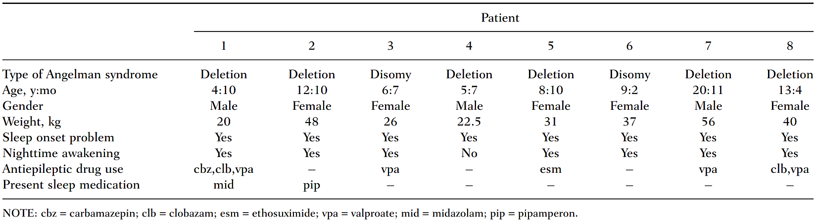
Regarding PK results in 35 of 80 salivary samples, the amount of saliva was too low for a melatonin analysis; the remaining 45 samples showed that salivary melatonin concentrations, on a day no study medication was given, increased substantially after melatonin treatment (i.e., child 2, 4, 5, and 8), whereas melatonin concentrations after placebo treatment (i.e., child 1, 3, 6, and 7) did not change. In patients 4 and 8, salivary melatonin concentrations were above 50 pg/mL at the first evening after discontinuation of 4 weeks of melatonin treatment. In patient 5, the first sample (collected at 5 PM) contained more than 50 pg/mL (Table 26).
Table 26. Melatonin (pg/mL) in saliva at baseline and the last day of the fourth treatment week (Braam, W. et al., 2008⁴⁸)
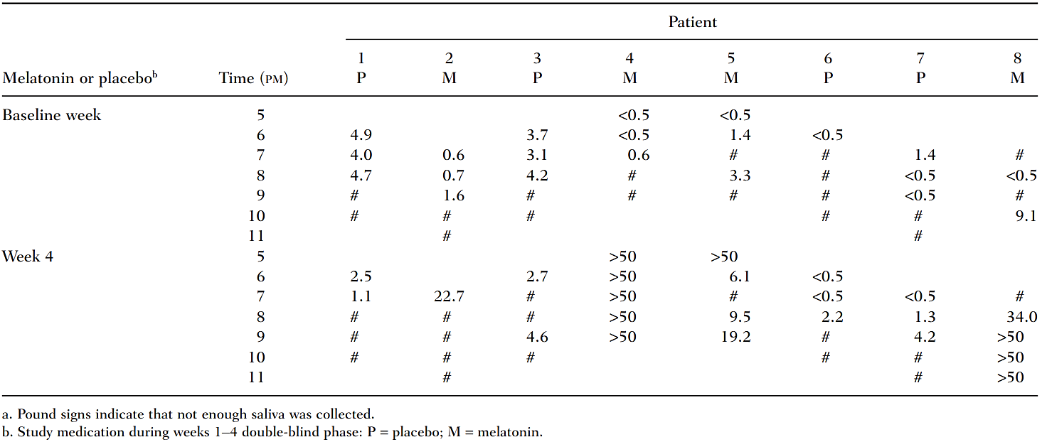
a. Pound signs indicate that not enough saliva was collected.
b. Study medication during weeks 1-4 double-blind phase: P = placebo; M = melatonin.
Regarding efficacy outcomes, assessment of sleep diaries from patients treated with melatonin and placebo showed that melatonin significantly improved multiple sleep parameters compared to placebo.
In the melatonin group, sleep latency decreased by 32 minutes, sleep onset advanced by 28 minutes, and TST increased by 56 minutes. The mean number of nights with nocturnal awakenings decreased from 3.1 to 1.6 per week on average. These changes significantly differed from placebo (p < 0.05; Table 27).
Table 27. Difference in sleep parameters from baseline to week 4 (Braam, W. et al., 2008⁴⁸)
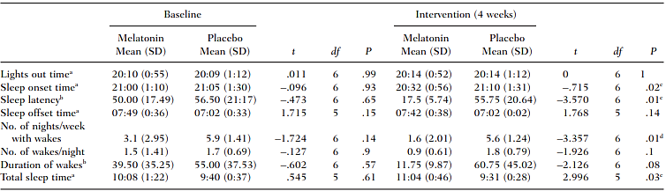
a. Hours:minutes. b. Minutes. c. P < .05. d. P < .01.
Furthermore, parents reported that their child’s behaviour was easier to manage, and they were less sleepy and more attentive during the day. The parents of 50% of melatonin-treated children (during the initial phase) rated the improvement as strong, while the rest rated it as moderate. After the 4 weeks of OL treatment, the parents of two children treated with melatonin for a total of 8 weeks decided to continue melatonin treatment after the study ended. After the 4 weeks of OL treatment, the parents of 3 children previously treated with placebo opted for continuation of melatonin treatment because of the strong improvement observed.

Hancock, E. et al., 200552
This was a randomised, DB, PC, crossover trial investigating the response to oral melatonin using two dose regimens (5 mg or 10 mg daily) in patients with sleep disorders associated with TSC.
Patients with a confirmed diagnosis of TSC and severe sleep problems were identified through the Bath tuberous sclerosis clinic, research, and epidemiologic studies.
The goal of this study was to investigate whether there is a dose-related response to exogenous melatonin when using a dose higher than 5 mg in patients suffering from sleep disorder associated with TSC. Efficacy outcomes examined included SL, TST, and the NOA each night were recorded in sleep diaries.
The trial consisted of four parts: an initial 2-week baseline period to confirm the sleep disorder and familiarise the parent or carer with the requirements of the trial during which the patients received no treatment; a 2-week period during which the patient received either 5 or 10 mg of melatonin; a 2-week washout period during which the patient received no treatment; and a 2-week period during which the patient received the alternate dose of melatonin (i.e., 5 mg after 10 mg or 10 mg after 5 mg). The parent or carer completed both sleep and seizure diaries throughout to document the sleep disorder and seizure frequency.
The melatonin was supplied by Penn Pharmaceuticals Services Ltd (Tredegar, Gwent, Wales, UK). Melatonin was administered approximately 30 minutes before the patient’s usual bedtime; each patient received two identical capsules, either 2 x 5 mg of melatonin (10 mg in total) or 1 x 5 mg plus 1 x placebo (5 mg in total). The patients, carers, and researchers did not know in which weeks they received either 5 or 10 mg of melatonin.
The sleep diaries were used to monitor the SL (i.e., time taken to fall asleep), the TST, and the NOA each night. The seizure diaries were used to monitor the frequency and type of seizures (if any) experienced by the patients during the study period. The carers were also asked to record any illnesses the child had or any possible side effects that they suffered during the trial period.
Inclusion criteria included a diagnosis of TSC was confirmed by the presence of at least one hamartoma present in each of a minimum of two different organs. A diagnosis of sleep disorder was confirmed by a Quine sleep index score of at least 6 of a possible 836.
Regarding exclusion criteria, children were excluded from the trial if their sleep disorder proved to be situational (a higher Quine score at home with a score of < 6 elsewhere); such patterns were considered likely behavioural in origin, and unlikely to respond to melatonin treatment.
The results were analysed using paired t-tests.
Regarding baseline demographics there were 4 male and 3 female patients, with an age range of 18 months to 31 years (median age: 9 years). All patients had epilepsy and were on concurrent anticonvulsants; 2 patients were well controlled. All had mental retardation and behavioural difficulties
Regarding efficacy outcomes results there was no evidence of a dose effect between 5 and 10 mg was seen with respect to any outcome measure (Table 27):
- There was a small and not statistically significant improvement in SL when patients were taking melatonin 10 mg (mean 76 minutes) compared with 5 mg (mean 86 minutes; 95% CI: -39 to +18 minutes; p = 0.4) daily.
- There was no significant difference in TST (8 hours, 57 minutes on 5 mg and 9 hours, 4 minutes on 10 mg; 95% CI: +42 to +63 minutes; p = 0.6).
- The mean NOA was recorded for five of the patients. There was no difference between the two groups in terms of NOA (awakenings on melatonin 5 mg were 0.8 and on 10 mg were 1.0; p = 0.5).
Table 27. Mean sleep latency, TST, and NOA after the administration of 5 and 10 mg of melatonin (Hancock, E. et al., 2005⁵²)
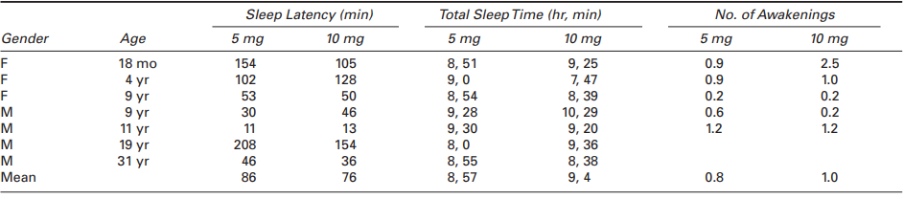

O’Callaghan, JF. et al., 199951
This was a randomised, DB, PC, crossover trial which sought to assess the effect of melatonin in patients with TSC and severe sleep problems.
Patients were identified either through the Tuberous Sclerosis Association of Great Britain or through a specialist tuberous sclerosis clinic based at the Royal United Hospital, Bath.
During the study, there was an initial treatment period of 2 weeks during which time patients received either melatonin or placebo, followed by a 1-week washout period, followed by another 2-week period where patients received the alternate treatment (either placebo or melatonin). The dose of melatonin used was 5mg. Melatonin was supplied by Penn Pharmaceuticals Ltd. Therapy was given 20 minutes before each patient’s usual bedtime. A total of 7 patients were recruited who satisfied the inclusion criteria, and all 7 completed the study.
Regarding efficacy outcomes examined, throughout the total 5-week period of the trial, the individual patient’s response was monitored by a sleep diary completed by the main carer. Outcome measures determined before the study were TST, sleep-onset time (i.e. time taken to fall asleep), and NOA during the night.
The presence of significant sleep difficulties was confirmed before recruitment by a sleep diary, completed by the patients’ main carer over a 1-week period, which confirmed both delayed sleep onset and sleep fragmentation, and a Quine sleep-index score of greater than 6 out of 8 . The sleep index focuses on four areas of difficulty: problems settling the child to sleep, night-time waking, parental sleep loss, and frequency with which parents/carers have to attend to their child during the night. The sleep index sums the three-point scores (zero to two) for each of the four areas and gives a final score which can range from zero (no problems) to eight (severe problems in all four areas).
Regarding baseline demographic data 3 males and 4 females were included in the study. The age range was 2 to 28 years (median age 11 years). All patients had delayed sleep onset and fragmented sleep patterns. All patients had epilepsy and learning difficulties, and all were receiving anticonvulsant medications.
Regarding efficacy outcome results, mean TST improved in 6 patients whilst receiving melatonin. For the group, the mean improvement in TST was 0.55 hours (95% CI, 0.088 to 1.01) which, using a two-tailed t test, reached statistical significance (p=0.027; Figure 13.)
Figure 13. Mean TST (O’Callaghan, JF. et al., 1999⁵¹)
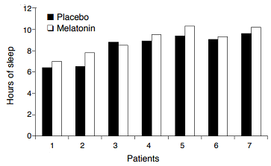
For mean sleep-onset time when treated with melatonin improved (i.e., decreased) in 4 patients, deteriorated in 2, and stayed the same in one. The mean improvement for the whole group was 0.39 hours (95% CI, –0.085 to 0.873) which was not statistically significant (p=0.079; Figure 14).
Figure 14. Mean sleep-onset time (O’Callaghan, JF. et al., 1999⁵¹)
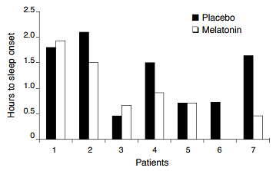
There was no obvious trend towards improvement in the mean number of awakenings per night while on melatonin: 3 patients showed improvement receiving melatonin, 3 deteriorated, and one patient was seemingly unaffected (Figure 15)
Figure 15. Mean NOA (O’Callaghan, JF. et al., 1999⁵¹)
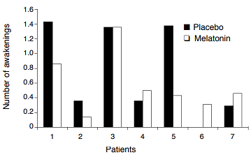

Zhdanova, IV. et al., 199923
This was a comparative study with concurrent controls in 13 children with AS who were experiencing insomnia.
The authors tested the possibility that actigraphically registered motor activity during sleep in AS children would be diminished when their circulating melatonin levels were increased to within the physiological or low pharmacological range, which was accomplished by the administration of a 0.3 mg dose of melatonin to the patients close to their bedtime. Thirteen children, aged 2-10 years old diagnosed with AS were recruited from Boston Children’s Hospital and the Angelman Syndrome Foundation. All patients completed the study.
The patients' 24-hour motor activity was monitored in their home environment for 7 days prior to melatonin treatment (baseline). The patient's parents maintained a sleep diary for their child, indicating bedtime, approximate times of falling asleep, and times of awakenings. Objective data on 24 hour motor activities were obtained using a portable body actigraph (Mini-logger 2000, Mini Mitter, Oregon), worn by the patient in a pocket on the back of a cloth vest.
Patients were subsequently admitted to the Children's Hospital Clinical Research Center (CRC) to evaluate their endogenous melatonin secretion patterns. Patients' rooms were maintained at 72°F, and lights were dimmed at 19.00 h to < 30 lux. In order to measure individual endogenous serum melatonin levels and the levels induced by melatonin treatment, blood samples (2 mL) were withdrawn at hourly intervals (from 1500 to 1000 the next morning, and from 1700 to 1100 the next morning, respectively).
Starting on the second day after the initial hospital admission, patients received a 0.3 mg oral dose of melatonin on each of six consecutive evenings, ½-1 h prior to their habitual bedtime ranging from 19.30 to 20.30 h. Each patient's activity and sleep were assessed as described above.
After six days of melatonin treatment, patients were again admitted to the CRC for PK sampling to assess the effects of the exogenous melatonin on their serum hormone profiles. The environment and procedures were held similar to those used during the first CRC admission.
For a total of 5 days a 0.3 mg dose of melatonin was administered 0.5 -1 hour before the patient's habitual bedtime. Melatonin was provided by mixing the contents of a gelatin capsule (0.3 mg melatonin, Nestle Co., Switzerland, and microcrystalline cellulose 'Avicel') with a teaspoon of a semi-liquid food and adding it to the child's evening snack.
Regarding inclusion and exclusion criteria children with AS with insomnia were included in the study. No further details were provided.
The efficacy outcomes of interest included the total sleep period (TSP) and the number of movements per hour during the TSP (M).
Regarding statistical methods The PK parameters of interest were time of onset and offset of nocturnal melatonin secretion, area under the time-melatonin concentration curve within this period (AUC), and peak night-time and minimum daytime hormone levels. Statistical analyses of the actigraph and melatonin concentration data involved repeated measures ANOVA to evaluate the differences between baseline levels of outcome variables and the levels on a 0.3 mg melatonin treatment. Individual and group means represent four consecutive days of a baseline period and four consecutive days of a treatment period. The last four days of the period were used for the analysis, unless the data were missing, in which case any available four consecutive days were chosen.
Thirteen patients (9 females and 4 males) with AS, aged 2-10 years, were included. Body weight ranged from 9.8 to 60.2 kg. All patients were taking concomitant medications.
Regarding efficacy outcomes endogenous serum melatonin profiles were highly variable. In ten of the children the onset of nocturnal hormone secretion was consistent with their bedtime and their sleep onsets; in 3 of the patients however, the nocturnal surge was substantially delayed.
Within an hour after ingestion of a capsule containing 0.3 mg of melatonin, circulating melatonin levels increased significantly (p < 0.001 for both C_{max} and AUC), and remained above the daytime baseline levels for 12-15 hours. The highest peak levels following treatment were in two year-old identical twin patients, whose body masses were the lowest in the group studied (9.8 kg and 10.1 kg). Daytime melatonin levels were less than 21.6 pmol/L (5 pg/mL) for all the children studied and were not significantly changed after five days of melatonin treatment (Table 28 and Figure 16).
Table 28. Melatonin PK before and after exogenous melatonin administration (Zhdanova, IV. et al., 1999²³)
Melatonin dose (mg) | Mean (±SEM) C_{max} (min-max) (pg/mL) | Mean (±SEM) AUC (min-max) (pg/mL•h)
0.0 | 90 ± 14.72 (19 – 177) | 637 ± 99.61 (141 – 1108)
0.3 | 601.6 ± 223 (96 – 2800) | 2683 ± 759.98 (629 – 9807)
Figure 16: Mean (± SEM) peak serum melatonin levels in thirteen AS children: endogenous levels (0.0) and after the administration of a 0.3 mg dose (Zhdanova, IV. et al., 1999²³)
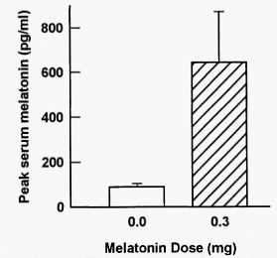
Administration of a 0.3 mg dose of melatonin substantially reduced the measured night-time motor activity in 11 of the patients studied; for the other 2 patients, baseline activities did not exceed 30 movements per hour, this is shown in Figure 17. Analysis of the group data revealed a significant decrease (p<0.001) in motor activity during the TSP following melatonin treatment, and a significant increase in the TST (p < 0.05). The study authors did not find a significant correlation between an individual's endogenous C_{max} or AUC and the number of his or her movements per hour of TSP under baseline conditions.
Figure 17. Actigraphically recorded TSP and the number of movements per hour of TSP (M) (Zhdanova, IV. et al., 1999²³)
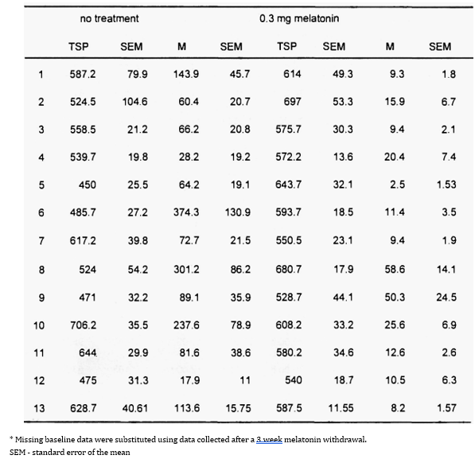
Figure 18 supports that increased motor activity in sleep appears to be inhibited by the increases in serum melatonin levels that follow administration of melatonin 0.3 mg. The sleep-promoting effect of the hormone treatment did not show a dependency on either the endogenous peak melatonin levels or the duration of the nocturnal increase in melatonin secretion.
Figure 18. Mean (±SEM) peak serum melatonin levels (left) and motor activity per hour of the sleep period (right) (Zhdanova, IV. et al., 1999²³)
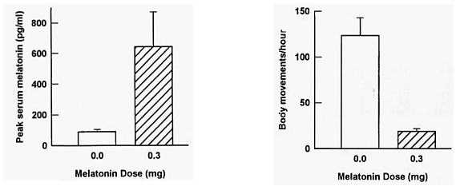
During the period of melatonin administration at home, parents reported that patients usually fell asleep within 15 to 60 minutes after melatonin administration, and that sleep onset occurred faster than it did prior to the treatment. In some cases, parents felt that the children, after falling asleep, were not aroused by sounds that would have awakened them prior to starting treatment. Parents reported that children were alert during the day after melatonin administration, and that there was either no change in daytime behaviour or that the patients were more attentive and interactive.

de Leersnyder, H. et al., 201149
This was a retrospective study, with the aim of assessing the long-term (up to 6 years) effectiveness and safety of melatonin (Circadin) in children with NDD, including SMS.
The parents of children who were followed in a neurodevelopmental clinic specialising in genetic and neurodevelopmental disorders, who had participated in a compassionate-use treatment programme with prolonged-release melatonin treatment (conducted between November 2002 and June 2008), were accessed by telephone between January 2002 and February 2010 and asked to participate in the present follow-up study. There were 88 participants; of those, 5 presented with AS, 5 with RS, and 1 with TSC.
The melatonin (Circadin) was supplied by Neurim Pharmaceuticals, Tel Aviv, Israel as 2 mg PR tablets. Children received a dose of 2-4 mg of prolonged-release melatonin if their body weight was < 40 kg, and 6 mg if their body weight was ≥ 40 kg. All participants received melatonin treatment in the context of regular care by a specialised physician. Treatment effects, doses, and timing of administration were discussed with the parents at regular control appointments with the prescribing physician. Parents filled in a questionnaire during their visits to the physician, which addressed problems with sleep onset, maintenance, and quality.
The recorded efficacy outcomes included sleep onset and offset times, sleep duration, SL, sleep quality (bad, 1; fair, 2; good, 3), NOA, daytime napping, and mood changes.
Regarding inclusion criteria patients were aged between 6-12 years, rigorously diagnosed genetic or neurodevelopmental disorders, and chronic sleep disorders. No exclusion criteria were noted.
Regarding statistical methods the statistical analysis was conducted according to Student t tests and Pearson χ2 tests.
Regarding baseline demographics the 88 participants consisted of 42 girls and 46 boys. Patients with a variety of genetic/ neurodevelopmental disorders were included, which reportedly ranged from moderate to severe according to ICD10 criteria. The mean age (± SD) of patients at the initiation of treatment with PR melatonin was 10.2 ± 4.4 years (range, 5-20 years).
Regarding exposure The follow-up time (mean ± SD) of this study was 33.5 ± 21.2 months. Sixty-two (70.5%) children still used melatonin daily at the time of follow-up. The duration of melatonin use ranged from 6-72 months (mean ± SD, 39.23 ± 21.33 months).
Twenty-six (29.5%) children discontinued melatonin treatment completely. The duration of melatonin use in this group ranged from 3-60 months (mean ± SD, 21.31 ± 13.60 months). The final dose of melatonin in the group that discontinued treatment ranged from 2-10 mg (mean ± SD, 5.08 ± 1.9 mg).
Regarding efficacy outcome results after 3 months of treatment with PR melatonin, compared to baseline, SL decreased by 44.0% (p < 0.001), the length of sleep time increased by 10.1% (p < 0.001), the awakening time was delayed by 56 minutes (p = 0.02), sleep quality improved by 81.9% (p < 0.001), the number of midnight awakenings decreased by 75% (p < 0.001), and those reporting daytime napping decreased from 80% to 16% (p < 0.001). Additionally, 90% of parents reported an improvement in sleep quality, and 12% of the parents reported improvements of mood in their children.
The results associated with the efficacy parameters for the 49 children whose parents gave full reports are presented in Table 29.
Table 29. Summary of parents’ opinions regarding effects of prolonged-release melatonin treatment on sleep parameters after 3 months of use (de Leersnyder, H. et al., 2011⁴⁹)
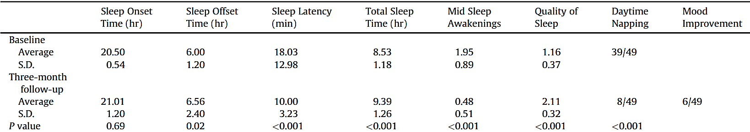

Takaesu, Y. et al., 201250
The aim of this study was to investigate the condition of circadian rhythm sleep disorders (CRSD) in AS patients and the relationship between AS and serum melatonin levels. The diurnal changes in serum melatonin levels of AS patients with and without CRSD with those of age-matched controls were compared. The effectiveness of melatonin treatment on CRSD in AS patients was evaluated.
Fifteen (15) consecutive AS patients from 12 facilities for individuals with mental retardation were included in the study. The AS subjects’ sleep–wake cycles were recorded by the caregivers or family members of the patients using sleep logs for approximately one month. Subjects with mental retardation due to causes of unknown aetiology, but without CRSD as confirmed on their sleep logs, were selected from the same facilities as the AS subjects and assigned as age-matched controls. Light intensity of the facilities where the AS subjects and the controls lived were measured midday (12:00) at the participants’ eye level in their bedroom.
A total of 6 AS patients with CRSD regularly took a daily dose of melatonin of 1 mg nocte for 3 months. The changes in sleep–wake patterns were evaluated approximately three months after starting the treatment using their sleep logs. For the diagnosis of CRSD, blood samples were drawn every 4 h through an intravenous catheter inserted continuously for 24 h into a forearm vein. Further details regarding PK sampling and analysis were not supplied.
The diagnoses of sleep disorders were established by physicians specialising in sleep disorders and were made on the basis of the criteria of ICSD-II using the patients’ sleep logs. Blood samples were drawn every 4 h through an intravenous catheter inserted continuously for 24 h into a forearm vein. A heparin lock was used to prevent clotting. Light intensity of the facilities was kept under 15 lux at nighttime to prevent the suppression of nocturnal melatonin secretion by bright light. The diurnal changes in serum melatonin levels of the AS patients were compared with those of the controls using the blood samples.
Inclusion criteria were subjects had AS (confirmed by DNA test). Exclusion criteria included patients with liver disease or renal dysfunction were not included in the study.
The primary efficacy outcomes examined included the prevalence of CRSD in AS patients and the effect of melatonin treatment on sleep patterns in AS patients with CRSD.
Regarding statistical methods the Mann–Whitney U-test was used for the comparison of descriptive variables between the AS patients and the controls. One-way ANOVA was performed for the comparisons of midday (12:00) environmental light intensity, TST per day, and the percentage of nocturnal sleep time among the AS patients with CRSD, those without CRSD, and the controls. The chi-square test was performed to compare the number of CRSD cases between child AS subjects and adult AS subjects, and to compare the number of subjects with severe mental retardation between the AS patients and the controls. The Pearson product–moment correlation coefficient was used to analyse the relationship between age and peak serum melatonin level in the AS patients and controls as well as the relationship between the daily doses of sodium valproate and the peak serum melatonin levels in the AS patients. A p-value of less than 0.05 was considered to represent a statistically significant difference.
Regarding baseline demographics there were 7 males and 8 females, and the mean age was 16.3 years. These included adults (n = 7, mean age 23.1 ± 2.7 years) and children (n = 8, mean age 10.4 ± 3.9 years). A comparison of the variables between the AS patients and the controls did not reveal any significant differences between the 2 groups in age (16.3 ± 7.3 vs. 13.4 ± 4.2 years, respectively) or gender (female/male ratio, 8/7 vs. 6/8, respectively; chi-square test, χ2 [1] = 0.32, p = ns). All of the AS subjects were receiving antiepileptic medications, and their epileptic episodes were well controlled for at least three months during the study period.
In the AS group, 8 patients (53%; 2 adult [≥ 20 years] subjects and 6 paediatric [< 20 years] patients) received diagnoses of CRSD on the basis of their sleep logs: irregular sleep–wake type (ISWT) in 4 patients, delayed sleep phase type (DSPT) in 2 patients, and free-running type (FRT) in 2 subjects. Regarding outcome measure of diurnal changes in serum melatonin levels in AS patients versus controls the peak serum melatonin level of AS patients was significantly lower than that of controls (59.8 ± 46.1 pg/mL vs 108.4 ± 35.0 pg/mL; p < 0.01), and significant differences (post hoc testing) were observed at 20:00, 00:00, 04:00, and 12:00 (p < 0.01) and 16:00 (p = 0.03), indicating abnormal melatonin secretion in AS (Figure 19).
In a two-way repeated ANOVA, there were main effects of both the diagnostic group and the time measurement points on serum melatonin levels, and a significant interaction between the diagnostic group and the time measurement point (p < 0.01).
Figure 19. Diurnal changes in serum melatonin levels: AS patients versus controls (Takaesu, Y. et al., 2012⁵⁰)
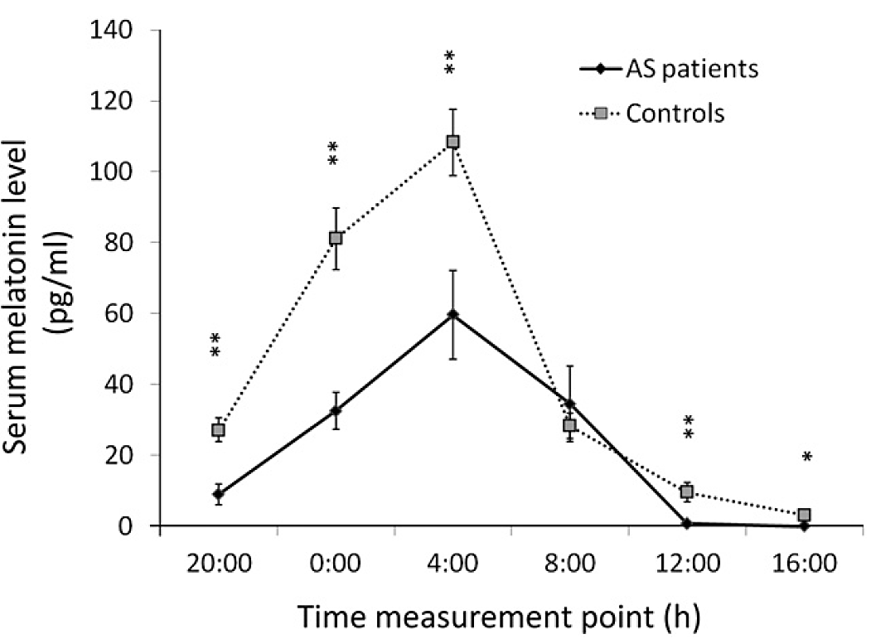
AS: Angelman syndrome. **p < 0.01, *p < 0.05. Two-way repeated ANOVA and the Bonferroni–Dunn test were used to compare the serum melatonin levels between the AS patients and the controls. The vertical error bars represent standard error (SE) of the mean.
A significant negative correlation between age and peak serum melatonin levels was observed in the controls (r = -0.73, p < 0.01); no significant correlation was found between these variables in AS patients (r = -0.19, p = ns; Figure 20). No significant correlation was found between the daily medicated dose of sodium valproate and the peak serum melatonin levels in the AS subjects (r = 0.35, ns).
Figure 20. Correlation between age and peak serum melatonin level in AS patients and controls (Takaesu, Y. et al., 2012⁵⁰)
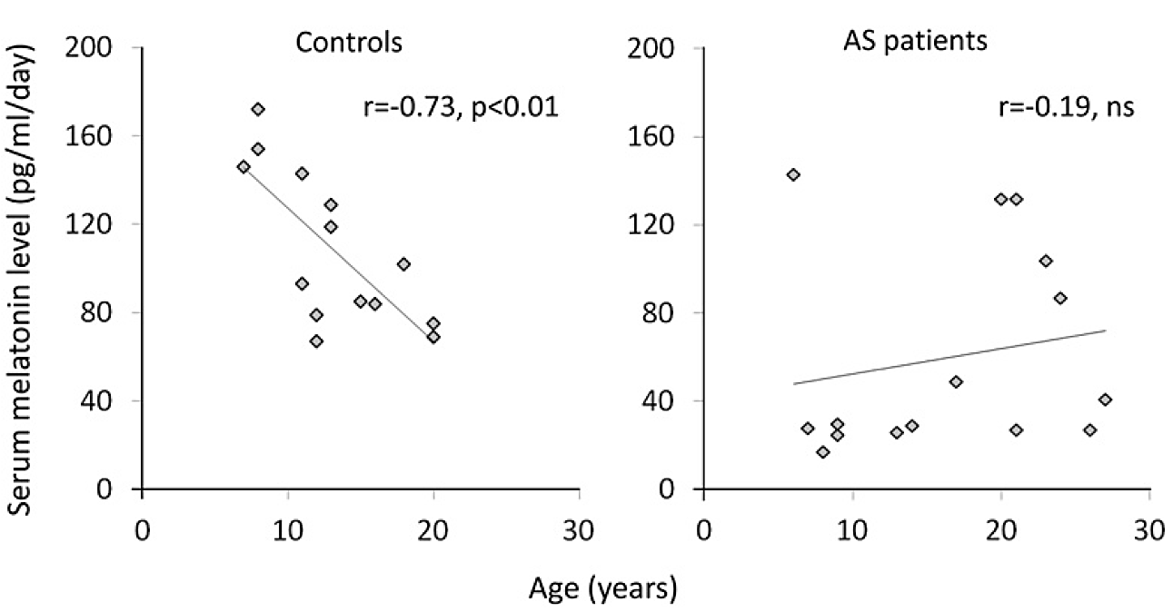
AS: Angelman syndrome, ns = not significant. The Pearson product–moment correlation coefficient was used to analyze the correlation between age and peak serum melatonin level in both the controls and the AS patients
Regarding the efficacy outcome results A total of eight of the 15 AS patients (53%) had CRSD, with the following subtypes: ISWT: 4 patients; FRT: 2 patients; and DSPT: 2 patients. One-way ANOVA revealed a significant difference in the TST per day among the AS subjects with CRSD (8.3 ± 1.4 h), the AS subjects without CRSD (9.8 ± 0.8 h), and the controls (9.0 ± 0.9 h) (F[2,26] = 3.94; p < 0.05). A significant difference was observed in the percentage of nocturnal sleep to TST among the AS patients with CRSD (55.9% ± 18.8%), the AS patients without CRSD (83.7% ± 2.5%), and the controls (78.2% ± 5.8%) (F[2,6] = 15.31; p < 0.01).
After three months of melatonin treatment, four out of six (67%) AS patients with CRDS showed an improvement in sleep patterns, with an advanced sleep onset and increased TST. The 2 patients with the FRT showed complete suppression of symptoms following melatonin administration, and 2/3 of those with the ISWT showed a decrease in the frequency of daytime sleep episodes and an increase in nocturnal sleep time.
Table 30. Diagnoses of CRSD, circadian measures, and outcome of melatonin treatment (Takaesu, Y. et al., 2012⁵⁰)
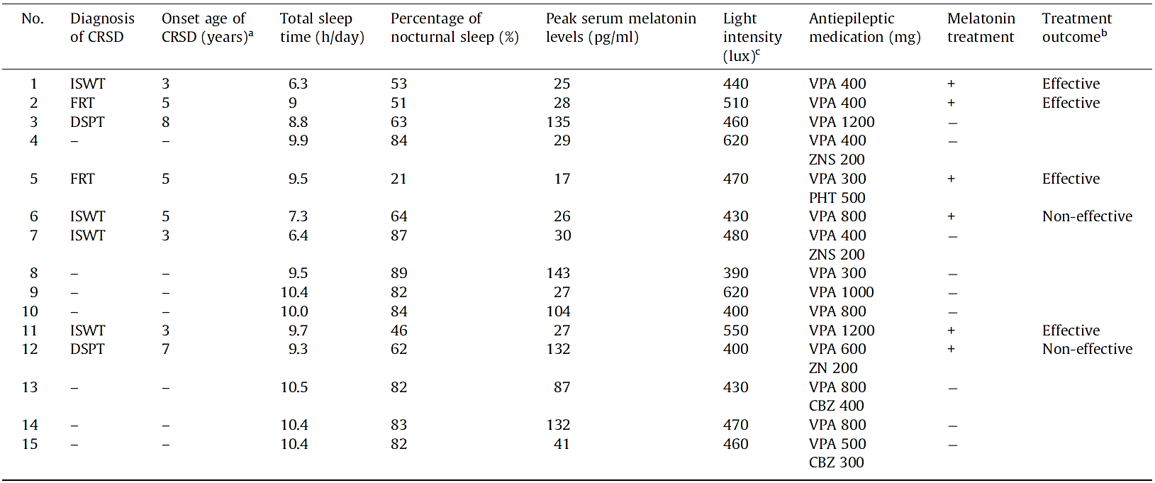
ISWT: irregular sleep–wake type FRT: free-running type DSPT: delayed sleep phase type VPA: sodium valproate CBZ: carbamazepine ZNS: zonisamide PHT: phenytoin.
a The onset age of CRSD was estimated on the basis of information obtained from the family members of the AS patients.
b The outcome was defined as effective if the percentage of nocturnal sleep to total sleep time exceeded 80% after treatment.
c Light intensity was measured in front of the eyes of the AS subjects at 12:00.
The mean percentages of nocturnal sleep of the four AS patients who responded (Cases 1, 2, 5, and 11), as measured on their sleep logs recorded for one month before the clinical evaluation, improved to more than 80% (Figure 21).
Figure 21. Changes in the percentage of nocturnal sleep time with melatonin treatment in each case (Takaesu, Y. et al., 2012⁵⁰)
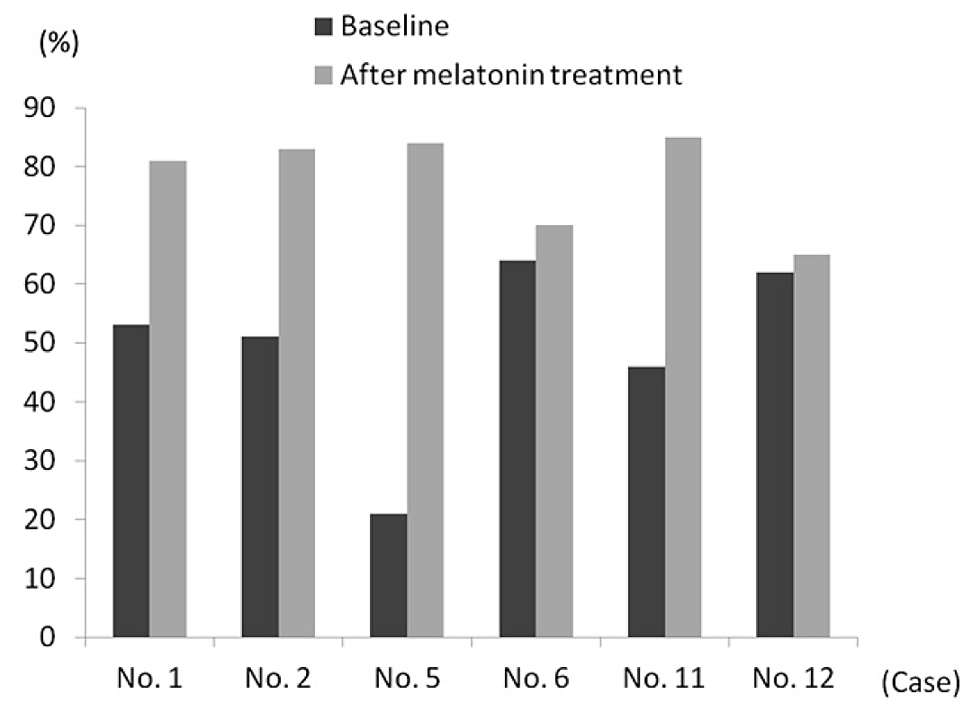

Efficacy and safety in level IV NGD studies

Martens, MA. et al., 201756
Design | This study was a retrospective survey of parents of patients with Williams Syndrome (WS).  The objective was to evaluate the use and effectiveness of sleep medications among a large sample of individuals with WS.  The Williams Syndrome Association (WSA) mailed postcards to its membership (2,846 members) before a National Williams Syndrome Conference. The postcard explained how to access an online survey regarding the use and effectiveness of sleep medications, along with other psychotropic medications, in individuals with WS. One email reminder was sent by the WSA to its membership approximately 2 months after the postcard was mailed.  The survey was part of a larger study investigating the use of medications to treat mood and behavioural difficulties in individuals with WS. Participants were provided with a list of commonly prescribed medications and asked whether their child currently took (or had ever taken) any of the medications. If participants reported that their child took a specific medication, they were asked for more details regarding the usage of that medication. Participants could also write in the name of a medication if it was not listed. The participants did not indicate whether they were taking medications simultaneously or sequentially. The survey also asked the age at which the medication was begun, its purpose, level of effectiveness, and whether the medication caused any side effects.
Included subjects | No details other than that the subjects had Williams Syndrome (WS) were provided.
Treatments | No study treatments were administered; parents reported which medications had been used to assist sleep in their children with WS. Regarding melatonin, parents did not report if IR or PR formulations were used.
Outcomes | Parents rated the helpfulness of the sleep medications as “helpful”, “somewhat helpful”, “not helpful”, and “unknown”.
Randomisation & blinding | Not applicable.
Populations | Not applicable.
Sample size | Not applicable.
Statistical methods | The statistical analysis included calculation of descriptive statistics. Medians were compared using the Wilcoxon rank-sum test. Detailed information on medication helpfulness was examined for the most commonly reported medications (reported by more than 10 participants). Some participants reported the use of more than one medication, leading to repeated measurements from some subjects. To account for the within-participant correlation of responses, generalised estimating equations with a logit link were used to compare helpfulness of the commonly reported medications. Analyses were performed using SAS System, version 9.3.
Participant flow | A total of 513 parents/caregivers completed the survey regarding their child or adult who has WS. Most participants (n = 435) completed the 57-question survey online; others (n = 73) completed the online survey using computers provided at the conference, or requested a paper copy that they completed and returned to the researcher associated with the study (n = 5).
Protocol violations | Not applicable.
Baseline data | For the 513 participants, 45% were male, mean age was 17.2 years (range 0.6–61 years), and 88% of participants were White.  Twenty-five percent of participants reported taking sleep medication at some point. The majority of those who reported taking medication for sleep issues (58%) were female, and the age range of those completing the survey who took sleep medication ranged from 1 to 45 years, with the average being 13.7 years. Participants who reported ever using sleep medication were on average younger at the time of survey completion than those who did not report using medications to aid in sleep (p = 0.001), but there were no other significant differences in demographics between sleep medication users and non-users.
Exposure | Melatonin was the most commonly reported medication taken for sleep, indicated by 67% (n = 87) of those who took any form of sleep medication. It was not noted if the melatonin was IR or PR. The majority (78%; n = 101) of participants reported using only one sleep medication, with 18% (n = 23) reporting two medications, 4% (n = 5) reporting three medications, and 1% (n = 1) reporting four medications.
Efficacy results | The helpfulness ratings of the two most common medications taken for sleep are shown. Melatonin had the highest helpfulness ratings, with 91% reporting it to be helpful or somewhat helpful. Fewer than half of those who reported taking diphenhydramine (Benadryl) indicated that it was helpful.  Helpfulness of sleep medications:  Data reported as % (n). Note: Using a generalized estimating equation logistic regression model, the odds of a person reporting that a medication was “helpful” or “somewhat helpful” was significantly different for melatonin compared with diphenhydramine (p=0.0042). There is also a significant difference if we compare “yes” to “somewhat/not helpful” (p=0.02).  There were no significant sex differences between the helpfulness ratings.
   | Helpful, % (n) | Somewhat Helpful, % (n) | Not Helpful, % (n) | Unknown, %
  Diphenhydramine | 42 (16) | 24 (9) | 24 (9) | 11 (4)
  Melatonin | 69 (60) | 22 (19) | 7 (6) | 2 (2)
Safety results | Those who reported taking melatonin reported the fewest side effects, with only 6% reporting any side effect at all. Most of the side effects were in the neurological category, with the majority being sleep problems.  Frequency of Side Effects for Sleep Medicationsª  a Data reported as % (n).  b Behavioral includes fighting and irritable.  c Gastrointestinal includes stomach ache.  d Neurological includes headache, muscle tics, sleep problems, tremors, zoned out, seizures, unusual movements, and tiredness.  e Physiological/metabolic includes low blood pressure, weight gain, and weight loss.  f Psychological includes hallucinations and suicidal thoughts.  g Participants who chose any side effect.  h Represents all 130 participants who reported taking any type of sleep medication. Includes sleep side effects for which a certain medication could not be determined along with side effects from other sleep drugs.  Specific side effects by sleep medication:  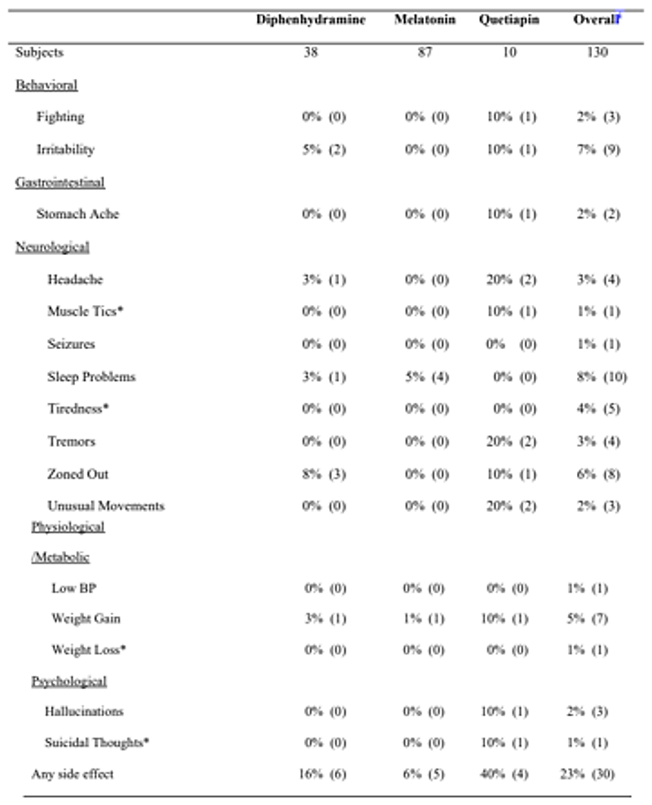
  Category | Diphenhydramine (n = 38) | Melatonin (n = 87) | Overall (n = 130)
  Behavioural side effects, % (n) | 5% (2) | 0% (0) | 7% (9)
  Gastrointestinal side effects, % (n) | 0% (0) | 0% (0) | 2% (2)
  Neurological side effects, % (n) | 13% (5) | 5% (4) | 17% (22)
  Physiological/metabolic side effects, % (n) | 3% (1) | 1% (1) | 7% (9)
  Psychological side effects, % (n) | 0% (0) | 0% (0) | 2% (3)
  Any side effect, % (n) | 16% (6) | 6% (5) | 23% (30)
Conclusions | This was reportedly the first study to consider the usefulness of melatonin in the treatment of sleep disorders in individuals with Williams Syndrome (WS). The study authors indicated that individuals with WS may have impaired nighttime production of melatonin.  Melatonin was reported to be significantly more helpful or somewhat helpful than diphenhydramine (p = 0.0042), although it was noted that medications were not compared within the same individuals. Several limitations of the study design were identified:  - the information was based on parental report and may be influenced by parents’ recollections of sleep problems and responses to medication;  - the sample may be biased towards those who had the financial means to attend the WSA conference and/or had access to computers/internet;  - the sample may be biased towards individuals with WS who have sleep difficulties or respond negatively to medication.  The generalisability of the findings was questioned by the study authors, as participants were all involved in the WSA, were not ethnically diverse, and there were no data on socioeconomic status or education levels. In spite of these limitations, the study is considered to lend some support to the use of melatonin in those with WS and sleep disturbances.

McArthur, AJ. et al., 199854
Design | This was a DB, PC, crossover study with randomised treatment order.  The objective was to assess the safety and efficacy of a 4-week exogenous melatonin treatment for sleep dysfunction in RS, with use of continuous wrist actigraphy.  Subjects were recruited from the Northwest Rett Syndrome Clinic at Oregon Health Sciences University and the Northwest Rett Syndrome Foundation, Portland, Oregon, via mailed questionnaires and telephone interviews.  Wrist actigraphs (Mini Motionlogger Actigraph®, Ambulatory Monitoring Inc., Ardsley, NY, USA) were worn to monitor subjects 24 hours a day for the duration of the study. In addition, daily diaries of sleep patterns were maintained by caregivers. A 1-week baseline assessment was done to determine the severity of sleep disorders in these patients. The first 4-week treatment regimen was initiated after the baseline week. Set bedtimes were established and treatment (either placebo or melatonin) was given 1 hour before bedtime. At the conclusion of the first trial, a one-week “washout” period was employed. A second 4-week treatment period using the alternate medication was done following the washout week.
Included subjects | No information beyond the inclusion of subjects with RS was supplied in the journal article.
Treatments | Analytical grade melatonin was purchased from Regis Chemical Company (Morton Grove, IL, USA). IR melatonin and identical looking placebo capsules, containing lactose, were formulated by Dr Keith Parrott at the College of Pharmacy, Oregon State University. Melatonin was administered either orally or via gastrostomy tube. Dosage was based upon individual body weight and ranged from 2.5 to 7.5 mg across patients to achieve comparable circulating levels of melatonin within the group.  Melatonin dose strategy:  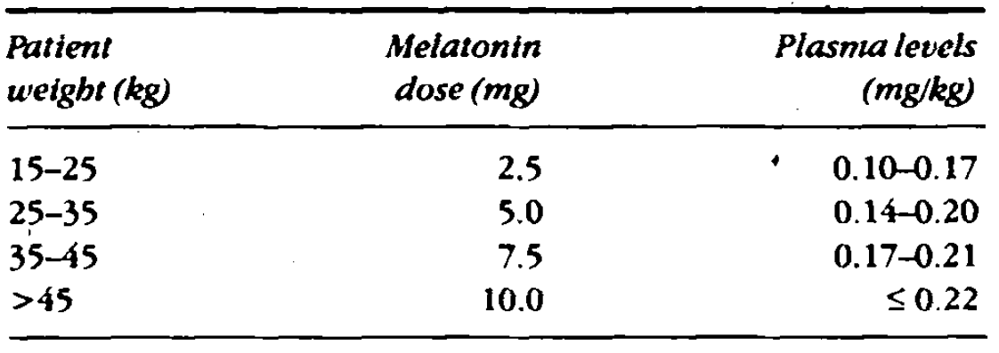  Various anticonvulsant medications were concurrently prescribed by the patients’ physicians and were not altered during the protocol.
Outcomes | The outcome measures included TST, sleep efficiency, NOA, and sleep-onset latency. Caregiver diaries were used to confirm bedtimes, sleep-onset latency, number of night-time awakenings, and final morning awakening. Sleep efficiency was calculated as that percentage of the time the patient was asleep between the time they were put into bed, according to diary data, and a final morning awakening, as determined by actigraphy.
Randomisation & blinding | Melatonin and placebo were administered in identical capsules. No details about randomisation or other blinding methods were supplied.
Populations | A total of 9 girls with RS were monitored and all completed the study.
Sample size | No sample size calculation was included.
Statistical methods | Actigraphy data were analysed using Action 111 software (Ambulatory Monitoring, Ardsley, NY, USA). ANOVA was done by comparing daily group means for placebo and melatonin treatment trials.
Participant flow | 22% of subjects withdrew from the study due to side effects or ineffectiveness, and 78% responded: 17 subjects to 2.5–3 mg (3 stopped this dose due to irritability/hyperactivity increase [2], and response), 14 to 5–6 mg (2 stopped this dose due to increased irritability and nighttime awakenings), and 4 to 10 mg (3 subjects failed to respond to the highest dose, 1 experienced decreased appetite and 1 increased fitting).
Protocol violations | No details were provided in the article.
Baseline data | Nine female patients (mean ±SE age, 10.1±1.5 years, range 4 to 17 years) with Stage III or Stage IV RS completed the study.  The baseline QOS in the patients was assessed as very poor, with mean (±SE) SOL of 42.1 (±12.0) minutes and mean (±SE) NOA per night of 14.9 (±2.3). Their mean TST (±SE) was 7.5 (±0.3) hours and their mean sleep efficiency (±SE) was 68.0 (±3.9)%. There was no correlation between the degree of sleep disorder and age of subject or stage of RS. None of the patients demonstrated obvious circadian-based sleep disturbances (e.g. free-running or non-24 hour sleep–wake patterns).
Efficacy results | Sleep-onset latency was significantly reduced by melatonin during the first 3 weeks of the trial. The mean (±SE) sleep-onset latency dropped from 32 (±8.6) minutes with placebo to 19.1 (±5.3) minutes with melatonin treatment (p < 0.05)  SOL after treatment with melatonin:  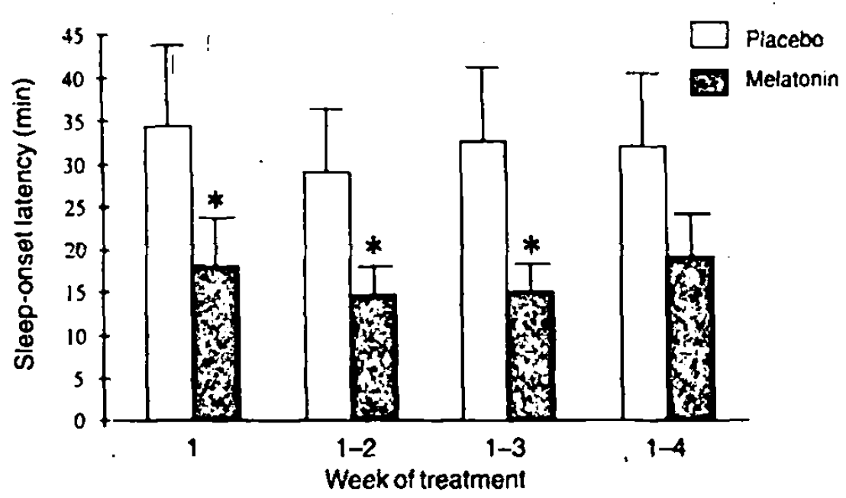  This decrease in sleep-onset latency was apparent during the first nights of treatment  Daily group averages for SL with melatonin or placebo:  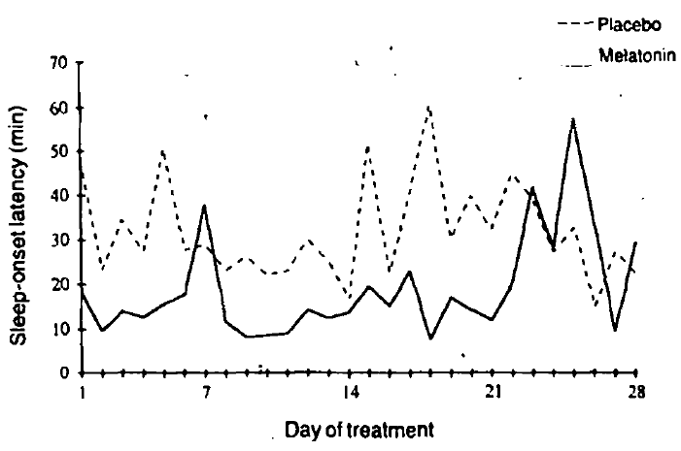  Melatonin treatment improved TST in the 3 patients with the lowest baseline sleep efficiency.  Individual 4-week TST averages plotted against the patients’ baseline sleep efficiency:  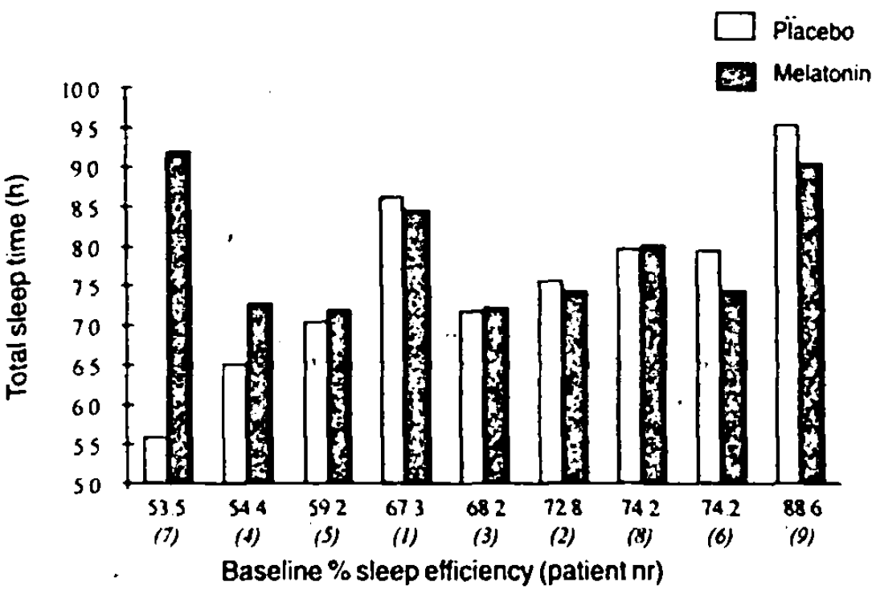  Although it was not statistically significant, the group mean revealed a clinical improvement of 29 minutes in TST. The effects of melatonin were seen during the first nights of treatment. The increase in TST could not be attributed to a decrease in night-time awakenings, as melatonin did not alter the frequency of these in this group.  Sleep efficiency also increased in the patients with the lowest baseline sleep efficiency although the mean improvement in this measure was slight (4.27%). The daily mean sleep efficiency during melatonin treatment was consistently higher than with placebo.  Individual 4-week sleep efficiency averages plotted against the patients’ baseline sleep efficiency:  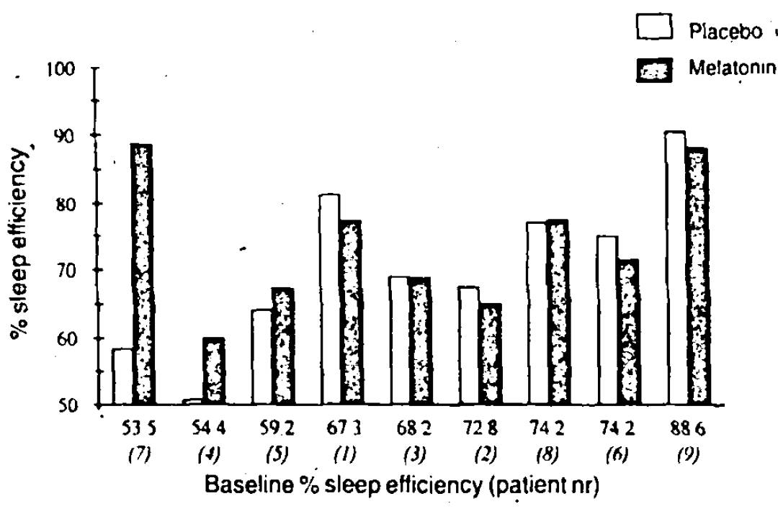  The actigraph proved to be much more reliable at monitoring long-term sleep–wake cycles compared with caregiver diary measures. Mechanical failure of the instrument and incidents of the monitor not being worn resulted in mean (±SE) data loss of 8.4±3.6% (62 nights), while the mean (±SE) diary data loss was 57.9±14.5% (41 nights).  Actigraphic data revealed that the children were often awake and moving around when their caregivers believed them to be asleep; a comparison between the actigraph and diary data in the 4 most complete diaries revealed the mean number of night-time awakenings detected by the actigraph (13.3±3.4 awakenings per night) was much greater than that noted in the diaries (0.6±0.2 awakenings per night).
Safety results | No adverse side effects were noted in any patient after 4 weeks of melatonin treatment. There was one parental report of “severe mood swings” while their child was taking melatonin, however no further information was provided.
Conclusions | The study authors concluded that while the variability of individual responsiveness was high, melatonin appeared to improve TST and sleep efficiency in the patients with the worst baseline sleep quality.  The variability in response was considered to be possibly multifactorial: administration of an ineffective low dose of melatonin, or perhaps underlying neuropathology in areas of the brain involved in sleep regulation that are not influenced by melatonin.  Melatonin’s effect to shorten sleep-onset latency was thought to be perhaps due to its direct hypnotic effect, or due to phase-advancement of the hypothalamic circadian clock. In one patient who received and responded to melatonin first, the response was maintained during the subsequent placebo treatment period; it was reported that this patient continued to sleep well with OTC melatonin (US).  The 3 worst sleepers in the group, who also responded to melatonin treatment, were taking sodium valproate/valproic acid, which has been found to suppress nocturnal melatonin levels in healthy young adults. This raised the possibility to the study authors that the sleep problems in these individuals may have been compounded by this anticonvulsant’s action on their endogenous melatonin synthesis.

Miyamoto, A. et al., 199955
Design | In this study, the circadian rhythm of serum melatonin levels in two patients with RS and sleep disorders was assessed. Subsequently, the efficacy and safety of long-term melatonin treatment for sleep disorders was tested.  The 2 girls with RS with sleep disorders who failed to respond to conventional treatments had their 24-h sleep patterns recorded by their mothers. The 2 patients subsequently received melatonin 5 mg orally at bedtime and efficacy and safety were monitored for two years.
Included subjects | No details were provided. The 2 participants both had classical RS.
Treatments | The 2 patients were given melatonin 5 mg orally prior to bedtime: Patient 1 at 19:30 and Patient 2 at 20:00. The melatonin product was not further identified.
Outcomes | Outcome measures included changes in sleep parameters, including sleep–wake cycle, number of NAs, and sleep duration.
Randomisation & blinding | Not applicable.
Populations | Not applicable.
Sample size | Not applicable.
PK analysis | Serum melatonin levels of the patients were examined before and during melatonin treatment. The patients were kept under room light illumination from 06:00 to 20:00. Using a heparinised catheter which was implanted transiently in a hand vein, blood samples were drawn every 4 h for 48 h in patient 1, and every 2 h for 24 h in patient 2. Sera were separated by centrifugation and stored at −20°C until assay. Serum melatonin was measured using radioimmunoassay (Nichols Institute Diagnostics, Wijchen, The Netherlands; Cat#40-6030).
Statistical methods | No details were provided.
Participant flow | Not applicable.
Protocol violations | Not applicable.
Baseline data | Both girls had symptoms compatible with classical RS. They had strabismus but sight.  Patient 1 was 7 years old at the time of reporting. At 3 years and 9 months, she developed a free-running rhythm of the sleep–wake cycle. Neither chloral hydrate nor vitamin B12 were effective.  Patient 2 was 13 years old at the time of reporting. Stereotyped hand movements and a fragmented sleep pattern accompanied by screaming during the night developed from 18 months of age. She was given 5 mg diazepam, 70 mg carbamazepine, and 0.5 mg bromocriptine, which were not effective in treating her sleep disorders.
PK results | Patient 1  At 4 years and 3 months of age, the circadian rhythm of serum melatonin was examined every 4 h for 48 h, and two peaks were observed during her sleep periods (Figure below). The time of each peak was delayed 6 h compared to normal control. The values of the two peaks were 98 and 41 pg/mL, which were at the lower limit (73.5–516 pg/mL, 90% CI for ages 3–5 years).  Two months after melatonin treatment, the serum levels of melatonin at 30 min after oral administration on 2 consecutive days were 2,200 and 6,800 pg/mL.  Serum melatonin pattern before (closed circle) and during (open circle) melatonin treatment in patient 1:  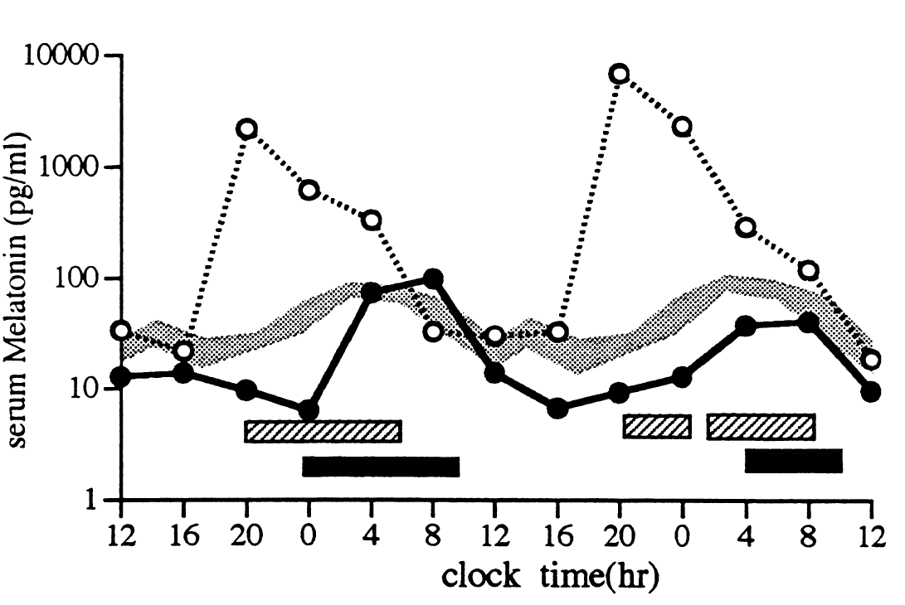  Oral melatonin, 5 mg administration at 19:30 h. Sleep time before (closed box) and during (striped box) melatonin treatment. Serum melatonin levels in normal prepubertal children reported by Ehrenkranz et al 1982 (thick shaded line).  Patient 2  At 10 years of age, the patient’s serum melatonin levels were examined every 2 h for  24 h (Figure below). The peak time of melatonin was 02:00 h, which corresponds to that of normal prepubertal children. The peak value of melatonin was 18 pg/mL, which was at the lower limit for normal children (14.5–282 pg/mL, 90% CI for ages 9–11 years).  After taking 5 mg melatonin at 20:00 h, serum melatonin levels elevated to 1,400 pg/mL at 22:00 h, and 8 h later melatonin levels returned to the same levels (4–9 pg/mL) as before melatonin treatment:  Serum melatonin pattern before (closed circle) and during (open circle) melatonin treatment in patient 2:  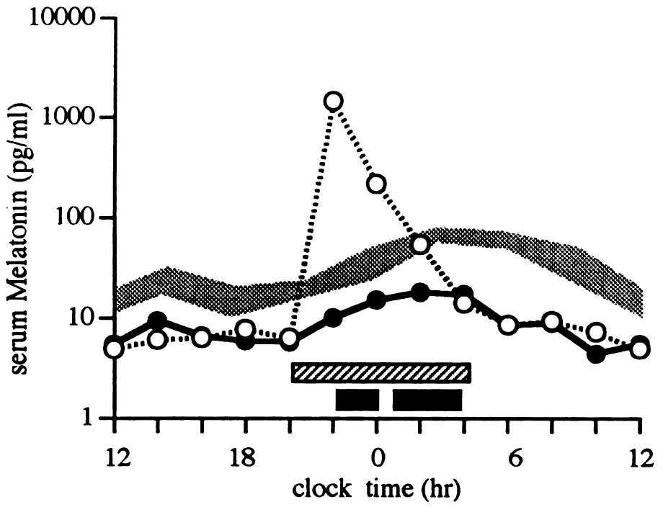  Oral melatonin, 5 mg administration at 19:30 h. Sleep time before (closed box) and during (striped box) melatonin treatment. Serum melatonin levels in normal prepubertal children reported by Ehrenkranz et al 1982 (thick shaded line).
Efficacy results | Patient 1  After melatonin administration, the patient generally fell asleep within 30 min. From the first day her sleep–wake cycle improved dramatically (to become normal), and the effect continued for 2 years.  Sleep–wake periods of patient 1 before (A) and after (B) melatonin treatment:  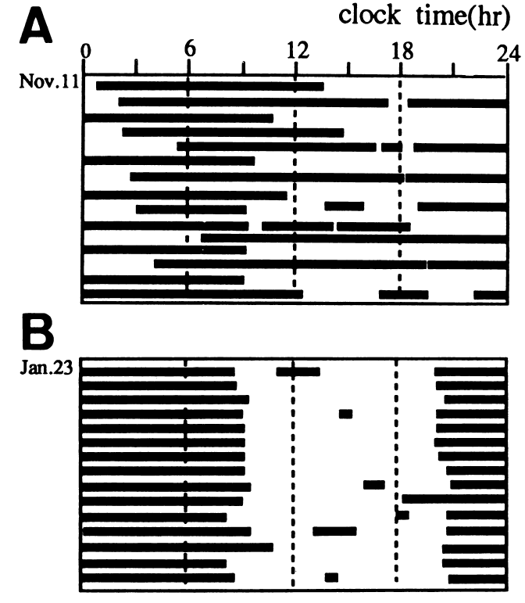  When the melatonin treatment was stopped, delayed sleep onset occurred occasionally and 1 year after the free-running rhythm of the sleep–wake cycle recurred. Oral administration of 3 mg melatonin was then effective in resetting the sleep–wake cycle.  Patient 2  This patient also slept within 30 min of melatonin administration, although she sometimes had early morning awakenings (Figure below). The dose of melatonin was increased from 5 to 10 mg, but this was not effective in treating the early morning awakenings. After the melatonin treatment was stopped, the fragmented sleep pattern recurred immediately, and 3 mg melatonin was then administered daily for 3 years reportedly without adverse effects.  Sleep–wake periods of patient 1 before (A) and after (B) melatonin treatment:  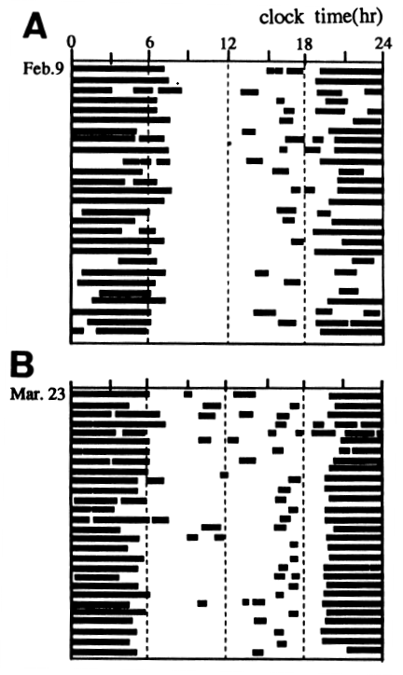  In both cases, the sleep improvements were reported to have “major benefits” for the families.
Safety results | There were no remarkable adverse effects during treatment with melatonin over the 2 years of the study. Repeated haematological tests, urinalysis, and endocrinological tests during the treatment were normal.  The patients did not develop any dependency on melatonin upon continued use of melatonin or show any withdrawal symptoms upon stopping the melatonin treatment.
Conclusions | The circadian rhythm of melatonin in RS had not been studied before this publication.  The starting dose of melatonin in both patients was 5 mg daily. The serum levels after administration were very high, allowing for the use of a lower dose (3 mg) when the melatonin was reinstated after it was withdrawn. The sponsor indicated that the PK results suggest an IR formulation was used in this study.  Due to the presence of severe mental retardation, the study authors considered the influence of the placebo effect could be ignored.  In both cases, after melatonin administration, the patients were able to fall asleep within 30 minutes. In both patients, the sleep disorders recurred when melatonin was stopped, and subsequent administration of a lower dose of melatonin (3 mg) was effective.  Although only 2 patients were included in this study, the treatment period was prolonged, as would likely occur in clinical practice. The results support the use of a lower starting dose of melatonin than 5 mg. The prolonged release nature of Slenyto is likely to be more efficacious in those with a sleep disorder similar to patient 2 than IR melatonin.

Safety

Pivotal Study NEU_CH_7911
A total of 125 children with ASD or SMS were included in this study, and 60 of these were treated with Slenyto 2 mg, 5 mg, or 10 mg over a period of 13 weeks; 51 of these subjects completed the study.
A total of 51 subjects who had received Slenyto and 44 who had received placebo in the DB phase entered the OL extension phase received Slenyto (2/5 mg) according to the DB phase dose, for 39 weeks with optional dose adjustment (2, 5, or 10 mg/day) after the first 13 weeks. The total number of weeks on Slenyto therapy for the 95 patients was 3,796 weeks.33
Eighty (80) children and adolescents (96% ASD) ages 2-17.5 years who completed the 39 weeks follow up were given 2, 5, or 10 mg Slenyto nightly up to 104 weeks, followed by a 2-week placebo period to assess withdrawal effects.
The most commonly reported TEAEs (reported by ≥ 10% of patients in any group) are shown below, for the 13-week DB phase and the 91-week OL phase:
Table 31. Study NEU_CH_7911: Most commonly reported treatment-emergent adverse events (safety set)
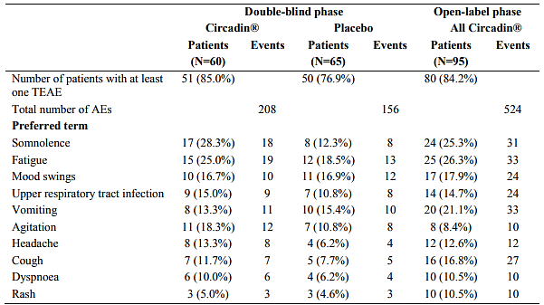
During the DB phase, most of the TEAEs were similar between groups and known symptoms in children with ASD (e.g., agitation, mood swings) or generally in children (e.g., upper respiratory tract infection, cough, dyspnoea, vomiting).
Nervous system disorders were more common in the Slenyto-treated group (41.7% vs 21.5%), with the difference mainly driven by somnolence and headache which were more common in the Slenyto-treated group (somnolence in 28.3% [Slenyto] vs 12.3% [placebo] patients; headache in 13.3% vs 6.2% patients, respectively).
Severe events were reported by 13 (21.7%) participants in the Slenyto and 13 (20.0%) participants in the placebo group, with similar patterns between groups.

Open label phase
- 39-week phase
Out of the 95 patients in the follow-up, 74 patients (77.9%) reported a total of 333 TEAEs that emerged in this phase. The most commonly reported TEAES were fatigue (18.9%), vomiting (17.9%), somnolence (16.8%), cough (13.7%), mood swings (13.7%), upper respiratory tract infection (10.5%), headache and rash (8.4% each), dyspnoea (7.4%), constipation, nausea and pyrexia (6.3% each), rhinorrhoea, aggression and agitation (5.3% each).
- 91-week phase
A total of 524 TEAEs were reported overall by 84.2% of patients during the OL phase. The most commonly reported AEs were somnolence, fatigue, mood swings, upper respiratory tract infection, and vomiting in the Slenyto group in the OL phase.

Safety in ADHD studies

Van Der Heijden, KB. et al., 200737
In this randomised, DB, PC trial in 105 unmedicated children with ADHD and chronic SOI, after 3 weeks of treatment, no AEs were reported in the placebo group, compared with 16 events in the melatonin group reported in 10 children (Table 32). The most common AEs reported in the melatonin group were headache, hyperactivity, dizziness, and abdominal pain. No AEs needed further treatment. There were no statistically significant differences between the number of AEs in the IR melatonin and placebo groups, and for the different doses of melatonin given (3 mg and 6 mg).
Table 32. Adverse events (Van Der Heijden, KB. et al., 200737)
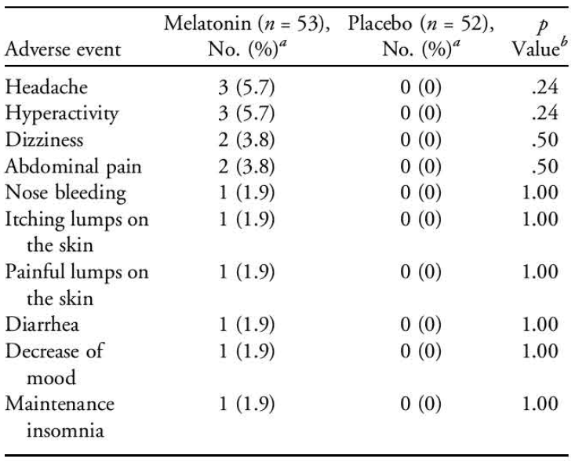
Patients could report more than one event.
b Fisher exact test.
At follow-up at 2 years after participation, of the 24 subjects with completed questionnaires, 7/24 of the parents reported one or more of the following AEs: bedwetting (n = 2), abnormal faeces (n = 2), drowsiness (n = 2), dizziness (n = 1), sleep maintenance problems (n = 1), skin pigment changes (n = 1), and decreased mood (n = 1).

Gringras, P. et al., 201732
This safety related results relate to study NEU_CH-7911.
During the DB phase, treatment-emergent AEs (TEAEs) were reported by 51 participants (85.0%) in the PedPRM group (202 events) and 50 participants (76.9%) in the placebo group (159 events). Most of these TEAEs were similar between groups and were known symptoms in children with ASD (e.g., agitation, mood swings) or experienced generally in children (e.g., upper respiratory tract infection, cough, dyspnoea, vomiting). Nervous system disorders were more common in the PedPRM-treated group (41.7% versus 21.5%); the difference was driven mainly by somnolence and headache, which were more common in the PedPRM-treated group.
Table 33. Most commonly reported TEAEs in the DB phase (Gringras, P. et al., 2017³²)
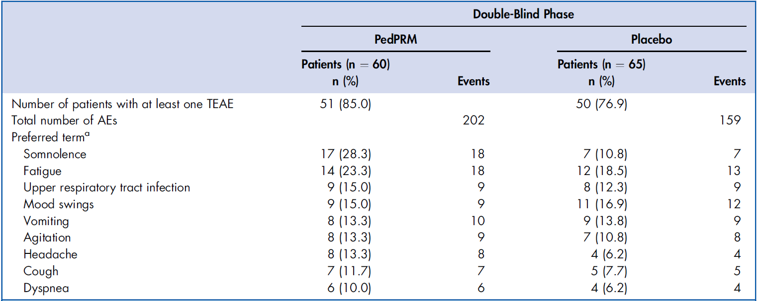
Note: AEs = adverse events; PedPRM = pediatric-appropriate prolonged-release melatonin minitablets.
a List includes TEAEs reported by ≥10% patients in any group.
TEAEs judged by the clinician as treatment related occurred in 12 participants (20.0%) in the PedPRM group and 11 (16.9%) in the placebo group (28 and 20 events, respectively). Somnolence, an expected AE of PedPRM, was more commonly reported in the PedPRM group than in the placebo group.
Table 34. Most commonly reported treatment-related AEs in the DB phase (Gringras, P. et al., 2017³²)
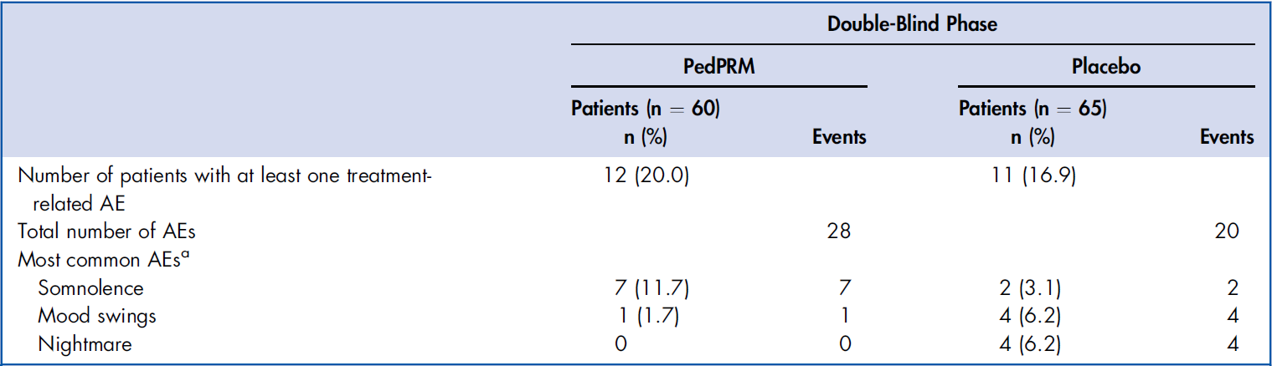
Note: PedPRM ¼ pediatric-appropriate prolonged-release melatonin minitablets.
a AEs reported as treatment-related by ≥5% patients in any group.
During the DB phase, severe events were reported by 13 participants (21.7%) in the PedPRM group and 13 (20.0%) in the placebo group, with similar patterns. One patient in the PedPRM group discontinued because of nonserious AEs (fatigue, agitation, and stereotypy). One patient in the placebo group temporarily discontinued due to 2 SAEs (pneumonia and respiratory tract infection viral) and one nonserious AE (tachypnoea).
Table 35. Most commonly reported severe AEs in the DB phase (Gringras, P. et al., 2017³²)
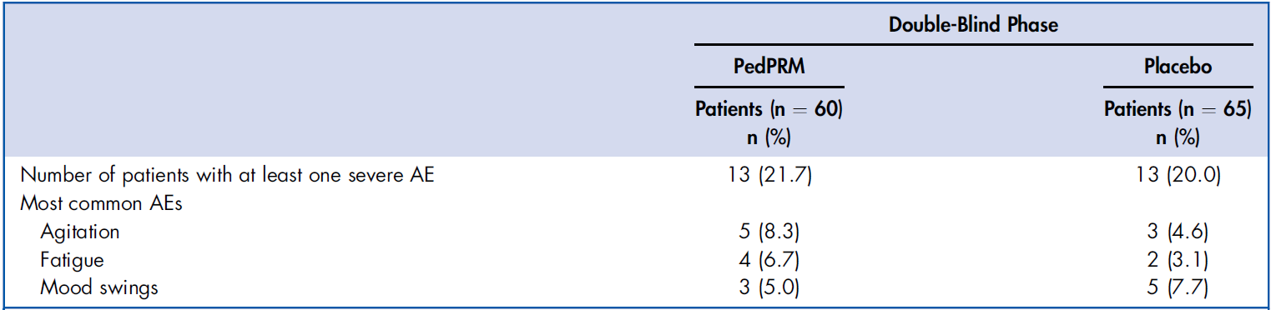
Note: Includes severe AEs reported by ≥ 5% patients in any group. PedPRM ¼ pediatric-appropriate prolonged-release melatonin minitablets.
There were no notable differences between PedPRM and placebo for mean changes in blood pressure, pulse rate, respiratory rate, or temperature. Overall, there were no clinically significant differences between PedPRM and placebo for weight, height, or BMI. At baseline, the Tanner assessments of pubertal development showed that a greater proportion of participants in the placebo group were preadolescent compared to those in the PedPRM group, reflecting the slightly lower age of participants in the placebo group (mean age 8.4 vs 9.0 years). In the 13-week DB phase, there was no apparent difference between PedPRM and placebo in change from baseline for SD scores of pubic hair, breast, and genitalia development.
Of 16 participants with a history of epilepsy in the study, only one had experienced a seizure (non-serious absence seizure), and this was during placebo treatment.

Hayashi, M. et al., 202246
Regarding safety results in this study during the randomisation phase, AEs occurred in 9 (13.8%), 19 (29.2%), and 12 (18.2%) of children in the 1-mg melatonin group, the 4-mg melatonin group, and the placebo group, respectively. The most predominant AEs were infections and infestations in 3 (4.6%), 7 (10.8%), and 5 (7.6%) subjects in the 1- mg melatonin group, the 4-mg melatonin group, and the placebo group, respectively, followed by nervous system disorders in 2 (3.1%), 4 (6.2%), and 2 (3.0%) subjects, respectively.
Pharyngitis occurred most predominantly: during the randomisation phase, in 2 (3.1%), 2 (3.1%), and 4 (6.1%) subjects in the 1-mg melatonin group, the 4-mg melatonin group, and the placebo group, respectively; and during the OL phase, in 25 (13.0%) subjects in the melatonin group.
Drug-related AEs occurred in 0 (0.0%), 5 (7.7%), and 3 (4.5%) subjects in the 1-mg melatonin group, the 4-mg melatonin group, and the placebo group, respectively.
During the OL phase, infections and infestations occurred most predominantly in 39 (20.2%) subjects; the second most predominant AEs were nervous system disorders in 13 (6.7%) subjects.
Neither SAEs nor deaths occurred during the randomisation and OL phases; although, 2 children were admitted to hospital due to abrupt deterioration of irritability on the first day of the post-monitoring phase. The authors speculated that the children were incapable of accommodating themselves to medicine discontinuation and developed excessive excitement, a feature of ASD.
Somnolence provoked temporary interruption and medication discontinuation in one child each in the 1- and 4-mg melatonin groups; the causality with melatonin was denied by the investigator in the former, but not in the latter.
No withdrawal symptoms or rebound effects occurred either immediately after the OL phase or during the post-monitoring phase.
Table 36. Adverse events in the safety data population during the randomisation and OL phases (Hayashi, M. et al., 2021⁴⁶)
 | Randomisation phase |  |  | Open label phase
 | Melatonin groups |  | Placebo group | Melatonin group
Category | 1 mg (N=65)  n (%) | 4 mg (N=65)  n (%) | (N=66)  n(%) | (N=193)  n(%)
Adverse events | 9 (13.8) | 19 (29.2) | 12 (18.2) | 70 (36.3)
Drug-related adverse events | 0 (0.0) | 5 (7.7) | 3 (4.5) | 10 (5.2)
Serious adverse events | 0 (0.0) | 0 (0.0) | 0 (0.0) | 0 (0.0)
Serious drug-related adverse events | 0 (0.0) | 0 (0.0) | 0 (0.0) | 0 (0.0)
Severe adverse events | 0 (0.0) | 0 (0.0) | 0 (0.0) | 0 (0.0)
An adverse event leading to temporary interruption* | 1 (1.5) | 0 (0.0) | 0 (0.0) | 0 (0.0)
An adverse event leading to discontinuation* | 0 (0.0) | 1 (1.5) | 0 (0.0) | 0 (0.0)
Adverse events leading to death | 0 (0.0) | 0 (0.0) | 0 (0.0) | 0 (0.0)
Infections and infestations | 3 (4.6) | 7 (10.8) | 5 (7.6) | 39 (20.2)
Blood and lymphatic system disorders | 1 (1.5) | 0 (0.0) | 0 (0.0) | 0 (0.0)
Metabolism and nutrition disorders | 0 (0.0) | 0 (0.0) | 0 (0.0) | 1 (0.5)
Psychiatric disorders | 0 (0.0) | 1 (1.5) | 0 (0.0) | 4 (2.1)
Nervous system disorders | 2 (3.1) | 4 (6.2) | 2 (3.0) | 13 (6.7)
Eye disorders | 0 (0.0) | 0 (0.0) | 1 (1.5) | 0 (0.0)
Ear and labyrinth disorders | 0 (0.0) | 0 (0.0) | 0 (0.0) | 2 (1.0)
Cardiac disorders | 0 (0.0) | 0 (0.0) | 1 (1.5) | 0 (0.0)
Respiratory, thoracic, and mediastinal disorders | 0 (0.0) | 2 (3.1) | 0 (0.0) | 3 (1.6)
Gastrointestinal disorders | 0 (0.0) | 3 (4.6) | 1 (1.5) | 6 (3.1)
Skin and subcutaneous tissue disorders | 1 (1.5) | 0 (0.0) | 0 (0.0) | 3 (1.6)
Musculoskeletal and connective tissue disorders | 0 (0.0) | 0 (0.0) | 1 (1.5) | 0 (0.0)
Kidney and urinary disorders | 0 (0.0) | 1 (1.5) | 0 (0.0) | 0 (0.0)
Reproductive system and breast disorders | 0 (0.0) | 0 (0.0) | 1 (1.5) | 1 (0.5)
General disorders and administration site conditions | 1 (1.5) | 0 (0.0) | 0 (0.0) | 3 (1.6)
Investigations | 0 (0.0) | 2 (3.1) | 0 (0.0) | 1 (0.5)
Injury, poisoning, and procedural complications | 2 (3.1) | 2 (3.1) | 0 (0.0) | 4 (2.1)
Adverse events were coded according to the Medical Dictionary for Regulatory Activities (MedDRA), version 19.0.
Children were counted once for each adverse event category even when having multiple events in the relevant category. Only children who received at least 1 dose of a double-blind study drug were included in the safety analysis data set.
*: Somnolence

Malow, B. et al., 202147
Regarding exposure in this study the mean time of PedPRM treatment in the entire study was 517.8 days (range 3–666 days) in the PedPRM group and 545.5 days (range 80–659 days) in the placebo group. By week 106, 23% (17/74) of participants were receiving 2 mg/day of PedPRM, 42% (31/74) were on 5 mg/day, and 35% (26/74) were on 10 mg/day, with a mean daily dose of 6.06 mg. No particular traits in optimal dose used, such as age, comedication, diagnosis, or symptom severity, were noticed. One participant exhibited a gradual loss of melatonin effect, which resolved by decreasing the dose from 10 mg to 5 mg. Treatment adherence was close to 100% throughout the study. Principal investigators reported that children were able to swallow the mini-tablets without crushing.
During the DB phase, 1 participant in the PedPRM group had a dose reduction from 5 mg to 2 mg owing to an unacceptable increase in daytime fatigue, and 2 participants in the placebo group had unscheduled dose decreases owing to unacceptable behavioural changes. In the 91- week OL phase, 6 participants had unscheduled dose decreases owing to unacceptable increases in daytime fatigue; in 4 of 6 participants, the increases in daytime fatigue occurred shortly after dose escalation and resolved by decreasing the dose to that used before the dose escalation. One patient had a dose decrease because of another reason, and 1 patient had a dose decrease because the treatment effect was reduced at the highest (10 mg) dose.
Regarding TEAE’s in the 91-week OL phase, TEAEs were reported in 84.2% (80/95) of participants across both groups. Most TEAEs were consistent with symptoms commonly seen in children with ASD (e.g., agitation, mood swings) or in the general paediatric population (e.g., upper respiratory infections, cough, dyspnoea, vomiting). This is shown in Table 37.
Table 37. Most Commonly Reported TEAEs, Safety Set (Malow, B. et al., 2021⁴⁷)
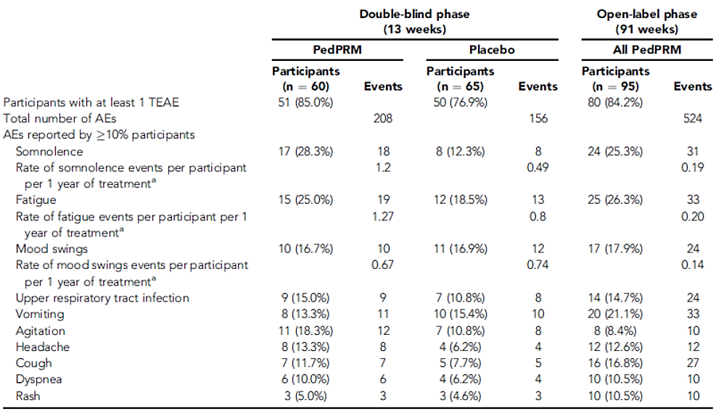
Note: PedPRM = pediatric prolonged-release melatonin; TEAE = treatment-emergent adverse event.
a Rate = number of observed events for the entire group divided by 13 (double-blind) or 91 (open-label), which equals the number of events for the entire group by week. This value is divided by the number of participants in the group to provide the number of events per week per participant. The value is multiplied by 52 (weeks/year) to determine the number of events per year of treatment per participant.
In the OL phase, 24 participants experienced 31 episodes of somnolence, corresponding to a low incidence rate of 0.19 events per participant per year— equivalent to fewer than one event per participant every five years.
Regarding TEAE’s that were deemed to be treatment related, the rate of treatment-related adverse events per participant per 1 year during PedPRM treatment decreased from 1.87 in the DB phase to 0.078 in the OL phase. The most commonly reported treatment-related AEs in the OL period were somnolence, fatigue, and mood swings as shown in Table 38.
Table 38. Most Commonly Reported Treatment-Related AEs , Safety Set. (Malow, B. et al., 2021⁴⁷)
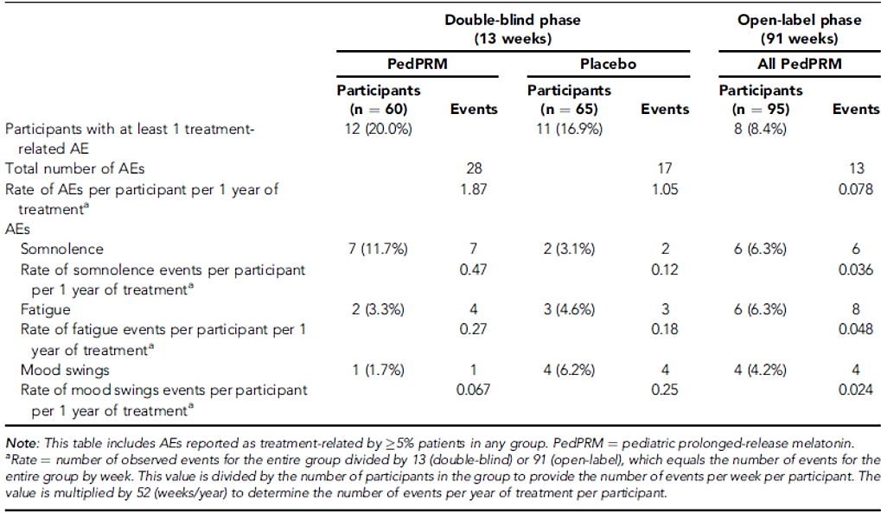
Note: This table includes AEs reported as treatment-related by >5% patients in any group. PedPRM = pediatric prolonged-release melatonin.
a. Rate = number of observed events for the entire group divided by 13 (double-blind) or 91 (open-label), which equals the number of events for the entire group by week. This value is divided by the number of participants in the group to provide the number of events per week per participant. The value is multiplied by 52 (weeks/year) to determine the number of events per year of treatment per participant.

No deaths occurred during any phase of the study. The most commonly reported serious TEAEs across both treatment groups were agitation, fatigue, and mood swings as shown in Table 39.
Table 39. Most Commonly Reported Serious Adverse Events, Safety Set (Malow, B. et al., 2021⁴⁷)
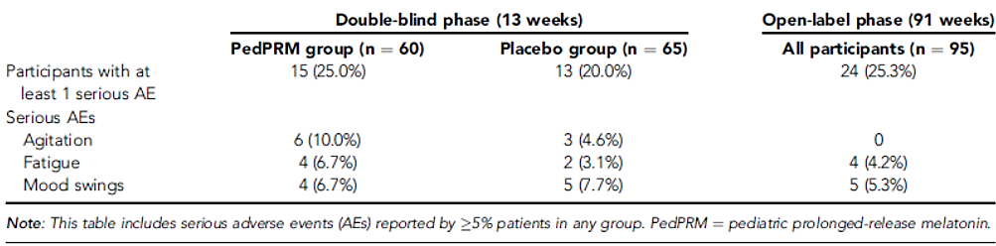
In the placebo group, one participant temporarily discontinued due to two SAEs (pneumonia and viral respiratory tract infection) and one non-serious event (tachypnoea).
Regarding discontinuations due to adverse events One participant in the PedPRM group discontinued treatment due to non-serious AEs including fatigue, agitation, and stereotypies.
Treatment-emergent signs and symptoms (TESS) events were assessed using a standardised questionnaire, and all reported events were intermittent. During the 13-week DB period, moderate to severe somnolence was significantly more frequent in the PedPRM group (26 participants) compared to the placebo group (12 participants; p = 0.005), with most cases occurring shortly after dose escalation. Headaches, predominantly mild to moderate, were also more common in the PedPRM group (23 participants) versus placebo (9 participants; p = 0.015). No other significant differences in TESS events were observed between treatment groups.
In the 91-week OL phase, moderate/severe somnolence was reported in 33 participants (26 from the PedPRM group and 7 from the placebo crossover group). At week 108, during the placebo run-out, no increase in TESS symptoms was observed, indicating no signs of withdrawal upon treatment discontinuation.
No noticeable changes were found in vital signs at any time point during the study.
Regarding tanner assessment of pubertal development More participants in the placebo group were preadolescent compared to those in the PedPRM group, which was attributed to a slightly younger average age at study entry (8.4 years vs 9.0 years). After two years of treatment, Tanner assessment data were available for 31 participants aged 8 years and older, while 13 participants declined the assessment. At week 106, SD scores for pubertal development in both the PedPRM and placebo groups remained within the normal range for age. At week 15, the change from baseline in SD scores for pubic hair, breast, and genitalia development was similar between groups. By week 106, these scores had increased by approximately 1 to 1.5 points in both treatment arms. Among participants, those with higher BMI appeared to mature slightly earlier. Most children aged over 8 years showed progression in Tanner stage relative to baseline. Overall, there was no evidence of delayed pubertal development associated with PedPRM treatment (Table 40 and Figure 22).
Table 40. Pubertal Development and Change From Baseline in Mean SD Scores at Week 106 in Children ≥ 8 Years of Age Treated With PedPRM (Malow, B. et al., 2021⁴⁷)
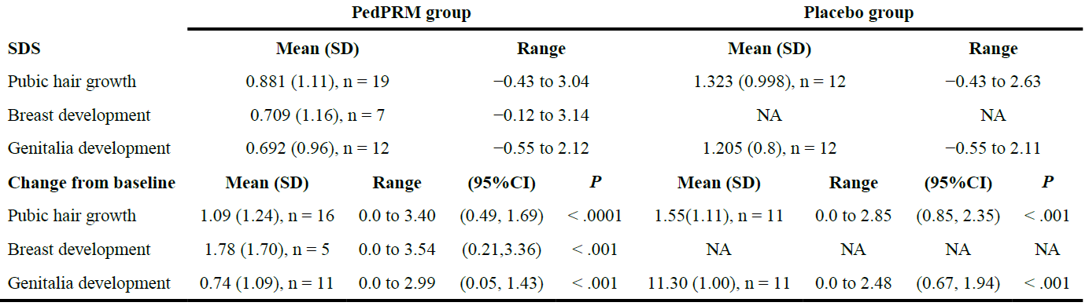
Note: NA = not applicable; SDS = standard deviation score.
Figure 22. Effects of continuous PedPRM treatment on pubertal development (Malow, B. et al., 2021⁴⁷)
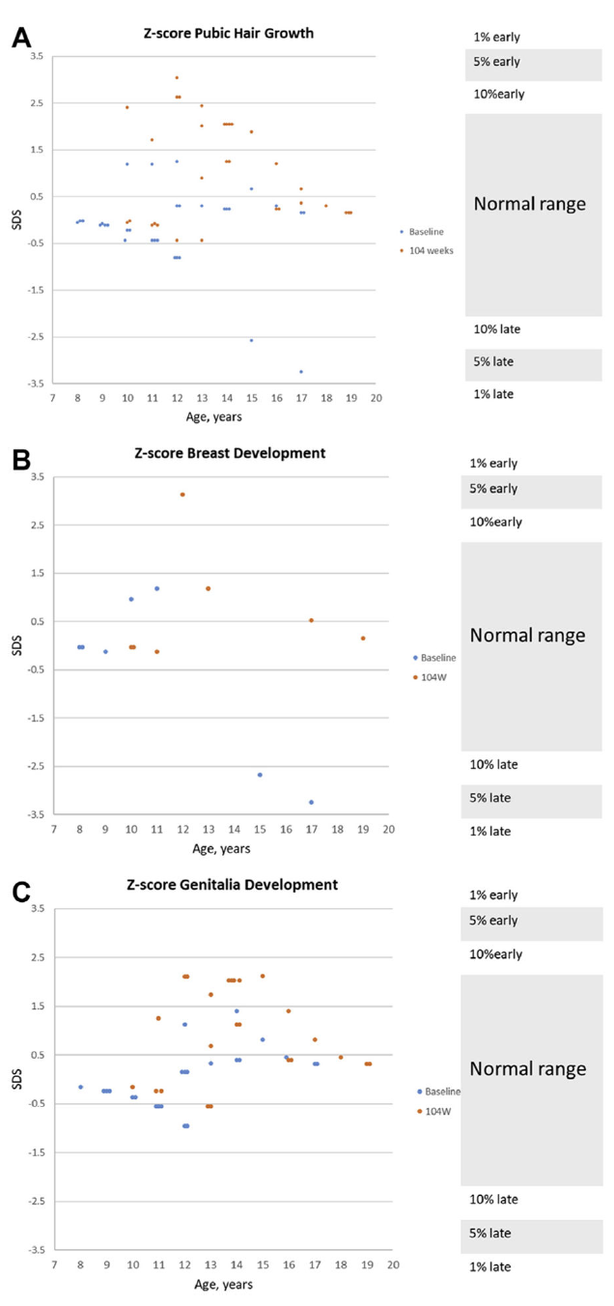
Note: Effects of continuous PedPRM treatment (104 weeks PedPRM, 91 weeks placebo) on (A) male and female participant pubic hair growth by age (n = 31), (B) female participant breast development by age (n = 7), and (C) male participant genitalia development by age (n = 24). The individual standard deviation scores (SDS) at baseline (week 2, blue) and end of PedPRM treatment (week 106, red) are depicted. Normal ranges are marked on the righthand y-axis
Regarding seizures, a history of seizures was present in 16 participants (12.8%). Four participants in the PedPRM group and 3 in the placebo group had received a diagnosis of epilepsy before the study. Two of these participants experienced absences seizures during the OL phase: 1 participant experienced 2 nonserious seizures of 1-minute duration each, and the other experienced one 1-minute mild seizure. Two participants experienced new-onset seizures: 1 experienced a nonserious absence seizure under placebo (DB), and the other experienced 2 generalised tonic-clonic seizures of 1-minute duration recorded at week 54 and week 106 (OL) as nonserious AEs, moderate in severity, and unlikely to be related to study treatment.

Mohammadi, MR. et al., 201234
At the end of 8th week of the trial, the Stimulant Drug Questionnaire was completed voluntarily by 20/26 mothers from the melatonin group and 18/24 mothers from the placebo group. Mean scores of side effects based on the stimulant drug side effects questionnaire were 11.35±8.81 in melatonin group and 10.16±9.05 in placebo group; this difference was not statistically significant (p = 0.686).
Table 41. Comparison of side effects after 8 weeks of melatonin treatment (Mohammadi, MR. et al., 2012³⁴)
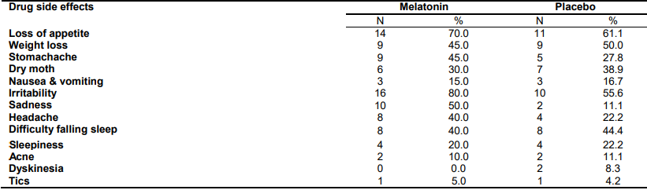

Weiss, MD. et al., 200638
All of the reported AEs were mild or moderate except for a migraine, which was rated as severe. The only AE reported to be related to the study was a rash caused by the actigraph wristband in two patients. There were no SAEs and no clinically significant changes in vital signs or abnormalities on physical examination. Twenty percent of all AEs were reported during melatonin treatment, and 23% were reported during randomised placebo treatment.

Safety in NGD studies

Braam, W. et al., 200848
No significant adverse effects were reported for the duration of the study in all participants. No seizures were reported by the parents of any participant during the study.
The parents of one child treated with melatonin reported an increase of the number of night wakes during the 4-week open treatment period and stopped treatment, even though they initially reported the treatment outcome as a strong improvement.

Hancock, E. et al., 200552
There were no adverse side effects reported by the parents or carers during the trial.
Three patients had well-controlled epilepsy and remained seizure-free during the study. Five patients had seizures during the trial, and there was no change in the frequency (or type) of seizures compared with the baseline period, at either dose (Table 42).
Table 42. Seizure frequency, without melatonin, after administration of 5 and 10 mg of melatonin (Hancock, E. et al., 2005⁵²)
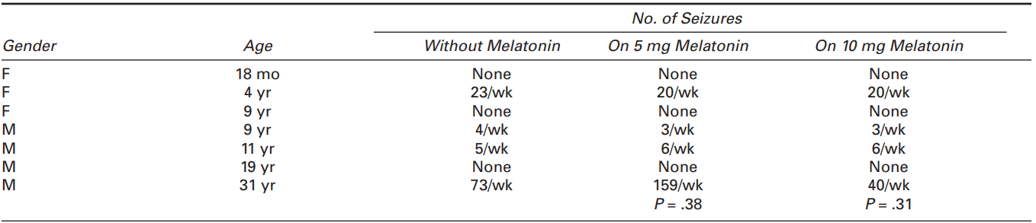

O’Callaghan, JF. et al., 199951
There were no adverse side effects reported for any of the patients during the 2 weeks of treatment.

De Leersnyder, H. et al., 201149
Eleven (11) children experienced AEs that the parents attributed to melatonin treatment. Ten parents reported one AE, and one parent reported 2 AEs.
Eight children took daytime naps, 2 experienced difficulties in swallowing the tablet, and two manifested daytime somnolence. One child with severe behavioural disorder took 30 mg of PR melatonin at one time and slept quietly for 12 hours.
None of the children felt faint, or manifested seizures, headaches, or digestive pain.

Takaesu, Y. et al., 201250
No significant AEs were reported.
All of the subjects were receiving antiepileptic medications, and their epilepsy was well controlled for at least three months during the study period, with no increase in epileptic seizures observed in any of the AS patients during melatonin treatment.

Post-marketing experience
Safety data were collected from the off-label use of Slenyto/Circadin in ADHD patients covering the period from 2008 until 30 Dec 2023. There were 130 patients on Slenyto and 176 on Circadin. Of these 306 cases, 77 also included ADHD as an indication and were reported as off label use without any AEs (53 for Slenyto and 24 for Circadin).
For Slenyto, 73.1% of the cases involved children or adolescents, consistent with the intended patient population for this product; only 1.5% involved adults and in 25.4% of the cases, the age of the patient was unknown.
Slenyto cases had proportionately far fewer AEs per case than Circadin (0.3 per case and 0.9 per case, respectively), reflecting the fact that many Slenyto cases only reported off label use/misuse, medication errors, or lack of efficacy, and did not include any AEs.
The most commonly reported AEs that are unlisted for both products were:
- Diarrhoea: 4 incidences (3 for Circadin, 1 for Slenyto)
- Middle insomnia: 4 incidences (2 for Circadin, 2 for Slenyto)
- Sleep disorder: 4 incidences (3 for Circadin, 1 for Slenyto)
- Anger: 3 incidences (2 for Circadin, 1 for Slenyto)
- Chest discomfort: 3 incidences (2 for Circadin, 1 for Slenyto)
- Dyspnoea: 3 incidences (3 for Circadin, 0 for Slenyto)
- Pruritus: 3 incidences (3 for Circadin, 0 for Slenyto)
- Tremor: 3 incidences (1 for Circadin, 2 for Slenyto)
- Visual impairment: 3 incidences (3 for Circadin, 0 for Slenyto)
The pattern of reported AEs was generally consistent between the two products with the exception of:
- Eye disorders: all 10 eye disorders occurred in patients taking Circadin. These were largely made up of reports of blurred vision (4) or visual impairment (3). Blurred vision is listed in the Company Core Safety Information (CCSI) for Circadin. Visual impairment is not listed, but it is possible that this is being conflated with visual acuity reduced which is listed in the CCSI.
- General disorders and administration site conditions: for Circadin, there were a total of 22 incidences of AEs distributed across 9 different MedDRA preferred terms (PTs). The most frequently reported MedDRA PT was fatigue which is listed in the CCSI for Circadin. For Slenyto, there were just 2 MedDRA PTs with one incidence for each: chest discomfort and screaming. Neither is listed in the PI for Slenyto, but screaming would be reasonably anticipated in children with NDD.
- Psychiatric disorders: although psychiatric disorders were the most frequently reported AEs for both products, a higher proportion was reported for Circadin than for Slenyto (51.3% vs 29.7% of all AEs).
  - For Circadin, 49 incidences of AEs were distributed across 29 different MedDRA PTs; the most frequently reported MedDRA PTs were aggression (5), insomnia (4), nightmare (4), depressed mood (3) and sleep disorder (3). All of these are listed in the CCSI for Circadin except for sleep disorder, but this is a relatively non-specific term and likely reflective of the underlying disorders of the patients.
  - For Slenyto, 20 incidences of AEs were distributed across 13 different MedDRA PTs (average of 1.5 incidences per MedDRA PT). The most frequently reported MedDRA PTs were aggression (4) and agitation (4), both of which are listed in the PI.

Risk Management Plan (RMP) evaluation
No RMP evaluation was required.

Risk-benefit analysis

Efficacy
As per the TGA-adopted EMA guideline on medicinal products for the treatment of insomnia, suggested criteria for efficacy in products developed for the treatment of acute and long term insomnia include: SOL, sleep continuity, sleep duration, feeling of restorative sleep and quality of sleep and subsequent daytime functioning in the natural setting. In the sponsor’s pivotal study TST (a primary efficacy outcome) and SL (a secondary efficacy outcome) were measured as with both studies also including secondary endpoints of outcomes measuring quality of life, which aligns with the recommendations in the EMA guideline. This guideline also recommends measurement of these efficacy outcomes using objective tools such as polysomnography or actigraphy.
Study NEU_CH_7911 used a sleep and nap diary to measure the primary efficacy outcome (TST; it is noted study NEU_CH_7911 also includes LSE as a secondary efficacy outcome). Objective evidence of improved TST and SL in this study were not obtained with polysomnography or actigraphy, the likely difficulty in obtaining polysomnography and actigraphy in the population studies in NEU_CH_7911 is acknowledged (actigraphy data was obtained from 25% of the children in this study, however, all the others could not tolerate the device for the full time needed for the analysis). It is noted that actigraphy was used to measure the primary efficacy endpoints in the sponsor’s cited study, which had a randomised, DB, PC study design in children with ADHD and chronic SOI and was identified as being appropriate to be defined as a 2nd pivotal study for ADHD indication.37 This aligns with recommendation in the referenced EMA guidelines regarding measurement of the primary efficacy outcomes.
In the other studies cited in this LBS for melatonin use in ADHD and NGD most efficacy outcomes examined a combination of SOL, TST or length of sleep episodes as well as other combinations of QoL or behavioural measures. Broadly, the studies in this LBS followed the recommended efficacy outcomes described in the referenced EMA guideline. However, most studies did not use polysomnography or actigraphy to measure the efficacy outcome, most studies used a caregiver recording the efficacy outcomes manually. This is a limitation of most of the referenced studies, however it is acknowledged that formal polysomnography or actigraphy may be difficult to obtain for the patient groups in these studies.
Regarding duration of trials the sponsors pivotal study NEU_CH_7911 had a randomised placebo controlled treatment period of 13 weeks with a 91 week OL extension, this fits with the recommended duration for short term trials in referenced guidelines for products investigating insomnia with a minimum duration of 2-4 weeks recommends. In the referenced EMA guidelines long term trials are recommended for 6 months with a randomised withdrawal design or a DB PC extension period, the pivotal study NEU_CH_7911 appears to have had an OL extension after 13 weeks. The sponsors cited study had a 1-week baseline observation period followed by a 4-week randomised, DB PC period.37 This aligns with the referenced recommended EMA guideline duration of 2-4 weeks for a short-term trial when investigating medicinal products for treatment of insomnia.
Other studies examining melatonin use in ADHD had DB randomization periods running from between 10 nights for up to 13 weeks. Other studies examining melatonin use in NGD had treatment periods in the prospective studies of between 6 nights up to 4 weeks.

Efficacy in ADHD studies
Study NEU_CH_7911 was the sponsor’s pivotal study which was a randomised, DB, PC study to assess the efficacy and safety of PR melatonin for insomnia in children diagnosed with ASD and neurodevelopmental disabilities caused by NGDs (SMS, AS, and TSC).
A total of 125 children aged 2 – 17 years were randomised into the DB phase; 60 were randomised to the Slenyto treatment arm and 65 to the placebo treatment arm. A total of 9 patients in the PR melatonin group discontinued the DB phase compared to 21 in the placebo group. ADHD was present as a comorbidity in 28.8% of children, and 10.4% of patients had prior ADHD treatment. A total of 77% of patients completing the DB phase with SDQ assessments had elevated hyperactivity/inattention scores of ≥ 7.
All eligible children underwent a 4-week basic sleep hygiene and behavioural intervention wash-out period (if required), before they started a 2-week single-blind placebo run-in period. There was an initial randomised (1:1) treatment period of 13 weeks,32,36 during which time patients received either placebo or melatonin (2 mg or 5 mg daily), followed by a 91-week OL extension period47,33, in which the long-term efficacy and safety of PR melatonin 2, 5, and 10 mg were assessed. Withdrawal effects were assessed during a 2-week single-blind placebo run-out period.
All patients received the same dose (2 mg Slenyto or placebo) during the first 3 weeks of DB study treatment. Subsequently, at Week 5, Visit 3, the Investigator reviewed the SNDs and the electronic case report form recommendation for dose increase, the dose could be increased to 5 mg at Visit 3, and patients continued on a dose of 2 mg or 5 mg for the remainder of the DB period.
The primary endpoint of the study was the change from baseline in mean SND-assessed TST after 13 weeks of DB treatment. The primary efficacy evidence that this study provides regarding patients with ADHD appears to be in a subgroup analysis of the primary endpoint in patients in this study who had ADHD as a comorbid diagnosis (28.8%).
Regarding the primary efficacy endpoint in children diagnosed comorbidly with ADHD there were 16 patients in the Slenyto 2 mg group and 19 patients in the placebo group who had a comorbid diagnosis of ADHD. The change in baseline adjusted treatment mean at 13 weeks in patients with ADHD for the efficacy outcome of TST was 57.88 (95% CI: 17.7, 98.05) in the melatonin treatment group compared to 24.89 in the placebo group, with a treatment difference of 32.99 between groups that was not statistically significant. This is noted to be very similar to the adjusted mean treatment difference in patients without a comorbid diagnosis of ADHD, which was 32.78 (and also not reaching statistically significant. In all patients the change from baseline to week 13 in adjusted treatment mean for TST in the FAS was 32.32 (95% CI 2.38, 62.26) with p-value of 0.035 (see Table 9). No other endpoints in the subgroup of patients in the study co-morbidly diagnosed with ADHD have been reported.
Overall, this study provides minor evidence to support melatonin efficacy in treatment of insomnia in patients 2-18 years of age with ADHD. This subgroup analysis (ADHD was present as a comorbidity in 28.8% of children) was performed for a population in whom the vast majority were diagnosed with ASD at baseline. The diagnosis of ASD present in the vast majority of patients at baseline (96.8%) in itself can manifest with significant behavioural, sleep and cognitive differences in children. This makes the results of the subgroup of patients with ASD and ADHD together of uncertain significance given ASD itself can affect a child’s behaviour, sleep and cognition to various degrees and thus this makes it difficult to know if the efficacy results of melatonin treatment for insomnia in this population only apply to children with ASD and ADHD together, or whether these results can be extrapolated to children with ADHD alone. Furthermore, the subgroup analysis did not prove to be statistically significant creating further difficulty to draw firm efficacy conclusions in children with ADHD alone (without ASD).
Van der Heijden, KB. et al., 200737 was a randomised, DB, PC study of children with ADHD and chronic SOI.
Of the 204 children screened, 107 children aged 6 to 12 years with diagnosed ADHD and SOI were enrolled in the study. The cohort consisted of outcomes for 53 patients treated with melatonin and 52 treated with placebo for a duration of 4 weeks. The children were randomised (1:1 ratio) to receive melatonin (3 mg when body weight < 40 kg [n = 44]; 6 mg when body weight > 40 kg [n = 9]) in fast-release tablets (Pharma Nord, Denmark) or identical-appearing placebo tablets at 7:00 PM. Treatment adherence was assessed after 3 weeks of treatment by medication counts.
The 4-week randomised, DB, PC period was undertaken immediately following a 1-week baseline period. Measurements took place at baseline and during the fourth week of treatment.
Efficacy endpoints for this study relating to change in sleep included: sleep onset, total time asleep, and sleep log item difficulty falling asleep (averaged over 7 days, on a scale of 1 [not difficult] to 5 [very difficult]). Sleep was estimated using actigraphy (Actiwatch, Cambridge Neurotechnology Ltd., Cambridge, UK) and sleep logs on seven consecutive days, at baseline, and during the fourth treatment week.
Table 16 shows the efficacy outcomes for this study comparing baseline to week 4 of treatment. Mean change from baseline in SL improved in the melatonin group (mean change -27minutes +/- 48 minutes) compared to placebo (mean change +10 minutes +/- 37minutes), this change was statistically significant (p-value=<0.0001). Mean change from baseline in total time asleep improved in the melatonin group (mean change +19.8 minutes +/- 61.9 minutes) compared to placebo (mean change -13.6 minutes +/- 50.6 minutes), this change was statistically significant (p-value=0.01). Mean change from baseline in difficulty falling asleep as measured by parents averaged over 7 days on a scale of 1 (not difficult) to 5 (very difficult) improved in Melatonin treatment (-1.2 on scale +/- 1.3) compared to the placebo group (-0.1 on the scale +/- 0.8), this was statistically significant with p-value=<0.0001). Immediate release melatonin in this study had no effect on problem behaviour, cognitive performance, or quality of life.
This study provides strong supportive evidence for the efficacy for melatonin (dose of 3mg or 6mg depending on weight with the melatonin group having n=44 for weight <40kg and n=9 for body weight >40kg) use in treatment of insomnia for patients ≥6 years old with ADHD. The outcomes of the efficacy results after 4 weeks suggest melatonin led to a statistically and clinically significant improvement in outcomes of SL, TST and reduced difficulty in falling asleep compared to placebo. It is noted that there was a small number of patients who were >40kg in the melatonin group and thus only small number who received 6mg of melatonin during the randomised treatment period.
Salanitro, M. et al., 202231 was a systematic review and metanalysis of efficacy on sleep parameters and tolerability of melatonin in individuals with sleep or mental disorders.
All the studies relating to ADHD34,37,38 are included as evidence in this submission, given these studies have been reviewed individually, the results of this systematic review do not provide further supportive evidence of efficacy for melatonin in treatment of insomnia in patients with ADHD.
Gringras, P. et al., 201732 reports the results of the DB part of the pivotal Study NEU_CH_7911, and will not be reviewed this section.
Hayashi, M. et al., 202146 was a multicentre, randomised, three parallel-group, DB, PC trial involving children aged 6-15 years with ASD including with or without ADHD who experienced SOL issues. There was a 7-day pre-monitoring phase, in which sleep status was checked, then a 14-day screening phase, during which SOL was assessed, then a 14-day, parallel-group, DB randomisation phase, in which eligible children were assigned 1:1:1 to receive 1 mg of melatonin (1-mg melatonin group), 4 mg of melatonin (4-mg melatonin group), or placebo (placebo group) once daily (before bedtime) and a 42 day OL phase.
Of the 229 children assessed for eligibility, 196 were enrolled in the study. A total of 65 children were assigned to the 1 mg melatonin group, 65 to the 4 mg melatonin group, and 66 to the placebo group (1:1:1 ratio).
The primary efficacy outcome was the change from the median of SOL recorded during the last 7 days of the screening phase (baseline) to the median of SOL recorded during the last 7 days of the randomisation phase or before medication discontinuation. Caregivers were instructed to enter all of the information on the sleep status of their children in the sponsor-provided electronic sleep diary after awakening. Key secondary variables assessed with actigraph included: SOL, number of wakening’s after sleep onset (number of wakening’s between time of falling asleep and wakening time), wakening time after sleep onset (total time of staying awake between time of falling asleep and wakening time), TST, and sleep efficiency (defined as TST divided by time in bed].
Overall, the mean (SD) age was 11.2 (2.5) years, 61.7% of the subjects were male, and ADHD was present in 108 (55.1%) of children. The number of patients with ADHD was reasonably balanced across all the treatment groups.
The changes in the median SOL from the end of the randomised phase/before medication discontinuation from that recorded during the last 7 days of the screening phase were − 5.0 min, − 22.0 min, and − 28.0 min for the placebo group, the 1 mg melatonin group, and the 4 mg melatonin group, respectively. Steel’s test p-value for the melatonin 1 mg group and 4 mg group against the placebo group was <0.0001.
Subgroup analyses conducted with respect to sex, age, weight (< 40 kg, ≥ 40 kg), SOL at baseline, history of ramelteon treatment, ID, ADHD, and height (< 145 cm, ≥ 145 cm) showed SOL shortened significantly (p < 0.05) in the 4 mg melatonin group than in the placebo group with respect to all subgroups. SOL shortened significantly (p < 0.05) more in the 1mg melatonin group than in the placebo group with respect to all subgroups except “female,” “previous history of ramelteon treatment,” and “≥ 145 cm in height.”
Regarding secondary efficacy outcomes SOL assessed with the actigraph shortened significantly (p < 0.0001) more in the 1 mg and 4 mg melatonin groups (− 21.0 min and − 20.0 min, respectively) than in the placebo group (1.0 min). Sleep efficiency improved in the 4 mg melatonin group (2.35%, p = 0.0408) but not in the 1 mg melatonin group. There were no significant changes in TST or NOA. In the 1 mg melatonin group, wakening time after sleep onset extended significantly (p = 0.0072).
This study provides minimal supportive evidence of efficacy for use of melatonin treatment in insomnia in patients with ADHD ≥6 years of age. All patients in in this study were diagnosed with autism spectrum disorder and patients with ADHD were a subgroup. It is difficult to know how these results apply to patients with ADHD alone given this study’s primary objective was to examine SOL in patients with ASD. The subgroup analysis in this study was a secondary or exploratory outcome. Results of the subgroup in this publication state there was a statistically significant reduction in SOL in the subgroup of patients also diagnosed with ADHD, however this was not quantified (e.g. was it similar to the overall SOL reduction in both melatonin groups?). This makes the effect size difficult to determine from this study. Overall, this study adds minimal supportive evidence for efficacy of melatonin in treatment of patients with ADHD.
Malow, BA. et al., 202147 is a publication concerning Study NEU_CH_7911, a randomised, DB, PC, parallel-group, multicentre study of PedPRM for 13 weeks, followed by a prospective 91-week OL PedPRM treatment, and finally 2 weeks of placebo to evaluate withdrawal effects. This study examined the long-term effects of PedPRM treatment (2 mg, 5 mg, or 10 mg daily up to 2 years of continuous use) on sleep, growth, BMI, and pubertal development.
Regarding efficacy outcomes relating to sleep in the OL extension period to weeks 28, 54, 106 and 108) there were no notable differences in outcomes at week 106 between participants originally assigned to placebo when given PedPRM treatment for 91 weeks (placebo group) or participants originally assigned to PedPRM and given PedPRM for 104 weeks (PedPRM group), thus allowing the groups to be combined (Figure 5).
The results presented are from an OL extension period with no placebo/control group during this period. This study is difficult to interpret given patients were diagnosed with ASD at baseline, making it difficult to determine the efficacy of treatment in the ADHD subgroup population with ASD at baseline. The dropout rate was significant with 125 initially randomised into the study with 74 being examined who reached the end of the 106-week OL extension period adding further difficulty in determining the efficacy results (e.g. did patients with less response drop out over time?). There were also 3 possible different doses of melatonin (2 mg,
5 mg or 10 mg) used during this period making it difficult to quantify efficacy at different doses. The efficacy outcomes measured in this study such as the CSDI sleep disturbance score, CSDI caregiver satisfaction score and WHO-5 caregiver QoL score are not the recommended efficacy outcomes to be measured for medicinal products for treatment of insomnia as per the referenced TGA EMA adopted guideline (total sleep duration or SL are more appropriate efficacy outcomes). These factors make it difficult to interpret the long term efficacy results presented in this study and provides minimal evidence of efficacy for the proposed indication in patients with ADHD.
Maras, A. et al., 201833 is a publication concerning Study NEU_CH_7911 and reviews efficacy and safety outcomes results of this study up to week 52. Efficacy outcomes up to week 52 have been reviewed in Study NEU_CH_7911 in this document. Given these efficacy results for this study have been reviewed already this publication has not been further reviewed.
Mohammadi, MR. et al., 201234 was a randomised, PC, DB trial of MPH-treated children with ADHD aged between 7 and 12 years.
The aim of this study was to determine melatonin effects on sleep patterns and symptoms of hyperactivity and attention deficiency in children with ADHD. Assessments of ADHD and sleep patterns were completed at baseline, and at the second, fourth, and eighth weeks after the commencement of treatment.
One group were administered melatonin (3 [for those < 30 kg] or 6 [for those > 30 kg] mg) combined with MPH (1mg/kg), and the other group took placebo combined with MPH (1 mg/kg) in a 1:1 ratio. Sixty children diagnosed with ADHD were eligible. Eight children (25%) in the placebo group and 2 (7.25%) in the melatonin group dropped out of the study voluntarily or were excluded due to irregular drug consumption. A total of 26 children in the melatonin group and 24 in the placebo group completed the study. The mean age of children was 9.57 ± 1.65 in the melatonin group, and 8.83 ± 1.82 in the placebo group.
Regarding the efficacy results for sleep parameters, while the mean SL and total sleep disturbance scores were reduced in the melatonin group, and increased in the placebo group, the differences between the two groups were not statistically significant (p ≥ 0.05). This is shown in Figure 6 and Figure 7.
Regarding the efficacy results for ADHD symptoms no statistically significant differences in attention deficiency or hyperactivity between the two groups were observed. This is shown in Figure 8 and Figure 9.
This study adds no support for the use of melatonin in patients with ADHD and insomnia, no results in this study reached statistical significance. Furthermore, it is unclear that patients in this study had symptoms of insomnia at baseline, therefore this study appears not to have been designed to examine the efficacy of melatonin for treatment of insomnia in patients with ADHD.
Schroder, CM. et al., 201936 was a randomised, DB, PC study aimed to evaluate the effects of PedPRM compared with placebo on child behaviour in children with ASD (96.8%) or SMS (3.2%) and insomnia as well as caregiver’s well-being outcomes. A total of 125 children aged 2-17.5 years were treated with Circadin 2 to 5 mg daily for 13 weeks in the DB phase; children could then continue in the OL phase of 91 weeks to receive Circadin 2, 5, or 10 mg daily. This publication concerns Study NEU_CH_7911, as such it will not be fully reviewed in this section. Select results from the publication are summarised below.
Efficacy outcomes examined in this study were related to child behaviour and caregiver’s outcomes included the SDQ, WHO-5, and PSQI. Outcomes for sleep included the ESS, TST, SL, and duration of uninterrupted sleep (LSE).
Results of the examined efficacy outcomes showed that PedPRM significantly improved externalising behaviour compared to placebo (mean difference: -0.83, p = 0.021) with clinically relevant improvements (≥ 1 unit improvement in externalising behaviour) in 53.7% of PedPRM-treated versus 27.6% of placebo-treated subjects. The 26% difference in percentage between the groups corresponds to an NNT of 3.8.
The greatest treatment effect in the total study population was for the hyperactivity/inattention SDQ item scores. Mean SDQ hyperactivity/inattention score improved significantly with PedPRM and worsened with placebo. The estimated mean treatment difference between PedPRM and placebo for the change from baseline in SDQ hyperactivity/inattention score after the 13 weeks of DB treatment was − 0.54, with a trend to benefit in favour of PedPRM versus placebo
(p = 0.065; Table 23).
Regarding caregiver related efficacy outcomes there was a statistically significant improvement observed in mean WHO-5-assessed QoL following 13 weeks of PedPRM treatment, with a treatment difference between the PedPRM and placebo groups of 2.17 points (p = 0.01); treatment effects were evident after 3 weeks of treatment. Statistically significant improvements were also observed with PSQI assessed caregiver’s sleep quality, while caregivers’ sleepiness (ESS) also improved but not significantly. In contrast, treatment with placebo did not result in improvements in any of these outcomes.
These results showed statistically significant treatment differences in SDQ score externalising behaviours with the SDQ total score and SDQ items numerically favouring the melatonin treatment group over placebo but did not reach statistical significance.
This publication provides no supportive evidence of efficacy of melatonin in treatment of insomnia in patients with ADHD. However, it provides minor supporting evidence that melatonin may have some ancillary benefit in some of the behavioural symptoms of ASD/ADHD and provides some supportive evidence of improvement in caregiver QoL in the melatonin treatment group compared to placebo in this population, it is unclear how clinically significant any improvement in ASD/ADHD behaviours in this population was.
Weiss, MD. et al., 200638 was a randomised, DB, PC crossover trial of children with ADHD and initial insomnia on stimulants.
Children aged 4-14 years old with ADHD and initial insomnia were recruited for this study through clinical referrals to the Provincial ADHD Program. This two-phase treatment study began with sleep hygiene intervention. Only children who continued to have initial insomnia of > 60 minutes were eligible to enter the DB, randomised, crossover part of the trial.
The crossover design permitted each patient to serve as his or her own control, so that between-subject variability caused by ADHD severity, stimulant medication, severity of sleep problem, or adherence to sleep hygiene could be minimised. The total duration of the randomised phase of the study was 30 days. Each treatment period was 10 days, followed by 5 days of washout with placebo to minimise carryover effects (Figure 11). A short-acting pharmaceutical-grade melatonin, 5 mg, manufactured by the study sponsor, Circa Dia BV, or placebo, was administered 20 minutes before bedtime.
Thirty-three (33) patients between 6 and 14 years seen in the ADHD clinic at British Columbia Children’s Hospital provided consent. Of these, 5 parents/patients withdrew consent or were unable to continue participating and 5 patients were sleep hygiene responders who did not continue into randomisation. Of the 23 patients eligible for randomisation, 1 withdrew consent and 3 discontinued due to protocol violations during the randomisation treatment phases, leaving 19 cases to be evaluated, all 19 patients completed the randomised part of the study.
The primary objective was to evaluate the efficacy of sleep hygiene and melatonin treatment for initial insomnia in children and adolescents with ADHD who were treated with stimulants. The primary efficacy variable examined was the mean SOL in each of the melatonin and placebo treatment phases as recorded on the parent-completed somnolog.
Secondary efficacy outcome measures obtained from somnolog recordings included night-to-night variability in SOL given by the SD of SOL and total sleep duration. The actigraph was used to provide an objective measure of sleep and data were analysed using the proprietary sleep software. Actigraph outcome measures included mean SOL, night-to-night variability in SOL, total sleep duration, and correlation with somnologs.
Regarding baseline demographic data the sample was 90.9% male with an average age of 10.29 (range 6.5-14.7) years.
Regarding the primary efficacy outcome the mean SOL before treatment was 91.7 minutes by somnolog and 98.1 minutes by actigraph. Five patients required repeated visits to achieve successful sleep hygiene. Five patients met the criteria for response to sleep hygiene (SL < 1 hour). Mean SOL after sleep hygiene was 69.3 minutes on the somnolog and 73.0 minutes on the actigraph. Both the somnolog and actigraph measures indicated significant improvement from baseline SOL (t (28) = 2.77, p = 0.01 and t (21) = 2.92, p < 0.01, respectively).
Mean somnolog SOL on placebo was 62.1 minutes (SD = 26.6) versus mean SOL on melatonin of 46.4 minutes (SD = 26.4). Two-sample t tests of the period and crossover differences indicated a significant difference between the sleep latencies for the two treatments, t (20) = -3.06, p < 0.01 and a significant period effect, t (20) = -2.20, p <0.05, respectively. There was no significant carryover effect. The effect size of the difference between melatonin and placebo treatment was 0.6. Treatment differences were evident on a somnolog measure of total nighttime sleep, where more time asleep (15.0 minutes) was evident during melatonin treatment, t (20) = 3.13, p G .01. Analysis of actigraph measurement of total sleep did not yield a significant treatment difference.
Melatonin was clinically (16 minutes) and statistically significantly superior to placebo on actigraph measurement of SOL, t (18) = -4.54, p < 0.01. Treatment differences were not statistically significant for both somnolog and actigraph measures of variability of SOL.
This study provides significant supportive evidence for the use of melatonin in the treatment of initial insomnia in patients with ADHD who fail sleep hygiene measures, as evidenced by changes in the primary outcome of SOL. The secondary outcome of SOL when measured by actigraph showed a treatment difference of 16 minutes favouring Melatonin compared to placebo on actigraph measurement of SOL, which was statistically significant, (t (18) = -4.54, p < 0.01.). It is noted that TST was not statistically significant between the melatonin and placebo group on actinograph.

Efficacy in level IV ADHD studies
These studies were a mix of prospective and retrospective studies that were uncontrolled. These studies offer minimal supportive evidence for efficacy of melatonin for insomnia in patients with ADHD. Given a lack of a placebo comparator control group in these trials it is difficult to determine if the changes in the efficacy outcomes are related to treatment are represent the natural history of patients with insomnia, where some improvement in efficacy measures could be expected, or whether participation in the clinical trial itself affected efficacy outcome results.

Efficacy on ADHD conclusion
The body of evidence presented in this LBS, especially results from Van der Heijden KB, et. al. 2007³⁷ (which provides the most robust supportive evidence), with results from study NEU_CH_7911 and Weiss MD, et al. 2006³⁸ also providing some supportive evidence (although less robust), for the efficacy of melatonin for the treatment of insomnia in patients with ADHD in the dose range proposed by the sponsor. As per discussion of the other studies above the remaining studies cited in the LBS provided minimal or no supportive evidence for the efficacy of melatonin in treatment of insomnia in ADHD. The evidence contained in the LBS is sufficient to establish that there is significant efficacy for the sponsor’s proposed indication: treatment of insomnia in children and adolescents aged 6-17 years with attention-deficit hyperactivity disorder (ADHD) where sleep hygiene measures have been insufficient.
Further discussion below regarding the risk benefit for the proposed indication in patients between 2-6 years of age is in the ‘Uncertainties and limitations of data’ section below.

Efficacy in NGD studies
Uncertainty regarding the definition of neurogenetic disorder has been discussed separately.
For the pivotal study, Study NEU_CH_7911, study there was only a small number of patients with NGDs, with 3.2% diagnosed with Smith-Magenis Syndrome in this study. Given the very small number of patients with a NDG in this study, and these patients have a single specific type of NGD (SMS), this study adds minimal evidence to support efficacy of melatonin for use in insomnia in patients with a NGDs, as the study contained only a very small number of patients with a NGD.
Braam, W. et al., 200848 was a randomised, PC, investigator-blinded trial of children with AS with idiopathic chronic insomnia.
The trial consisted of 2 consecutive periods: a 1-week qualification period and 4 weeks of treatment during which participants were randomly allocated to melatonin or placebo therapy. After the 4-week PC phase of the study, all patients received 4 weeks open treatment with melatonin.
Children 6 years or older received 5 mg melatonin daily at 7pm, while those under 6 years received 2.5 mg melatonin daily at 6pm. Melatonin was administered in fast-release tablets (Duchefa Farma BV, The Netherlands).
The objective of this study was to evaluate the efficacy of melatonin in treating chronic insomnia in children with AS. A total of 13 patients were referred to the sleep centre; 4 did not meet inclusion criteria and one patient’s parents elected not to participate. A total of 8 patients were randomly assigned to melatonin or placebo (4 per group). All 8 subjects completed the study.
Regarding efficacy variables examined the primary outcome measures were the between-group differences of SL, sleep onset, wake up time, and number and length of wakes. Secondary outcome measures were the between group differences in salivary melatonin concentrations, number of epileptic seizures, as well as adverse reactions of melatonin. The trial was performed in the home setting of each individual, and parents assessed sleep variables (lights-off time, sleep onset time, wake-up time, and number of NAs) and recorded them in a sleep diary.
Regarding efficacy outcomes Assessment of sleep diaries from patients treated with melatonin and placebo showed that melatonin significantly improved multiple sleep parameters compared to placebo.
In the melatonin group, SL decreased by 32 minutes, sleep onset advanced by 28 minutes, and TST increased by 56 minutes. The mean number of nights with NAs decreased from 3.1 to 1.6 per week on average. These changes significantly differed from placebo (p < 0.05; Table 26).
Furthermore, parents reported that their child’s behaviour was easier to manage, and they were less sleepy and more attentive during the day. The parents of 50% of melatonin-treated children (during the initial phase) rated the improvement as strong, while the rest rated it as moderate.
Taking into account the limitation of the very small sample size and use of parental sleep diaries (rather than more objective measures such as actigraphy/polysomnography), this study provides significant supportive evidence for the efficacy of melatonin in treatment of insomnia in patents with NGDs. The magnitude of effect size with SL decreased by 32 minutes, reduced number of nights/week waking in melatonin group (1.6) compared to placebo (5.6) and TST increased by 56 minutes are considered to be clinically significant, all these efficacy measures were also statistically significant. It is noted that patients in this study were diagnosed with AS, a type of NGD. This provides some supportive evidence of the efficacy of melatonin for use in other NGDs (aside from AS).
Hancock, E. et al., 200552 was a randomised, DB, PC, crossover trial investigating the response to oral melatonin using two dose regimens (5 mg or 10 mg daily) in patients with sleep disorders associated with TSC.
The goal of this study was to investigate whether there is a dose-related response to exogenous melatonin when using a dose higher than 5 mg in patients suffering from sleep disorder associated with TSC. Efficacy outcomes examined included SL, TST, and the NOA each night were recorded in sleep diaries.
The trial consisted of four parts: an initial 2-week baseline period to confirm the sleep disorder and familiarise the parent or carer with the requirements of the trial during which the patients received no treatment; a 2-week period during which the patient received either 5 or 10 mg of melatonin; a 2-week washout period during which the patient received no treatment; and a 2-week period during which the patient received the alternate dose of melatonin (i.e., 5 mg after 10 mg or 10 mg after 5 mg). The parent or carer completed both sleep and seizure diaries throughout to document the sleep disorder and seizure frequency. A total of 7 patients were included in this study.
Regarding baseline demographics there were 4 male and 3 female patients, with an age range of 18 months to 31 years (median age: 9 years).
Regarding efficacy outcomes results there was no evidence of a dose effect between 5 and 10 mg was seen with respect to any outcome measure:
- There was a small and not statistically significant improvement in SL when patients were taking melatonin 10 mg (mean 76 minutes) compared with 5 mg (mean 86 minutes; 95% CI: -39 to +18 minutes; p = 0.4) daily.
- There was no significant difference in TST (8 hours, 57 minutes on 5 mg and 9 hours, 4 minutes on 10 mg; 95% CI: +42 to +63 minutes; p = 0.6).
- The mean NOA was recorded for five of the patients. There was no difference between the two groups in terms of NOA (awakenings on melatonin 5 mg were 0.8 and on 10 mg were 1.0; p = 0.5).
This study provides no evidence of efficacy for melatonin use in the treatment of insomnia in patients with a NGD. Furthermore, there was no clear dose related response in the primary efficacy outcomes of SL, TST and NOA when patients received the melatonin 5 mg compared to the 10 mg dose.
O’Callaghan, JF. et al., 199951 was a randomised, DB, PC, crossover trial which sought to assess the effect of melatonin in patients with TSC and severe sleep problems.
During the study, there was an initial treatment period of 2 weeks during which time patients received either melatonin or placebo, followed by a 1-week washout period, followed by another 2-week period where patients received the alternate treatment (either placebo or melatonin). The dose of melatonin used was 5mg. A total of 7 patients were included in this study.
Regarding efficacy outcomes examined, throughout the total 5-week period of the trial, the individual patient’s response was monitored by a sleep diary completed by the main carer. Outcome measures determined before the study were TST, sleep-onset time (i.e. time taken to fall asleep), and NOA during the night.
Regarding baseline demographic data 3 males and 4 females were included in the study. The age range was 2 to 28 years (median age 11 years).
Regarding efficacy outcome results mean TST improved in 6 patients whilst receiving melatonin. For the group, the mean improvement in TST was 0.55 hours (95% CI, 0.088 to 1.01) which, using a two-tailed t test, reached statistical significance (p=0.027).
For mean sleep-onset time when treated with melatonin improved (i.e., decreased) in 4 patients, deteriorated in 2, and stayed the same in one. The mean improvement for the whole group was 0.39 hours (95% CI, –0.085 to 0.873) which was not statistically significant (p=0.079).
There was no obvious trend towards improvement in the mean NOA per night while on melatonin: 3 patients showed improvement receiving melatonin, 3 deteriorated, and one patient was seemingly unaffected.
Overall, this study provides minor supportive evidence for the efficacy of melatonin in the treatment of insomnia in patients with a NGD.
Zhdanova, IV. et al., 199923 was a comparative study with concurrent controls in 13 children with AS who were experiencing insomnia.
The authors tested the possibility that actigraphically registered motor activity during sleep in AS children would be diminished when their circulating melatonin levels were increased to within the physiological or low pharmacological range, which was accomplished by the administration of a 0.3 mg dose of melatonin to the patients close to their bedtime.
For a total of 5 days a 0.3 mg dose of melatonin was administered 0.5 -1 hour before the patient's habitual bedtime.
The efficacy outcomes of interest included the total sleep period (TSP) and the number of movements per hour during the TSP (M).
Regarding efficacy outcomes endogenous serum melatonin profiles were highly variable. In ten of the children the onset of nocturnal hormone secretion was consistent with their bedtime and their sleep onsets; in 3 of the patients however, the nocturnal surge was substantially delayed.
Within an hour after ingestion of a capsule containing 0.3 mg of melatonin, circulating melatonin levels increased significantly (p < 0.001 for both C_{max} and AUC), and remained above the daytime baseline levels for 12-15 hours. Daytime melatonin levels were less than 21.6 pmol/L (5 pg/mL) for all the children studied and were not significantly changed after five days of melatonin treatment (Figure 16 and Table 28).
Administration of a 0.3 mg dose of melatonin substantially reduced the measured night-time motor activity in 11 of the patients studied; for the other 2 patients, baseline activities did not exceed 30 movements per hour (Figure 17). Analysis of the group data revealed a significant decrease (p<0.001) in motor activity during the TSP following melatonin treatment, and a significant increase in the TST (p < 0.05). The study did not find a significant correlation between an individual's endogenous C_{max} or AUC and the number of his or her movements per hour of TSP under baseline conditions.
This OL, uncontrolled study provides minor supportive evidence for the efficacy of melatonin in the treatment of insomnia in patients with a NGD. In the majority of patients the effect sizes on increasing the TSP and reducing the movements per hour was large providing some supportive evidence of efficacy. However, the sample size was small with no PC comparator, and the length of the study was short (patients received active treatment for a total of 5 days). Furthermore only a single NGD was studied (AS) making it difficult to extrapolate efficacy to all patients with a NGD. These are significant limiting factors in interpreting the results of this study.
De Leersnyder, H. et al., 2011 was a retrospective study, with the aim of assessing the long-term (up to 6 years) effectiveness and safety of melatonin (Circadin) in children with NDD, including SMS.
The parents of children who were followed in a neurodevelopmental clinic specialising in genetic and neurodevelopmental disorders, who had participated in a compassionate-use treatment programme with prolonged-release melatonin treatment (conducted between November 2002 and June 2008), were accessed by telephone between January 2002 and February 2010 and asked to participate in the present follow-up study. There were 88 participants; of those, 5 presented with AS, 5 with RS, and 1 with TSC.
Melatonin (Circadin) was supplied by Neurim Pharmaceuticals, Tel Aviv, Israel as 2 mg PR tablets. Children received a dose of 2-4 mg of prolonged-release melatonin if their body weight was < 40 kg, and 6 mg if their body weight was ≥ 40 kg. All participants received melatonin treatment in the context of regular care by a specialised physician.
The recorded efficacy outcomes included sleep onset and offset times, sleep duration, SL, sleep quality (bad, 1; fair, 2; good, 3), NOA, daytime napping, and mood changes.
Regarding baseline demographics the 88 participants consisted of 42 girls and 46 boys. Patients with a variety of genetic/ neurodevelopmental disorders were included, which reportedly ranged from moderate to severe according to ICD10 criteria. The mean age (± SD) of patients at the initiation of treatment with PR melatonin was 10.2 ± 4.4 years (range, 5-20 years).
Regarding exposure The follow-up time (mean ± SD) of this study was 33.5 ± 21.2 months. Sixty-two (70.5%) children still used melatonin daily at the time of follow-up. The duration of melatonin use ranged from 6-72 months (mean ± SD, 39.23 ± 21.33 months).
Twenty-six (29.5%) children discontinued melatonin treatment completely. The duration of melatonin use in this group ranged from 3-60 months (mean ± SD, 21.31 ± 13.60 months). The final dose of melatonin in the group that discontinued treatment ranged from 2-10 mg (mean ± SD, 5.08 ± 1.9 mg).
Regarding efficacy outcome results after 3 months of treatment with PR melatonin, compared to baseline, SL decreased by 44.0% (p < 0.001), the length of sleep time increased by 10.1% (p < 0.001), the awakening time was delayed by 56 minutes (p = 0.02), sleep quality improved by 81.9% (p < 0.001), the number of midnight awakenings decreased by 75% (p < 0.001), and those reporting daytime napping decreased from 80% to 16% (p < 0.001). Additionally, 90% of parents reported an improvement in sleep quality, and 12% of the parents reported improvements of mood in their children (Table 29).
This study provides only minor supportive evidence for the efficacy of melatonin in treatment of insomnia in patients with NGD. A significant number of patients (29.5%) discontinued melatonin during treatment, which may have skewed the efficacy results to show higher effect sizes and statistical significance; also only 49 participants gave consent to publish efficacy results creating a smaller sample size. The retrospective nature of this study with no control group to compare to has further limitations including the possibility of significant recall biases, observer/researcher bias and possibility of convenience sampling in population sampling leading to the overall efficacy results not reflecting the total population of patients with NGD.
Takaesu, Y. et al., 201250 investigated the condition of circadian rhythm sleep disorders (CRSD) in AS patients and the relationship between AS and serum melatonin levels. The diurnal changes in serum melatonin levels of AS patients with and without CRSD with those of age-matched controls were compared. The effectiveness of melatonin treatment on CRSD in AS patients was evaluated.
Fifteen consecutive AS patients from 12 facilities for individuals with mental retardation were included in the study. The AS subjects’ sleep–wake cycles were recorded by the caregivers or family members of the patients using sleep logs for approximately one month. Subjects with mental retardation due to causes of unknown aetiology, but without CRSD as confirmed on their sleep logs, were selected from the same facilities as the AS subjects and assigned as age-matched controls.
The diagnoses of sleep disorders were established by physicians specialising in sleep disorders and were made on the basis of the criteria of ICSD-II using the patients’ sleep logs. Blood samples were drawn every 4 h through an intravenous catheter inserted continuously for 24 h into a forearm vein.
The primary efficacy outcomes examined included the prevalence of CRSD in AS patients and the effect of melatonin treatment on sleep patterns in AS patients with CRSD.
Regarding baseline demographics, there were 7 males and 8 females, and the mean age was 16.3 years.
Eight of the 15 AS patients (53%) had CRSD, with the following subtypes: ISWT: 4 patients; FRT: 2 patients; and DSPT: 2 patients. One-way ANOVA revealed a significant difference in the TST per day among the AS subjects with CRSD (8.3 ± 1.4 h), the AS subjects without CRSD (9.8 ± 0.8 h), and the controls (9.0 ± 0.9 h) (F[2,26] = 3.94; p < 0.05). A significant difference was observed in the percentage of nocturnal sleep to TST among the AS patients with CRSD (55.9% ± 18.8%), the AS patients without CRSD (83.7% ± 2.5%), and the controls (78.2% ± 5.8%) (F[2,6] = 15.31; p < 0.01).
A total of six AS patients with CRSD (two patients declined melatonin treatment) regularly took a daily dose of 1 mg of melatonin between 18:00 and 19:00 [17,18] for three months. After three months of melatonin treatment, four out of six (67%) AS patients with CRDS showed an improvement in sleep patterns, with an advanced sleep onset and increased TST. The 2 patients with the FRT showed complete suppression of symptoms following melatonin administration, and 2/3 of those with the ISWT showed a decrease in the frequency of daytime sleep episodes and an increase in nocturnal sleep time.
The mean percentages of nocturnal sleep of the four AS patients who responded (Cases 1, 2, 5, and 11), as measured on their sleep logs recorded for one month before the clinical evaluation, improved to more than 80% (Figure 21).
This study provides minor evidence to support the efficacy of melatonin in treatment of insomnia in patients with NGD. This was a small sample size study in patients with a single type of NGD (AS). There was no control group for comparison in this study making efficacy results and magnitude of effect difficult to interpret without a placebo comparator. Only a small sub-population of the total patients in the study (6 of the 15 total patients) underwent treatment with melatonin as this group were formally diagnosed with CRSD, making the sample size even smaller. These limitations make it difficult to extrapolate the efficacy findings to the total population of patients with a NGD.

Efficacy in NGD conclusions
The study by Braam, W. et al., 200848, which was a randomised PC study with an active versus placebo treatment period of 4 weeks, provides the most robust supportive evidence for the efficacy of melatonin in the treatment of insomnia in patients with a NGD.
Minor supportive evidence of melatonin for the treatment of insomnia in patients with NGD is provided by O’Callaghan JF. et al., 199951, Zhdanova, IV. et al., 199923, de Leersnyder, H. et al., 201149, and Takaesu, Y. et al., 201250. The level IV study by McArthur, AJ. et al., 199854 provides minor supportive evidence for the use of melatonin in the treatment of insomnia in patients with NGD.
The body of evidence presented in this literature-based submission provides enough support to establish efficacy for the indication of:
Treatment of insomnia in children and adolescents aged 2-18 years with Autism Spectrum Disorder (ASD), and / or neurogenetic disorders with aberrant diurnal melatonin secretion and/or nocturnal awakenings, where sleep hygiene measures have been insufficient.

Uncertainties and limitations of data
As discussed above, the term ‘neurogenetic disorder’ is ill defined and there is no entry of this term when used as a search term in the International Classification of disease version 11th revision6. This term does not represent a distinct disease entity with a characteristic set of signs of symptoms, rather it is an umbrella term used to cover many different neurological diseases with a well-defined genetic basis. The sponsor’s currently proposed indication is accepted, which clearly defines neurogenetic disorder for prescribers as written below:
‘Neurogenetic disorders are those of the central and peripheral nervous systems clearly associated with a characteristic set of symptoms and signs, which are caused by molecular defects in heritable material (usually DNA). Examples include Smith-Magenis syndrome, Angelman syndrome, Rett syndrome, Tuberous sclerosis complex, and Williams syndrome.’
The safety of melatonin for the proposed indication is an area of uncertainty. There was a total of 19 patients between the ages of 2-6 years inclusive in the sponsors pivotal study NEU_CH-7911. For the studies reviewed under ‘Other efficacy studies in ADHD’ and the sponsor’s other pivotal study relating to the ADHD indication by Van Der Heijden, KB. et al., 200737, it is unclear if there were any patients in all these studies between the ages of 2-6 years. It is noted in the ‘Efficacy and safety in level IV ADHD studies’ section that the study by Ayyash, H. et al., 201539 reported that 16 (36%) of participants were <5 years of age in this study with the safety outcomes of note being a worsening of seizures in a patient with ASD taking dexamphetamine and valproate, while another participant experienced decreased appetite.
In past evaluations of Slenyto, concerns were raised regarding the lack of PK data in children aged 2-6 years, and in those with SMS. However, the sponsor has submitted data that indicate the PK parameters of melatonin are independent of age and weight, and are rather primarily dependent on CYP1A2 activity, which is considered to mature by 2-3 years of age. On that basis, the lack of PK data in these populations was considered acceptable.
In the pivotal study NEU_CH-7911 the majority of patients were diagnosed with ASD (96.8%), and the subpopulation of patients with both ASD and ADHD were examined for efficacy (ADHD was present as a comorbidity in 28.8% of children, with ADHD being present in 16 out of 58 patients in the melatonin group and 19 out of 61 patients in the placebo group). It is unclear how many patients in the age range of 2-6 years were diagnosed with both ADHD and ASD in this study. Since all children in the sub-group with ADHD also had ASD, it is difficult to attribute these efficacy results to patients with ADHD alone, given no subjects in this study had a sole diagnosis of ADHD without ASD.
Overall, there was a very small number of patients in the literature-based search in the 2-6 years age range and the sponsor’s pivotal study NEU_CH-7911 contained no patients with ADHD alone. There is also likely to be increased difficulty in diagnosing ADHD in pre-school children and ADHD diagnostic criteria are suggested to be appropriate for children as young as 4 years of age. There is significant uncertainty around the appropriateness of the proposed indication of treatment of insomnia in patients with ADHD, where sleep hygiene measures have been insufficient for the age range of 2-6 years for the reasons stated, especially since there is increased difficulty in diagnosing ADHD in pre-school children and the diagnostic criteria for ADHD may not be appropriate for children <4 years of age. This creates uncertainty around whether it is appropriate to include children 2-6 years of age for treatment of insomnia in patients with ADHD given the diagnostic criteria for ADHD may not be suitable for the age group of <4 years and there is increased difficulty in diagnosis ADHD in the pre-school population.
After consideration of the LBS, the age range of 2-6 years is considered inappropriate for the indication of treatment of insomnia in patients with ADHD, where sleep hygiene measures have been insufficient. An age range for this indication of 6-17 years is appropriate. The sponsor's proposed alternate indication relating to ADHD, to align with the Slenyto EMA SmPC, is acceptable:
Treatment of insomnia in children and adolescents aged 6-17 years with attention-deficit hyperactivity disorder (ADHD) where sleep hygiene measures have been insufficient.

Safety
Data from the submitted studies is consistent with the known safety profile of Slenyto.
In study NEU_CH-7911 during the DB phase there were higher numbers of TEAE’s in the Circadin group (85%) compared to the placebo group (76.9%). Rates of somnolence were notably higher in the Circadin group (28.3%) compared to the placebo group (12.3%). Rates of fatigue were higher in the Circadin group (25%) compared to the placebo group (18.5%). Rates of headache were notably higher in the Circadin group (13.3%) compared to the placebo group (6.2%). There were a total of 6 SAE’s during the full 104 week treatment period (AE terms of aggression, constipation, otitis media, lower respiratory tract infection, oppositional defiant disorder, and eye infection) which included the OL phase with none of these being deemed to be related to treatment with Slenyto.
The most common adverse events noted during the DB phase of study NEU_CH-7911 are contained in the currently approved Slenyto Australian PI in section 4.8 and listed as “common” in an adverse events table, the AE terms of mood swings, aggression, somnolence, headache, fatigue, sudden onset sleep are present.
The safety outcomes from the study by Van Der Heijden, KB. et al., 2007³⁷ (Table 32) did not provide significant evidence of a new safety concern that could be considered different to the known safety profile of Slenyto. Furthermore, the safety outcomes noted from the ADHD studies32,46,47,34,38 did not raise any clear new significant safety concerns regarding the safety profile of Slenyto that is not consistent with the known safety profile of Slenyto.
The safety outcomes for studies related to NGD48,52,51,49,50 did not raise any clear new significant safety concerns regarding the safety profile of Slenyto that is not consistent with the known safety profile of Slenyto.
It is noted that the study by Malow, BA. et al., 202147, which examined the long-term effects of PedPRM treatment (2 mg, 5 mg, or 10 mg daily up to 2 years of continuous use) on sleep, growth, BMI, and pubertal development showed that Tanner assessment data for 31 participates at week 106 were within the normal range in both the PedPRM group and placebo group, the authors reported that there was no clear evidence of delayed pubertal development associated with PedPRM treatment.

Dosage
Dosages across studies in this submission varied significantly. Active treatment doses across the studies in this submission ranged from 0.3 mg of melatonin to 10 mg of melatonin.
The sponsor’s pivotal study NEU-CH-7911 used a dose of either 2 mg or 5 mg melatonin during the 13 week DB treatment phase. During the OL extension period for this study up to week 91, a dose of PR melatonin of 2 mg, 5 mg or 10 mg could be administered. Figure 4 shows there were a significant number of patients in this study on the highest melatonin dose of 10 mg (N=33 at week 28 and N=31 at week 41 of the OL extension).
Regarding studies related to ADHD the dosage of melatonin administered during in the study by Van der Heijden, KB. et al., 200737 was 3 mg when body weight < 40 kg (n = 44); 6 mg when body weight > 40 kg (n = 9), in fast-release tablets. The study by Hayashi, M. et al., 202146 had 3 treatment groups, with the two active treatment groups receiving 1 mg of melatonin and the second active treatment group receiving 4 mg melatonin. The study by Weiss, MD. et al., 200638 used a short acting formulation of 5 mg melatonin during the treatment period.
Regarding studies related to NGD, in Braam, W. et al., 2008 in the active treatment group children >6 years received 5 mg melatonin and children <6 years received 2.5 mg melatonin daily. In Hancock, E. et al., 2005 the authors examined the efficacy of safety of a 5 mg Melatonin dose compared to 10 mg melatonin dose in patients with sleep disorders associated with tuberous sclerosis. In the study by O’Callaghan, JF. et al., 1999, a melatonin dose of 5 mg was administered for the active treatment group. Zhdanova, IV. et al., 1999 used a treatment dose of 0.3mg in their study.
Slenyto is also currently approved for:
the treatment of insomnia in children and adolescents aged 2-18 with Autism Spectrum Disorder (ASD) and / or Smith-Magenis syndrome , where sleep hygiene measures have been insufficient.
Section 4.2 of the currently approved PI also states “The recommended starting daily dose is 2 mg of Slenyto. If an inadequate response has been observed, the daily dose should be increased to 5 mg, with a maximal dose of 10 mg. In the clinical study, the treatment with 10 mg of melatonin was required only for a small group of children.”
Based on the studies in this submission and the currently approved indication and dosage recommendation for Slenyto, the sponsor’s proposed starting dose for the ADHD indication of 1-2 mg daily is appropriate and if there is an inadequate response that daily dose can be increased to 5 mg, with a maximal dose of 10 mg. The evidence in this submission supports starting at lower doses of 1-2 mg for the proposed ADHD indication and only increasing dosage if there is an inadequate response, this ensures that patients are observed on smaller doses for efficacy and adverse effects prior to increasing to higher doses.
The dosage instructions for the ADHD indication also state that patients should be evaluated after 3 months of treatment and consider ceasing if no clinically relevant treatment effect is seen and that the patients should be monitored regularly (at least every 6 months) to check of Slenyto is still the most appropriate treatment. These recommendations which provide guidance around how often treatment with Slenyto for the proposed indications should be reviewed, and when to discontinue, are considered appropriate and should be imposed.
The dosage instructions relating to the proposed NGD indication have not been changed compared to the previously approved dosage instructions and are considered appropriate.

Conclusions
This submission, containing a combination of an original sponsor study and a LBS provides satisfactory evidence in establishing the efficacy of Slenyto for the following indication:
“Slenyto is indicated for:
- treatment of insomnia in children and adolescents aged 2-18 years with Autism Spectrum Disorder (ASD), and / or neurogenetic disorders with aberrant diurnal melatonin secretion and/or nocturnal awakenings, where sleep hygiene measures have been insufficient.
- treatment of insomnia in children and adolescents aged 6-17 years with attention-deficit hyperactivity disorder (ADHD) where sleep hygiene measures have been insufficient.
Neurogenetic disorders are those of the central and peripheral nervous systems clearly associated with a characteristic set of symptoms and signs, which are caused by molecular defects in heritable material (usually DNA). Examples include Smith-Magenis syndrome, Angelman syndrome, Rett syndrome, Tuberous sclerosis complex, and Williams syndrome.”
This submission did not raise any clear new safety concerns regarding use of Slenyto in addition to the already established safety profile of this product.
After consideration of the sponsor’s submission, overall the risk-benefit profile for Slenyto is favourable for the proposed indication.

Assessment outcome
Based on a review of quality, safety, and efficacy, the TGA decided to register Slenyto (melatonin) for the following extension of indications:
Slenyto is indicated for:
- treatment of insomnia in children and adolescents aged 2-18 years with Autism Spectrum Disorder (ASD), and / or neurogenetic disorders with aberrant diurnal melatonin secretion and/or nocturnal awakenings, where sleep hygiene measures have been insufficient.
- treatment of insomnia in children and adolescents aged 6-17 years with attention-deficit hyperactivity disorder (ADHD) where sleep hygiene measures have been insufficient.
Neurogenetic disorders are those of the central and peripheral nervous systems clearly associated with a characteristic set of symptoms and signs, which are caused by molecular defects in heritable material (usually DNA). Examples include Smith-Magenis syndrome, Angelman syndrome, Rett syndrome, Tuberous sclerosis complex, and Williams syndrome.

Product Information and Consumer Medicine Information
For the most recent Product Information (PI) and Consumer Medicine Information (CMI), please refer to the TGA PI/CMI search facility.

References/footnotes
This is the original indication proposed by the sponsor before the TGA commenced the evaluation of this submission.
2 Waz W.R & Lee T.M. Williams syndrome. In: UpToDate, Connor RF (Ed), Wolters Kluwer. (Accessed on 17th November 2025)
3 Suter B. Rett syndrome: Genetics, clinical features, and diagnosis. In: UpToDate, Connor RF (Ed), Wolters Kluwer. (Accessed on 17th November 2025)
4 Bacino C.A. Microdeletion syndromes (chromosomes 12 to 22). In: UpToDate, Connor RF (Ed), Wolters Kluwer. (Accessed on 17th November 2025)
5 Randle S. Tuberous sclerosis complex: Genetics and pathogenesis. ). In: UpToDate, Connor RF (Ed), Wolters Kluwer. (Accessed on 17th November 2025)
6 International Classification of Diseases Eleventh Revision (ICD-11). Geneva: World Health Organization; [Year]. License: CC BY-ND 3.0 IGO. Available from: https://icd.who.int/browse11
7 Murdoch Children’s Research Institute. 9th November 2015. Explainer: what are neurogenetic diseases?.
8 American Brain Foundation. 2025. Neurogenetic Diseases.
9 Chan E. Attention deficit hyperactivity disorder in children and adolescents: Epidemiology and pathogenesis. In: UpToDate.com, Connor RF (Ed), Wolters Kluwer. (Accessed on 17th November 2025)
10 American Psychiatric Association. Attention-deficit/hyperactivity disorder. In: Diagnostic and Statistical Manual of Mental Disorders, Fifth Edition, Text Revision, American Psychiatric Association, Washington, DC 2022.
11 Levy F at al. 1997. Attention-deficit hyperactivity disorder: a category or a continuum? Genetic analysis of a large-scale twin study. Journal of American Academy of Child & Adolescent Psychiatry. Vol 36(6):737-44.
12 Castellanos F.X et al. 2002. Developmental trajectories of brain volume abnormalities in children and adolescents with attention-deficit/hyperactivity disorder. Journal of the American Medical Association. Vol 288(14):1740
¹³ Thomas R et al. 2015. Prevalence of attention-deficit/hyperactivity disorder: a systematic review and meta-analysis. American Academy of Pediatrics. Vol 135(4):e994.
⁴ Btisko R.H et al. 2022. Morbidity and Mortality weekly reports. United States Centers for disease control and prevention. Vol 71(2):1-42.
¹⁵ Sung V et al. 2008. Sleep problems in children with attention-deficit/hyperactivity disorder: prevalence and the effect on the child and family. JAMA Pediatrics. Vol 162(4):336
⁶ Golan N et al. 2004. Sleep disorders and daytime sleepiness in children with attention-deficit/hyperactive disorder. Sleep. Vol 27(2):261.
⁷ Youssef N.A. 2011. Is obstructive sleep apnoea associated with ADHD? Annals of clinical psychiatry. Vol 23(3):213-24.
1⁸ Sung V et al. 2008. Sleep problems in children with attention-deficit/hyperactivity disorder: prevalence and the effect on the child and family. JAMA Pediatrics. Vol 162(4):336
1⁹ Chan E. Attention deficit hyperactivity disorder in children and adolescents: Clinical features and diagnosis. . In: UpToDate, Connor RF (Ed), Wolters Kluwer. (Accessed on 18th February 2026)
²⁰Ivanenko.A. Sleep in children and adolescents with attention deficit hyperactivity disorder. In: UpToDate, Connor RF (Ed), Wolters Kluwer. (Accessed on 17th November 2025)
2¹ Lynch HJ, Wurtman RJ, Moskowitz MA et al. Daily rhythm in human urinary melatonin. Science 1975; 187: 169-171
2² Akerstedt T, Froberg JE, Friberg Y, et al. Melatonin excretion, body temperature and subjective arousal during 64 hours of sleep deprivation. Psychoneuroendocrinology. 1979;4:219-225.
2³ Zhdanova IV, Wurtman RJ, Morabito C, et al. Effects of low oral doses of melatonin, given 2-4 hours before habitual bedtime, on sleep in normal young humans. Sleep. 1996;19(5):423-431
2⁴ Tzischinsky O, Shlitner A and Lavie P. The association between the nocturnal sleep gate and nocturnal onset of urinary 6-sulfatoxymelatonin. J Biol Rhythms. 1993;8(3):199-209.
2⁵ Melke J, Goubran Botros H, Chaste P, et al. Abnormal melatonin synthesis in autism spectrum disorders. Mol Psychiatry. 2008;13:90-98.
2⁶ Richdale AL. Sleep problems in autism: prevalence, cause, and intervention. Dev Med Child Neurol. 1999;41:60-66.
2⁷ Tordjman S, Anderson GM, Pichard N, et al. Nocturnal excretion of 6-sulphatoxymelatonin in children and adolescents with autistic disorder. Biol Psychiatry. 2005;57:134-138.
2⁸ Tordjman S Anderson GM, Bellissant E, et al. Day and nighttime excretion of 6-sulphatoxymelatonin in adolescents and young adults with autistic disorder. Psychoneuroendocrinology. 2012;37(12):1990-7.
2⁹ Feybesse C, Chokron S, Tordjman S. Melatonin in neurodevelopmental disorders: A critical literature review. Antioxidants. 2023, 12, 2017
3⁰ Therapeutic Goods Administration. Australian Public Assessment Report for Melatonin. 2020.
³ Salanitro M, Wrigley T, Ghabra H, et al. Efficacy on sleep parameters and tolerability of melatonin in individuals with sleep or mental disorders: A systematic review and meta-analysis. Neurosci Biobehav Rev. 2022;139:104723. doi:10.1016/j.neubiorev.2022.104723
3² Gringras P, Nir T, Breddy J, Frydman-Marom A, Findling RL. Efficacy and Safety of Pediatric Prolonged-Release Melatonin for Insomnia in Children With Autism Spectrum Disorder. J Am Acad Child Adolesc Psychiatry. 2017;56(11):948-957.e4. doi:10.1016/j.jaac.2017.09.414
3³ Maras A, Schroder CM, Malow BA, et al. Long-Term Efficacy and Safety of Pediatric Prolonged-Release Melatonin for Insomnia in Children with Autism Spectrum Disorder. J Child Adolesc Psychopharmacol. 2018;28(10):699-710. doi:10.1089/cap.2018.0020
34 Mohammadi MR, Mostafavi SA, Keshavarz SA, et al. Melatonin effects in methylphenidate treated children with attention deficit hyperactivity disorder: a randomized double blind clinical trial. Iran J Psychiatry. 2012;7(2):87-92.
3⁵ Mostafavi SA, Mohammadi MR, Hosseinzadeh P, et al. Dietary intake, growth and development of children with ADHD in a randomized clinical trial of Ritalin and Melatonin co-administration: Through circadian cycle modification or appetite enhancement?. Iran J Psychiatry. 2012;7(3):114-119.
3⁶ Schroder CM, Malow BA, Maras A, et al. Pediatric Prolonged-Release Melatonin for Sleep in Children with Autism Spectrum Disorder: Impact on Child Behavior and Caregiver's Quality of Life. J Autism Dev Disord. 2019;49(8):3218-3230. doi:10.1007/s10803-019-04046-5
3⁷ Van der Heijden KB, Smits MG, Van Someren EJ, Ridderinkhof KR, Gunning WB. Effect of melatonin on sleep, behavior, and cognition in ADHD and chronic sleep-onset insomnia. J Am Acad Child Adolesc Psychiatry. 2007;46(2):233-241. doi:10.1097/01.chi.0000246055.76167.0d
3⁸ Weiss MD, Wasdell MB, Bomben MM, Rea KJ, Freeman RD. Sleep hygiene and melatonin treatment for children and adolescents with ADHD and initial insomnia. J Am Acad Child Adolesc Psychiatry. 2006;45(5):512-519.
3⁹ Ayyash HF, Preece P, Morton R, Cortese S. Melatonin for sleep disturbance in children with neurodevelopmental disorders: prospective observational naturalistic study. Expert Rev Neurother. 2015;15(6):711-717. doi:10.1586/14737175.2015.1041511
4⁰ Checa-Ros A, Muñoz-Hoyos A, Molina-Carballo A, et al. Low Doses of Melatonin to Improve Sleep in Children with ADHD: An Open-Label Trial. Children (Basel). 2023;10(7):1121. Published 2023 Jun 28. doi:10.3390/children10071121
4¹ Hoebert M, van der Heijden KB, van Geijlswijk IM, Smits MG. Long-term follow-up of melatonin treatment in children with ADHD and chronic sleep onset insomnia. J Pineal Res. 2009;47(1):1-7. doi:10.1111/j.1600-079X.2009.00681.x
4² Masi G, Fantozzi P, Villafranca A, et al. Effects of melatonin in children with attention-deficit/hyperactivity disorder with sleep disorders after methylphenidate treatment. Neuropsychiatr Dis Treat. 2019;15:663-667. Published 2019 Mar 7. doi:10.2147/NDT.S193891
4³ Szeinberg A, Borodkin K, Dagan Y. Melatonin treatment in adolescents with delayed sleep phase syndrome. Clin Pediatr (Phila). 2006;45(9):809-818. doi:10.1177/0009922806294218
4⁴ Tjon Pian Gi CV, Broeren JPA, Starreveld JS, A Versteegh FG. Melatonin for treatment of sleeping disorders in children with attention deficit/hyperactivity disorder: a preliminary open label study. Eur J Pediatr. 2003;162(7-8):554-555. doi:10.1007/s00431-003-1207-x
⁴⁵ Yuge K, Nagamitsu S, Ishikawa Y, et al. Long-term melatonin treatment for the sleep problems and aberrant behaviors of children with neurodevelopmental disorders. BMC Psychiatry. 2020;20(1):445. Published 2020 Sep 10. doi:10.1186/s12888-020-02847-y
4⁶ Hayashi M, Mishima K, Fukumizu M, et al. Melatonin Treatment and Adequate Sleep Hygiene Interventions in Children with Autism Spectrum Disorder: A Randomized Controlled Trial. J Autism Dev Disord. 2022;52(6):2784-2793. doi:10.1007/s10803-021-05139-w
4⁷ Malow BA, Findling RL, Schroder CM, et al. Sleep, Growth, and Puberty After 2 Years of Prolonged-Release Melatonin in Children With Autism Spectrum Disorder. J Am Acad Child Adolesc Psychiatry. 2021;60(2):252-261.e3. doi:10.1016/j.jaac.2019.12.007
4⁸ Braam W, Didden R, Smits MG, Curfs LM. Melatonin for chronic insomnia in Angelman syndrome: a randomized placebo-controlled trial. J Child Neurol. 2008;23(6):649-654. doi:10.1177/0883073808314153
4⁹ De Leersnyder H, Zisapel N, Laudon M. Prolonged-release melatonin for children with neurodevelopmental disorders. Pediatr Neurol. 2011;45(1):23-26. doi:10.1016/j.pediatrneurol.2011.02.001
5⁰ Takaesu Y, Komada Y, Inoue Y. Melatonin profile and its relation to circadian rhythm sleep disorders in Angelman syndrome patients. Sleep Med. 2012;13(9):1164-1170. doi:10.1016/j.sleep.2012.06.015
⁵ O'Callaghan FJ, Clarke AA, Hancock E, Hunt A, Osborne JP. Use of melatonin to treat sleep disorders in tuberous sclerosis. Dev Med Child Neurol. 1999;41(2):123-126. doi:10.1017/s0012162299000237
5² Hancock E, O'Callaghan F, Osborne JP. Effect of melatonin dosage on sleep disorder in tuberous sclerosis complex. J Child Neurol. 2005;20(1):78-80. doi:10.1177/08830738050200011302
5³ Zhdanova IV, Wurtman RJ, Wagstaff J. Effects of a low dose of melatonin on sleep in children with Angelman syndrome. J Pediatr Endocrinol Metab. 1999;12(1):57-67. doi:10.1515/jpem.1999.12.1.57
5⁴ McArthur AJ, Budden SS. Sleep dysfunction in Rett syndrome: a trial of exogenous melatonin treatment. Dev Med Child Neurol. 1998;40(3):186-192. doi:10.1111/j.1469-8749.1998.tb15445.x
5⁵ Miyamoto A, Oki J, Takahashi S, Okuno A. Serum melatonin kinetics and long-term melatonin treatment for sleep disorders in Rett syndrome. Brain Dev. 1999;21(1):59-62. doi:10.1016/s0387-7604(98)00072-2
5⁶ Martens MA, Seyfer DL, Andridge RR, Coury DL. Use and Effectiveness of Sleep Medications by Parent Report in Individuals with Williams Syndrome. J Dev Behav Pediatr. 2017;38(9):765-771. doi:10.1097/DBP.0000000000000503
5⁷ Circadin is a prolonged release form of melatonin
5⁸ If the Investigator decided that a dose increase was necessary, the following criteria had to be met before the increase
could take place:
• The patient had an absence of SAEs related to study drug.
• The patient had an absence of daytime fatigue related to study drug.
• The parents demonstrated adherence in Sleep and Nap Diary completion. Compliance meant that in at least 5 out of 7 nights per week (total of 2 weeks before each scheduled visit) the parents completed the diary pages with all mandatory questions.
• The patient had received at least 5 of 7 doses in the current week based on Diary-reported data.
AND
• The patient had ≤6 hours of continuous sleep AND/OR ≥0.5 hours of sleep latency from light off in ≥3 out of 5 nights (i.e., in 3 nights or more a week, as a minimum of 5 diaries had to be completed each week) in each of the 2 weeks prior to Visit 3 or Visit 5. This was derived from the Sleep and Nap Diary and calculated by the eCRF.
OR
• The patient had ≤6 hours of continuous sleep AND/OR ≥0.5 hours of sleep latency from light off only in ≤2 out of 5 nights (i.e., in 2 nights or less a week, as a minimum of 5 diaries must be completed each week) in each of the 2 weeks prior to Visit 3 or Visit 5, AND did NOT improve from Visit 2 by at least 1 hour as measured by either shortening of sleep latency or increase in sleep duration or both. Change in sleep duration and sleep latency were measured by subtracting the Visit 2 mean duration and sleep latency values from the mean duration and the mean sleep latency values from all available nights 2 weeks prior to Visit 3 or Visit 5. Values were derived from the Sleep and Nap Diary and calculated by the eCRF. The eCRF advised whether a dose increase was recommended or not. If any of the above criteria were not met, or if there was any doubt regarding a criterion, the current dose was to be maintained.
Allowed dose increases included 2 mg to 5 mg at Visit 3, and/or 2 mg to 5 mg or 5 mg to 10 mg at Visit 5.
5⁹ Kenward MG, Roger JH. Small sample inference for fixed effects from restricted maximum likelihood. Biometrics. 1997;53(3):983-997.
6⁰ Clinical practice guideline: diagnosis and evaluation of the child with attention-deficit/hyperactivity disorder. American Academy of Pediatrics. Pediatrics. 2000;105(5):1158-1170. doi:10.1542/peds.105.5.1158
⁶ Dulcan MK, Benson RS. AACAP Official Action. Summary of the practice parameters for the assessment and treatment of children, adolescents, and adults with ADHD. J Am Acad Child Adolesc Psychiatry. 1997;36(9):1311-1317. doi:10.1097/00004583-199709000-00033
6² Aman, M. G. & Singh, N. N. (1994). Aberrant Behavior Checklist - Community. Supplementary Manual. East Aurora, NY: Slosson Educational Publications.
6³ It is unclear whether the treatment was administered for 5 or 6 nights
6⁴ TSP: within a bedtime period, was defined as an interval elapsing between the first of ten consecutive minutes without movements, and the last minute of the last ten minute interval without movements
6⁵ Prior to treatment, the sleep pattern in these 3 children did not correlate with the timing of melatonin secretion, i.e., their habitual bedtime and their sleep onset usually occurred in advance of the onset in nocturnal melatonin release. However, in two of them, daytime sleepiness until approximately noon was described by their parents, prior to melatonin administration.
6⁶ European Medicines Agency. Medicinal products for the treatment of insomnia - Scientific guideline. EMA/CHMP/16274/2009 Rev.1 Last updated: 26/02/2011

Therapeutic Goods Administration
PO Box 100 Woden ACT 2606 Australia
Email: info@tga.gov.au Phone: 1800 020 653 Fax: 02 6203 1605
https://www.tga.gov.au

This is the original indication proposed by the sponsor before the TGA commenced the evaluation of this submission.
Waz W.R & Lee T.M. Williams syndrome. In: UpToDate, Connor RF (Ed), Wolters Kluwer. (Accessed on 17th November 2025)
Suter B. Rett syndrome: Genetics, clinical features, and diagnosis. In: UpToDate, Connor RF (Ed), Wolters Kluwer. (Accessed on 17th November 2025)
Bacino C.A. Microdeletion syndromes (chromosomes 12 to 22). In: UpToDate, Connor RF (Ed), Wolters Kluwer. (Accessed on 17th November 2025)
Randle S. Tuberous sclerosis complex: Genetics and pathogenesis. ). In: UpToDate, Connor RF (Ed), Wolters Kluwer. (Accessed on 17th November 2025)
International Classification of Diseases Eleventh Revision (ICD-11). Geneva: World Health Organization; [Year]. License: CC BY-ND 3.0 IGO. Available from: https://icd.who.int/browse11
Murdoch Children’s Research Institute. 9th November 2015. Explainer: what are neurogenetic diseases?.
American Brain Foundation. 2025. Neurogenetic Diseases.
Chan E. Attention deficit hyperactivity disorder in children and adolescents: Epidemiology and pathogenesis. In: UpToDate.com, Connor RF (Ed), Wolters Kluwer. (Accessed on 17th November 2025)
American Psychiatric Association. Attention-deficit/hyperactivity disorder. In: Diagnostic and Statistical Manual of Mental Disorders, Fifth Edition, Text Revision, American Psychiatric Association, Washington, DC 2022.
Levy F at al. 1997. Attention-deficit hyperactivity disorder: a category or a continuum? Genetic analysis of a large-scale twin study. Journal of American Academy of Child & Adolescent Psychiatry. Vol 36(6):737-44.
Castellanos F.X et al. 2002. Developmental trajectories of brain volume abnormalities in children and adolescents with attention-deficit/hyperactivity disorder. Journal of the American Medical Association. Vol 288(14):1740
Thomas R et al. 2015. Prevalence of attention-deficit/hyperactivity disorder: a systematic review and meta-analysis. American Academy of Pediatrics. Vol 135(4):e994.
Btisko R.H et al. 2022. Morbidity and Mortality weekly reports. United States Centers for disease control and prevention. Vol 71(2):1-42.
Sung V et al. 2008. Sleep problems in children with attention-deficit/hyperactivity disorder: prevalence and the effect on the child and family. JAMA Pediatrics. Vol 162(4):336
Golan N et al. 2004. Sleep disorders and daytime sleepiness in children with attention-deficit/hyperactive disorder. Sleep. Vol 27(2):261.
Youssef N.A. 2011. Is obstructive sleep apnoea associated with ADHD? Annals of clinical psychiatry. Vol 23(3):213-24.
Sung V et al. 2008. Sleep problems in children with attention-deficit/hyperactivity disorder: prevalence and the effect on the child and family. JAMA Pediatrics. Vol 162(4):336
Chan E. Attention deficit hyperactivity disorder in children and adolescents: Clinical features and diagnosis. . In: UpToDate, Connor RF (Ed), Wolters Kluwer. (Accessed on 18th February 2026)
Ivanenko.A. Sleep in children and adolescents with attention deficit hyperactivity disorder. In: UpToDate, Connor RF (Ed), Wolters Kluwer. (Accessed on 17th November 2025)
Lynch HJ, Wurtman RJ, Moskowitz MA et al. Daily rhythm in human urinary melatonin. Science 1975; 187: 169-171
Akerstedt T, Froberg JE, Friberg Y, et al. Melatonin excretion, body temperature and subjective arousal during 64 hours of sleep deprivation. Psychoneuroendocrinology. 1979;4:219-225.
Zhdanova IV, Wurtman RJ, Morabito C, et al. Effects of low oral doses of melatonin, given 2-4 hours before habitual bedtime, on sleep in normal young humans. Sleep. 1996;19(5):423-431
Tzischinsky O, Shlitner A and Lavie P. The association between the nocturnal sleep gate and nocturnal onset of urinary 6-sulfatoxymelatonin. J Biol Rhythms. 1993;8(3):199-209.
Melke J, Goubran Botros H, Chaste P, et al. Abnormal melatonin synthesis in autism spectrum disorders. Mol Psychiatry. 2008;13:90-98.
Richdale AL. Sleep problems in autism: prevalence, cause, and intervention. Dev Med Child Neurol. 1999;41:60-66.
Tordjman S, Anderson GM, Pichard N, et al. Nocturnal excretion of 6-sulphatoxymelatonin in children and adolescents with autistic disorder. Biol Psychiatry. 2005;57:134-138.
Tordjman S Anderson GM, Bellissant E, et al. Day and nighttime excretion of 6-sulphatoxymelatonin in adolescents and young adults with autistic disorder. Psychoneuroendocrinology. 2012;37(12):1990-7.
Feybesse C, Chokron S, Tordjman S. Melatonin in neurodevelopmental disorders: A critical literature review. Antioxidants. 2023, 12, 2017
Therapeutic Goods Administration. Australian Public Assessment Report for Melatonin. 2020.
Salanitro M, Wrigley T, Ghabra H, et al. Efficacy on sleep parameters and tolerability of melatonin in individuals with sleep or mental disorders: A systematic review and meta-analysis. Neurosci Biobehav Rev. 2022;139:104723.doi:10.1016/j.neubiorev.2022.104723
Gringras P, Nir T, Breddy J, Frydman-Marom A, Findling RL. Efficacy and Safety of Pediatric Prolonged-Release Melatonin for Insomnia in Children With Autism Spectrum Disorder. J Am Acad Child Adolesc Psychiatry. 2017;56(11):948-957.e4. doi:10.1016/j.jaac.2017.09.414
Maras A, Schroder CM, Malow BA, et al. Long-Term Efficacy and Safety of Pediatric Prolonged-Release Melatonin for Insomnia in Children with Autism Spectrum Disorder. J Child Adolesc Psychopharmacol. 2018;28(10):699-710. doi:10.1089/cap.2018.0020
Mohammadi MR, Mostafavi SA, Keshavarz SA, et al. Melatonin effects in methylphenidate treated children with attention deficit hyperactivity disorder: a randomized double blind clinical trial. Iran J Psychiatry. 2012;7(2):87-92.
Mostafavi SA, Mohammadi MR, Hosseinzadeh P, et al. Dietary intake, growth and development of children with ADHD in a randomized clinical trial of Ritalin and Melatonin co-administration: Through circadian cycle modification or appetite enhancement?. Iran J Psychiatry. 2012;7(3):114-119.
Schroder CM, Malow BA, Maras A, et al. Pediatric Prolonged-Release Melatonin for Sleep in Children with Autism Spectrum Disorder: Impact on Child Behavior and Caregiver's Quality of Life. J Autism Dev Disord. 2019;49(8):3218-3230. doi:10.1007/s10803-019-04046-5
Van der Heijden KB, Smits MG, Van Someren EJ, Ridderinkhof KR, Gunning WB. Effect of melatonin on sleep, behavior, and cognition in ADHD and chronic sleep-onset insomnia. J Am Acad Child Adolesc Psychiatry. 2007;46(2):233-241. doi:10.1097/01.chi.0000246055.76167.0d
Weiss MD, Wasdell MB, Bomben MM, Rea KJ, Freeman RD. Sleep hygiene and melatonin treatment for children and adolescents with ADHD and initial insomnia. J Am Acad Child Adolesc Psychiatry. 2006;45(5):512-519.
Ayyash HF, Preece P, Morton R, Cortese S. Melatonin for sleep disturbance in children with neurodevelopmental disorders: prospective observational naturalistic study. Expert Rev Neurother. 2015;15(6):711-717. doi:10.1586/14737175.2015.1041511
Checa-Ros A, Muñoz-Hoyos A, Molina-Carballo A, et al. Low Doses of Melatonin to Improve Sleep in Children with ADHD: An Open-Label Trial. Children (Basel). 2023;10(7):1121. Published 2023 Jun 28. doi:10.3390/children10071121
Hoebert M, van der Heijden KB, van Geijlswijk IM, Smits MG. Long-term follow-up of melatonin treatment in children with ADHD and chronic sleep onset insomnia. J Pineal Res. 2009;47(1):1-7. doi:10.1111/j.1600-079X.2009.00681.x
Masi G, Fantozzi P, Villafranca A, et al. Effects of melatonin in children with attention-deficit/hyperactivity disorder with sleep disorders after methylphenidate treatment. Neuropsychiatr Dis Treat. 2019;15:663-667. Published 2019 Mar 7. doi:10.2147/NDT.S193891
Szeinberg A, Borodkin K, Dagan Y. Melatonin treatment in adolescents with delayed sleep phase syndrome. Clin Pediatr (Phila). 2006;45(9):809-818. doi:10.1177/0009922806294218
Tjon Pian Gi CV, Broeren JPA, Starreveld JS, A Versteegh FG. Melatonin for treatment of sleeping disorders in children with attention deficit/hyperactivity disorder: a preliminary open label study. Eur J Pediatr. 2003;162(7-8):554-555. doi:10.1007/s00431-003-1207-x
Yuge K, Nagamitsu S, Ishikawa Y, et al. Long-term melatonin treatment for the sleep problems and aberrant behaviors of children with neurodevelopmental disorders. BMC Psychiatry. 2020;20(1):445. Published 2020 Sep 10. doi:10.1186/s12888-020-02847-y
Hayashi M, Mishima K, Fukumizu M, et al. Melatonin Treatment and Adequate Sleep Hygiene Interventions in Children with Autism Spectrum Disorder: A Randomized Controlled Trial. J Autism Dev Disord. 2022;52(6):2784-2793. doi:10.1007/s10803-021-05139-w
Malow BA, Findling RL, Schroder CM, et al. Sleep, Growth, and Puberty After 2 Years of Prolonged-Release Melatonin in Children With Autism Spectrum Disorder. J Am Acad Child Adolesc Psychiatry. 2021;60(2):252-261.e3. doi:10.1016/j.jaac.2019.12.007
Braam W, Didden R, Smits MG, Curfs LM. Melatonin for chronic insomnia in Angelman syndrome: a randomized placebo-controlled trial. J Child Neurol. 2008;23(6):649-654. doi:10.1177/0883073808314153
De Leersnyder H, Zisapel N, Laudon M. Prolonged-release melatonin for children with neurodevelopmental disorders. Pediatr Neurol. 2011;45(1):23-26. doi:10.1016/j.pediatrneurol.2011.02.001
Takaesu Y, Komada Y, Inoue Y. Melatonin profile and its relation to circadian rhythm sleep disorders in Angelman syndrome patients. Sleep Med. 2012;13(9):1164-1170. doi:10.1016/j.sleep.2012.06.015
O'Callaghan FJ, Clarke AA, Hancock E, Hunt A, Osborne JP. Use of melatonin to treat sleep disorders in tuberous sclerosis. Dev Med Child Neurol. 1999;41(2):123-126. doi:10.1017/s0012162299000237
Hancock E, O'Callaghan F, Osborne JP. Effect of melatonin dosage on sleep disorder in tuberous sclerosis complex. J Child Neurol. 2005;20(1):78-80. doi:10.1177/08830738050200011302
Zhdanova IV, Wurtman RJ, Wagstaff J. Effects of a low dose of melatonin on sleep in children with Angelman syndrome. J Pediatr Endocrinol Metab. 1999;12(1):57-67. doi:10.1515/jpem.1999.12.1.57
McArthur AJ, Budden SS. Sleep dysfunction in Rett syndrome: a trial of exogenous melatonin treatment. Dev Med Child Neurol. 1998;40(3):186-192. doi:10.1111/j.1469-8749.1998.tb15445.x
Miyamoto A, Oki J, Takahashi S, Okuno A. Serum melatonin kinetics and long-term melatonin treatment for sleep disorders in Rett syndrome. Brain Dev. 1999;21(1):59-62. doi:10.1016/s0387-7604(98)00072-2
Martens MA, Seyfer DL, Andridge RR, Coury DL. Use and Effectiveness of Sleep Medications by Parent Report in Individuals with Williams Syndrome. J Dev Behav Pediatr. 2017;38(9):765-771. doi:10.1097/DBP.0000000000000503
Circadin is a prolonged-release form of melatonin
If the investigator decided that a dose increase was necessary, the following criteria had to be met before the increase could take place: • The patient had an absence of SAEs related to study drug. • The patient had an absence of daytime fatigue related to study drug. • The parents demonstrated adherence in Sleep and Nap Diary completion. Compliance meant that in at least 5 out of 7 nights per week (total of 2 weeks before each scheduled visit) the parents completed the diary pages with all mandatory questions. • The patient had received at least 5 of 7 doses in the current week based on Diary-reported data. AND • The patient had ≤6 hours of continuous sleep AND/OR ≥0.5 hours of sleep latency from light off in ≥3 out of 5 nights (i.e., in 3 nights or more a week, as a minimum of 5 diaries had to be completed each week) in each of the 2 weeks prior to Visit 3 or Visit 5. This was derived from the Sleep and Nap Diary and calculated by the eCRF. OR • The patient had ≤6 hours of continuous sleep AND/OR ≥0.5 hours of sleep latency from light off only in ≤2 out of 5 nights (i.e., in 2 nights or less a week, as a minimum of 5 diaries must be completed each week) in each of the 2 weeks prior to Visit 3 or Visit 5, AND did NOT improve from Visit 2 by at least 1 hour as measured by either shortening of sleep latency or increase in sleep duration or both. Change in sleep duration and sleep latency were measured by subtracting the Visit 2 mean duration and sleep latency values from the mean duration and the mean sleep latency values from all available nights 2 weeks prior to Visit 3 or Visit 5. Values were derived from the Sleep and Nap Diary and calculated by the eCRF. The eCRF advised whether a dose increase was recommended or not. If any of the above criteria were not met, or if there was any doubt regarding a criterion, the current dose was to be maintained. Allowed dose increases included 2 mg to 5 mg at Visit 3, and/or 2 mg to 5 mg or 5 mg to 10 mg at Visit 5.
Kenward MG, Roger JH. Small sample inference for fixed effects from restricted maximum likelihood. Biometrics. 1997;53(3):983-997.
Clinical practice guideline: diagnosis and evaluation of the child with attention-deficit/hyperactivity disorder. American Academy of Pediatrics. Pediatrics. 2000;105(5):1158-1170. doi:10.1542/peds.105.5.1158
Dulcan MK, Benson RS. AACAP Official Action. Summary of the practice parameters for the assessment and treatment of children, adolescents, and adults with ADHD. J Am Acad Child Adolesc Psychiatry. 1997;36(9):1311-1317. doi:10.1097/00004583-199709000-00033
Aman, M. G. & Singh, N. N. (1994). Aberrant Behavior Checklist - Community. Supplementary Manual. East Aurora, NY: Slosson Educational Publications.
It is unclear whether the treatment was administered for 5 or 6 nights
TSP: within a bedtime period, was defined as an interval elapsing between the first of ten consecutive minutes without movements, and the last minute of the last ten minute interval without movements
Prior to treatment, the sleep pattern in these 3 children did not correlate with the timing of melatonin secretion, i.e., their habitual bedtime and their sleep onset usually occurred in advance of the onset in nocturnal melatonin release. However, in two of them, daytime sleepiness until approximately noon was described by their parents, prior to melatonin administration.
European Medicines Agency. Medicinal products for the treatment of insomnia - Scientific guideline. EMA/CHMP/16274/2009 Rev.1 Last updated: 26/02/2011

