Australian Public Assessment Report for Skyclarys
  - Active ingredient: Omaveloxolone
  - Sponsor: Biogen Australia Pty Ltd
July 2026

About the Therapeutic Goods Administration (TGA)
- The Therapeutic Goods Administration (TGA) is part of the Australian Government Department of Health, Disability and Ageing and is responsible for regulating therapeutic goods, including medicines, medical devices, and biologicals.
- The TGA administers the Therapeutic Goods Act 1989 (the Act), applying a risk management approach designed to ensure therapeutic goods supplied in Australia meet acceptable standards of quality, safety, and efficacy.
- The work of the TGA is based on applying scientific and clinical expertise to decision-making, to ensure that the benefits to the Australian public outweigh any risks associated with the use of therapeutic goods.
- The TGA relies on the public, healthcare professionals and industry to report problems with therapeutic goods. The TGA investigates reports received to determine any necessary regulatory action.
- To report a problem with a therapeutic good, please see the information on the TGA website.

About AusPARs
- The Australian Public Assessment Report (AusPAR) provides information about the evaluation of a prescription medicine and the considerations that led the TGA to approve or not approve a prescription medicine submission. Further information can be found in Australian Public Assessment Report (AusPAR) guidance.
- AusPARs are prepared and published by the TGA.
- AusPARs are static documents that provide information that relates to a submission at a particular point in time. The publication of an AusPAR is an important part of the transparency of the TGA’s decision-making process.
- A new AusPAR may be provided to reflect changes to indications or major variations to a prescription medicine subject to evaluation by the TGA.

Copyright
© Commonwealth of Australia 2026
This work is copyright. You may reproduce the whole or part of this work in unaltered form for your own personal use or, if you are part of an organisation, for internal use within your organisation, but only if you or your organisation do not use the reproduction for any commercial purpose and retain this copyright notice and all disclaimer notices as part of that reproduction. Apart from rights to use as permitted by the Copyright Act 1968 or allowed by this copyright notice, all other rights are reserved and you are not allowed to reproduce the whole or any part of this work in any way (electronic or otherwise) without first being given specific written permission from the Commonwealth to do so. Requests and inquiries concerning reproduction and rights are to be sent to the TGA Copyright Officer, Therapeutic Goods Administration, PO Box 100, Woden ACT 2606 or emailed to <tga.copyright@tga.gov.au>.

Contents
List of abbreviations 4
Product submission 9
Submission details 9
Product background 10
Condition – Friedreich’s ataxia 10
Current treatment options 11
Clinical rationale 11
Regulatory status at the time of TGA assessment 12
Australian regulatory status 12
International regulatory status 12
Registration timeline 13
Assessment overview 14
Quality evaluation summary 14
Nonclinical evaluation summary 16
Clinical evaluation summary 18
Summary of clinical studies 18
Efficacy 40
Safety 57
Risk-benefit analysis 93
Delegate’s considerations 93
Pharmacokinetics 93
Efficacy 94
Safety 97
Uncertainties and limitations of data 101
Proposed indication 105
Dosing 105
Conclusions 107
Risk management plan (RMP) evaluation 107
Independent expert advice 108
Assessment outcome 110
Specific conditions of registration 110
Product Information and Consumer Medicine Information 110

List of abbreviations
Abbreviation | Meaning
9-HPT | 9-hole peg test
ACM | Advisory Committee on Medicines
ACV | Advisory Committee on Vaccines
AE | Adverse event
ALP | Alkaline phosphatase
ALT | Alanine aminotransferase
ADME | Absorption, distribution, metabolism, and excretion
ANCOVA | Analysis of covariance
ARE | Antioxidant response elements
ARP | All-randomised population
AST | Aspartate aminotransferase
ATP | Adenosine triphosphate
AUC | Area under the plasma concentration-time curve
AUC0-24 | Area under the plasma concentration-time curve from time 0 to 24 hours
AUC0-inf | Area under the plasma concentration-time curve from time 0 extrapolated to infinity
AUC0-tlast | Area under the plasma concentration-time curve from time 0 to the last measurable concentration
BCRP | Breast cancer resistance protein
BCS | Biopharmaceutics classification system
BMI | Body mass index
BNP | Brain natriuretic peptide
BSEP | Bile salt export pump
CFU | Colony-forming units
CGIC | Clinical global impression of change
CI | Confidence interval
CK | Creatinine kinase
CL/(F) | (Apparent) clearance
Cmax(ss) | Maximum observed plasma concentration (at steady-state)
CNS | Central nervous system
CPP | Critical process parameter
CQA | Critical quality attribute
C-QT | Concentration-QT
Ctrough | trough concentration
CYP | Cytochrome P450
DDI | Drug-drug interaction
DILI | Drug-induced liver injury
DMF | Dimethylformamide
DoE | Design of experiments
DRF | Dose range finding
DSC | Differential scanning calorimetry
DSMB | Data and Safety Monitoring Board
ECG | Electrocardiogram
EFD | Embryofetal developmental
eGFR | Estimated glomerular filtration rate
EMA | European Medicines Agency
E-R | Exposure-response
EU | European Union
F | Bioavailability
FA | Friedreich’s ataxia
FA-ADL | Friedreich’s ataxia activities of daily living
FA-COMS | Friedreich's ataxia clinical outcome measures; a Friedreich's ataxia natural history study
FARA | Friedreich’s Ataxia Research Alliance
(m)FARS | (modified) Friedreich's ataxia rating scale
FAS | Full analysis set
FDA | Food and Drug Administration
FTIR | Fourrier transform infrared spectroscopy
FXN | frataxin gene
GAA | guanine-adenine-adenine
GAA1 repeat length | length of a trinucleotide repeat composed of 1 guanine and 2 adenines in the guanosine-adenine-adenine 1 allele
GC | Gas chromatography
GCP | Good clinical practice
GGT | Gamma-glutamyl transferase
GLP | Good laboratory practice
HDL | High-density lipoprotein
hERG | Human ether-a-go-go-related gene
H2O2 | Hydrogen peroxide
HPLC | High performance liquid chromatography
HPMC | Hydroxypropyl methyl cellulose
IC50 | 50% inhibitory concentration
IPC | In-process control
IR | Infrared
ISR | Incurred sample reproducibility
IV | Intravenous
Ka | Absorption rate constant
Keap1 | Kelch-like ECH-associated protein 1
KF | Karl Fischer titration
KIM-1 | Kidney injury molecule-1
LC-MS/MS | Liquid chromatography-tandem mass spectrometry
LD | Lactation day
LDPE | Low density polyethylene
(V)LDL | (Very) Low-density lipoprotein
LLN | Lower limit of normal
(V)LOFA | (Very) late-onset FA
LS | Least squares
MAA | Marketing Authorisation Application
M17 | Metabolite 17; 1,2-dihydro-29-OH omaveloxolone
M22 | Metabolite 22; 1,2-dihydro-30-COOH omaveloxolone
M29 | Metabolite 29; 1,2-epoxy omaveloxolone
MATE(1)(2-K) | Multidrug and toxin extrusion transporter (1) (2-K)
MAR | Missing at random
MDR1 | Multidrug resistant transporter 1
MHRD | Maximum human recommended dose
MMRM | Mixed models repeated measures
mRNA | Messenger ribonucleic acid
MRT | Mean residence time
MS | Mass spectrometry
NADH | Nicotinamide adenine dinucleotide
NADPH | Nicotine amide dinucleotide phosphate
NGAL | Neutrophil gelatinase-associated lipocalin
NLT | Not less than
NMR | Nuclear magnetic resonance
NMT | Not more than
NOAEL | No-observable-adverse-effect level
NOR | Normal operating range
Nrf2 | Nuclear factor, erythroid 2 like 2
OAT(1)(3) | Organic anion transporter (1)(3)
OATP(1B1)(1B3) | Organic anion transporting polypeptide (1B1)(1B3)
OCT(1)(2) | Organic cation transporter (1)(2)
Omav | Omaveloxolone treatment group
Omav-Omav | Omaveloxolone-omaveloxolone treatment group
PAR | Proven acceptable range
PBBM | Physiologically based biopharmaceutical model
PBPK | Physiologically based pharmacokinetic(s)
PBT | Persistence, bioaccumulation, and toxicity
PD | Pharmacodynamic
PGIC | Patient global impression of change
Ph. Eur. | European Pharmacopoeia
P-gp | P-glycoprotein
PIP | Paediatric investigational plan
PK | Pharmacokinetic
Placebo-Omav | Placebo-omaveloxolone treatment group
popPK | Population pharmacokinetics
PPND | Pre- and post-natal developmental
PSD | Particle size distribution
PT | Preferred term
Q | Intercompartmental clearance
QD | Once daily
QTc(F) | Corrected QT interval by Fridericia’s formula
QTPP | Quality target product profile
RH | Relative humidity
RRT | Relative retention time
RMP | Risk management plan
ROS | Reactive oxygen species
SAE | Serious adverse event
SAP | Statistical analysis plan
SAR | Structure activity relationship
SCr | Serum creatinine
SmPC | Summary of product characteristics
SOC | system organ class
t1/2 | Apparent plasma terminal elimination half-life
TAMC | Total aerobic microbial count
tBHP | Tert-butyl hydroperoxide
T25FW | Timed 25-foot walk
TEAE | Treatment-emergent adverse event
TK | Toxicokinetics
tmax | Time to achieve maximum observed plasma concentration
TYMC | Total combined yeasts/moulds count
US | United States
ULN | upper limit of normal
UV | Ultraviolet
Vz/F | Apparent distribution volume
Vc/(F) | (Apparent) central distribution volume
Vp/(F) | (Apparent) peripheral distribution volume
XRPD | X-ray (powder) diffraction
XRPD | X-ray (powder) diffraction

Product submission

Submission details
Type of submission: | New chemical entity
Product name: | SKYCLARYS omaveloxolone 50 mg capsule bottle
Active ingredient: | Omaveloxolone
Decision: | Approved for registration in the Australian Register of Therapeutic Goods (ARTG)
Date of decision: | 23 May 2025
Approved therapeutic use for the current submission: | SKYCLARYS is indicated for the treatment of Friedreich’s ataxia in adults and adolescents aged 16 years and older.
Date of entry into ARTG: | 26 June 2025
ARTG number: | 453725
Black Triangle Scheme | Yes
Sponsor’s name and address: | Biogen Australia Pty Ltd  PO Box 380, NORTH RYDE BC  NSW, 1670 Australia
Dose form: | Capsule, hard
Strength: | 50 mg
Container: | Bottle
Pack size: | 270 capsules, 90 capsules
Route of administration: | Oral
Dosage: | The recommended dose is 150 mg omaveloxolone (3 capsules of 50 mg each) taken orally once daily.  For further information regarding dosage, refer to the Product Information.
Pregnancy category: | Category C  Drugs that owing to their pharmacological effects have caused or may be suspected of causing, harmful effects on the human fetus or neonate without causing malformations. These effects may be reversible. Accompanying texts should be consulted for further details.  The use of any medicine during pregnancy requires careful consideration of both risks and benefits by the treating health professional. The pregnancy database must not be used as the sole basis of decision making in the use of medicines during pregnancy. The TGA does not provide advice on the use of medicines in pregnancy for specific cases. More information is available from obstetric drug information services in your state or territory.

Product background
This AusPAR describes the submission by Biogen Australia Pty Ltd (the sponsor) to register Skyclarys (omaveloxolone) for the following proposed indication:
For the treatment of Friedreich’s ataxia in adults and adolescents aged 16 years and older.
This is a comparable overseas regulatory-approach B submission with the comparable overseas regulator being the European Medicines Agency (EMA).

Condition – Friedreich’s ataxia
Friedreich’s ataxia is a hereditary group of genetic diseases that are characterized by motor incoordination due to cerebellar dysfunction. Most cases of Friedreich’s ataxia are due to mutation in the frataxin (FXN) gene on chromosome 9q13. The most common mutation is an expanded guanine-adenine-adenine (GAA) trinucleotide repeat present in both alleles of the FXN gene. This results in reduced transcription of the gene with decreased expression of the gene product, which is frataxin. Clinical phenotype is usually more severe with earlier age of onset and with increasing numbers of GAA repeats.
Frataxin is a mitochondrial protein involved in iron regulation within mitochondria, this protein is expressed at higher levels in tissues affected by Friedrich’s ataxia (heart and brain). A hypothesis for how reduced FXN can cause tissue damage involves increased mitochondrial iron accumulation resulting in oxidative stress and tissue damage. Pathology identified in central nervous system (CNS) tissues include thinning of dorsal nerve roots, degermation of posterior column of spinal cord, atrophy of spinocerebellar fibres and atrophy of dentate nucleus in the cerebellum. Nerve biopsy can reveal loss of myelinated sensory fibres and axonal degeneration can occur in alters stages of the disease, cerebellar atrophy. Hypertrophic cardiomyopathy is a common complication and can affect up to 85% of patients with Friedreich’s ataxia by early adulthood.
Friedrich’s ataxia occurs with a frequency between 1 in 30,000 to 50,000 and is found more frequently in people of European, north African, middle eastern or Indian origin. Age of onset is usually during adolescence and age of onset predicts disease progression. ~29% of cases are diagnosed from 0-7 years, ~39% diagnosed between ~8-14 years and ~21% diagnosed between 15-24 years. Diagnosis can be made through typical clinical features combined with molecular genetic testing to examine for the pathological variants of the FXN gene.
Clinical features are predominantly neurological and cardiac. Of note, diabetes mellitus is diagnosed in this cohort at a much higher rate compared to age matched controls. Neurological involvement manifests as a constellation of motor symptoms including progressive ataxia of all 4 limbs (almost universal), motor weakness in feet and legs which can progress to involve hands, dysarthria, dysphagia, reduced visual acuity, bladder dysfunction and skeletal abnormalities due to neuropathy (e.g. pes cavus, hammer toes). Cognition is usually preserved.
Hypertrophic cardiomyopathy is a common cardiac complication related to Friedreich ataxia with arrhythmias and cardiac failure being a frequent cause of death in this condition.
Friedreich ataxia is a progressive disease with severity and rate of progression being associated with number of GAA repeats. Mean time from symptom onset to use of wheelchair can be between 11 to 25 years, and most affected patients die between 30-40 years of age with the major causes of death being due to: heart failure, arrhythmias, aspiration or pneumonia due to inability to protect airway.

Current treatment options
Current treatment options are limited and involve mainly symptom management and anticipatory care. Regular allied health assessment from occupational therapist and physiotherapists are usually conducted due to progressive loss of balance and weakness. Regular cardiac evaluations are usually conducted to monitor for development of cardiomyopathy and its complications. Regular swallowing, ophthalmic and audiology reviews are usually conducted as these are common complications as the disease progresses. Regular monitoring for Diabetes is usually undertaken.
There are currently no registered treatments for Friedreich’s ataxia in Australia. Treatments that have been trialled previously include antioxidants such as idebenone, coenzyme Q10 and vitamin E and iron chelation agents such as Deferiprone. No clear evidence of significant efficacy for this indication has been found with these treatments.

Clinical rationale
Regarding the mechanism of action of Skyclarys, the proposed Australian PI states:
‘the precise mechanism by which omaveloxolone exerts its therapeutic effect in patients with Friedreich’s ataxia is unknown. Omaveloxolone has been shown to activate the Nuclear factor (erythroid-derived 2)-like 2 (Nrf2) pathway in vitro and in vivo in animals and humans. The Nrf2 pathway is involved in the cellular response to oxidative stress. There is substantial evidence that Nrf2 levels and activity are suppressed in cells from patients with Friedreich’s ataxia.’
Part of the mechanism of action is believed to be related to restoration of activity of Nrf2, which are reduced in patients with Friedreich ataxia. Increased Nrf2 function is thought to reduce the oxidative stress, oxidative damage and inflammation which is believed to occur in the disease, thus reducing damage in the predominantly affected tissues in Friedreich’s ataxia.
Regarding the absorption, distribution, metabolism and excretion of omaveloxolone the proposed Australian PI states:

Absorption
Omaveloxolone was absorbed after oral administration in healthy fasted subjects with peak plasma concentrations typically observed 7 to 14 hours post dose. Patients with Friedreich's ataxia demonstrated a 2.3-fold faster absorption of omaveloxolone than fasted healthy subjects.
Co-administration of a high-fat meal resulted in a small increase (1.15-fold) in area under the plasma concentration vs time curve from time 0 extrapolated to infinity (AUC_{0-inf}) but caused a 4.5-fold increase in C_{max} compared to fasted conditions. It is recommended that Skyclarys be taken without food.
Omaveloxolone C_{max} and AUC_{0-inf} were similar when capsule contents were sprinkled on apple sauce or when administered as intact capsules. The median time to achieve C_{max} (t_{max}) of omaveloxolone was shortened from approximately 10 hours to 6 hours when sprinkled on apple sauce (see Dose and method of administration).
The absolute or relative bioavailability of omaveloxolone has not been determined.

Distribution
Omaveloxolone is 97% bound to protein in human plasma. Omaveloxolone shows low to moderate membrane permeability. The average apparent volume of distribution is 7361 L (105 L/kg).

Metabolism
Following a single oral dose of [14C]-omaveloxolone administered to healthy male subjects, omaveloxolone was found to be eliminated by metabolism via CYP3A4 to a series of 30 metabolites, of which 7 metabolites were quantified and identified. Metabolites M22 and M17 were major plasma metabolites that accounted for 18.6% and 10.9% of total plasma radioactivity, respectively. The other metabolites were minor, each accounting for less than 10% of total plasma radioactivity exposure. None of the metabolites has meaningful pharmacological activity.

Excretion
Following a single oral dose of radio-labelled omaveloxolone administered to healthy male subjects, approximately 92.5% of the dosed radioactivity was recovered within a 528-hour collection period: 92.4% via the faeces and 0.1% via the urine. The majority (90.7%) of the administered dose was recovered in the faeces within 96 hours after administration.
The average apparent plasma clearance of omaveloxolone is 109 L/hr and the average apparent plasma terminal half-life is 58 hours (32-94 hours).

Regulatory status at the time of TGA assessment

Australian regulatory status
This is the first application for registration of Skyclarys (omaveloxolone) in Australia.
Orphan drug designation was granted for Skyclarys in Australia by the TGA on the 14 May 2024.

International regulatory status
At the time of TGA assessment, Skyclarys had been approved in the European Union via centralized process on 9 February 2024 and the United States on 28 February 2023.
This application is a Type A comparable overseas regulator B (COR-B) application, which uses evaluation reports produced by the European Medicines Agency (EMA) during their evaluation. These evaluation reports have been used in the writing of the Delegate’s overview.
Table 1. International regulatory status at the time the TGA assessed this submission
Region | Submission date | Status | Approved indications
European Union (via centralised procedure |  | Approved on  9 February 2024 | Skyclarys is indicated for the treatment of Friedreich’s ataxia in adults and adolescents aged 16 years and older.
United States of America |  | Approved on  28 February 2023 | Skyclarys is indicated for the treatment of Friedreich’s ataxia in adults and adolescents aged 16 years and older.
Canada | Planned submission Q3 2024
New Zealand | To be submitted after TGA decision
Singapore | Planned submission to be confirmed
Switzerland | Submitted 12 January 2024 | Under evaluation | Skyclarys is indicated for the treatment of Friedreich’s ataxia in adults and adolescents aged 16 years and older.

Registration timeline
The active ingredient with its proposed indication was given orphan drug designation.
Table 2. Timeline for Skyclarys, submission PM-2024-02530-1-1
Description | Date
Designation (Orphan) | 14 May 2024
Submission dossier accepted evaluation commenced | 31 July 2024
Evaluation completed | 24 February 2025
Advisory committee meeting | 4 April 2025
Registration decision (Outcome) | 23 May 2025
Registration in the ARTG completed | 26 June 2025
Number of working days from submission dossier acceptance to registration decision* | 144 days
* The COR-B process has a 175 working day evaluation and decision timeframe.

Assessment overview
This submission was submitted through the TGA’s Comparable Overseas Regulator B (COR-B) process, using evaluation reports from the EMA. The full dossier was submitted to the TGA.
A summary of the TGA’s assessment for this submission is provided below.

Quality evaluation summary
The proposed product is indicated for the treatment of Friedreich’s ataxia in adults and adolescents aged 16 years and older, which is consistent with the Orphan drug designation approved 14 May 2024, and aligns with the indications approved in EU and the USA.
The EU submission was approved on 9 February 2024, although it is noted that the stability data provided for the EU submission was for a different condition (25°C/60% RH) to that proposed for Australia (30°C/75% RH).
The recommend maximum dose is 150 mg once daily.

Drug substance
Omaveloxolone is a semi-synthetic oleanane triterpenoid derived from naturally occurring oleanolic acid extracted from olive tree leaves.
Figure 1: Structure of the active substance (omaveloxolone)
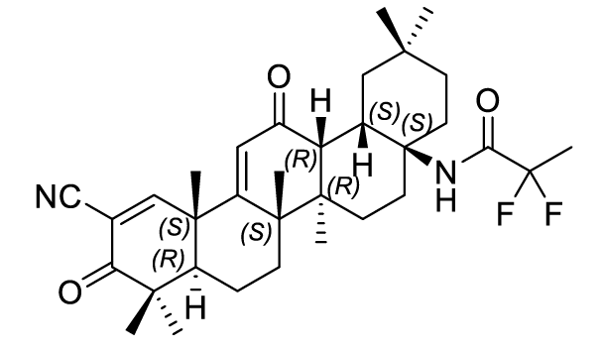 | 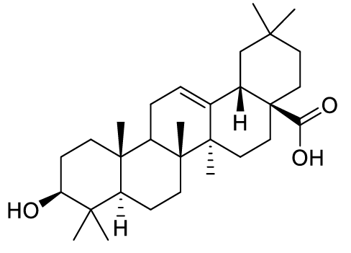
Active substance structure: Omaveloxolone | Oleanolic acid

Omaveloxolone has seven chiral centres. All chiral centres except for one (13R) are introduced with the raw material, oleanolic acid.
The drug substance is an amorphous powder. The amorphous form had higher aqueous solubility than the crystalline forms identified. Aqueous solubility is poor across the physiological pH range but increases to 0.45 mg/L at pH 10.
It is considered as a BCS Class 4 (based on the solubility across the physiological pH range and the maximum daily dose).
The particle size distribution is adequately controlled. It was not a critical parameter as particle size did not have an impact on the drug product dissolution, bioavailability, processability, stability, or content uniformity.
Apart from the minor issue pending from the MS5 evaluation, the proposed specification adequately controls the identity, potency, purity and chemical and physical properties of the drug substance relevant to the dose form.
The synthetic impurities are controlled to either ICH Q3A or where higher were adequately qualified.
Apart from the minor issues pending from the MS5 evaluation, the analytical methods used to analyse the product were adequately described and validated.
Risk evaluations on the potential presence of nitrosamines and elemental impurities were performed. No significant risk was identified.
The retest period is 48 months when stored below 25°C.

Drug product
The drug product is an immediate release oral capsule containing 50 mg of omaveloxolone and conventional excipients, filled into a size 0 hypromellose capsule imprinted with ‘RTA 408’ on the light green body and ‘50’ on the blue cap.
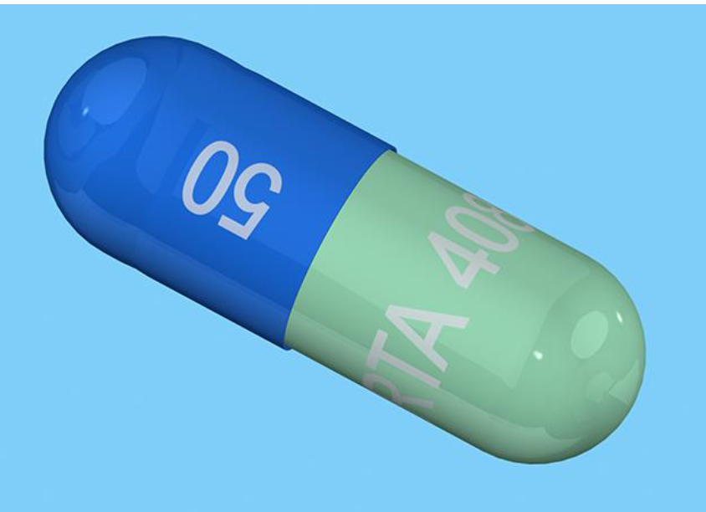
The capsules are packaged in opaque, white, high-density polyethylene (HDPE) bottles containing 90 capsules.
The capsules are manufactured by dry blending and encapsulation.
Apart from the issues with the assay and impurity 1,2-Dihydro RTA 408 limits raised during the MS5 evaluation, the drug product specifications adequately control the quality of the drug product at release and throughout the shelf-life.
The impurities are controlled to either ICH Q3B or where higher were adequately qualified.
The analytical methods used to analyse the product were adequately described and validated.
A risk assessment on the potential contamination of the product with nitrosamine impurities did not identify any significant risk.
The dissolution limits were adequately justified based on the dissolution profiles of the development and clinical study batches.
A shelf life of 48 months when stored below 30°C is supported.
An in-use shelf-life of 30 days is supported. The sponsor has provided a commitment to extend testing to 90 days, in line with the potential in-use period when dosed at 50 mg/day.
Biopharmaceutics
The drug product formulation used in the Phase 3 clinical studies is the same as the product formulation proposed for registration. No bridging studies were required.

Recommendation
It is expected that approval will be recommended from a quality and biopharmaceutic perspective once some minor outstanding issues raised in the MS5 evaluation report are resolved.

Nonclinical evaluation summary
Biogen Australia Pty Ltd has applied to register a new chemical entity, omaveloxolone (Skyclarys), a semi-synthetic oleanane triterpenoid and nuclear factor erythroid 2-like 2 (Nrf2) activator for the treatment of Friedreich’s ataxia (FA) in adults and adolescents aged 16 years and older. The proposed dosing regimen involves once daily oral administration of 3 hard capsules of 50 mg each (150 mg/day). Treatment is intended for chronic daily dosing.
The submitted Module 4 dossier was in accordance with the relevant ICH guideline for the nonclinical assessment of pharmaceutical (ICH M3(R2)). The overall quality of the nonclinical dossier was adequate. All pivotal safety-related studies were GLP compliant. This evaluation has used assessments and considerations in reviews conducted by the EMA.
In vitro, omaveloxolone (at clinically relevant concentrations) demonstrated the ability to restore Nrf2 levels and activity and rescue mitochondrial dysfunction, restore redox balance and suppressed inflammation in models of FA, (including cells from FA patients). In vivo, omaveloxolone demonstrated potent and effective activation of Nrf2, resulting in induction of its target genes, increase antioxidative capacity and increased mitochondrial function in the brain.
The in vivo efficacy studies of omaveloxolone were limited, in the absence of well-established and optimal animal models. Proof of concept and demonstration of the mode of action of omaveloxolone (mostly through in vitro studies) in the intended disease to be treated (i.e., proposed indication) was adequate and offer support for the utility of Skyclarys for the proposed indication.
Metabolites M22 and M17 (two major circulating metabolites of omaveloxolone) showed no relevant pharmacological activity relative to omaveloxolone.
No potential (clinically relevant) hazards were identified in secondary pharmacology studies.
No adverse effects were seen in safety pharmacology studies on CNS function or respiratory function in rats. At 750 nM and 1200 nM, omaveloxolone produced a concentration-dependent inhibition of hERG-mediated potassium currents of 6.72 and 21.5%, respectively. However, inhibition of hERG K+ channel tail current is not predicted at an unbound drug Cmax of 4 nM in patients. Omaveloxolone is not predicted to prolong the QT interval in patients.
Overall, the pharmacokinetic profile of omaveloxolone in animals was qualitatively similar to that of humans. It was rapidly absorbed with within 1-2 h (T_{max}) in mice and 4-8 h in rats, rabbits, and monkeys. In mice and rats, half-life values (5-11 h) were similar but were longer in monkeys (23 h) and humans (48 h). In monkeys omaveloxolone has low oral bioavailability (3.4%) and is extensively metabolised following PO and IV dosing. Plasma protein binding was high in all animal species (92.7 - 99.6%) and humans (96.9%). Tissue distribution was wide, with penetration into brain. Omaveloxolone-derived radioactivity did not bind to melanin-containing tissues (eyes and skin). CYP3A4 was identified as the main metabolising enzyme in human liver microsomes, with minor contribution from CYP2C8. The main human metabolites (M17 & 22) were significant metabolites in animals. Drug-related material was excreted via urine and faeces, with faeces the predominant route of excretion in animals and humans.
Based on in vitro studies, omaveloxolone is a CYP3A4 substrate, therefore CYP3A4 inhibitors and inducers could alter systemic exposure to omaveloxolone. Omaveloxolone is a weak inducer of CYP3A4 and CYP2C8 and therefore can alter exposure of co-administered drugs that are CYP3A4and CYP2C8 substrates. As omaveloxolone inhibited transporters MDR1 (P-gp), OCT1, OAT1 and OATP1B3 at low µM IC₅₀s values (>180-fold the clinical unbound Cmax), it is not predicted to affect exposure of drugs that are substrates of these transporters. Omaveloxolone is not an inhibitor of BCRP, BSEP, OAT3, OATP1B1, OATP1B3, OCT2, MATE1 and MATE2-K.
In repeat-dose PO toxicity studies in rats and Cynomolgus monkeys (up to 6 and 9 months, respectively), systemic exposures (AUC) were adequate (high in rats and low in monkeys). Target organs for toxicity (at clinically relevant exposures) were mostly partial to fully reversible liver alterations (increased liver weight, hepatocellular hypertrophy, bile duct hypertrophy/hyperplasia elevations in total bilirubin, GGT, ALT and AST), kidney (minimal to mild tubular degeneration/ regeneration with associated proteinuria) and gastrointestinal tract (squamous epithelial hyperplasia – rats: in the non-glandular portion of the forestomach stomach; rats and monkeys: oesophagus and larynx). Increases in APTT, lower erythrocyte mass and iron deficiency were also seen in monkeys.
In human peripheral blood lymphocytes, omaveloxolone was clastogenic. However, it was not mutagenic in the Ames test, two in vivo bone marrow micronucleus tests (rats) and in an in vivo rat liver comet assay. The major human metabolites both M17 (TX304571) is not a bacterial mutagen (in silico analysis; classified Class 5 per ICH) and M22 (TX304579) did not show any alerting mutagenic structures (in silico analysis) and was also negative in an Ames test.
In a 6-month PO carcinogenicity study in transgenic rasH2 hemizygous mice, there were no treatment related increases in tumours. NOELs for carcinogenicity in male and female rats were established at 30 and 100 mg/kg/day (ER_{AUC} 15 and 55), respectively. However, in two
6- and 9-month repeat dose toxicity studies, hyperplasia in the oesophagus and larynx of rats and monkeys (ER_{AUC} <1 and 2), respectively, was reported. The sponsor indicated that ‘risk of progression of the epithelial hyperplasia into tumours will be determined in an ongoing 2-year oral carcinogenicity study in rats (RTA-P-21070).’ The sponsor submitted the completed study (RTA-P-21070) in December 2025).
Fertility was unaffected in male and female rats with omaveloxolone exposures 7- and 2-fold the clinical AUC, respectively. In female rats, increased pre- and post-implantation loss, resorptions, and decreased implantation sites and viable embryos were seen at 10 mg/kg/day PO (ER_{AUC} 7).
In an embryofetal development (EFD) study in rats, there was no effect of omaveloxolone on maternal or fetal parameters up to 10 mg/kg/day (ER_{AUC} 6.3). However, at >10 mg/kg/day in rats (dose-range finding study), there were decreases in viable fetuses, litter size, gravid uterine weight, fetal body weight and increased post-implantation loss/resorptions.
In a rabbit EFD study, increased post-implantation loss, resorptions/late resorptions and lower fetal bodyweights were seen at a maternotoxic dose (ER_{AUC} 1.3). Although slightly higher than recent historical control data (84.2%), there was an increased treatment-related litter incidence of unilateral full rib (variation; 87.5% (ER_{AUC} 1.3).
In a PPND study in rats, at a maternotoxic dose (ER_{AUC} 6.3) increased litters with stillborn pups, reduced first pup survival, body weights, attaining preputial separation at a later time in male pups, as well as decreased numbers of corpora lutea and implantation sites in female pups were evident in dams treated with omaveloxolone during pregnancy and lactation. Increasing levels of omaveloxolone (correlating to doses administered to the dams) were observed in the plasma of the pups, suggesting excretion into milk. The effects in pups were directly linked to exposure to omaveloxolone and was not observed as secondary to maternal toxicity.
The proposed limit for 2 impurities in the drug substance has been adequately qualified by submitted toxicity data. An impurity identified later during drug production underwent in silico and in vitro evaluation and was not considered a bacterial mutagen.

Conclusions and recommendations
No major deficiencies were identified. The primary pharmacology studies lend support for the proposed indication and proposed clinical dose.
The sponsor noted the overall risk of progression of the epithelial hyperplasia to tumours will be investigated in the ongoing 2-year oral carcinogenicity study in rats (RTA-P-21070 – submitted to the TGA in December 2025).
Given the adverse effects embryofetal development and pre/postnatal development effects in animal species at clinically relevant exposures, omaveloxolone should not be used during pregnancy or while breast-feeding.
The sponsor proposes Use in Pregnancy Category B3, which is acceptable.
There are no nonclinical objections to the registration of omaveloxolone for the proposed indication.

Clinical evaluation summary

Summary of clinical studies
The clinical pharmacological development program for Skyclarys to support its use for the proposed indication consists of 8 studies:
- Four Phase 1 studies conducted in healthy participants, assessing the absorption, metabolism, and excretion (AME; Study 408-C-1805); the drug-drug interaction (DDI) potential (408-C-1806); the food effect and dose proportionality (Study 408-C-1703); a relative bioavailability study comparing the relative bioavailability of omaveloxolone when administered in tact capsules vs. omaveloxolone when administered as capsule content sprinkled over apple sauce (Study 408-C-2106).
- One Phase 1 study conducted in patients with hepatic impairment to assess the effect of hepatic impairment on the pharmacokinetic profile (Study 408-C-1804).
- Three Phase 2 studies: two Phase 2 studies conducted in the treatment of patients with FA (Study 408-C-1402 part 1 and part 2) and one Phase 2 study conducted in the treatment of patients with mitochondrial myopathy (Study 408- C-1403).
- Study 1402 is an Open Label Extension (OLE) trial for eligible participants who completed studies 1402 part 1 or study 1402 part 2.
The clinical and pharmacological studies related to this application are summarised in Tables 3 and 4.
Table 3: Summary of phase 1 clinical studies for oral omaveloxolone relating to proposed indication
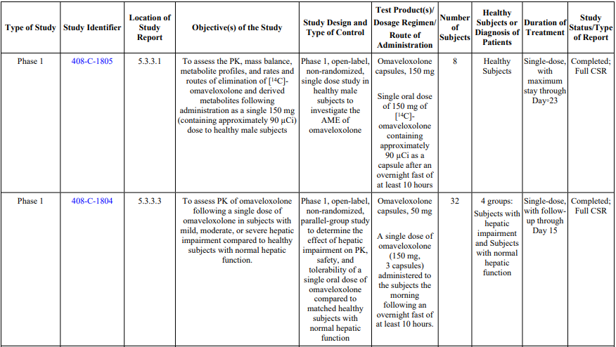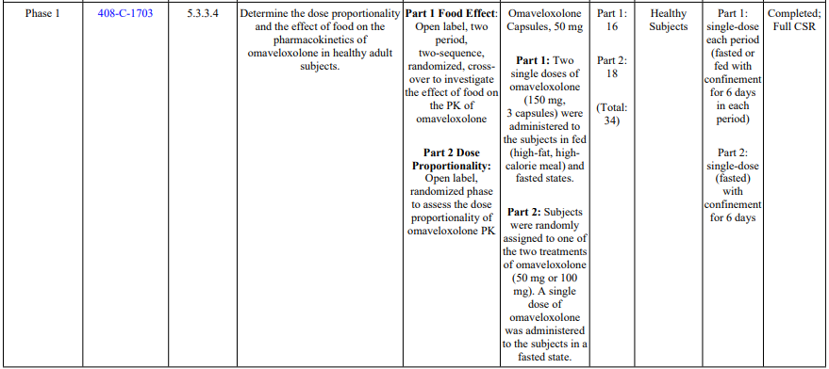
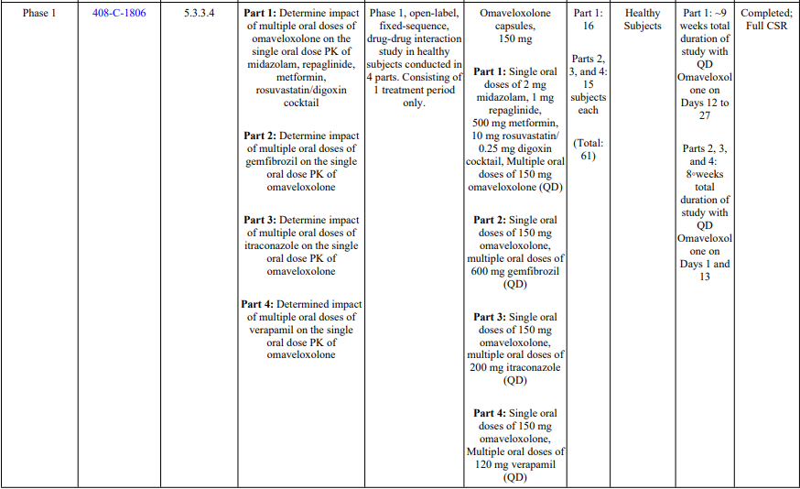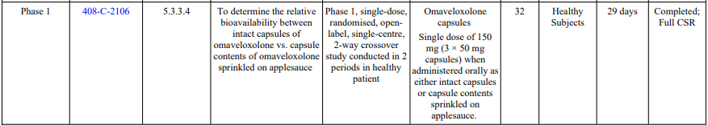

Table 4: Summary of phase 2 clinical studies for oral omaveloxolone relating to proposed indication
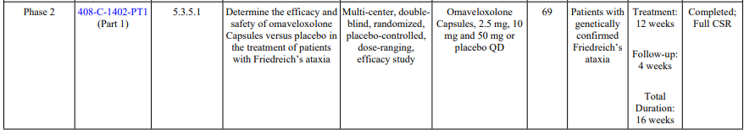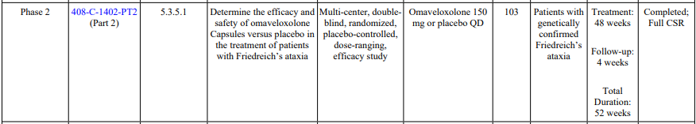
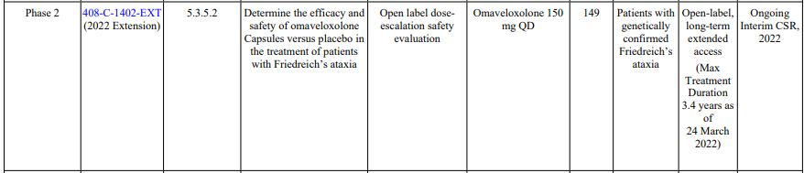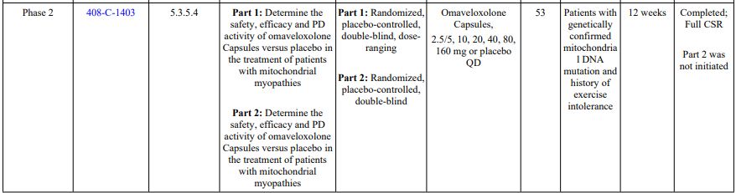

Pharmacology

Protein binding
Study RTA408-P-1124 examined in vitro plasma protein binding and blood-to-plasma partitioning of RTA 408 (omaveloxolone) in mice, rats, rabbits, dogs, minipigs, monkies, and humans. This study found that omaveloxolone is 97% bound to protein in human plasma, the blood-to-plasma ratio in human was 0.694 over the concentration range 10 to 2000 ng/mL, and no concentration dependence was observed for blood-to-plasma partitioning.

Hepatic metabolism
Study RTA408-P-1212 was a study involving in vitro cytochrome P450 reaction phenotyping of RTA 408 in human liver microsomes and recombinant human CYP Enzymes. This study suggested that omaveloxolone (RTA 408) is metabolized mainly by CYP3A4 with minor contributions from CYP2C8 and CYP2J2. Uridinediphosphate glucuronosyltransferase enzymes do not play a role in the in vitro metabolism of omaveloxolone (Study RTA408-P-1212). This is reflected in figure 2 when the direct acting CYP3A4/5 inhibitor ketaconazole was added to human liver microsome in increasing concentration this resulted in increasing reductions in omaveloxolone concentrations.
Figure 2: Effect of ketoconazole on the disappearance of RTA 408 by human liver microsomes (0.1 and 0.25mg protein/mL)
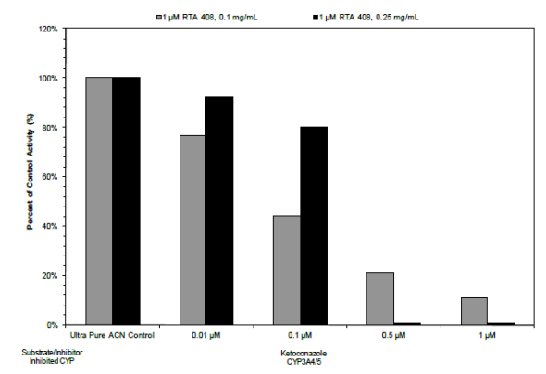

Pharmacokinetics (PK)

Study 1703 (effects of food on omaveloxolone PK and dose proportionality):
This was a single centre, open-label, phase 1 study conducted in 2 parts simultaneously.
Part 1 was a fixed-sequence crossover study that was to assess the food effect of omaveloxolone; part 2 was to assess dose proportionality.
The study consisted of a screening period of 28 days prior to study day -1. Patients were observed in a clinic setting from study day -1 to study day 6 in period 1 and in period 2 from study day 14 to study day 20 (in Part 1 only). Study designs of part 1 is outlined in figure 3.
In part 1, 32 patients were enrolled and randomly assigned to 1 of 2 treatment sequences, period 1 fed and period 2 fasted or period 1 fasted and period 2 fed. Two single doses of 150mg omaveloxolone were administered with ~240mL of water at beginning of each period. There was a 1-week washout period between period 1 and period 2.
Figure 3: Part 1, Food effect study schematic
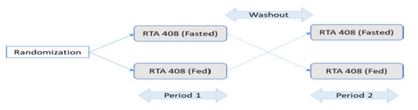
Part 2 was an open label randomized phase of the study to assess dose proportionality of omaveloxolone. 18 patients were randomly assigned to one of two treatment groups; these groups were receiving either omaveloxolone 50mg (N=8) or omaveloxolone 100mg (N=8). To assess dose proportionality of the 50mg, 100mg and 150mg doses data from patients during fasted period of part one were included in the part 2 analysis.
The primary objective was to determine the effect of food on PK of omaveloxolone (150mg) and the secondary objective was to assess safety, tolerability and dose proportionality of the 50mg, 100mg and 150mg doses. All patients were healthy males or females between 18 to 55 years of age. Fed and fasted PK value results from this study are shown in table 5.
Table 5: Effect of food on plasma omaveloxolone PK parameters
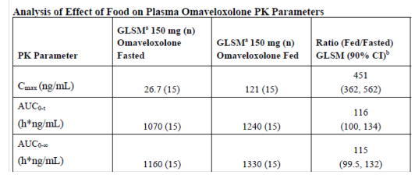
Figure 4: Concentration versus time of omaveloxolone in fed vs fasted patients
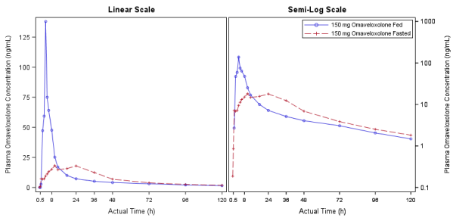
These results show that administration of 150mg omaveloxolone with a high fat meal caused an increase in the total exposure of omaveloxolone (AUC_{inf} increased by about 15%) compared to fasted conditions. In the fed state there was an approximate increase in C_{max} of ~4.5 fold compared to fasted conditions. High fat food increased the absorption rate of omaveloxolone with a median T_{max} of 5.0 hours for a 150mg dose.
In part 2 of this study, dose proportionality was investigated for omaveloxolone under fasted conditions. The median T_{max} was between 5.5hours and 11 hours for the dose ranges of 50mg to 150mg. Plasma omaveloxolone levels declined in a multi exponential manner following single dosing with PK parameters for each dose shown in table 6.
Table 6: Plasma omaveloxolone PK parameters from part 2 of study
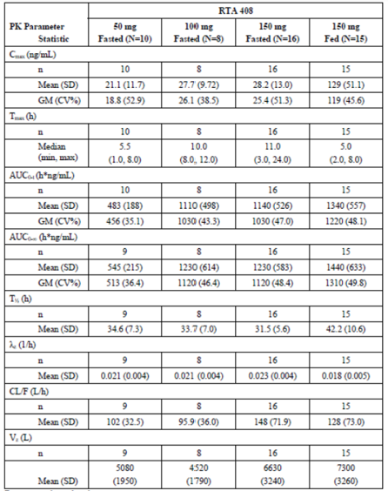
Dose proportionality was assessed by fitting a power model. The sponsor states in the study conclusion there was a ‘dose related increase over the dose range of 50 mg to 150 mg for AUC_{0-t} and AUC_{0-∞}, but not demonstrated for C_{max}, which increased in a less than dose proportional manner. The Delegate notes that the AUC_{0-t} and AUC_{0-∞} are approximately dose proportional between doses of 50mg and 100mg fasted, but the AUC_{0-t} values between the 100mg (Geometric mean 1030h*ng/mL) and 150mg (Geometric mean also 1030h*ng/mL) thus suggesting that between the doses of 100mg and 150mg omaveloxolone does not increase proportionally and may increase significantly less then proportionally. The evaluator has referenced a slope curve based on a power model which considers all 3 doses studied in an aggregate manner and does not appear to discriminate specifically in the dose range of 100mg to 150mg. The sponsor has stated that C_{max} increases less then dose proportionally which the Delegate agrees with. Based on this it is unclear regarding the dose proportionality of omaveloxolone at doses between 100mg to 150mgand higher, but given there is only a single recommended dose of omaveloxolone recommended for this indication that is supported by the pivotal trial using this dose the Delegate does not believe these results impact on the applicant’s application for the proposed indication at the recommended dose of 150mg daily.

Study 1805 (Absorption, metabolism and excretion of omaveloxolone)
This was a phase 1 study to investigate the absorption, metabolism, and excretion of [14C]-omaveloxolone following single oral dose administration in healthy male participants. The study was an open-label, non-randomized and single-dose study.
A total of 8 patients were enrolled in this study. Participants were screened 28 days prior to dosing. On morning of day 1 following at least a 10 hour fast, all patients received a single oral dose of (in the form of a capsule) 150 mg omaveloxolone containing approximately 90 μCi of
[14C]-omaveloxolone (radiolabelled omaveloxolone). Participants were monitored in an inpatient unit until at least day 9. A pre-dose blood test and a total of 18 blood samples were taken between 0 hours and 168 (days 0-8) hours post-dose to establish PK parameters, with more frequent blood samples taken in first 24 hours post dose. A total of 11 urine samples and 8 faecal samples were planned to be collected between days 0-8 to determine routes of elimination.
The primary objective of this study was to assess the pharmacokinetic (PK), mass balance, metabolite profiles, and rates and routes of elimination of [14C]-omaveloxolone and derived metabolites following administration as a single 150-mg (containing approximately 90 μCi) dose to healthy male participants. Study participants were healthy males aged between 18-55 years with BMI between 18.0-32.0.
The arithmetic mean (+SD) concentration profiles for omaveloxolone in plasma for all participants are presented in figure 5 with key PK parameters for all participants being presented in table 7.
Figure 5: Arithmetic mean (+SD) concentration profiles of plasma omaveloxolone, plasma total radioactivity, and whole blood total radioactivity
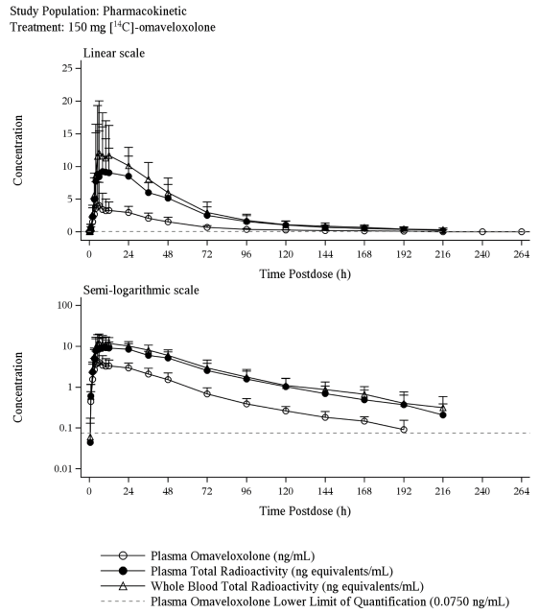

Table 7: Summary of the Pharmacokinetic (PK) parameters for omaveloxolone following single oral doses
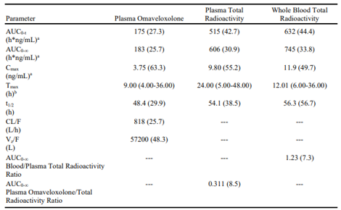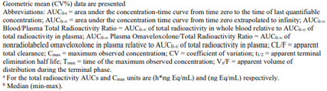
The PK results show a mean apparent volume of distribution of 57200L. For plasma omaveloxolone concentrations after a single 150mg dose, the mean apparent terminal half-life was calculated at 48.4 hours (SD 29.9). Mean C_{max} was calculated as 3.75 (SD 63.3) ng/mL after single dose. Mean apparent total clearance was calculated at 818 L/h (SD 25.7). Mean AUC_{0-∞} was calculated at 183 (SD 25.7) h*ng/mL. The evaluator has noted that in another clinical study (Study 1703) in healthy participants, the apparent clearance was determined to be 148L/hr (same dose). Volume of distribution in Study 1703 was also noted to be considerably lower in healthy participants at 6631.6L (same dose) compared to this study. Study 1703 also noted lower terminal half-life at 31.52 hours (same dose) and higher C_{max} of 28.18ng/mL (same dose).
Regarding elimination, it was found that after administration of a single oral dose of 150 mg containing approximately 90μCi of [14C]-omaveloxolone, faecal excretion was the predominant route of elimination, with a mean (SD) radioactivity recovery of 92.4% (4.91) through 528 hours post dose. The contribution of renal elimination was minor, with a mean (SD) recovery of the administered radioactivity in urine of 0.0968% (0.0347). Almost all the radiolabelled material voided in faeces had been recovered by 96 hours post-dose for all participants, with mean recovery of 90.7%. Of excreted radioactivity in faeces after 144 hours, 40.3% was unchanged omaveloxolone. The evaluator has noted that the unchanged drug product excreted could be overestimated by a large amount of non-absorbed drug material in this study.
It was shown that omaveloxolone underwent metabolism in human participants to produce 30 metabolites, of which seven were identified. The major metabolites identified in plasma were the M22 metabolite and M17 metabolite, accounting for 18.6% and 10.9%, respectively, of total plasma radioactivity. Of note, the M22 and M17 metabolite could not be detected in faeces where another major metabolite M29 was identified. It was demonstrated in in vitro assays that the identified metabolites were inactive.

Study 1804 (Effect of hepatic impairment on PK)
This was a single-dose, open-label pharmacokinetic study of omaveloxolone in participants with mild, moderate, or severe hepatic impairment, or with normal hepatic function.
Thirty-two participants were separated into 4 treatment groups: healthy matched controls (N=12, group 1), participants with mild hepatic impairment (N=8, group 2), participants with moderate hepatic impairment (N=7, group 3), and participants with severe hepatic impairment (N=5, group 4). Each subject with normal hepatic function was demographically matched (1:1) by sex, age and body mass index (BMI). Participants were screened within 28 days of first dose administration (day 1). Participants were admitted to a clinical research unit (CRU) and were confined to the CRU until discharge on day 6 with the last follow up visit on day 15 post dose. Following an overnight fast on morning of day 1 a 150mg (3 × 50-mg capsules) dose of omaveloxolone was administered with 240mL of water. Hepatic impairment group selection was via participants’ Child-Pugh scores.
The primary objective was to determine the PK parameters of omaveloxolone after single dose in people with mild, moderate and severe hepatic impairment with secondary objective of evaluating the safety and tolerability of a single dose of omaveloxolone in this population. Participants in this study were male or female aged between 18 and 70 years with BMI between 18.0 to 38. Participants were in good health except for the inclusion criteria relating to hepatic impairment.
PK results for this study are shown in table 8 with figure 6 showing the concentration time curves of arithmetic mean omaveloxolone concentrations for each treatment group.
Table 8: Summary of PK parameters for omaveloxolone following single oral dose of 150mg
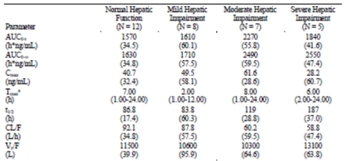
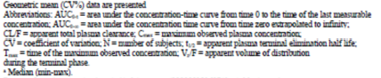
Figure 6: Arithmetic mean (+SD) omaveloxolone concentration profiles of each treatment group from 0 to 336 hours
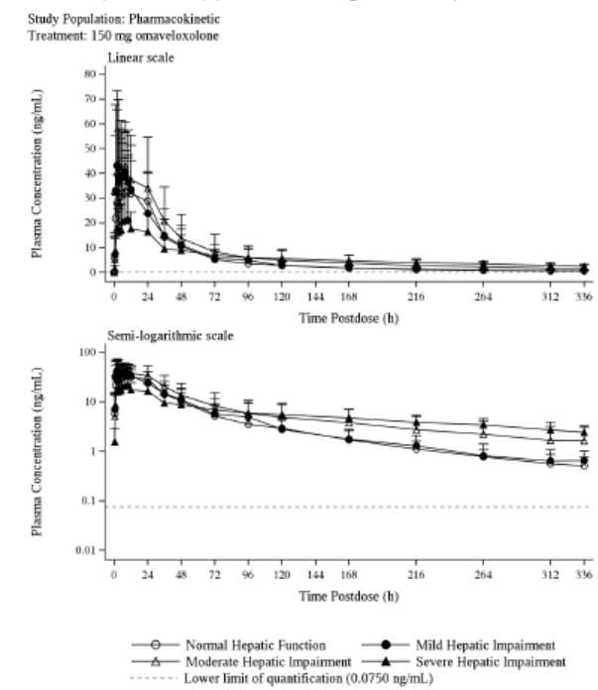
Mean t_{1/2} was increased for the moderate and severe hepatic impairment groups (119 hours and 187 hours respectively), compared to participants with normal hepatic function and the mild hepatic impairment groups (86.8 hours and 83.8 hours respectively).
Compared to the normal hepatic function group, participants with mild hepatic impairment had an approximately 22% increased mean C_{max} with a similar total exposure between these 2 groups. Participants with moderate hepatic impairment had 53% and 51% higher mean AUC_{inf} and mean C_{max} values respectively compared to the normal hepatic function group. Participants with severe hepatic impairment had an approximately 56% increase in mean AUC_{0-∞} compared to the normal hepatic group. C_{max} was approximately 30% lower for the severe impairment group compared to the normal group.

Study 1806 (Drug-drug interaction study)
This was a Phase 1, open-label, 4-part, drug-drug interaction study with Omaveloxolone in healthy participants.
A total of 16 participants were enrolled in part 1 as a single group. Study probe drugs in part 1 were chosen due to these being sensitive of different CYP enzymes as indicated in brackets next to the probe drugs’ names.
Part 1 of this study investigated the effect of multiple oral doses of omaveloxolone on the single dose PK of: midazolam (CYP3A), repaglinide (CYP2C8), metformin (OCT1) and rosuvastatin (BCRP)/digoxin (P-gp) cocktail in health participants. These were given sequentially on different study days as outlined in figure 7. Following a 28-day screening period, participants were admitted to a CRU until discharge on day 28 for part 1 or day 23 for parts 2, 3 and 4.
Figure 7: Study schematic for study part 1
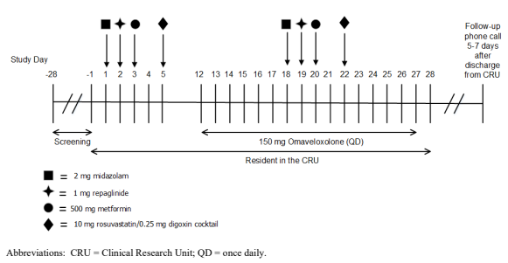
A total of 15 participants were enrolled in each of parts 2,3 and 4 of this study. Study drugs in parts 2 and 3 were chosen because Gemfibrozil and itraconazole are known strong inhibitors of CYP2C8 and CYP3A4 respectively. Verapamil was chosen in part 4 as it is a known inhibitor of the P-gp drug transporter. Parts 2, 3, and 4 were to investigate the effects of multiple oral doses of gemfibrozil, itraconazole, or verapamil, respectively, on the single oral dose PK of omaveloxolone in healthy participants. Figure 8 shows the study design of parts 2,3 and 4 and when doses of omaveloxolone, gemfibrozil, itraconazole and verapamil were given in each study part.
Omaveloxolone was administered at dose of 150mg (3x50mg capsules) in this study. All other study drug doses are shown in table 9.
All participants were healthy males or females aged between 18 to 55 with a BMI between 18.0 and 32.0.
Figure 8: Study schematic of parts 2,3 and 4
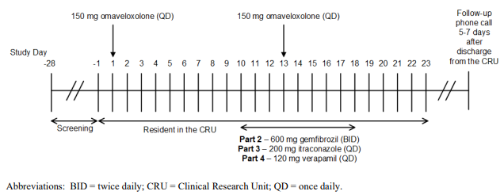
Table 9: Study drug treatments
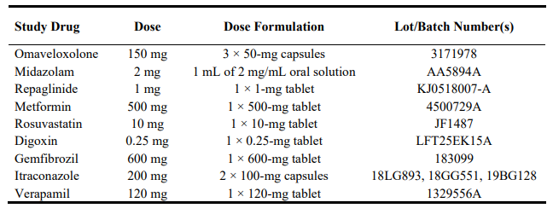
Part 1 results showed that the systemic exposure of the probe drugs was either unchanged or reduced following co-administration with omaveloxolone.
When co-administration of midazolam was compared with midazolam (CYP3A) administration alone, the ratio of geometric LS means (90% CI) of midazolam AUC0-∞ and Cmax were 0.549 (0.490, 0.616) and 0.657 (0.573, 0.753), respectively.
When co-administration of repaglinide (CYP2C8) with omaveloxolone was compared with repaglinide administration alone, the ratio of geometric LS means (90% CI) of repaglinide AUC0-∞ and Cmax were 0.652 (0.593, 0.716) and 0.765 (0.639, 0.915), respectively.
When co-administration of metformin (OCT1) with omaveloxolone was compared with metformin administration alone, the ratio of geometric LS means (90% CI) of metformin AUC_{0-∞} and C_{max} were 1.03 (0.962, 1.11) and 0.834 (0.752, 0.925), respectively.
When co-administration of rosuvastatin/digoxin (rosuvastatin was analyte) cocktail with omaveloxolone was compared with rosuvastatin (BCRP) /digoxin cocktail administration alone, the ratio of geometric LS means (90% CI) of rosuvastatin AUC0-∞ and Cmax were 0.695 (0.618, 0.781) and 0.609 (0.498, 0.744), respectively.
When co-administration of rosuvastatin/digoxin (P-gp) (digoxin was analyte) cocktail with omaveloxolone was compared with rosuvastatin/digoxin cocktail administration alone, the ratio of geometric LS means (90% CI) of digoxin AUC0-∞ and Cmax were 0.968 (0.875, 1.07) and 0.853 (0.758, 0.961), respectively.
Part 2 results indicated CYP2C8 was a minor contributing enzyme to omaveloxolone metabolism, with the systemic exposure to omaveloxolone being similar when administered alone compared to co-administration with gemfibrozil (a CYP2C8 inhibitor).
When co-administration of omaveloxolone with gemfibrozil was compared with omaveloxolone administration alone, the ratio of geometric LS means (90% CI) of omaveloxolone AUC0-∞ and Cmax were 0.914 (0.770, 1.09) and 0.881 (0.756, 1.03), respectively.
Part 3 results showed an increase in systemic exposure of omaveloxolone (approximately 4- and 3-fold in AUC_{0-∞} and C_{max}, respectively) was observed following co-administration with itraconazole (strong CYP3A4 inhibitor) compared to omaveloxolone administered alone.
When co-administration of omaveloxolone with itraconazole was compared with omaveloxolone administration alone, the ratio of geometric LS means (90% CI) of omaveloxolone AUC_{0-∞} and C_{max} were 4.12 (3.48, 4.87) and 2.77 (2.17, 3.54), respectively.
In part 4 of this study, the systemic exposure of omaveloxolone increased by approximately 24% to 28%, following co-administration with verapamil (P-gp transporter inhibitor) compared to omaveloxolone administration alone.

Study 2106 (assessed by the module 3, quality unit)
Study 408-C-2106 was performed in the USA to assess the relative bioavailability of omaveloxolone capsules at a dose of 150 mg (3 x 50 mg capsules) when administered as either intact capsules or capsule contents sprinkled on applesauce in healthy subjects. The study also assessed the safety, tolerability, and palatability of omaveloxolone with applesauce.
This was a phase 1, single-dose, randomised, open-label, single-centre, 2-way crossover study in healthy subjects. The study was conducted in 2 periods with a washout of at least 14 days in between periods.
Thirty-two adult male (44%) and female (56%) subjects between the ages of 18 and 55 years (inclusive), in generally good health, and who met the study eligibility criteria were enrolled to ensure at least 26 subjects completed the study. A total of 31 subjects completed the study – one subject was removed from the study due to violation of clinic rules.
Subjects were confined to the clinical unit and supervised for approximately 29 days. Serial blood samples were collected before study drug administration (pre-dose) and 0.5, 1, 2, 3, 4, 5, 6, 8, 10, 12, 18, 24, 36, 48, 72, 96, 120, 144, 168, 192, 216, 240, 288, and 336 hours after dosing. The period 2 pre-dose sample served as the 336-hour sample in period 1.
There were no major protocol deviations during the study. The most common minor protocol deviations included sample time deviations, procedural deviations, documentation deviations, and concomitant use of medications, and none of these deviations were likely to have a significant impact on the outcomes of the study.
Plasma concentrations of omaveloxolone were determined using a validated protein precipitation HPLC-MS/MS method. The analytical range of the method was 0.0750 – 40 ng/mL.
Concentrations remained quantifiable (≤0.677 ng/mL) for the majority of subjects at 336 hours post-dose for both treatments.
PK parameters were determined by noncompartmental methods using Phoenix® WinNonLin® Version 8.3.4. An analysis of variance (ANOVA) was performed on each of the natural-log (ln)-transformed PK parameters (Cmax, AUC0-t, and AUC0-∞) to assess the relative bioavailability of sprinkled versus intact capsules.
Table 10: PK parameters for treatment A (a single oral dose of 150mg omaveloxolone intact capsule [3x50mg] sprinkled on apple sauce) and Treatment B ((A single oral dose of 150mg omaveloxolone intact capsule [3x50mg])
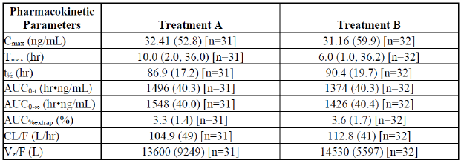
Table 11: Geometric mean ratios for AUC and C_{max} for treatment B and treatment A
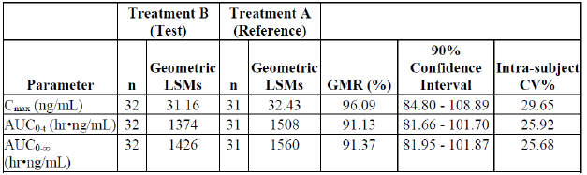
Figure 9: Linear plot of mean plasma concentrations versus time of omaveloxolone for Test product (treatment B) and Reference product (treatment A)
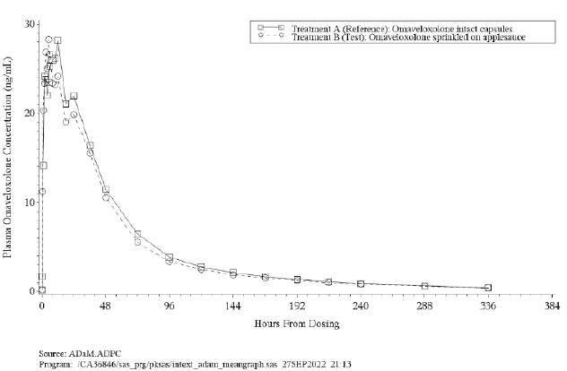
The peak (Cmax) and overall (AUC) exposures were similar following a single oral dose of 150 mg (3 x 50 mg) omaveloxolone sprinkled on applesauce versus intact capsules, with the 90% CIs of the GMRs falling within the 80.00% to 125.00% reference interval. However, the median Tmax occurred earlier for omaveloxolone sprinkled on applesauce compared to omaveloxolone intact capsules, at approximately 6 and 10 hours post-dose, respectively. These results suggest that absorption was faster following administration of omaveloxolone sprinkled on applesauce relative to omaveloxolone intact capsules.
The study supports the statement in the proposed PI regarding the absorption when administered with apple sauce:
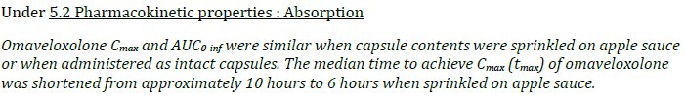

Population PK data (popPK)

PopPK report REAT-PMX-OMAV-2081
The sponsor states the objectives of this PopPK report were:
- To identify the intrinsic and extrinsic factors that affect omaveloxolone concentrations in plasma in adult healthy subjects and patients with FA using a population pharmacokinetic (PK) approach.
- To perform E-R modeling with the following endpoints: modified Friedreich’s ataxia rating scale (mars) scores, aminotransferase levels, cardiac adverse events (AEs), and infections and infestations AEs. All exposure-response (E-R) analyses were conducted with data from Study 408-C-1402 Part 1 and Part 2 only.
The sponsor states that the population PK model was developed using data from Studies
408-C-1402 Part 1, 408-C-1402 Part 2, 408-C-1403, 408-C-1703, 408-C-1804, and 408-C-1806. The E-R models for efficacy and safety were developed using data from Study 408-C-1402 Part 1 and Part 2. Study designs, including PK sampling, are summarized in table 12 on the following page.
The structural model is a 2-compartment disposition model, first-order absorption, and linear clearance. Interindividual variability terms are included on absorption rate constant (Ka), apparent total plasma clearance (CL/F), apparent central volume of distribution (Vc/F), apparent intercompartmental clearance, and apparent peripheral volume of distribution (Vp/F) parameters.
The PK analysis dataset included 3335 measurable PK observations from 252 subjects. Number of subjects, measurable observations, and below the lower assay limit of quantification (BLQ) observations across studies are summarized by study, number of subjects, and measurable observations excluded from the analysis in Table 13 (on page 37).
Table 12. Clinical studies included in PopPK analysis
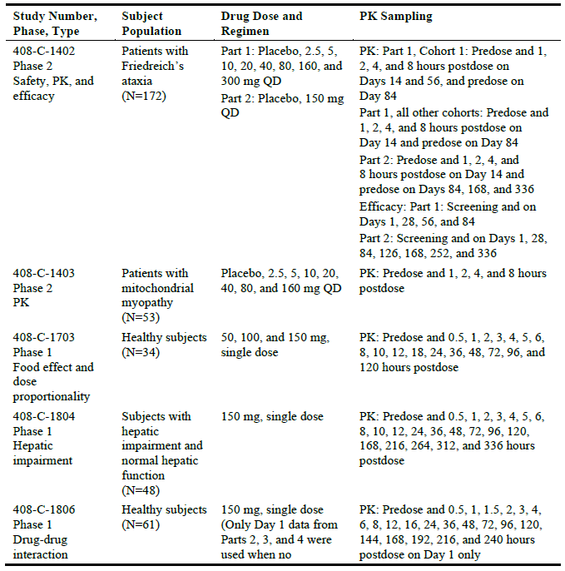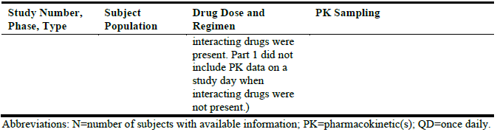

Table 13: Plasma concentrations in the PK analysis dataset
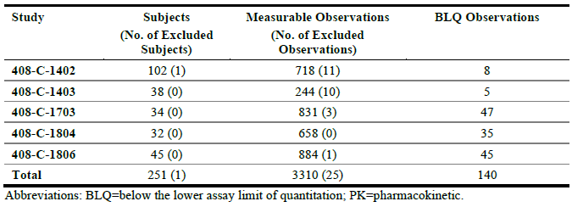

Covariates evaluated in this popPK model are shown in Table 14. For a covariate to be included in the formal covariate analysis the following conditions had to apply:
- The covariate had to be available in at least 80% of subjects.
- For categorical covariates, a minimum number of 15 subjects had to be in each category.
If covariates showed a correlation of >0.5, only one of the correlated covariates was included in the formal analysis. This was either the covariate with the strongest influence as determined by exploratory graphical analysis or the variable that was most meaningful from a clinical, biological, or practical perspective. Continuous covariates were preferred over categorized covariates with the same meaning.
Table 14: Covariates evaluated in the Population PK Model
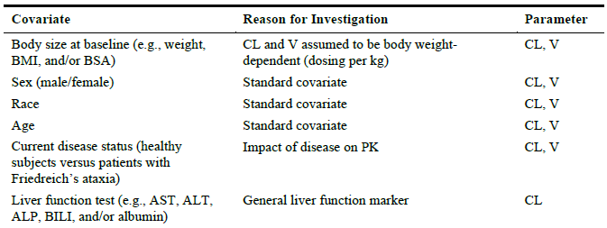
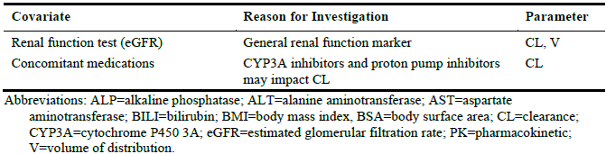
The continuous and categorical covariates included in this PopPK dataset are shown in tables 15 and 16 (page 39).
Table 15: Summary of continuous covariates at baseline
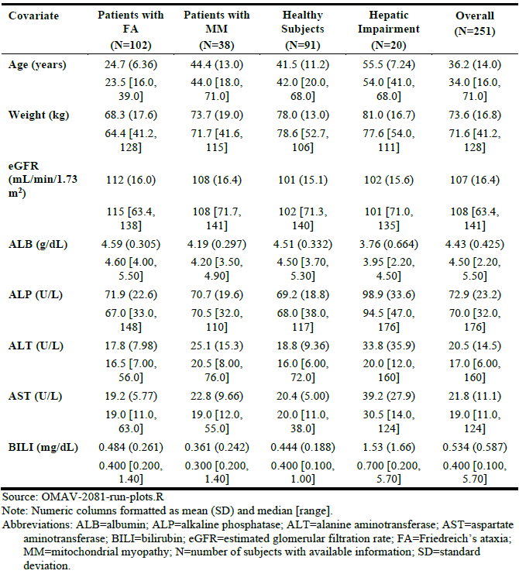
Table 16: Summary of categorical covariates
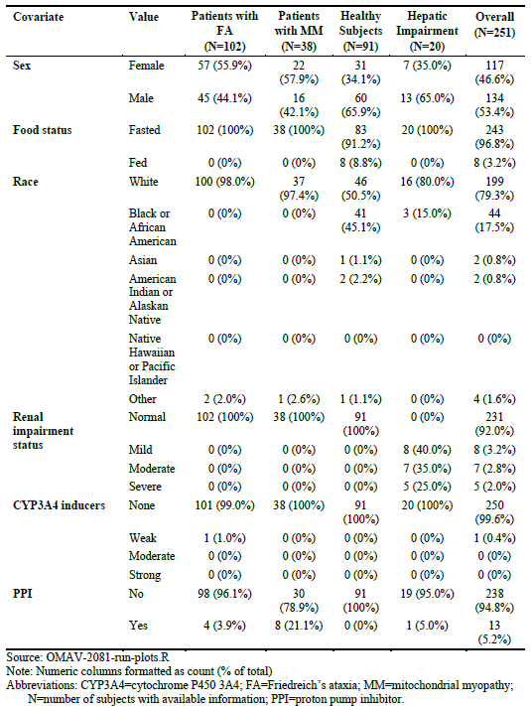

The sponsor makes the following conclusions based on this PopPK analysis:
- The PK of omaveloxolone following oral administration was well characterized by a 2-compartment disposition model with first-order absorption and linear CL.
- The following covariate/parameter relationships were retained in the final model.
  - The exponent for the effect of age on CL/F was -0.2767. The results suggest a lower CL in subjects 35 years and older relative to the CL of a subject who is 34 years old.
  - The exponent for the effect of baseline ALP on CL/F was -0.3393. The results suggest a higher CL in subjects with lower baseline ALP levels.
  - Healthy subjects were found to have a 55.6% lower Ka than patients with FA.
  - Healthy subjects under fed conditions were found to have a 508% higher Ka than healthy subjects under fasted conditions.
- E-R relationships were established for the effect of omaveloxolone on incidences of cardiac events as well as infections and infestations events.
  - The probability of a cardiac event showed a slight increase with increasing Cmax that was not statistically different from placebo. The model-predicted mean (5th, 95th prediction interval) probability of a cardiac event for a subject receiving a 150-mg dose was 16.5% (11.9%, 20.9%) compared to 14.8% (9.7%, 21.4%) for placebo.
  - The probability of an infections or infestations event showed a strong increase with increasing Cmax that was statistically different compared to placebo.
  - Overall, the model-predicted mean (5th, 95th prediction interval) probability of an infections or infestations event for a subject receiving 150-mg dose was 62.6% (55.0%, 69.9%) compared to 47.8% (39.1%, 56.1%) for placebo.
- E-R relationships were established for the effect of omaveloxolone on the time course of ALT and AST elevations.
  - The proposed models consist of the following components:
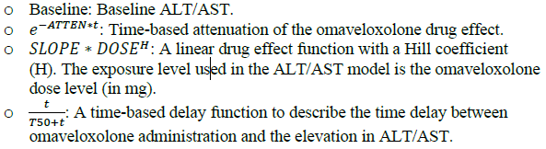

  - For ALT, covariate modelling suggested that baseline ALT was body weight dependent. Specifically, the results suggest that higher baseline ALT is associated with higher baseline body weight.
- E-R relationships were established for the effect of omaveloxolone on the time course of mFARS elevations.
  - The proposed models consist of the following components:
Baseline: Baseline mFARS.

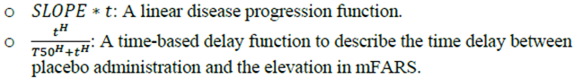

  - Covariate modelling suggested that time to 50% maximum mFARS was dependent on baseline mFARS and treatment effect was dependent on pes cavus status. Specifically, the results suggest that higher baseline mFARS (corresponding to more advanced disease) is associated with shorter time until mFARS begins to increase (corresponding to worsening of neurological function). Although results showed that having pes cavus is associated with a 1.1% decrease in treatment effect, these results should be interpreted with caution, as patients with pes cavus only represented 30% of all patients enrolled in Study 408-C-1402 part 1 and 408-C-1402 part 2.
- Median-predicted AUC in adults >65 years and children 6 to <12 years were 23% higher and 31% lower than the reference group, respectively. Median predicted Cmax in adults >65 years and children 6 to <12 years were 27% higher and 19% lower than the reference group, respectively.

Pharmacodynamics (PD)

Study 1402 Part 1
The sponsor states in their study report:
‘PD outcome of evidence of omaveloxolone PD activity (Nrf2 target gene induction) was assessed by analysing serum levels of ferritin, AST, ALT, GGT, and creatinine kinase (CK), which are regulated by Nrf2 (data included in the clinical chemistry analysis). AST and CK are also markers of mitochondrial function, as AST delivers substrate to the mitochondria for energy production as part of the malate shuttle and CK is involved in the utilization of ATP throughout cells. At Week 4, induction of ferritin (increase in the mean [SD] change from baseline) was noticeable in most omaveloxolone treatment groups. Additionally, there was a dose-related induction of GGT, ALT, and AST at Week 4 in omaveloxolone-treated patients, with patients in the 160 mg group showing a large positive change from baseline in these parameters (greater than all other dose groups for ALT and AST). Optimal median changes in CK were observed at omaveloxolone doses of 80-160 mg, with a high variability at the 300 mg dose. Typically, induction of these Nrf2 target genes was transient and not as apparent at Week 12. Importantly, despite these pharmacodynamic increases in ALT and AST, only 5 patients treated with omaveloxolone (3 in the 160 mg group and 2 in the 300 mg group) exceeded the threshold criterion of ALT or AST > 5x the upper limit of normal during the study (Listing 16.4.21). In all 5 patients, the increases occurred early in the study (on or before Week 4), and ALT and AST values decreased below this threshold limit by Week 8.’
The sponsor also states that the changes in these measured laboratory markers are PD markers of Nrf2 gene induction and increased mitochondrial function. The mean change from baseline in these PD markers are presented in Table 17.
Table 17: Mean (SD) Change from baseline in plasma biomarkers of Nrf2 induction overall (regardless of pes cavus status) – Safety Analysis Set
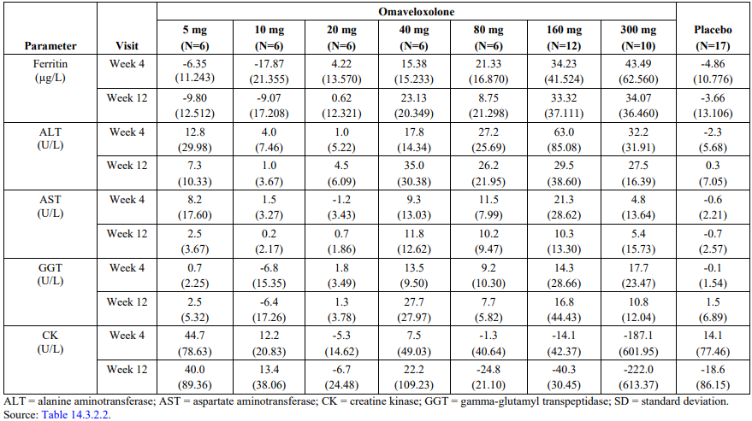

Efficacy

Study 1402 Part 1
This was a phase 2 study of the safety, efficacy, and pharmacodynamics of RTA 408 (Omaveloxolone) in the treatment of Friedreich’s ataxia. The study was conducted between
8 January 2015 and 13 June 2017.
Part 1 of this study was a randomized, placebo-controlled, double-blind, dose-ranging study to evaluate the safety, efficacy, PK, and PD activity of omaveloxolone at 2.5 mg, 5 mg, 10 mg, 20 mg, 40 mg, 80 mg, 160mg and 300 mg in patients with Friedreich’s ataxia. Intra-patient dose-escalation was only utilized in the first cohort to evaluate omaveloxolone at the first two dose levels (2.5 mg and 5 mg). 9 cohorts were planned to be enrolled in this study with participants randomized in a 3:1 ratio to receive omaveloxolone at the cohort specific dose (N=6) or placebo (N=2).
Data from part 1 of this study was used to inform the dose of the pivotal trial study 1402 part 2. A total of 52 participants were enrolled and randomized to each cohort in the pooled omaveloxolone group with 17 participants randomized to placebo. 1 participant in the pooled omaveloxolone group discontinued the study (withdrawal of consent) and 1 participant in the placebo group also discontinuing the study (due to skin rash).
Figure 10: Study design schema for Part 1 and Part 2 of study 1402
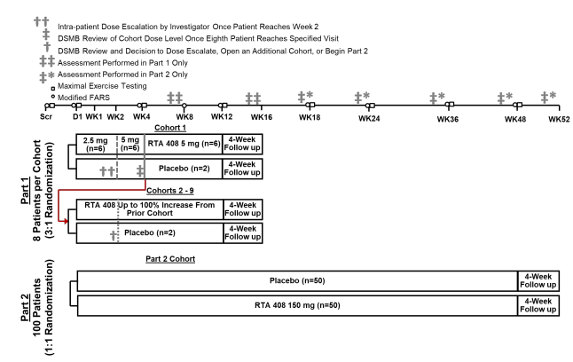
The primary objectives of part 1 of this study were:
- To evaluate the change in peak work during maximal exercise testing. This was done using cycle ergometry using a recumbent stationary bicycle with peak work and peak oxygen utilization being efficacy parameters. Efficacy assessment was the change in peak work and oxygen utilization during maximal exercise testing from baseline to weeks 4 and 12.
- To evaluate the safety and tolerability of omaveloxolone.
The secondary objective of part 1 was to evaluate change in the modified Friedreich’s ataxia rating scale (mFARS) score. Efficacy assessment was change in both the FARS neurological score and the mFARS scores from baseline to weeks 4, 8 and 12.
There were multiple exploratory objectives including: evaluation of change in peak oxygen utilisation, change in 25-foot timed walk test, change in 9-hole peg test, change in fatigue severity score, change in lower contrast visual acuity, change in cardiac parameters, change in perfusion reserve on cardiac MRI, evaluate change in pharmacodynamic (PD) markers in platelets, cheek swab and muscles samples and to characterize PK parameters of omaveloxolone after oral administration.

Inclusion criteria for this study
- Have genetically confirmed Friedreich’s ataxia.
- Have a modified FARS score ≥ 10 and ≤ 80.
- Male or female and ≥ 16 years of age and ≤ 40 years of age.
- Have no changes to their exercise regimen within 30 days prior to study day 1.
- Have the ability to complete maximal exercise testing.
- Have adequate kidney function defined as an estimated glomerular filtration rate (eGFR) ≥ 60 mL/min/1.73 m2.
- Have a left ventricular ejection fraction ≥ 40%.
- Able to swallow capsules.
- Willing and able to cooperate with all aspects of the protocol.
- Willing to practice medically acceptable methods of birth control.
- Have provided written informed consent for study participation, approved by the appropriate Institutional Review Board (IRB).

Exclusion criteria for this study
- Have uncontrolled diabetes (HbA1c > 11.0%).
- Have B-type natriuretic peptide (BNP) level > 200 pg/mL.
- Have a history of clinically significant left-sided heart disease and/or clinically significant cardiac disease, with the exception of mild to moderate cardiomyopathy associated with Friedreich’s ataxia.
- Have known active fungal, bacterial, and/or viral infection, including human immunodeficiency virus (HIV) or hepatitis virus (B or C).
- Have known or suspected active drug or alcohol abuse, as per investigator judgment.
- Have clinically significant abnormalities of clinical hematology or biochemistry, including but not limited to elevations greater than 1.5 times the upper limit of normal of AST or ALT.
- Have any abnormal laboratory test value or clinically significant pre-existing medical condition that, in the opinion of the investigator, would put the patient at risk by study enrolment.
- Have taken any of the following drugs within 7 days prior to Study Day 1 or plan to take any of these drugs during the time of study participation: Sensitive substrates for cytochrome P450 2C8 or 3A4, moderate or strong inhibitors or inducers of cytochrome P450 3A4 and Substrates for p-glycoprotein transporter (e.g., ambrisentan, digoxin)
- Have a history of clinically significant liver disease (e.g., fibrosis, cirrhosis, hepatitis) or abnormal liver function tests including:
  - alanine aminotransferase (ALT) and/or aspartate aminotransferase (AST) > 1.5-fold
  - upper limit of normal (ULN),
  - bilirubin > 1.2-fold ULN,
  - alkaline phosphatase (ALP) > 2-fold ULN,
  - albumin < lower limit of normal (LLN).
- Have participated in any other interventional clinical study within 30 days prior to Study Day 1.
- Cognitive impairment that may preclude ability to comply with study procedures.
- Unable to comply with the requirements of the study protocol or be unsuitable for the study for any reason, in the opinion of the investigator.
- Have used antioxidant supplements, including but not limited to idebenone, coenzyme Q10, nicotinamide, and vitamin E above the recommended daily allowance, within 14 days prior to Study Day 1 or plan to take any of these supplements during the time of study participation.
- Have previously documented mitochondrial respiratory chain disease.
- Have a history of thromboembolic events within the past 5 years.
- Have taken anticoagulant therapy within 30 days prior to Study Day 1.
- Have scheduled surgical treatment for scoliosis or foot deformity during the study.
- Have had significant current suicidal ideation within 1 month prior to Screening Visit as per investigator judgment or any history of suicide attempts.
- Pregnant or breastfeeding.
- Prior participation in a trial with omaveloxolone.
The mean age of the pooled omaveloxolone treatment cohort (N=52) was 25.9 years and was similar to the placebo cohort (N=17) with a mean age of 24.4 years.
Sex was adequately matched between the pooled omaveloxolone and placebo cohorts.
Almost all participants in both the pooled omaveloxolone cohort (98.1%) and the placebo cohort (94.1%) had a race description of white (Caucasian).
Baseline mean peak work was 1.08 watts/kg in the pooled omaveloxolone group and 0,99watts/kg in the placebo cohort, baseline mean peak work varied significantly across each cohort ranging from 0.72 watts/kg to1.60watts/kg.
Age of Friedreich’s ataxia onset was well matched across cohorts.
Duration of FA diagnosis was variable between cohorts ranging from a mean of 4.8 years to 8.5 years.
In the pooled omaveloxolone group 22 (42.3%) of participants had pes cavus compared to 10 (58.8%) participants in the placebo group.

Efficacy endpoints
The statistical plan for the primary analysis of efficacy data was based on the intention to treat (ITT) population, which included all enrolled participants. Analysis was performed for each omaveloxolone dose group. Summary statistics for observed values, change from baseline and percent change from baseline (including 95% CI) was presented by randomized treatment group. Nominal significance level was defined as p<0.05.
The primary efficacy endpoint was mean change from baseline in peak work (watts/kg) at week 12 in the ITT population. Change from baseline in peak work for each post first dose time point at weeks 4 and week 12 were analysed using a mixed model for repeated measures (MMRM).
The secondary efficacy outcome of mean change in mFARS score from baseline to week 12 was analysed using repeated measures analysis of variance with the same model used for the primary efficacy endpoint. Missing values for the mFARS were imputed using the last observation carried forward method.
The primary efficacy endpoint of mean change in peak work from baseline to week 12 is shown in table 18. Regardless of pes cavus status, for each omaveloxolone dose group at Week 12, the difference in change in peak work from baseline compared with placebo was not statistically significant.
Table 18: Change from baseline at Week 12 in Peak Work (W/kg), All Patients Regardless of Pes Cavus Status (ITT Population)
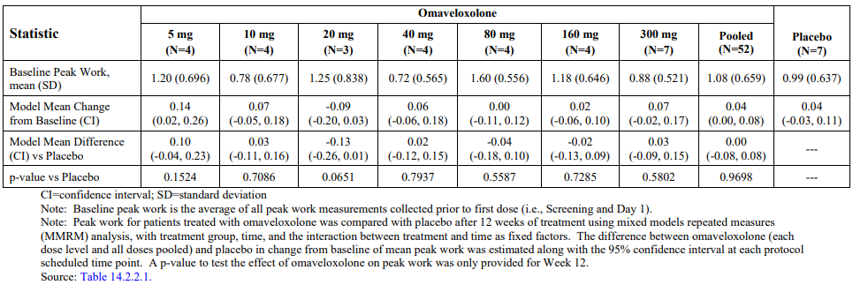
The secondary efficacy endpoint of change in mFARS score from baseline to week 12 is shown in table 19. No group reach statistical significance for reduction in mFARS compared to placebo, the 160mg dose had a mean change of -3.75 in mFARS score that did not reach statistical significance.
Table 19: Change from baseline at Week 12 in modified Friedreich’s Ataxia Rating Scale (mFARS) Score, all patients regardless of pes cavus status (ITT Population)
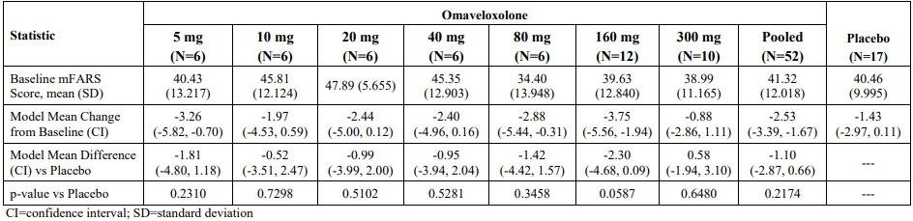
In the subgroup of patients without pes cavus there a statistically significant reduction from baseline compared to week 12 in the mFARS score of -5.96 (p=0.0112) in the 5mg treatment group and the same -5.96 (p=0.0112) was noted in the 160mg treatment group. No statistically significant reduction in mFARS scores in participants with pes cavus were noted (table 20).
Table 20: Change from baseline at week 12 in Modified Friedreich’s Ataxia Rating Scale (mFARS) score, patients without pes cavus (ITT Population)
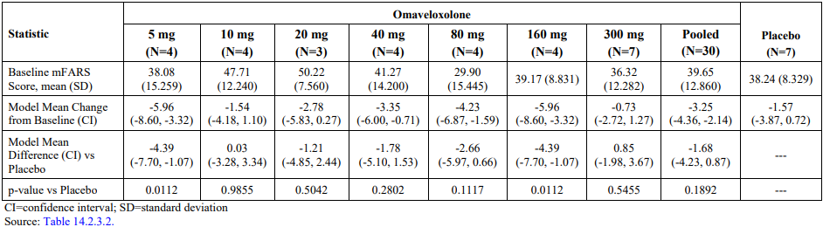
For all exploratory endpoints, changes from baseline were highly variable, and no clear dose-dependent or time-dependent trends were observed. None of the omaveloxolone treatment groups showed a statistically significant improvement compared with placebo at Week 12.

Study 1402 Part 2
This was the sponsor’s pivotal study in establishing safety and efficacy for use of omaveloxolone 150mg daily for the proposed indication in patients with FA.
Part 2 of this study was a randomized, placebo-controlled, double-blind, parallel-group study to evaluate the safety and efficacy of omaveloxolone 150 mg in patients with FA. The omaveloxolone dose of 150 mg was selected for Part 2 based on review by the Data Safety Monitoring Board (DSMB) and the sponsor of available data from part 1, including safety, efficacy, PK, and PD data. A total of 11 investigative sites (7 sites in the United States, 1 site in Australia, 1 site in Austria, 1 site in Italy, and 1 site in the United Kingdom) enrolled at least 1 patient. This study ran from 20 October 2017 to 31 October 2019.
Figure 11: Study 1402 Part 2 study design
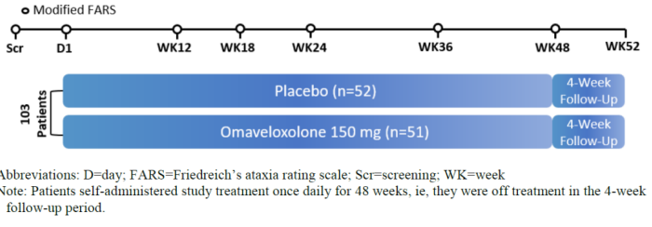
The sponsor has postulated that FA patients with pes cavus may have a different pathophysiology and clinical phenotype based on the results of part 1 of this study. This difference may result in difficulties using measures such as the mFARS (possibly due to increased difficulty with balancing and standing due to altered foot structure) score to detect improvements in the mFARS score in this FA population with pes cavus.
The sponsor states due to this possibility no more than 20% of FA participants enrolled in part 2 had pes cavus and randomization was stratified by pes cavus status.
The patients were randomized 1:1 to receive 48 weeks of omaveloxolone 150 mg or placebo. A total of 103 participants were randomized in this study. 51 participants were randomized to the omaveloxolone (150 mg) group, and 52 participants were randomized to the placebo group.
A total of 94 (91%) participants completed treatment through Week 48 of the study, including 44/51 (86.3%) randomized to the omaveloxolone group and 50/52 (96.2%) randomized to the placebo group. 4 (7.8%) in the omaveloxolone group and 2 (3.8%) in the placebo group discontinued treatment prior to week 48 due to occurrence of an adverse event (AE).
From study day 1 to end of week 48 participants were to self-administer 3 capsules (50mg) of omaveloxolone (or placebo) once daily, on an empty stomach (1 hour before meals or 2 hours after eating). A follow-up visits for safety occurred at Week 52 (4 weeks after the last dose). All study drug kits were packaged with blinded labels to maintain the study double-blind.
The primary objectives of part 2 of the study were to evaluate:
- change in the modified FA rating scale (mFARS) score at Week 48
- safety and tolerability of omaveloxolone.
The secondary objectives of part 2 were to evaluate:
- change in peak work during maximal exercise testing at Week 48
- Patient Global Impression of Change (PGIC) at Week 48
- Clinical Global Impression of Change (CGIC) at Week 48.
The exploratory objectives of part 2 were to:
- evaluate the distribution of change in mFARS scores at Week 48
- evaluate the change in the 36-Item Short-Form Health Survey (SF-36®) score
- evaluate the change in performance on a 9-hole peg test (9-HPT)
- evaluate the change in performance on a 25-foot timed walk test
- evaluate the change in the Friedreich’s Ataxia-Activities of Daily Living (ADL; FA-ADL) score
- evaluate the frequency of falls
- characterize the PK of omaveloxolone and potential metabolites after oral administration of omaveloxolone capsules.
In choosing the change in mFARS score as the primary efficacy endpoint, the sponsor states that the Friedreich's ataxia rating scale (FARS) is a validated 0- to 125-point scale consisting of assessment in 5 neurological domains that are each assigned a sub-score where a higher score indicates worse function. The mFARS ranges from 0 to 99 and includes 4 domains from the FARS examination (bulbar, upper limb coordination, lower limb coordination, and upright stability) but excludes the neurological section that is not considered clinically meaningful (i.e, peripheral nervous system assessments). The sponsor provided further justification for use of this tool as a primary efficacy endpoint in section 9.5.2 of the clinical study report.

Each section of the mFARS is outlined below:
- Subsection A: Bulbar Function – 4 assessments of speech, cough, and facial strength (maximum score = 11).
- Subsection B: Upper Limb Coordination – 5 assessments of coordination of movement and function in arms and hands with each limb being scored individually (maximum score = 36).
- Subsection C: Lower Limb Coordination – 2 assessments of coordination of movement and function of lower limbs with each limb being scored individually (maximum score = 16).
- Subsection E: Upright Stability – 9 assessments of sitting, standing, and walking; standing assessments are timed and performed up to 3 times (maximum score = 36).
The inclusion and exclusion criteria were identical to study 1402 part 1 (see study 1402 part 1 under efficacy heading for full criteria) except for a change in the second inclusion criteria of baseline mFARS score. For study 1402 part 2, this baseline mFARS score inclusion criteria were:
- Had an mFARS score ≥20 and ≤80.
- The average of the 2 mFARS values collected at Screening and Day 1 visits had to fall within the allowable range, and they must have been within 4.5 points of each other.
In all randomized population (n=103, this included participants with pes cavus) the baseline demographics showed a mean age of 24.1 years (minimum 16, maximum 40) in the placebo group and 23.4 years in the omaveloxolone group (minimum 16, maximum 39). 15 (28.8%) of participants were <18 years in the placebo group compared to 9 (17.6%) in omaveloxolone group.
There were 17 (32.7%) participants in the placebo group and 31 (60.8%) in the omaveloxolone group who were female.
Ethnicity was highly skewed with >95% in both the placebo and omaveloxolone treatment groups have a race label of white.
Weight and BMI were similar across treatment groups. Baseline mean (SD) mFARS score was 38.77 (11.03) in the placebo group and 40.94(10.39) in the omaveloxolone group.
Age of onset was similar between both treatment groups with a mean (SD) age at FA onset of 15.1 (5.34) years in the placebo group and 15.9 (5.74) years in the omaveloxolone group. Years since onset were also similar between treatment groups, with a mean (SD) year since onset of 4.7 (4.7) in the placebo group and 4.8 years in the omaveloxolone group. >90% of subjects in both treatment groups were ambulatory at baseline.
Overall, both treatment groups were well matched in terms of age, weight, baseline mFARS score, ambulatory status, age at FA onset and years since FA onset. There was a significant difference between treatment groups in gender with higher proportion of females in the omaveloxolone group compared to placebo.
Of note there was a significant difference in rates of known cardiomyopathy between treatment groups with 25 participants (49%) in the omaveloxolone group and 15 (28.8%) of in the placebo group having a history of cardiomyopathy.
The summary of analysis populations is shown in table 21. The statistical analysis techniques for the full analysis set (FAS) for the primary, secondary and other endpoints were:
- Primary endpoint: change from baseline of mFARS score at week 48. Difference between treatment groups in LS means were calculated MMRM model with no imputation.
- Key secondary endpoints: PGIC and CGIC at week 48 were analysed using an ancova model with imputation of missing values. Treatment based multiple imputation was used.
- Other secondary endpoints: nine-hole peg test (9-HPT) at Week 48, change in timed 25-foot timed walk test (T25-FWT) at Week 48, frequency of falls over 48 weeks, peak work during maximal exercise testing at Week 48, change in Activities of Daily Living (ADL) at Week 48. Difference between treatment groups were estimated using an MMRM model except for frequency of falls where a Poisson model was used.
- Intercurrent events were handled using “treatment policy strategy”, ICH E9(R1). I.e patients who discontinued either study treatment or the study itself were still followed up for mFARS assessments.
Two-sided p-values at a significance level of 5% were used. Test method was non-parametric rank sum test (Kruskall Wallis). A test hierarchy dealing with multiplicity was prespecified in the statistical analysis plan and is concordant with an overall test probability not to exceed 5%.
Table 21: Study 1402 Part 2: Summary of Analysis Populations for Efficacy Analyses
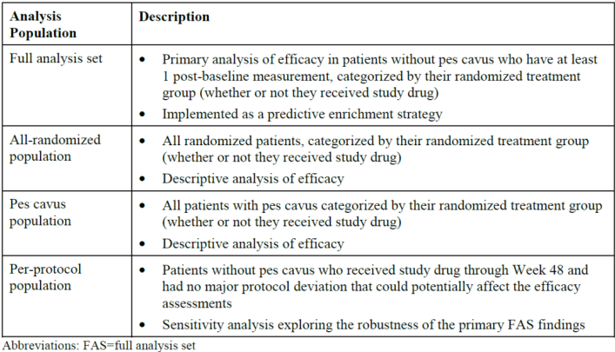
Sensitivity analyses were done throughout using alternative populations from the table 21. Additionally, multiple imputation with a control-based imputation strategy was done in the primary mFARS (MMRM) analysis to challenge the implicit MAR (missing at random) assumption. Tipping point analysis was also performed to investigate at which level the imputation would cancel the significant findings in the primary mFARS analysis.
There was a statistically significant reduction from baseline compared to week 48 in the least square (LS) mean mFARS score for the Full analysis population (without pes cavus) in the Omaveloxolone group compared to placebo with a LS mean difference of -2.40 (95% CI=-4.31, -0.50 and SE=0.956) with p-value=0.0141.

Baseline scores for each treatment group are shown in table 13. Patients randomized to omaveloxolone experienced a mean improvement from baseline in mFARS of - 1.55 points, while patients randomized to placebo experienced a mean worsening from baseline of mFARS of 0.85 points at Week 48 mFARS scores were conducted at regular intervals during the study period and the mFARS score results by visit are shown in figure 12. Omaveloxolone-treated patients experienced significant improvements from baseline in mFARS by Week 24 (mean ± SE: -1.66 ± 0.692 points; p = 0.0191) that persisted through Week 48.
Table 22: Modified Friedreich's Ataxia Rating Scale results and Least Squares (LS) mean change from baseline at week 48 (Full Analysis Population)
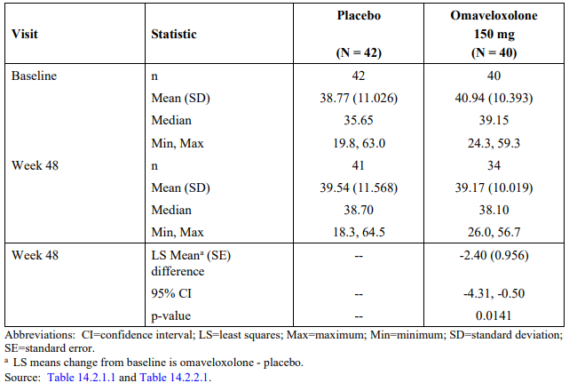
Figure 12: Modified Friedreich's Ataxia Rating Scale results by visit (Full Analysis Set)
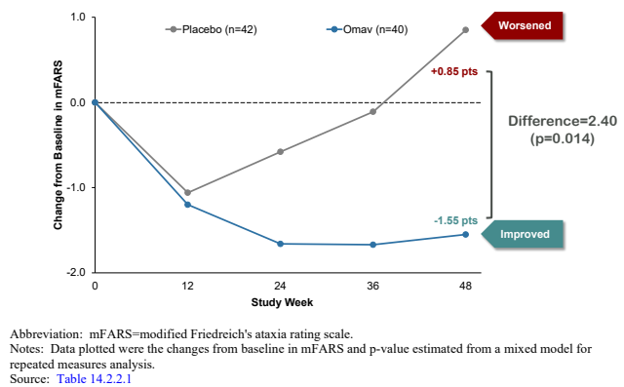
Prespecified analysis of the individual subsections of the mFARS showed that changes from baseline in each subsection of the mFARS (i.e., patients’ ability to speak/swallow [bulbar function], upper limb coordination, lower limb coordination, and upright stability) favoured omaveloxolone compared to placebo as shown in figure 13.
The key secondary endpoints, PGIC and CGIC scores at Week 48, were not statistically different for omaveloxolone compared with placebo in the FAS. PGIC and CGIC scores were numerically improved in omaveloxolone-treated patients (mean difference of -0.43, p = 0.1251; and - 0.13, p = 0.5199; respectively).
Figure 13: Study 1402 Part 2: Analysis of changes in mFARS subsections at week 48 (Full Analysis Set)
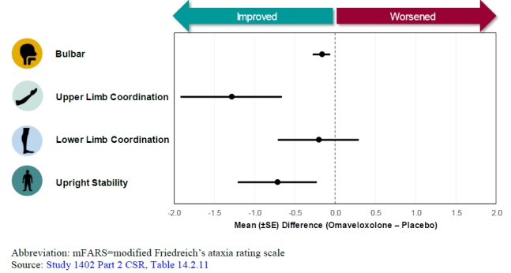
For the other key secondary outcome of change from baseline to week 48 in peak work, and exploratory outcomes of change from baseline to week 48 in: 9-hole peg test, 25-foot timed walk test, frequency of falls, there was no statistically significant difference between placebo and the omaveloxolone treatment group.
The only exploratory outcome that found a statistically significant difference between treatment groups was the mean total FA activities of daily living (FA-ADL) score over the study period. The LS mean change from baseline to week 48 was 1.14 ± 0.421 in placebo and -0.17 ± 0.45 for the omaveloxolone group. The between treatment group LS mean difference ± SE was -1.30 ± 0.629 with a p-value=0.04.
These other secondary and exploratory efficacy outcomes are shown in table 23.
Table 23: Other secondary and exploratory efficacy endpoints (Full Analysis Set)
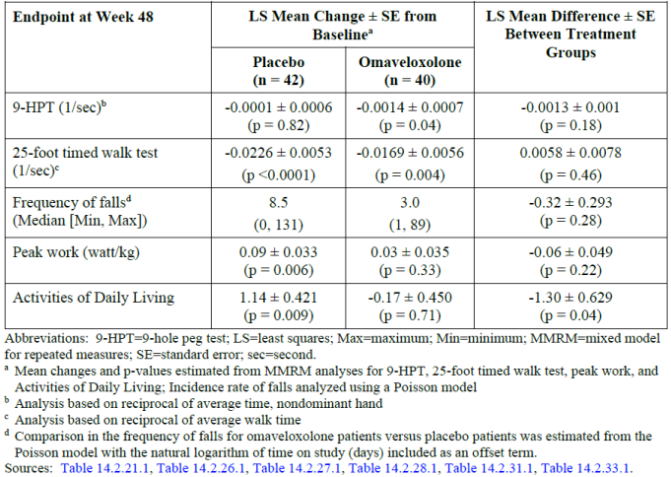
With inclusion of pes cavus patients in the all randomized population (ARP), omaveloxolone treatment improved mFARS by -1.93 points relative to placebo (n = 103; p = 0.0342). In the subset of participants with pes cavus omaveloxolone numerically improved mFARS relative to placebo by -1.19 points, but this was not statistically significant (n = 20; p = 0.5379). The reported worsening of PGIC by placebo-treated patients was more when the results from the pes cavus patients in the ARP were included. This resulted in a statistically significant improvement in PGIC at Week 48 for omaveloxolone-treated compared with placebo-treated patients (mean difference of -0.56, p = 0.0282).
Results comparing the key secondary outcomes between the full analysis set and the all ARP (which included participants with pes cavus) are shown in table 24.
Table 24: Study 1402 Part 2: Patient Global Impression of Change and Clinical Global Impression of Change responses at week 48
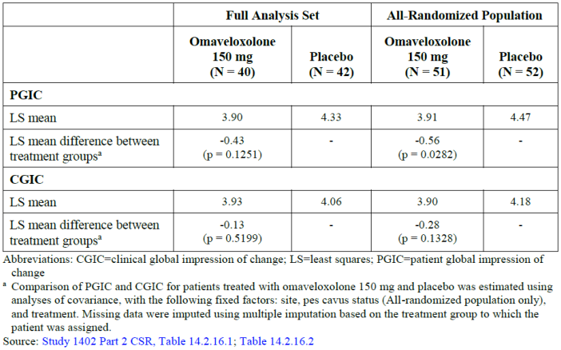
A sensitivity analysis was performed on the primary efficacy endpoint by performing a control based multiple imputation to assess the robustness in conclusion of the primary efficacy endpoint. The outcome of this sensitivity analysis supported the statistical significance of the primary endpoint. Additional post hoc analyses were performed to evaluate the effect of attrition and whether the timing of omaveloxolone missing data may have contributed to the separation in mFARS scores between the omaveloxolone and placebo groups. The results of this post-hoc analysis supported that the separation in mFARS scores over time in each treatment group was due to worsening in the placebo group, not dur to missing data.
Additional post hoc sensitivity analyses were performed to assess the impact of controlling for imbalances in baseline disease characteristics between the randomized cohorts. Accounting for a history of cardiomyopathy as a covariate in the model resulted in an improvement in mFARS of -2.65 points at Week 48 for omaveloxolone relative to placebo (p = 0.0064). Not all randomized patients had baseline GAA1 repeat length data, the inclusion of GAA1 repeat length as a covariate in the longitudinal model for the patients with available data (n = 31 for omaveloxolone and n = 36 for placebo) improved the treatment effect on mFARS with omaveloxolone, resulting in a difference between treatment groups of -3.36 points (p = 0.0017).
Inclusion of both covariates (i.e., history of cardiomyopathy and GAA1 repeat length) into the longitudinal model further improved the treatment effect with omaveloxolone, with a difference of - 3.48 points between treatment groups (p = 0.0012). Results from this sensitivity analysis are shown in figure 14.
Figure 14: Study 1402 Part 2: Analyses of change in mFARS from baseline at week 48 using the primary analysis MMRM methodology with additional baseline covariates (Full Analysis Set)
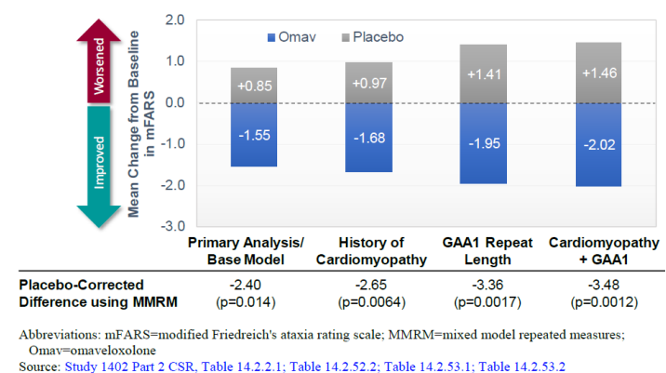
Improvements in mFARS favoured omaveloxolone across subgroups based on age, sex, ambulatory status, and GAA1 repeat length as shown in figure 15.
Figure 15: Study 1402 Part 2: Change in mFARS at week 48 in Pre-specified Subgroups
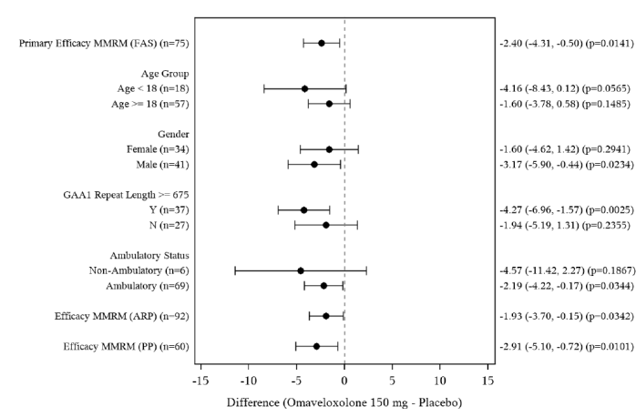

Responder analysis was performed with participants being categorized as: improved, stable or worsened in the primary and key secondary efficacy outcomes based on previously published rates of annual change in this population for these outcomes.
- Improvements were defined as changes from baseline ≤ −1.9 points for mFARS scores and
≤ 0.4 points for FA-ADL scores, and PGIC scores < 4.
- Stable scores were defined as changes from baseline between >−1.9 and −0.4 and 4.
- Worsening was defined as changes from baseline ≥ 1.9 points for mFARS scores and ≥ 0.4 points for FA-ADL scores, and PGIC scores > 4.
These results show that for the primary and key secondary outcomes of change from baseline mFARS score, FA-ADL score and PGIC score that there were an increased percentage of patient’s rated as ‘improved’ in the omaveloxolone treatment group compared to placebo (FAS) with a lesser percentage of patients being rated is ‘worsened’ in the omaveloxolone group compared to placebo. This is shown in table 25.
Table 25: Study 1402 part 2: Analyses of the proportion of patients who improved or worsened in primary and secondary measures at week 48 (Full Analysis Set)
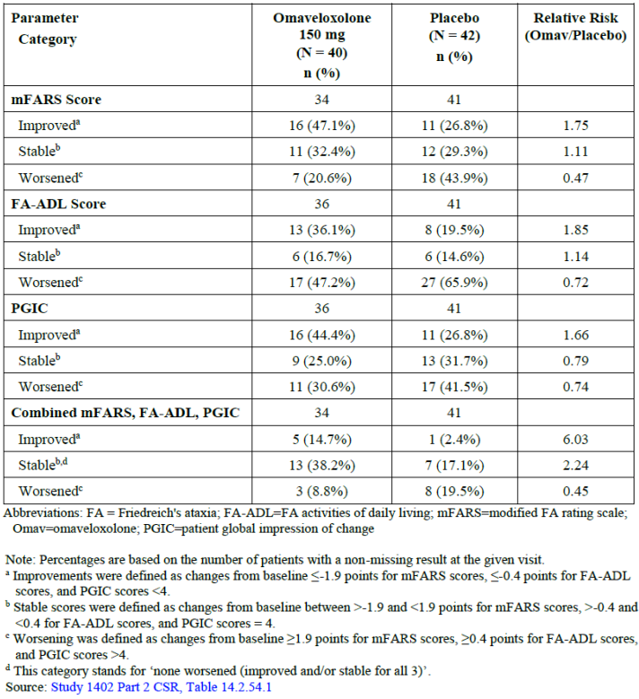

Study 1402 open label extension
Study 1402 is an open label extension (OLE) study is designed to assess long-term safety and tolerability of omaveloxolone in qualified patients with FA following completion of Study 1402 part 1 or Study 1402 part 2. Patients received open label omaveloxolone (150 mg) once daily until the drug was available through commercial channels or until patient withdrawal, whichever occurred first. First patient visit occurred on 10 October 2018 with database lock date of 24 March 2022.
Participants were assessed on day 1 of study 1402 extension, then week 4, week 24 and every 24 weeks thereafter. 149 participants were enrolled in study 1042 extension, 57 from 1042 part 1 and 92 from 1402 part 2. As of the interim database lock date of 24 March 2022, there were 123 (82.6%) continuing the study with 26 (17.4%) of participants who terminated early. The most common reason for study discontinuation was withdrawal by patient in 15 (10.1%) of cases followed by adverse events in 10 (6.7% of cases.).
Study participants disposition is shown in figure 16 with 106 participants designated as treatment naïve prior to study 1042 open label extension and 43 participants designated as continuing omaveloxolone.
Figure 16: Study 1402 patient disposition
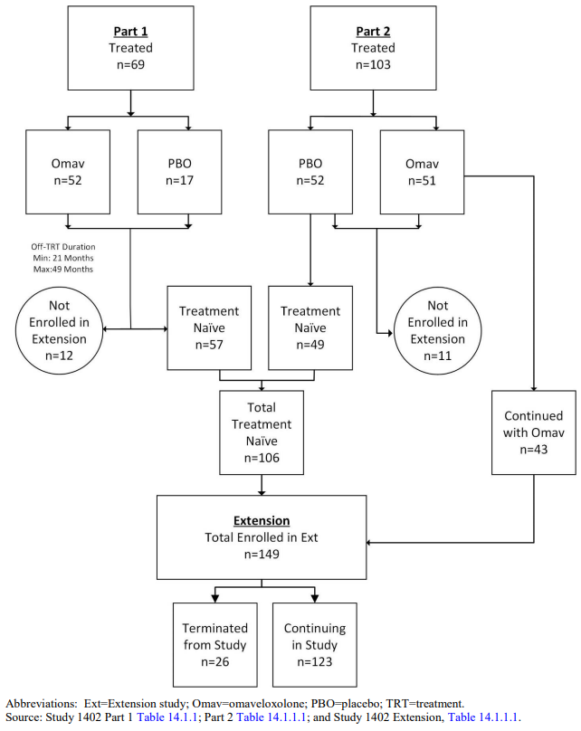
Regarding baseline demographics, patients were evenly distributed by sex in the Overall Omav group: 74 (49.7%) patients were female, and 75 (50.3%) patients were male.
The mean age (±SD) at baseline was 26.2 (±7.15) years. The majority of patients (92.6%, 138/149 patients) were ≥18 years of age; 11 (7.4%) patients were younger than 18 years. Regarding other baseline characteristics In the Overall Omav group, the mean (±SD) mFARS was 42.66 (±12.512) points, and the mean (±SD) ADL score was 12.50 (±4.980) points. The mean (±SD) age at onset of FA was 15.2 (±5.30) years and the mean (±SD) length of time since onset of FA was 11.0 (±5.35) years. Majority of patients were without pes cavus (104 [69.8%]), and 73 (49.0%) patients had a GAA1 repeat length ≥675.
Efficacy data within study 1402 extension was summarised descriptively with key efficacy endpoint data presented through to week 144 (table 26).
Table 26: Modified Friedreich’s Ataxia Rating Scale results and mean change from baseline by study visit (Safety Population)
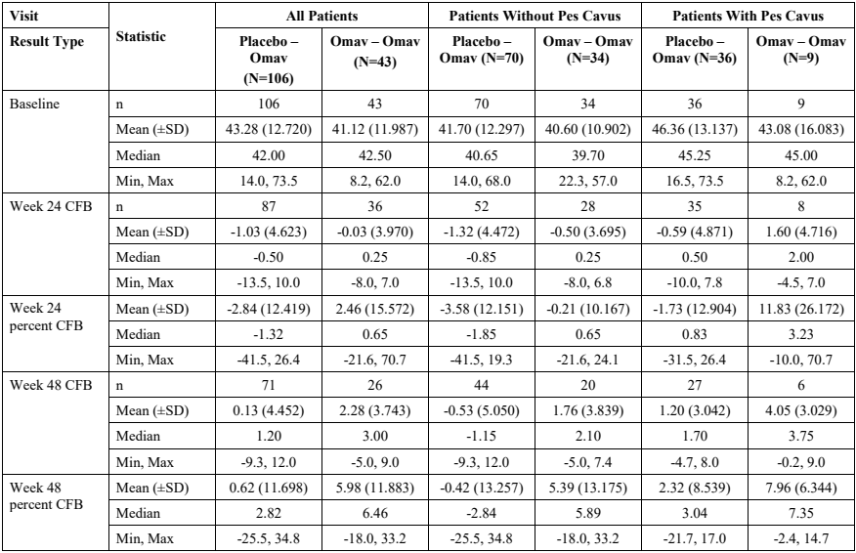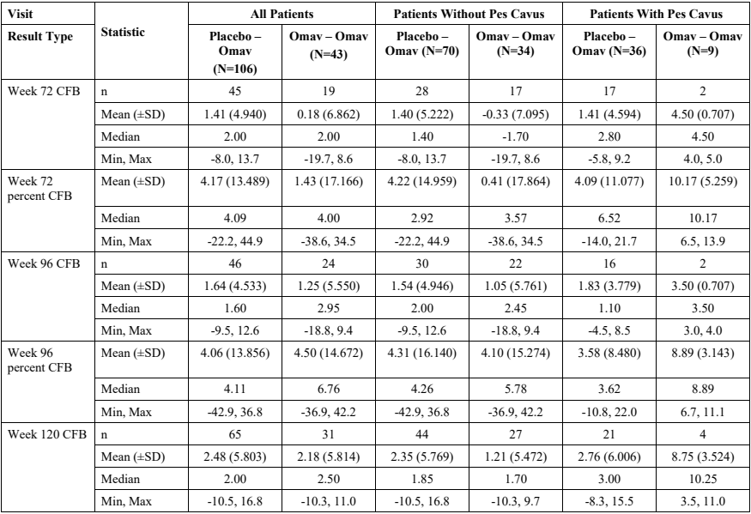
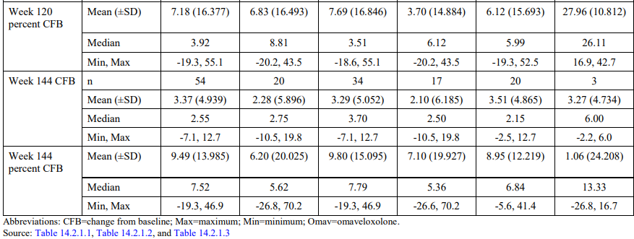
The key secondary efficacy endpoint in the pivotal trial was change in baseline of the PGIC and CGIC scores (PGIC and CGIC are 7-point scales that assess how much the patient’s illness has improved or worsened relative to baseline). PGIC and CGIC scores less than 4 represent some measure of improvement, scores greater than 4 represent some measure of worsening, and a score of 4 represents no change). Within all patient groups (regardless of pes cavus status), the Placebo-Omav group’s mean PGIC score was 3.5 at week 48, 3.9 at week 96, and 4.2 at week 144. For the Omav-Omav group, mean PGIC scores were week 24 (3.7), week 48 (3.5), week 96 (3.6), and week 144 (4.0). For the overall group of patients (regardless of pes cavus status), mean CGIC scores at week 48, week 96, and week 144 for the Placebo-Omav group were 3.5, 4.2, and 4.4, respectively. For the Omav-Omav group, mean CGIC scores at week 48, week 96, and week 144 were 3.6, 3.7, and 4.1, respectively.
Regarding the 9-hole peg test (9-HPT), the mean baseline values for average reciprocal time in units of 1/second to complete the 9-HPT using the nondominant hand, was 0.0188 seconds in the Placebo-Omav group and 0.0194 seconds in the Omav-Omav group. At week 48, the mean change was -0.0003 and -0.0007 seconds for Placebo-Omav group and the Omav-Omav group, respectively. At week 96, the mean change was -0.0010 and -0.0016 seconds in the Placebo-Omav group and the Omav-Omav group, respectively, while at week 144, the mean change was -0.0020 and -0.0024 seconds for the Placebo-Omav group and the Omav-Omav group, respectively.
Regarding results for activities of daily living (ADL) (lower scores in the ADL survey suggest improved function), baseline values for the mean total ADL score were similar in both prior treatment groups (12.698 in the Placebo-Omav group and 12.000 in the Omav-Omav group). Changes from baseline in total ADL score for the Placebo-Omav group at Week 48, Week 96, and Week 144 were 0.390, 1.405, and 1.873, respectively. Changes from baseline in total ADL score for the Omav-Omav group at Week 24, Week 48, Week 96, and Week 144 were -0.068, 0.212, 1.692, and 1.286, respectively.
Regarding the 25-foot timed walk test, at baseline, the mean value for average reciprocal time (units in 1/second) to complete the 25-foot walk test was 0.1102/second in the Placebo-Omav group and 0.1164/second in the Omav-Omav group. At week 48, the mean change from baseline was - 0.0143/second in the Placebo-Omav group and -0.0199/second in the Omav-Omav group. At week 96, the mean change from baseline was -0.0212/second in the Placebo-Omav group and - 0.0329/second in the Omav-Omav group. At week 144, the mean change from baseline was - 0.0294/second in the Placebo-Omav group and -0.0412/second in the Omav-Omav group.

Study 1403
This was a phase II, Randomized, placebo-controlled, double-blind, dose-ranging study conducted in patients with mitochondrial myopathy.
Efficacy outcomes in this study were related to patients diagnosed with mitochondrial myopathy. It is acknowledged that mitochondrial myopathy may share some overlapping features given the clinical features of Friedrich’s Ataxia are thought to result from mitochondrial dysfunction. However, the Delegate considers Friedrich’s Ataxia and mitochondrial myopathies distinct disease entities, therefore the efficacy outcomes of this trial have not been evaluated in this assessment.

Safety
The pivotal submission package to support approval of omaveloxolone includes the 2 randomized, placebo-controlled, double-blind portions of Study 1402 in patients with Friedrich’s Ataxia (Study 1402 Part 1 and Study 1402 Part 2), and data from Study 1402 Extension, which is open-label and informs long-term safety.
The pivotal and supportive clinical studies for the proposed indication of omaveloxolone for the treatment of Friedrich’s Ataxia in this integrated safety summary (ISS) include the studies 1042 part 1 and part 2 as well as study 1042 extension.
Definitions of the safety analysis set A, analysis set B and set C are shown below:
- Primary Placebo-Controlled Analysis Set A (hereafter referred to as ’Analysis Set A’) (103 patients: 51 omaveloxolone and 52 placebo): Includes data from Study 1402 part 2 in patients with FA. This analysis set is considered the primary analysis set for the proposed labelling, as it provides a placebo comparison and the proposed marketed dose and formulation of omaveloxolone. Summaries include placebo and omaveloxolone 150 mg.
- Friedrich’s Ataxia Overall Omaveloxolone Exposure Integrated Analysis Set C (hereafter referred to as ’Analysis Set C’) (165 patients: all omaveloxolone): Includes data from all omaveloxolone-treated patients (no placebo-treated patients) regardless of dose from all studies in patients with FA (i.e., Study 1402 part 1, Study 1402 part 2, and Study 1402 Extension). All phases of treatment are included (i.e., on or after treatment). In these analyses, doses are assessed categorically, as 5 to 20 mg, 40 to 80 mg, 150/160 mg, and 300 mg, and were combined to characterize patients treated with any omaveloxolone dose for any duration. This analysis set was assessed to confirm the safety profile of Analysis Set A.
- Long-Term Safety Study 1402 Subgroup Set D (Analysis Set D) (51 patients: 51 omaveloxolone): Includes all omaveloxolone-treated patients (no placebo-treated patients) who enrolled in Study 1402 part 2 and were randomized to omaveloxolone. Patients who completed Study 1402 part 1 and patients who were randomized to placebo in Study 1402 part 2 are not included in this subgroup. The results summarize the entire patient exposure on omaveloxolone in Study 1402 part 2 and Study 1402 Extension. This analysis set was assessed to confirm the long-term safety of omaveloxolone 150 mg QD.
Table 27 shows the number of people exposed to the capsule formulation of omaveloxolone during the clinical development program, this includes 2 open label oncology studies.
Table 27: total number of individuals exposed to capsule formulation of omaveloxolone
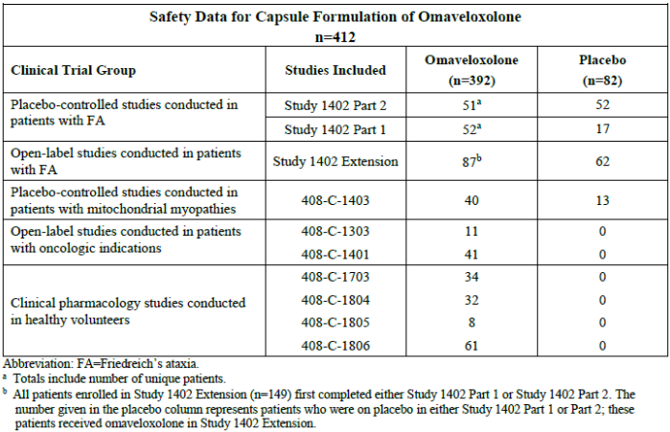
Table 28 shows the total exposure to omaveloxolone in patients who were enrolled in the placebo-controlled study 1402 part 2 (analysis set A) and patients in the overall omaveloxolone exposure integrated analysis set C (analysis set C), which includes data from all omaveloxolone treated patients regardless of dose from all studies in patients with FA.
Table 29 shows the extent of exposure to omaveloxolone in the adolescent age group for analysis sets A and C.
Table 28: Exposure in Analysis Sets A and C (All Patients)
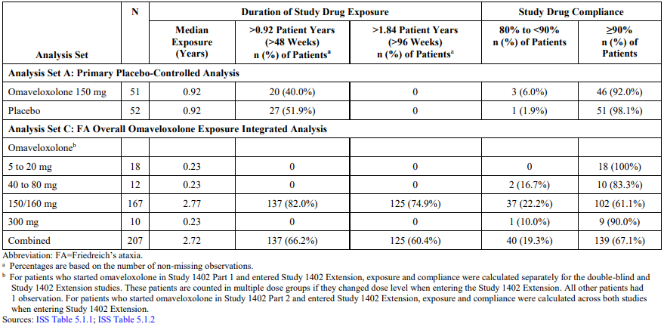
Table 29: Adolescent exposure in Analysis Sets A and C (All Patients)
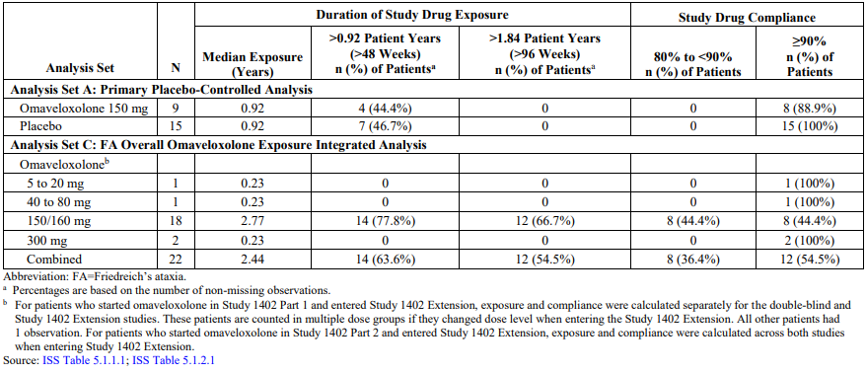

Safety analysis study 1402 part 1
Study design and methodology are further discussed in section ‘study 1402 part 1’ under efficacy heading.
In terms of overall investigational medicinal product (IMP) exposure for all dose groups, the duration of drug exposure was between 65.5 and 84.5 days. The summary of drug exposure by treatment group is shown in table 30.
Table 30: Summary of drug exposure by treatment group
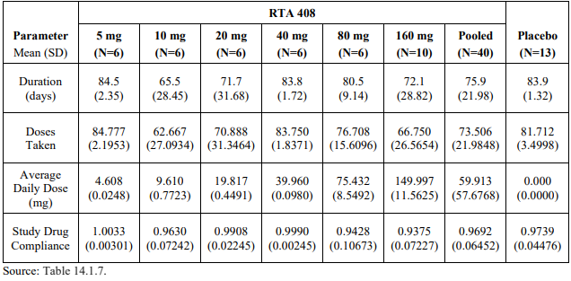
Treatment-emergent adverse events (TEAE) occurring in ≥ 2 patients in any dose group overall (i.e., regardless of pes cavus status) are summarized in Table 31. The most common TEAE was upper respiratory tract infection (22/52 patients, 42.3% in the pooled omaveloxolone group and 1/17 patients, 5.9% in the placebo group). No reported TEAEs of upper respiratory tract infection were considered related to omaveloxolone treatment by the investigator. The most frequent TEAEs considered related to omaveloxolone by the investigator (pooled omaveloxolone group) were diarrhea, increased ALT, and increased AST (6 patients, 11.5% each) and increased GGT and fatigue (4 patients, 7.7% each).
Table 31: Treatment-emergent Adverse Events (TEAEs) occurring in ≥ 2 Patients in Any Dose Group Overall (Regardless of Pes Cavus Status)
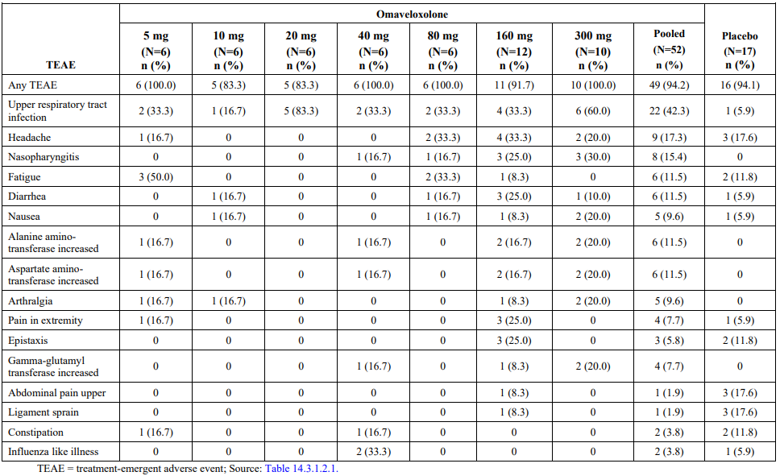
Two patients, both in the placebo group, reported serious adverse events (SAE): one patient was hospitalized for moderately severe drug withdrawal syndrome (benzodiazepine) and one patient suffered 3rd degree burns and was hospitalized to undergo skin graft surgery. Neither event was considered by the investigator or sponsor to be related to the study drug.
One male patient in the omaveloxolone 40 mg group permanently discontinued the study drug because of a TEAE of generalized rash, with onset approximately 20 days after starting the study drug. The rash was considered moderate in severity and probably related to the study drug by the investigator. The patient was treated with diphenhydramine hydrochloride and methylprednisolone, and the event resolved approximately 25 days after onset.
Two TEAEs in the cardiac disorders system organ class, palpitations, and tachycardia, were reported in one patient receiving omaveloxolone 160 mg (0 TEAE of palpitations or tachycardia occurred in placebo group). Neither of these events was considered related to study treatment by the investigator, and both events resolved without treatment.
Table 32 shows TEAE laboratory abnormalities. It is noted that in the pooled Omaveloxolone group there was alanine aminotransferase (ALT) in 6 (11.5%) compared to 0 in the placebo group. Aspartate aminotransferase was also increased in 6 (11.5%) in the pooled omaveloxolone group compared to placebo. For both groups, 4/6 events of raised AST and ALT occurred in the 160mg and 300mg groups (2 in each group). Gamma-glutamyl transferase was increased in 4 (7.7%) in the pooled omaveloxolone group compared to 0 in placebo, 3/4 events of increased GGT were in the 150mg and 300mg groups (1 in 160mg group, 2 in 300mg group). Increased blood creatinine kinase (CK) levels were reported in 1 patient in the 300mg group compared to 0 in placebo.
All of those related to serum chemistry values were considered related to study drug by the investigator. All of the TEAEs related to laboratory values were mild in severity, except for increased blood creatinine phosphokinase, which was considered moderate in severity.
Table 32: Treatment-emergent Adverse Events related to laboratory abnormalities
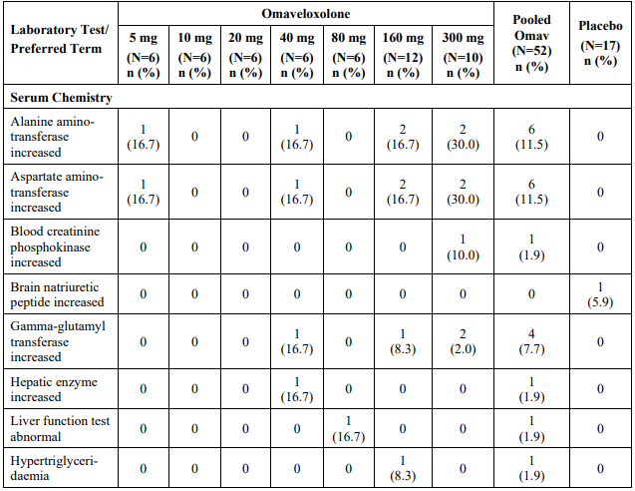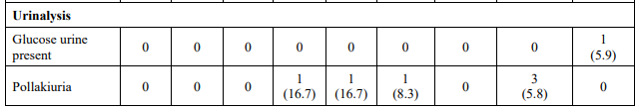
Five patients treated with omaveloxolone (3 in the 160 mg group and 2 in the 300 mg group) exceeded the threshold criterion of ALT or AST > 5x the upper limit of normal during the study. In all 5 patients, the increases occurred early in the study (on or before Week 4), and ALT and AST values were below this threshold limit by Week 8. In 3 of these patients (1 in the 160 mg group and 2 in the 300 mg group), the increases in ALT and AST (as well as increased GGT) were reported as TEAEs, all of which were mild in severity, considered possibly related to the study drug by the investigator, and recorded as DLTs. Total bilirubin levels did not increase in these patients. Hy’s Law criteria was not met by any patient in the study.

Safety analysis study 1402 part 2 (Analysis Set A)
Study design and methodology are further discussed in section ‘study 1402 part 2’ under efficacy heading.

Baseline characteristics of patients in analysis set A (primary placebo-controlled analysis) from the randomized placebo-controlled study 1042 part 2 included a total of 103 patients with 51 in omaveloxolone group and 52 in placebo group who received a daily omaveloxolone dose of 150mg.
Mean age in the omaveloxolone group was 23.4 years, which was similar to the placebo group mean age of 24.1 years. 9(17.6%) patients were <18 years old in omaveloxolone group compared to 15 (18.8%) <18 years old in placebo group (table 33).
Table 33: Age of patients in Safety Analysis Set A
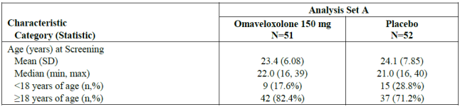
Other baseline demographics of patients in Analysis Set A are presented in table 34. 20 (39.2%) were male in the omaveloxolone group compared to 35 (67.2%) of patients being male in placebo group. A history of cardiomyopathy was noted in 25 (49%) of patients in omaveloxolone group compared to 25 (28.8%) in the placebo group.
Table 34: Baseline demographics of patients in Analysis Set A
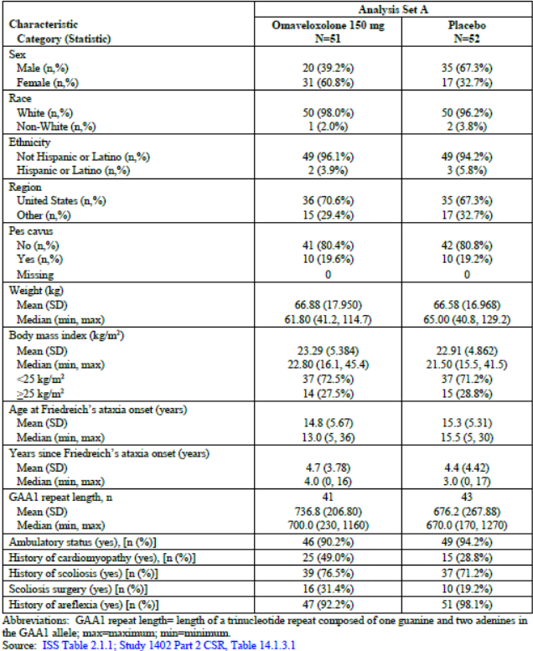
Regarding patient disposition, 7 (13.7%) discontinued from the omaveloxolone group compared to 2 (3.8%) in placebo group. In the placebo group, both patients withdrew due to AE. In the omaveloxolone group, 4 patients withdrew due to AE and 3 due to ‘withdrawal by patient’.
As outlined in table 35, 37 (72.5%) of patients in the omaveloxolone group experienced a TEAE deemed related to study drug, compared to 19 (36.5%) in the placebo group. Serious TEAE’s were experienced by 5 (9.8%) in the omaveloxolone group compared to 3 (5.8%) in the placebo group. Severe TEAE were reported in 5 (9.8%) in the omaveloxolone group compared to 0 in the placebo group. No death occurred during study 1402 part 2.
Table 35: Overall summary of TEAE’s (Analysis Set A)
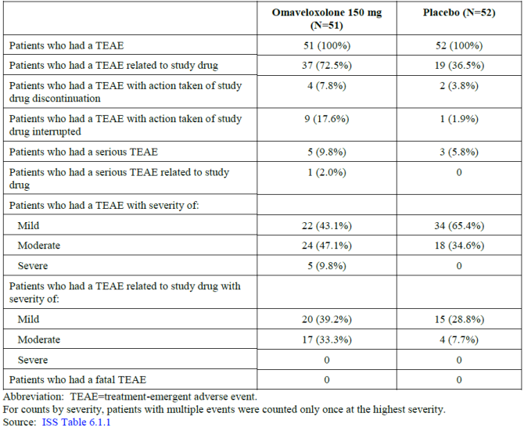
As shown in table 36 the most frequent TEAEs were reported in the system organ class (SOC) of gastrointestinal disorders (60.8% in the omaveloxolone treatment group and 36.5% in the placebo group). Nausea was the most frequent preferred term (PT) within the SOC (33.3% and 13.5%, respectively) followed by Diarrhoea (19.6% and 9.6%, respectively) and vomiting (15.7% and 11.5%, respectively). Abdominal pain upper (9.8% vs. 1.9%) and abdominal pain (7.8% vs. 1.9%) were also reported more frequently in the omaveloxolone treatment group.
Within the SOC of nervous system disorders (39.2% and 19.2%, respectively), headache was the most common PT and reported more frequently in the omaveloxolone treatment group (37.3% vs. 25.0%). Headache is included in the ADR table in the SmPC. Dyskinesia and somnolence were reported in 2 (3.9%) patients in the omaveloxolone treatment group and 0 in the placebo group.
Table 36: Summary of TEAE with incidence of ≥2% and excess in the omaveloxolone treatment group over the placebo group (primary placebo-controlled analysis set A)
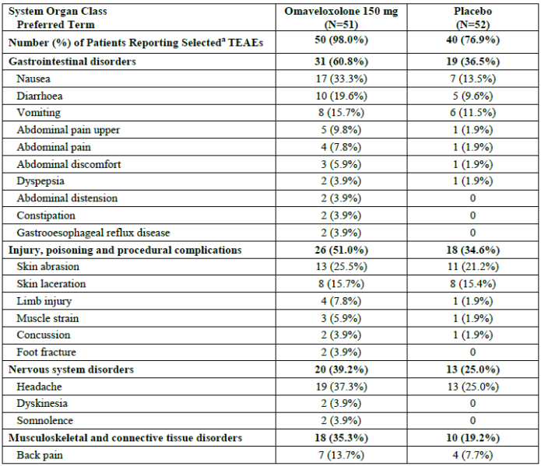
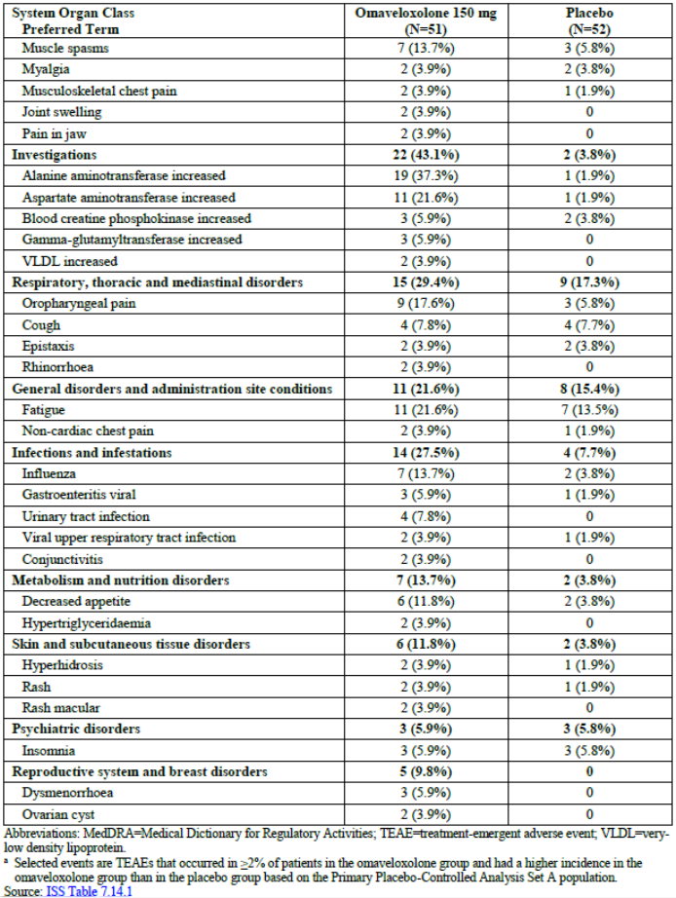
In the SOC Injury, poisoning and procedural complications (51.0% in the omaveloxolone treatment group and 34.6% in the placebo group), PTs were overall balanced between the omaveloxolone treatment group and placebo treatment group except for limb injury (7.8% vs. 1.9%), muscle strain (5.9% vs. 1.9%) and skin abrasion (25.5% vs. 21.2%). Within the SOC Musculoskeletal and connective tissue disorders (35.3% vs. 19.2%) Back pain was the most frequent reported PT (13.7% vs. 7.7%) followed by muscle spasms (13.7% vs. 5.8%).
Within the SOC Investigations (43.1% vs. 3.8%) Alanine aminotransferase increased (37.3% vs. 1.9%), Aspartate aminotransferase increased (21.6% vs. 1.9%), Gamma-glutamyl transferase increased (5.9% vs. 0%) and VLDL increased (3.9% vs. 0%) were reported more frequent in the omaveloxolone treatment group compared to the placebo group.
In the SOC Respiratory, thoracic and mediastinal disorders (29.4% vs. 17.3%), oropharyngeal pain (17.6% vs. 5.8%) and rhinorrhoea (3.9% vs. 0%) were reported more frequently in the omaveloxolone treatment group compared to the placebo group.
In the SOC infections and infestations (27.5% vs. 7.7%), influenza was the most frequently reported PT in the omaveloxolone treatment group (13.7% vs. 3.8%) followed by urinary tract infection (7.8% vs. 0%) and gastroenteritis viral (5.9% vs. 1.9%). Conjunctivitis was reported more frequently in the omaveloxolone treatment group compared to the placebo group (3.9% vs. 0%).
Decreased appetite (11.8% vs. 3.8%) and hypertriglyceridaemia (3.9% vs. 0%) were reported more frequently in the omaveloxolone treatment group compared to the placebo group within the SOC metabolism and nutrition disorders categories (13.7% vs. 3.8%). Rash macular (3.9% vs. 0%) was reported more frequently in the omaveloxolone treatment group compared to the placebo group in the SOC Skin and subcutaneous tissue disorders (11.8% vs. 3.8%).
The majority of the most common TEAEs in either group were mild to moderate in severity. Five (9.8%) omaveloxolone-treated patients experienced 6 severe TEAEs (contusion, skin laceration, migraine, blood creatine phosphokinase increased, suicidal ideation and hydrocele). Two severe TEAEs were in adolescent patients (hydrocele in 1 patient and contusion and skin laceration in 1 patient).

Evaluation of weight
Decrease in weight was gradual and only apparent after 24 weeks of treatment in Study 1402 part 2, and weight decreases with omaveloxolone treatment were more pronounced in patients with higher baseline BMI (≥25 kg/m2). Mean change from baseline to Week 48 was -1.35 ± 3.585 kg for omaveloxolone treated patients and 1.17 ± 4.108 kg for placebo-treated patients after 48 weeks of treatment. Relative to baseline, 34.0% (n=17) of the omaveloxolone-treated patients showed at least 5% weight loss, and 12.0% (n=6) of omaveloxolone treated patients showed at least 7% weight loss. Mean weight change during the first 24 weeks of omaveloxolone treatment was not meaningfully different from placebo. The mean changes in weight for adolescent patients treated with omaveloxolone were similar to that of adolescent patients treated with placebo.
Figure 17 Mean change from baseline to week 48 in weight (kg) (primary placebo-controlled Analysis Set A)
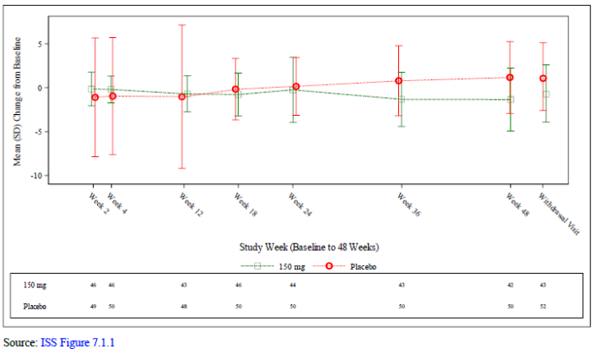

Table 37: Summary TEAE occurring in ≥10% of patients in the omaveloxolone group with a difference in incidence of ≥2% in the omaveloxolone treatment group over placebo group (primary placebo-controlled analysis set A)
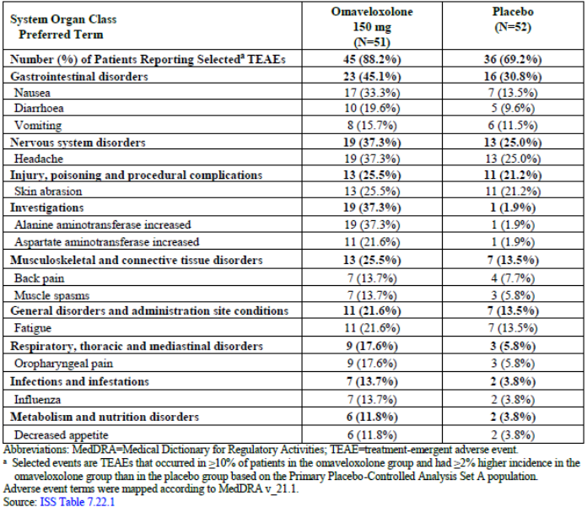
As shown in table 37 the TEAEs occurring in ≥10% of omaveloxolone-treated patients and with a difference in incidence of ≥2% between omaveloxolone-treated patients and placebo-treated patients in Analysis Set A included nausea, diarrhea, vomiting, headache, skin abrasion, ALT increased, AST increased, back pain, muscle spasms, fatigue, oropharyngeal pain, influenza, and decreased appetite.
Common TEAEs were reported at a similar proportion in omaveloxolone-treated adolescent and adult patients, with the exception of headache (0% of adolescent patients versus 45.2% of adult patients), ALT increased (0% of adolescent patients versus 45.2% of adult patients), AST increased (0% of adolescent patients versus 26.2% of adult patients), influenza (0% of adolescent patients versus 16.7% of adult patients), and muscle spasms (0% of adolescent patients versus 16.7% of adult patients).
The majority of the most common TEAEs in either group were mild to moderate in severity. Five (9.8%) omaveloxolone-treated patients experienced 6 severe TEAEs (Contusion, Skin laceration, Migraine, Blood creatine phosphokinase increased, Suicidal ideation and Hydrocele). Two severe TEAEs were in adolescent patients (hydrocele in 1 patient and contusion and skin laceration in 1 patient). No severe event occurred in more than 1 patient and none of the severe events were considered related to study drug. 0 patients in the placebo group experienced a severe TEAE.
Figure 18: Plot duration of AEs with incidence ≥2% and excess in omaveloxolone treatment group (Analysis Set A)
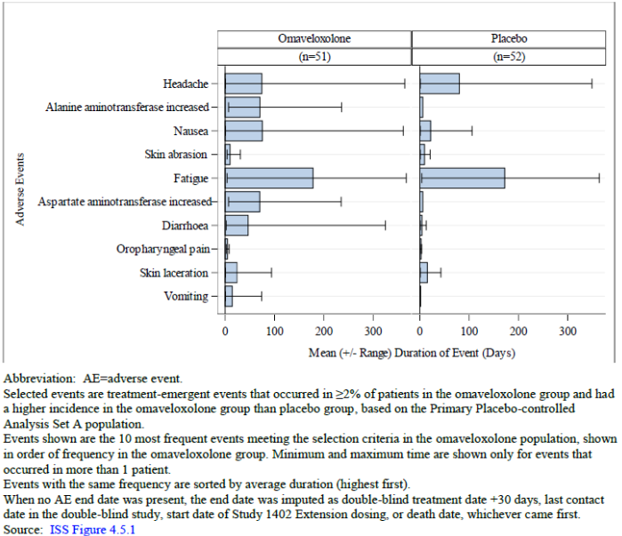
Nausea (75.3 vs. 22.0 days) and diarrhoea (46.7 vs. 4.4 days) had a longer mean duration in the omaveloxolone treatment group compared to placebo. However, most TEAEs resolved within 2 months of the event start date.
Patients were followed during a treatment withdrawal period to investigate the effects of omaveloxolone after treatment cessation, this was done during the 4-week off-treatment period after completion of 48 weeks of dosing in Study 1402 Part 2 prior to the patients had receiving their first dose in Study 1402 Extension. The TEAEs reported during the study drug withdrawal period were balanced between omaveloxolone-treated (29.4%) patients and placebo-treated (28.8%) patients. No new imbalances were observed.
No deaths were reported in the FA studies. Across the entire omaveloxolone development program, 7 deaths were reported, all in oncology studies in patients with stage 4 cancer.
A total of 5 (9.8%) of patients in the omaveloxolone group and 3 (5.8%) of patients experienced a serious TEAE during the study period. These events are shown in table 38.
Table 38: Serious TEAE’s by SOC and PT
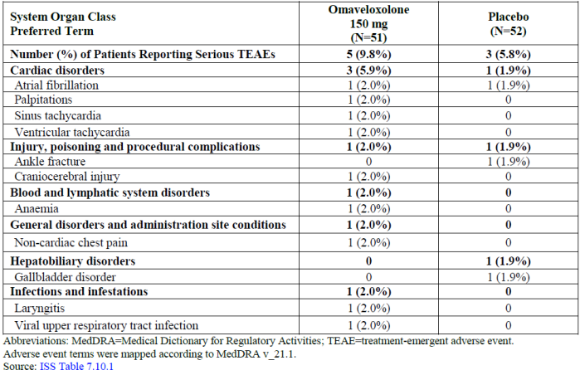

Safety topics of interest
Based on the pharmacological properties of omaveloxolone, the following were closely monitored during the development program:
- Hepatic safety was evaluated because of observed transient aminotransferase elevations in omaveloxolone clinical trials.
- Weight changes were evaluated since the target of omaveloxolone, Nrf2, affects cellular metabolism.
- Infections and infestations were evaluated because of the anti-inflammatory effects associated with Nrf2 activation that could possibly lead to a decreased immune response.
- Cardiovascular safety was evaluated because cardiomyopathy is common in patients with FA.

Hepatic safety
In omaveloxolone-treated patients, peak elevations in serum ALT were observed at Week 2, with values decreasing toward baseline values through Week 48 (figure 19). In contrast, serum ALT concentrations in placebo-treated patients remained unchanged throughout the 48-week treatment period, with mean serum ALT concentrations remaining below 25 U/L. Increases in ALT during omaveloxolone treatment appeared reversible, with mean serum ALT concentrations declining toward baseline values within 4 weeks following drug withdrawal.
Figure 19: Mean absolute Alanine aminotransferase level (U/L) (ALT), baseline to week 48 (primary placebo-controlled analysis set A)
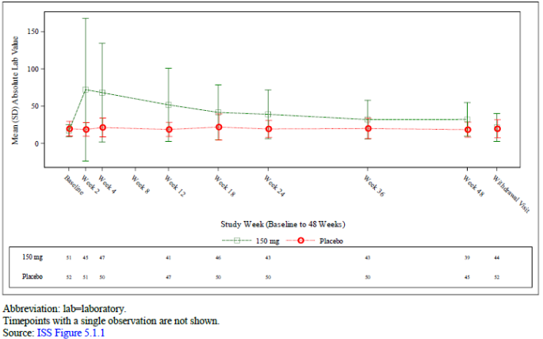
One omaveloxolone-treated patient had ALT values ≥10× ULN. The patient discontinued study drug due to protocol-specified criteria. As shown in table 39 and figure 19, ALT values tended to be raised earlier in the first 18 weeks of treatment with mean ALT values trending downwards closer to baseline by the end of the study period. Table 39 shows that 4-weeks after study drug withdrawal 4 (7.8%) patients with baseline ALT ≤upper limit of normal (ULT) had ALT levels ≥ULN to ≤3xULN. Increases in ALT were asymptomatic and not associated with increases in total bilirubin. None of the omaveloxolone-treated patients had maximum ALT or total bilirubin values that met potential Hy’s law criteria (i.e., ALT ≥3× ULN and total bilirubin >2× ULN). adolescent patients had similar transient increases in ALT, with the magnitude of increases was less than that observed in the adult population.
Table 39: Change from baseline ALT values in omaveloxolone treated patients: maximum on treatment values compared to values after 4-week withdrawal
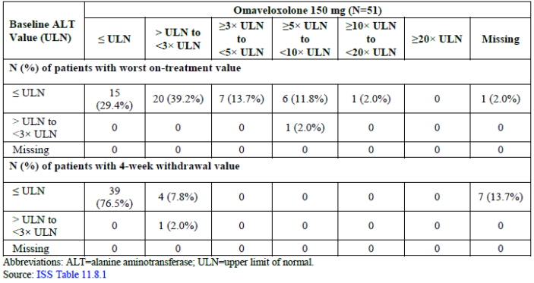
In omaveloxolone-treated patients mean absolute peak elevations in serum AST were observed at Week 2, with values decreasing toward baseline values through Week 48. Serum AST concentrations in placebo-treated patients remained unchanged throughout the 48-week treatment period, with mean serum AST concentrations remaining below 25 U/L. Mean serum AST concentrations were near-baseline values within 4 weeks following drug withdrawal. This is shown in figure 20.
Figure 20: Mean absolute AST (U/L) from baseline to week 48 (primary placebo-controlled analysis set A)
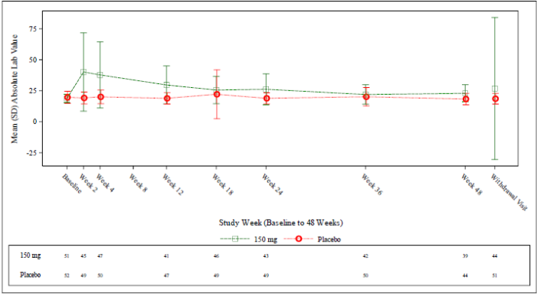
4/51 (7.8%) omaveloxolone-treated patients had maximum AST values ≥3× ULN at some time during the treatment period, AST values returned to near-baseline levels in the majority of patients after the 4-week off-treatment follow-up period. The 7 patients with missing values at the end of the 4-week off-treatment period all had AST values that were ≤ULN at their last on-treatment assessment. Adolescent patients also had transient increases in AST, but the magnitude of increases was smaller than that observed in the adult population.
In omaveloxolone-treated patients, mean decreases from baseline in total bilirubin were observed. The decreases in total bilirubin were apparent within the first few weeks after treatment initiation, remained lower than baseline values through Week 48, and returned to baseline after drug withdrawal. In contrast, mean serum total bilirubin in placebo-treated patients remained unchanged throughout the 48-week treatment period. This is shown in figure 21.
1 (2.0%) patient in the omaveloxolone-treated patient group had maximum bilirubin values > ULN at some point during the treatment period, none exceeded 2× ULN, and total bilirubin concentrations returned to below the ULN within 4 weeks of stopping treatment.
Adolescent patients treated with omaveloxolone also had similar decreases in total bilirubin but to a smaller extent than the adult population and had mean total bilirubin values that were similar to placebo-treated adolescent patients at Week 48.
It is noted that there was a reported event of hepatic steatosis as outlined below:

A male patient in Study 1402 Extension reported a mild TEAE of hepatic steatosis starting on Study Day 120. The TEAE was considered to be possibly related to study drug by the investigator; no changes to study drug administration were made, and no resolution date of the TEAE was provided.
Figure 21: Mean absolute total bilirubin levels (mg/dL) baseline to week 48 (Primary placebo-controlled Analysis Set A)
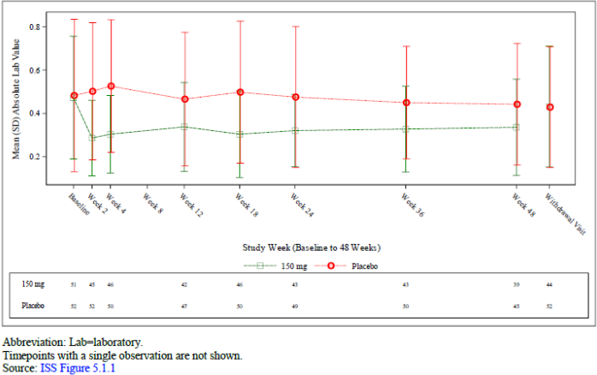
Figure 22 shows the eDISH plot for analysis set A. None of the omaveloxolone-treated patients had maximum ALT or total bilirubin values that met potential Hy’s law criteria (i.e., ALT ≥3× ULN and total bilirubin >2× ULN).
Figure 22: Maximum total bilirubin versus Alanine aminotransferase levels (primary placebo-controlled Analysis Set A)
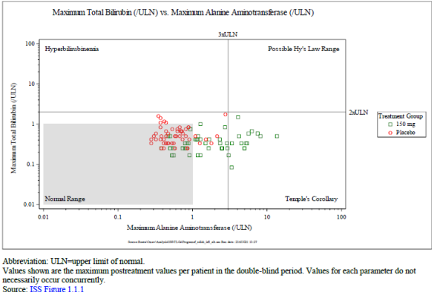

Evaluations for infections and infestations
TEAEs in the Infections and infestations SOC for Analysis Set A are presented in Table 40.
Two SAEs in the Infections and infestations SOC were reported in Analysis Set A, 1 event of laryngitis and 1 event of viral upper respiratory tract infection that were experienced in the same patient:
A female patient had an SAE of moderate laryngitis from Study Days 166 to 189. The SAE was considered to be unlikely related to study drug, and study drug was not changed. The patient also had an SAE of moderate viral upper respiratory tract infection from Study Days 166 to 189. The SAE was considered to be unlikely related to study drug, and no changes to study drug were made.
Overall, 66.7% of the omaveloxolone treated patients reported TEAEs within the SOC infections and infestations compared to 57.7% of the placebo treated patients. None of the Infections and infestations TEAEs were considered severe. Further Rates in each treatment group of infection and infestation by PT are outlined under table 40.
Table 40: Summary of infections and infestations TEAEs (primary placebo-controlled Analysis Set A)
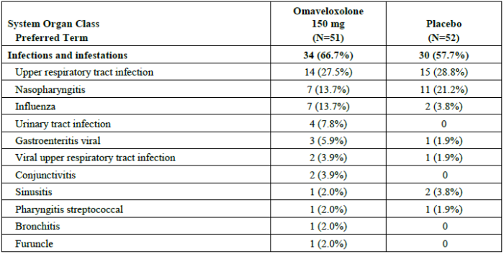
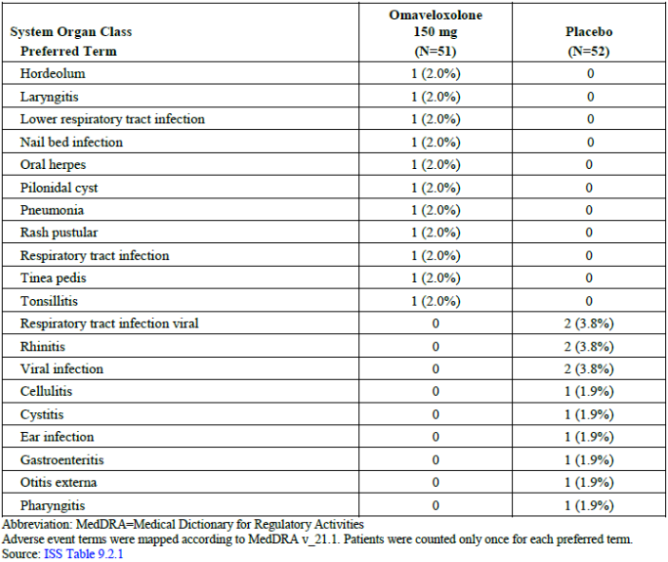

Evaluation of cardiovascular safety
Cardiovascular safety was evaluated as cardiomyopathy is a common comorbid condition for patients with FA. In these patients, heart failure and arrhythmia are common causes of death. In an early study with another NrF2 activator, bardoxolone methyl, congestive heart failure was observed.
Regarding blood pressure no mean changes from baseline in SBP or DBP were observed at Week 48 in patients in the omaveloxolone or placebo group. The number and proportion of patients with maximum SBP values that exceeded 140 mmHg was lower in the omaveloxolone-treated patients compared to placebo-treated patient. No omaveloxolone-treated patients had SBP values that exceeded 160 mmHg vs. 2 (3.8%) placebo-treated patients.
A small increase in pulse rate was seen in omaveloxolone treated patients with mean changes from baseline ranging from -4.0 to 4.4 bpm for omaveloxolone-treated patients and -5.9 to 0.3 bpm for placebo-treated patients.
Small mean increases in brain natriuretic peptide (BNP) were observed with omaveloxolone treatment relative to placebo and 2 (3.9%) patients had BNP values that exceeded 200 pg/mL. Small numerical increases from baseline in BNP were also seen in omaveloxolone-treated adolescent patients at Week 48. Mean BNP values for omaveloxolone-treated patients remained below the ULN (<100 pg/mL). Figure 24 shows the mean absolute BNP values from baseline to week 48 in analysis set A. Small numerical increases from baseline in BNP were also noted in omaveloxolone-treated adolescent patients at Week 48. Figure 23 also shows the BNP level across the 48-week randomized control period with line graphs showing mean BNP levels in placebo, and treatment groups there were further separated by history of cardiomyopathy or not.
Figure 23: B-type natriuretic peptide (BNP) and N-terminal prohormone of BNP over time by cardiomyopathy history (Safety Population)
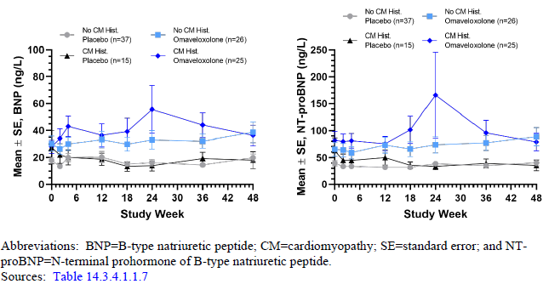
Figure 24: mean absolute BNP values from baseline to week 48 (primary placebo-controlled Analysis Set A)
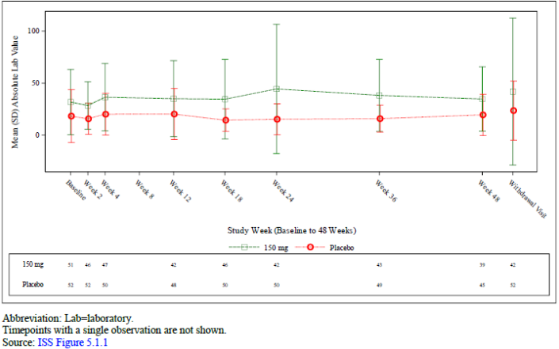
Omaveloxolone-treated patients had a higher incidence of increased total cholesterol (33.3% vs. 6.8%) and LDL (19.0% vs. 9.1%) values above the ULN and a higher incidence of low HDL (6.0% vs 4.3%) values under the ULN compared to placebo. There was 1 TEAE of hypercholesterolemia reported in an omaveloxolone-treated patient. Treatment emergent abnormal cholesterol values are shown in table 41 (page 84).
Patients treated with omaveloxolone showed mean increases in total cholesterol of approximately 20 mg/dL within the first 2 weeks of treatment that remained high but returned to baseline after withdrawal of drug. Adolescent patients had lower total cholesterol levels at baseline and had increases in total cholesterol after two weeks that slightly decreased until Week 48.
Patients treated with omaveloxolone showed a reduction in HDL cholesterol of 5.4 mg/dL during the treatment period. Adolescent patients treated with omaveloxolone also showed reductions in HDL cholesterol at Week 48 that were similar to omaveloxolone-treated adult patients.
Patients treated with omaveloxolone showed increases in LDL cholesterol of approximately 20 mg/dL within the first 2 weeks of treatment that remained high but returned to baseline after withdrawal of drug. The same increase was seen in adolescent patients.
A small increase in mean VLDL cholesterol was seen until week 24 in omaveloxolone treated patients. VLDL values above the ULN were reported in 37.2% of omaveloxolone-treated patients compared with 30.4% of placebo-treated patients.
The sponsor suggests that the changes in lipids are related to the PD activation of Nrf2. The changes seen were reversible after withdrawal of the drug.
Table 41: Treatment-emergent abnormal cholesterol/lipid values
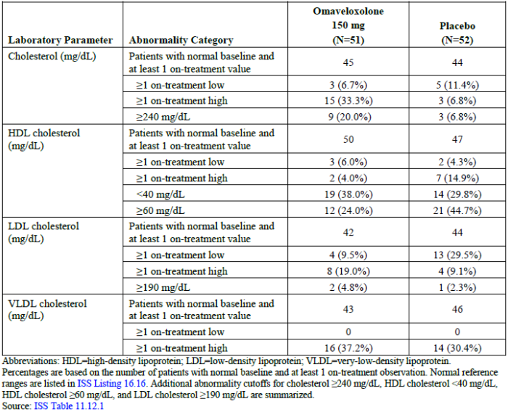
Regarding Electrocardiogram (ECG) findings, omaveloxolone-treated patients did not show meaningful changes in ECG parameters relative to baseline or compared with placebo-treated patients for PR interval, RR interval, ventricular heart rate or QRS duration. However, 3 (7.0%) omaveloxolone treated patients had QTcF interval >450 to 480 ms vs. 0 in the placebo group. Further, 5 (11.6%) omaveloxolone treated vs. 3 (6.0%) placebo treated patients had QTcB interval >450 to 480 ms and 1 (2.3%) vs. 0 had QTcB interval >480 to 500 ms.
The number of patients reporting TEAEs in the Cardiac disorders SOC was similar for omaveloxolone-treated and placebo-treated patients. Overall, the number of patients reporting TEAEs in the Cardiovascular standardized MeDRA query events (SMQs) were well balanced between omaveloxolone treated patients and placebo treated patients. However, evaluation of the Cardiac failure SMQ showed slightly more patients who reported TEAEs in the omaveloxolone group compared with the placebo group (3 [5.9%] patients vs. 1 [1.9%] patient, respectively).

Treatment-emergent adverse events related to depression, suicide, and self-injury
In Study 1402 pPart 2, fewer omaveloxolone-treated patients reported psychiatric disorder TEAEs, despite 1 of the omaveloxolone patients reporting suicidal ideation. In Analysis Set A, 15 (29.4%) Omaveloxolone-treated patients and 10 (19.2%) Placebo treated patients had a prior history of depression. In Study 1402 Part 2, 1 of the omaveloxolone treated patients reported suicidal ideation, this patient had a prior history of depression.

Laboratory findings
Regarding haematology findings: In Analysis Set A, small decreases in erythrocytes, haematocrit and haemoglobin were observed in omaveloxolone-treated patients at Week 48. None of the decreases were clinically significant. Overall, no clinically meaningful changes in hematology parameters were noted in Analysis Set A. No omaveloxolone-treated patients had hematology laboratory abnormalities reported as TEAEs.
Regarding clinical chemistry findings: No clinically significant changes were seen for total protein, glucose, lactate dehydrogenase, calcium, chloride or sodium at week 48 compared to baseline, nor for haemoglobin A1c at week 12 compared to baseline.
Baseline Albumin levels were lower in the omaveloxolone treatment group compared to placebo. There were no clinically significant changes throughout the week 48 and no patients reported low albumin values across treatment groups.
Regarding creatinine kinase (CK) and estimated glomerular filtration rate: An initial decrease in median CK levels was observed in the omaveloxolone treatment group that were generally maintained through Week 48. Omaveloxolone-treated patients had a median baseline of 87.0 U/L and a median change from baseline of -17.0 U/L at Week 48 versus a baseline of 111.0 U/L and a median change from baseline of -2.0 U/L in placebo-treated patients. Median CK values showed a change from baseline of -12.5 U/L after stopping study drug. A higher percentage of placebo-treated patients had ≥1 on-treatment high CK values compared with omaveloxolone-treated patients (15.2% versus 8.2%, respectively). The sponsor suggest that the results may indicate a decreased muscle inflammation and turnover in the omaveloxolone treated patients.
Regarding ferritin levels: Omaveloxolone-treated patients had increased values of ferritin. 1 (3.2%) omaveloxolone-treated patient had ≥1 on-treatment high ferritin values compared to 0 placebo treated patients. Omaveloxolone treated patients had a mean (±SD) change from baseline of 20.09 ± 41.570 ng/mL at Week 48 versus a mean (±SD) change from baseline of 1.38 ± 22.225 ng/mL in placebo-treated patients. The sponsor suggests that since Nrf2 induces the expression of the genes that encode the components of the ferritin complex, increases in ferritin likely reflect activation of Nrf2.
A small decrease in magnesium were observed in the omaveloxolone treated patients, however, no patients reported magnesium values below the lower limit of normal in Analysis Set A. Regarding serum potassium Omaveloxolone-treated patients had a mean change from baseline of 0.14 ± 0.344 mEq/L at Week 48 versus a mean change from baseline of -0.03 ± 0.375 mEq/L in placebo-treated patients. No omaveloxolone-treated patients had ≥1 on-treatment high potassium values.
Regarding uric acid, blood urea nitrogen and bicarbonate: Mean decreases in uric acid, BUN and bicarbonate were observed in omaveloxolone-treated patients in Analysis Set A. In omaveloxolone treated patients a mean change from baseline uric acid of -0.48 ± 0.800 mg/dL at Week 48 versus a mean change from baseline of -0.17 ± 0.679 mg/dL in placebotreated patients. A mean change from baseline BUN of -0.38 ± 2.740 mg/dL at Week 48 in omaveloxolone treated patients versus a mean change from baseline of -0.20 ± 2.262 mg/dL in placebo-treated patients was observed. Omaveloxolone-treated patients in Analysis Set A had a mean change from baseline bicarbonate of - 0.51 ± 2.585 mEq/L at Week 48 versus a mean change from baseline of -0.32 ± 2.082 mEq/L in placebo-treated patients. 3 (6.0%) patients in the omaveloxolone group had abnormal low bicarbonate versus 0 in the placebo group. The sponsor suggests the decreased uric acid, BUS and bicarbonate are due to increased kidney function.

Safety in special populations
Age
There were a small number of adolescent patients (n=9), no individual PT in these SOCs was reported with a notably different frequency in adolescent and adult patients. Due to the small number of adolescent patients, results should be interpreted with caution.
Sex
Overall, the incidence of TEAEs by sex was not meaningfully different across treatment groups, because 100% of patients reported a TEAE.
Pes Cavus status
In Analysis Set A, the majority of patients in both treatment groups did not have pes cavus (omaveloxolone, 80.4%; placebo, 80.8%). There were only 10 omaveloxolone-treated patients and 10 placebo-treated patients who did have pes cavus. Therefore, TEAE results should be interpreted with caution. Overall, the incidence of TEAEs by pes cavus status was not meaningfully different across treatment groups, because 100% of patients reported a TEAE.
Use in pregnancy and lactation
Omaveloxolone has not been investigated in pregnant or breastfeeding woman. Pregnancy and breastfeeding were criteria for permanent discontinuation in all omaveloxolone studies and women and men with reproductive potential were required to use a reliable method of birth control during the clinical studies. No women who were exposed to omaveloxolone became pregnant during any omaveloxolone study. Additionally, there were no pregnancies in partners of male patients exposed to omaveloxolone during their participation in a study.
Overdose
The highest doses used are from Study 1402 part 1 in doses up to 300 mg (up to 12 weeks). No other specific human data with omaveloxolone overdose is available.
Drug abuse potential
Based on its mechanism of action, omaveloxolone is not considered a drug for potential abuse and a drug abuse study was not conducted. This is acknowledged.

Effects on the Ability to Drive or Operate Machinery or Impairment of Mental Ability
Somnolence was reported in 2 (3.9%) patients in the omaveloxolone treatment group and no patients in the placebo group in Analysis Set A.

Safety analysis set C - (includes study 1402 extension)
This section includes safety analysis of set C, which includes data from all omaveloxolone-treated patients (no placebo-treated patients) regardless of dose, from all studies in patients with FA (i.e. Study 1402 Part 1, Study 1402 Part 2, and Study 1402 Extension).
Overall, at least 1 TEAE occurred in 98.2% of omaveloxolone treated patients (table 42). The overall pattern of TEAEs in Analysis Set C was comparable to Analysis Set A. However, the percentage of patients who discontinued study drug due to TEAEs (9.1%) and interrupted omaveloxolone use (23.6%) due to TEAEs, was greater than that of the omaveloxolone-treated patients in Analysis Set A (7.8% and 17.6%, respectively). No deaths were reported in Analysis Set C. This is shown in table 34. The majority of the most common TEAEs in either group were mild to moderate in severity. Twenty-one (12.7%) omaveloxolone-treated patients experienced severe TEAEs. 4 (2.4%) experienced severe TEAEs within the SOC Infections and infestations (2 corona virus infection, 1 influenza and 1 gastroenteritis). One additional omaveloxolone treated patient reported a severe event of ALT increased, 1 additional omaveloxolone-treated patient reported a severe suicide attempt and 1 severe TEAE of acute left ventricular failure were also reported.
Table 42: Overview of TEAEs (FA overall omaveloxolone exposure Integrated Analysis
Set C)
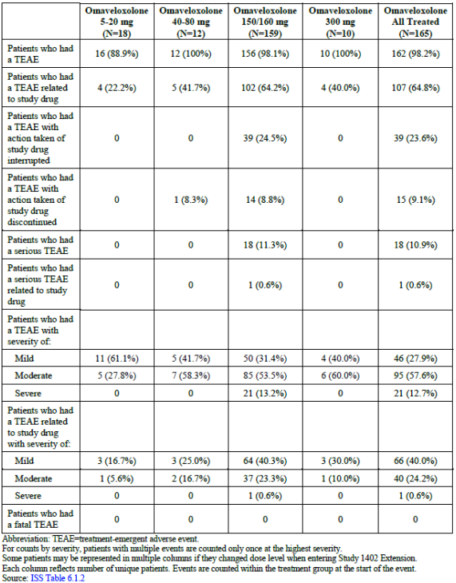
Table 43 includes a summary of common TEAEs occurring in ≥10% of patients in omaveloxolone-treated patients and with a difference in incidence of ≥2% between omaveloxolone treated patients and placebo-treated patients identified in Analysis Set A. All the above mentioned TEAEs were represented, which support the safety observations in Analysis A.
For analysis set C, the frequency of serious TEAEs reported in omaveloxolone-treated patients was similar to Analysis Set A (11.3% in the 150/160 mg dose).
Table 43: Summary of TEAE occurring in ≥10% in the omaveloxolone treatment group with a difference in incidence of ≥2% in the omaveloxolone treatment group over placebo group in analysis set A. (FA overall omaveloxolone exposure integrated analysis set C)
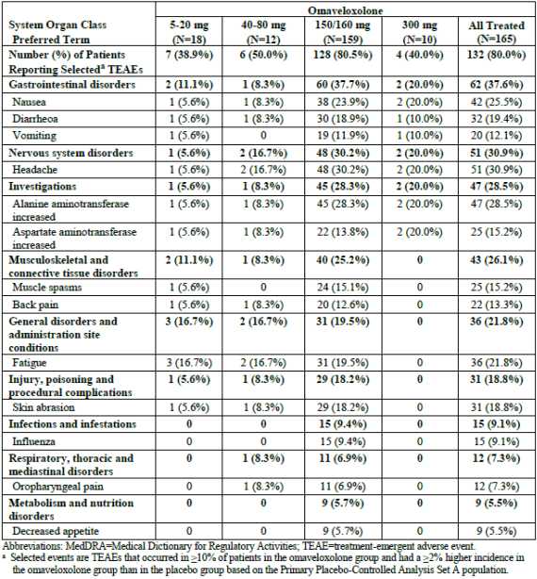

Safety topics of interest
Hepatic safety
The increase in ALT and AST were similar in Analysis Set C with a peak in week 24 and a decline through week 48. When looking at the mean absolute ALT and AST levels to week 168, there is a peak again in week 72 and subsequently a decline again (figures 25 and 26).
Figure 25: Mean absolute ALT levels (U/L), baseline to week 168 (FA overall omaveloxolone exposure Integrated Analysis Set C)
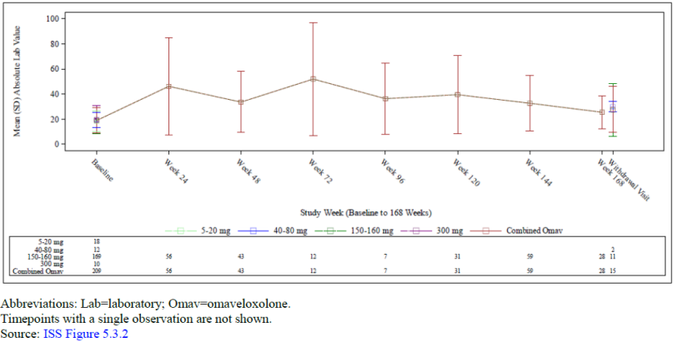
Figure 26: Mean absolute AST levels (U/L), baseline to week 168 (FA overall omaveloxolone exposure Integrated Analysis Set C)
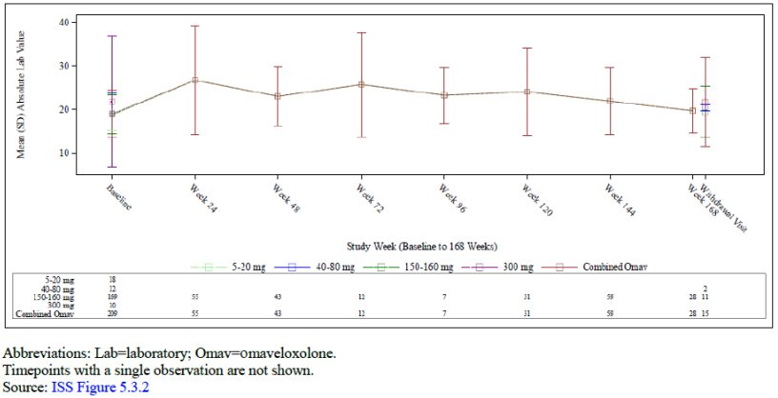
Three omaveloxolone-treated patients treated with the 150 mg dose had ALT elevations ≥10× ULN and one patient AST elevations ≥10× ULN.
The decrease in bilirubin and the increase in GGT in Analysis Set A were similar in Analysis Set C.
Compared with the results in Analysis Set A, increases in ALT, AST, and GGT reported as TEAEs occurred at a lower frequency in Analysis Set C (28.3%, 13.8% and 3.8%, respectively). 3 TEAEs of Cholelithiasis and 1 TEAE of Hepatic steatosis were reported in the omaveloxolone treatment group. This is shown in table 44.
Table 44: Summary of hepatic TEAE by SOC and PT (FA overall omaveloxolone exposure Integrated Analysis Set C)
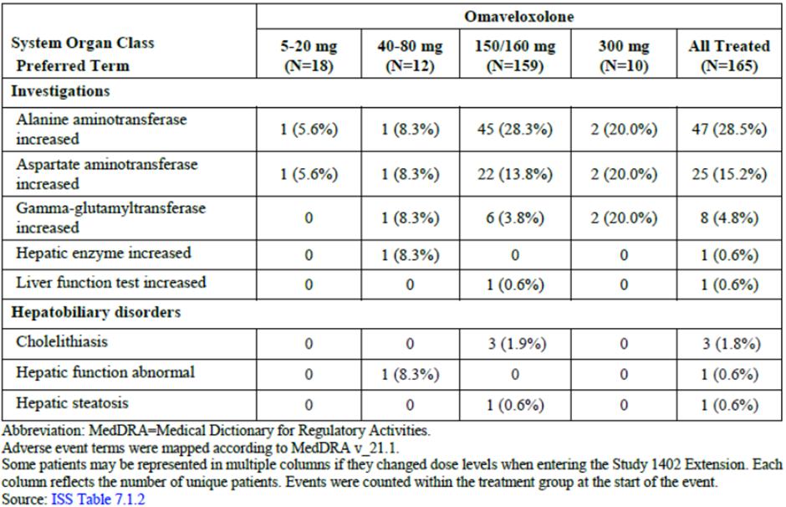
There were no SAEs related to hepatic safety in patients treated with omaveloxolone. However, five patients discontinued omaveloxolone treatment due to hepatic safety. Discontinuations due to elevations in transaminases and liver enzymes were not associated with concomitant elevations in bilirubin. The sponsor suggests that the increase in ALT, AST, and GGT could be due to pharmacological induction of enzymes without causing underlying injury.
Figure 27 shows an eDISH plot for analysis set C. None of the omaveloxolone-treated patients had maximum ALT or total bilirubin values that met potential Hy’s law criteria.
Figure 27: Maximum total bilirubin versus maximum ALT (FA overall omaveloxolone exposure integrated analysis set C)
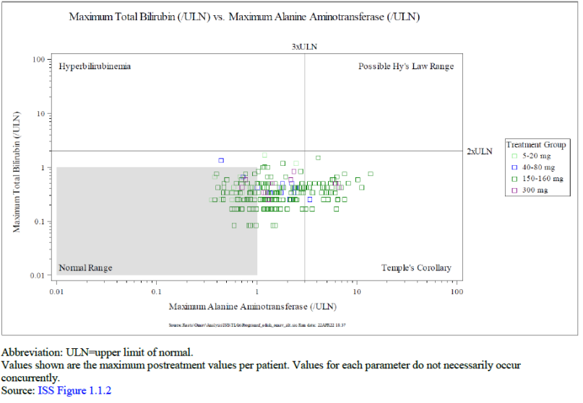
For analysis set C, table 44 shows that 18 (8.6%) patients had a maximum on treatment ALT shift from baseline to between ≥5 and <10x the ULN for ALT and 3 (1.4%) of patients had a shift from normal ALT levels to between ≥10 and <20x the ULN for ALT.
Table 45: Shift from baseline ALT values in omaveloxolone treated patients: maximum on treatment and withdrawal (FA overall omaveloxolone exposure integrated analysis set C)
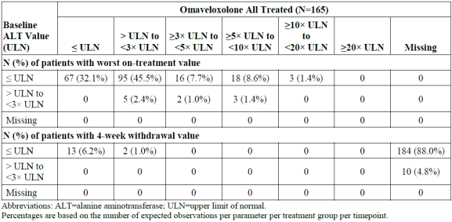
For analysis set C, table 46 shows that 1 (0.5%) patient had a maximum on treatment AST shift from baseline to between ≥5 and <10x the ULN for AST and 1 (0.5%) patient had a shift from normal AST levels to between ≥10 and <20x the ULN for AST.
Table 46: Shift from baseline AST values in omaveloxolone treated patients: maximum on treatment and withdrawal (FA overall omaveloxolone exposure integrated analysis set C)
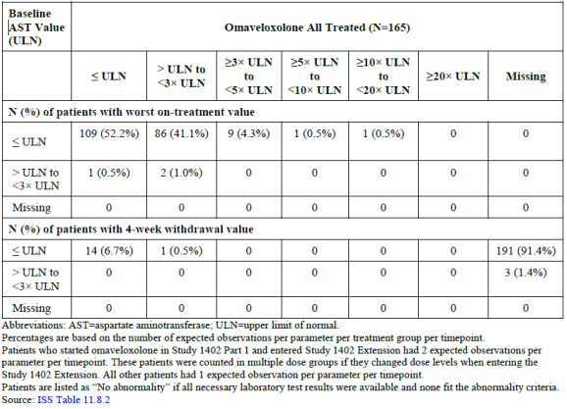
Figure 28: Mean absolute Bilirubin levels (mg/dL), baseline to week 168 (FA overall omaveloxolone exposure integrated analysis set C)
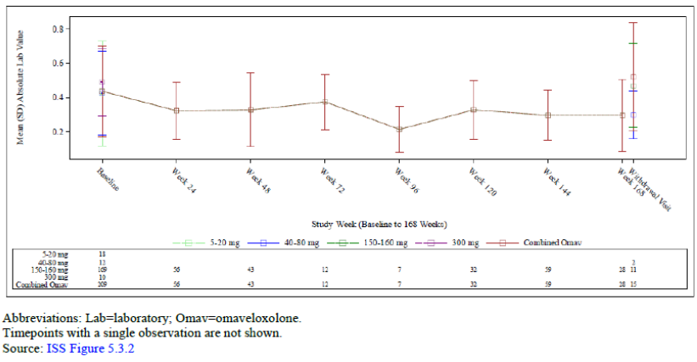
Table 47 shows that 4 (1.9%) of patients in analysis set C shifted from baseline bilirubin values to a maximum on treatment bilirubin value of >ULN to ≤2x ULN.
Table 47: Shift from baseline Bilirubin values in omaveloxolone treated patients: maximum on treatment and withdrawal (FA overall omaveloxolone exposure integrated analysis set C)
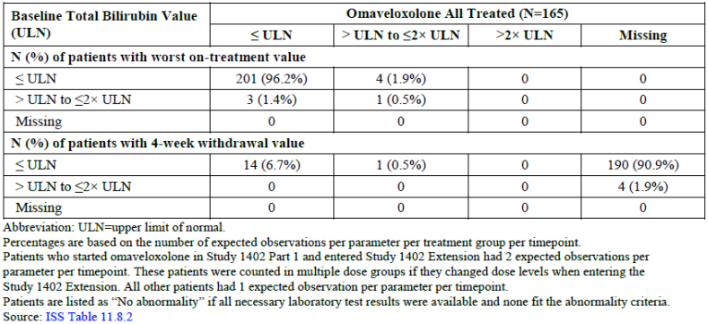
Evaluation of weight
Mean changes from baseline in weight in Analysis Set C are shown in figure 29. The weight loss in Analysis Set C generally showed similar trends as Analysis Set A. At Week 48, omaveloxolone-treated patients had a mean ± SD change from baseline weight of -1.60 ± 4.126 kg (median -1.10 kg). Weight loss of at least 5% relative to baseline was noted in 38.2% of the worst on-treatment weight loss values, and weight loss of at least 7% relative to baseline was noted in 23.7% of the worst on treatment weight loss value.
Analysis of weight change by age was consistent with Analysis Set A. Analysis of weight change by age subgroup showed that the mean weight among adolescent patients did not decrease over the 48-week or 96-week treatment period.
The overall changes in weight seen in Analysis Set C and in the subgroups was consistent with Analysis Set A.
Figure 29: Mean change from baseline to week 96 in weight (kg) (FA overall omaveloxolone exposure integrated analysis set C)
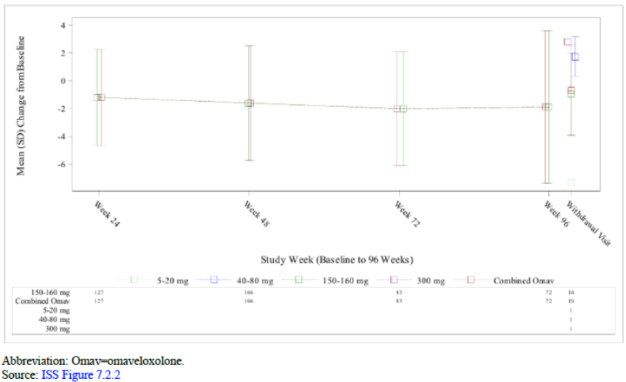
Evaluations of infections and infestations
For analysis set C 67.3% of the all-omaveloxolone treated patients reported TEAEs within the SOC infections and infestations. Upper respiratory infections and Corona virus infections were reported more frequently compared to Analysis Set A. Otherwise the pattern was comparable to Analysis Set A.
The majority of the TEAEs were considered mild to moderate in severity for omaveloxolone-treated patients. There were 4 severe TEAEs in the Infections and infestations SOC. No meaningful difference in the number of patients with Infections and infestations TEAEs was observed among the adolescent and adult populations. Analysis of infection and infestation TEAEs by other subgroups is provided in the following tables: sex, region, ethnicity, race, and pes cavus status. No clinically meaningful differences or trends were observed in these subgroups. These results are shown in table 48.
Table 48: Summary of infections and infestation TEAE in >2 patients (FA overall omaveloxolone exposure integrated analysis set C)
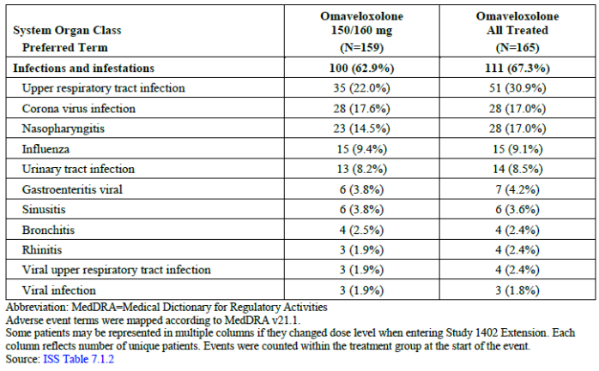
Evaluation of cardiovascular safety
For analysis set C, the profile of blood pressure over time was similar to the changes described above for the overall Analysis Set A population
For Analysis Set C, the profile of BNP over time was similar to that observed in Analysis Set A for the overall population and adolescent population. Slight increases in BNP were observed with omaveloxolone treatment. There were 5 patients (3.0%) who had a TEAE reported of BNP increased. None of these 5 patients had any BNP result over 200 ng/mL. BNP values that exceeded 200 pg/mL at any time while on study treatment were seen in 7 patients, cardiac AEs were reported for 2 of the 7 patients. (Data not included here, but available in the ISS 12.4.4.2.).
The incidence of total cholesterol above the ULN was lower compared to Analysis Set A (25.5% vs. 33.3%) and the incidence of LDL cholesterol values above the ULN was higher in Analysis Set C compared to Analysis Set A (25.9% vs. 19.9%).
There were 5 patients with TEAEs of hypercholesterolemia or lipids increased reported in omaveloxolone-treated patients. The mean change from baseline in total cholesterol at Weeks 48, 96, and 144 was 19.4, 40.6, and 28.9 mg/dL, respectively. Like in Analysis set A the change was reversible after withdrawal of the treatment. The Change in HDL, LDL and VLDL cholesterol were similar to the changes seen in Analysis Set A.
Regarding ECGs, omaveloxolone-treated patients did not show meaningful changes in ECG parameters relative to either baseline, similar to Analysis Set A, except for the mentioned events of QTc prolongations seen in Analysis Set A.
Regarding echocardiograms, treatment with omaveloxolone did not result in meaningful changes in echocardiogram parameters relative to baseline or compared with Analysis Set A. However, cases of left ventricle dilated at Week 48 (1 (2.3%). Left ventricular hypertrophy at week 48 (11 (25,6%)) and right ventricle enlargement at week 48 (2 (4.7%)) were reported.

Safety analysis study 1403
Part 1 of this study was a randomized, placebo-controlled, double-blind, dose-ranging study to evaluate the safety, efficacy, and PD activity of RTA 408 at 2.5 mg, 5 mg, 10 mg, 20 mg, and higher dose levels (not to exceed 160 mg) in patients with mitochondrial myopathy. The planned part 2 of this study was not conducted due to RTA 408 showing little to no efficacy with regard to the measured clinical endpoints.
Part 1 of the study evaluated the safety, efficacy, and PD activity of RTA 408 at 2.5 mg, 5 mg, 10 mg, 20 mg, 40 mg, 80 mg, and 160 mg in patients with mitochondrial myopathy. Each dose cohort consisted of 8 eligible patients randomized 3:1 to RTA 408 at the cohort specific dose(n=6) or placebo (n=2). Approximately 8 cohorts were to be enrolled in part 1 of the study to allow for adequate dose-ranging for selection of two doses of RTA 408 to be used in part 2; however, only 7 cohorts were enrolled, with 2 cohorts (1 of which enrolled only 5 patients) at the maximum dose (160 mg).
Figure 30: Intended schema for study of RTA 408 in patients with mitochondrial myopathy
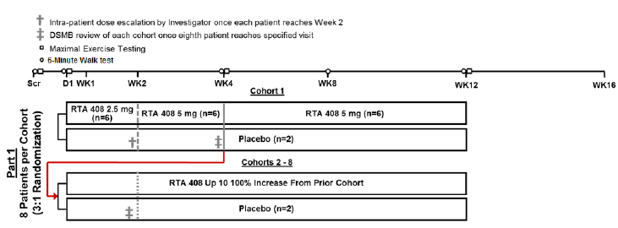
Key inclusion criteria were participants who have a known primary mitochondrial DNA mutation or a nuclear DNA defect that is associated with reduced activity of at least 1 mitochondrially encoded respiratory chain complex and be a healthy male or female ≥ 18 years of age and ≤ 75 years of age.
Summary of drug exposure by treatment group in this study is shown in Table 49.
Table 49: Summary of drug exposure by treatment group
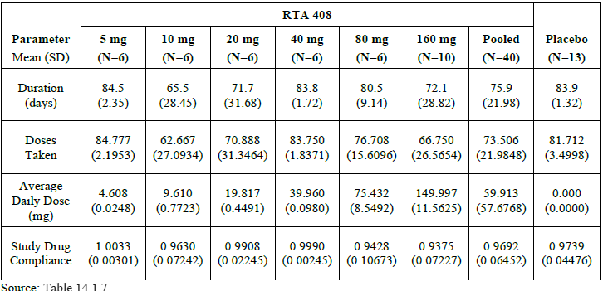
Regarding TEAE’s, 19 (47.5%) RTA 408 treated patients and 7 (53.8%) placebo treated patients experienced only TEAEs that were mild at worst severity, 11 (27.5%) RTA 408 treated patients and 3 (23.1%) patients treated with placebo experienced at least one TEAE that was moderate at worst severity, and 6 (15.0%) RTA 408 treated patients and 1 (7.7%) placebo treated patient experienced a severe TEAE.
Overall, 11 TEAEs occurred in ≥ 2 patients in any dose group. No apparent treatment or dose-related trends were observed for these TEAEs. This is shown in Table 50.
Table 50: TEAEs occurring in ≥ 2 patients in any dose group
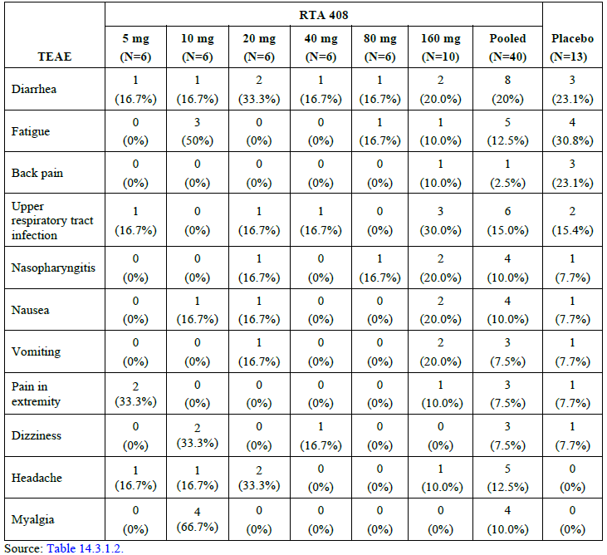
A total of 5 patients (9.4%) reported 7 SAEs, 4 patients treated with RTA 408 (10.0%) and 1 patient receiving placebo (7.7%). Four of the SAEs experienced by 3 patients treated with RTA 408 were considered by the investigator to be drug related (atrioventricular dissociation, tachycardia, ventricular tachycardia, and fatigue); however, the sponsor considered the cardiac disorder SAEs as unrelated to treatment. Additionally, tachycardia (mild and not considered an SAE) was reported in 1 patient treated with placebo. Drug-related SAEs led to withdrawal from treatment in 2 patients (those experiencing cardiac disorders) and treatment interruption in 1 patient (experiencing exacerbated fatigue; patient later withdrew from treatment after experiencing a non-serious AE). The SAE experienced by a patient receiving placebo (tonic epileptic seizure) was not considered to be drug related. SAEs are shown in Table 51.
Table 51: Serious Treatment-emergent Adverse Events by System Organ Class and Preferred Term Safety Population
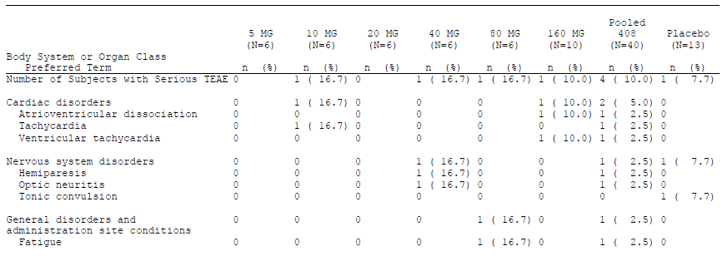
A total of 4 patients (10%) treated with RTA 408 exceeded the threshold criterion of ALT or AST > 3x the upper limit of normal (1 patient in the 40 mg group, and 3 patients in the 160 mg group), while no patients treated with placebo exceeded the threshold criterion. ALT and AST levels were below 3x the upper limit of normal by the next assessment for all patients. Two of these patients had ALT or AST levels that were considered high at baseline. One patient (2.5%) treated with RTA 408 (in the 160 mg group) who exceeded the threshold criterion of ALT or AST > 3x the upper limit of normal also exceeded the threshold criterion of ALT or AST > 8x the upper limit of normal (as discussed in Section 11.4.1.4).
Drug interruption as a result of exceeding these threshold criteria only occurred in the patient with ALT or AST > 8x the upper limit of normal. Specifically, the patient had AST levels of 23 U/L at baseline, but at week 1, their AST levels were 310 U/L, exceeding 8x the upper limit of normal. Additionally, the patient’s ALT levels (152 U/L) exceeded 3x the upper limit of normal at their week 1 visit (but were normal at baseline). Subsequently, treatment was interrupted.
By Week 2, AST levels had return to near normal levels and were 1.5x the baseline value (35 U/L). The patient’s ALT levels returned to 2x the baseline value (48 U/L). After the patient resumed treatment, their AST and ALT levels were in the normal range (at the Week 4 and Week 8 visits) until Week 12 when their AST levels were elevated to 2.1x the baseline value. At Week 16 (4 weeks after treatment ended), the patient’s AST and ALT levels were both elevated again to levels exceeding 3x the upper limit of normal. Increases in ALT or AST were not associated with changes in total bilirubin for any of the patients who exceeded these threshold criteria. These values are shown in Table 52.
Table 52: Summary of Subjects Exceeding Pre-Specified Hepatic enzyme Levels in Safety Population
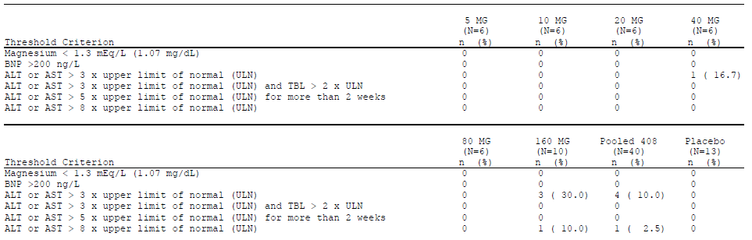

Risk-benefit analysis

Delegate’s considerations

Pharmacokinetics
The absorption, distribution, metabolism and excretion as described in the sponsor’s proposed Australian PI is described under ‘Background’ heading and subheading ‘Omaveloxolone’.
It is noted that study 1805 showed a much lower systemic exposure after single dose of omaveloxolone 150mg measured by a mean AUC_{0-∞} calculated at 183 (SD 25.7) h*ng/mL compared to other PK studies.
The sponsor explained that study 1805 used a study specific radiolabelled capsule that was prepared on site containing a mixture of radiolabelled active ingredient and cold active ingredient of omaveloxolone and that in this study omaveloxolone was administered as single 150mg capsule with no excipients present, compared to administration of x3 50mg capsules in all other studies with excipients being present. The sponsor believes that no excipients being present in the 150mg omaveloxolone capsule administered in study 1805 may have led to lower bioavailability of omaveloxolone in this study due to reduced dissolution due to lack of excipients and differences in absorption due to different number of capsules being administered.
The EMA evaluator also raised the possibility that the lower bioavailability may have resulted in underestimation of renal excretion. The sponsor responded that even if adjusted for 8 to 11 times lower plasma exposure the mean radioactivity excreted in urine would only be ~1.07% and the sponsor further explained that no omaveloxolone was detected in the urine in this study further supporting that renal elimination is very minor part of excretion of omaveloxolone. The Delegate agrees that the evidence supports that renal elimination of omaveloxolone is minimal and variations in renal function clinically are unlikely to have significant effects on systemic exposure for patients treat with omaveloxolone, but it needs to be acknowledged that the effects of moderate or severe renal impairment on the pharmacokinetics of omaveloxolone are unknown.
Study 1806 was a drug-drug interaction study in health volunteers. Results from this study showed significant increases in systemic omaveloxolone exposure when omaveloxolone was administered with the strong CYP3A4 inhibitor itraconazole. Co-administration of omaveloxolone with itraconazole was compared with omaveloxolone administration alone, the ratio of geometric LS means (90% CI) of omaveloxolone AUC_{0-∞} and C_{max} were 4.12 (3.48, 4.87) and 2.77 (2.17, 3.54), respectively, showing an approximately 3-fold increase in AUC_{0-∞.}
The proposed PI recommends avoiding concomitant use of moderate and strong CYP3A4 inhibitors with omaveloxolone. If co-administration of omaveloxolone with strong CYP3A4 inhibitors cannot be avoided, then a dose reduction of omaveloxolone 50mg daily is recommended with close monitoring for adverse reactions with recommendation to discontinue strong CYP3A4 inhibitor if adverse reactions emerge. For moderate CYP3A4 inhibitors the proposed PI recommends dose reduction to 100mg daily if concomitant use of omaveloxolone worth moderate CYP3A4 inhibitor cannot be avoided with further dose reduction to 50mg daily if adverse reactions occur. Concomitant use of strong or moderate CYP3A4 inducer with omaveloxolone is recommended to be avoided I the proposed PI. The Delegate agrees with the sponsor’s recommendations in the proposed PI when CYP3A4 inhibitors or inducers are used concurrently with omaveloxolone.
Study 1804 was a single dose pharmacokinetic study of omaveloxolone in participants with Mild, Moderate, or Severe Hepatic Impairment, or with Normal Hepatic Function. This study showed that participants with mild hepatic impairment had an approximately 22% increased mean C_{max} with a similar total exposure between these 2 groups. Participants with moderate hepatic impairment had a 53% and 51% higher mean AUC_{inf} and mean C_{max} values respectively compared to the normal hepatic function group. Participants with severe hepatic impairment had an approximately 56% increase in mean AUC_{0-∞} compared to the normal hepatic group.
The proposed Australian PI recommends a 150mg daily dose for those with mild hepatic impairment (Child Pugh Class A), an initial starting dose of 100mg daily in those with moderate hepatic impairment (Child Pugh Class B) with monitoring for adverse reactions and if adverse reactions occur then consideration of further dose reduction to 50mg daily can be considered. Patients with severe hepatic impairment (Child-Pugh Class C) are recommended to avoid omaveloxolone use. Based on the submitted data and study 1804 which investigated the effects of hepatic impairment on omaveloxolone PK, the Delegate agrees with the sponsor’s proposed recommended omaveloxolone dosing in patients with hepatic impairment.
Module 4 evaluation has noted that CYP3A4 was identified as the main metabolising enzyme in human liver microsomes, with minor contribution from CYP2C8. Section 4.5 of the proposed PI outlines clearly the interactions omaveloxolone is likely to have with strong or moderate CYP3A4 inhibitors and inducers, CYP3A4 substrates, CYP2C8 substrates and BCRP substrates. The Delegate finds these warnings regarding CYP and BCRP enzyme interactions adequate.

Efficacy
The tool used in the pivotal study in measuring the primary efficacy endpoint was the modified Friederichs ataxia rating scale. The sponsor has provided justification for use of this scale in section 9.5.2 of the clinical study report (e007747 (0000-) - 408-C-1402-PT2 Report Body).
Further outline of the mFAR tool is provided in Study 1402 Part 2, under efficacy heading. This scale has been specifically developed to measure neurological outcomes in patients with Friedreich’s ataxia. The mFARS 4 sub-section (bulbar function, upper limb co-ordination, lower limb co-ordination and upright stability) clearly aims to measure the key neurological clinical features that define Friedreich’s ataxia with a higher score indicating worse neurological function.
The Delegate believes the most compelling evidence provided regarding the validity of this tool in measuring outcomes in patients with Friedreich’s ataxia is from a referenced study by Patel et al, 2016, where initially 812 participants with Friedreich’s Ataxia were evaluated annually across 12 sites on different rating scales over a 5-year period to analyse neurological outcomes. The mFARS was one of the tools used in this study and showed a consistent, steady increase in scores annually over a 5-year period, with the sponsor stating that there was an average increase of 1-2 points per year on the mFARS score in the 234 participants who reached the 5 years follow up interval with the changes in mFARS score. The sponsor also stated that ‘changes in FARS scores are significantly correlated with a variety of measures of disease progression, including disease duration, ataxia staging, and ADL scores (p <0.0001)’, no reference was provided for this statement.
Based on the provided evidence, the Delegate was satisfied that the mFARS has sufficient validity to warrant being used as the primary efficacy endpoint tool in the sponsor’s pivotal study to determine a significant treatment difference between the omaveloxolone group compared to placebo.
Of note in study 1402 part 2, there were significant imbalances between treatment groups in gender, with 17 (32.7%) females in the placebo group compared to 31 (60.8%) females in the omaveloxolone group. Given the pathophysiology of Friedreich’s ataxia the Delegate does not have any reason to believe that this gender imbalance between treatment groups is likely to significantly affect the results of treatment outcomes in the pivotal trial.
In the pivotal trial 1402 part 2, the primary efficacy endpoint of change from baseline of mFARS score at week 48 showed a LS mean difference in mFARS score in the Omaveloxolone group compared to placebo (in participants defined as without pes cavus, N=82) of -2.40
(95% CI=-4.31, -0.50 and SE=0.956)( p-value=0.0141). Patients randomized to omaveloxolone experienced a mean improvement from baseline in mFARS of - 1.55 points, while patients randomized to placebo experienced a mean worsening from baseline of mFARS of +0.85 points at Week 48.
In the entire randomized population of 103 participants samples (which included participants with pes cavus) there was a treatment difference of -1.93 in LS mean mFARS score at week 48 favouring the omaveloxolone group compared to placebo (p-value 0.034). It is noted that the number of participants with pes cavus was only 20 (randomized equally with n=10 in placebo and n=10 in omaveloxolone group). In document ‘foreign evaluation report – Day 120 list of questions – responses – clinical on page 49’ the sponsor discusses their justification for exclusion of patients with severe pes cavus (and how this was defined) from the primary analysis population in study 1402 part 2. The sponsor’s justification stated: that pes cavus exists on a spectrum in FA so is not a binary variable and therefore many participants in the clinical trial (including in the group labelled ‘without pes cavus’) likely had varying degrees of pes cavus present, severe pes cavus was hypothesized to interfere with ability to complete the mFARS scale due to issues performing standing and balance assessment supporting exclusion from the primary analysis as well as the baseline demographic characteristics between patients labelled ‘with’ and ‘without’ pes cavus were, similar supporting that pes cavus is not a distinct phenotypic or clinical entity. After review of the sponsor’s response, the Delegate believes there is not enough evidence present to exclude patients with severe pes cavus from treatment with omaveloxolone and that on balance there is adequate evidence to support that omaveloxolone is in patients with Friedreich’s Ataxia and severe pes cavus (as defined by the sponsor) is likely to still have some meaningful benefit. Therefore, the Delegate has not recommended any change to the indication as proposed by the sponsor.
The key secondary endpoints of change in PGIC and CGIC scores at Week 48 compared to baseline were not statistically different for omaveloxolone compared with placebo in the FAS.
For the other key secondary outcome of change from baseline to week 48 in peak work and exploratory outcomes of change from baseline to week 48 in: 9-hole peg test, 25-foot timed walk test, frequency of falls there was no statistically significant difference between placebo and the omaveloxolone treatment group.
The only exploratory outcome that found a statistically significant difference between treatment groups was the mean total FA activities of daily living (FA-ADL) score over the study period. The LS mean change from baseline to week 48 was 1.14 ± 0.421 in placebo and -0.17 ± 0.45 for the omaveloxolone group. The between treatment group LS mean difference ± SE was -1.30 ± 0.629 with a p-value=0.04.
The omaveloxolone treatment groups LS mean mFARS score from baseline to week 48 improving is noted, which provides significant evidence of efficacy for the neurological signs/symptoms of Friedreich’s ataxia. Based on the longitudinal cohort study by Patel (2016) in patients diagnosed with Friedreich’s the mean change in mFARS at 1 year after entry into the study was +2.10 (SD +/- 6.23). In the pivotal study 1402 part 2 the placebo group had a mean worsening in mFARS score of +0.85 from baseline at week 28. Outcomes from the placebo arm of this pivotal study and from the longitudinal cohort study Patel (2016) suggest that in patients diagnosed with Friedreich’s ataxia on average the mFARS score will likely worsen after approximately 1 year. The Delegate feels that an improvement in LS mean score in the treatment group compared to placebo group on the mFARS provides significant evidence of efficacy for neurological signs/symptoms of Friedreich’s ataxia, this is due to Friedreich’s ataxia being known to be a progressive neurological disease which worsens over time with evidence suggesting that there is expected to be on average a worsening in mFARS score when measured annually over years in patients with Friedreich’s ataxia. The Delegate feels that this makes an improvement in the LS mean mFARS score from baseline to week 48 highly significant given the natural history of progressive neurological deterioration in Friedreich’s Ataxia.
The exploratory endpoint of a statistically significant difference in LS mean scores in the FA-ADL score between the omaveloxolone and placebo group provides some minor supportive evidence of efficacy for omaveloxolone for this indication, but given the multiple other secondary and exploratory endpoints that did not reach statistical significance the significance of this finding is of uncertain significance. It is noted that the exploratory endpoint of change in LS mean FA-ADL score showed that the LS-mean score for the omaveloxolone group improved, (LS mean for omaveloxolone group -0.17 ± 0.45 compared to LS mean worsening in 1.14 ± 0.421 in placebo group). Similar to the primary efficacy endpoint, a mean improvement in the FA-ADL score in the omaveloxolone group compared to placebo provides stronger supportive evidence of efficacy due to the progressive deterioration in neurological function expected with Friedreich’s Ataxia, which would be expected to cause a deterioration in activities of daily living over time, which was present using the LS mean FA-ADL score in the placebo group, but not the omaveloxolone treatment group, this is shown in the sponsor’s day 120 EMA evaluation report response to questions in figure 31.
Figure 31: Study 1402 part 2: Omaveloxolone Treatment Effect on FA-ADL (FAS)
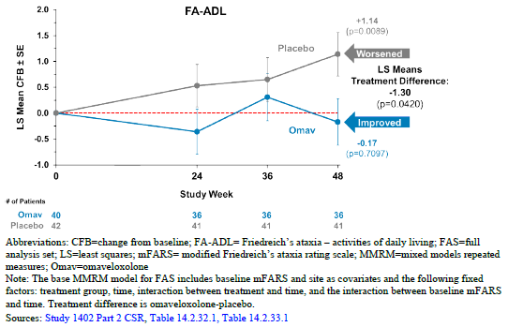
The key secondary endpoints (Patient Global Impression of Change [PGIC] and Clinical Global Impression of Change [CGIC]) showed no statistically significant improvement between the omaveloxolone group compared to placebo, although these outcomes were numerically improved in the omaveloxolone treatment group compared to placebo. This would have provided important supportive evidence of improvement in quality of life from both a patient and health professional perspective. However, even without statistically significant changes in these key secondary endpoints the Delegate believes the changes in the primary endpoint does establish the efficacy of omaveloxolone at the proposed dosage for the indication of treatment of Friedreich’s ataxia in adults and adolescents aged 16 years and older.

Safety
It is noted that there are small participants numbers in the placebo-controlled pivotal trial 1042 part 2 (omaveloxolone group N=51, placebo group N=52), making it difficult to determine the significance of small differences in TEAE’s between the omaveloxolone and placebo groups.
In the primary analysis set A, TEAE’s with incidence ≥2% and in excess in the omaveloxolone treatment group over the placebo group (primary placebo-controlled Analysis set A) included the following.
Under the SOC of gastrointestinal disorders:
- nausea occurred in 17 (33.3%) participants in the omaveloxolone treated group compared to 7 (13.5%) in placebo
- diarrhoea occurred in 10 (19.6%) participants in the omaveloxolone treated group compared to 5 (9.6%) in placebo
- vomiting occurred in 8 (15.7%) participants in the omaveloxolone treated group compared to 6 (11.5%) in placebo
- abdominal pain upper occurred in 5 (9.8%) participants in the omaveloxolone treated group compared to 1(1.9%) in placebo.
Under the SOC of nervous system disorder, headache occurred in 19 (37.3%) of participants in the omaveloxolone treated group compared to 13 (25%) in placebo.
Under the SOC of musculoskeletal and connective tissue disorder:
- back pain occurred in 7 (13.7%) of participants in the omaveloxolone treated group compared to 4 (7.7%) in placebo
- muscle spasms occurred in 7 (13.7%) of participants in the omaveloxolone treated group compared to 3 (5.8%) in placebo.
Oropharyngeal pain occurred in 9 (17.6%) in the omaveloxolone group compared to 3 (5.8%) in the placebo group, and fatigue occurred in 11 (21.6%) in the omaveloxolone group compared to 7 (13.5%) in the placebo group.
Under the SOC of infections and infestations:
- influenza occurred in 7 (13.7%) in the omaveloxolone group compared to 2 (3.8%) in the placebo group
- viral gastroenteritis occurred in 3 (5.9%) in the omaveloxolone group compared to 1 (1.9%) in the placebo group
- urinary tract infection occurred in 4 (7.8%) in the omaveloxolone group compared to 0 in the placebo group.
Decreased appetite occurred in 6 (11.8%) in the omaveloxolone group compared to 2 (3.8%) in the placebo group. Macular rash occurred in 2 (3.9%) in the omaveloxolone group compared to 0 in the placebo group. Dysmenorrhoea occurred in 3 (5.9%) in the omaveloxolone group compared to 0 in the placebo group.
The majority of the most common TEAEs in either group were mild to moderate in severity. Five (9.8%) omaveloxolone-treated patients experienced 6 severe TEAEs (contusion, skin laceration, migraine, increased blood creatine phosphokinase, suicidal ideation and hydrocele). Two severe TEAEs were in adolescent patients (hydrocele in 1 patient and contusion and skin laceration in 1 patient).
No severe event occurred in more than 1 patient and none of the severe events were considered related to study drug. No patients in the placebo group experienced a severe TEAE.
Regarding patient disposition in the primary analysis set A, 4 (7.8%) participants discontinued from the omaveloxolone group compared to 2 (3.8%) in placebo group. Reasons for discontinuation in the omaveloxolone group were: ventricular tachycardia, raised ALT and AST, muscle spasms, and rosacea (all these TEAE’s led to discontinuation in 1 participant). In the placebo group, study drug discontinuation occurred due to atrial fibrillation and erythrosis, both occurring in a single participant.
No deaths were reported in the FA studies. Across the entire omaveloxolone development program, 7 deaths were reported, all in oncology studies in patients with stage 4 cancer.
In the pivotal study 1402 part 2, rates of infection/infestation were significantly higher in the omaveloxolone treatment group (27.5%) compared to 7.7% in placebo. In the omaveloxolone treatment group, rates of influenza (13.7%), viral gastroenteritis (5.9%) and UTI (7.8%) were all higher compared to the placebo group with rates in the placebo group of influenza (7.7%), viral gastroenteritis (5.9%) and UTI (0%).
Interestingly, rates of viral upper respiratory tract infection were similar (3.9%) compared to placebo (1.9%). In the sponsor’s response to increased rates of infection during the pivotal trial (EMA foreign evaluation report day 150 – Question 165), the sponsor responded that infections/infestation were evaluated due to possible anti-inflammatory effects related to Nrf2 activation that could theoretically lead to a decreased immune response. The sponsor stated that in the pivotal trial there were no differences in white cell counts between treatment groups (including lymphocytes, monocytes, neutrophils, eosinophils, basophils), upper respiratory tract infection rates were similar between treatment groups, there were no discontinuation due to infection and the mean time to onset of a reported TEAE in the Infections and infestations system organ class for omaveloxolone-treated patients was similar to that for placebo-treated patients, 106.5 (±16.50) vs 105.3 (±20.93) days, indicating that administration of omaveloxolone did not compromise the immune response. The Delegate finds this justification adequate and at this point thinks there is not enough evidence to establish a clear link between omaveloxolone use and increased rates of infections.
Rates of nausea, abdominal pain, diarrhoea and decreased appetite in pivotal study 1402 part 2 were all significantly higher in the omaveloxolone treatment group compared to placebo. Mean change from baseline to week 48 was -1.35 ± 3.585 kg for omaveloxolone treated patients and 1.17 ± 4.108 kg for placebo-treated patients after 48 weeks of treatment. Relative to baseline, 34.0% (n=17) of the omaveloxolone-treated patients showed at least 5% weight loss, and 12.0% (n=6) of omaveloxolone treated patients showed at least 7% weight loss. The increased rates of gastrointestinal side effects may explain the mean decrease in weight noted in the pivotal trial in omaveloxolone treated patients. How omaveloxolone may lead to these gastrointestinal adverse effects is not clear. There is a warning in the proposed Australian PI stating treatment with Skyclarys has been associated with mild decreases in body weight and there is a recommendation to monitor weight regularly. The Delegate finds this warning adequate regarding weight loss.
Serious adverse events (SAE) in the SOC of cardiac disorders occurred at a higher rate in the omaveloxolone treatment group, with 3 (5.9%) in the omaveloxolone group compared to 1 (1.9%) in the placebo group. It is noted that the serious event of recurrent palpitations was reported in a female on omaveloxolone with an electrophysiology study showing sinus tachycardia and was prescribed ivabradine. The event was considered possibly related to study drug by investigator. A female on study day 2 on omaveloxolone experienced the serious TEAE of ventricular tachycardia assessed as mild in severity and did not require hospitalization. The narrative states it was felt to be unlikely this event was related to the study medication, but the participant was permanently discontinued from study drug. A male receiving omaveloxolone developed the SAE of atrial fibrillation on study day 52 that required electro cardioversion in an emergency department and treatment with diltiazem.
There were no significant differences in blood pressure noted over the 48-week treatment period in study 1402 part 2, an increase in pulse rate was seen in omaveloxolone treated patients with mean changes from baseline ranging from -4.0 to 4.4 bpm for omaveloxolone-treated patients and -5.9 to 0.3 bpm for placebo-treated patients.
Regarding ECG findings from the pivotal study 3, (7.0%) omaveloxolone treated patients had QTcF interval >450 to 480 ms vs. 0 in the placebo group. Further, 5 (11.6%) omaveloxolone treated vs. 3 (6.0%) placebo treated patients had QTcB interval >450 to 480 ms and 1 (2.3%) vs. 0 had QTcB interval >480 to 500 ms.
Small mean increases in brain natriuretic peptide (BNP) were observed with omaveloxolone treatment relative to placebo and 2 (3.9%) patients had BNP values that exceeded 200 pg/mL. Small numerical increases from baseline in BNP were also seen in omaveloxolone-treated adolescent patients at Week 48.
As discussed under ‘uncertainties and limitations of data’, the interpretation of the significance of results regarding increased rates of SAEs in cardiac disorders in the omaveloxolone group is unclear, especially given the small sample size and imbalance between treatment groups with a history of diagnosis of cardiomyopathy, which was higher in the omaveloxolone treatment group (49%) compared to placebo (28.8%).
In study 1402-part 1, dose dependant increases in ferritin, GGT, ALT and AST were noted. The sponsor states these are PD markers showing the omaveloxolone is having its intended effect of Nrf2 activation and does not represent an inflammatory reaction or hepatic tissue damage. In study 1402 part 2 regarding hepatic adverse events, one omaveloxolone-treated patient had ALT values ≥10× ULN. The patient discontinued the study drug due to protocol-specified criteria. Regarding raised ALT levels in participants whose ALT levels were ≤ULN in the omaveloxolone treatment group, 6 (11.8%) of participants in the Omaveloxolone treatment group developed ALT levels ≥5x ULN to <10x ULN, 7 (13.7%) participants in the omaveloxolone treatment group developed ALT levels ≥3x ULN to <5x ULN, and 20 (39.2%) developed ALT levels >ULN and <3x ULN. Mean ALT levels in the omaveloxolone group did trend downwards after week 4 and remained stable after week 12 of study 1402 part 2 as shown in figure 19. Mean ALT levels in omaveloxolone treatment group remained above placebo throughout the treatment period to week 48. Mean AST levels in the omaveloxolone treatment group were also higher compared to placebo at all timepoints from week 2 to week 48, this may also be confounded by the discontinuation of 1 patient in the omaveloxolone treatment group who discontinued omaveloxolone due to raised aminotransferase levels which may have slightly reduced mean AST and ALT levels overall in the omaveloxolone treatment group later in the study. Of note the range of ALT and AST values in the omaveloxolone treatment groups were much wider compared to the placebo treatment group. No cases of Hy’s law were noted, and mean bilirubin levels were reduced in the omaveloxolone treatment group compared to placebo, the cause of this appears to be unclear. As discussed in section ‘Uncertainties and limitations of data’ the Delegate does not accept that there is compelling evidence that the raised ALT and AST levels noted in the pivotal study are undoubtedly the result of induction of the Nrf2 gene by omaveloxolone. The possibility that these hepatic enzyme (raised AST and ALT, especially in the weeks after commencing omaveloxolone) changes may represent hepatocellular damage needs to be considered with longer-term effects of omaveloxolone on hepatic function beyond the period of the 48-week placebo-controlled trial period being unclear. The Delegate also notes during study 1402 that 4 participants in this study discontinued due to the adverse event of ‘Alanine aminotransferase increased’, this number appears significant given there were 149 participants in the OLE study and again raises uncertainty regarding long term effects of omaveloxolone use on the liver.
The high variation in participant numbers and low overall participant numbers at each study visit in study 1402 part 2 during the open label extension period, when examining mean ferritin, GGT, ALT and AST levels, make this data difficult to interpret, especially given the lack of a placebo group comparator. Due to this, the Delegate does not find this data adds significant value in determining the hepatic safety of omaveloxolone.
The post marketing periodic safety update submitted by the sponsor covering 28^{h} August 2023 to 27 February 2024 had an estimated patient exposure of 208.29 patient years in 401 patients. During this period there were 5 consumer reported events of interest relating to drug induced liver injury with the PT and seriousness of these events shown in table 53 below. The serious events of hepatic failure, hepatic cirrhosis and the non-serious event of hepatic steatosis are noted, raising the question whether these events are linked with omaveloxolone use.
Table 53: Overview of events by MedDRA PT and seriousness during PSUR from 28 August 2023 to 27 February 2024
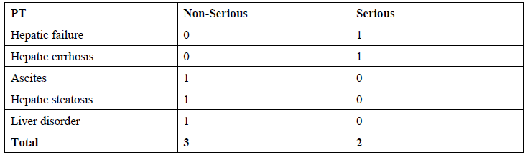
Regarding cholesterol, omaveloxolone-treated patients had a higher incidence of increased total cholesterol (33.3% vs. 6.8%) and LDL (19.0% vs. 9.1%) values above the ULN and a higher incidence of low HDL (6.0% vs 4.3%) values under the ULN compared to placebo. There was 1 TEAE of hypercholesterolemia reported in an omaveloxolone-treated patient. The metabolic pathway and mechanism by which these adverse effects on cholesterol occur with omaveloxolone use has not been clearly explained in any of the sponsor’s submission documents. The proposed Australian PI under section 4.4 states a clear warning regarding lipid abnormalities stating raised LDL levels and lower HDL levels can occur with omaveloxolone use and suggests lipid monitoring before and during treatment with omaveloxolone. The Delegate finds this warning adequate to inform prescribers of this risk and the recommended actions to take.

Uncertainties and limitations of data
The efficacy of omaveloxolone for the proposed indication is primarily supported by the pivotal study 1402 part 2, inclusion criteria in this trial required an mFARS score ≥20 and ≤80. This raises uncertainty regarding the efficacy of omaveloxolone in preventing neurological deterioration (as measured by mFARS score) in patients with Friedreich’s ataxia who have more severe neurological symptoms at baseline (those in real world population who’s mFARS score is >80 at baseline).
The sponsor has proposed that induction of the Nrf2 gene, which activates multiple mechanisms to protect against oxidative tissue damage is the primary mechanism of efficacy in patients with Friedreich’s ataxia. The Delegate accepts this as plausible based on the submitted information regarding Omaveloxolones mechanism of action combined with the known pathophysiology of Friedreich’s ataxia, but several limitations regarding the knowledge surrounding Omaveloxolone’s mechanisms of action and possible off target adverse effects are discussed below.
Regarding the increase in SAE’s noted in the pivotal study 1402, in the omaveloxolone treatment group under the SOC of ‘cardiac disorders’ the significance of this remains unclear. The sample size of the placebo (N=52) and omaveloxolone group (N=51) is small, so differences between treatment groups are difficult to interpret. Furthermore, the significant imbalance between rates of cardiomyopathy between the omaveloxolone group (49%) compared to the placebo group (28.8%) make rates of cardiovascular events such as arrhythmias difficult to interpret. This is because a history of cardiomyopathy would be more likely to pre-dispose a patient to arrhythmias, further increasing difficulty in interpretation of safety data regarding cardiac disorder in the pivotal trial 1402. It is noted that 2 patients in the omaveloxolone treatment group developed BNP levels >200pg/mL with 0 reaching this threshold in the placebo group. Figure 23 shows that patients in the omaveloxolone treatment group with a history of cardiomyopathy developed increases in mean BNP levels at multiple time points (compared to omaveloxolone treated participants with no history of cardiomyopathy), especially at week 24, where it is noted that the mean BNP elevation levels are higher in participants on omaveloxolone with a history of cardiomyopathy. Again, the significance of this is unclear and there is no clear biological pathway that would explain elevated BNP levels in the omaveloxolone treated group through its mechanism of action.
This rise in BNP is of concern as the most common driver of BNP elevation is through cardiac stretch due to increased cardiac pressures, which is a key mechanism for the development of heart failure. The sponsor has referenced mouse studies (EMA Foreign Evaluation Reports - Day 150 Assessment Reports – Clinical – Response to Question 100) where it is stated that in studies of mouse models with obesity, there was a decrease in heart weight with omaveloxolone analog treatment. The Delegate feels this does not provide a plausible explanation for BNP elevations in the sponsor’s pivotal study. Omaveloxolone’s mechanism of action through induction of the Nrf2 gene has pleiotropic effects resulting in changes to multiple metabolic pathways within the human body. Given the effects on multiple metabolic pathways, the possibility that omaveloxolone, acting through an unknown mechanism either increases cardiac compliance, or increases cardiac pressures (or both) leading to BNP elevations needs to be considered, especially in those with a history of cardiomyopathy.
From the submitted information, the Delegate feels it is an unknown risk whether these BNP elevations could represent pre-clinical signs of worsening heart failure due to raised cardiac pressures. In the pivotal trial 1402 part 2, only participants with mild to moderate cardiomyopathy associated with Friedreich’s ataxia were included and patients with an LV ejection fraction <40% were excluded. Therefore, the possibility that omaveloxolone could exacerbate or increase rates of heart failure in patients with more advanced cardiac disease (especially with ejection fraction <40%) needs to be considered. This raises the question about whether patients with Friederich’s ataxia who have more advanced hypertrophic cardiomyopathy, or who have ejection fractions <40% are suitable for treatment with omaveloxolone.
Regarding adverse hepatic events and abnormal laboratory values, the sponsor has provided justification (In Pharmacodynamics (PD) heading) for why consistent dose dependant elevation in GGT, ferritin, AST, ALT and reduction in CK noted in study 1402 part 1 are not considered to be related to hepatocyte damage or an inflammatory reaction, but rather due to induction of the Nrf2 gene causing pleiotropic effects leading to increased mitochondrial function and induction of metabolic pathways that reduce oxidative tissue damage. There is also evidence that in mouse models, induction of the Nrf2 gene has effects on regulating multiple Phase I and Phase II drug metabolizing genes that are involved in responses to oxidative stress. The sponsor has also cited evidence that the Nfr2 transcription factor directly regulates ferritin and GGT expression in cultured cells (EMA Foreign Evaluation Reports - Day 150 Assessment Reports – Clinical – Response to Question 100). It is noted that the sponsor has not proposed any clear metabolic pathway to explain the simultaneous elevation of both mean ALT and AST in the pivotal trial with omaveloxolone use. The plausibility of the raised ALT and AST levels in the pivotal trials being due to Nrf2 gene induction needs to be considered when the Nrf2 gene is largely regulating intracellular processes and does not necessarily explain why raised mean ALT and AST levels were noted with omaveloxolone use.

The most common reason for a simultaneous rise in ALT and AST levels in a participant’s serum would be hepatocellular damage releasing ALT and AST into serum (especially with 1 participant on omaveloxolone developing ALT levels >x10 ULN in an active treatment group with a small total number of participants on active treatment). The dose dependant rise in ALT and AST noted in Study 1402 part 1 provides some supporting evidence that these ALT and AST rises are a pharmacodynamic effect of omaveloxolone, rather than hepatic toxicity. But this evidence does not clearly exclude the possibility that this could indicate transient dose dependant hepatic toxicity through an unknown mechanism.
A further uncertainty is present regarding the safety and efficacy of omaveloxolone when used in patients <16 years of age. There were no patients <16 years of age included in the sponsor’s pivotal trial. It is noted that ~29% of patients with FA will be diagnosed at 0-14 years and ~39% diagnosed between 8-14 years. Given this, combined with currently available evidence of efficacy, it is highly likely that there will be interest in the use of omaveloxolone off-label for the same indication in patients <16years of age. In response to the EMA evaluator question regarding providing PK data for elderly subjects, the sponsor performed analysis using their popPK model to characterize the effect of age on the PK of omaveloxolone (EMA Foreign Evaluation Reports - Day 150 Assessment Reports – Clinical – Response to Question 93). Using this approach a box plot estimating the predicted C_{max, ss} and predicted AUC_{ss} was created by age as shown in figure 32 and figure 33. This shows that predicted C_{max, ss} and predicted AUC_{ss} are estimated to be lower for ages 6 to<12 years compared to reference age of 34 years with the upper extreme lower extreme and median value all lower compared to reference age of 34 years. Simulated steady state PK parameters by age were also created using the sponsor’s popPK model showing lower mean AUC_{ss} values in both the 6 to <12 year age group and 12 to <16 year age group compared to the reference age of 34 years (Table 54).
Figure 32: Predicted Cmax,ss following 150 mg once daily dosing stratified by age group
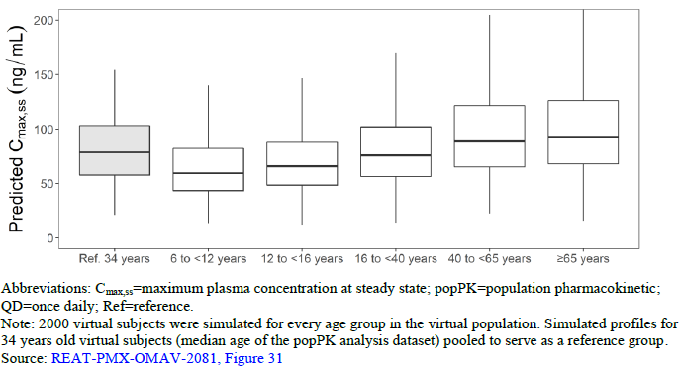
Figure 33: Predicted AUCss following 150 mg once daily dosing stratified by age group
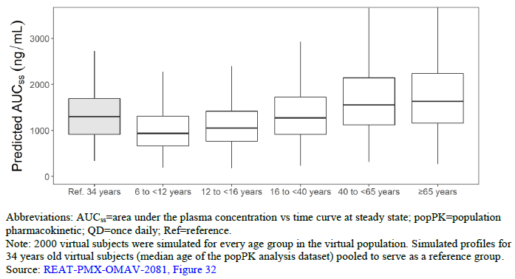
Table 54: Simulated steady-state PK parameters for typical patients receiving a 150 mg daily dose of omaveloxolone
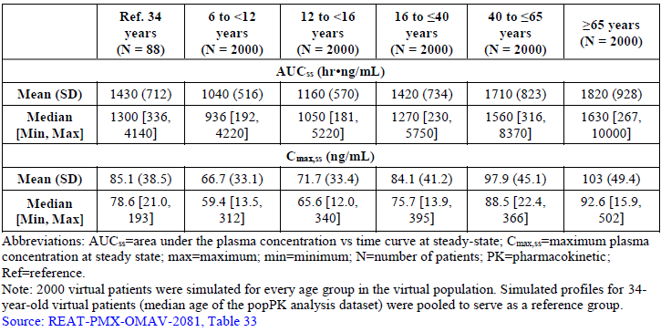
The popPK report REAT-PMX-OMAV-2081 states that an analysis of intrinsic and extrinsic covariates on the PK of omaveloxolone suggests that healthy subject status, food effect, baseline age and baseline ALP were significant covariates. The Delegate has noted that weight was not mentioned as a significant covariate in the PK of omaveloxolone in the creation of the popPK model. This data gives some background regarding the predictions of omaveloxolone PK in patients <16 years, but there is currently no real-world clinical study evidence to support this. The sponsor has confirmed there is a study for this indication.
There is uncertainty regarding efficacy of omaveloxolone use in patients with more severe neurological manifestations who’s baseline mFARS score is very high. The pivotal trial 1402 part 2 required an mFARS core of between ≥20 and ≤80 for entry into the trial. The scale ranged from 0 to 99 with a baseline mean (SD) mFARS score was 38.77 (SD 11.03) in the placebo group and 40.94 (SD 10.39) in the omaveloxolone group in study 1402 part 2.
After consideration, given the lack of other available treatment options for FA, the Delegate does not think there is sufficient reason to restrict omaveloxolone use in patients with severe neurological symptoms (who in clinical practice would likely have an mFARS score >80, or baseline mFARS score much higher than the baseline mean mFARS score of participants in study 1402 part 2). Given the main benefit of omaveloxolone for the proposed indication is likely to be in reducing the rate of neurological deterioration, rather than restoring function, it could be argued that the risks of omaveloxolone use in patients with severe neurological disease and severe functional impairment who require assistance with most activities of daily living would outweigh the benefits of treatment (because patients with severe neurological disease and high functional impairment may have less net benefit from treatment in preserving their function if a person is already dependant on others for all care needs).
After consideration, the Delegate thinks the prescriber is best placed to be the person to discuss with patients and their carers/families the expected benefits versus risks of omaveloxolone for the proposed indication in the cohort of patients who would likely have a very high baseline mFARS score in clinical practice (who’s baseline mFARS is likely much higher than the baseline mean mFARS of participants in study 1402 part 2), rather than restricting use of omaveloxolone in patients with severe neurological symptoms of FA.

Proposed indication
As discussed under headings ‘efficacy’ and ‘uncertainties and limitations of data’ the Delegate considers that the sponsor has adequately established efficacy for the proposed indication of:
treatment of Friedreich’s ataxia in adults and adolescents aged 16 years and older.

Dosing
The dosing for the proposed indication is:
The recommended dose is 150 mg omaveloxolone (3 hard capsules of 50 mg each) taken orally once daily with further instructions regarding method of administration stating Omaveloxolone should be taken on an empty stomach at least 1 hour before or 2 hours after eating.
For patients unable to swallow whole capsules the method of administration stated in the proposed PI is: Skyclarys capsules may be opened, and the entire contents sprinkled onto 2 tablespoons of apple sauce. Patients should consume all the medicine/food mixture immediately on an empty stomach at least 1 hour before or 2 hours after eating.
The efficacy for the 150mg daily dose has been shown in the pivotal trial 1402 part 2. This dose was chosen based on pharmacodynamic outcomes from study 1402 part 1, which showed dose dependant increases in ferritin, GGT, ALT and AST at week 4, with dose dependant reduction in CK noted at week 4. The sponsor has stated that these dose dependant increases at week 4 in represent induction of the Nrf2 gene and are therefore a pharmacodynamic effect which guided the sponsor’s choice of the omaveloxolone dose of 150mg daily in study 1402 part 2.
Study 1703 showed that the mean AUC_{0-∞} of fasted participants in this study at doses of 50mg (545h*ng/mL) and 100mg (1230h*ng/mL) increased in a roughly dose proportional manner, but the AUC_{0-∞} between doses of 100mg (1230h*ng/mL) and 150mg (1230 h*ng/mL) were the same, indicating no dose proportional increase between these doses. This study also showed that administration of omaveloxolone 150mg with a high-fat meal resulted in an approximately 4.5-fold increase in mean C_{max} and an approximately 15% increase in mean AUC_{inf} as compared to fasting conditions using the same 150mg omaveloxolone dose.
The bioavailability of Omaveloxolone was not formally studied during the clinical development program. As per review by EMA evaluators given the increased C_{max} and increased AUC_{0-∞} in the fed state it is recommended in the proposed PI that omaveloxolone is recommended to be taken at least
1 hour before or 2 hours after eating. Given changes in the C_{max} and AUC_{0-∞} noted in pharmacokinetic study 1703, the Delegate agrees with this recommendation.
Regarding the recommended dose of 150mg daily, it is noted the AUC_{0-∞} in study 1703 showed that dose proportionality was not clearly established in the dose range of 100mg to 150mg and that study 1402 part 1 showed mean increases in ferritin, AST and ALT at week 4 compared to baseline for the omaveloxolone 80mg daily dose. This raises the possibility, given systemic exposures for the 100mg and 150mg daily dose may be similar, that the 100mg daily omaveloxolone dose could have similar efficacy to the 150mg daily dose. But given the pivotal study 1402 part 2 only used the dose of 150mg daily, the Delegate agrees with 150mg daily being the recommended omaveloxolone dose for the proposed indication.
In document ‘foreign evaluation report – day 150 assessment reports – clinical’ on page 118 in response to the EMA evaluator queries regarding dose proportionality, the sponsor has used the popPK model (REAT-PMX-OMAV-2081) to generate a boxplot of individual post hoc clearance values vs dose for healthy subjects from Studies 408-C-1703 (dose proportionality assessment), 408-C-1804 (healthy subject controls from hepatic impairment study), and 408-C-1806 (omaveloxolone administered alone from clinical drug-drug interaction [DDI] study), and patients with FA from Study 1402 Part 1 and Part 2 shown in Figure 34.
Figure 34: Post hoc clearance vs dose in healthy subjects (Studies 408-C-1703 and 408-C-1806) and FA patients from Study 1402 part 1 and part 2
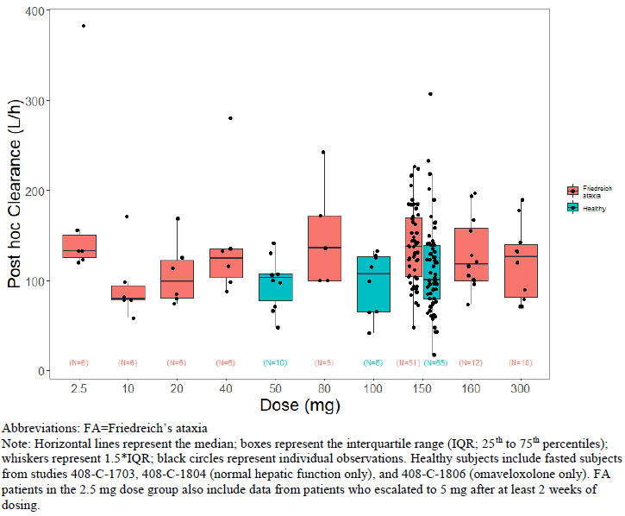
The sponsor states that consistent clearance values across doses in healthy subjects and FA patients is indicative of linear PK and dose proportional behaviour with respect to total systemic exposure as measured by AUC. The Delegate accepts this data provides supportive evidence that omaveloxolone displays linear PK.
See heading ‘Pharmacokinetics’ in discussion section for discussion of omaveloxolone dosing in renal and hepatic impairment, as well as drug-drug interactions.

Conclusions
The submitted application shows significant efficacy for the proposed indication: for the treatment of Friedreich’s ataxia in adults and adolescents aged 16 years and older. The primary efficacy endpoint in the pivotal study mainly relates to long term neurological outcomes, as measured by differences in the mFARS score between omaveloxolone and placebo treatment groups. Long term this may also correlate with a slowing of deterioration in a patient’s day to day activities of daily living and function. Whilst there are adverse events noted with omaveloxolone that are relatively common, these are adequately described in the product information.
Uncertainty remains regarding whether longer omaveloxolone treatment has any effect on mortality in patients with Friedreich’s ataxia. There is also uncertainty regarding whether rises in hepatic enzymes occurring after treatment with omaveloxolone are related to a pharmacodynamic effect of omaveloxolone or a result of hepatic injury. Long term effects of omaveloxolone treatment on cardiac function also remains uncertain, especially whether cardiac disorders in patients with Friedreich’s ataxia on long term omaveloxolone will increase, remain the same or be reduced compared to patients with Friedreich’s Ataxia not taking omaveloxolone.
The Delegate acknowledges that Friedreich’s ataxia is a debilitating, progressive neurological disorder (with significant cardiac manifestations) that commonly results in premature mortality and high rates of disability with no currently available effective pharmacological treatment.
After consideration of the sponsor’s submission, the Delegate finds that overall, the risk-benefit profile for Skyclarys is favourable for the proposed indication. Whilst a final decision has not been reached, I am inclined to approve the registration of Skyclarys for the proposed indication pending resolution of the outstanding issues.

Risk management plan (RMP) evaluation
The summary of safety concerns and their associated risk monitoring and mitigation strategies are summarised in Table 55. The TGA may request an updated RMP at any stage of a product's life cycle, during both the pre-approval and post-approval phases. Further information regarding the TGA’s risk management approach can be found in risk management plans for medicines and biologicals and the TGA's risk management approach. Information on the Australia-specific annex (ASA) can be found on the TGA website.
Table 55: Summary of safety concerns
Summary of safety concerns |  | Pharmacovigilance |  | Risk Minimisation
 |  | Routine | Additional | Routine | Additional
Important identified risks | None | – | – | – | –
Important potential risks | Drug-induced liver injury | * | # |  | –
Important potential risks | Congestive heart failure | * | # |  | –
Missing information | Use in pregnancy |  | – |  | –
Missing information | Long-term safety |  | # | – | –
*Follow-up questionnaire
# Post-market registry (Multinational study)
This summary of safety concerns is the same as that approved by the EMA. Subject to clinical and nonclinical evaluators’ comments on the RMP, this summary of safety concerns is acceptable from an RMP perspective.
The pharmacovigilance plan is acceptable. The sponsor stated Australian patients will not be included in the post-market registry as the study will be fully enrolled, or close to be fully enrolled by the time Skyclarys is available in Australia. If any findings from this registry warrant updates to the RMP, the sponsor is expected to update the RMP accordingly.
Only routine risk minimisation activities are proposed. This is the same approach approved by the EMA. Routine risk minimisation measures are acceptable to mitigate the risks associated with this product.

Independent expert advice
The Delegate received the following independent expert advice.

Advisory Committee on Medicines considerations
The Advisory Committee on Medicines (ACM), having considered the evaluations and the Delegate’s overview, as well as the sponsor’s response to these documents, advised the following.

Specific advice to the Delegate
The ACM advised the following in response to the Delegate’s specific request for advice:
- What is ACM opinion on risks associated with off label use of omaveloxolone in patients with Friedreich’s ataxia <16 years of age?
The ACM advised that there was no data presented regarding safety and efficacy in patients under 16 years of age.
The ACM noted that the sponsor has commenced a Phase 1 paediatric trial to identify the appropriate dose for the paediatric population aged from 2 years to 16 years. A subsequent Phase 3 randomised trial is currently planned to commence later in 2025.
Off-label use in younger patients would be an untested treatment. The ACM noted that symptoms usually begin from 5 to 15 years of age, so omaveloxolone is unlikely to be prescribed to children under the age of 5 years when pharmacokinetics can be markedly different. Management of paediatric Friedreich’s ataxia patients would typically be undertaken by multidisciplinary care teams, including neurologists, cardiologists, endocrinologists, urologists, physiotherapists, occupational and speech therapists, and social workers.
The ACM suggested a change to the proposed PI to help mitigate off label use, through ensuring initiation and supervision by neurologists experienced in the management of patients with Friedreich’s ataxia.
- What is ACM opinion on whether rises in hepatic enzymes with omaveloxolone use are related to a pharmacodynamic effect of omaveloxolone or a result of hepatic injury?
The ACM advised that raised GGT may be enzyme induction while raised ALT/AST is more likely due to hepatic injury from a toxic intermediate of drug metabolism with reversal due to adaption.
A small number of individuals may be predisposed to increased toxicity and unless liver injury is detected early by close monitoring and omaveloxolone promptly ceased, hepatic failure may develop.The ACM noted that 2 cases of hepatic failure were documented in the Periodic Safety Update Report since the first international registration date of omaveloxolone of 28 February 2023.
Because of the limited number of subjects exposed to omaveloxolone so far, it is difficult to estimate the risk of severe and fatal drug induced liver injury (DILI). Provided there is close monitoring of ALT and prompt cessation of the medicine according to the stopping rules in the proposed PI, the evidence suggests severe DILI is likely to be avoidable.
- What is ACM opinion on the recommended monitoring of hepatic enzymes after initiation of omaveloxolone in the proposed PI?
The ACM advised that the recommended monitoring could be strengthened. Testing of ALT, AST, and bilirubin prior to initiation of omaveloxolone, monthly testing during the first 3 months of treatment, and periodic testing thereafter as clinically indicated was appropriate. In addition, if abnormal ALT is found, monthly monitoring should continue for an additional 3 months and then at a reduced frequency of 3 months if improvement is noted. Additionally, ALT should be monitored monthly for 3 months after the introduction of another medicine which may increase levels of omaveloxolone (e.g. CYP3A4 inhibitors).
The ACM agreed with the recommended dose adjustments for patients with hepatic impairment in the proposed PI, including when omaveloxolone should be ceased.
Therapeutic Goods Administration
Advisory Committee on Medicines Minutes – SKYCLARYS – omaveloxolone – Biogen Australia Pty Ltd – PM-2024-02530-1-1 Ratified on 17 April 2025 Page 7 of 8
- What is ACM opinion on risks of long term omaveloxolone use on cardiac function?
The ACM advised that elevation of BNP suggests omaveloxolone may worsen or expedite cardiac dysfunction. The implications of this in a condition where cardiomyopathy is a common terminal event are unclear. The ACM noted that in the study there were no reported heart failure related admissions or deaths. It was considered that the significant improvement on functional status was likely to be a significant priority for individuals with Friedrich’s Ataxia. The ACM noted the PI acknowledges the cardiac risks.
The ACM advised that the CMI should state that an increased BNP is a marker ‘of’ heart problems (not ‘for’).
The ACM noted that patients with Friedreich’s ataxia will typically be managed by multidisciplinary care teams, including cardiologists.

Advisory committee conclusion
The ACM considered this product to have an overall positive benefit-risk profile for the indication:
Treatment of Friedreich’s ataxia in adults and adolescents aged 16 years and older.

Assessment outcome
Based on a review of quality, safety, and efficacy, the TGA decided to register Skyclarys omaveloxolone 50 mg capsule bottle. The approved indication for this therapeutic good is:
Skyclarys is indicated for the treatment of Friedreich’s ataxia in adults and adolescents aged 16 years and older.

Specific conditions of registration
- Skyclarys (omaveloxolone) is to be included in the Black Triangle Scheme. The PI and CMI for Skyclarys must include the black triangle symbol and mandatory accompanying text for five years, which starts from the date of first supply of the product.
- The Skyclarys EU-Risk Management Plan (RMP) (version 1.0, date 12 December 2023 DLP 24 March 2022), with Australia-Specific Annex (ASA) (version 1.0, dated June 2024), included with submission PM-2024-02530-1-1, and any subsequent revisions, as agreed with the TGA will be implemented in Australia.
- An obligatory component of risk management plans is routine pharmacovigilance. Routine pharmacovigilance includes the submission of periodic safety update reports (PSURs).
Reports are to be provided in line with the current published list of EU reference dates and frequency of submission of PSURs until the period covered by such reports is not less than three years from the date of this approval letter. Each report must be submitted within ninety calendar days of the data lock point for that report.The reports are to at least meet the requirements for PSURs as described in the European Medicines Agency’s Guideline on good pharmacovigilance practices (GVP) Module VII-periodic safety update report (Rev 1), Part VII.B Structures and processes. Note that submission of a PSUR does not constitute an application to vary the registration.
- The sponsor submitted the final study report for the 2-year oral carcinogenicity study in rats (RTA-P-21070) to the TGA in December 2025.

Product Information and Consumer Medicine Information
For the most recent Product Information (PI) and Consumer Medicine Information (CMI), please refer to the TGA PI/CMI search facility.

Therapeutic Goods Administration
PO Box 100 Woden ACT 2606 Australia
Email: info@tga.gov.au Phone: 1800 020 653 Fax: 02 6203 1605
https://www.tga.gov.au

This is the original indication proposed by the sponsor when the TGA commenced the evaluation of this submission. It may differ to the final indication approved by the TGA and registered in the Australian Register of Therapeutic Goods.
Opal P & Zoghbi H.Y. Friedreich ataxia. In: UpToDate, Connor RF (Ed), Wolters Kluwer. (Accessed on 17th July, 2024).
Opal P & Zoghbi H.Y. Friedreich ataxia. In: UpToDate, Connor RF (Ed), Wolters Kluwer. (Accessed on 17th July, 2024).
Opal P & Zoghbi H.Y. Friedreich ataxia. In: UpToDate, Connor RF (Ed), Wolters Kluwer. (Accessed on 27th February, 2025).
Opal P & Zoghbi H.Y. Friedreich ataxia. In: UpToDate, Connor RF (Ed), Wolters Kluwer. (Accessed on 27th February, 2025).
Opal P & Zoghbi H.Y. Friedreich ataxia. In: UpToDate, Connor RF (Ed), Wolters Kluwer. (Accessed on 17th July, 2024).
Opal P & Zoghbi H.Y. Friedreich ataxia. In: UpToDate, Connor RF (Ed), Wolters Kluwer. (Accessed on 17th July, 2024).
Opal P & Zoghbi H.Y. Friedreich ataxia. In: UpToDate, Connor RF (Ed), Wolters Kluwer. (Accessed on 17th July, 2024).
Opal P & Zoghbi H.Y. Friedreich ataxia. In: UpToDate, Connor RF (Ed), Wolters Kluwer. (Accessed on 17th July, 2024).
Opal P & Zoghbi H.Y. Friedreich ataxia. In: UpToDate, Connor RF (Ed), Wolters Kluwer. (Accessed on 17th July, 2024).
Opal P & Zoghbi H.Y. Friedreich ataxia. In: UpToDate, Connor RF (Ed), Wolters Kluwer. (Accessed on 17th July, 2024).
Opal P & Zoghbi H.Y. Friedreich ataxia. In: UpToDate, Connor RF (Ed), Wolters Kluwer. (Accessed on 17th July, 2024).
Lynch DR et al. 2006. Measuring Friedreich ataxia: complementary features of examination and performance measures. Neurology. 2006;66(11):1711-6. Epub 2006/06/14. doi: 10.1212/01.wnl.0000218155.46739.90. PubMed PMID: 16769945.
Patel M, et al. 2016. Progression of Friedreich ataxia: quantitative characterization over 5 years. Ann Clin Transl Neurol. 2016;3(9):684-94.
Wu KC, Cui JY, Klaassen CD (2012) Effect of Graded Nrf2 Activation on Phase-I and -II Drug Metabolizing Enzymes and Transporters in Mouse Liver. PLoS ONE 7(7): e39006. doi:10.1371/journal.pone.0039006.

