Australian Public Assessment Report for Redemplo
  - Active ingredient: Plozasiran sodium
  - Sponsor: Arrowhead Australia Pty Ltd
July 2026

About the Therapeutic Goods Administration (TGA)
- The Therapeutic Goods Administration (TGA) is part of the Australian Government Department of Health, Disability and Ageing and is responsible for regulating therapeutic goods, including medicines, medical devices, and biologicals.
- The TGA administers the Therapeutic Goods Act 1989 (the Act), applying a risk management approach designed to ensure therapeutic goods supplied in Australia meet acceptable standards of quality, safety, and efficacy.
- The work of the TGA is based on applying scientific and clinical expertise to decision-making, to ensure that the benefits to the Australian public outweigh any risks associated with the use of therapeutic goods.
- The TGA relies on the public, healthcare professionals and industry to report problems with therapeutic goods. The TGA investigates reports received to determine any necessary regulatory action.
- To report a problem with a therapeutic good, please see the information on the TGA website.

About AusPARs
- The Australian Public Assessment Report (AusPAR) provides information about the evaluation of a prescription medicine and the considerations that led the TGA to approve or not approve a prescription medicine submission. Further information can be found in Australian Public Assessment Report (AusPAR) guidance.
- AusPARs are prepared and published by the TGA.
- AusPARs are static documents that provide information that relates to a submission at a particular point in time. The publication of an AusPAR is an important part of the transparency of the TGA’s decision-making process.
- A new AusPAR may be provided to reflect changes to indications or major variations to a prescription medicine subject to evaluation by the TGA.

Copyright
© Commonwealth of Australia 2026
This work is copyright. You may reproduce the whole or part of this work in unaltered form for your own personal use or, if you are part of an organisation, for internal use within your organisation, but only if you or your organisation do not use the reproduction for any commercial purpose and retain this copyright notice and all disclaimer notices as part of that reproduction. Apart from rights to use as permitted by the Copyright Act 1968 or allowed by this copyright notice, all other rights are reserved and you are not allowed to reproduce the whole or any part of this work in any way (electronic or otherwise) without first being given specific written permission from the Commonwealth to do so. Requests and inquiries concerning reproduction and rights are to be sent to the TGA Copyright Officer, Therapeutic Goods Administration, PO Box 100, Woden ACT 2606 or emailed to <tga.copyright@tga.gov.au>.

Contents
List of abbreviations 4
Product submission 6
Submission details 6
Product background 7
Disease or condition – Familial chylomicronaemia syndrome (FCS) 7
Current treatment options 8
Clinical rationale 9
Regulatory status at the time of assessment 10
Australian regulatory status 10
International regulatory status 10
Registration timeline 10
Assessment overview 11
Quality evaluation summary 11
Nonclinical evaluation summary 12
Conclusions and recommendations from the nonclinical evaluation 13
Clinical evaluation summary 13
Pharmacology 13
Efficacy 20
Safety 33
Risk Management Plan (RMP) evaluation summary 39
Risk-benefit analysis 39
Delegate’s considerations 39
Proposed action 41
Assessment outcome 41
Specific conditions of registration 41
Product Information and Consumer Medicine Information 42

List of abbreviations
Abbreviation | Meaning
Δ | change in
ΔΔ | placebo-corrected change from baseline
ADA | anti-drug antibody
ALP | alkaline phosphatase
AP | acute pancreatitis
APOC3 | apolipoprotein C3
ASCVD | atherosclerotic cardiovascular disease
ASPGR | asialoglycoprotein receptor
AUC | area under the concentration-time curve
AUC_{0-inf} | area under the time-concentration curve from time 0 to infinity
AUC_{0-t} | area under the time-concentration curve from time 0 to the last measurable concentration
BLQ | below the limit of quantification
BMI | body mass index
CI | confidence interval
CL | systemic clearance
CL/F | apparent clearance
CM | chylomicron
C_{max} | maximum concentration
CV% | percent coefficient of variation
DCO | data cut-off
ECG | electrocardiogram
EMA | European Medicines Agency
EU | Europe
FAS | full analysis set
FCS | familial chylomicronaemia syndrome
FDA | Food and Drug Administration
GalNAc | N-acetylgalactosamine
GFR | glomerular filtration rate
HbA1c | haemoglobin A1c
HDL-C | high-density lipoprotein cholesterol
HTG | hypertriglyceridaemia
LDL | low-density lipoprotein cholesterol
LPL | lipoprotein lipase
MCS | multifactorial chylomicronemia syndrome
mRNA | messenger ribonucleic acid
ODD | Orphan Drug Designation
OLE | open-label extension
PD | pharmacodynamic
PFS | prefilled syringe
PK | pharmacokinetic
popK-PD | population kinetic-pharmacodynamic
PRD | Priority Review Determination
Q3M | every 3 months
QTcF | corrected QT interval using the Fridericia method
RNAi | ribonucleic acid interference
SAE | severe adverse event
SC | subcutaneous
siRNA | small interfering ribonucleic acid
SmPC | Summary of Product Characteristics
t½ | half-life
TEAE | treatment-emergent adverse event
TG | triglyceride
TRL | triglyceride-rich lipoprotein
US | United States
V/F | volume of distribution
VLDL | very low-density lipoprotein – cholesterol
VPC | Visual predictive checks

Product submission

Submission details
Type of submission: | New chemical entity
Product name: | Redemplo
Active ingredient: | Plozasiran sodium
Decision: | Approved for registration in the Australian Register of Therapeutic Goods (ARTG)
Date of decision: | 22 April 2026
Date of entry into ARTG: | 24 April 2026
ARTG number: | 510165
Black Triangle Scheme  for the current submission: | Yes
Sponsor’s name and address: | Arrowhead Australia Pty Ltd
Dose form: | Injection, solution
Strength: | 25 mg
Container: | Syringe - Glass Type I Clear
Pack size: | 1
Approved therapeutic use for the current submission: | Redemplo is indicated as an adjunct to diet to reduce triglyceride levels for adult patients with familial chylomicronaemia syndrome (FCS) for whom standard triglyceride lowering therapies have been inadequate.
Route of administration: | Subcutaneous  This medicine is intended for subcutaneous use only. It should not be administered intramuscularly or intravenously.
Dosage: | The recommended dosage of Redemplo is 25 mg administered as a single subcutaneous injection every 3 months.  If a dose is missed, administer Redemplo as soon as possible.  Thereafter, dosing should be resumed every 3 months from the most recently administered dose.  For detailed information regarding dosage, such as dosage modifications to manage adverse reactions, refer to the Product Information (PI).
Use in pregnancy category: | Category B1  Drugs that have been taken by only a limited number of pregnant women and women of childbearing age, without an increase in the frequency of malformation or other direct or indirect harmful effects on the human fetus having been observed.  Studies in animals have not shown evidence of an increased occurrence of fetal damage.  For detailed information refer to the PI.  The use of any medicine during pregnancy requires careful consideration of both risks and benefits by the treating health professional. The pregnancy database must not be used as the sole basis of decision making in the use of medicines during pregnancy. The TGA does not provide advice on the use of medicines in pregnancy for specific cases. More information is available from obstetric drug information services in your state or territory.

Product background
This AusPAR describes the submission by Arrowhead Australia Pty Ltd (the sponsor) to register Redemplo (plozasiran) 25 mg/0.5 mL solution for injection pre-filled syringe for the following proposed indication:
Redemplo is indicated as an adjunct to diet to reduce triglyceride levels for adult patients with genetically confirmed or clinically diagnosed familial chylomicronaemia syndrome (FCS) for whom standard triglyceride lowering therapies have been inadequate.

Disease or condition – Familial chylomicronaemia syndrome (FCS)
FCS is recognised as a severe and ultra-rare autosomal recessive clinical condition. FCS is most commonly caused by monogenic biallelic pathogenic variants in 1 of 5 genes (LPL, APOA5, APOC2, GPIHBP1 and LMF1) that result in either a deficiency or loss-of-function of LPL, which impacts the breakdown of triglyceride-rich lipoproteins (TRL), such as chylomicrons (CMs) and very low-density lipoproteins (VLDLs). LPL, produced by adipocytes and myocytes, binds to heparan sulphate at the capillary endothelium, enabling hydrolysis of TGs in CMs and VLDL. When LPL activity is reduced or absent, this hydrolysis cannot occur, resulting in the accumulation of TRLs, mainly CMs, and the development of severe hypertriglyceridaemia (HTG), with levels often exceeding 10 mmol/L (880 mg/dL), representing the top 0.1% of TG levels, and persistent chylomicronaemia.
Severe HTG leads to a range of serious, debilitating, and potentially fatal complications. These include acute pancreatitis (AP), recurrent abdominal pain, eruptive xanthomas, lipaemia retinalis, hepatosplenomegaly or splenomegaly, nausea, vomiting, and transient confusion or ‘brain fog’. AP is a major, life-threatening complication of FCS. The risk of AP is clinically significant if TGs are >10 mmol/L and the incidence increases 3% to 4% for every 1.13 mmol/L (100 mg/dL) increase in TGs.
AP is postulated to arise due to increased blood viscosity that impairs pancreatic tissue blood flow and the hydrolysis of TG by pancreatic lipase, which releases free fatty acids. Evidence shows that AP resulting from severely elevated TGs is often more severe and associated with worse outcomes than pancreatitis from other causes. AP is the primary source of morbidity and mortality in FCS, characterised by severe, persistent upper abdominal pain and elevated serum lipase and/or amylase levels. Complications associated with AP include organ failure, frequent emergency department presentations, hospitalisations, chronic pancreatitis, and death.
Diagnosing FCS can also be challenging, as a negative genotype does not always rule out the condition as not all variants are known or yet proven pathogenic. Multifactorial chylomicronaemia syndrome (MCS), a polygenic disorder affecting ~1 in 400 people, can present similarly to FCS, with a subset of MCS patients experiencing persistent and severe chylomicronaemia, chronic abdominal pain, and recurrent pancreatitis, even in the absence of known pathogenic FCS variants.
To improve identification of patients at high risk, especially those without genotyping or within the higher-risk MCS subset (sometimes referred to as ‘clinical FCS’), validated scoring systems have been developed. These tools use specific clinical criteria to predict the presence of classical FCS variants, guide strategic use of genetic testing, and to support diagnosis in the absence of genetic confirmation. Expert guidelines recommend applying these clinical criteria alongside genotyping to more accurately identify FCS cases. Key features of the FCS scoring system include:
- severe, persistent elevation of plasma TGs (fasting levels >10 mmol/L [>885 mg/dL] on multiple occasions)
- refractoriness to standard TG-lowering therapies
- young age at symptom onset
- absence of secondary factors contributing to HTG
- history of AP episodes and abdominal pain.
Although both FCS and MCS are associated with an increased risk of AP, the risk is significantly higher in FCS (odds ratio of 360) compared to MCS (odds ratio of 50). Some experts suggest that identifying a genetic variant consistent with MCS, rather than classic FCS, does not warrant the need for FCS-specific treatments, as standard TG-lowering therapies may be effective in this population, and treatment of MCS relies on addressing secondary causes and management of other associated risks such as atherosclerotic cardiovascular disease (ASCVD); which patients with FCS are thought to be at reduced risk of. While others have argued that in the absence of a biomarker to predict the risk of developing pancreatitis, prevention of severe HTG remains the only valid target to avoid new episodes of pancreatitis, therefore genetic confirmation should not be conditional for treatment.

Current treatment options
The current goal of treatment in FCS is to maintain fasting TG values well below 10 mmol/L
(885 mg/dL). Additionally, a reduction in TGs approaching 50% would be expected to confer considerable benefit to FCS patients.
Currently, there are no approved therapies in Australia that effectively treat FCS. International guidelines for managing HTG and dyslipidaemia, prioritise a diet highly restricted in fat (less than 20 grams per day, roughly equivalent to one tablespoon of olive oil) and simple carbohydrates for individuals with FCS. While dietary fat restriction can reduce the risk of pancreatitis, it does not normalise TG levels, and maintaining dietary compliance poses a significant challenge for patients. In addition, patients are advised to abstain from alcohol and avoid medications known to elevate TG levels, such as thiazides, beta-blockers, and oestrogen.
Other existing treatments for lowering TGs act through the LPL pathway, which is typically absent or dysfunctional in FCS patients, rendering these therapies largely ineffective. However, fibrates, omega-3 fatty acids or statins may be considered as adjuncts when TG levels remain significantly elevated despite a fat-restricted diet. Notably, certain drug classes used to lower TGs, such as fibrates, may also increase the risk of AP.
Plozasiran is a novel, synthetic, double-stranded siRNA that is conjugated with GalNAc to facilitate targeted uptake by hepatocytes through the asialoglycoprotein receptors (ASGPRs). In hepatocytes, plozasiran selectively degrades messenger RNA (mRNA) transcripts for the APOC3 protein via the endogenous RNA interference (RNAi) mechanism, thereby reducing hepatic and plasma levels of APOC3 protein.
APOC3 is a small apolipoprotein (79 amino acids, ~8.8 kDa) mainly secreted by the liver (80%) and, to a lesser extent, by the small intestine (20%). APOC3 is a protein component of TRLs, including VLDL-C, intermediate-density cholesterol, CMs, and remnant particle lipoproteins. The protein inhibits the hydrolysis of TG on TRL at the capillary level in muscle and adipose tissue by suppressing LPL activity (the LPL-dependent pathway), and delays clearance of lipoprotein remnants by the liver through inhibition of hepatocyte receptor-mediated uptake (the LPL-independent pathway). APOC3 regulates fasting and postprandial plasma TG levels through both LPL-dependent and LPL-independent pathways.
Given the central role of APOC3 in modulating TG metabolism and its primary synthesis in hepatocytes, it is an ideal target for RNAi-mediated gene silencing. Human genetic studies have shown that heterozygous carriers of null mutations in the APOC3 gene have lower APOC3 levels, fasting and postprandial TG levels, higher high-density lipoprotein (HDL-C), and lower low-density lipoprotein (LDL-C) compared to non-carriers. Individuals deficient in APOC3 do not exhibit significant hepatic steatosis and appear phenotypically normal, while those completely lacking APOC3 show blunted postprandial rise in plasma TGs. In patients with FCS and MCS, reducing hepatic APOC3 expression is expected to lower elevated TG levels through the LPL-independent pathway. The therapeutic goal of plozasiran is to meaningfully reduce time-averaged TG levels in FCS patients and thereby decrease the risk of AP.

Clinical rationale
Plozasiran is a novel, synthetic, double-stranded siRNA that is conjugated with GalNAc to facilitate targeted uptake by hepatocytes through the asialoglycoprotein receptors (ASGPRs). In hepatocytes, plozasiran selectively degrades messenger RNA (mRNA) transcripts for the APOC3 protein via the endogenous RNA interference (RNAi) mechanism, thereby reducing hepatic and plasma levels of APOC3 protein.
APOC3 is a small apolipoprotein (79 amino acids, ~8.8 kDa) mainly secreted by the liver (80%) and, to a lesser extent, by the small intestine (20%). APOC3 is a protein component of TRLs, including VLDL-C, intermediate-density cholesterol, CMs, and remnant particle lipoproteins. The protein inhibits the hydrolysis of TG on TRL at the capillary level in muscle and adipose tissue by suppressing LPL activity (the LPL-dependent pathway), and delays clearance of lipoprotein remnants by the liver through inhibition of hepatocyte receptor-mediated uptake (the LPL-independent pathway). APOC3 regulates fasting and postprandial plasma TG levels through both LPL-dependent and LPL-independent pathways.
Given the central role of APOC3 in modulating TG metabolism and its primary synthesis in hepatocytes, it is an ideal target for RNAi-mediated gene silencing. Human genetic studies have shown that heterozygous carriers of null mutations in the APOC3 gene have lower APOC3 levels, fasting and postprandial TG levels, higher high-density lipoprotein (HDL-C), and lower low-density lipoprotein (LDL-C) compared to non-carriers. Individuals deficient in APOC3 do not exhibit significant hepatic steatosis and appear phenotypically normal, while those completely lacking APOC3 show blunted postprandial rise in plasma TGs. In patients with FCS and MCS, reducing hepatic APOC3 expression is expected to lower elevated TG levels through the LPL-independent pathway. The therapeutic goal of plozasiran is to meaningfully reduce time-averaged TG levels in FCS patients and thereby decrease the risk of AP.

Regulatory status at the time of assessment

Australian regulatory status
Redemplo received TGA Orphan Drug Designation (ODD), indicated for ‘the treatment of genetically confirmed or clinically diagnosed familial chylomicronaemia syndrome’ on 28 March 2025.
Redemplo received TGA Priority Review Determination (PRD) for the proposed indication ‘As an adjunct to diet to reduce triglyceride levels for adult patients with genetically confirmed or clinically diagnosed familial chylomicronaemia syndrome (FCS) for whom standard triglyceride lowering therapies have been inadequate’ on 20 June 2025.

International regulatory status
The following table summarises these submissions and provides the indications where approved.
Table 1: International regulatory status at the time of assessment
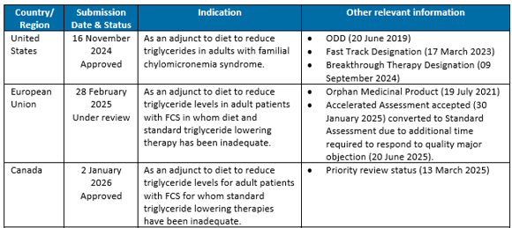

Registration timeline
Table 2 summarises the key steps and dates for this submission.
This submission was assessed under the priority registration process.
Table 2: Registration timeline
Description | Date
Designation – Orphan Drug Designation (ORD) | 28 March 2025
Determination – Priority Review Determination (PRD) | 20 June 2025
Submission dossier accepted and first round evaluation commenced | 29 September 2025
Second round evaluation completed | 27 February 2026
Registration decision (Outcome) | 22 April 2026
Administrative activities and registration in the ARTG completed | 24 April 2026
Number of working days from submission dossier acceptance to registration decision* | 137 days
*Target timeframe for priority submissions is 150 working days from acceptance for evaluation to the decision.

Assessment overview
A summary of the TGA’s assessment for this submission is provided below.

Quality evaluation summary
Plozasiran is a synthetic, double-stranded, hepatocyte targeted N-acetyl galactosamine (NAG)- conjugated small interfering RNA (siRNA) designed to target messenger RNA (mRNA) transcripts from the APOC3 gene using an RNAi mechanism, thereby reducing hepatic and plasma levels of APOC3 protein. The 2´ positions of the ribose subunits of plozasiran have been modified with either fluorine (2´ F) or methoxy (2´ O-Me) groups. Each strand (Antisense and Sense strand) of plozasiran contains twenty-one 2´ modified nucleotide subunits. Each strand also includes multiple phosphorothioates linkages.
Redemplo is presented as a single-use solution for injection, containing 25 mg plozasiran in 0.5 ml in a prefilled syringe (PFS).
The recommended dosage of Redemplo is 25 mg self-administered (or by caregiver) as a single subcutaneous (SC) injection every 3 months (Q3M) into the abdomen (except within two inches of the navel) or thigh region. If a caregiver administers the injection, the upper arm can also be used.
The initial Phase 1 study was done with a 100 mg/mL or 200 mg/mL formulation of plozasiran drug substance (salt-free basis) in 1 mM phosphate buffer packaged in 2R vials. The later phase clinical studies, i.e. phase 2 and the blinded portion of the pivotal phase 3 clinical study used the 200 mg/mL formulation only. To comply with excess volume recommendations prescribed by USP <1151>, the drug product in prefilled syringes (PFS) for commercial distribution was chosen. The pivotal phase 3 study AROAPOC3-3001 used two dose levels for clinical evaluation, 25 mg and 50 mg of plozasiran.
The application and the supporting data relating to the composition, development, manufacture, quality control, and stability of the product have been assessed and checked for compliance, as applicable, with Australian legislation and requirements for new medicines and in accordance with pharmacopoeial standards and the technical guidelines adopted by the TGA.
Approval is recommended from a quality perspective.

Nonclinical evaluation summary
The submitted nonclinical evaluation dossier was in accordance with the relevant ICH guideline ICH M3(R2). The overall quality of the nonclinical dossier was high. All pivotal safety-related studies were GLP compliant. Plozasiran has a perfect sequence match to the target in APOC3 mRNA of monkeys, and 6, 7 and 2 mismatches to that of mice, rats and rabbits, respectively.
The primary pharmacology monstrated in vivo in human APOC3-expressing transgenic (TgAPOC3) mice, chowed-fed and dyslipidemic monkeys and rats. In all species, plozasiran reduced APOC3 mRNA in the liver (up to 88% in monkeys) leading to correlated reduction of circulating APOC3 by up to 92% and 57% in the TgAPOC3 mice and monkeys at clinically relevant doses, respectively. A concurrent decrease in serum triglyceride was observed in all models with reduction of total cholesterol and LDL-C in the TgAPOC3 mice and dyslipidemic monkeys.
No significant secondary pharmacodynamic concerns were identified.
No adverse effects were seen on CNS or respiratory function in rats, or cardiovascular function in monkeys at high doses. No significant inhibition of hERG K+ channel tail current was observed at very high concentrations. Plozasiran is not predicted to affect CNS, respiratory or cardiovascular function in patients based on nonclinical data.
Overall, the pharmacokinetic profiles in rats and monkeys were sufficiently similar to that of humans. The plasma kinetic profile in animals and humans is as expected given the chemical nature of plozasiran, a GalNAc siRNA containing phosphorothioate residues: characterised by a short plasma half-life but long half-life in the liver, moderate plasma protein binding, minimal penetration into the CNS and minimal CYP450-mediated metabolism. Plozasiran is expected to undergo some metabolism to shorter oligonucleotides by hepatocellular ribonucleases with some unchanged drug excreted via the urine. Pharmacokinetic drug interactions involving CYP450 enzymes and transporters are unlikely.
Repeat-dose toxicity studies by the SC route were conducted in mice (4 weeks), rats (up to 6 months) and cynomolgus monkeys (up to 9 months). Maximum exposures (AUC) were very high. Target organs for plozasiran in animals were the liver, lymph nodes and injection sites and kidney. Most of the findings were known class effects of GalNAc-siRNAs. No clinically relevant toxicities were observed.
Plozasiran was not mutagenic in the bacterial mutation assay or clastogenic in vitro (human TK6 lymphoblastoid cells) or in vivo (the mouse micronucleus test). No treatment related increase in tumour incidence was observed in a 6-month study in transgenic mice. A 2-year rat carcinogenicity study is ongoing with the in-life experiment completed. Increases in the incidence of hepatocellular adenomas and carcinomas were seen at high relative exposures. These are not considered a concern for patients.
Fertility was unaffected in male and female rats treated with plozasiran at high relative exposures. In a rat embryofetal development study, increased incidences of embryofetal deaths and fetal skeletal abnormalities were seen, but only in the context of significant maternotoxicity. No adverse embryofetal development effects were seen in a rabbit study. No adverse effects on pup development were seen in rats following maternal exposure during gestation and lactation at levels far exceeding the clinical exposure.
Plozasiran does not raise a concern for immunotoxicity (cytokine induction, complement activation and platelet aggregation) or cyto-/mitochondrial toxicity.
Limits for specified impurities have been toxicologically qualified.

Conclusions and recommendations from the nonclinical evaluation
- The primary pharmacology studies support the proposed indication, dose and dosing regimen.
- The set of clinical safety studies did not raise any concerns for patients.
- There are no nonclinical objections to registration.
- The draft Product Information should be amended as directed.

Clinical evaluation summary
The submission included a full clinical development program of pharmacology, efficacy and safety studies.
The primary clinical evidence supporting plozasiran use in individuals with FCS comes from the placebo-controlled study 3001. Additional supportive evidence comes from 3 completed phase 1 studies, two completed phase 2 studies in patients with severe HTG and mixed hyperlipidaemia, and two ongoing open-label extension (OLE) studies.
This Delegate’s overview focusses on the 25 mg dose of plozasiran with supportive evidence provided by other dosing regimens. The sponsor did not seek approval for the 50 mg dose used in the pivotal study.

Pharmacology
Table 3 provides a summary of the pharmacokinetic (PK) and pharmacodynamic (PD) studies included in the clinical dossier.
Table 3: Summary of PK and PD studies
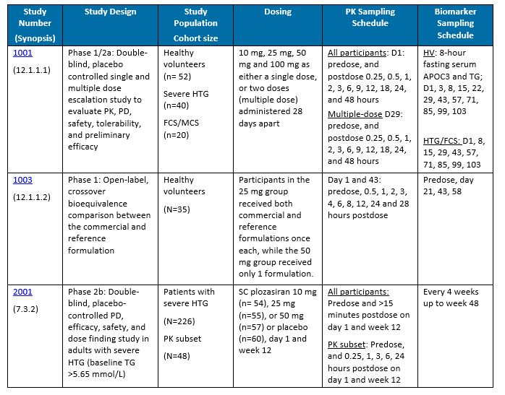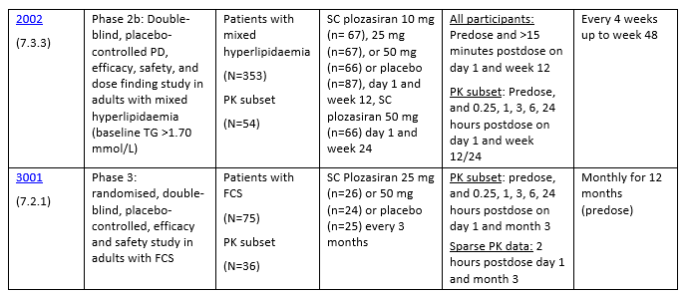

Pharmacokinetics (PK)
PK of plozasiran was found to be linear and proportional to dose up to 50 mg. Following SC injection, plozasiran exhibited rapid and sustained absorption, with maximum concentration (C_{max}) values observed within 3 to 8 hours post dose. Subsequently, plozasiran plasma concentration declined in a multiphasic fashion with a typical mean terminal-phase half-life (t½) of 3.8 hours, which appeared to be dose independent. Systemic accumulation of plozasiran was not observed. The systemic clearance (CL) is estimated to reflect the rate of absorption suggesting that plozasiran is efficiently taken up by the liver via an endocytic process facilitated by the ASGPRs exclusively expressed on the surface of hepatocytes. Plozasiran CL was dose-independent with a mean value of 25.1 L/h with the commercial formulation.
Plozasiran plasma (area under the concentration-time curve) AUC and C_{max} values were approximately proportional to the dose for both single and repeat dose administration. Higher body weight was found to lower plozasiran plasma exposure at a given dose. No other intrinsic or extrinsic factors were shown to influence plozasiran PK parameters. Plozasiran plasma exposures exhibited moderate inter-participant variability with percent coefficient of variation (CV%) for the AUC values ranging from approximately 10% to 37% in healthy volunteers and 44.9% in patient with FCS.

Pharmacokinetics in healthy participants
After SC injection, plozasiran exhibits rapid and sustained systemic absorption with a median T_{max} value of 4.1 hours (range: 3-8). The mean C_{max} in healthy volunteers after plozasiran 25 mg SC injection using the PFS is 110 ng/mL (range: 56-250).
The median C_{max} and T_{max} for FCS patients were 71.4 ng/mL and 2.0 hours, respectively.
A 50 mg/mL in 0.9% saline plozasiran solution prepared in a 25 mg dose PFS is the intended commercial product formulation. During clinical trials, a 200 mg/mL in 1.0 mM phosphate buffer plozasiran solution was administered from vial and syringe. Study 1003 was conducted in healthy volunteers to determine the bioequivalence between the two product formulations.
The two formulations were not bioequivalent as the 90% confidence intervals (CIs) of the geometric mean ratio for area under the time-concentration curve from time 0 to the last measurable concentration (AUC_{0-t}) and C_{max} exceeded the standard bioequivalence upper boundary criteria of 125% (132.8% and 131.7%, respectively). The sponsor estimated the plasma exposure averaged 22% greater in the commercial formulation, either as a result of excess delivery associated with the need to meet minimal dispensable volume targets, or due to a marginally greater systemic bioavailability compared to the vial formulation.
In healthy volunteers at day 21 postdose, the comercial formulation showed a greater median percentage reduction in APOC3 concentration from baseline (91.1% vs 84.3%), but a lower median percentage reduction in TG levels (47.4% vs 60.1%), when compared to the clinical trials formulation. However, a model-based simulation that was performed identified that plozasiran PD parameters are similar between the 25 mg PFS and vial formulations when administered Q3M to a patient with FCS.
Dose proportionality and multiple dosing have not been analysed using the commercial formulation.
Eleven FCS participants have received the commercial formulation during the OLE study 3001. Preliminary data suggests percentage TG reductions from baseline are maintained with the commercial formulation when compared to the clinical trials formulation.
Using the clinical trial formulation, the mean apparent volume of distribution (V/F) of plozasiran in a healthy volunteer and patient with FCS was predicted to be 187 L and 204 L, respectively.
With the commercial formulation, the mean V/F was predicted to be 137 L.
Plozasiran is primarily metabolised by ribonucleases in the liver to shorter oligonucleotides of varying lengths.
The terminal elimination t½ of plozasiran in plasma is approximately 3-4 hours. Plozasiran apparent SC dose clearance (CL/F) was dose-independent across the dose cohorts.
With the clinical trial formulation, the CL/F of plozasiran in a healthy volunteer and patient with FCS was predicted to be 33.8 L/h and 40.7 L/h, respectively.
With the commercial formulation, the mean CL/F was predicted to be 25.1 L/h.

Pharmacokinetics in the target population
The population PK modelling results indicated that FCS disease state was not an independent covariate and did not alter plozasiran PK.
Notably, there are no dedicated studies to ascertain the effect of hepatic or renal impairment on plozasiran PK. Given the clearance mechanism of plozasiran, renal impairment may elevate systemic drug levels which may therefore affect hepatic uptake. Conversely, impaired liver function may result in higher urinary clearance of plozasiran due to reduced hepatic uptake. Low numbers of participants with mild or moderate hepatic or renal impairment were included in the clinical development program. Therefore, additional evaluation of PK parameters in individuals with moderate renal and hepatic impairment are justified. The sponsor reported results for a combined renal and hepatic impairment clinical study are expected to be available in the second half of 2026.
The effects of several other intrinsic and extrinsic factors on the PK of plozasiran were assessed and no dose adjustments were recommended. Of note, plozasiran exposure from a fixed dose tends to be lower in patients with higher body weight and BMI, leading to higher trough TG concentrations in individuals with higher body weight and BMI. The population PK modelling results indicated that FCS disease state was not an independent covariate and did not alter plozasiran PK, noting the subset of FCS participants in the model was relatively low (n=12, total n=146). Injection site was investigated and found not to be a significant covariate impacting PK parameters of plozasiran. The vast majority of injections during clinical trials were administered to the abdomen. PK data regarding administration to the arm is limited, while no such data is available for administration to the thigh. The PI suggests all 3 sites are suitable for administration. As these injection sites are commonly accepted for SC injection and any differences in bioavailability are unlikely to be clinically meaningful, the PI instructions have been accepted.
No clinical drug-drug interaction studies have been performed for plozasiran.
Clinical studies for plozasiran specifically excluded participants who were pregnant, breastfeeding or <18 years of age. Therefore, data in these specific populations are missing. The PI for Redemplo states use should be avoided during pregnancy, and no clinical data exists for use in paediatrics.

Population PK data (popPK)

Final PopPK model
An integrated population PK analysis was conducted based on the pooled data from 5 clinical studies which enrolled healthy volunteers and patients with FCS, severe HTG, or mixed hyperlipidaemia.
Following SC injection, plozasiran displays rapid and sustained absorption into plasma circulation with complex kinetics that can be described by differential rates of absorption from two injection-site depot compartments. The final model indicated that 58.7% of the dose was absorbed with a fast rate of absorption without a lag-time. Beginning once the absorption process of the first compartment is almost complete, the remaining dose is absorbed with a slower rate.
In circulation, plozasiran is rapidly cleared with a typical elimination t½ of 3.4 hours. Plozasiran PK are approximately dose-linear and appear to be time-invariant with multiple administrations.
No accumulation of plozasiran in the plasma compartment is expected before the second SC injection.
Body weight is the major significant covariate to affect plozasiran PK with allometric scaling factors of 0.881 for CL and 1.0 for V/F. BMI 30 to 35 kg/m² has an additional effect to increase plozasiran V/F. As a result, plozasiran plasma concentrations (AUC and C_{max}) from a fixed dose tend to be lower in patients with higher body weight and BMI.
There were no other intrinsic or extrinsic factors identified as independent, statistically significant covariates in the popPK analysis (Figure 2), noting that some subgroup analyses are limited by small numbers. Specifically, the popPK modelling result suggested plozasiran PK are not significantly different for individuals with FCS compared to other populations.
Injection site was investigated and found not to be a significant covariate impacting PK parameters of plozasiran.
Figure 1: Forest plot of covariate-stratified plasma exposures after a single dose of 25 mg SC plozasiran
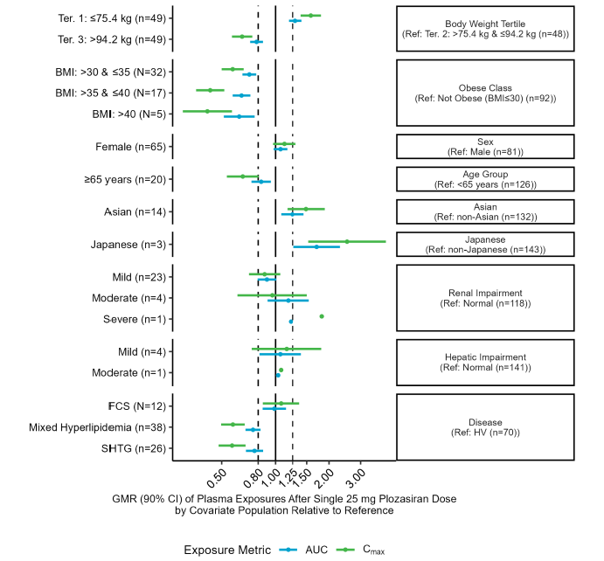

PK interactions
No clinical drug-drug interaction studies have been performed for plozasiran.
The sponsor reported that in vitro metabolism studies suggest that plozasiran is not a substrate, inhibitor, or inducer of cytochrome P450 enzymes or transporters typically encountered in clinical drug interactions.
The sponsor reported plozasiran showed very low permeability across the monolayer cell membranes. In vitro analyses found plozasiran at clinically relevant concentrations was not a substrate for any of the following uptake transporters: MATE1, MATE2-K, OAT1, OAT3, OATP1B1, OATP1B3, and OCT2 SLC. As a result, plozasiran poses very minimal risk of inhibiting these drug transporters that are associated with clinical drug-drug interactions.

Pharmacodynamics (PD)

Studies providing PD information
A summary of the PD studies is provided in table 4 (page 20).
Table 4: Summary of PD studies
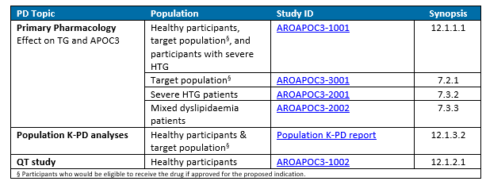

Summary of PD

Mechanism of action
Plozasiran is a first-in-class synthetic, double-stranded, hepatocyte-targeted GalNAc conjugated siRNA oligonucleotide designed to target mRNA transcripts from the APOC3 gene using an RNAi mechanism. Selective degradation of the mRNA for APOC3 is expected to reduced serum TG by preventing APOC3-mediated inhibition of LPL, thus allowing enhanced peripheral LPL activity, and hepatocyte uptake of TRL remnants.
Lowering of serum TGs aims to reduce episodes of HTG-induced pancreatitis.

Pharmacodynamic effects
Reductions in serum APOC3 and TG may be regarded as the on-target pharmacological response and treatment efficacy, respectively. Serum APOC3 and fasting TG concentrations were determined centrally using validated methods. PD data were analysed as change and percent change from baseline in serum APOC3 and TG concentration following SC administration of plozasiran at various doses. The sponsor reported TG levels may be impacted by dietary fat intake, alcohol consumption and medication adherence. Additionally, as plozasiran is minimally absorbed in the intestines, post-prandial elevations of TG levels are expected.
Decreases in serum APOC3 protein were observed within a few days after dose administration, indicating a rapid onset of target engagement by plozasiran. Plozasiran PD steady state is achieved following the first dose. Reductions in APOC3 and TG were demonstrated for all plozasiran doses and dosing frequencies studied.
In the pivotal study (3001) conducted in genetically confirmed or clinically diagnosed FCS patients, the recommended dose of 25 mg Q3M led to median reductions in serum APOC3 and TG of 93% and 80% at Month 10, respectively.
Fasting TG levels of <5.6 mmol/L (<500 mg/dL), a clinically recognised threshold for increased risk of acute pancreatitis, <9.9 mmol/L (880 mg/dL) and <11.3 mmol/L (1,000 mg/dL) were achieved for 50.0% (12/24), 75% (18/24) and 83% (20/24) of participants, respectively, who received plozasiran 25 mg Q3M at the 10 month analysis.
Results were maintained through the OLE study.

Population pharmacodynamics data (popPD)
Because of the disconnect between plasma PK and PD for plozasiran, PD is described by a kinetic-PD (K-PD) model that is not directly associated with plozasiran concentrations in the plasma compartment. A population kinetic-PD (popK-PD) model of plozasiran was developed based on serum APOC3 and TG data collected in the phase 3 pivotal study in FCS patients.
The typical plozasiran dose to inhibit 50% of APOC3 was estimated at ~2.2 mg for FCS participants suggesting a high on-target pharmacological potency of plozasiran.
Overall, there is a strong positive correlation between the relative changes from baseline in the two PD biomarkers (lowering of serum APOC3 and TG were generally associated with each other). However, there were a small percentage of PD samples showing significant reductions in APOC3 (>50% from baseline) which did not always translate into the expected lowering in TG levels, indicating that the relationship between APOC3 knockdown and resulting TG reduction may vary between individuals.
The popK-PD model identified BMI as a statistically significant covariate impacting plozasiran PD. Modelling results suggested that patients with FCS who had a BMI < 25 kg/m² tended to have greater percent reductions in serum APOC3 from baseline compared to patients with a higher BMI (≥ 25 kg/m²); due to higher plozasiran plasma exposure (AUC).
However, an increased sensitivity of response in TG-lowering for a same degree of reduction in APOC3 was seen in patients with higher BMI. Therefore, the net result is that FCS patients have comparable TG reductions when administered the same dose of plozasiran irrespective of their BMI.
Additionally, a potential synergistic effect between plozasiran and other TG-lowering therapeutics was also noted.
No other intrinsic or extrinsic factors were identified as significant covariates in the population PD analysis.
Plozasiran is assumed to increase non-HDL-C concentration, and increase the concentration of HDL-C and LDL-C.
Dyslipidaemia is a major risk factor for atherosclerotic cardiovascular disease (ASCVD). Specifically, elevated concentrations of LDL-C is an established risk factor for ASCVD and a primary target for prevention of adverse cardiovascular events. The clinical benefit of lowering LDL-C depends on the achieved LDL-C reduction; therefore, individuals with higher ASCVD risk require more intense LDL-C lowering to achieve the same absolute level of residual risk as compared with individuals with lower risk. LDL-C levels <1.8 and <1.4 mmol/L are targets for individuals at high risk and very high risk of ASCVD, respectively. Due to the pathophysiology of FCS, baseline levels of LDL-C in this population are typically low.
Sustained reductions were noted in non-HDL-C, VLDL-C, and total cholesterol while sustained increases in HDL-C, LDL-C (measured by ultracentrifugation) and ApoB were observed. In the total FCS population, median LDL-C absolute levels remained below those associated with increased risk for ASCVD (<1.4 mmol/L).
In the Phase 1 study AROAPOC31001, participants who received two 50 mg doses of plozasiran 4 weeks apart maintained APOC3 and TG reductions through 12 weeks after the second dose, Persistent effects were also observed in Phase 2 studies, with >50% reduction of TGs for at least 24 weeks after the last dose of plozasiran 25 mg.
An exposure-response analysis was conducted for the healthy participants with PK data who received single dose administrations. Plateauing of serum APOC3 and TG response appeared to start from plozasiran plasma AUC value of ~1000 h*ng/mL, which is between the mean AUCs observed for the 25 mg and 50 mg dose cohorts. The sponsor emphasised that there is a fundamental disconnect between plasma exposure and PD activity for RNAi compounds as a class. Therefore, the exposure-response relationship presented is an indirect association of plozasiran plasma PK exposure and PD activity.
Requested during the EMA evaluation, a model-based projection of the dose-response relationship suggested that a saturation or plateau region of PD response starts at approximately the dose of 25 mg for an FCS patient with a BMI of 25 kg/m² who is receiving TG-lowering therapy.
The popPK-PD analysis found that neither renal nor hepatic impairment significantly influenced plozasiran’s PD. The limited data available for assessment of effect of renal and hepatic impairment on plozasiran’s PD parameters in the FCS population raises some concern. However, it is important to note that plozasiran has demonstrated consistent dose-PD response relationships across different populations. This consistency supports the likelihood that extrapolation to the FCS population is valid. Additionally, FCS itself is not expected to alter liver function, and none of the participants in the pivotal study had baseline liver impairment, despite no exclusion criteria regarding liver function. It is also again noted that a clinical study is currently being conducted to further assess plozasiran use in individuals with hepatic and renal impairment.

Efficacy
Data supporting the efficacy of plozasiran use in patients with FCS is derived from the phase 3 pivotal study 3001, and its OLE which aims to evaluate treatment up to 2 years.
Additional evidence for plozasiran's efficacy in other patient groups has been provided to support the findings of the pivotal FCS trial (see table 5 below).
Table 5: Effect of plozasiran across phase 2b and 3 clinical trials
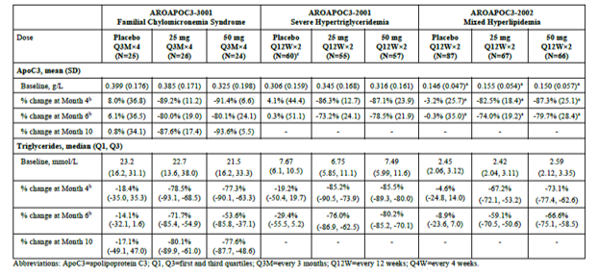

Pivotal study - AROAPOC3-3001
This study was a phase 3, randomised, double-blind, and placebo-controlled clinical trial to evaluate the efficacy and safety of plozasiran in adults with genetically confirmed or clinically diagnosed FCS. The objectives of the study were to evaluate the efficacy and safety of plozasiran in adults with FCS. The study, which began 21 December 2021 was conducted across 54 sites in 20 countries.

Inclusion criteria
Key study inclusion criteria were men and nonpregnant women (using highly effective contraception), age ≥18 years, fasting TGs ≥10 mmol/L (≥880 mg/dL) at screening that was refractory to standard lipid-lowering therapy, a diagnosis of FCS based on a documented history of fasting TG levels >1000 mg/dL on repeated testing (≥3 prior occasions), and at least 1 of the following:
- a supportive genetic test
- history of recurrent episodes of acute pancreatitis (AP) not caused by alcohol or cholelithiasis
- history of recurrent hospitalisations for severe abdominal pain without other explainable cause
- history of childhood pancreatitis
- family history of HTG-induced pancreatitis.
All participants underwent genotyping at screening (unless a valid result was already available) for pathogenic or likely pathogenic variants present in canonical FCS genes (LPL, APOC2, APOA5, GPIHBP1 and LMF1).
Participants were permitted to continue on stable lipid-lowering regimens provided their regimen had not changed for at least 4 weeks prior to screening and they agreed to maintain it throughout the study.
Participants were required to adhere to dietary counselling aligned with the local standard of care, which included a recommendation to limit fat intake to ≤20 g per day throughout the study period.

Exclusion criteria
Exclusion criteria included use of hepatocyte-targeted siRNA or antisense oligonucleotides in the 1 year prior to screening, new or poorly controlled (haemoglobin A1c (HbA1c) ≥9.0%) diabetes, recent active pancreatitis or acute coronary events, moderate liver dysfunction, severe renal impairment, marked proteinuria, clinically significant coagulation abnormalities, uncontrolled hypertension, heart failure, hypothyroidism, or clinical evidence of Cushing’s syndrome.
All dose cohorts enrolled in parallel with participants assigned by a block randomisation algorithm 2:1:2:1 to plozasiran 25 mg and volume-matched normal saline 0.9% placebo or plozasiran 50 mg and volume-matched placebo, respectively. Randomisation was also stratified by level of TGs at screening (≥22.6 mmol/L versus <22.6 mmol/L). Following the initial
12-month randomised period, an OLE study was available.
Figure 2: Study 3001 study design schematic
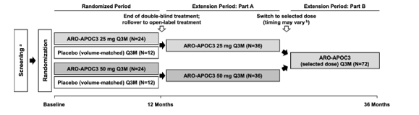
The primary study endpoint was the percent change from baseline at Month 10 in fasting TG levels.
The alpha-controlled, key secondary endpoints were the percentage change from baseline at months 10 and 12 (averaged) in fasting TG levels; the percent change from baseline at month 10 and 12 in fasting APOC3, respectively; and the incidence of blinded independent positively adjudicated events of acute pancreatitis.
An event of AP occurred if 2 of the following criteria were met:
- abdominal pain consistent with AP
- serum lipase activity (or amylase activity) ≥3 times ULN
- characteristic findings of AP on contrast-enhanced computed tomography, magnetic resonance imaging, or transabdominal ultrasound.
Other secondary endpoints assessed include changes from baseline in lipid parameters (non-HDL-C, HDL-C, and fasting TGs) at Months 10 and 12, the proportion of participants achieving specific TG levels (<500, 880, and 1000 mg/dL) or reductions (≥40%, ≥70%), as well as the occurrence of treatment-emergent adverse events (TEAEs) throughout the study period.
Exploratory endpoints also assessed changes from baseline in a comprehensive range of fasting lipid and metabolic parameters, quality of life scores, incidence and timing of AP events, hospitalisations for abdominal pain, incidence of emergent apheresis, and incidence of anti-drug antibodies (ADAs) to plozasiran, over the study period.
Fasting serum TGs and other lipid parameters were collected prior to dosing after at least a 10-hour fast. At month 10, fasting lipid samples were collected twice, 2 to 7 days apart, for calculation of study endpoints.
The full analysis set (FAS) included all randomised participants and treatment assigned at randomisation.
The safety analysis set included all randomised participants who received at least 1 dose of plozasiran.
The per-protocol analysis set included all randomised participants who completed the study period without major protocol deviations.
A total of 123 individuals were screened, with 75 meeting the eligibility criteria and being randomised equally to receive either placebo (n=25), plozasiran 25 mg (n=26), or plozasiran 50 mg (n=24). Of these, 64 participants (85.3%) completed the 12-month randomised study treatment period, with overall compliance at 92%.
Discontinuations were observed across all groups: in the placebo arm, 6 (24.0%) participants discontinued the study, 3 due to AP and 3 by self-withdrawal. In the plozasiran 25 mg group, 2 (7.7%) participants discontinued due to TEAEs (diabetes mellitus and urticaria) and 1 (3.8%) participant due to pregnancy. In the 50 mg group, 1 (4.2%) participant discontinued due to increased HbA1c and another self-withdrew.

Sample size
The study planned to enrol 72 participants, randomly assigned to receive either plozasiran 25 mg, plozasiran 50 mg, or volume-matched placebo in a manner that enabled direct comparison between each dose group and a pooled placebo cohort. With an estimated 99% statistical power, the design aimed to detect significant changes in TG levels using a 2-sided test (2.5% significance level) and Holm’s step-down multiple comparison procedure. The analysis assumed substantial reductions from baseline in fasting TGs at month 10 for the active treatment groups (75% for 25 mg, 80% for 50 mg) compared to a modest reduction for placebo (5%), assuming a standard deviation of 40% and a dropout rate between 10% and 15%.

Statistical methods
No interim analysis was planned or conducted for this study.
The primary efficacy analysis was based on data collected up to 16 May 2024. Efficacy analyses were performed using the FAS unless otherwise noted. The principal hypothesis tested whether there was a difference in the median percent change from baseline in fasting TGs at month 10 between plozasiran and placebo. Additional hypotheses examined changes in fasting APOC3 and average TGs at months 10 and 12. To control for Type I errors, a fixed-sequence hierarchical step-down method of analysis was employed. Adjustment for multiplicity of testing of 2 plozasiran treatment groups versus placebo was carried out using Holm’s step-down procedure. Statistical significance from both dose levels was required prior to moving through the analysis sequence. For the analysis of the incidence of AP, plozasiran 25 mg and 50 mg groups were pooled together to be compared with placebo.
Given the expected distribution of TGs, a nonparametric approach was used, specifically the Hodges-Lehmann method for estimating median differences and 95% CIs. Missing data for primary and secondary endpoints were imputed using a pattern-mixture model, which incorporated participant characteristics and adherence, with separate imputation strategies for the placebo and plozasiran groups based on observed data. Sensitivity analyses were conducted to assess the robustness of results, and similar analytical approaches were applied to secondary endpoints.

Baseline data
Of the 75 participants, there was a balanced representation of male and female participants (49.3% male) (table 6).
The median age was 44 years, ranging from 22 to 76 years. The majority of participants were White (73.3%), while 21.3% identified as Asian. The mean weight was 70.2 kg (range: 43.5–118 kg), and the mean BMI was 25.5 kg/m². Just over half (54.7%) of the participants had genetically confirmed FCS. Distribution of the location of pathogenic variants included LPL (81.8%), GPIHBP1 (9.1%), LMF1 (6.8%), APOA5 (2.3%), and APOC2 (2.3%).
Table 6: Participant baseline characteristics
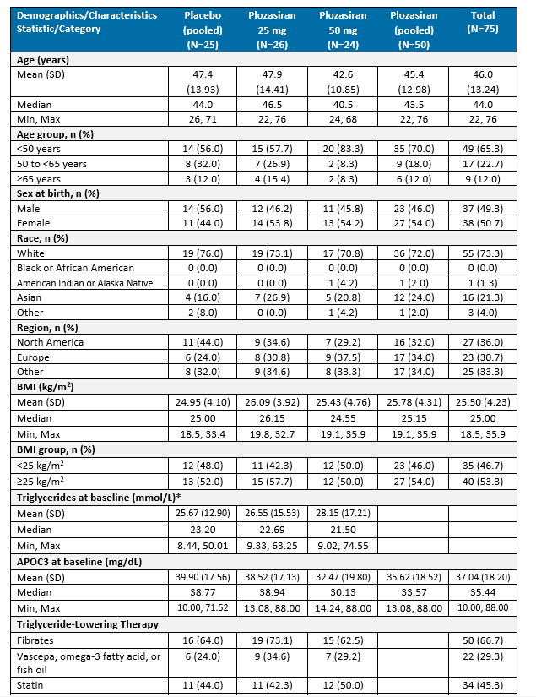
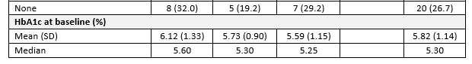
Table 6 (continued): Participant baseline characteristics
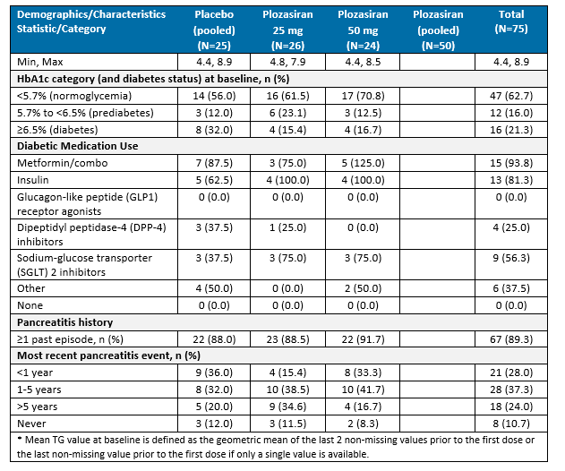
Table 7: Baseline characteristics by FCS status
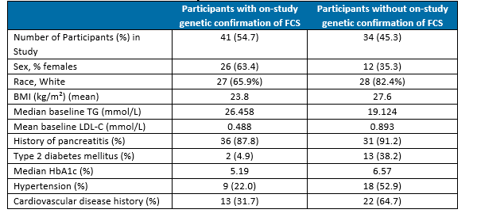

Study treatments
Eligible participants first initiated a treatment stabilisation period for at least 4 weeks, during which diet, lifestyle, and medication regimen were stabilised at the principal investigator’s discretion and in accordance with the local standard of care. Dietary counselling was reinforced at intervals throughout the treatment period. This approach aimed to minimise the potential effects of dietary changes that can alter TG levels and confound interpretation of study results.
All dose cohorts enrolled in parallel with participants assigned by a block randomisation algorithm 2:1:2:1 to plozasiran 25 mg and volume-matched normal saline 0.9% placebo or plozasiran 50 mg and volume-matched placebo, respectively. Randomisation was also stratified by level of TGs at screening (≥22.6 mmol/L versus <22.6 mmol/L). Following the initial 12-month randomised period, an OLE study was available.

Results

Primary endpoint – Percent change in fasting TGs from baseline at month 10
Both doses of plozasiran significantly reduced fasting TGs at month 10 compared with placebo.
Between-group median differences versus placebo were -58.7% for plozasiran 25 mg (p<0.0001) and -52.5% for plozasiran 50 mg (p=0.0002) (table 8 and figure 3 below).
Table 8: Median difference in percent change from baseline at month 10 in fasting TGs
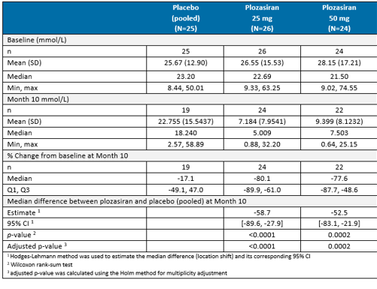
Figure 3: Waterfall plots of percent change from baseline in fasting TGs at month 10
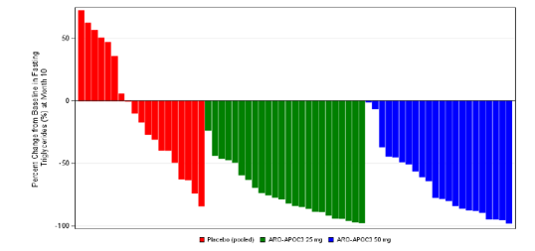

Results for other efficacy outcomes

Averaged percent change in fasting TGs from baseline at month 10 and 12
Median differences versus placebo were -59.6% (95% CI: -91.6, -27.5) for plozasiran 25 mg (p<0.0001) and -50.8% (95% CI: -83.5, -18.1) for plozasiran 50 mg (p=0.0007).

Percent Change from Baseline in fasting APOC3 at 10 and 12 months
At month 10, median changes from baseline in fasting APOC3 in the placebo, plozasiran 25 mg, and plozasiran 50 mg groups were -1.3%, -93.0%, and -96.2%, respectively. Between-group median differences versus placebo were -90.5% (95% CI: -108.29, -72.67) for plozasiran 25 mg (p<0.0001) and -93.4% (95% CI: -109.38, -77.42) for plozasiran 50 mg (p<0.0001).
At month 12, median changes from baseline in fasting APOC3 in the placebo, plozasiran 25 mg, and plozasiran 50 mg groups were 7.7%, -89.3%, and -87.7%, respectively. Between-group median differences versus placebo at Month 12 were -87.0% (95% CI: -112.93, -60.96) for plozasiran 25 mg (p<0.0001) and -87.5% (95% CI: -112.42, -62.54) for plozasiran 50 mg (p<0.0001).

Incidence of acute pancreatitis (AP)
Treatment emergent adverse events (TEAEs) that were potentially consistent with an event of AP were reported by investigators for 24 participants overall. The blinded, independent expert committee positively adjudicated 9 total events as definite AP: 7 events occurred in 5 (20.0%) participants in the placebo group and 2 events occurred in 2 (4.0%) participants in the pooled plozasiran groups. The odds of AP were 83% lower (odds ratio=0.169; 95% CI: 0.030, 0.942; p=0.0292) in the pooled plozasiran groups compared with the placebo group. The mean (SEM) time to the first positively adjudicated case of AP was 115 (43) days for placebo and 110 (65) days for plozasiran. The events of AP were reported by the sponsor to be severe in placebo participants only. However, it is noted that all pancreatitis events met criteria of a serious adverse event due to requirement for hospitalisation. Insufficient data was provided to determine if pancreatitis events differed in severity between participants receiving placebo or plozasiran.
Abdominal pain consistent with potential AP was reported for 6 (24.0%), 1 (3.8%), and 4 (16.7%) participants, respectively, in the placebo, plozasiran 25 mg, and plozasiran 50 mg groups.

Other secondary efficacy outcomes
At month 10, the proportion of participants achieving fasting TGs of <5.6 mmol/L (<500 mg/dL) in the placebo, plozasiran 25 mg, and plozasiran 50 mg groups was 5.3%, 50.0%, and 45.5%, respectively. For the plozasiran 25 mg participants, the proportion of participants achieving the <5.6 mmol/L threshold remained between 44.0% and 68.0% over the 12 monthly measurements.
At month 10, 23 (95.8%) participants in the 25 mg plozasiran group had achieved a ≥ 40% reduction in baseline TG levels and 16 (66.7%) participants had achieved a ≥70% reduction in baseline fasting TGs.
Subgroup analyses identified a higher mean reduction from baseline TGs at month 10 for participants receiving plozasiran who used concomitant TG-lowering therapies. For the 25 mg dose at month 10, the median percent reduction in TGs was -82.8% (n=12) and -65.9% (n=12) for the genetically confirmed and clinical FCS subgroups (table 9), while the reduction for the 50 mg dose was -64.0% (n=15) and -94.5% (n=7), respectively.
Table 9: Subgroup analyses of percent change from baseline in fasting TGs at month 10
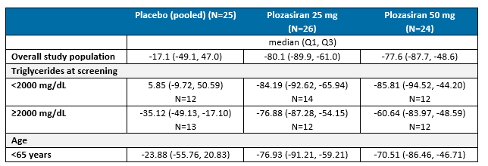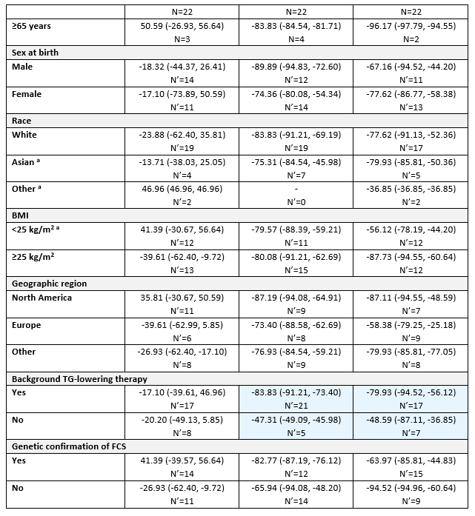

Other efficacy studies

Open-label extension 3001
The 2-part OLE of study 3001 was structured to assess the long-term safety and efficacy of plozasiran for a further 2 years of treatment, while continuing a low-fat diet (≤20 g per day). In part A, participants received either 25 mg or 50 mg of plozasiran SC Q3M. Participants were then transitioned to part B of the study (from 06 June 2024) once the 25 mg dose had been determined as the commercial dose. An additional substudy (n=~12) has been included in the investigational plan to assess the impact of plozasiran on postprandial serum TG levels in participants following the ingestion of a higher fat meal (~40 g). As of 13 September 2024, the 25 mg dose was planned to be administered using the commercial PFS plozasiran solution (25 mg/0.5 mL; 50 mg/mL).
Among the 64 participants who completed the randomised part of study 3001, 62 (97%) participants entered the OLE. Additionally, 3 participants unblinded due to pancreatitis events also joined the OLE, resulting in a total of 65 participants. At the time of DCO (01 November 2024), 60 participants (92.3%) remained in the study (21 in the placebo/plozasiran group and 39 in the plozasiran/plozasiran group), 2 (3.1%) of which had completed the study. Discontinuations occurred due to loss to follow-up, increased glycosylated haemoglobin, 1 confirmed pregnancy and 2 participants wishing to become pregnant.
Plozasiran had been administered for a total of 24 months (randomised and OLE periods combined) for 27 (42%) participants. Three (5%) participants had received 33 months of treatment; the longest duration at time of the DCO. Baseline demographics for OLE participants were comparable to those in the randomised period.
Efficacy analyses demonstrated that plozasiran treatment led to sustained reductions in median fasting TG levels. For those who initially received placebo, TG reductions were observed 1 month after the first administration of plozasiran, consistent with observations during the randomised period. At month 18 since commencement of plozasiran, 25 (38.5%) participants achieved fasting TGs below 5.65 mmol/L, while 43 (66.2%) participants reached below ~10 mmol/L. In response to the EMA evaluation, the sponsor reported that for participants who reduced plozasiran from 50 mg to 25 mg during part B of the OLE, TG levels mostly remained stable or decreased slightly post-switch. For these participants, median TG values were 6.65 mmol/L in Part A and 7.24 mmol/L in Part B, respectively.
Reductions in fasting ApoC3 were maintained throughout the OLE period, with immediate decreases seen in participants who commenced plozasiran during the OLE.
Only 2 events of possible pancreatitis were reviewed, only 1 of which was confirmed as AP. Notably, this occurred in the same participant who had 3 events of AP while receiving placebo during the randomised period and no plozasiran dose adjustment occurred following.
Figure 4: Median value of fasting TGs during the OLE
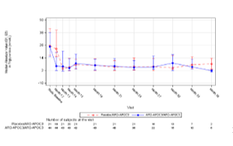
Figure 5: Mean percent change from study baseline in fasting APOC3
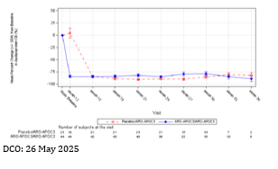

Study AROAPOC3-2001
This Phase 2b study was a multinational, randomised, double-blind, placebo-controlled trial conducted in 8 countries (Australia, Canada, Germany, Hungary, The Netherlands, New Zealand, Poland, and the US) between May 2021 and August 2023. The study enrolled adult participants with severe HTG, defined by fasting TG levels between 5.65 and 45.2 mmol/L, and documented medical history of the same. Participants were randomly assigned in a 3:1 ratio to receive 1 of 3 doses of plozasiran (10, 25, or 50 mg) or placebo, with each participant receiving 2 SC injections on day 1 and week 12. The primary objective was to assess the safety and efficacy of plozasiran and determine an appropriate dose for further clinical development, with the primary efficacy endpoint being the mean percent change in fasting TG at week 24.
All doses of plozasiran significantly reduced fasting TG levels at week 24 compared with placebo (see Table below). Sensitivity analyses were consistent with the primary result. The effect of plozasiran on TG reduction at week 24 was generally robust across all subgroups (baseline fasting TG tertiles, baseline LDL-C categories, age (<65 years or ≥65 years), sex at birth (male or female), BMI (<25 kg/m² or ≥25 kg/m²), 10-year CHD risk (<10%, 10% to ≤20%, or >20%), genetic FCS (Yes or No), concomitant statin use (Yes or No)).
Table 10: Study 2001 least-squares mean percent change from baseline at week 24 in fasting TG
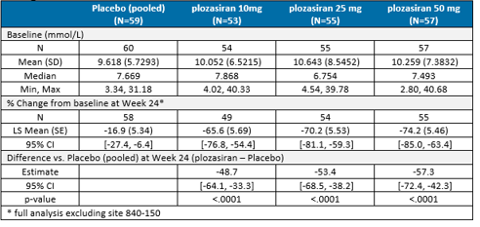
TG reductions over time were similar between the plozasiran 25 and 50 mg dose groups, while the magnitude of effect was less in the 10 mg dose group (figure 6 below). Greater than 90% of participants in the plozasiran 25 and 50 mg groups and >80% of participants in the plozasiran 10 mg group consistently achieved TG reductions below 11.3 mmol/L from week 4 through week 24.
Figure 6: Study 2001 mean percent change from baseline in fasting TG over time
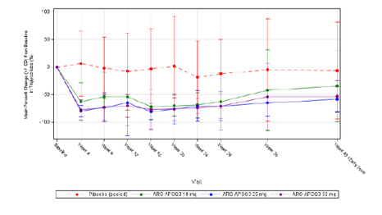

Study AROAPOC3-2002
This phase 2b study was a multinational, randomised, double-blind, placebo-controlled trial conducted in 6 countries (Australia, Canada, Hungary, New Zealand, Poland, and the US) between September 2021 and August 2023. The study enrolled adult participants with mixed hyperlipidaemia, defined by screening levels and history of fasting TG levels between 1.70 and 5.64 mmol/L, and either non-HDLC ≥2.59 mmol/L or LDL-C >1.81 mmol/L at screening. Participants were randomly assigned in a 3:1 ratio to receive 1 of 3 doses of plozasiran (10, 25, or 50 mg) or placebo, with each participant receiving 2 SC injections on day 1 and week 12. In one additional 50 mg cohort, each participant received SC injection on day 1 and week 24. The primary objective was to assess the safety and efficacy of plozasiran and determine an appropriate dose for further clinical development, with the primary efficacy endpoint being the mean percent change in fasting TG at week 24.
All doses of plozasiran significantly reduced fasting TG levels at week 24 compared with placebo (Table below). Sensitivity analyses were consistent with the primary result. The effect of plozasiran on TG reduction at week 24 was generally robust across most subgroups (baseline LDL-C categories, age (<65 years or ≥65 years), sex at birth (male or female), BMI (<25 kg/m² or ≥25 kg/m²), 10-year CHD risk (<10%, 10% to ≤20%, or >20%), concomitant statin use (Yes or No)).
Table 11: Study 2002 least-squares mean percent change from baseline at week 24 in fasting TG
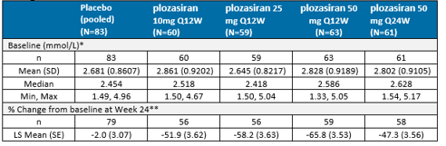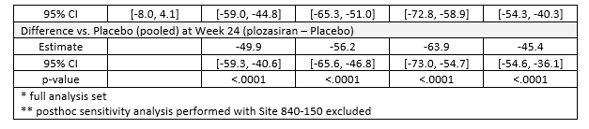
Plozasiran 50 mg dosed 24 weeks apart (Q24W) demonstrated similar effects on TGs as the 50 mg Q12W over the first 12 weeks but showed waning efficacy from week 12 to 16.

Study AROAPOC3-2003
This phase 2 OLE study is evaluating the long-term safety and efficacy of plozasiran in adults with dyslipidaemia who participated in studies 2001 and 2002. The primary endpoint is the incidence of TEAEs among participants, while changes from baseline in fasting lipid parameters are secondary endpoints. The planned duration of the OLE study is approximately 2 years with the supplied interim analysis DCO of 8 November 2024.
Upon initiation of the OLE, all participants transitioned to active treatment, with dosing determined by their initial cohort assignment. As of 22 November 2022, those receiving 50 mg doses were switched to 25 mg, and from 4 December 2023, the final clinical dosing regimen of 25 mg administered Q3M was adopted for all participants for the remainder of the study. The commercial PFS formulation was introduced upon its availability from 25 September 2024.
A total of 418 participants entered the OLE, including 103 who transitioned from placebo to plozasiran. By the DCO, 39 (9.3%) participants had completed the study and 323 (77.3%) were ongoing in the study. Discontinuation due to TEAEs had occurred for 18 participants (4.3%), and 2 deaths were reported. The majority (90%) of participants had completed at least 12 months in the OLE.
At OLE month 15, the median percentage change from the parent study baseline in fasting TG levels was -80.64% in the placebo/plozasiran group and -81.08% in the plozasiran/plozasiran group for participants originally enrolled in studies 2001. The corresponding median percentage changes from parent study baseline at OLE Month 18 were -69.38% and -69.04% respectively, for participants originally enrolled in studies 2002.
Median ApoC3 reductions of ~80 to 84% relative to pretreatment baseline levels were also observed.
For participants in the placebo/plozasiran groups, the TG and APOC3 response to the first dose of plozasiran in the OLE mirrored what had been seen in participants randomised to plozasiran in the blinded phase.
There has been no analysis of the commercial formulation’s efficacy in the target population, as only 11 FCS participants have received the 25 mg PFS formulation during the OLE. Preliminary data suggests percentage TG reductions from baseline are maintained with the commercial formulation when compared to the clinical trials formulation. Therefore, considered the rarity of the condition and the benefit of the PFS for self-administration, this is considered acceptable. Efficacy analysis results from the OLE study 3001, specifically addressing the PFS compared with the clinical trials formulation should be considered as a condition of registration.

Summary of efficacy
Overall, plozasiran consistently and robustly lowers fasting APOC3 and TG levels in patients with severe HTG, including those with FCS, with sustained effects observed in OLE studies. There is evidence for a reduction in AP risk in the target population, although confirmation of clinical benefit is complicated by limitations in AP event assessment and the relatively small number of long-term treated FCS patients. The available efficacy data are considered adequate for the rarity of FCS, but ongoing collection of long-term and real-world evidence is warranted to fully establish the clinical impact of plozasiran.

Safety
The overall clinical safety data includes 654 participants from 3 Phase 2/3 studies:
- The pivotal phase 3 study (3001) enrolled 75 adult participants with FCS, 65 (86.7%) of these patients continued into an OLE period.
- The phase 2b studies (2001 and 2002) enrolled 226 adult participants with severe HTG and 353 adult participants with mixed hyperlipidaemia, 418 (72.2%) of these patients continued into the OLE study 2003.
Exposure to plozasiran during placebo-controlled studies is detailed in table 12.
When considering the 481 participants of phase 2 and 3 studies, the majority have continued to the OLE period, and the median cumulative exposure is 797 days for receipt of the 25 mg dose.
The majority of study participants have received >16 months of plozasiran treatment and 66 participants have been treated with plozasiran 25 mg for >31 months. Details of participant exposure to the 25 mg SC Q3M dose can be found in table 13.
Table 12: Exposure to plozasiran in clinical studies
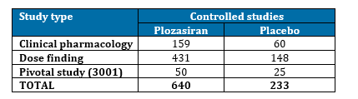
Table 13: Exposure to proposed dose of plozasiran (25 mg SC Q3M) in clinical studies
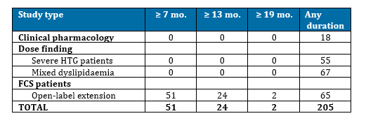

All adverse events (irrespective of relationship to study treatment)

Integrated safety analyses
In the phase 2/3 studies, the overall incidence of treatment emergent adverse events (TEAEs) was similar between the placebo (68.2%) and plozasiran 25 mg group (70.3%), and slightly higher in the plozasiran 50 mg Q12W group (79.5%). The majority of TEAEs were mild in the plozasiran groups and moderate in the placebo group. The most common reported TEAEs are summarised in table14.
During the OLE periods for these studies, TEAEs were reported in 53.5% of participants in the plozasiran 10 mg group, 64.4% of participants in the plozasiran 25 mg group, and 61.5% of participants in the plozasiran 50 mg group. The majority of TEAEs were mild or moderate in the plozasiran 10 and 25 mg groups. The incidence of severe and life-threatening TEAEs increased with dose increase.
No TEAEs were reported in the 7 participants administered with the plozasiran commercial
25 mg PFS formulation during the OLE study 2003.
Table 14: Treatment emergent adverse events (TEAEs) by incidence and exposure-adjusted incidence (randomised period, phase 2/3 studies)
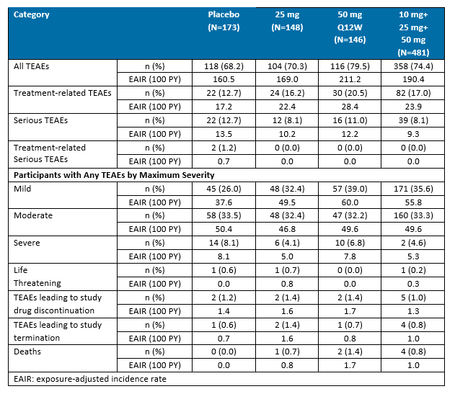
Table 15: Incidence of TEAEs (randomised period, phase 2/3 studies)
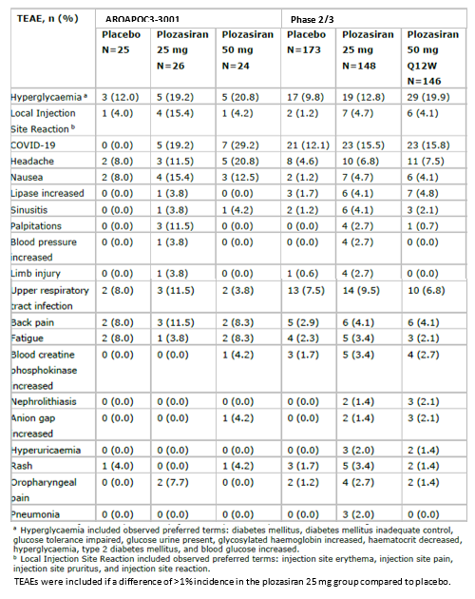

Pivotal efficacy study
TEAEs were reported by 88.5% of participants in the plozasiran 25 mg group, 83.3% of participants in the plozasiran 50 mg group and 80.0% of participants in the placebo group. The most common TEAEs were abdominal pain, COVID-19, headache, and nasopharyngitis (table 16). Severe TEAEs were low in frequency and more common in the placebo group (20.0%) compared to the plozasiran 25 mg (7.7%) and 50 mg (12.5%) groups. One participant (25 mg group) had a life-threatening event of coronary artery disease, which was not considered related to plozasiran treatment.
Table 16: Study 3001 commonly reported TEAEs
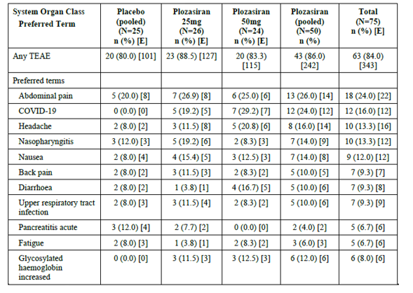

Treatment related adverse events (TEAEs)

Integrated safety analyses
In the phase 2/3 studies, the large majority of TEAEs (~80%) were considered not related to study drug by the Investigator. Ten TEAEs were considered by the sponsor as possible adverse drug reactions: worsening of glycaemic control, local injection site reaction, COVID-19, headache, nausea, lipase increased, sinusitis, palpitations, blood pressure increased, and limb injury.
After further evaluation for biological or physiological plausibility and alternative aetiologies, COVID-19, lipase increased, nausea, blood pressure increased, and limb injury were excluded as adverse drug reactions by the sponsor due to a low plausibility of a causal association of plozasiran treatment with these events.

Pivotal efficacy study
TEAEs were reported by fewer participants for placebo or plozasiran 25 mg compared with plozasiran 50 mg (24.0%, 26.9%, and 33.3%, respectively).
Probably related TEAEs included injection site reactions, nausea, palpitations and hyperglycaemia.
Possibly related TEAEs included headache, constipation, dizziness, nasopharyngitis, injection site pain, liver disorder, and urticaria.

Adverse events of special interest

Pancreatitis
During the pivotal study, 21 TEAEs possibly consistent with pancreatitis were reported in 9 participants in the placebo group, 8 TEAEs for 7 participants receiving 25 mg of plozasiran, and 9 TEAEs for 8 participants receiving 50 mg of plozasiran.
Events of AP were adjudicated according to the 2013 Atlanta definition if 2 of the following 3 criteria were met:
- abdominal pain consistent with AP (acute onset of a persistent, severe, epigastric pain often radiating to the back)
- serum lipase activity (or amylase activity) ≥3 x ULN
- characteristic findings of AP on contrast-enhanced computed tomography, MRI, or transabdominal ultrasound.
In the pivotal efficacy study, positively adjudicated AP events occurred in 5 (20.0%) participants in the placebo group, compared to only 2 (4.0%) participants in the combined plozasiran treatment groups. During the OLE period, 1 participant experienced an episode of pancreatitis approximately 19 months after beginning plozasiran therapy. Notably, this participant had received placebo during the randomised phase, during which they had 3 events of positively adjudicated AP, and subsequently received plozasiran 50 mg and 25 mg during Parts A and B of the OLE, respectively, indicating a high baseline risk for recurrence.
In the phase 2 studies, participants typically had lower TG levels than those diagnosed with FCS and were therefore at less risk of events of AP, especially those in study 2002.
- In study 2001, 4 adjudicated AP events occurred in 3 participants. Two placebo cohort participants, both of which had a history of pancreatitis, had events on day 37 and 278 of the study, respectively. One participant, who had a history of recurrent pancreatitis and a genotype consistent with FCS, had an event of AP on day 318, 8 months after receiving their final dose of plozasiran 50 mg.
- In study 2002, 1 participant in the plozasiran 50 mg Q24W cohort (without a prior history of pancreatitis) experienced a severe adverse event (SAE) of pancreatitis on day 212, 40 days after their last plozasiran dose; this individual’s TG levels were between 0.7 and 2 mmol/L throughout the study.
- In the OLE study 2003, no positively adjudicated AP events were reported, though 3 TEAEs in 3 participants were possibly consistent with pancreatitis.

Injection site reactions
In the phase 2/3 studies, local injection site reactions was 4.0% for participants in the placebo group, 15.4% of participants in the plozasiran 25 mg group, and 4.2% of participants in the plozasiran 50 mg group.

Hyperglycaemia
Patients with FCS are at risk of developing diabetes due to loss of islet cell mass caused by recurrent or severe pancreatitis. At baseline, diabetes (HbA1c ≥6.5%) or prediabetes (HbA1c ≥5.7% and <6.5%) were common in the pivotal study with 12 (48%) participants, 11 (42%) participants, and 9 (38%) participants randomised to placebo, plozasiran 25 mg, and plozasiran 50 mg, respectively. The overall incidence of hyperglycaemia/new onset diabetes mellitus events was 8.0%, 23.1%, and 20.8% in the placebo, plozasiran 25 mg, and plozasiran 50 mg groups, respectively. The effects of plozasiran on glycaemic control were most apparent in participants with already compromised glucose tolerance. At month 10, median increase in HbA1c was 0.20%, 0.45%, and 0.75% for those who had HbA1c < 5.7% (n=31), 5.7% to < 6.5% (n=6) and ≥6.5% (n=4) at baseline, respectively. Mean HbA1c values remained stable through to month 24 of the OLE, after which participant number limit analysis. Among subjects with diabetes at baseline, worsening of diabetes was also reported in 60% of plozasiran-treated subjects versus 11.1% in placebo, and in prediabetic subjects, new-onset diabetes occurred in up to 15.4% of treated subjects compared with 0% in placebo.
During the pivotal study, there were no events of hypersensitivity or anaphylaxis.

Serious adverse events (SAEs)
The incidence of SAEs during the phase 2 and 3 studies was higher in the placebo group (12.7%) compared to the plozasiran 25 mg group (8.1%). None of the SAEs were considered treatment-related in the plozasiran group

Liver function and liver toxicity

Integrated safety analyses
Elevations in liver enzymes were observed more frequently among participants receiving plozasiran compared to those receiving placebo, with ALT increases reported in up to 46% and AST increases in up to 38% of the treatment group, versus up to 8% in the placebo group. In the FCS population, increases in ALT and AST within normal limits occurred during the initial 3 months of therapy and subsequently stabilised.
During the phase 2/3 studies, plozasiran led to mild and reversible increases in transaminases, primarily ALT. Mean increases in ALT were less than 10 U/L. No Grade 3 or Grade 4 shifts in ALT or AST were observed on plozasiran therapy. There were no cases of Hy’s Law. There was no evidence of disproportionate harm amongst individuals with impaired baseline liver function. During the washout period of the phase 2 studies, the effects were shown to be reversible with cessation of therapy.
During the OLE periods, ALT increases >ULN occurred in 11.3%, 14.6%, and 28.0% of participants in the plozasiran 10, 25, and 50 mg groups, respectively. AST increases >ULN occurred in 6.6%, 11.3%, and 28.0% of participants in the plozasiran 10, 25, and 50 mg groups, respectively. A small number of participants experienced transaminase elevations of >3 x ULN (ALT: 4 participants, AST: 2 participants). No participants had plozasiran dosing held or discontinued due to liver function abnormalities or met the criteria for Hy’s Law and no participant with chronic liver disease at baseline experienced more severe transaminitis than those with normal liver function at baseline.
Plozasiran was not associated with elevations in bilirubin or alkaline phosphatase (ALP).

Immunogenicity and immunological events
Overall, the risk of developing clinically relevant immunogenicity is low from plozasiran treatment (<2%).
The development of ADAs was rare.

Summary of safety
In summary, the data support a favourable safety profile for plozasiran in patients with FCS and is supported by phase 2 evidence in populations with HTG. Monitoring for impaired glucose tolerance is recommended and should be included in the PI.
Some uncertainty remains due to the limited number of participants with renal or hepatic impairment, especially considering renal monitoring was not robust. Nonetheless, the low incidence of renal complications and absence of drug-induced liver injury are reassuring. Ongoing clinical studies are expected to further address these risks.
Finally, it should be noted that clinical safety data for the commercial formulation and PFS administration are limited, with only 7 participants having received a single dose in the available phase 2 data.

Risk Management Plan (RMP) evaluation summary
The proposed summary of safety concerns and their associated risk monitoring and mitigation strategies are summarised in table 17. Note is made that the ASA Version 0.4 March 2026 outlines the safety concerns applicable to Australia, which are in line with the safety concerns described in the EU RMP version 0.2 as shown below in table 17.
Table 17: Summary of safety concerns
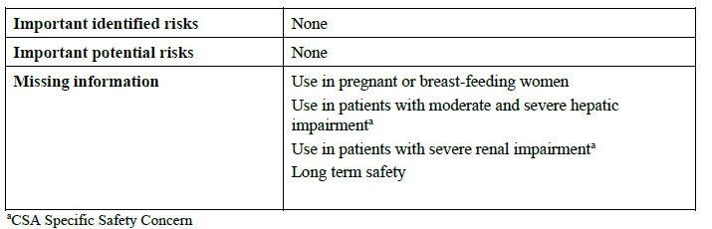
The pharmacovigilance plan is acceptable.
Only routine risk minimisation activities are proposed. The absence of additional risk minimisation measures is acceptable, considering there are no important identified or important potential risks in the summary of safety concerns.
The TGA may request an updated RMP at any stage of a product's life cycle, during both the pre-approval and post-approval phases. Further information regarding the TGA’s risk management approach can be found in risk management plans for medicines and biologicals and the TGA's risk management approach. Information on the Australia-specific annex (ASA) can be found on the TGA website.

Risk-benefit analysis

Delegate’s considerations
The benefit-risk balance of Redemplo as an adjunct to diet to reduce triglyceride levels for adult patients with familial chylomicronaemia syndrome (FCS) for whom standard triglyceride lowering therapies have been inadequate, is favourable.
Plozasiran has demonstrated robust, consistent, and sustained reductions in TG levels across multiple clinical studies, including the target population of patients with FCS. These reductions have reached clinically meaningful thresholds and have been associated with statistically significant decreases in the risk of AP, a critical therapeutic outcome for this rare disease. Notably, in phase 2b and 3 studies across patients with FCS, severe HTG, or mixed hyperlipidaemia, plozasiran consistently reduced APOC3 by 80% to 90% and TGs by 70% to 80%.
While the pivotal study and supporting phase 2 and OLE studies provide strong evidence of efficacy, some uncertainties remain. It has not been feasible to power trials sufficiently to use AP as the primary endpoint. Given the strong epidemiology relating TG levels to pancreatitis risk, TG reductions have been used as a surrogate. Few AP events were reported, only in those with a history of pancreatitis and the study duration was relatively short. However, given the morbidity and mortality risks of AP, an argument exists that plozasiran should not be restricted to only those who have previously experienced AP events. Therefore, the benefit of plozasiran in FCS participants who have previously experienced AP event should be extrapolated to all FCS patients, not just those at high risk.
Additionally, plozasiran consistently lowered APOC3 and TGs in both genetically confirmed and clinically diagnosed FCS populations, which was confirmed during subgroup analyses. Therefore, plozasiran should be accessible to all FCS patients who either have a disease-causing genetic variant or meet the pivotal study's diagnostic criteria. Considering the patient selection details in Section 4.2 Dose and Method of Administration of the Australian PI, the removal of the distinction between genetic and clinical cohorts from the indication is recommended.
It is also noted that the US indication does not require TG lowering therapies to have been inadequate. During the pivotal study, inclusion criteria required participants to have elevated triglyceride levels unresponsive to standard lipid-lowering therapies, and a synergistic effect was demonstrated when plozasiran was used in combination with these therapies. Furthermore, considering the currently available lipid lowering regimens possess reasonable safety profiles and have established long-term data, it is deemed necessary to retain this requirement in Redemplo’s indication, to encourage their use where benefit has been observed. However, the wording is also not considered so restrictive that it requires Redemplo to be prescribed in conjunction with lipid lowering therapies, therefore allowing Redemplo to remain available to those who do not tolerate other lipid lowering therapies.
The safety data for Redemplo are generally positive, though long-term safety information and experience in some subpopulations remain limited. The incidence of adverse drug reactions such as worsening glycaemic control and elevated LDL-C levels was higher in plozasiran-treated patients, particularly those with pre-existing diabetes and higher baseline LDL-C, warranting ongoing monitoring. These risks have been adequately described in the PI. Some study participants experienced mild transaminase elevations; however, no dose adjustments are recommended. The use of plozasiran in individuals with moderate hepatic or renal impairment should be guided by careful clinical risk-benefit determination until further data become available. Of note, the FCS participants in the pivotal study did not have any significant degree of hepatic impairment (in the absence of specific hepatic exclusion criteria), suggesting a low prevalence of hepatic disease in this population. Additional evaluation of PK, PD, efficacy and safety parameters in these populations is anticipated. The sponsor reported that results for a combined renal and hepatic impairment clinical study are expected to be available in the second half of 2026.
Long-term efficacy and safety data remains limited. Additionally, it is difficult to determine whether reductions in dietary counselling in real word use will impact efficacy or whether dietary complacency will occur as a result of TG reductions. The impact dietary changes may have on AP events, arguably the most crucial clinical outcome, is uncertain.
In summary, plozasiran provides a substantial and clinically meaningful improvement in key outcomes for FCS patients, most notably in reducing very high TG levels and the incidence of AP. The absence of approved therapies specifically for FCS in Australia further amplifies the significance of these findings. While some uncertainties and limitations persist, particularly regarding long-term safety and rare event incidence, the collective evidence supports a favourable benefit-risk balance for plozasiran in the intended population. Ongoing real-world monitoring and future study results will be essential to further refine and confirm its safety and efficacy profile.

Proposed action
Based on the evaluation of the clinical data, the Delegate recommends approval of Redemplo (plozasiran) as an adjunct to diet to reduce triglyceride levels for adult patients with familial chylomicronaemia syndrome (FCS) for whom standard triglyceride lowering therapies have been inadequate.

Assessment outcome
Based on a review of quality, safety, and efficacy, the TGA decided to register Redemplo (plozasiran sodium) 25 mg/0.5 mL solution for injection pre-filled syringe.
The approved indication for this therapeutic good is:
Redemplo is indicated as an adjunct to diet to reduce triglyceride levels for adult patients with familial chylomicronaemia syndrome (FCS) for whom standard triglyceride lowering therapies have been inadequate.

Specific conditions of registration
- Redemplo (plozasiran) is to be included in the Black Triangle Scheme. The PI and CMI for Redemplo must include the black triangle symbol and mandatory accompanying text for five years, which starts from the date of first supply of the product.
- The Redemplo EU-Risk Management Plan (RMP) (version 0.2, date 13 August 2025; DLP November 2024), with Australia-Specific Annex (ASA) (version 0.3, dated 12 January 2026), included with submission PM-2025-03576-1-6, and any subsequent revisions, as agreed with the TGA will be implemented in Australia.
- An obligatory component of risk management plans is routine pharmacovigilance. Routine pharmacovigilance includes the submission of periodic safety update reports (PSURs).
  - Unless agreed separately between the supplier who is the recipient of the approval and the TGA, the first report must be submitted to TGA no later than 15 calendar months after the date of this approval letter. The subsequent reports must be submitted no less frequently than annually from the date of the first submitted report until the period covered by such reports is not less than three years from the date of this approval letter. The annual submission may be made up of two PSURs each covering six months. If the sponsor wishes, the six-monthly reports may be submitted separately as they become available.
  - If the product is approved in the EU during the three-year period, reports can be provided in line with the published list of EU reference dates no less frequently than annually from the date of the first submitted report until the period covered by such reports is not less than three years from the date of this approval letter.
  - The reports are to at least meet the requirements for PSURs as described in the European Medicines Agency’s Guideline on good pharmacovigilance practices (GVP) Module VII-periodic safety update report (Rev 1), Part VII.B Structures and processes. Note that submission of a PSUR does not constitute an application to vary the registration. Each report must be submitted within ninety calendar days of the data lock point for that report.
- Efficacy analysis results from the OLE study 3001, specifically addressing the PFS compared with the clinical trials formulation should be provided.
  - In addition, data from the ongoing combined renal and hepatic impairment clinical study should be provided (RI/HI clinical study).

Product Information and Consumer Medicine Information
For the most recent Product Information (PI) and Consumer Medicine Information (CMI), please refer to the TGA PI/CMI search facility.

Therapeutic Goods Administration
PO Box 100 Woden ACT 2606 Australia
Email: info@tga.gov.au Phone: 1800 020 653 Fax: 02 6203 1605
https://www.tga.gov.au

This is the original indication proposed by the sponsor when the TGA commenced the evaluation of this submission. It may differ to the final indication approved by the TGA and registered in the Australian Register of Therapeutic Goods.
Berberich, A. J. and R. A. Hegele (2023). "Genetic testing in dyslipidaemia: An approach based on clinical experience." Best Pract Res Clin Endocrinol Metab 37(3): 101720; Shamsudeen, I. and R. A. Hegele (2022). "Safety and efficacy of therapies for chylomicronemia." Expert Rev Clin Pharmacol 15(4): 395-405.
Moulin, P., et al. (2018). Identification and diagnosis of patients with familial chylomicronaemia syndrome (FCS): Expert panel recommendations and proposal of an "FCS score". Atherosclerosis 275: 265-272.
Shamsudeen, I. and R. A. Hegele (2022). Safety and efficacy of therapies for chylomicronemia. Expert Rev Clin Pharmacol 15(4): 395-405.
Mach, F., et al. (2025). 2025 Focused Update of the 2019 ESC/EAS Guidelines for the management of dyslipidaemias. Eur Heart J 46(42): 4359-4378.
Mach, F., et al. (2025). 2025 Focused Update of the 2019 ESC/EAS Guidelines for the management of dyslipidaemias. Eur Heart J 46(42): 4359-4378.

