Australian Public Assessment Report for Zynlonta
  - Active ingredient: loncastuximab tesirine
  - Sponsor: Swedish Orphan Biovitrum Pty Ltd
June 2026

About the Therapeutic Goods Administration (TGA)
- The Therapeutic Goods Administration (TGA) is part of the Australian Government Department of Health, Disability and Ageing and is responsible for regulating therapeutic goods, including medicines, medical devices, and biologicals.
- The TGA administers the Therapeutic Goods Act 1989 (the Act), applying a risk management approach designed to ensure therapeutic goods supplied in Australia meet acceptable standards of quality, safety, and efficacy.
- The work of the TGA is based on applying scientific and clinical expertise to decision-making, to ensure that the benefits to the Australian public outweigh any risks associated with the use of therapeutic goods.
- The TGA relies on the public, healthcare professionals and industry to report problems with therapeutic goods. The TGA investigates reports received to determine any necessary regulatory action.
- To report a problem with a therapeutic good, please see the information on the TGA website.

About AusPARs
- The Australian Public Assessment Report (AusPAR) provides information about the evaluation of a prescription medicine and the considerations that led the TGA to approve or not approve a prescription medicine submission. Further information can be found in Australian Public Assessment Report (AusPAR) guidance.
- AusPARs are prepared and published by the TGA.
- AusPARs are static documents that provide information that relates to a submission at a particular point in time. The publication of an AusPAR is an important part of the transparency of the TGA’s decision-making process.
- A new AusPAR may be provided to reflect changes to indications or major variations to a prescription medicine subject to evaluation by the TGA.

Copyright
© Commonwealth of Australia 2026
This work is copyright. You may reproduce the whole or part of this work in unaltered form for your own personal use or, if you are part of an organisation, for internal use within your organisation, but only if you or your organisation do not use the reproduction for any commercial purpose and retain this copyright notice and all disclaimer notices as part of that reproduction. Apart from rights to use as permitted by the Copyright Act 1968 or allowed by this copyright notice, all other rights are reserved and you are not allowed to reproduce the whole or any part of this work in any way (electronic or otherwise) without first being given specific written permission from the Commonwealth to do so. Requests and inquiries concerning reproduction and rights are to be sent to the TGA Copyright Officer, Therapeutic Goods Administration, PO Box 100, Woden ACT 2606 or emailed to <tga.copyright@tga.gov.au>.

Contents
List of abbreviations 4
Product submission 5
Submission details 5
Product background 6
Disease or condition 6
Current treatment options 7
Clinical rationale 9
Regulatory status 9
Australian regulatory status 9
International regulatory status 9
Registration timeline 13
Assessment overview 14
Quality evaluation summary 14
Nonclinical evaluation summary 15
Conclusions 16
Clinical evaluation summary 17
Pharmacology 19
Efficacy 21
Safety 25
Risk management plan 31
Risk-benefit analysis 32
Defining the condition 32
Indication 33
Confirmatory study 33
Assessment outcome 34
Specific conditions of registration 34
Product Information and Consumer Medicine Information 35

List of abbreviations
Abbreviation | Meaning
ADA | Anti-drug antibodies
Ab | Antibody
ARTG | Australian Register of Therapeutic Goods
ASCT | Autologous stem cell transplant
C_{avg} | Average concentration
CL | Clearance
CMI | Consumer Medicines Information
CR | Complete response
CRR | Complete response rate
DCO | Data cut-off
DLBC | Diffuse large B-cell lymphoma
ER | Exposure-response
NHL | Non-Hodgkin lymphoma
NOS | Not otherwise specified
ORR | Overall response rate
OS | Overall survival
PR | Partial response
PK | Pharmacokinetics
PBD | Pyrrolobenzodiazepine
PI | Product Information
PSUR | Periodic safety update report
Q3W | Dosing every 3 weeks
RMP | Risk management plan
TEAEs | Treatment-emergent adverse events
TGA | Therapeutic Goods Administration

Product submission

Submission details
Type of submission: | New biological entity
Product name: | Zynlonta
Active ingredient: | loncastuximab tesirine
Decision: | Approved
Date of decision: | 9 April 2026
Approved therapeutic use for the current submission: | Zynlonta monotherapy is provisionally approved for the treatment of adult patients with relapsed or refractory diffuse large B-cell lymphoma after two or more lines of systemic therapy.  Zynlonta is not indicated for patients with primary central nervous system lymphoma.  The decision to approve this indication has been granted on the results from an open-label, uncontrolled Phase 2 study based on the overall response rate. Continued approval of this indication depends on verification and description of benefit in confirmatory trials.
Date of entry onto ARTG: | 13 April 2026
ARTG number: | 481165
Black Triangle Scheme | Yes
Sponsor’s name and address: | Swedish Orphan Biovitrum Pty Ltd Suite 3, Level 2, Building D, 12-24 Talavera Road, Macquarie Park, NSW 2113
Dose form: | Powder
Strength: | Each vial of powder for concentrate for solution for infusion contains 10 mg of loncastuximab tesirine. After reconstitution, each vial contains 5 mg/mL of loncastuximab tesirine.
Container: | Zynlonta is supplied in a pack containing one single vial (clear Type 1 glass) closed with a stopper (fluoropolymer-coated rubber), with an aluminium seal with plastic flip-off cap.
Route of administration: | Intravenous infusion
Dosage: | The recommended dose of Zynlonta is 0.15 mg/kg every 3 weeks for first 2 cycles, followed by 0.075 mg/kg every 3 weeks for subsequent cycles.  For further information regarding dosage, refer to the Product Information.
Pregnancy category: | Category D  Drugs which have caused, are suspected to have caused or may be expected to cause, an increased incidence of human fetal malformations or irreversible damage. These drugs may also have adverse pharmacological effects. Accompanying texts should be consulted for further details.  The use of any medicine during pregnancy requires careful consideration of both risks and benefits by the treating health professional. The pregnancy database must not be used as the sole basis of decision making in the use of medicines during pregnancy. The TGA does not provide advice on the use of medicines in pregnancy for specific cases. More information is available from obstetric drug information services in your state or territory.

Product background
This AusPAR describes the submission by Swedish Orphan Biovitrum Pty Ltd (the sponsor) to register Zynlonta (loncastuximab tesirine) for the following proposed indication:
Zynlonta is indicated for the treatment of adult patients with relapsed or refractory diffuse large B-cell lymphoma after two or more lines of systemic therapy.

Disease or condition
Diffuse large B-cell lymphoma (DLBCL) is a malignancy arising from mature B-cells and is the most common form of non-Hodgkin lymphoma (NHL), accounting for around 30-40% of all cases of NHL. The current World Health Organization (WHO) classification of haematolymphoid tumours (5th edition) classifies DLBCL not otherwise specified (NOS) as encompassing all patients with nodal and extra-nodal large B-cell lymphoma that do not belong to a specific diagnostic category of mature B-cell neoplasms3. This classification therefore does not represent a single disease, but a grouping of morphologically, genetically and clinically different diseases.
This heterogeneity is reflected in the multiple possible ways in which DLBCL can be sub-categorised. Morphologic variants, based on microscopic appearance of tumour cells, include centroblastic, immunoblastic and anaplastic variants, with other rarer variants described. Immunophenotypic variants are determined by specific antigen expression on tumour cells.3, Cytogenetic analysis can identify specific chromosomal abnormalities in DLBCL cells, with translocations involving the BCL6, MYC, and BCL2 genes commonly assessed as part of DLBCL diagnostic work-up. Gene expression profiling forms the basis of the molecular ‘cell-of-origin’ classification, with two major subcategories denoted ‘germinal centre B-cell-like’ (GCB), and ‘activated B-cell-like’ (ABC).3,4 The cell-of-origin is the basis of sub-categorisation of DLBCL in current classification schema, however, in general, accurate prediction of prognosis and response to treatment via sub-categorisation of DLBCL remains elusive.4
The median age at diagnosis of DLBCL is mid-60s; and the incidence is higher in males. The aetiology of DLBCL involves a combination of genetic, environmental, and immunological factors. Common genetic mutations in DLBCL include BCL2, BCL6, MYC and chromosomal translocations, such as t(14;18). Environmental factors linked to increased risk of DLBCL include viral infections (such as EBV and HIV), and exposure to certain chemicals, including pesticides and herbicides. Individuals with autoimmune diseases, like rheumatoid arthritis or Sjögren's syndrome, may have a higher risk of developing DLBCL.
Cluster of differentiation (CD)19 expression is maintained at high levels in the majority of B-cell malignancies, including DLBCL, Burkitt lymphoma, and follicular lymphoma, thereby representing an attractive target for their treatment using immunotherapeutic agents.

Current treatment options
In patients with advanced disease, the most commonly used frontline therapy is rituximab, cyclophosphamide, doxorubicin, vincristine and prednisone (R-CHOP). Approximately 60% of DLBCL patients will be cured, with more favourable outcomes seen in patients with limited stage disease. Unfortunately, approximately 10% to 15% of patients exhibit primary refractory disease (nonresponse or relapse within 3 months of therapy) and an additional 20% to 25% of patients relapse, usually within the first 2 years, following initial response.
Salvage therapy, including high-dose (HD) chemotherapy and autologous stem cell transplant (ASCT), can be effective treatment for DLBCL patients with chemotherapy-sensitive relapse. However, over half of the patients treated in this fashion will not have long-term disease control. The prognosis of patients whose disease is refractory to salvage chemotherapy and are therefore not eligible for HD-ASCT, or who relapse early after HD-ASCT is extremely poor. These patients have a poor response to additional salvage therapy, with an objective response rate of 26% (complete response [CR] rate [CRR] of 7%) and a median survival of approximately 6 months. The management of patients with DLBCL who are ineligible for HD-ASCT or who relapse after HD-ASCT is difficult.
The European Society for Medical Oncology (ESMO) provides the following overview of treatment options for patients with relapsed/refractory (R/R) DLBCL (Figure 1).
Figure 1. ESMO Living Guideline – Lymphomas – Relapsed/Refractory DLBCL
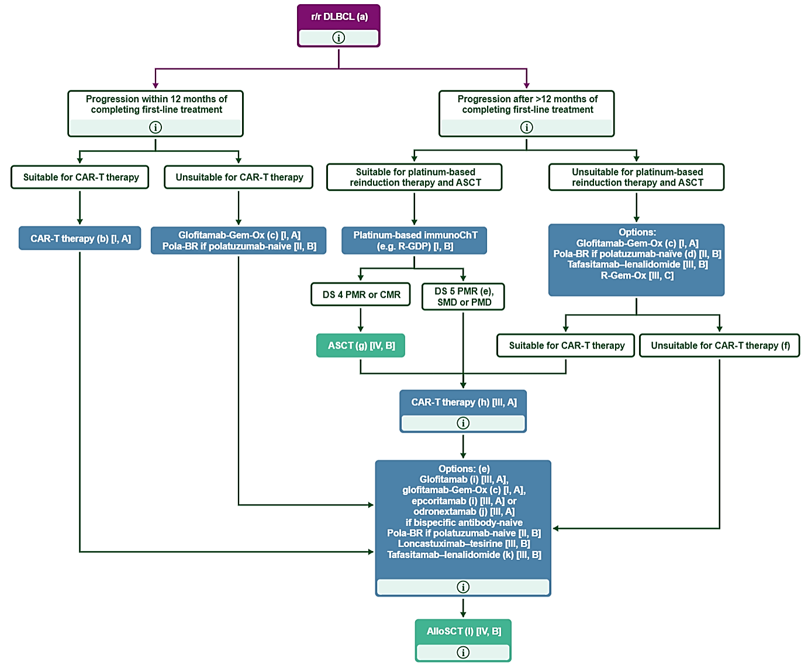
Purple: algorithm title; blue: systemic anticancer therapy or their combination; turquoise: non-systemic anticancer therapies or combination of treatment modalities; white: other aspects of management and non-treatment aspects.
AlloSCT, allogeneic stem-cell transplantation; ASCT, autologous stem-cell transplantation; CAR-T, chimeric antigen receptor T cell; CMR, complete metabolic response; DLBCL, diffuse large B-cell lymphoma; DS, Deauville Score; EMA, European Medicines Agency; FDA, Food and Drug Administration; glofitamab-Gem-Ox, glofitamab–gemcitabine–oxaliplatin; immunoChT, immunochemotherapy; ISRT, involved site radiotherapy; PET, positron emission tomography; PMD, progressive metabolic disease; PMR, partial metabolic response; Pola-BR, polatuzumab vedotin–bendamustine–rituximab; R-GDP, rituximab–gemcitabine–dexamethasone–cisplatin; R-Gem-Ox, rituximab–gemcitabine–oxaliplatin; r/r, relapsed or refractory; SMD, stable metabolic disease.
(a) Rebiopsy at each relapse, where feasible, to confirm DLBCL [V, B].
(b) Axicabtagene ciloleucel and lisocabtagene maraleucel are FDA and EMA approved for second-line use.
(c) Glofitamab-Gem-Ox is recommended after one or more line of therapy, if available [I, A; EMA approved, not FDA approved].
(d) Caution when selecting Pola-BR for patients who may be candidates for CAR-T therapy as a subsequent treatment line. Bendamustine may have an impact on the quality of T-cells.
(e) Consider DS 5 PMR as failure of second-line platinum-based immunoChT on a case-by-case basis.
(f) Consider palliative care at each treatment in appropriately selected patients [V, B].
(g) Consider ISRT to initial isolated bulky relapse or residual isolated PET-avid disease before or after ASCT [IV, B].
(h) Axicabtagene ciloleucel, lisocabtagene maraleucel and tisagenlecleucel are FDA- and EMA-approved options for patients who have received two or more prior lines of therapy according to availability and patient preference.
(i) Epcoritamab and glofitamab are FDA and EMA approved for patients who have received two or more prior lines of therapy.
(j) EMA approved, not FDA approved.
(k) Option for patients relapsing after second- or third-line CAR-T therapy or relapsing after second-line treatment if CAR-T-unsuitable.
(l) For selected young, fit patients who relapse after CAR-T therapy and who obtain a subsequent remission.

Clinical rationale
Loncastuximab tesirine is a human CD19-targeted antibody-drug conjugate (ADC), consisting of a humanised immunoglobulin G1 kappa monoclonal antibody specific for human CD19, conjugated to SG3199, a pyrrolobenzodiazepine (PBD) dimer cytotoxic drug, through a protease-cleavable valine-alanine linker. The toxin SG3199 attached to the linker is designated as SG3249, also known as tesirine.
Expression of CD19 is maintained in haematologic B-cell malignancies, including leukaemias (B-cell acute lymphoblastic leukaemia [B-ALL], pre-B-ALL, hairy cell leukaemia) and non-Hodgkin lymphomas (NHLs, Burkitt lymphoma, follicular lymphoma, diffuse large B-cell lymphoma [DLBCL])., As CD19 is expressed on all types of B-lymphocytes except plasma cells, it represents an attractive target for treatment of B-cell malignancies, including DLBCL.

Regulatory status

Australian regulatory status
This is the first application to register loncastuximab tesirine in Australia.
The sponsor was granted orphan drug designation for Zynlonta on 9 December 2024, for “the treatment of Diffuse Large B-Cell Lymphoma (DLBCL)”.
The sponsor was granted provisional determination for Zynlonta on 25 November 2024, for “the treatment of adult patients with relapsed or refractory large B-cell lymphoma after two or more lines of systemic therapy, including diffuse large B-cell lymphoma (DLBCL) not otherwise specified, DLBCL arising from low grade lymphoma, and high-grade B-cell lymphoma (HGBL)”.

International regulatory status
At the time the TGA considered this submission, a similar submission had been considered by other regulatory agencies. Table 1 summarises these submissions and provides the indications where approved.
Table 1. International regulatory status at the time the TGA considered this submission
Country/ Region | Applicant / MAH | Submission date | Status | Indications | Other relevant information
USA | ADCT | 21-Sep-2020 | Approved; 23-Apr-2021 | Zynlonta is indicated for the treatment of adult patients with relapsed or refractory large B-cell lymphoma after two or more lines of systemic therapy, including diffuse large B-cell lymphoma (DLBCL) not otherwise specified, DLBCL arising from low grade lymphoma, and high-grade B-cell lymphoma. | Approval pathway: Priority Review & Accelerated Approval (based on LOTIS-2) Approval conditions: Confirmatory study LOTIS-5 completion by Dec 2025  Orphan Drug Designation: Granted 8 June 2017  Marketed/launch date: 30 April 2021
European Union Procedure: centralised Rapporteur: Denmark Co-rapporteur: France | MAH: Sobi  (Note: Applicant was ADCT) | 6-Oct-2021 | Approved;  20-Dec-2022* | Zynlonta as monotherapy is indicated for the treatment of adult patients with relapsed or refractory diffuse large B-cell lymphoma (DLBCL) and high-grade B cell lymphoma (HGBL), after two or more lines of systemic therapy. | Approval pathway: Conditional Marketing Authorisation (MA) (based on LOTIS-2)  Approval conditions: Confirmatory study LOTIS-5 completion by Dec 2025 Marketed/launch date: 15-May-2023
United Kingdom | MAH: Sobi  (Note: Applicant was ADCT) | 20-Sep-2022 | Approved; 7-Feb-2023 | Zynlonta as monotherapy is indicated for the treatment of adult patients with relapsed or refractory diffuse large B-cell lymphoma (DLBCL) and high-grade B-cell lymphoma (HGBL), after two or more lines of systemic therapy. | Approval pathway: Conditional Grant of MA (based on LOTIS-2) via ECDRP** Approval conditions: Confirmatory study LOTIS-5 completion by Dec 2025 Marketed/launch date: 22-Dec-2023
Taiwan | Overland ADCT BioPharma (MAH - Orient EuroPharma Co., Ltd.) | 31-Mar-2023 | Approved; 19-Jul-2024 | For the treatment of adult patients with relapsed or refractory large B-cell lymphoma and high-grade  B-cell lymphoma after two or more lines of systemic therapy. This indication is approved under accelerated approval based on overall response rate. Continued approval for this indication may be contingent upon verification and description of clinical benefit in a confirmatory trial(s). | Approval Pathway: Accelerated approval
Singapore | Overland ADCT BioPharma (MAH - Orient EuroPharma Co., Ltd.) | 4-Nov-2022 | Approved; 25-Sep-2024 | Zynlonta is indicated for the treatment of adult patients with relapsed or refractory diffuse large B-cell lymphoma (DLBCL) after two or more lines of systemic therapy. This indication is approved based on overall response rate [see Clinical Studies (14.1)]. Continued approval for this indication may be contingent upon verification and description of clinical benefit in a confirmatory trial(s). | Information not available
Canada | Sobi | 28 Feb 2024 | Approved; 07-Mar-2025 | Proposed: Zynlonta is indicated for the treatment of adult patients with relapsed or refractory large B-cell lymphoma, including diffuse large B-cell lymphoma (DLBCL) not otherwise specified, DLBCL arising from low grade lymphoma, and high-grade B-cell lymphoma, who have received two or more lines of systemic therapy and cannot receive CAR-T cell therapy or have previously received CAR-T cell therapy. | Review Pathway: Notice of Compliance with Conditions (NOC/c)
Saudi Arabia | Sobi | 21-Jun-2023 | Ongoing | Proposed: Zynlonta as monotherapy is indicated for the treatment of adult patients with relapsed or refractory diffuse large B-cell lymphoma (DLBCL) and high-grade B-cell lymphoma (HGBL), after two or more lines of systemic therapy. | Review Pathway: Priority Review
Brazil | Sobi | 21-Dec-2023 | Ongoing | Proposed: Zynlonta as monotherapy is indicated for the treatment of adult patients with relapsed or refractory diffuse large B-cell lymphoma (DLBCL) and high-grade B-cell lymphoma (HGBL), after two or more lines of systemic therapy. | Review pathway: RDC 205/2017 rare disease pathway
Switzerland | Sobi | 3-July-2023 | MAA withdrawal 16 May 2024 | Proposed: Zynlonta is indicated for the treatment of adult patients with relapsed or refractory diffuse large B-cell lymphoma and high-grade B-cell lymphoma (HGBL), after two or more lines of systemic therapy. | Review pathway: Standard.  Applicant decision to withdraw since the following feedback from the Swiss Agency was received: the pivotal single-arm, open-label LOTIS-2 study design is not sufficient to support a standard authorisation in the proposed indication.
China | Overland ADCT BioPharma | 2-July-2023 | 10 Dec 2024 | Zynlonta is indicated for the treatment of relapsed or refractory DLBCL the treatment of relapsed or refractory DLBCL in adult patients who have failed 2 or more prior lines of systemic treatment. | Information Not Available
Hong Kong | Overland ADCT BioPharma | 30-Jun-2023 | Ongoing | Proposed: Zynlonta is indicated for the treatment of adult patients with relapsed or refractory large B-cell lymphoma after two or more lines of systemic therapy, including diffuse large B-cell lymphoma (DLBCL) not otherwise specified, DLBCL arising from low-grade lymphoma, and high-grade B-cell lymphoma. | Information Not Available
* Positive CHMP Opinion: 15-Sep-2022
** ECDRP: European Commission Decision Recognition Procedure
Note:
ADC Therapeutics (ADCT) holds the market authorisation for Zynlonta in the US, while Sobi is the MAH for the EU and UK and has an exclusive license agreement with ADC Therapeutics to develop and commercialise Zynlonta for use in haematology and other indications of large unmet medical need in most international markets including Australia and Canada.
Overland ADCT BioPharma, is the joint venture of ADCT and Overland Pharmaceuticals for Zynlonta regulatory submissions in Greater China, Singapore and Taiwan. Overland ADCT BioPharma’s partner Orient Europharma Pte Ltd (OEP) is the Marketing Authorization Holder for Zynlonta in Taiwan and Singapore

Registration timeline
Table 2 captures the key steps and dates for this submission.
This submission was evaluated under the provisional registration process.
Table 2. Timeline for Zynlonta (loncastuximab tesirine) registration
Description | Date
Designation (Orphan) | 9 December 2024
Determination (Provisional) | 25 November 2024
Submission dossier accepted evaluation commenced | 31 March 2025
Evaluation completed | 12 February 2026
Registration decision (Outcome) | 9 April 2026
Registration in the ARTG completed | 13 April 2026
Number of working days from submission dossier acceptance to registration decision* | 164
* The provisional registration process is designed with a target timeframe of 220 working days from acceptance for evaluation through to the delegate’s decision. The statutory timeframe for both provisional registration and standard registration is 255 working days (regulation 16C(3)).

Assessment overview

Quality evaluation summary

Drug substance
Loncastuximab tesirine is an antibody-drug conjugate comprising a full-length, humanised IgG1 kappa mAb produced in Chinese hamster ovary (CHO) cells by recombinant DNA technology, conjugated to SG3199, a PBD dimer cytotoxic alkylating agent, through a protease-cleavable valine-alanine linker. SG3199 attached to the linker is designated as SG3249, also known as tesirine. A schematic representation of loncastuximab tesirine is provided in Figure 2, and general properties of the drug substance are summarised below in Table 3.
Figure 2. Schematic Representation and Chemical Structure of Loncastuximab Tesirine
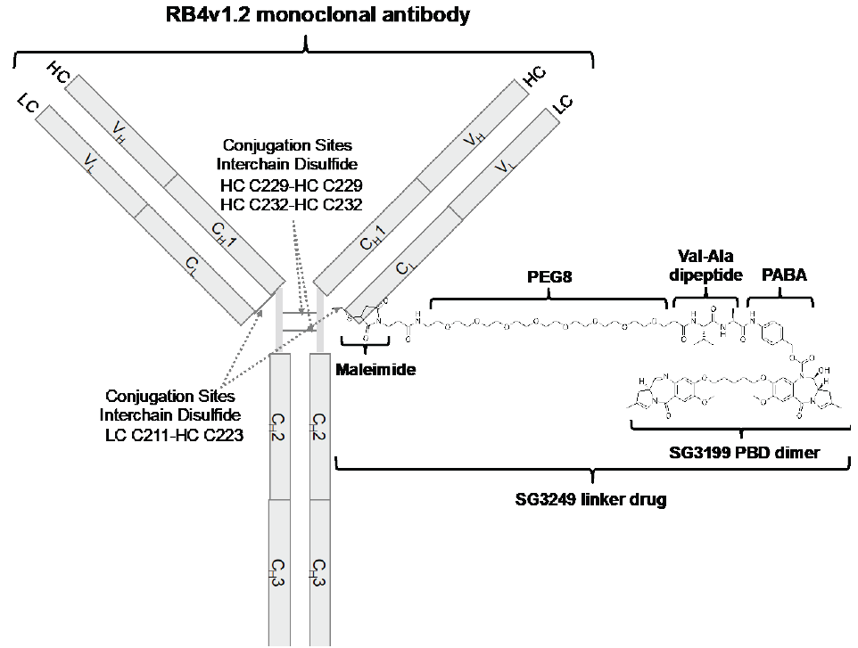
Ala = alanine; PABA = para-aminobenzoic acid; PBD = pyrrolobenzodiazepine, PEG = polyethylene glycol;
RB4v1.2 = humanized monoclonal antibody directed against human CD19 antigen; Val = valine.
Schematic above illustrates conjugation to one of the interchain cysteine conjugation sites. Loncastuximab tesirine has an average drug/antibody ratio (DAR) of approximately 2.3 consisting of a distribution of drug load species with DAR values ranging from 0 to 6.
Table 3. General properties of loncastuximab tesirine drug substance
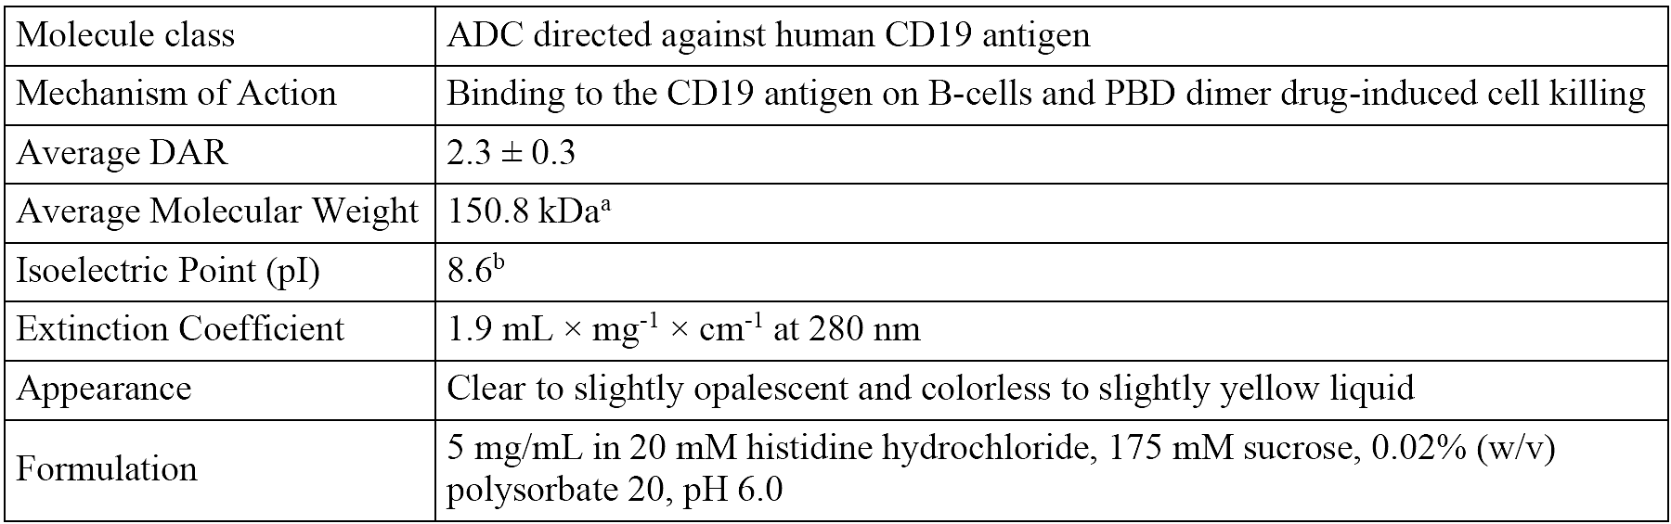
ADC = antibody drug conjugate; CD19 = cluster of differentiation 19; DAR = drug-to-antibody ratio; PBD = pyrrolobenzodiazepine
ª Corresponding to N-linked glycosylated form of complex biantennary core-fucosylated oligosaccharide ending in terminal N acetyl glucosamines (G0F) at Asparagine 300 of each heavy chain and cyclization of the N-terminal glutamine in the heavy chain to pyroglutamic acid
^{b} Corresponding to the main isoform of the antibody drug conjugate

Drug product
Loncastuximab tesirine (ADCT-402) drug product is a sterile, white to off-white, lyophilised, preservative-free cake or powder in a single-use vial (10 mg/vial) for reconstitution with 2.2 mL sterile water for injection. Loncastuximab tesirine is administered as an intravenous (IV) infusion. The formulation of the drug product is provided in Table 4.
Table 4. Formulation of loncastuximab tesirine drug product
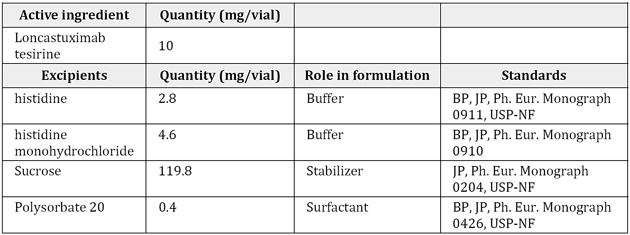
At the conclusion of the evaluation period, there were no objections on quality grounds to the approval of loncastuximab tesirine 10 mg powder for concentrate for solution for infusion vial.

Nonclinical evaluation summary
The set of studies submitted in the nonclinical dossier were in general accordance with the relevant ICH guidelines. However, based on its epitope site and experimental data, loncastuximab tesirine does not bind to CD19 from animal species and the set of studies would not have assessed potential on-target effects. This is a limitation of the nonclinical dossier but not considered a major deficiency.
In vitro, loncastuximab tesirine was specifically cytotoxic to human CD19-positive cells, with the cytotoxic activity attributed to the SG3199-containing drug component. SG3199 forms DNA interstrand crosslinks, leading to irreversible damage and cell death. Significant anti-tumour activity and an increased survival rate was seen in mice harbouring xenografts (both SC and systemic) of CD19-positive human lymphoma/leukemia.
Off-target cytotoxic effects associated with circulating SG3199 may be seen in patients.
Safety pharmacology endpoints incorporated into general repeat-dose toxicity studies revealed no effects of loncastuximab tesirine on CNS, respiratory or cardiovascular function in monkeys. No adverse effects on the function of these organ systems are predicted during clinical use.
Following IV administration, the pharmacokinetics of loncastuximab tesirine in rats, monkeys and human subjects was generally consistent with that of an IgG antibody: long half-lives and limited distribution. No specific studies on metabolism, excretion or pharmacokinetic interactions were conducted with loncastuximab tesirine, which is acceptable. Plasma binding of SG3199 is high across rat, monkey and humans. In a tissue distribution study with 3H-SG3199, there was no evidence of retention of radioactivity in the melanin-containing uveal tract or skin and no evidence of blood-brain barrier penetration; however, the sensitivity of the assay was poor. SG3199 undergoes metabolism by CYP3A4/5 and a non-CYP enzyme mediated mechanism.
Biliary/faecal excretion was the major excretion route of SG3199-related material in rats. Given the species-specificity of loncastuximab tesirine, target mediated drug disposition would not have been assessed in animals.
Based on in vitro studies with SG3199, loncastuximab tesirine is not predicted to alter the pharmacokinetics of co-administered drugs through interactions with transporters or CYP450 enzymes. SG3199 is a substrate for P-glycoprotein. The effect of co-administered P-glycoprotein inhibitors on SG3199 exposures appears to have been considered in the clinical dataset. However, P-glycoprotein inhibitors may increase the potential for adverse CNS effects. As SG3199 is a substrate for CYP3A4/5, it is uncertain if inhibitors of these enzymes may affect SG3199 exposure in patients.
A single-dose toxicity study with loncastuximab tesirine indicated a moderate order of toxicity in rats by the IV route.
Repeat-dose toxicity studies by the IV route were conducted with loncastuximab tesirine in cynomolgus monkeys (up to 3 months) and with SG3199 in rats (4 weeks). The toxicities observed with loncastuximab tesirine included skin changes (epidermal hyperpigmentation with hyperplasia/hyperkeratosis) both at the injection site and at sites distant from the injection site, bone marrow suppression with particular effects on the erythroid lineage, nephrotoxicity and testicular atrophy with reduced spermatogenesis. The testicular atrophy had generally not reversed after a period of two spermatogenesis cycles. The toxicities were attributed to the drug component of loncastuximab tesirine (SG3199), and maximum exposures to this component were subclinical in monkeys. Additional clinically-relevant toxicities seen in rats treated directly with SG3199, included greater evidence of bone marrow suppression with pancytopaenia,
hepatobiliary toxicity and gastrointestinal effects. Expected effects due to the CD19-targetting aspect of the drug include depletion of peripheral B-cells with a consequential risk of infection in patients.
SG3199 is a DNA reactive compound and is expected to be mutagenic and carcinogenic. Positive results were seen in in vitro micronucleus and chromosomal aberration tests.
Reproductive and developmental studies were not conducted. This is acceptable given the repeat dose toxicity findings in the male reproductive organs and the genotoxic properties of SG3199. The testicular atrophy with reduced spermatogenesis activity of loncastuximab tesirine suggest that loncastuximab tesirine would have adverse effects on male fertility. SG3199 is expected to be teratogenic and cause embryofetal death, while placental transfer of loncastuximab tesirine is possible.
SG3199 is photoreactive. Exposure to visible light, UVA or UVB radiation enhanced the ability of SG3199 to mediate DNA crosslinking and induce double-stranded breaks. This photoreactivity may be the underlying cause of the skin reactions seen in monkeys, though this has not been confirmed.

Conclusions
The primary pharmacology studies lend support for the proposed clinical use of loncastuximab tesirine in patients with relapsed or refractory DLBCL.
Follow-up clinical assessment/analysis of the effect of CYP3A4/5 inhibitors on the exposures to and/or safety of SG3199 may be warranted.
The nonclinical assessment identified the following notable findings of potential clinical relevance:
- Skin reactions, including epidermal hyperpigmentation at the injection site as well as sites distant from the injection site;
- Bone marrow suppression, potentially affecting all lineages;
- Nephrotoxicity;
- Reduced spermatogenesis in males, which was not reversed after a 12-week treatment-free period;
- Hepatobiliary toxicity and gastrointestinal disturbances;
- Teratogenicity and risk if used during pregnancy
There are no objections on nonclinical grounds to the registration of loncastuximab tesirine for the proposed indication.

Clinical evaluation summary
The submission included two clinical studies providing evaluable efficacy and safety data for loncastuximab tesirine monotherapy for ≥3rd line treatment for patients with relapsed or refractory (R/R) DLBCL at the proposed dose of 150 µg/kg every 3 weeks (Q3W) for 2 cycles followed by 75 µg/kg Q3W: ADCT-402-201 and ADCT-402-101.

Study ADCT-402-201 (LOTIS-2)
This is the pivotal efficacy study for the submission. Study ADCT-402-201 was a Phase 2, open-label, single-arm, multi-centre trial evaluating loncastuximab tesirine for the treatment of R/R DLBCL in patients who had received at least 2 prior lines of therapy. The primary endpoint was overall response rate (ORR) by central review.
Trial inclusion criteria included:
- Age 18 years or older
- Pathologic diagnosis of DLBCL, as defined by the 2016 WHO classification, to include: DLBCL NOS; primary mediastinal large B-cell lymphoma (PMBCL); and high-grade B-cell lymphoma (HGBL) with MYC and BCL2 and/or BCL6 rearrangements
- Relapsed or refractory disease following 2 or more multi-agent systemic treatment regimens
Exclusion criteria included diagnosis of Burkitt’s lymphoma, stem cell transplant within 30 days (autologous) or 60 days (allogeneic) prior to first dose of study drug, lymphoma with active CNS involvement at the time of screening, bulky disease (any tumour ≥10 cm in longest dimension), congenital long QT syndrome or QTcF interval of >480 ms at screening.
Loncastuximab tesirine was administered as an IV infusion over 30 minutes on Day 1 of each 3-week cycle at a dose of 150 μg/kg for 2 cycles followed by 75 μg/kg for subsequent 3-week cycles until disease progression or unacceptable toxicity.
Patients with BMI ≥35 kg/m² had their dose calculated based on the following protocol-specified adjusted body weight (ABW) formula:
- Adjusted body weight (ABW) in kg = 35 kg/m²* (height in metres)²
- Dose to administer (mg) = dosage (µg/kg) * ABW / 1000
In addition to the study drug (loncastuximab tesirine), other protocol-specified medications included:
- Dexamethasone premedication for all participants (unless contraindicated): 4 mg orally BD for 3 days, starting on the day before loncastuximab tesirine administration, if possible; or, if not able to be given the day before, for 2 days, starting at least 2 hours before loncastuximab tesirine administration.
- Spironolactone at standard doses and titrated as clinically indicated for patients with weight gain greater than 1 kg from Cycle 1 Day 1, new or worsening oedema, or new or worsening pleural effusion.
A 2-stage study design was used, with an interim analysis for futility using the data on the first 52 patients. If ≥10 patients responded (CR+partial response[PR]), the study was to proceed to full enrolment. There were 37 study sites in 4 countries: the USA (24 sites), the UK (7 sites), Italy (5 sites), and Switzerland (1 site). The final clinical study report, dated 11 Apr 2023, presents results from data cut-off (DCO) 15 Sep 2022.

Study ADCT-402-101 (LOTIS-1)
This is the supportive study for the proposed dose in patients with DLBCL. Study ADCT-402-101 was a first-in-human, open-label, Phase 1 dose-escalation (Part 1) and expansion (Part 2) study to evaluate the safety and tolerability of loncastuximab tesirine in 183 patients with R/R B-NHL (137 with DLBCL, of whom 70 received the proposed dose) who had failed or were intolerant to established therapy or for whom no other treatment options were available. The study was conducted at 8 centres in the US, 2 in the UK and 1 in Italy and was completed on 21 Feb 2019. Primary objectives were safety and tolerability. Secondary objectives included efficacy and pharmacokinetics (PK).
In Part 1, dosing was initially planned to escalate from 15 µg/kg Q3W to a maximum dose of up to 300 µg/kg once every 3 weeks. No intra-patient dose escalation was allowed. However, based on the safety information from Dose Level 7 (200 µg/kg Q3W) and the evolving PK data, the protocol was amended to assess the following alternative dose levels:
- 120 or 150 µg/kg Q3W for 2 cycles followed by 60 µg/kg every 6 weeks (Q6W) for patients who had a stable disease [SD] or better after Cycle 2;
- 200 µg/kg Q6W for 2 cycles followed by 60 µg/kg Q6W for patients who had SD or better after Cycle 2; and
- 200 µg/kg Q6W for 1 cycle followed by 60 µg/kg Q6W for patients who had SD or better after Cycle 1.
Although no maximum tolerated dose was identified, no dose escalation beyond 200 μg/kg dose was investigated.
In Part 2, patients were assigned to the recommended dose level(s) and schedule(s) of loncastuximab tesirine identified in Part 1 based on evolving safety, efficacy, and PK data:
- 120 µg/kg Q3W; and
- 150 µg/kg Q3W; some patients in this group had their dose reduced to 75 µg/kg Q3W after 3 cycles at 150 µg/kg.
All patients in Part 2 were to receive dexamethasone premedication unless contraindicated.

Pharmacology

Pharmacokinetics
Exposure to loncastuximab tesirine PBD-conjugated antibody (Ab) and total Ab in the circulation are comparable. The sponsor states that this is indicative of good in vivo linker stability and ability for precise and efficient delivery to CD19-expressing tumour cells.
A summary of the PK parameters for PBD-conjugated Ab in the first two cycles of loncastuximab tesirine from studies ADCT-402-201 and ADCT-402-101 is provided in Table 5.
Table 5. Pharmacokinetic parameters of PBD-conjugated antibody after loncastuximab tesirine dose of 150 μg/kg Q3W, by Study
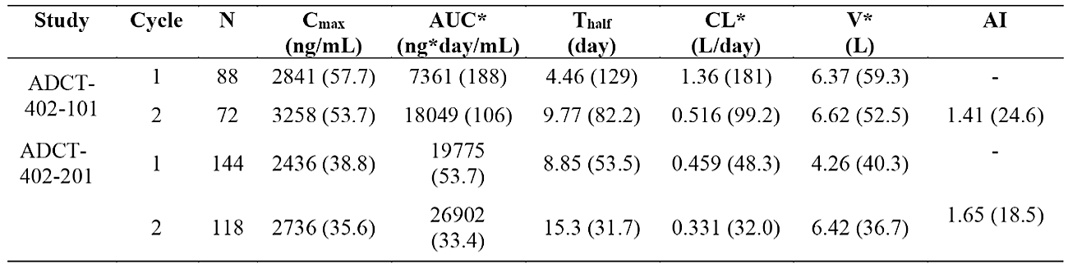
Note: Data are presented as geometric mean (CV%)
AI = accumulation index; AUC* = area under the serum concentration-time curve from time 0 to infinity (AUC_{inf}) for Cycle 1 and area under the serum concentration-time curve from time 0 to end of dosing interval (AUC_{tau}) for Cycle 2; CL* = apparent clearance for Cycle 1 and apparent clearance at steady state for Cycle 2; C_{max} = maximum serum concentration; CV% = percent coefficient of variation; PBD = pyrrolobenzodiazepine; Q3W = every 3 weeks; T_{half} = apparent terminal half-life; V* = apparent volume of distribution at steady state (V_{ss}); - = not available.
The cytotoxic agent, SG3199, is highly protein bound (~94%) in human plasma. Exposure to unconjugated SG3199 is typically below quantifiable limits for most patients, but with measurable levels briefly observed more frequently at higher doses by end-of-infusion. SG3199 did not exhibit accumulation with the Q3W dosing regimen.

Population PK data
Population PK analysis was undertaken on pooled data from studies ADCT-402-101 and ADCT-402-201. It included a total of 5,328 conjugated Ab samples, 5,267 total Ab samples, and 235 SG3199 samples measurable from 328 subjects with DLBCL or other forms of NHL. NONMEM 7.4 was used for non-linear mixed effects modelling.
The analyses found that concentrations of loncastuximab tesirine were characterised by a two-compartment PK model with linear clearance and time-dependent clearance in parallel. The final popPK model had estimated CL value of 0.224 L/day and estimated volume of distribution in the central compartment (V₁) of 4.02 L. The between-subject variability (BSV) of CL was 45.4% and the BSV of V₁ was 33.8%.
The typical parameter estimates of the final popPK model were used to simulate serum concentration-time profiles for PBD-conjugated Ab and total Ab typical serum for the dosing regimen of 150 μg/kg Q3W ×2 followed by 75 μg/kg Q3W (Figure 3). Steady state was reached relatively quickly at the 75 μg/kg Q3W dose thereafter, with minimal further accumulation from Cycle 3 onwards.
Figure 3. Model predicted typical concentration-time profile of PBD-conjugated antibody and total antibody in serum after 150 μg/kg Q3W ×2 followed by subsequent 75 μg/kg Q3W doses of loncastuximab tesirine
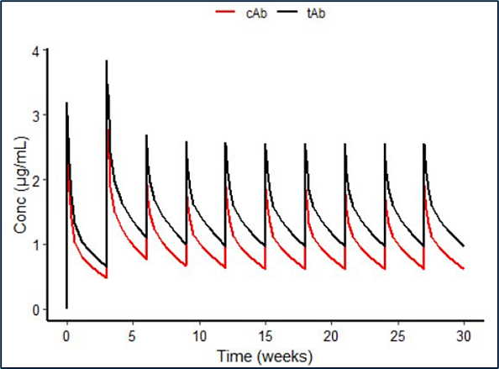
cAb = PBD-conjugated antibody; Conc = concentration; PBD = pyrrolobenzodiazepine; PK = pharmacokinetic(s); Q3W = every 3 weeks; tAb = total antibody.
Clinically important differences in the exposure to conjugated Ab were reported as follows:
- Exposure was 42% lower with mild-moderate hepatic impairment (mild: n=49; moderate: n=1) compared to normal hepatic function (n=277). There were no subjects with severe hepatic impairment.
- Exposure was 52% lower in patients with low albumin (17 to 34 g/L, n=49) compared to normal albumin levels (35 to 52 g/L, n=279).
- Exposure was 61% lower in non-DLBCL NHL patients (n=44) compared to patients with a diagnosis of DLBCL (n=284)
No clinically important differences in the exposure to conjugated Ab were observed for variables including renal impairment, age, sex and race.

Pharmacodynamics

Exposure-response analyses
The final dataset used for ER efficacy and safety analyses was pooled from studies ADCT-402-101 and ADCT-402-201. Efficacy data included only patients with DLBCL. Safety data comprised all patients who were included in the popPK analysis described above. Efficacy analysis examined ORR and time-to-event endpoints including overall survival (OS) and DOR. Safety data with Grade ≥2 treatment-emergent adverse events (TEAEs) were used in the ER analysis due to limited numbers of patients with Grade ≥3 TEAEs.
ER for OS was characterised by a multivariate Cox proportional hazards model using Cycle 1 C_{avg} and the following covariates with a significant effect (α=0.01) on OS: baseline albumin, bulky disease, and hepatic function. The model predicted improved OS in with increasing exposure at Cycle 1. ORR was characterised by a multivariate logistic regression model and demonstrated increased ORR with increasing exposure (Cycle 1 C_{avg}). No effect of exposure was found on DOR.
Based on univariate logistic regression, increasing exposure increased Grade ≥2 TEAEs for increased GGT, skin and nail, and LFT. Of the safety outcomes, increased GGT (Grade ≥ 2) showed the most significant relationship with increasing exposure, and the relationship remained significant in a multivariate logistic regression model.

Immunogenicity
Across 3 clinical studies (ADCT-402-101, ADCT-402-201, and ADCT-402-102; n=363), a total of 8 patients (2.2%) were confirmed positive for anti-drug antibodies (ADA), of whom 7 were positive pre-dose. Two patients had positive ADAs in post-dose samples and further evaluation of the pattern indicated that these were not induced by loncastuximab tesirine and most probably related to higher backgrounds of tested sera in the assay. The sponsor concluded that no ADA responses were induced by loncastuximab tesirine in any treated patients.
Based on a validated neutralising antibody assay, none of the ADA positive samples were identified as neutralising.
The impacts of ADA-positivity on PK, efficacy, safety were assessed using data from studies ADCT-402-101 and ADCT-402-201. However, meaningful conclusions are difficult to draw because of the small number of ADA-positive patients (n=7). The limited available data do not give rise to concern.

Baseline tumour features
Available archival or pre-treatment tumour tissue samples from patients in study ADCT-402-201 were assessed for CD19 expression and rearrangements of MYC, BCL2 and/or BCL6. Double hit tumours were those with MYC+BCL2 or MYC+BCL6 rearrangements. Triple hit tumours had rearrangements of MYC+BCL2+BCL6. The pharmacodynamic information of tumour CD19 expression, double hit/triple hit molecular signatures were analysed by different clinical response subgroups: CR+PR, SD+PD, and not evaluable (NE).
The analysis did not appear to show any difference of tumour CD19 expression among the three clinical response groups.
The exploratory analysis suggests that double/triple hit subgroups had fewer responses and were associated with less favourable clinical outcome, however there are only 11 patients with presence of double/triple hit molecular signature and this is consistent with the known association of double/triple hit molecular signature with poor prognosis in DLBCL patients. Given the small sample size, the result warrants cautious interpretation.
The relationships between safety and different tumour CD19 expression, and presence or absence of molecular signatures for double/triple hit were also evaluated. The analysis did not show any significant differences in safety in these subgroups in general, except there appeared to be a trend of higher relative frequency of oedema-effusion and platelet count decrease or thrombocytopenia in the double/triple hit subgroups. However, the number of patients in the double/triple hit subgroups was very limited, and any definite conclusion cannot be drawn.

Efficacy

Study ADCT-402-201 (LOTIS-2)

Sample size
The primary hypothesis was that the ORR based on central review was significantly greater than 20%. This hypothesis was tested with a 2-sided, type I error of 0.05.
Using an exact test for single proportion, a sample size of 140 patients had > 99% power to achieve a 2-sided significance level of 0.05. This sample size was reported by the sponsor to provide adequate precision for observed ORR in the expected range and a robust population for safety evaluation.

Baseline data
A total of 145 patients were enrolled and received at least 1 dose of study drug. The majority were male (58.6%) and White (89.7%). The median age was 66 years (range: 23 to 94 years) and the median BMI was 25.97 kg/m² (range: 17.2 to 50.5 kg/m²).
Most patients (88.3%) were diagnosed with DLBCL NOS according to the 2016 WHO classification¹. As per the same classification reference, there were 10 patients (6.9%) with HGBL (with MYC and BCL2 and/or BCL6 rearrangements), and 7 patients (4.8%) with PMBCL. Approximately one fifth of participants (20.7%) had transformed DLBCL, most commonly from follicular lymphoma. Most patients had Stage IV disease (64.1%) and extranodal involvement (60.0%) at a median of 2.0 sites (range: 1 to 18). Spleen involvement was uncommon (4.1%).
As expected, this was a heavily pre-treated cohort with a median of 3.0 prior systemic therapies (range: 2 to 7). Most patients (61.4%) were refractory to last line of prior therapy. A minority of participants had previously received a stem cell transplant (16.6%).

Primary endpoint – ORR
In the All-Treated Population, the ORR by independent reviewer was 48.3% (95% CI: 39.9, 56.7) with complete response rate (CRR) of 24.8% (95% CI: 18.0, 32.7) (Table 6).
Table 6. Overall Response Rate by Independent Reviewer (All-Treated Population)
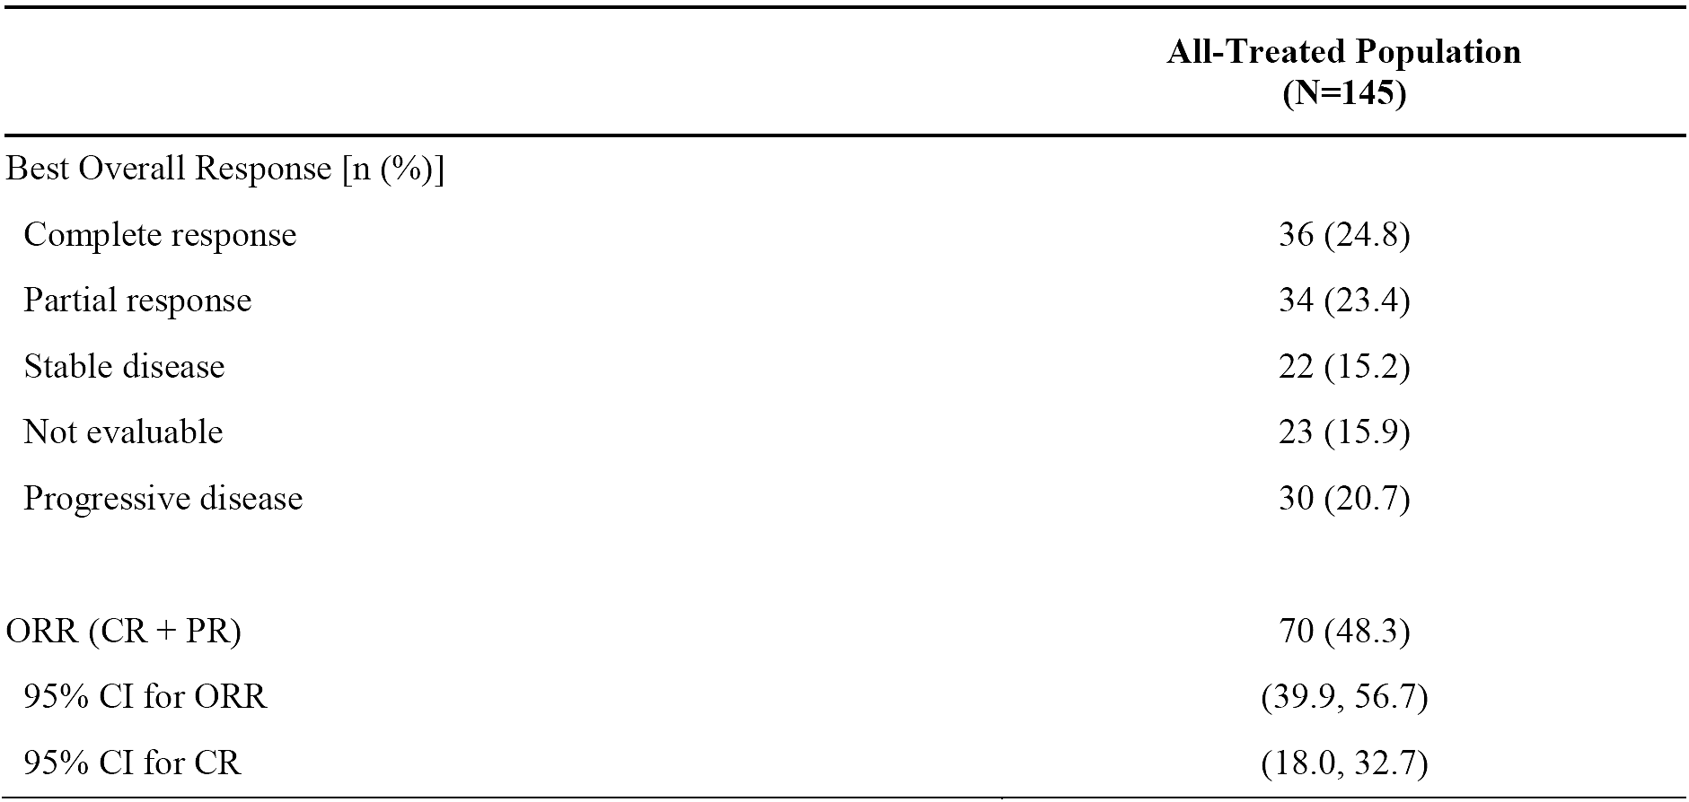
CI=confidence interval, CR=complete response, ORR=overall response rate, PR=partial response
Note: Best overall response by independent reviewer. Not evaluable included patients without any scan to the independent reviewer (even clinical progressive disease) or patients whose scan was determined to be not evaluable by the independent reviewer.
In subgroup analyses, ORRs appeared approximately comparable when examined by sex, age, and number of prior lines of therapy (Figure 4).
Notable imbalances in ORR included:
- Primary disease subgroup: ORR was 50.0% in the DLBCL NOS group (n=64/128), 50.0% in the HGBL group (n=5/10), and 14.3% in the PMBCL group (n=1/7).
- Bulky disease: ORR was 49.6% in patients without bulky disease (n=68/137) and 25.0% in patients with bulky disease (n=2/8).
ORR was 48.9% in patients without prior CAR-T therapy (n=64/131) and 42.9% in patients with prior CAR-T therapy (n=6/14). Additionally, the ORR to CAR-T therapy received subsequent to loncastuximab tesirine was 56.3% (n=9/16).
Despite similar ORR by sex (female [n=60]: 50.0% vs male [n=85]: 47.1%), the CRR was notably higher in female patients compared to males (36.7% vs 16.5%, respectively).
However, caution is needed in interpreting subgroup results because these analyses are exploratory with smaller sample sizes.
Figure 4. Forest Plot of Overall Response Rate by Subgroup (All-Treated Population)
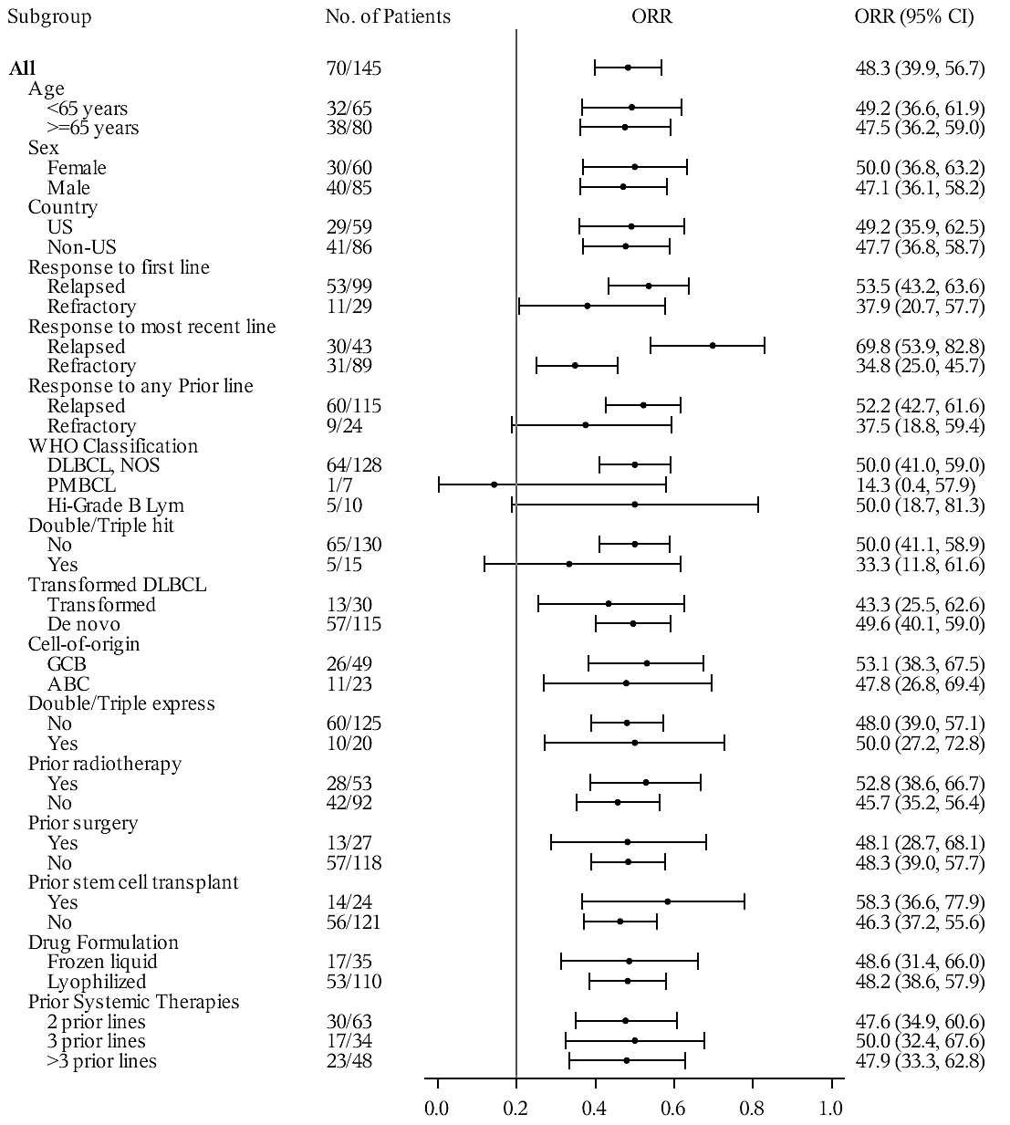
Note: Best overall response (BOR) by independent reviewer. ORR=Overall Response Rate. CI=Confidence Interval.

Secondary efficacy endpoints

Duration of response
The median DoR in responders was 13.37 months (95% CI: 6.87 to NE) (Table 7).
Table 7. Summary of Duration of Response by Independent Reviewer (All-Treated Population)
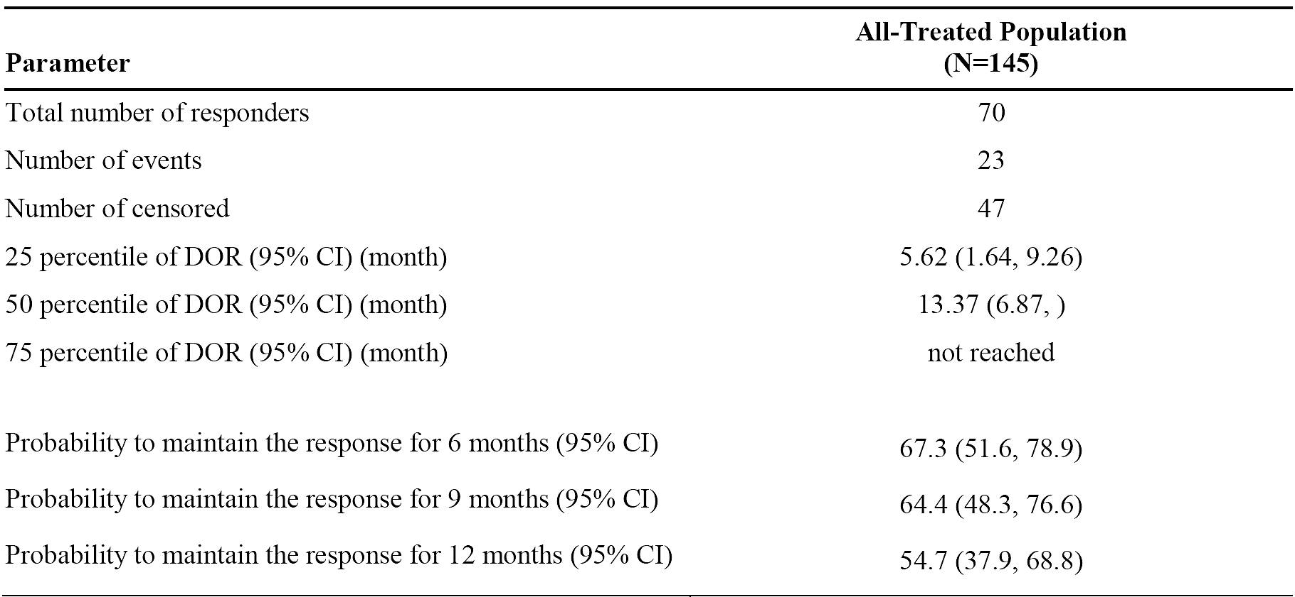
Patients with CR had a longer median DOR than those whose best response was PR (Figure 5).
Figure 5. Kaplan-Meier Plot of Duration of Response by Independent Reviewer by Best Overall Response (CR/PR) (All-Treated Population)
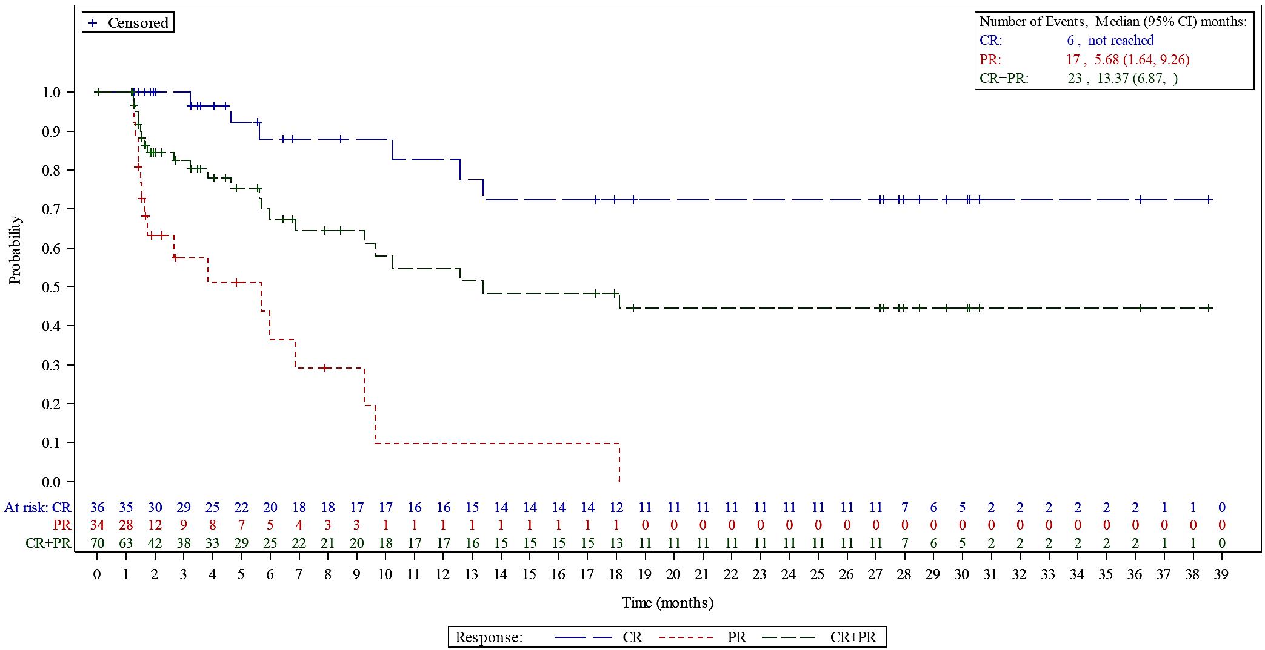
CR=Complete Response; PR=Partial Response. Based on independent reviewer data, including death as event.

Progression-free survival (PFS) and overall survival (OS)
The median PFS was 4.93 months (95% CI: 2.89, 8.31) and median OS was 9.53 months (95% CI: 6.74, 11.47).
There is no comparator group in Study ADCT-402-201. This markedly limits the ability to meaningfully interpret time-to-event endpoints such as DOR, PFS, and OS.

Study ADCT-402-101 (LOTIS-1)
The primary measure of clinical activity was ORR as assessed by the Investigator. Other efficacy measures were DOR, PFS and OS. The results from this study for the subset of patients with DLBCL in the 150 µg/kg dose group (n=70) are summarised below:
- ORR was 41.4% (95% CI: 29.8, 53.8); with CRR of 21.4%
- Median DOR was 4.04 months (95% CI: 2.14, 9.46)
- Median PFS was 2.83 months (95% CI: 1.41, 4.04)
There were no separate data for OS in patients at the 150 µg/kg dose level, but median OS in the DLBCL group for all doses combined (n=137) was 7.46 months (95%.5.95 to 9.79 months).
As for the previous study, there is no comparator group in Study ADCT-402-101. This markedly limits the ability to meaningfully interpret time-to-event endpoints such as DOR, PFS, and OS.

Safety
The approach to the evaluation of safety has been to compare the safety data from study ADCT-402-201 (LOTIS-2), study ADCT-402-101 (LOTIS-1) and the pooled dataset from the two studies for the 215 patients with DLBCL in the 150 µg/kg dose groups presented in the Summary of Clinical Safety. The comparison is based on the integrated analysis presented in the Summary of Clinical Safety with a DCO of 1 March 2021.
The exposure to loncastuximab tesirine at 150 µg/kg across studies ADCT-402-201 and ADCT-402-101 was median 45 days’ duration (range: 1, 569) and median 3.0 cycles (range: 1, 26).
Summaries of overall of TEAEs and Grade ≥3 TEAEs by preferred term (PT) for DLBCL patients who received loncastuximab tesirine monotherapy (150 µg/kg dose groups) are presented in Table 8 and Table 9, respectively
Table 8. Overall Summary of TEAEs for loncastuximab tesirine monotherapy treated DLBCL patients in the 150 µg/kg dose groups
TEAE parameter | ADCT-402-201  N=145  N (%) | ADCT-402-101  N=70  N (%) | Pooled  N=215  N (%)
Number of TEAEs | 1780 | 1061 | 2841
Patients with any TEAE | 143 (98.6) | 69 (98.6) | 212 (98.6)
Patients with any Grade 3 or higher TEAE | 107 (73.8) | 53 (75.7) | 160 (74.4)
Patients with any TEAE related to LT | 118 (81.4) | 58 (82.9) | 176 (81.9)
Patients with any TEAE leading to LT dose delay or reduction | 75 (51.7) | 27 (38.6) | 102 (47.4)
Patients with any TEAE leading to LT withdrawal | 36 (24.8) | 8 (11.4) | 44 (20.5)
Patients with any serious TEAE | 57 (39.3) | 30 (42.9) | 87 (40.5)
Patients with any TEAE with fatal outcome | 8 (5.5) | 11 (15.7) | 19 (8.8)
DLBCL= diffuse large B-cell lymphoma; LT = loncastuximab tesirine; TEAE = treatment-emergent adverse event
Pooled studies = ADCT-402-201 and ADCT-402-101.
Related TEAEs include TEAEs that were considered by the Investigator to be possibly or probably related to the study drug or TEAEs with a missing relationship on the case report form. Adverse events were graded using CTCAE v4.0. For each category (except for Number of TEAEs), patients were included only once, even if they experienced multiple events in that category.
DCO 01 March 2021.

Table 9. Most common (≥ 5% of patients) grade ≥3 TEAEs by PT in Study ADCT-402-201 by descending order of frequency with corresponding percentages for the relevant TEAEs from Study ADCT-402-101 and the pooled datasets.
 | ADCT-402-201  N=145  N (%) | ADCT-402-101  N=70  N (%) | Pooled  N=215  N (%)
Any Grade ≥3 TEAE | 107 (73.8) | 53 (75.7) | 160 (74.4)
Neutropenia | 38 (26.2) | 14 (20.0) | 52 (24.2)
GGT increased | 25 (17.2) | 12 (17.1) | 37 (17.2)
Thrombocytopenia | 26 (17.9) | 8 (11.4) | 34 (15.8)
Anaemia | 15 (10.3) | 10 (14.3) | 25 (11.6)
Leukopenia | 13 (9.0) | 0 | 13 (6.0)
Hypophosphataemia | 8 (5.5) | 1 (1.4) | 9 (4.2)
Lymphopenia | 8 (5.5) | 0 | 8 (3.7)
In the pooled group, 145 DLBCL patients died (67.4%); mostly due to disease progression (n=108/145). Fatal TEAEs occurred in 8.8% (n=19) of patients and are summarised in Table 10.
Table 10. Fatal TEAEs by SOC and PT in the three relevant datasets
SOC  PT | ADCT-402-201  N=145  N (%) | ADCT-402-101  N=70  N (%) | Pooled  N=215  N (%)
Patients with any fatal TEAEs | 8 (5.5) | 11 (15.7) | 19 (8.8)
GIT disorders (SOC) | 1 (0.7) | 2 (2.9) | 3 (1.4)
GIT haemorrhage | 0 | 1 (1.4) | 1 (0.5)
Abdominal compartment syndrome | 0 | 1 (1.4) | 1 (0.5)
Small intestine perforation | 1 (0.7) | 0 | 1 (0.5)
General disorders & administration site conditions (SOC) | 1 (0.7) | 3 (4.3) | 4 (1.9)
Disease progression | 1 (0.7) | 3 (4.3) | 4 (1.9)
Infections & infestations (SOC) | 3 (2.1) | 2 (2.9) | 5 (2.3)
Sepsis | 1 (0.7) | 1 (1.4) | 2 (0.9)
Lung infection | 0 | 1 (1.4) | 1 (0.5)
Pneumonia | 1 (0.7) | 0 | 1 (0.5)
Septic shock | 1 (0.7) | 0 | 1 (0.5)
Injury, poisoning & procedural complication (SOC) | 0 | 1 (1.4) | 1 (0.5)
Subdural haematoma | 0 | 1 (1.4) | 1 (0.5)
Neoplasms benign, malignant & unspecified (incl cysts and polyps) (SOC) | 1 (0.7) | 3 (4.3) | 4 (1.9)
DLBCL | 1 (0.7) | 2 (2.9) | 3 (1.4)
Lymphoma | 0 | 1 (1.4) | 1 (0.5)
Renal & urinary disorders (SOC) | 1 (0.7) | 0 | 1 (0.5)
Acute kidney inury | 1 (0.7) | 0 | 1 (0.5)
Respiratory, thoracic and mediastinal disorders (SOC) | 1 (0.7) | 0 | 1 (0.5)
Haemoptysis | 1 (0.7) | 0 | 1 (0.5)
DLBCL= diffuse large B-cell lymphoma; GIT = gastrointestinal tract; PT = preferred term; SOC = system organ class; TEAE = treatment-emergent adverse event
Pooled studies = ADCT-402-201 and ADCT-402-101.
Adverse events are coded using MedDRA version 22.0. For each SOC and PT patients are included only once at the maximum severity.
DCO 01 March 2021.
In study ADCT-402-201, the most frequent TEAE leading to dose reduction, dose delay or treatment withdrawal was GGT increased (occurring in 4.1%, 21.4%, and 12.4% of patients, respectively).
Oedema or effusion, LFT increased, and skin reactions and nail disorders were identified as adverse event (AE) groups of particular interest based on the AE profiles of other PBD-based therapies. The statistical analysis plan additionally included pain and fatigue for a total of five special interest AE groups. A summary of these AE groups is provided in Table 11.
Table 11. Selected TEAEs by group, with PTs reported in ≥ 10% of patients with DLBCL in Study ADCT-402-201 and corresponding events for Study ADCT-402-101 and 215 patients in the pooled dataset, 150 µg/kg groups.
Grouped selected TEAE (all Grades), with PTs ≥ 10% | ADCT-402-201  N=145  N (%) | ADCT-402-101  N=70  N (%) | Pooled  N=215  N (%)
Oedema or effusion | 45 (31.0) | 33 (47.1) | 78 (36.3)
Oedema peripheral | 29 (20.0) | 21 (30.0) | 50 (23.3)
Pleural effusion | 16 (11.0) | 13 (18.6) | 29 (13.5)
Fatigue | 56 (38.6) | 28 (40.0) | 84 (39.1)
Fatigue | 40 (27.6) | 25 (35.7) | 65 (30.2)
Liver function tests | 76 (52.4) | 22 (31.4) | 98 (45.6)
ALT increased | 23 (15.9) | 12 (17.1) | 35 (16.3)
AST increased | 23 (15.9) | 11 (15.7) | 34 (15.8)
Blood ALP increased | 29 (20.0) | 12 (17.1) | 41 (19.1)
GGT increased | 61 (42.1) | 16 (22.9) | 77 (35.8)
Pain | 38 (26.2) | 22 (31.4) | 60 (27.9)
Skin reactions & nail disorders | 63 (43.4) | 37 (52.9) | 100 (46.5)
Erythema | 15 (10.3) | 7 (10.0) | 22 (10.2)
Phototosensitivity reaction | 15 (10.3) | 2 (2.9) | 17 (7.9)
Pruritus | 19 (13.1) | 6 (8.6) | 25 (11.6)
Rash | 19 (13.1) | 24 (34.3) | 43 (20.0)

Special populations
The data in this section all relate to the pooled dataset comprising DLBCL patients who received loncastuximab tesirine at 150 μg/kg in studies ADCT-402-201 and ADCT-402-101.

Age
There was a higher incidence of peripheral oedema in patients aged ≥65 years (n=105) compared to <65 years (n=110): 27.6% vs 19.1%, respectively.

Sex
Female patients (n=94) had a higher rate than males (n=121) of anaemia (36.2% vs 23.1%) and vomiting (22.3% vs 9.9%).

Race
Most patients in the pooled dataset were White (n=197; 91.6%). Therefore, comparisons between the racial groups were not undertaken because it was considered that they would not be clinically meaningful.

Geographical region
Patients were from either Europe (n=125; 58.1%) or the USA (n=90; 41.9%). The rate of any TEAEs leading to dose delay or reduction was numerically higher among European participants (52.8%) compared to those in the USA (40.0%), as was the rate of any TEAEs with a fatal outcome (10.4% vs 6.7%).
There was imbalance in the reported incidence of the some TEAEs between patients in Europe versus the US, including:
- oedema peripheral: 14.4% vs 35.6%
- dyspnoea: 8.8% vs 25.6%
- dizziness: 0.8% vs 18.9%
- GGT increased (any grade): 44.8% vs 23.3%
- GGT increased (Grade ≥3): 23.2% vs 8.9%
The sponsor has commented that the reasons for these regional differences are unclear.

Cardiac safety
In study ADCT-402-201, 3 consecutive (also called triplicate) 12-lead ECGs were performed at defined time points during the study per protocol. Concentrations of PBD-conjugated Ab and unconjugated SG3199 were assessed at all paired triplicate ECG-PK time points.
Results of the cardiac safety analyses indicate that loncastuximab tesirine does not have a clinically relevant effect on heart rate or on the QT interval corrected for heart rate by the Fridericia method (QTcF).
In the concentration-QTc analysis for PBD-conjugated Ab, a QTcF effect exceeding 10 ms (upper bound of 90% CI) was able to be excluded at therapeutic exposures. The concentration-QTc analysis for SG3199 was not considered relevant due to the limited exposure and minimal time points with detectable SG3199 in serum.

Post-marketing experience
During the clinical evaluation of loncastuximab tesirine, the sponsor informed the TGA of three verified safety signals for the drug:
- Severe liver injury
- Capillary leak syndrome (CLS)
- Cutaneous collagenous vasculopathy (CCV)
In response to these signals, the sponsor planned to include severe liver injury and CLS in the EU RMP as important potential risks, and to update Warnings and Precautions section of the product label with both conditions. Additionally, the sponsor planned to update the adverse reactions section of the product information with information about CCV.

Other

Dosage selection
The dose for the key Phase 2 study ADCT-402-201 for patients with R/R DLBCL (150 μg/kg Q3W x 2 then 75 µg/kg Q3W) was chosen based on cumulative safety, PK and efficacy data from the Phase 1, first-in-human, study ADCT-402-101. The main dose-finding results for study ADCT-402-101 are summarised below.
In Part 1, patients were assigned to treatment according to a 3+3 dose-escalation design. The maximum tolerated dose was not reached due to the low number of dose-limiting toxicities. However, based on a cumulative increase in non-dose-limiting toxicities in the 200 μg/kg dose group and evidence of clinical activity (efficacy) at the 120 μg/kg and 150 μg/kg dose levels, these latter two dose regimens were selected for expansion in Part 2 of the study.
In Part 2, all patients were assigned to dose groups 120 µg/kg Q3W or 150 µg/kg Q3W, with some patients in the higher dose group having their dose reduced to 75 µg/kg Q3W after 2 or 3 cycles at 150 µg/kg.

Clinical activity (efficacy)
In patients with DLBCL (n=139), the ORR was 43.8% (95% CI: 26.4, 62.3) in the 120 μg/kg Q3W group (n=32), and 41.4% (95% CI: 29.8, 53.8) in the overall 150 μg/kg Q3W group (n=70). For subsets of the 150 μg/kg group by dosage regimen, the ORRs were:
- 43.5% (95% CI: 23.2, 65.5) for 150 μg/kg Q3W ongoing (n=23)
- 33.3% (95% CI: 18.0, 51.8) for 150 μg/kg Q3W x 3 then 75 µg/kg Q3W (n=33)
- 57.1% (95% CI: 28.9, 82.3) for 150 μg/kg Q3W x 2 then 75 µg/kg Q3W (n=14)

Safety
In the safety analysis set in study ADCT-402-101for DLBCL, the 150 μg/kg Q3W dose group included 88 patients overall, with 39 patients receiving 150 μg/kg Q3W x 3 then 75 µg/kg Q3W, and 33 patients receiving 150 μg/kg Q3W ongoing. The 120 μg/kg Q3W group comprised 42 patients total for the safety analysis.
A greater proportion of patients in the DLBCL 150 µg/kg group than in the 120 µg/kg dose group experienced serious TEAEs (52.9% vs 43.8%) and fatal TEAEs (27.1% vs 18.8%). Safety profiles were otherwise comparable between these groups. The probability of a first TEAE leading to dose modifications rose sharply after the second dose: from <15% during the first two doses, to approximately 30% at the third dose, and approximately 50% at the fourth dose.
Table 12 presents a summary of TEAE rates by dose subsets of the 150 µg/kg group. Rates of any Grade ≥3 TEAEs, any serious TEAEs, and fatal TEAEs were lower in patients receiving 150 μg/kg Q3W x 2 then 75 µg/kg Q3W compared to other regimens in the 150 μg/kg group.
Table 12. Summary of TEAEs in patients in the 150 μg/kg dose group by dosage regimen (Study ADCT-402-101, Part 2; Safety Analysis Set)
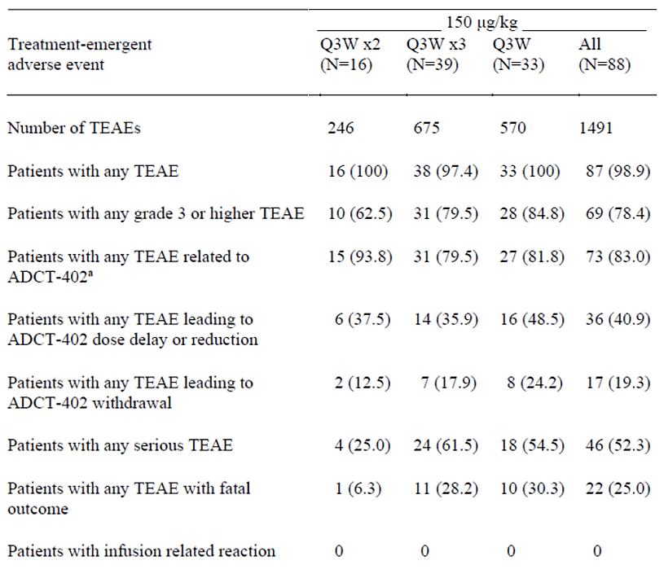
ADCT-402 = loncastuximab tesirine
a "Related" defined as possibly related, probably related, or related including missing relationship.
Note: Adverse events are graded using CTCAE v4.0. Only treatment-emergent adverse events are summarised. For each category, patients are included only once, even if they experienced multiple events in that category.

Final dose selection
In addition to the above data from study ADCT-402-101, the final dose selection for study ADCT-402-201 was also informed by the ER modelling which demonstrated associations between increasing exposure and improved ORR and OS, but also with increased risk of adverse effects such as increased GGT.
Overall, the 150 μg/kg Q3W × 2 followed by 75 μg/kg Q3W regimen was selected for study ADCT-402-201 to optimise the balance between maximising anti-tumour efficacy and mitigating cumulative toxicity through a planned dose reduction strategy.

Confirmatory study
To satisfy the requirements of the proposed provisional registration, the sponsor has commenced confirmatory study ADCT-402-311 (LOTIS-5), which is a phase 3 randomised study of loncastuximab tesirine combined with rituximab versus combined rituximab, gemcitabine and oxaliplatin (R-GemOx) in patients with R/R DLBCL. The primary endpoint of LOTIS-5 is PFS by independent central review and estimated TGA submission is by the end of 2027 (Table 13).
Regular meetings of the independent Data Monitoring Committee have all recommended the study to continue without modification, including at a pre-specified futility interim analysis in July 2024, and safety review at the most recent meeting on 30 Sep 2025. The study is now fully enrolled with 420 randomised patients.
Loncastuximab tesirine has received conditional or provisional approval based on LOTIS-5 as the agreed confirmatory study in several jurisdictions, including the United States (April 2021), the European Union (December 2022), the United Kingdom (February 2023), and Canada (Mar 2025).
Table 13. Clinical study plan for provisional registration
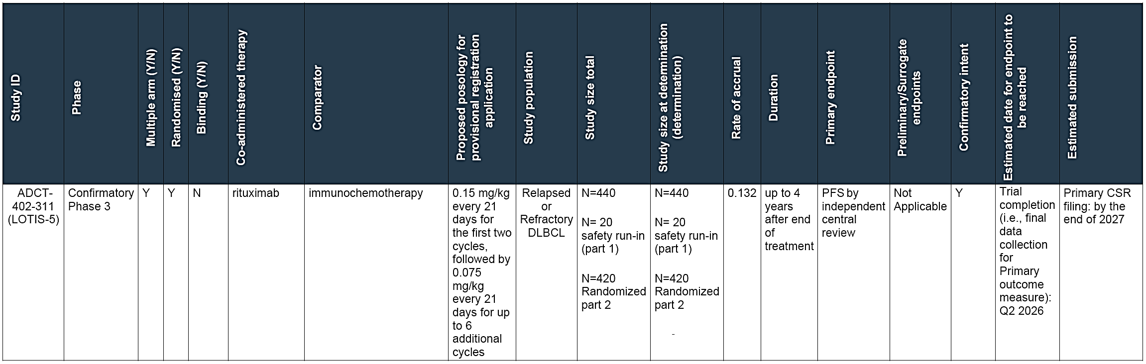
Abbreviations: PFS = progression free survival; ORR = overall response rate; DoR = duration of response

Risk management plan
The sponsor has submitted EU-RMP version 3.0 (date 18 Sep 2025; DLP 01 Mar 2021) and Australian-Specific Annex (ASA) version 0.3 (date 17 Dec 2025) in support of this application.
The summary of safety concerns is outlined below in Table 14.
Table 14. Summary of safety concerns
Summary of safety concerns |  | Pharmacovigilance |  | Risk Minimisation
 |  | Routine | Additional | Routine | Additional
Important identified risks | Phototoxicity | ü# | – | ü | ü*
Important identified risks | Oedema and effusion | ü | – | ü | –
Important potential risks | Embryo-foetal toxicity | ü | – | ü | –
Missing information | Use in patients with moderate or severe hepatic impairment | ü | ü† | ü | –
Missing information | Use in patients with severe renal impairment | ü | – | ü | –
#Follow-up questionnaire
†Hepatic impairment study
*Patient Card
The RMP evaluator has commented that the summary of safety concerns and pharmacovigilance plan are both acceptable from an RMP perspective, and that there were no RMP recommendations that would impede decision on this submission.
The RMP evaluator has advised the sponsor to update the Risk Minimisation Plan section of the ASA as detailed in their report when the ASA is next updated, and that the Patient Card in its final format should be submitted for review no later than 6 weeks prior to product launch.

Risk-benefit analysis
R/R DLBCL is an aggressive malignancy with a particularly poor prognosis in patients who are ineligible for, or who have failed, salvage chemotherapy. A large, international, retrospective study (SCHOLAR-1) reported an average ORR of 26% (CRR 7%) and a median OS of 6.3 months in this population. Whilst several novel treatments have received approval in the later line setting in recent years, optimal therapy remains unclear and there is an unmet clinical need for further safe and effective options.

Defining the condition
Interpretation of DLBCL studies requires consideration of the evolving classification systems. DLBCL is technically not a single disease, but a grouping of morphologically, genetically and clinically different diseases3. Consequently, advances in scientific methods result in updated classifications/sub-categorisations. Pivotal phase 2 study ADCT-402-201 was designed at the time of the 2016 WHO classification (revised 4th edition)9 and appropriately used these diagnostic definitions. However, the 5th edition has subsequently been published with several updates, including a major change to the classification of HGBL with MYC and BCL2 and/or BCL6 rearrangements.3, This category now consists exclusively of MYC and BCL2 rearranged DLBCL/HGBL, while the MYC+BCL6-rearranged cases are considered subtypes of DLBCL NOS or of HGBL NOS⁴. Some of the relevant changes are illustrated in Figure 6.
Figure 6. Summary of the relationship between large B-cell lymphoma entities as named and defined in the revised 4th edition of the WHO classification (WHO-HAEM4R) and in the present 5th edition (WHO-HAEM5)
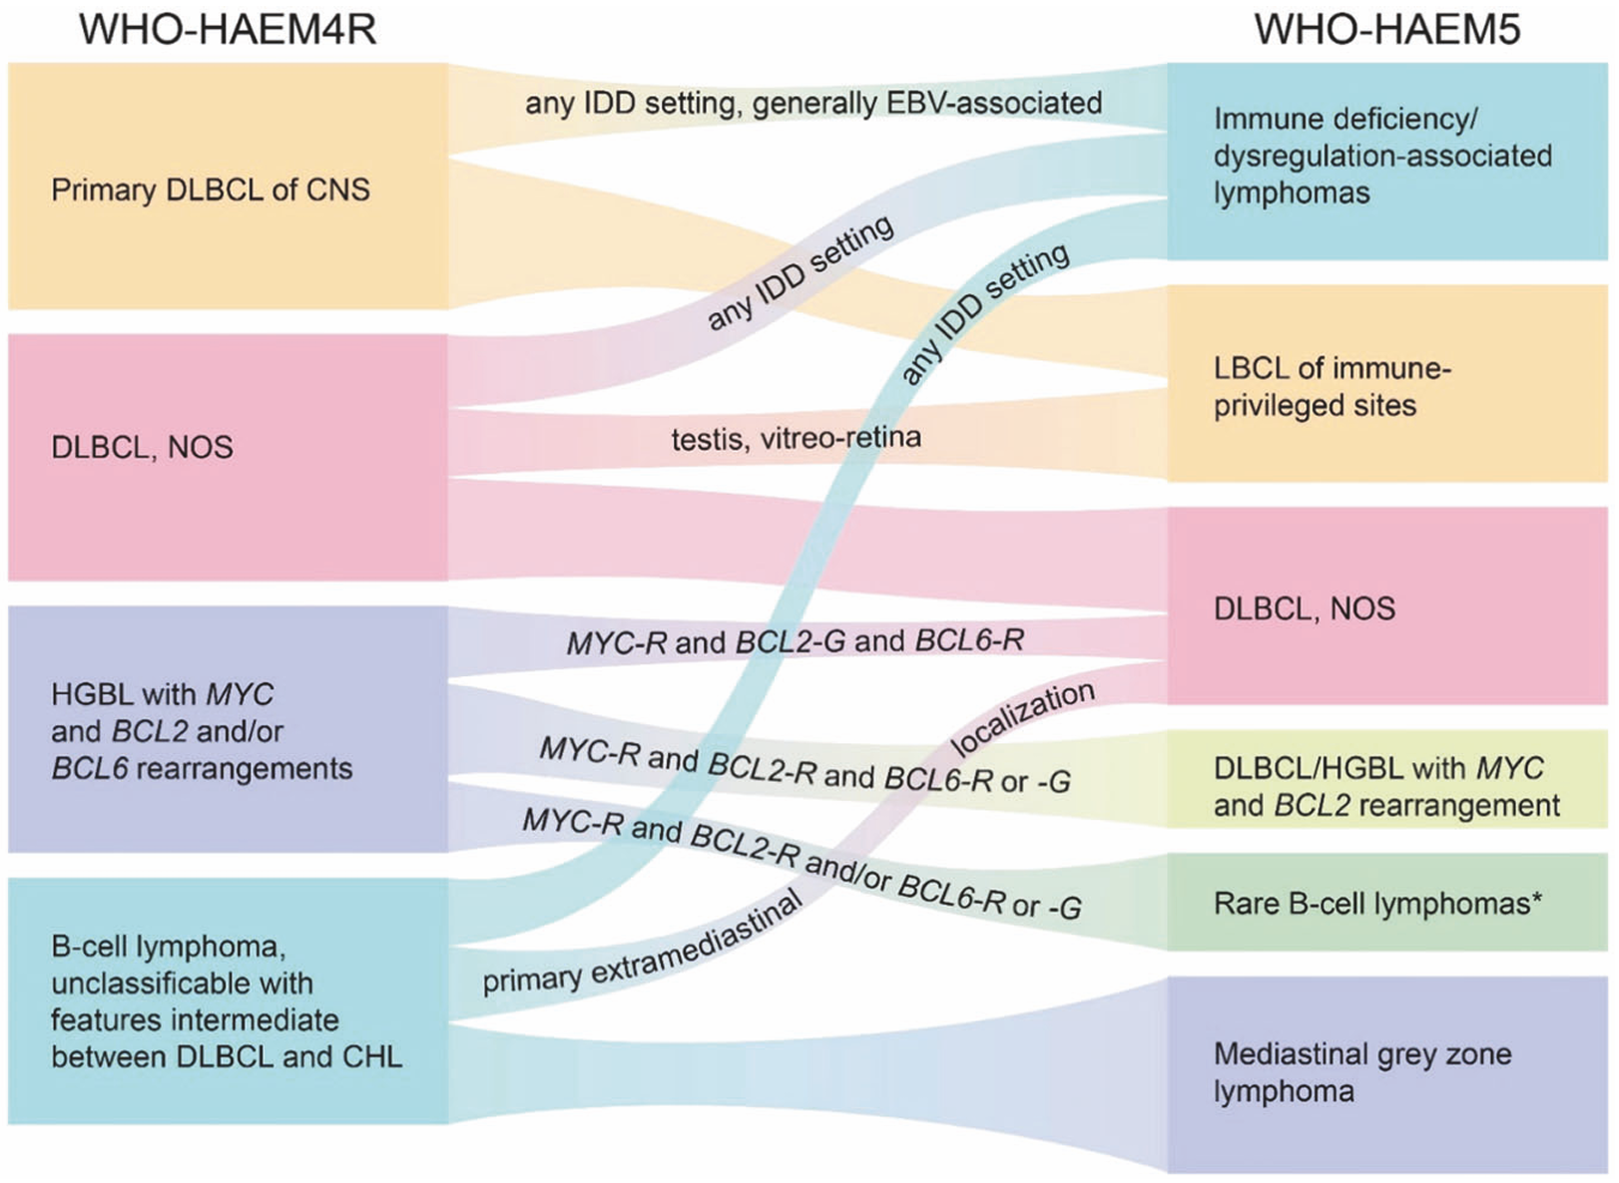
CHL = classic Hodgkin lymphoma; CNS = central nervous system; DLBCL = diffuse large B-cell lymphoma; G = germline configuration; HGBL = high-grade B-cell lymphoma; IDD = immune deficiency/dysregulation; LBCL = large B-cell lymphoma; NOS = not otherwise specified; R = rearrangement
* “Rare B-cell lymphomas” refer to those fulfilling definitions of specific clinico-pathological entities while incidentally bearing concomitant MYC and BCL2 rearrangements. Examples are fluid overload-associated large B-cell lymphomas and rare follicular lymphomas.
Additionally, the International Consensus Classification (ICC)4 co-exists alongside the WHO schema as a valid alternative reference, with some differences in definitions and categorisation.
For this application, the sponsor-proposed indication is “for the treatment of adult patients with relapsed or refractory diffuse large B-cell lymphoma”. This differs from some international registrations which specify DLBCL NOS, HGBL, and/or DLBCL arising from low grade lymphoma because the Australian orphan drug designation was approved for the “treatment of Diffuse Large B-Cell Lymphoma (DLBCL)”.
The exact diagnostic inclusion criterion in the study protocol for ADCT-402-201 was: “Pathologic diagnosis of DLBCL, as defined by the 2016 WHO classification, to include: DLBCL not otherwise specified; primary mediastinal large B-cell lymphoma; and high-grade B-cell lymphoma, with MYC and BCL2 and/or BCL6 rearrangements”
Overall, the Delegate was satisfied with maintaining the broader umbrella condition of DLBCL in the indication as proposed by the sponsor because:
- The baseline demographic and disease characteristics of the study population for ADCT-402-201 are sufficiently similar to Australia to maintain external validity
- The definition of HGBL with MYC and BCL2 and/or BCL6 rearrangements has changed significantly since the enrolment of the study, and it is unclear how the patients with this diagnosis would be classified today and this group was small (n=10)
- A not insignificant proportion of the patients with HGBL with MYC and BCL2 and/or BCL6 rearrangements may now be re-classified as a form of DLBCL.
- The proposed indication encompasses DLBCL arising from low grade lymphoma
- An accepted amendment to the indication specifies that loncastuximab tesirine is not indicated for patients with primary CNS lymphoma
- The nature of DLBCL is such that its classification will continue to evolve and, therefore, I have recommended amendments to section 5.1 of the Product Information to clarify how the disease was defined at the time of the study ADCT-402-201. Thus, prescribers can refer to this to understand the pivotal study population rather than making the indication more prescriptive in a way which may not remain accurate into the future.

Indication
The Delegate considered that the following amendment to the indication is required to clarify that the proposed use has only been established with use of the product as monotherapy.
Zynlonta monotherapy is provisionally approved for the treatment of adult patients with relapsed or refractory diffuse large B-cell lymphoma after two or more lines of systemic therapy.
Zynlonta is not indicated for patients with primary central nervous system lymphoma.
The decision to approve this indication has been granted on the results from an open-label, uncontrolled Phase 2 study based on the overall response rate. Continued approval of this indication depends on verification and description of benefit in confirmatory trials.

Confirmatory study
The pivotal phase 2 study for the current application for provisional registration, ADCT-402-201, has established the efficacy (ORR 48.3% [95% CI: 39.9, 56.7]) and safety profile of loncastuximab tesirine for monotherapy of R/R DLBCL in adults sufficiently to meet the standards of provisional registration.
The proposed confirmatory phase 3 study, ADCT-402-311, is underway comparing loncastuximab tesirine + rituximab to R-GemOx in adults with R/R DLBCL after at least 1 prior line of therapy, with primary endpoint PFS. Although the study is evaluating combination therapy, the effect of loncastuximab is able to be isolated because of the use of rituximab in both arms, and the use of a combination confirmatory trial to support a monotherapy provisional approval has precedent. Therefore, the Delegate accepted ADCT-402-311 as the confirmatory study.

Assessment outcome
Based on a review of quality, safety, and efficacy, the TGA decided to provisionally register Zynlonta (loncastuximab tesirine) for the following indication:
Zynlonta monotherapy is provisionally approved for the treatment of adult patients with relapsed or refractory diffuse large B-cell lymphoma after two or more lines of systemic therapy.
Zynlonta is not indicated for patients with primary central nervous system lymphoma.
The decision to approve this indication has been granted on the results from an open-label, uncontrolled Phase 2 study based on the overall response rate. Continued approval of this indication depends on verification and description of benefit in confirmatory trials.]

Specific conditions of registration
Zynlonta (loncastuximab tesirine) is to be included in the Black Triangle Scheme. The PI and CMI for Zynlonta must include the black triangle symbol and mandatory accompanying text for five years, or the product’s entire period of provisional registration, whichever is longer.
The Zynlonta EU-Risk Management Plan (RMP) (version 3.0, date 18 September 2025; DLP 1 March 2021), with Australia-Specific Annex (ASA) (version 0.3, dated 17 December 2025), included with submission PM-2025-00489-1-4, and any subsequent revisions, as agreed with the TGA will be implemented in Australia.
An obligatory component of risk management plans is routine pharmacovigilance. Routine pharmacovigilance includes the submission of periodic safety update reports (PSURs).
Unless agreed separately between the supplier who is the recipient of the approval and the TGA, the first report must be submitted to TGA no later than 15 calendar months after the date of this approval letter. The subsequent reports must be submitted no less frequently than annually from the date of the first submitted report until the period covered by such reports is not less than three years from the date of this approval letter, or the entire period of provisional registration, whichever is longer. Each report must be submitted within ninety calendar days of the data lock point for that report.
The reports are to at least meet the requirements for PSURs as described in the European Medicines Agency’s Guideline on good pharmacovigilance practices (GVP) Module VII-periodic safety update report (Rev 1), Part VII.B Structures and processes. Note that submission of a PSUR does not constitute an application to vary the registration.
The sponsor must conduct studies as described in the clinical study plan in version 0.3 (date 17 December 2025) of the Australia-Specific Annex. Study reports for ADCT-402-311 (LOTIS-5) should be submitted to the TGA for evaluation.

Laboratory testing & compliance with Certified Product Details (CPD)
- All batches of Zynlonta loncastuximab tesirine10 mg powder for concentrate for solution for infusion vial supplied in Australia must comply with the product details and specifications approved during evaluation and detailed in the Certified Product Details (CPD).
- When requested by the TGA, the Sponsor should be prepared to provide product samples, specified reference materials and documentary evidence to enable the TGA to conduct laboratory testing on the Product. Outcomes of laboratory testing are published biannually in the TGA Database of Laboratory Testing Results http://www.tga.gov.au/ws-labs-index and periodically in testing reports on the TGA website.

Certified product details
The Certified Product Details (CPD), as described in Guidance 7: Certified Product Details of the Australian Regulatory Guidelines for Prescription Medicines (ARGPM), in PDF format, for the above products should be provided upon registration of these therapeutic goods. In addition, an updated CPD should be provided when changes to finished product specifications and test methods are approved in a Category 3 application or notified through a self-assessable change.
A template for preparation of CPD for biological prescription medicines can be obtained from the TGA website:
Certified Product Details guidance
Certified Product Details form

Product Information and Consumer Medicine Information
For the most recent Product Information (PI) and Consumer Medicine Information (CMI), please refer to the TGA PI/CMI search facility.

Therapeutic Goods Administration
PO Box 100 Woden ACT 2606 Australia
Email: info@tga.gov.au Phone: 1800 020 653 Fax: 02 6203 1605
https://www.tga.gov.au
Reference/Publication #

This is the original indication proposed by the sponsor when the TGA commenced the evaluation of this submission. It may differ to the final indication approved by the TGA and registered in the Australian Register of Therapeutic Goods.
Li, S., Young, K. H., & Medeiros, L. J. (2018). Diffuse large B-cell lymphoma. Pathology, 50(1), 74–87. https://doi.org/10.1016/j.pathol.2017.09.006
Kurz, K. S., Ott, M., Kalmbach, S., et al. (2023). Large B-Cell Lymphomas in the 5th Edition of the WHO-Classification of Haematolymphoid Neoplasms-Updated Classification and New Concepts. Cancers, 15(8), 2285. https://doi.org/10.3390/cancers15082285
Campo, E., Jaffe, E. S., Cook, J. R., et al. (2022). The International Consensus Classification of Mature Lymphoid Neoplasms: a report from the Clinical Advisory Committee. Blood, 140(11), 1229–1253. https://doi.org/10.1182/blood.2022015851.
European Society for Medical Oncology (ESMO). (2025). ESMO Living Guideline – Lymphomas – Relapsed/Refractory DLBCL. v1.0 - October 2025. Last accessed 26 Nov 2025 from https://www.esmo.org/guidelines/living-guidelines/esmo-living-guideline-lymphomas/diffuse-large-b-cell-lymphoma-dlbcl/dlbcl-disease-management/relapsed-refractory-dlbcl
Tiberghien AC, Levy JN, Masterson LA, et al. Design and synthesis of tesirine, a clinical antibody- drug conjugate pyrrolobenzodiazepine dimer payload. ASC Med Chem Lett 2016;7(11):983–7.
Anderson KC, Bates MP, Slaughenhoupt BL, et al. Expression of human B cell-associated antigens on leukaemias and lymphomas: a model of human B cell differentiation. Blood 1984;63(6):1424–33.
Scheuermann RH and Racila E. CD19 antigen in leukaemia and lymphoma diagnosis and immunotherapy. Leuk Lymphoma 1995;18(5-6):385–97.
Swerdlow, S. H., Campo, E., Pileri, S. A., et al. (2016). The 2016 revision of the World Health Organization classification of lymphoid neoplasms. Blood, 127(20), 2375–2390. https://doi.org/10.1182/blood-2016-01-643569
Crump, M., Neelapu, S. S., Farooq, U., et al. (2017). Outcomes in refractory diffuse large B-cell lymphoma: results from the international SCHOLAR-1 study. Blood, 130(16), 1800–1808. https://doi.org/10.1182/blood-2017-03-769620
Alaggio, R., Amador, C., Anagnostopoulos, I., et al. (2022). The 5th edition of the World Health Organization Classification of Haematolymphoid Tumours: Lymphoid Neoplasms. Leukemia, 36(7), 1720–1748. https://doi.org/10.1038/s41375-022-01620-2
Alaggio, R., Amador, C., Anagnostopoulos, I., et al. (2022). The 5th edition of the World Health Organization Classification of Haematolymphoid Tumours: Lymphoid Neoplasms. Leukemia, 36(7), 1720–1748. https://doi.org/10.1038/s41375-022-01620-2
The Delegate of the Secretary of the Department of Health, Disability and Ageing who decided the submission under Section 25 of the Therapeutic Goods Act 1989.

