Australian Public Assessment Report for Qdenga
  - Active ingredients: Dengue virus serotype 1, 2, 3, and 4 (live, attenuated)

  - Sponsor: Takeda Pharmaceuticals Australia Pty Ltd
June 2026

About the Therapeutic Goods Administration (TGA)
- The Therapeutic Goods Administration (TGA) is part of the Australian Government Department of Health, Disability and Ageing and is responsible for regulating therapeutic goods, including medicines, medical devices, and biologicals.
- The TGA administers the Therapeutic Goods Act 1989 (the Act), applying a risk management approach designed to ensure therapeutic goods supplied in Australia meet acceptable standards of quality, safety, and efficacy.
- The work of the TGA is based on applying scientific and clinical expertise to decision-making, to ensure that the benefits to the Australian public outweigh any risks associated with the use of therapeutic goods.
- The TGA relies on the public, healthcare professionals and industry to report problems with therapeutic goods. The TGA investigates reports received to determine any necessary regulatory action.
- To report a problem with a therapeutic good, please see the information on the TGA website.

About AusPARs
- The Australian Public Assessment Report (AusPAR) provides information about the evaluation of a prescription medicine and the considerations that led the TGA to approve or not approve a prescription medicine submission. Further information can be found in Australian Public Assessment Report (AusPAR) guidance.
- AusPARs are prepared and published by the TGA.
- AusPARs are static documents that provide information that relates to a submission at a particular point in time. The publication of an AusPAR is an important part of the transparency of the TGA’s decision-making process.
- A new AusPAR may be provided to reflect changes to indications or major variations to a prescription medicine subject to evaluation by the TGA.

Copyright
© Commonwealth of Australia 2026.
This work is copyright. You may reproduce the whole or part of this work in unaltered form for your own personal use or, if you are part of an organisation, for internal use within your organisation, but only if you or your organisation do not use the reproduction for any commercial purpose and retain this copyright notice and all disclaimer notices as part of that reproduction. Apart from rights to use as permitted by the Copyright Act 1968 or allowed by this copyright notice, all other rights are reserved, and you are not allowed to reproduce the whole or any part of this work in any way (electronic or otherwise) without first being given specific written permission from the Commonwealth to do so. Requests and inquiries concerning reproduction and rights are to be sent to the TGA Copyright Officer, Therapeutic Goods Administration, PO Box 100, Woden ACT 2606 or emailed to <tga.copyright@tga.gov.au>.

Contents
List of abbreviations 4
Product submission 6
Submission details 6
Product background 7
Disease 7
Current treatment options 8
Clinical rationale 9
Regulatory status 10
Australian regulatory status 10
International regulatory status 10
Registration timeline 10
Assessment overview 11
Quality evaluation summary 11
Nonclinical evaluation summary 11
Clinical evaluation summary 12
Pharmacology 12
Efficacy 14
Safety 23
Risk management plan 24
Risk-benefit analysis 26
Delegate’s considerations 26
Proposed action 26
Assessment outcome 27
Specific conditions of registration 27
Product and Consumer Medicine Information 29

List of abbreviations
Abbreviation | Meaning
ACM | Advisory Committee on Medicines
ACV | Advisory Committee on Vaccines
AE(s) | Adverse event(s)
ARTG | Australian Register of Therapeutic Goods
ASA | Australia-specific annex
ATAGI | Australian Technical Advisory Group on Immunisation
BMI | Body mass index
CHMP | Committee for Medicinal Products for Human Use
CI | Confidence interval
CMI | Consumer Medicines Information
DENV | Dengue virus
DHF | Dengue haemorrhagic fever
DLP | Data lock point
DP | Drug product
DSS | Dengue shock syndrome
eCRF | electronic case report form
EMA | European Medicines Agency
EU | European Union
GLP | Good laboratory practice
GMOs | Genetically modified organisms
GMTs | Geometric mean titres
HD | High dose
ID | Intradermal(ly)
LD | Low dose
MAAE(s) | Medically attended adverse event(s)
MNT | Microneutralization test
PFS | Pre-filled syringe
PFU | Plaque-forming unit
PI | Product Information
PPS | Per-protocol set
PRNT | Plaque-reduction neutralisation test
PSUR | Periodic safety update report
RMP | Risk management plan
RR | Relative risk
SAGE | Scientific Advisory Group of Experts
SC | Subcutaneous(ly)
SD | Standard deviation
TDV | Tetravalent dengue vaccine
TGA | Therapeutic Goods Administration
US(A) | United States of America
VCD | Virologically confirmed dengue
VE | Vaccine efficacy
WHO | World Health Organization
YF | Yellow Fever

Product submission

Submission details
Type of submission: | New biological entity
Product name: | Qdenga
Active ingredients: | Dengue virus serotype 1 (live, attenuated), dengue virus serotype 2 (live, attenuated), dengue virus serotype 3 (live, attenuated), and dengue virus serotype 4 (live, attenuated).
Decision: | Approved
Date of decision: | 31 March 2026
Date of entry onto ARTG: | 8 April 2026
ARTG numbers: | 484846, 506646
Black Triangle Scheme  for the current submission: | Yes
Sponsor’s name and address: | Takeda Pharmaceuticals Australia Pty Ltd  Level 39, 225 George Street  Sydney NSW 2000  Australia
Dose forms: | Powder and solvent for injection.
Strength: | 1 dose (0.5 mL) contains live attenuated:  - Dengue virus serotype 1: ≥ 3.3 log10 PFU (Plaque-forming unit) /dose*  - Dengue virus serotype 2: ≥ 2.7 log10 PFU/dose #  - Dengue virus serotype 3: ≥ 4.0 log10 PFU/dose*  Dengue virus serotype 4: ≥ 4.5 log10 PFU/dose*  *Produced in Vero cells by recombinant DNA technology. Genes of serotype-specific surface proteins engineered into dengue type 2 backbone  # Produced in Vero cells by recombinant DNA technology
Containers: | Powder for injection: Type I clear glass vial.  Solvent: Pre-filled syringe (Type 1 glass) or vial (Type 1 glass).
Pack sizes: | Pack size: 1 (vial/pre-filled syringe)  Pack size: 1 or 10 (vial/vial)
Approved therapeutic use for the current submission: | Qdenga is indicated for the prevention of dengue disease in individuals from 4 years of age.  The use of this vaccine should be in accordance with official recommendations.
Route of administration: | Subcutaneous injection (upper arm)
Dosage: | 0.5 mL dose as part of a two-dose schedule (0 and 3 months).  For further information regarding dosage, such as dosage modifications to manage adverse reactions, refer to the Product Information.
Pregnancy category: | Category B2  Qdenga is a live attenuated vaccine, therefore Qdenga is contraindicated during pregnancy (see section 4.3 CONTRAINDICATIONS).  Women of childbearing potential should avoid pregnancy for at least one month following vaccination. Women who intend to become pregnant should be advised to delay vaccination.  There is limited amount of data from the use of Qdenga in pregnant women. These data are not sufficient to conclude on the absence of potential effects of Qdenga on pregnancy, embryo-foetal development, parturition and post-natal development.  The use of any medicine during pregnancy requires careful consideration of both risks and benefits by the treating health professional. The pregnancy database must not be used as the sole basis of decision making in the use of medicines during pregnancy. The TGA does not provide advice on the use of medicines in pregnancy for specific cases. More information is available from obstetric drug information services in your state or territory.

Product background
This AusPAR describes the submission by Takeda Pharmaceuticals Australia Pty Ltd to register Qdenga dengue tetravalent vaccine (live, attenuated - dengue virus serotypes 1, 2, 3, and 4) powder (vial) & solvent (vial) or (PFS) for injection for the following proposed indication:
Qdenga is indicated for the prevention of dengue disease caused by any dengue virus serotype in individuals from 4 years of age.

Disease
Dengue is a viral infection caused by one of four different serotypes of the dengue virus (DENV-1, DENV-2, DENV-3, DENV-4). The dengue virus is transmitted primarily by the Aedes aegypti mosquito with mosquitos of the Aedes genus also acting as potential vectors. Dengue has a wide spectrum of clinical presentation, often with unpredictable clinical evolution and outcome. The majority of patients will either be asymptomatic or recover following a self-limiting non-severe clinical course that may be characterised by high fever, headache, myalgia, arthralgia, nausea, and rash. However, a small proportion of individuals will progress to severe forms of dengue infection (dengue haemorrhagic fever [DHF] and dengue shock syndrome [DSS]), characterised by severe plasma leakage with/without haemorrhage and severe organ impairment.
For dengue wild type disease, it has been observed that secondary infections, especially with a different serotype than the primary infection have a higher risk of developing severe disease. The biological mechanism for this phenomenon is unknown. Primary infection with any of the 4 dengue serotypes is thought to result in life-long protection from re-infection by the same serotype (homotypic protection) but does not protect against a secondary infection with the other dengue serotypes and may lead to an increased risk of severe disease over the course of secondary infection. Following recovery from a second infection, broadly cross-neutralising antibodies are induced (multitypic protection), such that severe disease with tertiary and quaternary infections is considered rare.
The incidence of dengue has grown dramatically around the world in recent decades, with cases reported to the World Health Organization (WHO) increasing from 50,5430 cases in 2000 to 5.2 million in 2019. Dengue is now endemic across over 100 countries spanning Africa, the Americas, Eastern Mediterranean, South-East Asia and the Western Pacific. Several factors have been associated with the increasing spread of dengue including increased urbanisation and population growth; changing distribution of vectors across regions; consequences of climate change leading to increasing temperatures, high rainfall and humidity; fragile health systems in the midst of the COVID-19 pandemic; political and financial instabilities in countries facing complex humanitarian crises; and high population movement.²
A systematic review of reported dengue serotypes over 70 years found DENV-1 to be reported most frequently, followed by DENV-2, DENV-3, and DENV-4. Additionally, a review of 174 outbreaks reported in published literature between 1990 and 2015 reported DENV-1 and DENV-2 being the 2 dominant circulating dengue serotypes, whilst prevalence of DENV-4 was observed to be infrequent.
In Australia, a total of 13,343 dengue cases were reported to the National Notifiable Disease Surveillance System between 2012-2022. Of these cases, 12,568 (94%) were imported, 584 (4%) were locally acquired and 191 (1%) had no origin recorded. Overall trends suggest a general increase in imported cases (with the exception of 2020-21 which corresponded to border closures during the COVID-19 pandemic) and a decline in locally acquired cases over time. Of the imported cases, the majority were acquired in South-East Asia, Southern and Central Asia, and Oceania. Almost two-thirds (64%) of imported cases to Australia originated from Indonesia, Thailand and India, reflecting their popularity as travel destinations. Although 59% of imported cases did not have dengue serotype recorded, of the cases that did, DENV-2 (17%) and DENV-1 (12%) represented the predominant serotypes. For locally acquired dengue, DENV-1 represented the most common serotype (67%).

Current treatment options
Treatment of dengue fever is supportive and based solely on managing clinical signs and symptoms, with fluid replacement required for haemorrhagic or shock cases. An antiviral therapy for dengue virus infection is not available. Most of the current preventive measures that rely on mosquito control and individual protection are of limited efficacy, complex to implement, and questionable in terms of cost-effectiveness. While the malaria transmitting Anopheles mosquitoes predominantly feed during the night, the dengue transmitting Aedes mosquitoes feed predominantly at dusk and bed nets are therefore not effective. Dengue continues to spread despite the use of vector control measures. New technologies under development appear to be effective at stopping local dengue transmission, such as instances where mosquitoes infected with Wolbachia (which reduces a mosquito’s ability to transmit human viruses) are released into the environment.
Vaccine development has assumed the need for tetravalent vaccines against all 4 serotypes to avoid any potential risk of vaccine-induced immune enhancement, as has been well documented with natural (wild-type) infection. A first tetravalent dengue vaccine (chimeric Yellow Fever [YF] virus-Dengue virus Tetravalent Dengue Vaccine, Dengvaxia) has been approved since 2015 in several Asian and Latin American countries as well as in the United States of America (US) and European Union (EU). This vaccine was initially approved for use in vaccine recipients ≥9 years of age because clinical data indicated an unfavourable benefit-risk profile for children less than 9 years of age. More recent analyses found that individuals who were dengue seronegative before vaccination had a higher risk of severe disease and/or being hospitalised when they were infected by dengue virus after vaccination with Dengvaxia than individuals who were already seropositive.
In a revised recommendation from April 2018, the Scientific Advisory Group of Experts (SAGE) on Immunisation concluded that for countries considering Dengvaxia vaccination as part of their dengue control program, a ‘pre-vaccination screening strategy’ would be the preferred option, and only dengue-seropositive individuals should be vaccinated. This advice was echoed by the Australian Technical Advisory Group on Immunisation (ATAGI) in a statement provided in July 2019 regarding use of Dengvaxia for Australians.
Dengvaxia was registered on the ARTG on 20 July 2017. It was however, not marketed in Australia and was only available via the Special Access Scheme, on a case-by-case basis. The use of Dengvaxia in Australia has been limited with only 90 doses imported up to December 2023. Registration of Dengvaxia was cancelled on 17 December 2024 under Section 30(1)(c) of the Therapeutic Goods Act 1989.

Clinical rationale
In light of the prevailing epidemiology of dengue, lack of available antiviral treatments, and limitations with existing dengue vaccines, there remains an unmet public health need in Australia for a safe and effective vaccine against dengue infection. To address this unmet public health need, the Sponsor has developed a tetravalent vaccine that protects against dengue irrespective of baseline dengue serostatus and that can be administered to children as young as 4 years of age.
Qdenga contains live attenuated dengue viruses. The primary mechanism of action of Qdenga is to replicate locally and elicit an immune response to confer protection against dengue disease caused by any of the four dengue virus serotypes. Qdenga activates multiple arms of the immune system, including binding antibodies, complement fixing antibodies, functional antibodies to dengue non-structural protein 1 (NS1), and cell-mediated immune responses (CD4+, CD8+, and natural killer cells).

Regulatory status

Australian regulatory status
This product is considered a new biological entity for Australian regulatory purposes

International regulatory status
At the time the TGA considered this submission, a similar submission had been considered by other regulatory agencies. The following table summarises these submissions and provides the indications where approved.
Table 1. International regulatory status.
Region | Submission date | Status | Approved indications
European medicines Agency (EMA) | 3 March 2021 | Approved on 5 December 2022 | Qdenga is indicated for the prevention of dengue disease in individuals from 4 years of age.
United Kingdom | 18 October 2022 | Approved on 26 January 2023 | Qdenga is indicated for the prevention of dengue disease in individuals from 4 years of age.
Switzerland | 13 April 2023 | Approved on 29 July 2024 | Qdenga is indicated for the prevention of dengue disease in individuals from 4 years of age.

Registration timeline
The following table captures the key steps and dates for this submission.
This submission was evaluated under the standard prescription medicines registration process.
Table 2. Timeline for Submission PM-2025-00874-1-2.
Description | Date
Submission dossier accepted and first round evaluation commenced | 30 April 2025
Evaluation completed (End of round 2) | 14 January 2026
Registration decision (Outcome) | 31 March 2026
Registration in the ARTG completed | 8 April 2026
Number of working days from submission dossier acceptance to registration decision* | 185
*Statutory timeframe for standard submissions is 255 working days

Assessment overview
A summary of the TGA’s assessment for this submission is provided below.

Quality evaluation summary
The dengue tetravalent vaccine drug product (DP) consists of four molecularly characterised serotypes: one attenuated serotype 2 virus strain and three recombinant virus strains expressing the surface antigens corresponding to dengue serotypes 1, 3 and 4, engineered into the attenuated serotype 2 backbone.
Qdenga is presented as a composite pack containing a lyophilised powder for injection (1 dose) vial and a diluent (0.5 mL of 37 mM sodium chloride solution) presented in either a vial or pre-filled syringe (PFS). The lyophilised powder is a mixture of the four vaccine serotypes and excipients. Prior to administration, the lyophilised DP is reconstituted with the entire contents of the diluent. The recommended storage condition of the composite pack prior to reconstitution is at 2-8ᵒC (no freezing).
The shelf-life for the lyophilised tetravalent dengue vaccine (TDV) DP is 24 months.
After reconstitution with the solvent provided, Qdenga should be used immediately. If not used immediately, the reconstituted Qdenga vaccine must be used within 2 hours from reconstitution.
There are no significant issues identified from the Module 3 evaluation of the submitted data that would indicate the products should not be fully registered based on quality, or safety-related issues arising from the quality of the products. The manufacturing quality information submitted by the Sponsor supports the full registration of:
- Qdenga dengue tetravalent vaccine (live, attenuated) powder (vial) & solvent (vial) for injection
- Qdenga dengue tetravalent vaccine (live, attenuated) powder (vial) & solvent (PFS) for injection

Nonclinical evaluation summary
The nonclinical data in support of Qdenga consisted of immunogenicity, protective efficacy, neurovirulence, biodistribution, and repeat-dose toxicity studies in AG129 mice, one pharmacology study in non-human primates, and a reproductive toxicity study in rabbits. All safety studies were GLP-compliant.
TDV vaccine induced neutralising antibodies against all 4 serotypes in mice and monkeys. However, comparison of monovalent and tetravalent vaccine indicated interference between serotypes. Cell-mediated responses were not investigated in nonclinical studies.
Nonclinical biodistribution, toxicity and neurovirulence studies in mice showed that the vaccine viruses are highly attenuated, with a transient minimal to slight inflammatory reaction at the injection site being the only finding. Viremia was low and transient, and no virus shedding was detected. Genetic stability studies indicated that reversion to virulence by back mutation or recombination is unlikely.
Reproductive toxicity studies in rabbits did not show any direct adverse effects on the foetus. Due to limitations of the models, a pregnancy category of B2 is recommended. TDV vaccine is contraindicated in pregnancy and breastfeeding. Women should avoid pregnancy for 1-month post-vaccination, consistent with human viremia data and WHO guidance.
There are no nonclinical objections to registration.

Clinical evaluation summary

Pharmacology

Pharmacokinetics (PK)
Clinical pharmacology trials, including pharmacokinetic trials, were not appropriate for this vaccine and were therefore not performed. The absence of Pharmacokinetic studies is considered acceptable. Pharmacokinetic studies are usually not required for vaccines per TGA approved EMA guidance.

Population PK data (popPK)
Not applicable

Pharmacodynamics (PD)
The assessment of immunogenicity is considered a surrogate measure of the pharmacodynamic effects of TDV. According to WHO guidelines, the plaque-reduction neutralisation test (PRNT) is currently recognised as the assay of choice for measuring functional, dengue neutralising antibodies in human serum.
A standardised and validated functional dengue microneutralization test (MNT) assay was used to quantify dengue virus-neutralising antibodies following vaccination with TDV. This assay was developed by the Sponsor in accordance with WHO PRNT guidance such that it was considered functionally equivalent to the PRNT assay. The MNT assays was initially validated for research purposes in the Phase 1 studies and Phase 2 study DEN-203. It was subsequently qualified for use in Phase 2 studies DEN-106, DEN-204 and DEN-205 and validated for use in the Phase 3 studies. The Evaluator notes that the use of the MNT assay for quantification of dengue neutralising antibodies had also been accepted by the CHMP.
The MNT assay was used during the entire clinical development of TDV and supported primary, secondary and exploratory immunogenicity endpoints across all studies. Evaluation of the neutralising antibody response by the MNT assay was based on quantifying geometric mean titre (GMTs) of neutralising antibodies against each of the four dengue serotypes as well as seropositivity and seroconversion rates (for each dengue serotype and multiple serotypes) at multiple timepoints after vaccination. The lower limit of quantification was established as 10 for all serotypes. Subjects with antibody titres ≥10 were considered seropositive. This approach is endorsed.
Across all the Phase 1 and 2 studies, all formulations of TDV were found to be immunogenic against all 4 dengue serotypes, regardless of baseline serostatus. GMTs to neutralising antibodies were consistently highest for DENV-2, and lowest for DENV-4. In the initial Phase 1 studies DEN-101 and DEN-102, immune responses in healthy baseline seronegative subjects appeared to be higher in subjects who received high dose (HD) TDV compared to low dose (LD) TDV, especially against DENV-1 and DEV-2. Overall immune responses against DENV-3 and DENV-4 were generally lower and varied between the doses and by routes of administration (SC or ID).
The immunogenicity of LD TDV was subsequently explored in study DEN-103, where LD TDV was administered either intradermally using needle or a needle-free PharmaJet Injector in healthy adult subjects. Overall, two simultaneous injections of LD TDV induced higher GMTs to neutralising antibodies against DENV-2 and had potential to improve seroconversion rates against DENV-1 and DENV-2 when compared to single injection. The administration of a second or third dose of LD TDV at Month 3 however, did not result in marked increase in GMT across most dengue serotypes. The value of these findings, however, are limited as the intradermal route of administration was not pursed for further development given the higher local reactogenicity seen with ID injection in prior studies.
Study DEN-104 subsequently evaluated the immunogenicity of different dose schedules and formulations of HD TDV including HD2 TDV (containing higher content of TDV-4) when administered SC in healthy baseline seronegative adults. Overall, a strong immune response was elicited against DENV-2 following the first dose of either formulation. For HD TDV, no clinically meaningful differences in GMTs against any of the serotypes was observed between the first dose when administered as a single injection or 2 simultaneous injections. An additional dose of HD TDV administered at Month 3 did not result in marked increases in GMTs to any serotype. Increasing the DENV-4 content in HD2 TDV resulted in a small numerical increase in GMTs to DENV-4 compared to HD TDV, although the magnitude of the difference between the formulations was not considered clinically meaningful. Seroconversion rates against DENV-4 however, were consistently higher for HD2 TDV than HD TDV at all timepoints, although no dose effect was observed.
Study DEN-203 was the first study to evaluate immunogenicity of HD TDV in both adult and paediatric subjects. Additionally, subjects were recruited from regions endemic for dengue and as such the study included both baseline seropositive and seronegative subjects. Based on data from study DEN-104, HD TDV was administered SC as a 2-dose schedule 3 months apart. Following the second dose, high seropositivity rates ≥ 95.5% were observed against DENV-1, -2, and -3 whilst rates were comparatively lower against DENV-4 (≥72.7%) across all study groups. Seropositivity rates persisted up to 36 months, with high rates against DENV-1 (≥94.4%) and DENV-2 (≥95.2%). Against DENV-3, seropositivity rates up to 36 months were lower (≥77.8%) and were even lower against DENV-4 (≥42.9%). In general, seropositivity rates against each of the dengue serotypes was higher for baseline seropositive subjects compared to baseline seronegative subjects. In particular, seropositivity rates up to 36 months in baseline seronegative subjects were low against DENV-3 (33.3%-100%) and DENV-4 (8.3%-40%).
Studies DEN-204 and DEN-205 both evaluated the final lyophilized TDV formulation which contained reduced levels of TDV-2 (relative to HD TDV). Study DEN-204 evaluated immune responses to TDV using different dose schedules up to 18 months following completion of the primary vaccination course. Overall, TDV induced an immunogenic response against all 4 dengue serotypes, with no marked differences in the GMTs to neutralising bodies between different dose regimens up to Month 12. Subjects who received a booster dose at Month 12 however, were observed to have increases in GMTs to neutralising antibodies against DENV-1, -3 and -4, with this being more pronounced in baseline seronegative subjects. Tetravalent seropositivity rates increased from baseline following the first TDV vaccination and remained high and above baseline through to Month 18.
In study DEN-205, the immune response to a single dose of HD TDV was compared with TDV (containing 10-fold lower viral content of TDV-2). As with study DEN-204, GMTs peaked at Month 1 following the first dose with either formulation, and remained above baseline through to Month 12. Overall GMTs between the two formulations were generally similar for each serotype except for DENV-2, which was higher for HD TDV. Seropositivity rates similarly peaked at Month 1 and remained elevated through to Month 12 with both formulations. Seropositivity rates against DENV-2 were higher for HD TDV whilst against DENV-4, they were higher for TDV.
Overall, TDV was able to elicit an immune response in the form of dengue neutralising antibodies against each of the four dengue serotypes, irrespective of baseline serostatus. GMTs to dengue neutralising antibodies and seropositivity rates increased from baseline to Month 1 and remained well above baseline up to Month 18 regardless of dose schedule. Immune response was consistently highest against DENV-2 and lowest against DENV-4. Attenuation of the vital content of TDV-2 in the vaccine, leading to the final formulation of TDV was shown to lead to a more balanced immune response against all 4 serotypes compared to HD TDV. In general, the immune response was higher in baseline seropositive subjects than seronegative subjects.

Efficacy
Final formulation and dose schedule
Based on the results from the Phase 1 and 2 studies, the final formulation selected for the pivotal Phase 3 study DEN-301 was that of a lyophilized TDV formulation containing a 10-fold reduction in the TDV-2 viral content compared to the HD TDV formulation. The TDV vaccine has a 2-dose regimen, given 3 months apart and is administered subcutaneously.
A total of 10 studies provided evaluable efficacy and immunogenicity data. Of these studies, only the pivotal study DEN-301 provided data on the protective efficacy of TDV in preventing virologically confirmed dengue (VCD) fever.

Study ID DEN-301

Study design and objectives
This was a Phase 3, double-blind, randomised, placebo-controlled, 2-parallel group study. The study was comprised of 5 parts (Parts 1, 2, 3 for all subjects and Parts 4 and 5 for subjects participating in the booster phase) for the surveillance of febrile illness with potential dengue aetiology in subjects aged 4 to 16 living in endemic regions (Figure 1).
Part 1, 2 and 3
Part 1 was designed to evaluate the primary objective of efficacy of the vaccine in preventing virologically confirmed dengue (VCD) fever induced by any dengue serotype. Part 1 formed the primary analysis period, comprising a 15-month period and lasting until 12 months post-second dose. This part commenced on the day of vaccination and ended once both of the following criteria had been met:
- 120 cases of confirmed dengue fever; and
- the minimum duration of subject follow-up reached 12 months post-second vaccination.
To maintain consistent duration of follow-up after the second vaccination, the end of Part 1 was defined individually for each subject. Virologically confirmed cases in Part 1 counted towards the primary efficacy objective if they occurred at least 30 days post-second vaccination.
Part 2 provided extended follow-up data for the assessment of vaccine efficacy (VE) against hospitalisation due to VCD fever. This part comprised 6 months of additional active surveillance for each subject following the completion of Part 1. Virologically confirmed cases in Parts 1 and 2 contributed towards the secondary efficacy objectives.
Part 3 was undertaken as long-term follow-up for evaluation of safety. It comprised a period of modified active surveillance in all subjects following completion of Part 2 and lasted approximately 2.5 to 3 years per subject.
In total, subjects were followed for at least 36 months after the completion of Part 1 (at least 6 months in Part 2 and 2.5-3 years in Part 3). At between 4-4.5 years post-dose 2 in Part 3, the parent(s)/guardian of per-protocol set (PPS) subjects aged 4-11 years at the time of randomisation on Day 1 (Month 0) were asked to allow their child to receive the booster dose of TDV or placebo.
Figure 1. Schematic for study DEN-301.
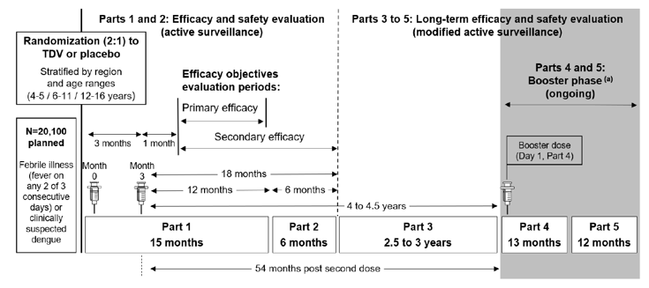
Abbreviations: N, total number of subjects.
Part 4 and 5
Parts 4 and 5 involved periods of modified active surveillance for exploratory efficacy, immunogenicity, and safety analyses post-booster vaccination. Only subjects from the PPS who were aged 4 to 11 years at the time of randomisation on Day 1 (Month 0) in Part 1 were eligible for the booster phase of the study. Subjects who participated in the booster phase were not re-randomised but instead received a single dose of TDV or placebo, according to their assigned group in Part 1. The date of booster vaccination was referred to as Day 1b (Month 0b).
Part 4 lasted a minimum of 13 months for each subject and Part 5 lasted a further 1 year for each subject following the completion of Part 4. Modified active surveillance methodology was identical to that used in Part 3.
Objectives
Primary objective
To evaluate the efficacy of 2 doses of TDV in preventing symptomatic dengue fever of any severity and due to any of the 4 dengue virus serotypes in 4–16-year-old subjects.
Secondary objectives
Efficacy
Assessed post-second vaccination
- To assess the efficacy of TDV in preventing symptomatic dengue fever of any severity induced by individual dengue serotypes.
- To assess the efficacy of TDV in preventing symptomatic dengue fever of any severity by dengue exposure status at baseline.
- To assess the efficacy of TDV in preventing hospitalisation due to VCD fever.
- To assess the efficacy of TDV in preventing severe dengue induced by any dengue serotype.
Immunogenicity
- To assess the immunogenicity of TDV in a subset of subjects (N = 4000).
Inclusion criteria
Subjects were eligible for the study if they met the following key criteria:
- The subject was aged 4 to 16 years inclusive, at the time of randomisation.
- Individuals who were in good health at the time of entry into the study as determined by medical history, physical examination, and clinical judgment of the investigator.
Parts 4 and 5 (booster phase)
Subjects were eligible for the booster phase if they met the following key criteria:
- The subjects were included in the per-protocol set (PPS) for Parts 1-3 of the study.
- The subject was aged 4 to 11 years at the time of randomisation.
Exclusion criteria
Subjects who met any of the following key criteria were not eligible for entry (all parts):
- Febrile illness (temperature ≥38°C) or moderate or severe acute illness or infection at the time of randomisation.
- History or any illness that, in the opinion of the investigator, could have interfered with the results of the study or pose an additional risk to the subject due to participation in the study, including but not limited to the following key conditions: known hypersensitivity/allergy to any vaccine components; female subjects (post-menarche) who were pregnant or breastfeeding; serious chronic or progressive diseases per the judgement of the investigator (including neoplasm, cardiac, renal, or hepatic disease, neurological or seizure disorder, insulin-dependent diabetes, Guillain-Barré Syndrome; and known to suspected immune function impairment.
- Receipt of any other vaccine within 14 days (for inactivated vaccines) or 28 days (for live vaccines) prior to Day 1 (Month 0) or planning to receive any vaccine within 28 days after Day 1 (Month 0).

Study treatments
The investigational vaccine was lyophilized TDV provided in single-use 2 mL glass vials and reconstituted by adding 0.7 mL diluent to facilitate withdrawal of 1 dose (0.5 mL) for SC injection. All products were labelled and packaged according to applicable regulatory requirements.
The dosing schedule comprised of a single dose of TDV or placebo administered on Day 1 (Month 0) and Day 90 (Month 3). For Part 4, a single booster dose of TDV or placebo was administered on Day 1b (Month 0b). All injections were administered into the upper arm via SC injection.

Efficacy variables and outcomes
Primary endpoint
Vaccine efficacy (VE) of 2 doses of TDV in preventing VCD fever induced by any dengue serotype occurring from 30 days post-second vaccination (Day 120 [Month 4]) until the end of Part 1. VE was defined as 1 - (λV/λC) (where λV and λC denote the hazard rates for the TDV and placebo arms, respectively).
Secondary endpoints
Efficacy
- Key secondary efficacy endpoint
Vaccine efficacy of 2 doses of TDV in preventing hospitalisation due to VCD fever induced by any dengue serotype from 30 days post-second vaccination (Day 120-Month 4) until the end of Part 2.
- Additional secondary efficacy endpoints
  - Vaccine efficacy of 2 doses of TDV in preventing VCD fever induced by each dengue serotype from 30 days post-second vaccination (Day 120 [Month 4]) until the end of Part 2.
  - Vaccine efficacy of 2 doses of TDV in preventing VCD fever induced by any dengue serotype from 30 days post-second vaccination (Day 120 [Month 4]) until the end of Part 2 in subjects dengue seronegative at baseline.
  - Vaccine efficacy of 2 doses of TDV in preventing VCD fever induced by any dengue serotype from 30 days post-second vaccination (Day 120 [Month 4]) until the end of Part 2 in subjects dengue seropositive at baseline.
  - Vaccine efficacy of 2 doses of TDV in preventing severe VCD fever induced by any dengue serotype from 30 days post-second vaccination (Day 120 [Month 4]) until the end of Part 2.
Immunogenicity
- Subset (post-first and post-second vaccinations)
  - Seropositivity rate (% of seropositive subjects) for each of the 4 dengue serotypes at pre-vaccination on Day 1 (Month 0), post-first vaccination on Day 30 (Month 1), pre-vaccination on Day 90 (Month 3); post-second vaccination at Day 120 (Month 4), Day 270 (Month 9), Day 450 (Month 15), and then annually.
  - Seropositivity rate (% of seropositive subjects) for any 1 (monovalent), 2 (bivalent), 3 (trivalent), and 4 (tetravalent) dengue serotypes, as well as at least bivalent (seropositive for ≥2 dengue serotypes) and at least trivalent (seropositive for ≥3 dengue serotypes) at pre-vaccination on Day 1 (Month 0), post-first vaccination on Day 30 (Month 1), pre-vaccination on Day 90 (Month 3), post-second vaccination on Day 120 (Month 4), Day 270 (Month 9), Day 450 (Month 15), and then annually.
  - GMTs of neutralising antibodies for each dengue serotype at pre-vaccination on Day 1 (Month 0), post-first vaccination on Day 30 (Month 1), pre-vaccination on Day 90 (Month 3); post-second vaccination at Day 120 (Month 4), Day 270 (Month 9), Day 450 (Month 15), and then annually.

Participant flow
Overall, 20,099 subjects were randomised to the study, with approximately a 2:1 ratio receiving TDV (N=13,401) and placebo (N=6698). This ratio was also maintained across age groups and regions. The disposition of subjects to the end of Part 2 for efficacy and immunogenicity analyses is presented in Figure 2.
Figure 2. Subject disposition to end of Part 2 for efficacy and immunogenicity analyses (All subjects) – Study DEN-301.
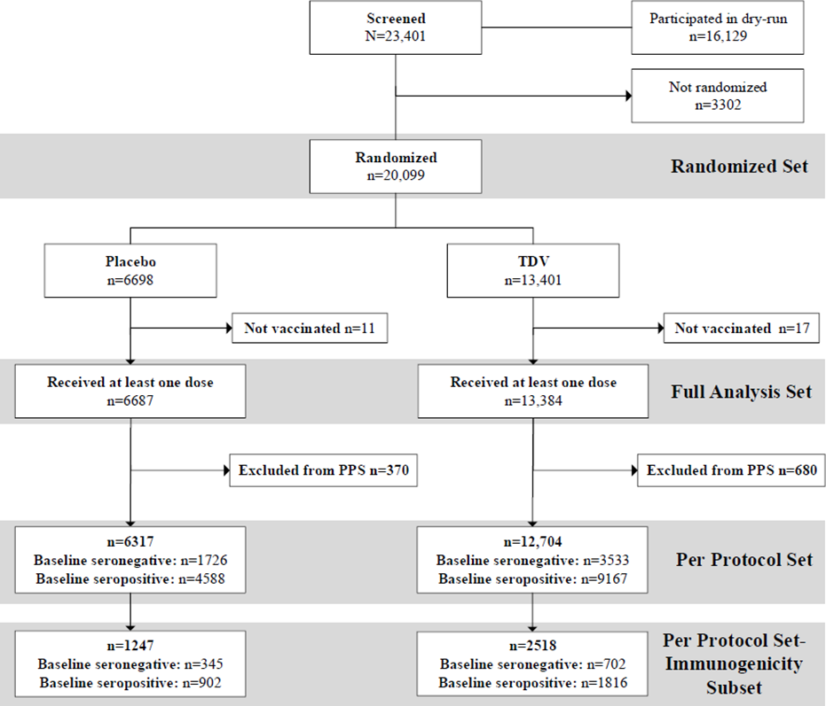

Baseline data
Table 3 summarises the demographic and baseline characteristics of subjects in the PPS. No important differences were noted between the placebo and TDV groups.
Table 3. Demographic and baseline characteristics (PPS) – Study DEN-301.
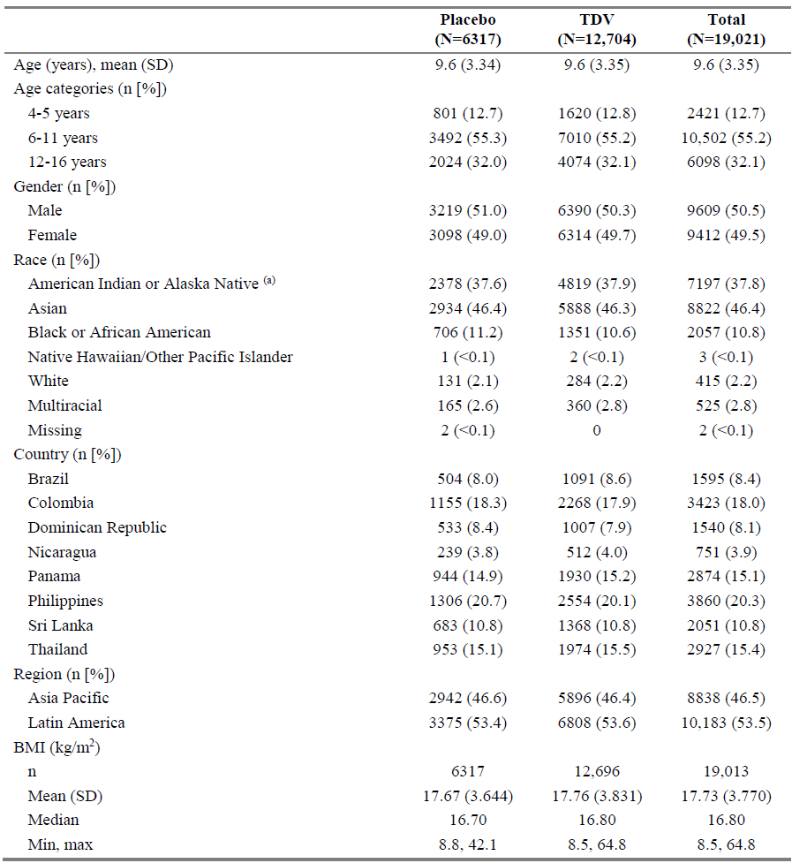
Abbreviations: BMI, body mass index; eCRF, electronic case report form; max, maximum; min, minimum; n, number of subjects; SD, standard deviation; TDV, tetravalent dengue vaccine candidate.
Due to limited check-box options for “Race” on the eCRF, investigators mostly chose “American Indian/Alaskan Native” to describe the race of subjects in Latin America.
Overall, 72.3% of subjects were seropositive and 27.7% were seronegative at baseline with no difference between the placebo and TDV groups. Likewise, no marked differences were noted in the baseline seropositivity rate to each dengue serotype between the study groups. The overall baseline seropositivity was higher for DENV-2 (70.3%) compared to the other serotypes (DENV-1 [65.0%]; DENV-3 [62.8%]; DENV-4 [63.6%]). The majority of subjects were seropositive to multiple serotypes at baseline (63.0% at least trivalent and 60.3% tetravalent).
Overall baseline seropositivity rates by region was slightly higher in the Asia Pacific (74.2%) compared to Latin America (70.7%). Within regions, there were no important differences in baseline seropositivity rates between placebo and TDV. The highest seropositivity rates in the Asia Pacific region were reported in the Philippines (87.6%) and in Latin America were reported in the Dominican Republic (97.2%).

Results for the primary efficacy outcome
Primary endpoint
VE of TDV in preventing VCD from 30 days post-second vaccination to end of Part 1
The rates of VCD fever from 30 days post-second vaccination to the end of Part 1 were 2.4% in the placebo group and 0.5% in the TDV groups, with an associated VE of 80.2% (95% CI: 73.3, 85.3; p<0.001) (Table 4). As the lower bound of the 2-sided 95% CI for VE was above 25%, the primary efficacy objective was therefore considered to have been met.
Table 4. Vaccine efficacy of TDV in preventing VCD fever induced by any dengue serotype from 30 days post-second vaccination to end of Part 1 (PPS) – Study DEN-301.
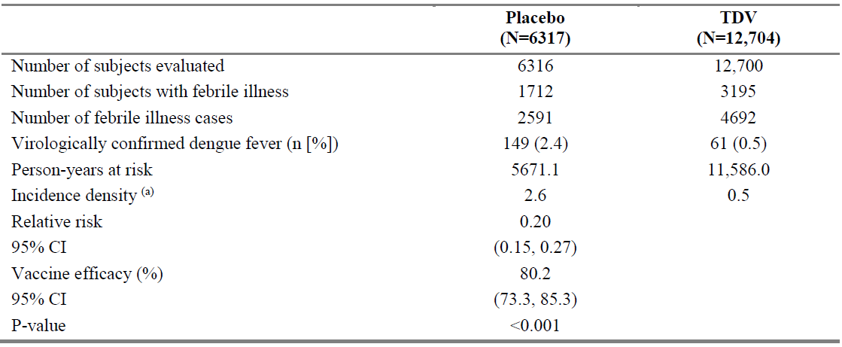
Abbreviations: TDV, tetravalent dengue vaccine candidate; VCD, virologically confirmed dengue. (a) Number of VCD fever cases per 100 person-years.
Sensitivity analysis of the primary endpoint (analysis based on the FAS; analysis using exact 95% CIs calculated as described by Breslow & Day; and analysis in which cases of VCD fever were observed at any time post-second vaccination) all yielded consistent findings to that of the primary analysis.
Figure 3 graphically represents the cumulative incidence of VCD over time during Part 1.
Figure 3. Cumulative incidence of VCD fever over time until end of Part 1 (PPS) – Study DEN-301.
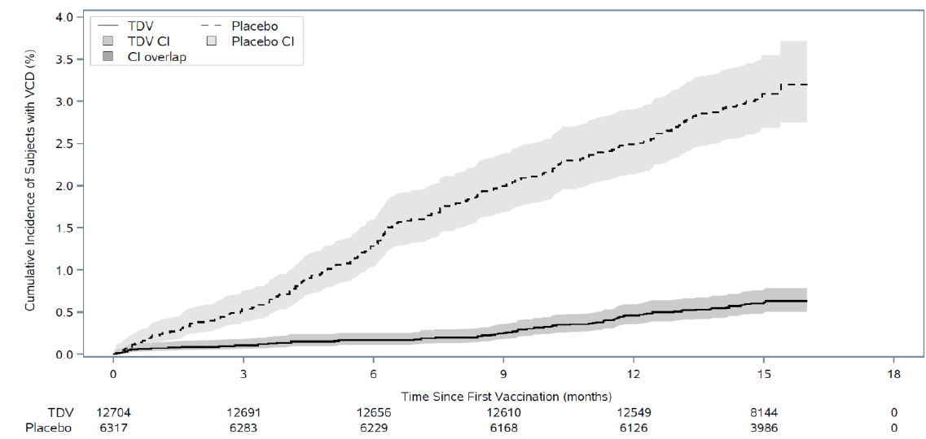
Abbreviations: CI, (95%) confidence interval; VCD, virologically confirmed dengue. The number of subjects at risk per study group and time point are shown below the graph.

Key secondary efficacy endpoint
VE of TDV in preventing hospitalisation due to VCD from 30 days post-second vaccination to end of Part 2
As statistical significance was reached for the primary endpoint, the key secondary endpoint was subsequently tested for in a hierarchical manner, with results summarised in Table 5. The rates of hospitalisation due to VCD fever from 30 days post-second vaccination to 18 months post-second vaccination (i.e. until the end of Part 2) was 1.0% in the placebo group and 0.1% in the TDV group, giving a VE estimate of 90.4% (95% CI: 82.6, 94.7; p<0.001). The key secondary objective was therefore met as the lower bound of the 2-sided 95% CI for VE was above 0%.
Table 5. Vaccine efficacy of TDV in preventing hospitalisation due to VCD fever induced by any dengue serotype from 30 days post-second vaccination to end of Part 2 (PPS) – Study DEN-301.
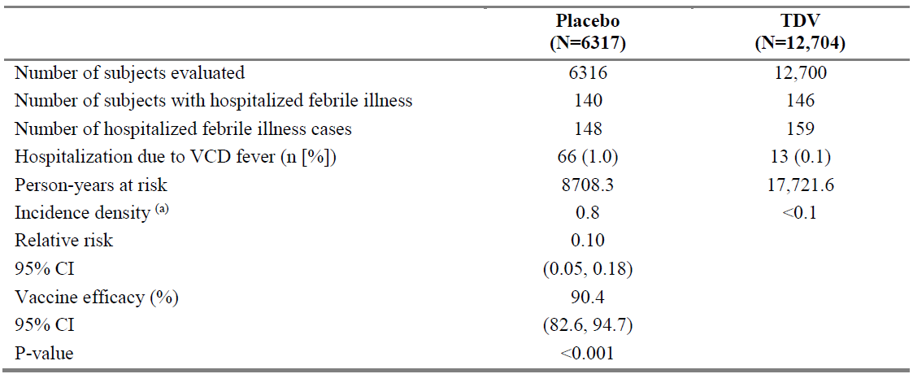
Abbreviations: TDV, tetravalent dengue vaccine candidate; VCD, virologically confirmed dengue. (a) Number of VCD fever cases per 100 person-years.
Figure 4 graphically represents the cumulative incidence of hospitalised VCD over time to the end of Part 2.
Figure 4. Cumulative incidence of hospitalised VCD fever over time until end of Part 2 (PPS) – Study DEN-301.
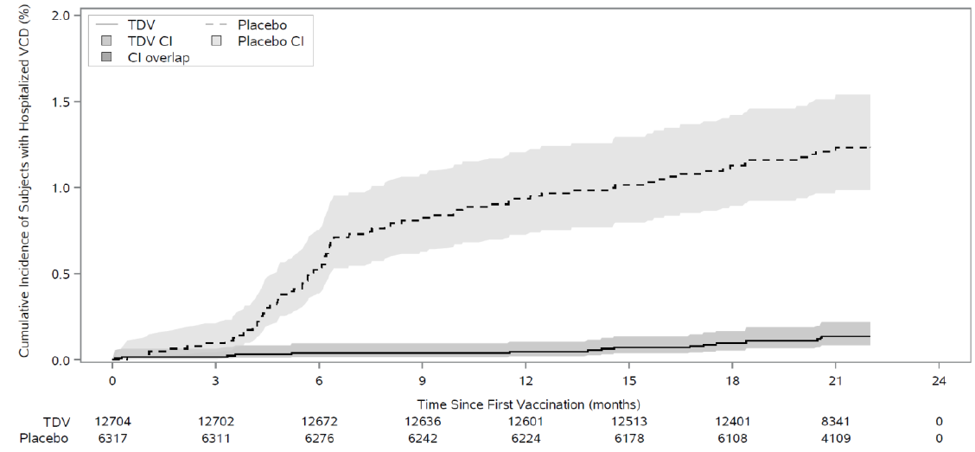
Abbreviations: CI, (95%) confidence interval; VCD, virologically confirmed dengue. The number of subjects at risk per study group and time point are shown below the graph.

Vaccine efficacy by age group
Forest plots of VE for the corresponding cumulative timeframe are provided in Figure 5 below.
Figure 5. Forest plot of vaccine efficacy for virologically confirmed dengue from 30 days to 54 months post-second vaccination by age group (PPS) – Study DEN-301.
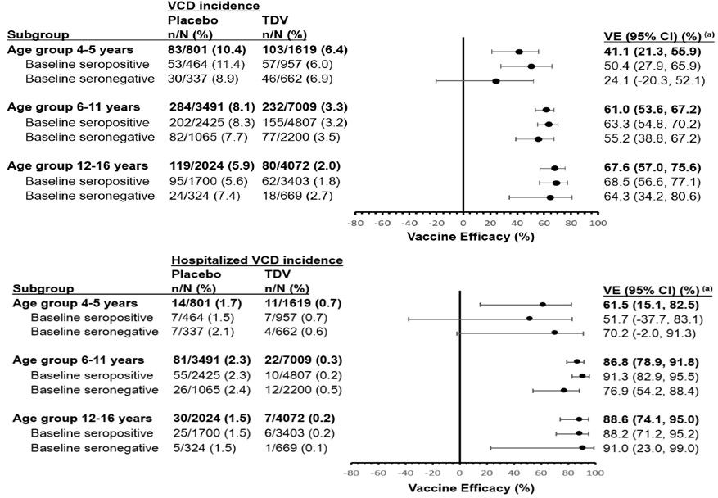
Abbreviations: CI, confidence interval; n, number of subjects with VCD fever; N, total number of evaluable subjects; VCD, virologically confirmed dengue; VE, vaccine efficacy.
(a) VE was defined as 1 - (λV/λC), where λV and λC denote the hazard rates for developing VCD fever for the TDV and placebo arms, respectively.

Other Phase 2 and 3 studies
In addition to the pivotal study DEN-301, the Sponsor provided 9 additional Phase 2 and 3 studies which assessed the immunogenicity of TDV when administered as a 2-dose schedule given 3 months apart. Across the 9 studies, immunogenicity was assessed in a total of 3887 subjects, of which 2796 were from endemic regions and 1081 were from non-endemic regions.
Studies conducted in endemic regions included DEN-301, DEN-313, and DEN-204. Studies conducted in non-endemic regions included studies DEN-304, DEN-307, DEN-315, DEN-305, DEN-314 and DEN-210. In all studies, immunogenicity to TDV was assessed through analysis of GMT of dengue neutralising antibodies (using the validated MNT50 assay) and seropositivity rates against all 4 dengue serotypes. Dengue neutralising antibodies have been generally accepted as the immune response endpoint for dengue vaccine trials. However, although TDV elicits tetravalent neutralising antibodies as demonstrated in the Phase 1 and 2 studies, to date a definitive correlate of protection has yet to be determined.

Immunobridging analysis
The proposed therapeutic indication being sought is for the prevention of dengue disease caused by any dengue virus serotype in individuals from 4 years of age. Evidence of the efficacy and immunogenicity data was derived from pivotal study DEN-301 that was conducted in subjects aged 4 to 16 years in endemic regions. As previously noted, no other studies evaluated the protective efficacy of TDV. An immunobridging analysis was therefore performed by the Sponsor to allow for extrapolation of efficacy data from study DEN-301 to people aged <16 to 60 years.
Primary immunobridging analysis was based on demonstration of similar levels of immune response in baseline seronegative subjects from study DEN-301 (aged 4-16 years from endemic regions) and study DEN-304 (aged 18-60 years from non-endemic regions) at the 1 and 6 month post-second vaccine timepoints. Analysis was restricted to baseline seronegative subjects to minimise the confounding effect of previous dengue exposure on immune response and thus ensure the two populations were comparable in all factors except for age. Immunogenicity endpoints included GMTs of neutralising antibodies (measured by MNT50) and seropositivity (defined as reciprocal neutralising MNT50 titre ≥10) rates for each of the 4 dengue serotypes.
In general, seropositivity rates tended to be slightly lower for the adult population than the paediatric population at most timepoints and against most dengue serotypes. For baseline seronegative subjects, seropositivity rates in both age groups to any dengue serotypes were ≥96.7% at Month 4 and ≥92.1% at Month 9. At least trivalent and tetravalent seropositivity rates at Month 4 in paediatric subjects were 99.8% and 99.5%, respectively, whilst for adults they were 97.3% and 95.6% respectively. At Month 9, these proportions were slightly lower for both age groups: 97.5% and 91.3%, among paediatric subjects and 94.1% and 85.1%, among adult subjects. Seropositivity rates for all subjects (irrespective of baseline serostatus) were similar to that of baseline seronegative subjects.

Safety
A total of 19 studies (8 Phase 3 studies, 6 Phase 2 studies, and 5 phase 1 studies) comprising 28,187 subjects from dengue-endemic and non-endemic regions, covering an age range from 1.5 to 60 years provided data for safety evaluation of TDV.

Solicited AEs
In the target population, the overall incidence of solicited local AEs and solicited systemic AEs after any vaccination were consistently higher in the TDV group than the placebo group. For both groups, the incidence of solicited AEs was generally lower after the second vaccine dose than the first dose.
The higher incidence of solicited local AEs in the TDV group was largely attributed to the higher frequency of mild injection site pain (41.8% for TDV vs 25.4% for placebo). The incidence of other injection site reactions (erythema and swelling) occurred at much lower frequencies in both groups but remained higher for TDV relative to placebo. Overall, most solicited local AEs were of mild or moderate severity, had a median onset time of 1 day and resolved within 1 to 3 days.
The incidence of solicited systemic AEs in the target population was numerically higher for TDV than placebo (46.1% and 40.1%), although this difference was much less than that of solicited local AEs. The most frequently reported solicited systemic AE were headache, myalgia and asthenia, with all occurring at a slightly higher incidences for TDV than placebo. In comparison, incidence of fever (≥38°C) was lower for TDV than placebo (8.9% vs 10.5%). Overall, most solicited systemic AEs were of mild severity, with a slightly higher incidence of severe systemic AEs for TDV than placebo (4.1% vs 3.5%). The median onset of solicited systemic events was 1 day in both groups, with median durations of 3 days for TDV and 2 days for placebo.

Unsolicited AEs
For unsolicited AEs up to 28 days after any vaccination in the target population, no clinically important differences were identified between TDV and placebo. Most unsolicited AEs were of mild or moderate severity. There were few severe unsolicited AEs in either study group (0.5% for TDV and 0.2% for placebo). The majority of unsolicited AEs were not considered treatment-related within the target population and paediatric population. In the adult population however, there was a higher incidence of treatment related unsolicited AEs in the TDV group than the placebo group (9.6% vs 4.6%), that was largely attributed to the increased frequency of mild injection site reaction in the TDV group.
There were no significant differences in the incidence of any MAAEs between TDV and placebo groups in subjects aged from 12 to 60 years.
In the target population (4 to 60 years), the overall incidence of SAEs was lower in the TDV group than the placebo group (7.99% vs 9.64%). Overall, no causal link could be established between administration of TDV and any specific SAE. Across all studies, there were a total of 27 deaths (18 subjects who received TDV and 9 subjects who received placebo). No deaths were considered related to TDV.
The overall incidence of AEs leading to vaccine/study discontinuation were low (< 0.2%) and comparable between TDV and placebo. There were few treatments related AEs leading to vaccine/study discontinuation (<0.1%) in both groups.
Evaluation of VCD fever including hospitalised VCD cases and severe forms of dengue was primarily derived from pivotal study DEN-301 which examined these parameters up to 54 months post-second vaccination (also as efficacy outcomes). The overall incidence of VCD for any dengue serotype was significantly lower for TDV than placebo (3.30% vs 8.18%), with a corresponding RR of 0.40. These findings were similarly reflected in baseline seropositive subjects (RR: 0.38) and in baseline seronegative subjects (RR: 0.47).

Risk management plan
Takeda Pharmaceuticals Australia Pty Ltd has submitted EU-RMP version 3.0 (date 11 October 2024; DLP 29 February 2024) and ASA version 1.1 (date 6 November 2025) in support of this application.
The proposed summary of safety concerns and their associated risk monitoring and mitigation strategies are summarised below in Table 6. The TGA may request an updated RMP at any stage of a product's life cycle, during both the pre-approval and post-approval phases.
Table 6. Summary of safety concerns.
Summary of safety concerns |  | Pharmacovigilance |  | Risk Minimisation
 |  | Routine | Additional | Routine | Additional
Important identified risks | None | – | – | – | –
Important potential risks | Dengue disease due to waning protection against dengue over time. | ü‡ | ü*† | ü | –
Important potential risks | Severe and/or hospitalised dengue following vaccination caused by dengue virus serotype 3 or 4 in individuals not previously infected by dengue virus. | ü‡ | ü*† | ü | –
Missing information | Safety profile of inadvertent use in pregnant or lactating women | ü‡ | – | ü | –
Missing information | Safety and immunogenicity in immunocompromised individuals | ü‡ | – | ü | –
Missing information | Safety and immunogenicity of concomitant administration with other vaccines, other than Hepatitis A virus (HAV), Yellow fever (YF) and Human Papilloma Virus (HPV) vaccines | ü‡ | – | ü | –
Missing information | Safety and reactogenicity of a booster dose | ü | ü*† | ü | –
* Efficacy, Safety and Immunogenicity of TDV in Trial DEN-301 (Part 4 and 5)
† Long-term safety and antibody persistence of TDV and the impact of a booster dose (Trial DEN-303)
‡ Cumulative review
The summary of safety concerns proposed in the ASA align with the EU-RMP and is considered acceptable from an RMP perspective.
The sponsor has proposed routine pharmacovigilance for all safety concerns, including cumulative reviews to address several safety concerns. Additional pharmacovigilance has been proposed for the important potential risks of Dengue disease due to waning protection against dengue over time, severe and/or hospitalised dengue following vaccination caused by dengue virus serotype 3 or 4 in individuals not previously infected by dengue virus, and missing information including safety and reactogenicity of a booster dose. The pharmacovigilance plan is acceptable from an RMP perspective.
The sponsor has only proposed routine risk minimisation activities. The risk minimisation plan proposed in the ASA is acceptable from an RMP perspective.
The TGA may request an updated RMP at any stage of a product's life cycle, during both the pre-approval and post-approval phases. Further information regarding the TGA’s risk management approach can be found in risk management plans for medicines and biologicals and the TGA's risk management approach. Information on the Australia-specific annex (ASA) can be found on the TGA website.

Risk-benefit analysis

Delegate’s considerations
Quality
The evaluator has recommended that Qdenga is suitable for registration regarding manufacturing quality.
Efficacy
The pivotal Phase 3 study DEN-301 is the primary source of data that informs the clinical efficacy of TDV. This was the sole study to assess the protective efficacy of TDV in preventing virologically confirmed dengue fever of any serotype in comparison to a placebo. The additional studies that were submitted with this application provided supportive data regarding immunogenicity.
Overall, the rationale and evidence provided to support the formulation development and choice of dose schedule is considered to be acceptable.
The vaccine efficacy (VE) of TDV in preventing virologically confirmed dengue (VCD) from any dengue serotype from 30 days to 12 months post-second vaccination was 80.2% for the primary efficacy endpoint (95% CI: 73.3, 85.3). The VE of TDV in preventing hospitalisation due to VCD fever from any dengue serotype from 30 days to 18 months post-second vaccination was 90.4% (95% CI: 82.6, 94.7) for the key secondary endpoint. The primary and key secondary efficacy endpoints were both met. The long-term vaccine efficacy of TDV against VCD fever overall and hospitalised VCD is supported by the results of the primary and secondary analysis. Despite the evidence suggesting a general decline in efficacy over time, VE was able to be observed up to 54 months after the second vaccination.
The immune response data in baseline seronegative subjects from study DEN-301 (702 subjects aged 4-16 years from endemic regions) and study DEN-304 (379 subjects aged 18-60 years from non-endemic regions) were compared in a post-hoc immunobridging analysis. At one month after the second TDV vaccine dose, the immune response of paediatric subjects was non-inferior to that of adult subjects against DENV-1, -2, and -4. However, this threshold was only marginally not met for DENV-3. Against all dengue serotypes, the non-inferiority criterion was satisfied six months after the second TDV vaccine dose. The immunobridging analysis's results, in general, provide support to the extrapolation of evidence regarding the efficacy of TDV in the prevention of dengue disease caused by any dengue virus serotype in individuals aged 4-60 years.
Safety
Qdenga is generally well tolerated from a safety perspective, with no significant safety concerns identified for up to 4.5 years following primary vaccination in the clinical studies or post-marketing data to date.

Proposed action
Overall, based on the review of data on quality, safety and efficacy, the Delegate considers that the benefit-risk balance of Qdenga (dengue tetravalent vaccine (live, attenuated)) is favourable in the following indication:
Qdenga is indicated for the prevention of dengue disease in individuals from 4 years of age. The use of this vaccine should be in accordance with official recommendations.

Assessment outcome
Based on a review of quality, safety, and efficacy, the TGA decided to register:
- 484846 – Qdenga (dengue tetravalent vaccine (live, attenuated) dengue virus serotypes 1, 2, 3, and 4), powder (vial) & solvent (vial) for injection
- 506646 - Qdenga (dengue tetravalent vaccine (live, attenuated) dengue virus serotypes 1, 2, 3, and 4), powder (vial) & solvent (PFS) for injection
indicated for:
Qdenga is indicated for the prevention of dengue disease in individuals from 4 years of
age.
The use of this vaccine should be in accordance with official recommendations.

Specific conditions of registration
- Qdenga (dengue tetravalent vaccine (live, attenuated)) is to be included in the Black Triangle Scheme. The PI and CMI for Qdenga must include the black triangle symbol and mandatory accompanying text for five years, which starts from the date of first supply of the product.
- The Qdenga EU-Risk Management Plan (RMP) version 3.0 (dated 11 October 2024, data lock point 29 February 2024), with Australia-Specific Annex (ASA) version 1.1 (dated 06 November 2025), included with submission PM-2025-00874-1-2 and any subsequent revisions, as agreed with the TGA will be implemented in Australia.
- An obligatory component of risk management plans is routine pharmacovigilance. Routine pharmacovigilance includes the submission of periodic safety update reports (PSURs).
Reports are to be provided in line with the current published list of EU reference dates and frequency of submission of PSURs until the period covered by such reports is not less than three years from the date of this approval letter. Each report must be submitted within ninety calendar days of the data lock point for that report.
The reports are to at least meet the requirements for PSURs as described in the European Medicines Agency’s Guideline on good pharmacovigilance practices (GVP) Module VII-periodic safety update report (Rev 1), Part VII.B Structures and processes. Note that submission of a PSUR does not constitute an application to vary the registration.
- GMP clearance for listed manufacturers
All relevant manufacturing sites require approved and current GMP Clearances prior to Australian supply. A commitment is required from the Sponsor that they maintain the validity of all manufacturer GMP Clearances for the duration of product supply to Australia. Additionally, that adherence to the conditions of GMP Clearance approval is upheld.
- Batch release testing and compliance
It is a condition of registration that all independent manufacturing batches of:
  - Qdenga dengue tetravalent vaccine (live, attenuated) powder (vial) & solvent (vial) for injection [ARTG 484846]; and
  - Qdenga dengue tetravalent vaccine (live, attenuated) powder (vial) & solvent (PFS) for injection [ARTG 506646]
vaccines imported into Australia are not released for sale until samples and the manufacturer’s release data have been assessed and you have received notification acknowledging release from the Laboratories Branch, TGA.
For each independent batch of the product imported into Australia, the Sponsor must supply the following:
- A completed Request for Release Form, available from vaccines@health.gov.au
- Complete summary protocols for manufacture and QC, including all steps in production in the agreed format.
- At least 3 (three) vials or PFS (Samples) of each manufacturing batch of Qdenga dengue tetravalent vaccine (live, attenuated) with the Australian approved labels, PI and packaging (unless an exemption to supply these has been granted) representative of all batches of product seeking distribution in Australia.
- At least 1 (one) vial or PFS (Sample) of any further consignments of a manufacturing batch of Qdenga dengue tetravalent vaccine (live, attenuated) with the Australian approved labels, PI and packaging (unless an exemption to supply these has been granted). Further consignments cover batches previously supplied to TGA for the purposes of batch release testing but are seeking to be supplied again.
- If the manufacturing batch has been released in Europe or United Kingdom a copy of the EU Official Control Authority Batch Release (OCABR) certificate (or equivalent from the UK) must be provided.
- Any reagents, reference material and standards required to undertake testing, as requested by Laboratories Branch, TGA.
Sponsors must provide all requested Samples and data in sufficient time (at least 5 (five) business days) prior to any distribution date to allow the TGA to perform testing and review. Distribution of each batch of vaccine is conditional upon fulfilment of these conditions and receipt of a letter from the Laboratories Branch acknowledging release.
Samples and data should be forwarded to the Biotherapeutics Section, Laboratories Branch before release of each batch and with sufficient lead time to allow for Laboratories Branch testing. The address for courier delivery is:
ATTN: Batch Release Coordinator
Batch Release Unit
TGA Laboratories Branch
1 Tindal Lane
Canberra Airport, ACT 2609

The shipments (including reagents) to TGA are the responsibility of the Australian Sponsor/Agent who will be required to facilitate the import and customs clearance process.
- Certified Product Details
An electronic copy of the Certified Product Details (CPD) as described in Guidance 7: Certified Product Details of the Australian Regulatory Guidelines for Prescription Medicines (ARGPM) https://www.tga.gov.au/guidance-7-certified-product-details should be provided upon registration of the therapeutic good. In addition, an updated CPD, for the above products incorporating the approved changes is to be provided within one month of the date of approval letter. A template for preparation of CPD for biological prescription medicines and Vaccines can be obtained from the TGA website https://www.tga.gov.au/form/certified-product-details-cpd-biological-prescriptionmedicines. The CPD should be sent as a single bookmarked PDF document to Vaccines@health.gov.au as soon as possible after registration/approval of the product or any subsequent changes as indicated above.

Product and Consumer Medicine Information
For the most recent Product Information (PI) and Consumer Medicine Information (CMI), please refer to the TGA PI/CMI search facility.

Therapeutic Goods Administration
PO Box 100 Woden ACT 2606 Australia
Email: info@tga.gov.au Phone: 1800 020 653 Fax: 02 6203 1605
https://www.tga.gov.au
Reference/Publication #

This is the original indication proposed by the sponsor when the TGA commenced the evaluation of this submission. It may differ to the final indication approved by the TGA and registered in the Australian Register of Therapeutic Goods.
World Health Organization (WHO). Dengue and Severe Dengue Fact Sheet. 2022. Accessed July 22, 2025. https://www.who.int/news-room/fact-sheets/detail/dengue-and-severe-dengue
Messina JP, Brady OJ, Scott TW, Zou C, Pigott DM, Duda KA, et al. (2014) Global spread of dengue virus types: mapping the 70-year history. Trends in Microbiology. Mar;22(3):138-146. https://doi.org/10.1016/j.tim.2013.12.011
Guo, C., Zhou, Z., Wen, Z., Liu, Y., Zeng, C., Xiao, D., Ou, M., Han, Y., Huang, S., Liu, D., Ye, X., Zou, X., Wu, J., Wang, H., Zeng, E. Y., Jing, C., & Yang, G. (2017). Global Epidemiology of Dengue Outbreaks in 1990-2015: A Systematic Review and Meta-Analysis. Frontiers in cellular and infection microbiology, 7, 317. https://doi.org/10.3389/fcimb.2017.00317
Sohail A, Anders KL, McGuinness SL, Leder K. (2024) The epidemiology of imported and locally acquired dengue in Australia, 2012-2022. JTravel Med. 31(2):taae014. https://doi.org/10.1093/jtm/taae014
Sridhar S, Luedtke A, Langevin E, et al. Effect of Dengue Serostatus on Dengue Vaccine Safety and Efficacy. The New England Journal of Medicine. 2018 Jul;379(4):327-340. https://doi.org/10.1056/nejmoa1800820
World Health Organization (WHO). Revised SAGE recommendation on use of dengue vaccine. Executive Summary: CYD-TDV Dengue Vaccine. World Health Organization; 2018. Accessed July 18, 2025. https://terrance.who.int/mediacentre/data/sage/SAGE_Docs_Ppt_April2018/5_session_dengue/April2018_session5_executive_summary_dengue_SAGE.pdf
Department of Health, Disability and Ageing. ATAGI advice on the use of Dengvaxia for Australians. 2019. Accessed July 18, 2025. ATAGI advice on the use of Dengvaxia® for Australians | Australian Government Department of Health, Disability and Ageing
Yan Zhu, Deborah J Mills, Christine Mills, Colleen L Lau, Luis Furuya-Kanamori, (2024) Use of Dengvaxia® in Australian travellers: a case series, Journal of Travel Medicine. 31(4) taae052, https://doi.org/10.1093/jtm/taae052
Department of Health, Disability and Ageing. DENGVAXIA dengue tetravalent vaccine (live, attenuated), powder and diluent for suspension for injection Cancelled under Section 30(1)(c) of the Act. Guidance and resources. 2024. Accessed July 18, 2025. https://www.tga.gov.au/resources/cancellations-by-sponsors/dengvaxia-dengue-tetravalent-vaccine-live-attenuated-powder-anddiluent-suspension-injection-cancelled-under-section-301c-act
European Medicines Agency. Guideline on clinical evaluation of new vaccines. Committee for Human Medicinal Products (CHMP), October 2006. Clinical evaluation of new vaccines - Scientific guideline | European Medicines Agency (EMA)

