Australian Public Assessment Report for Orserdu
  - Active ingredient: Elacestrant
  - Sponsor: A. Menarini Australia Pty Ltd
May 2026

About the Therapeutic Goods Administration (TGA)
- The Therapeutic Goods Administration (TGA) is part of the Australian Government Department of Health, Disability and Ageing and is responsible for regulating therapeutic goods, including medicines, medical devices, and biologicals.
- The TGA administers the Therapeutic Goods Act 1989 (the Act), applying a risk management approach designed to ensure therapeutic goods supplied in Australia meet acceptable standards of quality, safety, and efficacy.
- The work of the TGA is based on applying scientific and clinical expertise to decision-making, to ensure that the benefits to the Australian public outweigh any risks associated with the use of therapeutic goods.
- The TGA relies on the public, healthcare professionals and industry to report problems with therapeutic goods. The TGA investigates reports received to determine any necessary regulatory action.
- To report a problem with a therapeutic good, please see the information on the TGA website.

About AusPARs
- The Australian Public Assessment Report (AusPAR) provides information about the evaluation of a prescription medicine and the considerations that led the TGA to approve or not approve a prescription medicine submission. Further information can be found in Australian Public Assessment Report (AusPAR) guidance.
- AusPARs are prepared and published by the TGA.
- AusPARs are static documents that provide information that relates to a submission at a particular point in time. The publication of an AusPAR is an important part of the transparency of the TGA’s decision-making process.
- A new AusPAR may be provided to reflect changes to indications or major variations to a prescription medicine subject to evaluation by the TGA.

Copyright
© Commonwealth of Australia 2026
This work is copyright. You may reproduce the whole or part of this work in unaltered form for your own personal use or, if you are part of an organisation, for internal use within your organisation, but only if you or your organisation do not use the reproduction for any commercial purpose and retain this copyright notice and all disclaimer notices as part of that reproduction. Apart from rights to use as permitted by the Copyright Act 1968 or allowed by this copyright notice, all other rights are reserved and you are not allowed to reproduce the whole or any part of this work in any way (electronic or otherwise) without first being given specific written permission from the Commonwealth to do so. Requests and inquiries concerning reproduction and rights are to be sent to the TGA Copyright Officer, Therapeutic Goods Administration, PO Box 100, Woden AC`T 2606 or emailed to <tga.copyright@tga.gov.au>.

Contents
List of abbreviations 4
Product submission 5
Submission details 5
Product background 6
Disease or condition 6
Current treatment options 8
Clinical rationale 10
Regulatory status 11
Australian regulatory status 11
International regulatory status 11
Registration timeline 13
Assessment overview 14
Quality evaluation summary 14
Nonclinical evaluation summary 15
Conclusions 16
Clinical evaluation summary 17
Efficacy 17
Safety 57
Risk management plan 63
Risk-benefit analysis 64
Assessment outcome 65
Specific conditions of registration 65
Product Information and Consumer Medicine Information 66

List of abbreviations
Abbreviation | Meaning
AI | Aromatase inhibitor
ARTG | Australian Register of Therapeutic Goods
CBR | Clinical benefit rate
CDK4/6i | cyclin dependent kinase 4/6 inhibitor(s)
CHMP | Committee for Medicinal Products for Human Use
CMI | Consumer Medicines Information
CR | Complete response
ctDNA | circulating tumour deoxyribonucleic acid
DCO | Data cut-off
DoR | Duration of response
ER | Estrogen/Oestrogen receptor
ESR1 | Estrogen Receptor 1 gene
HR+ | Hormone receptor positive
HER2 | Human epidermal growth factor receptor 2
IRC | Independent Review Committee
ITT | Intention-to-Treat Population
MBC | Metastatic breast cancer
OS | Overall survival
PR | Partial response
PFS | Progression free survival
PI | Product Information
PRec | Progesterone receptor
PK | Pharmacokinetic(s)
QD | Dosing once a day
RP2D | Recommended Phase 2 dose
SAE | Serious adverse event(s)
SERD | Selective Estrogen Receptor Degrader
SOC | Standard of care
TGA | Therapeutic Goods Administration
TEAE | Treatment-emergent adverse event

Product submission

Submission details
Type of submission: | New chemical entity
Product names: | Orserdu
Active ingredient: | elacestrant
Decision: | Approved
Date of decision: | 11 December 2024
Approved therapeutic use for the current submission: | Orserdu monotherapy is indicated for the treatment of postmenopausal women, and men, with estrogen receptor (ER)-positive, human epidermal growth factor receptor 2 (HER2)-negative, locally advanced or metastatic breast cancer with an activating ESR1 mutation who have disease progression following at least one line of endocrine therapy including a CDK 4/6 inhibitor.
Date of entry onto ARTG: | 1 April 2026
ARTG numbers: | Orserdu (elacestrant dihydrochloride) 345 mg film coated tablet AUST R 437532  Orserdu (elacestrant dihydrochloride) 86 mg film coated tablet AUST R 437531
Black Triangle Scheme | Yes
Sponsor’s name and address: | A. Menarini Australia Pty Ltd Level 8/67 Albert Avenue CHATSWOOD NSW 2067
Dose form: | Film coated tablets
Strengths: | 86 mg, 345 mg
Container: | Aluminium-aluminium blisters packed into a cardboard box
Pack size: | 28 film coated tablets: 4 blisters with 7 tablets each
Route of administration: | Oral use
Dosage: | The recommended dose is 345 mg (one 345 mg film coated tablet), once daily. The maximum recommended daily dose of Orserdu is 345 mg.  For further information regarding dosage, refer to the Product Information.
Pregnancy category: | Category D  Drugs which have caused, are suspected to have caused or may be expected to cause, an increased incidence of human fetal malformations or irreversible damage. These drugs may also have adverse pharmacological effects. Accompanying texts should be consulted for further details.  The use of any medicine during pregnancy requires careful consideration of both risks and benefits by the treating health professional. The pregnancy database must not be used as the sole basis of decision making in the use of medicines during pregnancy. The TGA does not provide advice on the use of medicines in pregnancy for specific cases. More information is available from obstetric drug information services in your state or territory.

Product background
This AusPAR describes the submission by A. Menarini Australia Pty Ltd (the Sponsor) to register Orserdu (elacestrant) for the following proposed indication:
Orserdu monotherapy is indicated for the treatment of postmenopausal women, and men, with estrogen receptor (ER)-positive, human epidermal growth factor receptor 2 (HER2)-negative, locally advanced or metastatic breast cancer with an activating ESR1 mutation who have disease progression following at least one line of endocrine therapy including a CDK 4/6 inhibitor.

Disease or condition

Breast cancer

Epidemiology
Breast cancer is the leading cancer diagnosis in women. Overall rates of diagnosis of breast cancer have been increasing by around 0.5% per year. The American Cancer Society estimates that women have a 12.9% chance of developing breast cancer in their lifetime and estimated that there were 300,590 new cases of breast cancer in 2023 and 43,700 deaths from breast cancer in the United States. In Australia, the most diagnosed cancer in females is breast cancer (estimated 20,428 cases in 2022). Breast cancer is the seventh leading cause of death in women in Australia, with an estimated 3,140 deaths from this diagnosis in 2022. Against this increase in incidence, breast cancer mortality rates have decreased since the 1970’s due to enhanced screening and improved adjuvant therapy.

Detection and diagnosis
In countries with breast screening programs, most cases are diagnosed after detection of an abnormality on mammogram. However, up to 15% of women present with a breast mass that is not detected on mammogram. The diagnosis is confirmed by the presence of malignant epithelial cells on biopsy. The most common histological types, accounting for about 95% of cases, are infiltrating ductal carcinoma, infiltrating lobular carcinoma and mixed ductal and lobular carcinoma.

Staging
After diagnosis, patients undergo staging to determine local and distant extent of disease. Staging is based on the American Joint Committee on Cancer and International Union for Cancer Control classification for Tumour, Nodes and Metastases (TNM). Prior to surgery, staging is termed clinical (cTNM). Post surgery staging is termed pathological (pTNM).
About 5% of patients present with metastatic disease (stage IV) ab initio.
Non metastatic breast cancer is classified into two categories:
- early stage (Stage I, IIA, T2N1) or
- locally advanced (Stage IIB, IIIA-C).

Breast cancer receptor testing
Newly diagnosed breast cancers are tested for expression of estrogen receptor (ER), progesterone receptor (PRec) expression and for overexpression of human epidermal growth factor 2 (HER2) receptors.
Hormone receptor positivity is defined using immunohistochemistry as the presence of ER and/or PRec on more than 1% of tumour cells. The majority of hormone receptor positive cancers express ER or ER plus PRec. Few express PRec alone. They are usually grouped together and treated as hormone receptor positive (HR+) tumours.
HER2 overexpression is defined as uniform intense membrane staining of > 10% of tumour cells, or by the detection of HER2 gene amplification by fluorescence in situ hybridization. The cut off is a ratio of HER2/chromosome 17 centromeres (CEP17) ≥ 2.0 with HER2 copy number signals/cell >4.
The frequency of receptor subtypes was studied in a large (61,309) cohort of cases between 1999 and 2004. The majority (80%) of cancers were hormone receptor (HR = ER±PRec) positive. HER2 overexpression was present in 23%. Of the HER2 positive cases, 67% were hormone receptor positive. Thirteen percent were triple negative - ER, PRec and HER2 negative. Immunohistochemical evaluation of triple negative cancers for programmed death ligand
(PD-L1) expression guides initial therapy.
Tumours can be further characterised by gene expression assays. Gene expression assays provide prognostic and therapy predictive information that complements Tumor, Node, Metastasis and biomarker information. The National Comprehensive Cancer Network uses the 21-gene assay (Oncotype Dx) for prognosis and predicting chemotherapy benefit.

Current treatment options

Early-stage breast cancer
Patients with early-stage breast cancer undergo primary surgery to the breast and regional lymph nodes with or without radiotherapy. Following primary surgery, adjuvant systemic therapy may be offered depending on primary tumour characteristics, such as size, number of involved lymph nodes and receptor status. Neoadjuvant therapy may be offered pre-surgery in certain subgroups.

Lymph nodes
Patients with clinical suspicion of involvement of axillary lymph nodes should have fine needle aspirate. Axillary lymph node dissection, and possibly systemic neoadjuvant therapy, are indicated if the biopsy is positive. Patients with clinically negative axillary lymph nodes, and those with negative biopsy of axillary nodes, should have sentinel lymph node biopsy at the time of primary surgery.

Neoadjuvant and adjuvant systemic therapies
Preoperative neoadjuvant, or post operative adjuvant systemic therapies can be endocrine, chemo, or biologic. Tumour characteristics predict which patients are likely to benefit from specific types of therapy.
For example, HER2-negative patients are treated with chemotherapy with or without checkpoint inhibitors (e.g. pembrolizumab) if they have expression of PD-L1 receptors; or chemotherapy plus poly(ADP-ribose) polymerase (PARP) inhibitors (eg olaparib) if they have BRCA1/2 germline mutations. In contrast, HER2-positive patients are treated with chemotherapy plus HER2-targeted therapy (eg trastuzumab).
Hormone receptor positive cancers are treated with ovarian suppression and endocrine therapy. Ovarian suppression can be achieved with gonadotropin-releasing hormone agonist agonists, radiation therapy and/or oophorectomy. Endocrine therapies include aromatase inhibitors (AIs; blocking estrogen synthesis), and tamoxifen, a selective estrogen receptor modulator. Endocrine therapy is recommended for at least 5 years and up to 10 years after diagnosis in some guidelines.

Locally advanced breast cancer
Locally advanced breast cancer is best managed with multimodal therapy employing systemic and locoregional therapy. Most patients with locally advanced breast cancer, and some with earlier-stage disease (particularly if triple negative or human epidermal growth factor receptor 2 [HER2] positive), are treated with neoadjuvant systemic therapy. The goal of treatment is to induce a tumour response before surgery. Neoadjuvant therapy results in long-term distant disease-free survival and overall survival (OS) benefit comparable to that achieved with primary surgery followed by adjuvant systemic therapy.
Patients should undergo surgery after neoadjuvant therapy even if they have a complete clinical and/or radiological response. If they experience locoregional progression, but not distant spread, while on neoadjuvant, they should also proceed with surgery. Decisions about the details of surgery (breast conserving or not) and management of regional lymph nodes require complex expert judgement and are beyond the scope of this discussion.

Adjuvant therapy for locally advanced breast cancer
In general, the same principles as used for the adjuvant treatment of early breast cancer apply.
- Patients with HR+ breast cancer should receive endocrine therapy to reduce the risk of breast cancer recurrence and breast cancer-related mortality. Further chemotherapy in the form of adjuvant treatment is unlikely to improve OS in this subset. The selection of endocrine therapy is made according to menopausal status.
- Patients with triple negative breast cancer who have a complete response to neoadjuvant therapy would typically not receive further chemotherapy in the adjuvant setting as there is no evidence that the addition of adjuvant chemotherapy improves OS. These patients should begin post-treatment surveillance.
- Patients with HER2-positive breast cancer who have a pathologically complete response at the time of surgical resection should receive trastuzumab, with or without pertuzumab, following completion of surgery to complete a year of treatment, without the addition of further chemotherapy. In cases where the tumor has not had a complete response to neoadjuvant therapy, adjuvant ado-trastuzumab emtansine for 14 cycles, rather than trastuzumab, is recommended.

Germline genetic testing
Patients found to have breast cancer susceptibility gene 1 and 2 (BRCA1, BRCA2) have increased risk of developing a second breast cancer. They may opt to undergo bilateral mastectomy. For select patients with BRCA1/2 mutations and high-risk early, HER2-negative breast cancer, adjuvant treatment with olaparib, an inhibitor of PARP, has been shown to improve disease-free survival outcomes.

Metastatic breast cancer
Median OS after diagnosis of metastatic breast cancer (MBC) is around three years. Median survival has improved from 21 months (95%CI 18-25 months) in 1980-1990 to 38 months (95%CI 23-43 months) in 1990 to 2010.10 The authors concluded: ‘improvements in treatment remains the simplest explanation to account for lengthening of recurrence-free survival and lengthening of survival after recurrence’.10
The selection of a therapeutic strategy depends upon both tumour biology and clinical factors, with the goal being a tailored approach. Although a subset of patients with oligometastatic disease may benefit from an intensified locoregional approach, most patients with MBC receive systemic medical therapy consisting of chemotherapy, endocrine therapy, targeted therapy and/or biologic therapies, and supportive care measures.
The primary goals of systemic treatment for MBC are prolongation of survival, alleviation of symptoms, and maintenance or improvement in quality of life, while balancing the toxicity associated with treatment.
Biopsy of a metastatic lesion allows confirmation of the diagnosis and reassessment of HR and HER2 receptor status; a change in receptor status from positive to negative or negative to positive may impact choice of therapy. Immunohistochemical analysis for PD-L1 may be of assistance in triple negative cancers. Germline testing for breast cancer susceptibility gene 1 or 2 (BRCA1 or BRCA2) is also recommended for all patients with MBC in view of therapeutic options (PARP inhibitors).

HER2 Negative advanced breast cancer treatment
For HR-positive HER2-negative patients in Europe and Australia the recommended first line standard of care for locally advanced or MBC is endocrine therapy. Endocrine therapy is beneficial with fewer side effects than chemotherapy. Endocrine therapy consists of treatment with an AI e.g. letrazole, anastrazole or treatment with fulvestrant, plus a cyclin dependent kinase (CDK4/6) inhibitor e.g. palbociclib, ribociclib or abemaciclib. Chemotherapy may be offered in patients with extensive visceral metastases, or in women who progress after two lines of endocrine therapy.
Fulvestrant is a selective ER degrader (SERD). It binds to the estrogen receptor and destabilizes it, causing the cell’s normal protein degradation processes to destroy it. First approved for use in the USA in 2002, it is the only SERD available in Australia. Fulvestrant is administered as long-acting intramuscular injections, in the hospital clinic. It is administered slowly as two 5 mL injections, one in each buttock, at intervals of 1 month. Injection site reactions are common including sciatica, neuralgia and peripheral neuropathy. Patients find the treatment painful and difficult to tolerate, leading to treatment refusal. Further, fulvestrant is indicated only for post-menopausal women and not recommended in men.
There are limited therapeutic options once the disease progresses. Recent data suggest that resistance to endocrine therapy is attributed to mutations in the ESR1 gene encoding ERα.
- For triple-negative patients (HR-, HER2-), first line chemotherapy is recommended with or without immunotherapy. A check point inhibitor is offered for patients who have PD-L1 positive disease. Late line therapy includes antibody-drug combination (sacituzumab-govitecan)
- For HER2-negative, BRCA1/2 and PALB2 associated tumors, PARP inhibitors (olaparib or tolazaparib) may be used sequentially before or after chemotherapy

HER2 Positive
- HR-positive: These patients can be treated with chemotherapy, endocrine therapy and HER2 directed therapy e.g. trastuzumab. HER2 directed therapy has been shown to improve survival and should be part of first line therapy.
- HR-negative: These patients are recommended to be treated with HER2 directed therapy and chemotherapy.

Late line therapies and tumour agnostic treatments.
For tropomyosin receptor kinase fusion positive cancers, that have progressed on all other options, tropomyosin receptor kinase inhibitors, entrectinib and larotrectinib, may be used.
Patients with microsatellite-high/DNA mismatch-repair deficient, unresectable or MBC (regardless of ER, PR, and HER2 status) may also benefit from pembrolizumab or dostarlimab-gxly after progression on other treatment options. Similarly, patients with high tumor mutational burden (≥10 mutations/megabase) unresectable or MBC (regardless of ER, PR, and HER2 status) may also benefit from pembrolizumab, after progression on other treatment options.

Clinical rationale
Elacestrant, a novel tetrahydronaphthalene compound, is the first orally available SERD and antagonist which binds to the ERα with high affinity. Elacestrant inhibits the estradiol-dependent and independent growth of ERα-positive breast cancer cells, including models harbouring ESR1 gene mutations and models resistant to fulvestrant or CDK4/6 inhibitors.
Preclinical and early clinical data suggest that elacestrant displays significant activity in advanced ER+/HER2- MBC and therefore could add a significant treatment option for patients with few or no effective therapies available to them.

Regulatory status

Australian regulatory status
This product is considered a new chemical entity for Australian regulatory purposes.

International regulatory status
At the time the TGA considered this submission, a similar submission had been considered by other regulatory agencies. Table 1 summarises these submissions and provides the indications where approved.
Table 1. International regulatory status at the time the TGA considered this submission
Country | Product | Date Submitted | Approval Date | Approved Indication
United States | Orserdu | 17 June 2022 | 27 January 2023 | Orserdu is indicated for the treatment of postmenopausal women or adult men with estrogen receptor (ER)-positive, human epidermal growth factor receptor 2 (HER2)-negative, ESR1-mutated advanced or metastatic breast cancer with disease progression following at least one line of endocrine therapy
United Arab Emirates | Orserdu | 10 March 2023 | 23 May 2023 | Orserdu is indicated for the treatment of postmenopausal women or adult men with estrogen receptor (ER)-positive, human epidermal growth factor receptor 2 (HER2)-negative, ESR1-mutated advanced or metastatic breast cancer with disease progression following at least one line of endocrine therapy
European Union¹ European Economic Area² Centralised Procedure³ | Orserdu | 27 July 2022 | 15 September 2023 | Orserdu monotherapy is indicated for the treatment of postmenopausal women, and men, with estrogen receptor (ER)-positive, HER2-negative, locally advanced or metastatic breast cancer with an activating ESR1 mutation who have disease progression following at least one line of endocrine therapy including a CDK 4/6 inhibitor.
Kuwait | Orserdu | 14 July 2023 | 24 September 2023 (Priority Track 1 Year approval)  16 May 2024 (Fast Track Full approval) | Orserdu is indicated for the treatment of postmenopausal women or adult men with estrogen receptor (ER)-positive, human epidermal growth factor receptor 2 (HER2)-negative, ESR1-mutated advanced or metastatic breast cancer with disease progression following at least one line of endocrine therapy
United Kingdom European Commission Decision Reliance Procedure (ECDRP) | Korserdu | 25 July 2023 | 06 December 2023 | Korserdu monotherapy is indicated for the treatment of postmenopausal women, and men, with estrogen receptor (ER)‑positive, HER2-negative, locally advanced or metastatic breast cancer with an activating ESR1 mutation who have disease progression following at least one line of endocrine therapy including a CDK 4/6 inhibitor.
Israel | Orserdu | 01 May 2023 | 14 April 2024 | Orserdu is indicated for the treatment of postmenopausal women or adult men with estrogen receptor (ER)-positive, human epidermal growth factor receptor 2 (HER2)-negative, ESR1-mutated advanced or metastatic breast cancer with disease progression following at least one line of endocrine therapy.
Switzerland | Orserdu | 04 May 2023 | 04 June 2024 | Orserdu is used as monotherapy for the treatment of postmenopausal women with  estrogen receptor (ER)-positive, HER2 -negative, locally advanced or metastatic breast cancer with an activating ESR1 mutation whose disease has progressed after at least one line of endocrine therapy combined with a CDK 4/6 inhibitor.
Macao | Orserdu | 28 December 2023 | 29 February 2024 | Orserdu is indicated for the treatment of postmenopausal women or adult men with estrogen receptor (ER)-positive, human epidermal growth factor receptor 2 (HER2)-negative, ESR1-mutated advanced or metastatic breast cancer with disease progression following at least one line of endocrine therapy.
Singapore | Orserdu | 18 March 2024 | 25 September 2024 | Orserdu monotherapy is indicated for the treatment of postmenopausal women, and men, with estrogen receptor (ER)-positive, HER2-negative, locally advanced or metastatic breast cancer with an activating ESR1 mutation who have disease progression following at least one line of endocrine therapy including a CDK 4/6 inhibitor.
Hong Kong | Orserdu | 19 March 2024 | 15 December 2024 | Orserdu monotherapy is indicated for the treatment of postmenopausal women, and men, with estrogen receptor (ER)-positive, HER2-negative, locally advanced or metastatic breast cancer with an activating ESR1 mutation who have disease progression following at least one line of endocrine therapy including a CDK 4/6 inhibitor.
Qatar | Orserdu | 9 June 2024 | 6 October 2024 | Orserdu is indicated for the treatment of postmenopausal women or adult men with estrogen receptor (ER)-positive, human epidermal growth factor receptor 2 (HER2)-negative, ESR1-mutated advanced or metastatic breast cancer with disease progression following at least one line of endocrine therapy.
Kingdom of Saudi Arabia | Orserdu | 27 July 2023 | 15 May 2025 (was Pending during TGA’s review) | Orserdu monotherapy is indicated for the treatment of postmenopausal women, and men, with estrogen receptor (ER)-positive, HER2-negative, locally advanced or metastatic breast cancer with an activating ESR1 mutation who have disease progression following at least line of endocrine therapy including a CDK 4/6 inhibitor for at least 12 months.  This indication is approved based on progression free survival. Continued approval of this indication  may be contingent upon verification and description of clinical benefit (overall survival) in the confirmatory trials.
Turkey | Orserdu | 13 February 2024 | 26 August 2025 (Was Pending during TGA review) | Orserdu monotherapy is indicated for the treatment of postmenopausal women, and men, with estrogen receptor (ER)-positive, HER2-negative, relapsed/metastatic breast cancer with an activating ESR1 mutation who have disease progression following endocrine therapy including a CDK4/6 inhibitor.
Oman | Orserdu | 03 October 2024 | 25 March 2025 (Was Pending during TGA review) | Orserdu is indicated for the treatment of postmenopausal women or adult men with estrogen receptor (ER)-positive, human epidermal growth factor receptor 2 (HER2)-negative, ESR1-mutated advanced or metastatic breast cancer with disease progression following at least one line of endocrine therapy.
Bahrain | Orserdu | 02 June 2025 | 17 June 2025 | Orserdu is indicated for the treatment of postmenopausal women or adult men with estrogen receptor (ER)-positive, human epidermal growth factor receptor 2 (HER2)-negative, ESR1-mutated advanced or metastatic breast cancer with disease progression following at least one line of endocrine therapy.
Canada | - | Under consideration | - | -
Japan | - | Under consideration | - | -
New Zealand | - | Under consideration | - | -
1 Austria, Belgium, Bulgaria, Croatia, Republic of Cyprus, Czech Republic, Denmark, Estonia, Finland, France, Germany, Greece, Hungary, Ireland, Italy, Latvia, Lithuania, Luxembourg, Malta, Netherlands, Poland, Portugal, Romania, Slovakia, Slovenia, Spain and Sweden
2 Iceland, Liechtenstein and Norway
3 Rapporteur country: Netherlands; Co-Rapporteur country: Germany

Registration timeline
Table 2 captures the key steps and dates for this submission.
This submission was submitted through the TGA’s Comparable Overseas Regulator A process, using evaluation reports from the European Medicines Agency (EMA). The full dossier was submitted to the TGA.
Table 2. Timeline for Orserdu (elacestrant), submission PM-2024-00137-1-4
Description | Date
Submission dossier accepted evaluation commenced | 29 February 2024
Evaluation completed | 4 November 2024
Registration decision (Outcome) | 11 December 2024
Registration in the ARTG completed | 1 April 2026
Number of working days from submission dossier acceptance to registration decision* | 110
* The COR-A process has a 120 working day evaluation and decision timeframe.

Assessment overview

Quality evaluation summary
The proposed trade name Orserdu was accepted, and the evaluation of the drug substance and drug product was largely based on EMA and FDA assessments, which were found to be acceptable, with additional considerations applied to meet Australian regulatory requirements.
Elacestrant (Figure 1) is a novel SERD presented as the dihydrochloride salt. Tablets are supplied in Alu-Alu blister packs with a pack size of 28 tablets.
Figure 1. Chemical structure of elacestrant
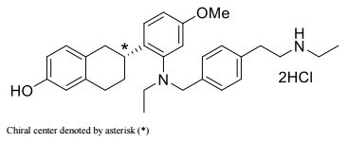
The drug substance is manufactured via an eight-step synthetic process, with commercially scaled batches demonstrating consistent quality. Specifications, impurity controls (including genotoxic, elemental and nitrosamine impurities), batch analyses and reference standards were assessed and considered acceptable. Nitrosamine risk was deemed negligible, and routine testing was not required. For the drug substance, the Sponsor demonstrated that quality control specifications and analytical methods applied at the finished product manufacturing site are equivalent to those used by the active substance manufacturer. Comparative analytical data for three batches confirmed successful method transfer and batch comparability.
For the finished drug product tablet images were supplied and found to be consistent with the product description. Formulation development was appropriate and supported by biopharmaceutic and dissolution data. A key issue reviewed was dissolution testing for the 345 mg strength; although a shorter dissolution time had been proposed, justification aligned with the final EMA position, supporting the application of a uniform dissolution limit for both strengths at release and throughout shelf life.
Manufacturing processes were considered conventional and capable of reproducibly producing product of the intended quality. All nominated manufacturers and sites held valid GMP clearances beyond the anticipated decision date. Stability data from multiple commercial-scale batches demonstrated compliance under long-term and accelerated conditions, supporting the proposed drug product shelf life of 24 months when stored below 30 degrees Celsius.
Blister and carton labelling were considered acceptable, including confirmation of pack configuration and clarification that serialisation and data matrix codes will not be included on carton labels.
Approval was recommended from a pharmaceutical chemistry perspective.

Nonclinical evaluation summary
The nonclinical data evaluation was based on the EMA nonclinical assessment and the US Food and Drug Administration nonclinical review.
The scope of the nonclinical dossier was adequate, consistent with the nonclinical evaluation of anticancer pharmaceuticals (ICHS9). All pivotal safety-related studies were GLP-compliant.
In vitro, elacestrant bound the ERα receptor with nanomolar affinity, inhibited estradiol-induced signalling through this receptor as well as inducing the degradation of the receptor. Elacestrant showed anti-proliferative activity in vitro against ER-positive/HER2-negative breast cancer cell lines. Elacestrant was active in both ESR1 wildtype and ESR1 mutated (Y537S and D538G) breast cancer cell lines as well as CDK4/6i resistant cell lines. In vivo, elacestrant inhibited tumour growth in ER-positive mouse xenograft and ER-positive patient derived xenograft (PDX) breast cancer models. Elacestrant also inhibited tumour growth in models with the xenograft models with an ESR1 mutation (Y537S and D538G) and in PDX model of human ER+ breast cancer considered to have acquired resistance to palbociclib and fulvestrant combination therapy. Efficacious concentrations and exposures were within those expected in patients. These results support the proposed clinical indication.
No clinically relevant hazards were identified in secondary pharmacodynamic studies. Elacestrant induces estrogen-like agonist effects in bone and in a rat model of vasomotor instability, while demonstrating antagonism of estrogen stimulation of uterine tissue and decreased plasma cholesterol levels.
Safety pharmacology studies assessed effects on the cardiovascular, respiratory, gastrointestinal and central nervous systems. Other studies also investigated the effects of elacestrant on bleeding time, wound healing and the gastrointestinal system. There were no adverse effects on CNS or respiratory function in rats. There was no clinically-relevant inhibition of hERG K+ tail current or effects on action potential duration in rabbit Purkinje fibres. Increased diastolic, systolic, mean arterial blood pressures and heart rate and decreased PR interval and QRS duration were observed in cynomolgus monkeys at doses resulting approximately 2.6-4.6 times the clinical Cmax. Elacestrant slightly increased bleeding time in rats but did not affect wound healing at clinically relevant doses. In ferrets, elacestrant induced emesis following oral administration, with tolerability observed following repeated dosing.
Overall, the pharmacokinetic profile in animals was qualitatively similar to that of humans, with the exception of a higher proportion of a glucuronide metabolite (M16) formed in human subjects. While oral absorption of elacestrant was rapid in mice and humans and slower in rats and monkeys, oral bioavailability was low in all species. Plasma protein binding of elacestrant was very high in all tested animal species and humans. Tissue distribution of drug-related material was wide but penetration into brain, spinal cord and testes was very limited. Retention of drug-related material in the melanin-containing uveal tract was evident. In humans, elacestrant penetrates the blood brain barrier in a dose-dependent manner but at low level. The main human metabolite (M16) was a minor circulating metabolite in rats. In rats and human subjects, drug-related material was excreted primarily in the faeces likely due to unabsorbed drug (significant) and biliary excretion of metabolites.
Based on in vitro studies, inhibitors/inducers of CYP3A4 or OATP2B1 could alter the systemic exposure to elacestrant. Elacestrant may increase the exposure of co-administered drugs that are substrates of P-glycoprotein or BCRP. With the exception of OATP2B1, the above potential interactions have been assessed in clinical studies. Using the basic model and mechanistic static model elacestrant was a potentially clinically-relevant inhibitor of intestinal CYP3A4. The Sponsor states that the clinical relevance has been dismissed based on PBPK simulations. These have not been evaluated by the Nonclinical Evaluator.
Elacestrant had a moderate to high order of acute oral toxicity in rats and monkeys.
Repeat-dose toxicity studies by the oral route were conducted in rats (up to 26 weeks) and cynomolgus monkeys (up to 39 weeks). Maximum exposures (AUC) were low in both rats and monkeys. Target organs/systems for toxicity included pharmacologically-mediated effects on male and female reproductive organs (decreased cellularity testicular Leydig cell in male rats, ovarian changes including enlargement with accompanying histological changes such as hyperplasia, reduced corpora lutea, and cyst formation, atrophy of vagina, cervix, uterus and mammary gland in female rats and monkeys), pituitary gland (atrophy in male and females rats, increased basophilic pituicytes in male monkeys), kidney (mineralisation in rats), bone (effects on trabecular bone in the femur of male and female rats), stomach and GI tract (histopathology in the stomach and GI tract and associated clinical signs of dehydration, vomitus, liquid/unformed faeces, decreased food intake and decreased bodyweight).
Elacestrant was not mutagenic in the bacterial mutation assay or clastogenic in vitro (in human lymphocytes) or in vivo (in the rat micronucleus test). No carcinogenicity studies were conducted, though granulosa ovary cell benign tumours were seen in the 26-week rat study.
Fertility and pre/postnatal development studies were not conducted. In repeat-dose toxicity studies in rats and monkeys, pharmacologically mediated effects on male and female reproductive organs were observed in the ovary, vagina, cervix, uterus, mammary gland and testes at clinically relevant doses. Male and female fertility is known to be impaired in ERα knockout mice. In an embryofetal development study in rats, embryofetal death and teratogenicity were observed.
Elacestrant does not pose a phototoxic risk.

Conclusions
The in vitro and in vivo pharmacology data together provided a mechanism of action of using elacestrant for the proposed indication. However, not all possible ESR1 mutations were examined.
No adverse effects on ECG, respiration, or neurological behaviour were observed in the conducted safety pharmacology studies.
In vitro pharmacokinetic drug interaction studies predicted:
- inhibitors and inducers of CYP3A4 or OATP2B1 may alter the systemic exposure to elacestrant,
- Elacestrant may increase the exposure of co-administered drugs that are substrates of P-glycoprotein or BCRP.
The toxicity profile of elacestrant was consistent with others in the pharmacological class. Notable target organs for toxicity included pharmacologically-mediated effects on male and female reproductive organs (testes, ovary, uterus, vagina, cervix, mammary gland), pituitary gland, kidney, bone, stomach and GI tract. Emesis and vomiting were evident in ferrets. These effects are expected in patients.
The nonclinical studies predicted effects on fertility and embryofetal toxicity if administered to pregnant patients at the proposed clinical dose. The proposed pregnancy category for elacestrant (Category D) is acceptable.
There are no objections to the registration of elacestrant for the proposed indication from a nonclinical perspective.

Clinical evaluation summary
This overview focuses on the three studies in patients with MBC: Study RAD1901-005, Study RAD1901-106 and the pivotal study, RAD1901-308.

Efficacy

Study RAD1901-005
A phase 1, multicentre, open-label, multipart, dose-escalation study of RAD1901 in postmenopausal women with advanced estrogen receptor positive and HER2-negative breast cancer.
The following summary is taken from the Committee for Medicinal Products for Human Use (CHMP) 210-day assessment report published by the EMA.

Study design
This was a Phase 1, multicentre, open-label, multi-part, dose-escalation study to determine the maximum tolerated dose (MTD) and/or recommended Phase 2 dose (RP2D) of elacestrant in subjects with ER+/HER2- MBC. Secondary objectives included evaluating the pharmacokinetics (PK) of elacestrant and an exploratory assessment of pharmacodynamics.
The study consisted of 4 parts:
- Part A: to evaluate the safety and tolerability, PK, and preliminary anti-tumour efficacy of elacestrant in a 3 + 3 dose-escalation phase using capsules
- Part B: a safety expansion phase at the RP2D using capsules
- Part C: to evaluate the tablet formulation administered at the RP2D
- Part D: to evaluate the safety and tolerability, PK, and preliminary anti-tumour efficacy of elacestrant tablet formulation at the RP2D of 400 mg QD in a population of subjects with more homogeneous anticancer therapies.
Parts A, B, and C included postmenopausal women with ER+/HER2- MBC who had received 2 or fewer chemotherapy regimens with progression after at least 6 months of endocrine therapy. Part D included postmenopausal women with ER+/HER2- MBC with at least 2 lines of prior endocrine therapy, including prior fulvestrant and prior treatment with a cyclin-dependent kinase (CDK) 4/6 inhibitor.
Subjects in Part A were treated with elacestrant 200 mg QD, 400 mg QD, or 600 mg QD. All subjects in Parts B, C, and D were treated with 400 mg QD. Upon confirmation of the RP2D (400 mg QD), subjects enrolled at lower doses in Part A were permitted to have their dose escalated to RP2D. The study was terminated prior to completion of enrolment of the Part D cohort due to a change in corporate strategy. Treatment cycles were of 28 days per cycle.

Results
The RP2D was determined to be 400 mg QD. Of 57 postmenopausal women enrolled, 50 received the RP2D (400 mg QD: 26 capsules, 24 tablets). Median age was 63 years, median 3 prior anticancer therapies including CDK4/6i (52.0%), SERD (52.0%), and ESR1 mutation (circulating tumour DNA; 50.0%). No dose-limiting toxicities occurred; the most common adverse events at RP2D (400 mg tablet; n = 24) were nausea (33.3%) and increased blood triglycerides and decreased blood phosphorus (25.0% each). Most adverse events were Grade 1 to 2 in severity. Although no dose-limiting toxicities were reported per-protocol, the 600 mg dose was deemed not tolerable primarily due to gastrointestinal events. The incidence of nausea, vomiting, and constipation was higher in subjects who received the 600 mg dose (67% to 100%) compared with those who received the 400 mg dose (17% to 65%). The 400 mg dose, which was associated with fewer gastrointestinal events, was selected as the RP2D for the subsequent clinical studies. An overall summary of adverse events (Table 3) and the incidence of gastro-intestinal events (Table 4) are shown below.
Table 3. Overall Summary of Adverse Events (ITT Population)
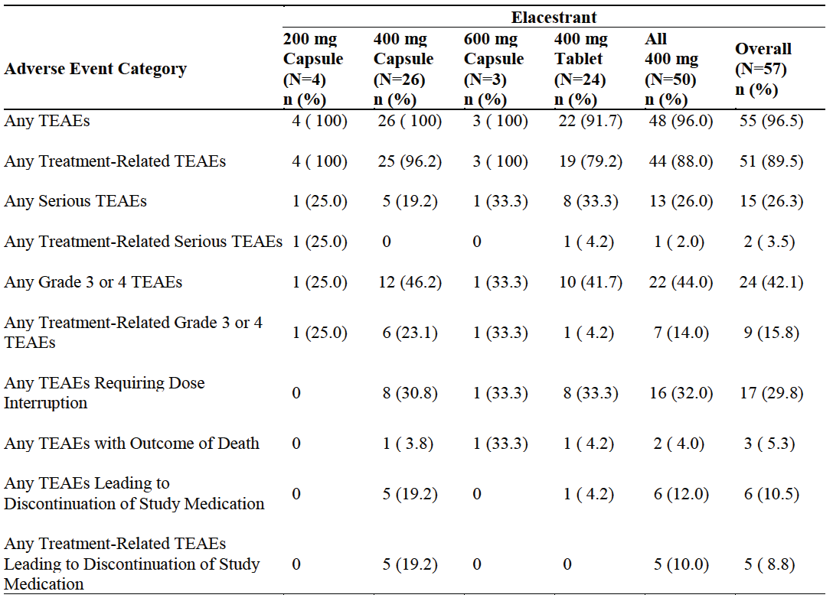
Abbreviations: ITT = intent-to-treat; TEAE = treatment emergent adverse event
Study RAD1901-005 database lock date: December 20, 2019.
Table 4. Frequently reported (≥ 10%) Gastrointestinal TEAE's in Study 005
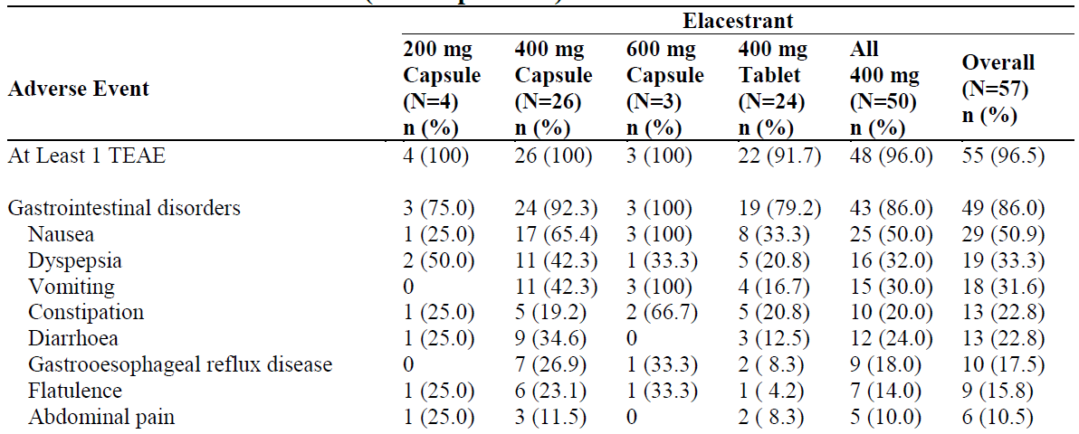
The objective response rate (ORR) was 19.4% (n = 31 evaluable subjects receiving the RP2D), 15.0% in subjects with prior SERD (n = 3 out of 20), 16.7% in subjects with prior CDK4/6 inhibitor (n = 3 out of 18), and 33.3% in subjects with ESR1 mutation (n = 5 out of 15).

Study RAD1901-106
A phase 1b study to evaluate the effect of RAD1901 on the availability of estrogen receptor biding sites in MBC lesions using 16α-18F-fluoro-17β- oestradiol positron emission tomography imaging.
The following summary is taken verbatim from the CHMP assessment report.13
Study RAD1901-106 was a Phase 1b, open-label, non-randomized, multicentre, international, 2 dose cohort study in postmenopausal women with histologically-confirmed, ER+, HER2- MBC. The study included postmenopausal women 18 years of age or older with histologically-proven ER+, HER2- inoperable and/or MBC, tumour progression after ≥6 months of at least 1 line of hormonal systemic treatment in the metastatic setting, with ECOG performance status 0-2. Subjects had to have had ≤3 lines of endocrine therapy for metastatic disease.

Results
A total of 8 subjects were initially enrolled and treated with 400 mg elacestrant; a second cohort of 8 subjects was subsequently enrolled and treated with 200 mg elacestrant for 14 days, after which the dose was escalated to 400 mg QD. Elacestrant was dosed QD continuously with 28-day treatment cycles. Fluoroestradiol-positron emission tomography (FES-PET) imaging was conducted at baseline and on Day 14. Response and progression were evaluated using RECIST v1.1 criteria.
The primary endpoint was the percentage difference in Fluoroestradiol (FES) uptake in tumour lesions (up to a maximum of 20 lesions) after 14 days of treatment with elacestrant compared to baseline. Elacestrant reduced FES uptake from baseline to Day 14. Median reduction in FES uptake was 88.0% (range: 59% to 97%), showing target engagement. This reduction in FES uptake was similar in subjects with or without ESR1 mutations (data not shown). All but 1 subject in the 400 mg dose cohort (7/8; 87.5%) and 57% of subjects (4/7) in the 200/400 mg cohort obtained a greater than 75% reduction in FES uptake.
ORR was 11.1% (1/9; partial response), CBR at 24 weeks was 30.8%, duration of response (DoR) was 22 weeks, time to response was 7.9 weeks, and median progression-free survival (PFS) was 5.3 months in the overall population. The single response was observed in the initial 400 mg dose group. No significant correlation was found between FES uptake and best overall response using Spearman’s rank correlation coefficient (0.2608 overall; p-value >0.5).

Pivotal Study RAD1901-308
Elacestrant monotherapy vs. standard of care for the treatment of patients with ER+/HER2- advanced breast cancer following CDK4/6i therapy: a phase 3 randomized, open-label, active-controlled, multicentre trial (EMERALD)
The following summary is derived from the CHMP 210-day assessment report.13

Methods
Pivotal Study 308 (Figure 2) was an international, multisite, randomized, open-label, active-controlled, event-driven, Phase 3 clinical study comparing the efficacy and safety of elacestrant versus standard of care (SOC) therapy (fulvestrant or AI) in postmenopausal women and men with ER+/HER2- MBC whose disease has relapsed or progressed on at least 1 and no more than 2 prior lines of endocrine therapy for MBC, which must have included CDK4/6i therapy in combination with fulvestrant or an AI. Subjects must have received no more than 1 line of cytotoxic chemotherapy for MBC. Endocrine monotherapy with 1 of the SOC drug options (fulvestrant, anastrozole, letrozole, exemestane) must have been an appropriate treatment option for subjects enrolled in this study.
Figure 2. Study Design (Study 308 EMERALD)
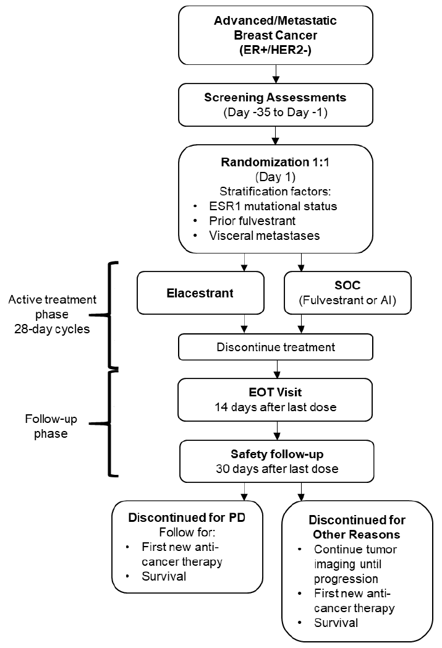
Abbreviations: AI = aromatase inhibitor; EOT = end of treatment; ER+ = estrogen receptor positive; ESR1 = estrogen receptor gene 1; HER2- = human epidermal growth factor receptor 2 negative; PD = progressive disease; SOC = standard of care.

Inclusion Criteria
- Must have had a histologically- or cytologically-proven diagnosis of adenocarcinoma of the breast with evidence of either locally advanced disease not amenable to resection or radiation therapy with curative intent or metastatic disease not amenable to curative therapy
- Must have been appropriate candidates for endocrine monotherapy
- Must have had 1 of the following as defined by RECIST version 1.1:
  - Measurable disease
  - Bone only disease with evaluable lesions.
- Female or male ≥ 18 years of age
- Female subjects must have been postmenopausal women, defined by 1 of the following criteria:
  - Documented bilateral surgical oophorectomy
  - Age ≥ 60 years with amenorrhea ≥ 1 year since last menses
  - Age < 60 years with amenorrhea ≥ 1 year since last menses with no alternative pathological or physiological cause and serum oestradiol and follicle stimulating hormone levels within the laboratory reference range for postmenopausal women
  - Age < 60 years with tamoxifen or toremifene therapy within the last 12 months, with documentation of 12 months of amenorrhea prior to tamoxifen or toremifene therapy and serum oestradiol and follicle stimulating hormone levels within the laboratory reference range for postmenopausal women
  - Females with hormonally-induced menopause (on ongoing suppression) were not eligible
- Male subjects had to, even if surgically sterilized (i.e., status post-vasectomy):
  - Agree to practice highly effective barrier contraception OR agree to practice true abstinence during the entire study treatment period and through 120 days after the last dose of study drug
  - Agree not to donate sperm during the course of treatment period of this study or within 120 days after receiving the last dose of the study drug
- Must have had ER+ and HER2- tumour status confirmed per local laboratory testing. Status may have been confirmed on original diagnosis tissue samples or post-treatment samples (most recent biopsy preferred, if testing available). ER and HER2 testing was to be performed in the following manner:
  - Documentation of ER+ tumour with ≥ 1% staining by immunohistochemistry as defined in the 2010 ASCO recommendations for ER testing, with or without PRec positivity
AND
  - Documentation of HER2- tumour with an immunohistochemistry result of 0 or 1+ for cellular membrane protein expression or an in situ hybridization negative result as defined in the 2013 or 2018 ASCO recommendations for HER2 testing.,
- Must have previously received at least 1 and no more than 2 lines of endocrine therapy, either as monotherapy or as a combination therapy with another agent, for MBC:
  - Must have progressed during or within 28 days of completion of each line of endocrine therapy; i.e., if a subject was discontinued due to toxicity without progression, this would not count as a line of prior therapy
  - For subjects who progressed during or within 12 months of adjuvant endocrine therapy, this will count as 1 line of endocrine therapy for MBC. In the absence of such progression, adjuvant therapy does not count as 1 of the required lines of endocrine therapy
- Must have progressed during or within 28 days of completion of prior treatment with a CDK4/6i in combination with either fulvestrant or an AI (this counts as a line of prior endocrine therapy) for MBC:
  - Prior treatment with a CDK4/6i not in combination with fulvestrant or an AI would not fulfil this criterion
  - Discontinuation of prior CDK4/6i due to toxicity, in the absence of progression, would not fulfil this criterion
- Must have received no more than 1 line of cytotoxic chemotherapy in the advanced/metastatic setting:
  - Cytotoxic chemotherapy does not include: CDK4/6i, mechanistic target of rapamycin inhibitors, PI3K inhibitors, or immunotherapy. There are no restrictions on prior use of these agents
  - There is no requirement for documentation of progressive disease (PD) to prior chemotherapy
  - Chemotherapy given in combination with endocrine therapy counts as both a line of endocrine therapy and a line of chemotherapy.
  - Chemotherapy administered for less than 1 cycle will not be counted as a prior line of chemotherapy
  - For subjects who progress within 12 months of neoadjuvant or adjuvant chemotherapy, this will count as 1 prior line of therapy for advanced/metastatic disease
- Eastern Cooperative Oncology Group (ECOG) performance status 0 or 1
- Resolution of all toxic effects of prior therapies or surgical procedures to Grade ≤ 1 (except alopecia and peripheral neuropathy)
- Adequate organ function as defined below:
  - Hematologic function (in the absence of transfusion of red blood cells or platelets or the use of growth factors within the preceding 4 weeks)
- Absolute neutrophil count ≥ 1.0 × 109/L
- Platelet count ≥ 75 × 109/L
- Haemoglobin ≥ 9.0 g/dL
  - Renal function
- Estimated glomerular filtration rate ≥ 30 mL/min/1.73 m2 or creatinine clearance calculated by Cockcroft-Gault equation ≥ 30 mL/min
  - Hepatic function
- Alanine aminotransferase (ALT) ≤ 3 × upper limit of normal (ULN)
- Aspartate aminotransferase (AST) ≤ 3 × ULN
- Total bilirubin ≤ ULN or total bilirubin ≤ 1.5 × ULN with direct bilirubin ≤ ULN of the laboratory in subjects with documented Gilbert’s Syndrome
  - Chemistry
- Potassium, sodium, calcium (corrected for albumin), magnesium, and phosphorus National Cancer Institute Common Terminology Criteria for AEs (NCI CTCAE) version 5.0 Grade ≤ 1. If Screening assessments are abnormal, chemistry assessments may be repeated up to 2 times; subjects may receive appropriate supplementation or treatment prior to reassessment.
  - Coagulation
- International normalized ratio (INR) ≤ 1.5. Note: Subjects who are receiving anticoagulation treatment which is monitored by INR may be allowed to participate if they have a stable INR (i.e., within therapeutic range) for at least 28 days prior to the first dose of study drug, in the absence of any exclusionary medical conditions, and provided that an AI would be appropriate therapy for the subject.
- Ability to understand the protocol and provide informed consent

Exclusion criteria
- Prior treatment with elacestrant or investigational SERD or ER antagonist
- Prior anticancer or investigational drug treatment within the following windows:
  - Fulvestrant treatment (last injection) < 42 days before first dose of study drug
  - Any other endocrine therapy < 14 days before first dose of study drug
  - Chemotherapy or other anticancer therapy < 21 days before first dose of study drug
  - Any investigational anticancer drug therapy < 28 days or 5 half-lives (whichever is shorter) before the first dose of study drug. Enrolment of subjects whose most recent therapy was an investigational agent was to be discussed with Radius
  - Bisphosphonates or RANKL inhibitors initiated or dose changed < 3 months prior to first dose of study drug
- Radiation therapy within 14 days (28 days for brain lesions per Exclusion Criterion 4) before the first dose of study drug
- Presence of symptomatic metastatic visceral disease, including but not limited to, extensive hepatic involvement, untreated or progressive central nervous system (CNS) metastases, or symptomatic pulmonary lymphangitic spread. Subjects with discrete pulmonary parenchymal metastases were eligible provided their respiratory function was not significantly compromised as a result of disease in the opinion of the investigator. Subjects with previously treated CNS metastases were eligible provided that all known lesions were previously treated, they had completed radiotherapy at least 28 days prior to first dose of study drug and were clinically stable. If anticonvulsant medication was required, subjects were to be stable on a non-enzyme inducing anticonvulsant regimen.
- Intact uterus with a history of endometrial intraepithelial neoplasia (atypical endometrial hyperplasia or higher-grade lesion)
- Diagnosis of any other malignancy within 5 years before enrolment, except for adequately treated basal cell or squamous cell skin cancer, carcinoma in situ of the cervix, or second primary breast cancer
- Any of the following within 6 months before enrolment: myocardial infarction, severe/unstable angina, ongoing cardiac dysrhythmias of NCI CTCAE version 5.0 Grade ≥ 2, prolonged total depolarization and repolarization time (QT) corrected by Fridericia's formula (QTcF) ≥ Grade 2 (i.e., > 480 msec), uncontrolled atrial fibrillation of any grade, coronary/peripheral artery bypass graft, heart failure ≥ Class II as defined by the New York Heart Association guidelines, or cerebrovascular accident including transient ischemic attack
- Child-Pugh Score greater than Class A (i.e., score > 6)
- Coagulopathy or any history of coagulopathy within the past 6 months, including history of deep vein thrombosis or pulmonary embolism. However, subjects with the following conditions were allowed to participate:
  - Adequately treated catheter-related venous thrombosis occurring > 28 days prior to the first dose of study drug
  - Treatment with an anticoagulant for a thrombotic event occurring > 6 months before enrolment, or for an otherwise stable and allowed medical condition, provided dose and coagulation parameters (as defined by local SOC) are stable for at least 28 days prior to the first dose of study drug and provided that an AI would be an appropriate therapy for the subject
- Known bleeding disorder which, in the opinion of the investigator, would prohibit administration of fulvestrant if that would be the SOC choice for the subject
- Known difficulty in tolerating oral medications or conditions which would impair absorption of oral medications such as: uncontrolled nausea or vomiting (i.e., CTCAE ≥ Grade 3 despite antiemetic therapy), ongoing gastrointestinal obstruction/motility disorder, malabsorption syndrome, or prior gastric bypass
- Unable or unwilling to avoid prescription medications, over-the-counter medications, dietary/herbal supplements, and/or foods that are moderate/strong inhibitors or inducers of CYP3A4 activity. Participation was allowed if the medication, supplements, and/or foods were discontinued for at least 5 half-lives or 14 days (whichever is longer) prior to study entry and for the duration of the study
- Major surgery < 28 days before the first dose of study drug
- Any concurrent severe, acute, or chronic medical or psychiatric condition or laboratory abnormality that may increase the risk associated with study participation or investigational product administration or may interfere with compliance with study procedures or the interpretation of study results and, in the judgment of the investigator, would make the subject inappropriate for entry into this study
- Known hypersensitivity reaction to drugs chemically related to elacestrant or their excipients
- Known hypersensitivity to fulvestrant, anastrozole, letrozole, or exemestane (or to any of their excipients), unless treatment with 1 of the other 3 of these 4 treatment options would be appropriate therapy
- Subjects who met any contraindication, according to the respective PI or Summary of Product Characteristics (SmPC), for any SOC drug that the investigator would choose for that subject, should the subject be randomised to the SOC group.

ESR1 mutation status
Blood samples for circulating tumour deoxyribonucleic acid (ctDNA) analysis were analysed using the Food and Drug Administration (FDA)-approved Guardant360 (Guardant Health) assay to determine ESR1 mutational status. The Guardant360 assay uses digital sequencing technology to detect all missense nucleotide variants within the ligand-binding domain of the ESR1 gene. Detection of any ESR1 mutation(s), as defined by Guardant Health for the assay, was reported as ESR1 mutation present (i.e., ESR1-mut). The designation of ‘No ESR1 mutation detected’ (ESR1-mut-nd) was assigned if there was no mutation present in the ESR1 gene (i.e., wild-type) or if there was no detectable ctDNA present in the blood sample. ESR1 test results were used for stratification at randomization; however, the site was not provided with a subject’s mutational status during the subject’s active treatment phase, unless otherwise required by regulation. Results were provided to sites semi-blinded (i.e., coded as Group A or Group B) for randomization.

Treatments
For subjects randomized to the control group, the investigator was to select 1 of the available SOC options based on the individual subject’s prior treatment history and the investigator’s judgment. Sites were required to select the investigator's choice of the control arm during the Screening Phase. This was entered into the Integrated Response Technology (IRT) system by the Investigator at the screening visit prior to randomization.

The following SOC options were available for subjects randomized to this treatment group:
- Fulvestrant: 500 mg administered IM into the buttocks as two 5 mL injections on Cycle 1 Day 1 (C1D1), C1D15, C2D1, and Day 1 of every subsequent 28-day cycle
- Anastrozole: 1 mg QD orally on a continuous dosing schedule
- Letrozole: 2.5 mg QD orally on a continuous dosing schedule
- Exemestane: 25 mg QD orally on a continuous dosing schedule
The investigator was to select 1 of the available SOC options according to what was appropriate based on the individual subject’s prior treatment history and the investigator’s judgment, considering the following general guidance:
- Subjects who had not previously received fulvestrant should be treated with fulvestrant (unless there was a known contraindication).
- Subjects who progressed on prior fulvestrant should be treated with an AI.
- The selection of an AI should be based on prior AI therapy and any known contraindications, as follows
  - If the subject had previously progressed on a nonsteroidal AI (anastrozole or letrozole) but not received exemestane, the preferred option would be exemestane.
  - If the subject had previously progressed on exemestane but not received a nonsteroidal AI, the preferred option would be a nonsteroidal AI.
For subjects randomized to the elacestrant group, 400-mg tablets were administered orally QD by the subjects on an outpatient basis and at study visits.
Dose reductions of elacestrant due to adverse events were allowed in this study. Dose levels could be reduced to 300 mg QD (3 × 100 mg tablets) and, subsequently, to 200 mg QD (2 × 100 mg tablets) representing 25% and 50% dose reductions from the 400 mg QD starting dose, respectively. Dose reductions below 200 mg QD were not allowed and, if required in the opinion of the Investigator, the subject was to discontinue treatment. Once a dose has been reduced, it could not be re-escalated. No dose escalations above the starting dose of 400 mg QD were permitted.
Dose reductions for subjects receiving AIs were not allowed, as per the prescribing information of these drugs. Dose reductions for subjects receiving fulvestrant were permitted for subjects who developed moderate hepatic impairment (Child-Pugh class B) if deemed unrelated to study drug or disease progression, for whom the dose of fulvestrant should be reduced to 250 mg.
Dose interruptions of elacestrant and SOC treatment of ≤14 consecutive days were permitted. A dose interruption of >14 consecutive days required discussion with the Sponsor prior to resuming study treatment. For all subjects, 1 treatment cycle was 28 days.
Crossover from any treatment group or therapy to another was not allowed while participating in the study.

Objectives
The primary objective of the study was to demonstrate that elacestrant, compared with SOC (fulvestrant or AI), is superior in prolonging PFS based on blinded Independent Review Committee (IRC) assessment in postmenopausal women and men with ER+/HER2- MBC, either in ESR1-mut subjects or in all subjects (ESR1-mut +ESR1-mut-nd). The key secondary objective was to compare OS between treatment groups in ESR1-mut subjects and in all subjects (ESR1-mut + ESR1-mut-nd).

Outcomes/endpoints

Definitions
- Progression free survival (PFS) was defined as the time from the date of randomization until the date of objective disease progression or death (by any cause in the absence of progression).
- Overall survival was defined as the time from the date of randomization until death due to any cause.
- IRC-assessed ORR was defined as the percentage of subjects whose best overall response (BOR) was either complete response (CR) or partial response (PR), where BOR was derived using blinded IRC assessment following the RECIST v1.1 criteria.
- Duration of response (DoR) was defined as the duration from the first response until disease progression or death from any cause.
- Clinical benefit rate (CBR) was defined as the proportion of subjects who had confirmed CR or PR any time during the study or stable disease that lasted at least 24 weeks (including disease assessments performed up to a week earlier than the scheduled date).

Endpoints
The primary endpoints of the study were:
- IRC-assessed PFS in ESR1-mut subjects
- IRC-assessed PFS in all subjects (ESR1-mut + ESR1-mut-nd)
To control the family-wise Type I error rate, the truncated Hochberg procedure was used. The selection of this procedure allowed for alpha to pass along from the analyses of the primary endpoint of PFS to the analyses of the key secondary endpoint of OS.

The key secondary endpoints of the study were:
- OS in ESR1-mut subjects
- OS in all subjects (ESR1-mut + ESR1-mut-nd)
Other secondary endpoints were analysed for ESR1-mut-nd subjects:
- IRC-assessed PFS
- OS
The following endpoints were analysed for ESR1-mut subjects, ESR1-mut-nd subjects, and all subjects (ESR1-mut + ESR1-mut-nd):
- Local investigator-assessed PFS
- IRC-assessed ORR
- IRC-assessed duration of response (DoR)
- IRC-assessed clinical benefit rate (CBR)
- Local investigator-assessed ORR
- Local investigator-assessed DoR
- Local investigator-assessed CBR
The following endpoints were assessed for ESR1-mut subjects and all subjects (ESR1-mut + ESR1-mut-nd):
- Safety and tolerability: AEs, SAEs, dose modifications, clinical laboratory parameters (i.e., haematology, chemistry, and coagulation), ECGs, ECOG performance status, and vital signs
- Pharmacokinetics: Evaluation of elacestrant concentrations at predose (pretreatment) and 4 hours post-dose on Cycle 1 Day 1 (C1D1), predose (trough concentration [C_{trough}]) and 4 hours post-dose on C1D15, and predose (C_{trough}) on C2D1
- Patient-reported outcome endpoints: Assessed using the HRQOL scales EQ-5D-5L, EORTC QLQC30, and PRO-CTCAE

Exploratory endpoints
The following exploratory objectives were planned to be assessed in all subjects (ESR1-mut + ESR1-mut-nd), ESR1-mut subjects, and ESR1-mut-nd subjects:
- To determine the difference between treatment groups in time to chemotherapy, defined as the number of days from randomization to initiation of chemotherapy
- To evaluate alterations in ctDNA relevant to ER+ breast cancer and the CDK4/6 pathway and to explore the relationship between these findings and clinical response
- To characterize alterations in tumour-specific genes, proteins, and RNAs related to oncogenic pathways and proliferation and cell cycle markers in tumour tissue and the relationship between these findings and clinical response.

Efficacy assessments
Tumour assessments were performed every 8 weeks (± 7 days) from the date of randomization during the active treatment phase of the study and assessed per RECIST v1.1. PROs were also assessed in conjunction with tumour assessments.
Subjects with bone lesions identified by radionuclide bone scan or whole-body magnetic resonance imaging (MRI) at baseline underwent repeat bone scans or whole-body MRI performed every 24 weeks (± 7 days) from the date of randomization and at the time of confirmation of a CR.

Sample size
It was estimated that approximately 466 subjects (220 ESR1-mut; 246 ESR1-mut-nd) would be enrolled in the study in a 1:1 randomization.
Among the ESR1-mut subjects, the study required approximately 160 PFS events to have a power of 80% to detect a hazard ratio (HR) of 0.610 at the 2-sided alpha level of 2.5%. The sample size estimate assumed a median PFS of 5.3 months for the SOC treatment group and 8.7 months for the elacestrant treatment group, an increase of approximately 3.4 months among the ESR1-mut subjects.
The assumption of median PFS of 5.3 months for the SOC treatment group was based on available data at that time related to the efficacy of fulvestrant as a second/third line treatment in the following pivotal clinical trials:
- EFECT: Median PFS on fulvestrant monotherapy: 3.7 months.
- BELLE-2: Median PFS on fulvestrant monotherapy: 5.0 months.
- PALOMA-03: Median PFS on fulvestrant monotherapy: 4.6 months.
Among all subjects (ESR1-mut + ESR1-mut-nd), a total of approximately 340 PFS events had 92% power to detect a HR of 0.667 at the 2-sided alpha level of 2.5%. The 2-sided alpha level of 2.5% for sample size calculation was selected to ensure that at least 1 of the 2 primary efficacy endpoints would pass the Hochberg procedure to control the overall alpha level at 5.0%.

Among all subjects (ESR1-mut and ESR1-mut-nd), the study was to have 60% power to detect a HR of 0.75 for OS at a 1-sided alpha level of 2.5%. Assuming a median OS of 25 months for the SOC treatment group, this HR represents a median OS of 33 months for the elacestrant treatment group. This calculation also accounts for 1 interim analysis at an information fraction of 0.4 with an alpha spending equal to 0.0001 at the interim analysis.
Approximately 114 OS events were expected among the ESR1-mut subjects at the time of the second analysis of OS. With 114 OS events, the study was to have 39% power to detect a HR of 0.73 at a 1-sided alpha level of 2.5%. Assuming a median OS of 28 months for the SOC treatment group, this treatment effect represents a median OS of 38 months for the elacestrant treatment group, an increase of approximately 10 months among the ESR1-mut subjects. This calculation also accounts for 1 interim analysis at an information fraction of 0.4 with an alpha spending equal to 0.0001 at the interim analysis.

Randomisation and blinding
Eligible subjects were randomized in a 1:1 ratio to either elacestrant or SOC with randomization stratified by the following:
- ESR1 mutation status (detected [ESR1-mut] vs not detected [ESR1-mut-nd])
- Prior treatment with fulvestrant (yes vs no)
- Presence of visceral metastases (yes vs no); visceral includes lung, liver, brain, pleural, and peritoneal involvement
This was an open-label study as one of the study treatment options was administered via IM injections; thus, study subjects and investigators were not blinded to treatment assignment. To minimize bias in study conduct, personnel performing statistical analyses, including biostatisticians and programmers, were blinded to treatment assignments and aggregated data by treatment assignment until after database lock. Contract research organization study team members and select Sponsor team members were not blinded to an individual subject’s treatment assignment during the conduct of the study but were blinded to aggregated data by treatment assignment until after database lock.

Statistical methods
The study was of superiority design. Analyses of the primary endpoints were performed based on assessments by the blinded IRC. Analyses based on investigator assessment were also performed as supportive analyses. Efficacy data were reviewed at prespecified intervals by an Independent Data Monitoring Committee (IDMC), as per the IDMC charter. An interim analysis for futility was performed by the IDMC at the time when approximately 70% enrolment had been achieved. The IDMC’s recommendation was to continue the study unmodified.
The final PFS analysis was planned to be performed when approximately 160 PFS events (objective disease progression assessed by the blinded IRC or death) among the ESR1-mut subjects and 340 PFS events among all subjects (ESR1-mut + ESR1-mut-nd) had occurred. OS analyses were planned to be conducted at the same time as the final PFS analysis, and again when approximately 50% of subjects have died at which time the study will be considered complete.

Analysis populations for efficacy
Intention-to-Treat (ITT) Population: The ITT population included all randomized subjects. This was the primary population for PFS and OS analyses. Subjects were analysed according to their randomized treatment assignment.
Per-Protocol (PP) Population: The PP population included all randomized subjects who did not have any major protocol deviations that may confound the interpretation of the primary analyses conducted on the ITT population. The PP population was used to perform sensitivity analyses for the primary efficacy endpoint of PFS if the primary endpoint was statistically significant. Subjects were analysed according to their randomized treatment assignment.
Response-Evaluable (RE) Population: The RE population included all ITT subjects who had measurable disease (i.e., at least 1 target lesion) at baseline and at least 1 postbaseline RECIST assessment on any (target or nontarget) lesions and/or had a new lesion.
Clinical-Benefit-Evaluable (CBE) Population: The CBE population included all ITT subjects who had measurable and/or evaluable disease (i.e., target and/or nontarget lesions) at baseline and at least 1postbaseline RECIST assessment on any (target or nontarget) lesions and/or had a new lesion.

Primary endpoints
Progression free survival was defined as the duration (in months) from the date of randomization to the earliest date of documented disease progression per RECIST v1.1 or death due to any cause.
For subjects without objective disease progression or death, PFS was censored on the date of the last adequate tumour assessment or, if no tumour assessment was performed after the baseline visit, at the date of randomization.
The difference in the primary endpoints between the treatment groups was to be analysed using a log rank test stratified by the factors used to stratify the randomization.
KM methods were to be used to display the time to-event graphs and estimate the median event times and their 95% CIs, Q1 and Q3 and their 95% CIs, and the rates at Months 3, 6, 12, and 18 and their 95% CIs.

Sensitivity analysis
The following sensitivity analyses were to be performed:
- Sensitivity Analysis 1 Actual event PFS analysis
- Sensitivity Analysis 2 Backdating PFS analysis
- Sensitivity Analysis 3 Unstratified analysis
- Sensitivity Analysis 4 COVID-19 analysis
- Sensitivity Analysis 5 Per-Protocol Population analysis

Restricted mean survival time analysis RMST
The RMST methodology is independent of the proportional hazards assumption and can be used as a supplemental analysis to explore the robustness of the primary analysis results.

Key secondary endpoints
Analyses of OS in all subjects and in ESR1-mut subjects were to be performed using the ITT population. The KM method was to be used to estimate median survival times, which were to be displayed with the survival curve.
A sensitivity analysis for OS was to examine the censoring patterns to rule out attrition bias.
RMST analysis was also to be provided for the key secondary endpoints.

Other secondary endpoints
Although multiple exploratory analyses of other secondary endpoints were undertaken, no statistical significance can be claimed for any endpoints other than the primary and key secondary endpoints.

Multiple comparison adjustment
To ensure the family-wide error rate does not exceed 5%, multiplicity adjustments were to account for the analyses of 2 primary endpoints, 2 key secondary OS endpoints, and the analyses of the key secondary OS endpoints at 2 time points. The multiplicity correction between the two timepoints for OS were to be done using the Haybittle-Peto method.
During the study, the OS analysis plan was changed with the addition of the formal test at the time of the primary PFS analysis.
A parallel gatekeeping strategy based on the truncated Hochberg procedure was to be used to control the family-wise type I error rate at 5% (2-sided) and to allow alpha to pass along from the analyses of the primary endpoint of PFS to the analyses of the key secondary endpoint of OS.

Subgroup analyses
Subgroup analyses of IRC-assessed PFS, OS, ORR, DoR, and CBR were to be performed in the same manner as the analyses using the ITT population for all subjects (ESR1-mut + ESR1-mut-nd) and for ESR1-mut subjects only for the following stratification factors and categories:
- Prior treatment with fulvestrant (yes vs no)
- Presence of visceral metastasis (yes vs no)
- Age (< 65 years vs ≥ 65 years)
- Age (< 75 years vs ≥ 75 years)
- Race (Caucasian vs Asian vs Other)
- Region (Europe, North America, Asia, Other)
- Baseline Eastern Cooperative Oncology Group (ECOG) performance status (0 vs 1)
- Measurable disease at baseline (yes vs no)
- Number of prior lines of endocrine therapy in the advanced/metastatic setting (1 vs 2)
- Number of lines of chemotherapy in the advanced/metastatic setting (0 vs 1)

Results
Participant flow
Overall, this study screened 695 subjects who granted informed consent for participation and randomized 478 subjects to treatment with either elacestrant or SOC (Figure 3). Of the 217 (31.2%) subjects who did not pass screening, 204 (29.4%) were excluded for failure to meet eligibility criteria, 10 (1.4%) due to withdrawal of consent, 2 (0.3%) due to the investigator’s decision, and 1 (0.1%) due to significant noncompliance.
Figure 3. Participant Flow Study 308 EMERALD
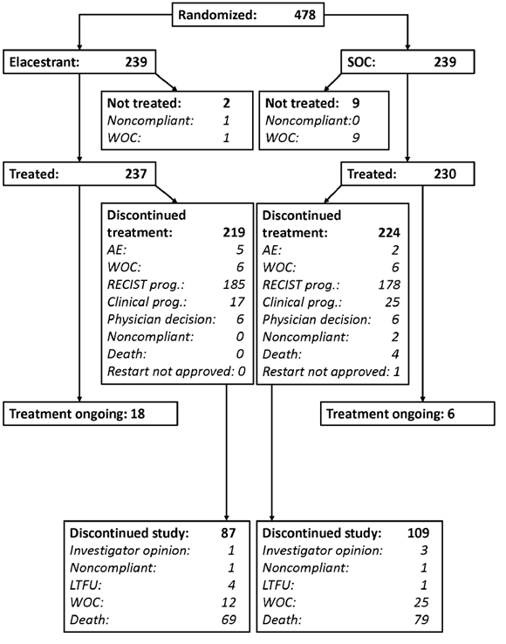
Abbreviations: AE = adverse event; LTFU =lost to follow-up; prog. = progression; RECIST = Response Evaluation
Criteria in Solid Tumors; SOC = standard of care; WOC = withdraw of consent.
Subjects discontinued study includes the subjects who discontinued prior to starting treatment.
Among all subjects, randomization was equal to each group (239 elacestrant, 239 SOC). As of the data cut-off (DCO) date (06 September 2021), 18 subjects (7.5%) in the elacestrant group and 6 subjects (2.5%) in the SOC group were still on treatment. Most subjects discontinued treatment (91.6% elacestrant, 93.7% SOC). The most common reason for treatment discontinuation was investigator-assessed progression per RECIST criteria (77.4% elacestrant, 74.5% SOC).
Recruitment
Subjects were enrolled in 17 countries at 150 of the 224 study sites initiated. The first patient was enrolled on 10 May 2019. The last patient last visit was not reached, as the study was ongoing as of the clinical data cut at 06 September 2021.
Protocol variations
There were several minor protocol amendments and one significant one. In the global change from version 4.0 to 5.0, the ESR1-WT (wild type) population planned for some secondary analyses was changed to the ESR1-mut-nd (mutant not detected) population, the latter including subjects with no mutation detected as well as subjects with an unknown mutation status.
Protocol deviations
Major protocol deviations (Table 5) were defined as a deviation from the basic requirements of the study protocol, including main inclusion and exclusion criteria; concomitant medication restrictions; dosing (i.e., outside of ± 20% prescribed dose of study drug); or any protocol requirements that resulted in a significant added risk to the study subject, had an impact on the quality of the data collected, or had an impact on the outcome of the study.
Table 5. Major protocol deviations (intention to treat population)
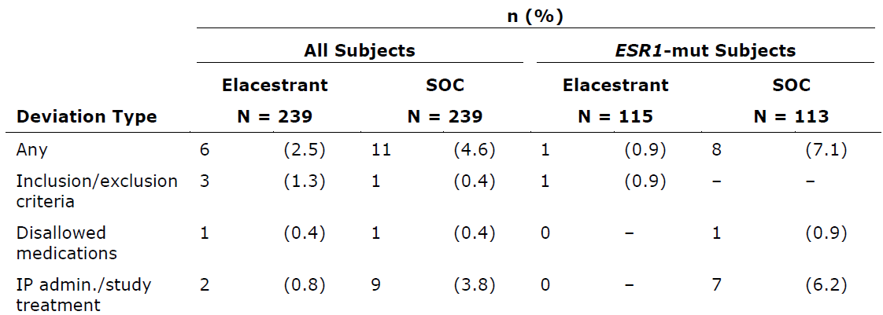
Abbreviations: Admin = administration; AE = adverse event; ESR1 = estrogen receptor 1 gene; ESR1-mut = ESR1 mutation; IP = investigational product; n = number of subjects with the observed group characteristic; N = total number of subjects in group; SOC = standard of care.
In addition to the 17 patients with major protocol deviations, minor protocol deviations were reported in 472 (98.7%) patients. Of the 478 patients on study, 138 unique patients (71 elacestrant, 67 SOC) reported to have minor deviations involving either I/E criteria only (total 90 patients, elacestrant treated=48 patients and SOC treated=42 patients), ICFs only (total 37 patients, elacestrant=18 patients, SOC=19 patients) or both I/E criteria and ICF deviations (total 11, elacestrant=5 patients, SOC=6 patients).

Baseline data
Table 6. Baseline demographic characteristics (Study 308 - ITT population)
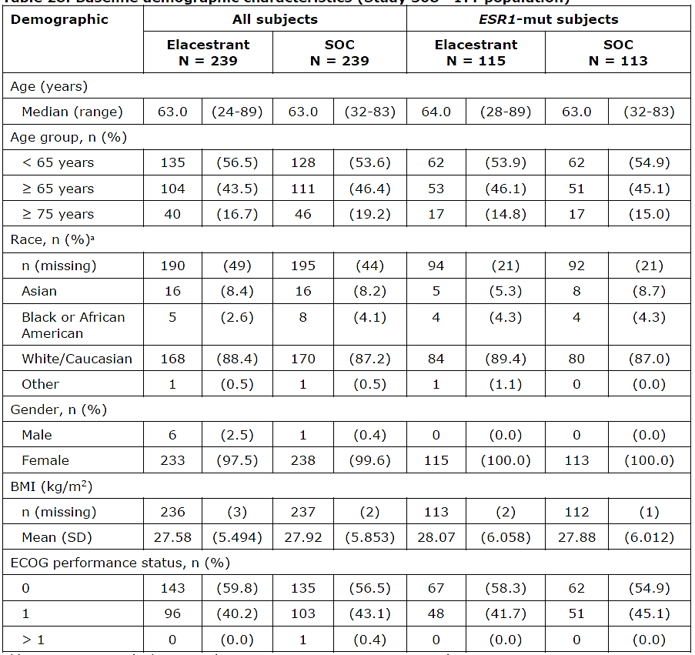
Abbreviations: BMI = body mass index; ECOG = Eastern Cooperative Oncology Group; ESR1 = estrogen receptor 1 gene; ESR1-mut = ESR1 mutation positive; ITT = intent-to-treat; n = number of subjects with the observed group characteristic; N = total number of subjects in group; SD = standard deviation; SOC = standard of care.
a Subjects could select more than one race.
The median age of patients (elacestrant vs standard of care) at baseline was 63.0 years (range of 24-89) vs 63.5 (range of 32-83) and 45.0% were over 65 (43.5 vs 46.6).
The median time since initial diagnosis in all groups was between 4.92 and 6.28 years. Most subjects (65.3%) had ductal tumour histology. Metastatic sites were most commonly in the bone (78.9% [bone only: 14.0%]), liver (49.6%), lymph nodes (28.5%), and lung (26.23). Brain metastases were uncommon and was reported in 7 patients in total (1.5%).
Table 7. Baseline demographic and disease characteristics – all patients (ITT population, Study 308 EMERALD)
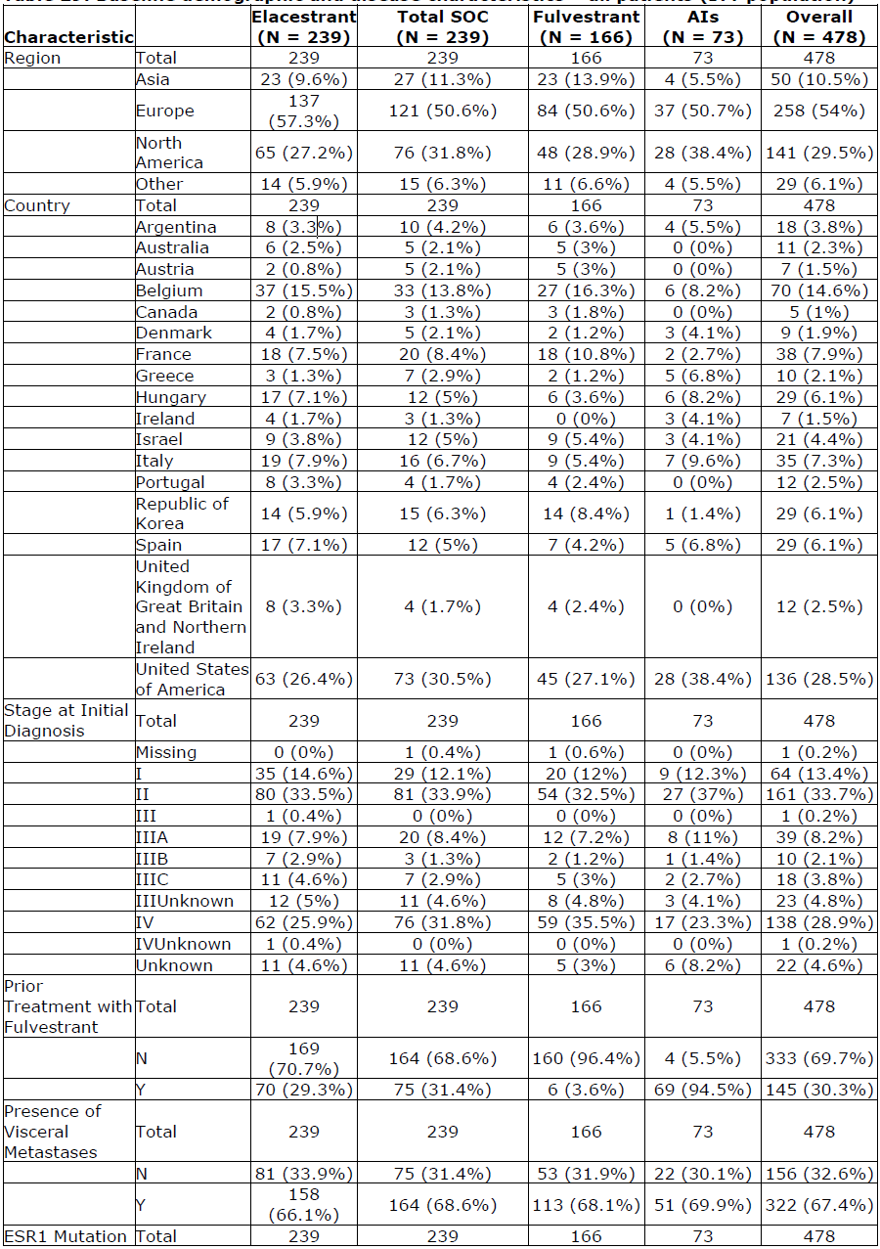
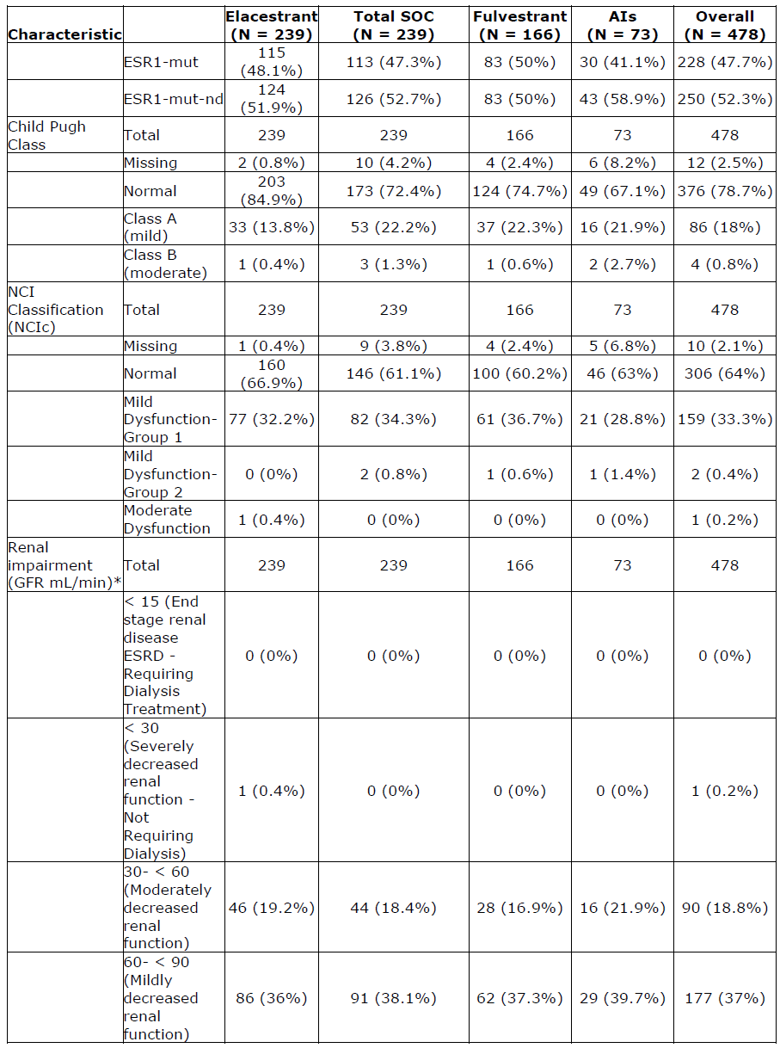
Abbreviations: SOC = Standard of Care; AI = Aromatase Inhibitor; ESR1-mut = ESR1 mutation, ESR1-mut-nd = No ESR1 mutation detected; GFR = absolute Glomerular Filtration Rate; ITT = intent-to-treat; NCIc = National Cancer Institute classification.
* Based on EMA Guideline on the evaluation of the pharmacokinetics of medicinal products in patients with decreased renal function (EMA/CHMP/83874/2014, 2015)
Child-Pugh and National Cancer Institute classifications for hepatic dysfunction. Data cut-off: 08 July 2022.

Prior systemic anticancer therapies
- Consistent with the inclusion criteria, all subjects had at most 1 line of chemotherapy for advanced/metastatic disease and either 1 or 2 lines of endocrine therapy in the advanced or metastatic setting.
- For all subjects, in any setting, prior AI therapy was reported for 235 subjects in the elacestrant group and 231 subjects in the SOC group. The median duration of AI therapy was 25.0 months (range 2 to 164 months) in the elacestrant group and 24.3 months (2 to 154 months) in the SOC group. Similar proportions and durations of therapy were observed for ESR1-mut subjects.
- All subjects had prior CDK4/6i therapy in any setting.

Numbers analysed
Table 8. Numbers analysed- Study 308 EMERALD.
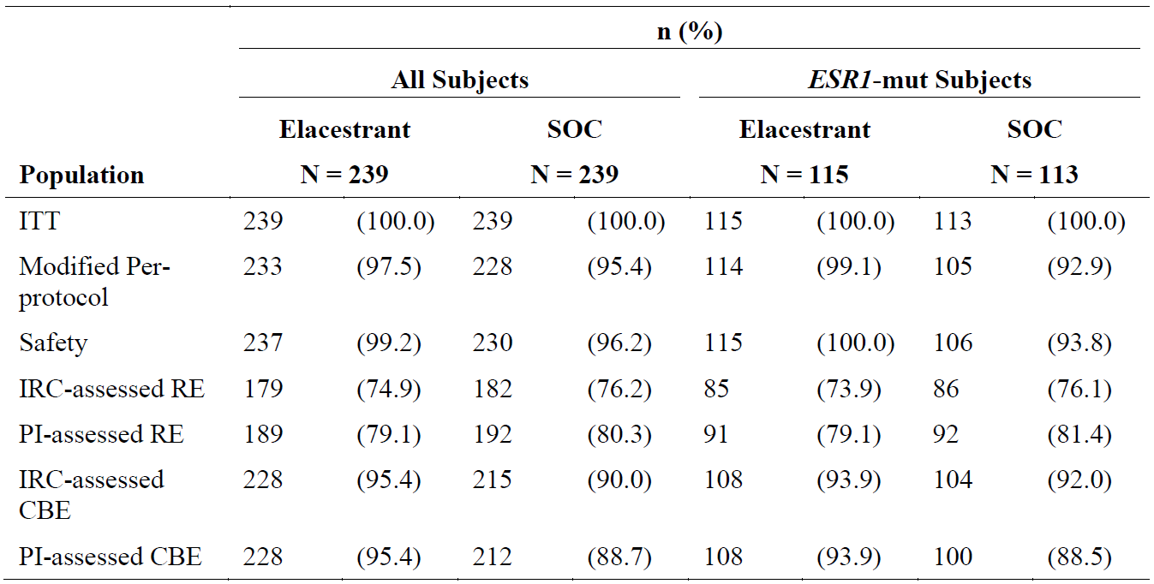
Abbreviations: CBE = clinical benefit evaluable; ESR1 = estrogen receptor 1 gene; ESR1 mut = ESR1 mutation;
IRC = Imaging Review Committee; ITT = intent-to-treat; n = number of subjects with the observed group
characteristic; N = total number of subjects in group; PI = principal investigator; RE = response evaluable;
SOC = standard of care
Outcomes and estimation
The analysis of the primary outcome variable, PFS, is presented in Table 9 and Table 10. Kaplan Meier Curves are presented in Figure 4 and Figure 5.
Table 9. Analysis of Blinded IRC Assessment of PFS in ITT Population
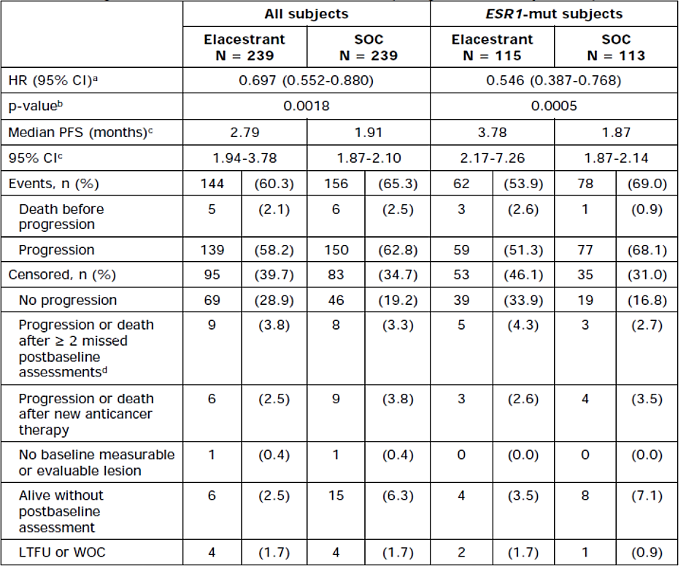
Abbreviations: CI = confidence interval: ESR1 = estrogen receptor 1 gene; ESR1-mut = ESR1 mutation positive:
HR = hazard ratio: IRC = imaging review committee; ITT = intent-to-treat; KM = Kaplan-Meier; LTFU = loss to
follow-up: n = number of subjects with the observed group characteristic; N = total number of subjects in group;
PFS = progression-free survival: SOC = standard of care: WOC = withdrawal of consent.
ª The analysis was performed using a stratified Cox proportional hazards model with ties=Efron and the stratification factors: prior treatment with fulvestrant (yes vs no) and presence of visceral metastases (yes vs no): the Cl calculated using a profile likelihood method.
^{b} The p-value was generated by using a 2-sided stratified log-rank test.
^{c} Calculated using KM technique. Cl for median PFS is derived based on the Brookmeyer-Crowley method using a
linear transformation.
^{d} Date of last tumour assessment before missed assessments or date of randomization, whichever is later.

Table 10. Landmark analysis of blinded IRC assessment of PFS
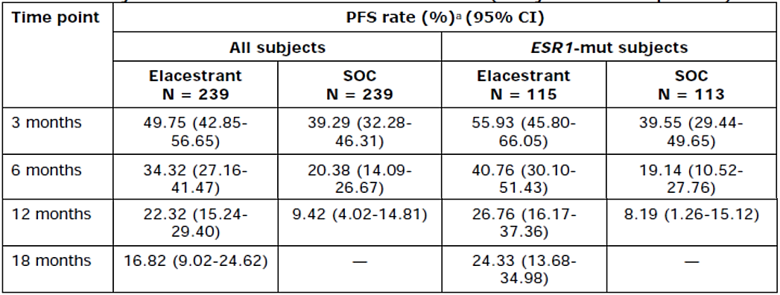
Abbreviations: CI = confidence interval; ESR1 = estrogen receptor 1 gene: ESR7-mut = ESR1 mutation positive: IRC = imaging review committee: ITT = intent-to-treat; KM = Kaplan-Meier: N = total number of subjects in group; PFS = progression-free survival; SOC = standard of care.
* Calculated using KM technique. Cl for PFS is derived based on the Brookmeyer-Crowley method using a linear transformation.

Figure 4. Kaplan-Meier plot for blinded IRC assessment of PFS in All Subjects
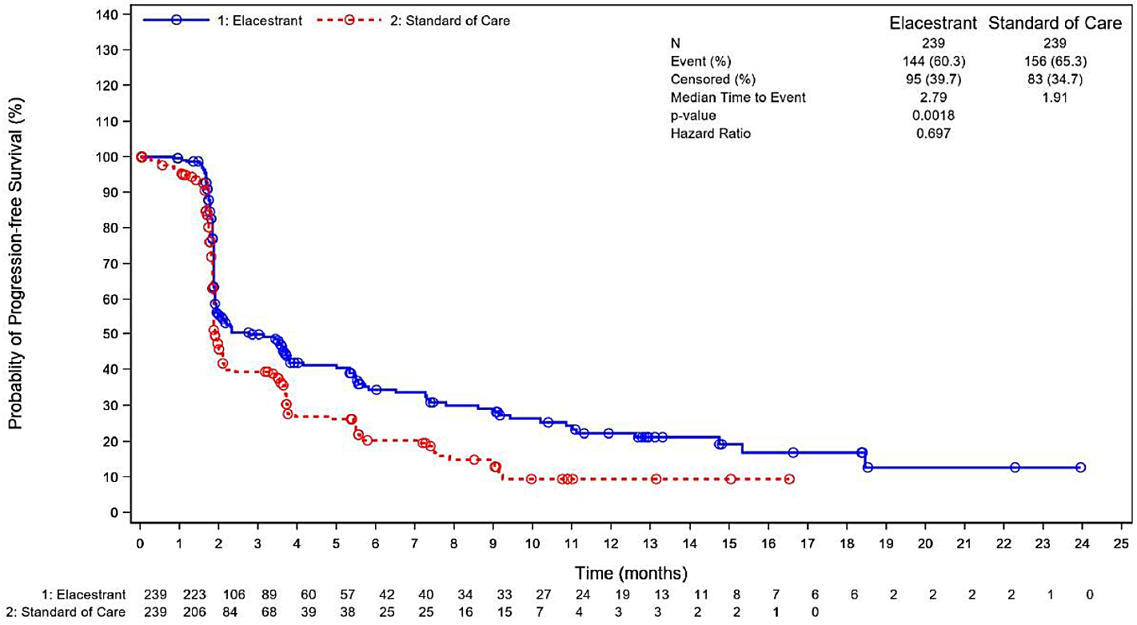

Figure 5. Kaplan-Meier Plot for Blinded IRC Assessment of PFS in ESR1-mut subjects
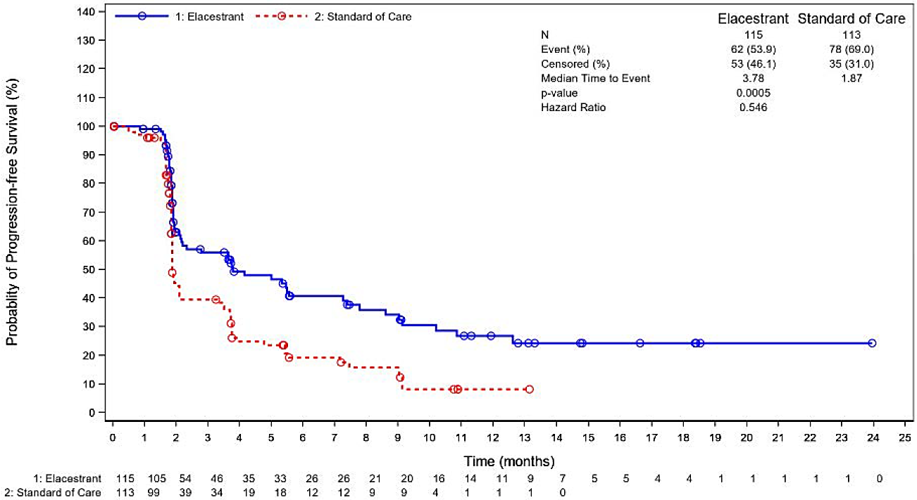
Key secondary endpoint – Overall Survival: At the time of the DCO date (06 September 2021), an interim analysis for OS was performed. The results are presented in Table 11 and Table 12. KM curves are presented in Figure 6 and Figure 7. At the 06 September 2021 DCO, a total of 57 subjects were censored for OS due to withdrawal of consent, physician decision, or lost to follow-up. All sites were contacted. The “vast majority” of the sites refused to give updated survival information or were non-responsive. There was insufficient data to calculate median OS at this stage.
Updated OS analysis: An updated analysis for OS was performed with a cut-off date of 02 September 2022 with a median follow-up for OS of 26.0 months for both the overall population and the ESR1-mut population. Summary results are presented in Table 13. Median OS was calculable for all four groups at this DCO. There is no significant difference in OS between elacestrant and SOC in Overall group (Figure 8) or in the ESR1-mut group (Figure 9). Study 308 continues and further follow up for survival is ongoing.
Table 11. Analysis of Overall Survival Study 308 (EMERALD) DCO September 2021
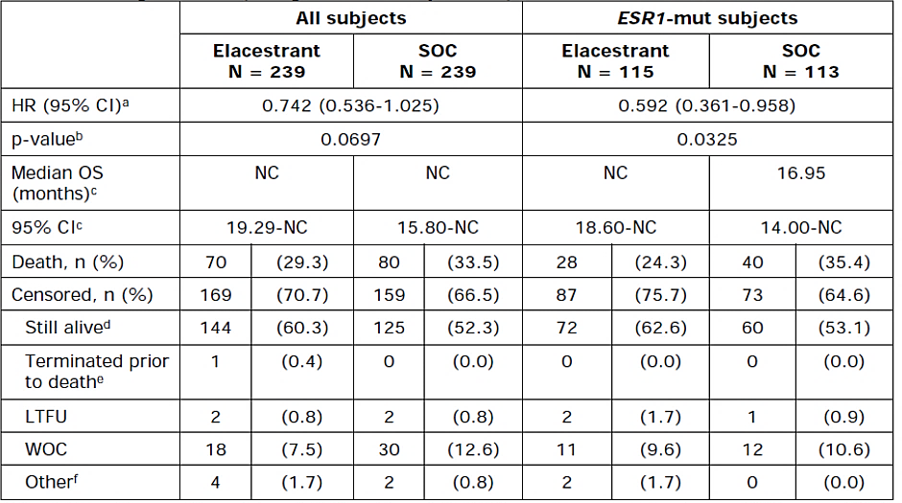
Abbreviations: CI = confidence interval; DCO = data cutoff; ESR7 = estrogen receptor 1 gene; ESR7-mut = ESRT
mutation positive; HR = hazard ratio; ITT = intent-to-treat; KM = Kaplan-Meier; LTFU = loss to follow-up;
n = number of subjects with the observed group characteristic; N = total number of subjects in group; NC = not
calculable; OS = overall survival; SOC = standard of care; WOC = withdrawal of consent.
a The analysis was performed using a stratified Cox proportional hazards model with ties=Efron and the
Stratification factors: prior treatment with fulvestrant (yes vs no) and presence of visceral metastases (yes vs no)
the Cl calculated using a profile likelihood method.
b The p-value was generated by using a 2-sided stratified log-rank test.
c Calculated using KM technique. Cl for median OS is derived based on the Brookmeyer-Crowley method using a
linear transformation.
d Includes subjects known to be alive at DCO (06 September 2021).
e Includes subjects with unknown survival status.
f Includes any reason other than LTFU and WOC.
Table 12. Landmark Analysis of Overall Survival Study 308 (EMERALD) DCO September 2021
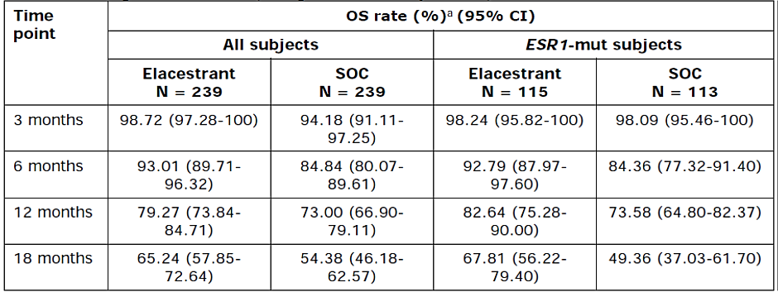
Abbreviations: CI = confidence interval; ESR7 = estrogen receptor 1 gene; ESR7-mut = ESR7 mutation positive;
ITT = intent-to-treat; KM = Kaplan-Meier; N = total number of subjects in group; OS = overall survival:
SOC = standard of care.
ª Calculated using KM technique. CI for OS is derived based on the Brookmeyer-Crowley method using a linear
transformation.
Figure 6. KM Plot Overall Survival All Subjects (ITT population) Study 308 (EMERALD) DCO Sep 2021
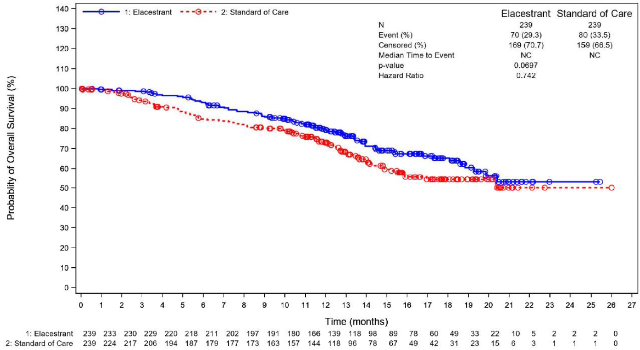
Figure 7. KM Plot for Overall Survival in ESR1-mut Subjects (ITT) Study 308 (EMERALD) DCO Sep 2021
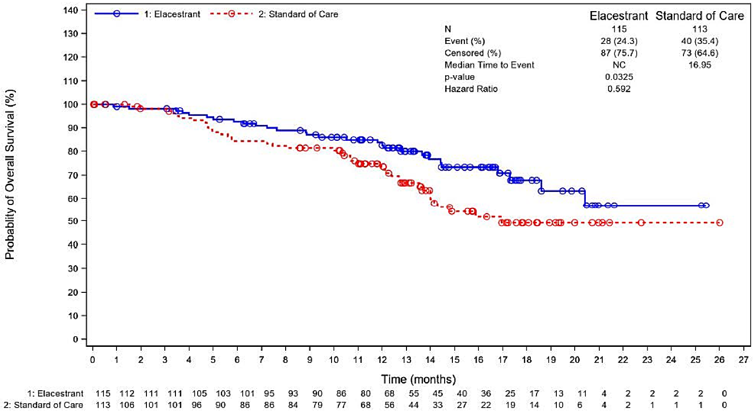
Table 13. Updated Overall Survival ITT Population Study 308 (EMERALD) DCO Sep 2022
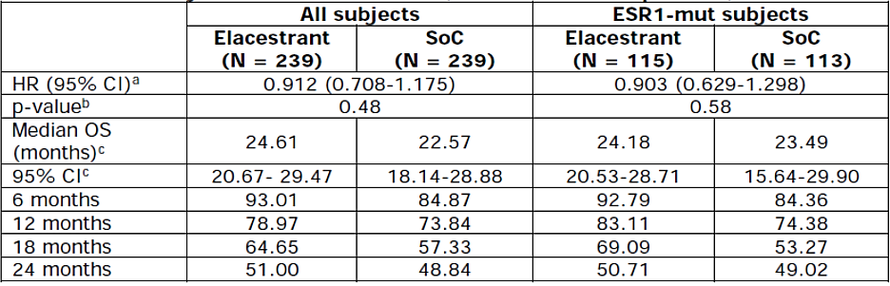
Abbreviations: CI = confidence interval; ESR1 = estrogen receptor 1 gene; ESR1‑mut = ESR1 mutation positive; ESR1-mut-nd = ESR1 mutation not detected; HR = hazard ratio; IRC = Imaging Review Committee; KM = Kaplan-Meier; ITT = intent-to-treat; N = total number of subjects in group; OS = Overall survival; SoC = standard of care.
^{a.} The analysis was performed using a stratified Cox proportional hazards model with ties = Efron and the stratification factors: prior treatment with fulvestrant (yes vs no) and presence of visceral metastases (yes vs no); the CI calculated using a profile likelihood method.
^{b}. The p-value was generated by using a 2-sided stratified log-rank test.
^{c}. Calculated using KM technique. CI for median is derived based on the Brookmeyer-Crowley method using a linear transformation.
Figure 8. Updated KM plot of OS ITT All Subjects and ESR1-mut Study 308 (EMERALD) DCO Sep 2022
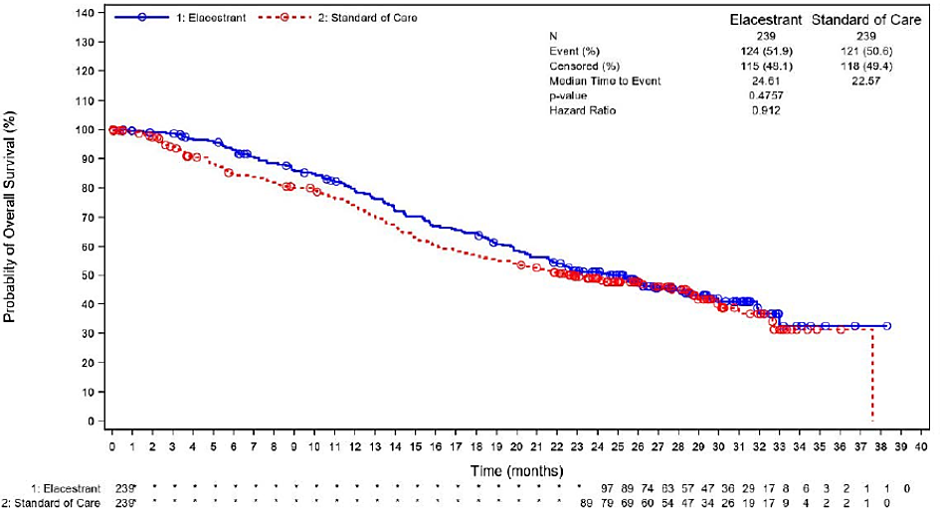

Figure 9. Updated KM plot of OS ITT ESR1-mut Study 308 (EMERALD) DCO Sep 2022.
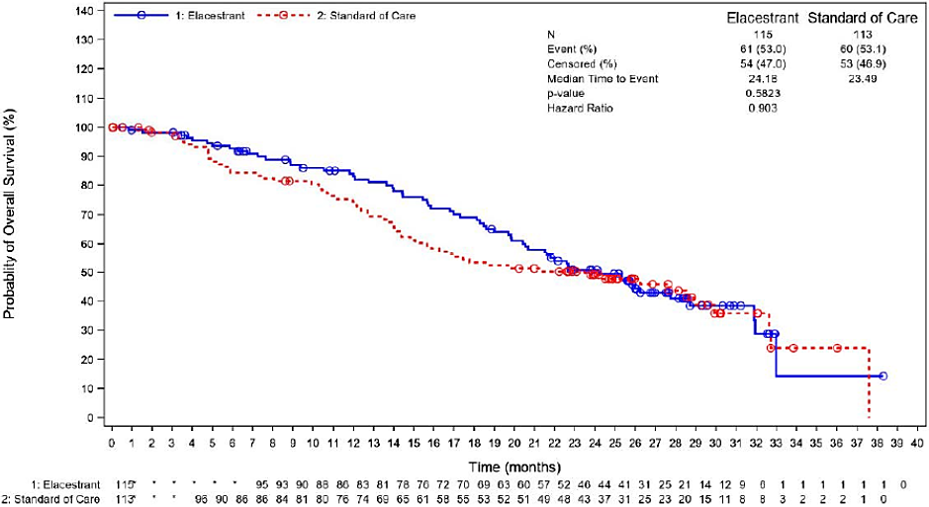

Other Secondary endpoints
Progression free survival in ESR1-mu-nd subjects by blinded IRC: The analysis of the blinded IRC assessment of PFS in ESR1-mut-nd subjects is shown in Table 14 and landmark analysis in Table 15. In ESR1-mut-nd subjects, HR for PFS was 0.863 (95% CI: 0.628-1.186), p = 0.3082, stratified log-rank test). A KM plot of PFS for ESR1-mut-nd subjects is shown in Figure 10.
Table 14. Analysis of Blinded IRC Assessment of PFS in ESR1-mut-nd subjects Study 308 (EMERALD)
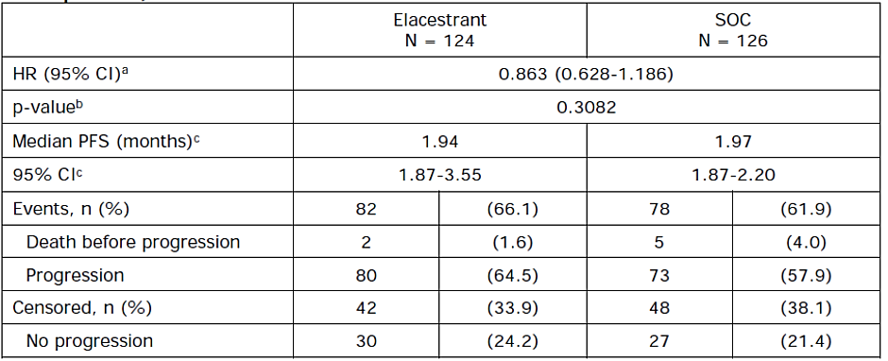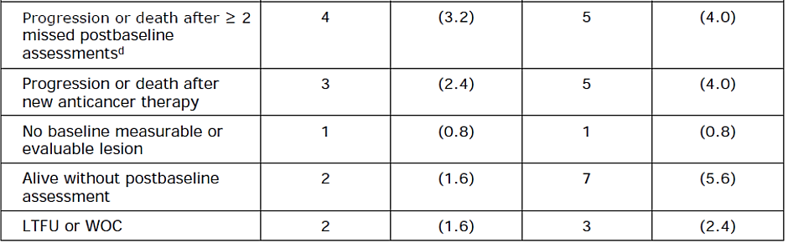
Abbreviations: CI = confidence interval; ESR1 = estrogen receptor 1 gene; ESR1-mut-nd = no ESR1 mutation detected; HR = hazard ratio; IRC = imaging review committee; ITT = intent-to-treat; KM = Kaplan-Meier; LTFU = loss to follow-up; n = number of subjects with the observed group characteristic; N = total number of subjects in group; PFS = progression-free survival; SOC = standard of care; WOC = withdrawal of consent.
ª The analysis was performed using a stratified Cox proportional hazards model with ties=Efron and the stratification factors: prior treatment with fulvestrant (yes vs no) and presence of visceral metastases (yes vs no); the CI calculated using a profile likelihood method.
^{b} The p-value was generated by using a 2-sided stratified log-rank test.
^{c} Calculated using KM technique. CI for median PFS is derived based on the Brookmeyer-Crowley method using a linear transformation.
^{d} Date of last tumour assessment before missed assessments or date of randomization, whichever is later.
Table 15. Landmark Analysis Blinded IRC Assessment PFS ESR1-mut-nd Subjects Study 308 EMERALD)
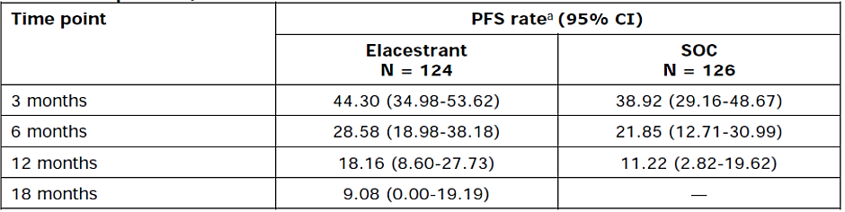
Abbreviations: CI = confidence interval; ESR1 = estrogen receptor 1 gene; ESR1-mut-nd = no ESR1 mutation detected; IRC = imaging review committee; ITT = intent-to-treat; KM = Kaplan-Meier; N = total number of subjects in group; PFS = progression-free survival; SOC = standard of care.
ª Calculated using KM technique. CI for PFS is derived based on the Brookmeyer-Crowley method using a linear transformation.
Figure 10. KM Plot Blinded IRC Assessment PFS ESR1-mut-nd Study 308 (EMERALD)
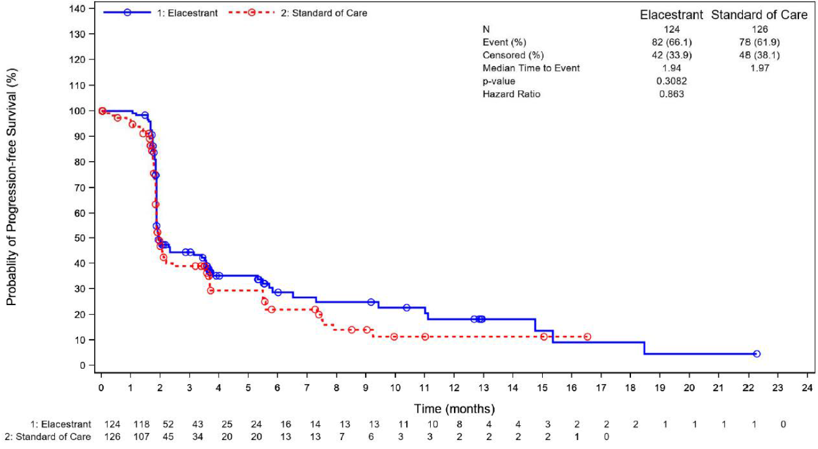

Investigator assessment of PFS
There was a degree of discordance between IRC assessment of disease progression (PFS) and that of the principal investigator. This is summarised in Table 16. However, analysis of Investigator assessment of PFS results were in the same general direction as IRC assessment results, (Table 17) with a slightly larger HR and p-value for the key comparisons between elacestrant and SOC in ESR1-mut subjects (0.647 p= 0.0049 cf 0.546 p= 0.0005). KM analysis generated similar curves (not shown).
Table 16. Discordance between IRC and Principal Investigator derived PFS Study 308 (EMERALD)
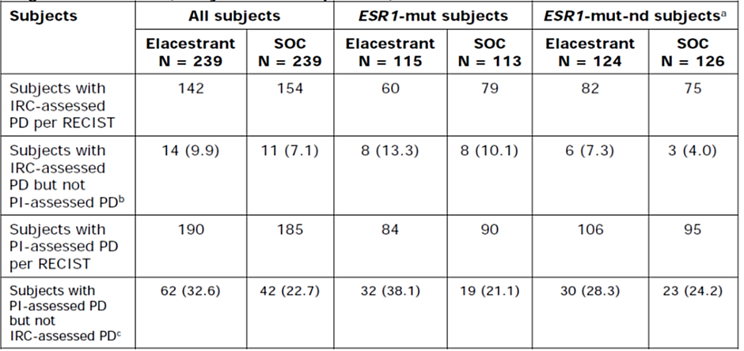
Abbreviations: ESR71 = estrogen receptor 1 gene: ESR1-mut = ESR7 mutation positive: IRC = Imaging Review
Committee; ITT = intent-to-treat; N = total number of subjects in group: PD = progressive disease;
PFS = progression-free survival; Pl = principal investigator; RECIST = Response Evaluation Criteria in Solid
Tumours; SOC - standard of care.
ª ESR1-mut-nd values were calculated as subtraction between all subjects and ESR71-mut subjects.
^{b} Subjects with missing Pl response assessment were not included in the no PD category. Percentage was
calculated using number of subjects with IRC-assessed PD as denominator.
^{c} Subjects with missing IRC response assessment were not included in the no PD category. Percentage was
calculated using number of subjects with local Pl-assessed PD as denominator.
Table 17. Analysis of Investigator Assessment of PFS Study 308 (EMERALD)
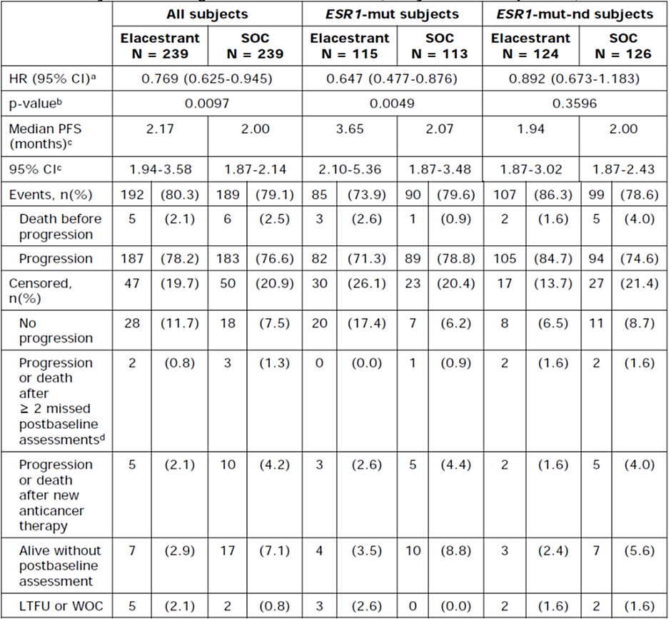
Abbreviations: CI = confidence interval: ESR1 - estrogen receptor 1 gene: ESR1-mut - ESR7 mutation positive:
HR = hazard ratio: ITT = intent-to-treat: KM - Kaplan-Meier; LTFU = loss to follow-up: n = number of subjects
with the observed group characteristic: N = total number of subjects in group: PFS = progression-free survival:
SOC = standard of care; WOC = withdrawal of consent.
ª The analysis was performed using a stratified Cox proportional hazards model with ties=Efron and the
stratification factors: prior treatment with fulvestrant (yes vs no) and presence of visceral metastases (yes vs no);
the CI calculated using a profile likelihood method.
^{b} The p-value was generated by using a 2-sided stratified log-rank test.
^{c} Calculated using KM technique. CI for median PFS is derived based on the Brookmeyer-Crowley method using a
linear transformation.
d Date of last tumour assessment before missed assessments or date of randomization, whichever is later.
Objective response rate
The ORR as assessed by the blinded IRC in the response evaluable population. No subjects had a complete response (CR). For ESR1-mut-nd subjects, the ORR was 2.1% in the elacestrant group and 4.2% in the SOC group. There was no statistically significant difference in ORR between elacestrant and SOC for any cohort (all subjects, ESR1-mut subjects, or ESR1-mut-nd subjects).
Clinical benefit rate (CBR)
The CBR was assessed by the blinded IRC in the clinical benefit evaluable population. There were no subjects with confirmed complete response (CR), so the CBR consists of subjects with any best overall response (BOR) of partial response (PR) or BOR of stable disease (SD) sustained for at least 24 weeks. Among ESR1-mut-nd subjects, the CBR was 13.3% in the elacestrant group versus 15.3% in the SOC group.
Duration of response (DOR)
The median DOR as assessed by the blinded IRC could not be calculated in the elacestrant group for either cohort of subjects, as all such subjects were censored without progression or death.
Patient reported outcomes
Rates of completion of the questionnaires ranged from 70% at best to less than 20% in late stages. There were no noteworthy differences between the treatment groups and no noteworthy changes over time in either group, either for all subjects or ESR1-mut subjects.
Time to chemotherapy (as a surrogate for “failed treatment or disease progression”)
Among all subjects, chemotherapy as first systemic therapy after treatment discontinuation was recorded for approximately half of the subjects. In the elacestrant group, 114 subjects received chemotherapy after treatment discontinuation (47.7%). In the SOC group, 120 subjects received chemotherapy after treatment discontinuation (50.0%). In the ESR1-mutated population the proportion receiving chemotherapy after treatment discontinuation was 43.5% and 52.2%, in the elacestrant and SOC arm, respectively.
The mean (SD) time to chemotherapy was similar in the elacestrant and SOC groups, at 111.0 (70.14) days and 97.8 (67.28) days, respectively. Subjects with ESR1-mut had a time to chemotherapy of 105.8 (63.04) days in the elacestrant group and 102.8 (71.31) days in the SOC group. Subjects with ESR1-mut-nd had a time to chemotherapy of 115.0 (75.46) days in the elacestrant group and 92.9 (63.36) days in the SOC group. Some subjects may have received therapy other than chemotherapy as their first post-study therapy. Time from randomization to first new anti-cancer therapy in the overall population was at median 92.0 days in the elacestrant arm and 77.5 days in the SOC arm.
Restricted mean survival time
In all patients, restricted mean survival time (RMST) was 7.54 months (SE 0.85) in the elacestrant arm and 5.18 (SE 0.50) in the SOC arm. RMST difference was 2.36 (95% CI: 0.59-4.13), p-value 0.0088. For ESR1-mutated patients, restricted mean survival time (RMST) was 9.25 (SE 1.15) in the elacestrant arm and 5.17 (SE 0.87) in the SOC arm. RMST difference was 4.08 (95% CI: 1.57-6.59), p-value 0.0015.
Subgroup analyses
Prespecified subgroup analyses were conducted and displayed by forest plot for all subjects (Figure 11) and ESR1-mut subjects (Figure 12).
Figure 11. Forest Plot Blinded IRC Assessment PFS in all subjects (n=478) Study 308 (EMERALD)
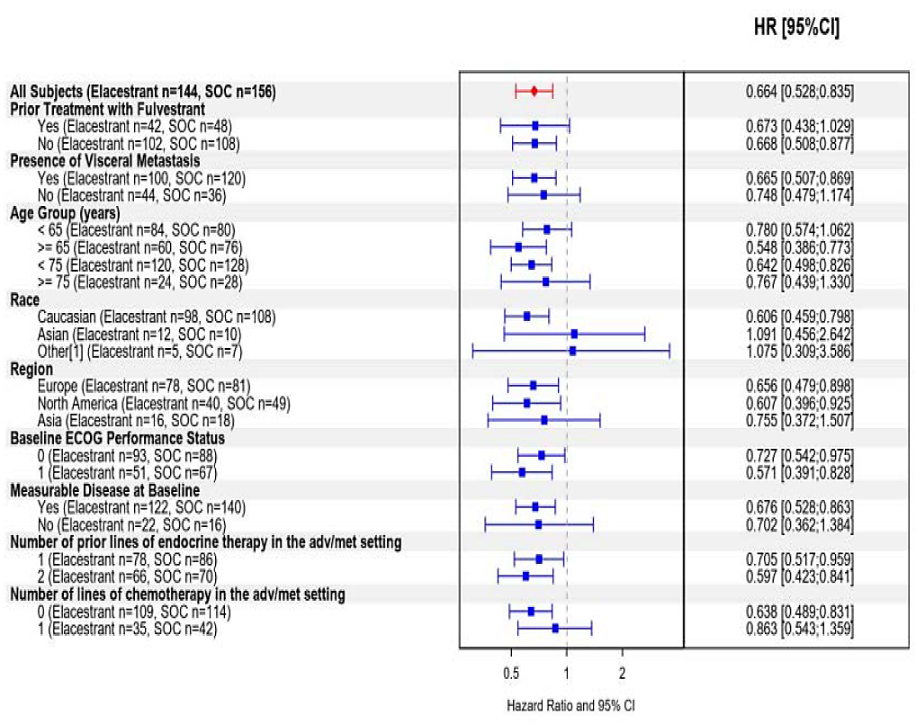
Abbreviations: adv/met = advanced/metastatic; CI = confidence interval; ECOG = Eastern Cooperative Oncology
Group; HR = hazard ratio; IRC = imaging review committee; ITT = intent-to-treat; n = number of PFS events;
PFS = progression-free survival; SOC = standard of care.
Note: Includes subjects with multiple races
HR is calculated using an unstratified Cox proportional hazards model with ties = Efron. The CI is calculated using a profile likelihood approach.

Figure 13. Forest Plot Blinded IRC Assessment PFS in ESR1-mut (n=228) Study 308 (EMERALD)
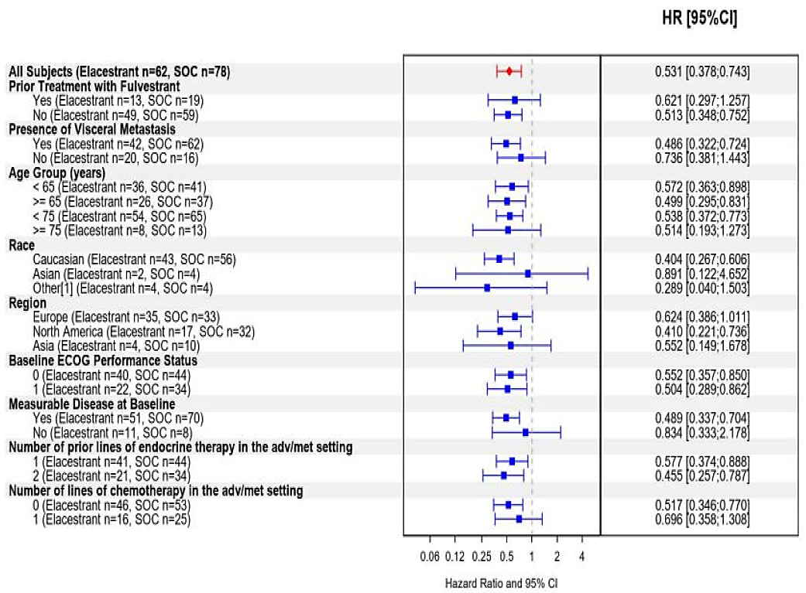
Abbreviations: adv/met = advanced/metastatic; CI = confidence interval; ECOG = Eastern Cooperative Oncology
Group; ESR1-mut = ESR1 mutation positive; HR = hazard ratio; IRC = imaging review committee;
ITT = intent-to-treat; n = number of PFS events; PFS = progression-free survival; SOC = standard of care.
Note: Includes subjects with multiple races
HR is calculated using an unstratified Cox proportional hazards model with ties = Efron. The CI is calculated using a profile likelihood approach
Prior treatments with or without fulvestrant
Since fulvestrant is a SERD, like elacestrant, prior treatment with it could conceivably influence the response to elacestrant. An analysis of PFS grouped by prior fulvestrant yes/no is presented in Table 18.
It is worth noting that the median PFS in subjects given elacestrant who had not previously received fulvestrant appears to be almost double that of those who had received fulvestrant. This is evident in the elacestrant group in all-subjects comparison (median PFS 3.65 vs. 1.91) and the ESR1-mut subjects (median PFS 4.14 vs 1.91). There was no such interaction in the SOC group. It can also be appreciated from examination of the forest plots (Figure 12 and Figure 13).
Prior treatment with fulvestrant appears to be associated with attenuated effect for elacestrant (Table 18).
Table 18. Subgroup analysis blinded IRC Assessment PFS by prior treatment with fulvestrant
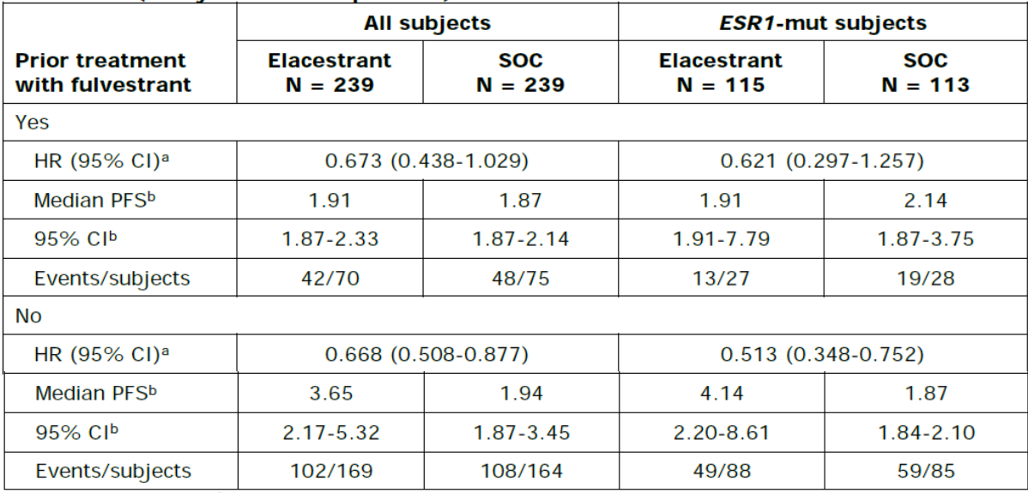
Abbreviations: CI = confidence interval; ESR1 = estrogen receptor 1 gene: ESR1-mut = ESR1 mutation positive;
HR = hazard ratio: IRC = imaging review committee: ITT = intent-to-treat: KM = Kaplan-Meier; N = total number
of subjects in group: PFS = progression-free survival; SOC = standard of care.
ª HR is calculated using an unstratified Cox proportional hazards model with ties- Efron. The Cl is calculated using
a profile likelihood approach.
^{b} Calculated using KM technique. Cl for median PFS is derived based on the Brookmeyer-Crowley method using a
linear transformation.

Fulvestrant-as-SOC versus elacestrant
Among all subjects, 166 out of 239 subjects (69%) received fulvestrant as the SOC treatment in this study, and the HR for the comparison with elacestrant was 0.684 (95% CI: 0.521-0.897). The IRC-assessed PFS estimates at the various time points are presented below.
- At 3 months: 49.75% in the elacestrant group versus 40.86% in the SOC group
- At 6 months: 34.32% in the elacestrant group versus 22.86% in the SOC group
- At 12 months: 22.32% in the elacestrant group versus 10.15% in the SOC group
- At 18 months: 16.82% in the elacestrant group versus “data not available” in SOC
Among ESR1-mut subjects, 83 out of 113 subjects (73%) received fulvestrant as the SOC treatment in this study, and the HR for the comparison with elacestrant was 0.504 (95% CI: 0.341-0.741). The IRC-assessed PFS estimates at the various time points are presented below.
- At 3 months: 55.93% in the elacestrant group versus 37.42% in the SOC group
- At 6 months: 40.76% in the elacestrant group versus 20.75% in the SOC group
- At 12 months: 26.76% in the elacestrant group versus 8.41% in the SOC group
- At 18 months: 24.33% in the elacestrant group versus “data not available” in SOC
Aromatase inhibitors-as-SOC versus elacestrant
Among all subjects, 73 out of 239 subjects (31%) received an AI as the SOC treatment in this study, and the HR for the comparison with elacestrant was 0.779 (95% CI: 0.520-1.172). Median PFS was 2.79 months (95% CI: 1.94-3.78) in the elacestrant group and 1.87 months (95% CI: 1.87-2.20) in the AI group.
Among ESR1-mut subjects, 30 out of 113 subjects (27%) received an AI, and the HR for the comparison with elacestrant was 0.659 (95% CI: 0.320-1.329). Median PFS was 3.78 months (95% CI: 2.17-7.26) in the elacestrant group and 2.14 months (95% CI: 1.87-3.75) in the AI group.
Among ESR1-mut-nd subjects, 43 out of 126 subjects (34%) received an AI. The HR for the comparison with elacestrant versus AI treatment was 0.848 (95% CI: 0.517 to 1.409), stratified log-rank test p-value = 0.4763.
Duration of CDK4/6
An exploratory post-hoc analysis examining the PFS of elacestrant, relative to standard of care, according to the duration of prior treatment with CDK4/6i plus endocrine therapy in the metastatic setting is presented in Table 19. Numbers were small, but patients with a longer period of pretreatment (response to treatment) with CDK4/6i had an observed further increase in PFS with elacestrant, compared with SOC.
Table 19. PFS by duration of CDK4/6i in ESR1-mut subjects
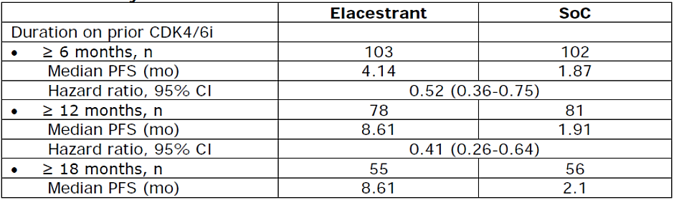
PFS by type of ESR1 mutation
Table 20 presents a list of the mutations in ESR1 sequenced on patient’s ctDNA with the frequency with which they occurred, and the median PFS for that mutation, if calculable. No specific mutation seemed to be associated with an increased or decreased impact of elacestrant on PFS compared with SOC. Numbers in each cell were small.
Table 20. Frequency and median PFS (where calculable) for each ESR1 mutant detected by Guardant 360x Companion Diagnostic, within the proposed biomarker definition (codon 310 -530)
Abbreviations: NA = not applicable; PFS = progression-free survival.
NA: not applicable, when the number of patients in the corresponding category is 6 or less.
Updated PFS analysis September 2022
An update of the PFS analyses with a data cut-off date of 02 September 2022, providing approximately one additional year of data, was conducted. At that time only 7 additional PFS events were observed (5 in the elacestrant group and 2 in SOC), leading to a total of 307 events, relative to the original cut-off date of 06 September 2021. Table 21 and 22 show the results of the updated PFS analysis for all patients and ESR1-mut patients, based on a cut-off date of 02 September 2022. At this cut-off, median follow-up in the study was 20.4 months for all patients and for ESR1 mut patients. For PFS median follow-up was 24.0 months. The primary efficacy outcome of enhanced PFS was virtually unchanged at the updated DCO.
Table 21. Blinded IRC PFS Analysis All Subjects DCO 6 Sep 2021 versus Updated DCO 2 Sep 2022
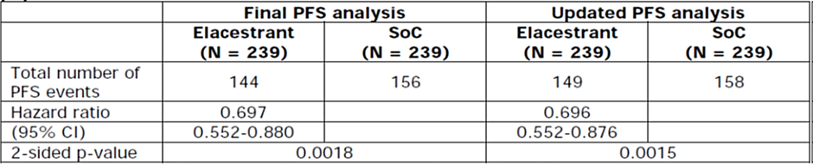
Abbreviations: CI = confidence interval: PFS = progression-free survival: SoC = standard of care.
* The p-value was generated by using a two-sided stratified log-rank test.
Table 22. Blinded IRC PFS Analysis ESR1-mut Subjects DCO 6 Sep 2021 versus Updated DCO 2 Sep 2022
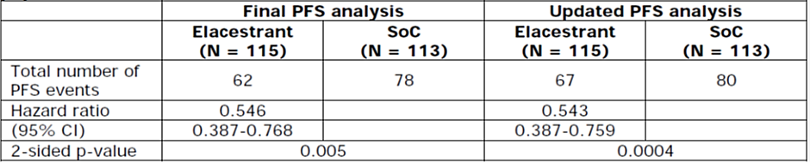
Abbreviations: CI = confidence interval: PFS = progression-free survival: SoC = standard of care.
* The p-value was generated by using a two-sided stratified log-rank test.
Sensitivity analyses
To investigate the impact of discordance between IRC and PI derived PFS, a sensitivity analysis was performed in which all PFS events either IRC or PI were counted. The HR for comparison between elacestrant and SOC in all subjects was 0.774 95% CI 0.633 – 0.956 p = 0.0099. The HR for comparison between elacestrant and SOC in ESR1-mut subjects was 0.643 95% CI 0.479 – 0.863 p = 0.0034.
Further sensitivity analysis of the primary endpoint was conducted. Using backdating analysis, unstratified analysis, per protocol analysis. All yielded comparable results.
PFS stability was confirmed at multiple time points through the conduct of the study.
Early censoring
During the first 2 months after randomisation, the KM curves showed 92 (31.9%) censored subjects. The numbers are relatively balanced between the two treatment arms (40 (30.1%) in elacestrant and 52 (33.5%) in SOC. Reasons for IRC-censoring during the first 2 months after randomization are reported in Table 23.
Later censoring is higher in the elacestrant arm (55 (52%) subjects) vs the SOC arm (31 (37%) subjects) reflecting the fact that patients in the elacestrant arm stay longer in treatment with no progression.
Table 23. Frequency table for censoring of PFS < 2 months, All Subjects Blinded IRC
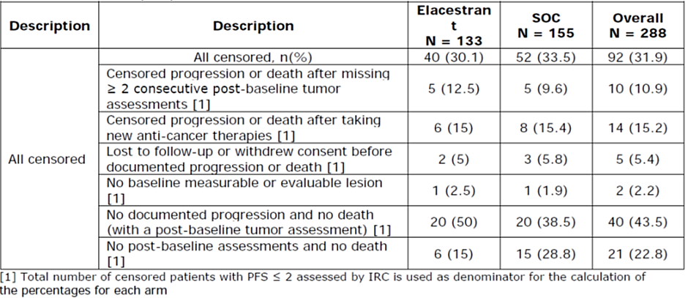
A tipping point analysis was performed to assess the robustness of the estimate of HR against the unknown effect of censored subjects.
- All patients censored within the first 2 months were considered as events. Then +1 day was added incrementally to the date of the event for those patients in both groups at each analysis run. A HR of 1 was never reached, even after adding 10000 days (HR = 0.79 for ALL patients, and HR = 0.577 for ESR1-mut). It was concluded that even such an unlikely deviation would keep the results statistically significant in favour or elacestrant.
- Censored patients were turned into events for the elacestrant arm only (representing the worst-case scenario), sorting the patients by time to censoring (ascending order). When all the first 40 censored patients were transformed into the event, the HR still favours the ELA (HR of 0.923 in all subjects and 0.808 in ESR1-mut patients). The process then continued by transforming into events one by one all the remaining patients censored with a PFS time greater than 2 months. The tipping point was found to be between 55 and 60 for the all-patient population, while in the ESR1-mut population HR never reaches 1.0 even when all the censored patients in the elacestrant arm are turned into events (maximum HR equal to 0.929).

Conclusions on clinical efficacy (EMERALD)13
The primary endpoint IRC-assessed PFS shows significant, but small differences in favour of elacestrant compared to SOC in the overall population and the population with an ESR1 mutation. The results seem to be mainly driven by patients with an ESR1 mutation who have a longer PFS in the elacestrant group compared to the overall population, but the SOC performs similar in the ESR1-mut-nd and overall group. Therefore, the indication was restricted to patients with an activating ESR1-mutated tumour. The differences in PFS were only observed at and after the first scan at 8 weeks, but tipping point analyses correcting for early censoring, showed that in the ESR1-mut population the results are robust.
The key secondary endpoint OS was not statistically different between the elacestrant and SOC arms in both the overall and ESR1-mut population, though reassuringly the KM curves did not show signals of a detriment.
During the study, two major changes were conducted regarding the efficacy testing procedures. The first change was an earlier than planned PFS analysis. Although the decision for changing the analysis time point seems to have been made by persons not blinded to treatment assignment, these had no access to aggregated data. In addition, additional analyses with an updated PFS analysis and stable HR ratios over time support that the final PFS analysis provided can be regarded as a reliable alternative to the originally planned final analysis. Regarding the second amendment, the OS testing procedure was changed late in an open-label study. This change was motivated by external advice from the FDA and no data from the ongoing study was used to inform the changes made. As neither the interim nor the final OS analysis showed a statistically significant effect on OS, there is also no impact of the late definition of the multiplicity procedure on the interpretation of the OS analysis. Based on this, it is considered that the internal validity of the study was maintained irrespective of the changes in the testing procedures and that the presented efficacy results do allow for an adequate B/R assessment.
An additional issue identified is the discordance between independent and investigator review of PFS with the risk of informative censoring biasing IRC-assessed PFS in the elacestrant arm. A sensitivity analysis counting both investigator- and IRC-assessed progression as event showed a very small difference between the elacestrant and SOC arm, even in the ESR1-mutated population. However, with the restriction of the indication to ESR1-mut patients and the gain of median PFS of 1.58 months reported for investigator-assessed PFS in favour of elacestrant in this subpopulation, this issue will not be further pursued. A sensitivity analysis where the start of new anticancer therapy was reported as event was in line with the final PFS analysis.

Safety

Patient exposure
Overall, as of 27 December 2021, a total of 815 subjects were exposed to elacestrant across all completed studies, which included, besides MBC, several studies in healthy subjects and 2 phase 2 studies in postmenopausal women with vasomotor symptoms. The dose range studied was 200 mg – 1000 mg, most subjects received 400 mg. As of 06 September 2021, a total of 312 subjects with MBC were exposed to elacestrant: 239 subjects from the Phase 3 Study 308, 57 subjects from the completed Phase 1 Study 005, and 16 subjects from the completed Phase 1 Study 106. Most subjects received 400 mg, 4 subjects in study 005 received 200 mg and 3 subjects received 600 mg. In Study 006, 2 subjects received 200 mg only.
Safety data were presented for the proposed registration dose for elacestrant of 400 mg QD for both the pooled phase 1 (RAD1901-105 and RAD1901-106) studies (n=64) and the phase 3 RAD1901-308 study (n=237) separately, as subjects enrolled in the Phase 1 studies were more heavily pre-treated and with more advanced disease and 40 subjects received the initial capsule formulation.
Median exposure for elacestrant was 117.0 days (range: 5-1288) and 84.0 days (range: 13-756) for the phase 1 Pool and Study 308, respectively. The median duration of treatment was 85 days (range 5to 1288). Median exposure for the SOC fulvestrant was 84.0 days (range: 2-464) and for AIs 64.5 days (1-554). Relative dose intensity was above 90% for 97%-100% of subjects across studies and treatment arms.

Adverse events

Treatment emergent adverse events
Overall, most subjects (>30%) treated with elacestrant reported a treatment-emergent adverse event (TEAE) in the Gastrointestinal Disorders category (65.4%), followed by Musculoskeletal and connective tissue disorders (44.7%), General disorders and administration site conditions (37.6%), and Investigations (34.2%).
The most frequently reported TEAEs (≥10%) for elacestrant per preferred term (PT) were nausea (35.0% vs 16.1% with fulvestrant vs 25.0% with AI), vomiting (19.0% vs 7.5% with fulvestrant vs. 10.3% with AI), and fatigue (19.0% vs. 21.7% with fulvestrant vs. 11.8% with AI). Other commonly (≥10%) observed adverse events with elacestrant were decreased appetite, back pain, arthralgia, diarrhoea, aspartate aminotransferase increased (AST), constipation, headache, hot flush, and dyspepsia.
Gastrointestinal TEAEs, except diarrhoea, were more frequently reported than for the SOC. Frequencies of other TEAEs were in general in the same order of magnitude as for the SOC. AEs reported more frequently (≥5% difference) with fulvestrant compared to elacestrant were injection site pain (8.7%) related to the intramuscular route of administration and blood pressure increased for AI (8.8% vs. 3.8%). Common TEAEs for the SOC are in line with that known and reported in the Summary of Product Characteristics.
Most TEAEs were Grade 1 or 2; 27.0% in the elacestrant arm and 20.5% in the SOC were Grade 3 or4. Most commonly reported Grade 3 or 4 TEAEs with elacestrant were nausea, back pain, bone pain (2.5% each), alanine aminotransferase increased, and blood pressure increased (2.1% each). Most commonly reported Grade 3 or 4 TEAEs with fulvestrant were blood pressure increased (2.5%) and anaemia (1.2%). For AI, most commonly reported Grade 3 or 4 TEAEs were nausea, abdominal pain, blood pressure increased, gamma-glutamyl transferase increased, neutropenia, and tumour pain (2.9% each).

Treatment Related Adverse Events
Gastrointestinal events were also the most frequently reported treatment-related TEAEs for elacestrant, mainly nausea (25.3%), and vomiting (11.0%) and at higher rates than for the SOC (Table 24). Fatigue was another frequently reported treatment-related TEAE (11.0%). The most common treatment-related TEAEs for fulvestrant were nausea (8.7%), fatigue (8.1%), and injection site pain (8.1%). The most common treatment-related TEAEs for AI were nausea (8.8%), decreased appetite (8.8%), and fatigue (7.4%). TEAEs in the SOC Musculoskeletal disorders and connective tissue were more often reported as treatment-related for the comparator arm (17.9% vs. 7.6%).
Table 24. Treatment related TEAE's in > 5% of subjects (Safety Population)
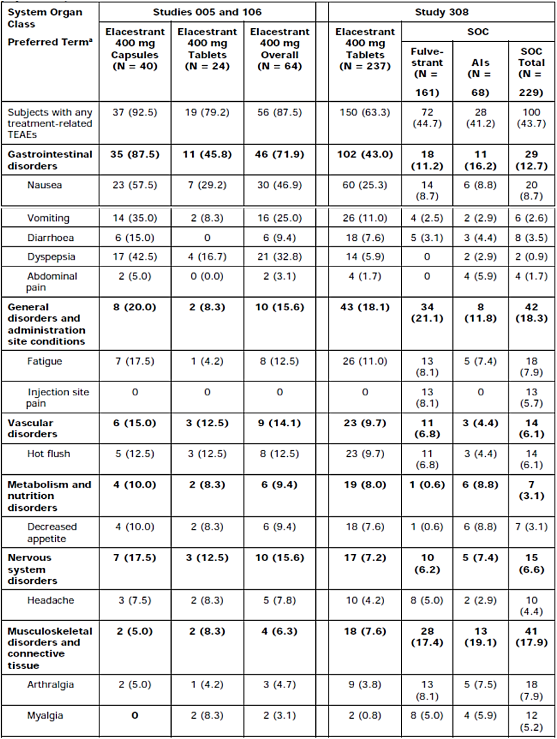
Abbreviations: AE = adverse event: Al = aromatase inhibitor; eCRF = electronic case report form; ISS = Integrated
Summary of Safety; MedDRA = Medical Dictionary for Regulatory Activities; N = total number of subjects in
group; SOC = standard of care; TEAE = treatment-emergent adverse event.
* Preferred terms are summarized using AE synonym terms.
Note: MedDRA Version 23.0 was used. Subjects with 1 or more AEs within a system organ class of MedDRA were
counted only once. A TEAE is considered treatment related if its causality was “possibly related,” “definitely
related,” or “related” on the AE eCRF pages from each study. System organ classes are sorted by descending
order of frequency of preferred terms in the elacestrant group in Study 308. Preferred terms are sorted by
descending order of frequency in the elacestrant group in Study 308 within each system organ class.

Serious adverse events/deaths and other significant events

Deaths
Overall, frequencies were low; 1.7% (n=4) of subjects had a TEAE with an outcome of death in the elacestrant arm, compared to 2.6% (n=6) in the SOC. For each TEAE, only single cases were reported. None of the death cases were assessed as study-drug-related by the investigator.

Serious adverse events
Frequencies of serious adverse events (SAEs) were comparable between elacestrant and the SOC (12.2% vs. 10.9%). Serious TEAEs by PT occurring in more than 1 subject were nausea with elacestrant (1.3%), pneumonia with fulvestrant (1.2%), and abdominal pain and urinary tract infection (each 2.9%) with AI. Treatment-related serious TEAEs occurred only in the elacestrant arm in study 308 (1.3%).
The only treatment-related serious TEAE reported in more than one subject was nausea (n=2, 0.8%). Treatment-related SAEs in the pooled phase 1 studies included one subject with acute hepatic failure (elacestrant 400 mg tablet), and one subject with pulmonary embolism and dyspnoea (elacestrant 400 mg capsules).
Considering the phase 1 studies, there was 1 case of grade 4 acute hepatic failure in study RAD1901-005, possibly related to elacestrant. In addition, there were two cases of treatment-related serious TEAEs pulmonary embolism (one in phase 1 study pool and one in study 308).

Laboratory abnormalities
No significant or clinically meaningful changes in clinical laboratory evaluations were observed in subjects treated with elacestrant.
Shifts from NCI CTCAE Grade 0, 1, or 2 at baseline to any incidence of Grade 3 or 4 on treatment were infrequent, occurring in 7 subjects or less in any group for haematology variables, 5 subjects or less in any group for chemistry variables, and 2 subjects or less in any group for coagulation variables in Study 308. High cholesterol (75.5% vs 58.5%), triglycerides (60.8% vs. 44.1%), creatinine (25.7% vs. 16.2%), and low bicarbonate (23.2% vs. 17.5%) were more common in the elacestrant group, whereas high alanine aminotransferase (ALT, 23.6% vs 16.5%), AST (33.2% vs. 28.3%), alkaline phosphatase (ALP, 24.9% vs 16.5%), and bilirubin (9.2% vs. 3.0%) were more common in the SOC group. Grade 3 or 4 abnormalities were rare in both groups. The only Grade 3 laboratory abnormality reported in ≥5% of subjects in any group was low lymphocytes (6.3% for elacestrant subjects and 3.9% for SOC subjects). No Grade 4 laboratory abnormalities were reported in ≥5% of subjects in any group.

Vital signs, physical findings, and other observations related to safety
No trends over time or differences between groups were observed in vital signs or blood pressure and no meaningful difference in abnormal vital signs was observed between elacestrant and the SOC in Study 308.
No significant or clinically meaningful changes in ECG parameters were observed in subjects treated with elacestrant in Study 308. Notably, there were no significant shifts in QT interval corrected with Fridericia’s method (QTcF) during treatment with elacestrant. In Study 308, no subject had a change from baseline in QTcF that was > 60 msec. No TEAEs of bradycardia/sinus bradycardia or QTc prolongation were observed in the elacestrant group.

Safety in special populations
Age: Most subjects (n=174) in the pooled phase 1 and phase 3 studies treated with elacestrant were <65 yrs of age; 127 subjects were ≥65 yrs and n=45 were ≥75 yrs. In general, no trends were observed for elacestrant (data not shown). In the RAD1901-308 study, 104 patients who received elacestrant were ≥ 65 years and 40 patients were ≥ 75 years. Gastrointestinal disorders were reported more frequently in patients aged ≥ 75 years.
Race: There were no differences in the overall safety profile between race (data not shown).
Hepatic impairment: Elacestrant is metabolized by the liver, and impaired hepatic function can increase risk for adverse reactions. AUCs of the moderate hepatic impairment group (n=10) were considerably higher (76% to 83%) than those of the normal hepatic function group, whereas exposure in subjects in the mild hepatic impairment group (n=10) was similar to that of the normal hepatic function group (Study RAD1901-117). Elacestrant has not been studied in patients with severe hepatic impairment, therefore no dose recommendation can be made for patients with severe hepatic impairment.
Renal impairment: The renal excretion of elacestrant is reported to be minimal, therefore no renal impairment studies have been conducted. No dose adjustments are required in subjects with renal impairment.

Safety related to drug-drug interactions and other interactions
Briefly, elacestrant is primarily metabolized by cytochrome P450 (CYP)3A4 and is primarily eliminated in the liver via hepatic metabolism (CYP3A4) and biliary secretion. Therefore, elacestrant should not be co-administered with strong or moderate inhibitors of CYP3A4, which may increase the risk of adverse reactions, or strong or moderate inducers of CYP3A4, which may decrease elacestrant activity.
Elacestrant’s relevance as a potential inhibitor of the efflux transporters P-glycoprotein and breast cancer resistance protein was evaluated in a clinical drug-drug interaction study (Study RAD1901-118). Elacestrant slightly increases digoxin exposure by 27% for C_{max} and 13% for AUC. Elacestrant increases rosuvastatin exposure by 45% for C_{max} and 23% for AUC

Discontinuation due to adverse events
Overall, frequencies of TEAEs leading to discontinuation were low (6.3% elacestrant vs 4.4% SOC). For elacestrant, the most frequently reported TEAE by PT was nausea (1.3%).
A total of 15.2% in the elacestrant arm had dose interruptions due to TEAEs. The most frequently reported TEAEs leading to dose interruptions were in the SOC of Gastrointestinal disorders (5.1%) and the most frequently reported GI TEAEs by PT were nausea (3.4%), abdominal pain upper and vomiting (each 1.3%). Dose interruptions were observed less frequently in the comparator arm (fulvestrant:3.1%, AI: 10.3%).
TEAEs leading to dose reduction occurred in 3.0% in the elacestrant arm and none in the comparator arm. The most frequently reported TEAEs leading to dose reductions were in the SOC of Gastrointestinal disorders (2.1%) and the most frequently reported GI TEAEs by PT was nausea (1.7%).

Update safety database, data cut-off 8-Jul-2022
The Sponsor submitted an update of the safety database with longer follow-up of study 308 (additional 10 months) based on the new DCO of 8-Jul-2022 (initial DCO: 06 September 2021). Further, one additional patient was identified that was treated with fulvestrant (adding up to n=230) and included in the updated safety set. A total of 8/237 and 3/230 patients were continuing treatment with elacestrant and SOC, respectively. At the initial DCO, most patients already discontinued treatment (18/237 and 6/229 patients continued treatment with elacestrant and SOC, respectively).
With the safety update, median exposure time for study 308 remained the same but the maximum time on treatment increased, for elacestrant maximum exposure increased from 756 to 978 days.
Within study 308, 51 patients on elacestrant had a treatment duration of 6 months or longer, and 25 patients had a treatment duration of 12 months or longer.
Frequencies of TEAEs were comparable to that of the initial DCO. There were no clinically relevant changes or new safety signals based on the updated safety database.

Conclusions on clinical safety
The safety profile of the oral SERD elacestrant in the proposed target population resembles that known for endocrine therapies, however frequencies of gastrointestinal events like nausea and vomiting were markedly increased. No new safety issues were identified. Treatment-related TEAEs were more frequently observed compared to the SOC, mainly due to an increase in gastrointestinal events such as nausea and vomiting. Most events were mild or moderate and dose reductions or discontinuations were observed in a low portion of subjects, indicating acceptable tolerability of the recommended dose with supportive measures. Long-term safety information on elacestrant is limited, however this is not of major concern due to the long-standing experience with fulvestrant which is a similar drug-in-class. Elacestrant offers the convenience of the oral route of administration compared to the IM administration of fulvestrant at the cost of milder to moderate GI events. The safety profile is overall acceptable and clinically manageable.

Companion diagnostic testing
Biomarker testing in RAD1901-308 (EMERALD): The definition, ‘Any ESR1 mutation between codons 310 and 547’ was utilised to identify a patient as ‘ESR1 mutation positive’ (‘ESR1-mut’). Patients without an ESR1 mutation or those who did not have detectable circulating tumour DNA were defined as ESR1-mut-nd. The definition covers any mutations in the ESR1 ligand domain, and therefore follows the rationale that any ESR1 mutation in the ligand domain leads to resistance to endocrine therapy.
Confirmation test: Guardant360 (Guardant Health, Redwood City, CA) was the only assay used to determine the ESR1 mutation status in the single pivotal study RAD1901-308 (EMERALD).
Analytical method including assay platform, specimen, pre-analytical processing requirements and read-out method: Guardant360 is a qualitative next generation sequencing-based in vitro diagnostic device that uses targeted high throughput hybridization-based capture technology for detection of biomarkers utilizing ctDNA (i.e. it as so-called liquid biopsy) and is used to detect ESR1 mutations between codons 310 and 547.
Literature shows that ctDNA is a commonly used method to determine ESR1 mutation status. A recent review describes that ESR1 mutations may be detected from tumour tissue or circulating tumour DNA with good concordance between the two specimen types.
Guardant360 CDx is a laboratory test composed of the following major processes: whole blood collection and shipping, plasma isolation and circulation cell-free DNA extraction, library preparation and enrichment DNA sequencing, data analysis and reporting. Whole blood is collected in the provided blood collection tubes, Streck Cell-Free DNA BCTs, which stabilize cfDNA and nucleated blood cells for shipping. The blood sample is sent to a laboratory for testing. A minimum of 5 mL whole blood is required for testing. Plasma is isolated via centrifugation and cfDNA is extracted from plasma within 7 days. Extracted cfDNA, 5 to 30 ng, is then used to prepare sequencing libraries which are enriched by hybridization capture.
The enriched libraries are then sequenced using next generation sequencing on the Illumina NextSeq 550 platform. Quality control measures are taken throughout sample processing and sequencing. cfDNA quantity and fragment size distribution are measured at several points during sample processing to ensure sample integrity. Additionally, a sequence variant control, containing both expected positive and negative variants (the Variant Control) are used with each batch. All the somatic quality control measures must pass for each sample result to be considered valid. Sequencing data are analyzed using a custom-developed bioinformatics pipeline. Upon completion of testing, a Guardant360 CDx results report will be generated for use by a qualified individual with appropriate clinical training.
To support clinical validity of Guardant360 CDx as a predictive biomarker, the treatment effect of elacestrant vs SOC for PFS in ESR1-muation positive patients was descriptively compared with the treatment effect of elacestrant in ESR1-mutation not detected patients from pivotal study RAD1901-308 (EMERALD).
No clinical thresholding was performed. Minor allele frequency of ≥ 0.001% was employed as cutoff. Therefore, it remains unclear whether the threshold applied in study RAD1901-308 (EMERALD) was optimal or whether a lower or higher threshold defining patients as ‘ESR1-mutant’ would lead to a better benefit-risk ratio.

Risk management plan
A Menarini Australia Pty Ltd has submitted EU-RMP version 1.0 dated 19 July 2023; DLP 8 July 2022 and ASA version 1.0 (dated January 2024) in support of this application.
The Sponsor has provided ASA version 1.1 (dated 15 July 2024) in association with the previously submitted EU-RMP version 1.0 (dated 19 July 2023; DLP 8 July 2022).
No safety concerns are proposed. This is similar to the approved EU-RMP and is acceptable from an RMP perspective.
Only routine pharmacovigilance measures have been proposed. This is acceptable from an RMP perspective.
Only routine risk minimisation activities have been proposed.

Risk-benefit analysis

EMA CHMP conclusions on clinical efficacy13
The primary endpoint IRC-assessed PFS shows significant, but small differences in favour of elacestrant compared to SOC in the overall population and the population with an ESR1 mutation. The results seem to be mainly driven by patients with an ESR1 mutation who have a longer PFS in the elacestrant group compared to the overall population, but the SOC performs similar in the ESR1-mut and overall group. Therefore, the indication was restricted to patients with an activating ESR1-mutated tumour. The differences in PFS were only observed at and after the first scan at 8 weeks, but tipping point analyses correcting for early censoring, showed that in the ESR1-mut population the results are robust.
The key secondary endpoint OS was not statistically different between the elacestrant and SOC arms in both the overall and ESR1-mut population, though reassuringly the KM curves did not show signals of a detriment.

EMA CHMP conclusions on clinical safety13
The safety profile of the oral SERD elacestrant in the proposed target population resembles that known for endocrine therapies, however frequencies of gastrointestinal events like nausea and vomiting were markedly increased. No new safety issues were identified. Treatment-related TEAEs were more frequently observed compared to the SOC, mainly due to an increase in gastrointestinal events such as nausea and vomiting. Most events were mild or moderate and dose reductions or discontinuations were observed in a low portion of subjects, indicating acceptable tolerability of the recommended dose with supportive measures. Long-term safety information on elacestrant is limited, however this is not of major concern due to the long-standing experience with fulvestrant which is a similar drug-in-class. Elacestrant offers the convenience of the oral route of administration compared to the IM administration of fulvestrant at the cost of milder to moderate GI events. The safety profile is overall acceptable and clinically manageable.

Delegate’s conclusions
The unmet need associated with this indication arises from the diminishing therapeutic options and poor outlook for women (and men) with locally advanced or MBC, that has progressed despite standard-of-care first and second line treatment. For these patients, the median overall survival is around 2 years. For those who have a response to subsequent lines of therapy, the median time to disease progression is 2-3 months. For those who do not respond, the only option is supportive/palliative care.
For patients with HER2-negative ER-positive MBC, who have had disease progression after SOC first line therapy, consensus guidelines recommend chemotherapy or IM fulvestrant. Both options are burdensome interventions at a late stage in the disease. There is an appreciable dropout rate of patients who choose to cease therapy. A new therapeutic option which has potential efficacy, acceptable safety, and simplified administration (oral) would be a welcome addition.
The Sponsor has presented a scientific rationale for treating these patients with elacestrant. In vitro and in vivo pharmacology of elacestrant demonstrated anti-tumour activity via estrogen receptor mechanisms in models of breast cancer, including those with acquired resistance to a range of first line drugs. The Sponsor noted that ESR1 mutations are a significant cause of acquired resistance to endocrine therapy and that elacestrant efficacy in this subgroup would be of particular interest.
The pivotal study, EMERALD, was well designed and well conducted. It demonstrated a small but robust improvement in PFS in ESR1-mut patients who had received elacestrant 400 mg per day, compared with standard of care. This was more pronounced in patients who had received longer periods of prior treatment with CDK4/6i and less pronounced in patients who had prior treatment with Fulvestrant. There was no impact on overall survival (but no detriment).
EMERALD used a California-based, next generation in vitro diagnostic test (CDx) that targeted ctDNA to detect ESR1 mutations between codons 310 and 547, the genes coding for the binding domain of ERα. Minor allele frequency of ≥ 0.001% was employed as cutoff. Whether this threshold was optimal or whether a lower or higher threshold defining patients as ‘ESR1-mutant’ would lead to a better benefit-risk ratio is unknown.
For the safe and effective use of elacestrant to treat patients with ER-positive, HER2-negative advanced breast cancer, testing of plasma to detect activating ESR1 mutation(s) in ctDNA is essential. Testing used in clinical practice should be adequately comparable to the testing used in the pivotal study EMERALD.
The principal toxicity was gastrointestinal intolerance – nausea, vomiting, diarrhoea, dyspepsia. Pharmacokinetic modelling from phase 1 studies suggested that the rate of adverse events was, to an extent, dose related. Pharmacodynamic studies suggested that there was a measurable effect on estrogen receptor mechanisms at a dose of 200 mg/day. The dose employed in the pivotal study was 400 mg daily and this will be the approved dose going forward. Whether satisfactory benefit/risk ratio would be maintained or improved by alternative dosing is unknown.

Assessment outcome
Based on a review of quality, safety, and efficacy, the TGA decided to register Orserdu (elacestrant) for the following indication:
Orserdu monotherapy is indicated for the treatment of postmenopausal women, and men, with estrogen receptor (ER)-positive, human epidermal growth factor receptor 2 (HER2)-negative, locally advanced or metastatic breast cancer with an activating ESR1 mutation who have disease progression following at least one line of endocrine therapy including a CDK 4/6 inhibitor.

Specific conditions of registration
Orserdu (Elacestrant dihydrochloride) is to be included in the Black Triangle Scheme. The PI and CMI for Orserdu must include the black triangle symbol and mandatory accompanying text for five years, which starts from the date of first supply of the product.
The Orserdu EU-Risk Management Plan (RMP) (version 1.0, dated 19 July 2023, data lock point 8 July 2022), with Australian Specific Annex (version 1.1, dated 15 July 2024), included with submission PM-2024-00137-1-4, and any subsequent revisions, as agreed with the TGA will be implemented in Australia.
An obligatory component of risk management plans is routine pharmacovigilance. Routine pharmacovigilance includes the submission of periodic safety update reports (PSURs).
Reports are to be provided in line with the current published list of EU reference dates and frequency of submission of PSURs until the period covered by such reports is not less than three years from the date of this approval letter. Each report must be submitted within ninety calendar days of the data lock point for that report.
The reports are to at least meet the requirements for PSURs as described in the European Medicines Agency’s Guideline on good pharmacovigilance practices (GVP) Module VII-periodic safety update report (Rev 1), Part VII.B Structures and processes. Note that submission of a PSUR does not constitute an application to vary the registration.

Companion Diagnostic Testing
The Sponsor will adhere to the companion testing plan provided to TGA, October 2024, and will promptly notify the TGA of any significant changes in writing.

Product Information and Consumer Medicine Information
For the most recent Product Information (PI) and Consumer Medicine Information (CMI), please refer to the TGA PI/CMI search facility.

Therapeutic Goods Administration
PO Box 100 Woden ACT 2606 Australia
Email: info@tga.gov.au Phone: 1800 020 653 Fax: 02 6203 1605
https://www.tga.gov.au
Reference/Publication #

Giaquinto AN, Sung H, Miller KD, et al. Breast cancer statistics, 2022. CA Cancer J Clin. Published online October 3, 2022. 10.3322/ caac.21754
Siegel RL, Miller KD, Wagle NS, Jemal A. Cancer statistics, 2023. CA Cancer J Clin. 2023 Jan;73(1):17-48. doi: 10.3322/caac.21763. PMID: 36633525.
Australian Institute of Health and Welfare, Cancer’, https://www.aihw.gov.au/reports/australias-health/cancer; accessed 02/04/2024
Australian Bureau of Statistics. Causes of Death, Australia. 2022.
Munoz D, Near AM, van Ravesteyn NT, Lee SJ, Schechter CB, Alagoz O, Berry DA, Burnside ES, Chang Y, Chisholm G, de Koning HJ, Ali Ergun M, Heijnsdijk EA, Huang H, Stout NK, Sprague BL, Trentham-Dietz A, Mandelblatt JS, Plevritis SK. Effects of screening and systemic adjuvant therapy on ER-specific US breast cancer mortality. J Natl Cancer Inst. 2014 Sep 24;106(11):dju289. doi: 10.1093/jnci/dju289. PMID: 25255803; PMCID: PMC4271026.
Esserman LJ, Shieh Y, Rutgers EJ, Knauer M, Retèl VP, Mook S, Glas AM, Moore DH, Linn S, van Leeuwen FE, van 't Veer LJ. Impact of mammographic screening on the detection of good and poor prognosis breast cancers. Breast Cancer Res Treat. 2011 Dec;130(3):725-34. doi: 10.1007/s10549-011-1748-z. Epub 2011 Sep 4. PMID: 21892702; PMCID: PMC5646368.
Parise CA, Bauer KR, Brown MM, Caggiano V. Breast cancer subtypes as defined by the estrogen receptor (ER), progesterone receptor (PR), and the human epidermal growth factor receptor 2 (HER2) among women with invasive breast cancer in California, 1999-2004. Breast J. 2009 Nov-Dec;15(6):593-602. doi: 10.1111/j.1524-4741.2009.00822.x. Epub 2009 Sep 17. PMID: 19764994.
Peters A, Tadi P. Aromatase Inhibitors. [Updated 2023 Jul 4]. In: StatPearls [Internet]. Treasure Island (FL): StatPearls Publishing; 2026 Jan-. Available from: https://www.ncbi.nlm.nih.gov/books/NBK557856/
Caswell-Jin JL, Plevritis SK, Tian L, Cadham CJ, Xu C, Stout NK, Sledge GW, Mandelblatt JS, Kurian AW. Change in Survival in Metastatic Breast Cancer with Treatment Advances: Meta-Analysis and Systematic Review. JNCI Cancer Spectr. 2018 Nov;2(4):pky062. doi: 10.1093/jncics/pky062. Epub 2018 Dec 24. PMID: 30627694; PMCID: PMC6305243.
Wikipedia contributors, 'Fulvestrant', Wikipedia, The Free Encyclopedia, 27 January 2026, [accessed 25 June 2024].
International Conference on Harmonisation of Technical Requirements for Registration of Pharmaceuticals for Human Use. ICH S9 Non-clinical evaluation for anticancer pharmaceuticals - Scientific guideline. 2013.
European Medicines Agency. Committee for Medicinal Products for Human Use (CHMP). Orserdu. Assessment report. 20 July 2023.
Eisenhauer EA, Therasse P, Bogaerts J, Schwartz LH, Sargent D, Ford R, Dancey J, Arbuck S, Gwyther S, Mooney M, Rubinstein L, Shankar L, Dodd L, Kaplan R, Lacombe D, Verweij J. New response evaluation criteria in solid tumours: revised RECIST guideline (version 1.1). Eur J Cancer. 2009 Jan;45(2):228-47. doi: 10.1016/j.ejca.2008.10.026. PMID: 19097774.
Hammond ME, Hayes DF, Dowsett M, Allred DC, Hagerty KL, Badve S, Fitzgibbons PL, Francis G, Goldstein NS, Hayes M, Hicks DG, Lester S, Love R, Mangu PB, McShane L, Miller K, Osborne CK, Paik S, Perlmutter J, Rhodes A, Sasano H, Schwartz JN, Sweep FC, Taube S, Torlakovic EE, Valenstein P, Viale G, Visscher D, Wheeler T, Williams RB, Wittliff JL, Wolff AC. American Society of Clinical Oncology/College Of American Pathologists guideline recommendations for immunohistochemical testing of estrogen and progesterone receptors in breast cancer. J Clin Oncol. 2010 Jun 1;28(16):2784-95. doi: 10.1200/JCO.2009.25.6529. Epub 2010 Apr 19. Erratum in: J Clin Oncol. 2010 Jul 20;28(21):3543. PMID: 20404251; PMCID: PMC2881855.
Wolff AC, Hammond MEH, Allison KH, Harvey BE, Mangu PB, Bartlett JMS, Bilous M, Ellis IO, Fitzgibbons P, Hanna W, Jenkins RB, Press MF, Spears PA, Vance GH, Viale G, McShane LM, Dowsett M. Human Epidermal Growth Factor Receptor 2 Testing in Breast Cancer: American Society of Clinical Oncology/College of American Pathologists Clinical Practice Guideline Focused Update. J Clin Oncol. 2018 Jul 10;36(20):2105-2122. doi: 10.1200/JCO.2018.77.8738. Epub 2018 May 30. PMID: 29846122.
Wolff AC, Hammond ME, Hicks DG, Dowsett M, McShane LM, Allison KH, Allred DC, Bartlett JM, Bilous M, Fitzgibbons P, Hanna W, Jenkins RB, Mangu PB, Paik S, Perez EA, Press MF, Spears PA, Vance GH, Viale G, Hayes DF; American Society of Clinical Oncology; College of American Pathologists. Recommendations for human epidermal growth factor receptor 2 testing in breast cancer: American Society of Clinical Oncology/College of American Pathologists clinical practice guideline update. J Clin Oncol. 2013 Nov 1;31(31):3997-4013. doi: 10.1200/JCO.2013.50.9984. Epub 2013 Oct 7. PMID: 24101045.
Chia S, Swain SM, Byrd DR, Mankoff DA. Locally advanced and inflammatory breast cancer. J Clin Oncol. 2008 Feb 10;26(5):786-90. doi: 10.1200/JCO.2008.15.0243. PMID: 18258987.
Baselga J, Im SA, Iwata H, Cortés J, De Laurentiis M, Jiang Z, Arteaga CL, Jonat W, Clemons M, Ito Y, Awada A, Chia S, Jagiełło-Gruszfeld A, Pistilli B, Tseng LM, Hurvitz S, Masuda N, Takahashi M, Vuylsteke P, Hachemi S, Dharan B, Di Tomaso E, Urban P, Massacesi C, Campone M. Buparlisib plus fulvestrant versus placebo plus fulvestrant in postmenopausal, hormone receptor-positive, HER2-negative, advanced breast cancer (BELLE-2): a randomised, double-blind, placebo-controlled, phase 3 trial. Lancet Oncol. 2017 Jul;18(7):904-916. doi: 10.1016/S1470-2045(17)30376-5. Epub 2017 May 30. Erratum in: Lancet Oncol. 2019 Feb;20(2):e71-e72. doi: 10.1016/S1470-2045(19)30015-4. PMID: 28576675; PMCID: PMC5549667.
Cristofanilli M, Turner NC, Bondarenko I, Ro J, Im SA, Masuda N, Colleoni M, DeMichele A, Loi S, Verma S, Iwata H, Harbeck N, Zhang K, Theall KP, Jiang Y, Bartlett CH, Koehler M, Slamon D. Fulvestrant plus palbociclib versus fulvestrant plus placebo for treatment of hormone-receptor-positive, HER2-negative metastatic breast cancer that progressed on previous endocrine therapy (PALOMA-3): final analysis of the multicentre, double-blind, phase 3 randomised controlled trial. Lancet Oncol. 2016 Apr;17(4):425-439. doi: 10.1016/S1470-2045(15)00613-0. Epub 2016 Mar 3. Erratum in: Lancet Oncol. 2016 Apr;17(4):e136. doi: 10.1016/S1470-2045(16)00155-8. Erratum in: Lancet Oncol. 2016 Jul;17(7):e270. doi: 10.1016/S1470-2045(16)30222-4. PMID: 26947331.
Toy W, Shen Y, Won H, Green B, Sakr RA, Will M, Li Z, Gala K, Fanning S, King TA, Hudis C, Chen D, Taran T, Hortobagyi G, Greene G, Berger M, Baselga J, Chandarlapaty S. ESR1 ligand-binding domain mutations in hormone-resistant breast cancer. Nat Genet. 2013 Dec;45(12):1439-45. doi: 10.1038/ng.2822. Epub 2013 Nov 3. PMID: 24185512; PMCID: PMC3903423., Brett et al. Breast.Cancer Res. 2021
Downton T, Zhou F, Segara D, Jeselsohn R, Lim E. Oral Selective Estrogen Receptor Degraders (SERDs) in Breast Cancer: Advances, Challenges, and Current Status. Drug Des Devel Ther. 2022 Sep 2;16:2933-2948. doi: 10.2147/DDDT.S380925. PMID: 36081610; PMCID: PMC9447452.

