Australian Public Assessment Report for Niktimvo
  - Active ingredient: Axatilimab
  - Sponsor: Specialised Therapeutics Alim Pty Ltd
June 2026

About the Therapeutic Goods Administration (TGA)
- The Therapeutic Goods Administration (TGA) is part of the Australian Government Department of Health, Disability and Ageing and is responsible for regulating therapeutic goods, including medicines, medical devices, and biologicals.
- The TGA administers the Therapeutic Goods Act 1989 (the Act), applying a risk management approach designed to ensure therapeutic goods supplied in Australia meet acceptable standards of quality, safety, and efficacy.
- The work of the TGA is based on applying scientific and clinical expertise to decision-making, to ensure that the benefits to the Australian public outweigh any risks associated with the use of therapeutic goods.
- The TGA relies on the public, healthcare professionals and industry to report problems with therapeutic goods. The TGA investigates reports received to determine any necessary regulatory action.
- To report a problem with a therapeutic good, please see the information on the TGA website.

About AusPARs
- The Australian Public Assessment Report (AusPAR) provides information about the evaluation of a prescription medicine and the considerations that led the TGA to approve or not approve a prescription medicine submission. Further information can be found in Australian Public Assessment Report (AusPAR) guidance.
- AusPARs are prepared and published by the TGA.
- AusPARs are static documents that provide information that relates to a submission at a particular point in time. The publication of an AusPAR is an important part of the transparency of the TGA’s decision-making process.
- A new AusPAR may be provided to reflect changes to indications or major variations to a prescription medicine subject to evaluation by the TGA.

Copyright
© Commonwealth of Australia 2026
This work is copyright. You may reproduce the whole or part of this work in unaltered form for your own personal use or, if you are part of an organisation, for internal use within your organisation, but only if you or your organisation do not use the reproduction for any commercial purpose and retain this copyright notice and all disclaimer notices as part of that reproduction. Apart from rights to use as permitted by the Copyright Act 1968 or allowed by this copyright notice, all other rights are reserved and you are not allowed to reproduce the whole or any part of this work in any way (electronic or otherwise) without first being given specific written permission from the Commonwealth to do so. Requests and inquiries concerning reproduction and rights are to be sent to the TGA Copyright Officer, Therapeutic Goods Administration, PO Box 100, Woden ACT 2606 or emailed to <tga.copyright@tga.gov.au>.

Contents
List of abbreviations 4
Product submission 5
Submission details 5
Product background 6
Disease or condition 6
Current treatment options 7
Clinical rationale 7
Regulatory status 7
Australian regulatory status 7
International regulatory status 8
Registration timeline 8
Assessment overview 8
Quality evaluation summary 8
Nonclinical evaluation summary 9
Clinical evaluation summary 10
Pharmacology 10
Efficacy 13
Safety 25
Risk management plan 26
Risk-benefit analysis 27
Efficacy 27
Safety 29
Conclusions 29
Assessment outcome 29
Specific conditions of registration 30
Product Information and Consumer Medicine Information 31

List of abbreviations
Abbreviation | Meaning
ADA | Anti-drug antibodies
AEs | Adverse events
ARTG | Australian Register of Therapeutic Goods
AUC | Area under the concentration-time curve
cGVHD | Chronic graft versus host disease
CMI | Consumer Medicines Information
C_{max} | Maximum concentration
CSF-1R | Colony-stimulating factor 1 receptor
E-R | Exposure-Response
HSCT | Haematopoietic stem cell transplantation
IV | Intravenous
mLSS | Modified Lee Symptom Scale
ORR | Overall response rate
PI | Product Information
PK | Pharmacokinetics
PSUR | Periodic safety update report
Q2W | Dosing once every two weeks
Q4W | Dosing once every four weeks
RP2D | Recommended Phase II dose
RMP | Risk management plan
TEAEs | Treatment emergent adverse events
TGA | Therapeutic Goods Administration
T_{max} | Time to maximum concentration

Product submission

Submission details
Type of submission: | New biological entity
Product name: | Niktimvo
Active ingredient: | axatilimab
Decision: | Approved
Date of decision: | 28 April 2026
Approved therapeutic use for the current submission: | Axatilimab is indicated for the treatment of chronic graft-versus host disease (cGVHD) after failure of at least two prior lines of systemic therapy in adult and paediatric patients 6 years and older weighing at least 40 kg.
Date of entry onto ARTG: | 1 May 2026
ARTG numbers: | Niktimvo axatilimab 9 mg / 0.18 mL solution for injection glass vial (492526)  Niktimvo axatilimab 22 mg / 0.44 mL solution for injection glass vial (492525)
Black Triangle Scheme | Yes
Sponsor’s name and address: | Specialised Therapeutics Alim Pty Ltd Level 2, 17 Cotham Road, Kew, Victoria, 3101
Dose form: | Solution for injection
Strengths: | 9 mg of axatilimab in 0.18 mL at a concentration of 50 mg/mL  22 mg of axatilimab in 0.44 mL at a concentration of 50 mg/mL
Container: | 2R Type I glass vial closed with a bromobutyl rubber stopper and an aluminium overseal with a flip-off cap
Pack size: | I vial in a carton
Route of administration: | Intravenous infusion
Dosage: | For patients weighing at least 40 kg, 0.3 mg/kg axatilimab, up to a maximum dose of 35 mg, as an intravenous infusion over 30 minutes every 2 weeks. Continue axatilimab until disease progression or unacceptable toxicity.  Dosing for axatilimab in patients less than 40 kg has not been established  For further information regarding dosage, refer to the Product Information.
Pregnancy category: | Category D  Drugs which have caused, are suspected to have caused or may be expected to cause, an increased incidence of human fetal malformations or irreversible damage. These drugs may also have adverse pharmacological effects. Accompanying texts should be consulted for further details.  The use of any medicine during pregnancy requires careful consideration of both risks and benefits by the treating health professional. The pregnancy database must not be used as the sole basis of decision making in the use of medicines during pregnancy. The TGA does not provide advice on the use of medicines in pregnancy for specific cases. More information is available from obstetric drug information services in your state or territory.

Product background
This AusPAR describes the submission by Specialised Therapeutics Alim Pty Ltd (the sponsor) to register Niktimvo (axatilimab) for the following proposed indication:
The treatment of adult and pediatric patients 6 years and older with chronic graft-versus-host disease (cGVHD) who have received at least two prior lines of systemic therapy.

Disease or condition
Chronic graft versus host disease (cGVHD) is an immune-mediated, potentially life-threatening complication following allo-haematopoietic stem cell transplantation (HSCT). Chronic GVHD presents typically with multi-organ pathology usually within the first year post-HSCT but can occur after one year. Chronic GVHD presents with features of autoimmunity and immunodeficiency with significant morbidity and reduced quality of life and mortality.
The overall one-year incidence of cGVHD ranges from 12% to 52% in the US.,. Similar figures for one year incidence of cGVHD are seen in Canada (10-18.3%), China (15%) and Japan (20.8%). Analysis of patients in Sweden undergoing allo-HSCT reported cGVHD incidence amongst patients surviving greater than or equal to six months post-HSCT as 71.9%.
In the US, the one-year incidence of cGVHD was similar across race and ethnicity.
The estimated rates of survival from day of onset of moderate to severe cGVHD at 1, 2 and 3 years is 82%, 73% and 71%, respectively. For severe cGVHD, corresponding survival rates are 77%, 67% and 63%, respectively.

Current treatment options
Systemic corticosteroids are currently recommended as first line treatment for cGVHD although refractory cGVHD occurs in the majority of such patients and requires additional systemic therapies. Common therapies for this steroid-refractory phase include calcineurin inhibitors (CNIs), immunomodulatory agents (e.g. extracorporeal photopheresis and mTOR inhibitors) and cytostatic agents (e.g. mycophenolate mofetil and rituximab).
There have been recent global approvals for the treatment of refractory cGVHD:
- Ibrutinib after failure of one or more lines of systemic therapy.
- Ruxolitinib after failure of one or two lines of systemic therapy (approved by TGA), and
- Belumosudil in patients with cGVHD treatment failure of two or more prior lines of treatment (approved by TGA)

Clinical rationale
Axatilimab is a humanised IgG4 monoclonal antibody with high affinity against colony-stimulating factor 1 receptor (CSF-1R). Axatilimab can affect the migration, proliferation, differentiation, and survival of circulating monocyte populations and monocyte-derived macrophages by binding to CSF-1R and blocking activation by its two known ligands, CSF-1 and IL-34.
Monocyte-derived macrophages are key mediators of cGVHD pathogenesis, and targeting them through the inhibition of CSF-1R has proven highly effective in animal models. Based on its mechanism of action, axatilimab may provide an effective immunomodulatory approach to treat diseases such as cGVHD.

Regulatory status

Australian regulatory status
This product is considered a new biological entity for Australian regulatory purposes.
Axatilimab was granted orphan designation and priority determination by the TGA on 24 March 2025.

International regulatory status
At the time the TGA considered this submission, a similar submission had been considered by other regulatory agencies. Table 1 summarises these submissions and provides the indications where approved.
Table 1. International regulatory status at the time the TGA considered this submission
Agency | Orphan drug designation approval | Orphan drug designation Indication | Registration application | Approved indication
FDA | 29 March 2021 | Treatment of cGVHD | Approved 14 August 2024 (Fast track designation, Priority Review) | For the treatment of cGVHD after failure of at least two prior lines of systemic therapy in adult and paediatric patients weighing at least 40 kg.
Health Canada | N/A | N/A | Submitted December 2024 | Under Review

Registration timeline
Table 2 captures the key steps and dates for this submission.
Table 2. Timeline for Niktimvo (axatilimab), submission PM-2025-02541-1-2
Description | Date
Priority determination | 24 March 2025
Designation (Orphan) | 24 March 2025
Submission dossier accepted and first round evaluation commenced | 11 July 2025
Evaluation completed | 20 February 2026
Registration decision (Outcome) | 28 April 2026
Number of working days from submission dossier acceptance to registration decision* | 164
*Target timeframe for priority submissions is 150 working days from acceptance for evaluation to the decision.

Assessment overview

Quality evaluation summary
Niktimvo is a new biological entity supplied as a concentrate for intravenous (IV) infusion in two vial strengths, 9 mg/0.18 mL and 22 mg/0.44 mL, both at a concentration of 50 mg/mL. Axatilimab is a recombinant humanised IgG4 monoclonal antibody produced in Chinese Hamster Ovary cells.
The finished product consists of axatilimab formulated in a citrate‑buffered solution with glycine, sucrose and polysorbate 80 as excipients. All excipients are well‑established pharmaceutical ingredients that comply with relevant pharmacopoeial standards, and no novel excipients are used. The product is supplied in Type I glass vials with a bromobutyl rubber stopper and aluminium seal, and container closure integrity, compatibility and stability have been adequately demonstrated.
Axatilimab active substance is manufactured using a validated recombinant DNA process that includes cell culture expansion, clarification, multistep chromatography, viral inactivation and clearance, ultrafiltration/diafiltration and sterile filtration. The manufacturing process and control strategy were assessed as acceptable, with extensive characterisation showing appropriate control of critical quality attributes, impurities and contaminants. Quality control testing includes identity, purity, potency, quantity, impurities and endotoxins, with biological activity assessed using a validated cell‑based bioassay. Real‑time and stressed stability data support a shelf life of 36 months for the active substance when stored at or below –60°C.
A critical quality issue was identified in relation to a sequence variant present at approximately 2.5% relative abundance in commercial active substance batches. Available data on the variant demonstrate no impact on receptor binding, potency or drug product quality, and the sponsor has assessed the clinical risk as low. The evaluator accepted this position but noted the need for ongoing lifecycle control. The sponsor has committed to continued monitoring using LC‑MS methods and to establishing specification limits once sufficient data are available, with the expectation that any future limits should not exceed levels observed in clinical material.
The finished product is manufactured under aseptic conditions using a validated filling and inspection process. Comparability studies confirmed that commercial material is comparable to that used in phase III clinical trials. Quality control testing for the finished product includes identity, potency, purity, impurities, sterility and endotoxin. Stability data support a shelf life of 24 months when stored at 2°C to 8°C. In‑use stability data support immediate use after dilution, with limited allowances for short‑term storage under defined refrigerated or room‑temperature conditions. The product is not photostable and must be protected from light.
Evaluations covering sterility, adventitious agent safety, endotoxin and container safety concluded that adequate controls are in place.
Approval of Niktimvo is recommended on quality grounds.

Nonclinical evaluation summary
The submitted nonclinical dossier was in accordance with the relevant ICH guideline for the nonclinical assessment of biological medicines (ICH S6). All pivotal safety-related studies were GLP compliant.
In vitro, axatilimab bound the CSF-1 receptor with nanomolar affinity and inhibited it with an IC50 value (8.08 ng/mL) well below expected clinical plasma concentrations. In vivo, axatilimab intravenous administration to monkeys resulted in a significant accumulation of serum CSF-1 at doses that were higher than recommended clinical dose for adults. Anti-murine CSF-1R surrogate antibody reduced tumour burden in several cell lines in mice but at very high mean serum levels than the clinical steady state C_{max}. Therefore, the in vivo pharmacology data to support the proposed indication are limited.
Specific secondary pharmacology studies were not conducted. In a tissue cross-reactivity study performed in human and monkey tissues, the reactivity of axatilimab was generally consistent between monkey and human tissue sample with a concentration-dependent cytoplasmic staining of reticuloendothelial cell types.
Core organ system safety pharmacology endpoints (respiratory rate, electrocardiography, blood pressure and neurobehavioral examinations) were evaluated in the repeat-dose toxicity studies.
Based on the results, no adverse effects on cardiovascular, respiratory or CNS function are predicted during clinical use.
Overall, the pharmacokinetic profile in monkeys was qualitatively similar to that of humans. Half-life values increased with dose in both monkeys and humans. Extravascular tissue distribution of axatilimab is expected to be limited based on the predicted volume of distribution. The anti-drug antibodies were observed during the course of the treatment and incidence was inversely related to the dose. It is expected that axatilimab will be eliminated by normal protein degradation pathways for IgG molecules.
Axatilimab had a low order of acute IV toxicity in monkeys.
Repeat-dose toxicity studies by the IV route were conducted in Cynomolgus monkeys (up to 6 months). Maximum exposures (AUC) were high in monkey studies. Target organs for toxicity were the eyes (periorbital swelling), serum chemistry changes (increased AST, ALT, GLDH, LDH and CK), femoral bone/bone marrow (thickening of the growth plate and metaphysis), and accumulation of basophilic material in organs/tissues with collagenous fibrous tissue (skin, eye, thyroid, heart, lung, lymph nodes, tongue, stomach, intestine, urinary bladder, kidney).
No genotoxicity studies were conducted. Given the protein nature of the drug this is considered acceptable. No carcinogenicity studies were conducted. No proliferative lesions were seen in the repeat-dose toxicity study.
No reproductive toxicity studies were submitted. Axatilimab is unlikely to have clinically relevant effects on male and female reproductive organs. The Pregnancy Category D is considered appropriate for axatilimab given the mechanism-based concerns for effects on embryofetal development.
Axatilimab is proposed for paediatric patients 6 years and older but no specific studies in juvenile animals were submitted. The axatilimab potential effects particularly on skeletal system development in children will be based on the clinical data.
There are no nonclinical objections to the registration of axatilimab (Niktimvo).

Clinical evaluation summary

Pharmacology

Pharmacokinetics
Phase 1 randomised double blind placebo controlled study SNDX-6352-0001 and Phase 1a/1b and 1/2 open-label multi-centre dose escalation studies (SNDX-6352-0502 and SNDX-6352-0503) were presented assessing pharmacokinetics (PK) as well as safety tolerability and pharmacodynamics (PD), using axatilimab solution IV over 30 minutes in doses ranging from 0.15 to 6mg/kg IV as single dose 2 or 4 weekly. Axatilimab exhibited nonlinear PK due to target-mediated drug disposition.
Pharmacokinetic parameters of C_{max} and AUC increased with increasing doses and with a T_{max} ranging from 1 to 1.25 hours after start of infusion. A geometric mean half-life increased from 10.7 to 100 hours with increasing IV dose and geometric mean clearance decreased from 2.31 to 0.21 ml/h/kg with increasing IV dose (0.5 to 3.0mg/kg 30 minute IV infusion).
Figure 1. Geometric mean (D) SNDX-6352 plasma concentrations versus time (linear and semi-logarithmic scale)
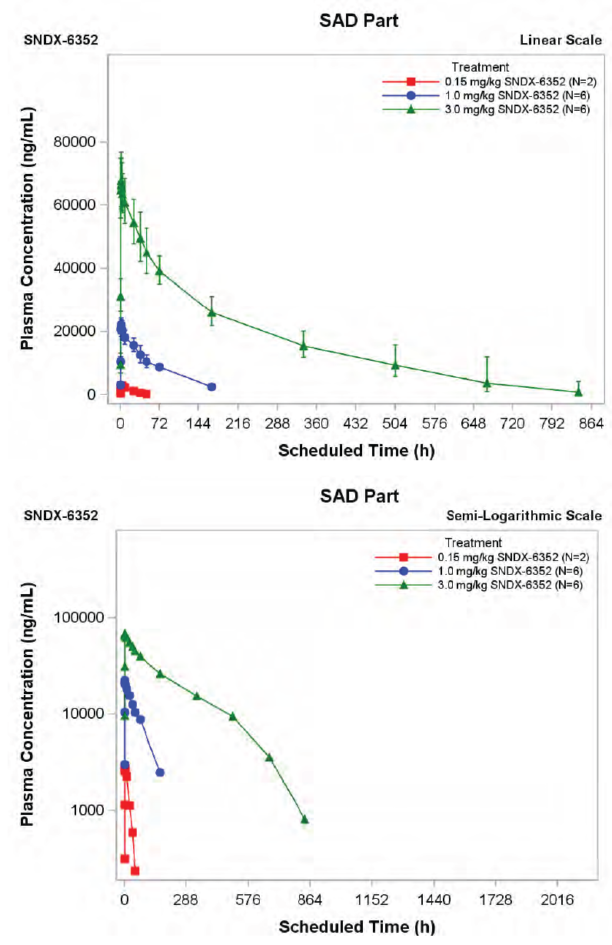
The volume of distribution ranged from 30.3 to 49.1 ml/kg, approximating serum volume.
When doses of 1, 2, 3 and 6 mg/kg every two weeks were given, the week two PK parameters for each dose were generally comparable, suggesting no drug accumulation following two-weekly dosing over the dose range tested. In a population PK/PD analysis including data from 325 participants, of 24 covariates studied, 21 had no significant impact, (<20%) on axatilimab PK model parameters including sex, race, age, cGVHD severity, participant population, renal impairment, hepatic impairment, calcineurin inhibitor administration, corticosteroid administration, albumin, ALP, ALT, AST, bilirubin, CPK, LDH, lipase and monocytes.
Three covariates (positive anti-drug antibody [ADA] status, baseline CSF-1 and body weight) were significant covariates for PK model parameters. The linear clearance increased with baseline CSF-1 concentration and positive ADA status, and volume of distribution of the central component increased with body weight. However, the impact of these three covariates on axatilimab PK was not significant at the 0.3mg/kg every two weeks dose regimen.
Exposure-Response (E-R) analyses were conducted on 13 efficacy endpoints for participants from the AGAVE-201 study. Axatilimab exposure (C_{max} after single dose) was a significant predictor for the primary efficacy endpoint of overall response rate (ORR) in the first six cycles and the key secondary efficacy endpoint (≥7-point improvement in the modified Lee Symptom Scale [mLSS]), the predicted probability of response declining as the axatilimab exposure increased.
The incidences of Grade 3 adverse events (AEs), AEs that resulted in axatilimab dose reduction or discontinuation, elevated liver enzymes, infusion-related reactions, periorbital oedema, and increased laboratory measurements (e.g., amylase, CPK, LOH, and lipase) were positively correlated with Cycle 1 axatilimab exposure in AGAVE-201 patients who received 0.3 mg/kg Q2W, 1 mg/kg Q2W, or 3 mg/kg Q4W. The incidence of Grade 3 and severe AEs and dosage modifications was numerically higher in patients with a higher body weight (e.g., > 100 kg). This may be attributed to the increased exposures in this subgroup following weight-based (i.e., mg/kg) dosing.
The fixed dosage is not adequately supported due to the lack of additional efficacy benefit at doses above 35 mg Q2W, the limited clinical efficacy data with axatilimab exposures significantly less than median exposure following the 0.3 mg/kg Q2W dosage, and the exposure response associations for safety. Provided that a body weight minimum and dose limit are enforced, it is deemed acceptable that axatilimab 0.3 mg/kg Q2W has an acceptable benefit-risk profile.

Population pharmacokinetics
Population PK (popPK) simulations suggested following IV administration of axatilimab 0.3mg/kg, the clearance was 0.09 L/h (95% PI: 0.04, 0.23), the V_{SS} was 2.86 litre (95% PI: 1.7, 5.15) and the effective half-life was 21.93 hours (95% PI: 11.18, 40.45).
The sponsor’s popPK/PD model adequately characterized PK in patients with cGVHD. Higher body weight was associated with higher axatilimab exposure following 0.3 mg/kg IV.
The popPK and the E-R assessment do not provide sufficient support for the proposed fixed dosage at specific body weights, as there are substantial discrepancies in predicted exposure compared to the 0.3 mg/kg Q2W dosage.
After considering the influence of body weight on PK and exposure, no associations were observed across age or age subgroups. The efficacy of the lower exposure in <40 kg patients has not been demonstrated, and adult and paediatric patients weighing <40 kg had a lower exposure than those weighing 40 kg and above following 0.3 mg/kg Q2W. There was lack of clinical data available for patients weighing less than 40 kg, and only 6 of the 239 patients in AGAVE-201 were under 40 kg. Only one of the six patients was assigned to the 0.3 mg/kg Q2W cohort, and despite the dose-escalation from 0.3 mg/kg Q2W to 1 mg/kg Q2W in Cycle 4, this patient did not experience a response within the first six cycles. Axatilimab dosage that is deemed acceptable for paediatric and adult patients who weigh less than 40 kg has not been established.
The maximal baseline body weight in AGAVE-201 patients who received 0.3 mg/kg Q2W was only 118 kg. The popPK and E-R safety analyses indicate that patients weighing over 118 kg may be at a higher risk of several safety events, including periorbital oedema and elevated liver enzymes, as a result of increased exposure. However, no clinical safety data are available for the 0.3 mg/kg Q2W dosage in patients weighing more than 118 kg.
In patients weighing 40 kg or more, a dosage of 0.3 mg/kg Q2W is recommended, with a maximal dose of 35 mg Q2W, as supported by modelling and simulation. The median predicted exposures remain similar to or higher than those at the median body weight of 73 kg, despite the fact that the maximum dose limit of 35 mg results in lower exposure in patients weighing >118 kg compared to 0.3 mg/kg Q2W with no maximum dose. Consequently, clinical pharmacology and pharmacometrics assessments anticipate that a maximal dose of 35 mg Q2W at a concentration of 0.3 mg/kg will result in comparable efficacy and a reduced risk of adverse events in patients with high body weight.
Patients with a higher body weight may be at a higher risk of treatment emergent adverse events (TEAEs) as a result of the increased exposure observed following 0.3 mg/kg Q2W in comparison to patients with an average body weight. The PPK assessment provides support for a dosage of 0.3 mg/kg (maximum 35 mg) IV Q2W in patients weighing 40 kg or more.

Pharmacodynamics
Axatilimab inhibits ligand-mediated CSF-1R signalling and affects the differentiation and function of CSF-1R-expressing monocytes and macrophages, mediators of end organ damage in cGVHD.
Consistent with the known mechanism of action of axatilimab, CSF-1 levels increased after all treatment groups, as did IL-34, increasing further with increasing dose levels.
Classical monocytes reduced after IV axatilimab, the magnitude of reduction increasing with increasing doses. This was also the case for non-classical monocytes.
Whilst the pre-existing ADA to axatilimab were noted in small numbers prior to the commencement of the study, approximately one-third of participants receiving axatilimab had at least one ADA positive sample in the study. ADA status did appear to have a clinically meaningful effect on PK, PD, efficacy, or safety of axatilimab 0.3 mg/kg Q2W.
A dose of 3 mg/kg every four weeks met the optimal biological dose definition (100% reduction of non-classical monocytes at the time of dose interval and plateaued increase of circulating CSF-1 that persisted for entire dosing levels).
Non-responders to axatilimab appear to have a higher median level of CSF-1 through the dosing period, although there was large variation within these groups.

Efficacy
In the Phase 1/2 dose escalation and dose expansion study, SNDX-6352-0503, a dose of 3 mg/kg given every four weeks was considered the optimal biological dose, and a dose of 1 mg/kg every two weeks was the recommended Phase II dose (RP2D) based on Phase 1 studies.
Predictions using the final E-R models for efficacy and safety demonstrated that the optimal weight-based dose regimen was 0.3 mg/kg Q2W. This dose provided the highest probability of achieving a response and the best overall safety profile among the 3 dose regimens tested in the AGAVE-201 study.
The phase 1/2 dose finding study SNDX-6352-0503 confirmed the recommended Phase 2 dose as 1 mg/kg every two weeks, although the single pivotal Phase 2 study AGAVE-201 (SNDX-6352-0504) found that 0.3 mg/kg every two weeks was the safest and most efficacious dose when given long term in patients with recurrent or refractory cGVHD.

Study SNDX-6352-0504 (AGAVE-201)
This study was a Phase 2 open-label, randomised, multicentre study evaluating the efficacy, safety, and tolerability of axatilimab at three different doses in patients with recurrent or refractory active cGVHD who have received at least two lines of systemic therapy, in line with the proposed indication. Prior therapies included TGA-registered ruxolitinib and belumosudil, thus being relevant to the Australian context.
The study consisted of three periods, with screening of up to one month, treatment up to 24 months and follow up (safety follow-up for up to three months after last administration of axatilimab and OS follow-up for up to five years after cycle one day one). This study was conducted in 84 study centres in 15 countries.
Eligible participants were randomised in a 1:1:1 ratio to one to the three axatilimab dose groups (0.3 mg/kg every two weeks IV, 1 mg/kg every two weeks IV or 3 mg/kg every four weeks IV). Participant assignments were stratified by severity of cGVHD (mild, mild/moderate versus severe) and prior use of at least one of the following therapies: ibrutinib, ruxolitinib, or belumosudil (prior therapy versus no prior therapy). Within each dose group, Simon's optimal 2-stage design was implemented (Figure 2).
Figure 2. Study SNDX-6352-0504 (AGAVE-201) design
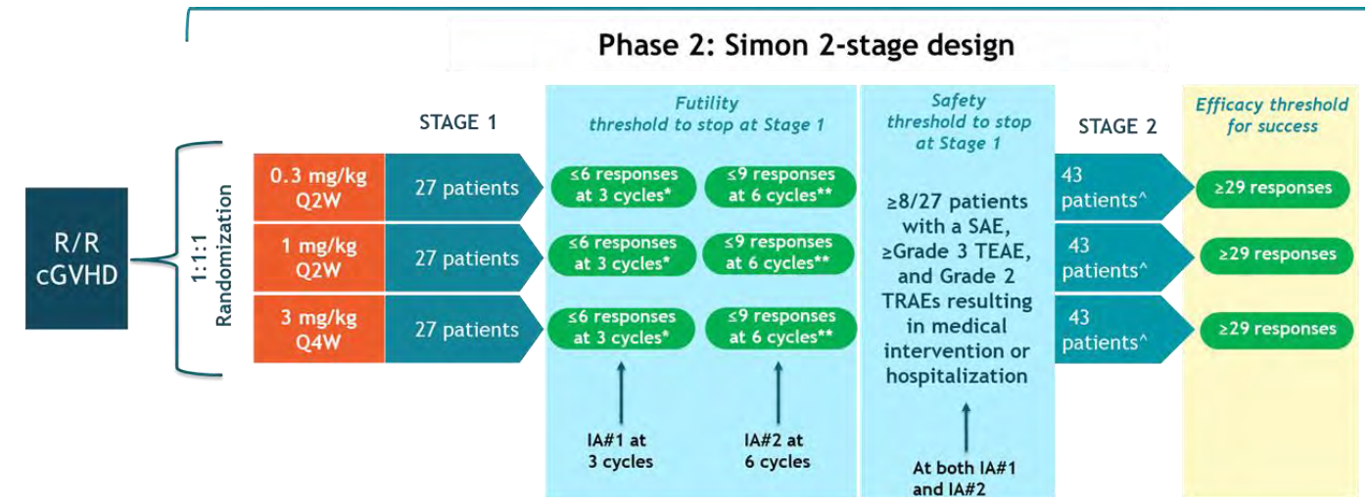
* Efficacy assessment at 3 cycles.
** Efficacy assessment at 6 cycles.
^ All participants enrolled at the selected dose(s) will be evaluated for efficacy.

The primary objective was to evaluate the ORR of axatilimab 0.3 mg/kg IV every two weeks,
1 mg/kg IV every two weeks and 3 mg/kg IV every four weeks in participants with cGVHD, after failure of at least two prior lines of therapy. The endpoint was ORR in the first six cycles as defined by the 2014 NIH Consensus Development Project on Criteria for Clinical Trials in cGVHD and is clinically appropriate in judging an anti-cGVHD effect.2 The key secondary efficacy endpoint was to evaluate measures of clinical benefit by the proportion of participants with clinically significant improvement in the mLSS.
Table 3. Objectives and Endpoints
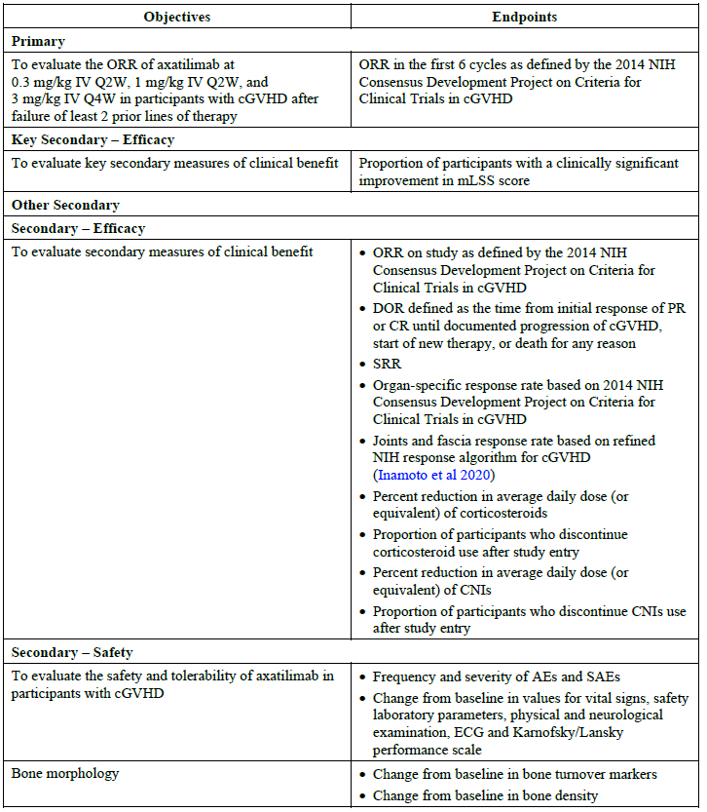
Table 3. Objectives and Endpoints (continued)
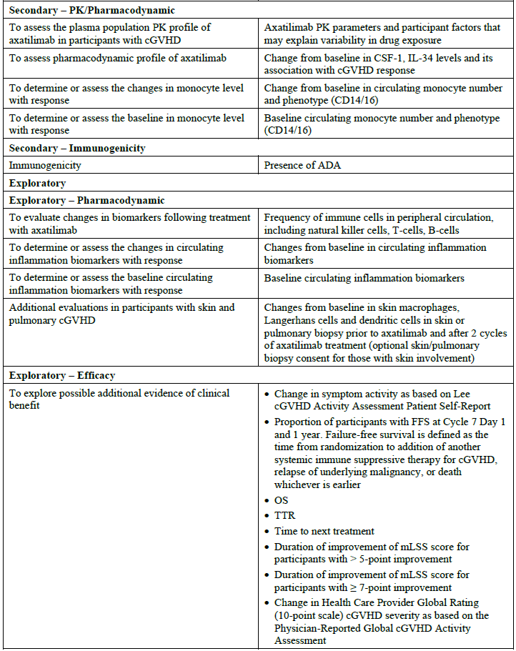
Males and females aged two years or older who were allogeneic HSCT recipients with recurrent or refractory active cGVHD requiring systemic immune suppression after at least two lines of systemic treatment were eligible for the study. Participants were to have a Karnofsky performance status or Lansky performance status of ≥60 to be eligible.
Table 4. Study treatment administered
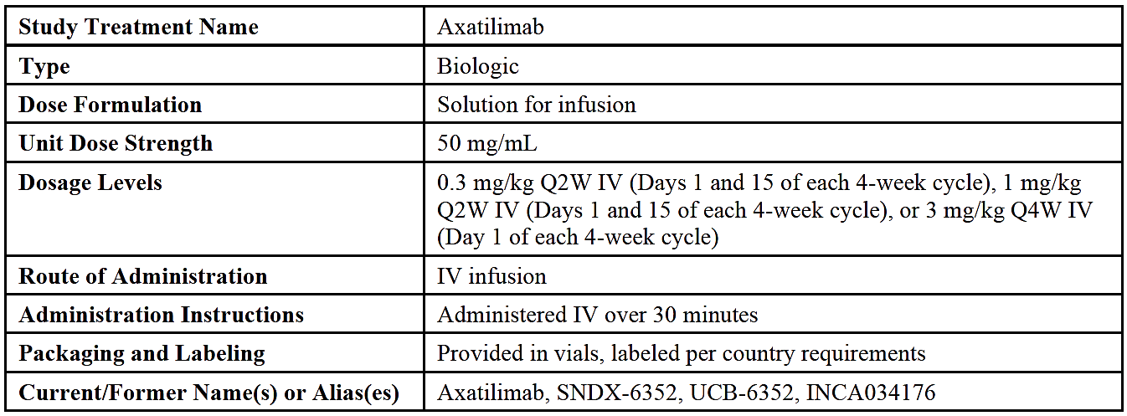
The Intention-to-treat population included 241 participants who were randomised to a dose level. The safety analysis set included 239 participants who received at least one dose of axatilimab during the study.
Table 5. Analysis populations (all screened population)
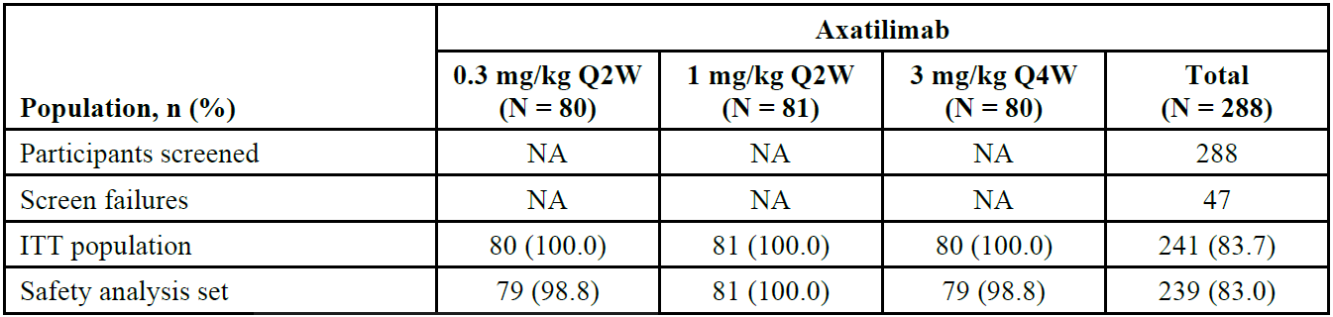
A total of 288 participants were screened. Of the 241 randomised, 239 received axatilimab and 2 were not treated. As of the data cut-off date, 98 participants (40.7%) had ongoing treatment, and 140 participants (58.1%) had discontinued treatment. Across all data groups the most common reasons for treatment discontinuation were progressive disease (19.9%), AEs (15.8%) and withdrawal of consent (9.1%).
Table 6. Summary of demographics and baseline characteristics (Intent-to-Treat Population)
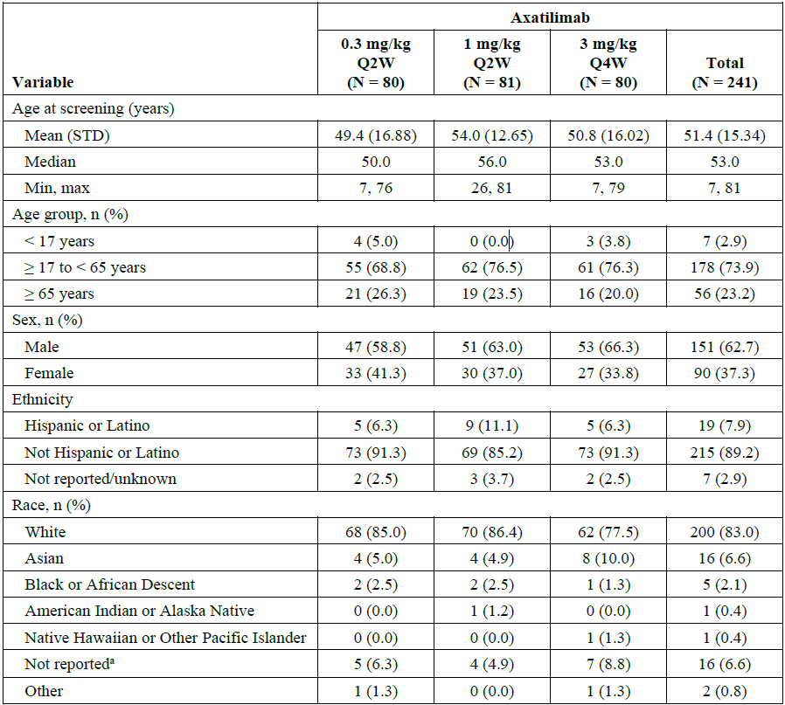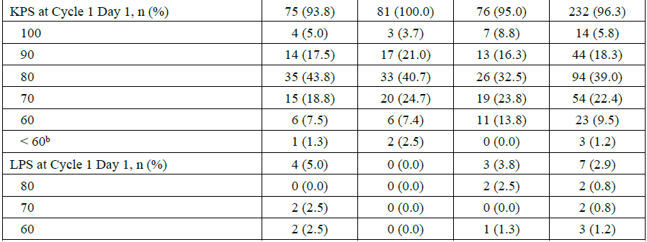
a Data on race and/or ethnicity were not collected for 11 participants in France because of local regulations.
b Participants met the Karnofsky performance status ≥ 60 eligibility criterion at screening.
Table 7. Baseline disease characteristics (Intent-to-Treat Population)
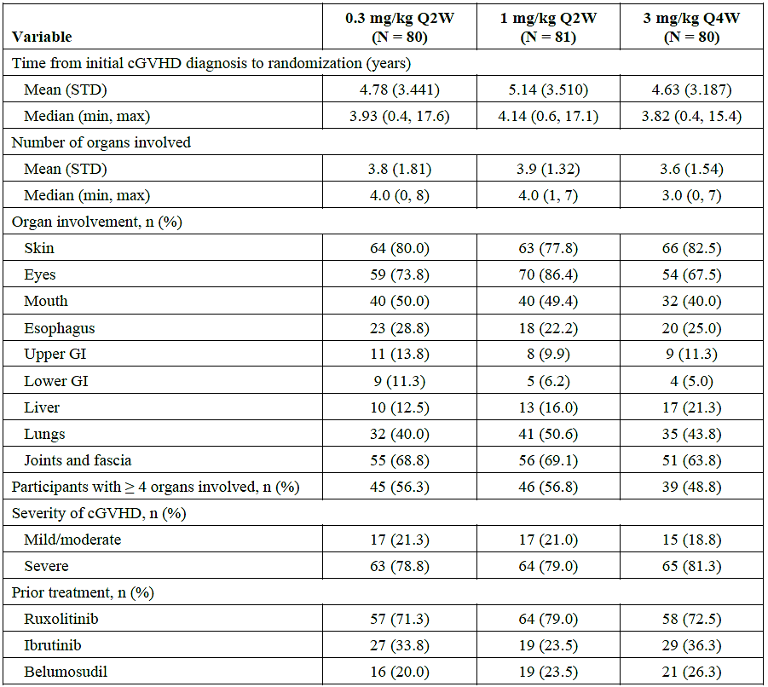

Results for the primary efficacy outcome
In terms of the primary endpoint of the study (the ORR of each dose group in the first six cycles as assessed by investigator review of cGVHD response according to the NIH Response Criteria), the study met its primary objective and showed that the lower bound of the 95% CI for ORR in the first six cycles exceeded 30% at each dose level.
Table 8. Summary of overall response in the first 6 cycles (Intent-to-Treat Population)
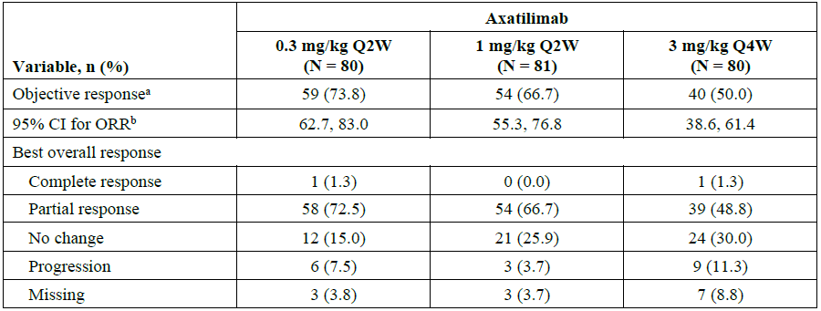
a A participant was considered an objective responder if they had an overall response of CR or PR at any timepoint up to Day 176 or the beginning of Cycle 7, whichever was later.
b Confidence intervals were calculated based on the exact method for binomial distributions.
Figure 3. Forest plots of overall response and 95% confidence intervals in the first 6 cycles of axatilimab 0.3mg/kg Q2W (Intent-to-Treat population)
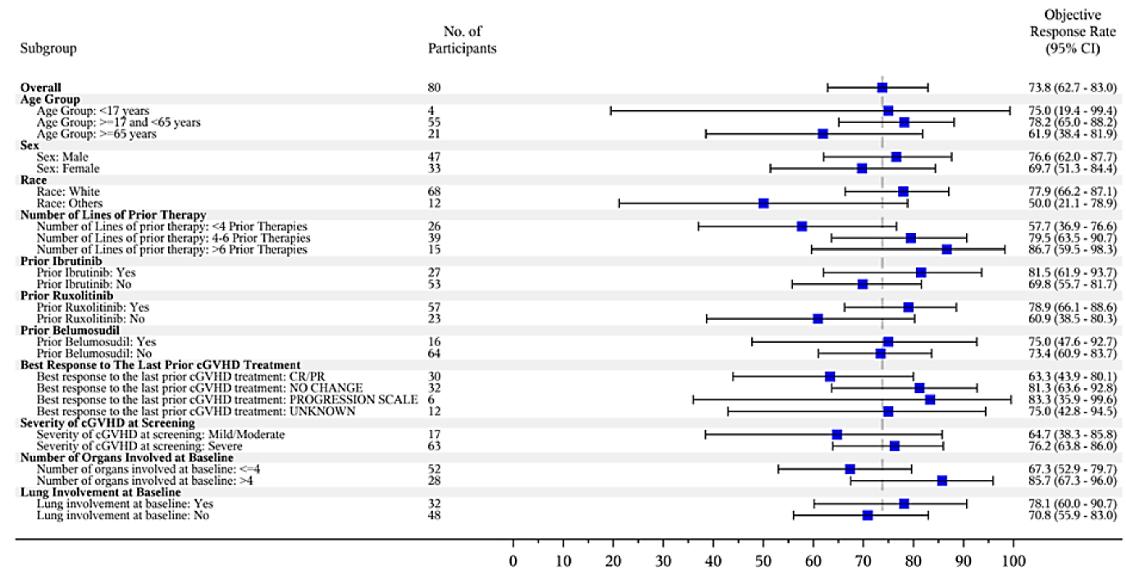
The ORR in the first six cycles across subgroups was generally consistent with the ORR for the total population regardless of number of prior therapies (<4, 4 to 6, or >6), type of prior therapy (ruxolitinib, ibrutinib, or belumosudil), best response to prior therapy (complete response or partial response, no change or progression), or age of participants (<17, 17 to <65, or ≥65 years of age). It is noted, however, that only 7 participants (2.9%) were <17 years of age, making interpretation of efficacy difficult in this subgroup. Sub analysis of those participants < 17 years of age showed very wide confidence intervals.
The key secondary endpoint was the proportion of participants with a clinically significant improvement (>7-point decrease from baseline) in normalised score using the mLSS.
An improvement in the mLSS score of at least seven points on or before cycle seven day one was most commonly seen in the 0.3mg/kg every-two-week group (55.1%) and 1mg/kg every-two-week group (53.8%) as shown in Table 9.
Table 9. Responder analysis based on the normalized mLSS (Intent-to-Treat Population)
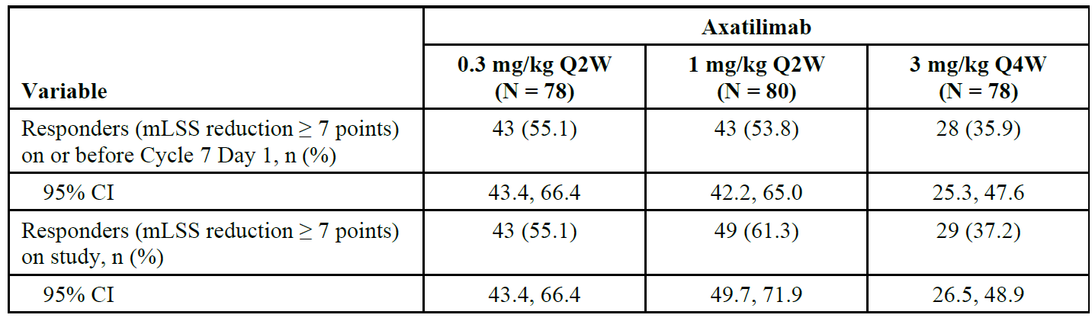
Note: N corresponds to the number of participants with valid mLSS at baseline.
In response to a question from the clinical evaluator to provide additional efficacy data in the young adult/paediatric population, the Sponsor provided data from 11 paediatric patients treated via the Expanded Access Program (EAP; INCA34176-MA-GD-301)
The EAP included participants > 6 years old per the indication, who had active cGVHD and had failed at least 2 prior lines of systemic therapy. Participants were dosed with axatilimab at 0.3mg/kg Q2W at clinician discretion for as long as clinical benefit was observed and/or treatment withdrawal criteria were not met or until closure of the EAP due to commercial availability. No patients below the age of 6 years of age were treated in the EAP. There were 11 patients < 17 years old enrolled on the EAP. By the date of data transfer (27 October 2025), all 11 patients had discontinued treatment on the EAP (Table 10); the primary reasons for discontinuation were other (n=5), participant death (n=2) and participant transitioned to commercial product (n=2).
Table 10. Summary of participant disposition in the Expanded Access Program
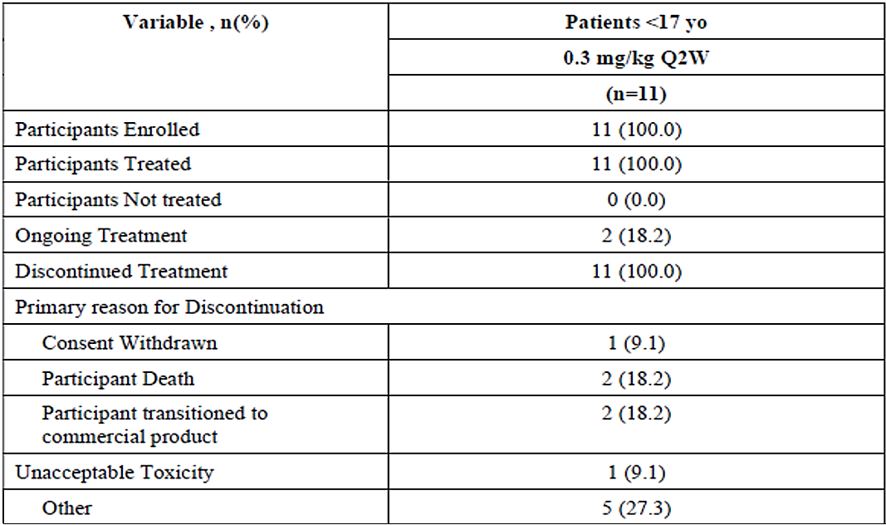
Table 11. Summary of participant baseline characteristics in the Expanded Access Program
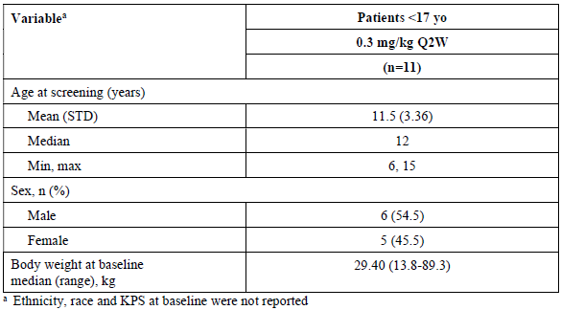

Table 12. Overall summary of treatment-emergent adverse events in the Expanded Access Program
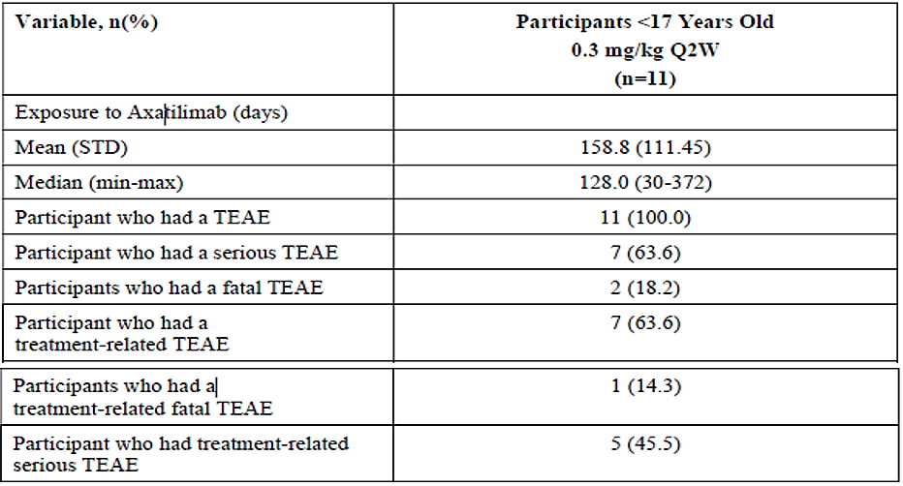
Table 13. Summary of treatment emergent adverse events by AE term in decreasing order of frequency occurring in > 2 participants in the Expanded Access Program
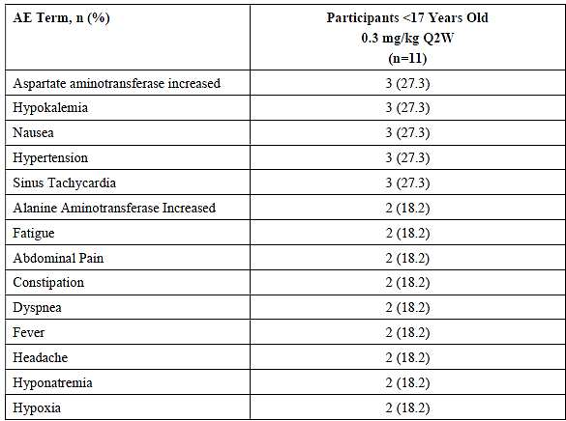

Table 14. Summary of serious treatment-emergent adverse events by AE terms in decreasing order of frequency in >1 participants in the Expanded Access Program
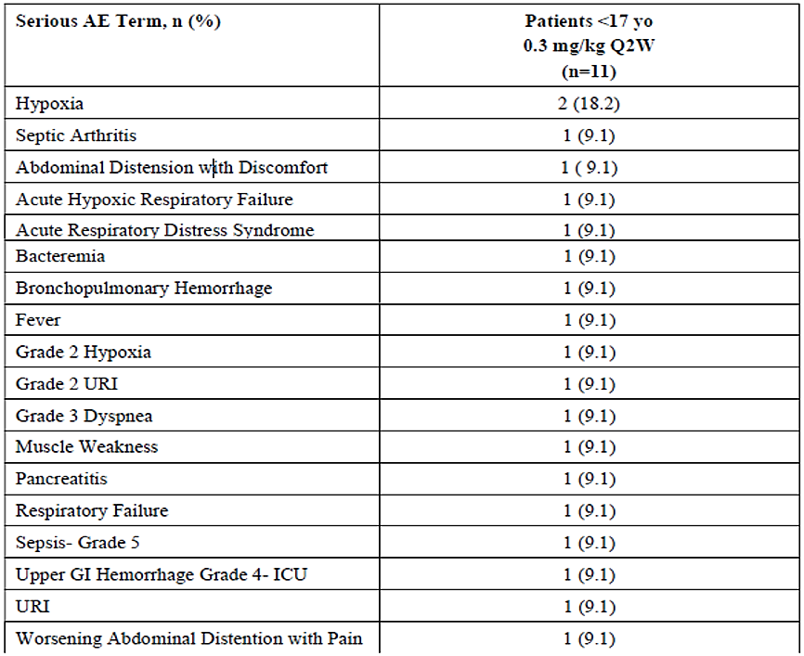
The safety profile of axatilimab in the EAP appeared generally consistent with that observed in the AGAVE-201 clinical trial with no new or unexpected toxicities reported.
Axatilimab effectiveness was captured on the EAP through physician-reported assessment of clinical benefit and response categorization, according to the NIH 2014 Consensus Criteria. These data were not monitored or centrally confirmed by the Sponsor.
Table 15. Summary of best response during Expanded Access Program based on physician assessment.
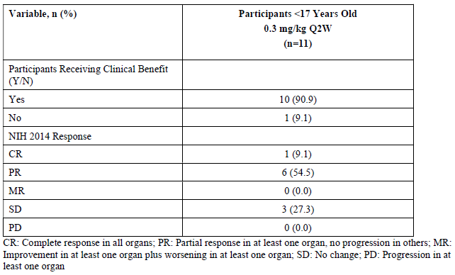
CR: complete response in all organs; PR: Partial response in at least one organ, no progression in others; MR: improvement in at least one organ plus worsening in at least one organ; SD: No change; PD: progression in at least one organ.

Study INCA34176-358: supportive clinical data in paediatric participants: (Japan)
Additional data has been obtained in Study INCA34176-358 for Japanese participants > 6 years old, who had active cGVHD and had failed at least 2 prior lines of systemic therapy. Participants were dosed with axatilimab at 0.3 mg/kg Q2W until progressive disease, a need for new systemic cGVHD therapy, unacceptable toxicity, or other discontinuation criteria were met.
There were 3 patients < 17 years old enrolled in Study INCA34176-358. By the cutoff date (6 August 2025), 1 of these patients had discontinued treatment on the study; the primary reason for discontinuation was “other” (lung transplantation). The remaining 2 paediatric patients remained on treatment and in follow-up per protocol at the data cutoff.
The safety profile of axatilimab in the paediatric population of Study INCA34176-358 appears consistent with that observed in the AGAVE-201 clinical study with no new or unexpected toxicities reported. Of the 3 participants <17 years all experienced at least 1 TEAE; 1 (33.3%) experienced at least 1 serious TEAE; 0 experienced a fatal TEAE. No TEAEs occurred in > 1 paediatric participant.
Table 16. Summary of treatment‑emergent adverse events by preferred term in INCA 34176-358
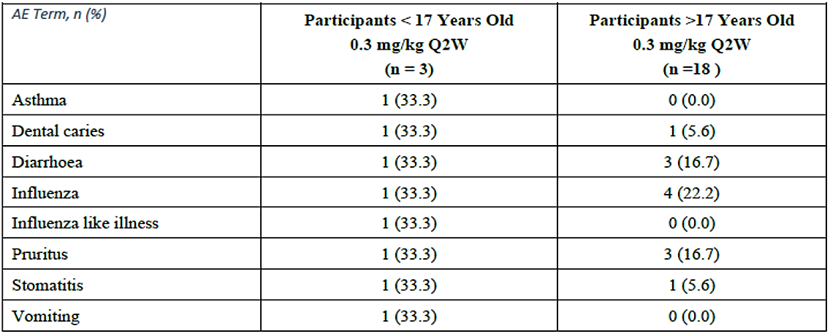
Axatilimab efficacy data are outlined in Table below. Investigators reported 1 partial response (33.3%) and 2 unchanged (66.6%) as the best response observed.
Table 17. Summary of best overall response in the first 6 treatment cycles
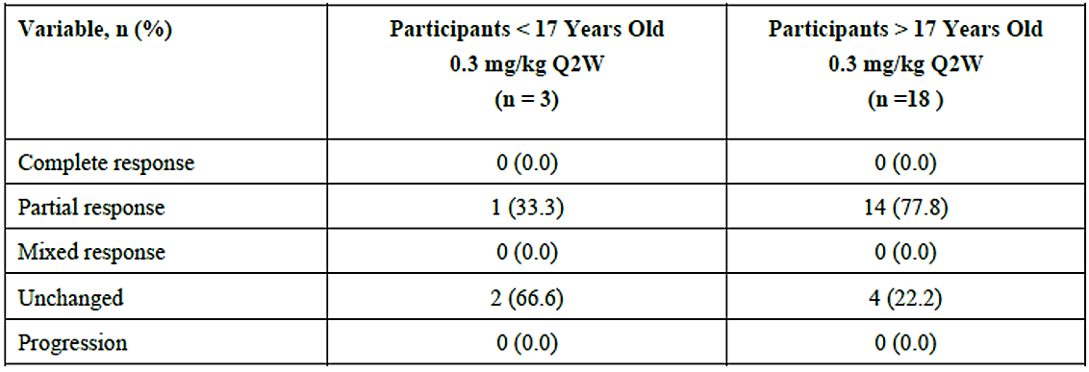
Complete Response: complete response in all organs; Partial Response: partial response in at least 1 organ, no progression in others; Mixed Response: Improvement in at least 1 organ plus worsening in at least 1 organ; Unchanged: No change; Progression: Progression in at least 1 organ, no response in others.

Safety
In the pivotal Phase 2 randomised, open-label uncontrolled study of axatilimab 0.3mg/kg every two weeks IV, 1mg/kg every two weeks IV, or 3mg/kg every four weeks IV (SNDX-6352-0504 [AGAVE-201]), most participants had at least one TEAE (97.9%) and 193 (80.8%) had at least one TEAE considered related to study drug by the investigators. A total of 144 participants (60.3%) had at least one TEAE that was grade 3 or higher and serious TEAEs occurred in 101 participants (42.3%), including 14 participants (5.9%) who had serious TEAEs.
At least one TEAE resulted in either axatilimab discontinuation (for 37 participants, 15.5%), dose interruption (for 89 participants, 37.2%), or dose reduction (for 24 participants, 10.0%). There appeared to be no overall differences across the dose groups in TEAE numbers.
The majority (97.9%) of all study participants having at least one TEAE most frequently occurred in the following SOCs: investigations (69.5%), infections and infestations (72.0%) and general disorders and administration site conditions (51.0%). The most frequently occurring TEAEs (in >20% of participants) were AST increase (35.6%), CPK increase (35.1%), lipase increase (28.9%), LDH increase (27.2%), ALT increase (24.7%) and fatigue (23.0%).
For TEAEs occurring in >10% of participants, the incidence was over twice as high in at least one of the higher dose groups (1mg/kg every two weeks and 3mg/kg every four weeks) versus participants in the 0.3mg/kg every-two-week dose group. These included AST elevation, CPK elevation, lipase elevation, blood LDH elevation, ALT elevation, amylase elevation, GGT elevation, periorbital oedema, hypophosphataemia, ALP increase, and hypertension.
The most frequently occurring events in >5% of participants of grade 3 or higher TEAE were pneumonia (8.4%), CPK increase (7.9%) and COVID-19 (5.4%). It is noted that increased CPK, GGT and GGT, cellulitis, lipase increase, periorbital oedema and AST increase was seen in greater numbers with the higher doses of axatilimab (1mg/kg every two weeks and 3mg/kg every four weeks) compared to 0.3mg/kg every two weeks.
A total of 14 participants (5.9%) had TEAEs with a fatal outcome, one, seven and six participants in each of the 0.3mg/kg every-two-week group, 1mg/kg every-two-week group and 3mg/kg every-four-week group, respectively (1.3%, 8.6% and 7.6%, respectively), suggesting a dose-response pattern. The only fatal TEAE in the 0.3mg/kg every-two-week group (dyspnoea) occurred in a participant with a medical history of severe cGVHD with lung involvement, arterial hypertension and respiratory insufficiency.
Serious TEAEs were seen in 42.3% of all study participants, most frequently being reported as pneumonia (7.9%), COVID-19 (4.6%), respiratory failure (3.3%) and cellulitis (2.5%). All other serious TEAEs occurred in less than 2% of participants. The 0.3mg/kg every-two-week dose group had a lower incidence of serious TEAEs.
In the Phase 1/2 open-label multicentre dose escalation and dose expansion study (SNDX-6352-0503), all participants experienced at least one TEAE. total of 32 participants (80.0%) had a TEAE considered by the investigator to be related to study treatment. Eighteen (45.0%) had a serious TEAE of whom 6 (15.0%) had a serious TEAE considered to be related to study treatment. There was one fatal TEAE which was not considered to be related to study treatment. There were no notable differences between the participants who received 1mg/kg every two weeks and the total population. Additionally, regarding the pediatric participants, altogether there were 8 participants younger than 17 years in the integrated safety population, all of them in the safety pool. Only 3 participants were younger than 12 years of age (all were 7 years of old).
TEAEs of liver parameters included increased AST (77.4%), increased ALT (56.9%). These changes were usually lower in the 0.3mg/kg every-two-week group compared to the two high dose groups.
The E-R safety analyses were conducted for participants from SNDX-6352-0503 and AGAVE-201. A total of 29/37 safety endpoints were associated with axatilimab steady-state AUC. The probability of these 29 AEs increased with axatilimab total exposure.

Risk management plan
Specialised Therapeutics Alim Pty Ltd has submitted Core-RMP version 1.0 (dated 21 November 2024; DLP 7 April 2023) and ASA version 1.0 (dated April 2025) in support of this application.
The proposed summary of safety concerns and their associated risk monitoring and mitigation strategies are summarised in Table 18.
Table 18. Summary of safety concerns
Summary of safety concerns |  | Pharmacovigilance |  | Risk Minimisation
 |  | Routine | Additional | Routine | Additional
Important identified risks | Infusion-Related Reactions | ü | – | ü | –
Important potential risks | None | ü | – | ü | –
Missing information | None | ü | – | ü | –

The TGA may request an updated RMP at any stage of a product's life-cycle, during both the pre-approval and post-approval phases. Further information regarding the TGA’s risk management approach can be found in risk management plans for medicines and biologicals and the TGA's risk management approach. Information on the Australia-specific annex (ASA) can be found on the TGA website.

Risk-benefit analysis

Efficacy
A single pivotal Phase 2 open-label, multi-centre study (SNDX-6352-0504: AGAVE-201) assessing efficacy, safety and tolerability of axatilimab at three different doses in patients with recurrent or refractory active cGVHD who had previously received at least two lines of systemic therapy, in line with the proposed indication, was provided. Prior therapies included ruxolitinib and belumosudil, thus being relevant to the Australian context.
ADA positivity was seen in approximately 30% of samples assessed, a minority of these being baseline positive. ADA presence did not, however associate with any negative effects upon efficacy of axatilimab 0.3 mg/kg IV every 2 weeks.
Each dose level achieved a significant overall response rate, the lower bound of the 95% CI for ORR in the first six cycles exceeding 30%. The ORR in the first six cycles across any treatment group was similar in subgroups of participants (demographics, underlying disease severity and duration of treatment history), although only 7 participants (2.9%) were < 17 years of age, make efficacy interpretation difficult in the younger age group. Efficacy analysis in this small subgroup revealed very wide confidence intervals.
The 0.3 mg/kg Q2W dosage cohort did not adequately represent patients under the age of 12; however, age was not associated with any distinct differences in PK or exposure after accounting for the impact of body weight across the age range of 7 to 81 years. It is uncertain whether the reduced exposure at body weights less than 40 kg may affect efficacy, as patients weighing less than 40 kg experienced a lower exposure following 0.3 mg/kg Q2W compared to patients weighing 40 kg and above. In AGAVE-201, the 0.3 mg/kg Q2W cohort was allotted to a single patient weighing less than 40 kg. Despite the fact that the dose was escalated from 0.3 mg/kg Q2W to 1 mg/kg Q2W in Cycle 4, the patient did not respond within the first six cycles (BOR for stable disease). Therefore, a safe and efficacious dosage of axatilimab has not been established for patient populations weighing less than 40 kg, including paediatrics and adults.
In the Study SNDX-6352-0504, only four patients under the age of 17 were administered axatilimab at a dosage of 0.3 mg/kg Q2W, while only one patient under the age of 17 was administered axatilimab in the Study SNDX-6352-0503. The pathogenesis and natural history of cGVHD appear identical in paediatric and adult patients. Furthermore, the treatment regimen is consistent for both paediatric and adult patients. Consequently, it appears reasonable to extrapolate the efficacy of the disease from the adequate and well-controlled study in adults to paediatric patients if exposure can be matched, given the biological comparability of the disease across the age range. The development programme did not adequately represent paediatric patients under the age of 12 (N=1 received 0.3 mg/kg Q2W); however, there was sufficient clinical data to characterise the exposure profile in patients 6 years and older weighing at least 40 kg. In contrast, there is no information regarding the safety or PK of the drug in paediatric patients who are smaller in size. As a result, the extrapolation potential is restricted, necessitating additional research to ascertain an effective dosage for the smaller paediatric patients.
The axatilimab dose- and exposure-response relationships indicate that there is an increase in safety events, including Grade3 and serious adverse events (AEs) and AEs that result in dosage reduction and discontinuation. However, no additional efficacy benefit was observed at higher axatilimab exposures in patients with a higher body weight following 0.3 mg/kg Q2W. The maximum dose limit of 35 mg Q2W is supported by clinical safety data, popPK analysis, and E-R analyses of efficacy and safety. This dose is equivalent to a 0.3 mg/kg dose in a 118 kg patient, which is the highest body weight included in the 0.3 mg/kg Q2W cohort in AGAVE-201.
The AGAVE-201 trial investigated three dosing regimens: 0.3 mg/kg Q2W, 1 mg/kg Q2W, and 3 mg/kg Q4W. The sponsor's proposed fixed dose regimen was not investigated in any of the clinical data presented in this application. This is an attempt to optimise the PK exposure metrics that were observed subsequent to the administration of the 0.3 mg/kg Q2W dosage. The predicted axatilimab exposures in the target paediatric and adult populations following the proposed fixed dose regimen did not adequately match those observed following the clinically studied 0.3 mg/kg Q2W dosage. Axatilimab dosage of 0.3 mg/ kg Q2W has an acceptable benefit-risk profile; however, the proposed fixed dose regimen is not comparable to the 0.3 mg/kg Q2W dosage across the range of body weight in the general patient population. The proposed fixed dosing regimen is expected to produce substantial exposure differences in certain body weight subgroups when contrasted with the 0.3 mg/kg Q2W dosing regimen that is supported by clinical data from Study AGAVE-201. The proposed paediatric fixed dosage is not adequately supported by the population PK (popPK) or the E-R assessment, as there are significant differences in predicted exposure compared to the 0.3 mg/kg Q2W dosage at certain body weights.
The activity of axatilimab for the treatment of adult and paediatric patients 6 years and older weighing at least 40 kg with cGVHD after failure of at least two prior lines of systemic therapy is established by the 75% ORR by Cycle 7 Day 1, with a lower bound of 64% and substantial durability in the 0.3 mg/kg every 2 weeks dosage arm of Study AGAVE-201. Additionally, a 7-point reduction in mLSS score was experienced by 56% of patients.
It is determined that the proposed, fixed dosage is inadequately supported. Consequently, the following prescribing instructions are suggested: 0.3 mg/kg Q2W for adult and paediatric patients aged 6 years and older who weigh a minimum of 40 kg, with a maximum dosage of 35 mg Q2W.

Safety
Adverse events were observed in a variety of Phase 1 and Phase 2 studies, often in a dose-dependent manner. These events included abnormal liver function tests, elevated CPK, lipase, amylase, infusion-related reactions, and infections. A reported event was periorbital oedema. In the pivotal Phase 2 study AGAVE-201, the lowest dose studied, 0.3mg/kg every two weeks, exhibited the most favourable safety profile of the three dose levels. Immunogenicity (anti-drug antibodies) were frequently observed; however, they were not associated with an adverse impact on the safety profile of axatilimab 0.3 mg/kg IV administered every 2 weeks. The dose that was found to be most safe was 0.3 mg/kg q2w (n=79) and was well-tolerated. The safety database was of sufficient size to evaluate safety, except for the paediatric cohort.
In comparison to 1 mg/kg Q2W or 3 mg/kgQ4W, the 0.3 mg/kg Q2W dosage was associated with lower exposure and, as a result, reduced rates of select TEAEs. This supports the safety of the 0.3 mg/kg Q2W dosage. It is also suggested that the likelihood of multiple TEAEs increases with increased exposure in patients who receive 0.3 mg/kg Q2W. Exposure was inversely proportional to body weight following 0.3 mg/kg Q2W. The clinical pharmacology assessment recommends a maximum dose cap of 35 mg Q2W for the 0.3 mg/kg Q2W dosage, because of the increased risk of TEAEs at higher exposure, the absence of clear efficacy benefits at higher exposure, and the absence of clinical safety data in patients weighing over 118 kg who received 0.3 mg/kg Q2W.
In general, the E-R safety analysis and the safety data support a dosage of 0.3 mg/kg (maximum 35 mg) for adult and paediatric patients aged 6 years and older who weigh 40 kg or more, and they demonstrate an acceptable safety profile.

Conclusions
It is concluded that the optimal dosage of axatilimab for patients aged 6 years and older who weigh a minimum of 40 kg is 0.3 mg/kg Q2W, with a maximum of 35 mg. This recommendation is founded on the following reasons: (i) The axatilimab exposures following the proposed fixed dose regimen and the clinically studied 0.3 mg/ kg Q2W dosage are significantly different, which may impact efficacy or safety outcomes. (ii) The potential for a higher safety risk at higher exposures with higher body weight following 0.3 mg/ kg Q2W without a maximum dose cap is also present. (iii) All of the clinical evidence presented, including AGAVE-201, EAP access programme, and Study INCA34176-358, only included patients aged 6 years and older.
For the treatment of recurrent or refractory cGVHD in adult and paediatric patients aged 6 years and older and weighing 40 kg or more, the PPK and E-R efficacy and safety analyses indicate a favourable benefit-risk profile for 0.3 mg/kg (maximum 35 mg) Q2W after at least two prior lines of systemic therapy.

Assessment outcome
Based on a review of quality, safety, and efficacy, the TGA decided to register Niktimvo (axatilimab) for the following indication:
Axatilimab is indicated for the treatment of chronic graft-versus host disease (cGVHD) after failure of at least two prior lines of systemic therapy in adult and paediatric patients 6 years and older weighing at least 40 kg

Specific conditions of registration
Niktimvo (axatilimab) is to be included in the Black Triangle Scheme. The PI and CMI for Niktimvo must include the black triangle symbol and mandatory accompanying text for five years, which starts from the date of first supply of the product.
The Niktimvo Core-Risk Management Plan (RMP) (version 1.0, dated 21 November 2024; data lock point 07 April 2023), with Australia-Specific Annex (ASA) (version 1.0, dated April 2025), included with submission PM-2025-02541-1-2, and any subsequent revisions, as agreed with the TGA will be implemented in Australia.
An obligatory component of risk management plans is routine pharmacovigilance. Routine pharmacovigilance includes the submission of periodic safety update reports (PSURs).
Unless agreed separately between the supplier who is the recipient of the approval and the TGA, the first report must be submitted to TGA no later than 15 calendar months after the date of this approval letter. The subsequent reports must be submitted no less frequently than annually from the date of the first submitted report until the period covered by such reports is not less than three years from the date of this approval letter. The annual submission may be made up of two PSURs each covering six months. If the sponsor wishes, the six monthly reports may be submitted separately as they become available.
If the product is approved in the EU during the three years period, reports can be provided in line with the published list of EU reference dates no less frequently than annually from the date of the first submitted report until the period covered by such reports is not less than three years from the date of this approval letter.
The reports are to at least meet the requirements for PSURs as described in the European Medicines Agency’s Guideline on good pharmacovigilance practices (GVP) Module VII-periodic safety update report (Rev 1), Part VII.B Structures and processes. Note that submission of a PSUR does not constitute an application to vary the registration. Each report must be submitted within ninety calendar days of the data lock point for that report.

Laboratory testing & compliance with Certified Product Details (CPD)
- All batches of Niktimvo axatilimab 22 mg/0.44 mL solution for injection glass vial and Niktimvo axatilimab 9 mg/0.18 mL solution for injection glass vial supplied in Australia must comply with the product details and specifications approved during evaluation and detailed in the Certified Product Details (CPD).
- When requested by the TGA, the Sponsor should be prepared to provide product samples, specified reference materials and documentary evidence to enable the TGA to conduct laboratory testing on the Product. Outcomes of laboratory testing are published biannually in the TGA Database of Laboratory Testing Results http://www.tga.gov.au/ws-labs-index and periodically in testing reports on the TGA website.

Certified Product Details
The Certified Product Details (CPD), as described in Guidance 7: Certified Product Details of the Australian Regulatory Guidelines for Prescription Medicines (ARGPM), in PDF format, for the above products should be provided upon registration of these therapeutic goods. In addition, an updated CPD should be provided when changes to finished product specifications and test methods are approved in a Category 3 application or notified through a self-assessable change.
A template for preparation of CPD for biological prescription medicines can be obtained from the TGA website:
Certified Product Details guidance
Certified Product Details form

Product Information and Consumer Medicine Information
For the most recent Product Information (PI) and Consumer Medicine Information (CMI), please refer to the TGA PI/CMI search facility.

Therapeutic Goods Administration
PO Box 100 Woden ACT 2606 Australia
Email: info@tga.gov.au Phone: 1800 020 653 Fax: 02 6203 1605
https://www.tga.gov.au
Reference/Publication #

This is the original indication proposed by the sponsor when the TGA commenced the evaluation of this submission. It may differ to the final indication approved by the TGA and registered in the Australian Register of Therapeutic Goods.
Jagasia MH, Greinix HT, Arora M, Williams KM, Wolff D, Cowen EW, Palmer J, Weisdorf D, Treister NS, Cheng GS, Kerr H, Stratton P, Duarte RF, McDonald GB, Inamoto Y, Vigorito A, Arai S, Datiles MB, Jacobsohn D, Heller T, Kitko CL, Mitchell SA, Martin PJ, Shulman H, Wu RS, Cutler CS, Vogelsang GB, Lee SJ, Pavletic SZ, Flowers ME. National Institutes of Health Consensus Development Project on Criteria for Clinical Trials in Chronic Graft-versus-Host Disease: I. The 2014 Diagnosis and Staging Working Group report. Biol Blood Marrow Transplant. 2015 Mar;21(3):389-401.e1. doi: 10.1016/j.bbmt.2014.12.001. Epub 2014 Dec 18. PMID: 25529383; PMCID: PMC4329079.
Qayed M, Wang T, Hemmer MT, Spellman S, Arora M, Couriel D, Alousi A, Pidala J, Abdel-Azim H, Aljurf M, Ayas M, Bitan M, Cairo M, Choi SW, Dandoy C, Delgado D, Gale RP, Hale G, Frangoul H, Kamble RT, Kharfan-Dabaja M, Lehman L, Levine J, MacMillan M, Marks DI, Nishihori T, Olsson RF, Hematti P, Ringden O, Saad A, Satwani P, Savani BN, Schultz KR, Seo S, Shenoy S, Waller EK, Yu L, Horowitz MM, Horan J. Influence of Age on Acute and Chronic GVHD in Children Undergoing HLA-Identical Sibling Bone Marrow Transplantation for Acute Leukemia: Implications for Prophylaxis. Biol Blood Marrow Transplant. 2018 Mar;24(3):521-528. doi: 10.1016/j.bbmt.2017.11.004. Epub 2017 Nov 16. PMID: 29155316; PMCID: PMC5826854.
Mirza AS, Tandon A, Jenneman D, Cao S, Brimer T, Kumar A, Kidd M, Khimani F, Faramand R, Mishra A, Liu H, Nishihori T, Perez L, Lazaryan A, Bejanyan N, Nieder M, Anasetti C, Pidala J, Elmariah H. Outcomes Following Intolerance to Tacrolimus/Sirolimus Graft-versus-Host Disease Prophylaxis for Allogeneic Hematopoietic Cell Transplantation. Transplant Cell Ther. 2022 Apr;28(4):185.e1-185.e7. doi: 10.1016/j.jtct.2022.01.003. Epub 2022 Jan 10. PMID: 35017119.
Novitzky-Basso I, Schain F, Batyrbekova N, Webb T, Remberger M, Keating A, Mattsson J. Population-based real-world registry study to evaluate clinical outcomes of chronic graft-versus-host disease. PLoS One. 2023 Mar 9;18(3):e0282753. doi: 10.1371/journal.pone.0282753. PMID: 36893113; PMCID: PMC9997892.
Farhadfar, N, Al-Mansour Z, W Tao, Chen K, Pidala J, MacMillan ML, Carrie LK, Spellman SR, Wingard JR, Lee SJ. Racial, Ethnic and Socioeconomic Disparity in Outcomes of Patients with Chronic Graft-Versus-Host Disease: A CIBMTR Analysis. Blood (2022) 140 (Supplement 1): 5108–5109.
Bashey A, Zhang X, Morris LE, Holland HK, Solh M, Solomon SR. Improved Survival of Patients Diagnosed with Severe (Grade 3-4) Acute GVHD or Severe NIH Grade Chronic GVHD in the Current Era Compared to Historic Controls. Blood (2019) 134 (Supplement_1): 2006.
Martini DJ, Chen YB, DeFilipp Z. Recent FDA Approvals in the Treatment of Graft-Versus-Host Disease. Oncologist. 2022 Aug 5;27(8):685-693. doi: 10.1093/oncolo/oyac076. PMID: 35443042; PMCID: PMC9355804.
Alexander KA, Flynn R, Lineburg KE, et al. CSF-1-dependant donor-derived macrophages mediate chronic graft-versus-host disease. J Clin Invest 2014;124:4266-4280.
International Conference on Harmonisation of Technical Requirements for Registration of Pharmaceuticals for Human Use. ICH S6 (R1) Preclinical safety evaluation of biotechnology-derived pharmaceuticals - Scientific guideline. 2011.
Alexander KA, Flynn R, Lineburg KE, Kuns RD, Teal BE, Olver SD, Lor M, Raffelt NC, Koyama M, Leveque L, Le Texier L, Melino M, Markey KA, Varelias A, Engwerda C, Serody JS, Janela B, Ginhoux F, Clouston AD, Blazar BR, Hill GR, MacDonald KP. CSF-1-dependant donor-derived macrophages mediate chronic graft-versus-host disease. J Clin Invest. 2014 Oct;124(10):4266-80. doi: 10.1172/JCI75935. Epub 2014 Aug 26. PMID: 25157821; PMCID: PMC4191032.

