Completing an application for consent to import, supply or export a medical device that does not meet UDI-related Essential Principles
  - User guide for the consent application form on the TGA Business Services (TBS) portal

Version 1.0, May 2026

Copyright

© Commonwealth of Australia 2026
This work is copyright. You may reproduce the whole or part of this work in unaltered form for your own personal use or, if you are part of an organisation, for internal use within your organisation, but only if you or your organisation do not use the reproduction for any commercial purpose and retain this copyright notice and all disclaimer notices as part of that reproduction. Apart from rights to use as permitted by the Copyright Act 1968 or allowed by this copyright notice, all other rights are reserved and you are not allowed to reproduce the whole or any part of this work in any way (electronic or otherwise) without first being given specific written permission from the Commonwealth to do so. Requests and inquiries concerning reproduction and rights are to be sent to the TGA Copyright Officer, Therapeutic Goods Administration, PO Box 100, Woden ACT 2606 or emailed to <tga.copyright@tga.gov.au>.

Contents
Introduction 5
UDI Consent to Supply (CtS) process 5
UDI CtS applications before 1 July 2026 5
Eligibility for the UDI CtS process 6
Eligible ARTGs and Applications for Inclusion 7
UDI-related Essential Principles 9
UDI-related Essential Principle conditions 9
EP 13C.5 – direct marking 11
UDI CtS application fees 11
Scope and eligibility 11
Fee calculation 12
How to pay 12
Applications submitted prior to 1 July 2026 13
Accessing the consent for non-compliance dashboard 13
Creating a new UDI CtS application 16
Application name 16
What the application seeks consent for 16
Saving an application as a draft 17
Completing an application 19
Application details section 20
Selecting the consent activity 21
Reason for non-conformance 21
Potential risks associated with non-conformance 22
Supporting documents 23
Completing the section 23
Non-compliant Essential Principles section 23
Adding an Essential Principle 23
Explaining non-compliance 25
Editing or deleting Essential Principles 26
Device groups section 26
Create a single device group 26
Applications with different proposed consent durations 27
Creating a device group 28
Adding ARTG entries to a device group 29
Stock level information 33
Proposed consent duration 33
Strategies to rectify non-compliance 34
Documents 35
Adding second device groups 35
Completing the section 36
Declaration section 36
Agreeing to the declaration 37
Viewing a submitted UDI CtS 38
Status of a UDI CtS application 39
Viewing, printing or withdrawing submitted applications 39
Resources 41
Contact us 41

Introduction
This guide explains how to apply for consent to import or supply medical device(s) that do not meet Unique Device Identification (UDI) related Essential Principles (EPs).
 | Use this guide only when your application relates solely to UDI-related EPs.  If your application includes both UDI and non-UDI EPs, you must:  - use the standard Consent to Supply (CtS) process  - pay the standard application fee.

UDI Consent to Supply (CtS) process
Amendments to the Therapeutic Goods (Medical Devices) Regulations 2002 introduced UDI requirements in March 2025.
Mandatory UDI compliance starts on 1 July 2026 for Class III and Class IIb medical devices, with lower device classifications commencing in later staged phases.
 | More information on the Australian UDI framework is available on the Unique Device Identification (UDI) hub.
The Therapeutic Goods Administration (TGA) expects compliance with the EPs, but extenuating circumstances may temporarily prevent sponsors from meeting one or more of the EP requirements.
Sponsors may need system and process changes to meet UDI obligations. These include changes to:
- manufacturing processes
- quality management systems
- IT systems
- business processes.
UDI non-compliance presents low safety risk and is unlikely to impact the safety or performance of these devices. Given the low risk associated with UDI non-compliance, the TGA has developed a streamlined approval pathway with proportionately reduced fees.
This pathway allows sponsors unable to achieve UDI compliance to apply for Consent to import, supply, or export medical devices that do not meet the Essential Principles.

UDI CtS applications before 1 July 2026
We are implementing a streamlined process for the submission and assessment of UDI CtS applications. In parallel, we are introducing a reduced fee for these applications, which will commence from 1 July 2026.
The streamlined approval process and reduced fee will not apply to applications submitted before 1 July 2026. Sponsors who submit applications before this date will be subject to the existing assessment process and fee.
We therefore strongly encourage sponsors intending to use the UDI CtS process to submit their application(s) from 1 July 2026, rather than before this date.
To support sponsor readiness and maintain continuity of medical device supply between 1 July 2026 and the granting of consent for a UDI CtS application, we advise that:
- Sponsors are not required to submit any UDI CtS application for Class III and Class IIb medical devices before 1 July 2026.
- We do not intend to take regulatory action where sponsors apply for a UDI CtS from 1 July 2026 and import or supply the devices during the period from 1 July 2026 and when the consent is granted.

Eligibility for the UDI CtS process
You can use the UDI CtS process if your application:
- includes UDI-related EPs only
- meets the conditions related to UDI-related EPs
- includes only eligible ARTGs or Applications for Inclusion on the date of application.
You cannot use the UDI CtS process if you include any non-UDI related EPs in your application. If you include non-UDI-related EPs, your application will be processed under the standard CtS process with the standard fees.
If your application includes UDI-related EPs that do not meet the conditions related to UDI-related EPs, you may only receive partial consent, or your application may be rejected.
If your application includes ARTGs or Applications for Inclusion that are not eligible on the date that you apply, these ARTGs or Applications for Inclusion will not be approved.
Additional rules apply:
- The maximum consent period is 2 years.
- The TGA will reduce longer requested periods to 2 years.
- The TGA will not grant CtS for ineligible ARTGs or Applications for Inclusion included in an application.
- Consent extensions will not be granted; however, you may reapply if needed. Applications will be assessed by the TGA on a case-by-case basis.
Figure 1: UDI CtS eligibility flowchart
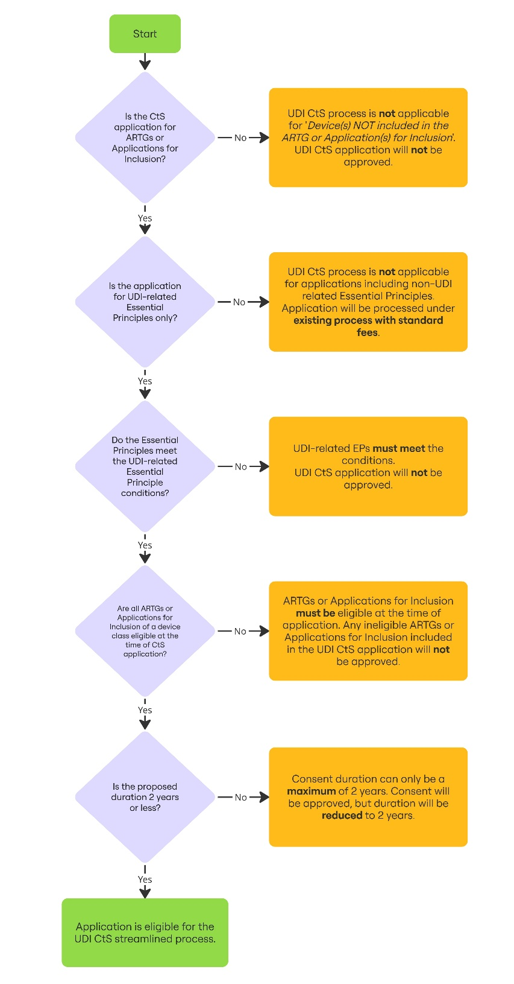

Eligible ARTGs and Applications for Inclusion
You must include only ARTGs or Applications for Inclusion that are eligible on the date you apply.
An ARTG or Application for Inclusion is eligible when its device classification is within 12 months of its mandatory compliance date or is already past that date.
Table 1: Eligible ARTGs and Applications for Inclusion
Device classification | UDI mandatory compliance start date | Date you can apply for UDI CtS
Class III | 1 July 2026 | From 1 July 2026
Class IIb | 1 July 2026 | From 1 July 2026
Class IIa | 1 July 2027 | From 1 July 2026
Class Is | 1 July 2028 | From 1 July 2027
Class 4 IVD | 1 July 2028 | From 1 July 2027
Class 3 IVD | 1 July 2028 | From 1 July 2027
Class 2 IVD | 1 July 2029 | From 1 July 2028
Class 1 IVD | 1 July 2029 | From 1 July 2029
You may include ARTGs or Applications for Inclusion that cover multiple device classes in one UDI CtS application if:
- all device classes included have passed the mandatory compliance date, or
- some device classes are already past the mandatory compliance date and other device classes have a mandatory compliance date within 12 months.
For example, you may submit UDI CtS applications on 31 December 2026 for Class III and Class IIa devices because:
- Class III mandatory compliance began on 1 July 2026
- Class IIa mandatory compliance begins on 1 July 2027, which is within 12 months.
However, including multiple device classes may result in a reduced consent period, as only a maximum of 2 years will be provided per application.
If you wish to obtain the full 2-year consent period for each ARTG or Application for Inclusion, we encourage you to submit separate applications per device class. Submitting a single application covering multiple device classes may result in a reduced consent period.
A single application covering multiple device classes results in reduced consent duration
Example: Anabela the sponsor
Anabela cannot meet UDI-related EPs for 3 ARTG entries:
- one Class III ARTG
- one Class IIa ARTG
- one Class Is ARTG.
Anabela submits a UDI CtS application on 1 July 2026. She includes her Class III, Class IIa and Class Is ARTGs in a single application.
Consent will be approved for her Class III and Class IIa ARTG entries, because they are both eligible on the date of application as:
- the mandatory compliance date has passed for Class III medical devices
- the Class IIa ARTG is within the 12-month window.
If Anabela includes both her Class III and Class IIa ARTGs, she can only propose a single consent duration. This means that her Class IIa ARTG will have a reduced consent duration. For more information, see Applications with different proposed consent durations.
However, submitting a combined application for Class III and Class IIa ARTG entries will result in a reduced consent period for the Class IIa ARTG entry, which in this case would be until 30 June 2028. This is because each application will only be granted for a maximum of 2 years.
Her Class Is ARTG entry will also not receive consent, because it is not eligible on the date of submission.
She can apply again from 1 July 2027 for her Class Is ARTG.
Multiple applications covering multiple device classes results in maximum consent duration
Example: Jess the sponsor
Jess cannot meet UDI-related EPs for 3 ARTG entries:
- one Class III ARTG
- one Class IIa ARTG
- one Class Is ARTG.
On 1 July 2026, Jess submits a UDI CtS application for her Class III ARTG entry. The TGA grants consent for this application.
Jess later submits separate applications for the remaining inclusions:
- the Class IIa inclusion on 1 May 2027
- the Class Is inclusion on 1 May 2028.
Submitting separate applications means:
- Jess receives the full 2-year consent duration for each ARTG
- each application includes only eligible ARTG inclusions.

UDI-related Essential Principles
To be eligible for the streamlined process and reduced fees described in this guide, your application must only include UDI-related EPs. We will accept applications with the following UDI-related EPs, provided they meet the applicable conditions:
- EP13.5 UDI medical devices—UDI device identifier and UDI production identifier
- EP13.6 UDI medical devices—medical device packaging identifier
- EP13A.2 Patient implant cards etc. for implantable devices
- EP13C.1 Identifiers relating to UDI medical devices
- EP13C.2 Inclusion of identifiers in the Australian Unique Device Identification Database
- EP13C.3 Inclusion of other information in the Australian Unique Device Identification Database
- EP13C.4 Information in the Australian Unique Device Identification Database to be accurate and up to date
- EP13C.5 UDI device identifier and UDI production identifier to be directly marked on UDI medical device.

UDI-related Essential Principle conditions
You must understand the conditions under which each UDI-related EP will be accepted.
Table 2: UDI-related Essential Principle conditions
Essential Principle | Conditions
13.5 UDI medical devices—UDI device identifier and UDI production identifier  This EP covers UDI labelling requirements. | - You may select this EP alone or with other UDI-related EPs.
13.6 UDI medical devices—medical device packaging identifier  This EP covers UDI requirements for packaging. | - You may select this EP alone or with other UDI-related EPs.
13A.2 Patient implant cards etc. for implantable devices  This EP covers UDI requirements for Patient Implant Cards. | - You may select this EP alone or with other UDI-related EPs.
13C.1 Identifiers relating to UDI medical devices  This EP covers allocation of the UDI-DI by a TGA recognised Issuing Agency. | - You cannot select this EP alone.  - You cannot request consent to use a self-created UDI-DI or a UDI-DI from a non-TGA recognised Issuing Agency.  - You must only select this EP where you have not obtained a UDI-DI from a TGA recognised Issuing Agency.  - If you select this EP, you must also select all other UDI-related EPs.
13C.2 Inclusion of identifiers in the Australian Unique Device Identification Database  This EP covers submission of the UDI-DI to the Australian UDI Database (AusUDID). | - You cannot select this EP alone.  - You must select EP13C.3 with this EP, because the AusUDID does not accept partial records.
13C.3 Inclusion of other information in the Australian Unique Device Identification Database  This EP covers submission of all other mandatory UDI data to the AusUDID. | - You cannot select this EP alone.  - You must select EP13C.2 with this EP, because the AusUDID does not accept partial records.
13C.4 Information in the Australian Unique Device Identification Database to be accurate and up to date  This EP covers the requirement to maintain accurate and current UDI records in the AusUDID. | - You should only select this EP where information is not accurate or up to date in the AusUDID because of:  - mergers or acquisitions  - transfer of sponsorship  - Device Change Requests.
13C.5 UDI device identifier and UDI production identifier to be directly marked on UDI medical device  This EP covers UDI direct marking on reusable devices reprocessed between uses on multiple patients. | - You may select this EP alone or with other UDI-related EPs.  - See: EP13C.5 – direct marking.
Under the streamlined process, your application will not be granted if:
- it selects EP13C.1 alone
- it selects EP13C.2 alone
- it selects EP13C.3 alone.
If your application includes non-UDI related EPs, it will be granted; however, it will be processed under the full fee. It will not be granted under the streamlined UDI CtS process.

EP 13C.5 – direct marking
Direct marking has different compliance dates from UDI labelling and UDI record submission.
You may include EP13C.5 in a UDI CtS application if the device class is eligible, even if direct marking is not yet mandatory.
For example, you may include EP13C.5 in an application for a Class III medical device submitted on 1 July 2026, even though mandatory compliance for direct marking of Class III medical devices starts on 1 January 2028.
However, each UDI CtS application will only be granted for a maximum of 2 years. If you include EP13C.5, this will only receive consent for the period granted. If you need consent beyond the 2-year period, you must submit a separate application for EP13C.5.
Managing direct marking obligations under a UDI Consent to Supply process
Example: Michael the sponsor
Michael cannot meet UDI-related EPs for a Class III ARTG entry.
Michael applies for consent to supply on 1 July 2026. He requests consent for the period of 1 July 2026 to 30 June 2028. He includes EP13C.5 in his application.
The TGA will grant only one 2-year consent period for this application.
If Michael cannot meet EP13C.5 by 30 June 2028, he must submit a new UDI CtS application.
If he cannot meet other UDI-related EPs by 30 June 2028, he may include them in that new application.

UDI CtS application fees
The application fee applies to each ARTG entry in the UDI CtS application.
From 1 July 2026, application fees for UDI CtS applications are reduced to reflect lower recovery costs for TGA staff.
The fee paid for the application is not refundable.
Applications submitted before 1 July 2026 will be charged the existing consent to supply application fee, which is higher than the reduced fee that will apply to UDI CtS applications from 1 July 2026.
No refunds will be provided for application fees paid before 1 July 2026.

Scope and eligibility
These fees apply to applications for UDI-related EPs only. Applications that include any non-UDI related EPs must use the standard consent application process. Applications that include non-UDI related EPs are not eligible for the reduced UDI CtS fees.

Fee calculation
Fees are calculated based on the total number of ARTG entries in the UDI CtS application.
For example, if you include 220 ARTG entries that do not meet UDI-related EPs in your application, you will calculate the total as follows:
Table 3: Example of calculating fees
220 ARTG inclusions | Calculation | Cost
First ARTG inclusion | $80 for the first ARTG | $80
Next 219 | $10 x 219 additional ARTG | $2,190
Total | ($80 x 1) + (219 x $10) | $2,270
If the same 220 ARTGs also include any non-UDI related EPs, you must use the standard consent application process. You are not eligible for the reduced UDI CtS fee in that case.
The above is an example, and the dollar values used may not reflect the current fee. For up to date fees, refer to the Fees and Charges web page and Schedule 5 – Fees, Part 1 – General of the Therapeutic Goods (Medical Devices) Regulations 2002 (the Regulations).
If you apply for consent to supply prior to 1 July 2026, you must pay the full fee.
From 1 July 2026, changes to the Therapeutic Goods (Medical Devices) Regulations 2002 will introduce a fee concession for sponsors seeking consent to import or supply devices that are not compliant with UDI requirements.
The TGA will not apply this fee concession retrospectively. The TGA will not refund the difference in fees for sponsors who have applied prior to the reduced fee taking effect.

How to pay
You can pay on invoice or immediately after submission of your application.
Payment on invoice is the preferred method.
Your application and payment will be linked during processing using the TBS Client ID Number and the application reference number (consent application ID) provided in the payment details.
- Payment against invoice
To pay against invoice, complete and submit your UDI CtS application. The TGA will issue an invoice to the submitter for the processing fees.
Note that if you apply before 1 July 2026, you must pay the full fee. The TGA will not refund the difference in fees for sponsors who have applied prior to the reduced fee taking effect.
- Immediate payment
To pay immediately after you submit your UDI CtS application:
  - Calculate the total fee for your UDI CtS application based on the number of ARTG entries, per the example above. Note that if you apply before 1 July 2026, you must pay the full fee.
  - Go to the TGA payment page.
  - In the Biller Code field, select Option 9: ‘Exemption under S41MA device’.
  - Enter your TBS Client ID number in the box provided.
  - Enter the application reference number (consent application ID) in the ‘ARTG No.’ field to link the payment to your application.
  - Enter the total amount of fees to be paid in AUD.
  - Select the payment method.
  - Follow the instructions to complete the payment.
Applications will only be processed once the application fees have been paid in full.

Applications submitted prior to 1 July 2026
From 1 July 2026, changes to the Therapeutic Goods (Medical Devices) Regulations 2002 will introduce a fee concession for sponsors seeking consent to import or supply devices that are not compliant with UDI requirements.
The TGA will not apply this fee concession retrospectively. The TGA will not refund the difference in fees for sponsors who have applied prior to the reduced fee taking effect.

Accessing the consent for non-compliance dashboard
Log into the TBS portal to access the Consent for non-compliance dashboard.
Open the Applications drop-down menu and select Medical Device Post Market Compliance under Regulatory Compliance.
Figure 2: TBS portal
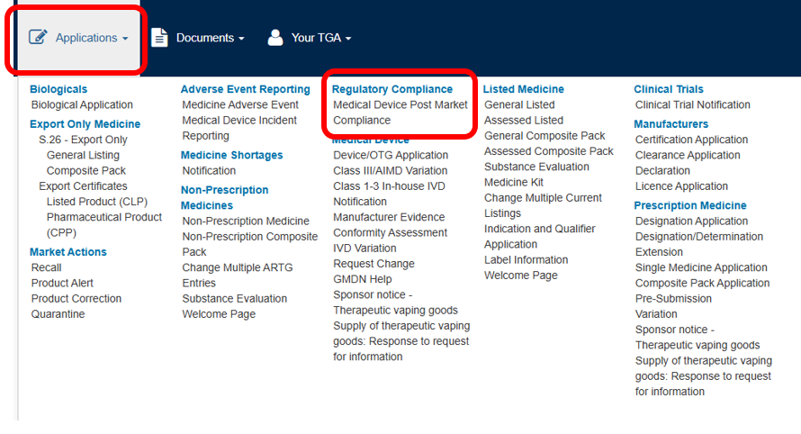
Select Devices Compliance (PMR).
Figure 3: Regulatory and Compliance Portal
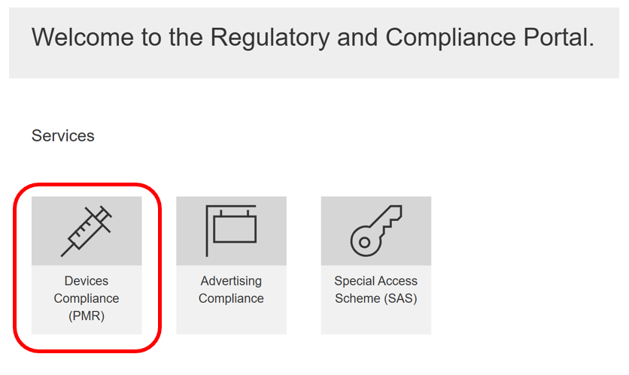
Select Consent for Non-compliance Applications to open the dashboard.
Figure 4: PMR Compliance Dashboard
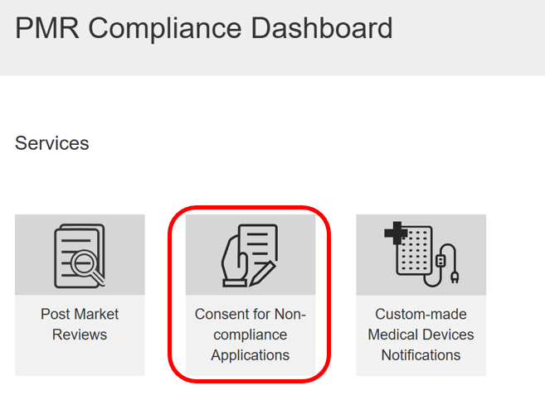
On the dashboard, you can:
- view Draft applications
- view Submitted applications
- view Notifications related to applications
- search for applications by using the search bar indicated by the magnifying glass symbol [🔍]
- sort the table by selecting the column heading.
Figure 5: Consent for Non-compliance Dashboard
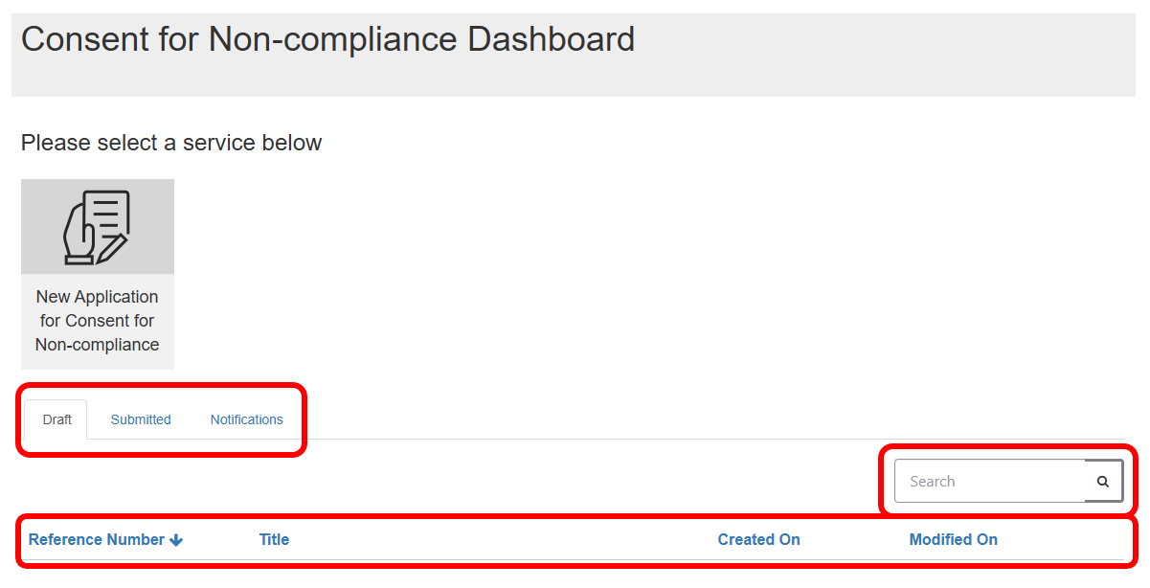
For detailed instructions on the dashboard, including deleting or editing draft applications, see Completing an application for consent to import, supply, or export medical devices that do not meet the Essential Principles.

Creating a new UDI CtS application
Fields marked with a red asterisk [*] are mandatory.
On the Consent for Non-compliance Dashboard, select the New Application for Consent for Non-compliance tile.
Figure 6: Consent for Non-compliance Dashboard
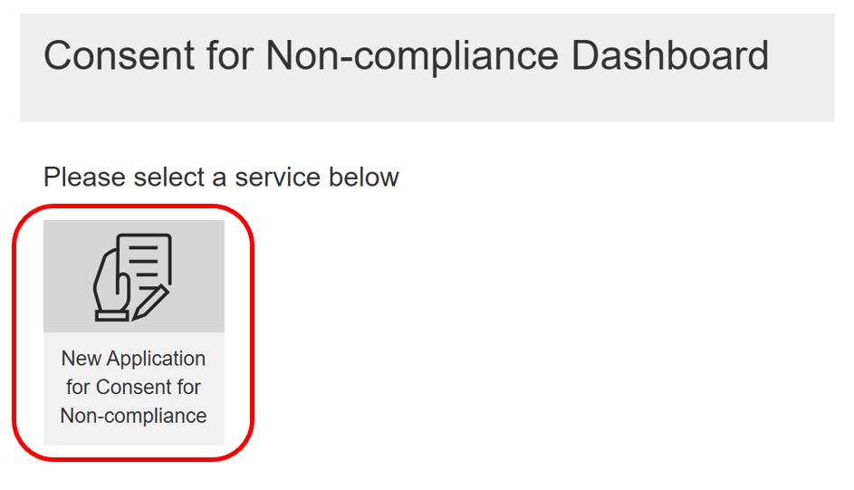
This action opens a new window. You must provide additional information on this page.

Application name
Choose any name meaningful to your organisation.
Include ‘UDI’ at the beginning to help ensure streamlined processing and correct fee assessment. This also helps you distinguish applications over time.

What the application seeks consent for
Select only:
- Device(s) included in the ARTG, or
- Device(s) included in Application(s) for Inclusion
You must not select ‘Device(s) NOT included in the ARTG or Application(s) for Inclusion’ for UDI CtS applications.
Figure 7: New application for Consent for Non-compliance
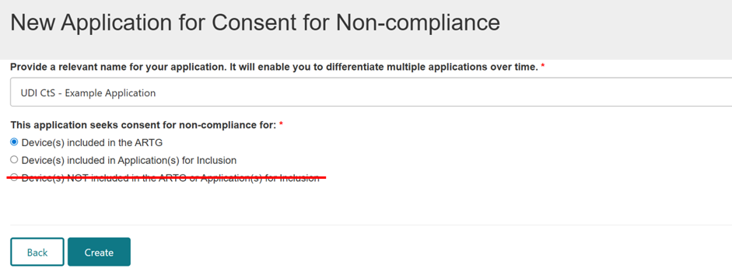
After naming your application and selecting the relevant option, select Create at the bottom of the page. The system will generate the application.
Figure 8: New application for Consent for Non-Compliance
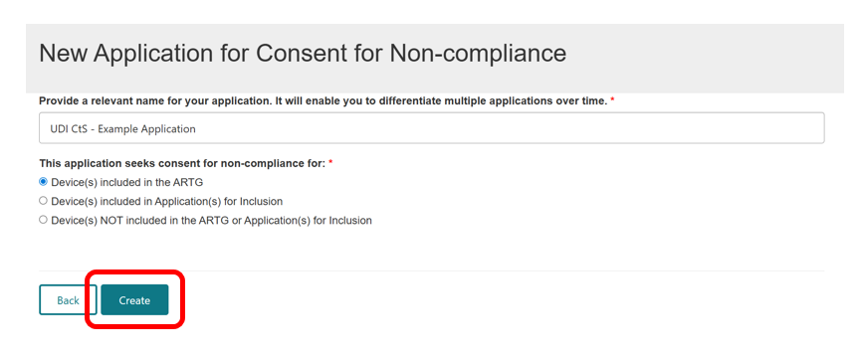
The system then assigns an application reference number (also referred to as a consent application ID).
You can find the application reference number in the Application details section.
You should use this ID in any communications with the TGA regarding your application. You must also use this ID if you select the immediate payment option.

Saving an application as a draft
Select Save at the bottom of the page to save your application as a draft.
Figure 9: UDI CtS example application
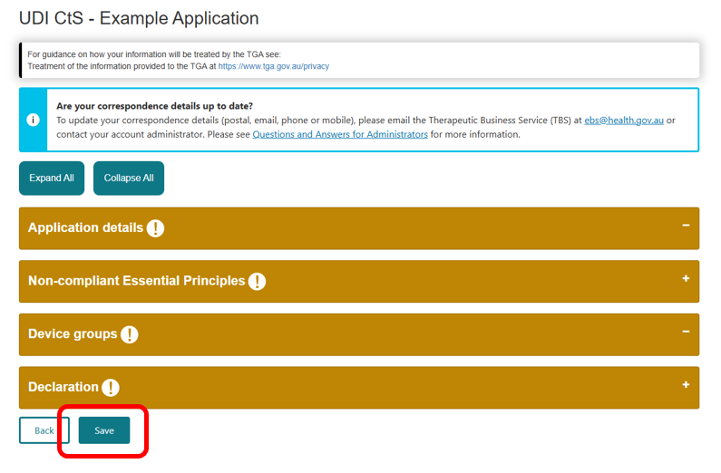
The system will confirm that the draft saved successfully.
Figure 10: UDI CtS example application
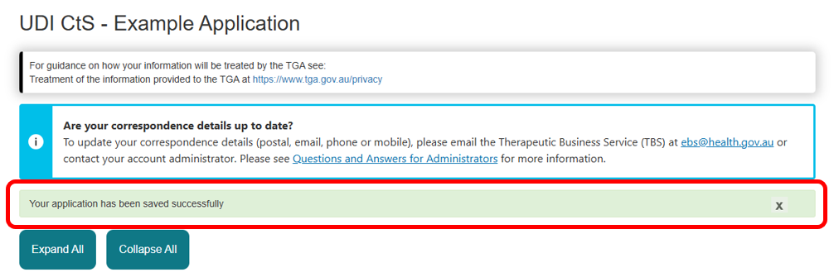
You can now access the draft from the Consent for Non-compliance Dashboard.
Figure 11: Draft in Consent for Non-compliance Dashboard
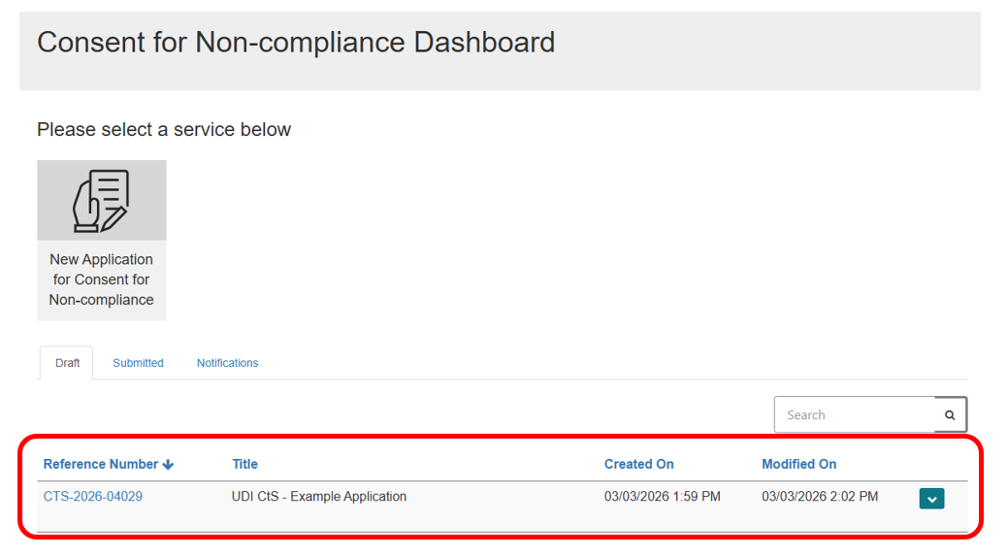
By including UDI in your application name, you can search for any applications related to UDI.
Figure 12: UDI CtS application search results
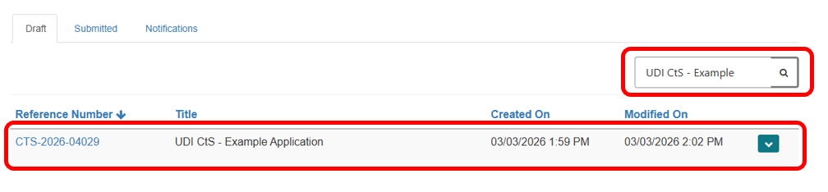

Completing an application
Select the relevant draft on the dashboard to continue working on your application.
If you just created the application, continue entering the required information.
Sections display in amber when mandatory information is missing and green once you provided all required information.
Figure 13: Example of sections changing colour
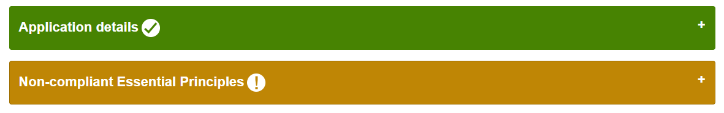
You may expand all sections or collapse all sections when completing the form.
Figure 14: Expand and collapse buttons
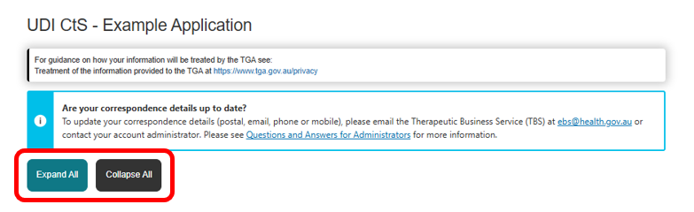
You can also expand a single section by selecting its header.
Figure 15: Section header
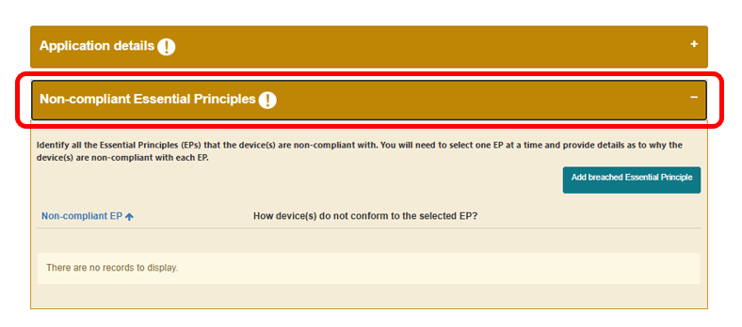

Application details section
The Application details section contains the following information:
- The application reference number (consent application ID), which you must use in correspondence with the TGA.
- The application name, auto populated from the name you entered during creation.
- The sponsor’s name, auto populated from your TGA Business Services (TBS) profile.
Figure 16: Application details section
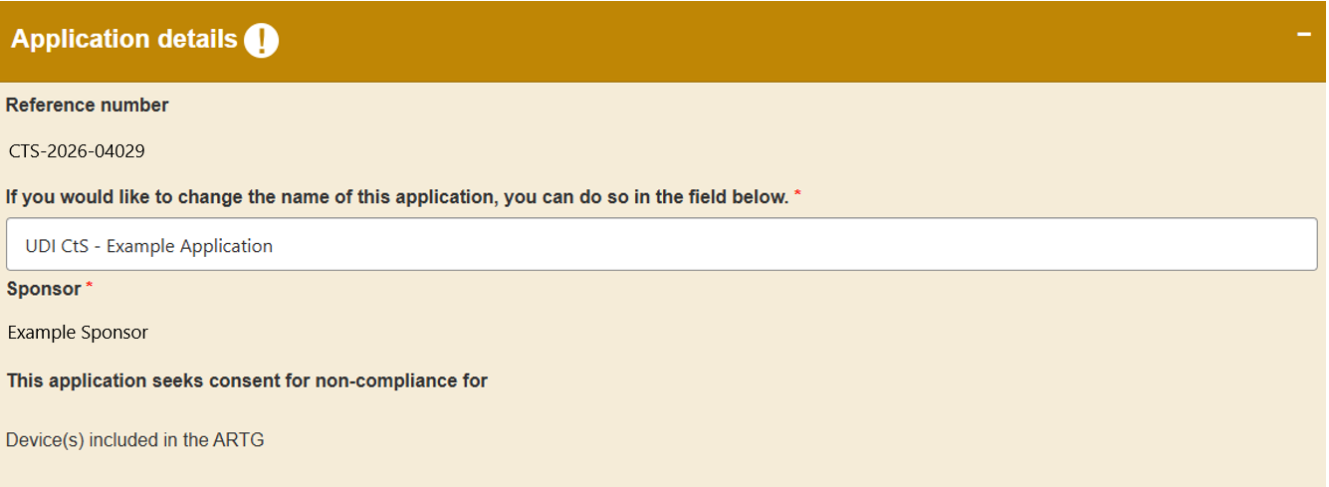

Selecting the consent activity
You must select whether the application seeks consent for the devices to be:
- imported
- supplied.
Do not select ‘Exported’, because UDI obligations do not apply to export-only devices.
Even if added, you cannot get consent to export as it does not apply.
Figure 17: Types of devices consent you can seek consent for checkboxes
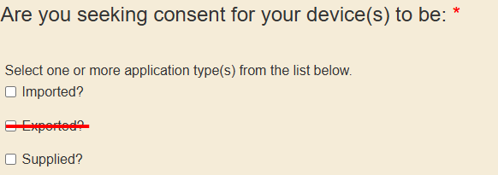

Reason for non-conformance
You must specify why the device does not conform to UDI-related Essential Principles.
For UDI CtS applications, you must select ‘Is this a result of UDI implementation?’
Figure 18: Reason for non-conformance dropdown
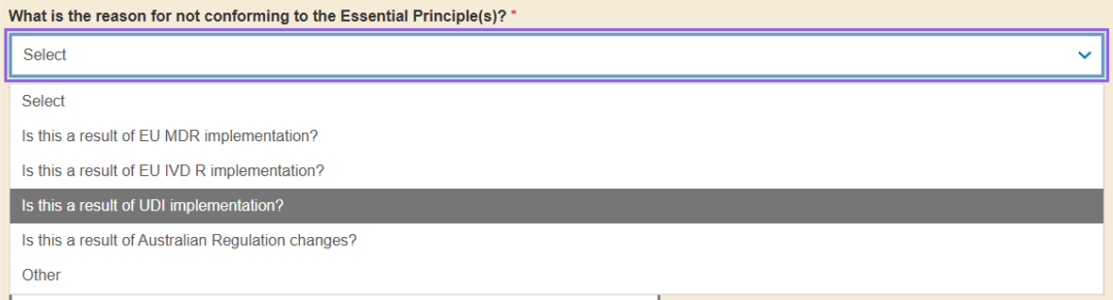

Potential risks associated with non-conformance
You must provide an explanation of the real or potential risks if the non-conforming device is:
- imported
- supplied.
Do not consider exported devices, because UDI does not apply to export-only devices.
Use the wording below for UDI CtS applications. This wording supports streamlined processing and correct fee assessment.
UDI CtS template wording – potential risks associated with the non-conformance if the non-conforming device(s) were to be imported, exported, or supplied
While UDI requirements can enhance patient safety, there are minimal potential risks associated with non-conformance with UDI-related Essential Principles if the non-conforming device(s) are imported or supplied.
The safety risk from non-compliance with UDI requirements is low. While UDI compliance provides supplementary information that helps identify and track approved devices, it does not change device approvals.
Non-compliance with the UDI requirements has the potential to disrupt supply of medical devices.
Figure 19: Potential risks associated with non-conformance text box
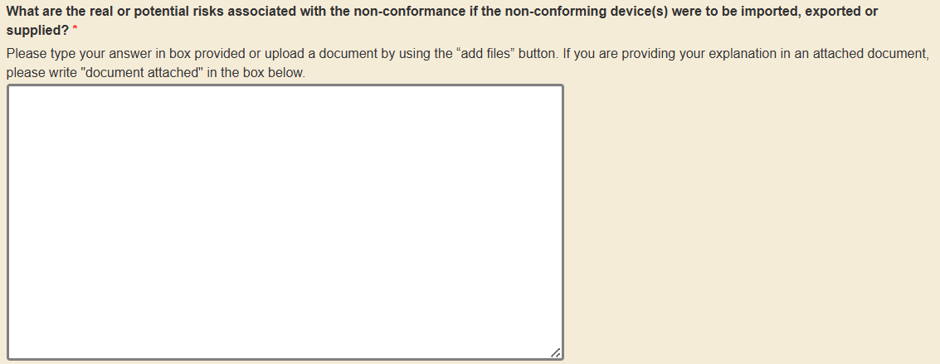

Supporting documents
The form allows you to upload supporting documents such as files or emails. Do not upload additional files for UDI CtS applications, as this may delay streamlined processing.
Figure 20: Supporting documents
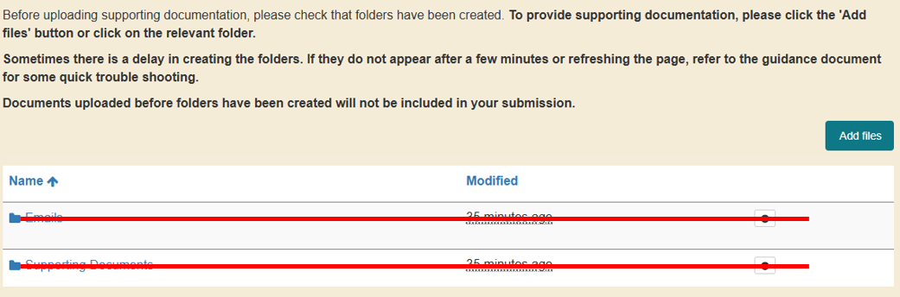

Completing the section
The Application details section will turn green once you complete all mandatory fields.
Figure 21: Section colours
You may then save the application to continue later or proceed with the remaining sections.

Non-compliant Essential Principles section
You must select all UDI-related EPs that the device(s) do not meet.
Select one UDI-related EP at a time and explain the non-compliance.

Adding an Essential Principle
Select Add breached Essential Principle to add an EP.
Figure 22: Add breached Essential Principle button
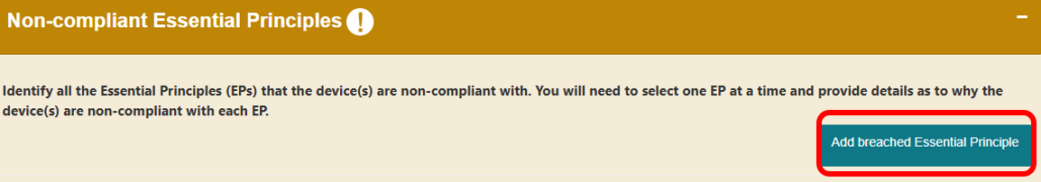
This will open a window where you can choose the relevant Essential Principle and provide details.
For a UDI CtS application, select UDI-related EPs only.
If you select any non-UDI related EPs, the TGA will process the application under the standard CtS process with the full fee.
Figure 23: Add Non-compliant Essential Principle text dropdown and text box
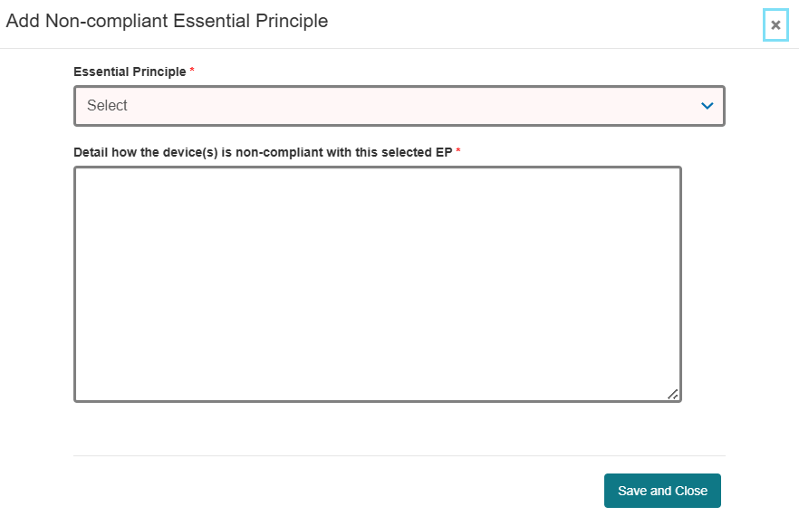
Scroll through the list to locate the UDI-related EPs.
Figure 24: Essential Principle dropdown
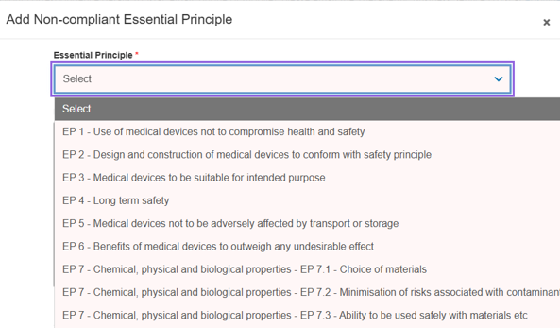

Explaining non-compliance
You must explain how the device(s) do not comply with the selected UDI-related EPs.
For example:
- if the UDI is not on the label, explain why the label cannot include the UDI
- if the UDI is not on the packaging, explain why the packaging cannot include the UDI.
Select Save and Close once you complete the entry. Repeat this process for each UDI-related EP that applies.
The section will turn green after you add one EP. However, you must add all the UDI-related EPs that the device(s) do not meet.
Figure 25: Essential Principle save and close button
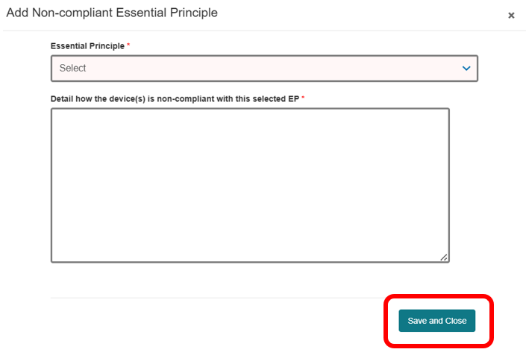

Editing or deleting Essential Principles
Select the down-arrow on the right-hand side to edit or delete an EP.
Choose Edit to update the details or Delete to remove the EP.
Figure 26: Edit and delete dropdown
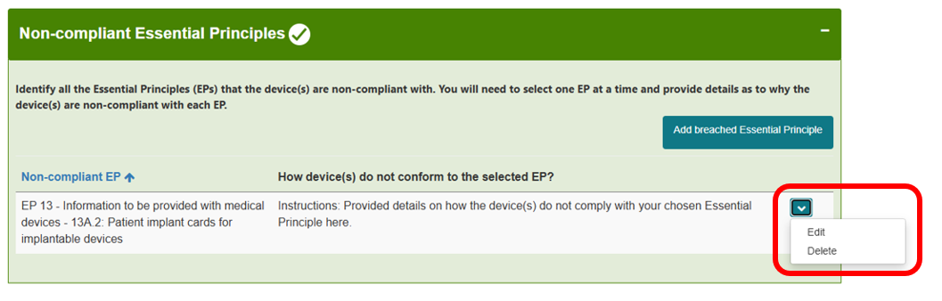
We recommend selecting Save at the bottom of the page after each section to avoid losing your work.

Device groups section

Create a single device group
For UDI CtS applications, include all eligible ARTGs or Applications for Inclusion in one device group with the same proposed consent duration. This ensures:
- the application can be approved under the streamlined UDI CtS approach with reduced fees
- each device receives the full requested consent duration.
Under the streamlined process, the TGA grants only one consent period per application. The maximum period is 2 years for all ARTGs or Applications for Inclusion in that application.
If you need different consent periods, you can:
- submit multiple applications, or
- reapply when the consent expires.
You may separate ARTGs or Applications for Inclusion by device classification if you prefer; however, each group should use the same proposed consent duration to ensure it receives the maximum consent duration. For example:
- one device group for Class III medical devices with the proposed consent duration of 1 July 2026 to 30 June 2028
- one device group for Class IIb medical devices with the proposed consent duration of 1 July 2026 to 30 June 2028.
Grouping devices by classification while using a single consent duration
Example: Karlyn the sponsor
Karlyn cannot meet UDI-related EPs for a Class III ARTG entry and a Class IIb ARTG entry. She submits a UDI CtS application that:
- includes her Class III and Class IIb devices in one application
- places all ARTGs or Applications for Inclusion in one device group
- separates the devices by device classification, if she prefers.
If Karlyn has multiple device groups, each group must:
- have the same proposed consent duration, including start and end dates
- include a proposed consent duration of 2 years or less.
Karlyn proposes 1 July 2026 to 30 June 2028 and provides all required information. The TGA will approve her application for the full requested consent duration because:
- she applied within the 12-month window
- each group uses the same proposed consent duration
- she requested no more than 2 years.

Applications with different proposed consent durations
You may include multiple ARTGs or Applications for Inclusion with different device classifications when they share the same start and end dates. If the device classes need different dates, you must submit separate applications. This ensures:
- each ARTG or Application for Inclusion receives the full 2-year consent period, if requested
- the application can be approved under the streamlined process with reduced fees
- no device exceeds the allowable 2-year duration.
If you create device groups with different proposed consent durations, the TGA will only approve consent for a maximum of 2 years starting from the first proposed start date provided. This is because the streamlined process only grants a one 2-year period.
This means that ARTGs or Applications for Inclusion with later mandatory compliance start dates may not receive the full 2 years consent period.
If you need different consent durations, submit separate applications. For example:
- one application for Class III devices for 1 July 2026 to 30 June 2028
- one application for Class IIa devices for 1 July 2027 to 30 June 2029.
This differs from standard consent applications, which allow multiple device groups with different proposed consent durations.
Different proposed consent durations results in a single 2‑year consent period
Example: Carolyn the sponsor
Carolyn cannot meet UDI-related EPs for her ARTGs covering Class III, Class IIa and Class Is devices.
She applies on 1 July 2026 and includes her Class III, Class IIa and Class Is in one UDI CtS application. She enters her Class III, Class IIa and Class Is into 3 separate device groups and proposes consent durations of:
- 1 July 2026 to 1 July 2028 for her Class III devices
- 1 July 2027 to 1 July 2029 for her Class IIa devices
- 1 July 2028 to 1 July 2030 for her Class Is devices.
Her application will be approved only until 30 June 2028 for all 3 device classifications.
If Carolyn wishes to obtain the proposed consent periods for her Class IIa devices (1 July 2027 to 1 July 2029) and Class Is devices (1 July 2028 to 1 July 2030), she must submit 2 new, separate UDI CtS applications:
- one application covering her Class IIa devices from 1 July 2027 to 1 July 2029, and
- one application covering her Class Is devices from 1 July 2028 to 1 July 2030.
Shared proposed consent durations results in a shared 2‑year consent period
Example: Gary the sponsor
Gary cannot meet UDI-related EPs for his ARTGs covering Class III and IIa devices.
He applies on 1 July 2026 and includes both his Class III and Class IIa ARTG entries in one application. He includes them in a single device group and requests a consent period from 1 July 2026 to 30 June 2028 for both device classes.
His application will be approved. Both device classes will receive consent only from 1 July 2026 to 30 June 2028.
If Gary wants the full 2-year period for both his Class III and Class IIa ARTG entries, he must submit separate applications or reapply when consent expires. Gary may choose to also reapply for consent for his Class III device if he needs additional time to become UDI compliant.

Creating a device group
Select Add Device group to create a new group.
Figure 27: Device groups section
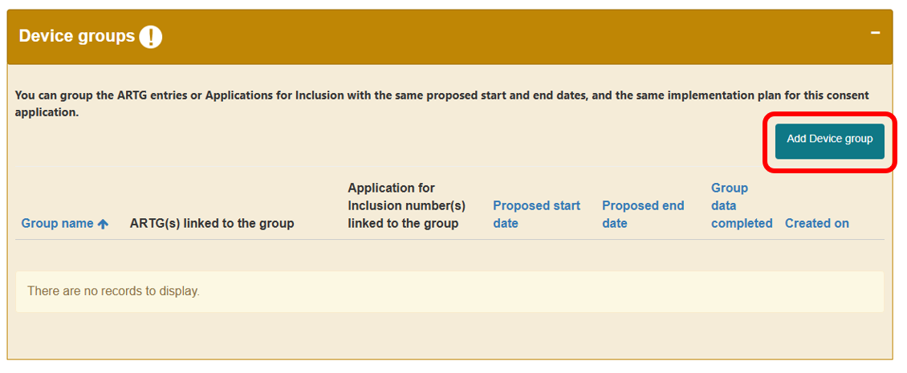
Provide a name for your device group. You may choose to repeat the application name or consent application ID.
Select Save and Close to create the group.
Figure 28: Device group save and close button
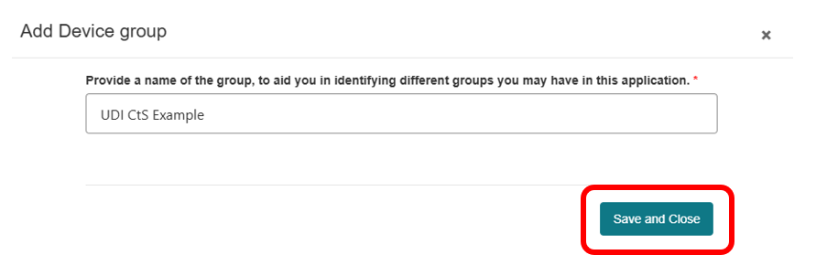
Your device group will now appear in the Device groups section.
Figure 29: Example of device group
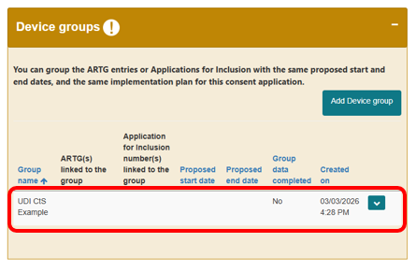

Adding ARTG entries to a device group
The process may vary depending on your application. These instructions provide high-level guidance on adding a group.
Select the down-arrow beside the device group and choose Edit.
Figure 30: Device group edit and delete dropdown
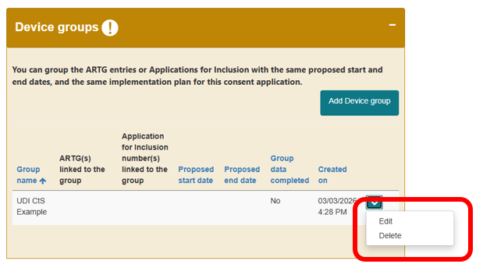
A new window will open displaying your device group name at the top.
Figure 31: Add ARTG button
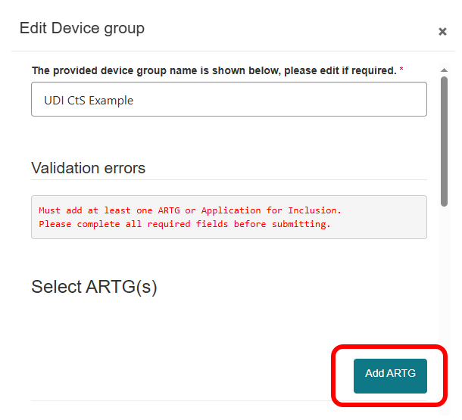
Select Add ARTG to add ARTG entries. A list of your organisations ARTG entries will appear.
If you are completing an application for Applications for Inclusion, this will appear differently however you may complete this section in the same way.
Figure 32: Lookup records screen
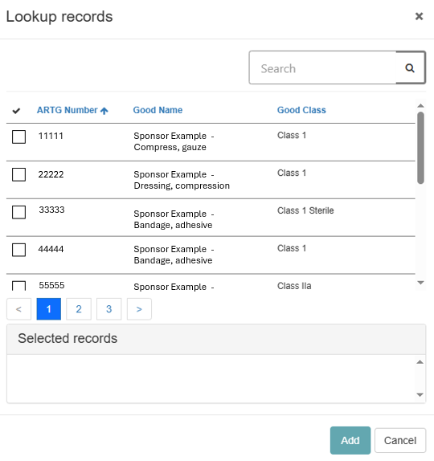
You may select one or multiple ARTGs by ticking the box beside the ARTG ID.
In the lookup records view:
- a tick symbol [✓] indicates an ARTG entry has been selected
- you may search ARTG entries using the search bar indicated by the magnifying glass icon [🔍]
- you may search using partial text with an asterisk [*] as a wildcard
- you may sort the table by selecting the column headings; the up arrow [↑] shows ascending order and the down arrow [↓] shows descending order.
Select Add once you have selected all required ARTG entries.
Figure 33: Add button
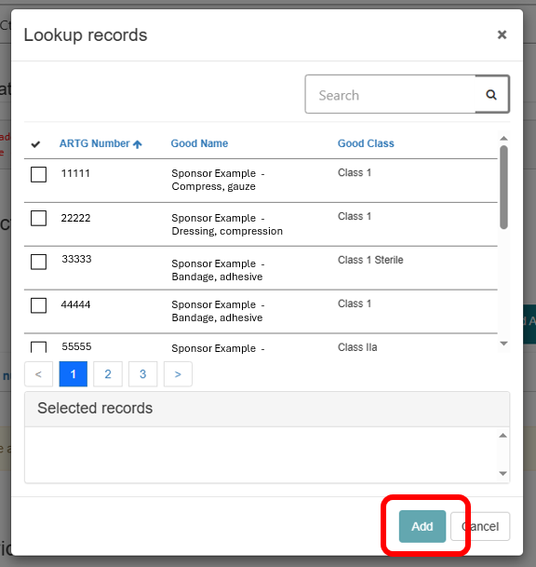
The selected ARTG entries will appear within the device group.
Figure 34: ARTG entries appearing in device group
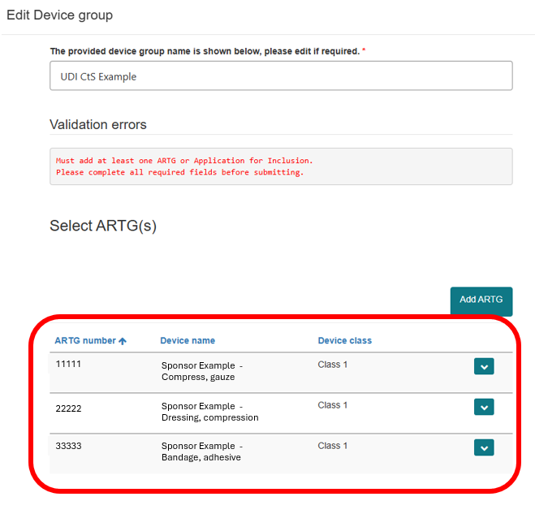

You may add additional ARTG inclusions by selecting Add ARTG again.
To remove an inclusion, select the down-arrow beside the entry and choose Remove ARTG.
Figure 35: Remove ARTG dropdown
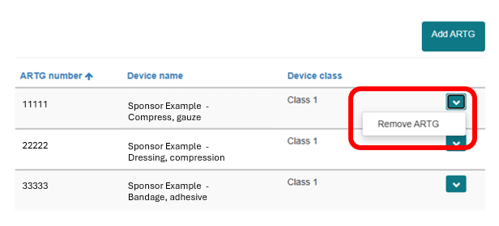
Save your application and refresh your browser after selecting all ARTG inclusions. Devices will not appear in later sections until you refresh.
After refreshing, reopen the device group by selecting Edit.
Figure 36: Device groups edit dropdown

Stock level information
UDI CtS applications do not require stock level information. You may provide stock information if desired. Select the down-arrow beside the ARTG entry, choose Edit, and add the information.

Proposed consent duration
You must include the proposed consent duration.
UDI CtS applications will only be approved for durations of a maximum of 2 years (24 months) or less.
Under the streamlined process, the TGA grants only one consent period per application. The maximum period is 2 years for all ARTGs or Applications for Inclusion in that application.
If you need different consent periods, you can:
- submit multiple applications, or
- reapply when the consent expires.
For more information, see Applications with different proposed consent durations.
You should choose a start date that aligns with the UDI mandatory compliance date for that device class. For example, mandatory compliance for Class III devices begins on 1 July 2026, so you should nominate 1 July 2026 as the proposed start date.
Figure 37: Proposed consent duration fields
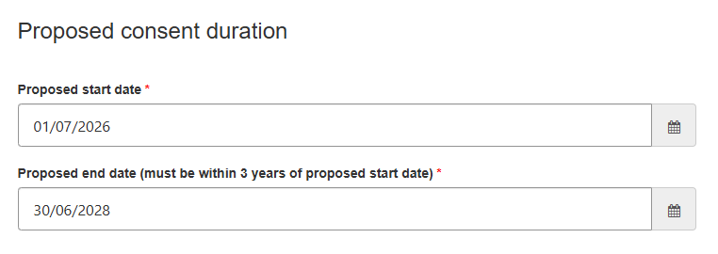
You must also provide a reason for the proposed duration. Use concise dot points describing how you will use that period.
UDI CtS applications do not require batches affected.
Figure 38: Example of reason for duration of consent
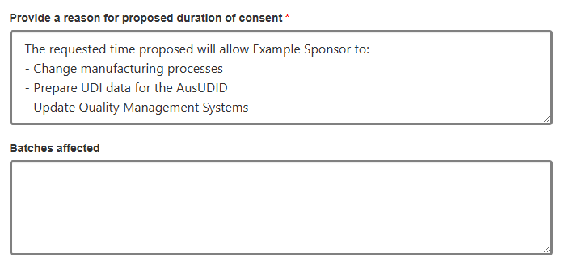

Strategies to rectify non-compliance
You must provide the strategies implemented or proposed to address the non-conformance. Use concise dot points describing the high-level actions intended to achieve UDI compliance.
Figure 39: Example of strategies to rectify non-compliance
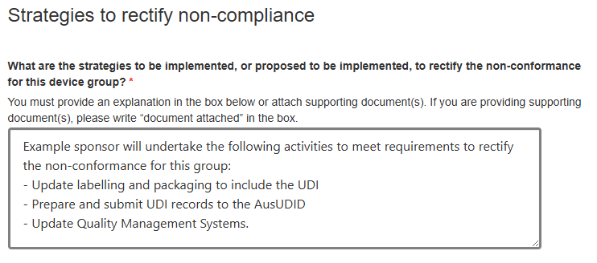

Documents
You may attach documents, but attachments are optional.
Once completed, select Save and Close at the bottom of the window.
Figure 40: Save and close button
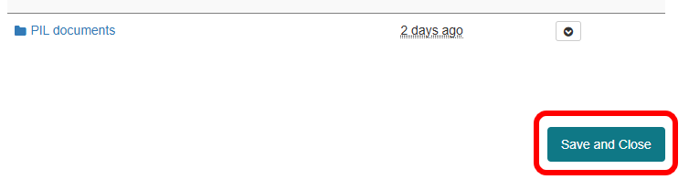

Adding second device groups
To add a second device group, follow the steps above. The second group will display in your Device groups section.
Before adding another device group, ensure you understand how consent will be approved when there is more than one device group with different consent periods.

Figure 41: Example of multiple device groups
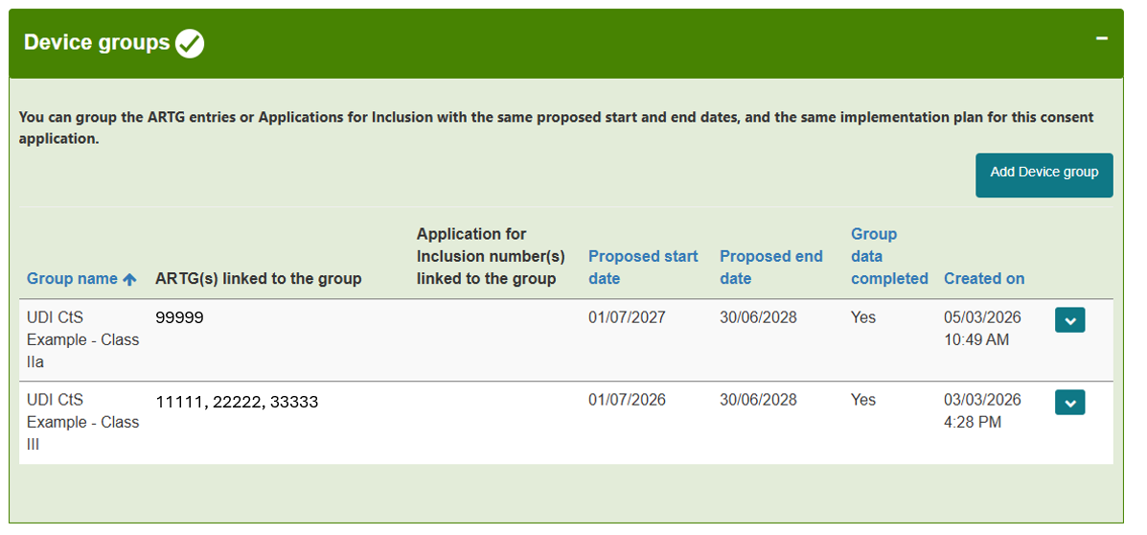

Completing the section
Select Save and Close when finished. Your device group will appear in the Device groups section.
The section will appear green when complete. If the device group remains amber and the Group data completed column displays No, mandatory information is missing. You must edit the group and complete all required fields.
Figure 42: Completed section
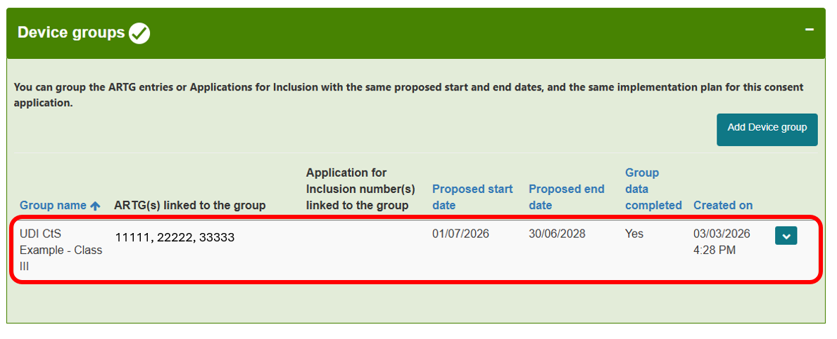

Declaration section
You can only complete the Declaration section after all other sections display green. If any section still displays amber and requires mandatory information, the declaration tick box will remain disabled.
Figure 43: Declaration section
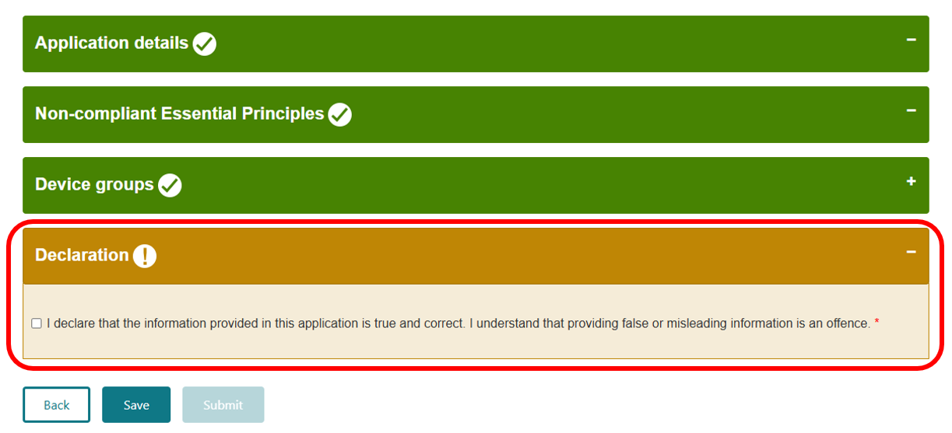

Agreeing to the declaration
Read the declaration statement once all sections are complete. If you agree, select the tick box to provide your declaration.
You declare that the information provided in your application is true and correct, and providing false or misleading information is an offence.
Figure 44: Declaration section
The Declaration section will turn green once ticked, which activates the Submit button.
Figure 45: Completed declaration and submit button
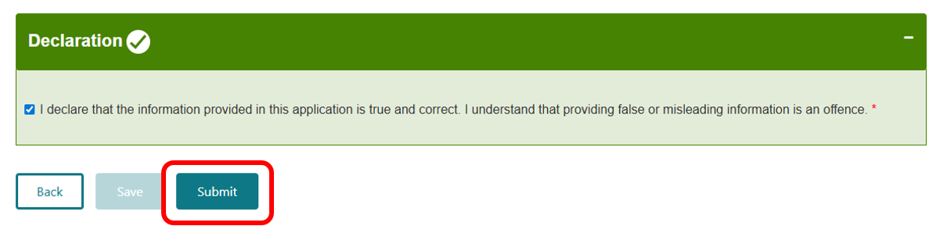
You may then:
- submit the application by selecting Submit
- save the application to submit later by selecting Save.
If all mandatory fields are complete and you still cannot save your response in the declaration section, check your TBS system role in the TBS portal.
- Only users with the Submitter role can save a declaration and submit the application.
- Users with the Drafter role can save the application only after clearing the declaration tick box.
Your TBS Administrator can change your system role. For assistance, contact the TBS Helpdesk at eBS@health.gov.au.

Viewing a submitted UDI CtS
Open the Consent for Non-compliance Dashboard to view your submitted UDI CtS application.
Your application will appear under the Submitted tab. You may also search for your application using the search bar.
Figure 46: Submitted application appearing in dashboard with submitted status
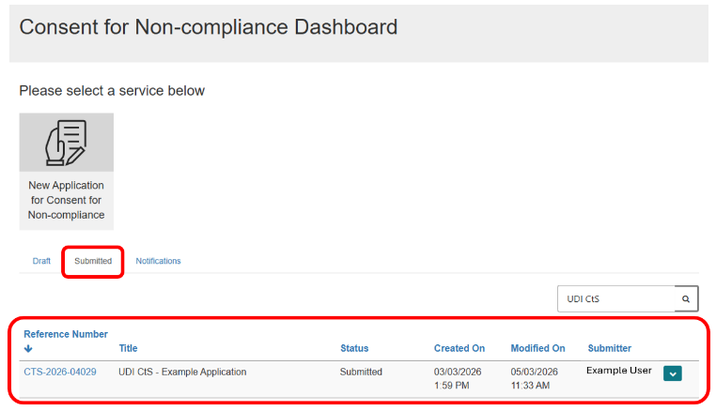

Status of a UDI CtS application
You can view your application status on the Submitted tab.
Figure 47: Submitted status
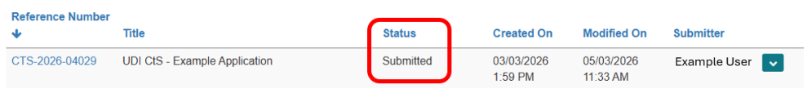
Your application may display one of the following statuses:
- Submitted: The application has been submitted but not yet under review.
- Review: The application is paid and under review.
- Approved: The application is approved, and consent is granted.
- Not Approved: The application was not approved, and consent has not been granted.
- Revoked: An approved consent has been revoked.
- Expired: The consent period has expired.
- Withdrawn: The application has been withdrawn by the sponsor.

Viewing, printing or withdrawing submitted applications
Select the down-arrow to:
- view details
- preview
- withdraw application.
Figure 48: View, print and preview dropdown
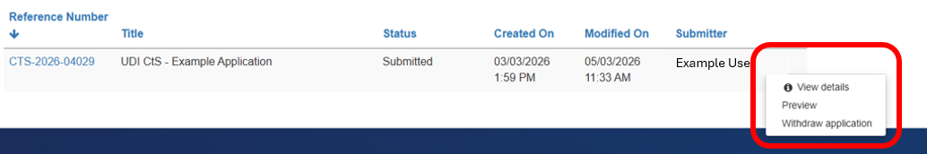
View details allows you to review all submitted information.
Figure 49: View details screen
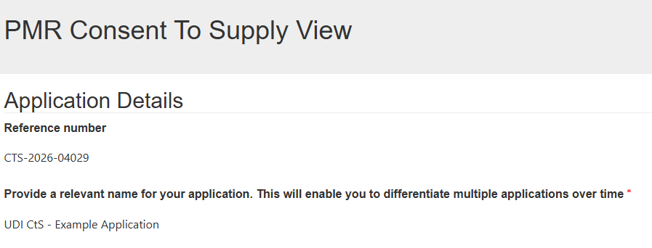
Preview allows you to view and print the application.
Figure 50: Preview screen with print button
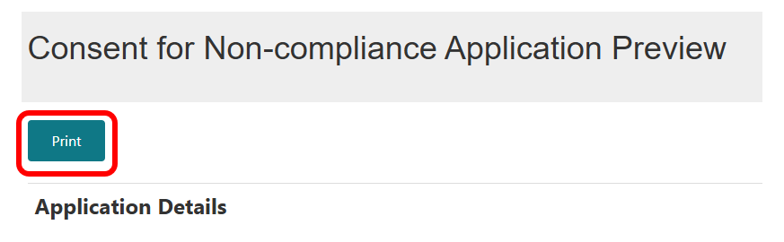
Withdraw application allows you to withdraw the application after submission.
It is important to note that once withdrawn, an application cannot be reactivated. The TGA does not refund application fees. If you later require consent for the same devices, you must lodge a new application.
To withdraw an application, select Withdraw application. Provide a reason and select Withdraw.
Figure 51: Withdraw screen with text box and withdraw button
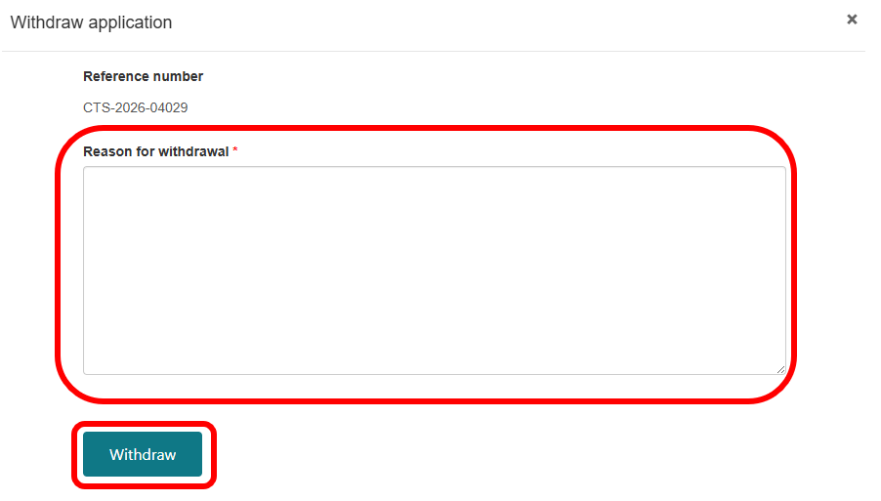

Resources
For resources specific to UDI, see: Unique Device Identification (UDI) hub.

Contact us
For help submitting your application, contact the Medical Device Consent Team:
 | mdconsent@health.gov.au
 | 1800 141 144
For UDI-specific assistance, contact the UDI Support Team:
UDI@health.gov.au

Version history
Version | Description of change | Author | Effective date
V1.0 | Original publication | Device Reforms Taskforce  Devices Application and Triage Section | May 2026

