Special Access Scheme (SAS)
  - Special Access Scheme & Authorised Prescriber Scheme Online System User Guide
Version 2.0, May 2026

Copyright
© Commonwealth of Australia 2026
This work is copyright. You may reproduce the whole or part of this work in unaltered form for your own personal use or, if you are part of an organisation, for internal use within your organisation, but only if you or your organisation do not use the reproduction for any commercial purpose and retain this copyright notice and all disclaimer notices as part of that reproduction. Apart from rights to use as permitted by the Copyright Act 1968 or allowed by this copyright notice, all other rights are reserved and you are not allowed to reproduce the whole or any part of this work in any way (electronic or otherwise) without first being given specific written permission from the Commonwealth to do so. Requests and inquiries concerning reproduction and rights are to be sent to the TGA Copyright Officer, Therapeutic Goods Administration, PO Box 100, Woden ACT 2606 or emailed to <tga.copyright@tga.gov.au>.

Contents
Online system overview 5
Terminology and definitions 5
Features of the SAS & authorised prescriber online system 6
Account management 7
Account registration 7
Health practitioners 11
Non-health practitioners 12
Change Password 12
Updating account information 15
Affiliated sites 16
Purpose 16
Site registration 16
Adding a site administrator(s) 19
Sending invitations to affiliate 20
Requesting to affiliate with a site 22
Approving or rejecting a request to affiliate with a site 24
SAS/AP validation search tool 25
User dashboards 25
Filtering dashboard information 26
Exporting submission data 26
Cloning submissions 26
Draft submissions 27
Completed submissions 28
Status of completed submissions 28
Downloading receipts and outcome letters 29
Expiring and expired submissions 29
Submitting SAS applications and notifications 30
Step 1 – Prescriber details 31
Step 2 – Product selection 32
Step 3 – Product details 36
Step 4 – Patient details 37
Step 5 – Summary 38
Submitting S3 products as a pharmacist 39
Medicinal cannabis submissions 44
When not to use the system to submit medicinal cannabis applications 44
Notifying or applying to a state or territory health department via the system 44
TGA contact details 48

Online system overview
The Special Access Scheme (SAS) & Authorised Prescriber (AP) Online System (the system) allows Health Practitioners to submit SAS applications and notifications. The system is designed to reduce administrative burden and provide health practitioners and organisations such as hospitals with additional reporting and management functions to assist in the management of their SAS applications and notifications.
This document provides users of the system with guidance about how to use the system. To reduce processing times, healthcare practitioners are strongly encouraged to submit submissions through the online system.
If you wish to access information regarding the submission of Authorised Prescriber applications via the online system, please refer to the Authorised Prescriber Scheme Online System User Guidance.
For information regarding the Special Access Scheme, please refer to:
Special Access Scheme: Guidance for health practitioners
Special Access Scheme: Guidance for sponsors

Terminology and definitions
Terminology | Definition
Account | Upon successful registration in the system, each user will have created an ‘account’ which is accessible using their credentials (username and password) selected as part of the registration process.
Affiliation | Where a user has successfully been accepted by a Site Administrator to affiliate with a site providing ability to 1) share submissions with the site; and 2) view submissions shared with the site by other users in their dashboard.
Affiliated Site | Creation of a site of practice within the system (such as a hospital or pharmacy department) to which system users may affiliate (by way of request or invitation from a Site Administrator). Once users become affiliated, they will then have the ability to share submissions with that site.
Outcome letter | The Approval or Rejection letter provided by the TGA in response to SAS Category B applications.
Receipt | A copy of the SAS Category A or SAS Category C notification form which can be downloaded via a user’s dashboard.
Request for Information (RFI) | The process by which the TGA requests additional information to be provided by the user after submission of an application.
Share | Upon being affiliated with a site, a user has the option to make the SAS submission visible to other users who are also affiliated with that site. Sharing submissions will result in other users of the affiliated site to see that submission in their dashboard.
Site Administrator | A system user who initially registered a site. The user will have the ability to invite other users to affiliate with that site, accept/reject requests to affiliate with that site; remove a system user’s affiliations from that site, and invite other affiliated users to become Site Administrators.

Features of the SAS & authorised prescriber online system
- Registered health practitioners are required to register an account before they can begin drafting and submitting SAS applications and notifications to the TGA.
The system allows health practitioners to submit on behalf of the prescribing health practitioner. However, medicinal cannabis submissions must be made by the prescribing health practitioner.
- Users have a dashboard within their account to:
  - Track the status of their application (in the case of SAS Category B).
  - Search previously submitted applications and notifications for reporting purposes using parameters such as patient details, therapeutic good, prescriber, submission date and status (i.e. approved, rejected, withdrawn, completed).
  - Download a PDF copy of the application or notification to be saved locally.
  - Identify applications and notifications that are expiring (i.e. duration of supply is running out) or that have expired
  - Download a copy of the TGA decision letter in the case of SAS Category B applications.
  - Clone (copy) previously submitted SAS submissions.

Account management

Account registration
All users of the system are required to register a personal account. Users are required to provide the following information to successfully register an account:
- A unique username; password; email address (for the purposes of account registration).
- Personal information such as full name; health practitioner type (if applicable); contact details (this will be used to populate the user’s profile).
- Step 6 must be completed to submit applications/notifications.
Note: users who have registered with other systems hosted by the TGA should attempt to login(rather than register) using the username and password to which they registered with the first TGA system.
- To register a personal account, select Special Access Scheme (SAS) from the Regulatory and Compliance Portal home page
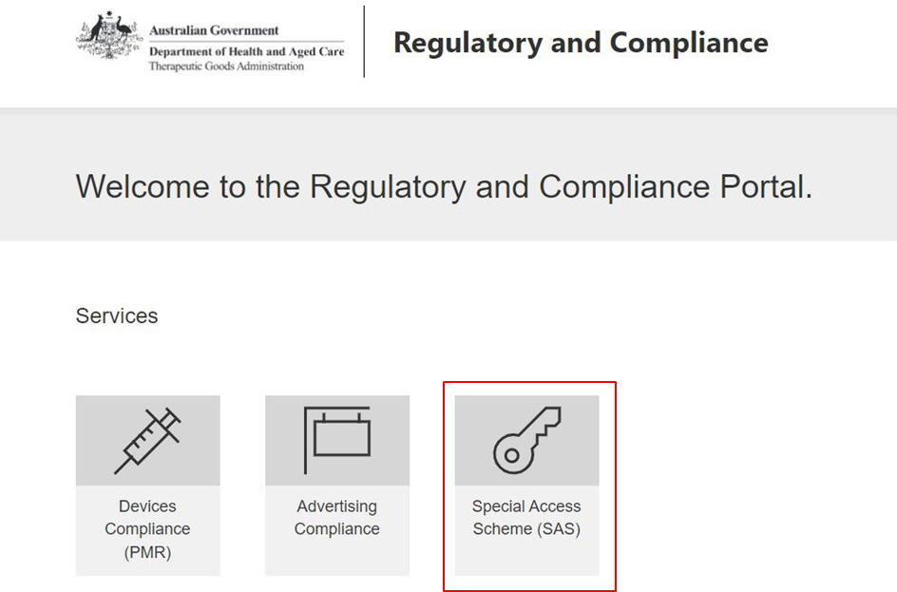

- Select ‘Register Now’.
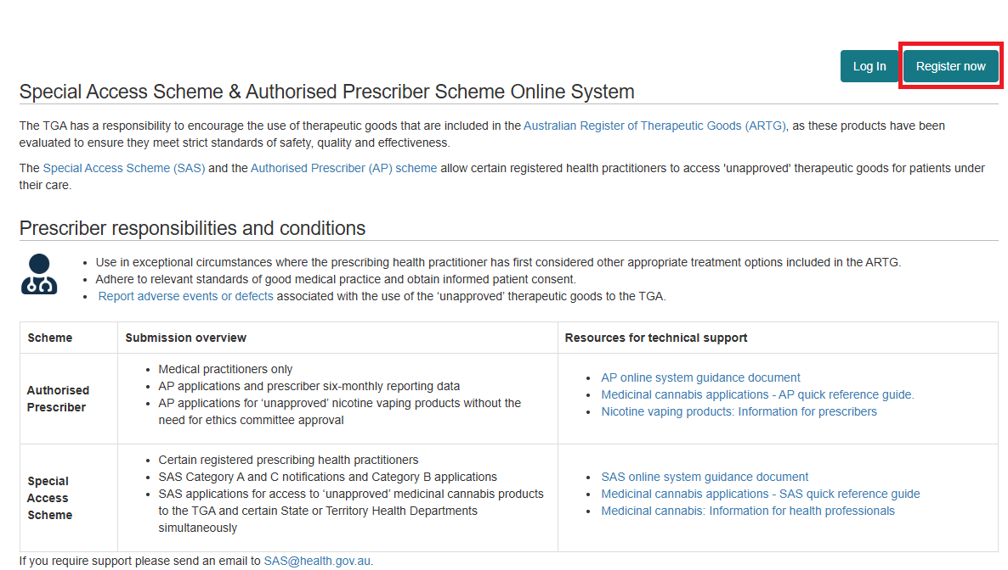
- Provide a unique username; password; email address (for the purposes of account registration).
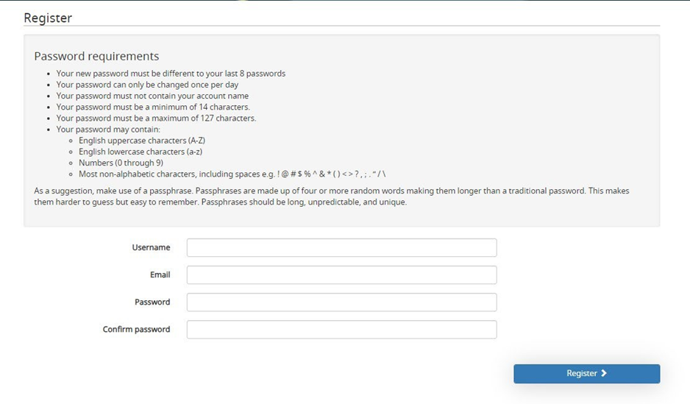
A registration confirmation email will be sent to your nominated email address.
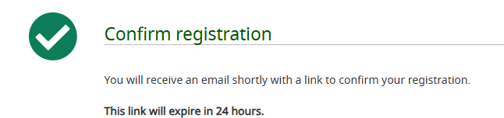

- Click on the hyperlink in the email (note this link will expire 24 hours after receiving this email).
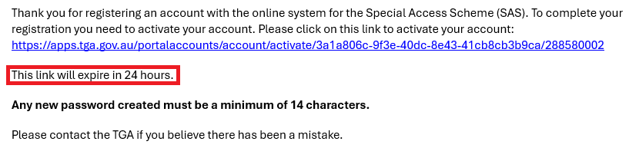
- Log in with your username and password.
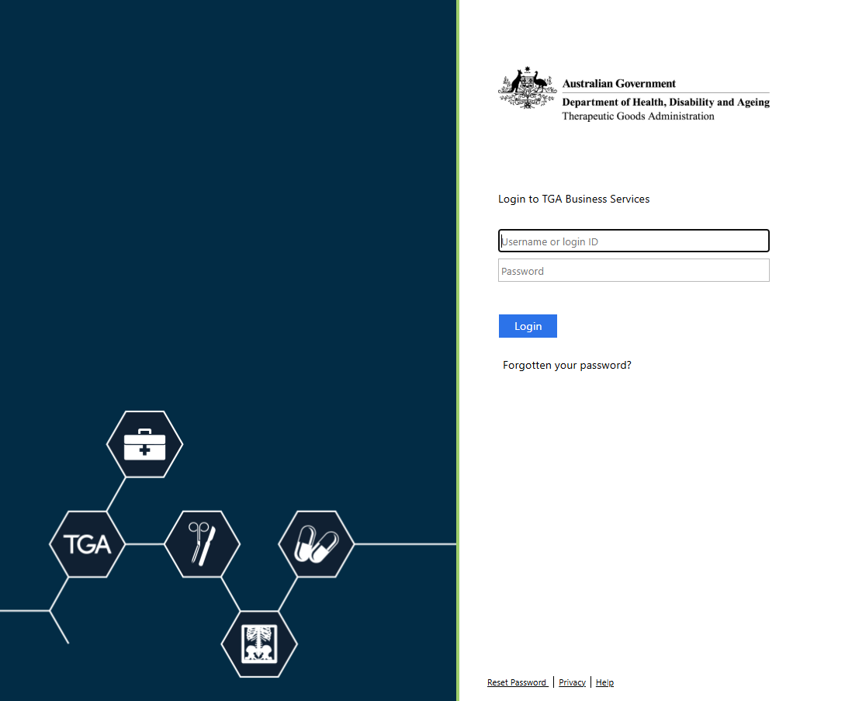

- Complete your profile’s information. Your account registration is not finalised until you complete this step, and you will not be able to submit applications/notifications.
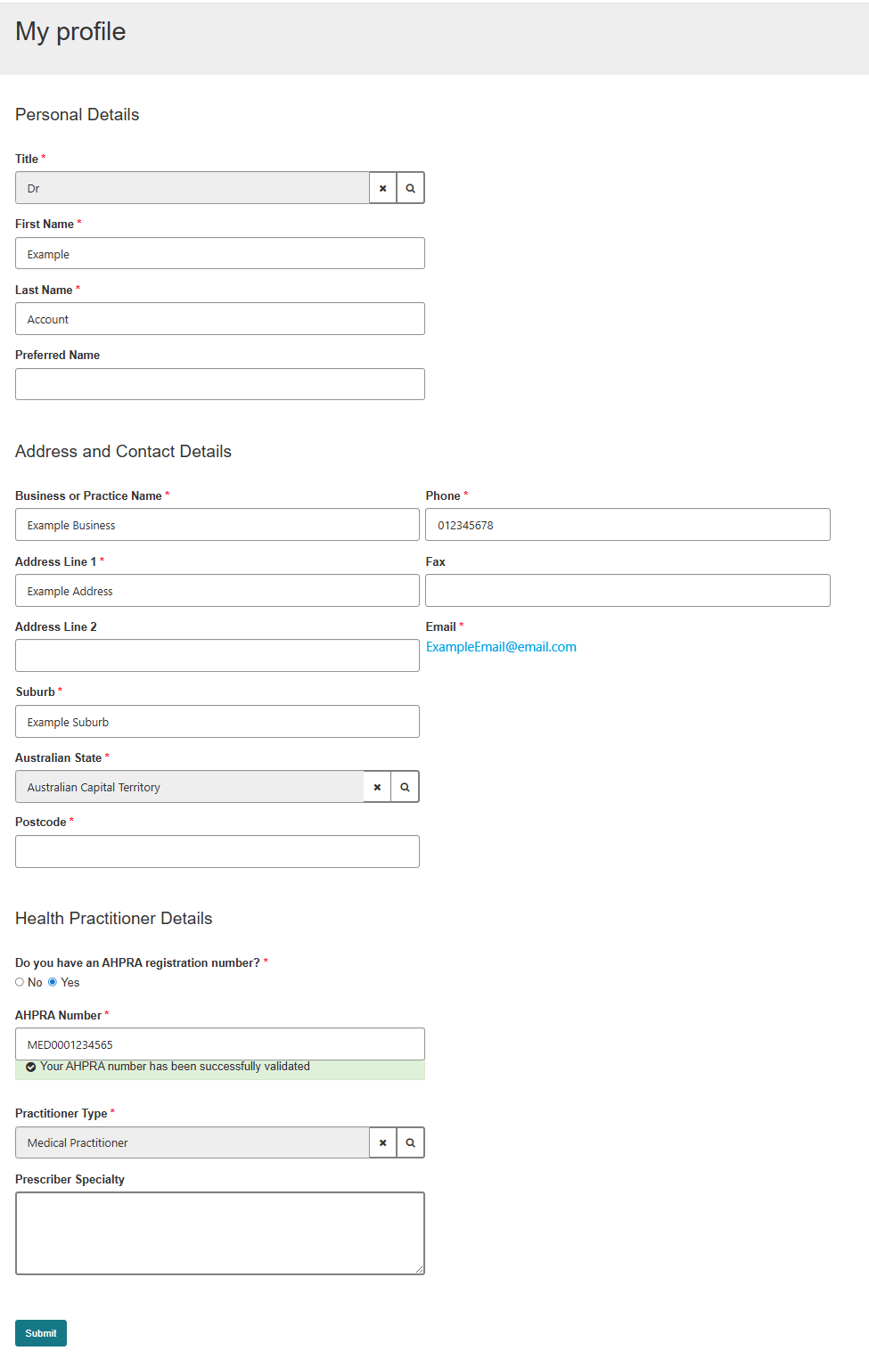

Health practitioners
Upon registration of an account, health practitioners will have the ability to draft and submit SAS applications and notifications to the TGA. In the account registration process, users will be presented with the following question to determine their health practitioner status.if you have incorrectly responded to these questions, Contact SAS.Support@health.gov.au as they cannot be updated from your profile.
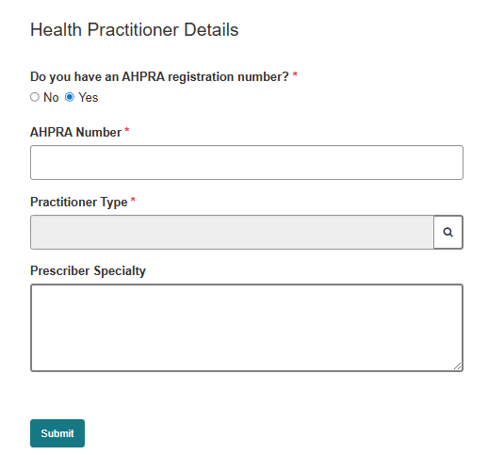
Health practitioners registering an account in the system will be asked to provide their AHPRA registration number. The AHPRA registration number should be entered exactly as it appears in the AHPRA public register, including the three-letter prefix (i.e. MED1234567890).
Note: Those health practitioners able to submit SAS applications and notifications to the TGA are defined in the Therapeutic Goods Act 1989. This definition is as follows:
“Health practitioner means a person who, under a law of a State or internal Territory, is registered or licensed to practice in any of the following health professions:
- Aboriginal and Torres Strait Islander health practice
- dental (not including the professions of dental therapist, dental hygienist, dental prosthetist or oral health therapist)
- medical
- medical radiation practice
- nursing
- midwifery
- occupational therapy
- optometry
- pharmacy
- physiotherapy
- podiatry
- psychology”

Non-health practitioners
Upon registration of an account, non-health practitioners will not be able to draft or submit applications to the TGA. This is in accordance with the relevant provisions of the Therapeutic Goods Act 1989 (the Act) and associated regulations relevant to the SAS. However, non-health practitioner users will be able to affiliate with a site to view the progress of submissions made to the TGA in their user dashboards (see ‘Affiliated Sites’ section for further information).
 | Health practitioners  Have the ability to draft and submit SAS applications and notifications to the TGA, including the submission of applications and notifications on behalf of prescribing health practitioners.  Non-health practitioners  Do not have the ability to draft and submit SAS applications and notification to the TGA however may have oversight of applications and notifications being made by their affiliated site.

Change Password
Passwords will expire every 90 days as per the security requirements policy of the Department of Health, Disability and Aged Care.
- Select the ‘Change password’ option from the dropdown menu in your user profile. Alternatively, this can also be done when attempting to login to the system.
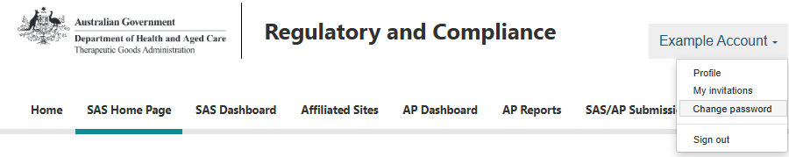

- Enter your new password.
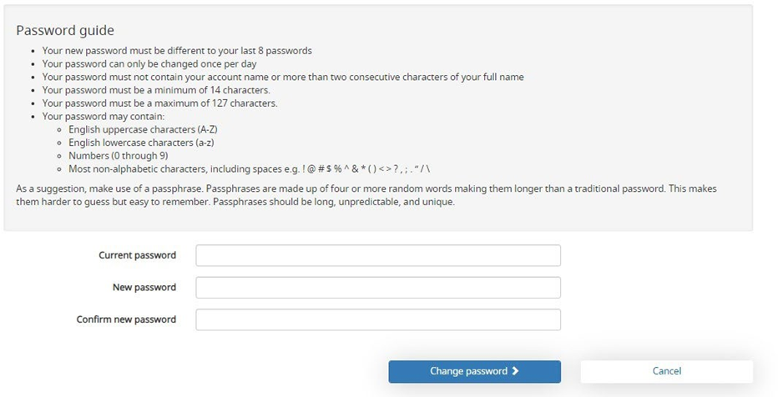
Note: Passwords cannot be reset or changed more than once in a 24-hour period.
If you are locked out of your account for 24 hours, please do not attempt to reset the password until after the time has lapsed otherwise the lockout period will be reset. Once the lockout has lapsed follow the steps to reset your password.

Forgotten your password
- If you have forgotten your password, select “log in”.
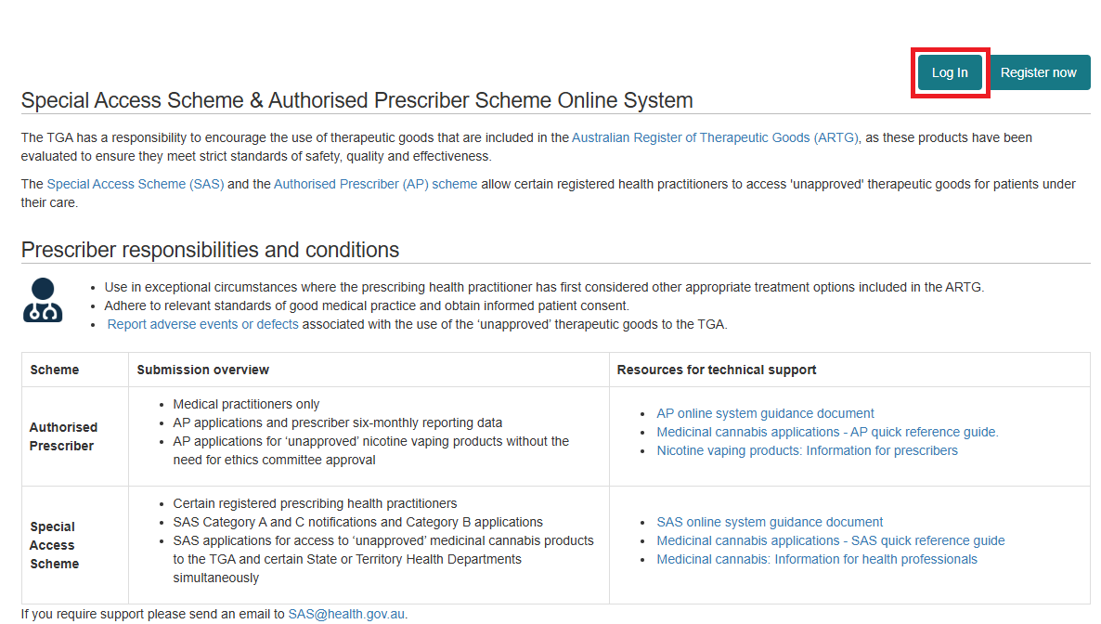

- Select “Forgotten your password?”.
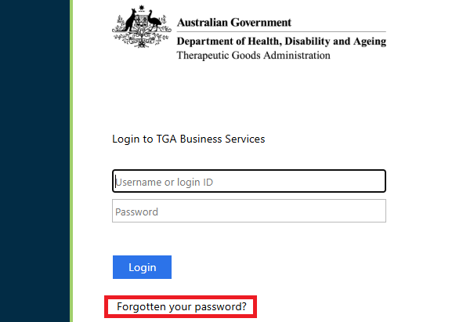
- Enter your username and select “Reset”.
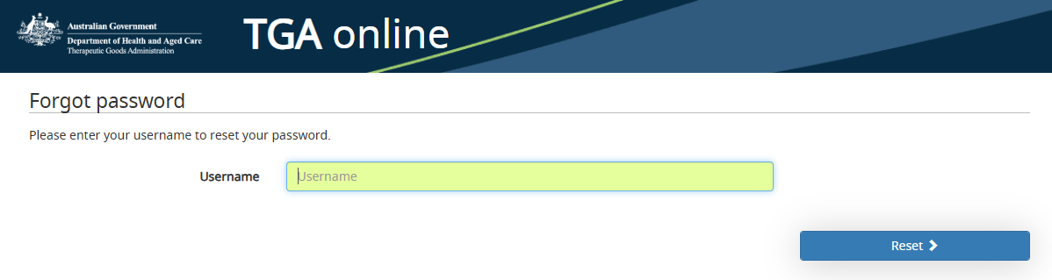
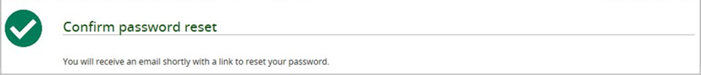
- A password reset email will be sent to the email address associated with your username.

- Click on the hyperlink provided to reset your password (note this link will expire in 24 hours after receiving this email).
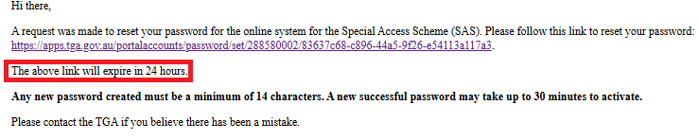

- Enter your new password.
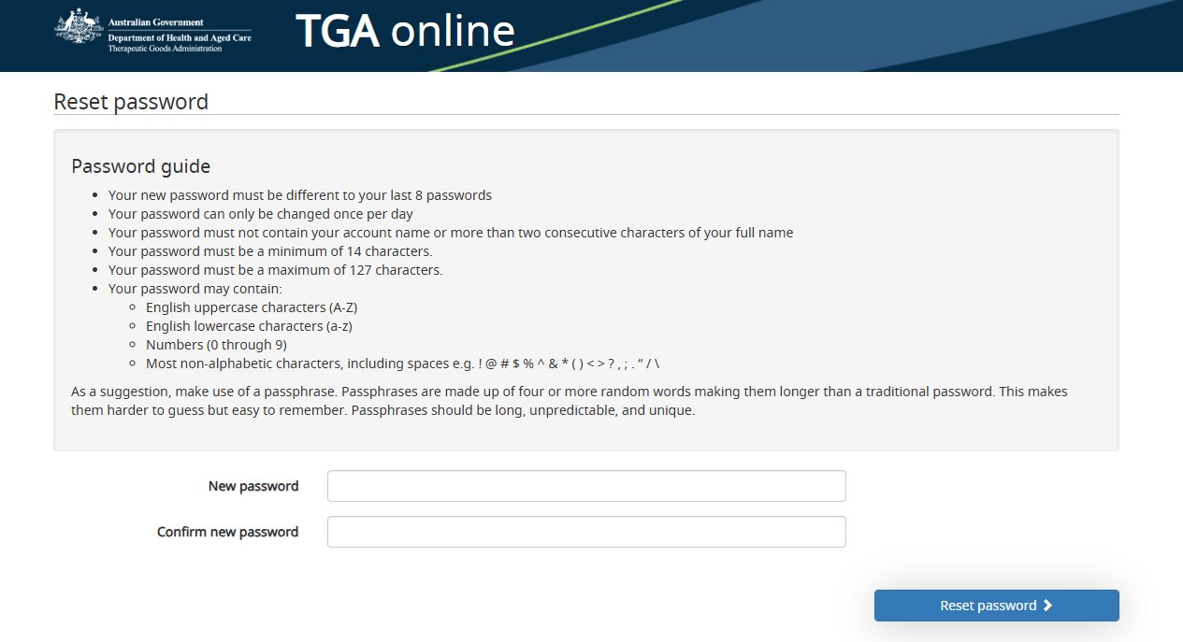
Note: Passwords cannot be reset or changed more than once in a 24-hour period.
If you are locked out of your account for 24 hours, please do not attempt to reset the password until after the 24 hour lockout time has lapsed otherwise the lockout period will be reset. Once the lockout has lapsed follow the steps to reset your password.

Updating account information
Once an account has been registered in the system, users will be able to update the information associated with their account (such as name and contact details) by updating their user profile.
If your health practitioner details (AHPRA Number, Prescriber Specialty, or Practitioner Type) need changing, please reach out to SAS.Support@Health.gov.au
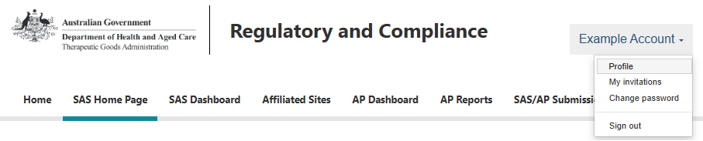

Affiliated sites

Purpose
To enable better oversight and management of applications and notifications submitted via SAS, the system allows users to share applications and notifications with other users who are affiliated under a Site (such as those working at a particular hospital or pharmacy). In sharing applications and notifications with a particular Site, other affiliated users can then identify those submissions and access any documentation that may be relevant to the procurement of the good (such as copies of approval letters).

Site registration
Any user may register a Site in the system. It is important to note that the user who registers a Site will automatically become the Site Administrator. Site Administrators can:
- Send invitations to affiliate with the Site via email.
- Accept or reject requests to affiliate with the Site.
- Edit the details of the affiliated Site (Site name, location information etc).
- Assign other users as Site Administrators (assuming they have successfully affiliated). To register a new site in the system, follow the below instructions:
- Select the ‘Affiliated Sites’ tab.
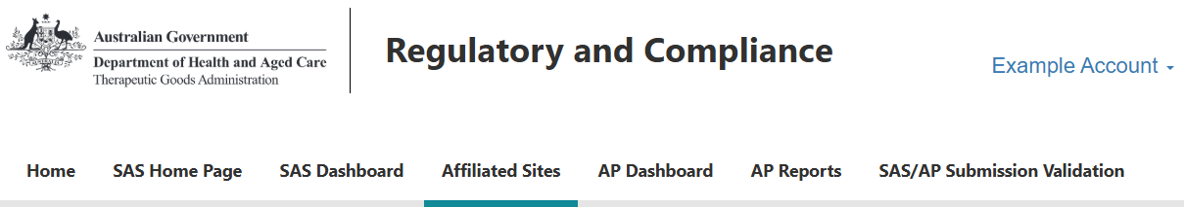
- Select ‘Register a new site’.
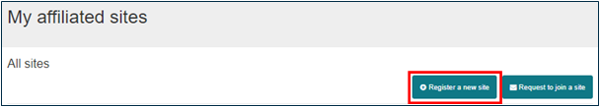
- Read and acknowledge the following declaration.
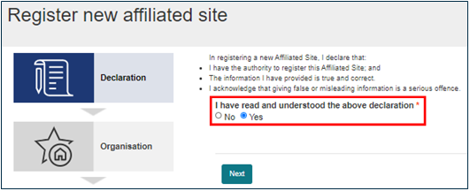
- Select the lookup icon to search for the organisation you wish to register the Site against.
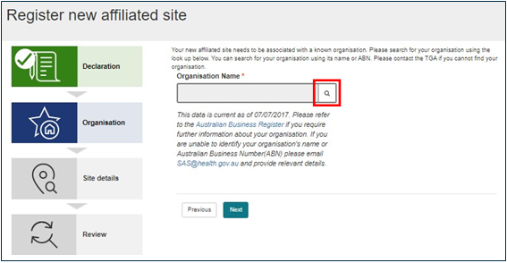
- New organisations need to be added to the Online System. If your organisation is not available, please email SAS@health.gov.au with the Organisation Name and ABN so that it can be added to the look-up function. Once complete, this will allow users to then select that organisation and register an Affiliated Site(s).
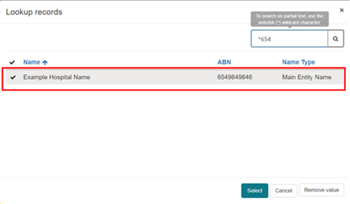

- Once the organisation has been selected, provide the additional details associated with the Site you wish to register. It is important to note that the ‘Site Name’ is different from that of the organisation name. Multiple Sites may be registered under a single organisation (for example, a hospital may wish to register individual departments under the single organisation, resulting in various Sites). Once the Site name has been entered, the system will validate the uniqueness of the name to ensure no other Sites exist that also use that name.
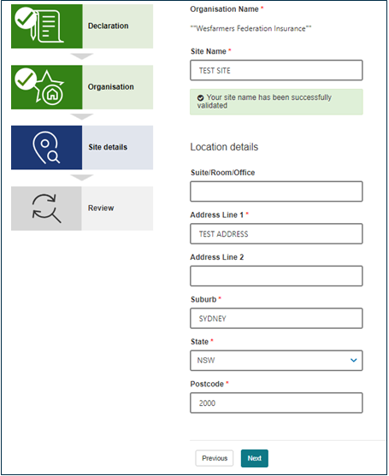
- Review the details before registering the Site.
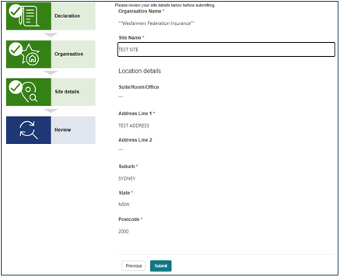
- Once the Site has been registered, it will appear under the ‘Affiliated Sites’ tab.
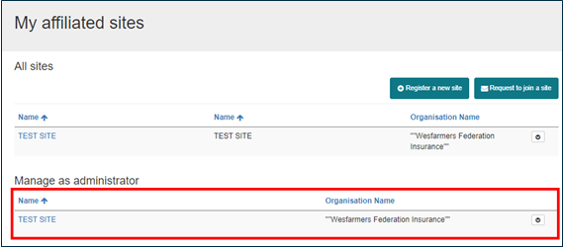

Adding a site administrator(s)
The role of a Site Administrator is automatically assigned to the user who first registers that site into the system. It is important to ensure that the user registering the site for the first time is an appropriate person as they will be granted rights to invite other users via email and approve or reject any requests made by users to affiliate with the site (explained below). Users who are affiliated with a site have visibility of all SAS applications and notifications shared with that site. Site Administrators may invite other users who of their site to become additional Administrators.
- To invite another user to become an Administrator, select the ‘View details’ button on the site.
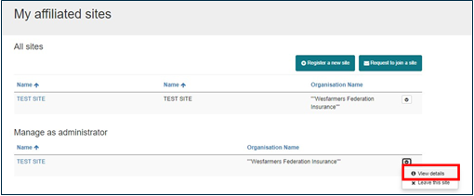
- Select the user you wish to invite to become an Administrator and select the ‘Edit’ button.
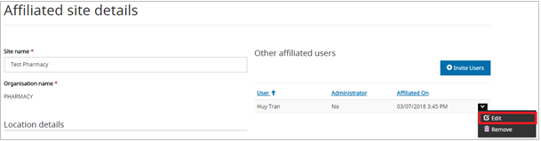
- Under ‘Site Administrator’, select ‘Yes’.
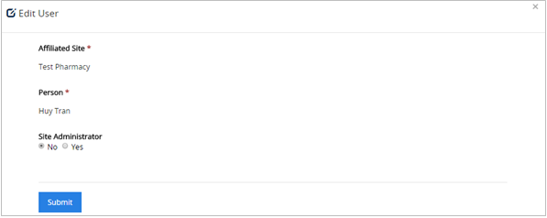
- The user will now be listed as a Site Administrator.
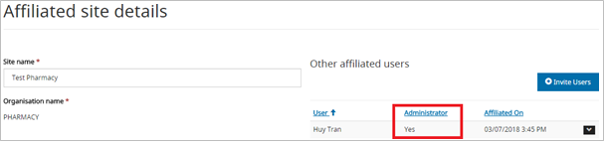

Sending invitations to affiliate
- Site Administrators can invite others to affiliate with a site by clicking the ‘Invite Users’ button.
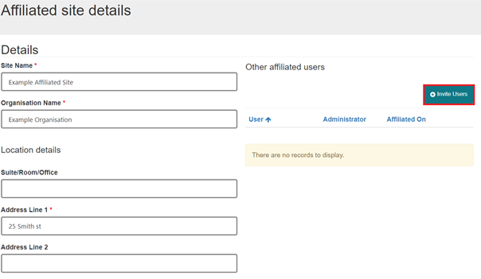

- Invites to affiliate with the site will be sent via email. Email addresses can be entered individually.
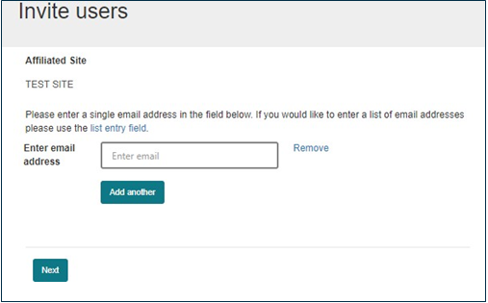
- Or email addresses can be entered in bulk (each email address will need to be on a new line as shown below).
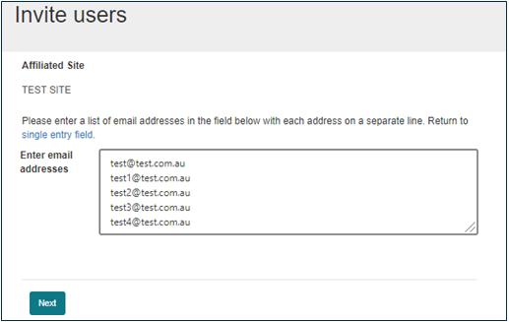
- The system will identify those users who do not yet have a personal account registered in the system. In the below example, the 4 email addresses are not registered in the system. Upon opening the email containing the invitation to affiliate with the site, the user will be required to register a personal account in the system first. Once this has been registered, they will be presented with the option to accept or decline the invitation to affiliate.
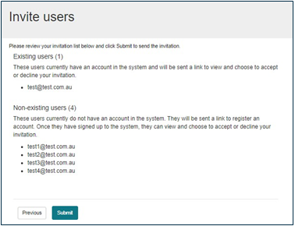

Requesting to affiliate with a site
- Once a site has been registered in the system, users may request to join a site (rather than being invited by a Site Administrator). Select ‘Request to join a site’.
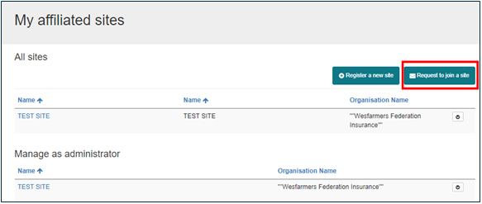
- Select the look-up icon to search for the organisation to which the site is registered under.
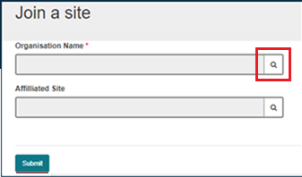

- Search for the organisation by using the organisation name or ABN.
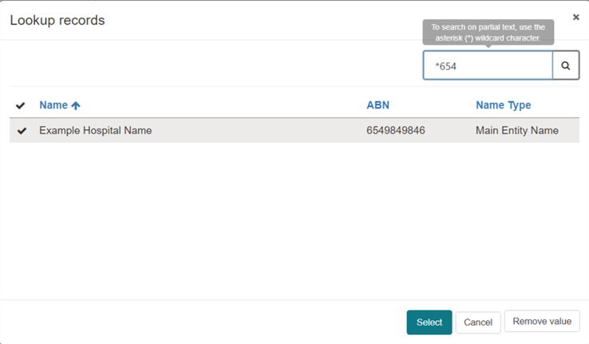
- Once an organisation has been selected, users will be able to search all the sites registered under that organisation. Select the look-up icon to search through the registered sites.
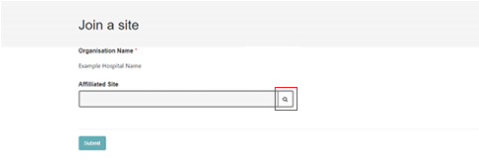

- In the below example, only a single site has been registered against that organisation. Where multiple sites have been registered (such as different hospital departments), identify and select the desired site.
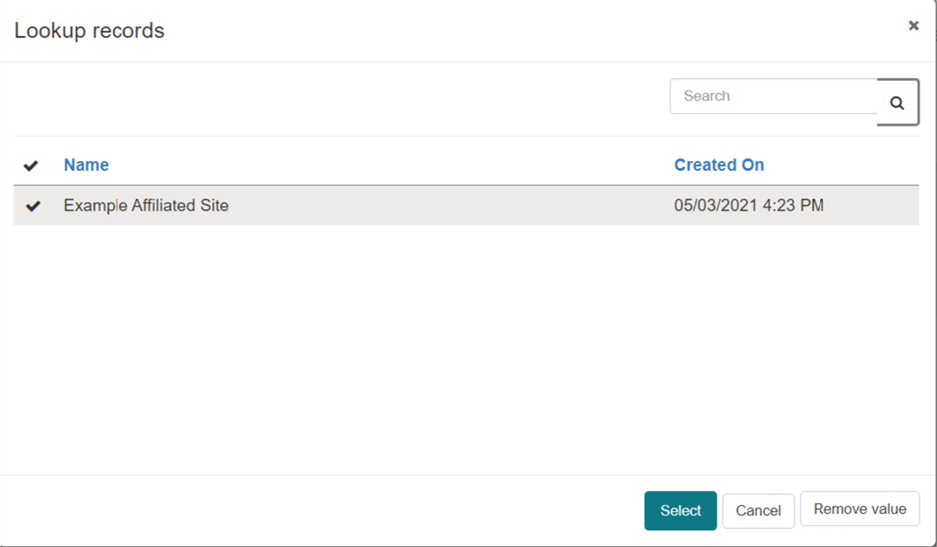
- Once selected, a confirmation message will be presented, and the request will be sent to the Administrator(s) or the site for review.
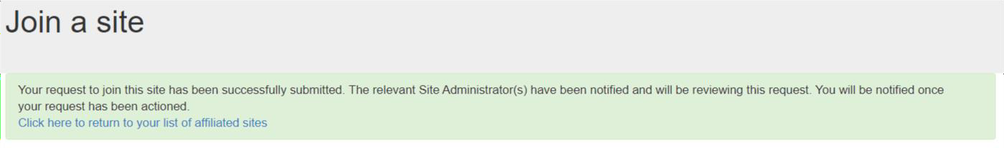

Approving or rejecting a request to affiliate with a site
- Site Administrators will be notified in their user dashboard when a request to affiliate with a site has been made. Site Administrators can review this request by clicking the link provided.
- Select ‘View details’.
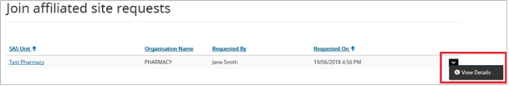
- Site Administrators should ensure that the user requesting to affiliate is appropriate to view the information that is contained in submissions that will be viewable upon accepting the request.
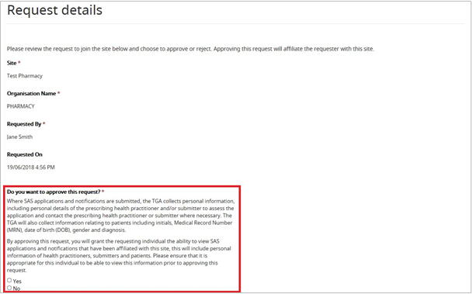

SAS/AP validation search tool
Health practitioners can use the SAS/AP submission validation search to view real-time information relating to the TGA status of SAS and AP submissions. If there is an active TGA authorisation or notification, the search tool will display the status of the submission and other relevant information.
If the search does not return any results, then the prescriber should be contacted.
To access the validation tool:
- Open SAS & AP online system, login at the top right-hand corner.
- Click the ‘SAS/AP Submission Validation’ tab on the right-hand side
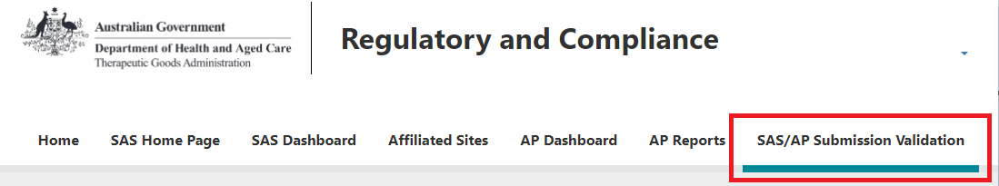
- Enter the submission number provided by the prescriber and click ‘Search’.
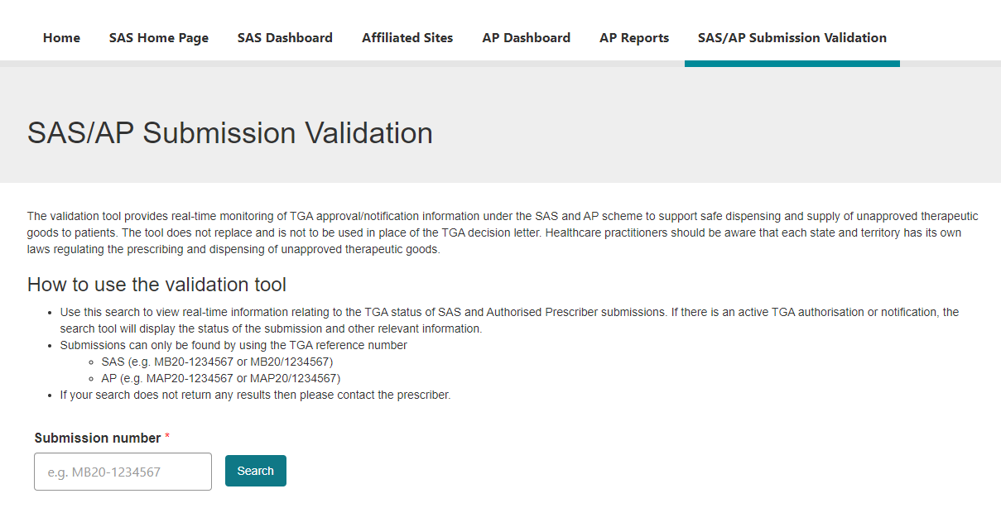
- If the approval/notification is valid you will be shown the relevant details of the submission including its status. If the submission is no longer valid or does not exist, an error message will appear. In these cases, please contact the prescriber.

User dashboards
All users who have registered an account in the SAS & AP online system will have a personal dashboard that displays information specific to SAS applications and notifications they have drafted or submitted via the system. These dashboards differ between health practitioners and non-health practitioners.

Filtering dashboard information
- Dashboards allow users to search and filter submissions based on the fields shown below.
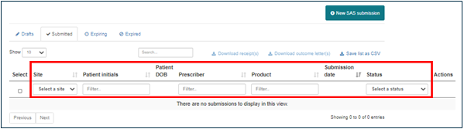
- Users can also apply a uniform search across all available data fields by typing in the below text box.
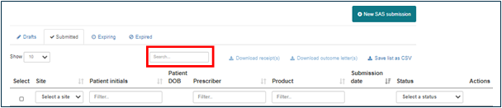

Exporting submission data
- Selection of submissions and selecting the ‘Save list as CSV’ link will download a local .csv copy of the available data fields contained in the dashboard for those selected submissions as shown below.
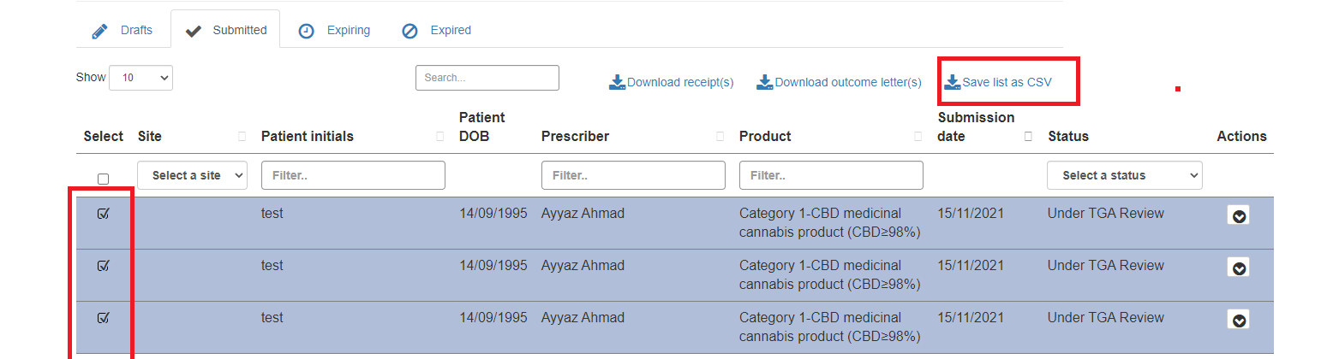

Cloning submissions
All SAS submissions visible in a user’s dashboard, including those submissions shared by another user via an Affiliated Site, can be cloned. The purpose of this function is to reduce the administrative burden of re-entering identical information into renewal submissions, or submissions for frequently used unapproved goods.
Upon cloning a submission, previously entered information will be used to prepopulate a new draft SAS submission. It is the responsibility of the submitter to review the information copied into the cloned submission to ensure that the correct information is provided to the TGA.
Please be aware that the following information will not be prepopulated into the new draft by the cloning function, and will need to be provided before submitting to the TGA:
- Answer to whether the patient’s condition meets the SAS Category A definition (‘yes/no’)
- Intended date of supply
- Any attachments uploaded with the original submission
- Answer to the privacy statement on the Summary step (‘yes/no’)
Note: Information specific to State or Territory Health Department for medicinal cannabis submissions will not be copied into the new draft submission. This information will need to be provided in Step 5 before submitting.
Identify the submission that needs to be cloned by filtering in the user dashboard; click the ‘Actions’ tab and select ‘Clone’ from the dropdown.
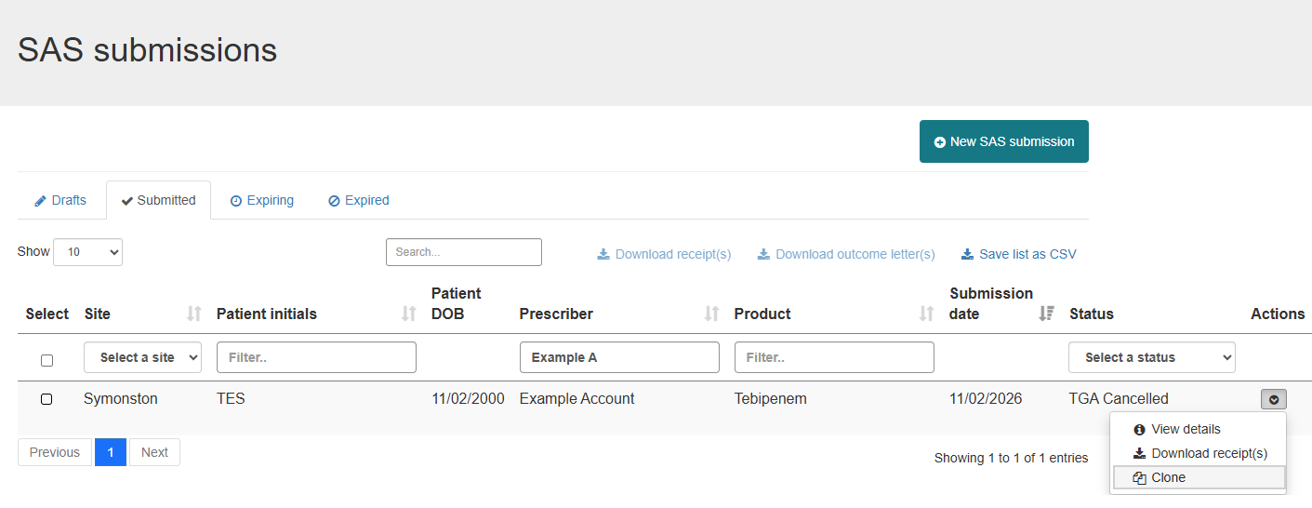
Navigate through the workflow and provide/update any relevant information specific to the new SAS application or notification before submitting to the TGA.

Draft submissions
Draft submissions are saved when a user has entered information as part of a new SAS application or notification but has not yet submitted this to the TGA. A draft submission saves information already entered into the application or notification which can then be accessed from the dashboard for completion at a later date. Draft submissions appear under the ‘Drafts’ tab of the dashboard. No information is displayed in the ‘submitted date’ field.
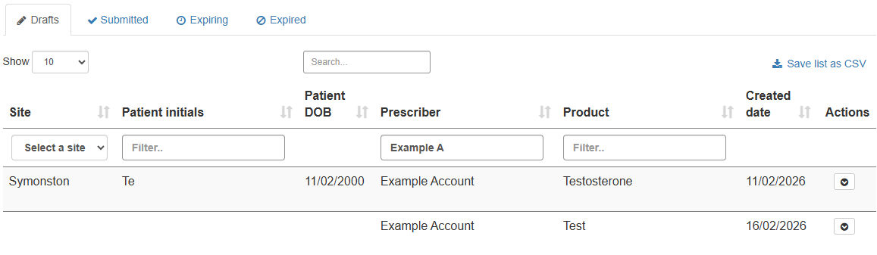
Non-health practitioners
Dashboards for non-health practitioners will not include the ‘Draft
Submissions’ tab as they are unable to submit SAS applications or notification to the TGA as per the provisions of the Act and associated regulations.
Saving as ‘Draft’
The system does not include a ‘save as draft’ button to be selected. A draft submission is saved automatically when a user 1) closes their browser prior to submitting; or 2) navigates to another part of the system outside of the workflow.

Completed submissions

Status of completed submissions
All SAS applications and notifications that have been submitted via the system will appear under the ‘submitted tab’ and will each be accompanied by a ‘status’.
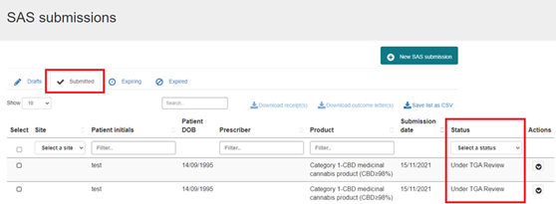
A list of the status terminology can be found below.
Status | Description
“TGA Approved” | Reflects TGA’s approval of a SAS Category B (SASB) application.
“TGA Completed” | Completion of a compliant SAS Category A (SASA) or SAS Category C (SASC) notification.
“TGA Non-compliant” | Completion of a SASA or SASC notification where 1) the notification was submitted greater than 28 days after supply; or 2) an incorrect type of health practitioner has supplied the good.
“TGA Rejected” | Reflects TGA’s rejection of a SASB application.
“Under TGA Investigation” | When a SASA or SASC notification has been submitted and the TGA is investigating the compliance of the notification with the SASA regulatory requirements or SASC Rules.
“Under TGA Review” | Completion of a successful SASB application to the TGA to which a decision is yet to be made on that application.
“TGA Withdrawn” | Reflects the status of a SASB application that has been submitted via the system and subsequently withdrawn at the request of the applicant.

Downloading receipts and outcome letters
Users will have the ability to download receipts and outcome letters provided by the TGA through their dashboard. This can be done on a single submission basis or a bulk download by selecting the submissions of interest as shown below.
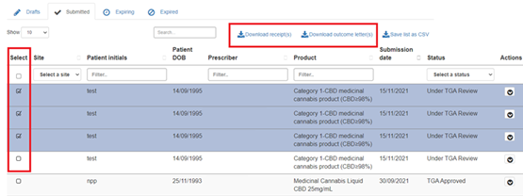

Expiring and expired submissions
The terms ‘expiring and ‘expired’ are made in reference to the duration of supply remaining on a SAS application or notification:
- Expiring means there are less than 14 calendar days remaining on the duration of supply of the SAS application/notification.
- Expired means that the duration of supply approved/notified under the SAS has been exceeded.
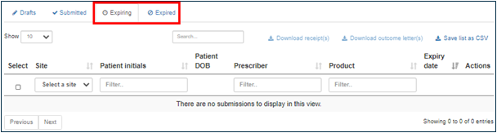
The purpose of displaying expiring and expired SAS applications and notifications in these tabs is to:
- Prompt health practitioners to conduct a review of the patient’s condition post-treatment.
- Ensure continuation of patient care by accessing unapproved therapeutic goods under the SAS should the patient require further treatment.
- If supply of the unapproved therapeutic good is still required after the expiry date, a new SAS application/notification should be made for that patient.

Submitting SAS applications and notifications
Pharmacists submitting SAS notification/applications for S3 unapproved therapeutic goods please see the submitting S3 Products as a Pharmacist section below.
The online system has been designed to guide health practitioners down the correct SAS pathway when seeking access to unapproved therapeutic goods.
To complete a SAS application or notification and submit this to the TGA via the system, go to your dashboard and select ‘New SAS submission’.
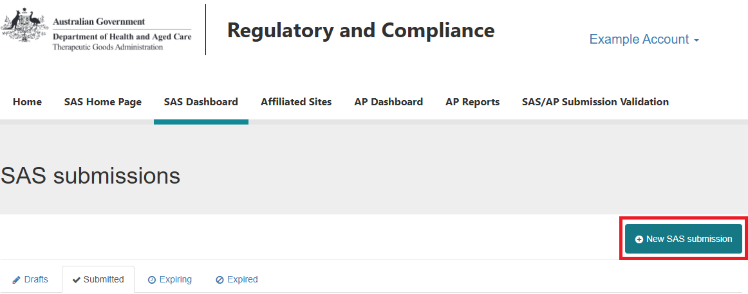

Step 1 – Prescriber details
- If submitting as the prescriber, the details will be automatically populated from the account which was registered through the system, as shown below. Note that contact details may be amended prior to continuing.
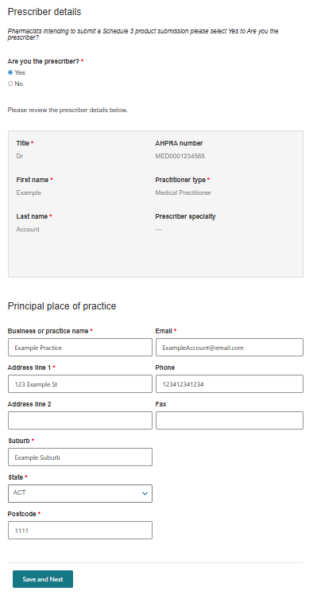
- If you are not the prescriber, the user will be asked to provide the AHPRA registration number for the prescriber. The system will then search the TGA’s internal database in attempts to identify whether a profile associated with that AHPRA registration number already exists. If not, the user will be required to provide the prescriber’s information before proceeding with the submission.
Note: The validation of this AHPRA ID does not refer to the AHPRA registry. 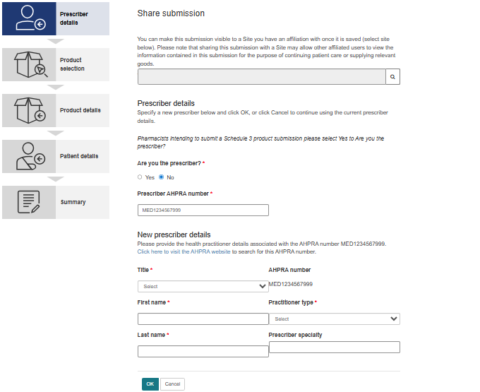

Step 2 – Product selection
- Select the type of unapproved therapeutic good for which access is being sought.
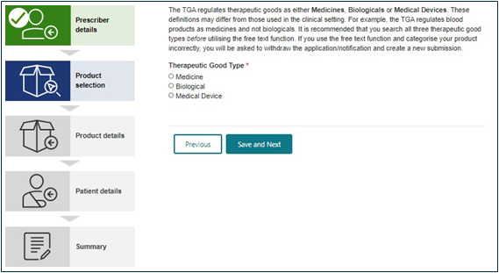
- Upon selecting a type of therapeutic good, the user will be prompted to provide details of the product such as the active ingredient, dosage form and indication. A look-up function is available to search TGA’s internal database of existing entries as shown below.
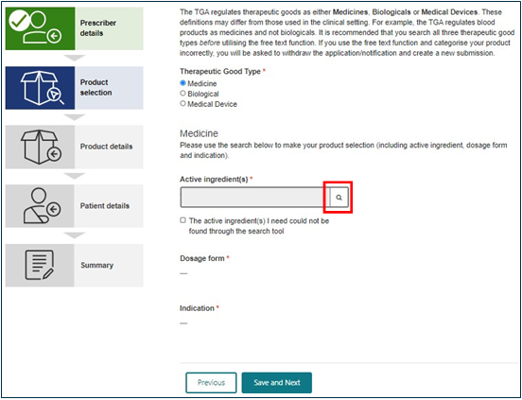
- Use the search bar to identify the active ingredient. To search on partial text, use the asterisk (*) wildcard character.
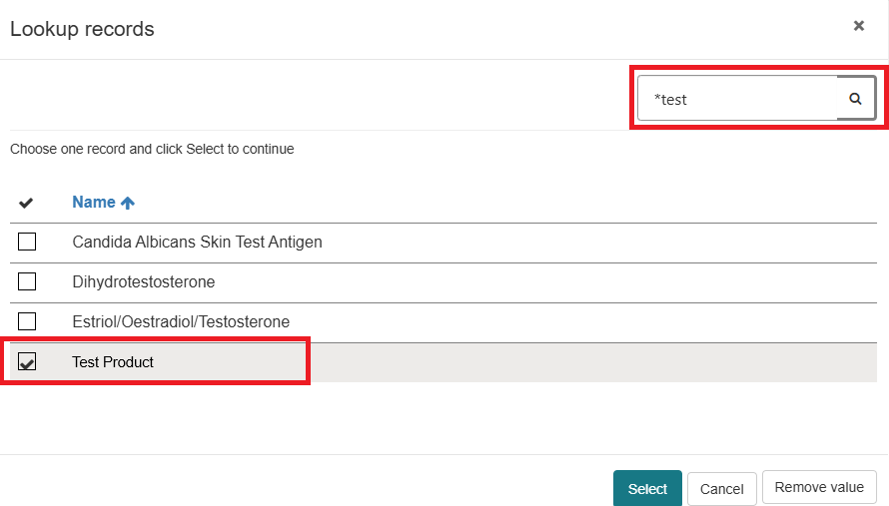
- If you are unable to identify the required information via the look-up function, select the checkbox below the search field. This will allow users to provide a free-text entry to support the submission.
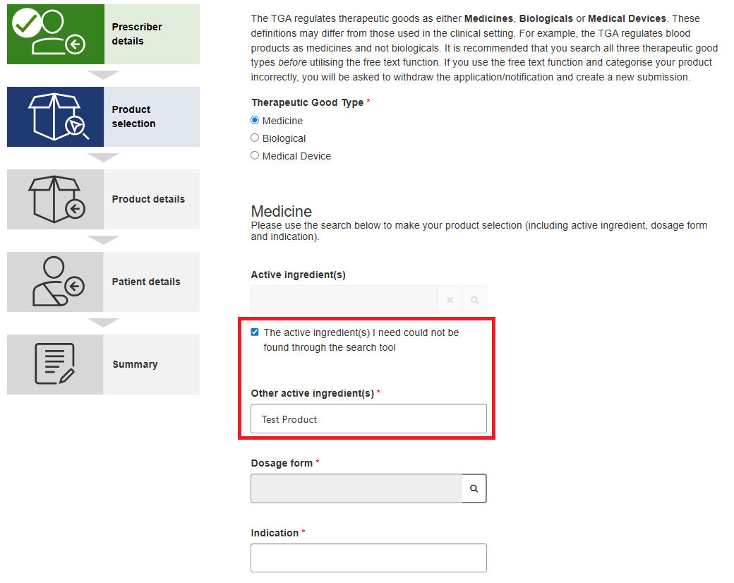

- If the product and indication are not able to be supplied by way of notification under the SAS Category C pathway, the user is prompted to confirm whether the patient meets the definition of a SAS Category A patient. This question is only presented as an option where the prescriber for the submission is a medical practitioner). The answer to the below determines whether the submission is processed as a SAS Category A notification or SAS Category B application.
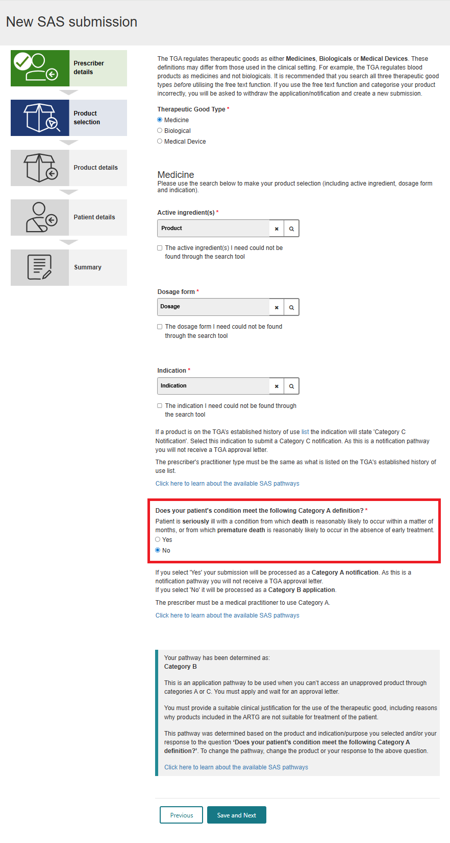

Step 3 – Product details
For SAS Category B applications, additional data fields specific to the product are required to be completed as shown below.
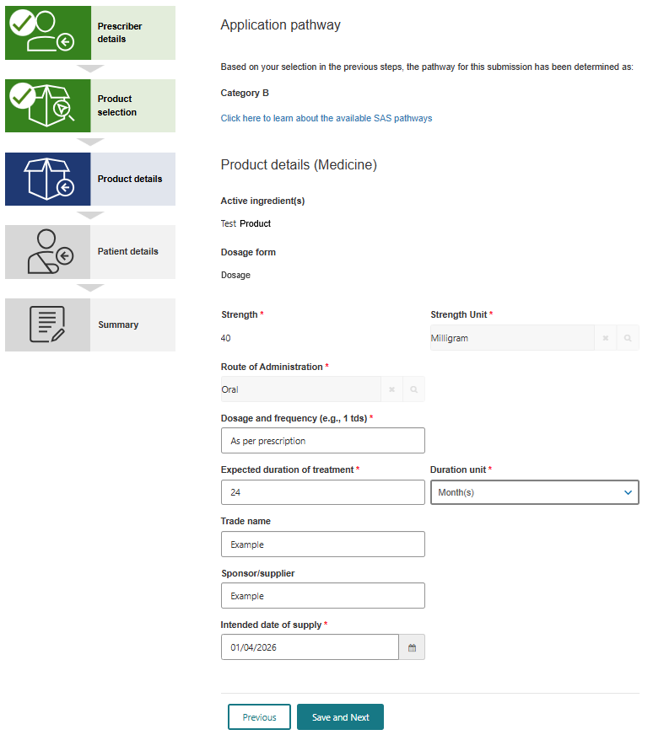

Step 4 – Patient details
Complete the patient details section and attach any supporting information via the upload function.
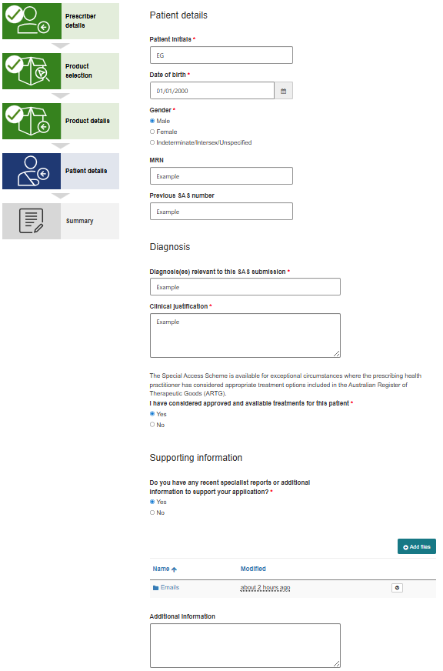

Step 5 – Summary
Acknowledge that you have read and understood the following disclaimer to submit the SAS application or notification to the TGA.
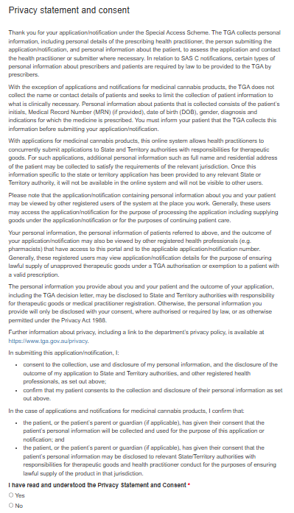

Submitting S3 products as a pharmacist
S3 submissions can be made through the same SAS submission process as all other unapproved goods. Some additional steps are required to ensure submissions are correctly received by the TGA.
To complete a SAS application or notification and submit this to the TGA via the system, go to your dashboard and select ‘New SAS submission’.

Step 1 – Prescriber details
Select the ‘Yes’ option for ‘Are you the prescriber’, the details will be automatically populated from the account, which was registered through the system, as shown below.
Note that contact details may be amended prior to continuing.

Step 2 – Product selection
- Select the type of unapproved therapeutic good for which access is being sought.
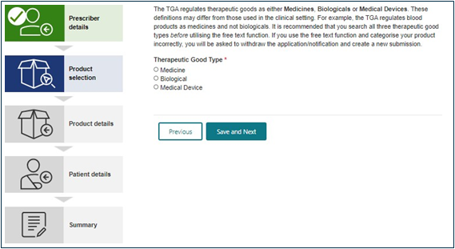
- Upon selecting a type of therapeutic good, the user will be prompted to provide details of the product such as the active ingredient, dosage form and indication. A look-up function is available to search TGA’s internal database of existing active ingredients, their dosage forms, and indications, as shown below.

- Use the search bar to identify the active ingredient. To search on partial text, use the asterisk (*) wildcard character.
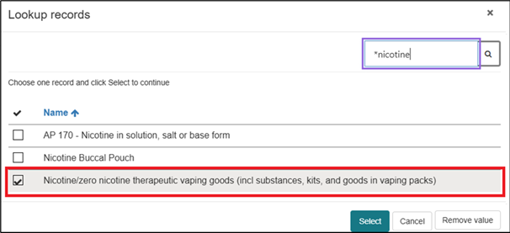
- Use the search bar to identify the dosage form. To search on partial text, use the asterisk (*) wildcard character.
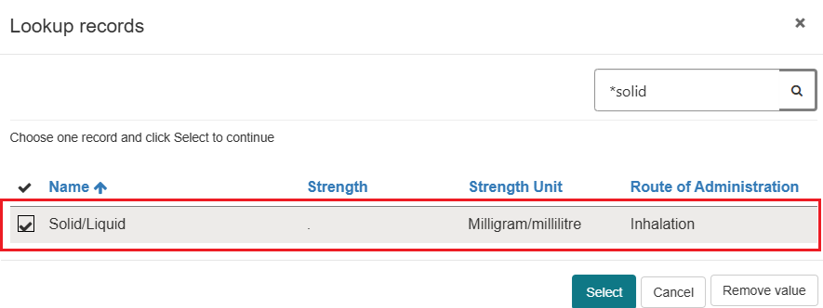
- For Schedule 3 Products included in the SAS C list, type “S3” into the search bar and identify the indication that includes ‘Category C’ as part of the text. To search on partial text, use the asterisk (*) wildcard character (e.g. “*S3”).
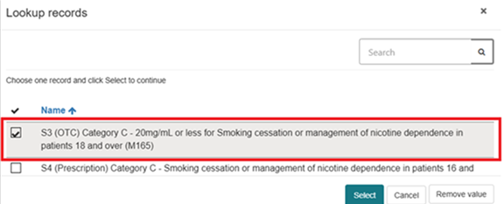
Note: If the indication you select does not begin with “S3” then the prescriber listed in step 1 should not be a pharmacist.

Step 3 – Product details
For S3 notifications, additional data fields specific to the product are required to be completed as shown below.
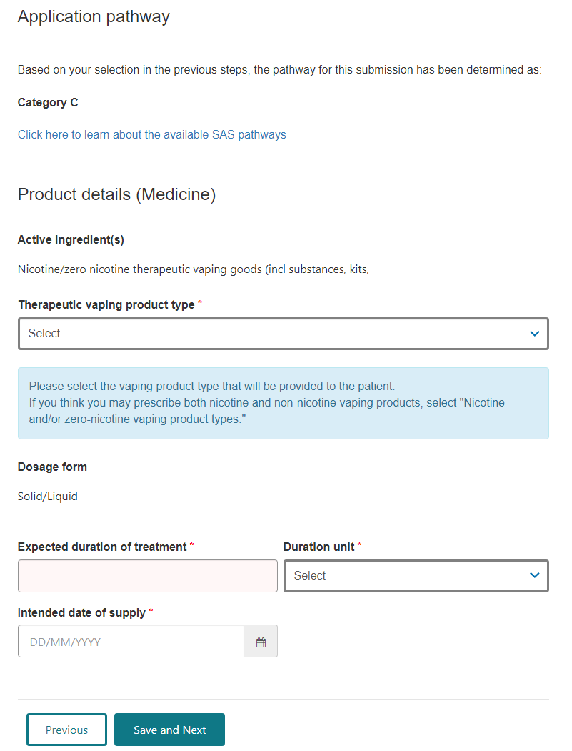

Step 4 – Patient details
Complete the patient details section and attach any supporting information via the upload function.
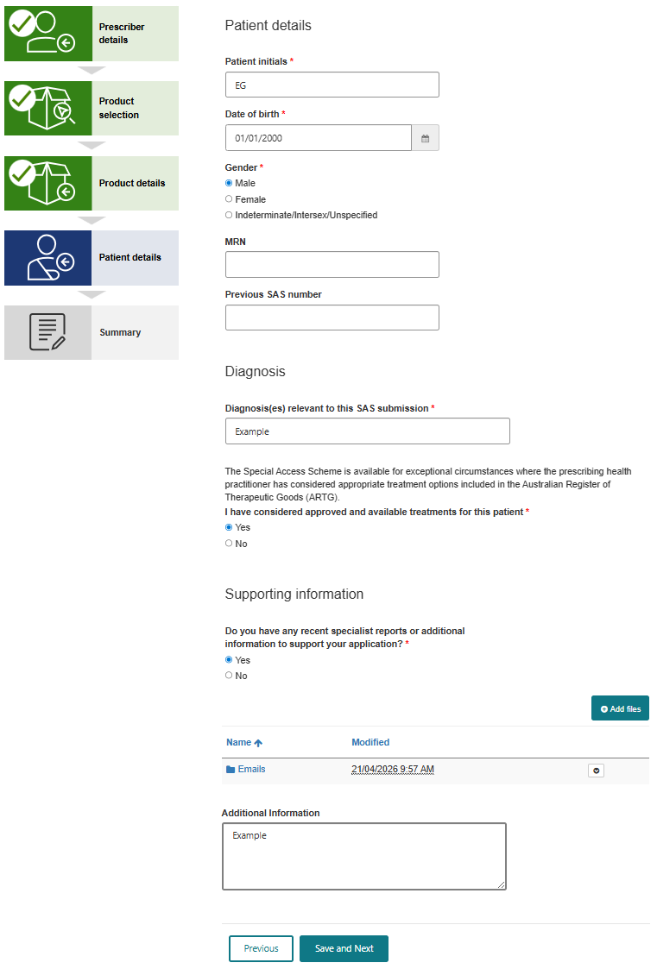

Step 5 – Summary
Acknowledge that you have read and understood the following disclaimer to submit the SAS application or notification to the TGA.
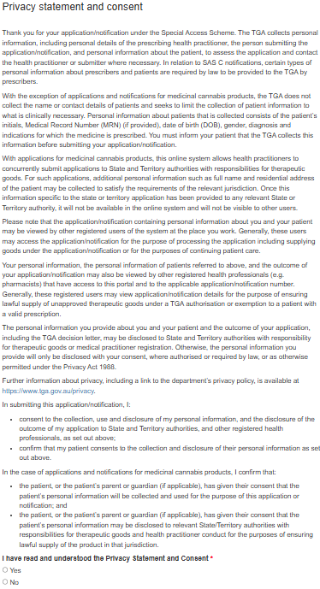

Medicinal cannabis submissions
In April 2018, the Commonwealth and State and Territory Health Departments announced a collaborative approach to streamline access to unapproved medicinal cannabis products for Australian health practitioners through a ‘single-in’ application process where medical practitioners can notify or apply to both the Commonwealth and the relevant State or Territory Health Department (where applicable) to prescribe and supply medicinal cannabis products via a single application. Historically, prescribers of unapproved medicinal cannabis products had been required to separately apply/notify the TGA and the State or Territory Health Department (where applicable) for approval/authorisation to supply these products.
Note that only one state or territory can be applied to for a single application. In instances where multiple state/territory authorisations are required, the additional authorisation will need to be sought directly from the State or Territory Health Department. Contact details are available on the TGA webpage contacts for State/Territory medicines & poisons regulation units

When not to use the system to submit medicinal cannabis applications
There are circumstances where the TGA’s SAS & Authorised Prescriber Online System should not be used for medicinal cannabis submissions. These circumstances include:
- Where the prescriber of the unapproved therapeutic good is not the prescribing health practitioner.
- Where the prescriber is in possession of a current TGA approval and the notification/application only relates to the state or territory. A notification or application in these circumstances should be made directly to the relevant State or Territory Health Department. Contact details are available on the TGA webpage contacts for State/Territory medicines & poisons regulation units

Notifying or applying to a state or territory health department via the system
- Upon selecting ‘medicine’ as the therapeutic good type, the prescriber will be prompted to provide details of the medicinal cannabis product such as the active ingredient. A look-up function is available to search TGA’s internal database of existing entries.
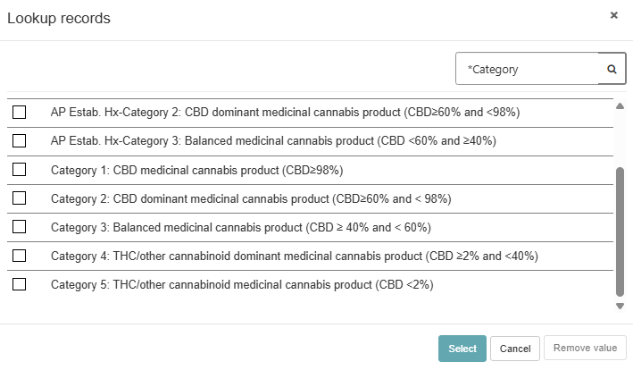
In selecting a medicinal cannabis active ingredient category from the look-up function, the prescriber will then be prompted to select whether a State or Territory Health Department should also be notified or applied to as part of the submission. It is the responsibility of the prescribing healthcare practitioner to know the legislative requirements of the jurisdiction(s) in which they are practising.
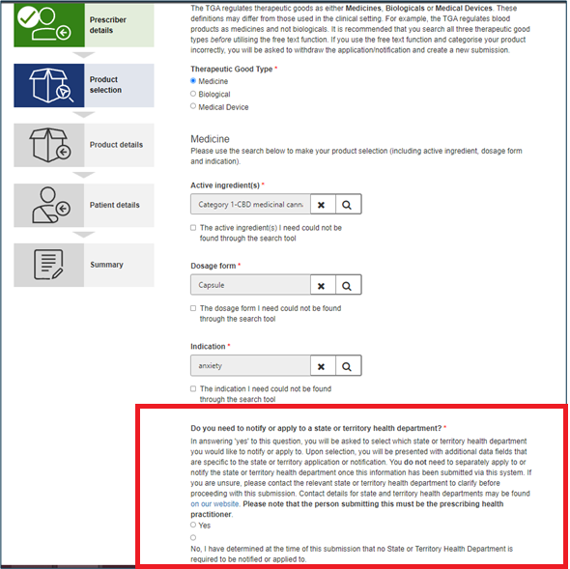
- If ‘Yes’ is selected to the above question, the prescriber will be asked which State or Territory Health Department should receive the notification/application. If you need to notify or apply to a State or Territory Health Department not included in the system, you will need to contact the State or Territory Health Department directly.
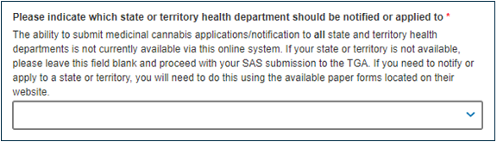
- Determine what SAS form type (Category A or Category B) should be submitted to the TGA.
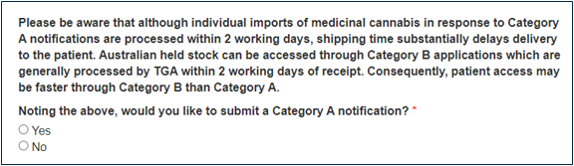
- Enter the product details.
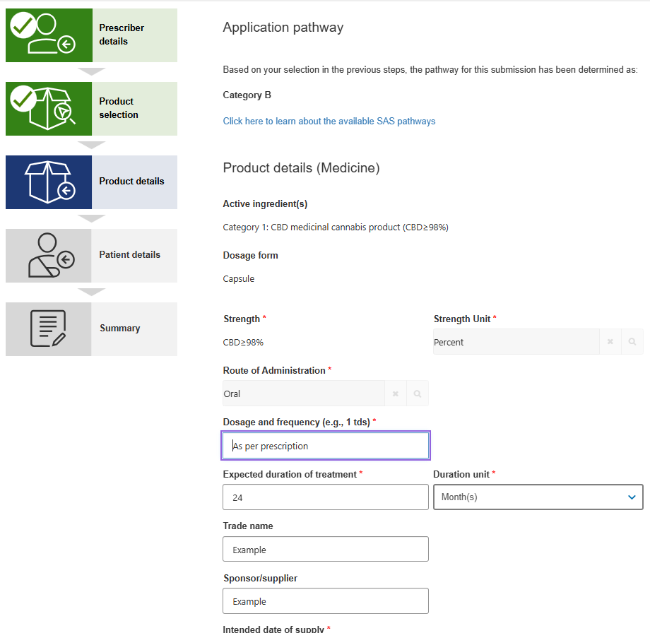

- Enter the patient details.
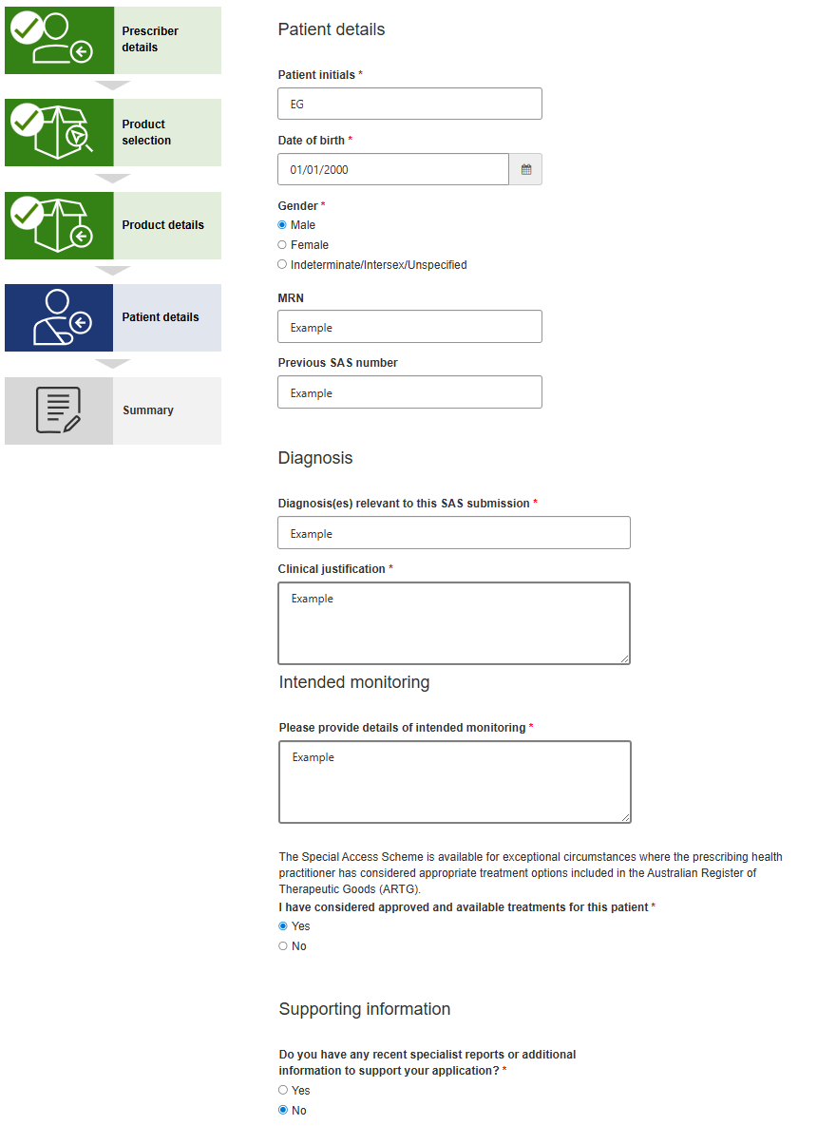
- When a State or Territory Health Department has been selected, an additional step will be included in the system containing the data fields relevant to the state or territory application process.
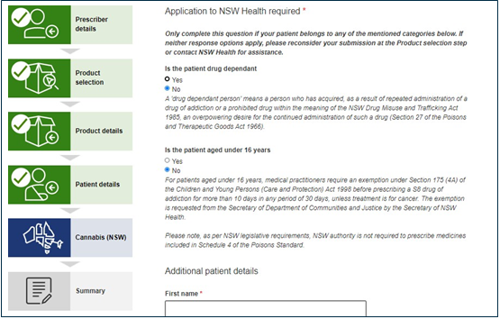
- Once all the information requested in the system has been completed as part of the submission, the prescriber will then submit the application/notification. In submitting the application/notification via the system, both the TGA and selected State or Territory Health Department will concurrently receive the application information. This means that prescribers do not need to then separately notify or apply to the relevant State or Territory Health Department.
- The TGA and relevant State or Territory Health Department will each conduct their own evaluation processes on the information submitted via the system. It is important to note that as part of these evaluation processes, the TGA and State or Territory Health Department may contact the prescriber seeking further information in support of the application.
- The prescriber will receive a single email from the TGA containing both the TGA and state or territory outcome letters within 48 hours (2 business days) of having received all information required to evaluate the application.

TGA contact details
Gather the following information before you ask for help with the SAS and AP Online System:
- description or screenshot of error
- submitting practitioner's name
- username for SAS and AP Online System
- email address used for SAS and AP Online System
- AHPRA number
- web browser used (for example Chrome or Edge)
- SAS/AP reference number (if applicable).
To get help email the above information to SAS.Support@health.gov.au.

Version history
Version | Description of change | Author | Effective date
V1.0 | Original publication. | Experimental Products Section (EPS); Pharmacovigilance and Special Access Branch (PSAB) | 31 July 2018
V1.1 | Guidance updates based on system changes. | Experimental Products Section (EPS); Pharmacovigilance and Special Access Branch (PSAB) | 28 September 2018
V1.2 | Guidance updates based on system changes. | Experimental Products Section (EPS); Pharmacovigilance and Special Access Branch (PSAB) | 22 April 2021
V1.3 | Guidance updates based on system changes. | Experimental Products Section (EPS);  International Regulatory Branch (IRB) | 14 December 2021
V1.4 | Guidance updates based on system changes. | Experimental Products Section (EPS);  International Regulatory Branch (IRB) | 03 February 2022
V1.5 | Guidance updated based on system changes. | Experimental Products Section (EPS);  International Regulatory Branch (IRB) | 21 March 2022
V1.6 | Guidance updated based on system changes. | Special Access Section (SAS);  International Regulatory Branch (IRB) | 06 June 2022
V1.7 | Guidance updated based on system changes | Special Access Section (SAS);  International Regulatory Branch (IRB) | 11 October 2023
V1.8 | Guidance updated based on system changes | Business Improvements and Compliance Section (BICS); International Regulatory Branch (IRB) | February 2024
V1.9 | Guidance updated based on changes to SAS and AP online system. | Business Improvements and Compliance Section; International Regulatory Branch. | March 2024
V1.10 | Updated title to User Guide and updated content based on system changes | Business Improvement and Compliance Section (BICS); International Regulatory Branch (IRB) | 1 October 2024
V2.0 | Guidance updated based on system changes | Unapproved Medicines Access Section (UMAS); International Regulatory Branch (IRB) | May 2026

Therapeutic Goods Administration
PO Box 100 Woden ACT 2606 Australia
Email: info@tga.gov.au Phone: 1800 020 653 Fax: 02 6203 1605
https://www.tga.gov.au
Reference/Publication #

