Australian Public Assessment Report for Tezspire
  - Active ingredient: Tezepelumab
  - Sponsor: AstraZeneca Pty Ltd
May 2026

About the Therapeutic Goods Administration (TGA)
- The Therapeutic Goods Administration (TGA) is part of the Australian Government Department of Health, Disability and Ageing and is responsible for regulating therapeutic goods, including medicines, medical devices, and biologicals.
- The TGA administers the Therapeutic Goods Act 1989 (the Act), applying a risk management approach designed to ensure therapeutic goods supplied in Australia meet acceptable standards of quality, safety, and efficacy.
- The work of the TGA is based on applying scientific and clinical expertise to decision-making, to ensure that the benefits to the Australian public outweigh any risks associated with the use of therapeutic goods.
- The TGA relies on the public, healthcare professionals and industry to report problems with therapeutic goods. The TGA investigates reports received to determine any necessary regulatory action.
- To report a problem with a therapeutic good, please see the information on the TGA website.

About AusPARs
- The Australian Public Assessment Report (AusPAR) provides information about the evaluation of a prescription medicine and the considerations that led the TGA to approve or not approve a prescription medicine submission. Further information can be found in Australian Public Assessment Report (AusPAR) guidance.
- AusPARs are prepared and published by the TGA.
- AusPARs are static documents that provide information that relates to a submission at a particular point in time. The publication of an AusPAR is an important part of the transparency of the TGA’s decision-making process.
- A new AusPAR may be provided to reflect changes to indications or major variations to a prescription medicine subject to evaluation by the TGA.

Copyright
© Commonwealth of Australia 2026
This work is copyright. You may reproduce the whole or part of this work in unaltered form for your own personal use or, if you are part of an organisation, for internal use within your organisation, but only if you or your organisation do not use the reproduction for any commercial purpose and retain this copyright notice and all disclaimer notices as part of that reproduction. Apart from rights to use as permitted by the Copyright Act 1968 or allowed by this copyright notice, all other rights are reserved and you are not allowed to reproduce the whole or any part of this work in any way (electronic or otherwise) without first being given specific written permission from the Commonwealth to do so. Requests and inquiries concerning reproduction and rights are to be sent to the TGA Copyright Officer, Therapeutic Goods Administration, PO Box 100, Woden ACT 2606 or emailed to <tga.copyright@tga.gov.au>.

Contents
List of abbreviations 4
Product submission 6
Submission details 6
Product background 7
Disease 7
Current treatment options 9
Clinical rationale 12
Regulatory status 13
Australian regulatory status 13
International regulatory status 13
Registration timeline 16
Assessment overview 16
Quality evaluation summary 16
Nonclinical evaluation summary 17
Clinical evaluation summary 17
Summary of clinical studies 17
Pharmacology 19
Efficacy 24
Safety 39
DESTINATION LTE study (D5180C00018) 47
Risk management plan 57
Risk-benefit analysis 58
Delegate’s considerations 58
Proposed action 62
Advisory Committee considerations 63
Assessment outcome 65
Specific conditions of registration 65
Product Information and Consumer Medicine Information 66

List of abbreviations
Abbreviation | Meaning
AER | Asthma exacerbation rate
AAER | Annualised asthma exacerbation rate
ACM | Advisory Committee on Medicines
ACQ-6 | Asthma Control Questionnaire 6
ADA | Anti-drug antibody
AE | Adverse event
aPFS | Accessorised prefilled syringe
AQLQ(S)+12 | Standardised Asthma Quality of Life Questionnaire for 12 years
ARTG | Australian Register of Therapeutic Goods
ASA | Australia-specific annex
ASD | Asthma symptom diary
BMI | Body mass index
CL | Clearance
CMI | Consumer Medicines Information
DLP | Data lock point
EFU | Extended follow-up
FeNO | Fractional exhaled nitric oxide
FEV₁ | Forced expiratory volume in 1 second
GINA | Global Initiative for Asthma, an international organisation
ICS | Inhaled corticosteroid
IgE | Immunoglobulin E
IL | Interleukin
IV | Intravenous
LABA | Long-acting beta 2-agonist
LS | Least squares
LTE | Long-term extension
mAb | Monoclonal antibody
MACE | Major adverse cardiovascular events
OCS | Oral corticosteroid
OR | Odds ratio
PD | Pharmacodynamics
PFS | Prefilled syringe
PI | Product Information
PK | Pharmacokinetic
PopPK | Population pharmacokinetics
PSUR | Periodic safety update report
Q2W | Every 2 weeks
Q4W | Every 4 weeks
RMP | Risk management plan
SAE | Serious adverse events
SC | Subcutaneous
SOC | System organ class
TGA | Therapeutic Goods Administration
TSLP | Thymic stromal lymphopoietin

Product submission

Submission details
Type of submission: | New biological entity
Product name: | Tezspire
Active ingredient: | Tezepelumab
Decision: | Approved
Date of decision: | 21 March 2025
Date of entry into ARTG: | 24 March 2025
ARTG numbers: | 427956 and 432812
Black Triangle Scheme  for the current submission: | Yes
Sponsor’s name and address: | AstraZeneca Pty Ltd  66 Talavera Road, Macquarie Park. NSW. 2113
Dose form: | Solution for injection
Strength: | 210 mg in 1.91 mL
Container: | Prefilled syringe
Pack size: | One
Approved therapeutic use for the current submission: | TEZSPIRE is indicated as an add-on maintenance treatment in patients aged 12 years and older with severe asthma who are inadequately controlled despite optimal therapy including medium or high dose inhaled corticosteroids plus another non-steroidal medicinal product for maintenance treatment.
Route of administration: | Subcutaneous injection
Dosage: | The recommended dose is 210 mg by subcutaneous injection every 4 weeks.  For further information regarding dosage, such as missed dose and instructions for administration, refer to the Product Information and Instructions for Use booklet.
Pregnancy category: | Category B1: Drugs which have been taken by only a limited number of pregnant women and women of childbearing age, without an increase in the frequency of malformation or other direct or indirect harmful effects on the human fetus having been observed.  Studies in animals have not shown evidence of an increased occurrence of fetal damage.

Product background
This AusPAR describes the submission by AstraZeneca Pty Ltd (the sponsor) to register Tezspire (tezepelumab) 210 mg in 1.91 mL solution for injection in prefilled syringe and prefilled pen for the following proposed indication:
Tezspire is indicated as an add-on maintenance treatment in patients with severe asthma aged 12 years and older.

Disease
Asthma is a common, complex, heterogenous, chronic respiratory disease affecting adults and children characterised by chronic airway inflammation, bronchial hyperresponsiveness, and defined by respiratory symptoms, such as wheeze, shortness of breath, chest tightness and cough, and with variable expiratory airflow limitation. Symptoms and airflow limitation usually vary over time and in intensity. Asthma is triggered by factors such as exercise, allergen, irritant exposure, change in weather, or viral respiratory infections. Asthma affects quality of life through social, emotional, physical, educational, and occupational impacts. If symptoms are severe, emergency health care, including hospital admission may be required. Asthma can lead to death.
In 2019, globally, asthma affected an estimated 262 million people, caused 461,000 deaths,³ and was responsible for 21.6 million disability adjusted life-years (DALYs), being 21% of DALYs from chronic respiratory disease. The Australian Bureau of Statistics estimates about 2.8 million (10.8%) people in Australia had asthma in 2022, with the prevalence of asthma in Australia remaining steady over the past decade. Asthma accounted for 2.5% of total disease burden and 35% of the total burden of disease for all respiratory conditions in 2023, as reported by the Australian Institute of Health and Welfare (AIHW) in 2024. Overall, females are more likely than males to have asthma (12.2% and 9.4%, respectively). However, among those aged 0 to 14 years, boys were more likely than girls (10.1% and 6.2%, respectively) to have asthma.
In 2020–2021, an estimated $851.7 million of expenditure in the Australian health system was attributed to asthma, representing 0.6% of total health expenditure and 19% of expenditure of all respiratory conditions. In 2021-2022 there were 38,000 hospitalisations, and 59,200 Emergency Department presentations where asthma was the main diagnosis (AIHW 2024 report) There were 467 deaths (1.8 deaths per 100,000 population) from asthma in 2022.
Aboriginal and Torres Strait Islander people are 1.6 times more likely to have asthma than non-indigenous Australians.⁴ Asthma mortality rates are higher in remote or lower socioeconomic areas, and for Aboriginal and Torres Strait Islander people.
Symptoms and airflow limitation may resolve spontaneously or in response to medication. Patients may experience exacerbations that may be life-threatening and carry a significant burden to patients and the community. Whilst many people report their asthma is well controlled, a 2012 survey of 2,686 Australians aged 16 years of age and over with current asthma found that it was not well-controlled in 45%. Over half of this group were not a using a preventer inhaler at all, or regularly, whilst some experience persistent symptoms, despite optimal treatment. Similarly in a database analysis from the United States, less than half of patients escalated to biologics met criteria for uncontrolled asthma, and over half had evidence of suboptimal maintenance medication adherence. Additionally, nearly half of patients were only using the equivalent of Step 2 or Step 3 Global Initiative for Asthma (GINA) therapy.
A diagnosis of ‘severe asthma’ or ‘severe treatment-refractory asthma’ is that which is uncontrolled despite adherence to maximal optimised treatment,² or that worsens when high dose treatment is decreased,³ or asthma requiring corticosteroids for at least half of the year to prevent it from becoming uncontrolled.
It is estimated that between 3 and 10% of people with asthma have severe disease.³ In Australia, this represents 52,800 to 176,000 people. Patients suffering from the most severe forms of the disease have the greatest impairment in their quality of life, have the highest risk of mortality and generate the highest medical and societal costs. Severe asthma accounts for about 60% of healthcare costs from asthma in Australia.⁴
The long-term goals of asthma management are to achieve good symptom control and maintain normal daily activities and to minimise future risk associated with asthma and its treatment. These risks include asthma exacerbations, suboptimal lung development (children), or loss of lung function over time (adults), and adverse effects from asthma medications. Pharmacologic treatment is the mainstay of management in most patients with asthma.
Asthma is heterogeneous in terms of severity, clinical features, natural history, and treatment responsiveness, and this heterogeneity reflects the underlying pathophysiology mechanisms. Clinical phenotypes (young atopic, obese middle aged, and elderly) and endotypes [T helper 2-high (allergic and/or eosinophilic) and T helper 2-low (non-eosinophilic)] have been identified. Type 2 inflammation is present in many people with severe treatment-refractory asthma, however, up to one-third exhibit non-type 2 inflammation, with a prevalence of neutrophils or a paucigranulocytic pattern. Inflammatory markers, such as blood/sputum eosinophil counts, total serum immunoglobulin E (IgE), and fractional exhaled nitric oxide (FeNO), may be helpful in identification of the presence of type 2 inflammation in a person with asthma, and may assist in directing therapy.⁹
Biologic therapies provide additional asthma control for some patients with severe asthma, and those targeting IgE, interleukin [IL]-4/IL-13 and IL-5 are included in treatment guidelines (GINA, Australian Asthma guidelines). However, one-third of patients with severe asthma have an inadequate response to, or are ineligible for, currently approved biologics, especially where there is non-type 2 inflammation endotype. Other studies, including a multinational study in severe asthma centres globally (Heaney 2021) found that the vast majority of patients (over 80%) have the eosinophilic phenotype, and that the proportion of patients with a non-eosinophilic phenotype is very rare, (1.6%) noting this data is from the International Severe Asthma Registry, and thus may represent a skewed population for several reasons, including selection bias, and large numbers of patients on oral corticosteroid medications.

Current treatment options
Asthma medicines are classified by their role in asthma management (preventers and relievers) as well as by their pharmacological and chemical classes. Preventers include combination preventers (inhaled corticosteroid and long-acting beta-2 agonist combinations). Other medicines used in asthma management are neither relievers nor preventers, but have specific roles in the management of flare-ups, severe acute asthma, or difficult-to-treat asthma. The main pharmacological classes of asthma medicines are beta-2 receptor agonists, corticosteroids, leukotriene receptor antagonists and other medication including monoclonal antibodies (mAb). Information on available products is outlined in table 1.
Table 1: Classification of asthma medications
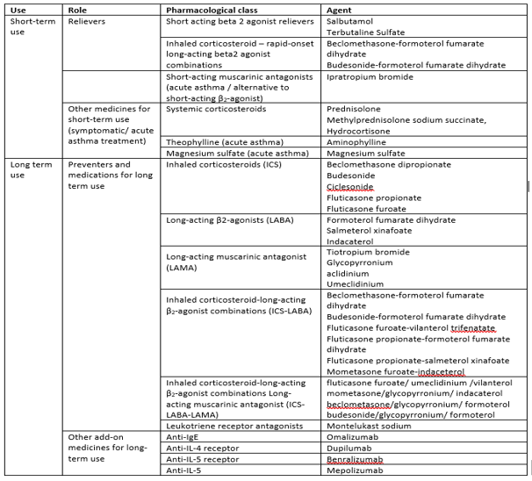

A stepwise approach is recommended by GINA for adjusting treatment for individual patient needs. Over time as more treatments have become available, guidelines have become more complex, although the general rules still apply. Australian guidelines follow a similar stepwise approach (see figure below). While the majority of patients are successfully managed with this step-wise treatment approach, a subset of patients with asthma remain uncontrolled despite maximal medical management (that is, patients with severe asthma).
Figure 1: Personalised management for adults and adolescents to control symptoms and minimise future risk (from GINA 2024)
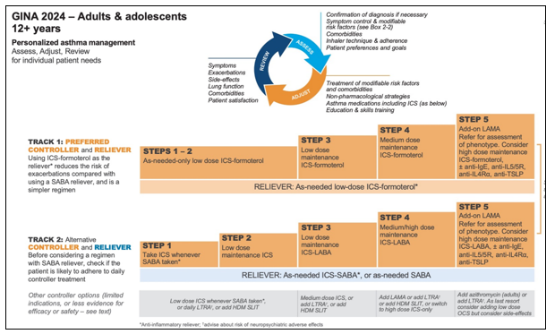
Figure 2: Managing asthma in Australia: Selecting and adjusting medication for adolescents and adults (from Australian Asthma Handbook, v2.2)

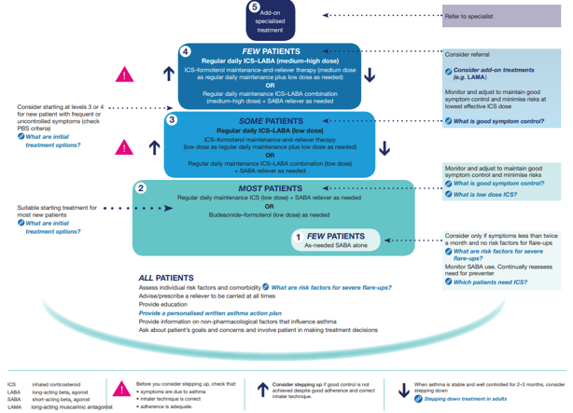

Five monoclonal antibody therapies have been approved by the TGA (Table 3) as add-on therapy for the treatment of patients with severe eosinophilic or moderate to severe allergic asthma uncontrolled despite optimised standard treatment, including high-dose inhaled corticosteroids and long-acting beta-2 agonists. Four are currently available in Australia while resilizumab is not marketed. The National Asthma Council of Australia lists the 4 monoclonal antibodies available in Australia for the treatment of asthma as ‘add-on specialised treatment’ (Level 5) in its chart for Selecting and Adjusting Asthma Medication for Adults and Adolescents and GINA guidelines list these at step 5.
Table 2: Monoclonal antibodies approved in Australia as add-on therapy for the treatment of severe eosinophilic asthma or the treatment of moderate to severe allergic asthma
Medicine | Action | TGA Approved indication | Dosage (Adults and adolescents 12 years and older) and dose presentations
Benralizumab (Fasenra) Marketed | Anti-IL-5 receptor. Humanised monoclonal antibody directed against IL-5 receptor Rα on surface of eosinophils and basophils. | Add-on therapy in patients aged 12 years and over with severe eosinophilic asthma (blood eosinophil count ≥300 cells/μL or ≥ 150 cells/μL if on oral corticosteroid treatment) | 30 mg SC every 4 weeks for 3 injections then 8-weekly  • Pre-filled syringe (30 mg/mL) for SC injection  • Pre-filled pen (30 mg/mL) for SC injection
dupilumab  (Dupixent)  Marketed | Anti-IL-4 receptor. Human monoclonal antibody directed against α subunit of IL-4 receptor. | Add on maintenance treatment in patients aged 6 years and older with moderate to severe asthma with type 2 inflammation (elevated eosinophils or elevated FeNO) that is inadequately controlled despite therapy with other medicinal products for maintenance. | 400 mg SC then 200 mg every 2 weeks; higher dose of 600 mg initially followed every 2 weeks for patients with oral corticosteroids-dependent asthma or with co-morbid moderate-to-severe asthma.  • Pre-filled syringe with needle shield SC injection (300 mg in 2 mL [300 mg]; 200 mg in 1.14 mL [175mg])  • Pre-filled pen SC injection (300 mg in 2 mL [300 mg]; 200 mg in 1.14 mL [175 mg]).
mepolizumab  (Nucala)  Marketed | Anti-IL-5. Humanised monoclonal antibody directed against IL-5 | Add-on treatment for uncontrolled severe eosinophilic asthma in adults and adolescents ≥12 years | 100 mg SC 4 weekly.  • Pre-filled pen (auto-injector) or pre-filled syringe (safety syringe)– 100 mg in 1 mL (100 mg/mL).  • Powder for injection – 100 mg (100 mg/mL for SC injection after reconstitution).
omalizumab  (Xolair)  Marketed | Anti-IgE. Humanised monoclonal antibody directed against IgE | Add-on treatment for allergic asthma – severe allergic asthma in children 6 to < 12 years and moderate to severe allergic asthma in adults and adolescents ≥ 12 years despite inhaled corticosteroids. | Dose (SC) calculated according to baseline IgE and body weight. Usual dose every 2–4 weeks (larger doses divided in 2 and administered every 2 weeks)  • Pre-filled syringe– 75 mg/0.5 mL; 150 mg/mL.  • Powder with diluent for SC injection – 75 mg per 0.6 mL (125 mg/mL after reconstitution); 150 mg per 1.2 ml (125 mg/mL after reconstitution).
reslizumab  (Cinquar)  Not marketed | Anti-IL-5. Humanised monoclonal antibody directed against IL-5. | Add-on therapy in adult patients with severe eosinophilic asthma (blood eosinophil count ≥400 cells/µL). | Recommended dose based on body weight (3.0 mg/kg every 4 weeks) by IV infusion.  • 100 mg/10 mL concentrated solution vial.

Monoclonal antibody therapy has been reported to reduce the rate of severe flare-ups requiring systemic corticosteroids. Several studies have also reported improvements in asthma symptoms compared with placebo or baseline, but few studies have reported clinically significant differences in Asthma Control Questionnaire scores compared with placebo. Some studies evaluating mepolizumab, benralizumab and dupilumab in patients with severe corticosteroid-dependent asthma have also shown a reduction in maintenance dose of oral corticosteroid. The monoclonal therapies are generally well tolerated. Injection site reactions are among the most common adverse events. Systemic reactions, including anaphylaxis, are rare but can occur.

Clinical rationale
Tezepelumab is a human immunoglobulin G2λ monoclonal antibody that binds to human thymic stromal lymphopoietin (TSLP) with high affinity and prevents its interaction with the heterodimeric TSLP receptor. Thymic stromal lymphopoietin, an epithelial cell-derived cytokine, occupies an upstream position in the asthma inflammatory cascade and is believed to play a central role in the initiation and persistence of airway inflammation in asthma (Figure 3) by regulating immunity at the airway barrier surface, affecting dendritic cells and other innate and adaptive immune cells, thus inducing downstream inflammatory processes and bronchial hyper-responsiveness. Thymic stromal lymphopoietin has been shown to be present in increased levels within bronchial mucosa of asthmatics, with TSLP expression increased within a subset of severe asthmatics despite high-dose corticosteroid therapies.
In asthma, both allergic and non-allergic triggers induce TSLP production.¹⁵ Blocking TSLP with tezepelumab reduces levels of a broad spectrum of biomarkers and cytokines associated with inflammation (for example, blood eosinophils, IgE, FeNO, IL−5, and IL−13).
Figure 3: Thymic stromal lymphopoietin: its role and potential as a therapeutic target in asthma
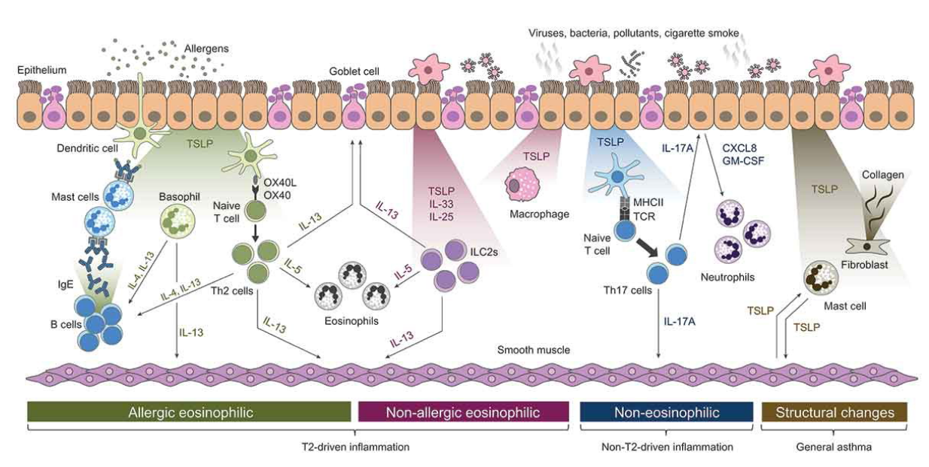
CXCL8 = chemokine (C-X-C motif) ligand 8; GM-CSF = granulocyte-macrophage colony-stimulating factor; IgE = immunoglobulin E; IL = interleukin; ILC2 = group 2 innate lymphoid cell; OX40 L = OX40 ligand; T2 = type 2; Th = T helper; TSLP = thymic stromal lymphopoietin.

Regulatory status

Australian regulatory status
This product is considered a new biological entity for Australian regulatory purposes.

International regulatory status
At the time the TGA considered this submission, a similar submission had been considered by other regulatory agencies. The following table summarises some of the key submissions and provides the indications where approved.
Table 3: International regulatory status
Region | Submission date | Status | Approved indications
United States | May 2021, for accessorised prefilled syringe (aPFS) and vial | Approved on 17 December 2021 | TEZSPIRE is indicated for the add-on maintenance treatment of adult and pediatric patients aged 12 years and older with severe asthma.  Limitations of Use: TEZSPIRE is not indicated for the relief of acute bronchospasm or status asthmaticus.
United States | April 2022, for autoinjector | Approved on 1 February 2023
European Union | May 2021, for aPFS | Approved on 19 September 2022 | Tezspire is indicated as an add-on maintenance treatment in adults and adolescents 12 years and older with severe asthma who are inadequately controlled despite high dose inhaled corticosteroids plus another medicinal product for maintenance treatment.
European Union | September 2022, for autoinjector | Approved on 12 January 2023
Switzerland | July 2021, for aPFS | Approved on 13 June 2022 | TEZSPIRE is indicated in addition to inhaled maintenance therapy in adults with severe asthma who meet the following criteria:  • inadequate asthma control and at least one severe exacerbation in the past 12 months despite concomitant treatment with inhaled corticosteroids and long-acting bronchodilators.  • systemic corticosteroids are not used as long-term therapy for asthma control.
Switzerland | August 2022, for autoinjector | Approved on 23 August 2023
Canada | August 2021, for aPFS and autoinjector | Approved on 28 July 2022 | TEZSPIRE (tezepelumab injection) is indicated as an add-on maintenance treatment in adults and adolescents 12 years and older with severe asthma.  TEZSPIRE is not indicated for relief of acute bronchospasm or status asthmaticus (see WARNINGS AND PRECAUTIONS).
Singapore | 14 September 2021, for aPFS and autoinjector | Approved 4 July 2023 | Tezspire is indicated as an add-on maintenance treatment in adults and adolescents 12 years and older with severe asthma who are inadequately controlled despite medium or high dose inhaled corticosteroids plus another medicinal product for maintenance treatment.
United Kingdom | July 2022, for aPFS | Approved on 23 September 2022 | Tezspire is indicated as an add-on maintenance treatment in adults and adolescents 12 years and older with severe asthma who are inadequately controlled despite high dose inhaled corticosteroids plus another medicinal product for maintenance treatment.
United Kingdom | April 2023, for autoinjector | Approved on 9 June 2023
New Zealand | April 2023, for aPFS and autoinjector | Approved 16 May 2024 | TEZSPIRE is indicated as an add-on maintenance treatment in adults and adolescents 12 years and older with severe asthma who are inadequately controlled despite high dose inhaled corticosteroids plus another medicinal product for maintenance treatment.

Registration timeline
The following table captures the key steps and dates for this submission.
This submission was evaluated under the standard prescription medicines registration process.
Table 4: Timeline for Submission PM-2023-05365-1-5
Description | Date
Submission dossier accepted and first round evaluation commenced | 30 November 2023
Evaluation completed (End of round 2) | 31 August 2024
Advisory committee meeting | 5 and 6 December 2024
Registration decision (Outcome) | 21 March 2025
Registration in the ARTG completed | 24 March 2025
Number of working days from submission dossier acceptance to registration decision* | 197 days
*Statutory timeframe for standard submissions is 255 working days

Assessment overview
A summary of the TGA’s assessment for this submission is provided below.
Relevant guidelines or guidance documents referred to by the Delegate are listed below:
- Guideline on the clinical investigation of medicinal products for the treatment of asthma. CHMP/EWP/2922/01 Rev. 1.
- Guideline on immunogenicity assessment of monoclonal antibodies intended for in vivo clinical use. EMA/CHMP/BMWP/86289/2010.

Quality evaluation summary
Tezepelumab is a human immunoglobulin G2λ (IgG2λ) monoclonal antibody directed against thymic stromal lymphopoietin (TSLP), produced in Chinese hamster ovary (CHO) cells by recombinant DNA technology. Tezepelumab has a molecular weight of approximately 147 kDa. The PI includes a schematic of the structure of tezepelumab.
Stability data supported the storage conditions ‘Store at 2°C to 8°C (Refrigerate. Do not freeze)’, ‘Store the prefilled syringe/ prefilled pen in the original package in order to protect from light’, and ‘Do not expose to heat’, with a 3-year shelf-life.
The prefilled syringe is comprised of 1.91 mL solution in a siliconised Type I glass prefilled syringe subassembly consisting of a 27-gauge 12.7 mm stainless steel special thin wall needle covered with a needle cover and plunger-stopper.
- The prefilled syringe (also called an accessorised prefilled syringe, aPFS) consists of the prefilled syringe subassembly with a needle guard and an extended finger flange
- The prefilled pen (also called an autoinjector or pen) consists of the prefilled syringe subassembly and handheld, mechanical (spring-based) injection device.
The quality evaluation concluded that there is no objection on quality grounds to the approval of tezepelumab. Quality-related conditions of registration were proposed.

Nonclinical evaluation summary
Primary pharmacology adequately demonstrated nonclinical efficacy and selectivity for human TSLP.
No clinically relevant hazards related to off-target effects of tezepelumab or exaggerated pharmacological actions on organ systems was identified.
The only notable findings in toxicity studies were associated with anti-drug antibody (ADA) formation.
Treatment-related toxicities associated with weekly injections of tezepelumab in monkeys were minimal and limited to injection site reactions which were generally resolved by the end of the treatment-free period.
Based on its pharmacological action, tezepelumab may perturb immunological responses in patients.
Pregnancy Category B1, as proposed by the sponsor, is considered appropriate.
There is no nonclinical objection to the registration of Tezspire for the proposed indication.

Clinical evaluation summary

Summary of clinical studies
The clinical dossier consisted of:
- 6 completed Phase I studies
  - Study 20080390: Initial single-ascending dose safety and pharmacokinetic (PK) study in healthy subjects with subcutaneous (SC) doses up to 420 mg
  - Study 20070620: Initial multiple-ascending dose safety and PK study in healthy subjects with intravenous (IV) doses up to 700 mg
  - PATH-BRIDGE (D5180C00012): A comparative PK study in healthy subjects administered tezepelumab via vial and syringe, accessorised pre-filled syringe (aPFS), or autoinjector device
  - Study D5180C00003: Single-dose PK study in healthy Japanese subjects
  - Study 20101183: Multiple dose proof-of-concept study in asthma subjects
  - Study D5180C00002A: Single-dose PK study in adolescents with asthma.
- 6 completed studies in Phase II and Phase III
  - CASCADE (D5180C00013): Phase II, randomised, double-blind, placebo-controlled study evaluating the effects of tezepelumab 210 mg SC every 4 weeks (Q4W) over treatment for 28 weeks on airway inflammation, as measured by submucosal cell counts, in adult subjects aged 18 to 75 years with moderate to severe asthma
  - NAVIGATOR (D5180C00007) (pivotal study): Phase III, randomised, double-blind, placebo-controlled, study of tezepelumab 210 mg SC Q4W over 52 weeks in adult and adolescent subjects aged 12 to 80 years with inadequately controlled asthma
  - PATHWAY (CD-RI-MEDI9929-1146; dose-ranging): Phase IIb, randomised, double-blind, placebo-controlled dose-ranging study of tezepelumab 70 mg SC Q4W, 210 mg SC Q4W and 280 mg SC every 2 weeks (Q2W) over 52 weeks in adults aged 18 to 75 years with inadequately controlled asthma
  - SOURCE (D5180C00009): Phase III, randomised, double-blind, placebo-controlled study of tezepelumab 210 mg SC Q4W over 48 weeks in reducing oral corticosteroid (OCS) use in adults aged 18 to 80 years with OCS dependent asthma
  - PATH-HOME (Study D5180C00011): Phase III study open-label study that evaluated the performance of tezepelumab 210 mg SC Q4W administered to patients with severe asthma via single-use aPFS and pen devices in the clinic and in an at-home setting
  - VECTOR: Phase IIIb, multicentre, randomised, double-blind, parallel-group, placebo controlled study of tezepelumab 210 mg SC Q4W in young adults and adolescents with moderate or severe asthma to evaluate the potential effect of tezepelumab on the humoral immune response to seasonal quadrivalent influenza vaccine in the autumn/winter of 2021 to 2022 in the US.
- one ongoing Phase III study
  - DESTINATION Long-term extension (LTE) study: Multicentre, randomised, double-blind, placebo-controlled, parallel-group, LTE study designed to evaluate the safety (primary objective) and efficacy of 210 mg SC Q4W of tezepelumab in adults and adolescents with severe uncontrolled asthma for up to 2 continuous years of treatment, which includes up to 1 year of treatment in predecessor studies. Subjects who completed treatment in either NAVIGATOR or SOURCE (referred to as ‘predecessor studies’) were eligible to enrol in this study.
- population pharmacokinetic analyses
  - single study designed to characterise the population PK of tezepelumab by developing a population PK (PopPK) model based on pooled PK data from 8 clinical studies:
- 6 Phase I studies in healthy volunteers (20070620 Part A, 20080390, 20101183, D5180C00002, D5180C00003, and PATH-BRIDGE)
- 2 studies in patients with asthma (one Phase IIb study [PATHWAY] and one Phase III study [NAVIGATOR]).

Pharmacology
Tezepelumab is an anti-TSLP human mAb IgG2λ that binds to human TSLP with high affinity and prevents its interaction with the TSLP receptor. Blocking TSLP with tezepelumab reduces levels of a broad spectrum of biomarkers and cytokines associated with inflammation (for example, blood eosinophils, IgE, FeNO, IL-5, and IL-13) (Figure 3).

Pharmacokinetics
The PK of tezepelumab have been adequately described in the submission in healthy subjects and in adolescents and adults with asthma. Tezepelumab is a human mAb, and its PK profile is similar to those of other therapeutic human mAbs. The PK in the target population is similar to that for healthy volunteers and were confirmed in the PopPK study. Tezepelumab has been developed for SC administration.

Absorption
The PK of tezepelumab were dose-proportional following SC doses of 2.1 mg to 420 mg and IV doses of 210 mg to 700 mg. Following single-dose SC administration of tezepelumab, the time to achieve maximum observed serum concentration was 3 to 10 days. The SC bioavailability was estimated to be 81% based on the ratio of the mean area under the plasma concentration time curve (AUC) extrapolated to infinity after a single SC 210 mg dose over that of the same dose administered IV. The estimated absolute bioavailability based on PopPK analysis was 77%. After repeated SC administration Q4W, serum tezepelumab concentrations approached steady state by 12 weeks, with a mean accumulation ratio of 1.86-fold. The plasma concentration time profiles for the 3 administration techniques, (aPFS, autoinjector, and vial and syringe) and for different body sites (abdomen, thigh, or upper arm) were similar. In the LTE study (DESTINATION), after repeated SC administration of tezepelumab 210 mg SC Q4W, mean steady-state concentrations were maintained until Week 104. Exposure decreased with increasing body weight.

Distribution
Following IV administration, there is an initial redistribution phase that is compatible with a two-compartment model. Terminal elimination was first order. The estimated central and peripheral volumes of distribution of tezepelumab were 3.91 L and 2.17 L, respectively, for a 70 kg individual, based on PopPK analysis. This is typical of mAbs, which are largely confined to the vascular and interstitial spaces due to their large molecular size and poor lipophilicity.

Metabolism
Tezepelumab is a human mAb that is degraded by proteolytic enzymes widely distributed in the body. Tezepelumab is not metabolised by hepatic enzymes.

Elimination
As a typical mAb, tezepelumab is eliminated by intracellular catabolism and there is no evidence of target-mediated clearance (CL) in the dose range tested clinically. The estimated clearance for tezepelumab was 0.172 L/day for a 70 kg individual, based on PopPK analysis. There was no dose-dependent change of clearance or apparent clearance observed with increasing doses. The estimated elimination half-life of tezepelumab was 25.5 days.

Population pharmacokinetic data
Data used to perform the PopPK analysis were collected from 8 studies: 2 studies in patients with asthma (Phase III NAVIGATOR, Phase II PATHWAY); and 6 Phase I studies in healthy subjects (Studies 0620 Part A, 0390, 1183, 0002, Japan Study 0003, and PATH-BRIDGE). Exploratory data analysis revealed that tezepelumab exhibited a 2-compartment linear disposition model over the tested dose range (2.1 mg to 420 mg SC and 210 mg to 700 mg IV) with first-order absorption and elimination.
The final dataset included 12,541 observations from 1,368 subjects. Simulations were performed using the final model in order to predict the need for dose adjustment based on body weight, age, sex, race, and body mass index (BMI). In the dataset, there were 766 (56.0%) females, 602 (44.0%) males and the age range was 12 to 80 years. Body mass index ranged from 16.9 to 64.1 kg/m².
The typical value for CL/F was 0.712 L/day, central volume of distribution was 3.91 L, and peripheral volume of distribution was 2.17 L. The estimates for inter-individual variability (expressed as CV%) were 29.9% for CL/F. 35.8% for central volume of distribution, and 13.1% for peripheral volume of distribution. Bioavailability was estimated as 76.8%.
The only significant covariate was body weight which had a significant effect on exposure. However, this issue is further addressed by the sponsor in the pharmacodynamic (PD) studies (NAVIGATOR Study – Clinical Exposure-Response Analysis Report). In that study, an analysis of exposure and response was performed which found no identifiable relationship between exposure and response. This supports the conclusion that dose modification is not required for extremes of weight.

Pharmacokinetics according to age
The PK of tezepelumab in adolescents was similar to that in adults.

Effect of intrinsic and extrinsic factors on the pharmacokinetics of tezepelumab
Based on PopPK and relevant efficacy, safety, and exposure-response analyses, there was no clinically relevant effect of age (12 years and above), sex, race, geographical region, weight, BMI, renal or hepatic impairment, disease severity, baseline biomarkers, concomitant asthma medications and smoking history on the PK of tezepelumab at the dose of 210 mg SC Q4W. Therefore, no dose adjustment is required for these intrinsic or extrinsic factors.

Pharmacodynamics
Based on the understanding of the inflammatory cascade, blocking TSLP with tezepelumab would be expected to reduce levels of a broad spectrum of biomarkers and cytokines associated with inflammation (for example, blood eosinophils, FeNO, IgE, IL-5, and IL-13). The clinical studies providing PD data in subjects with severe asthma were NAVIGATOR, PATHWAY, SOURCE, and CASCADE. The key PD parameters describing the primary pharmacology of tezepelumab evaluated in these studies are summarised in table 5.
Table 5: Studies with pharmacodynamic data
Parameter | NAVIGATOR (P3) | SOURCE (P3) | CASCADE (P2) | PATHWAY (P2)
Parameter | Adolescents and Adults | Adults | Adults | Adults
Parameter | TEZ 210 mg Q4W | TEZ 210 mg Q4W | TEZ 210 mg Q4W | TEZ 70 mg Q4W, 210 mg Q4W, 280 mg Q2W
Parameter | Placebo-controlled | Placebo-controlled | Placebo-controlled | Placebo-controlled
Blood eosinophils | ⬇ | ⬇ | ⬇ | ⬇
Total IGE | ⬇ | ⬇ | ⬇ | ⬇
FeNO | ⬇ | ⬇ | ⬇ | ⬇
IL-5 | ⬇ | ⬇ | ⬇ | N/A
IL-13 | ⬇ | ⬇ | ⬇ | N/A
IL-6 | ⬌ | N/A | N/A | N/A
CRP | ⬌ | N/A | N/A | N/A
Plasma eosinophil -derived neurotoxin | N/A | N/A | ⬇ | N/A
Bronchial submucosal inflammatory cells | N/A | N/A | ⬇ | N/A
Notes: Table prepared based on PD data from the individual studies. P3 = Phase 3; P2 = Phase 2; TEZ = Tezepelumab; ⬇ = reduction compared with placebo over the course of the study; ⬌ = no change compared with placebo over the course of the study; N/A = Not applicable for the study.

Pharmacodynamic effects
The sponsor has investigated the effects of tezepelumab on bronchial inflammation, airway calibre, inflammatory biomarkers, and cytokines and on lung function.
Tezepelumab reduced levels of biomarkers (eosinophils, FeNO) and also caused a progressive reduction in IgE, (Figure 4) with effects generally seen by 2 to 4 weeks (2 weeks was the earliest time point assessed) and maintained for up to 52 weeks. The results were generally comparable across NAVIGATOR, SOURCE, CASCADE, and PATHWAY.
Figure 4: NAVIGATOR Adjusted means and 95% Confidence Intervals over time for (a) Eosinophils (b) Fraction exhaled nitric oxide (c) Immunoglobulin E, as Change from baseline (Full analysis set)
(a) Eosinophils (cells/μL)
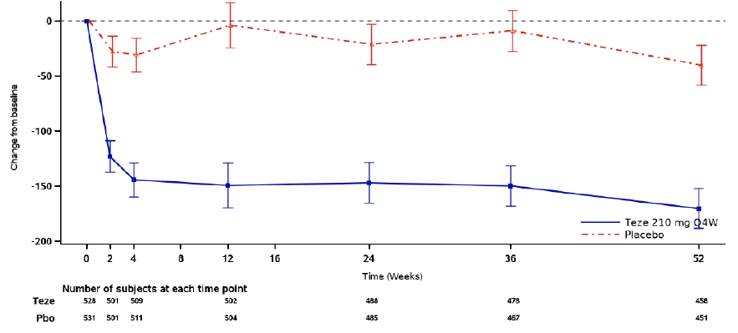
(b) FeNO (ppb)
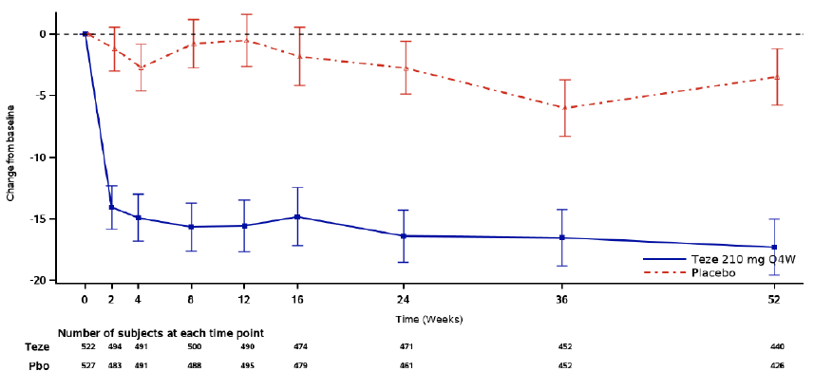
(c) Total serum IgE (IU/mL)
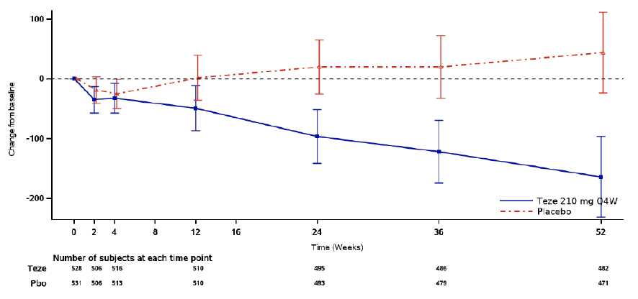
Baseline is defined as the last non-missing measurement recorded on or prior to randomisation.
The model with Unstructured covariance structure is: Change from baseline in Biomarker = Treatment group + region + age + baseline Biomarker + visit + treatment * visit.
CI = confidence interval; Pbo = placebo; Q4W = every 4 weeks; Teze = tezepelumab.

Across NAVIGATOR, PATHWAY, SOURCE, and CASCADE, tezepelumab reduced serum IL-5 and serum IL-13 levels.
In the CASCADE study, levels of the eosinophil activation marker in plasma were reduced from baseline to end of treatment (28 weeks to 48 weeks). In the tezepelumab group, plasma eosinophil activation marker decreased from a mean (Standard Deviation [SD]) baseline of 16.787 (10.056) ng/mL to 11.878 (3.850) ng/mL at end of treatment; there was no change in the placebo arm.
In Study 20101183 there was improvement in forced expiratory volume in 1 second (FEV₁) post-allergen challenge in the treatment group.
In the CASCADE study, where airway inflammation was assessed via bronchial biopsies, there was a decrease in submucosal eosinophils in the tezepelumab group compared to placebo, but no significant difference in neutrophils, CD3+ cells, CD4+ cells or mast cells.
Tomography scanning indicated an increase in airway lumen area in the tezepelumab group (in CASCADE).
Asthma Control Questionnaire 6 (ACQ-6) response was greater in the tezepelumab group compared to placebo (in CASCADE).
The time-course for the effects was from early in the course of treatment and the effects were maintained for the duration of treatment.
Adolescent subjects who received tezepelumab had reduced levels of blood eosinophils, FeNO and total serum IgE, similar findings to adult subjects (in NAVIGATOR).
There were no formal studies investigating PD drug-drug interactions. However, there is low risk of clinically significant PD interactions between tezepelumab and small drug molecules. Due to its large molecular size, drug-drug interactions with tezepelumab as either a victim or perpetrator are not expected with small molecule drugs that induce or inhibit the cytochrome P450 pathways.

VECTOR (Study D5180C00031)
This was a Phase IIIb, multicentre, randomised, double-blind, parallel-group, placebo-controlled study of tezepelumab 210 mg SC Q4W in young adults and adolescents with moderate or severe asthma to evaluate the potential effect of tezepelumab on the humoral immune response to seasonal quadrivalent influenza vaccine in the autumn/winter of 2021 to 2022 in the USA.
A total of 81 subjects were enrolled and 70 subjects were randomised (35 subjects each to the tezepelumab and placebo group) All 70 randomised subjects received study intervention. Overall, 66 (94.3%) randomised subjects completed treatment, 32 (91.4%) subjects in the tezepelumab group and 34 (97.1%) subjects in the placebo group.
The humoral immune response following seasonal influenza vaccination measured by haemagglutination inhibition and microneutralisation assays was generally similar between the tezepelumab and placebo groups in adolescent and young adult subjects with moderate to severe asthma. There were no tezepelumab ADA-positive subjects among 35 subjects in the tezepelumab group.

Dose selection for the pivotal studies

Pharmacokinetics and pharmacodynamics: dose finding studies
Studies have described the PK of tezepelumab, and this supports a Q4W dosing regimen. The PD studies have explored the exposure-effect relationships. These data support the 210 mg Q4W dosing regimen.

Phase II dose finding studies
PATHWAY examined 70 mg Q4W, 210 mg Q4W and 280 mg Q2w. The results for annualised asthma exacerbation rate (AAER) indicated 210 mg Q4W was the optimal dose regimen, although respiratory function improved to a greater extent with the 280 mg Q2W dosing regimen.
The remaining Phase III studies only examined the 210 mg Q4W dosing regimen, which is appropriate.
The dose finding data from the Phase II study (PATHWAY) demonstrated the efficacy of tezepelumab 210 mg SC Q4W for further investigation for the proposed indication in the pivotal Phase III study (NAVIGATOR). In PATHWAY, clinically significant added benefit of the tezepelumab 210 mg SC Q4W regimen over the tezepelumab 70 mg SC Q4W regimen was demonstrated for the primary efficacy endpoint (AAER at 52 weeks) supported by the results for multiple secondary efficacy endpoints, including improvement in lung function. The clinical data from PATHWAY suggest that there is no clinically meaningful difference between the tezepelumab 210 mg SC Q4W and the tezepelumab 280 mg SC Q2W doses.

Efficacy
The following studies provided evaluable efficacy data.
Confirmatory asthma exacerbation studies:
- PATHWAY (Study CD-R-MEDI9929-1146) – Phase IIb - 108 centres in 12 countries: USA, Slovakia, Bulgaria, Czech Republic, Hungary, Israel, Japan, Latvia, Lithuania, Serbia, South Africa, and Ukraine. Conducted December 2013 to March 2017.
- NAVIGATOR (Study D5180C00007) – Phase III - 297 centres in 18 countries (Argentina, Australia, Austria, Brazil, Canada, France, Germany, Israel, Japan, South Korea, Russia, Saudi Arabia, South Africa, Taiwan, Ukraine, United Kingdom, United States, and Vietnam. Conducted November 2017 to November 2020.
Oral corticosteroid reduction study in asthma:
- SOURCE (Study D5180C00009) - Phase III - 60 centres in 7 countries: Argentina, Germany, South Korea, Turkey, Poland, Ukraine, and the US. Conducted March 2018 to September 2020.
At-home functionality and device performance study:
- PATH-HOME (Study D5180C00011) – Phase III - 31 centres in 4 countries: Canada, Japan, Poland, and the US. Conducted May 2019 to June 2020.
Safety and efficacy over 2 years:
- DESTINATION an ongoing long-term extension study. The 3-month safety update was submitted in the initial dossier. Subsequently a Data Notification Document, and a clinical study report and addendum were provided on 25 February 2022 and 1 July 2022 respectively.
The key study details are outlined in table 6.
Table 6: Key features of efficacy studies
 | Study design | Primary objectives | Primary and key secondary outcomes | Number of participants randomised and treated
PATHWAY | RD/DB/PC  52-week treatment & 12-week follow-up  Teze: 70, 210 mg Q4W, 280 mg Q2W SC, placebo | Dose ranging study: effectiveness of 3 dose levels of tezepelumab on asthma exacerbations | Primary: Asthma exacerbations  Secondary: effect on lung function, symptoms and QOL | 550 adults (18-75 yrs)  138 teze 70 mg  137 teze 210 mg  137 teze 280 mg  138 placebo
NAVIGATOR | RD/DB/PC  52-week treatment & 12-week follow-up  Teze 210 mg Q4W SC or placebo | Assess the effect of tezepelumab 210 mg SC Q4W on asthma exacerbations | Primary: Asthma exacerbations  Secondary: effect on lung function, symptoms and QOL | 1059 adults/adolescents  528 teze  531 placebo  (82 subjects aged 12-17yr)
SOURCE | RD/DB/PC  48-week treatment  Teze 210 mg Q4W SC or placebo | Evaluate the effect of tezepelumab in reducing the OCS maintenance dose in asthmatic patients | Primary: Reduction of OCS dose  Secondary: effect on exacerbations | 150 adults (18-80 years)  74 teze  76 placebo
PATH-HOME | RD/OL  24-week treatment  Teze 210 mg Q4W SC administered by aPFS or Autoinjector by HCP / subjects | Assess functionality and performance of 2 alternative methods of administration | Primary: Successful administration with APFS or Autoinjector | 216 adults /adolescents  111 APFS  105 Autoinjector  (24 subjects aged 12-17yr)
aPFS = Accessorised prefilled syringe; DB = Double-blind; FeNO = Fraction Exhaled Nitric oxide; HCP = Health care provider; HRQoL = Health-related Quality of Life; OCS = Oral corticosteroid, PC = Placebo-controlled; Q2W = Every 2 weeks; Q4W = Every 4 weeks; RD = Randomised design; SC = Subcutaneous; QOL = Quality of life.

Navigator and pathway

Study designs
The PATHWAY and NAVIGATOR studies were well designed and conformed with regulatory guidance. The selection of patients and the outcome measures were consistent with the Guideline on the Clinical Investigation of Medicinal Products for the Treatment of Asthma (CHMP/EWP/2922/01 Rev. 1). The NAVIGATOR study included adults and adolescents aged 12 years to 80 years, while PATHWAY included adults aged 18 years to 75 years. Eligibility criteria (Table 7) included asthma which was inadequately controlled by stable dose medium/high dose inhaled corticosteroids and at least one controller with or without oral corticosteroids. Both studies also required a documented history of at least 2 severe asthma exacerbations (or 1 exacerbation resulting in hospitalisation in PATHWAY) in the 12 months prior to study entry. Patients with well-controlled comorbid disease on a stable treatment regimen for 15 days prior to Visit 1 were eligible.
Table 7: NAVIGATOR and PATHWAY asthma-related inclusion criteria
Study | Asthma history | Baseline therapy ª | Lung function | Evidence of uncontrolled asthma
NAVIGATOR (Phase III) | Physician-diagnosed asthma for at least 12 months FEV₁ at least 12% and at least 200 mL | MD or HD ICS for at least 12 months  At least 1 additional maintenance therapy (LABA / LAMA / LTRA / etc) for at least 3 months | Morning pre-BD FEV₁ less than 80% (90% for adolescent subjects) predicted normal | At least 2 asthma exacerbations within 12 months  ACQ-6 score at least 1.5 at screening and at randomisation
PATHWAY (Phase IIb) | Physician-diagnosed asthma for at least 12 months  FEV₁ at least 12% and at least 200 mL | MD or HD ICS and LABA for at least 6 months | Morning pre-BD FEV₁ at least 40% and less than 80% predicted normal | At least 2 asthma exacerbations or 1 severe with hospitalisation within 12 months  ACQ-6 score at least 1.5 twice during screening
a In PATHAWY, MD defined as 250 to 500 microgram fluticasone dry powder inhaler or a total daily dose of 220 to 440 microgram fluticasone metered-dose inhaler or equivalent; in NAVIGATOR, MD or HD defined as at least 500 microgram fluticasone propionate dry powder formulation equivalent total daily dose.
ACQ-6 = Asthma Control Questionnaire 6; BD = Bronchodilator; FEV₁ = Forced expiratory volume in 1 second; HD = High-dose; ICS = Inhaled corticosteroids; LABA = Long-acting beta 2-agonist; LAMA = Long-acting muscarinic antagonist; LTRA = Leukotriene receptor antagonist, MD = Medium-dose.

The primary endpoint in NAVIGATOR and PATHWAY was AAER reduction over 52 weeks for tezepelumab versus placebo. Asthma exacerbations were defined as worsening of asthma leading to:
- temporary bolus/burst of systemic corticosteroids (or increase in stable dose) for at least 3 consecutive days); and/or
- an Emergency room or urgent care visit (of less than 24 hours) that required systemic corticosteroids for at least 3 consecutive days; and/or
- an in-patient hospitalisation (of at least 24 hours) for asthma.
This definition is consistent with the European Respiratory Society/American Thoracic Society (Reddel 2009),⁶ and GINA guidelines (GINA 2020).²
NAVIGATOR included multiplicity-controlled key secondary endpoints [change in pre-bronchodilator FEV₁, Asthma Quality of Life Questionnaire for 12+ years (AQLQ(S)+12) score, ACQ-6 score, Asthma Symptom Diary (ASD) score, rescue medication use]. PATHWAY included secondary analyses of pre-bronchodilator FEV₁, AQLQ(S)+12 score, and ACQ-6 score, and rescue medication use. In NAVIGATOR, the same endpoints were used in the enrolled adolescent population.
The studies consisted of a screening/run-in period of 5 to 6 weeks, a treatment period of 52 weeks, and a post-treatment follow-up period of 12 weeks. During the treatment period, tezepelumab was administered SC Q4W from Day 0 until Week 48. No tezepelumab was administered at Week 52. Subjects who discontinued tezepelumab during the study were encouraged to undergo appropriate study visits/procedures for the full 52-week period.

Study population data summary
In NAVIGATOR, 1061 subjects were randomised and 1059 were treated (528 and 531 tezepelumab and placebo groups respectively). In PATHWAY, 550 subjects were randomised and treated (137 tezepelumab 210 mg Q4W, 138 placebo); the remaining subjects in PATHWAY received tezepelumab 70 mg Q4W or 280 Q2W. A total of 95.6% and 89.8% subjects in NAVIGATOR and PATHWAY completed the study.
Demographic and baseline disease characteristics were generally balanced between the groups in both NAVIGATOR and PATHWAY. Most subjects were White (NAVIGATOR = 62%, PATHWAY = 92%) and female (NAVIGATOR = 64%, PATHWAY = 66%), although higher proportions of Black/African American (NAVIGATOR = 5.8%, PATHWAY = 3.5%) and Asian (NAVIGATOR = 28%, PATHWAY = 3.5%) subjects were included in the NAVIGATOR study. In NAVIGATOR, the mean age was 49.5 years, and the full analysis set included 82 (7.7%) adolescents aged 12 to 17 years. In PATHWAY, the mean age was 51.6 years. The mean BMI was similar in both studies (NAVIGATOR = 28.5, PATHWAY = 28.2).
Key respiratory and baseline biomarker characteristics were similar across treatment groups in each study and across studies. Subjects with both eosinophilic and non-eosinophilic asthma phenotypes were well represented in both studies; 58.4% in NAVIGATOR and 51.3% in PATHWAY had baseline blood eosinophils under 300 cells/μL, and 26.1% and 24.9% respectively, had levels under 150 cells/μL.
Virtually all subjects had at least 2 exacerbations in the 12 months prior to the study (NAVIGATOR = 99.9%, PATHWAY = 98.2%). At baseline, approximately 75% of subjects in NAVIGATOR and 49% in PATHWAY were on high dose inhaled corticosteroids (ICS), 99% and 100%, respectively, were on ICS/long-acting beta 2-agonist (LABA), and approximately 9% of subjects in each study were on maintenance OCS. Mean baseline FEV₁ % was 62.7% in NAVIGATOR and 59.55% in PATHWAY. The mean ACQ-6 score was similar in the 2 studies (NAVIGATOR = 2.81, PATHWAY = 2.68).

Efficacy results
In both studies, tezepelumab 210 mg Q4W treatment resulted in significant reductions in the rate of asthma exacerbations over 52 weeks compared with placebo by 56% in NAVIGATOR (AAER ratio 0.44 [95% confidence interval (CI) 0.37, 0.53]; p < 0.001) and 71% in PATHWAY (AAER ratio 0.29 [95% CI 0.16, 0.51]; p < 0.001) (see table below). In both studies, tezepelumab resulted in reductions in AAER in subjects with a baseline blood eosinophil count less than 300 cells/μL as well as in subjects with baseline eosinophils at and above 300 cells/μL.
Table 8: NAVIGATOR and PATHWAY annual asthma exacerbation rate ratio over 52 weeks
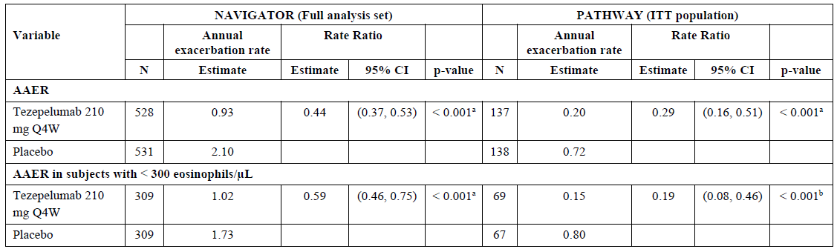
a Statistically significant under multiple testing procedure. b Nominal p-value. A rate ratio less than 1 favours tezepelumab.
AAER = Annualised asthma exacerbation rate; CI = Confidence interval; ITT = Intent-to treat; N = Number in treatment group; Q4W = Every 4 weeks.
The AAER was notably higher in the tezepelumab group relative to the placebo group in PATHWAY compared with NAVIGATOR (71% versus 56%, respectively). The sponsor referred to differences between the 2 studies that might account for the difference in the tezepelumab asthma exacerbation rates (AER); including:
- the smaller sample size for the 210 mg SC Q4W in PATHWAY (n = 137) compared to NAVIGATOR (n = 528)
- design changes made for NAVIGATOR to ensure a population with severe, uncontrolled asthma were at risk of experiencing exacerbations; these changes had an impact, as seen by a higher AAER being observed in the placebo group in NAVIGATOR (2.10) compared with PATHWAY (0.72), and
- noting that in studies with other biologics the exacerbation rate in the placebo arm is lower in subgroups with lower eosinophil counts compared with higher eosinophil counts. This trend was observed in NAVIGATOR, where the AER was lower in subjects with less than 300 eosinophils/µL in the placebo group than in the overall population (1.73 versus 2.10, respectively), but not in PATHWAY (0.80 versus 0.72, respectively).
Tezepelumab also resulted in reductions in asthma exacerbation-related hospitalisation and emergency visits in both studies (rate ratio 0.21 [95% CI 0.12, 0.37] for NAVIGATOR; rate ratio 0.15 [95% CI 0.04, 0.58] for PATHWAY). The time to first exacerbation was longer for the tezepelumab group compared with placebo in NAVIGATOR (Hazard Ratio 0.59 [95% CI 0.50, 0.70]) and PATHWAY (Hazard ratio 0.45 [95% CI 0.26, 0.75]).
Regarding body weight, rate ratios (95% CI) of AAER over 52 weeks between the tezepelumab and placebo groups were similar: 0.42 (0.29 to 0.61), 0.45 (0.31 to 0.66), 0.49 (0.34 to 0.72), and 0.41 (0.28 to 0.60), respectively, for the first to the fourth body weight quartiles. Weight did not influence pre-bronchodilator FEV₁ response.
The significant decrease in asthma exacerbations relative to placebo was independent of baseline eosinophil count, FeNO or allergic status (Figure 5, Figure 6). However, there was a greater benefit with tezepelumab with increasing levels of eosinophils and FeNO levels (Figure 7) but not IgE levels.
Figure 5: NAVIGATOR Annualised asthma exacerbation rate ratio over 52 weeks, negative binomial model Forest plot by subgroups by baseline biomarkers (full analysis set)
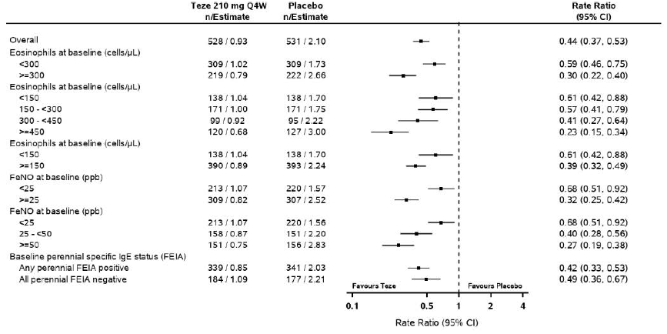Rate ratio is displayed on the log scale. Dotted line represents no treatment difference. CI = Confidence interval; FeNO = Fractional exhaled nitric oxide; IgE = Immunoglobulin E; FEIA = Fluorescence enzyme immunoassay; n = Number of subjects in analysis; Q4W = Every 4 weeks; Teze = Tezepelumab.

Figure 6: PATHWAY Annualised asthma exacerbation rate ratio over 52 weeks, negative binomial model - Forest plot by subgroup by baseline biomarkers (ITT analysis set)
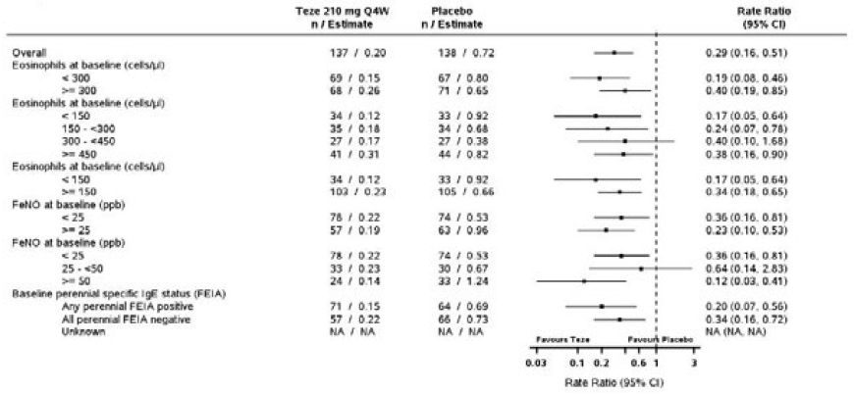
Rate ratio is displayed on the log scale. Dotted line represents no treatment difference. CI = Confidence interval; FeNO = Fractional exhaled nitric oxide; IgE = Immunoglobulin E; FEIA = Fluorescence enzyme immunoassay; n = Number of subjects in analysis; Q4W = Every 4 weeks; Teze = Tezepelumab.

Figure 7: NAVIGATOR Locally weighted regression and smoothing scatterplots (LOESS) of Annual asthma exacerbation rates over 52 weeks (95% confidence intervals) by Baseline Eosinophils and Fractional exhaled nitric oxide; planned treatment (full analysis set)
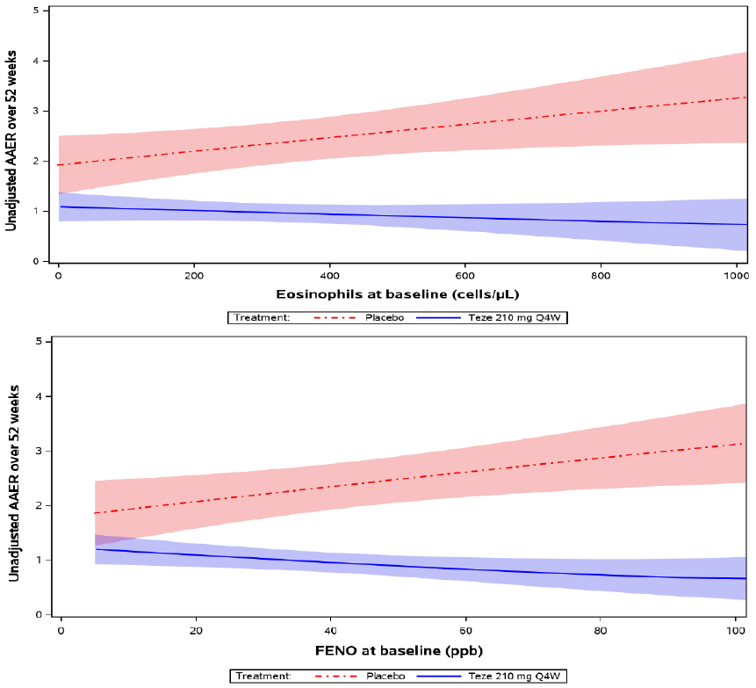
Treatment with tezepelumab resulted in improvements from baseline in NAVIGATOR and PATHWAY in secondary endpoints related to lung function, quality of life, asthma control and asthma symptoms that were each statistically significantly greater than placebo in NAVIGATOR. Similar changes were seen in PATHWAY (see table below.)
Table 9: NAVIGATOR and PATHWAY Summary results for key secondary efficacy endpoints
a Statistically significant under multiple testing procedure.
b Nominal p-values.
c The changes from baseline in the mean AQLQ(S)+12 and ACQ-6 scores were evaluated over time. For the Week 52 visit in PATHWAY, the ePRO device had to be manually triggered; however, many study sites did not perform this function, which resulted in considerably fewer subjects completing the questionnaire at the Week 52 visit. Therefore, Week 48 and 50 data (respectively) are presented for PATHWAY.
d ASD was evaluated in NAVIGATOR only.

Pathway - Efficacy of doses
All tezepelumab treatment groups were superior to placebo, and although there was no significant difference between the tezepelumab groups, the 210 mg Q4W had the lowest rate of exacerbations. The AAER (95% CI) was 0.72 (0.59 to 0.88) for placebo, 0.27 (0.19 to 0.38) for 70 mg Q4W, 0.20 (0.13 to 0.30) for 210 mg Q4W and 0.23 (0.16 to 0.34) for 280 mg Q2W. In the subgroup analysis, the efficacy was maintained across all subgroups, including eosinophil count. For the 210 mg Q4W dose the rate reduction (95% CI) compared to placebo was 60% (15 to 81%) for the eosinophil count of at least 300 cells/μL group and 81% (54 to 92%) for the eosinophil count below 300 cells/μL group.
Respiratory function improved in all treatment groups but improved most in the highest dose group (280 mg Q2W). Improvements in pre-bronchodilator FEV₁ were greater with eosinophil count of at least 300 cells/μL and FeNO of at least 24 ppb. For the 210 mg Q4W dose level the least squares (LS) mean difference (95% CI) in FEV₁ compared to placebo was 0.205 (0.060 to 0.350) L for the eosinophil count at least 300 cells/μL group and 0.054 (−0.082 to 0.191) L for the eosinophil count below 300 cells/μL group. For the 210 mg Q4W dose level the LS mean difference (95% CI) in FEV₁ compared to placebo was 0.215 (0.054 to 0.375) L for the FeNO of at least 24 ppb group and 0.066 (−0.057 to 0.189) L for the FeNO below 24 ppb group.

Adolescent participants
A total of 82 adolescents were included in the NAVIGATOR study with 41 adolescents in each treatment group. Baseline demographic characteristics for adolescent subjects were reasonably well balanced in the 2 treatment groups. Baseline demographic characteristics in the total adolescent population (n = 82) were: mean (SD) age = 14.7 (1.6) years; predominantly female = 53.7%; predominantly White = 70.7%; predominantly not Hispanic or Latino = 63.4%; mean (SD) height = 162.43 (8.50) cm; mean (SD) weight = 59.63 (14.13) kg; and mean (SD) BMI = 22.56 (5.0) kg/m². Approximately 50% of subjects were randomised in South America. No adolescent subjects were randomised in Australia.
In the adolescent subgroup, there was an imbalance in the proportion of subjects with blood eosinophil levels below 300 cells/μL (56.1% in the tezepelumab and 34.1% in the placebo), blood eosinophils of at least 300 cells/μL (43.9% in tezepelumab, 65.9% in placebo), and blood eosinophils below 150 cells/μL (19.5% in the tezepelumab and 14.6% in the placebo). There was also an imbalance between treatment groups in FeNO levels, ICS dose, and perennial aeroallergen-specific IgE results, with 26.8% of subjects with FeNO below 25 ppb in the tezepelumab and 39.0% in the placebo group, 63.4% and 51.2% receiving medium-dose ICS in the tezepelumab and placebo groups, respectively, and 87.8% and 92.7% adolescents being positive for any perennial aeroallergen-specific IgE in the tezepelumab and placebo groups, respectively. One subject in the tezepelumab and 2 subjects in the placebo group had nasal polyps, and one subject in the tezepelumab group received maintenance OCS.
In the adolescent subgroup, there were no statistically significant differences between the 2 treatments for the primary efficacy endpoint or any of the key secondary efficacy endpoints. However, the study was not powered to demonstrate a statistically significant difference in the endpoints in the adolescent population. Clinically meaningful numerical improvements were observed in favour of the tezepelumab group compared to the placebo group for the AAER and FEV₁ (AAER ratio 0.70 [95% CI 0.34,1.46]) and lung function (LS mean change versus placebo was 0.17 L [95% CI -0.01, 0.35]) compared with placebo, with no differences versus placebo observed in the patient reported outcomes of ACQ-6, AQLQ(S)+12, or ASD (see table below).
The numerical differences between tezepelumab and placebo for the primary efficacy and key secondary efficacy endpoints were greater in the 2 adult subgroups than in the adolescent subgroup, suggesting that tezepelumab is more effective for the treatment of adult subjects compared with adolescent subjects.
Table 10: NAVIGATOR Primary and key secondary endpoints in adolescents (full analysis set)
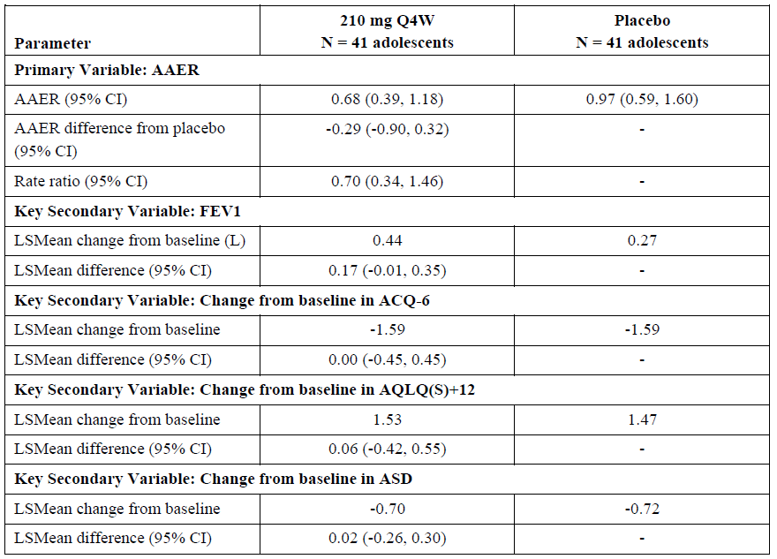
AAER = annual asthma exacerbation rate; ACQ-6 = Asthma Control Questionnaire-6; AQLQ(S)+12 = Standardised Asthma Quality of Life Questionnaire for Ages 12 and Older; ASD = Asthma Symptom Diary; CI = confidence interval; FEV1 = forced exhalation volume in one second; LS = least squares; Q4W = every 4 weeks.
An analysis of annual asthma exacerbation rate in adolescent participants was performed to adjust for differences between the treatment groups in these baseline characteristics. The results confirmed that there was no or minimal impact of any of these imbalances on the AAER treatment effect in adolescents or the other age groups.

SOURCE
SOURCE evaluated the efficacy and safety of tezepelumab in reducing oral corticosteroid use in 150 adults with OCS-dependent (at least 7.5 mg and up to 30 mg) asthma. Participants were also on high-dose ICS and a LABA. The primary efficacy measure was the categorised percent reduction in the daily OCS dose at Week 48 whilst maintaining asthma control. Secondary outcomes included AAER, lung function, quality of life and symptoms.
Of 150 randomised subjects (74 to tezepelumab, 76 to placebo), all were included in efficacy and safety analyses. There were 68 subjects (91.9%) in the tezepelumab group and 73 (96.1%) in the placebo group who completed the study. There were 8 subjects (10.8%) in the tezepelumab group and 5 subjects (6.6%) in the placebo group who discontinued treatment, and one death in the tezepelumab group.
Most participants were White (84%) and female (62.7%) with a median age of 53.4 years, a mean BMI of 28, median FEV₁/forced vital capacity pre-bronchodilator of 52% and the median exacerbation frequency over the preceding 12 months was 2. All were treated with OCS (median 10 mg). Baseline characteristics were similar for the 2 treatment groups.
In terms of the primary efficacy outcome measure there was no significant difference between tezepelumab and placebo [Odds Ratio (OR) (95% CI) 1.28 (0.69 to 2.35), p = 0.434] (see table below). There is a high rate of OCS reduction in both groups with 74% of the tezepelumab group and 70% of the placebo group having at least 50% reduction in their steroid dosage and 54% and 46% having at least 90% reduction. There was no difference in mean daily exposure of systemic corticosteroids over 48 weeks. However, there was benefit for patients with eosinophils of at least 300 cells/μL, [OR (95% CI) 3.49 (1.16 to 10.49)], and eosinophils of at least 150 cells/μL [OR (95% CI) 2.58 (1.16 to 5.75)]. There was no subgroup effect for FeNO or IgE status.
Table 11: SOURCE Proportion of subjects in different categories based on % reduction from Baseline in Final Daily OCS Dose at Week 48 - Proportional Odds Model, Planned Treatment (Full analysis set)
For the secondary endpoints, there was no significant difference in AAER overall, mean difference (95% CI) −0.62 (−1.40 to 0.15) (p=0.111) but, there was benefit for patients with eosinophils of at least 300 cells/μL, difference (95% CI) −2.08 (−3.62 to −0.53); rate ratio (95% CI) 0.29 (0.14 to 0.63). There was an increase in FEV₁ in the tezepelumab group relative to placebo: least squares mean difference (95% CI) 0.26 (0.13 to 0.39). The improvement was greater in the patients with higher eosinophil counts at baseline. Other secondary endpoints had similar findings.
The failure of SOURCE to meet both its primary efficacy endpoint and key secondary efficacy endpoint raises uncertainty about whether tezepelumab should be used in patients on maintenance dose OCS.

Path-home (Study D518000011)
This study evaluated the functionality and performance of 2methods of administration: accessorised pre-filled syringe (aPFS) or autoinjector in adolescents and adults. The primary outcome was successful administration. Metrics of asthma (ACQ-6) control were also collected. There were 216 people in the study: 111 to aPFS and 105 to autoinjector, with 109 (98.2%) and 105 (100%) subjects who completed the study. Patients received 6 SC doses of tezepelumab 201 mg SC at 4-week intervals. The 2 subjects in the aPFS group who discontinued treatment did so because of adverse events (AE).
The median age was 51 years, 50% were female, with 78% White. The median BMI was 28.4, the median FEV₁ was 71%, and over half (52.3%) had not had an asthma exacerbation in the preceding 12 months. Treatment groups were similar. All the patients were on ICS at medium to high dose, 98% were on LABA, and 4.6% were on oral corticosteroids.
Nearly all healthcare professionals, subjects, and caregivers successfully administered tezepelumab using an aPFS or an autoinjector device. Overall success rate (95% CI) was 91.7% (85.05 to 95.60%) for aPFS and 92.4% (85.68 to 96.09%) for autoinjector. There was improvement in ACQ-6 with treatment in both groups, with similar efficacy for both administration devices. At Week 24, the mean ACQ-6 change from baseline was −1.141 in the aPFS group and −0.941 in the autoinjector group.

Destination (Study D5180C00018)
DESTINATION is a LTE study. It is a Phase III, multicentre, randomised, double-blind, placebo-controlled, parallel group study. The aim of this study was to evaluate the safety and tolerability of tezepelumab 210 mg Q4W in adults and adolescents for up to 2 continuous years (1 year predecessor studies; 1 year DESTINATION). Subjects who had continued to receive tezepelumab and attended the end of treatment (EOT) visit in NAVIGATOR (D5180C00007) or SOURCE (D5180C00009) were able to enrol if they fulfilled the inclusion/exclusion criteria. All subjects were re-randomised to maintain blinding.
Subjects previously randomised to tezepelumab remained on tezepelumab. Subjects randomised to placebo in predecessor studies were re-randomised (1:1) to either tezepelumab or placebo. The last dose of tezepelumab was administered at Week 100 and the EOT visit was conducted at Week 104. No tezepelumab was administered at Week 104 or during the subsequent follow-up period. For subjects from the NAVIGATOR study there was an option to enter a 36-week Extended Follow-up period (Figure 8).
There are 5 possible treatment groupings across each predecessor study and the LTE (DESTINATION) as shown in Figure 8. The analysis sets are shown in Table 12.
Figure 8: DESTINATION flow chart of study design
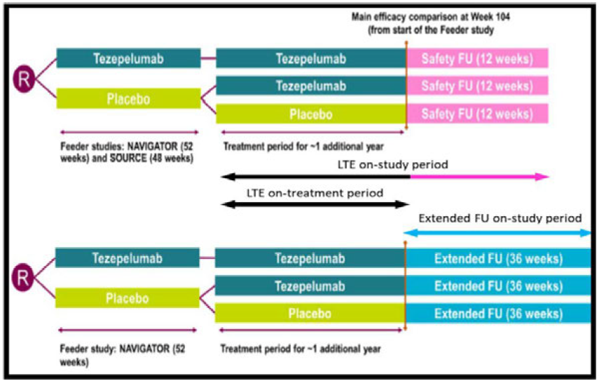
EOT = end-of-treatment; FU = follow-up; LTE = long-term extension; R = randomisation; V = visit(s).

Figure 9: DESTINATION treatment groupings
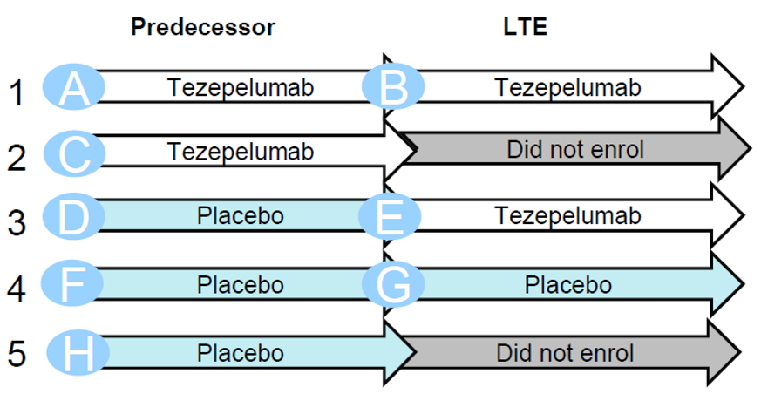

Primary objective
- To evaluate the long-term safety and tolerability of tezepelumab in subjects with severe asthma. The outcome variables used to assess the primary objective were exposure-adjusted incidence rates per 100 subject-years of adverse events (AEs) and serious adverse events (SAEs) over 104 weeks (on-treatment period).

Secondary objective
- To assess the long-term effect of 210 mg tezepelumab SC Q4W on asthma exacerbations in adult and adolescent subjects with severe uncontrolled asthma compared with placebo. The outcome variable used to assess the secondary objective was AAER over 104 weeks (Baseline at Week 0 in predecessor studies NAVIGATOR and SOURCE).

Exploratory objectives
- Assessment of efficacy, immunogenicity, biomarkers, persistence of clinical effect and changes in PD effects for up to 40 weeks after the final dose of Tezepelumab.
- Assess relationship between PK and clinical outcome/PD effects during the extended follow-up after final dose of tezepelumab.
- Assess subject-reported experience at Week 104 or discontinuation of tezepelumab.
Table 12: DESTINATION analysis sets
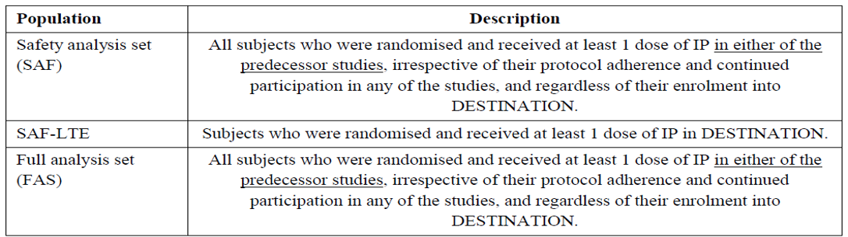
IP = investigational product; LTE = long-term extension.
The first subject was enrolled in DESTINATION on 7 January 2019 and the last subject last visit for the final database lock was 18 May 2022. A total of 951 subjects were randomised at 181 sites in 18 countries, with 827 subjects from NAVIGATOR (including 72 adolescents) and 124 subjects from SOURCE. One subject who received placebo in the predecessor study NAVIGATOR and was randomised into the tezepelumab group for DESTINATION, died during the DESTINATION run-in period prior to receiving treatment. Thus 950 subjects received treatment in DESTINATION LTE period.
Overall, the DESTINATION study population represented the intended population of severe, uncontrolled asthma and severe, OCS-dependent asthma derived from its predecessor studies NAVIGATOR and SOURCE, respectively. Demographic and baseline characteristics were well balanced across the Rand Teze (all subjects randomised to tezepelumab in predecessor period) and Rand Pbo (all subjects randomised to placebo in predecessor period excluding data from long term extension period for subjects switched to tezepelumab) treatment groups. Compliance was high across all treatment groups and the effects of the COVID-19 pandemic on treatment compliance were minimal.
Regarding AAER, this was reduced in the tezepelumab group compared to placebo across 104 weeks for patients previously enrolled in NAVIGATOR (risk reduction [RR] 0.42; 95% CI 0.35, 0.51) (Table 13) or SOURCE (RR 0.61; 95% CI 0.38, 0.96) (Table 14).
Clinically meaningful reductions in AAER versus placebo were observed across biomarker subgroups (blood eosinophils, FeNO, IgE), with a greater magnitude of benefit with increasing baseline eosinophil counts. In SOURCE, 40 (66.7%) subjects on tezepelumab and 15 (46.9%) subjects on placebo reduced their OCS dose to zero at Week 104.
Improvements from baseline in the exploratory endpoints of pre-bronchodilator FEV₁, ACQ-6, and St. George’s Respiratory Questionnaire were observed in the tezepelumab treatment group compared to placebo through to Week 104.
For adolescent subjects, tezepelumab 210 mg SC Q4W treatment resulted in a reduction in the rate of asthma exacerbations by 28% compared to placebo over 104 weeks.
Table 13: DESTINATION Annual asthma exacerbation rate ratio over 104 weeks - negative binomial model. planned treatment, subjects from NAVIGATOR as predecessor (full analysis set)
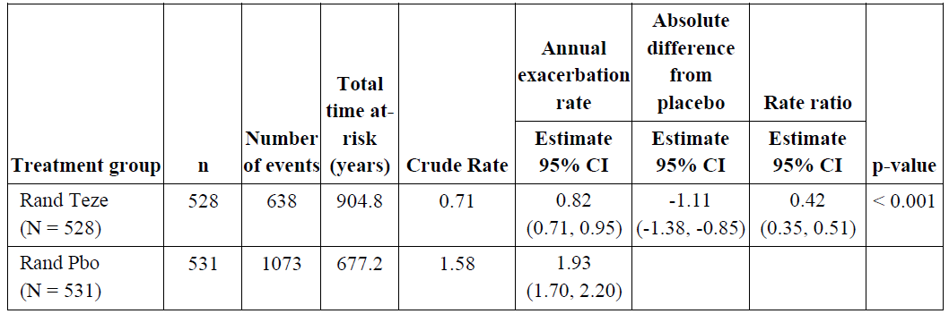
CI = confidence interval; n = number of subjects in analysis; FAS = Full analysis set; N = number of subjects in treatment group; Rand Pbo = all subjects randomised to placebo in predecessor period excluding data from long term extension period for subjects switched to tezepelumab; Rand Teze = all subjects randomised to Tezepelumab in predecessor period.
Table 14: DESTINATION Annual asthma exacerbation rate ratio over 104 weeks - negative binomial model. planned treatment, subjects from SOURCE as predecessor (full analysis set)
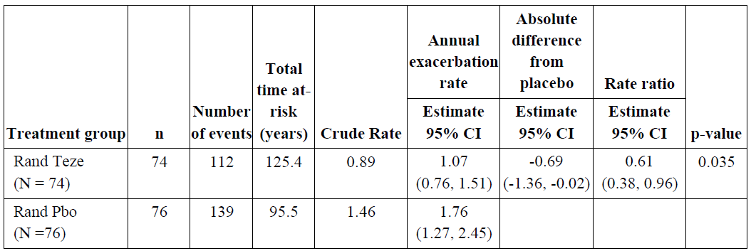
CI = confidence interval; n = number of subjects in analysis; FAS = Full analysis set; N = number of subjects in treatment group; Rand Pbo = all subjects randomised to placebo in predecessor period excluding data from long term extension period for subjects switched to tezepelumab; Rand Teze = all subjects randomised to Tezepelumab in predecessor period.

Safety

Patient exposure
The overall clinical development program included safety assessments for 2143 subjects with asthma administered at least 1 dose of tezepelumab or placebo, including 1326 subjects treated with tezepelumab representing over 1100 subject-years of exposure to tezepelumab at any dose. Two pools of study data were provided: the Primary Safety Pool and the Exposure Pool.
- The Exposure Pool included 1289 subjects with asthma who received at least one dose of tezepelumab SC at doses of 70 mg, 210 mg or 280 mg Q2W, representing approximately 1107 subject-years of exposure. A total of 1104 subjects were exposed to tezepelumab doses of 210 mg SC Q4W or higher for 6 months (defined as at least 20 weeks of dosing) and 787 subjects were exposed to tezepelumab doses of 210 mg SC Q4W or higher for one year (at least 48 weeks of dosing).
- The Primary Safety Pool included 665 subjects who received tezepelumab 210 mg SC Q4W for up to one year, representing approximately 640 subject-years of exposure.
The Primary Safety Pool (for integrated summary of safety) consists of data from the asthma exacerbation studies NAVIGATOR and PATHWAY for the 210 mg Q4W SC dose and placebo groups. These studies have similar design and inclusion/exclusion criteria, the same treatment duration and same safety endpoints and compatible frequency and timing of safety assessments. There were 1334 people who received treatment, 665 in the tezepelumab 210 mg Q4W group and 669 in the placebo group. Of these 91% completed treatment and 90.7% completed treatment and the study. The mean duration of exposure was similar in both groups: 349.63 days (SD: 65.62; range 15.0 to 404.0 days) in tezepelumab group and 348.03 days (SD: 71.74; range 29.0 to 397.0 days) in the placebo group, with 615 subjects receiving at least 48 weeks of cumulative drug exposure to tezepelumab 210 mg Q4W.
Adverse event data from SOURCE, and PATH-HOME, were not integrated in the Primary Safety Pool. This is because the SOURCE design incorporated a planned reduction of OCS which could confound the interpretation of results, and PATH-HOME was not a placebo-controlled study, used different study methods and the length of study was shorter.
In SOURCE, 74 people received tezepelumab 210 mg Q4W, the median (range) exposure in this group was 337.5 (24 to 344) days and total exposure was 64.57 patient-years. A total of 91.3% of subjects completed treatment and 94.0% completed the study.
In PATH-HOME 216 patients were exposed to tezepelumab 210 mg Q4W for 6 doses.
In CASCADE 116 subjects were randomised and included in the analyses (59 to tezepelumab 210 mg SC Q4W and 57 to placebo) and a total of 112 subjects completed treatment and completed the study (56 [94.9%] in the tezepelumab group and 56 [98.2%] in the placebo group).
Additionally, the long-term safety extension study DESTINATION, based on pooled exposure data for subjects from both predecessor studies (NAVIGATOR and SOURCE), included a total of 839 subjects in the tezepelumab group who were exposed to tezepelumab with an overall mean duration of exposure of 558.7 days (range: 24 to 796 days).

Adverse events

Integrated safety analysis

Primary Safety Pool - NAVIGATOR and PATHWAY subjects
The Primary Safety Pool included 1336 randomised subjects, of whom 1334 received treatment, (665 on tezepelumab 210 mg Q4W, 669 on placebo); these 1334 subjects comprise the safety analysis set. Of these 1216 (91.0%) completed treatment as planned and 1212 (90.7%) completed the study. The mean duration of exposure was similar in both groups: 349.63 days (SD: 65.62) range (15.0 to 404.0 days) in the tezepelumab group and 348.03 days (SD: 71.74) range (29.0 to 397.0 days) in the placebo group.
The majority of subjects in the Primary Safety Pool were White (68.2%), female (63.9%), not Hispanic or Latino (87.6%) and the average BMI was 28.49 kg/m² with over 30% of subjects in each of the BMI Index Groups 18.5 to less than 25, at least 25 to 30, and over 30 kg/m². The mean age was 50.1 years (range: 12 to 80 years); 82 (6.1%) were aged at least 12 years to 17 years (that is, adolescents) and 213 (16.0%) were at least 65 years to 80 years old.
The proportion of subjects with eosinophils less than 300 cells/µL was similar between groups (57.0% in the tezepelumab group and 57.1% in the placebo group), as was the proportion of subjects with baseline FeNO levels of less than 25 ppb (43.8% in the tezepelumab group and 43.9% in the placebo group). The majority (63.2% overall) had 2 exacerbations in the 12 months prior to randomisation, 20.9% had 3 exacerbations, and 15.4% had 4 or more exacerbations in this time period; with a mean of 2.7 (SD 1.4) exacerbations in both groups in the 12 months prior to randomisation. Baseline disease characteristics, and treatments were similar across groups.
Time periods for the safety data include:
- On-study period: AEs in the on-study period were defined as those with onset between day of first dose of study treatment and the day of study completion or withdrawal date
- On-treatment period: AEs in the on-treatment period were defined as those with onset between day of first dose of study treatment and the earliest of the following dates: date of last dose of tezepelumab + 33 days, date of death, or date of study withdrawal.
The overall incidence of AEs was similar between the tezepelumab and placebo groups; 74.6% and 76.5% respectively (Table 15). The majority of on-treatment AEs in the tezepelumab 210 mg SC Q4W and placebo groups were considered mild or moderate in intensity and were not considered causally related to tezepelumab based per the Investigators’ assessment.
The incidence of SAEs in the on-treatment period was 8.6% in tezepelumab-treated subjects and 13.0% in placebo-treated subjects. Asthma was the most commonly reported SAE in both groups (2.3% and 6.9% of subjects in the tezepelumab and placebo groups, respectively). Apart from asthma, no SAE Preferred Term (PT) was reported in more than 2 subjects in the tezepelumab group. The incidence of SAEs considered causally related to tezepelumab was 0.9% in the tezepelumab group and 0.7% in the placebo group. The incidence of AEs leading to discontinuation of tezepelumab in the tezepelumab, and placebo groups was 2.0% and 3.0%, respectively.
There were no deaths in the tezepelumab 210 mg group. There were 2 deaths in the placebo group (PT: Death; PT: Cardiac failure); both were in the on-study period of the NAVIGATOR study and neither was considered related to tezepelumab by the investigator.
Table 15: Adverse events - any category - reported during on-treatment period (Primary Safety Pool)
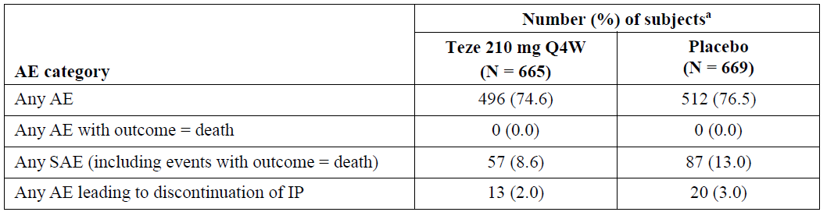
ª Subjects with multiple events in the same category are counted only once in that category. Subjects with events in > 1 category are counted once in each category. Includes events with an onset date between the date of first dose of IP and minimum (date of last dose of IP + 33 days, date of death, date of study withdrawal).
AE = adverse event; IP = investigational product; N = number of subjects in treatment group; Q4W = every 4 weeks; SAE = serious AE; Teze = Tezepelumab.
The 4 most common AEs reported in the tezepelumab group were nasopharyngitis, upper respiratory tract infection, headache, and asthma, reported by 19.5%, 9.3%, 7.8%, and 7.4% of subjects respectively, compared with 19.1%, 13.3%, 7.5%, and 15.7% subjects in the placebo group (Table 16). The incidence of injection site reactions was low and comparable across both treatment arms in the Primary Safety Pool (3.8% and 3.1% in the tezepelumab and placebo groups respectively).
Incidences of most AEs were similar across groups, except for upper respiratory infection, asthma, and sinusitis, which were higher in the placebo group. (13.3% versus 9.3%; 15.7% versus 7.4%; 6.3% versus 3.5%, respectively) (Table 16).
Most AEs were mild or moderate. Severe infections were uncommon, and no opportunistic infections were reported. The AE profile of tezepelumab was consistent across all pre-defined subgroups including baseline blood eosinophil count, allergic status, baseline ICS dose, baseline OCS dose, age, gender, BMI, race, country, and region.
Table 16: Most common adverse event (frequency of 3% or higher) reported during the on-treatment period by Preferred Term (Primary Safety Pool, Safety analysis set)
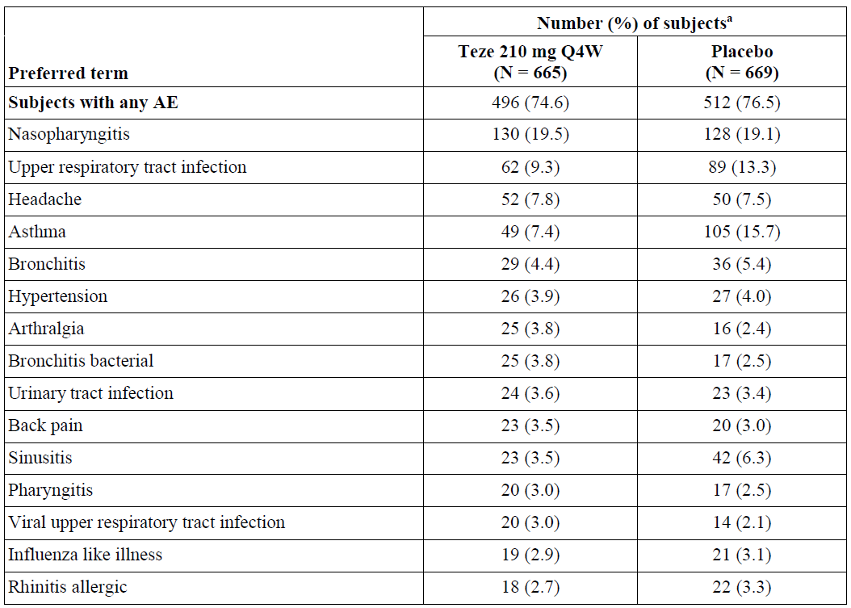
a Number (%) of subjects with AEs, sorted by decreasing frequency for preferred term in subjects treated with tezepelumab. Subjects with multiple events in the same preferred term are counted only once in that preferred term. Subjects with events in more than 1 preferred term are counted once in each of those preferred terms. Includes adverse events with an onset date between the date of first dose of IP and minimum (date of last dose of IP + 33 days, date of death, date of study withdrawal).
AE = adverse event; IP = Investigational product; N = number of subjects in treatment group; Q4W = Every 4 weeks; Teze = Tezepelumab.

PATHWAY
Treatment-emergent adverse events (TEAEs) were reported in 65.9% patients in the placebo, 67.4% in the tezepelumab 70 mg Q4W, 65.7% in 210 mg Q4W and 65.0% in the 280 mg Q2W. The most frequent TEAEs were asthma, nasopharyngitis, bronchitis and headache, and were mild or moderate. There were no dose effects for TEAEs.

SOURCE
Treatment-emergent adverse events were reported in 53 (71.6%) patients in the tezepelumab group and 65 (85.5%) patients in the placebo group. The most frequent TEAEs were nasopharyngitis and upper respiratory tract infection. Most were of mild or moderate severity. The most frequently reported AE of severe intensity was the PT of asthma, reported in 3 (4.1%) subjects and 8 (10.5%) subjects in the tezepelumab and placebo groups, respectively.

PATH-HOME
Treatment-emergent adverse events were reported in 52 (46.8%) patients in the aPFS group and 55 (52.4%) in the autoinjector group. The most frequent TEAEs were nasopharyngitis, upper respiratory tract infection and asthma. There were no TEAEs related to device malfunction.

Treatment related adverse events (adverse drug reactions)
The number of subjects and incidence of AEs assessed as related to tezepelumab, as judged by the investigator, during the on-treatment period was 60 (9.0%) subjects in the tezepelumab group and 54 (8.1%) in the placebo group.
In NAVIGATOR treatment-related TEAEs were reported in 46 (8.7%) patients in the tezepelumab group and 43 (8.1%) in the placebo group; most frequently being injection site erythema (8 [1.5%] in tezepelumab group and 10 [1.9%] in placebo group) and headache (8 [1.5%] in tezepelumab group and 5 [0.9%] in placebo group). Injection site reactions were reported by 8 (1.5%) subjects in the tezepelumab group and 5 (0.9%) subjects in the placebo group.
In PATHWAY treatment-related TEAEs were reported in 11 (8.0%) patients in the placebo group, 14 (10.1%) patients in the tezepelumab 70 mg Q4W group, 14 (10.2%) patients in the 210 mg Q4W group and 12 (8.8%) patients in the 280 mg Q2W group. There was no pattern to the treatment related TEAEs.
In SOURCE there were 3 treatment-related TEAEs reported in 3 (4.1%) patients in the tezepelumab group (myalgia, erythema, pyrexia) and 10 events in 4 patients (5.3%) in the placebo group. There were no injection site reactions reported in the tezepelumab group.
In PATH-HOME there were no injection site reactions with aPFS but 10 reactions were reported in 6 (2.8%) patients with the autoinjector: pain (3 reports), erythema (2), swelling (2), bruising (1), papule (1) and urticaria (1).

Deaths and other serious adverse events and adverse events of special interest
In the Primary Safety Pool, there were no deaths reported during the on-treatment period. However, deaths were reported in the individual study reports. In PATHWAY there was one death in the 70 mg Q4W group (cerebrovascular accident). In NAVIGATOR there were 2 deaths in the placebo group (unknown cause, heart failure), both occurring during the follow-up period. In SOURCE there was one death in the tezepelumab group (cardiac arrest).
In the Primary Safety Pool, SAEs were reported in 57 (8.6%) patients in the tezepelumab group and 87 (13.0%) patients in the placebo group during the on-treatment period. Asthma was the most frequent SAE and was more frequent in the placebo group (6.9%) compared to 2.3% in the tezepelumab group. Infections occurred in approximately 2% of each group. Eleven subjects reported malignancies (6 subjects [0.9%] in the tezepelumab group and 5 subjects [0.7%] in the placebo group). Hypersensitivity reactions were reported in 56 subjects (8.4%) in the tezepelumab group and 58 subjects (8.7%) in the placebo group; of these, only 3 subjects reported serious AEs of hypersensitivity reaction (1 in tezepelumab group and 2 in placebo group). A single event of Guillain-Barré syndrome was reported in the PATHWAY study, occurring in the tezepelumab 210 mg Q4W treatment group.
The majority (133 out of 144) of subjects experiencing SAEs in the Primary Safety Pool experienced SAEs that were not considered related to tezepelumab as assessed by the investigator. The proportion of subjects with SAEs considered causally related to tezepelumab by the investigator was low across the tezepelumab (0.9% [6 subjects]) and placebo (0.7% [5 subjects]) groups.

In SOURCE SAEs were seen in 11 (14.9%) patients in the tezepelumab group and 16 (21.1%) in the placebo group. Asthma was the most common SAE and more frequent in the placebo group (13.2%) compared to 2.7% patients in the tezepelumab group. One case of breast cancer was reported in the tezepelumab group. Four subjects discontinued treatment with tezepelumab due to an SAE, 2 (2.7%) in the tezepelumab group (PTs: invasive breast carcinoma; acute kidney injury) and 2 (2.6%) in the placebo group (PTs: headache, arthritis).
In PATH-HOME SAEs were reported in 3 (2.7%) patients in each group; in the aPFS (renal colic, diverticulitis, urinary tract infection) and in the autoinjector group (asthma, asthma/pneumothorax/varicella, asthma/psychogenic seizure).
Across these studies, there were no anaphylactic or serious allergic reactions considered causally related to tezepelumab by the investigator, and there were no reports of immune complex disease, opportunistic infections, or helminth infections with tezepelumab treatment. Clinical laboratory evaluations were assessed on an individual study basis in the tezepelumab asthma program. Overall, there were no clinically meaningful mean changes over time in haematology (except for the recognised PD effects of tezepelumab on lowering blood eosinophil counts and serum IgE levels) and clinical chemistry parameters, and no notable differences were observed between tezepelumab and placebo treatment groups in the studies, NAVIGATOR, PATHWAY, and SOURCE. There was no clinical meaningful effect of tezepelumab treatment on other immunoglobulin isotypes, that is, IgA, IgG, and IgM.

Discontinuations due to adverse events
In the Primary Safety Pool, discontinuations due to AEs were reported in 13 (2.0%) patients in the tezepelumab group and 20 (3.0%) in the placebo group. The majority were not thought to be related to the investigational product.
In NAVIGATOR discontinuations due to AE were reported in 11 (2.1%) patients in the tezepelumab group and 19 (3.6%) in the placebo group. Two patients in the tezepelumab group discontinued because of malignant melanoma and 2 in the placebo group discontinued because of basal cell carcinoma. Four patients in the placebo group discontinued because of asthma and 2 patients because of allergic rhinitis.
In SOURCE AEs leading to discontinuation were reported in 2 (2.7%) patients in the tezepelumab group (invasive breast cancer, acute kidney injury) and 2 (2.6%) in the placebo group (headache, arthritis).
In PATHWAY discontinuation due to AE was reported in one patient in the placebo group, none in the tezepelumab 70 mg Q4W group, 2 patients in the 210 mg Q4W and 3 patients in the 280 mg Q2W group. There was no pattern to the discontinuations due to AEs.
In PATH-HOME AEs leading to discontinuation were reported in 2 (1.8%) patients in the aPFS group (pain in extremity, pancreatitis) and none in the autoinjector group.

Adverse events of special interest
In the Primary Safety Pool:
- the incidence of SAEs reported in the Infections and Infestations system organ class (SOC) was similar between the tezepelumab (n = 13; 2%) and placebo (n = 15; 2.2%) groups.
- No event of opportunistic infection was reported.
- No event of helminth infection was reported.
- No anaphylactic or serious allergic reaction that was considered causally related to tezepelumab occurred. Hypersensitivity reactions were similar in both groups: 56 (8.4%) in the tezepelumab group and 58 (8.7%) in the placebo group.
- Eleven subjects reported a malignancy: 6 subjects (0.9%) in the tezepelumab group and 5 subjects (0.7%) in the placebo group. One case of malignant melanoma in situ in the tezepelumab group was considered to be causally related to tezepelumab by the investigator.
- Forty-six subjects experienced injection site reactions (25 subjects [3.8%] and 21 subjects [3.1%] in the tezepelumab and placebo groups, respectively).
- One event of Guillain-Barré syndrome occurred (PATHWAY) in the tezepelumab group. The event was considered causally related to tezepelumab by the investigator but not by the sponsor.
In NAVIGATOR – Adolescents subjects (n=82):
- The AE profile of tezepelumab was generally similar in adolescents to that seen in adults.
- Adverse events (on-treatment period) were 30 (73.2%) in the tezepelumab group versus 29 (70.7%) in placebo group subjects; most commonly nasopharyngitis (19.5% versus 12.5%); upper respiratory tract infection (14.6% versus 7.3%); rhinitis (9.8% versus 2.4%); pharyngitis (7.3% versus 4.9%); and viral upper respiratory tract infection (7.3% versus 4.9%).
In SOURCE:
- There was no report of adrenal crisis. A total of 3 subjects reported adrenal insufficiency during the on-treatment period, 2 (2.7%) in tezepelumab group and 1 (1.3%) in placebo group.
In PATH-HOME:
- The safety profile was consistent with that seen in other tezepelumab studies that used the single-dose vial presentation.
In CASCADE:
- The safety profile observed was consistent with that observed in the Primary Safety Pool.
In the 6 Phase I studies:
- Tezepelumab was well tolerated when administered as single or multiple doses IV up to 700 mg, and the safety and tolerability profile of single SC doses administered using aPFS or autoinjector was found to be similar to that of tezepelumab when administered using the single-dose vial presentation, with no additional safety concerns raised.

Selected adverse events of regulatory interest
In addition to the adverse events of special interest described above, other selected AEs of particular regulatory interest in the Primary Safety Pool have been reviewed and are summarised here (that is, cardiac, vascular, haematological, hepatobiliary, renal and dermatological).
Whilst the incidence of any Cardiac disorders by SOC were similar in subjects in the 2 treatment groups, the incidence of SAE by SOC Cardiac disorders was numerically greater in the tezepelumab group than in the placebo group. The greater incidence of serious cardiac adverse events in the tezepelumab group compared with the placebo group occurred in the context of SAEs (any events) occurring more frequently in subjects in the placebo group than in the tezepelumab group. The greater incidence of serious cardiac adverse events reported in the tezepelumab group in the Primary Safety Pool appears to have been the trigger for the extensive investigation of these events undertaken by the sponsor in the LTE study (DESTINATION).
Vascular disorders by SOC in the on-treatment period were reported in 35 (5.3%) subjects in the tezepelumab group and 39 (5.8%) subjects in the placebo group.
Blood and lymphatic disorders by SOC in the on-treatment period were reported in 7 (1.1%) subjects in the tezepelumab group and 8 (1.2%) subjects in the placebo group.
Hepatobiliary disorders by SOC in the on-treatment period were reported in 6 (0.9%) subjects in the tezepelumab group and 7 (1.0%) subjects in the placebo group.
Renal and urinary disorders by SOC in the on-treatment period were reported in 15 (2.3%) subjects in the tezepelumab group and 14 (2.1%) subjects in the placebo group.
Skin and subcutaneous tissue disorders by SOC were reported in 54 (8.1%) subjects in the tezepelumab group and 54 (8.1%) subjects in the placebo group.

Clinical laboratory values and vital signs
There were no clinically meaningful abnormalities in clinical chemistry parameters or urinalysis. Haematology findings were also generally minor and balanced between treatment groups. However, there was a clinically meaningful decrease in the mean values of circulating eosinophils in subjects receiving tezepelumab compared with placebo. There were no clinically meaningful changes in vital signs or electrocardiogram findings over time and no meaningful differences between the 2 treatment groups.

Immunogenicity
Overall, ADA to tezepelumab were detected in only a small percentage of subjects and did not have a discernible clinical effect. Neutralising antibodies were detected in only one subject who received tezepelumab (and one placebo subject).
In PATHWAY, 12 (2.9%) patients in the tezepelumab groups and 13 (9.4%) patients in the placebo group were positive for ADA at any time during the study.
In NAVIGATOR, 26 (4.9%) patients in the tezepelumab group and 44 (8.3%) patients in the placebo were positive for ADA at any time during the study. There were 9 (1.7%) patients in the tezepelumab group and 18 (3.4%) patients in the placebo group with treatment emergent ADA. Neutralising antibodies to tezepelumab were identified in one subject in each group.
In SOURCE, 3 (4.1%) patients in the tezepelumab group and 2 (2.6%) patients in the placebo group had detectable ADA at any time during the study; one (1.4%) patient in the tezepelumab group had treatment-emergent ADA.
In PATH-HOME, 2 (1.8%) patients in the aPFS group and 11 (10.5%) patients in the autoinjector group were positive for ADA at some stage during the study; 2 (1.8%) patients in aPFS group and 8 (7.6%) patients in the autoinjector group became treatment-emergent positive for ADA during the study.
In DESTINATION for subjects who received tezepelumab in both the predecessor period and the LTE period and continued in the extended follow-up (EFU) period, treatment-emergent ADA positive (ADA incidence) results were found for 2 of 287 (0.7%) subjects in the predecessor, 1 of 285 (0.4%) subjects in the LTE, and 5 of 282 (1.8%) subjects in the EFU periods. Those who received placebo in both predecessor and LTE periods and continued in the EFU period, treatment-emergent ADA positive results were reported in 7 of 136 (5.1%) subjects in the predecessor period, 6 of 135 (4.4%) subjects in the LTE period, and 10 of 136 (7.4%) subjects in the EFU period. No treatment-induced antibodies (neutralising antibody incidence) were detected in the 3 study periods in subjects who received tezepelumab or placebo.

Use in pregnancy and lactation
Monoclonal antibodies are transported across the placenta as pregnancy progresses; thus potential effects are likely to be greater during the second and third trimester of pregnancy.
Eleven patients in the pivotal asthma studies reported pregnancies, 4 in PATHWAY (2 in 210 mg Q4W, 2 in 280 mg Q2W group, all during on-treatment period) and 7 in NAVIGATOR (3 in the 210 mg Q4W group [2 during on-treatment period] and 4 in the placebo group [2 during on-treatment period]). Seven patients delivered healthy, full-term infants. One patient (PATHWAY 280 mg Q2W) delivered pre-term twins after experiencing an SAE of pre-eclampsia. One patient (PATHWAY tezepelumab 280 mg Q2W) had a spontaneous abortion at 11 weeks. Two patients in NAVIGATOR had spontaneous abortions (6 and 9 weeks), both patients were in the tezepelumab 210 mg Q4W group, one became pregnant during the on-treatment period.
It is unknown whether tezepelumab is excreted in human milk.
No fertility studies have been conducted with tezepelumab in humans or animals.

DESTINATION LTE study (D5180C00018)
DESTINATION is a Phase III, multicentre, double-blind, placebo controlled, parallel group extension study (database lock on 30 June 2022). The primary objective of DESTINATION is to evaluate safety and tolerability of tezepelumab in adult and adolescent patients with severe asthma over 104 weeks. For those who rolled over from the NAVIGATOR study, there was an option to enter a 36 week follow-up (as opposed to a 12 week follow-up).
Subjects who completed NAVIGATOR (n = 1014; 827 included in DESTINATION) or SOURCE (n = 135; 124 included in DESTINATION) predecessor studies were eligible for DESTINATION (Figure 8). No Japanese sites participated in DESTINATION. Some other study centres also chose not to participate in DESTINATION. Of those subjects enrolled in DESTINATION, 876 (NAVIGATOR n = 798; SOURCE n = 109) completed the 104 weeks of treatment, and 74% of those who completed 104 weeks of treatment from NAVIGATOR were included in the EFU.
The COVID-19 pandemic was ongoing during this study; with 6.5% experiencing at least one study disruption (missed/altered study visits/measurements) due to the pandemic. Additional analyses conducted to assess the impact of the COVID-19 pandemic on the primary objective and on a secondary objective (FEV₁) showed results similar to the primary analysis.

Analysis sets in DESTINATION
The datasets used in the analysis of the DESTINATION study are complex. These datasets are defined by the definitions of the analysis sets and the time periods. The protocol allowed for a 12-week or a 36-week follow-up period, commencing 33 days after the final dose (Figure 8).

Extent of exposure
A total of 839 subjects (1282.9 patient-years) were exposed to tezepelumab; and 607 (799.0 patient-years) to placebo. The mean duration of exposure to tezepelumab in the All Tezepelumab group (N = 839) was 558.7 (SD: 202.7) days; range of 24 to 796 days. The total exposure to tezepelumab was 1283.27 subject years, comprising 575.62 subject-years from treatment of 602 subjects in the predecessor period and 708.94 subject-years from treatment of 712 subjects in the LTE period, respectively.

Overall summary of adverse events including serious adverse events and deaths
The primary objective of DESTINATION is ‘to evaluate the long-term safety and tolerability of tezepelumab in severe asthma subjects’ using as the primary outcome variable ‘exposure-adjusted incidence rates of AEs/SAEs over 104 weeks’. This is the on-treatment period (refers to 104-week planned treatment period). The on-study period is the planned treatment period and planned follow-up. Hence, the on-treatment period includes 33 days after the last dose of tezepelumab; the on-study period includes up to 36 weeks after the last dose.
In DESTINATION, tezepelumab was generally well tolerated for up to 104 weeks of treatment. The exposure-adjusted incidence rates of AEs were similar between the tezepelumab and placebo groups. The majority of AEs were mild to moderate in severity, with nasopharyngitis being the most common AE is both groups. For the most part incidence of AEs in DESTINATION was similar to that observed in the predecessor studies. However, despite the AEs being balanced between treatment groups and similar to the predecessor studies, there are more deaths for tezepelumab versus placebo [NAVIGATOR (incidence rate 0.76 versus 0.14) and SOURCE (incidence rate 1.55 versus 0.00] (Table 17). There were also more Cardiac disorders observed in the tezepelumab group compared to placebo in both NAVIGATOR (incidence rate 0.87 versus 0.00) and SOURCE (incidence rate 3.09 versus 0.00).
Safety data from the 36-week EFU period (in which subjects were followed-up for up to 40 weeks after receiving their last dose of tezepelumab) did not indicate the occurrence of any specific AEs or pattern of AEs of concern arising off-treatment.
For respiratory, mediastinal, and thoracic disorders there were fewer events in the tezepelumab group versus placebo (NAVIGATOR: incidence rate 1.74 and 6.29; SOURCE: incidence rate 10.00 and 2.32). This imbalance was also observed in predecessor studies and driven by higher rates of SAE of asthma in the placebo groups.
Table 17: DESTINATION Adverse events (any category) reported during on-treatment period for subjects from NAVIGATOR and SOURCE as Predecessor (Safety analysis set)
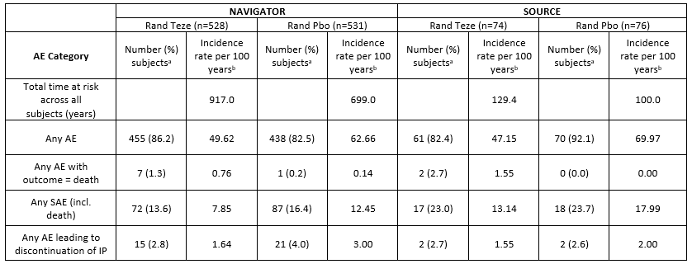
a = Subjects with multiple events in the same category are counted only once in that category. Subjects with events in more than 1 category are counted once in each of those categories. b = Number of subjects with AEs/SAEs divided by total time at risk across all subjects in given treatment group, multiplied by 100.
Includes adverse events with an onset date between the date of first dose of IP and minimum (date of last dose of IP + 33 days, date of death, date of study withdrawal, day prior to start of another biologic). AE = adverse event; IP = investigational product; LTE = long term extension; N= number of subjects in treatment group; Rand Teze = all subjects randomised to tezepelumab in predecessor period; Rand Pbo = all subjects randomised to placebo in predecessor period, excluding data from LTE period for subjects switched to tezepelumab; SAE = serious AE; SAF = safety analysis set.
In the on-study period there are approximately 60 additional subject-years at risk per group for subjects from NAVIGATOR compared to the equivalent on-treatment subject-years at risk in the Rand Teze and Rand Pbo groups. There was still a numerical imbalance in the exposure-adjusted incidence rate of deaths on-study, with incidence rates of 0.82 [8 deaths] and 0.66 [5 deaths] per 100-subject-years in the Rand Teze and Rand Pbo groups, respectively.
From SOURCE in on-study period there is approximately 15 additional subject-years at risk per group compared to the equivalent subject-years at risk on-treatment in the Rand Teze and Rand Pbo groups. The results for the on-study data were consistent with the previously reported results for the on-treatment data for the high-level AE categories. The number of deaths reported from SOURCE were the same in the on-treatment and updated on-study periods for the Rand Teze and Rand Pbo groups.
The main safety signals from DESTINATION relate to the numerical imbalance for SAEs occurring in the SOC of Cardiac disorder and for AEs with a fatal outcome, with the exposure-adjusted incidence rate being higher in tezepelumab-treated subjects compared with placebo-treated subjects for both AE categories in both the on-treatment and on-study periods.

Deaths
More deaths occurred in the tezepelumab treatment groups compared with placebo in the on-treatment and on-study periods. For subjects from NAVIGATOR, 2 deaths occurred in the placebo group in the predecessor period and one subject (placebo group) died during the run-in period of DESTINATION prior to receiving tezepelumab. In the long-term extension period, there were 8 deaths in the Teze+Teze group, 1 death in the Pbo+Teze group, and 2 deaths in the Pbo+Pbo group. Two deaths were also reported in the tezepelumab group from NAVIGATOR during the ongoing EFU period. For subjects from SOURCE, one death in the Teze+Teze group occurred in the LTE period and one death occurred in the tezepelumab group in the predecessor study.
For AEs with a fatal outcome, the exposure-adjusted incidence rate per 100 subject-years in the safety analysis set was greater in the All Teze group versus the Rand Pbo group (Table 18) in both the on-treatment period (IR = 0.78, 10 [1.2%] subjects versus IR=0.13, 1 [0.2%] subject, respectively) and the on-study period (IR = 0.80, 11 [1.3%] subjects versus IR=0.58, 5 [0.8%] subjects, respectively).
The exposure-adjusted incidence rate difference per 100 subject years (95% CI) between the All Teze versus the Rand Pbo groups in the safety analysis sets was 0.65 (95%: CI 0.02, 1.32) for the on-treatment period and 0.22 (95%: CI −0.61, 0.94) for the on-study period. Based on the 95% CIs, the difference between the All Teze and Rand Pbo groups for fatal AEs was nominally statistically significant in the on-treatment period (excluded zero) but not in the on-study period (included zero).
Table 18: DESTINATION Summary of deaths and cardiac disorder SOC serious adverse events by treatment
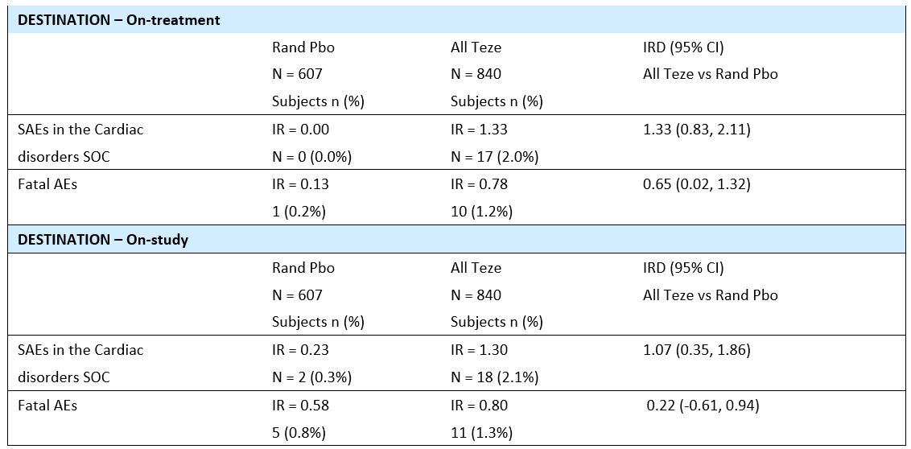
Rand Teze = All subjects randomised to tezepelumab in predecessor period; Rand Pbo = All subjects randomised to placebo in predecessor period excluding data from long-term extension period for subjects re-randomised to receive tezepelumab; SAEs = Serious adverse events; AEs = Adverse events; SOC = System, Organ, Class; IR = Exposure-adjusted incidence rate per 100 subject years; IRD = Incidence rate difference.
In the All Teze group, there were 10 fatal AEs in the on-treatment period and 11 fatal AEs in the on-study period. In the All Teze group, the only additional fatal AE in the on-study period compared with the on-treatment period was one fatal event of septic shock. Two additional deaths were reported during the 36-week EFU period for subjects continuing in this period from NAVIGATOR: one subject in the Pbo+Teze group (PT sudden death) and one subject in the Teze+Teze group (PT COVID-19 pneumonia). Neither of these 2 events were considered to be related to tezepelumab by the Investigator.
Apart from the single events of ‘malignancy death’, the deaths in DESTINATION can be considered to be grouped in 2 main topics, fatal infections and fatal cardiac events and/or major adverse cardiovascular events (MACE). COVID-19 related fatalities were generally balanced across the treatment groups.
The 95% CI for the exposure-adjusted incidence rate difference between the All Teze versus Rand Pbo groups for the on-treatment (safety analysis set) and on-study (SAF) analyses used the Miettinen and Nurminen’s score method. Two additional statistical analyses, using methodology proposed by the clinical evaluator during review of the initial application in place of the Miettinen and Nurminen’s score method (logrank method and Cox proportional hazards) were conducted by the sponsor for the All Teze versus Rand Pbo comparison.
In the log-rank test of deaths, the separation of Kaplan-Meier survival curves was not statistically significant for either the on-study (p=0.717) or the on-treatment (p=0.089) periods (see figure below), respectively.
Figure 10: NAVIGATOR and SOURCE Time to death (days) on-treatment or on-study (Safety analysis set)
On treatment
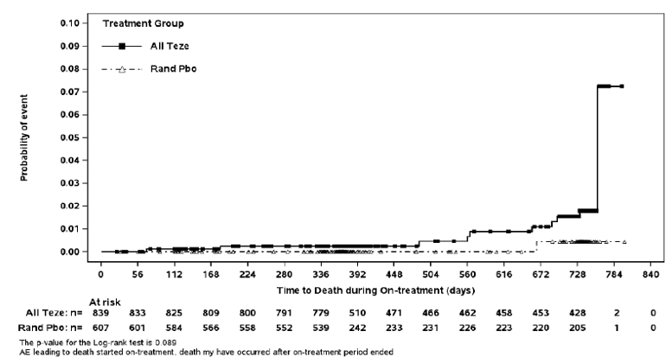
On study
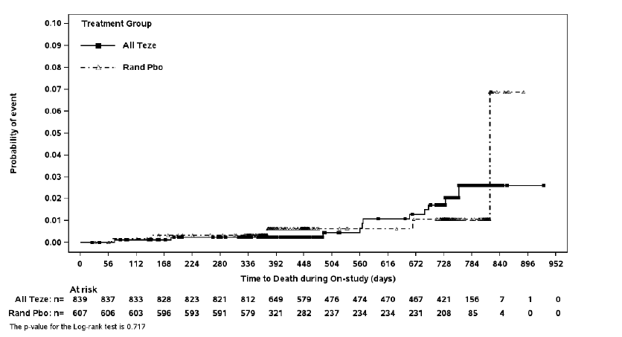
When results were analysed using a Cox proportional hazards model for the on-treatment period: hazard ratio 4.99 (95% CI: 0.64, 39.22); p = 0.126; 10 (1.19%) deaths in the All Teze group (n=839) and 1 (0.16%) death in the Rand Pbo group (Table 19). The Cox proportional hazard ratio showed that the risk of death on-treatment was approximately 5-times greater in the All Teze group relative to the Rand Pbo group, although the ratio was not statistically significant and the 95% CI was wide.
Table 19: DESTINATION Time to death (days), Cox Proportional Hazards Model, on-treatment (subjects from NAVIGATOR and SOURCE)
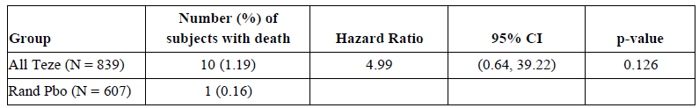
Hazard ratio, 95% CIs for Hazard ratio, and p-values are estimated using a Cox regression model with treatment and predecessor study as covariates. A hazard ratio less than 1 favours Tezepelumab. All Teze = Rand Teze + switchers who received at least one dose of Teze. Subjects switching from Placebo to Teze are counted in both the Rand Pbo and All Teze groups. There are 840 on planned treatment for All Teze, while actually only 839 were treated. CI = Confidence interval.
Fatality case report information was provided by the sponsor. On review of the case reports for patients who died, it is clear that for many participants the cause of death has been deduced from the clinical details including prior morbidities, and not from autopsy. Of the 16 deaths, 11 stated there was no autopsy performed despite several of these having an unknown cause of death or having natural causes or sudden death listed. Only one subject is recorded as having had an autopsy, and in the remaining 4 fatalities it is unclear whether an autopsy was undertaken.
Most subjects did not have autopsies performed, giving the multinational nature of the study, and the varying requirements at the local level. The cause of death has been determined by the best available information. Thus, potential for misclassification for cause of death is present.

Summary
The study was not powered to demonstrate statistical significance between the All Teze and Rand Pbo groups. The exposure-adjusted incidence rate for fatal AEs in DESTINATION was consistently numerically higher in the All Teze group than in Rand Pbo group irrespective of the analytical method used, although none have reached statistical significance.
The exposure-adjusted incidence rate per 100 subject-years on-treatment was nominally statistically significantly greater in the All Teze group than in the Rand Pbo group. Furthermore, the Cox proportional hazard ratio showed that the risk of death on-treatment was approximately 5-times greater in the All Teze group relative to the Rand Pbo group, although the ratio was not statistically significant, and the 95% CI was wide. In addition, non-statistically significant separation of the Kaplan-Meier curves in favour of the tezepelumab group relative to the placebo group occurred in both the on-treatment and on-study periods and separation continued over the duration of the study.
Based on the results of the statistical analyses, it is uncertain whether a causal relationship between tezepelumab and fatal AEs exists.

Cardiac disorder serious adverse events
There were numerical differences in SAEs in the SOC of Cardiac disorders and Independent Adjudication Committee-adjudicated MACEs observed in DESTINATION, with subjects treated with tezepelumab reporting more serious cardiac events compared with subjects treated with placebo. The exposure-adjusted incidence rate per 100 subject-years for SAEs in the Cardiac disorders SOC was greater in the All Teze group compared with the Rand Pbo in both the on-treatment period (104 weeks) and on-study period (104 weeks on treatment + 12 weeks subsequent follow-up) (Table 18).
With regards to cardiac disorder SAEs, on treatment, there were 17 events in the tezepelumab group, IR (95% CI) 1.33 (0.77 to 2.12) /100 patient-years and none in the placebo, IR (95% CI) 0.00 (0.00 to 0.37) /100 patient-years (Table 18). Comparing the sponsor’s 95% CI there is a statistically significant difference between the treatment groups.
On-study, there were 18 cardiac disorder SAEs in the tezepelumab, IR (95% CI) 1.30 (0.77 to 2.06) per 100 patient-years and 2 in the placebo, IR (95% CI) 0.23 (0.03 to 0.83) per 100 patient-years. The incidence rate ratio (IRR) (95% CI) was 5.66 (1.35 to 50.33), 2-sided p-value 0.0059, indicating a clinically and statistically significant increase in cardiac disorder SAEs, for the on-study data, with tezepelumab.
The exposure-adjusted incidence rate differences per 100 subject-years for SAEs in the Cardiac disorders SOC in the on-treatment and on study periods (SAF) were:
- On-treatment: Rand Teze versus Rand Pbo 1.15 (0.66, 1.99); All Teze vs Rand Pbo 1.33 (0.83, 2.11)
- On-study: Rand Teze versus Rand Pbo 0.93 (0.20, 1.77); All Teze vs Rand Pbo 1.07 (0.35, 1.86).
In both periods, the exposure adjusted incidence rate differences were nominally statistically significant for both pairwise comparisons, as the 95% CIs for both differences excluded zero.
Most subjects in DESTINATION were at cardiovascular risk at baseline. Consequently, the observed numerical imbalance in serious adverse events between the 2 treatment groups is unlikely to be due to an imbalance in baseline risk factors for CV disease. There were no data for the incidence of serious cardiac adverse events in subjects with low risk of cardiovascular events.
Despite numerical imbalances in rates of cardiac disorders and fatal events, there was no apparent pattern in type of cardiac disorder SAEs or fatal events (Table 20). However, the cardiac disorder SAEs reported by the sponsor can predominantly be attributable to coronary vascular disease. Coronary vascular disease can lead to myocardial infarction, arrhythmias, and heart failure. These data raise concerns that tezepelumab may be associated with an increased risk of coronary vascular disease. This would likely have been unexpected from the known pharmacology of tezepelumab.
All tezepelumab treated subjects who experienced a Cardiac disorder SAE had a cardiovascular disorder or another cardiovascular risk factor at baseline, with all having at least 2 risk factors, and over half having at least 5 cardiovascular risk factors at baseline. Similarly, the 2 placebo subjects also had risk factors with one having 2 risk factors and the other having 6 risk factors at baseline.
Furthermore, similar percentages of subjects in each group (Table 21) in DESTINATION were at cardiovascular risk at baseline (9.6% tezepelumab, 10.7% placebo and 10.2% all tezepelumab groups). Consequently, the observed numerical imbalance in serious adverse events between the 2 treatment groups is unlikely to be due to an imbalance in baseline risk factors for cardiovascular disease. There were no data for the incidence of serious cardiac adverse events in subjects with low risk of cardiovascular events.
Table 20: DESTINATION Serious adverse events report on-treatment with SOC of Cardiac Disorders by Preferred Term – subjects from NAVIGATOR and SOURCE (Safety analysis set)
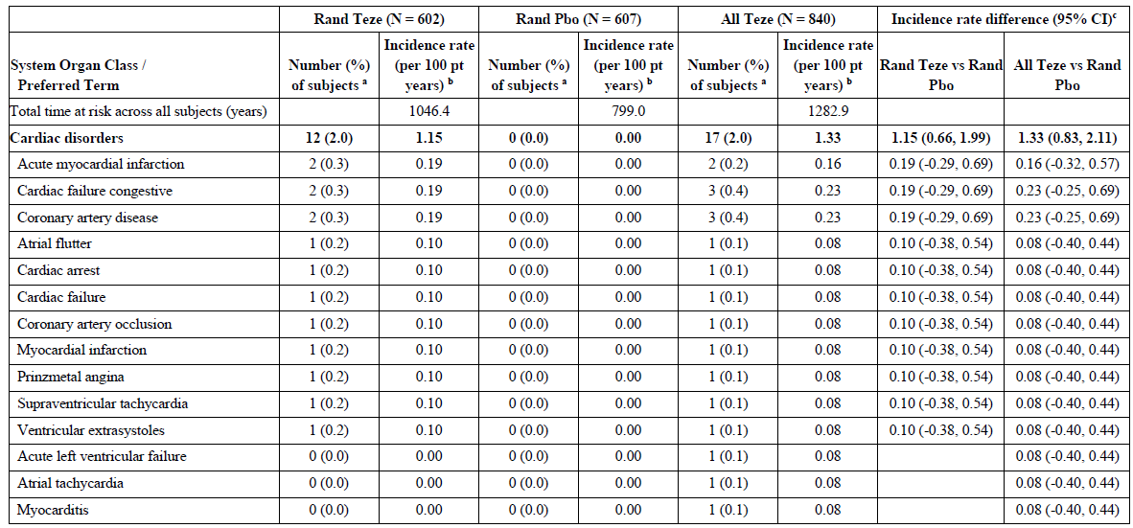
a Number (%)with AEs, sorted using international order for Preferred Term (PT) by decreasing frequency in those treated with tezepelumab.
b Number of subjects with AEs divided by the total time at risk across all subjects in given treatment groups, multiplied by 100.
c The 95% CI of the incidence rate difference is based on the Miettinen and Nurminen's score method.
A subject can have one or more PTs reported under a given SOC. For each PT, the number and percentage of subjects reporting at least one occurrence will be presented, tie, for a subject multiple occurrences of an AE will only be counted once.
Table 21: Summary of baseline cardiovascular disorders and risk factors - subjects from both NAVIGATOR and SOURCE (Safety analysis set)
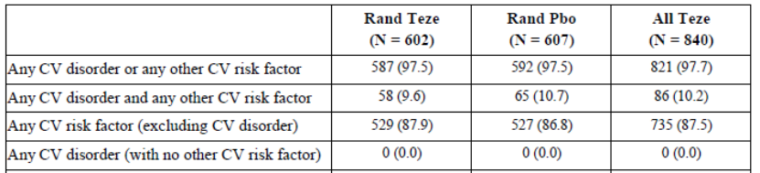
The sponsor’s Cardiovascular Safety Knowledge Group (CV SKG), a consultant group within AstraZeneca, independently reviewed the full package of available data relating to the serious cardiac events observed in DESTINATION. In particular, the CV SKG was requested to ‘undertake a review of the cardiovascular safety data from the DESTINATION trial, and in particular consider the observed numerical imbalance in SAEs in the SOC cardiac disorders that was seen between tezepelumab and placebo treatment arms, 17 versus 0, respectively on-treatment (18 versus 2, respectively on-study)’.

Summary conclusions of the astrazeneca cardiovascular safety knowledge group (1 April 2022)
Following review of the available data the CV SKG finds the variable cardiac event types in the SAEs of SOC cardiac disorders in the DESTINATION study having variable onset times speak against a common pathway or a common pathophysiological mechanism.
Seven of the SAE events seem not to be truly treatment emergent events, instead it seems they are cardiac disorders discovered by other medical reasons, and there is currently no known biological plausibility associated with tezepelumab that would indicate that the treatment is associated with or has contributed to an increase in the number of SOC cardiac disorders SAEs.
The finding of zero SAEs in SOC cardiac disorders in the placebo treatment arm (on treatment) of the DESTINATION study seems to be an outlying result which is supported by the [real world evidence] RWE data when considering the patient population with inclusion also of elderly patients, having severe asthma and prevalence of multiple CV risk factors at baseline.
After the adjudication of all deaths by the independent committee the cause of death had changed in comparison with the Investigators assessments and assigned preferred terms in a few patients in the treatment groups and they were considered to have died due to sudden cardiac death, a CV death, according to the adjudication.
The incidence rates of the investigator reported SAE cardiac disorders events including myocardial infarction were similar or lower in the tezepelumab arm of the DESTINATION study compared to what would be expected in this population of asthma patients according to the RWE data.
The sponsor also noted the following:
- Based on assessment of data from the tezepelumab program and published literature, the sponsor stated that it has not identified a plausible mechanism by which blocking TSLP would lead to cardiac pathophysiology.
- The sponsor reports that no cardiac safety concerns were identified in the tezepelumab safety pharmacology study, nonclinical toxicology studies, or tissue cross-reactivity study with human and cynomolgus monkey tissues.
- The sponsor reported that review of the available published data has shown that patients with severe asthma are at increased risk of experiencing cardiovascular events.
- The sponsor argues that ‘Incidence rates of Cardiac disorder SOC SAEs with tezepelumab were consistent with what has been estimated based on published data with other biological medicines evaluated in severe asthma populations’.
- The sponsor provided data on background rates of cardiac events in a severe asthma population using real world data.
- The sponsor also provided detail regarding how other regulatory agencies in the USA, Europe and Canada have addressed the safety concerns from DESTINATION.
- The incidence of cardiac SAEs is higher with tezepelumab than with placebo.

Summary
Most subjects in DESTINATION were at cardiovascular risk at baseline. Consequently, the observed numerical imbalance in serious adverse events between the 2 treatment groups is unlikely to be due to an imbalance in baseline risk factors for cardiovascular disease. The CV SKG’s opinion does not alter or explain the imbalance in serious cardiac events between tezepelumab-treated patients and placebo-treated patients. There remains a clinically meaningful increased risk of serious cardiac events, which is unexplained. The significance of this remains uncertain.

Post marketing experience
The post-marketing data for tezepelumab for the treatment of severe asthma are limited. The currently available post-marketing safety data are consistent with the clinical trial safety data included in the re-submission. No new or unexpected clinically significant safety signals have emerged from the limited post-marketing data.

Additional information provided by sponsor
Opinion letters from 4 Australian key opinion leaders were provided by the sponsor in support of the registration of Tezspire.

Risk management plan
The summary of safety concerns and their associated risk monitoring and mitigation strategies is presented in Table 22. The TGA may request an updated risk management plan (RMP) at any stage of a product's life-cycle, during both the pre-approval and post-approval phases.
Table 22: Summary of safety concerns
Summary of safety concerns |  | Pharmacovigilance |  | Risk minimisation
 |  | Routine | Additional | Routine | Additional
Important identified risks | None | − | − | − | −
Important potential risks | Serious infection | ü | ü* | ü | −
Important potential risks | Serious cardiac events | ü | ü* ‡ | ü | −
Important potential risks | Malignancy | ü | ü* | − | −
Missing information | Use in pregnant and breast-feeding women | ü | ü† | ü | −
Missing information | Long-term use | ü | ü* | − | −
- = Phase III study; † = Database study of use and safety; ‡ = Post-authorisation safety study
The RMP evaluation noted the following:
- the pharmacovigilance plan is acceptable from an RMP perspective
- routine risk minimisation measures are planned to be implemented. The Instructions for Use document will be included in the product pack. No additional risk minimisation measures have been proposed. The risk minimisation plan is acceptable from an RMP perspective.
The clinical evaluation and the Delegate recommended to include serious cardiac events and fatal adverse events as important identified risks in the summary of safety concerns. Once the summary of safety concerns is updated, the revised ASA should be provided for review.
As part of routine pharmacovigilance, the sponsor proposes using post-marketing targeted follow-up questionnaires for new important potential risks: Serious infections, Serious cardiac events, and Malignancies. Additionally, the sponsor is undertaking study D5180C00024 (SUNRISE) study and study D5180c00021 (DIRECTION) study.
The RMP evaluation recommended conditions of registration relating to the versions of the risk management plan, requirement for periodic safety update reports, and inclusion of the medicine in the Black Triangle Scheme.

Risk-benefit analysis

Delegate’s considerations

Discussion
Asthma is a common heterogenous chronic respiratory condition with up to 10% of patients having severe treatment resistant asthma. Severe asthma represents a socioeconomic burden with mortality, morbidity, quality of life and healthcare costs. Optimal asthma management aims to achieve and maintain disease control, thereby improving the person’s current quality of life and reducing the future risk (risk of adverse outcomes such as exacerbations, poor control, accelerated decline in lung function and side-effects of treatment).⁶ There is an ever-increasing number of available treatments for asthma, including 4 currently approved biologic therapies in Australia. Tezepelumab is a new monoclonal antibody which targets thymic stromal lymphopoietin (TSLP), an epithelial cell derived cytokine that occupies an upstream position in the asthma inflammatory pathway.

Pharmacology
The pharmacokinetics (PK) and pharmacodynamics (PD) of tezepelumab have been adequately described in healthy adults, and in adolescents and adults with moderate to severe asthma.
The PK of tezepelumab were dose-proportional following administration of SC doses ranging from 2.1 mg to 420 mg and IV doses ranging from 210 mg to 700 mg. The maximum observed serum concentration was reached in 3 to 10 days. Bioavailability was comparable when single dose tezepelumab 210 mg was administered SC at different injection sites (abdomen, thigh, or upper arm) or using different devices. After repeat administration SC every 4 weeks, serum tezepelumab concentrations approached steady state by 12 weeks. After repeated SC administration of tezepelumab 210 mg SC Q4W, mean steady-state concentrations were maintained until Week 104. The rate of elimination was in accordance with the elimination half-life of tezepelumab (25.5 days).
There was no clinically relevant effect of age (from 12 years of age and older), sex, race, geographic region, weight, BMI, renal or hepatic disease, asthma severity, biomarker level or medication usage.
Results from clinical studies of tezepelumab in subjects with severe asthma demonstrated that the levels of inflammatory biomarkers (for example, blood eosinophil counts, FeNO, and total serum IgE) and cytokines (for example, serum IL-5 and serum IL-13), decreased following treatment with tezepelumab compared with placebo. In addition, tezepelumab reduced airway inflammation, as measured by decreases in bronchial submucosal eosinophils compared with placebo. Tezepelumab ADA had no effects on the PK, PD (blood eosinophil counts, FeNO levels, and total serum IgE levels), efficacy (AAER and FEV₁), or safety of tezepelumab. The humoral immune response following seasonal influenza vaccination was generally similar between the tezepelumab and placebo groups in adolescent and young adult subjects with moderate to severe asthma.

Efficacy
For efficacy interpretation of treatments in asthma, measures of exacerbation frequency, lung function and symptoms are important and are used to assess current control and future risk. The following are thought to be the minimal clinically important difference: annualised asthma exacerbations rate (AAER) reduction at least 20% to 40%, FEV₁ change at least 0.1 to 0.2 L and/or 10%,⁶ ¹⁹ change in AQLQ(S)+12 total score and in each domain of at least −0.5 units, ⁶, and changes in ACQ-6 and ASD total scores of at least −0.5 units. ¹⁹
Tezepelumab (210 mg) treatment over 1 year resulted in statistically significant and clinically meaningful reductions in the rate of annualised asthma exacerbations compared to placebo in both the NAVIGATOR (56% reduction) and PATHWAY (71% reductions) studies. Treatment with tezepelumab resulted in reductions in subjects with both low and high blood eosinophil counts, although there is a higher rate of reduction associated with higher eosinophil counts. Similar findings are present for allergic status and FeNO levels. Reductions in AAER are seen out to 2 years of continuous treatment with tezepelumab in the NAVIGATOR study (58% reduction).
Adolescent subjects also had reductions in AAER, although the magnitude of the response was less (30% at 52 weeks, 28% at 104 weeks) than that seen in adults.
In terms of key secondary outcomes, at Week 52, tezepelumab resulted in a mean increase of pre-bronchodilator FEV₁ by 0.13 L in both studies, a mean difference in the ACQ-6 of −0.33 in NAVIGATOR and −0.36 in PATHWAY and a mean difference in AQLQ(S)+12 of −0.33 in both studies. The mean reduction in ASD in NAVIGATOR was −0.11. These improvements persisted through to Week 104.
In the oral corticosteroid reduction study SOURCE, there was no significant difference between tezepelumab and placebo subjects in terms of reduction in OCS usage. In both groups there is a high rate of OCS dosage reduction with 74% of tezepelumab patients and 70% of placebo patients reducing their dose by at least 50% and about half of subjects (54% and 46% respectively) reducing their dose by at least 90%. Over the 2-year treatment period, 67% of subjects on tezepelumab and 47% of subjects on placebo reduced their OCS dose to zero by Week 104. However, there was a benefit for patients with higher eosinophil levels. There was no subgroup effect for FeNO or IgE status. Regarding secondary endpoints, there was no difference in AAER, but changes in FEV₁ (0.26L), ASQ-6 (−0.37), AQLQ(S)+12 (+ 0.36) and ASD (−0.25) were seen.

Safety
In the Primary Safety Pool (NAVIGATOR and PATHWAY subjects) and the SOURCE and PATH-HOME studies, over up to 12 months of treatment, tezepelumab appeared to have a favourable safety profile. The rates of TEAEs, treatment related TEAEs, SAEs and withdrawals due to AE were similar in tezepelumab and placebo groups. The most frequently reported TEAEs were nasopharyngitis, upper respiratory tract infection and asthma. Most adverse events were mild or moderate in severity.
The DESTINATION study provides safety and efficacy data out to 2 years of continuous treatment. Whilst the incidence of AEs was generally balanced between groups, there is a higher incidence rate of deaths (on-treatment: tezepelumab 0.78, placebo 0.13; on-study: tezepelumab 0.8, placebo 0.58) and serious cardiac disorder events (on-treatment: tezepelumab 1.33, placebo 0.00; on-study: tezepelumab 1.30, tezepelumab 0.23) in the subjects treated with tezepelumab.
The sponsor has conducted an in-depth evaluation of the DESTINATION cardiac events and deaths, has assessed supportive clinical and nonclinical information from the tezepelumab program, and has contextualised the DESTINATION data by evaluating the literature, real-world data in a severe asthma population, and data from other asthma biologic clinical trials in severe asthma patients.

Significance of the safety findings
The benefit-risk balance for tezepelumab is likely positive but remains uncertain. While significant clinical benefit in terms of a reduced rate of asthma exacerbations has been demonstrated, along with improvements in key measures of lung function and symptom control, there is an unexplained higher number of deaths and cardiac disorder serious adverse events in tezepelumab-treated subjects compared to placebo subjects in DESTINATION, that is apparent in the second year of treatment. The incident rate ratios for on-treatment deaths and on-treatment and on-study cardiac disorder serious adverse events shows a significant difference between the groups. Notably the trend persists despite multiple statistical analyses. However, it is also noted that the study was not powered to demonstrate statistical significance between the All Teze and Rand Pbo groups. Furthermore, no causal relationship between tezepelumab and these events has been established, nor has a patient population at risk of these events been identified. The sponsor stated that while there is an imbalance in cardiac events, no causal relationship has been identified between tezepelumab and cardiac disorders or fatal events and benefits of tezepelumab were maintained over 104 weeks of treatment.
The actual numbers of deaths and serious adverse cardiac events are small. The sponsor has stated that ‘Despite numerical imbalances in rates of cardiac disorders and fatal events, there was no apparent pattern in type of cardiac disorder SAEs or fatal events and cardiac disorder SAEs were not considered by the investigator to be causally related to the use of tezepelumab’. The sponsor has extensively investigated the numerical imbalances noting the ‘imbalance in deaths was not statistically or clinically persuasive, and that the deaths may be explained by other factors’. Nevertheless, given that the tezepelumab groups and the placebo groups were well matched at baseline, these results raise the possibility of an unacceptable risk for some/all patients with severe asthma who receive treatment with tezepelumab.
The sponsor noted that there is no identified plausible mechanism by which blocking thymic stromal lymphopoietin (TSLP) would lead to cardiac pathophysiology. A literature review to assess the potential for the tezepelumab (anti-TSLP mAb) mechanism to detrimentally impact the heart concluded that ‘published literature is largely based on murine models and relevance to human pathophysiology is not known’. A study of the human proteome assessed human TSLPR and TSLP RNA expression in 3 datasets representing the human ventricle and atrium. The study found very low expression of TSLP and TSLPR, suggesting that signalling via the TSLP receptor pathway in these tissues is very unlikely.
The absence of TSLP expression in cardiac tissue does not exclude alternative mechanisms, such as an immunologically mediated mechanism. Emerging evidence indicates that components of type 2 immunity are involved in facilitating the healing process after tissue injury. Low eosinophil and lymphocyte counts were strongly associated with increased short-term incidence of heart failure and coronary death in a healthy population of 775,231 individuals aged 30 years or older. Other studies have shown a beneficial role of eosinophils in infarcting hearts by producing IL-4, and other molecules, mitigating the cardiac inflammatory cell profile, limiting cardiomyocyte apoptosis, modulating fibroblast activity, and regulating post-myocardial infarction heart inflammatory cell adhesion and infiltration. Low eosinophil counts independently predicts cardiovascular death and correlates negatively with death rates.
The sponsor also noted that no cardiac safety concerns were identified in the tezepelumab safety pharmacology study, nonclinical toxicology studies, or tissue cross-reactivity study with human and cynomolgus monkey tissues. This does not exclude a possible causative mechanism in humans.
The sponsor also presented data for other biological treatments for asthma. On review of this information, these show that the rate of cardiac SAEs with tezepelumab is similar to other biological treatments for asthma. This raises the possibility that medications which impact on type 2 inflammation may impact on cardiac disorder SAEs. Thus, rather than demonstrating no effect for tezepelumab, it may be that other available biologics also are associated with an increased risk of cardiac disorder SAEs. Dupilumab and omalizumab also have statistically significant increased rates of cardiac disorder SAEs compared to placebo, and there be is a dose effect with dupilumab.
The placebo rate observed in DESTINATION was lower than that observed in placebo-treated subjects in other AstraZeneca trials conducted in populations with severe uncontrolled asthma. While this was the case for EXCELS, MENSA and the Pooled placebo database, it was not true for the placebo rate observed with dupilumab in QUEST. In QUEST, the exposure-adjusted incidence rate per 100 subject-years in the placebo group was zero, which was the same incidence rate observed for placebo in DESTINATION. In the tezepelumab, dupilumab and mepolizumab studies, the exposure-adjusted incidence rates per 100 subject-years were lower in the placebo group than in the active biologic comparator treatment group. Overall, the results suggest that there may be a class-effect relating to serious adverse events for biological agents used to treat asthma.
Given the unexpected finding of an increased risk of mortality and cardiac disorder serious adverse events in tezepelumab-treated subjects (and in other participants receiving biologics for severe asthma), and that these all occurred in participants who had underlying risk factors, that a causal relationship has been missed and warrants further consideration. It is also acknowledged that the identified numerical imbalance is a chance finding.
In order to further characterise risks associated with tezepelumab a post marketing questionnaire will be utilised and the sponsor will continue to collect serious infections and cardiac events from the following ongoing studies:
- SUNRISE [OCS reduction study in severe asthma; 28-week treatment period with 12-week safety follow up; planned N = 207, randomised 2:1])
- DIRECTION [China/Asia regional efficacy and safety study in severe asthma; 52-week treatment period with 12-week safety follow-up; planned N =404, randomised 1:1]).
The sponsor has stated the following:
The DIRECTION study supports previous assessments of benefit risk for tezepelumab. This study is ongoing. Preliminary analysis following the primary database lock containing data from all patients who completed their 52-week assessment showed that the overall incidence rates of serious cardiac events were low. A total of 1 (0.5%) and 1 (0.5%) of subjects in the tezepelumab and placebo groups respectively experienced a serious cardiac event during the on-treatment period. The incidence rates for serious cardiac events were 0.51 per 100 PY and 0.54 per 100 PY in the tezepelumab and placebo groups, respectively (data on file). Thus, there was no imbalance in the rate of serious cardiac events in the DIRECTION study.
Final study reports are not yet available.

Conclusion
The benefit-risk balance for tezepelumab given the proposed usage is currently uncertain. Whilst significant clinical benefits are evident, there is an unexplained mortality and cardiac disorder serious adverse events risk in tezepelumab treated subjects.

Proposed action
It is not possible for the Delegate to make a final decision as to approval or non-approval of tezepelumab, currently given the safety concerns. Pending advice from the ACM, a decision will be made.
If tezepelumab is approved the wording of the indication will be reviewed. The following is suggested (proposed changes are underlined):
Tezspire is indicated as an add-on maintenance treatment in adults and adolescents 12 years and older with severe asthma who are inadequately controlled despite optimally managed asthma including high dose inhaled corticosteroids plus another non steroid medicinal product for maintenance treatment.
Advice regarding the indication wording will be sought from the ACM and subsequently negotiated with the sponsor.

Advisory Committee considerations
The Advisory Committee on Medicines (ACM), having considered the evaluations and the Delegate’s overview, as well as the sponsor’s response to these documents, advised the following.

Specific advice to the Delegate
- Could the ACM provide advice on the level of risk they believe would be associated with the use of tezepelumab in severe asthma in Australia?
The ACM advised that there is a potential increased risk of adverse cardiac events with long term use. The absolute risk is likely to be very small.
The ACM acknowledged the challenge of balancing the 2 aspects of tezepelumab treatment: increased risk of death from non-asthma causes against the reduced risk of death from asthma.
- Please comment on the relevance of the numerical increase in deaths/cardiac SAE in the tezepelumab group.
On-study, there were 18 cardiac disorder SAEs in the tezepelumab group, with incidence rate 1.30 (95% CI 0.77, 2.06) per 100 patient-years and 2 in the placebo group, with incidence rate 0.23 (95% CI 0.03, 0.83) per 100 patient-years. The incidence rate ratio was 5.66 (95% CI 1.35, 50.33), 2-sided p-value 0.0059, indicating a clinically and statistically significant increase in cardiac disorder SAEs, for the on-study data, with tezepelumab.
The ACM viewed the numerical increase in deaths/cardiac SAE as a potential association with long term use of tezepelumab. Although the sponsor postulated that events (and hence risk) occurred mostly in people with cardiac risk factors, there was in fact no difference in the number of cardiac risk factors between people on drug and people on placebo.
The ACM advised that ‘numerical imbalance’ should be replaced in the PI with ‘more deaths and serious adverse cardiac events’ in patients taking tezepelumab. The treatment groups in randomised trials were balanced with respect to cardiovascular risk factors, and so ‘imbalance’ is seeking to minimise the relevance of the observations.
The ACM advised that in order to raise prescriber awareness a boxed warning should be included in the PI. The ACM suggested the following text:
More deaths and cardiovascular adverse events were seen in the people on drug than on placebo. Prescription of this medication should occur after individual risk profile assessment and patient-centred shared decision making. Post hoc data analysis revealed that these events mostly occurred in people over the age of 50, with a cardiovascular diagnosis or cardiovascular risk factor. The difference in events compared with placebo was present despite a similar spread of cardiovascular risk factors and diagnoses between the drug and the placebo groups at baseline. It is unknown whether goal directed treatment of cardiovascular risk factors reduces this association. Whilst a known mechanism is not currently recognised, the possibility that these events reflect an unintended medication side effect remains.
The ACM acknowledged that better asthma control, especially reduced corticosteroid use, is likely to have a long-term benefit by reducing cardiac disease.
- What is the ACM’s advice regarding whether to approve/not approve the registration of tezepelumab?
The ACM, on balance, supported the approval of tezepelumab. The medicine provides significant benefit as an add-on therapy to people with severe asthma not controlled on medium dose inhaled corticosteroid/long-acting beta-agonist.
- Would the ACM please advise regarding the inclusion of adolescents (12 to 17 year olds) in the proposed indication. How (if at all) does the safety possibility affect this.
The ACM advised that adolescents should be included in the proposed indication. This is consistent with trial data, although only 6% of participants were in this age group.
The ACM noted that long-term use (in adolescents as well as adults) is an area of missing information and should be stated clearly in the PI.
- If approved – what is the ACM’s advice regarding which groups of patients would benefit most from tezepelumab? (for example, only those with low cardiovascular system risk, those not on oral steroids, only those on high dose inhaled corticosteroid etc)
The ACM advised that benefit would be greatest in those with persistent type 2 inflammation.
- Please provide advice on the wording of the proposed indication. Specifically, what should be stated regarding current asthma treatment. (Please consider the Australian Asthma guideline). Should it be similar to what is proposed? Or perhaps despite maximal inhaled therapy (including medium or high dose inhaled corticosteroid)?
The ACM advised that the indication should refer to ‘optimal therapy including medium dose inhaled corticosteroids plus another non steroid medicinal product’, rather than referring to ‘optimally managed asthma’. Mention of high dose inhaled corticosteroid should be eschewed as they do not necessarily improve asthma control.
‘Severe asthma’ should be defined in the PI, consistent with the Australian Asthma Handbook.
‘Inadequate control despite treatment’ should be defined in the PI as either ACQ5 > 2.0, or one or more exacerbations requiring prednisone.
- Please comment on adequacy of RMP, and/or suggest any additions.
The ACM were supportive of strong pharmacovigilance measures with this product.
The ACM advised that serious cardiac events, including fatal events, should be considered an identified risk rather than a potential risk. The ACM additionally advised that a boxed warning would be appropriate to communicate these risks to patients and prescribers.
- The committee is also requested to provide advice on any other issues that may be relevant to a decision on whether or not to approve this application.
The ACM suggested that the PI should include stopping rules for non-responders.
The ACM suggested that consideration be given to a wider review of post-market data for other monoclonal antibodies for the treatment of asthma regarding risk of cardiac events, infection and malignancy.

Advisory committee conclusion
The ACM considered this product to have an overall positive benefit-risk profile for the indication:
Tezspire is indicated as an add-on maintenance treatment in adults and adolescents 12 years and older with severe asthma who are inadequately controlled despite optimal therapy including medium dose inhaled corticosteroids plus another non steroid medicinal product for maintenance treatment.
The effect of tezepelumab may not be evident in those with eosinophil count < 150 cells/μL and fractional exhaled nitric oxide (FeNO) below 25 ppb.

Assessment outcome
Based on the assessment of quality, safety, and efficacy, the TGA decided to register Tezspire (tezepelumab) 210 mg in 1.91 mL solution for injection in prefilled syringe and prefilled pen, indicated for:
TEZSPIRE is indicated as an add-on maintenance treatment in patients aged 12 years and older with severe asthma who are inadequately controlled despite optimal therapy including medium or high dose inhaled corticosteroids plus another non-steroidal medicinal product for maintenance treatment.

Specific conditions of registration
- Tezspire (tezepelumab) is to be included in the Black Triangle Scheme. The PI and CMI for Tezspire must include the black triangle symbol and mandatory accompanying text for 5 years, which starts from the date of first supply of the product.
- The Tezspire EU-Risk Management Plan (RMP) (Version 2; Succession 2, dated 23 January 2023; DLP 31 August 2022), with Australia-Specific Annex (Version 2; Succession 2, dated 18 July 2024), included with submission PM-2023-05365-1-5, and any subsequent revisions, as agreed with the TGA will be implemented in Australia.
- An obligatory component of risk management plans is routine pharmacovigilance. Routine pharmacovigilance includes the submission of periodic safety update reports (PSURs).
Reports are to be provided in line with the current published list of EU reference dates and frequency of submission of PSURs until the period covered by such reports is not less than 3 years from the date of the approval letter. Each report must be submitted within 90 calendar days of the data lock point for that report.
The reports are to at least meet the requirements for PSURs as described in the European Medicines Agency’s Guideline on good pharmacovigilance practices (GVP) Module VII-periodic safety update report (Rev 1), Part VII.B Structures and processes. Note that submission of a PSUR does not constitute an application to vary the registration.
- Laboratory testing & compliance with Certified Product Details
- All batches of Tezspire (tezepelumab) 210 mg in 1.91 mL (110 mg/mL) solution for injection prefilled syringe, and Tezspire (Tezepelumab) 210 mg in 1.91 mL (110 mg/mL) solution for injection prefilled pen supplied in Australia must comply with the product details and specifications approved during evaluation and detailed in the Certified Product Details (CPD).
- When requested by the TGA, the sponsor should be prepared to provide product samples, specified reference materials and documentary evidence to enable the TGA to conduct laboratory testing on the product. Outcomes of laboratory testing are published biannually in the TGA Database of Laboratory Testing Results http://www.tga.gov.au/ws-labs-index and periodically in testing reports on the TGA website.
- Certified Product Details
  - The Certified Product Details (CPD), as described in Guidance 7: Certified Product Details of the Australian Regulatory Guidelines for Prescription Medicines (ARGPM), in PDF format, for the above products should be provided upon registration of these therapeutic goods. In addition, an updated CPD should be provided when changes to finished product specifications and test methods are approved in a Category 3 application or notified through a self-assessable change.
  - A template for preparation of CPD for biological prescription medicines can be obtained from the TGA website
  - [for the form] https://www.tga.gov.au/form/certified-product-details-cpdbiological-prescription-medicines
  - [for the CPD guidance] https://www.tga.gov.au/guidance-7-certified-product-details
- The following study reports are to be submitted to the TGA as soon as they are available
  - Study D5180C00024 (SUNRISE)
  - Study D5180c00021 (DIRECTION).

Product Information and Consumer Medicine Information
For the most recent Product Information (PI) and Consumer Medicines Information (CMI), please refer to the TGA PI/CMI search facility.

Therapeutic Goods Administration
PO Box 100 Woden ACT 2606 Australia
Email: info@tga.gov.au Phone: 1800 020 653 Fax: 02 6203 1605
https://www.tga.gov.au

This is the original indication proposed by the sponsor when the TGA commenced the evaluation of this submission. It may differ to the final indication approved by the TGA and registered in the Australian Register of Therapeutic Goods.
Global Initiative for Asthma. Global Strategy for Asthma Management and Prevention, 2022. Available from: www.ginasthma.org
GBD 2019 Diseases and Injuries Collaborators. Global burden of 369 diseases and injuries in 204 countries and territories, 1990–2019: a systematic analysis for the Global Burden of Disease Study 2019. Lancet 2020;396(10258):1204-1222. doi: 10.1016/S0140-6736(20)30925-9.
Australian Institute of Health and Welfare. Asthma [Internet]. Canberra: Australian Institute of Health and Welfare, 2024 [cited 2025 Jul. 22]. Available from: https://www.aihw.gov.au/reports/chronic-respiratory-conditions/asthma.
Australian Bureau of Statistics. Asthma [Internet]. Canberra: ABS; 2022 [cited 2025 July 22]. Available from: https://www.abs.gov.au/statistics/health/health-conditions-and-risks/asthma/latest-release.
Reddel HK, Sawyer SM, Everett PW, Flood PV, Peters MJ. Asthma control in Australia: a cross-sectional web-based survey in a nationally representative population. Med J Aust 2015; 202(9):492-496. doi: 10.5694/mja14.01564.
Bender B, Oppenheimer J, George M, et al. Assessment of Real-World Escalation to Biologics in US Patients With Asthma. J Allergy Clin Immunol Pract 2022;10(11):2941-2948. doi: 10.1016/j.jaip.2022.07.016. 10:2941.
Chung KF, Wenzel SE, Brozek JL, et al. International ERS/ATS guidelines on definition, evaluation and treatment of severe asthma. Eur Respir J 2014;43(2):343-373. doi: 10.1183/09031936.00202013.
Rodriguez del Rio P, Liu AH, Borres MP, et al. Asthma and Allergy: Unravelling a Tangled Relationship with a Focus on New Biomarkers and Treatment. Int J Mol Sci 2022;23:3881. doi: 10.3390/ijms23073881.
Ambrose CS, Chipps BE, Moore WC, et al. The CHRONICLE study of US adults with subspecialist-treated severe asthma: objectives, design, and initial results. Pragmat Obs Res. 2020;16:11:77-90. doi: 10.2147/POR.S251120.
Akenroye A, McCormack M, Keet C. Severe asthma in the US population and eligibility for mAb therapy. J Allergy Clin Immunol. 2020;145(4):1295-1297.e6. doi: 10.1016/j.jaci.2019.12.009.
Heaney LG, Perez de Llano L, Al-Ahmad M, et al. Eosinophilic and Noneosinophilic Asthma: An Expert Consensus Framework to Characterize Phenotypes in a Global Real-Life Severe Asthma Cohort. Chest. 2021;160(3):814-830. doi: 10.1016/j.chest.2021.04.013.
Corren J, Parnes JR, Wang L, et al. Tezepelumab in adults with uncontrolled asthma. N Engl J Med. 2017;377(10):936-946. doi: 10.1056/NEJMoa1704064. Erratum in: N Engl J Med. 2019;380(21):2082. doi: 10.1056/NEJMx180026.
Gauvreau GM, O’Byrne PM, Boulet L-P, et al. Effects of an anti-TSLP antibody on allergen-induced asthmatic responses. N Engl J Med. 2014;370(22):2102-2110. doi: 10.1056/NEJMoa1402895.
Gauvreau GM, Sehmi R, Ambrose CS, et al. Thymic stromal lymphopoietin: its role and potential as a therapeutic target in asthma. Expert Opinion on Therapeutic Targets 2020; 24(8):777–792. doi: 10.1080/14728222.2020.1783242
Pham TH, Ren P, Parnes JR, et al. Tezepelumab reduces multiple key inflammatory biomarkers in patients with severe, uncontrolled asthma in the Phase 2b PATHWAY study. Am J Respir Crit Care Med 2019;199:A2677. doi: 10.1164/ajrccm-conference.2019.199.1_MeetingAbstracts.A2677.
The sponsor did not seek registration of a vial in Australia.
Rand Teze = all subjects randomised to tezepelumab in predecessor period. Rand Pbo = all subjects randomised to placebo in predecessor period, excluding data from LTE period for subjects switched to tezepelumab.
Bonini M, Di Paolo M, Bagnasco D, et al. Minimally clinically important difference for asthma endpoints: an expert consensus report. Eur Respir Rev 2020;29:190137. doi: 10.1183/16000617.0137-2019.
Juniper EF, Svensson K, Mork AC, Stahl E. Measurement properties and interpretation of three shortened versions of the asthma control questionnaire. Respir Med. 2005;99(5):553-8. doi: 10.1016/j.rmed.2004.10.008.
Juniper EF, O'Byrne PM, Guyatt GH, et al. Development and validation of a questionnaire to measure asthma control. Eur Respir J. 1999;14(4):902-7. doi: 10.1034/j.1399-3003.1999.14d29.x.
Uhlen M, Faberberg L, Hallstrom BM, et al. Proteomics. Tissue-based map of the human proteome. Science. 2015 Jan 23;347(6220):1260419. doi: 10.1126/science.1260419.
Shah AD, Denaxas S, Nicholas O, Hingorani AD, Hemingway H. Low eosinophil and low lymphocyte counts and the incidence of 12 cardiovascular diseases: a CALIBER cohort study. Open Heart. 2016;3(2):e000477. doi: 10.1136/openhrt-2016-000477.
Liu J, Yang C, Liu T, et al. Eosinophils improve cardiac function after myocardial infarction. Nat Commun. 2020;11(1):6396. doi: 10.1038/s41467-020-19297-5.
Xu J-Y, Xiong Y-Y, Lu X-T, Yang Y-J. Regulation of Type 2 Immunity in Myocardial Infarction. Front. Immunol. 2019;10:62. doi: 10.3389/fimmu.2019.00062.
Cikrikcioglu MA, Soysal P, Dikerdem D, et al. Absolute blood eosinophil count and 1-year mortality risk following hospitalization with acute heart failure. Eur J Emerg Med. 2012;19(4):257-63. doi: 10.1097/MEJ.0b013e32834c67eb.

