▼This medicinal product is subject to additional monitoring in Australia. This will allow quick identification of new safety information. Healthcare professionals are asked to report any suspected adverse events at www.tga.gov.au/reporting-problems.
AUSTRALIAN PRODUCT INFORMATION
TEZSPIRE® (tezepelumab) solution for injection prefilled syringe and prefilled pen
- NAME OF THE MEDICINE
Tezepelumab

QUALITATIVE AND QUANTITATIVE COMPOSITION
Each TEZSPIRE prefilled syringe contains 210 mg tezepelumab in 1.91 mL (110 mg/mL). Each TEZSPIRE prefilled pen contains 210 mg tezepelumab in 1.91 mL (110 mg/mL).
For the full list of excipients, see Section 6.1 List of excipients.

PHARMACEUTICAL FORM
Solution for injection.
Clear to opalescent, colourless to light yellow solution for injection in a prefilled syringe or prefilled pen.

CLINICAL PARTICULARS

Therapeutic indications
TEZSPIRE is indicated as an add-on maintenance treatment in patients aged 12 years and older with severe asthma who are inadequately controlled despite optimal therapy including medium or high dose inhaled corticosteroids plus another non-steroidal medicinal product for maintenance treatment.

Dose and method of administration
TEZSPIRE should be initiated and monitored by a specialist physician experienced in the diagnosis and treatment of severe asthma.
In clinical trials patients receiving TEZSPIRE had significant reductions in the annualised rate of asthma exacerbations compared with placebo and showed improvement in lung function and symptoms within the initial 12 months. Ongoing prescribing is dependent on an adequate response to treatment. Continued therapy should be carefully reconsidered in a patient exhibiting no improvement in exacerbation frequency, lung function or symptoms within 12 months of commencing treatment with TEZSPIRE.

Adults and adolescents (12 years and over)
The recommended dose is 210 mg of TEZSPIRE by subcutaneous (SC) injection every 4 weeks. Available data for TEZSPIRE in adolescents aged 12 to 17 years are described in Section 5.1 Pharmacodynamic properties.

Missed dose
If a dose is missed, administer the dose as soon as possible. Thereafter, the patient can resume dosing on the usual day of administration. If the next dose is already due, then administer as planned.

Special patient populations

Paediatric use
The safety and efficacy of TEZSPIRE in children below 12 years of age have not been established.

Use in the elderly
No dose adjustment is required for elderly patients age 65 or older (see Section 5.2 Pharmacokinetic properties).

Renal impairment
No dose adjustment is required for patients with renal impairment (see Section 5.2 Pharmacokinetic properties).

Hepatic impairment
No dose adjustment is required for patients with hepatic impairment (see Section 5.2 Pharmacokinetic properties).

Method of administration
TEZSPIRE is administered as a subcutaneous injection.
A patient may self-inject TEZSPIRE or someone else may administer TEZSPIRE after training in SC injection technique. Provide proper training to patients and/or someone else on the preparation and administration of TEZSPIRE prior to use according to the “Instructions for Use”.
TEZSPIRE should be injected into the thigh or abdomen, except for the 5 cm around the navel. If a healthcare professional or caregiver administers the injection, the upper arm can also be used. A patient should not self-inject into the arm. TEZSPIRE should not be injected into areas where the skin is tender, bruised, erythematous or hardened. It is recommended to rotate the injection site with each injection. See section 6.6 Special precautions for disposal.

Instructions for administration
TEZSPIRE is for single-use in one patient only. Discard any residue.
TEZSPIRE solution for injection is supplied in a sterile prefilled syringe/prefilled pen for individual use. Do not shake. Do not freeze. Protect from light.
Prior to administration, if the TEZSPIRE prefilled syringe/prefilled pen has been stored in the refrigerator, allow TEZSPIRE to reach room temperature (approximately 60 minutes).
Visually inspect TEZSPIRE for particulate matter and discolouration prior to administration. TEZSPIRE is clear to opalescent, colourless to light yellow. Do not use TEZSPIRE if liquid is cloudy, discoloured, or if it contains large particles or foreign particulate matter.
Additional information and instructions for the preparation and administration of TEZSPIRE using the prefilled syringe/prefilled pen are given in the Instructions for Use booklet provided in each pack.

Contraindications
TEZSPIRE is contraindicated in patients who have known hypersensitivity to tezepelumab or any of its excipients listed in section 6.1 (see Section 4.4 Special warnings and precautions for use).

Special warnings and precautions for use
TEZSPIRE should not be used to treat acute asthma exacerbations.
Patients should be instructed to seek medical advice if their asthma remains uncontrolled or worsens after initiation of treatment.
Abrupt discontinuation of corticosteroids after initiation of TEZSPIRE therapy is not recommended. Reduction in corticosteroid doses, if appropriate, should be gradual and performed under the supervision of a physician.

Serious cardiac events
In a long-term clinical study, there were more numerically serious cardiac adverse events observed in patients treated with tezepelumab compared to those treated with placebo. No causal relationship between tezepelumab and these events has been established, nor has a patient population at risk of these events been identified.
The exposure-adjusted incidence rate differences per 100 subject-years for serious adverse events in the Cardiac disorders SOC for the all Tezepelumab group versus the Randomised placebo group versus the Randomised placebo group were, in the on-treatment period (IR = 1.33, 17 (2.0%) subjects vs IR 0.0, 0(0%) subject, respectively) and in the on-study period (IR = 1.30, 18 [2.1%] subjects vs IR=0.23, 2 [0.3%] subjects, respectively).
The difference in events compared with placebo was present despite a similar spread of cardiovascular risk factors and diagnoses between the drug and the placebo groups at baseline. All patients who experienced a serious cardiac adverse event had an existing cardiovascular disorder or at least two cardiovascular risk factors at baseline. The types of serious cardiac adverse events were heterogeneous.
Patients should be advised of signs or symptoms suggestive of a cardiac event (for example, chest pain, dyspnoea, malaise, feeling lightheaded or faint) and to seek immediate medical attention if such symptoms occur. If patients develop a serious cardiac event while receiving tezepelumab treatment, therapy with tezepelumab should be discontinued until the acute event stabilises. There is currently no data on re-treatment of patients who develop a serious cardiac event or serious infection.

Hypersensitivity reactions
Hypersensitivity reactions (e.g. anaphylaxis, rash) may occur following administration of TEZSPIRE (see Section 4.8 Adverse effects (Undesirable effects)). These reactions may occur within hours of administration, but in some instances have a delayed onset (i.e. days).
In the event of a hypersensitivity reaction, TEZSPIRE should be discontinued, and appropriate therapy initiated.

Serious infections
Blocking thymic stromal lymphopoietin (TSLP)may theoretically increase the risk of serious infections. In placebo-controlled studies, no increase in serious infections was observed with tezepelumab.

Patients with pre-existing serious infections should be treated before initiating therapy with tezepelumab. If patients develop a serious infection while receiving tezepelumab treatment, therapy with tezepelumab should be discontinued until the serious infection resolves.

Parasitic (helminth) infection
Thymic stromal lymphopoietin (TSLP) may be involved in the immunological response to some helminth infections. Patients with known helminth infections were excluded from participation in clinical trials. It is unknown if TEZSPIRE may influence a patient’s response against helminth infections.
Treat patients with pre-existing helminth infections before initiating therapy with TEZSPIRE. If patients become infected while receiving treatment with TEZSPIRE and do not respond to anti-helminth treatment, discontinue treatment with TEZSPIRE until infection resolves.

Interactions with other medicines and other forms of interactions
No formal drug interaction studies have been performed (see Section 5.2 Pharmacokinetic properties).
In a randomised, double blind, parallel group study of 70 patients aged between 12 and 21 years with moderate to severe asthma, tezepelumab treatment did not appear to affect the humoral antibody responses induced by seasonal quadrivalent influenza vaccination.
The use of live attenuated vaccines should be avoided in patients receiving TEZSPIRE.

Fertility, pregnancy and lactation Effects on fertility
There are no fertility data in humans and effects on male and female fertility have not been directly evaluated in the clinical studies. Examination of surrogate parameters (menstrual cycle, semen analysis, and organ weights and histopathology of reproductive tissues) in sexually mature male and female cynomolgus monkeys in a 6 months repeat-dose toxicity study revealed no effects suggesting impairment of fertility up to the highest dose tested (300mg/kg/week SC; yielding systemic exposure more than 100 times greater than in patients at the recommended clinical dose).

Use in pregnancy – Category B1
The data on pregnancy exposure from the clinical studies are insufficient to inform on drug-associated risk.
In a prenatal and postnatal development study conducted in cynomolgus monkeys, following intravenous (IV) administration of tezepelumab up to 300 mg/kg/week from early gestation through delivery, no adverse effects on maternal health, pregnancy outcome, embryofetal development, or neonatal development were observed. Systemic exposure (serum AUC) in animals at the highest tested dose was approximately 168 times greater than in patients at the recommended clinical dose.
Human IgG antibodies, such as tezepelumab, are transported across the placenta barrier; therefore, TEZSPIRE may be transmitted from the mother to the developing fetus. Tezepelumab was detectable in infant monkeys following maternal treatment.
It is recommended not to use TEZSPIRE during pregnancy unless the expected benefit to the pregnant mother is greater than any possible risk to the fetus.

Use in lactation
It is unknown whether tezepelumab is excreted in human milk. However, IgG antibodies are known to be present in human milk and tezepelumab was detected in milk in lactating monkeys (albeit at low levels; <0.5% of the concentration in maternal serum). Risk to the breast-fed child cannot be excluded.
A decision must be made whether to discontinue breast-feeding or to discontinue/abstain from using TEZSPIRE, taking into account the benefit and risk of breast-feeding for the child and the benefit of therapy for the mother.

Effects on ability to drive and use machines
TEZSPIRE has no or negligible influence on the ability to drive and use machines.

Adverse effects (Undesirable effects) Overall summary of the safety profile
In clinical studies in patients with severe asthma, the most commonly reported adverse drug reaction during treatment were arthralgia and pharyngitis.

Adverse Drug Reactions
A total of 739 patients with uncontrolled, severe asthma received at least one 210 mg recommended dose of TEZSPIRE in 3 randomised, placebo-controlled, multicentre trials of 48 to 52 weeks duration (Trial 1 [PATHWAY], Trial 2 [NAVIGATOR], and Trial 3 [SOURCE]). The pooled safety population (Trial 1 and Trial 2) consists of 665 adults and adolescents who received at least one 210 mg recommended dose of TEZSPIRE during the two placebo-controlled clinical studies of 52 weeks duration (Table 1). The adverse reactions with tezepelumab seen in Trial 3 were similar to the pooled safety population of Trial 1 and Trial 2.
Adverse drug reactions (ADRs) are organised by MedDRA System Organ Class (SOC). Within each SOC, preferred terms are arranged by decreasing frequency and then by decreasing seriousness. Frequencies of occurrence of adverse reactions are defined as: very common (≥1/10); common (≥1/100 to <1/10); uncommon (≥1/1,000 to <1/100); rare (≥1/10,000 to <1/1000); very rare (<1/10,000); not known (cannot be estimated from available data).

Table 1 Adverse drug reactions

MedDRA SOC | MedDRA Term | Tezepelumab Frequency
Infections & infestations | Pharyngitis* | Common
Skin and subcutaneous tissue disorders | Rash† | Common
Musculoskeletal and connective tissue disorders | Arthralgia | Common
General disorders and administration site conditions | Injection site reaction | Common
* Pharyngitis was defined by the following grouped preferred terms: pharyngitis, pharyngitis bacterial, pharyngitis streptococcal and viral pharyngitis
† Rash was defined by the following grouped preferred terms: rash, rash pruritic, rash erythematous, rash maculo-papular, rash macular

Summary of post-marketing data
The following adverse reactions have been identified during post approval use of TEZSPIRE. It is generally not possible to reliably determine the frequency because such reactions have been reported spontaneously from a population of uncertain size.
The frequency of these adverse reactions is therefore ‘not known’ (cannot be estimated from available data).
Immune system disorders: Anaphylaxis

Description of selected adverse reaction

Injection site reactions
In the pooled safety population, injection site reactions (e.g. injection site erythema, injection site swelling, injection site pain) occurred at a rate of 3.8% in patients treated with tezepelumab 210 mg SC every 4 weeks (Q4W) compared with 3.1% in patients treated with placebo.

Long-term safety
In a long-term extension trial (Trial 4 [DESTINATION]) in patients with severe asthma, 839 patients from Trials 2 and 3 were treated with tezepelumab 210 mg SC Q4W for up to 104 weeks. The safety profile during the long-term extension trial was generally similar to the known safety profile of tezepelumab.

Reporting suspected adverse effects
Reporting suspected adverse reactions after registration of the medicinal product is important. It allows continued monitoring of the benefit-risk balance of the medicinal product. Healthcare professionals are asked to report any suspected adverse reactions at www.tga.gov.au/reporting-problems.

Overdose
In clinical trials, doses of up to 280 mg SC every 2 weeks (Q2W) and doses of up to 700 mg IV Q4W were administered to patients with asthma without evidence of dose-related toxicities.
There is no specific treatment for an overdose with tezepelumab. If overdose occurs, the patient should be treated supportively with appropriate monitoring as necessary.
For information on the management of overdose, contact the Poison Information Centre on 131126 (Australia).

PHARMACOLOGICAL PROPERTIES

Pharmacodynamic properties Mechanism of action
Tezepelumab is an anti-TSLP, human monoclonal antibody (IgG2λ) that binds to human TSLP with high affinity and prevents its interaction with the heterodimeric TSLP receptor. TSLP, an epithelial cell-derived cytokine, occupies an upstream position in the asthma inflammatory cascade and plays a role in the initiation and persistence of airway inflammation in asthma. TSLP regulates immunity at the airway barrier surface, affecting dendritic cells and other innate and adaptive immune cells, and inducing downstream inflammatory processes and bronchial hyper-responsiveness. TSLP has also been shown to have indirect effects on airway structural cells (e.g. fibroblasts and airway smooth muscle). In asthma, both allergic and non-allergic triggers induce TSLP production. Blocking TSLP with tezepelumab reduces a broad spectrum of biomarkers and cytokines associated with inflammation (e.g. blood eosinophils, IgE, FeNO, IL-5, and IL-13).

Pharmacodynamic effects
In a Phase 1 allergen inhalation challenge study of patients with mild allergic asthma, administration of tezepelumab 700 mg IV Q4W for a total of 3 doses (n=16) suppressed the inhaled allergen-induced increase in blood and sputum eosinophils and FeNO relative to placebo (n=15) and reduced both the late and early asthmatic response following allergen challenge.
In Trial 2 (NAVIGATOR), administration of tezepelumab 210 mg SC Q4W (n=528) reduced inflammatory biomarkers and cytokines from baseline compared with placebo (n=531) with an onset of effect by 2 weeks and sustained reduction to 52 weeks for blood eosinophil counts, FeNO, serum IL-5 concentration, and serum IL-13 concentration. Tezepelumab caused a progressive reduction in serum total IgE concentration, with levels continuing to decrease throughout 52 weeks of treatment. Similar effects were seen in Trial 1 (PATHWAY). In the long-term extension trial (Trial 4 [DESTINATION]), reductions from baseline were maintained to Week 104 for blood eosinophils and FeNO and there was a progressive decrease in total IgE to Week 64 followed by a sustained reduction to Week 104 in patients treated with tezepelumab compared to placebo (see section 5.1).
A 28-week Phase 2 randomised, double-blind, placebo-controlled, parallel-group mechanistic study evaluated the effect of tezepelumab 210 mg SC Q4W on airway inflammation in adults (n=116) with inadequately controlled moderate to severe asthma. Tezepelumab reduced submucosal eosinophil counts by 89% (end of treatment to baseline ratio 0.11 [90% CI 0.06, 0.21]) compared with a 25% reduction with placebo (0.75 [90% CI 0.41, 1.38]). Reduction was consistent regardless of baseline subgroup levels of blood eosinophils, FeNO, serum IL-5, serum IL-13 and allergic status (determined by a perennial aeroallergen specific IgE).

Immunogenicity
In Trial 2, anti-drug antibodies (ADA) were detected at any time in 26 (4.9%) out of 527 patients who received tezepelumab at the recommended dosing regimen during the 52-week study period. Of these 26 patients, 10 patients (1.9% of patients treated with tezepelumab) developed treatment-emergent antibodies and 1 patient (0.2% of patients treated with tezepelumab) developed neutralising antibodies. ADA titres were generally low and often transient. No evidence of ADA impact on pharmacokinetics, pharmacodynamics, efficacy, or safety was observed. The immunogenicity profile of tezepelumab was maintained over 76 weeks of treatment in Trial 4 for severe asthma patients originally enrolled in Trial 2 (n=415).

Clinical trials

Severe asthma
The efficacy of TEZSPIRE was evaluated in three randomised, double-blind, parallel group, placebo-controlled clinical trials (Trial 1 [PATHWAY], Trial 2 [NAVIGATOR] and Trial 3 [SOURCE]) of 48 to 52 weeks in duration in patients aged 12 years and older. In all three trials, patients were enrolled without requiring a minimum baseline level of blood eosinophils or other inflammatory biomarkers (e.g. FeNO or IgE).
Trial 1 was an exacerbation trial 52-weeks in duration that randomised a total of 550 patients (18 years of age and older) with severe, uncontrolled asthma to receive treatment with tezepelumab 70 mg SC Q4W, tezepelumab 210 mg SC Q4W, tezepelumab 280 mg SC Q2W or placebo.
Patients were required to have a history of 2 or more asthma exacerbations requiring oral or systemic corticosteroid treatment or 1 asthma exacerbation resulting in hospitalisation in the past 12 months.
Trial 2 was an exacerbation trial 52-weeks in duration that randomised a total of 1061 patients (adults and adolescents 12 years of age and older) with severe, uncontrolled asthma to receive treatment with tezepelumab 210 mg SC Q4W or placebo. Patients were required to have a history of 2 or more asthma exacerbations requiring oral or systemic corticosteroid treatment or resulting in hospitalisation in the past 12 months.

In both Trial 1 and Trial 2, patients were required to have an Asthma Control Questionnaire 6 (ACQ-6) score of 1.5 or more at screening, and reduced lung function at baseline (pre-bronchodilator FEV1 below 80% predicted in adults, and below 90% predicted in adolescents). Patients were required to have been on regular treatment with medium- or high-dose inhaled corticosteroids (ICS) and at least one additional asthma controller with or without oral corticosteroids (OCS). Patients continued background asthma therapy throughout the duration of the trials.
Trial 3 was an OCS reduction trial 48-weeks in duration that randomised a total of 150 asthma patients (18 years of age and older) who required treatment with daily OCS (7.5 mg to 30 mg per day) in addition to regular use of high-dose ICS and long-acting beta-agonist (LABA) with or without additional controller(s). Patients were required to have a history of at least 1 exacerbation in the past 12 months. After an up to 8-week OCS optimisation phase, patients received either tezepelumab 210 mg SC Q4W or placebo for a total of 48 weeks. Patients continued to receive their baseline background asthma medications during the study; however, their OCS dose was reduced every 4 weeks during the OCS reduction phase (Week 4 to 40), as long as asthma control was maintained. This was followed by an 8-week maintenance phase during which patients were to remain on the OCS dose achieved by Week 40. Median OCS dose at the end of the optimisation phase (baseline) was 10 mg for the two treatment groups.

Table 2 Demographics and Baseline Characteristics of Asthma Trials

 | Trial 1  N=550 | Trial 2  N=1059 | Trial 3  N=150
Mean age (year) (SD) | 52 (12) | 50 (16) | 53 (12)
Female (%) | 66 | 64 | 63
White (%) | 92 | 62 | 84
Black or African American (%) | 3 | 6 | 1
Asian (%) | 3 | 28 | 15
Hispanic or Latino (%) | 1 | 15 | 16
Never smoked (%) | 81 | 80 | 74
High-dose ICS use (%) | 49 | 75 | 99
OCS use (%) | 9 | 9 | 100
Mean number of exacerbations in previous year (SD) | 2.4 (1.2) | 2.8 (1.4) | 2.0 (1.5)
Mean duration of asthma (years) (SD) | 17 (12) | 22 (16) | 23 (15)
Mean baseline % predicted FEV1 (SD) | 60 (13) | 63 (18) | 54 (18)
Mean post-bronchodilator FEV1 reversibility (%) (SD) | 23 (20) | 15 (15) | 15 (15)
Mean baseline blood EOS count (cells/µL) (SD) | 371 (353) | 340 (403) | 242 (180)
Positive allergic status (%)* | 46 | 64 | 39
Mean FeNO (ppb) (SD) | 35 (39) | 44 (41) | 41 (39)
Mean ACQ-6 (SD) | 2.7 (0.8) | 2.8 (0.8) | 2.5 (1.1)
* Positive allergic status as defined by a positive serum IgE result specific to any perennial aeroallergen in the FEIA panel.

ACQ-6, Asthma Control Questionnaire 6; EOS, Eosinophils; FEIA, Fluorescent enzyme immunoassay; FeNO, Fractional exhaled nitric oxide; FEV1, Forced expiratory volume in one second; ICS, Inhaled corticosteroid; IgE, Immunoglobulin E; OCS, Oral corticosteroid; ppb, Parts per billion; SD, Standard deviation.

The results summarised below are for the recommended tezepelumab 210 mg SC Q4W dosing regimen.

Exacerbations
The primary endpoint for Trial 1 and Trial 2 was the rate of clinically significant asthma exacerbations measured over 52 weeks. Clinically significant asthma exacerbations were defined as worsening of asthma requiring the use of or increase in oral or systemic corticosteroids for at least 3 days or a single depo-injection of corticosteroids, and/or emergency department visits requiring use of oral or systemic corticosteroids and/or hospitalisation.
In both Trial 1 and Trial 2, patients receiving TEZSPIRE had significant reductions in the annualised rate of asthma exacerbations compared with placebo (Table 3). There were also fewer exacerbations requiring emergency room visits and/or hospitalisation in patients treated with TEZSPIRE compared with placebo. Additionally, a greater proportion of patients receiving EZSPIRE did not experience an asthma exacerbation during the 52-week treatment compared with placebo.

Table 3 Rate of Clinically Significant Exacerbations Over 52 Weeks, Trial 1 and Trial 2

 | Trial 1 |  | Trial 2
 | TEZSPIRE  N=137 | Placebo  N=138 | TEZSPIRE  N=528 | Placebo  N=531
Annualised Asthma Exacerbation Rate
Rate | 0.20 | 0.72 | 0.93 | 2.10
Rate ratio (95% CI) | 0.29 (0.16, 0.51) |  | 0.44 (0.37, 0.53)
p-value | <0.001 |  | <0.001
Exacerbations requiring hospitalisation/emergency room visit
Rate | 0.03 | 0.18 | 0.06 | 0.28
Rate ratio (95% CI) | 0.15 (0.04, 0.58) |  | 0.21 (0.12, 0.37)
p-value | 0.005* |  | <0.001*
Exacerbations requiring hospitalisation
Rate | 0.02 | 0.14 | 0.03 | 0.19
Rate ratio (95% CI) | 0.14 (0.03, 0.71) |  | 0.15 (0.07, 0.33)
p-value | 0.017* |  | <0.001*
* Nominal p-value

The time to first exacerbation was longer for the patients receiving TEZSPIRE compared with placebo Trial 2 (Figure 1). Similar results were seen in Trial 1.

Figure 1 Kaplan-Meier Cumulative Incidence Curves for Time to First Exacerbation Through Week 52, Trial 2
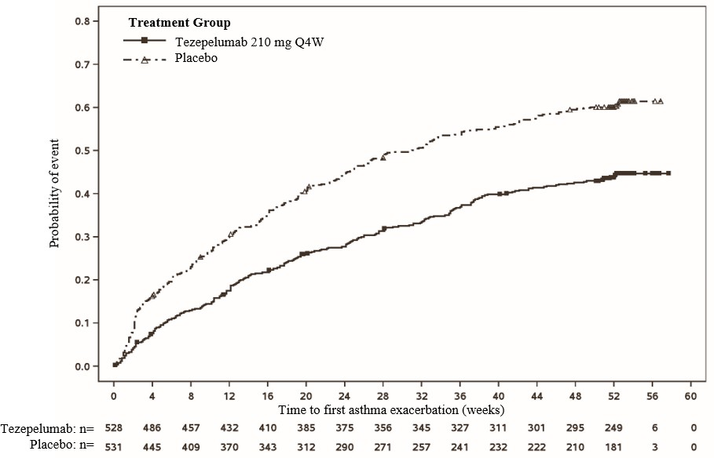

Subgroup Analysis
In Trial 2, TEZSPIRE demonstrated a reduction in the rate of asthma exacerbations regardless of the baseline levels of blood eosinophils, FeNO, as well as allergic status (determined by a perennial aeroallergen specific IgE) (Figure 2). Similar results were seen in Trial 1.

Figure 2 Annualised Asthma Exacerbation Rate Ratio Over 52 Weeks Across Different Baseline Biomarkers, Trial 2
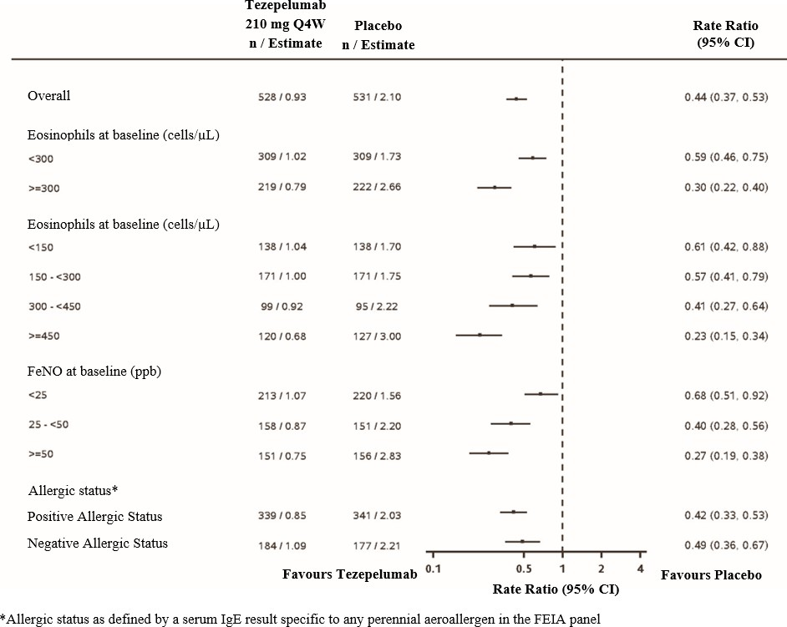

Lung Function
Change from baseline in FEV1 was assessed as a secondary endpoint in Trial 1 and Trial 2. Compared with placebo, TEZSPIRE provided clinically meaningful improvements in the mean change from baseline in FEV1 in both Trial 1 and Trial 2 (Table 4).

Table 4 Mean Change from Baseline in Pre-Bronchodilator FEV1 at Week 52, Trial 1 and Trial 2

 | Trial 1 |  | Trial 2
 | TEZSPIRE  N=133* | Placebo  N=138* | TEZSPIRE  N=527* | Placebo  N=531*
LS Mean Change from Baseline (L) | 0.08 | -0.06 | 0.23 | 0.10
LS Mean Difference from Placebo (L) (95% CI) | 0.13 (0.03, 0.23) |  | 0.13 (0.08, 0.18)
p-value | 0.009† |  | <0.001
* Number of patients contributing to the full analysis (FA) with at least 1 change from baseline value
†Nominal p-value

In Trial 2, improvement in FEV1 was seen as early as 2 weeks after initiation of treatment and was sustained through week 52 (Figure 3).

Figure 3 Mean Change (95% CI) from Baseline in Pre-Bronchodilator FEV1 (L) Over Time, Trial 2

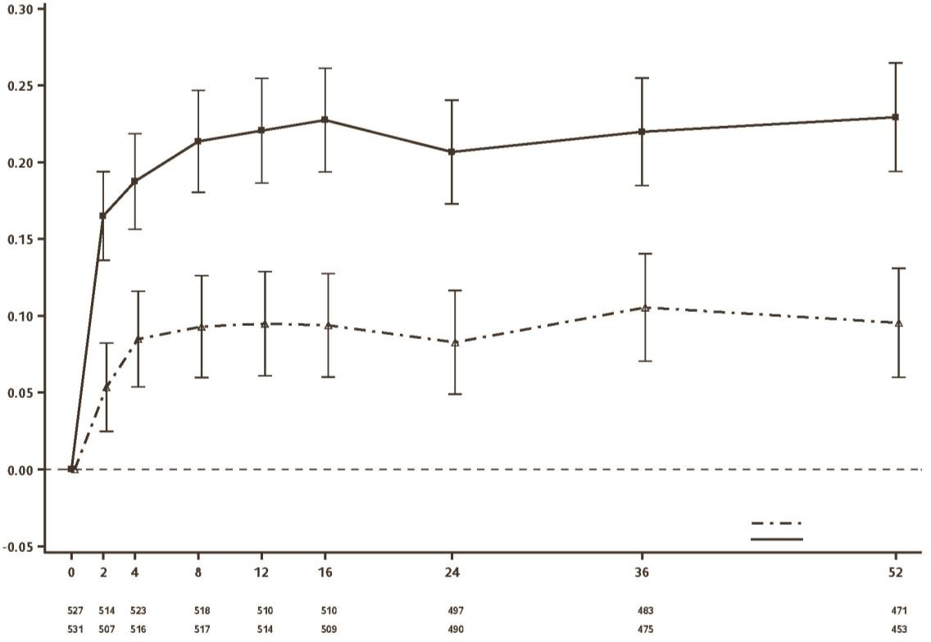
Placebo
Pre-BD FEV1 Change from Baseline (95% CI)
Tezepelumab 210 mg Q4W

Number of subjects with a change from baseline value at each time point Time (Weeks)
Tezepelumab Placebo

Patient Reported Outcomes
Changes from baseline in Asthma Control Questionnaire 6 (ACQ-6) and Standardised Asthma Quality of Life Questionnaire for ages 12 and older [AQLQ(S)+12] were assessed as secondary endpoints in Trial 1 and Trial 2. Results for Trial 2 are shown in Table 5. Improvements in ACQ-6 and AQLQ(S)+12 were seen as early as 2 weeks and 4 weeks after administration of TEZSPIRE, respectively, and sustained through Week 52 in both trials.
In both trials, more patients treated with TEZSPIRE compared to placebo had a clinically meaningful improvement in ACQ-6 and AQLQ(S)+12. Clinically meaningful improvement (responder rate) for ACQ-6 and AQLQ(S)+12 was defined as improvement in score of 0.5 at end of trial. In Trial 2, the ACQ-6 responder rate for TEZSPIRE was 86% compared with 77% for placebo (odds ratio=1.99; 95% CI 1.43, 2.76) and the AQLQ(S)+12 responder rate for TEZSPIRE was 78% compared with 72% for placebo (odds ratio=1.36; 95% CI 1.02, 1.82). Similar findings were seen in Trial 1.
Weekly mean Asthma Symptom Diary (ASD) scores were also assessed as a secondary endpoint in Trial 2. Severity of wheezing, shortness of breath, cough, and chest tightness were assessed twice daily (morning and evening). Night-time awakening and activity were assessed on a daily basis. The total ASD score was calculated as the mean of 10 items. More patients treated with TEZSPIRE compared to placebo had a clinically meaningful improvement in the ASD score.
Clinically meaningful improvement (responder rate) was defined as improvement in score of 0.5 or more at end of trial. The ASD responder rate for TEZSPIRE was 58% compared with 51% for placebo (odds ratio=1.68; 95% CI 1.12, 2.53).
Table 5 Results of AQLQ(s)+12, ACQ-6 and ASD at Week 52, Trial 2

 | N* | LS Mean Change from Baseline | Difference from Placebo (95% CI) | p-value
AQLQ(S)+12 total score
TEZSPIRE | 525 | 1.48 | 0.33  (0.20, 0.47) | <0.001
Placebo | 526 | 1.14 | 0.33  (0.20, 0.47) | <0.001
ACQ-6 score
TEZSPIRE | 527 | -1.53 | -0.33  (-0.46, -0.20) | <0.001
Placebo | 531 | -1.20 | -0.33  (-0.46, -0.20) | <0.001
ASD
TEZSPIRE | 525 | -0.70 | -0.11  (-0.19, -0.04) | 0.004
Placebo | 531 | -0.59 | -0.11  (-0.19, -0.04) | 0.004
* Number of patients contributing to the full analysis (FA) with at least 1 change from baseline value

Oral Corticosteroid Reduction
Trial 3 evaluated the effect of TEZSPIRE on reducing the use of maintenance OCS. The primary endpoint was categorised percent reduction from baseline of the final OCS dose at Week 48 (≥90% reduction, ≥75% to <90% reduction, ≥50% to <75% reduction, >0% to <50% reduction, and no change or any increase in OCS), while maintaining asthma control. Compared with placebo, more patients receiving TEZSPIRE achieved a reduction from baseline in maintenance OCS dose without losing asthma control (cumulative odds ratio=1.28; 95% CI 0.69, 2.35), but the difference was not statistically significant. A total of 40 (54%) patients receiving tezepelumab compared with 35 (46%) patients receiving placebo achieved a ≥90% to 100% reduction in their OCS. Reductions of 50% or higher in the OCS dose were observed in 55 (74%) patients receiving TEZSPIRE compared to the 53 (70%) patients receiving placebo.
Secondary outcomes in Trial 3, including the annualised rate of asthma exacerbations, change from baseline in pre-bronchodilator FEV1, ACQ-6, and AQLQ(S)+12 improved with TEZSPIRE compared with placebo.

Long-term extension trial
The long-term efficacy and safety of tezepelumab was evaluated in a phase 3, randomised, double blind, placebo-controlled, extension trial (Trial 4). The trial enrolled a total of 951 patients (879 adults and 72 adolescent patients aged 12 years and older) from Trial 2 and Trial 3. The results summarised below are based on the Trial 2 treatment groups.
Patients receiving tezepelumab had reductions in annualised rate of asthma exacerbations compared with placebo over 104 weeks (rate ratio 0.42 [95% CI 0.35, 0.51]) regardless of baseline levels of blood eosinophils, FeNO, as well as allergic status (determined by a perennial aeroallergen specific IgE). Tezepelumab treatment reduced the rate of asthma exacerbations associated with hospitalisation or emergency room visits compared with placebo over 104 weeks by 79% (rate ratio 0.21 [95% CI 0.13, 0.36]). Sustained improvement in FEV1 (LS mean
difference 0.08 L [95% CI 0.02, 0.15]) and ACQ-6 (LS mean difference -0.30 [95% CI -0.45, - 0.15]) was observed in patients treated with tezepelumab compared with placebo at Week 104.

Paediatric Population
A total of 82 adolescents aged 12 to 17 with severe, uncontrolled asthma were enrolled in Trial 2 and received treatment with TEZSPIRE (n=41) or placebo (n=41). Compared with placebo, clinically meaningful improvements in annualised asthma exacerbation (rate ratio 0.70; 95% CI 0.34, 1.46) and FEV1 (LS mean change from placebo 0.17 L; 95% CI -0.01, 0.35) were observed in adolescents treated with TEZSPIRE. The safety profile and pharmacodynamic responses in adolescents were generally similar to the overall study population.
A total of 72 adolescents aged 12 to 17 years with severe asthma were enrolled in the long-term study (Trial 4). The efficacy profile of tezepelumab in adolescent patients was sustained up to 104 weeks. Safety was generally similar with the known safety profile of tezepelumab.

Pharmacokinetic properties
The pharmacokinetics of tezepelumab were dose-proportional following SC administration over a dose range of 2.1 mg to 420 mg.

Absorption
Following a single SC administration, the maximum serum concentration was reached in approximately 3 to 10 days. Based on population pharmacokinetic analysis, the estimated absolute bioavailability was approximately 77%. There was no clinically relevant difference in bioavailability when administered to different injection sites (abdomen, thigh, or upper arm).

Distribution
Based on population pharmacokinetic analysis, central and peripheral volume of distribution of tezepelumab was 3.9 L and 2.2 L respectively, for a 70 kg individual.

Metabolism
Tezepelumab is a human monoclonal antibody (IgG2λ) that is degraded by proteolytic enzymes widely distributed in the body and not metabolised by hepatic enzymes.

Excretion
As a human monoclonal antibody, tezepelumab is eliminated by intracellular catabolism and there is no evidence of target-mediated clearance. From population pharmacokinetic analysis, the estimated clearance for tezepelumab was 0.17 L/d for a 70 kg individual. The elimination half-life was approximately 26 days.

Special patient populations

Age, Gender, Race
Based on population pharmacokinetic analysis, age, gender, and race had no clinically meaningful effects on the pharmacokinetics of tezepelumab.

Body Weight
Based on population pharmacokinetic analysis, higher body weight was associated with lower exposure. However, the effect of body weight on exposure had no meaningful impact on efficacy or safety and does not require dose adjustment.

Paediatric patients
Based on the population pharmacokinetic analysis, there was no clinically meaningful age-related difference in the pharmacokinetics of tezepelumab between adults and adolescents aged 12 to 17 years. Tezepelumab has not been studied in children under 12 years of age (see Section 4.2 Dose and method of administration).
Elderly patients (≥65 years old)
Based on population pharmacokinetic analysis, there was no clinically meaningful difference in the pharmacokinetics of tezepelumab between patients 65 years of age or older and younger patients.
Of the 665 patients with asthma exposed to TEZSPIRE in the two placebo-controlled clinical studies of 52 weeks duration, a total of 119 patients were 65 years or older. Safety in this age group were similar to the overall study population.
Efficacy in this age group was similar to the overall study population in Trial 2. Trial 1 did not include sufficient numbers of patients aged 65 and over to determine efficacy in this age group.

Renal impairment
No formal clinical studies have been conducted to investigate the effect of renal impairment on tezepelumab. Based on population pharmacokinetic analysis, tezepelumab clearance was similar in patients with mild renal impairment (creatinine clearance 60 to < 90 mL/min), moderate renal impairment (creatinine clearance 30 to < 60 mL/min) and those with normal renal function (creatinine clearance ≥ 90 mL/min). Tezepelumab has not been studied in patients with severe renal impairment (creatinine clearance < 30 mL/min); however, tezepelumab is not cleared renally.

Hepatic impairment
No formal clinical studies have been conducted to investigate the effect of hepatic impairment on tezepelumab. IgG monoclonal antibodies are not primarily cleared via hepatic pathway; change in hepatic function is not expected to influence tezepelumab clearance. Based on population pharmacokinetic analysis, baseline hepatic function biomarkers (ALT, AST, and bilirubin) had no effect on tezepelumab clearance.

Drug-Drug Interaction
No formal drug interaction studies have been conducted. A clinically relevant effect of tezepelumab on the pharmacokinetics of co-administered asthma medications is not expected. Based on the population pharmacokinetic analysis, commonly co-administered asthma medications (including leukotriene receptor antagonists, theophylline/aminophylline, and OCS) had no effect on tezepelumab clearance.

Preclinical safety data
Non-clinical data reveal no special hazards for humans based on conventional studies of safety pharmacology and repeated dose toxicity studies in cynomolgus monkeys.

Genotoxicity
No genotoxicity studies have been conducted with tezepelumab. As a large protein molecule, tezepelumab is not expected to interact directly with DNA or other chromosomal material.

Carcinogenicity
No carcinogenicity studies have been conducted with tezepelumab.

PHARMACEUTICAL PARTICULARS

List of excipients
TEZSPIRE prefilled syringe and prefilled pen contain the excipients glacial acetic acid, proline, polysorbate 80, sodium hydroxide and water for injections.

Incompatibilities
In the absence of compatibility studies, this medicinal product must not be mixed with other medicinal products.

Shelf life
In Australia, information on the shelf life can be found on the public summary of the Australian Register of Therapeutic Goods (ARTG). The expiry date can be found on the packaging.

Special precautions for storage
Store at 2°C to 8°C (Refrigerate. Do not freeze).
TEZSPIRE may be kept at room temperature up to 25°C for a maximum of 30 days. After removal from the refrigerator, TEZSPIRE must be used within 30 days or discarded. Store the prefilled syringe/ prefilled pen in the original package in order to protect from light.
Do not freeze. Do not shake. Do not expose to heat.

Nature and contents of container TEZSPIRE prefilled syringe
The prefilled syringe is comprised of 1.91 mL solution in a siliconised type I glass prefilled syringe subassembly consisting of a 27-gauge 12.7 mm (½-inch) stainless steel special thin wall needle covered with a needle cover and plunger-stopper. The prefilled syringe subassembly is assembled with a needle guard and an extended finger flange.
TEZSPIRE prefilled syringe is available in a pack containing one single-dose, single-use, sterile prefilled syringe.

TEZSPIRE prefilled pen
The prefilled pen is comprised of 1.91 mL solution in a siliconised type I glass prefilled syringe subassembly consisting of a 27-gauge 12.7 mm (½-inch) stainless steel special thin wall needle covered with a needle cover and plunger-stopper. The prefilled pen consists of the prefilled syringe subassembly and handheld, mechanical (spring-based) injection device.
TEZSPIRE is available in a pack containing one single-dose, single-use, sterile prefilled pen.

Special precautions for disposal
Discard used TEZSPIRE prefilled syringe/prefilled pen into a sharps disposal container.
In Australia, any unused medicine should be disposed of by taking to your local pharmacy.

Physicochemical properties
Tezepelumab is a human immunoglobulin G2λ (IgG2λ) monoclonal antibody directed against thymic stromal lymphopoietin (TSLP), produced in Chinese hamster ovary (CHO) cells by recombinant DNA technology. Tezepelumab has a molecular weight of approximately 147 kDa.

Figure 4 General structure of tezepelumab
V
H


Fab
1
1
Glycosylation
CH3
CH2
C
H
1
V
L

Hinge Region
C
L

Fc

CAS number: 1572943-04-4

MEDICINE SCHEDULE (POISONS STANDARD)
Prescription only medicine (Schedule 4)

SPONSOR
AstraZeneca Pty Ltd ABN 54 009 682 311
66 Talavera Road
MACQUARIE PARK NSW 2113
Telephone: 1800 805 342

DATE OF FIRST APPROVAL
24 March 2025

DATE OF REVISION
TBC

Summary table of changes

Section changed | Summary of new information
5.1 | Minor editorial changes to the footnote of Figure 3

TEZSPIRE is a trademark of Amgen Inc. and AstraZeneca.
© AstraZeneca, 2025 VV-RIM-08625662 v1

