Australian Public Assessment Report for mNEXSPIKE XBB.1.5
  - Active ingredient: SARS-CoV-2 spike protein (mRNA) XBB.1.5

  - Sponsor: Moderna Australia Pty Ltd
May 2026

About the Therapeutic Goods Administration (TGA)
- The Therapeutic Goods Administration (TGA) is part of the Australian Government Department of Health, Disability and Ageing and is responsible for regulating therapeutic goods, including medicines, medical devices, and biologicals.
- The TGA administers the Therapeutic Goods Act 1989 (the Act), applying a risk management approach designed to ensure therapeutic goods supplied in Australia meet acceptable standards of quality, safety, and efficacy.
- The work of the TGA is based on applying scientific and clinical expertise to decision-making, to ensure that the benefits to the Australian public outweigh any risks associated with the use of therapeutic goods.
- The TGA relies on the public, healthcare professionals and industry to report problems with therapeutic goods. The TGA investigates reports received to determine any necessary regulatory action.
- To report a problem with a therapeutic good, please see the information on the TGA website.

About AusPARs
- The Australian Public Assessment Report (AusPAR) provides information about the evaluation of a prescription medicine and the considerations that led the TGA to approve or not approve a prescription medicine submission. Further information can be found in Australian Public Assessment Report (AusPAR) guidance.
- AusPARs are prepared and published by the TGA.
- AusPARs are static documents that provide information that relates to a submission at a particular point in time. The publication of an AusPAR is an important part of the transparency of the TGA’s decision-making process.
- A new AusPAR may be provided to reflect changes to indications or major variations to a prescription medicine subject to evaluation by the TGA.

Copyright
© Commonwealth of Australia 2026.
This work is copyright. You may reproduce the whole or part of this work in unaltered form for your own personal use or, if you are part of an organisation, for internal use within your organisation, but only if you or your organisation do not use the reproduction for any commercial purpose and retain this copyright notice and all disclaimer notices as part of that reproduction. Apart from rights to use as permitted by the Copyright Act 1968 or allowed by this copyright notice, all other rights are reserved, and you are not allowed to reproduce the whole or any part of this work in any way (electronic or otherwise) without first being given specific written permission from the Commonwealth to do so. Requests and inquiries concerning reproduction and rights are to be sent to the TGA Copyright Officer, Therapeutic Goods Administration, PO Box 100, Woden ACT 2606 or emailed to <tga.copyright@tga.gov.au>.

Contents
List of abbreviations 4
Product submission 6
Submission details 6
Product background 7
Disease or condition 7
Current treatment options 8
Clinical rationale 8
Regulatory status 8
Australian regulatory status 8
International regulatory status 8
Registration timeline 9
Assessment overview 9
Quality evaluation summary 9
Nonclinical evaluation summary 11
Clinical evaluation summary 11
Summary of clinical studies 11
Efficacy 13
Safety 19
Risk management plan 27
Risk-benefit analysis 27
Delegate’s considerations 27
Proposed action 28
Assessment outcome 29
Specific conditions of registration 29
Product Information and Consumer Medicine Information 31

List of abbreviations
Abbreviation | Meaning
ABN | Australian Biological Name
ACM | Advisory Committee on Medicines
ACV | Advisory Committee on Vaccines
AE(s) | Adverse event(s)
AESI | Adverse event of special interest
AR | Adverse reaction
ARTG | Australian Register of Therapeutic Goods
ASA | Australia-specific annex
CDC | Centres for Disease Control and Prevention (USA)
CI | Confidence interval
CMI | Consumer Medicines Information
COVID-19 | Coronavirus disease 2019
DLP | Data lock point
DP | Drug product
EMA | European Medicines Agency
EU | European Union
FDA | Food and Drug Administration (USA)
GM | Geometric mean
GMFR | Geometric mean fold-rise
GMR | Geometric mean ratio
IM | Intramuscular
LLOQ | Lower limit of quantification
LNP | Lipid nanoparticle
MAAE | Medically attended adverse event
mRNA | Messenger ribonucleic acid
NAb | Neutralizing antibody
NP | Nasopharyngeal
NTD | N-terminal domain
PI | Product Information
PSUR | Periodic safety update report
RBD | Receptor-binding domain
RMP | Risk management plan
RT-PCR | Reverse transcription polymerase chain reaction
rVE | Relative vaccine efficacy
SAE | Serious adverse event
SARS-CoV-2 | Severe acute respiratory syndrome coronavirus 2
SRR | Seroresponse rate.
TGA | Therapeutic Goods Administration
URTI | Upper respiratory tract infections
VE | Vaccine efficacy

Product submission

Submission details
Type of submission: | New biological entity
Product name: | mNEXSPIKE XBB.1.5
Active ingredient: | SARS-CoV-2 spike protein (mRNA) XBB.1.5
Decision: | Approved
Date of decision: | 12 December 2025
Date of entry onto ARTG: | 18 December 2025
ARTG number: | 471090
Black Triangle Scheme  for the current submission: | Yes
Sponsor’s name and address: | Moderna Australia Pty Ltd  101 Collins St,  Melbourne,  Victoria 3000  Australia
Dose form  Strength: | One dose of 0.2 mL  10 micrograms of SARS-CoV-2 spike protein (mRNA) XBB.1.5
Container: | Pre-filled syringe (without needle)
Pack size: | 1 pre-filled syringe or 10 pre-filled syringes
Approved therapeutic use for the current submission: | mNEXSPIKE XBB.1.5 (SARS-CoV-2 spike protein (mRNA) XBB.1.5) COVID-19 Vaccine is indicated for:  Active immunisation to prevent coronavirus disease 2019 (COVID-19) caused by SARS-CoV-2 in individuals 12 years of age and older.  The use of this vaccine should be in accordance with official recommendations.
Route of administration: | Intramuscular injection
Dosage: | One dose of 0.2 mL, given intramuscularly for individuals 12 years of age and older.  If previously vaccinated, mNEXSPIKE XBB.1.5 should be administered at least 3 months after a recent dose of a COVID-19 vaccine (see sections 4.4 and 5.1).  For further information regarding dosage, such as dosage modifications to manage adverse reactions, refer to the Product Information.
Pregnancy category: | Pregnancy Category B1  No adequate and well-controlled studies of mNEXSPIKE XBB.1.5 use in pregnant women have been conducted. Available clinical data on mNEXSPIKE XBB.1.5 administered to pregnant women are insufficient to inform vaccine-associated risks in pregnancy.  The use of any medicine during pregnancy requires careful consideration of both risks and benefits by the treating health professional. The pregnancy database must not be used as the sole basis of decision making in the use of medicines during pregnancy. The TGA does not provide advice on the use of medicines in pregnancy for specific cases. More information is available from obstetric drug information services in your state or territory.

Product background
This AusPAR describes the submission by Moderna Australia Pty Ltd to register mNEXSPIKE XBB.1.5 (SARS-CoV-2 spike protein (mRNA) XBB.1.5) COVID-19 vaccine, 10 micrograms in 0.2 mL, suspension for injection, in a prefilled syringe for the following proposed indication:
mNEXSPIKE XBB.1.5 (SARS-CoV-2 spike protein (mRNA) XBB.1.5) COVID-19 Vaccine is indicated for:
Active immunisation to prevent coronavirus disease 2019 (COVID-19) caused by SARS-CoV-2 in individuals 12 years of age and older.
The use of this vaccine should be in accordance with official recommendations.

Disease or condition
COVID-19 is a variable clinical syndrome caused by infection with the SARS-CoV-2 virus. COVID caused a pandemic between its emergence in China in late 2019 and October 2023 resulting in approximately 31000 deaths in Australia. It is now endemic with seasonal epidemics during the winter months caused by human-to-human transmission via respiratory droplets from coughing or sneezing but can also persist on surfaces.
Over the pandemic new strains of COVID emerged which generally had a lower virulence and higher transmissibility than the original virus. This meant that the risk of severe disease and death became focused on vulnerable groups including the elderly, those with co-existing chronic disease, and immunosuppressed individuals. Age has been identified as a key risk factor for severe COVID-19 outcomes, particularly among adults over 65 years.
Common symptoms of currently circulating strains of COVID include an influenza-like illness (fever, cough, sore throat, myalgia, chills, headache) but this can rarely progress to pneumonia or pneumonitis requiring hospitalisation. Long term sequelae of COVID can include lung injury, hypertension, prolonged symptoms of fatigue (long-COVID) and an increased risks of cardiovascular events for several years post-infection.

Current treatment options
Treatment for COVID consists of antiviral medications and monoclonal antibodies which target the virus, immune modulators which reduce systemic inflammation in severe cases, and supportive care. However the mainstay of medical intervention is vaccination, which has been demonstrated to reduce the rate of severe COVID disease and death in protected individuals.

Clinical rationale
The nucleoside-modified mRNA in mNEXSPIKE is formulated in lipid particles, which encodes the membrane-bound, linked N-terminal domain (NTD) and receptor-binding domain (RBD) of the spike (S) glycoprotein from SARS-CoV-2 strains, which are known to be the immuno-dominant epitopes for protective immune responses. The vaccine elicits an immune response to the NTD and RBD of the S antigen, which may contribute to protection against COVID-19.

Regulatory status

Australian regulatory status
This product is considered a new biological entity for Australian regulatory purposes.

International regulatory status
At the time the TGA considered this submission, publicly available information indicates that mRNA-1283 - mNEXSPIKE XBB.1.5 (SARS-CoV-2 spike protein (mRNA) XBB.1.5) COVID-19 vaccine had been registered by Health Canada, the United States’ Food and Drug Administration (FDA) and received a positive opinion from the European Medicines Agency (EMA).
The following table summarises these submissions and provides the indications where approved.
Table 1. International regulatory status.
Region | Submission date | Status | Approved indications
United States of America (FDA) | 30 September 2024 | Approved on 30 May 2025 | Active immunization to prevent coronavirus disease 2019 (COVID-19) caused by severe acute respiratory syndrome coronavirus 2 (SARS-CoV-2).  MNEXSPIKE is approved for use in individuals who are:  65 years of age and older, or  12 years through 64 years of age with at least one underlying condition that puts them at high risk for severe outcomes from COVID-19.
Canada (Health Canada) | 15 October 2024 | Approved on 29 September 2025 | Active immunization against coronavirus disease 2019 (COVID-19) caused by the severe acute respiratory syndrome coronavirus 2 (SARS-CoV-2) virus in previously vaccinated individuals 18 years of age and older.

Registration timeline
The following table captures the key steps and dates for this submission.
This submission was evaluated under the standard prescription medicines registration process.
Table 2. Timeline for Submission PM-2024-05463-1-2.
Description | Date
Submission dossier accepted and first round evaluation commenced | 2 January 2025
Evaluation completed (End of round 2) | 20 October 2025
Registration decision (Outcome) | 12 December 2025
Registration in the ARTG completed | 18 December 2025
Number of working days from submission dossier acceptance to registration decision* | 152
*Statutory timeframe for standard submissions is 255 working days

Assessment overview
A summary of the TGA’s assessment for this submission is provided below.

Quality evaluation summary
Moderna Australia Pty Ltd submitted a Category 1 Type A application to register a new biological entity (vaccine):
- mNEXSPIKE XBB.1.5 (SARS-CoV-2 spike protein (mRNA) XBB.1.5) COVID-19 Vaccine, 10 micrograms in 0.2 mL, suspension for injection, pre-filled syringe
The proposed product is an mRNA vaccine intended for active immunisation for the prevention of coronavirus disease 2019 (COVID-19) caused by SARS-CoV-2 in individuals 12 years of age and older. The active ingredient is mRNA-1283, and the Australian Biological Name (ABN) is SARS-CoV-2 spike protein (mRNA) XBB.1.5.
In this submission, the proposed COVID-19 variant used in mRNA-1283 is Omicron XBB.1.5 (RNA-101-B815).
The mRNA-1283 encodes for the membrane-bound linked N-terminal domain (NTD) and receptor-binding domain (RBD) of the spike (S) glycoprotein of SARS-CoV-2, which contain the immunodominant epitopes for protective immune responses. The encoded RBD-NTD are linked together, which anchors the linked RBD-NTD polypeptide into the cell membrane of antigen-expressing cells. The vaccine elicits an immune response to the RBD and NTD of the Spike protein, which protects against COVID-19.
For comparison, the mRNA-1273 used in the currently registered Spikevax COVID-19 vaccine encodes for the full-length spike protein of SARS-CoV-2, and after translation, three (3) protomers combine into a membrane-bound spike trimer (Figure 1).
Figure 1. Structural design of the antigens encoded by mRNA-1283 and mRNA-1273.
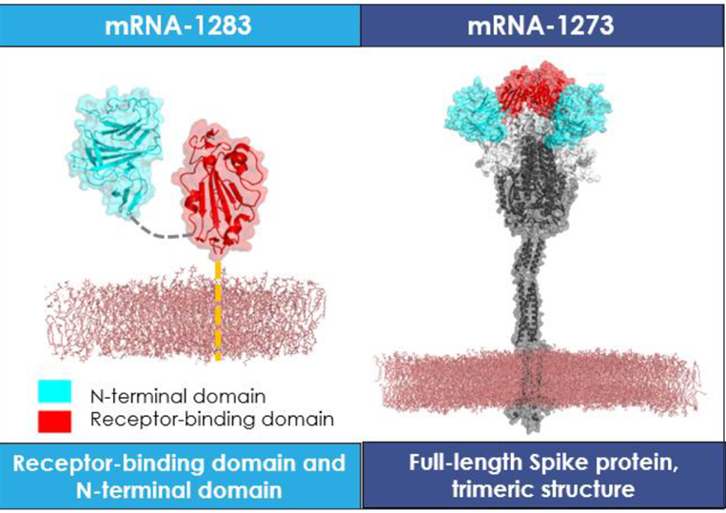
The drug product (DP) is supplied as a sterile, single-dose, ready-to-use liquid solution at 10 µg/0.2 mL for intramuscular (IM) administration in a 1 mL pre-filled syringe (PFS). Each PFS delivers 10 µg of RNA and 200 µg of total lipids as a white to off-white dispersion in a preservative-free buffer.
The proposed pack sizes for registration were 1, 2 and 10 packs, however not all pack sizes may be marketed.
In Australia, information on the shelf life can be found on the public summary of the Australian Register of Therapeutic Goods (ARTG). The expiry date can be found on the packaging. The drug product can be stored for 9 months at -40º C to -15º C. Within the period of 9 months, after removal from the freezer, pre-filled syringes may be stored refrigerated at 2°C to 8°C, protected from light, for 30 days. Once thawed, the vaccine should not be refrozen. Pre-filled syringes may be stored at 23°C to 27°C for up to 24 hours after removal from refrigerated conditions at the point of care site. The pre-filled syringe is for single use in one patient only.
The quality and manufacturing evaluator has raised no objection to the registration of mRNA-1283.

Nonclinical evaluation summary
While there are some limitations with the nonclinical efficacy data with mRNA-1283.815, the totality of data presented (immunogenicity in mice with mRNA-1283.815 and limited data suggesting similar protective efficacy in mice with variant-matched mRNA-1283 and mRNA-1273 vaccines, albeit not specifically targeting XBB.1.5) lend some support for efficacy, noting that adequate clinical efficacy data are required and should address some of the limitations noted above.
The absence of a biodistribution study specifically with a mRNA-1283-variant is not a major deficiency, though not ideal. Based on data with lipid nanoparticle (LNP)-surrogates, the distribution of lipids and mRNA (but not protein) with mRNA-1283.815 would be expected to be similar to currently and previously approved mRNA-1273 variants. The fate and longevity of expressed protein from mRNA-1283.815 is not known.
The safety of the lipid composition of the proposed vaccine has been adequately assessed based on previously submitted studies and extensive clinical use. In regard to the protein expressed from mRNA-1283.815, there were no unexpected safety signals in two 4-week (2 doses in each study) repeat-dose toxicity studies in rats with mRNA-1283 variants (effects could largely be attributed to injection site reactions and the expected immune response).
However, one study was limited in scope (particularly set of tissues examined in histopathological analyses) and the studies were of generally short duration, though high relative doses were used, somewhat overcoming the short duration follow-up and uncertainties regarding the effects of any differences in non-coding regions of the mRNA that may alter mRNA stability or translation efficiency. The amino acid differences in protein expressed from mRNA-1283.815 cf. the variants used in the studies would not be expected to significantly affect the safety profile in similarly designed studies.
Overall, there were no major safety concerns identified in the submitted Module 4 dossier as well as consideration of previously evaluated studies and historical use of similar LNP-based vaccines that would preclude registration from a nonclinical perspective.

Clinical evaluation summary

Summary of clinical studies
The mRNA-1283 clinical development program includes a Phase 1 Study (mRNA-1283-P101), a Phase 2a Study (mRNA-1283-P201), a Phase 3 study (Pivotal, mRNA-1283-P301) which evaluated a bivalent formulation (mRNA-1283.222, targeting Original and Omicron BA.4/5), and a country specific-study conducted in Japan (Study P301-Japan), which evaluated a monovalent formulation (mRNA-1283.815) targeting Omicron XBB.1.5.
The clinical evaluation included the following clinical studies:
- mRNA-1283-P101: A Phase 1, randomised observer-blind, dose-ranging, study to evaluate the safety, reactogenicity, and immunogenicity of mRNA-1283 and mRNA-1273.
- mRNA-1283-P201: A Phase 2a observer-blind, dose-ranging, single-dose study
- mRNA-1283-P301 (Pivotal Study): A Phase 3 randomised, observer-blind, active-controlled study to investigate the safety, immunogenicity, and relative vaccine efficacy of a single dose of mRNA-1283 compared to mRNA-1273
- mRNA-1283-P301: Japanese Amendment: A Phase 3 randomised, observer-blind, active-controlled study to investigate the safety and immunogenicity of a single dose of mRNA-1283 compared to mRNA-1273.
In line with the development of vaccines, there were no biopharmaceutical or pharmacokinetic studies submitted.

Phase I/II dose finding studies
There were two Phase I/II dose finding studies conducted prior to the pivotal study, as described below.

Study mRNA-1283-P101
This was a Phase 1, randomised, observer-blind, dose-ranging study to Evaluate the Safety, Reactogenicity and Immunogenicity of mRNA-1283 and mRNA-1273 SARS-CoV-2 vaccine in adults aged 18 to 55.
Approximately 125 participants were randomised into 5 treatment arms with three dose levels (10, 30, and 100 μg) of mRNA-1283 (Arms 1 through 3) in a 2-dose regimen, one dose level (100 μg) of mRNA-1283 was evaluated in a single-dose regimen (Arm 4), and one dose level (100 μg) of mRNA-1273 (Arm 5) was evaluated in a 2-dose regimen, with the doses administered 28 days apart. They were randomised in a 1:1:1:1:1 ratio to receive a study intervention, with approximately 25 participants per arm. All study arms were enrolled in parallel.
Immunogenicity results (Day 57 and up to day 394) suggested that all dose levels of 10, 30 and 100 μg of mRNA-1283 administered as 2 doses 28 days apart in vaccine-naïve and infection-naïve participants, induced comparable neutralizing antibody responses compared with mRNA-1273 for the original SARS-CoV-2 D614G, Beta, and Omicron BA.1 variants. Cellular immunity results suggest that the mRNA-1283 primary series, even at the lowest dosage (10 μg and 30 μg), induced CD4+ and CD8+ T cell-responses against SARS-CoV-2 similar to mRNA-1273 100μg.

Study mRNA-1283-P201
This was a Phase 2a dose-ranging study for a single dose of mRNA-1283 and mRNA-1283 variant-containing vaccines in adults. Part A evaluated the safety, reactogenicity, and immunogenicity of mRNA-1283 (2.5, 5, 10 μg) and mRNA-1283.211 (5 and 10 μg) compared to mRNA-1273 50 μg in a randomised, observer-blind study design. Part B was added after the emergence of Omicron variants and evaluated the safety, reactogenicity, and immunogenicity of mRNA-1283.529 (5 and 10 μg) in an open-label study design.
In Part A at Day 29, among participants without SARS-CoV-2 infection at pre-booster, mRNA-1283 (2.5, 5, 10 μg) elicited a potent nAb response against the original SARS-CoV-2 (D614G), Beta, and Omicron BA.1 variants, which was overall similar or higher to that of mRNA-1273 50 μg. The antibody response persisted up to 1-year post vaccination and there was an increase of the antibody response regardless of prior SARS-CoV-2 infection.
In Part B, at Day 29, among participants without previous SARS-CoV-2 infection, mRNA-1283.529 (5 and 10 μg) elicited a potent nAb response against the original SARS-CoV-2 (D614G) and Omicron BA.1. A persistent antibody response was also observed throughout 1-year of follow-up.

Efficacy

Pivotal Study mRNA-1283-P301 (Study 301)
Study 301 was a randomised, active-controlled study that examined the relative vaccine efficacy of mRNA-1273 (Spikevax) and mRNA-1283. The study treated 11417 subjects randomised 1:1 to receive mRNA-1273 (n=5726) or mRNA-1283 (n=5728) from 28 March 2023.
Enrolled subjects were 12 or more years of age and had received a primary course of COVID vaccination. Those >18 years of age had received at least 1 booster but no more than 5 COVID vaccines in total.
Subjects received a single dose of either mRNA-1283 (10 micrograms) or mRNA-1273 (50 micrograms). The mRNA-1283 targeted Original and Omicron BA.4/5 strains, and mRNA-1273 bivalent Original/Omicron BA.4/5.
The primary endpoints of Study 301 were as per Table 3.
Table 3. Primary endpoints of Study 301.
Objectives | Endpoints
Primary
To demonstrate a noninferior neutralizing antibody response of mRNA-1283.222 10 μg compared to mRNA-1273.222 50 μg against Omicron BA.4/5 based on GMR and SRR difference at Day 29.  To demonstrate a noninferior neutralizing antibody response of mRNA-1283.222 10 μg compared to mRNA-1273.222 50 μg against the ancestral SARS-CoV-2 D614G based on GMR and SRR difference at Day 29. | Co-primary immunogenicity endpoints:  GMR of Omicron BA.4/5 mRNA-1283.222 10 μg over the Omicron BA.4/5 mRNA-1273.222 50 μg at Day 29.  SRRª difference of Omicron BA.4/5 between mRNA-1283.222 10 μg and mRNA-1273.222 50 μg at Day 29.  GMR of the ancestral SARS-CoV-2 D614G mRNA-1283.222 10 μg over the ancestral SARS-CoV-2 D614G mRNA-1273.222 50 μg at Day 29.  SRRª difference of ancestral SARS-CoV-2 D614G between mRNA-1283.222 10 μg and mRNA-1273.222 50 μg at Day 29.
To demonstrate noninferior rVE of mRNA-1283 compared to mRNA-1273 (variant formulations) to prevent COVID-19. | rVE of mRNA-1283 compared to mRNA-1273 (variant formulations) to prevent the first event of COVID-19 starting 14 days after study injection.  CDC-defined COVID-19 case definition (primary definition):  The presence of ≥1 CDC-listed symptom (https://www.cdc.gov/coronavirus/2019-ncov/symptoms-testing/symptoms.html); AND  A positive RT-PCR test on a respiratory sample.  Protocol-defined COVID-19 case definition (secondary definition). The participant must have:  Experienced ≥2 systemic symptoms: Fever (≥38°C/100.4°F), chills, myalgia, headache, sore throat, new olfactory and taste disorder(s), OR  Experienced ≥1 respiratory signs/symptoms: cough, shortness of breath or difficulty breathing, OR clinical or radiographical evidence of pneumonia; AND  ≥1 NP swab, nasal swab, or saliva sample (or respiratory sample, if hospitalized) positive for SARSCoV-2 by RT-PCR.
To evaluate the safety and reactogenicity of mRNA-1283.222 10 μg. | Solicited local and systemic reactogenicity Ars during a 7-day follow-up period.  Unsolicited AEs during the 28-day follow-up period.  SAEs, MAAEs, AEs leading to withdrawal, and AESIs from Day 1 to end of study.
Abbreviations: AE = adverse event; AESI = adverse event of special interest; AR = adverse reaction; GMR = geometric mean ratio; LLOQ = lower limit of quantification; MAAE = medically attended adverse event; NP = nasopharyngeal; RT-PCR= reverse transcriptase polymerase chain reaction; rVE = relative vaccine efficacy; SAE = serious adverse event; SRR = seroresponse rate.
a. Seroresponse at the participant level is defined as an antibody value change from baseline below the LLOQ to ≥4 × LLOQ, or at least a 4-fold rise if baseline is ≥ LLOQ and <4 × LLOQ, or at least a 2-fold rise if baseline is ≥4 × LLOQ.
Subjects were followed up for 12 months post treatment, although the majority of subjects had only reached 6 months follow-up by the data-cutoff for the submitted report. Patients were tested for COVID if they developed symptoms consistent with the condition, and at routine clinic visits (days 29, 91, 181 and 365) based on qualifying symptoms.
Vaccine efficacy
The primary relative vaccine efficacy (rVE) objective was to demonstrate non-inferiority with a 10% margin comparing mRNA-1283 with mRNA-1273. There was a total of 1,177 COVID-19 events included in the analysis, with 560 (9.9%) in the mRNA-1283.222 group and 617 (10.8%) in the mRNA-1273.222 group. (Table 4). This gave a relative vaccine efficacy of 9.31% (calculated as 1-hazard ratio), which was above the -10% pre-specified margin for non-inferiority.
Results were stratified by age, sex, race and previous vaccine doses with no clear indication of heterogeneity, although these descriptive analyses were not powered. The highest rVE was observed in subjects aged 65-years and older (Table 5). The Delegate notes that there is relatively little certainty in the estimate of non-inferiority of mRNA-1283 in adolescents due to the small numbers of participants of that age in the study.
Table 4. Study mRNA-1283: P301 - Primary Analysis of Relative Vaccine Efficacy - COVID-19 Events through 31 Jan 2024 (PPSE).
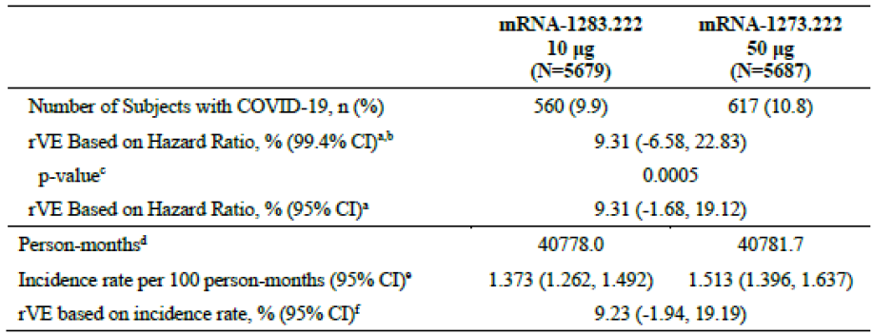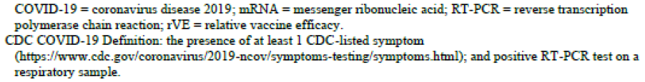
Table 5. Study P301: Descriptive Analysis of Relative Vaccine Efficacy - Subgroup Analysis based on Age.
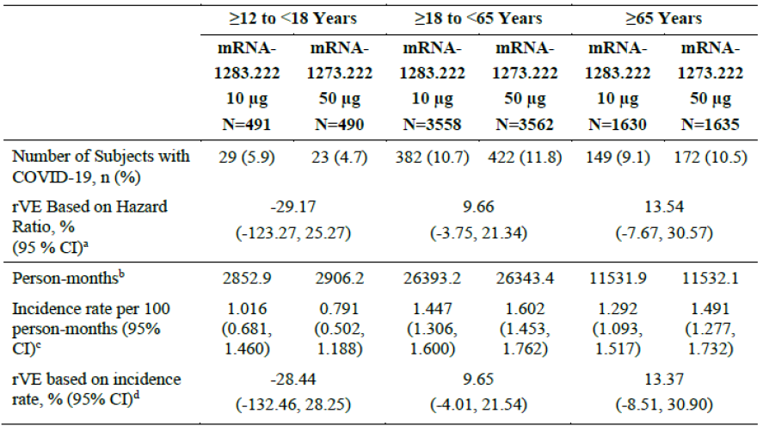
CI= confidence interval; COVID-19 = coronavirus disease 2019; RT-PCR= reverse transcription polymerase chain reaction; rVE= relative vaccine efficacy.
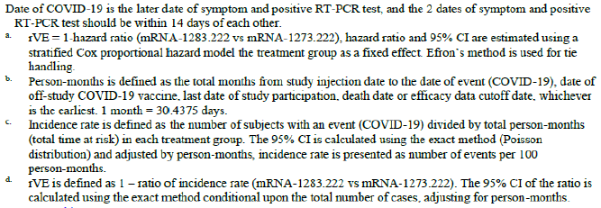
Immunogenicity
The primary immunogenicity objective was met with noninferior neutralizing antibody responses of mRNA-1283.222 vs mRNA-1272.222. The Day 29 BA.4/5 GMR was 1.335 (95% CI: 1.194, 1.492) with the lower bound of the CI >0.667. The SRR difference was 14.4% (95% CI: 9.3, 19.4), with the lower bound of the CI >-10%. The Day 29 original SARS-CoV-2 GMR was 1.240 (95% CI: 1.128, 1.362) with the lower bound of the CI >0.667. The SRR difference was 10.7% (95% CI: 6.0, 15.4) with the lower bound of the CI >-10%.
In the mRNA-1283.222 group, the geometric mean (GM) was 355.9 (95% CI: 324.8, 389.9) pre-vaccination and 2346.2 (95% CI: 2158.0, 2550.9) at Day 29, with a 6.59-fold increase (GMFR=6.59 [95% CI: 6.03, 7.21]). In the mRNA-1273.222 group, the GM was 346.1 (95% CI: 312.2, 383.7) pre-vaccination and 1753.8 (95% CI: 1607.0, 1914.0) at Day 29, with a 5.07-fold rise (GMFR=5.07 [95% CI: 4.63, 5.55]). Therefore, mRNA-1283.222 induced a higher fold-rise relative to mRNA-1273.222 (Table 6).
Table 6. Study mRNA-1283: P301 - Summary of Pseudo-virus Neutralizing Antibody Level Against BA.4/5 Variant (PPIS).
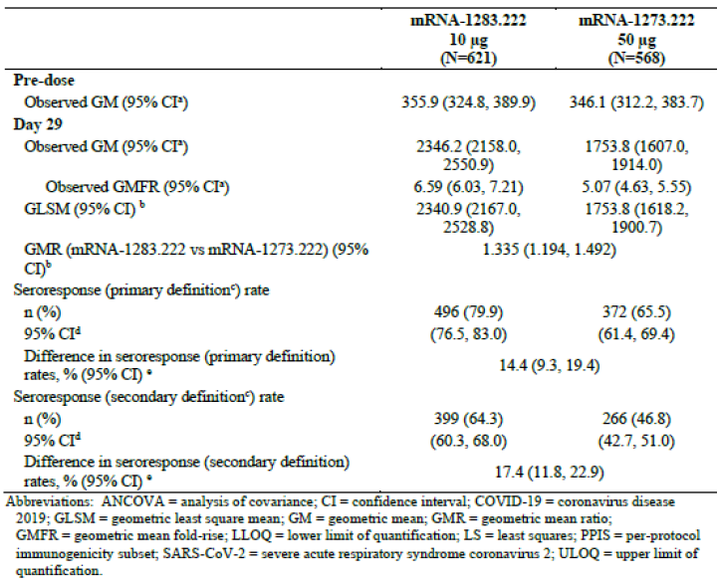

Japanese sub-study: Study mRNA-1283-P301, Addendum (Japan)
This is a randomised, observer-blind, active-controlled Phase 3 study to investigate the safety and immunogenicity of mRNA-1283 compared with mRNA-1273 in participants aged 12 years of age and older in Japanese participants. This study presents the results of an interim analysis conducted when all participants had completed at least 29 days of follow up (with data cutoff date 2 May 2024).
The Japanese cohort was added to this study due to the country-specific protocol. The primary objectives of the study include non-inferior immunogenicity of mRNA-1283.815 vs mRNA-1273.815. This study followed a similar study design to Study mRNA-1283-P301.
689 participants were dosed, with 343 in the mRNA-1283.815 group and 346 in the mRNA-1273.815 group. The study included Japanese participants aged over 12 who were medically stable. It excluded participants who were breastfeeding or pregnant.
Baseline demographics between both groups were balanced as shown in Table 7.
Table 7. Study P301: Japanese Amendment - Baseline Demographics - Safety Set.
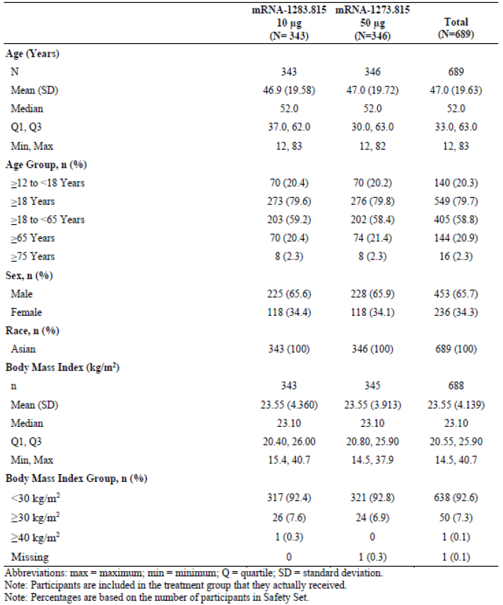
The primary immunogenicity objective was met as the GMR [95% CI] of mRNA-1283.815 over mRNA-1273.815 was 1.195 [1.028, 1.389], lower bound of the 95% CI >0.667). This was consistent across age groups with subgroup analyses including age strata of 12-18, 18-65, and ≥65 years. The highest XBB.1.5 GMR point estimate was observed in the ≥65-year-old age subgroup (1.278, 95% CI: 0.874, 1.871). Therefore, the immune responses (as measured by GMR against XBB.1.5) generated by mRNA-1283.815 are noninferior to those induced by mRNA-1273.815, meeting the study success criterion.
Study mRNA-1283-P301: Japanese Amendment provides further immunogenicity information to compare mRNA-1283.815 to the previously approved vaccine, mRNA-1273.815. The study also provided evidence of immunogenicity against newer COVID-19 variants, including XBB.1.5, which were not studied in the pivotal P301 study.
However, immunogenicity data was only provided to day 29 in this population and owning to the small sample size compared with P301, vaccine efficacy was not assessed. Nevertheless, this study provided additional immunogenicity information on mRNA-1283 in this specific population and against newer variants.
Table 8. Study mRNA-1283: P301 - Japanese Amendment: Summary of Pseudovirus Neutralizing Antibody Level Against XBB.1.5 Variant (PPIS).
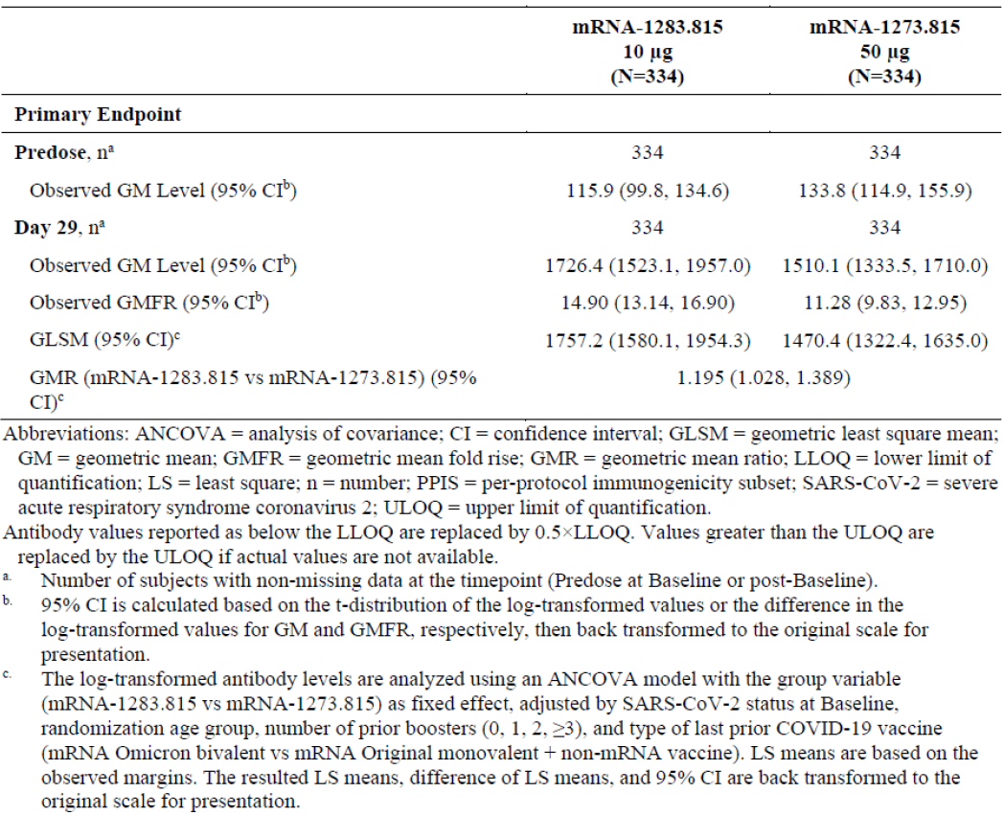

Safety

Pivotal Study mRNA-1283-P301 (Study 301)
The primary focus on safety data is within mRNA-1283-P301 (Pivotal Study), as this had the most participants (5706 participants) and is conducted with the proposed dose.
Unsolicited AEs were recorded within 28 days postvaccination. Serious adverse events, adverse events of special interest and medically attended adverse events were recorded throughout the study with no date cutoff. At the time of the cutoff for the submitted report, 6268 patients had received at least 1 dose of mRNA-1283 across all the studies with the majority of these (91.0%) being in Study 301.
Table 9. Study P301: Summary of Study Duration (Safety Set)
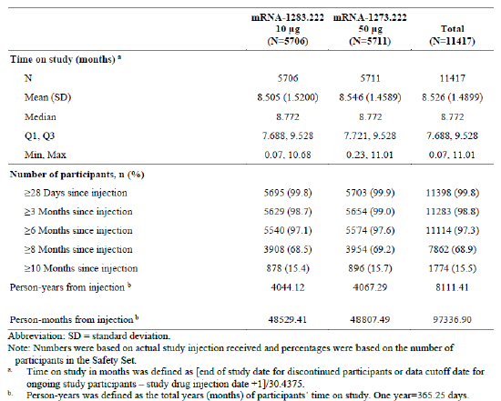
Solicited adverse events
Solicited adverse events were reported with lower incidence in the mRNA-1283.222 group with 4571/5702 (80.2%, 95% CI: 79.1-81.2) participants and 4781/5706 (83.8%, 95% CI 82.8-84.7) participants in the mRNA-1273.222 group reporting any solicited AR within 7 days after vaccination. The figures below demonstrate the solicited local and systemic adverse reactions within 7 days.
Reactogenic adverse events were reported slightly less commonly in mRNA-1283 treated patients than in those who received mRNA-1273 (Figure 2). The median day of onset of solicited ARs was 2 days in the mRNA-1283.222 group compared with 1 day in the mRNA-1273.222 group.
Solicited local and systemic AEs overall incidence were lower in participants aged 65 and over compared to those are less than 65. Systemic adverse events were reported at nearly the same rate between the two vaccines (Figure 3).

Figure 2. Study mRNA-1283-P301: Solicited Local Adverse Reactions within 7 Days After Injection (Solicited Safety Set).
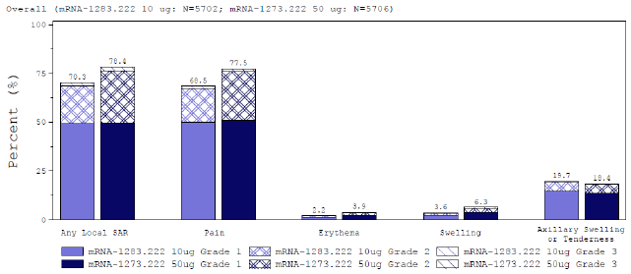
Figure 3. Study mRNA-1283-P301: Solicited Systemic Adverse Reactions within 7 Days After Injection (Solicited Safety Set).
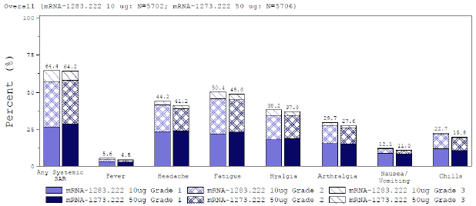
Unsolicited adverse events
The incidence of unsolicited adverse events was similar in both groups across 28 days after vaccination, being 12.3% and 11.9% in the mRNA-1283 and mRNA-1273 groups respectively. In both groups the most frequently reported adverse event was infections and infestations, particularly upper respiratory tract infections (URTIs) (1.4% in mRNA-1283 and 1.5% in the mRNA-1273).
There were no reports of myocarditis or pericarditis in the mRNA-1283 group. There were no trends in adverse event reporting identified in subjects aged under 18 years.

Japanese sub-study: Study mRNA-1283-P301, Addendum (Japan)
Solicited ARs were lower in the mRNA-1283.815 group (307/343, 89.5%) than the mRNA-1273.815 group (329/346, 95.7%) within 7 days of study injection. Consequently, local and systemic solicited ARs were lower in the mRNA-1283.815 group compared with the mRNA-1273.815 group.
In both groups, the most frequently reported solicited local AR was injection site pain (291/343 [84.8%] in the mRNA-1283.815 group and 327/346 [94.5%] participants in the mRNA-1273.815 group) followed by axillary swelling or tenderness (84/343 [24.5%] participants in the mRNA-1283.815 group and 90/346 [26.0%] participants in the mRNA-1273.815 group). In both vaccine groups, the most frequently reported solicited systemic ARs were fatigue (175/343 [51.0%] in the mRNA-1283.815 and 220/346 [63.6%] in the mRNA-1273.815 groups), followed by headache (146/343 [42.6%] in the mRNA-1283.815 and 194/346 [56.1%] participants and mRNA-1273.815 groups, respectively).
The highest proportion of solicited and systemic ARs were Grade 1 with no Grade 4 ARs reported.
Incidence of solicited local ARs were numerically lower in participants ≥65 years of age in the mRNA-1283.815 group (54/70 [77.1%] [95% CI: 65.6, 86.3]) compared to participants in the mRNA-1273.815 group (68/74 [91.9%] [95% CI: 83.2, 97.0]). The incidence of solicited systemic ARs were similar in participants ≥65 years of age in both vaccine groups (35/70 [50.0%] [95% CI 37.8, 62.2] for the mRNA-1283.815 group, and 44/74 [59.5%] [95% CI 47.4, 70.7] for the mRNA-1273.815 group).
The proportion of participants reporting unsolicited AEs was similar in both groups up to 28 days from study injection (24/343 [7.0%] participants in the mRNA-1283.815 and 24/346 [6.9%] participants in the mRNA-1273.815 group) and through the data cutoff date (31/343 [9.0%] participants in the mRNA-1283.815 and 27/346 [7.8%] participants in the mRNA-1273.815 group).
There were no myocarditis or pericarditis events and analysis of AESIs did not identify any safety concerns.

Study mRNA-1283-P101: Safety Results
mRNA-1283 was well tolerated in the study, with the overall safety profile consistent with the known safety profile of the mRNA-1273 comparator. The lowest dose of mRNA-1283 had the most favourable reactogenicity profile.
In Study P101, solicited ARs were reported for 20/21 (95.2%) participants in the mRNA-1283 10 μg group, 20/22 (90.9%) in the mRNA-1283 30 μg group, 21/21 (100%) participants in the mRNA-1283 100 μg group, 15/18 (83.3%) in the placebo + mRNA-1283 100 μg group, and 22/22 (100%) in the mRNA-1273 group.
The most frequently reported solicited local AR was injection site pain, followed by axillary swelling or tenderness. The most frequently reported solicited systemic ARs after any injection were fatigue and headache in all vaccine and dose groups after any injection.
In Study P101, the proportion of reported solicited local ARs was lower in the mRNA-1283 10 μg group (15/21 [71.4%]), the mRNA-1283 30 μg group (17/22 [77.3%]), and the placebo + mRNA-1283 100 μg group (14/18 [77.8%]); the proportion was higher in the mRNA-1283 100 μg group (19/21 [90.5%]) and for the mRNA-1273 group (21/22 [95.5%])
In Study P101, the highest proportion of solicited systemic ARs reported were Grade 1 or Grade 2 across all mRNA-1283 groups, with exception of the mRNA-1283 30 μg group and the mRNA-1283 100 μg group. In the mRNA-1283 30 μg group and in the mRNA-1283 100 μg group, the highest proportion of solicited systemic ARs reported were Grade 3 (9/22 [40.9%] and 12/21 [57.1%] respectively), followed by Grade 2 (8/22 [36.4%] and 7/21 [33.3%] respectively) and Grade 1 (2/22 [9.1%] and 2/21 [9.5%] respectively). No Grade 4 solicited systemic ARs were reported in the study.

Study mRNA-1283-P201: Safety Results
In Part A, mRNA-1283 (2.5, 5, and 10 μg) and mRNA-1283.211 (5 and 10 μg) were well tolerated in adults and had an overall similar reactogenicity and safety profile compared to mRNA-1273 50 μg. The incidence of solicited local and systemic ARs in the mRNA-1283 and mRNA-1283.211 groups were similar to or lower than in the mRNA-1273 group. The majority of solicited ARs were Grade 1 or Grade 2 and no Grade 4 ARs were reported. The incidence of unsolicited AEs was also similar between the mRNA-1283 and mRNA-1273 vaccine groups. No SAEs were assessed by the Investigator as related to study vaccine, and there were no AEs leading to discontinuation.
Across groups, the most frequently reported solicited local ARs were injection site pain. The highest proportion of reported solicited local ARs were Grade 1 across all vaccine groups. No Grade 4 solicited local ARs were reported in any groups. Most solicited and systemic ARs had onset on Day 1 or Day 2 after vaccination for all groups.
In Part B, both mRNA-1283 5 and 10 μg were well tolerated and the overall incidence of local and systemic reactogenicity were similar with that observed with mRNA-1273 50 μg in other studies. No SAEs were assessed by the Investigator as related to study vaccine, and no AEs leading to discontinuation were reported up to 28 days after vaccination. Two SAEs with fatal outcomes were reported (death of unknown cause and myocardial infarction); both were assessed as unrelated to the study vaccine by the Investigator.
The incidence of any solicited local ARs was lower in the mRNA-1283.529 5μg group (46/103, 44.7%) of participants compared with to the mRNA-1283.529 10 μg (69/96, 71.9%) of participants. The most frequently reported solicited local AR in both groups were injection site pain, with a higher proportion in the 10μg. The highest proportion of solicited ARs were Grade 1 followed by Grade 2. There were no Grade 3 or Grade 4 solicited ARs reported in either group. The safety and reactogenicity results, particularly for mRNA-1283 at the 10μg dose which was selected for the pivotal study was also lower compared with other higher doses of mRNA-1283 or mRNA-1273.

Treatment related adverse events (adverse drug reactions)
Identification of AEs of interest for mRNA-1283 was based on predefined events of interest for mRNA-1273 and other COVID-19 vaccines in general and included investigator-assessed AESIs and programmed MedDRA queries.
For investigator-assessed AESIs, investigators were to report unsolicited AEs as AESIs based on definitions provided in the study protocols for each of the mRNA-1283 studies.
In addition to the special events of interest, there were supplemental queries for myocarditis and pericarditis.
Table 10. Adverse Events of Special Interest in this Summary of Clinical Safety.
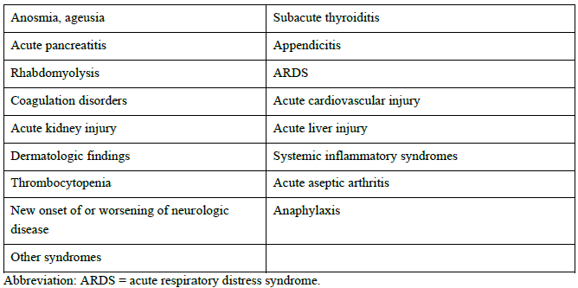
Pivotal and/or main efficacy studies
In Study P301, the proportion of unsolicited AEs that were considered related were similar across both groups (48/5706, 0.8% in the mRNA-1283.222 group compared with 52/5711, 0.9% of participants in the mRNA-1273.222 group).
There were three participants in the mRNA group who had an unsolicited AEs beyond 28 days considered related to the study vaccine: 1 participant had a nonserious arthritis and SAEs of acute septic arthritis and oligoarthritis, 1 participant with a nonserious event of hypothyroidism, and 1 participant with a nonserious event of lymphadenopathy.
Further, in Study P301, with the exception of the singular pericarditis case in mRNA-1273, there were no other acute cardiovascular injury AESIs assessed by the investigator.
Other studies
In Study P201, up to 28 days after study injection, 4/103 (3.9%) participants in the mRNA-1283.529 5 μg group and 2/97 (2.1%) participants in the mRNA-1283.529 10 μg group experienced unsolicited AEs that were assessed as related to study injection by the Investigator and all were nonserious.
There were no unsolicited AEs that occurred beyond 28 days as assessed by the investigator as related to the study vaccination (Table 11)
Table 11. Study P201: Part B: Participants Incidence of Unsolicited AEs Assessed as Related to Study Injection per Investigator by SOC and PT up to 28 days after Injection (Safety Set).
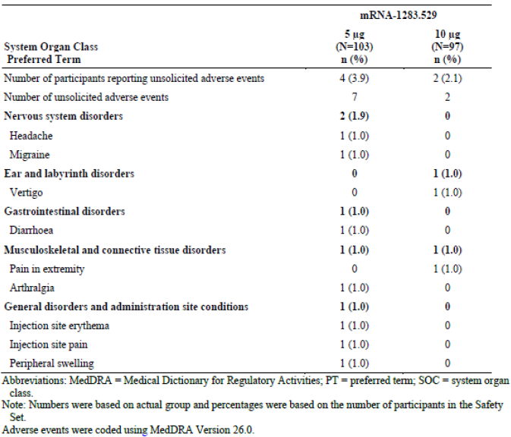

Deaths and other serious adverse events
Pivotal and/or main efficacy studies
Study P301
SAEs were similar in both groups, through 28 days of vaccination (13/5706, 0.2%) of participants in the mRNA-1283.222 group and (18/5711, 0.3%) in the mRNA-1273.222 group. Through to the data cut-off date, the incidence in the mRNA-1283.222 group was (156/5706, 2.7%) compared with 151/5711 (2.6%) of participants in the mRNA-1273.222 group.
There were 5 fatal adverse events reported in the mRNA-1283 and 10 in the mRNA-1273 arm of the study. Across these 15 fatal AEs, only 1 was considered possibly related to study drug in the mRNA-1273 arm by the investigator and not related to study drug by the Sponsor. This involved a 77yo woman with underlying cardiac disease and multiple pre-existing comorbidities.
There was 1 SAE considered related to mRNA-1283 (up to 28 days), which was a case of anaphylaxis in a 41-year-old woman, with all symptoms resolved within hours, except for diarrhoea, which resolved 2 days later. Beyond 28 days, there were 2 related SAEs in 1 participant who reported sudden left knee swelling was found by the investigator, but not the sponsor to have acute aseptic arthritis.
Other studies
Study P101
There were no deaths in the mRNA-1283 intervention groups.
Study P201
There were 2 deaths in the mRNA-1283 group, and both were assessed as not related to the study injection by the Investigator and Sponsor due to both occurring after 90 days. Further, within part B, all SAEs were reported after 28 days of study injection.
Study P301: Japanese Amendment
Up to the data cutoff data, no SAEs, severe unsolicited AEs, AESIs, or AEs leading to discontinuation were reported in either vaccine group. Up to the data extraction group, no deaths were reported in either vaccine group.

Discontinuations due to adverse events
Within Study P301, of the 5,706 participants who were dosed with mRNA-1283.222, 3 patients withdrew from the study due to an adverse event which were assessed as not related to the study vaccine. The reasons included metastatic gastric cancer, polycythaemia vera and a suicide attempt. This was in addition to the 5 participants in the mRNA-1283.222 group who were discontinued due to death.
There were no discontinuations in Study P301: Japanese Amendment due to adverse events.

Other safety issues

Safety in special populations
Age Groups
In Study P301, the incidence of unsolicited AEs was similar for both vaccine groups and consistent across age cohorts.
12-18 Paediatric Subgroup
In Study P301, within the adolescent subgroup, assessment of unsolicited AEs did not reveal any safety concerns for the adolescent population, with no differences of AEs noted between the vaccine groups (58/497, 11.7% of participants in the mRNA-1283 group vs 56/495, 11.3% in the mRNA-1273 group). Up to 28 days, no SAEs (including deaths) or AESIs were reported, and no AEs led to discontinuation for adolescents in either group.
Above 28 days, the proportion of unsolicited AEs in adolescents was similar for both groups (175/497, 35.2% in mRNA-1283 vs 150/495, 30.3% in the mRNA-1273). The rates of unsolicited AEs, SAEs and were similar across both groups. There were 1 death recorded in each group due to homicide and not related to the study vaccination.
Use in Pregnancy and Lactation
There were no studies conducted on the effects of mRNA-1283 on pregnancy and lactation.
In Study P301, 3 participants in the mRNA-1283.222 were pregnant which were pending an outcome.
In Study P201, 2 pregnancies occurred after 10 μg mRNA-1283.529 exposure (beyond 28 days after mRNA-1283 vaccination: Day 113 and 233) with 1 pregnancy reporting a full-term birth without complications for the mother and the child; the outcome of the other pregnancy is not yet known.
In Study P101, no pregnancies were reported during the study.

Risk management plan
Moderna Australia Pty Ltd has submitted EU-Risk Management Plan (RMP) version 0.1 (date 8 November 2024, DLP 2 May 2024) with Australia-Specific Annex (ASA) version 1.0 (dated 26 November 2024), in support of this submission PM-2024-05463-1-2.
The proposed summary of safety concerns and their associated risk monitoring and mitigation strategies are summarised in Table 12. The TGA may request an updated RMP at any stage of a product's life cycle, during both the pre-approval and post-approval phases.
Table 12. Summary of safety concerns.
Summary of safety concerns |  | Pharmacovigilance |  | Risk minimisation
 |  | Routine | Additional | Routine | Additional
Important identified risks | None | - | - | - | -
Important potential risks | Myocarditis | ✓ | ✓* | ✓ | -
Important potential risks | Pericarditis | ✓ | ✓* | ✓ | -
Missing information | Use in pregnancy | ✓ | - | ✓ | -
Missing information | Long-term safety | ✓ | ✓* | - | -
* mRNA-1283-P301 and mRNA-1283-P901
RMP evaluator recommendations regarding condition/s of registration
The mNEXSPIKE EU-Risk Management Plan (RMP) version 0.1 (date 8 November 2024, DLP 2 May 2024) with Australia-Specific Annex (ASA) version 1.0 (dated 26 November 2024), included with submission PM-2024-05463-1-2, and any subsequent revisions, as agreed with the TGA will be implemented in Australia.
Further information regarding the TGA’s risk management approach can be found in risk management plans for medicines and biologicals and the TGA's risk management approach. Information on the Australia-specific annex (ASA) can be found on the TGA website.

Risk-benefit analysis

Delegate’s considerations
mRNA-1283 is a reformulation of mRNA COVID vaccine that includes a number of significant changes to the coding sequence. The dossier provides sufficient evidence that the efficacy of the new formulation was non-inferior to the current mRNA-1273 formulation in a population over the age of 12 years of age. This was assessed through both relative vaccine efficacy in preventing infection with BA.4/5 COVID and generation of neutralising antibody titres.
The Sponsor has hypothesized that the revised mRNA coding in the new formulation will have a better safety profile than mRNA-1273 The Delegate considers this a reasonable proposition but notes that pre-licensure studies are unable to determine the rate of rare adverse events like myocarditis. Based on the short-term safety data in the pivotal trial, mRNA-1283 appears to have a similar safety profile to mRNA-1273 and no new safety signals were detected.
The quality and manufacturing evaluators have discussed the appropriate release specifications for mRNA-1283 with the Sponsor at some length. It is noted that the upper limit of lipid related impurities has been set for end of shelf-life, which is higher than the existing limit for mRNA-1273. However, because the amount of lipid in mRNA-1283 is lower when compared to mRNA-1273, the amount of lipid impurity permitted in mRNA-1283 is lower than in the existing product. Therefore, the Delegate has concluded that this revised limit does not raise immediate safety concerns. The tighter limits for lipid impurities at release of mRNA-1283 are material to this conclusion as this indicates that impurity levels over the current shelf-life of the product are likely to remain low, regardless of the upper limit at the end of shelf-life. The Delegate further notes, however, that irrespective of an assessment of clinical safety, relatively stringent impurity limits are important to provide assurance of consistency between manufactured batches which, in this case, may be produced at a newly commissioned site.
The Delegate notes that the quality and manufacturing evaluators have specified the limits for relative protein expression in mRNA-1283; indicating to the Sponsor that they will align with the approved EMA limits. The Delegate understands that they have contacted the EMA to provide their specifications. However, it is not clear how rapidly the EMA will respond to the TGA’s correspondence. The Delegate notes that the limits appear to have been proposed by the Sponsor prior to 20 November, and it is not clear on what basis the Sponsor has subsequently proposed reducing the lower limit.
The Delegate is of the view that, regardless of the EMA position, the agreed upon limit is an acceptable specification for protein expression and that the Sponsor can be reasonably expected to be able to comply with these limits at the proposed shelf-life for mRNA-1283. While the Delegate feels it would be reasonable to adopt the EMA limits for the purposes of consistency and is willing to do so in accordance with the TGAs position in communication with the Sponsor, they do not consider alignment with the EMA necessary to fulfil legislative requirements under the Therapeutic Goods Act (1989). That being so, the Delegate is mindful of the need to resolve this application within a reasonable timeframe and so will not delay decision making until confirmation of the release limits is available from the EMA. Unless such confirmation is available from the EMA by the time a decision on this application would otherwise be made, the Delegate will approve the specification for relative protein expression.
The Delegate notes that the description of Study 301 in the draft Product Information document submitted by the Sponsor refers to mNEXSPIKE XBB1.5, as opposed to mNEXSPIKE (mRNA-1283.222, the study drug). The vaccines tested in this trial were BA.4/5 coded. This is acceptable for the purposes of concluding non-inferiority to the existing mRNA-1273 vaccine in a head-to-head trial, but it is misleading to suggest the numerical results (i.e. infection rates etc) have been demonstrated to apply to XBB.1.5 COVID. The approved PI will, therefore, refer only to the strains that were actually tested in that study in the description of the clinical trials data.

Proposed action
The Delegate intends to approve the application to register mRNA-1283 for the indication
Active immunisation to prevent coronavirus disease 2019 (COVID-19) caused by SARS-CoV-2 in individuals 12 years of age and older.
The use of this vaccine should be in accordance with official recommendations.
The approved specifications for the product will be as set out as per correspondence with the TGA unless confirmation of different specifications for percentage protein expression is received from the EMA prior to the decision date. In this latter case this limit will be approved in accordance with the EMA standard.
The approved Product Information will be amended from that provided by the Sponsor in sequence 0008 as set out in the Discussion of this Overview. The Sponsor is invited to provide clean and annotated versions of an appropriately amended product information document to TGA by 10 December 2025 as this will facilitate timely resolution of this application.

Assessment outcome
Based on a review of quality, safety, and efficacy, the TGA decided to register mNEXSPIKE XBB.1.5 (SARS-CoV-2 spike protein (mRNA) XBB.1.5) COVID-19 Vaccine, 10 micrograms in 0.2 mL, suspension for injection, prefilled syringe. The approved indication for this therapeutic good is:
mNEXSPIKE XBB.1.5 (SARS-CoV-2 spike protein (mRNA) XBB.1.5) COVID-19 Vaccine is indicated for:
Active immunisation to prevent coronavirus disease 2019 (COVID-19) caused by
SARS-CoV-2 in individuals 12 years of age and older.
The use of this vaccine should be in accordance with official recommendations.

Specific conditions of registration
- mNEXSPIKE (SARS-CoV-2 spike protein (mRNA) XBB.1.5) is to be included in the Black Triangle Scheme. The PI and CMI for mNEXSPIKE must include the black triangle symbol and mandatory accompanying text for five years, which starts from the date of first supply of the product.
- The mNEXSPIKE EU-Risk Management Plan (RMP) version 0.1 (date 8 November 2024, DLP 2 May 2024) with Australia-Specific Annex (ASA) version 1.0 (dated 26 November 2024), included with submission PM-2024-05463-1-2, and any subsequent revisions, as agreed with the TGA will be implemented in Australia.
- An obligatory component of risk management plans is routine pharmacovigilance. Routine pharmacovigilance includes the submission of periodic safety update reports (PSURs).
Unless agreed separately between the supplier who is the recipient of the approval and the TGA, the first report must be submitted to TGA no later than 15 calendar months after the date of the approval letter. The subsequent reports must be submitted no less frequently than annually from the date of the first submitted report until the period covered by such reports is not less than three years from the date of the approval letter. The annual submission may be made up of two PSURs each covering six months. If the sponsor wishes, the six-monthly reports may be submitted separately as they become available.
If the product is approved in the EU during the three years period, reports can be provided in line with the published list of EU reference dates no less frequently than annually from the date of the first submitted report until the period covered by such reports is not less than three years from the date of this approval letter.
The reports are to at least meet the requirements for PSURs as described in the European Medicines Agency’s Guideline on good pharmacovigilance practices (GVP) Module VII-periodic safety update report (Rev 1), Part VII.B Structures and processes. Note that submission of a PSUR does not constitute an application to vary the registration. Each report must be submitted within ninety calendar days of the data lock point for that report.
- Quality
  - GMP clearance for listed manufacturers: All relevant manufacturing sites require approved and current GMP Clearances prior to Australian supply. A commitment is required from the Sponsor that they maintain the validity of all manufacturer GMP Clearances for the duration of product supply to Australia. Additionally, that adherence to the conditions of GMP Clearance approval is upheld.
  - Post-approval stability protocol and stability commitment: The manufacturer has provided commitment to continue the ongoing stability studies presented in the stability studies protocol. Additionally, one (1) batch of DP per year for all relevant products will be placed on long-term stability program and on accelerated stability testing where significant changes are made to the manufacturing process. The manufacturer has committed to communicate any out of specifications stability test results to the TGA.
- Batch Release Testing and Compliance with Certified Product Details
It is a condition of registration that all independent batches of:
  - mNEXSPIKE XBB.1.5 (SARS-CoV-2 spike protein (mRNA) XBB.1.5) COVID-19 VACCINE, 10 micrograms in 0.2 mL, suspension for injection, pre-filled syringe [AUST R 471090]
imported into Australia are not released for sale until samples and the manufacturer’s release data have been assessed and you have received notification acknowledging release from the Laboratories Branch, Therapeutic Goods Administration.
For each independent batch of the product imported into Australia, the Sponsor must supply the following:
  - A completed Request for Release Form, available from vaccines@health.gov.au
  - Complete summary protocols for manufacture and QC, including all steps in production in the agreed format.
  - At least thirty (30) prefilled syringes (PFS; Samples) of each manufacturing batch of the above listed vaccine with the Australian approved labels, PI, and packaging (unless an exemption to supply these has been granted) representative of all batches of product seeking distribution in Australia.
  - At least ten (10) PFS (Samples) of any further consignments of a manufacturing batch of the above listed vaccine with the Australian approved labels, PI and packaging (unless an exemption to supply these has been granted). Further consignments cover batches previously supplied to TGA for the purposes of batch release testing but are seeking to be supplied again.
  - If the manufacturing batch has been released in Europe or United Kingdom a copy of the EU Official Control Authority Batch Release (OCABR) certificate (or equivalent from the UK) must be provided.
  - Any reagents, reference material and standards required to undertake testing, as requested by Laboratories Branch, TGA.
Sponsors must provide all requested Samples and data in sufficient time (at least 5 business days) prior to any distribution date to allow the TGA to perform testing and review. Distribution of each batch of vaccine is conditional upon fulfilment of these conditions and receipt of a letter from the Laboratories Branch acknowledging release.
Samples and data should be forwarded to the Biotherapeutics Section, Laboratories Branch before release of each batch and with sufficient lead time to allow for Laboratories Branch testing. The address for courier delivery is:
ATTN: Batch Release Coordinator
Batch Release Unit
TGA Laboratories Branch
1 Tindal Lane
Canberra Airport
ACT 2609
The shipments (including reagents) to TGA are the responsibility of the Australian Sponsor/Agent who will be required to facilitate the import and customs clearance process.
- Certified Product Details
An electronic copy of the Certified Product Details (CPD) as described in Guidance 7: Certified Product Details of the Australian Regulatory Guidelines for Prescription Medicines (ARGPM) https://www.tga.gov.au/guidance-7-certified-product-details should be provided upon registration of the therapeutic good. In addition, an updated CPD, for the above products incorporating the approved changes is to be provided within one month of the date of approval letter. A template for preparation of CPD for biological prescription medicines and Vaccines can be obtained from the TGA website https://www.tga.gov.au/form/certified-productdetails-cpd-biological-prescription-medicines . The CPD should be sent as a single bookmarked PDF document to Vaccines@health.gov.au as soon as possible after registration/approval of the product or any subsequent changes as indicated above.

Product Information and Consumer Medicine Information
For the most recent Product Information (PI) and Consumer Medicine Information (CMI), please refer to the TGA PI/CMI search facility.

Therapeutic Goods Administration
PO Box 100 Woden ACT 2606 Australia
Email: info@tga.gov.au Phone: 1800 020 653 Fax: 02 6203 1605
https://www.tga.gov.au
Reference/Publication #

This is the original indication proposed by the sponsor when the TGA commenced the evaluation of this submission. It may differ to the final indication approved by the TGA and registered in the Australian Register of Therapeutic Goods.
The SARS-CoV-2 virus will, in keeping with common vernacular usage, be referred to as ‘COVID’ in this document unless a distinction between the virus and the clinical syndrome it causes is required.
Chalkias S, Dennis P, Petersen D et al. (2025) Efficacy, immunogenicity, and safety of a next-generation mRNA-1283 COVID-19 vaccine compared with the mRNA-1273 vaccine (NextCOVE): results from a phase 3, randomised, observer-blind, active-controlled trial. The Lancet Infectious Diseases. 25; 1230-1242. https://doi.org/10.1016/S1473-3099(25)00236-1

