Australian Public Assessment Report for Ekterly
  - Active ingredient: sebetralstat
  - Sponsor: JACE Pharma Pty Ltd
April 2026

About the Therapeutic Goods Administration (TGA)
- The Therapeutic Goods Administration (TGA) is part of the Australian Government Department of Health, Disability and Ageing and is responsible for regulating therapeutic goods, including medicines, medical devices, and biologicals.
- The TGA administers the Therapeutic Goods Act 1989 (the Act), applying a risk management approach designed to ensure therapeutic goods supplied in Australia meet acceptable standards of quality, safety, and efficacy.
- The work of the TGA is based on applying scientific and clinical expertise to decision-making, to ensure that the benefits to the Australian public outweigh any risks associated with the use of therapeutic goods.
- The TGA relies on the public, healthcare professionals and industry to report problems with therapeutic goods. The TGA investigates reports received to determine any necessary regulatory action.
- To report a problem with a therapeutic good, please see the information on the TGA website.

About AusPARs
- The Australian Public Assessment Report (AusPAR) provides information about the evaluation of a prescription medicine and the considerations that led the TGA to approve or not approve a prescription medicine submission. Further information can be found in Australian Public Assessment Report (AusPAR) guidance.
- AusPARs are prepared and published by the TGA.
- AusPARs are static documents that provide information that relates to a submission at a particular point in time. The publication of an AusPAR is an important part of the transparency of the TGA’s decision-making process.
- A new AusPAR may be provided to reflect changes to indications or major variations to a prescription medicine subject to evaluation by the TGA.

Copyright
© Commonwealth of Australia 2026
This work is copyright. You may reproduce the whole or part of this work in unaltered form for your own personal use or, if you are part of an organisation, for internal use within your organisation, but only if you or your organisation do not use the reproduction for any commercial purpose and retain this copyright notice and all disclaimer notices as part of that reproduction. Apart from rights to use as permitted by the Copyright Act 1968 or allowed by this copyright notice, all other rights are reserved and you are not allowed to reproduce the whole or any part of this work in any way (electronic or otherwise) without first being given specific written permission from the Commonwealth to do so. Requests and inquiries concerning reproduction and rights are to be sent to the TGA Copyright Officer, Therapeutic Goods Administration, PO Box 100, Woden ACT 2606 or emailed to <tga.copyright@tga.gov.au>.

Contents
List of abbreviations 4
Product submission 5
Submission details 5
Product background 6
Disease or condition 6
Current treatment options 6
Clinical rationale 6
Regulatory status 7
Australian regulatory status 7
International regulatory status 7
Registration timeline 7
Assessment overview 8
Quality evaluation summary 8
Nonclinical evaluation summary 9
Clinical evaluation summary 11
Pharmacology 11
Efficacy 15
Safety 21
Risk management plan 24
Risk-benefit analysis 24
Assessment outcome 25
Specific conditions of registration 25
Product Information and Consumer Medicine Information 26

List of abbreviations
Abbreviation | Meaning
ARTG | Australian Register of Therapeutic Goods
AUC | Area under concentration-time curve
AUC0-inf | AUC extrapolated to infinity
AUC0-t | AUC from time of dosing to time of last measurable concentration
CL/F | Apparent total clearance of the drug from plasma after oral administration
Cmax | Maximum concentration
CMI | Consumer Medicines Information
Evaluator | A technical expert employed at the TGA who assesses the safety, quality, and efficacy of medicines and medical devices before they are approved for the Australian market.
Delegate | The Delegate of the Secretary of the Department of Health, Disability and Ageing who decided the submission under section 25 of the Act.
HAE | Hereditary angioedema
IMP | Investigational medicinal product
PGI-C | Patient Global Impression of Change
PI | Product Information
PK | Pharmacokinetics
RMP | Risk management plan
TGA | Therapeutic Goods Administration
Tmax | Time to C_{max}
V_{z}/F | Apparent volume of distribution during the terminal phase after oral drug administration

Product submission

Submission details
Type of submission: | New chemical entity
Product names: | Ekterly
Active ingredient: | sebetralstat
Decision: | Approved
Date of decision: | 9 October 2025
Approved therapeutic use for the current submission: | Ekterly is indicated for the treatment of hereditary angioedema (HAE) attacks caused by C1 inhibitor deficiency or dysfunction in patients aged 12 years and older.
Date of entry onto ARTG: | 19 November 2025
ARTG number: | 462847
Black Triangle Scheme | Yes
Sponsor’s name and address: | JACE Pharma Pty Ltd, Level 2, 8 Clunies Ross Court Brisbane Technology Park, Eight Mile Plains, Queensland 4113
Dose form: | Film-coated tablet
Strength: | Each film-coated tablet contains 300 mg sebetralstat
Container: | Tablets are packed in Oriented Polyamide/Aluminum/Polyvinyl Chloride (oPA/Al/PVC) with aluminium lidding blisters (1 tablet per blister).
Pack size: | Four or six tablets
Route of administration: | Oral
Dosage: | 300 mg administered at the earliest recognition of an attack. A second dose of 300 mg may be taken at least 3 hours after the first dose if response is inadequate, or if symptoms worsen or recur.  For further information regarding dosage, refer to the Product Information.
Pregnancy category: | Category D  Drugs which have caused, are suspected to have caused or may be expected to cause, an increased incidence of human fetal malformations or irreversible damage. These drugs may also have adverse pharmacological effects. Accompanying texts should be consulted for further details.  The use of any medicine during pregnancy requires careful consideration of both risks and benefits by the treating health professional. The pregnancy database must not be used as the sole basis of decision making in the use of medicines during pregnancy. The TGA does not provide advice on the use of medicines in pregnancy for specific cases. More information is available from obstetric drug information services in your state or territory.

Product background
This AusPAR describes the submission by JACE Pharma Pty (the Sponsor) to register Ekterly (sebetralstat) for the following proposed indication:
Ekterly is for 'the treatment of hereditary angioedema (HAE) attacks in adult and adolescents aged 12 years and older’.

Disease or condition
Hereditary angioedema generally refers to a genetic condition which is either inherited as an autosomal dominant (75% of cases) or occurs from spontaneous mutations (25%) and results in dysfunctional C1 inhibitor regulation of bradykinin production. HAE either results in reduced levels of C1 inhibitor (Type 1 HAE, 85% of cases) or mutation of C1 inhibitor (Type II HAE, 15% of cases), leading to excess production of bradykinin. There are also types of HAE syndrome with normal C1 inhibitor levels which may not be due to bradykinin production (e.g. type III HAE).
HAE is characterised by ‘attacks’ which can, but do not necessarily, occur following an identified trigger such as stress, trauma, infection, menstruation, pregnancy or medications. Attacks produce general signs of inflammation such as skin swelling, abdominal pain, submucosal oedema or upper airways swelling. The latter can produce potentially life-threatening airways obstruction if not treated. Attacks develop over 12-36 hours and can, if untreated, last 2-5 days before subsiding.
The unpredictable, sometimes frequent and severe nature of HAE attacks has a significant impact on the quality of life of people with HAE.

Current treatment options
Treatment of acute HAE attacks depends on severity and the body part affected, and compromise of the airways can require urgent intervention independent of controlling the HAE attack itself.
To terminate or reduce the severity of HAE attacks plasma or recombinant C1 inhibitor concentrates (e.g. Berinert) can be administered to lower bradykinin levels.
In recent years a number of medications have been developed which are either plasma kallikrein inhibitors (e.g. landelumab) or bradykinin antagonists (e.g. icatibant). sebetralstat would be the first oral on-demand treatment, for use when an attack starts, registered in Australia.

Clinical rationale
Bradykinin is a bioactive peptide produced through the kinin–kallikrein system via the enzymatic cleavage of precursor proteins called kininogens.
Plasma kallikrein is responsible for the vascular production of bradykinin. It circulates in the blood as an inactive zymogen, prekallikrein. It is activated into plasma kallikrein primarily by Factor XIIa. It specifically cleaves high molecular weight kininogens to release bradykinin directly.
Sebetralstat is a novel small molecule inhibitor of human plasma kallikrein (PKa). Following oral administration, it is rapidly absorbed, resulting in near complete suppression of plasma kallikrein activity, thereby inhibiting the cleavage of high molecular weight kininogens to bradykinin. The Sponsor proposes that sebetralstat prevents spontaneous activation of the kallikrein kinin system via reduced bradykinin production which suppresses vascular permeability and subsequent edema in mucosal and/or subcutaneous tissues.

Regulatory status

Australian regulatory status
This product is considered a new chemical entity for Australian regulatory purposes.

International regulatory status
At the time the TGA considered this submission, a similar submission had been considered by other regulatory agencies. Table 1 summarises these submissions.
Table 1. International regulatory status at the time the TGA considered this submission
Country | Date of Submission / Intent to submit | Date of Approval | Proposed indication
USA | 17 June 2024 | N/A – review ongoing | For the treatment of hereditary angioedema (HAE) attacks in adult and paediatric patients aged 12 years and older.
EU/EEA – Centralised Procedure | 25 July 2024 | N/A – review ongoing | For the treatment of hereditary angioedema (HAE) attacks in adult and adolescents aged 12 years and older.
United Kingdom | 30 September 2024 | N/A – submission pending | For the treatment of hereditary angioedema (HAE) attacks in adult and adolescents aged 12 years and older.
Singapore | 13 September 2024 | N/A – submission pending | For the treatment of hereditary angioedema (HAE) attacks in adult and adolescents aged 12 years and older.
Switzerland | 30 September 2024 | N/A – submission pending | For the treatment of hereditary angioedema (HAE) attacks in adult and adolescents aged 12 years and older.

Registration timeline
Table 2 captures the key steps and dates for this submission.
Ekterly with its proposed indication was given orphan drug designation on 2nd August 2024.
Table 2. Timeline for Ekterly (sebetralstat), submission PM-2024-04190-1-2
Description | Date
Designation (Orphan) | 2 August 2024
Submission dossier accepted evaluation commenced | 30 October 2024
Evaluation completed | 11 July 2025
Registration decision (Outcome) | 9 October 2025
Registration in the ARTG completed | 19 November 2025
Number of working days from submission dossier acceptance to registration decision* | 183
*Statutory timeframe for standard submissions is 255 working days

Assessment overview
This submission was evaluated as part of the Australia-Canada-Singapore-Switzerland-United Kingdom (ACCESS) Consortium with work-sharing between the TGA, Health Sciences Authority Singapore, Swissmedic and the Medicines and Healthcare Products Regulatory. Each regulator made independent decisions regarding approval (market authorisation) of the new medicine.

Quality evaluation summary
Sebetralstat (INN/USAN) is a white to off-white, slightly hygroscopic crystalline solid. The molecular formula is C₂₆H₂₆FN₅O₄ with relative molecular mass 491.52 (Figure 1). Aqueous solubility is low across neutral conditions, with increased solubility at low pH.
Figure 1. Structure of sebetralstat
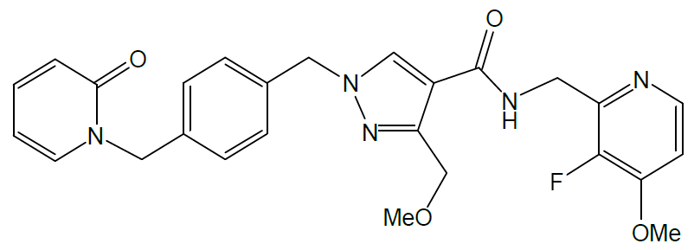
The manufacturing route is described as a convergent, eight-step chemical synthesis. Three starting materials are used to generate two key intermediates, which are coupled to form sebetralstat. The control strategy is built around identification of critical steps and parameters that directly affect impurity formation, reaction completeness, and solid-state outcome, supported by in-process controls and intermediate specifications. Starting material selection and control are described in line with ICH Q11 principles.
Starting material specifications have been developed to assure that named impurities are readily purged and other impurities are controlled. Impurity control is presented across structurally related organic impurities, residual reagents/solvents, potential mutagenic (genotoxic) impurities, and elemental impurities, aligned to relevant ICH guidance. The control strategy combines drug substance specification controls (e.g., 2-chloropropane) with upstream controls in starting material and intermediate specifications, consistent with an ICH M7 approach. Residual solvents (including cleaning solvents, process solvents, and solvents potentially formed during processing) are controlled using limits set according to ICH Q3C.
The drug product is an oral, immediate-release, film-coated tablet containing 300 mg of sebetralstat. There are no novel excipients and no excipients of human or animal origin; excipients used are noted as being present in medicines approved for children aged 12 years and older.
The drug product control strategy comprises standard tests for identity, assay, impurities/degradants, dissolution, uniformity, and key physical attributes, with stability specifications aligned to release criteria and defined acceptance limits. Degradants and specified/unspecified impurities are controlled per the specification, and limits are supported through toxicological assessment and ICH aligned justification. Validated or qualified chromatographic methods are used for assay and impurities, and dissolution testing is performed using the defined acidic medium and conditions described for routine quality control.
The container closure system described includes a high density polyethylene (HDPE) bottle with a polypropylene child resistant closure and induction seal liner, with silica gel desiccant included, providing moisture protection consistent with the product’s hygroscopicity considerations.
The stability program described includes long term and accelerated studies on representative commercial or registration batches in the proposed commercial packaging configuration. Monitored attributes include assay, impurities/degradants, dissolution, moisture and physical properties, and appearance (including coating) against defined acceptance criteria. Based on the reported stability outcomes, the data support a shelf life of 36 months for the sebetralstat 300 mg film-coated tablets packed in oPA/Al/PVC/Al blisters.
The application and the supporting data relating to the composition, development, manufacture, quality control, stability and bioavailability of the product have been assessed and checked for compliance, as applicable, with Australian legislation and requirements for new medicines and in accordance with pharmacopoeial standards and the technical guidelines adopted by the TGA.
There are no objections to the registration of sebetralstat from a quality perspective.

Nonclinical evaluation summary
The nonclinical package was considered adequate in scope and consistent with ICH M3(R2). All pivotal safety-related studies were GLP compliant.
In vitro, sebetralstat demonstrated nanomolar affinity for human plasma kallikrein PKa (Ki ~3 nM) with rapid association/dissociation kinetics, inhibited PKa activity in activated human plasma (including plasma from individuals with HAE; IC₅₀ values in the tens of nM range), and prevented Factor XIIa generation. sebetralstat recognises mouse, rat and cynomolgus monkey PKa with comparable affinity to human, although not all common laboratory species were pharmacologically relevant. Broad secondary pharmacology screening did not identify clinically relevant off-target activity and selectivity over related serine proteases was reported as high.
No specific animal model for HAE was available during development; instead, a rat carrageenan-induced paw oedema model was used as a general inflammation/oedema model and showed dose-dependent inhibition when dosed prior to inflammatory challenge. Dedicated safety pharmacology studies assessed CNS, respiratory and cardiovascular endpoints. No adverse CNS or respiratory findings were observed in rats at high doses, and no treatment-related effects on ECG, blood pressure or heart rate were seen in monkeys at tested doses in the dedicated cardiovascular study. hERG channel inhibition was not considered clinically concerning at relevant concentrations (per reported margins).
In animals, sebetralstat showed moderate oral bioavailability overall, with T_{max} generally within 1.5 hours after dosing. Half-life was short by the IV route (about 1 hour or less) and longer after oral dosing; human oral half-life was reported as longer than in key nonclinical species. Plasma protein binding was high in rodents (mid 90% range) and lower in humans (~77%) and non-human primates (NHPs;~62%). Distribution of radiolabel in rats after oral dosing was rapid and widespread, with highest non-GI concentrations in liver, kidney and adrenal gland, and limited brain penetration.
Metabolism occurred mainly via O-desmethylation and oxidative transformations, with no unique human metabolites reported. Metabolism is primarily mediated by CYP3A4 with a lesser contribution from CYP2C8. Excretion was predominantly faecal in rats and NHPs (with minor urinary contribution), whereas in humans both faecal and urinary excretion contribute. As a CYP3A4 substrate, inhibitors/inducers may increase/decrease exposure. sebetralstat was also identified as a substrate of transporters (including BCRP and P-gp) in vitro, and inhibitors may alter exposure (noted as minor in some clinical studies per the report summary). In vitro data also suggested potential inhibition of multiple enzymes/transporters (including CYP2C9/CYP3A4 and several uptake/efflux transporters), which were flagged for consideration in the Product Information document.
No dedicated single-dose toxicity studies were conducted. Repeat-dose oral toxicity studies were conducted in rats (up to 26 weeks, plus a 2 year carcinogenicity study) and cynomolgus monkeys (up to 26 weeks), and were considered appropriately designed (species, dose selection, duration and endpoints). Highest doses in pivotal repeat-dose studies produced systemic exposures to unbound sebetralstat above those in patients at the maximum recommended human dose (MRHD) of 900 mg/day, with higher margins in rats than in NHPs. Target organs included liver (principal target in NHPs) and, in rats, liver as well as kidney, adrenal, ovary and thyroid (generally minimal severity). Liver findings included hepatocellular hypertrophy and related clinical pathology changes (for example, liver enzymes/bilirubin changes), with evidence of partial or complete reversibility after recovery. Some findings (such as certain organ weight changes in rats at high dose) were noted without a clear histopathologic correlate, and overall interpretation emphasised minimal severity, reversibility and clinical relevance in the context of exposure margins.
Genotoxicity was assessed in a standard battery (including Ames testing, in vitro mammalian cell gene mutation/chromosomal damage testing, and an in vivo rat micronucleus test) and was negative. Carcinogenicity studies were conducted in transgenic rasH2 mice (26 weeks) and rats (104 weeks). No treatment-related increase in malignant tumours was observed and the overall conclusion was that sebetralstat was not carcinogenic in mice or rats. Treatment-related benign tumours were reported in rats at higher doses (including findings in liver, thyroid, pituitary, ovary and testes) and were interpreted alongside non-neoplastic changes as suggestive of an adaptive hepatic response and mild hormonal perturbation.
In rats, no effects on male or female fertility were observed up to the highest dose tested in fertility studies (as summarised in the report). In embryofetal development studies, rat findings included embryofetal toxicity and malformations at higher doses/exposures (including fetal deaths and structural malformations), and this was treated as a key nonclinical safety concern. In rabbits, decreased fetal body weight and fetal malformations were reported; however, rabbits are not a pharmacologically relevant species for PKa binding, creating uncertainty regarding attribution. Placental transfer was described as limited in rats, and drug-related radioactivity was detected in milk in lactating rats at concentrations broadly similar to plasma. A juvenile rat study did not show increased sensitivity relative to adults (per report summary), supporting potential future paediatric development. While the Sponsor proposed Pregnancy Category B3, the Evaluator considered Pregnancy Category D more appropriate based on rat embryofetal harm at relatively low exposure ratios and recommended stronger pregnancy/contraception statements in Product Information.
There were no objections from a nonclinical perspective to the registration of Ekterly.

Clinical evaluation summary

Pharmacology

Pharmacokinetics
The pharmacokinetics (PK) of sebetralstat were characterised in 10 pharmacology studies in healthy adults, as well as two studies in patients with HAE.
In summary, the extent of oral absorption of sebetralstat is high at >75% based on pharmacokinetic modelling and animal studies. Absorption is rapid, reaching T_{max} in 30 mins to 1 hour post-dose under fasted conditions.
The apparent volume of distribution is 208L (in study KVD900-110) and has a plasma protein binding of approximately 77% in human plasma. The majority of sebetralstat in plasma is unchanged drug, with a minor proportion of M19 and M10 metabolites present at <10% each.
About 96% of radioactivity is recovered by 216 hours post dose in faeces (63.4%) or urine (32.4%) after dosing [¹⁴C]-sebetralstat. Unchanged sebetralstat is a minor component of urine excretion (8.66% of dose) with drug being mostly metabolised prior to urinary excretion. Biliary excretion is likely given the high proportion of drug-related material recovered from faeces.
Table 3. Sebetralstat and total radioactivity pharmacokinetic parameters following administration of ¹⁴C-labelled sebetralstat (600 mg)
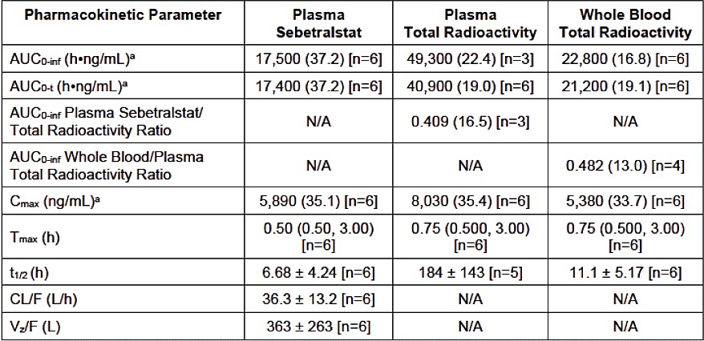
Note: AUC and C_{max} values are presented as geometric mean (geometric CV). Tmax is presented as median (minimum, maximum). All other parameters are presented as arithmetic mean + SD
ª Units for total radioactivity AUCs and C_{max} are h.ng equivalents/mL and ng equivalents/mL, respectively
The PK of sebetralstat was dose-proportional between 5 mg and 600 mg.
In vitro studies using human liver microsomes indicate that CYP3A4 is the main P450 isoform involved in sebetralstat metabolism.
In-vitro incubation of sebetralstat with ketoconazole reduced metabolism of sebetralstat >3 fold. The only other CYP isoform who inhibition had an impact on metabolism of sebetralstat was 2C8 although this was only about a 25% reduction in metabolism compared to controls.

Drug interactions
Sebetralstat is a substrate of CYP3A4. Coadministration with a strong inhibitor of CYP3A4 (Itraconazole) increased C_{max} and AUC of sebetralstat by 135% and 420%, respectively. A moderate CYP3A4 inhibitor (verapamil) increased the C_{max} and AUC of sebetralstat by 76% and 102% respectively. Co-administration with a weak CYP3A4 inhibitor (cimetidine) did not increase sebetralstat C_{max} or AUC. The Evaluator has noted that while no dose adjustment is required in patients taking strong CYP3A4 inhibitors, a single dose of 300 mg is recommended.
Coadministration of sebetralstat with a strong CYP3A4 inducer (phenytoin) reduced the C_{max} and AUC of sebetralstat by 66% and 83% respectively. A moderate CYP3A4 inducer (efavirenz) reduced the C_{max} and AUC of sebetralstat by 63% and 79% respectively. A weak CYP3A4 inhibitor (modafinil) reduced the C_{max} and AUC of sebetralstat by 11% and 21% respectively. The Clinical Evaluator has noted that in patients taking strong or moderate CYP3A4 inducers, a single dose of 900 mg is recommended.

Food effect
In KVD900-101, sebetralstat was rapidly absorbed, with median T_{max} approximately 1 hour under fasted conditions. When administered under fed conditions, with a high-fat, high-calorie breakfast, the observed median T_{max} was at 2.5 hours. No food effect was observed on overall plasma exposure (area under the concentration versus time curve [AUC]). Despite the impact of food on T_{max}, no clinically significant food effect was observed on the pharmacodynamic (PD) profile of sebetralstat 600 mg administered in fed and fasted states in KVD900-101.

Predicted effects of stomach pH on PK
A physiologically based pharmacokinetic (PBPK) model was developed to estimate the effect of stomach PH on the PK of sebetralstat. The model was validated against data in several clinical studies. In the fasted state, at a dose level of 300 mg, with an increase of pH from the baseline value of 1.3 to 4.0, predicted C_{max} decreased by 25%, AUC_{0-inf} decreased by 6%, and T_{max} moved from 0.88 to 1.2 hours. In the fed state, C_{max}, AUC_{0-inf} and T_{max} were all predicted to be insensitive to an increase in stomach pH from 3.0 to 6.4.

Population pharmacokinetic data
A population PK (PPK) analysis was conducted using data from several healthy volunteer studies and one in HAE patients (KVD900-201) to identify any significant factors affecting the PK of the medication.
Table 4. Clinical studies included in the PPK analysis for sebetralstat
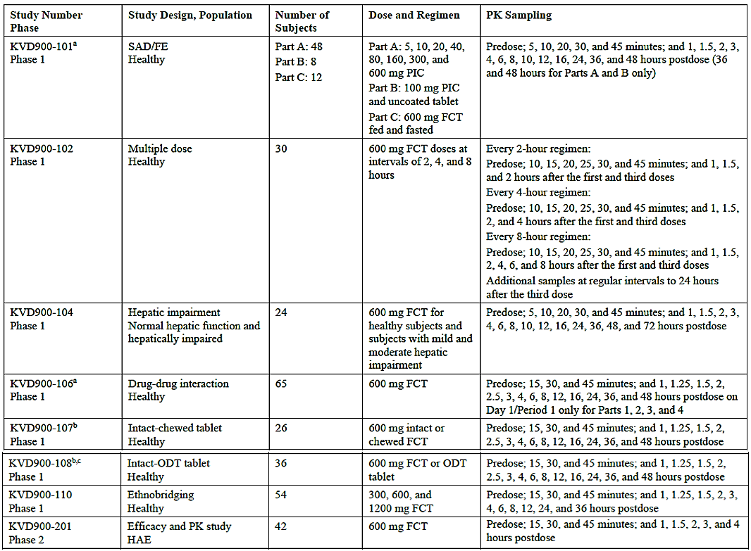
Most covariates examined had minimal impact on sebetralstat. Renal impairment had a minimal effect on systemic sebetralstat exposure. There was a minimal effect of age, sex or race.
The effect of hepatic impairment on sebetralstat was examined in data from PK study KVD900-104 that administered a single dose of 600 mg sebetralstat to 24 participants stratified by Child-Pugh classification of hepatic impairment.
Figure 2. Plasma concentrations of sebetralstat in KVD900-104 in patients with differing grades of hepatic impairment.
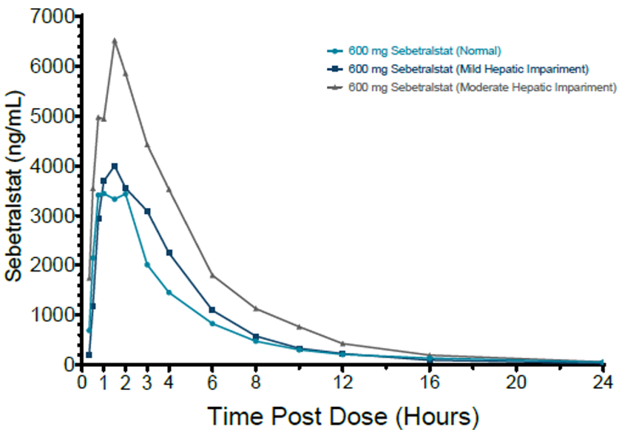
C_{max} and AUC were increased in patients with moderate hepatic impairment compared to controls by a factor of about 1.6. The Clinical Evaluator concluded that no dose modification was required for mild to moderate hepatic impairment, but noted that there was no data to support use in patients with severe hepatic impairment.

Pharmacodynamics
Sebetralstat produces rapid and near-complete inhibition of plasma kallikrein activity following administration, which is the intended mechanism of action of the medication.
Figure 3. Plasma kallikrein inhibition after fed or fasted doses of sebetralstat
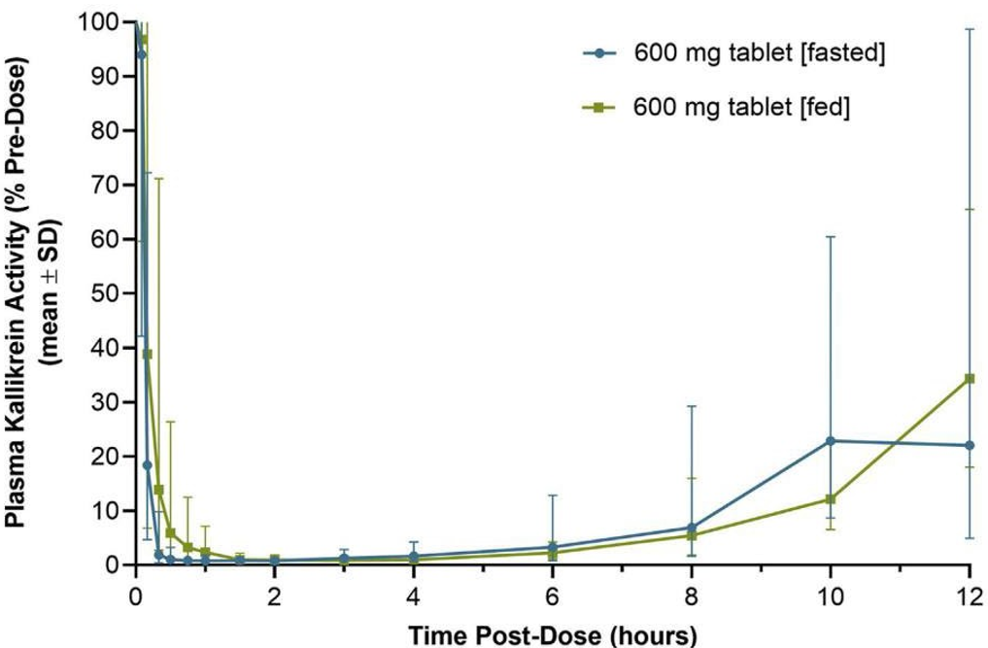
Sebetralstat produces >90% inhibition of plasma kallikrein activity rapidly after dosing in fed and fasted states. The Clinical Evaluator has noted this is significant due to the reduced T_{max} predicted in fed patients and indicates that peak sebetralstat levels are not required to achieve a drug effect. The inhibitory effect of sebetralstat is maintained for 4-6 hours.

Efficacy
Pivotal study KVD900-301 was a placebo controlled randomised controlled trial in patients 12 years and older with type I or II HAE. Patient (n=136) were equally randomised to six treatment sequences in a 3-way crossover design.
Figure 4. Design of study KVD900-301
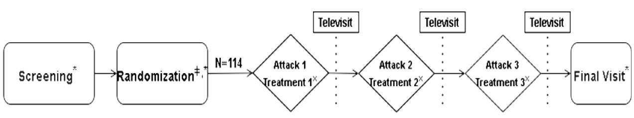
Notes:*if in-clinic visits were not possible (e.g., in the event of a pandemic, or other reasons that prevent the patient from attending in-clinic visits), home health visits were to be permitted in place of in-clinic visits. Information captured during a home health visit would mirror that captured in an in-clinic visit.
*The Randomization Visit may have occurred as a televisit or in-clinic visit.
* Patients were to contact a call center after the initial dose of IMP, prior to a second dose of IMP, and prior to a dose of conventional on-demand treatment for each treated attack.
Enrolled patients all had confirmed type I or II HAE, and patients with normal C1 inhibitor (type III HAE) were excluded. Patients receiving ongoing treatment with strong P450 CYP3A4 inhibitors or inducers were excluded.
The average age of patients was in middle age (37.7 years) with near balanced sex ratio (60:40 F:M respectively).
When patients suffered an eligible HAE attack they self-administered the study medication according to their randomised sequence over three such attacks. An eligible HAE attack was defined as:
- Not a severe laryngeal attack
- Able to identify the start time of the attack
- At least 48 hours must have elapsed since patient has used conventional on-demand treatment or investigational medicinal product (IMP) to treat an HAE attack
- Must have been able to complete at least the first 4 hours of diary assessments following the first administration of IMP
- Post-attack tele-visit must have been completed for the previous eligible attack (applicable to eligible attacks 2 and 3 only)
Table 5. Treatment sequence for six randomised arms of trial KVD900-301
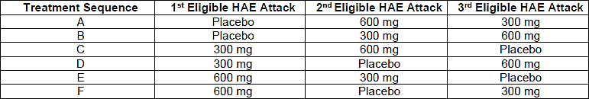
The primary objective of the study was time to beginning of symptom relief, defined as “a little better” within 12 hours of the first medication administration. This was assessed using the Patient Global Impression of Change (PGI-C) scale, a 7-point scale which change in symptoms was scored as much better, better, a little better, no change, a little worse, worse, and much worse.
Secondary endpoints included:
- Time to first incidence of decrease from baseline (2 time points in a row) within 12 hours of the first IMP administration.
- Time to complete HAE attack resolution defined as “none” within 24 hours of the first IMP administration.
These were assessed using the Patient Global Impression of Severity (PGI-S) a five-point scale of HAE symptom severity (very severe, severe, moderate, mild, none)
Table 6. Characteristics of eligible HAE attacks at onset
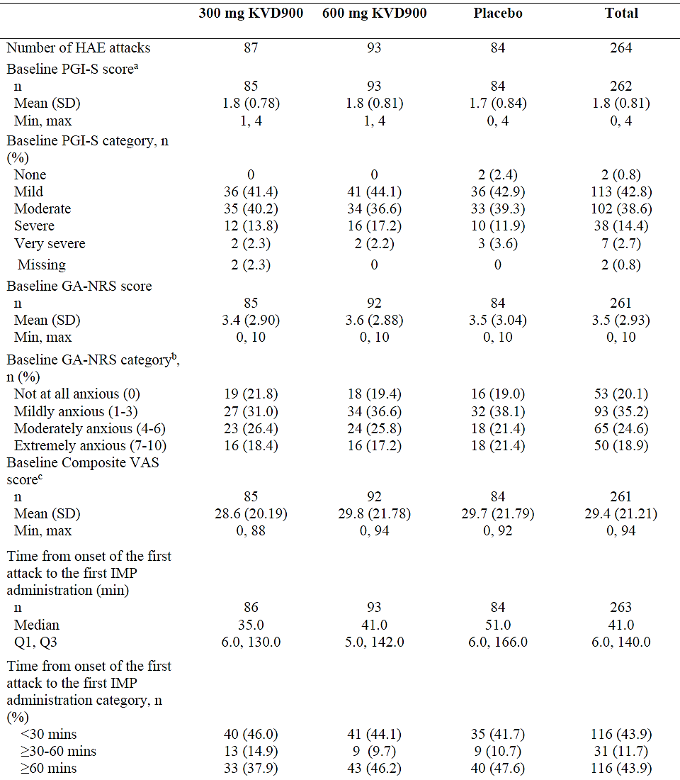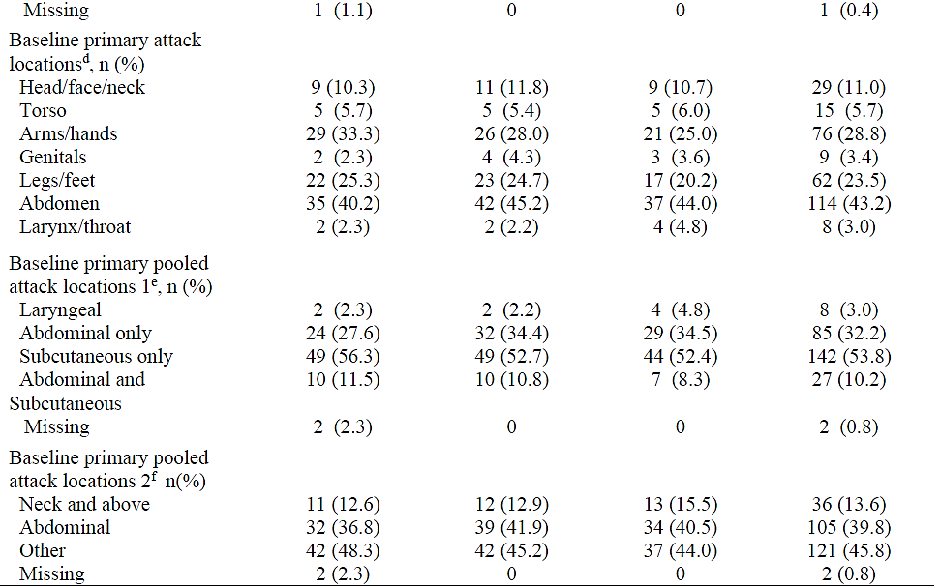
Notes: Number of HAE attacks is number of IMP-treated HAE attacks. The number of IMP-treated HAE attacks is equivalent to the number of patients in each group.
ª The PGI-S score was transformed into numeric values: 0=none, 1=mild, 2=moderate, 3=severe, and 4=very severe.
^{b} GA-NRS score was categorized into intervals: 0=not at all anxious, 1-3=mildly anxious, 4-6=moderately anxious, and 7-10=extremely anxious.
^{c} The composite VAS score was derived as the average score across the 3 symptoms (abdominal pain, skin pain, and skin swelling).
^{d} One patient could be summarized in several attack locations.
^{e} Baseline primary pooled attack locations 1 are using locations: laryngeal, an attack involving at least 1 laryngeal location, including the larynx/throat, regardless of other locations involved; abdominal only, an attack with abdomen location only; subcutaneous only, an attack with arms/hands, genitals, legs/feet, head/face/neck, or torso location(s) only; and abdominal and subcutaneous, an attack with at least 1 abdominal location and at least 1 subcutaneous location.
_{f} Baseline primary pooled attack locations 2 were using locations: neck and above, an attack involving larynx/throat or head/face/neck location(s), regardless of other locations involved; abdominal, an attack involving abdomen location and not involving larynx/throat or head/face/neck locations, regardless of other locations involved; and other, an attack involving arms/hands, genitals, legs/feet, or torso location(s) only.
A total of 264 HAE attacks were treated, of which 87 received 300 mg sebetralstat, 93 received 600 mg sebetralstat and 87 received placebo. Most attacks were mild (42.8%) or moderate (38.6%) at the time of treatment, with severe and severe attacks occurring in 14.4% and 2.7% of cases respectively.
Table 7. Time to beginning of symptom relieve (primary endpoint) study KVD900-301
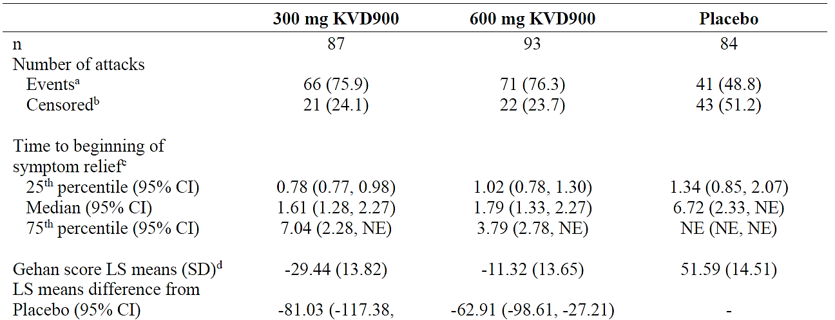
Notes: n is number of IMP-treated HAE attacks. The number of IMP-treated HAE attacks is equivalent to the number of patients in each group.
Time to the beginning of symptom relief within 12 hours was defined as an HAE attack being rated “a little better” or higher on the PGI-C for 2 time points in a row within 12 hours of the first IMP administration.
Time to the beginning of symptom relief was calculated as date/time of first rating of “a little better” or higher (i.e., better or much better) and immediately followed by another rating of “a little better” or higher (without missing values in between) – date/time of first IMP administration.
ª Attacks that achieved the described event within 12 hours.
^{b} Attacks were treated as right-censored at 12 hours if they did not achieve beginning of symptom relief defined by PGI-C as at least “a little better” (2 time points in a row) or received conventional attack treatment within 12 hours of the first IMP administration. In the case of discontinuation that prevented event “a little better” or higher HAE attack rating occurrence, patients were censored at the time of discontinuation.
^{c} Kaplan-Meier estimates for the time to the beginning of symptom relief within 12 hours.
^{d} LS means, LS means differences, p-values, and adjusted p-values from the linear mixed model used to analyze Gehan score transformation of time to beginning of symptom relief within 12 hours including terms for sequence, period, and treatment in the model as fixed effects and patient nested within the sequence as a random effect.
^{e} Adjusted P-value came from Bonferroni adjustment.
There was a statistically significant improvement in the time to the beginning of symptom relief between sebetralstat and placebo at the 300 mg and 600 mg doses. Mean time to improvement of “a little better” was 1.61 hours and 1.79 hours for the 300 mg and 600 mg doses of sebetralstat respectively, and 6.72 hours for placebo.
Table 8. Kaplan-Meier plot for HAE attack resolution within 24 hours.
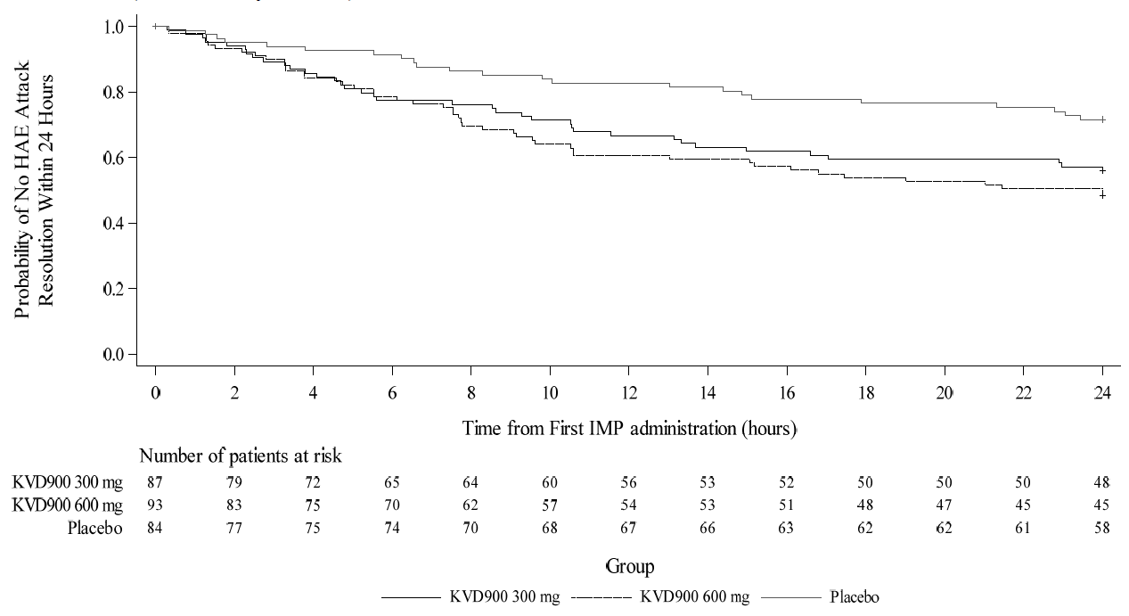
Notes: The number of patients in each group is equivalent to of IMP-treated HAE attack. Results come from Kaplan-Meier model used to analyze time to HAE attack resolution within 24 hours.
Time to HAE attack resolution (hours) = date/time of first rating of “none” – date/time of first IMP administration.
Attacks were treated as right-censored at 24 hours if they did not have a HAE attack resolution or received conventional attack treatment within 24 hours of IMP administration. In the case of discontinuation that prevented the event, attack was censored at the time of discontinuation. In the case of underivable time-to-event results due to lack of at least 1 post-baseline assessment, attacks were censored at time 0.
‘+’ Censored patient
There was a statistically significant improvement in the time to reduction in severity between 300 mg KVD900 (adjusted p=0.0036) versus placebo group and 600 mg KVD900 (adjusted p=00.0032) versus placebo group. The median (95% CI) time to reduction in severity in PGI-S score was 9.27 hours (95% CI: 4.08, not evaluable) for 300 mg KVD900 group, 7.75 hours (95% CI: 3.27, not evaluable) for 600 mg KVD900 group, and not evaluable i.e., >12 hours for placebo group.

Supportive efficacy
Study KVD900-201 was a phase II study which examined the efficacy of sebetralstat compared to placebo in terminating HAE attacks in adults. Patients (n=60) were randomised to receive one dose of sebetralstat and one dose placebo over two HAE attacks either as sebetralstat+placebo (n=30) or placebo+sebetralstat (n=30). Inclusion and exclusion criteria were similar to study KVD900-301.
The primary endpoint of the study was the time to relief from an HAE attack, assessed as the time to when the patient used conventional (e.g. non study treatment) HAE treatment within 12 hours of receiving a study treatment.
Table 9. Analysis of time to use of conventional HAE relief within 12 hours of study treatment
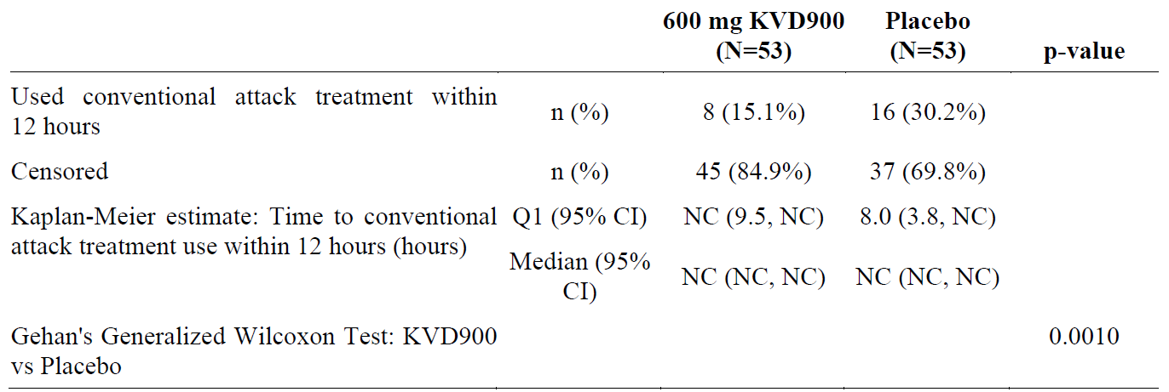
Abbreviations: CI=confidence interval; NC=non-calculable; Q1=first quartile
The denominator for each percentage is the number of subjects in the Full Analysis Set within a treatment.
Censoring occurs where a subject did not use conventional attack treatment within 12h post-study drug dosing.
When an endpoint result was NC within 12 hours, if the event did occur the event must have occurred >12 hours following study drug.
In this study 30.2% of patients receiving placebo and 15.1% of patients receiving 600 mg sebetralstat used conventional treatment within 12 hours, which was a significant difference (p=0.01)

Study KVD900-302
This was an open-label extension trial that examined the long-term use of 600 mg sebetralstat in patients 12 years and older with type I or II HAE. It included patients who had completed study KVD900-301 and new patients.
Figure 5. Design of study KVD900-302
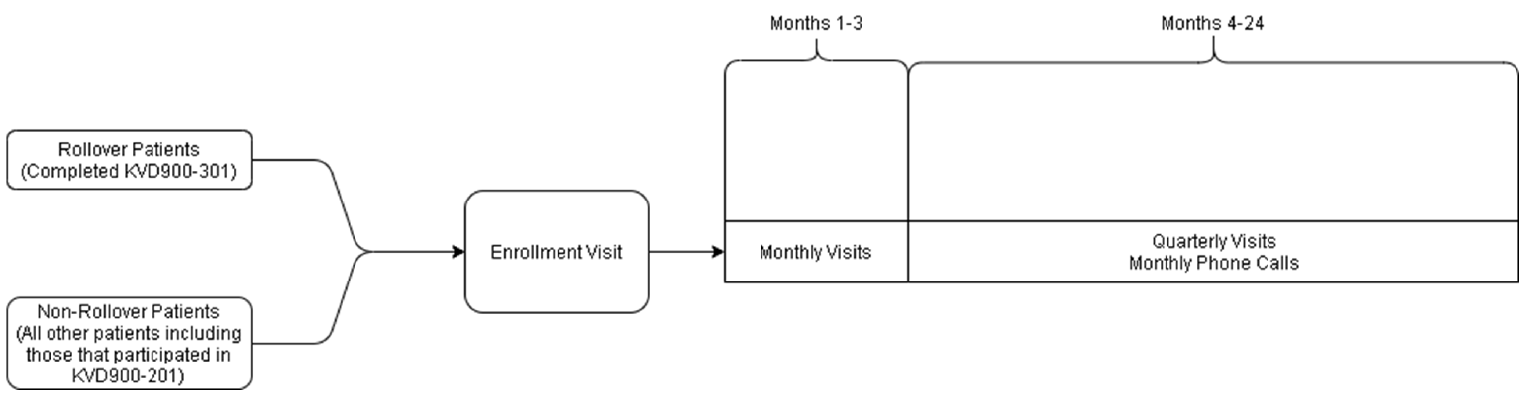
Note: Patients completed the End of Trial Visit at Month 24 or if they terminated early from the trial.
All enrolled patients had type I or II HAE, and had suffered at least 2 documented HAE attacks within 3 months of the enrolment visit.
Patients took 600 mg sebetralstat for each HAE attack and were permitted to take an additional 600 mg at least 3 hours following the first attack if symptoms persisted (i.e. a maximum of 1200 mg).
The primary endpoint was the proportion of patients who experienced any adverse events in the first 24 months or discontinued therapy.
A secondary endpoint was the time to symptom relief defined as at least ‘a little better’ using the PGI-C scale (as per the pivotal trial KVD900-301).
Figure 6: Patient disposition in study KVD900-302
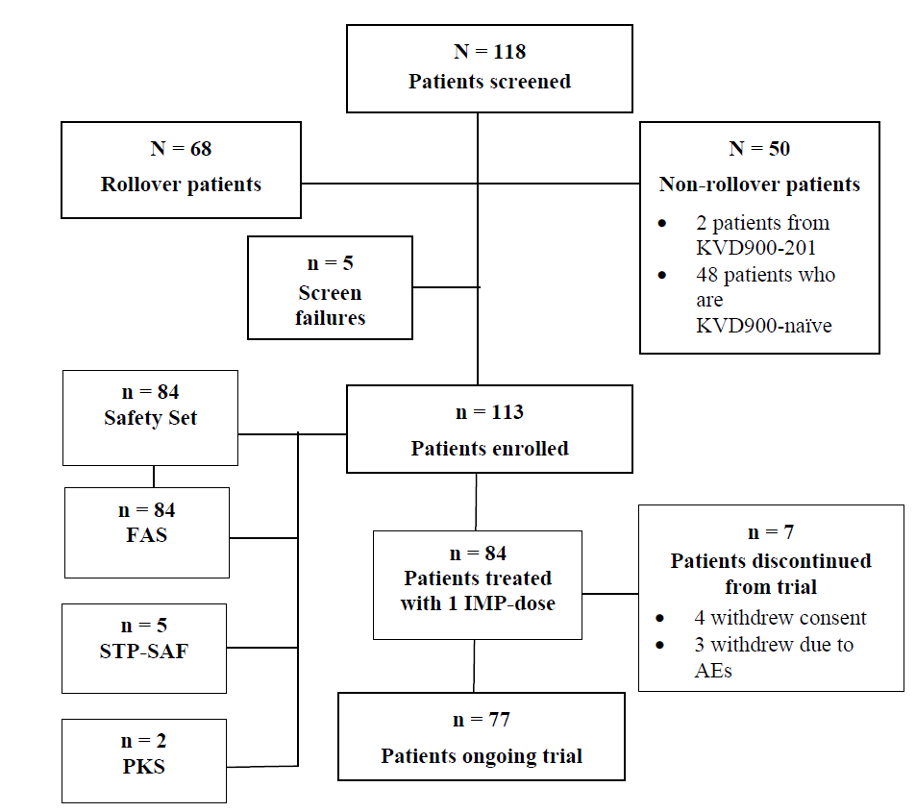
Notes: The screened set included all patients who had signed the ICF.
The Safety Set includes all patients who received at least 1 IMP dose.
The FAS includes all enrolled patients who received at least 1 IMP dose after an HAE attack.
The STP-SAF includes all patients who received at least 1 dose of the IMP as short-term prophylactic therapy.
The PKS includes all patients who accepted to participate in an elective PK subtrial, Trial KVD900-302a, and provided at least 1 PK sample.
A total of 639 HAE attacks were examined with 475 (74.3%) achieving the primary endpoint definition of symptom relieve within 12 hours. Overall, the median time to the beginning of symptom relief was 1.8 hours.

Safety

Patient exposure
The dossier included information on 670 patients who received at least one dose of sebetralstat, of whom 213 were in the phase 2 or 3 program. Of these participations, 575 received a total of 1970 doses of sebetralstat ≥300 mg and 537 received 1829 doses of sebetralstat ≥600 mg.
Table 10. Treatment emergent adverse events, pivotal study KVD900-301
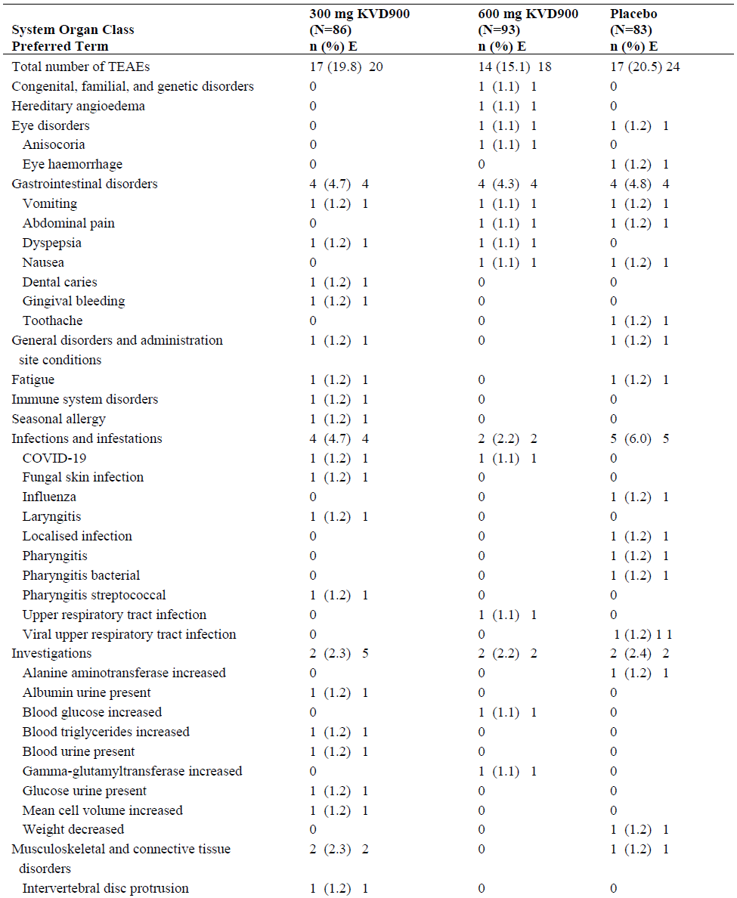
Table 10. Treatment emergent adverse events, pivotal study KVD900-301 continued
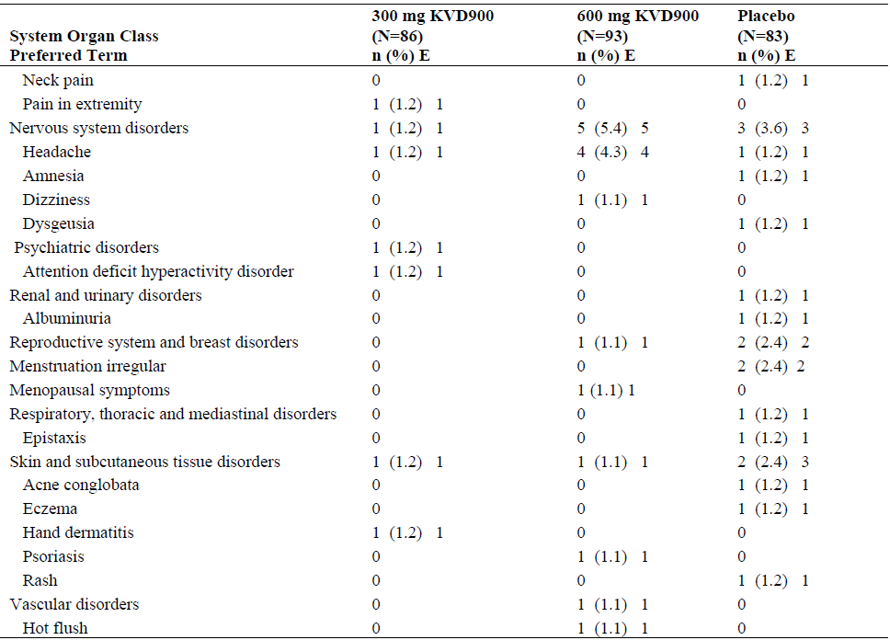
Notes: At each level of patient summarization, a patient was counted once if the patient reported 1 or more events.
n represents the number of patients at each level of summarization. N is number of patients randomized using a permuted block randomization method to ensure a balanced assignment to each of the 6 treatment sequences, to receive that received 300 mg KVD900, 600 mg KVD900, or matching placebo for the analyzed IMP-treated HAE attacks, according to the actual treatment received.
[E] represents the number of events at each level of summarization.
Adverse events were coded using MedDRA, Version 26.0.
Overall sebetralstat was well tolerated. The most common adverse event was headache, occurring in 1.2% of patients who received 300 mg and 4.3% of those who received 600 mg of sebetralstat.
No deaths occurred in the studies.
Table 11: Serious treatment emergent adverse events in phase 2 and 3 trials
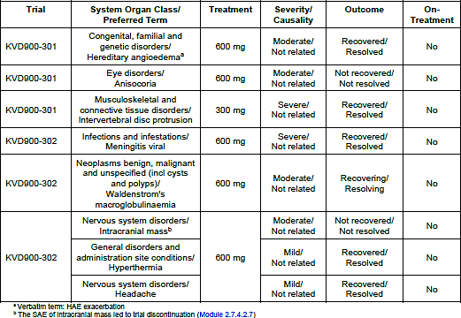
Eight treatment emergent serious adverse events were reported in six patients in the clinical trial program. None of these occurred within 3 days of sebetralstat administration or were considered related to sebetralstat.

Special populations
There was no clinical data to inform the safety of sebetralstat in pregnant or lactating women.
21 patients between the ages of 12 and 18 were enrolled in the phase III trials. No differences in the rates of adverse events were observed in this group.
10 patients ≥65 years of age were enrolled in clinical trials. There was no specific safety signal identified in this group.
No experience of overdose in sebetralstat was reported.

Risk management plan
Jace Pharma Pty Ltd has submitted EU-RMP version 1.0 (dated 21 June 2024; DLP 31 January 2024) and ASA version 1.0 (dated 27 September 2024) in support of this application. Important identified risks, important potential risks and occurrences of missing information were not identified in this application.

Risk-benefit analysis
Sebetralstat is a new agent for the treatment of HAE that is taken when an attack occurs. The submitted data indicates that it provides a statistically significant improvement in the time to improvement of HAE attack symptoms when measured either on an ordinal symptom scale or by the time-to-use of standard medications. The median time to onset of symptom relief in the pivotal study KVD900-301 was under 2 hours for patients taking sebetralstat compared to over 6 hours for placebo. The medicine appears to be well tolerated, with no significant treatment-related adverse events identified. Headache and gastrointestinal adverse events were the most commonly reported by patients taking sebetralstat, but these occurred in a minority of patients and were generally of mild to moderate severity.
The Delegate notes that the proposed dosing is 300 mg at the onset of HAE symptoms with another 300 mg possible at an unspecified time thereafter. This is lower than the US FDA approved dosing which is 600 mg at onset and a further 600 mg at least 3 hours thereafter if needed. Although doses up to 1200 mg were examined in the dose-ranging studies, the majority of the clinical evidence was in 300 mg-600 mg doses.
The Delegate notes that in study KVD900-301 the median time to symptom relief was 1.61 hours (95% CI 1.28-2.27) for the 300 mg dose and 1.79 hours (95%CI 1.33-2.27) for the 600 mg dose and so there does not appear to be any significant advantage to the higher dose. The majority of attacks, 66.3%, were resolved with a single 300 mg dose, compared to 77.1% with the 600 mg dose. The open-label study KVD900-302 suggested that only 11.9% of patients (2.8% of attacks) required 3 doses. Nevertheless, in patients who required two doses this seemed to be consistent over subsequent attacks.
Therefore, the Delegate has concluded that the data supports the proposed dosing of 300 mg to 600 mg, although a minimum time-interval between doses should be specified.
The proposed indication:
Ekterly is indicated for the treatment of hereditary angioedema (HAE) attacks in adult and adolescents aged 12 years and older.
does not specify type I or type II HAE. The Delegate notes that this stipulation is found in most other medications for HAE registered in Australia either explicitly or by reference to ‘C1-inhibitor deficiency’. The submitted studies in sebetralstat specifically excluded HAE without C1 inhibitor deficiency or dysfunction, formerly known as type III HAE, and the Delegate has concluded that this should be specified in the indication for clarity.
The Delegate notes that there is no placebo controlled clinical data on the use of sebetralstat in patients with severe laryngeal HAE attacks as these patients were excluded from the clinical trials, however open label data for all severities supports inclusion in the label. Airways compromise is a medical emergency and so the Delegate concurs with the Clinical Evaluator recommendation that specific advice be provided that patients seek urgent medical attention after taking sebetralstat.

Assessment outcome
Based on a review of quality, safety, and efficacy, the TGA decided to register Ekterly (sebetralstat) for the following indication:
Ekterly is indicated for the treatment of hereditary angioedema (HAE) attacks caused by C1 inhibitor deficiency or dysfunction in patients aged 12 years and older.

Specific conditions of registration
Ekterly (sebetralstat) is to be included in the Black Triangle Scheme. The PI and CMI for Ekterly must include the black triangle symbol and mandatory accompanying text for five years, which starts from the date of first supply of the product.
The Ekterly EU-RMP (version 1.1, dated 10 March 2025, data lock point 31 January 2024), with Australia-Specific Annex (version 1.1, dated 1 April 2025), included with submission PM-2024-04190-1-2, and any subsequent revisions, as agreed with the TGA will be implemented in Australia.
An obligatory component of risk management plans is routine pharmacovigilance. Routine pharmacovigilance includes the submission of periodic safety update reports (PSURs).
Unless agreed separately between the supplier who is the recipient of the approval and the TGA, the first report must be submitted to TGA no later than 15 calendar months after the date of this approval letter. The subsequent reports must be submitted no less frequently than annually from the date of the first submitted report until the period covered by such reports is not less than three years from the date of this approval letter. The annual submission may be made up of two PSURs each covering six months. If the Sponsor wishes, the six monthly reports may be submitted separately as they become available.
If the product is approved in the EU during the three years period, reports can be provided in line with the published list of EU reference dates no less frequently than annually from the date of the first submitted report until the period covered by such reports is not less than three years from the date of this approval letter.
The reports are to at least meet the requirements for PSURs as described in the European Medicines Agency’s Guideline on good pharmacovigilance practices (GVP) Module VII-periodic safety update report (Rev 1), Part VII.B Structures and processes. Note that submission of a PSUR does not constitute an application to vary the registration. Each report must be submitted within ninety calendar days of the data lock point for that report.

Product Information and Consumer Medicine Information
For the most recent Product Information (PI) and Consumer Medicine Information (CMI), please refer to the TGA PI/CMI search facility.

Therapeutic Goods Administration
PO Box 100 Woden ACT 2606 Australia
Email: info@tga.gov.au Phone: 1800 020 653 Fax: 02 6203 1605
https://www.tga.gov.au

This is the original indication proposed by the Sponsor when the TGA commenced the evaluation of this submission. It may differ to the final indication approved by the TGA and registered in the Australian Register of Therapeutic Goods.
ICH Q11 Development and manufacture of drug substances (chemical entities and biotechnological/biological entities) - Scientific guideline.
ICH M7 Assessment and control of DNA reactive (mutagenic) impurities in pharmaceuticals to limit potential carcinogenic risk - Scientific guideline
ICH Q3C (R9) Residual solvents - Scientific guideline
ICH M3 (R2) Non-clinical safety studies for the conduct of human clinical trials for pharmaceuticals - Scientific guideline. 2013

