This medicinal product is subject to additional monitoring in Australia. This will allow quick identification of new safety information. Healthcare professionals are asked to report any suspected adverse events at www.tga.gov.au/reporting-problems.

AUSTRALIAN PRODUCT INFORMATION – EKTERLY® (SEBETRALSTAT) FILM-COATED TABLET

NAME OF THE MEDICINE
Sebetralstat

QUALITATIVE AND QUANTITATIVE COMPOSITION
Each film-coated tablet contains 300 mg sebetralstat
For the full list of excipients, see section 6.1 List of excipients.

PHARMACEUTICAL FORM
Film-coated tablet
Yellow, oval shaped, biconvex tablets debossed with KalVista logo “K” on one side and “300” on the other side.

CLINICAL PARTICULARS

Therapeutic indications
Ekterly is indicated for the treatment of hereditary angioedema (HAE) attacks caused by C1 inhibitor deficiency or dysfunction in patients aged 12 years and older.

Dose and method of administration
The decision to initiate treatment with oral sebetralstat should be made by a healthcare professional experienced in the management of patients with HAE.
Dosage
The recommended dose of Ekterly is 300 mg administered at the earliest recognition of an attack. A second dose of 300 mg may be taken at least 3 hours after the first dose if response is inadequate, or if symptoms worsen or recur.
Special populations Elderly population
No dose adjustment is required for patients above 65 years of age.
Renal impairment
No dose adjustment is required for patients with renal impairment (see section 5.2 Pharmacokinetic properties).
Hepatic impairment
No dose adjustment of Ekterly is required for patients with mild or moderate hepatic impairment (Child-Pugh A or B). Use of Ekterly in patients with severe hepatic impairment (Child-Pugh C) is not recommended (see section 5.2 Pharmacokinetic properties).
Paediatric population
The safety and efficacy of sebetralstat in children under 12 years of age have not been established. No data are available.
Patients taking strong CYP3A4 inhibitors
In patients who are taking a strong CYP3A4 inhibitor a single dose of 300 mg is recommended when treating an HAE attack.
Patients taking strong or moderate CYP3A4 inducers
In patients who are taking strong or moderate CYP3A4 inducers a single dose of 900 mg (3 x 300 mg tablets) is recommended when treating an HAE attack.
Method of administration
For oral use. The film-coated tablets can be taken with or without food.

Contraindications
Hypersensitivity to the active substance or to any of the excipients listed in section 6.1 List of excipients.

Special warnings and precautions for use
Laryngeal attacks: Following treatment of laryngeal attacks with Ekterly, advise patients to seek immediate medical attention.
There are no data available on the use of sebetralstat in HAE patients with normal C1-esterase inhibitor (nC1-INH). Some subcategories of nC1-INH HAE may not respond to treatment with sebetralstat due to alternative pathways that do not include plasma kallikrein activation.
The potential for interaction should be considered when sebetralstat is administered to patients taking substrates of CYPs 2C9 and 3A4, and the transporters BCRP, OATP1B1, OATP1B3, OAT3, OCT2, MATE1 and MATE2-K (see section 4.5).
Use in the elderly
No special warnings and precautions for the use of Ekterly in patients above 65 years of age.
Paediatric use
No special warnings and precautions for the use of Ekterly in patients 12 years and above. For patients below 12 years of age no data available.
Effects on laboratory tests
No data available.

Interactions with other medicines and other forms of interactions

Effects of other medicinal products on sebetralstat
Sebetralstat is a substrate of P-glycoprotein (P-gp) and breast cancer resistance protein (BCRP).
Quinidine, a P-gp inhibitor, increased the maximum concentration (C_{max}) of sebetralstat by 18% and the AUC of sebetralstat by 14%. Sebetralstat exposure may be increased with concomitant administration of P-gp inhibitors, however no dose adjustment is required.
Eltrombopag, a BCRP inhibitor, increased the C_{max} of sebetralstat by 12%, however the AUC of sebetralstat remained unchanged. Sebetralstat peak levels may be increased with concomitant administration of BCRP inhibitors, however no dose adjustment is required.
Sebetralstat is a substrate of CYP3A4.
Itraconazole, a strong CYP3A4 inhibitor, increased the C_{max} of sebetralstat by 135% and the AUC by 420%. The moderate CYP3A4 inhibitor verapamil increased the C_{max} of sebetralstat by 76% and the AUC by 102%. Co-administration with the weak CYP3A4 inhibitor cimetidine caused no increase in the C_{max} or AUC of sebetralstat. In patients who are taking a strong CYP3A4 inhibitor a single dose of 300 mg is recommended when treating an HAE attack. No dose adjustment is required when taking weak or moderate CYP3A4 inhibitors.
Phenytoin, a strong CYP3A4 inducer, reduced the C_{max} of sebetralstat by 66% and the AUC by 83%. The moderate CYP3A4 inducer efavirenz reduced the C_{max} of sebetralstat by 63% and the AUC by 79%. Co-administration with the weak CYP3A4 modafinil reduced the C_{max} of sebetralstat by 11% and the AUC by 21%. In patients taking strong or moderate CYP3A4 inducers, it is recommended that an HAE attack is treated with a single dose of 900 mg (3 x 300 mg tablets). No dose adjustment is required when taking weak CYP3A4 inducers.
Effects of sebetralstat on other medicinal products
In vitro studies indicate that sebetralstat inhibits CYPs 2C9 and 3A4, and the transporters BCRP, OATP1B1, OATP1B3, OAT3, OCT2, MATE1 and MATE2-K. Clinical interaction data are not available. The potential for interaction should be considered when sebetralstat is administered to patients taking substrates of these enzymes and transporters, particularly narrow therapeutic index substrates. If possible, substrates of these drugs and transporters should not be taken at the same time of the day as sebetralstat is used to treat an HAE attack to minimise the potential for an interaction.
In vitro studies indicate that sebetralstat inhibits UGTs 1A4 and 1A9. Clinical interaction data are not available.

Paediatric population
Interaction studies have only been performed in adults.

Fertility, pregnancy and lactation

Effects on fertility
There are no data regarding the effects of Ekterly on human fertility. No effect on male or female fertility was observed with sebetralstat in rats at oral doses up to 600 mg/kg/day (estimated to yield 8 times the exposure in patients at the maximum recommended human dose (MRHD) of 900 mg/day [based on plasma AUC for unbound drug]).
Use in pregnancy – Pregnancy Category D
There are no data from the use of Ekterly in pregnant women.
Studies in pregnant rats indicate that daily sebetralstat administration was associated with embryofetal deaths and fetal malformations at ≥600 mg/kg/day (12 times the clinical exposure at the MRHD on an unbound plasma AUC basis). In rabbits, decreased fetal body weight and major malformations in the fetus at doses tested up to 300 mg/kg/day (exposure ratio (ER) = 7 times in relation to MRHD on an unbound plasma AUC basis) were without a dose response effect. However, all malformations have been observed in historical controls, and rabbit is not a pharmacologically relevant species and thus, the clinical relevance is uncertain.
Ekterly should not be used during pregnancy unless the potential benefit justifies the potential risk for the fetus (e.g. for treatment of potentially life-threatening laryngeal attacks). Women of childbearing potential should use highly effective, medically appropriate contraception during treatment with Ekterly and for a period of 24 hours after the last dose.
Use in lactation
It is unknown whether sebetralstat or its metabolites are excreted in human milk. Available pharmacodynamic/toxicological data in animals have shown excretion of sebetralstat and/or its metabolites in milk.
A risk to newborns/infants cannot be excluded.
A decision must be made whether to discontinue breast-feeding or to discontinue/abstain from Ekterly therapy taking into account the benefit of breast-feeding for the child and the benefit of therapy for the woman.

Effects on ability to drive and use machines
Ekterly has no or negligible influence on the ability to drive and use machines.

Adverse effects (Undesirable effects)

Summary of the safety profile
Ekterly has been administered to a total of 411 healthy subjects and 239 hereditary angioedema patients. In clinical studies used for registration, 1945 HAE attacks have been treated with Ekterly.

The most common adverse reaction in HAE patients treated with Ekterly from the Phase 2 and 3 clinical studies is headache (reported by 9.2% of patients). The reported events of headache were generally mild to moderate in severity, non-serious and resolved without any further intervention.

Table 1. All treatment-emergent adverse events in the Ekterly groups of the KONFIDENT study with a greater incidence than placebo
System Organ Class  Preferred Term | EKTERLY 300 mg  N=86 n (%) | EKTERLY 600 mg  N=93 n (%) | Placebo N=83 n (%)
All TEAEs | 17 (19.8) | 14 (15.1) | 17 (20.5)
Congenital, familial and genetic disorders
Hereditary angioedema | 0 | 1 (1.1) | 0
Eye disorders
Anisocoria | 0 | 1 (1.1) | 0
Gastrointestinal disorders
Dental caries | 1 (1.2) | 0 | 0
Dyspepsia | 1 (1.2) | 1 (1.1) | 0
Gingival bleeding | 1 (1.2) | 0 | 0
Immune system disorders
Seasonal Allergy | 1 (1.2) | 0 | 0
Infections and infestations
COVID-19 | 1 (1.2) | 1 (1.1) | 0
Fungal Skin Infections | 1 (1.2) | 0 | 0
Laryngitis | 1 (1.2) | 0 | 0
Pharyngitis streptococcal | 1 (1.2) | 0 | 0
Upper respiratory tract infection | 0 | 1 (1.1) | 0
Investigations
Albumin urine present | 1 (1.2) | 0 | 0
Blood glucose increased | 0 | 1 (1.1) | 0
Blood triglycerides increased | 1 (1.2) | 0 | 0
Blood urine present | 1 (1.2) | 0 | 0
Gamma-glutamyl transferase increased | 0 | 1 (1.1) | 0
Glucose urine present | 1 (1.2) | 0 | 0
Mean Cell volume increased | 1 (1.2) | 0 | 0
Musculoskeletal and connective tissue disorders
Intervertebral disc protrusion | 1 (1.2) | 0 | 0
Pain in extremity | 1 (1.2) | 0 | 0
Nervous system disorders
Headache | 1 (1.2) | 4 (4.3) | 1 (1.2)
Dizziness | 0 | 1 (1.1) | 0
Psychiatric disorders
Attention deficit hyperactivity disorder | 1 (1.2) | 0 | 0
Reproductive system and breast disorders
Menopausal symptoms | 0 | 1 (1.1) | 0
Skin and subcutaneous tissue disorders
Hand dermatitis | 1 (1.2) | 0 | 0
Psoriasis | 0 | 1 (1.1) | 0
Vascular disorders
Hot flush | 0 | 1 (1.1) | 0
List of adverse reactions
The following CIOMS convention has been used for the classification of the adverse reactions:
Very common (≥1/10); common (≥1/100 to <1/10); uncommon (≥1/1,000 to <1/100); rare (≥1/10,000 to <1/1,000); very rare (<1/10,000), and frequency not known (cannot be estimated from the available data)
There are no adverse events or adverse reactions with incidence <1%.
Common adverse reactions are:
Nervous System Disorder
Common: Headache
Reporting suspected adverse effects
Reporting suspected adverse reactions after registration of the medicinal product is important. It allows continued monitoring of the benefit-risk balance of the medicinal product. Healthcare professionals are asked to report any suspected adverse reactions at www.tga.gov.au/reporting-problems.

Overdose
No case of overdose has been reported in clinical trials.
For information on the management of overdose, contact the Poisons Information Centre on 13 11 26 (Australia).

PHARMACOLOGICAL PROPERTIES

Pharmacodynamic properties
Pharmacotherapeutic group: Other haematological agents, drugs used in hereditary angioedema, ATC code: B06AC08.
Mechanism of action
Sebetralstat is a competitive, reversible inhibitor of plasma kallikrein. Plasma kallikrein is a serine protease that cleaves high molecular weight kininogen (HK) releasing bradykinin (BK) which increases vascular permeability through activation of BK receptors causing oedema. Sebetralstat inhibits the cleavage of HK to BK, preventing activation of the BK receptors and halting the progression of HAE attacks. Sebetralstat also inhibits the positive feedback mechanism of the kallikrein kinin system by plasma kallikrein, thereby reducing factor XIIa and additional plasma kallikrein generation.
Pharmacodynamic effects
Concentration-dependent inhibition of plasma kallikrein, measured as a reduction from baseline of specific enzyme activity, was demonstrated to be rapid, with near complete suppression of plasma kallikrein as early as 15 minutes after dosing in patients with HAE.
Clinical trials
The efficacy of Ekterly for the treatment of hereditary angioedema (HAE) attacks in adult and adolescent patients aged 12 years and older was demonstrated in the KONFIDENT trial, a randomised, double-blind, placebo-controlled, three-way cross-over design.
A total of 110 patients treated 264 attacks; 87 treated with 300 mg Ekterly, 93 treated with 600 mg Ekterly, and 84 treated with placebo. Attacks ranged in severity from mild to very severe and occurred in all anatomic locations. Following treatment of each attack an additional dose could be taken if needed. The primary efficacy endpoint was the time to beginning of symptom relief, assessed using the Patient Reported Global Impression of Change (PGI-C). The PGI-C required patients to assess their attack symptoms using a seven-point scale (“much worse” to “much better”). To achieve the primary endpoint, a patient had to report a positive and sustained response on the PGI-C within 12 hours.
There was a statistically significant faster time to the beginning of symptom relief for 300 mg Ekterly (Bonferroni adjusted p < 0.0001) and 600 mg Ekterly (Bonferroni adjusted p < 0.0013) compared to placebo (Table 2, Figure 1).

Table 2. KONFIDENT Trial - Time to beginning of symptom relief within 12 hours of dosing
 | 300 mg Ekterly | 600 mg Ekterly | Placebo
N | 87 | 93 | 84
Median (95% CI) | 1.61  (1.28, 2.27) | 1.79  (1.33, 2.27) | 6.72  (2.33, NE)
NE = not evaluable at 12 hours
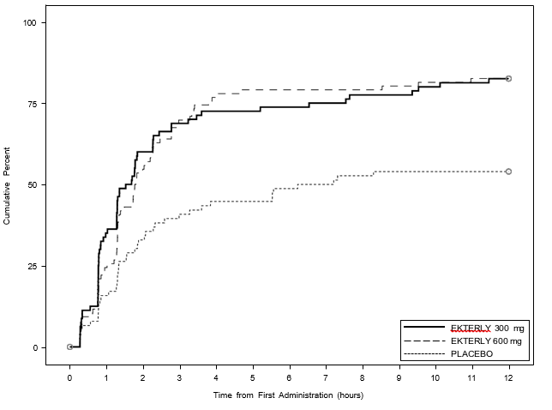

Figure 1. KONFIDENT Trial – Kaplan-Meier plot for time to beginning of symptom relief within 12 hours of dosing

The first key secondary endpoint was time to reduction in severity on the Patient Global Impression of Severity (PGI-S) within 12 hours of dosing. There was a statistically significant faster time to reduction in severity for 300 mg Ekterly (adjusted p=0.0036) and 600 mg Ekterly (adjusted p=0.0032) compared to placebo (Figure 2).
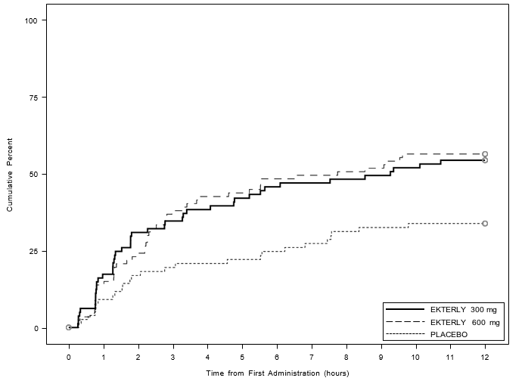

Figure 2. KONFIDENT Trial – Kaplan-Meier plot for time to reduction in severity within 12 hours of dosing
The second key secondary endpoint was time to complete attack resolution defined as “none” on PGI-S. There was a statistically significant faster time to complete attack resolution for 300 mg Ekterly (adjusted p=0.0022) and 600 mg Ekterly (adjusted p<0.0001) compared to placebo (Figure 3).

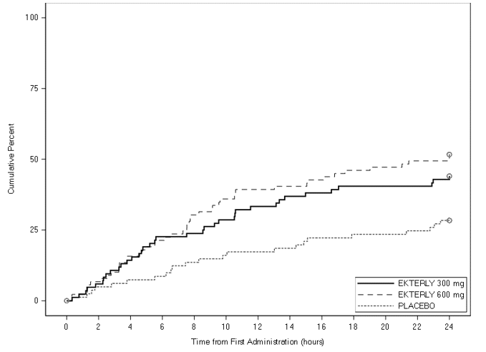

Figure 3. KONFIDENT Trial – Kaplan-Meier plot for time to complete attack resolution within 24 hours of dosing

Treatment with Ekterly reduced cumulative anxiety over 12 hours after dosing compared to placebo.
Assessment of primary and key secondary efficacy endpoints results in the KONFIDENT trial in all subgroups, including sex, race, age, baseline attack severity, baseline attack location, time from onset of attack to treatment, use of long-term prophylactic treatment and geography were consistent with the results in the overall population.
In the open-label KONFIDENT-S trial, patients treated multiple attacks with Ekterly for up to 2 years. A total of 134 patients (including 23 adolescents) have treated 1706 attacks. The median number of attacks treated was 8 and ranged from 1-61 attacks. The median time from onset of attack to treatment was 10 minutes. For adolescent patients the median time from onset of attack to treatment was 4 minutes. The efficacy results were consistent with the results of the KONFIDENT trial (Table 2). Efficacy was maintained with repeated treatments.
Four laryngeal HAE attacks were treated in the KONFIDENT trial (2 with 300 mg, 2 with 600 mg). In the open label KONFIDENT-S trial, 32 laryngeal attacks were treated with 600 mg. The results were similar to patients with non-laryngeal attacks with respect to time to onset of symptom relief. No events of difficulty swallowing Ekterly tablets were reported.
Paediatric population
The KONFIDENT trial included 13 paediatric patients aged 12 to <18 years of age. The safety and efficacy in paediatrics were consistent with that observed in adults.
The safety and efficacy of Ekterly in paediatric patients aged <12 years of age have not been established.

Pharmacokinetic properties

Absorption
After a dose of 300 mg, sebetralstat was rapidly absorbed with peak plasma concentrations occurring at approximately 1 hour.
Food effect
In an evaluation of food effect, no difference in the AUC of sebetralstat was observed following a dose of 600 mg sebetralstat with a high-fat meal, there was an approximately 29% reduction in C_{max}, and median T_{max} was delayed by 2 hours.
Ekterly can be taken with or without food.
Distribution
Plasma protein binding in humans is approximately 77%. After a dose of 600 mg radiolabelled sebetralstat, the blood to plasma ratio of radioactivity was approximately 0.65. The geometric mean apparent volume of distribution (Vz/F) was 208 L after a dose of 300 mg.
Elimination
After a dose of 300 mg, the geometric mean elimination half-life of sebetralstat was 3.7 hours. The geometric mean apparent clearance (CL/F) was 38.5 L/h.
Metabolism
Sebetralstat is primarily metabolised by CYP3A4. After a dose of 600 mg radiolabelled sebetralstat, sebetralstat represented 64.1% of the total plasma radioactivity AUC₀₋₂₄, with 11 metabolites, each accounting for between 0.39% and 7.1% of the total radioactivity AUC₀₋₂₄. The most prevalent plasma metabolite is not pharmacologically active.
Excretion
After a dose of 600 mg radiolabelled sebetralstat to healthy male subjects, approximately 32% of radioactivity was excreted in urine and 63% was excreted in faeces. Approximately 8.7% and 12.5% of the dose was recovered in the urine and faeces, respectively, as unchanged sebetralstat.
Sebetralstat is mainly eliminated by hepatic metabolism via the faeces.
Linearity/non-linearity
Across a dose range of 5 mg to 600 mg, the C_{max} of sebetralstat was proportional to dose; the AUC was greater than dose proportional, likely due to emergence of a longer terminal elimination phase at higher doses.
Special populations
Hepatic impairment
The pharmacokinetics of 600 mg sebetralstat were studied in patients with mild and moderate hepatic impairment (Child-Pugh Class A or B). In patients with mild hepatic impairment C_{max} was increased by 7% and AUC by 16% compared to patients with normal hepatic function. In patients with moderate hepatic impairment, C_{max} was increased by 63% and AUC was increased by 100% (see section 4.2 and 4.5).
Renal impairment
Sebetralstat is not primarily renally eliminated and is not administered as a chronic treatment. Sebetralstat pharmacokinetics have not been studied in patients with renal impairment. No dose adjustment is required (see section 4.2 Dose and method of administration).
Elderly
KONFIDENT did not include sufficient numbers of patients 65 years of age and older to determine whether they respond differently from younger adult patients; however, age is not expected to affect exposure to Ekterly (see section 4.2).

Preclinical safety data

Genotoxicity
Sebetralstat was not genotoxic in assays for mutagenicity in bacteria, for mutagenicity and clastogenicity in mammalian cells in vitro (mouse lymphoma assay), and clastogenicity in vivo (the bone marrow micronucleus test in rats).
Carcinogenicity
Carcinogenicity of sebetralstat was evaluated in a 26-week study in rasH2-Tg transgenic mice and a 104-week study in rats after oral administration. There were no increases in malignant tumours and no evidence of carcinogenicity in either species at any dose level. Treatment-related benign tumours were observed in the rat study, including hepatocellular adenoma in the liver, follicular cell adenoma of the thyroid, pituitary gland adenoma, granulosa cell tumours of the ovaries, and Leydig cell tumours. The benign tumour findings are suggestive of an adaptive response in the liver, enzyme induction and mild hormonal disturbance. Exposure at the highest dose (200 mg/kg/day in male mice and 300 mg/kg/day in female mice and in male and female rats) were 0.23 and 0.44 times MRHD, in male and female mice respectively and 6 times MRHD in rats, on an unbound plasma AUC basis.
Reproductive and Development Toxicology
An embryofetal development study conducted in pregnant rats administered sebetralstat daily at exposures (on an unbound plasma AUC basis) 3 times the MRHD revealed no evidence of harm to the developing fetus. At higher exposures (on an unbound plasma AUC basis) of 12 times the MRHD, there were embryofetal losses and a low incidence of malformations (cleft palates and ventricular septal defects, aortic valve irregularities and a single fetus with anophthalmia, reduced orbital cavity in size, reduced number of presacral vertebra and fusion events involving the axial skeleton (vertebra and ribs)) at ≥600mg/kg/day. There were no effects in a rat pre-and-post natal development study, where exposure in pregnant female rats (on an unbound plasma AUC basis) was at least 3 times the MRHD.
An embryofetal development study with daily dosing was conducted in pregnant rabbits administered exposures (on an unbound plasma AUC basis) up to 7 times the MRHD. A low incidence of major malformations was observed in all sebetralstat dose groups (including fused vertebra and ribs, interventricular septal defects). However, there was no dose response and all malformations had been observed in historical control data. Therefore, the association with sebetralstat is equivocal and clinical relevance uncertain. The rabbit is not a pharmacologically relevant species.
Sebetralstat had no effects on mating or fertility in male and female rats at exposures (on an unbound plasma AUC basis) that were 8 times the exposure at the MRHD.
Administration of a single dose of radiolabelled sebetralstat to lactating rats resulted in similar concentrations of total radioactivity in milk and plasma, with the maximum concentration observed at 1 hour post dose. By 24 hours post dose mean levels of radioactivity in both milk and plasma were close to background.

PHARMACEUTICAL PARTICULARS

List of excipients
Tablet core
Microcrystalline cellulose Croscarmellose sodium Povidone
Magnesium stearate Film-coatings
OPADRY EZ Easy Swallow Film Coating System 254U590005 Clear OPADRY QX Quick and Flexible Film Coating System 321A220055 Yellow

Incompatibilities
Not applicable.

Shelf life
In Australia, information on the shelf life can be found on the public summary of the Australian Register of Therapeutic Goods (ARTG). The expiry date can be found on the packaging.

Special precautions for storage
Store below 30°C.

Nature and contents of container
Tablets are packed in oPA/Al/PVC with aluminium lidding blisters (1 tablet per blister). Pack size: 4 or 6 tablets.
Not all pack sizes may be marketed.

Special precautions for disposal
Any unused medicinal product or waste material should be disposed of in accordance with local requirements.

Physicochemical properties

Chemical structure
Chemical name: N-[(3-fluoro-4-methoxypyridin-2-yl)methyl]-3-(methoxymethyl)-1-({4-[(2-oxopyridin-1yl)methyl]phenyl}methyl)pyrazole-4-carboxamide
Molecular formula and molecular mass: C₂₆H₂₆FN₅O₄ (491.52) Structural formula:
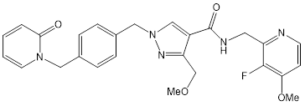
CAS number
1933514-13-6

MEDICINE SCHEDULE (POISONS STANDARD)
Prescription Only Medicine (Schedule 4)

SPONSOR
JACE Pharma Pty Ltd
Level 2, 8 Clunies Ross Court Brisbane Technology Park
Eight Mile Plains, Queensland 4113

DATE OF FIRST APPROVAL
DD/MM/YYYY

DATE OF REVISION
Summary table of changes

Section Changed | Summary of new information

