Australian Public Assessment Report for Blenrep
  - Active ingredient: belantamab mafodotin
  - Sponsor: GlaxoSmithKline Australia Pty Ltd
April 2026

About the Therapeutic Goods Administration (TGA)
- The Therapeutic Goods Administration (TGA) is part of the Australian Government Department of Health, Disability and Ageing and is responsible for regulating therapeutic goods, including medicines, medical devices, and biologicals.
- The TGA administers the Therapeutic Goods Act 1989 (the Act), applying a risk management approach designed to ensure therapeutic goods supplied in Australia meet acceptable standards of quality, safety, and efficacy.
- The work of the TGA is based on applying scientific and clinical expertise to decision-making, to ensure that the benefits to the Australian public outweigh any risks associated with the use of therapeutic goods.
- The TGA relies on the public, healthcare professionals and industry to report problems with therapeutic goods. The TGA investigates reports received to determine any necessary regulatory action.
- To report a problem with a therapeutic good, please see the information on the TGA website.

About AusPARs
- The Australian Public Assessment Report (AusPAR) provides information about the evaluation of a prescription medicine and the considerations that led the TGA to approve or not approve a prescription medicine submission. Further information can be found in Australian Public Assessment Report (AusPAR) guidance.
- AusPARs are prepared and published by the TGA.
- AusPARs are static documents that provide information that relates to a submission at a particular point in time. The publication of an AusPAR is an important part of the transparency of the TGA’s decision-making process.
- A new AusPAR may be provided to reflect changes to indications or major variations to a prescription medicine subject to evaluation by the TGA.

Copyright
© Commonwealth of Australia 2026
This work is copyright. You may reproduce the whole or part of this work in unaltered form for your own personal use or, if you are part of an organisation, for internal use within your organisation, but only if you or your organisation do not use the reproduction for any commercial purpose and retain this copyright notice and all disclaimer notices as part of that reproduction. Apart from rights to use as permitted by the Copyright Act 1968 or allowed by this copyright notice, all other rights are reserved and you are not allowed to reproduce the whole or any part of this work in any way (electronic or otherwise) without first being given specific written permission from the Commonwealth to do so. Requests and inquiries concerning reproduction and rights are to be sent to the TGA Copyright Officer, Therapeutic Goods Administration, PO Box 100, Woden ACT 2606 or emailed to <tga.copyright@tga.gov.au>.

Contents
List of abbreviations 4
Product submission 5
Submission details 5
Product background 6
Disease or condition 6
Current treatment options 7
Clinical rationale 8
Regulatory status 8
Australian regulatory status 8
International regulatory status 8
Registration timeline 9
Assessment overview 9
Quality evaluation summary 9
Nonclinical evaluation summary 10
Clinical evaluation summary 12
Pharmacology 12
Efficacy 13
Safety 33
Risk management plan 35
Risk-benefit analysis 36
Efficacy 36
Safety 37
Conclusions 38
Assessment outcome 39
Specific conditions of registration 39
Product Information and Consumer Medicine Information 40

List of abbreviations
Abbreviation | Meaning
AEs | Adverse event(s)
ARTG | Australian Register of Therapeutic Goods
ASA | Australia-specific annex
AUC | Area under the concentration-time curve
BCMA | B-cell maturation antigen
BPd | belantamab mafodotin, pomalidomide, and dexamethasone
BVd | belantamab mafodotin, bortezomib and dexamethasone
C_{avg} | Average concentration over a dosing interval
CL | Clearance
C_{max} | Maximum concentration
CMI | Consumer Medicines Information
cys-mcMMAF | Cysteine monomethyl auristatin F
DVd | Daratumumab, bortezomib and dexamethasone
DoR | Duration of response (DoR)
E-R | Exposure-Response
ITT | Intention-to-Treat
MRD | Minimal residual disease
MM | Multiple myeloma
PFS | Progression free survival
PI | Product Information
PSUR | Periodic safety update report
Q3W | Every 3 weeks
RMP | Risk management plan
R-ISS | Revised- International Staging System
RRMM | Relapsed/Refractory Multiple Myeloma
SAE | Serious adverse event(s)
TGA | Therapeutic Goods Administration
T_{max} | Time to maximum drug concentration
V1 | Volume of Distribution of the Central Compartment
V2 | Volume of Distribution of the Peripheral Compartment

Product submission

Submission details
Type of submission: | New chemical entity
Product names: | Blenrep
Active ingredient: | belantamab mafodotin
Decision: | Approved
Date of decision: | 12 November 2025
Approved therapeutic use for the current submission: | Blenrep is indicated for the treatment of adults with relapsed or refractory multiple myeloma:  - in combination with bortezomib and dexamethasone in patients who have received at least one prior therapy; and  - in combination with pomalidomide and dexamethasone in patients who have received at least one prior therapy including lenalidomide
Date of entry onto ARTG: | 17 November 2025 - Blenrep belantamab mafodotin 100 mg powder for injection vial (464325)  18 November 2025 -Blenrep belantamab mafodotin 70 mg powder for injection vial (464326)
ARTG numbers: | Blenrep belantamab mafodotin 100 mg powder for injection vial (464325)  Blenrep belantamab mafodotin 70 mg powder for injection vial (464326)
Black Triangle Scheme | Yes
Sponsor’s name and address: | GlaxoSmithKline Australia Pty Ltd Level 4, 436 Johnston Street, Abbotsford, Victoria, 3067
Dose form: | Powder for injection
Strength: | Each vial contains 70 mg or 100 mg of belantamab mafodotin.  After reconstitution, the solution contains 50 mg per mL belantamab mafodotin.
Container: | Sterile lyophilised powder in a type I glass vial with bromobutyl rubber stopper and an aluminium overseal with a plastic removable cap.
Route of administration: | Intravenous infusion
Dosage: | For information regarding dosage, refer to the Product Information.
Pregnancy category: | Category D  Drugs which have caused, are suspected to have caused or may be expected to cause, an increased incidence of human fetal malformations or irreversible damage. These drugs may also have adverse pharmacological effects. Accompanying texts should be consulted for further details.  The use of any medicine during pregnancy requires careful consideration of both risks and benefits by the treating health professional. The pregnancy database must not be used as the sole basis of decision making in the use of medicines during pregnancy. The TGA does not provide advice on the use of medicines in pregnancy for specific cases. More information is available from obstetric drug information services in your state or territory.

Product background
This AusPAR describes the submission by GlaxoSmithKline Australia Pty Ltd (the sponsor) to register Blenrep (belantamab mafodotin) for the following proposed indication:
Blenrep is indicated for the treatment of adults with multiple myeloma:
-in combination with bortezomib and dexamethasone in patients who have received at least one prior therapy; and
-in combination with pomalidomide and dexamethasone in patients who have received at least one prior therapy including lenalidomide.

Disease or condition
Multiple myeloma (MM) is a neoplastic disorder of plasma cells. Plasma cells are differentiated B-lymphocyte white blood cells that have been activated by antigenic stimulation and are capable of secreting immunoglobulins (antibodies). In MM there is an abnormal proliferation of a clone of plasma cells resulting in overproduction of monoclonal immunoglobulins. This can lead to clinical manifestations including hypercalcaemia, renal dysfunction, anaemia, bone pain and bone lytic lesions. Factors contributing to the causation include alterations and translocations in promoter genes, especially chromosome 14, and oncogenes, including NRAS, KRAS and BRAF.
Other factors, which are also implicated in other types of neoplasia, include obesity, alcohol consumption, and environmental exposures, including insecticides, organic solvents, agent orange and radiation.
In 2024, MM was the second most frequently diagnosed blood cancer in Australia. The annual incidence of MM in Australia, age standardised to the 2024 population, is around 9.5/100,000 persons, with a higher incidence in males, around 12/100,000 males, compared to females at around 7/100,000 females. The annual incidence increases with age: 30/100,000 persons aged 65 to 74 years, 50/100,000 persons aged 75 to 84 years and 50/100,000 persons aged ≥85 years. In 2018, it was estimated that there were 1700 prevalent cases of MM in Australia. On average, over the years 2005 to 2019, in Australia the 5 year survival following initial diagnosis of MM was 53.1%.4
This compares to an incidence in the US of 7/100,000/year.5 In the US, MM is more than twice as common in African Americans. The global age-standardised incidence of MM is 2.1/100,000 males and 1.4/100,000 females. The age-standardised mortality is 1.3/100,000 males and 0.9/100,000 females.
The diagnosis of MM is based on clonal bone marrow plasma cells more than 10% or biopsy-proven bony or extramedullary plasmacytoma; and at least one of: clinical manifestations (hypercalcaemia, renal insufficiency, anaemia and/or bone lesions), clonal bone marrow plasma cell percentage 60% or more, serum free light chains ratio of 100 or more, and/or more than one focal lesion on MRI studies.
The Revised- International Staging System (R-ISS) for MM has three stages:
- Stage 1: serum beta-2-microglobulin (B2M) is less than 3.5 mg/L; albumin level is 3.5 g/dL or more; lactate dehydrogenase levels are normal; and cytogenetics are considered not high risk.
- Stage 2: results higher than stage 1 but lower than stage 3
- Stage 3: B2M is 5.5 mg/L or more, either lactate dehydrogenase levels are high or genetic test results are considered high risk
Overall survival (OS) at five years was 82% for Stage 1, 62% for Stage 2 and 40% for Stage 3. progression free survival (PFS) at five years was 55% for Stage 1, 36% for Stage 2 and 24% for Stage 3.

Current treatment options
The current Australian treatment recommendations are to monitor monoclonal gammopathy of uncertain significance (MGUS) and asymptomatic MM. This should be with 3 to 12 monthly visits and laboratory investigations, depending upon the level of risk for progression.
Patients <65 year requiring treatment would be offered autologous stem cell transplant (ASCT), after a pre-treatment induction with lenalidomide-dexamethasone or bortezomib-lenalidomide-dexamethasone (VRd).6 Generally, patients up to the age of 70 may be offered ASCT depending on age, comorbidity, frailty and disability. Tandem ASCT may be considered in high-risk patients.
Patients who are ineligible for ASCT can be offered induction therapy with triplet combinations (e.g. immunomodulatory drug [IMID] + PI + dexamethasone, VRd (bortezomib, lenalidomide and dexamethasone), combination PI + chemotherapy + corticosteroids [VCd: bortezomib cyclophosphamide dexamethasone; VMP: bortezomib, melphalan, prednisolone; PAD: bortezomib, anthracycline, dexamethasone]) or doublet combination (lenalidomide and dexamethasone). Induction therapy would be followed by maintenance therapy with lenalidomide.
For relapsed or refractory MM (RRMM), the MSAG Myeloma Clinical Practice guideline states: “In Australia, the main treatment options for RRMM), are combinations incorporating IMiDs (thalidomide, lenalidomide and pomalidomide), PI (bortezomib and carfilzomib), anti-CD38 mAb (daratumumab), alkylating agents, anthracyclines, and corticosteroids, with selected patients undergoing HDT with ASCT. These various agents can be used in various combinations within PBS restrictions (please refer to www.pbs.gov.au), and in different sequences. No best sequence has been defined”.6

Clinical rationale
B-cell maturation antigen (BCMA; also referred to as tumor necrosis factor receptor superfamily member 17) is a cell-surface receptor expressed on normal and malignant, late-stage B cells. Upon binding to its natural ligands (A Proliferation-Inducing Ligand [APRIL or TNFSF13] and B-cell-activating factor [BAFF or TNFSF13B]), BCMA promotes the survival of bone marrow plasma cells. BCMA is widely expressed on malignant plasma cells in MM and to a lesser degree in other B-cell malignancies; thus, the restricted expression profile of BCMA makes it a therapeutic target for MM with less potential for off-target effects.
Belantamab mafodotin is an antibody-drug conjugate (ADC) comprised of an afucosylated, humanized IgG1 that binds specifically to BCMA and competes with a proliferation-inducing ligand and B cell activating factor. The BCMA-targeted mAb is conjugated via a protease resistant maleimidocaproyl linker to a cytotoxic, microtubule-disrupting agent, monomethyl auristatin F (MMAF). Belantamab mafodotin binds to BCMA and kills MM cells via a multi-modal mechanism including delivery of cys-mcMMAF to BCMA-expressing MM cells, thereby inducing apoptosis, enhancing antibody-dependent cellular cytotoxicity (ADCC) and antibody dependent cellular phagocytosis, and inducing release of markers characteristic of immunogenic cell death.8,

Regulatory status

Australian regulatory status
This product is considered a new chemical entity for Australian regulatory purposes.

International regulatory status
At the time the TGA considered this submission, a similar submission had been considered by other regulatory agencies. Table 1 is a summary of the status of similar regulatory applications as of August 2025.

Table 1. International regulatory status at the time the TGA considered this submission
Country | Strength | Submission date | Supporting Study | Approval date
EU | 70mg and 100mg | 28 June 2024 | DREAMM-7 / DREAMM-8 | Approved – 23 July 2025
UK | 70mg and 100mg | 26 July 2024 | DREAMM-7 / DREAMM-8 | Approved – 17 April 2025
Canada | 70mg and 100mg | 25 July 2024 | DREAMM-7 | Approved – 21 July 2025
Canada | 70mg and 100mg | 26 July 2024 | DREAMM-8 | Approved – 21 July 2025
Switzerland | 70mg and 100mg | 22 August 2024 | DREAMM-7 | Under Review
Switzerland | 70mg and 100mg | 22 August 2024 | DREAMM-8 | Approved – 19 June 2025
Turkey | 70mg and 100mg | 27 August 2024 | DREAMM-7 / DREAMM-8 | Under Review
Japan  Japan | 70mg | 28 February 2025 | DREAMM-7 / DREAMM-8 | Under Review
Japan  Japan | 100 mg | 13 September 2024 | DREAMM-7 / DREAMM-8 | Approved – 19 May 2025
US | 70mg | 21 September 2024 | DREAMM-7 / DREAMM-8 | Under Review

Registration timeline
Table 2 captures the key steps and dates for this submission.
This submission was evaluated under the standard prescription medicines registration process.
Table 2. Timeline for Blenrep (belantamab mafodotin), submission PM-2024-04725-1-4
Description | Date
Submission dossier accepted evaluation commenced | 2 January 2025
Evaluation completed | 12 September 2025
Registration decision (Outcome) | 12 November 2025
Registration in the ARTG completed | 17, 18 November 2025
Number of working days from submission dossier acceptance to registration decision* | 168
*Statutory timeframe for standard submissions is 255 working days

Assessment overview

Quality evaluation summary
Blenrep is a first in class ADC targeting that consists of an afucosylated, humanised IgG1 monoclonal antibody conjugated to the cytotoxic payload monomethyl auristatin F (MMAF) via a protease resistant linker.
The active substance, belantamab mafodotin, is produced using recombinant DNA technology in a CHO cell line. Manufacture involves controlled cell culture expansion, harvest, clarification, and a purification process incorporating multiple chromatography steps, viral inactivation and clearance, ultrafiltration/diafiltration, and final filtration. Conjugation of the antibody to the drug linker occurs at interchain cysteine residues, resulting in a target drug to antibody ratio of approximately four. The manufacturing process is well described, with critical process parameters identified and validated. Good Manufacturing Practice compliance for all manufacturing and testing sites has been demonstrated.
The finished product is a sterile, lyophilised powder formulated with sodium citrate dihydrate, citric acid monohydrate, trehalose dihydrate, disodium edetate (EDTA), and polysorbate 80. Water for Injection is used for reconstitution. All excipients are established pharmaceutical ingredients and comply with relevant Ph. Eur., USP NF, and JP standards, with no novel excipients included. The formulation used for commercial supply is the same as that used in pivotal Phase III clinical trials.
Blenrep is presented in Type I clear glass vials with fluorinated bromobutyl rubber stoppers and aluminium overseals. Container closure systems were assessed through compatibility, extractables and leachables, and stability studies, with no safety concerns identified. The container is considered suitable for its intended use.
Comprehensive specifications are established for both the drug substance and drug product, covering appearance, identity, purity, potency, quantity, general tests, impurities, and contaminants. Analytical methods are appropriately validated, and many assays are shared between drug substance and finished product testing. Biological activity is confirmed using cell based and binding assays, ensuring consistent clinical performance. Batch analysis data demonstrate manufacturing consistency.
Extensive stability data were generated under real time and stressed conditions. Based on these data, the recommended shelf life for the drug substance is 24 months when stored at ≤ –35°C, protected from light. The drug product has a recommended shelf life of 24 months when stored at 2–8°C. In use stability data support storage of the reconstituted solution for up to four hours at room temperature or under refrigeration, and the diluted infusion solution for up to 24 hours refrigerated, with up to six hours at room temperature including infusion time. Allowable temperature excursions include up to five freeze–thaw cycles and up to 15 days at temperatures ≤30°C. Storage instructions are consistent across the labels, Product Information, Consumer Medicines Information, and ARTG entries.
All relevant secondary quality evaluations, including microbiology (sterility), endotoxin, viral safety, adventitious agents, and container safety, were completed and identified no outstanding issues. The quality aspects of the drug linker (SGD 1269) were also assessed and found acceptable from a pharmaceutical chemistry perspective.
Overall, the chemical, pharmaceutical, and biological quality of Blenrep is acceptable. Manufacturing processes, controls, specifications, and stability data demonstrate consistent product quality and compliance with Therapeutic Goods legislation, relevant standards, and regulatory guidelines. From a quality perspective, there are no objections to registration.

Nonclinical evaluation summary
The submitted nonclinical dossier was in accordance with the relevant ICH guideline for the nonclinical assessment of anticancer pharmaceuticals (ICH S9) and biological medicines (ICH S6). The overall quality of the nonclinical dossier was high. All pivotal safety-related studies were Good Laboratory Practice compliant.
In vitro, belantamab mafodotin and unconjugated belantamab bound human BCMA with similar nanomolar affinity. BCMA-bound ADC is internalised by an MM cell and subject to lysosomal degradation, where drug linker maleimidocaproyl (mc) monomethyl auristatin F can inhibit tubulin polymerisation. Belantamab mafodotin inhibited cell growth by inducing G2/M cell cycle arrest and apoptosis. Fc-mediated ADCC and antibody-dependent cell-mediated phagocytosis (ADCP) also contributes to the anti-tumour activity of belantamab mafodotin. In mouse models of various MM cell line xenografts, belantamab mafodotin had a durable anti-tumour response and improved survival at clinically relevant doses. Macrophage infiltration and phagocytosis likely contributed to anti-tumour effects. Overall, pharmacology data are supportive of the proposed clinical use.
Tissue cross reactivity studies with belantamab mafodotin did not identify any clinically relevant cross-reactivity with human tissue targets. An in vitro study found that in the presence of a human IgG, belantamab evoked agonist activity against BCMA, suggesting that belantamab crosslinked with anti-drug antibodies may also elicit BCMA agonism. As an IgG1 immunoglobulin, belantamab binds to Fcγ receptors FcγR I, FcγRIIIaV, FcγRIIIaF and FcRn, indicating that belantamab mafodotin may also produce Fc-mediated effector functions, such as ADCC and CDC.
Safety pharmacology assessments on the cardiovascular and respiratory systems do not predict clinically significant organ system hazards with belantamab mafodotin or cysteine monomethyl auristatin F (cys-mcMMAF). Whilst formal assessments on the CNS were not conducted, clinical monitoring of animals in toxicity studies did not identify any treatment-related changes to CNS functions.
Belantamab mafodotin, administered as an intravenous infusion, is 100% bioavailable. Systemic exposures were dose proportional. Plasma protein binding of cys-mcMMAF was low to moderate in all animal species and humans. Belantamab mafodotin tissue distribution was observed in the liver, kidneys and eyes (although not in the cornea). CNS penetration was very limited. Metabolism of cys-mcMMAF is low and occurs mostly through non-enzymatic reactions. The faecal route is the main route of excretion of cys-mcMMAF in rats, monkeys and humans.
Based on in vitro studies with cys-mcMMAF, clinically relevant pharmacokinetic interactions with belantamab mafodotin are considered unlikely.
Belantamab mafodotin exhibited a low to moderate order of acute toxicity via the intravenous route in rats and monkeys.
Repeat-dose toxicity studies were conducted in rats and cynomolgus monkeys with belantamab mafodotin (up to 13 weeks), unconjugated antibody (monkeys only, up to 13 weeks) and
cys-mcMMAF (5 days). Acceptable multiples of clinical exposures (as AUC) to belantamab mafodotin and cytotoxic payload cys-mcMMAF were achieved in toxicity studies.
Target organs for toxicity were the kidney (tubular degeneration, urothelial single cell necrosis), lung (increased presence of alveolar macrophages and inflammatory cell infiltrates), haematopoietic system (reduced cellularity in bone marrow, reductions in red cell parameters and lower levels of immunoglobulins in monkeys), lymphoid organs (reduced cellularity in spleen and thymus, lymphoid necrosis), liver (Kupffer cell hypertrophy/hyperplasia, hepatocellular necrosis, neutrophilic infiltrates), eyes/corneas (bilateral single cell necrosis in corneal epithelium, corneal haze) and male reproductive organs (moderate to severe atrophy and degeneration of seminiferous tubules, hypospermia/aspermia). Corresponding toxicities were minimal or absent in animals dosed with cys-mcMMAF due to its low cell permeability.
In GLP studies, cys-mcMMAF was not mutagenic in the bacterial mutation assay or forward mutation assay in mouse lymphoma cells, nor was there in vivo evidence of clastogenicity in the rat micronucleus test. Belantamab mafodotin however returned positive findings of clastogenicity in a non-GLP in vitro chromosomal aberration assay. As a microtubule inhibitor, cys-mcMMAF is expected to be genotoxic (aneugen). The lack of genotoxic findings with cys-mcMMAF is explained by low cell permeability limiting intracellular access to microtubules.
Reproductive and developmental toxicity studies on belantamab mafodotin were not conducted. Effects on fertility are expected based on the mechanism of actions of cytotoxic payload, cys-mcMMAF, which targets rapidly dividing cells and evidence of aneugenic effects. Non-reversible findings in reproductive organs (testicular atrophy, tubular degeneration, aspermia in males and luteinised non-ovulatory follicles in females) were observed in rats and monkeys from repeat dose toxicity studies. Belantamab mafodotin is also expected to be embryotoxic if taken during pregnancy.
There are no objections on nonclinical grounds to registration of belantamab mafodotin for the proposed indications.

Clinical evaluation summary

Pharmacology
There were two clinical pharmacology studies that provide PK data:
- Study BMA117159 (DREAMM-1)
- Study 209626 (DREAMM-12)
There were also the following population PK analyses:
- Population PK and exposure-response analyses of the effect of belantamab mafodotin (GSK2857916) in subjects with RRMM (Study 205678 and BMA117159) (PopPK D1,D2)
- GSKP-PMX-GSK2857916-3241 (PopPK D2, D3)
Pharmacokinetics The population pharmacokinetics (PopPK) model supported dose-proportionality for both ADC and cys-mcMMAF. Dose proportionality for C_{max} is also supported in DREAMM-1.In vitro, cys-mcMMAF exhibited low protein binding (70% unbound at a concentration of 5 ng/mL) in human plasma in a concentration-dependent manner.
The monoclonal antibody portion of belantamab mafodotin is expected to undergo proteolysis to small peptides and individual amino acids by ubiquitous proteolytic enzymes.
Cys-mcMMAF had limited metabolic clearance in human hepatic S9 fraction incubation studies.No formal drug interaction studies have been performed with belantamab mafodotin.
In vitro studies demonstrated that cys-mcMMAF is not an inhibitor, an inducer, or a sensitive substrate of cytochrome P450 enzymes, but is a substrate of organic anion transporting polypeptide (OATP)1B1 and OATP1B3, multidrug resistance-associated protein (MRP)1, MRP2, MRP3, bile salt export pump (BSEP), and a possible substrate of P-glycoprotein (Pgp).

Population pharmacokinetics data (popPK)
The popPK analyses were conducted in the target population. The models have adequately described the concentration data to evaluate the effects of covariates on PK and to provide exposure measures for exposure-response analyses.

Pharmacodynamics (PD)
In the Exposure-Response (E-R) analysis from PopPK D1, D2 a higher level of response tended to be observed with increased quartile of ADC. A dose-response relationship could be described from the data.
E-R analysis D6, D7 and E-R analysis D8 confirmed the relationship between exposure and effect.
In the E-R analysis from PopPK D1,D2 there was greater risk of corneal event with higher ADC exposure. The severity of corneal event also increased with ADC trough concentration.
E-R analysis D6,D7 and E-R analysis D8 confirmed the relationship between exposure and ocular toxicity.
In PopPK D2,D3 the exposure response plots for C_{avg} indicate that the concentration effect relationships for response, and increased risk of corneal events and decreased BCVA overlap. The relationship is such that the effectiveness of belantamab mafodotin in monotherapy is limited by the risk of significant visual loss.

Efficacy
Study DREAMM-1, Study DREAMM-2 and Study DREAMM-6 identified 2.5 mg/kg q3w as the starting dosing schedule. Further post-hoc analyses demonstrated a relationship between ADC exposure and both efficacy and safety. This means that increased efficacy is traded off against increased ocular toxicity.
There were five studies that provided evaluable efficacy data.
There were two pivotal studies:
- Study 207503 (DREAMM-7)
- Study 207499 (DREAMM-8)
There were three supportive studies:
- Study 207495 (DREAMM-3)
- Study 205678 (DREAMM-2)
- Study 207497 (DREAMM-6)

Study 207503 (DREAMM-7)
DREAMM-7 was a Phase III, open-label, randomised, comparator-controlled trial of belantamab mafodotin combined with bortezomib and dexamethasone (BVd) compared with daratumumab bortezomib and dexamethasone (DVd) in participants with RRMM (Figure 1). The study commenced on 21st May 2020 and is ongoing, with a database lock for the submitted report in the dossier of 6th November 2023. The study was conducted at 142 centres in 20 countries (Australia, Belgium, Brazil, Canada, China, Czechia, France, Germany, Greece, Israel, Italy, Japan, Netherlands, New Zealand, Poland, Republic of Korea, Russian Federation, Spain, United Kingdom, and the United States).
The inclusion criteria included:
- Male or female, 18 years or older.
- Confirmed diagnosis of MM as defined by the International Myeloma Working Group criteria.
- Previously treated with at least one prior line of MM therapy and must have documented disease progression during or after their most recent therapy.
- Eastern Cooperative Oncology Group (ECOG) performance status of 0 to 2.
The exclusion criteria included:
- Intolerant to daratumumab.
- Refractory to daratumumab or any other anti-CD38 therapy.
- Intolerant to bortezomib, or refractory to bortezomib.
- Ongoing Grade 2 or higher peripheral neuropathy or neuropathic pain.
- Prior treatment with anti-BCMA therapy.
Figure 1. Schematic of Study DREAMM-7 Design
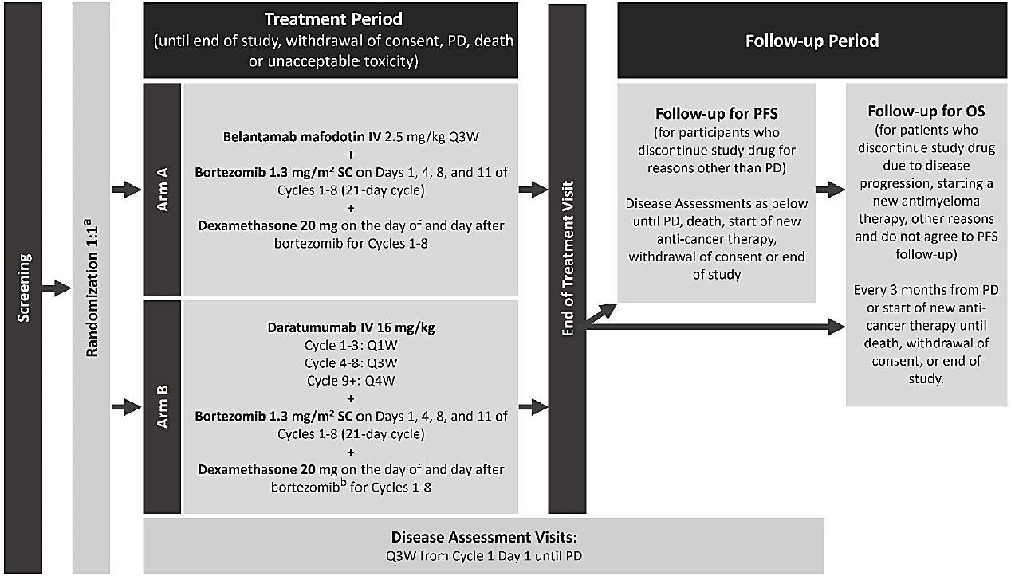
a. Stratification: Prior lines of treatment (1 vs. 2/3 vs. ≥4), R-ISS I vs. R-ISS II/III, Prior bortezomib (yes vs. no).
b. Reduce starting dose of dexamethasone to 10 mg for participants older than 75 years of age, who had a body mass index of <18.5 kg/m², who had previous unacceptable side effects associated with glucocorticoid therapy, or who were unable to tolerate the starting dose.
The primary efficacy outcome measure was PFS, defined as the time from date of randomisation until the earliest date of documented disease progression or death from any cause.
The key secondary efficacy outcome measures were:
- Overall survival (OS), defined as the time from the date of randomization until the date of death due to any cause duration of response (DoR), defined as the time from first documented evidence of PR or better until PD or death due to any cause
- Minimal residual disease (MRD) negativity rate, defined as the percentage of participants who are MRD negative by next-generation sequencing (NGS)
The safety outcome measures were adverse events (AEs), laboratory parameters and ocular findings on ophthalmic examination.
Randomisation was by centralised Interactive Response Technology in the ratio 1:1. There was no blinding.
Time to event outcome measures were analysed using Cox proportional hazards models. Median (95% CI) time to event were summarised using the Brookmeyer Crowley method. Multiplicity was addressed with a multiple testing strategy (Figure 2).
Figure 2: DREAMM-7 Multiple Testing Strategy
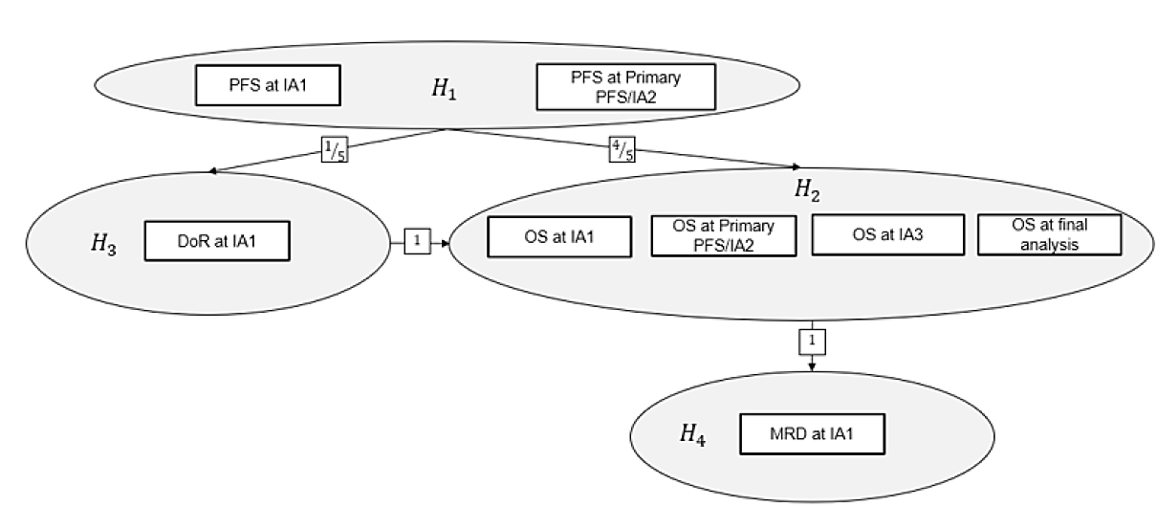
Hi denotes the 1-sided null hypothesis for the primary and key secondary endpoints, where i=1,2,3,4 denotes the index indicating PFS, OS, DoR, and MRD negativity rate, respectively. Upon successful rejection of the hypothesis and regardless of the timing of rejection, the full alpha allocated to testing the hypothesis can be propagated. Arrows indicate the direction and proportion of alpha re-allocation. H1 was to be tested at the 1-sided 2.5% significance level.
All other hypotheses had an initial alpha of 0% assigned. The number of rectangular boxes indicates the number of planned analyses with alpha allocation for a given hypothesis, with text indicating the corresponding endpoint and timepoint of data extraction to be tested. Alpha was to be adjusted to account for multiple testing of an endpoint across timepoints using the Lan DeMets approach that approximates the O'Brien and Fleming spending function. The efficacy boundaries were to be adjusted based on the observed number of events at the time of analysis.

Figure 3: Participant Disposition (DREAMM-7)
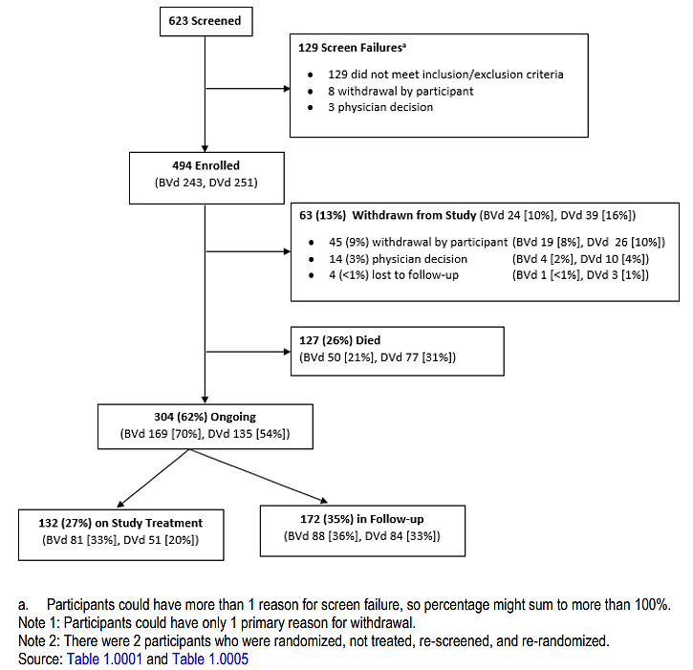
a. Participants could have more than 1 reason for screen failure, so percentage might sum to more than 100%.
Note 1: Participants could have only 1 primary reason for withdrawal.
Note 2: There were 2 participants who were randomized, not treated, re-screened, and re-randomized.
There were 272 (55%) males and 222 (45%) females. The median (range) age was 64.5 (32 to 89) years; 180 (36%) participants were aged 65 to <75 years and 67 (14%) were aged ≥75 years. There were 409 (83%) White participants and 61 (12%) Asian.
Disease characteristics were similar for the two treatment groups. There were 268 (54%) relapsed participants and 211 (43%) refractory. The median (range) lines of prior therapy were 1 (1 to 7). There were 337 (68%) participants with prior stem cell transplant. There were 83 (17%) participants with high-risk cytogenetic abnormalities.
Prior antimyeloma treatment was similar for the two treatment groups. There were 40% of participants who were refractory to immunomodulatory agents.
There was a higher use of blood products in the BVd group, 68 (28%) participants, compared with the DVd group, 41 participants (16%). There were 45 (19%) participants in the BVd group and 22 (9%) in the DVd who received platelet transfusions.

Results for the primary efficacy outcome
For PFS, BVd was superior to DVd. Progression or death were recorded for 91 (37%) participants in the BVd group and 158 (63%) in the DVd. Median (95% CI) PFS was 36.6 (28.4 to NC) months for BVd and 13.4 (11.1 to 17.5) months for DVd. The HR (95% CI) BVd/DVd for PFS was 0.41 (0.31 to 0.53), p <0.00001.
Table 3: Progression-free survival based on Independent Reviewer-Assessed Response (Intention-to-Treat [ITT] Population)
 | BVd  (N=243) | DVd  (N=251)
Number of participants, n (%)
Progressed or died (event) | 91 (37%) | 158 (63%)
Censored, follow-up ended | 44 (18%) | 41 (16%)
Censored, follow-up ongoing | 108 (44%) | 52 (21%)
Event summary, n (%)
Disease progression | 67 (28%) | 139 (55%)
Death | 24 (10%) | 19 (8%)
Estimates for time variable (months)ᵃ
1st Quartile | 14.5 | 6.4
95% CI | (9.5, 17.5) | (4.9, 7.0)
Median | 36.6 | 13.4
95% CI | (28.4, -) | (11.1, 17.5)
3rd Quartile | – | 33.1
95% CI | (–, –) | (26.3, –)
Hazard ratioᵇ
Number of participants in the model | 243 | 251
Estimate | 0.41
95% CI | (0.31, 0.53)
Stratified log-rankᶜ
P-value | <0.00001
Progression-free survival rate
Time-to-event endpoint at 6 months | 0.88 | 0.77
95% CI | (0.83, 0.91) | (0.71, 0.82)
Time-to-event endpoint at 12 months | 0.78 | 0.53
95% CI | (0.72, 0.83) | (0.47, 0.60)
Time-to-event endpoint at 18 months | 0.69 | 0.43
95% CI | (0.62, 0.75) | (0.36, 0.49)
a. CIs were estimated using the Brookmeyer Crowley method.
b. Hazard ratios were estimated using a Cox Proportional Hazards model stratified by the number of lines of prior therapy (1 vs. 2/3 vs. ≥4), prior bortezomib (no, yes) and R-ISS at screening (I vs. II/III), with a covariate of treatment.
c. P-value from 1-sided stratified log-rank test.
Note: There were 2 participants in the ITT Population who were randomized, not treated, re-screened, and re-randomized. They were counted as 4 unique participants in this table.
Significant benefit for PFS was apparent within 3 months of commencing treatment and persisted throughout the treatment period (Figure 4).
Figure 4: Kaplan Meier curves of PFS based on Independent Reviewer-Assessed Response (ITT Population) recommendation following the clinical evaluation
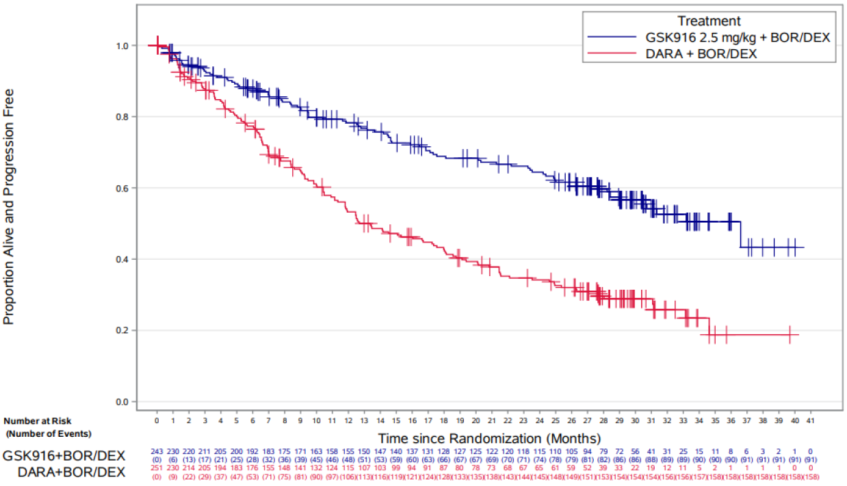
Note: There were 2 participants in the ITT Population who were randomized, not treated, re-screened, and re-randomized. They were counted as 4 unique participants in this figure.
There were no apparent subgroup effects (Figure 5).
Figure 5: Forest Plot – Progression-Free Survival Based on Independent Reviewer-Assessed Response (ITT Population)
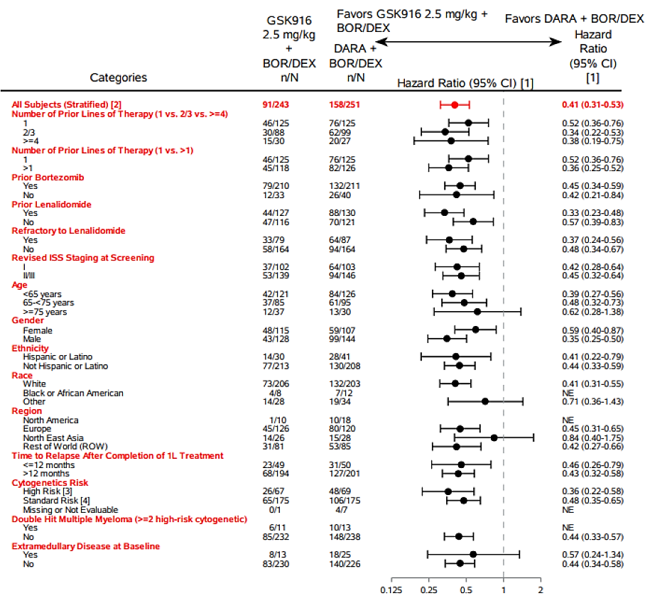
[1] HRs for subgroups were only plotted if number of events ≥20 in total across both treatments. HRs for subgroups were estimated using Cox Proportional Hazard models, without adjustment for stratification variables.
[2] Stratified by the number of lines of prior therapy (1 vs. 2/3 vs. ≥4), prior bortezomib (no, yes), and R-ISS at screening (I vs. II/III) according to IVRS strata with a covariate of treatment.
[3] A participant was considered as high risk if the participant had any of the following cytogenetics: t(4;14), t(14;16), or 17p13del.
[4] A participant was considered standard risk if the participant had negative results for all high-risk abnormalities: t(4;14), t(14;16), or 17p13del.
Note: There were 2 participants in the ITT Population who were randomized, not treated, re-screened, and re-randomized. They were counted as 4 unique participants in this figure.
The investigator assessments of progressive disease were in concordance with the Independent Review Committee (IRC) assessments. The sensitivity analyses were in agreement with the primary analysis.

Results for the key secondary efficacy outcome measures
Overall Survival: death was reported for 54 (22%) participants in the BVd group and 87 (35%) in the DVd . The hazard ratio (95% CI) BVd/DVd for death was 0.57 (0.40 to 0.80), p = 0.00049. The OS benefit was apparent by Month 12 and persisted to Month 40 (Table 4 and Figure 6).
Table 4: Summary of Overall Survival (ITT Population)
 | BVd  (N=243) | DVd  (N=251)
Number of participants, n (%)
Died (event) | 54 (22%) | 87 (35%)
Censored, follow-up ended | 20 (8%) | 28 (11%)
Alive date obtained | 6 (2%) | 12 (5%)
No alive date obtained | 14 (6%) | 16 (6%)
Censored, follow-up ongoing | 169 (70%) | 136 (54%)
Event summary, n (%)
Death | 54 (22%) | 87 (35%)
Estimates for time variable (months)ᵃ
1st quartile | 33.9 | 15.2
95% CI | (21.9, –) | (12.3, 21.1)
Median | – | –
95% CI | (–, –) | (–, –)
3rd quartile | – | –
95% CI | (–, –) | (–, –)
Hazard ratioᵇ
Number of participants in model | 243 | 251
Estimate | 0.57
95% CI | (0.40, 0.80)
Stratified log-rankᶜ
P-value | 0.00049
Overall survival rate
Time-to-event endpoint at 6 months | 0.91 | 0.89
95% CI | (0.87, 0.94) | (0.84, 0.92)
Time-to-event endpoint at 12 months | 0.87 | 0.81
95% CI | (0.81, 0.90) | (0.75, 0.85)
Time-to-event endpoint at 18 months | 0.84 | 0.73
95% CI | (0.79, 0.88) | (0.67, 0.78)
a. CIs were estimated using the Brookmeyer Crowley method.
b. Hazard ratios were estimated using a Cox Proportional Hazards model stratified by the number of lines of prior therapy (1 vs. 2/3 vs. ≥4), prior bortezomib (no, yes), and R-ISS at screening (I vs. II/III), with a covariate of treatment.
c. P-value from 1-sided stratified log-rank test.
Note: There were 2 participants in the ITT Population who were randomized, not treated, re-screened, and re-randomized. They are counted as 4 unique participants in this table.
Figure 6: Kaplan-Meier Curves of Overall Survival (ITT Population)
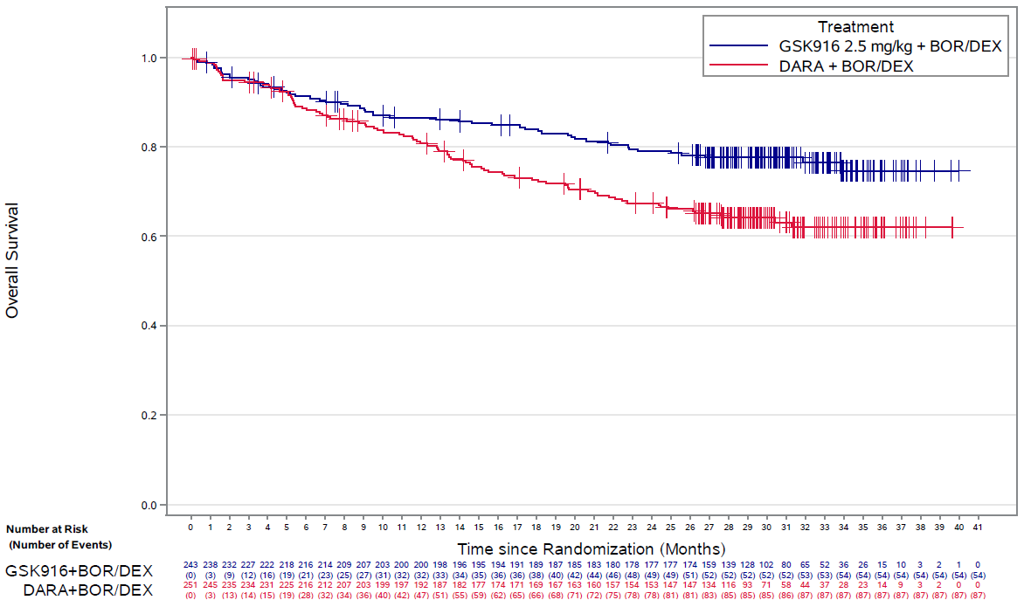
Note: There are 2 subjects in the ITT Population that were randomized, not treated, re-screened, and re-randomized. They are counted as 4 unique subjects in this output.
The Sponsor provided an updated analysis for OS, with cut-off date of 7th October 2024.
OS: death was reported for 68 (28%) participants in the BVd group and 103 (41%) in the DVd. Median survival time was not estimable for either treatment group. The hazard ratio (HR, 95% CI) BVd/DVd for death was 0.58 (0.43 to 0.79), p = 0.00023. The OS benefit was apparent by Month 12 and persisted to Month 52 (Table 5 and Figure 7).
Table 5: Summary of updated Overall Survival (ITT Population) DREAMM-7
 | BVd  (N=243) | DVd  (N=251)
Number of participants, n (%)
Died (event) | 68 (28) | 103 (41)
Censored, follow-up ended | 26 (11) | 33 (13)
Alive date obtained | 12 (5) | 16 (6)
No alive date obtained | 14 (6) | 17 (7)
Censored, follow-up ongoing | 149 (61) | 115 (46)
Event summary, n (%)
Death | 68 (28) | 103 (41)
Estimates for time variable (months)¹
1st quartile | 33.9 | 15.2
95% CI | (21.9, 44.5) | (12.3, 21.1)
Median | – | –
95% CI | (–, –) | (41.0, –)
3rd quartile | – | –
95% CI | (–, –) | (–, –)
Hazard ratio²
Number of participants in the model | 243 | 251
Estimate | 0.58
95% CI | (0.43, 0.79)
Stratified log-rank³
p-value | 0.00023
Overall survival rate
Time-to-event endpoint at 6 months | 0.91 | 0.89
95% CI | (0.87, 0.94) | (0.84, 0.92)
Time-to-event endpoint at 12 months | 0.87 | 0.81
95% CI | (0.81, 0.90) | (0.75, 0.85)
Time-to-event endpoint at 18 months | 0.84 | 0.73
95% CI | (0.79, 0.88) | (0.67, 0.78)
Time-to-event endpoint at 24 months | 0.79 | 0.67
95% CI | (0.73, 0.84) | (0.61, 0.73)
Time-to-event endpoint at 36 months | 0.74 | 0.60
95% CI | (0.68, 0.79) | (0.54, 0.66)
1. CIs were estimated using the Brookmeyer Crowley method.
2. Hazard rates were estimated using a Cox Proportional Hazards model stratified by the number of lines of prior therapy (1 vs. 2/3 vs. 24), prior bortezomib (no, yes), and R-ISS at screening (I vs. II/IIl), with a covariate of treatment.
3. p-value from 1-sided stratified log-rank test.
Note: There were 2 participants in the ITT Population who were randomized, not treated, re-screened, and re-randomized. They are counted as 4 unique participants in this table.
Figure 7: DREAMM-7: Graph of updated Kaplan-Meier Curves of Overall Survival (ITT Population)
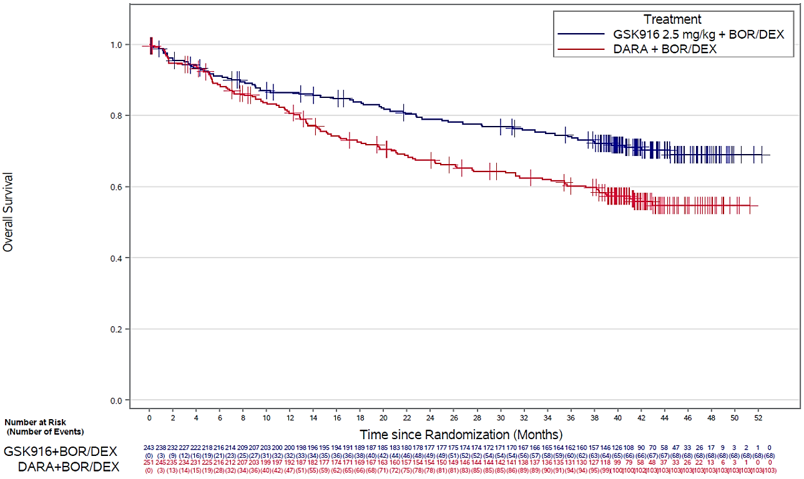
Note: There are 2 participants in the ITT Population that were randomized, not treated, re-screened, and rerandomized. They are counted as 4 unique participants in this output.
DoR: mean (95% CI) DoR at 27.8 months was 19.0 (17.7 to 20.4) months for BVd and 13.2 (11.8 to 14.6) months for DVd: estimated difference (95% CI) 5.9 (4.0 to 8.8) months; mean ratio (95% CI) BVd/DVd 1.45 (1.28 to 1.64), p <0.00001, and demonstrating statistical significance .
MRD negativity rate: MRD was determined for 60 (24.7%) participants for BVd and 24 (9.6%) for DVd. The MRD negativity rate (95% CI) was 24.7 (19.4 to 30.6) % for BVd and 9.6 (6.2 to 13.9) % for DVd, p <0.00001, and considered statistically significant.

Results of the other efficacy outcomes
- The complete response rate (CRR; 95% CI) was 34.6 (28.6 to 40.9) % for BVd and 17.1 (12.7 to 22.4) % for DVd, difference (95% CI), BVd-DVd, 17.4 (8.6 to 26.1) %.
- The overall response rate (ORR; 95% CI) was 82.7 (77.4 to 87.3) % for BVd and 71.3 (65.3 to 76.8) % for DVd, difference (95% CI), BVd-DVd, 11.4 (2.6 to 20.1) %.
- The clinical benefit rate (CBR;95% CI) was 86.0 (81.0 to 90.1) % for BVd and 75.7 (69.9 to 80.9) % for DVd, difference (95% CI), BVd-DVd, 10.3 (1.4 to 19.1) %.
- The median (range) time to response (TTR) was 1.41 (0.7 to 8.4) months for BVd and 0.85 (0.7 to 11.1) months for DVd.
- The median (95% CI) time to progression (TTP) was 36.6 (33.2 to not evaluable [NE]) months for BVd and 16.0 (12.5 to 19.4) months for DVd; HR (95% CI) 0.32 (0.24 to 0.44).
- Median progression-free survival on subsequent line of therapy (PFS2) was not estimable for BVd. The HR (95% CI) for PFS2, BVd/DVd, was 0.56 (0.41 to 0.76).

Study 207499 (DREAMM-8)
DREAMM-8 was a Phase 3, open-label, randomised efficacy and safety study of belantamab mafodotin in combination with pomalidomide and dexamethasone (B-Pd) compared to pomalidomide, bortezomib and dexamethasone (PVd) in participants with RRMM (Figure 8). The study commenced on 13th October 2020 and is ongoing, with the database lock for the present report on 19th February 2024. The study was conducted at 95 centres in 18 countries (Australia, Brazil, Canada, China, Czechia, France, Germany, Greece, Israel, Italy, Japan, New Zealand, Poland, Republic of Korea, Russian Federation, Spain, Turkiye, United Kingdom, United States).
Figure 8. Schematic of DREAMM-8 study design
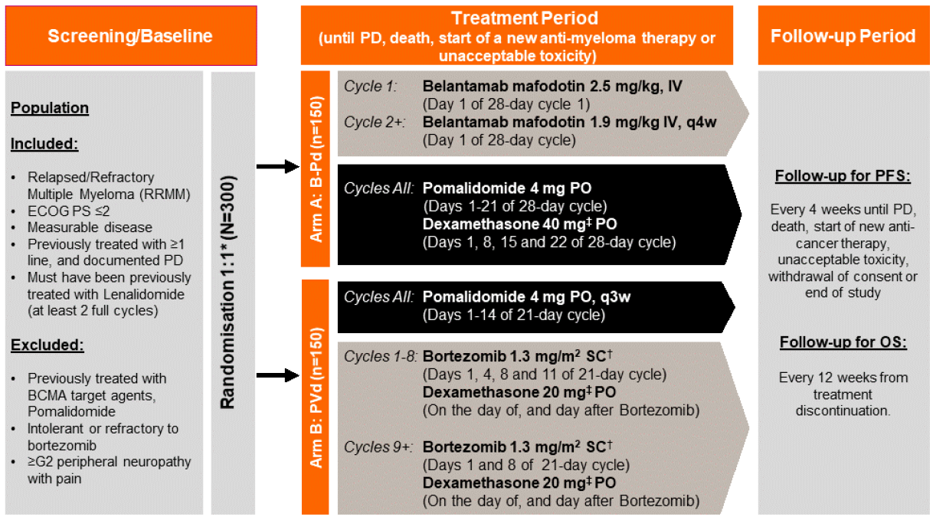
* Stratification: Prior lines of treatment (1 vs. 2 / 3 vs. ≥4), prior bortezomib treatment (yes or no) and prior anti-CD38 treatment (yes or no). No more than 50% of participants with 2 or more prior lines of treatment were enrolled. It was anticipated that no more than 15% of participants with 4 or more prior lines of treatment would be enrolled. No cross-over was allowed. Prior to Protocol Amendment 1, stratification included ISS status (I vs. II/III) instead of anti-CD38 treatment.
† SC administration of bortezomib only.
‡ The dose level of dexamethasone was reduced by half if participant age >75 years or had comorbidities or were intolerant to 40 mg dose in Arm A or 20 mg dose in Arm B, respectively.
The inclusion criteria included:
- Male or female, 18 years or older.
- Have a confirmed diagnosis of MM as defined by the International Myeloma Working Group.
- ECOG performance status of 0 to 2.
- Have been previously treated with at least one prior line of MM therapy including a lenalidomide-containing regimen (lenalidomide must have been administered for at least 2 consecutive cycles) and must have documented disease progression during or after their most recent therapy. Participants intolerant or refractory to bortezomib at 1.3 mg/m² dose twice weekly dosing schedule are not eligible.
The exclusion criteria included:
- Active plasma cell leukaemia at the time of screening. Symptomatic amyloidosis, active POEMS syndrome (polyneuropathy, organomegaly, endocrinopathy, monoclonal plasma proliferative disorder, and skin changes)
- Participants after prior allogeneic stem cell transplant.
- Systemic anti-myeloma therapy (including chemotherapy and systemic steroids) or use of an investigational drug within 14 days or five half-lives (whichever is shorter) preceding the first dose of study drug; Prior treatment with an anti-MM monoclonal antibody drug within 30 days of receiving the first dose of study drugs.
The key efficacy and safety outcome measures were the same as for DREAMM-7.
Figure 9. Multiple Testing Strategy: DREAMM-8
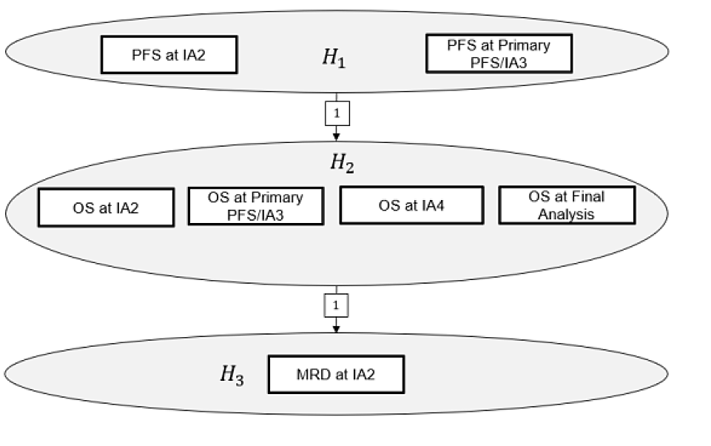
Hi denotes the 1-sided null hypothesis for the primary and key secondary endpoints, where i=1, 2, 3 denotes the index indicating PFS, OS, and MRD negativity rate, respectively. Upon successful rejection of the hypothesis and regardless of the timing of rejection, the full alpha allocated to testing the hypothesis can be propagated. Arrows indicate the direction and proportion of alpha re-allocation. H1 was to be tested at the 1-sided 2.5% significance level. All other hypotheses had an initial alpha of 0% assigned. The number of rectangular boxes indicates the number of planned analyses with alpha allocation for a given hypothesis, with text indicating the corresponding endpoint and timepoint of data extraction to be tested. Alpha was to be adjusted to account for multiple testing of an endpoint across timepoints using the Lan DeMets approach that approximates the O’Brien and Fleming spending function. The efficacy boundaries were to be adjusted based on the observed number of events at the time of analysis.
Figure 10. DREAMM-8 participant disposition
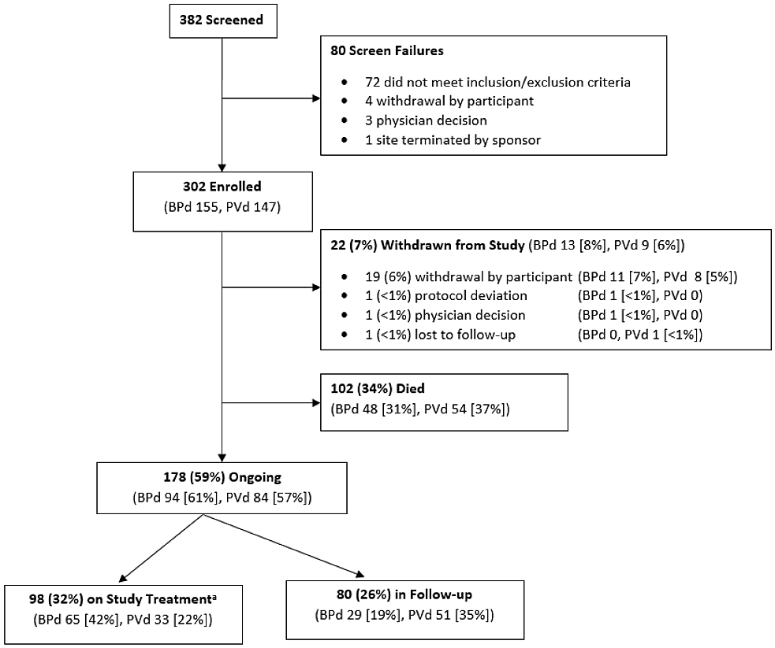
a. Any study treatment component.
Note 1: Participants could have only 1 primary reason for withdrawal
There were 181 (60%) males and 121 (40%) females. The median (range) age was 67.0 (34 to 86) years; 131 (43%) participants were aged 65 to <75 years and 54 (18%) were aged ≥75 years. There were 260 (86%) White participants and 37 (12%) Asian.
Disease characteristics were similar for the two treatment groups. The median (range) lines of prior therapy were 1 (1 to 9). There were 181 (60%) participants with prior stem cell transplant. There were 99 (33%) participants with high-risk cytogenetic abnormalities.
Prior antimyeloma treatment was similar for the two treatment groups. There were 127 (82%) participants in the belantamab mafodotin, pomalidomide, and dexamethasone (BPd) group and 111 (76%) in the PVd refractory to immunomodulatory agents.
There was a higher use of blood products in the BPd group, 46 (30%) participants, compared with the PVd group, 37 participants (25%). There was higher use of GCSF in the BPd group: 64 (41%) participants in the BPd group and 44 (30%) in the PVd.

Results for the primary efficacy outcome
For PFS, BPd was superior to PVd. Progression or death were recorded for 62 (40%) participants in the BPd group and 80 (54%) in the PVd. Median (95% CI) PFS was not estimable (20.6 months to not estimable) for BPd and 12.7 (9.1 to 18.5) months for PVd. The HR (95% CI) BPd/PVd for PFS was 0.52 (0.37 to 0.73), p <0.001 (Table 6).
Table 6: Progression-Free Survival based on IRC-Assessed Response (ITT Population)
Category | BPd (N=155) | PVd (N=147)
Number of participants, n (%)
Progressed or died (event) | 62 (40%) | 80 (54%)
Censored, follow-up ended | 25 (16%) | 34 (23%)
No adequate baseline assessments | 1 (<1%) | 1 (<1%)
No adequate post-baseline assessments: randomized, not dosed, withdrawn | 4 (3%) | 1 (<1%)
No adequate post-baseline assessments before start of new anti-myeloma therapy | 0 | 2 (1%)
No adequate post-baseline assessments: other | 0 | 0
With adequate post-baseline assessment and new anti-myeloma treatment started | 7 (5%) | 17 (12%)
Progression after extended loss-to-follow-up | 2 (1%) | 3 (2%)
Death after extended loss-to-follow-up | 4 (3%) | 4 (3%)
Post-baseline assessment but no progression (or death) | 7 (5%) | 6 (4%)
Censored, follow-up ongoing | 68 (44%) | 33 (22%)
Event summary, n (%)
Disease progression | 46 (30%) | 66 (45%)
Death | 16 (10%) | 14 (10%)
Estimates for time variable (months)ª
1st Quartile | 10.3 | 5.5
95% CI | (5.6, 14.0) | (3.7, 6.5)
Median | – | 12.7
95% CI | (20.6, –) | (9.1, 18.5)
3rd Quartile | – | –
95% CI | (–, –) | (20.3, –)
Hazard ratio^{b}
Estimate^{d} | 0.52
95% CI | (0.37, 0.73)
Stratified log-rank^{c}
P-value^{d} | <0.001
P-value^{e} | <0.001
P-value^{g} | <0.001
Progression-free survival rate
Time-to-event endpoint at 6 months | 0.82 | 0.72
95% CI | (0.75, 0.87) | (0.64, 0.79)
Time-to-event endpoint at 12 months | 0.71 | 0.51
95% CI | (0.63, 0.78) | (0.42, 0.60)
Time-to-event endpoint at 18 months | 0.62 | 0.43
95% CI | (0.54, 0.70) | (0.34, 0.52)
a. CIs for time variables estimated using the Brookmeyer Crowley method.
b. Hazard ratios were estimated using a Cox Proportional Hazards model with stratification factors and covariates according to the corresponding footnote.
c. P-values from 1-sided stratified log-rank test with stratification factors according to the corresponding footnote.
Nominal p-values are provided for sensitivity analyses.
d. Stratification factors: A and B assessed according to the IVRS strata; Covariate: Treatment.
e. Stratification factors based on pooling stratification in SAP using A, B, C, and D; Covariate: Treatment.
f. Stratification factors: A and B assessed according to the IVRS strata; Covariate: Treatment, C and D according to eCRF data.
g. Stratification factors: A and B according to eCRF data; Covariate: Treatment.
Note: A: Number of lines of prior therapy; B: Prior bortezomib use; C: ISS status; D: Prior anti-CD38.
Significant benefit for PFS was apparent within 3 months of commencing treatment and persisted throughout the treatment period (Figure 11) .
Figure 11: Kaplan-Meier Curves of Progression-Free Survival Based on IRC-Assessed Response (ITT Population)
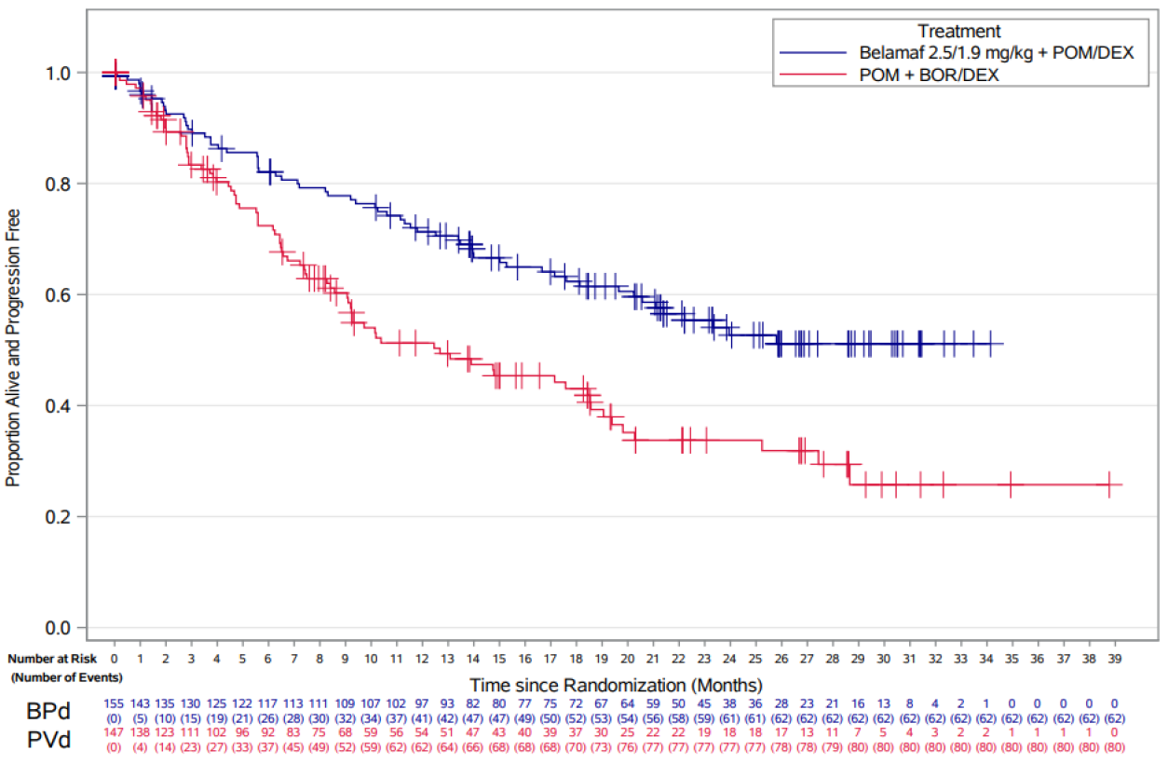
There were no apparent subgroup effects (Figure 12).
Figure 12: Forest Plot – Progression-Free Survival Based on IRC-Assessed Response by Subgroup (ITT Population)
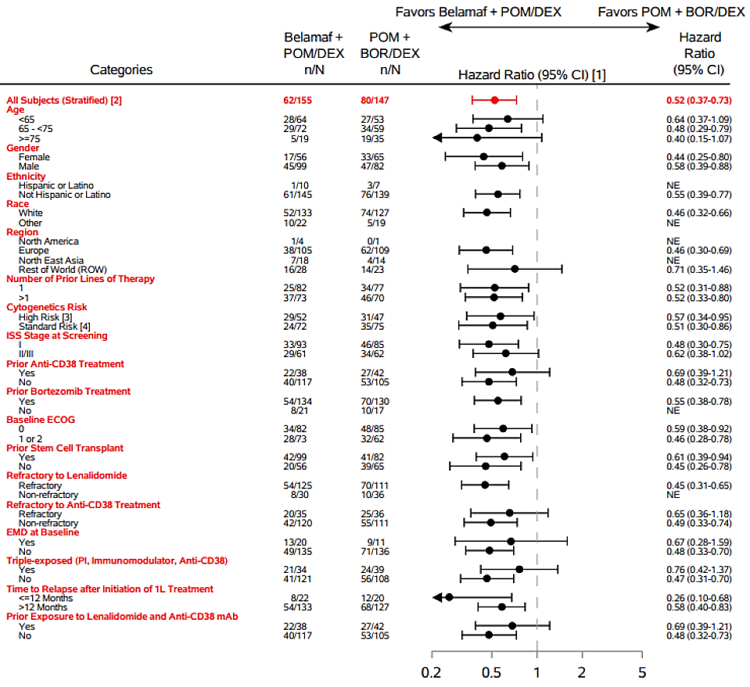
[1] HRs for subgroups were only plotted if number of events was ≥20 in total across both treatments. HRs for subgroups were estimated using Cox Proportional Hazard models, without adjustment for stratification variables.
[2] Stratified by the number of lines of prior therapy (1 vs. 2/3 vs. ≤4), prior bortezomib (no, yes), and according to IVRS strata with a covariate of treatment.
[3] A participant was considered as high risk if the participant had any of the following cytogenetics: t(4;14), t(14;16), or 17p13del.
[4] A participant was considered standard risk if the participant had negative results for all high-risk abnormalities: t(4;14), t(14;16), and 17p13del.
The investigator assessments of progressive disease were in concordance with the IRC assessments. The sensitivity analyses were in agreement with the primary analysis.

Results of the key secondary efficacy outcome measures
OS: there was no significant difference in OS between the two treatment groups. Death was reported for 49 (32%) participants in the BPd group and 56 (38%) in the PVd. The HR (95% CI) BPd/PVd for death was 0.77 (0.53 to 1.14), p = 0.095. The survival curve suggests a benefit for BPd, but this was not statistically significant (Table 7 and Figure 13).
Table 7: Summary of Overall Survival (ITT Population)
 | BPd  (N=155) | PVd  (N=147)
Number of participants, n (%)
Died (event) | 49 (32%) | 56 (38%)
Censored, follow-up ended | 12 (8%) | 7 (5%)
Censored, follow-up ongoing | 94 (61%) | 84 (57%)
Event summary, n (%)
Death | 49 (32%) | 56 (38%)
Estimates for time variable (months)ᵃ
1st quartile | 19.0 | 12.7
95% CI | (12.2, 23.3) | (8.0, 18.5)
Median | – | –
95% CI | (33.0, –) | (25.2, –)
3rd quartile | – | –
95% CI | (–, –) | (–, –)
Hazard ratioᵇ
Estimatedᵈ | 0.77
95% CI | (0.53, 1.14)
Stratified log-rankᶜ
P-valueᵈ | 0.095
OS rate
Time-to-event endpoint at 6 months | 0.93 | 0.88
95% CI | (0.88, 0.96) | (0.81, 0.92)
Time-to-event endpoint at 12 months | 0.83 | 0.76
95% CI | (0.76, 0.88) | (0.68, 0.82)
Time-to-event endpoint at 18 months | 0.76 | 0.69
95% CI | (0.69, 0.82) | (0.61, 0.76)
a. CIs for time variables estimated using the Brookmeyer Crowley method.
b. Hazard ratios were estimated using a Cox Proportional Hazards model according to the corresponding footnotes.
c. P-Value from 1-sided stratified log-rank test according to the corresponding footnotes.
d. Stratification factors: Number of lines of prior therapy (1 vs. 2/3 vs. ≥4) and prior bortezomib use (yes or no) assessed according to IVRS strata; Covariate: Treatment.

Figure 13: Kaplan-Meier Curves of Overall Survival (ITT Population)
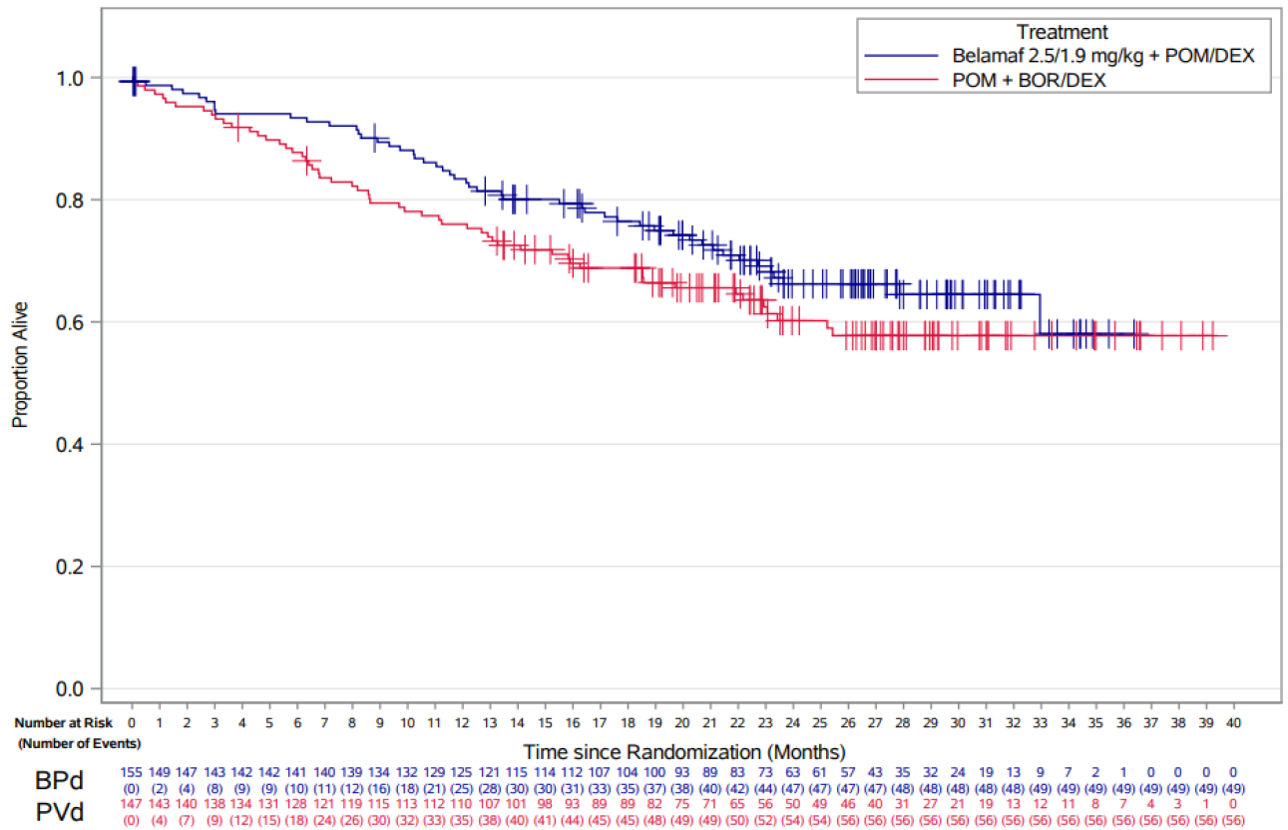
- DoR: estimated mean (95% CI) DoR at 28.8 months was 17.5 (15.7 to 19.3) months for BPd and 12.7 (10.7 to 14.7) months for PVd: estimated difference (95% CI) 4.8 (2.1 to 7.5) months; mean ratio (95% CI) BPd/PVd 1.38 (1.14 to 1.66), p <0.001.
- MRD negativity rate: MRD was determined for 37 (23.9%) participants for BPd and seven (4.8%) for PVd. The MRD negativity rate (95% CI) was 23.9 (17.4 to 31.4) % for BPd and 4.8 (1.9 to 9.6) % for PVd, p <0.001.
For the other efficacy outcomes:
- The complete response rate (CRR;95% CI) was 40 (32.2 to 48.2) % for BPd and 16 (10.7 to 23.3) % for PVd, difference (95% CI), BPd-PVd, 24 (12.5 to 34.4) %.
- The ORR (95% CI) was 77 (70.0 to 83.7) % for BPd and 72 (64.1 to 79.2) % for PVd, difference (95% CI), BPd-PVd, 5 (-6.0 to 16.5) %.
- The Very good partial response (VGPR)+rate (95% CI) was 64 (55.8 to 71.4) % for BPd and 38 (30.2 to 46.5) % for PVd, difference (95% CI), BPd-PVd, 26 (14.6 to 36.5) %.
- The median (range) time to best response (TTBR) was 5.59 (0.9 to 26.1) months for BPd and 2.50 (0.7 to 25.7) months for PVd.
- The median (range) TTR was 1.07 (0.9 to 9.3) months for BPd and 1.05 (0.7 to 11.2) months for PVd.
- The median (95% CI) TTP was not estimable for BPd (25.8 months to not estimable) and 17.1 (9.3 to 19.8) months for PVd.
- Median PFS2 was not estimable for BPd. The HR (95% CI) PFS2, BPd/PVd, was 0.61 (0.43 to 0.86).

Other efficacy studies

Study 207495 (DREAMM-3)
DREAMM-3 was a Phase III, open-label, randomised efficacy and safety study of single agent belantamab mafodotin compared to pomalidomide plus low dose dexamethasone (Pom/Dex) in participants with RRMM. The study was conducted at 108 centres in 18 countries from April 2020 to September 2022. The dose of belantamab mafodotin was 2.5 mg/kg on Day 1 of each 21-day cycle (q3w). The study included 325 participants: 218 treated with belantamab mafodotin and 107 with Pom/Dex. There were 184 (57%) males and 141 (43%) females, with a median (range) age of 68.0 (38 to 90) years. Belantamab mafodotin was not demonstrated to be superior to Pom/Dex. The HR (95%) CI for PFS was 1.03 (0.72 to 1.47) and for OS was 1.14 (0.77 to 1.68).

Study 205678 (DREAMM-2)
DREAMM-2 was a Phase II, open-label, randomised, two dose level , two arm study of efficacy and safety of belantamab mafodotin who had three or more prior lines of treatment, were refractory to a proteasome inhibitor and an immunomodulatory agent and have failed an anti-CD38 antibody. The study was conducted at 58 centres in eight countries from June 2018 to March 2022. Belantamab mafodotin was administered IV as monotherapy at two dose levels:
- 2.5 mg/kg q3w
- 3.4 mg/kg q3w
The study included 196 participants: 97 treated with 2.5 mg/kg and 99 treated with 3.4 mg/kg. There was also an independent cohort of 25 participants treated with a lyophilized presentation of belantamab mafodotin at 2.4 mg/kg. In the main cohort, there were 107 (55%) males and the age range was 34 to 85 years.
There was no significant difference in ORR between the treatment groups: ORR (95% CI) 32 (21.7 to 43.6) % for 2.5 mg/kg and 35 (24.8 to 47.0) % for 3.4 mg/kg. There was no significant difference in CBR between the treatment groups: CBR (95% CI) 36 (26.6 to 46.5) % for 2.5 mg/kg and 40 (30.7 to 50.7) % for 3.4 mg/kg. The median OS was 15.3 months in the 2.5 mg/kg group and 14.0 months in the 3.4 mg/kg.

Study 207497 (DREAMM-6)
DREAMM-6 was a Phase I/II, open label, dose-escalation and expansion study of belantamab mafodotin in combination with either lenalidomide plus dexamethasone (Arm A) or bortezomib plus dexamethasone (Arm B) in patients with RRMM. The study was conducted at 26 centres in five countries. The study commenced on 18th October 2018, and the data cut-off for the dossier was 28th February 2023. The highest dose level assessed in Arm A was 2.5 mg/kg, and in Arm B was 3.4 mg/kg. Arm A included 45 participants: 35 (78%) males, ten (22%) females, with an age range of 36 to 80 years. ORR (95% CI) was 69 (41.3 to 89.0) %. CRR (95% CI) was 44 (19.8 to 70.1) %. CBR (95% CI) was 69 (41.3 to 89.0) %.
Arm B included 107 participants: 69 (64%) males, 38 (36%) females, with an age range of 32 to 83 years. Response rates appeared to be optimal at the 2.5 mg/kg dose level, with no greater response at the 3.4 mg/kg level.
The supportive studies provide limited evidence of efficacy. The primary analysis of the Phase 3 DREAMM-3 study did not meet its primary endpoint for investigator-assessed PFS.. DREAMM-2 and DREAMM-6 are supportive of the 2.4 mg dose level, over the 3.4 mg/kg dose level.

Safety
The Summary of Clinical Safety and the tabulated Integrated Summary of Safety presented the safety data by study, and not as a pooled analysis. This can be justified because of the different drug combinations used. The safety data from the individual studies are discussed below.
The safety profile of belantamab mafodotin is dominated by the risk of ocular adverse events, which were common, of long duration and leading to disability in up to 25% of cases.
Almost all of the participants in the clinical trials reported adverse events. In DREAMM-7 AEs were reported in 242 (100%) participants in the BVd group and 246 (100%) in the DVd group. In DREAMM-8 AEs were reported in 149 (99.3%) participants in the BPd group and 139 (96%) in the PVd. In DREAMM-7 in the BVd group, dry eye was reported in 51% participants, photophobia in 47%, eye irritation in 43% and foreign body sensation in the eye in 44%. In DREAMM-8 in the BPd group, vision blurred was reported in in 79% participants, dry eye in 61%, foreign body sensation in the eyes in 61%, eye irritation in 50%, and photophobia in 44%.
The profile of AEs also differed between the treatment combinations. In DREAMM-7 the most frequently reported AE was thrombocytopenia in 69% participants in the BVd group and 50% in the DVd, whereas in DREAMM-8 thrombocytopenia was reported in 36% participants in the BPd group and 30% in the PVd. In DREAMM-8 infections were more frequent in the BPd group: 82% participants compared with 68% in the PVd. Infective pneumonia was more frequent in the BPd group: 38% participants compared with 17% in the PVd.
The profile of treatment related AEs was similar to that of overall AEs. However, in DREAMM-2 there was an increased risk with increasing dose: 88% participants in the 2.5 mg/kg group and 95% in the 3.4 mg/kg.
In both pivotal studies, death rates were lower in the belantamab mafodotin regimens, and SAEs leading to death occurred at similar rates.
In DREAMM-7 overall death was reported for 50 (21%) participants in the BVd group and 77 (31%) in the DVd. Fatalities were reported in 23 (10%) participants in the BVd group and 19 (8%) in the DVd group. The most frequent serious adverse event (SAE) leading to death in the BVd group was pneumonia in seven (3%) participants. SAEs were reported in 121 (50%) participants in the BVd group and 90 (37%) in the DVd group. The difference in rates between the two groups appears to be due to a higher rate of pneumonia and lower respiratory tract infections in the BVd group. SAEs related to study treatment were reported in 47 (19%) participants in the BVd group and 30 (12%) in the DVd group.
In DREAMM-8 overall, 47 (31%) participants in the BPd group and 53 (37%) in the PVd died. Fatal AEs were reported in 17 (11%) participants in the BPd group and 16 (11%) in the PVd. The most common SAE leading to fatality was COVID pneumonia in five (3%) participants in the BPd group and two (1%) in the PVd. SAEs were reported in 95 (63%) participants in the BPd group and 65 (45%) in the PVd. Pneumonia was reported for 27 (18%) participants in the BPd group and 11 (8%) in the PVd. COVID-19 pneumonia was reported for 17 (11%) participants in the BPd group and six (4%) in the PVd.
The SAEs were predominantly infections, particularly pneumonia and lower respiratory tract infections, and these occurred at higher rates (11% to 18% of participants) in the belantamab mafodotin groups.
Treatment discontinuations were more frequent with the BVd regimen. In DREAMM-7 AEs leading to permanent discontinuation of any study treatment were reported in 31% participants in the BVd group and 19% in the DVd group; and in DREAMM-8 15% in the BPd group and 12% in the PVd. With belantamab mafodotin, ocular AEs were the most frequent AE leading to dose reduction or dose interruption/delay.
The indicators of hepatic or renal injury were similar for the belantamab mafodotin regimens and the comparator regimens.
The haematology effects differed between the belantamab treatment combinations. In DREAMM-7 Grade 4 thrombocytopenia was more frequent in the BVd group: 45% participants compared to 21% in the DVd. In DREAMM-8 Grade 4 neutropenia was more frequent in the BPd group: 30 % participants compared to 13 % in the PVd group.
Ocular AEs were common: in DREAMM-7 79% participants in the BVd group and in DREAMM-8 89% in the BPd. These were in DREAMM-7, vision blurred in 66%, dry eye in 51%, photophobia in 47%, foreign body sensation in the eye in 44%, eye irritation in 43% and eye pain in 32%; and in DREAMM-8: vision blurred in 79%, dry eye in 61%, foreign body sensation in the eye in 61%, eye irritation in 50%, photophobia in 44% and eye pain in 33%. In DREAMM-7, investigator assessed corneal events occurred in 84% participants in the BVd group with Grade 4 events in 22%, and in DREAMM-8, in 87% participants in the BPd group, with Grade 4 events in 7%. In DREAMM-7, bilateral worsening of BCVA to 20/50 or worse was reported for 33.9% participants in the BVd group; and in DREAMM-8, 34% participants in the BPd group. In DREAMM-7, 15.3% participants in the BVd group stopped reading due to eyesight issues and 17.8% stopped driving due to eyesight issues. In DREAMM-8, 23.3% participants in the BPd group stopped reading due to eyesight issues and 24.7% stopped driving due to eyesight issues. In DREAMM-7 and DREAMM-8, the median (range) duration of occurrence, for participants who recovered, was 50.0 (12 to 574) days and 59.0 (3 to 785) days, respectively.
Table 8: Summary of Blenrep associated ocular adverse reactions in DREAMM-7
 | Ocular adverse reactionsᵃ | Best Corrected Visual Acuity (BCVA)ᵇ |  | Corneal examination findings (Grade 2+ events)ᶜ
 | Ocular adverse reactionsᵃ | 20/50 or worse for patients | 20/200 or worse for patients | Corneal examination findings (Grade 2+ events)ᶜ
Number of patients with event n (%) | 194 (80) | 84 (35) | 5 (2) | 209 (86)
Median time to first onset (days) | 42 | 79 | 105 | 43
Improvement of first eventᵈ, n (%) | N/A | 81 (96) | 5 (100) | N/A
Resolution of first eventᶜ, n (%) | 88 (45) | 78 (93) | 4 (80) | 180 (86)
Median time to resolution of first event (days) | 51 | 63.5 | 86.5 | 106
Ongoing first eventᶜ, n (%) | 106 (55) | 6 (7) | 1 (20) | 29 (14)
On treatment and follow-up ongoing, n (%) | 28 (14) | 1 (1) | – | –
Discontinued treatment and follow-up ongoing, n (%) | 40 (21) | – | – | 5 (2)
Discontinued treatment and follow-up ended, n (%) | 38 (20) | 5 (6) | 1 (20) | 24 (11)
N/A = Not applicable.
a Resolution of ocular adverse reactions was defined as time to being free from any ocular adverse reactions.
b Resolution of visual acuity was defined as time to 20/25 or better in at least one eye.
c Resolution of corneal examination findings was defined as time to Grade 1 or better based on the ophthalmic examination findings.
d Improvement was defined as bilateral improvement to better than 20/50, or 20/200.
e At the time of the data cut-off (7 October 2024).
Table 9: Summary of Blenrep associated ocular adverse reactions in DREAMM-8
 | Ocular adverse reactionsᵃ | BCVA – 20/50 or worse for patients | BCVA – 20/200 or worse for patients | Corneal examination findings (Grade ≥2 events)ᶜ
Number of patients with event, n (%) | 133 (89) | 51 (34) | 2 (1) | 125 (83)
Median time to first onset (days) | 29 | 112 | N/Aᵈ | 29
Improvement of first eventᶠ, n (%) | N/A | 49 (96) | 2 (100) | N/A
Resolution of first eventᵃ, n (%) | 109 (82) | 45 (88) | 1 (50) | 113 (90)
Median time to resolution of first event (days) | 134.5 | 57 | N/Aᵈ | 88
Ongoing first eventᵃ, n (%) | 24 (18) | 6 (12) | 1 (50) | 12 (10)
Treatment ongoing, n (%) | 5 (4) | 1 (2) | 0 | 0
Discontinued treatment and follow-up ongoing, n (%) | 6 (5) | 1 (2) | 0 | 4 (3)
Discontinued treatment and follow-up ended, n (%) | 13 (10) | 4 (8) | 1 (50) | 8 (6)
N/A = Not applicable.
ᵃ Resolution of ocular adverse reactions was defined as time to being free from any ocular adverse reactions.
ᵇ Resolution of visual acuity was defined as time to 20/25 or better in at least one eye.
ᶜ Resolution of corneal examination findings was defined as time to Grade 1 or better based on the ophthalmic examination findings.
ᵈ In patients with 20/200 or worse, two patients were reported. Time to first onset was 29 and 673 days. Both events improved to better than bilateral 20/200 by the data cut off, of which 1 event resolved after 57 days.
e Improvement was defined as bilateral improvement to better than 20/50, or 20/200.
f At the time of the data cut off (7 October 2024).

Risk management plan
The sponsor has provided approved EU-RMP version 1.0 (dated 5 June 2025; data lock point 29 January 2024) and ASA version 1.2 (dated 23 August 2025).
The summary of safety concerns and their associated risk monitoring and mitigation strategies are summarised in Table 10. The TGA may request an updated RMP at any stage of a product's life-cycle, during both the pre-approval and post-approval phases.
Table 10: Summary of safety concerns
Summary of safety concerns |  | Pharmacovigilance |  | Risk Minimisation
 |  | Routine | Additional | Routine | Additional
Important identified risks | Corneal examination findings (including keratopathy), potentially resulting in vision changes | * | – |  | ‡
Important potential risks | None | – | – | – | –
Missing information | None | – | – | – | –
* Specific targeted follow up form for ocular events (visual disturbances)
‡ Eye-related side effects Guide for HCPs, Eye-related side effects Guide for Patients and Patient Wallet Card
Routine risk minimisation is proposed for all safety concerns. Additional risk minimisation is proposed for the important identified risk of ‘Corneal examination findings (including keratopathy), potentially resulting in vision changes. At round 2, the sponsor has clarified that the additional risk minimisation activities consist of a Prescriber Guide, a Patient Guide and a Patient Alert Card, and clarified the dissemination plan. The CMI has been revised as requested. At round 3 the risk minimisation plan is acceptable, subject to revision of the Patient Guide and HCP Guide as requested.

Risk-benefit analysis

Efficacy
The clinical PK data are limited, but this is because of the toxicity of cys-mcMMAF which limits the ability to study the drug in volunteer populations, or outside of the context of treatment. However, the Sponsor has provided adequate data to inform the PI, and these data are based on patient populations during active treatment. The population PK analyses are thorough and were well conducted. The population PK analyses were conducted in the target population. The models appeared to have adequately described the concentration data evaluate the effects of covariates on PK and to provide exposure measures for exposure-response analyses.
The PK and PD of belantamab mafodotin have been adequately researched.

Study 207503 (DREAMM-7)
The study was designed and conducted in accordance with regulatory guidance. Although the study was open label, the primary and key secondary outcome measures were objective, and unlikely to be biased because of the lack of blinding.
The participants were representative of patients with RRMM in Australia. The definition of MM was consistent with that applied in Australia. The comparator treatment is an accepted treatment for RRMM in Australia, at the same doses and regimen as that used in the study. The background treatments were standardised and did not vary between the study groups. The outcome measures were all accepted measures as per the Guideline on the Clinical Evaluation of Anticancer Medicinal Products (EMA/CHMP/205/95 Rev.6). The statistical measures were appropriate. The objective of this study was to evaluate the efficacy and safety of the combination of belantamab mafodotin, bortezomib, and dexamethasone (BVd) compared with the combination of daratumumab, bortezomib and dexamethasone (DVd) in participants with RRMM with at least 1 prior line of therapy, a total of 494 participants were randomised. Belantamab mafodotin was administered IV at the dose of 2.5 mg/kg on Day 1 of every 21-day cycle in combination with Vd for the first 8 cycles. From Cycle 9 onwards, belantamab mafodotin was administered as monotherapy.
For PFS (the primary endpoint), BVd was superior to DVd. Progression or death were recorded for 91 (37%) participants in the BVd group and 158 (63%) in the DVd. Median (95% CI) PFS was 36.6 (28.4 to NC) months for BVd and 13.4 (11.1 to 17.5) months for DVd. The HR (95% CI) BVd/DVd for PFS was 0.41 (0.31 to 0.53), p <0.00001. Significant benefit for PFS was apparent within 3 months of commencing treatment and persisted throughout the treatment period.
For OS, in the updated analysis, death was reported for 68 (28%) participants in the BVd group and 103 (41%) in the DVd. The HR (95% CI) BVd/DVd for death was significant with 0.58 (0.43 to 0.79), p = 0.00023. The OS benefit was apparent by Month 12 and persisted to Month 52.
The remaining secondary efficacy outcome measures were supportive of efficacy. For PRO-CTCAE there was increasing severity and interference from baseline of blurred vision in the BVd group compared to the DVd group.

Study 207499 (DREAMM-8)
The study was designed and conducted in accordance with regulatory guidance. Although the study was open label, the primary and key secondary outcome measures were objective, and unlikely to be biased because of the lack of blinding. The participants were representative of patients with RRMM in Australia. The definition of MM was consistent with that applied in Australia. The comparator treatment is an accepted treatment for RRMM in Australia, at the same doses and regimen as that used in the study. The outcome measures were all accepted measures as per the Guideline on the Clinical Evaluation of Anticancer Medicinal Products (EMA/CHMP/205/95 Rev.6). The statistical measures were appropriate.
A total of 302 participants with RRMM, previously treated with at least 1 prior line of therapy including a lenalidomide-containing regimen, were randomised to evaluate the efficacy and safety of the combination belantamab mafodotin, pomalidomide and dexamethasone (BPd) compared with pomalidomide, bortezomib and dexamethasone (PVd) in participants. Belantamab mafodotin was administered IV at a single dose of 2.5 mg/kg on Day 1 of Cycle 1 and 1.9 mg/kg on Day 1 of Cycle 2 onwards in each 28-day cycle. Subjects were randomised 1:1 to BPd or PVd.
For PFS, BPd was superior to PVd. Progression or death were recorded for 62 (40%) participants in the BPd group and 80 (54%) in the PVd. The HR (95% CI) BPd/PVd for PFS was 0.52 (0.37 to 0.73), p <0.001. Significant benefit for PFS was apparent within 3 months of commencing treatment and persisted throughout the treatment period.
For OS, there was no significant difference between the two treatment groups at the time of the primary PFS analysis, with a median (range) duration of follow-up of 21.78 (0.03 to 39.23) months. Death was reported for 49 (32%) participants in the BPd group and 56 (38%) in the PVd. The HR (95% CI) BPd/PVd for death was 0.77 (0.53 to 1.14), p = 0.095. In the FDA 120-day update (provided in response to the rolling questions), with a data cut-off of 7th October 2024, in DREAMM-8, there were 54 (36%) participants who died in the BPd group and 57 (39%) in the PVd. Follow-up for OS is ongoing.
The other secondary efficacy outcome measures were supportive of efficacy and indicate improved disease control for BPd. There was increased ocular adverse effects, and ocular related impairment, with BPd.

Safety
Almost all the participants in the clinical trials reported adverse events.
The profile of AEs differed between the treatment combinations. Thrombocytopenia was reported in 69% with BVd. Infections were more frequent with BPd group: 82% participants compared with 68% in the PVd. Infective pneumonia was more frequent in the BPd group: 38% participants compared with 17% in the PVd.
In both pivotal studies, death rates were lower in the belantamab mafodotin regimens, and SAEs leading to death occurred at similar rates.
The SAEs were predominantly infections, particularly pneumonia and lower respiratory tract infections, and these occurred at higher rates (11% to 18% of participants) in the belantamab mafodotin groups.
The haematology effects differed between the belantamab treatment combinations. Grade 4 thrombocytopenia was more frequent with BVd group: 45% participants compared to 21% with DVd. Grade 4 neutropenia was more frequent with BPd: 30% participants compared to 13% with PVd.
Ocular AEs were common in both belantamab treatment combinations(79% to 89% participants), of long duration and leading to disability in up to 25% of cases. These were, vision blurred, dry eye, photophobia, foreign body sensation, eye irritation and eye pain. Investigator assessed corneal events occurred in 84% to 87% participants. Bilateral Worsening of BCVA to 20/50 or worse was reported for 34% participants. In DREAMM-7, 15.3% participants in the BVd group stopped reading due to eyesight issues and 17.8% stopped driving due to eyesight issues. In DREAMM-8, 23.3% participants in the BPd group stopped reading due to eyesight issues and 24.7% stopped driving due to eyesight issues. In DREAMM-7 and DREAMM-8, the median (range) duration of occurrence, for participants who recovered, was 50.0 (12 to 574) days and 59.0 (3 to 785) days, respectively.
Warnings for this risk including all the adverse reactions reported in the safety database are adequately represented in the Australian Product Information (PI). The risk mitigation strategy includes inclusion of a black box warning in the PI about this risk, its screening, ongoing monitoring, management guidance and follow up advise. The RMP includes a routine risk minimisation proposed for all safety concerns and an additional risk minimisation for the important identified risk of ‘Corneal examination findings (including keratopathy), potentially resulting in vision changes. The additional risk minimisation also includes activities which consist of a HCP Guide, a Patient Guide and a Patient Alert Card, and with a dissemination plan. The risk mitigation plan appears robust, and it is expected that this risk can be adequately managed.

Conclusions
Both the DREAMM-7 and DREAMM-8 studies showed statistically significant improvements in PFS with BVd was superior to DVd and BPd was superior to PVd. The BVd group has a statistically significant OS advantage over the DVd group for DREAMM-7. The available OS data for DREAMM-8 is restricted, but it does not suggest a detrimental effect on patients who have been exposed to belantamab mafodotin.
The safety profile of belantamab mafodotin is well characterised. In general, the toxicity of combinations containing belantamab mafodotin is greater than that of the Standard of care combinations. Eye disorders are the most significant safety concern. Nevertheless, the safety profile of belantamab mafodotin in the target population can be deemed manageable in general, as the risk mitigation plan in place is robust. This encompasses the provision of educational materials for patients and healthcare professionals, proposed treatment modifications, close monitoring, and adequate warning of this risk in the PI.

Assessment outcome
Based on a review of quality, safety, and efficacy, the TGA decided to register Blenrep (belantamab mafodotin) for the following indication:
Blenrep is indicated for the treatment of adults with relapsed or refractory multiple myeloma:
•in combination with bortezomib and dexamethasone in patients who have received at least one prior therapy; and
•in combination with pomalidomide and dexamethasone in patients who have received at least one prior therapy including lenalidomide

Specific conditions of registration
Blenrep (belantamab mafodotin) is to be included in the Black Triangle Scheme. The PI and CMI for Blenrep must include the black triangle symbol and mandatory accompanying text for five years, which starts from the date of first supply of the product.
The Blenrep EU-Risk Management Plan (RMP) (version 1.0, dated 5 June 2025, data lock point 29 January 2024), with Australia-Specific Annex (ASA) (version 1.2, dated 23 August 2025), included with submission PM-2024-04725-1-4, and any subsequent revisions, as agreed with the TGA will be implemented in Australia.
An obligatory component of risk management plans is routine pharmacovigilance. Routine pharmacovigilance includes the submission of periodic safety update reports (PSURs).
Reports are to be provided in line with the current published list of EU reference dates and frequency of submission of PSURs until the period covered by such reports is not less than three years from the date of this approval letter. Each report must be submitted within ninety calendar days of the data lock point for that report.
The reports are to at least meet the requirements for PSURs as described in the European Medicines Agency’s Guideline on good pharmacovigilance practices (GVP) Module VII-periodic safety update report (Rev 1), Part VII.B Structures and processes. Note that submission of a PSUR does not constitute an application to vary the registration.
Laboratory testing & compliance with Certified Product Details (CPD)
- All batches of Blenrep supplied in Australia must comply with the product details and specifications approved during evaluation and detailed in the Certified Product Details (CPD).
- When requested by the TGA, the Sponsor should be prepared to provide product samples, specified reference materials and documentary evidence to enable the TGA to conduct laboratory testing on the Product. Outcomes of laboratory testing are published biannually in the TGA Database of Laboratory Testing Results http://www.tga.gov.au/ws-labs-index and periodically in testing reports on the TGA website.
Certified Product Details
The Certified Product Details (CPD), as described in Guidance 7: Certified Product Details of the Australian Regulatory Guidelines for Prescription Medicines (ARGPM), in PDF format, for the above products should be provided upon registration of these therapeutic goods. In addition, an updated CPD should be provided when changes to finished product specifications and test methods are approved in a Category 3 application or notified through a self-assessable change.
A template for preparation of CPD for biological prescription medicines can be obtained from the TGA website:
Certified Product Details guidance
Certified Product Details form

Product Information and Consumer Medicine Information
For the most recent Product Information (PI) and Consumer Medicine Information (CMI), please refer to the TGA PI/CMI search facility.

Therapeutic Goods Administration
PO Box 100 Woden ACT 2606 Australia
Email: info@tga.gov.au Phone: 1800 020 653 Fax: 02 6203 1605
https://www.tga.gov.au
Reference/Publication #

This is the original indication proposed by the sponsor when the TGA commenced the evaluation of this submission. It may differ to the final indication approved by the TGA and registered in the Australian Register of Therapeutic Goods.
Albagoush SA, Shumway C, Azevedo AM. Multiple Myeloma. [Updated 2023 Jan 30]. In: StatPearls [Internet]. Treasure Island (FL): StatPearls Publishing; 2026 Jan-. Available from: https://www.ncbi.nlm.nih.gov/books/NBK534764/
Allen HC, Sharma P. Histology, Plasma Cells. [Updated 2022 Dec 30]. In: StatPearls [Internet]. Treasure Island (FL): StatPearls Publishing; 2026 Jan-. Available from: https://www.ncbi.nlm.nih.gov/books/NBK556082/
Australian Institute of Health and Welfare. Cancer data in Australia. Blood cancer incidence and survival by histology (experimental data). Last updated: 08 Oct 2025.
Padala SA, Barsouk A, Barsouk A, Rawla P, Vakiti A, Kolhe R, Kota V, Ajebo GH. Epidemiology, Staging, and Management of Multiple Myeloma. Med Sci (Basel). 2021 Jan 20;9(1):3. doi: 10.3390/medsci9010003. PMID: 33498356; PMCID: PMC7838784
Myeloma Australia Medical and Scientific Advisory Group (MSAG). Clinical Practice Guideline Multiple Myeloma. Updated June 2022.
Tai YT and Anderson KC. Targeting B-cell maturation antigen in multiple myeloma, Immunotherapy, 2015; 7: 1187-99.
Tai YT, Mayes PA, Acharya C, et al. Novel anti-B-cell maturation antigen antibody-drug conjugate (GSK2857916) selectively induces killing of multiple myeloma. Blood. 2014;123(20):3128-38.
Montes de Oca R, Bhattacharya S, Vitali NJ, et al. The anti-BCMA antibody-drug conjugate GSK2857916 drives immunogenic cell death and immune-mediated anti-tumor responses, and in combination with an OX40 agonist potentiates in vivo activity. Hemasphere. 2019;3(S1):231.
International Conference on Harmonisation of Technical Requirements for Registration of Pharmaceuticals for Human Use. ICH S9 Non-clinical evaluation for anticancer pharmaceuticals - Scientific guideline. 2013.
International Conference on Harmonisation of Technical Requirements for Registration of Pharmaceuticals for Human Use. ICH S6 (R1) Preclinical safety evaluation of biotechnology-derived pharmaceuticals - Scientific guideline. 2011.

