Australian Public Assessment Report for Audenz
  - Active ingredient: influenza virus haemagglutinin H5N1
  - Sponsor: Seqirus Pty Ltd
April 2026

About the Therapeutic Goods Administration (TGA)
- The Therapeutic Goods Administration (TGA) is part of the Australian Government Department of Health, Disability and Ageing and is responsible for regulating therapeutic goods, including medicines, medical devices, and biologicals.
- The TGA administers the Therapeutic Goods Act 1989 (the Act), applying a risk management approach designed to ensure therapeutic goods supplied in Australia meet acceptable standards of quality, safety, and efficacy.
- The work of the TGA is based on applying scientific and clinical expertise to decision-making, to ensure that the benefits to the Australian public outweigh any risks associated with the use of therapeutic goods.
- The TGA relies on the public, healthcare professionals and industry to report problems with therapeutic goods. The TGA investigates reports received to determine any necessary regulatory action.
- To report a problem with a therapeutic good, please see the information on the TGA website.

About AusPARs
- The Australian Public Assessment Report (AusPAR) provides information about the evaluation of a prescription medicine and the considerations that led the TGA to approve or not approve a prescription medicine submission. Further information can be found in Australian Public Assessment Report (AusPAR) guidance.
- AusPARs are prepared and published by the TGA.
- AusPARs are static documents that provide information that relates to a submission at a particular point in time. The publication of an AusPAR is an important part of the transparency of the TGA’s decision-making process.
- A new AusPAR may be provided to reflect changes to indications or major variations to a prescription medicine subject to evaluation by the TGA.

Copyright
© Commonwealth of Australia 2026.
This work is copyright. You may reproduce the whole or part of this work in unaltered form for your own personal use or, if you are part of an organisation, for internal use within your organisation, but only if you or your organisation do not use the reproduction for any commercial purpose and retain this copyright notice and all disclaimer notices as part of that reproduction. Apart from rights to use as permitted by the Copyright Act 1968 or allowed by this copyright notice, all other rights are reserved, and you are not allowed to reproduce the whole or any part of this work in any way (electronic or otherwise) without first being given specific written permission from the Commonwealth to do so. Requests and inquiries concerning reproduction and rights are to be sent to the TGA Copyright Officer, Therapeutic Goods Administration, PO Box 100, Woden ACT 2606 or emailed to <tga.copyright@tga.gov.au>.

Contents
List of abbreviations 4
Product submission 6
Submission details 6
Product background 7
Disease 7
Current treatment options 8
Clinical rationale 8
Regulatory status 9
Australian regulatory status 9
International regulatory status 9
Registration timelines 10
Assessment overview 11
Quality evaluation summary 11
Nonclinical evaluation summary 11
Clinical evaluation summary 11
Summary of clinical studies 11
Immunogenicity, dose selection and safety 12
Safety 26
Risk management plan 40
RMP evaluator recommendations regarding condition/s of registration 41
Risk-benefit analysis 41
Delegate’s considerations for Audenz 41
Advisory Committee considerations 42
Assessment outcome 43
Specific conditions of registration 43
Quality 44
Product Information and Consumer Medicine Information 45

List of abbreviations
Abbreviation | Meaning
ACM | Advisory Committee on Medicines
ACPM | Advisory Committee on Prescription Medicines (now the ACM)
ACV | Advisory Committee on Vaccines
AE(s) | Adverse event(s)
AESI | Adverse events of special interest
aH5N1c | Audenz, Celldemic
ARTG | Australian Register of Therapeutic Goods
ASA | Australia-specific annex
BMI | Body mass index
CBER | Center for Biologics Evaluation and Research
CHMP | Committee for Medicinal Products for Human Use
CI | Confidence Interval
CMI | Consumer Medicines Information
DLP | Data lock point
DP | Drug product
EU | European Union
EMA | European Medicines Agency
FAS | Full Analysis Set
FDA | Food and Drug Administration
GMR | Geometric mean ratio
GMT(s) | Geometric mean titre(s)
HA | Haemagglutinin
HI | Hemagglutination inhibition
IM | Intramuscular
ISS | Integrated safety summary
MDCK | Madin Darby Canine Kidney (cells)
MHRA | Medicines and Healthcare products Regulatory Agency
NA | Neuraminidase
NOCD | New Onset of Chronic Disease
PFS | Pre-filled syringe
PI | Product Information
PSUR | Periodic safety update report
PT | Preferred term
RMP | Risk management plan
SAE | Serious adverse event
SOC | System Organ Class
TGA | Therapeutic Goods Administration
UK | United Kingdom
URTI | Upper respiratory tract infection
US/ USA | United States of America
VRBPAC | Vaccines and Related Biological Products Advisory Committee (FDA)
WHO | World Health Organisation

Product submission

Submission details
Type of submission: | New biological entity
Product name: | Audenz Pandemic Influenza Vaccine
Active ingredient: | Influenza virus haemagglutinin (A/turkey/Turkey/1/2005 NIBRG-23)
Decision: | Approved
Date of decision: | 4 June 2025
Date of entry onto ARTG: | 11 June 2025
ARTG number: | 446671
Black Triangle Scheme  for the current submission: | Yes
Sponsor’s name and address: | Seqirus Pty Ltd  63 Poplar Road,  Parkville,  Victoria, 3052  Australia
Strength/ Dose form: | 7.5 micrograms haemagglutinin per 0.5 mL dose  The vaccine is a purified, inactivated, monovalent, surface antigen (haemagglutinin and neuraminidase), adjuvanted vaccine containing antigen of the following type: A/turkey/Turkey/1/2005 NIBRG-23
Container: | Each pre-filled syringe (PFS) contains 1 dose of 0.5 mL suspension for injection.
Pack size: | 10 x 0.5 mL pre-filled syringes needle free.
Approved therapeutic use for the current submission: | Audenz is indicated for active immunisation against influenza A in persons from 6 months of age and older in an officially declared pandemic.  Audenz should be used in accordance with official recommendations.
Route of administration: | Intramuscular injection.
Dosage: | Individuals 6 months of age and older: Administer two doses (0.5 mL each), at least 21 days apart.  Elderly: No dose adjustment is required in elderly individuals ≥ 65 years of age.  For further information regarding dosage, such as dosage modifications to manage adverse reactions, refer to the Product Information.
Pregnancy category: | Pregnancy Category B1  Healthcare providers should assess the benefit and potential risks of administering the vaccine to pregnant women taking into consideration official recommendations.  The safety of Audenz in pregnancy has not been assessed in clinical trials.  The use of any medicine during pregnancy requires careful consideration of both risks and benefits by the treating health professional. The pregnancy database must not be used as the sole basis of decision making in the use of medicines during pregnancy. The TGA does not provide advice on the use of medicines in pregnancy for specific cases. More information is available from obstetric drug information services in your state or territory.

Product background
This AusPAR describes the submissions by Seqirus Pty Ltd to register Audenz (Influenza virus haemagglutinin) 7.5 micrograms haemagglutinin per 0.5 mL dose, as pre-filled syringe (PFS) for the following proposed indication:
Prophylaxis of influenza in an officially declared pandemic situation in persons 6 months of age and older. Pandemic influenza vaccine should be used in accordance with Australian Health Authorities’ recommendations, taking into account the recommendation of the World Health Organisation.
The Sponsor submitted two concurrent applications, Audenz and Celldemic, for registration in Australia. The dossiers for Audenz and Celldemic, include the same vaccine - MF59-adjuvanted cell culture-derived H5N1 inactivated subunit influenza virus vaccine (aH5N1c), with different regulatory purposes. Two distinct, yet comparable AusPAR documents have been prepared for Audenz and Celldemic.

Disease
Influenza is a highly contagious infectious disease that occurs in epidemics throughout the winter months in the Northern and Southern Hemispheres.
An influenza pandemic occurs when a novel influenza virus emerges against which most of the world’s population has no immunity. Outbreaks of influenza in animals, especially when synchronous with seasonal outbreaks in humans, can result in the merging of zoonotic and human influenza viruses increasing the chances of a pandemic.
In the last few years, the world has faced several threats with influenza pandemic potential, making the occurrence of the next pandemic likely (Vaccines and Related Biological Products Advisory Committee [VRBPAC], 2018). This phenomenon has been observed only with Influenza A viruses and results from the emergence of a new antigenic variant (antigenic shift) typically caused by substitution of the haemagglutinin (HA) antigen on the surface of the virus, with or without a concomitant change in neuraminidase (NA).,, The H2, H5, H7 and H9 subtypes of Influenza A are the most likely to be transmitted to humans and present a potential pandemic threat. Currently, H5 strains continue to circulate in wild birds and domestic poultry, and more recently in cattle herds in the United States of America (USA). There has already been spread (albeit limited) to humans, including cases without any contact with cattle or birds.

Current treatment options
At the time the TGA considered this submission, one zoonotic vaccine was registered in Australia. Panvax H5N8 pre-pandemic, Pre-pandemic influenza vaccine (split-virion, inactivated) for the strain A/Astrakhan/3212/2020 (H5N8)-like virus is approved for use in persons from 6 months of age, to prevent influenza disease caused by the influenza A virus.
There are two pandemic vaccines approved by the TGA i.e. Panvax H1N1 Vaccine / Panvax H1N1 Vaccine Junior H1N1 Pandemic influenza vaccine (split virion, inactivated),,, indicated for active immunisation to prevent influenza disease caused by the influenza A(H1N1) virus, in persons from 6 months of age, and Panvax Pandemic influenza vaccine (split virion, inactivated adjuvanted) intended for preparedness against a future pandemic influenza strain.

Clinical rationale
Influenza vaccines are designed to provide protection against illness caused by circulating virus strains, as prevention is far superior to treating influenza infections. This is particularly important given the limited availability of effective antiviral therapies for influenza, a challenge that is especially pronounced in hospital settings.
Pandemic preparedness vaccines contain influenza antigens that are different from those in the currently circulating influenza viruses. These antigens can be considered as ‘novel’ antigens and simulate a situation where the target population for vaccination is immunologically naïve. Data obtained with the pandemic preparedness vaccine will support a vaccination strategy that is likely to be used for the pandemic vaccine: clinical immunogenicity, safety and reactogenicity data obtained with pandemic preparedness vaccines are relevant for the pandemic vaccines.
Audenz - aH5N1c- pandemic influenza is a surface antigen, inactivated, cell-based, adjuvanted vaccine and contains influenza virus surface antigens haemagglutinin (HA) and neuraminidase (NA) from a potential pandemic virus strain candidate. The monovalent vaccine is prepared in MDCK cell cultures and adjuvanted with MF59C.1 (MF59). Each 0.5 millilitre (mL) dose contains A/turkey/Turkey/1/2005 NIBRG- 23 7.5 micrograms HA, and 0.25 mL of the M59C.1 adjuvant.

Regulatory status

Australian regulatory status
This product is considered a new biological entity for Australian regulatory purposes. Audenz is a new cell-based, adjuvanted influenza pandemic preparedness vaccine. Seqirus seeks approval for Audenz as a Core Pandemic Dossier as per the ‘Guideline on influenza vaccines – submission and procedural requirements’ adopted by the TGA in February 2020. In the event a pandemic is declared, a strain change will be submitted.
The Sponsor has submitted two concurrent applications, Audenz and Celldemic, for registration in Australia. Celldemic is a new cell-based, adjuvanted influenza zoonotic (pre-pandemic) vaccine and is intended for use with the strain contained in the vaccine, A/turkey/Turkey/1/2005 NIBRG-23.
The dossiers for Audenz and Celldemic are identical and include the same vaccine, MF59-adjuvanted cell culture-derived H5N1 inactivated subunit influenza virus vaccine (aH5N1c), with different regulatory purposes.

International regulatory status
A submission under the tradename of Audenz was approved by the United States Food and Drug Administration (FDA -USA) in January 2020 for pre-filled syringes and in June 2021 for multi-dose vials.
The tradename for Audenz is Incellipan in the European Union (EU), United Kingdom (UK) and Switzerland.
The submission for Audenz/ Incellipan was conditionally approved by the European Medicines Agency (EMA) in April 2024, for the below indication:
‘In the event of a pandemic, once the virus strain causing the pandemic has been identified, the manufacturer can include it in the pandemic preparedness vaccine and apply for a ‘final’ authorization’.
The conditions of approval include ‘fulfilment of a noninterventional observational effectiveness study in children and adults against laboratory confirmed influenza during the next declared pandemic.’
The submission was also conditionally approved in the UK under the International Recognition Procedure Route B, with similar conditions to the European Union (EU). The multi-dose vial presentation was not submitted in the EU.
At the time of submission, similar applications to other regulatory agencies were being considered, including Singapore and Switzerland. The following table includes the approved indications for Audenz in the US, European Union and the United Kingdom (Table 1).
Table 1. International regulatory status for Audenz.
Region | Submission date | Status | Approved indications
United States of America (FDA) | 31 January 2019 (PFS)  June 2021 (multi-dose vial) | Approved on 31 January 2020  Approved on 29 October 2021 | Audenz is an inactivated vaccine indicated for active immunization for the prevention of disease caused by the influenza A virus H5N1 subtype contained in the vaccine. Audenz is approved for use in persons 6 months of age and older at increased risk of exposure to the influenza A H5N1 virus subtype contained in the vaccine.
European Union (EMA)  (Centralised procedure) | 24 November 2022 | Approved on 19 April 2024 | Incellipan* is indicated for active immunisation against influenza in an officially declared pandemic.  Incellipan* should be used in accordance with official recommendations.
United Kingdon (MHRA) | 12 June 2024 | Approved on 13 November 2024 | Incellipan* is indicated for active immunisation against influenza in an officially declared pandemic.  Incellipan* should be used in accordance with official recommendations.
*Tradename is Incellipan in EU and UK

Registration timelines
The following table captures the key steps and dates for this submission.
The submission was evaluated under the standard prescription medicines registration process.
Table 2. Timeline for Submission PM-2024-01544-1-2.
Description | Date
Submission dossier accepted and first round evaluation commenced | 31 May 2024
Evaluation completed (End of round 2) | 11 February 2025
Advisory committee meeting | 2 April 2025
Registration decision (Outcome) | 4 June 2025
Registration in the ARTG completed | 11 June 2025
Number of working days from submission dossier acceptance to registration decision* | 212
*Statutory timeframe for standard submissions is 255 working days

Assessment overview
A summary of the TGA’s assessment for this submission is provided below.

Quality evaluation summary
Audenz is an inactivated influenza vaccine prepared from influenza virus propagated in Madin Darby Canine Kidney (MDCK) cells, adapted to grow freely in suspension culture medium. The potency of the vaccine is expressed as the concentration of HA protein and is formulated to contain a minimum of 7.5 μg HA per 0.5 mL dose. Audenz presents as a milky-white homogenous suspension, with a shelf-life of 12 months. The expiry date can be found on the packaging. Store at +2°C to +8°C. Refrigerate, do not freeze. Discard if the vaccine has been frozen and protect from light.
The pre-filled syringe (PFS) drug product (DP) is presented as a single dose ready-to-use liquid for injection; in a needle free 1 mL Type I glass syringe containing 0.5 mL of antigen solution (formulated vaccine). The PFS DP is a milky-white homogenous fluid in appearance and is preservative-free.
There are no significant issues identified from the Quality Evaluation of the submitted data that would indicate the prefilled syringe presentation of the product should not be registered on the basis of quality, or safety-related issues arising from the quality of the product. The manufacturing quality information submitted by the Sponsor supports the registration of the following:
- Audenz Pandemic Influenza Vaccine H5N1 (surface antigen, inactivated, adjuvanted) suspension for injection PFS needle-free.

Nonclinical evaluation summary
There are no nonclinical objections to registration of pre-filled syringe presentation of Audenz for prophylaxis of influenza in an officially declared pandemic situation in persons aged 6 months of age and older.
Immunogenicity of the influenza virus haemagglutinin was demonstrated in ferrets and mice.
Repeat-dose toxicity studies with influenza virus haemagglutinin at total HA doses higher than the clinical dose showed only localised reactions and mild systemic effects, consistent with a transient response to the adjuvant or an immune response to the vaccine antigens.
No effects on female fertility, or on pre- and post-natal development were observed in rabbits following administration of influenza virus haemagglutinin. Thus, the proposed Pregnancy Category B1 is considered acceptable.

Clinical evaluation summary

Summary of clinical studies
The clinical dossier for aH5N1c included two studies considered pivotal to demonstrate immunogenicity and safety in persons aged 18 years of age and older (Study V89_18), and persons aged 6 months to 18 years of age (Study V89_11). It also included an additional four key studies (Study V89P1, Study V89_04, Study V89_13 and Study V110_04) and two supportive studies (Study V129_01 and Study V131_01).
Studies V110_04, V129_01 and V131_01 are dose-ranging studies with MF59 adjuvanted cell culture-derived influenza vaccines of other subtypes. Study V110_04 was conducted with the H1N1 subtype in paediatric subjects, Study V129_01 with the H3N2 subtype in paediatric and adults, including older adults, and Study V131_01 included the H7N9 subtype and was conducted in adults. These studies are considered supportive and will not be described in detail in this AusPAR.
Study V89P1 demonstrated that in healthy adults aged 18 - 40 years of age, adjuvant is needed to achieve licensure criteria and that the lowest dose formulation studied (3.75μg HA of a cell culture H5N1) with half the standard MF59 dose met the European CHMP pandemic vaccine requirements set for haemagglutination inhibition and single radial haemolysis. Findings for the pivotal and key studies are briefly described in the table below (Table 3).
Of the submitted studies, only one study (Study V89_18), was placebo controlled. The phase 2 studies in children (Study V89_11), healthy adults aged 18 - 49 years (Study V89_04) and adults aged 65 years and older (Study V89_13) compared two full doses and two half doses administered 3 weeks apart. The phase 1/2 dose ranging study (Study V89P1) included the cell culture-derived H5N1subunit influenza virus vaccine (A/Indonesia/5/2005), with/without MF59.

Immunogenicity, dose selection and safety
Table 3. Overview of Studies V89_18, V89_11, V89P1, V89_04 and V89_13.
Trials | Title | Design and population | Dosing | Number of subjects enrolled | Follow up
Study V89_18 | A Phase 3 Randomized, Observer-Blind, Multi-centre, Controlled Study to Evaluate Safety, Immunogenicity, and Lot-to-Lot Consistency of an Adjuvanted Cell Culture-Derived, H5N1 Subunit Influenza Virus Vaccine in Healthy Adult Subjects ≥18 yrs of Age | Randomised, observer-blind, placebo controlled, lot-to-lot consistency, Healthy adults ≥18 years | Subjects randomised in a 1:1:1:1 ratio to receive 2 doses (on day 1 and day 22) of either one of the 3 consecutively produced aH5N1c vaccine lots or placebo (Groups A, B, C, D)  Each dose was 0.5 mL and contained 7.5 micrograms hemagglutinin with 0.25 mL MF59. A fourth group received 0.5 mL placebo | 3196 | Day 183
Study V89_11 | Phase II, Randomized, Observer-Blind, Multicentre, Study to Evaluate Safety, Tolerability and Immunogenicity of an Adjuvanted Cell Culture-Derived H5N1 Subunit Influenza Virus Vaccine at Two Different Formulations in Healthy Paediatric Subjects. | Randomised, observer blind, 2 doses  Healthy paediatric subjects 6 months to ≤ 17 years | MF59 adjuvanted cell culture-derived subunit inactivated monovalent, A/turkey/Turkey/1/2005 (H5N1) strain vaccine (formulated as 7.5 μg HA of H5N1 with 0.25 mL MF59 or 3.75 μg HA of H5N1 with 0.125 mL MF59) | 662 | Day 387
Study V89P1 | A Phase 1/2, Randomised, Observer-blind, Multicentre, Dose Ranging Study to Evaluate the Immunogenicity, Safety and Tolerability of Different Formulations of an Adjuvanted or Non-Adjuvanted Cell Culture-Derived H5N1 Subunit Influenza Virus Vaccine in Healthy Subjects 18 – 40 Years of Age | Randomised, observer blind, dose-ranging  Healthy adults 18 to ≤ 40 years of age | Cell culture-derived subunit inactivated monovalent, A/Indonesia/5/2005 (H5N1) strain vaccine with 0, 0.0625, 0.125 or 0.25 mL MF59 and 3.75 μg, 7.5 μg or 15 μg HA of H5N1 0.5 mL IM injection  Two vaccinations 3 weeks apart | 753 | Day 366: immunogenicity  Day 546: safety
Study V89_04 | Phase II, Randomized, Observer-Blind, Multicentre, Study to Evaluate Safety, Tolerability and Immunogenicity of an Adjuvanted Cell Culture-Derived H5N1  Subunit Influenza Virus Vaccine at Two Different Formulations in Healthy Adult Subjects. | Phase 2 Randomised, observer-blind, 2 doses  Healthy adults, 18 to <65 years | MF59 adjuvanted cell culture-derived subunit inactivated monovalent, A/turkey/Turkey/1/2005 (H5N1) strain vaccine (formulated as 7.5 μg HA of H5N1 with 0.25 mL MF59 or 3.75 μg HA of H5N1 with 0.125 mL MF59) 0.5 mL or 0.25 mL IM injection  Two vaccinations 3 weeks apart | 979 | Day 387
Study V89_13 | A Phase II, Randomized, Observer-Blind, Multicentre, Study to Evaluate Safety, Tolerability and Immunogenicity of an Adjuvanted Cell Culture-Derived H5N1 Subunit Influenza Virus Vaccine at Two Different Formulations in Healthy Elderly Subjects. | Phase 2 Randomised, observer-blind, 2 doses  Healthy adults ≥65 years | MF59 adjuvanted cell culture-derived subunit inactivated monovalent, A/turkey/Turkey/1/2005 (H5N1) strain vaccine (formulated as 7.5 μg HA of H5N1 with 0.25 mL MF59 or 3.75 μg HA of H5N1 with 0.125 mL MF59) | 1393 | Day 387
The following criteria were used for the evaluation of immunogenicity in the included studies (Table 4).
Table 4. CBER and Formerª CHMP Criteria for the evaluation of immunogenicity of Influenza Vaccines.
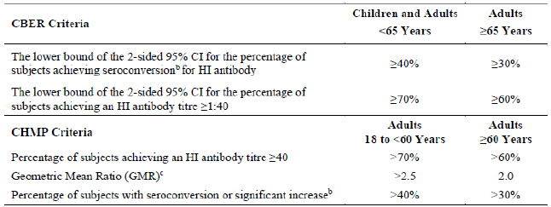
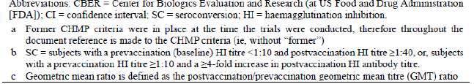

Study V89_18
This was a Phase 3, Randomised, Observer-Blind, Multicentre, Placebo-controlled, lot-to-lot consistency study.

Co-primary immunogenicity objectives
To demonstrate lot-to-lot consistency across 3 consecutively produced lots of aH5N1c vaccine, as assessed by the ratio of geometric mean titres (GMTs) of hemagglutination inhibition (HI) antibody responses to the H5N1 vaccine strain 3 weeks after the second vaccine administration (Day 43) in healthy adult subjects aged 18 years and older.
Lot-to-lot consistency would be demonstrated if the limits of the 2-sided 95% confidence intervals (CI) for the GMT ratio were within the predefined equivalence range of 0.67 to 1.5.
‘After lot-to-lot consistency was demonstrated, the populations of all aH5N1c vaccine recipients were pooled in order to evaluate immune responses to aH5N1c vaccine according to immunogenicity criteria defined by Center for Biologics Evaluation and Research (CBER) guidance 3 weeks after the second vaccine administration (Day 43) as measured by age cohort and by strain-specific HI assay.’¹³

Secondary objectives
- To evaluate immune responses to aH5N1c vaccine according to immunogenicity criteria defined by CHMP recommendations 3 weeks after the second vaccine administration (Day 43) in healthy adult subjects 18 years of age and older, by age cohort, as measured by strain-specific HI assay.
- To evaluate immune responses to aH5N1c vaccine according to immunogenicity criteria defined by CBER and CHMP recommendations 3 weeks after the first vaccine administration (Day 22) in healthy adult subjects ≥ 18 years by age cohort, as measured by strain-specific HI assay.
- To evaluate immune responses to aH5N1c vaccine 6 months after the first vaccine administration (Day 183) in healthy adult subjects ≥ 18 years of age, by age cohort, as measured by strain-specific HI assay.

Study treatments
Enrolled subjects were stratified by age to include adults aged 18 to 64 years, and adults aged 65 years and older. Subjects were randomised in a 1:1:1:1 ratio to receive 2 doses (on day 1 and day 22) of either one of the 3 consecutively produced aH5N1c vaccine lots or placebo (Groups A, B, C, D) (Table 5).
Table 5. Study vaccine lots in V89_18.
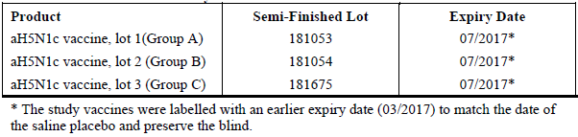

Results for the primary efficacy outcome
Lot-to-lot consistency across three consecutively produced lots of aH5N1c vaccine was demonstrated, as assessed by the ratio of GMTs of HI antibody responses to the H5N1 vaccine strain, three weeks post second vaccine administration. The 2-sided 95% CIs of the pairwise comparisons of GMTs between all three lots fell between the predefined equivalence ranges of 0.667 and 1.5 (Table 6).
The CBER immunogenicity criterion at Day 43 was also met. The lower bound of the 2-sided 95% CI for the percentage achieving a HI antibody titre ≥ 1:40 exceeded 70% (for subjects 18-< 65 years of age) and 60% (for subjects ≥ 65 years of age) after using data from subjects receiving all lots, pooled (Tables 6, 7 and Figure 1). The following figure is extracted from the published paper for this study. ¹³
Table 6. Adjusted Geometric Mean HI Titre and Geometric HI Ratio for Lot-To-Lot Consistency- PPS V89_18.
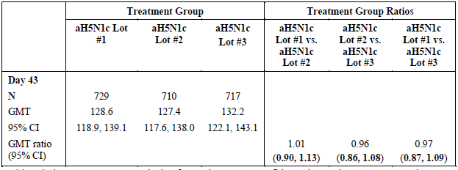
Abbreviations: ANCOVA=analysis of covariance; CI=confidence interval; GMT=geometric mean titer; HI=hemagglutination inhibition; N=number of subjects with available data. Bold shows the 2-sided 95% CI lies within the protocol-defined equivalence range of (0.667, 1.5).
Adjusted estimates of GMTs, and their associated 95% CIs at Day 43 were computed using ANCOVA with factors for lot, age groups (18 to <65, ≥ 65), center and a covariate for the effect defined by the log-transformed prevaccination antibody titer (Day 1).
Table 7. Percentage of Subjects (95% CI) with HI ≥1:40 at day 1 and 43 Against Homologous Strain by CBER Age - PPS in V89_18.
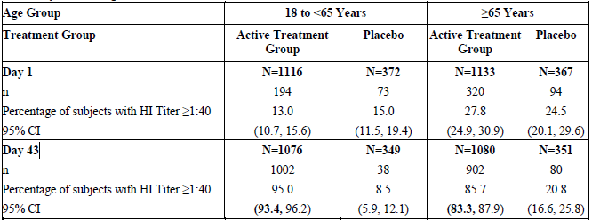
Abbreviations: CBER=Center for Biologics Evaluation and Research; CI=confidence interval; HI=hemagglutination inhibition; n=number of subjects with values in category; N= number of subjects with available data.
Bold indicates CBER criterion met. CBER Criterion for subjects aged 18 to < 65 years: The lower bound of the adjusted 2-sided 95% CI for the percentage of subjects achieving an HI antibody titer ≥ 1:40 should meet or exceed 70%. CBER Criterion for subjects aged ≥ 65 years: The lower bound of the adjusted 2-sided 95% CI for the percentage of subjects achieving an HI antibody titer ≥1:40 should meet or exceed 60%.
Figure 1. Proportion of subjects with HI≥1:40 on Day 43 in the pooled aH5N1c and placebo groups.
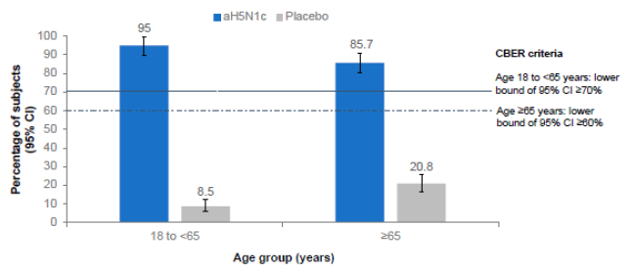
Centre for Biologics Evaluation Research (CBER) criteria were met if the lower bound of the 95% CI was ≥ 70% in subjects aged 18 to <65 years and ≥60% in subjects aged ≥ 65 years.
The CBER immunogenicity criteria for the percentage who achieved seroconversion as measured by HI titre were met at day 43 in both age groups in the active treatment groups (Table 8). The CBER criteria for percentage achieving an HI antibody titre ≥ 1:40 and percentage achieving seroconversion as measured by HI titre were not met in either age groups at day 22 (Table 9).

Secondary immunogenicity outcomes
Table 8. Immune Responses (GMT & GMR) Against Homologous Strain at days 1, 22, 43, and 183 by Treatment Group – PPS V89_18.
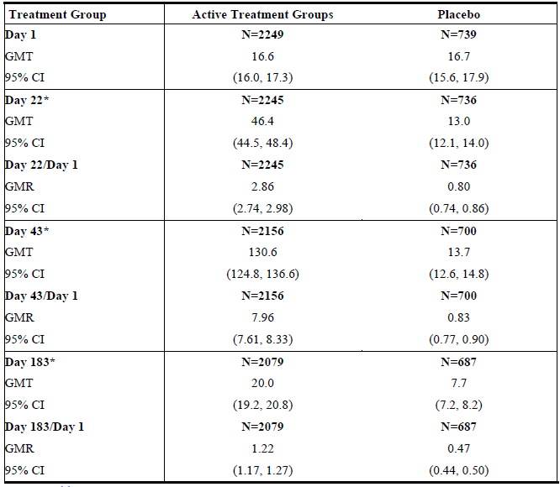
Abbreviations: ANCOVA= analysis of covariance; CI=confidence interval; GMR=geometric mean ratio; GMT=geometric mean titer; N= number of subjects with available data.
*Adjusted estimates of GMTs, and their associated 95% CIs at Day 22, Day 43 and Day 183 were computed using ANCOVA with factors for treatment (active treatment groups or placebo), center and a covariate for the effect defined by the log-transformed pre-vaccination antibody titer (Day 1).
Table 9. Immune Responses (GMT & GMR) Against Homologous Strain at days 1, 22, 43, and 183 by Treatment Group – Analysis by CBER Age – PPS in V89_18.
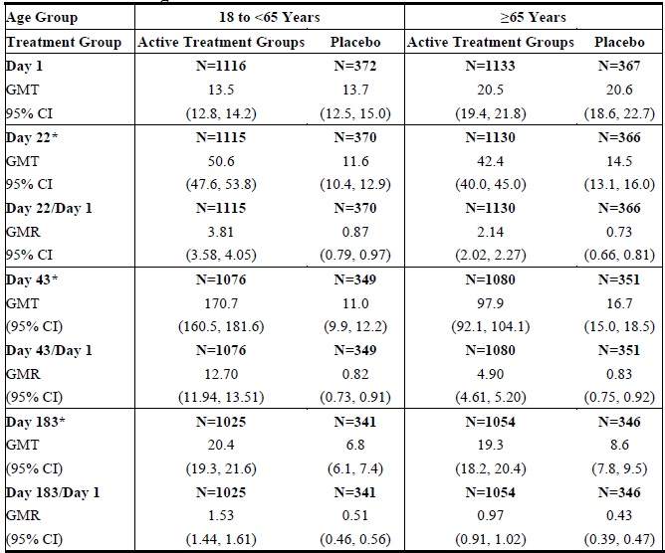
Abbreviations: ANCOVA=analysis of covariance; CBER=Center for Biologics Evaluation and Research; CI=confidence interval; GMR=geometric mean ratio; GMT=geometric mean titer; N=number of subjects with available data.
*Adjusted estimates of GMTs, and their associated 95% CIs at Day 22, Day 43 and Day 183 were computed using ANCOVA with factors for treatment (active treatment groups or placebo), center and a covariate for the effect defined by the log-transformed pre-vaccination antibody titer (Day 1).

Evaluator conclusions
Both co-primary immunogenicity objectives were met i.e. Lot-to-lot consistency of three consecutively produced lots of aH5N1c vaccine was demonstrated, and the age-appropriate CBER immunogenicity criterion was met in both the age groups. Vaccination with aH5N1c (7.5 μg) vaccine elicited an immune response as shown by the increase in HI GMT after the first vaccination that was further increased after the second vaccination.

Delegate comments
The study addressed responses to homologous strains only. Responses were lower in older adults. The EU public assessment report highlighted a reduction in antibody responses 6 months after immunisation, suggesting there may be a need for a booster dose. No booster data were available for either homologous or heterologous strains. The Delegate is aware of the completed booster study evaluating ‘the Safety and Immunogenicity of One or Two Heterologous Booster Vaccinations with an MF59-adjuvanted, Cell Culture-derived H5N6 Influenza Vaccine in Adults Primed with MF59-adjuvanted, Cell Culture-derived H5N1 Influenza Vaccine or Unprimed.’
The EU public assessment report also highlighted that HI and MN assays for the phase 3 trial were performed at a different laboratory compared to the phase 2 trials.

Study V89_11
This was a phase 2, randomised, observer-blind, multicentre study conducted in healthy paediatric subjects aged 6 months to 17 years. Two publications arising from this study have been included as reference documents for the ACV.,

Primary objectives
Immunogenicity: To select the vaccine (low dose or high dose aH5N1c) to be tested in phase 3 based on achievement of CBER criteria 3 weeks after the second vaccine administration as measured by strain-specific HI assays.

Secondary objectives: Immunogenicity
- For each aH5N1c vaccine (low or high dose), to evaluate achievement of all CHMP criteria 3 weeks after the second vaccine administration as measured by strain-specific HI assay.
- For each aH5N1c vaccine (low or high dose), to evaluate achievement of CBER and CHMP criteria 3 weeks after first vaccine as measured by strain-specific HI assay.
- To evaluate immunogenicity of each aH5N1c vaccine (low or high dose) 12 months after the primary 2-doses with respect to CBER and CHMP criteria, using strain-specific HI assays.

Exploratory objectives: immunogenicity
For each aH5N1c vaccine (low or high dose), to evaluate the antibody responses against heterologous influenza strain(s) as measured by HI assay; for each aH5N1c vaccine (low or high dose), to evaluate the antibody responses against heterologous and homologous influenza strain(s) as measured by MN assay.
Safety Objective: To evaluate safety and tolerability of low and high dose aH5N1c vaccine in subjects 6 months to 17 years of age.

Study treatments
Investigational vaccine: MF59 adjuvanted cell-culture derived subunit inactivated monovalent, A/turkey/Turkey/1/2005 (H5N1) NIBRG-23 strain vaccine formulated as 7.5 μg HA of H5N1 with 0.25 mL MF59 for a total of 0.5 mL extractable volume in PFS. This 0.5 mL extractable volume was the high dose vaccine. The pre-filled syringe included a ring mark to indicate the volume for administration of the low dose (3.75 μg HA of H5N1 with 0.125 mL MF59 for a total injection volume of 0.25 mL) and was ready for use for IM administration, preferably in the nondominant arm or in the anterolateral thigh as necessary for younger children.
The primary course of vaccination was two IM injections, separated by approximately 3 weeks.

Results

Results for the primary efficacy outcome
The primary immunogenicity objective was met in both low and high dose groups by satisfying the CBER criteria of seroconversion and HI ≥ 1:40 against homologous strain (Table 10).
Table 10. CBER Criteria Achievement on day 43 for Homologous Strain –FAS - HI Assay in V89_11.
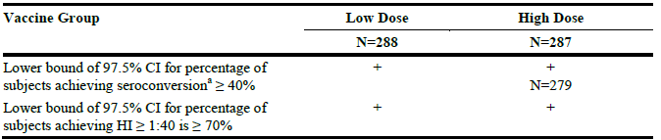
Abbreviations: CBER, Center for Biologics Evaluation and Research; CI, confidence interval, HI, hemagglutination inhibition; FAS, full analysis set. ª Seroconversion is defined as the percentage of subjects with either a pre-vaccination HI < 1:10 and a postvaccination HI ≥ 1:40 or a pre-vaccination HI ≥ 1:10 and a minimum 4-fold rise in postvaccination HI antibody titer.
On day 43, i.e. 3 weeks after second vaccination, the lower bound (LB) of the 2-sided 97.5% CI for the percentage achieving seroconversion exceeded 40% in both formulations, i.e. 97.5% CI was 81% - 90% for low dose group and 93% - 98% for high dose group (Table 11).
Table 11. Percentage of Subjects (97.5% CI) with Seroconversion Against Homologous Strain –HI Assay – FAS V89_11.
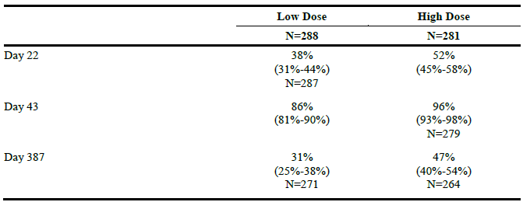
Abbreviations: CI, confidence interval, HI, hemagglutination inhibition, FAS, full analysis set. ª Seroconversion is defined as the percentage of subjects with either a pre-vaccination HI < 1:10 and a postvaccination HI ≥ 1:40 or a pre-vaccination HI ≥ 1:10 and a minimum four-fold rise in postvaccination HI antibody titer.
The following figure from the published paper describes the geometric mean HI titres (95% CI) against the homologous strain on days 1, 22, 43 and 387 in subjects stratified by age sub: group: (A) 6 – 35 months of age; (B) 3 – 8 years of age; (C) 9 – 17 years of age and (D) 6 months – 17 years of age (overall) (Figure 2).¹⁷
Figure 2. Geometric mean HI titers (95% CI) on days 1, 22, 43 and 387 in subjects (A) 6–35 months of age; (B) 3–8 years of age; (C) 9–17 years of age and (D) 6 months–17 years of age (overall).¹⁷
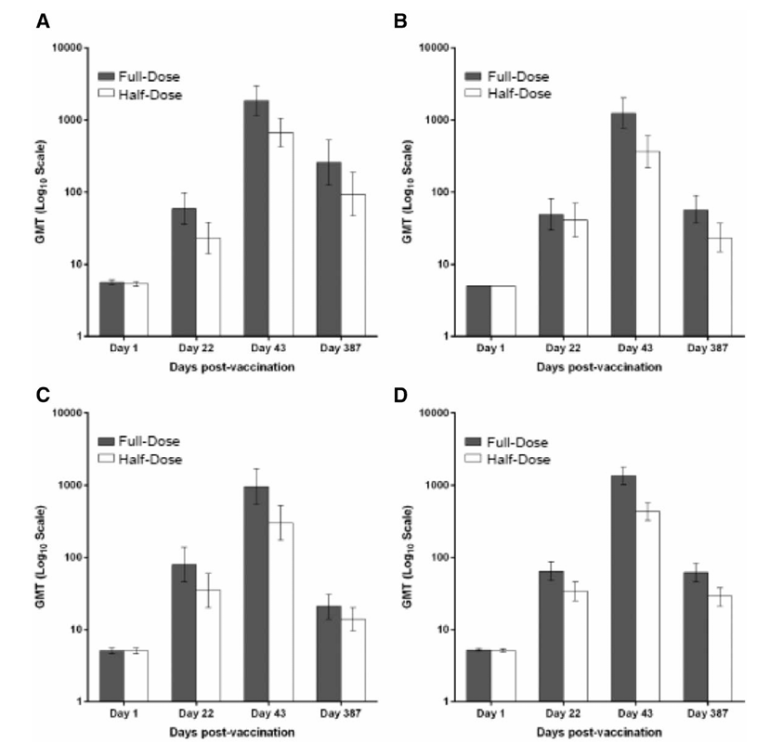

Immunogenicity to heterologous strains
Immunogenicity against heterologous strains was an exploratory endpoint for this study. The sample size was small, with 332 paediatric subjects randomised to receive the full dose of the vaccine and only 69 subjects from the full dose group included in this exploratory analysis.
The published paper¹⁶ provides a summary of the antibody responses to the heterologous strains and these results are also included in the proposed PI. There were some cross-reactive immune responses to heterologous strains in the full dose group.

Study V89_04 and Study V89_13
Study V89_04 and Study V89_13 were studies with similar study designs that enrolled adults 18 to 64 years of age and elderly adults 65 years of age and older, respectively. Publications arising from these studies have been included as attachments for the ACV.,

Primary objectives: Immunogenicity
To select the vaccine (low dose or high dose aH5N1c) to be tested in phase 3 based on achievement of CBER criteria 3 weeks after the second vaccine administration as measured by strain-specific HI assays.

Secondary objectives: Immunogenicity
- For each aH5N1c vaccine (low or high dose), to evaluate achievement of all CHMP criteria 3 weeks after the second vaccine administration measured by strain-specific HI assay.
- For each aH5N1c vaccine (low or high dose), to evaluate achievement of CBER and CHMP criteria 3 weeks after the first vaccine administration measured by strain-specific HI assay.
- To evaluate immunogenicity of each aH5N1c vaccine (low or high dose) 12 months after the primary 2-dose course with respect to CBER and CHMP criteria, as measured by strain-specific HI assays.

Exploratory objectives
Immunogenicity:
- For each aH5N1c vaccine (low or high dose), to evaluate the antibody responses against heterologous influenza strain(s) as measured by HI assay.
- For each aH5N1c vaccine (low or high dose), to evaluate the antibody responses against heterologous and homologous influenza strain(s) as measured MN assay.

Results

Results for the primary efficacy outcome Study V89_04 (adults 18 to <65 years)
CBER criteria at day 43: At day 22, a higher percentage of subjects in the high dose group (48%) showed seroconversion than in the low dose group (27%); similar trends were observed 3 weeks after the second vaccination (day 43; Table 12). Twelve months after the second vaccination, there was a decrease in the percentage with seroconversion in both vaccine groups, but it was still higher in the high dose group (22%) than in the low dose group (9%).
Table 12. Number (%) of Subjects (97.5% CI) with Seroconversionª Against Homologous Strain – HI Assay – FAS V89_04.
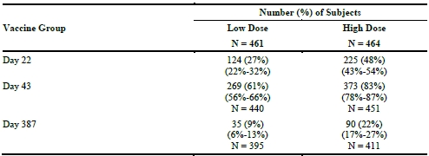
Abbreviations: CI, confidence interval; HI, hemagglutination inhibition; FAS, full analysis set; N, number of subjects. ªSeroconversion is defined as either a pre-vaccination HI < 1:10 and a postvaccination HI ≥ 1:40 or a pre-vaccination HI ≥ 1:10 and a minimum 4-fold rise in postvaccination HI antibody titer.

Evaluator conclusions
The evaluator noted that the primary objective of this study was to select the preferred vaccine, low dose (3.75 μg HA of H5N1 combined with 0.125 mL MF59) or high dose (7.5 μg HA of H5N1 with 0.25 mL of MF59) to be tested in Phase 3, based on achieving CBER criteria for the homologous HI assays 3 weeks after the second vaccine administration. Immunogenicity results indicated that the high dose vaccine was the more appropriate formulation for adults 18 - 64 years of age to be further developed in Phase 3 studies. Cross-reactive antibody responses against 5 heterologous H5N1 strains were measurable but quite variable.

Results for the primary efficacy outcome Study V89_13 (adults ≥ 65 years of age)
Seroconversion: At day 22, a higher percentage in the high dose group (36%) showed seroconversion against Influenza A H5N1 Turkey/2005 CC Ab strain vs. low dose group (21%); similar trends were observed 3 weeks after second vaccination (day 43; Table 13). At day 387, there was a decrease in the percentage of subjects with seroconversion in both vaccine groups, but it was still higher in the high dose group (23%) than the low dose group (10%).
Table 13. Number (%) of Subjects (97.5% CI) with Seroconversionª Against Homologous Strain – HI Assay – FAS V89_13.
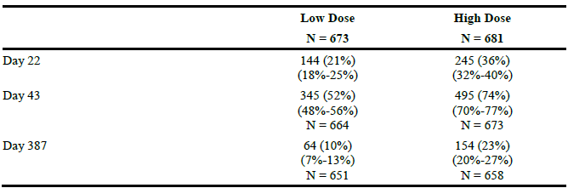
Abbreviation: CBER, Center for Biologics Evaluation and Research CI, confidence interval; FAS, full analysis set; HI, hemagglutination inhibition. ªSeroconversion according to CBER is defined as either a pre-vaccination HI < 1:10 and a postvaccination HI ≥ 1:40, or a pre-vaccination HI ≥ 1:10 and a minimum 4-fold rise in postvaccination HI antibody titer.

The published papers for these studies provide useful summaries of the results for the homologous and heterologous strains in adults, stratified by age group. Below are the results extracted from the published paper.¹⁹
Figure 3. Percentage of subjects with hemagglutination inhibition (HI) titers ≥ 1:40 in adults aged 18 – 64 years (a) and aged ≥ 65 years (b).¹⁹
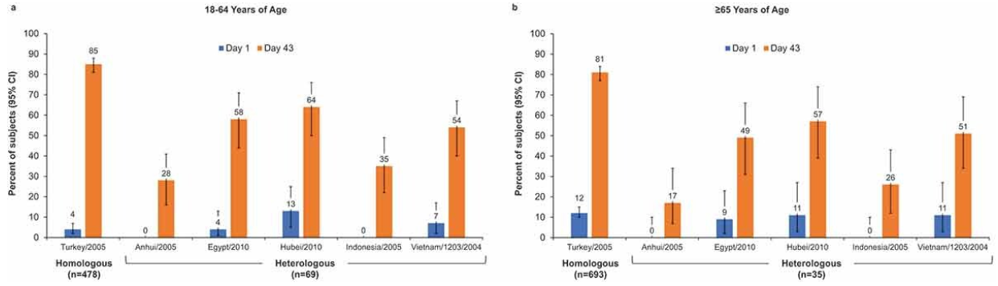
Error bars represent the 95% confidence interval (CI) for heterologous strains and the 97.5% CI for the homologous strain.
Figure 4. Percentage of subjects with seroconversion (defined as hemagglutination inhibition [HI] ≥ 1:40 for subjects negative at baseline [HI <1:10] or a minimum 4-fold increase in HI titer for subjects positive at baseline [HI ≥ 1:10]) on Day 43) or a ≥ 4-fold increase in microneutralization (MN) titers.¹⁹
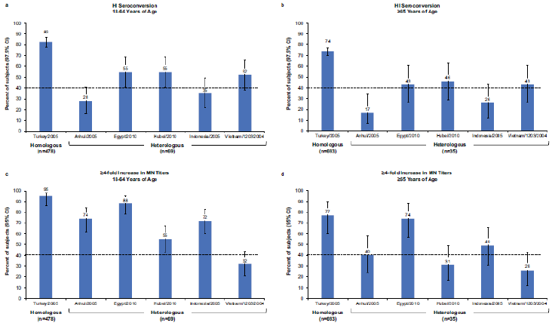
(a, b) Seroconversion in adults aged 18–64 y (a) and ≥65 y (b). Error bars represent the 97.5% confidence interval (CI). (c, d) at least 4-fold increase in MN titers in adults aged 18–64 y (c) and ≥65 y (d). Error bars represent the 95% CI.

Immunogenicity to heterologous strains
As for the paediatric study, there were limited data presented for the heterologous strains in studies V89_04 and V89_13. The results have been included in the PI. Only a subset of subjects were included: 69 younger and 35 older adults, respectively, in these exploratory analyses.

Safety
The summary of the aH5N1c clinical development program is summarised in Table 14. In the integrated safety summary, the following is presented: pooled data from 3 studies in adults and elderly (Studies V89_18, V89_04, and V89_13); data from Phase 3 Study V89_18; Data from dose-ranging Study V89P1; Data from paediatric Study V89_11. No pivotal studies assessed safety as the sole primary outcome.
Table 14. Summary of aH5N1c Clinical Development Program.
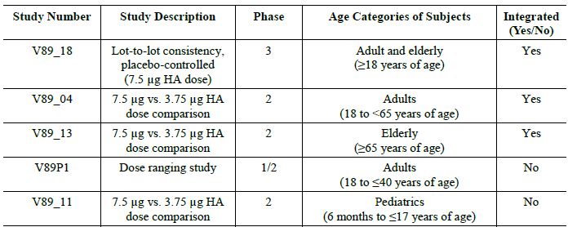
Monitoring periods for safety assessments were similar for all 5 studies (Table 15), except for the total study period, used for selected unsolicited AEs (i.e. SAEs, deaths, AESIs, NOCDs, AEs leading to vaccine/study withdrawal, medically attended AEs, and concomitant medications associated with these events), which was ≈ 1.5 years after first vaccination (day 546) for Study V89P1 and one year after last vaccination (Day 387) for all other studies.
Table 15. Monitoring Periods for Safety Assessment in aH5N1c Studies and Studies of MF59 Adjuvanted Cell Culture-Derived Influenza Vaccines of Other Subtypes.
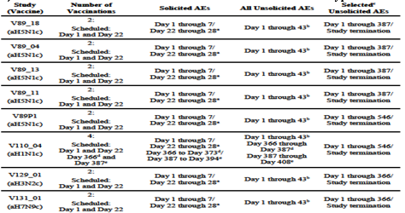
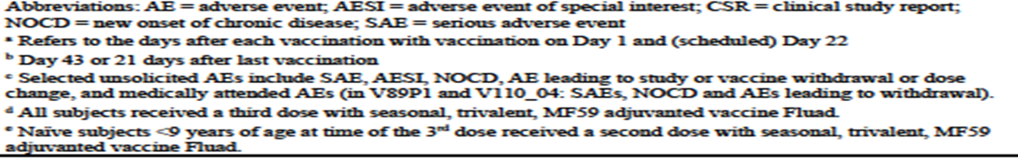
In this report, unsolicited AEs have been listed as ‘All adverse events (irrespective of relationship to study treatment)’, and solicited AEs listed as ‘Treatment related adverse events (adverse drug reactions)’. The severity of solicited local AEs, including injection site erythema, ecchymosis and induration was categorised and summarised by grades based on the linear measurement of the widest diameter of these AEs. Injection site pain and systemic AEs (except fever) occurring in the first 7 days (inclusive) after each vaccination were summarised according to ‘mild’, ‘moderate’ or ‘severe’. Grading of local and systemic solicited AEs in the paediatric setting are summarised in Table 16.
All unsolicited AEs (including solicited AEs that continued beyond day 7 or 28, respectively) were collected for the period day 1-21 after last vaccination (i.e. day 1 to 43 inclusive). During that period and continuing through the completion of the study (≈1.5 years after first vaccination [day 546] for V89P1 and one year after last vaccination [day 387] for all other studies), specified categories of unsolicited AEs were collected separately (monitoring periods for safety assessments are provided in Table 15). These included SAEs, AESIs, NOCDs, AEs leading to vaccine/study withdrawal (including deaths), AEs leading to dose change, medically attended AEs, associated concomitant medications for any of these events, and all vaccinations. These data were captured through the diary card, by interview of the subject, and by review of available medical records. For all unsolicited (S)AEs (including AESIs and NOCDs) the severity and relationship to study vaccine was determined and classified as ‘mild,’ ‘moderate’ or ‘severe’, as per the assessment of the investigator in all individual studies. Grades of Relatedness as determined by the Investigator were ‘Not related’; ‘Possibly related’; ‘Probably related’.
Table 16. Grading of Solicited Local and Systemic AEs in Paediatric Subjects in V89_11 & V129_01.
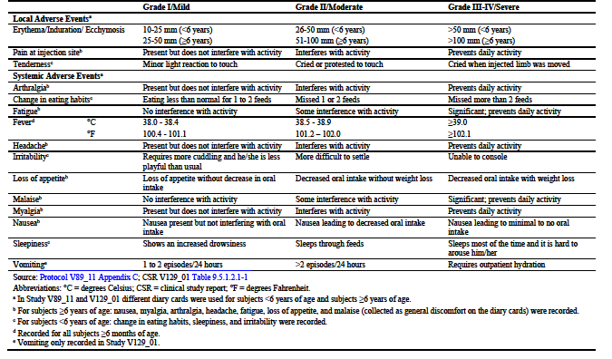
Abbreviations: °C = degrees Celsius; CBER = Center for Biologics Evaluation and Research; ER = emergency room; °F = degrees Fahrenheit; PLT = potentially life threatening; SAP = statistical analysis plan.
ª In Study V89_11 and V129_01 different diary cards were used for subjects <6 years of age and subjects ≥6 years of age.
^{b} For subjects ≥6 years of age: nausea, myalgia, arthralgia, headache, fatigue, loss of appetite, and malaise (collected as general discomfort on the diary cards) were recorded.
^{c} For subjects <6 years of age: change in eating habits, sleepiness, and irritability were recorded.
^{d} Recorded for all subjects ≥6 months of age.
^{e} Vomiting only recorded in Study V129_01.

Subject exposure
As summarised in Table 17, 4884 adults (including 126 adults from the V89P1 dose finding study) and 658 paediatric subjects were exposed to aH5N1c including either a full or half dose of the vaccine. Of these, 3643 adults and 329 paediatric subjects were exposed to the intended full dose. 796 subjects received saline placebo.
Table 17. Overview of Subjects Exposed to Two Dose Levels and Included in the Summary of Clinical Safety.
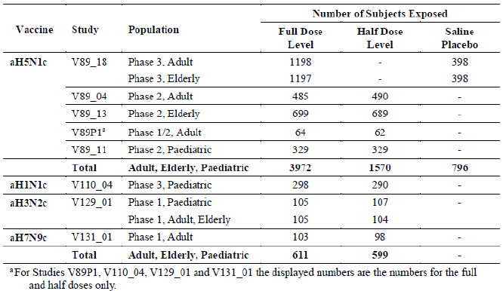
Assessment of the safety of aH5N1c was primarily based on the three adult studies and one paediatric study. Doses explored in both the paediatric and adult setting were the ‘full dose’ 7.5 μg HA in 0.5 mL (adjuvanted with 0.25 mL MF59), and the half-dose3.75 μg HA in 0.25 mL, adjuvanted with 0.125 mL MF59, both as a two-dose series separated by 21 days between doses.

All adverse events (irrespective of relationship to study treatment)

Pivotal studies

Studies V89_04, V89_13 and V89_18: Ages ≥ 18 Years, Full Dose and Placebo in the ISS
Day 1 through study termination: The proportion of subjects for whom unsolicited (related) AEs were reported from day 1 - 43 was comparable for subjects who received aH5N1c full dose vs. placebo (Table 18). The majority of reported unsolicited AEs were of mild or moderate severity. Similar proportions of subjects in both treatment groups reported any unsolicited events, including SAEs, AESIs, AE(s) leading to NOCD, any AE leading to premature withdrawal and medically attended AE(s), from day 1 through study termination. One subject in the aH5N1c group and 2 subjects in the placebo group reported related SAEs, the latter were also classified as AESIs. There were 17 deaths, 16 (0.4%) in the aH5N1c full dose group and 1 (0.1%) death reported in the placebo group. None of the deaths were attributed to aH5N1c or placebo.
Day 1-43: The proportion of subjects for whom unsolicited AEs were reported during the treatment period from day 1 - 43 after any vaccination was similar for the aH5N1c full dose (25.7%) and the placebo groups (22.6%). There was no clear increase in the frequency, or difference in nature of unsolicited AEs in the aH5N1c group vs. placebo group. The proportion of unsolicited AEs considered at least possibly related to vaccination was similar in the aH5N1c full dose group and placebo group (8.2% vs. 6.2%).
The most frequently affected SOC in both treatment groups was ‘Infections and infestations’ (6.9% (aH5N1c group) vs. 6.5% (placebo group)) followed by ‘General disorders and administration site conditions’ (5.9% and 5.0%, respectively). There were no possibly or probably related AEs in the SOC ‘Immune system disorders’. Both for subjects who received aH5N1c full dose or placebo, the most frequently reported unsolicited AEs (PT) during the treatment period were headache (aH5N1c: 2.2%, placebo: 2.1%) and injection site bruising (aH5N1c:1.8%, placebo: 1.6%). At PT level, no notable differences were found between aH5N1c and placebo for unsolicited AEs that were considered related to study vaccination. The most frequently reported related unsolicited AEs were injection site bruising (aH5N1c: 1.7%, placebo: 1.5%) and fatigue (aH5N1c:1.0%, placebo: 0.9%). Across the 2 treatment groups, <1% reported the unsolicited AEs injection site bruising and fatigue which were solicited AEs continuing beyond day 7 after the first and second vaccination. Most unsolicited AEs reported from day 1-43 after any vaccination were of mild (aH5N1c: 18.0%, placebo: 14.3%) or moderate severity (aH5N1c: 6.8%, placebo: 7.0%). Severe unsolicited AEs were experienced by 1.0% in the aH5N1c full dose group and 1.3% in the placebo group. The most frequent severe unsolicited AEs with aH5N1c full dose after any vaccination were fatigue (0.1%, n=5), headache (0.1%, n=5), and arthralgia (0.1%, n=4). Of these, 3 severe cases of fatigue, 2 severe cases of arthralgia and 1 severe case of headache were considered possibly or probably related to aH5N1c. The majority of the unsolicited AEs had resolved by the end of the studies.
Table 18. Ages ≥ 18 Years (Full Dose and Placebo) – Number (%) of Subjects with All and at Least Possibly Related Unsolicited Adverse Events by Preferred Term (Occurring in ≥ 1% in Any Group) Reported from Day 1 Through Day 43 After Any Vaccination – Unsolicited Safety Set.
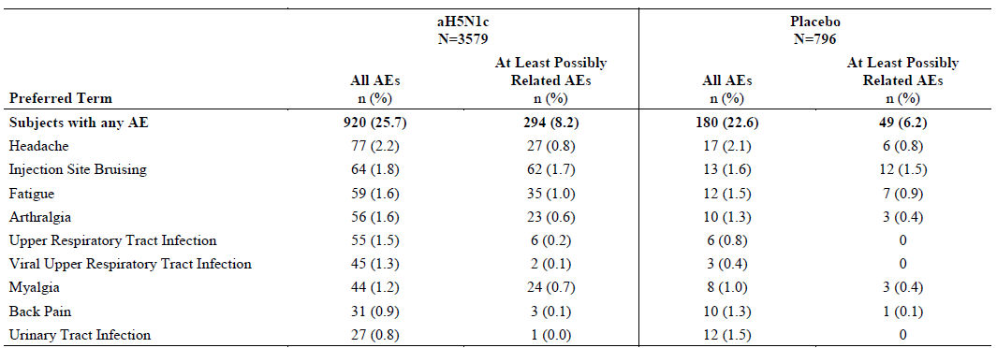
Abbreviations: AE = adverse event; MedDRA = Medical Dictionary for Regulatory Activities; n = number of subjects with values in category; N = total number of subjects. Coded using MedDRA version 20.0. Note: percentages of <0.1% are displayed as 0.0%.
In comparison to the first vaccination, a lower percentage of subjects reported unsolicited AEs after the second vaccination in both the aH5N1c full dose group (first vaccination: 17.3%; second vaccination: 12.6%) and placebo group (first vaccination: 14.4% vs. second vaccination: 10.8%). In total, 3.6% of the subjects in the aH5N1c group and 3.1% of subjects in the placebo group had at least possibly or probably related unsolicited AEs as per the investigator after the second vaccination. Like the unsolicited AEs reported after the first vaccination, the most frequently affected SOC in both groups was ‘Infections and infestations’ (3.1% aH5N1c group vs. 2.6% placebo group) followed by ‘General disorders and administration site conditions’ (2.3% and 2.4%, respectively).

Paediatric Study V89_11
The unsolicited AEs reported through 21 days after each vaccination and by full and the half dose are detailed in Table 19. Overall, the percentage of subjects reporting unsolicited AEs after any vaccination was similar between the half dose and full dose group (29% vs. 26%). In comparison to the first vaccination, the incidence of unsolicited AEs was lower after the second vaccination in both the half dose group (first vaccination: 18%; second vaccination: 14%) and full dose group (first vaccination: 20% vs. second vaccination: 11%). In total, 3% of subjects in the half dose and 2% of subjects in the full dose group reported SAEs from day 1 through study termination. None of these SAEs were considered related to the study vaccination by the investigator No deaths were reported during the study. Only one subject in the full dose group (< 1%) was prematurely withdrawn from the study due to unsolicited AEs of gastroenteritis and rash. Medically attended AEs were reported by 35% and 34% of subjects in the half and full dose group, respectively. Unsolicited AEs leading to NOCD were reported by 1% of subjects in the half dose group and in none of the subjects in the full dose group. The unsolicited AEs leading to NOCD were assessed as not related to the study vaccine by the investigator. No AESIs were reported throughout the study.
After the second vaccination (day 23 - 43), 14% of subjects in the half dose group and 11% in the full dose group reported unsolicited AEs, with ≤1% assessed as possibly or probably related as per the investigator. The most frequently affected SOC after second vaccination was ‘Infections and infestations’ (9% vs. 7%, in respective dose groups). URTI (3% (half dose) vs. 4% (full dose group)) was the most frequently reported unsolicited AE followed by pyrexia (2% vs. 1%) and nasopharyngitis (1% vs. 2%). Solicited AEs continuing beyond day 7 after the second vaccination (reported as unsolicited AEs) such as nausea, fatigue, injection site pain, myalgia and headache were reported by ≤ 1% of subjects.
Table 19. Study V89_11 – Numbers (%) of Subjects Reporting Unsolicited AE for 21 days After Any and Each Vaccination– Overall Safety Set.

Treatment related adverse events (adverse drug reactions)

Pivotal studies

Studies V89_04, V89_13 and V89_18: Solicited Adverse Events data in the ISS.
The criteria for assessment of solicited local and systemic Adverse Events (AEs) is summarised in Table 20.
61.9% of the subjects in the aH5N1c full dose group and 38.0% of placebo subjects reported any solicited AE after any vaccination. The frequency of any solicited AE (local and systemic) was higher in the aH5N1c group than in the placebo group after each vaccination. The proportion of subjects for whom any solicited AE was reported was lower after the second vaccination than after the first vaccination both in the aH5N1c group and the placebo group. Overall, the solicited AEs were predominantly either mild or moderate in severity. During the first 30 minutes after any vaccination, 4.8% of the aH5N1c full dose subjects and 3.4% of the placebo recipients reported any local and systemic AEs. Similar proportions of subjects in both treatment groups used analgesic/antipyretic medication within 24 hours prior to Vaccination 1 (aH5N1c: 17.7%, placebo: 20.9%), and Vaccination 2 (aH5N1c: 14.3%, placebo: 15.1%).
During the first 30 minutes after any vaccination, 4.0% aH5N1c full dose subjects and 2.9% of placebo subjects reported experiencing a local AE, with pain the most frequently reported local AE in the aH5N1c group (3.8%) and in the placebo group (2.6%). In most subjects, the solicited local AEs were experienced within the first 2 days after vaccination and resolved within 3 to 4 days. Ecchymosis and pain, reported by 0.2% (aH5N1c group), were the only local AEs reported to continue beyond day 7 after any vaccination (as unsolicited AEs). The mean duration of ecchymosis was 6.5 days after Vaccination 1 and 7.1 days after Vaccination 2. The mean duration of pain was 1.9 days after Vaccination 1 and 2.0 days after Vaccination 2. The most reported (> 10% of subjects) solicited systemic AEs after any vaccination in subjects ≥ 18 years of age were: fatigue, headache, malaise, and myalgia in both treatment groups, and also arthralgia in the aH5N1c group. Overall, in both groups, solicited systemic AEs were predominantly mild or moderate in severity. In both groups, systemic AE after any vaccination was generally lower from day 4 - 7 than from day 1-3. There was no clear difference in frequency of solicited systemic AEs in the aH5N1c group vs. the placebo group, except for malaise, reported more frequently in aH5N1c (19.4% vs. 11.9% after any vaccination with aH5N1c vs. placebo).
Table 20. Solicited Local and Systemic Adverse Events Assessed in Studies V89_18, V89_04, V89_11, V89_13, V89P1, V110_04, V129_01, and V131_01.
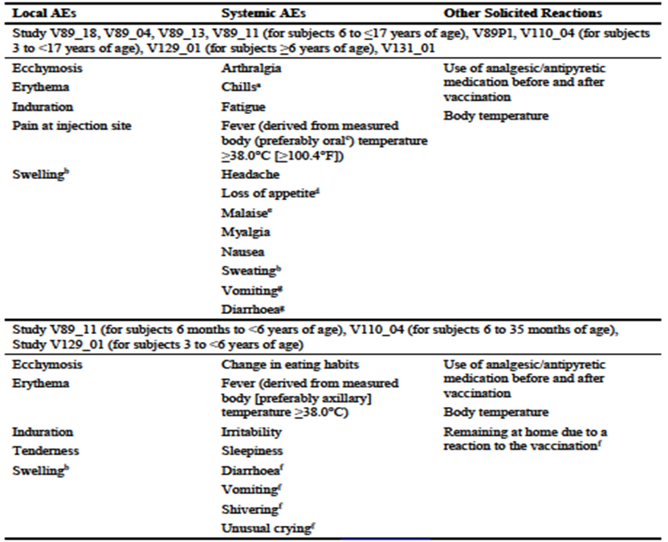
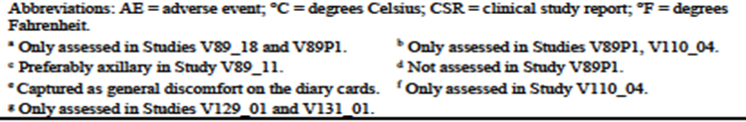
As shown in Figure 5, the tolerability did not get worse with age, if anything it improved with older age.
Figure 5. Frequency (%) of any Solicited AEs (Local or Systemic) from day 1 (Excluding 30 Minutes) through day 7 in Age Subgroups – Full Dose and Placebo.

Solicited adverse events data for Study V89_11
Overall summary of solicited AEs in the first 7 days after any vaccination by age (6 months to < 6 years and 6 years to ≤ 17 years) are summarised in Table 21.
Solicited AEs - Children less than six years of age: For subjects 6 months to less than 6 years of age, tenderness was the mostly frequently (56% in both dose groups) observed solicited local AE between day 1 through day 7 after any vaccination (first vaccination: 49% in half dose group vs. 47% in full dose group; second vaccination: 38% vs. 43%, respectively). Most of the solicited local AEs were of mild to moderate severity in both dose groups. Apart from severe tenderness after the first vaccination (1 subject in half dose group; 2 subjects in full dose group), no subjects in either of the dose groups experienced severe solicited local AEs. After each vaccination, 1% of subjects had erythema and 1% of subjects had induration across the 2 dose groups. Only 1 subject had ecchymosis, after the second vaccination. Most AEs resolved within a few days. Overall, similar rates of solicited local AEs after any vaccination were observed in subjects 6 months to < 3 years of age and subjects 3 to < 6 years of age. Severe solicited local AEs were infrequent in both age subgroups.
Subjects 6 to 17 years of age: In subjects 6 years and up to 17 years of age, pain was the most frequently reported solicited local AE; 72% of subjects in the half dose group and 68% subjects in the full dose group reported pain of mild to moderate severity after any vaccination (first vaccination: 69% vs. 67%; second vaccination: 41% vs. 38%). Two subjects in the full dose and none in the half dose group reported erythema, and none of the subjects in both dose groups reported ecchymosis after any vaccination. Induration was reported by 1% of subjects in the half dose group and 2% of subjects in the full dose group. Neither group reported severe local AEs, except for 1% of subjects who reported severe pain after each vaccination. Overall, in both age groups, the percentages reporting solicited local AEs were similar between the half dose and full dose groups. For the majority, the onset of solicited local AEs after each vaccination was between 30 minutes through day 3 for subjects < 6 years of age and between 30 minutes through day 2 for subjects 6 to ≤17 years of age; most of these events were resolved within day 7. Local AEs were in general mild to moderate in severity; in both age groups, only 1% of subjects reported severe tenderness or pain after each vaccination; there were no other severe events. Most events resolved spontaneously within a few days.
Solicited Systemic AEs - Subjects 6 months to < 6 years of age: The most frequently observed solicited systemic AE after any vaccination was irritability (half dose: 28%, full dose: 30%), sleepiness (25% in both dose groups) and change in eating habits (half dose: 12% vs. full dose: 18%). Across the dose groups, ≤ 1% reported severe sleepiness and severe irritability after the first vaccination. Fever (≥ 38.0°C) was experienced by 8% of subjects in the half dose group (first vaccination: 6%; second vaccination: 3%) and by 16% of subjects in the full dose group (first vaccination: 7%; second vaccination 10%) after any vaccination. Only 1 subject in the full dose group had body temperature ≥ 40.0°C, which occurred post second vaccination. Prophylactic use of analgesic or antipyretic medication was reported for 16% of subjects in the half dose group and 11% of subjects in the full dose group. For the treatment of pain and/or fever after any vaccination, 16% vs. 23% of subjects in respective dose groups received analgesic or antipyretic medications. Overall, rates of solicited systemic AEs after any vaccination appeared to be slightly higher in the subjects 6 months to < 3 years of age than the subjects 3 to < 6 years of age. Severe solicited systemic AEs were infrequent in both age subgroups.
Subjects 6 to ≤17 years of age: The most frequently reported solicited systemic AE after any vaccination was myalgia (half dose: 28%, full dose: 30%), fatigue (30% vs. 27%, respectively) and headache (29% vs. 22%, respectively). Fever (≥38.0°C) was reported by 3% of subjects in the half dose group (first vaccination: 2%; second vaccination: 1%) and 4% of subjects (first vaccination: 3%; second vaccination: 1%) in the full dose group after any vaccination. No subjects developed a fever of ≥ 40.0°C. In both dose groups, ≤ 1% reported severe solicited systemic AEs. Prophylactic use of analgesic or antipyretic medication was reported for 6% and 9% of subjects in the half dose and full dose groups respectively. 14% vs. 15% of subjects in respective dose groups received analgesic or antipyretic medications for the pain and/or fever after any vaccination.
Table 21. Study V89_11 – Numbers (%) of Subjects with at Least One Solicited AE, reported from day 1 (excluding first 30 minutes) through day 7, After Any Vaccination, and by Vaccination (Type 2)ª –Age 6 months to < 6 Years and 6 to ≤ 17 Years – Solicited Safety Set
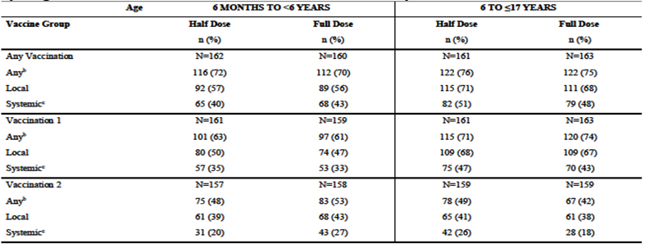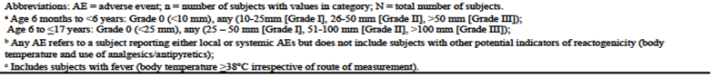
In summary, across the 2 age groups, the percentage with solicited systemic AEs was similar between the 2 dose groups. However, in the age group ≥ 6 months to < 6 years, a higher percentage of subjects in the full dose group reported fever and used analgesics/antipyretic medication. The majority of the solicited systemic AEs were of mild to moderate severity. The onset of solicited systemic AE was mostly between 30 minutes through day 5 for subjects 6 months to < 6 years of age, whereas the onset was between 30 minutes through day 4 for subjects 6 to ≤ 17 years of age. Most of the systemic AEs were resolved within day 7 after vaccination. The incidence of solicited systemic AEs was lower after the second compared to the first vaccination.

Deaths and other serious adverse events

Pivotal and/or main efficacy studies
Deaths in the ISS (Studies V89_04, V89_13 and V89_18): 17 deaths were reported. Sixteen deaths were reported in the full dose group, and 1 in the placebo group. All deaths occurred during the follow-up period (i.e. > 21 days after last vaccination received) with a mean of 234.4 days (range 38-512 days) for the aH5N1c group and 227 days for the placebo group. All deaths were reported in subjects with underlying diseases, taking multiple concomitant medications or were accidental (gunshot wounds). No patterns, trends or safety signals were identified during a review of the combined cases of death reported across the trials. None of the deaths were assessed as related to the study vaccine by either the investigator or by Seqirus Pty Ltd.
SAEs Ages ≥ 18 Years, Full Dose and Placebo in the ISS (V89_04, V89_13 and V89_18): The frequency of subjects with SAEs from day 1 through study termination was 6.3% in the aH5N1c full dose group and 9.3% in the placebo group. Most of the SAEs were reported after day 43, during the follow-up period (aH5N1c: 5.8% of subjects; placebo: 8.4% of subjects). In total, 14 subjects in the ≥ 18 years of age, full dose population reported SAEs after the first vaccination comprising 9 subjects (0.3%) in the aH5N1c group and 5 subjects (0.6%) in the placebo group. After the second vaccination, 14 subjects reported an SAE (aH5N1c: 11 subjects [0.3%]; placebo: 3 subjects [0.4%]). During the treatment period (day 1-43), the most frequently reported SOC for SAEs in the aH5N1c full dose group was ‘Infections and infestations’ (7 subjects [0.2%]) and in the placebo group ‘cardiac disorders’ and ‘Gastrointestinal disorders’ (each 3 subjects [0.4%]). During the entire study period (day 1 through study termination), the most frequently reported SOC for SAEs was ‘cardiac disorders’ for both treatment groups (aH5N1c: 1.1%, placebo: 2.8%). The three most frequent PTs for SAEs in the aH5N1c group were atrial fibrillation (0.3%), osteoarthritis (0.5%), and pneumonia (0.2%). In the placebo group, the most frequent SAEs by PT were atrial fibrillation (1.0%), followed by osteoarthritis, myocardial infarction, and respiratory failure (all 0.5%).
Related SAEs Ages ≥ 18 Years, Full Dose and Placebo in the ISS (V89_04, V89_13 and V89_18): In 3 subjects (aH5N1c: 1 subject [<0.1%]; placebo: 2 subjects [0.3%]) the SAEs, all reported during the follow-up period, were considered possibly or probably related to study vaccination (as per investigator). These SAEs included spontaneous abortion (aH5N1c group) and immune thrombocytopenic purpura and polymyalgia rheumatica (both placebo group). Except for the spontaneous abortion (V89_04), these related SAEs occurred in subjects ≥ 65 years of age. Polymyalgia rheumatica and immune thrombocytopenic purpura were defined as an AESI.
In the paediatric Study V89_11, 24 SAEs were reported from day 1 through study termination. 14 SAEs were reported by 11 subjects in the half dose group, and 10 SAEs by 8 subjects in the full dose group. As per investigator, none were considered related to study vaccine. No deaths reported.
AESI Ages ≥ 18 Years, Full Dose and Placebo in the ISS (V89_04, V89_13 and V89_18): In the pooled data, 18 subjects developed an AESI, comprising 11 subjects (0.3%) with the full dose of aH5N1c and 7 subjects (0.9%) in the placebo group. For the subjects that were vaccinated with aH5N1c, all AESIs occurred beyond day 43. In the placebo group, 1 subject (0.1%) experienced an AESI (colitis ulcerative) after Vaccination 2 prior to day 43; all other AESIs were reported after day 43. None of the AESIs in the aH5N1c full dose group were assessed as possibly related to study vaccination; however, 2 AESIs reported for subjects (placebo group) were assessed by the investigator as possibly related to study vaccination: one with immune thrombocytopenic purpura and the other subject was diagnosed with polymyalgia rheumatica. Both of these AESIs were reported as SAEs (as above).
Paediatric Study V89_11: No AESIs reported throughout the study.
NOCD in the ISS (V89_04, V89_13 and V89_18) Ages ≥ 18 Years, Full Dose and Placebo: The proportion of subjects with unsolicited AEs leading to NOCD was similar for subjects who received aH5N1c full dose (9.7%) and subjects who received placebo (9.2%). Most of the NOCDs occurred after day 43 (aH5N1c: 8.9%, placebo: 8.5%). In 23 subjects (0.6%) NOCDs occurred after first vaccination during the treatment period and in 17 subjects (0.5%) after the second vaccination with aH5N1c during the treatment period. In the placebo group, the incidence of NOCDs after Vaccination 1 and after Vaccination 2 was 0.4% (n=3). During the entire study period, the most frequently reported NOCDs were in the SOC ‘Musculoskeletal and connective tissue disorders’ (aH5N1c: 2.0%, placebo: 1.8%). The most frequent PTs for NOCDs in the aH5N1c group were hypertension (0.9%), osteoarthritis (0.5%), and atrial fibrillation (0.4%). In the placebo group, the most frequent NOCDs by PT were coronary artery disease (0.6%), hypertension and atrial fibrillation (both 0.5%).
Paediatric Study V89_11: 3 subjects (1%), all in the half dose group, had NOCDs: bone cyst, attention deficit/ hyperactivity disorder, and dyspepsia. None were considered related to the study vaccine by the investigator.

Discontinuations due to adverse events

Pivotal studies
Ages ≥ 18 Years, Full Dose and Placebo in the ISS (Studies V89_04, V89_13 and V89_18): 21 of the 4375 subjects experienced AEs that led to premature study withdrawal: 18 subjects (0.5%) in the aH5N1c full dose group and 3 subjects (0.4%) in the placebo group. Most subjects discontinued after day 43. Two subjects (0.1%) in the aH5N1c group and 1 subject (0.1%) in the placebo group experienced AEs (assessed as possibly or probably related) that led to study withdrawal during the treatment period, all after the first vaccination (day 1 - 22). In the aH5N1c group, these AEs were rash (1 subject) and constipation (1 subject).
Paediatric Study V89_11: Only one subject (< 1%) in the full dose group was prematurely withdrawn on day 22 due to unsolicited AEs, gastroenteritis rotavirus and rash, which were considered to be not related to study vaccine by the investigator.

Evaluation of issues with possible regulatory impact

Pivotal studies
A general physical examination was performed in all subjects before first vaccination in all aH5N1c studies. Symptom-directed physical examinations were performed if deemed necessary by the investigator. No consistent or clinically significant changes in vital signs, physical findings, or other observations related to the safety of the vaccines were observed for the subjects participating in any of the studies described.

Other safety issues

Safety in special populations

Intrinsic factors (age/gender/race)
Pooled analyses of major age group (18 to < 65 years and ≥ 65 years) for solicited and unsolicited AEs are described earlier in this Section, as are the data for solicited AEs by age group (< 6 years and 6 to ≤ 17 years). In both pooled data sets, there was a higher proportion of females enrolled.

Solicited AE by Sex in the ISS (Studies V89_04, V89_13 and V89_18) Ages ≥ 18 Years
Solicited Local AEs: Reported for 44.5% male vs. 57.1% female subjects in the aH5N1c group and 11.7% vs. 17.1% in the placebo group, respectively.
Solicited Systemic AEs: Reported for 34.3% (males) vs. 42.6% (females) in the aH5N1c group and 23.4% vs. 40.4% in the placebo group, respectively. This pattern was also seen for the individual AEs. A similar pattern, ie, differences between male and female subjects, was found in the full and half dose combined. No notable difference in the frequency of fever between male and female subjects from day 1 (excluding 30 minutes) through day 7 (aH5N1c: 1.0% vs. 1.4%, placebo: 0.6% vs. 1.8% for males vs. females).
Study V89_18
Solicited Local AEs: From day 1 (excluding 30 minutes) through day 7, the most commonly reported solicited local AE was pain, with higher frequency in the females than in the males in both treatment group (55.3% vs. 43.1% for aH5N1c and 17.1% vs. 11.7% for placebo group).
Solicited Systemic AEs: From Day 1 (excluding 30 minutes) through day 7, the most commonly reported solicited systemic AE was fatigue in both sexes and treatment group; however, the frequency was higher in females than in males (24.8% vs. 18.9% in the aH5N1c group and 25.2% vs. 14.5% in the placebo group). From day 1 (excluding 30 minutes) through day 7, there was no notable difference in fever between the sexes for each treatment group. However, during this period, antipyretic/analgesic use for treatment was reported more frequently in females than in males in both treatment group (4.5% vs. 1.3% for aH5N1c group and 2.1% vs. 0 for placebo group).

Paediatric Study V89_11
Subjects 6 months to < 6 years of age: From day 1 (excluding 30 minutes) through day 7, the proportion of subjects <6 years of age reporting any solicited AE after any vaccination was higher in females than males both for the half dose group (78% vs. 67%) and the full dose group (73% vs. 68%). Similarly, the proportion reporting solicited local AEs after any vaccination was higher in females than males for both dose group (half dose: 65% vs. 50%, full dose: 61% vs. 50%). The proportion with solicited systemic AEs was similar for females and males for the half dose group (40% vs. 40%) and higher in female than male subjects for the full dose group (45% vs. 40%).
Subjects 6 to ≤ 17 years of age: From day 1 (excluding 30 minutes) through day 7, the proportion of subjects ≥ 6 years of age reporting any solicited AE after any vaccination was higher in females than males in the full dose group (81% vs. 71%). In the half dose group, the proportions were comparable (77% vs. 75%). The proportion of females reporting solicited local AEs after any vaccination was higher than the proportion of males for both dose groups: 73% vs. 69% (half dose) and 75% vs. 64% (full dose). The proportion of females reporting solicited systemic AEs after any vaccination was higher than the proportion of males for both dose groups: 53% vs. 48% (half dose) and 60% vs. 41% (full dose).

Analyses by Race in the ISS (Studies V89_04, V89_13 and V89_18)
The majority of the subjects were white: aH5N1c full dose: 76.9%, and placebo: 83.3%. The proportion of Asian subjects was higher in the aH5N1c group (full dose: 10.1%) than in the placebo group (0.9%) as a consequence of the countries where the studies were conducted. Overall, weight, height, and BMI were lower in Asian subjects. This subgroup contained relatively more female subjects and subjects ≥ 65 years of age than the subgroup of white and black or African American subjects. No notable differences were found in the overall frequency of solicited local AEs after any vaccination between races. Solicited local AEs were reported by 52.2% white, 48.7% black or African American, and 49.9% Asian subjects in the aH5N1c group and 14.9% white and 14.7% black or African American subjects in the placebo group. Note, Asian subjects made up 0.9% of the placebo group in the pooling, vs. 10.1% in the full dose aH5N1c pooling.
Solicited Systemic AEs: No notable differences were found in the overall frequency of solicited systemic AEs after any vaccination between races. Solicited systemic AEs were reported by 38.8% white, 40.4% black or African American, and 38.7% Asian subjects in the aH5N1c group and 32.1% white and 34.9% black or African American in the placebo group, respectively. The proportion of Asian subjects (4.8%) presenting with fever after vaccination with aH5N1c full dose was higher as compared to black or African American (1.0%) and white subjects (0.7%). The number of subjects with fever in the placebo group, shown by race, was too small to draw any conclusions.
Paediatric Study V89_11 Subjects 6 months to <6 years of age: Most subjects in the 6 months to < 6 years of age group included in the Solicited Safety Set was either Asian (239 subjects) or white (59 subjects). From day 1 (excluding 30 minutes) through day 7, the proportion of white subjects reporting any solicited AE after any vaccination was higher than the proportion of Asian subjects in both dose group (half dose: 78% vs. 69%, full dose: 91% vs. 64%). A similar pattern, i.e. higher proportions of solicited AEs in white than Asian subjects was found both for the solicited local AEs and for solicited systemic AEs (local: half dose: 63% vs. 55%, full dose: 78% vs. 51%; systemic: half dose: 59% vs. 35%, full dose: 59% vs. 37%). The difference between proportions of Asian and white subjects reporting any or solicited local AEs was larger in the full dose than in the half dose group.
Subjects 6 to ≤17 years of age: In the ≥ 6 years of age group most of the subjects included in the Solicited Safety Set were either Asian (total 236 subjects) or white (total 74 subjects). For American Indian or Alaska Native (1 subject), black or African American (11 subjects) and Other (2 subjects), the sample size was too small to make any meaningful comparisons across races. From day 1 (excluding 30 minutes) through day 7, the proportion of white subjects reporting any solicited AE after any vaccination was higher than the proportion of Asian subjects in both dose group (half dose: 92% vs. 70%, full dose: 92% vs. 70%). A similar pattern, i.e. higher proportions of solicited AEs in white than Asian subjects was found both for the solicited local AEs and for solicited systemic AEs (local AEs: half dose: 89% vs. 66%, full dose: 84% vs. 65%; systemic AEs: half dose: 59% vs. 46%, full dose: 59% vs. 45%)

Pregnancy
Although pregnancy was an exclusion criterion in all clinical trials with adjuvanted and non-adjuvanted H5N1c formulations, 55 pregnancies were reported, 47 after the administration of aH5N1c, 3 of the pregnancies with non-adjuvanted H5N1c and 5 with placebo during studies V89P1, V89_04, V89_11, and V89_18.
Study V89_18: 11 pregnancies were reported (6 aH5N1c group; 5 placebo group); 9 subjects became pregnant after day 43, 2 subjects in the placebo group became pregnant between day 1 -43. In 1 subject the pregnancy was identified prior to the second vaccination on day 22 and the subject did not receive the second dose of study treatment. For the second subject, the pregnancy was confirmed 3 weeks after the second vaccination. An outcome of spontaneous abortion occurred in 3 subjects (1 aH5N1c group; 2 placebo group), of which none were considered related to study treatment. 7 subjects reported normal delivery (5 aH5N1c group; 2 placebo group). No outcome data was available for the one remaining subject in the placebo group.
Study V89_04: 15 pregnancies reported (8 with the full dose and 7 with the half dose of aH5N1c); 8 subjects became pregnant after day 43 and 7 between day 1 - 43. Two of the 7 subjects who became pregnant during the treatment period delivered a healthy baby, and for 3 subjects no further information was available. For 2 of these 7 subjects, spontaneous abortions were reported: One subject in the full dose group had a spontaneous abortion (Missed miscarriage [secondary to molar pregnancy]). Two of the 8 subjects who became pregnant after the treatment period delivered a healthy baby, and for 5 of these 8 subjects no further information was available. For 1 of these 8 subjects an SAE of a missed abortion was reported. No causal relationship with the study vaccine was suspected.
Study V89_11: Two pregnancies were reported, 1 subject in the full dose group became pregnant during the treatment period (day 1 - 43) and 1 subject in the half dose group during the follow-up period, after day 43). Both subjects delivered a healthy infant.
Study V89P1: 27 subjects became pregnant during the course of the study up to day 546, 24 in the adjuvanted group and 3 in the non-adjuvanted group; 19 of 27 became pregnant after day 43 and 8 subjects between day 1 - 43. 25 of 27 occurred with antigen or adjuvant levels other than the proposed vaccine doses of aH5N1c for adults or paediatrics. Of the 19 who became pregnant after day 43, 12 delivered a healthy baby, 3 underwent a therapeutic abortion and for 4 subjects no further information is available. Of the 8 subjects who became pregnant between day 1 - 43, 2 subjects delivered a healthy baby, and for 6 subjects a therapeutic abortion was reported.
Extrinsic Factors. The proposed indication is independent of extrinsic factors, such as medical environment, use of other drugs, use of tobacco, use of alcohol, and good habits.

Conclusion
The evaluator concluded that no significant safety concerns have been identified with aH5N1c vaccine in adults. Both full and half doses were well tolerated, with a similar safety profile to approved seasonal influenza vaccines including those that are adjuvanted with MF59C.1. The monovalent vaccine was well tolerated, irrespective of antigen or adjuvant content. In addition, both full and half doses of the vaccine were well-tolerated in healthy paediatric subjects 6 months to ≤ 17 years of age. In adult subjects and paediatric subjects, a trend for fewer reactions after the second vaccination as compared with the first vaccination was observed.
No data in pregnant or breastfeeding women were provided, as they were excluded from all the studies in this application. Immunocompromised children and adults and those with co-morbidities were excluded from participation.
The safety database for paediatrics was limited, with 339 paediatric subjects exposed to the full dose level in study V89_11.
The EU assessment similarly concluded that ‘the reported safety profile indicates that the aH5N1c vaccine is well tolerated after both vaccinations and did not reveal unexpected safety signals or lead to significant safety concerns. Data from studies undertaken with other vaccine constructs, i.e. H1N1, H3N2 and H7N9, further support this conclusion.’ The FDA assessment reached similar conclusions regarding safety.

Risk management plan
Seqirus Pty Ltd has submitted EU RMP version 0.4 (date 20 February 2024; DLP 7 January 2022) and ASA version 0.1 (date 5 April 2024) in support of this application. With the s31 responses, the sponsor provided an updated ASA version 0.2 (date 19 December 2024).
The proposed summary of safety concerns and their associated risk monitoring and mitigation strategies for Audenz are summarised in Table 22.
Table 22. Summary of safety concerns.
Summary of safety concerns |  | Pharmacovigilance |  | Risk Minimisation
 |  | Routine | Additional | Routine | Additional
Important identified risks | None | – | – | – | –
Important potential risks | Neuritis | ü | – | ü | –
Important potential risks | Convulsions | ü | – | ü | –
Important potential risks | Encephalomyelitis | ü | – | ü | –
Important potential risks | Vasculitis | ü | – | ü | –
Important potential risks | Guillain-Barré syndrome | ü | – | ü | –
Important potential risks | Demyelination | ü | – | – | –
Important potential risks | Bell’s palsy | ü | – | – | –
Important potential risks | Immune thrombocytopenia | ü | – | – | –
Missing information | Use in pregnancy | ü | ü* | ü | –
*Pregnancy registry is planned in the event of a pandemic

RMP evaluator recommendations regarding condition/s of registration
The Audenz EU-Risk Management Plan (RMP) version 0.4 (dated 20 February 2024; DLP 7 January 2022), with Australian Specific Annex, version 0.2 (dated 19 December 2024), included with c, and any subsequent revisions, as agreed with the TGA will be implemented in Australia.
The TGA may request an updated RMP at any stage of a product's life cycle, during both the pre-approval and post-approval phases. Further information regarding the TGA’s risk management approach can be found in risk management plans for medicines and biologicals and the TGA's risk management approach. Information on the Australia-specific annex (ASA) can be found on the TGA website.

Risk-benefit analysis

Delegate’s considerations for Audenz
The Delegate is of the opinion that the pre-filled syringe (PFS) formulation of Audenz may be approved, considering the immunogenicity and safety data presented and provided the results of the non-interventional observational effectiveness study requested by the EMA be submitted to the TGA as an additional condition of registration.
The Sponsor has outlined in their response to the Section 31 request that at the time of a pandemic, it is anticipated that the strain in Audenz will be changed to address the current pandemic strain in circulation and that the Sponsor will interact with the TGA and other regulatory agencies to align on the clinical studies that are needed to support the use of Audenz.
‘The timing of study initiation, and availability of data will be dependent on when the relevant Candidate Vaccine Virus becomes available. We anticipate conducting clinical trials in adults, elderly and paediatric populations collecting immunogenicity and safety data.’
The safety database presented for this submission, including the MF59C.1 adjuvant, did not raise significant concerns, acknowledging that only one study, V89_18, in adults included a placebo group and there were few paediatric subjects exposed to the intended dose level in study V89_11.

Proposed action
Approval for the pre-filled syringe formulation is recommended, subject to implementation of the RMP and Quality conditions of registration, additional condition of registration proposed by the Delegate and satisfactory resolution of the product information.

Advisory Committee considerations
The Advisory Committee on Vaccines (ACV), having considered the evaluations and the Delegate’s overview, as well as the sponsor’s response to these documents, advised the following.

Specific advice to the Delegate
The ACV advised the following in response to the Delegate’s specific request for advice.
- The Delegate has proposed an additional condition of registration, in light of the conditional approval by the EMA. Does the ACV have further comments on the Delegate’s proposal?
The inclusion of a non-interventional observational effectiveness study as an additional pharmacovigilance activity is a component of the risk management plan. The ACV agreed with the Delegate that this is appropriate.
The ACV noted the absence of clinical data on patterns of administration and spacing between vaccines that are likely to occur during a pandemic: candidate pandemic vaccine as Dose 1 followed by customised pandemic vaccine as Dose 2; two doses of candidate pandemic vaccine followed at a variable interval by two doses of the customised pandemic vaccine. Controlled clinical trials or observational effectiveness studies to address these issues are recommended to provide additional data.
The ACV noted that, if registered, an update to the antigen strain in Audenz from the A/turkey/Turkey/1/2005 NIBRG-23 strain to a strain relevant to the pandemic-in-progress would be managed by a TGA process similar to that used for annual seasonal (non-pandemic) influenza vaccine updates; this process does not include provision of clinical data. However, clinical studies on the use of Audenz updated with the pandemic strain, should be generated so as to inform ongoing use of the pandemic specific vaccine formulation as early as possible in the pandemic phase.
- Please provide comment on the Delegate’s revised wording of the indication.
The ACV noted that the sponsor’s revised wording of the indication aligns with that of the Delegate, other than a minor difference of ‘individual’ or ‘person’, on which the ACV had no particular view.
- The approved EU SmPC for Incellipan includes safety information on 2009 H1N1 vaccines manufactured with the MF59 adjuvant. Does the ACV have a view on whether this information should be included in the proposed PI for Australia?
The ACV supported the inclusion of safety data in the PI on the related adjuvanted H1N1 vaccines as relevant to the safety of the aH5N1c vaccines (Audenz and Celldemic). Safety data on Audenz are limited.
The ACV noted that there were no data on vaccination of pregnant women, people with impaired immune systems, or the frail elderly regarding safety information to include in the PI. The ACV supported inclusion of information similar to the EU document, that ‘The efficacy, safety and immunogenicity of the vaccine have not been assessed in immunocompromised individuals, including those receiving immunosuppressant therapy. The immune response of Incellipan [EU brand name for Audenz] may be lower in immunosuppressed individuals and may be insufficient to provide protection’.
The ACV recommended the inclusion in the PI of information on the safety of MF59 adjuvanted influenza vaccines, including on the risk of systemic events.
- The ACV is also requested to provide advice on any other issues that it thinks may be relevant.

Advisory committee conclusions
The ACV considered this product to have an overall positive benefit-risk profile for the indications:
Audenz is indicated for active immunisation against influenza A in individuals from 6 months of age and older in an officially declared pandemic.
Audenz should be used in accordance with official recommendations.

Assessment outcome
Based on a review of quality, safety, and efficacy, the TGA decided to register Audenz Pandemic Influenza Vaccine H5N1 (surface antigen, inactivated, adjuvanted) suspension for injection PFS needle-free indicated for:
Audenz is indicated for active immunisation against influenza A in persons from 6 months of age and older in an officially declared pandemic.
Audenz should be used in accordance with official recommendations.

Specific conditions of registration
Audenz (pandemic influenza vaccine) is to be included in the Black Triangle Scheme. The PI and CMI for Audenz must include the black triangle symbol and mandatory accompanying text for five years, which starts from the date of first supply of the product.
- The Audenz EU-Risk Management Plan (RMP) version 0.4 (dated 20 February 2024; DLP 7 January 2022), with Australian Specific Annex (ASA) version 0.2 (dated 19 December 2024), included with submission PM-2024-01544-1-2, and any subsequent revisions, as agreed with the TGA will be implemented in Australia.
- An obligatory component of risk management plans is routine pharmacovigilance. Routine pharmacovigilance includes the submission of periodic safety update reports (PSURs).
- Reports are to be provided in line with the current published list of EU reference dates and frequency of submission of PSURs until the period covered by such reports is not less than three years from the date of this approval letter. Each report must be submitted within ninety calendar days of the data lock point for that report.
- The reports are to at least meet the requirements for PSURs as described in the European Medicines Agency’s Guideline on good pharmacovigilance practices (GVP) Module VII-periodic safety update report (Rev 1), Part VII.B Structures and processes. Note that submission of a PSUR does not constitute an application to vary the registration.

Quality

GMP clearance for listed manufacturers
All relevant manufacturing sites require approved and current GMP Clearances prior to Australian supply. A commitment is required from the Sponsor that they maintain the validity of all manufacturer GMP Clearances for the duration of product supply to Australia. Additionally, that adherence to the conditions of GMP Clearance approval is upheld.

Post-approval stability protocol and stability commitment
The manufacturer has provided commitment to continue the ongoing stability studies presented in the stability studies protocol. Additionally, one (1) batch of drug product per year for all relevant products will be placed on long-term stability program and on accelerated stability testing where significant changes are made to the manufacturing process. The manufacturer has committed to communicate any out of specifications stability test results to the TGA.

Batch release testing and compliance
It is a condition of registration that all independent batches of:
- Audenz Pandemic Influenza Vaccine H5N1 (surface antigen, inactivated, adjuvanted) suspension for injection PFS needle-free imported into Australia are not released for sale until samples and the manufacturer’s release data have been assessed, and you have received notification acknowledging release from the Laboratories Branch, TGA.
- For each independent batch of the product imported into Australia, the Sponsor must supply samples, reagents and standards as described in Seasonal influenza vaccines – quality module (Version 2.0, September 2023) which includes the following:
  - A completed Request for Release Form, available from vaccines@health.gov.au.
  - Complete summary protocols for manufacture and QC, including all steps in production in the agreed format.
  - At least 20 (twenty) prefilled syringes (Samples) of each manufacturing batch of the above listed vaccines with the Australian approved labels, PI, and packaging (unless an exemption to supply these has been granted) representative of all batches of product seeking distribution in Australia.
  - At least 10 (ten) prefilled syringes (Samples) of any further consignments of a manufacturing batch of the above listed vaccines with the Australian approved labels, PI, and packaging (unless an exemption to supply these has been granted). Further consignments cover batches previously supplied to TGA for the purposes of batch release testing but are seeking to be supplied again.
  - Details of reference antigen and antisera to be used for the release testing for each subtype. These details should also be included in the supplied summary protocol.
  - For non-TGA reagents, a minimum of 20 (twenty) vials of reference antigen and 20 (twenty) vials of antisera. Additionally, supply 1 (one) vial of reference antigen and antisera for each batch that is intended for release in Australia.
  - At least 3 (three) batches of Monovalent Bulk (5 mL) for each strain included in the vaccine. These should be from recent batches and should be provided along with the associated protocol or Certificate of Analysis that states the HA content of the bulk.
  - If the manufacturing batch has been released in Europe or United Kingdom a copy of the EU Official Control Authority Batch Release (OCABR) certificate (or equivalent from the UK) must be provided.
- Sponsors must provide all requested samples and data in sufficient time (at least 5 business days) prior to any distribution date to allow the TGA to perform testing and review. Distribution of each batch of vaccine is conditional upon fulfilment of these conditions and receipt of a letter from the Laboratories Branch acknowledging release.
- Samples and data should be forwarded to the Biotherapeutics Section, Laboratories Branch before release of each batch and with sufficient lead time to allow for Laboratories Branch testing. The address for courier delivery is:
ATTN: Batch Release Coordinator,
Batch Release Unit,
TGA Laboratories Branch,
1 Tindal Lane, Canberra Airport, ACT 2609.
The shipments (including reagents) to TGA are the responsibility of the Australian Sponsor/Agent who will be required to facilitate the import and customs clearance process.

Certified Product Details
- An electronic copy of the Certified Product Details (CPD) as described in Guidance 7: Certified Product Details of the Australian Regulatory Guidelines for Prescription Medicines (ARGPM) https://www.tga.gov.au/guidance-7-certified-product-details should be provided upon registration of the therapeutic good. In addition, an updated CPD, for the above products incorporating the approved changes is to be provided within one month of the date of approval letter. A template for preparation of CPD for biological prescription medicines and Vaccines can be obtained from the TGA website https://www.tga.gov.au/form/certified-product-details-cpd-biological-prescriptionmedicines.
- The CPD should be sent as a single bookmarked PDF document to Vaccines@health.gov.au as soon as possible after registration/approval of the product or any subsequent changes as indicated above.
- The final results of the non-interventional observational effectiveness study in children and adults against laboratory confirmed influenza during the next declared pandemic requested by the EMA should be submitted to the TGA.

Product Information and Consumer Medicine Information
For the most recent Product Information (PI) and Consumer Medicine Information (CMI), please refer to the TGA PI/CMI search facility.

Therapeutic Goods Administration
PO Box 100 Woden ACT 2606 Australia
Email: info@tga.gov.au Phone: 1800 020 653 Fax: 02 6203 1605
https://www.tga.gov.au

This is the original indication proposed by the sponsor when the TGA commenced the evaluation of this submission. It may differ to the final indication approved by the TGA and registered in the Australian Register of Therapeutic Goods.
Rubino, I., & Choi, H. J. (2017). Respiratory Protection against Pandemic and Epidemic Diseases. Trends in biotechnology, 35(10), 907–910. https://doi.org/10.1016/j.tibtech.2017.06.005
Webster, R. G., & Govorkova, E. A. (2014). Continuing challenges in influenza. Annals of the New York Academy of Sciences, 1323(1), 115–139. https://doi.org/10.1111/nyas.12462
WHO (2014) How Pandemic influenza emerges. How pandemic influenza emerges
Panvax H5N8 pre-pandemic, Pre-pandemic influenza vaccine (split-virion, inactivated) 10 mL multi-dose injection vial (421511) | Therapeutic Goods Administration (TGA)
PANVAX H1N1 VACCINE, H1N1 pandemic influenza vaccine (split-virion, inactivated) 0.5mL injection pre-filled syringe (163900) | Therapeutic Goods Administration (TGA)
PANVAX H1N1 VACCINE, H1N1 pandemic influenza vaccine (split-virion, inactivated) 10mL multi-dose injection vial (163897) | Therapeutic Goods Administration (TGA)
PANVAX H1N1 VACCINE, H1N1 pandemic influenza vaccine (split-virion, inactivated) 5mL multi-dose injection vial (165345) | Therapeutic Goods Administration (TGA)
PANVAX H1N1 VACCINE JUNIOR H1N1 pandemic influenza vaccine (split-virion, inactivated) 0.25mL suspension for injection pre-filled syringe (166312) | Therapeutic Goods Administration (TGA)
PANVAX pandemic influenza vaccine, adjuvanted 10 ml suspension for injection vial (137704) | Therapeutic Goods Administration (TGA)
Influenza vaccines – submission and procedural requirements - Scientific guideline | European Medicines Agency (EMA)
https://www.ema.europa.eu/en/documents/overview/incellipan-epar-medicine-overview_en.pdf
Peterson, J., Van Twuijver, E., Versage, E., & Hohenboken, M. (2022). Phase 3 Randomized, Multicenter, Placebo-Controlled Study to Evaluate Safety, Immunogenicity, and Lot-to-Lot Consistency of an Adjuvanted Cell Culture-Derived, H5N1 Subunit Influenza Virus Vaccine in Healthy Adult Subjects. Vaccines, 10(4), 497. https://doi.org/10.3390/vaccines10040497
European Medicines Agency (EMA) (2024) Incellipan (pandemic influenza vaccine (H5N1) (surface antigen, inactivated, adjuvanted, prepared in cell cultures) https://www.ema.europa.eu/en/documents/overview/incellipan-epar-medicine-overview_en.pdf
A Study to Evaluate Safety and Immunogenicity of One or Two Booster Vaccinations with H5N6 Influenza Vaccine in Adults Primed with H5N1 Influenza Vaccine or Unprimed. https://clinicaltrials.gov/study/NCT05422326#more-information
Chanthavanich, P., Versage, E., Van Twuijver, E., & Hohenboken, M. (2021). Antibody responses against heterologous A/H5N1 strains for an MF59-adjuvanted cell culture-derived A/H5N1 (aH5N1c) influenza vaccine in healthy pediatric subjects. Vaccine, 39(47), 6930–6935. https://doi.org/10.1016/j.vaccine.2021.10.010
Chanthavanich, P., Anderson, E., Kerdpanich, P., Bulitta, M., Kanesa-Thasan, N., & Hohenboken, M. (2019). Safety, Tolerability and Immunogenicity of an MF59-adjuvanted, Cell Culture-derived, A/H5N1, Subunit Influenza Virus Vaccine: Results From a Dose-finding Clinical Trial in Healthy Pediatric Subjects. The Pediatric infectious disease journal, 38(7), 757–764. https://doi.org/10.1097/INF.0000000000002345
Frey, S. E., Shakib, S., Chanthavanich, P., Richmond, P., Smith, T., Tantawichien, T., Kittel, C., Jaehnig, P., Mojares, Z., Verma, B., Kanesa-Thasan, N., & Hohenboken, M. (2019). Safety and Immunogenicity of MF59-Adjuvanted Cell Culture-Derived A/H5N1 Subunit Influenza Virus Vaccine: Dose-Finding Clinical Trials in Adults and the Elderly. Open forum infectious diseases, 6(4), ofz107. https://doi.org/10.1093/ofid/ofz107
Frey, S. S., Versage, E., Van Twuijver, E., & Hohenboken, M. (2023). Antibody responses against heterologous H5N1 strains for an MF59-adjuvanted cell culture–derived H5N1 (aH5n1c) influenza vaccine in adults and older adults. Human Vaccines &amp; Immunotherapeutics, 19(1). https://doi.org/10.1080/21645515.2023.2193119
O Murchu E, Comber L, Jordan K, Hawkshaw S, Marshall L, O'Neill M, et al. Systematic review of the efficacy, effectiveness and safety of MF59 adjuvanted seasonal influenza vaccines for the prevention of laboratory-confirmed influenza in individuals ≥18 years of age. Rev Med Virol 2023; 33(3):e2329. DOI: 10.1002/rmv.2329

