Australian Public Assessment Report for Adzynma
  - Active ingredient: Apadamtase alfa /cinaxadamtase alfa

  - Sponsor: Takeda Pharmaceuticals Australia Pty Ltd
May 2026

About the Therapeutic Goods Administration (TGA)
- The Therapeutic Goods Administration (TGA) is part of the Australian Government Department of Health, Disability and Ageing and is responsible for regulating therapeutic goods, including medicines, medical devices, and biologicals.
- The TGA administers the Therapeutic Goods Act 1989 (the Act), applying a risk management approach designed to ensure therapeutic goods supplied in Australia meet acceptable standards of quality, safety, and efficacy.
- The work of the TGA is based on applying scientific and clinical expertise to decision-making, to ensure that the benefits to the Australian public outweigh any risks associated with the use of therapeutic goods.
- The TGA relies on the public, healthcare professionals and industry to report problems with therapeutic goods. The TGA investigates reports received to determine any necessary regulatory action.
- To report a problem with a therapeutic good, please see the information on the TGA website.

About AusPARs
- The Australian Public Assessment Report (AusPAR) provides information about the evaluation of a prescription medicine and the considerations that led the TGA to approve or not approve a prescription medicine submission. Further information can be found in Australian Public Assessment Report (AusPAR) guidance.
- AusPARs are prepared and published by the TGA.
- AusPARs are static documents that provide information that relates to a submission at a particular point in time. The publication of an AusPAR is an important part of the transparency of the TGA’s decision-making process.
- A new AusPAR may be provided to reflect changes to indications or major variations to a prescription medicine subject to evaluation by the TGA.

Copyright
© Commonwealth of Australia 2026
This work is copyright. You may reproduce the whole or part of this work in unaltered form for your own personal use or, if you are part of an organisation, for internal use within your organisation, but only if you or your organisation do not use the reproduction for any commercial purpose and retain this copyright notice and all disclaimer notices as part of that reproduction. Apart from rights to use as permitted by the Copyright Act 1968 or allowed by this copyright notice, all other rights are reserved and you are not allowed to reproduce the whole or any part of this work in any way (electronic or otherwise) without first being given specific written permission from the Commonwealth to do so. Requests and inquiries concerning reproduction and rights are to be sent to the TGA Copyright Officer, Therapeutic Goods Administration, PO Box 100, Woden ACT 2606 or emailed to <tga.copyright@tga.gov.au>.

Contents
List of abbreviations 4
Product submission 6
Submission details 6
Product background 7
Disease or condition 8
Current treatment options 8
Clinical rationale 9
Regulatory status 9
Australian regulatory status 9
International regulatory status 9
Registration timeline 10
Assessment overview 11
Quality evaluation summary 11
Nonclinical evaluation summary 13
Clinical evaluation summary 14
Pharmacology 14
Efficacy 16
Safety 25
Risk management plan 27
Risk-benefit analysis 28
Advisory Committee considerations 29
Assessment outcome 30
Specific conditions of registration 30
Product Information and Consumer Medicine Information 31

List of abbreviations
Abbreviation | Meaning
ACM | Advisory Committee on Medicines
ADAMTS13 | A disintegrin and metalloproteinase with thrombospondin motifs 13
AE | Adverse event(s)
ARTG | Australian Register of Therapeutic Goods
AUC_{0-t} | Area under the plasma-time concentration curve from zero to the last
C_{ave,ss} | Average ADAMTS13 activity under steady state conditions
CL | Clearance
C_{max} | Maximum concentration following infusion
CMI | Consumer Medicines Information
cTTP | Congenital thrombotic thrombocytopenic purpura
Delegate | The Delegate of the Secretary of the Department of Health, Disability and Ageing who decided the submission under section 25 of the Act
EC₅₀ | Effective concentration associated with 50% of the maximum effect
EMA | European Medicines Agency
E_{max} | Maximum effect
ERT | Enzyme replacement therapy
Evaluator | A technical expert—such as a scientist, toxicologist, or clinician—who assesses the safety, quality, and efficacy of medicines and medical devices before they are approved for the Australian market.
FFP | Fresh frozen plasma
iTTP | Immune thrombotic thrombocytopenic purpura
LS | Least squares
MAHA | Microangiopathic haemolytic anaemia
PD | Pharmacodynamic(s)
PI | Product Information
PK | Pharmacokinetic(s)
QW | Once weekly dosing
Q2W | Dosing once every 2 weeks
PSUR | Periodic safety update report
RMP | Risk management plan
SD | Standard deviation
SoC | SoC standard of care
TEAE | treatment-emergent adverse event(s)
TGA | Therapeutic Goods Administration
T_{max} | Minimum time to reach C_{max}
TTP | Thrombotic thrombocytopenic purpura
V_{c} | Central volume of distribution
V_{ss} | Volume of distribution at steady state

Product submission

Submission details
Type of submission: | New biological entity
Product names: | Adzynma
Active ingredient: | apadamtase alfa/cinaxadamtase alfa
Decision: | Approved
Date of decision: | 6 January 2026
Approved therapeutic use for the current submission: | Adzynma is a recombinant ADAMTS13 (rADAMTS13) enzyme replacement therapy (ERT) indicated for the treatment of ADAMTS13 deficiency in patients with congenital thrombotic thrombocytopenic purpura (cTTP).  Adzynma can be used for all age groups.
Date of entry onto ARTG: | 8 January 2026
ARTG numbers: | Adzynma apadamtase alfa/cinaxadamtase alfa 1500 IU powder and solvent for injection vials (473505)  Adzynma apadamtase alfa/cinaxadamtase alfa 500 IU powder and solvent for injection vials (469165)
Black Triangle Scheme | Yes
Sponsor’s name and address: | Takeda Pharmaceuticals Australia Pty Ltd, Level 39, 225 George Street, Sydney NSW 2000.
Dose form: | Powder and solvent for injection.  Adzynma is formulated as a white lyophilised powder. The solvent is a clear and colourless solution
Strengths: | Adzynma 500 IU powder for injection with solvent vial  Each vial of powder contains 500 International Units (IU) of rADAMTS13 activity, as measured in terms of its potency. After reconstitution with the 5 mL solvent provided, the solution has a nominal potency of approximately 100 IU/mL.  Adzynma 1500 IU powder for injection with solvent vial  Each vial of powder contains 1500 International Units (IU) of rADAMTS13 activity, as measured in terms of its potency. After reconstitution with the 5 mL solvent provided, the solution has a nominal potency of approximately 300 IU/mL
Container: | The powder for injection and the solvent are filled in a Type 1 glass vial closed with a butyl rubber stopper.
Route of administration: | Intravenous injection
Dosage: | Prophylactic enzyme replacement therapy  - Administer 40 IU/kg body weight once every other week.  - The prophylaxis dosing frequency may be adjusted to 40 IU/kg once weekly based on prior prophylactic dosing regimen or based on clinical response.  On-demand enzyme replacement therapy  In case of acute TTP episode, the recommended dose of Adzynma to treat acute TTP episodes is as follows:  - 40 IU/kg body weight on day 1.  - 20 IU/kg body weight on day 2.  - 15 IU/kg body weight starting day 3 once daily until two days after the acute event is resolved.  For further information regarding dosage, refer to the Product Information.
Pregnancy category: | Category B1  Drugs which have been taken by only a limited number of pregnant women and women of childbearing age, without an increase in the frequency of malformation or other direct or indirect harmful effects on the human fetus having been observed.  Studies in animals have not shown evidence of an increased occurrence of fetal damage.  The use of any medicine during pregnancy requires careful consideration of both risks and benefits by the treating health professional. The pregnancy database must not be used as the sole basis of decision making in the use of medicines during pregnancy. The TGA does not provide advice on the use of medicines in pregnancy for specific cases. More information is available from obstetric drug information services in your state or territory.

Product background
This AusPAR describes the submission by [Takeda Pharmaceuticals Australia Pty Ltd] (the Sponsor) to register Adzynma (apadamtase alfa/cinaxadamtase alfa) for the following proposed indication:
A recombinant ADAMTS13 enzyme replacement therapy (ERT) for the treatment of ADAMTS13 deficiency in patients with congenital thrombotic thrombocytopenic purpura (cTTP).
Adzynma can be used for all age groups.

Disease or condition
Congenital thrombotic thrombocytopenic purpura (cTTP) is an autosomal recessive hereditary disorder of the “a disintegrin and metalloproteinase with thrombospondin motifs 13” ADAMTS13 gene which encodes the von Willebrand factor-cleaving protease (VWFCP). The location of the gene is on 9q34.2. Hereditary thrombotic thrombocytopenic purpura (or cTTP) represents 5% of cases of TTP, with the majority of other cases being autoimmune. cTTP is associated with <5% of normal ADAMTS13 activity. The condition is very rare: the incidence of thrombotic thrombocytopenic purpura (TTP) is 2 to 6 per million and cTTP accounts for <5% of cases. Hence the incidence is <1 per million population.
Von Willebrand factor (VWF) is involved in the recruitment of platelets to sites of endothelial damage. When VWF is activated, through shear-induced conformational changes, it also exposes the A2 domain cleavage sites. These A2 domain sites interact with ADAMTS13 and, in turn, the binding of ADAMTS13 to VWF induces conformational change in ADAMTS13 exposing the metalloprotease domain, resulting in proteolysis. Thus, activated VWF in turn activates ADAMTS13, which then regulates the action of VWF.
The clinical manifestations of cTTP result from unregulated platelet activation/aggregation. This results in thrombocytopaenia, haemolytic anaemia and micro-emboli, which then disrupt the blood flow in the nervous system, heart, kidneys and other organs. This leads to ischaemic organ damage. Symptoms present from early childhood.
Differentiation between cTTP and immune TTP (iTTP) requires the identification of antibodies to ADAMTS13. The majority of cases of TTP are iTTP, and the treatments for cTTP and iTTP differ. Hence, this differentiation is a crucial step in the management of TTP. cTTP responds to fresh frozen plasma (FFP) whereas iTTP does not, and requires plasmapheresis/plasma exchange and immunosuppression.
Despite prophylactic FFP, patients with cTTP still experience significant long-term morbidity. In a study of 55 patients in Japan, 16 patients developed organ damage: chronic kidney disease (CKD) was observed in 13; end-stage renal failure in five, cerebral infarction in six and cardiac hypofunction in one patient. In a separate study, milder symptoms were reported in all patients, which included headaches, difficulty in concentration, depression, vision changes, forgetfulness, fatigue, neuropathy, dysarthria, seizures, transient weakness, falls, and dysphagia. With ageing, strokes are common.

Current treatment options
Patients with suspected or confirmed cTTP are generally treated with plasma infusion (10 to 15 mL/ kg) at a frequency of every 1 to 3 weeks for maintenance therapy or daily for a symptomatic patient until the symptoms resolve and normalization of platelet counts.
For patients with cTTP in remission, the International Society of Thrombosis and Haemostasis (ISTH) guidelines recommend either regular plasma infusions or a watch and wait strategy. The justification for the watch and wait strategy was the burden on patients of healthcare attendances and repeated infusions.
Critically ill patients may require intensive care support, renal replacement therapy and/or venous thromboembolism prophylaxis. Precipitating infections should be treated with appropriate antibiotics.

Clinical rationale
ADAMTS13 is a plasma zinc metalloprotease that binds and cleaves newly released ultra-large forms of VWF in the A2 domain between Tyr1605 and Met1606, usually anchored on the endothelial surface as strings/bundle. This site-specific cleavage reduces the VWF size and its platelet-binding properties. Thus, the biological role of plasma ADAMTS13 is to regulate the activity of VWF by cleaving large and ultra-large VWF multimers to smaller units and thereby reducing the platelet binding properties of VWF and its propensity to induce formation of platelet rich microthrombi., As a recombinant equivalent to endogenous ADAMTS13, with similar potency, pharmacokinetic (PK) and pharmacodynamic (PD) properties, the use of apadamtase alfa/cinaxadamtase alfa in cTTP patients replenishes plasma ADAMTS13 activity, which is expected to reduce or eliminate the spontaneous formation of VWF-platelet microthrombi and thus, the occurrence of TTP events, as well as TTP manifestations.

Regulatory status

Australian regulatory status
This product is considered a new biological entity for Australian regulatory purposes. Adzynma was granted Orphan Drug Designation by the TGA on 15 July 2024.

International regulatory status
At the time the TGA considered this submission, a similar submission had been considered by other regulatory agencies. Table 1 summarises these submissions and provides the indications where approved.
Table 1: International regulatory status at the time the TGA considered this submission
Country/  region | Submission date | Status | Indications (approved or requested)
United States of America | 17 Mar 2023 | 09 Nov 2023 (approved) | Adzynma (ADAMTS13, recombinant-krhn) is a human recombinant “A disintegrin and metalloproteinase with thrombospondin motifs 13” (rADAMTS13) indicated for prophylactic or on demand enzyme replacement therapy (ERT) in adult and paediatric patients with congenital thrombotic thrombocytopenic purpura (cTTP).
EU  Centralized Procedure | 17 Apr 2023 | 01 Aug 2024 (approved) | Adzynma is an enzyme replacement therapy (ERT) indicated for the treatment of ADAMTS13 deficiency in children and adult patients with congenital thrombotic thrombocytopenic purpura (cTTP).  Adzynma can be used for all age groups.
Japan | 16 Aug 2023 | 26 Mar 2024  (approved) | Adzynma Intravenous 1500 (apadamtase alfa (Genetical Recombination)/Cinaxadamtase Alfa (Genetical Recombination)) for treatment of congenital thrombotic thrombocytopenic purpura (cTTP) for adults and children ≥ 12 years was approved on March 26, 2024.
Switzerland | 30 Oct 2024 | Under review | Adzynma is an enzyme replacement therapy (ERT) for the treatment of ADAMTS13 deficiency in children and adults with congenital thrombotic thrombocytopenic purpura(cTTP). Adzynma is suitable for all age groups.
United Kingdom Wide License including Great Britain and Northern Ireland | 31 Oct 2024 | Under review | Adzynma is an enzyme replacement therapy (ERT) indicated for the treatment of ADAMTS13 deficiency in children and adult patients with congenital thrombotic thrombocytopenic purpura (cTTP). Adzynma can be used for all age groups.

Registration timeline
Table 2 captures the key steps and dates for this submission.
This submission was evaluated under the standard prescription medicines registration process.
Table 2. Timeline for Adzynma (apadamtase alfa/cinaxadamtase alfa), submission PM-2024-05423-1-6
Description | Date
Designation (Orphan) | 15 July 2024
Submission dossier accepted evaluation commenced | 2 January 2025
Evaluation completed | 22 September 2025
Advisory committee meeting | 5 December 2025
Registration decision (Outcome) | 6 January 2026
Registration in the ARTG completed | 8 January 2026
Number of working days from submission dossier acceptance to registration decision* | 190
*Statutory timeframe for standard submissions is 255 working days

Assessment overview

Quality evaluation summary
Recombinant ADAMTS13 is a mixture of two types of recombinant ADAMTS13 proteins, expressed in Chinese Hamster Ovary (CHO) cells. One protein is native rADAMTS13. The second protein differs from the native rADAMTS13 by a single amino acid at position 23 with glutamine in the native protein, apadamtase alfa, exchanged for arginine in the variant protein, cinaxadamtase alfa. In the human population, the ADAMTS13 gene naturally exists in these two common allelic forms. By including both variants, the recombinant therapy better mimics the endogenous enzyme profile found across the broader patient population. The ratio of the two proteins in the drug substance is based on the specification ‘Relative percentage of the rADAMTS13 variant – 58-83%’.
Mature recombinant ADAMTS13 (rADAMTS13) consists of 1353 amino acids, folded in a 3-dimensional structure containing the N-terminal metalloprotease domain, a disintegrin domain, a thrombospondin type-1 (TSP-1) motif, a cysteine-rich domain, a spacer domain, seven additional TSP-1 motifs and two CUB domains (Figure 1).
Figure 1. Schematic overview of the rADAMTS13 protein
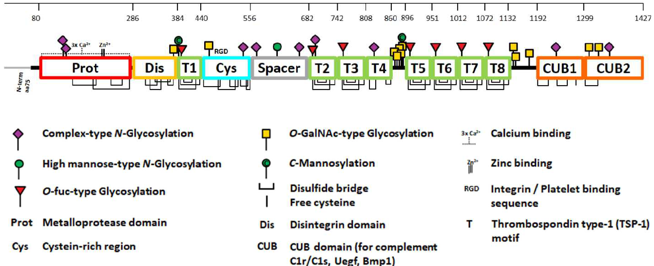

The active drug substance in Adzynma, rADAMTS13, is a highly glycosylated recombinant human protein. Manufacture begins with thaw and expansion of the working cell bank, followed by controlled bioreactor cultivation and harvest, clarification and a multi-step purification train. Purification includes orthogonal chromatography steps, nanofiltration, defined viral inactivation/clearance measures and ultrafiltration/diafiltration, with final formulation and sterile filtration prior to storage. The process is described as controlled, robust and reproducible, supported by validation, defined critical process parameters and acceptance criteria, and consistent elution and performance profiles across campaigns.
Control of the active substance is based on extensive characterisation and routine release testing that covers appearance and pH (compendial where applicable), identity, purity, quantity, potency and relevant process-related impurities, together with microbiological controls such as endotoxin/bioburden. Potency is measured using a validated functional assay specific for rADAMTS13 activity. Specification limits are justified using batch analysis and stability data and are considered appropriate for ensuring consistent quality. The active substance is stored in sterile PETG bottles at temperatures of ≤ –60°C and shipped under controlled conditions, with container compatibility and extractables/leachables work indicating negligible patient risk from leachables. Real-time stability data support a proposed shelf life of 36 months for the drug substance at ≤ –60°C with protection from light, and no noteworthy stability concerns were identified within the submitted dataset.
Adzynma finished product is presented as a lyophilised powder for solution for infusion in two strengths (500 IU/vial and 1500 IU/vial) and is administered by intravenous infusion after reconstitution with 5 mL sterile water for injection. The formulation is preservative-free and buffered to approximately pH 7.0, and includes commonly used excipients (sodium chloride, calcium chloride dihydrate, L-histidine, mannitol, sucrose and polysorbate 80) with compendial compliance to Ph. Eur., USP and JP where applicable. The product is supplied as a composite pack comprising the powder vial, a separate diluent vial, and administration devices to support reconstitution and delivery. The primary container for the drug product is a 10 mL Type I glass vial with a butyl rubber stopper, aluminium crimp seal and flip-off cap; the diluent is provided in a Type I glass vial with compatible closure components. The container closure system is assessed as suitable for intended use based on compatibility and stability information.
The finished product is manufactured via an aseptic process that includes pooling of active substance, sterilising-grade filtration, aseptic filling into vials, lyophilisation, crimping and 100% visual inspection, with compliant vials stored refrigerated pending labelling and packaging. The dossier describes the manufacturing process with sufficient detail, including in-process controls, development of critical process parameters and validation activities designed to ensure consistent manufacture of the commercial product. Where manufacturing or process changes are relevant, comparability assessments were provided and were considered satisfactory, supporting the conclusion that commercial product quality remains consistent with material used in pivotal clinical studies. Analytical methods used for release and stability are described, and non-compendial methods are validated; where applicable, methods align with those used for active substance testing, and the reference standard approach is consistent across drug substance and drug product testing.
Finished product specifications include tests for identity, potency, purity and impurities, sterility and bacterial endotoxin (compendial where applicable), alongside other general quality attributes needed for batch release and ongoing stability monitoring. Stability studies under real-time and stressed conditions support a recommended shelf life of 36 months when stored at 2–8°C. In-use stability data support use immediately after reconstitution or within 3 hours at room temperature, after which any unused portion should be discarded; from a microbiological perspective, immediate use is recommended. The product is not photostable, and storage in the original carton to protect from light is reflected in labelling. Allowable temperature excursions for the drug product were evaluated under tested conditions, and the storage statements across the PI, ARTG-related information and labels are described as consistent with the recommended shelf life and handling requirements, including not returning product to refrigerated storage after an approved period at room temperature and recording the date of removal from refrigeration where relevant.
Secondary quality evaluations addressing sterility and microbiological controls, adventitious agents (including viral safety, transmissible spongiform encephalopathies and mycoplasma) and container/endotoxin safety provide additional assurance that contamination risks are appropriately controlled through testing of starting materials, in-process controls, validated decontamination and clearance steps and final product testing. The submitted evidence supports adequate removal or reduction of contaminants to levels considered safe, and no manufacturing or manufacturer-related quality issues were identified.
Overall, the physicochemical and biological attributes relevant to consistent clinical performance have been adequately investigated, and the combined information on development, manufacture, control and stability of both active substance and finished product supports the conclusion that Adzynma has acceptable quality and should exhibit satisfactory and uniform performance in clinical use, provided it is used and stored according to the approved PI, labels and related registration details.
From a quality perspective, the Evaluator’s overall recommendation is that there are no objections on quality grounds to approval of either strength of Adzynma.

Nonclinical evaluation summary
The submitted nonclinical dossier was in accordance with the relevant ICH guideline for the nonclinical assessment of biological medicines (ICH S6). The overall quality of the nonclinical dossier was high. All pivotal safety-related studies were conducted with GLP compliance.
In vivo pharmacology studies showed that rADAMTS13 prevented and resolved the symptoms of TTP in ADAMTS13 knockout mice when the animals were challenged with high doses of VWF.
Off target activity is considered unlikely, as ADAMTS13 selectively targets VWF with high affinity and no other additional substrates have been identified to date.
Safety pharmacology assessments of rADAMTS13 were integrated into the repeat-dose toxicity studies conducted in rats and cynomolgus monkeys. No adverse effects were observed on the functions of the central nervous, cardiovascular or respiratory systems.
Overall, the pharmacokinetic profile of rADAMTS13 in rats and cynomolgus monkeys was broadly similar to that observed in humans. However, systemic exposure to rADAMTS13 in cynomolgus monkeys was attenuated to subclinical levels with repeat-dosing due to neutralising anti-drug antibodies (ADAs). Consequently, only rats were considered suitable for the evaluation of chronic toxicity.
Pharmacokinetic drug interactions are considered unlikely given the chemical nature of rADAMTS13.
rADAMTS13 had a low order of acute toxicity by the IV route in rats and cynomolgus monkeys.
The collective data from the repeat-dose toxicity studies in rats raised no safety concerns for patients at the proposed clinical dose and dosing frequency. Repeated IV injections of rADAMTS13 were also well-tolerated at the tissues of the injection site.
Genotoxicity and carcinogenicity studies with rADAMTS13 were not submitted. However, as rADAMTS13 is a recombinant protein derived from human endogenous VWF, and given its pharmacological action, there are no genotoxic or carcinogenic concerns.
Minimal placental transfer was seen in rats. No treatment-related adverse effects on female fertility, embryofetal development or postnatal development were observed in this species.
Primary pharmacology studies support the use of rADAMTS13 to treat ADAMTS13 deficiency in patients with congenital thrombotic thrombocytopenic purpura (cTTP).
No clinically relevant hazards were identified from the secondary pharmacodynamics, safety pharmacology and toxicity evaluation programs.
There are no objections to the registration of Adzynma from a nonclinical perspective.

Clinical evaluation summary
The clinical studies submitted in this dossier supporting the application includes the following:
- a Phase I safety, tolerability and PK study - Study 281101
- a pivotal Phase III study - Study 281102
- a long-term safety and efficacy study - Study 3002
- a PopPK analysis, Study TGRD-PMX-TAK755-2375_PKER (Study PKER)
The age inclusion criteria for the phase I PK study (281101) was 12-65 years old. The age inclusion criteria for the main pivotal efficacy study (281102) and the long-term safety/efficacy study (3002) was 0-70 years old. In Study 281102, the age range of enrolled participants was 3 to 68 years. There were four subjects aged 12 to <18 years, four aged 6 to <12 years and 4 aged <6 years. In Study 281101 (Phase I), the age range of enrolled participants was 16 to 41 years. There were two participants in Study 3002 and no neonates had been enrolled at the Interim Analysis 2 cutoff date.

Pharmacology

Pharmacokinetics
Adzynma has a molecular weight of approximately 172 kDa. The reconstituted solution has a pH of 6.7 to 7.3, and an osmolality of no lower than 240 mOsmol/kg. Adzynma is administered intravenously.
In Study 281101, T_{max} was around 20 minutes. The results of the PK analysis differ slightly depending on the assay used. Using the ADAMTS13 FRETS-VWF73 assay, the majority of the observations were below limit of quantification (BLQ) for the 5 U/kg dose. For the 20 U/kg and 40 U/kg dose levels, there was dose proportionality for C_{max} but a greater than proportional increased in AUC_{0-t}. Mean (SD) C_{max} was 0.415 (0.149) U/mL for the 20 U/kg dose and 0.957 (0.140) U/mL for the 40 U/kg dose. Mean (SD) AUC_{0-t} was 15.8 (4.88) U•h/mL for the 20 U/kg dose and 49.2 (14.1) U•h/mL for the 40 U/kg dose. Clearance (CL) was higher at the 20 U/kg dose: mean (SD) 72.8 (24.5) mL/h for the 20 U/kg dose and 65.2 (24.2) mL/h for the 40 U/kg dose. Mean (SD) V_{ss} was 5300 (1030) mL at the 40 U/kg dose level.
The results were slightly different using the ADAMTS13 Technozym assay. Using this assay there appears to be dose proportionality. Mean (SD) C_{max} was 0.364 (0.129) U/mL for the 20 U/kg dose and 0.851 (0.160) U/mL for the 40 U/kg dose. Mean (SD) AUC_{0-t} was 20.7 (4.72) U•h/mL for the 20 U/kg dose and 48.1 (14.8) U•h/mL for the 40 U/kg dose. CL was similar: mean (SD) 65.2 (27.9) mL/h for the 20 U/kg dose and 69.7 (20.8) mL/h for the 40 U/kg dose. Mean (SD) V_{ss} was 5900 (1770) mL at the 40 U/kg dose level.
The PK parameters for ADAMTS13 Antigen (Ag) were similar to those for ADAMTS13 activity. At the 40 U/kg dose level, mean (SD) C_{max} was 0.678 (0.103) U/mL, AUC_{0-t} was 17.3 (2.25) U•h/mL, CL was 64.5 (24.1) mL/h and V_{ss} was 5510 (1680) mL.
In study 281102, ADAMTS13 Ag C_{max} was around five times higher with rADAMTS13: geometric mean (CV%) 0.699 μg/mL (20.2%), compared with 0.135 (43.0%) for standard of care (SoC). ADAMTS13 Ag AUC₀₋₁₆₈ was around six times higher with rADAMTS13: geometric mean (CV%) 32.53 h•IU/mL (23.9%), compared with 5.347 (156.3%) for SoC. However, the terminal half-life (t_{½}) was similar: geometric mean (CV%) 52.02 h (25.7%), compared with 52.25 (63.5%) for SoC. The results were similar for ADAMTS13 activity.
In Study 281101, ADAMTS13 FRETS-VWF73 mean (SD) V_{ss} was 5300 (1030) mL at the 40 U/kg dose level. For the ADAMTS13 Technozym assay, mean (SD) V_{ss} was 5900 (1770) mL at the 40 U/kg dose level. For ADAMTS13 Ag, V_{ss} was 5510 (1680) mL.
The metabolism of rADAMTS13 can be expected to be the same as for endogenous ADAMTS13, via the normal processes of proteolysis and catabolism.
In Study 281101, for ADAMTS13 measured by FRETS-VWF73, CL was higher at the 20 U/kg dose: mean (SD) 72.8 (24.5) mL/h for the 20 U/kg dose and 65.2 (24.2) mL/h for the 40 U/kg dose. For ADAMTS13 measured with Technozym, CL was similar: mean (SD) 65.2 (27.9) mL/h for the 20 U/kg dose and 69.7 (20.8) mL/h for the 40 U/kg dose. For ADAMTS13 Ag, CL was 64.5 (24.1) mL/h for the 40 U/kg dose.
Taken together, the PK of ADAMTS13 has been adequately characterised in subjects aged 3 to 68 years across the studies. This has demonstrated, in the population studied, that there is low variability and the PK are typical for a protein-based drug product. The results support the PK information in the PI. The results also support the proposed dosing regimen.
However, there was limited PK data for children <3 years age. PK samples were collected and analysed for the two participants, and their individual PK parameters were provided in Study 3002 IA2 dataset.

Population pharmacokinetic data
In population PK Study PKER, the base model was two compartment, with zero order infusion and CL. Between-subject variability (BSV) was estimated on CL and central volume of distribution (Vc). The residual error was a combined additive and proportional model. There was allometric scaling of weight on CL and Vc with centred on the median. The difference between in treatment in the content of ADAMTS13 was accounted for by using relative bioavailability. The parameter estimates were estimated with good precision and shrinkage was acceptable. None of the covariates tested were significant. There were too few subjects with anti-ADAMTS13 binding antibodies to evaluate this effect in the model.
The typical estimates were 0.0398 L/h for CL, 2.69 L for Vc, 0.0456 L/h for intercompartmental clearance (Q), and 3.71 for peripheral volume of distribution (Vp). BSV, expressed as CV% was 14.3% for CL and 25.4% for Vc.

Weight was not a significant covariate effect on ADAMTS13 activity in the presence of weight-based dosing. Key intrinsic factors such as age, race, sex and blood group did not have any effect on CL and Vc. Markers of hepatic function or renal function also did not have any impact on CL. Thus, no major intrinsic factors were found to have a clinically and statistically significant impact on the PK of ADAMTS13 activity in participants with cTTP.
For Q2W dosing, the mean (SD) duration of ADAMTS13 activity >10% was 8.99 (2.52) days.

Pharmacodynamics
Adzynma is a recombinant form of the endogenous ADAMTS13. ADAMTS13 is a plasma zinc metalloprotease that regulates the activity of VWF by cleaving large and ultra-large VWF multimers to smaller units and thereby reducing the platelet binding properties of VWF and its propensity to form microthrombi. The use of Adzynma in patients with cTTP provides targeted ADAMTS13 supplementation and replenishment of plasma ADAMTS13 activity which is expected to reduce or eliminate the spontaneous formation of VWF-platelet microthrombi that leads to platelet consumption and thrombocytopenia, which is a marker of disease activity in patients with cTTP.
The effects of rADAMTS13 appear to be immediate and are related to its plasma concentration.
The popPK study (PKER) noted the following relationships between exposure and response:
- The effect of ADAMTS13 on thrombocytopenia was modelled using a Poisson regression model and an E_{max} model. The EC₅₀ for C_{ave,ss} was 0.0149 IU/mL.
- A concentration response for microangiopathic haemolytic anemia was described using a linear Poisson regression model. This analysis indicated equivalent response for the once weekly (QW) and once every two weeks (Q2W) dosing regimens.
- The effect of ADAMTS13 on a composite endpoint was modelled using a Poisson regression model and an E_{max} model. The EC₅₀ for C_{ave,ss} was 0.0378 IU/mL.
- The Cox proportional hazards modelling for thrombocytopenia demonstrated a concentration effect relationship. The CI analysis of the hazard ratios indicate QW is superior to Q2W and rADAMTS13 is superior to SoC. The results were similar for the <12 years and ≥12 years populations. For microangiopathic haemolytic anaemia (MAHA), rADAMTS13 was superior to SoC but there was no significant difference between QW and Q2W.
The repeated time to event analysis estimated an EC₅₀ of 0.0113 IU/mL for prevention of thrombocytopenia and 0.0133 IU/mL for prevention of MAHA.
The findings support the information in the PI and also support the dosing recommendations. However, information on the concentration effect relationships has not been provided in the PI.
There was limited pharmacodynamic data for children <3 years age.

Dose selection
The Phase I study examined 5 IU/kg, 20 IU/kg and 40 IU/kg administered intravenously as a single dose. This dose range was selected based on the amounts of ADAMTS13 present in FFP, which was administered as SoC. For ADAMTS13 FRETS-VWF73 for the 5 IU/kg dose the majority of the observations were BLQ. For the PD parameters:
- There was a trend for decreasing large multimers (including ultra-large multimers) and increasing levels of the intermediate form was observed over the first 24 hours post-dose in individual profiles at the higher doses of 20 IU/kg or 40 IU/kg.
- Detectable ADAMTS13-mediated VWF cleavage products were observed over a longer period of time at higher dose levels: for 20 IU/kg, up to 24 hours post-dose for all subjects and up to 48 hours in two subjects (66.7%); and for 40 IU/kg, up to 48 hours post-dose for all subjects and as long as 264 hours in one subject (14.3%).
The results here supported the 40 IU/kg dose level.
Only one dosing regimen was investigated in the pivotal study. The dose regimen used in the final study was derived from the Phase I study, Study 281101. This was based on the ADAMTS13 content of FFP, which is the SoC. Subsequently, Study PKER provided further analysis and has confirmed this dosing strategy.
However, the dosing regimen for the on-demand therapy, and for breakthrough TTP episodes, has undergone limited evaluation. This dosing was also based on Study 281101 but because of the rarity of the outcome there is limited supporting data in the dossier.

Efficacy
One pivotal efficacy Phase III randomised, controlled two-period crossover study, Study 281102, and one long-term open-label, single treatment arm, follow-up extension study, Study 3002, were provided. Study 281102 was conducted from October 2017 to August 2022. The study was conducted at 34 centres in the EU, the US, the UK and Japan. No Australian sites were included in Study 281102.
The primary objective of Study 281102 was the incidence of acute TTP events.
The secondary objectives included the following:
- Proportion of acute TTP events responding to rADAMTS13, defined as not requiring the use of another ADAMTS13-containing agent
- Time to resolution of acute TTP events following initiation of treatment with rADAMTS13 or SoC agent
- Incidence of thrombocytopenia defined as a drop in platelet count ≥25% of baseline or a platelet count <150,000/μL
- Incidence of MAHA defined as an elevation of lactate dehydrogenase >1.5x of baseline or >1.5xULN
- Incidence of neurological symptoms (e.g., confusion, dysphonia, dysarthria, focal or general motor symptoms including seizures)
- Incidence of renal dysfunction defined as an increase in serum creatinine >1.5xbaseline
- Incidence of abdominal pain
- Incidence of supplemental doses prompted by subacute TTP events
- Incidence of dose modification not prompted by an acute TTP event
- Incidence of acute TTP events while subjects are on their final dose and dosing regimen in the study
Exploratory efficacy outcome measures were:
- Incidence of TTP manifestations, defined as composites of secondary outcome measures while receiving prophylactic treatment during the 6 months of the corresponding treatment
- Incidence of TTP manifestations, defined as a composite of secondary outcome measures, while receiving the final prophylactic treatment regimen
- Incidence of TTP manifestations, defined as a composite of secondary outcome measures, requiring supplemental dose treatment
- Incidence of the subacute TTP events in subjects receiving prophylactic treatment.
The order of treatment was randomised in blocks. There was no blinding to treatment allocation.
The planned enrolment was approximately 67 eligible subjects 0 to 70 years of age with cTTP, with 48 subjects in the prophylactic cohort and 9 subjects in the on-demand cohort. Study design schematic is presented below (Figure 2).
The sample size was pragmatic because of the rarity of cTTP. The sample size was not based on a power calculation for a significance test. No formal statistical tests were planned in the study.
Figure 2. Prophylactic cohort cross-over schematic
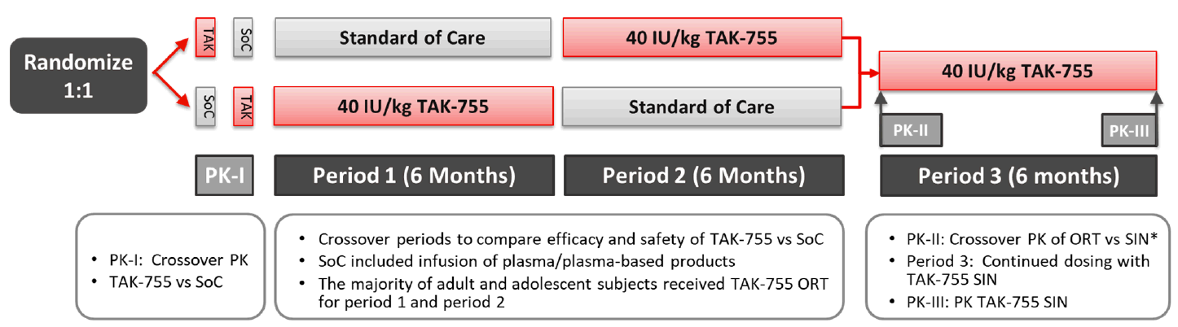

Figure 3: By-Participant Disposition for the Prophylactic and OD Cohorts — All Participants ENR
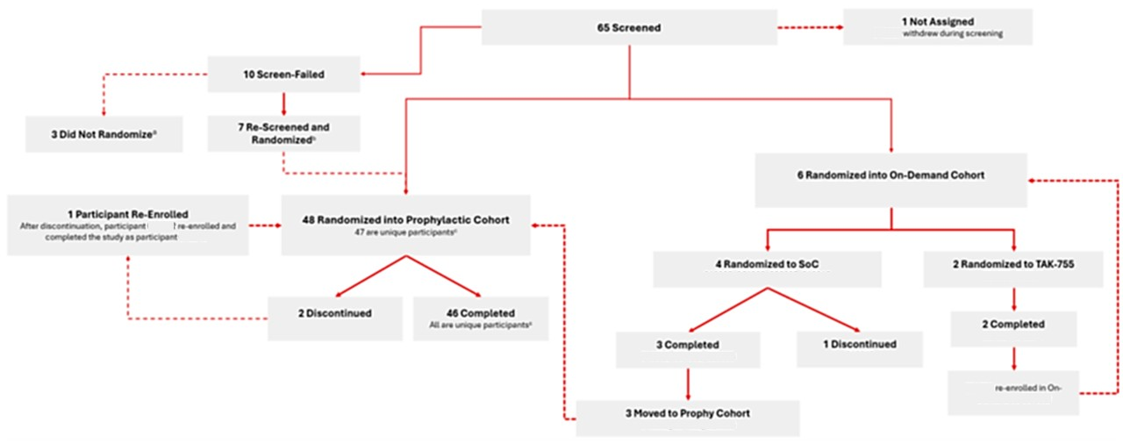
ª Three participants (2 unique) screen-failed and did not enter the study
^{b} Seven participants (6 unique) re-screened and were randomized into the prophylactic cohort: (bold indicates the participant ID in which they were randomized into the prophy cohort).
^{C} is the same person who enrolled once in the OD Cohort and twice in the prophylactic cohort of the study.
^{d} Participant was terminated early from the study when it was determined that the participant had iTTP and not cTTP.

In the prophylactic cohort, there were 28 (58.3%) females and 20 (41.7%) males. The age range was 3 to 68 years. There were four subjects aged 12 to <18 years, four aged 6 to <1 years and 4 aged <6 years. There were 32 (66.7%) White subjects and five (10.4%) Asian. In the on-demand cohort, there were four males and two females, five subjects were aged ≥18 years and one was <6 years.
In the prophylactic group, prior treatment was FFP for 33 (68.8%) subjects, solvent/detergent treated plasma for 12 (25.0%) and FVIII-VWF concentrates for three (11.1%). In the on-demand group, prior treatment was FFP for three subjects, solvent/detergent treated plasma for two and FVIII-VWF concentrates for one. The randomisation groups were similar for baseline characteristics.
The majority of subjects (93.8%) in the prophylactic cohort had prior medical conditions, and 26 (54.2%) had prior nervous system disorders.
Adherence to study treatment was high. In the prophylactic cohort, mean (SD) compliance was 99.68 (1.184) % for rADAMTS13 and 94.76 (8.502) %. In the on-demand cohort compliance was 100%.
Table 3. Demographics by treatment cohort — safety analysis set
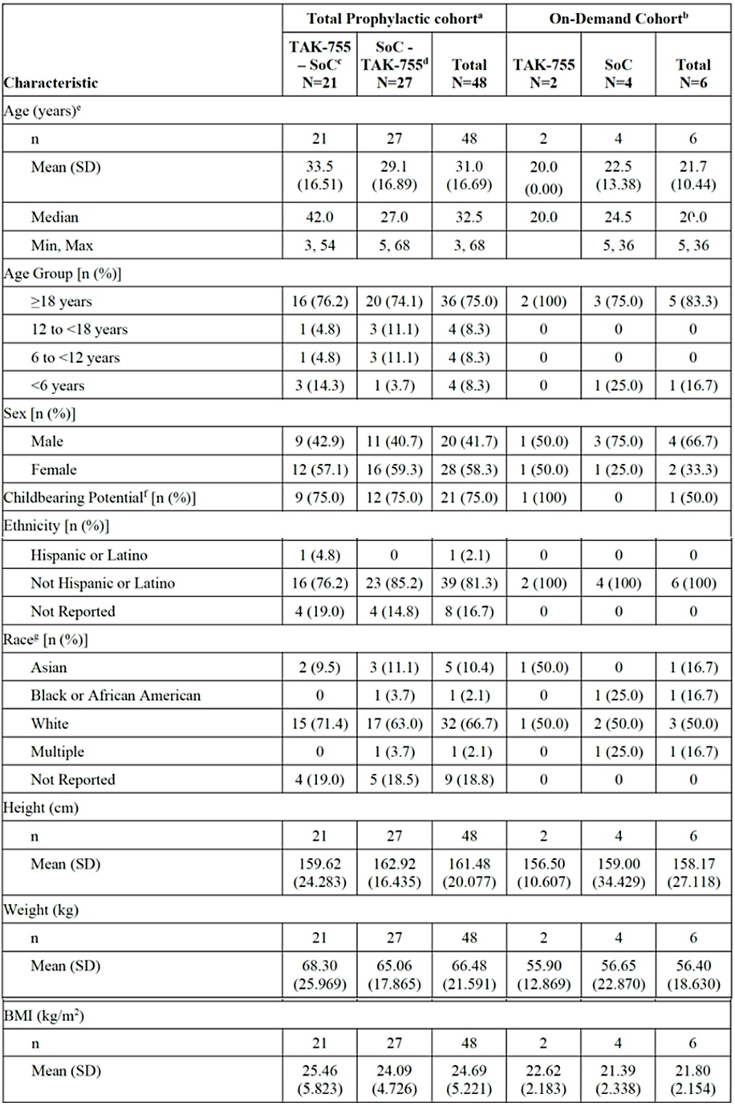
One participant in the SAF (Participant) had randomized treatment sequence TAK-755 - SoC but actual
treatment sequence SoC - TAK-755.
Percentages are based on all participants in the SAF within each column.
Two rescreened participants passed screening and entered the study more than once.
. For each participant. all data collected are included into the analysis.
ª Total prophylactic cohort includes the participants who were originally enrolled in the prophylactic cohort and the
participants who moved to the prophylactic cohort from the OD Cohort.
^{b} OD Cohort includes the participants who enrolled in the OD Cohort.
^{c} Participants in TAK-755 - SoC took TAK-755 in Period | and SoC in Period 2.
^{d} Participants in SoC - TAK-755 took SoC in Period | and TAK-755 in Period 2.
^{e} Age was obtained from the eCRF.
^{f} Percentage of female participants.
^{g} Race is not reported in some countries as race question is not permitted.
Table 4. cTTP history by treatment cohort — safety analysis set
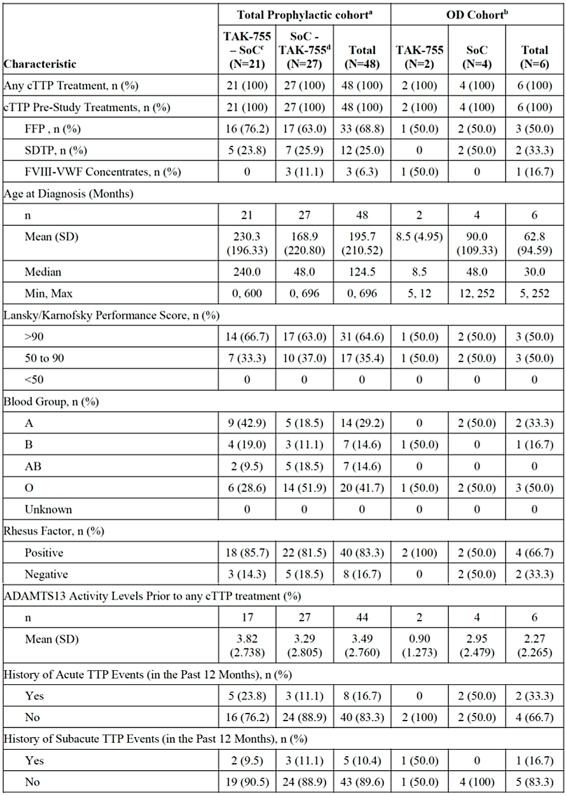
One participant in the SAF had randomized treatment sequence TAK-755 - SoC but actual
treatment sequence SoC - TAK-755.
Percentages are based on all participants in the SAF within each column.
Two rescreened participants passed screening and entered the study more than once.
. For each participant, all data collected are included into the analysis.
ª Total prophylactic cohort includes the participants who were originally enrolled in the prophylactic cohort and the
participants who moved to the prophylactic cohort from the OD Cohort.
^{b} OD Cohort includes the participants who enrolled in the OD Cohort.
^{c} Participants in TAK-755 - SoC took TAK-755 in Period | and SoC in Period 2.
^{d} Participants in SoC - TAK-755 took SoC in Period | and TAK-755 in Period 2.

With regard to the primary efficacy endpoint, there was one TTP event in one adult participant in the SoC arm and none in the Adzynma prophylaxis group. Hence, there were insufficient events to perform a statistical analysis. The mean (SD) annualised event rate was 0.05 (0.280) /year for SoC and 0.00 (0.000) /year for rADAMTS13.
For the secondary efficacy outcome measures:
- Proportion of acute TTP events responding to rADAMTS13, defined as not requiring the use of another ADAMTS13-containing agent: the one acute TTP event in the SoC group responded to rADAMTS13. In the sensitivity analysis, there were two acute TTP events in the on-demand cohort that responded to rADAMTS13.
- The median time to resolution of acute TTP events following initiation of treatment with rADAMTS13 or SoC agent for both the prophylactic and on-demand cohorts was 4.0 days for rADAMTS13 and 4 days for SoC.
- There were significantly more thrombocytopenia event manifestations (defined as a drop in platelet count ≥25% of baseline or a platelet count <150,000/μL) during SoC than during rADAMTS13. The LS mean (SE) annualised rate of thrombocytopenia events was 0.90 (0.262) during rADAMTS13 and 1.63 (0.445) during SoC, ratio (95% CI) 0.6 (0.4 to 0.8), p = 0.002.
- Incidence of MAHA defined as an elevation of lactate dehydrogenase >1.5x of baseline or >1.5xULN was, LS mean (SE) annualised rate, 0.37 (0.135) during rADAMTS13 and 0.58 (0.189) during SoC, ratio (95% CI) 0.6 (0.3 to 1.2), p = 0.152.
- The incidence of neurological symptoms (e.g., confusion, dysphonia, dysarthria, focal or general motor symptoms including seizures) was, LS mean (SE) annualised rate, 0.14 (0.070) during rADAMTS13 and 0.23 (0.108) during SoC, ratio (95% CI) 0.6 (0.3 to 1.2), p = 0.140.
- The incidence of renal dysfunction defined as an increase in serum creatinine >1.5xbaseline was, LS mean (SE) annualised rate, 0.17 (0.090) during rADAMTS13 and 0.08 (0.052) during SoC, ratio (95% CI) 2.2 (0.5 to 8.7), p = 0.266.
- The incidence of abdominal pain was, LS mean (SE) annualised rate, 0.09 (0.055) during rADAMTS13 and 0.17 (0.086) during SoC, ratio (95% CI) 0.5 (0.1 to 1.9), p = 0.338.
- Incidence of supplemental doses prompted by subacute TTP events was nine in the SoC treatment period, mean annualised event rate (SD) 0.39 (1.466), none during rADAMTS13 Periods 1 and 2, and five during rADAMTS13 Period 3, mean annualised event rate (SD) 0.15 (0.745).
- The incidence of dose modification not prompted by subacute TTP events was three in the SoC treatment period, mean annualised event rate (SD) 0.12 (0.467), none during rADAMTS13 Periods 1 and 2, and one during rADAMTS13 Period 3, mean annualised event rate (SD) 0.02 (0.157).
- There was one acute TTP events while subjects are on their final dose and dosing regimen in the SoC treatment period and none in the rADAMTS13.
For the exploratory efficacy outcome measures:
- For Periods 1 and 2, there were 143 TTP manifestations, defined as composites of secondary outcome measures while receiving prophylactic treatment during the 6 months of the corresponding treatment, in 28 (60.9%) subjects during SoC and 102 in 24 (53.3%) during rADAMTS13. The mean annualised event rate (SD) was 6.81 (8.411) for SoC and 4.54 (6.545) during rADAMTS13.
- For Periods 1 and 2, the incidence of TTP manifestations, defined as a composite of secondary outcome measures, while receiving the final prophylactic treatment regimen, mean annualised event rate (SD), was 7.26 (8.758) for SoC and 4.37 (6.577) for rADAMTS13.
- Incidence of subacute TTP manifestations, during periods 1 and 2 was, LS mean (SE) annualised event rate, 0.30 (0.809) for subjects receiving SoC and 0.04 (0.275) for subjects receiving rADAMTS13
Table 5. Summary of acute TTP events by study period in the prophylactic cohort — modified full analysis set (Age ≥12 Years)
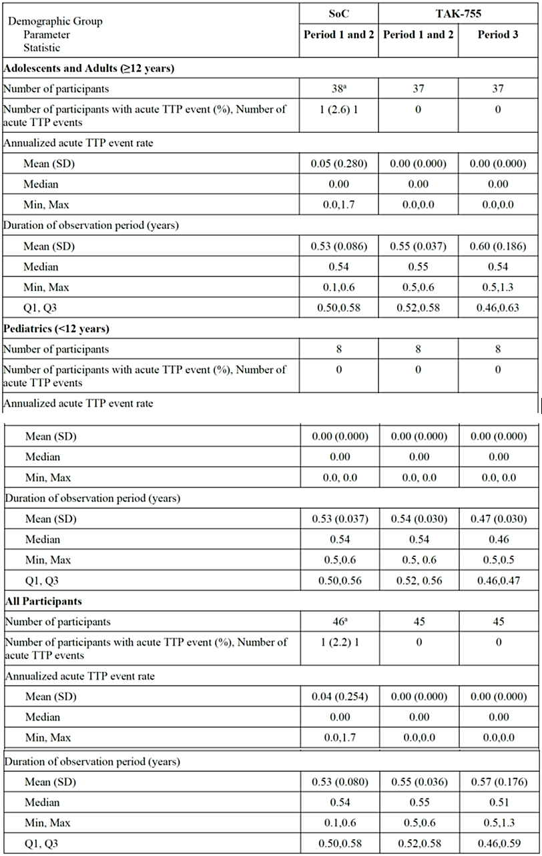
Data from Periods 1, 2 and 3 are used for participants in the prophylactic cohort and those who moved from OD to
prophylactic cohort.
ª A unique participant passed screening and entered the study more than once and is included in
the modified full analysis set as 2 study participants.
Table 6. Inferential analysis of annualised event rates of TTP manifestations for Periods 1 and 2 in the Prophylactic Cohort — modified full analysis set
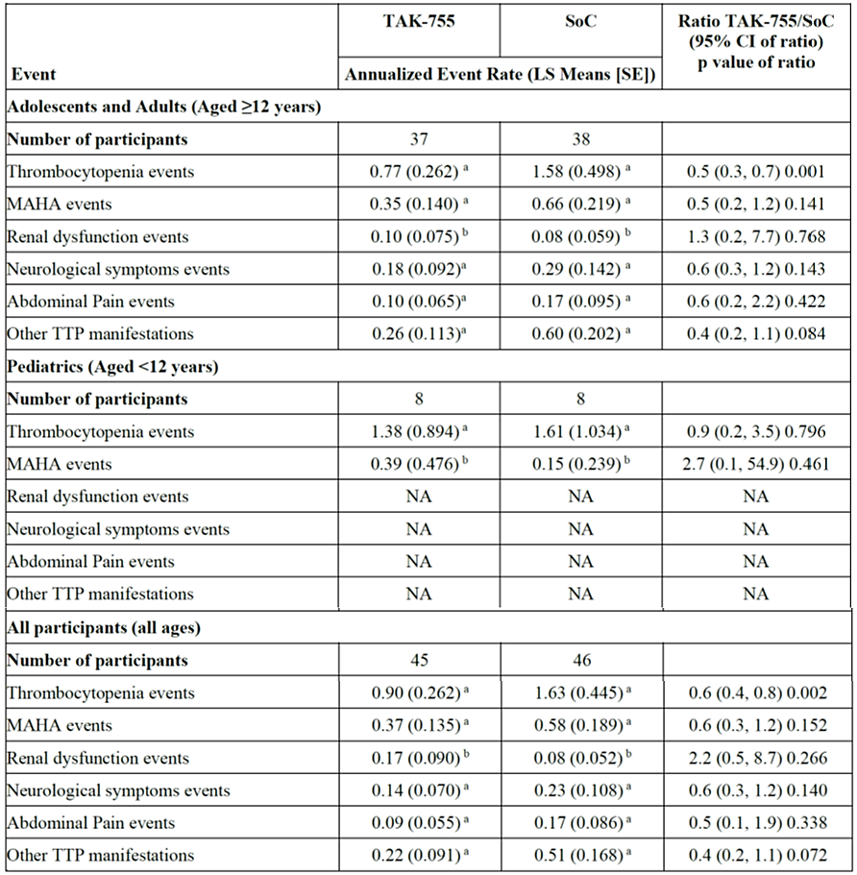
One participant passed screening and entered the study more than once and is included in the MFAS as
2 study participants.
For each participant. all data collected are included in analysis.
ª From a generalized linear mixed-effects model with a negative binomial distribution as a family and a logarithmic
link function with treatment as a fixed effect, participant as a random effect. and the logarithm of follow-up time
(in years) as an offset. Period (1 and 2) and sequence (TAK-755 - SoC, SoC - TAK-755) were included in the
model as categorical variables.
^{b} Due to sparse events, the full model did not converge. Therefore, these results are from a generalized linear mixed-
effects model that did not include the treatment sequency as a covariate.
The main findings of the Study 281102 were a statistically significant decrease in thrombocytopenia episodes. There were significantly more thrombocytopenia event manifestations (defined as a drop in platelet count ≥25% of baseline or a platelet count <150,000/μL) during SoC than during rADAMTS13. The LS mean (SE) annualised rate of thrombocytopenia events was 0.90 (0.262) during rADAMTS13 and 1.63 (0.445) during SoC, ratio (95% CI) 0.6 (0.4 to 0.8), p = 0.002. Thrombocytopenia is directly related to the underlying pathology, so it is an appropriate clinical endpoint. The other efficacy outcome measures, although not statistically significant, also supported efficacy.
There was also a decrease in healthcare resource utilisation with rADAMTS13. However, there was no significant difference in quality-of-life outcomes.
There were no children aged <3 years in Study 281102, so efficacy would need to be extrapolated to children aged from 0 to <3 years. This was considered acceptable because the underlying pathophysiology of the condition is the same across the age groups, and response to treatment can be expected to be the same. It would not be feasible to conduct a separate efficacy study in this age group.
In the long-term open-label, single treatment arm, follow-up extension study, Study 3002, there was no primary efficacy outcome measure. The key secondary efficacy outcome measure was the annual rate of acute TTP events in subjects with cTTP undergoing prophylactic treatment with rADAMTS13 along with a number of other secondary efficacy endpoints.
The follow-on study used the same inclusion and exclusion criteria as the pivotal study, and used the same outcome measures. Hence the study is a reasonable representation of the long-term maintenance of the efficacy outcomes demonstrated in the pivotal study.
The efficacy outcomes were maintained during the follow-on study. In the follow-on study the annualised event rate for thrombocytopenia was (SD) 0.62 (1.708) and in the pivotal study was 0.90 (0.262). In the follow-on study the annualised event rate for MAHA was (SD) 0.54 (2.120) and in the pivotal study was 0.6 (0.3 to 1.2). The study also demonstrated maintenance of the health-related quality of life outcomes.
In response to Evaluator questions, the Sponsor submitted that two participants were enrolled and received TAK-755 prophylaxis in Study 3002. The efficacy data were included in Study 3002 IA2 analysis (cutoff date 19 Jan 2024) and submitted for evaluation at Round 2. Although the sample size is very small, efficacy results appear comparable across paediatric, adult and adolescent groups and the limited paediatric data do not indicate any difference in response to the adult and adolescent groups.
Further, the Sponsor submitted that Study 281102 was part of the EU Paediatric Investigation Plan as a commitment to the marketing authorisation in the EU and the report was also submitted to EMA in December 2024 and at the time of evaluation for Australian marketing authorisation, the report was undergoing review with the Committee for Medicinal Products for Human Use (EMA).

Safety
Safety data submitted were derived from the pivotal efficacy Phase III randomised, controlled two-period crossover study, Study 281102, the long-term open-label, single treatment arm, follow-up extension study, Study 3002, and the Phase I safety, tolerability and PK study, Study 281101.
A total of 123 subjects have been exposed to rADAMTS13 in clinical trials, with a total exposure time of 12.60 person-years. There were 81 subjects exposed for >7 days to <6 months and one subject exposed for 6 to <12 months.
A total of 85 subjects with cTTP have been exposed to rADAMTS13 in clinical trials, with a total exposure time of 12.60 person-years. There were 69 subjects with cTTP exposed for >7 days to <6 months and one subject exposed for 6 to <12 months.
Overall, there were seven subjects aged 2 to <6 years, nine aged 6 to <12 years and 11 aged 12 to <18 years. There were no subjects aged <2 years. There were 72 females and 51 males.
There were no adverse events (AEs) of special interest.
Across the studies, there were no deaths related to AEs or AEs leading to deaths. There were no treatment-emergent adverse events (TEAEs) that led to study discontinuation. There were TEAEs that resulted in interruption of Adzynma treatment.
Adzynma has a favourable safety profile in the proposed usage. The overall incidence of TEAEs was similar between rADAMTS13 and SoC. The difference between the treatments was in the incidence of transfusion reactions, which was greater with SoC.
In the pivotal study, Study 281102, there were 300 TEAEs reported in 44 (91.7%) subjects with SoC, and 273 in 39 (83.0%) with rADAMTS13. The most frequently reported TEAEs were headache, vomiting, COVID-19 and fatigue.. Urticaria and allergic transfusion reactions were more frequent with SoC: urticaria was reported in six (12.5%) subjects with SOC, none with rADAMTS13 in periods 1 and 2, and two (4.2%) with rADAMTS13 in period 3. Allergic transfusion reactions were reported in six (12.5%) subjects with SOC and none with rADAMTS13.
Also in the pivotal study, Study 281102, there were 37 treatment related TEAEs reported in 22 (45.8%) subjects during SoC and eight in two (4.3%) during rADAMTS13. In the SoC treatment period there were 16 skin and subcutaneous tissue disorders (including urticaria, rash and pruritus) reported in 11 subjects, and none with rADAMTS13. Allergic transfusion reaction was reported in six (12.5%) subjects with SoC and none with rADAMTS13.
There were no TEAEs leading to study discontinuation. In Study 281102, there was one TEAE leading to discontinuation of Adzynma reported in one (2.1%) subject during SoC (rash), and none with rADAMTS13. There were 18 TEAEs leading to interruption of treatment reported in 13 (27.1%) subjects with SoC and none with rADAMTS13.
The laboratory test abnormalities noted during the study were attributable to the underlying condition and none were attributed to rADAMTS13.
In Study 281102, one subject experienced atrial fibrillation while in the rADAMTS13 treatment arm. It was considered to be mild and unrelated to study treatment.
Immunogenicity appeared to be a bigger problem with SoC than with rADAMTS13. In the pivotal study, Study 281102, there were 24 hypersensitivity TEAEs reported in 16 (33.3%) subjects with SoC and none with rADAMTS13. Urticaria and allergic transfusion reactions reported as TEAEs were more frequent with SoC: urticaria was reported in six (12.5%) subjects with SOC in periods 1 and 2, none with rADAMTS13 in periods 1 and 2, and two (4.2%) with rADAMTS13 in period 3. Allergic transfusion reactions were reported in six (12.5%) subjects with SOC and none with rADAMTS13.
No neutralising antibodies or treatment-emergent or treatment-boosted antibodies were detected in confirmed cTTP participants. One subject who was considered to have iTTP had anti-rADAMTS13 binding and neutralising antibodies. However, it was not clear whether or not this was a patient with cTTP who subsequently developed antibodies, or a patient with iTTP. The Sponsor provided further clarification that this subject was confirmed to have iTTP rather than cTTP after enrolment.
Two participants in the prophylactic cohort had transient, low-titre anti-CHO antibodies at a single time point only with subsequent negative anti-CHO Ab results
In Study 3002, anti-rADAMTS13 binding antibodies were detectable at low titre (1:20 or 1:40) in five rollover subjects providing an incidence rate of 13.9% for this study. Detection of these binding antibodies was not temporally associated with TTP events, AEs, or development of neutralising antibodies. The titres remained low over time and did not increase. No neutralising antibodies were reported in any subject on study. In Study 281101, all subjects were negative for anti-ADAMTS13 neutralising antibodies, anti-CHO protein antibodies and anti-rADAMTS13 binding and inhibitory antibodies.
Again, in response to Evaluator questions, the Sponsor submitted that two participants were enrolled and received TAK-755 prophylaxis in Study 3002. The safety data derived were also included in Study 3002 IA2 analysis (cutoff date 19 Jan 2024) and submitted in Round 2. The Sponsor submitted that the safety data again appeared comparable across paediatric, adult and adolescent groups and the limited paediatric data do not indicate any additional safety concerns.
There remains a gap in knowledge with regard to safety in patients <2 years of age.
It was noted that the Adzynma clinical studies identified its target population using molecular genetic testing and ADAMTS13 activity using the FRETS-VWF73 assay. Details of molecular genetic testing have not been specified within the clinical study protocols. It was also noted that for any individual study participant, these tests may have been performed at a central laboratory at the time of screening if there were no confirmation if these tests had previously been performed. The Delegate has raised to the Sponsor that Australian laboratories may not use the same FRETS-VWF73 assay/platform to measure ADAMTS13 activity and enquired if the Sponsor considered the FRETS-VWF73 assay in measuring ADAMTS13 activity was crucial and specific in identifying target patients.
The Sponsor considered that TTP diagnosis was not reliant on specific assays and that the Royal College of Pathologists of Australasia (RCPA) described a number of methods for measuring ADAMTS13 activity. The Sponsor anticipated that the experienced clinicians who cared for patient with cTTP would be able to identify the patients according to standard diagnostic criteria and would be able to consider the appropriateness of Adzynma using their clinical judgement and expertise. As such, the Sponsor concluded that a companion diagnostic was not required for Adzynma.
The Delegate considered this clinically appropriate.

Risk management plan
Takeda Pharmaceuticals Australia Pty Ltd has submitted EU-RMP version 1.0 (dated 17 June 2024; DLP 29 September 2023) and ASA version 1.0 (dated 3 October 2024) in support of this application. The Sponsor has submitted an updated ASA version 1.1 (dated 25 September 2025) in support of this application.
The proposed summary of safety concerns and their associated risk monitoring and mitigation strategies are summarised in Table 7 below:
Table 7. Summary of safety concerns
Summary of safety concerns |  | Pharmacovigilance |  | Risk Minimisation
 |  | Routine | Additional | Routine | Additional
Important identified risks | None | – |  | – | –
Important potential risks | Neutralising (inhibitory) antibodies to rADAMTS13 | ✓* | ✓† | ✓ | –
Important potential risks | Hypersensitivity reactions | ✓ | ✓† | ✓ | ✓§
Missing information | Risks in case of pregnancy and lactation | ✓* | ✓† | ✓ | –
Missing information | Long-term safety | ✓ | ✓† | – | –
* Targeted questionnaires
†TAK-755 PASS
§ Healthcare Professional Guide and Patient Alert card

Risk-benefit analysis
Congenital thrombotic thrombocytopenic purpura is a very rare autosomal recessive hereditary disorder of the ADAMTS13 gene that is associated with <5% of normal ADAMTS13 activity with an incidence of <1 per million population that results in catastrophic disordered bleeding and clotting due to unregulated platelet activation/aggregation. The clinical manifestations of cTTP include thrombocytopaenia, haemolytic anaemia and micro-emboli, which then disrupt the blood flow in the nervous system, heart, kidneys and other organs. This leads to ischaemic organ damage. Symptoms present from early childhood. Despite prophylactic FFP, patients with cTTP still experience significant long-term morbidity.
In the pivotal study, there were insufficient events for the primary efficacy outcome measure (acute TTP events) to enable any conclusions for this variable. There were also too few subjects receiving on-demand treatment to determine efficacy in this context.
However, use of Adzynma was considered superior to standard of care (SoC). There were significantly more thrombocytopenia event manifestations in the SoC arm than the Adzynma arm. The LS mean (SE) annualised rate of thrombocytopenia events was 0.90 (0.262) in the Adzynma arm and 1.63 (0.445) in the SoC arm, ratio (95% CI) 0.6 (0.4 to 0.8), p = 0.002.
The other efficacy outcome measures, such as MAHA, neurological events and abdominal pain, although not statistically significant, also supported efficacy. In addition, there was also a decrease in healthcare resource utilisation with Adzynma use. However, there were no significant difference in quality-of-life outcomes.
Efficacy was noted to be maintained in the long-term follow-on study. In the follow-on study the annualised event rate for thrombocytopenia was (SD) 0.62 (1.708) and in the pivotal study was 0.90 (0.262). In the follow-on study the annualised event rate for MAHA was (SD) 0.54 (2.120) and in the pivotal study was 0.6 (0.3 to 1.2). The study also demonstrated maintenance of the health-related quality of life outcomes.
Adzynma has a favourable safety profile in the proposed usage with overall incidence of TEAEs similar between Adzynma and SoC. The difference between the treatments was in the incidence of transfusion reactions, which was greater with SoC. No neutralising antibodies or treatment-emergent or treatment-boosted antibodies were detected in confirmed cTTP participants. Anti-rADAMTS13 binding antibodies were detectable at low titre (1:20 or 1:40) in five rollover subjects providing an incidence rate of 13.9% for this study. Detection of these binding antibodies was not temporally associated with TTP events, AEs, or development of neutralising antibodies. The titres remained low over time and did not increase. No neutralising antibodies were reported in any subject on study.
In the context of a very rare disease, while the primary efficacy outcome measure was not reached in the pivotal efficacy study, the totality of evidence supports Adzynma use with lower rates of thrombocytopaenia events, decreased healthcare resource utilisation, and signal trends in secondary efficacy endpoints of MAHA, neurological events and incidence of abdominal pain. The safety profile of Adzynma is considered acceptable, again in the context of a very rare disease with possible catastrophic organ damage. Further, there are no Australian registered therapeutic goods for treatment of those with congenital TTP.
There remains slight uncertainty about the efficacy and safety data to the paediatric population, in particular those aged 0-3 years. No children aged <3 years were enrolled into the pivotal efficacy study, and therefore, efficacy would need to be extrapolated to children from 0 to <3 years. Two were enrolled into the long-term follow-on study and received Adzynma prophylaxis therapy. No neonates were enrolled in any studies. As such, the Advisory Committee on Medicines (ACM) advice is sought with regards to the extrapolation of the available efficacy and safety data to paediatric patients aged 0-3 years.
Secondly, there were limited subjects who received on-demand Adzynma therapy. The understanding of the pharmacology of Adzynma, its mechanism of action, the supporting evidence towards it likely efficacy albeit the inability to reach its primary efficacy outcome measure, suggests that Adzynma on-demand therapy could be effective. However, there is limited data submitted to draw such conclusions. Therefore, the ACM’s advice is also sought with regards to the extrapolation of data to the use of Adzynma as on-demand therapy.

Advisory Committee considerations
The Advisory Committee on Medicines (ACM), having considered the evaluations and the Delegate’s overview, as well as the Sponsor’s response to these documents, advised the following.
No patient <3 years old was enrolled into Study 281102 (pivotal efficacy study) and only two participants were enrolled and received prophylaxis treatment in Study 3002 (long-term follow-up open label study). No neonates were enrolled in any study.
a. Does the committee consider the limited data in the 0-3 years age group sufficient to support the use of Adzynma in paediatric patients aged 0-3 years as prophylactic therapy?
The ACM noted that clinical trial enrolments can be challenging in the 0-3 years age group despite 50% of cTTP patients presenting prior to five years of age. One third of patients present in the neonatal period which carries a 10% mortality highlighting the vulnerability of this cohort.
The ACM discussed the underlying pathophysiology of the condition noting its equivalence across age groups. Therefore, the ACM was satisfied that response to treatment can be expected to be comparable across age groups.
The ACM acknowledged the lack of efficacy data in the paediatric population, particularly those aged under three years. No children or neonates were included in the pivotal efficacy study. The ACM considered whether the available efficacy data could be extrapolated to children within this age group. The ACM were satisfied that the limited paediatric data did not indicate a difference in response to rADAMTS13 in paediatric patients compared to adults.
Furthermore, case reports of the use of rADAMTS13 in neonates provided some support as to its safety and efficacy in this age group.
The ACM noted that there was no significant difference in primary outcomes in the pivotal study (mortality and acute TTP events). However, differences observed in pre-specified TTP manifestations (e.g., thrombocytopenia, elevated lactate dehydrogenase , increased creatinine, neurological symptoms, and abdominal pain) and exploratory outcomes (e.g., composite TTP manifestations and other TTP manifestations) which favoured rADAMTS-13.
The ACM advised that, on balance; there was sufficient data to support the use of Adzynma as prophylactic therapy in the 0-3 years age group.
b. Does the committee consider that the data provided can be extrapolated to this population to support the use of Adzynma as on-demand therapy in paediatric patients aged 0-3 years?
The ACM acknowledged the challenges in obtaining robust data for on-demand therapy in paediatric patients given the rarity of acute events. Nonetheless, based on the demonstrated efficacy of Adzynma in rapidly increasing ADAMTS13 activity to normal levels, the ACM agreed that the same biological reasoning suggests Adzynma will be effective both in neonates and small children.
The ACM advised that given the context and the rarity of the disease, existing biological reasoning and the provided data may be extrapolated to support the use of Adzynma as on-demand therapy for paediatric patients aged 0-3 years. The ACM noted that use of
Adzynma for on-demand therapy was only likely to be considered in the context of a tertiary hospital in the care of appropriately experienced paediatric haematologists.
In Study 281102 (pivotal efficacy study), six participants were enrolled into the on-demand therapy group; two completed the study, three participants transferred to the prophylactic cohort after an acute event (and completed the study), and one participant discontinued the study. In Study 3002 (longer term follow-on safety study), there were a total of 4 acute TTP events, and all events were successfully resolved with administration of Adzynma using the on-demand regimen. Does the committee consider the limited data available sufficient to support the use of Adzynma as on-demand therapy?
The ACM noted the equivalence of the underlying biology and the observed clinical outcomes demonstrated effective resolution of acute TTP, signifying Adzynma’s efficacy in rapidly restoring ADAMTS13 activity. The ACM supported the proposed on-demand therapy regimen, encouraged by population pharmacokinetic modelling and limited clinical experience across all age groups. Ongoing pharmacovigilance activities will further inform safety and efficacy in real-world use.
The ACM advised that the available data supports the use of Adzynma as on-demand therapy, across all age groups.

Advisory committee conclusion
The ACM considered this product to have an overall positive benefit-risk profile for the indication:
Adzynma is indicated for the treatment of ADAMTS13 deficiency in patients with congenital thrombotic thrombocytopenic purpura (cTTP).
Adzynma can be used for all age groups.

Assessment outcome
Based on a review of quality, safety, and efficacy, the TGA decided to register Adzynma - apadamtase alfa/cinaxadamtase alfa for the following indication:
Adzynma is a recombinant ADAMTS13 (rADAMTS13) enzyme replacement therapy (ERT) indicated for the treatment of ADAMTS13 deficiency in patients with congenital thrombotic thrombocytopenic purpura (cTTP).
Adzynma can be used for all age groups

Specific conditions of registration
Adzynma (Apadamtase alfa/ cinaxadamtase alfa) is to be included in the Black Triangle Scheme. The PI and CMI for Adzynma must include the black triangle symbol and mandatory accompanying text for five years, which starts from the date of first supply of the product.
The Adzynma EU-Risk Management Plan (RMP) (version 1.0, dated 17 June 2024, data lock point 29 September 2023), with Australia-Specific Annex (ASA) (version 1.1, dated 25 September 2025), included with submission PM-2024-05423-1-6, and any subsequent revisions, as agreed with the TGA will be implemented in Australia.
An obligatory component of risk management plans is routine pharmacovigilance. Routine pharmacovigilance includes the submission of periodic safety update reports (PSURs).
Reports are to be provided in line with the current published list of EU reference dates and frequency of submission of PSURs until the period covered by such reports is not less than three years from the date of this approval letter. Each report must be submitted within ninety calendar days of the data lock point for that report.
The reports are to at least meet the requirements for PSURs as described in the European Medicines Agency’s Guideline on good pharmacovigilance practices (GVP) Module VII-periodic safety update report (Rev 1), Part VII.B Structures and processes. Note that submission of a PSUR does not constitute an application to vary the registration.
Laboratory testing & compliance with Certified Product Details (CPD)
- All batches of < Adzynma apadamtase alfa/cinaxadamtase alfa (rADAMTS13) 500 IU Powder for injection vial with solvent vial > and <Adzynma apadamtase alfa/cinaxadamtase alfa (rADAMTS13) 1500 IU Powder for injection vial with solvent vial > supplied in Australia must comply with the product details and specifications approved during evaluation and detailed in the Certified Product Details (CPD).
- When requested by the TGA, the Sponsor should be prepared to provide product samples, specified reference materials and documentary evidence to enable the TGA to conduct laboratory testing on the Product. Outcomes of laboratory testing are published biannually in the TGA Database of Laboratory Testing Results http://www.tga.gov.au/ws-labs-index and periodically in testing reports on the TGA website.
Certified Product Details
The Certified Product Details (CPD), as described in Guidance 7: Certified Product Details of the Australian Regulatory Guidelines for Prescription Medicines (ARGPM), in PDF format, for the above products should be provided upon registration of these therapeutic goods. In addition, an updated CPD should be provided when changes to finished product specifications and test methods are approved in a Category 3 application or notified through a self-assessable change.
A template for preparation of CPD for biological prescription medicines can be obtained from the TGA website:
Certified Product Details guidance
Certified Product Details form
A final Clinical Study Report for the TAK-755-PASS study (a non-interventional, retrospective cohort study to further evaluate the safety concerns of Adzynma in patients with cTTP) is to be provided upon completion for evaluation.

Product Information and Consumer Medicine Information
For the most recent Product Information (PI) and Consumer Medicine Information (CMI), please refer to the TGA PI/CMI search facility.

Therapeutic Goods Administration
PO Box 100 Woden ACT 2606 Australia
Email: info@tga.gov.au Phone: 1800 020 653 Fax: 02 6203 1605
https://www.tga.gov.au
Reference/Publication #

This is the original indication proposed by the Sponsor when the TGA commenced the evaluation of this submission. It may differ to the final indication approved by the TGA and registered in the Australian Register of Therapeutic Goods.
Online Mendelian Inheritance in Man (OMIM). #274150, THROMBOTIC THROMBOCYTOPENIC PURPURA, HEREDITARY; TTP. Accessed 16th March 2025.
Petri A, Kim HJ, Xu Y, de Groot R, Li C, Vandenbulcke A, Vanhoorelbeke K, Emsley J, Crawley JTB. Crystal structure and substrate-induced activation of ADAMTS13. Nat Commun. 2019 Aug 22;10(1):3781. doi: 10.1038/s41467-019-11474-5. PMID: 31439947; PMCID: PMC6706451
Sakai K, Matsumoto M. Clinical Manifestations, Current and Future Therapy, and Long-Term Outcomes in Congenital Thrombotic Thrombocytopenic Purpura. J Clin Med. 2023 May 9;12(10):3365. doi: 10.3390/jcm12103365. PMID: 37240470; PMCID: PMC10219024.
Zheng XL, Vesely SK, Cataland SR, Coppo P, Geldziler B, Iorio A, Matsumoto M, Mustafa RA, Pai M, Rock G, Russell L, Tarawneh R, Valdes J, Peyvandi F. Good practice statements (GPS) for the clinical care of patients with thrombotic thrombocytopenic purpura. J Thromb Haemost. 2020a Oct;18(10):2503-2512. doi: 10.1111/jth.15009. Epub 2020 Sep 11. PMID: 32914535; PMCID: PMC7880820
Zheng XL, Vesely SK, Cataland SR, Coppo P, Geldziler B, Iorio A, Matsumoto M, Mustafa RA, Pai M, Rock G, Russell L, Tarawneh R, Valdes J, Peyvandi F. ISTH guidelines for treatment of thrombotic thrombocytopenic purpura. J Thromb Haemost. 2020b Oct;18(10):2496-2502. doi: 10.1111/jth.15010. Epub 2020 Sep 11. PMID: 32914526; PMCID: PMC8091490
Alwan, F., Vendramin, C., Liesner, R., Clark, A., Lester, W., Dutt, T., et al. 2019. Characterization and treatment of congenital thrombotic thrombocytopenic purpura. Blood, 133(15), 1644-51.
Sukumar, S., Lämmle, B. and Cataland, S. R. 2021. Thrombotic Thrombocytopenic Purpura: Pathophysiology, Diagnosis, and Management. J Clin Med, 10(3), 536.
International Conference on Harmonisation of Technical Requirements for Registration of Pharmaceuticals for Human Use. ICH S6 (R1) Preclinical safety evaluation of biotechnology-derived pharmaceuticals - Scientific guideline. 2011.

