Post market review compliance dashboard guidance
  - User guide for sponsors of medical device

Version 2, March 2026

Copyright
© Commonwealth of Australia 2026
This work is copyright. You may reproduce the whole or part of this work in unaltered form for your own personal use or, if you are part of an organisation, for internal use within your organisation, but only if you or your organisation do not use the reproduction for any commercial purpose and retain this copyright notice and all disclaimer notices as part of that reproduction. Apart from rights to use as permitted by the Copyright Act 1968 or allowed by this copyright notice, all other rights are reserved and you are not allowed to reproduce the whole or any part of this work in any way (electronic or otherwise) without first being given specific written permission from the Commonwealth to do so. Requests and inquiries concerning reproduction and rights are to be sent to the TGA Copyright Officer, Therapeutic Goods Administration, PO Box 100, Woden ACT 2606 or emailed to <tga.copyright@tga.gov.au>.

Contents
Purpose 4
Introduction 4
Role types 4
Symbols used in this guide 4
Section 1: How to login to the dashboard 5
Section 2: PMR Notification Dashboard overview 7
How to preview or view details of your notifications 8
How to draft a response to your notification 9
Section 3: How to respond to an initial request for information and/ or samples notice. 11
Notification details section 11
Goods and model details section 12
Including additional goods in scope of the PMR 12
Adding models of goods in scope of the PMR 14
Editing the model details 16
Adding supply, complaints and adverse events data 21
Legislative breaches and responses section 36
How to submit your response 42
Section 4: How to respond to additional information request. 44
Notification details section 45
Goods and model details section 45
Other required responses 46
How to submit your response 51
Section 5: How to respond to a proposal to take action. 54
Notification details section 54
Goods and model details section 55
How to submit your response 60
Section 6: How to request for an extension. 63

Purpose
The purpose of this guidance is to help sponsors and manufacturers understand the process in which the Therapeutic Goods Administration (TGA) requires sponsors and manufacturers to respond to notifications relating to post-market reviews of medical devices.
This is a guide only, and sponsors and manufacturers are encouraged to familiarise themselves with the legislative and regulatory requirements in Australia. If necessary, seek professional advice as it is the responsibility of each sponsor and/or manufacturer to understand and comply with these requirements.
There are some repetitions of the instructions throughout this document to allow users to download or print just the section that they need at that time.
This document will evolve over time and updates and clarifications will be included as required.

Introduction
This Post Market Review Compliance Dashboard (the dashboard) user guide provides step-by-step instructions on how to (pre)view and respond to a medical device post-market review (PMR) notification from the TGA through the dashboard.
The TGA may undertake a PMR of medical devices in response to emerging signals of safety, performance, or quality concerns and to ensure devices continue to meet legislative requirements. During a PMR, the TGA may send you a written notice outlining the specific information required to undertake the review or when regulatory action is being taken. The notices may include:
- requests for information and/or samples, and
- proposals to take action when a potential non-compliance with the legislative requirements is identified, or
- notifications that regulatory action is being undertaken.
We have updated the dashboard to allow sponsors of devices included in the Australian Register of Therapeutic Goods (ARTG) (Goods included in the ARTG) and exempt goods, such as therapeutic vaping devices and device accessories (Goods not included in the ARTG), to view or respond to any notifications from the TGA through the dashboard.

Role types
In the dashboard, there are two role types:
- Drafter: The drafter can review, upload documents, and edit responses to a notification.
- Submitter: The submitter can review, upload documents, edit, and submit responses to a notification.
These roles are designated by your TGA Business Services (TBS) administrator.

Symbols used in this guide
Symbol | Meaning
 | Important: Highlights key information or system behaviour sponsors should be aware of.
 | Information: Provides additional explanatory or contextual information.
 | Warning: Indicates a potential risk, limitation, or consequence if not followed.

Section 1: How to login to the dashboard
The PMR compliance dashboard is found within the TGA Business Services (TBS) website which can be accessed by clicking ‘Open TGA Business Services’ (Figure 1.1) and logging in with your sponsor username and password (Figure 1.2). If you experience issues logging into your TGA Business Services (TBS) account, please contact the TGA using the details provided on the webpage linked above.
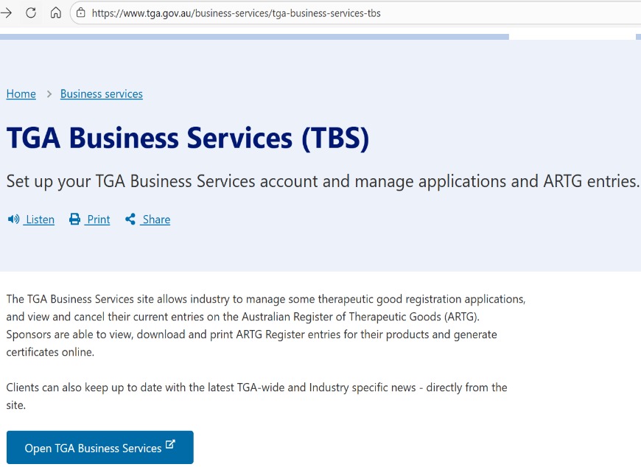
Figure 1.1: TGA Business Services (TBS) landing page showing a link to open the TGA Business Services portal.
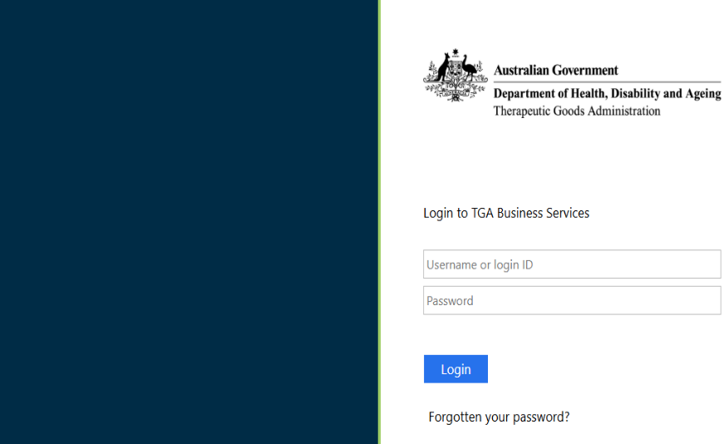
Figure 1.2: TGA Business Services login page.
In the ‘Applications’ drop-down menu, select ‘Medical Device Post Market Compliance’ under the ‘Regulatory Compliance’ heading (Figure 1.3).
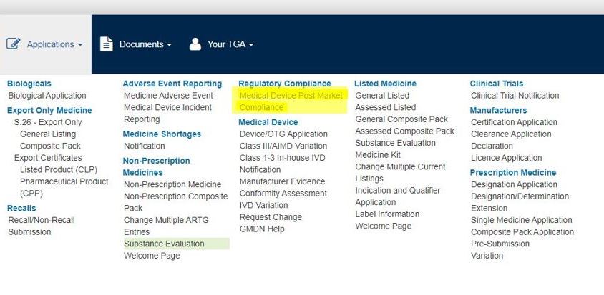
Figure 1.3: ‘Medical Device Post Market Compliance’ located within the TGA Business Services Applications menu.
On the ‘Regulatory and Compliance Portal’ page, select the ‘Devices Compliance (PMR)’ tile to access the ‘PMR Compliance Dashboard’ (Figure 1.4).
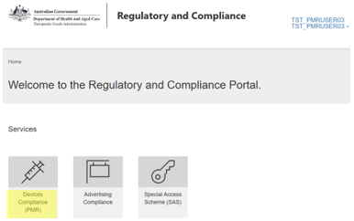
Figure 1.4: ‘Regulatory and Compliance Portal’ home page showing how to access the dashboard.
On the ‘PMR Compliance Dashboard’, select the ‘Post Market Reviews’ tile to access your notifications (Figure 1.5).
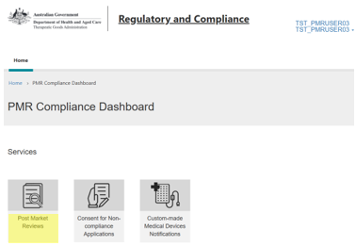
Figure 1.5: ‘PMR Compliance Dashboard’ home page showing how to access post market reviews.

Section 2: PMR Notification Dashboard overview
All notifications relating to PMRs of your medical devices will be displayed on the dashboard.
- There are three options to find and view your notifications. You can:
- view your notifications by the following statuses (Figure 2.1):
- Notification – Active: Select this option to view for notifications you need to review and submit a response to.
- Notification – All Notifications older than 32 days: Select this option to view notifications older than 32 days.
- Notification – Submitted: Select this option to view those notifications that have already been responded to.
- Notification – View Action: Select this option to view notifications that provide information on actions being taken by the TGA.
- Notification – View Migrated Notifications: Select this option to view notifications which were sent from the TGA prior to the portal being deployed but were in progress at that time.
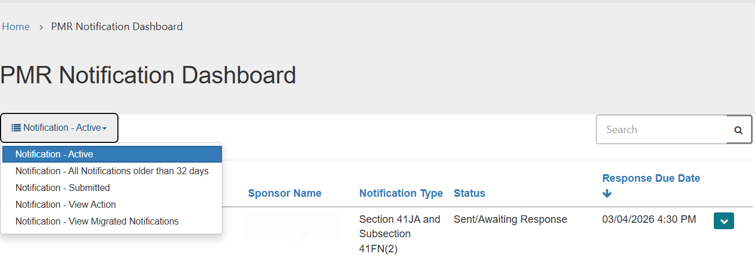
Figure 2.1: How to view your notifications by different statuses in the dashboard.
  - use the search box (magnifying glass symbol) to find notifications by typing in the review description, notification type or notification status if known (Figure 2.2), or
 | To search partial text, use the asterisk (*) wildcard character.
  - sort your notification by clicking on ‘Review Description’, ‘Notification Type’, ‘Status’ and ‘Response Due Date’ column headers (Figure 2.2).

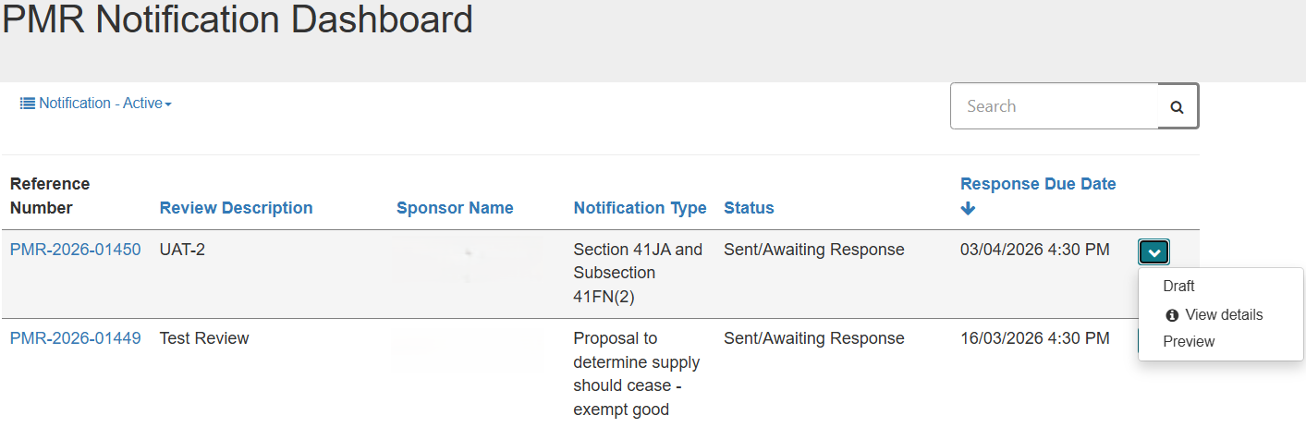

Figure 2.2: ‘PMR Notification Dashboard’ homepage showing the different ways to sort and search for notifications.

How to preview or view details of your notifications
- For more information on the details of the notification, you can click on the down-arrow on the right side of the relevant notification and select ‘Preview’ (Figure 2.3).
Add an Info Tint Box from the ribbon: Insert > Quick Parts > Info Tint Box
To delete this Tint box Select the whole table and then right click and choose Cut or Ctrl X

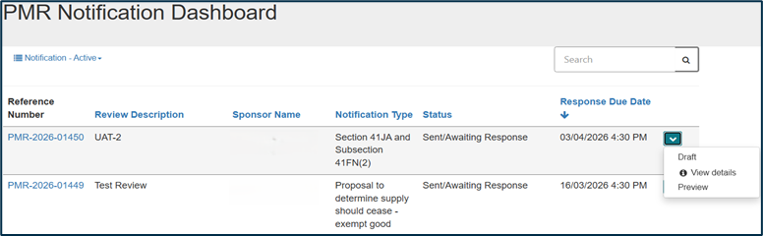
Figure 2.3: Preview your notifications in the dashboard.
- If you select ‘Preview’ (Figure 2.3) you can view the details for the notification and you have the option to print a copy of the notification by clicking on ‘Print’ (Figure 2.4).

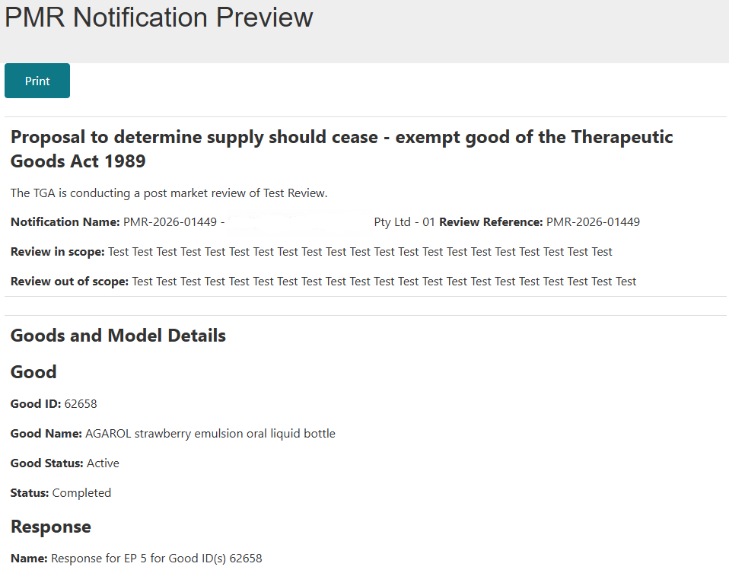
Figure 2.4: ‘PMR Notification Preview’ page.

- Once you have previewed your notification, click the back-browser button to go back to the ‘PMR Compliance Dashboard’.

How to draft a response to your notification
- Click on the down-arrow on the right side of the relevant notification and select ‘Draft’ (Figure 2.5) to open the ‘PMR Notification Draft’ page (Figure 2.6).
Note: This is the only view in which you can add a response

Figure 2.5: Draft a response to notifications in the dashboard.

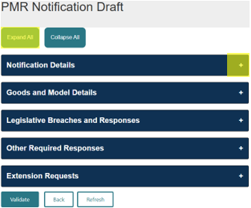
Figure 2.6: Different sections of the ‘PMR Notification Draft’ page.
Click on the ‘Expand All’ button to expand all the sections or the + button on the right to expand each section (Figure 2.6).

Note: The ‘PMR Notification Draft’ page can have up to 5 sections that are displayed and editable depending on the type of notification you receive (Table 1).

Table 1: Sections of the ‘PMR Notification Draft’ page that are displayed and editable depending on the notification type.
 | Initial request for information and/or samples | Additional/ad hoc request for information | Proposal to take regulatory action
Notification Details | ✓ | ✓ | ✓
Goods and Model details | ✓# | ✓ | ✓#
Legislative Breaches and Responses | ✓#
Other Required Responses | ✓ | ✓# | ✓
Extension Requests | ✓# | ✓# | ✓#
#Editable sections for the different notifications
For notifications where a regulatory action is being undertaken, there is no option to provide a response through the dashboard. You can view or preview these notifications in the ‘Notification – View Action’ option (Figure 2.1).

Section 3: How to respond to an initial request for information and/ or samples notice.
For an initial request for information notice, you are required to provide a response in the ‘Goods and Model Details’ and ‘Legislative Breaches and Responses’ sections (Figure 3.1).

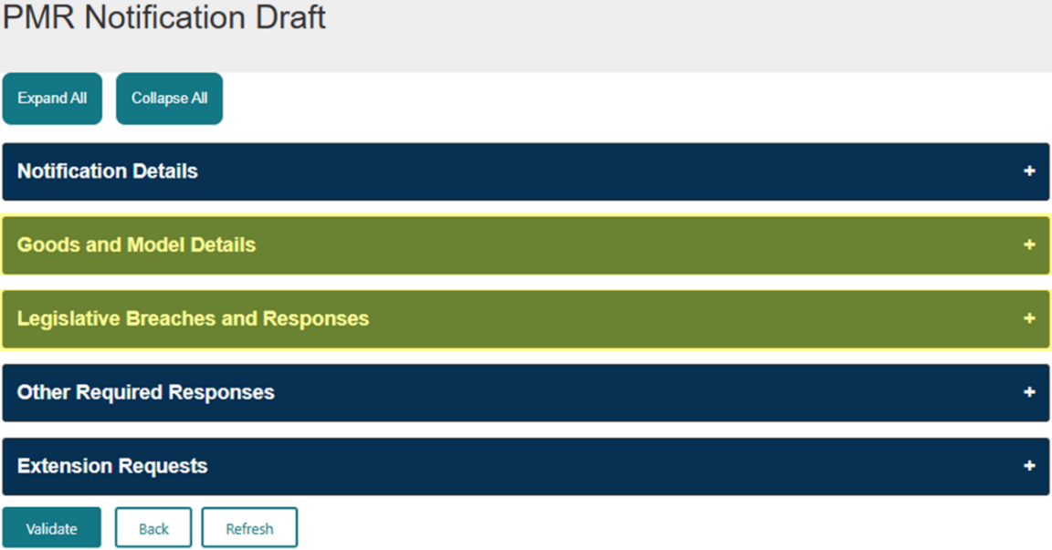
Figure 3.1: ‘PMR Notification Draft’ page highlighting the ‘Goods and Model Details, and
Legislative Breaches and Responses sections.

Notification details section
- In the ‘Notification Details’ section (Figure 3.2), you can:
  - view the scope of the review
  - view all the document(s) associated to the notification and download the notification letter sent to you by the TGA
  - view the list of folders that will hold the document(s) you upload as part of your submission
  - view all the documents you uploaded as part of your response, and
  - find the process to bulk upload information for the submission (see steps 26 - 35 for details).

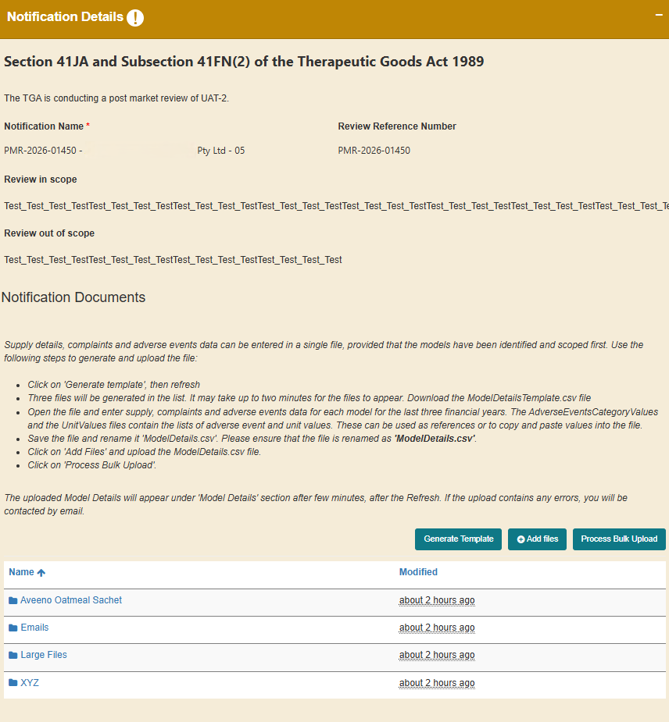
Figure 3.2: ‘Notification Details’ section of an initial request for information notification showing the different folders and bulk upload functionality.

Goods and model details section
- In the ‘Goods and Model Details’ section, you can view the list of ARTG entries or exempt goods (Goods) that have been included in the notification. For an initial request for information and/or samples, you are required to add:
- any additional Goods that may be in scope of the PMR
- model (or edit model) details, and
- supply, complaints, and adverse events data for all models in scope of the review.
Adding Goods, model details, and supply information is only available when responding to initial requests for information.

The process described below of adding new Goods and models to the review, and editing models is similar for both ‘Good(s) included in the ARTG’ or ‘Good(s) not included in the ARTG’.

Including additional goods in scope of the PMR
- If you are a sponsor of a Good that should be included in the PMR but is not included in the list of models, you can add it by clicking ‘Add Good’ and selecting ‘Good(s) included in the ARTG’ or ‘Good(s) not included in the ARTG’ depending on the type of Goods you sponsor (Figure 3.3).
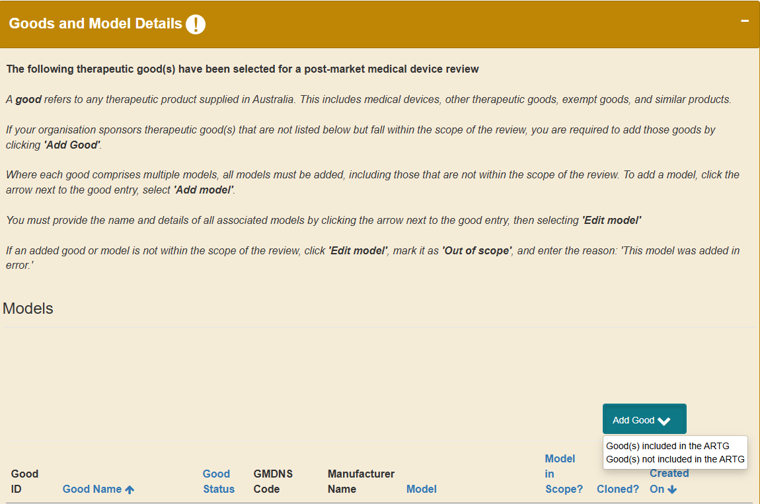
Figure 3.3: Adding in-scope Goods to a PMR.

- Click on the search icon to open the ‘Lookup record’ pop-up (Figure 3.4).
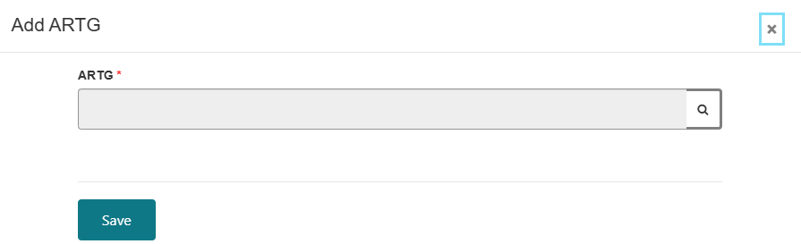
Figure 3.4: Add ARTG or Non-included Good pop-up.
- A list of Goods associated with ONLY your sponsor login (both active and revoked entries or goods on the notified vapes list) will be available for you to select (Figure 3.5). Click on the Good that is related to this PMR and click ‘Select’.
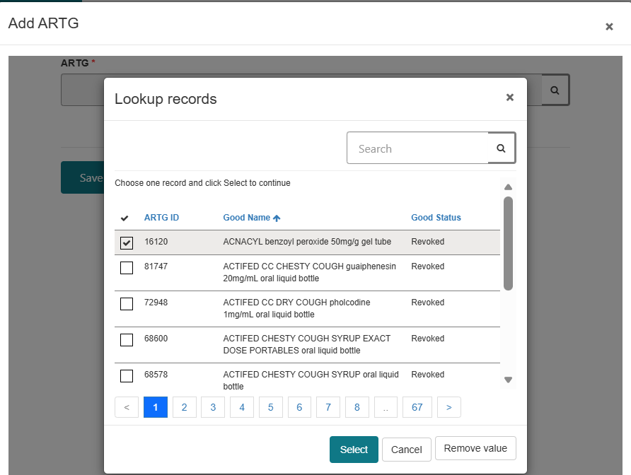
Figure 3.5: ‘Lookup record’ pop-up used to select Goods associated with the PMR.
- Click ‘Save’ to include the good in the review (Figure 3.6).
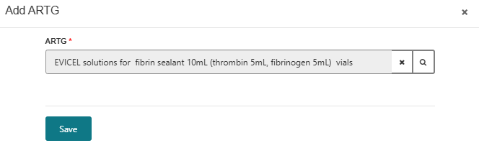
Figure 3.6: Pop-up to add an ARTG entry or non-included good, showing the selected Good and the option to save.

- Repeats steps 3 – 6 to add all the additional Goods in scope of the PMR.

Adding models of goods in scope of the PMR
- If there are multiple models under the one Good, click on the down-arrow on the right side of the Good and select ‘Add model’ (Figure 3.7). All models must be entered, even if they are not in the scope of the review.

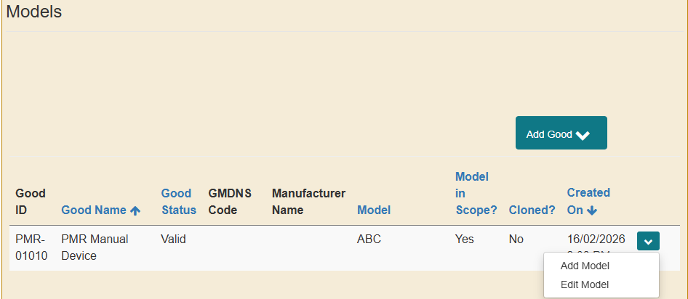
Figure 3.7: Adding models of Goods included in the PMR.
- Click ‘Proceed’ on the ‘Add Model’ pop-up (Figure 3.8). This will clone the details of the Good (Figure 3.9). A clone cannot be deleted but it can be marked out of scope with N/A in the model number field if added in error.

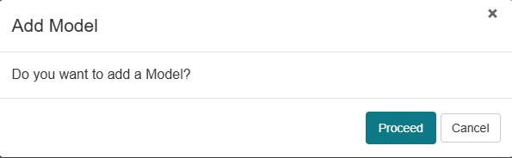
Figure 3.8: ‘Add Model’ pop-up is used to confirm the addition of a model.

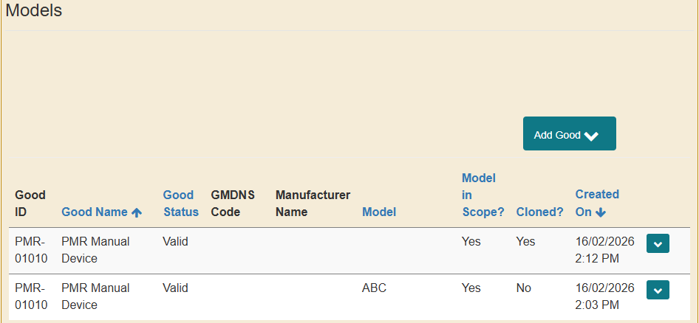
Figure 3.9: The ‘Models’ table showing any cloned Goods.
- Repeat steps 8 - 9 to add all models associated with the Goods included in the PMR.

Editing the model details
- To enter the model details for each Good, click on the down-arrow on the right side of the Good and select ‘Edit model’ (Figure 3.10).

Figure 3.10: Editing model details of Goods included in the PMR.
- In the ‘Edit Model’ pop-up (Figure 3.11) you can:
- enter the model name/identifier
- select ‘Yes’ or ‘No’ if the model is in-scope of the PMR (refer to the notification for the scope of the PMR)
Note: If you select ‘No’, you need to provide a reason why you consider the good entry/model is not within the scope of the PMR.

- attach supporting documentation. For each device model (both those that you consider to be in-scope and out-of-scope of the PMR) you will need to upload a copy of the instructions for use (IFU). Microsoft Word, Excel, and Adobe Acrobat documents are accepted. There are two options depending on the size of the document:
    - ‘Add files’ button to upload documents less than 50MB size (see step 13 for details).
    - ‘Upload Large files’ button to upload documents more than 50MB size (see step 14 for details).
Folders are created in the background during this process to store the information. It may take 1 to 2 minutes for the ‘Add files’ and ‘Upload Large files’ buttons to appear. You can also try refreshing your screen if they do not appear automatically.

- select the check-box to acknowledge that at least one file has been uploaded and click ‘Save’ to add the model details against the Good.

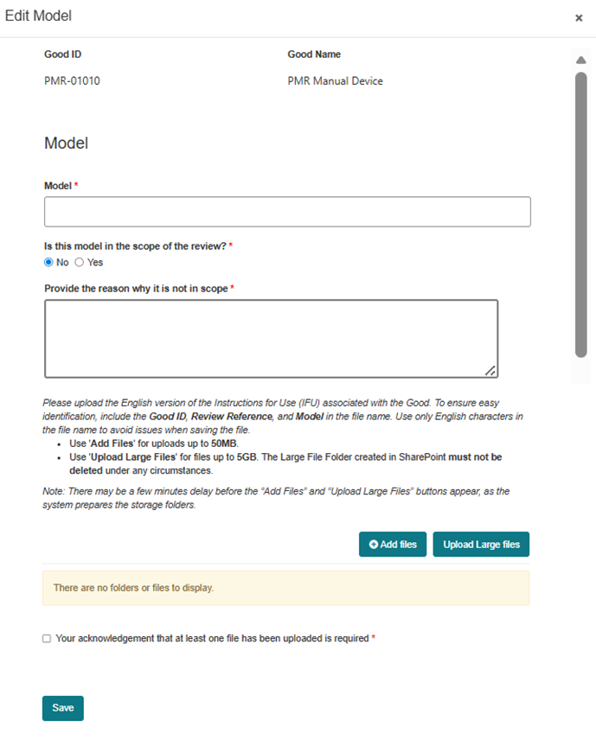
Figure 3.11: ‘Edit Model’ pop-up showing where to enter model details, confirm whether the model is in-scope of the review and upload the instructions for use.
If the request for information notice requires you to provide samples for laboratory investigation, you must provide a sample tracking number for each model. A field for this information is in the ‘Edit Model’ pop-up (Figure 3.12).
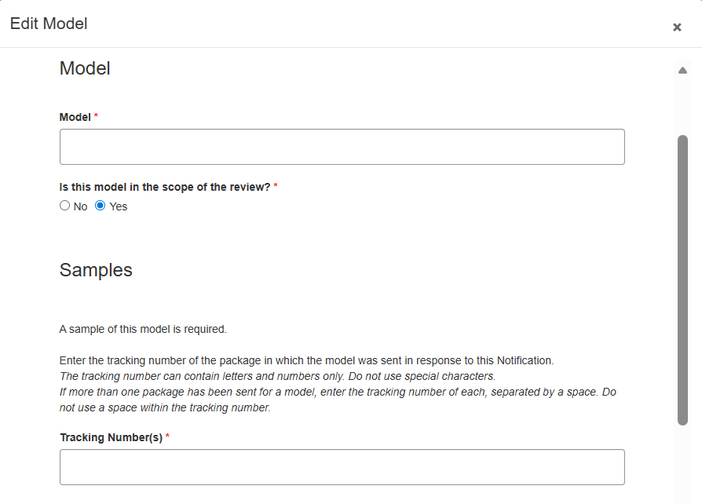
Figure 3.12: ‘Edit Model’ pop-up provides a field to input the sample tracking number, when required.
To add files less than 50MB:
- click ‘Add files’ button within the ‘Edit Model’ pop-up (Figure 3.11) to open the ‘Add files’ pop-up, and
- click ‘Choose files’ and select the file you want to upload from your computer. Once you have selected your file, click the ‘Add files’ button (Figure 3.13).
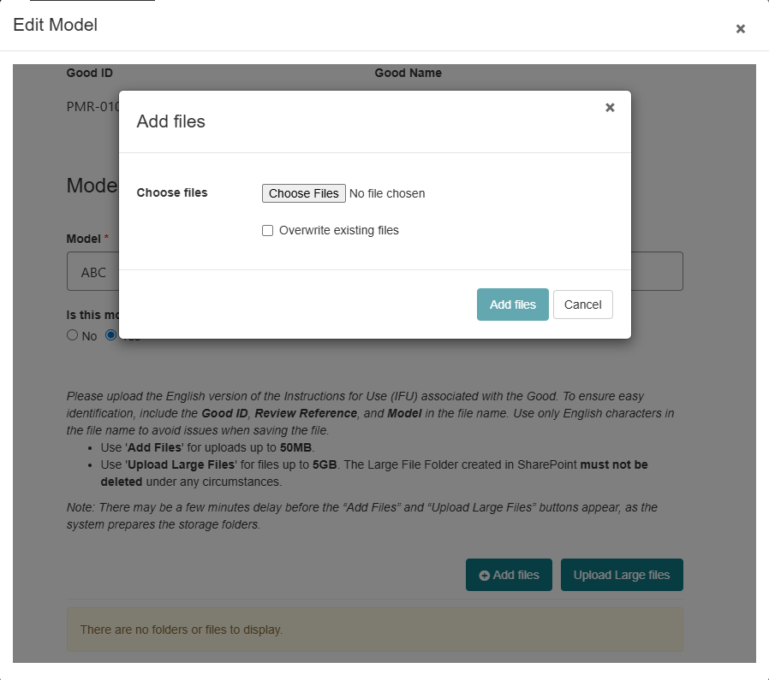
Figure 3.13: ‘Add files’ pop-up used to choose and add relevant files.
The file you uploaded will be displayed in the ‘Edit Model’ pop-up (Figure 3.14).

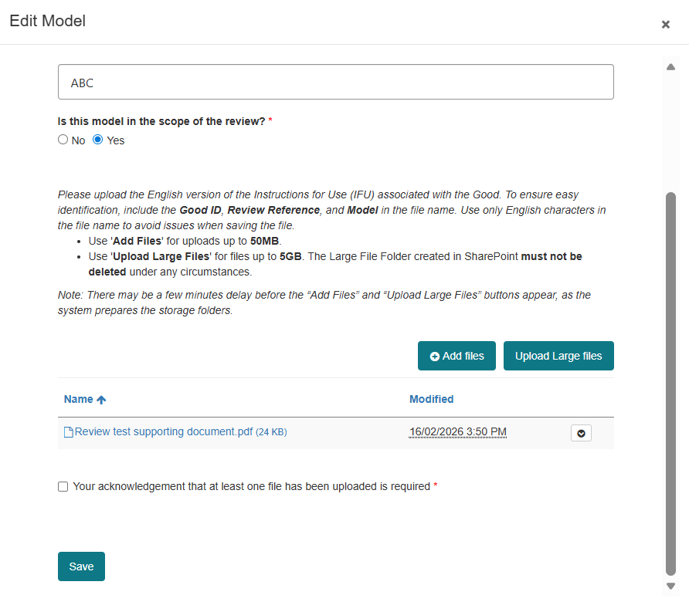
Figure 3.14: The ‘Edit Model’ pop-up shows the files you have uploaded.
- To add files more than 50MB size up to 5GB:
  - click ‘Upload Large files’ button within the Edit Model pop-up (Figure 3.11)
  - a new window will open directing you to the SharePoint site (Figure 3.15)
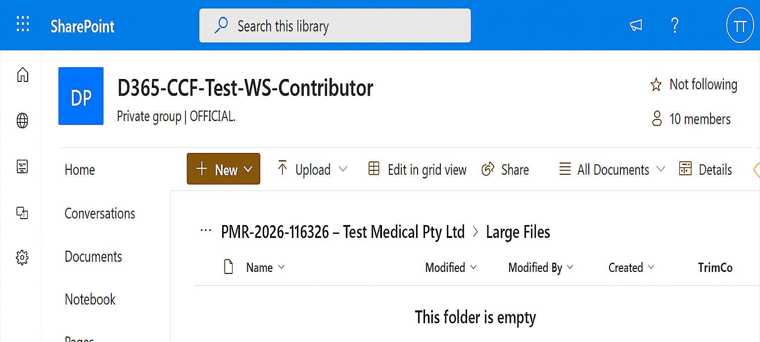
Figure 3.15: SharePoint landing page for large file upload.
  - click ‘Upload’ and then ‘Files’ (Figure 3.16) to select and upload the relevant files from your computer
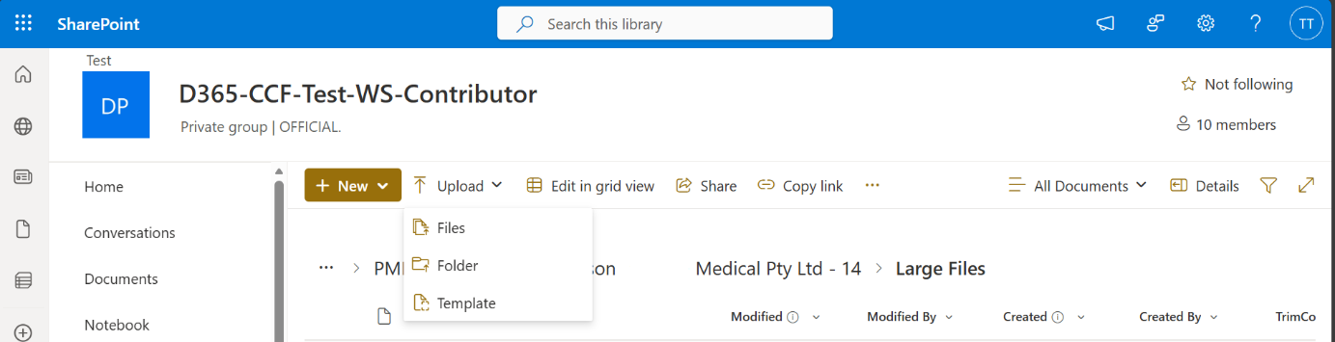
Figure 3.16: SharePoint site showing how to upload files.
  - close the browser window once the uploaded files are added to the SharePoint site (Figure 3.17), and
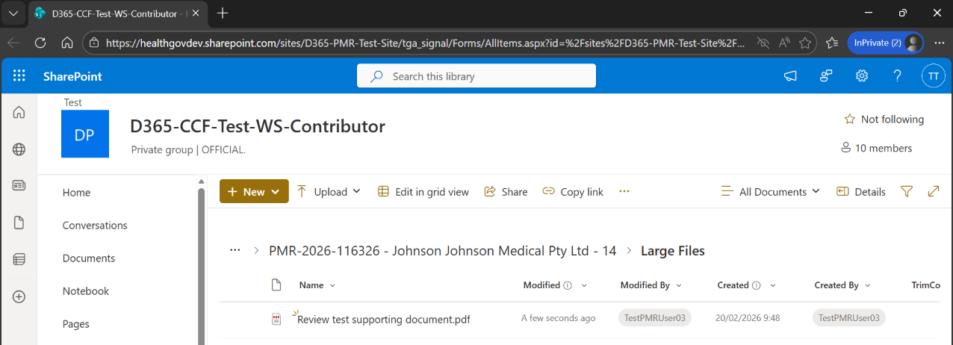
Figure 3.17: SharePoint site showing uploaded documents.
  - within the ‘Edit Model’ pop-up, select the check-box to acknowledge that at least one file has been uploaded. Click ‘Save’ (Figure 3.18).
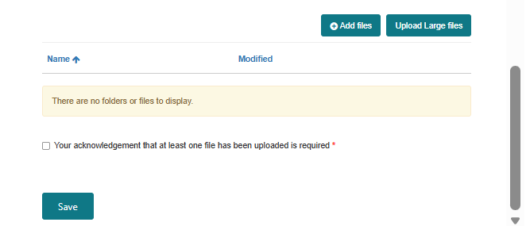
Figure 3.18: The ‘Edit Model’ pop-up showing the check-box used to acknowledge files have been uploaded.
The details of the model are updated against the Good in the ‘Models’ table (Figure 3.19).

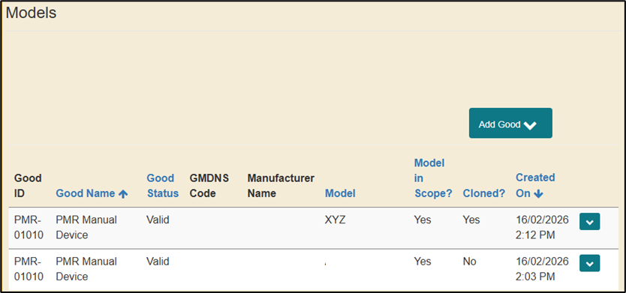
Figure 3.19: ‘Models’ tables showing the model details.
- Repeat steps 11 – 14 to update the model details for all Goods in the PMR.

Adding supply, complaints and adverse events data
For each device model in scope of the PMR, you will be required to provide supply, complaint, and adverse event data for a specified number of financial years. This is stated in the notification.
The supply, complaint, and adverse event data for each model, can be completed in the ‘Model Details’ section within the ‘Goods and Model Details’ section by updating the details for:
- each individual financial year per model (see steps 16 - 25), or
- all models in a single file using the bulk upload functionality (see steps 26 - 35).

Adding the financial years for each model
- To update the model details for each individual financial year:
- click ‘Add Model Financial Year’ (Figure 3.20) to select which model you are going to add the financial year data against
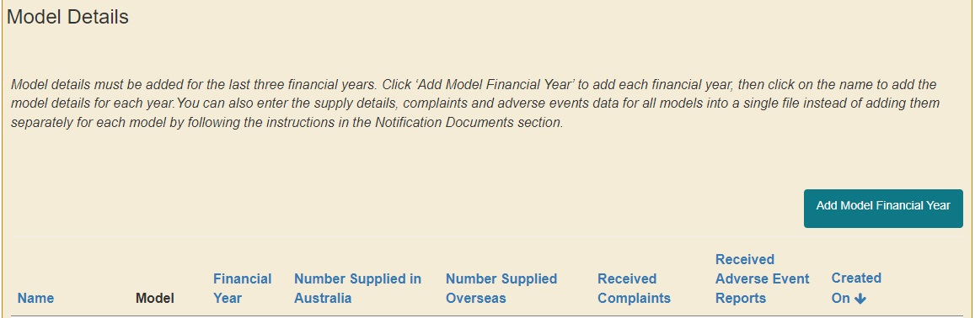
Figure 3.20: Add model financial year within the ‘Model Details’ section.
- click on the magnifying glass to search for the model (Figure 3.21)
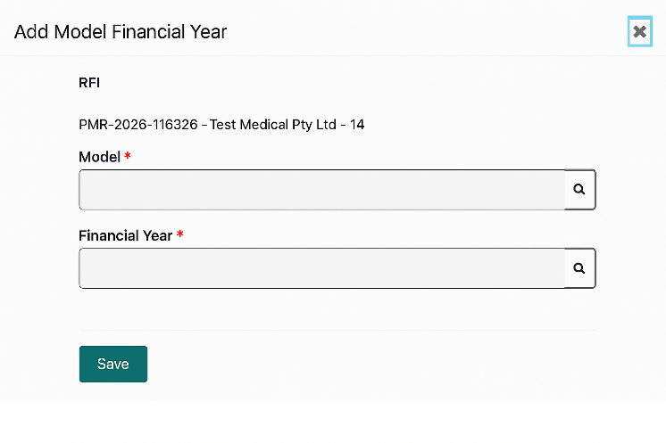
Figure 3.21: ‘Add Model Financial Year’ pop-up used to select in-scope models.
- select the model and click ‘Select’ (Figure 3.22)
Note: Only in scope models will be displayed.

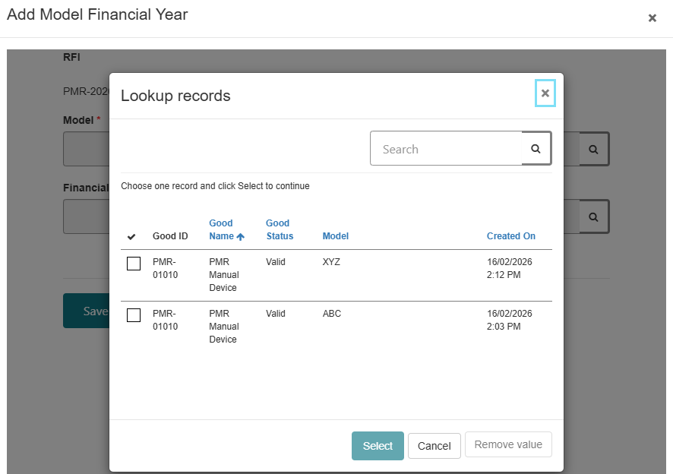
Figure 3.22: ‘Lookup records’ pop-up used to select the in-scope model for adding financial year data.
- click on the magnifying glass to select the financial year (Figure 3.23)
Note: Check the notification letter for details on which financial years you are required to provide the above data.

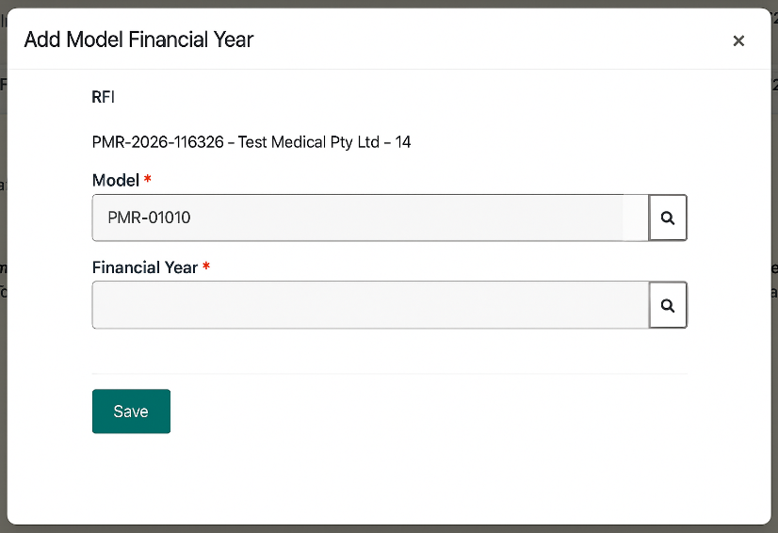
Figure 3.23: ‘Add Model Financial Year’ pop-up used to select relevant financial year.
- check the box for the applicable financial year you want to provide data on and click ‘Select’ (Figure 3.24)
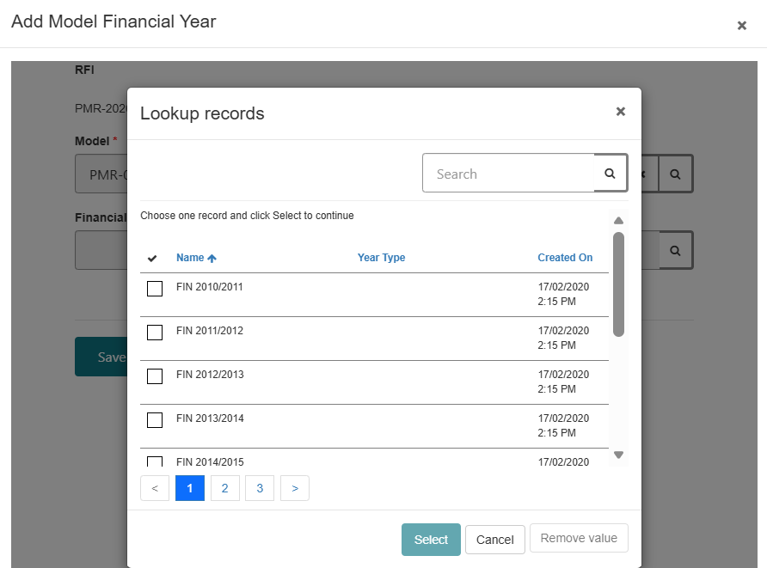
Figure 3.24: ‘Lookup records’ pop-up used to select financial year for the selected model.
- click ‘Save’ (Figure 3.25)
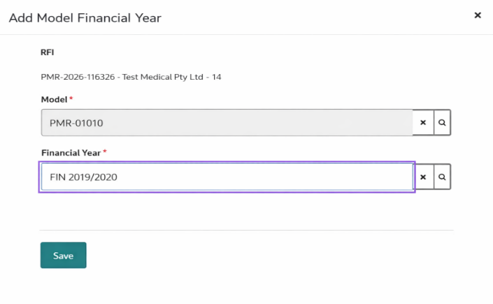
Figure 3.25: ‘Add Model Financial Year’ pop-up showing the selected model, financial year and option to save this information.
- the financial year details are updated in the ‘Model Details’ section within the ‘Goods and Model Details Section’ (Figure 3.26)
If you select the incorrect financial year, you can remove the financial year by clicking ‘Remove’ (Figure 3.26).

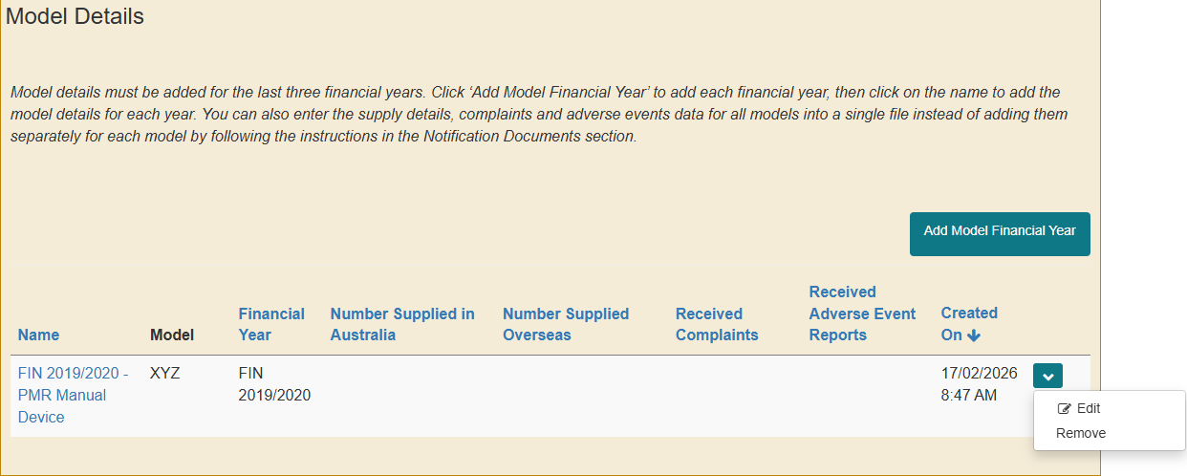
Figure 3.26: The selected model and financial year are updated in the ‘Model Details’ table.
- repeat steps a – g to add each financial year (as requested in the notice) for all in scope models.

Adding supply details for each financial year for each model
- Click ‘Edit’ to add the supply details, complaints, and adverse events data for each financial year/ in scope model (Figure 3.27).
Figure 3.27: Edit the financial year details within the ‘Model Details’ table.
- This will open the ‘PMR Notification Model Details Edit’ page which has 4 sections (Figure 3.28). Each section will change colour from amber to green when the data is entered.
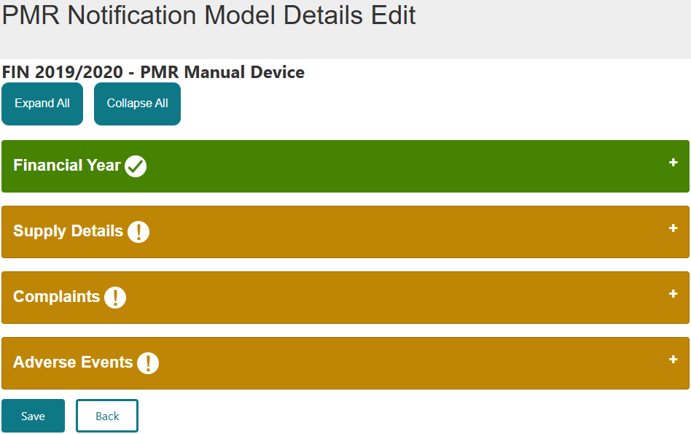
Figure 3.28: Sections of the ‘PMR Notification Model Details Edit’ page.
- The ‘Financial Year’ section is read-only and prefilled with the model’s details and the financial year you are providing information for (Figure 3.29).
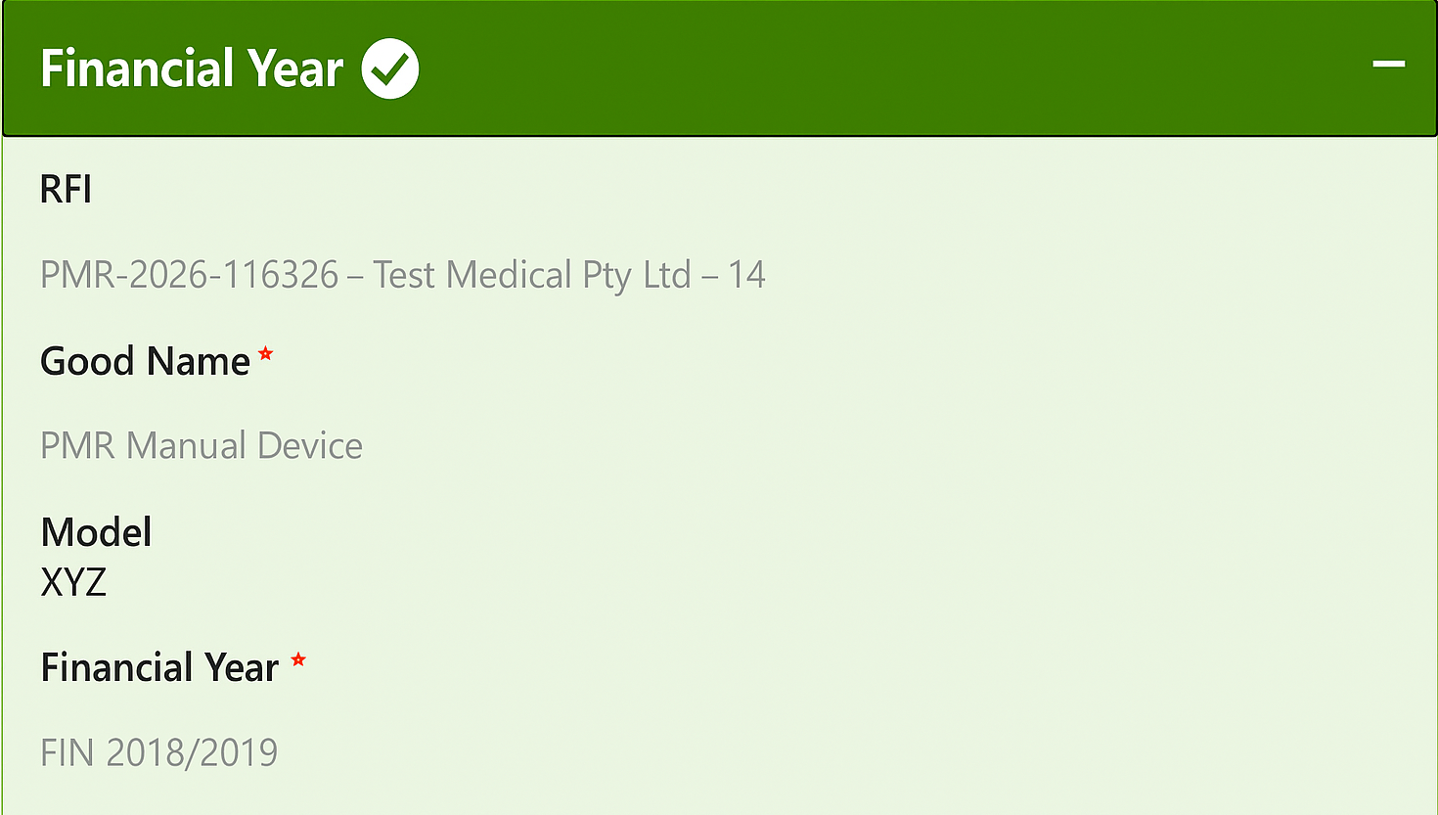
Figure 3.29: ‘Financial Year’ section of the ‘PMR Notification Model Details Edit’ page showing the relevant model and financial year.

- In the ‘Supply Details’ section:
- enter the number of that model of device that were supplied in Australia, in that particular financial year, in the ‘Number Supplied in Australia’ field (Figure 3.30)
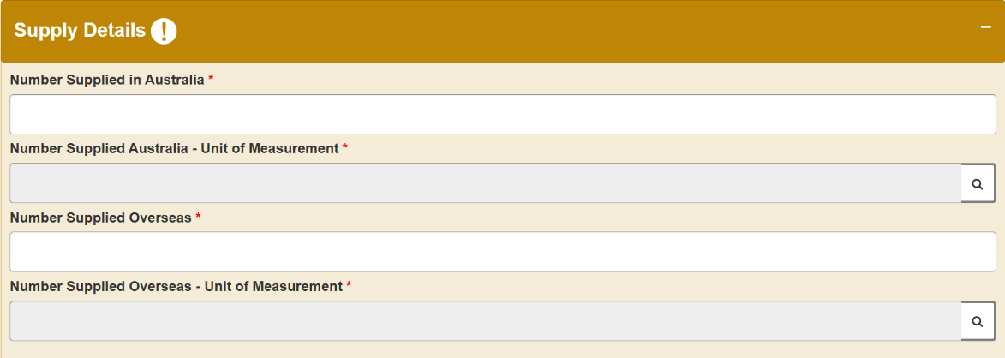
Figure 3.30: ‘Supply Details’ section of the ‘PMR Notification Model Details Edit’ page showing where to provide number supplied and units of measure in Australia.
- in the ‘Number Supplied Australia – Unit Measurement’ field, click on the magnifying glass to select the unit measurement from the ‘Lookup records’ pop-up (Figure 3.31), then click on ‘Select’, and

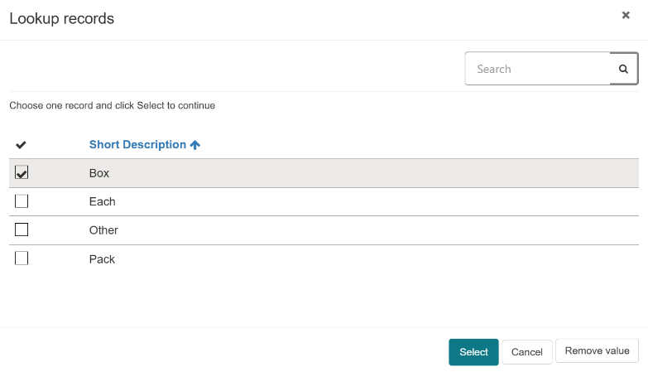
Figure 3.31: ‘Lookup records’ pop-up to select a unit of measure value.
- enter the number of devices supplied overseas and the unit measurement in that financial year (Figure 3.32).
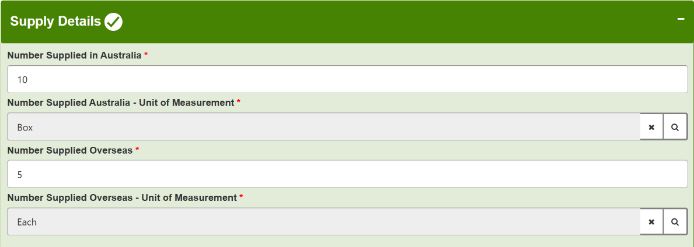
Figure 3.32: ‘Supply Details’ section of the ‘PMR Notification Model Details Edit’ page showing where to provide number supplied and units of measure overseas.

Adding complaint details for each financial year for each model
- In the ‘Complaints’ section (Figure 3.33) you need to provide information on both Australian and worldwide complaints.
- Select ‘No’ if there were no complaints received for the model. If you select ‘No’, complete the ‘Adverse Events’ section in step 22, or
- Select ‘Yes’ if complaints were received against the model. If you select ‘Yes’, you need to provide:
  - the total number of complaints that were from Australia in that specific financial year
  - the total number of complaints that were from overseas in that specific financial year, and
  - a breakdown of the most common types of complaints made in Australia. This is a free text description of the complaint type with the number of those types of complaints received from Australia. You can provide up to ten of the most common types of complaints and must enter at least one received’ (Figure 3.34).

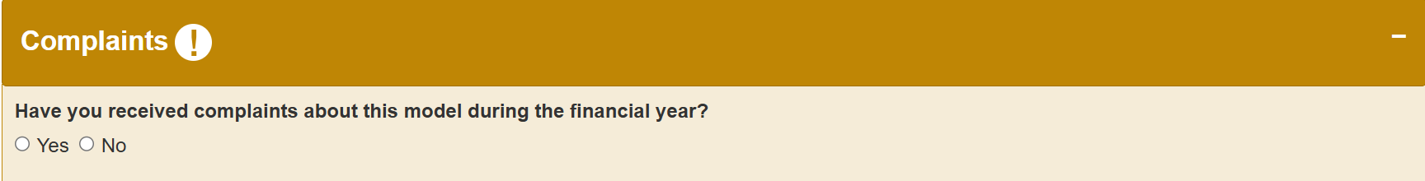
Figure 3.33: Confirm whether complaints were received in the ‘Complaints’ section of the ‘PMR Notification Model Details Edit’ page.
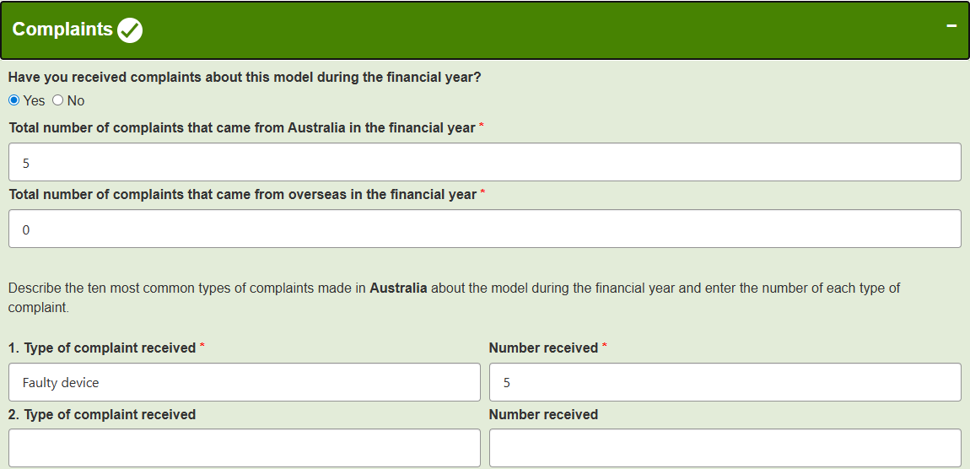
Figure 3.34: The ‘Complaints’ section showing where to enter the number of complaints received in Australia and overseas, and the type of complaints.

- You have the option to upload supporting documents using the ‘Add files’ and ‘Upload Large files’ function (Figure 3.35). For step-by-step instructions on how to upload files less than 50MB refer to step 13 or step 14 for large files (more than 50MB size up to 5GB).

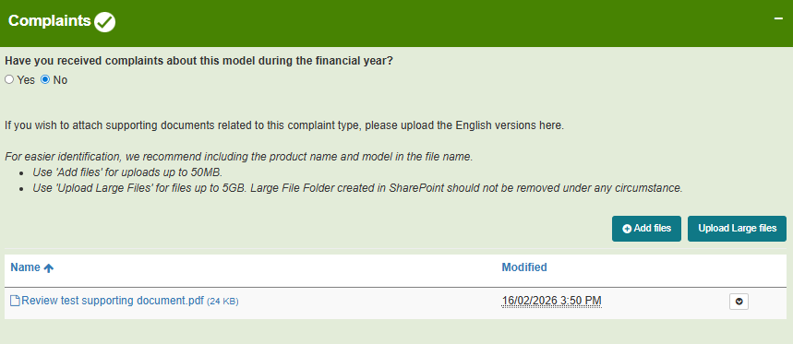
Figure 3.35: The ‘Complaints’ section showing where to attach supporting documents.
Any files that have already been uploaded relating to this good will be displayed in the list of files.

Adding adverse event details for each financial year for each model
- In the ‘Adverse Events’ section (Figure 3.36) you need to provide information on both Australian and worldwide adverse events.
- Select ‘No’ if there were no adverse events received for the model in the relevant financial year. If you select ‘No’, click ‘Save’ and refer to step 23.
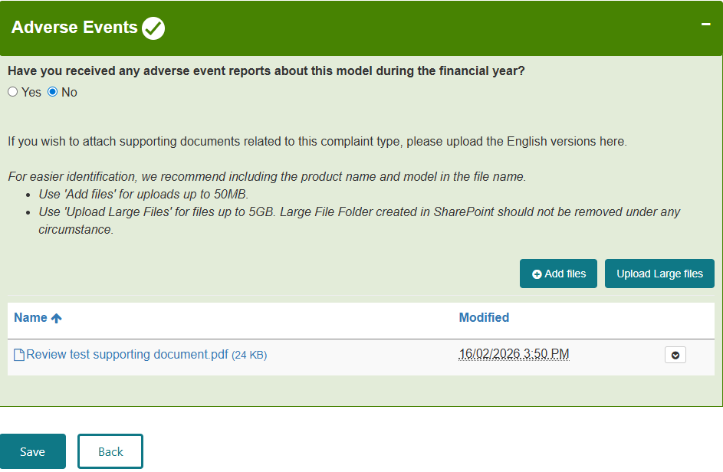
Figure 3.36: Confirm whether adverse events were received within the financial year in the ‘Adverse Events’ section of the ‘PMR Notification Model Details Edit’ page.
- Select ‘Yes’ if adverse events were received against the model in the relevant financial year. If you select ‘Yes’, provide the following details (Figure 3.37):
    - the total number of adverse events that came from Australia in the financial year
    - the total number of adverse events that came from overseas in the financial year
    - a breakdown of the most common types of adverse events that occurred in Australia. This is coded data that uses the International Medical Device Regulator Forum (IMDRF) Adverse Event Terminology (see note below). You can provide up to ten of the most common types of adverse events, but must provide at least ONE type of adverse event, and the number of reports relevant to that type of adverse event received for that model, during the financial year. Click on the magnifying glass to select at least one common ‘Category of adverse event’, from the ‘Lookup records’ pop-up and click ‘Select’. Complete the Level 2 and Level 3 terminologies in the same way, if applicable (Figure 3.38).

- The adverse event terminologies are derived from ANNEX C of the IMDRF Adverse Event Terminology Web Browser | International Medical Device Regulators Forum
- If there were adverse events reported in Australia, the adverse event types are related to the Australian adverse events. If there were no adverse events reported in Australia, the adverse event types are related to the worldwide adverse events. The region is identified in the heading.

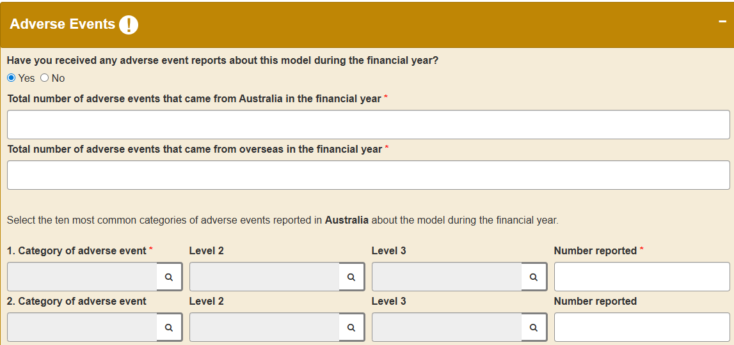
Figure 3.37: ‘Adverse Events’ section showing where to enter the number of adverse events received in Australia and overseas.
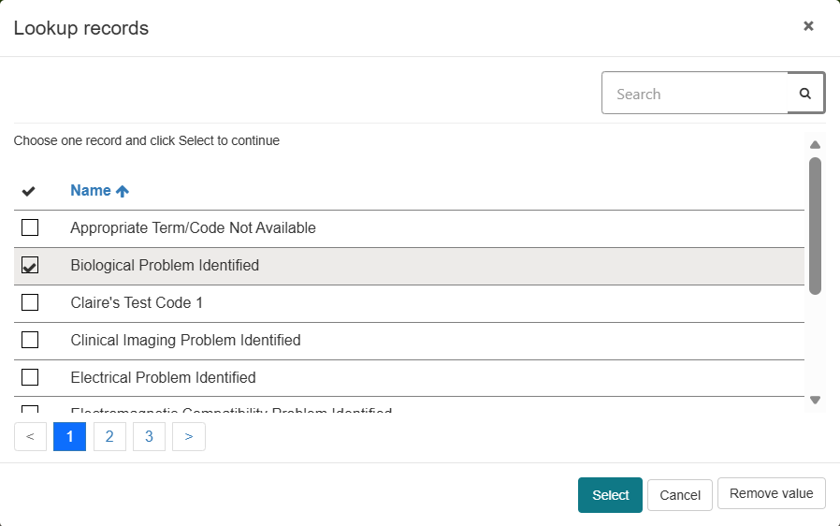
Figure 3.38: ‘Lookup records’ pop-up to select an adverse event category.
You have the option to upload supporting documents relating to this adverse event using the ‘Add files’ and ‘Upload Large files’ function (Figure 3.39). For step-by-step instructions on how to upload files less than 50MB refer to step 13 or step 14 for large files (more than 50MB size up to 5GB).
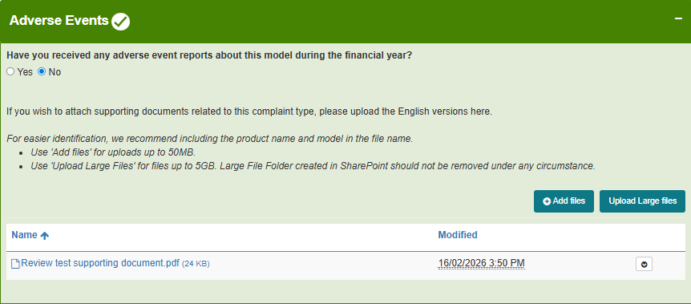
Figure 3.39: Adverse events section showing where to attach supporting documents.
Any files that have already been uploaded relating to this goods entry will be displayed in the list of files

- Click ‘Save’ and the following message will appear ‘Model Details has been successfully saved. Please click on the ‘Back’ button to go back to the previous page’ and click on the ‘Back’ button to go back to the previous page (Figure 3.40).
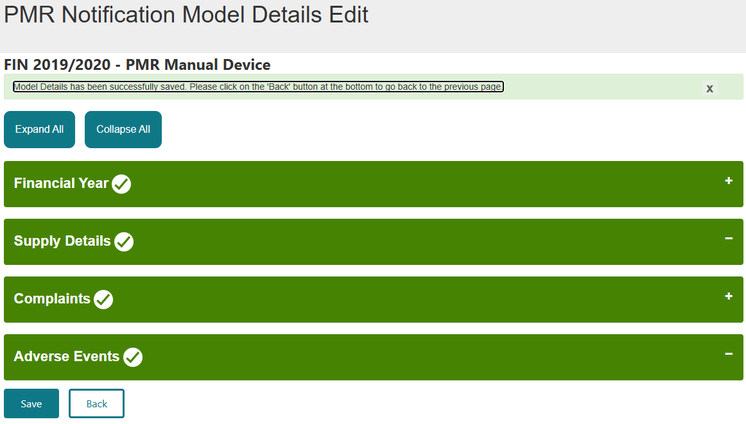
Figure 3.40: ‘PMR Notification Model Details Edit’ page showing how to save the financial year model details and go back to the dashboard.
- The model details for the selected financial year are updated in the ‘Model Details section within the ‘Goods and Model Details’ section (Figure 3.41).
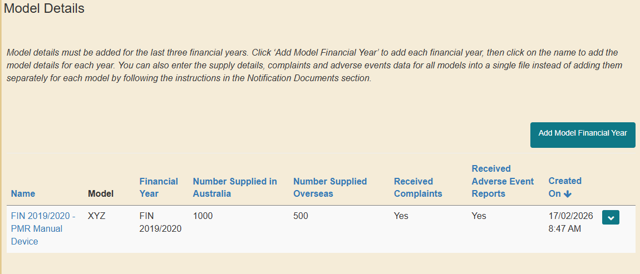
Figure 3.41: The ‘Model Details’ table is updated with the supply, complaints and adverse events data for the financial year.
- Repeat steps 16 to 24 to include the supply details, complaints, and adverse events data for all models in-scope of the PMR.

Adding supply, complaints and adverse events data using the bulk upload functionality
To update the supply details, complaints, and adverse events data for all models, for multiple financial years, in a single file, you can use the bulk upload functionality in the ‘Notification Details’ section.
- Click ‘Generate Template’ to create the bulk upload templates from the ‘Notification Details’ section (Figure 3.42) and click ‘OK’ (Figure 3.43).
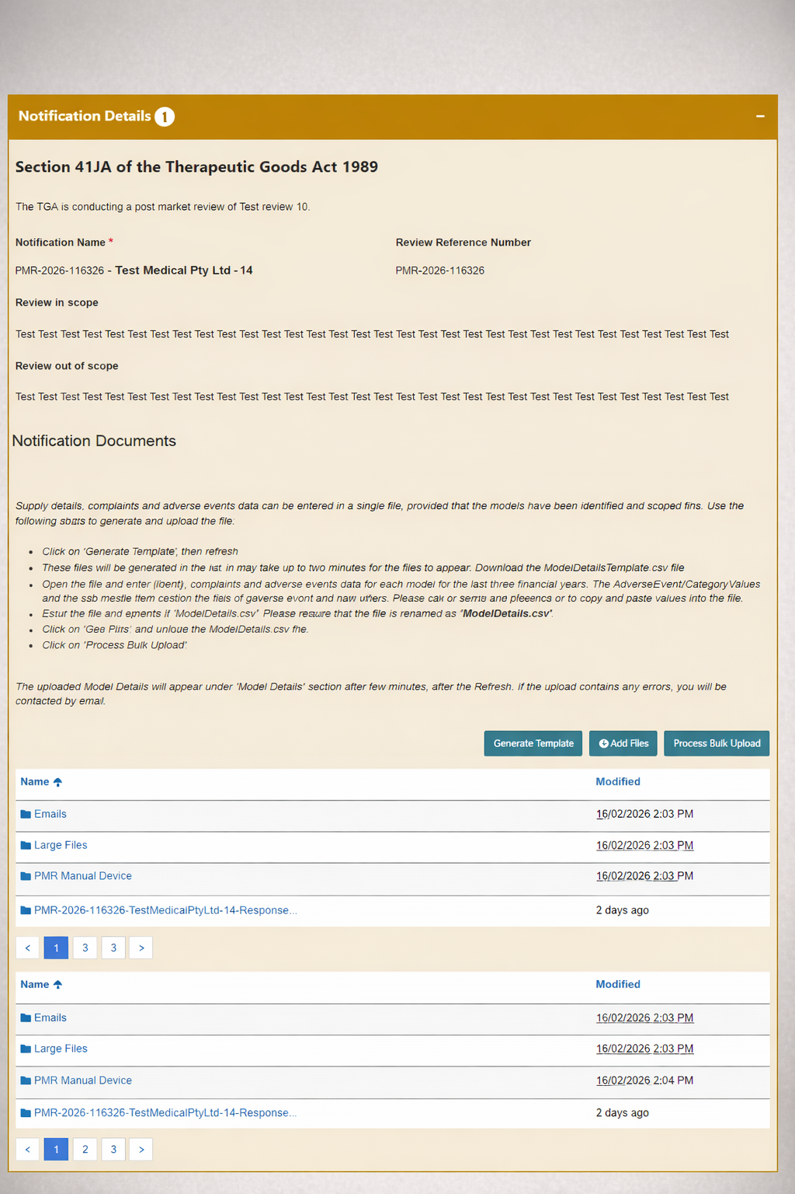
Figure 3.42: ‘Notification Details’ section showing how to generate templates.
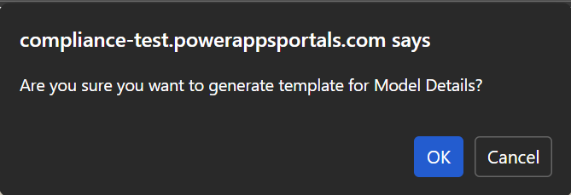
Figure 3.43: A pop-up to confirm the option to generate model detail templates.
- You may need to go to page 2 to access the created bulk upload templates, which includes (Figure 3.44):
- ModelDetailsTemplate – Downloadable file that you can edit to add the supply, complaints, and adverse events data.
- AdverseEventsCategoryValues – Downloadable reference file that provides a breakdown of the type of adverse event (derived from ANNEX C of the IMDRF Adverse Event Terminology Web Browser | International Medical Device Regulators Forum).
- UnitValues – Downloadable reference file with the supply data units of measurement.
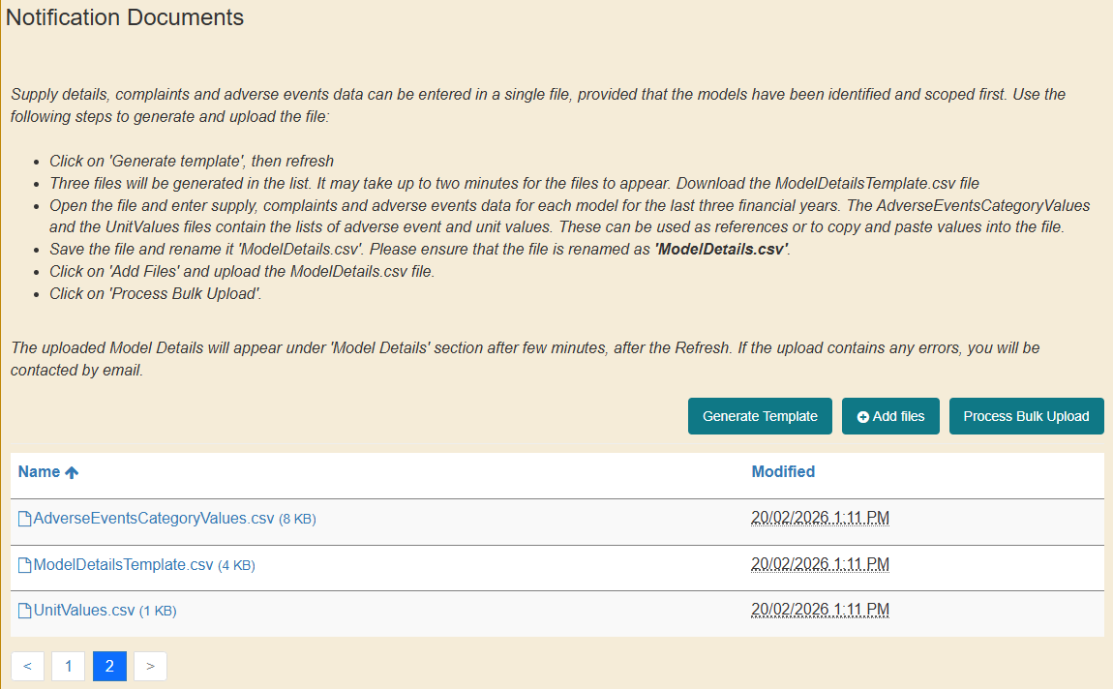
Figure 3.44: The generated model detail templates located in the ‘Notification Documents’ section within the ‘Notification Details’ section of the ‘PMR Notification Draft’ page.
If the templates are not yet generated, you may need to click ‘Refresh’ at the bottom of your screen to view the new template (Figure 3.45).

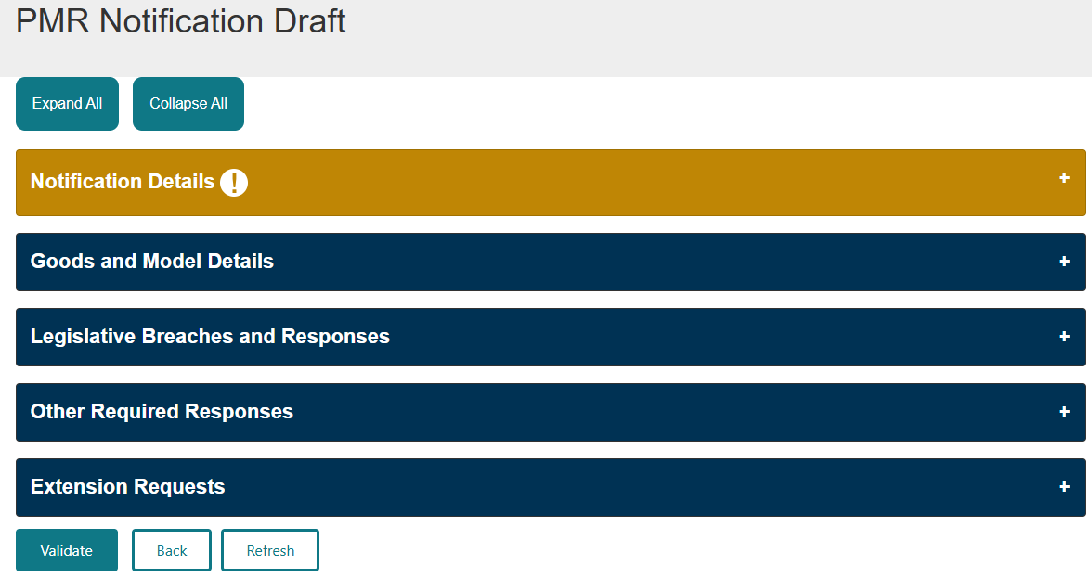
Figure 3.45: How to refresh the ‘PMR Notification Draft’ page.
- Double click on the ‘ModelDetailsTemplate’ to download the file.
Download ‘AdverseEventsCategoryValues’ and ‘UnitValues’ files that will be used as references or to copy and paste the values into your ‘ModelDetailsTemplate’ file as part of the next step.

- Open the ‘ModelDetailsTemplate’ file and enter the supply, complaints, and adverse events data for each in-scope model for the last three financial years (Figure 3.46).
Figure 3.46: An example of the model details template.
- Note:
- Some columns are pre-filled by the system, and the information should not be changed (Column header labelled with ‘Do Not Modify’).
- The ‘ModelDetailsTemplate’ file will be pre-filled with the last 3 financial years for you to add the supply, complaints and adverse events data.

- If you are required to provide data for more than 3 financial years (please check the notice sent to you by the TGA for the specific number of years):
- duplicate the details of the good in the ‘ModelDetailsTemplate’ file. Do not amend the Model ID, Good ID and Model Name under any circumstance (Figure 3.47).
- the Model should remain the same as the one entered in the ‘Edit Model’ pop-up (Steps 11 - 12)
- add the additional financial years in chronological order.

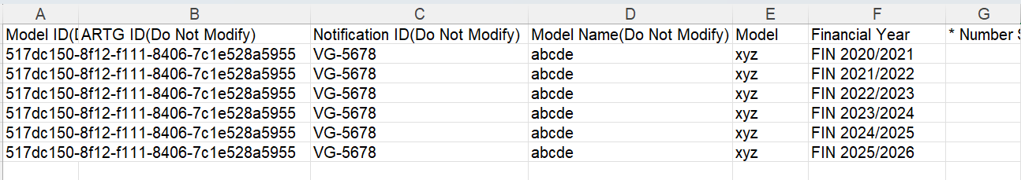
Figure 3.47: An example of the model details template showing how to add additional financial years.
- The following columns are mandatory and must be completed (mandatory column headers have an asterisk (*):
- column G: Number Supplied in Australia
- column H: Unit, the only values that can be used are in the ‘UnitValues’ file
- column J: Number Supplied Overseas
- column K: Unit, the only values that can be used are in the ‘UnitValues’ file
- column M: Have you received complaints about this model during the financial year? (Yes/No).
    - If the answer is ‘No’, proceed to column AJ
    - If the answer is ‘Yes’, column N to column Q are mandatory
- column N: Total number of complaints that came from Australia in the financial year
- column O: Total number of complaints that came from overseas in the financial year
- column P: type of Complaint Received (Free text)
- column Q: Number of complaints received in column P
If more than 1 complaint was received for a device, use columns R – AI to provide the type of compliant and number received. You can provide up to 10 of the most common complaints.
Note: Columns R – AI are optional and can be deleted if no additional complaints were received.
- column AJ: Have you received any adverse event reports about this model during the financial year? (Yes/No)
    - If the answer is ‘No’, proceed to step 31
    - If the answer is ‘Yes’, column AK to column AP are mandatory
- column AK: Total number of adverse events that came from Australia in the financial year
- column AL: Total number of adverse events that came from overseas in the financial year
- column AM: Category of Adverse Event Level 1 (column A of the AdverseEventsCategoryValues file) (Figure 3.48)
- column AN: Category of Adverse Event Level 2 (column B of the AdverseEventsCategoryValues file) (Figure 3.48)
- column AO: Category of Adverse Event Level 3, (column C of the AdverseEventsCategoryValues file, if applicable) (Figure 3.48)
- column AP: Category of Adverse Event Number Reported
If more than 1 adverse event was received for a device, use columns AQ – BZ to provide the type of adverse event and number received. You can provide up to 10 of the most common complaints.
Note: Columns R – AI are optional and can be deleted if no additional adverse events were received.

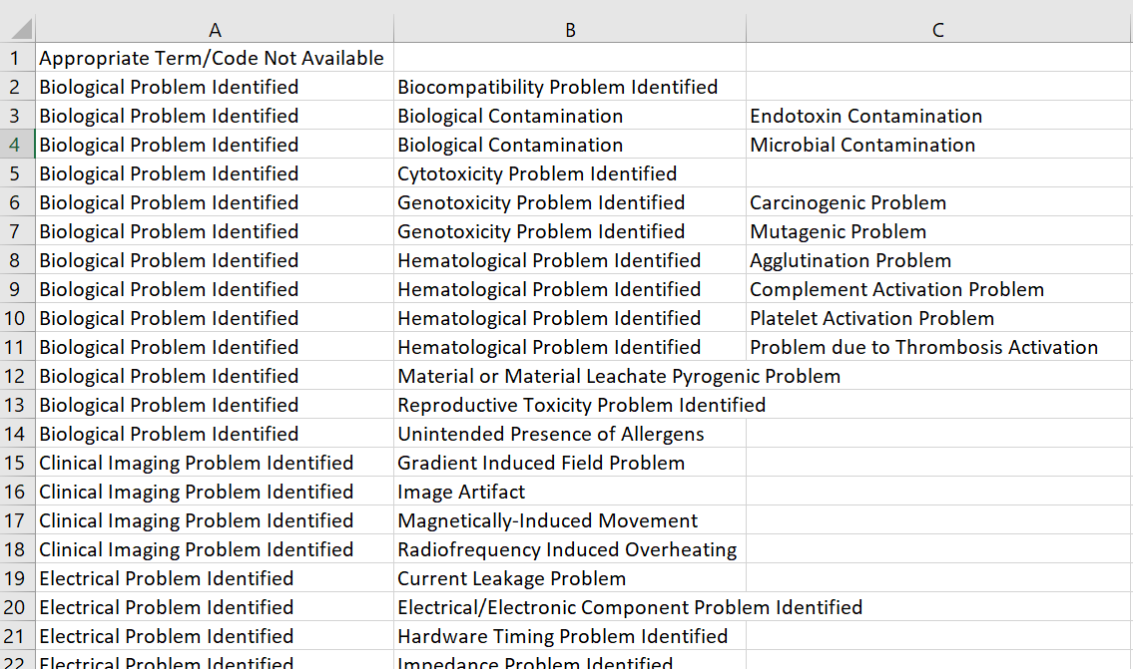
Figure 3.48: Column A - C of the ‘AdverseEventsCategoryValues’ file.
- Once you have completed the required information in the ‘ModelDetailsTemplate’ file, you need to save the file as ‘ModelDetails.csv’ (Figure 3.49).

Note: It is important to save the file as ‘ModelDetails.csv’ for the system to identify the document when you upload it to the dashboard.

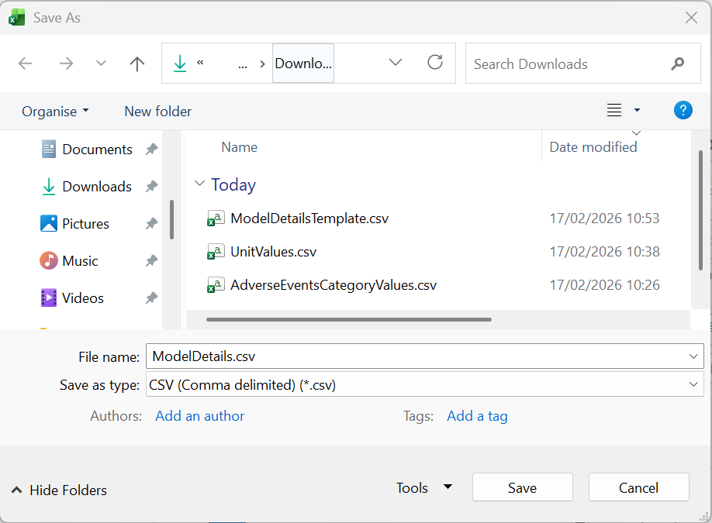
Figure 3.47: Correct saving of the model details file.
- To upload the file, click ‘Add files’ in the ‘Notification Details’ section (Figure 3.50).
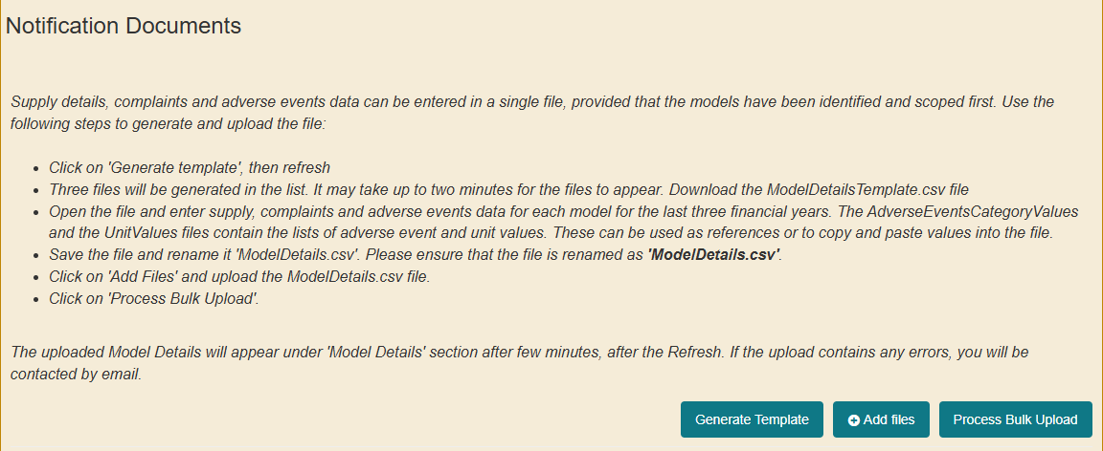
Figure 3.50: The ‘Notification Details’ section showing how to add the completed model details file.
- Click ‘Choose Files’ and select the completed ‘ModelDetails.csv’ file from your computer and click the ‘Add files’ button (Figure 3.51).
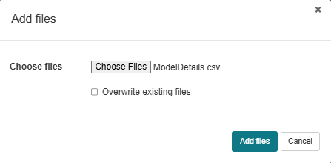
Figure 3.51: ‘Add files’ pop-up showing how to chose and add the model details file.
- Click on ‘Process Bulk Upload’ to upload the data in the ‘ModelDetails.csv’ file (Figure 3.52).
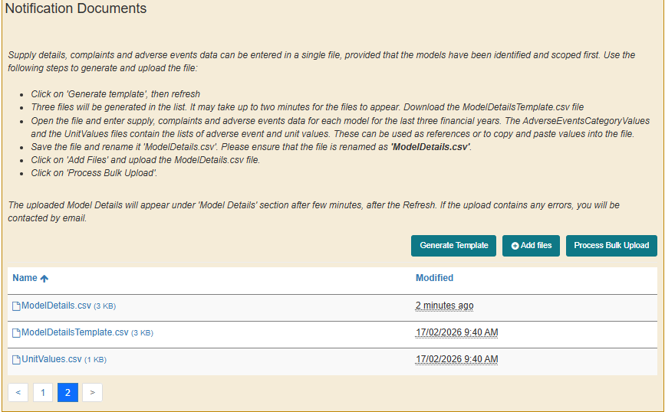
Figure 3.52: The ‘Notification Details’ section showing the uploaded model details file and how to process the document.
- The supply, complaints and adverse events data will be uploaded in the Model Details section within the Goods and Model Details section (Figure 3.53).
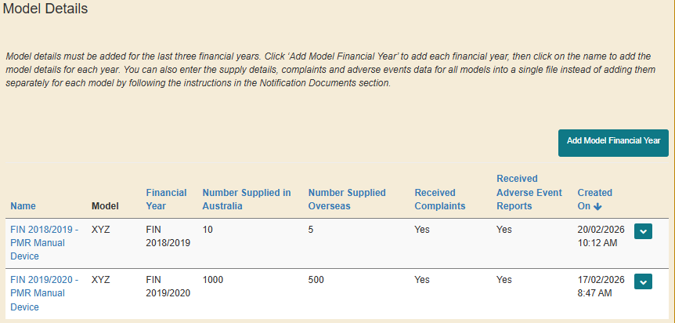
Figure 3.53: The ‘Model Details’ table is updated with the supply, complaints, and adverse events data extracted from the uploaded model details file.
Note:
If the supply, complaints and adverse events data is not uploaded in the ‘Model Details’ section, this indicates an error has occurred when updating the bulk upload file in step 35. Please make sure you complete all mandatory fields, and the right information is entered. If you still have issues, please contact the Post Market Devices Team (postmarketdevices@health.gov.au).
If you have any documents associated to the model details you entered in the bulk upload file, you can upload it at a candidate level by following steps 12 and 13.
If you need to make any amendments to the saved bulk upload file, it is easier to manually update it from the ‘Model Details’ section by clicking on ‘Edit’ (Figure 3.54) and following steps 17 – 25 to make changes in the relevant section.
If you have a large number of bulk upload files that you need to make changes to, it will be easier to contact the Post Market team by sending an email to the Device Post Market Review Section (postmarketdevices@health.gov.au) mailbox. The team will be able to arrange for a bulk removal of your selected files.

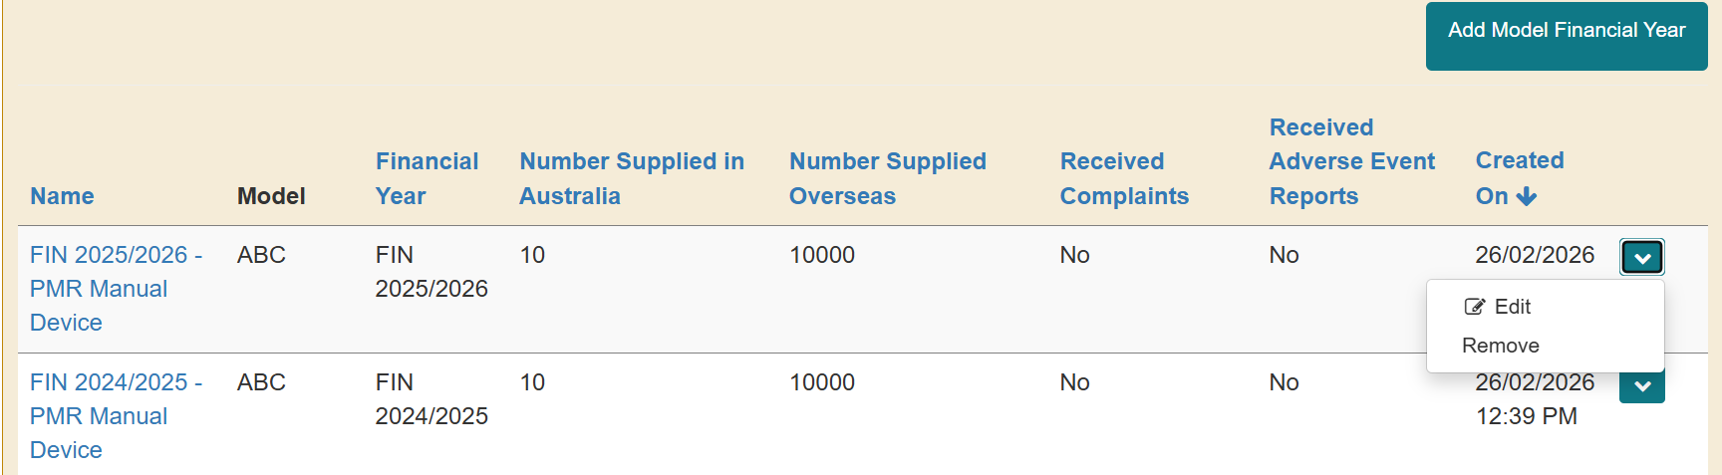
Figure 3.54: How to edit the supply, complaint and adverse events data.

Legislative breaches and responses section
The following instructions outline how to upload the information and documents to demonstrate compliance with the specific areas of the legislation that have been identified as potentially in breach in the initial request for information notification letter.
- Click the drop-down arrow on the right of a specific breach under investigation and click ‘Add Response’ (Figure 3.55).
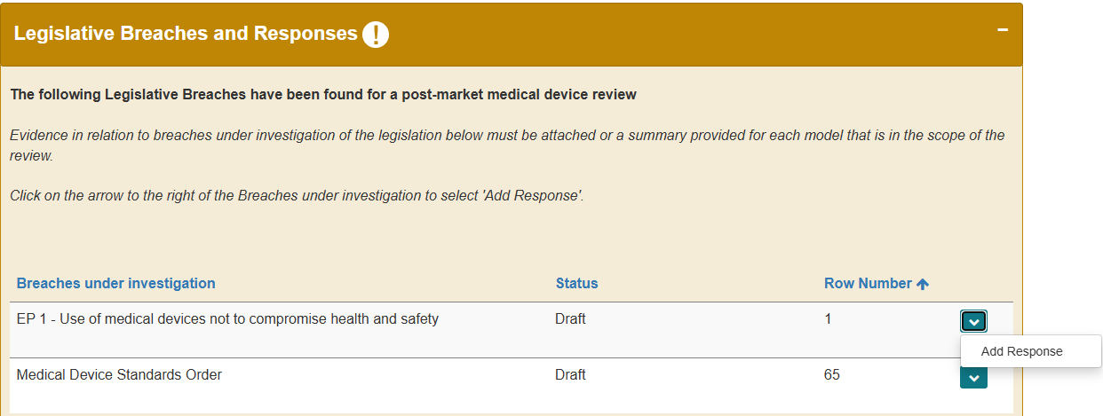
Figure 3.55: How to add a response in the ‘Legislative Breaches and Responses’ section.
- Click ‘Proceed’ on the ‘Add Response’ pop-up (Figure 3.56).
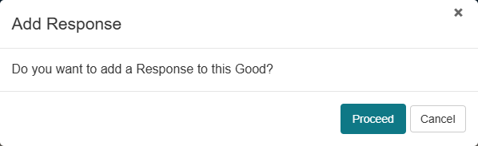
Figure 3.56: ‘Add Response’ pop-up to confirm the option to add a response.
- Click ‘Refresh’ at the bottom of the page or ‘Created On’ column header on the ‘Legislative Breaches Responses’ table to populate the created response (Figure 3.57).
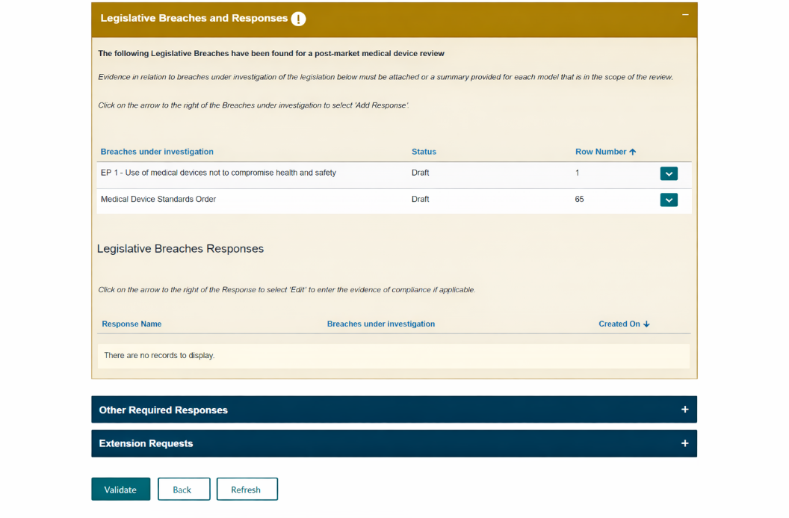
Figure 3.57: How to refresh the page to populate the created response.
- Click on the down-arrow on the right side of the created response and click ‘Edit’ (Figure 3.58) to open the ‘Edit compliance with potential legislative breach response’ pop-up.
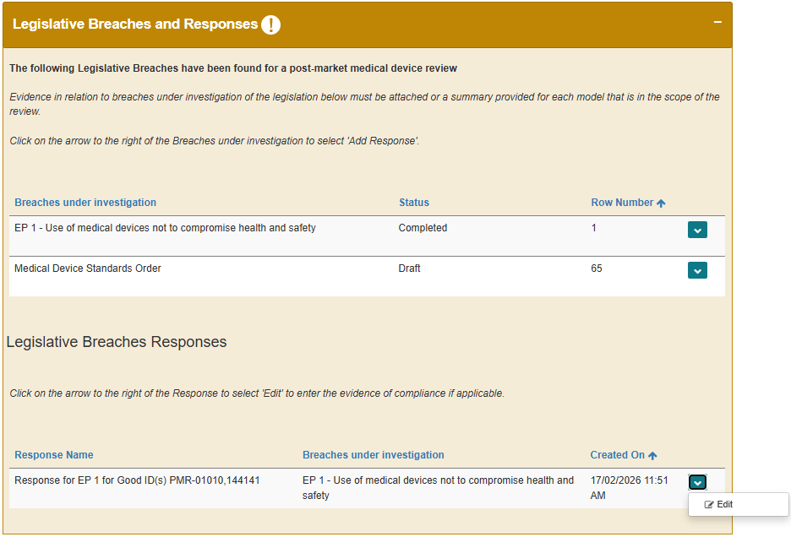
Figure 3.58: Legislative breach status changes from draft to complete once a response is created. The lower panel shows how to edit the responses to the potential legislative breaches.
Note: The status of the ‘Breach under Investigation’ will change from ‘Draft’ to ‘Completed’.

- In the ‘Edit compliance with potential legislative breach response’ pop-up you can (Figure 3.59):
- view the legislative breach you are providing evidence of compliance against
- view the goods included in the PMR you are providing a response for, and
- select how you wish to provide your response from the drop-down menu options:
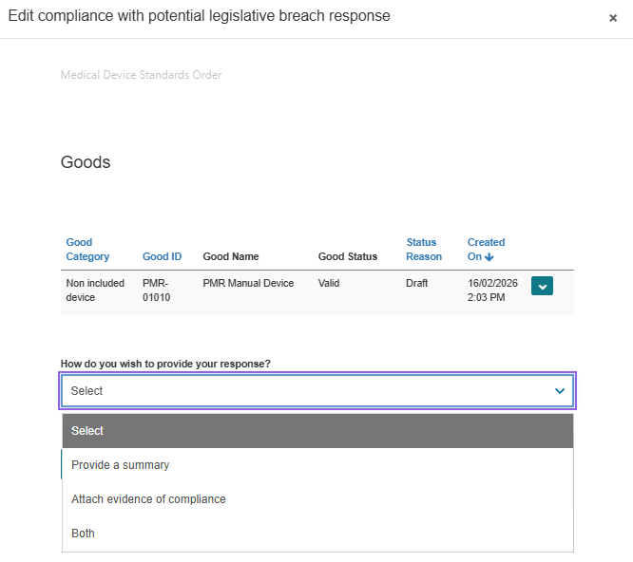
Figure 3.59: The ‘Edit compliance with potential legislative breach response’ pop-up showing how to provide a response.
Note: For each identified potential legislative breach, evidence of compliance must be provided for all goods included in the PMR. However, if the evidence being provided is not applicable to a particular good, you can remove the good from the response and generate a different response for the good. Refer to steps 42 – 49 on how to remove a good from response and generate a separate response.
    - Select ‘Attach evidence of compliance’ to provide evidence of compliance as document attachment(s). At least one file must be provided (Figure 3.60).
        - Click on ‘Add files’ to attach files up to 50MB (see step 13) or ‘Upload Large Files’ to attach files between 50MB – 5GB (see step 14).
        - Click the checkbox to acknowledge that at least one file has been uploaded and click Save.
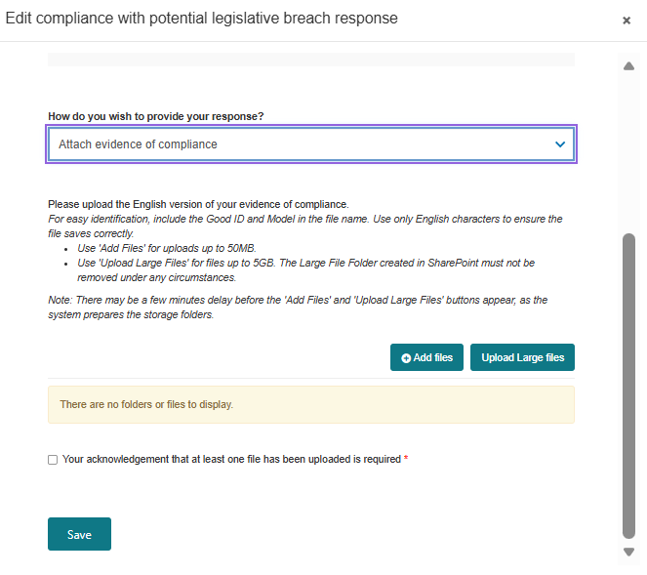
Figure 3.60: The ‘Edit compliance with potential legislative breach response’ pop-up showing how to attach evidence of compliance.
    - Select ‘Provide a Summary’ to type your response and click ‘Save’ (Figure 3.61). The summary must be between 20 - 200 characters.
Note: If a summary response is over 200 characters, select ‘Attach evidence of compliance’ and upload the summary as an attachment.

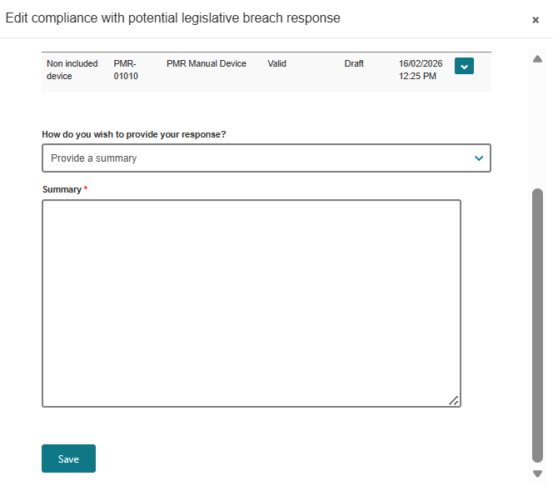
Figure 3.61: The ‘Edit compliance with potential legislative breach response’ pop-up showing how to provide evidence of compliance as a summary.
    - Select ‘Both’ to ‘Attach evidence of compliance’ and ‘Provide a Summary’ (Figure 3.62).
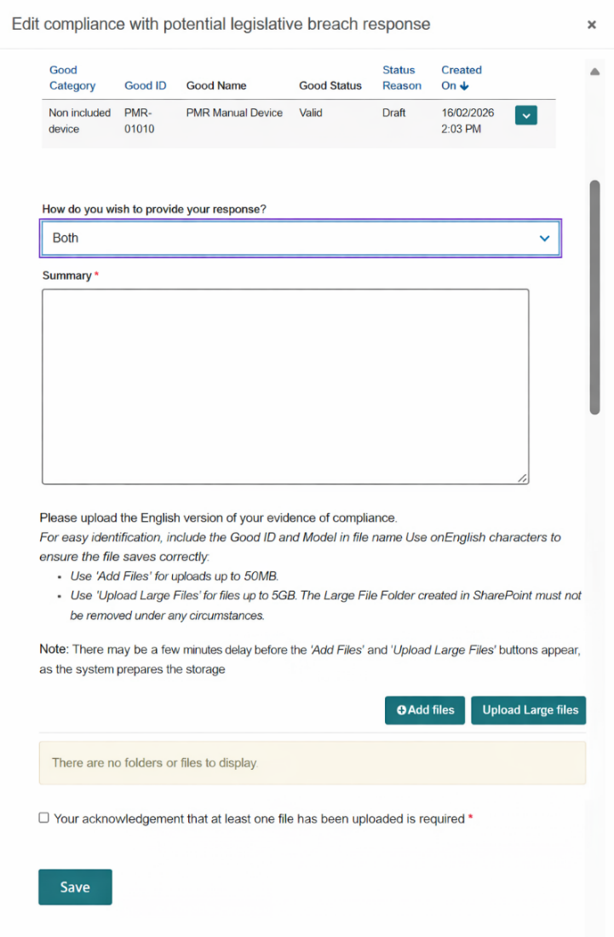
Figure 3.62: The ‘Edit compliance with potential legislative breach response’ pop-up showing how to attach evidence of compliance and provide a summary.
- Repeat steps 36 - 40 for all potential legislative breaches included in the notification.
Removing a Good from a response and generating a separate response for the Good.
Evidence of compliance must be provided for all Goods included in the PMR. However, if the evidence being provided is not applicable to a particular good, you can remove the Good from the response and generate a different response for the Good.
- Click on the down arrow on the right of the ‘Edit compliance with potential legislative breach response’ pop-up and click ‘Remove’ (Figure 3.63).
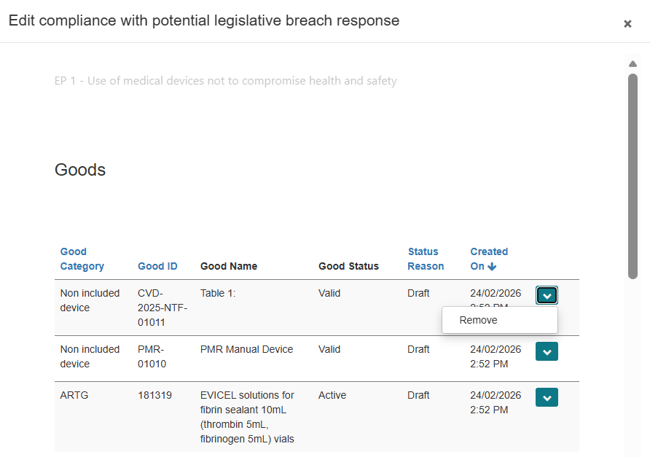
Figure 3.63: ‘Edit compliance with potential legislative breach response’ pop-up showing how to remove a Good from a response.
- Click ‘Remove’ (Figure 3.64).
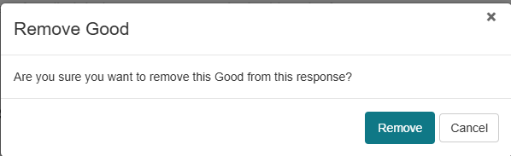
Figure 3.64: The ‘Remove Good’ pop-up with the option to confirm the removal of the Good.
- The Good will be removed from the list of Goods you are providing a response for (Figure 3.65) and the status of the ‘Breach under Investigation’ will change from ‘Completed’ to ‘Draft’ (Figure 3.66).
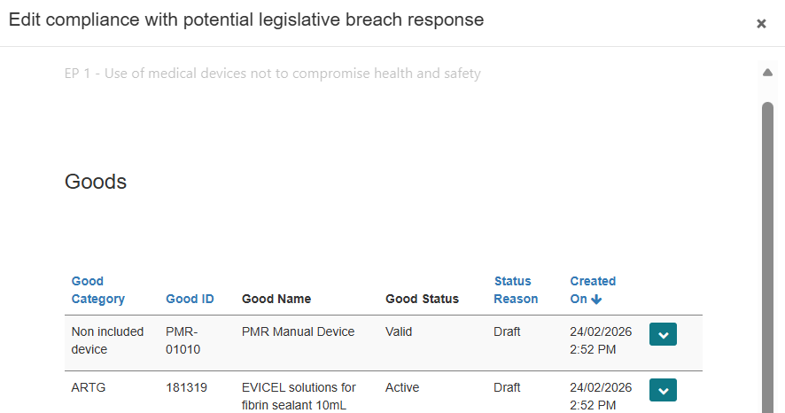
Figure 3.65: The ‘Edit compliance with potential legislative breach response’ pop-up showing a Good has been removed from the response.

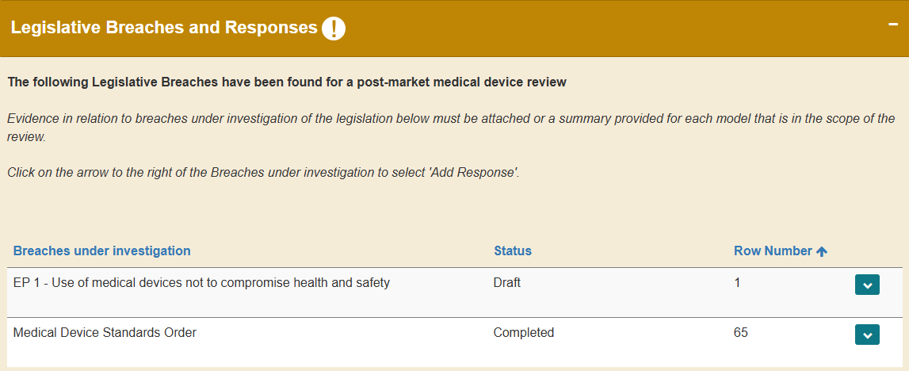
Figure 3.66: The legislative breach status changes from complete to draft when a Good is removed from a response.
If a Good has been removed from a response, you will not be able to submit the response. If you attempt to ‘Validate’ your response, the error message below will appear (Figure 3.67)

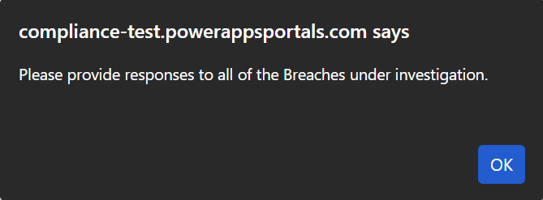
Figure 3.67: The error message displayed when a new response is not generated after a Good is removed from a response and you attempt to validate the response.
- To recreate a response for the removed Good, click the drop-down arrow on the right of the breach under investigation where the Good removed from and click ‘Add Response’ (Figure 3.68).
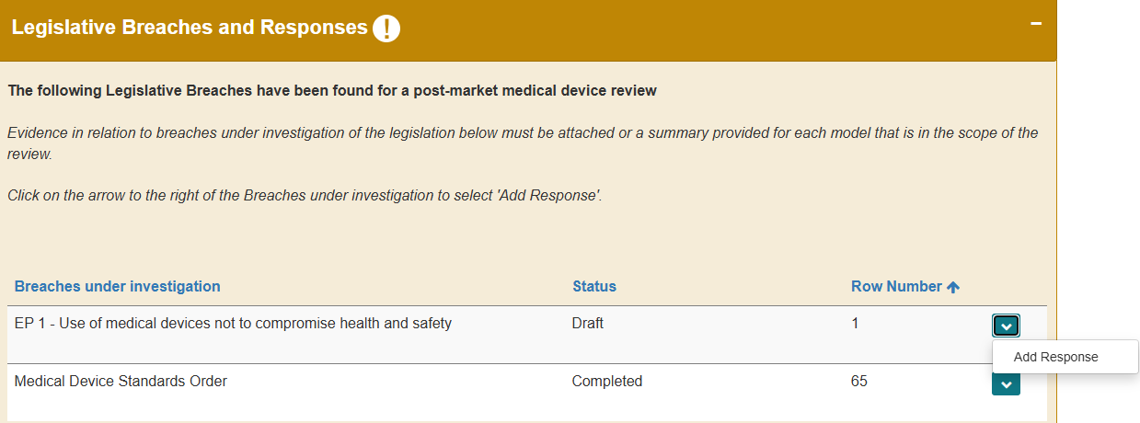
Figure 3.68: How to add a response for a removed Good in the legislative breaches and responses section.
- Click ‘Proceed’ on the ‘Add Response’ pop-up (Step 37 and Figure 3.56).
- Click ‘Refresh’ at the bottom of the page or ‘Created On’ column header on the ‘Legislative Breaches Responses’ table to populate the created response containing the removed Good (Step 38 and Figure 3.57).
Note: The status of the ‘Breach under Investigation’ will change from ‘Draft’ to ‘Completed’ (Figure 3.69).

- Click on the down-arrow on the right side of the created response and click ‘Edit’ to open the ‘Edit compliance with potential legislative breach response’ pop-up (Figure 3.69).
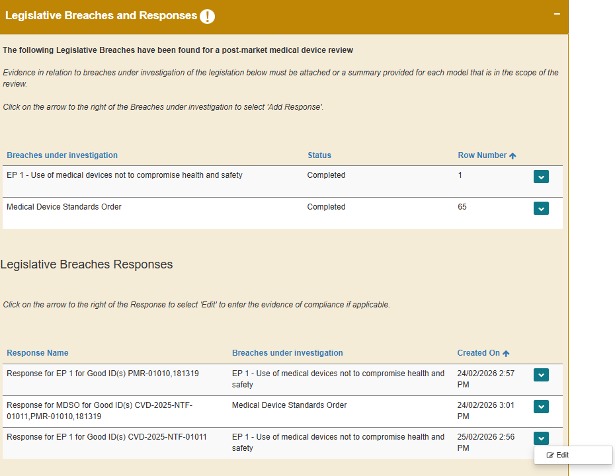
Figure 3.69: The legislative breach status changes from draft to completed when a response is generated for a removed Good. The lower panel shows how to edit the created response.
- Follow step 40 to provide evidence of compliance for the good.

How to submit your response
- When you are ready to submit your response, click ‘Validate’ (Figure 3.70).
Only the Submitter will be able complete the following steps to submit the response.

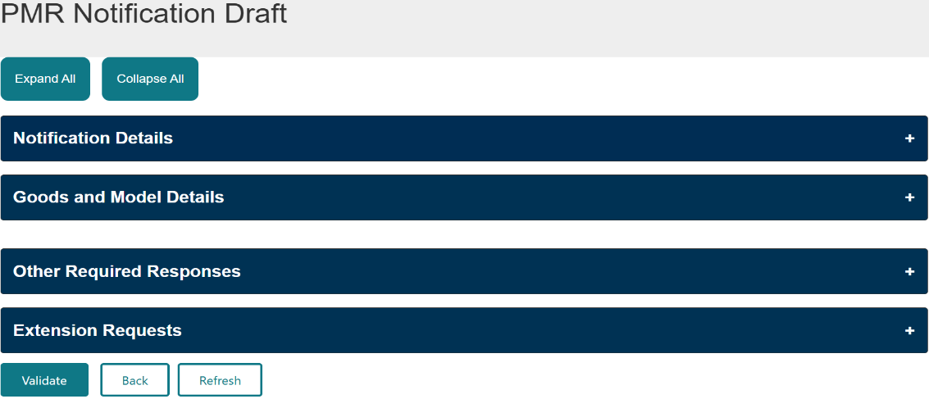
Figure 3.70: The ‘PMR Notification Draft’ page showing how to validate your response.
- Once the response has been successfully validated, click ‘Declare’ (Figure 3.71) to read the declaration.
Note: If you wish to preview your responses before submitting, click ‘Preview’ to open the ‘PMR RFI Preview’ page (Figure 3.72).

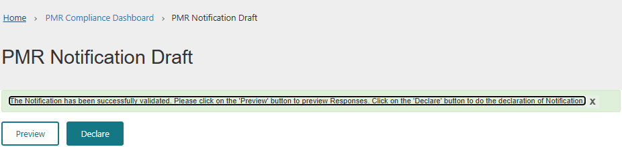
Figure 3.71: The ‘PMR Notifcation Draft’ page showing how to move to the declaration page for your response.
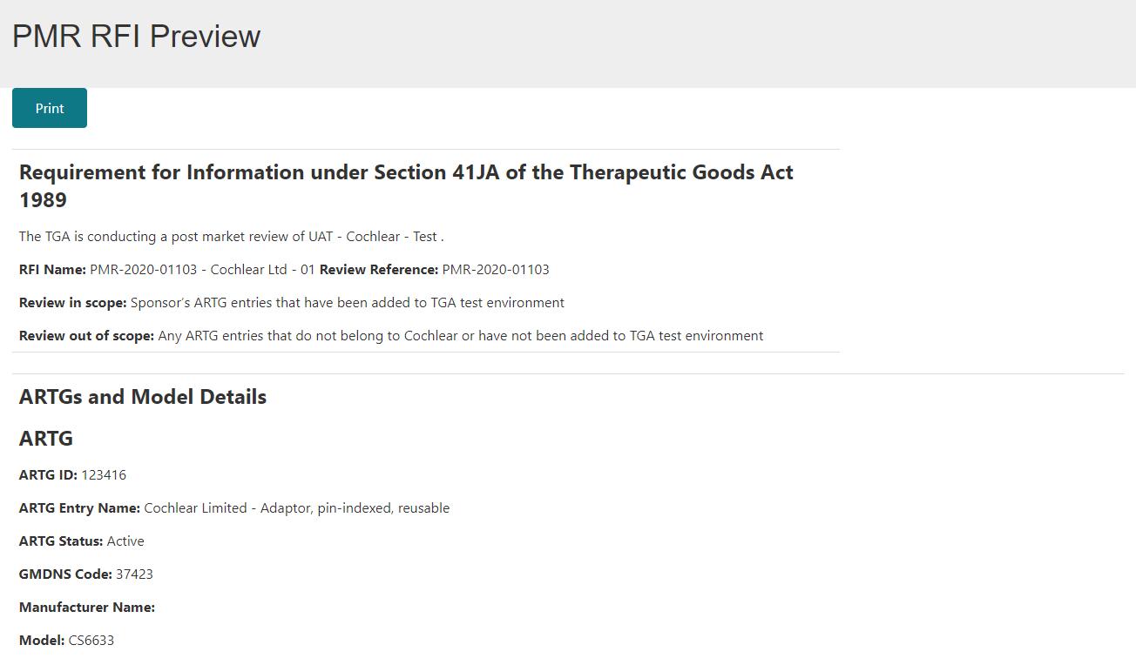
Figure 3.72: PMR Notification Preview page.
- On the ‘Declaration’ pop-up:
- select ‘Yes’ if you agree to the declaration and click ‘Submit’ (Figure 3.73). Then click ‘OK’ (Figure 3.74) to submit your response.
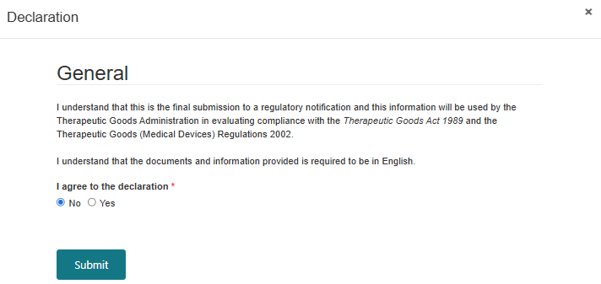
Figure 3.73: The declaration requiring confirmation that the information provided in response to the notification is complete and in English before submitting the PMR response.
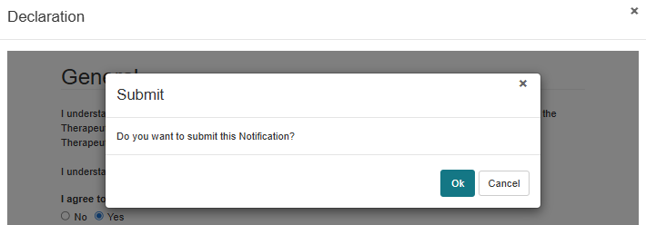
Figure 3.74: The submission confirmation prompt before finalising the PMR notification.
- Select ‘No’ if you do not agree to the declaration and click ‘Submit’ (Figure 3.73). You will not be able to submit your response, and the error message below will appear (Figure 3.74). Click ‘Ok’ to go back to the ‘Declaration’ pop-up (Figure 3.73).
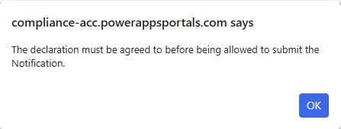
Figure 3.74: System alert prompting the user to agree to a declaration before submitting a response to a notification in the dashboard.

Section 4: How to respond to additional information request.
If a notification requires additional information on another specific matter, you are required to provide a response in the ‘Other Required Responses’ section (Figure 4.1).
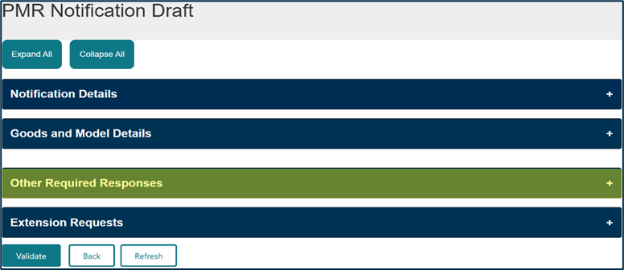
Figure 4.1: ‘PMR Notification Draft’ page highlighting the ‘Other Required Responses’ section.

Notification details section
- In the ‘Notification Details’ section (Figure 4.2), you can view:
- the scope of the review
- all the document(s) associated to the notification and download the notification letter sent to you by the TGA
- the list of folders that will hold the document(s) you uploaded as part of your submission, and
- all the documents you uploaded as part of your response.
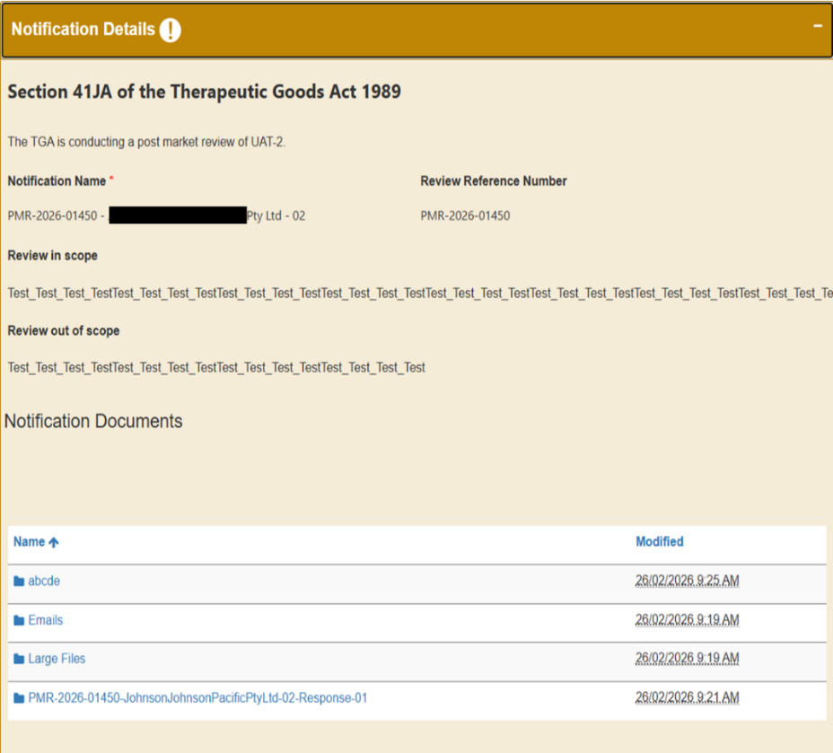
Figure 4.2: ‘Notification Details’ section of an additional request for information notification showing the different folders.

Goods and model details section
- The ‘Goods and Model Details’ section is read-only for this kind of notification (Figure 4.3) and lists the Goods that are included in the notification.
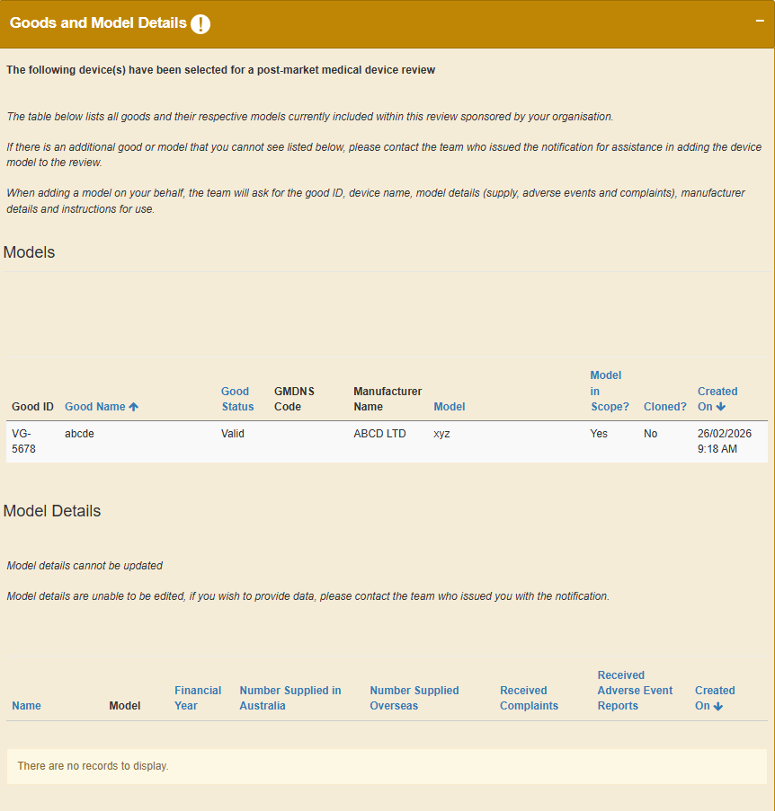
Figure 4.3: The ‘Goods and Model Details’ section is read-only and shows the Goods included in the notice.

Other required responses
- Click on the drop-down arrow on the right and click ‘Edit’ to provide a response to a specific request (Figure 4.4).
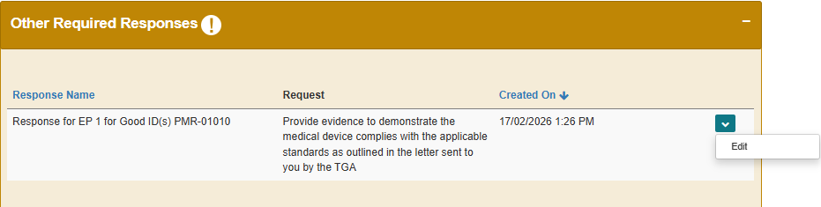
Figure 4.4: Edit the ‘Other Required Responses’ section.
- In the ‘Edit Other required response’ pop-up, you can (Figure 4.5):
  - view details of the request
  - view the goods included in the additional request for information notice
  - view the potential legislative breaches under investigation, and
  - select how you wish to provide your response from the drop-down menu options:
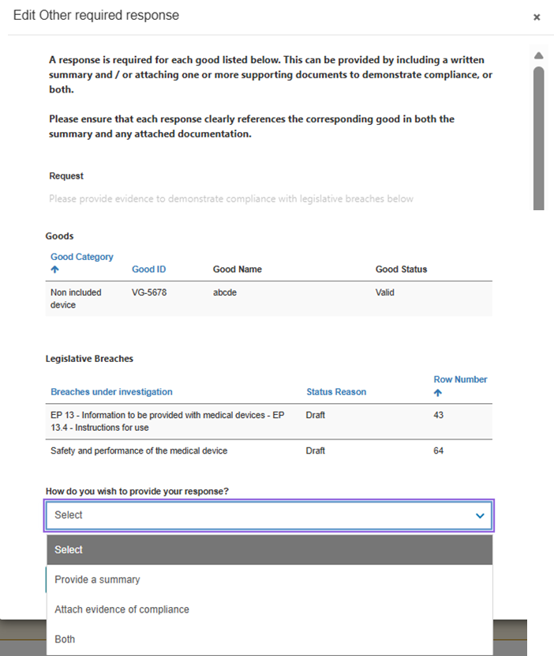
Figure 4.5: The ‘Edit Other required response’ pop-up showing how to provide a response.
    - select ‘Attach evidence of compliance’ to provide evidence of compliance as document attachment(s). At least one file must be provided (Figure 4.6).
      - click on ‘Add files’ to attach files up to 50MB (see step 5) or ‘Upload Large Files’ to attach files between 50MB – 5GB (see step 6)
      - click the checkbox to acknowledge that at least one file has been uploaded and click ‘Save’.

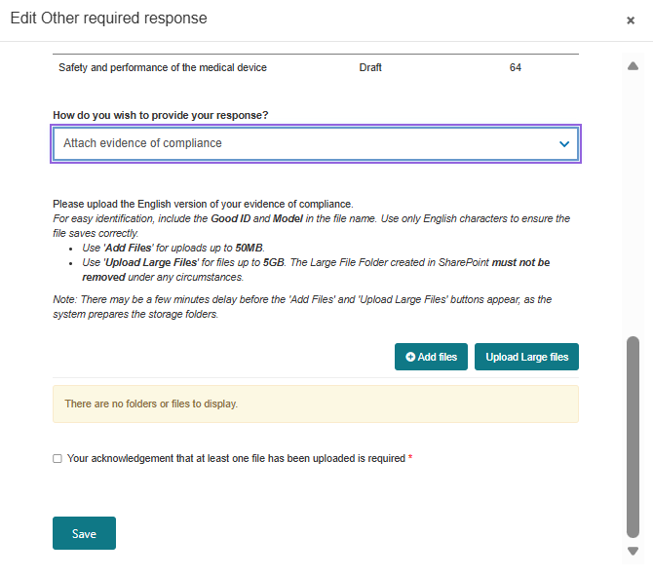
Figure 4.6: The ‘Edit Other required response’ pop-up showing how to attach evidence of compliance.
    - select ‘Provide a Summary’ to type your response and click ‘Save’ (Figure 4.7). The summary must be between 20 - 200 characters.
Note: If a summary response is over 200 characters, select ‘Attach evidence of compliance’ and upload the summary as an attachment.

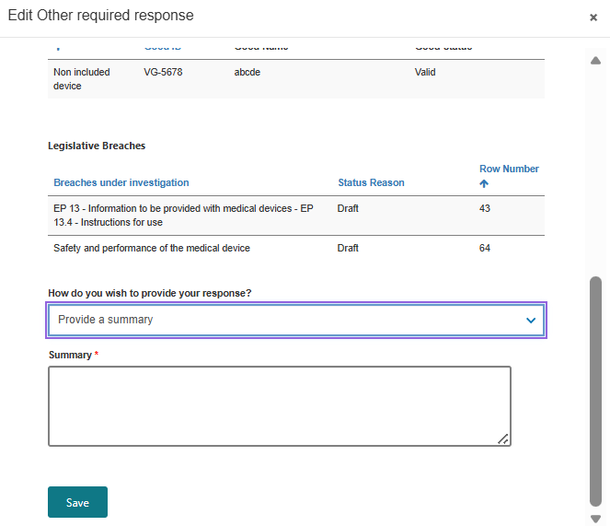
Figure 4.7: The ‘Edit Other required response’ pop-up showing how to provide evidence of compliance as a summary.
    - select ‘Both’ to attach evidence of compliance in the form of documents as well as providing a text summary (Figure 4.8).
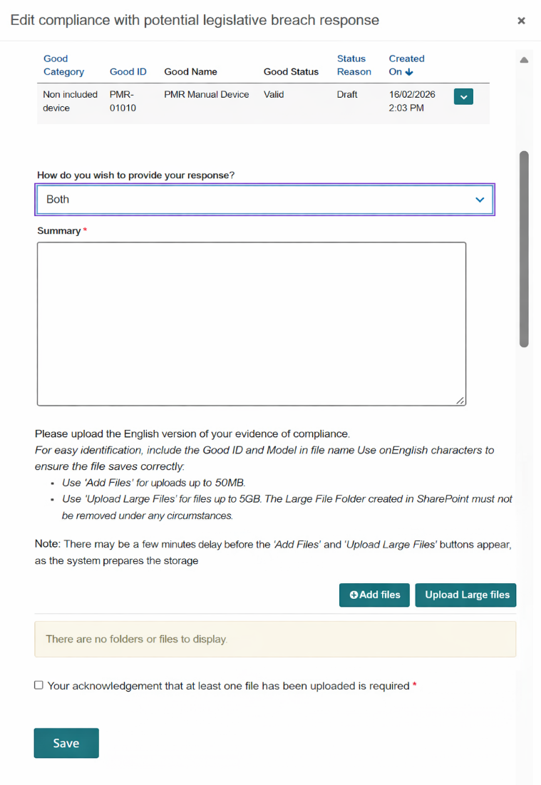
Figure 4.8: The ‘Edit Other required response pop-up showing how to attach evidence of compliance and provide a summary.
- To add files less than 50MB:
  - click ‘Add files’ button within the ‘Edit Other required response’ pop-up (Figure 4.8) to open the ‘Add files’ pop-up (Figure 4.9)
  - click ‘Choose files’ and select the file you want to upload from your computer. Once you have selected your file, click the ‘Add files’ button (Figure 4.9)
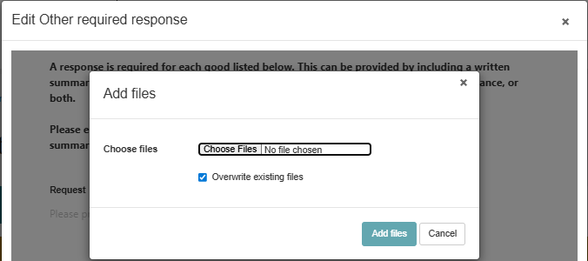
Figure 4.9: The ‘Add files’ pop-up used to choose and add relevant files.
  - the file you uploaded will be displayed in the ‘Edit Model’ pop-up (Figure 4.10).

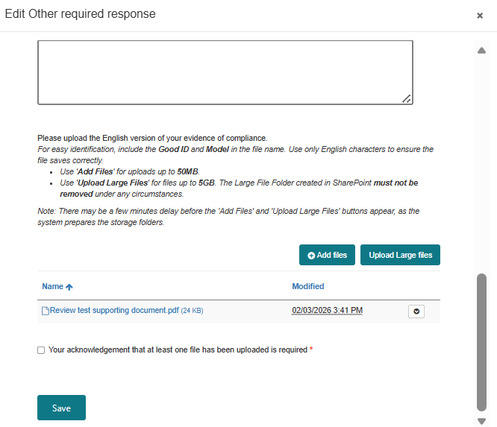
Figure 4.10: The ‘Edit Other required response’ pop-up showing files you have uploaded.
- To add files more than 50MB size up to 5GB:
- click ‘Upload Large files’ button within the ‘Edit Other required response’ pop-up (Figure 4.8)
- a new window will open directing you to the SharePoint site (Figure 4.11)
Figure 4.11: SharePoint landing page for large file upload.
- click ‘Upload’ and then ‘Files’ (Figure 4.12) to select and upload the relevant files from your computer
Figure 4.12: SharePoint site showing how to upload files.
- close the browser window once the uploaded files are added to the SharePoint site (Figure 4.13)
Figure 4.13: SharePoint site showing uploaded documents.
- within the ‘Edit Model’ pop-up, select the check-box to acknowledge that at least one file has been uploaded and click ‘Save’ (Figure 4.14).

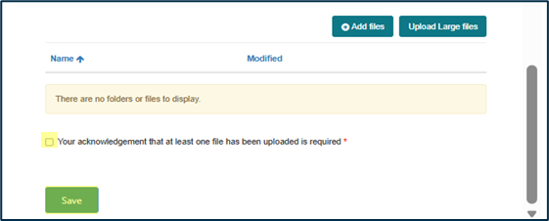
Figure 4.14: The ‘Edit other required response’ pop-up showing the check-box used to acknowledge files have been uploaded.

How to submit your response
- When you are ready to submit your response, click ‘Validate’ (Figure 4.15).
Only the Submitter will be able complete the following steps to submit the response.

Figure 4.15: The ‘PMR Notification Draft’ page showing how to validate your response.
- Once the response has been successfully validated, click ‘Declare’ (Figure 4.16) to proceed to the declaration.

Note: If you wish to preview your responses before submitting, click ‘Preview’ to open the ‘PMR RFI Preview’ page (Figure 4.17).

Figure 4.16: The ‘PMR Notifcation Draft’ page showing how to move to the declaration page for your response.
Figure 4.17: ‘PMR Notification Preview’ page.
- On the ‘Declaration’ pop-up:
  - select ‘Yes’ if you agree to the declaration and click ‘Submit’ (Figure 4.18). Then click ‘OK’ (Figure 4.19) to submit your response.
Figure 4.18: The declaration requiring confirmation that the information provided is complete and in English before submitting the PMR response.

Figure 4.19: Submission confirmation prompt before finalising the PMR notification.
  - Select ‘No’ if you do not agree to the declaration and click ‘Submit’ (Figure 4.18). You will not be able to submit your response, and the error message below will appear (Figure 4.20). Click ‘Ok’ to go back to the ‘Declaration’ pop-up (Figure 4.18).
Figure 3.73: System alert prompting the user to agree to a declaration before submitting a response to a notification in the dashboard.

Section 5: How to respond to a proposal to take action.
For a notification that proposes to take regulatory action notice, you can only provide a response in the ‘Goods and Model Details’ section (Figure 5.1).
For this type of notification, you are not required to include additional Goods or models to the review, or to provide supply, complaint, and adverse event data.
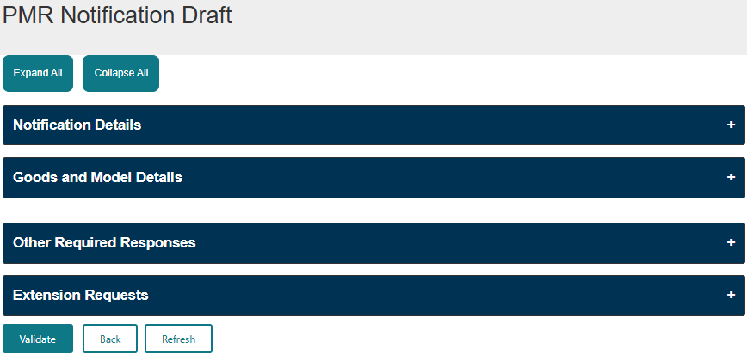
Figure 5.1: The ‘PMR Notification Draft’ page highlighting the ‘Goods and Model Details’ section.

Notification details section
- In the ‘Notification Details’ section (Figure 5.2), you can view:
- the scope of the review
- all the documents associated to the notification and download the notification letter sent to you by the TGA
- the list of folders that will hold the document(s) you upload as part of your submission, and
- all the documents you upload as part of your response.

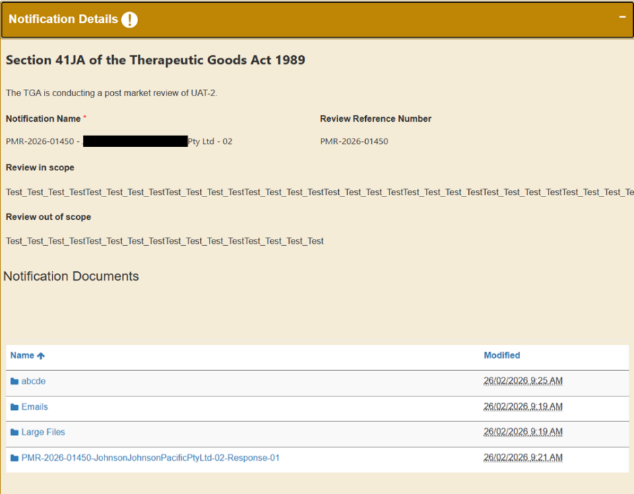
Figure 5.2: The ‘Notification Details’ section in response to a proposal to take regulatory action notification.

Goods and model details section
- Click on the drop-down arrow on the right and click ‘Add Response’ (Figure 5.3).

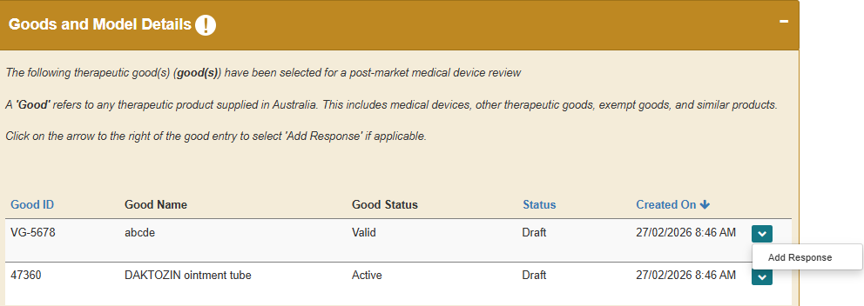
Figure 5.3: How to add a response in the ‘Goods and Model Details’ section.
- Click ‘Proceed’ on the ‘Add Response’ pop-up (Figure 5.4).
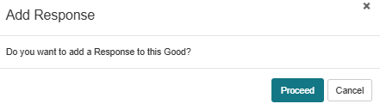
Figure 5.4: ‘Add response’ pop-up with the confirmation to proceed.
- Click on the ‘Created On’ column header in the ‘Good Responses’ table (Figure 5.5) or ‘Refresh’ at the bottom of the page (Figure 5.6) to populate the table to begin the response.
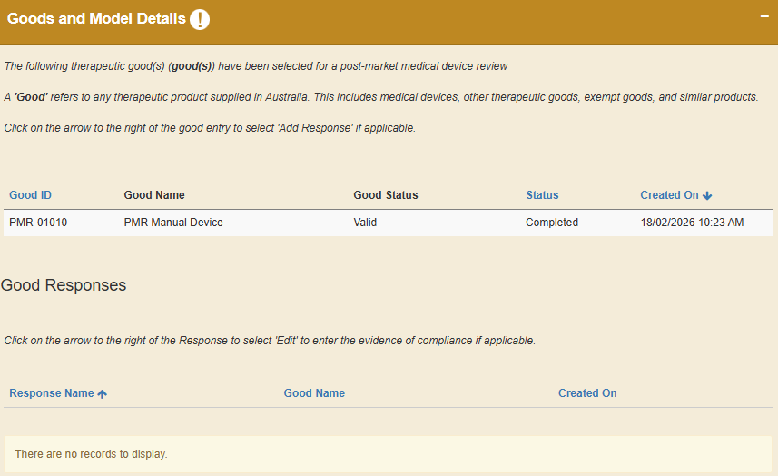
Figure 5.5: How to refresh the table within the ‘Goods and Model Details’ section to prepare responses.
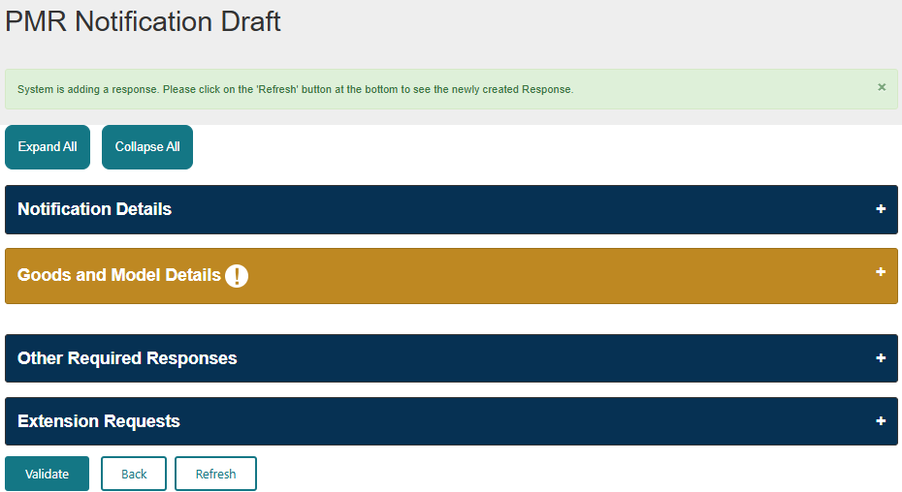
Figure 5.6: How to refresh the page to populate the table for a response.
- Click on the drop-down arrow on the right and click ‘Edit’ to open the ‘Edit Good Response’ pop-up (Figure 5.7).
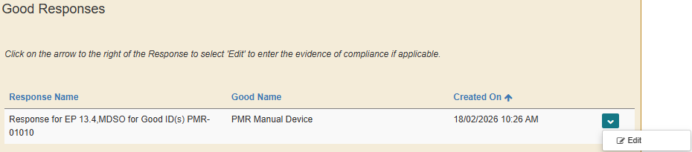
Figure 5.7: The drope-down selction to edit the response for a particular Good.
- In the ‘Edit Good Response’ pop-up, you can (Figure 5.8):
  - view the Good you are providing a response for
  - view the potential legislative breaches under investigation, and
  - select how you wish to provide your response from the drop-down menu options:
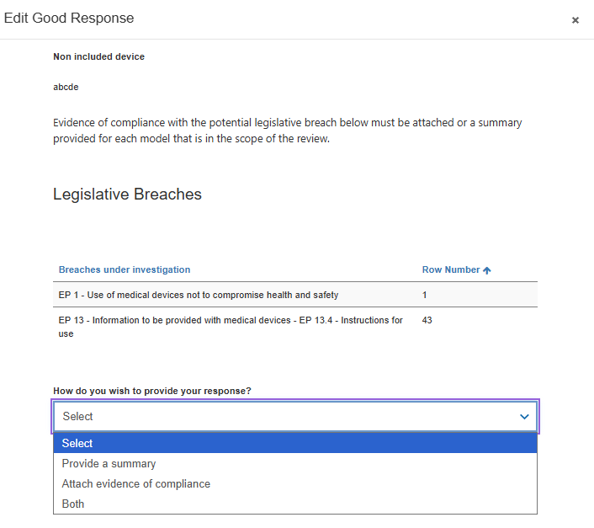
Figure 5.8: The ‘Edit Good Response’ pop-up showing the options of provide a response:
- Select ‘Attach evidence of compliance’ to provide evidence of compliance as document attachment(s). At least one file must be provided (Figure 5.9).
      - Click on ‘Add files’ to attach files up to 50MB (see step 7) or ‘Upload Large Files’ to attach files between 50MB – 5GB (see step 8).
      - Click the checkbox to acknowledge that at least one file has been uploaded and click Save.
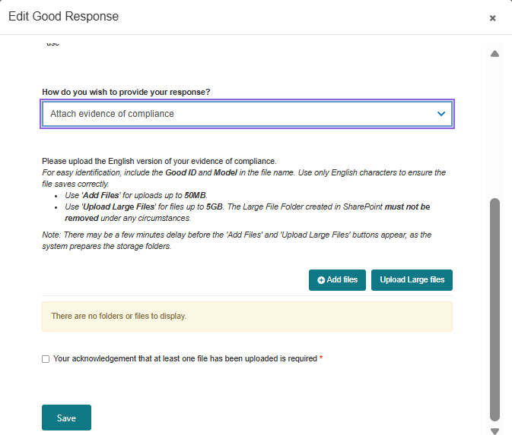
Figure 5.9: Edit good response pop-up showing the attach evidence of compliance option.
- Select ‘Provide a Summary’ to type your response and click ‘Save’ (Figure 5.10). The summary must be between 20 - 200 characters.
Note: If a summary response is over 200 characters, select ‘Attach evidence of compliance’ and upload the summary as an attachment.

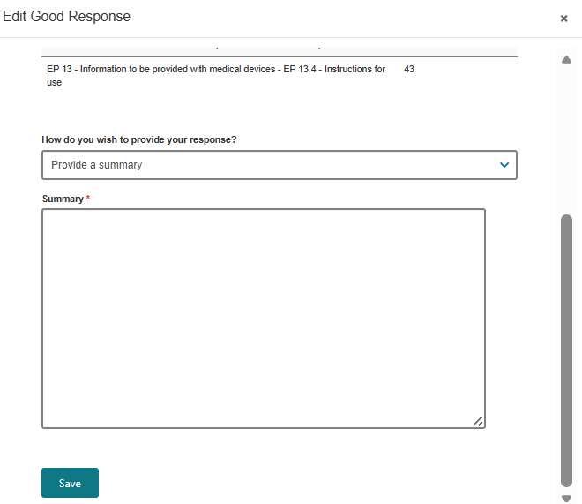
Figure 5.10: ‘Edit Good Response’ pop-up showing the showing option to provide evidence of compliance as a summary.
- Select ‘Both’ to ‘Attach evidence of compliance’ and ‘Provide a Summary’ (Figure 5.11).
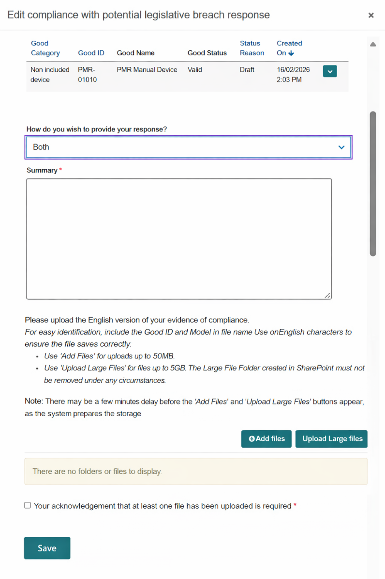
Figure 5.11: ‘Edit Good Response’ pop-up showing the showing option to provide evidence of compliance as a summary and attach documents.
- To add files less than 50MB:
  - click ‘Add files’ button within the ‘Edit Good Response’ pop-up (Figure 5.9) to open the ‘Add files’ pop-up (Figure 5.12)
  - click ‘Choose files’ and select the file you want to upload from your computer. Once you have selected your file, click the ‘Add files’ button (Figure 5.12)
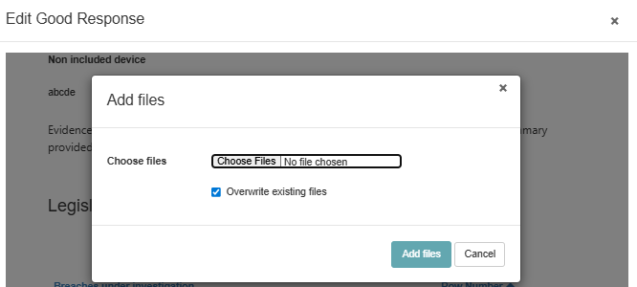
Figure 5.12: The ‘Add files’ pop-up used to choose and add relevant files.
  - the file you uploaded will be displayed in the ‘Edit Model’ pop-up (Figure 5.13).

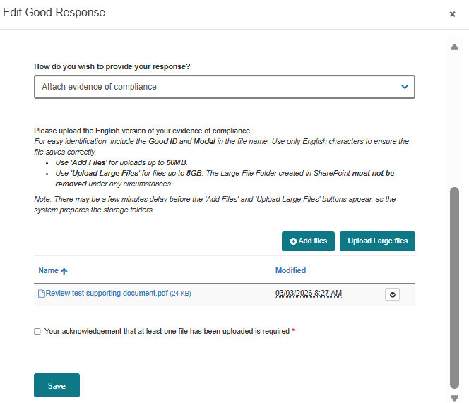
Figure 5.13: Edit good response pop-up showing files you have uploaded.
- To add files more than 50MB size up to 5GB:
- click ‘Upload Large files’ button within the ‘Edit Good response’ pop-up (Figure 5.9)
- a new window will open directing you to the SharePoint site (Figure 5.14)
Figure 5.14: SharePoint landing page for large file upload.
- click ‘Upload’ and then ‘Files’ (Figure 5.15) to select and upload the relevant files from your computer
Figure 5.15: SharePoint site showing how to upload files.
- close the browser window once the uploaded files are added to the SharePoint site (Figure 5.16)
Figure 5.16: SharePoint site showing the uploaded documents.
- within the ‘Edit Model’ pop-up, select the check-box to acknowledge that at least one file has been uploaded and click ‘Save’ (Figure 5.17).
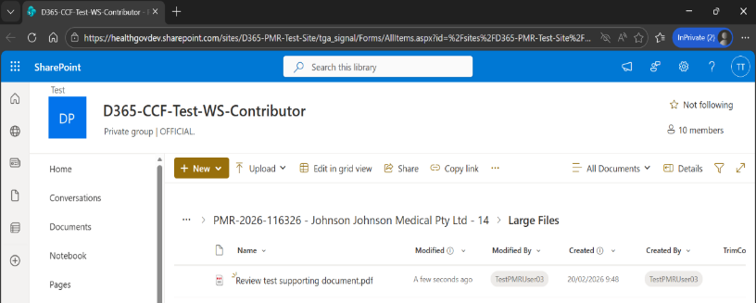
Figure 5.17: The ‘Edit Good response’ pop-up with a check-box used to acknowledge files have been uploaded.

How to submit your response
- When you are ready to submit your response, click ‘Validate’ (Figure 5.18).
Only the Submitter will be able complete the following steps to submit the response.

Figure 5.18: The ‘Validate’ button at the bottom of the ‘PMR Notification Draft’ page used to validate your response.
- Once the response has been successfully validated, click ‘Declare’ (Figure 5.19) to move to the declaration.
Note: If you wish to preview your responses before submitting, click ‘Preview’ to open the ‘PMR RFI Preview’ page (Figure 5.20).

Figure 5.19: The ‘Declare’ button on the ‘PMR Notifcation Draft’ page used to progress to the declaration page.
Figure 5.20: The page where you can preview the response you have compiled in response to the notification.
- On the ‘Declaration’ pop-up:
  - select ‘Yes’ if you agree to the declaration and click ‘Submit’ (Figure 5.21). Then click ‘OK’ (Figure 5.22) to submit your response.
Figure 5.21: The declaration requiring confirmation that the information provided is complete and in English before submitting the PMR response.
Figure 5.22: Submission confirmation prompt before the submission to the PMR notification is complete.
  - Select ‘No’ if you do not agree to the declaration and click ‘Submit’ (Figure 5.21). You will not be able to submit your response, and the error message below will appear (Figure 5.23). Click ‘Ok’ to go back to the ‘Declaration’ pop-up (Figure 5.21).
Figure 5.23: System alert prompting the user to agree to a declaration before submitting a response to a notification in the dashboard.

Section 6: How to request for an extension.
When the TGA sends you a notification, the date the documents and information are due by is listed in the dashboard (Figure 6.1). If a response is not submitted by the due date, you will not be able to draft and submit a response to a notice through the dashboard.
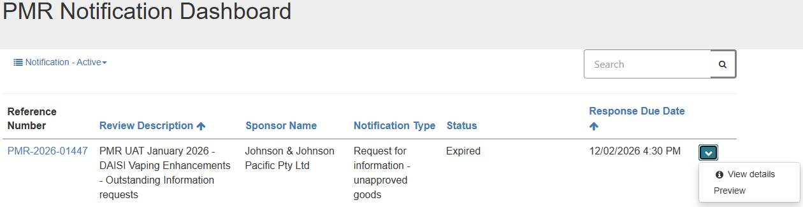Figure 6.1: The dashboard showing the notification due date and status.
If you are having difficulty providing the documents, information, or samples in the required timeframe and need an extension, you can submit a request in the ‘Extension Requests’ section of the ‘PMR Notification Draft’ page (Figure 6.2).
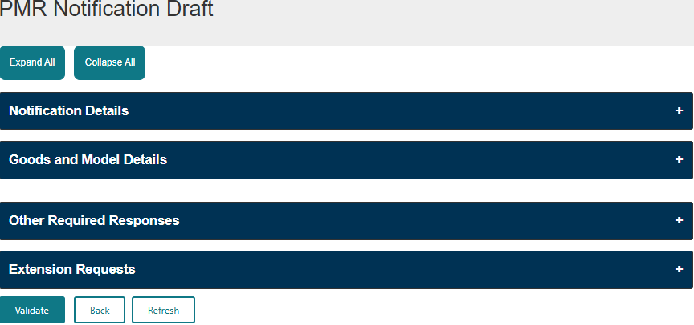
Figure 6.2: ‘PMR Notification Draft’ page highlighting the extension request section.
Please note:
- an extension request can only be submitted before the notification due date has lapsed, and
- a request for an extension may not be able to be provided in all cases.

- Click ‘Request Extension’ in the ‘Extension Requests’ section (Figure 6.3).
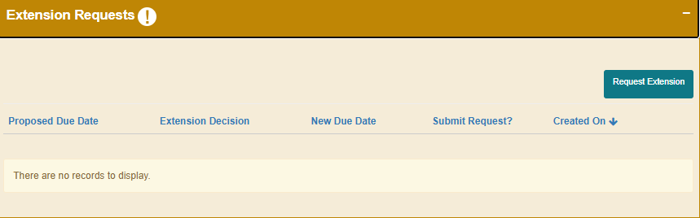
Figure 6.3: ‘Request Extension’ button within the ‘Extension Requests’ section.
- In the ‘Extension Request’ pop-up (Figure 6.4):
  - enter the new date in the ‘Proposed Due Date’ field
Note: This date must be later than the current notification due date.
.

  - enter the reason for requesting for an extension in the ‘Extension Request’ field
  - select ‘Yes’ if you are ready to submit the request. If not, select ‘No’ to save the request and submit later.
Click ‘Save’.
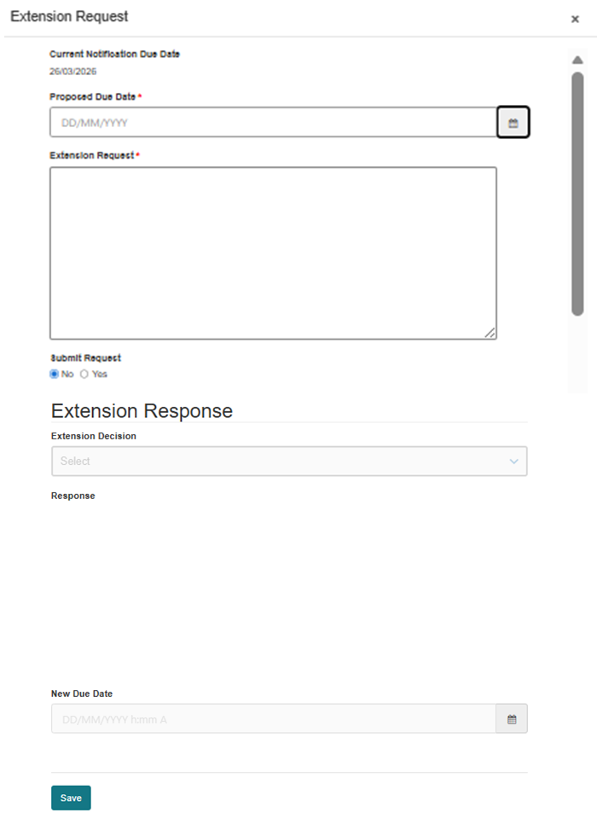
Figure 6.4: ‘Extension request’ pop-up showing where to enter a proposed due date, provide a reason for the request, and submit the extension.
- If you have clicked ‘Yes’, click ‘OK’ in the pop-up to submit the request (Figure 6.5).
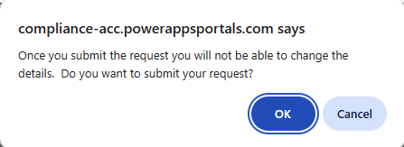
Figure 6.5: Confirmation prompt displayed before submitting an extension request in the Dashboard.

Version history
Version | Description of change | Author | Effective date
V1.0 | Original publication | Medical Devices Surveillance Branch | October 2020
V1.1 | Minor additions to clarify drafting of responses process | Medical Devices Surveillance Branch | December 2020
V1.2 | Minor additions to clarify drafting process and order of processes | Medical Devices Surveillance Branch | March 2021
V2 | Additions to clarify drafting process and order of processes. Updating of screenshots to include the dashboard updates for medical devices not included in the ARTG | Medical Devices Surveillance Branch | March 2026

Therapeutic Goods Administration
PO Box 100 Woden ACT 2606 Australia
Email: info@tga.gov.au Phone: 1800 020 653 Fax: 02 6203 1605
https://www.tga.gov.au
Reference/Publication #

