 | TGA USE ONLY
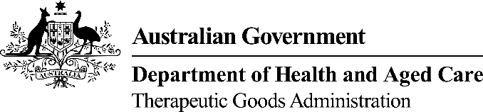
This form, when completed, will be classified as 'For official use only'.
For guidance on how your information will be treated by the TGA see: Treatment of information provided to the TGA at <https://www.tga.gov.au/treatment-information-provided-tga>.

Request to cancel an entry/entries* from the Australian Register of Therapeutic Goods (ARTG)

Section 1: Sponsor details
Sponsor name
TBS Client ID
Telephone
Email

Section 2: ARTG entry details
I request cancellation of the entries in the ARTG below:
(*Please note: the cancellations of an entry in the ARTG will cancel all products included in that entry)
ARTG number | Entry name/description

Section 3: Sponsor authorisation
This form must be authorised by a nominated person – that is, a person authorised by the sponsor to act on their behalf, or a person nominated as a ‘submitter’ in the TBS system in relation to the sponsor.
Full name
Position
Signature |  | Date

For all enquiries, please phone 1800 010 624. Please email completed form to ebs@health.gov.au. Please note that all cancellations only become effective when the Secretary makes a decision to cancel the goods. You will be notified of the date of effect of the cancellation.
* In relation to medical devices, this means all the devices of the kind covered by the entry.

