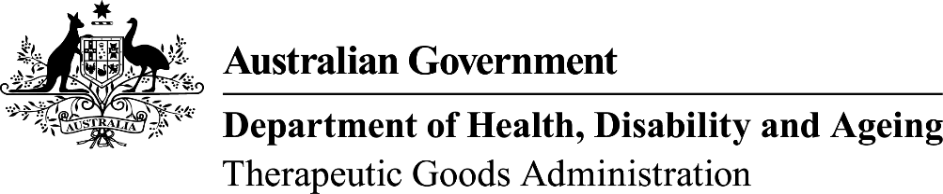 | TGA USE ONLY
This form, when completed, will be classified as 'For official use only'.
For guidance on how your information will be treated by the TGA see: Treatment of information provided to the TGA at <https://www.tga.gov.au/treatment-information-provided-tga>.

Updating organisation administrator
Use this form to nominate a new representative from your organisation to be the administrator. This person will be able to add, remove and update contact details.
For more information about the Administrator role see:
<https://www.tga.gov.au/tga-business-services-how-use-site#administrator-role-specific-information>.

 | This form collects information about the legal entity making applications under the Therapeutic Goods ACT 1989 and the authority granted by that entity to another to make applications on its behalf.  TGA Business Services (TBS) Terms and Conditions

Organisation details
Organisation name:
Organisation ID:

Administrator details
Previous Administrator
(if known):
New Administrator name:
Email address:
Phone:
Date:

Declaration
Please note: The following declaration must be signed by an authorised contact.
I declare that the information provided in this form is true and correct

Printed name:
Position in company:
Signature: |  | Date:

