Australian Public Assessment Report for Kavigale
  - Active ingredient: Sipavibart
  - Sponsor: AstraZeneca Pty Ltd
April 2026

About the Therapeutic Goods Administration (TGA)
- The Therapeutic Goods Administration (TGA) is part of the Australian Government Department of Health, Disability and Ageing and is responsible for regulating therapeutic goods, including medicines, medical devices, and biologicals.
- The TGA administers the Therapeutic Goods Act 1989 (the Act), applying a risk management approach designed to ensure therapeutic goods supplied in Australia meet acceptable standards of quality, safety, and efficacy.
- The work of the TGA is based on applying scientific and clinical expertise to decision-making, to ensure that the benefits to the Australian public outweigh any risks associated with the use of therapeutic goods.
- The TGA relies on the public, healthcare professionals and industry to report problems with therapeutic goods. The TGA investigates reports received to determine any necessary regulatory action.
- To report a problem with a therapeutic good, please see the information on the TGA website.

About AusPARs
- The Australian Public Assessment Report (AusPAR) provides information about the evaluation of a prescription medicine and the considerations that led the TGA to approve or not approve a prescription medicine submission. Further information can be found in Australian Public Assessment Report (AusPAR) guidance.
- AusPARs are prepared and published by the TGA.
- AusPARs are static documents that provide information that relates to a submission at a particular point in time. The publication of an AusPAR is an important part of the transparency of the TGA’s decision-making process.
- A new AusPAR may be provided to reflect changes to indications or major variations to a prescription medicine subject to evaluation by the TGA.

Copyright
© Commonwealth of Australia 2026
This work is copyright. You may reproduce the whole or part of this work in unaltered form for your own personal use or, if you are part of an organisation, for internal use within your organisation, but only if you or your organisation do not use the reproduction for any commercial purpose and retain this copyright notice and all disclaimer notices as part of that reproduction. Apart from rights to use as permitted by the Copyright Act 1968 or allowed by this copyright notice, all other rights are reserved and you are not allowed to reproduce the whole or any part of this work in any way (electronic or otherwise) without first being given specific written permission from the Commonwealth to do so. Requests and inquiries concerning reproduction and rights are to be sent to the TGA Copyright Officer, Therapeutic Goods Administration, PO Box 100, Woden ACT 2606 or emailed to <tga.copyright@tga.gov.au>.

Contents
List of abbreviations 4
Product submission 9
Submission details 9
Product background 10
COVID-19 10
Current treatment options 11
Clinical rationale 11
Regulatory status at the time of assessment 11
Australian regulatory status 11
International regulatory status 12
Registration timeline 12
Assessment overview 12
Quality evaluation summary 12
Non-clinical evaluation summary 13
Clinical evaluation summary 13
Summary of clinical studies 13
Pharmacology 14
Efficacy evaluation 14
Pivotal study D7000C0001 – SUPERNOVA 14
Safety evaluation 17
Risk management plan evaluation 21
Risk-benefit analysis 22
Delegate’s considerations 22
Proposed action 23
Assessment outcome 24
Specific conditions of registration 24
Product Information and Consumer Medicine Information 25

List of abbreviations
Abbreviation | Meaning
ACE2 | Angiotensin-converting enzyme 2
ADA | Anti-drug antibody
ADE | Antibody-dependent enhancement
Adj | Adjusted
AE | Adverse event
AESI | Adverse event of special interest
AIC | Akaike information criterion
AIDS | Acquired immune deficiency syndrome
ALT | Alanine aminotransferase
ANCOVA | Analysis of covariance
ARDS | Acute respiratory distress syndrome
AST | Aspartate aminotransferase
AUC | Area under the serum concentration-time curve
AUC_{0-180day} | Area under the serum concentration-time curve from time zero to Day 180
AUC_{0-90day} | Area under the serum concentration-time curve from time zero to Day 90
AUC_{inf} | Area under the serum concentration-time curve from time zero to infinity
AZD3152 | sipavibart
AZD5156 | Sipavibart and cilgavimab
AZD7442 | EVUSHELD, combination of tixagevimab and cilgavimab
Β-hCG | Beta-human chorionic gonadotropin
BIC | Bayesian information criterion
BLQ | Below limit of quantification
BMI | Body mass index
BP | Blood pressure
BSA | Body surface area
C1q | Complement component 1q
CAD | Coronary artery disease
CDC | Centers for Disease Control and Prevention
CHF | Chronic heart failure
CI | Confidence interval
CKD | Chronic kidney disease
CL | Total body clearance
CL/F | Apparent total body clearance of drug from serum after extravascular administration
C_{max} | Maximum serum concentration
CMT | Compartment
COVID-19 | Coronavirus disease 2019
CTCAE | Common Terminology Criteria for Adverse Events
CV | Coefficient of variation
CV | Cardiovascular
CWRES | Conditional weighted residuals
DCO | Data cut-off
DV | Dependent variable
DVT | Deep vein thrombosis
ECG | Electrocardiogram
EDV | Early discontinuation visit
eGFR | Estimated glomerular filtration rate
EMA | European Medicines Agency
EU | European Union
Exp | Exposure
FAS | Full analysis set
Fc | Fraction crystallizable
FcγR | Fc gamma receptor
FcRn | Neonatal Fc receptor
FIM | Absolute bioavailability following intramuscular administration
FOCE | First order conditional estimation method of NONMEM
GCP | Good clinical practice
GCV | Geometric coefficient of variation
Geomean | Geometric mean serum concentration
GMFR | Geometric mean fold rise
GMT | Geometric mean titre
gSD | Geometric standard deviation
h | Hour
HIV | Human immunodeficiency virus
HR | Hazard ratio
IC | Immunocompromised
IC50 | 50% inhibitory concentration
IC80 | 80% inhibitory concentration
ICH | International Council for Harmonisation
ICU | Intensive care unit
I/E | Inclusion/Exclusion
Ig | Immunoglobulin
IgG | Immunoglobulin G
IIV | Inter-individual variability
IL-D | Illness visit – Day
IM | Intramuscular
IMP | Investigational medicinal product
INN | International non-proprietary name
IPRED | Individual predictions
IRT | Interactive response technology
IV | Intravenous
ka | Absorption rate constant
kg | Kilogram
LLOQ | Lower limit of quantification
MAAE | Medically attended adverse event
mAb | Monoclonal antibody
Max | Maximum
MDV | Missing dependent variable
MedDRA | Medical Dictionary for Regulatory Affairs
MHRA | Medicines and Healthcare Products Regulatory Agency
Min | Minimum
N | Number of participants per group
n | Number of participants with no missing data for continuous variables and number of participants per category for categorical variables (unless otherwise defined in table or figure legend)
NA | Not applicable
nAb | Neutralising antibody
NC | Not calculable
NNT | Number needed to treat
NONMEM | Nonlinear mixed-effects modelling software
NP | Nasopharyngeal
NQ | Not quantifiable
OFV | Objective function value as calculated in NONMEM software. In non-linear mixed effects, this is the -2 times the log-likelihood of the parameters under the observed data.
ORF | Open reading frame
PBMC | Peripheral blood mononuclear cell
pcVPC | Prediction corrected visual predictive check
PD | Pharmacodynamic
PDMP | Protocol Deviations Management Plan
PI | Prediction interval
PK | Pharmacokinetic
popPK | Population pharmacokinetics
PRED | Population predictions
PT | Preferred term
PVD | Peripheral venous disease
PY | Participant-years
Q | Intercompartmental clearance
QTL | Quality tolerance limits
Q1 | First quartile
Q2 | Second quartile
Q3 | Third quartile
Q4 | Fourth quartile
RBD | Receptor binding domain
ROW | Rest of world
RSE | Relative standard error
RT-PCR | Reverse transcription polymerase chain reaction
RTSM | Randomisation and Trial Supply Management
SAE | Serious adverse event
SEAM | Stochastic approximation expectation maximisation
SAP | Statistical Analysis Plan
SARS-CoV-2 | Severe acute respiratory syndrome coronavirus 2
SC | Subcutaneous
SD | Standard deviation
SOC | System organ class
SMQ | Standardised MedDRA Query
SN | SUPERNOVA study
t_{½} | Terminal elimination half-life
T2DM | Type 2 diabetes mellitus
TE-ADA | Treatment emergent anti-drug antibody
TM | L234F/L235E/P331S substitutions in the immunoglobulin heavy chain to reduce Fc receptor and C1q binding
T_{max} | Time to reach maximum observed concentration
ULN | Upper limit of normal
ULOQ | Upper limit of quantification
US | United States of America
V | Volume of distribution
V_{c} | Central volume of distribution
V_{p} | Peripheral volume of distribution
VPC | Visual predictive check
V_{ss} | Volume of distribution at steady state
V_{z} | Volume of distribution based on terminal phase
V_{z}/F | Apparent volume of distribution based on terminal phase
WHO | World Health Organisation
WOCBP | Women of childbearing potential
w/v | Weight per volume
YTE | M252Y/S254T/T256E substitutions in the immunoglobulin heavy chain to increase FcRn affinity that results in the increased half-life of an antibody

Product submission

Submission details
Type of submission: | New chemical entity – Type A application
Product name: | Kavigale, sipavibart, 300 mg in 2 mL (150 mg/mL), Solution for injection/infusion vial
Active ingredient: | Sipavibart
Decision: | Approved
Date of decision: | 20 May 2025
Date of entry into ARTG: | 22 May 2025
ARTG number: | 459773
Black Triangle Scheme  for the current submission: | Yes
Sponsor’s name and address: | AstraZeneca Pty Ltd  PO Box 131,  NORTH RYDE,  NSW, 1670  Australia
Dose form: | Solution for injection/infusion vial
Strength: | 300 mg in 2 mL (150 mg/mL)
Container: | Vial – Glass Type I Clear
Pack size: | Each pack contains 1 vial
Approved therapeutic use for the current submission: | Kavigale is indicated for the pre-exposure prophylaxis of  COVID-19 in adults and adolescents aged 12 years and older weighing at least 40 kg who are immunocompromised due to a medical condition or receipt of immunosuppressive medications or treatments.  Kavigale is not recommended as a substitute for vaccination in individuals for whom COVID-19 vaccination is recommended.
Route of administration: | Intramuscular or intravenous
Dosage: | The dosage in adults and adolescents aged 12 years and older weighing at least 40 kg is 300 mg of KAVIGALE administered as an intramuscular injection or intravenous infusion. Subsequent doses of 300 mg KAVIGALE administered as an intramuscular injection or intravenous infusion may be given every 3 months until no longer required.  For further information regarding dosage, such as dosage modifications to manage adverse reactions, refer to the Product Information (PI) document.
Pregnancy category: | Category B2  Drugs which have been taken by only a limited number of pregnant women and women of childbearing age, without an increase in the frequency of malformation or other direct or indirect harmful effects on the human fetus having been observed.  Studies in animals are inadequate or may be lacking, but available data show no evidence of an increased occurrence of fetal damage.  The use of any medicine during pregnancy requires careful consideration of both risks and benefits by the treating health professional. The pregnancy database must not be used as the sole basis of decision making in the use of medicines during pregnancy. The TGA does not provide advice on the use of medicines in pregnancy for specific cases. More information is available from obstetric drug information services in your state or territory.

Product background
This AusPAR describes the submission by AstraZeneca (the sponsor) to register Kavigale for the following proposed indication:
KAVIGALE is indicated for the pre-exposure prophylaxis of COVID-19 in adults and adolescents aged 12 years and older weighing at least 40 kg who are immunocompromised due to a medical condition or receipt of immunosuppressive medications or treatments.
Kavigale is a recombinant IgG1 antibody that binds to the receptor binding domain (RBD) of COVID-19 virus of the BA.2 linage. BA.2 is a subvariant of Omicron COVID-19 that emerged in 2021 but is no longer the dominant circulating strain, having been displaced by JN.1 and its descendent strains.
Kavigale is similar to Evusheld, a product manufactured by the sponsor and registered in 2022 to provide passive immunity against then circulating Delta and early Omicron strains of
COVID-19.
The antibody contains amino acid substitutions to reduce clearance and therefore increase the duration of effect. It is intended that Kavigale is administered by infusion every 3 months.
This application is based mainly on the phase III SUPERNOVA study, supported by population pharmacokinetic and safety analyses of data in this study.

COVID-19
COVID-19 is a clinical syndrome caused by the SARS-CoV-2 virus, which emerged in 2019 to become a pandemic outbreak from 2020-2024. COVID-19 remains endemic in Australia and over the course of the pandemic new immunotypes of the virus have regularly emerged. COVID-19 is spread by respiratory aerosol and droplets, and is characterised by fever, cough, fatigue and shortness of breath. Severe cases can develop viral pneumonitis requiring supplemental oxygen or ventilatory support and leading, in a minority of cases, to respiratory failure. Extrapulmonary manifestations of COVID-19 include gastroenteritis, clotting and acute cardiac injury. Disease is more severe in older patients, and in those with concomitant illness such as diabetes, heart failure, renal impairment or chronic pulmonary disease.

Current treatment options
Moderate to severe cases of COVID-19 are treated with antivirals (remdesivir, nirmatrelvir/ritonavir or remdesivir) and with supportive care. The mainstay of COVID-19 management is prevention, either through vaccination or passive immunisation using immunoglobulins. Vaccination and immunoglobulin treatments reduce the incidence of
COVID-19 infection, but also the severity of breakthrough infections.

Clinical rationale
The clinical rationale, as stated by the Sponsor, is outlined below.
SARS-CoV-2, a coronavirus, is the causative agent of COVID-19. Most coronaviruses cause mild disease in humans and animals. However, SARS-CoV-2 can replicate in the lower respiratory tract to cause acute respiratory distress syndrome and fatal pneumonia. Advanced age and underlying medical conditions such as immunocompromise, cardiovascular disease, diabetes, chronic respiratory disease, obesity, or cancer are associated with severe outcomes of COVID-19.
There is a clear unmet medical need to protect the most vulnerable individuals, who do not mount an adequate response to vaccination or cannot receive a vaccine, from developing
COVID-19. The immunocompromised are disproportionally hospitalised due to COVID-19, resulting in an increased burden on the health system as well as delays in treatment for the underlying diseases, which result in the immunocompromised condition and reduced overall survival. Neutralising monoclonal antibodies such as EVUSHELD were demonstrated to be effective in preventing development of symptomatic COVID-19 and subsequent hospitalisation when used as pre-exposure prophylaxis.
The emergence of the Omicron lineage resulted in loss of neutralization by antibodies developed early in the pandemic, necessitating the development of new monoclonal antibodies (mAbs).
Sipavibart represents a new therapeutic entity, isolated from a donor following recovery from COVID-19, and binds to a unique epitope on the RBD. Sipavibart utilizes the same platform (i.e., mechanism of action and critical half-life extension technologies) that enabled its predecessor antibody EVUSHELD to demonstrate efficacy against COVID-19 in this same population. As the variant landscape has evolved, so has the need to develop new mAbs that, while built on the same platform, are further tailored to address new variants.
The potential for sipavibart to address the unmet medical need in high-risk populations is of major interest to public health. Enabling rapid access to sipavibart for vulnerable populations is necessary to protect these individuals and reduce burden of disease and hospitalisation.

Regulatory status at the time of assessment

Australian regulatory status
This product is considered a new biological entity for Australian regulatory purposes.

International regulatory status
Similar applications have been approved in Japan (27 December 2024), the European Union (inc EEA) (20 January 2025) and Canada (21 March 2025). Applications were voluntarily withdrawn from the UK and Switzerland.
The sponsor has indicated that the application to the United States (24 January 2024) was for an Emergency Use Authorization (EUA), which is an emergency provision rather than a standard regulatory approval, this application is currently on hold.

Registration timeline
The following table captures the key steps and dates for this submission.
This submission was evaluated under the priority registration process.
Table 1: Timeline for Submission PM-2024-03590-1-2
Description | Date
Submission dossier accepted and first round evaluation commenced | 10 September 2024
Evaluation completed (End of round 2) | 10 February 2025
Registration decision (Outcome) | 20 May 2025
Registration in the ARTG completed | 22 May 2025
Number of working days from submission dossier acceptance to registration decision* | 125 days
*Statutory timeframe for standard submissions is 255 working days

Assessment overview
A summary of the TGA’s assessment for this submission is provided below.

Quality evaluation summary
Sipavibart is a glycosylated IgG lambda monoclonal antibody that selectively binds to the receptor binding domain (RBD) of the SARS-CoV-2 spike protein. The molecular weight is approximately 148kD comprising two heavy chain molecules and two light chain molecules.
The active ingredient was produced using recombinant DNA technology. Information about the manufacturing, storage and control facilities for the active substance has been provided in the dossier. GMP compliance for the manufacturers has been demonstrated.
The overall quality of the active substance was demonstrated via adequate control of the starting material, control of critical steps and intermediates, process validation, extensive characterisation using orthogonal and state-of-the-art analytical methods, control of impurities and contaminants, generation of robust reference materials and batch analyses that covered multiple manufacturing campaigns.
Stability data have been generated under stressed and real time conditions to characterise the stability profile of the product. Following evaluation, the recommended storage condition is 2 years when stored at 2-8ºC.
In-use stability data have also been submitted. The recommended shelf life and storage conditions for the opened product are the total time from vial puncture to administration not to exceed either:
- 24 hours in a refrigerator at 2°C to 8°C
OR
- 4 hours at room temperature up to 25°C.
Stability studies have been conducted in accordance with relevant ICH guidelines.
The quality evaluator had no objections to the approval of Kavigale from a quality perspective.

Non-clinical evaluation summary
The non-clinical evaluator concluded the following.
- In vitro pharmacology results suggest efficacy against currently circulating variants and variants of concern/interest. However, it does not retain in vitro neutralisation activity against XBB subvariants harbouring T415I, K458E, and F456L mutations.
- Efficacy studies in animal models support the prevention and treatment indication for Kavigale.
- Kavigale is not expected to affect antibody responses to COVID-19 adenovirus-based vaccination.
- No toxicity was observed in a repeat-dose toxicity study in monkeys at high exposures. However, in the absence of in vivo pharmacology and tissue–cross-reactivity studies in monkeys, the pharmacological responsiveness to sipavibart and appropriateness of the selected species cannot be commented upon. Therefore, the repeat-dose toxicity study is considered of limited value.
- There are no objections on nonclinical grounds to the registration of Kavigale for the proposed indication.
The non-clinical evaluator recommended amendments to the PI.

Clinical evaluation summary

Summary of clinical studies
The dossier comprised the following.
- Two clinical studies that provided evaluable efficacy data, including one pivotal study and one other efficacy study.
  - Pivotal Phase III study: Study D7000C0001 – SUPERNOVA Parent Study (main cohort)
  - Other efficacy study: Study D7000C00001 – SUPERNOVA Substudy
- Clinical pharmacology study: Study D7000C00004 – Little DIPPER
- Study evaluable for safety only: SUPERNOVA Sentinel Study
- Pharmacometric studies:
  - Population Pharmacokinetic Analysis for Sipavibart (AZD3152) in Pre-exposure Prophylaxis of COVID-19
  - Exposure-response analysis
In addition to the clinical studies there was a clinical overview, summaries of clinical safety, efficacy and clinical pharmacology, and a Risk Management Plan.

Pharmacology
The pharmacokinetics of Kavigale were determined from the population PK model developed using data from the SUPERNOVA and Little Dipper studies.
In brief, bioavailability was estimated to be 81% and 62% when administered IM in the thigh and gluteus respectively. Volume of distribution was 4.59L, with a clearance of 0.44L/day giving a median half -life 81 days (range 42.9-125.8 days).
There was no significant effect of liver or renal function on pharmacokinetics. There was no data submitted on pharmacokinetics in children <12years or pregnant women.
Exposure-response analyses for Kavigale were mainly explored in vitro. The clinical evaluator has noted that there was no strong relationship between dose and effect, and higher doses produced poorer responses. COVID-19 vaccination appeared to be complimentary to the effect of Kavigale, supporting the continued use of active immunisation even where Kavigale is added to a patient’s treatment.

Efficacy evaluation

Pivotal study D7000C0001 – SUPERNOVA
SUPERNOVA was an ongoing phase I/III placebo-controlled study that examined the safety and efficacy of Kavigale, for which twelve-month data was presented. The study was divided into two cohorts: a Sentinel Safety Cohort that examined safety in healthy participants, and the Main Cohort which compared Kavigale with Evushield in patients with diminished immunity to COVID-19.
Figure 1: Study Design – Main Cohort SUPERNOVA
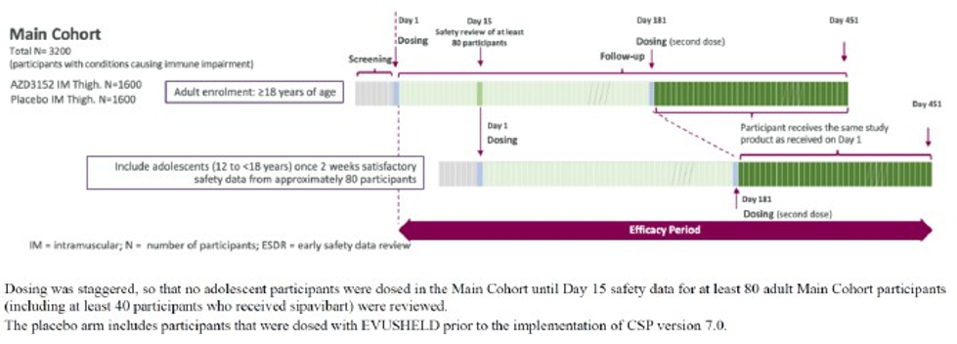
The trial enrolled a total of 3711 participants randomised 1:1 active:comparator. The participants were 12 years of age or older, had a negative RAT test prior to dosing and weight >40kg at screening. They had at least one risk factor for diminished immunity to COVID-19 including receiving immunosuppressive therapy (74.3%), having a haematological malignancy, or having a primary immunodeficiency. Pregnant women were excluded from the trial.
Participants received either:
- Kavigale 300mg IM in the thigh (active)
- Evusheld 600mg IM x2 in the thigh (comparator) or
- saline placebo (comparator).
A second dose of treatment was administered at day 181 if participants met prespecified criteria.
The Main Cohort initially used Evusheld as a comparator, but this was changed to saline placebo during the study. This means that the comparator arm includes both participants who received saline placebo as dose 1 and 2, and participants who received Evusheld (AZD7442) at dose 1 and placebo at dose 2.
The co-primary efficacy outcomes of SUPERNOVA were:
- prevention of symptomatic COVID-19 up to day 181 from infusion
- prevention of symptomatic COVID-19 due to matched variants up to day 361 from infusion.
Table 3: Patient disposition in the SUPERNOVA trial. AZD3152 is Kavigale and AZD7442 is Evusheld
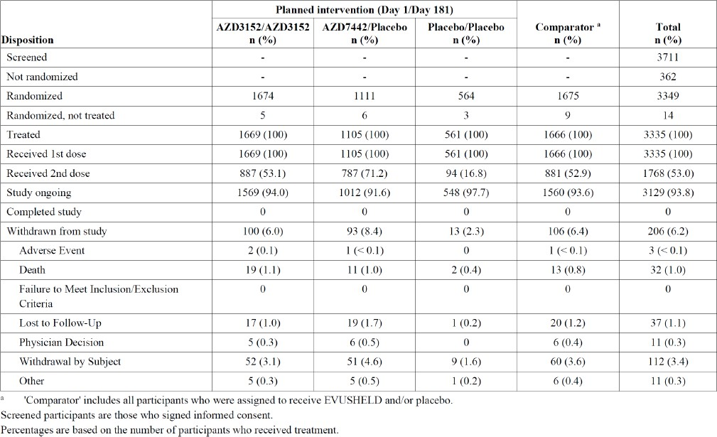
The study population had slightly more women (57%) than men (43%). There were few participants aged 12-18 years of age (n=15), and the majority (63%) were aged between 18 and 65 years of age.
Table 4: Baseline participant characteristics (AZD3152 is Kavigale and AZD7442 is Evusheld)
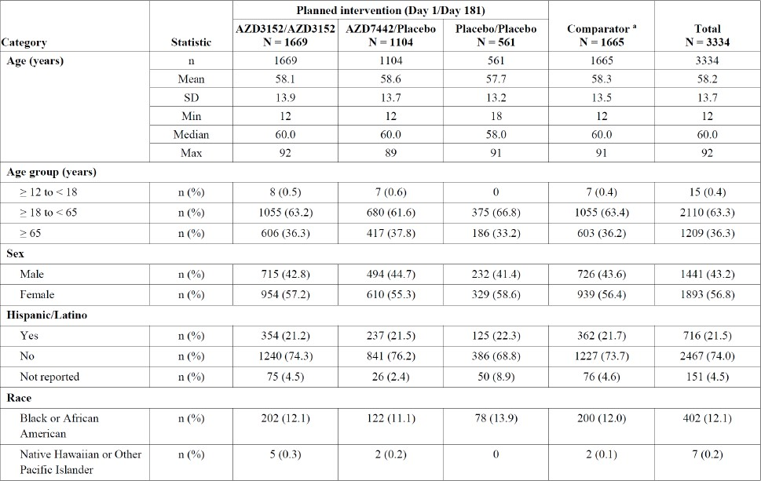
Figure 2: Incidence of symptomatic COVID-19 infection (any variant) in Kavigale (AZD3152) or comparator treatment to 361 days from first dose
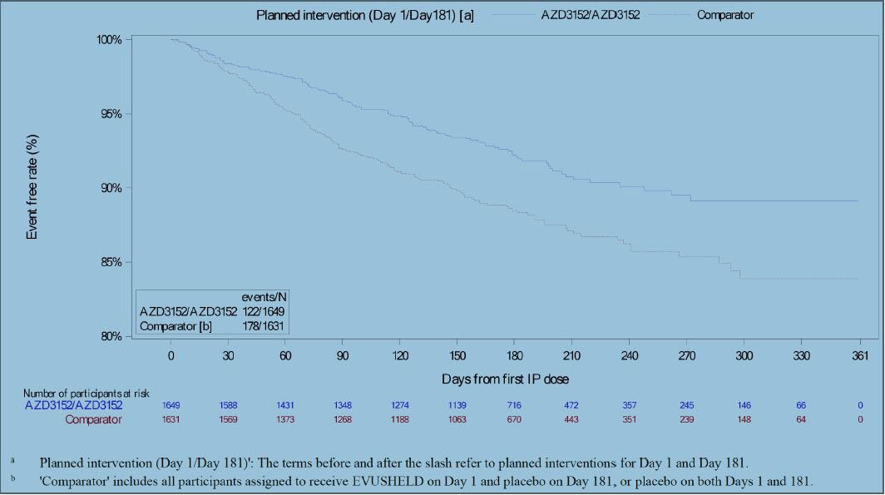
For any COVID-19 variant there were 122 (7.4%) infections in the Kavigale and 178 (10.9%) infections in the comparator group up to day 361 (Figure 2). This indicated a relative risk reduction of 34.9% (95%CI 17.8-48.4) from Kavigale, which was a highly significant difference from comparator treatment (p<0.001). The clinical evaluator has noted that the absolute risk reduction was only 3.5%.
There was a relative risk reduction for all the variants observed, but this was lower for JN.1 and F456L variants, for which statistical significance was not demonstrated (Table 5). The Delegate notes that this indicates Kavigale appears to have efficacy against current strains of COVID-19, but at a lower level than the BA.2 strain to which the product is targeted.
The clinical evaluator has noted that the efficacy of Kavigale was greater in participants who had received COVID-19 vaccine within 6 months of treatment, producing a relative risk reduction of 50% compared to 31.9% in the incidence of infections.
Additionally, the clinical evaluator has noted there was no difference in hospitalisation or severe COVID-19 rates between treatments (non-primary endpoints), but the study was not adequately powered to detect this.
Table 5: Incidence of symptomatic COVID-19 cases up to day 361 for specific variants
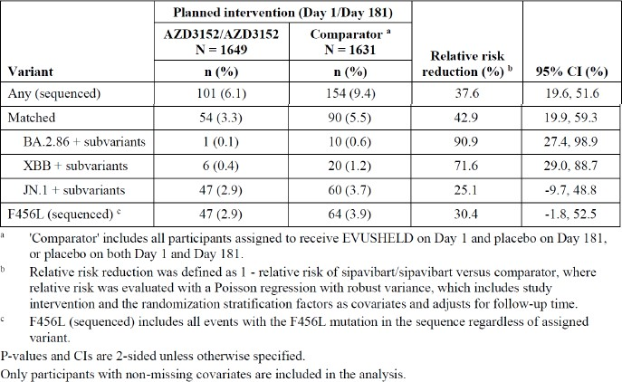

Safety evaluation
There were no pivotal studies examining safety in the proposed treatment group as a sole outcome.
Safety data was specifically examined in the Sentinel Safety Cohort of SUPERNOVA, the phase I element of this study that examined the PK and immunogenicity of Evusheld and Kavigale in healthy volunteers.
Safety data in the proposed patient population was provided by the SUPERNOVA Main Cohort.
Table 6: Duration of follow-up of patients in the Main Cohort of SUPERNOVA study
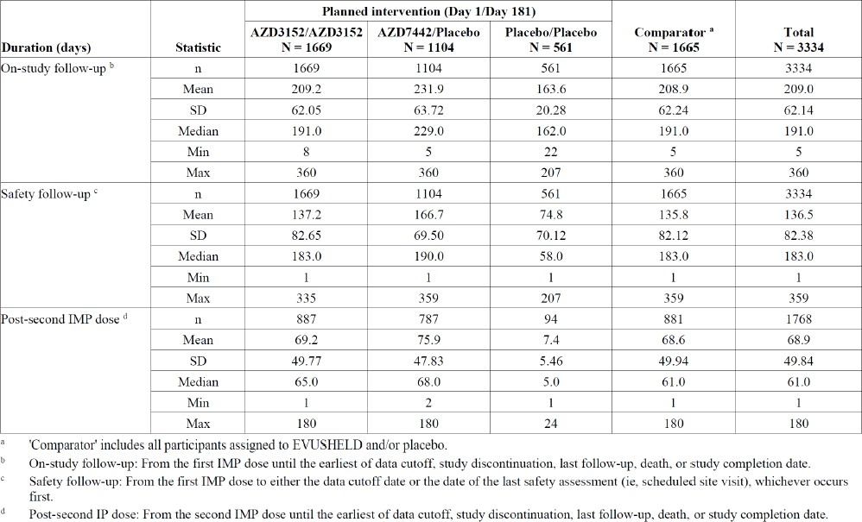
The rate of adverse events (AEs) in SUPERNOVA was similar for Kavigale as for comparator groups. AEs were reported in 49.9% of participants treated with Kavigale compared to 53.3% when treated with Evusheld and 48.1% when treated with placebo (Table 7).
Table 7: Overall summary of adverse events up to day 91 after first dose in SUPERNOVA Main Cohort
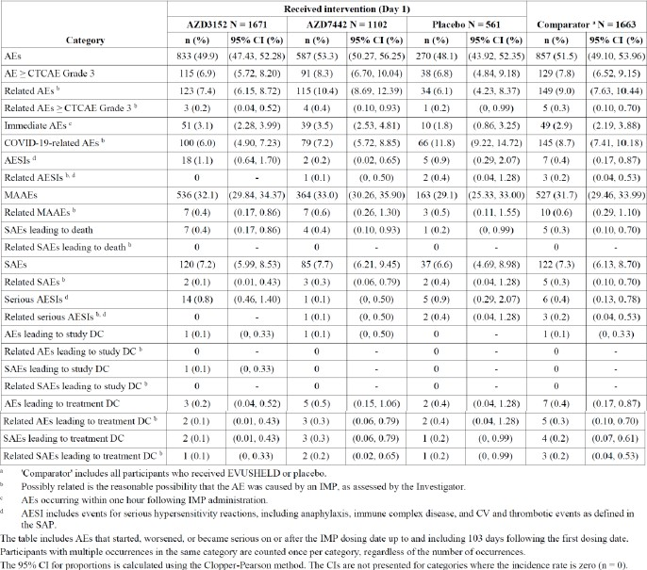
Serious AEs (SAEs) were reported in 7.2%, 7.7% and 6.6% of Kavigale, Evusheld and
placebo-treated patients respectively (Table 8). The most commonly reported SAE was pneumonia, which occurred in 0.6%, 0.5% and 0.2% of the Kavigale, Evusheld and placebo groups respectively.
There were 7 deaths (0.4%) in Kavigale treated patients, 4 (0.4%) among Evusheld treated patients and 1 in a placebo treated patient. None of the deaths was attributed to study treatment.
Table 8: Serious Adverse Events (SAEs) up to day 91 by preferred term in SUPERNOVA Main Cohort
In the SUPERNOVA Main Cohort, treatment emergent anti-drug antibodies (ADAs) were detected in 4 patients treated with two doses of Kavigale (in 1 patient who received 1 dose of Kavigale and 3 patients who received Evusheld).
Table 9: Rates of ADA detection and treatment-emergent ADAs in SUPERNOVA Main Cohort
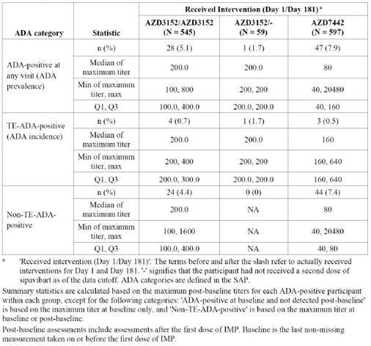
The clinical evaluator has noted the absence of safety information in children below the age of 12 years or pregnant women. The Delegate notes the small number of children aged 12-18 enrolled in the SUPERNOVA study, indicating a general lack of robust paediatric safety data.

Risk management plan evaluation
The summary of safety concerns and their associated risk monitoring and mitigation strategies are summarised in Table 9.
The TGA may request an updated Risk management plan (RMP) at any stage of a product's life cycle, during both the pre-approval and post-approval phases. Further information regarding the TGA’s risk management approach can be found in risk management plans for medicines and biologicals and the TGA's risk management approach. Information on the Australia-specific annex (ASA) can be found on the TGA website.
Table 10: Summary of safety concerns
Summary of safety concerns |  | Pharmacovigilance |  | Risk minimisation
 |  | Routine | Additional | Routine | Additional
Important identified risks | None | – | – | – | –
Important potential risks | None | – | – | – | –
Missing information | Use in pregnancy | ✓ | ✓* | ✓ | –
*PASS (D7000R00017)
The RMP evaluator noted the following.
- The summary of safety concerns in the ASA aligns with the EU-RMP and is satisfactory.
- Routine and additional pharmacovigilance activities are proposed. The additional pharmacovigilance activity is a PASS which will provide information regarding Missing Information ‘use in pregnancy’. The pharmacovigilance plan is acceptable.
- Routine risk minimisation activities only are proposed, which is adequate to manage the proposed safety concerns.

Risk-benefit analysis

Delegate’s considerations
Kavigale is a targeted antibody therapy for pre-exposure prophylaxis against COVID-19. This class of agents has been in use for several years but, as with vaccines, evolution of circulating COVID-19 strains has required new products to be formulated to maintain efficacy. This dossier has provided good evidence that Kavigale, at least in the period 2023-2024 that SUPERNOVA was conducted, provided protection against symptomatic COVID-19 disease in an immunosuppressed population. The trial did not provide evidence of a reduction in the severity of COVID-19 cases, but a lowered incidence of infection is a reasonable clinical endpoint. The Sponsor examined this across several strains of COVID-19 and there was protection against contemporary (e.g. JN1) strains.
Generally, Kavigale is well tolerated with the spectrum of adverse events reported consistent with antibody therapy, and experience with other products of this class.
The clinical evaluator has noted that the efficacy of Kavigale was higher in patients who had been vaccinated in the 6 months prior to SUPERNOVA than in those who had not. The relative risk reduction for vaccinated patients was 50.0 (95% CI 6.7-73.2) compared to 31.9 (95% CI 12.6-47.0). The clinical evaluator has proposed that this was due to a synergistic effect between COVID-19 infection and Kavigale.
The Delegate notes that COVID-19 vaccination independently reduces the incidence of COVID-19 infections and so it is not entirely surprising that the incidence of disease was lower in patients who received vaccination and Kavigale when compared to those treated with Kavigale alone.
This is a clinically additive effect, but the Delegate does not conclude that it implies a pharmacological synergy. Synergy implies that the effects of Kavigale and vaccination together were greater than the sum of the effects of each treatment alone, such as the synergy between penicillin and clavulanic acid. This doesn’t seem to be the case, and indeed the difference between vaccinated and non-vaccinated patients was not statistically significant.
The CE has raised concerns regarding the optimal timing of Kavigale treatment after COVID-19 vaccination. In SUPERNOVA patients had to have not received COVID-19 vaccine within 3 months of the first dose of Kavigale, which the Delegate concludes is a reasonable exclusion to baseline the trial population. A second dose of Kavigale could be given within 14 days of COVID-19 vaccination, and the CE proposes that this exclusion also be included in any approved labelling.
The Delegate notes that there was no requirement to be vaccinated prior to enrolment in SUPERNOVA. If the Sponsor had maintained a 3-month exclusion during the trial it would have made it very difficult for unvaccinated participants to get vaccinated, but a short exclusion period would be necessary to baseline adverse events (such as fatigue, headache, injection pain) which are common in both vaccination and Kavigale. There is no good evidence that administering Kavigale less than 14 days after vaccination reduces the efficacy of either treatment, or that it increases the rates of adverse events from that attendant on each treatment alone. Immunoglobulins and vaccines are often administered together, albeit at separate sites (e.g. measles vaccine and immunoglobulin for post-exposure prophylaxis).
The Delegate notes, however, that the trend to greater efficacy in vaccinated patients does highlight the importance of Kavigale (and passive immunity generally) not being used in place of vaccination but together with it. The Delegate notes that the labelling for Evusheld, a very similar product from the same Sponsor, contained a definitive statement to this effect in section 4.1 of the labelling:
Evusheld is no recommended as a substitute for vaccination in individuals for whom COVID-19 vaccination is recommended.
The Delegate notes that while SUPERNOVA was nominally a study in patients 12 years and older, only 15 patients between the ages of 12-18 were actually enrolled. This does not amount to a robust examination of the safety and efficacy of this age group. While the Delegate is not minded to exclude these patients from the Kavigale indication, the Delegate has concluded that the lack of data in this population should be outlined in the Prescribing Information.

Proposed action
The Delegate intends to approve Kavigale for the amended indication:
KAVIGALE is indicated for the pre-exposure prophylaxis of COVID-19 in adults and adolescents aged 12 years and older weighing at least 40 kg who are immunocompromised due to a medical condition or receipt of immunosuppressive medications or treatments.
KAVIGALE is not recommended as a substitute for vaccination in individuals for whom COVID-19 vaccination is recommended.
The PI will be amended from that provided in response to the round 2 clinical evaluation as follows:
- The statements identified by comment numbers RG1 and RG2 will be removed.
- The ‘Paediatric use’ statement will read:
The safety and efficacy of sipavibart in children <12 years of age has not been studied and no data is available. There is limited clinical trial evidence supporting the safety and efficacy of sipavibart in children 12-18 years of age due to the low number of trial participants in this age group (See SUPERNOVA study in Clinical Trials)

Assessment outcome
Based on a review of quality, safety, and efficacy, the TGA decided to register Kavigale for the following indication:
Kavigale is indicated for the pre-exposure prophylaxis of COVID-19 in adults and adolescents aged 12 years and older weighing at least 40 kg who are immunocompromised due to a medical condition or receipt of immunosuppressive medications or treatments.
Kavigale is not recommended as a substitute for vaccination in individuals for whom COVID-19 vaccination is recommended.

Specific conditions of registration
- Kavigale (sipavibart) is to be included in the Black Triangle Scheme. The PI and CMI for Kavigale must include the black triangle symbol and mandatory accompanying text for five years, which starts from the date of first supply of the product.
- The KAVIGALE EU-Risk Management Plan (RMP) (version 1.0 succession number 2.0, dated 8 October 2024, data lock point 29 March 2024), with Australia-Specific Annex (ASA) (version 1.0 succession number 2.0, dated 13 November 2024), included with submission PM-2024-03590-1-2, and any subsequent revisions, as agreed with the TGA will be implemented in Australia.
- An obligatory component of risk management plans is routine pharmacovigilance. Routine pharmacovigilance includes the submission of periodic safety update reports (PSURs).
  - Unless agreed separately between the supplier who is the recipient of the approval and the TGA, the first report must be submitted to TGA no later than 15 calendar months after the date of this approval letter. The subsequent reports must be submitted no less frequently than annually from the date of the first submitted report until the period covered by such reports is not less than three years from the date of this approval letter. The annual submission may be made up of two PSURs each covering six months. If the sponsor wishes, the six-monthly reports may be submitted separately as they become available.
  - If the product is approved in the EU during the three years period, reports can be provided in line with the published list of EU reference dates no less frequently than annually from the date of the first submitted report until the period covered by such reports is not less than three years from the date of this approval letter. The reports are to at least meet the requirements for PSURs as described in the European Medicines Agency’s Guideline on good pharmacovigilance practices (GVP) Module VII-periodic safety update report (Rev 1), Part VII.B Structures and processes. Note that submission of a PSUR does not constitute an application to vary the registration. Each report must be submitted within ninety calendar days of the data lock point for that report.
- Laboratory testing & compliance with Certified Product Details (CPD)
  - i. All batches of KAVIGALE sipavibart 300 mg in 2mL (150 mg/mL) solution for injection vial supplied in Australia must comply with the product details and specifications approved during evaluation and detailed in the Certified Product Details (CPD).
  - ii. When requested by the TGA, the Sponsor should be prepared to provide product samples, specified reference materials and documentary evidence to enable the TGA to conduct laboratory testing on the Product. Outcomes of laboratory testing are published biannually in the TGA Database of Laboratory Testing Results http://www.tga.gov.au/ws-labs-index and periodically in testing reports on the TGA website.
- Certified Product Details
  - The Certified Product Details (CPD), as described in Guidance 7: Certified Product Details of the Australian Regulatory Guidelines for Prescription Medicines (ARGPM), in PDF format, for the above products should be provided upon registration of these therapeutic goods. In addition, an updated CPD should be provided when changes to finished product specifications and test methods are approved in a Category 3 application or notified through a self-assessable change.
  - A template for preparation of CPD for biological prescription medicines can be obtained from the TGA website:
- [for the form] https://www.tga.gov.au/form/certified-product-details-cpd-biologicalprescription-medicines
- [for the CPD guidance] https://www.tga.gov.au/guidance-7-certified-product-details

Product Information and Consumer Medicine Information
For the most recent Product Information (PI) and Consumer Medicine Information (CMI), please refer to the TGA PI/CMI search facility.

Therapeutic Goods Administration
PO Box 100 Woden ACT 2606 Australia
Email: info@tga.gov.au Phone: 1800 020 653 Fax: 02 6203 1605
https://www.tga.gov.au

This is the original indication proposed by the sponsor when the TGA commenced the evaluation of this submission. It may differ to the final indication approved by the TGA and registered in the Australian Register of Therapeutic Goods.

