Australian Public Assessment Report for Alyftrek
  - Active ingredients: Vanzacaftor, tezacaftor, deutivacaftor
  - Sponsor: Vertex Pharmaceuticals Australia Pty Ltd
April 2026

About the Therapeutic Goods Administration (TGA)
- The Therapeutic Goods Administration (TGA) is part of the Australian Government Department of Health, Disability and Ageing and is responsible for regulating therapeutic goods, including medicines, medical devices, and biologicals.
- The TGA administers the Therapeutic Goods Act 1989 (the Act), applying a risk management approach designed to ensure therapeutic goods supplied in Australia meet acceptable standards of quality, safety, and efficacy.
- The work of the TGA is based on applying scientific and clinical expertise to decision-making, to ensure that the benefits to the Australian public outweigh any risks associated with the use of therapeutic goods.
- The TGA relies on the public, healthcare professionals and industry to report problems with therapeutic goods. The TGA investigates reports received to determine any necessary regulatory action.
- To report a problem with a therapeutic good, please see the information on the TGA website.

About AusPARs
- The Australian Public Assessment Report (AusPAR) provides information about the evaluation of a prescription medicine and the considerations that led the TGA to approve or not approve a prescription medicine submission. Further information can be found in Australian Public Assessment Report (AusPAR) guidance.
- AusPARs are prepared and published by the TGA.
- AusPARs are static documents that provide information that relates to a submission at a particular point in time. The publication of an AusPAR is an important part of the transparency of the TGA’s decision-making process.
- A new AusPAR may be provided to reflect changes to indications or major variations to a prescription medicine subject to evaluation by the TGA.

Copyright
© Commonwealth of Australia 2026.
This work is copyright. You may reproduce the whole or part of this work in unaltered form for your own personal use or, if you are part of an organisation, for internal use within your organisation, but only if you or your organisation do not use the reproduction for any commercial purpose and retain this copyright notice and all disclaimer notices as part of that reproduction. Apart from rights to use as permitted by the Copyright Act 1968 or allowed by this copyright notice, all other rights are reserved, and you are not allowed to reproduce the whole or any part of this work in any way (electronic or otherwise) without first being given specific written permission from the Commonwealth to do so. Requests and inquiries concerning reproduction and rights are to be sent to the TGA Copyright Officer, Therapeutic Goods Administration, PO Box 100, Woden ACT 2606 or emailed to <tga.copyright@tga.gov.au>.

Contents
List of abbreviations 4
Product submission 6
Submission details 6
Product background 7
Disease or condition 7
Current treatment options 11
Clinical rationale 12
Regulatory status 13
Australian regulatory status 13
International regulatory status 13
Registration timeline 15
Assessment overview 16
Quality evaluation summary 16
Nonclinical evaluation summary 17
Clinical evaluation summary 19
Summary of clinical studies 19
Pharmacology 19
Efficacy 25
Safety 35
Risk management plan 40
Risk-benefit analysis 41
Delegate’s considerations 41
Advisory Committee considerations 44
Assessment outcome 45
Specific conditions of registration 45
Product Information and Consumer Medicine Information 46

List of abbreviations
Abbreviation | Meaning
ACM | Advisory Committee on Medicines
AEs | Adverse events
AESI | Adverse events of special interest
ARTG | Australian Register of Therapeutic Goods
ASA | Australia-specific annex
AUC | Area under concentration curve
AUC_{0-24h} | Area under the concentration time curve from time zero to 24 hours
BMI | Body mass index
CF | Cystic fibrosis
CFQ-R | Cystic Fibrosis Questionnaire-Revised
CFRD | Cystic fibrosis related diabetes
CFTR | Cystic fibrosis transmembrane conductance regulator
CI | Confidence interval
CMI | Consumer Medicines Information
CNS | Central Nervous System
D-IVA | Deutivacaftor
DLP | Data lock point
ECG | Electrocardiogram
ELX | Elexacaftor
EMA | European Medicines Agency
E_{max} | Maximum effect attributable to the drug
E-R | Exposure-response
EU | European Union
FAS | Full analysis set
FDA | Food and Drug Administration
FDC | Fixed dose combination
FEV₁ | Forced expiratory volume in one second
F/F | Homozygous for F508del
F/G | Heterozygous for F508del and a gating mutation
F/RF | Heterozygous for F508del and a residual function mutation
FRT | Fischer Rat Thyroid
GI | Gastrointestinal
HBE | Human bronchial epithelial
IQR | Interquartile range
IVA | Ivacaftor
LS | Least squares
MBW | Multiple breath washout
PD | Pharmacodynamic(s)
PEx | Pulmonary exacerbation
PI | Product Information
PK | Pharmacokinetic(s)
PopPK | Population pharmacokinetic(s)
ppFEV1 | Percent predicted forced expiratory volume in 1 second
PSUR | Periodic safety update report
qd | Once daily
QTc | Corrected QT interval
QTcF | QT interval corrected using Fridericia’s formula
RD | Respiratory domain
RMP | Risk management plan
SAEs | Serious adverse events
SD | Standard deviation
SwCl | Sweat chloride
TEAEs | Treatment emergent adverse effects
TC | Triple combination
TEZ | Tezacaftor
TGA | Therapeutic Goods Administration
T_{max} | Time after administration of a drug when the maximum plasma concentration is reached
V/F | Apparent volume of distribution after oral dosing
VNZ | Vanzacaftor

Product submission

Submission details
Type of submissions: | New chemical entity and new fixed dose combination
Product name: | Alyftrek
Active ingredients: | Vanzacaftor (VNZ), tezacaftor (TEZ), deutivacaftor (D-IVA).
Decision: | Approved
Date of decision: | 14 November 2025
Date of entry onto ARTG: | 18 November 2025
ARTG numbers: | 452345, 452346
Black Triangle Scheme  for the current submission: | Yes
Sponsor’s name and address: | Vertex Pharmaceuticals Australia Pty Ltd  Suite 3, Level 3  601 Pacific Highway  St Leonards,  NSW 2065  Australia
Dose forms: | Alyftrek 10/50/125 - Each film-coated tablet contains 10 mg of vanzacaftor (as calcium), 50 mg of tezacaftor and 125 mg of deutivacaftor as a fixed-dose combination.  Alyftrek 4/20/50 - Each film-coated tablet contains 4 mg of vanzacaftor (as calcium), 20 mg of tezacaftor and 50 mg of deutivacaftor as a fixed-dose combination.
Containers: | Blister packs
Pack sizes: | Packs of 56 or 84 film-coated tablets
Approved therapeutic use for the current submission: | Alyftrek is indicated for the treatment of those who meet the diagnostic criteria for cystic fibrosis (CF) in people aged 6 years and older who have at least one mutation in the cystic fibrosis transmembrane conductance regulator (CFTR) gene that is responsive based on clinical or in vitro evidence (see section 5.1 Pharmacodynamic Properties, Table 4).
Route of administration: | Oral
Dosage: | Adults and paediatric patients aged 6 years and older -  Less than 40kg: Three tablets of vanzacaftor 4 mg/tezacaftor 20 mg/deutivacaftor 50 mg once daily  Equal to or over 40kg: Two tablets of vanzacaftor 10 mg/tezacaftor 50 mg/deutivacaftor 125 mg once daily.  For further information regarding dosage, such as dosage modifications to manage adverse reactions, refer to the Product Information (PI).
Pregnancy category: | Category B3  No adequate and well-controlled studies of Alyftrek in pregnant women have been conducted. Animal studies do not indicate direct or indirect harmful effects with respect to reproductive toxicity. Because animal reproduction studies are not always predictive of human response, Alyftrek should be used during pregnancy only if the potential benefits outweigh the potential risks. Vanzacaftor, tezacaftor, ivacaftor and/or their metabolites were shown to cross the placenta in laboratory animal species (rats and/or rabbits).  The use of any medicine during pregnancy requires careful consideration of both risks and benefits by the treating health professional. The pregnancy database must not be used as the sole basis of decision making in the use of medicines during pregnancy. The TGA does not provide advice on the use of medicines in pregnancy for specific cases. More information is available from obstetric drug information services in your state or territory.

Product background
This AusPAR describes the submission by Vertex Pharmaceuticals Australia Pty Ltd to register Alyftrek (vanzacaftor 4 mg/tezacaftor 20 mg/deutivacaftor 50 mg) and Alyftrek (vanzacaftor 10 mg/tezacaftor 50 mg/deutivacaftor 125 mg) film-coated tablets for the following proposed indication:
VNZ/TEZ/D-IVA is indicated for the treatment of cystic fibrosis (CF) in people aged 6 years and older who have at least one F508del mutation or another responsive mutation in the cystic fibrosis transmembrane conductance regulator (CFTR) gene.

Disease or condition
Cystic fibrosis (CF) is a life-limiting, autosomal recessive disorder caused by mutations in the CFTR (cystic fibrosis transmembrane conductance regulator) gene. These mutations impair the expression, function, or stability of the CFTR protein (Figure 1) - an ion channel responsible for regulating chloride and sodium transport across epithelial surfaces. The resulting ion transport dysfunction leads to thick, sticky secretions in multiple organs, including the lungs, pancreas, intestines, biliary tract, and reproductive system. Although CF affects multiple systems, progressive lung disease remains the leading cause of morbidity and mortality.
Over 2,000 CFTR mutations have been identified since the gene’s discovery in 1989. However, not all are disease-causing. As of September 2024, the CFTR2 database lists 1,167 variants: 1,085 associated with CF, 55 of uncertain significance, and 27 considered non-pathogenic. CF is caused by pathogenic mutations on both CFTR alleles. The severity of disease correlates with the degree of CFTR dysfunction. Mutations are classified into six functional classes (Figure 1) based on their molecular effects. Generally, classes I–III are associated with more severe disease, while classes IV–VI tend to result in milder phenotypes. Some mutations span multiple classes.
Figure 1. Classes of CFTR Mutations.
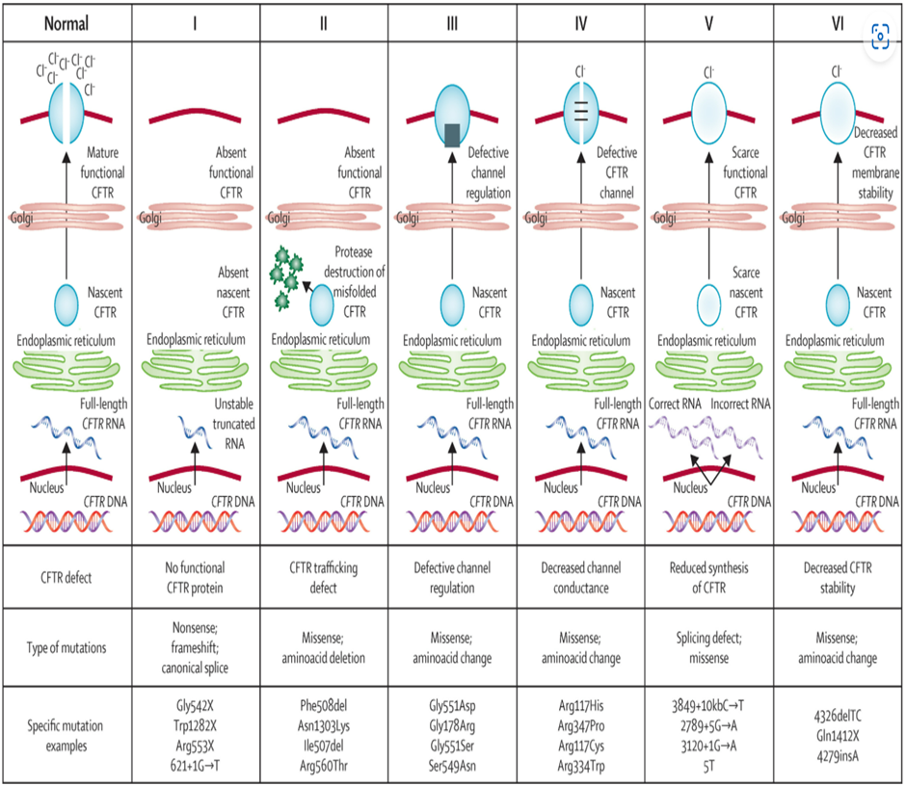
Mutations in the cystic fibrosis transmembrane conductance regulator (CFTR) gene can be divided into six classes. Class I mutations result in no protein production. Class II mutations (including the most prevalent, Phe508del) cause retention of a misfolded protein at the endoplasmic reticulum, and subsequent degradation in the proteasome. Class III mutations affect channel regulation, impairing channel opening (e.g., Gly551Asp). Class IV mutants show reduced conduction—i.e., decreased flow of ions (e.g., Arg117His). Class V mutations cause substantial reduction in mRNA or protein, or both, Class VI mutations cause substantial plasma membrane instability and include Phe508del when rescued by most correctors (rPhe508del).
The most common mutation, F508del, involves the deletion of three DNA bases encoding phenylalanine at position 508. Present in approximately 82% of European Caucasian CF patients, F508del severely disrupts CFTR protein folding and trafficking. As a result, little to no functional protein reaches the cell surface, and the small amount that does has impaired channel activity—leading to near-complete loss of chloride transport.,
In 2023, there were 3,798 people with CF registered with the Australian CF data registry, which is thought to represent > 95% of Australia’s CF population. The median age is 21.7 years, and 52.5% were male. Of the 3798 people in the registry, 2,212 (58%) were adults (18+ years) and 1,586 (42%) were children/adolescents (0-17years). The number of new diagnoses of notified to the registry in 2023 was 68, including 53 (78%) people diagnosed at less than one year of age, 6 aged 1-17 years and 9 cases who were at least 18 years of age.
There is no cure for CF. Existing treatment for CF falls into two categories:
- Supportive therapies to manage CF symptoms, complications, and comorbidities (e.g., antibiotics, mucolytics, pancreatic enzyme replacement, nutritional supplements). These target the downstream consequences and symptoms of the disease.
- CFTR modulators, which target the underlying cause of disease by improving the performance of the CFTR protein.
The clinical effects usually present in infancy with respiratory illness but can present in the neonatal period with meconium ileus and in milder cases can present with chronic respiratory illness in later childhood or even in adults. The life expectancy of CF patients has substantially lengthened over the past few decades, due to early diagnosis and improvements in symptomatic therapeutic regimens. In Australia, the median age of death in 2023 was 40.6 years of age including those who had a lung transplant and 48.3 years of age for excluding those who had a lung transplant. The median age of death continues to increase. Quality of life remains impacted by the disease limited, as these individuals are subjected to considerable clinical, psychosocial and economic burdens.⁵
Cystic fibrosis transmembrane conductance regulator (CFTR) modulators are a class of drugs that act by improving production, intracellular processing, and/or function of the defective CFTR protein. These orally bioavailable medicines target the underlying cause by restoring CFTR function and thereby modifying the course of disease in the lung and multiple other organs affected by CF. Although these drugs do not reverse the existing disease, they have been shown to provide substantial and durable clinical benefits in pulmonary and extra pulmonary endpoints for CF patients ≥ 2 years of age with at least one copy of F508del.,,, The ultimate goal of cystic fibrosis CFTR modulators is to reach normal CFTR function in people with CF, aiming to prevent disease progression.
There are three main types of CFTR modulators:
- Potentiators are drugs that can improve the function of a defective CFTR protein that is expressed at the cell surface. These drugs improve the conductance of chloride through the channel.
- Correctors help a defective CFTR protein to assume the correct shape so that if can avoid degradation within the cell and instead be transported to the surface membrane.
- Amplifiers increase the production of CFTR protein by the cell. These drugs are currently in development and are not marketed.
Ivacaftor (IVA) has efficacy for Class III & IV mutations, by restoring function to defective CFTR proteins on the cell surface membrane (potentiate). Vanzacaftor (VNZ), lumacaftor, tezacaftor (TEZ) and Elexacaftor (ELX) are designed for Class II mutations, to restore function (correct) to abnormal CFTR proteins allowing them to be transported to the cell surface membrane where ivacaftor, in combination, is used to potentiate the effect.
CFTR correctors and potentiators have distinct but complementary mechanisms of action. CFTR correctors work by increasing the quantity of CFTR delivered to the cell surface to enhance chloride transport. CFTR potentiators work by potentiating the channel open probability (channel gating activity) of CFTR at the cell surface to increase chloride transport. The broader spectrum of activity for ELX/TEZ/IVA when compared to TEZ/IVA or IVA is due to the ability of triple combination therapy to result in high levels of functional CFTR at the cell surface. Trikafta is comprised of two CFTR correctors, ELX and TEZ, and a CFTR potentiator, IVA.
In Australia (2023), there were 46% of people with CF who were F508del homozygous, and 44% who were F508del heterozygous. The most common variant alleles other than F508del in 2023 were G551D (4.0%), R117H (2.0%) and G542X (1.6%) respectively, with 8.4% being unknown. Based on the approved indications and the CFTR mutations, a total of 3,680 of the 3798 (97%) people with CF in the Australian registry had known eligibility status for CFTR. Of these 26% of children/adolescents (Including all < 1 year of age) and 7% of adults were ineligible.⁵
The efficacy of ELX/TEZ/IVA to treat CF in people aged ≥ 2 years age, with at least one copy of the F508del mutation has been established through multiple clinical studies, and data collected in the real-world setting.^{6,7,8,9,,,} Results have shown substantial improvements in lung function, CFTR function, and nutritional status in this population, and was generally safe and well tolerated with a low rate of treatment discontinuation. More recently ELX/TEZ/IVA has also been shown to have effectiveness for a range of non F508del mutations who do not have 2 class 1 mutations.
Sweat chloride levels correlate with CFTR function and clinical outcomes such as lung function, pancreatic health, nutrition, survival (Table 1). Genotype and CFTR dysfunction influence disease progression, noting there is wide variation of severity of CF even in those with the same mutations. The classic or typical form of CF is diagnosed if a patient demonstrates clinical disease in one or more organ systems and has elevated sweat chloride (≥60 mmol/L) and harbours 2 CF causing mutations.
Table 1. CFTR Function Correlation with clinical manifestations of CF Disease.
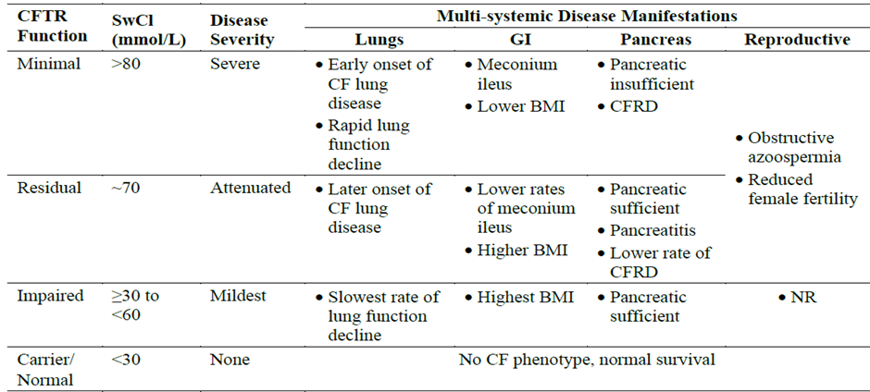BMI: body mass index; CF: cystic fibrosis; CFRD: cystic fibrosis related diabetes; GI: gastrointestinal; NR: not reported; SwCl: sweat chloride

Current treatment options
Currently, there are four approved CFTR modulators available in Australia (Table 2).
Table 2. CFTR modulators currently approved in Australia.
 | Mechanism of action | Approved indication
Trikafta  (elexacaftor/tezacaftor/ ivacaftor) | Combined action of CFTR correctors and potentiator | Trikafta is indicated for the treatment of those who meet the diagnostic criteria of cystic fibrosis (CF) in patients aged 2 years and older who have at least one mutation in the cystic fibrosis transmembrane conductance regulator (CFTR) gene that is responsive based on clinical or in vitro evidence.
Orkambi  (lumacaftor/ivacaftor) | Combined action of CFTR corrector and potentiator | Orkambi is indicated for the treatment of cystic fibrosis (CF) in patients aged 1 year and older who are homozygous for the F508del mutation in the CFTR gene.
Symdeko  (tezacaftor/ ivacaftor) | Combined action of CFTR corrector and potentiator | Symdeko is indicated for the treatment of patients with cystic fibrosis (CF) aged 6 years and older who are homozygous for the F508del mutation or who have at least one mutation in the cystic fibrosis transmembrane conductance regulator (CFTR) gene that is responsive to tezacaftor/ivacaftor based on in vitro data and/or clinical evidence (Refer to Table 1: list of responsive mutations.)
Kalydeco  (ivacaftor) | CFTR potentiator | Kalydeco is indicated for the treatment of cystic fibrosis (CF) in patients aged 1 month and older who have at least one mutation in the CFTR gene that is responsive to ivacaftor potentiation based on clinical and/or in vitro assay data (Refer Table 6: list of responsive mutations)

Other than CFTR modulators, the main existing treatment options for CF comprise drugs or physiotherapy for the co-morbidities of CF. Existing non-CFTR treatments for CF include therapies that manage the symptoms, complications, and comorbidities of the disease (e.g., antibiotics, mucolytics, pancreatic enzyme replacement therapy). Organ transplantation is used when required.

Clinical rationale
Despite the availability of elexacaftor/ tezacaftor/ ivacaftor, there remains an unmet need for even more highly effective CFTR modulators for people with CF. Treatment with elexacaftor/ tezacaftor/ ivacaftor improves CFTR function, but leaves a substantial subset of the total eligible population above the clinically meaningful sweat chloride (SwCl) thresholds of <60 mmol/L and <30 mmol/L. As demonstrated by natural history and pooled clinical study data with CFTR modulators, there is clinical benefit in bringing people with CF below these SwCl thresholds.
The goal of the next-generation, highly effective CFTR modulator vanzacaftor/ tezacaftor/ deutivacaftor (VNZ/TEZ/D-IVA) is to get more people with CF to SwCl levels <60 mmol/L, which is below the CF diagnostic threshold, and <30 mmol/L, which is consistent with normal/carrier levels and is associated with no disease. Restoration of CFTR function to normal/carrier levels in people with CF at an early age has the potential to restore normal physiology consistent with people who do not have CF and prevent the development and/or progression of manifestations of CF, including progressive lung function and decline.
Additionally, there are people with CF whose genotypes are not indicated for currently approved CFTR modulator treatment, as available CFTR modulators have not demonstrated in vitro responsiveness for these mutations or clinical efficacy. This latter population would receive significant clinical benefit from CFTR modulator treatment as they currently rely on symptomatic therapies that do not address the underlying cause of CF.
Lastly, there are approximately 6,000 people with CF who have discontinued ELX/TEZ/IVA for a variety of reasons and require another highly effective treatment option. Therefore, there is a need for additional highly effective CFTR modulator treatments that are indicated for the broadest range of CFTR genotypes and further restore CFTR function towards normal/carrier levels.
Vanzacaftor and tezacaftor are CFTR correctors that bind to different sites on the CFTR protein and have an additive effect in facilitating the cellular processing and trafficking of select mutant forms of CFTR (including F508del-CFTR) to increase the amount of CFTR protein delivered to the cell surface compared to either molecule alone. Deutivacaftor potentiates the channel open probability (or gating) of the CFTR protein at the cell surface. The combined effect of vanzacaftor, tezacaftor and deutivacaftor is increased quantity and function of CFTR at the cell surface, resulting in increased CFTR activity as measured both by CFTR mediated chloride transport in vitro and by sweat chloride in people with CF.
The sponsor states that - the triple combination (TC) of vanzacaftor/tezacaftor/deutivacaftor (VNZ/TEZ/D-IVA) is a next-generation, once daily, highly effective CFTR modulator regimen that delivers greater restoration of CFTR function than elexacaftor/tezacaftor/ivacaftor (ELX/TEZ/IVA), the current standard of care for people with CF. VNZ/TEZ/D-IVA also provides a medicine for people with CFTR mutations for which ELX/TEZ/IVA did not show activity and thus is not indicated, and for the people with CF who have discontinued ELX/TEZ/IVA.

Regulatory status

Australian regulatory status
This product is considered a new chemical entity for Australian regulatory purposes.
This is the initial application for vanzacaftor and deutivacaftor. Tezacaftor has previously been approved by the TGA as a component of Symdeko (tezacaftor/ivacaftor),, and Trikafta (elexacaftor, tezacaftor and ivacaftor).
Deutivacaftor is chemically similar to ivacaftor, the difference being the substitution of nine hydrogen atoms with deuterium atoms. Ivacaftor was approved by the TGA in 2013.
The justification for a fixed dose combination product was accepted by the TGA on 2nd May 2024.

International regulatory status
At the time the TGA considered this submission, a similar submission had been considered by other regulatory agencies. The following table (Table 3) summarises these submissions and provides the indications where approved.
Table 3. International regulatory status.
Region | Submission date | Status | Approved indications
United States of America (USA) | 02 May 2024 | Approved  20 December 2024 | Alyftrek is a combination of deutivacaftor, a CFTR potentiator, tezacaftor, and vanzacaftor indicated for the treatment of cystic fibrosis (CF) in patients aged 6 years and older who have at least one F508del mutation or another responsive mutation in the CFTR gene.
European Union (EU) | 29 April 2024 | Approved  30 June 2025 | Vanzacaftor/tezacaftor/deutivacaftor triple combination therapy is indicated for the treatment of cystic fibrosis (CF) in people aged 6 years and older who have at least 1 non-class I mutation in the CFTR gene.
Canada | 26 June 2024 | Approved  21 July 2025 | Vanzacaftor/tezacaftor/deutivacaftor triple combination therapy is indicated for the treatment of cystic fibrosis (CF) in people aged 6 years and older who have at least one F508del mutation or another responsive mutation in the cystic fibrosis transmembrane conductance regulator (CFTR) gene.
United  Kingdom (UK) | 19 May 2024 | Approved  07 March 2025 | Alyftrek is indicated for the treatment of cystic fibrosis (CF) in people aged 6 years and older who have at least one F508del mutation or another responsive mutation in the cystic fibrosis transmembrane conductance regulator (CFTR) gene.
Switzerland | 28 June 2024 | Under consideration  Expected November 2025 | Alyftrek is indicated for the treatment of cystic fibrosis (CF) in people aged 6 years and older who have at least one F508del mutation in the cystic fibrosis transmembrane conductance regulator (CFTR) gene or a mutation in the CFTR gene, for which clinical and/or in vitro data demonstrate a response, or a response is expected based on extrapolation.
New Zealand | 31 July 2024 | Under consideration  Expected Q4 2025 | Vanzacaftor/tezacaftor/deutivacaftor triple combination therapy is indicated for the treatment of cystic fibrosis (CF) in people aged 6 years and older who have at least one F508del mutation or another responsive mutation in the cystic fibrosis transmembrane conductance regulator (CFTR) gene.

Registration timeline
The following table captures the key steps and dates for this submission.
The active ingredient with its proposed indication was given orphan drug designation.
Table 4. Timeline for Submission PM-2024-02396-1-5
Description | Date
Designation (Orphan) | 28 May 2024
Submission dossier accepted and first round evaluation commenced | 2 September 2024
Evaluation completed (End of round 2) | 11 September 2025
Advisory committee meeting | 2/3 October 2025
Registration decision (Outcome) | 14 November 2025
Registration in the ARTG completed | 18 November 2025
Number of working days from submission dossier acceptance to registration decision* | 212
*Statutory timeframe for standard submissions is 255 working days

Assessment overview
A summary of the TGA’s assessment for this submission is provided below.

Quality evaluation summary
The vanzacaftor drug substance is manufactured by a chemical synthetic process. The in-process controls and process parameters are considered sufficient to manufacture vanzacaftor of appropriate quality. The drug substance is a crystalline powder, obtained as the hydrate Form D. It is practically insoluble in aqueous media and slightly soluble in polar organic media. It is considered as a BCS Class II substance (based on the solubility across the physiological pH range and the maximum daily dose). The proposed specification adequately controls the identity, potency, purity and chemical and physical properties of the drug substance relevant to the dose form.
The manufacture and quality control of tezacaftor is consistent with that approved by the TGA in Vertex’s other tezacaftor-containing product Symdeko.^{14,15} As such, it was not subject to further detailed evaluation in related to this submission.
Deutivacaftor is manufactured by a synthetic chemical process. Deutivacaftor is analogous to the previously approved active substance ivacaftor, differing only in deuteration of three methyl groups, and as such the manufacturing process was modelled on that of ivacaftor. The proposed specification adequately controls the identity, potency, purity and chemical and physical properties of the drug substance relevant to the dose form. The synthetic impurities are controlled to either ICH Q3A or where higher were adequately qualified.
The proposed drug product (FDC tablets) come in two strengths:
- 4/20/50 strength is purple, 7.35 mm diameter round-shaped tablet debossed with ‘V4’ on one side and plain on the other.
- 10/50/125 strength is purple, 15 mm × 7 mm capsule-shaped tablet debossed with ‘V10’ on one side and plain on the other.
The proposed presentations are Aclar/PVC/Al blister packs in sizes of 84 (4/20/50 mg) or 56 (10/50/125 mg) tablets, sufficient for 28 days of treatment.
Dosing is depending on the weight of the patient:
- Patients weighing less than 40 kg take three 4/20/50 tablets once daily,
- Patients weighing equal to or greater than 40 kg take two 10/50/125 tablets once daily. Maximum daily doses, based on the dosing for patients weighing ≥40 kg, are: 20 mg (vanzacaftor); 100 mg (tezacaftor); 250 mg (deutivacaftor).
Tablets should be swallowed whole and taken with fat-containing food. Examples of meals or snacks that contain fat are those prepared with butter or oils or those containing eggs, peanut butter, cheeses, nuts, whole milk, or meats. Food or drink containing grapefruit should be avoided.
In Australia, a shelf life of 24 months when stored below 30 ᵒC is supported. The expiry date can be found on the packaging.
The evaluator has stated the following: ‘Approval is recommended for registration of the proposed product from a pharmaceutical chemistry perspective’.

Nonclinical evaluation summary
Nonclinical evaluation contained studies with single-agent vanzacaftor, single-agent deutivacaftor and vanzacaftor, tezacaftor and deutivacaftor in combination. As well, previously evaluated data for tezacaftor in combination with ivacaftor and elexacaftor, and ivacaftor as single agent (for comparison with deutivacaftor metabolism, exposure and safety) were also provided.
Vanzacaftor is a next-generation CFTR corrector (increasing the amount of CFTR delivered to the cell surface). Deutivacaftor, a deuterated isotopolog of ivacaftor, is a CFTR potentiator (increasing chloride channel open probability) with a reduced rate of clearance and longer half-life than ivacaftor. Tezacaftor is an earlier generation CFTR corrector. Vanzacaftor, tezacaftor, and deutivacaftor bind to distinct sites on the CFTR protein, located away from the site of the protein defect caused by F508del or other responsive CFTR gene mutations. Vanzacaftor binds to the same site on CFTR as elexacaftor.
In vitro studies showed that vanzacaftor in combination with tezacaftor and deutivacaftor improved CFTR processing and trafficking in human bronchial epithelial (HBE) cells derived from CF donors homozygous for common CF-causing CFTR mutation F508del or heterozygous for F508del and a minimal function (MF) CFTR mutation (e.g. G542X, 3905insT and 1898+1G>A). The triple combination increased F508del-CFTR-mediated chloride⁻ transport in HBE cells to a greater extent than dual agent or single agent treatment. Deutivacaftor and ivacaftor exhibited similar potency and efficacy for CFTR potentiator activity (i.e. chloride current conductance) in HBE cells.
Pharmacological profiling of CFTR mutants for responsiveness to the triple combination was also conducted in vitro using the Fischer Rat Thyroid (FRT) epithelial cell expression system. A set of 475 CF-causing CFTR mutations were screened for triple combination changes in CFTR processing and trafficking (as cell surface expression of CFTR protein) and function (as chloride transport above baseline that is ≥10% of normal wild-type CFTR activity). Of the 475 CFTR mutants, 420 (plus F508del) were found to be responsive to treatment with vanzacaftor, tezacaftor and deutivacaftor. A large subset of these responsive mutants was also shown to be responsive to the Trikafta combination of elexacaftor, tezacaftor and deutivacaftor (374 CFTR mutants of the 421 responsive to vanzacaftor, tezacaftor and deutivacaftor), indicating overlapping pharmacological activity. A total of 54 CFTR mutations were identified as not responsive to vanzacaftor, tezacaftor and deutivacaftor.
There are some limitations to the FRT assays (namely the qualitative nature of the assay; variability of testing conditions and imprecise clarity on their clinical relevance; exclusion of mutants that cannot be expressed in these cells such as splice variants, or those with large deletions/ truncations of the CFTR gene sequence; arbitrary threshold criterion for responsiveness). This suggests that the assay is more useful as an initial screening tool for identifying candidate CFTR variants likely to be clinically responsive.
Overall, primary pharmacology data sufficiently demonstrate pharmacological activity of vanzacaftor, tezacaftor and deutivacaftor for the intended target/s and are supportive of the proposed use.
No notable off-target interactions were observed between vanzacaftor or deutivacaftor and a panel of various ion channels, receptors and transporters at clinically relevant concentrations. Safety pharmacology studies covering the CNS, cardiovascular and respiratory systems did not indicate any likely acute effects on CNS, cardiovascular or respiratory function in patients.
The pharmacokinetic profiles of vanzacaftor and deutivacaftor in the key laboratory animal species used in the nonclinical program (rats and dogs) was sufficiently similar to allow them to serve as appropriate models for the assessment of their toxicity in humans. Vanzacaftor and deutivacaftor both exhibited slow oral absorption, low to moderate oral bioavailability, very long plasma half-life (~11-20h; cf. human plasma half-life of 93h for vanzacaftor and 19h for deutivacaftor), very high plasma protein binding (>99%), metabolism chiefly by CYP3A4/5, and excretion predominantly via the faeces. Tissue distribution of ¹⁴C-vanzacaftor- and ¹⁴C-deutivacaftor-derived radioactivity was rapid and wide in rats, with only limited penetration of the blood-brain barrier and no melanin binding evident.
In vitro studies indicated no relevant inhibition of systemic CYPs or P-glycoprotein (P-gp) by vanzacaftor or deutivacaftor. As all three drug actives in Alyftrek are substrate of CYP 3A4, systemic exposures may be affected by strong 3A4 inducers and inhibitors. Vanzacaftor inhibited BCRP in vitro at clinically relevant concentrations. Deutivacaftor and M1-deutivacaftor weakly inhibited CYPs 2C8, 2C9 and 3A4/5 in vitro. Both are also substrates of P-gp and BCRP and may potentially inhibit BCRP at clinically relevant concentrations.
A low to moderate order of acute oral toxicity was evident for vanzacaftor in mice, rats and dogs and deutivacaftor in rats and dogs. Pivotal repeat-dose toxicity studies with vanzacaftor were conducted by the oral route in rats (6 months duration) and dogs (9 months). No target organs for toxicity were identified for vanzacaftor. At high relative exposures of vanzacaftor (and only in rats), body weight loss, haematological changes and clinical chemistry changes associated with liver damage, and microscopic changes in the stomach, liver, kidney, spleen and thymus, were observed
Pivotal repeat-dose toxicity studies with deutivacaftor were conducted by the oral route in rats (up to 13 weeks duration) and dogs (4 weeks). The major target organs for toxicity by deutivacaftor identified were the liver, gastrointestinal tract, lung, heart and kidney (similar to those observed with ivacaftor). Since deutivacaftor was not evaluated in young animals, the possibility of development of cataracts in young patients (observed with ivacaftor) cannot be ruled out. Toxicity findings in rat studies with deutivacaftor were similar to those observed previously with ivacaftor, suggesting a comparable toxicity profile.
Combination toxicity studies in rats with vanzacaftor, tezacaftor and ivacaftor (3 months duration), in which moderate systemic exposures (AUC) to vanzacaftor were achieved, revealed no novel toxicity cf. that for the individual components. Effects observed in this study were limited to decreases in triglyceride concentrations and changes in urine parameters. Previously reported effects of tezacaftor and ivacaftor were not seen in rats (dilated lacteals in the villi tips in the small intestine). The studies demonstrated adequate safety.
Vanzacaftor was not genotoxic in the standard battery of tests, and not carcinogenic in a 6-month study in transgenic mice. A 2-year carcinogenicity study with vanzacaftor in rats is currently underway, which should be submitted to the TGA once finalised and available.
Fertility indices were unaffected by vanzacaftor in male and female rats, and vanzacaftor was not teratogenic in either the rat or the rabbit. Decreases in gravid uterine weight and intrauterine survival, as well as small increases in the incidence of visceral malformations and skeletal variations were observed with vanzacaftor at the highest dose level tested in rabbits, but this is considered to be secondary to maternotoxicity rather than to represent direct reproductive toxicity by vanzacaftor. Animal findings for vanzacaftor, and previously for tezacaftor and ivacaftor, supports Pregnancy Category B3 as proposed by the sponsor.
The impurity specification is considered to be toxicologically acceptable.
The non-clinical evaluator stated, ‘There are no nonclinical objections to the registration of Alyftrek for the proposed indication’.

Clinical evaluation summary

Summary of clinical studies
The vanzacaftor/tezacaftor/deutivacaftor (VNZ/TEZ/D-IVA) clinical development program comprises 18 studies conducted in healthy volunteers and individuals with cystic fibrosis (CF) and includes:
- 11 Phase 1 studies evaluating safety, tolerability, and pharmacokinetics,
- 2 Phase 2 studies assessing preliminary efficacy and dose-ranging, and
- 5 Phase 3 studies designed to confirm efficacy and safety in broader CF populations.
Population Pharmacokinetics (PopPK) and Pharmacokinetic/ Pharmacodynamic (PKPD) studies were also included: the key analyses were S388 and T299.
The Phase 3 program includes two randomized, double-blind, active-controlled trials comparing VNZ/TEZ/D-IVA to the current standard of care (ELX/TEZ/IVA) over 52 weeks. These studies enrolled individuals aged ≥12 years with at least one F508del mutation or another mutation responsive to triple combination (TC) therapy, as defined by responsiveness to ELX/TEZ/IVA. Additionally, a 24-week open-label study was conducted in children aged 6 to 11 years to evaluate pharmacokinetics (PK), safety, tolerability, and efficacy. There are 2 further phase 3 studies that are ongoing.

Pharmacology
The molecular mechanisms of CFTR modulators have been well characterized. Vanzacaftor and tezacaftor bind to distinct sites on the CFTR protein, exerting additive effects that enhance the cellular processing and trafficking of select mutant CFTR forms, including F508del-CFTR. (Figure 2) This results in increased delivery of functional CFTR protein to the cell surface. Deutivacaftor potentiates the channel open probability (gating) of the CFTR protein at the cell surface. All three modulators bind to regions of the CFTR protein that are distinct from the F508del mutation site.
The combined allosteric effects of vanzacaftor, tezacaftor, and deutivacaftor lead to increased quantity and enhanced function of CFTR at the epithelial cell surface. This is reflected in improved CFTR-mediated chloride transport, the key biomarker of therapeutic efficacy in CFTR modulator therapy.
The clinical pharmacology of VNZ/TEZ/D-IVA was characterized using a combination of nonclinical and clinical studies evaluating VNZ and D-IVA monotherapy and the triple combinations of VNZ, TEZ, IVA, and/or D-IVA in healthy subjects and/or CF subjects. These data were further supported by prior nonclinical and clinical pharmacology experience with TEZ and IVA from previous development programs for IVA, TEZ/IVA, and ELX/TEZ/IVA.
Figure 2. Allosteric Effect of CFTR Modulators.
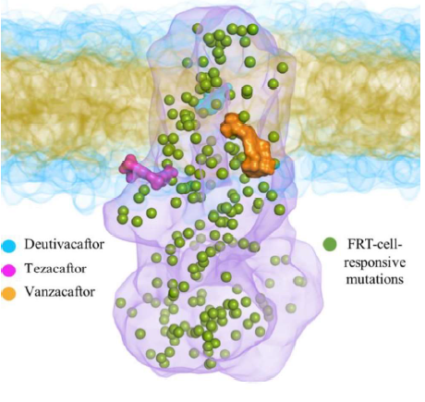

Pharmacokinetics (PK)
Table 5. Submitted pharmacokinetic studies
PK topic | Subtopic | Study ID | *
PK in healthy adults | General PK - Single dose | Study VX16-770-018 | *
PK in healthy adults | - Multi-dose | Study VX17-121-001 | *
PK in healthy adults |  | Study VX22-121-013 | *
PK in healthy adults | - Mass balance | Study VX20-121-004 | *
PK in healthy adults | - D-IVA PK | Study VX18-561-001 | *
PK in healthy adults | Bioequivalence † - Single dose | Study VX22-121-009 | *
PK in healthy adults |  | Study VX19-121-003 | *
PK in healthy adults |  | Study VX-21-121-005 | *
PK in healthy adults | Food effect | Study VX-21-121-005 | *
PK in special populations | Hepatic impairment | Study VX21-121-008 | *
PK interactions | VNZ, TEZ and D-IVA | Study VX21-121-006 | *
PK interactions | Itraconazole | Study VX21-121-007 | *
Population PK analyses | Target population | PopPK analysis S388 | §
* Indicates the primary PK aim of the study, † Bioequivalence of different formulations, § Subjects who would be eligible to receive the drug if approved for the proposed indication.
Sites and mechanism of absorption
Vanzacaftor (VNZ), tezacaftor (TEZ), and deutivacaftor (D-IVA) are administered orally as a fixed-dose combination tablet.
VNZ is absorbed slowly, with a median time to maximum plasma concentration (T_{max}) of 7.8 hours (range: 3.7–11.9 hours). TEZ and D-IVA are absorbed more rapidly, with median T_{max} values of 1.6 hours (range: 1.4–1.7 hours) and 3.7 hours (range: 2.7–11.4 hours), respectively.
In Study VX-21-121-005 exposure to VNZ and D-IVA were significantly increased in the fed state, whilst for TEZ exposure was similar in the fasted and fed states. With a high fat meal VNZ exposure was increased by six-fold and D-IVA exposure increased by five-fold. With a low-fat meal VNZ and D-IVA exposure were each increased by four-fold.
Bioavailability
Absolute bioavailability data were not provided. The sponsor stated that ‘low aqueous solubility of VNZ, TEZ, and D-IVA precludes the development of an intravenous formulation, making absolute bioavailability testing unfeasible’.
In Study VX17-121-001 at the 10 mg dose level, exposure was comparable between tablet and suspension formulations.
Comparison of the FDC tablet with separate tablets showed (Study VX19-121-003):
- VNZ: Exposure was approximately 50–55% lower with the FDC tablet.
- TEZ: Exposure was similar between formulations.
- D-IVA: Exposure was also similar.
In Study VX21-121-005, exposure and PK parameters were similar for VNZ at a 20 mg dose in the FDC and 10 mg dose in separate tablets. TEZ and D-IVA were similar at the same dose level.
In Study VX22-121-009, all three active ingredients were bioequivalent for the two tablet sizes.
In study VX17-121-00 when administered as single and multiple doses as a monotherapy, and in combination with TEZ/IVA, VX-121 exposure was approximately dose proportional.
Distribution
In vitro studies showed protein binding of VNZ, TEZ, D-IVA, and their major metabolites was high for VNZ (>99%), TEZ (approximately 99%), and D-IVA (>99%) in human plasma.
After oral administration of vanzacaftor/tezacaftor/deutivacaftor, the mean (SD) apparent volume of distribution of vanzacaftor, tezacaftor and deutivacaftor was 90.4 L (31.3), 123 L (43.2) and 157 L (47.3), respectively.
The values of V/F for VNZ, TEZ and D-IVA (apparent volumes of distribution after oral dosing) do not indicate preferential distribution to the tissues.
Metabolism
VNZ, TEZ, and D-IVA are extensively metabolized in humans, primarily by CYP3A4/5.
VNZ has no major circulating metabolite.
M1-TEZ has similar potency to that of TEZ and is considered pharmacologically active.
M2-TEZ is much less pharmacologically active than TEZ or M1-TEZ, and M5-TEZ is not considered pharmacologically active.
D-IVA and IVA have qualitatively similar metabolic pathways. M1-D-IVA has approximately one-fifth the potency of D-IVA and is considered pharmacologically active. M6-D-IVA is the other major metabolite of D-IVA and is not considered pharmacologically active.
Excretion
VNZ was mainly cleared by metabolism in humans. After a single oral dose of 20 mg (200 μCi) 14C-VNZ in healthy male subjects, the majority of radioactivity was recovered in faeces (91.6%) with minimal renal excretion.
Following oral administration of 14C-tezacaftor alone, the majority of the dose (72%) was excreted in the faeces (unchanged or as the M2-tezacaftor) and about 14% was recovered in urine.
Pre-clinical data indicate that the majority of 14C-deutivacaftor and 14C-ivacaftor are excreted in the faeces. The excretion of deutivacaftor in humans is expected to be similar to that of ivacaftor, based on similar structure and nonclinical data. After oral administration of 14C-ivacaftor alone, the majority of ivacaftor (87.8%) was eliminated in faeces after metabolic conversion. There was minimal elimination of ivacaftor and its metabolites in urine.
Based on popPK analyses, the shortest effective half-life based on CF subjects from Phase 3 Studies 102 and 103 for the VNZ, TEZ, and D-IVA was 19.2 hours, which supports once daily dosing of VNZ/TEZ/D-IVA.
Effect of intrinsic factors on pharmacokinetics
Body weight was determined to be the only intrinsic factor that had a clinically meaningful impact on the exposure of VNZ, TEZ, D-IVA, and their metabolites for people with CF weighing <40 kg With the proposed dosing regimen including a lower dose for people with CF <40 kg, exposures of VNZ, TEZ, M1-TEZ, and D-IVA in paediatric (6-11 years of age) and adolescent (12-17 years of age) subjects are generally within the range of exposures seen in subjects ≥18 years of age.
The majority of VNZ is excreted from the body in faeces after oral administration and is primarily metabolized by CYP3A4/5. Thus, hepatic metabolism is expected to be an important route of elimination for VNZ. In study VX21-121-008 clearance of VNZ was increased in subjects with moderate hepatic impairment compared to healthy subjects. There was no significant impact of moderate hepatic impairment on TEZ exposures. Clearance of D-IVA was increased in subjects with moderate hepatic impairment compared to healthy subjects.
VNZ, TEZ, and D-IVA PK were similar in subjects with mild and moderate renal impairment relative to those with normal renal function.
Extrinsic factors
VNZ, TEZ, and D-IVA are all extensively metabolized by CYP3A. Therefore, VNZ, TEZ, and D-IVA exposures are expected to be reduced by concomitant CYP3A inducers and increased by concomitant CYP3A inhibitors.
VNZ/TEZ/D-IVA is not expected to impact the efficacy or safety of hormonal contraceptives
Co-administration of VNZ/TEZ/D-IVA may increase systemic exposure of medicinal products that are substrates of P-gp, (e.g. Digoxin) which may increase or prolong their therapeutic effect and adverse reactions.
PK interactions between VNZ, TEZ, and D-IVA
Following multiple doses of VNZ, TEZ, and D-IVA administered in TC, exposures of VNZ, TEZ, D-IVA and their respective metabolites were all increased compared to administration of multiple doses of VNZ, TEZ and D-IVA as monotherapy but not to a clinically meaningful extent.
Population PK data: PopPK analysis S388
This was a population PK analysis of VNZ and D-IVA to support dose selection for patients aged 6 years through 11 years with cystic fibrosis receiving VNZ/ TEZ/ D-IVA in combination therapy.
Objectives of this analysis were:
- to characterize the PK disposition of VNZ and D-IVA in subjects 6 years and older using population methodology,
- to quantify the source of variability,
- to simulate the prospective VNZ/TEZ/D-IVA dosing regimen for CF subjects 6 to 11 years of age,
- to summarize predicted area under the curve (AUC) from the time of dosing (0 h) to 24h post dose (AUC_{0-24h}) exposures for VNZ and D-IVA,
- to simulate exposures of VNZ and D-IVA for different dosing regimens to inform dosing and/or weight bounds for subjects 6 through 11 years of age in Part B1 of Study VX21-121-105.
Model predicted exposures were simulated for the ≥6 to <12 years age group using the proposed dosing for VNZ and D-IVA. PopPK analyses identified weight as the key covariate having a clinically meaningful impact on VNZ, TEZ, and D-IVA disposition and informed dose selection for the 6- through 11-year-old paediatric population. Exposure at different dose levels was simulated over the expected weight bands. 50% or 60% of the adult dose provided the optimal exposures for VNZ and for D-IVA.
Thus, the following are the recommended does:
- People with CF ≥6 years of age weighing ≥40 kg: VNZ 20 mg qd/TEZ 100 mg qd/D-IVA 250 mg qd
- People with CF ≥6 years of age weighing <40 kg: VNZ 12 mg qd/TEZ 60 mg qd/D-IVA 150 mg qd

Pharmacodynamics (PD)
Sweat chloride (SwCl) is a clinically meaningful and sensitive endpoint that provides a direct, clinical measure of the extent of CFTR function, which is the fundamental underlying cause of abnormal physiology and clinical outcomes of CF. Sweat chloride is the most proximal measurement of CFTR function. Lower concentrations of sweat chloride are associated with reduced mortality and improved clinical outcomes, including a reduced rate of lung function decline, lower rates of lung transplantations, and better nutritional and growth parameters.,
Table 6. Submitted pharmacodynamic studies.
PD topic | Subtopic | Study ID
Primary Pharmacology | Effect on FEV1 | Study VX17-121-001
Primary Pharmacology |  | Study VX18-121-001
Primary Pharmacology | Effect on SwCl | Study VX18-121-101
Secondary Pharmacology | Effect on QTcF | Study VX22-121-013
Population PD and PK-PD analyses | Target population | ER Study T299

Primary pharmacology
In Study VX17-121-001, for VNZ, in Part D in subjects with CF, the change (95% CI) in ppFEV₁ was 8.3 (2.8 to 13.8) % in the active treatment group and -2.0 (-12.9 to 8.9) % in the placebo.
In Study VX18-121-101 Part 1, which examined the doses for VNZ of 5 mg, 10 mg and 20 mg in combination with TEZ 100 mg and D-IVA 150 mg once daily, the absolute change in ppFEV1 plateaued at the VNZ 10 mg dose level. The LS mean difference from placebo (95% CI) change from baseline in ppFEV1 was 2.7 (-5.9 to 11.3) % for VNZ 5 mg, 12.3 (4.9 to 19.6) % for VNZ 10 mg and 7.8 (0.4 to 15.2) % for VNZ 20 mg.
There was also a significant improvement in sweat chloride (SwCL) for all the VNZ dose levels, with the greatest improvement at the 20 mg dose level. The LS mean difference from placebo (95% CI) change from baseline in SwCL was -45.1 (-58.1 to -32.2) mmol/L for VNZ 5 mg, -48.1 (59.2 to -37.0) mmol/L for VNZ 10 mg and -51.8 (-63.2 to -40.1) mmol/L for VNZ 20 mg.
The benefits in both these measures were apparent by Day 15 of treatment.
Secondary pharmacology
In study VX22-121-013, a lack of QTc effect in healthy subjects was demonstrated at exposures corresponding up to 6-fold over those observed with the VNZ maximum recommended dose, and doses up to 3 times over the TEZ and D-IVA maximum recommended doses.
Relationship between drug concentration and pharmacodynamic effects
The exposure-response (E-R) relationship was explored in E-R analysis T299. The Phase 3 D-IVA E-R analyses were performed in the context of the TC and therefore incorporated the impact of any PK interactions between VNZ, TEZ, and D-IVA. The objectives were to:
- characterize the PKPD relationship of VNZ for the longitudinal pharmacodynamic endpoint SwCl,
- characterize the PKPD relationship of VNZ for the longitudinal clinical endpoint ppFEV1,
- simulate the dose-response relationship for VNZ in support of Phase 3 dose justification,
- evaluate the clinical impact and clinical significance level of covariates included in the VNZ population PK model, using the PKPD model,
- evaluate graphically the impact of steady-state exposures of TEZ and D-IVA on VNZ E_{max}.
Results:
- The E-R relationships for ppFEV1 and SwCl in the studied genotypes were well described by the PKPD models.
- The vanzacaftor exposures from the Phase 3 studies were on the plateau region of the E-R relationship for ppFEV1 and SwCl change from ELX/TEZ/IVA baseline.
- Vanzacaftor doses of 5, 10, and 20 mg daily administered with TEZ/D-IVA were associated with no additional increase in ppFEV1 beyond the increases achieved with ELX/TEZ/IVA treatment during the run-in period.
- The vanzacaftor 20 mg dose administered in combination with TEZ/D-IVA was associated with a reduction of up to 7.11 mmol/L in SwCl beyond the reduction achieved by ELX/TEZ/IVA, with the magnitude of the reduction depending on the genotype.
- The SwCl change from ELX/TEZ/IVA baseline for 20 mg vanzacaftor administered with TEZ/D-IVA was near maximal.
- The Emax for the SwCl response trended towards larger response with higher D-IVA exposures.
The E-R relationships for ppFEV1 and SwCl in the studied genotypes were well described by the PK/PD models and consistent with Phase 2 results.
The pharmacodynamic studies have demonstrated a dose-effect relationship and support the proposed dosing for VNZ/ TEZ/ D-IVA.

Efficacy

Pivotal trial design
The initial studies to establish the efficacy of the currently approved modulators were placebo-controlled studies. Placebo-controlled trials might no longer be ethical as modulator therapy has become the standard of care in many countries. New treatment can be investigated on top of another modulator, but additional improvements in lung function, as measured by FEV1, might not be possible due to the ceiling effects of both irreversible lung damage and achieving the physiological maximum lung function
The currently conducted pivotal trials used a non-inferiority design by showing an effect on the FEV1 using ELX/TEZ/IVA as comparator. Sweat chloride (SwCl) level was included as key secondary endpoint.
The evaluable efficacy data were provided in two pivotal studies (VX20-121-102, VX20-121-103 and three other efficacy studies (VX18-121-101, VX18-561-101, VX21-121-105)

Studies VX20-121–102 (Study 102) and VX20-121-103 (Study 103)
Study 102 and 103 were multicentre, randomised, active-controlled, phase 3 trials, evaluating the efficacy and safety of VNZ/TEZ/D-IVA in CF subjects ≥12 years of age. The active control was ELX/TEZ/IVA given this is the standard of care for people with CF and ≥1 ELX/TEZ/IVA responsive mutation.
Study 102 enrolled individuals with cystic fibrosis and a F/MF genotype [heterozygous for F508del and a minimal function mutation (F/MF). Study 103 enrolled individuals with cystic fibrosis with F508del-F508del (F/F), F508del-residual function (F/RF), F508del-gating, (F/G) or elexacaftor–tezacaftor– ivacaftor-responsive-non-F508del (TCR/non-F) genotypes. Study design was otherwise identical.
Study design
Participants were ≥12 years of age with a confirmed diagnosis of cystic fibrosis with eligible genotypes and stable disease. FEV1 % predicted at screening was 40–80% for those not on elexacaftor–tezacaftor–ivacaftor, or 40–90% for those who were receiving elexacaftor–tezacaftor–ivacaftor. The FEV 1 criteria aimed to enrol subjects with mild to moderate lung disease.
There was a 4-week run-in period, during which time, all participants received elexacaftor 200 mg once daily, tezacaftor 100 mg once daily, and ivacaftor 150 mg once every 12 h as two fixed-dose combination tablets in the morning and one ivacaftor tablet in the evening. Participants were then randomly assigned (1:1) to vanzacaftor–tezacaftor– deutivacaftor (20mg, `99mg, 250mg once daily) or continue elexacaftor–tezacaftor–ivacaftor for 52-week treatment period, after which participants could participate in an open-label extension study in which all participants received open-label vanzacaftor–tezacaftor–deutivacaftor, regardless of randomly assigned treatment (Figure 3).
Figure 3. Phase 3 Study Design: Studies 102 and 103.
D-IVA: deutivacaftor; ELX: elexacaftor; IVA: ivacaftor; TEZ: tezacaftor; VNZ: vanzacaftor
Randomisation was stratified on the basis of age (at screening: <18 years vs ≥18 years), FEV1 % predicted (on day –14: <70 percentage points vs ≥70 percentage points), sweat chloride concentration (on day –14: <30 mmol/L vs ≥30 mmol/L), previous CFTR modulator use (yes vs no), and, additionally for Trial VX20-121-103, by genotype group (F508del-F508del vs F508del-residual function vs F508del-gating vs elexacaftor–tezacaftor–ivacaftor-responsive-non-F508del genotypes).
The primary and key secondary efficacy endpoints were identical for study 102 and 103 and are shown in Table 7. The primary efficacy variable is the absolute change from baseline in ppFEV1 through Week 24 (estimated by averaging Weeks 16 and 24).
The study was designed as a non-inferiority study with the criterion for non-inferiority being a -3% difference in the absolute change in ppFEV1 through Week 24, innovator-reference. The non inferiority margin of -3.0 percentage points was selected based on FDA and EMA guidance.
Hypothesis tests were performed using a mixed effects model for repeated measures (MMRM). The model included fixed categorical effects for treatment, visit, age at screening, and treatment-by-visit interaction, with baseline ppFEV1 and baseline SwCl as continuous covariates. The models were estimated using restricted maximum likelihood. Multiplicity was addressed by a hierarchical testing procedure to control the overall type I error at an alpha of 0.05.
Key secondary endpoints were tested for superiority in the following hierarchical testing order: absolute change from baseline through week 24 in SwCl, proportion of participants with SwCl below 60 mmol/L (pooled from both trials), and proportion of participants with SwCl below 30 mmol/L (pooled trials) through week 24. Other secondary endpoints were not included in the multiplicity-controlled testing hierarchy.
Table 7. Studies 102 and 103: Efficacy Endpoints.
Primary endpoint | Absolute change from baseline in ppFEV1 through Week 24
Key secondary endpoints | Absolute change from baseline in SwCl through Week 24  Proportion of subjects with SwCl <60 mmol/L through Week 24 (pooled with data from Studies 102 and 103)  Proportion of subjects with SwCl <30 mmol/L through Week 24 (pooled with data from Studies 102 and 103)
Other secondary endpoints | Number of PEx through Week 52  Absolute change from baseline in CFQ-R RD score through Week 24  Absolute change from baseline in ppFEV1 through Week 52  Absolute change from baseline in SwCl through Week 52  Proportion of subjects with SwCl <60 mmol/L through Week 24  Proportion of subjects with SwCl <30 mmol/L through Week 24
CFQ-R: Cystic Fibrosis Questionnaire-Revised; PEx: pulmonary exacerbation; ppFEV1: percent predicted forced expiratory volume in 1 second; RD: respiratory domain; SwCl: sweat chloride
Results
In Study 102, 488 individuals were screened, of whom 435 entered the 4-week run-in period and subsequently 37 discontinued the run-in period and were excluded from analysis. Hence, 398 participants were randomly assigned to either elexacaftor–tezacaftor–ivacaftor (n=202) or vanzacaftor–tezacaftor–deutivacaftor (n=196), received at least one dose of study drug, and had the intended CTFR genotype (full analysis set). Of these 92% in both groups completed treatment.
In study 103, 699 individuals were screened, of whom 597 entered the 4-week run-in period, and subsequently 24 discontinued the run-in period and were excluded from analysis. Hence, 573 participants were randomly assigned to either elexacaftor–tezacaftor–ivacaftor (n=289) or vanzacaftor–tezacaftor–deutivacaftor (n=284), received at least one dose of study drug, and had the intended CTFR genotypes (full analysis set). Of these 94.5% in the ELX/TEZ/IVA group and 91.2% in the VNZ/TEZ/D-IVA group completed treatment.
Subject Demographics and Baseline Characteristics, Studies 102 and 103
Baseline demographic and baseline characteristics for Studies 102 and 103 are outlined in Table 8. In both studies, there was less than 15% of subjects aged 12 years, and up to 18 years of age at screening and only 2 subjects aged over 65 years (Table 8).
The median FEV1% predicted was similar across groups and the two studies, at approximately 67%. Almost half of all subjects had ppFEV1 ≥70%. Median sweat chloride concentrations were reduced in both studies, with lower concentrations in study 103 (~ 10 mmol/L) compared to study 102, (42.8 mmol/L vs 53.9 mmol/L) and about a quarter of subjects in study 103 having sweat chloride concentration < 30 mmol/L compared to 9% in study 102. The BMI was 22-23 kg/m² across the groups (Table 8). All (study 102) or most (study 103) had a least one F508del mutation. Only 42 subjects (7.3%) had a TCR/non-F genotype. Across both trials, most subjects had received prior CFTR treatment with 734 (76%) of 971 participants having previously received commercial elexacaftor–tezacaftor– ivacaftor, with lower frequency in study 103 (67.8%) compared to study 102 (86.7%).
Treatment groups in both trials were well matched at baseline. After trial completion, 336 (84%) participants from Trial VX20-121-102 and 486 (85%) participants in Trial VX20-121-103 enrolled in an open-label study evaluating long-term treatment with vanzacaftor–tezacaftor–deutivacaftor.
Table 8. Baseline demographic and clinical characteristics, full analysis set.
Characteristic | Study 102 |  | Study 103
Characteristic | ELX/TEZ/IVA  N = 202 | VNZ/TEZ/D-IVA  N = 196 | ELX/TEZ/IVA  N = 289 | VNZ/TEZ/D-IVA  N = 284
Age at Day 1 (years)  n  Mean (SD) | 202  30.9 (11.4) | 196  30.8 (10.5) | 289  34.0 (12.4) | 284  33.3 (12.6)
Age at Screening Visit, n (%)  ≥12 to <18 years  ≥18 years | 31 (15.3)  171 (84.7) | 26 (13.3)  170 (86.7) | 38 (13.1)  251 (86.9) | 41 (14.4)  243 (85.6)
Genotype group, n (%)  F/MF  F/F  F/G  F/RF  TCR/non-F | 202 (100)  0  0  0  0 | 196 (100)  0  0  0  0 | 0  224 (77.5)  20 (6.9)  23 (8.0)  22 (7.6) |  | 0  222 (78.2)  19 (6.7)  23 (8.1)  20 (7.0)
Weight (kg)  Mean (SD) | 64.54 (13.75) | 65.08 (13.32) | 65.05 (13.35) |  | 66.58 (13.98)
BMI (kg/m2)  Mean (SD) | 23.03 (3.85) | 22.71 (3.40) | 22.92 (3.27) |  | 23.27 (4.02)
ppFEV1 category at Day -14ª, n (%)  <70 percentage points  ≥70 percentage points | 106 (52.5)  96 (47.5) | 105 (53.6)  91 (46.4) | 166 (57.4)  123 (42.6) |  | 161 (56.7)  123 (43.3)
ppFEV1 (%) at baseline, n (%)  Mean (SD) | 67.2 (14.6) | 67.0 (15.3) | 66.4 (14.9) |  | 67.2 (14.6)
ppFEV1 category at baseline, n (%)  <40 percentage points  ≥40 to <70 percentage points  ≥70 to ≤90 percentage points  >90 percentage points  Missing | 3 (1.5)  111 (55.0)  79 (39.1)  8 (4.0)  1 (0.5) | 6 (3.1)  95 (48.5)  85 (43.4)  7 (3.6)  3 (1.5) | 7 (2.4)  160 (55.4)  107 (37.0)  12 (4.2)  3 (1.0) |  | 5 (1.8)  149 (52.5)  112 (39.4)  13 (4.6)  5 (1.8)
SwCl (mmol/L) at baseline  Mean (SD) | 54.3 (18.2) | 53.6 (17.0) | 42.1 (17.9) |  | 43.4 (18.5)
SwCl category at baseline, n (%)  <30 mmol/L  ≥30 to <60 mmol/L  ≥60 mmol/L  Missing | 19 (9.4)  105 (52.0)  77 (38.1)  1 (0.5) | 17 (8.7)  114 (58.2)  63 (32.1)  2 (1.0) | 80 (27.7)  154 (53.3)  48 (16.6)  7 (2.4) |  | 72 (25.4)  158 (55.6)  52 (18.3)  2 (0.7)
CFQ-R RD (points) at baseline  Mean (SD) | 82.9 (15.7) | 85.8 (14.7) | 85.6 (13.2) |  | 85.7 (13.2)
BMI: body mass index; CFQ-R RD: Cystic Fibrosis Questionnaire-Revised respiratory domain; FAS: Full Analysis Set; IVA: ivacaftor; max: maximum value; min: minimum value; n: size of subsample; N: total sample size; ppFEV1: percent predicted FEV 1 second; SwCl: sweat chloride; TCR/non-F: heterozygous for a triple combination responsive mutation and no F508del mutation

Efficacy: Studies 102 and 103
Primary efficacy outcome (Table 9)
Non-inferiority was shown in study 102, with the least squares mean absolute change in FEV1 % predicted from baseline through week 24 was 0·5 (SE 0·3) percentage points in the vanzacaftor– tezacaftor–deutivacaftor group versus 0·3 (0·3) percentage points in the elexacaftor–tezacaftor–ivacaftor group (least squares mean treatment difference of 0·2 percentage points [95% CI –0·7 to 1·1]; one-sided p<0·0001). There was greater efficacy for VNZ/ TEZ/ D-IVA in the subgroup of subjects with SwCl <30 mmol/L at baseline, but no other subgroup effects.
Non-inferiority was shown in study 102, with the least squares mean absolute change in FEV1 % predicted from baseline through week 24 was 0·2 (SE 0·3) percentage points in the vanzacaftor–tezacaftor– deutivacaftor group versus 0·0 (0·2) percentage points in the elexacaftor–tezacaftor–ivacaftor group (least squares mean treatment difference of 0·2 percentage points [95% CI –0·5 to 0·9]; one-sided p<0·0001) There were no subgroup effects for age, baseline ppFEV1 or baseline SwCl, and the response was similar for the different genotype groups.
Key secondary efficacy outcomes
Superiority was demonstrated for the key secondary efficacy endpoints in both studies (Table 9).
- For the absolute change from baseline in SwCl through Week 24
  - In study 102, LS mean difference (95% CI), VNZ/ TEZ/ D-IVA - ELX/ TEZ/ IVA, was -8.4 (-10.5 to -6.3) mmol/L, p-value <0.0001.
  - In study 103, LS mean difference (95% CI), VNZ/ TEZ/ D-IVA - ELX/ TEZ/ IVA, was -2.8 (-4.7 to -0.9) mmol/L, p-value = 0.0034
- For the proportion of subjects with SwCl <60 mmol/L through Week 24 (PFAS)
  - In study 102, the proportion was 85.8% for VNZ/ TEZ/ D-IVA and 76.6% for ELX/ TEZ/ IVA; OR (95% CI), VNZ/ TEZ/ D-IVA ÷ ELX/ TEZ/ IVA, 2.21 (1.55 to 3.15), p-value <0.0001.
  - In study 103, the proportion was 85.8% for VNZ/ TEZ/ D-IVA and 76.6% for ELX/ TEZ/ IVA; OR (95% CI), VNZ/ TEZ/ D-IVA ÷ ELX/ TEZ/ IVA, 2.21 (1.55 to 3.15), p-value <0.0001
- For the proportion of subjects with SwCl <30 mmol/L through Week 24 (PFAS)
  - In study 102, the proportion was 30.5% for VNZ/ TEZ/ D-IVA and 22.5% for ELX/ TEZ/ IVA; OR (95% CI), VNZ/ TEZ/ D-IVA ÷ ELX/ TEZ/ IVA, 2.87 (2.00 to 4.12), p-value <0.0001
  - In study 103, the proportion was 30.5% for VNZ/ TEZ/ D-IVA and 22.5% for ELX/ TEZ/ IVA; OR (95% CI), VNZ/ TEZ/ D-IVA ÷ ELX/ TEZ/ IVA, 2.87 (2.00 to 4.12), p-value <0.0001
- Pooled analysis: Proportion of Subjects with SwCl <60 mmol/L or <30 mmol/L Through Week 24
  - Subjects in the VNZ/TEZ/D-IVA group were about twice as likely to achieve SwCl <60 mmol/L compared to those in the ELX/TEZ/IVA group (odds ratio 2.21; P<0.0001; 95% CI: 1.55–3.15).
  - Subjects in the VNZ/TEZ/D-IVA were about three times more likely to achieve SwCl <30 mmol/L than those receiving ELX/TEZ/IVA (odds ratio 2.87; P<0.0001; 95% CI: 2.00–4.12).
Other efficacy endpoints
- Treatment with VNZ/TEZ/D-IVA resulted in similar rates in PEx, absolute change in CFQ-R, ppFEV1 and BMI through Week 52 compared to ELX/TEZ (Table 10).

Table 9. Primary and key secondary efficacy endpoints in study 102 and 103.
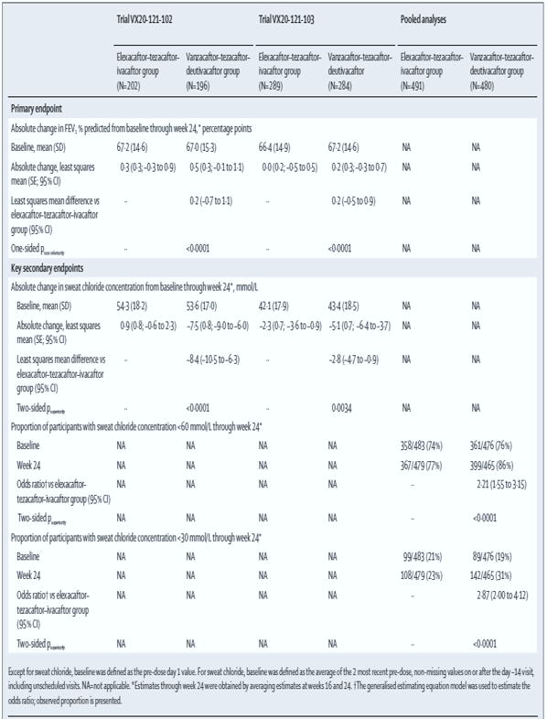
Table 10. Other secondary efficacy endpoints in study 102 and 103.
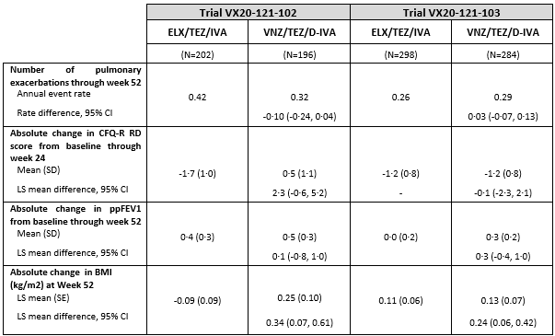
CFQ-R: Cystic Fibrosis Questionnaire–Revised; CI: confidence interval; ELX/TEZ/IVA: elexacaftor/tezacaftor/ivacaftor; LS: least squares; N: total sample size; ppFEV1: percent predicted forced expiratory volume in 1 second; RD: respiratory domain; SD: standard deviation; VNZ/TEZ/D-IVA: vanzacaftor/tezacaftor/deutivacaftor

Study VX21-121-105
This is a phase 3, 2 part (A,B) multicohort, multicentre, single-arm, open label phase 3 trial evaluating the PK, safety, tolerability, and efficacy of VNZ/TEZ/D-IVA TC therapy in cystic fibrosis (CF) subjects 1 through 11 years of age (inclusive) with at least 1 triple combination responsive (TCR) mutation in the CFTR gene. There are three separate descending cohorts according to age (6–11 years, 2–5 years, and 1 year to <2 years). The data for the 6 -11 years was presented in the dossier.
Study design
Part A of the study evaluated the pharmacokinetics, safety, and tolerability for 22 days. Part B followed by the evaluation of safety, pharmacokinetics, and efficacy for 24 weeks (Figure 4). Subjects who participated in Cohort A1 were permitted to participate in Cohort B1. No control treatment was included, consistent with guidance on paediatric extrapolation.
The study treatments were:
Cohort A1: VNZ 10 mg/ TEZ 50 mg/ D-IVA 125 mg once daily for 22 days.
Cohort B1: ELX/ TEZ/ IVA for a 28-day run-in period (waived for subjects on stable ELX/TEZ/IVA treatment) then VNZ/ TEZ/ D-IVA for 24 weeks.
Eligible children aged 6–11 years had a confirmed diagnosis of cystic fibrosis with at least one ELX/ TEZ/ IVA responsive CFTR variant, FEV1 % predicted of 60% or higher, and stable cystic fibrosis.
Efficacy was not an objective for Cohort A1 and a secondary objective for Cohort B1. The efficacy outcome measures SwCl, spirometry, pulmonary exacerbations, Cystic Fibrosis Questionnaire-Revised (CFQ-R), BMI, weight, height, and multiple breath washout (MBW).
Figure 4. Phase 3 Study Design: Study 105.
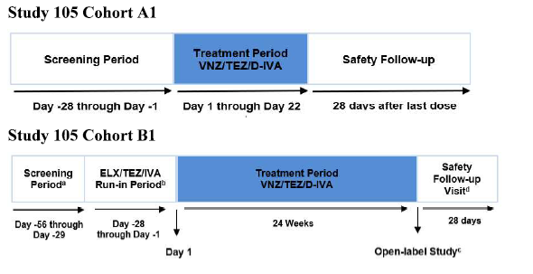
Results
In Cohort A1, 17 subjects were enrolled, all were treated and completed the study. CFTR genotype was F/F for nine (52.9%) subjects, F/MF for three (17.6%), F/G for one (5.9%) and TCR/any for four (23.5%).
In Cohort B1, 78 subjects were enrolled, and 77 (98.7%) subjects competed treatment. CFTR genotype was F/F for 37 (47.4%) subjects, F/MF for 24 (30.8%), F/G for three (3.8%), F/RF for one (1.3%), F/other for two (2.6%) and TCR/any for 11 (14.1) % of whom 5 subjects had the F508del mutation on the second (any) allele, leaving 6 subjects (7.7%) of the study population without an F508del mutation.
Efficacy
- Following baseline established on ELX/TEZ/IVA in CF subjects 6-11 years, lung function was normal (Mean [SD] ppFEV1 99.7 [15.1] percentage points). Treatment with VNZ/TEZ/D-IVA maintained this benefit in ppFEV1 (LS mean absolute change from baseline through Week 24 0.0 percentage points [95% CI: -2.0, 1.9]).
- Treatment with VNZ/TEZ/D-IVA over 24 weeks reduced SwCl: Within-group LS mean absolute change through Week 24 of -8.6 mmol/L (95% CI: -11.0, -6.3) compared to ELX/TEZ/IVA baseline of 40.4 mmol/L.
- The proportion of subjects with SwCl <60 mmol/L increased from 84.4% to 94.9%. The proportion of subjects with SwCl <30 mmol/L increased from 39.0% to 52.6%.
- Treatment with VNZ/TEZ/D-IVA over 24 weeks improved within-group values in CFQ-R RD score and maintained within-group values in ppFEV1 and nutritional parameters as compared to ELX/TEZ/IVA baseline.
- There were 6 exacerbations with an annualized rate of 0.15 events/year.
- Treatment with VNZ/TEZ/D-IVA resulted in improvements in CFQ-R RD score with an LS mean absolute change from baseline through Week 24 of 3.9 points (95% CI: 1.5, 6.3).
- There was no significant change in BMI z-score, weight z-score or height z-score.
- While direct comparisons between Study 105 Cohort B1 and Studies 102 and 103 cannot be made due to differences in study design, results were generally consistent with Studies 102 and 103.

Study VX18-121-101
Study VX18-121-101 was a Phase II, randomised, double-blind, active and placebo-controlled study to evaluate the safety and efficacy VNZ combination therapy in adult subjects with CF. The study was a dose-finding and proof of concept study. The study included male and female subjects with CF, who were on a stable dose of IVA and had either F/MF (part 1) or F/F (Part 2). The study design is shown in figure 5.
Figure 5. VX18-121-101 Study Design for Part 1 (F/MF Subjects) and Part 2 (F/F Subjects).
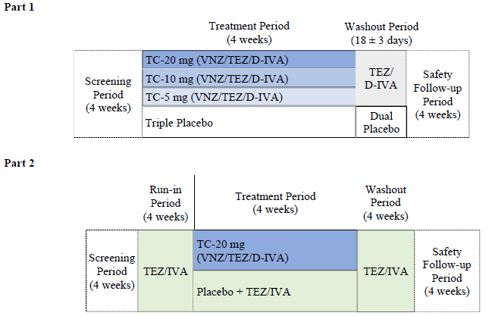
D-IVA: deutivacaftor; F/F: homozygous for F508del; F/MF: heterozygous for F508del and a minimal function mutation; qd: once daily; TC: triple combination; TC-5 mg: VNZ 5 mg qd/TEZ 100 mg qd/D-IVA 150 mg qd; TC-10 mg: VNZ 10 mg qd/TEZ 100 mg qd/D-IVA 150 mg qd; TC-20 mg: VNZ 20 mg qd/TEZ 100 mg qd/D-IVA 150 mg qd; TEZ: tezacaftor; VNZ: vanzacaftor
The efficacy assessments were spirometry, and the Cystic Fibrosis Questionnaire – Revised (CFQ-R) respiratory domain (RD). Safety outcome measures were AEs, clinical laboratory tests, vital signs and pulse oximetry. SwCl was measured as a PD outcome and plasma concentrations of VNZ, TEZ, D-IVA and IVA were measured for the PopPK analyses.
Results
A total of 87 CF subjects were enrolled in the study: 58 F/MF subjects in Part 1 and 29 F/F subjects in Part 2. Demographics and baseline ppFEV1, SwCl, and CFQ-R RD scores were generally similar between treatment groups in each part.
The efficacy results are summarised in Table 11. Treatment of CF subjects with F/MF or F/F genotypes with VNZ/TEZ/D-IVA resulted in improvements in ppFEV1. The benefit was apparent from Day 15. Improvements were also seen in SwCl and CFQ-R RD scores with VX-121/TEZ/D-IVA treatment
Table 11. Efficacy Results study VX18-121-101.
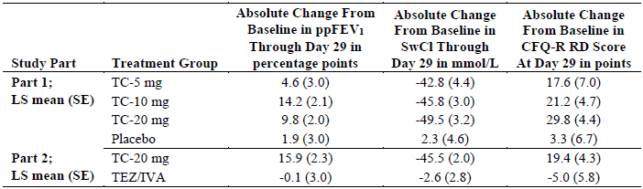
Within-group LS means (SE) compared to baseline are presented. Baseline in Part 2 was established after a 4-week TEZ/IVA Run-in Period.

Study VX18-561-101
Study VX18-561-101 was a Phase II, randomised, double-blind study to evaluate D-IVA in adults with CF with a gating mutation, who were on a stable dose of IVA (Figure 6). Subjects had pp FEV1 of ≥40% and ≤100%. The efficacy outcome measures were spirometry and SwCl.
Figure 6. VX18-561-101 Study Design.
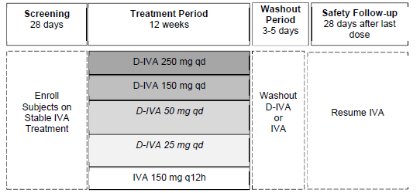
D-IVA: deutivacaftor; IVA: ivacaftor; q12h: every 12 hours; qd: once daily
Results
A total of 77 CF subjects were enrolled. The D-IVA 25 mg and 50 mg dose levels (with 17 individuals in these groups) were discontinued by the sponsor because of a decrease in ppFEV1 in five subjects identified as being in these treatment groups.
There was no significant change from baseline, or difference between IVA, for the D-IVA 150 mg and 250 mg dose levels. Results are shown in Table 12.
Table 12. Efficacy and PD of D-IVA Treatment Relative to IVA Baseline.
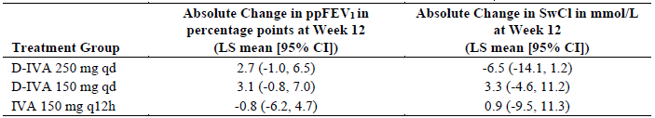

Summary conclusions regarding clinical efficacy
In the two pivotal trails,(Study 102, 103) phase 3 trials, in subjects with CF who were homozygous for F508del (F/F), heterozygous for F508del and a gating mutation (F/G) or a residual function mutation (F/RF), or have at least one other triple combination responsive CFTR mutation and no F508del deletion, non-inferiority was demonstrated for the primary efficacy endpoint (the change from baseline in ppFEV1 through Week 24) for VNZ/ TEZ/ D-IVA. The response was similar for the different genotype groups, noting the majority had a F508 mutation. The results of subgroup analyses (age, ppFEV1, SwCl, sex) were consistent with the result from the primary analysis. Efficacy results through 52 weeks of treatment, demonstrated the persistence of efficacy.
In the pivotal studies, for key secondary endpoints, VNZ/TEZ/D-IVA was superior to ELX/TEZ/IVA, with statistically significant and clinically meaningful improvements in SwCl. A greater number of people achieved clinically meaningful levels of CFTR function, as assessed by reductions in SwCl either below the diagnostic threshold for CF (<60 mmol/L) or to normal/carrier levels not associated with manifestation of CF disease (<30 mmol/L) whilst on VNZ/TEZ/D-IVA. Benefits were also observed for clinically relevant efficacy endpoints including exacerbation frequency, quality of life scores and nutritional parameters.
Consistent with pivotal studies 102 and 103 in subjects ≥12 years of age, treatment with VNZ/TEZ/D-IVA in Study 105 demonstrated clinically meaningful benefit in CF subjects 6 through 11 years of age. Following treatment with VNZ/TEZ/D-IVA, nearly all (95%) subjects achieved SwCl below the diagnostic threshold of CF and about a half, (53%) of subjects achieved normal/carrier levels of SwCl. Treatment with VNZ/TEZ/D-IVA over 24 weeks led to improved values in CFQ-R RD score and maintained nutritional parameters as compared to baseline ELX/TEZ/IVA treatment.
Study VX18-121-101 demonstrated efficacy for VNZ in comparison with placebo and provides supportive efficacy data. This was demonstrated for clinically meaningful outcomes (ppFEV1 and SwCl). Similarly, data from study VX18-561-101 showed similar clinical outcomes for D-IVA and IVA at the proposed doing. These data support dose selection to achieve maximal CFTR functional restoration in the Phase 3 studies.

Safety
Clinical safety data for VNZ/TEZ/D-IVA include 16 completed studies, that evaluated VNZ and D-IVA as a monotherapy or as the VNZ/TEZ/D-IVA TC regimen (Figure 7). The VNZ/TEZ/D-IVA safety profile is derived primarily from pivotal Studies 102 and 103, which enrolled adults with CF. Supportive safety data included a phase 3 (study 105) in children aged 6- 11 years of age, and phase 1 and 2 studies in healthy subjects and subjects with CF.
Standard safety assessments were performed across individual studies in the VNZ/TEZ/D-IVA clinical development program, including the following: AE data collection and reporting; clinical laboratory tests (serum chemistry, hematology, coagulation, and urinalysis); standard 12-lead ECG monitoring; vital signs assessments; pulse oximetry; and physical examinations including and ophthalmologic investigations.
Figure 7. Studies providing safety data.
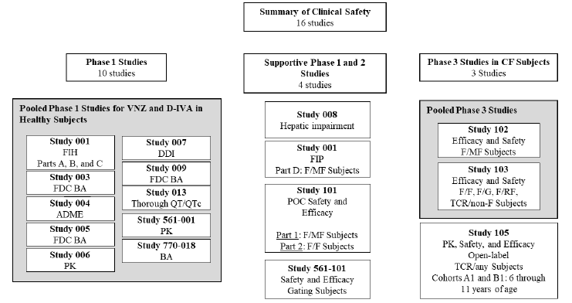
Patient exposure
In the development program for VNZ there were 1306 subjects exposed to at least one dose of VNZ, of whom 265 were healthy volunteers and 1135 had CF. There were 6.15 patient-years exposure in healthy volunteers and 1077.68 in subjects with CF. There were 965 subjects exposed to VNZ/TEZ/D-IVA: 51 healthy volunteers and 914 subjects with CF. There were 341 subjects exposed to triple combination for >24 to ≤52 weeks and 440 exposed for >52 weeks There were 81 subjects aged ≥6 to <12 years exposed to triple combination, 122 aged ≥12 to <18 years, 978 aged ≥18 to <65 years and 12 aged ≥65 years.
Core safety analysis (pooled safety set)
Safety data from Studies 102 and 103 were pooled for the Core Safety Analysis, and this included all subjects who received at least 1 dose of study drug during the Treatment Periods. The mean exposure duration was 49.5 and 49.9 weeks in the VNZ/TEZ/D-IVA group and ELX/TEZ/IVA groups respectively. This represents 495.5 and 510.9 patient-years of exposure in the groups, respectively. Overall, 293 subjects received ≥52 weeks of VNZ/TEZ/D-IVA and 456 subjects received >24 weeks of VNZ/TEZ/D-IVA in Studies 102 and 103 (Table 13).
Table 13. Summary of exposure (pooled safety set).
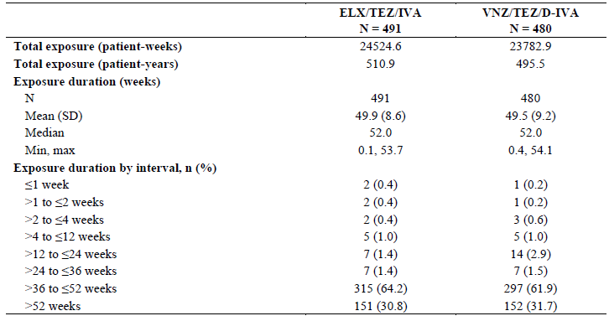
D-IVA: deutivacaftor; ELX: elexacaftor; IVA: ivacaftor; n: size of subsample; N: total sample size; TEZ: tezacaftor; VNZ: vanzacaftor
There were no clinically relevant differences in demography or baseline characteristics identified between the respective treatment groups that are likely to have affected safety outcomes. The majority of subjects (86.3%) were using a CFTR modulator prior to study involvement with 75.6% of all subjects having received commercial ELX/TEZ/IVA prior to study enrolment, with a median exposure of approximately 2 years.
Adverse events
Overall, VNZ/TEZ/D-IVA had a similar safety profile to ELX/TEZ/IVA. The incidence of AEs and serious AEs (SAEs) was similar between the VNZ/TEZ/D-IVA and ELX/TEZ/IVA groups (Table 14). Data for studies 445-102 (24-week placebo-controlled study) and 445-105 are the pivotal studies submitted within the ELX/TEZ/IVA submission. AEs were indirectly compared to 52-week ELX/TEZ/IVA data from Studies 445-102 and 445-105 in ELX/TEZ/IVA naïve patients.
- The incidence of subjects with at least 1 AE was high: 95.6% in the VNZ/TEZ/D-IVA group and 95.5% in the ELX/TEZ/IVA group.
- Most were mild or moderate in severity.
- The majority of AEs were assessed as not related or unlikely related to study drug.
- Treatment related TEAEs were reported in about 1/3 of subjects in both groups.
- One (0.2%) subject in the ELX/TEZ/IVA group and no subjects in the VNZ/TEZ/D-IVA group had life-threatening AEs.
- Sixty-eight (14.2%) subjects in the VNZ/TEZ/D-IVA group; 81 (16.5%) subjects in the ELX/TEZ/IVA group had SAEs. The most common was infective pulmonary exacerbation (29 [6%] vs 35 [7%]. Two (<1%) participants in both groups had a serious aminotransferase elevation adverse event.
- Very small numbers in both groups interrupted or discontinued the study drug due to AEs. The most common reason was aminotransferase elevation events.
- No deaths were reported during the clinical development program.

Common adverse events
The most common AEs were generally consistent with common manifestations of CF disease or with common illnesses in people with CF ≥12 years of age. These included:
- infective pulmonary exacerbation: 133 [28%] in VNZ/TEZ/D-IVA vs 158 [32%] in ELX/TEZ/IVA group
- cough (108 [23%] vs 101 [21%]),
- COVID-19 (107 [22%] vs 127 [26%]
- nasopharyngitis (102 [21%] vs 95 [19%]).
Table 14. Summary of AEs in Studies 102 and 103 (Treatment Period Pooled Safety Set) and from studies 445-102 and 105 for ELX/TEZ/IVA.
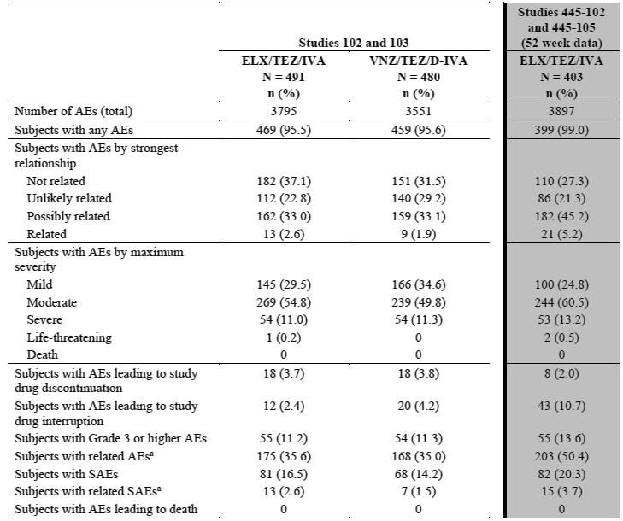
Adverse events of special interest
Forty-three (9.0%) subjects in the VNZ/TEZ/D-IVA group and 35 (7.1%) subjects in the ELX/TEZ/IVA group had at least 1 elevated transaminase event. The majority of events were mild or moderate in severity and resolved without treatment interruption.
Fifty-three (11.0%) subjects in the VNZ/TEZ/D-IVA group and 38 (7.7%) subjects in the ELX/TEZ/IVA group had a least 1 rash event. The majority of events were mild or moderate in severity, and no serious events occurred. Only 3 events (all in VNZ/TEZ/D-IVA group) lead to treatment discontinuation/interruption.
Adverse events of special interest (AESI) related to CK elevation (hereafter referred to as CK elevation events) occurred in 43 (9.0%) subjects in the VNZ/TEZ/D-IVA group and 41 (8.4%) subjects in the ELX/TEZ/IVA groups. These were mostly mild or moderate; 1 (0.2%) subject in the VNZ/TEZ/D-IVA and 2 (0.4%) subjects in the ELX/TEZ/IVA group had a severe CK elevation, and 1 in each group led to study drug interruption.
Eight (1.7%) subjects in the VNZ/TEZ/D-IVA group and 18 (3.7%) subjects in the ELX/TEZ/IVA group had a hypoglycaemia event. These were mild to moderate and did not impact study drug administration.
Three (0.6%) subjects in the VNZ/TEZ/D-IVA group and 4 (0.8%) subjects in the ELX/TEZ/IVA group had an AE of cataract, all were mild/moderate and did not impact vision.
Fifty-five (11.5%) subjects in the VNZ/TEZ/D-IVA group and 59 (12.0%) subjects in the ELX/TEZ/IVA group had at least 1 neuropsychiatric event. Of these there were 4 events in each group that were serious and 5 (2, 3 in groups respectively) led to treatment disruption.
There were no meaningful changes in other laboratory, vital signs, or ECG parameters.

Study VX21-121-105
Cohort A1
The incidence of subjects with at least 1 AE was 70.6%. All AEs were mild or moderate in severity, and no subjects had life-threatening AEs. There were no discontinuations or interruptions due to AEs. There were no deaths or other SAEs. There were 3 subjects who had a mild rash event, no other AE of special interest were present. There were no meaningful changes in laboratory, vital signs, or ECG parameters.
Cohort B1
The incidence of subjects with at least 1 AE was 96.2%. All subjects with AEs which were mild or moderate in severity; no subjects had AEs that were life-threatening in severity. Six (7.7%) subjects had SAEs. One (1.3%) subject interrupted study drug due to AEs (Seizure). One (1.3%) subject discontinued study drug due to AEs. There were no deaths. AEs were generally not thought to be related to the study treatment.
Four (5.1%) subjects had at least 1 elevated transaminase event, 4 subjects had at least 1 rash event, and 4 subjects had at least 1 neuropsychiatric event. There were no hypoglycaemic events, and there was 1 non-serious cataract event. There were no meaningful changes in other laboratory, vital signs, or ECG parameters.

Other studies
In the additional Phase 1 and Phase 2 studies evaluated in this submission in subjects with CF, healthy subjects, and special populations no unexpected findings were present. There were more reports of elevations of transaminases and creatinine kinase in both VNZ/TEZ/D-IVA and ELX/TEZ/IVA treatment populations than would be expected in the general population.

Summary conclusions regarding clinical safety
The safety of the proposed VNZ/TEZ/D-IVA triple combination regimen has been satisfactorily demonstrated in the submitted data. VNZ/TEZ/D-IVA was generally safe and well tolerated in subjects ≥6 years of age, with a low rate of treatment discontinuation due to adverse events (AEs). The AEs seen in the studies of subjects with CF are generally consistent with common CF manifestations, and the majority were mild to moderate in severity.
The safety profile of VNZ/TEZ/D-IVA is similar to that of ELX/TEZ/IVA, which is the current standard of care for approximately 90% of CF patients
The safety profile of VNZ/TEZ/D-IVA in CF subjects 6 through 11 years of age was similar to that observed in the pivotal studies in CF subjects ≥12 years of age.
Elevated transaminase and rash are known ADRs with ELX/TEZ/IVA. Overall, the risk of elevated transaminase events and rash events was similar for VNZ/TEZ/D-IVA and ELX/TEZ/IVA. The incidence of CK elevations was balanced between treatment groups.

Risk management plan
Vertex Pharmaceuticals (Australia) Pty Ltd has submitted EU-RMP version 0.1 (date 27 April 2024; DLP 12 February 2024) and ASA version 1.0 (date 13 June 2024) in support of this application. Later in the evaluation phase, the sponsor provided an updated EU RMP version (dated 24 April 2025; DLP 24 April 2024).
The proposed summary of safety concerns and their associated risk monitoring and mitigation strategies are summarised in Table 15.
Table 15. Summary of Safety Concerns and associated risk monitoring and mitigation strategies.
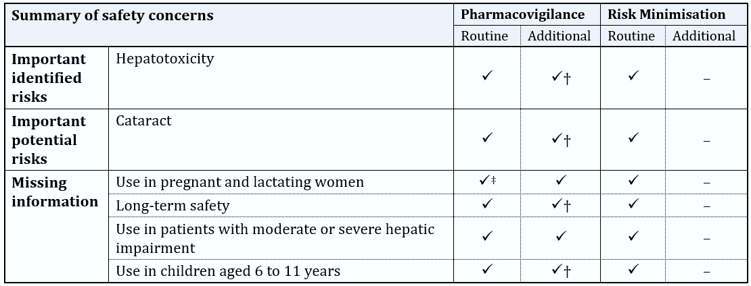‡Follow-up questionnaire †Phase 3 open-label extension study
The RMP evaluator noted the following:
- Subject to nonclinical aspects of the safety specification, the summary of safety concerns and the risk minimalization measures are acceptable from an RMP perspective.
- Routine and additional pharmacovigilance activities have been proposed (Table 16).
The TGA may request an updated RMP at any stage of a product's life cycle, during both the pre-approval and post-approval phases. Further information regarding the TGA’s risk management approach can be found in risk management plans for medicines and biologicals and the TGA's risk management approach. Information on the Australia-specific annex (ASA) can be found on the TGA website.

Table 16. Planned additional pharmacovigilance activities.
Safety Concern | Additional activity | Proposed actions/ outcomes | Planned submission date
Ongoing studies
• Hepatotoxicity  • Cataract  • Long-term safety | Open- label extension study in CF subjects ages 12 years and older (Study 104) | Primary Objective:  • To evaluate the long-term safety and tolerability of VNZ/TEZ/D-IVA  Secondary Objective:  • To evaluate the long-term efficacy of VNZ/TEZ/D-IVA | Final report upon request:  31 July 2026
• Hepatotoxicity  • Cataract  • Long-term safety  • Use in children aged 6 to 11 years of age | Open-label extension study in CF subjects ages 1 to 11 years (Study 106) | Primary Objective:  • To evaluate the long-term safety and tolerability of VNZ/TEZ/D-IVA  Secondary Objective:  • To evaluate the long-term efficacy of VNZ/TEZ/D-IVA | Final report upon request:  31 May 2030
Planned Studies
•Hepatotoxicity  • Use in pregnant women  • Long-term safety  • Use in patients with moderate or severe hepatic impairment  • Use in children aged 6 to 11 years | Post-authorisation Efficacy Study (PAES) | To evaluate the safety outcomes, CF disease progression, frequency and outcome of pregnancy, and drug utilisation patterns in CF patients taking VNZ/TEZ/D-IVA in the real-world setting. | Annual reports upon request:  31 December  2026/2027/2028/  2029  Final report upon request:  31 December 2030

Risk-benefit analysis

Delegate’s considerations
Cystic fibrosis (CF) is a chronic progressive disease caused by mutations in the CFTR gene, leading to high morbidity and mortality. The severity of CF is determined by the extent of loss of CFTR-mediated chloride transport. Despite advances in treatment, many people with CF have reduced life expectancy and quality of life.
Current treatments for CF include symptomatic therapies and CFTR modulators. Alyftrek (Vanzacaftor/Tezacaftor/Deutivacaftor) is a triple combination regimen composed of three CFTR modulators: vanzacaftor (VNZ), tezacaftor (TEZ), and deutivacaftor (D-IVA). This combination is administered once daily. VNZ and TEZ bind to different sites on the CFTR protein, facilitating cellular processing and trafficking of select mutant forms, including the F508del mutation, and D-IVA potentiates the channel open probability (gating) of the CFTR protein at the cell surface.

Pharmacology
The clinical pharmacology of VNZ/TEZ/D-IVA was characterized using a combination of nonclinical and clinical studies evaluating VNZ and D-IVA monotherapy and the triple combination of VNZ, TEZ, IVA, and/or D-IVA in healthy subjects and/or CF subjects. These data were further supported by prior nonclinical and clinical pharmacology experience with TEZ and IVA from previous development programs for IVA, TEZ/IVA, and ELX/TEZ/IVA.

Efficacy
The main evidence of efficacy and safety was obtained from two pivotal phase 3 trials. Both trials investigated the triple combination vanzacaftor 20 mg /tezacaftor 100 mg /deutivacaftor 250 mg once daily in comparison to the approved triple combination (Trikafta) elexacaftor 200 mg /tezacaftor 100 mg once daily and ivacaftor 150 mg twice per day. Alternative placebo-controlled designs are no longer considered ethically acceptable since ELX/TEZ/IVA is available as standard of care for the included study populations.
The trials had a similar design being a 52-week, randomized, double-blind, active-controlled, parallel-group study in CF patients 12 years and older, but included a different population based on the CFTR genotype. Study 102 enrolled individuals with cystic fibrosis and a F/MF genotype [heterozygous for F508del] and a minimal function mutation (F/MF). Study 103 enrolled individuals with cystic fibrosis with F508del-F508del (F/F), F508del-residual function (F/RF), F508del-gating, (F/G) or elexacaftor–tezacaftor–ivacaftor-responsive-non-F508del (TCR/non-F) genotypes. Both pivotal studies had a non-inferiority design using a 3% non-inferiority margin. Since the comparator ELX/TEZ/IVA is already effective in restoring lung function, the primary endpoint was tested for non-inferiority.
It is argued that lung function is not useful to discriminate any additional benefit from VNZ/TEZ/D-IVA, due to ceiling effects of both irreversible lung damage and physiological maximum lung function. The key secondary endpoint of SwCl was tested for superiority. The key secondary endpoint was the absolute change from baseline in sweat chloride and the new clinical endpoints of the proportion of subjects with SwCl <60 mmol/L or <30 mmol/L at week 24 (based on the pooled analysis from Studies 102 and 103). SwCl outcomes are regarded as supportive for the benefit risk assessment.
The studies design was appropriate, with acceptable inclusion and exclusion criteria, and appropriate clinically important endpoints. In Studies 102 and 103, demographic and baseline characteristics were generally balanced between the two treatment groups. Subjects were predominantly white, and most were already on ELX/TEZ/IVA prior to study enrolment. In line with the inclusion criteria, study 102 enrolled subjects who were heterozygous for F508del and an MF mutation. A MF mutation has no response to CFTRs; thus, the study data reflects F508del mutation. All (study 102) or most (study 103) had a least one F508del mutation. Only 42 subjects (7.3%) had a TCR/non-F genotype.
Results demonstrated that VNZ/TEZ/D-IVA was non-inferior to ELX/TEZ/IVA in improving lung function (ppFEV1) with differences of 0.2–0.3 percentage points. VNZ/TEZ/D-IVA showed statistically significant greater reductions in sweat chloride levels across genotypes, with patients approximately twice as likely to achieve SwCl <60 mmol/L and nearly three times as likely to reach <30 mmol/L compared to ELX/TEZ/IVA. Subgroup analyses confirmed consistent efficacy regardless of age, baseline lung function, or genotype subgroup. For other secondary endpoints not investigating effects on SwCl (such as rates in PEx, CFQ-R RD score, ppFEV1 through Week 52 and Nutritional parameters) in both studies, the results were similar between the treatment groups.
In the open-label study (Study 105) that evaluated safety and efficacy in children aged 6-11 years with at least one TCR mutation, the patients had normal lung function at baseline, which was maintained throughout treatment. Treatment with VNZ/TEZ/D-IVA resulted in a statistically significant greater reduction in SwCl from baseline through week 24 compared to ELX/TEZ/IVA, with an LS mean treatment difference of -8.4 mmol/L (95% CI: -10.5, -6.3).

Safety
VNZ/TEZ/D-IVA was generally safe and well tolerated in patients aged six years and older. The overall incidence and types of adverse events (AEs) and serious adverse events (SAEs) were comparable between VNZ/TEZ/D-IVA and ELX/TEZ/IVA treatment groups. Common AEs reflected typical CF manifestations, including pulmonary exacerbations, cough, and upper respiratory infections.
Specific treatment-related adverse events included elevated liver transaminases, rash, creatine kinase elevations, and neuropsychiatric events such as anxiety and insomnia. These events were generally manageable, with low rates of treatment discontinuation (~3.8%) and interruptions. No new safety concerns were identified in long-term open-label extension studies, although data in paediatric patients remain limited due to smaller sample size.

Limitations and Uncertainties
- Data in CFTR modulator treatment naïve patients is not available. Subjects who had a history of intolerance to ELX/TEZ/IVA or VNZ/TEZ/D-IVA were not eligible to enrol in studies 102 and 103.
- Most patients in the clinical studies were white. While CF has historically been more prevalent among people of European decent, it is increasingly being diagnosed in other populations and cultures around the world, and the types of mutations may be different.
- Although no new safety concerns were identified in an interim analysis of studies 104 and 106, long term safety data remains limited in adults and very limited in the paediatric population.
- Data is limited for those patients who have non-F508del mutations.
- Long term efficacy including prevention of deterioration in pulmonary function had not been studied. Furthermore, studies specifically looking at pancreatic function, other clinical manifestations of CF are unknown.
- Not all mutations carry the same risk of disease in people, and consequentially for some risk benefit of CFTR modulators may be less favourable. The issues of excluding people where there may be benefit, vs reducing risk to the person, and the cost to the community need to be balanced appropriately, which is likely difficult in given the complexity of the CFTR mutation landscape.

Conclusion
VNZ/ TEZ/ D-IVA has a favourable benefit-risk balance in the proposed usage. Non-inferiority has been demonstrated in comparison with ELX/ TEZ/ IVA. The adverse event profiles for the two treatments are similar. The benefits are clinically meaningful. In addition, VNZ/ TEZ/ D-IVA offers the benefit of a single, once daily, FDC treatment.
The delegate is inclined to approve this submission pending ACM advice and satisfactory negotiation of the PI, CMI and the conditions of registration.
If approved the proposed indication is:
VNZ/TEZ/D-IVA is indicated for the treatment of those who meet the diagnostic criteria of cystic fibrosis (CF) in patients aged 6 years and older who have at least one non-Class 1 mutation in the cystic fibrosis transmembrane conductance regulator (CFTR) gene that is responsive, based on clinical study or in vitro evidence.

Advisory Committee considerations
The Advisory Committee on Medicines (ACM), having considered the evaluations and the Delegate’s overview, as well as the sponsor’s response to these documents, advised the following.

Specific advice to the Delegate
The ACM advised the following in response to the Delegate’s specific request for advice:
- What is the ACMs advice regarding whether to approve/not approve the registration of Alyftrek?
After reviewing the evidence from the pivotal studies, the ACM advised that the efficacy of Alyftrek is well established. The ACM recommended the approval of Alyftrek for patients aged 6 years or older, based on its additional benefits including broader pathogenic variant coverage, enhanced CFTR function restoration, a comparable side effect profile, and the convenience of a once-daily dosing regimen.
Please comment of inclusion of participants with normal SwCL, normal lung function, lack of non F508del participants, lack of diversity, and whether this is likely to impact on approval in Australia.
The ACM noted that including participants with corrected to normal sweat chloride levels and lung function was appropriate. The ACM held the opinion that this data contributes to the evidence of non-inferiority to Trikafta. This inclusion provides evidence to support the viability of patients with managed CF on Trikafta changing to Alyftrek.
The F508del variant is the most prevalent CF causing pathogenic variant, affecting approximately 82% of the world’s CF population and Australia is among the few countries in the world where more than 90% of patients carry the F508del variant in at least one allele. The ACM held the view that these concerns would not pose an issue to the approvability of Alyftrek in Australia.
Would the ACM please provide advice on the wording of the proposed indication.
The ACM were supportive of approving the following indication, in line with the existing indication for Trikafta:
Alyftrek is indicated for the treatment of those who meet the diagnostic criteria of cystic fibrosis (CF) in patients aged 6 years and older who have at least one mutation in the cystic fibrosis transmembrane conductance regulator (CFTR) gene that is responsive, based on clinical study or in vitro evidence.
The committee is also requested to provide advice on any other issues that may be relevant to a decision on whether or not to approve this application
The ACM highlighted the potential drug induced liver injuries reported by the FDA and proposed precautionary measures and recommended that a statement similar to the following be included in the CMI:
‘Your doctor will request blood tests to assess your liver function before starting treatment with Alyftrek. These tests will then be conducted at least monthly for the first 6 months, every 3 months for the following 12 months, and at least annually thereafter. If you have liver disease or other clinical concerns, your doctor may recommend more frequent laboratory tests.’

Advisory committee conclusion
The ACM considered this product to have an overall positive benefit-risk profile for the indication:
Alyftrek is indicated for the treatment of those who meet the diagnostic criteria of cystic fibrosis (CF) in patients aged 6 years and older who have at least one mutation in the cystic fibrosis transmembrane conductance regulator (CFTR) gene that is responsive, based on clinical study or in vitro evidence.

Assessment outcome
Based on a review of quality, safety, and efficacy, the TGA decided to register –
- Alyftrek 10/50/125 vanzacaftor (as calcium) 10 mg / tezacaftor 50 mg / deutivacaftor 125 mg film-coated tablet blister pack
- Alyftrek 4/20/50 vanzacaftor (as calcium) 4 mg / tezacaftor 20 mg / deutivacaftor 50 mg film-coated tablet blister pack, indicated for:
Alyftrek is indicated for the treatment of those who meet the diagnostic criteria for
cystic fibrosis (CF) in people aged 6 years and older who have at least one mutation
in the cystic fibrosis transmembrane conductance regulator (CFTR) gene that is
responsive based on clinical or in vitro evidence (see section 5.1
PHARMACODYNAMIC PROPERTIES, Table 4).

Specific conditions of registration
- Alyftrek is to be included in the Black Triangle Scheme. The PI and CMI for Alyftrek must include the black triangle symbol and mandatory accompanying text for five years, which starts from the date of first supply of the product.
- The Alyftrek EU-Risk Management Plan (RMP) version 1.0 (dated 24 April 2025; DLP 24 April 2024), with Australia-Specific Annex (ASA) version 1.0 (dated 13 June 2024), included with submission PM-2024-02396-1-5, and any subsequent revisions, as agreed with the TGA will be implemented in Australia.
- An obligatory component of risk management plans is routine pharmacovigilance. Routine pharmacovigilance includes the submission of periodic safety update reports (PSURs).
Unless agreed separately between the supplier who is the recipient of the approval and the TGA, the first report must be submitted to TGA no later than 15 calendar months after the date of this approval letter. The subsequent reports must be submitted no less frequently than annually from the date of the first submitted report until the period covered by such reports is not less than three years from the date of this approval letter. The annual submission may be made up of two PSURs each covering six months. If the sponsor wishes, the six-monthly reports may be submitted separately as they become available.
If the product is approved in the EU during the three years period, reports can be provided in line with the published list of EU reference dates no less frequently than annually from the date of the first submitted report until the period covered by such reports is not less than three years from the date of this approval letter.
The reports are to at least meet the requirements for PSURs as described in the European Medicines Agency’s Guideline on good pharmacovigilance practices (GVP) Module VII-periodic safety update report (Rev 1), Part VII.B Structures and processes. Note that submission of a PSUR does not constitute an application to vary the registration. Each report must be submitted within ninety calendar days of the data lock point for that report.

Product Information and Consumer Medicine Information
For the most recent Product Information (PI) and Consumer Medicine Information (CMI), please refer to the TGA PI/CMI search facility.

Therapeutic Goods Administration
PO Box 100 Woden ACT 2606 Australia
Email: info@tga.gov.au Phone: 1800 020 653 Fax: 02 6203 1605
https://www.tga.gov.au
Reference/Publication #

This is the original indication proposed by the sponsor when the TGA commenced the evaluation of this submission. It may differ to the final indication approved by the TGA and registered in the Australian Register of Therapeutic Goods.
Elborn J. S. (2016). Cystic fibrosis. Lancet (London, England), 388(10059), 2519–2531. https://doi.org/10.1016/S0140-6736(16)00576-6
Lopes-Pacheco M. (2020). CFTR Modulators: The Changing Face of Cystic Fibrosis in the Era of Precision Medicine. Frontiers in pharmacology, 10, 1662. https://doi.org/10.3389/fphar.2019.01662
Castellani, C., Cuppens, H., Macek, M., Jr, Cassiman, J. J., Kerem, E., Durie, P., Tullis, E., Assael, B. M., Bombieri, C., Brown, A., Casals, T., Claustres, M., Cutting, G. R., Dequeker, E., Dodge, J., Doull, I., Farrell, P., Ferec, C., Girodon, E., Johannesson, M., … Elborn, J. S. (2008). Consensus on the use and interpretation of cystic fibrosis mutation analysis in clinical practice. Journal of cystic fibrosis: official journal of the European Cystic Fibrosis Society, 7(3), 179–196. https://doi.org/10.1016/j.jcf.2008.03.009
Cystic Fibrosis Australia (2026) CF Data Registry. CF Data Registry – Cystic Fibrosis Australia
Silva Filho, L. V. R. F. D., Athanazio, R. A., Tonon, C. R., Ferreira, J. C., & Tanni, S. E. (2024). Use of elexacaftor+tezacaftor+ivacaftor in individuals with cystic fibrosis and at least one F508del allele: a systematic review and meta-analysis. Jornal brasileiro de pneumologia : publicacao oficial da Sociedade Brasileira de Pneumologia e Tisilogia, 49(6), e20230187. https://doi.org/10.36416/1806-3756/e20230187
Kapouni, N., Moustaki, M., Douros, K., & Loukou, I. (2023). Efficacy and Safety of Elexacaftor-Tezacaftor-Ivacaftor in the Treatment of Cystic Fibrosis: A Systematic Review. Children, 10(3), 554. https://doi.org/10.3390/children10030554
Dawood, S. N., Rabih, A. M., Niaj, A., Raman, A., Uprety, M., Calero, M. J., Villanueva, M. R. B., Joshaghani, N., Villa, N., Badla, O., Goit, R., Saddik, S. E., & Mohammed, L. (2022). Newly Discovered Cutting-Edge Triple Combination Cystic Fibrosis Therapy: A Systematic Review. Cureus, 14(9), e29359. https://doi.org/10.7759/cureus.29359
Bower, J. K., Volkova, N., Ahluwalia, N., Sahota, G., Xuan, F., Chin, A., Weinstock, T. G., Ostrenga, J., & Elbert, A. (2023). Real-world safety and effectiveness of elexacaftor/tezacaftor/ivacaftor in people with cystic fibrosis: Interim results of a long-term registry-based study. Journal of cystic fibrosis: official journal of the European Cystic Fibrosis Society, 22(4), 730–737. https://doi.org/10.1016/j.jcf.2023.03.002
Van Goor, F., Hadida, S., Grootenhuis, P. (2008). Pharmacological Rescue of Mutant CFTR Function for the Treatment of Cystic Fibrosis. In: Fermini, B., Priest, B.T. (eds) Ion Channels. Topics in Medicinal Chemistry, vol 3. Springer, Berlin, Heidelberg. https://doi.org/10.1007/7355_2008_022
Nichols, D. P., Paynter, A. C., Heltshe, S. L., Donaldson, S. H., Frederick, C. A., Freedman, S. D., Gelfond, D., Hoffman, L. R., Kelly, A., Narkewicz, M. R., Pittman, J. E., Ratjen, F., Rosenfeld, M., Sagel, S. D., Schwarzenberg, S. J., Singh, P. K., Solomon, G. M., Stalvey, M. S., Clancy, J. P., Kirby, S., … PROMISE Study group (2022). Clinical Effectiveness of Elexacaftor/Tezacaftor/Ivacaftor in People with Cystic Fibrosis: A Clinical Trial. American journal of respiratory and critical care medicine, 205(5), 529–539. https://doi.org/10.1164/rccm.202108-1986OC
Middleton, P. G., Mall, M. A., Dřevínek, P., Lands, L. C., McKone, E. F., Polineni, D., Ramsey, B. W., Taylor-Cousar, J. L., Tullis, E., Vermeulen, F., Marigowda, G., McKee, C. M., Moskowitz, S. M., Nair, N., Savage, J., Simard, C., Tian, S., Waltz, D., Xuan, F., Rowe, S. M., … VX17-445-102 Study Group (2019). Elexacaftor-Tezacaftor-Ivacaftor for Cystic Fibrosis with a Single Phe508del Allele. The New England journal of medicine, 381(19), 1809–1819. https://doi.org/10.1056/NEJMoa1908639
Heijerman, H. G. M., McKone, E. F., Downey, D. G., Van Braeckel, E., Rowe, S. M., Tullis, E., Mall, M. A., Welter, J. J., Ramsey, B. W., McKee, C. M., Marigowda, G., Moskowitz, S. M., Waltz, D., Sosnay, P. R., Simard, C., Ahluwalia, N., Xuan, F., Zhang, Y., Taylor-Cousar, J. L., McCoy, K. S., … VX17-445-103 Trial Group (2019). Efficacy and safety of the elexacaftor plus tezacaftor plus ivacaftor combination regimen in people with cystic fibrosis homozygous for the F508del mutation: a double-blind, randomised, phase 3 trial. Lancet (London, England), 394(10212), 1940–1948. https://doi.org/10.1016/S0140-6736(19)32597-8
SYMDEKO 100/150 tezacaftor 100 mg/ivacaftor 150 mg film-coated tablet and ivacaftor 150 mg film-coated tablet composite pack (298329) | Therapeutic Goods Administration (TGA)
SYMDEKO 50/75 tezacaftor 50 mg/ivacaftor 75 mg film-coated tablet and ivacaftor 75 mg film-coated tablet composite pack (337367) | Therapeutic Goods Administration (TGA)
TRIKAFTA 100/50/75 GRANULES elexacaftor 100 mg/tezacaftor 50 mg/ivacaftor 75 mg granules and ivacaftor 75 mg granules sachet composite pack (402133) | Therapeutic Goods Administration (TGA)
KALYDECO ivacaftor 150mg film-coated tablets blister pack (198655) | Therapeutic Goods Administration (TGA)
McKone, E. F., Velentgas, P., Swenson, A. J., & Goss, C. H. (2015). Association of sweat chloride concentration at time of diagnosis and CFTR genotype with mortality and cystic fibrosis phenotype. Journal of cystic fibrosis : official journal of the European Cystic Fibrosis Society, 14(5), 580–586. https://doi.org/10.1016/j.jcf.2015.01.005
Fidler, M. C., Beusmans, J., Panorchan, P., & Van Goor, F. (2017). Correlation of sweat chloride and percent predicted FEV₁ in cystic fibrosis patients treated with ivacaftor. Journal of cystic fibrosis : official journal of the European Cystic Fibrosis Society, 16(1), 41–44. https://doi.org/10.1016/j.jcf.2016.10.002
Keating, C., Yonker, L. M., Vermeulen, F., Prais, D., Linnemann, R. W., Trimble, A., Kotsimbos, T., Mermis, J., Braun, A. T., O'Carroll, M., Sutharsan, S., Ramsey, B., Mall, M. A., Taylor-Cousar, J. L., McKone, E. F., Tullis, E., Floreth, T., Michelson, P., Sosnay, P. R., Nair, N., … VX20-121-103 Study Group (2025). Vanzacaftor-tezacaftor-deutivacaftor versus elexacaftor-tezacaftor-ivacaftor in individuals with cystic fibrosis aged 12 years and older (SKYLINE Trials VX20-121-102 and VX20-121-103): results from two randomised, active-controlled, phase 3 trials. The Lancet. Respiratory medicine, 13(3), 256–271. https://doi.org/10.1016/S2213-2600(24)00411-9

