Australian Public Assessment Report for Vyvgart
  - Active ingredient: Efgartigimod alfa
  - Sponsor: Argenx Australia Pty Ltd
March 2026

About the Therapeutic Goods Administration (TGA)
The Therapeutic Goods Administration (TGA) is part of the Australian Government Department of Health, Disability and Ageing and is responsible for regulating therapeutic goods, including medicines, medical devices, and biologicals.
The TGA administers the Therapeutic Goods Act 1989 (the Act), applying a risk management approach designed to ensure therapeutic goods supplied in Australia meet acceptable standards of quality, safety, and efficacy.
The work of the TGA is based on applying scientific and clinical expertise to decision-making, to ensure that the benefits to the Australian public outweigh any risks associated with the use of therapeutic goods.
The TGA relies on the public, healthcare professionals and industry to report problems with therapeutic goods. The TGA investigates reports received to determine any necessary regulatory action.
To report a problem with a therapeutic good, please see the information on the TGA website.

About AusPARs
The Australian Public Assessment Report (AusPAR) provides information about the evaluation of a prescription medicine and the considerations that led the TGA to approve or not approve a prescription medicine submission. Further information can be found in Australian Public Assessment Report (AusPAR) guidance.
AusPARs are prepared and published by the TGA.
AusPARs are static documents that provide information that relates to a submission at a particular point in time. The publication of an AusPAR is an important part of the transparency of the TGA’s decision-making process.
A new AusPAR may be provided to reflect changes to indications or major variations to a prescription medicine subject to evaluation by the TGA.

Copyright
© Commonwealth of Australia 2026
This work is copyright. You may reproduce the whole or part of this work in unaltered form for your own personal use or, if you are part of an organisation, for internal use within your organisation, but only if you or your organisation do not use the reproduction for any commercial purpose and retain this copyright notice and all disclaimer notices as part of that reproduction. Apart from rights to use as permitted by the Copyright Act 1968 or allowed by this copyright notice, all other rights are reserved and you are not allowed to reproduce the whole or any part of this work in any way (electronic or otherwise) without first being given specific written permission from the Commonwealth to do so. Requests and inquiries concerning reproduction and rights are to be sent to the TGA Copyright Officer, Therapeutic Goods Administration, PO Box 100, Woden ACT 2606 or emailed to <tga.copyright@tga.gov.au>.

Contents
List of abbreviations 4
Product submission 5
Submission details 5
Product background 6
Myasthenia Gravis (MG) 6
Current treatment options 8
Clinical rationale 9
Regulatory status at the time of assessment 10
Australian regulatory status 10
International regulatory status 10
Registration timeline 10
Assessment overview 11
Quality evaluation summary 11
Nonclinical evaluation summary 14
Clinical evaluation summary 17
Pharmacology 18
Efficacy evaluation 23
Safety evaluation 31
Risk Management Plan (RMP) evaluation 40
Risk-benefit analysis 42
Delegate’s considerations 42
Proposed indication 42
Efficacy 43
Safety 45
Proposed action 47
Assessment outcome 47
Specific conditions of registration 47
Product Information and Consumer Medicine Information 48

List of abbreviations
Abbreviation | Meaning
ADA | anti-drug antibody
EFG | efgartigimod
gMG | generalised Myasthenia Gravis
IMP | investigational medicinal product
MG | Myasthenia Gravis
MG-ADL | Myasthenia Gravis Activities of Daily Living
MGFA | Myasthenia Gravis Foundation of America
NAb | neutralizing antibody
NSID | nonsteroidal immuno suppressive drug
NSIST | non-steroidal immunosuppressive therapy
PH20 | recombinant human hyaluronidase PH20 (rHuPH20)a
QMG | Quantitative Myasthenia Gravis
TAD | Time after dose

Product submission

Submission details
Type of submission: | New chemical entity – Type A application
Product name: | Vyvgart
Active ingredient: | Efgartigimod alfa
Decision: | Approved
Date of decision: | 21 February 2025
Date of entry into ARTG: | 24 February 2025
ARTG numbers: | VYVGART efgartigimod alfa 1000 mg/5.6 mL solution for injection vial (444954)  VYVGART efgartigimod alfa 400 mg/20 mL concentrated injection for intravenous infusion vial (444955)
Black Triangle Scheme  for the current submission: | Yes
Sponsor’s name and address: | Argenx Australia Pty Ltd  Level 14, 2 Riverside Quay Southbank VIC 3006
Dose forms: | Injection solution for injection vial  Concentrated solution for intravenous infusion vial
Strength: | 1000 mg/5.6 mL (solution for injection vial)  400 mg/20 mL (concentrated solution for intravenous infusion vial)
Containers: | Vial – Glass Type 1 Clear
Pack size: | 5.6mL (injection, solution)  20mL (injection, intravenous solution)
Approved therapeutic use for the current submission: | Vyvgart is indicated as an add on to standard therapy for the treatment of adult patients with generalised Myasthenia Gravis (gMG) who are anti acetylcholine receptor (AChR) antibody positive.
Routes of administration: | Subcutaneous (SC)  Intravenous (IV)
Dosage: | For information regarding dosage, such as dosage modifications to manage adverse reactions, refer to the Product Information.
Pregnancy category: | Category C  Drugs which, owing to their pharmacological effects, have caused or may be suspected of causing, harmful effects on the human fetus or neonate without causing malformations. These effects may be reversible. Accompanying texts should be consulted for further details.  The use of any medicine during pregnancy requires careful consideration of both risks and benefits by the treating health professional. The pregnancy database must not be used as the sole basis of decision making in the use of medicines during pregnancy. The TGA does not provide advice on the use of medicines in pregnancy for specific cases. More information is available from obstetric drug information services in your state or territory.

Product background
This AusPAR describes the submission by Argenx Australia (the Sponsor) to register Vyvgart (efgartigimod alfa) for the following proposed indication:
Vyvgart is indicated as an add on to standard therapy for the treatment of adult patients with generalised Myasthenia Gravis (gMG) who are anti acetylcholine receptor (AChR) antibody positive.

Myasthenia Gravis (MG)
MG is an autoimmune neuromuscular disorder characterised by antibodies directed at proteins in the postsynaptic membrane of the neuromuscular junction, namely acetylcholine receptors or receptor-associated proteins. Clinical manifestations can vary widely both between patients and in individual patients, for whom symptoms and severity typically fluctuate throughout the course of a day, and over the course of the disease. 2,
Weakness of skeletal muscles is the hallmark manifestation, which may be localised or generalised, commonly affecting eye muscles resulting in ptosis and diplopia, and more commonly affecting proximal muscle groups.2, 3 The pattern of weakness is often symmetric, apart from eye involvement which is more commonly asymmetric, and typically shows fatiguability (an increase in weakness with exercise or repetitive muscle use).2, The two recognised clinical forms include ocular MG, in which weakness is limited to the eyelids and extraocular muscles, and gMG, in which weakness involves a variable combination of ocular, bulbar, limb and respiratory muscles.3
Symptom severity may also be used to categorise patients and guide treatment decisions, with the Myasthenia Gravis Foundation of America (MGFA) clinical classification widely used, shown in
Table 1.

Table 1. Myasthenia Gravis Foundation of America (MGFA) clinical classification
Class I | Any ocular muscle weakness  May have weakness of eye closure All other muscle strength is normal
Class II | Mild weakness affecting other than ocular muscles  May also have ocular muscle weakness of any severity
IIa | Predominantly affecting limb, axial muscles, or both  May also have lesser involvement of oropharyngeal muscles
IIb | Predominantly affecting oropharyngeal, respiratory muscles, or both  May also have lesser or equal involvement of limb, axial muscles, or both
Class III | Moderate weakness affecting other than ocular muscles  May also have ocular muscle weakness of any severity
IIIa | Predominantly affecting limb, axial muscles, or both  May also have lesser involvement of oropharyngeal muscles
IIIb | Predominantly affecting oropharyngeal muscles, respiratory muscles, or both  May also have lesser or equal involvement of limb, axial muscles, or both
Class IV | Severe weakness affecting other than ocular muscles  May also have ocular muscle weakness of any severity
IVa | Predominantly affecting limb and/or axial muscles  May also have lesser involvement of oropharyngeal muscles
IVb | Predominantly affecting oropharyngeal, respiratory muscles, or both  May also have lesser or equal involvement of limb, axial muscles, or both
Class V | Defined by intubation, with or without mechanical ventilation, except when employed during routine postoperative management.
Adapted from Bird SJ, Shefner JM, Goddeau Jr RP. Clinical manifestations of myasthenia gravis. UpToDate.3
Over time, manifestations of MG typically worsen and become more persistent. Many patients who initially present with symptoms isolated to ocular muscles eventually develop weakness in other muscle groups. Approximately 80% who present with isolated ocular symptoms develop generalised symptoms after 2-3 years.3 A potentially life-threatening complication is myasthenic crisis, which may affect 10-20% of patients at least once, manifesting as increasing generalised or bulbar weakness and respiratory insufficiency. Crises may be associated with a precipitant, such as concurrent infection, surgery or certain medications, and generally require management in an intensive care setting.5
Multiple autoantibodies are implicated in the pathogenesis of MG. Eighty to 90% of patients have detectable autoantibodies against the acetylcholine receptor (AChR), primarily of the IgG1 and IgG3 subtypes, which exert their pathologic effect by blocking acetylcholine binding to the AChR, as well as cross-linking and internalisation of AChR, and complement activation.2, Among AChR antibody-positive patients, the majority have thymic abnormalities, with hyperplasia seen in 60-70%, and thymoma in 10-12%. Autoantibodies against muscle-specific receptor tyrosine kinase (MuSK) are found in 1-10% of patients, associated with more severe weakness, commonly involving facial and bulbar muscles, with limb and ocular weakness less common.2 Around 1% of patients with MG have detectable antibodies against lipoprotein-related protein 4 (LRP4), associated with mild to moderate disease severity.2, 6 Seronegative MG is denoted by the absence of detectable serum antibodies against neuromuscular junction proteins, accounting for 10-15% of patients.2
Diagnosis of MG can be confirmed by the presence of typical symptoms with detectable autoantibodies, supplemented by neurophysiologic testing, pharmacologic testing, and response to treatment with an acetylcholinesterase inhibitor in seronegative patients or those with atypical features.2, 4
MG is relatively uncommon, with an estimated annual global incidence of 7 to 30 new cases per million people.3 It can occur at any age, however, a bimodal distribution has been characterised, with an early peak in the second and third decades which shows a female predominance, and a late peak in the sixth to eighth decades which shows a male predominance.3 Estimated Australian incidence is 24.9 per 1 million residents, in line with global estimates, with estimated prevalence 117 per million. With appropriate treatment, prognosis in terms of muscle strength, function, quality of life and survival is generally good.2

Current treatment options
The goals of MG treatment are remission of symptoms and maximisation of function, while minimising medication side effects. There are four primary therapeutic options: symptomatic treatment, consisting of acetylcholinesterase inhibition usually with pyridostigmine; chronic immunotherapies including corticosteroids and nonsteroidal immunosuppressive agents; rapid but short-acting immunomodulators including intravenous immunoglobulin (IVIg) and plasma exchange; and surgical thymectomy.
Treatment approach is variable, depending on specific clinical features, severity, autoantibody status, presence of thymic abnormalities, and treatment availability.2, 5
Pyridostigmine is generally the preferred option for symptomatic treatment and is part of initial treatment in most patients.9 While all subgroups of disease respond to acetylcholinesterase inhibition, those with anti-MuSK antibodies generally respond less favourably to symptomatic treatment.2 Most patients with gMG require additional immunosuppressive therapy to achieve treatment goals.2, 8
Corticosteroids are used commonly either alone or in combination with a nonsteroidal agent such as azathioprine or mycophenolate.2, 9 Other nonsteroidal options include cyclosporine, methotrexate and tacrolimus, with significant variance seen in clinical practice.9
Rituximab is a treatment option in patients with insufficient response to therapy, with consensus guidelines specifically advocating its use in patients who are anti-MuSK antibody positive with an inadequate response to initial immunotherapy. 10
Eculizumab, a humanised monoclonal antibody against the terminal C5 complement molecule, may be used in severe or refractory disease in anti-AChR antibody positive patients.10 Other biologic therapies including ravulizumab and zilucoplan, which both act on complement activation, have an emerging role in treatment.8
Thymectomy is a therapeutic option for patients with demonstrated thymoma, and for certain patient subgroups without thymoma.8 For acute exacerbations, including myasthenic crisis, rapid acting treatment options including IVIg and plasma exchange can be used alongside a combination of supportive care, symptomatic, and immunosuppressive treatment.2, 8, 9
The ARTG currently includes the following products with an indication for MG:
- Neostigmine, indicated for ‘… treatment of myasthenia gravis during acute exacerbations, when the condition is severe or in neonates.’
- Normal immunoglobulin, indicated for ‘… Myasthenia Gravis (MG) in acute exacerbation (myasthenia crisis) or prior to surgery and/or thymectomy: as maintenance therapy for moderate to severe MG when other treatments have been ineffective or caused intolerable side effects.’
- Pyridostigmine, indicated for ‘… treatment of myasthenia gravis.’
- Ravulizumab, indicated ‘… as an add-on to standard therapy for the treatment of adult patients with generalised myasthenia gravis (gMG) who are anti-acetylcholine receptor (AChR) antibody-positive’.
- Zilucoplan tetrasodium, indicated ‘… as an add-on to standard therapy for the treatment of generalised myasthenia gravis (gMG) in adult patients who are anti-acetylcholine receptor (AChR) antibody positive.’

Clinical rationale
Efgartigimod alfa is a human IgG1 antibody Fc fragment, engineered for increased affinity to the neonatal Fc [fragment crystallizable] receptor (FcRn), functioning as an FcRn antagonist. FcRn is widely expressed across different human cell types and has a specific role in recycling of all IgG subtypes, rescuing them from lysosomal destruction. Efgartigimod competes with endogenous IgG binding, thus preventing FcRn-mediated recycling of IgGs, leading to increased IgG degradation. This process affects all IgG subtypes, resulting in reduced IgG levels in serum.
The sponsor’s stated rationale for product development notes that current treatment options for generalised myasthenia gravis (gMG) may provide inadequate disease control or are associated with risk of serious side-effects or patient inconvenience, while commonly used medicines such as corticosteroids or non-steroidal immunosuppressive drugs lack randomised controlled trial data in myasthenia gravis (MG) and are often used off-label.
Additionally, the sponsor states that the solution for subcutaneous injection formulation was developed with the aim of improving treatment flexibility for patients. The solution for subcutaneous injection is formulated with human recombinant hyaluronidase (rHuPH20), intended to increase dispersion and absorption of efgartigimod.

Regulatory status at the time of assessment

Australian regulatory status
This product is considered a new chemical entity for Australian regulatory purposes.

International regulatory status
This submission was submitted through the TGA’s Comparable Overseas Regulator (COR-B) process, using evaluation reports from the European Medicines Agency (EMA) . The full dossier was submitted to the TGA.
The 400 mg/20 mL concentrated solution for intravenous infusion formulation received EMA marketing authorisation on 10 August 2022, and the 1000 mg/5.6 mL solution for injection formulation received EMA marketing authorisation on 15 December 2023, as an extension of the marketing authorisation for addition of the new strength, pharmaceutical form, and route of administration.
Current international regulatory status for both the IV and SC formulations is summarised in Table 2. Of note, the indication sought in this application is similar to approved indications in the European Union (EMA), United States (FDA) and Canada (Health Canada). Orphan drug designation was granted by FDA on 20 September 2017 and by EMA on 21 March 2018.
The sponsor has confirmed that no application to register Vyvgart for the gMG indication has been withdrawn or rejected by any regulatory authority.
Table 2. International regulatory status for Vyvgart, in intravenous and subcutaneous formulations at the time of this assessment
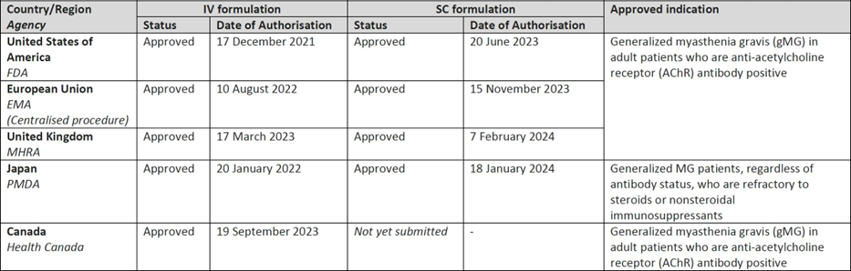

Registration timeline
Table 3: Timeline for Submission PM-2024-01111-1-1
Description | Date
Submission dossier accepted and first round evaluation commenced | 30 April 2024
Evaluation completed | 12 November 2024
Registration decision (Outcome) | 21 February 2025
Registration in the ARTG completed | 24 February 2025
Number of working days from submission dossier acceptance to registration decision* | 119
* The COR-B process has a 175 working day evaluation and decision timeframe.

Assessment overview

Quality evaluation summary
Vyvgart is presented as a:
- concentrated injection for intravenous administration containing 412 mg/vial of efgartigimod as active substance
- solution for injection for subcutaneous administration containing 1206 mg per vial of efgartigimod as active substance.
Formulations for each presentation are outlined in Table 4.
The Vyvgart efgartigimod IV product is available in a 20-ml glass vial (type I glass) with a rubber stopper, an aluminium seal, and a polypropylene flip-off cap.
The Vyvgart efgartigimod SC product is available in a 6-ml glass vial (type I glass) with a rubber stopper, an aluminium seal, and a polypropylene flip-off cap.
Table 4. Formulation of Vyvgart (efgartigimod alfa) in the concentrated injection for intravenous infusion and solution for injection presentations
Active ingredient | Quantity (mg/vial) |  |  |  | Concentration (mg/mL)
 | Concentrated injection for I.V. infusion | Solution for injection S.C. |  |  | Concentrated injection for I.V. infusion | Solution for injection S.C.
Efgartigimod (ARGX-113) | 412.0 | 1206.0 |  |  | 20  (400  mg/20mL) | 180  (1000  mg/5.6 mL)
Excipients | Quantity (mg/vial) |  | Role in formulation | Standards | Concentration (mg/mL)
Vorhyaluronidase alfa (rHuPH20) |  | 13 400 U | Permeation enhancer | Ph. Eur. |  | 2000 U/mL
Histidine |  | 9.4 | Buffering agent | Ph. Eur. |  | 1.4
Histidine hydrochloride monohydrate |  | 14.7 | Buffering agent | Ph. Eur. |  | 2.2
Methionine |  | 10.1 | Stabilising agent | Ph. Eur. |  | 1.5
Sucrose |  | 137.4 | Tonicity agent | Ph. Eur. |  | 20.5
Monobasic sodium phosphate monohydrate | 22.7 |  | Buffering agent | USP | 1.1
Dibasic sodium phosphate | 49.4 |  | Buffering agent | USP, Ph. Eur., JPE | 2.4
Sodium chloride | 119.5 | 38.9 | Tonicity agent | USP, Ph. Eur., JP | 5.8 | 5.8
Arginine hydrochloride | 651.0 |  | Tonicity agent | USP, Ph. Eur., JP | 31.6
Polysorbate 80 | 4.1 |  | Surfactant | NF, Ph. Eur., JP | 0.2
Polysorbate 20 |  | 2.7 | Surfactant | NF, Ph. Eur., JP |  | 0.4
Water for injections | q.s. to 20.6 mL1 | q.s. to 6.7mL2 | Diluent | USP, Ph.  Eur. | q.s. ad 1.0 mL | q.s. ad 1.0 mL
1 The target fill volume is 20.6 mL. This includes 3% overfill to guarantee withdrawal of at least 20.0 mL of drug product from the vial. 2 The target fill volume is 6.7 mL. This includes 8% overfill to allow withdrawal of at least 6.2 mL of the drug product from the vial.

Structure and manufacture
Efgartigimod drug substance is comprised of two identical peptide chains linked together by two interchain disulfide bonds. Efgartigimod contains an N-glycosylation site in the CH2 domain of each peptide chain and residues modified with engineered mutations (AntiBody that enhances IgG DEGradation; ABDEGTM) in either of the CH2 or CH3 domain of the Fc fragment.
These mutations increase the affinity of the efgartigimod for FcRn at neutral pH and pH 6.0. The molecular weight is approximately 53kD. The active ingredient was produced using recombinant DNA technology in a CHO cell line. Information about the manufacturing, storage and control facilities for the active substance has been provided in the dossier.
TGA GMP clearance for some manufacturers remained outstanding at the time of review. Manufacturing and purification processes were described in sufficient detail.
The overall quality of the active substance was demonstrated via adequate control of the starting material, control of critical steps and intermediates, process validation, extensive characterisation using orthogonal and state-of-the-art analytical methods, control of impurities and contaminants, generation of robust reference materials and batch analyses that covered multiple manufacturing campaigns.

Formulation and manufacture
The formulation development for both presentations has been adequately described and the final formulation intended for marketing was used in the phase III clinical trials. All excipients are well known pharmaceutical ingredients and their quality is compliant with Ph. Eur/NF/USP/JP standards. There no novel excipients used in the finished product formulation.
The container closure is considered suitable for its intended use as demonstrated by compatibility and stability studies.
To ensure that the finished product meets high quality standards, its manufacturing process was developed with defined manufacturing procedures, process validations, critical process parameters, in-process parameters, batch analyses of multiple manufacturing campaigns.
Finished product and active substance comparability studies were conducted to demonstrate that the quality of the commercial manufacturing process is comparable to the pre-change product. These were assessed and considered satisfactory.
All analytical methods used for testing of the finished product are satisfactorily described in the dossier and non-compendial methods have been validated. Many test methods used for release testing and stability testing of the finished product are the same as those used for release testing and stability testing of the active substance.

Specification and stability
Stability data have been generated under stressed and real time conditions to characterise the stability profile of the product. Following evaluation, the recommended storage condition for Vyvgart IV is 36 months when stored at 5 ± 3°C and 18 months when stored at 5 ± 3°C for Vyvgart SC.
In-use stability data have also been submitted. The recommended shelf life and storage conditions for the diluted Vyvgart IV product are 24 hours when stored at 5 ± 3°C. For the Vyvgart SC product, unopened vials may be stored at up to 30°C for up to 3 days and may be returned to refrigeration if unopened. The total combined time out of refrigeration should not exceed 3 days.
Stability studies have been conducted in accordance with relevant ICH guidelines.
There are no allowable temperature excursions when shipping the Vyvgart IV and SC product.
Storage/shelf-life details on the label(s) for both presentations: Store at 2°C to 8°C (Refrigerate. Do not freeze).

Secondary evaluations
Sterility, adventitious agents (viral, TSE and mycoplasma), container and endotoxin safety assessments were carried out with the aim of ensuring product quality and safety. These include (where appropriate) control/testing of starting materials, containers, in-process steps, decontamination/reduction steps active ingredient and finished product tests.
Adequate data has been presented which give reassurance on removal/reduction (to safe levels) of contaminants.

Conclusions and outstanding issues
The quality of this product is considered to be acceptable when used in accordance with the conditions defined in the product information (PI), labels, consumer medicines information (CMI) and the ARTG. Physicochemical and biological aspects relevant to the uniform clinical performance of the product have been investigated and are controlled in a satisfactory way. Information on development, manufacture and control of the active substance and finished product has been presented in a satisfactory manner. The results of tests carried out indicate consistency and uniformity of important product quality characteristics, and these in turn lead to the conclusion that the product should have a satisfactory and uniform performance in clinical use. From a quality perspective, compliance with Therapeutic Goods Legislations (TG Act/Regs) and relevant TG Orders as well as consistency with relevant guidelines and the ARGPM has been demonstrated.
TGA GMP clearances for the sites responsible for the manufacture, quality control and release testing of the excipient vorhyaluronidase (rHuPH20) are required.
To address this unresolved issue, the Sponsor submitted GMP clearances for the relevant manufacturing sites.

Recommendations
There are no objections on quality grounds to the approval of Vyvgart efgartigimod alfa 400 mg/20 mL concentrated injection for intravenous infusion vial and Vyvgart efgartigimod alfa 1000 mg/5.6 mL solution for injection vial, provided the following issue is addressed satisfactorily:
- Provision of TGA GMP clearances for the sites responsible for the manufacture, quality control and release testing of the excipient vorhyaluronidase (rHuPH20).

Nonclinical evaluation summary
There are outstanding issues in nonclinical evaluation, with the evaluator and sponsor unable to reach agreement regarding pregnancy category, and wording of nonclinical data in the PI. These issues are summarised below.
Following first round evaluation, the nonclinical evaluator provided the following summary:
- Argenx Australia Pty Ltd has applied to register a new biological entity, efgartigimod alfa Vyvgart, a neonatal Fc receptor (FcRn) antagonist, for the treatment of gMG in adult patients. Vyvgart is supplied as a 20 mg/mL concentrated injection for intravenous infusion, to be administered at 10 mg/kg, as 1 h intravenous infusions in cycles of once weekly for 4 weeks. It is also available as a 180 mg/mL solution for injection for subcutaneous use, which contains permeation enhancer recombinant human hyaluronidase (rHuPH20) and is to be administered at a dose of 1000 mg in cycles of once weekly for 4 weeks. Duration was not specified but Vyvgart is likely to be used intermittently.
- The submitted Module 4 dossier was in accordance with the relevant ICH guideline for the nonclinical assessment of biological medicines (ICH S6). The overall quality of the nonclinical dossier was high. All pivotal safety-related studies were GLP compliant.
- Efgartigimod is designed to compete with endogenous immunoglobulin (IgG) binding to FcRn at both acidic and neutral pH. IgGs do not bind with FcRn at neutral pH. Efgartigimod affinity for human FcRn exceeded that of wild-type Fc at pH 6.0, while at neutral pH (pH 7.4) only efgartigimod maintained affinity for FcRn at clinically relevant concentrations. Efgartigimod cross-reactivity for rat and monkey FcRn was comparable to human FcRn, supporting their use in pharmacology and toxicity assessments. In vivo, efgartigimod reduced serum levels of endogenous IgG in mice, rats, monkeys and rabbits, as well as rodent models of disease (i.e. inducing disease by infusing IgGs from MG patients). Primary pharmacology studies adequately demonstrated efficacy for the proposed indication.
- For secondary pharmacology assessments, efgartigimod was shown to bind to Fc gamma receptors (FcγRs) at concentrations at least 10-fold above those expected clinically: thus, effector functions mediated by FcγRs (e.g. ADCC and CDC) are unlikely to contribute to the pharmacological actions of efgartigimod. Efgartigimod did not affect serum albumin or circulating levels of IgA or IgM in animal studies. In vitro, using human and monkey tissue panels, efgartigimod-specific binding was localised to areas known to contain FcRn, namely epithelial and endothelial cells of various tissues.
- Safety pharmacology assessments covered the cardiovascular, respiratory and central nervous systems, which were incorporated in GLP toxicity studies in rats and monkeys. No significant findings were observed in any of the studies, at sufficiently high systemic exposures. Thus, adverse effects on organ system functions of the CNS, cardiovascular or respiratory systems are not expected during clinical use of efgartigimod.
- The pharmacokinetic profile of efgartigimod in animals (particularly monkeys) was qualitatively similar to that of humans. Both intravenous and subcutaneous dosing resulted in dose-proportional increases in AUC and Cmax. Bioavailability of subcutaneous efgartigimod was similar in monkeys and humans. Higher than expected clearance typical for an IgG was attributed to interference of FcRn-mediated recycling. The inclusion of permeation enhancer rHuPH20 in subcutaneous dosing augmented serum concentrations of efgartigimod (as Cmax or AUC). Distribution was not assessed but as an IgG Fc fragment, efgartigimod distribution is expected to be limited to vascular compartments. Efgartigimod is likely catabolised into smaller peptides and/or individual amino acids, via well-understood degradation pathways, and excreted or recycled. However, due to the relatively small peptide size of efgartigimod, low levels may also be excreted renally.
- Due to its pharmacological mode of action on FcRn, efgartigimod may affect elimination of monoclonal antibody products or other immunoglobulin therapies such as IVIg.
- Efgartigimod alfa had a low to moderate order of acute oral toxicity in cynomolgus monkeys.
- Repeat-dose toxicity studies using the IV formulation of efgartigimod were conducted in rats (4 weeks) and monkeys (up to 26 weeks). Maximum exposures (AUC) in monkeys were higher when once every 2 days dosing was used cf. once weekly. Efgartigimod was well tolerated in both rats and monkeys, with minimal or sporadic findings of uncertain relevance to treatment. A 12-week bridging study in monkeys using subcutaneous dosing with or without permeation enhance rHuPH20 did not uncover any new toxicities, with treatment reasonably well tolerated. Observations were limited to injection site findings that were minimal to mild in severity (transient swelling at the injection site, presence of inflammatory infiltrates), which resolved following a 12-week recovery period.
- As a biotechnology product, efgartigimod is not expected to interact with genetic material; thus, genotoxicity studies were not performed or required. In lieu of carcinogenicity studies, the sponsor provided a carcinogenicity risk assessment in which the weight of evidence indicates a low risk of carcinogenicity by efgartigimod.
- Fertility assessments in male and female rats did not identify any adverse effects on fertility by efgartigimod at doses up to 100 mg/kg/day IV. There was also no evidence of embryofetal harm (i.e. embryo/fetotoxicity, malformations or variations) at these doses in rats and rabbits, or of any treatment-related findings on gestation, parturition, pup viability, survival and growth, and on behavioural, motor and neurological parameters in the rat pre-/postnatal development study. FcRn is involved in placental transfer of maternal antibodies/IgG to the fetus: thus, through a pharmacologically mediated action, efgartigimod may reduce the transfer of maternal antibodies and impair acquired immunity in infants.
- Studies in rabbits and monkeys did not raise any concerns about the local tolerability of efgartigimod administered intravenously or subcutaneously.
- Lymphocyte typing conducted in toxicity studies and a dedicated study in monkeys assessing the T-cell dependent antibody response (TDAR) to antigen keyhole limpet haemocyanin (KLH) indicated that efgartigimod is unlikely to interfere with immune responses.
Nonclinical evaluator conclusions following first-round evaluation included the following.
- Primary pharmacology studies support the use of efgartigimod for the proposed indication.
- No clinically relevant off-target or organ system hazards were identified.
- Efgartigimod was well-tolerated in rats and monkeys when administered via the intravenous route (and the subcutaneous route when assessed in the latter).
- The proposed pregnancy category should be revised from B1 to C, due to the role of FcRn in placental transfer of maternal antibodies to the fetus and potential for impairments to neonatal passive immunity.
- There are no nonclinical objections to registration of efgartigimod (VYVGART) for the proposed indication.
- Amendments were requested to the draft PI.
In their response to first round evaluation, the sponsor respectfully disagreed with the non-clinical evaluator’s recommendation to revise the pregnancy category to category C, and instead proposed category B2 as the most appropriate. The sponsor provided justification for their position that pregnancy category C is inappropriate, supported by published literature references.
After considering the sponsor’s response to first round evaluation, and justification for proposed pregnancy category B2, the non-clinical evaluator did not support the proposal for pregnancy category B2, maintaining that category C is appropriate due to the potential for efgartigimod to impair passive protection in the fetus and newborn.
With respect to the outstanding issue in PI wording, the non-clinical evaluator proposed amendments to exposure multiples used in Section 4.6 of the PI (Fertility, Pregnancy and Lactation), under the subheading ‘Effects on fertility’, on the basis that ‘exposure multiples calculated using clinical AUC values from CSR ARGX-113-1602 have been used, since those were obtained in gMG patients and represented higher exposures than those from ARGX-113-1501 used by the sponsor.’ In their response to the first round evaluation, the sponsor proposed to retain the original exposure multiples, on the basis of maintaining consistency with the EU SmPC, particularly given that this application is a COR-B process based on EMA approval. The non-clinical evaluator did not accept this justification and maintained that the exposure multiples requested in first round evaluation should be retained.

Clinical evaluation summary
The clinical dossier included COR assessment documents and reports sufficient to meet TGA requirements for COR report-based applications, where the COR is the EMA. The dossier was comprised of EMA reports pertaining to two discrete EMA applications, namely the new biological entity application for efgartigimod alfa in the 400 mg/20 mL concentrated solution for intravenous infusion vial, and a separate application for extension of the marketing authorisation to register a new formulation, strength and route of administration, corresponding to the 1000 mg/5.6 mL solution for injection vial formulation for subcutaneous use.
Clinical evaluation is based on the COR assessment reports, clinical study reports and clinical summaries. The sponsor stated that studies used as the basis for clinical data in the dossier are compliant with Good Clinical Practice (GCP).
The following sections will consider clinical data relevant to the 400 mg/20 mL concentrated solution for intravenous infusion (hereafter referred to as ‘IV formulation’) and 1000 mg/5.6 mL solution for injection for subcutaneous use (hereafter referred to as ‘SC formulation’) separately where appropriate, and collectively when clinical data is not specific to a single formulation, with headings for each subsection clarifying the approach for the reader.

Information specific to the SC formulation
The formulation intended for marketing includes human recombinant hyaluronidase (rHuPH20) as a dispersing agent, with efgartigimod concentration 180 mg/mL and rHuPH20 concentration 2000 U/mL. This formulation was used in study ARGX-113-2001, a Phase 3 study which assessed non-inferiority of the pharmacodynamic effect of efgartigimod between the SC formulation and IV formulation, and in study ARGX-113-2002, a Phase 3, long-term, open-label, uncontrolled study evaluating long-term safety and tolerability of the SC formulation.
Other clinical studies in the dossier that pertain to the SC formulation, namely ARGX-113-1702, and ARGX-113-1901, used a formulation for SC injection that did not contain rHuPH20, while study ARGX-113-1907 utilised a formulation with the same concentration as rHuPH20 as the formulation intended for marketing (2000 U/mL), but contained a different concentration of efgartigimod (165 mg/mL).

Pharmacology

Pharmacokinetics (PK)

PK for the IV formulation
Evaluable PK data for the IV formulation in healthy subjects was contained in study ARGX-113-1501, a Phase 1, double-blind, placebo-controlled study which assessed different efgartigimod doses and dosing intervals between two treatment cohorts, and study ARGX-113-1702, a Phase 1 open-label, parallel group study comparing IV and SC efgartigimod formulations. PK data in patients with gMG is provided in study ARGX-113-1602, a Phase 2, double-blind, placebo-controlled study enrolling 24 subjects, and study ARGX-113-1704, the Phase 3 pivotal efficacy study that reported PK data. Population PK (popPK) analysis was undertaken, with the model developed to describe efgartigimod PK in study ARGX-113-1501 in healthy subjects and then optimised to describe PK in subjects with gMG using data from study ARGX-113-1602. The model incorporates first-order distribution and elimination kinetic processes, and model validation showed good agreement between observed and predicted data.
As efgartigimod is a therapeutic protein, no dedicated absorption, distribution, metabolism and excretion (ADME) study was performed. The terminal half-life (t½) is approximately 3-5 days, and clearance 0.21 L/h. At the recommended dose of 10 mg/kg the fraction excreted in urine during 72 h was 0.1% (n=4). The primary elimination pathways for monoclonal antibodies, and expectedly also Fc fragments like efgartigimod, are degradation by the reticuloendothelial system or by target-mediated elimination. Estimated volume of distribution in patients with gMG using the popPK model is ~ 13 L.
Dose proportionality was demonstrated in the dose range 2.0 – 50 mg/kg for the exposure parameters Cmax and AUC0-inf in study ARGX-113-1501, following administration of a single dose.
In study ARGX-113-1602, efgartigimod did not accumulate from day 1 to day 22 during a treatment cycle of 4 weekly IV infusions at 10 mg/kg in patients with gMG, evidenced by stable AUC0-168 and Cmax, as shown in Table 5.

Table 5. Efgartigimod pharmacokinetic parameters after 4 weekly infusions of efgartigimod IV 10 mg/kg in patients with generalised myasthenia gravis, study ARGX-113-1602
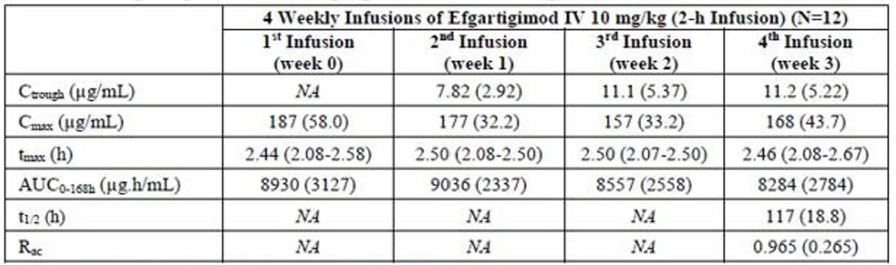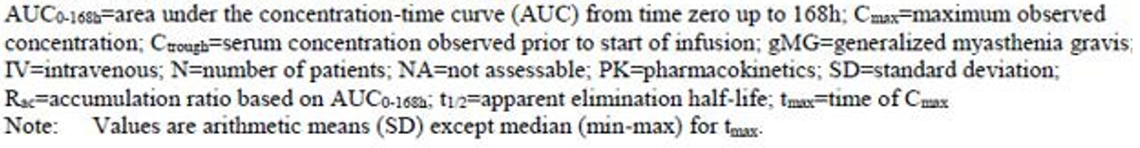

PK in the target gMG population is similar to PK in healthy subjects. Reported exposure PK data in the target population dosed with the intended 10 mg/kg IV regimen in the pivotal Phase 3 study ARGX-113-1704 are shown below in Table 6.
Table 6. Summary of efgartigimod pharmacokinetic parameters per treatment cycle, in patients with generalised myasthenia gravis, study ARGX-113-1704
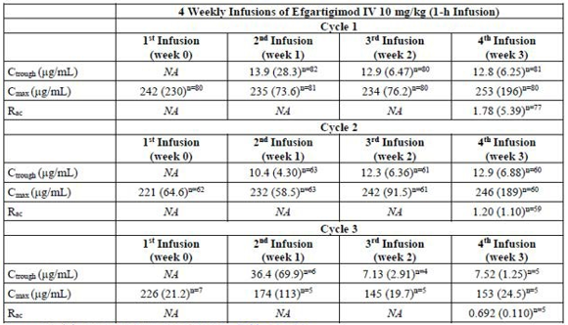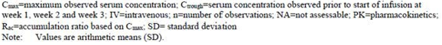
No dedicated pharmacokinetic studies were performed in patients with renal impairment. After 10,000 simulated replicates of the popPK dataset, the increase in exposure (AUC0-168h) for patients with mild renal impairment was in the range of 13 to 30%. Of the 167 patients included in phase 3 studies, 52 and 6 patients were classified as patients with mild (eGFR ≥ 60 to < 90mL/min/1.73 m2) and moderate (eGFR ≥ 30 to < 60 mL/min/1.73 m2) renal impairment, respectively. With respect to weight, popPK simulations with the chosen body weight adjusted dose regimen suggest an impact of high body weight on exposure. Following weekly doses of 1200 mg (corresponding to a patient weight of 120 kg), the median increase in exposure (AUC0-168h) was 36%, compared to the reference subject with a median weight of 79 kg. Subjects with low body weight (simulated for the 5th percentile body weight of 53 kg) have a median exposure of 80% of the reference patient. These deviations in exposure due to body weight are considered low and not clinically significant. Based on popPK analysis hepatic function markers, age and race did not appear to affect PK of efgartigimod.
The EMA assessment concluded that the PK data package was appropriate overall, and considered that, based on popPK data provided, dose adjustment in hepatic impairment is not required, and that whilst no dose adjustment is required in mild renal impairment, there is insufficient data relating to moderate and severe renal impairment.

PK for the SC formulation
Evaluable PK data for the SC formulation in healthy subjects was contained in study ARGX-113-1702, a Phase 1, randomised, open-label, parallel-group study comparing PK and PD of IV and SC formulations of efgartigimod, study ARGX-113-1901, a Phase 1, randomised, open-label, parallel-group study investigating PK and PD of 4 dose levels of efgartigimod formulated with the dispersing agent rHuPH20, and study ARGX-113-1907, a Phase 1, randomised, open-label, parallel-group non-inferiority study comparing PD of IV and SC formulations (with rHuPH20), with PK data also reported. PK data in patients with gMG was contained in study ARGX-113-2001, a Phase 3, randomised, open-label, parallel-group non-inferiority study comparing IV and SC formulations (with rHuPH20) over 4 treatment administrations, and the interim report for study ARGX-113-2002, a Phase 3, long-term, open-label study assessing multiple SC doses (with rHuPH20), primarily for safety.
The popPK model for the SC formulation was based on a 3-compartment PK model for the IV treatment, and included healthy subject data from the IV only studies ARGX-113-1501 and ARGX-113-1702 and SC formulation studies ARGX-113-1901 and ARGX-113-1907, and gMG patient data relating to both IV and SC formulations from studies ARGX-113-1602 and ARGX-113-1704. The model was updated with data from ARGX-113-2001 with re-estimation of parameters.
Based on popPK modelling the estimated bioavailability after SC administration is 76.5%, median Cmax 48 µg/mL and median tmax 48 hours, and volume of distribution 18 L. Elimination is comparable between the formulations, with median t1/2 78.7 hours and 82.7 hours for the IV and SC formulations respectively. Dose proportionality has not been assessed after SC dosing; based on evaluation of Ctrough accumulation of efgartigimod after the fourth administration compared to after the first administration of the SC formulation was minimal. Based on consistent Ctrough across treatment cycles, the PK of efgartigimod did not appear to change over time with multiple cycles.
In a categorical evaluation, patients with mild renal impairment (eGFR ≥ 60 to < 90 mL/min/1.73m2) were estimated to show 11% (90% CI: 3% to 19%) higher AUC0-168h, compared to patients with normal renal function (eGFR ≥ 90 mL/min/1.73m2). No patients with gMG and impaired hepatic function were studied; popPK analysis did not identify any influence of markers of hepatic function. There were no clinically significant differences identified in exposure based on gender, whilst neither age nor race was not found to influence model parameters on popPK/population PD analysis.
Results of all analyses indicate that effect of body weight on exposure of efgartigimod is limited and not clinically relevant. Population PK modelling was undertaken to compare PK after fixed dosing of efgartigimod with the SC formulation to weight-based dosing with the IV formulation, using both actual and modelled exposure PK data from healthy subjects and gMG patients, with administration of efgartigimod IV 10 mg/kg in participants in the weight range ≥ 60kg and < 90kg as a reference. Estimated AUC0-168h was comparable across the body weight groups, <60kg, ≥ 60kg to < 90kg, and ≥ 90kg, with the 90% CI of the geometric mean ration falling within bioequivalence margins of 0.8 to 1.25.
The EMA assessment concluded that the PK data package was adequate for the SC formulation but requested submission of the final bioanalytical reports for the extension study ARGX-113-2002 upon study finalisation.

Pharmacodynamics (PD)

Mechanism of action
The neonatal Fc receptor (FcRn) has a specific role in IgG homeostasis and recycles all IgG subtypes (IgG1, IgG2, IgG3, IgG4), rescuing them from intracellular lysosomal degradation. FcRn binds to pinocytosed IgG and protects the IgG from transport to degradative lysosomes by recycling it back to the extracellular compartment. This FcRn-mediated recycling accounts for the longer half-life and higher plasma concentrations of IgGs compared to other immunoglobulins that are not recycled by FcRn. Efgartigimod alfa is a human IgG1 Fc-fragment modified to have an increased affinity to FcRn. Efgartigimod outcompetes endogenous IgG binding, preventing FcRn-mediated recycling of IgGs and results in increased IgG degradation including pathogenic IgG autoantibodies.

PD for the IV formulation
Evaluable PD data for the IV formulation in healthy subjects was contained in studies ARGX-113-1501 and ARGX-113-1702, which also contained PK data summarised above, and in patients with gMG in studies ARGX-113-1602 and ARGX-113-1704, both included in the PK section above, as well as study ARGX-113-1705, a Phase 3 open-label extension of ARGX-113-1704. PD markers in all studies included total IgG and IgG subtypes (IgG1, IgG2, IgG3, IgG4), whilst to assess selective reduction of IgG by efgartigimod some studies assessed other Ig isotypes IgA, IgD, IgE and IgM, and in patients with gMG, the autoantibodies AChR-Ab and anti-MuSK antibodies were assessed.
The PD effects elicited by efgartigimod were comparable in patients with gMG and healthy subjects. After administration of 4 weekly infusions of efgartigimod IV 10 mg/kg, the pattern of total IgG reduction was similar in both populations achieving a maximum reduction one week after the last infusion. Based on the change from baseline values, after 4 weekly infusions total IgG was reduced by approximately 70% in healthy subjects and 60% to 70% in patients with gMG, as shown in Figure 1. Whilst total IgG baseline values differed between patients with gMG and healthy subjects, reduction following 4 weekly infusions consistently reduced total IgG to a nadir level of 2500 to 3500 µg/mL in both populations.
Figure 1. Mean percent change from baseline in total IgG after 4 weekly infusions of efgartigimod IV 10 mg/kg in healthy subjects, and patients with generalised myasthenia gravis
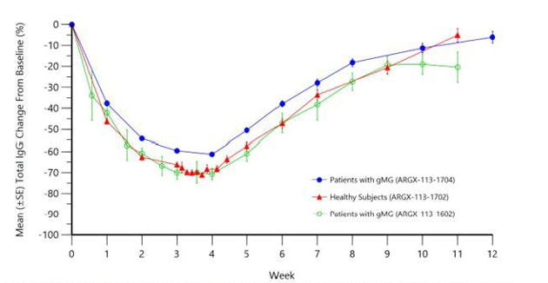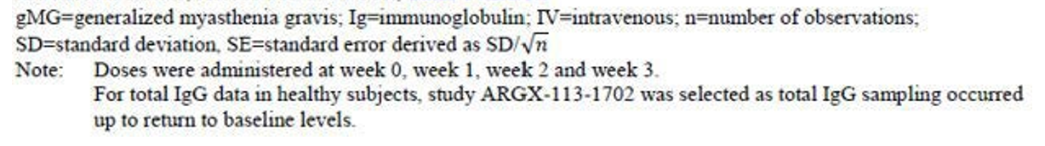
The reduction of AChR-Ab clearly followed the pattern of reduction of total IgG, and the time course and magnitude in reduction of the PD markers in subsequent cycles was comparable to cycle 1. Across the studies, similar results were obtained for the different IgG subtypes, although mean reduction in IgG4 was slightly less.
Based on results from the pivotal efficacy study ARGX-113-1704, PD effect correlated with efficacy, evidenced by reduction in Myasthenia Gravis Activities of Daily Living (MG-ADL) scores matching the time course of reduced total IgG and AChR-Ab levels, shown in Figure 2.
Figure 2. Change in MG-ADL total score and percent change in levels of IgG and ACh-R-Ab by cycle in the ACh-R seropositive population, study ARGX-113-1704

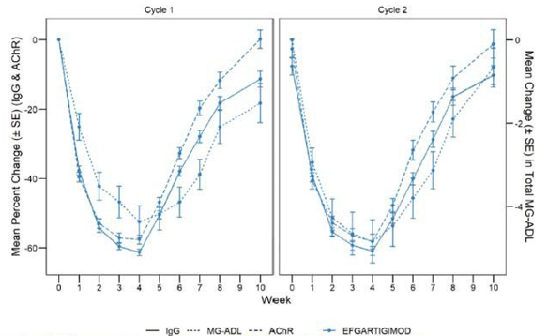
In a pooled PD analysis evaluating the total IgG levels in patients with gMG, the percentage change from cycle baseline did not differ across the first 7 cycles, whilst there was no difference in total IgG levels based on the presence of anti-drug antibodies (ADAs).

PD for the SC formulation
Comparative PD data in healthy subjects for the IV and SC formulations was contained in study ARGX-113-1907, which compared 4 once-weekly IV infusions 10 mg/kg efgartigimod and 4 once-weekly 1000 mg SC injections in 54 subjects randomised 1:1. The two formulations were non-inferior for the PD endpoint of total IgG level reduction at day 29, at the non-inferiority margin of 10%.
Similar results were shown in patients with gMG in study ARGX-113-2001, which had the same study treatments and dosing frequency, with 111 participants randomised between the IV and SC formulations. The two formulations were non-inferior in terms of total IgG level reduction at day 29, again at the non-inferiority margin of 10%. This is demonstrated in Figure 3. The least-squares mean (LSM) estimate of the percent change from baseline in total IgG levels at day 29 was -66.4% (95% CI: -68.91% to -63.86%) in the SC formulation arm, and -62.2% (95% CI: - 64.66% to -59.71%) in the IV formulation arm. The results were consistent when the ANCOVA analysis was repeated for total IgG in the AChR-Ab seropositive population.
Figure 3. Total IgG level percent change from baseline over time for the overall population, mITT Analysis Set, study ARGX-113-2001
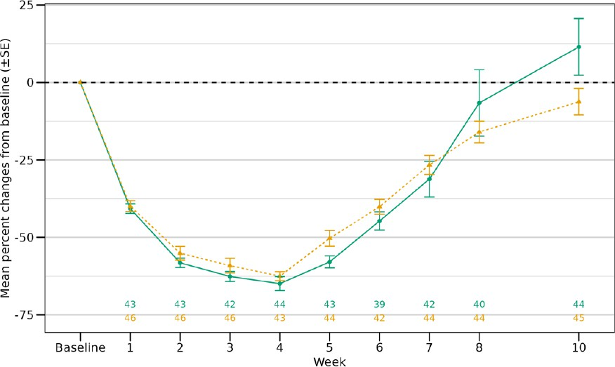
Evaluable PD data showed no evidence of difference attributable to ADAs.
The EMA assessment concluded that, based on data as summarised from studies ARGX-113-1907
and -2001, reduction in total IgG between healthy subjects and gMG patients receiving SC efgartigimod was very similar.

Efficacy evaluation
Efficacy endpoints used throughout the dossier include the MG-ADL and Quantitative Myasthenia Gravis (QMG) scale.
The MG-ADL scale is an 8-item patient-reported outcome tool used to assess MG symptoms and effects on daily activities. The scale comprises 2 items on daily life activities and 6 items on symptoms.
- The daily living items are (1) ability to brush teeth or comb hair and (2) limitations in the ability to rise from a chair.
- The MG symptom categories are diplopia, chewing, voice/speech, ptosis, swallowing, and respiratory.
Each item is graded on 4-point symptom severity scale (0 = normal to 3 = most severe), with the total score ranging from 0 to 24.
The QMG includes 13 items that measure endurance or fatigability, and accounts for fluctuations in disease state. The investigator-rated items are scored on a 4-point severity scale (0 = no symptoms to 3 = severe symptoms) and permissible scores range from 0 to 39, with higher scores indicative of greater disease severity.
Test domains are:
- ocular symptoms (2 items)
- facial/oropharyngeal symptoms (5 items, including 2 ocular items)
- non-facial symptoms (8 items).

Efficacy of the IV formulation
Selection of the dose for the pivotal studies was based on results of previous studies in healthy subjects and gMG patients, and popPK/population PD modelling, indicating that a dose of efgartigimod 10 mg/kg, administered as 4 weekly IV infusions, achieved close to maximal IgG reduction. Single ascending dose data showed that up to 10 mg/kg a dose-dependent decrease in IgG levels was observed, with higher doses of 25 mg/kg and 50 mg/kg not resulting in statistically significantly different IgG reduction, supported by similar findings following 4 weekly infusions of 10 mg/kg or 25 mg/kg, and similar IgG reduction observed between q4d dosing or q7d dosing at 10 mg/kg. The EMA assessment concluded that re-treatment with subsequent cycles of weekly infusions of efgartigimod IV 10 mg/kg or 4 weeks based on clinical evaluation is the most appropriate dose regimen for patients with gMG.
Efficacy of efgartigimod in the indication sought was evaluated in 3 clinical studies, a pivotal Phase 3 study ARGX-113-1704, an ongoing Phase 3 open-label extension ARGX-113-1705, and a supportive Phase 2 double-blind, placebo-controlled study ARGX-113-1602. These studies are summarised in Table 7, reproduced from the EMA assessment report.
Table 7. Clinical studies with efgartigimod supporting the clinical efficacy of efgartigimod in generalised Myasthenia Gravis
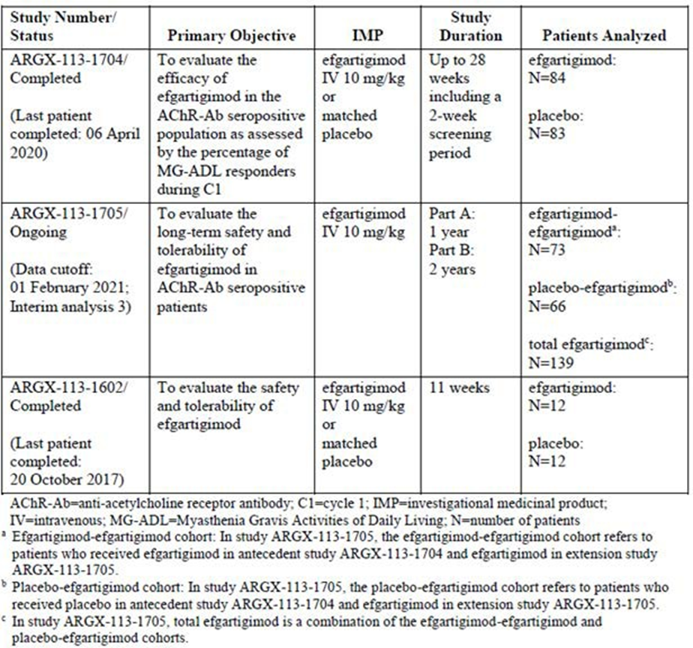

Study ARGX-113-1704, pivotal efficacy study
ARGX-113-1704 was a phase 3, randomised, double-blind, placebo-controlled, parallel-group, multicentre study conducted between August 2018 and April 2020 at 56 sites worldwide, to evaluate efficacy and safety in patients with gMG treated with efgartigimod. Patients were to be randomised 1:1 to receive treatment cycles (TCs) of efgartigimod 10 mg/kg IV or matched placebo infusions concomitantly with their existing gMG therapies, with subsequent TCs administered according to clinical response. Treatment comprised infusions every 7 days for 4 infusions. Patients were stratified according to AChR-Ab status, type of concomitant gMG treatment (non-steroidal immunosuppressive drugs [NSIDs] or not NSIDs) and whether they were Japanese or non-Japanese. Total study duration was up to 26 weeks, with the initial TC 8 weeks in duration (3-week treatment period and 5-week follow-up period), followed by a variable inter-TC period depending on clinical response based on pre-specified criteria. Changes were not permitted to type or dose of concomitant gMG therapies during the study, and rescue therapy was permitted if a patient deteriorated based on the investigator’s clinical assessment; patients who required rescue therapy were discontinued from the study.
Key inclusion criteria were adult patients with a diagnosis of MG with generalised muscle weakness, MGFA class II, III, IVa or IVb, and MG-ADL total score ≥ 5 points at screening and baseline with >50% of the total score attributed to non-ocular symptoms. Patients were required to be on stable doses of standard-of-care concomitant therapies for gMG, with specific dose stability conditions. Exclusion criteria were categorised as MG-related, including MGFA class I and V patients and a previously documented lack of clinical response to plasma exchange therapy, related to previous or concomitant treatments, including Ig-based therapy in the preceding 1 month or monoclonal antibody therapy in the preceding 6 months, related to infection or malignancy risk, including patients who had received a vaccination in the 4 weeks prior to screening, and other criteria, including pregnant and lactating women and patients with a history of other autoimmune condition.
The primary efficacy endpoint was percentage of MG-ADL responders after the first TC (TC1), defined as a reduction of at least 2 points on the MG-ADL total score for at least 4 consecutive weeks with the first decrease occurring at the latest 1 week after the last infusion, in the AChR-Ab seropositive population. Secondary endpoints included assessment of efficacy based on the QMG score, MG-ADL in the overall study population, and time from week 4 to qualify for re-treatment.
Sample size calculation was guided by Phase 2 results, assuming placebo response rate of 30%, and treatment difference 35% for the AChR-Ab seropositive population and 5% for the seronegative population. A sample size of 150 was determined to provide power of 96% in the primary population of AChR-Ab seropositive patients to detect a difference of 35% in the proportion of responders with 120 patients, assuming 20% enrolment of AChR-Ab seronegative patients. The primary efficacy endpoint was to be tested by means of a 2-sided test, stratified according to the pre-defined stratification factors, at the 2-sided 5% significance level, in AChR-Ab positive patients. Percentage responders were to be compared between study treatment and placebo using logistic regression, with baseline MG-ADL as covariate and Japanese/non-Japanese patient, AChR-Ab serotype, and standard-of-care as stratification variables. A hierarchical testing approach was used to control for multiplicity.
There were 216 patients screened, of whom 167 were enrolled and randomised; 129 (77.2%) were AChR-Ab seropositive, and 38 (22.8%) seronegative. Overall, 152 patients (91.0%) completed treatment and 156 (93.4%) completed the study. Patients in either group received a maximum of 3 TCs, with number of cycles per patient balanced between treatment groups.

Baseline patient demographics were comparable between treatment groups, with mean age of all patients 45.9 years in the efgartigimod group and 48.2 years in the placebo group, a slightly higher majority of females in the efgartigimod group (75.0% vs 66.3%) and >80% white race in both groups. Notably, among AChR-Ab seropositive patients receiving efgartigimod only 8 were aged ≥65 years. In terms of baseline disease characteristics, in the AChR-Ab seropositive population a higher proportion of patients in the efgartigimod group had undergone thymectomy (69.2% vs 46.9% in the placebo group), whilst symptom severity in terms of MGFA class, MG-ADL and QMG scores were comparable. Concomitant steroid use was slightly higher among the efgartigimod group compared to the placebo group (71.4% vs 80.7% in the overall population), but other therapies were broadly similar between treatment groups, with 60.7% and 61.4% in the efgartigimod and placebo groups respectively in the overall population on any NSID, the most common of which was azathioprine at a similar rate in both groups, and concomitant pyridostigmine use in 73.8% in the efgartigimod group and 74.7% in the placebo group overall. The majority of patients randomised were on 3 classes of concomitant treatments, with proportions similar across treatment groups.
There was a high rate of treatment compliance in both groups and across TCs, with 10 patients in total receiving 3 TCs, 7 in the efgartigimod group, 3 in the placebo group.
In terms of results for the primary efficacy endpoint, the MG-ADL responder criterion was met in 44 (67.7%) AChR-Ab seropositive patients in the efgartigimod group compared to 19 (29.7%) in the placebo group, giving a treatment difference of 38.0%, with an OR of 4.95 (95% CI 2.21; 11.53). This result was statistically significant (p<0.0001; logistic regression testing). Sensitivity analyses were supportive, and subgroup analyses found no major discrepancies according to stratification factors. Of note, among the AChR-Ab seronegative population 13 (68.4%) patients in the efgartigimod group and 12 (63.2%) patients in the placebo group were MG-ADL responders. Results for secondary efficacy endpoints are summarised in Table 8.
Table 8. Results for secondary efficacy endpoints in hierarchical order, study ARGX-113-1704
 | Efgartigimod | Placebo | Efgartigimod vs Placebo
 | Efgartigimod | Placebo | Odds Ratio (95% CI) | Difference LSM (95% CI) | P-value
QMG Responders in the AChR-Ab Seropositive Population During Cycle 1 n/N % | 41/65  63.1% | 9/64  14.1% | 10.842  (4.179,  31.200) |  | <0.0001
MG-ADL Responders in the Overall Population During Cycle 1  n/N % | 57/84  67.9% | 31/83  37.3% | 3.699  (1.854,  7.578) |  | <0.0001
MG-ADL Total Score Clinically Meaningful Improvement Percentage of Time in the AChR-Ab Seropositive Population  LSM (95%CI) | 48.714  (36.517;  60.912) | 26.649  (14.148;  39.151) |  | 22.065  (10.949;  33.181) | <0.0001
Time (days) to Qualify for Retreatment  Since Week 4 Visit Median (95% CI) | 35.0  (29.0, 43.0) | 8.0  (1.0; 30.0) |  |  | 0.2604
AChR-Ab = acetylcholine receptor antibody; QMG = Quantitative Myasthenia Gravis; MG-ADL = Myasthenia Gravis Activities of Daily Living; LSM = least squares mean; n = number of patients for whom the observation was reported; N = number of patients in the analysis set.
The EMA assessment considered overall study design to be acceptable, with the 26-week study duration sufficient to demonstrate short-term efficacy. They noted concern with the choice of placebo-controlled trial despite available approved therapies for gMG, however, concluded that given background concomitant gMG therapies were continued during the study that the approach was acceptable. The assessment also noted that background therapy may make it more difficult to interpret clinical results, in particular the assessment of the effect of an additional therapeutic agent (efgartigimod), however, the Committee for Medicinal Products for Human use (CHMP) concluded this did not hinder the strength of efficacy results. The use of both patient evaluated (MG-ADL) and physician evaluated (QMG) efficacy endpoints was considered appropriate. A 2-point reduction in MG-ADL total score was considered clinically meaningful, whilst QMG results for the first secondary efficacy endpoint were also considered clinically meaningful.
Given that MGFA class V patients were excluded from the study, and that data suggested onset of response can be delayed (seen within 2 weeks of initial infusion in 37/44 [84%] of patients treated with efgartigimod in the AChR-Ab seropositive MG-ADL responders), the EMA assessment cautioned that clinicians should not use efgartigimod as bridging therapy, or at the time of myasthenic exacerbations as rescue therapy.
The EMA and TGA evaluators both noted that, due to lack of power to assess the efficacy in AChR-Ab seronegative patients based on sample size considerations and the primary endpoint definition, heterogeneity resulting from inclusion of a broad AChR-Ab seronegative population, and no evidence of benefit for AChR-Ab seronegative patients on MG-ADL over placebo, the indication should be limited to AChR-Ab seropositive patients, which was agreed between the sponsor and CHMP.

Study ARGX-113-1705
Study ARGX-113-1705 is the open-label, single-arm, 2-part, 3-year extension of study ARGX-113-1704, ongoing at the time of submission. Patients are treated with efgartigimod 10 mg/kg IV on an “as needed” basis. There were 151 patients rolled onto this study, and 139 had received at least one dose of efgartigimod, of which 73 received efgartigimod in the preceding study (“efgartigimod-efgartigimod cohort”), and 66 patients had previously received placebo (“placebo-efgartigimod cohort”). Overall, 29 (20.9%) patients had discontinued treatment, and the maximum number of TCs completed was 10. In the AChR-Ab seropositive population mean change in MG-ADL from cycle baseline measured at cycle week 3 was similar for each TC up to cycle 9 in each treatment group, with generally lower mean reduction in MG-ADL seen for each TC in the placebo-efgartigimod cohort. This was an exploratory endpoint and no statistical comparison was completed.

Study ARGX-113-1602
Study ARGX-113-1602 was a Phase 2, randomised, double-blind, placebo-controlled study, which enrolled 24 patients with gMG randomised 1:1 to study treatments efgartigimod IV 10 mg/kg or matched placebo IV infusion q7d for 4 infusions, concomitantly with existing gMG therapies. Study inclusion and exclusion criteria were similar as for the pivotal study, ARGX-113-1704, and all patients in the study were AChR-Ab seropositive. The study included a 3-week treatment period, and 8-week follow-up period. Figure 4 shows mean change in MG-ADL from baseline between treatment groups measured at each study visit. Observed efficacy results were similar using other measures of MG disease severity.
Figure 4. Mean MG-ADL change from baseline, FAS, study ARGX-113-1602

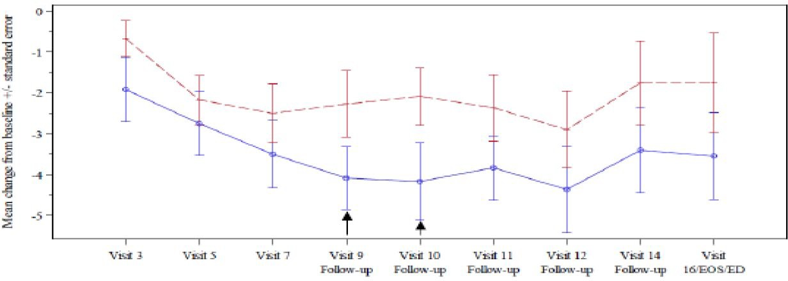
EID = Early Discontinuation; EOS = End.-of-Study; FU= Follow-up; MG-ADL = Myasthenia Gravis Activities of Daily Living; QMG = Quantitative Myasthenia Gravis;
Arrow shows statistically significant difference between ARGX-113 and placebo
Visit 3 = Day 8 , Visit 5 =Day 15; Visit 7 = Day 22, Visit 9 (Week l FU) = Day 29, Visit 10 (Week 2 FU) = Day 36, Visit 11 (Week 3 FU) = Day 43, Visit 12 (Week 4 FU) = Day 50, Visit 14 (Week 6 FU) = Day 64, Visit l6 (Week S FU EOS/ED) = Day 78
Doses administered at Day l (Visit I) , Day 8 (Visit 3), Day 5 (Visit 5) , and Day 21 (Visit 7)

Evaluator conclusions on efficacy for the IV formulation
The EMA assessment concluded that evidence of efficacy of VYVGART in the treatment of adult patients with gMG who are AChR-Ab seropositive, as an add-on to standard therapy, was demonstrated. They noted that maintenance of effect remains to be confirmed by longer term data. The TGA evaluator noted that efficacy data could be sufficient to support marketing authorisation in gMG due to rarity of the condition, if the pivotal study is considered as a single well-conducted and adequately powered confirmatory trial showing results sufficiently compelling with respect to internal and external validity.

Efficacy of the SC formulation
Selection of the dose for pivotal studies for the SC formulation was based on population PK/PD approach using data from study ARGX-113-1901, which evaluated PD of multiple doses of SC formulation. A fixed SC dose resulting in a similar PD effect as achieved with the efficacious and safe treatment cycle of efgartigimod IV 10mg/kg was targeted. Using the PK/PD model, simulating doses in the range 750 mg-1750 mg, using PK exposure and total IgG reduction metrics, SC doses of 925 mg, 900 mg, and 825 mg were found most comparable to the established IV dose. Taking into consideration both median values and 90% CI ranges of the PD outcome parameters considered, an SC dose of 1000 mg was chosen.
In the EMA assessment clinical studies using both IV and SC formulations were considered as providing evaluable efficacy data. The pivotal efficacy study for the SC formulation is ARGX-113-2001, a Phase 3 open-label study comparing efgartigimod IV and SC formulations with PD and efficacy endpoints, and ARGX-113-2002, the corresponding open-label extension study.

Study ARGX-113-2001
Study ARGX-113-2001 was a Phase 3, randomised, open-label, parallel-group 12-week study comparing PD, PK, efficacy, safety and immunogenicity of IV and SC formulations of efgartigimod, conducted from 5 February 2021 to 13 December 2021. This study sought to bridge from efgartigimod IV formulation to SC formulation by demonstrating a similar PD effect, measured by percent reduction from baseline in total IgG at day 29 with a non-inferiority margin of 10%, and by demonstrating that total IgG reduction was associated with clinical response in gMG patients. Criteria for MG diagnosis, study inclusion and exclusion were similar to the pivotal study for the IV formulation, ARGX-113-1704. Study treatments were 1000 mg of SC formulation or 10 mg/kg of the IV formulation once weekly for 4 administrations (on days 1, 8, 15 and 22), with concomitant stable dose of the patient’s current gMG therapy. In line with the PD bridging intent for the study, the primary endpoint was percent reduction from baseline in total IgG at day 29, with secondary efficacy endpoints including clinical response based on MG-ADL and QMG scores.
Sample size calculation was initially based on mean percent reduction in total IgG results from studies ARGX-113-1704 and ARGX-113-1907, with 20 participants calculated per treatment arm for 90% power to detect non-inferiority at the 10% level using a 1-sided, 2-sample t-test at a 2.5% significance level. Additional participants were planned to account for attrition, and in a subsequent protocol version to better quantify safety and efficacy profile.
In terms of statistical methods, the primary (PD) endpoint was analysed using an ANCOVA model with treatment as a factor and total IgG levels at baseline as a covariate, with noninferiority evaluation based on margin of 10%. Secondary endpoints, including efficacy endpoints, were summarised with descriptive statistics by treatment arm and overall. The difference in MG-ADL responders between treatment arms was analysed using meta-analysis predictive approach incorporating TC 1 data from the efgartigimod IV treatment arm in study ARGX-113-1704 as historical active controls, using a Bayesian hierarchical model. The TGA evaluator noted that provision for multiplicity was not mentioned.
A total of 111 patients were enrolled and randomised, 55 to the SC arm and 56 to the IV arm. Patient demographics were similar between groups; in the total population mean age was 53.4 years, 27.3% were ≥65 years, the majority were female (59.1%), over 90% were white race, and mean weight was 80.61 kg. The AChR-Ab seropositive population demographics were comparable to the overall population. Disease severity was also comparable at baseline, with mean MG-ADL score in the SC group 8.8 and IV group 8.5. In the SC group 81.8% were AChR-Ab seropositive, compared to 83.6% in the IV group. In terms of concomitant therapies, 69.1% in both treatment groups were on ≥2 baseline MG therapies, with comparable rates of corticosteroid, pyridostigmine and NSID use between groups.

In terms of results for the primary endpoint, total IgG reduction at day 29 was non-inferior between the treatment groups after 1 TC of 4 weekly administrations; in the AChR-Ab seropositive population LSM change in total IgG in the SC group was -66.9, and in the IV group - 62.4, with pre-specified non-inferiority criteria met. Results for secondary efficacy endpoints are summarised in Table 9, showing similar results for the SC and IV formulations.
Table 9. Percentage of MG-ADL responders by AChR-Ab status and overall (ITT analysis set), study ARGX-113-2001
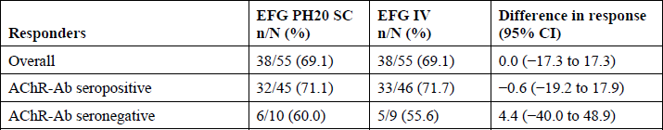
AChR-Ab = anti-acetylcholine receptor antibody; MG-ADL = Myasthenia Gravis Activities of Daily Living; N = number of participants in the analysis set; n = number of participants for whom the observation was reported.
Post-hoc analysis showed that reduction in AChR-Ab levels followed a comparable time course as total IgG levels in AChR-Ab seropositive patients and were similar between the SC and IV treatment groups.
The TGA evaluator highlighted that the study was powered to show non-inferiority in the primary endpoint only. The EMA assessment concluded that clinical efficacy of efgartigimod in the SC formulation was similar to efficacy for the IV formulation after 1 TC of 4 weekly infusions.

Study ARGX-113-2002, interim analysis
Study ARGX-113-2002 is a Phase 3, long-term, single-arm, open-label, multicentre study enrolling participants from studies ARGX-113-2001 and ARGX-113-1705, ongoing at the time of submission to the EMA. The interim analysis was considered to provide supportive evidence for efficacy of efgartigimod in the SC formulation for up to 5 TCs. The study was primarily a safety study but included secondary efficacy and PD endpoints. As of the cutoff date, 178 patients had rolled over to the study from antecedent studies, of whom 53 had received efgartigimod SC formulation in ARGX-113-2001, 52 had received the IV formulation in ARGX-113-2001, and 73 received the IV formulation in ARGX-113-1705.
A treatment period and its corresponding inter-treatment period were grouped into cycles for analysis. Median cycle durations were 56.0 days for Cycle 1 (C1), 56.0 days for C2, 50.0 days for C3, and 50.0 days for C4, with the maximum cycle duration of C1 reaching up to 204 days. The mean (SE) change from study baseline in MG-ADL total score in the total group at week 4 in the AChR-Ab seropositive population was -4.1 (0.29) in C1, -4.0 (0.32) in C2, -4.2 (0.35) in C3, and -4.6 (0.46) in C4.
The EMA evaluation concluded that, being aware of limitations relating to study design including exclusion of patients who did not respond to efgartigimod from rolling over into study ARGX-113-2002, the efficacy data is assessed as supportive evidence for maintenance of efficacy beyond the first cycle with the SC formulation.

Evaluator conclusions on efficacy for the SC formulation
The EMA assessment report, and conclusions on clinical efficacy, were based on the application to the EMA for marketing authorisation of the SC formulation being a line extension request, based on the previously approved IV formulation. Overall, study ARGX-113-2001 was considered acceptable for the purpose of showing therapeutic equivalence of the two formulations. The primary endpoint was not considered adequate on its own to demonstrate therapeutic equivalence, given that total IgG reduction as a PD biomarker is not mechanistically linked to the disease; reduction of AChR-Ab levels could be linked for the AChR-Ab seropositive population. The post-hoc analysis of reduction in AChR-Ab levels is therefore considered relevant.
The EMA assessment concluded that overall, in study ARGX-113-2001, the SC and IV formulations have demonstrated a similar and clinically relevant efficacy in treatment of AChR-Ab seropositive population in one treatment cycle, based on patient and physician rating, and by total IgG reduction at day 29. Results of study ARGX-113-2002 were considered supportive up to 4 cycles. Whilst the primary PD endpoint cannot be accepted to show therapeutic equivalence, the totality of evidence is considered to support therapeutic equivalence of the SC and IV formulations.
The TGA evaluator noted the discrepancy between applications to the EMA, with the SC formulation submitted as a line extension to the previously approved IV formulation, opposed to the TGA application for both formulations concurrently. The evaluator noted the lack of control for multiplicity in statistical testing.

Safety evaluation

Safety for the IV formulation
Safety data were presented according to individual studies and as pooled data, with pooling block 1 (PB1) including data from placebo-controlled studies in patients with gMG (ARGX-113-1602, and cycle 1 ARGX-113-1704), and pooling block 2 (PB2) including all gMG patients treated with efgartigimod (studies ARGX-113-1602, -1704, and -1705 up to data cutoff).
Among all gMG patients administered efgartigimod, 162 patients received at least 1 dose, mean (SD) duration of treatment combined with follow-up was 413.9 (170.26) days, and cumulative treatment exposure 183.6 patient-years. Duration of treatment and follow-up was at least 12 months in 118 (72.6%) patients. Table 10 gives an overview of treatment emergent adverse events (TEAEs) in pivotal study ARGX-113-1704 and long-term extension -1705.
Table 10. Overview of treatment emergent adverse events, studies ARGX-113-1704 and ARGX-113-1705 (safety analysis set)
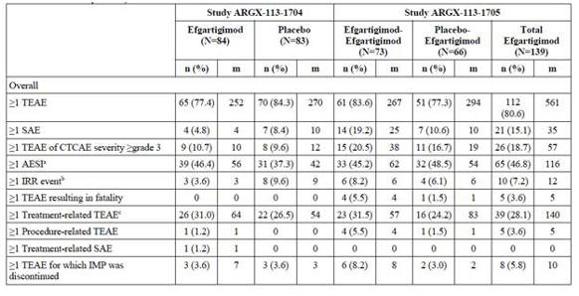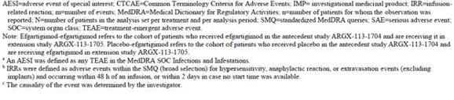
In PB2 the most common TEAEs during all cycles cumulatively by system organ class (SOC) and preferred term (PT) were: infections and infestations, with 179 events observed in 90 (55.6%) patients, with most common PTs nasopharyngitis (24 patients, 14.8%), urinary tract infection (16 patients, 9.9%) and upper respiratory tract infection (12 patients, 7.4%), nervous system disorders, with 198 events observed in 72 (44.4%) patients, with most common PT headache (56 patients, 34.6%), and gastrointestinal disorders, with 88 events observed in 46 (28.4%) patients, with most common PTs diarrhoea (18 patients, 11.1%) and nausea (14 patients, 8.6%).
In study ARGX-113-1704, TEAEs that led to treatment discontinuation occurred in 3 (3.6%) patients in each treatment group. In study ARGX-113-1705, TEAEs that led to discontinuation of efgartigimod treatment occurred in 8 (5.8%) patients in the total efgartigimod group. The TEAEs that led to discontinuation of efgartigimod reported in more than 1 patient in either cohort were myasthenia gravis and COVID-19 pneumonia. The following PTs reported in 6 patients were serious: spinal compression fracture, MG, lung neoplasm malignant, COVID-19 pneumonia, adenocarcinoma of colon, and acute myocardial infarction.
In study ARGX-113-1704, TEAEs of Common Terminology Criteria for Adverse Events (CTCAE) severity grade ≥ 3 occurred in 9 (10.7%) patients in the efgartigimod group and 8 (9.6%) patients in the placebo group. The only TEAE of CTCAE severity grade ≥ 3 that was reported in more than 1 patient in either group was MG, reported in 1 (1.2%) patient in the efgartigimod group, and 2 (2.4%) patients in the placebo group.
In study ARGX-113-1705, TEAEs of severity grade ≥ 3 occurred in 26 (18.7%) patients in the total efgartigimod group, with a slightly higher rate in the efgartigimod-efgartigimod group. Events reported in ≥ 2 patients in either cohort were COVID- 19 pneumonia (2 [2.7%] patients in the efgartigimod-efgartigimod cohort), headache (1 [1.4%] patient in the efgartigimod-efgartigimod cohort and 2 [3.0%] patients in the placebo-efgartigimod cohort), and MG (2 [2.7%] patients in the efgartigimod-efgartigimod cohort and 1 [1.5%] patient in the placebo-efgartigimod cohort).
TEAE data for PB2 by treatment cycle showed that TEAEs observed in the total efgartigimod group generally decreased in subsequent cycles, characterised by ≥1 TEAE observed in 108 patients (n= 162, 66.7%) in cycle 1, compared to 17 patients (n=67, 25.4%) in cycle 7.

Serious adverse events
The overall number of treatment-emergent serious adverse events (SAEs) observed in PB2 was low. In study ARGX-113-1704 4 (4.8%) patients in the efgartigimod group recorded ≥1 SAE compared to 7 (8.4%) patients in the placebo group, whilst in study ARGX-113-1705 the rate of observed SAEs was higher in the efgartigimod-efgartigimod group (14 patients, 19.2%) compared to the placebo-efgartigimod group (7 patients, 10.6%). Most common SAEs by SOC in the total efgartigimod cohort in PB2 were infections and infestations (6 patients, 3.7%) and nervous system disorders (6 patients, 3.7%), with most common PTs COVID-19 pneumonia and MG respectively. In pooled PB2 analysis 11 neoplasms were recorded in 8 (4.9%) patients, 4 of which had neoplasms arising from squamous cells; all neoplasms were considered not related to study treatment.

Deaths
5 fatal cases were reported in the efgartigimod cohorts and none in the placebo cohorts, with no deaths considered related to study treatment by investigators. Of these deaths, 2 were associated with the SAE of cardiovascular disease, 1 related to lung cancer, 1 due to myasthenic crisis, and 1 due to infections (COVID-19, pneumonia, UTI, septic shock). Case narratives confirmed relevant risk factors related to the deaths from cardiovascular disease and lung cancer.
With regard to the deaths from infection, the sponsor provided justification to the EMA, including analysis evaluating incidence of infectious events relative to nadir IgG levels in PB2, showing no clear correlation between IgG levels and infections categorised as serious. This was supplemented by published literature supporting no association between transient IgG reduction and incidence of infection.
The EMA assessment accepted this justification. The TGA evaluator concluded that, given the mechanism of action of efgartigimod, a possible association with the infections leading to death could not be excluded.

Adverse events of special interest
The SOC infections and infestations is defined as AESI for efgartigimod; in the pivotal study ARGX-113-1704, 46.4% of patients in the efgartigimod and 37.3% of patients in the placebo group reported TEAEs in this SOC, with the most frequently observed in both groups nasopharyngitis, upper respiratory tract infection, urinary tract infection, and bronchitis. With the exception of nasopharyngitis, all of these events were recorded more frequently in the efgartigimod group. All AESIs in SOC infections and infestations reported in the total efgartigimod group in PB2 during all treatment cycles cumulatively were of severity Grades 1 or 2, except for 12 events in 8 patients Grade ≥3. Herpes viral infections, candidiasis and vulvovaginal mycotic infection were only reported in efgartigimod-treated subjects during clinical development; for the 12 patients who had a herpes or candidiasis-relevant infection, 11 were receiving concomitant immunosuppressives.

The EMA assessment noted analysis of AESIs relative to nadir IgG levels, showing number of AESIs slightly higher in groups of nadir IgG categories below the median compared to above the median. The assessment concluded that the small increase in number of infections in the lowest 2 IgG nadir quartiles is consistent with the pharmacological action of efgartigimod. An analysis of infections by concomitant treatment for gMG showed that use of concomitant immunosuppressant treatment did not appear to affect risk of infection.

Laboratory findings
In study ARGX-113-1704, lymphocyte count decreased was the most frequently reported grade ≥ 3 abnormality, occurring in 8 (9.5%) patients in the efgartigimod group and 8 (9.6%) patients in the placebo group. In study ARGX-113-1705, there were no clinically meaningful mean changes from baseline in the clinical chemistry or haematology parameters or any noteworthy differences in mean changes between the cohorts of patients who received efgartigimod or placebo in the previous study.
The majority of clinical chemistry and haematology abnormalities at any time post-baseline in PB2 (over all of the cycles of treatment) were of severity CTCAE grade ≤ 2 with similar numbers of patients reporting laboratory abnormalities in the cohorts of patients who received efgartigimod or placebo in the previous study. The most frequently reported grade ≥ 3 abnormalities were lymphocyte count decreased (13 [9.4%]) followed by hypertriglyceridemia (4 [3.0%]), and high cholesterol (2 [1.5%]).

Vital Signs
Across PB2 there were no notable changes from baseline in vital sign parameters, neither by cycle or over time.

Electrocardiogram
A post-infusion QTcF interval measurement between >480 to ≤ 500ms was reported in 3 (1.9%) patients in the PB2 and none in the placebo cohorts. Two (1.2%) had a QTcF interval increase from baseline of >60ms in PB2 and 1 (1.2%) in the placebo cohort in study ARGX-113-1704.

Safety in special populations
There were no identifiable differences in tolerability between patients <65 years and ≥65 years in PB2, including within the SOB infections and infestations. There were 3 deaths in the ≥65 year group, with none attributed to study treatment.
Analysis of PB2 showed headache reported at higher frequency in females compared to males. There were no clinically meaningful differences by race or body weight.

Immunogenicity, IV formulation
In PB2, samples positive for anti-drug antibody (ADA) at baseline were reported in 32 out of 161 (19.9%) patients with gMG. In the total efgartigimod group, 130 out of 162 patients (80.7%) were classified as ADA negative, of which 30 of 162 (18.6%) had treatment-unaffected ADA. Thirty-one out of 162 (19.3%) patients were classified as ADA positive, of which 29 out of 162 (18.0%) patients had a treatment-induced ADA response and 2 out of 162 (1.2%) patients had a treatment-boosted ADA response. The ADA incidence in the total efgartigimod population was 19.3% and the ADA prevalence was 37.9%.
Most patients (142 out of 150; 95.3%) were neutralising antibody (NAb) negative, of which 140 (140/150; 94.0%) were classified as “NAb baseline negative – post-baseline negative” and 2 (2/150; 1.3%) were classified as “NAb baseline positive – post-baseline negative”. There were 7 (7/150; 4.7%) patients who were Nab positive and classified as “NAb baseline negative – post-baseline positive”. No patients were NAb positive at both baseline and post-baseline sampling timepoints. The NAb incidence was 4.7% in the total efgartigimod treatment group and the NAb prevalence was 6.0%. In the integrated analysis including all efgartigimod studies in gMG, there was no apparent impact of baseline ADA, treatment-induced ADA, or NAb on the safety profile of efgartigimod.

Evaluator conclusions on safety for the IV formulation
The EMA assessment noted patient exposure during clinical development, 143 patients treated with efgartigimod for at least 6 months, 118 patients for at least 12 months, but only 33 patients treated for 18 months and 1 patient for 2 years; this safety database was considered small, particularly considering MG as a chronic condition, with rare events not expected to be captured. Long-term safety data beyond 2 years was extremely limited and was to be addressed through post-authorisation safety studies. The assessment concluded that, overall, available safety data show that efgartigimod was generally well tolerated, however, is considered to be associated with a higher risk of infections.

Post-marketing experience
Whilst the IV formulation had not been marketed anywhere at the time of EMA assessment, the EMA assessment report for the SC formulation (submitted as a line extension to the previously approved IV formulation in the EU) contained post-marketing safety information for the IV formulation.
As of 31 March 2022, approximately 273 patients with gMG had been treated with efgartigimod in the US. 187 events had been reported, of which 16 (8.6%) were considered serious.
Commonly reported adverse events (≥3% by event count) included fatigue (7%), dyspnoea (4.8%), headache (3.2%), and diplopia (3.2%). There were 3 fatal cases reported, mean age 73.3, with only limited information available, insufficient to draw meaningful clinical conclusions.

Safety for the SC formulation
Studies ARGX-113-2001 and -2002, as well as the SC pooling block (SC PB), were the main source of safety data for the SC formulation, whilst safety data for the IV formulation (the IV pooling block) was used to identify any clinically meaningful difference in the safety profile between the two formulations. The SC PB comprises data from all participants with gMG treated with efgartigimod co-forumlated with rHuPH20 for SC administration in studies ARGX-113-2001 and -2002.
In study ARGX-113-2001 55 patients were randomised to efgartigimod SC formulation arm, with 49 receiving all 4 doses, and 56 randomised to the efgartigimod IV formulation arm, with 55 receiving all 4 doses. A total of 178 participants had rolled over to study ARGX-113-2002 from preceding studies (ARGX-113-2001 and -1705), and of these, 164 had received SC formulation efgartigimod in the study.
Overall, in study ARGX-113-2001, there were more reported AEs (67.3% vs. 50.9%), SAEs (14.5% vs. 7.3%), Grade 3 or higher AEs (16.4% vs. 7.3%), treatment related AEs (43.6% vs. 21.8%) and procedure related AEs (25.5% vs. 3.6%) in the efgartigimod SC formulation group compared to efgartigimod IV formulation group. The higher incidence of AEs, treatment- and procedure-related AEs in the SC formulation arm is primarily due to injection site reactions (38.2% vs. 1.8%). AESIs were well balanced between the arms, 18.2% vs. 16.4%.
Common TEAEs in studies ARGX-113-2001 and -2002 are presented in Table 11 according to treatment group, showing injection site rash, headache, injection site erythema and myasthenia gravis the most common in ARGX-113-2001, with a similar profile in the long-term extension study.
Table 11. Study ARGX-113-2001 and ARGX-113-2002 common (≥5% of participants) AEs, by SOC and PT (Safety analysis set)
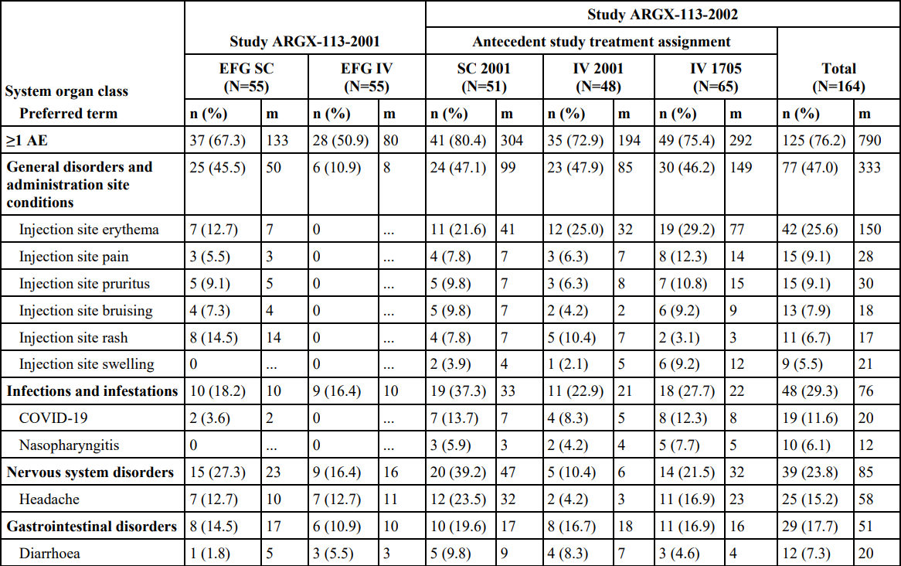
AE=adverse event; m=number of events; CSR=clinical study report; EFG=efgartigimod; efgartigimod PH20 SC=efgartigimod for SC administration coformulated with rHuPH20; IV=intravenous(ly); MedDRA=Medical Dictionary for Regulatory Activities; N=number of participants in the analysis set per treatment; n=number of participants for whom the observation was reported; PT=Preferred Term; rHuPH20=recombinant human hyaluronidase PH20; SC=subcutaneous(ly); SOC=System Organ Class Notes: Adverse events were coded by SOC and PT using MedDRA version 24.1 (Sep 2021). The SC 2001 group refers to participants who received efgartigimod PH20 in antecedent study ARGX-113-2001 and efgartigimod PH20 SC in extension study ARGX-113-2002. The IV 2001 group refers to participants who received efgartigimod IV in antecedent study ARGX-113-2001 and efgartigimod PH20 SC in extension study ARGX-113-2002. The IV 1705 group refers to participants who received efgartigimod IV in antecedent study ARGX-113-1705 and efgartigimod PH20 SC in extension study ARGX-113-2002. The total group refers to all participants who received efgartigimod PH20 SC in extension study ARGX-113-2002.
Table 12 presents common AEs through the first 4 cycles, presented by cycle, in the SC PB, with injection site erythema, headache, COVID-19 and injection site pruritic, the most commonly observed.
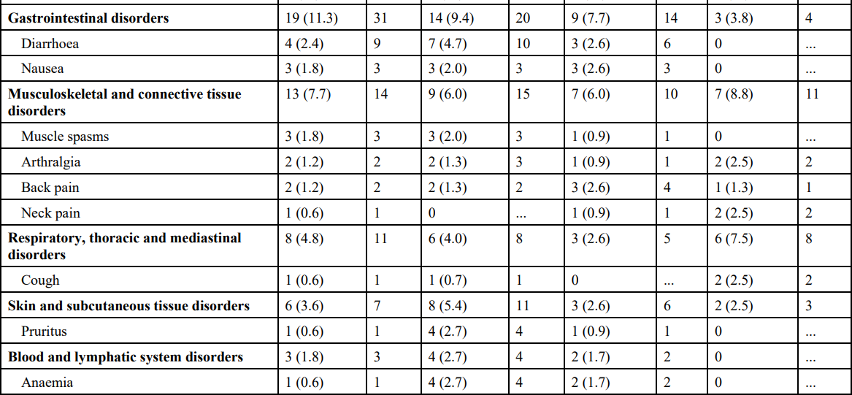
Table 12. AEs occurring in ≥2% of participants during any cycle through cycle 4, by cycle, SOC, PT, in the SC pooling block (Safety analysis set)
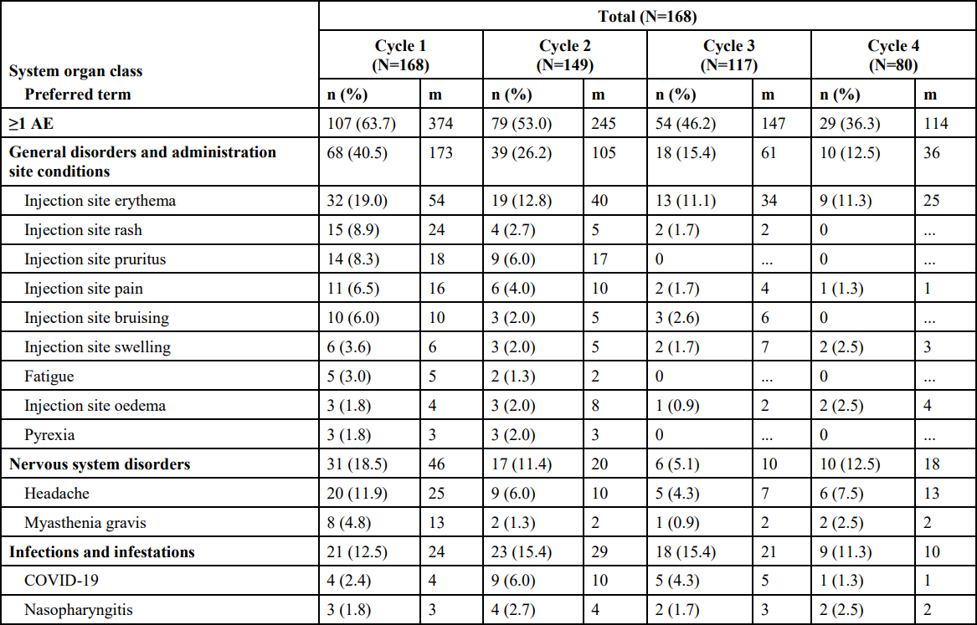
AE=adverse event; m=number of events; MedDRA=Medical Dictionary for Regulatory Activities; N=number of participants in the analysis set per cycle; n=number of participants for whom the observation was reported; PT=Preferred Term; SC=subcutaneous(ly); SOC=System Organ Class Note: AEs were coded using MedDRA version 24.1 (Sep 2021).

Deaths
Two fatal cases were reported in patients with gMG who received efgartigimod in the SC formulation, in addition to the 5 deaths recorded during clinical development of the IV formulation. One patient had a history of renal cancer and died from the SAE of renal cancer metastatic, and an [19-84]-year-old female died of COVID-19 and respiratory failure. Neither event was considered related to study treatment by the investigator.

Serious adverse events
In ARGX-113-2001, a total of 8 (14.5%) participants had SAEs in the efgartigimod SC arm compared with 4 (7.3%) participants in the efgartigimod IV arm. The higher incidence of SAEs in the efgartigimod SC arm was due to AE of MG. Across both arms in ARGX-113-2001, most SAEs occurred in 1 (1.8%) participant each. The most commonly reported SAE (≥ 5% of participants) was MG which occurred in 5 (9.1%) participants in the efgartigimod SC arm and in 1 (1.8%) participant in the efgartigimod IV arm. None of the SAEs were considered by the investigator to be related to efgartigimod.
In study ARGX-113-2002, SAEs occurred in 17 (10.4%) participants in the total group. The most commonly reported SAEs (≥ 2 participants) were MG (6 [3.7%]) participants), COVID-19 (3 [1.8%] participants), and Respiratory failure (2 [1.2%] participants). 1 SAE, a grade 3 MG crisis event, was considered related to efgartigimod SC.

Adverse events of special interest
In terms of infections and infestations, in the total efgartigimod group in the SC PB, AESI occurred in 57 (33.9%) of participants; the most common by PT were COVID-19, nasopharyngitis, and upper respiratory tract infection. 6 events were considered serious, including COVID-19 in 3 (1.8%) participants, and cellulitis, COVID-19 pneumonia, diarrhoea infectious, pneumonia, and rotavirus infection in 1 participant each, none of which were considered related to study treatment by the investigator. There was no clear association between this AESI and cycle number with the SC formulation.
In terms of the AESI injection related reactions, in the SC PB total efgartigimod group, 65 (38.7%) had injection-related reactions, all of which were CTCAE grades 1 or 2. The most commonly occurring (≥5% participants in the total group) injection-related reactions were injection site erythema, injection site pain, injection site rash, and injection site swelling.
In study ARGX-113-2001 there was a higher rate of AE of MG recorded for the SC formulation group compared to IV formulation group; the EMA assessment alternative explanations for some participants in which this AE was recorded, whilst the TGA evaluator noted it to be unlikely that differences in the observed rate of this AE were related to differences between the efgartigimod formulations.

Laboratory findings
In study ARGX-113-2001, 5 (4.5%) participants had grade 3 clinical laboratory abnormalities of lymphocyte count decreased, 3 in the SC formulation arm and 2 in the IV formulation arm; the investigator considered these unrelated to study treatment. In ARGX-113-2002 13 (8.1%) participants had lymphocyte count decreased observed, 1 of which was grade 4.

Vital signs
There were no notable changes form baseline in vital signs parameters, with data similar to that for the IV formulation.

Electrocardiogram findings
No participant in the SC PB had a QTcF interval measurement between > 480 to ≤ 500ms, and 1 (0.6%) female participant had a QTcF increase from baseline > 60ms.

Safety in special populations
There were no clinically meaningful differences identified in terms of age or body weight.

Immunogenicity for the SC formulation
Table 13 provides a summary of ADA data from study ARGX-113-2001, showing higher incidence and prevalence of ADAs against efgartigimod in the SC formulation compared to the IV formulation. Overall prevalence and incidence of NAbs was low, 3.6% in both groups.
Table 13. Classification, incidence and prevalence of ADA against efgartigimod, study ARGX-113-2001 in the overall population (Safety analysis set)
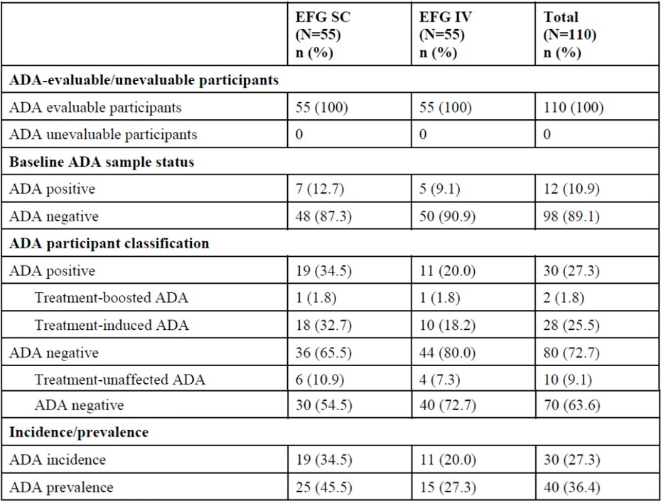
ADA = antidrug antibody; n = number of participants for whom the observation was reported.; N = number of participants per arm in the analysis set.
In general, in the integrated analysis, the highest ADA incidence was observed in the first treatment cycle. Overall, there was no apparent impact of ADA and NAb against efgartigimod on safety observed with either SC or IV formulations.
The incidence of antibodies against rHuPH20 showed a minor increase across the cycles, with incidences of 5.5%, 6.7%, and 12.5% in cycles 1, 2, and 3, respectively; however, the incidence of antibodies against rHuPH20 across all treatment cycles cumulatively remained low (14.5%). There was no observed impact of antibodies to rHuPH20 on the safety of the SC formulation.

Self-administration of the SC formulation
Per the study ARGX-113-2002 protocol efgartigimod may have been administered at home. Of the total number of administrations of efgartigimod in the SC formulation, 42.8% were performed by staff on-site, 30.5% by the participant at home, 24.8% by the participant on-site, 0.8% given by the caregiver at home, and 0.9% given by the caregiver on-site.
The TGA evaluator raised concern about the relatively low rate (31.3%) of at-home administration in the extension study, ARGX-113-2002.

Evaluator conclusions on safety for the SC formulation
The EMA assessment noted that there are no safety data on the efgartigimod SC formulation for more than 12 months; to support long-term safety the application relies on safety data for the SC formulation, with support from safety data for the IV formulation, which was considered acceptable given the same patient population and active substance.
The EMA assessment concluded that, overall, available safety data from the clinical development program show that efgartigimod was generally well tolerated. More AEs were reported in the SC arm compared to the IV arm in study ARGX-113-2001. Injection site reactions contributed to the higher frequency in the SC arm. Moreover, in study ARGX-113-2001, more patients in the SC arm reported AEs of MG compared to the IV arm. It is plausible, that the higher frequency could be due to the treatment-free follow up period of minimum 7 weeks in the clinical trial and a regular cycling administration likely could lower the frequency. However, other reasons cannot be ruled out. There are no safety-related major objections.
The TGA evaluator noted that direct safety comparison between the SC formulation and placebo was not made, instead relying on indirect comparison via the IV formulation.

Risk Management Plan (RMP) evaluation
Argenx Australia Pty Ltd has submitted EU-RMP version 2.4 (dated 11 March 2024; DLP 2 March 2022) and ASA version 0.1 (dated 28 March 2024) in support of this application. At round 2, the sponsor has submitted ASA version 0.2 (dated 12 September 2024), which is associated with previously submitted EU-RMP version 2.4 (dated 11 March 2024: DLP 2 March 2022).
The proposed summary of safety concerns and their associated risk monitoring and mitigation strategies are summarised in Table 14. The TGA may request an updated RMP at any stage of a product's life cycle, during both the pre-approval and post-approval phases. Further information regarding the TGA’s risk management approach can be found in risk management plans for medicines and biologicals and the TGA's risk management approach. Information on the Australia-specific annex (ASA) can be found on the TGA website.
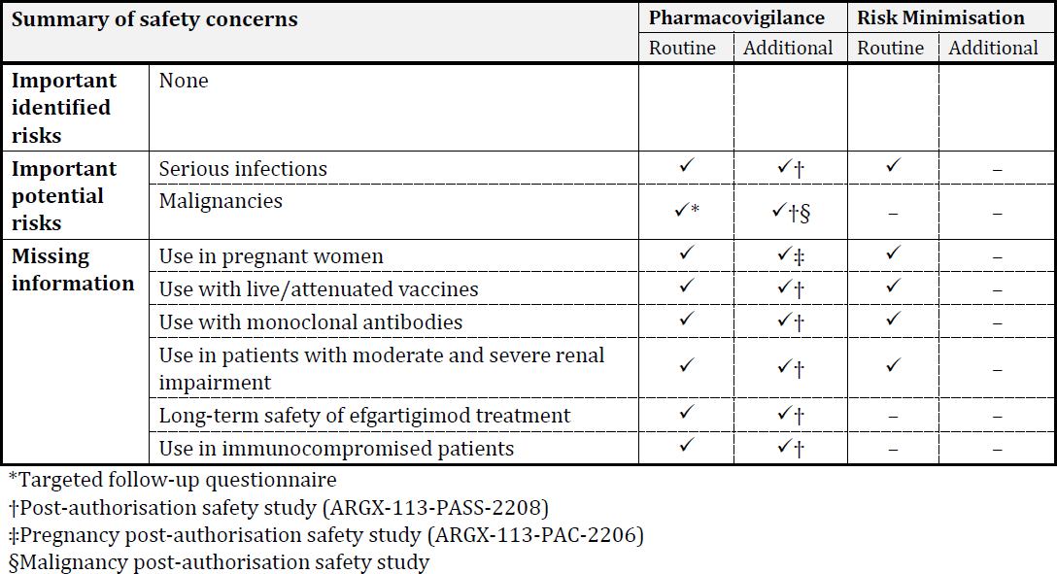
Table 14: Summary of safety concerns

The safety concerns proposed in the ASA align with those in the approved EU RMP. It is noted that ‘hypersensitivity reactions and infusion-related reactions’ was included as an important potential risk for Vyvgart in the latest PRAC PSUR assessment report (period covering from 16 December 2022 to 16 June 2023). At round 2, the sponsor provided justification for non-inclusion of this risk into the ASA which was considered acceptable. Further characterisation of this risk via routine pharmacovigilance including reporting in the PSUR is considered sufficient at this point in time. Non-clinical comment on the safety specifications in the RMP is still pending. However, from an RMP perspective the summary of safety concerns for Vyvgart are considered acceptable.

Pharmacovigilance plan
The sponsor has proposed routine pharmacovigilance for all safety concerns in Australia which includes targeted follow-up questionnaire for important identified risk ‘malignancies. Additional pharmacovigilance activities include study ARGX-113-PASS-2208, ARGX-113-PAC-2206 and a malignancy post-authorisation safety study summary. These studies will not include Australian patients; however, the results will be considered generalisable to the Australian public. The pharmacovigilance plan in the EU RMP align with the pharmacovigilance plan in the ASA and is acceptable from an RMP perspective.

Risk minimisation plan
The sponsor has proposed routine risk minimisation only to address all safety concerns except for the important potential risk ‘malignancies’ and missing information ‘long-term safety of efgartigimod treatment’ and ‘use in immunocompromised patients’. Routine risk minimisation also includes an instruction for use document for the subcutaneous formulation. This aligns with the EU RMP risk minimisation plan for VYVGART and is acceptable from an RMP perspective.
There was one outstanding recommendation at Round 2, which did not impede product registration: As per the Risk Management Plans for Medicines and Biologicals guidance, section 5.1 should state which risk communication materials will be included in the pack. The sponsor should state under section 5.1 of a revised ASA that the SC carton pack will contain the product information and instructions for use document. This recommendation can be addressed in the next ASA update.

Evaluator recommendations

Intravenous
The TGA evaluator recommended authorisation of Vyvgart IV formulation, subject to a satisfactory PI.

Subcutaneous
The TGA evaluator concluded that the benefit-risk balance for Vyvgart SC formulation was unfavourable, principally because, in the evaluator’s view, study ARGX-113-2001 did not meet the description of one controlled study with statistically compelling and clinically relevant results. The TGA evaluator stated that authorisation could not be recommended as prior approval of the IV formulation could not be assumed.

Risk-benefit analysis

Delegate’s considerations
This application to register the new biological entity efgartigimod alfa, in 400 mg/20 mL concentrated solution vial (for intravenous infusion) and 1000 mg/5.6 mL solution for injection vial (for subcutaneous injection) formulations, was submitted via the COR-B pathway based on EMA assessment. EU marketing authorisation was granted for the intravenous formulation in August 2022, with subsequent approval of the subcutaneous formulation as an extension to the marketing authorisation in December 2023. According to applicable TGA criteria for COR-report based process1 the EMA is an acceptable regulator for the purposes of the COR-B pathway, and all required COR assessment reports have been provided in the current application, for both formulations. Whilst TGA criteria states that COR-based applications should relate to a single medicine and ARTG entry, which would preclude the current application on the basis that the two proposed formulations would result in two ARTG entries, in discussion between the TGA and sponsor during the course of the submission it was agreed that both formulations would be considered. It should be noted that this arrangement is an exception and going forward a similar scenario will require separate applications. The Delegate has considered both formulations in this Delegate’s Overview and will make a decision with respect to each formulation.
MG is heterogeneous in terms of manifestations and course of illness, however, particularly in its generalised form, is characterised by chronicity and a significant burden of both disease and treatment. Current treatment is not standardised, with some commonly used drugs lacking robust randomised controlled data to support their use and associated with risk of serious adverse events. There remains unmet need for safe and effective treatment options.
The current application for efgartigimod in the IV formulation is primarily supported by one pivotal Phase 3, double-blind, placebo-controlled study in patients with gMG (ARGX-113-1704), with supportive data from the ongoing open-label extension study (ARGX-113-1705) and a Phase 2 placebo-controlled study (ARGX-113-1602). Both the EMA and TGA evaluators concluded the benefit-risk profile favourable. The current application for the SC formulation is supported by a Phase 3, open-label study which primarily sought to bridge the IV and SC formulations by demonstrating a similar pharmacodynamic effect (ARGX-113-2001), with supportive data from the long-term extension study (ARGX-113-2002). The EMA assessment found this approach acceptable and concluded a favourable benefit-risk profile, while the TGA evaluator, noting the discrepancy in this COR-B application containing two separate formulations, concluded that approval could not be recommended as prior approval of the IV formulation could not be assumed.

Proposed indication
The proposed indication specifies use of efgartigimod as an add-on therapy and defines the target patient population in terms of age, clinical form of MG and AChR-Ab status; ‘Vyvgart is indicated as an add on to standard therapy for the treatment of adult patients with generalized Myasthenia Gravis (gMG) who are anti acetylcholine receptor (AChR) antibody positive.’ This indication reflects data from the pivotal clinical studies. All studies providing evaluable efficacy data enrolled only adult patients aged ≥18 years, while inclusion criteria in the pivotal studies specified MG with generalised muscle weakness. Concomitant acetylcholinesterase inhibitor, corticosteroid or non-steroidal immunosuppressive drugs were permitted with stable dosing criteria in the pivotal efficacy studies, reflecting standard treatment according to international consensus guidelines for MG, with most randomised patients in both studies ARGX-113-1704 and ARGX-113-2001 on two or three classes of concomitant treatment. There is no evaluable clinical data regarding the use of efgartigimod in MG as a monotherapy, and as such, specification as an add-on therapy is appropriate.
With respect to AChR-Ab status, the primary efficacy endpoint in pivotal study ARGX-113-1704, and four of five secondary efficacy endpoints, were assessed in the AChR-Ab seropositive population only. This study enrolled and randomised 38 (22.8% of the total population) AChR-Ab seronegative patients, with no difference in treatment effect observed between the efgartigimod and placebo groups in the seronegative population in terms of MG-ADL response (68.4% in the efgartigimod group vs. 63.2% in the placebo group), in contrast to results in the seropositive population. In the overall population only 6 (3.6%) of patients were seropositive for anti-MuSK antibodies, precluding any meaningful assessment of efficacy in this population.
Overall, the proposed indication, including the specifications that define a sub-population of the broader MG patient population, is aligned with submitted clinical data and is considered appropriate.

Efficacy
Efficacy of the IV formulation of efgartigimod in AChR-Ab seropositive patients with gMG was established in the pivotal Phase 3, randomised, double-blind, placebo-controlled study ARGX-113-1704. This study was conducted over 26-week duration, and enrolled and randomised 167 adult patients (129 [77.2%] AChR-Ab seropositive) across 56 sites in 15 countries (no Australian sites); patients were predominantly female, white race, with a mean age of 45.9 years in the efgartigimod treatment group and 48.2 years in the placebo group. Diagnosis and classification of gMG was undertaken using clinically appropriate methods. The study population is considered generally reflective of Australian patients with gMG. There were broad study exclusion criteria; notable were exclusions related to infection and malignancy risk factors, any vaccination in the preceding 4 weeks, and patients with a known autoimmune disorder. Given the biological plausibility that efgartigimod may increase risk of infection based on its mechanism of action, the fact that patients with gMG are typically treated with concomitant immunosuppressant drugs and have an increased risk of comorbid autoimmune conditions, these exclusion criteria must be adequately factored into risk mitigation mechanisms including RMP and the proposed PI. Dose selection for the efgartigimod treatment group, 10 mg/kg as a 1-hour infusion every 7 days for 4 infusions, was based on Phase 1 clinical data and population PK/PD modelling, was adequately justified, and reflects dosing sought in this application.
The primary efficacy endpoint was the percentage of patients who, after the first treatment cycle, had a reduction of at least 2 points on the MG-ADL total score compared to cycle baseline, for at least 4 consecutive weeks with the first decrease occurring at the latest 1 week after the last infusion of study treatment, in the AChR-Ab seropositive population (‘MG-ADL responders’).
The MG-ADL scale is patient-reported and was complemented by a physician-reported scale, QMG, as the first secondary efficacy endpoint, with both scales adequately validated and used previously in clinical studies for MG. The MG-ADL responder endpoint was met in 44 (67.7%) patients in the efgartigimod treatment group compared to 19 (29.7%) in the placebo group. Based on pre-specified analysis, the treatment difference was 38.0%, with an OR of 4.95 (95% CI 2.21; 11.53), with p<0.0001. The first three secondary efficacy endpoints based on QMG score and other MG-ADL analyses were met. As noted above, there was no observed treatment effect difference between efgartigimod and placebo in the AChR-Ab seronegative population, with a high placebo response rate in this population that is not readily explained, including on further analysis undertaken during the EMA assessment. The Delegate agrees with the assessment of both EMA and TGA evaluators that these results are statistically significant and clinically meaningful for the AChR-Ab seropositive population and are sufficient to establish short-term efficacy following the first treatment cycle.

Establishing longer-term efficacy is important given the chronic and fluctuating disease course typical of gMG. Study ARGX-113-1705, the open-label, long-term extension of study ARGX-113-1704, provides evidence to support claims of efficacy through repeat treatment cycles, albeit not in a randomised controlled study design. Of the 167 patients enrolled in the antecedent study, 151 had rolled over into ARGX-113-1705, and 139 patients had received at least 1 dose of efgartigimod in the study, with 110 patients ongoing on study treatment at the time of data cut-off. Notably, efficacy endpoints in this study were exploratory, and differed from those used in the antecedent study, comprising change in MG-ADL score and QMG score from cycle baseline.
Based on descriptive statistics for the efficacy endpoints, efficacy of efgartigimod appears sustained up to at least 9 treatment cycles, however, interpretation of results for later treatment cycles is difficult given low patient numbers. Notwithstanding concerns relating to open-label study design, choice of efficacy endpoints and low patient numbers completing multiple treatment cycles, when considered alongside results of the antecedent study ARGX-113-1704 and considering the relative rarity of MG conferring difficulty in conducting long-term efficacy studies, ARGX-113-1705 does provide evidence to support the efficacy of efgartigimod across repeated treatment cycles.
Demonstration of efficacy of efgartigimod in the SC formulation relies in part on the use of primary PD and secondary efficacy endpoints in study ARGX-113-2001 to bridge the IV and SC formulations, as the basis for extrapolation of efficacy data generated during clinical development of the IV formulation. Study ARGX-113-2001 was a Phase 3, open-label, parallel-group, 12-week study comparing the IV and SC formulations, with the primary objective of demonstrating non-inferiority (margin 10%) between the formulations in terms of percent reduction from baseline in total IgG levels at day 29, over a single treatment cycle. Secondary efficacy endpoints were based on MG-ADL and QMG scores. A total of 111 patients were enrolled and randomised, 55 in the SC formulation arm and 56 in the IV formulation arm, with inclusion and exclusion criteria similar to study ARGX-113-1704. Dose selection for the SC formulation was based on population PK/PD modelling, using data from study ARGX-113-1901, which investigated the PD effect of 4 different SC doses.
On analysis of the primary endpoint, analysed in the AChR-Ab seropositive population, LSM reduction in total IgG at day 29 compared to baseline was -66.9 (95% CI -69.78, -64.02) in the SC formulation group and -62.4 (95% CI -65.22, -59.59) in the IV formulation group, giving LSM difference of -4.5 (95% CI -8.53, 0.46), meeting pre-specified criteria for non-inferiority (p<0.0001). Non-inferiority criteria were also met in the overall population. Post-hoc analysis showed that reduction in AChR-Ab levels followed a similar trajectory to total IgG. Analysis of secondary efficacy endpoints showed similar treatment effect between the IV and SC formulations in terms of MG-ADL and QMG response, providing supportive evidence of efficacy for the SC formulation, though noting that statistical analysis had no provision for multiplicity.
A total of 178 participants rolled over to the long-term open-label extension study for the SC formulation from the antecedent studies ARGX-113-2001 and ARGX-113-1705. Based on the efficacy endpoint change in MG-ADL score from baseline, interim results for ARGX-113-2002 provide supportive evidence for sustained effect for the SC formulation through 4 treatment cycles.
The Delegate agrees with the TGA evaluator that study ARGX-113-2001, by virtue of its study design, statistical analysis and choice of endpoints, does not meet the threshold for one controlled study with statistically compelling and clinically relevant results as per TGA-adopted guidance for applications with one pivotal study, and as such would be insufficient as a pivotal efficacy study to support registration of a standalone new biological/chemical entity. However, the relevant background is that this study was primarily intended to support an application for line extension for a product already registered by the EMA (efgartigimod in the IV formulation), analogous to a Type F (Major Variation) application to the TGA.
Pragmatically, the Delegate intends to consider the dossier in totality, and as such, will consider the SC formulation (and its associated pivotal study ARGX-113-2001) in relation to the submitted clinical data for the IV formulation. In this context, the Delegate agrees with the EMA assessment that while the primary endpoint in study ARGX-113-2001, reduction in total IgG levels at day 29, is insufficient on its own to establish therapeutic equivalence between the two formulations, when considered alongside the post-hoc analysis showing comparable reductions in AChR-Ab levels, as well as clinical pharmacology and efficacy data for both formulations in the dossier, there is sufficient evidence overall to support therapeutic equivalence. Therefore, in the Delegate’s opinion, efficacy data for the IV formulation can be used to support claims of efficacy for the SC formulation.
Long-term maintenance of effect remains an uncertainty based on submitted efficacy data, particularly considering the likely need for repeated treatment cycles over the long-term for gMG patients treated with efgartigimod. Efficacy has not been tested beyond 2 cycles in randomised controlled study design, and the total number of patients undergoing multiple treatment cycles across the submitted studies for both formulations is low. However, weighing the rarity of gMG, the absence of TGA-adopted guidance or guidance published by international regulators regarding therapies for gMG, and the fact that pivotal study ARGX-113-1704 is well-conducted, adequately powered, with validated efficacy endpoints, and statistically significant and clinically meaningful results, this is considered acceptable. Further, whilst clinical development did not generate comparative efficacy data between efgartigimod and an active comparator despite the existence of approved therapies for gMG, the use of standard-of-care concomitant therapies throughout clinical studies for most patients at stable doses is considered reasonable to demonstrate treatment effect for efgartigimod.
Overall, the Delegate is satisfied that efficacy has been adequately demonstrated for efgartigimod in the proposed indication, for both proposed formulations. The proposed dosing regimen for each formulation reflects dosing in the pivotal studies.

Safety
Overall, evaluable safety data showed efgartigimod to be generally well-tolerated in healthy subjects and the target population, with most observed AEs during clinical development being mild or moderate severity and relatively few SAEs attributed to study treatment. Increased risk of infection is an identified safety concern, which accords with efgartigimod’s mechanism of action, whilst long-term safety remains uncertain and is appropriately addressed in the RMP. In the COR assessment, evaluation of the SC formulation sought identifiable differences in safety profile compared to the IV formulation, with differences mainly attributable to injection related reactions.
In pooled safety data for the IV formulation 84.0% of all efgartigimod treated patients experienced ≥1 TEAE and 15.4% experienced ≥1 SAE. In pivotal study ARGX-113-1704 the most common TEAEs by PT were headache (28.6% in the efgartigimod group vs. 27.7% in the placebo group), nasopharyngitis (11.9% vs. 18.1%), upper respiratory infection (10.7% vs. 4.8%), urinary tract infection (9.5% vs. 4.8%) and nausea (8.3% vs. 10.8%).
The most common category of TEAEs overall was SOC ‘infections and infestations’, observed in 39 (46.4%) patients in the efgartigimod group and 31 (37.3%) patients in the placebo group. In pooled data most infections were mild to moderate, with 12 events in 8 patients classified as grade ≥3 severity. Herpes viral infections, candidiasis and vulvovaginal mycotic infection were only reported in efgartigimod-treated subjects. Across study ARGX-113-1704 and the extension study -1705 there were 8 infections classified as SAEs, 5 of which occurred in the ‘efgartigimod-efgartigimod’ group in study -1705, with PTs COVID-19, COVID-19 pneumonia and dysentery, and 1 of the 5 recorded deaths in pooled data for the IV formulation was due to infections (COVID-19, pneumonia, UTI and septic shock). While the majority of infections in pooled safety data were mild to moderate in nature, and the investigator assessed all infections among SAEs and deaths as not related to study treatment, it is biologically plausible that efgartigimod may increase risk of infection, which is adequately addressed in the RMP and proposed PI.
In pooled data for the IV formulation there were 5 deaths in the total efgartigimod group, and an additional 2 deaths in patients receiving SC efgartigimod in study ARGX-113-2002, the long-term extension for the SC formulation. Apart from the death caused by infections addressed above, other causes of death included cardiovascular disease, lung cancer, myasthenic crisis, metastatic renal cancer, and COVID-19 with respiratory failure. Case narratives for each event outline alternative risks factors in each case, supporting the investigator’s assessment that none of the events were related to study treatment.
For the SC formulation specifically study ARGX-113-2001 provides comparative safety data with the IV formulation, with rates of TEAEs, SAEs and CTCAE Grade 3 or higher AEs reported more frequently for the SC formulation: 67.3% vs. 50.59%, 14.5% vs. 7.3%, and 43.6% vs. 21.8% respectively. These differences were mainly attributable to injection site reactions, observed in 38.2% with the SC formulation compared to 1.8% for the IV formulation. In pooled data for the SC formulation administration site conditions were the most common SOC, with injection site erythema the most common PT overall (26.8%), with other common PTs comparable to the profile observed for the IV formulation, with headache (17.3%), COVID-19 (12.5%), nasopharyngitis (6.5%) and diarrhoea (7.1%) occurring commonly. Reassuringly, whilst observed commonly, all injection-related reactions in study ARGX-113-2001 were localised, and CTCAE Grades 1 or 2, with none classified as serious.
There were fewer SAEs recorded in study ARGX-113-2001 compared to the pooled data for the IV formulation, with 8 (14.5%) patients in the SC formulation group and 4 (7.3%) patients in the IV formulation group (compared to 15.4% experiencing ≥1 SAE in pooled IV formulation data), however, the comparison is limited by low numbers overall in study -2001. The most common SAE observed was myasthenia gravis, accounting for 5 events in the SC formulation group and 1 in the IV formulation group. No SAEs were assessed as related to study treatment by the investigators. In pooled data for the SC formulation rate and severity of infection was generally comparable to that seen for the IV formulation, though with a slightly lower overall rate for the SC formulation (33.9%). Most common infections by PT were COVID-19, nasopharyngitis, and upper respiratory tract infection. Most infections were mild to moderate, with infection in 6 (3.6%) participants classified as serious (cellulitis, COVID-19 pneumonia, diarrhoea, pneumonia, rotavirus).
Considered collectively long-term safety data in the submission is somewhat limited. The COR assessment for the IV formulation included 118 patients treated with efgartigimod for at least 12 months, and 33 patients treated for at least 18 months, whilst for the SC formulation specifically no patients were treated beyond 12 months. The primary associated risk is that rare adverse events may not be captured, which is particularly relevant for a medication that will likely require repeated treatment cycles over the long-term. The relative lack of long-term data may also impede characterisation of identified signals, such as infection. Risk mitigation strategies outlined in the RMP are reasonable and proportionate, and the sponsor will be asked to provide any additional relevant safety data not already submitted.
Additional risks and uncertainties identified during COR and TGA evaluation include a lack of data relating to pregnant women, effect on efficacy of vaccines, use of live/attenuated vaccines, concomitant use with monoclonal antibodies, use in moderate to severe renal impairment and use in immunocompromised patients. In safety data for the IV formulation from studies ARGX-113-1704 and -1705 there were 11 events of neoplasms recorded among 8 efgartigimod-treated patients, compared to 1 event in the placebo-treated group. The EMA assessment cited published literature regarding the role of IgG responses in tumour-associated immunity12 and a suggested role for FcRn in anti-tumour immune surveillance13 and included malignancies as an Important Potential Risk in the RMP. The Australian RMP is consistent with this.

Proposed action
The submitted data supports:
- a favourable benefit-risk profile for Vyvgart (efgartigimod alfa), for use as an add on to standard therapy for the treatment of adult patients with generalized Myasthenia Gravis who are anti acetylcholine receptor antibody positive
- registration of Vyvgart for the proposed indication, in both formulations included in this submission: 400 mg/20 mL concentrated solution for intravenous infusion vial and 1000 mg/5.6 mL solution for injection vial (for subcutaneous injection).

Assessment outcome
Based on a review of quality, safety, and efficacy, the TGA decided to register:
- Vyvgart efgartigimod alfa 1000 mg/5.6 mL solution for injection vial (444954)
- Vyvgart efgartigimod alfa 400 mg/20 mL concentrated injection for intravenous infusion vial (444955)
The approved indication for both formulations is:
Vyvgart is indicated as an add-on to standard therapy for the treatment of adult patients with generalised Myasthenia Gravis (gMG) who are anti-acetylcholine receptor (AChR) antibody positive.

Specific conditions of registration
- Vyvgart (efgartigimod alfa) is to be included in the Black Triangle Scheme. The PI and CMI for Vyvgart must include the black triangle symbol and mandatory accompanying text for five years, which starts from the date of first supply of the product.
- The efgartigimod alfa EU-Risk Management Plan (RMP) (version 2.4, dated 11 March 2024, data lock point 2 March 2022), with Australian Specific Annex (version 0.2, dated 12 September 2024), included with submission PM-2024-01111-1-1, and any subsequent revisions, as agreed with the TGA will be implemented in Australia.
- An obligatory component of risk management plans is routine pharmacovigilance. Routine pharmacovigilance includes the submission of periodic safety update reports (PSURs).
- Reports are to be provided in line with the current published list of EU reference dates and frequency of submission of PSURs until the period covered by such reports is not less than three years from the date of this approval letter. Each report must be submitted within ninety calendar days of the data lockpoint for that report.
- The reports are to at least meet the requirements for PSURs as described in the European Medicines Agency’s Guideline on good pharmacovigilance practices (GVP) Module VII-periodic safety update report (Rev 1), Part VII.B Structures and processes. Note that submission of a PSUR does not constitute an application to vary the registration.
- Conditions of registration resulting from primary evaluation:
- Provision of appropriate GMP clearances for all manufacturing sites.

- Laboratory testing and compliance with Certified Product Details (CPD)
- All batches of VYVGART supplied in Australia must comply with the product details and specifications approved during evaluation and detailed in the Certified Product Details (CPD).
- When requested by the TGA, the Sponsor should be prepared to provide product samples, specified reference materials and documentary evidence to enable the TGA to conduct laboratory testing on the Product.
- An updated Certified Product Details (CPD) should be provided when changes to finished product specifications and test methods are approved in a Category 3 application or notified through a self-assessable change.
- A template for preparation of CPD for biological prescription medicines can be obtained from the TGA website:
[for the form] https://www.tga.gov.au/form/certified-product-details-cpd- biologicalprescription-medicines
[for the CPD guidance] https://www.tga.gov.au/guidance-7-certified-product-details

Product Information and Consumer Medicine Information
For the most recent Product Information (PI) and Consumer Medicine Information (CMI), please refer to the TGA PI/CMI search facility.

Therapeutic Goods Administration
PO Box 100 Woden ACT 2606 Australia
Email: info@tga.gov.au Phone: 1800 020 653 Fax: 02 6203 1605
https://www.tga.gov.au

This is the original indication proposed by the sponsor when the TGA commenced the evaluation of this submission. It may differ to the final indication approved by the TGA and registered in the Australian Register of Therapeutic Goods.
Longo DL. Myasthenia Gravis. NEJM. 2016;375(26):2570-81.
Bird SJ, Shefner JM, Goddeau Jr RP. Clinical manifestations of myasthenia gravis. UpToDate. Updated 30 September 2024. Available from: https://www.uptodate.com/contents/clinical-manifestations-of-myasthenia-gravis?search=myasthenia%20gravis&source=search_result&selectedTitle=3%7E150&usage_type=default&display_ rank=3.
Hehir MK, Silvestri NJ. Generalized Myasthenia Gravis Classification, Clinical Presentation, Natural History, and Epidemiology. Neurol Clin. 2018;36:253-260.
Bird SJ, Shefner JM, Goddeau Jr RP. Myasthenic crisis. UpToDate. Updated 16 June 2023. Available from: https://www.uptodate.com/contents/myasthenic-crisis?search=myasthenia%20gravis&topicRef=5170&source=see_link.
Bird SJ, Shefner JM, Goddeau Jr RP. Pathogenesis of myasthenia gravis. UpToDate. Updated 6 June 2024. Available from: https://www.uptodate.com/contents/pathogenesis-of-myasthenia-gravis?search=myasthenia%20gravis&topicRef=5125&source=see_link.
Bird SJ, Shefner JM, Goddeau Jr RP. Pathogenesis of myasthenia gravis. UpToDate. Updated 6 June 2024. Available from: https://www.uptodate.com/contents/pathogenesis-of-myasthenia-
Bird SJ, Shefner JM, Goddeau Jr RP. Overview of the treatment of myasthenia gravis. UpToDate. Updated 6 September 2024. Available from: https://www.uptodate.com/contents/overview-of-the-treatment-of-myasthenia-gravis?search=myasthenia%20gravis&topicRef=5153&source=see_link.
9 Sanders DB, Wolfe GI, Benatar M et al. International consensus guidance for management of myasthenia gravis. Neurology. 2016; 87: 419-425.
10 Narayanaswami P, Sanders DB, Wolfe G et al. International Consensus Guidance for Management of Myasthenia Gravis 2020 Update. Neurology. 2021; 96: 114-122.

