Australian Public Assessment Report for Lytgobi
  - Active ingredient: Futibatinib
  - Sponsor: Taiho Pharma Oceania Pty Ltd
February 2026

About the Therapeutic Goods Administration (TGA)
- The Therapeutic Goods Administration (TGA) is part of the Australian Government Department of Health, Disability and Ageing and is responsible for regulating therapeutic goods, including medicines, medical devices, and biologicals.
- The TGA administers the Therapeutic Goods Act 1989 (the Act), applying a risk management approach designed to ensure therapeutic goods supplied in Australia meet acceptable standards of quality, safety, and efficacy.
- The work of the TGA is based on applying scientific and clinical expertise to decision-making, to ensure that the benefits to the Australian public outweigh any risks associated with the use of therapeutic goods.
- The TGA relies on the public, healthcare professionals and industry to report problems with therapeutic goods. The TGA investigates reports received to determine any necessary regulatory action.
- To report a problem with a therapeutic good, please see the information on the TGA website.

About AusPARs
- The Australian Public Assessment Report (AusPAR) provides information about the evaluation of a prescription medicine and the considerations that led the TGA to approve or not approve a prescription medicine submission. Further information can be found in Australian Public Assessment Report (AusPAR) guidance.
- AusPARs are prepared and published by the TGA.
- AusPARs are static documents that provide information that relates to a submission at a particular point in time. The publication of an AusPAR is an important part of the transparency of the TGA’s decision-making process.
- A new AusPAR may be provided to reflect changes to indications or major variations to a prescription medicine subject to evaluation by the TGA.

Copyright
© Commonwealth of Australia 2026
This work is copyright. You may reproduce the whole or part of this work in unaltered form for your own personal use or, if you are part of an organisation, for internal use within your organisation, but only if you or your organisation do not use the reproduction for any commercial purpose and retain this copyright notice and all disclaimer notices as part of that reproduction. Apart from rights to use as permitted by the Copyright Act 1968 or allowed by this copyright notice, all other rights are reserved and you are not allowed to reproduce the whole or any part of this work in any way (electronic or otherwise) without first being given specific written permission from the Commonwealth to do so. Requests and inquiries concerning reproduction and rights are to be sent to the TGA Copyright Officer, Therapeutic Goods Administration, PO Box 100, Woden ACT 2606 or emailed to <tga.copyright@tga.gov.au>.

Contents
List of abbreviations 5
Product submission 10
Submission details 10
Product background 11
Cholangiocarcinoma 11
Existing treatment options 12
Clinical rationale 12
Regulatory status at the time of assessment 13
Australian regulatory status 13
International regulatory status 13
Registration timeline 13
Assessment overview 14
Quality evaluation summary 14
Drug substance 14
Drug product 14
Biopharmaceutics 14
Other information 14
Recommendation 15
Nonclinical evaluation summary 15
Conclusions and recommendation 16
Clinical evaluation summary 17
Summary of clinical studies 17
Paediatric data 17
Clinical pharmacology 17
Efficacy 21
Study TAS-120-101 21
Safety 30
Deaths and serious adverse events (SAEs) 31
Discontinuation and/or dose interruption/reduction due to adverse events 32
Adverse events of special interest (AESI) 32
Clinical Evaluator’s summary on safety 32
Clinical Evaluator’s overall benefit-risk assessment 33
Clinical Evaluator’s Round 1 recommendation 33
Clinical Evaluator’s R2 recommendation 34
Risk management plan 34
Risk-benefit analysis 35
Delegate’s considerations 35
Proposed action 38
Independent expert advice 39
Advisory Committee considerations 39
Assessment outcome 40
Specific conditions of registration 40
Product Information and Consumer Medicine Information 42

List of abbreviations
Abbreviation | Meaning
[¹⁴C] | Carbon 14 isotope
6β-OHF | 6β-hydroxycortisol
90% CI | 90 percent confidence interval
%CfB | Percent change from baseline
Ae | Urinary excretion rate as percentage of dose
ADR | Adverse drug reaction
AE | Adverse event
AESI | Adverse events of special interest
ALT | Alanine aminotransferase
ANCOVA | Analysis of covariance
ANOVA | Analysis of variance
AST | Aspartate aminotransferase
AUC | Area under the plasma concentration time curve
AUC_{0-t} | Area under the plasma concentration time curve from time 0 to t hours
AUC₀₋₂₄/AUC₀₋₄₈ | Area under the plasma concentration time curve from time 0 to 24 / 48 hours
AUC_{0-∞} | Area under the plasma concentration time curve from time 0 to infinity
AUC_{%extrap} | Area under the plasma concentration time curve from time 0 to time of the last quantifiable plasma concentration
AUC_{last} | Area under the plasma concentration time curve from time 0 to time of the last quantifiable plasma concentration
AUC_{ss} | Area under the plasma concentration time curve at steady state
AUC_{τ} | Area under the plasma concentration time curve over the dosing interval
AUCR | AUC ratio
BCRP | Breast cancer resistance protein
BCS | Biopharmaceutical classification system
BLQ | Below limit of quantification
BOR | Best overall response
C_{avg} / C_{av} | Average plasma concentration
C_{avg.ss} | Average plasma concentration at steady state
C_{max} | Maximum plasma concentration
C_{min} | Minimum plasma concentration
C_{min.ss} | Minimum plasma concentration at steady state
C_{trough} | Concentration observed at the end of the dosing interval at steady state
CCA | Cholangiocarcinoma
CI | Confidence interval
CL_{CR} | Creatinine clearance
CL/F | Oral clearance
CLr | Renal clearance
CR | Complete response
CSR | Clinical study report
CTCAE | Common Terminology Criteria for Adverse Events
CTS | Change in tumour size
CV | Coefficient of variation
CYP | Cytochrome P450
DCR | Disease control rate
DDI | Drug drug interaction
ddQTcF | Time matched placebo corrected change from baseline in QTcF
DLT | Dose limiting toxicity
DOR | Duration of response
eCCA | Extrahepatic cholangiocarcinoma
ECG | Electrocardiogram
ECOG | Eastern Cooperative Oncology Group
EORTC-QLQ-C30 | European Organisation for Research and Treatment of Cancer Quality of Life Questionnaire – Core 30
EQ-VAS | EuroQoL visual analog scale
ER | Exposure response
EU | European Union
F | Relative bioavailability
FCT | Film coated tablet
FDA | Food and Drug Administration (USA)
FGF | Fibroblast growth factor
FGFR | Fibroblast growth factor receptor
FGFRi | Fibroblast growth factor receptor inhibitor
FGFR2 | Fibroblast growth factor receptor 2
FMI | Foundation Medicine, Inc.
FOLFOX | Folinic acid, 5-fluorouracil, and oxaliplatin
GCP | Good Clinical Practice
gCV | Geometric coefficient of variation
GEM/CIS | Gemcitabine, cisplastin
GGT | Gamma-glutamyltransferase
gMean | Geometric mean
GMR | Geometric mean ratio
HI | Hepatic impairment
iCCA | Intrahepatic cholangiocarcinoma
ICH | International Conference on Harmonisation
IRC | Independent review committee
IU | International unit
Kel | Apparent first order terminal elimination rate constant
LFHC | Liquid filled hard capsule
LCS | Liquid scintillation counting
LC/MS/MS | Liquid chromatography with tandem mass spectrometry
LC/RAD/MS | Liquid chromatography with radioactivity detection mass spectrometry
LDH | Lactate dehydrogenase
LLL | Left lower lid
LLOQ | Lower limit of quantification
LSM | Least square mean
MedDRA | Medical Dictionary for Regulatory Activities
MRT | Mean residence time
MTD | Maximum tolerated dose
NA | Not available
NC | Not calculable
NE | Not evaluable
ORR | Objective response rate
OS | Overall survival
PCIOL | Posterior capsule intraocular lens
PD | Pharmacodynamic
DP | Disease progression
PEE | Punctate epithelial erosions
PFS | Progression free survival
Pi | Inorganic phosphorus
PI | Product Information (Australia)
P-gp | P-glycoprotein
PK | Pharmacokinetic
PMDA | Pharmaceuticals and Medical Devices Agency
PO | Oral administration
PopPK | Population pharmacokinetics
PP | Per protocol
PPES | Palmar-plantar erythrodysesthesia syndrome
PR | Partial response
PT | Preferred term
QD | Once daily
QOD | Every other day (Monday, Wednesday, and Friday of each week)
QTc | Corrected value of the interval between the Q and T waves on the electrocardiogram tracing
QTcB | Bazett’s correction to the QT interval
QTcF | Fridericia’s correction to the QT interval
R | Accumulation ratio
RC_{max} | Ratio of plasma futibatinib C_{max} to plasma total radioactivity C_{max}
RAUC | Ratio of plasma futibatinib AUC to plasma total radioactivity AUC
RECIST 1.1 | Response Evaluation Criteria in Solid Tumours, Version 1.1
RLL | Right lower lid
ROI | Region of interest (% contribution of the component to the total sample radioactivity)
RP2D | Recommended Phase 2 dose
SAE | Serious adverse event
SAP | Statistical Analysis Plan
SD | Standard deviation
SE | Standard error
SOC | System organ class
T½ | Terminal elimination half life
TAS-120 | Futibatinib
T_{max} | Time to reach maximum plasma concentration
TEAE | Treatment emergent adverse event
TIW | Three times a week = QOD
TRA | Total Radioactivity
TRAE | Treatment related adverse event
ULN | Upper limit of normal
Vc/F | Apparent central volume of distribution
Vp/F | Apparent peripheral volume of distribution
Vz/F | Apparent volume of distribution

Product submission

Submission details
Type of submission: | New chemical entity
Product name: | Lytgobi
Active ingredient(s): | Futibatinib
Decision: | Approved for registration in the Australian Register of Therapeutic Goods (ARTG)
Date of decision: | 10 April 2025
Date of entry into ARTG: | 17 April 2025
ARTG number(s): | 441350
Black Triangle Scheme  for the current submission: | Yes
Sponsor’s name and address: | Taiho Pharma Oceania Pty Ltd
Dose form: | tablets
Strength: | 4 mg tablet
Container: | blister pack
Pack size: | 35 film-coated tablets
Approved therapeutic use for the current submission: | LYTGOBI monotherapy has provisional approval in Australia for the treatment of adult patients with locally advanced or metastatic intrahepatic cholangiocarcinoma with a fibroblast growth factor receptor 2 (FGFR2) fusion or rearrangement that have progressed after at least one prior line of systemic therapy. The decision to approve this indication has been made on the basis of the favourable objective response rate and duration of response in a single arm trial. Continued approval of this indication depends on verification and description of benefit in confirmatory trials.
Route of administration: | oral
Dosage: | The recommended starting dose is 20 mg futibatinib (5 x 4 mg tablets) taken orally once daily.  For further information regarding dosage, such as dosage modifications to manage adverse reactions, refer to the Product Information (PI).
Pregnancy category: | Use in pregnancy – Pregnancy Category D  There are no available data from the use of futibatinib in pregnant women. Based on animal data and the pharmacology of futibatinib, LYTGOBI use during pregnancy may cause embryofetal harm or loss. Advise pregnant women and women of reproductive potential of the potential risk to the fetus. A pregnancy test should be performed before treatment initiation to exclude pregnancy  The use of any medicine during pregnancy requires careful consideration of both risks and benefits by the treating health professional. The pregnancy database must not be used as the sole basis of decision making in the use of medicines during pregnancy. The TGA does not provide advice on the use of medicines in pregnancy for specific cases. More information is available from obstetric drug information services in your state or territory.

Product background
This AusPAR describes the submission by Taiho Pharma Oceania Pty Ltd (the sponsor) to provisionally register Lytgobi (futibatinib) 4 mg tablet blister pack for the following proposed indication:
LYTGOBI monotherapy has provisional approval in Australia for treatment of adult patients with locally advanced or metastatic cholangiocarcinoma with a fibroblast growth factor receptor 2 (FGFR2) fusion or rearrangement, that have progressed after at least one prior line of systemic therapy.
Futibatinib is a tyrosine kinase inhibitor indicated for the treatment of adult patients with locally advanced or metastatic cholangiocarcinoma with a fibroblast growth factor receptor 2 (FFR2) fusion or rearrangement that have progressed after at least one prior line of systemic therapy. It is to be taken once daily with or without food, in a maximum daily dose of 20 mg.
This submission is part of the Project Orbis program and has been approved by the US FDA (30 September 2022) and Japan (26 June 2023) and has conditional marketing authorisation in the EU (04 July 2023) and United Kingdom (18 August 2023).
During the course of evaluation, sponsorship transferred from Adjutor Healthcare Pty Ltd to Taiho Pharmaceuticals Oceania Pty Ltd (9 September 2024). The TGA was informed that Adjutor Healthcare would still act as the agent for Taiho Pharmaceuticals.

Cholangiocarcinoma
Cholangiocarcinoma (CCA) is a malignancy of the biliary tract classified into extrahepatic (eCCA), which account for the majority of all CCAs, and intrahepatic (iCCA). The majority of patients with CCA (>65%) have non-resectable, incurable disease at the time of diagnosis. CCAs represent the second-most common malignancy of the liver, accounting for approximately 15% of all primary liver cancers and approximately 3% of all gastrointestinal cancers. The incidence of CCA is rare overall, with 1-3 patients per 100,000 in regions like the United States and Europe. However, its incidence varies by region and is exceptionally high in some countries, including Chile, Bolivia, South Korea, and North Thailand. The prognosis of patients with stage III or IV CCA is poor, with 5-year survival rates of 10% and 0% respectively.
Fibroblast growth factor receptor 2 (FGFR2) rearrangements (including fusions) occur in about 10% to 20% of patients with iCCA. Baseline demographics of patients with CCA harbouring FGFR2 rearrangements appear to differ from those without, with a lower median age of 52 years than the reported median age of the overall CCA population (~65 years) and a female preponderance (13% vs 4%). Additionally, retrospective studies indicate a longer survival of CCA patients with FGFR2 rearrangements, suggesting the potential utility of FGFR2 fusion identification as a prognostic marker.

Existing treatment options
The first-line, standard of care treatment for patients with unresectable/metastatic disease in Australia was gemcitabine and cisplatin at the time of study conduct. Recently, guidelines have been updated to recommend cisplatin + gemcitabine + durvalumab as first-line treatment.
Therapeutic options for patients who progress on first-line treatment are limited.
FOLFOX combination therapy (folinic acid, 5-fluorouracil, and oxaliplatin) is recommended as second-line chemotherapy (Lamarca et al 2021). However, outcomes reported show limited clinical benefit with a median overall survival (OS) of 6.2 months (95% CI: 5.4, 7.6), median progression-free survival (PFS) of 4.0 months (95% CI: 3.2, 5.0), and a 5% objective response rate (ORR) (Lamarca et al 2021). In a retrospective meta-analysis including 22 studies with 761 patients undergoing second-line chemotherapy, the mean OS, PFS, and ORR were 7.2 months (95% CI: 6.2, 8.2), 3.2 months (95% CI: 2.7, 3.7), and 7.7% (95% CI: 4.6, 10.9), respectively (Lamarca et al 2014). Other chemotherapy regimens have similar limited efficacy.
FGFR inhibitors are recommended for the treatment of patients with FGFR2 fusions or rearrangements whose disease has progressed after at least one prior line of systemic therapy. Pemigatinib has TGA provisional approval for use in Australia in this setting. This was based on a single-arm Phase 2 study with 107 patients with iCCA with FGFR2 fusions or rearrangements showing an ORR of 35.5% (95% CI: 26.5, 45.4) and a median duration of response (DOR), PFS, and OS of 7.5 months (95% CI: 5.7, 14.5), 6.9 months (95% CI: 6.2, 9.6), and 21.1 months (95% CI: 14.8, NE), respectively (Abou-Alfa 2020).
Ivosidenib monotherapy is recommended for the treatment of adult patients with locally advanced or metastatic cholangiocarcinoma with an IDH1 R132 mutation after at least one prior line of systemic therapy. Ivosidenib has TGA approval for use in Australia in this setting.

Clinical rationale
Given the overall poor outcomes associated with currently available chemotherapy options in patients with CCA, there is an urgent need to develop novel targeted therapies for patients with this serious and life-threatening disease. Currently approved FGFR-targeting therapies have demonstrated clinical benefit in uncontrolled Phase 2 studies for CCA patients with FGFR2 rearrangements (including fusions) and are awaiting confirmation in ongoing randomised Phase 3 studies as compared to standard of care chemotherapy in advanced CCA patients with FGFR2 rearrangements (including fusions) receiving first-line treatment. Moreover, despite the 23% to 36% ORR reported for the ATP-competitive FGFR inhibitors infigratinib and pemigatinib, there remains an unmet need for novel targeted therapies leading to higher number of responses with greater durability for advanced CCA patients with FGFR2 rearrangement (including fusions).
Futibatinib is a novel tyrosine kinase inhibitor indicated for the treatment of adult patients with locally advanced or metastatic cholangiocarcinoma with a fibroblast growth factor receptor 2 (FGFR2) fusion or rearrangement that have progressed after at least one prior line of systemic therapy. It is to be taken once daily with or without food, in a maximum daily dose of 20 mg.

Regulatory status at the time of assessment

Australian regulatory status
This product is considered a new chemical entity for Australian regulatory purposes.

International regulatory status
Futibatinib has been granted:
- Accelerated approval by the US FDA on 30 September 2022 (with orphan drug status, Priority Review, Fast Track designation and Breakthrough designation)
- Conditional marketing authorisation in the EU via the Centralised Procedure on 04 July 2023
- Conditional marketing in the UK on 18 August 2023
- Full marketing authorisation by the PMDA in Japan on 26 June 2023
- Temporary authorisation by Swissmedic in Switzerland on 08 October 2024
The sponsor stated that this application has not been refused market approval or withdrawn in any region or country.
The indication approved in the US differs slightly from that approved in the EU and UK. Both are for patients with ‘previously treated’ disease (US) or ‘patients who have progressed after at least 1 prior line of systemic therapy’ (EU and UK). However, the US has also added the Words ’unresectable’ and ‘intrahepatic’ to the indication.
The indication requested in Australia is the same as that approved in the EU and UK.

Registration timeline
The following table captures the key steps and dates for this submission.
Table 1: Timeline for Submission PM-2024-00409-1-4
Description | Date
Designation (Orphan) | 13 December 2023
Determination (Provisional) | 13 December 2023
Submission dossier accepted and first round evaluation commenced | 2 April 2024
Evaluation completed (End of round 2) | 30 August 2024
Advisory committee meeting | 7 February 2025
Registration decision (Outcome) | 10 April 2025
Registration in the ARTG completed | 17 April 2025
Number of working days from submission dossier acceptance to registration decision* | 234 days
*Statutory timeframe for standard submissions is 255 working days

Assessment overview
A summary of the TGA’s assessment for this submission is provided below.

Quality evaluation summary
The manufacture, quality control and stability of the drug substance were the subject of FDA reports provided to the TGA. Information provided by the Sponsor to the TGA was consistent with the FDA reports and acceptable. Stability data provided supports a retest period of 48 months when stored below 25 °C.

Drug substance
The drug substance is a white crystalline powder. It is manufactured as the Form II polymorph and is practically insoluble in water.
The particle size distribution (PSD) is adequately controlled and reflects the particle size of the drug substance used in the pivotal clinical studies.
The impurities are adequately controlled by both the drug substance manufacturer and finished product manufacturer to ICH guidelines.
The proposed specifications adequately control the identity, potency, purity, and chemical and physical properties of the drug substance relevant to the dosage form.
The analytical methods used to analyse the product were adequately described and validated.

Drug product
The drug product is a 4 mg futibatinib tablet, packaged in PVC/PCTFE blister packs with aluminium foil lidding (containing five tablets). The carton contains seven blister packs providing 35 tablets per carton. The product is described as a white, round film-coated tablet with ‘4MG’ debossed on one side and ‘FBN’ debossed on the opposite side.
The tablets are manufactured by granulation and compression, are conventionally formulated, and do not contain any novel excipients. The manufacture of the tablets is conventional for the dosage form, and the process was adequately validated.
The specifications and limits of the tablets are suitable to control the quality of the product and includes adequate control of the dissolution.
The analytical methods used were adequately described and validated.
Stability data supports a shelf-life of 48 months when stored below 25°C.

Biopharmaceutics
Biopharmaceutic data was not evaluated for this product.

Other information
The Product Information (PI) is considered acceptable from a pharmaceutical quality perspective.
The labelling is considered acceptable from a pharmaceutical quality perspective.
The provisional ARTG records are finalised.

Recommendation
Approval is recommended from a quality and biopharmaceutical perspective, pending GMP clearance approval (under assessment as of date of quality evaluation summary).

Nonclinical evaluation summary
The non-clinical evaluator has no objections to the provisional registration of futibatinib for the proposed indication.
The evaluation summary is as follows:
- Taiho Pharma Oceania Pty Ltd has applied to provisionally register a new chemical entity, futibatinib (Lytgobi), a FGFR1–4 inhibitor as monotherapy for the treatment of adult patients with locally advanced or metastatic cholangiocarcinoma with a fibroblast growth factor receptor 2 (FGFR2) fusion or rearrangement that have progressed after at least one prior line of systemic therapy. The proposed starting dose is 20 mg taken orally once daily.
- The submitted Module 4 dossier was generally acceptable for a provisionally approved drug and in accordance with the relevant ICH guideline for the nonclinical assessment of anticancer pharmaceuticals (ICH S9). The overall quality of the nonclinical dossier was adequate. Most key safety-related studies were GLP compliant.
- Futibatinib, an irreversible inhibitor of FGFR1–4, inhibited FGFR-mediated signalling and the proliferation of cancer cell lines (in vitro) or rodent xenograft models with dysregulated FGFR signalling resulting from FGFR gene amplifications, translocations, fusions and point mutations. Futibatinib retained inhibitory activity in a number of FGFR2 mutants identified in patients who have acquired resistance to infigratinib and pemigatinib.
- High selectivity for FGFR1–4 over other kinases was demonstrated in vitro. However, a standard secondary pharmacodynamic screen to identify potential off targets has not been performed.
- Dedicated safety pharmacology studies assessed potential effects on CNS (in rats), respiratory (in rats and dogs) and cardiovascular function (in vitro and in dogs). No clinically relevant direct or acute effects were seen with futibatinib. However, effects on CNS, respiratory and cardiovascular function may be seen in patients secondary to hyperphosphataemia.
- Overall, the pharmacokinetic profile in rats and dogs was qualitatively similar to that of humans, characterised by a short plasma half-life, high plasma protein binding, extensive metabolism with generally similar metabolic pathways and excretion of drug-related material in the faeces primarily as metabolites. However, the main human metabolite, a cysteinylglycine conjugate, was not a prominent metabolite in rat or dog samples. While it is likely of low toxicological concern, the safety of the metabolite was not assessed in the submitted animal studies. A tissue distribution study in rats indicated a strong affinity for and retention of drug-related material in the melanin-containing uveal tract and retinal epithelial cells. In vitro studies indicated a major role for CYP3A4/5 in the oxidative metabolism of futibatinib with glutathione conjugation a less prominent pathway.
- Inhibitors/inducers of CYP3A4/5 could alter futibatinib exposures, which has been confirmed in clinical studies. Futibatinib was an irreversible inhibitor of CYP3A4. However, based on information in Module 2.7.2, this does not appear to be clinically relevant. Based on in vitro studies, futibatinib may increase exposures to co-administered P-glycoprotein or BCRP substrates or decrease exposures to CYP1A2 substrates. These potential interactions do not appear to have been assessed in clinical studies.
- Repeat-dose toxicity studies by the oral route were conducted in rats and dogs (up to 13 weeks). The main findings were consistent with the pharmacological action of the drug and consistent with others in the pharmacological class: mineralisation of soft tissues (probably secondary to altered calcium/phosphorus homeostasis), bone effects (growth plate and joint cartilage thickening, increased trabecular bone of the diaphysis), eye (corneal opacity). The tissue mineralisation and effects on bone had not reversed after a 4-week treatment-free period. Considering the low relative exposures to futibatinib at all dose levels, all these toxic effects are expected in patients.
- Futibatinib was not mutagenic in the bacterial mutation assay but induced structural chromosome aberrations in an in vitro clastogenicity assay in mammalian cells. However, futibatinib was not genotoxic in two in vivo assays (rat bone marrow micronucleus test and a Comet assay for DNA damage in hepatocytes). On balance, futibatinib does not pose a genotoxic risk in humans.
- Carcinogenicity studies were not performed and are not required for a medicine indicated for the treatment of advanced cancer.
- Exploratory reproductive toxicity studies (only covering embryofetal development in a single species) were not in compliance with GLP, which is acceptable given teratogenicity and embryofetal lethality were demonstrated with futibatinib in rats. Teratogenicity occurred in the absence of maternotoxicity and at doses well below that of patients. Assignment to Pregnancy Category D, as proposed by the Sponsor, is supported.

Conclusions and recommendation
The primary pharmacology studies lend support for the proposed indication.
The following toxic effects observed in nonclinical studies are expected in patients:
- perturbation to calcium/phosphorus homoeostasis and tissue mineralisation
- bone toxicity
- ocular toxicity
- reproductive and developmental toxicity.
Provided the adverse effects are adequately monitored or managed during clinical use, there are no nonclinical objections to the provisional registration of futibatinib for the proposed indication.
For full registration, the following studies or a justification for not performing these studies should be provided:
- assessment of futibatinib in a standard secondary pharmacodynamic screen to assess potential activity on non-kinase targets
- assessment of the safety of the significant human metabolite, the cysteinyl- glycine conjugate (TAS-06-22952)
- a more appropriately conducted CYP induction assay
The draft PI should be amended as directed. The Delegate noted that the Sponsor accepted all of the changes to the PI recommended in the non-clinical evaluation report.

Non-clinical – for full registration
The Delegate noted that the three studies specified by the non-clinical evaluator are expected to be submitted post-marketing.
For transition of futibatinib from provisional to full registration, these studies will need to be provided for module 4 evaluation (or justification for non-provision considered acceptable by the non-clinical evaluator). The module 4 evaluator has requested that these studies be added to the list of conditions of registration.

Clinical evaluation summary

Summary of clinical studies
The clinical dossier documented a full clinical development program of pharmacology, efficacy and safety studies and consisted of:
- 9 clinical pharmacology studies providing PK, PD and safety pharmacology data
- 2 dose-finding studies
- 1 Population PK (popPK) analyses
- 2 PK modelling reports
- 1 pivotal efficacy/safety study
- other reports: Integrated Summary of Safety
- literature references.

Paediatric data
The submission did not include paediatric data.
In the EU, Futibatinib received a Paediatric Committee Opinion on the 11 December 2019, granting a product-specific waiver for all subsets of the paediatric population for the treatment of cholangiocarcinoma. The EMA granted the waiver on 29 January 2020.
In the US, a deferred paediatric study is stipulated under postmarketing requirements for paediatric patients 1 year of age or older with advanced or metastatic solid tumours harbouring FGFR gene alterations. The Final Report Submission due date is June 2033. The Sponsor has a partial waiver from the paediatric requirements for ages <1 year since studies are impossible or highly impractical. A full waiver for all paediatric ages (0 to less than 17 years of age) for the treatment of cholangiocarcinoma was granted because cholangiocarcinoma rarely or never occurs in paediatrics.

Clinical pharmacology
None of the pharmacokinetic (PK) or pharmacodynamic (PD) studies had deficiencies that excluded their results from consideration.

Pharmacokinetics (PK) summary
The submission comprised a comprehensive range of PK studies, including 9 studies in healthy adults and 2 efficacy studies that also evaluated PK and all contributed to the PopPK analysis.
Single-dose and steady-state futibatinib exposures (AUC and Cmax) were dose proportional in the dose range of 4 to 24 mg QD (Study TAS-120-101).
In healthy subjects the mean values of Cmax and AUClast were different in the different studies but in cancer patients the results were more consistent (Table 2). As only 2 studies in patients were included, it is not clear if the same variability would be seen in a greater number of patients in practice.
In Western patients (US, UK, EU, and AUS) with advanced solid tumours the Mean Cmax was 256.703 ng/mL (27.3%) and AUClast (CV%) was 1189.003 ng·hr/mL (54.5%). Median Tmax (range) was approximately 2 hours (1-3 hours) and mean T½ (CV%) was 2.94 hours (26.5%). Japanese patients exhibited comparable PK profiles to Western patients.
Cmax and AUC of futibatinib displayed moderate to large inter-subject variability: CV% values of Cmax were from 27.3% to 63.4% and AUC from 50.3% to 72.9%.
Plasma futibatinib PK parameters following multiple doses of 20 mg QD were available for patients with advanced solid tumours from Studies TAS-120-101 and 10059010 but due to dose interruptions or reduction during treatment are only available for 2 patients in each study. Futibatinib exposures in healthy adults from Study TAS-120-105 were similar to that in patients with advanced solid tumours. Steady-state Cmax in Western patients without dose interruption was 208.64 and 132.52 ng/mL and AUC0-24, was 1515.93 and 843.02 ng·hr/mL.
Table 2: Single dose futibatinib (20 mg) PK studies under fasted conditions – Mean ± SD (%CV)
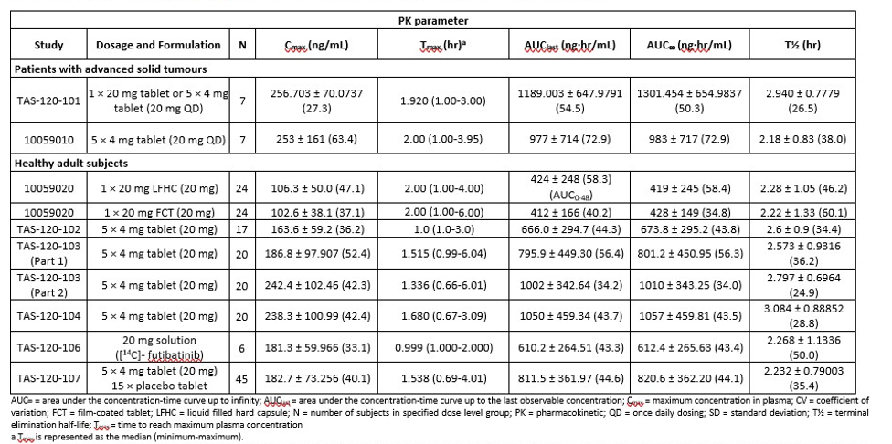
Table 3: Multiple dose futibatinib (20 mg) PK studies under fasted conditions – Mean ± SD (%CV)
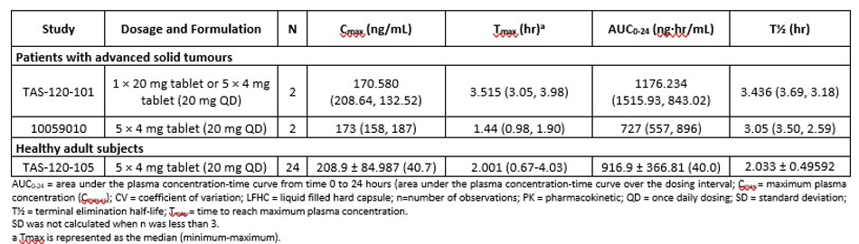
In part to make up for the small patient sample size, a population pharmacokinetic (PopPK) analysis was conducted. The PK parameters for 203 patients receiving oral futibatinib (20 mg QD) predicted by the PopPK analysis are shown in the table 4. The median (minimum – maximum) of Tmax at steady state was 2 hours (1.20 – 22.8 hours).
Table 4: PopPK Report: Model predicted PK parameters of futibatinib in patients at 20 mg QD (N=203)
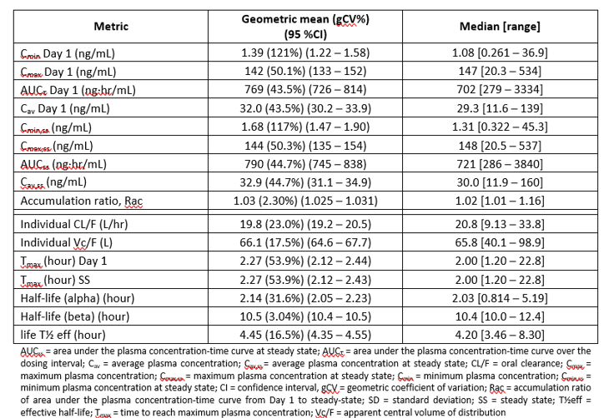
The PopPK analysis also found that none of the intrinsic factors - age, sex, health status (healthy or patient), liver enzymes, cancer type, FGFR mutation status, and ECOG score were predictors of futibatinib PK.
The results of the food effect study (Study TAS-120-102) showed that consumption of a high fat, high calorie meal affects the PK of a single dose of 20 mg futibatinib with reduced relative oral bioavailability (42%, 14%, and 11% reductions in Cmax, AUClast, and AUC∞, respectively) and delayed Tmax (median 2.5 hours). However, these differences were not considered to be clinically meaningful and that futibatinib could be administered with or without food.
Results of the mass balance study (Study TAS-120-106) showed that following a single dose of [14C]-futibatinib, the main component in plasma (59.19% of the radioactivity in pooled plasma [ROI]) was futibatinib, as an unchanged form. The primary circulating metabolites in plasma were a glucuronide conjugate of mono-oxidised product (8.97% of ROI), a cysteine conjugate (8.68% of ROI), and a cysteinylglycine conjugate (13.37% of ROI). Each of them accounted for approximately 10% of total exposure of the relevant compounds, and therefore no metabolites were considered as major.
The primary method of excretion was faecal (~64%) with only 6% recovered in urine.
The study in patients with hepatic impairment (Study TAS-120-108) did not demonstrate any clinically significant trends between the severity of hepatic impairment and increasing futibatinib exposure compared to healthy controls.
No studies were conducted in patients with severe renal impairment, but the PopPK analysis did not indicate any interaction.
The results of the interaction studies found the following.
- There was no clinically significant effect of futibatinib with lansoprazole (a proton pump inhibitor) (Study TAS-120-104).
- There was a marked interaction with strong CYP3A inhibitors and moderate to strong CYP3A inducers which should be avoided (Studies TAS-120-103 and 20DC01).
- Oral administration of 20 mg futibatinib QD had no clinically significant impact on exposures of the sensitive CYP3A substrate midazolam (Study TAS-120-105).
- Inhibitors of P-gp and BCRP are not expected to have a significant effect on the bioavailability of futibatinib (Study 20DB01).

Pharmacodynamics (PD) summary
Study 10059010 conducted in Japanese patients with advanced solid tumours measured serum FGF23, serum inorganic phosphorus (Pi), urine Pi and urine calcium after single and repeated administrations of futibatinib.
The results found that the dynamic changes in FGF23 and increased levels of serum Pi and decreased levels of urine Pi in a dose dependent manner indicated FGFR inhibition activity after administration of futibatinib.
Study TAS-120-101 demonstrated that futibatinib had an effect on serum FGF23 and serum phosphate as a marker for the PD effect.
- Following repeated dosing of futibatinib, the mean serum FGF23 concentrations for each dose levels were markedly up regulated compared to Cycle 1, Day 1 baseline results in both QOD and QD cohorts. The dynamic FGF23 serum changes indicated FGFR target engagement of futibatinib for both dosing schedules and were consistent with those observed in pre-clinical models.
- After repeated dosing of futibatinib, baseline serum phosphate levels were elevated compared to baseline levels on Cycle 1, Day 1 for QOD and QD dosing. The dynamic changes of serum phosphorus observed following futibatinib administration are in line with an expected increase in serum phosphate levels due to FGFR1 inhibition (i.e. reduction of phosphaturic FGF23 effect by FGFR1 inhibition in the proximal tubules of the kidney).
Study TAS-120-107 found that futibatinib did not appear to have any clinically significant effect on heart rate or ECG parameters. Therapeutic (20 mg) and supratherapeutic (80 mg) did not prolong the QTc interval.
The PopPK analysis included analysis of the Exposure/Response and Exposure/Safety relationships.
PK/PD analysis demonstrated target engagement for futibatinib QOD and QD as measured by increased FGF23 and phosphate serum levels with a trend towards dose dependency. This exposure-response relationship was more pronounced in QD than in the QOD cohorts consistent with a higher incidence of clinical Adverse Events (AEs) of hyperphosphatemia in QD cohorts compared to QOD cohorts.
There was no statistically significant E/R relationship for ORR, DCR, DOR, OS, PFS or CTS and any exposure metric evaluated (Cmin, Cmax and AUC on Cycle 1 Day 1 or at steady state), although the dose range and number of subjects are limited.
For the requested QD dosing, statistically significant exposure-safety relationships were observed for any grade of hyperphosphatemia and logarithmically transformed Cmin,ss, Cmin on Cycle 1 Day 1, and AUCss; for Grade ≥3 hyperphosphatemia and logarithmically transformed Cmin,ss, Cmin on Cycle 1 Day 1, AUCτ on Cycle 1 Day 1, and AUCss, and for any grade of nail disorders and logarithmically transformed Cmin,ss (steady-state exposure with lowest p-value), Cmin on Cycle 1 Day 1, AUCτ Cycle 1 Day 1 and AUCss.
No exposure-safety relationships were observed for any grade of hypercalcemia, hepatotoxicity, PPE, rash, and any exposure metric evaluated.
Baseline body weight, age (<65 and ≥65 years), and race showed no influence on the exposure safety relationships. Baseline serum phosphate was predictive of any grade of hyperphosphatemia and Grade ≥3 hyperphosphatemia. ECOG status and sex were identified as covariates for any grade of nail disorders and Grade ≥3 hyperphosphatemia, respectively.

Efficacy
The ‘pivotal’ data for efficacy come from Study TAS-120-101, a phase 1/2 study in patients with advanced solid tumours harbouring FGF/FGFR alterations. The efficacy results are provided below for both Phase 1 (Dose escalation and Dose expansion) and Phase 2. No controlled studies have been conducted.
The Delegate noted the following publication:
Goyal L, Meric-Bernstam F, Hollebecque A, et al. Futibatinib for FGFR2-Rearranged Intrahepatic Cholangiocarcinoma. N Engl J Med. 2023;388(3):228-239.

Study TAS-120-101

Study design
This was an open label, non-randomised, dose escalation and dose expansion phase 1/2 study conducted globally from July 2014to August 2021:
- Phase 1 dose escalation: 6 sites in 5 countries (USA, France, Spain, UK, and Australia).
- Phase 1 dose expansion: 37 sites in 8 countries (USA, France, Korea, Spain, UK, Taiwan, Italy and Australia).
- Phase 2: 48 sites in 13 countries (Australia, Canada, Germany, Spain, France, UK, Hong Kong, Italy, Japan, Korea, Netherlands, Taiwan, and USA).
Figure 1: Study TAS-120-101 – study schema
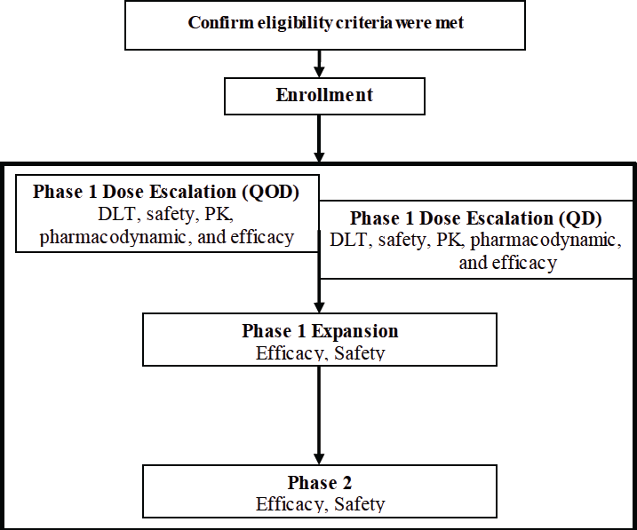
DLT = dose-limiting toxicity; PK = pharmacokinetics; QD = once daily (continuous) dosing; QOD = 3 times a week (Monday, Wednesday, Friday) dosing.

Analysis populations, statistical methods and patient flow/disposition

Phase 1 dose escalation
A total of 86 patients were enrolled. At the time of analysis, all 86 patients had discontinued study treatment. Most (n=77, 89.5%) had discontinued due to clinical or radiological disease progression (Table 5).
Table 5: Study TAS-120-101-Dose Escalation – Summary of patient disposition and reasons for discontinuation
Parameter | QOD Dosing  N=42 n (%) | QD Dosing  N=44 n (%)
Patients treated | 42 (100) | 44 (100)
On treatment | 0 | 0
Off treatment | 42 (100) | 44 (100)
Primary reason for treatment discontinuation:
- Radiographic progression | 25 (59.5) | 31 (70.5)
- Clinical progression | 14 (33.3) | 7 (15.9)
- Adverse event | 0 | 1 (2.3)ª
- Patient death | 1 (2.4)^{b} | 1 (2.3)^{b}
- Withdrawal of consent | 1 (2.4)
- Investigator decision | 1 (2.4) | 1 (2.3)
N = number of patients in arm; n=number of patients in group; QD = once daily; QOD = every other day
ª Grade 2 nausea and Grade 2 vomiting, both considered related to study drug (futibatinib) by the investigator.
^{b} Both deaths due to disease progression.

Phase 1 dose expansion
Dose expansion iCCA patients who received 20mg QD are summarised in Table 6.
Table 6: Study TAS-120-101 Expansion – Summary of patient disposition and reasons for discontinuation (patients with iCCA who received a dose of 20mg QD)
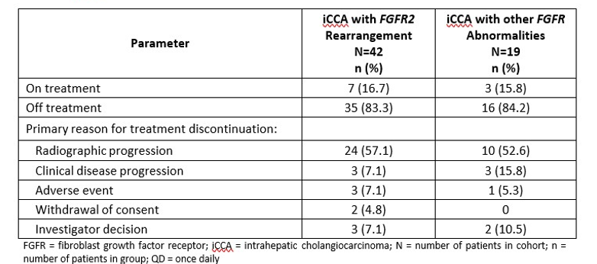

Phase 2
Phase 2 evaluated futibatinib in 103 patients with locally advanced unresectable or metastatic intrahepatic cholangiocarcinoma harbouring an FGFR2 gene fusion or rearrangement whose disease had progressed on or after at least 1 prior systemic therapy.
Phase 2 diagnostic criteria are summarised in Table 7.
Table 7: Study TAS-120-101 Phase 2– Diagnostic criteria
Phase 2 part of TAS120-101 (n=103)
Patients | Key inclusion criteria  - Histologically or cytologically confirmed locally advanced, metastatic or unresectable iCCA harbouring FGFR2 gene fusions or other FGFR2 rearrangements based on results  - from either Foundation Medicine testing or local testing by NGS, FISH, other assays able to determine FGFR2 gene fusions or rearrangements  - Previous treatment with at least 1 prior systemic Gem/Cis chemotherapy  - Documentation of DP on most recent prior therapy  - 18+ years  - ECOG: 0 or 1  - Measurable disease by RECIST 1.1  Key exclusion criteria  - History and/or current evidence of clinically significant non-tumour related alteration of calcium-phosphorous homeostasis, ectopic mineralisation or retinal disorder confirmed by retinal examination  - History and/or current evidence of serious uncontrolled VT  - QTcF >470msec
Intervention | Futibatinib 20mg orally once daily until disease progression or unacceptable toxicity
Comparator | Nil, single-arm study
Endpoints | Primary endpoint  - ORR (BICR)  Secondary endpoints  - DOR  - DCR  - PFS  - OS  - PROs  - Safety and tolerability
Baseline characteristics for Phase 2 were:
- Age median: 58.0 years (range: 22,79)
- Female: 56.3%
- Caucasian 49.5%, Asian: 29.1%
- ECOG 0: 46.6%, ECOG 1: 53.4%
- Median time since initial diagnosis: 12.7 months (2.0, 61.4)
- All 103 patients had intra-hepatic CCA
- All patients had at least one prior anti-cancer therapy
- 30% had had 2 prior treatments
- 23% had had at least 3 prior regimens
- 77.7% had FGFR2 fusions
- 22.3% had FGFR rearrangements other than fusions
Phase 2 patients and discontinuations are summarised in Table 8.
Table 8: Study TAS-120-101 Phase 2 – Summary of patient disposition and reasons for discontinuation
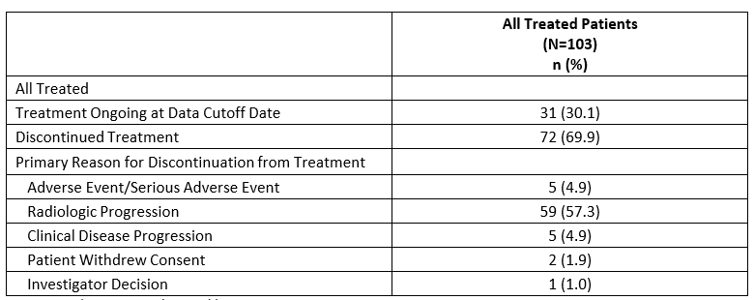

Protocol violations
The Sponsor did not consider any deviations to have affected the overall safety or efficacy conclusions presented.

Study objectives
- Phase 1 dose escalation
- Primary: To investigate the safety and to determine the MTD and the recommended Phase 2 dose (RP2D) and associated dosing schedule (every other day [QOD] or once daily [QD]) of futibatinib in patients with advanced solid tumours with or without FGF/FGFR abnormalities who have failed all standard therapies or for whom standard therapy does not exist
- Secondary: To investigate the clinical PK and PD of futibatinib and to determine any preliminary anti-tumour activity observed with futibatinib.
- Phase 1 dose expansion
- Primary: to evaluate the anti-tumour activity of futibatinib at the RP2D in each of the following populations:
- To evaluate objective response rate (ORR) in cholangiocarcinoma (iCCA or eCCA) patients with tumours harbouring FGFR2 gene fusions or other FGFR abnormalities
- To evaluate ORR and early progression rate (defined as progression-free rate at the end of Cycle 2) in patients with primary central nervous system (CNS) tumours harbouring FGFR gene fusions or FGFR1 activating mutations
- To evaluate ORR in patients with advanced urothelial carcinomas in tumours harbouring FGFR3 gene fusions or FGFR3 activating mutations
- To evaluate ORR in a basket of tumour types with tumours harbouring FGFR2 amplifications
- To evaluate ORR in a basket of tumour types (except CCA, brain tumours and advanced urothelial carcinomas that are included in other groups) with tumours harbouring FGFR gene fusions or activating mutations
- Secondary: To investigate the safety of futibatinib and to evaluate the disease control rate (DCR), duration of response (DOR), progression free survival (PFS) and overall survival (OS) in each treatment group.
- Phase 2
- Primary: To confirm ORR in iCCA with FGFR2 gene fusions or other rearrangements based on independent central radiology review.
- Secondary: To evaluate DOR, DCR, PFS, OS and patient reported outcomes (PROs) and safety and tolerability of futibatinib.
There were additional exploratory objectives for the PK evaluation.

Results
Efficacy was determined based on the Phase 2 part of Study TAS-120-101. For the 103 patients in the efficacy population, treatment with futibatinib resulted in a confirmed ORR of 41.7% (95% confidence interval [CI]: 32.1, 51.9), including 42 patients with a best response of PR and 1 patient with a best response of CR.
Table 9: Study TAS-120-101-Phase 2: Tumour response rate by independent review (efficacy population)
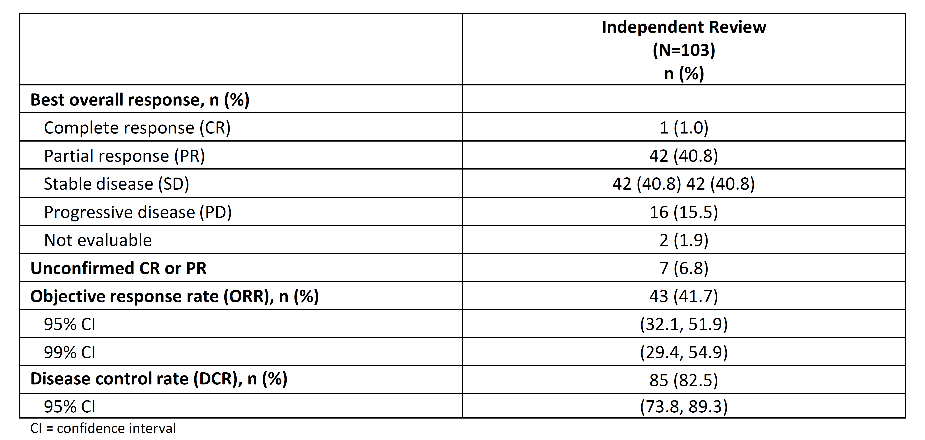
The ORR by investigator review was conducted as a sensitivity analysis. The confirmed ORR per local assessment was 36.9% (95% CI: 27.6, 47.0) including 37 patients with PR and 1 patient with CR. This ORR was consistent with the ORR by the Independent Review Committee (IRC), when considering the largely overlapping 95% CIs of both independent assessments.
Subgroup analysis: the treatment effect with respect to confirmed ORR by independent assessment was generally consistent across all subgroups assessed with 95% CIs comprising the primary ORR of 41.7% except for the subgroup of patients at age ≥65 years, with an even higher (ORR: 65.2%; 95% CI: 42.7, 83.6).
The ORR was 45.8% (95% CI: 34.0, 58.0) for patients with FGFR2 fusion and 33.3% (95% CI: 14.6, 57.0) for patients with FGFR2 rearrangement based on FMI assessment.
Figure 2: Study TAS-120-101-Phase 2: Objective response rate subgroup analysis based on independent evaluation (efficacy population)
CI = confidence interval; ECOG = Eastern Cooperative Oncology Group; FGFR = fibroblast growth factor receptor

Results for secondary endpoints

Duration of Response (DOR)
At the time of the data cutoff date, 42 of 43 patients responding to futibatinib had follow-up for at least 6 months following their initial response (median 11.76 months). One patient was followed for less than 6 months since the onset of response.
At the time of the data cutoff date, the median DOR by Kaplan-Meier analysis for the 43 responders was 9.69 months (95% CI: 7.62, 17.05) (Table 10). The majority of responders (31 [72.1%] patients) had DORs of ≥6 months. Fifteen patients had an ongoing response of at least 4 months as of this cutoff date; 10 of these 15 patients had an ongoing response and had not yet reached the median of 9.69 months as of the cutoff date.
Table 10: Study TAS-120-101-Phase 2: Time to response and duration of response
Independent Review
(N=43)
n (%)
Duration of response (months)
N | 43
Mean (SD) | 8.35 (4.401)
Medianª (min, max) | 7.56 (2.1, 22.5)
Kaplan-Meier Analysis
Median (95% CI) | 9.69 (7.62, 17.05)
Time to response (months)
N | 43
Mean (SD) | 2.63 (1.659)
Medianª (min, max) | 2.50 (0.7, 7.4)
Number of patients with duration of response of at least (%)
3 Months | 42 (97.7)
6 Months | 31 (72.1)
12 Months | 6 (14.0)
Patients with ongoing response of duration ≥4 months^{b} | 15 (34.9)
Patients with ongoing response of duration ≥6 months^{c} | 13 (30.2)
CI = confidence interval; SD = standard deviation
Note: Responders are patients with confirmed partial response or complete response.
ª Median is derived from univariate descriptive statistics.
^{c} Subjects with ongoing response consist of responders who had neither progressed nor initiated other anticancer therapy.

Disease Control Rate (DCR)
The DCR per independent review was 82.5% (95% CI: 73.8, 89.3).

Progression Free Survival (PFS) and Overall Survival (OS)
As per regulatory guidelines, time-to-event endpoints, such PFS and OS, are difficult to interpret in single arm trials, given the lack of contemporaneous internal controls. For completeness, the median PFS was 9 months, and the median OS was about 21 months. These results for PFS and OS have not been used for regulatory decision-making.

Patient reported outcomes (PROs)
Patient-reported outcome measures included the European Organisation for Research and Treatment of Cancer Quality of Life Questionnaire-Core 30 (EORTC QLQ-C30; 5 functional and 9 physical measures) and the EQ-5D-3L (utility index and 5 dimensions: anxiety/depression, mobility, pain/discomfort, self-care, and usual activity). Patient-reported outcomes were collected at Screening, Cycles 2 and 4, every 3 cycles after Cycle 4, and at the end of treatment. Change in mean score from baseline was assessed using predefined clinically meaningful thresholds for each time point with at least 19 observations (through Cycle 13).
Ninety-two of 103 (89%) enrolled patients had PRO data at baseline and at least 1 follow-up assessment; 48 patients had PRO data at Cycle 13.
Mean EORTC QLQ-C30 global health status scores were maintained from baseline to Cycle 13 (approximately 9 months on treatment) with no clinically meaningful (≥10-point) changes in functional measures. EORTC QLQ-C30 scores across symptom measures were also stable from baseline to Cycle 13.
Constipation was the only component with a mean 10.0-point worsening at only Cycle 4.
Mean EQ VAS scores were sustained from baseline to Cycle 13 (mean change -1.8 to +4.8 across cycles), with values maintained within the population normal range from across 20 countries.

Clinical Evaluator’s efficacy summary for Study TAS-120-101
The Clinical Evaluator’s summary for TAS-120-101 and clinical efficacy is as follows.
This was a complex study conducted in 3 parts with objectives to evaluate dose and dose regimen, PK, PD, and efficacy and safety. There were multiple changes to the protocol and statistical plan as the results evolved.
As previously noted, the relevant part to establish efficacy was the Phase 2 part of the study. This included 103 patients with locally advanced unresectable or metastatic intrahepatic cholangiocarcinomas harbouring FGFR2 gene fusion or other arrangements, whose disease had progressed after at least 1 prior systemic therapy (some patients receiving up to at least 3 prior lines of treatment).
Patients received 20 mg futibatinib administered orally once daily until disease progression or unacceptable toxicity. The outcome measures were Overall Response Rate (ORR) and Duration of Response (DOR) as determined by an independent review committee according to RECIST V1.1 criteria.
The results demonstrated an ORR of 42% which is a clinically meaningful improvement
Sensitivity analysis confirmed the results of the primary analysis.
Subgroup analysis of primary endpoint, based on local or central FGFR2 status testing:
- ORR for patients with FGFR2 fusion or rearrangement (n=93): ORR = 43% 95% CI: 32.8, 53.7
- ORR for patients with FMI Central lab confirmed FGFR2 Fusion or rearrangement (n=68):
ORR = 39.7% 95% CI: 28.0, 52.3
The median DOR for the 93 patients with FGFR2 fusion or rearrangement in the efficacy population was 7.59 months (range: 3.2 to 22.5 months) as assessed by independent review. The median time to response was 1.69 months (range: 0.7 to 6.7 months). A total of 12 (12.9%) patients had ongoing response durations ≥6 months as of the cut-off date.
This was a non-comparative, single arm study but demonstrates a clinically meaningful response rate and duration of response.
The other secondary endpoints of PFS, DCR and OS support the efficacy although OS is considered immature.
- PFS (months) median (95% CI) = 9.0 (6.9, 13.1)
- DCR (n, %) = 85 (73.8 – 89.3)
- OS (months) median (95% CI) = 21.7 (14.5, NE).

Clinical Evaluator’s summary for overall efficacy
As there is only one study supporting the efficacy of futibatinib the comments in the above section apply.
Study TAS-120-101-Phase 2 demonstrated a clinically meaningful result of ORR = 42% and PFS = 9 months.
There is concern with a single Phase 2 study and the lack of a second study to confirm the results.
The Sponsor is requesting a provisional approval based on the single study. This is in keeping with other products granted provisional approval.
There are concerns over the recommended dose. It is not clear that the optimal dose has been defined. The efficacy of 16 mg QD appears as effective but may be safer but it was only assessed in 27 patients. A large number of patients (60%) in Phase 2 required dose reductions and 80% required dose interruptions, mostly due to AEs.
The Sponsor included details of a proposed follow up confirmatory study, which is a condition of approval in the USA. The study, titled TAS- 120-301 or FOENIX-CCA3 ‘A Phase 3, Open‐Label, Randomised Study of Futibatinib Versus Gemcitabine‐Cisplatin Chemotherapy as First‐Line Treatment of Patients with Advanced Cholangiocarcinoma Harbouring FGFR2 Gene Rearrangements (FOENIX‐CCA3)’ opened to enrolment on 1 March 2020, with first patient randomised in January 2021. The study is multicentre and worldwide (including 3 sites in Australia) and is ongoing but very slow in recruitment leading to many discussions with the FDA. The study is expected to enrol 100 – 120 patients but the viability will be assessed ongoing with the FDA. According to the last information provided by the Sponsor to the FDA the study is not expected to be completed until the end of 2026 with results and the CSR available for submission by the end of 2027. It is unclear if this study has been amended since the last correspondence with the FDA in 2022 and so the final design and methodology of the study are unclear.

Safety
The clinical safety is described in 9 studies that were pooled to comprise the integrated safety population. The data is presented in 3 groups in the Summary of Clinical Safety (SCS) (Figure 3).
- Safety Data Group 1 (SDG1; N=145): This group comprises patients with iCCA harbouring FGFR2 rearrangement and treated at a starting dose of 20 mg QD in the TAS- 120-101-Phase 1 Expansion and TAS-120-101-Phase 2.
- Safety Data Group 2 (SDG2; N=469): This group comprises patients with all solid tumours, at any dose level in studies TAS-120-101 Phase 1 Dose Escalation portion, TAS- 120-101-Phase 1 Expansion, TAS-120-101-Phase 2, 10059010 Dose Escalation part, and 10059010 Expansion part. The futibatinib 20 mg QD population (N=318) comprises all patients with any tumour type who received a starting dose of 20 mg QD futibatinib and is included as supporting information throughout this summary.
- Safety Data Group 3 (SDG3; N=179): This group comprises subjects in clinical pharmacology studies in healthy volunteers: TAS-120-102, TAS-120-103, TAS-120-104, TAS-120-105, TAS-120-106, TAS-120-107, and 10059020.
Figure 3: Summary of Clinical Safety (SCS)
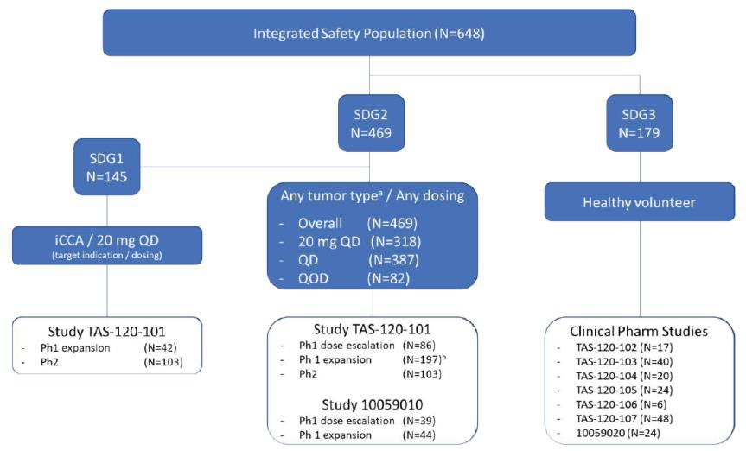
The pivotal study was TAS-120-101 (Study 10059010 was conducted in Japanese patients with advanced solid tumours).
- In SDG1, the most commonly reported AEs were hyperphosphataemia (85.5%) and constipation (37.1%).
- The most frequently reported Grade ≥3 TEAEs included hyperphosphataemia (26.9%), AST increased (9.0%), fatigue (7.6%) and hyponatraemia (7.6%).
Table 11: Study TAS-120-101-Phase 2: Most frequently reported (>20% any grade incidence) adverse events (AEs) by preferred term
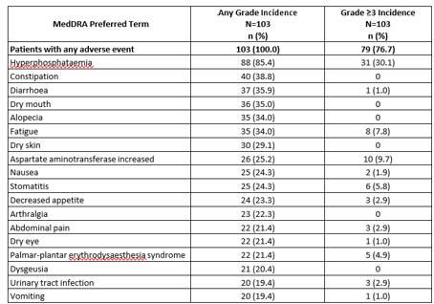

Deaths and serious adverse events (SAEs)
- No treatment-related serious adverse events (TRSAEs) resulted in death.
- In SDG1, SAEs were reported for 59 patients (40.7%) with iCCA who received a starting dose of 20 mg futibatinib and 52 of these patients (35.9%) experienced Grade ≥3 SAEs. The most frequently reported SAEs were disease progression, abdominal pain, upper gastrointestinal haemorrhage, pyrexia, bile duct obstruction, and sepsis. Seven patients (4.8%) experienced a TEAE with the outcome of death.
- In SDG1, TRSAEs were reported for 13 patients (9.0%). There were no treatment-related Grade 4 or Grade 5 SAEs. Treatment-related SAEs reported in >1 patient included intestinal obstruction and migraine (n=2 each, 1.4%); all remaining treatment-related SAEs occurred in a single patient each

Discontinuation and/or dose interruption/reduction due to adverse events
In SDG1, TEAEs led to:
- treatment discontinuation in 2.1%
- dose reduction in 47.6%
- dose interruption in 46.2%.

Adverse events of special interest (AESI)
AESI for futibatinib included: retinal disorders, hyperphosphataemia, hepatotoxicity, nail disorders, palmar-plantar erythrodysesthesia syndrome and rash.

Clinical Evaluator’s summary on safety
The overall safety profile of futibatinib is based on a small dataset of patients with the requested indication, i.e, patients with iCCA with FGFR2 rearrangements. The total dataset is only 103 patients. This is however, supported by larger dataset of patients with any advanced solid tumour, n=318, who received the requested dose regimen of 20 mg QD.
Overall, all patients with iCCA who received the requested dose regimen reported at least 1 AE. The most common AE was hyperphosphataemia which occurred in 86% of patients. While hyperphosphataemia is very common it can be treated if adequately monitored and treated early.
The other most frequently reported AES (≥20%) (other than hyperphosphataemia) were constipation, diarrhoea, dry mouth, alopecia, fatigue, dry skin, aspartate aminotransferase increased, nausea, stomatitis, decreased appetite, arthralgia, abdominal pain, dry eye, palmar-plantar erythrodysaesthesia syndrome, dysgeusia, urinary tract infection, vomiting.
Other AESI identified were retinal disorders (8%), nail disorders (47%) and PPE (21%) were generally reversible with careful monitoring and treatment, including dose modification.
There were no deaths directly related to futibatinib treatment and SAEs were generally low and considered unrelated to futibatinib.
In Sequence 0001, the Sponsor provided more information on the safety-exposure analysis and the retinal disorders. The safety-exposure analysis found that increasing futibatinib exposure was associated with increased risk of any AE Grade ≥3, retinal detachment, SAEs, and any AEs leading to discontinuation of the study drug. This supports the conclusion that the optimal dose is yet to be determined and may be lower than the recommended 20 mg QD.
The risk of retinal detachment is low but significant. The FDA ophthalmology assessment found major concerns over the level of monitoring and type of monitoring included in Phase 2.
In Sequence 0001, the FDA confirmed the incidence of retinal disorders (8%) as presented in the submission but raised concerns over the ophthalmological monitoring plan and especially as optical coherence tomography (OCT) was not included in testing unless considered necessary by the investigator. The FDA conclusion was FDA does not consider that the ophthalmologic toxicity of futibatinib has been adequately characterised, as some pathology, particularly retinal pigment epithelial detachment (RPED) may occur in the absence symptoms.
In addition, it was noted that there were a large number of missing examinations (examinations of the anterior ocular structures are missing in 29% of patients at Cycle 2 [the visit with the most examinations] and less than 20% of patients had an end of treatment assessment).
The FDA has required that post marketing studies include further characterisation of the ophthalmological toxicity of futibatinib.
Data are also limited on the safety of futibatinib in special patient populations (i.e, patients with mild-to-moderate renal, or hematologic impairment). No data are available for patients with severe renal, hepatic, or haematologic impairment, as patients with these conditions at baseline were excluded from the pivotal clinical trial.

Clinical Evaluator’s overall benefit-risk assessment
The benefit-risk balance for the proposed usage, is favourable.
This submission is for provisional approval for an orphan indication (requested indication more restricted than orphan designation).
The data supporting efficacy is based on a single study in 103 patients. The efficacy results demonstrated a clinically meaningful response with a significant duration. The ORR of 42% (95% CI: 32, 52) as assessed by an independent review according to RECIST 1.1 criteria. The median duration of response was 9.7 months (95%CI: 7.6, 17.1) is meaningful in the context of life expectancy for patients who have failed at least one and often more prior systemic therapies.
The safety analysis is based on a small database but consistent with an orphan drug and provisional approval. The database consists of 103 patients from Phase 2 plus 42 patients from the Expansion phase of the pivotal study.
The most common AEs seen in Phase 2 were consistent with those described for other FGFR inhibitors. The TEAEs (≥20%) included hyperphosphataemia, constipation, diarrhoea, dry mouth, alopecia, fatigue, dry skin, aspartate aminotransferase increased, nausea, stomatitis, decreased appetite, arthralgia, abdominal pain, dry eye, palmar- plantar erythrodysaesthesia syndrome, dysgeusia, urinary tract infection, and vomiting.
The significant AESIs include ophthalmic toxicity (dry eye, keratitis and retinal detachment) which was not adequately evaluated in the pivotal study and hyperphosphataemia can be adequately monitored and treated in practice.
There is still an outstanding issue relating to the optimal dose to be addressed in current ongoing study, the details of which should be provided and a condition of provisional approval should be the timely provision of the results of all planned or ongoing studies.

Clinical Evaluator’s Round 1 recommendation
Based on the clinical data submitted in Module 2 and 5, approval of Lytgobi, (subject to revision to the draft PI incorporating the recommended changes to the PI, is recommended for the following indication:
Lytgobi monotherapy is indicated for the treatment of adult patients with locally advanced or metastatic intrahepatic cholangiocarcinoma with a fibroblast growth factor receptor 2 (FGFR2) fusion or rearrangement that have progressed after at least one prior line of systemic therapy.
The requested indication was locally advanced or metastatic cholangiocarcinoma. Consideration should be given to restricting this to the indication approved by the USA by including the word ‘intrahepatic’ to read locally advanced or metastatic intrahepatic cholanciocarcinoma.
The submission has provided clinically meaningful benefit (improved ORR and DOR/PFS) for patients with a cancer with few treatment options.
- The safety database is small as is common for orphan/provision approval products.
- The common side effects are manageable with appropriate monitoring and treatment.
- Outstanding issues remain in regard to the optimal dose and optical toxicity. The Sponsor should be required to provide an update of the full details of any studies agreed as part of post registration requirements with the major agencies.

Clinical Evaluator’s R2 recommendation
No new clinical information was submitted in response to questions. While only one study was submitted to support efficacy in light of the clinical need, the assessment of benefit-risk is favourable for a provisional approval of an orphan drug.
The recommendation regarding registration is unchanged.
Based on the clinical data submitted in Module 2 and 5, approval of Lytgobi, subject to the draft PI incorporating the recommended changes to the PI, is recommended for the following indication:
Lytgobi monotherapy is indicated for the treatment of adult patients with locally advanced or metastatic intrahepatic cholangiocarcinoma with a fibroblast growth factor receptor 2 (FGFR2) fusion or rearrangement that have progressed after at least one prior line of systemic therapy.
The requested indication was locally advanced or metastatic cholangiocarcinoma. Consideration should be given to restricting this to the indication approved by the US by including the word and intrahepatic to read locally advanced or metastatic intrahepatic cholanciocarcinoma.

Risk management plan
The summary of safety concerns and their associated risk monitoring and mitigation strategies are summarised in Table 12. The TGA may request an updated RMP at any stage of a product's life cycle, during both the pre-approval and post-approval phases.
Table 12: Summary of safety concerns
Summary of safety concerns |  | Pharmacovigilance |  | Risk minimisation
 |  | Routine | Additional | Routine | Additional
Important identified risks | Serous  retinal detachment |  | – |  | –
Important potential risks | Embryo-foetal toxicity/  teratogenicity |  | – | ü | –
Missing information | None | – | – | – | –
The Delegate noted the following.
- The summary of safety concerns is acceptable.
- The Sponsor has proposed routine pharmacovigilance activities only to align with the EU-RMP. This is acceptable.
- The Sponsor has proposed routine risk minimisation activities only. This is acceptable.

Risk-benefit analysis

Delegate’s considerations
Futibatinib (LYTGOBI) is a potent and highly selective kinase inhibitor of fibroblast growth factor receptor (FGFR) 1-4, that irreversibly blocks FGF/FGFR signalling by its covalent mechanism of binding. Inhibition of FGF/FGFR signalling can lead to inhibition of cancer cell growth in tumours harbouring various types of genomic FGFR alterations, including cholangiocarcinoma harbouring FGFR2 rearrangements (including fusions).
Cholangiocarcinoma is a rare malignancy; extrahepatic and perihilar CCA are the most common types, with 5-10% being intra-hepatic. FGFR2 rearrangements (including fusions) occur in about 10% to 20% of patients with iCCA.
Therapeutic options for patients who progress on first-line therapy are limited. Second-line FOLFOX has limited efficacy. Pemigatinib has provisional approval for the treatment of patients with FGFR2 fusions or rearrangements whose disease has progressed after at least one prior line of systemic therapy (ORR of ~35% (95% CI: 26.5, 45.4) and a median DOR of ~7.5 months. Ivosidenib monotherapy is approved for the treatment of adult patients with locally advanced or metastatic cholangiocarcinoma with an IDH1 R132 mutation after at least one prior line of systemic therapy.
FGFR inhibition is now a recognised treatment option for patients with advanced CCA and is recommended by key national/international guidelines (e.g. NCCN; ESMO).
The ESMO MCBS score for futibatinib for the proposed indication is 3.

Proposed indication
The Sponsor initially proposed to provisionally register a new therapeutic entity for the following indication:
LYTGOBI monotherapy is indicated for the treatment of adult patients with locally advanced or metastatic cholangiocarcinoma (CCA) with a fibroblast growth factor receptor 2 (FGFR2) fusion or rearrangement, that have progressed after at least one prior line of systemic therapy.
This was amended following R1 evaluation to:
LYTGOBI monotherapy has provisional approval in Australia for treatment of adult patients with locally advanced or metastatic cholangiocarcinoma with a fibroblast growth factor receptor 2 (FGFR2) fusion or rearrangement, that have progressed after at least one prior line of systemic therapy. The decision to approve this indication has been made on the basis of the favourable objective response rate and duration of response in a single arm trial. Continued approval of this indication depends on verification and description of benefit in confirmatory trials.

Benefits and uncertainties of benefit
The Sponsor has provided adequate evidence of efficacy, based on the efficacy data of
Study TAS-120-101, to support provisional approval of futibatinib in patients with locally advanced or metastatic CCA patients with FGFR2 rearrangements (including fusions) who have previously received at least one line of systemic therapy.
A clinically meaningful and durable ORR in 103 patients with previously treated locally advanced or metastatic iCCA with an FGFR2 gene fusion or rearrangement who received 2L futibatinib was demonstrated (Table 13):
- ORR = 42% (95% CI: 32, 52)
- Median DOR = 9.7 months (95% CI: 7.6, 17.1) by BICR
- Of the 43 patients who achieved a PR (by BICR), 72% had a response ≥6 months
Table 13: Overall response rate based on Study TAS-120-101-Phase 2
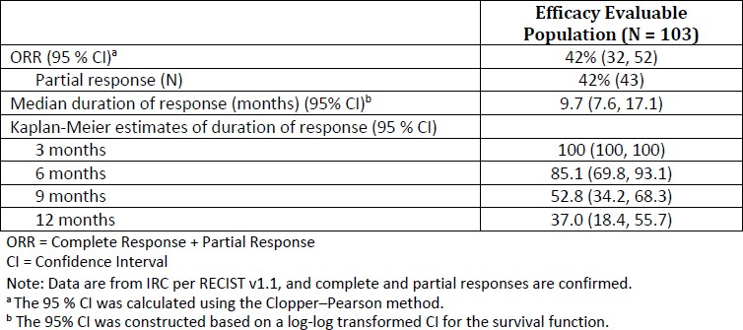

Uncertainties
Only data from a single study (single-arm phase 2) is available. Confirmatory data is required to verify and confirm the clinical benefit of futibatinib in the proposed population.
Provisional approval on the basis of single-arm study data has been previously granted for the use of other FGFR inhibitor(s) in patients with locally advanced or metastatic cholangiocarcinoma (with FGFR2 fusion or rearrangement), in view of the rarity of disease.
The Delegate notes that the initially proposed confirmatory RCT study (Foenix-CCA3) comparing futibatinib with cis+gem in the 1L setting in the proposed population has become non-viable due to poor accrual, leading to termination of the study in July 2024. The Sponsor has therefore advised that the confirmatory study will be a further phase 2 study, TAS-120-205, evaluating the efficacy and safety of futibatinib 20mg and 16mg. This study will provide further ORR and DOR data in a minimum of 120 patients with advanced CCA with FGFR2 fusion/rearrangements. The study has commenced and is expected to be completed in 2027.
Given the rarity of the condition, and the lack of feasibility of conducting an RCT in the context of this submission (unmet need, etc), the Delegate accepts the Sponsor’s plan for the submission of phase 2 TAS-120-205 study as a post-marketing requirement, which will provide further efficacy data for evaluation (enrolment of a minimum of 120 patients, all responders should have a minimum of 6 months from date of initial response).
The Clinical Evaluator has noted the outstanding issue relating to dose optimisation; to address this, the Sponsor at the request of the FDA has agreed to a post-marketing requirement to conduct a randomised trial comparing doses of 20mg and 16mg daily of futibatinib to verify and describe the benefit of futibatinib in the proposed population.

Risks and uncertainties of risk
The safety profile of futibatinib for the proposed population has been established. The most common AEs are hyperphosphataemia, nail disorders, constipation, alopecia, diarrhoea, dry mouth, fatigue, nausea, dry skin, increased AST, abdominal pain, stomatitis, vomiting, PPE, arthralgia and decreased appetite. This AE profile is consistent with that expected for drugs targeting the FGFR pathway, with the most common AEs consistent with those described for other similar FGFR inhibitors.
The most important identified risks are ocular toxicity (including serous retinal detachment, dry eyes, keratitis and blurred vision), and hyperphosphataemia. The Clinical Evaluator noted that ophthalmic toxicity (which was not adequately evaluated in the pivotal study) and hyperphosphataemia can be adequately monitored and treated in practice. Although these AEs are adequately described in the relevant sections of the PI (and are expected to be manageable with supportive therapy and/or dose modifications), these significant and serious adverse reactions require further characterisation, which will be addressed as a post-marketing requirement. These risks are acceptable in the context of the condition, for a patient population with poor life expectancy and limited treatment options.
Adequate advice regarding ophthalmological evaluation and monitoring should be included in the PI, i.e. as appears in the US PI, as per recommendations by the Clinical Evaluator. The Sponsor is requested to amend the relevant sections of the PI in relation to this, adding the additional information, including information regarding the description/incidence/dose modification for RPED and recommended ophthalmological examination and monitoring as detailed in the US label.

Uncertainties
The single arm study design of TAS-120-101 precludes the direct comparison of safety/toxicity profile of futibatinib with standard of care. The number of patients (=103) was relatively small, limiting the ability to fully characterise rare AEs; likewise, long-term safety data is limited as expected given the poor prognosis of the intended population. The confirmatory study TAS120- 205 should provide further safety data for evaluation in addition to post-marketing data.

Benefit-risk balance
Overall, the Delegate agrees with the Clinical Evaluator that the benefit-risk assessment for futibatinib in the assessed population is favourable; the ORR and DOR from the Study
TAS120- 101 are considered to be clinically meaningful and reasonably likely to predict clinical benefit, supporting the provisional registration of futibatinib for the following indication:
treatment of adult patients with locally advanced or metastatic intrahepatic cholangiocarcinoma with a fibroblast growth factor receptor 2 (FGFR2) fusion or rearrangement, that have progressed after at least one prior line of systemic therapy.
Noting the inclusion criteria of the pivotal study, the Clinical Evaluator has recommended restricting the indication to those with intrahepatic disease (as per wording of FDA indication). The Delegate’s current/preliminary view is in agreement with the Clinical Evaluator’s wording of the indication. However, it may be considered reasonable to extrapolate the data to patients with extra-hepatic cholangiocarcinoma (with FGFR2 fusions/rearrangements) given that the location of the tumour is not expected to affect its response to the product. Advice from ACM will be sought regarding this. The Delegate’s conclusion on the wording of indication will be directed by ACM advice.
The study design of TAS-120-101 limits interpretation of survival and precludes direct comparison of the efficacy and safety of futibatinib with current standards of care in the proposed population. Given the rarity of the condition and the lack of feasibility of conducting an RCT for the confirmatory study, the Sponsor will required to provide further data (to verify and confirm clinical benefit, as part of provisional registration) in a phase 2 study TAS120-205, which will also aid dose optimisation by comparing futibatinib 20mg and 16mg in the intended population.
Although futibatinib can cause serious adverse reactions (such as ocular toxicities and hyperphosphataemia), the safety profile demonstrated is acceptable when considered in the context of a life-threatening disease.
The sponsor will be required to submit final reports of corresponding post-marketing requirement studies.

Proposed action
The benefit-risk assessment for futibatinib is considered to be favourable, supporting the provisional registration of futibatinib for the intended population, for the indication as follows:
LYTGOBI monotherapy has provisional approval in Australia for treatment of adult patients with locally advanced or metastatic intrahepatic cholangiocarcinoma with a fibroblast growth factor receptor 2 (FGFR2) fusion or rearrangement, that have progressed after at least one prior line of systemic therapy.
The decision to approve this indication has been made on the basis of the favourable objective response rate and duration of response in a single arm trial. Continued approval of this indication depends on verification and description of benefit in confirmatory trials.”
Advice from the ACM will be sought regarding the clinical acceptability of including patients with advanced extrahepatic CCA with FGFR2 fusion or FGFR2 rearrangement in the therapeutic indication (i.e. to support the current wording of the Sponsor’s proposed indication).
Provisional approval of futibatinib is subject to confirmation that all outstanding Quality (i.e. GMP) issues have been satisfactorily addressed.
The Delegate proposes the following additional conditions of registration:
- Conduct, and submit final report for, a randomised clinical trial comparing dosages of futibatinib 16mg and 20mg once daily to verify and describe the clinical benefit of futibatinib in patients with advanced or metastatic cholangiocarcinoma harbouring an FGFR2 gene fusion or other rearrangement. The overall response rate and duration of response should be assessed by a blinded independent review. The study should also evaluate other clinical outcomes that denote clinical benefit, such as patient reported outcomes. This study should enrol a minimum of 120 patients, and all responders should have a minimum of 6 months from the date of initial response (or until disease progression, whichever comes first). Ensure that racial and ethnic minorities are adequately represented in the trial population, at a minimum, proportional to the prevalence of FGFR2 alterations in these subgroups in the US population.
- Conduct, and submit final report for, a clinical trial of futibatinib 20 mg once daily in a sufficient number of patients with cholangiocarcinoma harbouring a FGFR2 fusion or other rearrangement, that incorporates prospectively specified, scheduled ophthalmologic assessments that include optic coherence tomography (OCT), for all patients (symptomatic or asymptomatic), at baseline and during treatment with futibatinib, to further characterize the incidence and severity of futibatinib-related ocular adverse events.
- Conduct, and submit final report for, a randomised study that compares the recommended dosage of 20 mg daily to a lower dosage (e.g., 16 mg) to provide a comparative analysis of dose- and exposure-response relationships for safety including further characterization of the rates of Grade ≥3 adverse reactions, Grade ≥3 hyperphosphatemia, serious adverse reactions, and dose reductions, interruptions, and discontinuations due to adverse reactions. Incorporate systematically assessed patient- reported outcome assessments to evaluate tolerability. Core outcomes should include patient-reported symptomatic adverse event data, overall side effect bother, physical function, and role function. The study should also provide a comparative analysis of dose- and exposure-response relationships for efficacy, including overall response rate and duration of response.
- Conduct, and submit final report for, a drug interaction study to evaluate the effect of a P-gp inhibitor on the pharmacokinetics of futibatinib to assess the magnitude of increased drug exposure and determine appropriate dosage recommendations when futibatinib is administered concomitantly with P-gp inhibitors. Design and conduct the study in accordance with the FDA Guidance for Industry titled Clinical Drug Interaction Studies — Cytochrome P450 Enzyme- and Transporter-Mediated Drug Interactions.
A further additional condition of registration, as required by the Non-clinical Evaluator, is as follows:
- Conduct, and submit reports for:
  - assessment of futibatinib in a standard secondary pharmacodynamic screen to assess potential activity on non-kinase targets
  - assessment of the safety of the significant human metabolite, the cysteinyl- glycine conjugate (TAS-06-22952)
  - a more appropriately conducted CYP induction assay.

Independent expert advice
The Delegate received the following independent expert advice.

Advisory Committee considerations
The Advisory Committee on Medicines (ACM), having considered the evaluations and the Delegate’s overview, as well as the sponsor’s response to these documents, advised the following.

Specific advice to the Delegate
The ACM advised the following in response to the Delegate’s specific request for advice.
- Based on the available data, including findings from TAS-120-101, does ACM support the use of futibatinib in adult patients with locally advanced or metastatic cholangiocarcinoma with a fibroblast growth factor receptor 2 (FGFR2) fusion or rearrangement, that have progressed after at least one prior line of systemic therapy, i.e., including extrahepatic cholangiocarcinoma?
The ACM considered the lack of data for patients with extrahepatic CCA in the registration study as their main limiting factor preventing extension of indication. Additionally, the ACM noted there is currently a provisionally approved therapy for extrahepatic CCA in Australia.
Those in favour of the extended indication advised that theoretically futibatinib is likely targeting the FGFR2 receptor independent of primary tumour location and the inclusion of the extended indication could allow treatment for a small number of additional patients.
The ACM noted that additional data could enable the consideration of extending the indication.
After robust discussion the ACM advised to limit the indication to use for intrahepatic CCA.

Advisory committee conclusion
The proposed indication recommended by the ACM was:
LYTGOBI monotherapy has provisional approval in Australia for treatment of adult patients with locally advanced or metastatic intrahepatic cholangiocarcinoma with a fibroblast growth factor receptor 2 (FGFR2) fusion or rearrangement, that have progressed after at least one prior line of systemic therapy.

Assessment outcome
Based on a review of quality, safety, and efficacy, the TGA decided to register [Tradename (active ingredient) strength, dose form, container], indicated for [or] for the following extension of indications or change in dose regime:
LYTGOBI monotherapy has provisional approval in Australia for the treatment of adult patients with locally advanced or metastatic intrahepatic cholangiocarcinoma with a fibroblast growth factor receptor 2 (FGFR2) fusion or rearrangement that have progressed after at least one prior line of systemic therapy. The decision to approve this indication has been made on the basis of the favourable objective response rate and duration of response in a single arm trial. Continued approval of this indication depends on verification and description of benefit in confirmatory trials.

Specific conditions of registration
- Lytgobi (futibatinib) is to be included in the Black Triangle Scheme. The PI and CMI for Lytgobi must include the black triangle symbol and mandatory accompanying text for five years, or the product’s entire period of provisional registration, whichever is longer.
- The futibatinib EU-Risk Management Plan (RMP) (version 1.2, 02 May 2023, data lock point 01 October 2020), with Australian Specific Annex (version 0.2, dated 19 September 2024), included with submission PM-2024-00409-1-4, and any subsequent revisions, as agreed with the TGA will be implemented in Australia.
- An obligatory component of risk management plans is routine pharmacovigilance. Routine pharmacovigilance includes the submission of periodic safety update reports (PSURs).
  - Unless agreed separately between the supplier who is the recipient of the approval and the TGA, the first report must be submitted to TGA no later than 15 calendar months after the date of this approval letter. Reports are to be provided in line with the current published list of EU reference dates and frequency of submission of PSURs until the period covered by such reports is not less than three years from the date of this approval letter, or the entire period of provisional registration, whichever is longer. Each report must be submitted within ninety calendar days of the data lock point for that report.
  - The reports are to at least meet the requirements for PSURs as described in the European Medicines Agency’s Guideline on good pharmacovigilance practices (GVP) Module VII-periodic safety update report (Rev 1), Part VII.B Structures and processes. Note that submission of a PSUR does not constitute an application to vary the registration.
- Specifically, the sponsor must conduct studies as described in the clinical study plan inversion 0.2 (dated 19 September 2024) of the Australia-Specific Annex. The following study report should be submitted to TGA:
  - TAS-120-205, by Q4 2027
  - Further guidance for sponsors is available on the TGA website at: Applying for provisional registration extension or transition to full registration.
- Conduct and submit final report for a randomised clinical trial comparing dosages of futibatinib 16mg and 20mg once daily to verify and describe the clinical benefit of futibatinib in patients with advanced or metastatic cholangiocarcinoma harbouring anFGFR2 gene fusion or other rearrangement. The overall response rate and duration of response should be assessed by a blinded independent review. The study should also evaluate other clinical outcomes that denote clinical benefit, such as patient reported outcomes. This study should enrol a minimum of 120 patients, and all responders should have a minimum of 6 months from the date of initial response (or until disease progression, whichever comes first). Ensure that racial and ethnic minorities are adequately represented in the trial population, at a minimum, proportional to the prevalence of FGFR2 alterations in these subgroups in the US population.
- Conduct, and submit final report for, a clinical trial of futibatinib 20 mg once daily in a sufficient number of patients with cholangiocarcinoma harbouring a FGFR2 fusion or other rearrangement, that incorporates prospectively specified, scheduled ophthalmologic assessments that include optic coherence tomography (OCT), for all patients (symptomatic or asymptomatic), at baseline and during treatment with futibatinib, to further characterize the incidence and severity of futibatinib-related ocular adverse events.
- Conduct, and submit final report for, a randomised study that compares the recommended dosage of 20 mg daily to a lower dosage (e.g., 16 mg) to provide a comparative analysis of dose- and exposure-response relationships for safety including further characterization of the rates of Grade ≥3 adverse reactions, Grade ≥3hyperphosphatemia, serious adverse reactions, and dose reductions, interruptions, and discontinuations due to adverse reactions. Incorporate systematically assessed patient-reported outcome assessments to evaluate tolerability. Core outcomes should include patient-reported symptomatic adverse event data, overall side effect bother, physical function, and role function. The study should also provide a comparative analysis of dose- and exposure-response relationships for efficacy, including overall response rate and duration of response.
- Conduct, and submit final report for, a drug interaction study to evaluate the effect of a P-gp inhibitor on the pharmacokinetics of futibatinib to assess the magnitude of increased drug exposure and determine appropriate dosage recommendations when futibatinib is administered concomitantly with P-gp inhibitors. Design and conduct the study in accordance with the FDA Guidance for Industry titled Clinical Drug Interaction Studies — Cytochrome P450 Enzyme- and Transporter-Mediated Drug Interactions.
- Conduct assessment and submit reports for:
  - futibatinib in a standard secondary pharmacodynamic screen to assess potential activity on non-kinase targets
  - the safety of the significant human metabolite, the cysteinyl-glycine conjugate (TAS-06-22952)
  - a more appropriately conducted CYP induction assay.

Product Information and Consumer Medicine Information
For the most recent Product Information (PI) and Consumer Medicine Information (CMI), please refer to the TGA PI/CMI search facility.

Therapeutic Goods Administration
PO Box 100 Woden ACT 2606 Australia
Email: info@tga.gov.au Phone: 1800 020 653 Fax: 02 6203 1605
https://www.tga.gov.au

This is the original indication proposed by the sponsor when the TGA commenced assessment of this submission. It may differ to the final indication approved by the TGA and registered in the Australian Register of Therapeutic Goods.
This information was accurate at the time of LYTGOBI approval, however Study TAS-120-301/FOENIX CCA3 has since been terminated, with Study TAS-120-205 replacing this as the FDA agreed confirmatory study evaluating 20mg and 16 mg futibatinib in a randomized, open-label, uncontrolled study.

