Australian Public Assessment Report for Lynkuet
  - Active ingredient: Elinzanetant
  - Sponsor: Bayer Australia Ltd
March 2026

About the Therapeutic Goods Administration (TGA)
- The Therapeutic Goods Administration (TGA) is part of the Australian Government Department of Health, Disability and Ageing and is responsible for regulating therapeutic goods, including medicines, medical devices, and biologicals.
- The TGA administers the Therapeutic Goods Act 1989 (the Act), applying a risk management approach designed to ensure therapeutic goods supplied in Australia meet acceptable standards of quality, safety, and efficacy.
- The work of the TGA is based on applying scientific and clinical expertise to decision-making, to ensure that the benefits to the Australian public outweigh any risks associated with the use of therapeutic goods.
- The TGA relies on the public, healthcare professionals and industry to report problems with therapeutic goods. The TGA investigates reports received to determine any necessary regulatory action.
- To report a problem with a therapeutic good, please see the information on the TGA website.

About AusPARs
- The Australian Public Assessment Report (AusPAR) provides information about the evaluation of a prescription medicine and the considerations that led the TGA to approve or not approve a prescription medicine submission. Further information can be found in Australian Public Assessment Report (AusPAR) guidance.
- AusPARs are prepared and published by the TGA.
- AusPARs are static documents that provide information that relates to a submission at a particular point in time. The publication of an AusPAR is an important part of the transparency of the TGA’s decision-making process.
- A new AusPAR may be provided to reflect changes to indications or major variations to a prescription medicine subject to evaluation by the TGA.

Copyright
© Commonwealth of Australia 2026
This work is copyright. You may reproduce the whole or part of this work in unaltered form for your own personal use or, if you are part of an organisation, for internal use within your organisation, but only if you or your organisation do not use the reproduction for any commercial purpose and retain this copyright notice and all disclaimer notices as part of that reproduction. Apart from rights to use as permitted by the Copyright Act 1968 or allowed by this copyright notice, all other rights are reserved, and you are not allowed to reproduce the whole or any part of this work in any way (electronic or otherwise) without first being given specific written permission from the Commonwealth to do so. Requests and inquiries concerning reproduction and rights are to be sent to the TGA Copyright Officer, Therapeutic Goods Administration, PO Box 100, Woden ACT 2606 or emailed to <tga.copyright@tga.gov.au>.

Contents
List of abbreviations 4
Product submission 7
Submission details 7
Product background 8
Disease or condition 8
Current treatment options 8
Clinical rationale 9
Regulatory status 9
Australian regulatory status 9
International regulatory status 9
Registration timeline 10
Assessment overview 10
Quality evaluation summary 11
Nonclinical evaluation summary 11
Clinical evaluation summary 12
Summary of clinical studies 12
Pharmacology 14
Efficacy 20
Safety 27
Risk management plan 31
Risk-benefit analysis 32
Delegate’s considerations 32
Proposed action 38
Assessment outcome 38
Specific conditions of registration 38
Product Information and Consumer Medicine Information 39

List of abbreviations
Abbreviation | Meaning
ACM | Advisory Committee on Medicines
ACV | Advisory Committee on Vaccines
AE(s) | Adverse event(s)
AESIs | Adverse events of special interest
AET | Adjuvant endocrine therapy
ARTG | Australian Register of Therapeutic Goods
ASA | Australia-specific annex
AUC | Area under the concentration-time curve
AUC_{0-24h} | Area under the concentration time curve from time zero to 24 hours
AUC_{inf} | Area under the concentration time curve to infinity
AUC_{ss} | Area under the concentration time curve at steady state
AUC_{u} | Area under the concentration unbound
BMI | Body mass index
CI | Confidence interval
C_{max} | Maximum concentration
C_{max,u} | Max concentration unbound
CMI | Consumer Medicines Information
CNS | Central nervous system
CV | Coefficient of variation
DLP | Data lock point
EC₅₀ | Half (50%) maximal effective concentration
EOT | End-of-treatment
EU | European Union
FAS | Full analysis set
FDA | Food and Drug Administration
FSH | Follicle stimulating hormone
f_{u} | Fraction of total drug that is unbound in plasma
GLP | Good laboratory practice
GnRH | Gonadotropin-releasing hormone
HF(s) | Hot flash(es)
HFDD | Hot Flash Daily Diary
HRT | Hormone replacement therapy
ICH | International Council for Harmonisation (European Medicine Agency, European Union)
IxRS. | Interactive web/voice response system
KNDy | Kisspeptin/neurokinin B/dynorphin
LH | Luteinising hormone
LLOQ | Lower limit of quantification
LSM | Least squares mean
MENQOL | Menopause-specific quality of life scale
MHRA | Medicines and Healthcare products Regulatory Agency (UK)
MHT | Menopausal hormone therapy
MMRM | Mixed model repeated measures.
n | Sample size
OD | Once daily
PBPK | Physiologically based pharmacokinetic(s)
PD | Pharmacodynamics
PI | Product Information
PK | Pharmacokinetics
PopPK | Population pharmacokinetic(s)
PROMIS SD 8B | Patient reported outcomes measurement information system sleep disturbance short form 8b.
PSUR | Periodic safety update report
RI | Renal impairment
RMP | Risk management plan
RR | Risk Ratio
SAF | Safety analysis set
SD | Standard deviation
SE | Standard Error
SNRIs | Serotonin and norepinephrine reuptake inhibitors
SSRIs | Selective Serotonin Reuptake Inhibitors
TEAE(s) | Treatment-emergent adverse event(s)
TGA | Therapeutic Goods Administration
T_{max} | Time after administration of a drug when the maximum plasma concentration is reached
TQT studies | Thorough QT studies
UGT(s) | Uridine 5'-diphospho-glucuronosyltransferase
UK | United Kingdom
USA | United States of America
VMS | Vasomotor symptoms
V_{ss} | Volume of distribution at steady state
V_{z} | Volume of distribution

Product submission

Submission details
Type of submission: | New chemical entity
Product name: | Lynkuet
Active ingredient: | Elinzanetant
Decision: | Approved
Date of decision: | 5 September 2025
Date of entry onto ARTG: | 11 September 2025
ARTG number: | 459925
Black Triangle Scheme  for the current submission: | Yes
Sponsor’s name and address: | Bayer Australia Ltd  875 Pacific Highway  Pymble NSW 2073  Australia
Dose form: | 60 mg soft capsule blister pack
Containers: | Alu/ Aclar blister packs.
Pack sizes: | Blisters pack sizes: 24 (sample), 60, 180 capsules.
Approved therapeutic use for the current submission: | Lynkuet is indicated for the treatment of moderate to severe vasomotor symptoms (VMS) associated with menopause (see Section 5.1 Pharmacodynamic properties – Clinical Trials).
Route of administration: | For oral use
Dosage: | The recommended daily dose is 120 mg elinzanetant (two 60 mg capsules) taken orally once daily at bedtime.  For further information regarding dosage, such as dosage modifications to manage adverse reactions, refer to the Product Information.
Pregnancy category: | Pregnancy Category B3  The use of Lynkuet in pregnant women is not indicated.  There are no data on the use of Lynkuet in pregnant women. Studies in animals indicate the potential for reproductive and developmental toxicity in pregnant patients.  Pregnancy should be prevented in women of child-bearing potential by using effective contraception during treatment with Lynkuet. If pregnancy occurs during use of Lynkuet treatment should be withdrawn.  The use of any medicine during pregnancy requires careful consideration of both risks and benefits by the treating health professional. The pregnancy database must not be used as the sole basis of decision making in the use of medicines during pregnancy. The TGA does not provide advice on the use of medicines in pregnancy for specific cases. More information is available from obstetric drug information services in your state or territory.

Product background
This AusPAR describes the submission by Bayer Australia Ltd to register Lynkuet (elinzanetant) 60 mg soft capsule blister pack for the following proposed indication:
Lynkuet is indicated for the treatment of moderate to severe vasomotor symptoms (VMS) associated with menopause.

Disease or condition
Vasomotor symptoms (VMS) are common in women during and in the first years after menopause. The hot flashes (or hot flushes) mainly occur at the head, neck, chest and upper back and may be associated with other symptoms, such as palpitations. VMS may be associated with sleep disturbances and may have an impact on quality of life.
Depending on the source, between 60% and 85% of women experience VMS during menopause. Prevalence of VMS is highest during the first two years after menopause. However, in the meantime, it is known that VMS may last for up to a decade (or even more), with a median duration of 7.4 years mentioned in literature. The degree to which a woman experiences VMS may depend on factors like genetic background and psychological factors as well as on other health conditions or treatment.
VMS during menopause are caused by decreasing oestrogen levels as ovarian function declines. The decrease in oestrogen levels is (by a negative feedback mechanism) accompanied by an increase in gonadotropin levels, in particular FSH (but also LH) levels. Even if VMS are very common (and the most bothersome) symptom, the decrease in oestrogen levels results in a variety of physiologic changes and several clinical symptoms. Symptoms associated with menopause are sleep disorders, psychological symptoms (e.g. mood disturbances, anxiety, depression, irritability, emotional symptoms, difficulties in concentration, etc.), and later on vaginal atrophy and urogenitary symptoms including incontinence and an increased incidence of urinary infections.
Overall, VMS can have a significant impact on the health-related quality of life, including impact on sleep and emotional well-being. For this reason, they are also associated with a relevant economic and societal burden.

Current treatment options
Management options for VMS include:
- Systemic menopausal hormone therapy (MHT) (hormone replacement therapy (HRT)) including oestrogen-only MHT, combined MHT (oestrogen + progestogen), or other hormone products or combinations (e.g. tibolone).
- Intravaginal oestrogen therapy (mainly for vulvovaginal atrophy).
- Non-hormonal therapies (including non-pharmacological options): Symptomatic therapy for vasomotor symptoms (e.g. SNRIs, SSRIs, or gabapentinoids) or for other symptoms.
- NK3 receptor antagonists (e.g. fezolinetant).

Clinical rationale
Elinzanetant is a non-hormonal, selective neurokinin 1 (NK1) and 3 (NK3) receptors antagonist that blocks NK1 and NK3 receptor signalling on kisspeptin/neurokinin B/dynorphin (KNDy) neurons to modulate neuronal activity involved in thermo- and sleep regulation. KNDy neurons in the hypothalamus are hyperactivated due to estrogen decline in menopause.
Elinzanetant has high affinity for human NK1 receptors (pKi values of 8.7 to 10.2) and NK3 receptors (pKi values 8.0 to 8.8), and not for human NK2 receptors (as shown by a low pKi of 6.0). Elinzanetant is more than 100-fold selective for the human NK3 receptor and more than 300-fold for the human NK1 receptor versus multiple other non-NK receptors and off-targets.

Regulatory status

Australian regulatory status
This product is considered a new chemical entity for Australian regulatory purposes. Lynkuet has not been registered on the ARTG previously.

International regulatory status
This submission was evaluated as part of the Australia-Canada-Singapore-Switzerland-United Kingdom (ACCESS) Consortium with work-sharing between the TGA, Health Canada, Swissmedic (Switzerland) and the Medicines and Healthcare Products Regulatory Agency (UK). Each regulator made independent decisions regarding approval (market authorisation) of the new medicine
At the time of submission, a similar application had also been made in the United States (USA- July 2024) and was pending in the European Union (EU). The following table summarises these submissions and provides the indications where approved.
Table 1: International regulatory status.
Region | Submission date | Status | Approved indications
United States of America (FDA) | July 2024 | Approved on 24 October 2025 | Lynkuet is a neurokinin 1 (NK1) and neurokinin 3 (NK3) receptor antagonist indicated for the treatment of moderate to severe VMS due to menopause
Canada (Health Canada- Access work-sharing) | August 2024 | Approved on 23 July 2025 | Lynkuet is indicated for the treatment of moderate to severe VMS associated with menopause
United Kingdom (MHRA- Access work-sharing) | August 2024 | Approved on 8 July 2025 | Lynkuet is indicated for the treatment of moderate to severe VMS associated with menopause
Switzerland (Swissmedic - (Access work-sharing) | August 2024 | Approved on 5 August 2025 | Lynkuet is indicated for the treatment of moderate to severe VMS in postmenopausal patients
European Union (EU -EMA) | October 2024 | Approved on 17 November 2025 | Lynkuet is indicated for the treatment of moderate to severe vasomotor symptoms (VMS):  - associated with menopause  - caused by adjuvant endocrine therapy (AET) related to breast cancer

Registration timeline
The following table captures the key steps and dates for this submission.
This submission was evaluated under the standard prescription medicines registration process.
Table 2: Timeline for Submission PM-2024-03648-1-5.
Description | Date
Submission dossier accepted and first round evaluation commenced | 27 September 2024
Evaluation completed (End of round 2) | 13 May 2025
Registration decision (Outcome) | 5 September 2025
Registration in the ARTG completed | 11 September 2025
Number of working days from submission dossier acceptance to registration decision* | 179
*Statutory timeframe for standard submissions is 255 working days

Assessment overview
A summary of the TGA’s assessment for this submission is provided below.

Quality evaluation summary
The proposed specification adequately controls the identity, potency, purity and chemical and physical properties of the drug substance relevant to the dose form. The synthetic impurities are controlled according to ICH.
Drug Product
The proposed product is an opaque red, oblong soft capsules, size 20 with white printing of ‘EZN60’. The soft capsules were manufactured by dissolving the drug substance in the excipients and filling into capsules. The capsules are packed in Alu/ Aclar blisters in pack sizes of 24 (sample), 60, 180.
The drug product specifications adequately control the quality of the drug product at release and throughout the shelf-life. Impurities are controlled to either ICH Q3B or where higher were adequately qualified. A shelf life of 30 months when stored below 25 °C in the original packaging, is supported.
Recommendation
Approval is recommended from a quality and biopharmaceutic perspective.
The Product Information and labelling are considered acceptable from a pharmaceutical quality perspective.

Nonclinical evaluation summary
The nonclinical dossier was adequate in scope, consistent with ICH M3 [R2], and all pivotal safety-related studies were GLP-compliant.
Primary pharmacology studies established that elinzanetant is a potent, centrally acting NK1 and NK3 receptor antagonist, with a non-competitive mode of action. Elinzanetant has higher affinity for, and longer lasting occupancy of, NK1 receptors over NK3 receptors. Antagonism of NK1 and NK3 receptors by elinzanetant is expected to work synergistically to reduce VMS. No clinically relevant secondary pharmacological targets are identified for elinzanetant or its key human metabolites.
Safety pharmacology studies indicate no likely adverse effects on central nervous system (CNS), cardiovascular or respiratory function in patients.
Rapid absorption of elinzanetant after oral administration was seen in laboratory animal species and humans. Oral bioavailability and plasma half-life showed considerable variability across species. Plasma protein binding was high across laboratory animal species and very high in humans. No particular distribution into blood cells was apparent. Rapid and wide tissue distribution of 14C-elinzanetant-derived radioactivity was demonstrated in rats. Penetration of the blood-brain barrier in rats and other species was shown and binding to melanin was apparent. CYP3A4 was identified as the main enzyme involved in the metabolism of elinzanetant. Excretion of elinzanetant and/or its metabolites was predominantly via the faeces in rats and cynomolgus monkeys, as in humans. In vitro data indicate the potential for elinzanetant to produce pharmacokinetic interactions through inhibition of CYP3A4, P glycoprotein, BCRP, MATE1, OATP1B1 and OATP1B3.
Elinzanetant showed a moderate order of acute toxicity by the oral route in mice, rats and monkeys. Repeat-dose toxicity studies by the oral route were conducted in mice (up to 4 weeks duration), rats (up to 6 months) and cynomolgus monkeys (up to 9 months). The female reproductive system, central nervous system, skeletal muscle, gastrointestinal system and liver were identified as the key targets in these studies. The effects on the female reproductive system are seen to relate to the drug’s primary pharmacology. No or low clinical relevance is seen for findings for the other systems.
Elinzanetant was negative in the standard battery of tests for genotoxicity. Elinzanetant was not carcinogenic in a 6-month study in transgenic mice. An increased incidence of uterine neoplasms (endometrial adenocarcinoma and squamous cell carcinoma) and malignant lymphoma was observed in a 2-year study in female rats. From consideration of the apparent mechanism and/or relative exposure for the tumour findings, elinzanetant is not considered to pose a particular carcinogenic risk to patients.
Elinzanetant did not impair fertility in female rats, although adverse effects on early embryonic development were seen. Elinzanetant reduced perinatal survival of the offspring of rats at the clinical exposure level; additional adverse reproductive and developmental effects (but not malformations) were observed at higher doses.
Elinzanetant was shown to be phototoxic in an in vitro assay. Studies in monkeys support a lack of abuse potential for elinzanetant.
Proposed impurity limits for related substances in the drug substance and drug product are toxicologically acceptable.
Conclusions and recommendations
There are no nonclinical objections to the registration of Lynkuet for the proposed indication.
Phototoxicity potential was demonstrated for elinzanetant in vitro. Concerns for potential dermal phototoxicity in patients are held based on nonclinical and clinical data.

Clinical evaluation summary

Summary of clinical studies
The clinical development program for the VMS indication consisted of:
- 25 clinical pharmacology studies (including RELENT-1 and including 4 biopharmaceutic studies)
- 7 modelling and simulation-based evaluations
- 2 Phase 2 studies (RELENT-1 and SWITCH-1)
- 3 Phase 3 studies (OASIS 1, 2 and 3)
A list of clinical pharmacology studies and additional modelling and simulation-based evaluations is shown in Table 3. A list of clinical Phase 2 and 3 studies is in Table 4.
Table 3. Overview of clinical pharmacology studies.
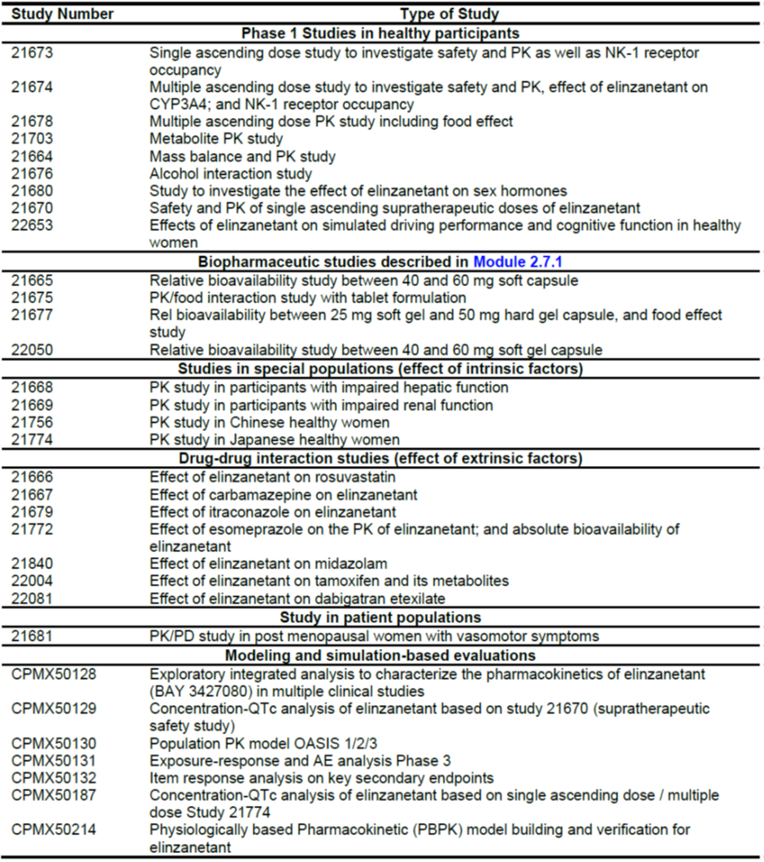
Table 4. Overview of clinical Phase 2 and 3 studies.
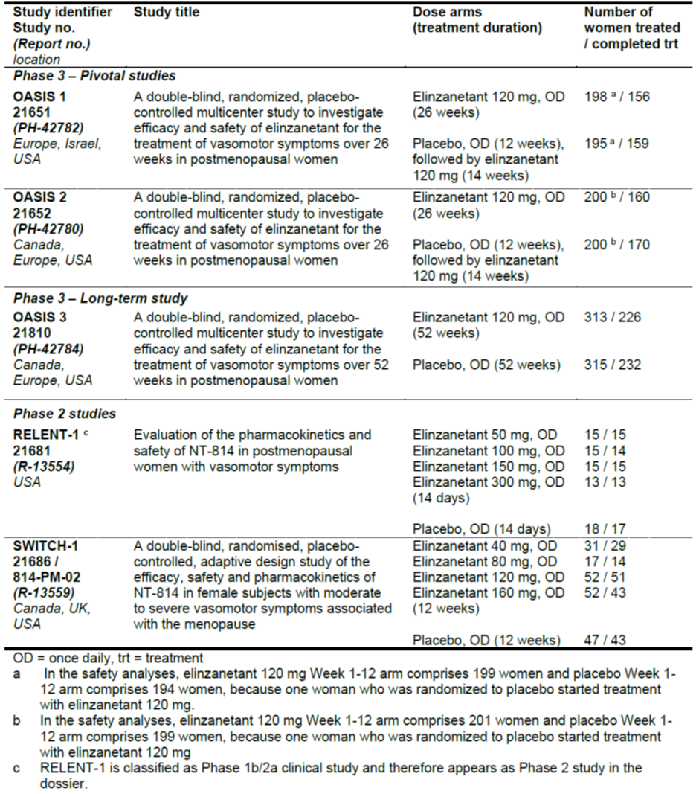

Pharmacology
Various formulations have been tested (suspension, tablets or hard gel capsules), but due to high PK variability issues with the tablet and hard gel capsule, a soft gel capsule will be the final presentation.

Pharmacokinetics (PK)
Absorption
Elinzanetant is rapidly absorbed with C_{max} usually achieved at 1 to 4 hours post-dose. The absolute bioavailability was estimated to be 52% under fasted conditions with the soft gel formulation after a single dose of 120 mg (Study 21772) and appears to be driven by the first pass metabolism, as a complete dissolution can be assumed.
Elinzanetant is practically insoluble in water and slightly soluble under acidic conditions.
Distribution
Elinzanetant and its metabolites demonstrate high plasma protein binding (>99.7%). Within the assessment of the absolute bioavailability, the volume of distribution (V_{ss}) of elinzanetant after IV infusion was 137 L (CV: 29.5%) indicating extensive extravascular distribution. The volume of distribution at the terminal phase V_{z} was calculated to be 241 L (CV: 30.2%) (Study 21772).
Brain penetration of elinzanetant and its metabolites was shown by demonstrating NK-1 receptor target engagement in the prefrontal lobe using positron emission tomography (PET) imaging (Studies 21673 and 21674). A similar EC₅₀ was established after a single dose intake and at steady state, indicating that the distribution equilibrium across the blood-brain barrier is quickly established.
Metabolism
Based on in vitro data, elinzanetant is eliminated primarily by metabolism, with CYP3A being the predominantly responsible enzyme with a minor contribution of UGTs. Three major metabolites M30/34 (stereoisomers), M27 and M18/21 (stereoisomers) were identified and quantified across multiple studies. The metabolites are formed by CYP3A metabolism and show similar activity to NK1 and NK3 compared to the parent. Their exposure was well described in the target patient population using the final PopPK model. At steady state, the geometric mean AUC_{ss} in plasma was corresponding to 53%, 29% and 27% of the AUC_{ss} of the parent drug in patients of the OASIS 1-3 studies for M30/34, M27 and M18/21, respectively.
In a human mass-balance study (Study 21664), elinzanetant covered 39.1% of total radioactivity in human plasma. Metabolites M30/M34, M27 and M18/M21 accounted for 13.7%, 7.6% and 4.9%, respectively. All other identified metabolites covered in sum 14.3% (each less than 3.5%), and approximately 80% of the total plasma radioactivity could be assigned to known structures. The unknown structures are likely attributed to other oxidative metabolites. In earlier clinical studies, M22 was also quantified, although only marginal exposures were found. M22 was no longer quantified after conducting the mass-balance study, where M22 was not identified. Elinzanetant and M30/34 show auto-inhibitive and auto-inductive properties for CYP3A in-vitro.
The postulated metabolic pathway (based on the PBPK model CPMX50214) is shown in Figure 1.
Figure 1. Postulated metabolic pathway of elinzanetant.
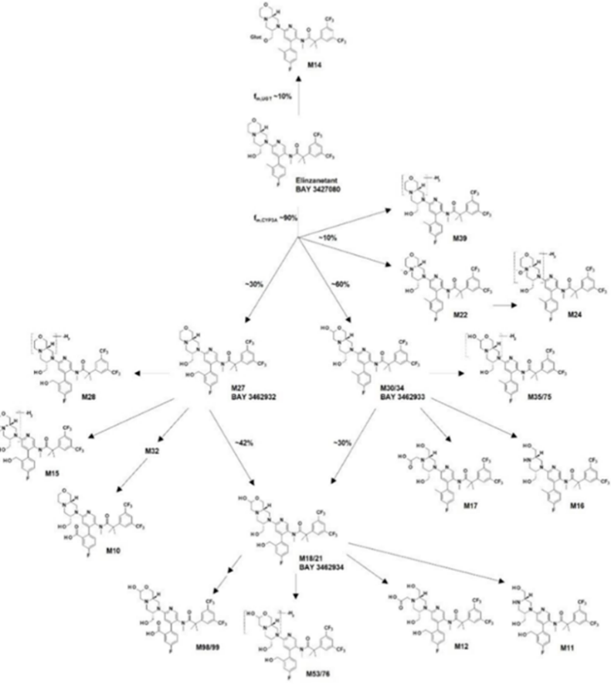
Excretion and elimination
The clearance of elinzanetant after single intravenous dose is 8.77 L/h. Based on the final PopPK model following oral administration (multiple dosing of 120 mg), the estimated effective median terminal elimination half-life was approximately 45 hours. The clearance of elinzanetant from plasma is sensitive to protein binding leading to an increased clearance with higher unbound fraction (f_{u}) based on a circadian fluctuation of f_{u}.
In the pivotal studies, evening dosing was used. Due to the circadian rhythm in clearance, morning dosing appears to lead to higher exposure (Figure 2). The predicted magnitude of the exposure increase is in the range of 1.2 to 1.5-fold. Based on this, no clinically significant differences are expected based on time of dosing.
Figure 2. PopPK Study CPMX50130. Graph of simulated apparent clearance vs. clock time for elinzanetant and M30/34 (RunF005).
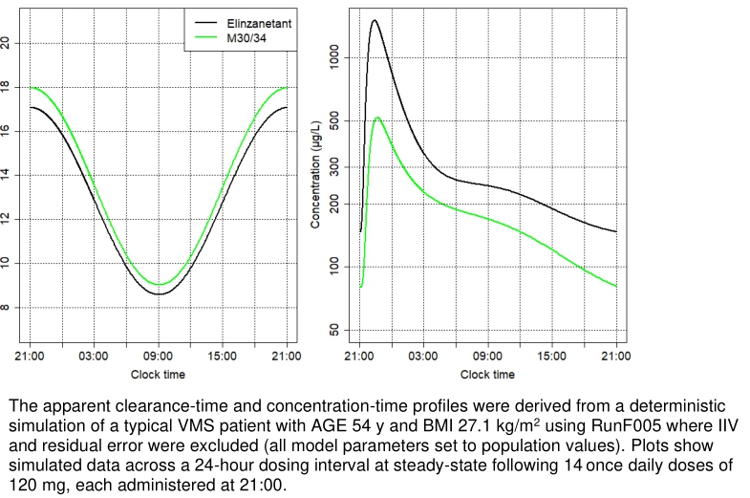
In the human mass-balance study, following oral administration of elinzanetant, 88.0%–91.2% of the dose was excreted with faeces (mainly as metabolites) and less than 1% with urine (Study 21664).
Dose proportionality
A greater than dose-proportional increase in exposure was observed in the dose range studied across different studies. Single doses from 40 mg up to 600 mg were tested with the soft gel formulation, and doses up 160 mg were tested at steady state. The greater than dose-proportional increase in exposure was approximately 20 to 50% and was independent if taken as single dose or at steady state.
Accumulation
At steady state, low accumulation ratios (below 2) for C_{max} and AUC were observed. This could be explained by the effective half-life ranging between 11-19 hours in contrast to the reported terminal half-life of approximately 45 hours.
Food effect
After a high fat/high calorie breakfast intake, a shift in T_{max} to 3-4 h post dose and a C_{max} ratio to the fasted conditions of 31% (90% CI: 0.27 to 0.35) was observed (Study 21678). The AUC was only observed over a period of 24 hours, with a ratio of 0.61 for the AUC_{0-24h}, and with AUC_{inf} unchanged. This is not considered clinically significant.
In study 22050, T_{max} was 1.5 h post dose when taken 3 hours after a standard dinner. In the pivotal studies OASIS 1-3, the drug was administered without restrictions on food, corresponding to the intended posology of elinzanetant.
Special populations
Hepatic impairment: Elinzanetant is primarily eliminated through CYP3A mediated metabolism. In mild hepatic impairment, the total C_{max} and AUC were increased by a factor of 1.16 (90% CI: 0.81 to 1.67) and 1.45 (90% CI: 1.04 to 2.04), respectively. No statistically significant effect on clearance was observed in the final PopPK model in VMS patients with mild hepatic impairment (n=74). In moderate hepatic impairment (Child-Pugh B), C_{max} and AUC were increased by a factor of 2.31 (90% CI: 1.61 to 3.33) and 2.34 (90% CI: 1.67 to 3.28) (Study 21668).
The relative exposures of the metabolites were unchanged. A contraindication for severe hepatic impairment is necessary.
Renal impairment (RI): Only a small fraction of unchanged elinzanetant is renally excreted (below 1%). In participants with renal impairment an increase in the unbound fraction, alongside with higher variability was observed. In moderate renal impairment, AUC_{u} and C_{max,u} in plasma were approximately 2.2-fold to 2.3-fold higher (1.6- and 1.8-fold for total plasma PK). In severe renal impairment, AUC_{u} and C_{max,u} in plasma were approximately 1.9-fold higher (approx. 1.0 for total plasma PK) compared to normal renal function (Study 21669).
In the final PopPK analysis, study 21669 data was excluded and no effect on clearance and secondary PK parameters was observed in patients included in the OASIS 1-3 studies with mild RI (n=526) and moderate RI (n=26).
No dose adaptations are needed for mild and moderate impairment, and patients with severe RI should not be treated with elinzanetant.
Age and body weight: There appear to be no clinically relevant PK effects of age (40 to 65 years), or body weight (based on popPK data).
Pharmacologically induced menopause: No data for use of elinzanetant in patients with pharmacologically induced menopause (e.g. in those treated with GnRH analogues) are available.

Population PK data
Two Population PK (popPK) analyses (Exploratory Study CPMX50128 and Study CPMX50130) investigated PK parameters and the impact of additional covariates.
Population PK Study CPMX50130
Method: A population pharmacokinetic model (RunF005), based on the existing model, was developed which adequately describes the observed pharmacokinetic data of elinzanetant and M30/34 in the OASIS-1, OASIS-2 and OASIS-3 studies and a further 12 clinical studies (21665, 21677, 21678, 21703, 21772, 21679, 21686, 21668, 21669, 21840, 22004, and 22050) used in model development. A justification for excluding the remaining studies of the program was provided.
Model: The final model (FAS data) included 8703 quantified elinzanetant observations valid for analysis from 1318 subjects and 5932 M30/34, 5873 M27 and 5800 M18/21 quantified observations valid for analysis from 1079 subjects. Approximately 5% of the observations were below the LLOQ.
Results:
- Interindividual variability: Healthy volunteers had a typical increase in clearance of 59.6% a compared to patients with vasomotor symptoms. Patients in phase III studies had approximately twice the interindividual variability in absorption compared to subjects in phase I studies. Some of this increased variability is likely related to less controlled compliance.
- Covariate/subgroup results: Increasing age was associated with decreasing clearance of M30/34, increasing BMI was associated with decreasing clearance of elinzanetant, and increasing BMI was associated with decreasing clearance of M30/34.
The identified influences resulted in patients with a BMI of 21.9 kg/m² (10th percentile) having a 9.8% lower, and patients with a BMI of 34.1 kg/m² (90th percentile) having a 14.7% higher steady-state AUC of elinzanetant than patients with a BMI of 27.1 kg/m2 (median). No significant influence of race or measures of hepatic function or renal function was identified.
Patients on chronic concomitant therapy with weak CYP3A4 inhibitors had higher AUC and C_{max} exposures (geometric mean ratio: 1.125 for elinzanetant AUC, 1.092 for elinzanetant C_{max}, 1.130 for M30/34 AUC, 1.064 for M30/34 C_{max})., but the differences were not clinically significant.

Pharmacodynamics (PD)
Mechanism of action
Elinzanetant is a non-hormonal, selective neurokinin 1 (NK1) and 3 (NK3) receptors antagonist that blocks NK1 and NK3 receptor signalling on kisspeptin/neurokinin B/dynorphin (KNDy) neurons to modulate neuronal activity involved in thermo- and sleep regulation. KNDy neurons in the hypothalamus are hyperactivated due to oestrogen decline in menopause.
Elinzanetant has high affinity for human NK1 receptors (pKi values of 8.7 to 10.2) and NK3 receptors (pKi values 8.0 to 8.8), and not for human NK2 receptors (as shown by a low pKi of 6.0). Elinzanetant is more than 100-fold selective for the human NK3 receptor and more than 300-fold for the human NK1 receptor versus multiple other non-NK receptors and off-targets.
Interactions
Based on in vitro data, elinzanetant is predominantly cleared by CYP3A mediated metabolism, (approx. 90%). The main results of the clinical interaction studies are in Table 5 and Table 6.
Weak CYP3A inhibitors: the effect of weak CYP3A inhibitors was assessed using the final PopPK model using the OASIS 1-3 dataset. No clinically significant effect was observed.
Moderate CYP3A4 inhibitors: Physiologically Based Pharmacokinetic (PBPK) modelling predictions after co-administration of 120 mg elinzanetant with the erythromycin showed a 3.0-fold increase of AUC and 2.0-fold increase for C_{max} of elinzanetant. PBPK modelling predictions after co-administration of 60 mg elinzanetant with moderate CYP3A4 inhibitor erythromycin showed a 1.4-fold increase of AUC and no increase for C_{max}. Hence, with co-administration of a moderate CYP3A4 inhibitor (e.g. erythromycin, ciprofloxacin, fluconazole and verapamil), the recommended daily dose is 60 mg.
Strong CYP3A4 inhibitors: Concomitant use with strong CYP3A4 inhibitors is contraindicated.
Moderate to strong CYP3A4 inducers: Co-administration of multiple daily doses of carbamazepine (600 mg), a strong CYP3A4 and P-gp inducer, and elinzanetant 120 mg resulted in a decrease of C_{max} by 44% and AUC by 64% of elinzanetant. Due to the reduction in exposure efficacy may be reduced. The efficacy of elinzanetant when co-administered with (e.g. rifampicin, carbamazepine, phenobarbital, St. John’s Wort) should be monitored.
Table 5. PK interaction studies. Effect of other medicines on elinzanetant.
Study number | Investigated DDI | Observed effect | Conclusions and issues
21667 | Effect of carbamazepine  Strong inducer of CYP2D6 and CYP3A | Elinzanetant  AUC↓ (64%), C_{max}↓(44%)  Similar effects for metabolites  Midazolam  AUC↓ (72%), C_{max}↓(56%) | Only a moderate induction observed during study conduct based on midazolam data (>80% on AUC↓ needed for strong effect).  Due to the reduction in exposure efficacy may be reduced.  The efficacy of elinzanetant should be monitored when co-administered with moderate to strong CYP3A4 inducers.
21679 | Effect of itraconazole Strong CYP3A inhibitor | Elinzanetant  AUC↑ (633%), C_{max}↑(331%) | Strong effect on elinzanetant exposure observed.  A contraindication is warranted for strong CYP3A inhibitors, since exposures above the highest tested would be reached.
21772 | Effect of esomeprazole  Proton pump inhibitor (PPI) | Elinzanetant  AUC↑ (13%), C_{max}↑(1%) | Multiple gastro-intestinal AEs observed in period 1. A sensitivity analysis was provided and indicated no influence of the AEs on the derived PK parameters  DDI not clinically relevant.

Cardiac safety: QT study
A dedicated TQT study (Study 21670) was conducted. It included a positive control (moxifloxacin) and single doses of 240 mg to 600 mg were investigated. The highest exposures were approx. 6-fold above the expected exposures at the therapeutic dose (Geo mean C_{max} = 7390 ng/mL and AUC_{inf =} 64900 at 600 mg, respectively), and no QT-prolongations were observed. The upper 90% CI at the highest elinzanetant plasma concentration was 3.0 ms (Report CPMX50129).

Dose-finding
Results from two Phase 2 studies (RELENT-1 and SWITCH-1), provided evidence for a daily dose of 120 mg used in the Phase 3 program (Table 4).
Table 6. PK interaction studies. Effect of elinzanetant on other medicines.
Study number | Investigated DDI | Observed effect | Conclusions and comments
21666 | Effect on Rosuvastatin  BCRP, OATP1B1/OATP1B3 and OAT3 substrate | Rosuvastatin  AUC↑ (23%), C_{max}↑(28%) with simultaneous dosing AUC↔, C_{max}↔ with delayed dosing (3h) | Increase likely due to gastro- intestinal inhibitions.  Weak inhibition when simultaneously dosed.
21840 | Effect on Midazolam  CYP3A substrate | Midazolam  AUC↑ (50%), C_{max}↑(15%) after elinzanetant single dose  AUC↑ (80%), C_{max}↑(49%) at elinzanetant steady state | Six cases of diarrhoea were reported on Period 1, Day 1. A sensitivity analysis was provided and indicated no influence of the AEs on the derived PK parameters.  Thus, elinzanetant is a weak CYP3A inhibitor.
22004 | Effect on Tamoxifen  CYP3A and CYP2D6 substrate, common adjuvant endocrine therapy | Tamoxifen AUC↑ (52%), C_{max}↑(23%)  4-hydroxytamoxifen AUC↑ (45%), C_{max}↑(8%)  N-desmethyltamoxifen AUC↓ (13%), C_{max}↓(51%)  Endoxifen (Active metabolite) AUC↓ (28%), C_{max}↓(57%) | Large carry-over observed for the active metabolite endoxifen.  Weak inhibition of the transformation of tamoxifen to its active metabolite endoxifen observed after a single dose. At steady state, please see below.  No restriction or dose adaptation requested for concomitant use. Supported by OASIS 4 data.
22081 | Effect on Dabigatran  Intestinal P-gp substrate | Dabigatran  AUC↑ (20%), C_{max}↑(15%) | No clinically relevant inhibition of gastro-intestinal P-gp.

Efficacy
To support the proposed indication, two global, randomised, double-blind, placebo-controlled pivotal Phase 3 studies with a duration of 12 weeks and almost identical design were conducted (OASIS 1 and 2). In OASIS 1, quality of sleep was additionally investigated by actigraphy in a subgroup of patients.

Pivotal phase 3 studies 21651 (OASIS 1) and 21652 (OASIS 2)
Design
Pivotal, 12-week (with a 14 week extension), phase 3, randomised, double-blind (open-label in the extension phase), multi-centre, 2-arm parallel-group (1:1), placebo-controlled studies to assess the efficacy and safety of elinzanetant in adult women aged 40 years and over, and 65 years and older, with moderate to severe VMS associated with menopause (Figure 3).
OASIS 1 was conducted from August 2021 to November 2023 at 89 centres in Europe, Israel and the USA. Approx. 60% of patients were recruited in the USA. 396 women were randomised 1:1 to receive elinzanetant 120 mg (199) or placebo (197).
OASIS 2 was conducted from October 2021 to October 2023 at 95 centres in North America and Europe. In this study, approx. half of the patients were recruited in Europe. 400 women were randomised 1:1 to receive elinzanetant 120 mg (200) or placebo (200).
Primary efficacy objective: to assess the efficacy of elinzanetant for the treatment of VMS associated with menopause.
Figure 3. OASIS 1 and OASIS 2. Study design schema.
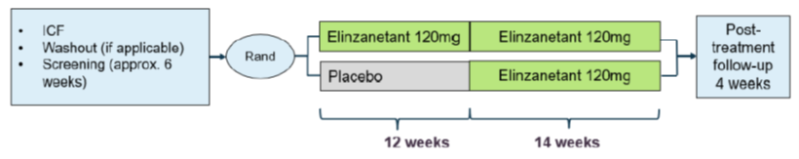
Inclusion criteria:² Women aged 40 to 65 years with confirmed postmenopausal status and a BMI between 18 and 38 kg/m², suffering from moderate or severe VMS.
Exclusion criteria:² Current or history (except complete remission for 5 years or more) of any malignancy (except basal and squamous cell skin tumours); adjuvant endocrine therapy; unexplained postmenopausal uterine bleeding; clinically relevant abnormal findings on mammogram; renal impairment greater than moderate; abnormal liver parameters; disordered proliferative endometrium, endometrial hyperplasia, polyp, or endometrial cancer.
Treatments: Eligible participants were randomised into 2 arms:
- Elinzanetant 120 mg daily for 26 weeks; or
- Placebo daily for 12 weeks, followed by elinzanetant 120 mg daily for 14 weeks.
Follow-Up: The treatment phase will be followed by a 4-week safety follow-up period.
Randomisation: Participants who met eligibility criteria were centrally assigned to randomised study intervention using IxRS.
Endpoints: The endpoints corresponding to the primary and secondary objectives are shown in Table 7.
Table 7. OASIS 1, OASIS 2, and OASIS 3- Endpoints.
Baseline characteristics:
In both studies, demographics and baseline characteristics were reasonably balanced between groups (pooled study data).
- Patient demographics (Table 8): The mean age was approximately 54.5 years (range: 40 to 65y). 80% of patients were White, and 17% Black. The mean BMI was 27.8kg/m².
Table 8. OASIS 1 and 2 (separate and pooled). Patient demographics (FAS).
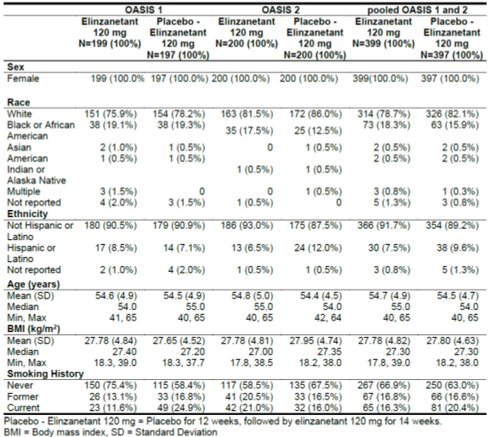
- Disease characteristics (Table 9): 38.8% of women had undergone a hysterectomy and 20.6% an oophorectomy. Prior hormone therapy use was reported for 31.4%. The median duration of amenorrhoea differed between studies and treatment arms. In OASIS 1, it was longer than in OASIS 2, and longer at 7 years in the placebo group as compared to the active group (6 years). In OASIS 2, the median duration was 5.6 years in the active group compared to 4.0 years in the placebo group.
At baseline, participants had a mean number of 14-15 moderate to severe VMS per day with a mean severity score of approx. 2.5 points. The baseline frequency was slightly higher in the placebo group than in the active group in both studies (14.3 vs. 13.4 in OASIS 1, 16.2 vs. 14.7 in OASIS 2). In contrast, the baseline severity was comparable between treatment groups.

Table 9. OASIS 1 and 2 (separate and pooled). Medical and surgical history by PT (SAF).
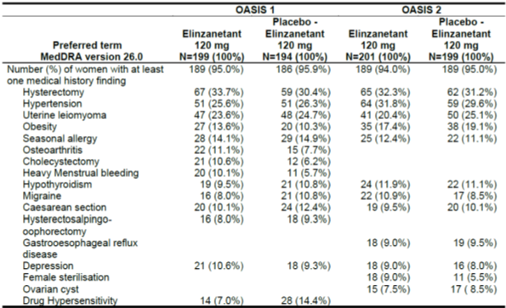
Magnitude of the treatment effect and its clinical significance
Primary and key secondary efficacy endpoints:
The pooled results (Studies OASIS 1 and 2) were:
- For the mean change in the frequency of moderate to severe HFs (Table 10):
  - from baseline to week 4, the LSM difference (95% CI) was: -3.11 (-4.06, -2.16).
  - from baseline to week 12, the LSM difference (95% CI) was: -3.19 (-4.26, -2.13).
- For the mean change in the severity of moderate to severe HFs (Table 9):
  - from baseline to week 4, the LSM difference (95% CI) was: -0.27 (-0.36, -0.19).
  - from baseline to week 12, the LSM difference (95% CI) was: -0.34 (-0.45, -0.24).
Week 1 results (for frequency only as key secondary endpoint) and individual results for OASIS 1 and 2 and are also shown in Table 10 and Table 11.

Table 10. OASIS 1 and OASIS 2 (separate and pooled). Primary endpoint results: Change from baseline in mean frequency of moderate to severe HFs at Week 4 and 12 comparing elinzanetant 120 mg vs. placebo (and Week 1 as key secondary endpoint result) (MMRM analysis) (FAS).
Table 11. OASIS 1 and OASIS 2 (separate and pooled). Key secondary endpoint results: Change from baseline in mean severity of moderate to severe HFs at Week 4 and 12 comparing elinzanetant 120 mg vs. placebo (MMRM analysis) (FAS).
Sensitivity analyses using the Per-Protocol population showed similar results.
The above results are supported by favourable results of the key secondary endpoints of:
- Mean change in PROMIS SD SF 8b total score from baseline to Week 12 (Table 12).
- Mean change in MENQOL total score from baseline to Week 12 (Table 13).
Table 12. OASIS 1 and OASIS 2 (separate and pooled). Key secondary endpoint results: PROMIS SD SF 8b total T-score change from baseline to Week 12 (MMRM analysis) (FAS).
Table 13. OASIS 1 and OASIS 2 (separate and pooled). Key secondary endpoint results: Mean change in MENQOL total score from baseline to Week 12 (MMRM analysis) (FAS).
Subgroup analyses of the primary endpoints
Pre-specified subgroup analyses were conducted for BMI, race, ethnicity, smoking history and geographic region. The results of the pre-specified sensitivity analyses were consistent with those of the primary analyses (including those for the requested post hoc analyses with regard to age, baseline frequency, and baseline severity). Furthermore, the supplementary analyses showed robustness of results from primary analyses with regard to intercurrent events.

Supportive long-term phase 3 Study OASIS 3
Design
Supportive, phase 3, randomised, double-blind, parallel-group (1:1), placebo-controlled, multi-centre 52-week study in 628 postmenopausal women (Figure 4). The study was conducted at 75 centres in North America and Europe from August 2021 to February 2024.
It had a primary efficacy endpoint of mean change in frequency of moderate to severe HFs from baseline to week 12 and a long-term safety evaluation up to 52 weeks. The study did not contain a HF severity endpoint. The inclusion criteria were similar to the OASIS 1/2 studies, but no minimum disease severity was required.
Figure 4. OASIS 3- Study design schema.
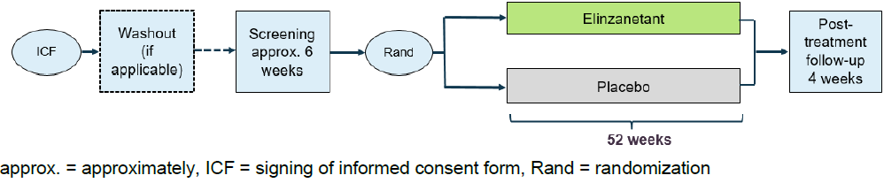
Magnitude of the treatment effect and its clinical significance
For the mean change in the frequency of moderate to severe HFs from baseline to week 12, the LSM difference (95% CI) was: -1.55 (-2.04, -1.05) (Table 14). Elinzanetant showed a statistically significant outcome on the primary HF frequency endpoint with a stable effect as evaluated up to Week 50 based on descriptive statistics.
Table 14. OASIS 3. Primary endpoint: Mean change in frequency of moderate to severe HFs from baseline to Week 12 (FAS).

Safety

Exposure
The main safety database is derived from the pooled safety analysis from the 4 main studies: OASIS 1, 2, and 3, as well as SWITCH-1 (Figure 5).
Pooled safety analysis Weeks 1-12: The safety analysis set comprises 765 women in the EZN 120 mg (Week 1-12) group and 754 women in the placebo (Week 1-12) group.
Pooled safety analysis after Week 12: 348 women in OASIS 1 and 2 switched treatments from placebo to receive elinzanetant 120 mg. 1113 women from SWITCH-1 and OASIS 1, 2 and 3 studies were exposed to at least one dose of elinzanetant 120 mg with varying exposure duration:
- 966 women were treated with elinzanetant 120 mg for at least 12 weeks
- 575 women were treated with elinzanetant 120 mg for at least 23 weeks
- 219 women were treated with elinzanetant 120 mg for at least 50 weeks
Figure 5. Summary of Study Drug Exposure.

Adverse event overview
During the first 12 weeks of treatment, the overall adverse event (AE) incidence was significantly higher in the elinzanetant group (50.8% vs. 43.2%; RR1.17 [95%-CI 1.06-1.31]).
Pooled safety analysis Weeks 1-12: (Table 15) The most common AEs reported during the first 12 weeks of treatment for patients receiving elinzanetant were headache (7.5% vs. 4.2%), fatigue (5.4% vs. 1.3%), somnolence (3.4% vs. 0.5%), dizziness (3.0% vs. 1.1%) and arthralgia (3.0% vs. 2.7%). Somnolence and fatigue were primarily documented during the first two weeks of treatment and resolved with continued treatment.
Pooled safety analysis after Week 12: (Table 16) After week 12, the safety profile remained largely unchanged.
Table 15. TEAEs up to Week 12 by PT > 2% in any group (SAF, pooled safety population).
Table 16. TEAEs up to Weeks 26 and 52 by PT >2% in any group (SAF, pooled safety population).

Treatment related adverse event (adverse drug reaction) overview
Treatment-related AEs were twice as common with active treatment than with placebo (22.6% vs. 10.7%; RR 2.10 [95% CI 1.65-2.69]). The most common AEs classified as treatment-related were fatigue, headache, somnolence, dizziness and nausea. With the exception of nausea, these AEs were more frequent with active treatment than with placebo.

Deaths
No deaths were reported in any of the clinical studies.

Serious adverse events
31 of 1113 women (2.8%) who received elinzanetant 120 mg had at least one serious TEAE (incidence rate: 5.46 per 100 person-years – Table 17). One serious TEAE in OASIS 2 (generalised tonic-clonic seizure) was considered related to the study drug by the investigator. In 7 of the 31 women with serious TEAEs, the study drug was discontinued due to the event.
Table 17. Study drug-related TEAEs up to Week 12 with a relative frequency of > 1 woman in any group (SAF, pooled safety population).
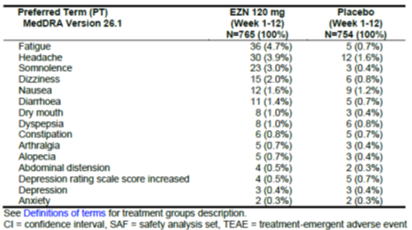

Discontinuations
TEAEs leading to discontinuation are shown in Table 18 (up to Week 12) and Table 19 (after Week 12). The study drug was discontinued permanently due to AEs in 7.8% of patients receiving active treatment compared to 3.6% of those being treated with placebo (RR 2.17 [1.40-3.37]) (driven by: fatigue 1.7% vs. 0; headache 1.4% vs. 0.7%). The study drug was interrupted due to AEs in 3.5% vs. 2.5%.
Table 18. TEAEs up to Week 12 resulting in discontinuation of the study drug reported in > 2 women in any group (SAF, pooled safety population).
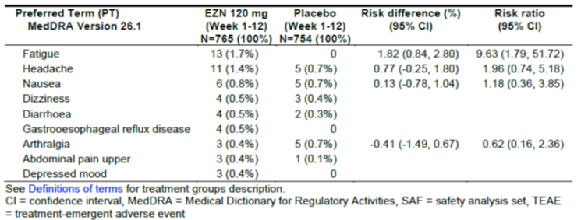
Table 19. TEAEs up to Weeks 26 and 52 resulting in study drug discontinuation reported in > 2 women in any group (SAF, pooled safety population).
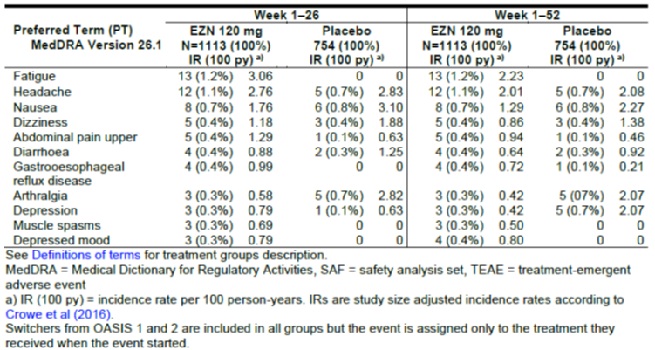

Adverse events of special interest
Adverse events of special interest (AESIs) were more common with elinzanetant than with placebo (11.0% vs. 4.5%; RR 2.44 [95%-CI 1.66-3.59]), largely driven by the AESI ‘somnolence or fatigue’ in this time period.
Somnolence or fatigue: This was more common with active treatment than with placebo in all studies included in the data pool and primarily reported during the first two weeks of treatment. No difference in the incidence of accidents or injuries between treatment groups was evident.
Liver toxicity: No imbalances between treatment groups or relevant changes from baseline in any of the four studies included in the data pool were identified. None of the cases fulfilled Hy’s Law criteria. No cases of cholestatic DILI were identified. However, patients with abnormal liver function or a BMI > 38 kg/m² were excluded from the trials.
Up to week 12, no cases were identified that fulfilled the criteria for ‘Close Liver Observation’ (CLO). By week 52, 12 such cases were identified (8 on elinzanetant vs. 2 on placebo). 3 of these 12 cases fulfilled the criteria of liver injury: 1 patient in the active group (after week 26) and 2 cases in the placebo group (1 after week 26, one in the time interval between week 12 and week 26). Of the 12 cases, 2 in OASIS 3 were considered as treatment related (one patient each with active treatment and with placebo.
Postmenopausal bleeding: There were no relevant differences between treatment groups. In none of the cases endometrial hyperplasia or carcinoma were identified. A causal relationship between the observed cases of postmenopausal bleeding and elinzanetant seems rather unlikely.
Phototoxicity: 10 cases were reported with 6 of these in the long-term study OASIS 3. 9 of the 10 events were reported with active treatment. The incidence appeared to increase with longer duration of exposure.
Bone safety (not a designated AESI): BMD was investigated by DEXA scans (baseline and at week 52) as a safety parameter in the long-term study OASIS 3 only. In both treatment groups, there were no meaningful changes, but BMD should be monitored during long-term treatment.
Endometrial safety (not a designated AESI): No clinically relevant changes to endometrial thickness were identified. Overall, from all three OASIS studies, EOT biopsies from 609 patients were available (302 from patients in the elinzanetant groups). No cases of endometrial hyperplasia or malignant changes were identified. However, of the 302 patients, only approximately half had been exposed for 12 months, and even though rather unlikely, an unfavourable effect cannot be definitely excluded.
CNS effects and suicidality (not a designated AESI): elinzanetant crosses the blood brain barrier, but no clinically relevant findings were identified (including withdrawal or rebound effects, or suicidal ideation). One case of seizures (generalised tonic-clonic seizures after switch from placebo to active treatment) was reported in the Phase II/III studies. The patient had a history of such seizures for more than 30 years, and a causal relationship was considered unlikely. The data available do not suggest that may increase the risk of seizures.

Post-market experience
No data available.

Risk management plan
Bayer Australia Ltd submitted Core-RMP version 1.0 (dated 27 June 2024; DLP 9 April 2024) and ASA version 1.0 (dated 21 August 2024) in support of this application. At round 2 the sponsor submitted EU-RMP version 1.1 (dated 27 September 2024; DLP 18 June 2024) and ASA version 2.0 (dated 25 April 2025). At round 3 the sponsor submitted EU-RMP version 1.2 (date 21 May 2025; DLP 18 June 2024) and ASA version 3.0 (date 10 June 2025).
The summary of safety concerns and their associated risk monitoring and mitigation strategies are summarised in Table 20. The TGA may request an updated RMP at any stage of a product's life cycle, during both the pre-approval and post-approval phases.
Table 20. Summary of safety concerns.
Summary of safety concerns |  | Pharmacovigilance |  | Risk Minimisation
 |  | Routine | Additional | Routine | Additional
Important identified risks | None | – | – | – | –
Important potential risks | None | – | – | – | –
Missing information | Long term use in the population of women using adjuvant endocrine therapy (AET) |  | * | – | –
* OASIS 4 (Part C)
No safety concerns are proposed. At round 2, the sponsor provided rationale for not including issues identified in the Swissmedic clinical evaluation report as safety concerns. At round 3, the sponsor has added missing information relating to use in women treated with AET. The summary of safety concerns is acceptable.
Pharmacovigilance plan
Routine pharmacovigilance activities only are proposed. At round 3 the sponsor included OASIS 4 (Part C) as additional pharmacovigilance relating to the missing information. The pharmacovigilance plan is acceptable.
Risk minimisation plan
Routine risk minimisation activities only are proposed (PI and CMI) which aligns with the EU-RMP and other similar products. At round 3 routine risk minimisation has been revised as requested and the risk minimisation plan is acceptable.
Outstanding issues
The following advice is for the sponsor and should not impede registration:
The sponsor is advised that submission of the final report of OASIS 4 (Part C) to the TGA is not required. However, safety outcomes should be considered in an updated RMP. Revision of Table 2 of the ASA to remove the submission requirement for Part C of OASIS 4 can be bundled with significant changes when they arise and provided as a post-market RMP update.
It is noted that the EU-RMP version date in the ASA (19 May 2025) does not correspond to the version date on the EU-RMP (21 May 2025). The sponsor should ensure that the EU-RMP details in the ASA and the date on the EU-RMP align in future ASAs.
Further information regarding the TGA’s risk management approach can be found in risk management plans for medicines and biologicals and the TGA's risk management approach. Information on the Australia-specific annex (ASA) can be found on the TGA website.

Risk-benefit analysis

Delegate’s considerations

Regulatory guidance
Elinzanetant is a non-hormonal selective antagonist of the NK3 receptor. There is no specific guidance available for NK3 receptor antagonists. In the absence of such guidance, EMEA/CHMP/021/97 Rev. 1 provides useful guidance whilst noting that many aspects do not necessarily apply to a non-hormonal treatment.

Clinical pharmacology
The pharmacokinetic properties of elinzanetant and the metabolic pathway (including its major metabolites) are well understood in the target patient population. Elinzanetant is eliminated primarily by metabolism, with CYP3A being the predominantly responsible enzyme. It could be classified as a weak CYP3A inhibitor.

Clinically relevant interactions
Clinically relevant interactions have been identified and are addressed in the product information document. The efficacy of elinzanetant should be monitored when co-administered with moderate to strong CYP3A4 inducers, as the reduction in elinzanetant exposure was associated with reduced efficacy in the clinical studies. PBPK modelling predictions suggest a daily dose of elinzanetant 60 mg when co-administered with moderate CYP3A4 inhibitors. A contraindication for strong CYP3A inhibitors is needed due to the resultant high elinzanetant exposures.
Tamoxifen could be expected to be co-administered with elinzanetant and this was specifically studied. There appears to be no clinically relevant effect on exposure of tamoxifen and its active metabolite endoxifen.

Hepatic or renal impairment
Based on available data, a contraindication for severe hepatic impairment is necessary. No dose adaptations are needed for mild and moderate impairment, and patients with severe RI should not be treated with elinzanetant.

Efficacy

Pooled phase 3 pivotal study results
The pooled results of the pivotal clinical trials OASIS 1 and 2 show a statistically significant treatment effect of elinzanetant 120 mg once daily when compared to placebo for treatment of moderate to severe VMS in postmenopausal women (Table 21). This applied to both significant reductions in both frequency and severity of VMS that were clinically meaningful, in particular for frequency.
The results were consistent in both studies: superiority over placebo was shown for elinzanetant in all 4 primary endpoints after 4 weeks as well as after 12 weeks.
A rather extensive treatment effect was observed in the placebo group. A relevant reduction in frequency was observed during the first week of treatment indicating a rather rapid onset of the therapeutic effect, in particular with regard to frequency (Figure 6).
The primary endpoint results were supported by clinically meaningful changes in the PROMIS SD SF 8b total score (sleep quality) and the MENQOL total score (quality of life) from baseline to Week 12.
Table 21. OASIS 1 and OASIS 2 (separate and pooled). Primary and key secondary endpoint result summary.

Figure 6. OASIS 1 and OASIS 2 (pooled). Change from baseline in mean daily frequency of moderate to severe HFs by treatment arm (FAS).

Phase 3 study population and generalisability
VMS are associated with a large variability in individual perception, with a cultural component.
The Phase 3 studies were conducted in Europe, Israel and North America. The population is largely generalisable to the Australian population (except for the large African American populations represented in the clinical trials, and the absent Australian Indigenous and largely absent Asian populations). Very few Asian patients were included in the pivotal clinical studies (approximately 0.5% only), and the number was not sufficient for Asian ethnicity to be included as a category in the pre-specified subgroup analysis. However, two pharmacology studies were conducted in healthy Asian participants. Population PK data did not indicate a significant influence of race on elinzanetant exposure.
In the phase 3 clinical trial program, the mean age was 54 to 55 years (range: 40-65 years). A larger proportion of younger women would have been beneficial. However, relevant subgroup analyses did not provide evidence for a difference in clinical treatment effect based on age. It is noted that patient with a similar age range have been included in many studies investigating treatment for postmenopausal VMS.
The median duration of amenorrhoea differed between studies and treatment arms. In OASIS 1, it was longer than in OASIS 2, and longer at 7 years in the placebo group as compared to the active group (6 years). In OASIS 2, the median duration was 5.6 years in the active group compared to 4.0 years in the placebo group. Pooling of the results could have mitigated some of those imbalances.
Regarding the rather large median duration of amenorrhoea: A reduction of symptoms could have been due to the natural progression of menopause rather than a definite treatment effect, but this would have also affected the placebo group.

Supportive OASIS 3 study
The results of the pivotal studies OASIS 1 and 2 are further supported by the long-term 52-week OASIS 3 study in which elinzanetant showed a statistically significant outcome on the primary HF frequency endpoint with a stable effect as evaluated up to Week 50 based on descriptive statistics.

Populations not specifically studied
Breast cancer patients: Elinzanetant has not been studied in in breast cancer patients, but a Phase III study in breast cancer patients (and patients at high risk for breast cancer) is currently ongoing (Study 21656).
Patients with breast cancer may receive anti-oestrogen treatment which is associated with severe VMS and/or other symptoms of oestrogen deficiency. No data are currently available, even though elinzanetant will likely be efficacious in this population as well. The potential influence of elinzanetant on the course of the malignant disease or the treatment success of the antitumour therapy is unknown. The decision to use elinzanetant in such patients should be based on individual benefit-risk considerations.
Women undergoing oncologic treatment (e.g. chemotherapy, radiation therapy) for breast cancer or other oestrogen-dependent malignancies have not been included in the clinical studies. Until sufficient data are available, elinzanetant is not recommended for use in this population at this stage.
Pharmacologically induced menopause: In the studies presented, elinzanetant was only studied in patients after physiological or surgical menopause with no data available on patients after pharmacologically induced menopause. This applies to breast cancer patients receiving oestrogen-lowering treatment as well as patients treated with GnRH agonists for conditions such as endometriosis or uterine fibroma. It is noted that the mechanism of action of elinzanetant is independent from the cause of menopause.
Perimenopausal women: Elinzanetant has been only studied in women with confirmed postmenopausal status. There are challenges determining the start of menopause, and it may be difficult to definitely distinguish between perimenopause and menopause. No effects of elinzanetant on the endometrium were observed in the clinical studies. Overall, there is no definite reason to assume that the efficacy would significantly differ compared to the studied population, and a therapeutic need can be assumed in this population.
Thus, in the indication, reference to section 5.1 points should be made to point prescribers to the clinical trial section of the PI in which the study population is described. This aligns with the approved Australian indication for fezolinetant, for which similar considerations had been made by the advisory committee (ACM).

Safety
Elinzanetant is a new chemical entity. Fezolinetant is the only other NK3 antagonist currently registered on the ARTG for the VMS indication, and may inform class effect safety data, most notably regarding hepatotoxicity.
The safety data for elinzanetant were generated from clinical trials with no post-market data available. The safety data consist mainly of short-term data from the clinical trial program, and appears to be satisfactory. For most AEs, there were no significant differences in incidence between active treatment and placebo. Only a small proportion of patients discontinued the study drug prematurely. Long-term data are only available up to a treatment duration of 12 months with no significant additional safety signals identified. However, rare events may not have been detected.
1113 women from SWITCH-1 and OASIS 1, 2 and 3 studies were exposed to at least one dose of elinzanetant 120 mg with varying exposure duration: 966 women were treated with elinzanetant 120 mg for at least 12 weeks; 575 women were treated with elinzanetant 120 mg for at least 23 weeks; and 219 women were treated with elinzanetant 120 mg for at least 50 weeks.
Overall, the incidence of AEs or SAEs with a possible causal relationship to elinzanetant, was relatively low. Subjective tolerability appeared to be satisfactory, with a low rate of discontinuations due to AEs.
There appeared to be no specific safety signals with regard to somnolence or fatigue, postmenopausal bleeding, phototoxicity, bone safety, endometrial safety, CNS effects and suicidality. In the clinical trials, there was no evidence for rebound or withdrawal effects.
However, as stated above unfavourable effects cannot be definitely excluded, and may only emerge with exposures in larger populations in a post-market setting. Inclusion in the black triangle scheme and PSUR requirements are in place.

Hepatic safety
In the clinical studies with elinzanetant, there have been no indications of hepatotoxicity so far. No imbalances between treatment groups or relevant changes from baseline in any of the four studies included in the data pool were identified. None of the cases fulfilled Hy’s Law criteria. No cases of cholestatic DILI were identified. However, patients with abnormal liver function or a BMI > 38 kg/m² were excluded from the trials.
Due to the limited number of patients who have been treated with elinzanetant in clinical studies, any rare hepatic adverse effects cannot be excluded and may only emerge in a post-market setting.
Hepatotoxicity has been reported with the use of a different NK-3 receptor antagonist, and due to this potential class effect, liver function testing is recommended before starting treatment and during treatment with elinzanetant. Relevant PI changes were requested to communicate this to prescribers.

Long-term use and periodic re-evaluation
In many instances, treatment for VMS will be required for several years. At this stage, the currently available safety data cannot exclude the risk of rare (and potentially severe) side effects. If treatment is intended to be continued after the first year, a thorough re-evaluation is recommended, in order to confirm the further need for therapy und to exclude relevant adverse reactions. In particular, liver function should be monitored based on the NK3 antagonist class effect rather than definite evidence for elinzanetant itself.
A statement that the benefit and duration of treatment should be periodically assessed based on the natural history and course of the vasomotor symptoms has been requested from the applicant.

Regulatory considerations and translation to clinical practice

Clinical practice
Hormone replacement therapy (HRT) has been used as first-line therapy in women with moderate to severe VMS. However, despite some additional beneficial effects on BMD, HRT is associated with certain safety issues (including some contraindications). An additional, non-hormonal treatment option for VMS is considered useful, in particular for those patients for whom HRT is contraindicated.
Elinzanetant is the second NK3 receptor antagonist for which registration is sought for a VMS indication. Fezolinetant has been registered on the ARTG on 26 February 2024.

Benefit-risk balance
Based on the clinical data presented, there appears to be a positive benefit-risk balance of elinzanetant for the treatment of moderate to severe VMS in post-menopausal women.
In agreement with the applicant, the final indication for this application is as follows:
LYNKUET is indicated for the treatment of moderate to severe vasomotor symptoms (VMS) associated with menopause (see Section 5.1 Pharmacodynamic properties – Clinical Trials).

Proposed action
Elinzanetant is not a first-in-class NCE. There were no outstanding issues, and as the applicant had agreed to the TGA-requested changes, the application was not referred to the ACM. The application was approved on 5 September 2025

Assessment outcome
Based on a review of quality, safety, and efficacy, the TGA decided to register Lynkuet (Elinzanetant) 60 mg soft capsule blister pack, indicated for:
Lynkuet is indicated for the treatment of moderate to severe vasomotor symptoms
(VMS) associated with menopause (see Section 5.1 Pharmacodynamic properties –
Clinical Trials).

Specific conditions of registration
- Lynkuet (elinzanetant) is to be included in the Black Triangle Scheme. The PI and CMI for Lynkuet must include the black triangle symbol and mandatory accompanying text for five years, which starts from the date of first supply of the product.
- The Lynkuet EU-Risk Management Plan (RMP) version 1.2, (dated 21 May 2025, data lock point 18 June 2024), with Australia-Specific Annex (ASA) version 3.0 (dated 10 June 2025), included with submission PM-2024-03648-1-5, to be revised to the satisfaction of the TGA, and any subsequent revisions, as agreed with the TGA will be implemented in Australia.
- An obligatory component of risk management plans is routine pharmacovigilance. Routine pharmacovigilance includes the submission of periodic safety update reports (PSURs).
Unless agreed separately between the supplier who is the recipient of the approval and the TGA, the first report must be submitted to TGA no later than 15 calendar months after the date of this approval letter. The subsequent reports must be submitted no less frequently than annually from the date of the first submitted report until the period covered by such reports is not less than three years from the date of this approval letter. The annual submission may be made up of two PSURs each covering six months. If the sponsor wishes, the six-monthly reports may be submitted separately as they become available.
If the product is approved in the EU during the three years period, reports can be provided in line with the published list of EU reference dates no less frequently than annually from the date of the first submitted report until the period covered by such reports is not less than three years from the date of this approval letter.
The reports are to at least meet the requirements for PSURs as described in the European Medicines Agency’s Guideline on good pharmacovigilance practices (GVP) Module VII-periodic safety update report (Rev 1), Part VII.B Structures and processes. Note that submission of a PSUR does not constitute an application to vary the registration. Each report must be submitted within ninety calendar days of the data lock point for that report.

Product Information and Consumer Medicine Information
For the most recent Product Information (PI) and Consumer Medicine Information (CMI), please refer to the TGA PI/CMI search facility.

Therapeutic Goods Administration
PO Box 100 Woden ACT 2606 Australia
Email: info@tga.gov.au Phone: 1800 020 653 Fax: 02 6203 1605
https://www.tga.gov.au
Reference/Publication #

This is the original indication proposed by the sponsor when the TGA commenced the evaluation of this submission. It may differ to the final indication approved by the TGA and registered in the Australian Register of Therapeutic Goods.
Pinkerton, J. V , Simon, J., Panay, N., Seitz, C., Parke, S., Caetano, C., Mellinger, U., Haseli M., Nazanin7; Haberland, C., Atanackovic, G., Holz, C., Mao, G., Morrison, M., Nisius, S., Schaefers, M. and Zuurman, L. (2024) Design of OASIS 1 and 2: phase 3 clinical trials assessing the efficacy and safety of elinzanetant for the treatment of vasomotor symptoms associated with menopause. Menopause 31(6):p 522-529. DOI: 10.1097/GME.0000000000002350

