Australian Public Assessment Report for Lutathera
  - Active ingredient: Lutetium (¹⁷⁷Lu) oxodotreotide
  - Sponsor: Novartis Pharmaceuticals Australia Pty Ltd
March 2026

About the Therapeutic Goods Administration (TGA)
- The Therapeutic Goods Administration (TGA) is part of the Australian Government Department of Health, Disability and Ageing and is responsible for regulating therapeutic goods, including medicines, medical devices, and biologicals.
- The TGA administers the Therapeutic Goods Act 1989 (the Act), applying a risk management approach designed to ensure therapeutic goods supplied in Australia meet acceptable standards of quality, safety, and efficacy.
- The work of the TGA is based on applying scientific and clinical expertise to decision-making, to ensure that the benefits to the Australian public outweigh any risks associated with the use of therapeutic goods.
- The TGA relies on the public, healthcare professionals and industry to report problems with therapeutic goods. The TGA investigates reports received to determine any necessary regulatory action.
- To report a problem with a therapeutic good, please see the information on the TGA website.

About AusPARs
- The Australian Public Assessment Report (AusPAR) provides information about the evaluation of a prescription medicine and the considerations that led the TGA to approve or not approve a prescription medicine submission. Further information can be found in Australian Public Assessment Report (AusPAR) guidance.
- AusPARs are prepared and published by the TGA.
- AusPARs are static documents that provide information that relates to a submission at a particular point in time. The publication of an AusPAR is an important part of the transparency of the TGA’s decision-making process.
- A new AusPAR may be provided to reflect changes to indications or major variations to a prescription medicine subject to evaluation by the TGA.

Copyright
© Commonwealth of Australia 2026
This work is copyright. You may reproduce the whole or part of this work in unaltered form for your own personal use or, if you are part of an organisation, for internal use within your organisation, but only if you or your organisation do not use the reproduction for any commercial purpose and retain this copyright notice and all disclaimer notices as part of that reproduction. Apart from rights to use as permitted by the Copyright Act 1968 or allowed by this copyright notice, all other rights are reserved and you are not allowed to reproduce the whole or any part of this work in any way (electronic or otherwise) without first being given specific written permission from the Commonwealth to do so. Requests and inquiries concerning reproduction and rights are to be sent to the TGA Copyright Officer, Therapeutic Goods Administration, PO Box 100, Woden ACT 2606 or emailed to <tga.copyright@tga.gov.au>.

Contents
List of abbreviations 4
Product submission 5
Submission details 5
Product background 6
Disease or condition 6
Current treatment options 7
Clinical rationale 7
Regulatory status 7
Australian regulatory status 7
International regulatory status 7
Registration timeline 9
Assessment overview 9
Quality evaluation summary 9
Nonclinical evaluation summary 11
Clinical evaluation summary 12
Pharmacology 12
Efficacy 14
Safety 21
Risk management plan 27
Risk-benefit analysis 28
Assessment outcome 29
Specific conditions of registration 29
Product Information and Consumer Medicine Information 30

List of abbreviations
Abbreviation | Meaning
AE | Adverse events
ARTG | Australian Register of Therapeutic Goods
AUC_{0-last} | Area Under the concentration-time Curve from time zero to the time of the last quantifiable concentration
CMI | Consumer Medicines Information
CV | Co-efficient of variation
Delegate | The Delegate of the Secretary of the Department of Health, Disability and Ageing who decided the submission under section 25 of the Act.
GEP-NETs | Gastro-entero-pancreatic neuroendocrine tumours
Gy | Gray, the International System of Units (SI) unit for absorbed radiation dose
MDS | Myelodysplastic syndrome
NETs | Neuroendocrine tumours
ORR | Overall response rate
OS | Overall survival
PI | Product Information
PSUR | Periodic safety update report
RMP | Risk management plan
SAE | Serious adverse events
SAF | Safety analysis population
SD | Standard deviation
SSTR2 | Somatostatin receptor subtype 2
TEAE | Treatment emergent adverse event
TGA | Therapeutic Goods Administration
ULN | Upper limit of normal

Product submission

Submission details
Type of submission: | New chemical entity
Product name: | Lutathera
Active ingredient: | lutetium (¹⁷⁷Lu) oxodotreotide
Decision: | Approved
Date of decision: | 14 November 2025
Date of entry onto ARTG: | 17 November 2025
ARTG number: | 455452
Black Triangle Scheme: | Yes
Sponsor’s name and address: | Novartis Pharmaceuticals Australia Pty Ltd, 54 Waterloo Road Macquarie Park. NSW, 2113
Dose form: | Lutathera is a clear, colourless to slightly yellow solution with a pH range of 4.5 to 6.0
Strength: | One mL of solution contains 370 MBq of lutetium (¹⁷⁷Lu) oxodotreotide at the date and time of calibration.
Container: | Clear, colourless type I glass vial, closed with a bromobutyl rubber stopper and aluminium cap.  Each vial contains a volume that ranges from 20.5 to 25.0 mL of solution, corresponding to a radioactivity of 7400 MBq ± 10% at the date and time of infusion.  The vial is enclosed within a lead shielded container and placed in a Type A cardboard shipping box.
Approved therapeutic use for the current submission: | Lutathera is indicated for the treatment of somatostatin receptor-positive gastroenteropancreatic neuroendocrine tumours (GEP-NETs), including foregut, midgut, and hindgut neuroendocrine tumours in adults.
Route of administration: | Intravenous infusion
Dosage: | The recommended treatment regimen of Lutathera in adults consists of 4 infusions of 7400 MBq each. The recommended interval between each infusion is 8 weeks (±1 week).  For further information regarding dosage, refer to the Product Information.
Pregnancy category: | Category X  Drugs which have such a high risk of causing permanent damage to the fetus that they should not be used in pregnancy or when there is a possibility of pregnancy.  The use of any medicine during pregnancy requires careful consideration of both risks and benefits by the treating health professional. The pregnancy database must not be used as the sole basis of decision making in the use of medicines during pregnancy. The TGA does not provide advice on the use of medicines in pregnancy for specific cases. More information is available from obstetric drug information services in your state or territory.

Product background
This AusPAR describes the submission by Novartis Pharmaceuticals Australia Pty Ltd (the sponsor) to register Lutathera (lutetium (¹⁷⁷Lu) oxodotreotide) for the following proposed indication:
Lutathera is indicated for the treatment of somatostatin receptor-positive gastroenteropancreatic neuroendocrine tumours (GEP-NETs), including foregut, midgut, and hindgut neuroendocrine tumours in adults.

Disease or condition
Gastro-entero-pancreatic neuroendocrine tumours (GEP-NETs) are a heterogeneous group of tumours that arise from neuroendocrine cells in the gastrointestinal tract.
They are characterised by the capacity for peptide hormone and biogenic amine production, that can lead to a range of clinical syndromes. A subset of tumours do not produce functional hormones, and present late with symptoms from a mass effect or distant metastases.
Most neuroendocrine tumours (NETs) are sporadic. Sporadic cases of pancreatic NETs can arise from germline mutations including in the DNA repair genes MUYTH, CHEK2 and BRCA2. GEP-NETs can arise in the setting of multiple endocrine neoplasia 1 syndrome. Pancreatic NETs are also associated with von Hippel-Lindau, tuberous sclerosis and neurofibromatosis.
Diagnostic work-up includes imaging comprising CT scan, MRI scan, ¹⁸F⁻fluorodeoxyglucose PET/CT (FDG-PET/CT), somatostatin receptor (SSTR)-PET/CT and/or SSTR PET/MRI and in certain circumstances endorectal ultrasound. In addition, haematological, biochemistry, (including tumour markers such as chromogranin A and 5-hydroxyindolacetic acid) and genetic testing.
The tumour-node-metastasis (TNM) classification can be used to stage GEP-NETs although the most recent American Joint Committee on Cancer classification has different criteria for stages 1-3 depending on the location of the tumour (stomach, small intestine, appendix, colon and rectum or pancreas). Tumours are classified by mitotic count and Ki-67 index (%) into Grade 1 through 3. Grade 3 is further subdivided into well differentiated and poorly differentiated.
Grade 1 tumours are typically indolent, particularly if localised or with limited metastases. Grade 2 is more variable, and Grade 3, particularly poorly differentiated Grade 3 tumours, tend to behave more aggressively.

Current treatment options
Surgical treatment may be with curative intent for small local disease, or to de-bulk more extensive disease. Ablation to target liver metastases may be considered in limited specific circumstances – either by transarterial embolisation or transarterial chemoembolization.
Somatostatin analogues reduce the release of hormones from NETs and slow tumour growth. They are recommended first line systemic therapy for lower grade metastatic well differentiated tumours. They have application in tumours with carcinoid syndromes (flushing and diarrhoea). Octreotide LAR (long-acting release) and lanreotide are the somatostatin analogues typically used in Australia.
After progression on Peptide Receptor Radionuclide Therapy such as Lutathera is a recognised therapy in international guidelines for patient with inoperable or metastatic tumours that express somatostatin receptors.
Other second-line options include combination of cytotoxic chemotherapy regimens such as carboplatin and etoposide, FOLFOX regimens (fluorouracil, oxaliplatin and folinic acid) and CAPTEM (capecitabine and temozolomide). Among other second-line options are everolimus, sunitinib, and cabozantinib. Belzutifan may be useful for patients with von-Hippel Lindau disease with pancreatic neuroendocrine tumours.

Clinical rationale
GEP-NETs usually have high levels of somatostatin receptor subtype 2 (SSTR2) expression. Lutetium (¹⁷⁷Lu) oxodotreotide is a somatostatin receptor agonist with high affinity for SSTR2. The compound binds to malignant cells that overexpress SSTR2. ¹⁷⁷Lu is a β-emitting radionuclide. The maximum path length of the β negative emission is about 2 mm, the mean is 0.27 mm, which is sufficient to effectively kill targeted tumour cells, and with only limited effect on neighbouring non-target cells.

Regulatory status

Australian regulatory status
This product is considered a new chemical entity for Australian regulatory purposes.

International regulatory status
At the time the TGA considered this submission, a similar submission had been considered by other regulatory agencies. Table 1 summarises these submissions and provides the indications where approved.
Table 1: International regulatory status at the time the TGA considered this submission
Region | Submission date | Status | Approved indications
United States of America | 26 July 2017 | Approved (26 January 2018) | Treatment of somatostatin receptor-positive gastroenteropancreatic neuroendocrine tumors (GEPNETs), including foregut, midgut, and hindgut neuroendocrine tumors in adults.
European Union | 26 April 2016 (centralised procedure) | Approved (26 September 2017) | Treatment of unresectable or metastatic, progressive, well differentiated (G1 and G2), somatostatin receptor positive gastroenteropancreatic neuroendocrine tumours (GEP NETs) in adults
Switzerland | 16 November 2017 | Approved (25 June 2019) | Indicated for the treatment of unresectable or metastatic, progressive, well differentiated (G1 and G2), somatostatin receptor positive gastroenteropancreatic neuroendocrine tumours (GEP NETs) in adults.
Canada | 11 June 2018 | Approved (9 January 2019) | Indicated for the treatment of unresectable or metastatic, well-differentiated, somatostatin receptor-positive gastroenteropancreatic neuroendocrine tumors (GEPNETs) in adults with progressive disease.
United Kingdom | 26 April 2016 | Approved (26 September 2017) | Indicated for the treatment of unresectable or metastatic, progressive, well differentiated (G1 and G2), somatostatin receptor positive gastroenteropancreatic neuroendocrine tumours (GEP NETs) in adults
Singapore | 27 August 2019 | Approved (1 June 2020) | Indicated for the treatment of unresectable or metastatic, progressive, well differentiated (G1 and G2), somatostatin receptor-positive gastroenteropancreatic neuroendocrine tumors (GEPNETs), including foregut, midgut, and hindgut neuroendocrine tumors in adults.

Registration timeline
Table 2 captures the key steps and dates for this submission.
This submission was evaluated under the standard prescription medicines registration process.
Table 2: Lutathera - lutetium (¹⁷⁷Lu) oxodotreotide - Novartis Pharmaceuticals Australia Pty Ltd - PM-2024-02583-1-6
Description | Date
Submission dossier accepted and evaluation commenced | 2 September 2024
Evaluation completed | 9 July 2025
Registration decision (Outcome) | 14 November 2025
Registration in the ARTG completed | 17 November 2025
Number of working days from submission dossier acceptance to registration decision* | 248
*Statutory timeframe for standard submissions is 255 working days

Assessment overview
This evaluation was facilitated through Project Orbis, an initiative of the United States Food and Drug Administration (FDA) Oncology Center of Excellence. Under this project, the FDA and the TGA collaboratively reviewed the submission. This evaluation process provided a framework for process alignment and management of evaluation issues in real-time across jurisdictions.
Each regulator made independent decisions regarding approval (market authorisation) of the new medicine.
A summary of the TGA’s assessment for this submission is provided below.

Quality evaluation summary
Lutetium (¹⁷⁷Lu) oxodotreotide is a radiolabelled somatostatin receptor agonist with high affinity for SST2. Its structure is depicted in Figure 1.
Figure 1. Structural formula of ¹⁷⁷Lu-DOTA0-Tyr3-Octreotate (Lutetium (¹⁷⁷Lu) oxodotreotide)
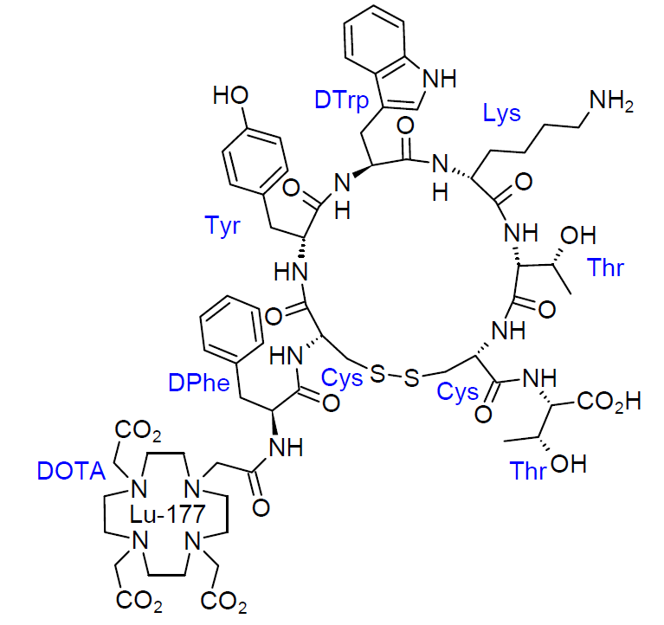
The drug substance is produced through a continuous automated radiolabelling process in which the radionuclide precursor lutetium ¹⁷⁷chloride is combined with the chemical precursor oxodotreotide to form the final active substance. Oxodotreotide is synthesised using standard 9-fluorenylmethyloxycarbonyl (FMOC) based solid phase peptide techniques, followed by dodecane tetraacetic acid (DOTA) conjugation, cleavage, purification, and cyclisation.
The radionuclide precursor may be manufactured either through the direct route, where neutron bombardment of ¹⁷⁶Lu yields carrier added ¹⁷⁷Lu, or through the indirect route using ¹⁷⁶Yb as the irradiated target, offering higher specific activity. Both precursor pathways have been adequately characterised, and their specifications are consistent with the British Pharmacopoeia monograph for lutetium ¹⁷⁷ radiolabelling solutions. Development studies support the proposed specific activity limits and demonstrate their suitability for achieving the required radiochemical purity.
The final drug product is manufactured via semi-automated dispensing. The solution containing lutetium ¹⁷⁷ oxodotreotide is formulated with a saline based dilution solution containing ascorbic acid and pentetic acid, followed by sterile filtration and filling into Type I glass vials sealed with bromobutyl rubber stoppers and aluminium caps.
The product is supplied in a lead shielded secondary container. Its Australian specification aligns with those approved in the EU and US and incorporates all relevant tests for radionuclide and radiochemical purity in accordance with British Pharmacopoeia general standards for radiopharmaceutical preparations. Sterility, endotoxin levels, and container safety meet requirements. Stability data support a shelf life of 72 hours when stored below 25°C, with additional stipulations to not freeze the product and to keep it within its original protective container.
From a biopharmaceutics perspective, no bioequivalence studies were required. The formulation used in the pivotal NETTER 1 Phase III clinical trial is identical to the proposed commercial formulation and consistent with that used in earlier clinical studies, removing the need for bridging studies.
The quality and biopharmaceutic data support approval of Lutathera for registration.

Nonclinical evaluation summary
The submitted Module 4 dossier was in accordance with the relevant ICH guideline for the nonclinical assessment of anticancer pharmaceuticals (ICH S9). The overall quality of the nonclinical dossier was high. All pivotal safety-related studies were GLP compliant. The nonclinical testing program mainly used (nonradioactive) lutetium (¹⁷⁵Lu) oxodotreotide.
In vitro, lutetium (¹⁷⁷Lu) oxodotreotide bound to the somatostatin SST2 receptor with nanomolar affinity, and decreased survival of CA20948 rat pancreatic tumour cells, within expected clinical plasma concentrations. In vivo, lutetium (¹⁷⁷Lu) oxodotreotide distributed to tumour tissue of mice harbouring pancreatic cancer cell xenografts and inhibited xenograft growth/induced tumour regression, supporting the proposed clinical indication.
No secondary pharmacodynamic studies were submitted. Octreotate compounds have shown high selectivity for the SST2 receptor and are therefore expected to primarily bind only to SSTR2 expressing tissue. There were no apparent off-target effects in general toxicity studies in rats and dogs, and no significant secondary pharmacological effects are expected in patients.
Safety pharmacology studies assessed effects of non-radioactive lutetium (¹⁷⁵Lu) oxodotreotide on the cardiovascular, respiratory and central nervous systems. No adverse effects were seen on CNS function in rats. Lutetium (¹⁷⁵Lu) oxodotreotide had a non-adverse and dose-dependent stimulatory effect on respiration in rats, and a transient hypertensive effect in dogs (which also caused reflex bradycardia). No significant inhibition of hERG K+ channel tail current was observed at clinically relevant concentrations. Lutetium (¹⁷⁷Lu) oxodotreotide is not predicted to prolong the QT interval in patients.
Overall, the pharmacokinetic profile in animals was qualitatively similar to that of humans. Exposure was dose proportional and without accumulation on repeat dosing. Half-life values were similar in dogs and humans but shorter in rats. Plasma protein binding was low to moderate in rats, dogs and humans. Lutetium (¹⁷⁷Lu) oxodotreotide distributed SSTR2-positive tissues (predominantly tumour xenografts and pancreas), and kidney (SSTR2 negative). Distribution to brain and spinal cord was very limited. Lutetium (¹⁷⁵Lu) oxodotreotide does not undergo hepatic metabolism and is excreted predominantly as unchanged drug via the urinary route, with faecal excretion playing a minor role.
Based on in vitro studies, no clinically relevant interactions between lutetium (¹⁷⁵Lu) oxodotreotide and CYP450 enzymes or membrane transporters are expected.
Lutetium (¹⁷⁵Lu) oxodotreotide exhibited a low order of acute toxicity in rats and dogs.
Repeat-dose toxicity studies by the IV route were conducted in rats and dogs (4 administrations over 7 weeks). Maximum exposures (AUC) relative to clinical exposures were very high in both species. The only target organ for toxicity was the pancreas (pancreatic acinar apoptosis). Pancreatic acinar apoptosis occurred at very high multiples of the clinical exposure and is therefore not expected in patients.
While lutetium (¹⁷⁷Lu) oxodotreotide is expected to be genotoxic due to ionising radiation, non-radioactive lutetium (¹⁷⁵Lu) oxodotreotide was not found to be mutagenic in the bacterial mutation assay or clastogenic in vitro (in mouse lymphoma cells). No carcinogenicity studies were submitted, which is considered acceptable.
No reproductive toxicity studies were submitted, which is considered acceptable, given the indication.
No local tolerance studies were submitted. No adverse effects at the injection site were observed in the toxicity studies in rats and dogs. No local reactions are expected in patients.
There are no nonclinical objections to the registration of Lutathera.

Clinical evaluation summary
The submission in Australia was primarily based on the results of the interim and final analyses of the NETTER-1 study and interim analysis of ERASMUS MC study.

Pharmacology

Pharmacokinetics
Pharmacokinetics were studied in patients. No healthy volunteer studies were conducted.
Lutathera is administered intravenously and is immediately and completely bioavailable. C_{max} generally occurred at the end of the infusion.
It is approximately 43% plasma protein bound. Transchelation of lutetium from [¹⁷⁵Lu]Lu-oxodotreotide into serum proteins was not demonstrated. Within 4 hours of administration, there was uptake into the kidney, tumour lesions, liver and spleen, and in some patients the pituitary or thyroid. The mean volume of distribution was 460 L (CV 54%) after a single therapeutic dose.
Co-administration of amino acids resulted in reduction of the median radiation absorbed dose in Gray (Gy) units to the kidneys by 47% (range 34% - 59%) and a mean 36% (21% CV) increase in blood clearance of lutetium (¹⁷⁵Lu) oxodotreotide.
Lutathera is poorly metabolised and is predominantly excreted in urine (91% in ERASMUS MC), around 58% of the dose in the first 24 hours and 65% of the dose in the first 48 hours. By radiometric HPLC, 99.8% was eliminated in urine. The mean blood elimination half-life was 3.5 (SD 1.4) hours, and the mean terminal half-life was 71 (SD 28) hours.
Dose proportionality: activities of 1.85, 3.7 and 7.4 gigabecquerels (GBq) had a dose normalised mean exposure (AUC_{0-last}) of Lutathera of 32 (CV 23%), 35 (CV 57%) and 26 (CV 31%), respectively.
Accumulation is not anticipated given the 71 hour half-life and the 8 week dosing interval.
There is little or no hepatic elimination. No dose adjustment is proposed for patients with mild to moderate hepatic impairment. The safety in patients with severe hepatic impairment defined as bilirubin > 3x ULN and any AST has not been established.
No dose adjustment is proposed for patients with kidney disease characterised as mild to moderate, noting that coadministration of amino acids is intended to be renally protective. There are no data in patients with a creatinine clearance (by Cockroft-Gault estimate) < 30 mL/min or patients with end-stage kidney disease. Treatment with Lutathera is not recommended for patients with creatinine clearance < 40 mL/min, and dose adjustment or permanent discontinuation is based on a reduction in renal function.
Radiation dosimetry was considered in both main studies, including a specific sub-study of the pivotal NETTER-1 study (n=20). Safety thresholds for exposure in the kidney is generally 29 Gy and 2 Gy for red bone marrow. The median (range) predicted absorbed doses (Gy) after a total exposure of 29.6 GBq from the NETTER-1 sub-study are shown in Table 3.
Table 3. Radiation Dosimetry NETTER-1 Study Lutathera Arm
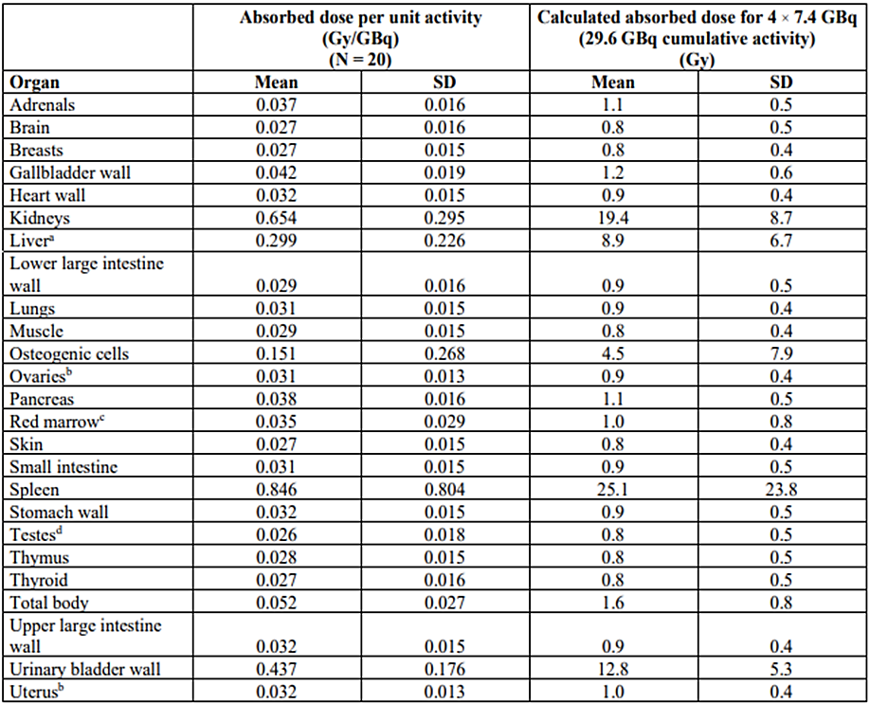
ªN = 18 (two patients excluded because the liver absorbed dose was biased by the uptake of the liver metastases).
^{b}N = 9 (female patients only).
^{c}Red marrow dosimetry estimates were determined using blood radioactivity.
^{d}N = 11 (male patients only).

Drug-drug interactions
Somatostatin analogues compete for the same receptors with Lutathera. The sponsor recommends discontinuation of long-acting analogues at least 4 weeks prior to Lutathera administration, and short acting analogues 24 hours prior to Lutathera administration.
No significant induction and no demonstrated inhibition of CYP450 enzymes, and no specific interaction with P-glycoprotein, OAT1, OAT3, OCT2, OATP1B1, OAT1B3, OCT1 or BCRP transporters was shown in preclinical studies.

Pharmacodynamics
The mechanism of action and primary pharmacodynamics (PD) was demonstrated in nonclinical studies.
An ECG substudy within the NETTER-1 study (n=20) did not demonstrate an increase in QTc > 20 msec for Lutathera but mean changes > 10 msec were observed with the largest change from baseline QTcF of 11.3 (90% CI 5.7, 16.9 msec).

Efficacy
The main study to support the proposed indication was the NETTER-1 study. The submission included a primary endpoint analysis dated in 2015 with a data lock date of 30 June 2016, and a final analysis of that study with a data lock date of 18 January 2021. Supportive data were provided from the Erasmus MC Phase I/II study.

NETTER-1 study
This was a multicentre, multinational, open-label, randomised, comparator controlled, parallel group Phase III study that compared Lutathera plus 30 mg Octreotide LAR (long acting release) with 60 mg Octreotide LAR in patients with inoperable, progressive, somatostatin receptor positive, midgut tumours.
The study commenced in 2012 and randomised the last patient in January 2016. As of primary analysis cut-off date, it randomised 229 patients (116 to Lutathera and 113 to octreotide). Two additional patients were randomised after the primary analysis cut-off date. Randomisation was stratified by somatostatin receptor scintigraphy tumour uptake (Grade 2, 3, or 4 based on the highest uptake in any tumour), and the length of time taking octreotide prior to randomisation (≤6 months, >6 months).
Figure 2. NETTER-1 Study Schematic
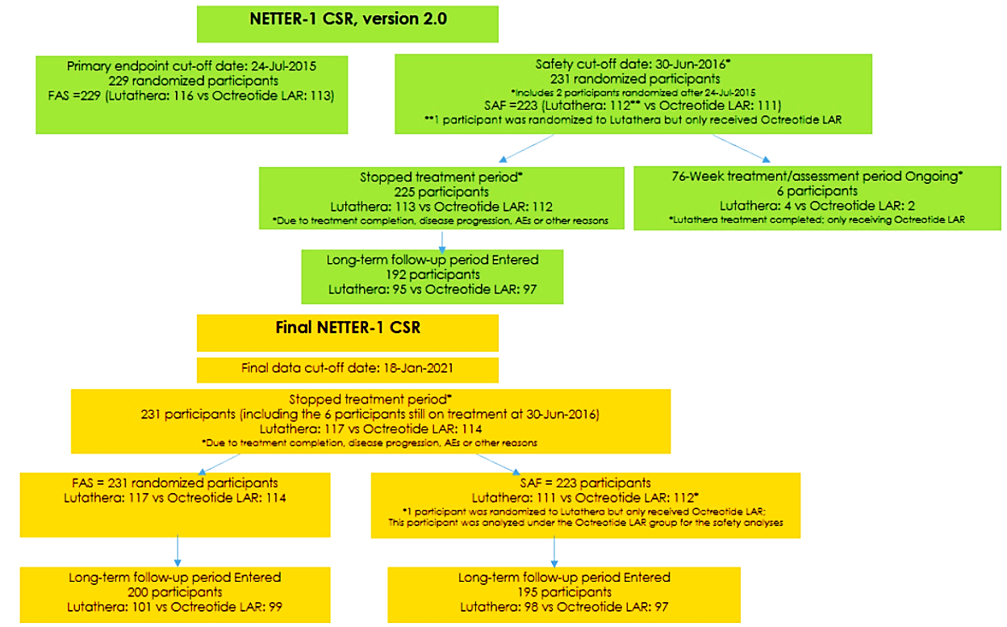
All patients had to have metastatic or locally advanced histologically proven, midgut carcinoid tumour (≥1 one measurable site of disease), that was not considered operable with curative intent, that was somatostatin receptor positive by scintigraphy with [¹¹¹In]In-pentetreotide (OctreoScan) within 6 months of study commencement and that had a Ki67 index of ≤20%. Patients had to be aged ≥ 18 years, and if on octreotide, to be on a stable dose of 20 mg or 30 mg every 3 to 4 weeks for at least 12 weeks prior to randomisation in the study. Tumours had to have progressed (pre RECIST v 1.1) while receiving fixed dose octreotide LAR. Karnofsky performance score had to be ≥60.
The main exclusion criteria were based on laboratory parameters (creatinine > 150 mmol/L or creatinine clearance < 50 mL/min measured/calculated by the Cockcroft Gault method; Hb < 8.0 g/dL, WBC <2 x 10⁹/L, platelets <75 x 10⁹/L, total bilirubin > 3x ULN, serum albumin ≤3 g/dL unless normal prothrombin). Patients could not have received treatment with Octreotide LAR >30 mg at 3 – 4 weekly intervals within 12 weeks of randomisation or peptide receptor radionuclide therapy at any time, or unable to interrupt short acting octreotide treatment for 24 h before and after the administration of Lutathera, or be receiving Octreotide LAR, which could not be interrupted for at least 6 weeks before the administration of Lutathera, unless the tumour uptake on target lesions on OctreoScan imaging during Octreotide LAR treatment was at least as high as normal liver uptake observed by planar scintigraphy imaging. Patients could not have received interferons, everolimus or other systemic therapies within 4 weeks of randomisation. Brain metastases had to be treated and stabilised for at least 24 weeks prior to randomisation. Patients were also excluded if they had uncontrolled heart failure (NYHA Class II or greater), or uncontrolled diabetes mellitus.
As of primary analysis data cut-off, 229 patients were randomised 1:1 to one of the following treatments:
- Experimental arm (n=116):
  - Lutathera as 4 IV doses of 7.4 GBq administered at 8 ± 1 week intervals (up to 16 weekly to allow for resolution of acute toxicity) and ≥ 36 g of lysine + arginine in ≤2L, and of <1100 mOsm/L).
  - 30 mg Octreotide LAR 24 hours after Lutathera dosing then every 4 weeks ± 3 days, while leaving a 6 week window between the last dose and the next Lutathera dose
- Control arm (n=113):
  - 60 mg Octreotide LAR every 4 weeks ± 3 days
Two additional patients were randomised, one to each arm, after the primary analysis data cut-off date.
The primary endpoint was progression free survival per RECIST v1.1 as assessed by an independent review committee. Key secondary endpoints were overall response rate (ORR) and overall survival (OS). Quality of life questionnaire were included in the assessment. The study was designed for a primary analysis of progression-free survival (PFS) after 74 evaluable events, with a planned 5 year follow up from the date of the last randomised patients and an OS analysis after 158 OS events or 5 years after the date of randomisation or the last patient, whichever came first. NETTER-1 study participant baseline demographic parameters are shown in Table 4, study baseline disease characteristics in Table 5 and study baseline neuroendocrine tumour markers in Table 6.
Table 4. NETTER-1 Study Participant Baseline Demographic Parameters
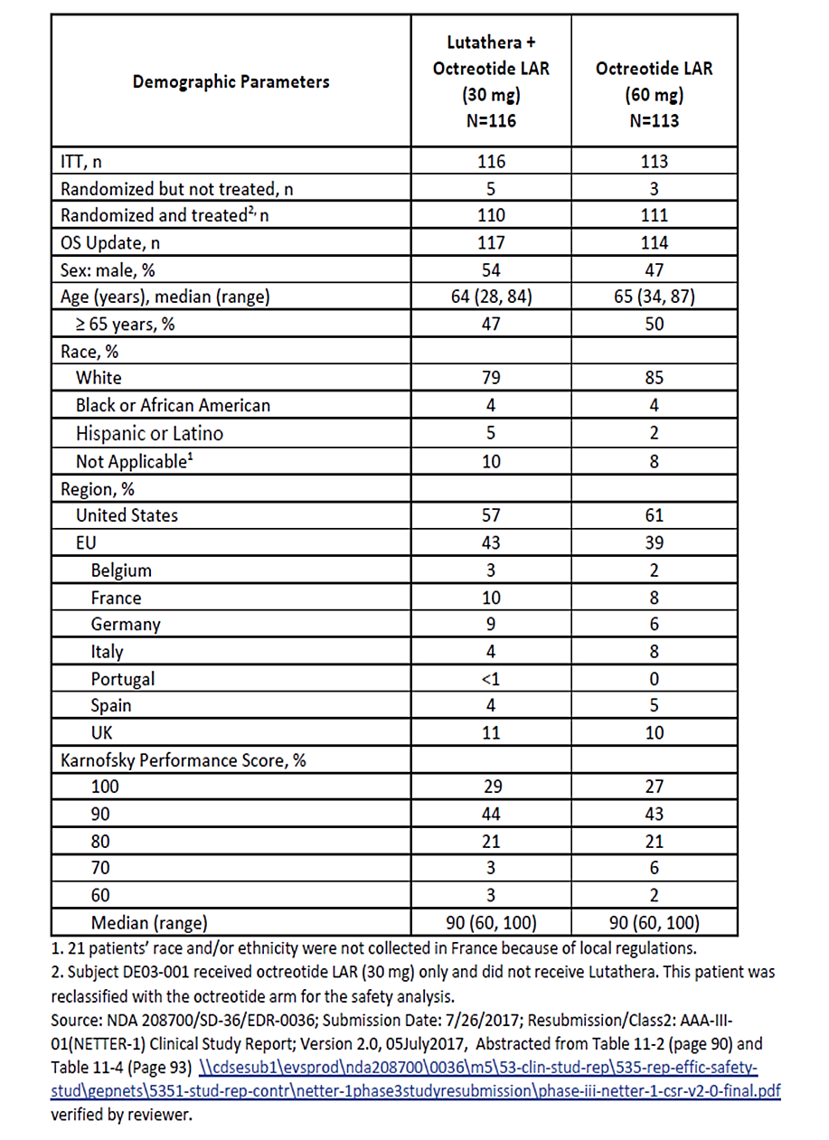
1. 21 patients’ race and/or ethnicity were not collected in France because of local regulations.
2. Subject DEO3-001 received octreotide LAR (30 mg) only and did not receive Lutathera. This patient was reclassified with the octreotide arm for the safety analysis.
Table 5. NETTER-1 Study Baseline Disease Characteristics
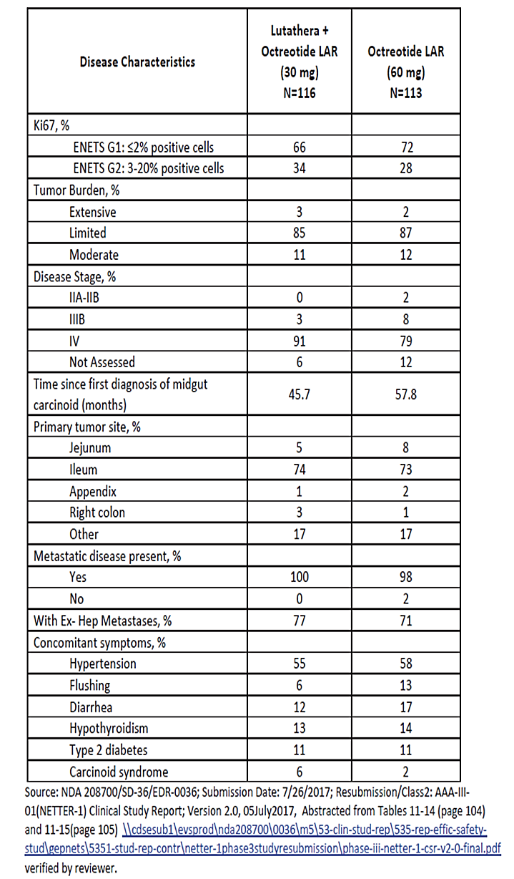
Most patients (around 74%) had been on a constant octreotide dose. By highest OctreoScan tumour uptake score most patients in each group had Grade 4 tumours (around 58%, around 39% Grade 3 and around 13% Grade 4).
Table 6. NETTER-1 Study Baseline Neuroendocrine Tumour Markers
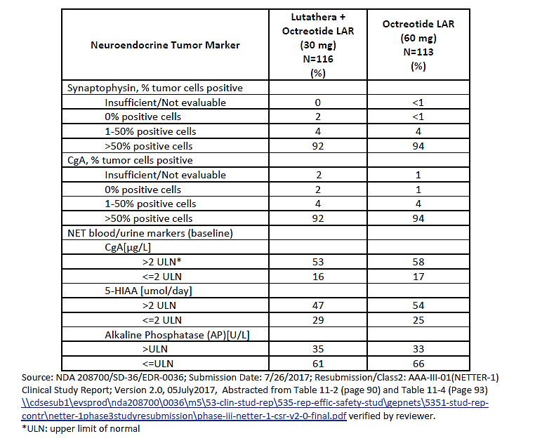
Disease progression was the most common reason for treatment discontinuation (16% vs 57%) in the Lutathera and Octreotide LAR arms, respectively. More patients on the Lutathera arm completed treatment (40% vs 10%). The two study arms were generally comparable in the other reasons.
Major protocol violations occurred in around 48 (23%) of patients, with similar proportions in each arm (Table 7).
Table 7. NETTER-1 Study Major Protocol Violations
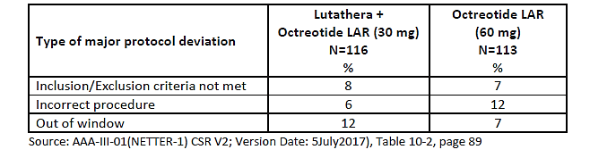

Primary endpoint – Progression-free survival
A statistically significant PFS benefit was demonstrated for the Lutathera group compared with the Octreotide LAR group (Table 8).
Table 8. NETTER-1 Study Primary Analysis Progression Free Survival – Sponsor analysis.
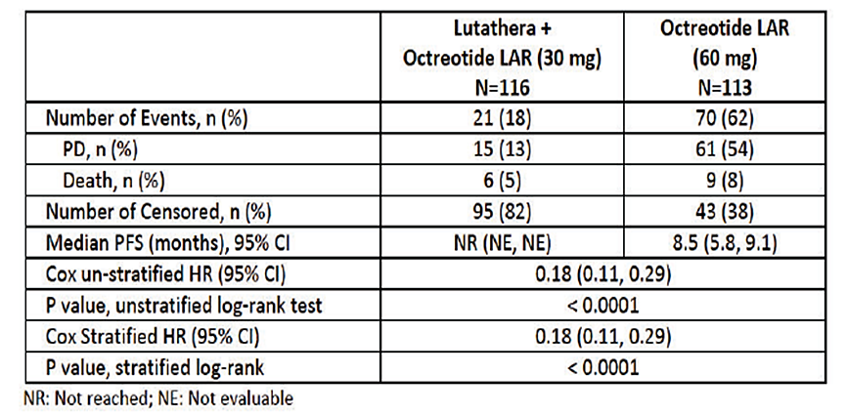
The FDA repeated the analysis using an assessment of PFS events regardless of whether the patient had missing scheduled visit, treatment discontinuation for toxicity or new anticancer treatment started without progression. The median PFS was not reached for the Lutathera arm and was 8.5 months (95% CI: 6.0,9.1) for the octreotide arm. The unstratified HR was reported as 0.21 (95% CI: 0.13, 0.32) for Lutathera vs Octreotide. Additional sensitivity analyses confirmed a benefit of similar magnitude.
Figure 3. NETTER-1 Progression Free Survival (PFS) - Kaplan-Meier graph (FAS).
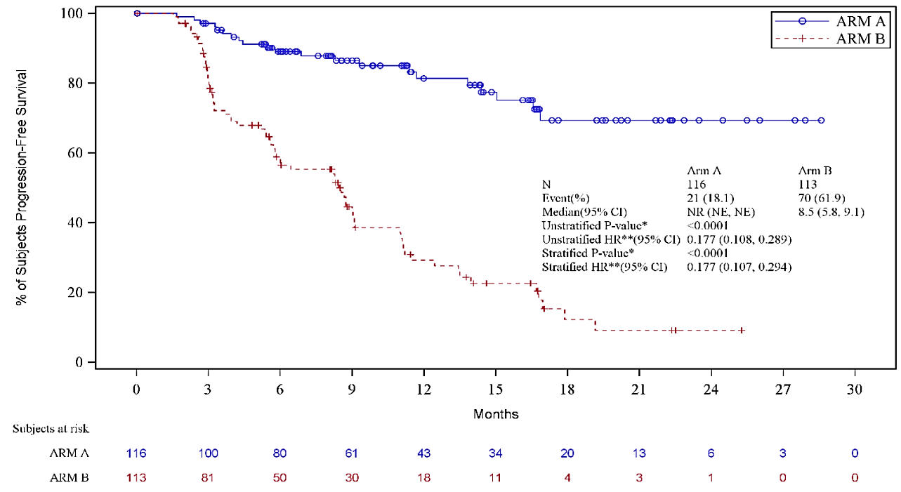
The Kaplan-Meier (KM) curves separate early, and the slope of the curves differ throughout their trajectory.

Key secondary endpoint overall response rate
Overall Response Rate (ORR) was 12.9% in the Lutathera group and 3.5% in the Octreotide LAR group.
Complete responses were reported for 0.9% and 0%, respectively, and Partial responses were reported in 12.1% and 3.5%, respectively. The comparison reached statistical significance (p=0.0148).

Key secondary endpoint overall survival
Table 9. NETTER-1 Study Overall Survival at Primary Analysis and at 2016 Data Cut
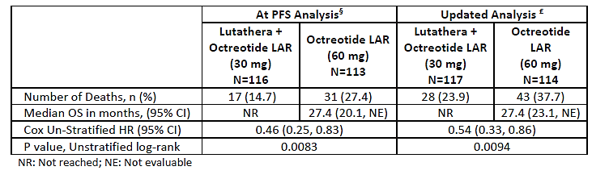
By baseline characteristic all subgroups demonstrated a similar benefit.
The submission includes data from the final analysis with a data lock of 18 January 2021. In the final study analysis, at least one subsequent treatment was received by 61.5% of the Lutathera group and 64.9% of the Octreotide group, including 37.7% of the Octreotide group that were treated with a therapeutic radiopharmaceutical. Cumulatively 22.8%, 30.7%, 34.2% and 34.2% within 24 months, 36 months, 48 months, and 60 months, respectively.
At the final analysis, and after a median follow up of 76.3 months in the Lutathera group and a median of 76.5 months in the Octreotide group, 20.5% of the Lutathera group and 16.7% of the Octreotide group had died. Median OS in Lutathera group was 48 months (95%CI: 37.4, 55.2) vs. (36.3 months; 95%CI: 25.9, 51.7) in the Octreotide LAR group. In the final analysis the unstratified OS HR was 0.84 (95% CI: 0.6, 1.17). Analysis using restricted mean survival time (RMST) analysis, rank-preserving structural failure time (RPSFT) and inverse probability of censoring weights (IPCW) all have an estimate of benefit tending to favour Lutathera.
In the Lutathera group 52.1% had a second progression or died, as did 56.1 of the Octreotide LAR group. The median PFS2 for Lutathera vs Octreotide was 45.0 months (95% CI: 39.6, 50.4) vs. 23.2 months (95% CI: 18.5, 28.4); unstratified HR 0.42 (95% CI: 0.29, 0.60; p <0.0001).

ERASMUS MC study
This study provided supportive data for the use of Lutathera in midgut NETs and provided evidence to support use in pancreatic NETs and foregut and hindgut tumours.
The ERASMUS MC study was a Phase I/II single arm, Phase I/II study designed to determine treatment efficacy (ORR and duration of responsory (DOR)), safety, QoL and to evaluate time to event endpoints of PFS, time to progression and OS. A biodistribution and dosimetry substudy conducted at the commencement of the trial evaluated the renal protective effect of coadministration of an amino acid infusion and provided a first estimate of the maximum safe dose of Lutathera. This was followed by an ascending dose study. Subsequently, treatment in this study and the NETTER-1 study was standardised to a regimen of a total of 29.6 GBq in 4 divided doses administered over 30 minutes at 6 – 13 week intervals. Each dose was given with a concomitant infusion of 2.5% lysine HCl and 2.5% arginine HCl in 1L 0.9% NaCl.
The study commenced in 2000 and enrolled 811 patients. Partial data collection occurred from December 2021 onwards and was limited to patients enrolled prior to that date. Analysis used data from 494 patients in the efficacy set and all 811 in the safety data set.
Patients had histologically proven GEP-NET, with somatostatin receptors demonstrated by OctreoScan within 6 months of the first dose Lutathera, serum creatinine < 150 μmol/L and either calculated or measured of > 40 mL/min, Hb ≥ 5.5 mmol/L, WBC ≥2 x 10⁹/L and platelets ≥75 x 10⁹/L, total bilirubin ≤3 x ULN serum albumin > 30 g/L and Karnofsky score ≥50. The main exclusion criteria were the possibility of surgery with curative intent, and uncontrolled congestive heart failure.
The study included Dutch and non-Dutch patients. Because of the greater proportion of patients with missing information in the non-Dutch patient data set, and the increased external validity of this population to the Australian context, the sponsor presented data from 559 Dutch national patients with GEP-NETS who had received at least one dose of Lutathera (safety population – SAF). A further 199 were excluded from the efficacy analysis because they did not have baseline tumour measurements recorded in the study, leaving 360 patients in the full analysis set (FAS).
For the FAS Dutch GEP-NET population, the ORR per RECIST was 45.0%: midgut NET 33.3%, bronchial NET 36.8%, hindgut NET 46.2%, foregut NET 58.3% and pancreatic NET 60.9%.
The ORR in 162 patients with progressive disease at baseline overall was 45%: midgut NET 33%, bronchial NET 36.8%, hindgut NET 46.2%, foregut NET 58.3% and pancreatic NET 60.9%.
In a sensitivity analysis performed using data from the SAF patients (N: 559) that considered the 199 patients without a baseline tumour measurement as a nonresponders, the ORR was 29%: midgut NET 22%, bronchial NET 18%, hindgut NET 23%, foregut NET 39% and pancreatic NET 41%. The ORR in 296 patients with measured progressive disease at baseline (radiologically or clinically assessed within 12 months) was 28%: midgut NET 22%, bronchial NET 8%, hindgut NET 25%, foregut NET 33% and pancreatic NET 44%.
Results for additional endpoints were provided in the submission. The Delegate notes time to event endpoints are difficult to interpret in the setting of a single arm study.

Safety
The Delegate recognises the international experience with the product and the PSURs included in the submission that support the safety of Lutathera.
The Safety Set (SAF) of the NETTER-1 study consisted of all randomised patients who received at least 1 dose of study drug (Lutathera or octreotide LAR). Of the 231 randomised patients (FAS), 112/117 (95.7%) patients from the Lutathera group and 111/114 (97.4%) patients from the Octreotide LAR group were included in the SAF. Of these, 98/117 (83.8%) and 97/114 (85.1%) patients, respectively, entered the long-term follow-up period. However, 1 patient who was randomised to Lutathera, only received octreotide LAR. Therefore, the final safety analysis was conducted on the 111 patients who received Lutathera and on 112 patients who received octreotide LAR.
In the NETTER-1 trial, the 111 patients in the Lutathera SAF received a mean total absorbed dose of 25.6 GBq, 26% received a cumulative dose of 29.6 GBq and 79% received a cumulative dose of ≥22.2 GBq. By the data cut-off of 30-June-2016, all Lutathera patients had completed treatment and 75.7% had received 4 Lutathera administrations with a mean total dose of 29.1 GBq. The exposure was greater in the ERASMUS MC safety set, with over 60% receiving ≥ 29.6 GBq. At the final analysis six patients were still on octreotide LAR across both treatment groups.

Adverse events
The common adverse events are summarised in Table 10.
Table 10. Safety Summary NETTER-1 Study
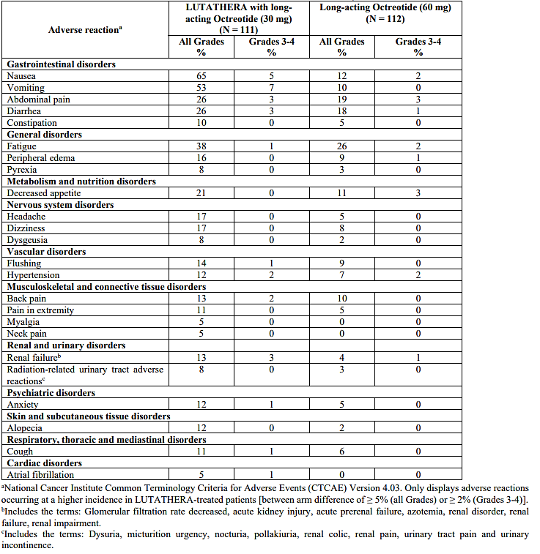
ª National Cancer Institute Common Terminology Criteria for Adverse Events (CTCAE) Version 4.03. Only displays adverse reactions occurring at a higher incidence in Lutathera-treated patients [between arm difference of > 5% (all Grades) or > 2% (Grades 3-4)].
^{b} Includes the terms: Glomerular filtration rate decreased, acute kidney injury, acute prerenal failure, azotemia, renal disorder, renal failure, renal impairment.
^{c} Includes the terms: Dysuria, micturition urgency, nocturia, pollakiuria, renal colic, renal pain, urinary tract pain and urinary incontinence.
The sponsor attributed gastrointestinal symptoms to the co-administration of the amino acid solution and the protocol required an antiemetic to be administered concurrently.
In the final analysis no new adverse event types were reported.
In the Lutathera arm, 7(6%) patients reported a treatment emergent AE (TEAE) that required a dose reduction (all thrombocytopenia). Lutathera was discontinued in 14 (13%) patients with a TEAE; 3 due to hematologic toxicity, 5 due to a renal-related event, 2 related to disease progression, 2 due to underlying disease or a disease-related procedural complication, and 2 for events not clearly related to Lutathera. In the Octreotide LAR arm, 12 (11%) patients discontinued study drug due to a TEAE.

Deaths
In NETTER-1, 16 deaths occurred on treatment or within 30 days following the last treatment in randomized patients (7%); 7 deaths (6%) occurred on the Lutathera arm and 9 {8%) occurred on the octreotide arm. None were considered related to study drug.
Deaths due to disease progression or unknown reasons were not reported as adverse events (AE). In the SAF, a total of 138 (61.9%) patients died during the study due to disease progression or other causes, with no meaningful differences between the treatment groups (70 patients, 63.1% in the Lutathera group vs. 68 patients, 60.7% in the Octreotide group).
During the treatment period, 4 (3.6%) patients in the Lutathera group vs. 5 (4.5%) patients in the Octreotide LAR group died due to disease progression. None died of other reasons. During the long-term follow-up period, 51 (45.9%) patients in the Lutathera group vs. 49 (43.8%) patients in the Octreotide LAR group died due to disease progression. A total of 15 (13.5%) patients in the Lutathera group and 14 (12.5%) patients in the Octreotide LAR group died due to other causes (including AEs).
Since the 30-Jun-2016 data cut-off, 1 new fatal event (oesophageal adenocarcinoma; reason for death was reported as disease progression) was reported and 2 events (oesophageal carcinoma and MDS) had the status updated to fatal.
In ERASMUS, deaths were reported in 446/1214 {37%) patients 397/811 {49%) in the Dutch subset, of which 16 {2%) occurred on treatment or within 30 days following the last treatment. None of these deaths were considered related to study drug.

Serious adverse events
During the interim analysis of NETTER-1 (data cut-off date 30-Jun-2016), 13 (11.6%) patients in the Lutathera group reported ≥1 SAE related to Lutathera. Of these, 10 (8.9%) patients had grade ≥ 3 SAEs related to Lutathera (lymphopenia, neutropenia, refractory cytopenia with multilineage dysplasia, ascites, intestinal obstruction, respiratory tract infection, acute kidney injury, hepatic encephalopathy, dehydration, refractory cytopenia with multilineage dysplasia). Each grade ≥ 3 SAE was reported in 1 (0.9%) patient each.
During the long-term follow-up period, no SAE related to Lutathera had an onset date after the interim data cut-off (30-Jun-2016). During the long-term follow-up period, 3 (2.7%) patients experienced a total of 5 SAEs related to Lutathera, and all occurred before the interim data cut-off. A summary of the SAEs is tabulated, below
Table 11. Serious adverse events related to Lutathera during long-term follow-up by SOC, preferred term, and maximum CTC Grade (Safety Set)
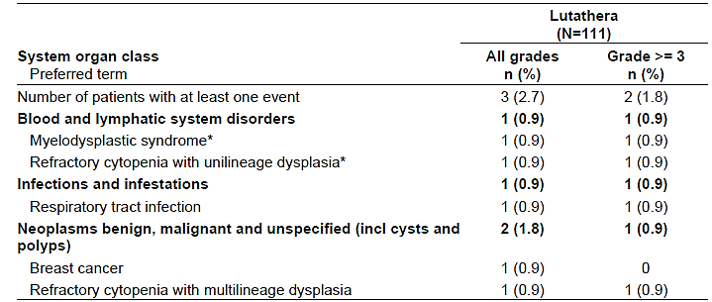
* Both events of MDS and refractory cytopenia with unilineage dysplasia were reported in the same patient with the same onset date.
This table summarizes events that started during the long-term follow-up only.
Results given as n (%) where n=number of patients, (%)=percentage based on N.
Preferred terms are sorted in descending frequency.
Every patient is counted a single time for each applicable specific adverse event with highest severity.
A patient with multiple adverse events within a system organ class is counted a single time for that system organ class with highest severity.
Coded using MedDRA version v18.0 and NCI CTCAE version 4.03.
The safety set comprises all patients that have had at least one administration of study drug in the treatment period.
The most frequent SAEs in ERASMUS were pancytopenia (10%), diarrhea (6%), abdominal pain (6%), anemia (5%); nausea, vomiting, and pyrexia (4% each); thrombocytopenia, constipation, pneumonia, dehydration, and dyspnea (3% each).

Organ toxicities

Hepatic Toxicity
Two cases of hepatic toxicity in the NETTER-1 study in the Lutathera arm were attributed to hepatic tumour burden.

Nephrotoxicity
In NETTER-1, with a median duration of follow-up of 19 months, no clinically meaningful difference was noted between study arm over time in either creatinine or creatinine clearance. In the final analysis, 1 patient had an event of blood creatinine increased (Investigator assessed it as caused by underlying disease) that worsened from grade 1 to grade 3, and the event was ongoing at the final data cut-off. The overall incidence of nephrotoxicity events was unchanged from what was reported previously.
In ERASMUS, the incidence of renal failure (including PTs of renal failure and renal impairment) was 2%.

Haematological toxicity
Haematological toxicity was expected based on the estimated cumulative radiation absorbed dose to the red marrow (Gy: mean=1.0; SD=0.8) for 4 treatment cycles of Lutathera in NETTER-1. In the early analyses, lymphopenia (all grades) was the most frequent hematologic toxicity, in 90% of the Lutathera arm. Grade 3-4 lymphopenia was seen in 44% of Lutathera treated patients. Anemia, leukopenia, thrombocytopenia, and neutropenia were also common, occurring in 81%, 55%, 53%, and 26% of Lutathera arm, respectively (all grades). Grade 3-4 neutropenia, leukopenia and thrombocytopenia occurring in 3%, 2%, and 1%, of the Lutathera arm, respectively.
In at least one SAE, lymphopenia may have contributed to susceptibility to an opportunistic infection (Pneumocystis jirovicii pneumonia).
In the final analysis, no major differences between the Lutathera and the Octreotide LAR groups: anaemia (55.9% vs. 48.2%), lymphopenia (50.5% vs. 33.9%), leukopenia (20.7% vs. 21.4%), neutropenia (9.0% vs. 13.4%), and thrombocytopaenia (21.6% vs. 20.5%). No toxicities of grade ≥ 3 had >2% difference in frequency between the groups.

Thrombocytopenia
In the NETTER-1 study, the mean time to platelet count nadir in Lutathera arm was 5.5 months.
Approximately one third of the Lutathera arm who developed thrombocytopenia, recovered to baseline platelet counts or higher during follow-up. Of the patients who did not recover to baseline platelet counts, all but one patient who remained at Grade 3, recovered to Grade 2 platelet counts or higher.

Laboratory Findings
A summary of the laboratory findings from NETTER-1 is shown in Table 12. The Delegate notes that not all the abnormal laboratory findings met the criteria for adverse events.
Table 12. Summary of laboratory findings from NETTER-1
Laboratory Abnormality | Lutathera  N = 111 |  | Octreotide LAR  N = 112
Laboratory Abnormality | Grades 1-4 | Grades 3-4 | Grades 1-4 | Grades 3-4
Laboratory Abnormality | %
Hematology
Lymphopenia | 90 | 44 | 39 | 4
Anaemia | 81 | 0 | 54 | 1
Leukopenia | 55 | 2 | 20 | 0
Thrombocytopaenia | 53 | 1 | 17 | 0
Neutropenia | 26 | 3 | 11 | 0
Renal/metabolic
Hyperglycaemia | 82 | 4 | 67 | 2
Hypoglycaemia | 15 | 0 | 8 | 0
Hypocalcaemia | 32 | 0 | 14 | 0
Hyperuricemia | 34 | 6 | 29 | 6
Hypokalaemia | 26 | 4 | 21 | 2
Hyperkalaemia | 19 | 0 | 11 | 0
Creatinine increased | 85 | 1 | 73 | 0
Hypernatremia | 17 | 0 | 7 | 0
Gastrointestinal
GGT increased | 66 | 20 | 67 | 16
Alkaline phosphatase increased | 65 | 5 | 54 | 9
ASAT increased | 50 | 5 | 35 | 0
ALAT increased | 43 | 4 | 34 | 0
Blood bilirubin increased | 30 | 2 | 28 | 0
*Values are worst grade observed after randomization; N = number of patients
National Cancer Institute Common Terminology Criteria for Adverse Events Version 4.03

Secondary malignancies
In NETTER-1, one patient with a prior diagnosis of breast cancer was diagnosed with diffuse large B-cell lymphoma 14 months after the initial Lutathera dose. Two patients (1.8%) were identified with a possible diagnosis of myelodysplastic syndrome (MDS), diagnosed 8 to 15 months after the initial Lutathera dose. One patient with a history of breast cancer had received alkylator therapy 20 years before the MDS diagnosis. In the other two cases, patients had underlying hematologic changes. After the interim data cut-off (30-Jun-2016), in the Lutathera group, 1 patient with a grade 4 refractory cytopenia with unilineage dysplasia at the interim data cut-off had the event updated to grade 5 MDS with fatal outcome at the final data cut-off.
In the Dutch sub-set of ERASMUS (n=811), 4 patients developed acute leukemia (< 1%). The time of onset from the initial Lutathera dose ranged from 30 to 120 months. One of these patients had a history of FOLFIRI treatment and a hepatic transplant for pNET. Another patient had prior external beam radiotherapy for breast cancer. Sixteen Dutch patients (2%) were reported to have MDS. The median time of onset was 24 (Range: 10 -60) months following the initial Lutathera treatment.
The risk of acute leukemia appeared <1% and the risk of MDS appeared around 2-3%.
At the final analysis three patients in the Lutathera arm had 5 new-onset secondary solid tumours: 1 patient had oesophageal adenocarcinoma that led to death; 1 patient with a history of grade 1 malignant melanoma in situ (that occurred during the treatment period and was resolved by the prior data cut-off), experienced new grade 2 events of malignant melanoma in situ, basal cell carcinoma, and squamous cell carcinoma of skin, all of which resolved; and 1 patient had grade 2 squamous cell carcinoma that resolved. All these solid tumour events were assessed by the investigator to be unrelated to Lutathera.

Neuroendocrine hormonal crises
There were some differences between the NETTER-1 and ERASMUS MC studies in the reporting of symptoms in the peri-infusion period which limit the between-study comparison for these events. No events were reported in the NETTER-1 study.
Neurohormonal crisis (flushing, intractable diarrhea, bronchospasm and hypotension) was reported in 8 patients (1%) of the efficacy (Dutch) subset of ERASMUS, and 5/8 required administration of intravenous octreotide and steroids. The onset of symptoms typically occurred while on or within 24-48 hours of the Lutathera administration.

Safety analyses by demographic subgroups
In NETTER-1, SAEs by age (< 65 years vs ≥ 65 years) were 31% vs 37%. In the Dutch subset of ERASMUS, the overall rate of SAEs and the rate of renal events were similar in both age groups {overall: 64% vs 60%; renal: 4% vs 5%) in the < 65-year vs ≥ 65-year groups, respectively.

Other safety findings
Hypersensitivity events, such as angioedema have emerged in the post-market setting. The evaluator noted tumour lysis particularly in patients with chronic kidney disease and a high tumour burden is a potential risk.
The evaluation noted elevations of liver enzymes Because Lutathera is primarily excreted through the kidneys, and because the pattern of liver enzyme elevation was non-specific no firm conclusions about the aetiology were drawn.

Other matters
Amino acids solutions for infusion containing L-lysine and L-arginine must be used for renal protection when administering Lutathera. The sponsor proposes health facilities will compound their own formulations under the exemptions set out in Schedule 5A of the Therapeutic Goods Regulations 1990, or by using a commercially available preparation. Instructions for use for either type of amino acid product when administered as part of the dosing regimen for Lutathera are provided in the draft Lutathera PI.
Patient reported outcomes included in the submission were not considered to have been presented in a sufficiently robust manner for regulatory decision making. Real World Evidence was not used for decision-making in this submission.

Risk management plan
The EU-RMP versions 2.0 (dated 9 August 2021; data lock point 18 January 2021) and ASA versions 1.0 (dated 3 July 2024) and version 1.12 (dated 7 March 2025) were evaluated. The summary of safety concerns are reported in the Table 13.
Table 13. Summary of safety concerns
Summary of safety concerns |  | Pharmacovigilance |  | Risk Minimisation
 |  | Routine | Additional | Routine | Additional
Important identified risks | Renal dysfunction |  | * |  | –
Important identified risks | Myelosuppression / cytopenias (immediate haematotoxicity) |  | * |  | –
Important identified risks | Myelodysplastic syndrome / acute leukemia (late haematotoxicity) |  | * |  | –
Important identified risks | Hepatotoxicity |  | * |  | –
Important identified risks | Tumor lysis syndrome |  | * |  | –
Important identified risks | Hormone release-induced crises |  | * |  | –
Important identified risks | Hypogonadism, sexual dysfunction |  | * |  | –
Important identified risks | Drug interaction with somatostatin/somatostatin analogues |  | * |  | –
Important potential risks | Radiotoxicity, including occupational exposure and inadvertent exposure |  | * |  | †
Important potential risks | Secondary malignancies (solid tumors) |  | * |  | –
Important potential risks | Embryo-fetal toxicity |  | * |  | –
Missing information | Radiation exposure during breast feeding |  | * |  | –
Missing information | Exposure in patients with renal impairment |  | * |  | –
Missing information | Exposure in patients with severe hepatic impairment |  | * |  | –
Missing information | Long-term safety data |  | * |  | –
*Study ALUT- T-E02- 402 (SALUS)
†Patient Guide
The sponsor proposed a post authorisation registry protocol ALUT-T-E02- 402 (SALUS), to investigate the incidence of primary malignancies over a 7-year period, to quantify the incidence of the important identified and important potential risks identified in Table 13 to detect new potential risks and to further quantify the risks of under-represented patients groups in the clinical trials. The evaluator noted the study was expected to be submitted on 31 December 2028 and recommended its submission on completion. This study will not include Australian patients.
The RMP evaluator has recommended conditions of registration that have been accepted by the Delegate.

Risk-benefit analysis
This submission seeks approval for a therapeutic radiopharmaceutical, Lutathera, for the treatment of gastroenteropancreatic neuroendocrine tumours including foregut, midgut and hindgut neuroendocrine tumours.
NETTER-1 is the pivotal study. This was a multicentre, multinational, open-label, randomised, comparator controlled, parallel group Phase III study that compared Lutathera plus 30 mg Octreotide LAR with 600 mg Octreotide LAR in patients with inoperable, progressive, somatostatin receptor positive, midgut tumours.
At the primary PFS analysis, the median PFS in the Lutathera group was not reached and was 8.5 months (95% CI: 5.8, 9.1) in the Octreotide LAR group, with a stratified HR of 0.18 (95% CI: 0.11, 0.29), p<0.0001. The KM curves separate early and are persistently separated.
Median OS at the 2015 and 2016 data cut points was not estimable in the Lutathera group and was 27.4 months in the Octreotide group. In the updated analysis the unstratified HR was 0.54 (95% CI: 0.33, 0.86).
By the time of the final analysis (median of around 76.4 months across the study) 37.7% of the comparator group had received a radiopharmaceutical therapeutic. In the final analysis the unstratified OS HR was 0.84 (95% CI: 0.6, 1.17). Analysis using restricted mean survival time (RMST) analysis, rank-preserving structural failure time (RPSFT) and inverse probability of censoring weights (IPCW) all tending to favour Lutathera. In the Lutathera group 52.1% had a second progression or died (PFS2), as did 56.1% of the Octreotide LAR group. The median PFS2 for Lutathera vs Octreotide was 45.0 months (95% CI: 39.6, 50.4) vs. 23.2 months (95% CI: 18.5, 28.4); unstratified HR 0.42 (95% CI: 0.29, 0.60; p <0.0001).
The comparator Octreotide LAR was an acceptable comparator at the time the NETTER-1 study commenced. It is a treatment option for symptom control, and higher dose octreotide therapy may still be an option for tumours not initially responsive to lower dose treatment. Alternative treatments in the same clinical setting have emerged subsequently, but not all patients will be suitable for tyrosine kinase inhibitor therapy. Of note is the PFS benefit and early OS benefit. Although the magnitude of OS benefit is less at 5 years and did not reach statistical significance, the incremental increase of a median of 11.7 months is clinically meaningful.
ERASMUS MC is a supportive study. It contributed with Phase I and II data that supported the development of the proposed dose and established the benefit of an amino acid infusion to be co-administered as a renal protective measure. It also contributed with single arm data from patients with inoperable Grade 1 or 2 disease, that had progressed on octreotide in GEP tumours. Of relevance to the requested indication, descriptive data from patients with foregut, midgut, hindgut and pancreatic NETS were included. Dosing in this study was in intervals of 6 – 13 weeks. Most patients received at least as high a Lutathera dose as the maximum dose in the NETTER-1 study.
The Delegate considers there is sufficient clinical efficacy evidence to establish the efficacy of Lutathera.
The Delegate recognises the considerable experience with the product. While general safety information is derived from the aggregated data sets of the ERASMUS MC and NETTER -1 studies, supplemented by post marketing information via PSURs, the clinical trial evidence of the comparative safety of Lutathera with octreotide is only found in the NETTER-1 study.
Gastrointestinal adverse events including nausea, vomiting, diarrhoea and constipation were among the more frequently reported events. Across both studies safety findings included increased risk of kidney dysfunction (somewhat mitigated by the concomitant administration of amino acids lysine and arginine), myelosuppression and cytopenias, and later haematological toxicity (myelodysplastic syndrome and acute leukemia), hormone-release related crises and the potential for radiotoxicity. Hypersensitivity, in the form of angioedema, has emerged in the post marketing setting internationally.
The co-administration of L-arginine and L-lysine is essential for renal protection when administering Lutathera. As with some other oncology indications, where medicines are used in combination, a requesting sponsor is not required to arrange reciprocal indications for all the components of the combination before approval can be granted. Synthamin is contraindicated for patients with severe liver disease, a congenital abnormality of amino acid metabolism or hypersensitivity to any of the ingredients (active ingredients or excipients). There is therefore a potential subset of patients that may require a specifically compounded formulation. A contraindication to either of lysine or arginine is considered a contraindication to the use of Lutathera.
Overall, the Delegate considers the safety of Lutathera for the proposed use has been satisfactorily established.

Assessment outcome
Based on a review of quality, safety, and efficacy, the TGA decided to register Lutathera (lutetium (¹⁷⁷)Lu oxodotreotide) 370 MBq/mL solution for the following indication:
Lutathera is indicated for the treatment of somatostatin receptor-positive gastroenteropancreatic neuroendocrine tumours (GEP-NETs), including foregut, midgut, and hindgut neuroendocrine tumours in adults

Specific conditions of registration
Lutathera (lutetium (¹⁷⁷Lu) oxodotreotide) is to be included in the Black Triangle Scheme. The PI and CMI for Lutathera must include the black triangle symbol and mandatory accompanying text for five years, which starts from the date of first supply of the product.
The Lutathera EU-RMP (version 2.0, dated 9 August 2021, data lock point 18 January 2021), with Australia-Specific Annex (ASA) (version 1.1, dated 7 March 2025), included with submission PM-2024-02583-1-6, and any subsequent revisions, as agreed with the TGA will be implemented in Australia.
An obligatory component of risk management plans is routine pharmacovigilance. Routine pharmacovigilance includes the submission of periodic safety update reports (PSURs).
Reports are to be provided in line with the current published list of EU reference dates and frequency of submission of PSURs until the period covered by such reports is not less than three years from the date of this approval letter. Each report must be submitted within ninety calendar days of the data lock point for that report.
The reports are to at least meet the requirements for PSURs as described in the European Medicines Agency’s Guideline on good pharmacovigilance practices (GVP) Module VII-periodic safety update report (Rev 1), Part VII.B Structures and processes. Note that submission of a PSUR does not constitute an application to vary the registration.

Product Information and Consumer Medicine Information
For the most recent Product Information (PI) and Consumer Medicine Information (CMI), please refer to the TGA PI/CMI search facility.

Therapeutic Goods Administration
PO Box 100 Woden ACT 2606 Australia
Email: info@tga.gov.au Phone: 1800 020 653 Fax: 02 6203 1605
https://www.tga.gov.au
Reference/Publication #

This is the original indication proposed by the sponsor when the TGA commenced the evaluation of this submission. It may differ to the final indication approved by the TGA and registered in the Australian Register of Therapeutic Goods.
Sedlack AJH, Varghese DG, Naimian A, et al Update in the management of gastroenteropancreatic neuroendocrine tumours Cancer 2024: 130(18): 3090-3105
Díez M, Teulé A, Salazar R. Gastroenteropancreatic neuroendocrine tumors: diagnosis and treatment. Ann Gastroenterol. 2013;26(1):29-36. PMID: 24714698; PMCID: PMC3959515.
Pavel M, Oberg K, Falconi M, Krenning EP et al Gastroenteropancreatic neuroendocrine neoplasms: ESMO Clinical Practice Guidelines for diagnosis, treatment and follow-up Ann Oncol 2020; 31 (7):844-860
National Comprehensive Cancer Network Guidelines Version 2.2025 Neuroendocrine and Adrenal Tumors neuroendocrine.pdf, last accessed 14 September 2025.
Del Rivero J, Perez K, Kennedy EB, Mittra ES et al Systemic Therapy for Tumour Control in Metastatic Well-Differentiated Gastroenteropancreatic Neuroendocrine Tumours: ASCO Guideline J Clin Oncol 2023; 41(32): 5049 - 5067
International Conference on Harmonisation of Technical Requirements for Registration of Pharmaceuticals for Human Use. ICH S9 Non-clinical evaluation for anticancer pharmaceuticals - Scientific guideline. 2013.

