Australian Public Assessment Report for Ixifi
  - Active ingredient: Infliximab
  - Sponsor: Pfizer Australia Pty Ltd
March 2026

About the Therapeutic Goods Administration (TGA)
- The Therapeutic Goods Administration (TGA) is part of the Australian Government Department of Health, Disability and Ageing and is responsible for regulating therapeutic goods, including medicines, medical devices, and biologicals.
- The TGA administers the Therapeutic Goods Act 1989 (the Act), applying a risk management approach designed to ensure therapeutic goods supplied in Australia meet acceptable standards of quality, safety, and efficacy.
- The work of the TGA is based on applying scientific and clinical expertise to decision-making, to ensure that the benefits to the Australian public outweigh any risks associated with the use of therapeutic goods.
- The TGA relies on the public, healthcare professionals and industry to report problems with therapeutic goods. The TGA investigates reports received to determine any necessary regulatory action.
- To report a problem with a therapeutic good, please see the information on the TGA website.

About AusPARs
- The Australian Public Assessment Report (AusPAR) provides information about the evaluation of a prescription medicine and the considerations that led the TGA to approve or not approve a prescription medicine submission. Further information can be found in Australian Public Assessment Report (AusPAR) guidance.
- AusPARs are prepared and published by the TGA.
- AusPARs are static documents that provide information that relates to a submission at a particular point in time. The publication of an AusPAR is an important part of the transparency of the TGA’s decision-making process.
- A new AusPAR may be provided to reflect changes to indications or major variations to a prescription medicine subject to evaluation by the TGA.

Copyright
© Commonwealth of Australia 2026
This work is copyright. You may reproduce the whole or part of this work in unaltered form for your own personal use or, if you are part of an organisation, for internal use within your organisation, but only if you or your organisation do not use the reproduction for any commercial purpose and retain this copyright notice and all disclaimer notices as part of that reproduction. Apart from rights to use as permitted by the Copyright Act 1968 or allowed by this copyright notice, all other rights are reserved and you are not allowed to reproduce the whole or any part of this work in any way (electronic or otherwise) without first being given specific written permission from the Commonwealth to do so. Requests and inquiries concerning reproduction and rights are to be sent to the TGA Copyright Officer, Therapeutic Goods Administration, PO Box 100, Woden ACT 2606 or emailed to <tga.copyright@tga.gov.au>.

Contents
List of abbreviations 4
Product submission 6
Submission details 6
Product background 8
Disease or condition 9
Current treatment options 9
Clinical rationale 9
Regulatory status 10
Australian regulatory status 10
International regulatory status 10
Registration timeline 10
Assessment overview 10
Quality evaluation summary 11
Nonclinical evaluation summary 11
Clinical evaluation summary 12
Summary of clinical studies 12
Pharmacology 12
Efficacy 14
Safety 22
Recommendation following the clinical evaluation 24
Risk management plan 24
Risk-benefit analysis 25
Delegate’s considerations 25
Proposed action 26
Assessment outcome 26
Specific conditions of registration 27
Product Information and Consumer Medicine Information 27

List of abbreviations
Abbreviation | Meaning
ACR | American College of Rheumatology
ADA | Anti-drug antibodies
AE(s) | Adverse event(s)
ALT | Alanine aminotransferase
ARTG | Australian Register of Therapeutic Goods
ASA | Australian-specific annex
AST | Aspartate aminotransferase
AUC_{0-inf} | Area under the concentration time curve from 0 to infinity
AUC_{0-last} | Area under the concentration time curve from time zero to time of last quantifiable serum concentration
AUC_{0-T} | Area under the concentration time curve from time 0 to the time of the last measurable concentration
CI | Confidence interval
C_{max} | Maximum concentration
CMI | Consumer Medicines Information
C_{trough} | Trough concentration
CV | Coefficient of variation
DAS | Disease activity score
DAS28-CRP | Disease Activity Score-28; 4 components based on hs-CRP
DLP | Data lock point
DMARDs | Disease-modifying antirheumatic drugs
ELISA | Enzyme-linked immunosorbent assay
EMA | European Medicines Agency
EU | European Union
EULAR | European League Against Rheumatism
FDA | United States Food and Drug Administration
HAQ-DI | Health Assessment Questionnaire Disability Index
hs-CRP | High sensitivity C-reactive protein
ITT | Intent-to-treat
NAb | Neutralising antibodies
PI | Product Information
PK | Pharmacokinetic(s)
RMP | Risk management plan
TEAE(s) | Treatment emergent adverse event(s)
TGA | Therapeutic Goods Administration
TNF | Tumour necrosis factor
TNFα | Tumour necrosis factor alpha
US | United States (of America)
USA | United States of America

Product submission

Submission details
Type of submission: | New biosimilar
Product name: | Ixifi
Active ingredient: | Infliximab
Decision: | Approved
Date of decision: | 20 September 2024
Date of entry onto ARTG: | 27 September 2024
ARTG number: | 422316
Black Triangle Scheme  for the current submission: | No
Sponsor’s name and address: | Pfizer Australia Pty Ltd  Level 17, 151 Clarence Street  Sydney NSW 2000
Dose form: | Powder for injection
Strength: | 100 mg
Container: | Vial
Pack size: | One vial
Approved therapeutic use for the current submission: | Rheumatoid Arthritis in adults  Ixifi, in combination with methotrexate, is indicated for the reduction of signs and symptoms and prevention of structural joint damage (erosions and joint space narrowing) in:  - patients with active disease despite treatment with methotrexate.  - patients with active disease who have not previously received methotrexate.  Ixifi should be given in combination with methotrexate. Efficacy and safety in Rheumatoid Arthritis have been demonstrated only in combination with methotrexate.  Ankylosing Spondylitis  Ixifi is indicated for the reduction of signs and symptoms and improvement in physical function in patients with active disease.  Psoriatic arthritis  Ixifi is indicated for the treatment of the signs and symptoms, as well as for the improvement in physical function in adult patients with active and progressive psoriatic arthritis who have responded inadequately to disease-modifying anti-rheumatic drug (DMARD) therapy.  Ixifi may be administered in combination with methotrexate.  Psoriasis  Ixifi is indicated for the treatment of adult patients with moderate to severe plaque psoriasis for whom phototherapy or conventional systemic treatments have been inadequate or are inappropriate. Safety and efficacy beyond 12 months have not been established.  Crohn’s Disease in adults and in children and adolescents (6 to 17 years)  Ixifi is indicated for the treatment of moderate to severe Crohn’s disease, to reduce the signs and symptoms and to induce and maintain clinical remission in patients who have an inadequate response to conventional therapies.  Refractory Fistulising Crohn’s Disease  Ixifi is indicated for reducing the number of draining enterocutaneous and rectovaginal fistulas and maintaining fistula closure in adult patients.  Ulcerative colitis in adults and in children and adolescents (6 to 17 years)  Ixifi is indicated for the treatment of moderately severe to severe active ulcerative colitis in patients who have had an inadequate response to conventional therapy.
Route of administration: | Intravenous
Dosage: | Ixifi treatment is to be administered under the supervision of specialised physicians experienced in the diagnosis and treatment of rheumatoid arthritis, ankylosing spondylitis, inflammatory bowel diseases, psoriasis or psoriatic arthritis.  For adult and paediatric patients, administer the infusion solution over a period of not less than 2 hours.  All patients administered Ixifi are to be observed for at least 1 to 2 hours post infusion for side effects.  For further information regarding dosage, such as dosage modifications to manage adverse reactions, refer to the Product Information.
Pregnancy category: | C  Drugs which, owing to their pharmacological effects, have caused or may be suspected of causing, harmful effects on the human fetus or neonate without causing malformations. These effects may be reversible. Accompanying texts should be consulted for further details.  The use of any medicine during pregnancy requires careful consideration of both risks and benefits by the treating health professional. The pregnancy database must not be used as the sole basis of decision making in the use of medicines during pregnancy. The TGA does not provide advice on the use of medicines in pregnancy for specific cases. More information is available from obstetric drug information services in your state or territory.

Product background
This AusPAR describes the submission by Pfizer Australia Pty Ltd (the sponsor) to register Ixifi (infliximab) 100 mg, powder for injection, vial for the following proposed indication:
Rheumatoid Arthritis in adults
Ixifi, in combination with methotrexate, is indicated for the reduction of signs and symptoms and prevention of structural joint damage (erosions and joint space narrowing) in:
- patients with active disease despite treatment with methotrexate
- patients with active disease who have not previously received methotrexate.
Ixifi should be given in combination with methotrexate. Efficacy and safety in Rheumatoid Arthritis have been demonstrated only in combination with methotrexate.
Ankylosing Spondylitis
Ixifi is indicated for the reduction of signs and symptoms and improvement in physical function in patients with active disease.
Psoriatic arthritis
Ixifi is indicated for the treatment of the signs and symptoms, as well as for the improvement in physical function in adult patients with active and progressive psoriatic arthritis who have responded inadequately to disease-modifying anti-rheumatic drug (DMARD) therapy.
Ixifi may be administered in combination with methotrexate.
Psoriasis
Ixifi is indicated for the treatment of adult patients with moderate to severe plaque psoriasis for whom phototherapy or conventional systemic treatments have been inadequate or are inappropriate. Safety and efficacy beyond 12 months have not been established.
Crohn’s Disease in adults and in children and adolescents (6 to 17 years)
Ixifi is indicated for the treatment of moderate to severe Crohn’s disease, to reduce the signs and symptoms and to induce and maintain clinical remission in patients who have an inadequate response to conventional therapies.
Refractory Fistulising Crohn’s Disease
Ixifi is indicated for reducing the number of draining enterocutaneous and rectovaginal fistulas and maintaining fistula closure in adult patients.
Ulcerative colitis in adults and in children and adolescents (6 to 17 years)
Ixifi is indicated for the treatment of moderately severe to severe active ulcerative colitis in patients who have had an inadequate response to conventional therapy.

Disease or condition
Rheumatoid arthritis, ankylosing spondylitis, psoriatic arthritis, psoriasis, Crohn’s disease and ulcerative colitis are chronic inflammatory conditions.

Current treatment options
The treatment of rheumatoid arthritis includes glucocorticoids and disease-modifying antirheumatic drugs (DMARDs) which include conventional synthetic DMARDs (hydroxycholoroquine, sulfasalazine, methotrexate, leuflunomide), biologic DMARDs, and targeted synthetic DMARDs. Biological drugs are usually used in moderate to severe disease, where other treatments are not suitable.
Infliximab is one of a number of treatments that are used in the management of rheumatoid arthritis, ankylosing spondylitis, psoriatic arthritis, psoriasis, Crohn’s disease and ulcerative colitis.
Remicade, the innovator infliximab product, and the biosimilar infliximab products, Remsima, Inflectra and Renflexis are approved for use in the indications proposed for Ixifi.

Clinical rationale
Infliximab is a tumour necrosis factor alpha (TNFα) inhibitor and is a monoclonal antibody. Ixifi is considered a new biosimilar medicine. The innovator infliximab is Remicade.2
Tumour necrosis factor (TNF) signalling has been implicated in the pathogenesis of chronic inflammatory conditions, and elevated concentrations of TNF have been found in involved tissues and fluids of patients with various autoimmune conditions. In these conditions, TNF expression is high, predominantly from immune cells. Infliximab has been shown to be efficacious in rheumatoid arthritis, ankylosing spondylitis, psoriatic arthritis, psoriasis, Crohn’s disease and ulcerative colitis.
The proposed dosage form of Ixifi (powder for injection), strength (100 mg) and concentration after reconstitution (10 mg/mL) are consistent with the dosage form, strength, and concentration after reconstitution of the innovator infliximab Remicade.
There have been other biosimilars to infliximab that have been approved in Australia for marketing authorisation. These are Remsima, Inflectra and Renflexis.
The availability of a number of infliximab products on the Australian Register of Therapeutic Goods (ARTG) will enable ongoing access to treatment if the supply of one or more products is disrupted.

Regulatory status

Australian regulatory status
This product is considered a new biosimilar medicine for Australian regulatory purposes.
The innovator infliximab product, Remicade, was first approved in Australia on 2 August 2000. Currently approved indications pertain to rheumatoid arthritis, ankylosing spondylitis, psoriatic arthritis, psoriasis, Crohn’s disease and ulcerative colitis.
Ixifi has not appeared in the ARTG previously.

International regulatory status
At the time the TGA considered this submission, a similar submission had been approved in the United States of America (USA) on 13 December 2017, Canada on 21 December 2021, Japan on 2 July 2018 and Singapore on 3 June 2020.

Registration timeline
The following table captures the key steps and dates for this submission.
This submission was evaluated under the standard prescription medicines registration process.
Table 1: Timeline for Submission PM-2023-04183-1-3
Description | Date
Submission dossier accepted and first round evaluation commenced | 31 October 2023
Evaluation completed | 2 August 2024
Registration decision (Outcome) | 20 September 2024
Registration in the ARTG completed | 27 September 2024
Number of working days from submission dossier acceptance to registration decision* | 153
*Statutory timeframe for standard submissions is 255 working days

Assessment overview
A summary of the TGA’s assessment for this submission is provided below.
Relevant guidelines or guidance documents referred to by the Delegate are listed below:
- TGA: Guideline on biosimilar medicines regulation by Australian Government Department of Health, Version 2.2.
Last updated April 2018.
- EMA: Guideline on similar biological medicinal products. (CHMP/437/04 Rev. 1).
TGA-adopted, effective date: 25 May 2015.
- EMA: Guideline on similar biological medicinal products containing monoclonal antibodies - non-clinical and clinical issues (EMA/CHMP/BMWP/403543/2010).
TGA-adopted, effective date: 17 August 2015.
- EMA: Guideline on Clinical Investigation of Medicinal Products Indicated for the Treatment of Psoriasis (CHMP/EWP/2454/02 corr.)
TGA-adopted, effective date: June 2005.

Quality evaluation summary
Infliximab (PF-06438179) is a chimeric human-murine immunoglobulin G1 monoclonal antibody that selectively binds to human TNF neutralising its effects. The molecular weight is approximately 149 kD comprising two heavy chain molecules and two light chain molecules.
The active ingredient was produced using recombinant DNA technology in Chinese hamster ovary cells.
Information about the manufacturing, storage and control facilities for the active substance was provided in the dossier. Good Manufacturing Principles compliance for the manufacturers has been demonstrated.
The recommended shelf life for Ixifi is 60 months when stored at 2 °C to 8 °C (refrigerate do not freeze). The following thermal excursions are allowed within the shelf life:
- storage at -20 ± 5 °C for one month, or
- storage at 40 ± 2 °C/75 ± 5% relative humidity for one month.
The active substance of Ixifi (infliximab), has been developed as a similar biological medicinal product (biosimilar) to that of the currently registered reference product Remicade (infliximab). The sponsor has demonstrated that Ixifi infliximab is comparable to European Union (EU)/ United States (US) Remicade in terms of structure, species, function and degradation profile (that is, physicochemically and biologically).
There are no objections on quality grounds to the approval of Ixifi infliximab 100 mg powder for injection vial.

Nonclinical evaluation summary
The scope of the nonclinical program is adequate under the relevant EU guideline, the set of pharmacological assessments performed with Ixifi, and EU- and US-sourced Remicade is considered acceptable to cover all proposed indications. No data were provided for nonclinical evaluation to verify the comparability of the EU-sourced and Australian-sourced Remicade.
No meaningful differences between Ixifi and Remicade were observed in the comparative pharmacology studies. Pharmacokinetic and toxicity studies were conducted in rats, but since infliximab is only active against human or chimpanzee TNFα, studies in a non-responsive species have limited utility. In line with the recommendation by the guidelines, Ixifi was not evaluated by nonclinical evaluation. Therefore, adequate comparability and determination of biosimilarity will need to rely upon quality and clinical evaluations.

Clinical evaluation summary

Summary of clinical studies
The clinical dossier consisted of:
- Study B5371001: a Phase I, single centre, double blind, randomised, parallel group, single dose, 3 arm, comparative pharmacokinetic study of PF-06438179 and infliximab sourced from US and EU administered to healthy volunteers.
- Study B5371002: a comparative clinical trial, randomised (1:1), double blind study assessing the efficacy and safety of PF-06438179 and infliximab-EU in combination with methotrexate in subjects with moderately to severely active rheumatoid arthritis who have had an inadequate response to methotrexate.
- Study B5371004: a Phase I, single centre, single dose, single arm, open label, pilot, pharmacokinetic variability study of infliximab administered intravenously to healthy subjects.
The pivotal Phase III study included in the submission was in patients with moderate to severe rheumatoid arthritis. The sponsor considered rheumatoid arthritis as the most appropriate indication to demonstrate clinical equivalence. The sponsor has provided a detailed rationale for the extrapolation of efficacy and safety pertaining to the rheumatoid arthritis indication from Study B5371002 to the other proposed indications based on the overall evidence of comparability provided from the comparability exercise.
The scientific justification for extrapolation is based on the argument that if PF-06438179 has been shown to be highly similar to Remicade through multiple lines of evidence (including through a clinical trial in one indication), then it is expected to have similar clinical activity as Remicade in all clinical adult and paediatric settings in which Remicade has been evaluated. Additionally, data established with Remicade in various subpopulations (such as those based on age, gender, ethnicity, comorbidities, concurrent therapies, etc) as well as data with the use of Remicade at different dosages and in combination regimens are also extrapolated from Remicade to PF-06438179.

Pharmacology

Pharmacokinetics

Study B5371001
Study B5371001 was the comparative pharmacokinetic (PK) study and was a Phase I, double blind (sponsor unblinded), randomised (1:1:1), parallel group, single dose, 3-arm, comparative PK study of infliximab-Pfizer, infliximab-US and infliximab-EU administered intravenously to healthy volunteers.
The PK similarity testing was based on maximum concentration (C_{max}), area under the concentration time curve from time 0 to the time of the last measurable concentration (AUC_{0-T}) and area under the concentration time curve from time zero to infinity (AUC_{0-inf}). The acceptance interval was (80.00% to 125.00%).
The PK analysis was performed on the per-protocol analysis set, which was defined as all randomised subjects who received the full dose of the assigned study treatment and who did not have major protocol deviations.
Based on the per protocol analysis set, infliximab-Pfizer was demonstrated to be bioequivalent to infliximab-EU and infliximab-US, respectively. The 90% confidence intervals (CI) around the ratios of the adjusted means (test/reference) for C_{max}, AUC_{0-T} and AUC_{0-inf} were within the acceptance interval (80.00% to 125.00%) for the comparisons of infliximab-Pfizer with infliximab-EU and infliximab-US, respectively. The infliximab-EU and infliximab-US were also demonstrated to be bioequivalent based on the pre-specified acceptance interval.
The Australian innovator infliximab product, Remicade, was not used in the comparative PK study. The sponsor has provided a justification for not providing appropriate biopharmaceutic studies to demonstrate that the Australian innovator infliximab product, Remicade, is biosimilar to:
- the infliximab products used in the comparative PK study, Study B5371001, which were infliximab-EU (Remicade) and infliximab-US (Remicade)
- the reference infliximab used in the comparative clinical study, Study B5371002, which was infliximab-EU (Remicade).
The sponsor highlights that bioavailability studies are not required for the proposed medicine as it is a biosimilar medicine and is administered intravenously.
Based on the TGA reference medicines requirements in the guidance, where a reference medicine is used in a comparability study that has not been registered in Australia, the following requirements must be met:
- The reference medicine must be approved for general marketing by a regulatory authority with similar scientific and regulatory standards as TGA (for example, European Medicines Agency (EMA) or US Food and Drug Administration (FDA))
- A bridging study must be provided to demonstrate that the comparability studies are relevant to the Australian reference medicine (this bridging study may be abridged or omitted if you include evidence that the medicine is manufactured in a single site for global distribution).
The sponsor stated that:
A scientific ‘bridge’ was established between Remicade-US and Remicade-EU in that the 2 products were demonstrated to be indistinguishable at the analytical and clinical PK data levels. This scientific ‘bridge’ provides justification for the interchangeable use of Remicade-US and Remicade-EU in the clinical development program.
In Study B5371001, the comparative PK study, infliximab-EU and infliximab-US were demonstrated to be bioequivalent based on the pre-specified acceptance interval. The sponsor has presented information in relation to Remicade-EU, Remicade-US and Remicade-AU to demonstrate that they are the same product. This justification is based on similarities between Remicade-EU, Remicade-US and Remicade-AU in relation to trade name, sponsor, active ingredient quantity, excipients, product description, indications, manufacturer and manufacturing site. This justification was reasonable to the clinical evaluation.

Study B5371004
Study B5371004 was a Phase I, single arm, single dose, open label, pilot PK variability study. The primary objective of Study B5371004 was to assess the inter-subject variability in single dose PKs of infliximab in healthy subjects.

Study B5371002
Study B5371002 was the comparative clinical study. The PK endpoint was serum drug concentrations. It is indicated that this was a secondary endpoint of the study.
Blood samples were collected to measure drug concentrations of infliximab in serum. The blood samples were collected at the following time points: within 4 hours prior to dose administration at Weeks 0, 2, 6, 14, 22, 30, 38, 54, and 62, within 5 minutes prior to the end of the infusion at Weeks 0 and 14, and anytime during the study visits at Weeks 4 and 78.
Serum samples were assayed using an enzyme-linked immunosorbent assay (ELISA). It is reported that the ELISA used is validated. In Treatment Period 1, based on the PK population, the serum concentration-time profiles for PF-06438179 and infliximab-EU were similar. The median trough concentration (C_{trough}) and C_{max} values, and their respective ranges, were generally similar for each treatment group at each assessment time point as was the effect of the presence of antidrug antibodies (ADA). In each treatment group, the median C_{trough} and C_{max} values at each assessment time point were lower in subjects who were ADA positive compared with the subjects who were ADA negative. Based on Treatment Period 2 PK population, and observed data, during Treatment Period 2, between the treatment groups, there was variability in the median C_{trough} values at Week 38, Week 46 and Week 54. Based on all subjects in the Treatment Period 3 PK population, the median C_{trough} values were different between the treatment groups at Week 54, Week 62 and Week 78/end of treatment/early termination, respectively. The %CV values were high.
In subjects who received a dose escalation from 3 mg/kg to 5 mg/kg during Treatment Period 1, the median pre-dose serum concentrations in each treatment group were generally similar. In subjects who did not receive a dose escalation, the median pre-dose serum concentrations in each treatment group were also generally similar.
Based on the PK results for Treatment Period 1, small differences in the results for C_{trough} and C_{max} between the proposed biosimilar product PF-06438179 and infliximab-EU (Remicade) do not suggest potential safety and efficacy differences for any of the proposed indications. In Treatment Period 2 and Treatment Period 3, there was variability in the median C_{trough} values and differences between the treatment groups. It is difficult to interpret whether these differences between the treatment groups suggest potential safety and efficacy differences associated with switching infliximab products compared with continuing treatment with the same product.

Pharmacodynamics
A secondary objective of Study B5371002 was to evaluate the pharmacodynamic response to PF-06438179 and infliximab-EU.
The pharmacodynamic endpoint was the serum high sensitivity C-reactive protein (hs-CRP) concentration. At each assessment time point the median serum hs-CRP concentration was similar for each treatment group. The median decrease from study baseline was also similar for each treatment group at each of the assessment time points. Overall, the evaluation concluded that the effect of each study treatment on hs-CRP concentrations was similar in each of the three treatment periods.

Efficacy
Study B5371002 was the pivotal Phase III, randomised, double blind, 2-arm, parallel group study.
The primary objective of Study B5371002 was to compare the efficacy between PF-06438179 and infliximab-EU in subjects with moderately to severely active rheumatoid arthritis who are treated with infliximab in combination with methotrexate.
The study had six secondary objectives:
- To evaluate the overall safety and tolerability of PF-06438179 and infliximab-EU.
- To evaluate the immunogenicity of PF-06438179 and infliximab-EU.
- To evaluate the overall safety, tolerability and immunogenicity of PF-06438179 after treatment transition from infliximab-EU to PF-06438179.
- To evaluate the population PK of PF-06438179and infliximab-EU.
- To evaluate the pharmacodynamic response to PF-06438179 and infliximab-EU.
- To evaluate the individual American College of Rheumatology (ACR) criteria parameters of clinical response to PF-06438179 and infliximab-EU.
In Treatment Period 2, a unique secondary objective was assessed, which was the blinded evaluation of treatment transition from infliximab-EU to PF-06438179 at Week 30 (infliximab-EU/ PF-06438179), as compared with continued treatment with infliximab-EU (infliximab-EU/infliximab-EU).
There were three study periods:
- Treatment Period 1: This period commenced with the first dose of study drug on Week 0 (Day 1). It ended with the completion of the Week 30 pre-dose assessments.
- Treatment Period 2: This period commenced with the dosing on Week 30. It ended with the completion of the Week 54 pre-dose assessments.
- Treatment Period 3: This period commenced with the dosing on Week 54. The end of treatment visit was on Week 78.
Figure 1: Study B5371002 design schematic
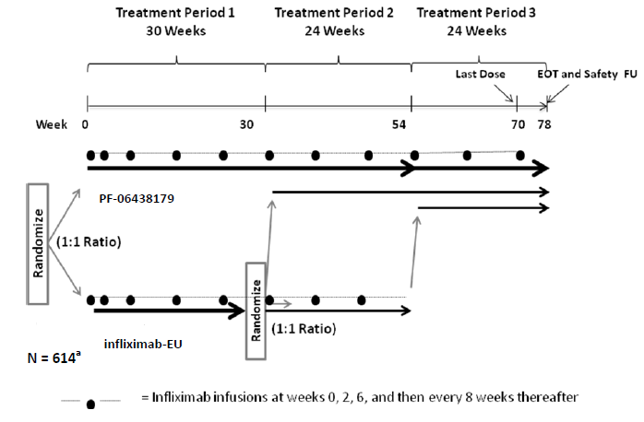
Abbreviations: EOT = end of treatment, FU = follow-up, N = number of subjects.
a. This study originally planned to enrol approximately 614 subjects; the actual number of subjects randomised was 650.
The inclusion criteria included subjects who were adults with moderately to severely active rheumatoid arthritis who were receiving a stable dose of methotrexate. Subjects were required to be on a stable dose of oral folic acid or folinic acid supplementation. There were inclusion criteria pertaining to prior, and concomitant, oral corticosteroid use and non-steroidal anti-inflammatory drug/cyclooxygenase-2 inhibitor use. The exclusion criteria pertained primarily to current and past medical history and current or prior treatment with specified drugs. Women who were pregnant or breastfeeding were excluded from the study.
The primary efficacy endpoint was the proportion of subjects achieving 20% or greater improvement in ACR clinical response (ACR20 response rate) at Week 14. The ACR definition for improvement in rheumatoid arthritis was calculated as a percent improvement from Baseline (Day 1) in the number of tender and swollen joints and percent improvement in 3 of the 5 other ACR-core set measures, specifically patient’s and physician’s global assessment of arthritis, patient’s assessment of arthritis pain, patient’s assessment of disability using the Health Assessment Questionnaire Disability Index (HAQ-DI), and an acute-phase reactant, hs-CRP. Sixty-eight joints were assessed for tenderness or pain, and 66 joints were assessed for swelling.
For Treatment Period 1, the secondary efficacy endpoints were:
- ACR20 response rates at time points of Weeks 2, 4, 6, 12, 22, and 30.
- ACR50 and ACR70 response rates at Week 14 and other protocol-defined time points up to Week 30.
- Change from Baseline in individual components of the ACR response criteria (including HAQ-DI) at Week 14 and other protocol defined time points up to Week 30.
- Change from Baseline in disease activity measured by Disease Activity Score-28; 4 components based on hs-CRP (DAS28-CRP) at Week 14 and other protocol-defined time points up to Week 30.
- Proportion of subjects with response (no, moderate or good response) defined according to the European League Against Rheumatism (EULAR) response criteria, at Week 14 and other protocol defined time points up to Week 30.
- Proportion of subjects with a disease activity score (DAS) remission (DAS < 2.6) at Week 14 and other protocol defined time points up to Week 30.
- Proportion of subjects with ACR/EULAR remission at Week 14 and other protocol defined time points up to Week 30.
The key secondary efficacy endpoints were ACR20 response rate and DAS28-CRP response at Week 22 and Week 30.
For Treatment Period 2, the secondary efficacy endpoints were as follows:
- ACR20 response rate at Week 38, Week 46 and Week 54.
- ACR50 response rate at Week 38, Week 46 and Week 54.
- ACR70 response rate at Week 38, Week 46 and Week 54.
- DAS remission (< 2.6) at Week 38, Week 46 and Week 54.
- EULAR response at Week 38, Week 46 and Week 54.
- ACR/EULAR remission at Week 38, Week 46 and Week 54.
- DAS28-CRP and its change from study Baseline at Week 38, Week 46 and Week 54.
- HAQ-DI and its change from study Baseline at Week 38, Week 46 and Week 54.
- Swollen joint count (66) and its change from study Baseline at Week 38, Week 46 and Week 54.
- Tender joint count (68) and its change from study Baseline at Week 38, Week 46 and Week 54.
- Patient’s assessment of arthritis pain and its change from study Baseline at Week 38, Week 46 and Week 54.
- Patient’s global assessment of arthritis and its change from study Baseline at Week 38, Week 46 and Week 54.
- Physician’s global assessment of arthritis and its change from study Baseline at Week 38, Week 46 and Week 54.
- hs-CRP and its change from study Baseline at Week 38, Week 46 and Week 54.
For Treatment Period 3, the secondary efficacy endpoints were as follows:
- ACR20 response rate at Week 62, Week 70 and Week 78.
- ACR50 response rate at Week 62, Week 70 and Week 78.
- ACR70 response rate at Week 62, Week 70 and Week 78.
- DAS remission (< 2.6) at Week 62, Week 70 and Week 78.
- EULAR response at Week 62, Week 70 and Week 78.
- ACR/EULAR remission at Week 62, Week 70 and Week 78.
- DAS28-CRP and its change from study Baseline and change from Week 54.
- HAQ-DI and its change from study Baseline and change from Week 54.
- Swollen joint count (66) and its change from study Baseline and change from Week 54.
- Tender joint count (68) and its change from study Baseline and change from Week 54.
- Patient’s assessment of arthritis pain and its change from study Baseline and change from Week 54.
- Patient’s global assessment of arthritis and its change from study Baseline and change from Week 54.
- Physician’s global assessment of arthritis and its change from study Baseline and change from Week 54.
- hs-CRP and its change from study Baseline and change from Week 54.
The planned sample size for the intent-to-treat (ITT) population was 614 subjects. The sample size was calculated using the difference in the ACR20 response rate between the two treatment arms.
Therapeutic equivalence of PF-06438179 and infliximab-EU was based on the primary efficacy endpoint. Therapeutic equivalence was demonstrated based on two different pre-specified equivalence margins, which were specified by the EMA and US FDA, respectively. The results of analyses for the primary endpoint based on the ITT population, per-protocol population, and using different methods to handle missing data, respectively, were consistent.

Results for the primary efficacy outcome
All randomised subjects were included in the ITT population. Relative to the ITT population, the per-protocol population was comprised of 86.1% (279 out of 324) of subjects in the PF-06438179 treatment group and 89.0% (290 out of 326) of subjects in the infliximab-EU treatment group.
Based on the subjects in the ITT population with non-missing ACR20 response data, the proportion of subjects in the PF-06438179 treatment group who achieved ACR20 response was 62.7% (203 out of 324) compared with 64.1% (209 out of 326) in the infliximab-EU treatment group. The difference in ACR20 response rate at Week 14 (PF-06438179-infliximab-EU) was -1.46%. The results based on the per-protocol population were supportive of the results in the ITT population. (Table 2).
Table 2: Study B5371002, descriptive summary of ACR20 response rate at Week 14, Treatment Period 1
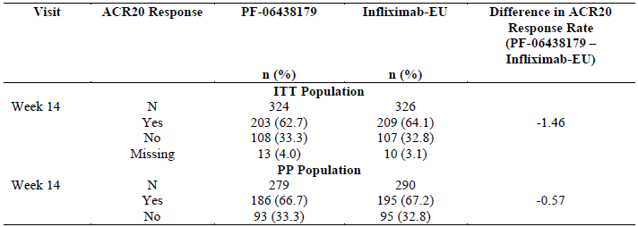
Abbreviations: EU = European Union, ITT = intent-to-treat, n = number of subjects, N = number of subjects randomised, TP1 = Treatment Period 1, PP = per-protocol.
For the application to the EMA, a symmetric equivalence margin was used. Equivalence between the two treatment arms was to be declared if the 2-sided 95% CI for the observed difference in ACR20 response rates at Week 14 fell within the pre-specified equivalence margin of (-13.5%, 13.5%). For the application in the USA, a pre-specified asymmetric equivalence margin criterion of (-12%, 15%) with a 90% 2-sided CI was agreed on with the US FDA.
For the primary analysis of ACR20, missing data were imputed using a non-responder imputation method. Therapeutic equivalence between the test infliximab (PF-06438179) and reference infliximab (infliximab-EU) was demonstrated.
Using the symmetric equivalence margin, the 2-sided 95% CI for the observed difference in ACR20 response rates at Week 14 fell within the equivalence margin of (-13.5%, 13.5%) (Table 3 and Figure 2). Using the asymmetric equivalence margin, the 90% 2-sided CI for the observed difference in ACR20 response rates at Week 14 fell within the equivalence margin of (-12%, 15%) (Table 4 and Figure 3).
Table 3: Study B5371002, exact binomial approach for ACR20 response rate at Week 14, using non-responder imputation for missing data, Treatment Period 1 (95% CIª)
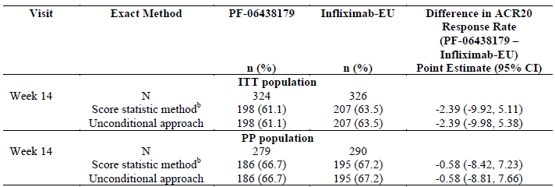
Abbreviations: CI = confidence interval, EU = European Union, ITT = intent-to-treat, n = number of subjects with ACR20 response, N = number of subjects with non-missing ACR20 response data, PP = per-protocol, TP1 = Treatment Period 1.
a. 95% CI is part of the symmetric margin criterion.
b. Score statistic was the primary inference for similarity.
Figure 2: Study B5371002, therapeutic equivalence of ACR20 response rate at Week 14 established between PF-06438179 and infliximab-EU, using non-responder imputation for missing data, Treatment Period 1 (95% CI and symmetric margin)
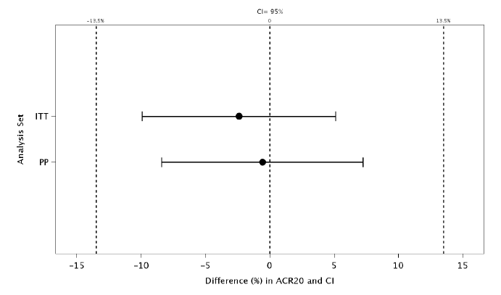
Abbreviations: CI = confidence interval, EU = European Union, ITT = intent-to-treat, PP = per-protocol, TP1 = Treatment Period 1.
Table 4: Study B5371002, exact binomial approach for ACR20 response rate at Week 14, using non-responder imputation for missing data, Treatment Period 1 (90% CIª)
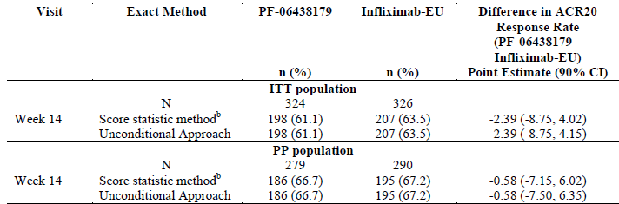
Abbreviations: CI = confidence interval, EU = European Union, ITT = intent-to-treat, n = number of subjects with ACR20 response, N = number of subjects with non-missing ACR20 response data, PP = per-protocol, TP1 = Treatment Period 1.
a. 90% CI is part of the asymmetric margin criterion.
b. Score statistic was the primary inference for similarity.
Figure 3: Study B5371002, therapeutic equivalence of ACR20 response rate at Week 14 established between PF-06438179 and infliximab-EU, using non-responder imputation for missing data, Treatment Period 1 (90% CI and asymmetric margin)
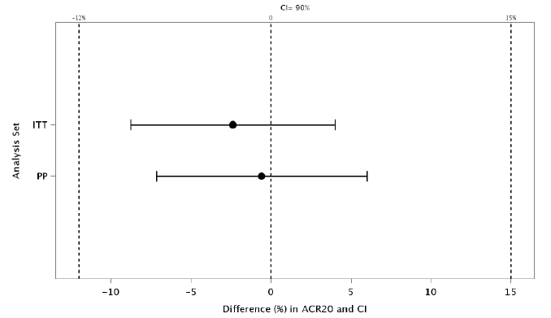
Abbreviations: CI = confidence interval, EU = European Union, ITT = intent-to-treat, PP = per-protocol, TP1 = Treatment Period 1.

Key secondary efficacy endpoints
No equivalence testing was undertaken for the secondary efficacy endpoints. The results for the key secondary efficacy outcomes and other secondary efficacy endpoints in Treatment Period 1 were generally supportive of the results for the primary efficacy endpoint. The key secondary efficacy endpoints were ACR20 response rate and DAS28-CRP response at Week 22 and Week 30.

ACR20 response rate at Week 22 and Week 30
At Week 22, the difference in the ACR20 response rate between the two treatment groups (PF-06438179-infliximab-EU) was -2.07%. (Table 5). At Week 30, the difference in the ACR20 response rate between the two treatment groups (PF-06438179-infliximab-EU) was -3.31%. (Table 5). The proportion of subjects in each treatment group who achieved ACR20 response at Week 22 and Week 30, respectively, was similar irrespective of the dose received at Week 14 (continuing 3 mg/kg or dose escalation to 5 mg/kg).
Table 5: Study B5371002, descriptive summary of ACR20 response rate by visit up to Week 30, intent-to-treat population, Treatment Period 1
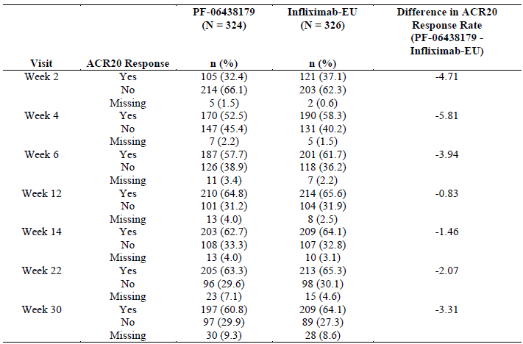
Abbreviations: EU = European Union, ITT = intent-to-treat, n = number of subjects, N = number of subjects randomised, TP1 = Treatment Period 1.

DAS28-CRP response at Week 22 and Week 30
Based on subjects in the ITT population contributing to the response, DAS28-CRP response at Week 22 and Week 30, respectively, was similar in each treatment group.
At Week 22, the median DAS28-CRP was 3.790 (range: 1.03 to 8.01) in the PF-06438179 treatment group (n = 301) and 3.916 (range: 1.09 to 8.16) in the infliximab-EU treatment group (n = 307).
At Week 30, the median DAS28-CRP was 3.621 (range: 1.05 to 8.13) in the PF-06438179 treatment group (n = 292) and 3.797 (range: 1.04 to 7.58) in the infliximab-EU treatment group (n = 297).
The results based on the per-protocol population were similar to the results in the ITT population.
The efficacy results for Treatment Period 2 suggest no loss of efficacy, based on the efficacy parameters assessed, with switching from infliximab-EU to PF-06438179.
The efficacy results for Treatment Period 3 suggest that switching infliximab study treatments during the study did not affect the comparability of efficacy.

Safety
In Study B5371002, safety endpoints were secondary endpoints.

Patient exposure
In Treatment Period 1, based on the safety population, the median duration of treatment was the same in each treatment group (22.1 weeks). The majority of subjects in each treatment group received treatment for a duration of 99 to 210 days (PF-06438179: 92.3% (298 out of 323); infliximab-EU: 96.0% (313 out of 326)). The median total dose of study treatment received by subjects in each treatment group was generally comparable. The proportion of subjects who missed a dose was 4.3% (14 out of 323) in the PF-06438179 treatment group and 4.6% (15 out of 326) of subjects in the infliximab-EU treatment group. Based on the Treatment Period 2 safety population, the median duration of treatment during Treatment Period 2 was 16.1 weeks in each treatment group. Based on the Treatment Period 3 safety population (n = 505), the median duration of treatment during Treatment Period 3 was 16.1 weeks in each treatment group.

Treatment-emergent adverse events
For the treatment-emergent adverse event (TEAE) preferred terms reported in ≥ 3% in any treatment group, the two treatment groups were generally comparable. In Treatment Period 1, Treatment Period 2 and Treatment Period 3 of Study B5371002, based on the safety population, a similar proportion of subjects in each treatment group were reported with adverse events (AEs):
- Treatment Period 1: PF-06438179: 57.3% (185 out of 323); Infliximab-EU: 54.0% (176 out of 326).
- Treatment Period 2: PF-06438179/ PF-06438179: 36.8% (103 out of 280); infliximab-EU/infliximab-EU: 33.6% (48/143), infliximab-EU/PF-06438179: 37.8% (54 out of 143).
- Treatment Period 3: PF-06438179/PF-06438179/PF-06438179: 28.9% (73 out of 253); infliximab-EU/infliximab-EU/PF-06438179: 30.2% (38 out of 126); infliximab-EU/ PF-06438179/PF-06438179: 29.4% (37 out of 126).
A single subject in the PF-06438179/PF-06438179/PF-06438179 treatment group had treatment-related neutropenia and 3 subjects in the infliximab-EU/PF-06438179/PF-06438179 treatment group had four treatment-related Grade 3 TEAEs falling under the infections and infestations system organ class (cellulitis, chronic sinusitis, encephalitis and tuberculosis).

Immunogenicity and immunological events
In Study B5371002, the immunogenicity endpoints were the number and proportion of subjects who had at least one sample that tested positive for ADAs and, for ADA positive subjects, neutralising antibodies (NAb), and the titres of ADA and NAb in response to PF-06438179 and infliximab-EU. It is indicated that these endpoints were secondary endpoints.
Based on the safety population, at each of the assessment time points during Treatment Period 1 (Week 0 (Baseline), Week 2, Week 6, Week 14 and Week 30), the proportion of subjects who were ADA positive was similar in each treatment group. In each treatment group, the proportion of subjects who were ADA positive was highest at Week 30.
Of those subjects who were ADA positive, the proportions of subjects who were NAb positive were higher in the Infliximab-EU treatment group, compared with the PF-06438179 treatment group, at these time points.

Deaths and other serious adverse events
The proportion of subjects between treatment groups with serious TEAEs were overall similar or were higher in the Infliximab-EU/Infliximab-EU treatment group compared to the PF-06438179/PF-06438179 group.
There were three deaths in total in the PF-06438179 treatment group, with causes being acute myocardial infarction, unknown cause of death and sudden cardiac death. There was one subject in the Infliximab-EU treatment group who died from pulmonary embolism and acute perforated diverticulitis. The investigators did not consider these to be related to the study drug.

Issues with possible regulatory impact
The proportion of subjects with Grade 1 to 2 TEAEs of alanine aminotransferase (ALT) increased and aspartate aminotransferase (AST) increased, respectively, was generally similar in each treatment group. In Treatment Period 2 a subject in the infliximab-EU/infliximab-EU treatment group was reported with serious treatment-related AEs of ALT increased and AST increased and led to study drug discontinuation. In Treatment Period 3, two subjects in the PF-06438179/PF-06438179/PF-06438179 treatment group and one subject in the infliximab-EU/PF-06438179/PF-06438179 were reported with Grade 3 TEAEs of ALT increased.

Renal function and renal toxicity
The proportion of subjects with Grade1 to 2 creatinine increased was similar in each treatment group throughout each of the treatment periods.

Recommendation following the clinical evaluation
The clinical evaluation considered the overall benefit-risk balance of Ixifi as favourable and supported its registration.

Risk management plan
The sponsor submitted global risk management plan (RMP) version 3.0; dated 27 July 2020; data lock point (DLP) 6 July 2017 (clinical trial data) and 19 May 2020 (post-marketing data) and Australian specific annex (ASA) version 1.0 dated 18 July 2023 in support of this application.
The summary of safety concerns and their associated risk monitoring and mitigation strategies are summarised in Table 6. The TGA may request an updated RMP at any stage of a product's life-cycle, during both the pre-approval and post-approval phases.
Table 6: Summary of safety concerns
Summary of safety concerns |  | Pharmacovigilance |  | Risk Minimisation
 |  | Routine | Additional | Routine | Additional
Important identified risks | Serious infection/sepsis | ü | – | ü | –
Important identified risks | Demyelinating disorders | ü | – | ü | –
Important identified risks | Malignancy | ü | –
Important identified risks | Bacillus Calmette-Guérin (BCG) breakthrough infection and agranulocytosis in infants within utero exposure to infliximab | ü | – | ü | –
Important potential risks | Colon carcinoma/dysplasia (in paediatric ulcerative colitis) | ü | – | ü | –
Missing information | None | – | – | – | –
The summary of safety concerns aligns with the innovator and is considered acceptable.
The sponsor has proposed routine pharmacovigilance activities for all safety concerns. The pharmacovigilance plan aligns with the innovator and is acceptable from an RMP perspective.
The sponsor has proposed routine risk minimisation activities for all safety concerns. The risk minimisation plan aligns with the innovator and is acceptable from an RMP perspective.
The sponsor amended the CMI as requested. The sponsor also clarified that the package insert provided inside the medicine carton is an ‘Instruction of Use’ document.
The RMP evaluation recommended conditions of registration relating to the versions of the risk management plan.

Risk-benefit analysis

Delegate’s considerations

Proposed indications
The proposed indications for Ixifi are the same as those for Remicade. This is appropriate for a biosimilar. The sponsor has justified extrapolation across the indications, primarily based on the structural and functional similarity between Ixifi to Remicade. The sponsor also justified the extrapolation to paediatric patients (Crohn’s disease and ulcerative colitis) on the basis that the pharmacokinetics of Ixifi and Remicade are similar, and that the efficacy in rheumatoid arthritis and paediatric Crohn’s disease and paediatric ulcerative colitis are similar due to shared mechanism of action. These justifications are acceptable.

Pharmacokinetic equivalence
Equivalence of Ixifi to Remicade (US and EU products) was demonstrated in the Phase I Study B5371001. The 90% confidence interval of the geometric mean ratios of the primary PK parameters (AUC_{0-inf} and C_{max}) were within the prespecified acceptance intervals (80.00% to 125.00%).
The PK obtained from the Phase III comparative clinical Study B5371002 also demonstrated similar PK of Ixifi and Remicade-EU.

Efficacy
The efficacy of Ixifi in treating adults with moderate to severely active rheumatoid arthritis who were receiving a stable dose of methotrexate is demonstrated in Study B5371002. The study was of appropriate size and duration, and the endpoints were acceptable and supported by the EU guideline. Therapeutic equivalence was demonstrated based on two different pre-specified equivalence margins, which were specified by the EMA and US FDA, respectively.
The proposed rheumatoid arthritis indication refers to patients who have active disease despite treatment with methotrexate and to patients with active disease who have not previously received methotrexate. This was an appropriate choice for the single Phase III study due to the expected robust treatment effect (that is, better sensitivity to detect any difference) and fewer patient comorbidities and concomitant immunosuppressant use. The study was designed according to EMA guidelines and adopted after consultation with the EMA and FDA. The selected efficacy endpoints are accepted validated measures that have been used in previous rheumatoid arthritis studies and are consistent with the EU guideline. Overall, Ixifi demonstrated comparable efficacy to EU Remicade for adult patients with rheumatoid arthritis.
Ixifi demonstrated equivalence to Remicade for the primary endpoint and was supported by several secondary endpoints, consistent with the EU guideline on rheumatoid arthritis. The pre-specified equivalence margins of ± 13.5% for the symmetric equivalence margin criterion, and asymmetric equivalence margins of -12%, 15%, are considered clinically acceptable for the purpose of confirming equivalence of the proposed infliximab product with Remicade. The equivalence margins of ± 13.5% was reported to be the equivalence margin accepted by the EMA and the asymmetric equivalence margin criterion of -12%, 15% was reported to be the equivalence margin agreed on with the US FDA.

Safety
The safety data were comparable between Ixifi and Remicade. This includes no signal for differences in the most concerning adverse events such as infusion-related reactions, hypersensitivity, malignancy, serious and opportunistic infection and tuberculosis. There was a similar incidence of ADAs, and switching from the reference infliximab product to the proposed infliximab product did not suggest potential safety issues with switching. There are a number of infliximab products that are on the Australian Register of Therapeutic Goods. The safety profile of infliximab has already been established in each of the proposed indications and at the dosages proposed for Ixifi.

Risk-benefit-uncertainty assessment
The risk-benefit assessment is generally supportive of Ixifi as a Remicade biosimilar.

Proposed action
Overall adequate evidence has been presented to support Ixifi as a Remicade biosimilar for all indications.

Assessment outcome
Based on a review of quality, safety, and efficacy, the TGA decided to register Ixifi (infliximab) 100 mg, powder for injection, vial, indicated for:
Rheumatoid Arthritis in adults
Ixifi, in combination with methotrexate, is indicated for the reduction of signs and symptoms and prevention of structural joint damage (erosions and joint space narrowing) in:
- patients with active disease despite treatment with methotrexate.
- patients with active disease who have not previously received methotrexate.
Ixifi should be given in combination with methotrexate. Efficacy and safety in Rheumatoid Arthritis have been demonstrated only in combination with methotrexate.
Ankylosing Spondylitis
Ixifi is indicated for the reduction of signs and symptoms and improvement in physical function in patients with active disease.
Psoriatic arthritis
Ixifi is indicated for the treatment of the signs and symptoms, as well as for the improvement in physical function in adult patients with active and progressive psoriatic arthritis who have responded inadequately to disease-modifying anti-rheumatic drug (DMARD) therapy.
Ixifi may be administered in combination with methotrexate.
Psoriasis
Ixifi is indicated for the treatment of adult patients with moderate to severe plaque psoriasis for whom phototherapy or conventional systemic treatments have been inadequate or are inappropriate. Safety and efficacy beyond 12 months have not been established.
Crohn’s Disease in adults and in children and adolescents (6 to 17 years)
Ixifi is indicated for the treatment of moderate to severe Crohn’s disease, to reduce the signs and symptoms and to induce and maintain clinical remission in patients who have an inadequate response to conventional therapies.
Refractory Fistulising Crohn’s Disease
Ixifi is indicated for reducing the number of draining enterocutaneous and rectovaginal fistulas and maintaining fistula closure in adult patients.
Ulcerative colitis in adults and in children and adolescents (6 to 17 years)
Ixifi is indicated for the treatment of moderately severe to severe active ulcerative colitis in patients who have had an inadequate response to conventional therapy.

Specific conditions of registration
- The Ixifi Global-Risk Management Plan (RMP) (version 3.0, dated 27 July 2020, data lock point 6 July 2017 (clinical trial data) and 19 May 2020 (post-marketing data), with Australian Specific Annex (version 1.0, dated 18 July 2023), included with submission PM-2023-04183-1-3, and any subsequent revisions, as agreed with the TGA will be implemented in Australia.

Product Information and Consumer Medicine Information
For the most recent Product Information (PI) and Consumer Medicine Information (CMI), please refer to the TGA PI/CMI search facility.
Therapeutic Goods Administration
PO Box 100 Woden ACT 2606 Australia
Email: info@tga.gov.au Phone: 1800 020 653 Fax: 02 6203 1605
https://www.tga.gov.au

This is the original indication proposed by the sponsor when the TGA commenced the evaluation of this submission. It may differ to the final indication approved by the TGA and registered in the Australian Register of Therapeutic Goods.
Remicade was first registered in Australia on 2 August 2000.

