Australian Public Assessment Report for Imdelltra
  - Active ingredient: tarlatamab
  - Sponsor: Amgen Australia Pty Ltd
March 2026

About the Therapeutic Goods Administration (TGA)
- The Therapeutic Goods Administration (TGA) is part of the Australian Government Department of Health, Disability and Ageing and is responsible for regulating therapeutic goods, including medicines, medical devices, and biologicals.
- The TGA administers the Therapeutic Goods Act 1989 (the Act), applying a risk management approach designed to ensure therapeutic goods supplied in Australia meet acceptable standards of quality, safety, and efficacy.
- The work of the TGA is based on applying scientific and clinical expertise to decision-making, to ensure that the benefits to the Australian public outweigh any risks associated with the use of therapeutic goods.
- The TGA relies on the public, healthcare professionals and industry to report problems with therapeutic goods. The TGA investigates reports received to determine any necessary regulatory action.
- To report a problem with a therapeutic good, please see the information on the TGA website.

About AusPARs
- The Australian Public Assessment Report (AusPAR) provides information about the evaluation of a prescription medicine and the considerations that led the TGA to approve or not approve a prescription medicine submission. Further information can be found in Australian Public Assessment Report (AusPAR) guidance.
- AusPARs are prepared and published by the TGA.
- AusPARs are static documents that provide information that relates to a submission at a particular point in time. The publication of an AusPAR is an important part of the transparency of the TGA’s decision-making process.
- A new AusPAR may be provided to reflect changes to indications or major variations to a prescription medicine subject to evaluation by the TGA.

Copyright
© Commonwealth of Australia 2026
This work is copyright. You may reproduce the whole or part of this work in unaltered form for your own personal use or, if you are part of an organisation, for internal use within your organisation, but only if you or your organisation do not use the reproduction for any commercial purpose and retain this copyright notice and all disclaimer notices as part of that reproduction. Apart from rights to use as permitted by the Copyright Act 1968 or allowed by this copyright notice, all other rights are reserved and you are not allowed to reproduce the whole or any part of this work in any way (electronic or otherwise) without first being given specific written permission from the Commonwealth to do so. Requests and inquiries concerning reproduction and rights are to be sent to the TGA Copyright Officer, Therapeutic Goods Administration, PO Box 100, Woden ACT 2606 or emailed to <tga.copyright@tga.gov.au>.

Contents
List of abbreviations 4
Product submission 5
Submission details 5
Product background 6
Disease or condition 6
Current treatment options 6
Clinical rationale 7
Regulatory status 7
Australian regulatory status 7
International regulatory status 8
Registration timeline 8
Assessment overview 8
Quality evaluation summary 8
Nonclinical evaluation summary 10
Clinical evaluation summary 11
Pharmacology 11
Efficacy 12
Safety 20
Risk management plan 27
Risk-benefit analysis 28
Efficacy 28
Safety 29
Assessment outcome 29
Specific conditions of registration 29
Certified Product Details 30
Product Information and Consumer Medicine Information 31

List of abbreviations
Abbreviation | Meaning
ARTG | Australian Register of Therapeutic Goods
ASA | Australia-specific annex
BICR | Blinded independent central review
BiTE | Bispecific T-cell engager
CI | Confidence interval
CMI | Consumer Medicines Information
CR | Complete response
CRS | Cytokine release syndrome
DLL3 | Delta-like ligand 3
DoR | Duration of response
E-R | Exposure - response
ES-SCLC | Extensive-stage small cell lung cancer
ICANS. | Immune Effector Cell-Associated Neurotoxicity Syndrome
IVSS | Intravenous solution stabiliser
ORR | Objective response rate
OS | Overall survival
PFS | Progression-free survival
PI | Product Information
PR | Partial response
PSUR | Periodic safety update report
Q2W | Every 2 weeks
Q3W | Every 3 weeks
RECIST | Response Evaluation Criteria in Solid Tumors
RMP | Risk management plan
SCLC | Small cell lung cancer
TGA | Therapeutic Goods Administration

Product submission

Submission details
Type of submission: | New biological entity
Product name: | Imdelltra
Active ingredient: | Tarlatamab
Decision: | Approved
Date of decision: | 4 June 2025
Date of entry onto ARTG: | 26 June 2025
ARTG numbers: | 453165, 453166
Black Triangle Scheme  for the current submission: | Yes
Sponsor’s name and address: | Amgen Australia Pty Ltd
Dose form: | Lyophilised powder for injection
Strengths/pack sizes: | 0.9 mg/mL (1 mg tarlatamab lyophilised powder after reconstitution with 1.3 mL of sterile water for injections; 1 mg package contains 1 vial of 1 mg Imdelltra and 2 vials of 7 mL IV solution stabiliser.
Strengths/pack sizes: | 2.4 mg/mL (10 mg tarlatamab lyophilised powder. After reconstitution with 4.4 mL sterile water for injections; 10 mg package contains 1 vial of 10 mg Imdelltra and 2 vials of 7 mL IV solution stabiliser.)
Approved therapeutic use for the current submission: | Imdelltra has provisional approval in Australia for the treatment of adult patients with extensive-stage small cell lung cancer (ES-SCLC) with disease progression on or after platinum-based chemotherapy.  The decision to approve this indication has been made on the basis of overall response rate and duration of response in a single arm trial. Continued approval of this indication depends on verification and description of benefit in confirmatory trials.
Route of administration: | Intravenous infusion
Dosage: | For further information regarding dosage/dosage schedule, refer to the Product Information.
Pregnancy category: | Category C  Drugs which, owing to their pharmacological effects, have caused or may be suspected of causing, harmful effects on the human fetus or neonate without causing malformations. These effects may be reversible.  The use of any medicine during pregnancy requires careful consideration of both risks and benefits by the treating health professional. The pregnancy database must not be used as the sole basis of decision making in the use of medicines during pregnancy. The TGA does not provide advice on the use of medicines in pregnancy for specific cases. More information is available from obstetric drug information services in your state or territory.

Product background
This AusPAR describes the submission by Amgen Australia Pty Ltd (the sponsor) to register Imdelltra (tarlatamab) for the following proposed indication:
Treatment of adult patients with advanced small cell lung cancer (SCLC) with disease progression on or after platinum-based chemotherapy

Disease or condition
Globally, lung cancer is the second most commonly diagnosed cancer and leading cause of cancer death, representing approximately 1 in 10 (11.4%) cancers diagnosed and 1 in 5 (18.0%) cancer deaths. Small cell lung cancer accounts for approximately 15% of overall lung cancer cases with approximately 330 000 new cases worldwide each year based on an estimated 2.2 million cases of lung cancer in 2020,,,2). There are approximately 270 000 new deaths worldwide due to SCLC based on approximately 1.8 million lung cancer deaths in 2020.2
Small cell lung cancer is a high-grade neuroendocrine tumor marked by an exceptionally high proliferative rate, strong predilection for early metastasis, and poor prognosis.5 While 30% of patients present with disease that can be encompassed by one radiotherapy field (limited stage), the majority of cases have disease diagnosed as extensive stage. Although 20% to 30% of patients with limited stage can be cured with radio-chemotherapy, treatment is rarely curative in extensive stage, and SCLC is associated with poor long-term survival overall (5-year survival is <10%).
In Australia, in 2018 the 5-year total lung cancer prevalence was 23,169 persons. SCLC accounts for 15% of these persons, or 3475. Using an Australian population of 26,997,898 (as of January 2024), this equates to a prevalence of 1.28 per 10,000 individuals.

Current treatment options
Current first-line treatment for ES-SCLC generally consists of etoposide in combination with platinum chemotherapy and a programmed death ligand 1 (PD-L1) immune checkpoint inhibitor. Although this first-line regimen in extensive-stage SCLC has a relatively high response rate of 60% to 70%, resistance and relapse almost always occur, usually within the first year after treatment for nearly all patients with extensive-stage SCLC.5 Almost all patients relapse after initial therapy and the median overall survival from front-line ES-SCLC trials is approximately 12 to 13 months.,,
Topotecan is the only fully approved drug by the TGA for the treatment of patients with SCLC with disease progression after first line chemotherapy. Lurbinectedin is provisionally approved in Australia for the treatment of metastatic SCLC that has progressed on or after prior platinum-containing therapy.
There are currently no approved therapies for patients failing two prior lines of therapy, and only 20% to 30% of patients diagnosed with SCLC receive third-line therapy. Options include rechallenging with the initial regimen and other single agent or combination chemotherapy regimens. Response rates in third-line are approximately 21%, and median overall survival (OS) is approximately 4 months. Patients receiving best supportive care in third-line have a median OS expectation of only 0.9 months.

Clinical rationale
Tarlatamab is a novel half-life extended bispecific T-cell engager (BiTE) molecule. Tarlatamab consists of 2 single-chain variable fragment (scFv) binding domains that are specific for the tumor antigen Delta-like ligand 3 (DLL3) and for the T cell receptor-associated complex. The activity of tarlatamab requires the simultaneous binding to both target cells and T cells. The pharmacological effect of tarlatamab is mediated by specific redirection of previously primed cytotoxic CD8+ or CD4+ T lymphocytes to kill DLL3+ cells. DLL3, a non-canonical ligand within the Notch signaling pathway, which plays a role in the development of pulmonary neuroendocrine cells, is a potential therapeutic target for SCLC. DLL3 is expressed almost exclusively in the intracellular compartment of a few normal tissues but is upregulated and abnormally expressed on the cell surface of SCLC and other high-grade neuroendocrine tumours.,

Regulatory status

Australian regulatory status
This product is considered a new biological entity for Australian regulatory purposes.

International regulatory status
At the time the TGA considered this submission, Imdelltra had received Accelerated Approval in the US on 16 May 2024 for the treatment of adult patients with extensive stage small cell lung cancer (ES-SCLC) with disease progression on or after platinum-based chemotherapy.

Registration timeline
Table 1 captures the key steps and dates for this submission.
This submission was evaluated under the provisional registration process.
The active ingredient with its proposed indication was given orphan drug designation.
Table 1. Timeline for Imdelltra (tarlatamab), Submission PM-2024-02535-1-4
Description | Date
Designation (Orphan) | 13 March 2024
Determination (Provisional) | 22 April 2024
Submission dossier accepted and first round evaluation commenced | 31 July 2024
Evaluation completed | 28 February 2025
Registration decision (Outcome) | 4 June 2025
Registration in the ARTG completed | 26 June 2025
Number of working days from submission dossier acceptance to registration decision | 185

Assessment overview
This evaluation was facilitated through Project Orbis, an initiative of the United States Food and Drug Administration (FDA) Oncology Center of Excellence. Under this project, the FDA, the Brazilian Health Regulatory Agency (ANVISA), Health Canada (HC), Israel’s Ministry of Health (IMoH), the United Kingdom’s Medicines and Healthcare products Regulatory Agency (MHRA) and the TGA collaboratively reviewed the submission. This evaluation process provided a framework for process alignment and management of evaluation issues in real-time across jurisdictions. Each regulator made independent decisions regarding approval (market authorisation) of the new medicine.
A summary of the TGA’s assessment for this submission is provided below.

Quality evaluation summary
Imdelltra is supplied as a composite pack consisting of one vial of lyophilised tarlatamab powder for injection (either 1 mg or 10 mg), and two vials of intravenous solution stabiliser (IVSS), each containing 7 mL. The drug product is administered by intravenous infusion. Due to the low concentration of drug product administered, the IVSS is required to prevent adsorption of tarlatamab to infusion bags and tubing, ensuring dose accuracy and consistent clinical performance.
The formulation of the lyophilised drug product includes sucrose, glutamic acid, sodium hydroxide, and polysorbate 80, all of which are well-established excipients compliant with USP, Ph. Eur., and JP standards. The IVSS contains lysine hydrochloride, citric acid monohydrate, polysorbate 80, sodium hydroxide, and water for injections. No novel excipients are used in either component.
Tarlatamab is a single-chain antibody derivative of the BiTE class, expressed in Chinese Hamster Ovary (CHO) cells, with a molecular weight of approximately 105 kDa. It comprises two single-chain variable fragments (scFv) targeting DLL3 and CD3, fused to a half-life-extended Fc fragment. The molecule is aglycosylated by design, through elimination of the glycosylation site in the Fc domain (Figure 1).
Figure 1: Schematic structure of tarlatamab
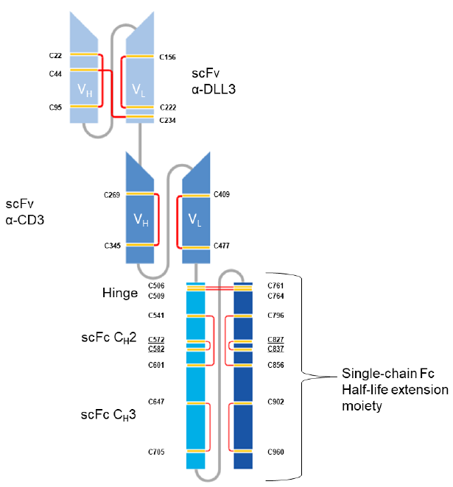
scFv = single-chain variable fragment; α-DLL3 = anti-delta-like ligand 3; α-CD3 = anti-cluster of differentiation 3; V_{H} = variable heavy chain region; V_{L} = variable light chain region; scFc = single-chain fragment crystallizable; C_{H}2 = constant heavy chain 2; C_{H}3 = constant heavy chain 3
The active substance is manufactured using recombinant DNA technology at Immunex Rhode Island Corporation (USA). The manufacturing process includes cell culture expansion, clarification, multiple chromatography steps, viral inactivation and filtration, ultrafiltration/diafiltration, formulation, sterile filtration, and storage. Control of critical process parameters, intermediates, and impurities is described in sufficient detail, with extensive characterisation performed using state-of-the-art analytical methods.
The active substance shelf life is supported for 24 months at −30 ± 10 °C, based on real-time, accelerated, and stress stability studies. Extractables and leachables studies for the storage containers demonstrated negligible patient risk.
The finished product is manufactured at Amgen Inc., Thousand Oaks, California, via a process that includes formulation, sterile filtration, aseptic filling, lyophilisation, inspection, and refrigerated storage. The container closure system (Type I glass vial with fluoropolymer-laminated elastomeric stopper) was demonstrated to be suitable through compatibility and stability studies.
Quality control testing for batch release includes comprehensive testing of both the lyophilised powder and the reconstituted product, covering appearance, identity, purity, potency, sterility, endotoxin levels, and other physicochemical parameters. All non-compendial analytical methods were appropriately validated.
Stability data support a finished product shelf life of 18 months at 2–8 °C, protected from light. The IVSS has a longer shelf life; however, the composite pack shelf life is governed by the shorter 18-month drug product shelf life. Approved temperature excursions during transport are:
- −20 °C for up to 48 hours,
- 25 °C for up to 10 days, and
- 40 °C for up to 24 hours.
In-use stability studies support storage of the prepared Imdelltra infusion bag for:
- Up to 7 days at 2–8 °C, or
- Up to 8 hours at 23–25 °C, inclusive of preparation and administration time.
The product is not photostable and must be stored in the original carton to protect from light. Storage conditions are consistent across the labels, Product Information (PI), Consumer Medicines Information (CMI), and ARTG entries, with no discrepancies identified.
Evaluations covering sterility, endotoxin, viral safety, and container safety identified no outstanding issues.
There are no objections on quality grounds to the approval of Imdelltra in either the 1 mg or
10 mg presentations.

Nonclinical evaluation summary
The submitted nonclinical dossier was in accordance with the relevant ICH guidelines for the nonclinical assessment of anticancer anti-cancer pharmaceuticals (ICH S9) and biological medicines (ICH S6). The overall quality of the nonclinical dossier was high with all pivotal safety-related studies being GLP compliant. The application was submitted as part of a Project ORBIS evaluation, using review documents from the FDA to complete the nonclinical evaluation report.
In vitro, tarlatamab bound both human and monkey DLL3 and T-cell receptor subunit cluster of differentiation 3 epsilon (CD3ℇ) with nanomolar affinity and mediated lysis of the membrane bound DLL3-expressing cell lines with human and monkey T-cells. Tarlatamab also induced dose-dependent upregulation of T-cell activation markers, cytokine release, as well as cytotoxicity of DLL3+ positive cells. In vivo, in multiple xenograft mouse models, tarlatamab resulted in T-cell activation, redirection of T cells to achieve tumour cell lysis, and reduced tumour burden.
Tarlatamab demonstrated limited potential for on target-off tissue activity or target-independent activation of T cells in vivo at clinically relevant concentrations.
While no dedicated safety pharmacology studies were conducted, effects on the cardiovascular, respiratory, and central nervous systems were assessed in repeat dose toxicity studies. No tarlatamab-related changes in electrocardiogram, body temperature, respiration rate, and neurological examination parameters were reported.
Overall, the pharmacokinetic profile in monkeys was sufficiently similar to that of humans to serve as reasonable proxies for examining toxicity based on the pharmacokinetic profiles. Half- life values were broadly comparable between monkey and human, as was clearance. Tarlatamab-mediated redirection of lymphocytes to the pituitary was noted indicating a mild distribution to the pituitary in the absence of tumour cells, likely due to DLL3 expression.
No dedicated single dose toxicity studies were conducted. In monkey repeat dose toxicity studies, tarlatamab had a low order of acute IV toxicity.
Repeat-dose toxicity studies by the IV oral route were conducted in mice (28-days; using a mouse surrogate molecule, muS757) and in monkeys (28-days and 3-months). Maximum exposures based on body surface area (BSA) were moderate in both species. No major organs of toxicities were identified.
No genotoxicity or carcinogenicity studies were conducted. This is consistent with ICH guidelines for an anti-cancer therapeutic and biological product.
No dedicated reproductive toxicity studies were conducted with tarlatamab, which is consistent with ICH guidelines for an anticancer therapeutic. However, an embryofetal development toxicity study conducted in mice with muS757 did not result in maternal toxicity nor any fetal effects.
No tarlatamab-related changes in dermal irritation parameters were reported.
There are no nonclinical objections to registration.

Clinical evaluation summary

Pharmacology
Tarlatamab clinical pharmacology was evaluated from the phase 2 Study 20200491 and the phase 1 first-in-human Study 20160323.
The pharmacokinetic (PK) profile of tarlatamab was characterized based on evaluation of data from the above two studies.
Dose proportionality: The exposure of tarlatamab increased dose proportionally in the evaluated dose range of 1 mg to 100 mg.
Distribution: Tarlatamab’s steady state volume of distribution is 8.6 L (18.3%).
Elimination: Tarlatamab’s median elimination half-life (min, max) is 11.2 (4.3 to 26.5) days, and the estimated clearance is 0.65 L/day (44%) in patients with SCLC. Steady state was achieved by Cycle 2 Day 15.
Immunogenicity: 3 % (4/214) of patients tested positive for ADA and none of the patients tested positive for nAb in the pivotal Study 20200491.
No clinically meaningful differences in the PK were observed based on age (32 to 82 years), body weight (35 to 149 kg), sex, race (White and Asian), mild to moderate renal impairment, or mild hepatic impairment. None of the covariates evaluated above found to have important effect on E-R relationships for efficacy. Therefore, no dose adjustment is needed based on these intrinsic or extrinsic covariates. The effects of severe renal impairment, end-stage renal disease, moderate to severe hepatic impairment, anti-drug antibodies (ADA), or ethnicity (e.g., Hispanic or Latino) are unknown due to limited or unavailable data.

Population pharmacokinetics
Population PK (popPK) analysis was performed using pooled serum concentration-time data from 420 subjects enrolled in phase 1 first-in-human Study 20160323 and pivotal phase 2 Study 20200491. The final population PK model was a 2-compartment model with first order elimination. Tarlatamab serum clearance, central volume of distribution, peripheral volume of distribution, and volume of distribution at steady state were estimated to be 0.65 L/day, 3.44 L, 5.06 L, and 8.5 L, respectively for a typical 73 kg White individual. The inter-individual variability for tarlatamab clearance and central volume of distribution were 43.7% and 38.7%, respectively.
No dose adjustment for tarlatamab is needed for intrinsic and extrinsic factors including age, BW, sex, race (White and Asian), mild to moderate renal impairment, or mild hepatic impairment, as the popPK analyses showed no clinically important effect of these covariates on the PK or exposure-response (E-R) efficacy relationship of tarlatamab. Due to limited data, the effects of severe renal impairment, end-stage renal disease, moderate to severe hepatic impairment, ADA, or ethnicity (e.g., Hispanic or Latino) on tarlatamab PK are unknown.

Pharmacodynamics
Transient elevation of serum cytokines IL-2, IL-6, IL-8, IL-10, and IFN-γ were observed at a tarlatamab dosage of 0.3 mg Q2W and above. Peak elevation of cytokines was generally observed 20-24 hours following the initial dose of tarlatamab at 1 mg on Cycle 1 Day 1 and generally returned to baseline levels prior to the next infusion on Cycle 1 Day 8.
Higher exposures were associated with higher objective response rate (ORR). The efficacy reached a plateau at the higher exposures of target dosage 10 mg Q2W supporting the proposed dosage. Higher tarlatamab exposures were associated with higher incidences of any grade neutropenia, grade 1 and grade 2 neurotoxicity including Immune Effector Cell-Associated Neurotoxicity Syndrome (ICANS). E-R for safety analysis did not identify major safety concerns for the proposed dosage.

Efficacy
Dose selection of 1/10 mg was based on the PK, efficacy and safety data from Studies 20200491 and 20160323. The efficacy data from Study 20160323 indicated that dosages ≥ 3 mg are active. Based on the predicted higher antitumor activities and acceptable safety, 1/10 mg and 1/100 mg were selected to expand in Part 1 of Study 20200491 dose randomization study. The 1/10 mg cohorts achieved a numerically higher confirmed objective response rate (ORR) than 1/100 mg cohort with fewer all grade neutropenia and ICANS. A benefit-risk assessment based on results from Study 20200491 determined that 1/10 mg achieved a clinically meaningful efficacy with an acceptable safety profile.
The pertinent E-R analyses appear to be adequate with sufficient number of patients (N = 217) from 1/10 and 1/100 mg cohorts. Consistent with dose-response (D-R) data in Study 20200491, E-R analyses for efficacy suggested a higher tarlatamab exposure may associate with a higher ORR rate; however, a plateau of efficacy was reached at the exposure of 1/10 mg, supporting the proposed dosage. The E-R safety analyses did not identify major safety concerns with the proposed dosing. The E-R relationships for efficacy and safety support proposed 1/10 mg dosage.
The proposed restart recommendations after dose delay were implemented in Study 20200491. In Study 20200491, there were 6 episodes of repriming with 1 mg step up dose: 2 episodes of > 21 days of dose delays following the 1 mg step-up dose, 2 episodes of >28 days of dose delay follow the first full dose of 10 mg on Day 8, and 2 episodes of >36 days of dose delay following third and later 10 mg Q2W. No cytokine release syndrome (CRS) was reported in any of these episodes of repriming. Although CRS associated with tarlatamab treatment occurred primarily with the first dose, risk of CRS re-emerged when a patient was off treatment for a prolong period. This is due to re-sensitization of the immune system and potential rebound of the target cells. Therefore, repeating step-up dose 1 mg at the proposed cutoffs following dose delays is needed to mitigate the risk of rebound CRS. The proposed recommendations for restarting therapy after dose delay were based on clinical data and PK simulations. This appears acceptable.
The primary support for the efficacy of the proposed indication is based on results from Part 1 and Part 2 of pivotal phase 2 Study 20200491 (Table 2). The phase 2 results will be subsequently confirmed by the controlled, phase 3 Study 20210004.
Table 2. Pivotal phase 2 Study 20200491
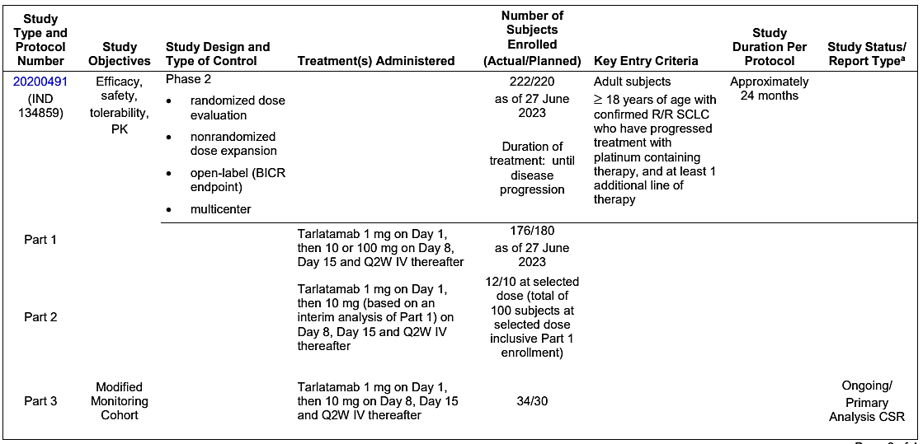
The supportive efficacy data came from first in human (FIH) Study 20160323.
Table 3. First in human Study 20160323
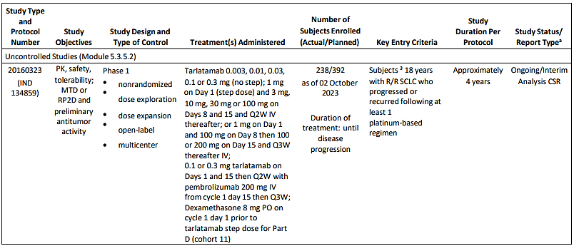
Additional three phase 1b studies were performed in a different population or with combination therapy, as described below:
- Study 20200040 – tarlatamab monotherapy in metastatic de novo or treatment-emergent NEPC in the second line or later
- Study 20200439 – tarlatamab combination therapy with anti-PD-1 antibody, AMG 404, in relapsed SCLC in the second line or later
- Study 20200469 – tarlatamab combination therapy with PD-L1 inhibitor  chemotherapy (carboplatin, etoposide) in extensive stage SCLC in first line.
Efficacy data from Part 3 of Study 20200491 and from patients who received the proposed tarlatamab dose from Study 20160323 were considered as supportive data for efficacy.

Pivotal Study 20200491
Study 20200491 is an ongoing phase 2, open-label, registrational study in subjects with recurrent SCLC who had progressed or recurred following 1 platinum-based regimen (with or without immune checkpoint inhibitor) and at least 1 other line of therapy (re-treatment with a platinum-based regimen was considered a second line of therapy).
This study was conducted in 3 parts. Part 1 evaluated 2 dose levels of tarlatamab in which approximately 180 eligible subjects were planned to be enrolled and randomized 1:1 to treatment with a target dose of either 10 mg or 100 mg tarlatamab. To select a target dose for expansion, an interim analysis was performed after 30 subjects on each arm in Part 1 had the opportunity to confirm an objective response after the first posttreatment scan, or up to 13 weeks of follow-up, whichever occurred first. Enrolment continued in a randomized fashion until dose selection was finalized. Part 2 was a dose expansion phase at the selected target dose based on an interim analysis of Part 1 and enrolled until approximately 100 subjects (from Part 1 and Part 2 combined) had been enrolled at the selected target dose level. Part 3 was initiated after completing enrolment of Part 1 and Part 2, to enrol up to approximately 30 additional subjects at the selected dose, with modified cycle 1 monitoring criteria.
Eligible subjects were ≥ 18 years of age (or legal adult age within country) with histologically or cytologically confirmed relapsed or refractory SCLC who progressed or recurred following 1 platinum-based regimen and at least 1 other prior line of therapy. Eligible subjects had measurable lesions as defined per response evaluation criteria in solid tumours (RECIST) 1.1 within 21 days prior to the first dose of tarlatamab and had adequate organ function (as defined in the protocol). Key exclusion criteria included symptomatic brain metastases, evidence of interstitial lung disease or non-infectious pneumonitis and active immunodeficiency.
Figure 2. Pivotal Study DeLLphi-301 (Study 20200491)
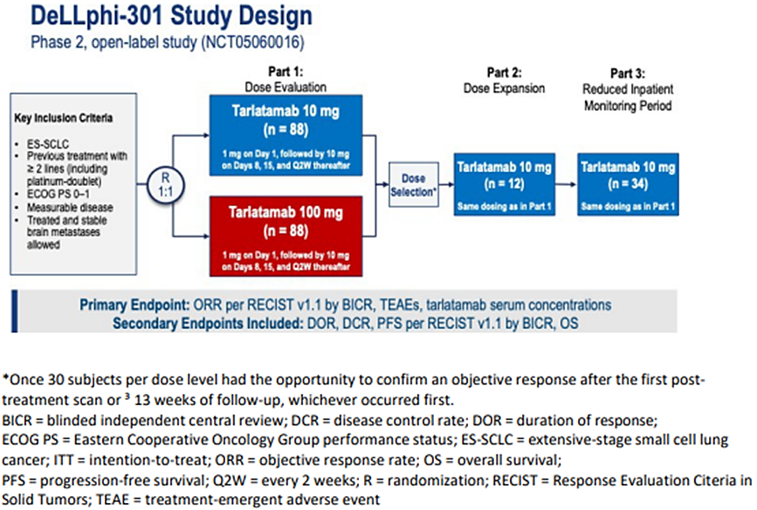
*Once 30 subjects per dose level had the opportunity to confirm an objective response after the first post-treatment scan or ³ 13 weeks of follow-up, whichever occurred first.
BICR = blinded independent central review; DCR = disease control rate; DOR = duration of response; ECOG PS = Eastern Cooperative Oncology Group performance status; ES-SCLC = extensive-stage small cell lung cancer; ITT = intention-to-treat; ORR = objective response rate; OS = overall survival; PFS = progression-free survival; Q2W = every 2 weeks; R = randomization; RECIST = Response Evaluation Citeria in Solid Tumors; TEAE = treatment-emergent adverse event.
The primary analysis was planned to occur when all subjects had been enrolled in Part 1 and Part 2 and had the opportunity to have at least 24 weeks of follow-up from the first scheduled postbaseline tumor assessm0ent. Primary analysis was based on the disease response assessment by blinded independent central review (BICR) per RECIST 1.1. The final analysis will occur when enrolment is complete and each subject completes the study, including long-term follow-up.

Analyses of Primary Efficacy Endpoint – Objective Response
The number and percentage of subjects with a best overall response of complete response (CR) or partial response (PR) were summarized along with a Clopper-Pearson exact 97.5% confidence interval (CI). Subjects without a postbaseline tumor assessment were considered as non-responders.
Baseline demographics and disease characteristics were generally consistent across the 10 and 100 mg dose groups. Overall, across all parts, 70.9% of subjects were men, and the majority were White (62.7%) and not Hispanic or Latino (61.4%). The median (range) age was 64 (34 to 82) years, and the majority of subjects were younger than 65 years (52.7%). A higher proportion of male patients were enrolled compared with female patients (71% vs. 28%), however, the ORR was similar between both groups of patients (38% for males vs. 46% for females).
All patients who received 10 mg tarlatamab from Parts 1 and 2 of Study 20200491 had ES-SCLC, 97% of patients had metastatic disease and 73 patients (74%) had received prior anti-PD-(L)1 therapy. Of these 73 patients, 58 (59%) received anti-PD-(L)1 therapy in combination with platinum-based chemotherapy in the first line setting which is representative of frontline standard of care treatment in the US. In addition, 50 patients (51%) received prior topoisomerase-I inhibitors including 20% of patients who received prior topotecan. Of the 49 patients who did not receive a topoisomerase I inhibitor, the majority (89%) received treatments that are considered standard of care options in the US, including platinum-based chemotherapy rechallenge, lurbinectedin, CAV, temozolomide, paclitaxel. Other treatments received include amrubicin, PD-(L)1 in combination with experimental agents and gemcitabine in combination with paclitaxel.

Results
Study 20200491 is ongoing as of the primary analysis data cutoff date (27 June 2023). Overall, 222 subjects were randomised (Part 1) or enrolled (Parts 2 and 3) and 220 subjects received at least 1 dose of tarlatamab, including 99 subjects in the 10 mg target dose group across Parts 1 and 2, 87 subjects in the 100 mg target dose group in Part 1, and 34 subjects in the Part 3 modified safety monitoring 10 mg target dose group. As of the data cutoff date, 149 subjects (67.1%) discontinued tarlatamab. The most frequent reason for discontinuation was disease progression (46.8%).

Primary Efficacy Endpoint – Objective Response for Part 1 and Part 2
A total of 185 and 186 subjects were included in the BICR or Investigator Full Analysis/Safety Analysis Set, respectively. The key efficacy results for tumor response from the phase 2 Study 20200491 (safety analysis set) Part 1 and 2.
Objective response was defined as a best overall response of either complete response or partial response per RECIST 1.1. Of the 186 evaluable subjects in the Safety Analysis Set for Parts 1 and 2 (10 and 100 mg), 7 subjects (3.8%) had a confirmed complete response, and 63 subjects (33.9%) had a confirmed partial response. The ORR (95% CI) by BICR was 41.4% (31.6, 51.8) for subjects who received the 10 mg target dose and 33.3% (23.6, 44.3) for subjects who received the 100 mg target dose. Within the 10 mg dose, the lower limit of the 95% CI excluded the prespecified benchmark ORR of 15%. The overall ORR (95% CI) by BICR was 37.6% (30.7, 45.0).
Table 4: Summary of Objective Response as Assessed by BICR (BICR Full Analysis Set for Part 1 and Part 2) (Study 20200491 Primary Analysis)
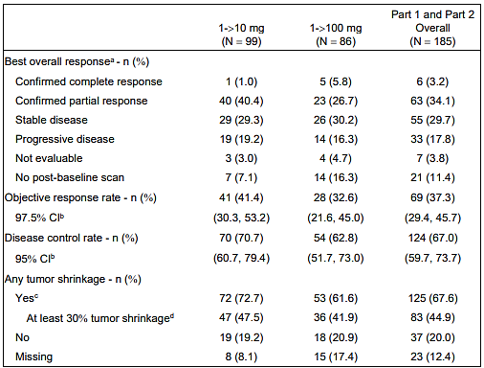
-> = Step dose to target dose (eg. 1 -> 10 mg = 1 mg step dose to 10 mg target dose)
BICR = blinded independent central review; RECIST = response evaluation criteria in solid tumors
The BICR full analysis set for Part 1 and Part 2 consists of all subjects who were randomized (Part 1) or enrolled (Part 2), received at least 1 dose of tarlatamab, and had 1 or more measurable lesions at baseline as assessed by BICR using RECIST 1.1 criteria.
Objective response rate is defined as the proportion of subjects with a best overall response of complete response or partial response as defined by RECIST 1.1.
Disease control rate is defined as the proportion of subjects with a best overall response of complete response or partial response or stable disease as defined by RECIST 1.1.
a. Assessment of disease response was determined based on RECIST 1.1 guidelines.
b. Exact confidence interval was calculated using the Clopper Pearson method.
c. Includes subjects who had any tumor shrinkage in the target lesions at postbaseline assessment.
d. Includes subjects who had at least 30° tumor shrinkage in the target lesions at postbaseline assessment.
Data snapshot date: 01 March 2024; data cutoff date: 27 June 2023.

Secondary Efficacy Endpoints

Duration of response
Duration of response was defined as time from first evidence of CR or PR to disease progression or death due to any cause, whichever occurred first. For Part 1 and Part 2 overall, the median (95% CI) duration of response among confirmed responders as assessed by BICR was 8.3 (6.9, not estimable [NE]) months. The median (range) time to objective response was 1.4 (1.1 to 9.6) months.
Of the 41 responders in the 10 mg target dose group, 23 subjects (56.1%) and 10 subjects (24.4%) had a duration of response (DOR) of at least 6 and 9 months, respectively. As of 27 June 2023, 22 of 41 responders (53.7%) in the 10 mg target dose group were still having ongoing responses (on treatment without disease progression or death), including 18 subjects (43.9%) whose responses reached at least 6 months and still had ongoing response.
Of the 33 subjects in the BICR Interim RECIST Analysis Set for Part 3, 4 subjects (12.1%) had a confirmed partial response. As of the data cutoff date, 5 subjects (15.2%) had an unconfirmed partial response awaiting a confirmatory scan. The overall ORR by BICR using a 97.5% CI was 12.1% (2.8%, 30.6%) for confirmed responders and 27.3% (11.9%, 48.0%) for confirmed and unconfirmed responses awaiting a confirmatory scan.
The interpretation of progression-free survival (PFS) and OS results as evidence for treatment effect are difficult to interpret in the absence of an appropriate control arm.
Although the sponsor proposed indication (SCLC with disease progression on or after platinum-based chemotherapy) differs from the population enrolled in Study 20200491 (SCLC with disease progression after receiving previous treatment with platinum-based chemotherapy and at least one other line of prior therapy) the sponsor has supported their proposed indication with reasonable justification. The enrolled population in the pivotal DeLLphi-301 study (Study 20200491) is representative of the relapsed SCLC population overall and observed efficacy extends to all analysed subgroups. Efficacy and safety data subsets from DeLLphi-301 and supportive Study 20160323 included patients who had received only 1 prior line of treatment. These patients demonstrated a similar efficacy and safety profile to the patients enrolled from the third line population.
In the second line setting, noteworthy response was seen across subgroups, including 51.9% ORR in subjects with < 90 days before progression after first line platinum therapy and in all subjects regardless of prior exposure to other recommended regimens. These data are favourable when viewed in the context of current regimens approved for patients with recurrent SCLC. In a third line setting where there are no approved therapies and patients receiving systemic therapy have a median survival of 4.4 months.
National Comprehensive Cancer Network (NCCN) Clinical Practice Guidelines in Oncology and other SCLC treatment guidelines and treatment patterns do not distinguish between second line vs third line and later therapies. Treatment options for patients with relapsed SCLC (after one prior line of therapy) are limited, the prognosis remains poor, and many patients do not survive to receive third line treatment. Limiting the indication to third line treatment will limit access for those most likely to benefit.
The confirmatory, controlled, phase 3 Study 20210004 (DeLLphi-304) will subsequently verify the phase 2 results through studying the patient population from the proposed indication (‘Subjects with relapsed or refractory SCLC who have progressed after one prior line of platinum-based chemotherapy’).

Supportive Study 20160323
An ongoing, phase 1, FIH, open-label, ascending, multiple-dose study evaluating tarlatamab as monotherapy and in combination with anti-PD-1 therapy. Tarlatamab is administered as an IV infusion Q2W or Q3W (in Part G) (with or without step dosing) in subjects with advanced SCLC that progressed or recurred after at least 1 platinum-based regimen. The study consists of multiple parts designed to evaluate the safety and tolerability of tarlatamab alone (Parts A, D, E, and G) or in combination with pembrolizumab (Part C) and to determine the maximum tolerated dose or recommended phase 2 dose of tarlatamab alone (Part A1) or in combination with pembrolizumab (Part C). Secondary objectives were to characterize the PK and evaluate preliminary antitumor activity of tarlatamab alone or in combination with pembrolizumab.
Figure 3. Supportive Study 20160323 design
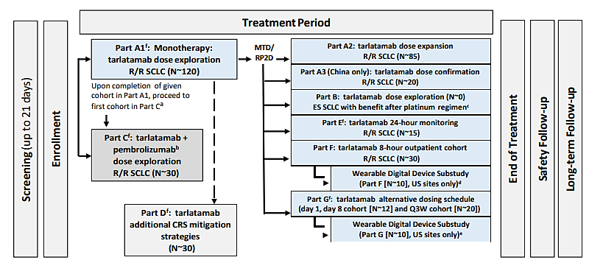
CRS = Cytokine Release Syndrome; ES = extensive stage; IV = intravenous; MTD = maximum tolerated dose; Q2W = every 2 weeks; RP2D = recommended phase 2 dose; R/R = relapsed/refractory; SCLC = small cell lung cancer.
Tarlatamab was administered as a short-term IV dose Q2W beginning in cycle 2. In cycle 1, step dosing may be implemented.
a. Depending on the observed safety data, a second cohort will be enrolled to test an increased dose.
b. Tarlatamab and pembrolizumab was administered using a staggered dosing schedule, with tarlatamab administered Q2W starting on day 1, and pembrolizumab administered Q3W starting on day 15.
c. Part B will not be opened.
d. Among the 30 subjects in Part F, 10 subjects from US sites only may be enrolled in the wearable digital device substudy.
e. Among the 32 subjects in Part G, 10 subjects from US sites only may be enrolled in the wearable digital device substudy.
f. Enrolment has been completed.
Eligible subjects were 18 years of age with relapsed or refractory SCLC who progressed or recurred following at least 1 platinum-based regimen. Subjects must have had measurable disease per modified Response Evaluation Criteria in Solid Tumours (RECIST) version 1.1, an ECOG performance status of 0 to 2, and adequate organ function. Eligibility criteria included adequate cardiac, pulmonary, kidney, and liver function. Subjects with acute and/or uncontrolled active systemic infection, active hepatitis B or C, or human immunodeficiency virus infection or COVID-19 infection were excluded.
A total of 208 subjects were enrolled in Study 20160323, and 205 subjects received at least 1 dose of tarlatamab, including 27 subjects in the 10 mg Q2W dose group, 63 subjects in the 100 mg Q2W dose group, and 13 subjects in the 100 mg Q2W dose group with modified safety monitoring. As of the data cutoff date, 180 subjects (86.5%) discontinued tarlatamab. The most frequent reason for discontinuation was disease progression (68.8%). Overall, 53 subjects (25.5%) completed the study and 115 subjects (55.3%) were discontinued from the study. The most frequently reported reason for discontinuation from the study was death (87 subjects; 41.8%).
In the overall population (N=205), more than half of subjects (56.1%) were men, mostly white (78.0%), and not Hispanic or Latino (77.6%). The median (range) age was 63.0 (32 to 80) years, with more than half of all subjects younger than 65 years (60.5%). Overall, subjects had a median (range) of 2.0 (1 to 7) prior lines of systemic therapy. Most subjects had received prior radiotherapy for current malignancy (77.1%) and prior PD-1 or programmed death protein 1 ligand (PD-L1) inhibitor therapy (61.0%). Most subjects had metastatic disease (92.2%) and an ECOG performance score of 0 (36.6%) or 1 (61.5%).
The primary endpoint for this study is safety and tolerability.

Secondary Efficacy Endpoint

Objective Response Rate
Of the 202 evaluable subjects overall, 4 subjects (2.0%) had a confirmed CR and 42 subjects (20.8%) had a confirmed PR. The confirmed ORR (95% CI) was 22.8% (17.2% to 29.2%). Three additional subjects had an unconfirmed PR and were awaiting confirmatory scans. The ORR (95% CI) for the 46 subjects with the confirmed response and the 3 subjects with the unconfirmed PR awaiting confirmatory scans was 24.3% (18.5% to 30.8%). Overall, the disease control rate (DCR; 95% CI) was 53.5% (46.3% to 60.5%). At the 10 mg monotherapy target dose, 24 subjects were evaluable. At this target dose, 2 subjects (8.3%) had a confirmed CR and 6 subjects (25.0%) had a confirmed PR, for a confirmed ORR (95% CI) of 33.3% (15.6% to 55.3%). One additional subject had an unconfirmed PR awaiting confirmatory scans. At the 100 mg monotherapy target dose, 76 subjects were evaluable. At this target dose, 2 subjects (2.6%) had a confirmed CR and 13 subjects (17.1%) had a confirmed PR, for a confirmed ORR (95% CI) of 19.7% (11.5% to 30.5%).

Duration of Response
Of the 46 confirmed responders overall, the median (range) DOR was 11.1 (6.6 to 14.8) months; 25 of 46 subjects (54.3%) had disease progression by the data cutoff date.
The PFS and OS results are difficult to interpret in the absence of an appropriate control arm.

Safety
The primary analysis of safety for the proposed indication is based on the integrated safety analysis of pooled data from subjects with SCLC who were treated with tarlatamab monotherapy at a dose of 10 or 100 mg Q2W in pivotal phase 2 Study 20200491 and FIH phase 1 Study 20160323. The exposures to tarlatamab in the pooled population of patients from Study 20200491 and Study 20160323 (n=187) with extensive stage SCLC who were treated with tarlatamab at the recommended dose of allowed for an adequate assessment of safety. The median duration of exposure was 108 days (range 1 to 427 days). Among these 187 patients, 31% were exposed for 6 months or longer and 14% were exposed for greater than one year. Median age was 66 years (range 35 to 82); other demographic information: male (65%), White (70%), Asian, (26%), Hispanic/Latino (2.1%) and Black (2.1%).
Table 5: Exposure to Tarlatamab Monotherapy – Studies 20200491, 20200040 and Monotherapy Cohorts of Study 20160323 (Safety Analysis Set)
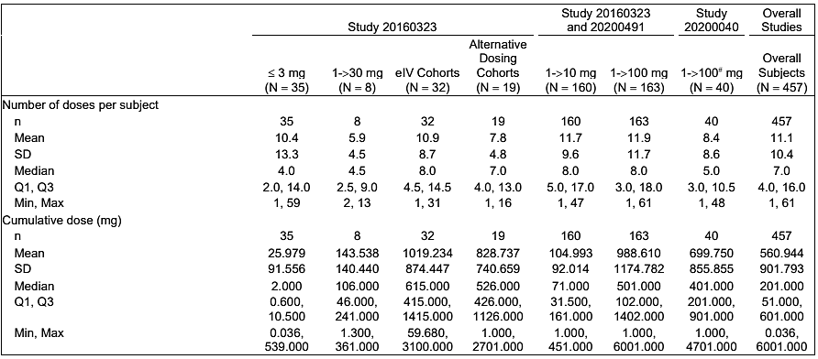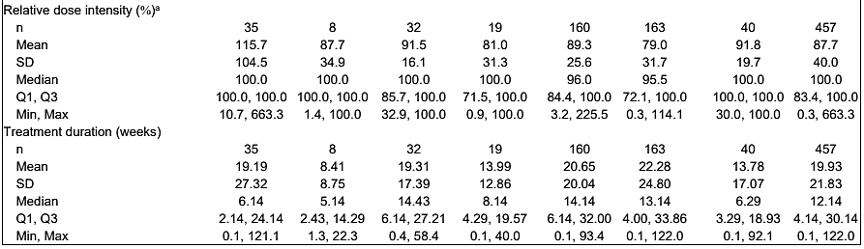
eIV = extended intravenous; N = number of subjects in the safety analysis set; n = number of subjects with observed data; Q3W = every 3 weeks
The safety analysis set is defined as all subjects who receive at least 1 dose of tarlatamab.
<3 mg includes cohorts 1-7; 1->30 mg includes cohort 9; elV Cohorts includes cohorts 26 (30 mg elV-100 mg), 27 and 31 (100 mg elV-100 mg); Alternative Dosing Cohorts include 2-step dosing cohort 23 (1->25-> 100 mg), cohort 37 (1->100->200 mg Q3W 21 day/cycle), and cohort 38 (1->100 mg day 1/day 8 21 day/cycle); 1->10 mg includes Study 20160323 cohorts 8 and 32 and Study 20200491 1->10 mg (Part 1 randomized am, Part 2, and Part 3); 1->100 mg includes Study 20160323 cohorts 10, 30, 11 (tarlatamab + dexamethasone), and 34 (24-hr outpatient) and Study 20200491 1->100 mg (Part 1 randomized arm); 1->100# mg includes all subjects in Study 20200040, including 3 subjects who received a lower dose of 30 mg because of adverse events. Overall Subjects includes all subjects who received tarlatamab as a monotherapy.
a. Relative dose intensity (%) is calculated as (actual cumulative dose / planned cumulative dose) * 100, where: Cumulative actual dose is the total dose of tarlatamab given up to the data cutoff. For subjects who did not take any drug the cumulative actual dose is 0 mg. Cumulative planned dose is the planned dose of tarlatamab accumulated over the actual duration on-study treatment.
Table 6: Exposure to Tarlatamab and Other Investigational Products
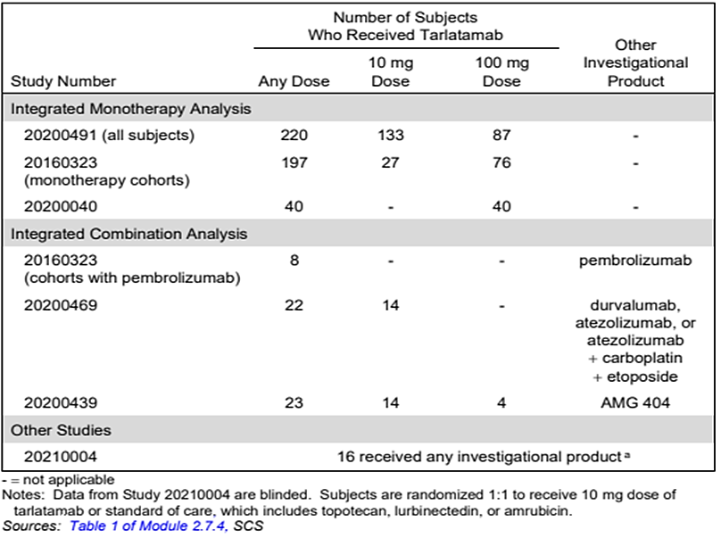
-= not applicable. Data from Study 20210004 are blinded. Subjects are randomised 1:1 to receive 10 mg dose of tarlatamab or standard of care, which includes topotecan, lurbinectedin, or amrubicin.
As of the data cut-off dates for Studies 20200491, 20160323, and 20200040, a total of 457 subjects were treated with tarlatamab monotherapy across all doses. This includes 160 subjects with SCLC treated with tarlatamab monotherapy at the 10 mg target dose across Studies 20200491 and 20160323 and 163 subjects with SCLC treated with tarlatamab monotherapy at the 100 mg target dose across Studies 20200491 and 20160323.
Of the 457 subjects in the integrated monotherapy safety analysis set, most were men (67.0%), White (69.8%), not Hispanic or Latino (68.5%), with a median (range) age of 63.0 (32 to 83) years, similar to the demographic characteristics observed in its phase 1 and phase 2 studies. Across the monotherapy studies, subjects had a median (range) of 2 (1 to 9) prior lines of therapy, including prior PD-1 or PD-L1 (63.5%). Most subjects had prior radiotherapy for current malignancy (78.8%). Most subjects had metastatic disease (93.9%), with liver metastases (40.0%) or brain metastases (24.3%), and an ECOG score of 1 (65.0%). Demographic and baseline characteristics in the tarlatamab 10 and 100 mg groups were similar to those in the overall monotherapy group.

Adverse events

Monotherapy safety analysis set
Overall Monotherapy: Adverse events were reported for 455 subjects (99.6%) treated with tarlatamab monotherapy, including 431 subjects (94.3%) with at least 1 treatment-related adverse event. Grade ≥ 3 adverse events were reported for 288 subjects (63.0%). Serious adverse events were reported for 271 subjects (59.3%). Adverse events leading to discontinuation of tarlatamab were reported for 32 subjects (7.0%). Fatal adverse events were reported for 19 subjects (4.2%), which were treatment related for 2 subjects (0.4%).
10 mg Target Dose: Adverse events were reported for 159 subjects (99.4%) with SCLC treated with 10 mg tarlatamab monotherapy, including 149 subjects (93.1%) with at least 1 treatment-related adverse event. Grade ≥ 3 adverse events were reported for 101 subjects (63.1%). Serious adverse events were reported for 87 subjects (54.4%). Adverse events leading to discontinuation of tarlatamab were reported for 11 subjects (6.9%). Fatal adverse events were reported for 5 subjects (3.1%), which were treatment related for 1 subject (0.6%).
Results for the 10 and 100 mg dose were generally comparable to those for the overall monotherapy population. Results for combination therapy studies were generally similar to those for monotherapy.

Common adverse events

Monotherapy safety analysis set
Overall Monotherapy: The most frequently reported (≥ 30% of subjects) adverse events by preferred term for subjects treated with tarlatamab monotherapy were CRS (59.1%), pyrexia (41.1%), decreased appetite (38.7%), constipation (33.5%), and dysgeusia (31.5%).
10 mg Target Dose: The most frequently reported (≥ 30% of subjects) adverse events by preferred term for subjects with SCLC treated with 10 mg tarlatamab monotherapy were CRS (53.8%), pyrexia (38.8%), decreased appetite (33.8%), and dysgeusia (31.3%).
100 mg Target Dose: The most frequently reported (≥ 30% of subjects) adverse events by preferred term for subjects with SCLC treated with 100 mg tarlatamab monotherapy were CRS (64.4%), pyrexia (42.9%), decreased appetite (41.7%), and constipation (33.1%).

Treatment-related adverse events
Overall Monotherapy: Treatment-related adverse events were reported for 431 subjects (94.3%) treated with tarlatamab monotherapy. Overall, the most frequently reported (≥ 25% of subjects) treatment-related adverse events by preferred term for subjects treated with tarlatamab monotherapy were CRS (59.1%), pyrexia (36.5%), dysgeusia (27.1%), and decreased appetite (25.8%).
10 mg Target Dose: Treatment-related adverse events were reported for 149 subjects (93.1%) with SCLC treated with 10 mg tarlatamab monotherapy. The most frequently reported (≥ 25% of subjects) treatment-related adverse events by preferred term for subjects with SCLC treated with 10 mg tarlatamab monotherapy were CRS (53.8%), pyrexia (34.4%), dysgeusia (28.1%), and decreased appetite (25.0%).
100 mg Target Dose: Treatment-related adverse events were reported for 156 subjects (95.7%) with SCLC treated with 100 mg tarlatamab monotherapy. The most frequently reported (≥ 25% of subjects) treatment-related adverse events by preferred term for subjects with SCLC treated with 100 mg tarlatamab monotherapy were CRS (64.4%) and pyrexia (38.0%).
Table 7: Treatment-related Adverse Events by Preferred Term (Occurring in at Least 5% of Subjects Overall) – Monotherapy – Studies 20200491, 20200040 and Monotherapy Cohorts of Study 20160323 (Safety Analysis Set).
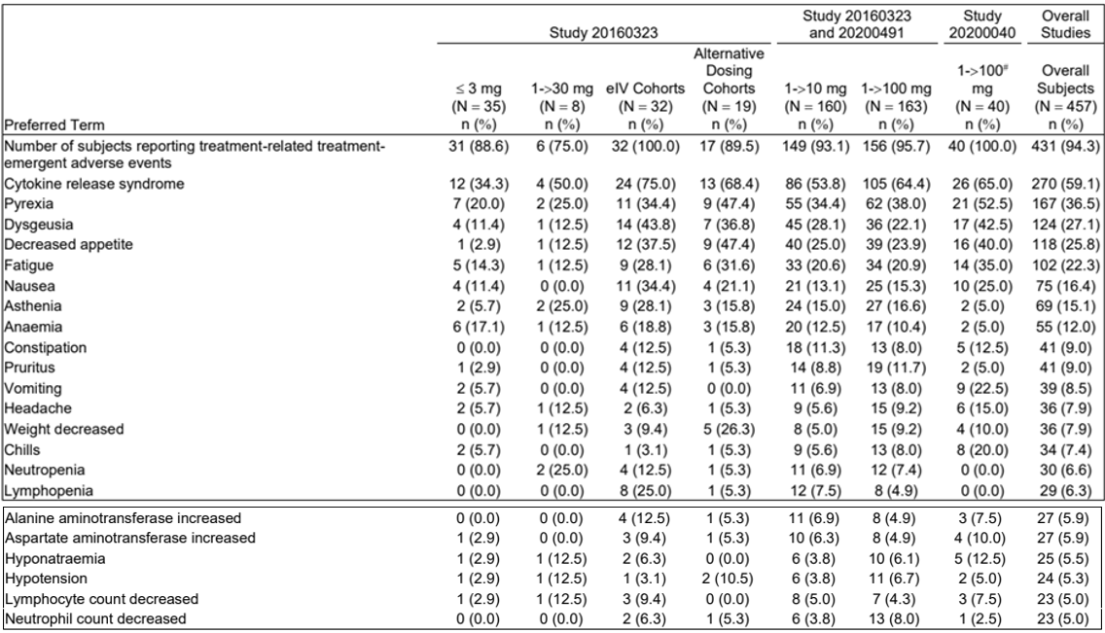
eIV = extended intravenous; MedDRA = Medical Dictionary for Regulatory Activities; N = number of subjects in the safety analysis set; n = number of subjects with observed data; Q3W = every 3 weeks
The safety analysis set is defined as all subjects who receive at least 1 dose of tarlatamab.
< 3 mg includes cohorts 1-7; 1->30 mg includes cohort 9; elV Cohorts includes cohorts 26 (30 mg elV-100 mg), 27 and 31 (100 mg elV-100 mg); Alternative Dosing Cohorts include 2-step dosing cohort 23 (1->25->100 mg), cohort 37 (1->100->200 mg Q3W 21 day/cycle), and cohort 38 (1->100 mg day 1/day 8 21 day/cycle); 1->10 mg includes Study 20160323 cohorts 8 and 32 and Study 20200491 1->10 mg (Part 1 randomized arm, Part 2, and Part 3); 1->100 mg includes Study 20160323 cohorts 10, 30, 11 (tarlatamab + dexamethasone), and 34 (24-hr outpatient) and Study 20200491 1->100 mg (Part 1 randomized arm); 1->100# mg includes all subjects in Study 20200040, including 3 subjects who received a lower dose of 30 mg because of adverse events. Overall Subjects includes all subjects who received tarlatamab as a monotherapy.
Coded using MedDRA version 26.1.
Event with missing relationship is considered treatment related.
Events of small cell lung cancer/disease progression are excluded.

Treatment-related grade 3 or higher adverse events
The subject incidence of treatment-related grade ≥ 3 adverse events that occurred in ≥ 1% of subjects in the Monotherapy Safety Analysis Set.
Overall Monotherapy: Treatment-related grade ≥ 3 adverse events were reported for 172 subjects (37.6%) treated with tarlatamab monotherapy. Overall, the most frequently reported (≥ 3% of subjects) treatment-related grade ≥ 3 adverse events by preferred term were fatigue (4.4%), decreased lymphocyte count and lymphopenia (4.2% each); CRS (3.5%); and neutropenia (3.3%).
10 mg Target Dose: Treatment-related grade ≥ 3 adverse events were reported for 50 subjects (31.3%) with SCLC treated with 10 mg tarlatamab monotherapy. The most frequently reported (≥ 3% of subjects) treatment-related grade ≥ 3 adverse events by preferred term were lymphopenia (6.3%), decreased lymphocyte count (4.4%), and fatigue (3.1%).
100 mg Target Dose: Treatment-related grade ≥ 3 adverse events were reported for 65 subjects (39.9%) with SCLC treated with 100 mg tarlatamab monotherapy. The most frequently reported (≥ 3% of subjects) treatment-related grade ≥ 3 adverse events by preferred term were CRS (6.1%), neutropenia and decreased neutrophil count (4.9% each); fatigue and decreased white blood cell count (4.3% each); and decreased lymphocyte count and lymphopenia (3.1% each).

Deaths

Monotherapy safety analysis set
Overall Monotherapy: Fatal adverse events were reported for 19 subjects (4.2%) treated with tarlatamab monotherapy. Overall, the most frequently reported (occurring in > 1 subject) fatal adverse events by preferred term were aspiration, cardio-respiratory arrest, neuroendocrine carcinoma of the prostate, pneumonia, and respiratory failure (2 subjects [0.4% each]).
10 mg Target Dose: Fatal adverse events were reported for 5 subjects (3.1%) with SCLC treated with 10 mg tarlatamab monotherapy, no preferred term was reported for more than 1 subject.
100 mg Target Dose: Fatal adverse events were reported for 6 subjects (3.7%) with SCLC treated with 100 mg tarlatamab monotherapy. The only fatal adverse event by preferred term reported for more than 1 subject was cardio-respiratory arrest (2 subjects [1.2%]).

Treatment-related fatal adverse events
Overall Monotherapy: Treatment-related fatal adverse events were reported for 2 subjects (0.4%) treated with tarlatamab monotherapy, including 1 subject (0.6%) with SCLC treated with tarlatamab monotherapy at 10 mg; no subjects with SCLC treated with tarlatamab monotherapy at 100 mg had a treatment-related fatal adverse event. In both subjects, preferred term was respiratory failure (2 subjects [0.4%]).
No fatal adverse events were reported for subjects treated with tarlatamab combination therapy in Studies 20160323 Part C or 20200469.

Serious adverse events
Table 8: Serious Adverse Events by Preferred Term (Occurring in at Least 1% of Subjects Overall) – Monotherapy – Studies 20200491, 20200040 and Monotherapy Cohorts of Study 20160323 (Safety Analysis Set)
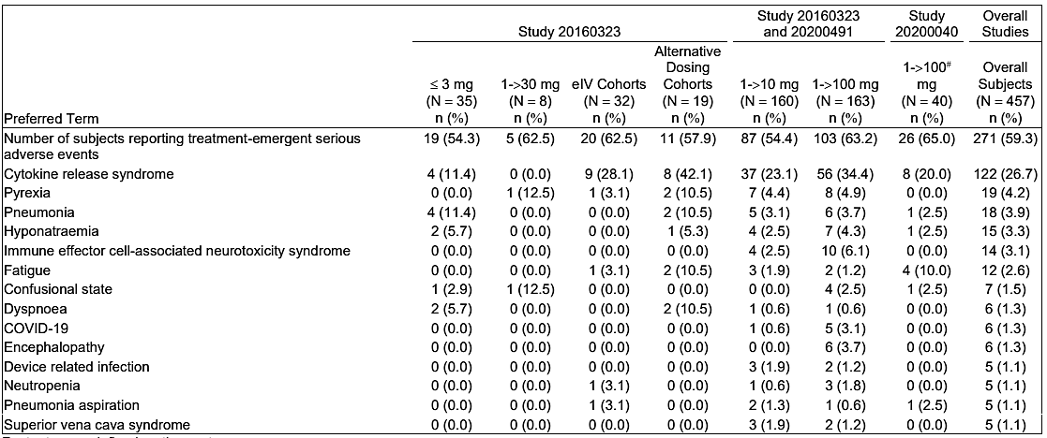
eIV = extended intravenous; MedDRA = Medical Dictionary for Regulatory Activities; N = number of subjects in the safety analysis set; n = number of subjects who received at least 1 dose of tarlatamab; Q3W = every 3 weeks
The safety analysis set is defined as all subjects who receive at least 1 dose of tarlatamab.
< 3 mg includes cohorts 1-7; 1->30 mg includes cohort 9; elV Cohorts includes cohorts 26 (30 mg elV-100 mg), 27 and 31 (100 mg elV-100 mg); Alternative Dosing Cohorts include 2-step dosing cohort 23 (1->25->100 mg), cohort 37 (1->100->200 mg Q3W 21 day/cycle), and cohort 38 (1->100 mg day 1/day 8 21 day/cycle); 1->10 mg includes Study 20160323 cohorts 8 and 32 and Study 20200491 1->10 mg (Part 1 randomized am, Part 2, and Part 3); 1->100 mg includes Study 20160323 cohorts 10, 30, 11 (tarlatamab + dexamethasone), and 34 (24-hr outpatient) and Study 20200491 1->100 mg (Part 1 randomized arm); 1->100# mg includes all subjects in Study 20200040, including 3 subjects who received a lower dose of 30 mg because of adverse events. Overall Subjects includes all subjects who received tarlatamab as a monotherapy.
Coded using MedDRA version 26.1.
Events of small cell lung cancer/disease progression are excluded.
The incidence of serious adverse events was generally lower across the combination therapy studies (25.0% to 64.3%) compared with monotherapy (59.3%); the most frequently reported serious adverse event with combination therapy was CRS. In Study 20200491 alone, serious adverse events were reported for 134 subjects (60.9%) overall (58 subjects [58.6%] in the 10 mg target dose group in Part 1 and Part 2, 61 subjects [70.1%] in the 100 mg target dose group, and 15 subjects [44.1%] in the Part 3 modified safety monitoring 10 mg target dose group).

Treatment-related serious adverse events
Overall Monotherapy: Treatment-related serious adverse events were reported for 189 subjects (41.4%) treated with tarlatamab monotherapy. Overall, the most frequently reported (≥ 2% of subjects) serious adverse events by preferred term were CRS (26.7%), pyrexia (3.5%), and ICANS (3.1%). 10 mg Target Dose: Treatment-related serious adverse events were reported for 52 subjects (32.5%) with SCLC treated with 10 mg tarlatamab monotherapy. The most frequently reported (≥ 2% of subjects) serious adverse events by preferred term were CRS (23.1%), pyrexia (3.1%), and ICANS (2.5%). 100 mg Target Dose: Treatment-related serious adverse events were reported for with 81 subjects (49.7%) with SCLC treated with 100 mg tarlatamab monotherapy. The most frequently reported (≥ 2% of subjects) serious adverse events by preferred term were CRS (34.4%), ICANS (6.1%), pyrexia (4.3%), and encephalopathy (3.7%).

Specific safety issues of interest

Cytokine Release Syndrome
Most instances of CRS were Grade 1 or 2 and that most patients experienced CRS following tarlatamab administration of initial step-up dose of 1 mg IV on Cycle 1 Day 1. Patients received premedication with dexamethasone 8 mg IV administered 1 hour prior to infusion on Days 1 and 8 of Cycle 1 only and post IV hydration with 1 Liter of normal saline over 4-5 hours. In the pooled safety population (n = 187), CRS occurred in 55% of patients, including 34% Grade 1, 19% Grade 2, 1.1% Grade 3 and 0.5% Grade 4 of tarlatamab-treated patients. Tocilizumab was used in 9% of patients and there were no fatal Grade 5 events. Recurrent CRS occurred in 24% of tarlatamab-treated patients (18% Grade 1, 6% Grade 2).
Most events (43%) of CRS occurred after the first dose with 29% of patients experiencing any grade CRS after the second dose and 9% of patients experiencing CRS following the third dose or later. Following the Day 1, Day 8, Day 15 infusions, 16%, 4.3%, and 2.1% of patients experienced ≥ Grade 2 CRS, respectively. The median time to onset of all grade CRS from most recent dose of tarlatamab was 13.5 hours (range: 1 to 268 hours). The median time to onset of ≥ Grade 2 CRS from most recent dose of tarlatamab was 14.6 hours (range: 2 to 566 hours).

Immune Effector Cell-associated Neurotoxicity Syndrome and Associated Neurological events
In the pooled safety population, neurologic toxicity including ICANS occurred in 47% of patients who received tarlatamab, including 10% Grade 3; there were no Grade 4 events. The most frequent neurologic toxicities were headache (14%), peripheral neuropathy (7%), dizziness (7%), insomnia (6%), muscular weakness (3.7%), delirium (2.1%), syncope (1.6%) and neurotoxicity (1.1%). ICANS occurred in 9% of patients and recurrent ICANS occurred in 1.6% of patients. Most patients experienced ICANS following cycle 2 day 1 (24%). Following Day 1, Day 8, and Day 15 infusions, 0.5%, 0.5% and 3.7% of patients experienced ≥ Grade 2 ICANS, respectively. The median time to onset of ICANS from the first dose of tarlatamab was 29.5 days (range: 1 to 154 days). The median time to resolution of ICANS was 33 days (range: 1 to 93 days).

Neutropenia
The treatment emergent adverse events of interest the pooled safety population included cytopenias which includes neutropenia, thrombocytopenia and anaemia. In the pooled safety population, decreased neutrophils occurred in 12% of patients, including Grade 3 or 4 in 6% of patients. The median time to onset for Grade 3 or 4 neutropenia was 29.5 days (range: 2 to 213). Decreased platelets occurred in 33% including Grade 3 or 4 in 3.2% of patients. The median time to onset for Grade 3 or 4 decreased platelets was 50 days (range: 3 to 420). Decreased haemoglobin occurred in 58% including 5% Grade 3 or 4. Febrile neutropenia occurred in 0.5% of patients treated with Imdelltra.

Risk management plan
Amgen Australia Pty Ltd has submitted Core-RMP version 0.2 (dated 9 April 2024; DLP 27 June 2023) and ASA version 1.0 (dated 14 June 2024) in support of this application.
The summary of safety concerns and their associated risk monitoring and mitigation strategies are summarised in Table 9. The TGA may request an updated RMP at any stage of a product's life-cycle, during both the pre-approval and post-approval phases.
Table 9: Summary of safety concerns
Summary of safety concerns |  | Pharmacovigilance |  | Risk Minimisation
 |  | Routine | Additional | Routine | Additional
Important identified risks | Cytokine release syndrome | * | – |  | †‡
Important identified risks | Immune effector cell-associated neurotoxicity syndrome (ICANS) | * | – |  | †‡
Important potential risks | None
Missing information | None
*Targeted follow up questionnaire for specific events.
† Patient Alert Card
‡ Patient Guide

Risk-benefit analysis

Efficacy
Efficacy data from Parts 1 and 2 of Study 20200491 in patients who received the tarlatamab 10 mg proposed dose comprise the primary dataset to support this application. Efficacy data from Part 3 of Study 20200491 and in patients who received the tarlatamab 10 mg dose in Study 20160323 were evaluated as supportive evidence of effectiveness for this application.
Although the sponsor proposed indication (SCLC with disease progression on or after platinum-based chemotherapy) differs from the population enrolled in the pivotal Study 20200491 (SCLC with disease progression after receiving previous treatment with platinum-based chemotherapy and at least one other line of prior therapy) the sponsor has supported their proposed indication with reasonable justification. The enrolled population in the pivotal DeLLphi-301 study (Study 20200491) is representative of the relapsed SCLC population overall and observed efficacy extends to all analysed subgroups. Efficacy and safety data subsets from DeLLphi-301 and supportive Study 20160323 included patients who had received only 1 prior line of treatment. These patients demonstrated a similar efficacy and safety profile to the patients enrolled from the third line population.
In the second line setting, noteworthy response was seen across subgroups, including 51.9% ORR in subjects with < 90 days before progression after first line platinum therapy and in all subjects regardless of prior exposure to other recommended regimens. These data are favourable when viewed in the context of current regimens approved for patients with recurrent SCLC. In a third line setting where there are no approved therapies and patients receiving systemic therapy have a median survival of 4.4 months14.
National Comprehensive Cancer Network (NCCN) Clinical Practice Guidelines in Oncology and other SCLC treatment guidelines and treatment patterns do not distinguish between second line vs third line and later therapies. Treatment options for patients with relapsed SCLC (after one prior line of therapy) are limited, the prognosis remains poor, and many patients do not survive to receive third line treatment. Limiting the indication to third line treatment will limit access for those most likely to benefit.
The confirmatory, controlled, phase 3 Study 20210004 (DeLLphi-304) will subsequently verify the phase 2 results through studying the patient population from the proposed indication. (‘Subjects with relapsed or refractory SCLC who have progressed after one prior line of platinum-based chemotherapy’).
The primary efficacy population consisted of 99 patients enrolled in from Parts 1 and 2 of Study 20200491 who received tarlatamab at the proposed dose, in this phase 2, open-label, in subjects with recurrent SCLC who had progressed or recurred following 1 platinum-based regimen (with or without immune checkpoint inhibitor) and at least 1 other line of therapy (re-treatment with a platinum-based regimen was considered a second line of therapy). Of the 99 patients, 73 patients (74%) had received prior anti-PD-(L)1 therapy; of these 73 patients, 58 (59%) received anti-PD-(L)1 therapy in combination with platinum-based chemotherapy in the first line setting. The observed 40% response rate (95% CI: 31%, 51%) from patients enrolled to Parts 1 and 2 of Study 20200491 who received tarlatamab at the proposed dosing regimen is considered a clinically meaningful improvement over available therapy. The response rates were supported by a median DoR of 9.7 months with 68% of patients with an observed DoR ≥6 months and 40% of patients with an observed DoR ≥12 months. The observed ORR was generally consistent across most patient subgroups, defined by relevant demographic and disease-related characteristics, including across subgroups of patients with platinum-sensitive and platinum-refractory disease and across subgroups with various DLL3 expression cut-offs. The PFS and OS results are difficult to interpret in the absence of an appropriate control arm.

Safety
The primary analysis of safety for the proposed indication is based on the integrated safety analysis of pooled data from subjects with SCLC who were treated with tarlatamab monotherapy at a dose of 10 or 100 mg Q2W in pivotal phase 2 Study 20200491 and FIH phase 1 Study 20160323.
The most common adverse reactions were cytokine release syndrome, fatigue, pyrexia, dysgeusia, decreased appetite, musculoskeletal pain, constipation, anaemia, and nausea. It is agreed that the CRS and neurotoxicity including ICANS can be managed through communication in labelling (including a black box warning), dosing recommendation and enhanced pharmacovigilance. Other significant adverse events included infections, hepatotoxicity, cytopenias and hypersensitivity which are included in the Warnings and Precaution section of the label. The observed toxicity profile of tarlatamab is considered acceptable in the context of a life-threatening disease.

Assessment outcome
Based on a review of quality, safety, and efficacy, the TGA decided to register Imdelltra (tarlatamab) for the following indication:
Imdelltra has provisional approval in Australia for the treatment of adult patients with extensive-stage small cell lung cancer (ES-SCLC) with disease progression on or after platinum-based chemotherapy.
The decision to approve this indication has been made on the basis of overall response rate and duration of response in a single arm trial. Continued approval of this indication depends on verification and description of benefit in confirmatory trials.

Specific conditions of registration
Imdelltra (Tarlatamab) is to be included in the Black Triangle Scheme. The PI and CMI for Imdelltra must include the black triangle symbol and mandatory accompanying text for five years, or the product’s entire period of provisional registration, whichever is longer.
The Imdelltra Core-Risk Management Plan (RMP) (version 0.2, dated 9 April 2024, data lock point 27 June 2023), with Australia-Specific Annex (ASA) (version 1.0, dated 14 June 2024), included with submission PM-2024-02535-1-4, and any subsequent revisions, as agreed with the TGA will be implemented in Australia.
An obligatory component of risk management plans is routine pharmacovigilance. Routine pharmacovigilance includes the submission of periodic safety update reports (PSURs). Unless agreed separately between the supplier who is the recipient of the approval and the TGA, the first report must be submitted to TGA no later than 15 calendar months after the date of this approval letter. The subsequent reports must be submitted no less frequently than annually from the date of the first submitted report until the period covered by such reports is not less than three years from the date of this approval letter, or the entire period of provisional registration, whichever is longer. Each report must be submitted within ninety calendar days of the data lock point for that report.
The reports are to at least meet the requirements for PSURs as described in the European Medicines Agency’s Guideline on good pharmacovigilance practices (GVP) Module VII-periodic safety update report (Rev 1), Part VII.B Structures and processes. Note that submission of a PSUR does not constitute an application to vary the registration.
Laboratory testing & compliance with Certified Product Details (CPD)
- All batches of Imdelltra tarlatamab 1 mg powder for injection vial with intravenous (IV) solution stabiliser and Imdelltra tarlatamab 10 mg powder for injection vial with intravenous (IV) solution stabiliser> supplied in Australia must comply with the product details and specifications approved during evaluation and detailed in the Certified Product Details (CPD).
- When requested by the TGA, the Sponsor should be prepared to provide product samples, specified reference materials and documentary evidence to enable the TGA to conduct laboratory testing on the Product. Outcomes of laboratory testing are published biannually in the TGA Database of Laboratory Testing Results https://www.tga.gov.au/safety/safety-monitoring-and-information/product-testing-and-investigations/testing-therapeutic-goods/information-about-tga-laboratory-testing-results and periodically in testing reports on the TGA website.

Certified Product Details
The Certified Product Details (CPD), as described in Guidance 7: Certified Product Details of the Australian Regulatory Guidelines for Prescription Medicines (ARGPM), in PDF format, for the above products should be provided upon registration of these therapeutic goods. In addition, an updated CPD should be provided when changes to finished product specifications and test methods are approved in a Category 3 application or notified through a self-assessable change.
A template for preparation of CPD for biological prescription medicines can be obtained from the TGA website
- [for the form] https://www.tga.gov.au/resources/resources/forms/certified-product-details-cpd-biological-prescription-medicines
- [for the CPD guidance] https://www.tga.gov.au/resources/guidance/submitting-certified-product-details-cpd-biological-prescription-medicines
The following study reports/data will have to be submitted before a definitive authorisation can be considered:
- Confirmatory trial data (as identified in the sponsor’s plan to submit comprehensive clinical data on the safety and efficacy of the medicine before the end of the 6 years that would start on the day that registration would commence) must be provided.
- Specifically, the sponsor must conduct studies as described in the clinical study plan the Australia-Specific Annex; Phase 3 Study 20210004 (DeLLphi-304).
Submit the final study report of Study 20200491 following completion.

Product Information and Consumer Medicine Information
For the most recent Product Information (PI) and Consumer Medicine Information (CMI), please refer to the TGA PI/CMI search facility.

Therapeutic Goods Administration
PO Box 100 Woden ACT 2606 Australia
Email: info@tga.gov.au Phone: 1800 020 653 Fax: 02 6203 1605
https://www.tga.gov.au

This is the original indication proposed by the sponsor when the TGA commenced the evaluation of this submission. It may differ to the final indication approved by the TGA and registered in the Australian Register of Therapeutic Goods.
Sung H, Ferlay J, Siegel RL, et al. Global Cancer Statistics 2020: GLOBOCAN Estimates of Incidence and Mortality Worldwide for 36 Cancers in 185 Countries. CA Cancer J Clin. 2021;71(3):209-249.
NCI. National Cancer Institute. PDQ↓ Adult Treatment Editorial Board. Small cell lung cancer treatment. Bethesda, MD: Updated 02 March 2023. Available at https://www.cancer.gov/types/lung/hp/small-cell-lung-treatment-pdq.
NORD. National Organization for Rare Disorders. Rare Disease Database. Small Cell Lung Cancer. 2021. https://rarediseases.org/rare-diseases/small-cell-lung-cancer/
Rudin CM, Brambilla E, Faivre-Finn C, & Sage J. Small-cell lung cancer. Nat Rev Dis Primers. 2021;7:3
American Cancer Society. Cancer Facts & Figures 2022. American Cancer Society, GA, USA (2022).
Australian Institute of Health and Welfare. Lung cancer in Australia: an overview. Updated 15 August 2023.
NCCN Clinical Practice Guidelines in Oncology (NCCN Guidelines) for Small Cell Lung Cancer V.3.2023.  National Comprehensive Cancer Network, Inc. 21 December 2022
Tariq S, Kim SY, Monteiro de Oliveira Novaes J, & Cheng H. Update 2021: Management of Small Cell Lung Cancer. Lung. 2021;199:579-587.
Paz-Ares L, Champiat S, Lai WV, et al. Tarlatamab, a first-in-class DLL3-targeted bispecific T-cell engager, in recurrent small-cell lung cancer: An open-label, phase I study. Journal of Clinical Oncology. 2023;41(16):2893-2903
Horn L, Mansfield AS, Szczesna A, et al. First-line atezolizumab plus chemotherapy in extensive-stage small-cell lung cancer. N Engl J Med. 2018;379:2220-2229
Giffin MJ, Cooke K, Lobenhofer EK, et al. AMG 757, a half-life extended, DLL3-targeted bispecific T-cell engager, shows high potency and sensitivity in preclinical models of small-cell lung cancer. Clin Cancer Res. 2021;27:1526-1537
Owen DH, Giffin MJ, Bailis JM, Smit MD, Carbone DP, and He K. DLL3: an emerging target in small cell lung cancer. J Hematol Oncol. 2019;12:61
Coutinho AD, Shah M, Lunacsek OE, Eaddy M, Willey JP. Real-world treatment patterns and outcomes of patients with small cell lung cancer progressing after 2 lines of therapy. Lung Cancer. 2019 Jan;127:53-58. doi: 10.1016/j.lungcan.2018.11.009. Epub 2018 Nov 8. PMID: 30642551.

